Digital Twin-enabled Graduation Intelligent Manufacturing System for Fixed-position Assembly Islands
Daqiang Guo^{a,b}, Ray Y. Zhongª, Peng Linª, Zhongyuan Lyuª, Yiming Rong^{b}, George Q. Huangª*
ªDepartment of Industrial and Manufacturing Systems Engineering, The University of Hong Kong, Hong Kong, China
^{b}Department of Mechanical and Energy Engineering, Southern University of Science and Technology, Shenzhen, China
* Corresponding author. E-mail address: gqhuang@hku.hk
Abstract
The layout of fixed-position assembly islands is widely used in the heavy equipment industry, where the product remains at one assembly island for its entire assembly period, while required workers, equipment and materials are moved to the island according to the assembly process and production plan. Such layout is not only suitable for producing bulky or fragile products, but also offers considerable flexibility and competitive operational efficiency for products with medium variety and production volumes. However, due to inherent complexity of the product, sophisticated assembly operations heavily rely on skilled operators, and the complexity and uncertainty are high and amplified by highly dynamic of material, equipment and manpower flows with massive manual interventions. Aim at reducing complexity and uncertainty by utilizing information visibility and visualization, this paper introduces a digital twin-enabled Graduation Intelligent Manufacturing System (DT-GiMS) for fixed-position assembly islands. Inspired by the success of graduation ceremony, an assembly system Graduation Manufacturing System (GMS) is proposed for fixed-position assembly islands, in which job tickets, setup tickets, operation tickets and logistics tickets are designed to organize the production activities. Following the concept of the digital twin, unified digital representations with appropriate sets of information are created at object level, product level and system level, respectively. Through Internet of Things (IoT) and industrial wearable technologies, vital information including identity, status, geometric model, and production process can be captured, mapped and synchronized between the physical part and its digital representation on a real-time basis. The overall framework of DT-GiMS is presented with physical part layer, digital part layer, and service pool layer. Real-time convergence and synchronization among them promise to ensure that right resources are allocated and utilized to the right activities at the right time with enhanced visibility. Considering customer demand and production capacity constraints, real-time ticket pool management mechanisms are proposed to manage production activities in an optimal way under DT-GiMS. With the support of cloud-based services provided in service pool layer in DT-GiMS, managers could easily make optimal decisions, and onsite operators could efficiently complete their daily tasks with nearly error-free operations with enhanced visibility. Furthermore, a demonstrative case is carried out to verify the effectiveness of the proposed concept and approach.
Keywords: Digital twin; Intelligent manufacturing system; Fixed-position assembly; Cloud-based services; Real-time; Synchronization
1. Introduction
The layout of fixed-position assembly islands is widely used in the heavy equipment industry. It is normally adopted when products are too bulky or fragile, i.e., ships, aircraft, rotary printing presses and big milling machines [1, 2]. Among over 80,000 Hong Kong manufacturers in Pearl River District, most lift and mold manufacturers are of this type [3]. In this layout, workers move from one assembly site (often called an assembly island) to another, and required materials and equipment are moved to an assembly island, while the product normally remains at one assembly island for its entire manufacturing (assembly) period.
There are many advantages of fixed-position assembly islands comparing to typical job shop or flow shop, such as reduced damage or cost of product movement and more continuity of the assigned workforce since the product does not need to be moved frequently [4]. Such layout also offers considerable flexibility at the strategic level and competitive efficiency at the operational level for products with medium variety and production volumes. However, due to inherent complexity of the product, sophisticated assembly operations heavily rely on skilled operators, and it is prone to errors and disruptions with massive human interventions. Besides, since the product remains at one fixed island, required resources including workers, equipment and materials need frequently moved to the island at different stages. These challenges increase and amplify the complexity and uncertainty in fixed-position assembly islands.
For fighting complexity and uncertainty in the manufacturing industry, many advanced manufacturing systems have been developed by the manufacturing researchers and practitioners, such as enterprise resource planning (ERP) systems [5, 6] and manufacturing execution systems (MES) [7]. These advanced manufacturing systems provide effective solutions for improving collaboration and streamlining workflow for complex production processes. However, industrial practices show that they failed to reach the organization’s targets and expectations because of coherent data collection requirements and high sensitivity to variability and uncertainty [8-10]. With the support of information technologies, Internet of Things (IoT) technologies and devices, especially the RFID or Auto-ID technologies are widely applied in manufacturing scenarios to capture real-time data from the workshops [11-13]. Fortunately, the power of IoT promises to reduce uncertainty through information visibility and traceability by capturing real-time production data. However, IoT alone does not guarantee that as it does not really act as effective mechanisms for information sharing, and many challenges remain unsolved in fixed-position assembly islands.
Firstly, how to design an appropriate assembly system for the unique layout of fixed-position assembly islands? Due to the specific routing pattern, the material flow and workflow in fixed-position assembly islands are quite different from that in traditional flow shop and job shop. A specific assembly system with appropriate configurations and effective production strategies for fixed-position assembly islands are crucial, which is the basis of the whole system.
Secondly, how to create unified digital representations for fixed-position assembly islands? Since the product remains at one fixed site while being assembled, various manufacturing resources, including workers, equipment and materials are needed at different stages to organize and coordinate multi-echelon production activities. However, lack unified digitization approaches, vital information, such as identification, status, geometric model, and production process cannot be captured, mapped and shared on a real-time basis.
Thirdly, how to realize convergence between digital space and physical space in fixed-position assembly islands? Digital space is the reflection of real-life production in physical space. However, lack of convergence, it is hard to keep ultra-high fidelity and synchronization with the physical space. Besides, due to the lack of convergence and synchronization, the two spaces are isolated, and it is difficult to achieve optimization of global interaction and collaboration in fixed-position assembly islands.
Digital twin is considered as a promising approach to achieve convergence and synchronization between the physical space and its corresponding twin [14, 15]. To address the above challenges, this paper proposes a digital twin-enabled Graduation Intelligent Manufacturing System (DT-GiMS) for fixed-position assembly islands. Inspired by the success of the graduation ceremony, an assembly system Graduation Manufacturing System (GMS) is proposed, in which three kinds of tickets are designed to organize the production activities in fixed-position assembly islands. Under GMS, a unified digitization approach is proposed to create the digital representations with appropriate sets of information at object level, product level and system level, respectively. Following the concept of digital twin, the overall framework of DT-GiMS is presented. Besides, real-time ticket pool management mechanisms are proposed for managing production activities in an optimal way under DT-GiMS. Cloud-based services for managers and onsite operators are developed to facilitate their decision making and daily operations.
The rest of this paper is organized as follows. Section 2 briefly reviews the key related research streams in assembly system design, IoT-enabled manufacturing and digital twin. Section 3 presents an assembly system GMS for the unique layout of fixed-position assembly islands. In Section 4, DT-GiMS for fixed-position assembly islands are discussed. In Section 5, a laboratory demo is developed for demonstrating the effectiveness of DT-GiMS for fixed-position assembly islands. Section 6 summarises this paper by giving our findings, key contributions as well as future work.
2. Literature review
This section reviews the related research streams from three categories: assembly system design, IoT-enabled manufacturing and digital twin.
2.1 Assembly system design
The concept of assembly system design was discussed since the introduction of the first assembly line in Highland Park Ford Plant in Michigan. It refers to define appropriate configurations and effective production strategies for integrating the individual components into semi-finished or final products [16].
For assembly system design, both physical configurations and corresponding production strategies are investigated by researchers and practitioners. Shikdar et al. [17] designed a smart adjustable workstation to eliminate the ergonomic problems of traditional fixed workstations to improve the operator’s performance. Battini et al. [18] proposed a new framework to improve the assembly system design with consideration of technological variables, environmental variables and ergonomics evaluations. Pinnoi and Wilhelm [19] proposed a branch and cut approach to solve the classical single-product assembly line balancing problem. Boysen et al. [20] gave a classification scheme of assembly line balancing problems and identified the remaining research challenges. Hu et al. [21] discussed production strategies for designing and balancing assembly systems with product variety and presented a future paradigm of personalized product manufacturing. Wang et al. [22] reviewed the development of methodologies and tools for assembly process planning and pointed the potential of agent-based and function block enabled approaches in the future of assembly operations. Bortolini et al. [16] presented a general framework for assembly system design under the context of the fourth industrial revolution.
Although abundant research has been done on assembly system design, most of the relevant works focus on flow shop or job shop environment. To our best knowledge, currently, scare research has been conducted on assembly system design for fixed-position layout.
2.2 Internet of Things (IoT)-enabled manufacturing
The application of IoT in the manufacturing scenario was emerging in the field of computer integrated manufacturing (CIM) in the early 1990s [23, 24]. In recent years, along with the application of RFID or Auto-ID technologies [4, 25] in manufacturing industry, the conception of smart object [26, 27] and even wireless manufacturing [28, 29] and cloud manufacturing [30, 31] are becoming possible due to the benefits of ubiquitous connectivity and computing. Smart objects are the building block for the IoT-enabled manufacturing, with the deployment of RFID, Auto-ID and embedded sensors, once the resources (e.g. raw materials, pallets, machines and vehicles) are tagged, they become smart objects that can be identified and tracked throughout the whole production process. Multiple types of smart objects can be managed in a uniform model through the gateway technology [32], and the data carried by those smart objects can be collected and updated when their statuses and positions change from time to time [33]. Meanwhile, real-time production data are transferred to enterprise information systems (EISs) through communication networks such as WiFi, Bluetooth, 433 MHz and Zigbee [34]. In such ubiquitous manufacturing environment, production data including order progress, material consumptions, workforce situations, vehicle locations and machine statuses are captured and managed in an accurate and real-time way.
With the development of emerging technologies, manufacturing is moving towards automation, digitization and intelligence. However, it does not mean the absence of human beings, contrarily, as demand increases, products and their corresponding manufacturing processes become more complex, and there is an increasing awareness that the human presence and enhancement of human-machine interaction are crucial for the success of the next generation of manufacturing [35, 36]. Industrial wearable technologies aim to achieve seamless communication and collaboration between human and facilities in the industry [37]. The WearIT@work project aimed at facilitating real-life industrial deployment of wearable technology, and presented four pilot application scenarios including aircraft maintenance, car production, healthcare, and emergency response [38, 39]. Koskimaki et al. [40] proposed an activity recognition approach using a single wrist-worn inertial measurement unit in industrial assembly lines. Kong et al. [41] developed an industrial wearable system for establishing the human-cyber-physical symbiosis in the industrial environment. Li et al. [42] presented a mobile gateway operation system for bridging multiple heterogeneous industrial wearable with EISs.
Among all the relevant literature, applications of IoT in the fixed-position layout can be rarely found. Huang et al. [4] developed an RFID-based wireless manufacturing shop-floor for walking-worker assembly islands with fixed-position layout, but the perception and collaboration between human and facilities were not considered.
2.3 Digital twin
The concept of the digital twin was firstly introduced by Grieves in Michigan Executive Course on Product Lifecycle Management (PLM) at the University of Michigan in 2003 [14]. Though the main ideas behind digital twin have been in place for years, it was not until data acquisition technology (e.g. IoT), data management and processing technology (e.g. cloud computing and artificial intelligence (AI)), simulation technology and many other related technologies development that their real power could be revealed.
The first definition of the digital twin was developed by NASA as “A Digital Twin is an integrated multiphysics, multiscale, probabilistic simulation of an as-built vehicle or system that uses the best available physical models, sensor updates, fleet history, etc., to mirror the life of its corresponding flying twin” [43]. This definition originated from the aerospace field, and the main scope was to mirror and forecast the health of the vehicle or system through simulation and interaction between the physical part and its corresponding virtual twin. Ríos et al. [44] presented the definition of digital twin comprised a generic of “product”, opening the way to explore such a concept in other fields rather than only air vehicle. Haag and Anderl [45] viewed digital twin as the digital representation of an individual product, and presented a digital bending beam test bench model as a proof of the concept. Coronado et al. [46] presented the concept of shop floor digital twin as a manufacturing system for production control and optimization. Tao et al. [15, 47] regarded digital twin as a kind of enabling technology and explored the potential application of digital twin in product lifecycle management, including three main phases: design, manufacturing and service. Though there are many other unique understandings of the digital twin in particular fields, the core components of the digital twin mainly include three parts: physical part in real space, digital equivalent part in digital space, and the connections of data and information that ties the digital and physical parts together.
To date, research of digital twin in manufacturing application is still in its infancy, more efforts are needed to explore the applicability of digital twin for intelligent manufacturing, with respect to, how and in what ways the reflection, interaction, and optimization between physical part and its digital equivalent can lead the way to the future of manufacturing.
3. An assembly system Graduation Manufacturing System (GMS) for fixed-position assembly islands
3.1 The configuration of the fixed-position assembly islands
As a unique production mode, the layout of fixed-position assembly islands is widely used for producing bulky or fragile products. For simplicity of discussion but without losing generality, Fig. 1 shows the typical configuration of fixed-position assembly islands. It includes two main sections. One section shows the main manufacturing resources involved in the production process, which includes workers, equipment and materials. The other section illustrates the typical assembly process at the same assembly island at different time spots. In this configuration, with required manufacturing resources supplied at the right time, the product remains at this island for its entire assembly period.
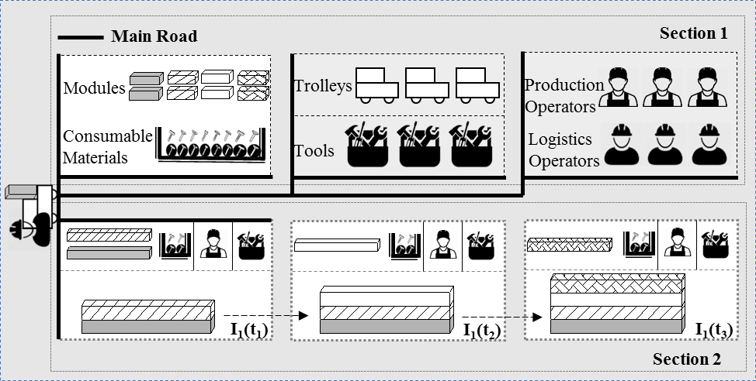
Fig. 1. The typical configuration of fixed-position assembly islands
Because of the limited space, each assembly island is only able to keep the work-in-process (WIP), a toolbox used by the production operator, a buffer for only one module needed for the forthcoming assembly task and consumable materials, and some space for the operator to perform the assembly operations. The fixed-position product assembly requires frequent and accurate movement of manufacturing resources, and the assembly task can be started only when all the required materials, tools and operators are ready. Once starts, the product will remain at the fixed site until it is fully assembled with specific sequences.
3.2 GMS for fixed-position assembly islands
However, due to inherent complexity of the product, there are some challenges when using fixed-position assembly islands configuration: (1) limited buffer space at island compared to the component size; (2) due to the complex assembly operations, sophisticated assembly operations heavily rely on skilled operators; (3) highly dynamic of material, equipment and manpower flows since the product remains at one fixed island and required resources need frequently moved to the island at different stages; (4) frequent setups for switching from production of product A to distinctive product B may be expensive and time-consuming; (5) it is prone to errors and disruptions with massive manual interventions. For overcoming the above challenges, an appropriate assembly system with effective production strategies is needed for the unique configuration of fixed-position assembly islands.
University graduation ceremony has been successfully conducted for hundreds of years even before the Industrial Revolution. Three kinds of tickets, including admission tickets, program tickets, and name tickets are deployed to achieve the success of the ceremony [9]. With real-time decentralized coordination through information visibility provided by tickets, physical signs and actions among all parties throughout the procedure, the ceremony is always orderly and robust to students with various degree and certificate programs.
Inspired by the success of the graduation ceremony, an assembly system GMS is proposed for fixed-position assembly islands. Three are three parties including managers, onsite operators, and materials involved in the system. By analogy to three kinds of tickets used in the graduation ceremony, three kinds of tickets including job ticket (JT), setup ticket (ST), operation ticket (OT) and twined logistics ticket (LT) correspond to admission tickets, program tickets and name tickets are designed in GMS. Fig. 2 illustrates the procedure.
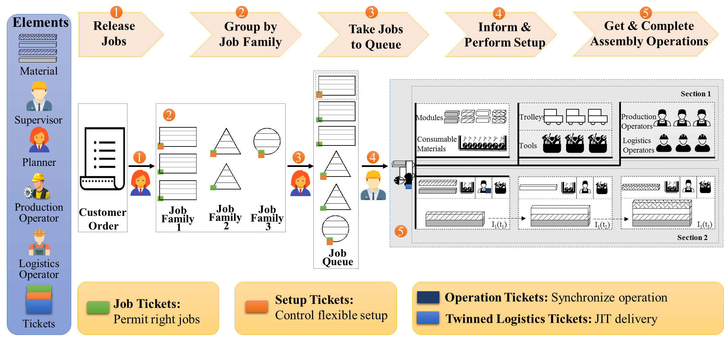
Fig. 2. An assembly system-GMS for fixed-position assembly islands
#1. JTs are assigned to production jobs. After converting customer orders into production jobs by priorities or specific rules, only permitted production jobs with right JTs are allowed to produce in one batch.
#2. Permitted production jobs are grouped by job family. Generally, production jobs share the same setup are grouped as one job family, and the first job in each family will be assigned to a ST that indicates the scope and details of the setup.
#3. Jobs are taken to the job queue by considering the customer requirement and production capacity constraints. These jobs wait in the queue and will be assigned to vacant assembly islands in sequence.
#4. When a job with ST joining the job queue, required manufacturing resources will be prepared in advance to perform the setup at the designated assembly island for the forthcoming job family.
#5. Queued jobs are assigned to the assembly islands one by one, and each job is equipped with a set of OTs based on the configuration and assembly process of the job. For the inherent dynamic and complex environment of manufacturing, to achieve synchronization of material flows and process operations in fixed-position assembly islands, twined LTs are designed to ensure just-in-time (JIT) delivery when performing specific assembly operations.
Three kinds of tickets play crucial roles in organizing production activities with simplicity and resilience in GMS. JTs are designed for permitting right jobs, considering customer demand and production capacity, only qualified jobs with right JTs are permitted to produce in one batch. It contains several essential elements, such as job attribute (e.g. ID, product mode, quantity and working hour), correlative customer order (e.g. customer order ID and due date), production status (e.g. priority and status), OTs and LTs. The information template of JT can be described as Formula (1).
JT = {JT_JA, JT_CCO, JT_PS, JT_OTs, JT_LTs} (1)
STs are designed for controlling flexible setups between different job families. With the aid of STs, the setup can be informed in advance and performed at the right time. Thus unnecessary waiting time can be reduced, and unreasonable setups can be avoided. Essential elements including setup attribute (e.g. ID, product family, quantity and working hour), correlative production job (e.g. end time of last production job and start time of the next distinctive production job), production status (e.g. priority and status), OTs and LTs are contained in ST, and the information template of ST can be described as Formula (2).
ST = {ST_SA, ST_CPJ, ST_PS, ST_OTs, ST_ LTs} (2)
OTs and twined LTs are designed to synchronize operation and JIT delivery. For OT, essential elements include operation attribute (e.g. ID, name, instruction and working hour), required resources (e.g. operator ID, tool ID and material ID), and production status (e.g. status, location, start time and end time). Similarly, logistics attribute (e.g. ID, name, instruction and working hour), required resources (e.g. operator ID, trolley ID and material ID), and production status (e.g. status, location, start time and end time) are contained in LT. Therefore, the information template of OT and LT can be described as Formula (3) and (4).
OT = {OT_OA, OT_RR, OT_PSP} (3)
LT = {LT_LA, LT_RR, LT_ PSP} (4)
The power of GMS promises to organize production activities with simplicity and resilience in fixed-position assembly islands. However, compared to the university graduation ceremony, GMS is facing several challenges. Firstly, unlike simple and visible environment in the graduation ceremony, the manufacturing environment is far more complex, and it lacks real-time information visibility and traceability. Secondly, rather than the simple and repetitive operations in the graduation ceremony, fixed-position assembly operations are more sophisticated and complicated, which is prone to disturbances or errors. Thirdly, in the graduation ceremony, real-time coordination can be achieved through real-time communication and interactions among different parties (working staff, students and department heads), however, as a complex manufacturing system, it is difficult to achieve real-time coordination among various manufacturing resources (workers, equipment and materials). Hence, DT-GiMS for fixed-position assembly islands is proposed for overcoming these challenges, which will be discussed in the following sections.
4. Digital twin-enabled Graduation Intelligent Manufacturing System (DT-GiMS) for fixed-position assembly islands
For exploring the application of digital twin in the manufacturing industry, several questions will be discussed first for better understanding its capabilities and potential benefits for intelligent manufacturing. Firstly, for digital twin, it should serve a specific purpose, for example, in this paper, digital twin services as an enabling technology to reduce complexity and uncertainty in fixed-position assembly islands by creating, establishing and utilizing information visibility and visualization. Secondly, an appropriate set of information should be contained in the digital representation of the physical part for the purpose. For example, in fixed-position assembly islands, appropriate digital representations at object level, product level and system level are created so that vital information including identity, status, geometric model, and production process can be captured, extracted and mapped on a real-time basis. Finally, the digital part should keep synchronization with the physical part with appropriate frequency to the purpose. For example, in fixed-position assembly islands, IoT, Web 3D and industrial wearable technologies are deployed to achieve real-time convergence and synchronization between digital space and physical space.
For DT-GiMS for fixed-position assembly islands, from small as a piece of manufacturing object, to big as the entire factory in physical space, all of them should have a digital equivalent representation in digital space. The key challenges are how to create digital representations of the manufacturing object, assembly processes of the product and even the production system with appropriate sets of information, and to realize convergence between digital space and physical space on a real-time basis. Therefore, this section will introduce DT-GiMS for fixed-position assembly islands from three levels: object level, product level and system level. Firstly, this section will show the digital twin of the manufacturing object through the concept of the cloud object. Then the digital twin of the assembly process of the product will be discussed. After that, this section will present the digital twin of the production system based on GMS and industrial wearable-enabled human-centric interaction system. Finally, the overall framework of DT-GiMS for fixed-position assembly islands will be discussed.
4.1 Digital twin of manufacturing object at object level
Due to the specific routing patterns of fixed-position assembly islands, it needs the frequent movement of manufacturing objects (e.g. tools and trolleys) at different production stages. To achieve the real-time status perception of these manufacturing objects in digital space, the concept of cloud object is proposed to create the digital twin of the manufacturing object at object level.
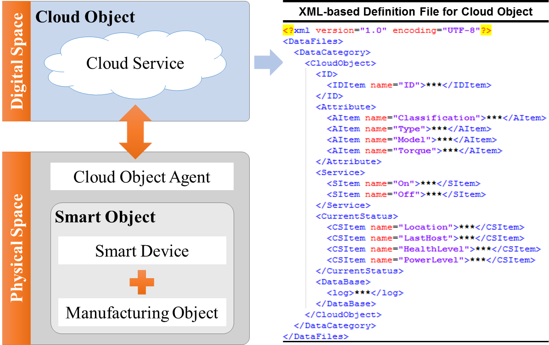
Fig.3. The digital representation of manufacturing object
Cloud object integrates the concept of smart object and cloud service [48]. By equipping with various smart devices, such as RFID devices, iBeacon devices, sensors, communication modules, microprocessors, the traditional manufacturing object becomes the smart object that can be uniquely identified and sensed in physical space. Through cloud object agent, various kinds of smart objects are shared and managed in a uniform protocol standard in digital space. Cloud service refers to several customized applications through cloud sharing. Based on this model, the digital representation of the manufacturing object with an appropriate set of information (e.g. ID, attribute, status and service) is built in digital space. An example of the digital representation of a tool (e.g. electric screwdriver) that presented as XML-based file is shown in Fig. 3, it includes object ID, attribute (e.g. classification, type, model and torque), service (e.g. on and off) and current status (e.g. location, last host, health level and power level). Through this model, real-time manufacturing status can be achieved and synchronized between manufacturing object and its corresponding digital twin with information visibility and traceability.
4.2 Digital twin of the assembly process of the product at product level
In fixed-position assembly islands, the assembly process of large-sized machines or facilities is complicated with sophisticated manual operations. The assembly process quality is the key to ensure the quality of the product. For achieving the high-quality product, the digital twin of the assembly process of the product is created for realizing assembly process quality control on a real-time basis.
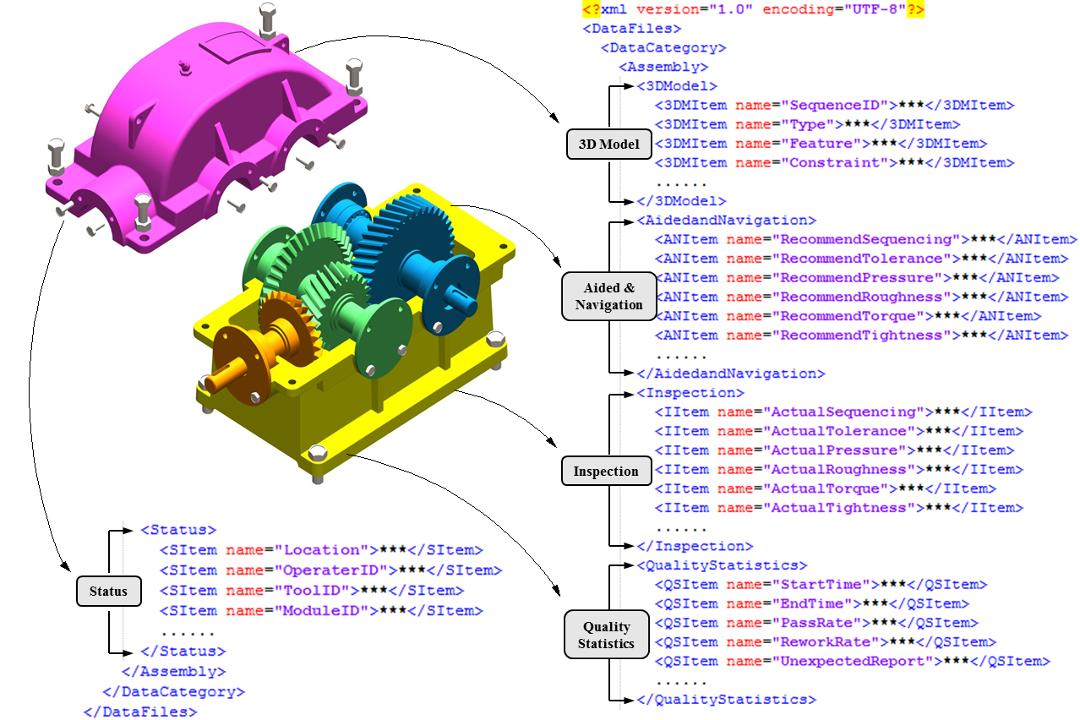
Fig.4. The digital representation of the assembly process of the product
The 3D model is playing an important role as a communication medium in manufacturing and production. For performing dynamic interaction and collaboration between physical assembly process of the product and its corresponding twin, real-time sharing and communication of relevant 3D models are crucial. Lightweight 3D model can be obtained by information hiding and geometrical simplification of the detailed 3D model designed by CAD software (e.g. UG, SolidWorks, Creo and CATIA) or by directly creating through Web 3D approach (e.g. X3DOM and XML3D) [49-51]. In consideration of assembly process quality control, the lightweight digital representation of the assembly process of the product with an appropriate set of information (e.g. 3D model, aided and navigation, inspection, quality statistics and status ) is built in digital space. An example of the lightweight digital representation of a product (e.g. gearbox) that presented as XML-based file is shown in Fig. 4, it includes 3D model (e.g. sequence ID, type, feature and constraint), aided and navigation (e.g. recommend sequencing, tolerance, pressure, roughness, torque and tightness), inspection (e.g. actual sequencing, tolerance, pressure, roughness, torque and tightness), quality statistics (e.g. start time, end time, pass rate, rework rate and unexpected report) and status (e.g. location, operator ID, tool ID and module ID). Real-time interaction and synchronization between the assembly process of the product and its digital twin can be achieved through the information capturing, sharing and visualizing.
4.3 Digital twin of the production system at system level
As an assembly system for the unique configuration of fixed-position assembly islands, GMS is developed for effectively organizing the production activities. In GMS, JTs, STs, OTs and LTs are designed for managing production activities from planning, scheduling to control and execution. To realize the successful implementation of these production strategies and activities with enhanced visibility, the digital twin of the production system is created based on GMS and the industrial wearable-enabled human-centric interaction system at system level.
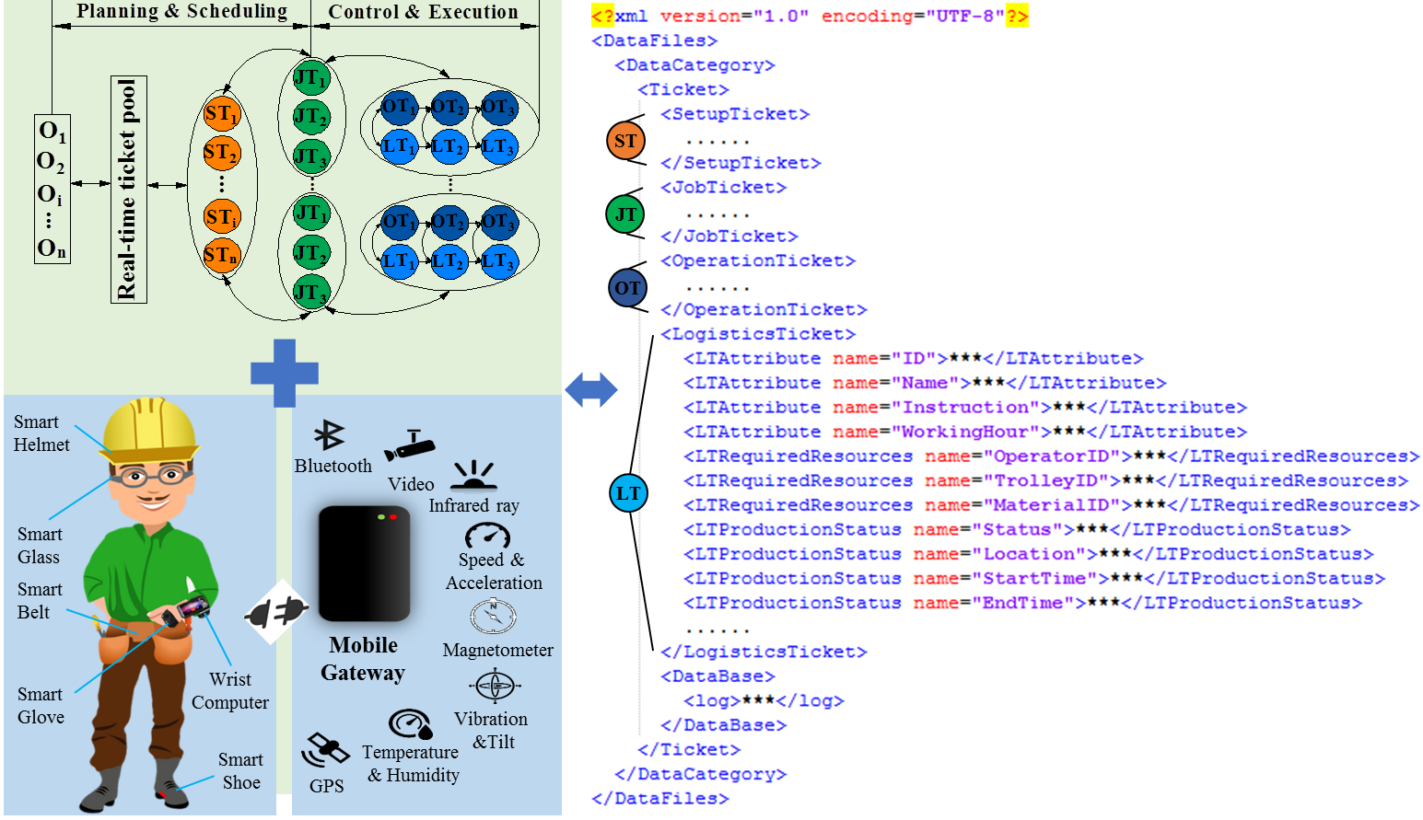
Fig.5. The digital representation of the production system
With the support of the industrial wearable-enabled human-centric interaction system, onsite operators are equipped with wearable devices (e.g. smart helmet, smart glass, smart belt, smart glove, smart shoe, wrist computer and smartphone) embedded with sensors, microprocessors, and wireless communication modules. Through the mobile gateway, the networked wearable devices can connect and communicate with each other, which greatly enhance the perception, communication and decision-making ability of onsite operators with real-time and multidimensional information supporting. Based on GMS and industrial wearable-enabled human-centric interaction system, the digital representation of the production system with an appropriate set of information (e.g. JTs, STs, OTs and LTs) is described as XML-based file in Fig. 5, for example, for LT, it includes logistics attribute (e.g.
ID, name, instruction and working hour), required resources (e.g. operator ID, trolley ID and material ID), and production status (e.g. status, location, start time and end time). With the support of GMS and industrial wearable-enabled human-centric interaction system, the production strategies and activities in physical space and digital space can be organized, mapped and synchronized on a real-time basis.
4.4 The overall framework of DT-GiMS for fixed-position assembly islands
Under the context of the digital twins of manufacturing object, the assembly process of the product and production system, the overall framework of DT-GiMS for fixed-position assembly islands is developed. As depicted in Fig. 6, it consists of three major layers: physical part layer, digital part layer, and service pool layer.
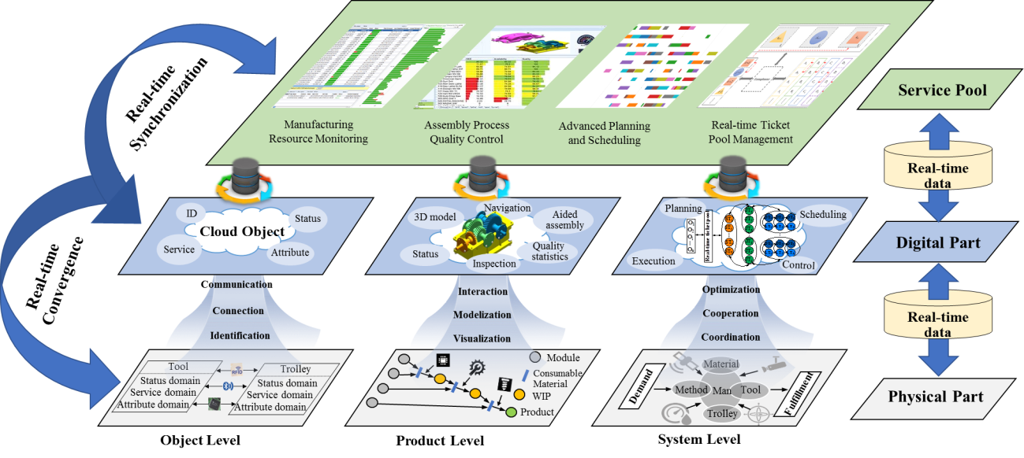
Fig.6. The overall framework of DT-GiMS for fixed-position assembly islands
Digital part layer is the high fidelity reflection of physical part layer, with the connections of real-time data, the physical space of fixed-position assembly islands could keep real-time convergence with the digital space at three levels. Object level focuses on manufacturing objects, such as tools and trolleys circulated in fixed-position assembly islands. Equipped with various IoT devices, the manufacturing status of the object (e.g. ID, attribute, status and service) can be captured and mapped on a real-time basis. Through identification, connection and communication, real-time convergence between the manufacturing object and its corresponding digital twin can be achieved. Product level focuses on the assembly process of the product, with support of IoT and Web 3D technologies, the lightweight 3D model and manufacturing status of the product assembly process can be published on the web on a real-time basis. Through modelization, visualization and interaction, real-time convergence between product assembly process and its corresponding digital twin can be achieved. System level focuses on the production system, based on GMS and industrial wearable-enabled human-centric interaction system, acquisition and allocation of limited resources (e.g. man, material, method, tool and trolley) to parallel and sequential activities to fulfill the demand can be conducted on a real-time basis. Through coordination, cooperation and optimization, real-time convergence between the production system and its corresponding digital twin can be achieved from planning, scheduling to control and execution.
With the support of real-time data, the service pool layer provides various customized applications. These applications are used to facilitate decision making and daily operations in fixed-position assembly islands under DT-GiMS, such as manufacturing resources monitoring service, assembly process quality control service, advanced planning and scheduling (APS) service, and real-time ticket pool management service. Real-time convergence and synchronization among the physical part layer, digital part layer and service pool layer make it feasible for real-time monitoring manufacturing resources. Assembly process quality control services mainly contain real-time visualized lightweight 3D model and assembly instructions for assembly process quality control. Continuous improvement of production planning, scheduling, control and execution can be made through APS services and real-time ticket pool management services. Moreover, as deployment in the cloud, users could easily access these applications through stationary and mobile terminals, such as PC, iPad, smartphone and wearable devices.
4.5 The real-time ticket pool management mechanisms
The concept of real-time ticket pool is proposed to manage production activities in an optimal way under DT-GiMS. Ticket pool is a representation of sequenced logic entity (e.g. jobs and operations). The basic idea of real-time ticket pool management is to dispatch JTs, STs, OTs and LTs to each assembly island to minimize the makespan of all customer orders on a real-time basis.
In order to solve this problem, several critical assumptions are made: a setup task is needed for switching from production of product A to distinctive product B and need a corresponding ST; each product assembly task can be treated as one job and need a corresponding JT; for each job or setup task, the operation and logistics task sequences are determined by the assembly process planning, each operation task need a corresponding OT and each logistics task need a corresponding LT, thus each specific JT or ST contains a certain set of sequential OTs and LTs; for each assembly island, only one job task or setup task can be processed on it at one time, and it is non-preemptive, once the task starts, it must be finished; all the assembly islands are alternative to each other, which means that the task can be performed on any assembly island when it becomes available. Some notations and variables used in this paper are given as follows:
I | The total number of assembly islands
i | The index of assembly island, i=1, 2,… I
CO | The total number of customer order
co | The index of customer order, co =1, 2,… CO
F | The total number of product family
f | The index of product family, f=1, 2,… F
 | The mth JT for assembling the product from product family f
 | The mth ST for performing setup of product family f
 | The number of required product from family f in customer order co
 | The setup time for performing setup of a product from family f
 | The processing time for assembly a product from family f
 | The arrival date of customer order co
 | The due date of customer order co
 | The start time of
 | The start time of
 | The makespan of all customer orders in all assembly islands
Considering customer demand and production capacity constraints, the objective is to dispatch STs and OTs to each island to minimize the makespan of all the customer orders, which can be formulated as follows:
Minimize (5)
S.t. (6)
(7)
(8)
(9)
or (10)
(11)
(12)
(13)
(14)
(15)
The objective function (5) is to minimize the makespan of all the customer orders. Constraint (6) represents that the production quantity should meet the demand requirement. Constraint (7) guarantees that the start time of job task for assembling the product from the customer order should not be precede the arrival date and no later than the due date of the customer order. Constraint (8) guarantees that the start time of setup task for performing setup for the product family from the customer order should not be precede the arrival date and no later than the due date of the customer order. Constraint (9) represents that the completion of each customer order should be not exceed the allowed completion time of the customer order. Constraint (10) represents that, for each assembly island, only one task can be handled on it at one time. Constraint (11) represents that at least one setup need to carry out for one product family. Constraint (12) and (13) defines the relationship between variables. Constraint (14) and (15) are the ranges of the variables.
5. Case study
Following the concepts and methodologies described in the preceding sections, this section will describe a demonstrative case aiming at:
- Verifying the feasibility of DT-GiMS for fixed-position assembly islands and its technical architecture;
- Demonstrating the effectiveness of DT-GiMS for fixed-position assembly islands, and illustrating its management and execution process.
In this case, the mini lathe machine assembly scenario is used to demonstrate the fixed-position product assembly in the lab. This section will first explain how to build a DT-GiMS for fixed-position assembly islands through the proposed concepts and methods and then illustrates the corresponding implementation.
5.1 Building the DT-GiMS for fixed-position assembly islands
Following the concepts and methodologies described in Section 4, the prototype of DT-GiMS for fixed-position assembly islands is built in the lab, as shown in Fig. 7. A parts warehouse (PW), a finished product warehouse (FPW), and three assembly islands (I₁, I₂, I₃) are involved in the demonstrative case.
In physical space, physical manufacturing resources including materials, tools and trolleys are equipped with smart devices and upgraded to cloud objects, considering the laboratory demonstration environment and positioning requirement, two types of smart devices are selected. One is Bluetooth Low Energy (BLE) based-iBeacon tag that is used to identify the smart object and track its movement. The other is innovated gateway, which consists of a credit card-sized microcomputer chip embedded BLE module and the wired/wireless communication module. Besides, onsite operators in fixed-position assembly islands, including production operators and logistics operators are equipped with smartphones.
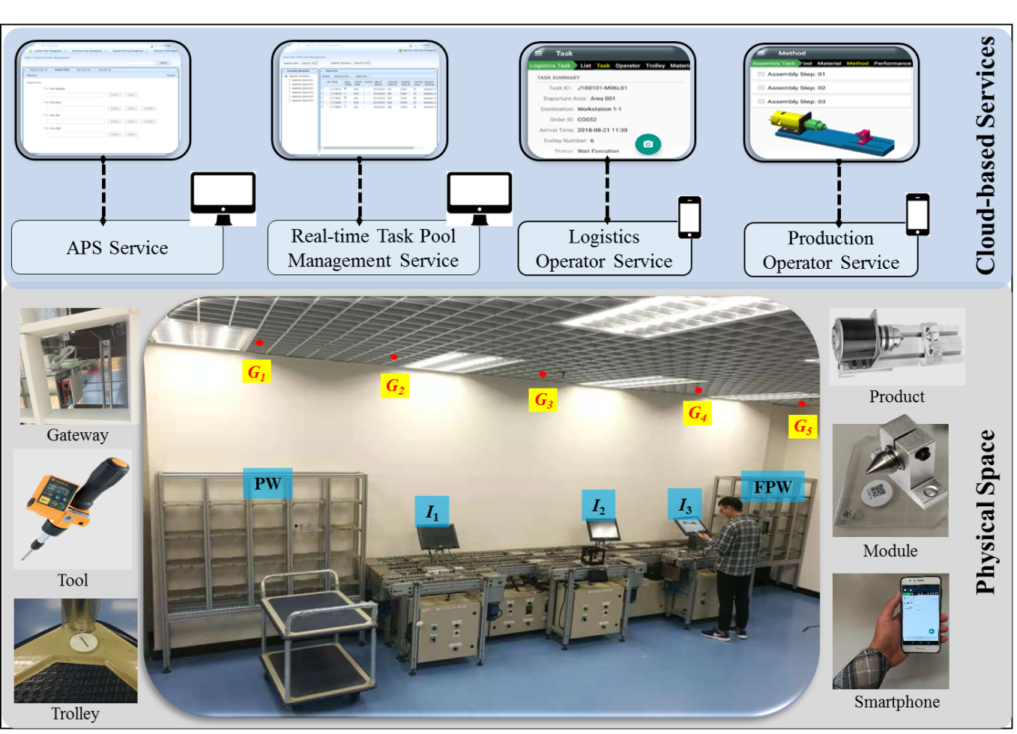
Fig.7. The prototype of DT-GiMS for fixed-position assembly islands in the lab
With the support of real-time data, cloud-based services for managers and onsite operators are developed for facilitating their decision making and daily operations. APS service is developed for the planner to manage customer order as well as convert customer order to production jobs. Real-time ticket pool management service is developed for the supervisor managing production activities through real-time managing JTs, STs, OTs and LTs. Logistics operator service is developed for onsite logistics operators moving the target object from one place to another. Production operator service is developed for onsite production operators to perform specific setup and assembly tasks.
5.2 Implementation of the DT-GiMS for fixed-position assembly islands
Fig. 8 depicts the implementation of DT-GiMS for fixed-position assembly islands. For managers, they could easily make considerate decisions benefit from the ticket-based production strategies and information visibility in DT-GiMS. Under the demonstration scenario, firstly, through APS service, new customer orders are imported through customer order management explorer. After production capacity planning, production jobs will be released into real-time ticket pool, and the whole production activities are organized and managed through JTs, STs, OTs and LTs.
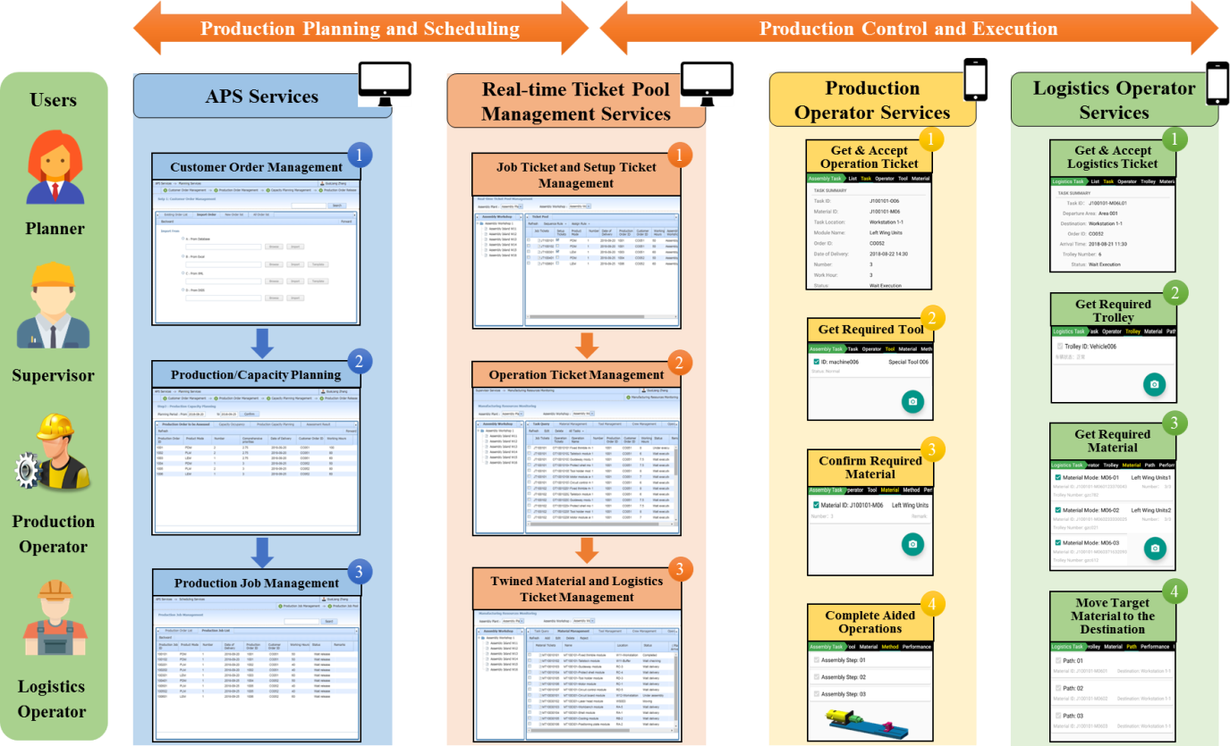
Fig.8. Implementation of DT-GiMS for fixed-position assembly islands
In this case three new customer orders are imported through order management explorer, and the detailed information is listed in Table 1. Table 1 shows the input of the computational model for real-time ticket pool management, for example, for customer order 1 with arrival date 21 and due date 240, it requires 2 product A with processing time 16 and setup time 4, 1 product B with processing time 18 and setup time 3, 3 product C with processing time 25 and setup time 5, and 2 product D with processing time 32 and setup time 7.
Table 1 The input of the computational model
co | f |  |  |  |  |  | I
1 | A | 16 | 4 | 2 | 21 | 240 | 3
1 | B | 18 | 3 | 1 | 21 | 240 | 3
1 | C | 25 | 5 | 3 | 21 | 240 | 3
1 | D | 32 | 7 | 2 | 21 | 240 | 3
2 | A | 16 | 4 | 3 | 25 | 300 | 3
2 | C | 25 | 5 | 1 | 25 | 300 | 3
2 | E | 38 | 6 | 5 | 25 | 300 | 3
3 | B | 18 | 3 | 2 | 26 | 280 | 3
3 | D | 32 | 7 | 4 | 26 | 280 | 3
3 | E | 38 | 6 | 3 | 26 | 280 | 3
Considering customer demand and production capacity constraints, STs and JTs are assigned to these three assembly islands through this model. The computational model is written in OPL and is solved to optimality in less than 0.1 seconds by CPLEX 12.8.0 on a 64-bit machine with Intel(R) Core(TM) i7-6700 CPU at 3.40 GHz processor and 16.00 GB RAM.
Fig.9. Setup and completion time at different islands
Fig. 9 shows the calculation results of required ST number, setup time and completion time at different islands based on the real-time ticket pool management mechanisms. In this scenario, the minimum makespan of all customer orders is 261, and 3, 2, and 5 STs are need at I₁, I₂, and I₃, respectively.
(a) Real-time ticket pool management of STs at different islands
(b) Real-time ticket pool management of JTs at different islands
Fig.10. Real-time ticket pool management of STs and JTs at different islands
Fig. 10 shows the real-time ticket pool management of STs and JTs at different islands, as the computational model is solved to optimality, with the support of real-time ticket information, the production activities can be managed in an optimal way.
For each specific ST or JT, it contains a certain set of sequential OTs and LTs according to the assembly process planning. Thus, in real-time ticket pool, OTs and LTs are automatically generated with STs and JTs are dispatched to different islands, which are used to assist onsite operators to complete their daily operations at the operational level. The execution process of OTs and LTs will be presented as follows.
For onsite operators, in DT-GiMS, with the support of real-time ticket pool management and production operator service, one production operator will receive OTs via the mobile application on his smartphone, and he can view the detail of the OT and choose to accept it. Only the right materials are checked and confirmed, the production operator can start the specific operations with the required tools. With the support of aided operation services, the production operator could complete the operations following the lightweight 3D model assembly navigations and operation instructions with the high standard within the period. Besides, when suffering unexpected events, the production operator could identify and report them timely to the manager for further decision making, which can minimize the impact of unexpected disturbances. With the real-time identification and location information on the phone, the logistics can easily find the target trolleys and materials, and move them to the designated areas. One LT task can be submitted by the logistics operator only when the target materials are detected and confirmed at the right places at the right time through the system.
With the cloud-based services provided in DT-GiMS, in fixed-position assembly islands, real-time convergence and synchronization among physical part layer, digital part layer and service pool layer make it possible to ensure that right resources (workers, equipment and materials) are moved to the right places at the right time in an optimal way with enhanced visibility. For managers and onsite operators, DT-GiMS dramatically facilitates their decision-making and daily operations. Managers could easily make optimal decisions based on the real-time ticket pool management mechanisms, and onsite operators could efficiently complete their daily tasks with nearly error-free operations with enhanced visibility.
6. Conclusion
Aim at reducing complexity and uncertainty in fixed-position assembly islands by utilizing information visibility and visualization. This paper introduces a DT-GiMS for fixed-position assembly islands. Firstly, inspired by the success of the graduation ceremony, an assembly system GMS is developed for fixed-position assembly islands. After creating unified digital representations of manufacturing object, the assembly process of the product and the production system, the overall framework of DT-GiMS is presented. Finally, a demonstrative case in the lab is given to verify the effectiveness of the proposed approach.
The main contribution of this paper can be concluded as follows: (1) This paper presents an assembly system GMS for the unique configuration of fixed-position assembly islands, in which JTs, STs, OTs and twined LTs are designed to organize the production activities with simplicity and resilience. JTs are designed for permitting right jobs with customer demand and production capacity. STs are designed to flexible control setups between different job families to reduce unnecessary waiting time and unreasonable setups. OTs and twined LTs are designed to synchronize operation and JIT delivery. (2) This paper proposes a unified digitization approach to create the digital representations with appropriate sets of information at object level, product level and system level in fixed-position assembly islands. At object level, the manufacturing status of the object (e.g. ID, attribute, status and service) can be captured, mapped, and converged on a real-time basis. The lightweight 3D model and manufacturing status of the product assembly process can be synchronously published on the web on a real-time basis at product level. System level focuses on the production system, which provides an effective way to achieve real-time convergence between the production system and its corresponding digital representation. (3) The DT-GiMS for fixed-position assembly islands is introduced, real-time convergence and synchronization among physical part layer, digital part layer and service pool layer make it possible to ensure that right resources are moved to the right places at the right time in an optimal way with enhanced visibility. Based on real-time ticket pool management mechanisms, with the support of cloud-based services provided in DT-GiMS, the managers and onsite operators could easily make optimal decisions and efficiently complete their daily tasks with nearly error-free operations.
Further research and development are necessary if the DT-GiMS for fixed-position assembly islands is to realize its full potentials. Firstly, the occurrence of unexpected disturbances (e.g. machine breakdowns, rush orders and worker absenteeism) is inevitable in practical production, how to design effective mechanisms integrating disturbance management under DT-GiMS need to be investigated. Another important issue is data management and analytics, as real-time data ties the physical space and digital space and numerous production data are collected from deployed smart devices. How to use historical and real-time production data to support accurate prediction and autonomous decision is to be taken into account.
Acknowledgment
Acknowledgment to Zhejiang Provincial, Hangzhou Municipal, Lin’an City governments, Hong Kong ITF Innovation and Technology Support Program (ITP/079/16LP) and Shenzhen Science, Technology and Innovation Commission Support Program (KQJSCX20170728162555608).
Reference
[1] G. Weigert, T. Henlich, Simulation-based scheduling of assembly operations, Int. J. Comput. Integr. Manuf. 22 (2009) 325–333.
[2] R. Lin, C.-J. Liao, Batch scheduling problem for a machinery factory with fixed-position layout, Int. J. Prod. Res. 51 (2013) 910–926.
[3] W. Qin, G.Q. Huang, A two-level genetic algorithm for scheduling in assembly islands with fixed-position layouts, J. Syst. Sci. Syst. Eng. 19 (2010) 150–161.
[4] G.Q. Huang, Y.F. Zhang, P.Y. Jiang, RFID-based wireless manufacturing for walking-worker assembly islands with fixed-position layouts, Robot. Comput. Integr. Manuf. 23 (2007) 469–477.
[5] J.K. Stratman, Realizing benefits from enterprise resource planning: does strategic focus matter?, Prod. Oper. Manag. 16 (2007) 203–216.
[6] M.G. Morris, V. Venkatesh, Job characteristics and job satisfaction: understanding the role of enterprise resource planning system implementation., Mis Q. 34 (2010).
[7] P. Blanc, I. Demongodin, P. Castagna, A holonic approach for manufacturing execution system design: An industrial application, Eng. Appl. Artif. Intell. 21 (2008) 315–330.
[8] M.J. Land, Cobacabana (control of balance by card-based navigation): A card-based system for job shop control, Int. J. Prod. Econ. 117 (2009) 97–103.
[9] P. Lin, L. Shen, Z. Zhao, G.Q. Huang, Graduation manufacturing system: synchronization with IoT-enabled smart tickets, J. Intell. Manuf. (2018) 1–16.
[10] F. Tian, S.X. Xu, How Do Enterprise Resource Planning Systems Affect Firm Risk? Post-Implementation Impact., Mis Q. 39 (2015).
[11] G.Q. Huang, Y.F. Zhang, P.Y. Jiang, RFID-based wireless manufacturing for real-time management of job shop WIP inventories, Int. J. Adv. Manuf. Technol. 36 (2008) 752–764.
[12] R.Y. Zhong, Q.Y. Dai, T. Qu, G.J. Hu, G.Q. Huang, RFID-enabled real-time manufacturing execution system for mass-customization production, Robot. Comput. Integr. Manuf. 29 (2013) 283–292.
[13] Y. Zhang, G. Zhang, Y. Liu, D. Hu, Research on services encapsulation and virtualization access model of machine for cloud manufacturing, J. Intell. Manuf. 28 (2017) 1109–1123.
[14] M. Grieves, Digital twin: Manufacturing excellence through virtual factory replication, White Pap. (2014) 1–7.
[15] F. Tao, J. Cheng, Q. Qi, M. Zhang, H. Zhang, F. Sui, Digital twin-driven product design, manufacturing and service with big data, Int. J. Adv. Manuf. Technol. 94 (2018) 3563–3576.
[16] M. Bortolini, E. Ferrari, M. Gamberi, F. Pilati, M. Faccio, Assembly system design in the Industry 4.0 era: a general framework, IFAC-PapersOnLine. 50 (2017) 5700–5705.
[17] A.A. Shikdar, M.A. Al-Hadhrami, Smart workstation design: an ergonomics and methods engineering approach, Int. J. Ind. Syst. Eng. 2 (2007) 363–374.
[18] D. Battini, M. Faccio, A. Persona, F. Sgarbossa, New methodological framework to improve productivity and ergonomics in assembly system design, Int. J. Ind. Ergon. 41 (2011) 30–42.
[19] A. Pinnoi, W.E. Wilhelm, Assembly system design: A branch and cut approach, Manage. Sci. 44 (1998) 103–118.
[20] N. Boysen, M. Fliedner, A. Scholl, A classification of assembly line balancing problems, Eur. J. Oper. Res. 183 (2007) 674–693.
[21] S.J. Hu, J. Ko, L. Weyand, H.A. ElMaraghy, T.K. Lien, Y. Koren, H. Bley, G. Chryssolouris, N. Nasr, M. Shpitalni, Assembly system design and operations for product variety, CIRP Ann. 60 (2011) 715–733.
[22] L. Wang, S. Keshavarzmanesh, H.Y. Feng, R.O. Buchal, Assembly process planning and its future in collaborative manufacturing: A review, Int. J. Adv. Manuf. Technol. 41 (2009) 132–144.
[23] S.J. Udoka, Automated data capture techniques: a prerequisite for effective integrated manufacturing systems, Comput. Ind. Eng. 21 (1991) 217–221.
[24] S.J. Udoka, The role of automatic identification (Auto ID) in the computer integrated manufacturing (CIM) architecture, Comput. Ind. Eng. 23 (1992) 1–5.
[25] D. McFarlane, S. Sarma, J.L. Chirn, C. Wong, K. Ashton, Auto ID systems and intelligent manufacturing control, Eng. Appl. Artif. Intell. 16 (2003) 365–376.
[26] G. Kortuem, F. Kawsar, V. Sundramoorthy, D. Fitton, Smart objects as building blocks for the internet of things, IEEE Internet Comput. 14 (2009) 44–51.
[27] C. González García, D. Meana Llorián, B.C. Pelayo García-Bustelo, J.M. Cueva Lovelle, A review about smart objects, sensors, and actuators, Int. J. Interact. Multimed. Artif. Intell. (2017).
[28] G.Q. Huang, P.K. Wright, S.T. Newman, Wireless manufacturing: a literature review, recent developments, and case studies, Int. J. Comput. Integr. Manuf. 22 (2009) 579–594.
[29] X.V. Wang, L. Wang, A. Mohammed, M. Givehchi, Ubiquitous manufacturing system based on Cloud: A robotics application, Robot. Comput. Integr. Manuf. 45 (2017) 116–125.
[30] X. Xu, From cloud computing to cloud manufacturing, Robot. Comput. Integr. Manuf. 28 (2012) 75–86.
[31] L. Wang, X. Vincent, L. Gao, CIRP Annals - Manufacturing Technology A cloud-based approach for WEEE remanufacturing, (2014) 8–11.
[32] J. Fang, T. Qu, Z. Li, G. Xu, G.Q. Huang, Agent-based gateway operating system for RFID-enabled ubiquitous manufacturing enterprise, Robot. Comput. Integr. Manuf. 29 (2013) 222–231.
[33] Z. Zhao, M. Zhang, C. Yang, J. Fang, G.Q. Huang, Distributed and collaborative proactive tandem location tracking of vehicle products for warehouse operations, Comput. Ind. Eng. 125 (2018) 637–648.
[34] R.Y. Zhong, C. Xu, C. Chen, G.Q. Huang, Big Data Analytics for Physical Internet-based intelligent manufacturing shop floors, Int. J. Prod. Res. 55 (2017) 2610–2621.
[35] Y. Hao, P. Helo, The role of wearable devices in meeting the needs of cloud manufacturing: A case study, Robot. Comput. Integr. Manuf. 45 (2017) 168–179.
[36] L. Wang, B. Schmidt, A.Y.C. Nee, Vision-guided active collision avoidance for human-robot collaborations, Manuf. Lett. 1 (2013) 5–8.
[37] V. Stanford, Wearable computing goes live in industry, IEEE Pervasive Comput. 1 (2002) 14–19.
[38] P. Lukowicz, A. Timm-Giel, M. Lawo, O. Herzog, Wearit@ work: Toward real-world industrial wearable computing, IEEE Pervasive Comput. 6 (2007) 8–13.
[39] T. Stiefmeier, D. Roggen, G. Ogris, P. Lukowicz, G. Tröster, Wearable activity tracking in car manufacturing, IEEE Pervasive Comput. (2008) 42–50.
[40] H. Koskimaki, V. Huikari, P. Siirtola, P. Laurinen, J. Roning, Activity recognition using a wrist-worn inertial measurement unit: A case study for industrial assembly lines, in: 2009 17th Mediterr. Conf. Control Autom., IEEE, 2009: pp. 401–405.
[41] X.T.R. Kong, H. Luo, G.Q. Huang, X. Yang, Industrial wearable system: the human-centric empowering technology in Industry 4.0, J. Intell. Manuf. (2018) 1–17.
[42] M. Li, G. Xu, P. Lin, G.Q. Huang, Cloud-based mobile gateway operation system for industrial wearables, Robot. Comput. Integr. Manuf. 58 (2019) 43–54.
[43] E. Glaessgen, D. Stargel, The digital twin paradigm for future NASA and US Air Force vehicles, in: 53rd AIAA/ASME/ASCE/AHS/ASC Struct. Struct. Dyn. Mater. Conf. 20th AIAA/ASME/AHS Adapt. Struct. Conf. 14th AIAA, 2012: p. 1818.
[44] J. Ríos, J.C. Hernández, M. Oliva, F. Mas, Product Avatar as Digital Counterpart of a Physical Individual Product: Literature Review and Implications in an Aircraft., in: ISPE CE, 2015: pp. 657–666.
[45] S. Haag, R. Anderl, Digital twin–Proof of concept, Manuf. Lett. 15 (2018) 64–66.
[46] P.D.U. Coronado, R. Lynn, W. Louhichi, M. Parto, E. Wescoat, T. Kurfess, Part data integration in the Shop Floor Digital Twin: Mobile and cloud technologies to enable a manufacturing execution system, J. Manuf. Syst. 48 (2018) 25–33.
[47] F. Tao, F. Sui, A. Liu, Q. Qi, M. Zhang, B. Song, Z. Guo, S.C.-Y. Lu, A.Y.C. Nee, Digital twin-driven product design framework, Int. J. Prod. Res. (2018) 1–19.
[48] G. Xu, G.Q. Huang, J. Fang, Cloud asset for urban flood control, Adv. Eng. Informatics. 29 (2015) 355–365.
[49] W. Liu, X. Zhou, X. Zhang, Q. Niu, Three-dimensional (3D) CAD model lightweight scheme for large-scale assembly and simulation, Int. J. Comput. Integr. Manuf. 28 (2015) 520–533.
[50] J. Posada, M. Zorrilla, A. Dominguez, B. Simoes, P. Eisert, D. Stricker, J. Rambach, J. Döllner, M. Guevara, Graphics and Media Technologies for Operators in Industry 4.0, IEEE Comput. Graph. Appl. 38 (2018) 119–132.
[51] M. Potenziani, M. Callieri, M. Dellepiane, R. Scopigno, Publishing and Consuming 3D Content on the Web: A Survey, Found. Trends® Comput. Graph. Vis. 10 (2018) 244–333.

