Design of a self-adaptive gripper with rigid fingers for Industrial Internet

Changhong Liu^{1,2}·Jianxiang Cheng^{2,4} ·Ziliang Li^{2,4}·Changxi Cheng²·Chunliang Zhang²·Yongjun Zhang¹·Ray Y. Zhong³

- School of Electromechanical Engineering, Guangdong University of Technology, Guangzhou, China.
- School of Mechanical and Electrical Engineering, Guangzhou University, Guangzhou, China.
- Department of Industrial and Manufacturing Systems Engineering, The University of Hong Kong, Hong Kong
- The Guangzhou Key Laboratory for Strengthen Grinding and High Performance Machining of Metal Material, Guangzhou University, Guangzhou, China.

Changhong Liu
lch@gzhu.edu.cn
+86-20-39366935

Abstract
Grippers are widely used in Industrial Internet for facilitating various operations such as logistics, materials handling, assembly, etc. Current grippers are specifically designed for a specific application so that it is difficult to adapt to a wide variety of shapes and sizes. Soft grippers have been developed to grasp objects with high surface complexity in Industrial Internet. Some challenges such as low controllability and long response time still exist. Rigid robot gripper shows good characters like robustness, accuracy and short response time. This paper thus presents a robot self-adaptive gripper using rigid fingers, where four rigid fingers are connected by springs that are tied to a screw rod. The screw rod is actuated by a rotary motor. Tip force of the fingers could be precisely controlled by the linear movement of the screw rod. The shapes and sizes of the object could be adaptively grasped due to the elasticity of the connecting springs. The proposed gripper is tested and verified to be highly flexible and controllable so that it could be suitable for most of the applications in production systems in the context of Industrial Internet.
Keywords: Self-adaptive, rigid gripper, fingers, springs, hysteresis, Industrial Internet.
1. Introduction
In recent years, there have been great advances in industrial Internet of Things (IIoT) and its related domains, such as industrial wireless networks (IWNs), big data, and cloud computing. These emerging technologies will bring great opportunities for promoting industrial upgrades and even allow the introduction of the fourth industrial revolution, namely, Industry 4.0 [1-3]. In the context of Industry 4.0, more and more types of robot arms and manipulators are proposed to finish repetitive work in the industrial process so as to reduce workload of human workers [4, 5]. Industrial robotic grippers have a pivotal role in modern automation since they constitute the end-of-arm of robotic manipulators and thus, they are in direct contact with the workpiece. Grippers as end-of-arm tools have to perform their tasks under demanding requirements in modern mass production because handling operations [6, 7].Besides, with the development of remote control and cloud computing, self-adaptive gripper is demanded, which would reduce the control precision and workload [8].
However, the increasing demand in modern society pushed the manufactory of complex products with a large variety of sizes and shapes [9, 10]. Current grippers are specifically designed for a single application and they are not flexible enough to adapt to a wide variety [11, 12]. In order to cover the industrial process with increasing complexity, novel types of mechanical end effecters with high flexibility, robustness and short response time have been investigated and developed to take the place of traditional low-flexibility end effecters [13, 14].
Among the end-effecters developed before, soft-bodied gripper and rigid-bodied gripper are two main structural schemes adapted to achieve the grasp of objects. Soft gripper has been developed and known that it has made full-automatic production line more possible [15, 16]. With new materials and new grasping scheme developed recently, the flexibility of soft gripper improved a lot. Generally, there are three types of grasping schemes: gripping by actuation, gripping by controlled stiffness, and gripping by controlled adhesion [17]. The soft grippers applying the scheme of gripping by actuation are FEAS [18-20], DEAs [21, 22], IPMCs [23], etc. There remain many challenges for gripping by actuation, including obtaining sufficient forces, controlling force and force distribution, especially for handling deformable objects. However, flat objects are not suited to this method [24, 25]. The under-actuated robotic gripper is also flexible [26, 27].Because it has only two fingers, which can grasp objects of limited shapes. The soft grippers applying the scheme of gripping by controlled stiffness are LMPAs, SMPs, etc. The stiffness of such grippers can be easily tuned. However the response time of thermal system is too long [28]. The soft grippers applying the scheme of gripping by controlled adhesion are [29, 30]. There is no existing soft end effecter that shows good controllability of the tip force. Besides, most types of soft grippers have a relatively long response time. Besides, there is a novel type of robot and underactuated hand based on soft robotic technology [31]. Although this kind of robot hand can well imitate human movements, it is troublesome to operate. It requires adjusting the air pressure of five fingers when picking accurately.
Therefore, we proposed a novel rigid-body adaptive gripper with relatively high flexibility zero response time and good control ability is proposed in this work, which is expected to be an applicable gripping scheme in industrial Internet of Things (IIoT) and its related domains. In the test, the novel gripper also shows good robustness and load performance. Structural stiffness and fraction property could be further improved by applying new materials in later works. The rest of this paper is organized as follows. Section 2 talks about the design in terms of the function, structure and working principle, as well as parameter setting. Section 3 reports on the analysis from different perspectives. Section 4 presents the characteristic of the self-adaptive gripper. Section 5 concludes this paper by giving our contributions and future work.
2. Design of the self-adaptive gripper for Industrial Internet
This section presents the design of the proposed self-adaptive gripper, including the design of function, structure, and parameters.
  - Function
The proposed self-adaptive gripper is designed to grip objects of various shapes, sizes, weights, stiffness, and orientations safely in order to suit the situations under Industrial Internet. Four fingers and a holder are integrated in the gripper. The fingers are installed on the holder by hinges as is shown in Fig. 1(a).
For small objects, the gripper can pinch them with the four fingertips (Fig. 1(b)) or grasp (fully grip) them by closing all fingers (Fig. 1(i)). For large objects, the gripper opens the fingers with enough span first and then pinches or grasps them (Fig. 1(e)). For some soft objects, the gripper pinches or grasps them by tuning the force (Fig. 1(h)). For sheet objects, the gripper pinches them on the tip of fingers (Fig. 1(d)). For complex objects, the fingers can shift the angle to fit the surface of object (Fig. 1(f)). For objects with an open cavity such as cups and tanks, the gripper can grip them on their inner surface by extension motion of the fingers (Fig. 1(g)). For grasping and placing objects in different angles, the gripper has good adaptability to the working environment (Fig. 1(j), 1(k), 1(m)).
Gripping force can be controlled by different kinds of springs with different stiffness coefficients and the place of movable block which help the gripper grip objects of various weights. The number of fingers and the end of fingers shape can also be changed to help pinch objects.
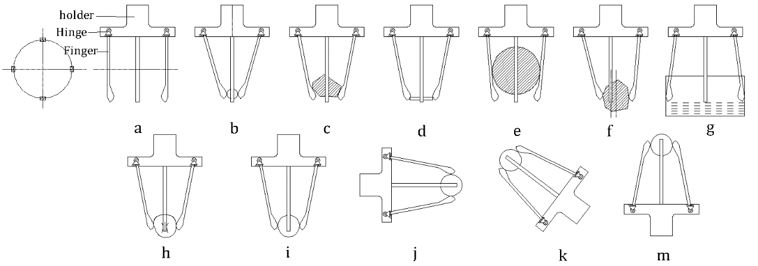
Fig. 1 Different motions are achieved by opening different angles.
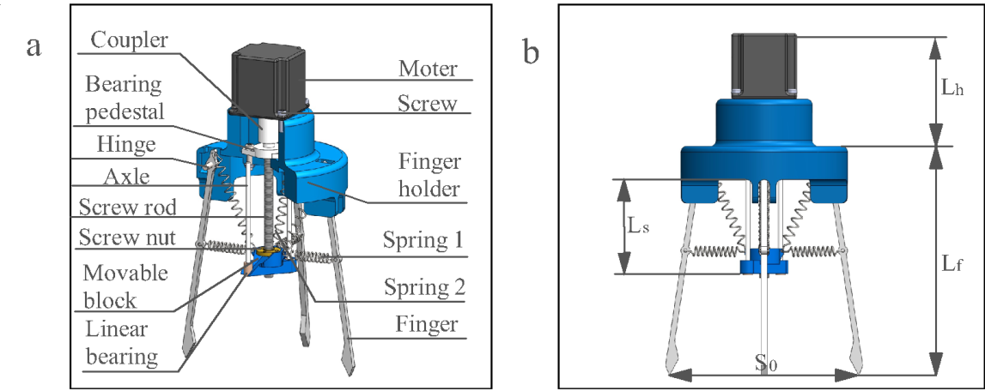
Fig. 2 Structure and dimensions of the self-adaptive gripper. (a) 1/3 cutaway view of the gripper assembly. (b) Geometric parameters in front view.
  - Structure and working principle
Fig. 2(a) shows the assembly of the self-adaptive gripper, which is mainly composed of four rigid fingers (made of polymethyl methacrylate). Please note that the shell shown in Fig.2 is a simplified 3D model. The real shell used in the test is made of Acrylic sheet, as is shown in Fig.3. The screw nut and linear bearing are installed in the movable block. The linear movement of the movable block is supported by the axle and the linear bearings. The middle part of the finger and the movable block is connected by spring 1. The upper end of the finger and the movable block is connected by spring 2. The working principle is introduced as follows. (In order to simplify, the process of fetching is shown in Fig. 1(i))
1) The self-adaptive Gripper driven by the robotic manipulator approaches the target object.
2) The upper motor of the gripper drives the screw nut to move up. Spring 2 restore the original length and spring 1 gets stretched. The tip of fingers moves towards the center and contacts the surface of the object.
3) The screw nut continues to move up to increase tip force of the fingers. At the same time, if the morphology of the object is complex (Fig. 1(f)). The center of the finger will move to adapt to the outline of the object. The net force of frictional and grasping forces on the tip of the gripper keeps the object stable. Finally, the object leaves the desk due to the movement of the robot arm.
The core gripping principle of the self-adaptive gripper is described as follows.
1) When the fingers expand outward, the spring 1 is stretched and the spring 2 is returned to keep the object from falling. Moreover, when the fingers gather inward. The springs can also hold the object when the gripper is not vertically downward (Fig. 1(j), 1(k), 1(m)).
2) Some fingers will firstly touch the object and others later when grasping a complex surface object. The length of each spring will be different. Therefore, the grasping force of the fingers of the object will be different.
2.3. Parameters Setting
Geometric parameters of the proposed self-adaptive gripper are shown in Fig. 2(a) and Fig. 2(b). These parameters are mainly designed according to common size of griper appeared in recent works. For example, to ensure proper variable range of open span, the length of the fingers should be designed suitably. The grasping force as well as the open span are closely related to the length of each finger. Literally, the longer the fingers, the wider the open span would be. But the grasping force would decline as the length of the fingers increases. Besides, other factors like the attribute of spring and fractional coefficient on the tip of each finger also attribute to the self-adaptive gripper. The Geometric Parameters of the proposed gripper and the attribute parameters are listed in Table 1. The circumstances of gripping objects with different shape are shown in Fig.3, where (a)~(c) shown gripping gesture with the screw nut set at different position, (d)~(e) shown Working conditions in different angles.
Table 1．Geometric Parameters of the self-adaptive gripper
Parameters | Symbol | Values
Effective length of the finger | $$L_{f}$$ | 65mm
Sectional of the finger | $$S_{f}$$ | 8mm x 5mm
The length of the spring 1 | $$L_{s1}$$ | 55mm
The length of the spring 2 | $$L_{s2}$$ | 40mm
The length from the spring 2 connection to the hinge | $$L_{3}$$ | 10mm
The length from the spring 1 connection to the hinge | $$L_{2}$$ | 70mm
The length from the spring 1 connection to the end of finger | $$L_{1}$$ | 70mm
Effective length of the screw rod | $$L_{s}$$ | 80mm
Overall size | $$L×W×H$$ | $$140mm×140mm×220mm$$
Total weight | G | 833g
The spring rate of spring 1 | $$k_{1}$$ | 0.2N/mm
The spring rate of spring 2 | $$k_{1}$$ | 0.2N/mm
The static friction coefficient of the end of finger | $$Μ$$ | 0.5
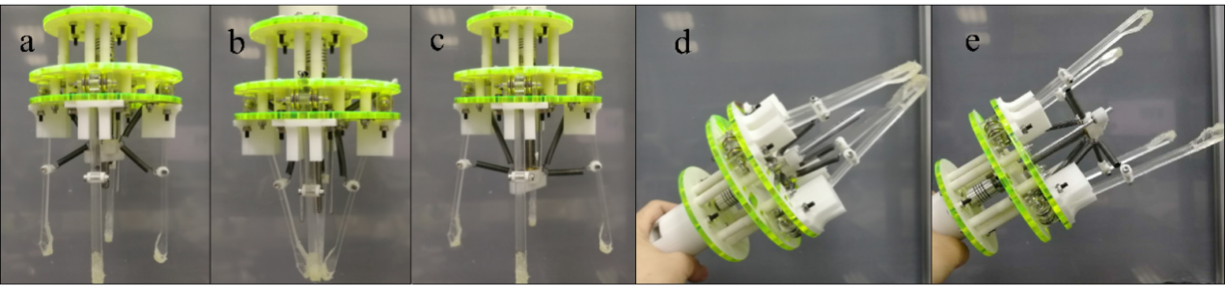
Fig. 3 Images of the self-adaptive gripper. (a) The movable block is at the middle of the screw rod, the fingers keep normal. (b) The movable block is in the top of the screw rod, the fingers closed. (c) The movable block is in the end of the screw rod, the fingers opened. (d) and (e) is Working conditions in different angles.
- Analysis
To demonstrate the structural stiffness and the workspace of the self-adaptive gripper, we modeled the force condition of one of the fingers, as is shown in the section Statics. Besides, the stress of the material is analyzed using SOLIDWORKS/SIMULATION, which is proposed in section Stiffness. The workspace of the self-adaptive gripper is analyzed in section Workspace.
  - Statics
To better illustrate the geometry feature of the gripper, the target object is considered as spherical, all the components are considered as rigid body. And the mass of each component is regarded as 0 during the calculation. As the four fingers are placed symmetrically, only one finger is modeled, as is shown in Fig.4.
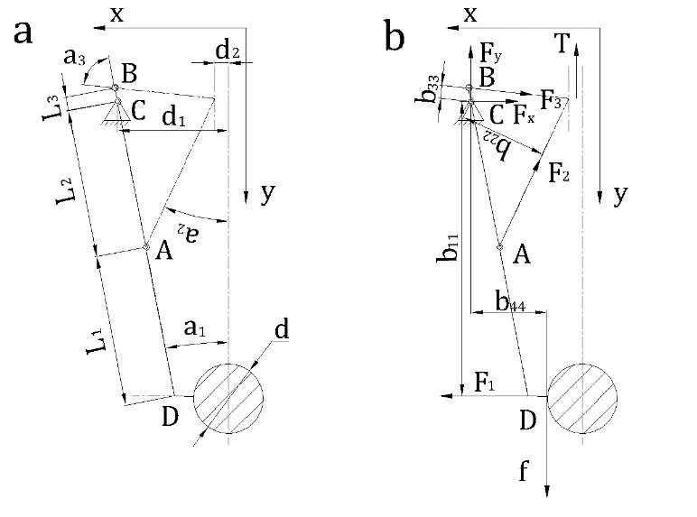
Fig. 4(a) Geometric parameters. (b) Force condition.

The linkage of spring 2 and finger is A. The linkage of spring 1 and finger is B. The fixed hinge is C. The contact point of object and the tip of the finger is D. AB=$L_{2}$, BC=$L_{1}$, DC=$L_{3}$, the diameter of the object is d. The distance between the spring 1 , spring 2 and movable block from the centerline link to C is $d_{2}$, and the distance from the link to C is $d_{1}$; The angle of spring 1 and finger is $α_{3}$, The angle of spring 2 and centerline is $α_{2}$; The angle of finger and centerline is $α_{1}$. The force from object to fingers is $F_{1}$; The force from spring 2 to finger is $F_{2}$; The force from spring 1 to finger is $F_{3}$; $F_{x}$ is horizontal force in hinge C, and the vertical force is $F_{y}$, the friction force between the object and the end of finger. T is the force of the screw rod on the moving block.
According to the statics analysis, the force condition of the moveable block could be expressed as:
$T=F_{2y}+F_{3y}$ (1)
$T=-F_{2}cos\left(α_{2}\right)+F_{3}cos(α_{1}+α_{3})$ (2)
$F_{2}=k_{1}Δx_{1}=k_{1}[\frac{\left(d-d_{2}\right)L_{2}+\left(d_{1}-d\right)L_{1}}{{(L}_{1}+L_{2})sin\left(α_{2}\right)}-L_{s1}]$ (3)
$F_{3}=k_{2}Δx_{2}=k_{2}[\frac{({L_{2}+L}_{3})sin\left(α_{1}+α_{2}\right)}{sin\left(α_{1}+α_{2}+α_{3}\right)}-L_{s2}]$ (4)
Force condition of each finger could be expressed as:
$∑F_{x} : F_{x}+F_{3}sin\left(α_{1}+α_{3}\right)+F_{2}sin\left(α_{2}\right)-F_{1}=0$ (5)
$∑F_{y} : F_{y}-F_{3}cos\left(α_{1}+α_{3}\right)+F_{2}cos\left(α_{2}\right)-f=0$ (6)
$∑M : F_{2}b_{22}-F_{1}b_{11}-F_{3}b_{33}-fb_{44}=0$ (7)
$f=μF_{1}$ (8)
Combine equation (5) ~ (8), the frictional force f on the tip of each finger could be expressed as:
$f=\frac{ F_{2}b_{22}-F_{3}b_{33}}{b_{44}+\frac{1}{μ}b_{11}}$ (9)
$b_{11}={(L}_{1}+L_{2})cos\left(α_{1}\right)$ (10)
$b_{22}=L_{2} sin\left(α_{1}+α_{2}\right)$ (11)
$b_{33}=L_{3}sin\left(α_{3}\right)$ (12)
$b_{44}=d_{1}-\frac{d}{2}$ (13)
Combine equation (9) ~ (13), the frictional force f on the tip of each finger could be expressed as:
$f=\frac{ F_{2}L_{2} sin\left(α_{1}+α_{2}\right)-F_{3}L_{3}sin\left(α_{3}\right)}{d_{1}-\frac{d}{2}+\frac{1}{μ}{(L}_{1}+L_{2})cos\left(α_{1}\right)}$ (14)
According to (2) and $nf=mg$，the mass of the target object could be expressed as:
$m=\frac{n}{m}[\frac{ F_{2}L_{2} sin\left(α_{1}+α_{2}\right)-F_{3}L_{3}sin\left(α_{3}\right)}{d_{1}-\frac{d}{2}+\frac{1}{μ}{(L}_{1}+L_{2})cos\left(α_{1}\right)} ]$ (15)
Where n is the number of the gripper and F₂ could be described as:
$F_{2}=k_{1}Δx_{1}=k_{1}[\frac{\left(d-d_{2}\right)L_{2}+\left(d_{1}-d\right)L_{1}}{{(L}_{1}+L_{2})sin\left(α_{2}\right)}-L_{s1}]$ (16)
Where $k_{1}$ is the spring rate of spring 1, $F_{2}$ is the net force of tension of each finger.
  - Stiffness
When objects of different size and shape are grasped, the stress condition of each finger differs. For instance, when grasping small size objects, the stress surface would be the end of the tip area of each finger, as is shown in Fig. 5. The combination of fraction and thrust keeps the object from falling. The stress condition of one finger when grasping the same object in different positions of finger ends are listed in Fig. 6. The stress surface can be divided into eight areas shown in Fig. 7(b). The eight areas are marked with a ~ h respectively. And the Von Mises stress of different area are listed in Fig. 7(c) according to simulation results.
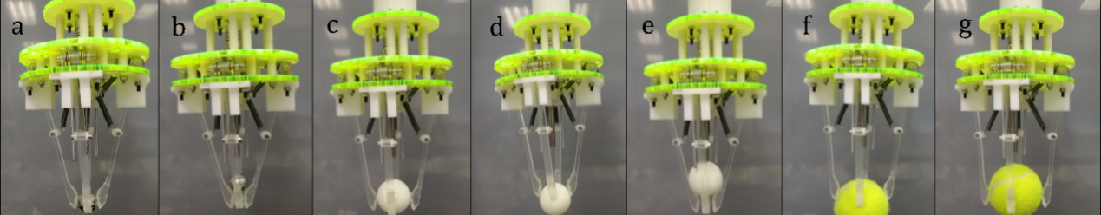
Fig. 5 Actual force in different positions of finger ends. (a), (c) and (g) shows the middle part of the end of the finger being stressed. (b) and (e) shows the tip part of the end of the finger being stressed. (d) and (f) shows the bottom part of the end of the finger being stressed.
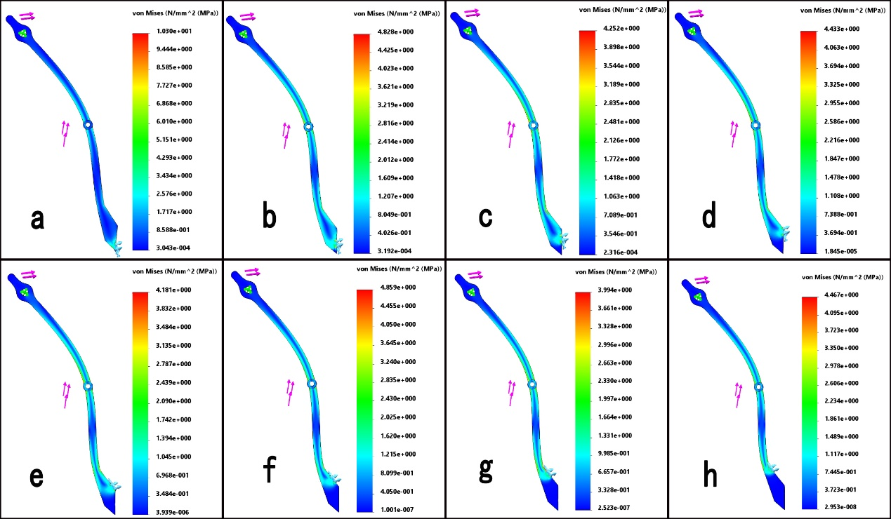
Fig. 6 Simulation of Von Mises stress on finger ends at different positions.
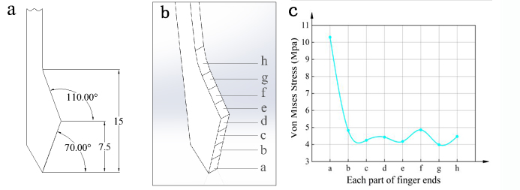
Fig. 7 (a) Parameters of the finger ends. (b) Division of each part of finger ends. (c)The Von Mises stress of plastic deformation at each part of finger ends.
In the simulation, we use a ~ h part of finger ends to grab a size of 60mm sphere. When the screw nut is at the top of the screw rod, the force of gripper is maximum, where $α_{1}=12.37°$, $α_{2}=18.21°$ and $α_{3}=73.31°$. According to (3) and (4), $F_{2}=5N$, $F_{3}=0.44N$. According to the simulation of Von Mises stress on finger ends at different positions shown in the Fig. 6. The Von Mises stress is continuously increasing when pressure point is located at c ~ d of the finger ends, where the clamping force and frictional force are the main contributing forces. The Von Mises stress increases rapidly when pressure point is located at e ~ f of the finger ends, where clamping force, frictional force and supporting force are the main contributing force of the object. However, at g ~ h, the Von Mises stress increases, mainly due to the morphology of the structure. Since part a is at the bottom of the finger ends, the stress concentration points are located at a, as can be seen in Fig. 6 a.
  - Workspace
Usable workspace of the gripper includes open span of the ﬁngers. The relation between the success rate and the number of the fingers installed on the gripper is shown as follows:
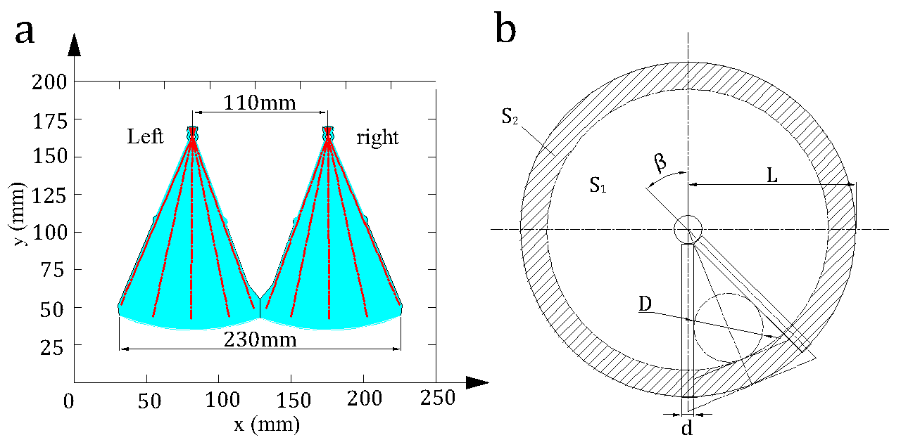
Fig. 8(a) Grapping space at the front of gripper. Red lines are special positions of the fingers. (b)The cyan area is the range of workspace.
The maximum range of grasping is a circular area with the radius of L. The success rate of grasping object varies with the number of the fingers. The diameter of the target object is marked with D the maximum and minimum diameter of the grasping object is marked with $D_{max}$ and $D_{min}$ respectively, as is shown in Fig. 8(b). When diameter D is in the range of $D_{min}$ and $D_{max}$, the object can be possibly picked up or dropped. The usable and unusable grasping areas are marked with $S_{1}$and $S_{2}$ respectively.
The ratio of usable workspace to the whole reachable space is known as:
$i=\frac{S_{1}}{S_{1}+S_{2}}×100\%$ (17)
Where
$S_{1}=π{\left(\frac{D}{2}\left(1+\frac{1}{\sin\left(β\right)}\right)\right)}^{2}$ (18)
$S_{1}+S_{2}=πL^{2}$ (19)
When$β$ $=\frac{2π}{n}$ . Then
$i=\frac{π{\left(\frac{D}{2}\left(1+\frac{1}{\sin\left(\frac{2π}{n}\right)}\right)\right)}^{2}}{πL^{2}}$ (20)
When $D$ > $D_{max}$, the grasping object would certainly be picked up, the success rate of grasping is 100%, $i$ = 1.
To find out the relation between the success rate and the number of the fingers, simulation was conducted on the gripper, when $L=140mm$，and n = 4,5,6,7,8, respectively, the ratio between the diameter D and the success rate of grasping is depicted in Fig. 9(a) by simulation. When $i$ = 1, the relation between the diameter D and the ratio of D to the whole grasping area is shown in Fig. 9(b).

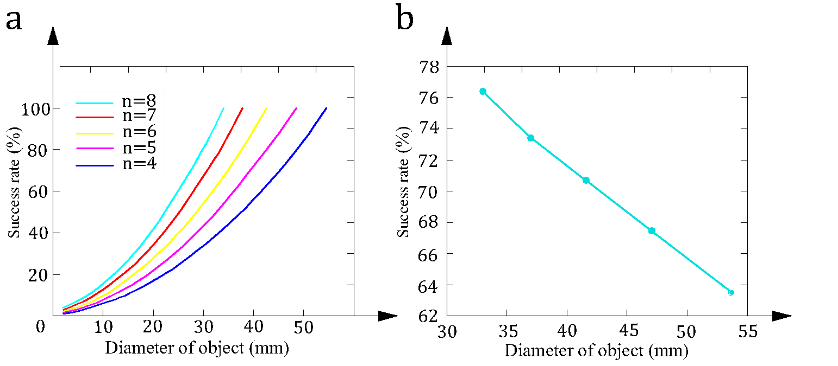
Fig. 9(a) The relationship between the number of fingers and success rate. (b) The relationship between the number of fingers and the diameter of objects when the success rate i=1.
The relationship between the number of fingers and success rate is shown in Fig. 9(a). The success rate varying with the size of the object is also shown in Fig. 9(b). When D < $D_{max}$ and the range of the whole reachable workspace is constant, the usable workspace increases as the number of the finger increases. When i=1, the minimum diameter decreases as the number of the finger increases. As is shown in Fig. 9(b), the success rate of grasping is always higher than 60% when n > 3. So the proposed gripper has a relatively large range of grasping.
- Gripping functions
This section presents the characteristic of the self-adaptive gripper, including the test of size, shape, flexibility, orientation and controllability.
  - Common characteristic test
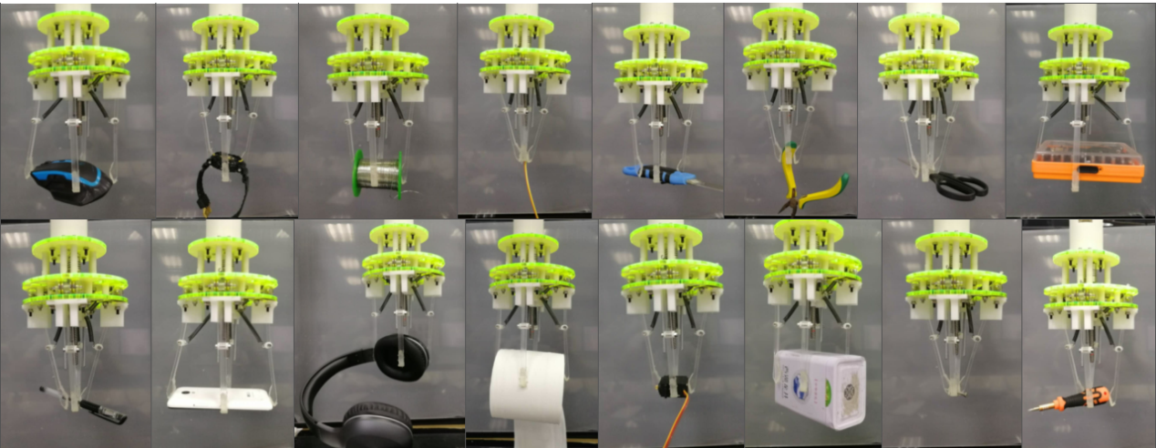
Fig. 10 Gripping objects of different shapes that are common in daily life. (Mouse, watch, Tin solder wire, line, knife, pincers, scissors, phone, headset, toilet paper and so on.)
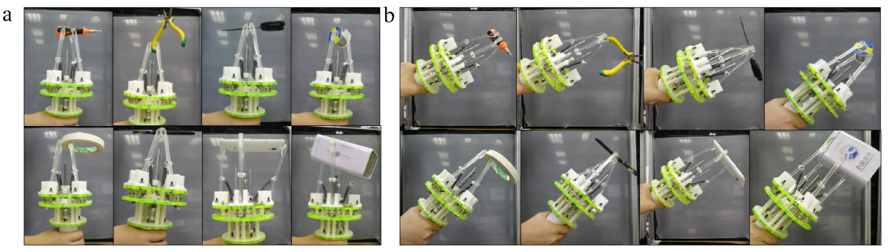
Fig. 11 Gripping objects of different orientations. (a) The angle between the self-adaptive gripper and the horizontal direction is 90 degrees. (b) The angle between the self-adaptive gripper and the horizontal direction is 45 degrees.
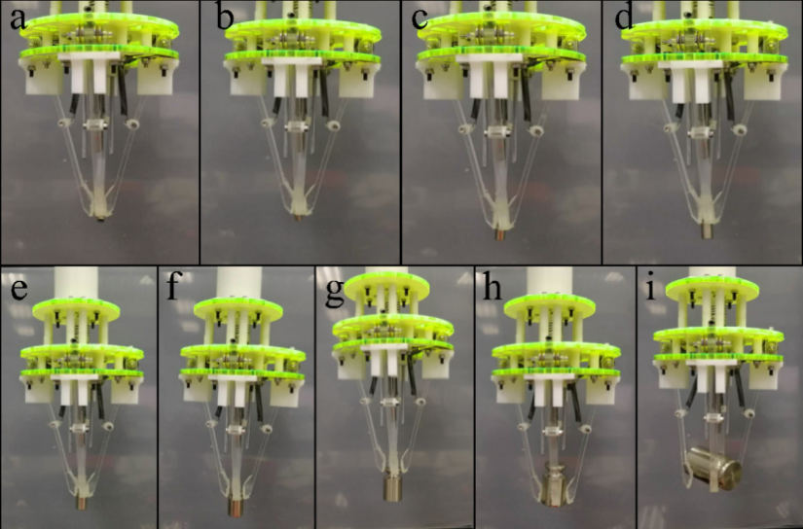
Fig. 12 Griping poises of different weight and size in different poses. (a) ~ (g) Pinch poise ((a)1g, φ6mm; (b) 2g, φ6mm; (c) 5g, φ8mm; (d) 10g, 10mm; (e) 20g, φ12mm; (f) 50g, φ18mm; (g) 100g, φ22mm;) ；(h) grasp poise (200g,φ28mm) ； ( i ) grasp poise of heavy weight (500g, φ38mm).
The gripping functions presented in the Function section (Fig. 1) is tested in this part. The proposed self-adaptive gripper can grip objects of different shapes and sizes using different gripping methods, as is shown in Fig. 10. Gripper can grasp objects in all directions of space, as is shown in Fig. 11. Further, the gripper can grip objects of different weights and sizes by different gripping methods and gripping force, as shown in Fig. 12. Therefore, the proposed self-adaptive gripper is verified to be versatile and adaptable to gripping objects of various shapes, sizes, weights, and orientations. In addition, this self-adaptive gripper using rigid fingers does not need pneumatic control, which is suitable for the industrial Internet of Things (IIoT) and its related domains.
  - Controllability test
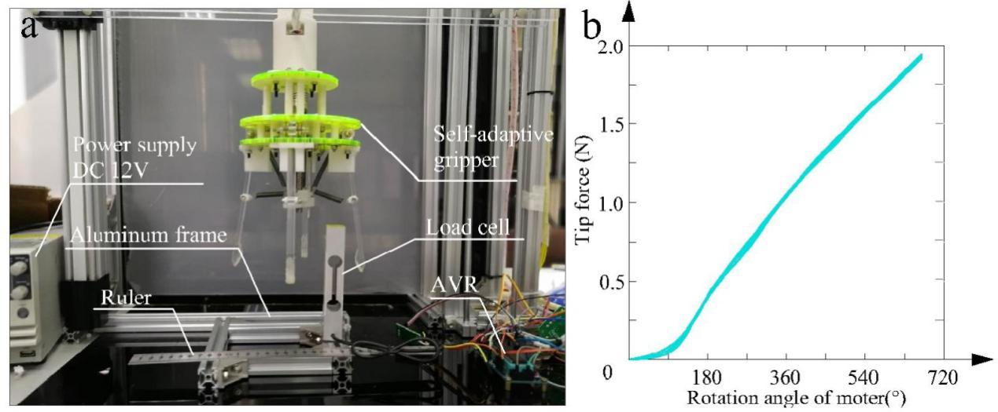
Fig. 13 (a)Experiment setup for testing the finger tip of self-adaptive gripper. (b) The results of the experiment.
Fig. 13 shows the experiment setup for testing controllability. To test the tip force, a load cell (AT8502, China, scale 3kg, accuracy 0.06%) is used, which is fixed on an aluminum frame. The screw nut on the screw rod is driven upward by the motor, driving the fingers to contract and touch the load cell fixed on the aluminum frame though the connecting springs. The experiment was repeated several times to better test the tip force. The relationship between the tip force and the angle of motor rotation is depicted in Fig. 13 (b). According to the curve shown in Fig13 (b), The response time is supposed to be short, while other kinds of soft gripper where pneumatic actuator are applied need longer time to acquire certain working pressure before movement[17]. As the curve shows, the response time is verified to be short. The relation of tip force and rotation angle is shown to be non-linear when finger just touched the load cell, which is probably due to assembly error. When the rotation angle increases continuously, tip force and rotation angle show a linear relation, and the results of repeated tests almost coincide with this relation. The result means that the force distributed on the finger can be accurately controlled by the motor without delay. Thus, the proposed rigid gripper has a better controllability and shorter response time than most soft grippers existed, which has high nonlinearity, serious hysteresis, and poor repeatability. The nonlinearity is mainly determined by nonlinear mechanics of the soft materials, such as hyper elasticity of the latex bladder[32], which is never a problem for a rigid self-adaptive gripper.
- Conclusion
This paper proposed a self-adaptive gripper using rigid fingers. The fingers are connected to a movable block that is attached to a screw rod with screw nut. The screw rod is actuated by a rotational motor. The screw nut attached to the screw rod can move linearly. The gripping function is achieved by the centripetal contraction of the fingers driven by the linear movement of the screw nut. The gripper is adaptable to gripping objects with a variety of sizes and shapes due to the elasticity of the springs. Compared with soft grippers, the rigid gripper proposed in this work has a shorter response time and a relatively equal adaptability. Correlated analysis and test of the adaptability are conducted on the gripper.
Analysis shows that the maximum open span is a 230mm with an initial value of 110mm. The success rate of gripping is positively related to the number of the fingers and the diameter of the gripping object. The tests show that the proposed gripper can be accurately controlled when grips objects of various sizes and shapes in time. The objects can be gripped in various orientations. The maximum weight of the gripper in the vertical direction is 500g. The contributions of this work include: (1) a development of a self-adaptive gripper with rigid fingers with a combination of rigid fingers and springs; (2) the analysis of gripping force by finite element analysis and gripping test; and (3) common characteristic test of gripping objects of all kinds of shapes. The proposed novel self-adaptive gripper has high rigidity and flexibility, which makes it has good robustness and load performance. Besides, the novel self-adaptive gripper is capable of self-locking. After successfully gripping the object, the gripper can use its self-locking property to maintain the state of gripping. This is a good application for industrial robots that need to gripping objects for a long time. When more than 3 fingers are installed on the gripper, the success rate of gripping will be more than 60%. Thus the proposed self-adaptive gripper is verified to have high flexibility, controllability and robustness. The present model is helpful to design rigid-body adaptive gripper and expected to be a applicable gripping scheme in industrial Internet of Things (IIoT) and its related domains.
The future work will be carried out from the following aspects. Firstly, it will be focused on modeling of the self-adaptive gripper and its force and motion control methods. Tensile tests of the elastic materials will be conducted, and then, the stress-strain relationship can be applied to construct a quasi-static or dynamic analytical model to predict gripping force and motion of the gripper in different working conditions. Secondly, based on the model, an open-loop control method can be used to control gripping force and motion of the gripper. If the open-loop method performs not well, a closed-loop control method will be considered. Then, sensors for capturing the gripping force and motion will be needed. Lastly, the adaptability shown in grasping experiment still has limitations. Therefore, we will further optimize the structure. In addition, we will also find effective control methods of the self-adaptive gripper.
Acknowledgments
The author acknowledges the funding of following science foundations: the National Natural Science Foundation of China (U1601204), the Science and Technology Planning Project of Guangdong Province (2017ZC0394), the Research Funds for Local Universities of Guangzhou (1201620451),the Innovative Academic Team Project of Guangzhou Education System(1201610013) ,the Educational Science Planning of Guangzhou(1201553679),the Education and Teaching Reform Project for Local Universities of Guangzhou (2019JG223),and the Guangdong Provincial Science and Technology Project (2017A010102010),and the Special Funds for Scientific and Technological Innovation and Cultivation of Guangdong University Students（pdjhb0402）.

Reference
[1] D. M. S. Velandia, N. Kaur, W. G. Whittow et al., “Towards industrial internet of things: Crankshaft monitoring, traceability and tracking using RFID,” Robotics and Computer-Integrated Manufacturing, vol. 41, pp. 66-77, Oct, 2016.
[2] X. V. Wang, L. Wang, A. Mohammed et al., “Ubiquitous manufacturing system based on Cloud: A robotics application,” Robotics and Computer-Integrated Manufacturing, vol. 45, pp. 116-125, Jun, 2017.
[3] J. Wan, S. Tang, Z. Shu et al., “Software-Defined Industrial Internet of Things in the Context of Industry 4.0,” Ieee Sensors Journal, vol. 16, no. 20, pp. 7373-7380, Oct 15, 2016.
[4] G. Veiga, J. N. Pires, and K. Nilsson, “Experiments with service-oriented architectures for industrial robotic cells programming,” Robotics and Computer-Integrated Manufacturing, vol. 25, no. 4-5, pp. 746-755, Aug-Oct, 2009.
[5] R. Bogue, “Underwater robots: a review of technologies and applications,” Industrial Robot-an International Journal, vol. 42, no. 3, pp. 186-191, 2015, 2015.
[6] L. Birglen, and T. Schlicht, “A statistical review of industrial robotic grippers,” Robotics and Computer-Integrated Manufacturing, vol. 49, pp. 88-97, Feb, 2018.
[7] M. Honarpardaz, M. Tarkian, J. Olvander et al., “Finger design automation for industrial robot grippers: A review,” Robotics and Autonomous Systems, vol. 87, pp. 104-119, Jan, 2017.
[8] Y. Hu, F. Zhu, L. Zhang et al., “Scheduling of manufacturers based on chaos optimization algorithm in cloud manufacturing,” Robotics and Computer-Integrated Manufacturing, vol. 58, pp. 13-20, 2019.
[9] P. Polygerinos, N. Correll, S. A. Morin et al., “Soft Robotics: Review of Fluid-Driven Intrinsically Soft Devices; Manufacturing, Sensing, Control, and Applications in Human-Robot Interaction,” Advanced Engineering Materials, vol. 19, no. 12, Dec, 2017.
[10] K. Amadori, M. Tarkian, J. Olvander et al., “Flexible and robust CAD models for design automation,” Advanced Engineering Informatics, vol. 26, no. 2, pp. 180-195, Apr, 2012.
[11] D. Rus, and M. T. Tolley, “Design, fabrication and control of soft robots,” Nature, vol. 521, no. 7553, pp. 467-475, May 28, 2015.
[12] K. C. Galloway, K. P. Becker, B. Phillips et al., “Soft Robotic Grippers for Biological Sampling on Deep Reefs,” Soft Robotics, vol. 3, no. 1, pp. 23-33, Mar, 2016.
[13] J. Hughes, U. Culha, F. Giardina et al., “Soft Manipulators and Grippers: A Review,” Frontiers in Robotics and Ai, vol. 3, Nov 16, 2016.
[14] B. T. Phillips, K. P. Becker, S. Kurumaya et al., “A Dexterous, Glove-Based Teleoperable Low-Power Soft Robotic Arm for Delicate Deep-Sea Biological Exploration,” Scientific Reports, vol. 8, Oct 3, 2018.
[15] L. Blanc, A. Delchambre, and P. Lambert, “Flexible Medical Devices: Review of Controllable Stiffness Solutions,” Actuators, vol. 6, no. 3, Sep, 2017.
[16] K. Shea, C. Ertelt, T. Gmeiner et al., “Design-to-fabrication automation for the cognitive machine shop,” Advanced Engineering Informatics, vol. 24, no. 3, pp. 251-268, Aug, 2010.
[17] J. Shintake, V. Cacucciolo, D. Floreano et al., “Soft Robotic Grippers,” Adv Mater, pp. e1707035, May 7, 2018.
[18] S. Terryn, J. Brancart, D. Lefeber et al., “Self-healing soft pneumatic robots,” Science Robotics, vol. 2, no. 9, Aug 30, 2017.
[19] M. Wilson, “Festo drives automation forwards,” Assembly Automation, vol. 31, no. 1, pp. 12-16, 2011, 2011.
[20] F. Ilievski, A. D. Mazzeo, R. E. Shepherd et al., “Soft Robotics for Chemists,” Angewandte Chemie-International Edition, vol. 50, no. 8, pp. 1890-1895, 2011, 2011.
[21] H. Imamura, K. Kadooka, and M. Taya, “A variable stiffness dielectric elastomer actuator based on electrostatic chucking,” Soft Matter, vol. 13, no. 18, pp. 3440-3448, May 14, 2017.
[22] G. Kofod, W. Wirges, M. Paajanen et al., “Energy minimization for self-organized structure formation and actuation,” Applied Physics Letters, vol. 90, no. 8, Feb 19, 2007.
[23] U. Deole, R. Lumia, M. Shahinpoor et al., “Design and test of IPMC artificial muscle microgripper,” Journal of Micro-Nano Mechatronics, vol. 4, no. 3, pp. 95-102, 2008.
[24] D. McCoul, S. Rosset, N. Besse et al., “Multifunctional shape memory electrodes for dielectric elastomer actuators enabling high holding force and low-voltage multisegment addressing,” Smart Materials and Structures, vol. 26, no. 2, Feb, 2017.
[25] E. Brown, N. Rodenberg, J. Amend et al., “Universal robotic gripper based on the jamming of granular material,” Proceedings of the National Academy of Sciences of the United States of America, vol. 107, no. 44, pp. 18809-18814, Nov 2, 2010.
[26] H. Dong, E. Asadi, C. Qiu et al., “Geometric design optimization of an under-actuated tendon-driven robotic gripper,” Robotics and Computer-Integrated Manufacturing, vol. 50, pp. 80-89, 2018.
[27] W. Chen, C. Xiong, W. Chen et al., “Mechanical adaptability analysis of underactuated mechanisms,” Robotics and Computer-Integrated Manufacturing, vol. 49, pp. 436-447, 2018.
[28] J. Shintake, S. Rosset, B. Schubert et al., “Versatile Soft Grippers with Intrinsic Electroadhesion Based on Multifunctional Polymer Actuators,” Advanced Materials, vol. 28, no. 2, pp. 231-238, Jan 13, 2016.
[29] I. D. Walker, D. M. Dawson, T. Flash et al., "Continuum robot arms inspired by cephalopods," Unmanned Ground Vehicle Technology VII, Proceedings of the Society of Photo-Optical Instrumentation Engineers (Spie) G. R. Gerhart, C. M. Shoemaker and D. W. Gage, eds., pp. 303-314, 2005.
[30] S. Song, D.-M. Drotlef, C. Majidi et al., “Controllable load sharing for soft adhesive interfaces on three-dimensional surfaces,” Proceedings of the National Academy of Sciences of the United States of America, vol. 114, no. 22, pp. E4344-E4353, May 30, 2017.
[31] R. Deimel, and O. Brock, “A novel type of compliant and underactuated robotic hand for dexterous grasping,” International Journal of Robotics Research, vol. 35, no. 1-3, pp. 161-185, Jan-Mar, 2016.
[32] Y. Fei, J. Wang, and W. Pang, “A Novel Fabric-Based Versatile and Stiffness-Tunable Soft Gripper Integrating Soft Pneumatic Fingers and Wrist,” Soft Robotics, vol. 6, no. 1, pp. 1-20, Feb 1, 2019.

