resetting response of PRECAST segments WITH gently keyed INTERFACE under seismic ACTION

Y.Q. Liu¹, Y. Yuan¹, F. Liang¹ and Francis T.K. Au¹

¹Department of Civil Engineering, The University of Hong Kong, Hong Kong, China

In an attempt to promote the use of precast segmental bridge columns in regions of moderate to high seismicity, sliding planar joints have been adopted to relieve the adverse effects of seismic action. However, despite the ability to survive an earthquake, the sliding segments often result in noticeable residual relative movements afterwards, which require costly repairs. To better understand the kinetic and self-centering performance of sliding segments with W-shaped gently keyed interface, the concept of sliding hysteresis center curve is put forward. A bi-directional asymmetrical pure sliding model is explored for better control of the self-centering ability, where the downslope slip caused by the energy at the post-peak stage of an earthquake may benefit the self-centering performance of asymmetrical sliding systems. A series of parametric studies using real earthquake records are then conducted to evaluate the effects of inclination $θ$ and coefficient of friction $μ$ at the interface on the dynamic response. It is found that the seismic excitations, especially the post-peak cycles, have profound influence on the residual displacement of an asymmetrical sliding system. With proper design, a W-shaped gently keyed sliding system can provide superior self-centering performance without affecting its seismic isolation ability during the peak stages of earthquakes.

KEYWORDS

Asymmetrical sliding systems, earthquakes, post-peak stage, segmental structures, seismic behavior

1. Introduction

As a popular method of accelerated bridge construction, precast concrete segmental construction can cover not only the decks of bridges of short-to-medium spans, but also the columns. The success in segmental column construction in the low-seismicity regions has prompted research in the design of seismic-resistant segmental columns (Kurama et al., 2018), which depends on the non-emulative joints that are basically dry connections between segments allowing separation. The gap opening between segments, carefully controlled by mono-strand tendon systems (Chou et al., 2013; Li et al., 2018) or multistrand tendon systems (Ou et al., 2007), has been utilized to incorporate rocking behavior into the segmental columns so that a higher drift ratio can be achieved without reaching the rocking failure modes (Makris and Zhang, 2001). Apart from gap opening, relative sliding has been wisely utilized to devise a type of segmental column with hybrid rocking-sliding joint (Sideris, 2012). In the research on masonry structures, it has been proved that the topological interlocking mechanism, introduced by shape variation to the mortarless segments, can bring benefits such as resistance to crack propagation, large energy absorption capacity, remarkable tolerance to local failures (Estrin et al., 2011), improved overall structural integrity (Dyskin et al., 2012) and better out-of-plane load bearing capacity (Zarrin et al., 2018).

However, despite the survival or retained functionality after an earthquake, noticeable residual relative movements are commonly observed at these sliding joints of mortarless segments, where costly repairs may be needed. On the other hand, the cyclic sliding behavior of manmade structures has been extensively investigated in geotechnical problems such as landslides using an asymmetrical friction model. Theoretical analyses have shown that the inclination of the slope and the dynamic characteristics of the seismic input are crucial factors that determine the residual sliding displacement of the model (Garini et al., 2011).

To ensure sufficient level of seismic isolation and to avoid excessive magnitude of post-earthquake residual top drift, it is desirable to investigate further the seismic sliding performance of assembled segments. In this study, the inclination of the gently keyed W-shaped segment interface is considered as an important parameter and an asymmetrical friction model is established. Particular emphasis is given to the development of new concepts of “sliding hysteresis center curve” and “post-peak resetting ability”, while key indexes of these concepts are developed and evaluated under various scenarios.

2. Theoretical analysis

2.1. Review of Asymmetric ‘Newmark’ sliding

Apart from the symmetrical sliding model proposed for non-structural components (Lopez and Soong, 2003), Newmark (1965) proposed the analogy of a rigid block on an inclined plane as a simple way of analytically obtaining approximate estimates of the permanent deformations of landslides or earth dams after the seismic event. Figure 1(a) shows a rigid block of mass $m$ resting on a plane inclined at an angle $θ$. Ground acceleration $A_{p}\left(t\right)$ is applied parallel to the slope and the sliding displacement is $D\left(t\right)$. The constant coefficient of Coulomb friction at the interface between the block and the plane is $μ$. The frictional resistance parallel to the slope changes its direction with that of the relative sliding behavior between the block and the base. The effective coefficients of friction for downslope and upslope movements, considering the additional effect of the inclined surface, are $α_{c1}=μ\cos\left(θ\right)-sin⁡(θ)$ and $α_{c2}=μ\cos\left(θ\right)+sin⁡(θ)$, respectively. The equivalent shear force applied to induce the sliding displacement with the positive direction taken to be upslope can therefore be drawn as shown in Figure 1(b). When the system is subject to shaking, relative slipping between the block and the plane may occur. The equivalent shear force can be similarly expressed in terms of $α_{c1}$ or $α_{c2}$. Typical sliding hysteresis response can therefore be obtained as shown schematically in Figure 1(c) where the numbers 1 to 10 indicate the sequence of various segments of curve. These curves are similar to those of the sliding hysteresis response of slip-dominant joints (Sideris et al., 2014a).

(a) (b) (c)

Figure 1 Newmark’s sliding-block analogy: (a) Schematic representation (Garini et al., 2011); (b) equivalent shear force vs slip displacement; (c) typical hysteresis response.

As this asymmetrical sliding system is simple and straightforward, it has been widely adopted. It has also been extended to solve real-life problems so as to develop design charts considering numerous recorded accelerograms. This model shows that the dynamic properties of the accelerograms, such as severe acceleration pulses or large velocity steps (Garini et al., 2011), may have profound and unpredictably detrimental effects on the residual slip of the asymmetrical sliding system. Moreover, these detrimental effects may be further exacerbated in situations of lower-friction contacts and large inclinations.

Figure 2 Fully unbonded tendon system and duct design of Sideris et al. (2014b).

Among the existing precast segmental structures, the majority of segmental columns (Billington et al., 1999) have adopted strong connections using epoxy grout, large shear keys or fully bonded post-tensioning so as to provide sufficient shear strength at the joints. This emulative system quickly gains popularity in regions of low seismicity due to its high constructional efficiency and design reliability. However, the non-emulative system with low-friction concrete contacts and special design of unbonded tendon duct adaptors (Sideris et al., 2014a) as illustrated in Figure 2 can allow initiation of sliding behavior during earthquake. Its superior seismic performance has been verified by shaking table tests (Sideris et al., 2014b).

2.2. Overall trends of residual sliding displacement in asymmetrical sliding system

Consider an asymmetrical sliding system under seismic loading, which has reasonable parameters, including the inclination of slope $θ$, the coefficient of Coulomb friction $μ$, and the mass of rigid block $m$. The block tends to move downslope with substantial residual displacement with respect to its original position. As the ultimate performance of the asymmetrical sliding system is governed also by the dynamic properties of external loading, it is worthwhile to explore the use of simple quasi-static analyses to predict the likely behavior of the asymmetrical sliding system.

2.2.1. Concept of Sliding Hysteresis Center Curve

(a) (b)

Figure 3 A general sliding system: (a) Schematic representation; (b) sliding hysteresis curve.

Considering the more general case of a block restrained by a linear spring sliding on an inclined plane as depicted in Figure 3(a), such that the spring force is zero when the block rests at the initial position as represented by the origin O, the sliding hysteresis curve for this sliding system can be obtained as shown in Figure 3(b). Based on the concept of MacRae and Kawashima (1997), the Sliding Hysteresis Center Curve (SHCC) can be constructed as the median of the top value ${SH}_{t}$ and bottom value ${SH}_{b}$ of the Sliding Hysteresis Curve as

$SHCC=({SH}_{t}+{SH}_{b})/2$ (1)

The SHCC concept is useful in describing the sliding residual displacements as it provides a convenient and verifiable estimate of (i) the location of the resetting center; and (ii) the tendency for the sliding system to return to this resetting center. In Figure 3(b), the value of SHCC denotes the equivalent shear force needed to counterbalance the system resultant forces excluding the frictional component, indicating that the system would have (i) an intrinsic tendency to move in the negative direction from point A; (ii) a weaker tendency to move in the positive direction from point B due to a smaller magnitude of the SHCC value; and (iii) a nominal resetting center at the intersection point $O_{c}$ between the SHCC and the $x$-axis. Particularly for the sliding system shown in Figure 1(a), its SHCC is a straight-line parallel to the $x$-axis, implying that the sliding system does not have any resetting center.

In Figure 3(b), the difference in value between SHCC and ${SH}_{t}$ (or ${SH}_{b}$) denotes the effective frictional component. Although this frictional behavior will affect neither the resetting center nor the resetting tendency, it is closely related to the equivalent loading, the resetting efficiency and the relative sliding performance over time.

2.2.2. Asymmetrical sliding behavior under simple harmonic excitation

Manmade structures may be subject to various types of cyclic loading, e.g. wave loading on a dam, wind-induced vibrations of a cable, and seismic excitation on a bridge. In view of the periodicity and reciprocating nature of earthquakes, a simple harmonic excitation of $A_{p}\left(t\right)=A∙cos⁡(ωt)$ expressed in terms of amplitude $A$, angular velocity $ω$ and time $t$ is selected to study the asymmetrical sliding behavior under earthquake.

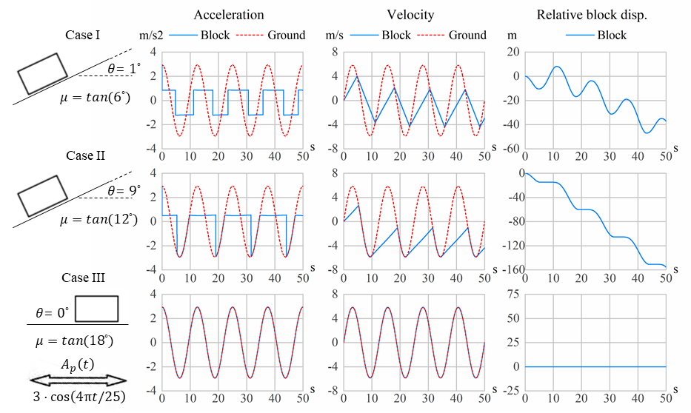

Figure 4 Asymmetrical sliding behavior under different conditions.

As the Sliding Hysteresis Curve derived under the quasi-static assumption is no longer applicable due to the dynamic nature of the sliding behavior, the asymmetrical sliding model and the shear-slip relationship shown in Figure 1 are employed. Friction is essentially a force resisting the relative motion at the interface. Therefore the kinematic equation for the asymmetrical sliding can be formulated in terms of the block velocity $V_{b}\left(t\right)$, the block acceleration $A_{b}\left(t\right)$, the ground velocity $V_{p}(t)$ and the ground acceleration $A_{p}(t)$ along the slope as

$\begin{matrix}When V_{b}\left(t\right)≠V_{p}\left(t\right), sign\left[A_{b}\left(t\right)\right]=-sign\left[V_{b}\left(t\right)-V_{p}\left(t\right)\right] \\ When V_{b}\left(t\right)=V_{p}\left(t\right), \left\{\begin{aligned}A_{b}\left(t\right)=A_{p}\left(t\right), if -α_{c2}∙μg≤A_{p}\left(t\right)≤α_{c1}∙μg \\ A_{b}\left(t\right)=α_{c1}∙μg, if A_{p}\left(t\right)>α_{c1}∙μg \\ A_{b}\left(t\right)=-α_{c2}∙μg, if A_{p}\left(t\right)<-α_{c2}∙μg \end{aligned}\right.\end{matrix}$ (2a)
$Initial conditions: V_{b}\left(0\right)=V_{p}\left(0\right)=0$ (2b)

where $g$ is the acceleration due to gravity. For an asymmetrical sliding system with $α_{c2}>α_{c1}$ under external excitation $A_{p}\left(t\right)=A∙cos⁡(ωt)∈(-A,A)$, there will be three possible critical conditions: (i) $-A<-α_{c2} μg<α_{c1} μg<A$; (ii) $-α_{c2} μg<-A<α_{c1} μg<A$; and (iii) $-α_{c2} μg<-A<A<α_{c1} μg$. The example of $A_{p}\left(t\right)=3∙cos⁡(25πt/4)$ is studied with three cases, i.e. Case I with mild slope of $θ=1°$ and low friction of $μ=\tan{6°}$; Case II with steep slope of $θ=9°$ and medium friction of $μ=\tan{12°}$; and Case III with zero slope of $θ=0°$ and high friction of $μ=\tan{18°}$. The asymmetrical sliding behavior for various cases can be visualized by the curves as shown in Figure 4. These graphs show that there will be no slipping in Case III, but the block will continue to move downslope in the other two cases.

In all three cases, the block acceleration $A_{b}\left(t\right)$ tends to approach a steady periodic manner with its angular frequency $ω$ equal to that of the excitation. While it takes only one cycle of excitation in Case II to achieve the steady state, it takes more cycles in Case I to approach the steady state. The magnitudes of $α_{c1}$ and $α_{c2}$ calculated based on the inclination of the slope $θ$ and the coefficient of friction $μ$, together with the dynamic parameters $A$ and $ω$ of the excitation, govern the steady state of the asymmetrical sliding block, which can be regarded as its tendency of downslope sliding.

2.2.3. Post-peak resetting ability during earthquake

Despite the complexity of the natural earthquake records, their nominal periods are normally around seconds while the duration of a single event can be hundreds of cycles in a couple of minutes. In the typical earthquake records shown in Figure 5, the most severe ground excitation normally happens shortly after commencement of shaking, which can be taken as the “peak stage”. This is then followed by a longer duration of shocks with smaller magnitudes, which can be regarded broadly as the “post-peak stage” of the earthquake record. A properly designed precast segmental bridge column should be able to survive the peak stage of severe ground excitation. After the peak stage of the earthquake record, there is normally a relatively short duration of excitation of medium intensity, which is followed by a longer process of attenuation. While the severe ground excitation in the peak stage may cause comparatively large relative displacements at the interface, the excitation of medium intensity in the post-peak stage of the earthquake record may assist in resetting performance if the interface are given appropriate shapes. There is little difficulty in identifying the peak ground acceleration from the time history of an earthquake record. However, the estimation of the properties of the post-peak stage of excitation is to certain extent ambiguous. Therefore, only rough estimates of these properties are obtained for classification purpose. The post-peak stage of the earthquake record may be roughly taken as the segment of time history with envelope having magnitudes of around 10% to 30% of the peak ground acceleration. The average absolute ground acceleration in the post-peak stage can be used to reflect the intensity of the cycles at the post-peak stage. The average period of shaking at the post-peak stage can be estimated based on the total duration and the number of zero-crossing points at this stage.

Figure 5 Typical earthquake acceleration records with post-peak stage enlarged for clarity.

It is a common practice to use pulse-like waves such as Ricker wavelet (Ricker, 1953) or single-cycle sinus pulse to characterize the ‘fling-step’ and ‘forward-directivity’ phenomena of the earthquakes at the severe excitation stage, while it is more reasonable to use Fourier-composite wavelets to represent the feature of the earthquakes at the post-peak stage. With the knowledge of the asymmetrical sliding behavior under simple harmonic excitation and the different stages of an earthquake record, the concept of post-peak resetting ability of a sliding system with suitable shape of interface can therefore be formulated as follows.

- The block can slide from the original position under severe excitations so that some degree of seismic isolation helps to reduce the base shear so as to protect the structure from excessive seismic damage.
- The block may tend to slide back to the original position under numerous cycles of small magnitudes at the post-peak stage of an earthquake, as if the dislocated block were reset after an earthquake.
- The dynamic characteristics and the duration of the earthquake record, together with the inclination of the slope and the coefficient of friction at the interface, are decisive parameters of the resetting tendency of an asymmetrical sliding block.

It is therefore desirable to explore how to optimize the resetting behavior of an asymmetrical sliding system by adjusting the geometry of the sliding surfaces with the use of SHCC.

2.3. W-shaped gently keyed sliding model

One of the inspiring designs of sliding joints has originated from Sideris et al. (2014a) as shown in Figure 6. The gaps between the unbonded tendon and the concrete are fully utilized for sliding. Three different stages of the sliding behavior can be obtained by a special design of the duct adaptor. According to the SHCC shown in Figure 6, the major limitation of this slip-dominant joint is that the resetting center of this sliding system falls into a range of points near the origin, resulting in residual dislocation between joints despite its small value.

In order to confine the resetting center to the origin and to take full advantages of the post-peak resetting mechanism, a bi-directional asymmetrical sliding model can be devised by introducing a W-shaped interface with gentle inclinations. Practical assumptions are also made in the analysis for further applications.

Figure 6 Sliding Hysteresis Curve for joints of Sideris et al. (2014a)

2.3.1. Basic assumptions

A rigid block of mass $m$, width $B$ and height $H$ (i.e. with an aspect ratio of $B/H$) rests on a V- or W-shaped interface with an inclination of $θ$ as shown in Figure 7, where the friction is $f$, the constant coefficient of Coulomb friction is $μ=tan⁡(γ)$ where $γ$ is the ‘friction angle’ of the interface, and a horizontal ground acceleration $a_{g}$ is applied. Apart from the gravity force $G=mg$, an initial vertical tendon force $T$ is applied at the center of mass of the block. The actual value of tendon force $T$ may fluctuate due to the variation of horizontal sliding displacements, but this fluctuation could be barely noticeable if the tendon system is long and unbonded. Since the tendon system is not the major concern of this paper, the tendon force $T$ is taken to be constant thereafter.

In considering the minor impact energy loss resulting from the change of velocity vector at the corners of slopes, completely inelastic collision is assumed, which means that the coefficient of restitution $e$ is taken as effectively zero in the direction parallel to that of the normal force $N$ when corner impact occurs. The change of coefficient of restitution $e$ may no longer matters to the overall energy of the system in view of the relatively small inclination of the slopes or the use of smoothened corner. It is conservative to take the coefficient of restitution as $e=0$ to account for more unfavorable energy loss during the sliding.

Prior to 1996, the mode of rigid-body motion was determined by considering static friction and the aspect ratio of the block only. Subsequent findings (Shenton, 1996; Scalia and Sumbatyan, 1996) have independently indicated that there should be a transitional sliding-rocking mode between the pure sliding mode and the pure rocking mode as the static friction goes up against the aspect ratio of the rigid block, and it also depends on the magnitude of the base acceleration. The boundary between sliding-rocking mode and pure rocking mode may be blurred due to the variation of the horizontal base acceleration, but the boundary between the pure sliding mode and sliding-rocking mode is still based on the initiation of an unbalanced moment on the rigid block induced by friction. Horizontal oscillation may cause the vanishing of normal force or complete detachment at certain parts of the inclined interface. The block may start to tip on a V-shaped interface as shown in Figure 7(a) during downslope sliding because of the lack of resisting moment. Therefore, an evenly spaced W-shaped interface as shown in Figure 7(b) is proposed so that the pure sliding assumption will hold during the downhill sliding subject to the conditions:

$\left\{\begin{matrix}No detachment\underset{⇒}{N = \cos\left(θ\right)\left(G+T\right)-sin\left(θ\right)a_{g}m > 0}a_{g}<\frac{G+T}{m∙\tan\left(θ\right)} \\ No tipping\underset{⇒}{\cos\left(θ\right)≈1 and f∙\frac{H}{2}-N∙\frac{B}{4} < 0}μ=\frac{f}{N}<{\frac{B}{2H}}_{} \end{matrix}\right.$ (3)

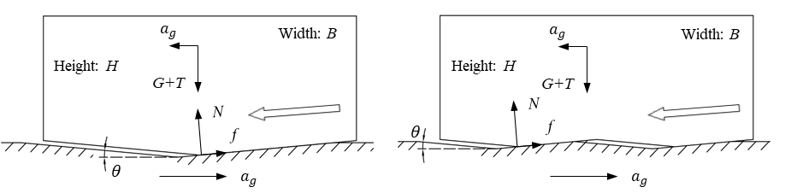
(a) (b)

Figure 7 Downslope equilibrium of sliding models under non-inertial reference frame with (a) V-shaped interface; (b) W-shaped interface.

2.3.2. Four-stage sliding hysteresis curve

By applying a horizontal applied force to the W-shaped gently keyed sliding model in a quasi-static manner, its sliding hysteresis curve can be obtained accordingly based on four representative stages of sliding motion: (i) downslope sliding towards the right; (ii) upslope sliding towards the left; (iii) upslope sliding towards the right; and (iv) downslope sliding towards the left as shown in Figure 8.

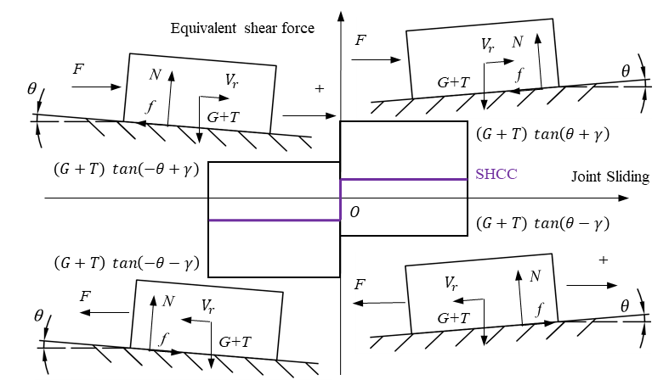

Figure 8 Four-staged sliding hysteresis curve of W-shaped gently keyed sliding model.

According to the equilibrium states in these four stages, and given that $μ=tan⁡(γ)$, the ratio of the equivalent shear force $F_{e}$ at time $t_{n}$ to the sum of gravity force $G$ and tendon force $T$ can be expressed in terms of the effective inclination of slope ${}_{n}$ and effective angle of friction ${}_{n}$ experienced by the motion of block at time $t_{n}$ as

$F_{e}/(G+T)=\tan\left(θ_{n}+γ_{n}\right)=\left\{\begin{matrix}\begin{matrix}tan\left(-θ+γ\right), Case (i): sliding right at left wedge \\ tan\left(-θ-γ\right), Case (ii): sliding left at left wedge \end{matrix} \\ \begin{matrix}\tan\left(θ+γ\right), Case (iii): sliding right at right wedge \\ tan\left(θ-γ\right), Case (iv): sliding left at right wedge \end{matrix}\end{matrix}\right.$ (4)

Considering that the friction angle $γ$ associated with concrete surfaces is normally larger than the value of $θ$ due to the gentle inclination assumed in the sliding model, a positive value of $tan⁡(-θ+γ)$ is still obtained in Case (i) of sliding and its corresponding branch of sliding hysteresis curve can be obtained. Following the same rationale, the complete sliding hysteresis curve can be constructed as shown in Figure 8. Then the SHCC for this sliding hysteresis curve can be obtained with a vertical line through the origin O, which shows that this W-shaped gently keyed sliding model has an effective resetting center at the origin. This resetting tendency is independent of the sliding displacement, which is an important property to achieve high resetting efficiency under cyclic loading.

3. Parametric studies

3.1. Strongly inelastic theoretical time-history analysis

While the sliding hysteresis curve reveals the resetting center and the resetting tendency of a sliding system, its real-time sliding performance can only be captured by time-history analysis under specific ground motions. The governing differential equation formulated based on Newton’s law of motion can be easily solved by explicit time integration using trapezoidal rule. To ensure accuracy, the time step $t$ used in time integration is taken to be one fifth of the sample interval of the seismic data. Equation (4) shows that the relative position and the relative velocity between the block and the ground at time $t_{n}=nt$ determine, respectively, the signs of effective inclination of slope $θ_{n}$ and effective angle of friction $γ_{n}$ experienced by the motion of block at time $t_{n}$ in the analysis. This can be interpreted as the basic principle for the time-history analysis of this W-shaped gently keyed sliding system. In addition to the above four stages of sliding hysteretic curve used during the analysis, the strongly inelastic nature of the bi-directional asymmetrical sliding system should also be considered properly particularly in respect of the initiation and termination of the relative sliding behavior in the vicinity of the original position. Essential details of the time-history analysis including the methodology to determine the signs of parameters and the initiation of sliding behavior are elaborated in Appendix A.

3.2. Sliding responses under earthquake excitations

3.2.1. Post-peak dynamics of sliding system

A total of 28 major earthquake records from a database of Pacific Earthquake Engineering Research Center (PEER) are shown in Table 1, which cover a variety of key properties including the fault type, distance to fault and peak ground acceleration (PGA) (Pacific Earthquake Engineering Research Center, 2020). As the average magnitude of the post-peak ground acceleration may vary slightly with the subjective selection of different duration after the peak stage, the values of post-peak acceleration period, PGA to post-peak average ground acceleration ratio (abbreviated as PPR) and post-peak duration are estimated in accordance with Section 2.2.3 and roughly classified as high (or long), medium and low (or short) for reference only. The criteria for classification are specified in the form of values for the medium ranges in the footnotes of Table 1.

Similar to the conventional properties of the earthquake records, Table 1 shows that the post-peak features indeed vary a lot due to the complexities in the formation as well as the transmission of these seismograms, and there is no obvious correlation between the PGA and the post-peak characteristics. However, for different seismograms recorded in the same event, it can be observed that PPR may have an ascending trend with their distance to the fault, whereas a descending trend can be found in the value of the post-peak acceleration period.

Table 1 List of significant earthquake records considering post-peak dynamics

Earthquake, magnitude, Fault type | Record name | Distance to fault#: km | PGA: g | Post-peak acceleration period*^ | PPR^ | Post-peak duration^
Kobe in 1995, Mw = 6.9, strike slip | FUK-0 | 159 | 0.03 | Long | Medium | Long
Kobe in 1995, Mw = 6.9, strike slip | FUK-90 | 159 | 0.04 | Medium | Low | Medium
Kobe in 1995, Mw = 6.9, strike slip | TOT-0 | 120 | 0.08 | Medium | Low | Medium
Kobe in 1995, Mw = 6.9, strike slip | TOT-90 | 120 | 0.07 | Medium | Medium | Medium
Kobe in 1995, Mw = 6.9, strike slip | MRG-0 | 25 | 0.21 | Long | Low | Long
Kobe in 1995, Mw = 6.9, strike slip | MRG-90 | 25 | 0.12 | Medium | Medium | Medium
Kobe in 1995, Mw = 6.9, strike slip | TAZ-0 | 0.3 | 0.68 | Medium | Low | Short
Kobe in 1995, Mw = 6.9, strike slip | TAZ-90 | 0.3 | 0.6 | Medium | Low | Short
Imperial Valley in 1979, Mw = 6.5, strike slip | No. 8-140 | 3.9 | 0.59 | Short | Medium | Short
Imperial Valley in 1979, Mw = 6.5, strike slip | No. 8-230 | 3.9 | 0.46 | Short | Medium | Short
Chi-Chi in 1999, Mw = 7.6, Reverse Oblique | CHY008-N | 40 | 0.13 | Medium | Medium | Medium
Chi-Chi in 1999, Mw = 7.6, Reverse Oblique | CHY008-W | 40 | 0.12 | Medium | Medium | Long
Chi-Chi in 1999, Mw = 7.6, Reverse Oblique | TCU068-N | 0.3 | 0.36 | Medium | Medium | Short
Chi-Chi in 1999, Mw = 7.6, Reverse Oblique | TCU068-E | 0.3 | 0.5 | Medium | Medium | Medium
Tabas in 1978, Mw = 7.4, Reverse | TAB-T1 | 2.1 | 0.85 | Medium | Medium | Medium
Tabas in 1978, Mw = 7.4, Reverse | TAB-L1 | 2.1 | 0.84 | Medium | Medium | Short
Landers in 1992, Mw = 7.3, strike slip | CLW-LN | 20 | 0.28 | Medium | Medium | Medium
Landers in 1992, Mw = 7.3, strike slip | CLW-TR | 20 | 0.41 | Medium | High | Short
Landers in 1992, Mw = 7.3, strike slip | LCN-260 | 2.2 | 0.77 | Short | Medium | Short
Landers in 1992, Mw = 7.3, strike slip | LCN-345 | 2.2 | 0.71 | Short | High | Short
Irpinia in 1980, Mw = 6.9, Normal | VLT-0 | 22 | 0.09 | Medium | High | Medium
Irpinia in 1980, Mw = 6.9, Normal | VLT-270 | 22 | 0.1 | Short | High | Medium
Irpinia in 1980, Mw = 6.9, Normal | CTR-0 | 8.8 | 0.12 | Medium | Medium | Medium
Irpinia in 1980, Mw = 6.9, Normal | CTR-270 | 8.8 | 0.13 | Medium | Medium | Medium
Cape Mendocino in 1992, Mw = 7.01, Reverse | CPM-0 | 7 | 1.47 | Short | Low | Short
Cape Mendocino in 1992, Mw = 7.01, Reverse | CPM-90 | 7 | 1 | Short | Medium | Short
Cape Mendocino in 1992, Mw = 7.01, Reverse | LFS-270 | 26 | 0.26 | Medium | Medium | Short
Cape Mendocino in 1992, Mw = 7.01, Reverse | LFS-360 | 26 | 0.26 | Medium | Medium | Medium
Notes: PGA = peak ground acceleration; PPR = PGA to post-peak average ground acceleration ratio
# Approximate closest distance from the actual ruptured (seismogenic) fault
* Average value estimated from post-peak stage according to Section 2.2.3
^ Medium ranges: 0.2 s < post-peak acceleration period < 0.8 s; 0.1 < PPR < 0.2; 10 s < post-peak duration < 30 s

3.2.2. Responses of selected sliding systems under normalized earthquake excitations

Three types of W-shaped gently keyed sliding models with different combinations of inclination $θ$ (i.e. 0° or 6°) and the coefficient of friction $μ$ (i.e. tan 6° or tan 18°) at the interface are studied. The initial tendon force $T$ is taken to be half of the value of gravity force $G$.

To cover a reasonable range of parameters for the analyses, six real earthquake records with combinations of post-peak characteristics defining various extreme scenarios are selected from Table 1 for the parametric study. The PGA of each of these six records is normalized to 1g and the key properties are listed below:

- Record Chi-Chi TCU068-E: typical near-fault record
- Record Kobe FUK-0: typical far-fault record
- Record Landers LCN-345: typical record with a high PPR
- Record Kobe TAZ-0: typical record with a low PPR
- Record Cape Mendocino CPM-0: typical record with a short post-peak duration
- Record Kobe MRG-0: typical record with a long post-peak duration

The sliding responses of various sliding systems subject to the above seismic excitations are shown graphically in Figures 9 to 14, where the time histories of relative block displacement are only shown from the initiation of sliding to stabilization of relative displacement for clarity. Generally speaking, the phenomenon of incessant downslope slipping in an asymmetrical sliding system induced by cyclic loading is observed in all the six cases. It results in a reduced residual slip in a sliding system with a 6° inclination compared to that with a planar interface, indicating the feasibility and potential of the proposed concept for post-peak resetting performance after an earthquake. According to the responses shown in Figures 9 to 14, the amount of residual sliding displacement drops quickly with the increase of the slope inclination, but it increases with the coefficient of friction at the interface. There is no clear relationship between the maximum sliding displacement and the slope when the inclination is gentle, but the combined effect of a higher coefficient of friction and a larger inclination of the interface decreases the maximum value of sliding displacement. Moreover, no rocking has been observed in all cases.

Figure 9 Responses of sliding systems under Record Chi-Chi TCU068-E with PGA normalized to 1g.

Figure 10 Responses of sliding systems under Record Kobe FUK-0 with PGA normalized to 1g

Figure 11 Responses of sliding systems under Record Landers LCN-345 with PGA normalized to 1g

Figure 12 Responses of sliding systems under Record Kobe TAZ-0 with PGA normalized to 1g

Figure 13 Responses of sliding systems under Record Cape Mendocino CPM-0 with PGA normalized to 1g

Figure 14 Responses of sliding systems under Record Kobe MRG-0 with PGA normalized to 1g

A noticeable amount of residual sliding displacement is observed in Type-III sliding system under excitation by Records TAZ-0, TCU068-E and CPM-0, which have relatively low PPRs and relatively short post-peak durations. As described in Table 1, the other three earthquake records that give perfect resetting performance have either higher PPR (Record LCN-345) or longer post-peak durations (Records FUK-0 and MRG-0). One can therefore infer that these two parameters of the post-peak stage of earthquake are relevant to the resetting performance of the sliding systems.

3.2.3. Effects of parameters of sliding system on responses under real earthquake excitations

As the characteristics of a seismogram may affect the resetting performance of a system with W-shaped gently keyed sliding models, the unedited earthquake records with relatively high PGA are used for this parametric study with changing variables of the W-shaped gently keyed sliding system. The following real earthquake records representative of certain extreme scenarios are adopted:

- Record Landers CLW-TR: PGA = 0.41g, high PPR, and short post-peak duration
- Record Cape Mendocino CPM-0: PGA = 1.47g, low PPR, and short post-peak duration
- Record Tabas TAB-T1: PGA = 0.85g, medium PPR, and medium post-peak duration
- Record Landers LCN-345: PGA = 0.71g, high PPR, and short post-peak duration
- Record Chi-Chi TCU068-E: PGA = 0.5g, low PPR, and medium post-peak duration
- Record Kobe TAZ-0: PGA = 0.68g, low PPR, and short post-peak duration

In each combination of interface with inclination $θ$ and coefficient of friction $μ$, the residual sliding displacement ratio $d_{rr}=D_{res}/D_{m}$ defined in terms of the maximum relative sliding displacement $D_{m}$ and the residual relative sliding displacement $D_{res}$ is calculated. The results are then presented as contour plots for further analysis. Figure 15 shows the contour plots of residual sliding displacement ratio of a sliding system under real earthquakes with extreme values of PGA, i.e. Record Landers CLW-TR with PGA = 0.41g and Record Cape Mendocino CPM-0 with PGA = 1.47g. Figure 16 shows the corresponding contour plots for real earthquakes with different values of PPR, i.e. Record Tabas TAB-T1 with medium PPR and Record Landers LCN-345 with high PPR. Figure 17 compares the corresponding contour plots for real earthquakes with different values of post-peak duration, i.e. Record Chi-Chi TCU068-E with medium post-peak duration and Record Kobe TAZ-0 with short post-peak duration. The white zones in the contour plots of Figures 15 to 17 indicate the conditions without relative sliding displacement during the entire earthquake, while the purely black zones indicate perfect resetting performance, i.e. zero residual sliding displacement.

Generally speaking, the entire area of non-white sliding zone caused by a specific seismic event is largely, if not completely, determined by the value of its PGA. A larger percentage of the purely black perfect resetting zone is observed in the contour plots associated with seismic records with high PPR values, indicating better resetting efficiency due to the dynamic nature of these earthquake records. The resetting performance of a sliding system improves as the inclination of slope $θ$ increases especially under condition of lower coefficient of friction at the interface. However, for a sliding system with parameters corresponding to points close to the boundary between the purely black and white zones in the contour plots, the maximum sliding displacement there is almost zero, and hence the apparently perfect resetting performance is trivial.

Examination of Figures 15 to 17 shows small patches of light areas close to the horizontal axes. They indicate that, with extremely low coefficient of friction (e.g. below 0.03), substantial oscillatory sliding movements may occur during earthquake excitation despite the provision of fair inclination of slope, thereby causing high residual sliding displacement ratio $d_{rr}$ in some cases. However, when the coefficient of friction exceeds 0.03, the resetting performance improves again and becomes steadier. It is noted that, even with the chemical polishing technique (Liu et al., 2019), it is unlikely to achieve a coefficient of friction below 0.05 between concrete surfaces, and hence the problem associated with the small patches of light areas close to the horizontal axes does not occur in practice.

In the case of Record Landers CLW-TR with a relatively high PPR and a relatively short post-peak duration, the residual sliding displacement ratio $d_{rr}$ remains high despite the use of a smooth interface with a realistic coefficient of friction and a steep slope, as shown in Figure 15(a). However, a relatively low residual sliding displacement ratio $d_{rr}$ is observed in the use of a gentle slope and high coefficient of friction at the interface in the case of Record Tabas TAB-T1, as shown in Figure 16(a), possibly due to the random nature of the excitation.

As the maximum relative sliding displacement reflects to some extent the seismic isolation ability of a sliding system, the parameters of the sliding system should be so chosen not only to ensure a reasonably low residual sliding displacement ratio $d_{rr}$, but also to allow sufficient sliding to occur. Therefore the desirable zone can be chosen as the lower left corner of the purely black zones in these contour plots.

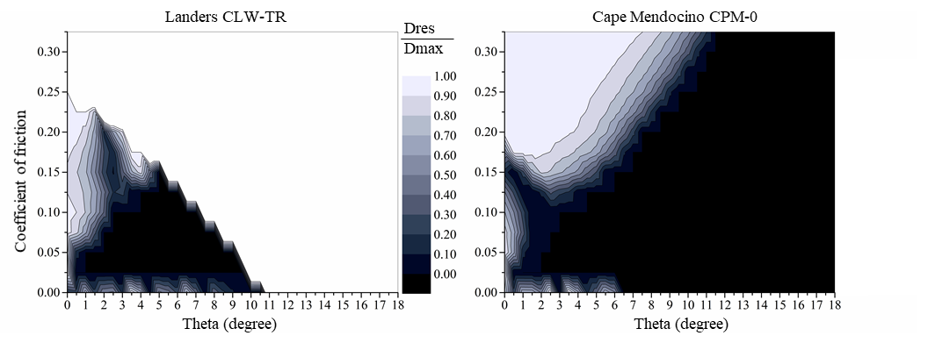
(a) (b)

Figure 15 Residual sliding displacement ratio of sliding system under earthquakes with extreme values of PGA (a) Record Landers CLW-TR with PGA = 0.41g; (b) Record Cape Mendocino CPM-0 with PGA = 1.47g

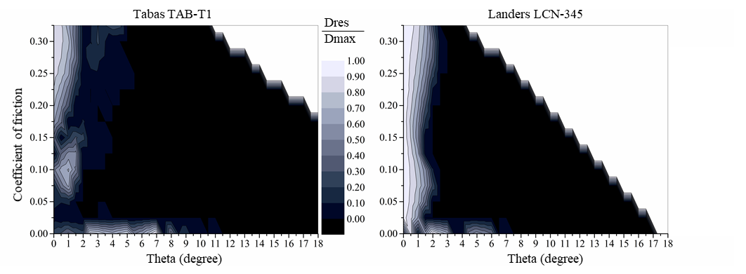
(a) (b)

Figure 16 Residual sliding displacement ratio of sliding system under earthquakes with different values of PPR (a) Record Tabas TAB-T1 with medium PPR; and (b) Record Landers LCN-345 with high PPR

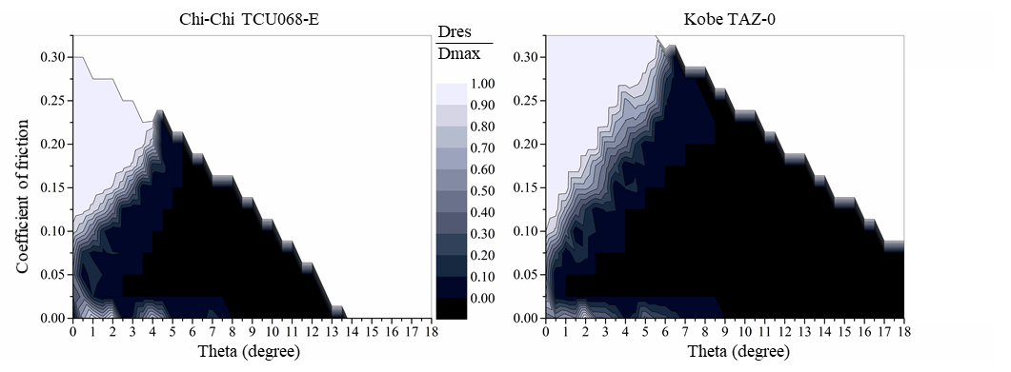
(a) (b)

Figure 17 Residual sliding displacement ratio of sliding system under earthquakes with different values of post-peak duration (a) Record Chi-Chi TCU068-E with medium post-peak duration; and (b) Record Kobe TAZ-0 with low post-peak duration

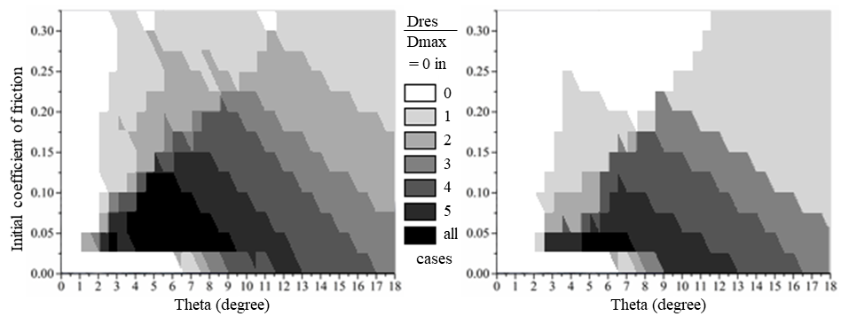
(a) (b)

Figure 18 Grayscale contour plot of resetting performance of a W-shaped sliding system under six real earthquake records: (a) with fixed coefficient of friction; and (b) with increasing coefficient of friction

In the search for a sliding system with optimal parameters, which performs well under the six representative earthquakes, the purely black zones of various contour plots in Figures 15 to 17 can be combined using low-threshold binarization and average grayscale visualization, giving the new grayscale contour plot as shown in Figure 18(a). The darkest zone at the lower left corner provides the range of optimal parameters that can give perfect resetting performance in all six scenarios. In particular, a W-shaped sliding system with smooth gentle slopes ($5°≤θ≤8°$ and $0.05≤μ≤0.1$) can be regarded as a robust design with satisfactory performance in resetting and seismic isolation under various seismic loading scenarios.

To investigate roughly the effects of possible increase in coefficient of friction due to deterioration of contact surfaces during ground shaking, analyses are repeated for the six representative earthquakes assuming that the coefficient of friction increases linearly from the initial value to double the initial value over the duration comprising the peak stage and post-peak stage of each earthquake record. Going through the same process, one can first obtain the contour plots of residual sliding displacement ratio for the six representative earthquakes, and then combine such results to form the grayscale contour plot as shown in Figure 18(b). Compared with the results with fixed coefficient of friction as shown in Figure 18(a), there is still an optimal region in Figure 18(b) although it has shrunk in size, indicating that it is more demanding to consider surface deterioration.

4. Discussion

The W-shaped gently keyed sliding model described in this paper is essentially a bi-directional asymmetrical sliding system on condition of pure sliding motion. Apparently, a block with large width to height ratio and flat interface is more likely to have pure sliding behavior. The no-tipping condition described in Equation (3) certainly depends on the shape of the interface, inclination of slope, coefficient of friction and the instantaneous center of rotation. Possible rocking at joints in segmental bridge piers has been utilized in many design schemes for seismic resistance and resetting performance is seldom an issue as long as stability during earthquake can be assured. In comparison, the resetting performance of the sliding mode at a joint is more of a concern.

To achieve satisfactory post-peak resetting performance for a sliding system, apart from providing gentle keys with suitable inclination, it is necessary to ensure that the low coefficient of friction at interface is reliable. The durability of the lubrication at interface should be assessed as it might take many years or even decades before any occurrence of an earthquake of the design level. Moreover, possible degradation of the interface due to wear and tear during the cyclic displacement caused by an earthquake could increase the coefficient of friction at the joint, thereby impeding the sliding mode and favoring the rocking mode. If the normal and the highest possible coefficients of friction can be identified, the proposed method can be used to estimate the possible responses for these extreme scenarios. If the increase in coefficient of friction due to deterioration of contact surfaces during ground shaking can be estimated, the proposed method can be easily modified to allow for the variation of coefficient of friction during cyclic displacement.

The reduction of the friction between concrete components by lubricants (Sideris, 2012; Hossain et al., 2016) is an ongoing research area. The chemical polishing technique (Liu et al., 2019) of floor treatment to create concrete surfaces with higher impermeability and hardness may be further investigated for practical application to resettable sliding joints (Au et al., 2019).

Apart from the dynamic sliding behavior at the joints of a segmental bridge pier under extreme seismic loading, the designer also needs to avoid excessive relative sliding movements at the joints under the other horizontal actions, including extreme wind loads, braking and traction of highway traffic, etc. Because of the different nature of loading, they should preferably be resisted in a static manner with proper choice of the inclination of gentle keys and tendon force taking into account possible uncertainty of the coefficient of friction. The feasible region can then be identified in conjunction with the contour plot as shown in Figure 18.

5. Conclusions

A number of concepts have been put forward to better understand the resetting response of asymmetrical sliding systems under seismic loading. A kinetic parametric study has been carried out using a W-shaped gently keyed sliding model under various earthquake excitations. The main findings are:

- The concept of Sliding Hysteresis Center Curve is useful in studying the dynamic responses of a sliding system, particularly the location of its resetting center and its resetting tendency. This can be applied to study the resetting performance of W-shaped gently keyed sliding system.

- The seismic energy at the post-peak stage of an earthquake is shown to be beneficial to the overall self-centering performance of a sliding system. This dynamic post-peak resetting mechanism may be utilized in the aseismic design of precast segmental bridge piers.

- The characteristics of seismograms will also influence the resetting performance of a sliding system. When normalized to the same PGA, pulse-like seismograms with short post-peak stage of lower magnitude tend to have lower resetting efficiency, thus leading to noticeable residual sliding displacement when the coefficient of friction increases and the inclination decreases.

- Using the resetting efficiency contour plots for various representative seismic events, a W-shaped gently keyed sliding system can be properly designed to provide superior post-peak resetting performance while assuring sufficient seismic isolation ability during the peak stages of the design seismic events.

Acknowledgments

The work described here has been partially supported by the Ministry of Science and Technology, China (Project No.: 2019YFB1600702).

REFERENCES

Au FTK, Liu YQ, Yuan Y, Su RKL and Lam NTK (2019), Seismic Performance of Precast Segmental Bridge Columns with Resettable Sliding Joints: Feasibility Study, Proceedings of the Bridge Engineering Institute Conference – Frontiers of Bridge Engineering – Honolulu, Hawaii, July 2019.

Billington SL, Barnes RW and Breen JE (1999), A precast segmental substructure system for standard bridges, PCI Journal: 56-73.

Chou CC, Chang HJ and Hewes JT (2013), Two-plastic-hinge and two dimensional finite element models for post-tensioned precast concrete segmental bridge columns, Engineering Structures, 46: 205-217.

Dyskin AV, Pasternak E and Estrin Y (2012), Mortarless structures based on topological interlocking, Frontiers of Structural and Civil Engineering. 6(2): 188–197.

Estrin Y, Dyskin AV and Pasternak E (2011), Topological interlocking as a material design concept, Materials Science and Engineering: C, 31(6): 1189-1194.

Garini E, Gazetas G and Anastasopoulos I (2011), Asymmetric ‘Newmark' sliding caused by motions containing severe ‘directivity' and ‘fling' pulses, Géotechnique: 61(9): 733-756.

Hossain MA, Totoev Y and Masia MJ (2016), Friction on mortar-less joints in semi interlocking masonry. Conference on Brick and Block Masonry – Trends, Innovations and Challenges – Modena, da Porto & Valluzzi (Eds), August 2016.

Kurama YC, Sritharan S, Fleischman RB, Restrepo JI, Henry RS, Cleland NM, Ghosh SK and Bonelli P (2018), Seismic-resistant precast concrete structures: State of the art, Journal of Structural Engineering, 144(4): 03118001.

Li C, Hao H and Bi K (2018), Seismic performance of precast concrete-filled circular tube segmental column under biaxial lateral cyclic loadings, Bulletin of Earthquake Engineering, 17(1): 271–296.

Liu YQ, Yuan Y, Au FTK, Su RKL, Lam NTK (2019), Seismic Performance of Precast Segmental Bridge Columns with Resettable Sliding Joints: Friction at Interface. Proceedings of the Bridge Engineering Institute Conference – Frontiers of Bridge Engineering – Honolulu, Hawaii, July 2019.

Lopez GD and Soong TT (2003), Sliding fragility of block-type non-structural components. Part 1: Unrestrained components. Earthquake Engineering & Structural Dynamics, 32(1): 111-129.

MacRae GA and Kawashima K (1997), Post-earthquake residual displacements of bilinear oscillators, Earthquake Engineering & Structural Dynamics, 26(7): 701-716.

Makris N & Zhang J (2001), Rocking response of anchored blocks under pulse-type motions. Journal of engineering mechanics, 127(5), 484-493.

Newmark NM (1965), Effects of earthquakes on dams and embankments, Géotechnique: 15(2): 139–160.

Ou YC, Chiewanichakorn M, Aref AJ and Lee GC (2007), Seismic performance of segmental precast unbonded posttensioned concrete bridge columns, Journal of Structural Engineering, 133(11): 1636-1647.

Pacific Earthquake Engineering Research Center (2020), PEER Ground Motion Database, Pacific Earthquake Engineering Research Center, Univ. of California, Berkeley, CA, Retrieved from https://ngawest2.berkeley.edu/.

Ricker N (1953), The form and laws of propagation of seismic wavelets. Geophysics, 18(1): 10-40.

Scalia A, Sumbatyan MA (1996), Slide rotation of rigid bodies subjected to a horizontal ground motion. Earthquake engineering & structural dynamics, 25(10): 1139-1149.

Shenton III HW (1996), Criteria for initiation of slide, rock, and slide-rock rigid-body modes. Journal of Engineering Mechanics, 122(7): 690-693.

Sideris P (2012), Seismic Analysis and Design of Precast Concrete Segmental Bridges, PhD Dissertation, Department of Civil, Structural and Environmental Engineering, State University of New York at Buffalo, Buffalo, NY.

Sideris P, Aref AJ and Filiatrault A (2014a), Quasi-static cyclic testing of a large-scale hybrid sliding-rocking segmental column with slip-dominant joints, Journal of Bridge Engineering, 19(10): 04014036.

Sideris P, Aref AJ and Filiatrault A (2014b), Large-scale seismic testing of a hybrid sliding-rocking posttensioned segmental bridge system, Journal of Structural Engineering, 140(6): 04014025.

Zarrin O, Totoev YZ and Masia MJ (2018), Evaluating Thrust Force Induced in Semi-Interlocking Masonry Panel During Horizontal and Vertical Arching. International Masonry Conference at Milan, Italy, July 9-11.

Appendix A: Essential details of time history analysis

In the explicit time integration for solution of the governing differential equation, the latest responses at time $t_{n}$ obtained from the last time step from time $t_{n-1}$ to $t_{n}$, i.e. the relative displacement $x_{r.n}$ and the relative velocity $v_{r.n}$ between the block and the ground at time $t_{n}$, will be used as initial conditions for determination of parameter sign and checking of sliding for analysis in the current time step from time $t_{n}$ to $t_{n+1}$. Simultaneous checking of both the parameter sign and possible sliding initiation should be conducted based on possible zero-crossing conditions, giving the following four scenarios of the initial responses at time $t_{n}$ for the current time step:

- Scenario I – Away from original position and moving ($v_{r.n}≠0 \& x_{r.n}≠0$): The signs of $θ_{n}$ and $γ_{n}$ are consistent with those of the relative position $x_{r.n}$ and the relative velocity $v_{r.n}$. No sliding check is needed.
- Scenario II – Back to original position but still moving ($v_{r.n}≠0 \& x_{r.n}=0$): The sign $γ_{n}$ is consistent with that of the relative velocity $v_{r.n}$, but the sign of $θ_{n}$ is opposite to that of $θ_{n-1}$. No sliding check is needed.
- Scenario III – Away from original position but coming to a rest temporarily ($v_{r.n}=0 \& x_{r.n}≠0$): The sign of $θ_{n}$ is consistent with that of the relative position $x_{r.n-1}$, and sliding check is needed.
- Scenario IV – Coming to a rest at original position ($v_{r.n}=0 \& x_{r.n}=0$): The sign of $θ_{n}$ is associated with that of the ground acceleration $a_{g.n}$, and sliding check is needed.

The sliding check for a sliding system with W-shaped gently keyed interface will be carried out once the relative velocity reaches zero ($v_{r. n}=0$) regardless of the location of block. The sliding check is similar to that for the original Newmark sliding system as described earlier. In particular for the sliding system with W-shaped gently keyed interface, when the block is at the original position ($x_{r. n}=0$), it can only slide upslope under the excitation of the ground motion. This special sliding check process can be described as:

$\begin{matrix}\begin{matrix}Initial conditions: sign of a_{g. n} and v_{r. n}=0 \\ When x_{r. n}=0\left\{ \begin{matrix}If \left|\frac{m\left|a_{g. n}\right|-(G+T)∙\tan\left(\left|θ_{n}\right|\right)}{\left(G+T\right)+m\left|a_{g. n}\right|∙\tan\left(\left|θ_{n}\right|\right)}\right|≤\left|\tan\left(γ_{n}\right)\right|, \\ Otherwise, sliding begins \end{matrix}\right.\end{matrix} no sliding \\ When x_{r. n}≠0\left\{ \begin{matrix}If \left|\frac{ma_{g. n}+(G+T)∙\tan\left(θ_{n}\right)}{\left(G+T\right)-ma_{g. n}∙\tan\left(θ_{n}\right)}\right|≤\left|\tan\left(γ_{n}\right)\right|,no sliding \\ Otherwise, sliding begins \end{matrix}\right.\end{matrix}$ (A.1)

One can determine the relative acceleration parallel to the slope $a_{r. n}$ based on the ground acceleration $a_{g. n}$ if relative sliding occurs. When the no-sliding condition is reached, the value of relative acceleration $a_{r. n}$ is set to be zero.

For the method adopted, exact zero values of $x_{r.n}$ and $v_{r.n}$ are important indicators for various types of checkings mentioned above and it is impossible to acquire them at finite steps with a pre-determined time interval, therefore, a sub-step is always imposed once signs of responses changed within that step, more specifically, if the values of $x_{r.n}$ and $v_{r.n}$ changes its sign in a step, the algorithm will find out the exact direction or position where that zero value occurs before running into the checking conditions.

Notations

$A$ peak value of ground acceleration $A_{p}\left(t\right)$ applied parallel to the slope
$A_{b}(t)$ acceleration time history of block parallel to slope
$α_{c1}g$ critical (threshold) yielding acceleration of block for downslope sliding
$α_{c2}g$ critical (threshold) yielding acceleration of block for upslope sliding
$a_{g}$ horizontal ground acceleration applied to W-shaped sliding model
$a_{g.n}$ horizontal ground acceleration applied to W-shaped sliding model at time $t_{n}$
$a_{r}$ relative acceleration between block and ground parallel to slope
$a_{r.n}$ relative acceleration between block and ground parallel to slope at time $t_{n}$
$B, H$ nominal width and height of block, respectively
$D\left(t\right), D_{m}$ sliding displacement time history and maximum sliding displacement, respectively
$D_{res}$ residual sliding displacement
$d_{rr}$ residual sliding displacement ratio $(d_{rr}=D_{res}/D_{m})$
$e$ coefficient of restitution for impact energy calculation
$F_{i}$ horizontal force applied to block at various sliding cases
$f$ frictional force
$G=mg$ gravity force acting on block of mass $m$
$g$ acceleration due to gravity
$O_{c}$ nominal resetting center for a sliding system based on Sliding Hysteresis Curve
$T$ tendon force
$V_{b}\left(t\right), V_{p}(t)$ velocity time histories of block and ground, respectively
$v_{r.n}$ relative velocity between block and ground parallel to slope at time $t_{n}$
$x_{r.n}$ relative displacement between block and ground parallel to slope at time $t_{n}$
$θ$ inclination of slope at interface
$θ_{n}$ effective inclination of slope experienced by motion of block at time $t_{n}$
$μ=tan⁡(γ)$ constant coefficient of Coulomb friction expressed in terms of nominal friction angle $γ$
$γ_{n}$ effective angle of friction experienced by motion of block at time $t_{n}$
$μ_{e}$ nominal effective coefficient of friction at various sliding stages

