High Quality MAPbBr₃ Cuboid Film with Promising Optoelectronic Properties Prepared by A Hot Methylamine Precursor Approach
Fei Ye,§ Haodi Wu,† Minchao Qin,‡ Shuo Yang,※ Guangda Niu,† Xinhui Lu,‡ Jiannong Wang,※ David B. Mitzi,* ,┴ and Wallace C.H. Choy*,§
§ Department of Electrical and Electronic Engineering, The University of Hong Kong, Pokfulam Road, Hong Kong SAR, China. † Wuhan National Laboratory, Huazhong University of Science and Technology Wuhan, Hubei Province, China. ‡ Department of Physics, The Chinese University of Hong Kong, Shatin, Hong Kong SAR, China. ※ Department of Physics, The Hong Kong University of Science and Technology, Clear Water Bay, Kowloon, Hong Kong SAR, China. ┴ Department of Mechanical Engineering and Materials Science and Department of Chemistry, Duke University, Durham, North Carolina 27708, United States.

Though CH₃NH₃PbBr₃ single crystals are frequently applied in various optoelectronic devices due to its favorable cuboid geometry, superior optoelectronic properties and better stability than CH₃NH₃PbI₃, CH₃NH₃PbBr₃ polycrystalline films normally show poorer morphology with scattered crystals than its iodide counterpart, inherently due to its different crystallization habit. In this work, a facile process based on a hot methylamine-based precursor with high viscosity and concentration is demonstrated to counteract the rapid ion diffusion. The precursor also has special features including large colloidal size, a solid form at room temperature, fast crystallization offered by the easy evacuation of methylamine. CH₃NH₃PbBr₃ films comprised of tightly aligned CH₃NH₃PbBr₃ cuboids on micron scale are obtained. Wide channel (100 μm) photodetectors made from the CH₃NH₃PbBr₃ films show promising photo-response and fast response speed on par with that based on single crystals, suggesting high film quality and good optoelectronic connections between neighboring cuboids.
TOC GRAPHICS
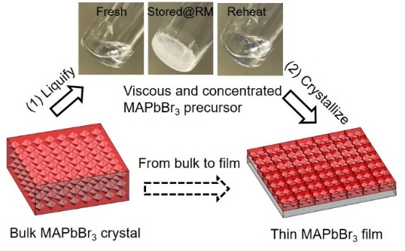

CH₃NH₃PbBr₃ (MAPbBr₃, where MA= CH₃NH₃⁺), as one of the typical organic–inorganic halide hybrid perovskite materials, has superior optoelectronic properties and better stability than iodide based perovskites MAPbI₃.¹⁻³ Excellent performances in the detection devices of photon ⁴⁻⁹ and charged particles¹⁰ based on MAPbBr₃ single crystals with favorable cuboid geometry have been frequently reported. Though MAPbBr₃ single crystals generally show less defects compared with polycrystalline films and thus the better device performances, it is still a challenging issue to integrate crystals with substrates to form large-area flat-panel devices due to the restrictions in lattice matching and poor compatibility with other functional device layers.^{4, 11} To obtain substrate integration with stand-alone single-crystal thin films (SCTF) by slicing bulk perovskite single crystals also presents challenges because of the fragile nature of these materials.^{12, 13} Therefore, a variety of applications in solar cells, ¹⁴⁻¹⁷ light-emitting diodes¹⁸ and lasers ¹⁹ were based on MAPbBr₃ thin films. Inherently, there is a tendency to form discontinuous MAPbBr₃ crystals scattering on substrates (which could reach micro-scale distance) when preparing MAPbBr₃ films by conventional methods such as spin-coating and dip-coating, even though these methods yield continuous and high-quality films for MAPbI₃.¹⁹⁻²⁵ The presumable reason is that the enhanced growth rate of the perovskite grains resulting from the higher diffusivity of the smaller bromide ion than the iodide ion.^{26, 27} There are efforts to improve MAPbBr₃ film quality by using additives such as PbCl₂,²⁰ polyimide,²⁵ and poly(ethylene oxide),^{23, 24} which however produces issues regarding film impurities and degraded optoelectronic properties. There are also efforts to grow films with small single crystals by seeding on substrates, but lead to a discontinuous appearance with wide gaps (on the scale of μm) between crystals and a concern over substrate attachment,²⁸ as well as by space-confinement but a long growth time and delicate setup are required.^{6, 17, 29} Consequently, it is highly desirable to realize MAPbBr₃ films with simultaneous high quality and well integration with substrate for unlocking their applications in high performance optoelectronic devices.
In this work, we propose a method to prepare high-quality and substrate-integrated MAPbBr₃ films consisting of compactly aligned MAPbBr₃ cuboids based on a solvent-free methylamine (CH₃NH₂) precursor without any extraneous additives. Taking into account the natural solid-state phase of the precursor at room temperature, hot methylamine gas is introduced to liquefy MAPbBr₃ crystals. By comprehensively understanding material and crystallization properties of the precursor in the hot methylamine gas environment, we achieve dense MAPbBr₃ films with crystallographically-oriented grain arrangement which show single-crystal-like properties that contribute to the high responsivity and fast response speed in wide channel (100 μm) photodetectors. We further unveil the formation mechanism that the continuous mosaic of MAPbBr₃ cuboids are resulted from the large density of nuclei within the precursor and the suppression of convection-induced defects in the viscous precursor. We believe that this new route to assemble MAPbBr₃ cuboids into high-quality MAPbBr₃ films will further diversify the range of perovskite fabrication processes, thereby providing new strategies for perovskite research and device design.
The schematic diagrams for MAPbBr₃·xCH₃NH₂ precursor preparation are shown in Scheme 1 (I), (II), and (III), with the detailed preparation described in the Experimental section. Briefly, CH₃NH₂ solution in water is added in a flask containing excess amount of KOH and heated at 70 ºC in an oil bath. The produced hot CH₃NH₂ is dried by CaO and then introduced into a vessel with MAPbBr₃ crystals to form MAPbBr₃·xCH₃NH₂ (the value of x will be discussed later). We studied the molecular interaction between CH₃NH₂ and MAPbBr₃ by nuclear magnetic resonance (NMR), as shown in Figure S1. ¹H NMR peak of the protons adjacent to nitrogen and carbon in CH3NH2 were reported to be located at 1.15 p.p.m. and 2.26 p.p.m., respectively.^{[30]} The ¹H NMR peaks of MABr (Figure S1 (a)) at 7.54 and 2.35 p.p.m. correspond to the resonances of protons from -NH₃⁺ and -CH₃⁺, respectively. The peak located at 4.12 p.p.m. for MAPbBr₃·xCH₃NH₂ (Figure S1 (b)) is roughly halfway between 1.15 p.p.m. of -NH₂ (CH₃NH₂) and 7.54 p.p.m. of -NH₃⁺ (CH₃NH₃⁺). The peaks corresponding to the -CH₃ protons are slightly changed. These results suggest that MAPbBr₃ and CH₃NH₂ mainly interact through the -NH₃⁺ (CH₃NH₃⁺) and -NH₂ (CH₃NH₂) groups.
We found that the precursor formed in Scheme 1 (III) turns into a solid when stored in a sealed vessel at room temperature for about 1 h and changes back to liquid phase when heated at a temperature of ~50 ºC or higher, as shown in Figure 1 (a). This phenomenon was neither reported previously for methylamine based treatment.^{30, 31, 32} We speculate that the solidification of MAPbBr₃·xCH₃NH₂ might be due to the stronger bonding of bromine anions to the neighboring cations and stronger Br…H-N hydrogen bonds, resulting from the larger electronegativity (2.96) and smaller Shannon ionic radius (1.96 Å) of bromine compared with iodine (2.66, and 2.2 Å for electronegativity and atom radius, respectively), which also makes CH₃NH₂ molecules more challenging to insert into the bromide perovskite than into the iodide analog. This rationalizes the importance of using more thermally active hot CH₃NH₂ gas to facilitate the reaction with MAPbBr₃. Additionally, the solidification of MAPbBr₃·xCH₃NH₂ precursor at room temperature necessitates the use of hot gas to maintain the flowing state of the precursor during preparation; if processed at room temperature, solid MAPbBr₃·xCH₃NH₂ may encase the unreacted MAPbBr₃ crystals and block further reaction, slowing the transition from pure perovskite to pure precursor. Overall, this first report of a solid CH₃NH₂-based precursor for MAPbBr₃ at room temperature offers the advantage of easy and safe transportation, facilitating the use of perovskite within practical applications.
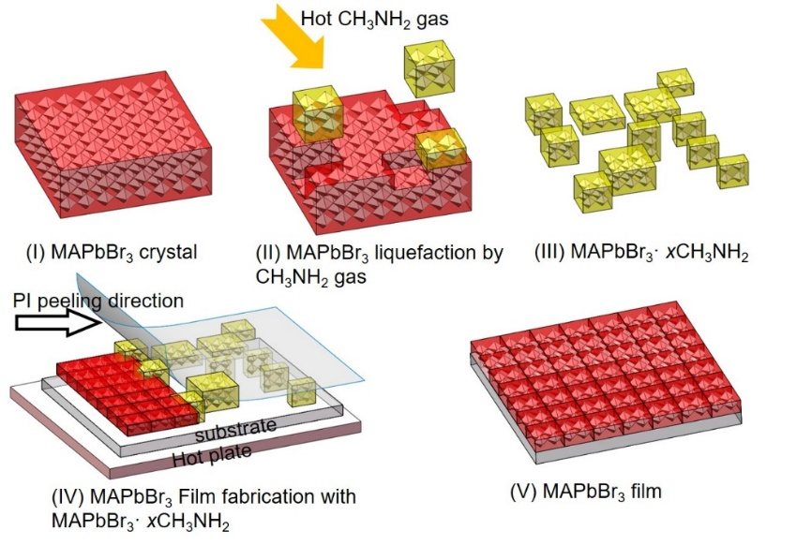
Scheme 1. Schematic diagrams for MAPbBr₃·xCH₃NH₂ precursor preparation and MAPbBr₃ formation by pressure-assisted soft-cover deposition. (I) MAPbBr₃ crystal; (II) MAPbBr₃ single crystal liquefied by hot CH₃NH₂ gas; (III) MAPbBr₃·xCH₃NH₂ precursor; (IV) MAPbBr₃ film fabrication by pressure-assisted soft-cover deposition; (V) MAPbBr₃ film.

The colloidal chemistry of liquid MAPbBr₃·xCH₃NH₂ precursor (at 50 ºC) was next studied by dynamic light scattering (DLS) and compared with typical MAPbBr₃/DMF precursor, as shown in Figure 1(b). For MAPbBr₃/DMF, the very small colloidal size (~1 nm average) reflects the good solvation of the polar solvent, in accordance with literature.³³ MAPbBr₃·xCH₃NH₂ precursor exhibits much larger colloidal size (~74 nm average), which could facilitate obtaining large grains in the perovskite film due to a prospective correlation between film grain size and precursor colloidal size.³⁴ We convert the DLS peak representative of large colloids to that of small colloids (~1.3 nm) when MAPbBr₃·xCH₃NH₂ is added into DMF (Figure S2). This observation suggests that large colloidal size in MAPbBr₃·xCH₃NH₂ stems from the absence of traditional polar solvents in the precursor. The coordination number of CH₃NH₂ in MAPbBr₃·xCH₃NH₂ precursor was determined by comparing the mass before and after liquefaction, that is x≈2.8, which is smaller compared with the value of 4 for MAPbI₃, perhaps due to the lower activity of MAPbBr₃ with CH₃NH₂.
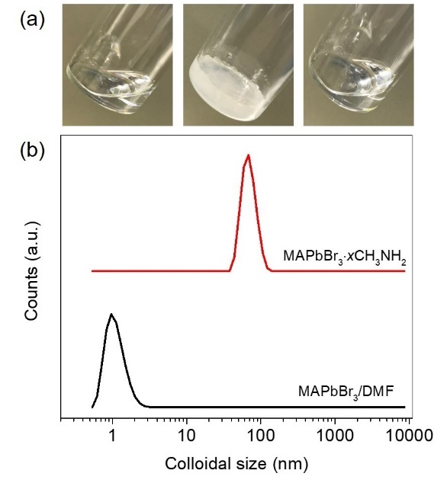
Figure 1. (a) Fresh MAPbBr₃·xCH₃NH₂ precursor (left), stored at room temperature for 1 h (middle), and liquid MAPbBr₃·xCH₃NH₂ precursor kept at 50 ºC for 30 min (right). (b) DLS for MAPbBr₃/DMF solution and MAPbBr₃·xCH₃NH₂ precursor at ~50 ºC.

The viscosity of liquid MAPbBr₃·xCH₃NH₂ precursor at 50 ºC was also measured, yielding a value of ~1000 cp, which is significantly higher than typical polar-solvent based precursors (with largest reported value of < 20 cp³⁵). The high viscosity is rationalized by the lack of liquid polar solvent in the MAPbBr₃·xCH₃NH₂ precursor. The MAPbBr₃ concentration of the precursor is calculated to be 3.94 M, i.e., rather high in comparison with the value (< 2 M) of typical polar-solvent based precursors, due to the limited solubility offered by the solvents.³⁶⁻⁴¹ The high viscosity of the MAPbBr₃·xCH₃NH₂ precursor is an important factor in suppressing convection-induced defects in scalable film fabrication processes.⁴² Here, we fabricate MAPbBr₃ films by pressure-assisted soft-cover deposition using the viscous MAPbBr₃·xCH₃NH₂ precursor at 50 ºC (hereinafter abbreviated as “present route”). Schematic illustrations of pressure-assisted soft-cover deposition appear in Scheme 1 (IV) and (V), with details of the process described in the Experimental Section. The crystallization process during soft-cover deposition is very fast (~3 s), presumably because the gas component, CH₃NH₂, is very easily evacuated from the liquid precursor. We studied the morphology of the present MAPbBr₃ films by scanning electron microscope (SEM) imaging and compared with typical spin-coated MAPbBr₃ films from MAPbBr₃/DMF solution (hereinafter abbreviated as “control”), as shown in Figure 2. A top-view SEM image of the present route MAPbBr₃ film (Figure 2 (a)) shows a continuous mosaic of regular MAPbBr₃ cuboids. The same compact films at lower magnification can be found in Figure S3. A cross-sectional SEM image of the film (Figure 2 (b)) shows well-aligned block-like MAPbBr₃ crystals, enabling the formation of a compact film with a columnar structure. No convection-induced defects (circular patterns⁴²) nor large gaps between domains⁴³ appear in the present MAPbBr₃ film, as shown by the SEM image in Figure 2 (a) and (b). These results suggest the effectiveness of the viscous MAPbBr₃·xCH₃NH₂ precursor in suppressing convection and thus its potential for application in scalable processes. The SEM images for the control (Figure 3 (c) and (d)) show loosely distributed and often deformed MAPbBr₃ cuboids. Discontinuous MAPbBr₃ cuboids have been frequently reported,^{19, 28, 44} suggesting general difficulty in controlling continuity of MAPbBr₃ cuboid films using previously reported processes. In contrast, the continuity of MAPbBr₃ cuboids in this work benefits from the high concentration and viscosity of the MAPbBr₃·xCH₃NH₂ precursor and the large density of nuclei, which ensure cuboids connect during nuclei growth.²¹ Further, the concentrated viscous MAPbBr₃·xCH₃NH₂ precursor with easy-to-remove CH₃NH₂ benefits the fabrication of thick MAPbBr₃ films, a desirable form for X-ray detection^{45, 46} and light management in solar cells, using a layer-by-layer approach (Figure S4). ⁴⁷⁻⁴⁹

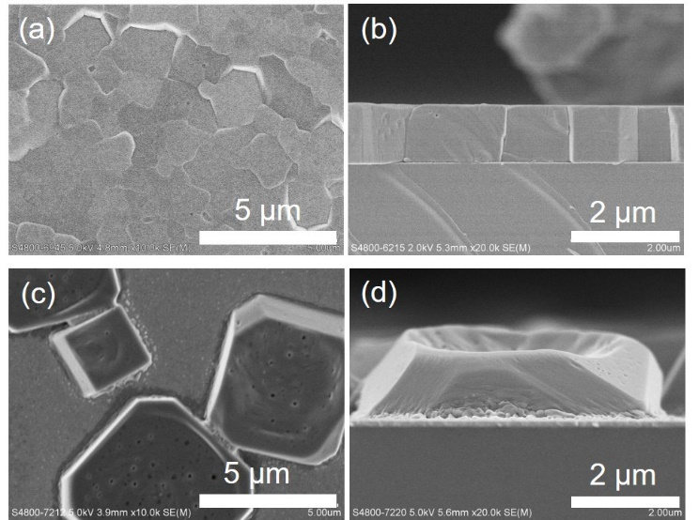
Figure 2. SEM images of MAPbBr₃ films. (a) and (b) are the top-view and side-view SEM images, respectively, of MAPbBr₃ films prepared with MAPbBr₃·xCH₃NH₂ precursor by pressure-assisted soft-cover deposition. (c) and (d) correspond to those prepared with a MAPbBr₃/DMF precursor by spin-coating.

The distinct diffraction of the selected-area diffraction (SAD) pattern shown in Figure 3 (a) suggests good crystallinity of the present MAPbBr₃ films. The SAD yields (110), (100) and (200) facets of the cubic MAPbBr₃ phase. As seen in the X-ray diffraction (XRD) pattern (Figure 3 (b)), the control MAPbBr₃ films exhibit (100), (110), (200) and (210), etc., peaks, while the present route mainly shows strong peaks for the (100) and (200) planes, suggesting an oriented arrangement of MAPbBr₃ crystals in the latter case. We further studied the crystal orientation by grazing-incidence wide-angle X-ray scattering (GIWAXS), as shown in Figure 3 (c) and (d). The discrete diffraction spots of the present MAPbBr₃ film suggest an ordered crystal alignment, while the control shows isotropic diffraction rings resulting from randomly oriented crystals, in accordance with the XRD results in Figure 3 (b).
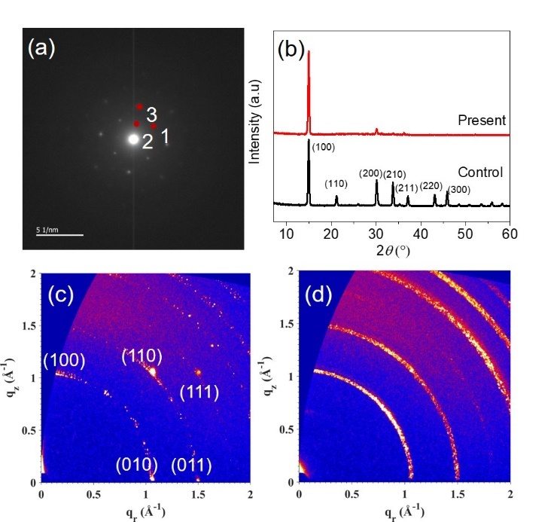
Figure 3. (a) SAD pattern of the present MAPbBr₃ film. (b) XRD patterns of the present MAPbBr₃ film and that for the control. (c) and (d) are GIWAXS of the present MAPbBr₃ films the control, respectively.

As the ultraviolet-visible (UV-Vis) absorption and photoluminescence (PL) spectra show in Figure 4(a), the MAPbBr₃ film fabricated using the present route displays an optical absorption cutoff at ~547 nm, with the inset showing the corresponding Tauc plot and the extrapolated optical band gap of 2.24 eV, close to the value reported for bulk MAPbBr₃ single crystal or that of MAPbBr₃ ISC (2.18~2.24 eV, as listed in Table S1). Table S1 also indicates that the PL emission (560-574 nm) of normal single crystals and ISC MAPbBr₃ films tends to red-shift compared with that of polycrystalline MAPbBr₃ (<545 nm) due to a combination of effects of photocarrier diffusion and re-absorption,^{[50]} except for the very high quality MAPbBr₃ single crystals by low-temperature-gradient crystallization (LTGC). The PL emission peak of the present MAPbBr₃ lies at 548 nm, in agreement with its optical band gap, and close to value of LTGC- MAPbBr₃. The time-resolved photoluminescence (TRPL) dynamics of the present MAPbBr₃ film is shown in Figure 4(b). The PL decay curve is well fitted by a bi-exponential decay model, yielding a fast time constant of 6±2 ns and a slow time constant of 34±8 ns. The fast time constant, presumably related to surface recombination, is comparable with the ISC MAPbBr₃ film (~7 ns²⁸). The slow time constant, characterizing bulk recombination, is shorter than that of the ISC MAPbBr₃ film (~189 ns), while it is still much longer than that of polycrystalline MAPbBr₃ films, which exhibit a lifetime of only several nanoseconds (see Table S1 for comparison details). The control MAPbBr₃ film in this work also shows a very short average lifetime of ~ 5 ns, corresponding to the reported time scale in Table S1. Because PL lifetime is related to recombination caused by defects, the longer PL lifetime suggests the good quality of the present MAPbBr₃ films. We studied the transport properties of the present MAPbBr₃ film using the Hall method. P-type conduction, a carrier density of 1.7×10⁹ cm⁻³, and a high carrier mobility value of 32 cm² V⁻¹ s⁻¹ were obtained, comparable with the values for ISC MAPbBr₃ films and bulk single crystals (Table S1). The long time constant and large mobility of the present high quality MAPbBr₃ film indicates single-crystal-like properties.

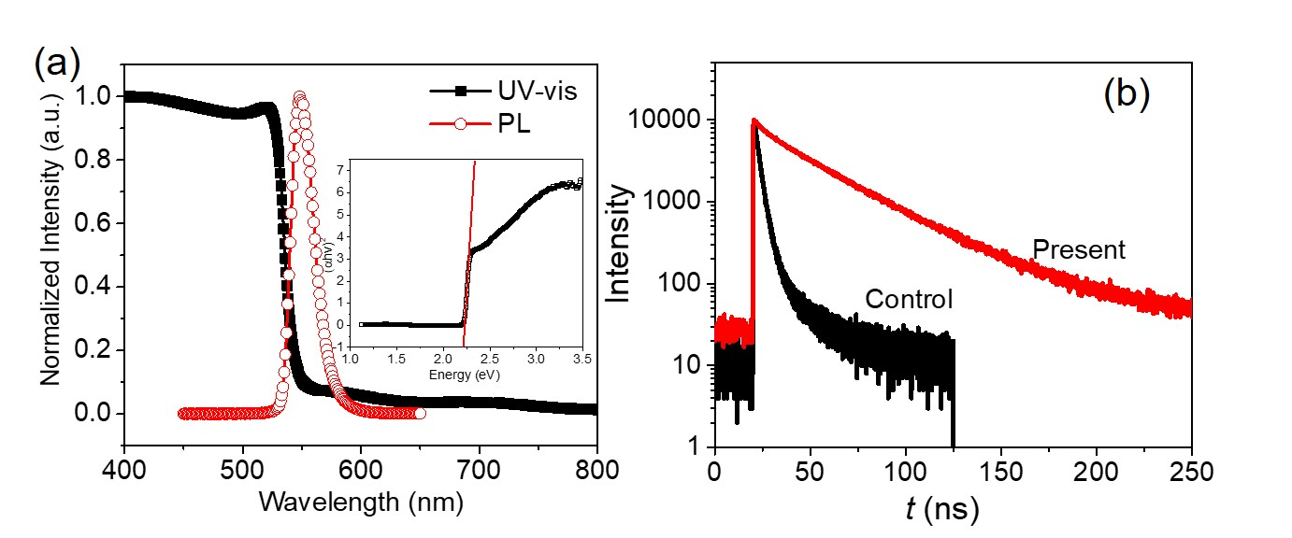
Figure 4. (a) UV-Vis absorption spectrum and steady-state PL spectrum, excited by 375 nm pulse laser, of the present MAPbBr₃ film. The inset is the corresponding Tauc plot displaying the extrapolated optical band gap. (b) Time-resolved photoluminescence (TRPL) dynamics of the present MAPbBr₃ film and the control, excited by 375 nm pulse laser.

To prove the tight connection between MAPbBr₃ cuboids and the high film quality, we fabricated large channel width (100 μm between two adjacent electrodes) photodetectors and tested the device performances. Photodetector current–voltage (J–V) curves were measured in the dark and under illumination (λ = 530 nm), with light intensities ranging from 9.5 to 130.4 μW cm⁻² (Figure S5). Responsivity (R, the photocurrent generated per unit of incident light power), external quantum efficiency (EQE), and detectivity (D*) (shot noise-limited) were determined from the J–V results under -5 V bias, as shown in Figure 5(a), (b) and (c), respectively (calculation details appear in Supporting Information). R, EQE, and D* all decrease linearly with increasing light intensity, because more charge recombination is expected under higher light intensity, with values of approximately 1.5×10³ mA W⁻¹, 356% and 5.8×10¹³ Jones, respectively, under 9.5 μW cm⁻² illumination. The high EQE >100% means the photodetectors belong to a photoconductor type.⁵¹ We summarize some typical device structures and photodetection parameters in Table S2. Due to the very different device structures, dimensions and measurement parameters, such as light intensity and wavelength, comparing results across different studies is difficult. Nevertheless, Table S2 shows that the present MAPbBr₃ film has promising properties with respect to photodetection application, when considering both the photodetection ability and ease of fabrication. Further, a fast response time (the period when the photocurrent increases from 90% to 10% of the saturated value) of 23 µs is obtained for the present MAPbBr₃ photodetector under -5 V bias (Figure 5(d)). This value is shorter than those reported for ISC MAPbBr₃ films, bulk MAPbBr₃ single crystals, and MAPbBr₃ nanostructures (Table S2). We also fabricated bulk MAPbBr₃ single crystal photodetectors with the same active channel width (100 μm), which showed a rather long response time of 53 μs (Figure S6), on the same time scale with literature values (Table S2). The fast response confirms the high crystal quality achieved with the new synthesis route for MAPbBr₃ films, since the response speed of a photodetector strongly correlates to charge transport and collection. Consequently, the above results confirm that the mosaic of MAPbBr₃ cuboids achieved with the present route are tightly connected, and that the high quality of the present MAPbBr₃ films contributes to promising light response when applied in photodetectors.
In conclusion, we have proposed and demonstrated a new method to fabricate MAPbBr₃ films based on a MAPbBr₃·xCH₃NH₂ precursor prepared with hot methylamine gas coupled with a pressure-assisted soft-cover deposition approach. Features of the precursor and resulting MAPbBr₃ films have also been evaluated. The high-quality of the MAPbBr₃ films, which consist of compactly-arrayed and crystallographically-aligned MAPbBr₃ cuboids, are resulted from the large density of nuclei and high viscosity of the precursor, as well as the ease of removing CH₃NH₂ during the soft cover process. We have fabricated wide channel (100 μm) photodetectors with the dense MAPbBr₃ films and achieved promising responsivity and very fast response speed of 23 μs, suggesting the aligned cuboids are in good optoelectronic connection. This new route is expected to provide a complementary strategy for future perovskite fabrication and device design.
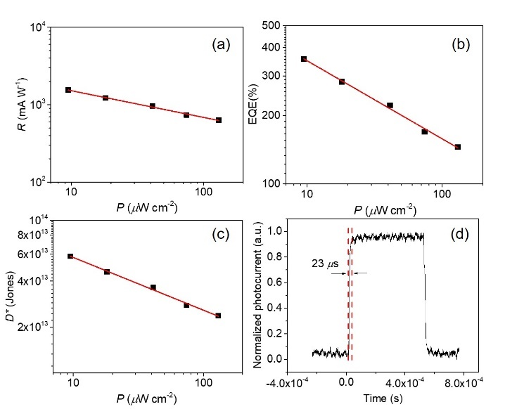
Figure 5. (a), (b) and (c) are responsivity (R), external quantum efficiency (EQE), and detectivity (D*), respectively, determined from the current-voltage results under -5 V bias, which were measured in dark and under illumination using a 530 nm LED, with light intensities ranging from 9.5 to 130.4 μW cm⁻² (see Figure S5). (d) Response time of the present MAPbBr₃ photodetectors under -5 V bias.

Experimental Methods
MAPbBr₃ single crystals synthesis: All materials were used as received unless otherwise stated. Lead bromide (PbBr₂, 98%, TCI) and methylammonium bromide (CH₃NH₃Br, 98%, Dyesol) were mixed in dimethylformamide (DMF, 1 ml, Acros, extra dry) with a molar ratio of 1:1 to form a 1 M solution, which was stirred at room temperature for 6 h and filtered using a 220 nm PTFE filter. Small MAPbBr₃ seeds (~ 1 mm edge length) were added in the solution and the solution was heated up to 80 ºC in an oil bath and kept for 6-8 h for crystal growth. The formed MAPbBr₃ single crystals were then collected and dried at 60 ºC under vacuum for approximately 12 h.
MAPbBr₃·xCH₃NH₂ precursor preparation and film fabrication: KOH pellets (5 g) were put into a suction flask (250 ml) and then 15 ml of methylamine solution (40 wt% in water, TCI) was added into the flask and constantly stirred at 150 rpm in an oil bath with a temperature of 70 ºC. The generated CH₃NH₂ gas then passed through a drying tower filled with desiccant (CaO) to remove moisture. The dried CH₃NH₂ gas was constantly introduced into the bottle (without heating) containing bulky MAPbBr₃ single crystals to gradually form a colorless and transparent MAPbBr₃·xCH₃NH₂ liquid. The bottle reaches a temperature of ~40 ºC during the reaction between CH₃NH₂ and MAPbBr₃. To ensure sufficient interaction between the gas and the single crystals, the bottle is sealed with parafilm, and the formed liquid was collected over time with a pipette. The MAPbBr₃ film was prepared by pressure-assisted soft-cover deposition as reported with slight modification.^{31, 32} Briefly, 20 μl of preheated (~50 ºC) perovskite precursor was dropped onto a 2 cm × 2 cm substrate, which was kept at ~50 ºC, and then a preheated (~50 ºC) polyimide (PI) film (Dupont, KF5025L, thickness=0.125 mm, RMS=0.6 nm) was covered onto the precursor. A piece of preheated glass (~50 ºC) was covered on the PI film and was pressed evenly to spread the liquid precursor onto the whole substrate. Then, the covered glass and PI film were removed at a rate of ~55 mm/s while heating (~50 ºC), and the formed precursor film on the substrate was further heated at ~50 ºC for 10 minutes to evaporate the CH₃NH₂ gas and to fully form the MAPbBr₃ film. Besides the thinner films shown in Fig. 2(a) and (b), the thick MAPbBr₃ film prepared using the MAPbBr₃·xCH₃NH₂ precursor (as shown in Figure S4) was prepared using two distinct MAPbBr₃ layers. Different from the pressure-assisted soft-cover deposition, it was fabricated with a nylon hairbrush with hair length ~1 cm on a 50 ºC hotplate. The top layer was deposited (i.e., “painted”) onto the bottom layer within ~20 seconds of the first layer, while being maintained at 50 ºC. The film was held at 50 ºC for 10 min to evaporate the excess CH₃NH₂ and to form MAPbBr₃.
Materials characterizations: ¹H NMR spectra were recorded on a Bruker Avance 400 (400 MHz) Fourier-transform NMR spectrometer. The samples were dissolved in DMSO-d6 and tested at 298 K. The DLS data were collected on a Malvern Zetasizer Nano ZS90 equipped with an internal HeNe laser (λ = 633.0 nm). The typical MAPbBr₃/DMF solution had a concentration of 1 M and the molar ratio of MABr and PbBr₂ was 1:1. DLS of the MAPbBr₃·xCH₃NH₂ precursor was measured at ~50 ºC in a sealed quartz cuvette. The coordination number was calculated according to the molar ratio of absorbed CH₃NH₂ to MAPbBr₃ crystals, which was obtained by weighing the mass of MAPbBr₃ crystals and the liquid that forms after reacting with CH₃NH₂. The MAPbBr₃ concentration was calculated according to the mass per volume—i.e., the mass of 200 μL MAPbBr₃·xCH₃NH₂ was weighed to be 0.446 g. The viscosity of MAPbBr₃·xCH₃NH₂ was tested at ~50 ºC under atmospheric pressure using an Ubbelohde viscometer with a capillary diameter of 1 mm. The time t of each precursor passing through the capillary was recorded, and the dynamic viscosity (cp) was calculated from the time t(s) and the density of precursor ρ (g cm⁻³) according to Poiseuille's law. The powder X-ray diffraction pattern (XRD) was obtained using Cu Kα radiation with λ of 1.54056 Å (Bruker D2 Phaser). The TEM was tested with FEI Tecnai G2 20. The morphology of the perovskite film was measured with a SEM (Hitachi S-4800 FEG) using an accelerating voltage of 5 kV. GIWAXS measurements were carried out with a Xeuss 2.0 SAXS/WAXS laboratory beamline using a Cu X-ray source (8.05 keV, 1.54 Å) and a Pilatus3R 300K detector. The incidence angle is 0.3°. The UV-Vis absorption spectra were obtained from a home-built system with a xenon lamp as the light source and an integrating sphere associated with a charge-coupled device (CCD, Ocean Optics QE Pro) as the detector. The PL spectra were measured with a 375 nm picosecond pulse laser (PicoQuant LDH-P-C-375) and a photomultiplier (PMA-C 192-M) detector. Hall effect was measured in the dark using a Physical Property Measurement System (PPMS, Quantum Design) with magnetic field intensity of 0.6 T and temperature of 300 K. The sample (~1.5 μm in thickness) for Hall measurement was fabricated on a piece of glass with a dimension of 1.7 cm × 1.7 cm, with 4 square Au/Cr metal electrodes (thickness: 50 nm/8 nm; area ~9 mm²) evaporated on the 4 corners.
Device fabrication and characterizations: Cr (10 nm)/Au(30 nm) electrodes were evaporated on the MAPbBr₃ film at a pressure ca. 5×10⁶ Torr to make the photodetector structure. The dimension of the MAPbBr₃ active channel between two adjacent Cr/Au pads is 100 μm in width, 4 mm in length and 1.5 μm in thickness. The active area of the device is about 0.4 mm². Current–voltage (J–V) curves of the photodetectors were measured using a Keithley 2635 SourceMeter in dark and under illumination using 530 nm wavelength light with intensity values: 9.5, 18.1, 41.1, 74.2, 130.4 μW cm⁻². Response time of the photodetector was measured under -5 V bias with 490 nm light.
ASSOCIATED CONTENT
Description of calculations, NMR results and DLS results of perovskite precursors, top-view SEM images of perovskite films at lower magnification, cross-sectional SEM image of thick perovskite film, tables for perovskite properties and device parameters, current-voltage curve and response time of photodetector devices.
AUTHOR INFORMATION
Corresponding Author
E-mail: chchoy@eee.hku.hk (Wallace C.H. Choy)
E-mail: david.mitzi@duke.edu (David B. Mitzi)
Notes
The authors declare no competing financial interest.
ACKNOWLEDGMENT
This research was supported by the University Grant Council of the University of Hong Kong (Grant# 201811159147, and Research Equipment Fund), the General Research Fund (Grant 17204117, and 17201819) and Collaborative Research Grant (C5037-18G), from the Research Grants Council (RGC) of Hong Kong Special Administrative Region, China. We thank Dr. Fred Kong and Prof. Vivian Wing-Wah Yam from Department of Chemistry at the University of Hong Kong for DLS and NMR measurement. We thank Prof. Jiang Tang from Huazhong University of Science and Technology for helpful measurement support. Prof. Jiannong Wang thanks the support from Research Grants Council of Hong Kong SAR under Grant Nos. 16302717 and C6013-16E. Prof. David B. Mitzi is supported by the ONR through award number N00014-17-1-2207.
REFERENCES
(1) Schmidt, L. C.; Pertegas, A.; Gonzalez-Carrero, S.; Malinkiewicz, O.; Agouram, S.; Minguez Espallargas, G.; Bolink, H. J.; Galian, R. E.; Perez-Prieto, J., Nontemplate Synthesis of CH₃NH₃PbBr₃ Perovskite Nanoparticles. J. Am. Chem. Soc. 2014, 136, 850-853.
(2) Saidaminov, M. I.; Abdelhady, A. L.; Murali, B.; Alarousu, E.; Burlakov, V. M.; Peng, W.; Dursun, I.; Wang, L.; He, Y.; Maculan, G.; Goriely, A.; Wu, T.; Mohammed, O. F.; Bakr, O. M., High-Quality Bulk Hybrid Perovskite Single Crystals within Minutes by Inverse Temperature Crystallization. Nat. Commun. 2015, 6, 7586-7892.
(3) Shi, D.; Adinolfi, V.; Comin, R.; Yuan, M.; Alarousu, E.; Buin, A.; Chen, Y.; Hoogland, S.; Rothenberger, A.; Katsiev, K.; Losovyj, Y.; Zhang, X.; Dowben, P. A.; Mohammed, O. F.; Sargent, E. H.; Bakr, O. M., Low Trap-State Density and Long Carrier Diffusion in Organolead Trihalide Perovskite Single Crystals. Science 2015, 347, 519-522.
(4) Wei, W.; Zhang, Y.; Xu, Q.; Wei, H.; Fang, Y.; Wang, Q.; Deng, Y.; Li, T.; Gruverman, A.; Cao, L.; Huang, J., Monolithic Integration of Hybrid Perovskite Single Crystals with Heterogenous Substrate for Highly Sensitive X-Ray Imaging. Nat. Photonics 2017, 11, 315-321.
(5) Wei, H.; Fang, Y.; Mulligan, P.; Chuirazzi, W.; Fang, H.-H.; Wang, C.; Ecker, B. R.; Gao, Y.; Loi, M. A.; Cao, L.; Huang, J., Sensitive X-Ray Detectors Made of Methylammonium Lead Tribromide Perovskite Single Crystals. Nat. Photonics 2016, 10, 333-340.
(6) Yang, Z.; Deng, Y.; Zhang, X.; Wang, S.; Chen, H.; Yang, S.; Khurgin, J.; Fang, N. X.; Zhang, X.; Ma, R., High-Performance Single-Crystalline Perovskite Thin-Film Photodetector. Adv. Mater. 2018, 30, 1704333-1704337.
(7) Liu, Y.; Zhang, Y.; Zhao, K.; Yang, Z.; Feng, J.; Zhang, X.; Wang, K.; Meng, L.; Ye, H.; Liu, M.; Liu, S. F., A 1300 mm² Ultrahigh-Performance Digital Imaging Assembly Using High-Quality Perovskite Single Crystals. Adv. Mater. 2018, 30, 1707314-1707325.
(8) Andričević, P.; Kollár, M.; Mettan, X.; Náfrádi, B.; Sienkiewicz, A.; Fejes, D.; Hernádi, K.; Forró, L.; Horváth, E., Three-Dimensionally Enlarged Photoelectrodes by a Protogenetic Inclusion of Vertically Aligned Carbon Nanotubes into CH₃NH₃PbBr₃ Single Crystals. J. Phys. Chem. C 2017, 121, 13549-13556.
(9) Fang, Y.; Dong, Q.; Shao, Y.; Yuan, Y.; Huang, J., Highly Narrowband Perovskite Single-Crystal Photodetectors Enabled by Surface-Charge Recombination. Nat. Photonics 2015, 9, 679-686.
(10) Xu, Q.; Wei, H.; Wei, W.; Chuirazzi, W.; DeSantis, D.; Huang, J.; Cao, L., Detection of Charged Particles with a Methylammonium Lead Tribromide Perovskite Single Crystal. Nucl. Instrum. Meth. A 2017, 848, 106-108.
(11) Li, Y.; Li, Y.; Shi, J.; Zhang, H.; Wu, J.; Li, D.; Luo, Y.; Wu, H.; Meng, Q., High Quality Perovskite Crystals for Efficient Film Photodetectors Induced by Hydrolytic Insulating Oxide Substrates. Adv. Funct. Mater. 2018, 28, 1705220-1705230.
(12) Liu, Y.; Sun, J.; Yang, Z.; Yang, D.; Ren, X.; Xu, H.; Yang, Z.; Liu, S. F., 20-mm-Large Single-Crystalline Formamidinium-Perovskite Wafer for Mass Production of Integrated Photodetectors. Adv. Opt. Mater. 2016, 4, 1829-1837.
(13) Rao, H. S.; Li, W. G.; Chen, B. X.; Kuang, D. B.; Su, C. Y., In Situ Growth of 120 cm² CH₃NH₃PbBr₃ Perovskite Crystal Film on FTO Glass for Narrowband-Photodetectors. Adv. Mater. 2017, 29, 1602639-1602646.
(14) Ryu, S.; Noh, J. H.; Jeon, N. J.; Chan Kim, Y.; Yang, W. S.; Seo, J.; Seok, S. I., Voltage Output of Efficient Perovskite Solar Cells with High Open-Circuit Voltage and Fill Factor. Energy Environ. Sci. 2014, 7, 2614-2618.
(15) Edri, E.; Kirmayer, S.; Cahen, D.; Hodes, G., High Open-Circuit Voltage Solar Cells Based on Organic-Inorganic Lead Bromide Perovskite. J. Phys. Chem. Lett. 2013, 4, 897-902.
(16) Noh, J. H.; Im, S. H.; Heo, J. H.; Mandal, T. N.; Seok, S. I., Chemical Management for Colorful, Efficient, and Stable Inorganic-Organic Hybrid Nanostructured Solar Cells. Nano Lett. 2013, 13, 1764-1769.
(17) Rao, H. S.; Chen, B. X.; Wang, X. D.; Kuang, D. B.; Su, C. Y., A Micron-Scale Laminar Mapbbr₃ Single Crystal for an Efficient and Stable Perovskite Solar Cell. Chem. Commun. (Camb.) 2017, 53, 5163-5166.
(18) Cho, H.; Jeong, S. H.; Park, M. H.; Kim, Y. H.; Wolf, C.; Lee, C. L.; Heo, J. H.; Sadhanala, A.; Myoung, N.; Yoo, S.; Im, S. H.; Friend, R. H.; Lee, T. W., Overcoming the Electroluminescence Efficiency Limitations of Perovskite Light-Emitting Diodes. Science 2015, 350, 1222-1225.
(19) Liao, Q.; Hu, K.; Zhang, H.; Wang, X.; Yao, J.; Fu, H., Perovskite Microdisk Microlasers Self-Assembled from Solution. Adv. Mater. 2015, 27, 3405-3410.
(20) Tidhar, Y.; Edri, E.; Weissman, H.; Zohar, D.; Hodes, G.; Cahen, D.; Rybtchinski, B.; Kirmayer, S., Crystallization of Methyl Ammonium Lead Halide Perovskites: Implications for Photovoltaic Applications. J. Am. Chem. Soc. 2014, 136, 13249-13256.
(21) Yu, J. C.; Kim, D. B.; Jung, E. D.; Lee, B. R.; Song, M. H., High-Performance Perovskite Light-Emitting Diodes Via Morphological Control of Perovskite Films. Nanoscale 2016, 8, 7036-7042.
(22) Ling, Y.; Yuan, Z.; Tian, Y.; Wang, X.; Wang, J. C.; Xin, Y.; Hanson, K.; Ma, B.; Gao, H., Bright Light-Emitting Diodes Based on Organometal Halide Perovskite Nanoplatelets. Adv. Mater. 2016, 28, 305-311.
(23) Bade, S. G. R.; Li, J.; Shan, X.; Ling, Y.; Tian, Y.; Dilbeck, T.; Besara, T.; Geske, T.; Gao, H.; Ma, B.; Hanson, K.; Siegrist, T.; Xu, C.; Yu, Z., Fully Printed Halide Perovskite Light-Emitting Diodes with Silver Nanowire Electrodes. ACS nano 2016, 10, 1795-1801.
(24) Li, J.; Bade, S. G.; Shan, X.; Yu, Z., Single-Layer Light-Emitting Diodes Using Organometal Halide Perovskite/Poly(Ethylene Oxide) Composite Thin Films. Adv. Mater. 2015, 27, 5196-5202.
(25) Li, G.; Tan, Z. K.; Di, D.; Lai, M. L.; Jiang, L.; Lim, J. H.; Friend, R. H.; Greenham, N. C., Efficient Light-Emitting Diodes Based on Nanocrystalline Perovskite in a Dielectric Polymer Matrix. Nano Lett. 2015, 15, 2640-2644.
(26) Zhou, Y.; Yang, M.; Game, O. S.; Wu, W.; Kwun, J.; Strauss, M. A.; Yan, Y.; Huang, J.; Zhu, K.; Padture, N. P., Manipulating Crystallization of Organolead Mixed-Halide Thin Films in Antisolvent Baths for Wide-Bandgap Perovskite Solar Cells. ACS Appl. Mater. Interfaces 2016, 8, 2232-2237.
(27) Dunlap-Shohl, W. A.; Zhou, Y.; Padture, N. P.; Mitzi, D. B., Synthetic Approaches for Halide Perovskite Thin Films. Chem. Rev. 2018, 119, 3193-3295.
(28) Saidaminov, M. I.; Adinolfi, V.; Comin, R.; Abdelhady, A. L.; Peng, W.; Dursun, I.; Yuan, M.; Hoogland, S.; Sargent, E. H.; Bakr, O. M., Planar-Integrated Single-Crystalline Perovskite Photodetectors. Nat. Commun. 2015, 6, 8724-8731.
(29) Chen, Y.-X.; Ge, Q.-Q.; Shi, Y.; Liu, J.; Xue, D.-J.; Ma, J.-Y.; Ding, J.; Yang, H.-J.; Hu, J.-S.; Wan, L.-J., General Space-Confined on-Substrate Fabrication of Thickness-Adjustable Hybrid Perovskite Single-Crystalline Thin Films. J. Am. Chem. Soc. 2016, 138, 16196-16199.
(30) Chen, H.; Ye, F.; Tang, W.; He, J.; Yin, M.; Wang, Y.; Xie, F.; Bi, E.; Yang, X.; Gratzel, M.; Han, L., A Solvent- and Vacuum-Free Route to Large-Area Perovskite Films for Efficient Solar Modules. Nature 2017, 550, 92-95.
(31) Chih, Y. K.; Wang, J. C.; Yang, R. T.; Liu, C. C.; Chang, Y. C.; Fu, Y. S.; Lai, W. C.; Chen, P.; Wen, T. C.; Huang, Y. C.; Tsao, C. S.; Guo, T. F., Niox Electrode Interlayer and CH₃NH₂/CH₃NH₃PbBr₃ Interface Treatment to Markedly Advance Hybrid Perovskite-Based Light-Emitting Diodes. Adv. Mater. 2016, 28, 8687-8694.
(32) Zhou, Z.; Wang, Z.; Zhou, Y.; Pang, S.; Wang, D.; Xu, H.; Liu, Z.; Padture, N. P.; Cui, G., Methylamine-Gas-Induced Defect-Healing Behavior of Ch3nh3pbi3 Thin Films for Perovskite Solar Cells. Angew. Chem. Int. Ed. 2015, 54, 9705-9709.
(33) Yan, K.; Long, M.; Zhang, T.; Wei, Z.; Chen, H.; Yang, S.; Xu, J., Hybrid Halide Perovskite Solar Cell Precursors: Colloidal Chemistry and Coordination Engineering Behind Device Processing for High Efficiency. J. Am. Chem. Soc. 2015, 137, 4460-4468.
(34) Han, Q.; Bai, Y.; Liu, J.; Du, K.-z.; Li, T.; Ji, D.; Zhou, Y.; Cao, C.; Shin, D.; Ding, J.; Franklin, A. D.; Glass, J. T.; Hu, J.; Therien, M. J.; Liu, J.; Mitzi, D. B., Additive Engineering for High-Performance Room-Temperature-Processed Perovskite Absorbers with Micron-Size Grains and Microsecond-Range Carrier Lifetimes. Energy Environ. Sci. 2017, 10, 2365-2371.
(35) Ye, F.; Chen, H.; Xie, F.; Tang, W.; Yin, M.; He, J.; Bi, E.; Wang, Y.; Yang, X.; Han, L., Soft-Cover Deposition of Scaling-up Uniform Perovskite Thin Films for High Cost-Performance Solar Cells. Energy Environ. Sci. 2016, 9, 2295-2301.
(36) Wu, Y. Z.; Islam, A.; Yang, X. D.; Qin, C. J.; Liu, J.; Zhang, K.; Peng, W. Q.; Han, L. Y., Retarding the Crystallization of PbI₂ for Highly Reproducible Planar-Structured Perovskite Solar Cells Via Sequential Deposition. Energy Environ. Sci. 2014, 7, 2934-2938.
(37) Ng, A.; Ren, Z.; Hu, H.; Fong, P. W. K.; Shen, Q.; Cheung, S. H.; Qin, P.; Lee, J. W.; Djurisic, A. B.; So, S. K.; Li, G.; Yang, Y.; Surya, C., A Cryogenic Process for Antisolvent-Free High-Performance Perovskite Solar Cells. Adv. Mater. 2018, 30, 1804402-1804412.
(38) Nayak, P. K.; Moore, D. T.; Wenger, B.; Nayak, S.; Haghighirad, A. A.; Fineberg, A.; Noel, N. K.; Reid, O. G.; Rumbles, G.; Kukura, P.; Vincent, K. A.; Snaith, H. J., Mechanism for Rapid Growth of Organic-Inorganic Halide Perovskite Crystals. Nat. Commun. 2016, 7, 13303-13311.
(39) Noel, N. K.; Habisreutinger, S. N.; Wenger, B.; Klug, M. T.; Hörantner, M. T.; Johnston, M. B.; Nicholas, R. J.; Moore, D. T.; Snaith, H. J., A Low Viscosity, Low Boiling Point, Clean Solvent System for the Rapid Crystallisation of Highly Specular Perovskite Films. Energy Environ. Sci. 2017, 10, 145-152.
(40) Barraza, E. T.; Dunlap-Shohl, W. A.; Mitzi, D. B.; Stiff-Roberts, A. D., Deposition of Methylammonium Lead Triiodide by Resonant Infrared Matrix-Assisted Pulsed Laser Evaporation. J. Electron. Mater. 2017, 47, 917-926.
(41) Wang, F.; Yu, H.; Xu, H. H.; Zhao, N., Hpbi3: A New Precursor Compound for Highly Efficient Solution-Processed Perovskite Solar Cells. Adv. Funct. Mater. 2015, 25, 1120-1126.
(42) Ye, F.; Tang, W.; Xie, F.; Yin, M.; He, J.; Wang, Y.; Chen, H.; Qiang, Y.; Yang, X.; Han, L., Low-Temperature Soft-Cover Deposition of Uniform Large-Scale Perovskite Films for High-Performance Solar Cells. Adv. Mater. 2017, 29, 1701440-1701446.
(43) Deng, Y.; Peng, E.; Shao, Y.; Xiao, Z.; Dong, Q.; Huang, J., Scalable Fabrication of Efficient Organolead Trihalide Perovskite Solar Cells with Doctor-Bladed Active Layers. Energy Environ. Sci. 2015, 8, 1544-1550.
(44) Edri, E.; Kirmayer, S.; Kulbak, M.; Hodes, G.; Cahen, D., Chloride Inclusion and Hole Transport Material Doping to Improve Methyl Ammonium Lead Bromide Perovskite-Based High Open-Circuit Voltage Solar Cells. J. Phys. Chem. Lett. 2014, 5, 429-433.
(45) Kim, Y. C.; Kim, K. H.; Son, D. Y.; Jeong, D. N.; Seo, J. Y.; Choi, Y. S.; Han, I. T.; Lee, S. Y.; Park, N. G., Printable Organometallic Perovskite Enables Large-Area, Low-Dose X-Ray Imaging. Nature 2017, 550, 87-91.
(46) Yakunin, S.; Sytnyk, M.; Kriegner, D.; Shrestha, S.; Richter, M.; Matt, G. J.; Azimi, H.; Brabec, C. J.; Stangl, J.; Kovalenko, M. V.; Heiss, W., Detection of X-Ray Photons by Solution-Processed Organic-Inorganic Perovskites. Nat. Photonics 2015, 9, 444-449.
(47) Liu, Z.; Qiu, L.; Juarez-Perez, E. J.; Hawash, Z.; Kim, T.; Jiang, Y.; Wu, Z.; Raga, S. R.; Ono, L. K.; Liu, S. F.; Qi, Y., Gas-Solid Reaction Based over One-Micrometer Thick Stable Perovskite Films for Efficient Solar Cells and Modules. Nat. Commun. 2018, 9, 3880-3891.
(48) Chen, Z.; Dong, Q.; Liu, Y.; Bao, C.; Fang, Y.; Lin, Y.; Tang, S.; Wang, Q.; Xiao, X.; Bai, Y.; Deng, Y.; Huang, J., Thin Single Crystal Perovskite Solar Cells to Harvest Below-Bandgap Light Absorption. Nat. Commun. 2017, 8, 1890-1897.
(49) Saidaminov, M. I.; Haque, M. A.; Savoie, M.; Abdelhady, A. L.; Cho, N.; Dursun, I.; Buttner, U.; Alarousu, E.; Wu, T.; Bakr, O. M., Perovskite Photodetectors Operating in Both Narrowband and Broadband Regimes. Adv. Mater. 2016, 28, 8144-8149.
(50)Yamada, T.; Yamada, Y.; Nishimura, H.; Nakaike, Y.; Wakamiya, A.; Murata, Y.; Kanemitsu, Y., Fast Free-Carrier Diffusion in Ch3nh3pbbr3single Crystals Revealed by Time-Resolved One- and Two-Photon Excitation Photoluminescence Spectroscopy. Advanced Electronic Materials 2016, 2, 1500290-1500290.
(51) Konstantatos, G.; Sargent, E. H., Nanostructured Materials for Photon Detection. Nat. Nanotechnol. 2010, 5, 391-400.

