Data analytics-enable production visibility for Cyber-Physical Production Systems
Pengcheng Fang
Jianjun Yang
Lianyu Zheng
Ray Y. Zhong
Yuchen Jiang
With the wide integration of the Cyber-Physical System (CPS) and Internet of things (IoT), the manufacturing industry has entered into an era of big data. Thus, manufacturing companies are facing challenges when conducting Big Data Analytics, including the high velocity of data generation, the enormous volume, the multifarious formats and types as well as the quality or fidelity. In this paper, a Cyber-Physical Production System (CPPS) using data analytics is proposed to enable production visibility. Firstly, this study uses data stream processing approaches to clean redundant data efficiently. Secondly, a Bayesian inference engine, which is used to identify the accuracy of an RFID-captured event online, is employed to train reliable simple events. Then, complex event processing is applied to fuse multi-source heterogeneous data. Finally, production progress visibility is achieved by the Business Process Management. The proposed system demonstrates that it is significant to implement real-time data collection, processing and visibility,as well as to improve production efficiency. A demonstrative case from the machinery industry is presented to validate the CPPS.
Production visibility ,CPPS ,Data analytics ,Event stream processing ,Complex event processing

Symbols
$$a$$ | the amplitude of a Gaussian basis function
$$b$$ | the centroid location of a Gaussian basis function
$$c$$ | the peak width of a Gaussian basis function
$$n$$ | the number of peaks to fit a Gaussian basis function
$$ant$$ | the antenna index
$$dir$$ | the direction of transportation
$$e_{m}$$ | a simple or comlex event instance
$$end$$ | the end time of event
$$epc$$ | the electronic product code of a tag object
$$id$$ | the event identification code
$$loc$$ | the location of occurrence
$$mem$$ | the tag memory information
$$pall$$ | the unique code of pallet
$$pro$$ | the custom special property set
$$start$$ | the start time of event
$$task$$ | the bound task unique code
$$time$$ | the timestamp of the event occurrence
$$x$$ | the input variable for a classifier
$$y$$ | the output class for a classifier
$$\left|D\right|$$ | the number of a sample set
$$N_{i}$$ | the number of all the possible values of the $i$-th attribute

Abbreviations
lp6cm AODE & Averaged One-Dependent Estimator
ASLO & Active smart logistics object
BPM & Business Process Management
CCR & Correctly classified rate
CEP & Complex Event Processing
CPPS & Cyber-Physical Production System
CPS & Cyber-Physical System
ESP & Event Stream Processing
FN & False negative
FP & False positive
IoT & Internet of things
MES & Manufacturing Execution System
MSE & MES simple event
PIE & PSLO intermediate event
PSLO & Passive smart logistics object
RFID & Radio Frequency Identification
RRD & RFID raw data
RSE & RFID simple event
SG & Session gap
TIE & Tag intermediate event
TN & True negatives
TP & True positives
TV & Predefined threshold value

1.Introduction
The production system is facing a challenge in the trend of personalized products . With the increasing disturbance, it is difficult to make a good decision timely. Additionally, traditional manufacturing data acquisition mainly relies on manual operations, which is not adapted for production visibility. Hence, increasing Radio Frequency Identification (RFID) device and other sensor devices contributes to track and trace manufacturing objects as well as acquire real-time production data, which promotes the rapid development of the Cyber-Physical Production System (CPPS). Thus, an industrial big data era is coming. Besides, the emerging data analytics is employed for data preprocessing, analysis, making-decision and visualization. However, major challenges still hinder the vision of data analytics-enable production visibility for CPPS.
Firstly, it is significant to bridge the current gap between the physical and the cyber world. Compared with manual recording, the CPPS deploys various and heterogeneous types of sensors in factories. The deployment of monitoring devices has a great impact on data collection, processing, decision-making and visualization. Thus, in order to extract meaningful information, the configuration scheme should be adapted to the production business. Morover, the CPPS needs to adapt to changes in production via the flexible configuration of manufacturing resources and sensors . Besides, it requires to integrate automatic data acquisition with the business processes for improving the visibility of the production process.
Secondly, it is critical to preprocess a huge amount of real-time data. The velocity of data generation is extremely high and unpredictable, as well as the volume of data is enormous in a CPPS . For example, an Ultra-high frequency RFID can collect 1000 tags per second. For a factory with hundreds of such devices, it is obvious how difficult it is to process the real-data timely. With the increasing use of smart sensors, the captured data is growing up greatly. Furthermore, as data constitutes the fuel of CPPS , its value can quickly decrease once the data is acquired. Thus, it is significant to collect, process and transfer the data with low latency.
Thirdly, it is valuable to study how to analyze the large amount of data collected from the various sensors for decision making and production visibility. In an environment of CPPS, the formats and types of data from a variety of data sources are multifarious. They need to be merged with each other to obtain meaningful production information. Moreover, it is inevitable that the collected data from on-site production contains noise and error data, so the quality or fidelity of data needs to be assessed for veracity. It is difficult to process them manually in the manufacturing industry. To enhance the reliability of the information, the CPPS needs to uncover the hidden and worthy patterns of the production process by mining the historical data. Therefore, efficient data analysis techniques are required.
The purpose of this study is to enhance the visibility and traceability of the production process, so data analytics is employed via collecting and processing data from various sensors in the CPPS. First of all, an event stream processing (ESP) method is applied to fuse redundancy data. Next, a Gaussian process modeling is utilized to obtain an appropriate terminal condition for fusing RFID raw data (RRD). Then, a Bayesian inference engine is used for identifying accurate events from an unreliability RFID event stream. Finally, to realize production progress visibility for CPPS, the smart decision-making method is employed according to the combination of Complex Event Processing (CEP) and Business Process Management (BPM).
The rest of the paper is organized as follows. Section 2 gives a literature review about CPPS, RFID, ESP and data analytics. Section 3 briefly describes the integration of the physical and cyber world. The edge processing is presented in Section 4. Section 5 presents the used data analytic approaches. In Section 6, a demonstrative case is used for evaluating the CPPS system. Finally, Section 7 concludes the paper and introduces the future work.

2 Literature Review

2.1 Cyber-Physical Production System
To meet the large numbers of customized needs, the Cyber-Physical System (CPS) and Internet of things (IoT) are applied to manufacturing enterprises rapidly. Lee firstly defined the concept of the CPS as integrations of computation with physical processes in 2006 . The pervasive presence around us of a variety of things or objects enabled by the IoT can interact with each other and cooperate with their neighbors to reach common goals . The projection of the CPS and IoT to the production domain is depicted as CPPS , which merges global production technology with information and communication technology . Thus, a shop floor deployed by the idea of CPPS can be regarded as an ecosystem that is composed of interconnected entities. Lu and Xu proposed a test-driven resource virtualization framework for developing CPPS to easily virtualize manufacturing assets. Uhlemann et al. realized a CPPS for obtaining product visibility at production machines along the process chain. Therefore, CPPS is able to cope with system complexity, increase information visibility and gain competitive advantages in the global market . To fill the gap between an overall cyber-physical and edge-cloud, Liu et al. proposed an edge-cloud orchestration driven solution design based on the CPS and industrial IoT .

2.2 Radio frequency identification
By using radio waves, the Radio frequency identification (RFID) technology allows a sensor to read a unique product identification code associated with a tag without contact . Due to the high adoption of mass environments such as high-temperature cases , RFID is more convenient for product identification than barcodes. Recently, RFID technology has been widely used in the manufacturing enterprise to track the movement and locations of large volumes of items . Jiang and Cao proposed a systematic RFID-driven graphical formalized deduction model for describing the time-sensitive state and position changes of work-in-progress material. To realize the real-time monitoring and dispatching of inter-enterprise production and transportation tasks, Ding et al. developed an RFID-enabled social manufacturing system . With enormous data generated by RFID-enabled smart manufacturing objects, the data mining approach was employed to excavate valuable information for providing advanced production decision-makings .

2.3 Event stream processing
The massive, potentially unbounded sequences of big data continuously generate quickly in the CPPS . To process it, batch processing and stream processing are investigated . For batch processing, a huge amount of data is stored and then the fixed data from the database is processed. It is hard to deal with big data because of its characteristics in CPPS, consisting of its huge quantity, its complexity and data generation at a high speed. However, via simple queries, stream processing can analyze the continuous arriving data well while running the sensor devices. Generally, each incoming stream of events is preprocessed by using generation time from a single source. Then, it gives instant results as useful information for data analytics. Hence the stream processing method is more suitable to fuse them than the traditional batch processing .
There are three types of windows to aggregate raw data by ESP, including time windows, count windows and session windows . The emergence of session windows fit well with data stream processing. Once the period of inactivity exceeds a defined time session gap (SG), two records are considered to belong to different session windows . However, small windows fail to fill in dropped readings and large windows fail to capture tag movement . As a matter of fact, the SG needs to be set appropriately. Shawn put forward a statistical smoothing filter for RFID data cleansing, which models the unreliability of RFID data readings by viewing RFID streams as a statistical sample of tags . Morover, in order to process in a constant speed data flow, Xu et al. proposed an improved statistical smoothing for unreliable RFID data scheme for cleaning RFID data .

2.4 Data analytics
Data analytics is defined as the application of a computer system to the analysis of large data sets for the support of decision-making . It has a particular capacity to reveal hidden and worthy patterns , as well as deal with two types of abnormal data, i.e. noisy data and error data.
Noisy data is caused by various interference and some uncertainty in the measurement phase. Capturing RFID data is susceptible to liquids and metals , as well as vulnerable to some factor, including the number of reading tags, the distance of tag with RFID antenna, the traveling speed of tags. Although RFID hardware manufacturers have already used error control and anti-collision algorithm to ensure the integrity and accuracy of RFID reading, it is still inevitable to produce noise. Due to the reader unreliability, up to 30$\%$ of the sensor readings is noisy data . Noisy data can adversely affect the results of data analysis and skew conclusions if not handled properly. Hence, the existence of unreliable RFID simple events (RSEs) needs to be identified, labeled and corrected. In practice, due to easily comprehensible and implement, the heuristic method is used. However, it is difficult to describe all production patterns by formulating heuristic rules. If listing all possibilities, they may collide with each other. Otherwise, there are a lot of noisy data that cannot be processed. Thus, some literature studied data analytics to process noise data, such as Bayesian Network. The Bayesian Network, which is defined over directed acyclic graphs , is widely used for dealing with unreliability. Tang et al. proposed a value-driven uncertainty-aware data processing method to improve the reliability of an assembly line . Chen et al. presented a Bayesian inference-based approach leveraging Spatio-temporal redundancy for cleaning RRD . After that, entropy is used to measure uncertainty. According to the received signal strength, Alfian et al. investigated several machine learning algorithms to filter false positives, i.e. Naive Bayes, multilayer perceptron, support vector machine and decision tree.
The error data result from the wrong input or measurement errors caused by wrong calibration . For example, the workers often forget to feedback tasks information and there exits a few false information derived from processing raw data. Therefore, the combination of CEP and BPM is used to address it. For one thing, a part of error can be eliminated by CEP that fuses multi-source data. Thomas et al. analyzed several real-time events from disparate sources with different time intervals for pattern detection and action initiation . As a complex event processing system, SASE was developed by Daniel et al. , using for efficiently executing monitoring queries over streams of RFID readings. For another, to process other errors, the CPPS needs to consult with a manager by BPM on the basis of a real situation in the workshop. Leveraging entailing a transformation of business process models to a relational database, Tsoury et al. proposed a semi-automated approach for data impact analysis . Soffer and Tsoury et al. suggests a semi-automated approach for data impact analysis by the combinations of BPM and CEP.
In summary, there are still some main literature gaps for data analytics-enable production visibility for CPPS, as follows.
- There is few research involving of the integration of automatic data acquisition with the business processes for improving the production visibility.
- Although the application of big data is widely used, ESP with the session windows is rarely studied in the field of the CPPS.
- Little investigation in the past focus on a hierarchical systematic architecture for processing noisy and error data.

3 Integration of physical and cyber world

3.1 Systematic framework of the CPPS
As shown in Fig. 1, the bottom two layers belong to physical space, whereas the top two layers deployed in the cloud platform are the cyber domain. There are two main input data sources from the factory in this study:(i)the RFID sensor, (ii) the mobile terminal of Manufacturing Execution System (MES). The RFID reader and edge computer comply with the Low Level Reader Protocol, while the Zigbee Protocol is used to communicate the MES mobile terminal to edge processing layer. Then the real-time RFID data is merged and analyzed into reliable RSEs in the edge computer. Next, the used communication protocol between physical world and cyber world is the Transmission Control Protocol/Internet Protocol to ensure timely and accurate information transfer. In addition, as one of the most important communication protocols for Industry 4.0, OPC Unified Architecture also can be used as a means for inter-operability with information technology tools . Besides, the role of humans turns out to be crucial to develop efficient manufacturing systems . In this context, the multi-source simple events are processed semi-automatically to meaningful information in the data analytic layer. Finally, the smart making-decision and the production visibility can be implemented, forming a closed-loop control system.
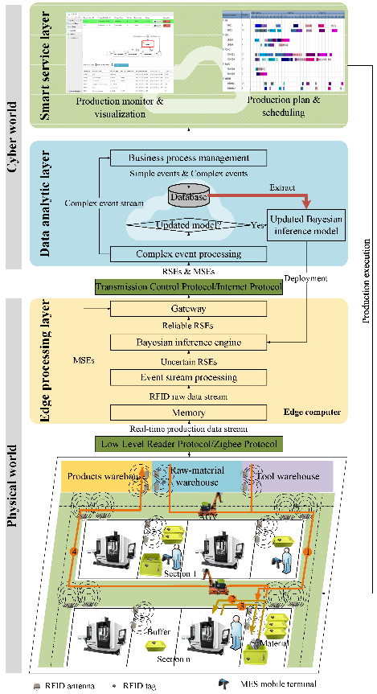
Systematic framework of the CPPS
- Production manufacture and smart connection: Any objects in a traditional factory can be transformed into smart logistics objects by deploying some smart sensors in the Physical world, which is introduced in the section 3.2. Thus, the MES system and RFID sensors in the physical layer generate two production data streams. MES data stream is used for monitoring the tasks’ status, while RFID data can reflect the objects’ location in the workshop. Besides, the production operations of a special job shop are illustrated in section 3.3.
- Edge processing: With sensors connected to the edge processing layer, a huge amount of RRD will be captured in real-time first. Then, some redundant data will be merged into a set of RSEs with noisy data by the ESP. Next, a Bayesian inference engine is utilized to deal with the unreliable data online. Finally, these reliable RSEs and MES simple events (MSE) will be send to cloud platforms.
- Data analytic: First of all, the CEP is exploited for processing some errors caused by the false inferences and the incorrect MES records. Then the production progress is driven by BPM and the remanent errors are handled by the manager. Next, simple events and complex events are stored in the historical database. Once the new data reaches a certain amount, they will be extracted and preprocessed. The following is to update and deploy the Bayesian inference model offline. Finally, accurate information is submitted to the smart service layer.
- Smart service: In this layer, production monitors are realized to track the production changes. Meanwhile, production visualization is developed to shows intuitively current and long-term production. Besides, the derived data are utilized as input in a production plan and control algorithm, which influences the production execution.

3.2 RFID-enabled smart logistics objects
To create an RFID-enabled intelligent shop floor environment, typical logistics resources are converted into smart manufacturing objects , including passive smart logistics object (PSLO) and active smart logistics object (ASLO).
An RFID tag is attached to each of the materials, tools, pallets and trolleys. These binding relationships are recorded in the CPPS. The warehouse manager selects the materials and tools required for a production task, puts them in a pallet, and binds all objects through an RFID reader. The picked items should be packed in one or more boxes. It is not allowed that several materials or tools required for different tasks put in a box. Once completing the bound operation, the materials, tools and pallets are considered as a PSLO.
A reader as ASLO can detect the PSLOs in the radiation scope of the antenna. There are two types of ASLOs: stationary ASLO and mobile ASLO. For one thing, a handheld RFID reader is called as mobile ASLO. Operators who hold it walks around inside the shop floor to check PSLOs. For another, two antennas are placed on the gate or buffer area to identify PSLOs, termed as stationary ASLO. The PSLOs’ transportation direction is determined through the sequence of events read by the two antennas, which can refer to the last research .

3.3 Production operations for CPPS
As shown in Fig. 1, each section contains two machines and two buffers. The transport corridor is divided into two roads in the workshop. A rule is that the traffic keeps on the right of the road. The real-time production operations are as follows:
- Production managers take out all PSLOs of a task with the highest priority and deliver them to the corresponding buffer. The PSLO will be identified through the stationary ASLO to monitor the status of the task.
- The required PSLO should be taken from the buffer after completion of a previous task. The CPPS will perceive that PSLO has left the buffer area and the start time of the task will be set up instantly.
- After finishing the task, the PSLO is transported back to the buffer and the completion time of the task is recorded instantly. Then, the material and the tools required for the next task are put into the pallet and re-bound into a PSLO, while other tools are put into an empty box and bound into a PSLO also.
- Two PSLOs wait for an idle trolley to transport them to the corresponding buffer or the warehouse.
- Continue to perform steps 1-4 until the last process task is completed. The finished products are re-bound as PSLOs and then they are transported to the products warehouses.

4 Edge processing
The RFID-captured raw data need to be processed by fusing redundant data and removing noisy data. Firstly, to clear redundant data, ESP transforms data from RRD to RSEs. Secondly, a statistical method is employed to compute an appropriate SG. Once the time lag of two adjacent RRDs is less than the session gap, they will be fused. Thirdly, a Bayesian inference model is employed for improving the reliability of RSEs online.

4.1 Event stream processing
An RRD is that a reader collects a tag at a point in time, representing an instantaneous and atomic occurrence, defined as in Eq. [eqs:RRD]. Additionally, an RSE (defined as in Eq. [eqs:RSE]) represents that a PSLO goes through a stationary ASLO.
$$R​R​D<epc,ant,time,mem>$$
Where $epc$ denotes the electronic product code of a tag object, $ant$ is an antenna index that the tag passes through, $time$ represents the timestamp of the event occurrence and $mem$ represents tag memory information including a task unique code.
$$\begin{matrix}R​S​E<id,task,pall,loc,dir,start,end,<pro>>\end{matrix}$$
Where $id$ is the event identification code, $task$ represents the bound task unique code, $pall$ represents the unique code of pallet, $loc$ signifies the location of occurrence, $dir$ signifies the direction of transportation, $start$ denotes the start time of the event, $end$ denotes its end time, $\left\langle pro\right\rangle$ is a custom special property set.
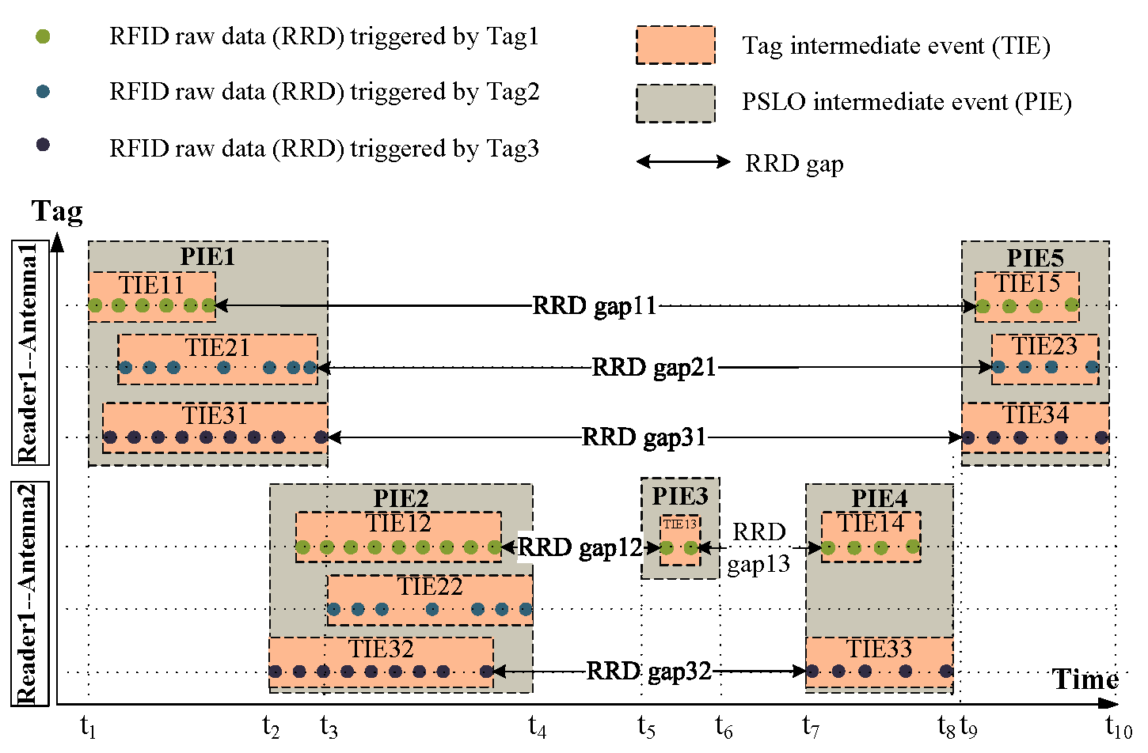
Graphical description of an event stream processing
Fig. 2 illustrates a graphical description of ESP. The bottom three lines represent a sequence of RRDs captured by antenna2 connected to reader1, while the other lines triggered by antenna1 connected to the same reader. The two antennas are deployed in an entrance of section in pairs. There are three types of events, consisting of RRDs, tag intermediate event (TIE) and PSLO intermediate events (PIE). A TIE represents that a tag pass through a stationary ASLO’s detection range, while a PIE denotes that all tags in a pallet pass through the stationary ASLO’s vicinity. First of all, every two RRDs merged successively, and then eventually generate some TIEs. For example, six RRDs are merged into the TIE11 by fusing five times, whereas TIE11 and TIE15 are divided on the account that the time gap of two closest RRDs between them longer than the $S​G$. Then several TIEs are merged into a PIE. Finally, two PIEs are meld and then the running direction of the PSLOs is also perceived. For instance, since the occurrence time of PIE1 is earlier than that of PIE2, it is inferred that a PSLO left the section. Similarly, it can deduce that a PSLO entered into the buffer from the PIE4 and the PIE5. Besides, PIE3 is noisy data.
Algorithm 1: Pseudo-code of Event Stream Processing
Input : RFID-captured raw data stream;
Output: RFID simple event stream
- while do
- if then
- $\{{R​R​D}_{i},{R​R​D}_{j}\}→{T​I​E}_{k}$
- else
- $\{{R​R​D}_{i},{R​R​D}_{j}\}→\{{T​I​E}_{k},{T​I​E}_{l}\}$
- end if
- while do
- if then
- $\{{T​I​E}_{k},{T​I​E}_{l}\}→\{{P​I​E}_{r},{P​I​E}_{s}\}$
- else
- $\{{T​I​E}_{k},{T​I​E}_{l}\}→{P​I​E}_{r}$
- end if
- while do
- if then
- else if then
- end if
- end while
- end while
- end while

ESP is made up of three steps to obtain simple events quickly from the RFID raw data stream. The procedure is detailed in Algorithm [Pseudo-code of Event Stream Processing].
- Algorithm 1:6 line reports that some adjacent RRDs in pairs are aggregated into a set of TIEs. The RRD gap denotes the interval between the two time-adjacent RRDs. Two contiguous RRDS with the same $epc$ and $ant$ will be merged when their RRD gap does not exceed a predefined SG. Otherwise, the current RRD ends and the subsequent RRD is assigned to a new TIE. Hence, RFID raw data stream is converted to a series of TIEs. In the situation, the start time and end time of a TIE are calculated, as well as the task index is obtained from the memory of the reading tag.
- Algorithm 7:12 line lists the meld of several TIEs based on the occurrence time of every TIE, location and task information. Two PIEs with the same $ant$ and $task$ are combined into a PIE once they have overlap on the time domain. Additionally, the system can get the pallet’s index by the combination of TIEs.
- Algorithm 13:18 line shows that every two PIEs generate an RSE. Once time distance between two PIEs is shorter than a threshold value (TV), an RSE with the running direction is obtained. Otherwise, they will be separated into two RSEs. The TV is set to 1 second in this study. After that, the location information is retrieved by the RFID device and RFID antenna index. By judging the sequence of two PIEs, the direction of the RSE is obtained.

4.2 Appropriate session gap model
Fig. 3 graphically displays the boxplot of tag readings with different numbers. One or more tags were placed about 0.5 meters from the reader along its central axis. For each test group with different numbers of tags, 6850 RRDs were collected and the time lag of each tag readings was computed. Although single tag readings have the lowest median of time lag in all groups, the inter-quartile range is very high. Along with the increasing number of tag readings from 2 to 6, the median of time lag is slightly improved, the inter-quartile range gradually augments and the maximum time lag increases quickly. Therefore, the SG of single tag readings and that of 6 tag readings are calculated separately, and the larger of them is set to the SG.
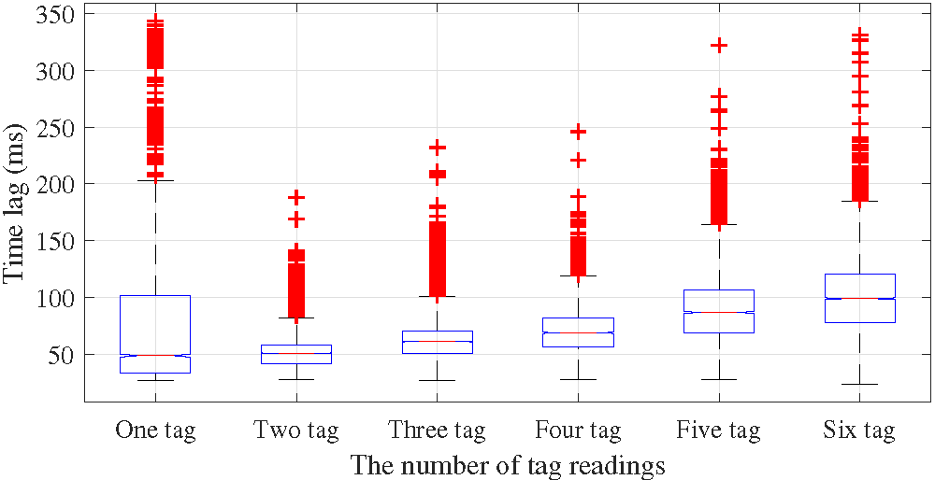
Boxplot of tag readings with different numbers
In this paper, the time lag data of RFID reading is calculated by on a Gaussian basis function on the basis of the least square regression. The appropriate SG is estimated to the maximum 95 percentile values of the time lag for Gaussian distributions.
Where $a$ is the amplitude, $b$ is the centroid location, $c$ is related to the peak width, and $n$ is the number of peaks to fit the Gaussian basis function.

4.2.1 Session gap model for single tag reading
For single tag reading, the $n$ value of the Gaussian basis function is set as 6. The fitting function is established by the least square regression, as follows.
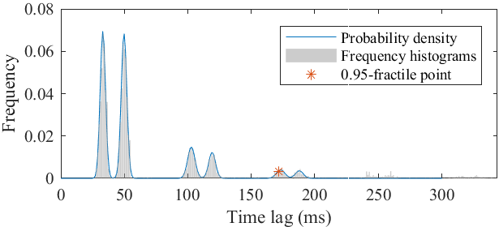
Gaussian curve for single tag reading
The sum of squares due to error is 30/133771, the coefficient of determination equals 1811/1825 and the root means squared error equals 93/81682. The 0.95-fractile of time lag for Gaussian distribution with single tag readings is 172 milliseconds. In addition, Fig. 4 presents the fitting probability density curve of the time lag for single tag readings.

4.2.2 Session gap model for multi-tag reading
It can be seen from Fig. 5 that there are five probability density curves of the time lag corresponding to the number of tag readings from 2 to 6. The time lag of 6-tag readings obeys a normal distribution which has the largest mean and deviation in all multi-tag readings. Therefore, the probability density function of the 6-tag readings is used to get an SG. The data in the time lag of each tag readings are from the same continuous distribution by using the two-sample Kolmogorov-Smirnov test. The $n$ value of the Gaussian basis function is set to 1 for 6-tag reading. The least-square regression with the Gaussian probability density function fits all tag lags for 6-tag readings. The sum of squares due to error is 28/81083, the coefficient of determination equals 607/658 and the root means squared error equals 7/5367.
The above equation expresses the fitting probability density curve of the time lag for multi-tag readings. The one-sample Kolmogorov-Smirnov test is used to examine a null hypothesis that the time lag for 6-tag readings does not obey a normal distribution with a mean of 97.13 and a standard deviation of 31.1692669. The result indicates that the null hypothesis is to be rejected at $5\%$ significance level. Therefore, the 0.95-fractile of time lag for Gaussian distribution with 6-tag readings, which equals 174 milliseconds, is set as an SG.
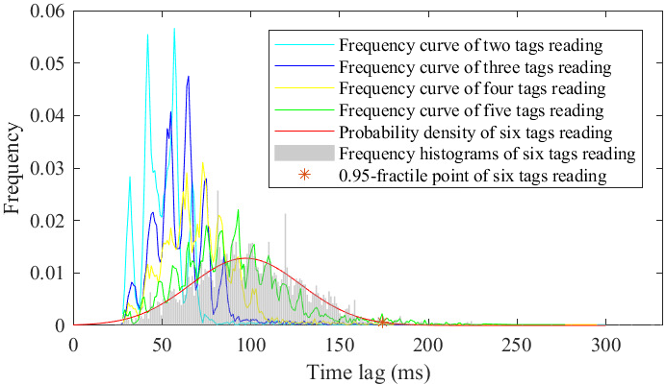
Gaussian curve for multi-tag reading

4.3 Bayesian inference engine
As shown in Fig. 2, three tags are stored in a PSLO. All tags in the PSLO are collected and then five PIEs are obtained. However, the number of captured tags in PIE3 and PIE4 is less than the real number by comparing it to the record in the database. Thus, the PIE3 shouldn’t have happened, which is a noisy data and should be labeled. The classification problem is to label whether or not a RSE occur. This study adopts a Bayesian inference model, i.e., the Averaged One-Dependent Estimator (AODE) . Its goal is to select the class with the maximum resulting term in Eq. [eqs:Problem Model] by analyzing six variables.
Where $y$=yes (no) represents a class that the PSLO (did not) passes through the ASLO’s detection range. $x_{1}$ denotes a variable that the real number of tags in a PSLO. Retrieving the database can obtain the real number of tags in a PSLO. The increasing number of tags leads to aggravating wave collision, so the noisy data will increase. $x_{2}$ indicates the distance between the reader and the PSLO. The variable can be inferred by the transport direction of transportation. The shorten distance may cause less noisy data. $x_{3}$ $(x_{4})$ is the value of that the tags number captured by previous (posterior) stationary ASLO is divided by $x_{2}$. $x_{5}$ $(x_{6})$ equals that the total reading times obtained by previous (posterior) stationary ASLO is divided by $x_{2}$ .
Since most of the obtained RSEs are correct, the RSEs that did not happen are low proportion in the training set and show a property of “sparse”. The information carried by other attributes is erased easily. Consequently, the Laplacian correction is used to smooth the prior probability and the conditional probability (as shown in Eq. [eqs:prior probability]-[eqs:conditional probability] separately).
$$\begin{matrix} & \hat{p}\left(y,x_{i}\right)=\frac{\left|D_{y,x_{i}}\right|+1}{\left|D\right|+N_{i}} \\ & \hat{p}\left(\left.x_{j}\right|y,x_{i}\right)=\frac{\left|D_{y,x_{i},x_{j}}\right|+1}{\left|D_{y,x_{i}}\right|+N_{i}}\end{matrix}$$
Where $N_{i}$ is the number of all the possible values of the $i​-​t​h$ attribute, $\left|D_{(y,x_{i})}\right|$ is the number of a sample set whose the class is $y$ and the value of the attribute $i$ equals $x_{i}$, $\left|D_{(y,x_{i},x_{j})}\right|$ is the number of a sample set whose the class is $y$ as well as the values of the attributes $i$ ($j$) equal $x_{i}$ ($x_{j}$).
The inference engine calculates the possible occurrences of outputs with input variables. Although the network can be large and complex, its processing time is linear . Thus, the Bayesian interference engine can be used to process the noisy data online in edge processing layer. However, there exists the possible misclassification of RSEs and some unprocessed error data from the MES system. These error data can be dealt with by leveraging the combination of CEP and BPM on the data analytic layer. The CEP will merge some muti-source heterogeneous data, while the other unpredictable and unhandled exception is solved by the BPM. Therefore, the noisy data and error data are eliminated semi-automatically.

5 Data analytic
In this section, the combination of CEP and BPM is investigated to ensure the quality of service. The CEP can extract valuable information from incomplete and uncertain disparate data of multiple systems. Besides, the BPM defines the activities and constraints, as well as determines the monitored events. The captured events follow the process model and change the corresponding task’s status. Their combination can not only monitor the executing of production progress, but also accurately provide knowledge for production visibility.

5.1 Complex event processing
Two types of exception events (defined as Eq. [eqs:CE]) are treated in this stage, including the misreading event and the missing event. The misreading events happen due to the overlap radiation scope of some antenna and the uncertain walking trajectory of the PSLOs. However, the missing events often occur because of the tag collision and the non-feedback by an operator.
$$C​E=f(e_{1},e_{2},...,e_{m})$$
Where $C​E$ is a complex event instance that has more meaning than anyone in the combined events, every item in $\{e_{1}...e_{m}\}$ represents a simple or complex event instance, and $f$ is an event composite function defined by domain experts. According to the SASE language, the various definition of rules drawn from an RFID-based machining scenario.
Algorithm [alg:Missing event rule] describes a missing event rule while the PSLOs enter the warehouse. Firstly, an SEQ construct includes three events in the order they occur. Each event is represented by an accompanying abbreviation, such as $e_{1}$ represents a “ENTER-SECTION” event. Additionally, non-occurrences of events are expressed using ’!’. Thus, the SEQ construct means that an $e_{1}$ event follows an $e_{3}$ event without an $e_{2}$ event. Secondly, the WHERE clause uses the above-mentioned events to compare their attributes. Thirdly, a WITHIN clause specify an aggregation window over the past 10 minutes. Finally, the TODO clause represents that the missing event will be added, once two events make a successful match of the missing event rule.
Algorithm [alg:Misreading event rule] represents a misreading event rule while the materials will be machined. The EVENT clause signifies that $e_{1}$, $e_{2}$ and $e_{3}$ occur in sequential order. The WHERE clause denotes that these events come from a task. The WITHIN clause specify that the three events need to be triggered in 10 minutes. The TODO clause expresses a manager will process the misreading event once these conditions are met. This is mainly because sometimes data contain unusual but correct data. Therefore, suspicious data should be handled with caution and should not be removed directly.

5.2 Business process management
In this study, each task generates a monitoring process instance based on its business process. To illustrate this point, a global business process model of a processing task is shown in Fig. 6, including three activities and five sub-processes.
Global business process model
- The “Finish packing” activity occurs after several physical objects are registered as a PSLO. Thereupon, the packing information is recorded, such as the transporting objects, the processing task and the destination.
- All PSLOs are transported to the buffer, waiting to be manufactured.
- Workers take out the PSLOs from buffer to neighboring machine if the task ready to start processing. Meanwhile, the start time of the task is recorded instantly.
- The “Finish processing” activity is triggered by an operator once completing the machining.
- After passing the inspection, the “Pass inspection” activity is triggered by an inspector.
- After that, the PSLOs move back to buffer and the finish time of the task is set up instantly.
- Once completing the last operation of the task, all PSLOs are transported to the product warehouse. Otherwise, they will be shipped to sequence buffer to process the next operation task.
The “transporting” business sub-process model
For simplicity, we consider a typical “transporting” sub-process model (see Fig. 7) to monitors a PSLO from the starting position to the target location. After running the sub-process model, the “Start transport” activity is automatically triggered when the ASLO at the starting location detects a leaving event. Then the ASLO will collect transport events of the PSLO until worker signs for materials and tools. If the event is not collected within ten minutes, a run-time exception is thrown and handled by the manager. Otherwise, the collected RSEs will be processed automatically by CEP. Once a run-error exception occurs, the manager will obtain and process the exception. For example, the running path is different from the predetermined path. Finishing the sub-process means that a PSLO was shipped to the destination.

5.3 Combination of CEP and BPM
The combination process of CEP and BPM is shown in Fig. 8, representing that the task’s status is changed by various simple events following the Spatio-temporal relations. For one thing, the simple events from multiple data sources will be merged together according to CEP. For another, these merged complex events trigger some activities in the business process model, resulting in the change of the task’s status. The status of the processing task contains the packing, transporting, waiting, etc.
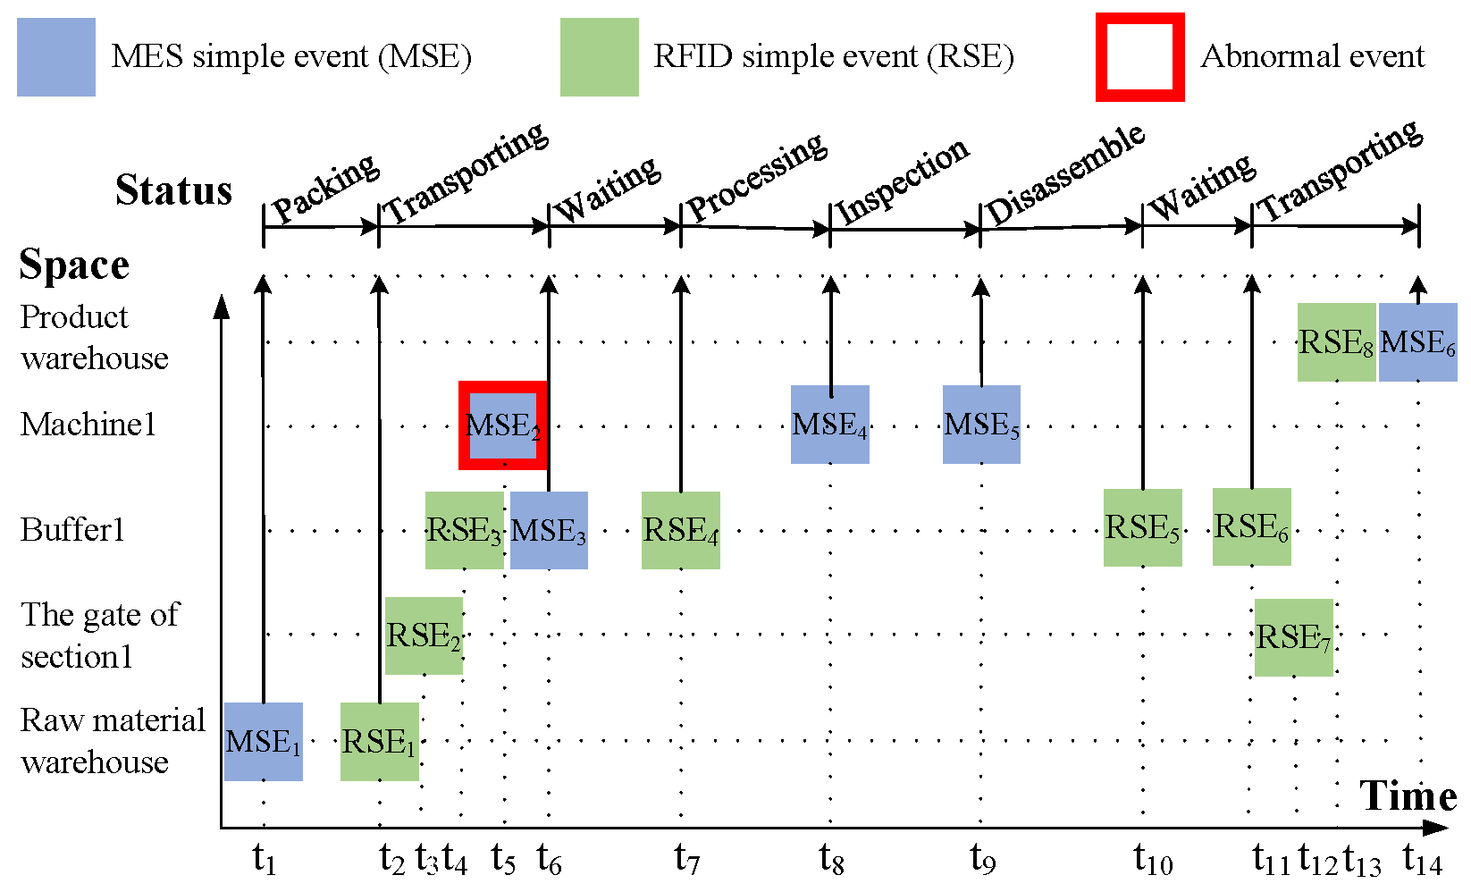
Spatio-temporal graph of simple events
In a “transporting” business sub-process, $R​S​E_{1}$ indicates a PSLO of the task left the raw material warehouse at the moment $t_{2}$. Thus a “Start transport” activity was triggered, resulting in the change of task’s status. Then the material entered into bffer1 ($R​S​E_{3}$), passing by the gate of section1 ($R​S​E_{2}$). In the “Collect event” activity, the memory still stored these collected events until a worker sign for these materials ($M​S​E_{3}$). Afterward, the “complex event processing” activity was triggered. Since occurring $M​S​E_{3}$, Algorithm [alg:Misreading event rule] was triggered. Finally, a production manager processed the abnormal event.

6 A demonstrative case

6.1 System deployment
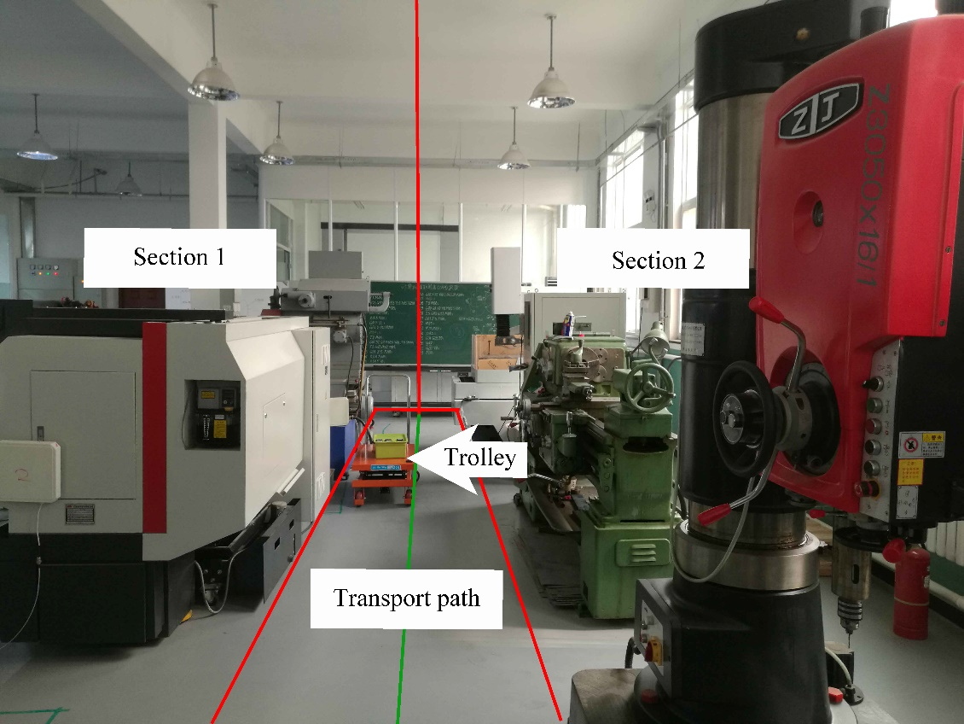
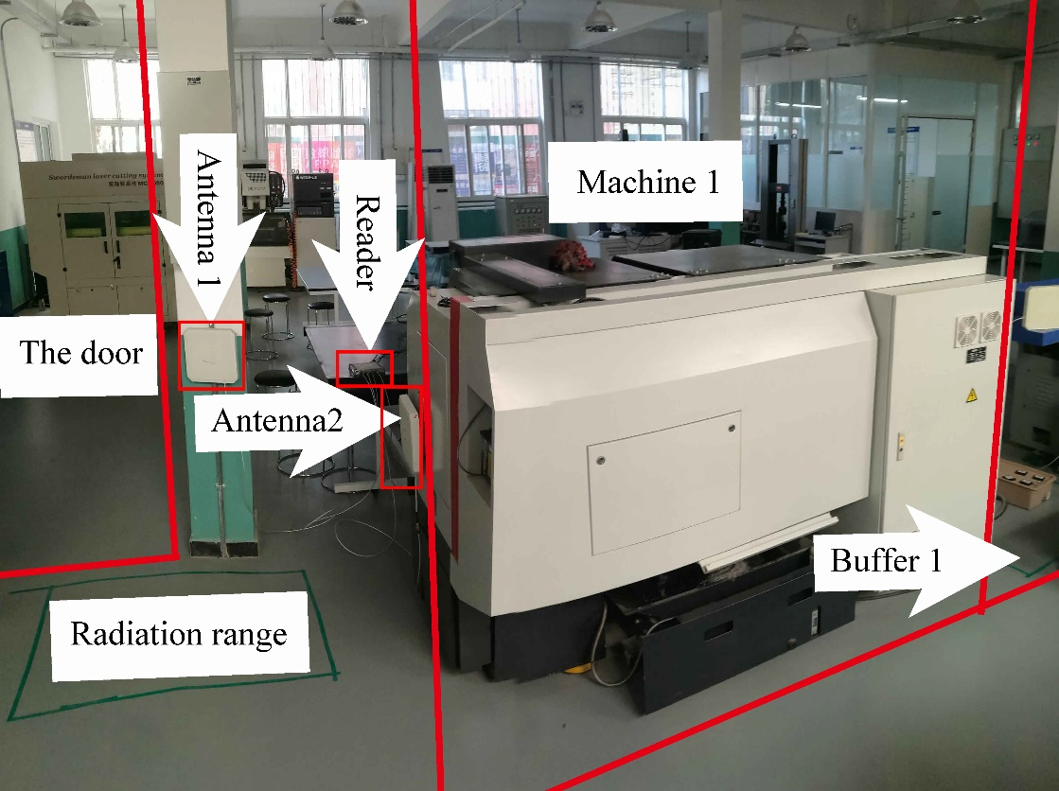
As shown in Fig. [fig:Smart production system deployed in a factory], the prototype system was implemented and deployed in a traditional factory. Ultra-high frequency RFID is selected on account of having a better detection range and an improved data transmission rate than the other frequency bands . Besides, the used RFID passive tags obey the ISO18000-6C protocol whose reading rate is up to 40kbps to 640kbps. In theory, the number of collected tags is more than 1000 at the same time. In addition, the capacity of electronic product code and user memory in RFID tags are 96 bits and 512 bits, respectively. Furthermore, a edge computer has a single CPU (2-core, 4-thread) with hyper-threading running at 2.7 GHz and an 8GB RAM.
Fig. [fig:Class diagram of the prototype system] presents the relationship between the RSE and the MSE in the class diagram. The “ComplexEvent” class is the parent class of the “MesSimpleEvent” class and the “RfidSimpleEvent” class. Besides, some association relationship between two classes is created. For example, the “TagMaterialLink” class creates the association relationship between the “Material” class and “Tag” class. Therefore, the relationship of tag and the objects including trolley, box and material can be registered in the CPPS. Besides, RRDs can be recorded in the “RfidRawData” class.
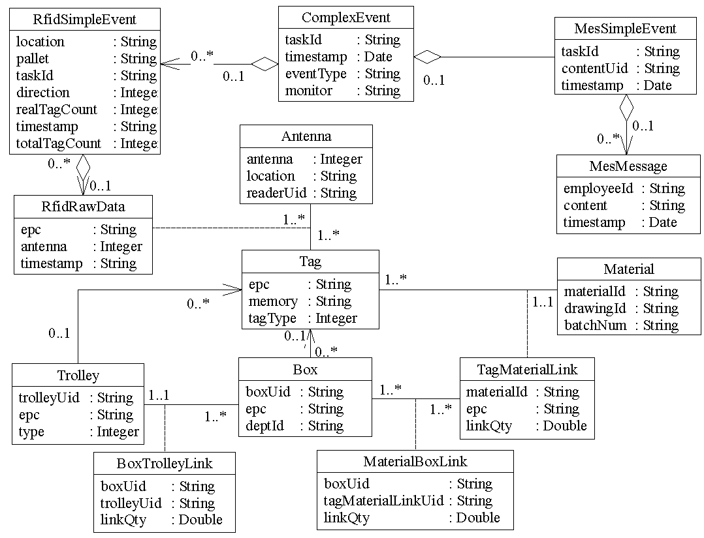

6.2 Entropy triangle
The entropy triangle is employed to test the proposed algorithm’s performance, which represents normalized values of the variation of information, the mutual information, and the increment of entropy from the uniform distribution in a ternary plot .
(1)
(2)
(3)

Where $X=x_{i}$ represents the input class to the classifier, $Y=y_{i}$ is the output class identifier, $P_{X}\left(x\right)$ , $P_{Y}\left(y\right)$ expresses the empirical estimates of the marginal distribution function of input variable and output class separately, $P_{X,Y}\left(x,y\right)$ denotes the empirical estimates of the joint probability mass function between input and output, $H_{P_{X\left|Y\right.}}$ defines the conditional entropies of X given Y ($H_{P_{Y\left|X\right.}}$ is that of $Y$ given $X$), and $H_{U_{XY}}$ counts the uniform entropies of joint probability mass function over $X$ and $Y$.
Eq. [eqs:the mutual information ratio] calculates the mutual information ratio, illustrating the remnant information in the conditional entropies. Eq. [eqs:the variation of information ratio] presents the variation of information ratio, which is used to compare to algorithm generality. Eq. [eqs:the increment of entropy ratio] describes the increment of entropy ratio, which measures the classification accuracy of all algorithms. The closer to the lower side, the more unreliable the classifier decisions are. To ensure the normalization of the sum of three metrics, each indictor is divided by $H_{U_{XY}}$.

6.3 Bayesian inference model building
The experimental data in Tab. [tab:RFID simple events in historical databases] is classified as three data sets. The first data set is extracted from No. 1:47, the second data set includes RSEs from No. 1 to No. 94, and the third data set contains the whole data. For assessing the generality of the algorithm, each set is randomly divided into a training set and a testing set five times on the basis of the 5-fold cross-validation. Then the average indicator of five running results is used to verify the performance of the algorithm.
For processing the RSEs with noisy data, the rule-based method is used usually in traditional approaches. In this study, the OneRule algorithm uses the rule that a simple event does not occur if the distance between it and the antenna is unknown, as well as vice versa. Besides, the A2DE-update algorithm discretizes the properties from $x_{3}$ to $x_{6}$ in which each element divided into two classes to solve it. Additionally, the TAN and A2DE algorithm use the normal estimator to process continuous data.
Algorithm | TP | FP | TN | FN | CCR (%) | group
A2DE-update | 37 | 1 | 2 | 7 | 93.617 | 1
A2DE-update | 76 | 1 | 2 | 15 | 96.809 | 2
A2DE-update | 118 | 0 | 1 | 22 | 99.291 | 3
TAN | 38 | 5 | 1 | 3 | 87.234 | 1
TAN | 76 | 3 | 2 | 13 | 94.681 | 2
TAN | 117 | 3 | 2 | 19 | 96.454 | 3
A2DE | 37 | 5 | 2 | 3 | 85.106 | 1
A2DE | 77 | 2 | 1 | 14 | 96.809 | 2
A2DE | 118 | 3 | 1 | 19 | 97.163 | 3
C4.5 | 39 | 6 | 0 | 2 | 87.234 | 1
C4.5 | 78 | 4 | 0 | 12 | 95.745 | 2
C4.5 | 118 | 2 | 1 | 20 | 97.872 | 3
OneRule | 35 | 4 | 4 | 4 | 82.979 | 1
OneRule | 74 | 8 | 4 | 8 | 87.234 | 2
OneRule | 115 | 8 | 4 | 14 | 91.489 | 3

After applying the five algorithms in three data sets, all results are aggregated to form a confusion matrix in Table [tab:Confusion Matrix]. The true positives (TP) and true negatives (TN) are the numbers of correct classifications. However, a false positive (FP) and a false negative (FN) represent that the outcome is incorrectly predicted. Besides, the correctly classified rate (CCR) equals that the sum of TP and TN events divided by the total number of the used data set. The big value of the CCR means that the classifier has high accuracy. In this table, one interesting finding is that there is a significant positive correlation between CCR and the number of the data set. It shows that increasing the training set to a certain extent can effectively improve the quality of classification. Another important finding is that the A2DE-update algorithm has the best CCR in all the algorithms, showing the validity of the algorithm.
Entropy triangle
By employing the entropy triangle, Figure 9 visualize three performance metrics of all algorithms on the three data set. It can be seen clearly that there has been a marked increase in the reliability of classifier as the volume of training data increases. Besides, the OneRule algorithm performs worse reliable than anything else, while its generality is the best. Although the A2DE-update is only a small reduction in generality compared to C4.5 and the OneRule on the third data set, it has a significant improvement in performance in all algorithms.
Figure 10 compares the average computing time, over five separate runs, of each classifier on every data set. Since applying heuristic rules, the OneRule algorithm has the fastest computation speed in five algorithms. Besides, the computational time of the A2DE-update algorithm in the third data set is 0.017s, which is still very fast in a small amount of data. Since the AODE is easy to implement reinforcement learning, the response speed will also be acceptable in a large amount of data.
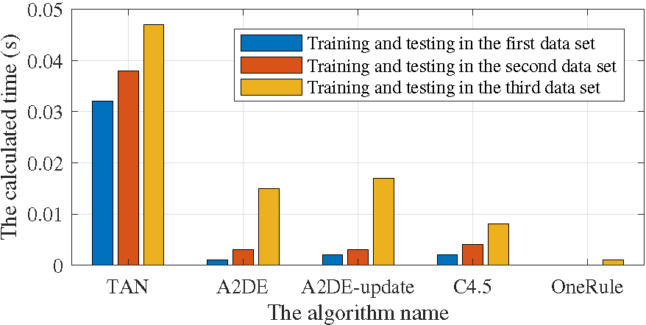
Calculated time of these algorithms

6.4 System verification
By applying the CPPS, the production task can be tracked and the production progress can be visualized, as shown in Fig. [fig:Software interface of production progress]. There are three roles shown in the left-hand menu: packager, logistic manager and process manager. The running process was opened under the logistic manager, including a “transporting” business sub-process model and a global business process model. They have the same business key, indicating that they come from a task. Meanwhile, the transport process is a sub-process of “My process”. After clicking the transport sub-process, the sub-process activity logs, which records past events, represent at the lower-right. Based on the red rectangle, the status of the processing task can be identified. It can be observed that this subprocess (shown in Fig. [fig:Software interface of production progress]) is unfinished and the “Report to manager” activity will be triggered. Meanwhile, the activity logs show that an error needs to be processed at that moment, which is deduced by the “complex event processing” activity. For instance, $R​S​E_{1}$ in Fig. 8 trigger the “Start transport” activity. After that, the “Collect data” activity records variety events until a predefined event occurs, such as $M​S​E_{3}$. Due to having an error event, the “complex event processing” activity throws it to the “Report to manager” activity according to Algorithm [alg:Misreading event rule].
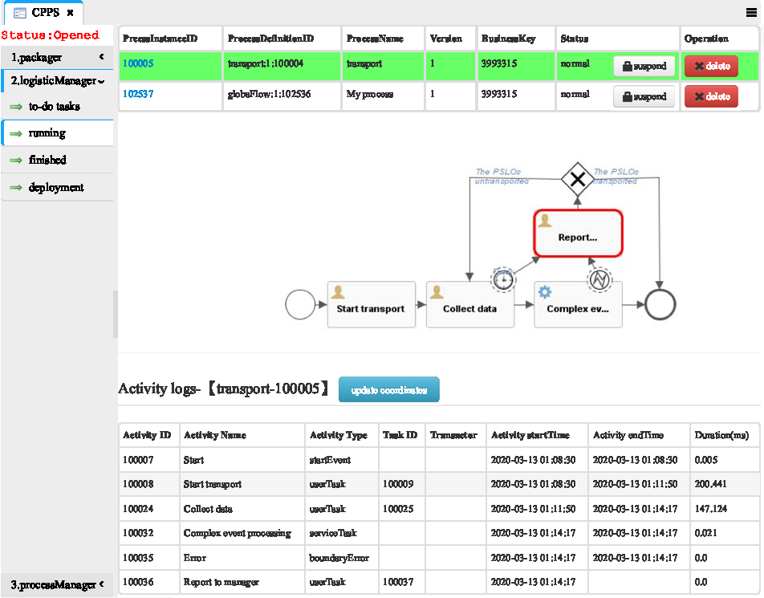

6.5 Discussion
This study aims to adapt to production changes in the physical world and improve production process visibility from the cyber world. Through deploying RFID, the objects in the factory transform smart objects for intelligent sensing. Then a large amount of the real-time production data transmits to the edge processing level. Thus the data is converted to simple events by ESP. Afterward, the noisy data will be processed by the Bayesian network engine online. By leveraging communication protocols and web servers, the data is transported from the physical world to cyber space. In addition, the combination of CEP and BPM in the data analytics layer fuses heterogeneous data to makes some semi-automatic decisions. Furthermore, the smart service layer realizes the production progress visibility and the production re-scheduling. Eventually, some smart decisions are carried out on the shop floor.
The statistical model is employed to establish the appropriate SG. Thus, the SG is set to the maximum among 0.95-fractiles of time lag distribution, which is 174 milliseconds in this lab environment. In addition, the Bayesian inference model will be updated on the basis of historical data off-line. Beside, further statistical tests revealed that the CCR obtaining by the A2DE-update algorithm is as high as reaching $99.291\%$. The CPPS may be accurate to distinguish unreliable RSEs after capturing more historical data. However, current approaches related to production progress are working in isolation without considering the actual production environment. Once considering the impact of many uncertain factors in the factory, the performance of data analytics will decrease a little bit.

7 Conclusions and future work
To achieve production visibility, this study proposes a CPPS in which data analytics is adopted. The proposed system from this study makes several contributions as listed below.
- A data analytics is put forward for exploring a cost-effective Cyber-Physical production system, resulting in an RFID-enabled intelligent shop floor environment. It has the capability of collecting production information semi-automatically and processing raw data quickly.
- An appropriate session gap model by leveraging the least square regression method on the basis of the Gaussian basis function is implemented to clean redundant data efficiently, leading to more precise events of the RFID tag movement.
- An improved Bayesian inference engine is proposed to identify the accuracy of RFID simple event, making the CPPS get reliable events in the stage of ESP.
- A combination of complex event processing and business process model is present to make smart decisions semi-automatically, ensuring that the production progress is stable and the production tasks are monitor.
- A real system has been applied in a factory to enable production visibility in this case, presenting highly efficiency and effectiveness compared to traditional ways.
To conclude, the present work contributes to production visibility by establishing a CPPS. The configuring sensors in a traditional manufacturing environment lead to that production process data is feedback to the cyberspace timely. In addition, the production process information will be analyzed and support to make semi-automated smart decisions. The feasibility of the proposed system was validated in a laboratory, which saves the cost of internal and external logistics effectively, improves working productivity greatly and shortens the production cycle.
Our future work will mainly focus on two aspects. For one thing, we will consider the influence of RFID-captured data in the production scheduling system. For another, we will focus on the definition of CEP rules according to the production scenario in manufacturing enterprises.

Appendix A
No. |  |  |  |  |  |  | y
1 | 3 | long | 0.33 | 0 | 0.67 | 0 | No
2 | 3 | long | 0.33 | 0.33 | 0.67 | 0.33 | No
3 | 3 | long | 0.33 | 0.67 | 3.67 | 8.67 | Yes
4 | 3 | long | 0.33 | 0.67 | 6.33 | 7.67 | Yes
5 | 3 | long | 0.67 | 0.67 | 3 | 7 | Yes
6 | 3 | long | 0.67 | 0.67 | 4.67 | 6 | Yes
7 | 3 | long | 0.67 | 0.67 | 5 | 8 | Yes
8 | 3 | long | 0.67 | 1 | 3.33 | 7.67 | Yes
9 | 3 | long | 0.67 | 1 | 3.33 | 7.67 | Yes
10 | 3 | short | 0.67 | 1 | 7 | 5.67 | Yes
11 | 3 | short | 0.67 | 1 | 8 | 6.33 | Yes
12 | 3 | short | 1 | 1 | 8.33 | 4.67 | Yes
13 | 3 | short | 1 | 1 | 9.33 | 2.67 | Yes
14 | 3 | short | 1 | 1 | 12.67 | 8.67 | Yes
15 | 3 | short | 1 | 1 | 12.67 | 9 | Yes
16 | 3 | unknown | 1 | 0 | 5.33 | 0 | No
17 | 6 | long | 0.17 | 0.17 | 1.17 | 0.33 | No
18 | 6 | long | 0.17 | 0.33 | 0.33 | 3.83 | Yes
19 | 6 | long | 0.17 | 0.67 | 2.17 | 5 | Yes
20 | 6 | long | 0.33 | 0.5 | 2.67 | 6 | Yes
21 | 6 | short | 0.67 | 0.33 | 3.5 | 2.17 | Yes
22 | 6 | short | 0.67 | 0.67 | 5.5 | 5.17 | Yes
23 | 6 | short | 0.83 | 0.5 | 3.67 | 2.33 | Yes
24 | 6 | short | 0.83 | 0.5 | 5.33 | 1.83 | Yes
25 | 6 | short | 0.83 | 0.5 | 5.5 | 1.33 | Yes
26 | 6 | short | 0.83 | 0.67 | 4.5 | 1.83 | Yes
27 | 6 | short | 0.83 | 0.83 | 4.17 | 2.5 | Yes
28 | 6 | short | 0.83 | 1 | 6.17 | 4.5 | Yes
29 | 6 | short | 1 | 0.33 | 8.33 | 4.5 | Yes
30 | 6 | short | 1 | 0.83 | 4.83 | 5.83 | Yes
31 | 6 | short | 1 | 0.83 | 6.33 | 4 | Yes
32 | 6 | unknown | 0.33 | 0 | 1.67 | 0 | No
33 | 6 | unknown | 0.67 | 0 | 2.17 | 0 | Yes
34 | 9 | long | 0.11 | 0.33 | 0.11 | 1.22 | No
35 | 9 | long | 0.11 | 0.67 | 0.89 | 4.11 | Yes
36 | 9 | long | 0.22 | 0.33 | 1.67 | 1.56 | Yes
37 | 9 | long | 0.22 | 0.33 | 2.33 | 3.11 | Yes
38 | 9 | long | 0.22 | 0.44 | 0.44 | 2.56 | Yes
39 | 9 | long | 0.44 | 0.56 | 3 | 2.33 | Yes
40 | 9 | long | 0.67 | 0.89 | 3.44 | 5.89 | Yes
41 | 9 | short | 1 | 0.44 | 5 | 3.78 | Yes
42 | 9 | short | 1 | 0.56 | 6.22 | 4.11 | Yes
43 | 9 | unknown | 0.11 | 0 | 1.33 | 0 | No
44 | 9 | unknown | 0.33 | 0 | 1 | 0 | No
45 | 9 | unknown | 0.56 | 0 | 3.78 | 0 | Yes
46 | 9 | unknown | 0.67 | 0 | 8 | 0 | Yes
47 | 9 | unknown | 0.78 | 0 | 6.22 | 0 | Yes
48 | 3 | long | 0.33 | 0.33 | 0.67 | 0.33 | No
49 | 3 | long | 0.33 | 0.67 | 2.33 | 7.33 | Yes
50 | 3 | long | 0.33 | 0.67 | 3.67 | 8.67 | Yes
51 | 3 | long | 0.67 | 0.67 | 3 | 7 | Yes
52 | 3 | long | 0.67 | 0.67 | 4.67 | 6 | Yes
53 | 3 | long | 0.67 | 0.67 | 5.67 | 4 | Yes
54 | 3 | short | 1 | 0.67 | 10 | 4 | Yes
55 | 3 | short | 1 | 1 | 7.33 | 5.33 | Yes
56 | 3 | short | 1 | 1 | 8.33 | 6.33 | Yes
57 | 3 | short | 1 | 1 | 9 | 5 | Yes
58 | 3 | short | 1 | 1 | 10 | 5.67 | Yes
59 | 3 | short | 1 | 1 | 10.67 | 5 | Yes
60 | 3 | short | 1 | 1 | 11 | 3.67 | Yes
61 | 3 | short | 1 | 1 | 11.33 | 5.33 | Yes
62 | 3 | short | 1 | 1 | 14 | 8 | Yes
63 | 3 | unknown | 0.67 | 0 | 7 | 0 | No
64 | 6 | long | 0.17 | 0.17 | 1 | 0.17 | No
65 | 6 | long | 0.17 | 0.17 | 1.17 | 2 | No
66 | 6 | long | 0.17 | 0.33 | 1.83 | 3 | Yes
67 | 6 | long | 0.33 | 0.5 | 1 | 3.17 | Yes
68 | 6 | long | 0.33 | 0.5 | 2.83 | 4.83 | Yes
69 | 6 | long | 0.67 | 1 | 1.33 | 4 | Yes
70 | 6 | short | 0.67 | 0.17 | 4.5 | 1.33 | Yes
71 | 6 | short | 0.67 | 0.5 | 6.17 | 3.83 | Yes
72 | 6 | short | 0.83 | 0.5 | 3.83 | 3 | Yes
73 | 6 | short | 0.83 | 0.5 | 4 | 1.83 | Yes
74 | 6 | short | 0.83 | 0.5 | 5.67 | 1.83 | Yes
75 | 6 | short | 0.83 | 0.67 | 2.67 | 3.5 | Yes
76 | 6 | short | 0.83 | 0.67 | 5.83 | 2.67 | Yes
77 | 6 | short | 0.83 | 0.83 | 3.83 | 4.17 | Yes
78 | 6 | short | 0.83 | 0.83 | 5.33 | 5.67 | Yes
79 | 6 | short | 0.83 | 0.83 | 7 | 5 | Yes
80 | 6 | short | 1 | 1 | 6.33 | 5.67 | Yes
81 | 6 | unknown | 0.33 | 0 | 2.33 | 0 | No
82 | 9 | long | 0.11 | 0.33 | 0.22 | 0.89 | No
83 | 9 | long | 0.11 | 0.33 | 1.56 | 3.33 | Yes
84 | 9 | long | 0.11 | 0.44 | 0.22 | 3.67 | Yes
85 | 9 | long | 0.11 | 0.56 | 0.11 | 3.22 | Yes
86 | 9 | long | 0.22 | 0.44 | 1.33 | 3.56 | Yes
87 | 9 | long | 0.33 | 0.44 | 2.67 | 4 | Yes
88 | 9 | long | 0.33 | 0.56 | 4.78 | 4.78 | Yes
89 | 9 | short | 0.78 | 0.56 | 5 | 3.78 | Yes
90 | 9 | short | 0.89 | 0.67 | 5.78 | 3.89 | Yes
91 | 9 | short | 0.89 | 0.78 | 4.67 | 3.67 | Yes
92 | 9 | short | 1 | 1 | 7.56 | 5.44 | Yes
93 | 9 | unknown | 0.22 | 0 | 0.22 | 0 | No
94 | 9 | unknown | 0.22 | 0 | 1.44 | 0 | No
95 | 3 | long | 0.33 | 0.67 | 0.67 | 2.33 | Yes
96 | 3 | long | 0.33 | 0.67 | 2.33 | 7.33 | Yes
97 | 3 | long | 0.33 | 0.67 | 6.33 | 7.67 | Yes
98 | 3 | long | 0.67 | 0.67 | 6 | 7.33 | Yes
99 | 3 | long | 0.67 | 0.67 | 6.33 | 4.67 | Yes
100 | 3 | short | 1 | 1 | 9.33 | 6.33 | Yes
101 | 3 | short | 1 | 1 | 10 | 5.67 | Yes
102 | 3 | short | 1 | 1 | 10 | 5.67 | Yes
103 | 3 | short | 1 | 1 | 12 | 7.33 | Yes
104 | 3 | short | 1 | 1 | 12.67 | 8.67 | Yes
105 | 3 | short | 1 | 1 | 13.67 | 9.33 | Yes
106 | 3 | short | 1 | 1 | 15 | 4.33 | Yes
107 | 3 | short | 1 | 1 | 15 | 6 | Yes
108 | 3 | short | 1 | 1 | 15.67 | 9.33 | Yes
109 | 3 | unknown | 0.67 | 0 | 7 | 0 | No
110 | 3 | unknown | 1 | 0 | 3 | 0 | No
111 | 6 | long | 0.17 | 0.33 | 1.67 | 3.5 | Yes
112 | 6 | long | 0.17 | 0.33 | 2 | 3.83 | Yes
113 | 6 | long | 0.17 | 0.33 | 3.33 | 3.5 | Yes
114 | 6 | long | 0.17 | 0.67 | 1.5 | 6.17 | Yes
115 | 6 | long | 0.33 | 0.33 | 0.83 | 3 | Yes
116 | 6 | short | 0.83 | 0.33 | 3.67 | 2.33 | Yes
117 | 6 | short | 0.83 | 0.33 | 4.33 | 0.83 | Yes
118 | 6 | short | 0.83 | 0.5 | 3.5 | 1.17 | Yes
119 | 6 | short | 0.83 | 0.5 | 5.33 | 1.5 | Yes
120 | 6 | short | 0.83 | 0.67 | 4.17 | 2.17 | Yes
121 | 6 | short | 0.83 | 0.67 | 6.5 | 6.33 | Yes
122 | 6 | short | 0.83 | 0.83 | 2.5 | 4.33 | Yes
123 | 6 | short | 0.83 | 0.83 | 3.83 | 2.33 | Yes
124 | 6 | short | 0.83 | 0.83 | 4.67 | 1.33 | Yes
125 | 6 | short | 0.83 | 0.83 | 6.83 | 4.67 | Yes
126 | 6 | short | 1 | 1 | 7.83 | 5.5 | Yes
127 | 6 | unknown | 0.17 | 0 | 1.33 | 0 | No
128 | 9 | long | 0.11 | 0.33 | 1 | 1.78 | Yes
129 | 9 | long | 0.11 | 0.33 | 1.56 | 2.11 | Yes
130 | 9 | long | 0.11 | 0.44 | 1.56 | 3.44 | Yes
131 | 9 | long | 0.33 | 0.44 | 2.11 | 1.89 | Yes
132 | 9 | long | 0.44 | 0.56 | 3.11 | 7.33 | Yes
133 | 9 | long | 0.44 | 0.67 | 1.33 | 5.56 | Yes
134 | 9 | long | 0.56 | 0.56 | 4.22 | 4.44 | Yes
135 | 9 | short | 0.89 | 0.78 | 5.56 | 2.67 | Yes
136 | 9 | short | 0.89 | 0.78 | 5.89 | 4 | Yes
137 | 9 | short | 0.89 | 0.89 | 5 | 4.89 | Yes
138 | 9 | short | 1 | 0.56 | 6 | 4.78 | Yes
139 | 9 | unknown | 0.11 | 0 | 1.22 | 0 | No
140 | 9 | unknown | 0.33 | 0 | 0.56 | 0 | No
141 | 9 | unknown | 0.44 | 0 | 2.22 | 0 | No

