Extra work hardening in room-temperature quenching and partitioning medium Mn steel enabled by intercritical annealing
B.B. He^{1*}, S. Pan¹, M.X. Huang^{2*}
¹Department of Mechanical and Energy Engineering, Southern University of Science and Technology, Shenzhen, 518055, China
² Department of Mechanical Engineering, The University of Hong Kong, Hong Kong, China
*Corresponding author: Dr. B.B. He: e-mail: hebb@sustech.edu.cn,
Tel: +86-755-88015374
*Corresponding author: Dr. M.X. Huang: mxhuang@hku.hk, Tel: +85228597906; Fax: +85228585415

Abstract
The present work applies an intercritical annealing process on a room-temperature quenching and partitioning (RT Q&P) medium Mn steel. It is found that the intercritical annealing maintains the amount of austenite while improves its mechanical stability. The reverse transformation during the intercritical annealing competes with the martensitic transformation during the quenching, resulting in a similar quantity of austenite after the intercritical annealing. Both reverse transformation and martensitic transformation help to refine the austenite grain size and facilitate C enrichment, enhancing the austenite stability. The intercritical annealing improves both ultimate tensile strength and uniform elongation of RT Q&P medium Mn steel, which is ascribed to an extra work hardening resulted from the improved austenite stability.

Keywords: Room-temperature quenching and partitioning; Work hardening; Intercritical annealing; TRIP effect; Medium Mn steel.

1. Introduction
Quenching and partitioning (Q&P) steel generally has a dual-phase microstructure consists of retained austenite and martensite [1]. The martensite is formed during quenching while the austenite grains are reserved through C enrichment during partitioning [2]. The work hardening behaviour of Q&P steel is mainly governed by the transformation-induced plasticity (TRIP) effect which is correlated to the martensitic transformation during the plastic deformation [3]. The effectiveness of the TRIP effect in improving the work hardening rate relies on the quantity of austenite and its mechanical stability [4]. Therefore, the target of Q&P process is to elevate the amount of austenite while maintaining proper mechanical stability, which could be realized by tuning the quenching temperature [5, 6], partitioning temperature [6, 7], partitioning time [6] and annealing temperature [8, 9].
In general, the Q&P treatment is a continuous thermal process that consists of quenching at a certain temperature followed by instantaneous partitioning at an elevated temperature. Recently, it is found that the quenching and partitioning can be completely separated by employing a room-temperature (RT) quenching [10, 11]. The key element in the RT Q&P process is the selection of room-temperature as the optimal quenching temperature in terms of austenite volume fraction and its stability [4, 10]. The tensile properties of RT Q&P steel can be improved by engineering dislocation using the warm rolling process [12, 13]. Nevertheless, the intercritical annealing (IA) which has been frequently utilized to produce a dual-phase microstructure of austenite and ferrite has not been attempted in the RT Q&P steel [14].
The present work finds that the IA does not change the austenite volume fraction in the RT Q&P steel, although the reverse transformation and martensitic transformation takes place during IA and quenching, respectively. Nevertheless, the IA can refine the austenite grain size through the reverse transformation and martensitic transformation, providing improved TRIP effect to enhance the work hardening behaviour.

2. Experiments
The chemical composition of investigated steel is Fe-10Mn-0.2C-2Al-0.1V (in wt.%). The present steel strips with a thickness of 12 mm are prepared by sequential melting, casting, and forging processes [10]. The ASTM E8 tensile specimens prepared by wire cut have gauge dimensions of 25 mm×6 mm×4 mm for length, width, and thickness, respectively. A successive intercritical annealing at 800 ºC for 10 mins, water quenching down to room-temperature (~25 ºC), and tempering at either 300 ºC or 350 ºC for 10 mins is employed to fabricate the IA-RT Q&P steel. For comparison purposes, the RT Q&P steel is prepared by tempering the forged sample at either 300 ºC or 350 ºC for 10 mins, followed by water quenching down to room temperature. The tensile measurements are carried out under a crosshead speed of 1.2 mm/mins at ambient temperature. The mechanical property of constituting phases is measured by nanoindentation in a Hysitron TI 950 Triboindenter armed with a Berkovich indenter of a face angle of 65.3°. The classical continuous stiffness method is used to calculate the nanohardness [15]. The position of indents is determined by a scanning electron microscope (SEM) observation. The initial microstructure is characterized by SEM and electron backscattered diffraction (EBSD) in Zeiss Merlin Field Emission SEM. The step size of the EBSD measurement is either 0.5 μm or 0.1 μm. The distribution of the Mn element is determined by using energy-dispersive X-ray spectroscopy (EDX). The samples for EBSD and nanoindentation measurements are prepared by electro-polishing in a solution containing 15% perchloric acid and 85% ethanol (vol%). The martensitic transformation is captured by measuring the dilatation based on the Linseis L78 QD dilatometer. The austenite volume fraction is determined based on the integrated intensities of the diffraction reflections ((2 0 0)α, (2 1 1)α, (2 0 0)γ, (2 2 0)γ and (3 1 1)γ) obtained by the X-ray diffraction (XRD) measurements with a Co Kα radiation (~1.788 Å).

3. Results and discussions
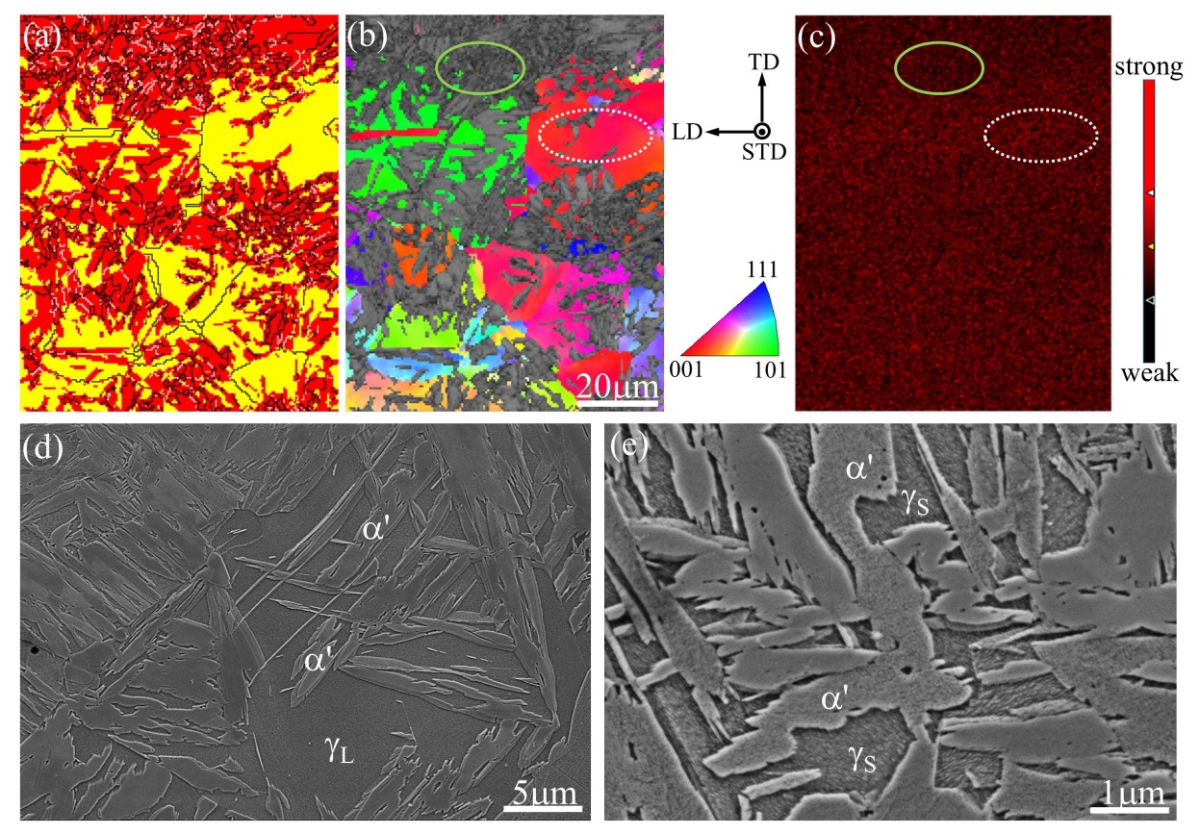
Figure 1: Initial microstructure of the forged sample. (a) EBSD phase image. Yellow color represents the austenite while red color shows the martensite. (b) The orientation map of the austenite phase overlapped with the band contrast image of martensite. (c) The distribution of Mn content in the forged sample. (d)-(e) SEM images. γ_{L}: large austenite; γ_{S}: small austenite; α': martensite. (Colour image can be found online)

The initial microstructure of the forged sample consists of austenite and martensite as shown in Figure 1 (a)-(b). The austenite phase consists of large austenite grains (~22±4.8 μm) and small austenite grains (~1±0.34 μm) [16]. The Mn distribution in austenite grains is inhomogeneous which could be ascribed to the Mn segregation (Figure 1 (c)) [17]. The amount of Mn content is estimated to be 11 wt.% and 9 wt.% for the large and small austenite grains, respectively [16]. The SEM observation confirms the presence of austenite with different grain sizes in the forged sample (Figure 1 (d)-(e)). The austenite volume fraction is around 0.31 according to the XRD test (Table 1).
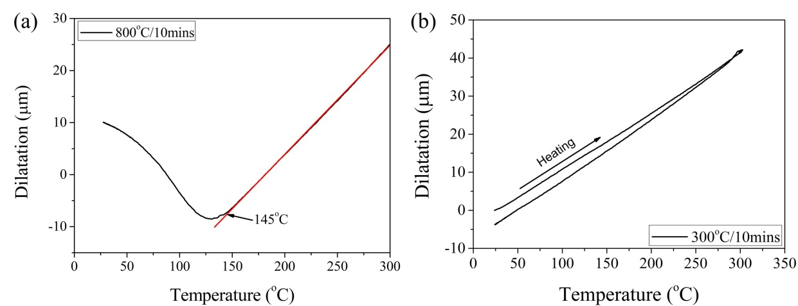
Figure 2: (a) The continuous cooling curve of the present steel after annealing at 800 ºC for 10 mins, showing the occurrence of martensitic transformation during quenching down to room-temperature. (b) The dilatational curve during the tempering process at 300 ºC for 10 mins, demonstrating negligible phase transformation during tempering and final quenching.

The formation of martensite during the quenching process after the intercritical annealing is captured by a dilatometry test. The martensite start (M_{s}) temperature is estimated to be 145 ºC according to the tangent method (Figure 2 (a)) [18]. The martensitic transformation does not reach the typical plateau during the quenching process (Figure 2 (a)), which could be due to both high austenite stability and prior intercritical annealing process. The phase transformation is negligible during tempering at 300 ºC and the austenite grains are stable during the final quenching (Figure 2 (b)).
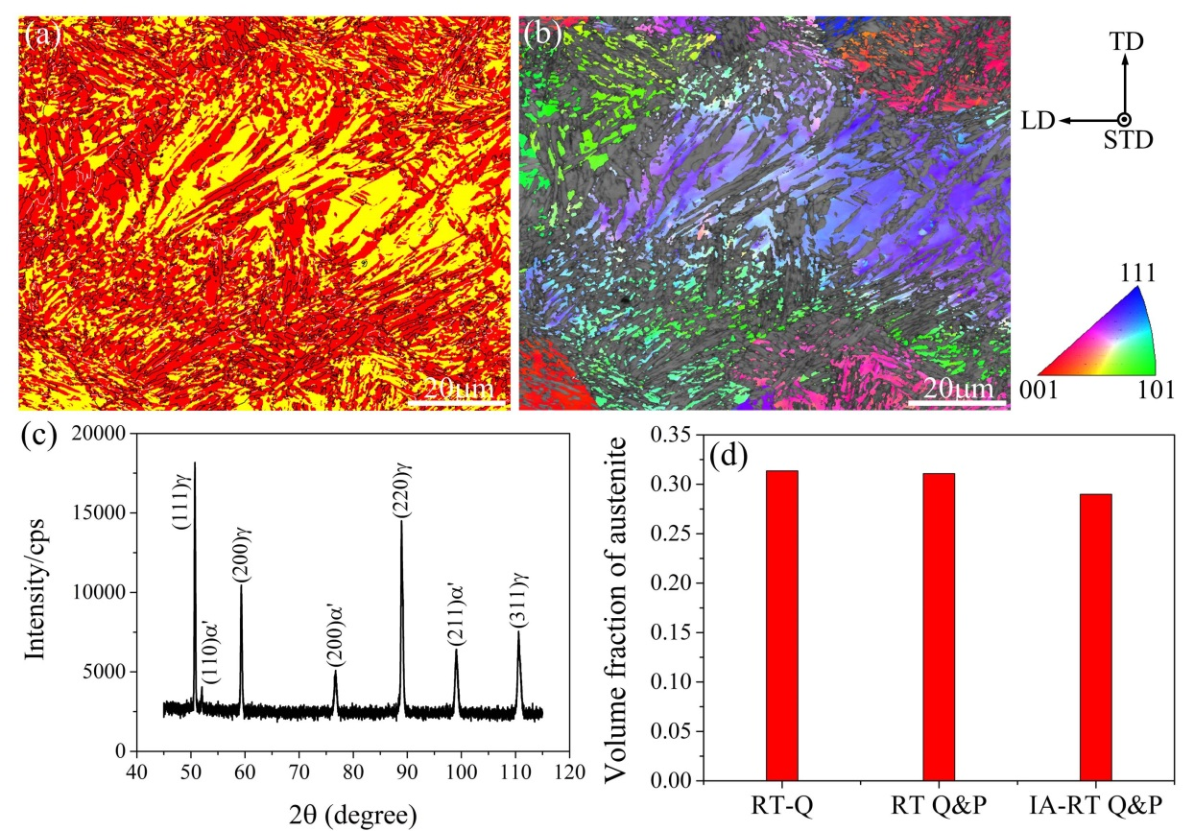
Figure 3: Initial microstructure of the present IA-RT Q&P steel. (a) EBSD phase image overlapped with the band contrast map. Yellow: austenite; red: martensite/ferrite. (b) The orientation map of austenite overlapped with the band contrast map of martensite/ferrite. (c) The XRD profile. (d) The evolution of austenite volume fraction with respect to thermal processing. RT-Q: room-temperature quenching. (Colour image can be found online)

The initial microstructure of IA-RT Q&P steel is shown in Figure 3 (a)-(c). By comparing to the forged sample (Figure 1 (a)), the austenite grain size treated by IA-RT Q&P is smaller (Figure 3 (a)), which could be ascribed to the martensitic transformation during quenching (Figure 2 (a)). A grain orientation spread is found in the large austenite grains (Figure 3 (b)), owing to the accommodation of transformation strain associated with the martensitic transformation [19]. The orientation image confirms that the small austenite grains within the same prior austenite grain (PAG) have the same orientation (Figure 3 (b)), which may suggest that these small austenite grains are not reversely transformed from the lath martensite. The austenite volume fraction is found to be 0.29 based on the XRD profile (Figure 3 (c) and Table 1). The austenite volume fraction in the IA-RT Q&P steel is comparable to the RT Q&P steel (Figure 3 (d) and Table 1). Since the phase transformation does not take place during the tempering process (Figure 2 (b)), the similar austenite volume fraction suggests that the reverse transformation should take place during the intercritical annealing to compensate the reduced austenite volume fraction resulted from martensitic transformation during the quenching process (Figure 2 (a)).
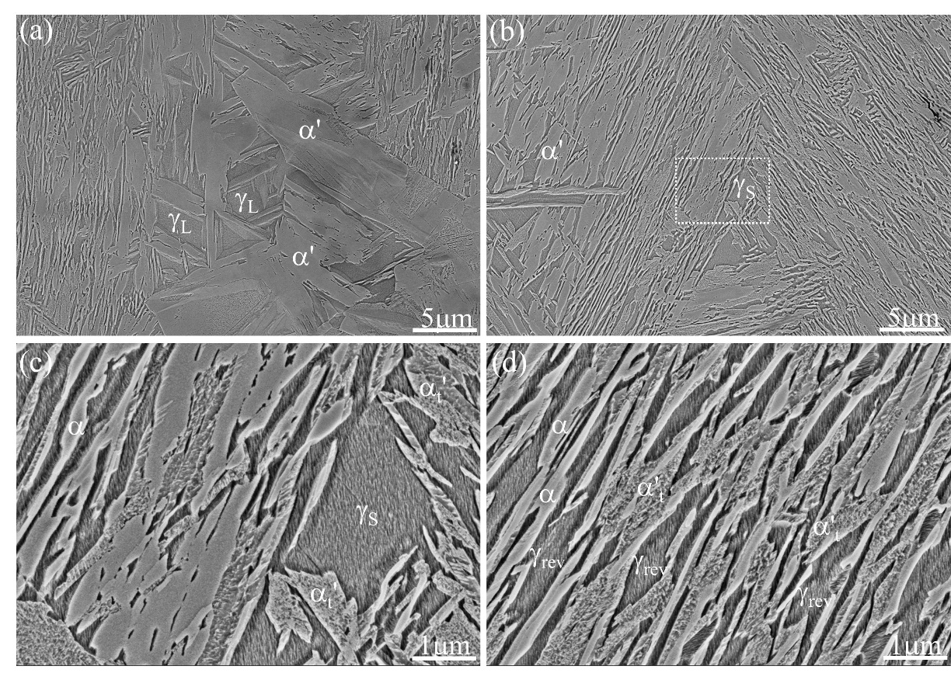
Figure 4: (a) SEM image showing the presence of lath martensite in large austenite grains. γ_{L}: large austenite; α': martensite. (b) SEM image displaying the presence of small austenite grains (γ_{S}) surrounded by tempered martensite (α'_{t}). (c) Enlarged view of the dashed rectangle in (b). (d) SEM image demonstrating the presence of reversed austenite grains (γ_{rev}) and ferrite (α) with lamellar morphology.

The large fresh martensite is observed in the large austenite grains of IA-RT Q&P steel (Figure 4 (a)). Considering the transformation sequence of martensite, the large martensite should transform earlier than the small martensite [20]. The fresh state of large martensite suggests that it may transform during the quenching process after the intercritical annealing. The Mn content of large austenite grains is determined to be 11.5 wt.%, which is similar to the large austenite grains in RT Q&P steel. The tempered martensite is found in IA-RT Q&P steel (Figure 4 (b)-(c)) and it could be subject to tempering during the intercritical annealing. Some small austenite grains with equiaxed morphology are enclosed by the tempered martensite (Figure 4 (b)-(c)), suggesting that they could remain intact during the intercritical annealing and quenching process. These small austenite grains have Mn content of 10 wt.%. Some small austenite grains have a lamellar morphology and are close to either ferrite or tempered martensite (Figure 4 (d)). It is reported that martensite is initially tempered during the heating process, resulting in the precipitation of cementite at its lath boundary [21]. The austenite could then nucleate on the cementite and grows along the lath boundary, resulting in the lamellar morphology of austenite grains. Thus, the small austenite grains with lamellar morphology could be reversely transformed from the lath martensite. The reversed austenite grains have Mn content of 9.5 wt.%.
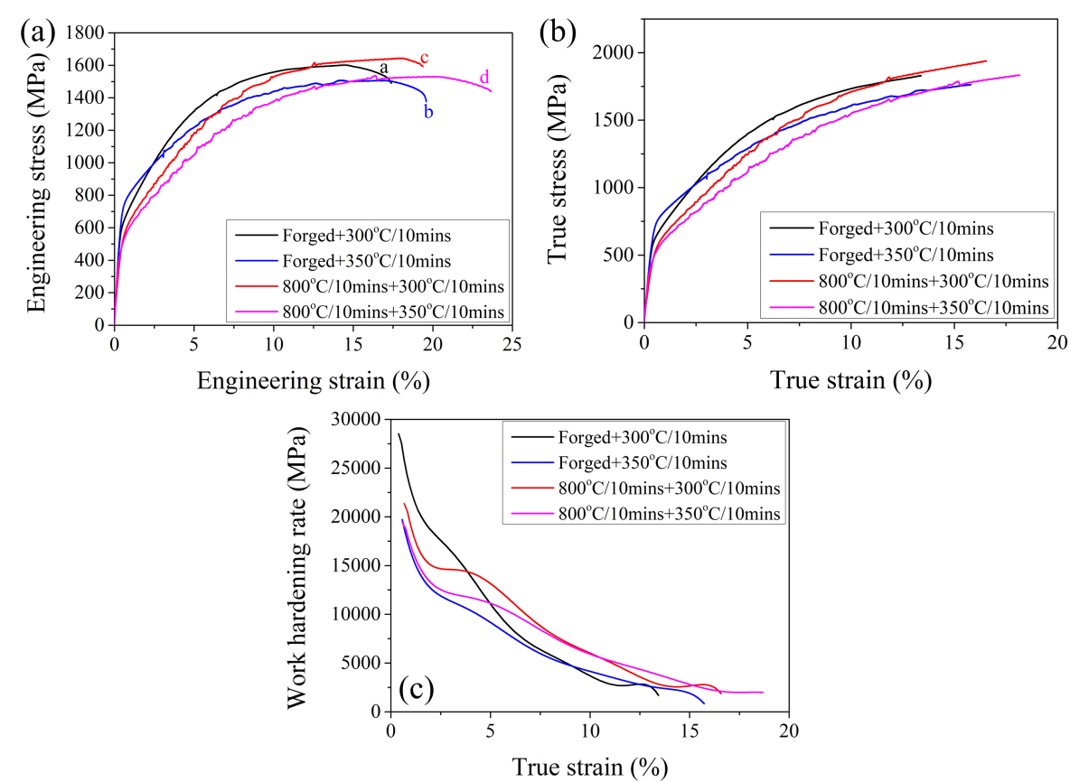
Figure 5: (a) Engineering stress-strain curves of the present steels. (b) The true stress-strain curves and (c) the work hardening curves.

The tensile properties of the current steels treated by different thermal processes are shown in Figure 5 (a). Although the yield strength is decreased by around 180 MPa after the intercritical annealing, the corresponding ultimate tensile strength is increased by about 30 MPa after the intercritical annealing (Figure 5 (a) and Table 1). Moreover, the intercritical annealing improves the tensile uniform elongation up to 18.2%-20.5%. Consequently, the true ultimate tensile strength is obviously improved after the intercritical annealing (Figure 5 (b)). A typical plateau at the true strain regime of 2-5% is observed in the IA-RT Q&P steel, while it is absent in the RT Q&P steel (Figure 5 (c)). The IA-RT Q&P steel demonstrates enhanced work hardening behaviour at the strain regime beyond the plateau until necking (Figure 5 (c)). Therefore, an extra work hardening is observed in the present steel after the intercritical annealing (Figure 5 (c)).

Table 1 Microstructure and tensile properties of the investigated steel grades.
 | Sample | V_{γ} | YS (MPa) | UTS (MPa) | UE (%) | TE (%)
RT Q&P |  | 0.31 | 685±57 | 1554±49 | 15.9±1.3 | 18.5±1.1
IA-RT Q&P |  | 0.29 | 504±15 | 1587±58 | 19.3±1.2 | 21.6±2.2
V_{γ}, austenite volume fraction prior to the tensile test; YS, yield strength; UTS, ultimate tensile strength; UE, uniforms elongation; TE, total elongation. Errors represent the standard deviation.

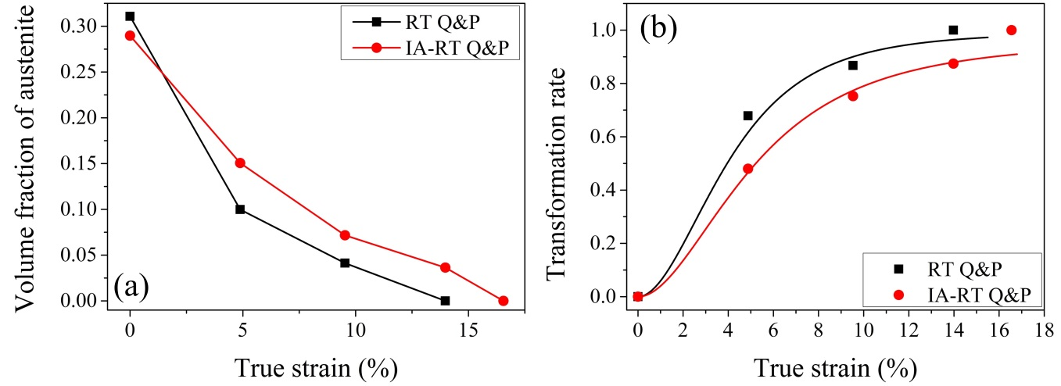
Figure 6: (a) The evolution of austenite volume fraction with respect to true strains. (b) The transformation rate of austenite grains during the tensile test.

Since the austenite volume fraction is similar between the IA-RT Q&P steel and RT Q&P steel (Figure 3 (d)), the difference of work hardening behaviour may lie in the austenite mechanical stability. The austenite volume fraction in the present IA-RT Q&P steel exhibits a retarded decrease with true strains (Figure 6 (a)). The kinetics of martensitic transformation during plastic deformation has been established by Olson–Cohen as below [22]:
where f_{α'} is the martensitic transformation rate. α indicates the nucleation rate from the shear bands, while β describes the possibility of a martensitic embryo resulted from the shear bands. The best-fitting to the experimental results by using the Olson–Cohen model yields a value of 5.2 and 11.5 for α and β for RT Q&P steel, while it is 3.2 and 12 for α and β for IA-RT Q&P steel (Figure 6 (b)). The value of β is similar between these two steels. However, the α value of RT Q&P steel is larger than the IA-RT Q&P steel, indicating that the intercritical annealing decreases the nucleation rate from the shear bands [22].
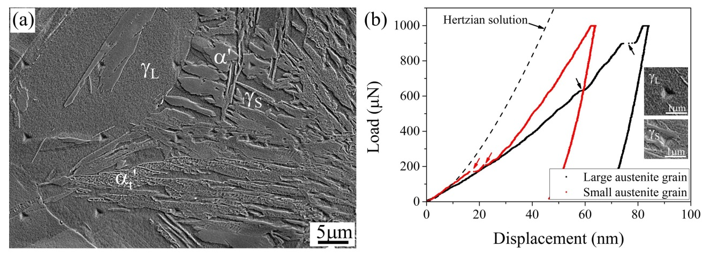
Figure 7: (a) SEM image showing the indentation impressions in the present IA-RT Q&P steel. (b) Typical load-displacement (P-h) curves of austenite with different grain sizes. The insets in (b) are the SEM images showing the indents on the individual grains. Arrows in (b) mark the strain burst which is commonly known as pop-in in P-h curves.

To verify the varied austenite stability, the nanoindentation measurement is performed on the IA-RT Q&P steel. The position of the indents is determined by the post-analysis using the SEM observation (Figure 7 (a)). Figure 7 (b) shows the typical load-displacement (P-h) curves of austenite with varied grain sizes. The elastic deformation of austenite can be investigated by the Hertzian solution which relates the applied load (P) to the indentation depth (h) as below [23],
where R_{i}=200 nm is the effective radius of the indenter. E and v are Young’s modulus and Poisson’s ratio of the indenter, respectively. The subscript r, i and s represent the representative, indenter, and specimen, respectively. Taken E_{i}=1140 GPa, E_{s}=187 GPa , v_{i}=0.07 and v_{s}=0.3 [24, 25], the Hertzian solution is shown in Figure 7 (b). Beyond the Hertzian solution, the austenite grains deform plastically (Figure 7 (b)). The plastic deformation of austenite with varied grain sizes associates with the occurrence of the strain burst (or pop-in) (Figure 7 (b)), which could manifest the formation of martensite beneath the indenter [26-28]. The first pop-in load during the plastic deformation of austenite represents the stability of retained austenite grains [27]. It is found that such pop-in load in small austenite grains is smaller as compared to large austenite grains (Figure 7 (b)), suggesting that small austenite grains are less stable, which could be due to their lower Mn content.
Despite the lower yield strength, the present IA-RT Q&P steel demonstrates enhanced work hardening behaviour, achieving a better combination of tensile strength and ductility (Figure 5). The improved work hardening behaviour could be due to the enhanced austenite stability after the intercritical annealing (Figure 6). The austenite stability is governed by grain size [29], chemical composition [30], morphology [31], and dislocation density [32]. Although the large austenite grains are subjected to dislocation recovery during annealing, the formation of martensite during the quenching process can deform the austenite matrix [19]. In other words, the dislocation density in large austenite grains may not be the main factor for the difference in mechanical stability. Nevertheless, the generation of lath martensite during quenching refines the large austenite grains (Figure 1 (a)-(b) and Figure 3 (a)-(b)) and could facilitate the C partitioning during the tempering at 300 ºC [2]. Moreover, the reverse transformation results in the formation of ultrafine austenite grains with lamellar morphology (Figure 4 (d)) and allows the C partitioning between newly transformed austenite and adjacent ferrite. It is found that the average C content of austenite is increased for around 0.14 wt.% after the intercritical annealing, which is estimated from the lattice parameter using the XRD measurement. The Mn content in the different types of austenite grains remains similar after the intercritical annealing at 800 ºC for 10 mins. Besides, both martensitic transformation and reverse transformation could increase the aspect ratio of austenite grains (Figure 3 (a)-(b) and Figure 4 (d)). It is reported that the blocky austenite is less stable than the filmy austenite [31]. Thus, the increased aspect ratio of austenite may contribute to its mechanical stability. Therefore, the enhanced austenite stability after the intercritical annealing (Figure 6) can be ascribed to the refined austenite grain size, C enrichment, and the change of morphology.
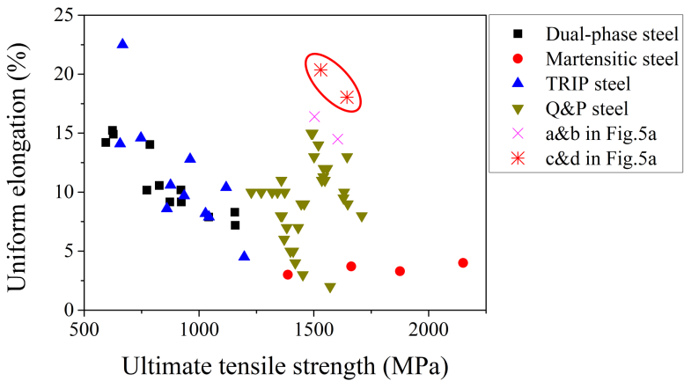
Figure 8: The comparison of tensile properties of the present steels with other advanced high strength steel grades [6, 33-37]. The uniform elongation and ultimate tensile strength are selected to represent the ductility and strength of steels, respectively.

The tensile properties of the present IA-RT Q&P steel are better than other advanced high strength steel grades in terms of the combination of ultimate tensile strength and uniform elongation (Figure 8). More importantly, despite the lower yield strength (Figure 5 (a)), the IA-RT Q&P steel can achieve higher strength and better ductility than the RT Q&P steel (Figure 8). This is ascribed to the extra work hardening provided by the improved mechanical stability of austenite grains.

4. Conclusions
In this contribution, the influence of intercritical annealing on the microstructure and tensile properties of RT Q&P medium Mn steel is investigated. It is found that the intercritical annealing does not change the austenite volume fraction, which is a result of the competition between the martensitic transformation during quenching and the reverse transformation during annealing. Nevertheless, both martensitic transformation and reverse transformation is effective to reduce the austenite grain size. Despite reduced yield strength (~180MPa) after the intercritical annealing, an extra work hardening is observed in the IA-RT Q&P medium Mn steel, which enables higher ultimate tensile strength and better uniform elongation with extents of improvement to be 30MPa and 3.4%, respectively. Owing to the limited change of austenite volume fraction after the intercritical annealing, the improved work hardening behaviour can be ascribed to the enhanced austenite stability contributed by the grain refinement, the C enrichment and the change of morphology.

Acknowledgments:
B.B. He acknowledges the financial support from Start-up Funding from the Southern University of Science and Technology (33/Y01336122). B.B. He would like to acknowledge the technical support from SUSTech Core Research Facilities. M.X. Huang acknowledges the financial support from the National Key Research and Development Program of China (No. 2019YFA0209900), National Natural Science Foundation of China (No. U1764252), and Research Grants Council of Hong Kong (No. 17255016, 17210418, R7066-18).

References
[1] L. Wang, J.G. Speer, Quenching and partitioning steel heat treatment, Metallography, Microstructure, and Analysis 2(4) (2013) 268-281.
[2] J. Speer, D. Matlock, B. De Cooman, J. Schroth, Carbon partitioning into austenite after martensite transformation, Acta Mater. 51(9) (2003) 2611-2622.
[3] L. Liu, B. He, M. Huang, The Role of Transformation‐Induced Plasticity in the Development of Advanced High Strength Steels, Advanced Engineering Materials 20(6) (2018) 1701083.
[4] L. Liu, B. He, G. Cheng, H. Yen, M. Huang, Optimum properties of quenching and partitioning steels achieved by balancing fraction and stability of retained austenite, Scripta Mater. 150 (2018) 1-6.
[5] E.J. Seo, L. Cho, B.C. De Cooman, Application of Quenching and Partitioning Processing to Medium Mn Steel, Metall. Mater. Trans. A 46(1) (2015) 27-31.
[6] E.D. Moor, J.G. Speer, D.K. Matlock, J.-H. Kwak, S.-B. Lee, Effect of carbon and manganese on the quenching and partitioning response of CMnSi steels, ISIJ Int. 51(1) (2011) 137-144.
[7] T. Tsuchiyama, J. Tobata, T. Tao, N. Nakada, S. Takaki, Quenching and partitioning treatment of a low-carbon martensitic stainless steel, Mater. Sci. Eng., A 532 (2012) 585-592.
[8] L. Cho, E.J. Seo, B.C. De Cooman, Near-A c3 austenitized ultra-fine-grained quenching and partitioning (Q&P) steel, Scripta Mater. 123 (2016) 69-72.
[9] X. Wang, L. Liu, R. Liu, M. Huang, Benefits of Intercritical Annealing in Quenching and Partitioning Steel, Metall. Mater. Trans. A 49(5) (2018) 1460-1464.
[10] B. He, L. Liu, M. Huang, Room-Temperature Quenching and Partitioning Steel, Metall. Mater. Trans. A 49(8) (2018) 3167-3172.
[11] Z. Hou, X. Zhao, W. Zhang, H. Liu, H. Yi, A medium manganese steel designed for water quenching and partitioning, Mater. Sci. Technol. 34(10) (2018) 1168-1175.
[12] B.B. He, M. Wang, M.X. Huang, Improving Tensile Properties of Room-Temperature Quenching and Partitioning Steel by Dislocation Engineering, Metall. Mater. Trans. A 50(9) (2019) 4021-4026.
[13] M.X. Huang, B.B. He, Alloy design by dislocation engineering, Journal of Materials Science & Technology 34(3) (2018) 417-420.
[14] S. Lee, B.C. De Cooman, Effect of the Intercritical Annealing Temperature on the Mechanical Properties of 10 Pct Mn Multi-phase Steel, Metall. Mater. Trans. A 45(11) (2014) 5009-5016.
[15] W.C. Oliver, G.M. Pharr, Improved technique for determining hardness and elastic modulus using load and displacement sensing indentation experiments, J. Mater. Res. 7(6) (1992) 1564-1583.
[16] B.B. He, M. Wang, L. Liu, M.X. Huang, High-strength medium Mn quenching and partitioning steel with low yield ratio, Mater. Sci. Technol. (2019) 1-6.
[17] F. HajyAkbary, J. Sietsma, R.H. Petrov, G. Miyamoto, T. Furuhara, M.J. Santofimia, A quantitative investigation of the effect of Mn segregation on microstructural properties of quenching and partitioning steels, Scripta Mater. 137 (2017) 27-30.
[18] Y.C. Liu, F. Sommer, E.J. Mittemeijer, Abnormal austenite–ferrite transformation behaviour in substitutional Fe-based alloys, Acta Mater. 51(2) (2003) 507-519.
[19] G.W. Greenwood, R.H. Johnson, The Deformation of Metals Under Small Stresses During Phase Transformations, Proc. Roy. Soc. London A 283(1394) (1965) 403-422.
[20] B. He, M. Huang, Revealing the Intrinsic Nanohardness of Lath Martensite in Low Carbon Steel, Metall. Mater. Trans. A 46(2) (2015) 688-694.
[21] S. Lee, B.C. De Cooman, Influence of carbide precipitation and dissolution on the microstructure of ultra-fine-grained intercritically annealed medium manganese steel, Metall. Mater. Trans. A 47(7) (2016) 3263-3270.
[22] G. Olson, M. Cohen, Kinetics of strain-induced martensitic nucleation, Metall. Mater. Trans. A 6(4) (1975) 791-795.
[23] K.L.Johnson, Contact mechanics, Cambridge University Press, Cambridge, 1985.
[24] S. Shim, H. Bei, E.P. George, G.M. Pharr, A different type of indentation size effect, Scripta Materialia 59(10) (2008) 1095-1098.
[25] F. Lani, Q. Furnémont, T. Van Rompaey, F. Delannay, P.J. Jacques, T. Pardoen, Multiscale mechanics of TRIP-assisted multiphase steels: II. Micromechanical modelling, Acta Materialia 55(11) (2007) 3695-3705.
[26] T.H. Ahn, C.S. Oh, D.H. Kim, K.H. Oh, H. Bei, E.P. George, H.N. Han, Investigation of strain-induced martensitic transformation in metastable austenite using nanoindentation, Scripta Mater. 63(5) (2010) 540-543.
[27] B.B. He, M.X. Huang, Z.Y. Liang, A.H.W. Ngan, H.W. Luo, J. Shi, W.Q. Cao, H. Dong, Nanoindentation investigation on the mechanical stability of individual austenite grains in a medium-Mn transformation-induced plasticity steel, Scripta Mater. 69(3) (2013) 215-218.
[28] B. He, M. Huang, On the mechanical stability of austenite matrix after martensite formation in a medium Mn steel, Metallurgical Materials Transactions A 47(7) (2016) 3346-3353.
[29] S. Lee, S.J. Lee, B.C. De Cooman, Austenite stability of ultrafine-grained transformation-induced plasticity steel with Mn partitioning, Scripta Mater. 65(3) (2011) 225-228.
[30] K. Andrews, Empirical formulae for the calculation of some transformation temperatures, J. Iron Steel Inst. Jpn. 203(7) (1965) 721-727.
[31] X.C. Xiong, B. Chen, M.X. Huang, J.F. Wang, L. Wang, The effect of morphology on the stability of retained austenite in a quenched and partitioned steel, Scripta Mater. 68(5) (2013) 321-324.
[32] S. Chatterjee, H.S. Wang, J.R. Yang, H.K.D.H. Bhadeshia, Mechanical stabilisation of austenite, Mater. Sci. Technol. 22(6) (2006) 641-644.
[33] G. Speich, R. Miller, Tempering of Ferrite--Martensite Steels, Fundamentals of Dual-Phase Steels (1981) 279-304.
[34] G. Speich, R. Miller, Mechanical Properties of Ferrite--Martensite Steels, Structure and Properties of Dual-Phase Steels (1979) 145-182.
[35] A. Arlazarov, O. Bouaziz, A. Hazotte, M. Gouné, S. Allain, Characterization and modeling of manganese effect on strength and strain hardening of martensitic carbon steels, ISIJ Int. 53(6) (2013) 1076-1080.
[36] J.-l. ZHAO, X. Yan, S. Wen, L. Lin, Microstructure and mechanical properties of high manganese TRIP steel, Journal of Iron and Steel Research, International 19(4) (2012) 57-62.
[37] M. Zhang, L. Li, R. Fu, D. Krizan, B. De Cooman, Continuous cooling transformation diagrams and properties of micro-alloyed TRIP steels, Mater. Sci. Eng., A 438 (2006) 296-299.

