Evolution of dislocation and twin densities in a Mg alloy at quasi-static and high strain rates
M. Wangª, X.Y. Xuª, H.Y. Wang^{b}, L.H. He^{c,d}, M.X. Huang^{a*}
ªDepartment of Mechanical Engineering, The University of Hong Kong, Pokfulam Road, Hong Kong, China
^{b}State Key Laboratory of Automotive Simulation and Control, Jilin University, Changchun, 130012, PR China
^{c}Beijing National Laboratory for Condensed Matter Physics, Institute of Physics, Chinese Academy of Sciences, Beijing, 100190, China
^{d}Spallation Neutron Source Science Center, Dongguan, 523803, China
*Corresponding author: M.X. Huang: email: mxhuang@hku.hk, Tel: +85228597906; Fax: +85228585415

Abstract
The present work, for the first time, quantitatively studies the evolution of both dislocations and deformation twins with various strain rates in a MM31 Mg alloy. Interrupted tensile tests were performed at the strain rates of 0.001, 1 and 600 s⁻¹. Deformation twins were characterized by microscopy techniques and evaluated using the fractions of twin boundaries and twinned area. The average dislocation density and the relative fractions of dislocations with different Burgers vectors were determined from neutron diffraction data. It was found that the twin fraction increases remarkably and becomes saturated at lower strain rates (0.001-1 s⁻¹), while the dislocation density only obtains an obvious enhancement at a much higher strain rate (600 s⁻¹). Besides, the distinctively high flow stress at high strain rate leads to a substantial increase in the density of the hard-to-activate $〈c+a〉$-type dislocations, after the $〈a〉$-type dislocation density reaches rapidly its saturated value at a small strain level. The twinning modes with opposite polarities are able to coexist in the same grains because of the high local stress concentration at strain rates above 1 s⁻¹.
Keywords: Mg alloys; strain rate; twinning; dislocation density; Hopkinson tensile bar;

Introduction
Slip and twinning are two major plastic deformation mechanisms in magnesium (Mg) and its alloys. Slip in Mg and its alloys takes place primarily along the $〈11\overline{2}0〉$ ($〈a〉$) direction on basal and $\left\{10\overline{1}0\right\}$ prismatic planes [1-4]. Since none of the above slip systems with $〈a〉$-type Burgers vector is able to accommodate c-axis strain, either deformation twinning or slip systems along the $〈11\overline{2}\overline{3}〉$ ($〈c+a〉$) direction must be activated to provide sufficient degrees of freedom for generalized plastic deformation [5-7]. The commonly observed twin modes in Mg alloys are $\left\{10\overline{1}2\right\}〈\overline{1}011〉$ extension twinning and $\left\{10\overline{1}1\right\}〈10\overline{1}\overline{2}〉$ contraction twinning, which in general accommodate tension and compression along the c-axis, respectively [8]. In addition, secondary extension twins tend to form within primary contraction twins lamella, resulting in the appearance of $\left\{10\overline{1}1\right\}$-$\left\{10\overline{1}2\right\}$ double twins [9]. The polarity of twinning determines that the nucleation of twins is restricted to occur in one direction, in contrast to dislocations that can glide in both positive and negative directions in slip planes [10-12]. Thus, if the direction of applied stress is unfavorable for twinning, the hard-to-activate $〈c+a〉$-type slip mode is required. The existence of $〈c+a〉$-type dislocations on pyramidal $\left\{\overline{1}\overline{1}22\right\}$ and $\left\{10\overline{1}1\right\}$ planes has been confirmed in deformed Mg alloys [11, 13-17].
The experimentally measured critical resolved shear stress (CRSS) values for the slip systems and twinning in Mg and its alloys have been reported in many studies [18-23]. In fact, the nucleation of twins is still a matter of debate [24-27]. A prevalent view is that twinning occurs in grains with a high resolved shear stress on the twin system [23, 28, 29]. Some studies pointed out that twin nucleation is also influenced by grain boundary structure and local stress state [26, 30-32]. Although the Schmid’s law does not completely rationalize the nucleation of twins, it is informative to compare the reported CRSS values for different deformation modes. The general trend is that the CRSS values for basal slip and extension twinning are smaller than those for prismatic $〈a〉$ slip, pyramidal $〈c+a〉$ slip and contraction twinning under general loading condition. Moreover, the CRSS values for basal slip and twinning are widely accepted to be insensitive to strain rate in view of their athermal nature, whereas those for non-basal slip systems are largely dependent on strain rate [20, 33]. Therefore, a Mg alloy subjected to high strain rate loading is likely to present a different deformation mechanism compared with its counterpart deformed at quasi-static strain rate. Considering the usage of Mg alloys, as light structural materials, in metal forming process and automotive industry over a wide range of strain rates [34], it is of great interest to study the evolution of microstructure with strain rate and how it influences the macroscopic behavior.
Up to now, many studies have focused on the microstructural evolution and mechanical performance of Mg alloys subjected to various loading rates. For instance, Ishikawa et al. [35] examined the mechanical properties of AZ91 alloy at the strain rates of 10⁻³ to 10³ s⁻¹ over a wide temperature range and found that, during dynamic loading tests, deformation twins form even when temperature reaches 673 K, which is not the case at 10⁻³ s⁻¹. Tucker et al. [36] performed compression tests on AZ31B alloy in the normal, rolling and transverse directions at two strain rates, 0.001 and ~4000 s⁻¹. The results indicated that the strain-rate dependence of yield stress is anisotropic, while twin density increases with strain rate in all the orientations. The enhanced fraction of extension twins at 10³ s⁻¹ was also observed by Ulacia et al. [37] and Dudamell et al. [25] in AZ31 alloy. Besides, Ulacia et al. [37] found that the variation in yield stress with strain rate is evident when prismatic and basal $〈a〉$ slips predominate. Dudamell et al. [25] revealed that high strain rate is capable of promoting the nucleation of extension twins even in grains which are not favorable for extension twinning at quasi-static strain rate. While it seems that the promotion of deformation twinning at dynamic loading rates is a certainty, surprisingly, Dudamell et al. [38] discovered a decrease in the twin density in a Mg alloy containing neodymium at the strain rate of about 10³ s⁻¹, emphasizing the strengthening effect of rare-earth element on basal slip systems at quasi-static strain rate. Recently, Yu et al. [39] explored the microstructural evolution of EW75 alloy at strain rates ranging from 1000 to 3000 s⁻¹ and the results showed that the fraction of extension twins remains a low value above the strain rate of 1000 s⁻¹.
Additionally, the rate-dependent evolution of twins is associated with work hardening behavior. For example, Jiang et al. [40] suggested that, below 150 ºC, the increased amount of double twins in AM30 alloy, as strain rate increases from 0.001 to 0.1 s⁻¹, produces more softening effect and leads to a decrease in the strain hardening rate. Li et al. [41] attributed the increased strain hardening rate of ZK60 alloy, with increasing strain rate up to 8000 s⁻¹, to the activation of profuse extension twinning. Feather et al. [42] proposed that the higher strain hardening rate in WE43 alloy under dynamic loading condition than under quasi-static condition can be explained by the improvement of relative activity of contraction and double twinning modes.
In contrast to twinning, the evolution of dislocation substructure with strain rate was rarely reported in Mg alloys. Pan et al. [43] promoted more $〈c+a〉$ and $〈a〉$-type dislocations in a Mg-Sn alloy by raising strain rate from 10 to 2000 s⁻¹. The enhanced dislocation activities were found to be associated with the positive strain rate sensitivity of ultimate tensile strength and elongation. Lee et al. [44] presented that the total dislocation density in AZ80 alloy increases as strain rate increases from 800 to 2200 s⁻¹ and emphasized the strengthening effect of dislocations. It appears that the influence of strain rate on dislocation density in Mg alloys has only been studied by using transmission electron microscopy (TEM). Despite the fact that TEM allows a direct observation of dislocation structure owing to its high resolution, the small field of view in a TEM micrograph may not be characteristic of the bulk. Alternatively, line profile analysis (LPA) of X-ray or neutron diffraction pattern has been proved to be a powerful tool to evaluate the density of dislocations with better statistics [45, 46]. In particular, the penetration depth of neutron diffraction can reach several cm. So far, a quantitative investigation combining the rate-dependent developments of dislocations and twins has not been carried out in Mg alloys.
The present work aims to explore the evolution of dislocation and twin densities with strain and strain rate in a MM31 Mg alloy. With this purpose, interrupted tensile tests at the strain rates of 0.001, 1 and 600 s⁻¹ were conducted. Deformation twins were characterized by microscopy techniques and dislocation density was determined from neutron diffraction data for the samples subjected to various strains and strain rates. The comprehensive analysis of microstructural evolutions was then used to elucidate the rate-dependent mechanical response.

Experiments
A Mg alloy MM31 with a chemical composition of Mg-2.64Al-0.64Zn-0.46Mn-0.72Sn-0.01Y (wt.%) was employed in the present study. All the specimens used in the experiments were cut into dog-bone shape from an as-received extruded sheet with a thickness of 1.2 mm. Tensile tests were carried out at room temperature over a wide range of strain rates from 0.001 s⁻¹ to 600 s⁻¹, with the loading axis parallel to the extrusion direction (ED). The quasi-static tensile tests were performed using a Kammrath & Weiss tensile module with a maximum load capacity of 10 kN at 0.001 s⁻¹. The tensile tests at intermediate strain rates, i.e., 0.01 s⁻¹, 0.1 s⁻¹ and 1 s⁻¹, were performed in a MTS 810 universal testing machine. The high-strain-rate tensile tests at 600 s⁻¹ were conducted by a split Hopkinson tensile bar (SHTB) apparatus and its technical details were presented in Ref. [47]. Specimens used in both the quasi-static and high-strain-rate tensile tests have a 4 mm wide and 10 mm long gauge section. Specimens with a gauge length of 25 mm and a width of 6 mm were used in the intermediate-strain-rate tensile tests. To study the evolution of microstructure during straining, specimens deformed to different strains at various strain rates were obtained. The tensile tests at 0.001 s⁻¹ and 1 s⁻¹ were interrupted at 0.02 and 0.05 strains. In addition, the high-strain-rate tests were interrupted at the strain levels of 0.02 and 0.06 using the following techniques: (i) shortening the striker bar in the SHTB system to reduce the duration of effective tensile loading and thus the amount of deformation of specimens, (ii) conducting pretests to keep the amplitude of tensile loading wave, which is positively correlated with strain rate, constant for each striker bar of different lengths and (iii) placing two additional bars, which are referred to as momentum trap bars (MTBs), coaxially in front of the incident bar in the SHTB system to protect the specimens from being damaged by residual loading waves [48]. Several points regarding the MTBs and the implementation of interrupted high-strain-rate tensile tests were introduced in Ref. [47].
Electron backscattered diffraction (EBSD) measurements were operated at 20 kV in a Zeiss Sigma 300 microscope equipped with an EBSD analysis system (Oxford HKL Channel 5) and performed on the normal direction (ND) plane of the specimens. Pole figures and twin area fractions were obtained using ATEX software [49]. The EBSD samples were prepared by mechanical grinding and electro-polishing using a solution of 10% perchloric acid and 90% ethanol (vol.%) at 30 V and at 238 K. In EBSD mapping, a step size of 4 μm was chosen for areas of 2.2 mm by 1.5 mm to characterize the initial microstructure and a step size of 2 μm was selected for other areas to highlight twin boundaries. The fractions of twin boundaries were obtained by the HKL Channel 5 software. Quasi-in-situ EBSD observations were performed along with the interrupted tensile tests at 0.001 s⁻¹ to directly monitor the evolution of deformation twins with strain in the same region, before and after each straining operation. To examine the evolution of dislocation density, which is representative for a macroscopic sample, neutron diffraction experiments were conducted using the general purpose powder diffractometer (GPPD) [50] at the China Spallation Neutron Source (CSNS). The neutron measurements were taken from the entire gauge volumes of the specimens. The time-of-flight (TOF) neutron data were collected from the 90° detector bank with fine radial collimator. Vickers hardness tests were conducted with a load of 100 gram-force (gf) in a standard micro-hardness tester (Mitutoyo, AVK-C2). The bulk average value of Vickers hardness of each specimen was measured by averaging the results of 20 data points in the gauge part. The 20 points were placed in three rows (7 points in the first two rows and 6 points in the last row) and the distance between two adjacent points was set to be 1 mm so that the investigated area is large enough to represent the bulk sample.

Results
Fig. 1 illustrates the initial microstructure and texture of the as-received MM31 alloy. It can be seen that most grains have basal planes aligned approximately perpendicular to the ND and the rest can be divided into two groups: one with the c-axis nearly parallel to the transverse direction (TD) observed in the area denoted as Zone 1 (Fig. 1b-c) and the other with the c-axis nearly parallel to the ED observed in the area denoted as Zone 2 (Fig. 1d-e). A transitional area between Zone 1 and Zone 2 is shown in Fig. 1a.
Fig. 2a with an inset presents the engineering stress-strain curves until failure at strain rates ranging from 0.001 to 600 s⁻¹. The enhancement of yield stress at higher strain rate is obvious and the ability of work hardening at strains less than 0.02 is lower with increasing strain rate. In addition, the ultimate tensile strength does not increase dramatically until the strain rate reaches 600 s⁻¹. Three strain rates, 0.001, 1 and 600 s⁻¹, were chosen for further investigation and the corresponding true stress-strain curves up to necking and work hardening rates are displayed in Fig. 2b and 2c, respectively. It is noted that the samples deformed at the strain rates of 0.001 and 1 s⁻¹ show monotonically decreasing strain hardening rates in general, whereas their counterpart at 600 s⁻¹ exhibits an increased strain hardening rate shortly after about 0.02 strain. Moreover, the tensile curves obtained in the interrupted SHTB experiments at 600 s⁻¹ are illustrated in Fig. 2d.
Fig. 3 shows the quasi-in-situ EBSD inverse pole figure (IPF) maps of a sample in the unloaded state and after straining to 0.02 and 0.05 at 0.001 s⁻¹. It is apparent that only a small amount of deformation twins appear at 0.02 strain and more twins nucleate and propagate during subsequent straining, acutely increasing the extent of twinning activity at 0.05 strain. Besides, orientation gradients associated with grain rotation occur in many grains, which is believed to be caused by dislocation slip. Since most grains in Zone 1 (Fig. 3a-c) have their c-axes aligned approximately perpendicular to the loading direction, they do not favor twinning activation as strongly as many grains in Zone 2 (Fig. 3d-f) with their c-axes aligned approximately parallel to the tensile direction. The types of deformation twins were identified according to the twin/matrix misorientations in EBSD maps. Specifically, the boundaries with misorientations of 86.3°, 56.2° and 37.5° (with a tolerance angle of 5°) around the $〈11\overline{2}0〉$ axis were denoted as $\left\{10\overline{1}2\right\}$ extension, $\left\{10\overline{1}1\right\}$ contraction and $\left\{10\overline{1}1\right\}$-$\left\{10\overline{1}2\right\}$ double twin boundaries, respectively. Fig. 4 visibly shows that the observed twins mainly are extension type. Besides, T1 and T2 defined in Fig. 4b share the similar line profiles of misorientation angle as presented in Fig. 4c, indicating the occurrence of contraction twinning at 0.05 strain. The appearance of deformation bands with extremely low image quality (dark) in Fig. 4b has been reported in many studies [51, 52] and the dark bands are likely to consist of the fragments of contraction and double twins. It is worth noting that contraction and double twins were not observed at 0.02 strain at 0.001 s⁻¹.
Fig. 5 displays the EBSD IPF maps of the samples after straining to 0.02 at the strain rates of 1 and 600 s⁻¹. The numbers in Fig. 5 represent the fractions of twinned area. The corresponding types and fractions of twin boundaries are depicted in Fig. 6. It is interesting to find that there is basically no difference in the amount of twins between the samples loaded at 1 and 600 s⁻¹. While there is no substantial activity of contraction and double twins at 0.02 strain in quasi-static tensile testing (Fig. 4a), these twins are activated at the very early stage of plastic deformation under dynamic loading conditions, as shown in Fig. 6a and 6b. In addition, the activity of extension twins is sharply enhanced as strain rate reaches 1 s⁻¹ or higher, not only in grains favorably oriented for this mechanism to operate (Fig. 6c-d), but also even in those grains which are not suitably oriented for the activation of extension twinning (Fig. 6a-b). Further, the coexistence of different twinning modes in one grain is exclusively discovered in the samples deformed at 1 and 600 s⁻¹.
Fig. 7 presents the EBSD IPF maps of the samples deformed up to 0.05 strain at 1 s⁻¹ and 0.06 strain at 600 s⁻¹, and Fig. 8 characterizes the corresponding twin boundaries. In Zone 1 where twinning is not favorable, it can be seen from Fig. 7a and 7b that as strain exceeds 0.02, the twins become thicker and more difficult to be fully indexed by EBSD because of high lattice distortion. In addition, Fig. 8a and 8b indicate that the relative activity of double twins is clearly improved. In Zone 2 where many grains are properly oriented for extension twinning, Fig. 7c and 7d present that the extension twins grow rapidly and almost encompass the entire grain at large strains.
Besides twinning, dislocation slip is also a key mechanism of plastic deformation. To investigate the evolution of dislocation density at a macroscopic level, neutron diffraction experiments were conducted on the undeformed sample and samples deformed to various strains at 0.001, 1 and 600 s⁻¹. The methods used to evaluate dislocation density from diffraction line profiles, known as the classical Williamson-Hall (WH) method [53] and Warren-Averbach (WA) method [54], were proposed in the 1950s for elastically isotropic metals (e.g. tungsten and aluminum). Ungar et al. [55] introduced a novel parameter, dislocation contrast factor, into the WH method to take into account the anisotropy of elastic properties. After the modification, theoretical curves tend to fit well with experimental data, leading to more reliable results for elastically anisotropic metals and alloys, including Mg alloys. It is noted that the WA method possesses the same dislocation contrast factors as the WH method. Therefore, the modified WH (MWH) and modified WA (MWA) methods have been widely employed in combination [47, 56, 57]: the former determines contrast factors from solely the width of diffraction peaks, and the latter utilizes the contrast factors and the shape of the peaks to calculate dislocation density. In this study, the neutron diffraction data were also analyzed by the combined MWH-MWA method. The analysis procedure in details for the undeformed sample is served as an example and illustrated as follows.
Initially, the measured neutron diffraction profile was ﬁtted using the pseudo-Voigt function [58], as presented in Fig. 9. The fitting error was calculated as the percent root-mean-square difference (PRD) [59] between the measured data and the pseudo-Voigt model. The data in Fig. 9 gave a PRD equal to 4.4%, indicating that a good fit was obtained. Eight peaks including (10.0), (00.2), (10.1), (10.2), (11.0), (10.3), (11.2) and (20.1) reflections were used in the subsequent calculations. The full width at half-maximum (FWHM) of each diffraction peak $∆K$ was described in the MWH equation [60] as:
$∆K=0.9/D+(πA^{2}b^{2}{ρ/2)}^{1/2}\left(K{\overline{C}}^{1/2}\right)+O(K^{2}\overline{C})$ (1)
where D, b, ρ, K represent the volume averaged crystallite size, the magnitude of the Burgers vector, the average dislocation density and the Bragg position, respectively. Here A is a parameter dependent on the effective outer cut-off radius of dislocations R_{e} and O denotes the negligible higher order terms in $K^{2}\overline{C}$. For hexagonal crystals, the average contrast factor $\overline{C}$ corresponding to each {hk.l} reflection was proposed as [61]:
$\overline{C_{hk.l}}=\overline{C_{hk.0}}\left(1+q_{1}x+q_{2}x^{2}\right)$ (2)
$x=(2/3){(l/ga)}^{2}$ (3)
where $\overline{C_{hk.0}}$, $l$, $g$ and $a$ stand for the average contrast factor for {hk.0} reflections, the fourth index of the {hk.l} reflection, the magnitude of the diffraction vector and the basal lattice parameter, respectively. Besides, $q_{1}$ and $q_{2}$ are variables associated with the anisotropic elastic constants of the material. Eq. (1) can be rewritten in quadratic form by substituting $\overline{C}$ with the right-hand side of Eq. (2) as:
$\frac{{\left(ΔK-α\right)}^{2}}{K^{2}}=β\left(1+q_{1}x+q_{2}x^{2}\right)$ (4)
where $α={\left(0.9/D\right)}^{2}$ and $β=(πA^{2}ρ/2)\overline{C_{hk.0}b^{2}}$. In this equation, the values of K, ∆K and x can be obtained directly from the measured neutron diffraction profile. Thus, the values of $α$, $β$, $q_{1}$ and $q_{2}$ were determined by achieving the best quadratic fit between ${\left(ΔK-α\right)}^{2}/K^{2}$ and $x$, as the MWH plot in Fig. 10a illustrates. It was shown that the measured values of $q_{1}$ and $q_{2}$ from the MWH plot, denoted as $q_{1,2}^{(m)}$, can be employed to decide the relative fractions of dislocations with three basic Burgers vector types ($〈a〉$, $〈c〉$ and $〈c+a〉$) by following the b2C procedure [62, 63].
There are eleven slip systems in hexagonal crystals and their Burgers vectors and slip planes are listed according to Ref. [64] in Table 1. It is noted that each slip system is characterized by unique theoretical values of $\overline{C_{hk.0}}$, $q_{1}$ and $q_{2}$, which were evaluated numerically using a computer program ANIZC [65] for a large number of hexagonal crystals including Mg and summarized in Ref. [61]. If the number of possible activated slip systems is denoted as N_{A} (usually 0 < N_{A} < 11), then the fractions of $〈a〉$, $〈c〉$ and $〈c+a〉$ Burgers vector groups are given as:
$h_{a}=\frac{N_{A}^{a}}{N_{A}}; h_{c}=\frac{N_{A}^{c}}{N_{A}}; h_{c+a}=\frac{N_{A}^{c+a}}{N_{A}}$ (5)
where $N_{A}^{a}$, $N_{A}^{c}$ and $N_{A}^{c+a}$ are the numbers of the activated slip systems in $〈a〉$, $〈c〉$ and $〈c+a〉$ Burgers vector types. For every possible combination of activated slip systems, the weighted averages of the theoretical $q_{1}$ and $q_{2}$ values, denoted as $q_{1,2}^{\left(eff\right)}$, were introduced as [62]:
$q_{1}^{\left(eff\right)}=\frac{h_{a}b_{a}^{2}\sum_{j=1}^{N_{A}^{a}}{{\overline{C}}_{hk.0}^{\left(j\right)}q_{1}^{\left(j\right)}}+h_{c}b_{c}^{2}\sum_{j=1}^{N_{A}^{c}}{{\overline{C}}_{hk.0}^{\left(j\right)}q_{1}^{\left(j\right)}}+h_{c+a}b_{c+a}^{2}\sum_{j=1}^{N_{A}^{c+a}}{{\overline{C}}_{hk.0}^{\left(j\right)}q_{1}^{\left(j\right)}}}{h_{a}b_{a}^{2}\sum_{j=1}^{N_{A}^{a}}{{\overline{C}}_{hk.0}^{\left(j\right)}}+h_{c}b_{c}^{2}\sum_{j=1}^{N_{A}^{c}}{{\overline{C}}_{hk.0}^{\left(j\right)}}+h_{c+a}b_{c+a}^{2}\sum_{j=1}^{N_{A}^{c+a}}{{\overline{C}}_{hk.0}^{\left(j\right)}}}$ (6)
$q_{2}^{\left(eff\right)}=\frac{h_{a}b_{a}^{2}\sum_{j=1}^{N_{A}^{a}}{{\overline{C}}_{hk.0}^{\left(j\right)}q_{2}^{\left(j\right)}}+h_{c}b_{c}^{2}\sum_{j=1}^{N_{A}^{c}}{{\overline{C}}_{hk.0}^{\left(j\right)}q_{2}^{\left(j\right)}}+h_{c+a}b_{c+a}^{2}\sum_{j=1}^{N_{A}^{c+a}}{{\overline{C}}_{hk.0}^{\left(j\right)}q_{2}^{\left(j\right)}}}{h_{a}b_{a}^{2}\sum_{j=1}^{N_{A}^{a}}{{\overline{C}}_{hk.0}^{\left(j\right)}}+h_{c}b_{c}^{2}\sum_{j=1}^{N_{A}^{c}}{{\overline{C}}_{hk.0}^{\left(j\right)}}+h_{c+a}b_{c+a}^{2}\sum_{j=1}^{N_{A}^{c+a}}{{\overline{C}}_{hk.0}^{\left(j\right)}}}$ (7)
where $b_{a}$, $b_{c}$ and $b_{c+a}$ are the $〈a〉$, $〈c〉$ and $〈c+a〉$-type Burgers vectors and the letter “j” indicates that the theoretical values for the jth slip system are used. A possible combination of activated slip systems is considered valid once the weighted averages $q_{1,2}^{\left(eff\right)}$ and the measured parameters $q_{1,2}^{(m)}$ satisfy the tolerance conditions in Ref [62]. After finding all valid slip system combinations, the corresponding $h_{a}$, $h_{c}$ and $h_{c+a}$ values and their frequencies are illustrated in Fig. 10b. Therefore, the average fractions of the three dislocation groups, $\overline{h_{a}}$, $\overline{h_{c}}$ and $\overline{h_{c+a}}$, are the centres of gravity of the histograms. Furthermore, the values of $\overline{h_{a}}$, $\overline{h_{c}}$ and $\overline{h_{c+a}}$ were used in the calculation of $\overline{C_{hk.l}b^{2}}$ for each diffraction vector $g$ as follows [62]:
$\overline{C_{hk.l}b^{2}}=\overline{h_{a}}b_{a}^{2}\frac{1}{N_{A}^{a}}\sum_{j=1}^{N_{A}^{a}}{{\overline{C}}_{hk.0}^{\left(j\right)}\left[1+q_{1}^{\left(eff\right)}x+q_{2}^{\left(eff\right)}x^{2}\right]}+ \overline{h_{c}}b_{c}^{2}\frac{1}{N_{A}^{c}}\sum_{j=1}^{N_{A}^{c}}{{\overline{C}}_{hk.0}^{\left(j\right)}\left[1+q_{1}^{\left(eff\right)}x+q_{2}^{\left(eff\right)}x^{2}\right]}+\overline{h_{c+a}}b_{c+a}^{2}\frac{1}{N_{A}^{c+a}}\sum_{j=1}^{N_{A}^{c+a}}{{\overline{C}}_{hk.0}^{\left(j\right)}\left[1+q_{1}^{\left(eff\right)}x+q_{2}^{\left(eff\right)}x^{2}\right]}$ (8)
The evaluation of $\overline{C_{hk.l}b^{2}}$ enables the operation of the MWA method and the MWA equation was proposed as [66]:
$lnA\left(L\right)=lnA^{s}\left(L\right)+Y\left(L\right)\left(K^{2}\overline{C_{hk.l}b^{2}}\right)+O'(K^{4}\overline{C_{hk.l}^{2}b^{4}})$ (9)
$Y\left(L\right)=-(ρπL^{2}/2)ln⁡(R_{e}/L)$ (10)
where L, $A\left(L\right)$, $A^{s}\left(L\right)$ and $O'$ represent the Fourier length, the Fourier coefficients of the diffraction profile, the size contribution and higher order terms, respectively. According to Eq. (9), the first-order coefficient $Y\left(L\right)$ was determined by fitting $lnA\left(L\right)$ against $K^{2}\overline{C_{hk.l}b^{2}}$ as the MWA plot in Fig. 10c displays. Further, Eq. (10) can be rewritten as:
$Y(L)/L^{2}=\left(πρ/2\right)\ln{L}-\left(πρ/2\right)\ln{R_{e}}$ (11)
This linear relationship between $Y(L)/L^{2}$ and $\ln{L}$ implies that the dislocation density ρ and outer cut-off radius of dislocations R_{e} can be calculated from the slope $πρ/2$ and the intercept $-(πρ/2)lnR_{e}$, respectively. It is noticed that no instrumental profile was used to eliminate the instrumental contribution to peak broadening, which means that all the results obtained here do not indicate the exact values of dislocation density. Nevertheless, the relationship of all the results to one another is able to depict the trend of dislocation density with increasing strain and strain rate. Fig. 11 illustrates the evolutions of average dislocation density and Vickers hardness with strain in the samples deformed at 0.001, 1 and 600 s⁻¹. The calculated dislocation densities and measured values of Vickers hardness represent the bulk average values of the entire gauge parts of the specimens. It is obvious that the results of dislocation density and hardness are in good agreement with each other. The amount of dislocations produced at 0.001 s⁻¹ is close to that at 1 s⁻¹, whereas the sample loaded at 600 s⁻¹ has a visibly higher dislocation density at all strains, distinguishing itself from others. Moreover, Fig. 12 unveils the variation of the average density of dislocations in each Burgers vector group with strain and strain rate. Since $〈c〉$-type dislocations do not provide any independent slip modes [7], the focus is placed on the other two types. It is clear that the dislocations with Burgers vector $〈a〉$ prevail at strains less than 0.02 under all loading rates, which is in accordance with their easier activation compared with those with Burgers vector $〈c+a〉$. The prominent finding is that at strains ranging from 0.02 to 0.06 at 600 s⁻¹, $〈a〉$-type dislocations are saturated, whereas $〈c+a〉$-type dislocation density increases by a considerable amount, in contrast to its counterparts at the other two strain rates. The dislocation activity at 0.001 and 1 s⁻¹ still mostly depends on $〈a〉$-type slip systems with increasing strain from 0.02 to 0.05.

Discussion
The predominant twinning and slip modes in hexagonal crystals are largely ascribed to texture. In this work, basal slip is suppressed by the as-received texture at first since the basal planes are approximately either parallel or perpendicular to the loading direction (Fig. 1c and 1e), leading to a small Schmid factor (SF) value for this deformation mode in most grains. However, many studies reported that basal slip is still activated to some extent under this circumstance owing to its extremely low CRSS value and may play an important role at the later stage of deformation [37, 67-69]. On the other hand, prismatic $〈a〉$ slip is likely to contribute to deformation shortly after yielding commences, regarding its high SF value in the majority of the grains, which have their c-axes aligned nearly perpendicular to the loading direction (Fig. 1c and 1e). In addition, extension twinning is highly favored where the c-axes are oriented parallel to the tensile direction, particularly in Zone 2 (Fig. 1e). It is well known that mechanical twinning can influence the strain hardening behaviour of Mg alloys, which is accompanied by an increase of dislocation density during plastic deformation, in many different ways. On the one hand, twinning is able to facilitate the accommodation of strain along the c-axis and thus produces a softening effect. On the other hand, twinning has the potential to increase strain hardening rate based on the following mechanisms: (i) the role of twin boundaries acting as obstacles for dislocation movement [70, 71], (ii) the dynamic Hall-Petch effect due to the reduced effective grain size with the appearance of twin boundaries [72, 73] and (iii) the Basinski mechanism arising from the transmutation of the glissile dislocations in matrix to sessile dislocations by twinning [74, 75]. Moreover, it was pointed out that twin-twin interactions may also cause an additional hardening effect [76, 77]. Thus, the variations in the activities of twins and dislocations with strain and strain rate are discussed below and the rate-dependent mechanical properties shown in Fig. 2 are also rationalized.
The trends of the twin density at 0.02 strain with strain rate in Zone 1 and Zone 2 (Fig. 3-6) are summarized in Fig. 13a and 13b, respectively. Here, the twin density is evaluated using the fraction of twin boundaries and the fraction of twinned area, which share the same tendency with loading rate in this study. It is clear that the twin density in Zone 2 is much higher than that in Zone 1 since twinning is the major contributor to the longitudinal strain in Zone 2, while it only accommodates the lateral strain in Zone 1. Nevertheless, the general trend of twin fractions with strain rate is independent of grain orientation. In both Zone 1 and Zone 2, as strain rate increases from 0.001 to 1 and then to 600 s⁻¹, the twin fractions initially go up by a pronounced amount and then become saturated. The upsurge in twin density at strain rate reaching 1 s⁻¹ can be attributed to two factors.
Firstly, on account of the positive strain rate sensitivity of the CRSS value of prismatic $〈a〉$ slip, the tensile yield stress increases with strain rate as presented in Fig. 2b, inducing more driving force for the activation of twinning. It is widely accepted that a higher flow stress above a critical value is capable of increasing the number of twins per grain [28] or inducing a hard-to-activate twinning system. For example, at 0.02 strain, contraction twinning mode is extensively activated at the strain rates of 1 and 600 s⁻¹ (Fig. 6a-b), but no contraction twins form at 0.001 s⁻¹ (Fig. 4a). That is because the flow stress at small strains (up to about 0.02) at 0.001 s⁻¹ is lower than its counterparts at the other two strain rates (Fig. 2b). Secondly, local stress concentration is likely to make a contribution to the increased frequency of twinning. The evidence is that extension and contraction twins, which have opposite polarities, are able to nucleate in the same grains at 0.02 strain exclusively at 1 and 600 s⁻¹, as illustrated in Fig. 6a and 6b. Similar phenomena were also observed under dynamic loading conditions in Ref. [25, 37, 42]. By contrast, Fig. 4b indicates that although contraction twins appear at 0.001 s⁻¹ as the strain reaches 0.05, where the stress level is higher than that at 0.02 strain at 1 s⁻¹, the coexistence of two different twinning modes in one grain is still absent. As a consequence, the frequent occurrence of extension twinning in Fig. 6a and 6b cannot be explained solely by the magnitude of flow stress. Instead, it is postulated that the decreased waiting time of dislocations at obstacles at higher strain rate intensifies the local stress concentration and thus induces more sites for the nucleation of extension twins.
Further, the pronounced increase in twinning activity at strains lower than 0.02 at the strain rates of 1 and 600 s⁻¹, as shown in Fig. 13a and 13b, assists in the accommodation of both longitudinal (Zone 2) and lateral (Zone 1) plastic deformation, producing a softening effect. Accordingly, Fig. 2c demonstrates that the corresponding work hardening rates at 1 and 600 s⁻¹ decline rapidly to a lower level, compared with their counterpart at 0.001 s⁻¹. Another interesting fact shown in Fig. 13a and 13b is that, with increasing strain rate from 1 to 600 s⁻¹, either the fraction of twin boundaries or the fraction of twinned area almost remains unchanged. Since the coalescence of twins is not common at 0.02 strain as seen evidently in Fig. 5, the twin boundary fraction can represent the extent of twin nucleation. Therefore, the saturation of twin boundary fraction implies that the number of nucleation sites nearly reaches a maximum value at the strain rate of 1 s⁻¹. This phenomenon can also be understood as analogous to phase transformation [78]. The twinning at 0.001 s⁻¹ illustrates continuous nucleation (Fig. 3), i.e. the number of nuclei increases during deformation, whereas that at strain rates above a characteristic strain rate (~1 s⁻¹) belongs to site saturation type (Fig. 5 and Fig. 7), i.e. nearly all possible nuclei present at the beginning of deformation. Moreover, it is known that the stress to propagate an existing twin is only a fraction of the nucleation stress [79, 80]. As a result, the growth of existing nuclei at 1 and 600 s⁻¹ are mainly related to external strains, leading to their similar twin area fractions at 0.02 strain.
Different from the evolution of twin fractions, Fig. 13c shows that the average dislocation density at 0.02 strain does not obtain an apparent enhancement until the strain rate reaches 600 s⁻¹. It can be seen from Fig. 2b that the flow stress at small strains (up to about 0.02) at 600 s⁻¹ is much higher than those at 0.001 s⁻¹ and 1 s⁻¹. Therefore, the visibly high flow stress at 600 s⁻¹ is likely to overcome the critical stress for the activation of slip systems with low SF values or high CRSS values, so that the densities of three types of dislocations all reach high values at 600 s⁻¹ (Fig. 12). On the contrary, the flow stresses at 0.001 s⁻¹ and 1 s⁻¹ are not high enough so that the corresponding dislocation densities are lower. Additionally, it is noted that as the strain rate increases from 0.001 to 1 s⁻¹, the small increase in flow stress hardly makes an obvious difference to the dislocation density, but is able to increase the twin density as twinning stress is much lower than the stress for dislocation glide in the present material.
With increasing strain up to 0.05, the twin density grows by a significant amount (Fig. 4e) and contraction twinning occurs at 0.001 s⁻¹ (Fig. 4b), facilitating the corresponding deformation. At higher strain rates, besides the improved frequency of double twinning, the existing twins propagate and even encompass the whole grain (Fig. 7-8). Additionally, the samples deformed at the strain rates of 0.001 and 1 s⁻¹ share similar dislocation densities (Fig. 11-12) as well as flow stresses (Fig. 2b) at 0.05 strain, which implies the prevalence of basal slip, the only slip system with a strain-rate-insensitive CRSS value. While the above-mentioned samples exhibit tensile curves with the concave side downward, the sample deformed at 600 s⁻¹ is abruptly strengthened after about 0.02 strain, as illustrated in Fig. 2b. It is evident that deformation twinning solely cannot serve as the source of hardening at 600 s⁻¹. Because no obvious difference in the twinning activity at 0.02 strain was observed between the strain rates of 1 and 600 s⁻¹ (Fig. 5-6), but the work hardening rate at 1 s⁻¹ steadily decreases with strain (Fig. 2c). Hence, the twinning induced hardening mechanisms, such as the twin-twin interactions, Hall-Petch effect and Basinski mechanism, take little effect on the strain hardening behavior of the present Mg alloy. As a matter of course, the extra amount of dislocations generated at 600 s⁻¹ (Fig. 11), in contrast to those at other strain rates, must play an indispensable role here. It is noted that, owing to the high flow stress at 600 s⁻¹ (Fig. 2b), the $〈a〉$-type dislocation density rapidly reaches its saturated value at a small strain level of about 0.02 and the density of $〈c+a〉$-type dislocations keeps going up at a nearly constant rate in the studied strain range (Fig. 12). The $〈c+a〉$-type dislocations are not saturated and much less in amount compared with the $〈a〉$-type dislocations, since they are known as the most difficult deformation modes to be activated.
It was proposed that the $〈a〉$-type dislocation is able to fully or partially penetrate or be absorbed by a $\left\{10\overline{1}2\right\}$ twin boundary through various dislocation reactions in a twinned grain with a low dislocation density [71]. This explains why the activity of $〈a〉$-type dislocations constantly enhances at 1 s⁻¹ (Fig. 12) in spite of the remarkable twin density (Fig. 5). While the dislocation density in the twinned grain reaches a higher value, the above-mentioned penetration and absorption processes are unfavorable because the $〈a〉$-type dislocations are likely to be pinned at the twin boundaries and tangle with each other, resulting in an increase in the strain hardening rate [71]. Besides, $〈c+a〉$-type dislocations were extensively observed in the vicinity of extension twins at strain rates above 1000 s⁻¹ [69, 81] and exactly, $\left\{10\overline{1}2\right\}$ twin boundaries can be the source of $〈c+a〉$-type dislocations according to the reactions demonstrated in Ref. [8]. They are in accordance with the experimental results shown in Fig. 12 that, as strain increases from 0.02 to 0.06 at 600 s⁻¹, the growth of $〈a〉$-type dislocations is saturated and the density of the hard-to-activate $〈c+a〉$-type dislocations goes up to accommodate the deformation, compared with the cases at other strain rates. Therefore, the abrupt strengthening at about 0.02 strain at 600 s⁻¹ shown in Fig. 2b, to a large extent, is due to the slip-twin interactions in twinned grains with a high dislocation density.

Conclusions
EBSD measurements and neutron diffraction experiments were employed to quantitatively study the evolution of twin and dislocation densities at various strain rates in a MM31 Mg alloy. The main conclusions are listed as follows.
      - The strain rate of 1 s⁻¹ can produce a saturated density of twins, whereas a much higher strain rate of 600 s⁻¹ is required to substantially increase the dislocation density.
      - The evidently high flow stress at 600 s⁻¹ results in a saturated density of the $〈a〉$-type dislocations at a small strain level and afterwards the density of the hard-to-activate $〈c+a〉$-type dislocations increases by a considerable amount. The obviously high dislocation density at 600 s⁻¹ is likely to induce a hardening effect by slip-twin interactions, leading to an abrupt increase in work hardening rate.
      - The strain rates above 1 s⁻¹ are able to induce the coexistence of twinning modes with opposite polarities in the same grains, which can be interpreted in terms of local concentration.

Acknowledgments
M.X. Huang acknowledges the financial support from the National Key Research and Development Program of China (No. 2019YFA0209900), National Natural Science Foundation of China (No. U1764252), Research Grants Council of Hong Kong (No. R7066-18, 17210418), Seed Funding for Basic Research of HKU (No. 201811159041). H.Y. Wang acknowledges the financial support from National Natural Science Foundation of China (No. 51625402). The GPPD of the China Spallation Neutron Source (CSNS), Dongguan, China, is acknowledged for providing neutron diffraction facility.

References
[1] C.S. Roberts, Magnesium and its Alloys, Wiley1960.
[2] P.W. Flynn, J. Mote, J.E. Dorn, On the thermally activated mechanism of prismatic slip in magnesium single crystals, Transactions of the Metallurgical Society of AIME 221(6) (1961) 1148-1154.
[3] E. Kelley, The deformation characteristics of textured magnesium, Trans. of Metall. Soc. Of AIME 242 (1968) 654-660.
[4] A. Akhtar, E. Teghtsoonian, Solid solution strengthening of magnesium single crystals—ii the effect of solute on the ease of prismatic slip, Acta Metallurgica 17(11) (1969) 1351-1356.
[5] R.v. Mises, Mechanik der plastischen Formänderung von Kristallen, ZAMM‐Journal of Applied Mathematics and Mechanics/Zeitschrift für Angewandte Mathematik und Mechanik 8(3) (1928) 161-185.
[6] G.I. Taylor, Plastic strain in metals, J. Inst. Metals 62 (1938) 307-324.
[7] G.W. Groves, A. Kelly, Independent slip systems in crystals, Philos. Mag. 8(89) (1963) 877-887.
[8] M. Yoo, Slip, twinning, and fracture in hexagonal close-packed metals, Metallurgical Transactions A 12(3) (1981) 409-418.
[9] B.C. Wonsiewicz, Plasticity of magnesium crystals, Massachusetts Institute of Technology, 1966.
[10] U. Kocks, D. Westlake, The importance of twinning for the ductility of CPH polycrystals, AIME MET SOC TRANS 239(7) (1967) 1107-1109.
[11] S.R. Agnew, Ö. Duygulu, Plastic anisotropy and the role of non-basal slip in magnesium alloy AZ31B, Int. J. Plast. 21(6) (2005) 1161-1193.
[12] J.W. Christian, S. Mahajan, Deformation twinning, Progress in materials science 39(1-2) (1995) 1-157.
[13] T. Obara, H. Yoshinga, S. Morozumi, {112̄2}< 1123> Slip system in magnesium, Acta Metallurgica 21(7) (1973) 845-853.
[14] S. Ando, H. Tonda, Non-basal slips in magnesium and magnesium-lithium alloy single crystals, Mater. Sci. Forum, Trans Tech Publ, 2000, pp. 43-48.
[15] C.M. Byer, B. Li, B. Cao, K. Ramesh, Microcompression of single-crystal magnesium, Scr. Mater. 62(8) (2010) 536-539.
[16] B. Syed, J. Geng, R. Mishra, K. Kumar, [0 0 0 1] Compression response at room temperature of single-crystal magnesium, Scr. Mater. 67(7-8) (2012) 700-703.
[17] K.Y. Xie, Z. Alam, A. Caffee, K.J. Hemker, Pyramidal I slip in c-axis compressed Mg single crystals, Scr. Mater. 112 (2016) 75-78.
[18] G. Chin, W. Mammel, Competition among basal, prism, and pyramidal slip modes in hcp metals, Metallurgical and Materials Transactions B 1(2) (1970) 357-361.
[19] S. Agnew, M. Yoo, C. Tome, Application of texture simulation to understanding mechanical behavior of Mg and solid solution alloys containing Li or Y, Acta Mater. 49(20) (2001) 4277-4289.
[20] M. Barnett, A Taylor model based description of the proof stress of magnesium AZ31 during hot working, Metall. Mater. Trans. A 34(9) (2003) 1799-1806.
[21] X. Lou, M. Li, R. Boger, S. Agnew, R. Wagoner, Hardening evolution of AZ31B Mg sheet, Int. J. Plast. 23(1) (2007) 44-86.
[22] J. Zhang, S.P. Joshi, Phenomenological crystal plasticity modeling and detailed micromechanical investigations of pure magnesium, Journal of the Mechanics and Physics of Solids 60(5) (2012) 945-972.
[23] A. Chapuis, J.H. Driver, Temperature dependency of slip and twinning in plane strain compressed magnesium single crystals, Acta Mater. 59(5) (2011) 1986-1994.
[24] S. Agnew, J. Nie, Preface to the viewpoint set on: The current state of magnesium alloy science and technology, Scr. Mater. 63(7) (2010) 671-673.
[25] N. Dudamell, I. Ulacia, F. Gálvez, S. Yi, J. Bohlen, D. Letzig, I. Hurtado, M. Pérez-Prado, Twinning and grain subdivision during dynamic deformation of a Mg AZ31 sheet alloy at room temperature, Acta Mater. 59(18) (2011) 6949-6962.
[26] J. Jeong, M. Alfreider, R. Konetschnik, D. Kiener, S.H. Oh, In-situ TEM observation of {101¯ 2} twin-dominated deformation of Mg pillars: Twinning mechanism, size effects and rate dependency, Acta Mater. 158 (2018) 407-421.
[27] V. Kannan, K. Hazeli, K. Ramesh, The mechanics of dynamic twinning in single crystal magnesium, Journal of the Mechanics and Physics of Solids 120 (2018) 154-178.
[28] M. Meyers, O. Vöhringer, V. Lubarda, The onset of twinning in metals: a constitutive description, Acta Mater. 49(19) (2001) 4025-4039.
[29] A. Khosravani, D. Fullwood, B. Adams, T. Rampton, M. Miles, R. Mishra, Nucleation and propagation of {101 2} twins in AZ31 magnesium alloy, Acta Mater. 100 (2015) 202-214.
[30] I. Beyerlein, L. Capolungo, P. Marshall, R. McCabe, C. Tomé, Statistical analyses of deformation twinning in magnesium, Philos. Mag. 90(16) (2010) 2161-2190.
[31] I. Beyerlein, R. McCabe, C. Tomé, Effect of microstructure on the nucleation of deformation twins in polycrystalline high-purity magnesium: a multi-scale modeling study, Journal of the Mechanics and Physics of Solids 59(5) (2011) 988-1003.
[32] G.-D. Sim, G. Kim, S. Lavenstein, M.H. Hamza, H. Fan, J.A. El-Awady, Anomalous hardening in magnesium driven by a size-dependent transition in deformation modes, Acta Mater. 144 (2018) 11-20.
[33] J. Bhattacharyya, S. Agnew, P. Wu, W. Wittington, H. El Kadiri, Crystal plasticity modeling of the dynamic behavior of magnesium alloy, WE43-T5, plate, Magnesium Technology 2015, Springer2015, pp. 165-170.
[34] H.J. Frost, M.F. Ashby, Deformation mechanism maps: the plasticity and creep of metals and ceramics, Pergamon press1982.
[35] K. Ishikawa, H. Watanabe, T. Mukai, High strain rate deformation behavior of an AZ91 magnesium alloy at elevated temperatures, Mater. Lett. 59(12) (2005) 1511-1515.
[36] M.T. Tucker, M.F. Horstemeyer, P.M. Gullett, H. El Kadiri, W.R. Whittington, Anisotropic effects on the strain rate dependence of a wrought magnesium alloy, Scr. Mater. 60(3) (2009) 182-185.
[37] I. Ulacia, N.V. Dudamell, F. Gálvez, S. Yi, M.T. Pérez-Prado, I. Hurtado, Mechanical behavior and microstructural evolution of a Mg AZ31 sheet at dynamic strain rates, Acta Mater. 58(8) (2010) 2988-2998.
[38] N.V. Dudamell, P. Hidalgo-Manrique, A. Chakkedath, Z. Chen, C.J. Boehlert, F. Gálvez, S. Yi, J. Bohlen, D. Letzig, M.T. Pérez-Prado, Influence of strain rate on the twin and slip activity of a magnesium alloy containing neodymium, Mater. Sci. Eng. A 583 (2013) 220-231.
[39] J. Yu, B. Song, D. Xia, X. Zeng, Y. Huang, N. Hort, P. Mao, Z. Liu, Dynamic tensile properties and microstructural evolution of extruded EW75 magnesium alloy at high strain rates, Journal of Magnesium and Alloys (2020).
[40] L. Jiang, J.J. Jonas, A.A. Luo, A.K. Sachdev, S. Godet, Twinning-induced softening in polycrystalline AM30 Mg alloy at moderate temperatures, Scr. Mater. 54(5) (2006) 771-775.
[41] B. Li, S.P. Joshi, O. Almagri, Q. Ma, K.T. Ramesh, T. Mukai, Rate-dependent hardening due to twinning in an ultrafine-grained magnesium alloy, Acta Mater. 60(4) (2012) 1818-1826.
[42] W.G. Feather, S. Ghorbanpour, D.J. Savage, M. Ardeljan, M. Jahedi, B.A. McWilliams, N. Gupta, C. Xiang, S.C. Vogel, M. Knezevic, Mechanical response, twinning, and texture evolution of WE43 magnesium-rare earth alloy as a function of strain rate: Experiments and multi-level crystal plasticity modeling, Int. J. Plast. 120 (2019) 180-204.
[43] H. Pan, G. Qin, Y. Huang, Q. Yang, Y. Ren, B. Song, L. Chai, Z. Zhao, Activating profuse pyramidal slips in magnesium alloys via raising strain rate to dynamic level, J. Alloys Compd. 688 (2016) 149-152.
[44] W.-S. Lee, C.-W. Chou, Temperature-dependent variation in dynamic deformation behaviour and dislocation substructure in AZ80 magnesium, Mater. Sci. Technol. 33(18) (2017) 2253-2264.
[45] J. Gubicza, T. Ungár, Characterization of defect structures in nanocrystalline materials by X-ray line profile analysis, Z. Kristallogr. 222(11) (2007) 567-579.
[46] W. Woo, T. Ungár, Z. Feng, E. Kenik, B. Clausen, X-Ray and Neutron Diffraction Measurements of Dislocation Density and Subgrain Size in a Friction-Stir-Welded Aluminum Alloy, Metall. Mater. Trans. A 41(5) (2010) 1210-1216.
[47] M. Wang, M.X. Huang, Abnormal TRIP effect on the work hardening behavior of a quenching and partitioning steel at high strain rate, Acta Mater. 188 (2020) 551-559.
[48] M. Isakov, S. Hiermaier, V.-T. Kuokkala, Improved specimen recovery in tensile split Hopkinson bar, Phil. Trans. R. Soc. A 372(2023) (2014) 20130194.
[49] B. Beausir, J. Fundenberger, Analysis tools for electron and X-ray diffraction, ATEX-software, Université de Lorraine-Metz (2017).
[50] L. He, J. Chen, H. Lu, P. Luo, Y. Wu, L. Kang, J. Zhang, J. Zhang, R. Du, X. Jia, T. Liang, F. Wang, First experimental results from the GPPD diffractometer at the CSNS, Neutron News 29(2) (2018) 7-10.
[51] D. Guan, X. Liu, J. Gao, L. Ma, B.P. Wynne, W.M. Rainforth, Exploring the mechanism of “Rare Earth” texture evolution in a lean Mg–Zn–Ca alloy, Scientific Reports 9(1) (2019) 7152.
[52] M. Knezevic, A. Levinson, R. Harris, R.K. Mishra, R.D. Doherty, S.R. Kalidindi, Deformation twinning in AZ31: Influence on strain hardening and texture evolution, Acta Mater. 58(19) (2010) 6230-6242.
[53] G. Williamson, W. Hall, X-ray line broadening from filed aluminium and wolfram, Acta metallurgica 1(1) (1953) 22-31.
[54] B. Warren, B. Averbach, The effect of cold‐work distortion on X‐ray patterns, J. Appl. Phys. 21(6) (1950) 595-599.
[55] T. Ungár, I. Dragomir, Á. Révész, A. Borbély, The contrast factors of dislocations in cubic crystals: the dislocation model of strain anisotropy in practice, J. Appl. Crystallogr. 32(5) (1999) 992-1002.
[56] I.V. Ivanov, D.V. Lazurenko, A. Stark, F. Pyczak, A. Thömmes, I.A. Bataev, Application of Different Diffraction Peak Profile Analysis Methods to Study the Structure Evolution of Cold-Rolled Hexagonal α-Titanium, Metals and Materials International 26(1) (2020) 83-93.
[57] T. Shintani, Y. Murata, Y. Terada, M. Morinaga, Evaluation of Dislocation Density in a Mg-Al-Mn-Ca Alloy Determined by X-ray Diffractometry and Transmission Electron Microscopy, Mater. Trans. 51(6) (2010) 1067-1071.
[58] T.H. De Keijser, J. Langford, E.J. Mittemeijer, A. Vogels, Use of the Voigt function in a single-line method for the analysis of X-ray diffraction line broadening, J. Appl. Crystallogr. 15(3) (1982) 308-314.
[59] T. O’Haver, A pragmatic introduction to signal processing, University of Maryland at College Park (1997).
[60] T. Ungár, J. Gubicza, G. Ribárik, A. Borbély, Crystallite size distribution and dislocation structure determined by diffraction profile analysis: principles and practical application to cubic and hexagonal crystals, J. Appl. Crystallogr. 34(3) (2001) 298-310.
[61] I. Dragomir, T. Ungár, Contrast factors of dislocations in the hexagonal crystal system, J. Appl. Crystallogr. 35(5) (2002) 556-564.
[62] T. Ungár, O. Castelnau, G. Ribárik, M. Drakopoulos, J.L. Béchade, T. Chauveau, A. Snigirev, I. Snigireva, C. Schroer, B. Bacroix, Grain to grain slip activity in plastically deformed Zr determined by X-ray micro-diffraction line profile analysis, Acta Mater. 55(3) (2007) 1117-1127.
[63] J. Gubicza, Practical applications of X-ray line profile analysis, Materials Science and Engineering: Concepts, Methodologies, Tools, and Applications, IGI Global2017, pp. 1094-1132.
[64] R. Kužel, P. Klimanek, X-ray diffraction line broadening due to dislocations in non-cubic materials. II. The case of elastic anisotropy applied to hexagonal crystals, J. Appl. Crystallogr. 21(4) (1988) 363-368.
[65] A. Borbély, J. Dragomir-Cernatescu, G. Ribárik, T. Ungár, Computer program ANIZC for the calculation of diffraction contrast factors of dislocations in elastically anisotropic cubic, hexagonal and trigonal crystals, J. Appl. Crystallogr. 36(1) (2003) 160-162.
[66] T. Ungár, S. Ott, P. Sanders, A. Borbély, J. Weertman, Dislocations, grain size and planar faults in nanostructured copper determined by high resolution X-ray diffraction and a new procedure of peak profile analysis, Acta Mater. 46(10) (1998) 3693-3699.
[67] S.-G. Hong, S.H. Park, C.S. Lee, Role of {10–12} twinning characteristics in the deformation behavior of a polycrystalline magnesium alloy, Acta Mater. 58(18) (2010) 5873-5885.
[68] P. Chen, B. Li, D. Culbertson, Y. Jiang, Contribution of extension twinning to plastic strain at low stress stage deformation of a Mg-3Al-1Zn alloy, Mater. Sci. Eng. A 709 (2018) 40-45.
[69] N. Dixit, K.Y. Xie, K.J. Hemker, K.T. Ramesh, Microstructural evolution of pure magnesium under high strain rate loading, Acta Mater. 87 (2015) 56-67.
[70] A. Serra, D.J. Bacon, R.C. Pond, Twins as barriers to basal slip in hexagonal-close-packed metals, Metall. Mater. Trans. A 33(13) (2002) 809-812.
[71] S. Ni, Y.B. Wang, X.Z. Liao, R.B. Figueiredo, H.Q. Li, S.P. Ringer, T.G. Langdon, Y.T. Zhu, The effect of dislocation density on the interactions between dislocations and twin boundaries in nanocrystalline materials, Acta Mater. 60(6) (2012) 3181-3189.
[72] S.R. Kalidindi, A.A. Salem, R.D. Doherty, Role of Deformation Twinning on Strain Hardening in Cubic and Hexagonal Polycrystalline Metals, Advanced Engineering Materials 5(4) (2003) 229-232.
[73] D. Culbertson, Q. Yu, J. Wang, Y. Jiang, Pre-compression effect on microstructure evolution of extruded pure polycrystalline magnesium during reversed tension load, Mater. Charact. 134 (2017) 41-48.
[74] H. El Kadiri, A.L. Oppedal, A crystal plasticity theory for latent hardening by glide twinning through dislocation transmutation and twin accommodation effects, Journal of the Mechanics and Physics of Solids 58(4) (2010) 613-624.
[75] F. Wang, S.R. Agnew, Dislocation transmutation by tension twinning in magnesium alloy AZ31, Int. J. Plast. 81 (2016) 63-86.
[76] P. Chen, B. Li, D. Culbertson, Y. Jiang, Negligible effect of twin-slip interaction on hardening in deformation of a Mg-3Al-1Zn alloy, Mater. Sci. Eng. A 729 (2018) 285-293.
[77] Q. Yu, J. Wang, Y. Jiang, R.J. McCabe, N. Li, C.N. Tomé, Twin–twin interactions in magnesium, Acta Mater. 77 (2014) 28-42.
[78] D.A. Porter, K.E. Easterling, Phase transformations in metals and alloys (revised reprint), CRC press2009.
[79] M.V. Klassen-Neklyudova, Mechanical twinning of crystals, Springer Science & Business Media2012.
[80] P. Partridge, Cyclic twinning in fatigued close-packed hexagonal metals, The Philosophical Magazine: A Journal of Theoretical Experimental and Applied Physics 12(119) (1965) 1043-1054.
[81] V. Kannan, X. Ma, N.M. Krywopusk, L.J. Kecskes, T.P. Weihs, K. Ramesh, The effect of strain rate on the mechanisms of plastic flow and failure of an ECAE AZ31B magnesium alloy, J. Mater. Sci. 54(20) (2019) 13394-13419.
Figures
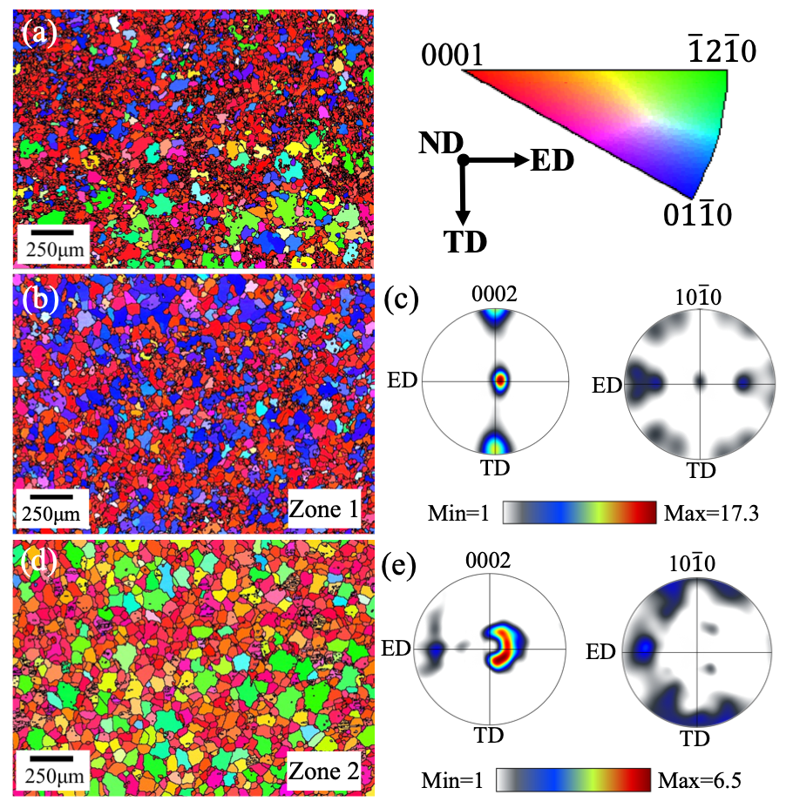
Fig. 1. EBSD inverse pole figure (IPF) maps (a, b, d) and pole figures (c, e) showing the initial microstructure and texture of the as-received samples. (a) is located between (b) (referred to as “Zone 1”) and (d) (referred to as “ Zone 2”). (c) and (e) were calculated from the EBSD data for the regions shown in (b) and (d), respectively.
Fig. 2. (a) Engineering stress-strain curves at various strain rates ranging from 0.001 s⁻¹ to 600 s⁻¹. (b) True stress-strain curves and (c) corresponding work hardening rate curves up to necking at the strain rates of 0.001 s⁻¹, 1 s⁻¹ and 600 s⁻¹. (d) Engineering stress-strain curves of interrupted tensile tests at 600 s⁻¹.
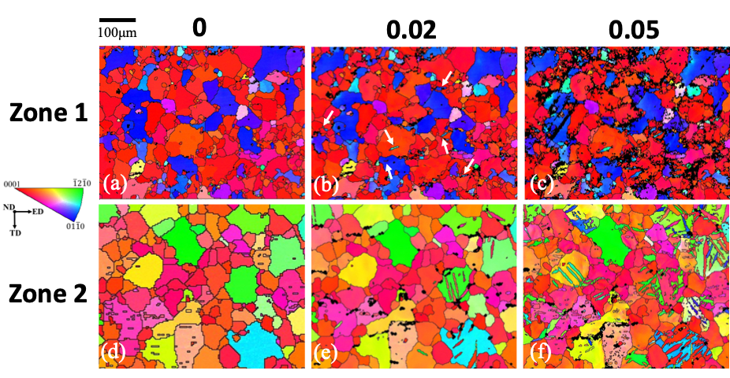
Fig. 3. Quasi-in-situ EBSD IPF maps of the sample (a, d) before deformation and deformed in tension along ED up to (b, e) 0.02 strain and (c, f) 0.05 strain at the strain rate of 0.001 s⁻¹. The subtle differences between (a) and (b) are marked by white arrows.

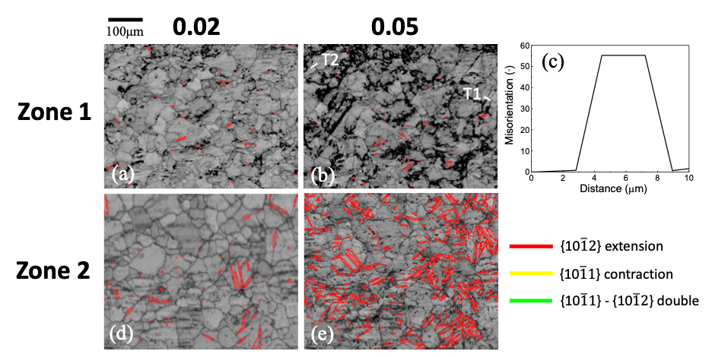
Fig. 4. (a, b, d, e) Band contrast maps superimposed by various twin boundaries showing three twinning modes identified in Fig. 3(b, c, e, f), respectively. (c) A line profile of the misorientation angle along the white line denoted as T1 in (b). The sample was deformed up to (a, d) 0.02 strain and (b, e) 0.05 strain at the strain rate of 0.001 s⁻¹.
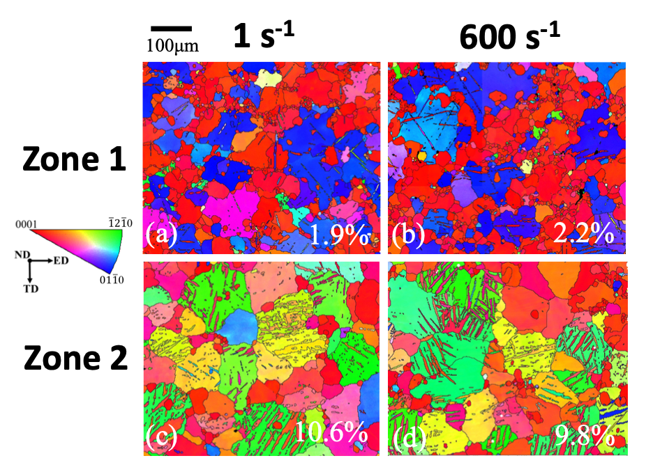
Fig. 5. EBSD IPF maps of the samples deformed in tension along ED up to 0.02 strain at the strain rates of (a, c) 1 s⁻¹ and (b, d) 600 s⁻¹. The number in each map shows the fraction of twinned area.

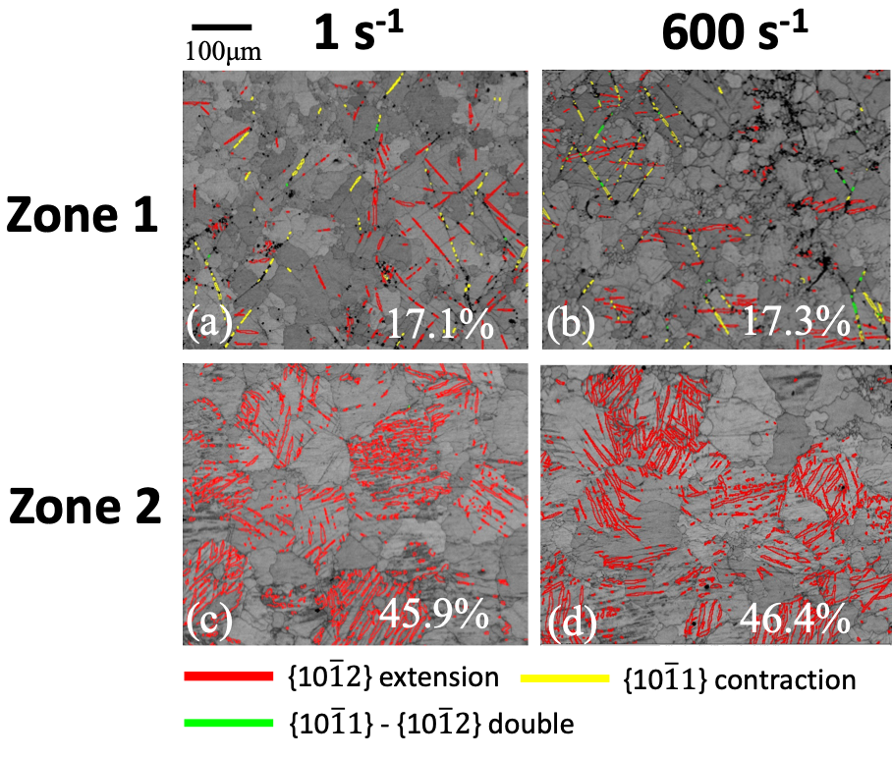
Fig. 6. Band contrast maps superimposed by various twin boundaries showing three twinning modes identified in the samples corresponding to Fig. 5. The number in each map shows the fraction of twin boundaries. The samples were deformed up to 0.02 strain at the strain rates of (a, c) 1 s⁻¹ and (b, d) 600 s⁻¹.
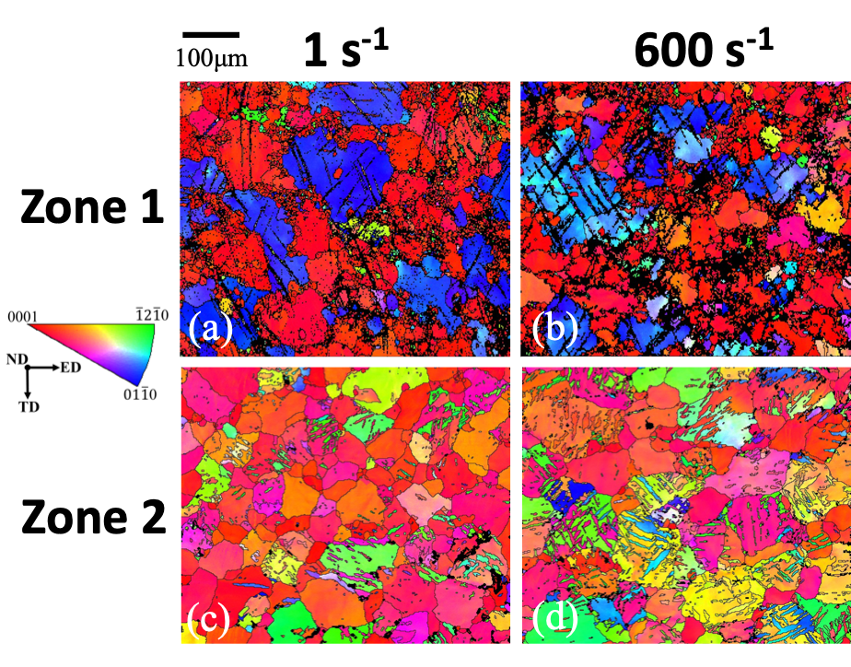
Fig. 7. EBSD IPF maps of the samples deformed in tension along ED up to (a, c) 0.05 strain at the strain rate of 1 s⁻¹ and (b, d) 0.06 strain at the strain rate of 600 s⁻¹.
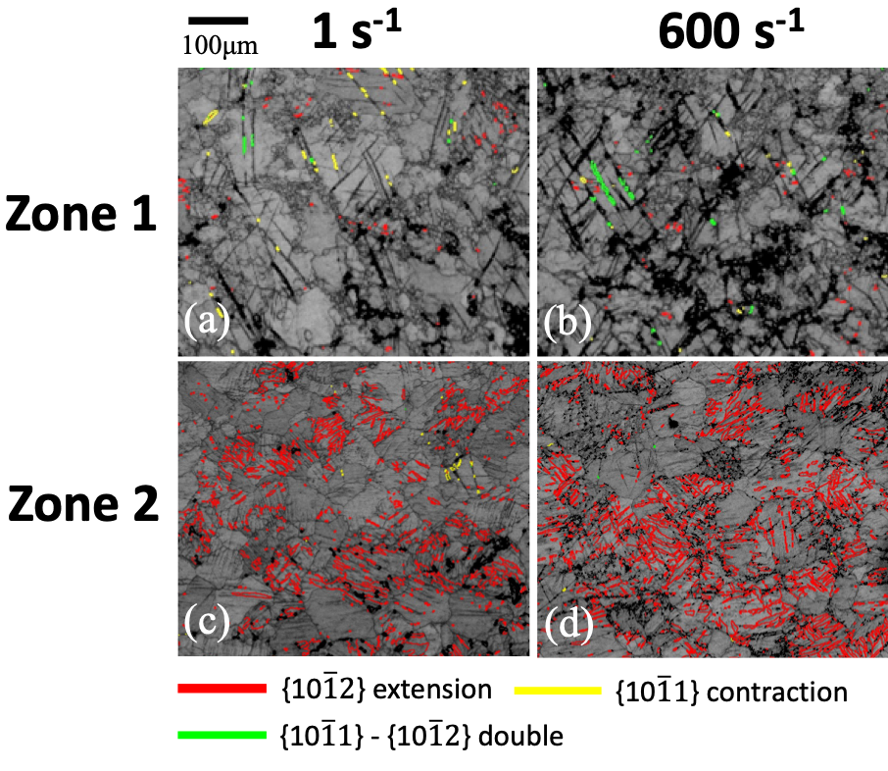
Fig. 8. Band contrast maps superimposed by various twin boundaries showing three twinning modes identified in the samples corresponding to Fig. 7. The samples were deformed up to (a, c) 0.05 strain at the strain rate of 1 s⁻¹ and (b, d) 0.06 strain at the strain rate of 600 s⁻¹.

Fig. 9. The measured and fitted neutron diffraction profiles of the undeformed sample. K is the reciprocal space variable.
Fig. 10. (a) Modified Williamson-Hall plot, (b) a typical histogram of the frequency distribution of possible fractions of $〈a〉$, $〈c〉$ and $〈c+a〉$-type dislocations (i.e. $h_{a}$, $h_{c}$ and $h_{c+a}$) and (c) modified Warren-Averbach plot obtained from the diffraction profile in Fig. 9.

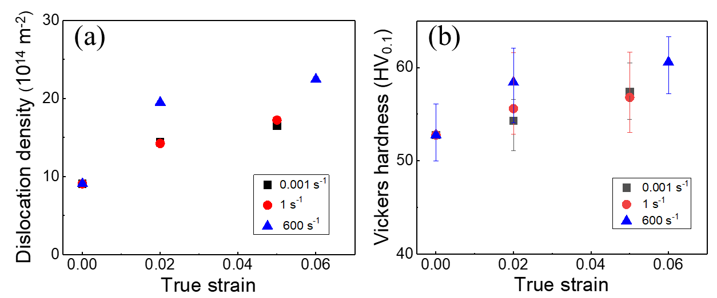
Fig. 11. Evolutions of (a) average dislocation density and (b) Vickers hardness with strain at the strain rates of 0.001 s⁻¹, 1 s⁻¹ and 600 s⁻¹. The results in (a) and (b) represent the bulk average values of the entire gauge parts of the samples.
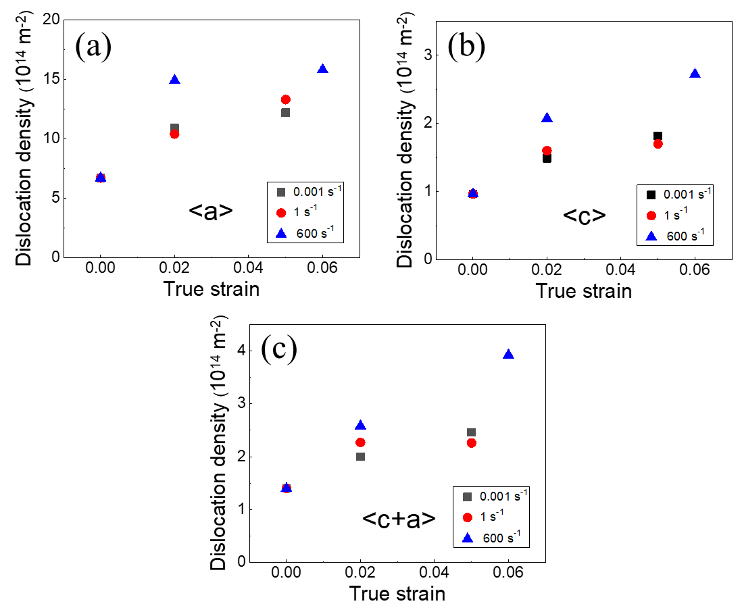
Fig. 12. Evolutions of the average density of (a) $〈a〉$, (b) $〈c〉$ and (c) $〈c+a〉$-type dislocations with strain at the strain rates of 0.001 s⁻¹, 1 s⁻¹ and 600 s⁻¹.
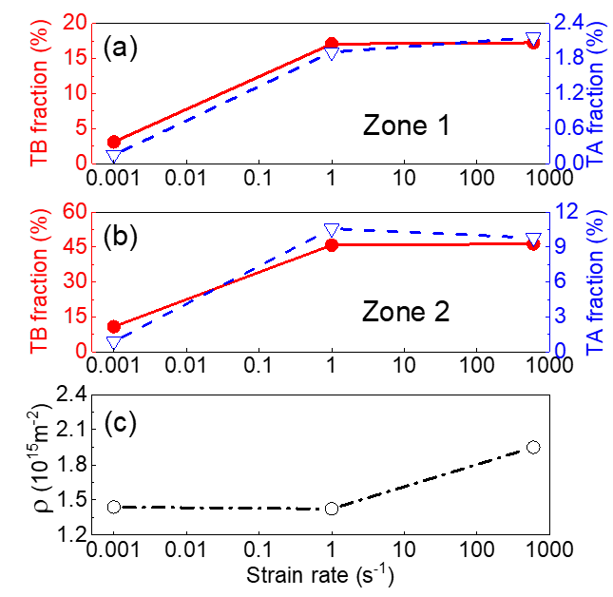
Fig. 13. Evolutions of twin boundary (TB) fraction (solid line) and twin area (TA) fraction (dashed line) in (a) Zone 1 and (b) Zone 2 and (c) average dislocation density ($ρ$) with strain rate at 0.02 strain.

Tables
Table 1
The main slip systems in hexagonal crystals
Major slip system | Sub-slip system | Burgers vector | Slip plane | Burgers vector type
Edge dislocations
Basal | BE | $$〈11\overline{2}0〉$$ | $$\left\{0001\right\}$$ | $$〈a〉$$
Prismatic | PrE | $$〈11\overline{2}0〉$$ | $$\left\{10\overline{1}0\right\}$$ | $$〈a〉$$
 | Pr2E | $$〈0001〉$$ | $$\left\{10\overline{1}0\right\}$$ | $$〈c〉$$
 | Pr3E | $$〈11\overline{2}\overline{3}〉$$ | $$\left\{10\overline{1}0\right\}$$ | $$〈c+a〉$$
Pyramidal | PyE | $$〈11\overline{2}0〉$$ | $$\left\{10\overline{1}1\right\}$$ | $$〈a〉$$
 | Py2E | $$〈11\overline{2}\overline{3}〉$$ | $$\left\{\overline{1}\overline{1}22\right\}$$ | $$〈c+a〉$$
 | Py3E | $$〈11\overline{2}\overline{3}〉$$ | $$\left\{11\overline{2}1\right\}$$ | $$〈c+a〉$$
 | Py4E | $$〈11\overline{2}\overline{3}〉$$ | $$\left\{10\overline{1}1\right\}$$ | $$〈c+a〉$$
Screw dislocations
 | S1 | $$〈11\overline{2}0〉$$ |  | $$〈a〉$$
 | S2 | $$〈11\overline{2}\overline{3}〉$$ |  | $$〈c+a〉$$
 | S3 | $$〈0001〉$$ |  | $$〈c〉$$

