Martensite enables the formation of complex nanotwins in a medium Mn steel
B.B. He^{a,b,c}, M.X. Huang^{a,b*}
ªDepartment of Mechanical Engineering, The University of Hong Kong, Hong Kong, China
^{b}Shenzhen Institute of Research and Innovation, The University of Hong Kong, Shenzhen 518000, China
^{c}Department of Mechanical and Energy Engineering, Southern University of Science and Technology, Shenzhen, 518055, China
*Corresponding author: M.X. Huang: mxhuang@hku.hk, Tel: +85228597906; Fax: +85228585415

Abstract
Nanotwins with high density have been introduced by severe plastic deformation to improve the mechanical properties of single-phase steels. In this paper, we revealed a pathway to generate intensive nanotwins in a dual-phase medium Mn steel. These nanotwins have a complex morphology and are developed by martensitic transformation during the quenching process and twinning induced plasticity (TWIP) effect during subsequent uni-axial tension. We envision that the complex nanotwins with very high twin density will be promising in enhancing the mechanical performance of steels.

Keywords: Complex nanotwins; Martensite; Austenite; Medium Mn steel.

Strong and ductile metallic materials are desirable to develop lightweight structural components for different engineering applications [1, 2]. However, improving strength often results in a reduced ductility, which is known as strength-ductility trade-off in metals and alloys [3, 4]. To alleviate such trade-off, coherent nanotwin boundaries have been employed in varied metallic materials [5-17]. The nanotwin boundaries can be not only effective barriers but also slip planes for dislocation glide [18-20]. It is proposed that the hierarchical nanotwins can enhance the interaction between coherent nanotwin boundaries and dislocations, achieving better strength and ductility combination as compared to the monolithic nanotwins [21, 22]. Such hierarchical nanotwins can be generated in single-phase metallic materials by using varied techniques [3, 23-26]. For example, the hierarchical nanotwins in steels with single austenitic phase can be developed by using severe plastic deformation, such as pre-torsion and uni-axial tension [3], surface mechanical grinding treatment (SMGT) [24] and surface mechanical attrition treatment (SMAT) [26].
In this paper, we revealed a pathway to generate a nanotwinned structure with complex morphology in a dual-phase medium Mn steel. Such complex nanotwins have a very high twin density. By detailed microstructural observation, we found that the quenched martensite, which is resulted from strong first-order solid state phase transformation [27], can facilitate the development of these complex nanotwins.
A medium Mn steel with a chemical composition of Fe-10%Mn-0.45%C-1%Al (in wt.%) is employed for the present investigation. It is prepared by casting and forging, followed by hot rolling to strips with a final thickness of 4 mm. The ASTM E-8 sub-sized tensile samples are wire cut along the rolling direction. The tensile samples are annealed at 1000 ºC for 1 hour, followed by water quenching (WQ) and immersing in liquid nitrogen (LN) for 10 mins to generate lath martensite. The martensite start (Ms) temperature of the present steel is predicted to be 75 ºC according to the empirical equations [28, 29]. The tensile samples are tempered at 620 ºC for 5 hours to allow C partitioning [30]. The tensile samples are plastically deformed to varied engineering strains at room temperature under a quasi-static strain rate of 5×10⁻⁴ s⁻¹. The microstructure is characterized by using scanning electron microscopy (SEM) and electron backscattered diffraction (EBSD) in a FEG SEM Leo 1530 at 5 kV and 20 kV, respectively. The EBSD sample is prepared by electro-polishing using a mixture of 15% perchloric acid and 85% ethanol (vol.%) after conventional mechanical grinding. The X-ray diffraction (XRD) measurements are performed to identify the evolution of austenite volume fraction during different thermal-mechanical processes. The details on the XRD measurements of the present steel can be found in [31, 32]. The electron probe microanalysis (EPMA) measurements have been performed to confirm the C partitioning between the martensite and austenite. The results of the EPMA measurements have been reported elsewhere [32]. The nanotwins are observed under transmission electron microscopy (TEM) in an FEI Tecnai G20 at 200 kV. The TEM sample is prepared by Twin-jet machine using a mixture of 5% perchloric acid and 95% ethanol (vol.%) at -30 ºC with a potential of 30 V.
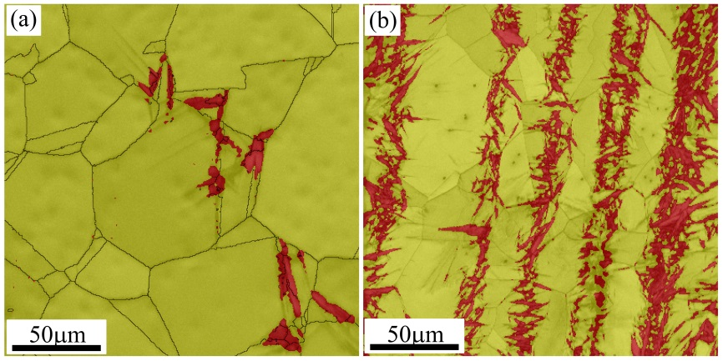
Figure 1: EBSD phase image of the present steel after (a) water quenching and (b) liquid nitrogen treatment. Red: martensite; Yellow: austenite. (Colour image can be found online)

Figure 1 (a) and (b) are the EBSD phase maps of the present steel after water quenching and liquid nitrogen treatment, respectively. Most of the martensite laths are distributed in the large austenite grains in the present steel after water quenching (Figure 1 (a)), which is consistent with the literature that the larger austenite grain is less stable [33]. The liquid nitrogen treatment triggers the martensitic transformation, which sweeps over most of the austenite grains (Figure 1 (b)). The martensitic transformation is along one direction and martensite bands are formed. The reason for the banded structure of martensite could be due to the Mn banding, which has been observed in most of Mn alloyed steels such as quenching and partitioning (Q&P) steel [34] and dual-phase (DP) steel [35]. Generally, prolonged annealing at high temperatures such as holding at 1200 ºC for 24 hours is required to remove the Mn banding. The volume fraction of martensite is estimated to be 9% and 26% after water quenching and liquid nitrogen treatment, respectively [31].
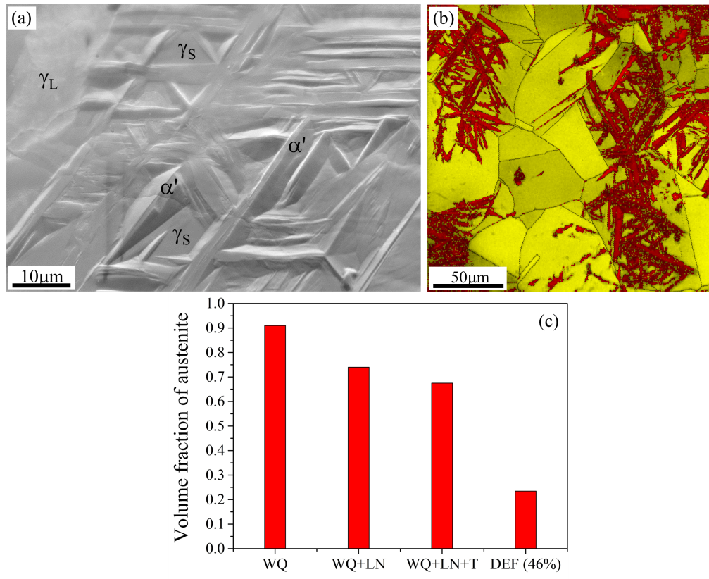
Figure 2: (a) SEM image and (b) EBSD phase image indicating a dual-phase microstructure after the tempering process. α': martensite; γ_{L}: large austenite; γ_{S}: small austenite. Red: martensite; Yellow: austenite. (c) Volume fraction of austenite during different thermal-mechanical processes obtained from the XRD measurement. WQ: water quenching; LN: liquid nitrogen; T: tempering; DEF: deformation. (Colour image can be found online)

Figure 2 (a) is a SEM image of the present medium Mn steel after tempering process, showing a dual-phase microstructure with lath martensite embedded in the austenite matrix. The embossment phase is martensite while the dent phase is austenite (Figure 2 (a)). Figure 2 (b) is an EBSD phase image, confirming the dual-phase microstructure in the present medium Mn steel. The austenite grains as shown in Figure 2 (a)-(b) have different grain size due to inhomogeneous grain growth during austenitization (Figure 1 (a)) and heterogeneous martensitic transformation during quenching (Figure 1 (b)). The average grain size of large austenite grain and small austenite grain are estimated to be 23 μm and 2.6 μm, respectively [32]. Figure 2 (c) shows the evolution of austenite volume fraction during different thermal-mechanical processes. The tempering process does not change the austenite volume fraction (Figure 2 (c)), suggesting that no substantial phase transformation takes place. This is consistent with the observation that the lath martensite remains intact after the tempering process (Figure 2 (a)-(b)). The retained austenite grains in the present medium Mn steel are metastable and around 44% volume fraction of austenite transformed to martensite during tensile deformation (Figure 2 (c)).
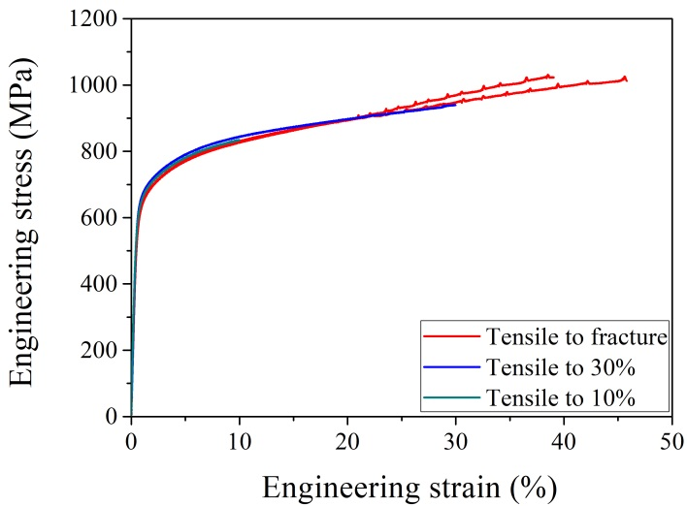
Figure 3: The engineering stress strain curves of the present steel. The interrupted tensile curves are also included.

Figure 3 shows the engineering stress strain curve of the present steel. The tensile curves generally coincide with each other, suggesting that the tensile behaviours are reproducible. The present steel demonstrates serrated plastic flow at an engineering strain larger than 20% (Figure 3). The serrations could be due to the generation of Portevin–Le Chatelier (PLC) bands, which is closely related to the dynamic strain aging (DSA) effect [36, 37]. The present steel is fractured just after the serrations (Figure 3), suggesting that the plastic flow is unstable due to formation of PLC bands.
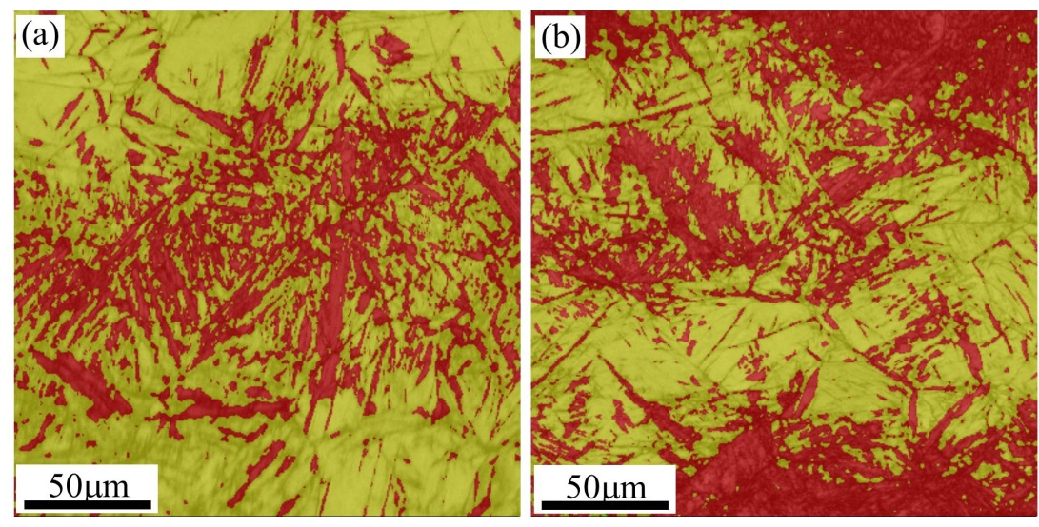
Figure 4: EBSD phase image of the present steel after tensile deformation of (a) 10% and (b) 30%. Red: martensite; Yellow: austenite. (Colour image can be found online)

Figure 4 (a) and (b) shows the microstructure of the present steel after tensile deformation of 10% and 30%, respectively. As compared to the initial microstructure (Figure 2 (b)), most of the large austenite grains are distributed with the lath martensite after tensile deformation (Figure 4), suggesting that strain-induced martensitic transformation takes place in the present medium Mn steel during uni-axial tension [38, 39]. As compared to the small austenite grains, the large austenite grains have low mechanical stability resulted from relatively low C content [28, 40] and coarse grain size [41, 42]. Therefore, the transformation-induced plasticity (TRIP) effect is mainly contributed by the martensitic transformation from the large austenite grains.
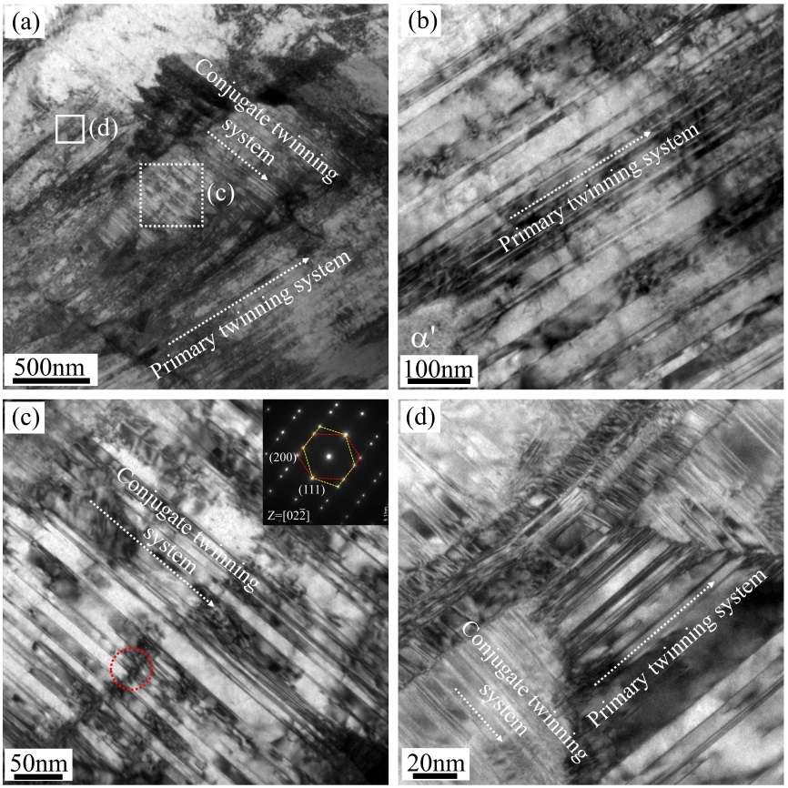
Figure 5: (a) TEM image showing the formation of two twinning systems in a single austenite grain after uni-axial tension. The magnified view of (b) primary twinning system and (c) conjugate twinning system. The dashed circle in (c) marks the position for selected area diffraction pattern (SADP) analysis. (d) The magnified view of the solid rectangle in (a) confirming the existence of austenite lamellae close to two major twinning systems.

Figure 5 (a) is a TEM image of a small austenite grain in the present steel after fracture. Intensive coherent twin boundaries are found in this small austenite grain (Figure 5 (a)). The small austenite grains have high C content because they have the surrounding martensite phase (Figure 2 (a)-(b)) which facilitates C partitioning during annealing at 620 ºC for 5 hours [32]. The evidence of C partitioning has been captured by EPMA measurement and the result has been shown in [32]. Consequently, the small austenite grains tend to generate deformation twins rather than martensitic transformation during tensile deformation owing to the proper stacking fault energy [43]. The deformation twins in the small austenite grain have two twinning systems, including the primary twinning system and conjugate twinning system (Figure 5 (a)) [44]. Figure 5 (b) and (c) are the magnified views of these two twinning systems, indicating the intensive distribution of deformation nanotwins in the small austenite grain. The formation of two twinning systems in a single austenite grain can also be found in other medium Mn steels with dual-phase microstructure of ferrite and austenite [45, 46]. Interestingly, some austenite nano-lamellae (~10-50 nm) in adjacent to the dominated twinning systems is observed in the present medium Mn steel (Figure 5 (d)). Note that such austenite nano-lamellae has not been observed in other dual-phase medium Mn steels before [45, 46]. Therefore, it is interesting to investigate the substructure of the austenite nano-lamellae in details.
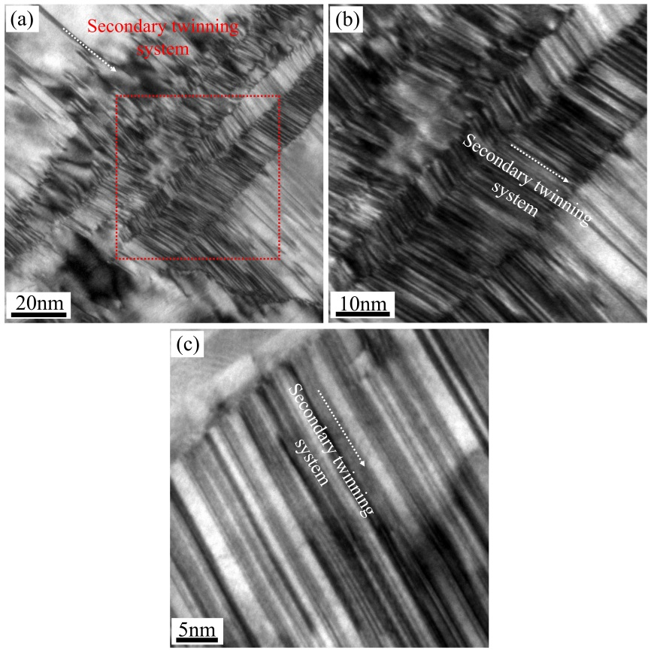
Figure 6: (a) TEM image showing the presence of austenite lamellae with different thickness. (b) The magnified view of red dashed rectangle in (a) indicating the alternating twin bundles in the complex nanotwins. (c) TEM image demonstrating a very high density of nanotwin boundaries in the complex nanotwins.

Figure 6 (a) is a TEM image of austenite nano-lamellae after uni-axial tension. A magnified view indicates that each austenite nano-lamella contains a single twinning system (Figure 6 (b)), which could be probably grouped into the secondary twinning system [44]. The collective formation of the single twinning system in individual austenite lamella generates an overall nanotwinned structure with complex morphology (Figure 6 (b)). Each austenite lamella could have a very high density of nanotwin boundaries (Figure 6 (c)), which may be resulted from the high-stress concentration during uniaxial tension.
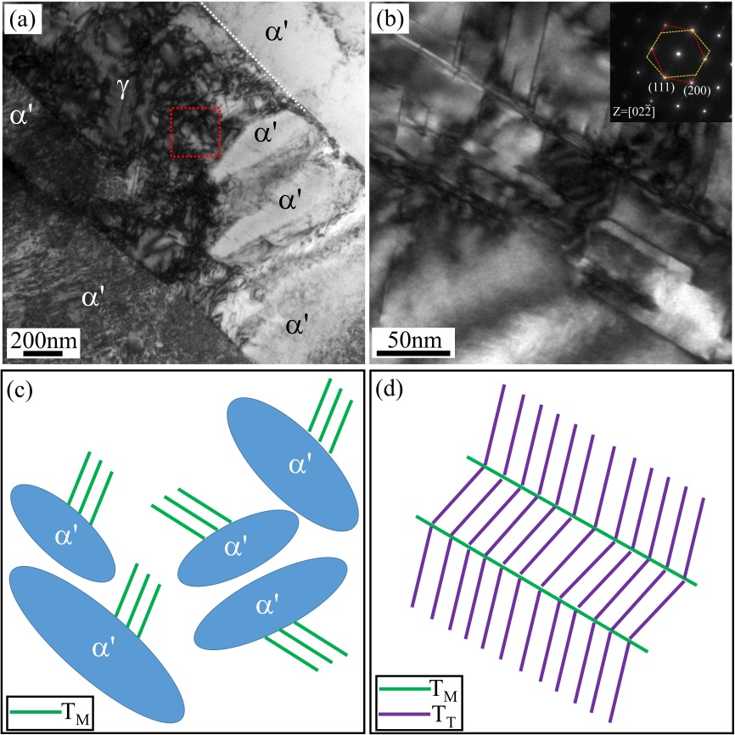
Figure 7: (a) TEM image showing the formation of dislocations in adjacent to austenite and martensite interface. White dashed line marks the interface. (b) A magnified view of the dashed rectangle in (a) confirming the nanotwin boundaries in the small austenite grain. (c) A schematic illustration of nanotwin boundaries generated due to the formation of adjacent lath martensite during the quenching process. T_{M}: nanotwin boundaries generated by quenched martensite. (d) A schematic illustration of complex nanotwins developed by both martensitic transformation and uniaxial tension. T_{T}: nanotwin boundaries formed by uniaxial tension.

Figure 7 (a) is a TEM image of small austenite grain in the present medium Mn steel before uniaxial tension, showing an intensive distribution of dislocations in adjacent to the austenite and martensite interface. A magnified view of the region close to interface suggests that the nanotwin boundaries are also present in this small austenite grain (Figure 7 (b)). The formation of these nanotwins could be due to the high localized stress concentration resulted from the generation of adjacent lath martensite during the quenching process [47]. The formation of lath martensite accompanies with a large transformation strain [48], which is accommodated by elastic/plastic deformation of both martensite and austenite phases [49, 50]. The plastic deformation in the austenite matrix is carried out by the generation of defects such as dislocations (Figure 7 (a)) and nanotwins (Figure 7 (b)-(c)). These nanotwins could be the main reason for the formation of austenite nano-lamellae in adjacent to the small austenite grain (Figure 5 (d) and Figure 6 (a)). In contrast, the strain-induced martensitic transformation is irrelevant to the formation of the austenite nano-lamellae because the former tends to take place in the large austenite grains during uni-axial tension [39]. Each austenite nano-lamellae develops single twinning variant with very high twin density during uni-axial tension, leading to the formation of complex nanotwins (Figure 7 (d)). Therefore, the generation of complex nanotwins in the present medium Mn steel could be ascribed to the martensitic transformation and subsequent uni-axial tension. In other words, the present complex nanotwins cannot be formed if the martensitic transformation does not take place prior to uniaxial tension. It has been demonstrated that the coherent nanotwin boundary strengthening plays a key role in achieving high strength in metallic materials with very high twin density [5]. However, it is difficult to introduce high twin density in nanotwinned steel with monolithic nanotwins [12]. The formation of complex nanotwins could be feasible to increase the twin density in nanotwinned steel [22]. However, such complex nanotwins are mostly generated by using severe plastic deformation [3, 24, 26]. In this paper, we propose a pathway to generate complex nanotwins with very high twin density (Figure 6) in a medium Mn steel by using martensitic transformation and subsequent simple uniaxial tension (Figure 7 (c)-(d)). Note that the volume fraction of austenite after tensile deformation of 46% decreases down to 0.23 (Figure 2 (c)). Therefore, it is expected that the amount of austenite grains with complex nanotwins is much lower than the martensite phase. Thus, the current alloy composition may not be the optimal one to demonstrate the enhancement of properties by complex nanotwins. Nevertheless, the alloy composition could be further improved by considering the austenite stability and stacking fault energy with an aim to generate large amount of austenite grains with complex nanotwins during quenching and deformation.
In summary, we revealed a nanotwinned structure with complex morphology in a dual-phase medium Mn steel. The formation of complex nanotwins is closely related to the generation of lath martensite during the quenching process. The martensitic transformation results in the distribution of nanotwin boundaries in austenite grains. These nanotwin boundaries act as the basic framework for the further development of deformation twins during uni-axial tension, leading to the formation of complex nanotwins. The complex nanotwins with very high twin density are expected to improve the mechanical properties of steels.

Acknowledgments:
M.X. Huang acknowledges the financial support from National Natural Science Foundation of China (No. U1764252, U1560204) and Research Grants Council of Hong Kong (No. 17255016, 17203014, C7025-16G). 17203014, C7025-16G). B.B. He acknowledges the financial support from National Young 1000-Talents Program (33/K19331102) and Start-up Funding from the Southern University of Science and Technology (33/Y01336122). B.B. He would like to acknowledge the technical support from SUSTech Core Research Facilities.

References
1. B B He, B Hu, H W Yen, G J Cheng, Z K Wang, H W Luo and M X Huang, Science 2017, vol. 357, pp. 1029-1032.
2. O. Bouaziz, H. Zurob and M. Huang, Steel Res. Int. 2013, vol. 84, pp. 937-947.
3. Y. Wei, Y. Li, L. Zhu, Y. Liu, X. Lei, G. Wang, Y. Wu, Z. Mi, J. Liu, H. Wang and H. Gao, Nat. Commun. 2014, vol. 5, pp. 3580-3587.
4. T Bhattacharjee, IS Wani, S Sheikh, IT Clark, T Okawa, S Guo, Pinaki Prasad Bhattacharjee and N Tsuji, Scientific reports 2018, vol. 8, p. 3276.
5. Lei Lu, Yongfeng Shen, Xianhua Chen, Lihua Qian and Ke Lu, Science 2004, vol. 304, pp. 422-426.
6. Ke Lu, Lei Lu and S Suresh, Science 2009, vol. 324, pp. 349-352.
7. L. Lu, Z. S. You and K. Lu, Scripta Mater. 2012, vol. 66, pp. 837-842.
8. Olivier Bouaziz, David Barbier, Philippe Cugy and Gérard Petigand, Advanced Engineering Materials 2012, vol. 14, pp. 49-51.
9. HT Wang, NR Tao and K Lu, Acta Mater. 2012, vol. 60, pp. 4027-4040.
10. K Lu, FK Yan, HT Wang and NR Tao, Scripta Mater. 2012, vol. 66, pp. 878-883.
11. FK Yan, NR Tao and K Lu, Scripta Mater. 2014, vol. 84, pp. 31-34.
12. P. Zhou, Z. Y. Liang, R. D. Liu and M. X. Huang, Acta Mater. 2016, vol. 111, pp. 96-107.
13. O Bouaziz, CP Scott and G Petitgand, Scripta Mater. 2009, vol. 60, pp. 714-716.
14. O Bouaziz, S Allain and C Scott, Scripta Mater. 2008, vol. 58, pp. 484-487.
15. O Bouaziz, Scripta Mater. 2012, vol. 66, pp. 982-985.
16. I Gutierrez-Urrutia and D Raabe, Scripta Mater. 2012, vol. 66, pp. 992-996.
17. Krystel Renard and PJ Jacques, Materials Science Engineering: A 2012, vol. 542, pp. 8-14.
18. Y. T. Zhu, X. L. Wu, X. Z. Liao, J. Narayan, L. J. Kecskés and S. N. Mathaudhu, Acta Mater. 2011, vol. 59, pp. 812-821.
19. Linli Zhu, Haihui Ruan, Xiaoyan Li, Ming Dao, Huajian Gao and Jian Lu, Acta Mater. 2011, vol. 59, pp. 5544-5557.
20. Hao Wang, Zesheng You and Lei Lu, Materials Research Letters 2018, vol. 6, pp. 333-338.
21. Linli Zhu, Shaoxing Qu, Xiang Guo and Jian Lu, J. Mech. Phys. Solids 2015, vol. 76, pp. 162-179.
22. Ligang Sun, Xiaoqiao He and Jian Lu, npj Computational Materials 2018, vol. 4, p. 6.
23. Hongning Kou, Jian Lu and Ying Li, Advanced Materials 2014, vol. 26, pp. 5518-5524.
24. NR Tao and K Lu, Scripta Mater. 2009, vol. 60, pp. 1039-1043.
25. Xiaowei Liu, Ligang Sun, Linli Zhu, Jiabin Liu, K. Lu and Jian Lu, Acta Mater. 2018, vol. 149, pp. 397-406.
26. Shen Qu, XH An, HJ Yang, CX Huang, Gang Yang, QS Zang, ZG Wang, SD Wu and ZF Zhang, Acta Mater. 2009, vol. 57, pp. 1586-1601.
27. LE Tanner and M Wuttig, Mater. Sci. Eng., A 1990, vol. 127, pp. 137-144.
28. KW Andrews, J. Iron Steel Inst. Jpn. 1965, vol. 203, pp. 721-727.
29. B Mintz, In Proceedings of the International Conference on TRIP-Aided High Strength Ferrous Alloys, Ghent, (2002), pp 379-382.
30. J Speer, DK Matlock, BC De Cooman and JG Schroth, Acta Mater. 2003, vol. 51, pp. 2611-2622.
31. BB He and MX Huang, Metallurgical Materials Transactions A 2016, vol. 47, pp. 3346-3353.
32. BB He, HW Luo and MX Huang, Int. J. Plast. 2016, vol. 78, pp. 173-186.
33. A. García-Junceda, C. Capdevila, F. G. Caballero and C. García de Andrés, Scripta Mater. 2008, vol. 58, pp. 134-137.
34. Farideh HajyAkbary, Jilt Sietsma, Roumen H Petrov, Goro Miyamoto, Tadashi Furuhara and Maria Jesus Santofimia, Scripta Mater. 2017, vol. 137, pp. 27-30.
35. Benoit Krebs, Lionel Germain, Alain Hazotte and Mohamed Gouné, J. Mater. Sci. 2011, vol. 46, pp. 7026-7038.
36. Sangwon Lee, Jinkyung Kim, Seok-Jae Lee and Bruno C De Cooman, Scripta Mater. 2011, vol. 65, pp. 528-531.
37. Lei Chen, Han-Soo Kim and Sung-Kyu Kim, ISIJ Int. 2007, vol. 47, pp. 1804-1812.
38. G. Olson and M. Cohen, Metall. Mater. Trans. A 1975, vol. 6, pp. 791-795.
39. B. B. He, H. W. Luo and M. X. Huang, Int. J. Plast. 2016, vol. 78, pp. 173-186.
40. E. Jimenez-Melero, N. H. van Dijk, L. Zhao, J. Sietsma, S. E. Offerman, J. P. Wright and S. van der Zwaag, Scripta Mater. 2007, vol. 56, pp. 421-424.
41. H.S. Yang and H. K. D. H. Bhadeshia, Scripta Mater. 2009, vol. 60, pp. 493-495.
42. E. Jimenez-Melero, N. H. van Dijk, L. Zhao, J. Sietsma, S. E. Offerman, J. P. Wright and S. van der Zwaag, Acta Mater. 2007, vol. 55, pp. 6713-6723.
43. S. Allain, J. P. Chateau, O. Bouaziz, S. Migot and N. Guelton, Mater. Sci. Eng., A 2004, vol. 387–389, pp. 158-162.
44. Tae-Ho Lee, Eunjoo Shin, Chang-Seok Oh, Heon-Young Ha and Sung-Joon Kim, Acta Mater. 2010, vol. 58, pp. 3173-3186.
45. Sangwon Lee and Bruno C De Cooman, Metall. Mater. Trans. A 2014, vol. 45, pp. 709-716.
46. Binhan Sun, Fateh Fazeli, Colin Scott, Nicolas Brodusch, Raynald Gauvin and Stephen Yue, Acta Mater. 2018, vol. 148, pp. 249-262.
47. Q. Meng, Y. Rong and T. Hsu, Metall. Mater. Trans. A 2006, vol. 37, pp. 1405-1411.
48. H. K. D. H. Bhadeshia and R. Honeycombe: Steels: Microstructure and Properties. 3rd ed. (Butterworth-Heinemann, Oxford, U.K., 2006).
49. G. W. Greenwood and R. H. Johnson, Proc. Roy. Soc. London A 1965, vol. 283, pp. 403-422.
50. F. D. Fischer, G. Reisner, E. Werner, K. Tanaka, G. Cailletaud and T. Antretter, Int. J. Plast. 2000, vol. 16, pp. 723-748.

Figure captions
Figure 1: EBSD phase image of the present steel after (a) water quenching and (b) liquid nitrogen treatment. Red: martensite; Yellow: austenite. (Colour image can be found online)
Figure 2: (a) SEM image and (b) EBSD phase image indicating a dual-phase microstructure after the tempering process. α': martensite; γ_{L}: large austenite; γ_{S}: small austenite. Red: martensite; Yellow: austenite. (c) Volume fraction of austenite during different thermal-mechanical processes obtained from the XRD measurement. WQ: water quenching; LN: liquid nitrogen; T: tempering; DEF: deformation. (Colour image can be found online)
Figure 3: The engineering stress strain curves of the present steel. The interrupted tensile curves are also included.
Figure 4: EBSD phase image of the present steel after tensile deformation of (a) 10% and (b) 30%. Red: martensite; Yellow: austenite. (Colour image can be found online)
Figure 5: (a) TEM image showing the formation of two twinning systems in a single austenite grain after uni-axial tension. The magnified view of (b) primary twinning system and (c) conjugate twinning system. The dashed circle in (c) marks the position for selected area diffraction pattern (SADP) analysis. (d) The magnified view of the solid rectangle in (a) confirming the existence of austenite lamellae close to two major twinning systems.
Figure 6: (a) TEM image showing the presence of austenite lamellae with different thickness. (b) The magnified view of red dashed rectangle in (a) indicating the alternating twin bundles in the complex nanotwins. (c) TEM image demonstrating a very high density of nanotwin boundaries in the complex nanotwins.
Figure 7: (a) TEM image showing the formation of dislocations in adjacent to austenite and martensite interface. White dashed line marks the interface. (b) A magnified view of the dashed rectangle in (a) confirming the nanotwin boundaries in the small austenite grain. (c) A schematic illustration of nanotwin boundaries generated due to the formation of adjacent lath martensite during the quenching process. T_{M}: nanotwin boundaries generated by quenched martensite. (d) A schematic illustration of complex nanotwins developed by both martensitic transformation and uniaxial tension. T_{T}: nanotwin boundaries formed by uniaxial tension.

