Three-dimensional nonlinear finite element modeling for bond performance of ribbed steel bars in concrete under lateral tensions

ABSTRACT
Development of experimental studies in bond behavior between deformed bar and concrete under complex stress conditions in the last two decades are significantly affecting the concrete design specification. This article presents a rib-scale finite element model (FEM) to study the bond behavior of deformed bar in concrete under lateral tensions. In this model, detailed modeling including the reinforcing bar ribs and the concrete keys in contact region is realized with real geometric parameters. At the concrete-bar interface, surface-to-surface contacts with tie constraints are used and relative sliding or separation between contact surfaces are inhibited; adhesion between concrete and deformed bar is ignored. A user-defined subroutine named VUSDFLD in ABAQUS software was incorporated into the concrete damaged plasticity (CDP) model to acquire more accurate concrete constitutive relations. The FEM is calibrated using pull-out test data from published papers. The simulation results show that all specimens failed in splitting mode. The lateral tension is an adverse factor on the bond property between steel bar and concrete, both the ultimate bond strength and the slip at the peak bond stress decrease with the increase of the lateral tensions. Comparison of computational simulation with the experimental data indicates that the proposed model gives a reasonable prediction of the bond stress-slip curves as well as the concrete crack patterns.
keywords: nonlinear finite element modeling; ribbed reinforcing bar; concrete; user-defined subroutine; bond stress-slip relationship; lateral tensions.

Introduction
Bond property between concrete and reinforcement steel bar is a crucial factor for fulfilling the performance of reinforced concrete structure. Reliable bonding is the foundation on which reinforcement steel bar and concrete could work together. Nevertheless, the characterization and estimation of bond property are full of challenges owing to the variety of parameters including the concrete strength, diameter of steel bar, reinforcement configuration and complex stress fields of concrete [1-5]. Hence, many individual tests typically represented by pullout tests are required to determine the bond behavior of reinforced concrete. Relative to the experimental research, the FEM is an effective numerical means to deal with bond problems which could validate the experimental tests and supply much richer data. Developing a reliable FEM for simulating the bond stress-slip relationship, which can not only assist in supplying a better understanding of bond mechanisms but also in studying various influential parameters systematically in a more economical way.
Multiple FEMs for bond behavior have been generated and evolved to simulate the bond response between reinforcement bar and concrete, 1D [6-7], 2D [8] and 3D [9-10] FEMs have been developed. These models can be summarized at several scales, namely, the element-scale, bar-scale, intermediate-scale and the rib-scale [11]. Of which, the element-scale models [12-13], bar-scale models [14-17] and intermediate-scale models [18-19] require the known bond stress-slip relationship, which is usually based on empirical formula provided by design specification or previous research results relevant for specific constraint conditions. While, the rib-scale finite element model does not need the known bond stress-slip relationship to define the interface property between reinforcement and concrete, it is established to calculate the unknown bond stress-slip relationship. The element-scale models and bar-scale models are applied for simulating the overall behavior of reinforced concrete structures and not suitable for studying the local bond mechanism. The intermediate-scale model can be used to study the local bond mechanism, but it is unable to simulate complex geometric configuration. The rib-scale finite element model can simulate complex geometric configuration to study the local bond mechanism. In a bar-scale model [10-11;20-22], the reinforcing bar and concrete are modeled with solid elements without known bond stress-slip relationship, the shape of the bonding interfaces with real geometric parameters of the reinforcement bar ribs and the concrete keys are precisely modeled or approximately considered through the interface model (or interface law), hence, the radial stress distribution of reinforcement bar, even the damage evolvement of concrete material can be attained to better understand the bond mechanism.
So far, few researchers have devoted special attentions to simulate the bond response of reinforced concrete in rib-scale models. As in the earlier study, Salem [20] and Lagier [21] developed a 2D and 3D rib-scale FEM respectively. In their researches, hard contact model with normal and shear behavior at the interface was introduced. Their studies indicated that the penalty stiffness in the tangential direction, namely, the friction and adhesion, has little effect on the results. This simulation results are consistent with the results of previous experiments, to a large extent, the bond stress of deformed bars depends on the surface texture and the geometry of the bars [23]. While, the normal bond stiffness at the interface, that is the interlocking of ribs against concrete, has a strong correlation with the bond strength. Even in early age, bond strength of deformed is also mainly related to the compressive cube strength and splitting tensile strength of concrete, which can be reflected by the constitutive relationship of concrete[24]. Zhao [10] and Seok [11] simplified the geometric configuration of steel bar ribs by interface law to design 3D axisymmetric FEM in rib-scale. In Zhao’s model, the bond behavior between ribbed steel bar and high-strength concrete after elevated temperatures was simulated by assigning the measured friction coefficient under different temperature to the contact property. Nevertheless, the adopted constitutive relation of concrete under compression remains constant after reaching the characteristic compressive strength of concrete, so scant description was provided regarding the descending branch of bond stress-slip curves. In Seok’s model, the adhesion between concrete and steel is ignored. The FEM can reproduce the overall load-displacement relationships and the mechanism of crack initiation, propagation and failure, but this FEM is not suit for calculating the bond property under complex stress conditions. Panteki [22] built a 3D rib-scale FEM to simulate the dynamic concrete-to-rebar bond experiment, this model not only involved detailed modeling of the steel bar ribs and the concrete keys in between, but also provided the complete descending branch of the bond stress-slip curves. The imperfection of this model is that the concrete material model is based on the soil and foam failure material model in LS-Dyna software, which is not a frequently-used constitutive equation for concrete material. To sum up, in rib-scale models, the friction and adhesion at the interface have insignificant influence on the bond behavior compared to the interlocking of ribs against concrete. The adopted constitutive relation of concrete would affect descending branch of the bond stress-slip curves.
Moreover, in reality, the majority of reinforced concrete structures are frequently subjected to biaxial/triaxial tension and/or compreesion, and they are usually prone to suffer a severer damage when subjected to tensile stress because of the quasi-brittle nature. Hence, althought some researchers have studied the bond behavior between steel reinforcements and concrete under lateral compressive stress, the concern about the bond performance under lateral tension stress should also be well addressed. However, to date, the FEM in rib-scale for bond property of ribbed bars and concrete under lateral stress has not been reported in previous entries in the literature.
Based on the results of past studies, this paper aims at developing a new 3D FEM in rib-scale to reproduce the bond stress-slip relationship of ribbed steel bars embedded in concrete under lateral tensions. To achieve it, the FEM is defined only by the measured material properties and geometric parameters in experiments rather than known bond stress-slip relationship. In particular, the deformed bars with noncentrosymmetric surface morphology were precisely modeled in actual size. The friction and adhesion behavior at the steel-concrete interface are ignored, at the same time, surface-to-surface contacts with tie constraints are used at the concrete-bar interface. A real-time updating failure criterion in user-defined subroutine was incorporated into the CDP model of ABAQUS software to calculate the full bond stress-slip curves. The proposed FEM is characterized by its capability: (1) to reproduce bond stress-slip curves of deformed bar in concrete under lateral tension; (2) to distinguish the failure mode of the pull-out specimens.
Based experiments for model development
The proposed FEM is verified by 33 groups of pull-out tests formerly obtained by the Wu et al. [3] at Dalian University of Technology. The pullout test was carried out on a retrofitted hydraulic servo-controlled triaxial testing machine. The loading device of the testing machine is consisted of three independent orthogonal hydraulic cylinders: one vertical and two horizontal. The horizontal and vertical pistons were utilized to exert lateral tensions and the pull-out load, respectively. The applied uniaxial or biaxial lateral tensions were designed for application on the transverse faces of the specimen. Spherical, self-aligning head was installed for each piston in the horizontal direction to avoid misalignment of the contact surface. Since deformed bars used in the test had noncentrosymmetric surface configuration, the effect of the direction of lateral tension should be considered. The lateral tension was applied in two different directions: one was perpendicular to the transverse rib (i.e., p₁ direction) and the other was parallel to the transverse rib (i.e., p₂ direction). The schematic diagram of pull-out specimen and loading conditions of the specimens are shown in Fig. 1, in which the deformed bar was installed in the center of the specimen with a relatively short embedded length l_{d}=5D, where D is the nominal diameter of the deformed bar. The schematic diagram of steel bar parameters and detailed geometric and mechanical properties parameters of steel bars are depicted in Fig. 2 and Table. 1 respectively. The measured concrete compression strength f_{cu} and tensile strength of concrete f_{t} are shown in Table 2. The measured elasticity modulus of C25 and C40 concrete are 28.6GPa and 30.2GPa respectively. The measured poisson ratio of C25 and C40 concrete are 0.22 and 0.24 respectively.
The loading process in experiment was divided into two steps. The first step was to exert the required tensions P₁ and P₂ and maintain them during the test. The second step was to impose the displacement on the reinforcement bar at a rate of 0.01 mm/s. Four linear voltage displacement transducers (LVDTs) and a load cell and were adopted to measure the pull-out force, P, the slips at the loaded, s_{l}, and unloaded ends, s_{f}, respectively. To eliminate the influence of the bar’s elongation induced by the pull-out load, the loaded-end slip s_{f} was amended as s_{l}*=s_{l}-4Pl₀/( πE_{s}D²), where l₀ was the length of steel bar between the fastening point and the bond zone at the loaded end. Then, the slip of the reinforcement bar relative to concrete could be solved by averaging s_{l}* and s_{f}, i.e., s₀=(s_{l}*+s_{f})/2. The bond stress could be found by dividing P by the area of the bond interface between the concrete and steel bar (i.e., τ_{u}=P/(πDl_{d}))). Eventually, the bond stress-slip relationship curves were obtained.
The combination of lateral tensions in finite element analysis are the same as the experimental study as shown in Table.2. The bond stress of finite element model could be found by dividing reaction force P by the area of the bond interface between the concrete and steel bar (i.e., τ_{u}*=P/(πDl_{d})). The reaction force P and the slip s₀* are extracted from the loaded point in the pull direction, respectively. The τ_{u}* and s₀* obtained in numerical modeling are also listed in Table.2.
3D FEM of the bond
Methodology
The model was carried out with the commercially available finite element environment ABAQUS (version 6.14-1; [25]). The geometry preparation was done in AutoCAD software and then imported into the ABAQUS. Mesh generation and optimization were done using the built-in ABAQUS meshing tool. The solver is explicit and a quasi-static finite element approach is adopted to simulate the loading procedure. In the quasi-static analysis under the gravity effect, a displacement was applied with a low velocity. The loading time was increased with a smooth amplitude curve from 0 (s) to 10 times of the first order natural frequency, the kinetic energy of the deformed material remained below 10% of the internal energy.
In order to adequately simulate the local concrete cracking and crushing at the bar-concrete interface, a complete solid element including concrete and deformed steel bar was chosen to describe the behavior at the noncentrosymmetric surface of deformed steel bars. Note that the ribs and concrete keys require extremely fine finite element meshes in modeling. Two types of deformed steel bars with a nominal diameter of 16 mm (D16) and 22 mm (D22) were adopted. The configuration and surface morphology of deformed bars is same with actual reinforcement bar as shown in Fig. 1, the rib geometry parameters and mechanical parameters of deformed bars are also same with actual reinforcement bar as listed in Table 1. The 4-noded tetrahedron elements were used for the contact regions of concrete keys and steel ribs with linear integration (C3D4) to benefit the convergence of model. The 8-noded hexahedral (brick) elements with linear integration (C3D8R) were used for other regions to avoid the shear locking effect [25]. All concrete elements and steel bar element had the same size of 5 mm. The details of the meshed model are shown in Fig. 3.
Material modeling
The concrete damaged plasticity model (CDP) in ABAQUS was selected as the constitutive models of concrete mechanical behavior. The detailed description of CDP model is given in the research of Genikomsou and Polak [26]. A self-compiling user-defined subroutine named VUSDFLD was incorporated into the CDP model. The 3D constitutive law of concrete can be decomposed into three uniaxial constitutive relations, with actual stresses being functions of equivalent uniaxial strains [27]. The uniaxial constitutive relationship of concrete in compression and tension follows the Chinses Standard GB 50010-2010. The uniaxial stress-strain relationship of concrete in tension is determined in Eqs. (1)-(4).
$σ=(1-d_{t})E_{c}ε$ (1)
$d_{t}=\left\{\begin{aligned}1-ρ_{t}⋅\left[1.2-0.2x^{5}\right] x≤1 \\ 1-\frac{ρ_{t}}{α_{t}⋅{\left(x-1\right)}^{1.7}+x} x>1 \end{aligned} \right.$(2)
$x=\frac{ε}{ε_{t,r}}$ (3)
$$ρ_{t}=\frac{f_{t,r}}{E_{c}ε_{t,r}} (4)$$
Where $α_{t}$ is the parameter of descending phase of uniaxial stress-strain relationship of concrete in tension; $f_{t,r}$ is the represents value of uniaxial tensile strength; $ε_{t,r}$ is the peak strain of uniaxial stress-strain relationship of concrete in tension; $d_{t}$ is the damage parameter of uniaxial stress-strain relationship of concrete in tension, the value of $α_{t}$ and $ε_{t,r}$ can refer to the Chinses Standard GB 50010-2010.
The uniaxial stress-strain relationship of concrete in compression is determined in Eqs. (5)-(9).
$σ=\left(1-d_{c}\right)E_{c}ε$(5)
$$d_{c}=\left\{\begin{aligned}1-\frac{ρ_{c}⋅n}{n-1+x^{n}} x≤1 \\ 1-\frac{ρ_{c}}{α_{c}⋅{\left(x-1\right)}^{2}+x} x>1\end{aligned} (6)\right.$$
$$ρ_{c}=\frac{f_{c,r}}{E_{c}ε_{c,r}} (7)$$
$$n=\frac{E_{c}ε_{c,r}}{E_{c}ε_{c,r}-f_{c,r}} (8)$$
$$x=\frac{ε}{ε_{c,r}} (9)$$
Where $α_{c}$ is the parameter of descending phase of the uniaxial stress-strain relationship of concrete in compression; $f_{c,r}$ is the represents value of uniaxial compression strength; $ε_{c,r}$ is the peak strain of uniaxial stress-strain relationship of concrete in compression; $d_{c}$ is the damage parameter of uniaxial stress-strain relationship of concrete in compression. The value of $α_{c}$ and $ε_{c,r}$ can be referred to Chinses Standard GB 50010-2010, and the curve of stress-strain by uniaxial tension and compression of concrete is shown as Fig. 4.
Five-parameter criteria for simulating complex mechanical behavior of concrete was adopted in CDP model [28]. The shapes of the smooth and convex failure surface are shown schematically in Fig. 5. The detailed description of the five-parameter failure criterion is given in the research of Zhao and Zhu [10].
In ABAQUS, five-parameter failure surface is determined by imputing the dilation angle $ψ$, eccentricity $ε$, the ratio of initial equibiaxial compressive yield stress to initial uniaxial compressive yield stress ${f_{b0}}/{f_{c0}}$, the shape factor $K_{c}$, and the viscosity parameter $μ$. In this model, the stress ratio ${σ_{b0}}/{σ_{c0}=1.16}$, the eccentricity $ε=0.1$. The dilation angle ψ, the shape factor $K_{c}$ and the viscosity parameter $μ$ are investigated and evaluated. Dilation angle ($ψ$) is a quasi-brittle material, the inelastic strains of concrete would bring considerable volume change which is represented by the dilatancy parameter $α_{p}$. The dilatancy is controlled by the non-associated flow rule [29]. Lee and Fenves et al. [30] evaluated $α_{p}$ to be 0.2 in the Drucker–Prager plastic potential function. Voyiadjis and Taqieddin [31] and Wu et al. [32] evaluated the parameter $α_{p}$ to range between 0.2 and 0.3. In the CDP model of ABAQUS software, the dilatancy could be reflected by defining the dilation angle ($ψ$). Previous research of Wu et al. [3] has shown that the CDP model describing the plastic potential function result in the dilation angle ($ψ$) of 31° for $α_{p}=0.2$. Therefore, when the parameter $α_{p}$ ranges between 0.2 and 0.3, the dilation angle ($ψ$) would range between 31° and 42°. The dilation angle ($ψ$) can be considered as a material parameter of concrete. In this paper, the dilation angle ($ψ$) of the model was examined with values varying from 20° to 42° (see Fig. 9) for specimen without lateral tension. As shown in Fig. 9, it can be seen that the difference in ultimate load is relatively small, the dilation angle of 40° was chosen for all specimens in the following analyses. The second deviatoric stress invariant ratio $K_{c}$is a parameter that determines the shape of the yield surface. The default value of $K_{c}$ is 0.667 and should satisfy the condition: $0.5<K_{c}≤1$ in ABAQUS (ABAQUS Manual 2014). Three different values of $K_{c}$: 0.667, 0.9 and 1 were investigated by performing analyses for specimens without lateral tension, Fig. 10 presents the results that the influence of $K_{c}$ in the bond stress-slip relationship of the steel-concrete that is not significant. It can also be seen that as the parameter $K_{c}$ is reduced, the bond strength and the slip at the peak bond stress tend to increase. Therefore, for all the subsequent analyses the parameter $K_{c}$ was chosen with its default value of 0.667. Viscosity parameter $μ$: it is a small value compared to the characteristic time increment, which usually helps improve the rate of convergence of the model in the softening regime. Two values for the viscosity parameter for the quasi-static analysis were compared; $μ=0.0001$ and $μ=0.0005$ as shown in Fig. 11. The results obtained from both analyses suggested that the viscosity parameter has little influence on the ultimate load and deflection.
In the presented 3D finite element analyses, a few concrete material parameters are included, namely, the modulus of elasticity $E_{c}$, the Poisson’s ratio $υ_{c}$, the density $ρ_{c}$, the compressive and tensile strengths of the concrete, these parameters were obtained by experiments of Wu et al. [3]. The density $ρ_{c}=0.00235t/{{mm}^{3}}$ was adopted. The Poisson’s ratio ${ υ}_{c}$was considered as a constant value in the CDP model even for the cracked concrete.
Damage was introduced to CDP model in tension and compression according to Figs. 6 and 7, respectively. It is assumed that concrete damage occurs within the softening range of tension and compression. For compression, the damage was introduced after reaching the peak load corresponding to the strain level, $ε_{0}$.
The material parameters of ribbed steel bar that were used in the analyses of this article include the modulus of elasticity $E_{s}$, the Poisson’s ratio${ υ}_{s}$, and the density $ρ_{s}$. The elasticity $E_{s}$ and the Poisson’s ratio${ υ}_{s}$ was obtained by experiments of Wu et al. [3], the density${ ρ}_{s}=0.00785t/{{mm}^{3}}$ is adopted. Given that the pulling force does not exceed the yield strength of steel, only the elastic behavior of steel is considered.
User-defined subroutine VUSDFLD
VUSDFLD is a user-defined subroutine that allows the redefinition of field variables at a material point. For 3D cases, it redefines the axial stresses and strains in six directions respectively. According to the theory of elasticity [33], the principal strain can be calculated by the 6 axial strains components gained in a material point using:
$ε^{3}-\left(ε_{x}+ε_{y}+ε_{z}\right)⋅ε^{2}+\left(ε_{y}⋅ε_{z}+ε_{z}{⋅ε}_{x}+ε_{x}⋅ε_{y}-\frac{γ_{yz}^{2}+γ_{zx}^{2}+γ_{xy}^{2}}{4}\right)⋅ε-\left(ε_{x}{⋅ε}_{y}⋅ε_{z}-\frac{ε_{x}⋅γ_{yz}^{2}+ε_{y}{⋅γ}_{zx}^{2}+ε_{z}⋅γ_{xy}^{2}}{4}+\frac{γ_{yz}{⋅γ}_{zx}{⋅γ}_{xy}}{4}\right)$=0 (15)
The principal strain of every node is calculated by the 6 axial strain of node acquired from a material point. If the principal strain exceeds the ultimate tensile strain $ε_{ct}$ or the ultimate compressive strain $ε_{cu}$ ( in terms of Chinses Standard GB 50010-2010 as shown in Fig. 4), the stresses of material point would be set to zero.
Contact model
In consideration of the fact that the friction and adhesion at the interface have insignificant influence on the bond behavior compared to the interlocking of ribs against concrete, their effects are ignored. At the same time, the surface-to-surface contact pair elements with tie constraints are used at the concrete-bar interface. It should be noted that, in some cases, the stress concentration may bring about the convergence difficulty of calculating due to the noncentrosymmetric interface of deformed steel bars under lateral tensions, introducing tie constraints is also more beneficial for convergence of calculating than the friction contact. Meanwhile, if the friction contact is adopted between steel bar and concrete, when the principal strains of concrete elements at the interface exceed the ultimate tensile strain $ε_{ct}$ or the ultimate compressive strain $ε_{cu}$ and the node stresses are set to be zero, the interfacial friction between the steel ribs and the outside-concrete would cause the fluctuation of resistance force. Therefore, surface to surface contacts in tie constraints were adopted for the steel-concrete interfaces correspondingly. The surfaces of steel are set as master surface due to the greater stiffness while the surfaces of concrete are set as slave surfaces.
Quasi-static analysis and boundary conditions
Quasi-static analysis of pulling deformed bar embedded in concrete is presented. The quasi-static explicit analysis of the pulling-out steel bar is carried out in two steps. The first step is to apply the lateral tension on one of the lateral surfaces until reaching the required level, while the other surfaces parallel to the loading surface are constrained. The second step is to pull the reinforcing bar in a displacement-controlled manner.
Boundary conditions were introduced on the surface of the specimens by restricting the displacement and rotation. On the surfaces parallel to the surfaces under lateral tensions and the surface counteracting the pulling force, the displacement in the direction of the lateral tension and rotation in three directions of coordinate axises are restricted. The lateral tension is applied to the surface as a uniformly distributed stress. The loading point of pulling force is in the center of the steel bar surface, which is coupled with the steel bar surface. The details of the load and boundary conditions for the whole specimen in simulations is shown in Fig. 8.

FEM Calibration and analysis
Failure modes
The maximum strain contours of each specimen are shown in Figs. 12-27, it can distinguish whether the specimen is pulled out or split. The splitting crack corresponding to the ultimate tensile strain run through the whole transversal section, it hints that all the specimens failed by splitting of the concrete cover regardless of the level of lateral tension. It should be noted that due to the small concrete cover (c/D ≈ 3) and long embedded length (l_{d}/D = 5), plus the lateral tension, the acutal bond failure observed in our experimental investigation are resulted from the concrete splitting. As such, the major focus of this numerical study is therefore concentrated on the damage of concrete, rather than the interface between the steel reinforcement and concrete.
Ultimate bond strength
For the bond strength, when no lateral tension is exerted, the ultimate bond strength of averaged experimental results τ_{u} for D16C40, D22C40, D22C25 are 14.41MPa, 14.09MPa, and 11.88MPa, respectively. The ultimate bond strength of numerical results τ_{u}* for D16C40, D22C40, D22C25 specimens are 16.38MPa, 14.43MPa, and 12.81MPa, respectively. The simulated bond stress is in good agreement with the test results. As the uniaxial lateral tension P₁ or P₂ increases, the ultimate bond strength shows an obvious reduction. When the uniaxial lateral tension P₁ is increased to 0.4f_{t}, the ultimate bond strength in numerical simulation of D16C40 and D22C40 specimens is reduced to 52% and 95% respectively. When the uniaxial lateral tension P₂ is increased to 0.4f_{t}, the ultimate bond strength in numerical simulation of D16C40, D22C40, and D22C25 specimens reduced to 77%, 88%, and 92%, respectively. While when the biaxial lateral tension P₁ and P₂ are increased to 0.6f_{t}, the ultimate bond strength in numerical simulation of D16C40, D22C40, and D22C25 specimens reduced to 76%, 64%, and 67%, respectively. The correlation coefficient of experimental results and numerical simulation in bond strength is 0.633. The mean absolute percentage error between τ_{u} and τ_{u}* is 15.8%.
Slip at the peak bond stress
For the slip at the peak bond stress, when no lateral tension is exerted, the slip s₀ at the peak bond stress of averaged experimental results for D16C40, D22C40, D22C25 are 0.981mm, 0.985mm and 0.941mm, respectively. The slips s₀* at the peak bond stress of numerical results for D16C40, D22C40, D22C25 specimens are 0.587 mm, 0.500 mm, and 0.400 mm, respectively. As the uniaxial lateral tension P₁ or P₂ increases, the s₀* also shows an obvious reduction. When the uniaxial lateral tension P₁ is increased to 0.4f_{t}, the s₀* of D16C40 is reduced to 54%, and when the uniaxial lateral tension P₂ is increased to 0.4f_{t}, the s₀* of D16C40 is reduced to 81%. But for D22C40 specimens, no matter P₁ or P₂ increases to 0.4f_{t}, the s₀* almost keeps unchanged, it means that the influence of lateral tension on slip decreases gradually with the increase of the bar diameter. When the biaxial lateral tension P₁ and P₂ are increased to 0.6f_{t}, the slip in numerical simulation of D16C40, D22C40, and D22C25 specimens reduced to 54%, 41% and 77% respectively. The correlation coefficient of experimental results and numerical simulation in slip at the peak bond stress is 0.399. The mean absolute percentage error between s₀ and s₀* is 33.7%. The s₀* is apparently less than the experimental results. The reasons to accout for this observation can be mainly attributed to the fact that basically, the bond response is quite random with a high uncertainty, which is affacted by many factors, especially the compactness between the ribs of concrete and steel reinforcement. For normal- and low- strength concrete, it is usually quite pronounced. However, in numerical simulation, such an interfacial action is quite difficult to be modelled. In this study, for simplicity, it is only modelled by the surface-to-surface contact pair elements with tie constraints, and the compactness issue is ignored. Besides, during the numerical calculation, the stresses of concrete elements which exceeds the ultimate strain are set to zero, the resistance in the pulling process is reduced, leading to a smaller slip at the peak bond stress. Therefore, the numerical results are much more stiffer than the experimental values.
Bond stress-slip relationship curves
For specimens with various bar diameters, strengths of concrete, and combinations of lateral tensions, the simulation results of bond stress-slip curves are compared against the average curve of experimental results of Wu et al. [3] as shown in Figs. 28-36. Because splitting failure happens to all specimens, the descending curve could not be captured in the experiments, while the numerical results can intuitively manifest the nonlinear behavior of the descending curve in a bond-slip relationship. The simulation results of the bond stress-slip relationship curve agree well with the experimental results. The experimental and numerical results of bond parameters under lateral tensions are shown in Table 2.
Conclusions
In this paper, a refined 3D finite element model is proposed to study the bond-slip behaviors of deformed bars embedded in the concrete. Based on the results, the following conclusions can be summarized:
1. A 3D finite element approach has been presented in order to predict realistically the bond stress-slip relationship curves and failure mode of specimens under different uniaxial lateral tensions. This refined model considers the non-simplified contact details between concrete and steel bar as well as the non-linear behavior of concrete with plastic damage capabilities.
2. Full and fair bond stress-slip curves can be attained by the proposed numerical model, thanks to the VUSDFLD subroutine which can ensure the principal strains of elements that exceed the ultimate tensile strain or ultimate compress strain zero.
3. The bond stress-slip relationship predicted by the numerical simulation is verified against the experimental results, which shows a good agreement for models with various strengths of concrete, bar diameters, and levels of uniaxial lateral tensions.

Acknowledgements
Financial support from the National Natural Science Foundation Grant Nos. 51278082, 51421064, and 51808475 of the People’s Republic of China are gratefully acknowledged.

References
[1] Harajli, M. H (2004) Comparison of bond strength of steel bars in normal and high-strength concrete. J Mater Civ Eng-ASCE 16(4):365-374. Doi: 10.1061/(ASCE)0899-1561(2004)16:4(365)
[2] Hanson, N. W (1969) Influence of surface roughness of prestressing strand on bond performance. PCI J, 14(1): 32-45. (https://trid.trb.org/view/105540)
[3] Wu, Z. M., Zhang, X., Zheng, J. J., Hu, Y., Li, Q. B (2014) Experimental Study on the Bond Behavior of Deformed Bars Embedded in Concrete Subjected to Lateral Tension. Mater Struct 47(10): 1647-1668. Doi: 10.1617/s11527-013-0143-0
[4] Xu, F., Wu, Z. M., Zheng, J. J (2012) Experimental Study on the Bond Behavior of Reinforcing Bars Embedded in Concrete Subjected to Lateral Pressure. J Mater Civ Eng-ASCE 24(1):125-133. Doi: 10.1061/(ASCE)MT.1943-5533.0000365
[5] Zhang, X., Wu, Z. M., Zheng, J. J., Hu, Y., Li, Q. B (2014) Experimental Study on the Bond Behavior of Deformed Bars Embedded in Concrete Subjected to Biaxial Lateral Tensile-compressive Stresses. J Mater Civ Eng-ASCE 26(4):761-772. Doi: 10.1061/(ASCE)MT.1943-5533.0000854
[6] Salari, M. R, Spacone, E (2001) Finite element formulations of one-dimensional elements with bond-slip. Eng Struct 23(7): 815-826. Doi: 10.1016/S0141-0296(00)00094-8
[7] Zanuy, C (2010) Investigating the negative tension stiffening effect of reinforced concrete. Struct Eng Mech 34(34): 189-211. Doi: 10.12989/sem.2010.34.2.189
[8] Wu, H. Q., Gilbert, R. I (2009) Modeling short-term tension stiffening in reinforced concrete prisms using a continuum-based finite element model. Eng Struct 31(10): 2380-2391. Doi: 10.1016/j.engstruct.2009.05.012
[9] Mazzarolo, E., Scotta, R., Berto, L., Saetta, A (2012) Long anchorage bond–slip formulation for modeling of rc elements and joints. Eng Struct 34(1): 330-341. Doi: 10.1016/j.engstruct.2011.09.005
[10] Zhao, W., Zhu, B (2017) Basic parameters test and 3d modeling of bond between high-strength concrete and ribbed steel bar after elevated temperatures. Struct Concrete 18(11). Doi: 10.1002/suco.20160000
[11] Seok, Seungwook., Haikal Ghadir., Ramirez, Julio A., Lowes, Laura N (2018) High-resolution finite element modeling for bond in high-strength concrete beam. Engineering Structures. 175(15):918-932. Doi: 10.1016/j.engstruct.2018.06.068
[12] Berry MP, Lehman DE, Lowes LN (2008) Lumped-plasticity models for performance simulation of bridge columns. ACI Struct J 105(3):270–9. Doi: 10.14359/19786
[13] Hwang S-H, Lignos DG (2017) Earthquake-induced loss assessment of steel frame buildings with special moment frames designed in highly seismic regions. Earthq Eng Struct Dynam 46(13):2141–62. Doi: 10.1002/eqe.2898
[14] Eligehausen R, Popov EP, Bertero VV (1983) Local bond stress-slip relationships of deformed bars under generalized excitations, UCB/EERC- 83/23. University of California (Berkeley, CA): Earthquake Engineering Research Center
[15] Lowes LN, Moehle JP, Govindjee S (2004) Concrete-steel bond model for use in finite element modeling of reinforced concrete structures. ACI Struct J 101(4):501–11. Doi: 10.14359/13336
[16] Murcia-Delso J, Shing PB (2015) Bond-slip model for detailed finite-element analysis of reinforced concrete structures. J Struct Eng 141(4):04014125. Doi: 10.1061/(ASCE)ST.1943-541X.0001070
[17] Murcia-Delso J, Shing PB (2016) Elastoplastic dilatant interface model for cyclic bond-slip behavior of reinforcing bars. J Eng Mech 142(2):04015082. Doi: 10.1061/(ASCE)EM.1943-7889.0000994
[18] Cox JV, Herrmann LR (1998) Development of a plasticity bond model for steel reinforcement. Mech Cohes-Frict Mater 3(2):155–80. Doi: 10.1002/(SICI)1099-1484(199804)3:2<155::AID-CFM45>3.0.CO;2-S
[19] Michou A, Hilaire A, Benboudjema F, Nahas G, Wyniecki P, Berthaud Y (2015) Reinforcement-concrete bond behavior: experimentation in drying conditions and meso-scale modeling. Eng Struct 101:570–82. Doi: 10.1016/j.engstruct.2015.07.028
[20] Salem HM, Maekawa K (2004) Pre- and postyield finite element method simulation of bond of ribbed reinforcing bars. J Struct Eng 130(4):671–80. Doi: 10.1061/(ASCE)0733-9445(2004)130:4(671)
[21] Lagier F, Massicotte B, Charron J-P (2016) 3D nonlinear finite-element modeling of lap splices in UHPFRC. J Struct Eng 142(11):04016087. Doi: 10.1061/(ASCE)ST.1943-541X.0001549
[22] Panteki, E., Máca, P., Häussler-Combe, U (2017) Finite element analysis of dynamic concrete-to-rebar bond experiments in the push-in configuration. International Journal of Impact Engineering 106(2017): 155-170. Doi: 10.1016/j.ijimpeng.2017.03.016
[23] Valcuende, M., and C. Parra. (2009) Bond behavior of reinforcement in self-compacting concretes. Constr. Build. Mater. 23(1): 162-170. Doi: 10.1016/j.conbuildmat.2008.01.007
[24] Hughes, B. P., Videla, C. (1992) Design criteria for early-age bond strength in reinforced concrete. Mater. Struct., 25 (1992): 445-463. Doi: 10.1007/BF02472635
[25] Abaqus Manual, A. (2014), Analysis user’s manual version 6.14, Dassault Systems Simulia Corp., Providence, RI, USA.
[26] Genikomsou, A. S., Polak, M. A (2015) Finite element analysis of punching shear of concrete slabs using damaged plasticity model in abaqus. Eng Struct 98: 38-48. Doi: 10.1016/j.engstruct.2015.04.016
[27] Darwin, D., Pecknold, D. A (1977) Nonlinear biaxial stress–strain law for concrete. J Eng Mech-ASCE 103(EM2):229-241. ( https://cedb.asce.org/CEDBsearch/record.jsp?dockey=0007279)
[28] Willam, K. J, Warnke, E. P (1975) Constitutive models for the triaxial behavior of concrete. In: Proceedings of International Association for Bridge & Structural Engineering–Concrete structures subjected to triaxial stresses. 19 (III): 1-30. (https://ci.nii.ac.jp/naid/10007462496/)
[29] Chen, W. F, Han, D. J (1988) Plasticity for structural engineers. New York: Springer.
[30] Lee, J., Fenves, G. L (1998) Plastic-damage model for cyclic loading of concrete structures. J Eng Mech-ASCE 124(8):892-900. Doi: 10.1061/(asce)0733-9399(1998)124:8(892)
[31] Voyiadjis, G. Z., Taqieddin, Z. N (2009) Elastic plastic and damage model for concrete materials: Part I-Theoretical formulation. Int J Struct Changes Solids-Mech Appl 1(1):31-59. (https://journals.tdl.org/ijscs/index.php/ijscs/article/view/2313)
[32] Wu, J. Y, Li, J., Faria, R (2006) An energy release rate-based plastic-damage model for concrete. Int J Solids Struct 43(3):583-612. Doi: 10.1016/j.ijsolstr.2005.05.038
[33] Timoshenko, S. P, Goodier, J. N (1970) Theory of elasticity[M], New York: McGraw-Hill.

Table 1 Geometric parameters and mechanical properties of steel bars
Type | D16 |  | D22
Nominal diameter D, mm | 16 |  | 22
Core diameter d, mm |  | 15.4 | 20.6
Average rib depth h_{r}, mm |  | 1.00 | 1.64
Rib spacing C_{r}, mm |  | 10.45 | 11.17
Rib inclination φ, ° |  | 62.1 | 61.7
Bond index R_{r} | 0.0813 |  | 0.0895
Yield strength f_{y}, MPa |  | 335 | 437
Ultimate strength f_{u}, MPa |  | 515 | 584
Elastic modulus E_{s}, GPa |  | 200 | 200
Poisson’s ratio υ_{s} |  | 0.3 | 0.3

Table.2 Experimental and numerical results of bond parameters under uniaxial lateral tensions
Specimen |  |  | f_{cu}  (MPa) | f_{t}  (MPa) |  | t_{u}  (MPa) | average of t_{u} (MPa) | s₀ (mm) | average of s₀ (mm) | t_{u}*  (MPa) | s₀*  (mm)
D16C40T-1 | 0 | 0 | 36.56 | 2.98 | 13.278 |  | 14.41 | 0.915 | 0.981 | 16.38 | 0.587
D16C40T-1 | 0 | 0 | 36.56 | 2.98 | 14.264 |  | 14.41 | 1.007 | 0.981 | 16.38 | 0.587
D16C40T-1 | 0 | 0 | 39.57 | 3.01 | 15.676 |  | 14.41 | 1.022 | 0.981 | 16.38 | 0.587
D16C40T-2 | 0.2 | 0 | 36.56 | 2.98 | 13.181 |  | 14.35 | 0.901 | 0.926 | 13.58 | 0.479
D16C40T-2 | 0.2 | 0 | 43.22 | 3.13 | 15.009 |  | 14.35 | 0.995 | 0.926 | 13.58 | 0.479
D16C40T-2 | 0.2 | 0 | 43.22 | 3.13 | 14.858 |  | 14.35 | 0.883 | 0.926 | 13.58 | 0.479
D16C40T-3 | 0.4 | 0 | 36.56 | 2.98 | 15.140 |  | 13.87 | 1.094 | 0.997 | 8.52 | 0.318
D16C40T-3 | 0.4 | 0 | 39.57 | 3.01 | 13.166 |  | 13.87 | 0.969 | 0.997 | 8.52 | 0.318
D16C40T-3 | 0.4 | 0 | 43.22 | 3.13 | 13.313 |  | 13.87 | 0.929 | 0.997 | 8.52 | 0.318
D16C40T-5 | 0 | 0.2 | 39.57 | 3.01 | 12.443 |  | 13.55 | 1.049 | 0.901 | 16.30 | 0.586
D16C40T-5 | 0 | 0.2 | 39.57 | 3.01 | 15.550 |  | 13.55 | 0.818 | 0.901 | 16.30 | 0.586
D16C40T-5 | 0 | 0.2 | 43.22 | 3.13 | 12.662 |  | 13.55 | 0.836 | 0.901 | 16.30 | 0.586
D16C40T-6 | 0 | 0.4 | 39.57 | 3.01 | 12.053 |  | 12.53 | 0.928 | 0.928 | 12.68 | 0.478
D16C40T-6 | 0 | 0.4 | 39.57 | 3.01 | 12.443 |  | 12.53 | 1.344 | 0.928 | 12.68 | 0.478
D16C40T-6 | 0 | 0.4 | 43.22 | 3.13 | 13.102 |  | 12.53 | 0.512 | 0.928 | 12.68 | 0.478
D16C40T-7 | 0 | 0.6 | 39.57 | 3.01 | 12.858 |  | 12.24 | 0.611 | 0.589 | 9.19 | 0.373
D16C40T-7 | 0 | 0.6 | 39.57 | 3.01 | 12.204 |  | 12.24 | 0.609 | 0.589 | 9.19 | 0.373
D16C40T-7 | 0 | 0.6 | 43.22 | 3.13 | 11.649 |  | 12.24 | 0.546 | 0.589 | 9.19 | 0.373
 | 0.2 | 0.2 | 39.33 | 3.05 | 13.885 |  |  | 0.743
D16C40T-8 | 0.2 | 0.2 | 39.33 | 3.05 | 15.039 |  | 13.97 | 1.059 | 0.911 | 14.35 | 0.477
 | 0.2 | 0.2 | 39.33 | 3.05 | 12.975 |  |  | 0.931
 | 0.4 | 0.4 | 39.33 | 3.05 | 12.085 |  |  | 0.833
D16C40T-9 | 0.4 | 0.4 | 39.33 | 3.05 | 11.671 |  | 11.91 | 0.789 | 0.742 | 11.00 | 0.422
 | 0.4 | 0.4 | 39.33 | 3.05 | 11.966 |  |  | 0.605
 | 0.6 | 0.6 | 39.33 | 3.05 | 10.643 |  |  | 0.557
D16C40T-10 | 0.6 | 0.6 | 39.33 | 3.05 | 11.947 |  | 10.96 | 0.509 | 0.565 | 7.82 | 0.320
 | 0.6 | 0.6 | 39.33 | 3.05 | 10.291 |  |  | 0.628
 | 0.2 | 0.4 | 39.33 | 3.05 | 12.950 |  |  | 0.986
D16C40T-11 | 0.2 | 0.4 | 39.33 | 3.05 | 12.449 |  | 13.02 | 0.734 | 0.867 | 11.36 | 0.370
 | 0.2 | 0.4 | 39.33 | 3.05 | 13.672 |  |  | 0.881
 | 0.4 | 0.2 | 39.33 | 3.05 | 13.596 |  |  | 1.095
D16C40T-12 | 0.4 | 0.2 | 39.33 | 3.05 | 13.082 |  | 12.88 | 0.859 | 0.902 | 12.47 | 0.423
 | 0.4 | 0.2 | 39.33 | 3.05 | 11.953 |  |  | 0.752
 | 0.6 | 0.2 | 39.33 | 3.05 | 13.772 |  |  | 0.946
D16C40T-13 | 0.6 | 0.2 | 39.33 | 3.05 | 12.066 |  | 12.31 | 0.935 | 0.866 | 9.30 | 0.318
 | 0.6 | 0.2 | 39.33 | 3.05 | 11.094 |  |  | 0.718
D22C40T-1 | 0 | 0 | 36.56 | 2.98 | 14.536 |  | 14.09 | 1.123 | 0.985 | 14.43 | 0.500
D22C40T-1 | 0 | 0 | 36.56 | 2.98 | 13.973 |  | 14.09 | 0.877 | 0.985 | 14.43 | 0.500
D22C40T-1 | 0 | 0 | 41.86 | 3.21 | 13.774 |  | 14.09 | 0.956 | 0.985 | 14.43 | 0.500
D22C40T-2 | 0.2 | 0 | 36.56 | 2.98 | 13.605 |  | 12.68 | 0.757 | 0.706 | 14.40 | 0.500
D22C40T-2 | 0.2 | 0 | 41.86 | 3.21 | 12.377 |  | 12.68 | 0.597 | 0.706 | 14.40 | 0.500
D22C40T-2 | 0.2 | 0 | 41.86 | 3.21 | 12.047 |  | 12.68 | 0.765 | 0.706 | 14.40 | 0.500
D22C40T-3 | 0.4 | 0 | 36.56 | 2.98 | 12.939 |  | 13.13 | 0.741 | 0.616 | 13.75 | 0.500
D22C40T-3 | 0.4 | 0 | 41.86 | 3.21 | 12.176 |  | 13.13 | 0.507 | 0.616 | 13.75 | 0.500
D22C40T-3 | 0.4 | 0 | 44.22 | 3.35 | 14.264 |  | 13.13 | 0.601 | 0.616 | 13.75 | 0.500
D22C40T-4 | 0.6 | 0 | 36.56 | 2.98 | 10.152 |  | 10.84 | 0.442 | 0.447 | 12.38 | 0.400
D22C40T-4 | 0.6 | 0 | 41.86 | 3.21 | 9.381 |  | 10.84 | 0.406 | 0.447 | 12.38 | 0.400
D22C40T-4 | 0.6 | 0 | 44.22 | 3.35 | 12.987 |  | 10.84 | 0.493 | 0.447 | 12.38 | 0.400
D22C40T-5 | 0 | 0.2 | 36.56 | 2.98 | 12.383 |  | 12.95 | 0.894 | 0.731 | 14.24 | 0.500
D22C40T-5 | 0 | 0.2 | 36.56 | 2.98 | 12.939 |  | 12.95 | 0.557 | 0.731 | 14.24 | 0.500
D22C40T-5 | 0 | 0.2 | 41.86 | 3.21 | 13.516 |  | 12.95 | 0.741 | 0.731 | 14.24 | 0.500
D22C40T-6 | 0 | 0.4 | 36.56 | 2.98 | 12.105 |  | 11.86 | 0.602 | 0.512 | 12.67 | 0.503
D22C40T-6 | 0 | 0.4 | 36.56 | 2.98 | 10.763 |  | 11.86 | 0.364 | 0.512 | 12.67 | 0.503
D22C40T-6 | 0 | 0.4 | 41.86 | 3.21 | 12.700 |  | 11.86 | 0.571 | 0.512 | 12.67 | 0.503
 | 0.2 | 0.2 | 42.22 | 3.35 | 13.153 |  |  | 0.665
D22C40T-7 | 0.2 | 0.2 | 42.22 | 3.35 | 12.901 |  | 12.86 | 0.661 | 0.655 | 14.69 | 0.500
 | 0.2 | 0.2 | 41.13 | 3.13 | 12.532 |  |  | 0.638
 | 0.4 | 0.4 | 44.22 | 3.35 | 12.096 |  |  | 0.569
D22C40T-8 | 0.4 | 0.4 | 44.22 | 3.35 | 10.886 |  | 10.95 | 0.737 | 0.573 | 12.39 | 0.504
 | 0.4 | 0.4 | 41.13 | 3.13 | 9.870 |  |  | 0.414
 | 0.6 | 0.6 | 44.22 | 3.35 | 9.024 |  |  | 0.464
D22C40T-9 | 0.6 | 0.6 | 44.22 | 3.35 | 9.868 |  | 9.02 | 0.312 | 0.338 | 4.94 | 0.207
 | 0.6 | 0.6 | 41.13 | 3.13 | 8.158 |  |  | 0.239
 | 0.2 | 0.4 | 44.22 | 3.35 | 11.478 |  |  | 0.745
D22C40T-10 | 0.2 | 0.4 | 44.22 | 3.35 | 13.080 |  | 11.93 | 0.537 | 0.665 | 13.90 | 0.501
 | 0.2 | 0.4 | 41.13 | 3.13 | 11.230 |  |  | 0.712
 | 0.4 | 0.2 | 44.22 | 3.35 | 12.714 |  |  | 0.725
D22C40T-11 | 0.4 | 0.2 | 44.22 | 3.35 | 10.294 |  | 11.63 | 0.587 | 0.672 | 13.06 | 0.503
 | 0.4 | 0.2 | 41.13 | 3.13 | 11.884 |  |  | 0.703
 | 0.2 | 0.6 | 44.22 | 3.35 | 10.194 |  |  | 0.363
D22C40T-12 | 0.2 | 0.6 | 44.22 | 3.35 | 11.105 |  | 10.05 | 0.399 | 0.358 | 12.13 | 0.402
 | 0.2 | 0.6 | 41.13 | 3.13 | 8.857 |  |  | 0.313
 | 0.6 | 0.2 | 44.22 | 3.35 | 10.985 |  |  | 0.481
D22C40T-13 | 0.6 | 0.2 | 44.22 | 3.35 | 11.118 |  | 10.69 | 0.847 | 0.602 | 5.01 | 0.201
 | 0.6 | 0.2 | 41.13 | 3.13 | 9.960 |  |  | 0.478
D22C25T-1 | 0 | 0 | 28.02 | 2.42 | 12.249 |  | 11.88 | 0.933 | 0.941 | 12.81 | 0.400
D22C25T-1 | 0 | 0 | 28.02 | 2.42 | 10.619 |  | 11.88 | 0.918 | 0.941 | 12.81 | 0.400
D22C25T-1 | 0 | 0 | 28.02 | 2.42 | 12.778 |  | 11.88 | 0.972 | 0.941 | 12.81 | 0.400
D22C25T-2 | 0 | 0.2 | 28.02 | 2.42 | 10.883 |  | 9.99 | 0.715 | 0.602 | 11.57 | 0.500
D22C25T-2 | 0 | 0.2 | 26.78 | 2.35 | 9.025 |  | 9.99 | 0.547 | 0.602 | 11.57 | 0.500
D22C25T-2 | 0 | 0.2 | 26.78 | 2.35 | 10.07 |  | 9.99 | 0.543 | 0.602 | 11.57 | 0.500
D22C25T-3 | 0 | 0.4 | 28.02 | 2.42 | 12.122 |  | 10.05 | 0.687 | 0.512 | 11.83 | 0.401
D22C25T-3 | 0 | 0.4 | 26.78 | 2.35 | 9.118 |  | 10.05 | 0.487 | 0.512 | 11.83 | 0.401
D22C25T-3 | 0 | 0.4 | 26.78 | 2.35 | 8.906 |  | 10.05 | 0.363 | 0.512 | 11.83 | 0.401
D22C25T-4 | 0 | 0.6 | 28.02 | 2.42 | 9.221 |  | 8.06 | 0.638 | 0.447 | 7.01 | 0.300
D22C25T-4 | 0 | 0.6 | 26.78 | 2.35 | 7.944 |  | 8.06 | 0.279 | 0.447 | 7.01 | 0.300
D22C25T-4 | 0 | 0.6 | 26.78 | 2.35 | 7.007 |  | 8.06 | 0.425 | 0.447 | 7.01 | 0.300
 | 0.2 | 0.2 | 26.78 | 2.35 | 11.882 |  |  | 0.564
D22C25T-5 | 0.2 | 0.2 | 26.78 | 2.35 | 9.988 |  | 10.71 | 0.526 | 0.468 | 12.27 | 0.402
 | 0.2 | 0.2 | 26.78 | 2.35 | 10.257 |  |  | 0.313
 | 0.4 | 0.4 | 26.78 | 2.35 | 9.020 |  |  | 0.328
D22C25T-6 | 0.4 | 0.4 | 26.78 | 2.35 | 8.782 |  | 8.96 | 0.348 | 0.381 | 11.06 | 0.403
 | 0.4 | 0.4 | 26.78 | 2.35 | 9.077 |  |  | 0.468
 | 0.6 | 0.6 | 26.78 | 2.35 | 7.923 |  |  | 0.201
D22C25T-7 | 0.6 | 0.6 | 26.78 | 2.35 | 7.116 |  | 7.98 | 0.245 | 0.312 | 7.70 | 0.306
 | 0.6 | 0.6 | 26.78 | 2.35 | 8.891 |  |  | 0.491

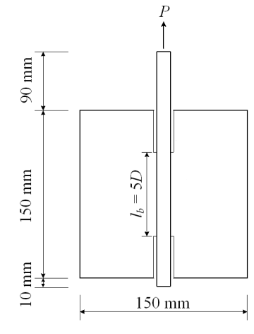
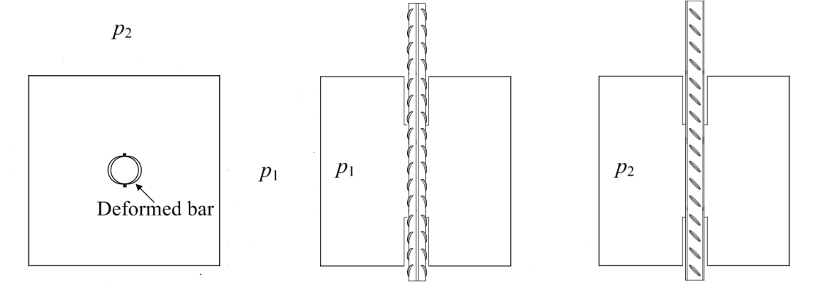

Fig. 1 Pull-out specimen and loading conditions of the specimens

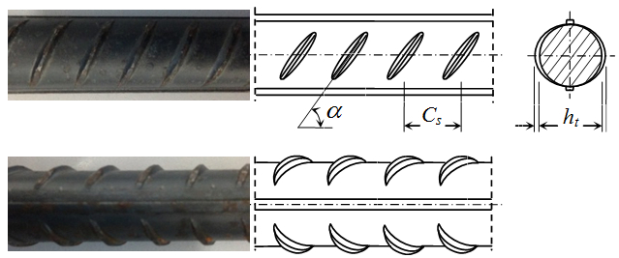
Fig. 2 Geometric parameters of deformed bar

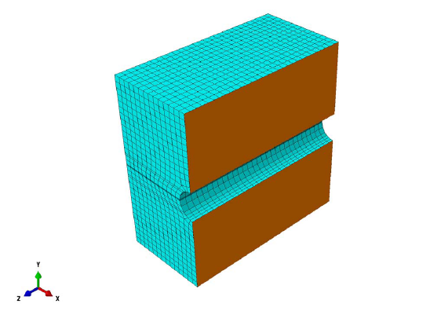
(a) The outer concrete elements (Solid elements)
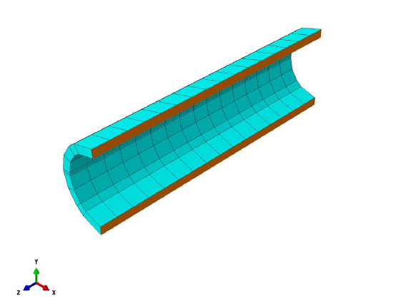
(b) The outer concrete elements of reinforcement ribs in bonding areas (Solid elements)
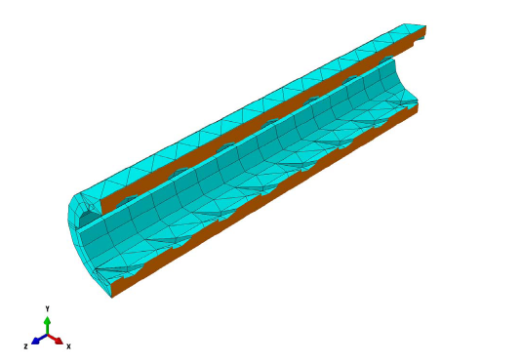
(c) The concrete elements contacting the reinforcement ribs in bonding areas (Solid elements)
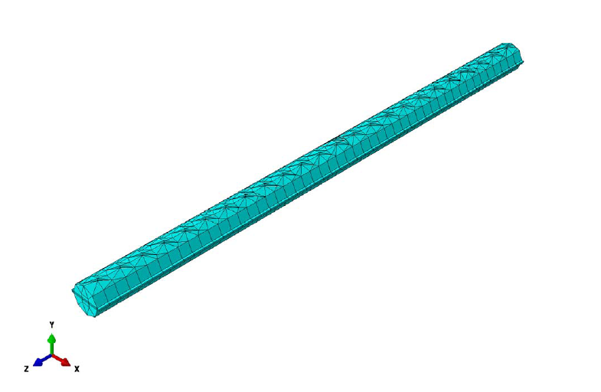
(d)The steel elements (Solid elements)
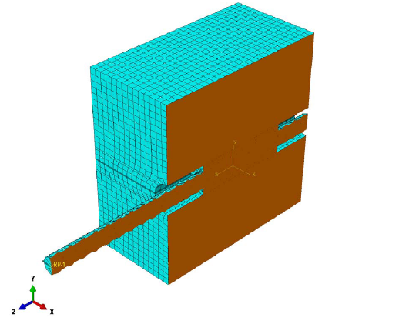
(e) combination of components
Fig. 3 Details of meshed model

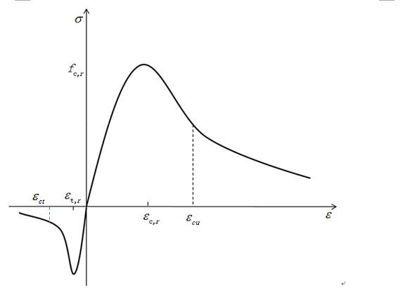
Fig. 4 the curve of stress-strain by uniaxial tension and compression of concrete
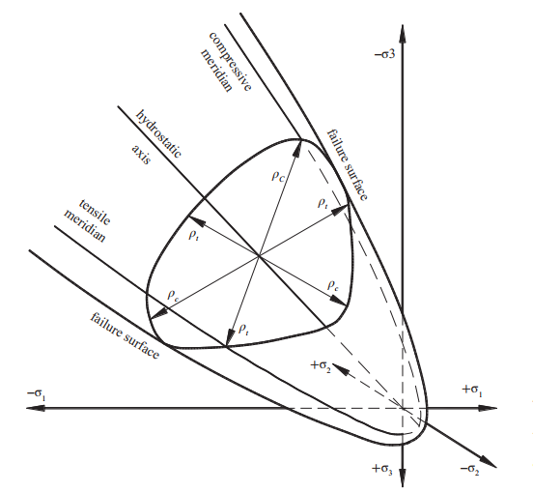
Fig. 5 Schematic representation of the failure surfaces in the principal stress space
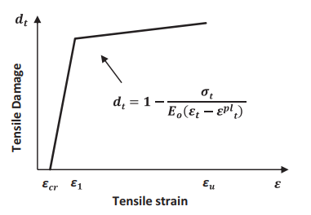
Fig. 6 Tensile damage parameter–strain relationship for concrete.
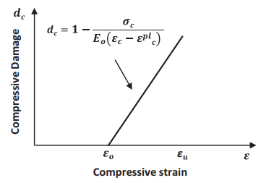
Fig. 7 Compressive damage parameter–strain relationship for concrete (simplified in linear form)
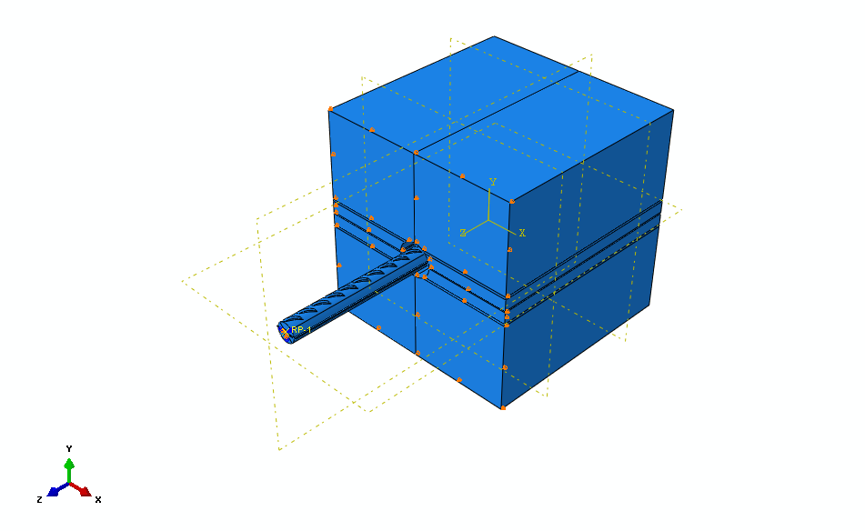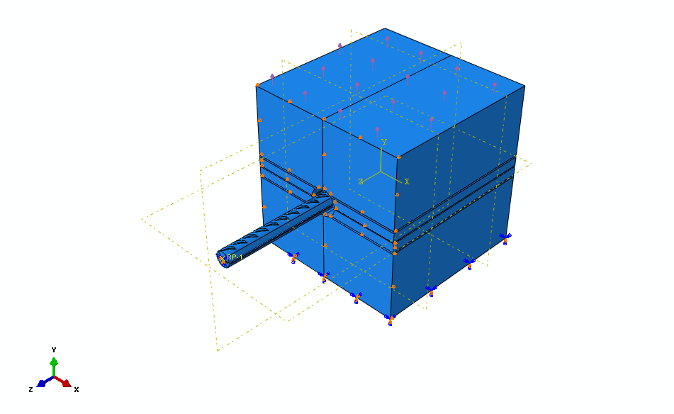
(a) without lateral tension (b) under uniaxial lateral tension
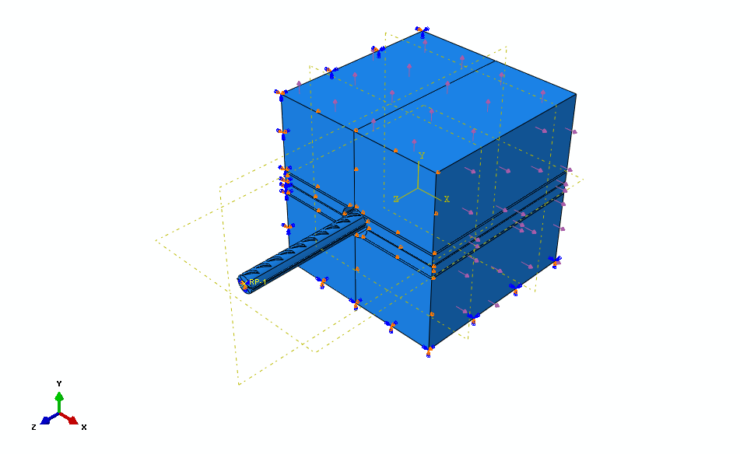
(c) under biaxial lateral tension
Fig. 8 The load and boundary conditions of the specimens that were used for the simulations
(a) Specimen D16C40 (b) Specimen D22C25
(c)Specimen D22C40
Fig. 9 Bond stress-slip curves for different values of dilation angle when no lateral tension
(a) Specimen D16C40 (b) Specimen D22C25
(c) Specimen D22C40
Fig. 10 Bond stress-slip curves for different shapes of the yield surface.

(a) Specimen D16C40 (b) Specimen D22C25
(c) Specimen D22C40
Fig. 11 Bond stress-slip curves for different viscosity parameter.

Fig. 12 The maximum strain contour of specimen D16C40 without lateral tension

(a) p₁=0f_{t}, p₂=0.2f_{t} (b) p₁=0f_{t}, p₂=0.4f_{t}
(c) p₁=0f_{t}, p₂=0.6f_{t}
Fig. 13 The maximum strain contour of specimens D16C40 under: p₁/p₂=0;

(a) p₁=0.2f_{t}, p₂=0f_{t} (b) p₁=0.4f_{t}, p₂=0f_{t}
(c) p₁=0.6f_{t}, p₂=0f_{t}
Fig. 14 The maximum strain contour of specimens D16C40 under: p₂/p₁=0;

(a) p₁=0.2f_{t}, p₂=0.2f_{t} (b) p₁=0.4f_{t}, p₂=0.4f_{t}
(c) p₁=0.6f_{t}, p₂=0.6f_{t}

Fig. 15 The maximum strain contour of specimens D16C40 under: p₂/p₁=1;

Fig. 16 The maximum strain contour of specimens D16C40 under: p₁/p₂=2;

Fig. 17 The maximum strain contour of specimens D16C40 under: p₂/p₁=2;

Fig. 18 The maximum strain contour of specimens D16C40 under: p₂/p₁=3;

Fig. 19 The maximum strain contour of specimens D22C40 under: p₁=p₂=0;

(a) p₁=0f_{t}, p₂=0.2f_{t} (b) p₁=0f_{t}, p₂=0.4f_{t}
(c) p₁=0f_{t}, p₂=0.6f_{t}
Fig. 20 The maximum strain contour of specimens D22C40 under: p₁/p₂=0;

(a) p₁=0.2f_{t}, p₂=0f_{t} (b) p₁=0.4f_{t}, p₂=0f_{t}

(c) p₁=0.6f_{t}, p₂=0f_{t}
Fig. 21 The maximum strain contour of specimens D22C40 under: p₂/p₁=0;

(a) p₁=0.2f_{t}, p₂=0.2f_{t} (b) p₁=0.4f_{t}, p₂=0.4f_{t}
(c) p₁=0.6f_{t}, p₂=0.6f_{t}
Fig. 22 The maximum strain contour of specimens D22C40 under: p₁/p₂=1;

Fig. 23 The maximum strain contour of specimens D22C40 under: p₁/p₂=2;

Fig. 24 The maximum strain contour of specimens D22C40 under: p₂/p₁=2;

Fig. 25 The maximum strain contour of specimens D22C25 under: p₁=p₂=0;

(a) p₁=0f_{t}, p₂=0.2f_{t} (b) p₁=0f_{t}, p₂=0.4f_{t}

(c) p₁=0f_{t}, p₂=0.6f_{t}
Fig. 26 The maximum strain contour of specimens D22C25 under: p₁/p₂=0;

(a) p₁=0.2f_{t}, p₂=0.2f_{t} (a) p₁=0.4f_{t}, p₂=0.4f_{t}
(c) p₁=0.6f_{t}, p₂=0.6f_{t}
Fig. 27 The maximum strain contour of specimens D22C25 under: p₁/p₂=1;
Fig. 28 Bond stress-slip curve for specimens D16C40 without lateral tension
(a) under: p₁/p₂=0 (b) under: p₂/p₁=0
Fig. 29 Bond stress-slip curve for specimens D16C40 under uniaxial lateral tensions
(a) under p₁/p₂=1 (b) under p₁/p₂=2
(c) under p₂/p₁=2 (d) under p₂/p₁=3
Fig. 30 Bond stress-slip curve for specimens D16C40 under biaxial tensions
Fig. 31 Bond stress-slip curve for specimens D22C40 without lateral tension
(a) under: p₁/p₂=0; (b) under: p₂/p₁=0;
Fig. 32 Bond stress-slip curve for specimens D22C40 under uniaxial lateral tensions
(a) under: p₁/p₂=1; (b) under: p₁/p₂=2;
(c) under p₂/p₁=2 (d) under p₁/p₂=3
(e) under p₂/p₁=3
Fig. 33 Bond stress-slip curve for specimens D22C40 under biaxial tensions
Fig. 34 Bond stress-slip curve for specimens D22C25 without lateral tension
Fig. 35 Bond stress-slip curve for specimens D22C25 under uniaxial lateral tensions
Fig. 36 Bond stress-slip curve for specimens D22C25 under biaxial tensions

