Effect of novel superabsorbent polymer composites on the fresh and hardened properties of alkali-activated slag

Chuanqing Fu¹, Hailong Ye^{2, *}, Aoke Lei¹, Guojun Yang¹, Pan Wan¹
¹College of Civil Engineering and Architecture, Zhejiang University of Technology, Hangzhou, China
²Department of Civil Engineering, The University of Hong Kong, Pokfulam, Hong Kong, China
* corresponding author, Email: hlye@hku.hk

Abstract: In this work, the poly(sodium-acrylate acrylamide) superabsorbent polymer (SAP) composites reinforced with micro silica and kaolin clay particles are evaluated as novel additives to control and improve the fresh and hardened properties of alkali-activated slag (AAS). The water swelling and retention capacity of plain and modified SAPs in various solutions pertinent to AAS binder systems (including deionized water, saturated Ca(OH)₂, 1.0 M NaOH, 0.5 M Na₂CO₃, and 0.5 M Na₂SO₄) are studied using the gravimetric ‘tea bag’ and thermogravimetric methods, together with molecular analysis. The results show that the use of micro silica and kaolin clay-reinforced SAP composites slightly alleviates the negative influence of conventional SAP counterparts on the flowability, setting, and early-age compressive strength of AAS pastes. Nevertheless, the addition of SAP composites merely postpones the early-stage drying shrinkage development but tends to increase the long-term deformation of hardened AAS in unsealed conditions, likely due to the reduced bulk stiffness with enlarged porosity.

Keywords: Low-carbon cement; Alkali-activated slag; Superabsorbent polymer; Fresh properties; Drying shrinkage

1. Introduction
The continuous increase of greenhouse gas emissions has brought enormous challenges to the cement industry, and it is imperative to develop sustainable alternative cementitious binders [1–4]. A number of low-carbon cement have been successfully developed and commercialized in recent decades, including the alkali-activated binders. The alkali-activated binders are commonly prepared by reacting aluminosilicate precursors (e.g., ground granulated blast-furnace slag, coal fly ash, calcined clays) with an alkaline activator (e.g., NaOH solution). The use of those industrial byproducts or natural pozzolans instead of ordinary Portland cement (OPC) clinkers reduces the CO₂ emissions of concrete products by up to 80% [5–7].

Alkali-activated slag (AAS) has a number of superior physicochemical properties over OPC-counterparts, including rapid strength development, low water and ionic permeability, and strong high-temperature and chemical resistance [4,8–13]. These remarkable properties make AAS concrete a viable and even occasionally preferred construction material in some specific application conditions, including sewerage and refractory structures. However, the poor volumetric stability and vulnerability of AAS concrete to early-age cracking have raised serious concerns regarding its practical application in the industry [14–17]. In order to control the shrinkage and cracking of AAS concrete, a number of mitigation strategies have been proposed, including adding shrinkage-reducing admixture and mineral expansive (e.g., sulfate-enriched) additives, high-temperature steam curing, and internal curing [18–22].

Internal curing is a process, in which saturated porous inclusions (e.g., lightweight aggregate, superabsorbent polymer) are added to concrete during mixing [23–26]. As concrete undergoes self-desiccation after setting, these internal moisture reservoirs can preferentially lose water (due to larger pore size) to keep the reacting paste saturated. Existing studies suggested that internal curing using superabsorbent polymers (SAP) can completely mitigate the autogenous shrinkage of AAS mixtures, but have little influence on the drying shrinkage [27–30]. In addition, the use of SAP affects many other fresh and hardened properties of AAS, including flowability, setting time, compressive strength, porosity, as well as shrinkage and cracking tendencies. However, most previous studies used the commercial SAP products (e.g., copolymer of acrylamide-sodium acrylate or cross-linked acrylate copolymer types) and did not link the composition and molecular structure of SAP to its effects on the properties of AAS.

The objectives of this study are to develop a new type of poly(sodium-acrylate acrylamide) SAP composites reinforced by micro silica and kaolin clay particles, and to investigate their influence on the fresh and hardened properties of AAS pastes. The research hypothesis behind this study is that the inclusion of reactive micro-silica and kaolin clay in the molecular structure of SAP can reduce or even eliminate the negative influence of conventional SAP on the properties of AAS. Towards this goal, the water swelling and retention capacity of the developed SAP composites are studied. Furthermore, the effect of novel SAP composites on the properties of NaOH-activated slag pastes, including flowability, setting time, early-age compressive strength, dry shrinkage, and pore structure, is investigated. The outcomes of this work provide important technical support for the engineering application of innovative SAP composites on alkali-activated concrete systems.

2. Materials and Methods
2.1 Raw materials for SAP synthesis
The chemical reagents used for the synthesis of poly(sodium-acrylate acrylamide) SAP composites in this study are all at the analytical grade. The acrylic acid (AA), acrylamide (AM), sodium pyrosulfite (Initiator), sodium persulfate (Initiator), and calcium hydroxide (Ca(OH)₂) were supplied by the Aladdin Biochemical Technology, Co., Ltd., China. The N-N’-methylenebisacrylamide (MBAM, Crosslinker) was from the Energy Chemical Technology, Co., Ltd., China. The deionized water (DI) prepared by Milli-Q 18.2 ΩM was used for the solution preparation. The median particle size of micro silica (micro-SiO₂) and kaolin clay powders are about 1 μm and 2 μm, respectively. The oxide composition of kaolin clay is listed in Table 1. The solid materials were dried at 105 °C for 24h prior to use.

2.2 Synthesis procedure of SAP composites
The poly(sodium-acrylate acrylamide) SAP composites reinforced with 0%, 5%, 10%, or 15% micro-SiO₂ or kaolin clay particles are prepared. The reference SAP (with 0% micro-SiO₂ or kaolin clay) was chosen based on the preliminary study which has the highest water swelling capacity with an optimum AM-to-AA ratio of ½ g/ml [24]. The proportions of raw materials for the SAP composites is listed in Table 2 and the synthesis procedure follows that described in [31]. At room temperature, the AA, NaOH solution, and DI water were added to the vials; upon being neutralized by hydroxide and carboxyl groups on the AA to form sodium acrylate, the solution was allowed to thermally equilibrate to room temperature. Then, the AM, MBAM, and micro-SiO₂ or kaolin clay were successively added into the vials, and the solution was thoroughly stirred until the solute was uniformly dispersed. Both initiators were added to the vials concurrently and stirred vigorously until they were too viscous to stir. The vials were placed in a water bath at 50 °C for 8h to guarantee the gelation occurrence. After the completion of the reaction, the polymer was taken out and washed with DI water for 24h, then oven-dried at 100 °C for 12h. The resulting product was taken out and washed several times with DI water, cut, and dried in a vacuum drying oven at 100 °C until a constant weight was obtained. Afterwards, all SAPs were pulverized and screened through a 200-mesh sieve.

2.3 SAP characterization
2.3.1 Molecular analysis
The synthetic SAP composites are characterized using scanning electron microscopy (SEM) and Fourier transform infrared spectrometer (FTIR). The FEI Quanta FEG650 field emission environmental scanning electron microscope was used to examine the morphology and particle size of the developed micro-SiO₂ or kaolin clay-reinforced SAP composites. The molecular structure of dry SAP samples was analyzed by using a Thermo Nicolet 6700 FTIR spectrometer at a resolution of 1 cm⁻¹ over the range from 4000 to 500 cm⁻¹.

2.3.2 Swelling and water retention capacity
The SAP samples were evaluated for the water swelling capacity in five different solutions, including DI water, saturated calcium hydroxide (Ca(OH)₂), 1.0 M sodium hydroxide (NaOH), 0.5 M sodium carbonate (Na₂CO₃), and 0.5 M sodium sulfate (Na₂SO₄) solutions. Following the gravimetric ‘tea bag’ method, a total of 0.2 g dry SAP samples were weighed and transferred to a prewetted tea bag. The bag was immersed in solutions and was taken out after 30s, 1, 3, 5, 10, 15, 30, 60, 120, 240 min. The mass was measured until the teabag’s surface did not flow out of unabsorbed solution. As such, the water swelling ratio, Q (g/g), was calculated according to the following equation [24]:

$Q=\frac{m-m_{d}-m_{w}}{m_{d}}$ (1)
In which, m(g) is the final weight, $m_{d}$(g) is the weight of the dry SAP samples, and $m_{w}$(g) is the initial prewetted tea bag mass.

The water retention capacity of water-saturated SAP was measured using the PerkinElmer 400 thermogravimetric analyzer (TGA), in which about 30 mg of SAP samples were taken out in DI water after 6h immersion and were heated within a temperature range of 25°C-150°C at a rate of 3°C/min.

2.4 Mixture proportion of alkali-activated slag
The mixture proportion of alkali-activated slag (AAS) pastes containing SAP is listed in Table 3. Two dosages of SAP at 2.5% or 5% mass ratio w.r.t. slag (denoted as LH1 to HH3) were adopted. The compositional and mineralogical analysis of the ground granulated blast-furnace slag (SG) is shown in Table 1 and Figure 1, respectively. According to the water swelling ratio of SAP in NaOH solution, the internal curing water of 15g/g in SAP S0, SK5, and SS5 were used. All mixtures had the same (activating) water-to-binder (w/b) ratio of 0.34. Dry SAP powder was added to slag and stirred for 5 minutes to improve dispersibility, before pouring the activating solution in the mixer.

2.5 Fresh properties
The flow diameters of AAS pastes were measured using the flow table test as per ASTM C1437. The initial and final setting time of AAS pastes were measured using the Vicat needle as per ASTM C191.

2.6 Hardened properties
The compressive strength of AAS pastes was measured on 40.0 mm cubic specimens after sealed curing in a standard moist curing room (100% relative humidity and 20 ± 0.5 °C) for 1d, 3d, 7d, and 28d. The drying shrinkage of AAS was assessed using non-standardized prism specimens with a dimension of 12.7 mm × 12.7 mm × 127.0 mm [16]. All specimens were cured in a moist room for 24h before demolding and then placed in two environmental chambers with relative humidity (RH) conditions prepared using saturated salt solutions according to ASTM E104-02, including (i) 43% RH and 20 °C ± 0.5 °C; (ii) 75% RH and 20 °C ± 0.5 °C. The length and mass changes of specimens were measured periodically using a balance with a measuring precision of 0.01 mg and digital comparator with a measuring precision of 0.01 mm. To consider the variability and measurement errors, at least three replicates were measured for each mixture. The autogenous shrinkage of SAP-cured AAS samples was not measured in this study, since there are already many studies on this topic in the literature [27–29,32].

The porosity and pore size distribution of hardened AAS paste samples were analyzed using Micromeritics AutoPore IV 9500 mercury intrusion porosimetry (MIP). The 28d paste samples after sealed curing were segmented into slices, immersed in isopropyl alcohol for 2d to stop the reaction, and then vacuum dried for 3d. The pressure was injected up to 414 MPa, which is capable of acquiring the size of pore diameters down to around 3 nm [33,34].

3. Results and Discussion
3.1 Molecular analysis of SAP composites
Figure 2 shows the SEM images of a random powder sample of SAP S0, SK5, and SS5. Due to the large surface area and wet environment, the SAP absorbed water rapidly in the air. Nevertheless, it is noticeable that SAP particles are regular and mostly round without a large size variation. There is little difference in the morphology and size of these three types of SAP.

Figure 3 shows the FTIR spectra of micro-SiO₂, kaolin clay, and the plain and modified SAP samples. In the plain SAP, the peak at 3423.6 cm⁻¹ corresponding to the N-H stretching in acrylamide unit, the peak at 2943.2 cm⁻¹ corresponding to the -CH- stretching in acrylic acid unit, the peak at 1675.9 cm⁻¹ corresponding to the C=O stretching in acrylamide unit, the peak at 1453.6 cm⁻¹ corresponding to the C-N stretching, and the peak at 1406.3 cm-1 and 1560.4 cm⁻¹ corresponding to the stretching vibration in -COO- in carboxylate, can be identified [24,35,36]. The -OH stretching of kaolin clay in the range of 3600-3700 cm⁻¹ disappears after being incorporated into the SAP composites, and the absorption band at 1031.6 cm⁻¹ and 1108.4 cm⁻¹ ascribed to Si-O is weakened. It suggests that the -OH groups of kaolin clay could react with AM and bond to the polymer chains to form the graft copolymerization without disruption of aluminosilicate network of kaolin clay [35]. In addition, the micro-SiO₂ reinforced SAP composite shows clear hump at around 1115.1 cm⁻¹ which indicates the enhancement of Si-O bonds.

3.2 Swelling and water retention behavior of SAP composites
Figure 4 shows the time-dependent swelling capacity, Q, of plain and modified SAP composites in five different solutions. The swelling capacity of reference SAP S0 is similar to that reported in the previous study [24], with the maximum Q value of about 65 g/g achieved within 15 min in DI water; while in the saturated Ca(OH)₂ solution, the Q value decreases after increasing to reach the swelling equilibrium. The results show that the Q value of SAPs in DI water follows the trend: Q(SK15) < Q(SK10) < Q(SK5) < Q(SS5) < Q(S0), which implies that the equilibrium swelling ratio decreases as the incorporation concentration of micro-SiO₂ and kaolin clay increases, probably due to the dilution effect. In addition, the Q value of SS is slightly larger than that of SK under the same level of inclusion concentration.

The presence of ions in solution leads to an increase of network crosslink density inside the polymer, resulting in a significant reduction in Q value of SAP in salt solutions; at the same time, the Q value of SAP decreases with the increase of ionic strength [37]. By comparing the swelling behaviors of SAP immersed in the same Na⁺ ionic strength solutions, it is observed that the type of anions (OH⁻, CO₃²⁻ and SO₄²⁻) in solutions has little effect on the water swelling capacity of SAP. Considering that the water adsorption capacity of S0, SK5, and SS5 in static solution may be different from the required internal curing water, the dosage required of extra water was chosen at 15g/g on AAS paste mixtures.

Figure 5 shows the water retention capacity of water-saturated SAP. It shows that the water retention capacity of micro-SiO₂ and kaolin clay-reinforced SAP composite (SK5 and SS5) is better than that of S0. Among them, the S0 has the fastest water loss rate while SS5 has the slowest water loss rate. At 75 °C, the water retention capacity of SK5 and SS5 is 48.1% and 61.4%, respectively, while S0 is merely 26.6%. More importantly, at 100 °C the water retention capacity of SAP SS5 still maintains at 7.1%. In addition, the micro-SiO₂ reinforced SAP has a better water retention capacity than kaolin clay-reinforced counterparts.

3.3 Flowability and setting time
Figure 6 shows the spread diameter of AAS paste containing SAP. The results show that the spread diameter decreases from 227 mm to 220 mm as the SAP dosage increases from 0.25% to 0.5%. The AAS containing S0 has the largest decrease, while the AAS containing SK5 has the least decrease in fluidity. Under the same extra water condition, this difference may be attributed to the change in the water swelling behaviors and molecular structure of SAP composites due to micro-SiO₂ and kaolin clay inclusion. This finding suggests the possibility of controlling the fluidity of AAS by tailoring the composition and molecular structure of SAP composites.

Figure 7 shows the initial and final setting time of AAS pastes. There is a conspicuous trend that all AAS pastes show about 10%-40% longer setting time than the REF, regardless of S0, SK5, or SS5 addition. The REF mix achieves the lowest initial and final setting time of 26 min and 41 min; while the HH1 has the highest initial and final setting time of 37 min and 59 min. The addition of SAP delays the chemical reaction in pastes due to the formation of swollen SAP with internal curing water and further postpones the reaction by diluting the alkaline solutions. Nevertheless, the incorporation of reactive micro-SiO₂ and kaolin clay alleviates this negative influence of SAP in AAS.

3.4 Compressive strength
Figure 8 shows the early-age compressive strength development of AAS pastes within 28d. It shows that the addition of SAP reduces the compressive strength of AAS at all ages. The strength loss of SAP-cured AAS at 28d varies from 17%-30%. As reported in the previous studies [28,29], the presence of swollen SAP results in formation of air voids, which impairs the strength development. Another possible reason responsible for the strength reduction in SAP-cured AAS is due to the dilution of alkalis in pore solution that lowers pH and slows down slag dissolution. As the amount of SAP addition increases, the strength loss increases, but it does not appear to be linear. Figure 9 shows the pore size distribution and cumulative pore size distribution of REF, LH1, and HH1 pastes at 28d. With the addition of SAP, the volume fraction of pores increases, but the distribution of pore size was similar. At a low SAP addition dosage (2.5%), the use of micro-SiO₂ and kaolin clay-reinforced SAP composite tends to alleviate the strength reduction of AAS by around 5%, in comparison to plain SAP. However, at a high addition dosage (5%), the difference among different SAP in AAS is marginal.

3.5 Drying shrinkage
Figures 10 and 11 show the time-dependent length and mass changes of hardened AAS paste specimens, and the shrinkage-mass change relationship. In comparison to the reference sample, the addition of SAP decreases the drying shrinkage of AAS at early stages. For instance, upon exposure to 43% RH, the addition of SAP reduces the shrinkage magnitude of AAS by 10%-50% before 21d. However, after 21d, there is a noticeable increase in the drying shrinkage of the SAP-cured samples. The addition of 0.25 % and 0.5 % SAP increases the drying shrinkage of AAS pastes at 49d to 70d by about 10% and 20%, respectively. In addition, there is no significant improvement in the shrinkage mitigation of AAS by using the micro-SiO₂ and kaolin clay-reinforced SAP composites.

According to the basic principle of capillary pressure theory, under a given drying RH, the amount of moisture loss in AAS is mainly controlled by the Kelvin radius and pore size distribution [38,39]. The Kelvin radius, which is the radius of the meniscus in capillary pores, is mainly influenced by the water activity of pore solution and RH. As all AAS specimens with various SAP incorporation were dried under the same RH, the Kelvin radius is similar among different systems. Therefore, the pore structure of AAS is a decisive factor affecting the early-age drying shrinkage behaviors. The analysis of pore size distribution in Figure 9 indicates that mass loss is considerably increased in AAS with an increasing SAP dosage since the moisture from the SAP-created void and pores is preferably lost under the same drying RH [39]. As such, there is a postponement of internal RH decrease by the water released from swollen SAP, which slightly mitigates the drying shrinkage of pastes at early stages. However, at later stages, the drying shrinkage deformation occurs in AAS dominantly due to viscoelastic/viscoplastic deformation of porous solids [16,40], which is unaffected by the presence of SAPs. Instead, the created voids and pores due to the SAP incorporation soften the bulk stiffness the AAS solids and therefore enlarge the long-term deformation. This finding may suggest that SAP is merely effective in controlling the shrinkage of AAS materials in which autogenous shrinkage is the dominant component.

Conclusions
In this paper, the effects of poly(sodium-acrylate acrylamide) superabsorbent polymer (SAP) composites on the fresh and hardened properties of alkali-activated slag pastes are investigated. The novel SAP composites modified by micro-SO₂ and kaolin clay particles are designed, synthesized, and characterized. Based on the experimental results, the following conclusions can be drawn:

(1) In comparison to plain SAP, the water retention capacity of SAP composites reinforced with micro-SiO₂ and kaolin clay can be improved; however, the water swelling capacity of SAP composites is reduced with micro-SiO₂ and kaolin clay inclusion, likely due to the dilution effect. The anionic type (OH⁻, CO₃²⁻ and SO₄²⁻) in the immersion solution has little influence on the water swelling behavior of SAP composites under the same level of cation concentration.

(2) The addition of conventional SAP reduces the flowability, increases the initial and final setting time, and decreases the compressive strength of AAS pastes. The range of compressive strength reduction lies between 17% and 32% at 28 days in AAS with increasing SAP dosage from 0. 25% to 5%. The use of SAP composites reinforced with micro-SiO₂ and kaolin clay can slightly mitigate the negative influence of conventional SAP on the fresh and hardened properties of AAS. This opens the opportunities of tailoring the molecular and composition of SAP composites for properties control of alkali-activated concrete systems.

(3) The incorporation of SAP composites tends to decrease the drying shrinkage magnitude of AAS pastes at early stages; however, the drying shrinkage of SAP-cured AAS is gradually larger than that of reference sample at the late stage. This is likely attributable to the reduced bulk stiffness of SAP-cured AAS due to porosity enlargement. The SAP composite behaves similarly in term of drying shrinkage mitigation in comparison to plain SAP in AAS systems.

Acknowledgments
The authors would like to thank the financial support from the National Natural Science Foundation of China (Project number: 51678529, 51978620, 51808475) and The University of Hong Kong. Any opinions, findings and conclusions or recommendations expressed in this material are those of the authors and do not necessarily reflect the views of the sponsors.

References
[1] A. Bouaissi, L. Li, M.M. Al Bakri Abdullah, Q.-B. Bui, Mechanical properties and microstructure analysis of FA-GGBS-HMNS based geopolymer concrete, Constr. Build. Mater. 210 (2019) 198–209. doi:10.1016/J.CONBUILDMAT.2019.03.202.
[2] M.B. Ali, R. Saidur, M.S. Hossain, A review on emission analysis in cement industries, Renew. Sustain. Energy Rev. 15 (2011) 2252–2261. doi:10.1016/J.RSER.2011.02.014.
[3] F. Pacheco-Torgal, Introduction to nanotechnology in eco-efficient construction, Nanotechnol. Eco-Efficient Constr. (2019) 1–9. doi:10.1016/B978-0-08-102641-0.00001-3.
[4] M.C.G. Juenger, F. Winnefeld, J.L. Provis, J.H. Ideker, Advances in alternative cementitious binders, Cem. Concr. Res. 41 (2011) 1232–1243.
[5] E. Crossin, The greenhouse gas implications of using ground granulated blast furnace slag as a cement substitute, J. Clean. Prod. 95 (2015) 101–108. doi:10.1016/J.JCLEPRO.2015.02.082.
[6] K.-H. Yang, J.-K. Song, K.-I. Song, Assessment of CO2 reduction of alkali-activated concrete, J. Clean. Prod. 39 (2013) 265–272. doi:10.1016/J.JCLEPRO.2012.08.001.
[7] R.J. Thomas, H. Ye, A. Radlinska, S. Peethamparan, Alkali-Activated Slag Cement Concrete, Concr. Int. (2016) 33–38.
[8] T. Bakharev, J.. Sanjayan, Y.-B. Cheng, Resistance of alkali-activated slag concrete to acid attack, Cem. Concr. Res. 33 (2003) 1607–1611. doi:10.1016/S0008-8846(03)00125-X.
[9] H. Ye, C. Fu, G. Yang, Influence of dolomite on the properties and microstructure of alkali-activated slag with and without pulverized fly ash, Cem. Concr. Compos. 103 (2019) 224–232. doi:https://doi.org/10.1016/j.cemconcomp.2019.05.011.
[10] H. Ye, L. Huang, Z. Chen, Influence of activator composition on the chloride binding capacity of alkali-activated slag, Cem. Concr. Compos. 104 (2019) 103368. doi:10.1016/J.CEMCONCOMP.2019.103368.
[11] Y. Zhang, X. Wan, D. Hou, T. Zhao, Y. Cui, The effect of mechanical load on transport property and pore structure of alkali-activated slag concrete, Constr. Build. Mater. 189 (2018) 397–408.
[12] J. Yang, D. Hou, Q. Ding, Structure, dynamics, and mechanical properties of cross-linked calcium aluminosilicate hydrate: A molecular dynamics study, ACS Sustain. Chem. Eng. 6 (2018) 9403–9417.
[13] H. Ye, Z. Chen, L. Huang, Mechanism of sulfate attack on alkali-activated slag: The role of activator composition, Cem. Concr. Res. 125 (2019) 105868. doi:https://doi.org/10.1016/j.cemconres.2019.105868.
[14] M. Mastali, P. Kinnunen, A. Dalvand, R. Mohammadi Firouz, M. Illikainen, Drying shrinkage in alkali-activated binders – A critical review, Constr. Build. Mater. 190 (2018) 533–550. doi:10.1016/j.conbuildmat.2018.09.125.
[15] A.A. Melo Neto, M.A. Cincotto, W. Repette, Drying and autogenous shrinkage of pastes and mortars with activated slag cement, Cem. Concr. Res. 38 (2008) 565–574. doi:10.1016/J.CEMCONRES.2007.11.002.
[16] H. Ye, C. Cartwright, F. Rajabipour, A. Radlińska, Understanding the drying shrinkage performance of alkali-activated slag mortars, Cem. Concr. Compos. 76 (2017) 13–24.
[17] H. Ye, Mechanisms and Mitigation of Shrinkage in Alkali-activated Slag, Pennsylvania State University, 2016.
[18] L. Kalina, V. Bílek, E. Bartoníčková, J. Krouská, Polypropylene glycols as effective shrinkage-reducing admixtures in alkali-activated materials, ACI Mater. J. 115 (2018) 251–256. doi:10.14359/51701099.
[19] C. Bilim, O. Karahan, C.D. Atiş, S. İlkentapar, Influence of admixtures on the properties of alkali-activated slag mortars subjected to different curing conditions, Mater. Des. 44 (2013) 540–547. doi:10.1016/J.MATDES.2012.08.049.
[20] M. Palacios, F. Puertas, Effect of superplasticizer and shrinkage-reducing admixtures on alkali-activated slag pastes and mortars, Cem. Concr. Res. 35 (2005) 1358–1367. doi:10.1016/j.cemconres.2004.10.014.
[21] M. Palacios, F. Puertas, Effect of shrinkage-reducing admixtures on the properties of alkali-activated slag mortars and pastes, Cem. Concr. Res. 37 (2007) 691–702. doi:10.1016/j.cemconres.2006.11.021.
[22] F. Collins, J.G. Sanjayan, Effect of pore size distribution on drying shrinkage of alkali-activated slag concrete, Cem. Concr. Res. 30 (2000) 1401–1406. doi:10.1016/S0008-8846(00)00327-6.
[23] M. Wyrzykowski, S.I. Igarashi, P. Lura, V. Mechtcherine, Recommendation of RILEM TC 260-RSC: using superabsorbent polymers (SAP) to mitigate autogenous shrinkage, Mater. Struct. Constr. 51 (2018). doi:10.1617/s11527-018-1241-9.
[24] M.J. Krafcik, K.A. Erk, Characterization of superabsorbent poly(sodium-acrylate acrylamide) hydrogels and influence of chemical structure on internally cured mortar, Mater. Struct. Constr. 49 (2016) 4765–4778. doi:10.1617/s11527-016-0823-7.
[25] V. Mechtcherine, M. Gorges, C. Schroefl, A. Assmann, W. Brameshuber, A.B. Ribeiro, D. Cusson, J. Custódio, E.F. Da Silva, K. Ichimiya, S.I. Igarashi, A. Klemm, K. Kovler, A.N. De Mendonça Lopes, P. Lura, V.T. Nguyen, H.W. Reinhardt, R.D.T. Filho, J. Weiss, M. Wyrzykowski, G. Ye, S. Zhutovsky, Effect of internal curing by using superabsorbent polymers (SAP) on autogenous shrinkage and other properties of a high-performance fine-grained concrete: Results of a RILEM round-robin test, Mater. Struct. Constr. 47 (2014) 541–562. doi:10.1617/s11527-013-0078-5.
[26] D.P. Bentz, S.Z. Jones, M.A. Peltz, P.E. Stutzman, Influence of Internal Curing on Properties and Performance of Cement-Based Repair Materials, (n.d.).
[27] A.R. Sakulich, D.P. Bentz, Mitigation of autogenous shrinkage in alkali activated slag mortars by internal curing, Mater. Struct. 46 (2013) 1355–1367.
[28] W. Tu, Y. Zhu, G. Fang, X. Wang, M. Zhang, Internal curing of alkali-activated fly ash-slag pastes using superabsorbent polymer, Cem. Concr. Res. 116 (2019) 179–190. doi:10.1016/j.cemconres.2018.11.018.
[29] S. Oh, Y.C. Choi, Superabsorbent polymers as internal curing agents in alkali activated slag mortars, Constr. Build. Mater. 159 (2018) 1–8. doi:10.1016/j.conbuildmat.2017.10.121.
[30] P. Chen, J. Wang, L. Wang, Y. Xu, Perforated cenospheres: A reactive internal curing agent for alkali activated slag mortars, Cem. Concr. Compos. (2019) 103351.
[31] Q. Zhu, C.W. Barney, K.A. Erk, Effect of ionic crosslinking on the swelling and mechanical response of model superabsorbent polymer hydrogels for internally cured concrete, Mater. Struct. Constr. 48 (2015) 2261–2276. doi:10.1617/s11527-014-0308-5.
[32] C. Song, Y.C. Choi, S. Choi, Effect of internal curing by superabsorbent polymers–internal relative humidity and autogenous shrinkage of alkali-activated slag mortars, Constr. Build. Mater. 123 (2016) 198–206.
[33] K.K. Aligizaki, Pore structure of cement-based materials: testing, interpretation and requirements, CRC Press, 2014.
[34] E.W. Washburn, The dynamics of capillary flow, Phys. Rev. 17 (1921) 273.
[35] W.M. Cheng, X.M. Hu, Y.Y. Zhao, M.Y. Wu, Z.X. Hu, X.T. Yu, Preparation and swelling properties of poly(acrylic acid-co-acrylamide) composite hydrogels, E-Polymers. 17 (2017) 95–106. doi:10.1515/epoly-2016-0250.
[36] A.S.G. Magalhães, M.P. Almeida Neto, M.N. Bezerra, N.M.P.S. Ricardo, J. Feitosa, Application of FTIR in the determination of acrylate content in poly (sodium acrylate-co-acrylamide) superabsorbent hydrogels, Quim. Nova. 35 (2012) 1464–1467.
[37] A. Li, A. Wang, Synthesis and properties of clay-based superabsorbent composite, Eur. Polym. J. 41 (2005) 1630–1637. doi:10.1016/j.eurpolymj.2005.01.028.
[38] H. Ye, A. Radlińska, A Review and Comparative Study of Existing Shrinkage Prediction Models for Portland and Non-Portland Cementitious Materials, Adv. Mater. Sci. Eng. 2016 (2016) 10–14.
[39] A. Radlinska, F. Rajabipour, B. Bucher, R. Henkensiefken, G. Sant, J. Weiss, Shrinkage mitigation strategies in cementitious systems: A closer look at differences in sealed and unsealed behavior, Transp. Res. Rec. 2070 (2008) 59–67.
[40] H. Ye, A. Radlińska, Shrinkage mitigation strategies in alkali-activated slag, Cem. Concr. Res. (2017).

Table 1 Oxide composition of ground granulated blast-furnace slag and kaolin clay.
Items | Results
Composition (Mass %) | Slag | Kaolin clay
SiO₂ | 37.44 | 48.8
CaO | 36.0 | 0.1
Al₂O₃ | 13.39 | 35.4
MgO | 9.71 | 0.2
S | 0.64 | -
TiO₂ | 0.64 | 0.1
K₂O | 0.55 | 2.8
Na₂O | 0.56 | 0.2
Fe₂O₃ | - | 0.8
Fe₃O₄ | 0.35 | -
Total | 99.28 | 88.40

Table 2 The proportions of raw materials for poly(sodium-acrylate acrylamide) synthesis.
Type^{b} | AA (mL) | AM (g) | DI (mL) | NaOH (mL) | MBAM (mL) | Initiator (mL) | Kaolin clay (%)ª | Micro-silica (%)ª
S0 | 2 | 1 | 3.8 | 3.2 | 4 | 0.5 | 0 | 0
SK2.5 | 2 | 1 | 3.8 | 3.2 | 4 | 0.5 | 2.5 | 0
SK5 | 2 | 1 | 3.8 | 3.2 | 4 | 0.5 | 5 | 0
SK10 | 2 | 1 | 3.8 | 3.2 | 4 | 0.5 | 10 | 0
SK15 | 2 | 1 | 3.8 | 3.2 | 4 | 0.5 | 15 | 0
SS2.5 | 2 | 1 | 3.8 | 3.2 | 4 | 0.5 | 0 | 2.5
SS5 | 2 | 1 | 3.8 | 3.2 | 4 | 0.5 | 0 | 5
SS10 | 2 | 1 | 3.8 | 3.2 | 4 | 0.5 | 0 | 10
SS15 | 2 | 1 | 3.8 | 3.2 | 4 | 0.5 | 0 | 15
Note: a: The concentration of kaolin clay and micro-silica was with respect to the mass of acrylic acid.
b: In the acronyms, SK and SS represent the SAP modified with kaolin clay and micro-silica, respectively; the number followed represents the percentage of kaolin clay and micro-silica.

Table 3 Mix proportion of AAS paste mixtures containing SAP composites.
Mix IDª | Slag (g) | NaOH (g) | DI water (g) | S0 (g) | SK5 (g) | SS5 (g)
REF | 100 | 5.52 | 34.48 | 0 | 0 | 0
LH1 | 100 | 5.52 | 34.48+3.75 | 0.25 | 0 | 0
LH2 | 100 | 5.52 | 34.48+3.75 | 0 | 0.25 | 0
LH3 | 100 | 5.52 | 34.48+3.75 | 0 | 0 | 0.25
HH1 | 100 | 5.52 | 34.48+7.5 | 0.5 | 0 | 0
HH2 | 100 | 5.52 | 34.48+7.5 | 0 | 0.5 | 0
HH3 | 100 | 5.52 | 34.48+7.5 | 0 | 0 | 0.5
Note: a: In the acronyms, LH and HH represent the AAS mixtures with low and high dosage of SAP, respectively; the number followed represents different types of SAP.

Figure 1 Mineralogical analysis of raw slag using X-ray diffraction

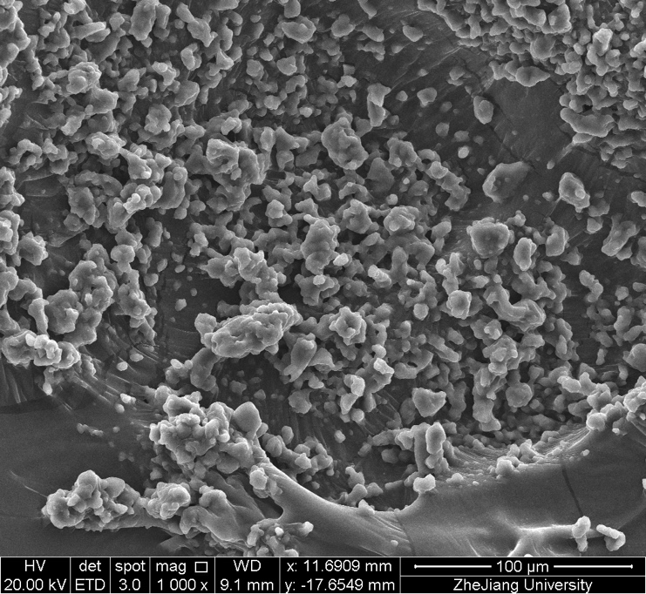 | 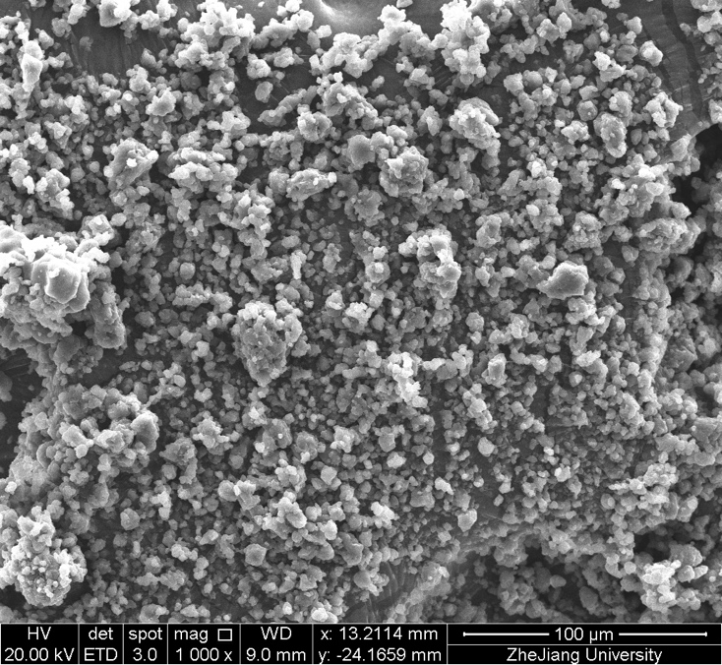
(a) | (b)
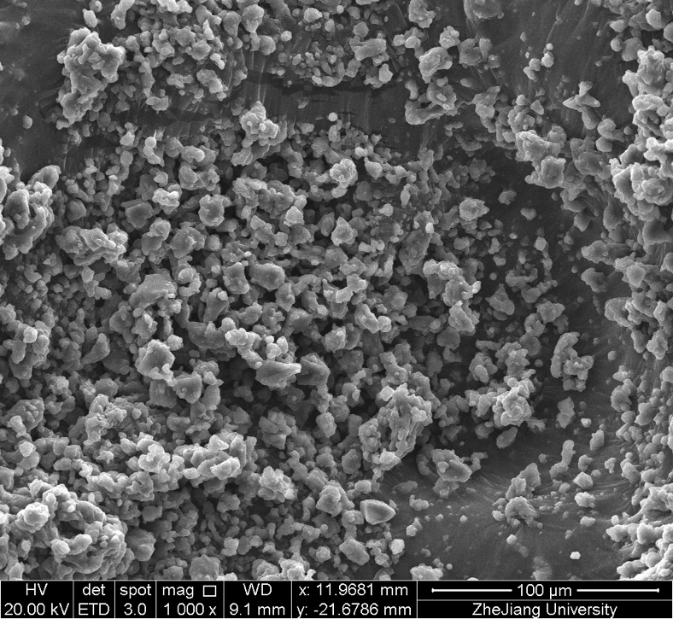
(c)
Figure 2 SEM images of plain and modified SAP samples (a) S0; (b) SK5; (c) SS5.

(a)
(b)
Figure 3 FTIR analysis (a) raw micro-SiO₂ and kaolin clay powders; (b) SAP samples S0, SK5, and SS5.

(a) | (b)
(c) | (d)
(e)
Figure 4 Swelling ratios of SAP in five different solutions: (a) DI water; (b) Saturated calcium hydroxide solution; (c) 1.0 mol L⁻¹ sodium hydroxide solution; (d) 0.5 mol L⁻¹ sodium carbonate solution; (e) 0.5 mol L⁻¹ sodium sulfate solution.
.

Figure 5 The water retention capacity of plain and modified SAP composites.

Figure 6 Fluidity of the AAS paste mixtures containing SAP of different dosages.
Figure 7 The initial and final setting times of AAS mixture with SAPs.

Figure 8 Compressive strength of AAS pastes containing different SAP dosages at various ages.

(a)
(b)
Figure 9 Pore size distribution of AAS mixtures REF, LH1 and HH1 at 28d (a) pore size diameter versus differential pore volume (b) pore size diameter versus accumulative pore volume.

(a)
(b)
(c)
Figure 10 (a) Time-dependent length change of AAS containing SAPs; (b) Time-dependent mass loss of AAS containing SAP; (c) relationship between length and mass changes of AAS containing SAPs at 43% RH and 20 °C.

(a)
(b)
(c)

Figure 11 (a) Time-dependent length change of AAS containing SAPs; (b) Time-dependent mass loss of AAS containing SAP; (c) relationship between length and mass changes of AAS containing SAPs at 75% RH and 20 °C.

