Mitigating shrinkage of alkali-activated slag by polypropylene glycol with different molecular weights

Hailong Ye^{1, *}, Chuanqing Fu², Aoke Lei²
¹Department of Civil Engineering, The University of Hong Kong, Pokfulam, Hong Kong, China
²College of Civil Engineering and Architecture, Zhejiang University of Technology, Hangzhou, China
* corresponding author, Email: hlye@hku.hk (H.Ye)

Abstract: In this work, the influence of polypropylene glycol (PPG), as the shrinkage-reducing admixture (SRA), on the fresh and hardened properties of alkali-activated slag (AAS) paste is studied. The flowability, setting time, compressive strength, pore structure, and drying shrinkage performance of AAS with PPG of three different molecular weights (i.e., PPG400, PPG1000, and PPG2000) at two addition dosages (i.e., 0.5% and 1.0% by slag mass) are evaluated. The results show that PPG addition slightly affects the flowability and setting behaviors of AAS, but retards its strength development likely due to the inhibiting effect of polymer agglomerates in PPG on slag dissolution and reaction. The PPG400 shows a higher shrinkage mitigation efficiency in AAS systems than its counterparts with a higher molecular weight. Nevertheless, the beneficial shrinkage mitigation role of PPG addition is merely significant in the AAS dried under a relatively low relative humidity level. The mechanism by which PPG addition mitigates shrinkage of AAS is attributed to the combinational effects of surface tension reduction of pore solution and coarsening of pore structure.

Keywords: Alkali-activated slag; Shrinkage mitigation; Shrinkage-reducing admixture; Drying shrinkage; Polypropylene glycol

1. Introduction
Alkali-activation of ground granulated blast-furnace slag produces cementitious binders with remarkable mechanical properties and chemical and fire resistance, thus being a promising alternative to ordinary Portland cement (OPC) for application in some specific environmental conditions (e.g., drainage and sewerage systems, refractory structures, fire protective coatings) [1–9]. Moreover, alkali-activated slag (AAS) is considered more environmentally-friendly to manufacture than OPC as it eliminates the clinkering process that generates great greenhouse gas emissions, although some debates on its sustainability and cost-effectiveness still exist [10,11].

One of the main obstacles that hinder the acceptance of AAS by the concrete construction industry is its high susceptibility to shrinkage cracking [7,12–17], which compromises the long-term durability and serviceability of concrete structures. Developing effective shrinkage mitigation strategies for AAS systems has been a hot topic in recent years [18–23]. Several conventional shrinkage mitigation solutions developed and implemented in the OPC systems have been evaluated for the AAS systems, including the addition of shrinkage-reducing admixture [24–26], expansive mineral addition (e.g., magnesia, calcium sulfoaluminate, gypsum) [27,28], internal curing (e.g., lightweight aggregates, superabsorbent polymers) [19,20,29–32], and steam curing treatments [21].

Shrinkage-reducing admixture (SRA) reduces the shrinkage of cementitious systems mainly through lowering the surface tension of pore solution and thus reducing capillary stress [33–35]. Several SRAs of different chemical compositions are commercially available but mostly designed for the OPC-based concrete rather than for alkali-activated systems. Depending on the composition and compounds they are composed of, the shrinkage reducing efficiency of these market-available SRAs (e.g., those based on polypropylene glycol, polyethylene glycol, oxyalkylene glycols, and hexylene glycol) on the AAS systems are vastly different. Among them, the polypropylene glycol (PPG)-based SRA has been shown to effectively reduce the drying shrinkage of AAS pastes and mortars by up to 50%, depending on the composition of AAS, drying relative humidity (RH) level, and SRA addition dosage. For instance, Palacios and Puertas observed that adding 1% PPG-based SRA in AAS mortars reduces its drying shrinkage by about 7% at 50% RH and 50% at 99% RH, respectively [24]. Bilim et al. found that the drying shrinkage of AAS, regardless of activator type and dosage, is reduced by 15-30% when incorporating 1% PPG-based SRA [36]. As suggested in [24–26], the PPG-based SRA reduces the shrinkage of AAS mainly through surface tension reduction of pore solution and its redistribution effect on the pore structure.

However, as most commercial PPG-based SRAs are developed for OPC systems rather than for the AAS systems, it remains unclear how does the molecular structure and weight of PPG affect the properties of AAS. As such, this study aims to investigate the influence of PPG of different molecular weights on the fresh and hardened properties of AAS, including setting, flowability, compressive strength, pore structure, and drying shrinkage performance at two different levels of RH. In addition, the mechanism by which PPG mitigates drying shrinkage of AAS is further discussed, providing the basis for identifying the most suitable PPG-based SRA for further application in the alkali-activated concrete systems.

2. Materials and Methods
2.1 Raw materials characterization
A commercial ground granulated blast-furnace slag with the compositional and mineralogical analysis shown in Table 1 and Figure 1, was used. According to the X-ray diffraction analysis, the slag is mainly composed of glassy phases with quartz (SiO₂), akermanite (Ca₂MgSi₂O₇), and merwinite (Ca₃MgSi₂O₈). The amorphous phase in slag is commonly known as the CaO-SiO₂-Al₂O₃-MgO glass [37]. The AAS pastes were prepared by mixing the slag with a NaOH solution at a constant 4.3% equivalent Na₂O content (by slag mass) and 0.34 water-to-binder (slag) mass ratio, as detailed in Table 2. The Na₂O dosage adopted in the AAS mixture was determined in the preliminary study considering the balance between strength development and cost-effectiveness.

To investigate the influence of polypropylene glycol (PPG) on the properties of AAS, the PPG with three different molecular weights (i.e., PPG400, PPG1000, and PPG2000) were evaluated. In addition, two addition dosages of each PPG were considered, including 0.5% and 1.0% w.r.t the slag mass, which are within the common doses of SRAs (usually 0.5-2% by mass of cement) used in the cementitious systems [38,39]. The molecular structure of the PPG was analyzed by using a Thermo Nicolet 6700 Fourier transform infrared spectrometer (FTIR) spectrometer equipped with attenuated total reflectance (ATR) at a 1 cm⁻¹ resolution over the wavelength range from 4000 to 500 cm⁻¹. The ATR-FTIR spectra of the PPG, as shown in Figure 2, suggest that there is an insignificant difference in the type and intensity of molecular bonds in the atomic structure of PPG due to the difference in molecular weight. The humps at ∼1108 cm⁻¹, ∼2870 cm⁻¹, ∼1454 cm⁻¹, and ∼1150–1070 cm⁻¹ are, respectively, assigned to the C-O-C stretching, -CH stretching, -CH deforming, and C-O-C in C-O stretching modes in the structure of PPG [40]. The hump at 3480 cm⁻¹ is assigned to the stretching vibration arising from the terminal -OH group of the PPG [41], which seems to be amplified for the one with a smaller molecular weight, suggesting a lower degree of polymerization.

On the other hand, the miscibility of PPG of different molecular weights in the deionized (DI) water and NaOH solution (mimics the pore solution chemistry of AAS) was monitored. The PPG was mixed with the aqueous liquid at a 5% mass ratio and the miscibility between these two liquid phases was monitored through observing the transparency and stability of each solution over time [33]. Figure 3 shows the examples of the mixed solution of PPG400 and PPG2000 with DI water and 4.0 M NaOH solution immediately after mixing (without stirring), and those standing for 2 minutes, 5 minutes, and 20 minutes after mixing and stirring. It can be seen that when mixed with the DI water, the PPG forms a cloudy and less transparent emulsion in comparison to the counterparts mixed with the NaOH solution. In particular, for the PPG2000 with a high molecular weight, particulate droplets are sedimented at the bottom. However, when mixed with the NaOH solution, phase separation occurred, in which a PPG-rich phase formed on the top of a PPG-dilute solution. This probably indicates that excessive PPG is not miscible with the NaOH solution, although it remains unclear how much percentage of PPG is uptake by the aqueous solution.

2.2 Flowability and setting time
The flow diameters of AAS pastes were measured using the procedure described in the flow table test [42]. In particular, the fresh AAS paste was cast into a flow mold of 60 mm in height, 70 mm in the inside diameter at the top, and 100 mm in the inside diameter at the bottom, and then placed on a drop table. The spread diameter of the new shape of the paste after testing was measured at four locations using a caliper and reported. The measurement of each mixture was done once by the same operator.

The initial and final setting times of AAS pastes were measured using the Vicat needle method [43]. Each paste mixture was first molded into a conical ring with a height of 40 mm, an inside diameter at the bottom of 75 mm, and an inside diameter at the top of 65 mm, and then placed in a moist cabinet. Periodic penetration tests were performed by allowing a 1-mm Vicat needle to settle into the paste. The average of two tests done by the same operator was reported.

2.3 Compressive strength
The compressive strength of AAS pastes was measured on three replicated 40.0 mm cubic specimens after sealed curing in a standard moist curing room (100% relative humidity and 20 ± 0.5 °C) for 1d, 3d, 7d, and 28d.

2.4 Length and mass changes
The drying shrinkage of AAS was assessed using non-standardized 12.7 mm × 12.7 mm × 127.0 mm prismatic specimens, which allows the drying equilibrium being achieved within a relatively short duration than the standardized specimens [23,44,45]. After casting, the specimens were cured in a moist room for 24h before demolding and then placed in environmental chambers with the relative humidity (RH) conditions maintained by using saturated salt solutions according to the method described in the ASTM E104. Two levels of drying RH condition were studied, including (i) 43% RH and 20 °C ± 0.5 °C (prepared using a supersaturated potassium carbonate solution); (ii) 75% RH and 20 °C ± 0.5 °C (prepared using a supersaturated sodium chloride solution). The length and mass changes of specimens were measured periodically using a high-precision balance and a digital comparator.

2.5 Pore structure characterization
The porosity and pore size distribution of hardened AAS paste samples were analyzed using the Micromeritics AutoPore IV 9500 mercury intrusion porosimetry (MIP). The 28d paste samples after sealed curing were segmented into slices, immersed in isopropyl alcohol for at least 2d, and then dried under vacuum pumping for 3d. The pressure was injected up to 414 MPa, which is capable of acquiring the size of pore diameters down to around 3 nm [46,47]. Moreover, a Hg contact angle of 130° and a surface tension of 0.485 N/m were adopted in the pore size calculation [48].

3. Results and Discussion
3.1 Flowability and setting time
Figure 4 shows the spread diameter of the fresh AAS pastes containing PPG with different molecular weights at two addition dosages. It can be seen that depending on the molecular weight of PPG incorporated, the flowability of AAS can be reduced, increased, or remained at a similar level. In particular, the incorporation of PPG2000 has a marginal influence on the flowability, while the PPG400 tends to reduce the spread diameter and the PPG1000 tends to increase the diameter from at the 1.0% addition dosage. As all AAS mixtures have the same water-to-binder ratio, this difference in flowability may be attributed to the impact of PPG incorporation on the rheological properties of the aqueous solution itself and/or dissolution process of slag grains. The PPG of different molecular weights may alter the aqueous viscosity and surface tension of the pore fluid in different manners. Nevertheless, considering the precision of the flow table test, the difference in workability among various AAS mixtures is not considered significant.

Figure 5 shows the initial and final setting times of AAS pastes. It can be seen that PPG400 tends to have a minor impact on the setting of AAS, while the other two PPG with a larger molecular weight seems to increase the setting times. This is probably due to the interference of polymer agglomerates in PPG on the chemical reaction of slag particles in the alkaline solution. Although the miscibility between PPG and NaOH is low, the dissolution of PPG can potentially reduce the polarity of water and alkalinity of pore solution, thus slowing down the slag dissolution. Nevertheless, a detailed investigation of the molecular alteration of PPG in the alkaline solutions and the associated alkalinity modification of PPG-diluted NaOH solution would be helpful to shed some light on this.

3.2 Compressive strength and pore structure
Figure 6 (a) shows the early-age compressive strength of AAS pastes incorporating PPG up to 28d, and Figure 6 (b) shows the evolution of relative strength development ratio over time (i.e., the ratio between the strength at time t and that at 28d). It can be seen that the addition of PPG, regardless of its molecular weight, has a negligible influence on the long-term strength magnitude at least till 28d, but noticeably delay its development. The retarding effect of PPG on the strength development of AAS is more significant for the PPG400 with a relatively small molecular weight. The MIP pore size distribution analysis of 28d hardened AAS pastes containing PPG (see Figure 7) suggests that the PPG addition enlarges the porosity but does not significantly alter the distribution and characteristic peak size of the pores. The observation supports that the PPG incorporation reduces the slag reaction level in AAS to some extent. The AAS containing PPG of smaller molecular weight tends to show a coarser pore structure, although the difference is quite marginal.

3.3 Drying shrinkage
Figures 8 and 9 show the time-dependent length and mass changes of hardened AAS pastes containing PPG and their corresponding length change vs. mass change relationship curve. It can be seen that the PPG can considerably mitigate the shrinkage of AAS by up to 50% when exposed to 43% RH, but hardly make a difference in the case of 75% RH. When dried at 43% RH, the correlation between shrinkage and mass loss indicates that the incorporation of PPG does not affect the shrinkage-mass loss behavior of AAS when the moisture loss is within 5%. However, beyond that, the slope of shrinkage gain per moisture loss is considerably reduced for AAS containing PPG. Insensitive to the dosage of PPG added, the PPG400 is the most effective in terms of shrinkage reducing efficiency in AAS systems, while the PPG1000 and PPG2000 show comparable performance. Nevertheless, when dried under 75% RH, all AAS mixtures regardless of PPG incorporation show similar shrinkage development behaviors, likely attributed to the low moisture loss (< 1%) at this relatively high RH condition. However, it seems that the PPG addition increases the moisture loss of AAS under the same drying condition.

To further understand by which mechanisms PPG addition mitigate drying shrinkage of AAS, a closer examination of the relationship among shrinkage, moisture loss, and pore structure is insightful. It has been well acknowledged that the capillary pressure built up in the pores of hardened AAS during drying at a relatively high RH (> 50%) is the driving force that results in shrinkage development [21,23,49]. The capillary pressure is generated due to the formation of menisci and defined as the difference between the gas pressure above the meniscus and pressure inside the liquid, as expressed in the modified Young-Laplace equation [50,51]:
(1)
whereis the capillary pressure [Pa],is the gas pressure [Pa],is the liquid pressure [Pa], is the capillary radius at the position of meniscus (Kelvin radius) [m],is the surface tension between pore water and vapor [N/m], is the contact angle between the pore liquid and the pore wall [°], and t is the thickness of an adsorbed layer [m], which is a function of RH.

The capillary pressure, , is further correlated to the ambient RH, as per the Kelvin equation [50,52]:
(2)
whereis the density of pore liquid [kg/m³], is the molar mass of pore liquid [kg/mol], is the universal gas constant [J/(mol·K)], is the temperature [K], and is the water activity.

Based on Eq. (1) and (2), the correlation between RH and Kelvin radius can be established for given cementitious systems with known properties of pore fluid, as illustrated in Figure 10. The Kelvin radius is the theoretical radius of the largest capillary pore saturated with pore fluid under a given RH at equilibrium condition [35,52–55]. It can be seen that when dried at 43%RH and 75%RH, the Kelvin radius of AAS is around 2 nm and 4 nm, respectively, given the value of surface tension and water activity in the Case 1.

According to the assumption that the addition of PPG in AAS reduces the surface tension of pore fluid, the Kelvin radius of AAS containing PPG tends to be smaller than that of plain AAS, under the same drying condition. As such, a higher moisture loss of AAS containing PPG is anticipated, as observed in the test results. Nevertheless, the AAS mixtures containing PPG of different molecular weight and dosage show similar moisture loss, but substantially different shrinkage performance, particularly for those incorporating PPG400. It may suggest that reducing the surface tension of the pore fluid of AAS is not the only mechanism that mitigates shrinkage, but also the pore coarsening effect. As evidenced in the MIP results, the AAS with PPG400 tends to show the coarsest pore structure, which can partially explain for the highest shrinkage mitigation efficiency of PPG400.

It should be emphasized that the low miscibility of PPG in the NaOH solution does not prevent it from being efficient in shrinkage mitigation in the AAS systems. Due to the ‘Marangoni effect’, under the drying condition, the phase separation of PPG with the pore solution allows the formation of the PPG-concentrated layers at the drying front [34,38]. At these top drying surfaces, the surface tension of pore fluid is comparatively low and thus the capillary pressure formed at the vapor-liquid interface is considerably reduced. This also partially explains why the shrinkage reduction by PPG is merely significant at a low RH and a later stage of drying since the movement kinetics of PPG to the drying front is faster under a larger drying gradient (i.e. lower drying RH level). Although some assumptions made in this analysis need to be verified in future studies, it is sufficient to illustrate the influence of PPG on the drying process and shrinkage development of AAS.

Conclusions
In this paper, the effects of polypropylene glycol (PPG)-based shrinkage reducing admixtures with different molecular weights on the fresh (flowability and setting time) and hardened properties (compressive strength, pore size distribution, and drying shrinkage) of alkali-activated slag (AAS) pastes are investigated. The molecular structure and miscibility of PPG with deionized water and sodium hydroxide activating solutions are studied. Based on the experimental results, the following conclusions can be drawn:

(1) The addition of PPG as shrinkage reducing admixture in AAS pastes retards its activation reaction and strength development; however, it has a little detrimental impact on the strength magnitude of AAS at least at 28d, regardless of the molecular weight of PPG.

(2) Depending on the molecular weight, the PPG admixture can increase (PPG2000), decrease (PPG4000), or keep (PPG1000) the flowability of AAS pastes, although the difference is quite marginal. However, with the increasing of addition dosage, the flowability of AAS tends to be reduced, likely due to the enhanced hindrance effect on slag reaction.

(3) The PPG with a relatively large molecular weight tends to increase the initial and final setting times of AAS, probably due to the interference of polymer agglomerates in PPG on the chemical reaction of slag particles in the alkaline solution.

(4) The PPG admixture considerably reduces the shrinkage magnitude of AAS dried under 43% RH, but shows little effect under 75% RH, suggesting that the efficiency of PPG addition on shrinkage mitigation depends on drying RH. The PPG with a molecular weight of 400 shows a better shrinkage mitigation capacity than those with a higher molecular weight. It highlights the importance of selecting PPG with an appropriate molecular weight for shrinkage cracking control applications in the AAS systems.

Acknowledgments
The authors would like to thank the financial support from the National Natural Science Foundation of China (Grant number: 51808475) and Guangdong Natural Science Fund (Grant number: 1146). Any opinions, findings and conclusions or recommendations expressed in this material are those of the authors and do not necessarily reflect the views of the sponsors.

References
[1] R.J. Thomas, H. Ye, A. Radlinska, S. Peethamparan, Alkali-Activated Slag Cement Concrete, Concr. Int. (2016) 33–38.
[2] L. Coppola, D. Coffetti, E. Crotti, A. Marini, C. Passoni, T. Pastore, Lightweight cement-free alkali-activated slag plaster for the structural retrofit and energy upgrading of poor quality masonry walls, Cem. Concr. Compos. 104 (2019) 103341.
[3] J.L. Provis, Alkali-activated materials, Cem. Concr. Res. 114 (2018) 40–48.
[4] H. Ye, Z. Chen, L. Huang, Mechanism of sulfate attack on alkali-activated slag: The role of activator composition, Cem. Concr. Res. 125 (2019) 105868. doi:https://doi.org/10.1016/j.cemconres.2019.105868.
[5] H. Ye, C. Fu, G. Yang, Alkali-activated slag substituted by metakaolin and dolomite at 20 and 50°C, Cem. Concr. Compos. 105 (2020) 103442. doi:https://doi.org/10.1016/j.cemconcomp.2019.103442.
[6] M. Jiang, X. Chen, F. Rajabipour, C.T. Hendrickson, Comparative life cycle assessment of conventional, glass powder, and alkali-activated slag concrete and mortar, J. Infrastruct. Syst. 20 (2014) 4014020.
[7] C. Cartwright, F. Rajabipour, A. Radlińska, Shrinkage characteristics of alkali-activated slag cements, J. Mater. Civ. Eng. 27 (2014) B4014007.
[8] T. Bakharev, J.. Sanjayan, Y.-B. Cheng, Resistance of alkali-activated slag concrete to acid attack, Cem. Concr. Res. 33 (2003) 1607–1611. doi:10.1016/S0008-8846(03)00125-X.
[9] C. Grengg, F. Mittermayr, N. Ukrainczyk, G. Koraimann, S. Kienesberger, M. Dietzel, Advances in concrete materials for sewer systems affected by microbial induced concrete corrosion: A review, Water Res. 134 (2018) 341–352. doi:10.1016/J.WATRES.2018.01.043.
[10] K.L. Scrivener, V.M. John, E.M. Gartner, Eco-efficient cements: Potential economically viable solutions for a low-CO2 cement-based materials industry, Cem. Concr. Res. 114 (2018) 2–26.
[11] K.L. Scrivener, Options for the future of cement, Indian Concr. J. 88 (2014) 11–21.
[12] M. Hojati, A. Radlińska, Shrinkage and strength development of alkali-activated fly ash-slag binary cements, Constr. Build. Mater. 150 (2017) 808–816.
[13] C.D. Atiş, C. Bilim, Ö. Çelik, O. Karahan, Influence of activator on the strength and drying shrinkage of alkali-activated slag mortar, Constr. Build. Mater. 23 (2009) 548–555.
[14] H. Ye, C. Cartwright, F. Rajabipour, A. Radlińska, Effect of drying rate on shrinkage of alkali-activated slag cements, in: Proc. 4th Int. Conf. Durab. Concr. Struct. ICDCS 2014, 2014.
[15] F. Collins, J.G. Sanjayan, Effect of pore size distribution on drying shrinkage of alkali-activated slag concrete, Cem. Concr. Res. 30 (2000) 1401–1406. doi:10.1016/S0008-8846(00)00327-6.
[16] H. Ye, A. Radlińska, Carbonation-induced volume change in alkali-activated slag, Constr. Build. Mater. 144 (2017).
[17] L. Coppola, D. Coffetti, E. Crotti, Pre-packed alkali activated cement-free mortars for repair of existing masonry buildings and concrete structures, Constr. Build. Mater. 173 (2018) 111–117.
[18] M. Mastali, P. Kinnunen, A. Dalvand, R. Mohammadi Firouz, M. Illikainen, Drying shrinkage in alkali-activated binders – A critical review, Constr. Build. Mater. 190 (2018) 533–550. doi:10.1016/j.conbuildmat.2018.09.125.
[19] S. Oh, Y.C. Choi, Superabsorbent polymers as internal curing agents in alkali activated slag mortars, Constr. Build. Mater. 159 (2018) 1–8. doi:10.1016/j.conbuildmat.2017.10.121.
[20] A.R. Sakulich, D.P. Bentz, Mitigation of autogenous shrinkage in alkali activated slag mortars by internal curing, Mater. Struct. 46 (2013) 1355–1367.
[21] H. Ye, A. Radlińska, Shrinkage mitigation strategies in alkali-activated slag, Cem. Concr. Res. (2017).
[22] H. Ye, A. Radlinska, Shrinkage mechanisms of alkali-activated slag, Cem. Concr. Res. 88 (2016) 126–135.
[23] H. Ye, C. Cartwright, F. Rajabipour, A. Radlińska, Understanding the drying shrinkage performance of alkali-activated slag mortars, Cem. Concr. Compos. 76 (2017) 13–24.
[24] M. Palacios, F. Puertas, Effect of shrinkage-reducing admixtures on the properties of alkali-activated slag mortars and pastes, Cem. Concr. Res. 37 (2007) 691–702. doi:10.1016/j.cemconres.2006.11.021.
[25] L. Kalina, V. Bílek, E. Bartoníčková, J. Krouská, Polypropylene glycols as effective shrinkage-reducing admixtures in alkali-activated materials, ACI Mater. J. 115 (2018) 251–256. doi:10.14359/51701099.
[26] L. Kalina, V. Bilek Jr, R. Novotny, Influence of alkali ions on the efficiency of shrinkage reduction by polypropylene glycol in alkali activated systems, Adv. Cem. Res. 30 (2017) 240–244.
[27] A.A. Melo Neto, M.A. Cincotto, W. Repette, Drying and autogenous shrinkage of pastes and mortars with activated slag cement, Cem. Concr. Res. 38 (2008) 565–574. doi:10.1016/J.CEMCONRES.2007.11.002.
[28] F. Jin, K. Gu, A. Al-Tabbaa, Strength and hydration properties of reactive MgO-activated ground granulated blastfurnace slag paste, Cem. Concr. Compos. 57 (2015) 8–16.
[29] P. Chen, J. Wang, L. Wang, Y. Xu, Perforated cenospheres: A reactive internal curing agent for alkali activated slag mortars, Cem. Concr. Compos. (2019) 103351.
[30] D. Shen, X. Wang, D. Cheng, J. Zhang, G. Jiang, Effect of internal curing with super absorbent polymers on autogenous shrinkage of concrete at early age, Constr. Build. Mater. 106 (2016) 512–522. doi:10.1016/J.CONBUILDMAT.2015.12.115.
[31] C. Song, Y.C. Choi, S. Choi, Effect of internal curing by superabsorbent polymers–internal relative humidity and autogenous shrinkage of alkali-activated slag mortars, Constr. Build. Mater. 123 (2016) 198–206.
[32] C. Fu, H. Ye, A. Lei, G. Yang, P. Wan, Effect of novel superabsorbent polymer composites on the fresh and hardened properties of alkali-activated slag, Constr. Build. Mater. 232 (2020) 117225.
[33] F. Rajabipour, G. Sant, J. Weiss, Interactions between shrinkage reducing admixtures (SRA) and cement paste’s pore solution, Cem. Concr. Res. 38 (2008) 606–615.
[34] D.P. Bentz, M.R. Geiker, K.K. Hansen, Shrinkage-reducing admixtures and early-age desiccation in cement pastes and mortars, Cem. Concr. Res. 31 (2001) 1075–1085.
[35] D.P. Bentz, O.M. Jensen, Mitigation strategies for autogenous shrinkage cracking, Cem. Concr. Compos. 26 (2004) 677–685.
[36] C. Bilim, O. Karahan, C.D. Atiş, S. İlkentapar, Influence of admixtures on the properties of alkali-activated slag mortars subjected to different curing conditions, Mater. Des. 44 (2013) 540–547. doi:10.1016/J.MATDES.2012.08.049.
[37] S.-D. Wang, K.L. Scrivener, Hydration products of alkali activated slag cement, Cem. Concr. Res. 25 (1995) 561–571.
[38] D.P. Bentz, Influence of shrinkage-reducing admixtures on early-age properties of cement pastes, J. Adv. Concr. Technol. 4 (2006) 423–429.
[39] J. Weiss, P. Lura, F. Rajabipour, G. Sant, Performance of shrinkage-reducing admixtures at different humidities and at early ages, ACI Mater. J. 105 (2008) 478.
[40] S.A. Suthanthiraraj, R. Kumar, B.J. Paul, FT-IR spectroscopic investigation of ionic interactions in PPG 4000: AgCF3SO3 polymer electrolyte, Spectrochim. Acta Part A Mol. Biomol. Spectrosc. 71 (2009) 2012–2015.
[41] H. Shinzawa, T. Uchimaru, J. Mizukado, S.G. Kazarian, Non-equilibrium behavior of polyethylene glycol (PEG)/polypropylene glycol (PPG) mixture studied by Fourier transform infrared (FTIR) spectroscopy, Vib. Spectrosc. 88 (2017) 49–55.
[42] ASTM, C 1437 Standard test method for flow of hydraulic cement mortar, (2007).
[43] ASTM, C191 Standard Test Method for Time of Setting of Hydraulic Cement by Vicat Needle, (1993).
[44] ASTM, C596 Standard Test Method for Drying Shrinkage of Mortar Containing Hydraulic Cement, (2018).
[45] A. Radlińska, J. Weiss, Toward the development of a performance-related specification for concrete shrinkage, J. Mater. Civ. Eng. 24 (2011) 64–71.
[46] K.K. Aligizaki, Pore structure of cement-based materials: testing, interpretation and requirements, CRC Press, 2014.
[47] E.W. Washburn, The dynamics of capillary flow, Phys. Rev. 17 (1921) 273.
[48] K. Scrivener, R. Snellings, B. Lothenbach, A practical guide to microstructural analysis of cementitious materials, Crc Press, 2018.
[49] H. Ye, A. Radlińska, Effect of Alkalis on Cementitious Materials:Understanding the Relationship between Composition, Structure, and Volume Change Mechanism, J. Adv. Concr. Technol. 15 (2017) 165–177. doi:10.3151/jact.15.165.
[50] A.W. Adamson, A.P. Gast, Physical chemistry of surfaces, (1967).
[51] H. Chen, M. Wyrzykowski, K. Scrivener, P. Lura, Prediction of self-desiccation in low water-to-cement ratio pastes based on pore structure evolution, Cem. Concr. Res. 49 (2013) 38–47.
[52] P. Lura, O.M. Jensen, K. Van Breugel, Autogenous shrinkage in high-performance cement paste: An evaluation of basic mechanisms, Cem. Concr. Res. 33 (2003) 223–232.
[53] A. Radlinska, F. Rajabipour, B. Bucher, R. Henkensiefken, G. Sant, J. Weiss, Shrinkage mitigation strategies in cementitious systems: A closer look at differences in sealed and unsealed behavior, Transp. Res. Rec. 2070 (2008) 59–67.
[54] G.W. Scherer, Theory of drying, J. Am. Ceram. Soc. 73 (1990) 3–14.
[55] G.W. Scherer, Drying, shrinkage, and cracking of cementitious materials, Transp. Porous Media. 110 (2015) 311–331.

Table 1 Oxide composition of ground granulated blast-furnace slag determined by X-ray fluorescence.
Composition (Mass %) | Slag
SiO₂ | 37.44
CaO | 36.0
Al₂O₃ | 13.39
MgO | 9.71
S | 0.64
TiO₂ | 0.64
K₂O | 0.55
Na₂O | 0.56
Fe₂O₃ | -
Fe₃O₄ | 0.35
Total | 99.28

Table 2 Mixture parameters of AAS pastes containing PPG (all percentages are w.r.t slag mass).
Mixture ID | Equivalent Na₂O content (%) | Water-to-binder ratio | PPG400 (%) | PPG1000 (%) | PPG2000(%)
REF | 4.3 | 0.34 | - | - | -
0.5-PPG400 | 4.3 | 0.34 | 0.5 | - | -
0.5-PPG1000 | 4.3 | 0.34 | - | 0.5 | -
0.5-PPG2000 | 4.3 | 0.34 | - | - | 0.5
1-PPG400 | 4.3 | 0.34 | 1.0 | - | -
1-PPG1000 | 4.3 | 0.34 | - | 1.0 | -
1-PPG2000 | 4.3 | 0.34 | - | - | 1.0

Figure 1 Mineralogical analysis of raw slag powder using X-ray diffraction.

Figure 2 FTIR spectrum of the polypropylene glycol with three different molecular weights (PPG400, PPG1000, and PPG2000)

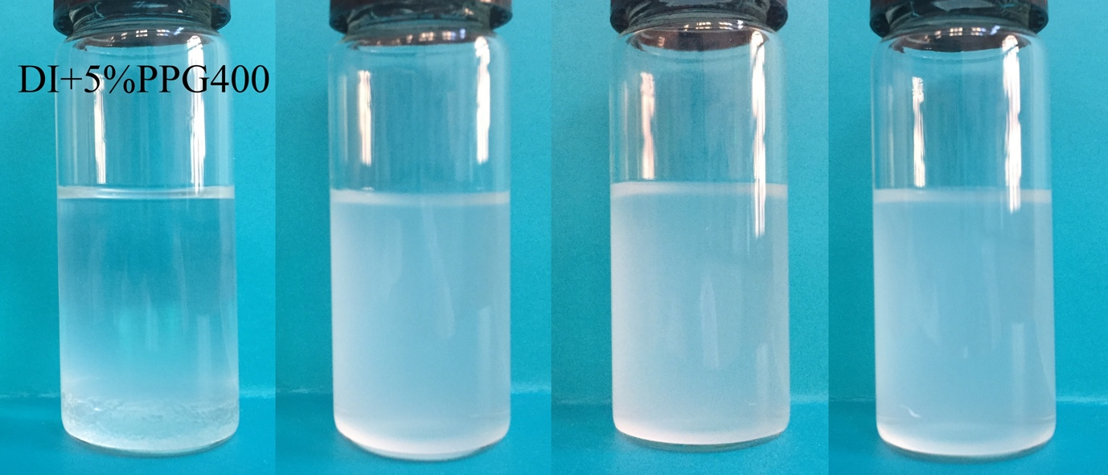
(a)
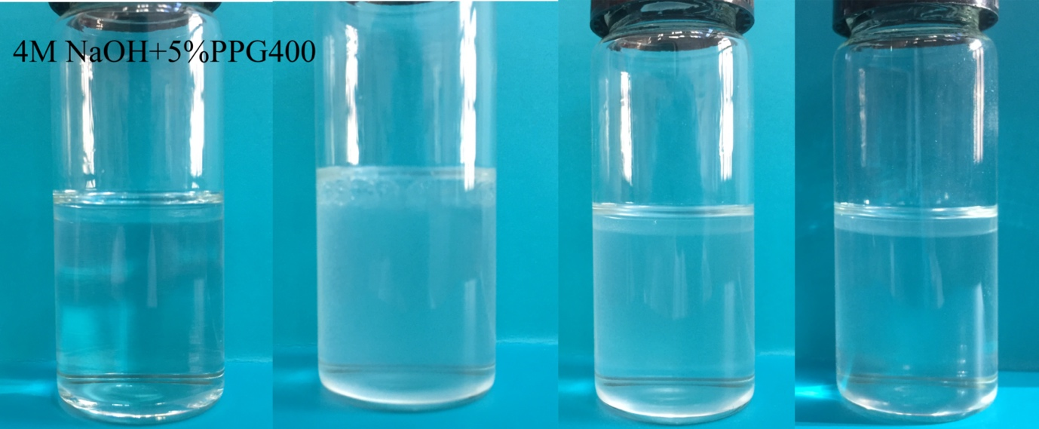
(b)
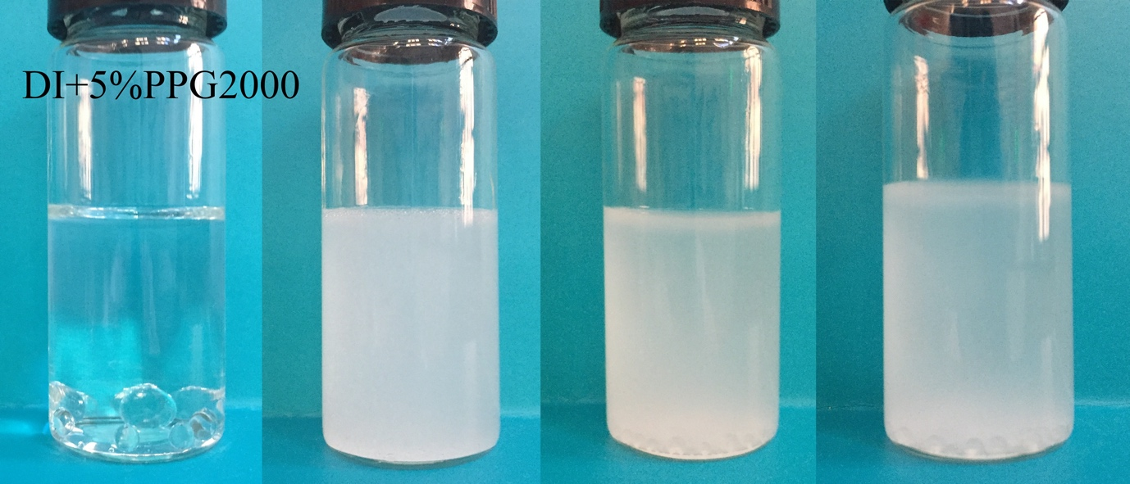
(c)
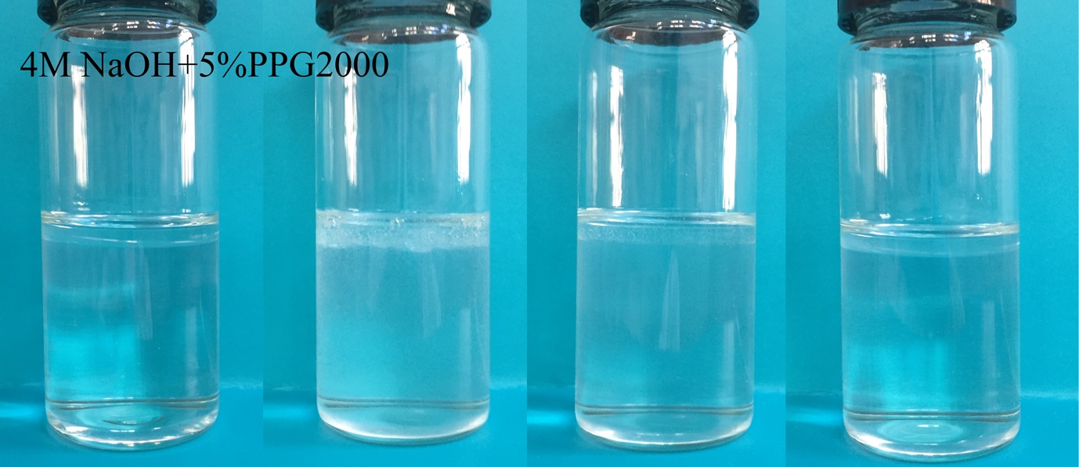
(d)
Figure 3 Dissolution of (a) PPG400 in DI water; (b) PPG400 in 4.0M NaOH; (c) PPG2000 in DI water; (d) PPG2000 in 4.0M NaOH, immediately after mixing without stirring, and standing for 2 minutes, 4 minutes, and 20 minutes after stirring (from the left to the right).

Figure 4 Fluidity of the AAS pastes containing PPG with different molecular weights at two different dosages.

Figure 5 The initial and final setting times of the AAS pastes containing PPG with different molecular weights at two different dosages.

(a)
(b)
Figure 6 (a) Compressive strength development and (b) relative strength development ratio of AAS pastes containing PPG with different molecular weights at two different dosages.

(a)
(b)

Figure 7 Pore size distribution of AAS pastes containing PPG with different molecular weights at two different dosages at 28d (a) pore size diameter versus differential pore volume (b) pore size diameter versus accumulative pore volume.

(a)
(b)
(c)
Figure 8 (a) Time-dependent length change; (b) Time-dependent mass loss; (c) relationship between length and mass changes of AAS pastes containing PPG with different molecular weights at two different dosages at 43% RH and 20 °C.

(a)
(b)
(c)
Figure 9 (a) Time-dependent length change; (b) Time-dependent mass loss; (c) relationship between length and mass changes of AAS pastes containing PPG with different molecular weights at two different dosages at 75% RH and 20 °C.

Figure 10 Correlation between Kelvin radius and relative humidity for various cases of surface tensions and water activities in cementitious systems, calculated based on the Kelvin-Laplace equations.

