Bond degradation of non-uniformly corroded steel rebars in concrete

Chuanqing Fu¹, Deming Fang¹, Hailong Ye^{2, *}, Le Huang^{2, *}, Jiandong Wang¹

¹College of Civil Engineering and Architecture, Zhejiang University of Technology, Hangzhou, China
²Department of Civil Engineering, The University of Hong Kong, Pokfulam, Hong Kong, China.
* Corresponding authors, Email: hlye@hku.hk (H. Ye); huangle@hku.hk (L. Huang)

Abstract: In this work, the bond degradation of non-uniformly corroded steel rebars embedded in concrete was studied. A total of 105 concrete specimens with accelerated corrosion of steel rebar were evaluated using the pull-out test. The influences of corrosion mode, corrosion level, orientation of the longitudinal rib, and the position of steel rebar on the bond degradation were analyzed. The cracking patterns of corrosion-induced cracks, bond failure modes, and bond stress-slip relations were discussed. The results showed that the orientation of longitudinal rib and the thickness of concrete cover play a vital role in determining the cracking patterns of corrosion-induced cracks. In comparison to the uniformly corroded specimens, the bond performance of specimens with non-uniform corrosion of steel rebar degraded more significantly, and this phenomenon became even more pronounced as the corrosion level increased. Moreover, the beneficial improvements caused by the expansive rust on the bond performance were greatly dependent on the degrees of concrete constraint and corrosion level.

Keywords: Bond degradation; cracking patterns; non-uniform corrosion; longitudinal rib; concrete cover.

1. Introduction
Reinforcement corrosion induced by chloride is one of the most common reasons accounting for the premature deterioration of reinforced concrete (RC) structures [1–3]. Upon propagation of reinforcement corrosion, the cross-sectional area of steel rebars embedded in concrete suffers a considerable reduction, and the generated expansive corrosion products could lead to concrete cover spalling [4–6]. As such, the bond performance of corroded steel rebar to surrounding concrete degrades significantly because of the weakening interface, resulting in undermined load-bearing capacity of RC components as a consequence [7–10].

To tackle this issue, extensive efforts have been dedicated to the bond performance evaluation of corroded steel rebar in concrete. In most existing laboratorial studies, three corrosion simulation techniques were adopted, including outdoor natural exposure [11–14], accelerated corrosion in artificial environments [15–19], and accelerated corrosion by the impressed current method [20–23]. In general, natural exposure is time-consuming and leads to large scattering and variation of test results; while accelerated corrosion in artificial environments is expensive, although the corrosion characteristics of steel rebar obtained by these two methods are generally satisfactory [16]. Nevertheless, owing to the short test duration and controllable corrosion level, the accelerated corrosion technique using impressed current method is most commonly adopted.

A vast number of studies on the bond behavior, flexural performance, and concrete cover cracking of corroded RC members have been carried out [17,18,24–35]. For the sake of simplicity, in the majority of the reported studies only the situation of uniform corrosion of steel rebar was involved, in which the corrosion process was assumed to occur evenly around the steel rebar in the circumferential direction and along the steel rebar in the longitudinal direction, resulting in an uniform expansion stress to the surrounding concrete. However, given the nature of chloride-induced pitting corrosion [36,37], this widely adopted assumption, in fact, is not very accurate when compared with the actual non-uniformly corroded status in in-service RC structures [38–40]. Particularly, at the early-stage corrosion, the non-uniform distribution of the corrosion products resulted from uneven protective concrete covers is much more common. The experimental results [7–9] and analytical studies [30,41–43] have repeatedly proved that the bond properties of non-uniformly corroded steel rebars to surrounding concrete are different from the uniformly corroded ones. However, unfortunately, being a lack of sufficient attention, not too much research has been specifically focused on this topic so far.

Moreover, regarding the steel rebars, an obvious improvement in bond performance is always obtained in comparison with plain round bars [44,45]. This is normally ascribed to the deformed ribs that increase the interfacial interlocking significantly [46]. Hence, substantial works have been conducted to analyze the influences of rib geometry including height, orientation, spacing, etc., on the bond behavior of corroded steel rebar to concrete [47,48]. Nevertheless, in most situations, the concerns are focused on the transverse ribs, while the longitudinal ribs (Fig. 1) are generally ignored. Thus, any further beneficial information in this respect is expected to provide a more complete understanding of the bond mechanism.

To this end, with the motivation to study the degradation of bond performance of steel rebar in concrete, an innovative approach was adopted in this study to generate non-uniform corrosion of steel rebar in circumferential direction, simulating the natural exposure scenarios. To highlight the potential effects of non-uniform corrosion on the degradation of bond response, five low designed corrosion levels representing the early-stage corrosion are finally used. After the accelerated corrosion, the bond performance of 105 specimens was evaluated using pull-out tests, in which the influences of corrosion mode, corrosion level, orientation of the longitudinal rib, and the position of steel rebar were analyzed. Moreover, to reveal the relations between the bond degradation and crack development, the cracking patterns of corrosion-induced cracks and the bond responses of different corroded specimens were emphatically discussed. Finally, it should be noted that as a preliminary study, the emphasis hereafter was concentrated on the local bond performance, and the stochastic variations in the longitudinal direction caused by the non-uniform corrosion along the steel rebar was not discussed.

2. Experimental program

2.1 Materials and specimen preparation
The mix proportion of the concrete was shown in Table 1. ASTM C150 Type Ⅰ equivalent ordinary Portland cement (OPC) was used as the binder. Natural river sand with the particle size smaller than 5 mm was used as the fine aggregate, and uncrushed gravel with the size ranging from 5 to 20 mm was used as the coarse aggregate. Deionized water was used as the mixing water. Besides, to initiate the reinforcement corrosion, small doses of 3.5% NaCl salts by cement mass was added during the concrete mixing. The average 28-day compressive strength of concrete on 150 mm cubes was 25.2 MPa, and the corresponding splitting tensile strength was 2.3 MPa.

Table 1. Mix proportion of the concrete (kg/m³)
Cement | Fine aggregate | Coarse aggregate | Water | Water-to-cement ratio
375 | 750 | 1125 | 200 | 0.53

The high-strength hot-rolled deformed steel bars with the yield strength of 535 MPa, as shown in Fig. 1, were used as reinforcements. For all specimens, the steel rebars were identical being 16 mm in diameter and 550 mm in length. Before casting, the rust and mill scale on the surface of rebars were removed, followed by the weight measurement using a scale with a measuring precision of 0.1 g.

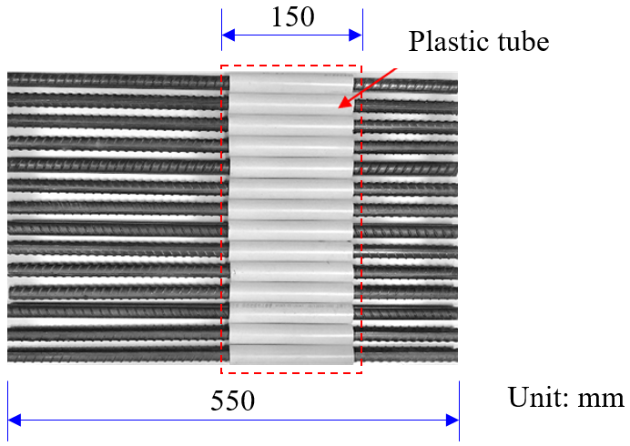
Fig.1. Profile of the threaded reinforcement and the location of the PVC pipe.

The dimension of the specimen was 150 mm × 150 mm × 200 mm, as shown in Fig. 2. To prevent the yielding or rupture of the rebars during the pull-out test, the recommended bond length of 5 times the rebar diameter, i.e. 80 mm, was adopted [49]. As such, a polyvinyl chloride (PVC) pipe of 150 mm in length was used to detach the concrete and rebar. Moreover, to generate non-uniform reinforcement corrosion, the newly-designed corrosion acceleration method introduced by the authors was used [21,50]. In particular, an ASTM 304 stainless wire with a diameter of 0.8 mm was additionally used as the auxiliary electrode, and it was placed 8 mm away from the steel rebar. The mechanism of this method will be further elaborated later in Section 2.2. All the specimens were cast in the direction perpendicular to the rebar with a needle vibrator, and were then demolded after 24 h. After that, they were cured in an environmental chamber with a temperature of 20 ± 2 °C and relative humidity of 75 ± 5% until the 28-day strength was obtained.

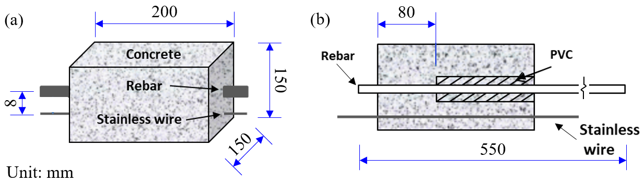
Fig.2. Dimension of the specimens, (a) front view; (b) cross-section view.

To investigate the influences of different corrosion modes, corrosion time, longitudinal rib angles, and positions of steel rebar on the bond performance, a total of 4 series (35 groups) of experiments were conducted, as summarized in Table 2. For each group, three replicates were prepared. To illustrate the position of steel rebar visually, a schematic diagram was displayed in Fig. 3, in which four typical cases were given correspondingly.

Table 2. Summary of the parameters considered in this study.
Series | Corrosion  mode* | Rib angle | Cover depth (mm) |  | c/d | Corrosion time (h)
Series | Corrosion  mode* | Rib angle | c₁ | c₂ | c/d | Corrosion time (h)
1 | U | 90° | 67 | 67 | 4.2 | 24, 48, 96, 120
1 | N | 90° | 67 | 67 | 4.2 | 24, 48, 96, 120
2 | N | 0° | 30 | 30 | 1.9 | 12, 24, 48, 96
2 | N | 45° | 30 | 30 | 1.9 | 12, 24, 48, 96
2 | N | 135° | 30 | 30 | 1.9 | 12, 24, 48, 96
3 | N | 0° | 30 | 67 | 1.9 | 12, 24, 48, 96
3 | N | 90° | 30 | 67 | 1.9 | 12, 24, 48, 96
3 | N | 135° | 30 | 67 | 1.9 | 12, 24, 48, 96
4 | Corrosion-free  (control groups) | 90° | 67 | 67 | 4.2 | 0
4 | Corrosion-free  (control groups) | 90° | 30 | 30 | 1.9 | 0
4 | Corrosion-free  (control groups) | 90° | 30 | 67 | 1.9 | 0
Note: for the corrosion mode*, “U” represents uniform corrosion, and “N” represents non-uniform corrosion.

In Series 1 (eight groups), the steel rebars were located in the center of the specimen, and the minimum thickness of concrete cover was 67 mm (c_{min} = c₁ = c₂). In this series, the influence of corrosion modes was studied that four groups of specimens were uniformly corroded with the outsourcing sponge while another four groups of specimens were non-uniformly corroded upon the auxiliary electrode. For all specimens, the longitudinal ribs of the steel rebars were uniformly placed horizontally (θ = 90°), and four respective corrosion time, 24 h, 48 h, 96 h, and 120 h, were selected to generate different corrosion levels.

In Series 2 (twelve groups) and Series 3 (twelve groups), the steel rebars were located in the corner (c₁ = c₂ = 30 mm) and middle bottom (c₁ = 30 mm, c₂ =67 mm), respectively. In these two series, the influences of longitudinal rib angles and positions were comprehensively compared, and the auxiliary electrode was used to realize the non-uniform reinforcement corrosion. The corrosion time was 12 h, 24 h, 48 h, and 96 h, respectively.

In Series 4, three groups of control specimens (corrosion-free) were designed corresponding to the aforementioned three different cases.

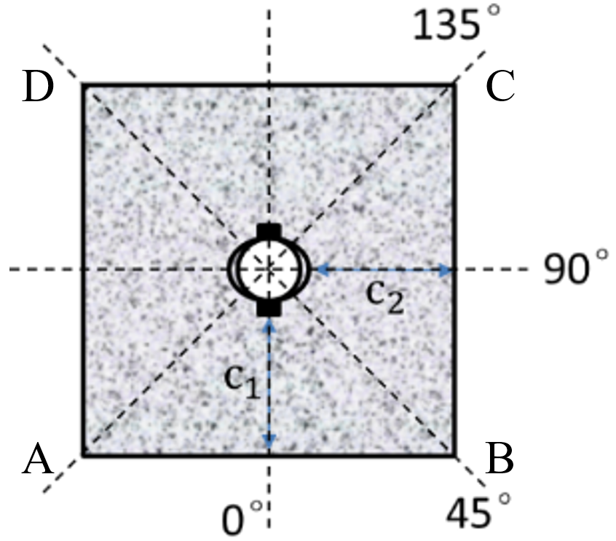 | 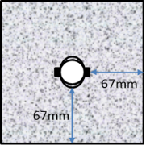  Series 1: U67-Z90 | 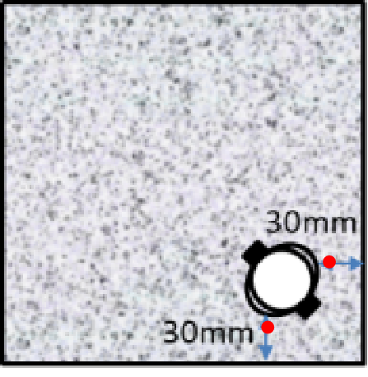  Series 2: N30-D45
 | 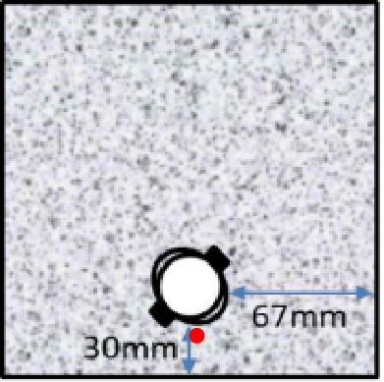  Series 3: N30-Z135 | 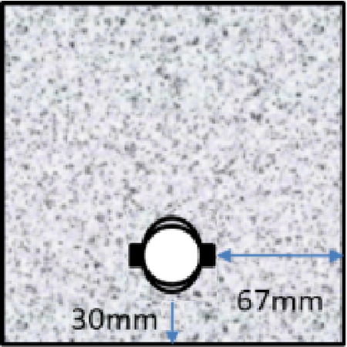  Series 4: 30-Z
(a) | (b)
Fig. 3. Schematic diagram of the position of steel rebars, (a) definition of the orientation of longitudinal rib, and (b) cross-section view of four typical positions in different series.

For the convenience of documenting specimens more clearly, the specimens were labeled as T-N/UC-Z/Dθ, in which T denotes the corrosion time (12 h, 24 h, 48 h, 96 h, or 120 h), N/U represents the corrosion mode (non-uniform or uniform corrosion), C refers to the minimum thickness of the concrete cover (30 mm or 67 mm), Z/D indicates the position of the steel rebar (middle or corner with respect to the side AB of the specimen shown in Fig. 3(a)), and θ is the longitudinal rib angle (0°, 45°, 90°, or 135°). For example, the nomenclature of 12-N30-Z135 represents the specimen shown in Fig. 3 (b-3) subjected to non-uniform corrosion for 12 hours.

2.2 Accelerated corrosion method
After moist curing for 28 days, all specimens were first immersed into NaCl solution with a concentration of 3.5% for 72 hours, followed by an accelerated corrosion process using the impressed current method.

Two corrosion modes, i.e., non-uniform corrosion and uniform corrosion, as shown in Fig. 4, were adopted. In both corrosion systems, the steel rebars were connected to the anode of power supply, but the connections of the cathode were different. For the non-uniform corrosion, the stainless wire was used as the auxiliary electrode; while for the uniform corrosion, the bonding section of the specimen was wrapped by sponge and stainless steel wire mesh successively and then connected to the cathode.

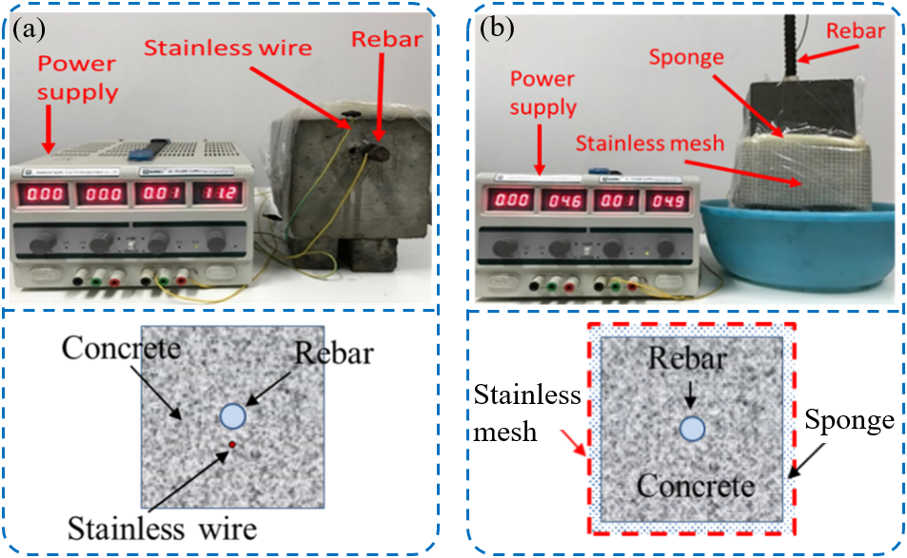
Fig. 4. Accelerated corrosion mode: (a) Non-uniform corrosion, and (b) uniform corrosion.

To better illustrate the mechanism of the proposed approach to generate non-uniform corrosion of steel rebar using the impressed current method, the schematic diagram was exhibited in Fig. 5. It can be seen that when the diameter of the steel rebar is much larger than that of the stainless steel wire, the distances l₀, l₁, l₂ …… l_{n} between the stainless steel wire and the points D₀, D₁, D₂ …… D_{n} on the surface of the steel rebar varies significantly. Under otherwise constant conditions, the resistance of concrete between the stainless steel wire and each point is greatly related to the electrode spacing. Hence, for each point, the current density on the surface of steel rebar is quite different from others, resulting in non-uniform reinforcement corrosion as a consequence.
Fig. 5. The schematic diagram of the non-uniform corrosion approach [21,50].
Previous studies have shown that in the case of high corrosion current density (i_{corr} = 350 μA/cm², for example), the induced reinforcement corrosion is quite different from that exposed to natural environment [20,51], and little significant difference in the degradation of bond strength is observed when the current density is between 50 and 250 μA/cm² [52]. Hence, in this study, the value of i_{corr} = 200 μA/cm² was adopted to generate the corrosion of steel rebar that is close to the actual situation, and the corrosion current I_{corr} was then calculated as,
(1)
where d is the diameter of steel rebars, and l_{b} is the bond length.

According to the Faraday’s law, the theoretical mass loss of the steel rebar Δm_{t} in such a case can be obtained as follows,
(2)
where M_{Fe} is the molecular weight of iron (M_{Fe} = 56 g/mol), t is the time of accelerated corrosion (s); Z_{Fe} is the ionic charge (Z_{Fe} = 2); F is the Faraday’s constant (F = 96485 C/mol). With this definition, the designed corrosion level ρ_{d} is given as,
(3)
where m_{i} is the initial mass of the rebar. However, to quantify the actual corrosion level ρ_{a} of the steel rebar accurately, the following equation is suggested,
(4)
being m_{f} the final mass of the steel rebar after removing the rust.

2.3 Recording of the corrosion-induced cracks
After the accelerated corrosion, all the specimens were dried at least one day before recording the corrosion-induced cracks. To map the cracks on the external section of the specimens, a plastic scale plate shown in Fig. 6 was used, and a crack visualizer with an accuracy of 0.001 mm was used to measure the crack width. It should be noted that since the crack width was not uniform along its propagation path, only the maximum width of each crack was used in the following discussions.
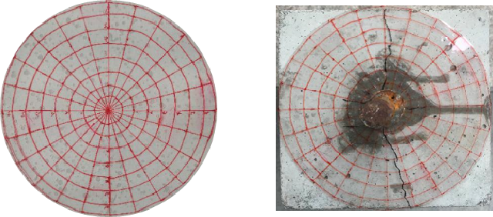
Fig. 6. The plastic scale plate used to record the corrosion-induced cracks.

2.4 Pull-out test
The pull-out test was conducted by a universal testing machine, as shown in Fig. 7. During the monotonic loading with a constant speed of 0.2 mm/min, two linear variable differential transducers (LVDTs) were mounted to measure the slips of the steel rebar at both the free end and loaded end. Moreover, a strain gauge was attached to the surface of the steel rebar to simultaneously monitor the tensile deformation. The load and displacement data were recorded at a frequency of 10 Hz.

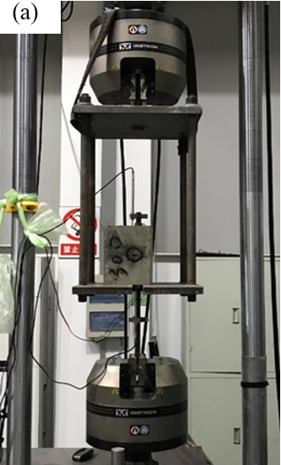 | 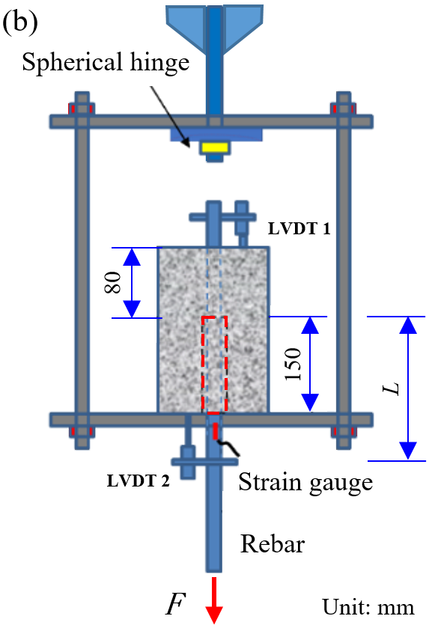
Fig. 7. Set-up for pull-out test, (a) site picture, and (b) schematic diagram.

Assuming the bond stress is uniformly distributed along the steel-to-concrete interface, the average bond strength τ_{a} therefore was expressed as
(5)
where F is the pull-out force. The actual slip of the steel rebar s_{a} was determined as
(6)
where s_{f} and s_{l} are the slips recorded at the free end and the loaded end, respectively; ε is the measured tensile strain of the steel rebar, and L is length between the beginning of the anchorage and the location of the LVDT at the loaded end, as shown in Fig. 7(b).

3. Experimental results

3.1 Cracking patterns of corrosion-induced cracks
It has been widely acknowledged that as the accumulation of corrosion products, increasing tensile stress around the steel rebar is generated and some microcracks may be formed when it exceeds the tensile strength of the concrete. Once the crack width expands to a critical value, the rust could permeate into the crack and further promote the cracking [53,54]. In this section, the typical cracking patterns of different specimens will be discussed according to the locations where the steel rebars were embedded.

3.1.1 The cases with steel rebar in the corner

The distributions of non-uniform corrosion-induced cracks of the specimens with steel rebar embedded in the corner (c₁ = c₂ = 30 mm) were shown in Fig. 8, in which three different angles of longitudinal rib, i.e. θ = 0°, 45°, and 135°, were compared, respectively.
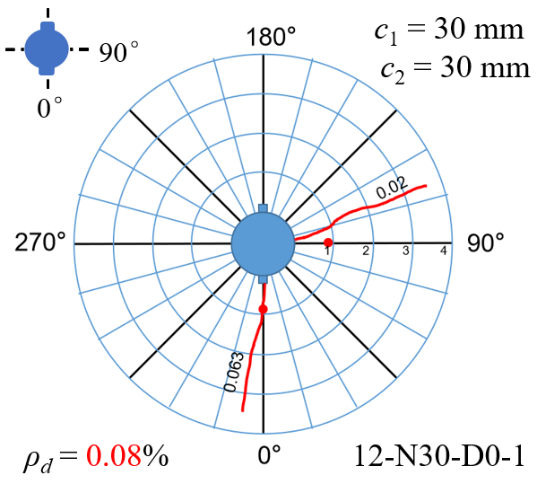 | 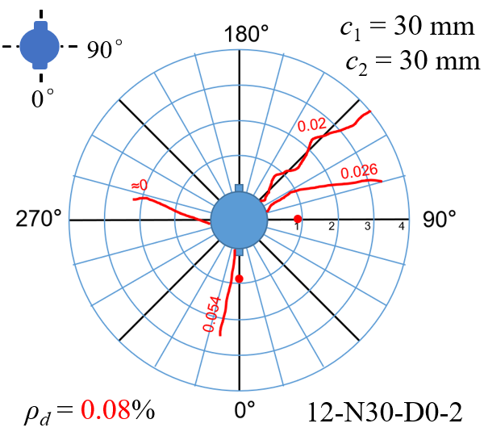 | 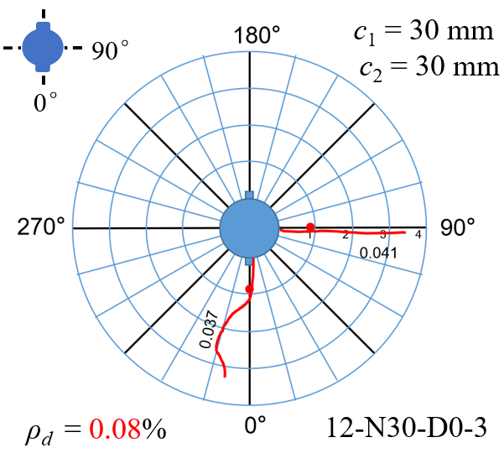
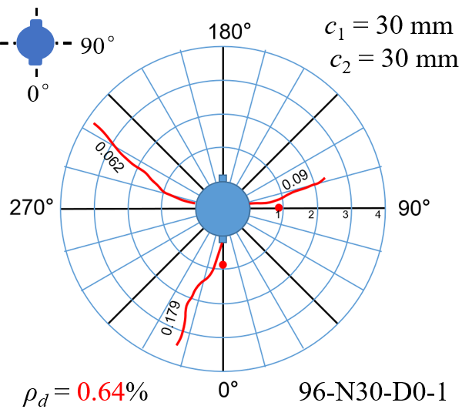 | 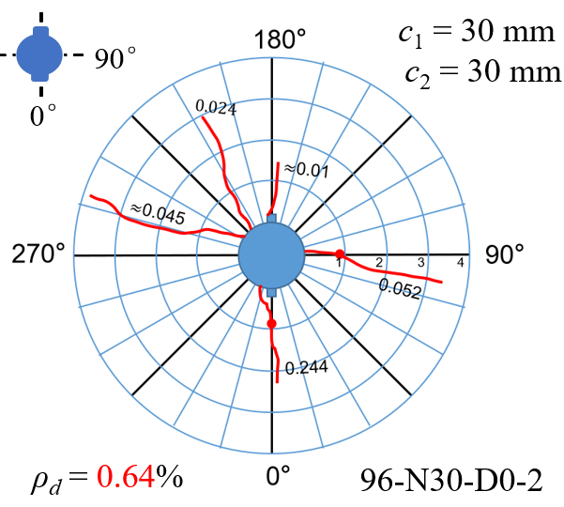 | 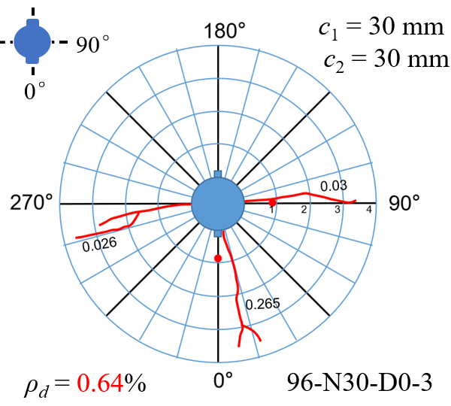
(a) non-uniformly corroded specimens N30-D0
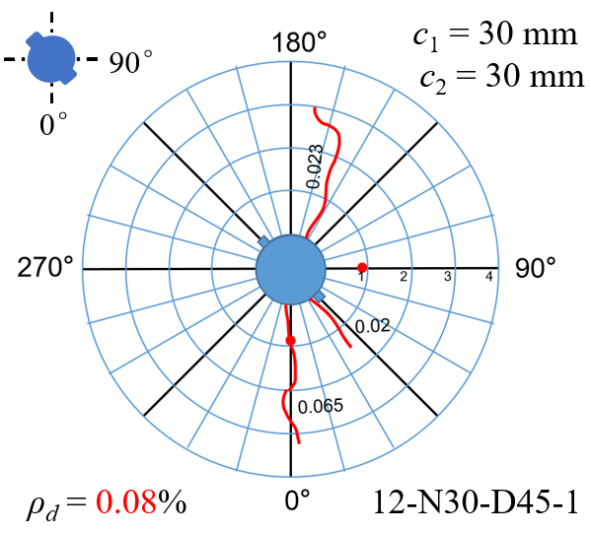 | 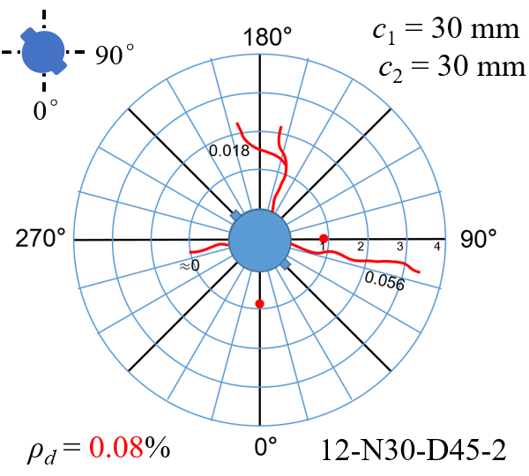 | 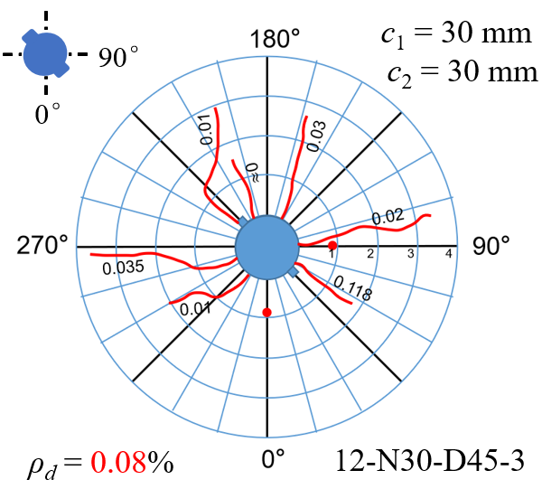
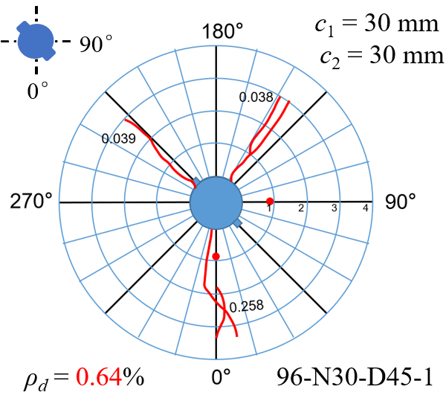 | 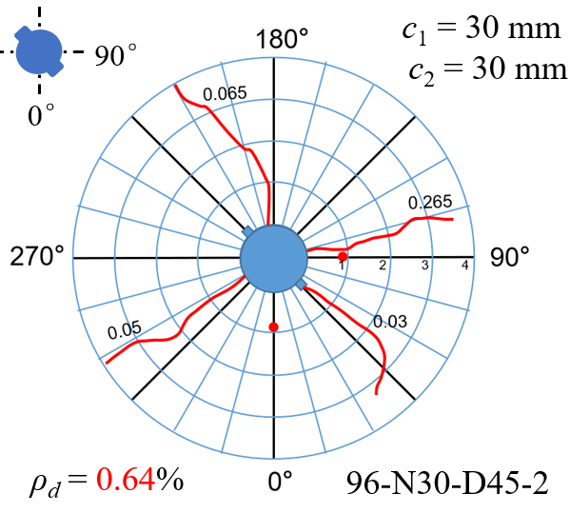 | 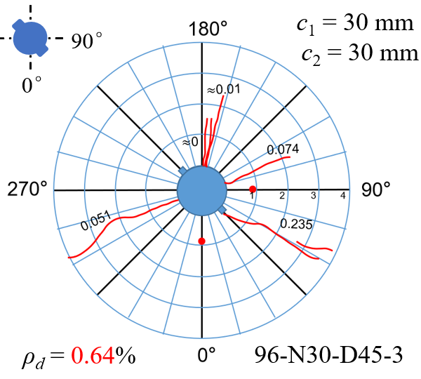
(b) non-uniformly corroded specimens N30-D45
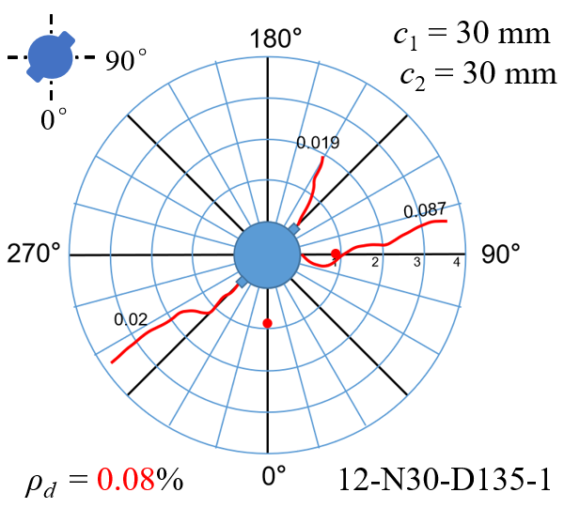 | 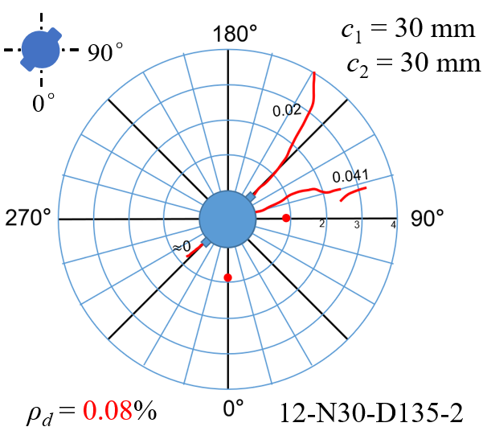 | 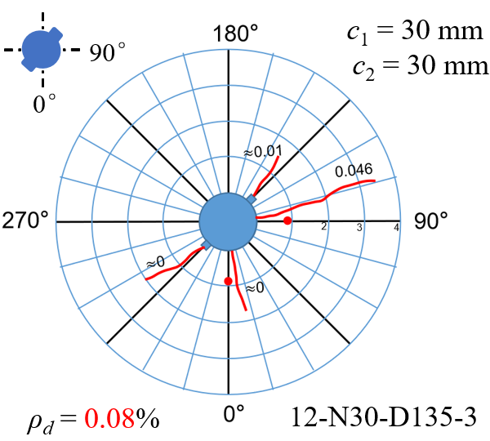
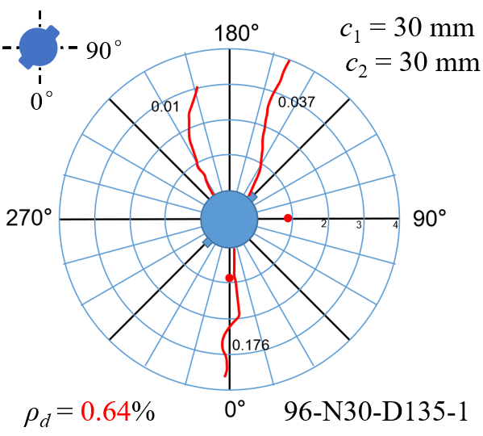 | 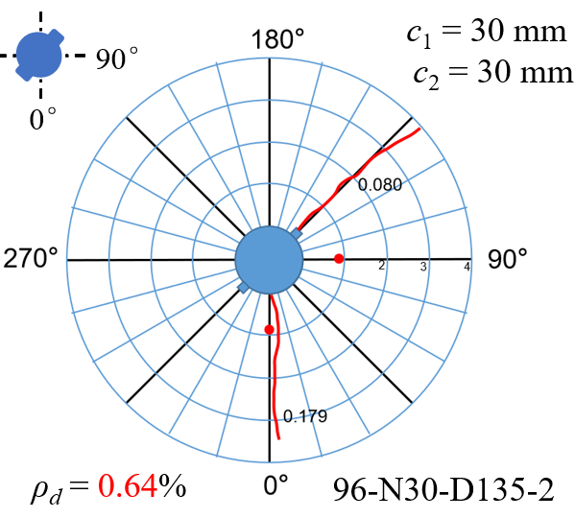 | 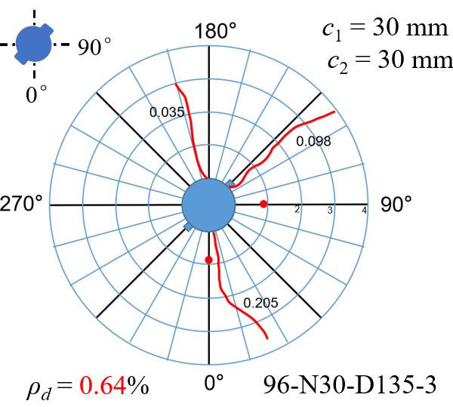
(c) non-uniformly corroded specimens N30-D135
Fig. 8. Cracking patterns of the specimens with rebar in the corner (c₁ = c₂ = 30 mm).

From the comparison, it can be seen that the majority of cracks (about 80% of the total amount) are generally initiated within the area of β = −45° ~ 135°, regardless of the orientation of the longitudinal rib. This is mainly attributed to the relative thinner concrete cover in these directions, leading to easier access of corrosive ions to the surface of steel rebar and result in more serious reinforcement corrosion consequently.
macrocracks | microcracks | 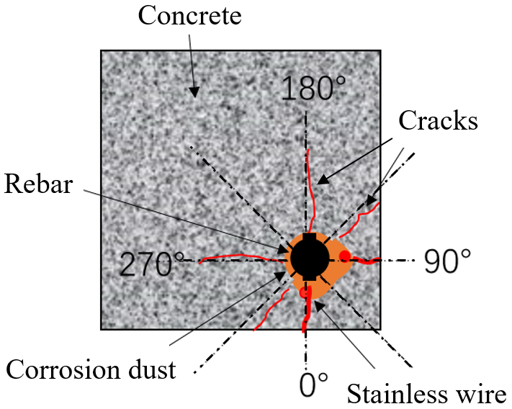  schematic diagram
(a) non-uniformly corroded specimens N30-D0
macrocracks | microcracks | 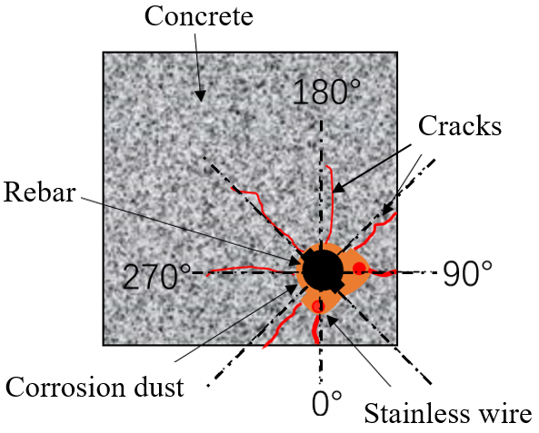  schematic diagram
(b) non-uniformly corroded specimens N30-D45
macrocracks | microcracks | 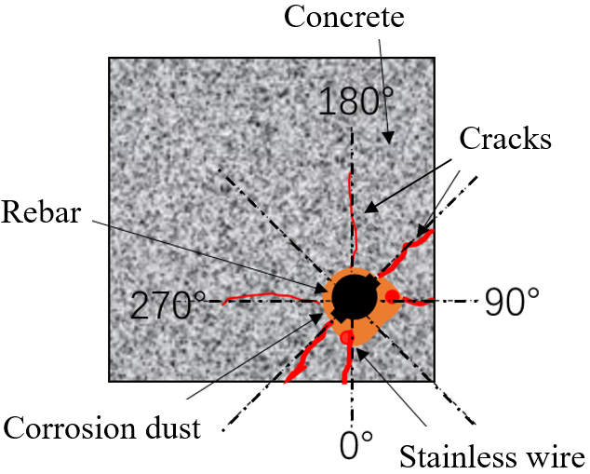  schematic diagram
(c) non-uniformly corroded specimens N30-D135
Fig. 9. Crack widths of the specimens with rebar in the corner (c₁ = c₂ = 30 mm).

To better quantify the development of these cracks, the maximum crack widths associated with the propagation directions were plotted in Fig. 9. From the illustration, it is clear that as the corrosion level increases, apart from the amount of cracks, the crack widths also increase significantly. In the case of low corrosion level (ρ_{d} = 0.08%, T = 12 h), the average maximum crack widths of non-uniformly corroded specimens 12-N30-D0, 12-N30-D45, and 12-N30-D135 were 0.037 mm, 0.031 mm and 0.035 mm, respectively; but when exposed to a severer corrosion (ρ_{d} = 0.64%, T = 96 h), they were extended up to 0.093 mm, 0.102 mm, and 0.103 mm, correspondingly. From this point of view, the variety of the angle of the longitudinal rib seems to have no obvious effect on the overall development of corrosion-induced cracks. However, regarding the propagation direction of the cracks, the divergences emerged. More specifically, for the specimens 12-N30-D0, the average width of the cracks in the direction of β = 0° was 0.051 mm, while in the direction of β = 90° was 0.027 mm (about 52.9% of the value in the orthogonal direction); for the specimens 12-N30-D45 and 12-N30-D135, the respective values were 0.065 mm/0.037mm and 0 mm (crack free)/0.058 mm, correspondingly. As the corrosion level increased, more pronounced divergences were generally observed. This can be mainly attributed to the incremental differences between the inadequate constraint of concrete cover and the increasing expansive force induced by the continued accumulation of the rust.

Besides, it was also interesting to observe that due to the rotation of steel bars by 45° or 135°, new main cracks were formed on the surface of concrete in these two directions. For example, the average maximum crack widths of the specimens N30-D45 in the direction of β = 45° were 0.069 mm (T = 12 h) and 0.101 mm (T = 96 h), which was comparable to or even bigger than the values in the directions with thinnest concrete cover (θ = 0° and 90°). Because of this, the cruciform cracking pattern of the specimens N30-D0 was found to transform into a diagonal cracking pattern, as shown in Fig. 9. This observation indicated that the orientation of longitudinal rib also plays a vital role in determining the formation of the main cracks, especially in the case of inadequate constraint provided by the concrete cover.

3.1.2 The cases with steel rebar in the middle bottom

Likewise, the distributions of non-uniform corrosion-induced cracks of the specimens with steel rebar embedded in the middle bottom (c₁ = 30 mm, c₂ = 67 mm) were shown in Fig. 10, in which three different angles of longitudinal rib, i.e. θ = 0°, 90°, and 135°, were analyzed, respectively. The crack maps showed that compared with the cases documented in section 3.1.1, only about 65% of the total amount of the cracks are initiated within the vulnerable area of β = −90° ~ 90° in such cases, but a much more distinct development of the main crack (in terms of the maximum crack width) in the direction of β = 90° is generally observed.

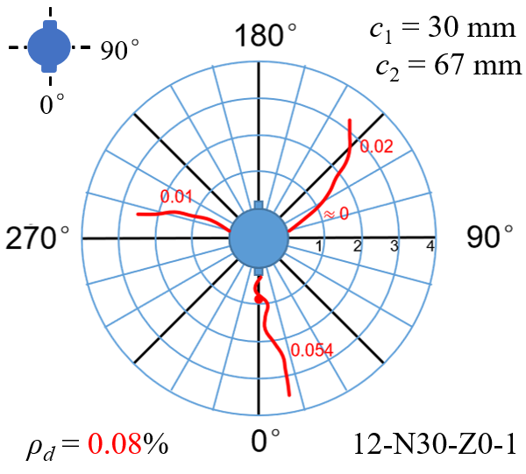 | 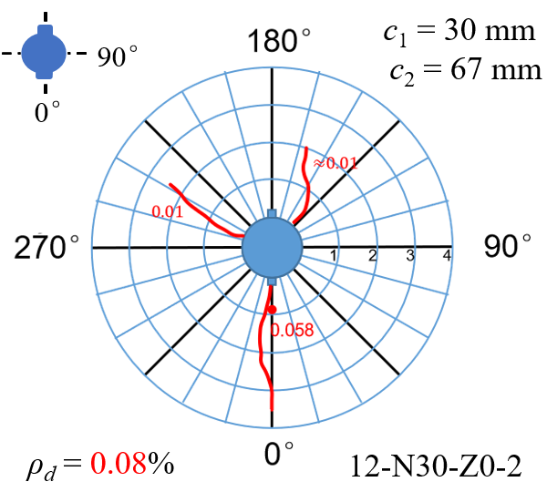 | 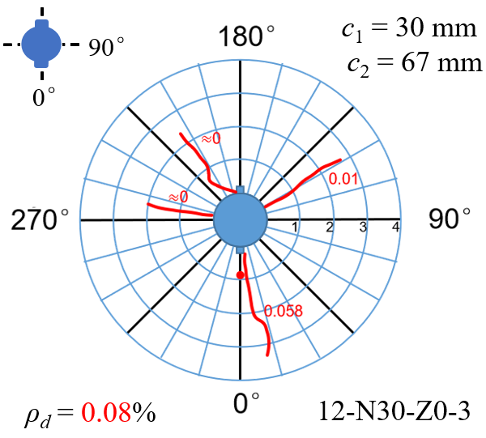
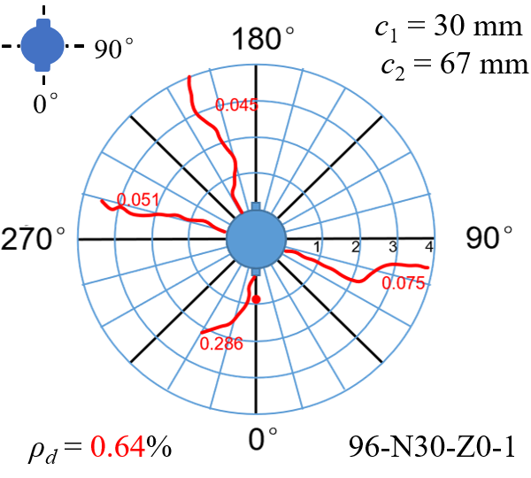 | 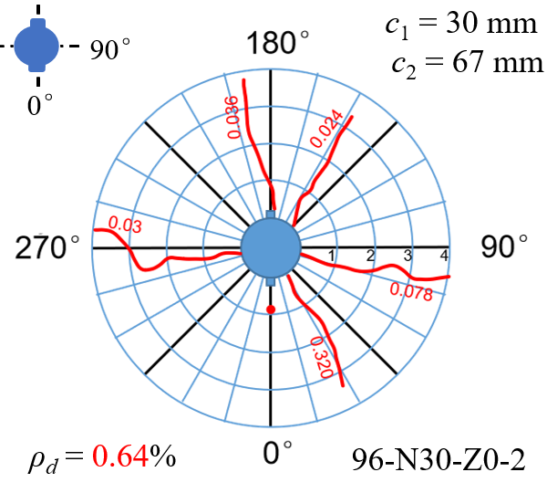 | 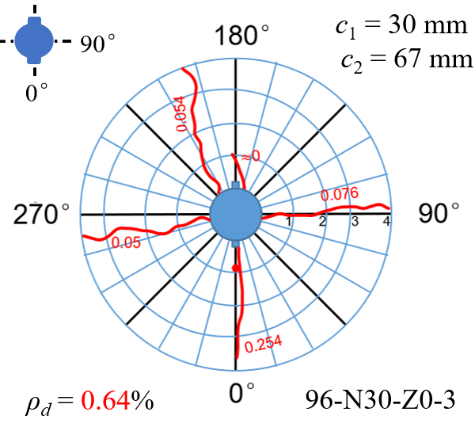
(a) non-uniformly corroded specimens N30-Z0
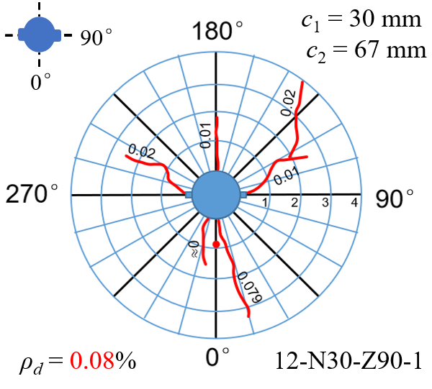 | 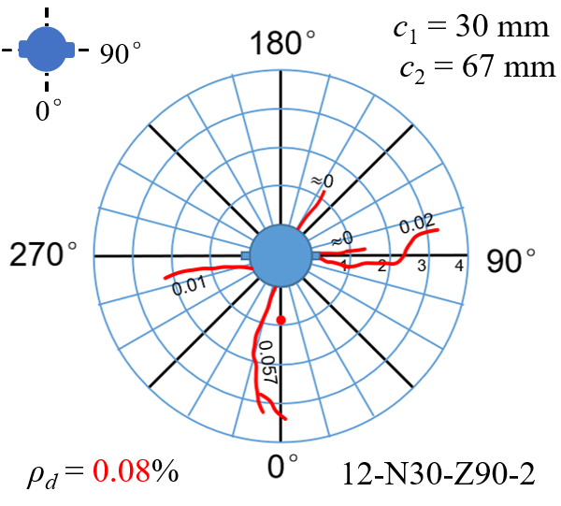 | 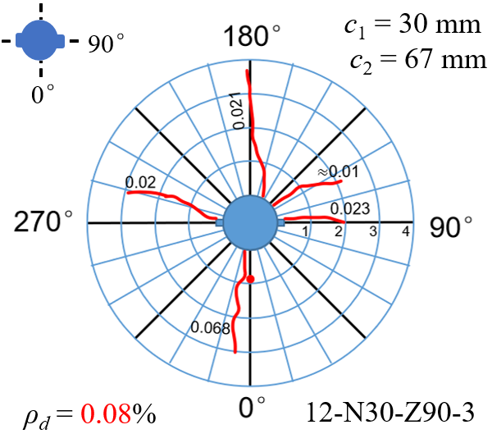
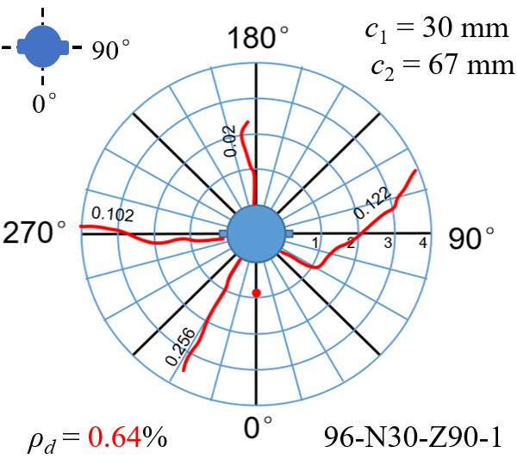 | 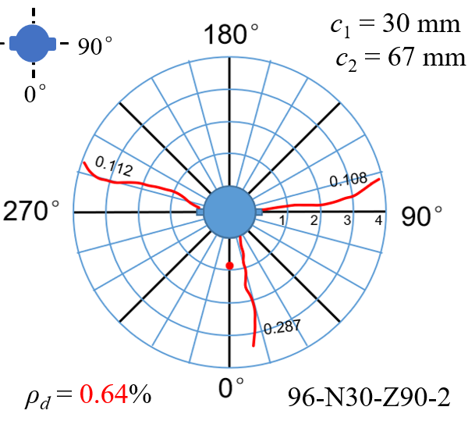 | 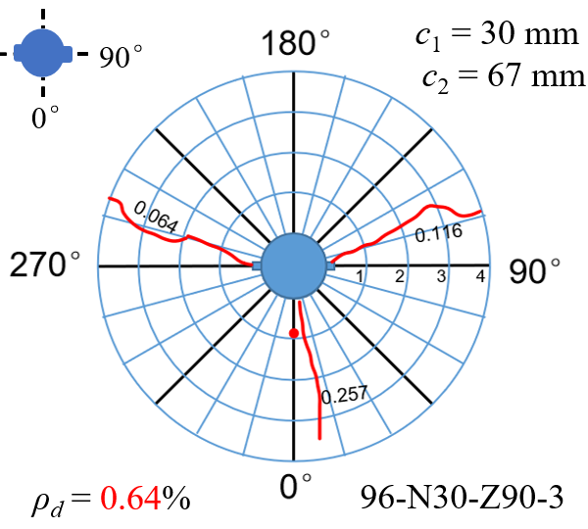
(b) non-uniformly corroded specimens N30-Z90
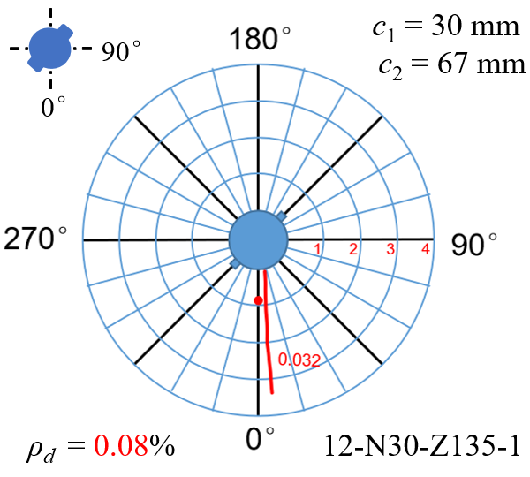 | 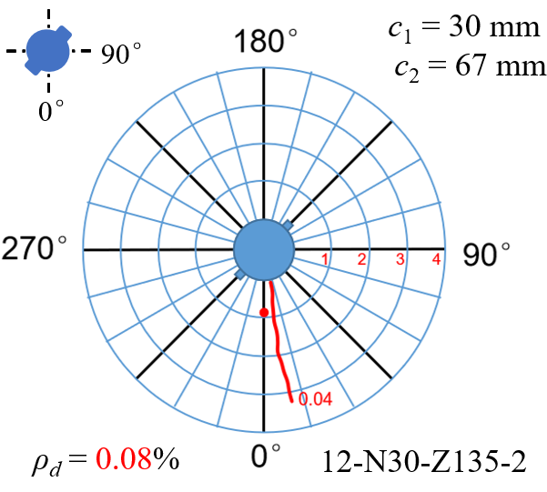 | 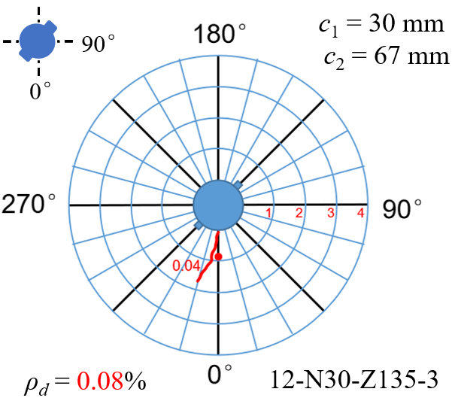
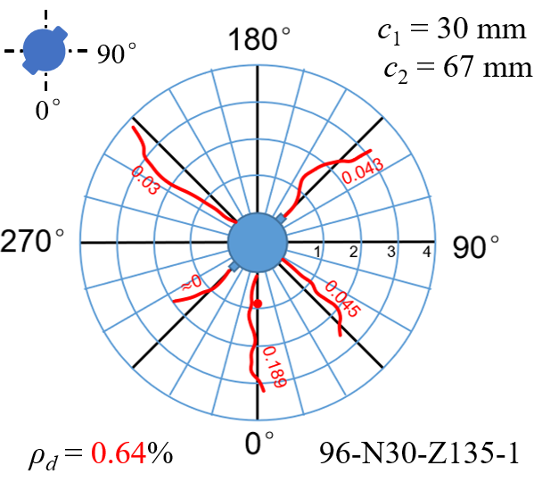 | 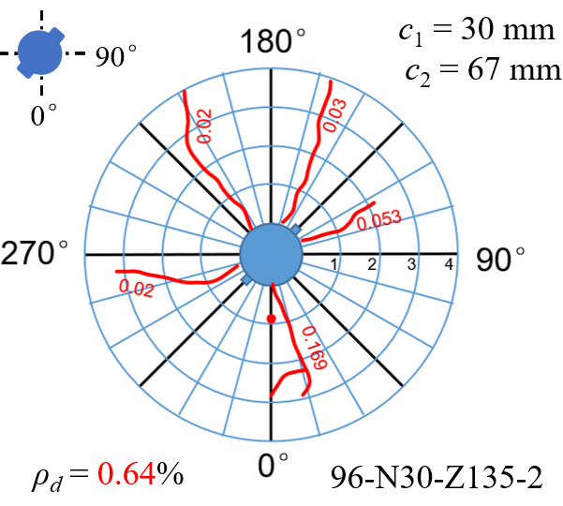 | 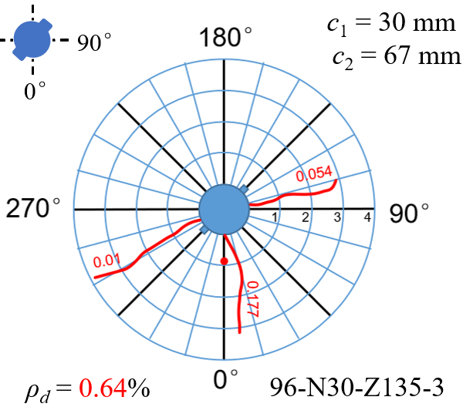
(c) non-uniformly corroded specimens N30-Z135
Fig. 10. Cracking patterns of the specimens with rebar in the middle bottom (c₁ = 30 mm, c₂ = 67 mm).

From polar diagrams of the maximum crack widths against the propagation directions shown in Fig. 11, it can be seen that as the corrosion level increases, the amount and the width of cracks increase obviously. When subjected to a low level of corrosion (ρ_{d} = 0.08%, T = 12 h), the average maximum crack widths of the specimens 12-N30-Z0, 12-N30-Z90, and 12-N30-Z135 were 0.029 mm, 0.030 mm and 0.036 mm, respectively, which were then extended to 0.102 mm, 0.144 mm, and 0.144 mm under a severer corrosion (ρ_{d} = 0.64%, T = 96 h). Similarly, regarding the propagation direction of the cracks, the divergences were also quite apparent, or even bigger. For the specimens 96-N30-Z0, the average width of the cracks in the direction of β = 0° (with thinnest concrete cover) was 0.270 mm, but in the direction of β = 90° was 0.060 mm (about 22.2% of the value in the orthogonal direction); for the specimens 96-N30-Z90 and 96-N30-Z135, the values were 0.272 mm/ 0.100mm and 0.178 mm/0.122 mm, correspondingly. Hence, due to the dominated effect of thinnest concrete cover on the development of cracks, the cracking pattern was mostly the T-shape in such cases, although a few cracks were also observed to propagate in the directions of β = 135° and 315°, as shown in Fig. 11 (c).
macrocracks | microcracks | 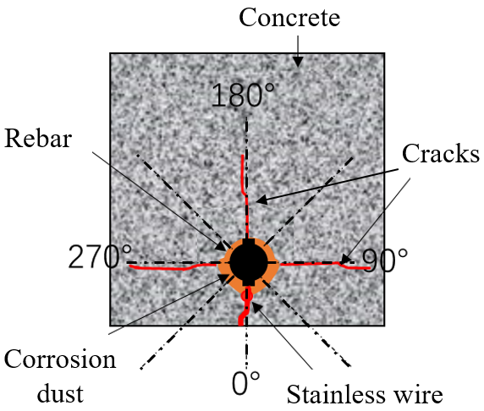  schematic diagram
(a) non-uniformly corroded specimens N30-Z0
macrocracks | microcracks | 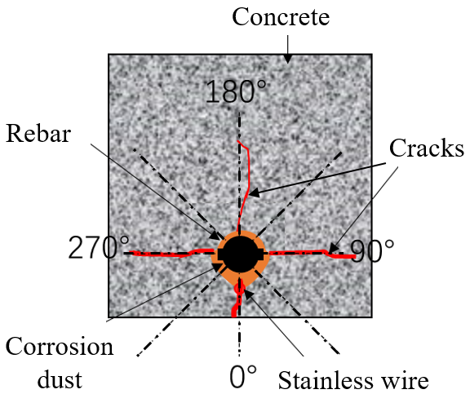  schematic diagram
(b) non-uniformly corroded specimens N30-Z90
macrocracks | microcracks | 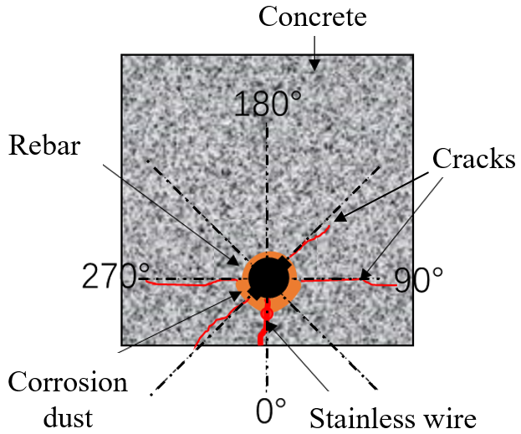  schematic diagram
(c) non-uniformly corroded specimens N30-Z135
Fig. 11. Crack widths of the specimens with rebar in the middle bottom (c₁ = 30 mm, c₂ = 67 mm).

3.1.3 The cases with steel rebar in the center

At last, to investigate the effects of the corrosion mode on the cracking pattern, the respective distributions of non-uniform and uniform corrosion-induced cracks of the specimens with steel rebar embedded in the center (c₁ = 67 mm, c₂ = 67 mm) were plotted in Fig. 12, in which the angle of the longitudinal rib was uniformly specified as θ = 90°.
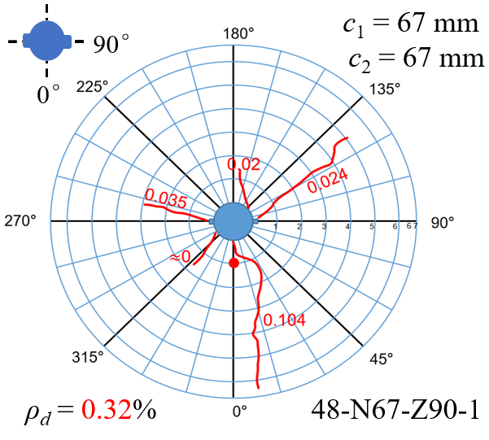 | 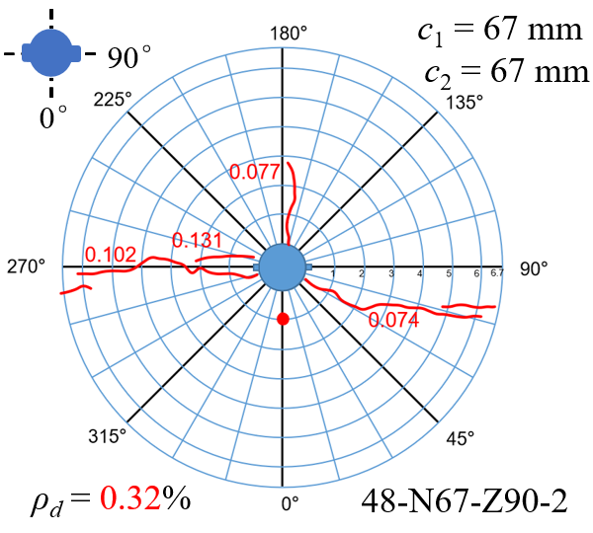 | 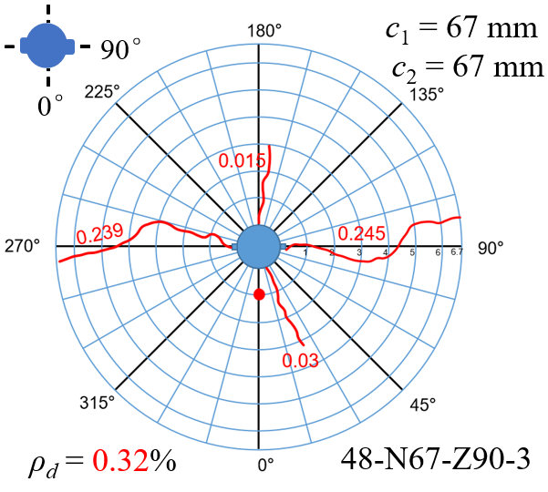
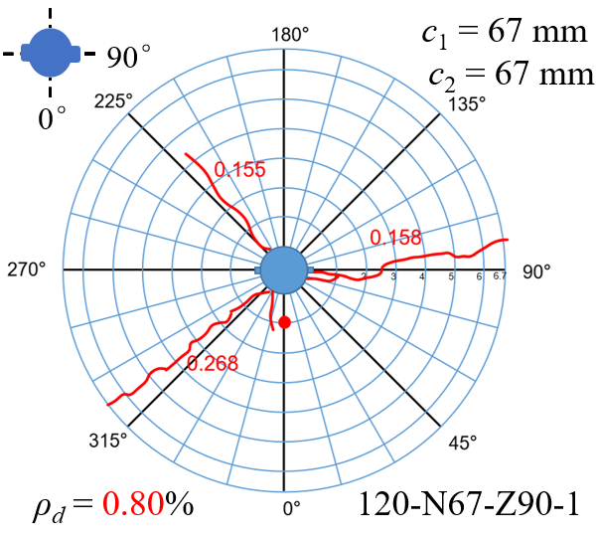 | 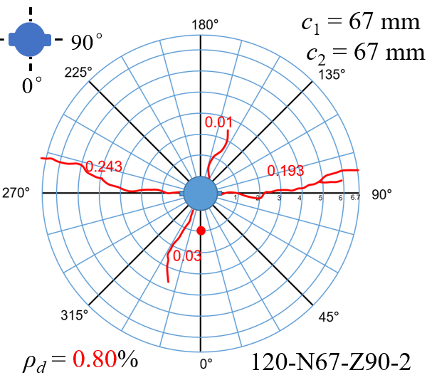 | 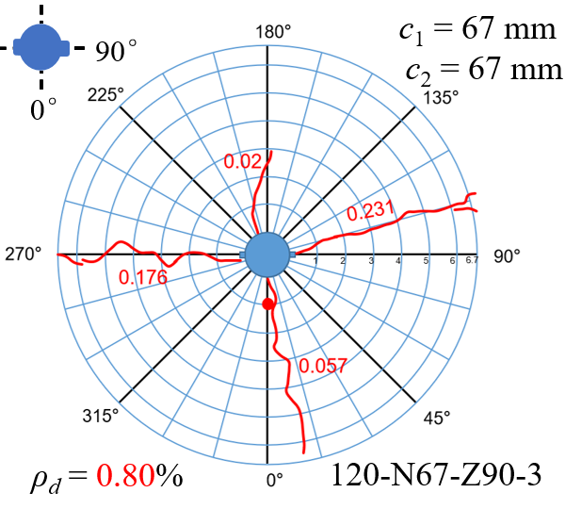
(a) non-uniformly corroded specimens N67-Z90
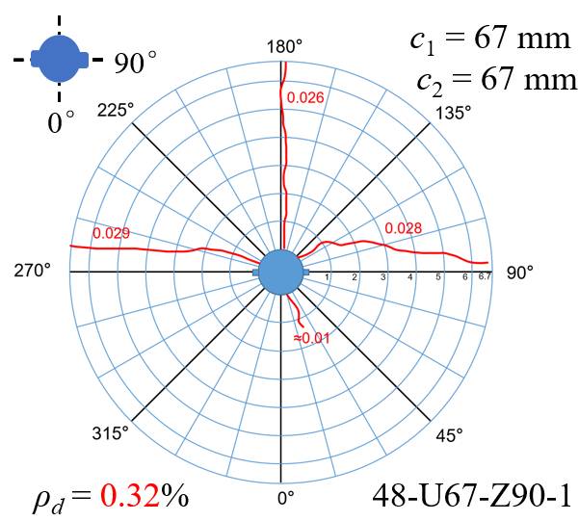 | 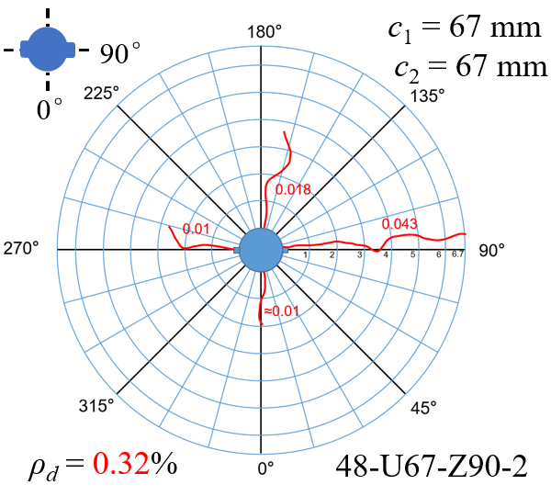 | 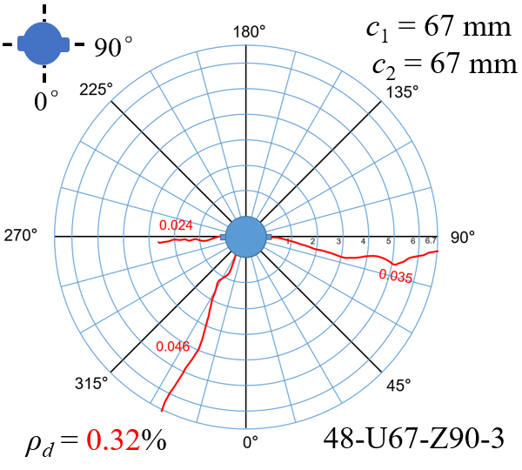
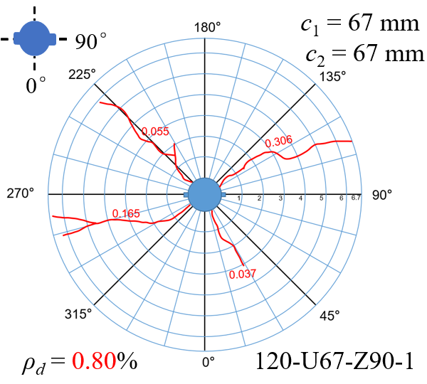 | 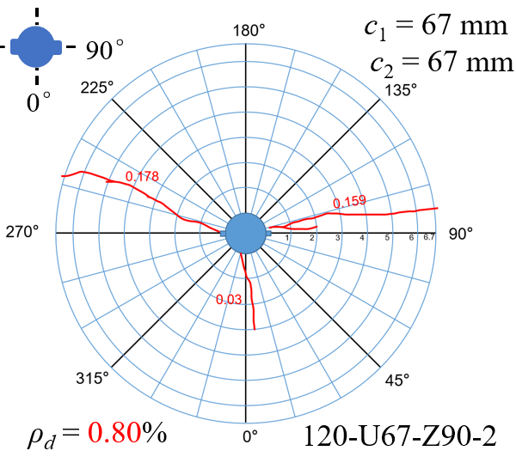 | 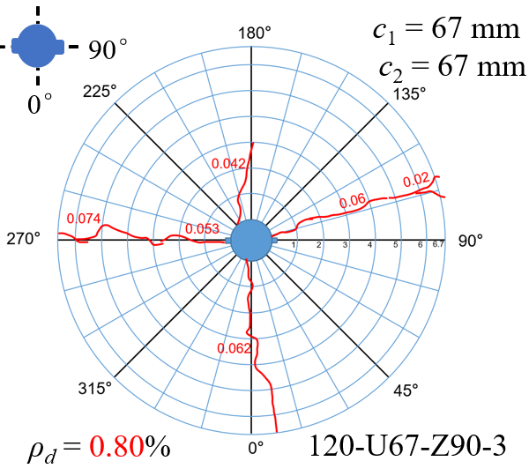
(b) uniformly corroded specimens U67-Z90
Fig. 12. Cracking patterns of the specimens with steel rebar embedded in the center (c₁ = c₂ = 67 mm).

It can be seen that owing to the equal effective concrete constraint in all directions, the cracking pattern of the specimens was mostly characterized by some random radial cracks that are gradually developed outwards. Due to the adequate constraint provided by the concrete cover (c/d = 4.19), all the specimens were found to be crack free on the surface of concrete when they were corroded for 24 h. As the corrosion time prolonged, the average maximum crack widths of non-uniformly corroded specimens 48-N67-Z90 (ρ_{d} = 0.32%, T = 48 h) and 120-N67-Z90 (ρ_{d} = 0.80%, T = 120 h) were extended to 0.090 mm and 0.140 mm, respectively; while for the uniformly corroded specimens 48-U67-Z90 and 120-U67-Z90, the values were 0.027 mm and 0.106 mm correspondingly.

Furthermore, concerning the propagation direction of the cracks, a more obvious divergence can be found upon the quantitative analyses of the maximum crack widths, as shown in Fig. 13. For the non-uniformly corroded specimens N67-Z90, a cruciform cracking pattern was generally observed, although the microcracks were randomly distributed. The average widths of the cracks in the directions of β = 0°/180° were 0.104 mm (ρ_{d} = 0.32%, T = 48 h) and 0.057 mm (ρ_{d} = 0.80%, T = 120 h), and the values in the directions of β = 90°/270° were 0.145 mm (ρ_{d} = 0.32%, T = 48 h) and 0.200 (ρ_{d} = 0.80%, T = 120 h). While for the uniformly corroded specimens U67-Z90, the macrocracks were found to be parallel to the orientation of the longitudinal rib. The average widths of the cracks in the directions of β = 0°/180° were 0.010 mm (ρ_{d} = 0.32%, T = 48 h) and 0.057 mm (ρ_{d} = 0.80%, T = 120 h), and the values in the directions of β = 90°/270° were 0.028 mm (ρ_{d} = 0.32%, T = 48 h) and 0.116 (ρ_{d} = 0.80%, T = 120 h), almost double times of the values in the orthogonal direction. This uneven development of the cracks again indicated that the formation of the main cracks is closely related to the orientation of longitudinal rib.

macrocracks | distribution over corrosion time | 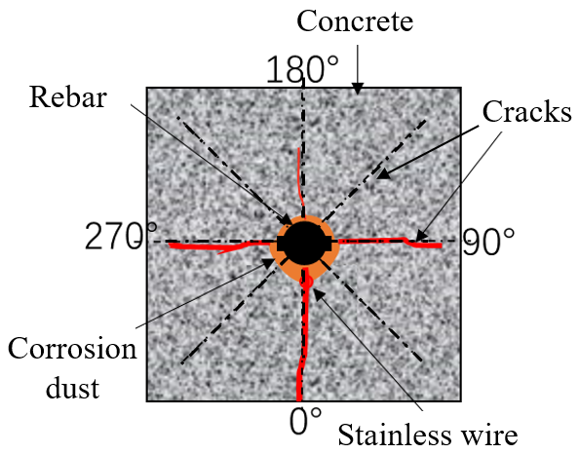  schematic diagram
(a) non-uniformly corroded specimens N67-Z90
macrocracks | distribution over corrosion time | 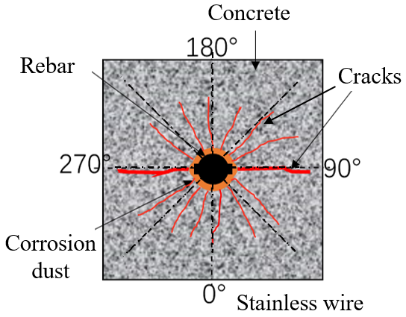  schematic diagram
(b) uniformly corroded specimens U67-Z90
Fig. 13. Crack widths of the specimens with steel rebar embedded in the center (c₁ = c₂ = 67 mm).

3.2 Bond performance of corroded steel rebar to concrete
Given the reinforcement corrosion, the interfacial bonding between the corroded steel rebar and surrounding concrete is expected to be quite different from the non-corroded one. In this section, the bond degradation of corroded specimens will be analyzed comprehensively, in terms of the failure modes and the bond stress-slip relationships.

3.2.1 Failure modes

Owing to the differences in effective concrete cover and corrosion situations, the corroded specimens failed in three modes, namely, splitting failure, pull-out failure, and an intermediate failure mode, as shown in Fig. 14.

For the splitting failure, the most common failure mode in the test, as documented in Table A1 of the Appendix, it occurred mainly due to the inadequate constraint provided by the thin concrete cover (c_{min} = 30 mm). In most instances, it was observed to fail in a sudden with a dramatic reduction of bond resistance when the load-induced radial macrocracks rapidly reached the outer surface of concrete. For the pull-out failure, it was observed to occur in the cases that the specimens, for example, 96-U67-Z90, were subjected to severe corrosion accompanied by adequate concrete constraint. It was characterized by an initial controllable opening of the corrosion-induced macrocracks on the surface of the specimen, followed by a gradual slide of steel rebar during the pull-out test without any concrete splitting. Finally, for the failure mode in between the former two modes, a mixed observation that the steel rebar was pulled out along with some underdeveloped cracks emerged on the surface of concrete can be captured.

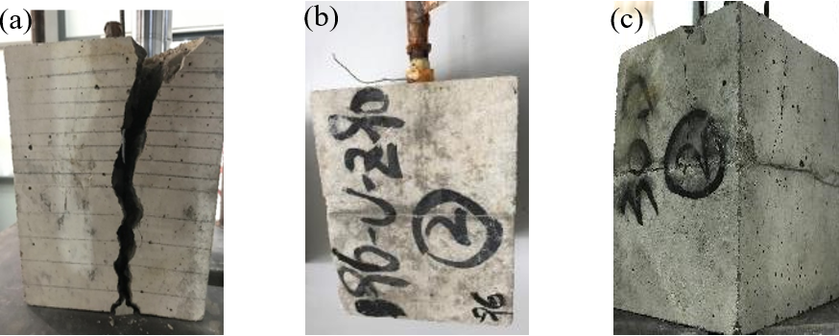
Fig.14. Failure modes of the specimens: (a) splitting failure, (b) pull-out failure, and (c) the intermediate failure mode characterized by the pull-out of steel rebar with some cracks on the surface of concrete.

3.2.2 Bond responses

3.2.2.1 The cases of uncorroded specimens

As aforementioned in section 2.1, three groups of corrosion-free specimens with steel rebar embedded in the corner (30-D), middle bottom (30-Z), and center (67-Z), respectively, were also prepared for the pull-out test. The bond stress-slip relationships of these control specimens were plotted in Fig. 15.

From the comparisons, it can be seen that the ultimate bond strengths of these three groups of specimens were almost equal; but the corresponding peak slips varied greatly, which increased obviously as the concrete constraint increased and resulted in a more ductile bond response. This phenomenon can be mainly attributed to the fact that all these corrosion-free specimens were failed in the pull-out failure model, albeit some cracks were observed on the concrete surface, as documented in Table A1. It implies that in such cases, the confinement provided by the concrete cover is able to mitigate the development of load-induced cracks. Similar observations can be found in [55]. With the increase of the concrete cover, this trend becomes more pronounced and many microcracks rather than macrocracks formed, leading to a bigger capability of absorbing dissipated energy during the debonding process. From the illustration, it is also indicated that compared with the bond strength, the ductility of the bond behavior seems to be more sensitive to the degree of concrete constraint.

Fig.15. Bond responses of uncorroded specimens with steel rebar in the position of (a) the corner, (b) the middle bottom, and (c) the center.

3.2.2.2 The cases of corroded specimens with steel rebar in the corner

The bond stress-slip relationships of non-uniformly corroded specimens with steel rebar in the corner (c₁ = c₂ = 30 mm) were shown in Fig. 16, and for comparison, the medial curve (not the average value of three curves) of the control specimens was also included.

The obvious divergences of the curves indicated that the bond response was greatly affected by the orientation of longitudinal rib. When subjected to low reinforcement corrosion (ρ_{d} = 0.08%, T = 12 h), compared with the control specimens, only a small degradation (about 5.7%) in bond strength was observed for the specimens 12-N30-D0; while for the specimens 12-N30-D45 and 12-N30-D135, a significant reduction (about 22.4%) was observed. The phenomenon was not quite consistent with reported studies that some enhancements could be obtained in the case of minor reinforcement corrosion. This was mainly attributed to the inadequate concrete constraint that the improvements caused by the expansive rust were counteracted by the formation of cracks in various magnitudes.

With further corrosion, a more significant reduction in bond strength was generally observed. For the specimens 96-N30-D0, 96-N30-D45, and 96-N30-D135, the reductions were 31.3%, 35.7%, and 42.2%, respectively, when compared to the control specimens. The results indicated that in the case of inadequate constraint of steel rebar in the corner, the most severe degradation is obtained when the orientation of longitudinal rib θ = 135°, followed by θ = 45° and θ = 0° in sequence.
Fig.16. Bond responses of corroded specimens with steel rebar in the corner.

3.2.2.3 The cases of corroded specimens with steel rebar in the middle bottom

As shown in Fig. 17, the bond stress-slip relationships of non-uniformly corroded specimens with steel rebar in the middle bottom (c₁ = 30 mm, c₂ = 67 mm) were compared in this section.

From the comparisons, it can be seen that after a short time of accelerated corrosion (ρ_{d} = 0.08%, T = 12 h), the respective bond strength of the specimens 12-N30-Z0, 12-N30-Z90, and 12-N30-Z135 generally exhibited a minor improvement when compared to the control specimens. The observation suggested that the steel rebars embedded in the middle bottom subject to a stronger constraint than those in the corner, although the minimum concrete cover (c_{min} = 30 mm) is identical. Hence, because of this, the beneficial effect of the expansive rust in improving the bond performance at the beginning of reinforcement corrosion can be reflected to some degree.
Fig.17. Bond responses of corroded specimens with steel rebar in the middle bottom.

With the further development of reinforcement corrosion, the bond degradation became more and more pronounced as expected. Compared to the corrosion-free specimen 30-Z-1, the respective reduction of the bond strength reached up to 35.9%, 30.5%, and 31.4% for the specimens 96-N30-Z0, 96-N30-Z90, and 96-N30-Z135. This phenomenon can be probably attributed to two reasons. First of all, the concrete constraint in the directions of β = 90°/270° was much greater than that in the orthogonal direction of β = 0° (c₂/c₁ = 2.23), and secondly, as already evidenced in section 3.1, the main cracks were prone to be initiated in the direction that is parallel to the orientation of longitudinal rib. Hence, it is reasonable that the most severe bond degradation was observed for the specimens with longitudinal rib orientated in the direction of θ = 0°.

3.2.2.4 The cases of corroded specimens with steel rebar in the center

In Fig. 18, the bond stress-slip relationships of corroded specimens with steel rebar in the center (c₁ = 67 mm, c₂ = 67 mm) were analyzed, in which two corrosion modes, i.e., non-uniform corrosion and uniform corrosion, were compared. The average bond stress-slip curve of the control specimens was also included.

From the illustration, obvious improvements in bond performance resulted from the corrosion of reinforcement can be observed when compared to the uncorroded specimens 67-Z. Given the high ratio between the concrete cover and rebar diameter (c/d = 4.19), the steel rebar is well-confined. Hence, in such case, the confinement caused by the expansive rust increased greatly, and as a consequence, the bond strengths of non-uniformly corroded specimens 24-N67-Z90 and uniformly corroded specimens 24-U67-Z90 were improved as much as 33.0% and 43.6%, respectively. Because of higher capability in controlling the opening of cracks, as shown in Fig. 18 (d), the improvements are much higher than those of the cases in which the steel rebars were embedded in the corner or middle bottom, whose confinement were weakened considerably. It was not until the corrosion time prolong to 96 h that the beneficial improvement provided by the expansive rust were approximately counteracted by its adverse effects.

Moreover, the comparisons between the non-uniformly corroded specimens and uniformly corroded specimens broadly indicated that regardless of the corrosion levels, more severe degradation of bond performance is always obtained in the case of non-uniform corrosion. This difference was mainly due to the stress concentration induced by non-uniformly accumulated rust around the steel rebar, which weakens the interfacial bonding greatly [41,50]. Hence, in practice, the test results of bond degradation caused by uniform reinforcement corrosion are not preferable in designing RC structures more safely, especially for those frequently exposed to harsh environments.
Fig.18. Bond responses of corroded specimens with steel rebar in the center.

4. Conclusions
In this study, a total of 105 specimens were tested to evaluate the degradation of bond performance induced by non-uniform corrosion of reinforcing bars in concrete. Based on the test results, the following conclusions can be drawn:

(1) Due to the stress concentration within the interface, the bond performance of non-uniformly corroded specimens generally degrade much more conspicuously in comparison with the case of uniform corrosion, which becomes also more pronounced as the corrosion level increases.

(2) Concerning the crucial role of the degree of concrete constraint in determining the cracking patterns, the beneficial improvements of expansive rust in bond performance at the early stage of reinforcement corrosion may be counteracted by the cracks formation in various magnitudes.

(3) The development of the corrosion-induced cracks is affected by the longitudinal rib. In most cases, the main cracks are prone to propagate along the direction of the longitudinal rib, regardless of the corrosion mode and the degree of concrete constraint.

(4) The influence of the orientation of longitudinal rib on the bond strength is greatly dependent on the position of steel rebar. For the cases with steel rebars embedded in the middle bottom, the bond strength of specimens with rib angle θ = 0° degrades most significantly, while for the cases with steel rebars embedded in the corner, the specimens with rib angle θ = 135° show the largest degradation.

Appendix

Table A1. Summary of the test results
Specimen |  | Actual corrosion level#  (%) |  | Ultimate bond strength  (MPa) |  |  | Failure mode⁑
Group | No. | ρ_{a} | ρ_{a,m} | τ_{u} | τ_{u,m} | η_{τ}* | Failure mode⁑
30-D | 1 | 0 | 0 | 13.31 | 13.98 |  | PO/S
30-D | 2 | 0 | 0 | 14.70 | 13.98 |  | PO/S
30-D | 3 | 0 | 0 | 13.93 | 13.98 |  | PO/S
30-Z | 1 | 0 | 0 | 13.86 | 13.90 |  | PO/S
30-Z | 2 | 0 | 0 | 13.75 | 13.90 |  | PO/S
30-Z | 3 | 0 | 0 | 14.10 | 13.90 |  | PO/S
67-Z | 1 | 0 | 0 | 15.02 | 14.16 |  | PO/S
67-Z | 2 | 0 | 0 | 13.57 | 14.16 |  | PO/S
67-Z | 3 | 0 | 0 | 13.89 | 14.16 |  | PO/S
12-N30-D0 | 1 | 0.06 | 0.05 | 13.5 | 13.18 | 0.97 | S
12-N30-D0 | 2 | 0.03 | 0.05 | 12.64 | 13.18 | 0.9 | PO
12-N30-D0 | 3 | 0.07 | 0.05 | 13.4 | 13.18 | 0.96 | S
24-N30-D0 | 1 | 0.12 | 0.14 | 11.41 | 11.52 | 0.82 | S
24-N30-D0 | 2 | 0.09 | 0.14 | 11.38 | 11.52 | 0.81 | S
24-N30-D0 | 3 | 0.22 | 0.14 | 11.76 | 11.52 | 0.84 | S
48-N30-D0 | 1 | 0.30 | 0.30 | 10.25 | 10.27 | 0.73 | S
48-N30-D0 | 2 | 0.26 | 0.30 | 10.44 | 10.27 | 0.75 | PO
48-N30-D0 | 3 | 0.35 | 0.30 | 10.11 | 10.27 | 0.72 | PO
96-N30-D0 | 1 | 0.59 | 0.58 | 9.99 | 9.62 | 0.72 | S
96-N30-D0 | 2 | 0.7 | 0.58 | 8.41 | 9.62 | 0.6 | S
96-N30-D0 | 3 | 0.45 | 0.58 | 10.46 | 9.62 | 0.75 | S
12-N30-D45 | 1 | 0.12 | 0.07 | 10.04 | 10.84 | 0.72 | PO
12-N30-D45 | 2 | 0.03 | 0.07 | 11.69 | 10.84 | 0.84 | PO
12-N30-D45 | 3 | 0.05 | 0.07 | 10.8 | 10.84 | 0.77 | S
24-N30-D45 | 1 | 0.12 | 0.13 | 9.97 | 10.12 | 0.71 | S
24-N30-D45 | 2 | 0.07 | 0.13 | 10.94 | 10.12 | 0.78 | S
24-N30-D45 | 3 | 0.2 | 0.13 | 9.46 | 10.12 | 0.68 | S
48-N30-D45 | 1 | 0.25 | 0.26 | 9.19 | 9.64 | 0.66 | PO
48-N30-D45 | 2 | 0.18 | 0.26 | 10.01 | 9.64 | 0.72 | PO
48-N30-D45 | 3 | 0.34 | 0.26 | 9.73 | 9.64 | 0.7 | PO
96-N30-D45 | 1 | 0.65 | 0.69 | 8.96 | 9.01 | 0.64 | S
96-N30-D45 | 2 | 0.69 | 0.69 | 9.20 | 9.01 | 0.66 | S
96-N30-D45 | 3 | 0.73 | 0.69 | 8.87 | 9.01 | 0.63 | S
12-N30-D135 | 1 | 0.03 | 0.04 | 10.32 | 10.72 | 0.74 | S
12-N30-D135 | 2 | 0.06 | 0.04 | 10.48 | 10.72 | 0.75 | S
12-N30-D135 | 3 | 0.02 | 0.04 | 11.37 | 10.72 | 0.81 | S
24-N30-D135 | 1 | 0.11 | 0.11 | 9.23 | 9.73 | 0.66 | S
24-N30-D135 | 2 | 0.08 | 0.11 | 10.12 | 9.73 | 0.72 | S
24-N30-D135 | 3 | 0.14 | 0.11 | 9.83 | 9.73 | 0.7 | S
48-N30-D135 | 1 | 0.29 | 0.31 | 9.17 | 9.04 | 0.66 | S
48-N30-D135 | 2 | 0.37 | 0.31 | 8.66 | 9.04 | 0.62 | S
48-N30-D135 | 3 | 0.27 | 0.31 | 9.28 | 9.04 | 0.66 | S
96-N30-D135 | 1 | 0.77 | 0.69 | 7.11 | 8.08 | 0.51 | S
96-N30-D135 | 2 | 0.71 | 0.69 | 8.69 | 8.08 | 0.62 | S
96-N30-D135 | 3 | 0.58 | 0.69 | 8.43 | 8.08 | 0.6 | S
12-N30-Z0 | 1 | 0.04 | 0.04 | 14.11 | 14.13 | 1.02 | S
12-N30-Z0 | 2 | 0.05 | 0.04 | 14.28 | 14.13 | 1.03 | S
12-N30-Z0 | 3 | 0.04 | 0.04 | 14.01 | 14.13 | 1.01 | PO
24-N30-Z0 | 1 | 0.12 | 0.13 | 12.21 | 12.24 | 0.88 | S
24-N30-Z0 | 2 | 0.17 | 0.13 | 12.82 | 12.24 | 0.92 | S
24-N30-Z0 | 3 | 0.09 | 0.13 | 11.7 | 12.24 | 0.84 | S
48-N30-Z0 | 1 | 0.41 | 0.35 | 11.21 | 11.80 | 0.81 | S
48-N30-Z0 | 2 | 0.27 | 0.35 | 12.03 | 11.80 | 0.87 | S
48-N30-Z0 | 3 | 0.36 | 0.35 | 12.17 | 11.80 | 0.88 | S
96-N30-Z0 | 1 | 0.59 | 0.60 | 8.89 | 9.64 | 0.64 | S
96-N30-Z0 | 2 | 0.66 | 0.60 | 9.94 | 9.64 | 0.72 | S
96-N30-Z0 | 3 | 0.55 | 0.60 | 10.1 | 9.64 | 0.73 | S
12-N30-Z90 | 1 | 0.09 | 0.06 | 13.87 | 13.92 | 1.00 | S
12-N30-Z90 | 2 | 0.02 | 0.06 | 12.89 | 13.92 | 0.93 | S
12-N30-Z90 | 3 | 0.06 | 0.06 | 15 | 13.92 | 1.08 | PO
24-N30-Z90 | 1 | 0.07 | 0.11 | 12.86 | 13.34 | 0.93 | S
24-N30-Z90 | 2 | 0.12 | 0.11 | 13.24 | 13.34 | 0.95 | S
24-N30-Z90 | 3 | 0.15 | 0.11 | 13.91 | 13.34 | 1.00 | S
48-N30-Z90 | 1 | 0.29 | 0.30 | 12.51 | 12.11 | 0.90 | S
48-N30-Z90 | 2 | 0.22 | 0.30 | 12.02 | 12.11 | 0.86 | S
48-N30-Z90 | 3 | 0.39 | 0.30 | 11.79 | 12.11 | 0.85 | S
96-N30-Z90 | 1 | 0.60 | 0.62 | 9.87 | 9.66 | 0.71 | S
96-N30-Z90 | 2 | 0.62 | 0.62 | 9.08 | 9.66 | 0.65 | PO
96-N30-Z90 | 3 | 0.66 | 0.62 | 10.03 | 9.66 | 0.72 | S
12-N30-Z135 | 1 | 0.05 | 0.05 | 14.19 | 14.00 | 1.02 | PO
12-N30-Z135 | 2 | 0.06 | 0.05 | 14.61 | 14.00 | 1.05 | S
12-N30-Z135 | 3 | 0.05 | 0.05 | 13.19 | 14.00 | 0.95 | S
24-N30-Z135 | 1 | 0.14 | 0.15 | 13.36 | 13.09 | 0.96 | S
24-N30-Z135 | 2 | 0.13 | 0.15 | 13.13 | 13.09 | 0.94 | S
24-N30-Z135 | 3 | 0.17 | 0.15 | 12.77 | 13.09 | 0.92 | S
48-N30-Z135 | 1 | 0.27 | 0.30 | 12.39 | 12.29 | 0.89 | S
48-N30-Z135 | 2 | 0.24 | 0.30 | 12.6 | 12.29 | 0.91 | S
48-N30-Z135 | 3 | 0.38 | 0.30 | 11.87 | 12.29 | 0.85 | S
96-N30-Z135 | 1 | 0.75 | 0.64 | 8.98 | 9.53 | 0.65 | S
96-N30-Z135 | 2 | 0.61 | 0.64 | 10.18 | 9.53 | 0.73 | S
96-N30-Z135 | 3 | 0.55 | 0.64 | 9.42 | 9.53 | 0.68 | S
24-N67-Z90 | 1 | 0.14 | 0.12 | 18.91 | 18.86 | 1.33 | S
24-N67-Z90 | 2 | 0.11 | 0.12 | 19.24 | 18.86 | 1.36 | S
24-N67-Z90 | 3 | 0.12 | 0.12 | 18.43 | 18.86 | 1.30 | S
48-N67-Z90 | 1 | 0.42 | 0.30 | 16.56 | 17.19 | 1.17 | S
48-N67-Z90 | 2 | 0.22 | 0.30 | 18.33 | 17.19 | 1.29 | S
48-N67-Z90 | 3 | 0.26 | 0.30 | 16.67 | 17.19 | 1.18 | S
96-N67-Z90 | 1 | 0.53 | 0.60 | 15.24 | 15.24 | 1.07 | PO
96-N67-Z90 | 2 | 0.60 | 0.60 | 15.74 | 15.24 | 1.11 | S
96-N67-Z90 | 3 | 0.66 | 0.60 | 14.74 | 15.24 | 1.04 | PO
120-N67-Z90 | 1 | 0.85 | 0.82 | 9.87 | 9.84 | 0.70 | PO
120-N67-Z90 | 2 | 0.78 | 0.82 | 9.80 | 9.84 | 0.69 | PO
120-N67-Z90 | 3 | / | 0.82 | / | 9.84 | / | /
24-U67-Z90 | 1 | 0.08 | 0.11 | 22.00 | 20.36 | 1.55 | S
24-U67-Z90 | 2 | 0.11 | 0.11 | 19.53 | 20.36 | 1.38 | S
24-U67-Z90 | 3 | 0.14 | 0.11 | 19.55 | 20.36 | 1.38 | S
48-U67-Z90 | 1 | 0.22 | 0.22 | 17.50 | 17.53 | 1.23 | S
48-U67-Z90 | 2 | 0.19 | 0.22 | 17.61 | 17.53 | 1.24 | S
48-U67-Z90 | 3 | 0.26 | 0.22 | 17.47 | 17.53 | 1.23 | S
96-U67-Z90 | 1 | 0.54 | 0.52 | 15.58 | 16.33 | 1.10 | PO
96-U67-Z90 | 2 | 0.59 | 0.52 | 16.79 | 16.33 | 1.18 | S
96-U67-Z90 | 3 | 0.43 | 0.52 | 16.63 | 16.33 | 1.17 | PO
120-U67-Z90 | 1 | 0.76 | 0.66 | 14.26 | 14.43 | 1.01 | PO
120-U67-Z90 | 2 | 0.69 | 0.66 | 15.14 | 14.43 | 1.07 | PO
120-U67-Z90 | 3 | 0.54 | 0.66 | 13.88 | 14.43 | 0.98 | PO
Note: 1. for the actual corrosion level#, due to the stochastic nature of corrosion, the measured values of specimens in one group are not identical, albeit they are quite close to the theoretical designed level.
2. the symbol η_{τ}* denotes the ratio between the ultimate bond strength of the corroded specimen and that of corresponding corrosion-free specimen with the same position (i.e., corner, middle bottom, or center).
3. for the failure mode⁑, “PO” represents the pull-out failure, “S” represents the splitting failure, and “PO/S” represents a failure mode in between the above two modes, mainly characterized by the pull-out of steel rebar but also accompanied with some cracks on the surface of concrete.

Acknowledgements
The financial support from the Zhejiang Provincial Natural Science Foundation of China (Grant No. LZ20E080003), and the National Natural Science Foundation of China (Grant Nos. 51978620 and 51678529) are gratefully acknowledged.

References
[1] S.Ahmad, Reinforcement corrosion in concrete structures, its monitoring and service life prediction––a review, Cem. Concr. Compos. 25 (2003) 459–471.
[2] J.P.Broomfield, Corrosion of steel in concrete: understanding, investigation and repair, CRC Press, Oxon, UK, 2003.
[3] H.Ye, C.Fu, Y.Tian, N.Jin, Chloride-Induced Steel Corrosion in Concrete Under Service Loads, Springer Nature, Singapore, 2020.
[4] H.Lin, Y.Zhao, P.Feng, H.Ye, J.Ozbolt, C.Jiang, J.-Q.Yang, State-of-the-art review on the bond properties of corroded reinforcing steel bar, Constr. Build. Mater. 213 (2019) 216–233.
[5] H.Lin, Y.Zhao, J.-Q.Yang, P.Feng, J.Ozbolt, H.Ye, Effects of the corrosion of main bar and stirrups on the bond behavior of reinforcing steel bar, Constr. Build. Mater. 225 (2019) 13–28.
[6] Y.Zhao, J.Yu, B.Hu, W.Jin, Crack shape and rust distribution in corrosion-induced cracking concrete, Corros. Sci. 55 (2012) 385–393. doi:10.1016/j.corsci.2011.11.002.
[7] I.Sæther, Bond deterioration of corroded steel bars in concrete, Struct. Infrastruct. Eng. 7 (2011) 415–429.
[8] Y.Auyeung, P.Balaguru, L.Chung, Bond behavior of corroded reinforcement bars, Mater. J. 97 (2000) 214–220.
[9] G.J.Al-Sulaimani, M.Kaleemullah, I.A.Basunbul, Influence of corrosion and cracking on bond behavior and strength of reinforced concrete members, Struct. J. 87 (1990) 220–231.
[10] R.Zhang, A.Castel, R.François, The corrosion pattern of reinforcement and its influence on serviceability of reinforced concrete members in chloride environment, Cem. Concr. Res. 39 (2009) 1077–1086. doi:10.1016/j.cemconres.2009.07.025.
[11] M.Otieno, H.Beushausen, M.Alexander, Chloride-induced corrosion of steel in cracked concrete - Part I: Experimental studies under accelerated and natural marine environments, Cem. Concr. Res. 79 (2016) 373–385. doi:10.1016/j.cemconres.2015.08.009.
[12] H.Jiang, N.Jin, H.Ye, Y.Tian, X.Jin, Q.Zeng, D.Yan, X.Xu, Fractal Characterization of Non-Uniform Corrosion of Steel Bars in Concrete Beams after Accelerated depassivation and Seven-Year Natural Corrosion, Materials (Basel). 12 (2019) 3919.
[13] O.Poupard, V.L’hostis, S.Catinaud, I.Petre-Lazar, Corrosion damage diagnosis of a reinforced concrete beam after 40 years natural exposure in marine environment, Cem. Concr. Res. 36 (2006) 504–520.
[14] C.Fu, N.Jin, H.Ye, X.Jin, W.Dai, Corrosion characteristics of a 4-year naturally corroded reinforced concrete beam with load-induced transverse cracks, Corros. Sci. 117 (2017) 11–23. doi:10.1016/j.corsci.2017.01.002.
[15] H.Ye, N.Jin, C.Fu, X.Jin, Rust distribution and corrosion-induced cracking patterns of corner-located rebar in concrete cover, Constr. Build. Mater. 156 (2017) 684–691. doi:10.1016/j.conbuildmat.2017.09.033.
[16] Y.Yuan, Y.Ji, S.P.Shah, Comparison of two accelerated corrosion techniques for concrete structures, ACI Struct. J. 104 (2007) 344.
[17] K.-Y.Dai, C.Liu, D.-G.Lu, X.-H.Yu, Experimental investigation on seismic behavior of corroded RC columns under artificial climate environment and electrochemical chloride extraction: A comparative study, Constr. Build. Mater. 242 (2020) 118014.
[18] H.Ye, C.Fu, N.Jin, X.Jin, Performance of reinforced concrete beams corroded under sustained service loads: A comparative study of two accelerated corrosion techniques, Constr. Build. Mater. 162 (2018) 286–297.
[19] W.Zhu, R.François, Y.Liu, Propagation of corrosion and corrosion patterns of bars embedded in RC beams stored in chloride environment for various periods, Constr. Build. Mater. 145 (2017) 147–156.
[20] T.A.ElMaaddawy, K.A.Soudki, Effectiveness of impressed current technique to simulate corrosion of steel reinforcement in concrete, J. Mater. Civ. Eng. 15 (2003) 41–47.
[21] C.Fu, N.Jin, H.Ye, J.Liu, X.Jin, Non-uniform corrosion of steel in mortar induced by impressed current method: An experimental and numerical investigation, Constr. Build. Mater. 183 (2018) 429–438. doi:10.1016/J.CONBUILDMAT.2018.06.183.
[22] Q.Li, L.Huang, H.Ye, C.Fu, X.Jin, Mechanical degradation of reinforced concrete columns corroded under sustained loads, Int. J. Civ. Eng. (2020) 10.1007/s40999-020-00511-w.
[23] L.Huang, H.Ye, X.Jin, N.Jin, Z.Xu, Corrosion-induced shear performance degradation of reinforced concrete beams, Constr. Build. Mater. 248 (2020) 118668.
[24] C.Q.Li, Initiation of chloride-induced reinforcement corrosion in concrete structural members—experimentation, Struct. J. 98 (2001) 502–510.
[25] R.K.L.Su, Y.Zhang, A double-cylinder model incorporating confinement effects for the analysis of corrosion-caused cover cracking in reinforced concrete structures, Corros. Sci. 99 (2015) 205–218.
[26] M.Moreno, W.Morris, M.G.Alvarez, G.S.Duffó, Corrosion of reinforcing steel in simulated concrete pore solutions: effect of carbonation and chloride content, Corros. Sci. 46 (2004) 2681–2699.
[27] R.K.L.Su, Y.Zhang, A novel elastic-body-rotation model for concrete cover spalling caused by non-uniform corrosion of reinforcement, Constr. Build. Mater. 213 (2019) 549–560.
[28] W.Zhu, R.François, D.Coronelli, D.Cleland, Effect of corrosion of reinforcement on the mechanical behaviour of highly corroded RC beams, Eng. Struct. 56 (2013) 544–554.
[29] X.-H.Wang, F.-Y.Liang, Performance of RC columns with partial length corrosion, Nucl. Eng. Des. 238 (2008) 3194–3202.
[30] R.K.Biswas, M.Iwanami, N.Chijiwa, K.Uno, Effect of non-uniform rebar corrosion on structural performance of RC structures: A numerical and experimental investigation, Constr. Build. Mater. 230 (2020) 116908.
[31] Y.Ballim, J.C.Reid, A.R.Kemp, Deflection of RC beams under simultaneous load and steel corrosion, Mag. Concr. Res. 53 (2001) 171–181.
[32] Y.Ballim, J.C.Reid, Reinforcement corrosion and the deflection of RC beams––an experimental critique of current test methods, Cem. Concr. Compos. 25 (2003) 625–632.
[33] Y.Kawasaki, S.Wasada, T.Okamoto, K.Izuno, Evaluation for RC specimen damaged from rebar corrosion by acoustic emission technique, Constr. Build. Mater. 67 (2014) 157–164.
[34] G.Malumbela, M.Alexander, P.Moyo, Steel corrosion on RC structures under sustained service loads—A critical review, Eng. Struct. 31 (2009) 2518–2525.
[35] M.Tapan, R.S.Aboutaha, Effect of steel corrosion and loss of concrete cover on strength of deteriorated RC columns, Constr. Build. Mater. 25 (2011) 2596–2603.
[36] G.T.Burstein, C.Liu, R.M.Souto, S.P.Vines, Origins of pitting corrosion, Corros. Eng. Sci. Technol. 39 (2004) 25–30.
[37] C.A.Apostolopoulos, S.Demis, V.G.Papadakis, Chloride-induced corrosion of steel reinforcement–Mechanical performance and pit depth analysis, Constr. Build. Mater. 38 (2013) 139–146.
[38] X.Gu, H.Guo, B.Zhou, W.Zhang, C.Jiang, Corrosion non-uniformity of steel bars and reliability of corroded RC beams, Eng. Struct. 167 (2018) 188–202.
[39] Z.Ye, W.Zhang, X.Gu, Deterioration of shear behavior of corroded reinforced concrete beams, Eng. Struct. 168 (2018) 708–720.
[40] J.Chen, W.Zhang, X.Gu, Modeling time-dependent circumferential non-uniform corrosion of steel bars in concrete considering corrosion-induced cracking effects, Eng. Struct. 201 (2019) 109766.
[41] E.Chen, C.K.Y.Leung, Finite element modeling of concrete cover cracking due to non-uniform steel corrosion, Eng. Fract. Mech. 134 (2015) 61–78.
[42] W.Zhu, J.-G.Dai, C.-S.Poon, Prediction of the bond strength between non-uniformly corroded steel reinforcement and deteriorated concrete, Constr. Build. Mater. 187 (2018) 1267–1276.
[43] M.Blomfors, K.Zandi, K.Lundgren, D.Coronelli, Engineering bond model for corroded reinforcement, Eng. Struct. 156 (2018) 394–410.
[44] L.Huang, H.Ye, S.Chu, L.Xu, Y.Chi, Stochastic damage model for bond stress-slip relationship of reinforcing bar embedded in concrete, Eng. Struct. 194 (2019) 11–25.
[45] T.Jiang, Z.Wu, L.Huang, H.Ye, Three-Dimensional Nonlinear Finite Element Modeling for Bond Performance of Ribbed Steel Bars in Concrete Under Lateral Tensions, Int. J. Civ. Eng. (2020). doi:10.1007/s40999-019-00488-1.
[46] L.R.Feldman, F.M.Bartlett, Bond strength variability in pullout specimens with plain reinforcement, ACI Struct. J. 102 (2005) 860.
[47] H.Lin, Y.Zhao, Effects of confinements on the bond strength between concrete and corroded steel bars, Constr. Build. Mater. 118 (2016) 127–138.
[48] A.A.Almusallam, A.S.Al-Gahtani, A.R.Aziz, Effect of reinforcement corrosion on bond strength, Constr. Build. Mater. 10 (1996) 123–129.
[49] BSI, BS EN 10080: 2005: Steel for the reinforcement of concrete: Weldable reinforcing steel–General, (2005).
[50] J.Chen, C.Fu, H.Ye, X.Jin, Corrosion of steel embedded in mortar and concrete under different electrolytic accelerated corrosion methods, Constr. Build. Mater. 241 (2020) 117971.
[51] T.ElMaaddawy, K.Soudki, A model for prediction of time from corrosion initiation to corrosion cracking, Cem. Concr. Compos. 29 (2007) 168–175.
[52] G.Horringmoe, I.Saether, R.Antonsen, B.Arntsen, Laboratory investigations of steel bar corrosion in concrete Background document SB-3.10, Sustain. Bridg. Assess. Futur. Traffic Demands Longer Lives. A Proj. Co-Funded by Eur. Comm. within Sixth Framew. Program. (2007).
[53] Y.Zhao, Y.Wu, W.Jin, Distribution of millscale on corroded steel bars and penetration of steel corrosion products in concrete, Corros. Sci. 66 (2013) 160–168.
[54] S.J.Pantazopoulou, K.D.Papoulia, Modeling cover-cracking due to reinforcement corrosion in RC structures, J. Eng. Mech. 127 (2001) 342–351.
[55] A.Torre-Casanova, L.Jason, L.Davenne, X.Pinelli, Confinement effects on the steel–concrete bond strength and pull-out failure, Eng. Fract. Mech. 97 (2013) 92–104.

