Corrosion-induced shear performance degradation of reinforced concrete beams

Le Huang ª, Hailong Ye ^{a,*}, Xianyu Jin ^{b}, Nanguo Jin ^{b}, Zhennan Xu ^{b}

ª Department of Civil Engineering, The University of Hong Kong, Hong Kong, China
^{b} College of Civil Engineering and Architecture, Zhejiang University, Hangzhou, China
* Corresponding author. E-mail: hlye@hku.hk

Abstract: Chloride-induced corrosion of reinforcement has been recognized as one of the most predominant causes of structural degradation. In this paper, experimental and numerical investigation was conducted to study the degraded shear performance of reinforced concrete beam. The corrosion of reinforcements, crack patterns, and structural behaviors of corroded specimens with various corrosion levels accelerated by the impressed current method were analyzed. The test results indicated that the corrosion-induced crack patterns have a close relationship with the level of reinforcement corrosion. Moreover, an obvious degradation of shear performance of corroded RC beams in terms of initial stiffness, cracking loads, ultimate bearing capacity, post-peak behavior, and energy dissipation capacity was observed, which became more pronounced as the corrosion level increased. When a severe corrosion level (η_{a} ≥ 12%) was encountered, the failure mode could even be changed from the shear-compression failure into a much more brittle diagonal splitting failure. In parallel, to numerically simulate the propagation of the main diagonal crack faithfully, the extended finite element method (XFEM) specified with an exponential softening traction-separation relationship was adopted. Moreover, to investigate the effect of corrosion-induced bond degradation, a user-defined element (UEL) was also developed to represent the interfacial bond response. The reasonable agreement between the numerical simulation and experimental results proved the feasibility of the proposed approach.
Keywords: Reinforcement corrosion; shear performance; degradation; XFEM; UEL
- Introduction
Over the past few decades, the deterioration of reinforced concrete (RC) structures induced by reinforcement corrosion has been one of the major challenges facing civil engineers worldwide, due to the deficient structural design, inefficient maintenance procedures, and more importantly, aggressive environment erosion [1-3]. As high as 80% of the total structural failure is closely associated with this stubborn problem according to incomplete statistics [4]. Among various aggressive factors, the ingress of chloride is regarded as the most detrimental mechanism, and such a scenario is more likely to be exacerbated for RC structures exposed to environments where de-icing salts or coastal conditions are encountered [5-7]. By means of massive existing macro- and micro-cracks, voids, and pores, chloride ions can ingress deep into inner concrete and break down the protective passive film on the surface of reinforcements, resulting in a continuous reduction of cross-sectional area of reinforcement subsequently [8]. Besides, the volumetric expansion of accumulated corrosion products further causes cracking, delamination, or even spalling of cover concrete that usually accompanies an obvious impairment of bond performance between steel reinforcements and surrounding concrete [9,10]. Therefore, these urgent questions have strongly necessitated the reevaluation of the mechanical performance of corroded RC members with different corrosion levels.
As such, substantial efforts have been continuously devoted to this issue, and several fundamental concerns have already been addressed well [11,12]. Nevertheless, it should be noted that the majority of reported experimental studies are mainly focused on the corrosion of main longitudinal reinforcements and its detrimental effects on the flexural behavior of RC beams, while the deterioration mechanism of shear performance is often overlooked [13-15], although research into the impact of corrosion on the shear resistance has a wide application [16,17]. In practice, field investigations have shown that because of severe reinforcement corrosion, an RC beam sometimes is more probable to fail in shear though it is initially designed to fail in flexure, transforming a ductile failure mode into a brittle one [18]. Hence, the bearing capacity and serviceability of the whole RC structure will be inevitably weakened to a certain extent, while available results are usually inconclusive and inadequate for predicting this phenomenon with a reliable accuracy [19]. Recently, it has already received some attention to further deepen the knowledge of this problem [20,21]. Of the limited studies, the degradation of shear behavior induced by the corrosion of stirrups has been emphatically analyzed, and a preferable evaluation result has been obtained [22,23].
On the other hand, owing to the repeatability and cost-effectiveness, numerical simulation is also treated as an efficient tool to estimate the performance of the corroded RC beams. By introducing the corrosion-induced damage into the numerical models, the computational result of mechanical performance obtained from most existing finite element method (FEM) simulations can be highly consistent with the experimental observations [24,25], despite that the realistic bond degradation sometimes is failed to be taken into account [26]. For example, to analyze the influence of rust expansion on the structural behavior, a theoretical model based on the thick-wall cylinder theory is firstly introduced by Bazant [27]; and later on, to model the cracking of concrete cover caused by the expansion of corrosion products, Berra et al. [28] proposed a novel analogy approach via imposing orthotropic thermal strains for steel reinforcements. Considering the adverse effects of reinforcement corrosion on the bond performance between steel bars and surrounding concrete, Ma et al. [29,30] conducted some experimental and theoretical studies in this point. However, on account of the inherent deficiency of FEM, the numerical result is less satisfactory regarding the modeling of crack propagation, especially in the case of shear failure [31]. As an alternative approach, the extended finite element method (XFEM) is of many advantages in this respect compared with conventional FEM, which can capture the path of crack development in two- and three-dimensions effectively without updating the original meshes [32]. The inclusion of cohesive forces transmitted through the crack is also quite simple that does not require any addition of interface elements [33]. So ever since it was proposed in 1999 by Belytschko et al. [34], it has already been widely applied in many fields to solve complicated fracture mechanical problems concerning mechanical and/or thermal load in anisotropic medium [35]. In recent years, the XFEM coupling the benefits of the continuum damage mechanics approach has also been demonstrated to have great potential to bridge the gap between continuous and discontinuous displacement fields [36-38].
To this end, the main objective of this study is to analyze the corrosion-induced cracking behavior and its consequent degradation of shear performance of RC beams, with due consideration of adverse effects of different corrosion levels. Moreover, in the numerical analysis, the XFEM in combination with a user-defined bond element was adopted, aiming to track the development of cracks and provide a more reliable guideline for the performance evaluation and maintenance of the corroded RC members.
- Experimental program
  - Materials
Designed in accordance with the Code JGJ 55-2011 [39], the mixture proportions of concrete are given in Table 1. The ordinary Portland cement with a grade of P.O. 42.5 (National Standard of China GB 175-2007) was used as the binder, the natural river sand with a fineness modulus of 2.64 was used as the fine aggregate, and the crushed gravel with the maximum size of 20 mm was used as the coarse aggregate. Moreover, to improve the workability and consistency, a superplasticizer with high water reducing ability was also adopted, and the slump of fresh concrete was about 53 mm.
Table 1
Mixture proportions of concrete (kg/m³).
Cement | Fine aggregate | Coarse aggregate | Water | Superplasticizer | Water-to-cement ratio
455 | 610 | 1240 | 205 | 0.91 | 0.45
Three types of steel reinforcement were adopted, in which the plain steel bar (HPB 300) with a nominal diameter of 6 mm was used as the stirrup, while the other two ribbed steel bars (HRB 400) were used as the major longitudinal reinforcement. According to the regulation specified by GB228/T-2002 [40], the main mechanical properties of reinforcing steels are listed in Table 2.
Table 2
Properties of steel reinforcements.
 | Type | D_{N} (mm) | σ_{sy} (MPa) | σ_{su} (MPa) | δ (%)
Stirrup | Φ6 | 6 | 380 | 530 | 29
Longitudinal reinforcement | Φ10 | 10 | 455 | 640 | 23
Longitudinal reinforcement | Φ12 | 12 | 450 | 645 | 21
Note: D_{N} is the nominal diameter, σ_{sy} is the yielding strength, σ_{su} is the ultimate strength, and δ is the elongation.
  - Specimens preparation
A total of twelve identical specimens with a small shear span ratio (λ = 1.69) were designed to investigate the shear behavior of reinforced concrete beams, as per the requirements of GB 50010-2010 [41]. As shown in Fig. 1, all specimens had the same dimension of 100 mm × 150 mm × 800 mm, and each of them was reinforced with two Φ10 in the compression zone and two Φ12 in the tension zone, as well as six equispaced stirrups with an interval of 150 mm. The thickness of concrete cover over the stirrups was 20 mm.
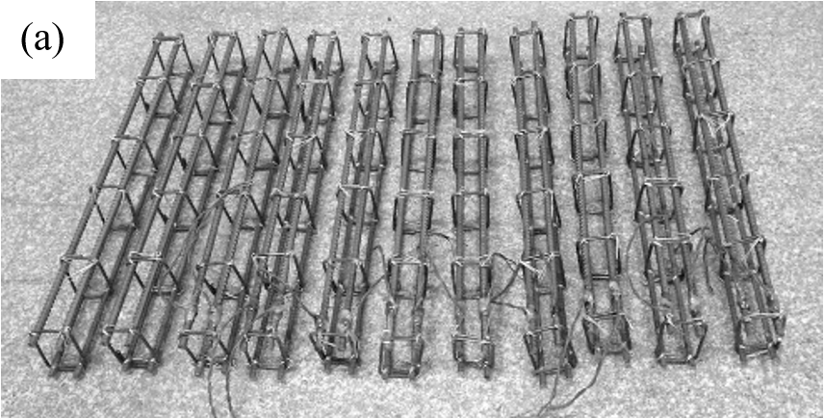
Fig. 1 Illustration of the specimens, (a) fabricated reinforcement cage, and (b) configuration of cross sections.
After installing the fabricated reinforced cages into the wooden molds, the beams were cast in a horizontal position with a needle vibrator. The specimens were demolded after 24 h and then moist-cured until 28 days strength was achieved. Meanwhile, three cubic concrete blocks (150 mm × 150 mm × 150 mm) were also cast from the same batch mixture, and the average 28d compressive strength was measured to be 56.0 MPa.
  - Accelerated corrosion technique
To shorten the test duration, an accelerated corrosion system by impressed current method was adopted in this study, in which a controllable direct current (DC) power supply was used. As shown in Fig. 2, the specimens were immersed into a 5% (by the mass) NaCl solution, and the upper longitudinal reinforcement was connected to the anode of DC source while a stainless steel bar was adopted as the cathode. For each group, the imposed current was controlled by a separate DC source.
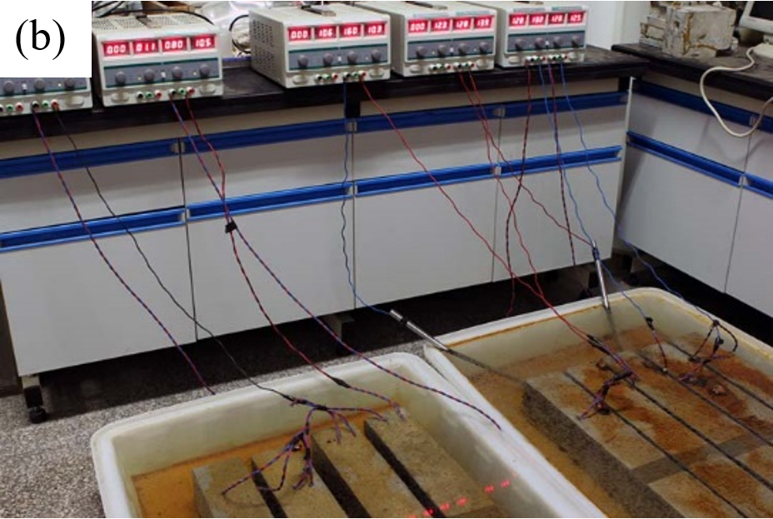
Fig. 2 Test setup for the accelerated corrosion. (a) Schematic diagram, and (b) actual experimental setup.
According to the wide survey of common practical situations, the corrosion can be generally divided into three degrees: minor corrosion (0-5%), moderate corrosion (5-12%), and severe corrosion (more than 12%) [42]. In light of this, three typical corrosion levels, i.e. 5%, 10%, and 15%, of the steel reinforcements were considered in this study, and the prepared specimens were therefore divided into four groups, including a control group (i.e., 0% corrosion level).
To quantify the reinforcement corrosion, the actual corrosion level η_{a} was generally defined as the weight loss percentage of the original state [43], that is,
(1)
where Δm is the weight loss, and m_{i} and m_{f} are the mass of the reinforcement before and after corrosion, respectively. To achieve the targeted corrosion level, the theoretical duration required was estimated based on the Faraday’s law as follows [44],
(2)
where I is the current (A), t is the time of accelerated corrosion (s), M is the molecular weight of iron (M = 56 g), n is number of equivalents (mols of electrons) transferred per mol of iron (n = 2 in this case), and F_{a} is the Faraday’s constant (F_{a} = 96500 As). In accordance to the above definition, the design of corrosion parameters was shown in Table 3.
Table 3
Design of the corrosion.
Specimens | η_{d} (%) | I (A) | i_{corr} (mA/cm²) | t (d)
S-00%-1, S-00%-2, S-00%-3 | 0 | 0 | 0 | 0
S-05%-1, S-05%-2, S-05%-3 | 5 | 0.48 | 0.3 | 12.12
S-10%-1, S-10%-2, S-10%-3 | 10 | 0.80 | 0.5 | 14.56
S-15%-1, S-15%-2, S-15%-3 | 15 | 1.28 | 0.8 | 13.65
Note: 1. The specimens are named as S-x%-y, in which x represents the corrosion level, and y denotes the series number for each group.
2. η_{d} is the designed corrosion level, I is the current magnitude, i_{corr} is the current density within the cross section, and t is the theoretical corrosion time.
During the corrosion process, the evolution of cracks on the surfaces of specimens was mapped periodically, and the crack width was measured using a crack visualizer with an accuracy of 0.02 mm. Once the theoretical corrosion time of any group of specimens was reached, the accelerated corrosion was terminated and the beams were moved out of the container for the subsequent mechanical tests.
  - Test apparatus and loading procedure
As shown in Fig. 3(a), all specimens were subjected to four-point bending. The load was applied by a hydraulic pressure servo actuator with a maximum bearing capacity of 600 kN, and a rigid I-beam was used to distribute the external load. Two linear variable differential transducers (LVDTs) with an accuracy of 0.01 mm were adopted to measure the beam deflection at midspan.
Before the test, the contact parts between the specimen and supports were ground smooth, and the surfaces of the specimens were white-washed with latex for mapping the evolution of load-induced cracks during the test. In the beginning, a trial loading was performed to ensure all components of the test apparatus are in firm contact with the specimen. Afterwards, a predetermined step loading procedure as sketched in Fig. 3(b) was carried out. Before cracking, the increment of the load at each step was 20% of the estimated ultimate bearing capacity. When the first crack was about to occur, the load increment was reduced to 10%, and around the occurrence of the first diagonal crack, it was further reduced to 5%. At the final stage approaching the ultimate bearing capacity, the displacement control was adopted, and the displacement increment was 0.4 mm. For each step mentioned above, the loading interval was 10 minutes. The test stopped when the concrete at the pure bending section crushed or the bearing capacity of the specimen decreased obviously.
Fig. 3 Setup for the four-point bending test and loading procedure.
- Experimental results
  - Corrosion-induced crack patterns
The cracking behavior of all the specimens induced by reinforcement corrosion is shown in Fig. 4, from which it can be seen that the development of the majority of cracks is along the longitudinal reinforcements and vertical stirrups. As the corrosion level increases, the maximum width and number of the cracks also increase accordingly.
Based on the periodical visual inspection, the corrosion period can be generally divided into three stages, i.e., internal corrosion, external cracking, leakage of corrosion products. The first stage started from the initiation of corrosion till the very beginning of the occurrence of cracks on the beam surfaces. At this stage, the internal cracks developed inside the beams were invisible, and only several localized regions of the specimens bulged a bit. At the second stage, due to the further volumetric expansion of accumulated corrosion products [45], the internal cracks finally reached the surface and then developed along the reinforcements. Once the cracks expanded to a critical width, some of the rusts would possibly permeate the cracked concrete cover and migrate out, leading to leakage of corrosion products. The amount of leakage was roughly proportional to the corrosion level. As the study [46] indicated that the rust in fact will not leak out actively during the corrosion-induced cracking process, this observation is mainly attributed to the reason that after the outside solution ingresses into the cracks, the rust will dissolve in it and be carried out gradually. However, it also should be noted that during the whole corrosion process, the integrity of all the specimens was maintained, and none of the spalling or delamination of concrete cover was observed.
Unit: mm
Fig. 4 Distribution of cracks induced by reinforcement corrosion.
  - Corrosion of reinforcements
To examine the corrosion levels of reinforcements embedded in RC beams, the specimens were further broken down after the bending test to extract all of the reinforcements.
Upon an appearance inspection of these corroded reinforcements, as shown in Fig. 5(a), two corrosion patterns, i.e. uniform corrosion and pitting corrosion, were visually observed. In general, the uniform corrosion, referred to a relatively even reduction of the cross-section, was mostly found in reinforcements taken from the specimens with a higher corrosion level; while the pitting corrosion was more common in those slightly corroded reinforcements, which is a consequence of the concentration of corrosion into limited regions, leading to the complexity of surface morphology, as illustrated in Fig. 5(b). Compared with uniform corrosion, the small corrosion pits were possibly resulted from the local steel depassivation by a small amount of concentrated chloride ions that permeate into inner concrete by virtue of the random distributed micro-cracks, voids, and pores [47].
Fig. 5 Corroded reinforcements after breaking specimens, (a) actual corrosion situation, (b) schematic of different corrosion types.
After removing corrosion products by mechanical and chemical cleaning according to the standard ASTM G1-03 [48], the mass of each corroded reinforcement was weighed, and the actual corrosion level was calculated in accordance with Eq. (1). The results expressed as weight loss were listed in Table 4, and for better illustration, the average values of reinforcements at corresponding locations of each group were compared in Fig. 6.
Table 4
Actual corrosion level of reinforcements from gravimetric measurements (%).
Corrosion level | Specimen | Longitudinal steel bars |  | Stirrups |  |  |  |  |  | Average*
Corrosion level | Specimen | Bottom | Upper | 1 | 2 | 3 | 4 | 5 | 6 | Average*
5% | S-05%-1 | 6.71 | 2.92 | 13.86 | 7.71 | 9.72 | 13.84 | 15.10 | 33.07 | 8.42
 | S-05%-2 | 6.08 | 1.86 | 22.20 | 11.63 | 8.36 | 6.95 | 6.38 | 11.97 | 6.32
 | S-05%-3 | 5.37 | 1.48 | 20.55 | 12.48 | 8.89 | 6.60 | 7.64 | 8.54 | 5.82
10% | S-10%-1 | 10.62 | 2.66 | 39.09 | 11.98 | 15.47 | 11.76 | 14.17 | 32.27 | 11.22
 | S-10%-2 | 10.29 | 4.58 | 40.23 | 20.37 | 19.76 | 17.17 | 19.05 | 27.15 | 12.99
 | S-10%-3 | 12.55 | 4.95 | 34.62 | 19.41 | 14.57 | 16.04 | 15.92 | 20.37 | 12.37
15% | S-15%-1 | 18.24 | 6.78 | 26.18 | 21.11 | 16.55 | 15.32 | 26.80 | 35.25 | 15.77
 | S-15%-2 | 17.97 | 7.96 | 42.91 | 48.27 | 23.77 | 21.62 | 26.04 | 27.38 | 19.04
 | S-15%-3 | 19.83 | 7.71 | 41.55 | 28.87 | 23.41 | 21.06 | 28.30 | 28.48 | 18.35
Note: 1. the numbers 1, 2, 3, 4, 5 and 6 refer to the series number of stirrups counting from the left of each specimen.
2. Average* represents the average weight loss of all reinforcements embedded in one specimen.
Overall, the results indicate that although the average weight losses of reinforcements approximately approach the targeted levels, the corrosion within the whole reinforcement frame actually is nonuniform and the weight loss of stirrups is much more pronounced than that of longitudinal reinforcements. To be more detailed, the corrosion of the bottom longitudinal reinforcements is severer than that of the upper reinforcements (Fig. 6(a)) due to the differences of real distribution of chloride ion concentration; while the stirrups at both ends is corroded much more seriously than those central stirrups (Fig. 6(b)) that is resulted from the two-dimensional ingress of aggressive agents at the corners of specimens.
Comparing these observations with the aforementioned corrosion-induced crack patterns, it is clearly seen that the reinforcement corrosion and the crack opening, in fact, are mutually causalities. In short, the thinner concrete cover of stirrups and higher concentration of conductive ions at the bottom region give rise to localization of corrosion products and cracking-prone zones; this, in turn, provides more channels for the penetration of oxygen, ions, and water to access the material inside the beam and leads to an accelerated corrosion of reinforcements as a consequence.
Fig. 6 Corrosion levels of reinforcements at different locations.
  - Structural performance of corroded specimens
3.2.1. General behaviors
In the four-point bending test, all the specimens failed in two typical failure modes, namely, shear-compression failure and diagonal splitting failure. The former failure mode was commonly observed for the most of specimens, while the latter mainly occurred in those severely corroded specimens, for example, the specimens S-15%-2 and S-15%-3, as shown in Table 5.
Table 5
Results of the four-point bending test.
Corrosion  level | Specimen | Failure mode | Initial stiffness K_{i} (kN/mm) | Flexure crack load F_{f} (kN) | Shear crack load F_{s} (kN) | Ultimate bearing capacity F_{u} (kN) | Energy dissipation capacity E (kNmm)
0% | S-00%-1 | S-C | 73.8 | 43.9 | 58.1 | 131.4 | 744.3
 | S-00%-2 | S-C | 65.1 | 36.8 | 54.2 | 126.6 | 688.1
 | S-00%-3 | S-C | 64.8 | 41.3 | 56.6 | 116.6 | 665.9
5% | S-05%-1 | S-C | 69.9 | 27.3 | 38.9 | 92.5 | 524.4
 | S-05%-2 | S-C | 79.1 | 25.7 | 37.6 | 92.4 | 520.8
 | S-05%-3 | S-C | 62.6 | 26.1 | 34.8 | 90.5 | 481.9
10% | S-10%-1 | D-S | 46.4 | 21.4 | 29.3 | 82.8 | 241.3
 | S-10%-2 | S-C | 34.7 | 28.1 | 36.6 | 92.6 | 428.9
 | S-10%-3 | S-C | 47.8 | 27.2 | 34.4 | 90.6 | 432.6
15% | S-15%-1 | D-S | 34.6 | 15.6 | 19.5 | 54.3 | 165.0
 | S-15%-2 | D-S | 28.6 | 18.3 | 24.7 | 66.3 | 170.5
 | S-15%-3 | D-S | 25.8 | 18.5 | 22.4 | 59.6 | 168.2
Note: 1. Failure mode: S-C refers to the shear-compression failure, and D-S refers to the diagonal splitting failure;
2. Flexure crack load F_{f} and shear crack load F_{s} represent the loads where the first flexural crack and shear crack occur, respectively;
3. Energy dissipation capacity E is calculated by integrating the area under load–midspan deflection curve, in which 85% of the ultimate bearing capacity is regarded as the failure point.
Regarding the propagation of cracks illustrated in Fig. 7, it was found that at the initial stage, only several fine vertical flexural cracks appeared at the midspan of the beams. As the external load further increased, some flexural-shear cracks occasionally initiated beside the pure bending region, followed by the formation of diagonal cracks between the support and load point subsequently. After that, the development of diagonal cracks, in terms of amount, width and length, became more and more pronounced until approaching 80% ~ 90% of the ultimate bearing capacity where the main diagonal crack dominated the deformation of the whole specimen. Finally, the main diagonal crack ran through the beam all of a sudden, and the bearing capacity suffered a sharp drop.
Moreover, it was also interesting to find that compared with the dense incline cracks in uncorroded specimens or specimens with low reinforcement corrosion level (η_{d} = 0 or 5%), the distribution of cracks of specimens with a higher corrosion level (η_{d} = 10% or 15%) was relative sparser. This was probably due to the premature weakening or failure of stirrups caused by severer corrosion, resulting in stress concentration within local regions. As these cracks developed to a certain degree, the transfer of stress within the beam was further hindered or even stopped, thus other cracks would remain unchanged or reclose gradually and a more localized formation of cracks was observed.
Fig. 7 Profile of the Load-induced crack of different RC beams.
3.2.2. Load-displacement response
The load-midspan displacement responses of specimens suffered from different levels of corrosion are displayed in Fig. 8, in which the mean curve of the control specimens free from corrosion is also included for comparison. Combining the experimental results summarized in Table 5, the following observations can be generally inferred:
(1) For corroded specimens, their mechanical performance in terms of initial stiffness, cracking loads and ultimate bearing capacity are apparently poorer than that of uncorroded specimens, and the degradation level becomes more pronounced as the corrosion level increases.
(2) By comparing Fig. 8 (a) and (b), the corrosion of reinforcement shows a more obvious adverse effect on the energy dissipation capacity of reinforced concrete beams, even when the ultimate bearing capacities of specimens are approximately equal.
(3) Severe reinforcement corrosion (η_{a} ≥ 12%) has a significant influence on the post-peak behavior, which can change the failure mode from the shear-compression failure into a much more brittle diagonal splitting failure, leading to a sharp drop in bearing capacity.
(4) For the specimens failed in a shear failure mode, the corrosion of stirrups seems to play a more predominated role, compared with the longitudinal reinforcements, in accounting for the reduction of the ultimate bearing capacity, as indicated in Fig. 8 (d).
Basically, all these findings are closely associated with the reinforcement corrosion and its consequent detrimental effects in three aspects. Firstly, the considerable reduction in cross-sectional area of reinforcements, especially the stirrups, reduces the overall stiffness, load-induced cracking limit, shear bearing capacity, etc. Secondly, the corrosion-induced cracks greatly weakens the integrality of whole RC beam and accelerates the corrosion process in turn. Finally, the deteriorated bond performance between concrete matrix and corroded reinforcements because of the cumulated corrosion products renders the crush of concrete keys and larger gap to adjacent reinforcement ribs.
Fig. 8 Load-midspan deflection relationship and comparison of the ultimate bearing capacity of different groups of RC specimens.
- Numerical simulation
With the experimental observations described above in mind, the numerical simulation of shear behavior of corroded RC beams was conducted, in which the crack opening, load-deflection relationship, and ultimate bearing capacity were considered comprehensively. To illustrate the propagation of main diagonal tension crack more faithfully, the extended finite element method (XFEM) was applied in the crack-prone zone and a cohesive traction-separation relationship with exponential softening was adopted. Moreover, to investigate the influences of corrosion-induced bond degradation, a user-defined element (UEL) based on the cohesive zone model (CZM) was also introduced to represent the bond response of steel-concrete interface. It should be noted that the initial corrosion-induced cracks are not included in the numerical model directly, but their adverse effects are considered in terms of the reductions in the mechanical properties and cross-sectional area of reinforcements and the bond performance.

  - Constitutive model
4.1.1. Concrete
Due to the superb capability of progressive damage simulation, the concrete damaged plasticity model (CDPM) was adopted to model the stress-strain response of concrete [49], that is,
(3)
where σ_{ij} is the function of stress state, d is the scalar damage variable, (0 ≤ d ≤1), $D_{ijkl}^{el}$ is the whole elasticity matrix, ε_{ij} is the total strain tensor, and $ε_{ij}^{pl}$ is the plastic strain tensor. According to the actual stress states, the damage variable d can be further replaced by d_{c} and d_{t}, as shown in Fig. 9, that correspond to the damage in compression and in tension as follows:
(4)
(5)
where σ_{c}, ε_{c}, ε_{c} ^{pl} and σ_{t}, ε_{t}, ε_{t} ^{pl} represent the stress, whole strain and plastic strain of concrete subjected to compression and tension, respectively, and E₀ is the initial elastic modulus.
Fig. 9 Stress-strain relationship of concrete in CDPM, (a) compressive curve and (b) tensile curve.
In this study, the damage evolution characterizing the mechanical behavior of concrete subjected to compression and tension were derived from the models provided in GB 50010-2010 [41], i.e.
(6)
(7)
where σ_{c0}, ε_{cu} and σ_{t0}, ε_{tu} represent the peak stress and corresponding strain of concrete subjected to compression and tension, respectively. α_{a}, α_{d}, α_{t} are the parameters that control the shape of ascending branch and descending branches, respectively, α_{a} = 2.4 ‒ 0.125σ_{c0}, α_{d} = 0.157σ_{c0}^{0.785} ‒ 0.905, and α_{t} = 0.312σ_{t0}².
However, the CDPM basically describes cracks as strain localized zones in a smeared sense, it is, therefore, more appropriate to simulate the loading scenarios involving microcrack formation [50]. With respect to the modeling of macrocrack propagation, as described earlier, an alternative approach XFEM that enables adding nodal enrichment functions to capture displacement jumps seems to be more promising in tacking this issue. It allows crack pass through elements without upgrading the mesh during its propagation (Fig. 10(a)), and yields a much more realistic result as a consequence. Hence, in the main diagonal crack-prone zone of the reinforced concrete beams, the XFEM in conjunction with an exponential softening model shown in Fig. 10(b) was adopted [51],
(8)
(9)
where t and δ are the traction stress and corresponding separation, D denotes the damage variable, K₀ is the stiffness that relates the traction stress to the displacement, δ₀, δ_{f}, and δ_{max} refer to the effective displacements at damage initiation, at complete failure, and maximum value ever reached during the loading history, respectively.
Fig. 10 Illustration of the XFEM and the adopted constitutive stress-separation model for the crack.
4.1.2. Steel reinforcement
Because of the higher microstructural homogeneity, the mechanical response of steel reinforcement is easier to be reproduced with accuracy, providing the initial elastic modulus, yielding plateau, and strain-hardening/softening branches are properly simulated, as shown in Fig. 11(a) [52].
However, as described earlier, the corrosion gradually reduces the cross-sectional area of steel reinforcements as the exposure duration prolongs, along with considerable degradation of mechanical properties in terms of elastic modulus, yielding stress, ultimate stress, elongation, etc. Also, it is well known that the decline degrees of these properties, particularly the ultimate stress, are closely related to the type of corrosion, i.e. uniform corrosion or pitting corrosion, as shown in Fig. 5(b). To reflect these complex effects of corrosion on steel reinforcement reasonably, many elaborated models have already been proposed [53].
In this study, for simplicity and safety, the widespread elastic-perfectly plastic constitutive model was finally adopted. For uncorroded steel reinforcement, the stress-strain relationship σ_{s} - ε_{s} as shown in Fig. 11(b) is given,
(10)
where E_{s} is the elastic modulus, σ_{sy}, ε_{sy}, ε_{su} represent the yielding strength, yielding strain and ultimate failure strain, respectively. While for corroded steel reinforcement, taking corrosion level η_{a} into consideration, the elastic modulus E_{s} and yielding strength σ_{sy} are rewritten as follow [54]
(11)
(12)
where E_{sc} and σ_{syc} are the modified elastic modulus and yield strength, respectively.
Fig. 11 Stress-strain relationship of steel reinforcement, (a) typical response [52], and (b) elastic-perfectly plastic model adopted.
4.1.3. Bond-slip behavior
To model the bond response of steel-concrete interface, a user-defined cohesive element implemented in a FORTRAN subroutine (UEL) was developed. For two-dimensional problem, the cohesive element is an orthotropic four-node plane stress element, which connects with the concrete element in nodes 1 and 2, and with steel element in nodes 3 and 4, as shown in Fig. 12(a). Physically, each element is subjected to a normal strain component and a shear strain component, and the induced shear stress is related to bond stress while the shear displacement to relative slip.
Hence, the components of stress within the element can be expressed as
(13)
(14)
where T_{τ1}', T_{n1}', and T_{τ2}', T_{n2}' are the shear stresses and normal stresses between nodes 1-4 and 2-3, respectively, and Δu₄₁', Δv₄₁' and Δu₃₂', Δv₃₂' are the normal and shear displacements, correspondingly; τ () and σ () are the shear and normal traction-separation constitutive laws.
Fig. 12 Illustration of the cohesive element and the proposed bond-slip model.
Considering the fact that the contact surface between concrete and steel reinforcement allow separation from each other rather than penetration, the cohesive element was defined to contain a hard contact model in the normal direction and a multisegment model in the tangential direction, as illustrated in Fig. 12(b). In this study, based on the recommendations in [24,55], a modified tangential relationship τ - s_{τ} is given as,
(15)
where τ_{u} and τ_{r} are the ultimate bond strength and residual bond strength, s₁, s₂ and s₃ are characteristic values of relative slip. According to [41], τ_{u} = 3f_{t}, τ_{r} = f_{t}, s₁ = 0.025d_{b}, s₂ = 0.04d_{b}, and s₃ = 0.55d_{b} are defined, in which f_{t} and d_{b} are the tensile strength of concrete and the diameter of reinforcement, respectively.
However, in the case of corrosion of steel reinforcement, the interfacial bond response will become much more complex, and no theoretical relationship between corrosion level and the degradation of bond performance has been proposed so far [56]. Hence, instead, upon some simplified empirical hypotheses, the ultimate bond strength τ_{u}, and the characteristic values of s₁ and s₂ are revised as [57]
(16)
(17)
(18)
where τ_{uc}, s_{1c}, s_{2c} are the modified values of corresponding parameters, and β_{u} = 10.544 ‒ 1.586 c/d_{b} is a correction factor to account for the effect of concrete cover c.
With the definitions described above, during the implementation of the proposed model, considering the thickness of the cohesive element is quite thin, the stress distribution is regarded to be uniformly in this direction, while is assumed to be linearly distributed in the tangential direction [58]. Thus, the nodal force vectors can be written as
(19)
(20)
(21)
where L represents the length of the element, F_{1τ}' and F_{1n}' denote the force components of node 1 in τ- and n-direction, respectively, and so on. The whole stiffness of the element in local coordinate system therefore is assembled as
(22)
where K' is the stiffness matrix in the local coordinate system, F' and u' are the force vector and displacement vector, respectively. During preprocessing, this local stiffness matrix will be further transformed into the global coordinate system by means of the matrix transformation theory.
  - Model verification
In this section, to validate the applicability of the abovementioned proposals, the numerical predictions were first compared with two classical independent experimental results, and then the test results of this present study. After that, a parametric analysis of the characteristic parameters involved in the bond-slip model was performed, which may provide a beneficial reference to understand the effects of reinforcement corrosion on the structural performance.
4.2.1. Comparisons with the test results of RC beam without web reinforcement
To deepen the knowledge of the formation of diagonal tension crack, Moody et al. [59] conducted a series of four-point bending tests on the shear behavior of reinforced concrete beam. Three groups of specimens with different concrete mixtures, reinforcement ratios, anchoring conditions and curing methods, were designed. In this study, for better illustration of the main diagonal crack, only the typical specimens III-28a and III-28b without web reinforcement were selected for the comparison. The test setup and the specimen size, as well as the majority of material parameters, were summarized in Table 6.
Table 6
Details of the specimens adopted by Moody et al. [59].
 | Specimen | Concrete |  |  |  | Steel
 | Specimen | E_{c}  (GPa) | σ_{ck}  (MPa) | σ_{ctm}  (MPa) | μ_{c} | E_{s}  (GPa) | σ_{sy}  (MPa) | σ_{su}  (MPa) | μ_{s}
 | III-28a | 30.7 | 23.3 | 2.46 | 0.2 | 200 | 313 | 535 | 0.3
 | III-28b | 30.5 | 22.4 | 2.40 | 0.2 | 200 | 313 | 535 | 0.3
Due to the symmetry of geometry and loading patterns, only a half part of each specimen was used to establish the finite element model, and a symmetrical restraint condition was applied to the symmetry boundary. To avoid the convergence difficulties, a displacement-controlled loading scheme was applied at the load point. Moreover, considering the compromise between computational efficiency and numerical accuracy, the plane stress elements CPS4R with hourglass control was finally adopted, and truss element T2D2 was specified to steel. The mesh size of 20 mm was chosen after a numerical test on the mesh sensitivity. Other parameters, like the dilation angle, eccentricity, biaxial/uniaxial ratio, K, and viscosity, were set as 36, 0.1, 1.225, 0.667 and 0.0005, respectively.
The numerical predictions and experimental results on the crack propagation are both illustrated in Fig. 13, from which it can be seen that owing to the absence of vertical stirrups, only a single main diagonal tension crack can be clearly observed, and the predicted failure mode agrees well with the experimental observation. This comparison solidly demonstrates the capacity of the proposed models in simulating the formation of diagonal tension crack.
(a) | (b) | (c)
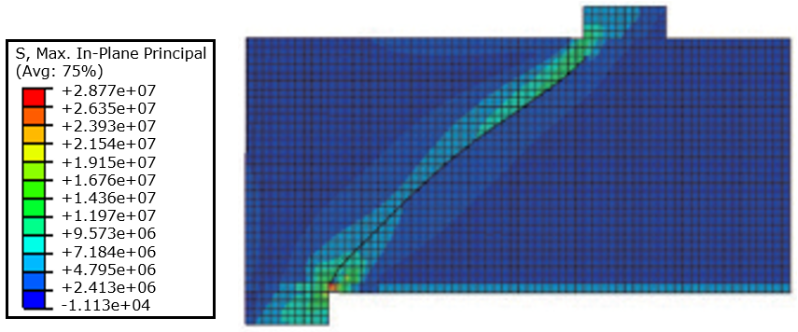 | 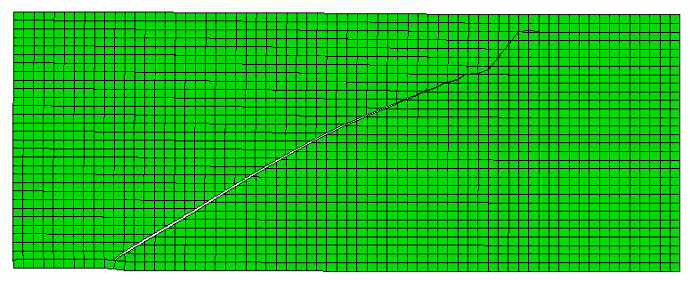 | 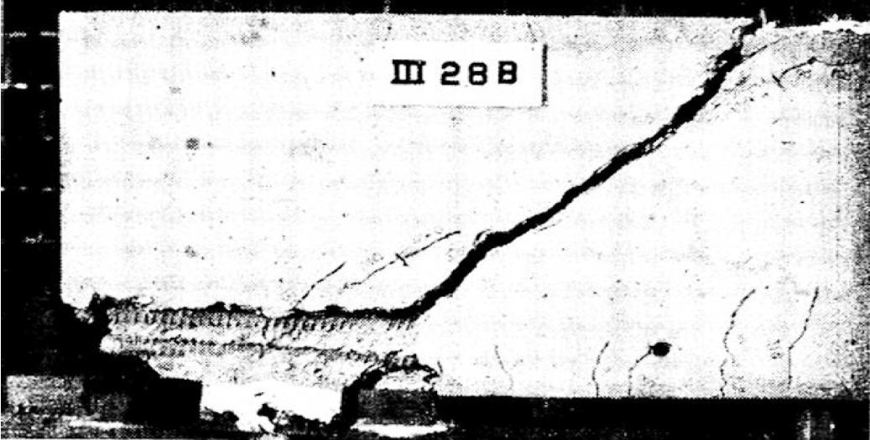
Fig. 13 Comparison between the numerical predictions and experimental results on the propagation of diagonal crack.
Later on, Lee et al. [60] carried out an experimental study to investigate the relationship between the degree of corrosion and structural behaviors of concrete beams singly reinforced with corroded reinforcements. In the test, the simply supported beams (800 mm × 100 mm × 85 mm) were loaded at two points, with the total span and shear span being 600 mm and 250 mm, respectively, as shown in Table 7. The main input material parameters for concrete and steel reinforcement, in accordance with the test results obtained from individual experiments, were also included in the table.
The predicted shear force-midspan deflection curves of specimens with different reinforcement corrosion levels are shown in Fig. 14(a), from which it can be seen that the corrosion-induced reduction of shear performance can be reasonably reflected by the numerical model, and the simulation results of the ultimate shear capacity agree well with the experimental results, as compared in Fig. 14(b).
Table 7
Details of the specimens adopted by Lee et al. [60].
 | Concrete |  |  |  | Steel
 | E_{c}  (GPa) | σ_{ck}  (MPa) | σ_{ctm}  (MPa) | μ_{c} | E_{s}  (GPa) | σ_{sy}  (MPa) | σ_{su}  (MPa) | μ_{s}
 | 38.5 | 70.1 | 3.67 | 0.18 | 197 | 359 | 511 | 0.3

Fig. 14 Comparison between the numerical simulation results and test results.
4.2.2. Comparisons with the test results of RC beams with web reinforcement
Moreover, to examine the ability of the model to reflect the effects of corrosion-induced reinforcement loss and bond degradation on the shear behaviors, a numerical simulation on the specimens of this study was also conducted. The adopted element types and mesh size were the same as those mentioned in Section 4.2.1, except that the additional web reinforcements were modeled with the truss element T2D2.
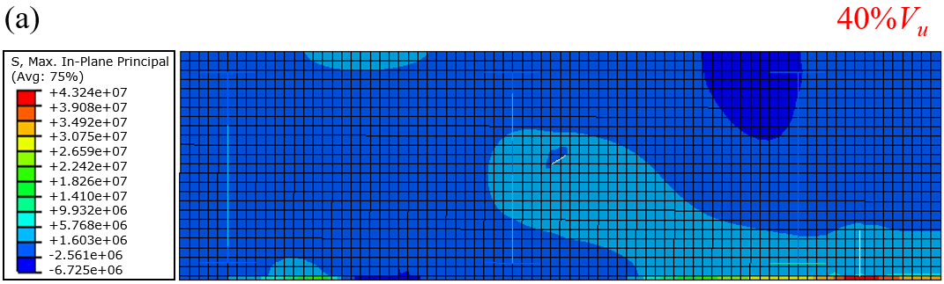 | 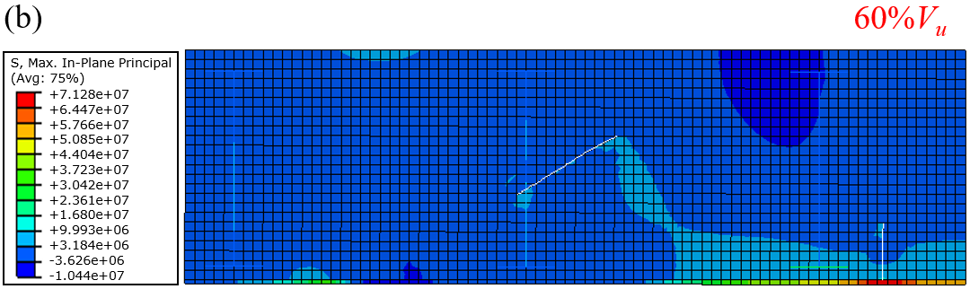
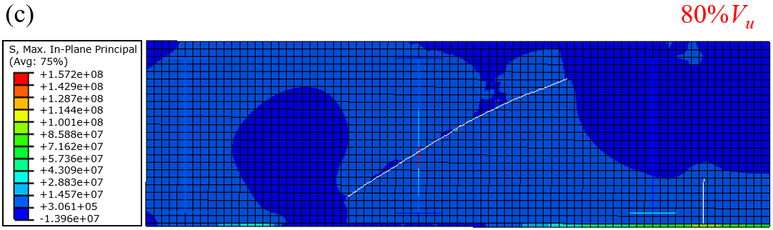 | 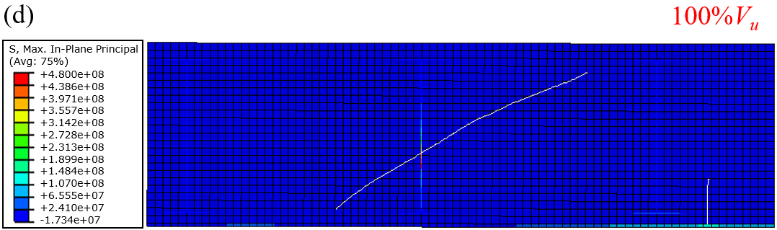
Fig. 15 The simulation results of the propagation process of the load induced-cracks.
From the numerical results shown in Fig. 15, it can be clearly seen that when loaded to about 40% ultimate shear capacity V_{u}, the main diagonal tension crack is initiated midway between the support and load point and is inclined form its inception. After that, as the load further increases, the diagonal crack propagates gradually at both ends, and the development directions are towards the support and load point, respectively. During this process, the diagonal crack crosses the web reinforcement at an angle of about 60º and generally passes over the ends of vertical tension cracks. At about 80% V_{u}, the propagation of these vertical cracks mostly stops and only the tips of the main diagonal crack still develops. Eventually, when approaching the ultimate shear capacity, the diagonal crack runs through the entire section with great rapidity. Compared with the actual evolutions of cracks that were mapped with numbers in order during the experiment as shown in Fig. 16, the numerical predictions about the whole propagation process of the loaded induced-cracks are in good agreement.
In Fig. 16, the crack openings of specimens with different corrosion levels are also compared, from which it is obvious that the maximum width of the main diagonal crack is positively correlated with the corrosion level. This observation is believed to be closely associated with the greater corrosion-induced reduction in the tensile strength of vertical stirrups, which is also evidenced by the decreasing maximum stress of stirrups shown in the legends, therefore leading to a weaker restriction to the transverse extension of the diagonal crack.
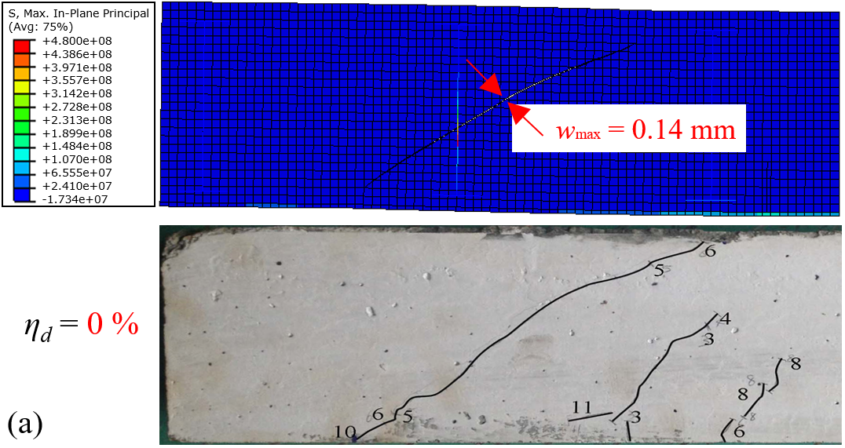 | 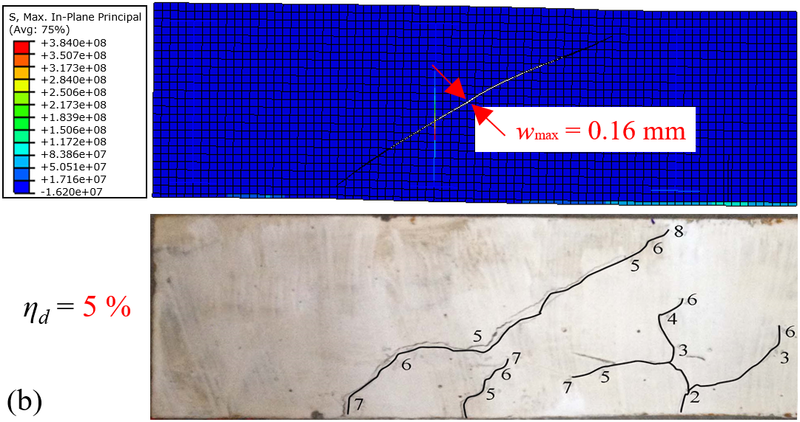
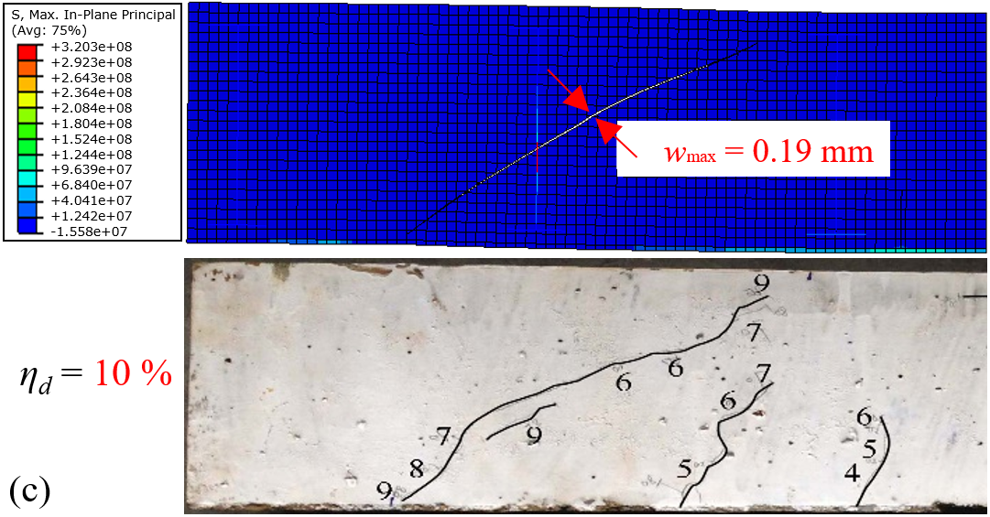 | 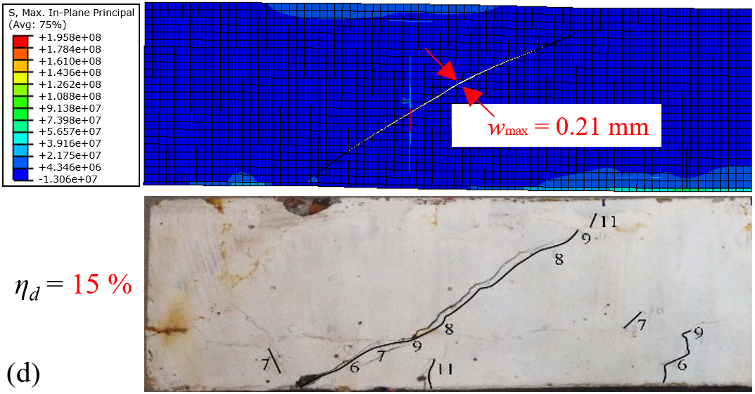
Fig. 16 Comparison of the crack opening considering the effect of corrosion level.
For illustrative purpose, the mean values of the complete shear force-midspan deflection curves obtained from test results are compared with numerical simulations in Fig. 17(a), and the ultimate shear capacities associated with different corrosion levels (mean values) are compared in Fig. 17(b). It is clearly seen that in general, the numerical curves give a satisfactory agreement with the test results, and both of them share a similar trend that as the corrosion level increases, the mechanical properties in terms of stiffness, ultimate shear capacity, and deformability degrades gradually.
Fig. 17 Comparison between the numerical simulation results and test results.
4.2.3. Parametric study of the bond-slip model
Because of the highly complex debonding process, the quantitative determination of the interfacial bond-slip relationship in real structures is very difficult to obtain and no non-destructive method is available to access this issue currently. Hence, conducting a parametric study of the bond-slip model to analyze the effects of reinforcement corrosion on the mechanical behavior of reinforced concrete beams is also quite in need. To this end, based on the numerical simulation, the five involved key parameters, i.e. ultimate bond strength τ_{u}, residual bond strength τ_{r}, and three characteristic slips s₁, s_{2,} and s₃, were further discussed in the following.
The effects of bond strengths on the whole mechanical responses are evaluated varying the ratio from 0.5 to 1.5 respectively, as shown in Fig. 18(a) and (b). It can be seen that under otherwise constant conditions, the variation of ultimate bond strength exhibits an obvious influence, while it is not true for the residual bond strength. This observation suggests that during the evaluation of the shear performance of corroded reinforced concrete beams, the ultimate bond strength, rather than the residual bond strength, is one of the most crucial issues that should be emphatically concerned, which is closely related to the stiffness, bearing capacity, ductility, etc.
Fig. 18 Parametric analyses of the parameters in the proposed bond-slip model.
Fig. 18(c), (d) and (e) are dedicated to analyzing the effect of characteristic values of relative slips s₁, s_{2,} and s₃, respectively. From the comparisons, it is clear that the numerical results are greatly influenced by the determinations of the values of slip s₁ and s₃, while the effect of s₃ could be ignored. Hence, with regards to the simulation of corroded reinforced concrete beams, the variation of relative slips s₁ and s₃ induced by reinforcement corrosion also should be concerned.
- Conclusions
Based on the experimental and numerical investigation on the shear performance of reinforced concrete beams with different corrosion levels, the following main conclusions can be drawn:
(1) During the corrosion process, the reinforcement corrosion and corrosion-induced crack patterns are mutually causalities. The corrosion of reinforcement will induce the propagation of cracks, and in turn, the development of cracks will accelerate the reinforcement corrosion.
(2) The reinforcement corrosion has an overall adverse effect on the shear performance of RC beams. As the corrosion level increases, the degradation becomes more pronounced, and the failure mode may even be changed from the shear-compression failure into a much more brittle diagonal splitting failure when a severe corrosion level (η_{a} ≥ 12%) is encountered.
(3) The adoption of extended finite element method, along with an adequate softening traction-separation relationship of concrete, is feasible to simulate the propagation of the main diagonal tension crack reasonably.
(4) The degradation of bond performance induced by the reinforcement corrosion can be reasonably modeled by a user-defined element, in which the determination of ultimate bond strength should be emphatically concerned.

Acknowledgements
The authors would like to thank the financial support from the Hong Kong Research Grants Council (Project number: 27204818), National Natural Science Foundation of China (Project number: 51808475), and National Basic Research Program (973 Program) (Project number: 2015CB655103). Any opinions, findings and conclusions or recommendations expressed in this material are those of the authors and do not necessarily reflect the views of the sponsors.

References

[1] Cabrera JG. Deterioration of concrete due to reinforcement steel corrosion. Cement Concrete Comp, 1996, 18(1): 47-59.
[2] Vu KAT, Stewart MG. Structural reliability of concrete bridges including improved chloride-induced corrosion models. Struct Saf, 2000, 22(4): 313-333.
[3] Azad AK, Ahmad S, Azher SA. Residual strength of corrosion-damaged reinforced concrete beams. ACI Mater J, 2007, 104(1): 40.
[4] El-Reedy MA. Steel-reinforced concrete structures: Assessment and Repair of corrosion. CRC press, 2017.
[5] Hájková K, Šmilauer V, Jendele L, Červenka, J. Prediction of reinforcement corrosion due to chloride ingress and its effects on serviceability. Eng Struct, 2018, 174: 768-777.
[6] Fu C, Jin N, Ye H, Jin X, Dai, W. Corrosion characteristics of a 4-year naturally corroded reinforced concrete beam with load-induced transverse cracks. Corros Sci, 2017, 117: 11-23.
[7] Ye H, Jin N, Jin X, Fu C, Chen W. Chloride ingress profiles and binding capacity of mortar in cyclic drying-wetting salt fog environments. Constr Build Mater, 2016, 127: 733-742.
[8] Ann KY, Song HW. Chloride threshold level for corrosion of steel in concrete. Corros Sci, 2007, 49(11): 4113-4133.
[9] Michel A, Solgaard AOS, Pease BJ, Geiker MR, Stang H, Olesen JF. Experimental investigation of the relation between damage at the concrete-steel interface and initiation of reinforcement corrosion in plain and fibre reinforced concrete. Corros Sci, 2013, 77: 308-321.
[10] Alonso C, Andrade C, Rodriguez J, Diez JM. Factors controlling cracking of concrete affected by reinforcement corrosion. Mater Struct, 1998, 31(7): 435-441.
[11] Ahmad S. Reinforcement corrosion in concrete structures, its monitoring and service life prediction-A review. Cement Concrete Comp, 2003, 25(4-5): 459-471.
[12] Otieno M, Beushausen H, Alexander M. Modelling corrosion propagation in reinforced concrete structures-A critical review. Cement Concrete Comp, 2011, 33(2): 240-245.
[13] Bicer K, Yalciner H, Balkıs AP, Kumbasaroglu A. Effect of corrosion on flexural strength of reinforced concrete beams with polypropylene fibers. Constr Build Mater, 2018, 185: 574-588.
[14] Torres-Acosta AA, Navarro-Gutierrez S, Terán-Guillén J. Residual flexure capacity of corroded reinforced concrete beams. Eng Struct, 2007, 29(6): 1145-1152.
[15] El Maaddawy T, Soudki K, Topper T. Long-term performance of corrosion-damaged reinforced concrete beams. ACI Struct J, 2005, 102(5): 649.
[16] Kotes P, Vican J. Influence of reinforcement corrosion on moment and shear resistance in RC bridge girder. Conference: 8th International Conference on Bridge Maintenance, Safety and Management, 2016.
[17] Stewart MG. Mechanical behaviour of pitting corrosion of flexural and shear reinforcement and its effect on structural reliability of corroding RC beams. Struct Saf, 2009, 31(1): 19-30.
[18] Broomfield JP. Corrosion of steel in concrete: Understanding, Investigation and Repair. CRC Press, 2003.
[19] Fathifazl G, Razaqpur AG, Isgor OB, Abbas A, Fournier B, Foo S. Shear strength of reinforced recycled concrete beams with stirrups. Mag Concrete Res, 2010, 62(10): 685-699.
[20] Ye Z, Zhang W, Gu X. Deterioration of shear behavior of corroded reinforced concrete beams. Eng Struct, 2018, 168: 708-720.
[21] Lachemi M, Al-Bayati N, Sahmaran M, Anil O. The effect of corrosion on shear behavior of reinforced self-consolidating concrete beams. Eng Struct, 2014, 79: 1-12.
[22] Xia J, Jin WL, Li LY. Shear performance of reinforced concrete beams with corroded stirrups in chloride environment. Corros Sci, 2011, 53(5): 1794-1805.
[23] Wang L, Zhang X, Zhang J, Ma Y, Liu Y. Effects of stirrup and inclined bar corrosion on shear behavior of RC beams. Constr Build Mater, 2015, 98: 537-546.
[24] Lee HS, Noguchi T, Tomosawa F. Evaluation of the bond properties between concrete and reinforcement as a function of the degree of reinforcement corrosion. Cement Concrete Res, 2002, 32(8): 1313-1318.
[25] Sæther I, Sand B. FEM simulations of reinforced concrete beams attacked by corrosion. ACI Struct J, 2012, 39(2): 15-31.
[26] Berto L, Simioni P, Saetta A. Numerical modelling of bond behaviour in RC structures affected by reinforcement corrosion. Eng Struct, 2008, 30(5): 1375-1385.
[27] Bazant ZP. Physical model for steel corrosion in concrete sea structures-theory. ASCE J Struct Div, 1979, 105(6): 1137-1153.
[28] Berra M, Castellani A, Coronelli D, Zanni S, Zhang G. Steel-concrete bond deterioration due to corrosion: finite-element analysis for different confinement levels. Mag Concrete Res, 2003, 55(3): 237-247.
[29] Ma YF, Guo Z, Wang L, Zhang JR. Experimental investigation of corrosion effect on bond behavior between reinforcing bar and concrete. Constr Build Mater, 2017, 152: 240-249.
[30] Ma YF, Guo Z, Wang L Zhang JR. Probabilistic life prediction for reinforced concrete structures subjected to seasonal corrosion-fatigue damage. J Struct Eng-ASCE, 2020. Doi: 10.1061/(ASCE)ST.1943-541X.0002666.
[31] Du YG, Chan AHC, Clark LA, Wang XT, Gurkalo F, Bartos S. Finite element analysis of cracking and delamination of concrete beam due to steel corrosion. Eng Struct, 2013, 56: 8-21.
[32] Moës N, Dolbow J, Belytschko T. A finite element method for crack growth without remeshing. Int J Numer Meth Eng, 1999, 46(1): 131-150.
[33] Sukumar N, Chopp D L, Moës N, Belytschko T. Modeling holes and inclusions by level sets in the extended finite-element method. Comput Method Appl M, 2001, 190(46-47): 6183-6200.
[34] Belytschko T, Black T. Elastic crack growth in finite elements with minimal remeshing. Int J Numer Meth Eng, 1999, 45(5): 601-620.
[35] De Borst R, Crisfield MA, Remmers JJ, Verhoosel CV. Nonlinear finite element analysis of solids and structures. John Wiley & Sons, 2012.
[36] Roth SN, Léger P, Soulaïmani A. A combined XFEM-damage mechanics approach for concrete crack propagation. Comput Method Appl M, 2015, 283: 923-955.
[37] Wang Y, Waisman H. From diffuse damage to sharp cohesive cracks: A coupled XFEM framework for failure analysis of quasi-brittle materials. Comput Method Appl M, 2016, 299: 57-89.
[38] Comi C, Mariani S, Perego U. An extended FE strategy for transition from continuum damage to mode I cohesive crack propagation. Int J Numer Anal Met, 2007, 31(2): 213-238.
[39] JGJ 55-2011. Specification for mix proportion design of ordinary concrete. China: Ministry of House and Urban-Rural Development of People’s Republic of China, 2011.
[40] GB228/T-2002. Metallic materials tensile testing at room temperature. Chinese National Technology Supervising Bureau, 2002.
[41] GB 50010-2010. Code for design of concrete structures. China: Ministry of House and Urban-Rural Development of People’s Republic of China; 2010.
[42] Xu S, Zhang Z, Qin G. Study on the seismic performance of corroded H-shaped steel columns. Eng Struct, 2019, 191: 39-61.
[43] Zhu W, François R, Coronelli D, Cleland D. Effect of corrosion of reinforcement on the mechanical behaviour of highly corroded RC beams. Eng Struct, 2013, 56: 544-554.
[44] Wang X, Zhang W, Cui W, Wittmann F. Bond strength of corroded steel bars in reinforced concrete structural elements strengthened with CFRP sheets. Cement Concrete Comp, 2011, 33(4): 513-519.
[45] Zhang W, Liu X, Gu X. Fatigue behavior of corroded prestressed concrete beams. Constr Build Mater, 2016, 106: 198-208.
[46] Zhao Y, Yu J, Wu Y, Jin W. Critical thickness of rust layer at inner and out surface cracking of concrete cover in reinforced concrete structures. Corros Sci, 2012, 59: 316-323.
[47] Zhu W, François R, Poon CS, Dai JG. Influences of corrosion degree and corrosion morphology on the ductility of steel reinforcement. Constr Build Mater, 2017, 148: 297-306.
[48] ASTM G1-03. Standard practice for preparing, cleaning, and evaluating corrosion test specimens, ASTM West Conshohocken, PA, 2003.
[49] Lubliner J, Oliver J, Oller S, Oñate E. A plastic-damage model for concrete. Int J Solids Struct, 1989, 25(3): 299-329.
[50] Lee J, Fenves GL. Plastic-damage model for cyclic loading of concrete structures. J Eng Mech ASCE, 1998, 124(8): 892-900.
[51] Hibbett, Karlsson, Sorensen. ABAQUS/standard: User's Manual, 1998.
[52] Mendes LAM, Castro LMSS. A simplified reinforcing steel model suitable for cyclic loading including ultra-low-cycle fatigue effects. Eng Struct, 2014, 68: 155-164.
[53] Bertolini L, Elsener B, Pedeferri P, Redaelli E, Polder R. Corrosion of steel in concrete. Weinheim, Germany: Wiley-Vch, 2013.
[54] Lee HS, Noguchi T, Tomosawa F. FEM analysis for structural performance of deteriorated RC structures due to rebar corrosion. Proceedings of the Second International Conference on Concrete under Severe Conditions. 1998: 327-336.
[55] Model Code 2010. International Federation for structural concrete (fib). Final draft, Lausanne, Switzerland, 2011.
[56] Blomfors M, Zandi K, Lundgren K, Coronelli D. Engineering bond model for corroded reinforcement. Eng Struct, 2018, 156: 394-410.
[57] Yuan Y, Yu S, Jia F. Deterioration of bond behavior of corroded reinforced concrete, Ind. Const, 1999, 29(11): 47-50 (In Chinese).
[58] Jendele L, Cervenka J. Finite element modelling of reinforcement with bond. Comput Struct, 2006, 84(28): 1780-1791.
[59] Moody KG, Viest IM, Elstner RC, Hognestad E. Shear strength of reinforced concrete beams Part 1-Tests of simple beams. Journal Proceedings. 1954, 51(12): 317-332.
[60] Lee HS, Tomosawa F, Noguchi T. Effects of rebar corrosion on the structural performance of singly reinforced beams. Durability of building materials and components, 1996, 7(1): 571-580.

