VOX model: Application of voxel-based packing algorithm on cementitious composites with 3D irregular-shape particles

Zushi Tian^{a, b}, Ye Tian^{a, *}, Hailong Ye^{b}, Xianyu Jinª, Nanguo Jinª

ª College of Civil Engineering and Architecture, Zhejiang University, Hangzhou, China
^{b} Department of Civil Engineering, The University of Hong Kong, Pokfulam, Hong Kong, China
*Corresponding author, cetianye@zju.edu.cn (Y. Tian)

Abstract
The internal structure of composite materials is usually composed of a continuous matrix with dispersed particles. To simulate the spatial distribution of particles, the random sequential addition algorithm (RSA) is commonly used. The existing RSA is unable to reach a high packing density (PD) and time-consuming in the case of irregularly shaped aggregates, such as in mortar and concrete systems. In this work, a geometrical model, named as VOX, is introduced to deal with 3D irregularly shaped particles. The model applies the voxel-based overlap determination [1, 2] in the RSA to improve the efficiency and packing density. Also, the model is applicable to the complex boundary conditions of any geometry and provides high-quality triangle meshes valuable for finite element analysis. The mortar and concrete cubes with real-shape particles are simulated, in which the packing density is increased to 65% and 51%, respectively. The VOX model successfully packs over 150,000 real-shape aggregates into the steel cage in a full-size reinforced concrete beam model on a desktop machine. Particle shape significantly affects the packing density in the RSA and the sphericity is recommended as an indicator. The particles with higher sphericity can achieve denser packing under the same effort of attempts. Real-shape gravel used in this study behaves similarly with regular octahedron because of the similar sphericity.

Keywords: packing algorithm, irregular particle, voxel, aggregate

1. Introduction
The composite material system can be represented by the model of dispersed particles embedded in a continuous matrix. Accurate acquisition and description of the internal structure of composites is important for understanding the materials performance, including mechanical and transport properties [3–7]. However, the experimental characterization techniques, such as X-ray computed tomography (CT), is expensive and time-consuming, and requires considerable post-processing efforts [7–11]. As an alternative, particle packing algorithms are numerical methods to reproduce the composite material model via simulating the random distribution of particles.

Particle packing algorithms can be classified into several types. Random sequential addition algorithm (RSA) [12, 13] adds particles at a random position sequentially and overlap is not allowed. Growth algorithm [14] expands the volume of placed particles to increase the packing density. The size of individual particle and the particle size distribution (PSD) are often uncontrollable. Relocation algorithm [1, 2] adjusts the particle’s position by assigning a random movement to achieve dense packing. The particles are usually in contact with each other and the domain size is not under control because the upward movement is limited. Among these algorithms, the RSA is the most commonly used in the simulation and modeling of cementitious composites. This is because the particles in the system of cement paste, mortar, or concrete suspend in the matrix, controlled by the stress transfer between matrix and particles, not the contact forces between particles [15]. The contact between particles is not necessary especially in the case with volume fraction. As a cost, RSA is computationally expensive and reach lower packing density compared to the other two algorithms.

For most published packing algorithms, regular-shaped particles including sphere [12, 16], ellipsoid [17], polyhedron [13], superball [18], superellipsoid [19], and superovoid [20] are used due to their simple mathematical representation. However, the real-shaped particles with bumps and pits are usually irregular and complex, such as the gravel and cobblestone in the cementitious composites [21–25]. The shape and texture of particle affect the performance of mortar and concrete in many ways [3, 26–29]. For irregularly shaped particles, the most critical strategy is how to represent shape and detect overlap of particles, which mainly includes mathematical analysis functions and discrete voxels.

The former represents particles using mathematical expressions, such as triangle meshes[30], clumps of overlapped spheres [31], and spherical harmonic expansions [32–34], and detects overlap based on comparing particle pairs. Among these models, the Anm model uses RSA algorithm and is used to simulate various composite material systems [35, 33, 36]. Multiple optimization algorithms are applied to speed up the overlap determination process, including bins division, extent overlap box (EOB) method [33, 37], and parallel computing [34]. However, it still demands weeks to achieve more than 30,000 particles and 52.7% volume fraction, which limits the widespread application of these models for the a large number of particle packing and a higher volume fraction [5].

The latter utilizes digitization both in particle shapes and the packing space to represent arbitrarily shaped particles with voxels, such as DigiPac series [1, 2]. The overlap detection is achieved at voxel level and only specific voxels are checked. Thanks to the significant improvement in efficiency and flexibility, the voxel-based algorithms is widely used and well developed in various fields, including parking density [16, 38, 39] and permeability [40–42]. The DigiPac is originally designed for dense packing, vibration, and infiltration problems by adjusting particle locations with a random movement. However, the relocation algorithm is not the best solution for cementitious material systems where particles are suspended in the matrix.

When the particle packing is applied to simulate cementitious material systems, there are some issues need to be solved. First, RSA provides a low packing density of around 0.45 [43, 13, 18], which is smaller than the discrete element method (DEM) results of random loose packing (RLP) of around 0.55 [44] and experiment results of 0.480~0.514 [45] and 0.622~0.703 [46]. Secondly, complex boundary condition widely exists in real concrete structures, for example, ribbed rebars with specific texture surrounded by irregular shaped aggregates in a reinforced concrete beam, as shown in Fig. 8 and Fig. 9. Geometrical details are extremely important in some specific studies, such as simulations of steel-concrete bond performance and steel pitting corrosion. While the achievement of above complex boundary conditions has not been reported. Moreover, the digital form is not appropriate for finite element analysis and needs to convert to the vector form or triangle mesh form. Although the conversion has been reported [47], the division and optimization of large-scale meshes is still computationally expensive.

In this work, a geometric model named as VOX model was developed, which combines the advantages of RSA framework and voxel-based overlap determination [1, 2]. The model was dedicated to the improvement and application of RSA in cementitious material systems. Thanks to the fast voxel-based overlap determination, the VOX model achieved a higher parking density than the other RSA. Also, the model achieved the complex boundary conditions of theoretically any geometry and provide high-quality triangle meshes valuable for finite element analysis. Several cases including the mortar, concrete, and reinforced concrete beam were simulated, one of which involves more than 150,000 real-shape aggregates. This model provides a potential solution on simulating cementitious composites with irregular-shape aggregates for mechanical and transport modeling. In addition, the effect of particle shape and packing density in the RSA was investigated to find key geometry indicators and establish the relationship of real-shape particles and regular particles in particle packing.

2. Mathematical representation of a 3D particle

2.1. Voxel matrix
The irregular shape of one individual particle can be described using a voxel dataset, including a binary three-dimensional matrix to characterize the state of voxels and a numerical parameter of the voxel size. The voxel matrix represents the value on a regular grid in three-dimensional space, with 0 defining the unoccupied space and 1 defining the particle. As with pixels in a bitmap, the voxel matrix records the arrangement of voxels in three dimensions with the matrix indexing of the corresponding element. In contrast to voxels, triangular meshes are often explicitly represented by the coordinates of their vertices. A direct consequence of this difference is that voxels discretize space and can directly and quickly extract local information with indexing in computer operations, while triangular meshes need to determine the position of points, lines, and surfaces by comparing coordinates. To describe the coordinates of voxels in physical space, the voxel size $l_{voxel}$ representing the side length of voxels should be determined, which is numerically equal to the physical resolution of the matrix. The coordinates of voxel centers (x, y, z) in physical space can be calculated using the matrix indexing (i, j, k) of the corresponding voxel by the following formula:
 | $$\begin{matrix}\left\{\begin{aligned}x=\left(i-0.5\right)×l_{voxel} \\ y=\left(j-0.5\right)×l_{voxel} \\ z=\left(k-0.5\right)×l_{voxel}\end{aligned}\right.\end{matrix}$$ | (1)
The size of particles and the resolution decide the size of the voxel matrix. For gravel of 4 mm ~ 20 mm, the resolution of 0.1 mm/voxel corresponds to the 2% relative error of the smallest particle and the voxel matrix of THE largest particle is about 200×200×200. For sand of 0.125 mm ~ 4 mm, the resolution of 0.01 mm/voxel corresponds to the 8% relative error of the smallest particle and the voxel matrix of the largest particle is about 400×400×400. The voxel matrix is a common method of describing the 3D structure of particles. The raw data of X-ray CT technology, which are the most commonly used test method to obtain internal structure, is stored typically in voxel form.

For the voxel matrix, many geometric properties of particles can be calculated in a simple way, including the geometric center, particle volume and boundary. Also, the geometric transformation including scaling, rotation, and translation can be achieved by operating the binary matrix. The geometric transformation information includes a translation vector, a rotary axis, and a rotation angle and a scaling factor.

2.2. Triangle mesh
Triangle mesh is a common data format to describe the irregular surface in 3D space and widely applied in the finite element simulation. Triangle meshes can be represented in a variety of ways and the face-vertex meshes (FV meshes) data format is chosen in this study. A face-vertex mesh includes a simple list of vertices that define the position using coordinates in a three-dimensional Cartesian coordinate system, and a set of triangles that point exactly to the 3 vertices it uses. Triangle meshes are typically saved using the file format named STL, which now is widely used for rapid prototyping, 3D printing and computer-aided manufacturing as the “Standard Triangle Language”.

For an individual particle which forms a 3D volume, the surface represented by the triangle mesh must be closed and connected. Correspondingly, the triangle mesh has to meet some certain properties, where every edge is part of exactly two triangles, and not self-intersecting. For closed triangular surfaces, many geometric properties including the geometric center, volume and surface area can be calculated. The geometric transformation for triangular meshes including scaling, rotation, and translation can be achieved simply by the corresponding operation of the coordinates of vertices. The geometric transformation information has the same form as that of the voxel matrix.

2.3. Conversion from voxel matrix to triangle mesh
The voxel matrix and triangle mesh are two widely used dataset to describe the geometrical shape of particles and have their own advantages. The voxel matrix has the basic unit with the same size and a good data structure, but the number of voxels is usually large. While triangle meshes accurately describe the geometric shape of particles and easily expands to tetrahedral meshes. Therefore, the conversion from voxel matrix to triangle mesh is common to obtain adaptive and high-quality for finite element analysis [47].

The conversion process is composed of a series of steps to produce a precise and high-quality triangle mesh, as illustrated in Fig. 1. First, all squares of voxels at the edge of the particle are detected and a dense triangle mesh is built based on the squares by connecting their diagonal. As shown in Fig. 2, the triangle mesh is too dense to apply to the finite element calculation and includes lots of unnecessary information, such as the sharp corner of voxels. As such, the triangle meshes are simplified by an open-source algorithm [48], where partial representative points are selected and reconnected to rebuild a sparser and smoother triangle mesh.

The number of representative points is the balance of the modeling accuracy and the mesh number. For a classic particle with the equivalent diameter of 8.12 mm, when the voxel size is 0.0695um which is decided by the resolution of the X-CT machine, the particle occupies 846178 voxels in the voxel matrix with the size of 117×138 ×171. After simplification, the simplified mesh contains 2945 vertices and 5886 triangle surfaces, as shown in Fig. 1. The volume of the particle represented by the voxel matrix and the triangle mesh are close (284.06 and 278.88 mm³, respectively) with the relative error less than 2%, which can accurately describe the particle geometric shape. In the VOX model, the conversion is executed in the process of building the particle library. In the process of particle packing, triangle meshes can be relocated easily via the corresponding geometric translation and rotation. It avoids repeated operation and saves considerable time because the geometric transformation is much faster than format conversion.

3. Packing algorithm

3.1. The framework and procedures of packing algorithm
In the simplest case, the VOX model simply places or packs particles into an empty cube to simulate the random distribution of aggregates in the concrete or mortar. The framework of packing algorithm can be divided into 5 relatively independent parts [49]: (i) build a particle library, (ii) select a set of particles according to the PSD, (iii) rotate and place particles randomly, (iv) determinate the new particle whether overlaps with placed particles, (v) repeat the previous steps until all particles are placed.

The VOX model starts with the pretreatment of X-ray CT test data and the establishment of a particle library. The internal structure of objects is commonly obtained using X-ray CT technology. The raw grayscale data representing object density is first binarized using the threshold segmentation, and then particles are separated and extracted according to the voxel connectivity and saved in the format of voxel matrix. The voxel matrix is converted into the triangle mesh via the above-mentioned method and the geometric properties are calculated. Consequently, a particle library mainly includes, (i) the geometric shape information in the format of the voxel matrix and the triangle mesh, (ii) the geometric transformation information of translation, rotating, scaling, and (iii) the geometric properties of particles. A particle library represents a type of physical objects, such as the sand or gravel, can be reused in the modeling.

A set of particles is selected on the basis of the PSD function before the particle packing. The PSD function can be defined as an arbitrary expression by the user to describe the gradation of different type particles. Particle size is determined by the equivalent diameter of equal volume sphere for irregular particles. As the total volume of particles is known, the number of different size particle can be simply calculated via the defined PSD function. The particle with the same shape and size allows to be used repeatedly if the model needs more particles than that the particle library can provide. To ensure the gradation strictly confirms the PSD function, the selected particles are not replaced or adjusted in the process of particle packing.

The particle packing starts from the largest particle because it would be more difficult to find enough space for them if the space has been occupied by other particles. When a new particle is packed, a group of random numbers is generated via the MATLAB built-in function as the location and direction information, including the coordinates, direction of the rotating axis, and rotating angle. After the particle are translated and rotated, the corresponding voxels are compared with the located voxel matrix to make overlap decision with the other packed particles and boundary conditions. The process and details of the overlap algorithm including the translation and rotation of voxels, the collision detection, and the boundary conditions are elaborated in the next section. If the particle overlaps with the other packed particles or conflicts with the defined boundary conditions, the particle will be replaced randomly. The translation and rotation are operated in every packing attempt to sure that the probability of particles appearing anywhere is the same. Otherwise, the particle is added to the global voxel matrix and the location and direction of the particle will be recorded. In order to achieve the high volume fraction under the premise of strictly meeting the designed PSD, the maximum number of attempts for one particle is not limited. Instead, the total running time of the program is limited to 24 hours. Once a particle is packed successfully, the triangle mesh is translated and rotated correspondingly according to the geometric transformation information, and then is integrated into the model in the format of the triangle mesh.

In the early stage, particles can be packed easily because of the sufficient space, but the probability of successful packing is gradually decreasing with the increase of packed particles due to the less remaining space and more restrictions. At the later stage, a new particle may need thousands or more attempts before it is packed successfully. Therefore, the optimization for speed and efficiency of the overlap algorithm is critical. At the final stage, the program automatically completes some post-processing work for further analysis and research. Some parameters including the overall volume fraction of the model are calculated for the double-check. The model represented by the voxel matrix and the triangle mesh is saved for the further finite element analysis.

3.2. Overlap algorithm
The overlap algorithm is to determine whether two particles overlap and the core step of the program, which is repeatedly and countlessly called. For a cube space with the size of (x ,y, z) and the voxel size of$l_{voxel}$, a global binary matrix M_{global} with the size of (x/$l_{voxel}$, y/$l_{voxel}$, z/$l_{voxel}$) is initialized to describe the model structure. In this matrix, the value of voxels describes the state of voxels, specifically 0 represents for the empty and 1 for occupied voxel. At the very beginning, the global voxel matrix is a zero matrix mathematically in the absence of user-defined boundary conditions. Or the user can define the specific voxels as 1 to avoid putting the particles in some specific regions, which is the non-contact boundary. When there are N particles placed in the cube space, as shown in Fig. 3, the corresponding voxels of the global voxel matrix are marked as 1.

Then a new particle is placed into the space, the particle matrix M_{particle} needs to be rotated and translated to the corresponding region in the global matrix. This operation is completed through the calculation of the voxel index. The indexes of voxels in the particle matrix multiply by the rotation matrix and the result is rounded as integer. The operation of discarding the decimal part may cause the appearance of holes in the rotated particle matrix, which can be avoid in the next steps.
 |  | $$\begin{matrix}\left(i',j',k'\right)=M_{rotation }\left(i-i_{c},j-j_{c},k-k_{c}\right)\end{matrix}$$ | (2)
where $\left(i,j,k\right)$ are the voxel indexes of the particle matrix, $( i_{c},j_{c},k_{c})$ are the center indexes of particle matrix, $\left(i',j',k'\right)$ are the new voxel indexes of the rotated particle matrix, and $M_{rotation }$is the rotation matrix of 3×3. The new indexes plus the translation coordinates (Cx, Cy, Cz) to find the corresponding voxels in the global matrix M_{global}. The corresponding region in the global matrix is defined as the local related matrix M_{local} and the translation coordinates are equal to its center indexes.

In the next step, the program compares the corresponding voxels of the entire particle matrix and local related matrix one by one, as shown in Fig. 3. Considering of the binary format of the voxel matrix, the process is achieved by computer logic operation as it is much faster than arithmetic operation. The logic operations of AND returns 1 only if two voxels’ value is 1.
 | $$\begin{matrix}value=M_{global}\left(C_{x}+i'-1,C_{y}+j'-1,C_{z}+k'-1\right)∧M_{particle}\left(i,j,k\right)\end{matrix}$$  $$\{i,j,k∈N, i≤N_{x}, j≤N_{y}, k≤N_{z}\}$$ | (3)
When the return value is 1, which means this voxel is occupied by two particles, the program will end the comparison and determine that the new particle overlaps with the other one. Otherwise, the program compares the next two voxels until operating all voxels. It should be noticed that only indexes of specific voxels are calculated but the particle matrix won't be rotated and translated entirely for the time. This avoids considerable calculations because the overlap determination will end early in most attempts, especially when the global matrix has included a lot of particles. After above all voxels pass the determination, the rotated particle matrix performs linear interpolation to remove the holes produced from the rotation. The newly added voxels continue with overlap determination to ensure the accurate result. If all voxels pass the determination, which means that the new particle does not overlap with any other particles, it is placed successfully. The rotated particle matrix will be written into the global matrix and the next packing starts, as shown in Fig. 3. Another problem of that particle matrix rotation is inevitable distortion. However, it is not a main problem for this algorithm because the particle matrix is rotated only once from the original matrix.

When the user customizes the boundary conditions, the initial global matrix is changed with specific voxels marked as 1. The local related matrix can contain voxels from other placed particles or customized boundary conditions, which are no different. If the voxels of the particle matrix are conflict with the voxels from boundary conditions in overlap determination, the particle will be rejected. Thus, the particles are parked in the empty regions without overlap with the occupied regions marked as 1, which is non-contact boundary conditions. Boundary conditions can be defined in arbitrary geometric shape after they are transformed into a voxel form. Thanks to the voxel-level overlap determination, the addition of boundary conditions won’t reduce the program efficiency.

4. Analysis and Discussion
The new algorithm is first applied to simulate the internal structure of cement-based materials, including the mesoscopic model of concrete and mortar. The former involves the arrangement of coarse aggregates in a mortar and the latter involves the arrangement of fine aggregates in a cement paste. In either case, the maximum volume fraction of aggregates is more than 50%, which achieves a total aggregates volume fraction of 60-80%. Moreover, a model of a full-size reinforced concrete beam is built on a meso scale.

The shape of real aggregates and the internal structure of cylindrical concrete specimens are obtained and investigated using the X-ray CT technique (Nikon XT H 320 LC). Then, the raw grayscale data is binarized by threshold segmentation [50–53] and aggregates are separated based on the connectivity. Finally, a library of coarse aggregate is established which includes 265 aggregate particles with the size from 4 to 16 mm. In parallel, a library of fine aggregate from 0.125 to 4 mm is obtained via the scaling the coarse aggregates. Although this method is not the best way to obtain the shape data of fine aggregates, it is sufficient to verify the workability and efficiency of the new algorithm. In the future, more particle libraries will be added to adapt various aggregates.

Some researchers [18, 54] used Fuller function to characterize aggregate PSD. However, the PSD of coarse aggregates and fine aggregates in this study is described based on Rosin-Rammler distribution function [55].
 | $$\begin{matrix}f=1-exp⁡[-{\left(\frac{d}{d_{63}}\right)}^{a}]\end{matrix}$$ | (4)
In which, d is the particle diameter defined as the equivalent diameter for irregular particles, f is the cumulative volume fraction of the particles smaller than the specific diameter, d₆₃ is the diameter of the particle at which the cumulative volume fraction is 63.21%, a is the index parameter. The parameters of d₆₃ and a describes the gradation of aggregates. Specifically, d₆₃ is directly related with the median particle size and a determines the distribution range of aggregates. For the gravel used in this study, the particle size is from 4 mm to 16 mm and the median particle size is 9.0 mm. Correspondingly, the parameters take the value as d₆₃=10, a=3.5 and the particle size distribution is shown in Fig. 4. For the sand, the range of particle size is from 0.125 mm to 4 mm and the median particle size is 1.15 mm. Correspondingly, the parameters take the value as d₆₃=1.6, a=1.1 and the particle size distribution is shown in Fig. 5.

For the modification, Just add a sentence in the revised manuscript like this ‘’.

4.1. Mortar cubic specimen
The mortar specimen was in a cube space of 10 mm, filled with sand, and the periodic boundary conditions were applied. The values of the many parameters were set high in order to ensure the modeling precision and try the limit of the volume fraction. The resolution of the global binary matrix was 0.00695 mm/voxel with the size of 1439×1439×1439. The maximum total volume of sand was 650 mm³, taking up 65% of the cube space. The result of the VOX model is shown in Fig. 6, where the aggregates with different size are presented in different colors. The actual gradation of placed sand is fully in line with the designed PSD function, as shown in Fig. 5. The packing density of 0.65 is achieved after packing 38,327 particles and spending 5.04 hours on a typical desktop PC, which is higher than the reported RSA results [13, 18, 15, 43]. The actual running time is, for. The running time can be further reduced. First, the program did not use parallel computing in the overlap algorithm. The computational efficiency is expected to have a significant improvement if the comparison of voxel pairs is operated by multiple processors. Secondly, the parameters in the VOX model were not optimized. The aggregate allowed rotating in each placement attempts to ensure the randomness. The number of attempts of each aggregate was not limited to achieve the designed PSD. Also, the voxel size was set to a small value, to precisely characterize the aggregate shape as much as possible. Finally, the computer processor ran at 3.10 GHz and was manufacture in 2015. The program would cost less time on a more modern and faster computer. In the near feature, the parallel method will be added into the VOX model and the effect of parameters on computational efficiency will be systematically investigated.

To investigate how running time varies with the volume fraction of aggregates, several models with the same PSD but different volume fractions were run on the same computer system using the VOX model. As shown in Table. 1, when the volume fraction rose from 55 % to 65 %, with the number of particles increased from 32,430 to 38,327, the running time increased nearly 20 times. It was because an increasing number of packing attempts was needed to find the empty space with the rising volume fraction of placed particles. To further confirm this reason, the total number of attempts was recorded by the program and the value increased about 12 times, which was consistent with 20 times of the running time.

4.2. Concrete cubic specimen
The concrete specimen was in a cube space of 150 mm, filled with gravel, and the non-contact boundary conditions were applied to establish the compressive concrete cube. The resolution was the same as that of the X-ray CT test, 0.0695 mm/voxel, in order to rebuild the true shape of gravel as much as possible. The size of the global binary matrix was with the size of 2158×2158×2158. The maximum total volume of gravel was 1518.75 cm3, taking up 45% of the cube space. The result of the VOX model is shown in Fig. 7 and the actual gradation of placed gravel is shown in Fig. 4. The actual running time is 6.89 hours for 8,028 particles. In these cases, the running time also had a remarkable growth when the volume fraction increased from 30% to 45%, as shown in Table. 1.

Comparing the cases of concrete and mortar, the latter achieved a higher volume fraction and more particles. For example, within a similar time (6.89 hours and 5.04 hours), the VOX model placed 8,028 gravels filling up 45% of the cube space for the concrete model, but 38,327 sands taking up 65% for the mortar model. There were two potential causes of this phenomenon. First, the non-contact boundary conditions restricted the random distribution of aggregate. It is more difficult to place aggregate near the boundary, resulting in the increase of packing attempts. Secondly, the gradation of gravel is narrower than that of sand, especially the lack of small aggregates. The minimum sand size was 0.125 mm in the mortar model with the side edge of 10 mm; however, the value was 4 mm for the 150 mm compressive concrete cubes. This means that sand could achieve greater bulk density since the space smaller than the minimum particle size is almost impossible to fill.

4.3. Reinforced concrete beam
A full-scale reinforced concrete beam model is established using the VOX model. The length, width, and height of the beam were 2000 mm, 150 mm, and 240 mm, respectively. The layout of reinforcements was designed to meet the loading bearing capacity requirements according to the Chinese Design Specification of Concrete Structure (GB 50010-2010), as shown in Fig. 8(a). In this model, the ribbed main reinforcements and plain stirrups were well rebuilt and the position and shape of each aggregate were clearly represented, as shown in Fig. 8 and Fig. 9. The volume fraction of gravel was 40% and the aggregate number reached 152,948. For this large-sized concrete member, the complex boundary conditions and the huge number of aggregates were the main challenges in building a model.

The boundary conditions were added in the VOX model via marking the specific voxels in the initial global matrix. In this case, the 3D shape of ribbed steel bars was measured using laser scanning technology. Then, the data was imported into a visual 3D modeling software where the reinforcement skeleton was established through the translation, rotation, and scaling, and then materialized through Boolean operations, as shown in Fig. 8. In the next step, the VOX model converted the boundary conditions stored in the STL data format into the initial global voxel matrix. The particles were placed into these regions marked as 0 and did not overlap with the steel bars.

For the large-scale model (beam) with small components (gravel and steel bar), a huge three-dimensional global voxel matrix was needed to ensure the precision of small structure, which had a high requirement for memory. In this case, the resolution reduced to 0.139 mm/voxel, as twice as the original, to reduce memory overhead. This had a limited effect on the overlap determination because the voxel size (0.139 mm) was still much smaller than the minimum particle size (4 mm). Also, the accuracy of the geometric model was not affected at all because the triangle meshes were based on the raw data of X-ray CT tests. A global matrix with the size of 14388×1079×1727 needed 25.0 GB memory space. In addition, the actual memory overhead could be about 1.5 to 2 times, considering the aggregate library and the triangle mesh data. However, it was quite acceptable for modern computer systems and the virtual memory technology would be automatically enabled in MATLAB to reduce the required physical memory.

4.4. Effect of shape on packing density
To investigate the effect of particle shape on packing density, several shapes of particles is selected and simulated using the VOX model, including sphere, regular icosahedron, regular octahedron , regular tetrahedron , and real-shape gravel, respectively, with different sphericity of 1 , 0.939 , 0.846, 0.671, and 0.842. The real-shape gravels are the same as that in Section 4.2 and the sphericity is calculated with surface area and volume of individual particles. The calculation of the surface area is affected by the representation accuracy. In this case, the surface area is calculated by the optimized triangles meshes with the sides of around 0.35 mm (See detailed information in Section 3.2). For a group of packed particles, the average sphericity is calculated as 0.842, with the maximum of 0.9188 and minimum of 0.7828.

Factors other than particle shape are strictly controlled. Particles are packed into a cube space of 50 mm with the resolution of 0.0695 mm/voxel, corresponding to a global binary matrix with the size of 719×719×719. The designed PSD function is shown in Fig. 4 and the particle size is defined by equivalent diameter. The maximum and minimum particle sizes are, respectively, 4 mm and 16 mm. The packed particles are selected based on PSD function before simulation and discarding and adjustment of particles is not allowed. The number of attempts is used as an indicator instead of running time because it can avoid the unrelated impact, such as computer hardware, resolution, and algorithm optimization. The packing density is gradually increased until the number of attempts exceeds 4,000,000 or the particle packing cannot be completed.

Fig. 10 shows the results of various particles with the highest packing density achieved in this simulation. Sphere has the highest packing density of 57.5% similar with the DEM results [44] while regular tetrahedron has the lowest packing density of 41%. Real-shape gravel reaches a packing density of 51%, similar to regular octahedron of 50%, but higher than the reported RSA results [13, 18, 43]. On the other hand, the number of attempts for sphere, regular polyhedron, and real-shape gravel is recorded, as shown in Fig. 11. Sphericity, as a measure of how closely the shape of a particle resembles that of a perfect sphere, significantly affects the packing density in the RSA. The particles with higher sphericity can achieved denser packing under the same number of attempts. Real-shape gravel used in this study behaves similarly with regular octahedron because the two have close sphericity of, respectively, 0.842 and 0.846.

5. Conclusion
In this study, a geometric model, named as VOX, is developed to simulate the internal geometrical structure of cementitious composites. The model applies the voxel-based overlap determination [1, 2] in random sequential addition algorithm (RSA). It provides a potential solution on simulating cementitious composites with irregular-shape aggregates for mechanical and transport modeling.

- The mortar and concrete cubes are simulated with real-shape particles obtained utilizing X-ray CT technology. Thanks to the fast overlap determination, the VOX model achieves a higher parking density than the other RSA. Under the similar conditions, the packing density increases from 52.7% to 65.0% for mortar and from 45% to 51% for concrete.

- Particle shape significantly affects the packing density in the RSA and the sphericity is recommended as an indicator. The particles with higher sphericity can achieve denser packing under the same number of attempts. Real-shape gravel used in this study behaves similarly with regular octahedron because of the similar sphericity.

- The VOX model is suitable to the complex boundary conditions in the particle packing, which can be theoretically any geometry. A full-size reinforced concrete beam model containing a complete steel skeleton has been simulated, which involves over 150,000 real-shape gravels. Also, the model provides the high-quality triangle meshes for finite element analysis and avoids the computationally expensive form conversion, even for a large-scale concrete structure.

Acknowledgements
This research is financially supported by National Key Basic Research Program of China (973 program) (Grant No. 2015CB655103), National Natural Science Foundation of China (Grant No. 51378012), and National Natural Science Foundation of China (Grant No. 51578497).

References
1. Jia X, Williams RA (2001) A packing algorithm for particles of arbitrary shapes. Powder Technol 120:175–186. https://doi.org/10.1016/S0032-5910(01)00268-6
2. Byholm T, Toivakka M, Westerholm J (2009) Effective packing of 3-dimensional voxel-based arbitrarily shaped particles. Powder Technol 196:139–146. https://doi.org/10.1016/j.powtec.2009.07.013
3. Liu L, Shen D, Chen H, Xu W (2014) Aggregate shape effect on the diffusivity of mortar: A 3D numerical investigation by random packing models of ellipsoidal particles and of convex polyhedral particles. Comput Struct 144:40–51. https://doi.org/10.1016/j.compstruc.2014.07.022
4. Bary B, Bourcier C, Helfer T (2017) Analytical and 3D numerical analysis of the thermoviscoelastic behavior of concrete-like materials including interfaces. Adv Eng Softw 112:16–30. https://doi.org/10.1016/j.advengsoft.2017.06.006
5. Xu W, Sun H, Chen W, Chen H (2017) Transport properties of concrete-like granular materials interacted by their microstructures and particle components. Int J Mod Phys B 32:1840011. https://doi.org/10.1142/S0217979218400118
6. Mehdipour I, Khayat KH (2018) Understanding the role of particle packing characteristics in rheo-physical properties of cementitious suspensions: A literature review. Constr Build Mater 161:340–353. https://doi.org/10.1016/j.conbuildmat.2017.11.147
7. Huang Y, Yan D, Yang Z, Liu G (2016) 2D and 3D homogenization and fracture analysis of concrete based on in-situ X-ray Computed Tomography images and Monte Carlo simulations. Eng Fract Mech 163:37–54. https://doi.org/10.1016/j.engfracmech.2016.06.018
8. Michel A, Pease BJ, Geiker MR, et al (2011) Monitoring reinforcement corrosion and corrosion-induced cracking using non-destructive x-ray attenuation measurements. Cem Concr Res 41:1085–1094. https://doi.org/10.1016/j.cemconres.2011.06.006
9. Itty P-A, Serdar M, Meral C, et al (2014) In situ 3D monitoring of corrosion on carbon steel and ferritic stainless steel embedded in cement paste. Corros Sci 83:409–418. https://doi.org/10.1016/j.corsci.2014.03.010
10. Dong B, Fang G, Liu Y, et al (2017) Monitoring reinforcement corrosion and corrosion-induced cracking by X-ray microcomputed tomography method. Cem Concr Res 100:311–321. https://doi.org/10.1016/j.cemconres.2017.07.009
11. Han J, Liu W, Wang S, et al (2016) Effects of crack and ITZ and aggregate on carbonation penetration based on 3D micro X-ray CT microstructure evolution. Constr Build Mater 128:256–271. https://doi.org/10.1016/j.conbuildmat.2016.10.062
12. Cooper DW (1988) Random-sequential-packing simulations in three dimensions for spheres. Phys Rev A 38:522–524. https://doi.org/10.1103/PhysRevA.38.522
13. Xu WX, Chen HS (2013) Numerical investigation of effect of particle shape and particle size distribution on fresh cement paste microstructure via random sequential packing of dodecahedral cement particles. Comput Struct 114–115:35–45. https://doi.org/10.1016/j.compstruc.2012.10.009
14. Lubachevsky BD, Stillinger FH (1990) Geometric properties of random disk packings. J Stat Phys 60:561–583. https://doi.org/10.1007/BF01025983
15. Qian Z, Garboczi EJ, Ye G, Schlangen E (2016) Anm: a geometrical model for the composite structure of mortar and concrete using real-shape particles. Mater Struct 49:149–158. https://doi.org/10.1617/s11527-014-0482-5
16. Gan M, Gopinathan N, Jia X, Williams RA (2004) Predicting Packing Characteristics of Particles of Arbitrary Shapes. KONA Powder Part J 22:82–93. https://doi.org/10.14356/kona.2004012
17. He H (2010) Computational Modelling of Particle Packing in Concrete
18. Lin J, Chen H, Zhang R, Liu L (2019) Characterization of the wall effect of concrete via random packing of polydispersed superball-shaped aggregates. Mater Charact 154:335–343. https://doi.org/10.1016/j.matchar.2019.06.024
19. Lin J, Chen H, Liu L (2020) Impact of polydispersity of particle shape and size on percolation threshold of 3D particulate media composed of penetrable superellipsoids. Powder Technol 360:944–955. https://doi.org/10.1016/j.powtec.2019.10.054
20. Li M, Chen H, Lin J (2020) Numerical study for the percolation threshold and transport properties of porous composites comprising non-centrosymmetrical superovoidal pores. Comput Methods Appl Mech Eng 361:112815. https://doi.org/10.1016/j.cma.2019.112815
21. Jia X, Garboczi EJ (2016) Advances in shape measurement in the digital world. Particuology 26:19–31. https://doi.org/10.1016/j.partic.2015.12.005
22. Cepuritis R, Garboczi EJ, Jacobsen S (2017) Three dimensional shape analysis of concrete aggregate fines produced by VSI crushing. Powder Technol 308:410–421. https://doi.org/10.1016/j.powtec.2016.12.020
23. Garboczi EJ, Bullard JW (2017) 3D analytical mathematical models of random star-shape particles via a combination of X-ray computed microtomography and spherical harmonic analysis. Adv Powder Technol 28:325–339. https://doi.org/10.1016/j.apt.2016.10.014
24. Estephane P, Garboczi EJ, Bullard JW, Wallevik OH (2019) Three-dimensional shape characterization of fine sands and the influence of particle shape on the packing and workability of mortars. Cem Concr Compos 97:125–142. https://doi.org/10.1016/j.cemconcomp.2018.12.018
25. lyu B, Wang A, Zhang Z, et al (2019) Coral aggregate concrete: Numerical description of physical, chemical and morphological properties of coral aggregate. Cem Concr Compos 100:25–34. https://doi.org/10.1016/j.cemconcomp.2019.03.016
26. Bullard JW, Garboczi EJ (2006) A model investigation of the influence of particle shape on portland cement hydration. Cem Concr Res 36:1007–1015. https://doi.org/10.1016/j.cemconres.2006.01.003
27. Lee KS, Choi J-I, Park SE, et al (2018) Damping property of prepacked concrete incorporating coarse aggregates coated with polyurethane. Cem Concr Compos 93:301–308. https://doi.org/10.1016/j.cemconcomp.2018.06.018
28. Li T, Xiao J, Zhang Y, Chen B (2019) Fracture behavior of recycled aggregate concrete under three-point bending. Cem Concr Compos 104:103353. https://doi.org/10.1016/j.cemconcomp.2019.103353
29. Sokhansefat G, Ley MT, Cook MD, et al (2019) Investigation of concrete workability through characterization of aggregate gradation in hardened concrete using X-ray computed tomography. Cem Concr Compos 98:150–161. https://doi.org/10.1016/j.cemconcomp.2019.02.008
30. Zhu Z, Chen H, Xu W, Liu L (2014) Parking simulation of three-dimensional multi-sized star-shaped particles. Model Simul Mater Sci Eng 22:035008. https://doi.org/10.1088/0965-0393/22/3/035008
31. Yang X, You Z, Jin C, Wang H (2016) Aggregate representation for mesostructure of stone based materials using a sphere growth model based on realistic aggregate shapes. Mater Struct 49:2493–2508. https://doi.org/10.1617/s11527-015-0662-y
32. Garboczi EJ, Bullard JW (2013) Contact function, uniform-thickness shell volume, and convexity measure for 3D star-shaped random particles. Powder Technol 237:191–201. https://doi.org/10.1016/j.powtec.2013.01.019
33. Qian Z, Garboczi EJ, Ye G, Schlangen E (2016) Anm: a geometrical model for the composite structure of mortar and concrete using real-shape particles. Mater Struct 49:149–158. https://doi.org/10.1617/s11527-014-0482-5
34. Thomas Stephen, Lu Yang, Garboczi E. J. (2016) Improved Model for Three-Dimensional Virtual Concrete: Anm Model. J Comput Civ Eng 30:04015027. https://doi.org/10.1061/(ASCE)CP.1943-5487.0000494
35. Lu Y, Thomas S (2015) Anm Model Approach for Lunar Soil Simulant Properties Study. In: Earth and Space 2014. American Society of Civil Engineers, St. Louis, Missouri, pp 76–83
36. Zuo Y, Qian Z, Garboczi EJ, Ye G (2018) Numerical simulation of the initial particle parking structure of cement/geopolymer paste and the dissolution of amorphous silica using real-shape particles. Constr Build Mater 185:206–219. https://doi.org/10.1016/j.conbuildmat.2018.07.063
37. Amirjanov A, Sobolev K (2008) Optimization of a Computer Simulation Model for Packing of Concrete Aggregates. Part Sci Technol 26:380–395. https://doi.org/10.1080/02726350802084580
38. Jia X, Caulkin R, Williams RA, et al (2010) The role of geometric constraints in random packing of non-spherical particles. EPL Europhys Lett 92:68005. https://doi.org/10.1209/0295-5075/92/68005
39. Sweley JC, Rose DJ, Jia X, et al (2014) Effect of flake shape on packing characteristics of popped popcorn. J Food Eng 127:75–79. https://doi.org/10.1016/j.jfoodeng.2013.11.028
40. Selomulya C, Tran TM, Jia X, Williams RA (2006) An integrated methodology to evaluate permeability from measured microstructures. AIChE J 52:3394–3400. https://doi.org/10.1002/aic.10967
41. Caulkin R, Islam MS, Jia X, Fairweather M (2014) Studies for the development of a virtual permeameter. Comput Chem Eng 68:190–202. https://doi.org/10.1016/j.compchemeng.2014.05.027
42. Menon M, Jia X, Lair GJ, et al (2015) Analysing the impact of compaction of soil aggregates using X-ray microtomography and water flow simulations. Soil Tillage Res 150:147–157. https://doi.org/10.1016/j.still.2015.02.004
43. Zhang M (2013) Multiscale lattice Boltzmann-finite element modelling of transport properties in cement-based materials
44. Wang M, Al-Tabbaa A, Wang W (2019) Improving discrete particle packing models for the microstructural formation simulation of Portland cement. Constr Build Mater 229:116841. https://doi.org/10.1016/j.conbuildmat.2019.116841
45. Wong CY, Chu WL, Marchant H, Phang SM (2007) Comparing the response of Antarctic, tropical and temperate microalgae to ultraviolet radiation (UVR) stress. J Appl Phycol 19:689–699. https://doi.org/10.1007/s10811-007-9214-3
46. Wong HHC, Kwan AKH (2008) Packing density of cementitious materials: measurement and modelling. Mag Concr Res 60:165–175. https://doi.org/10.1680/macr.2007.00004
47. Lu Yang, Garboczi Edward J. (2014) Bridging the Gap between Random Microstructure and 3D Meshing. J Comput Civ Eng 28:04014007. https://doi.org/10.1061/(ASCE)CP.1943-5487.0000270
48. Manu, Patch Remesher, MATLAB Central File Exchange. https://www.mathworks.com/matlabcentral/fileexchange/49691. Accessed 7 Apr 2020
49. Bažant Zdeněk P., Tabbara Mazen R., Kazemi Mohammad T., Pijaudier‐Cabot Gilles (1990) Random Particle Model for Fracture of Aggregate or Fiber Composites. J Eng Mech 116:1686–1705. https://doi.org/10.1061/(ASCE)0733-9399(1990)116:8(1686)
50. Kutay ME, Arambula E, Gibson N, Youtcheff J (2010) Three-dimensional image processing methods to identify and characterise aggregates in compacted asphalt mixtures. Int J Pavement Eng 11:511–528. https://doi.org/10.1080/10298431003749725
51. Zelelew HM, Papagiannakis AT (2011) A volumetrics thresholding algorithm for processing asphalt concrete X-ray CT images. Int J Pavement Eng 12:543–551. https://doi.org/10.1080/10298436.2011.561345
52. Jin Can, You Zhanping, Zhang Weihua, Liu Kai (2016) Microstructural Modeling Method for Asphalt Specimens Supporting 3D Adaptive and Automatic Mesh Generation. J Comput Civ Eng 30:04015013. https://doi.org/10.1061/(ASCE)CP.1943-5487.0000478
53. Jin C, Yang X, You Z (2017) Automated real aggregate modelling approach in discrete element method based on X-ray computed tomography images. Int J Pavement Eng 18:837–850. https://doi.org/10.1080/10298436.2015.1066006
54. Zheng J (2000) Mesostructure of concrete-stereological analysis and some mechanical implications
55. Aiqin W, Chengzhi Z, Ningsheng Z (1999) The theoretic analysis of the influence of the particle size distribution of cement system on the property of cement. Cem Concr Res 29:1721–1726. https://doi.org/10.1016/S0008-8846(99)00148-9

Table. 1 The comparison of running time for the model with different volume fraction
Specimen | Algorithm | Volume fraction | Number of aggregates | Number of attempts | Running time
Mortar | VOX model | 55% | 32,430 | 1,571,096 | 0.26 hours
 | VOX model | 60% | 35,378 | 7,934,694 | 0.57 hours
 | VOX model | 65% | 38,327 | 188,845,138 | 5.04 hours
 | Anm model 1.0 | 52.7% | 26,683 | - | About 11 weeks
 | Anm model 2.0 | 52.7% | 26,683 | - | About 6 weeks*
Concrete | VOX model | 30% | 5,352 | 98,215 | 0.22 hours
 | VOX model | 35% | 6,243 | 339,976 | 0.43 hours
 | VOX model | 40% | 7,135 | 1,482,751 | 1.13 hours
 | VOX model | 45% | 8,028 | 10,593,001 | 6.89 hours
 | Anm model 1.0 | 30% | 5,640 | - | About 2 weeks
 | Anm model 2.0 | 30% | 5,640 | - | About 1 week*
Beam | VOX model | 35% | 133,829 | 9,073,955 | 3.30 hours
Beam | VOX model | 40% | 152,948 | 46,037,043 | 7.06 hours
Cube | Voxel-based packing [2] | - | - | - | 0.18 hours
*The running time is estimated according to the efficiency improvement claimed in the Ref. [34].
(a) Voxel matrix (b)Triangle mesh
Fig. 1 The comparison of the voxel matrix and triangle mesh

(a)Voxel matrix (b)Triangle mesh (c)Simplified triangle mesh
Fig. 2 The process of the conversion from the voxel matrix to a triangle mesh

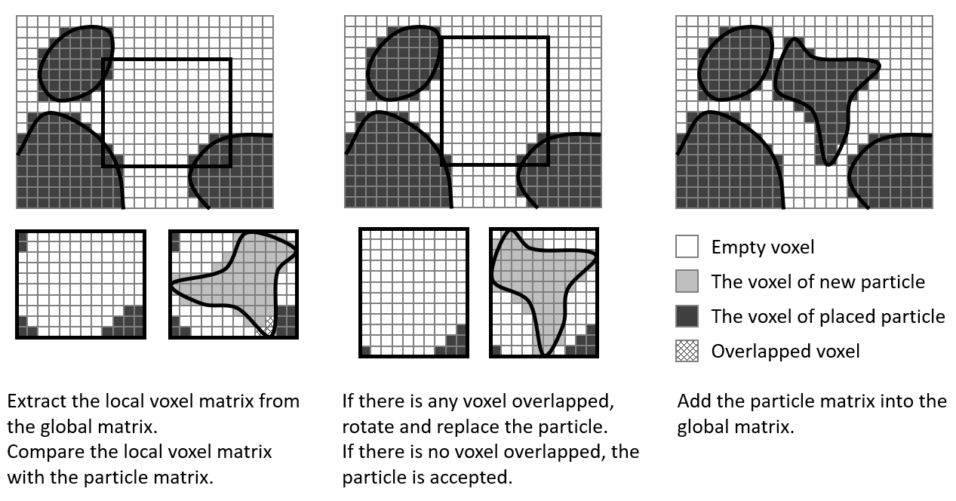
(a) Overlap (b) Not overlap (c) The placed particle
Fig. 3 The process of the overlap determination of one particle based on the voxel matrix

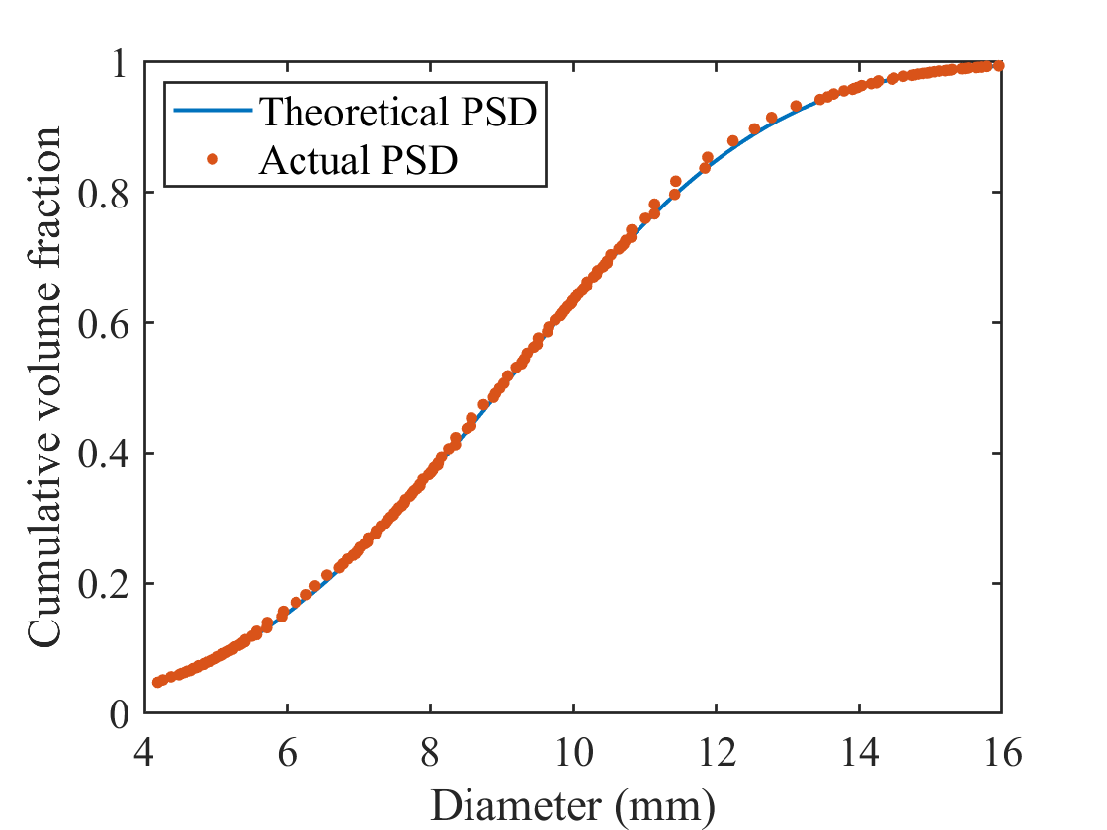
Fig. 4 The theoretical particle size distribution (d₆₃=10, a=3.5) and the actual gradation of gravel

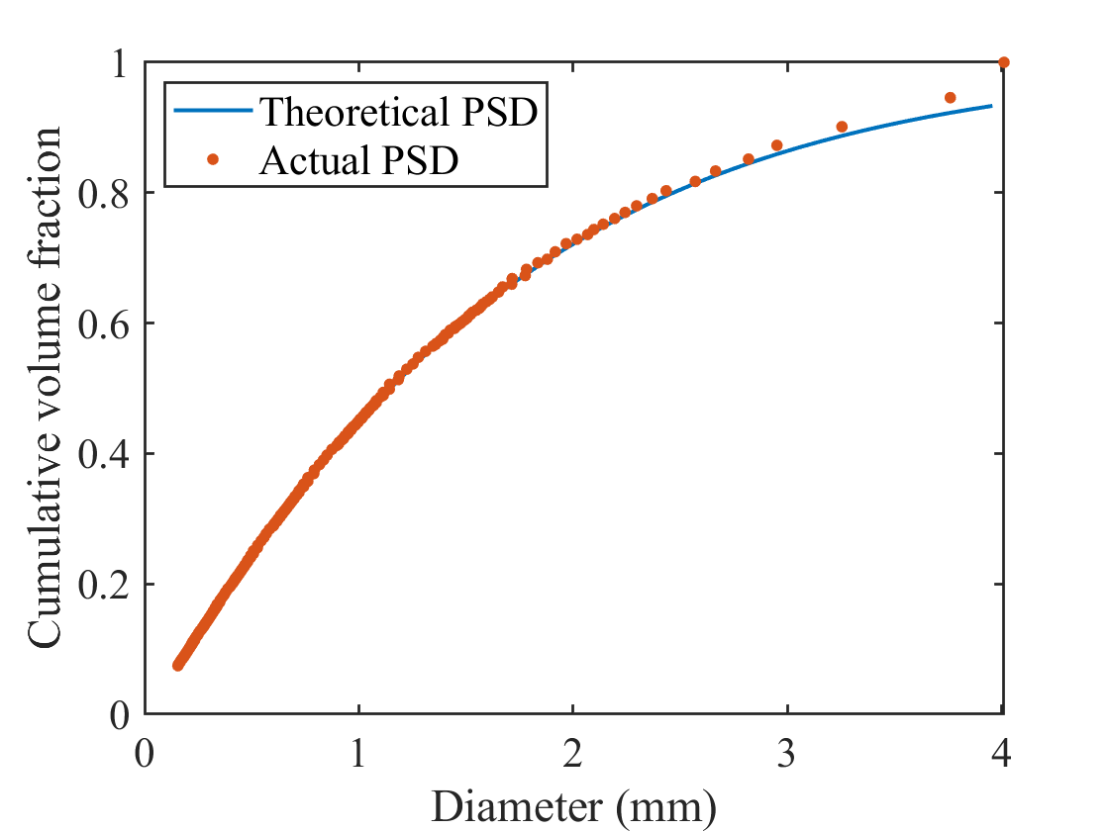
Fig. 5 The theoretical particle size distribution (d₆₃=1.6, a=1.1) and the actual gradation of sand

Fig. 6 The mesostructure mortar cube specimen with the volume fraction of 65% using periodic boundary conditions (The resolution is 0.00695 mm/voxel and the matrix size is 1438×1438×1438)

Fig. 7 The mesostructure of the concrete cube specimen with a volume fraction of 45% (The resolution is 0.0695 mm/voxel and the matrix size is 2158×2158×2158)

(a) The steel skeleton and the boundary conditions
(a) The particle distribution
Fig. 8 The steel skeleton and the particle distribution of the reinforced concrete beam with the volume fraction of 40% (The resolution is 0.139 mm/voxel and the matrix size is 14388×1079×1727)

(a) steel skeleton
(b) particle distribution
Fig. 9 The local mesostructure of the reinforced concrete beam
(a) Sphere (PD = 57.5%) (b) Icosahedron (PD = 52.5%)
(c) Octahedron (PD = 50%) (d) Tetrahedron (PD = 41%)
(e) Real-shape gravel (51%)

Fig. 10 The mesostructure of the concrete cube specimen with different shaped particles (The resolution is 0.0695 mm/voxel and the matrix size is 719×719×719)

Fig. 11 The relationship of the packing density and the number of attempts for sphere, regular polyhedron, and real-shape gravel with various sphericity.

