Spatial-temporal Out-Of-Order Execution for Advanced Planning and Scheduling in Cyber-Physical Factories
Mingxing Li
Ray Y. Zhong
Ting Qu
George Q. Huang
Abstract
Cyber-Physical System (CPS) is a crucial direction in realizing the next-generation smart manufacturing. Massive production data and information are real-timely accessible for decision-makers thanks to the application of various frontier technologies in CPS. However, the inherent complexity and uncertainty of manufacturing optimization still plague researchers and practitioners and hinder the development of smart manufacturing. The production planning and scheduling is such a complex and stochastic problem that has received considerable research attention. Whereas how to leverage the strengths of CPS for breaking the bottleneck of complexity and uncertainty, is still a question that needs further exploration. This paper proposes a novel “divide and conquer” approach, Spatial-temporal Out-Of-Order execution (ST-OOO), for achieving Advanced Planning and Scheduling (APS) in cyber-physical factories. ST-OOO divides the space and time scopes of a factory into finite areas and intervals to localize disturbances and approximate uncertainties so that the original complex optimization problem is discretized to a series of subproblems with different spatial and temporal characteristics. These small-size subproblems can be assembled using real-time visibility and traceability, and solved in a rolling spatial-temporal manner to generate a global solution. A case study shows that ST-OOO has a well-balanced and more stable performance compared to traditional strategies. Sensitivity analysis is carried out to investigate the impacts of spatial and temporal scale on the performance.

Keywords: Advanced Planning and Scheduling (APS); Spatial-temporal Out-Of-Order execution (ST-OOO); Cyber-Physical System (CPS); Synchronization; Smart Manufacturing

Introduction
Industry 4.0 promises next-generation smart manufacturing. But automation alone does not deliver such a revolution, especially when complexity and uncertainty are high and even further amplified by mixed production volumes and increasing product variety. Over the decades, researchers and practitioners on manufacturing optimization have been trying to resolve the complexity and uncertainty. The domain problem of this study, the Advanced Planning and Scheduling (APS) problem, is such a typical optimization problem plagued by complexity and uncertainty. For example, the Hybrid Flow Shop (HFS) scheduling problem, optimizing the sequence of a set of jobs that to be processed at a series of stages, is NP-hard in most cases (Ruiz & Vázquez-Rodríguez, 2010). Cyber-Physical System (CPS) is a crucial direction for realizing the Industry 4.0 manufacturing (Oztemel & Gursev, 2020; Yang, Kumara, Bukkapatnam, & Tsung, 2019; Zhong, Xu, Klotz, & Newman, 2017). In such a highly visible, transparent, and interconnected environment, how the APS problem is reshaped, and how to solve the problem by capitalizing on the real-time information and data in cyber-physical factories, are of concern in this paper.
Considerable efforts have been made from industry and academia to break the bottleneck of complexity and uncertainty. Leading manufacturers developed various APS systems to allocate materials and production capacity to meet the demand optimally. The usefulness of these systems is widely appreciated. However, the current APS systems lack versatility and the costs for customization are usually high, and it is hard for using these systems to respond to the disturbances and uncertain issues in actual production progress without utilizing real-time shopfloor data promptly. Besides, frequent rescheduling may cause resistance to change, which will be counterproductive for improving efficiency (Rahmani & Ramezanian, 2016). Then again, manufacturers invested massively to build highly-automated production lines. Still, the performance did not come up to expectations because automation is perfect for executing static schedules with its preciseness and efficiency, but it is not smart enough to tackle various uncertainties in a dynamic environment.
On the other hand, due to the NP-hard nature of the APS problem, researchers have tried a large variety of mathematical methods and computational algorithms. These approaches have produced more or less similar results that were theoretically optimal or near-optimal but can hardly put into practice because the uncertainties are not well tackled. Afterward, Hierarchical and Production Planning and Scheduling (HPPS) and Multi-Period Production Planning and Scheduling with Rolling Horizons (MPRH) have emerged. HPPS and MPRH are two typical approaches to locate and manage complexity and uncertainty. HPPS decomposes a complex problem into subproblems whose decision variables are deterministic (Hax & Meal, 1973). MPRH discretizes the planning horizon into multiple time intervals, which are short enough with manageable uncertainty (Z. Li & Ierapetritou, 2010). However, both MPRH and HPPS require but suffer from the lack of feedback and updating mechanisms to integrate subproblems.
Nowadays, the power of sharing information has been widely known for reducing the bull-whip effect. The new hope is to develop big data analytics to minimize complexity and uncertainty (Yang et al., 2019). Fortunately, the power of the Internet of Things (IoT) devices in CPS promises to capture real-time factory data (Fang & Zheng, 2020; Sisinni, Saifullah, Han, Jennehag, & Gidlund, 2018). However, IoT, as it is, does not readily serve as effective mechanisms for information sharing. Only very few companies have eventually implemented such IoT solutions on a large scale. Moreover, how real-time shop floor data can be utilized for supporting decision-making is still a question to be answered.
This paper proposes a “divide and conquer” approach, Spatial-temporal Out-Of-Order execution (ST-OOO), for achieving Real-Time Advanced Planning and Scheduling (RT-APS) in cyber-physical factories. ST-OOO divides the space and time scopes of a factory into finite areas and intervals to localize disturbances and approximate uncertainties so that the original complex optimization problem is discretized to a series of subproblems with different spatial and temporal characteristics. These small-size subproblems can be solved in a rolling spatial-temporal manner to generate a global solution. Several research questions are answered in this paper. First, how to discretize the traditional monolithic APS decision into a series of real-time decisions, and how to establish their connections and dependencies using real-time visibility and traceability? Second, how to design a dynamic job distribution and execution mechanism considering the actual shop floor situation such as the availability of men, machines, materials to organize production activities in a simple and resilient manner? Third, how the key parameters, spatial and temporal factors in the proposed method affect its performance?
This study aims to develop ST-OOO for real-time advanced production, planning, scheduling, and execution for cyber-physical factories. The research objectives are as below:
- To innovate a novel “divide and conquer” approach, ST-OOO, to break the bottleneck of complexity, uncertainty and localize the disturbances in real-life manufacturing optimization problem;
- To apply the proposed ST-OOO in a hybrid flow shop scenario with detailed steps for practically achieving RT-APS;
- To conduct a case study for evaluating the performance of the proposed method and investigating the impacts of the spatial and temporal factors, and some parameters of shopfloor configuration on the performance.
In terms of research significance, this study offers a brand-new perspective of complexity and uncertainty management using real-time visibility and traceability, and contributes to the theoretical basis for solving optimization problems in the CPS environment. From a practical point of view, this paper develops a new effective solution for optimization problems encountered in the real-life factory to reduce operational errors and improve efficiency, productivity, and resource utilization. In short, this study provides a novel solution that can obtain a good trade-off between theory and practice.
The rest of this article is organized as follows. Section 2 gives a literature review. The general idea and two key components of ST-OOO are presented in section 3. Section 4 explains the detailed steps of ST-OOO with a HFS example. The case study is conducted in section 5. Finally, section 6 summarizes the paper and gives future perspectives.

Literature Review

HFS Scheduling Problem
The HFS scheduling problem has attracted considerable research attention due to its theoretical complexity and practical relevance (Ruiz & Vázquez-Rodríguez, 2010). Researchers have proposed various approaches to tackle this problem mathematically and computationally, including exact methods, heuristics, and metaheuristics.
Branch and Bound (B&B), Dynamic Programming (DP), and Mathematical Programming were preferred exact methods for solving the HFS problem. Brah and Hunsucker (1991) firstly presented a B&B algorithm to solve a general HFS problem with $m$ stages and multiple processors per stage for optimizing the makespan. More advanced lower and upper bounds were investigated by Vandevelde, Hoogeveen, Hurkens, and Lenstra (2005). Wittrock (1988) decomposed the HFS problem and used DP to find a proper loading sequence. Moreover, Liu and Karimi (2008) developed and evaluated several different MILP for $m$-stages HFS with multiple machines, no-wait, and unlimited storage. These exact methods are perfect for small-size instances but incapable of tackling real-life HFS problems of large scale.
Heuristics and metaheuristics were commonly used in HFS scheduling because of their effectiveness and efficiency in solving large-size instances. Brah and Wheeler (1998) examined the performance of 9 dispatching rules in a HFS with mean flow time and makespan objectives. S. Wang and Liu (2013) proposed a B&B-based heuristics algorithm for a two-stage HFS problem with dedicated machines, close-to-optimal schedules were obtained in computational experiments. Metaheuristics were also applied in HFS scheduling, including Genetic Algorithms (GA), Artificial Immune System (AIS), and Ant Colony Optimization (ACO), etc. Komaki, Teymourian, and Kayvanfar (2016) addressed a two-stage HFS problem followed by an assembly machine using the AIS algorithm. Qin, Zhang, and Song (2018) designed an ACO-based strategy to solve a HFS problem with uncertain processing time. Due to the NP-hard nature of the APS problem, researchers tried a large variety of computational algorithms in the last few decades. However, these methods actually produced more or less similar results that were theoretically near-optimal, but still lack the ability to cope with frequent disturbances and uncertainties in real-life industry.

Hierarchical/Multi-Period Planning and Scheduling
It is acknowledged that the APS problems are complex and stochastic (Efthymiou, Mourtzis, Pagoropoulos, Papakostas, & Chryssolouris, 2016; Keller & Bayraksan, 2009). Researchers realize that the breakthrough to next-generation manufacturing is impossible without overcoming the bottleneck of complexity and uncertainty. Hierarchical Production Planning and Scheduling (HPPS) and Multi-Period Planning and Scheduling with Rolling Horizons (MPRH) are two typical approaches to manage complexity and uncertainty.
HPPS decompose planning and scheduling problem into subproblems to reduce complexity and uncertainty (Bitran, Haas, & Hax, 1982). Dempster et al. (1981) introduced a stochastic programming framework that encompasses the entire multi-level decision process. Omar and Teo (2007) presented a three-level hierarchical approach in a batch process environment with identical machines and multiple products. More recently, O'Reilly, Kumar, and Adam (2015) discussed the applications of HPPS in small- and medium-sized food manufacturers and developed a theoretical framework. Menezes, Mateus, and Ravetti (2016) studied planning and scheduling problem in bulk cargo terminals and proposed a hierarchical approach with a mathematical model for integration. MPRH discretizes the planning and scheduling horizon into multiple time periods which are short enough with manageable uncertainty. Sridharan, Berry, and Udayabhanu (1987) examined the impact on production and inventory costs of three decision variables in managing the stability of the Master Production Schedule within a rolling horizon framework. Balakrishnan and Cheng (2007) gave a comprehensive review of research to address the reconfiguration and uncertainty issues in cellular manufacturing under conditions of multi-period planning horizons. Torkaman, Ghomi, and Karimi (2017) presented MIP-based heuristic models with rolling horizons to solve a multi-stage multi-product multi-period capacitated flow shop planning problem with lot sizing.
Nevertheless, HPPS and MPRH did not break the bottleneck of complexity and uncertainty because both required but suffered from the lack of updating mechanism to integrate subproblems.

CPS for Smart Manufacturing
More recently, cutting-edge technologies such as IoT, big data analytics, and CPS provide new paradigms for improving data and information visibility. Udoka (1991) presented an overview of automated data capture technologies and claimed that these technologies are critical to the success of automated manufacturing systems. Huang, Zhang, Chen, and Newman (2008) proposed a RFID-enabled Wireless Manufacturing framework for adaptive assembly planning and control to improve operational efﬁciency and facilitate decisions. Zhong, Dai, Qu, Hu, and Huang (2013) developed a real-time MES with the deployment of RFID devices to support real-time planning and scheduling. Lin, Shen, Zhao, and Huang (2018) applied iBeacon technologies that provided real-time visibility to facilitate decision-making for supervisors and daily operations for workers. Moreover, the potential of industrial wearables is also widely investigated (Kong, Luo, Huang, & Yang, 2019; M. Li, Xu, Lin, & Huang, 2019). Thanks to the extensive applications of IoT technologies, vast amounts of production data are accessible. Kusiak (2017) revealed the importance of big data in smart manufacturing and identified five gAPS to filled for realizing the next industrial revolution. Besides, L. Wang and Haghighi (2016) considered a CPS as a holarchy of multi-operator in a systematic manner and implemented it using the combined strength of operators, distributed agents, and functional blocks to achieve better ﬂexibility, adaptability, and intelligence. Tao, Cheng, and Qi (2017) proposed a CPS-based Industrial IoT Hub to realize smart interconnection on the shop floor.
Indeed, manufacturing is getting smarter, and real-time data is becoming more accessible with the applications of IoT. However, IoT is not readily served as effective mechanisms for the conversion from data to valuable information and knowledge, as well as facilitating decision-making. Besides, how IoT technologies reshape the APS problems and what are the new characteristics of these problems in a CPS environment need further researches.

Finite Elements Method and Out-Of-Order Execution
This study also draws inspiration from the Finite Elements Method (FEM) and Out-Of-Order execution mechanism. FEM originated from complex elasticity and structural analysis problems in the early 1940s and obtained its real impetus in the 1960s thanks to the power of software programs and computers (Zienkiewicz, Taylor, & Zhu, 2013). The essential idea of FEM is to divide a complex system into smaller, simpler parts (finite elements) for which unknown function is approximated, and simple equations are easy to establish and solve. Then these simple equations are assembled into a larger system of equations that models the entire problem. The method captures local effects and seeks for a global solution. Inspired by FEM, this study divides a factory into finite elements by meshing so that the complexity and uncertainty are substantially minimized. Thus, simpler models can be established and solved with straightforward methods and the models for elements are integrated using real-time visibility and traceability.
Out-Of-Order (OOO) execution, since its formation in the 1960s and now widely implemented, has contributed to the advancement in high-performance CPUs. OOO makes use of instruction cycles that would otherwise be wasted to overcome efficiency problems encountered in in-order processors. The concept of OOO execution is allowing the processor to execute instructions in an order governed by the availability of input data and execution units, rather than by the original order in a program. In this way, OOO avoids a class of stalls that occur in in-order processors and improves the efficiency of instructions processing. OOO offers complex logics for dynamic analysis and resolution of data dependencies to enable more efficient use of multiple execution units. It inspires this study to introduce an OOO execution mechanism in CPS-enabled factories.

Spatial-temporal Out-Of-Order Execution
This section presents the general idea of the Spatial-temporal Out-Of-Order execution (ST-OOO) and how this method leverages the strengths of Cyber-Physical Factories (CPF) for achieving Real-Time Advanced Planning and Scheduling (RT-APS).

Real-Time Visibility and Traceability in CPF
In a CPF, the physical space is characterized by advanced connectivity between physical entities, high-quality data and information acquisition. The cyber space integrates cloud service, intelligent data management, data-centric analytics, and mechanisms for information sharing to support decision-making. Real-Time Visibility and Traceability (RTVT) is the most crucial and indispensable characteristic of a CPF. RTVT visualize the flows of men, machine, and materials from 4 dimensions (space, time, information, status) to provide a thorough understanding of the real-time situation. The dimensions of space and time describe “where and when” and present a straightforward spatial-temporal trajectory. The dimension of information usually specifies “what” (basic facts such as ID, type, customer order, due date, etc.), while the dimension of status refers to “how” (such as whether the job is queuing in buffer or under processing, is there any errors, etc.). These help to establish the dependencies such as how the job pools update over time and how the jobs flow between stages. RTVT extended the manufacturing facts to a higher reality in which data are fully utilized along multiple dimensions. A novel ST-OOO can accommodate to such a highly visible, transparent, and interconnected environment with real-time decision-making. Instead of generating an optimal solution at the beginning and perform rescheduling frequently to cope with uncertainties, ST-OOO keeps monitoring the actual situation on the shop floor using RTVT to support real-time production decision-making. The role of RTVT is further explained with a hybrid flow shop example in Section 4. Spatial-temporal Analytics and Out-Of-Order execution are the two key components of ST-OOO.

Key Component 1: Spatial-temporal Analytics
Spatial-temporal Analytics (STA) is initially inspired by the Finite Element Method (FEM) in the field of engineering and mathematical physics. The core spirit of both STA and FEM is “divide and conquer”. The FEM becomes practical thanks to the development of modern computers, while STA relies on the power of RTVT in a CPF.
Figure 1 shows the general process of STA. Firstly, discretizing the space scope $S$ and time scope $T$ of a complex and stochastic problem $P$ into simpler subproblems $p$ with smaller space scale $∆s$ and shorter time scale $∆t$ to generate the spatial-temporal mesh. These subproblems are called Spatial-temporal Elements (ST-Elements). Secondly, formulating the decision models for each ST-Element, the models should be simpler and relatively deterministic since the original complexity and uncertainty are substantially minimized after meshing. Thirdly, identifying the nodes, namely elemental connectivity, and boundary conditions using RTVT for the assembly of all isolated ST-Elements. Lastly, solving the subproblems under RTVT in a rolling spatial-temporal manner to generate a global solution.
STA provides a new perspective to solve manufacturing optimization problems by minimizing complexity, approximating uncertainties, and localizing disturbances. Real-time information and data collected in a CPF are fully exploited in STA to facilitate decision-making.
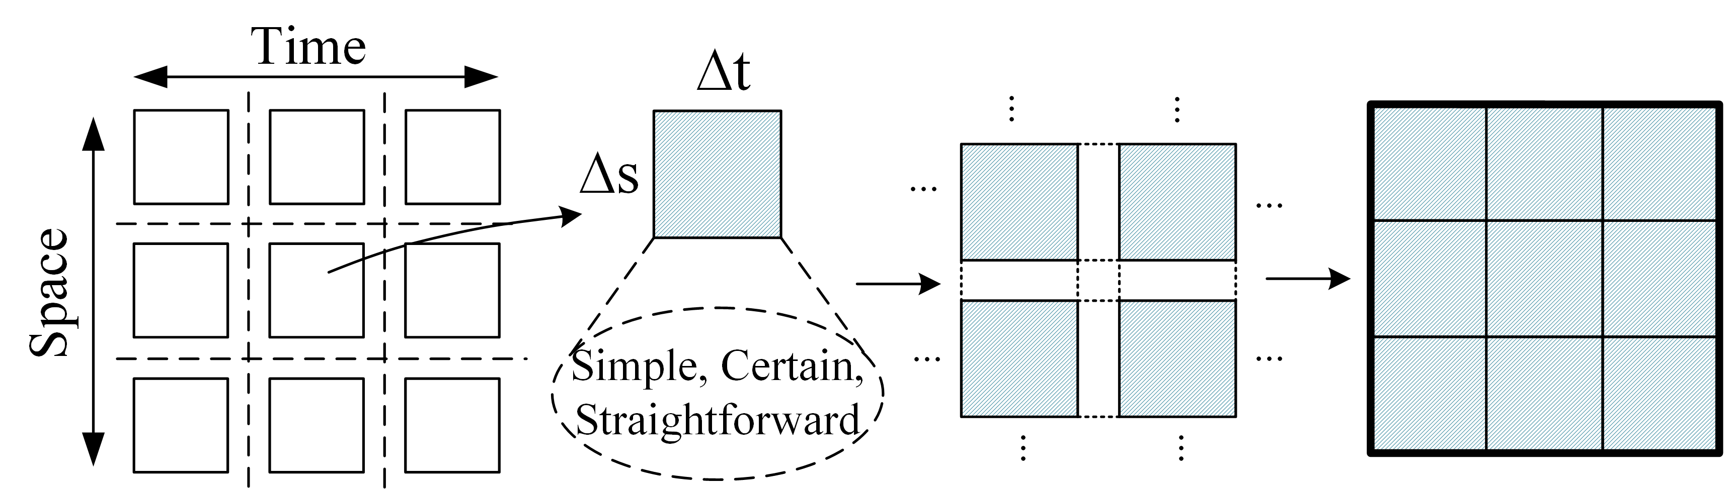
Figure 1. Spatial-temporal Analytics

Key Component 2: Out-Of-Order Execution
The key idea of OOO in computer engineering is to allow a processor to execute instructions in an order governed by the availability of input data and execution units. In this way, OOO avoids a class of stalls and improves resource utilization and processing efficiency. It inspires this study to introduce an OOO in CPF. That is, within a ST-Element, jobs are processed in an order governed by the availability of materials, machines, and men.
Figure 2 presents an example of OOO. Considering a simple CPU with 4 independent instructions in the queue, each instruction consists of 4 steps: Fetch (F), Decode (D), Execution (E), and Writeback (W). An in-order processor will process instructions one by one in the original order. If hazards occur, for instance, a cache miss (the data requested for $I_{2}$ is not found in the cache, it will take a longer time for RAM to lookup the address, retrieve the data, configure itself for output), the execution of $I_{2}$ delays and $I_{3}, I_{4}$ have to wait in the queue. In an OOO processor, when such a hazard occur, the CPU will check the availability of data for $I_{3}, I_{4}$ and process instructions out of the original order to avoid Stalls (S). Similarly, in a simple shop floor with 4 jobs in the queue, each job consists of 3 steps: Fetch (F), Execution (E), and Transfer (T). When a disturbance like material deficiency or loss occurs, the operator can decide to process other available jobs rather than wait.
OOO offers a robust way and complex logic for dynamic job distribution to cope with disturbances and enable more efficient use of production facilities in the shopfloor by giving operators a certain degree of autonomy.
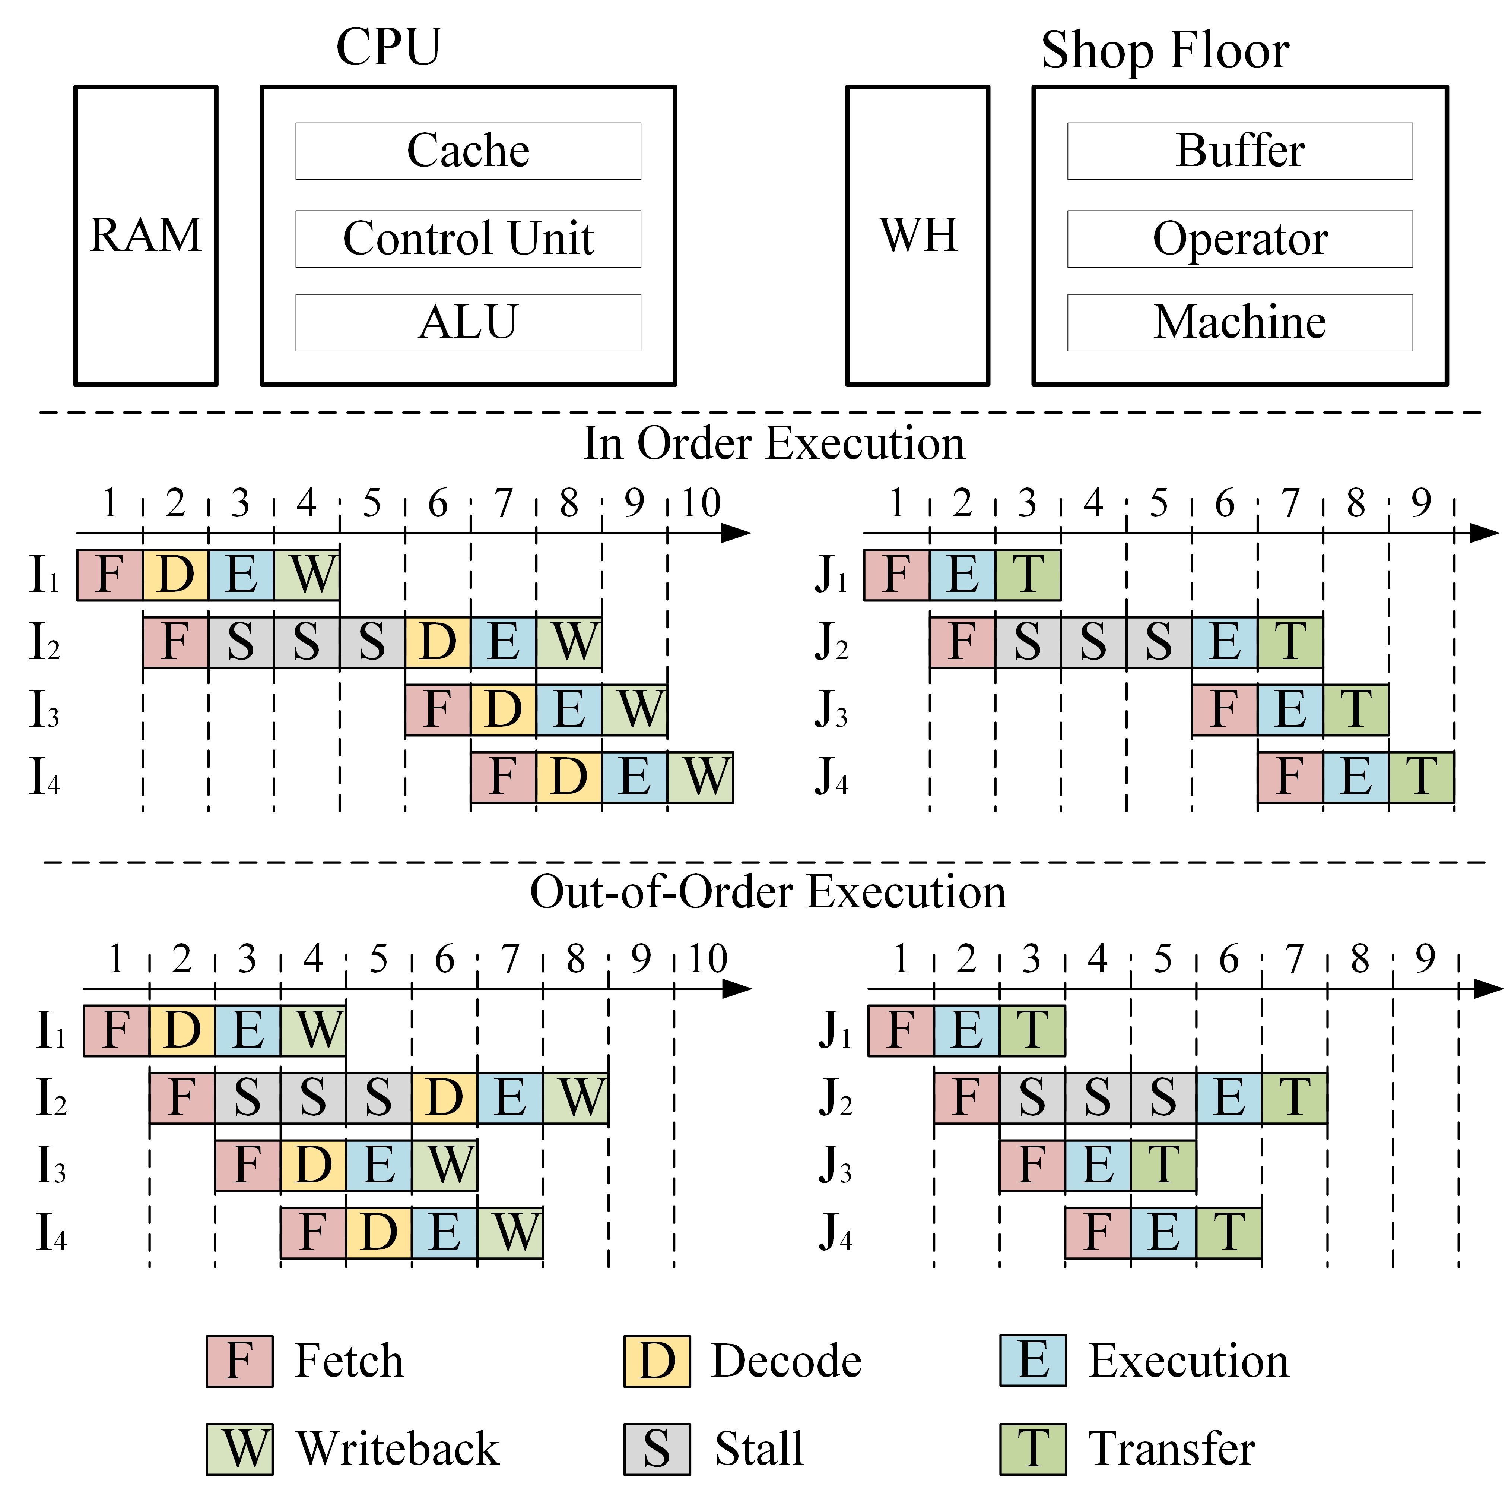
Figure 2. An Example of OOO in CPU and Shop Floor

Five Steps of the ST-OOO Application in CP-HFS
As shown in Figure 3, this section gives detailed steps and explanations on how to achieve RT-APS using proposed ST-OOO in a Cyber-Physical HFS. Firstly, discretizing the space and time scopes of factory to generate spatial-temporal mesh for minimizing complexity, localizing disturbances, and approximating uncertainty; Secondly, formulating the elemental models that should be simpler and relatively deterministic since the complexity and uncertainty of the original problem are reduced after meshing; Thirdly, implementing the job pools and the Out-Of-Order execution mechanism to support decision making within each ST-Element; Fourthly, identifying the connectivity between ST-Elements and boundary conditions of the problem for the assembly of isolated ST-Elements; Lastly, designing a clustering-based synchronization strategy for making the decision. The notations are given in Table 1.
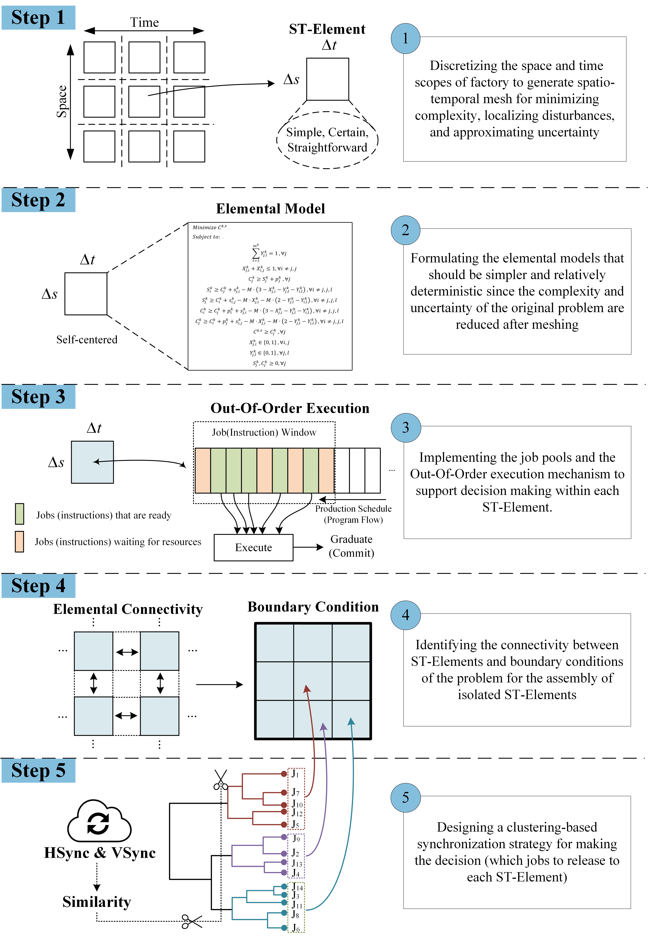
Figure 3. Five Steps of Spatial-temporal Out-Of-Order Execution
Table 1 Notations and Descriptions
Notations | Descriptions
$$P(S, T)$$ | A complex and stochastic problem with space scope $S$ and time scope $T$
$$p(∆s, ∆t)$$ | The subproblem with space scale $∆s$ and time scale $∆t$ after spatial-temporal meshing
$$CO$$ | $CO=\left\{1,2,…, o, …, O\right\}$, the set of customer orders
$$JOB$$ | $JOB=\left\{1,2,…, i,j, …, J\right\}$, the set of jobs
$$p_{j}^{k}$$ | Standard processing time for job $j$ at space unit $k$
$$s_{j, i}^{k}$$ | Setup time for changing from job $j$ to job $i$ at space unit $k$
$$m^{k}$$ | Number of machines at space unit $k$
$$X_{j, i}^{k}$$ | A binary variable that takes value 1 if job $j$ is processed before job $i$ at space unit $k$, and 0 otherwise
$$Y_{j, l}^{k}$$ | A binary variable that takes value 1 if job $j$ is assigned to machine $l$ at space unit $k$, and 0 otherwise
$$S_{j}^{k}$$ | A continuous variable for the starting time of job $j$ at space unit$k$
$$C_{j}^{k}$$ | A continuous variable for the completion time of job $j$ at space unit $k$
$$C^{k, τ}$$ | The completion time of the last job to leave space unit $k$in time unit $τ$
$$M$$ | A sufficiently large constant
$$S^{'}$$ | $S^{'}=\left\{1,2,…, k, …, K,K+1\right\}$, the set of finite space units, $1,…, K$ represent stages and $K+1$ denotes finished product area
$$T^{'}$$ | $T^{'}=\left\{0,1,2,…, τ, …, T\right\}$, the set of finite time units, $0$ represents the initial time
$$N_{τ-1,k}$$ | The set of new jobs assigned to job pool of space unit $k$ in time unit $τ-1$
$$Z_{τ,k}$$ | The set of jobs in job pool of space unit $k$ in time unit $τ$
$$Z_{τ-1,k,g}^{in}$$ | The set of jobs whose operation in previous space unit $g$ during time unit $τ-1$ has been completed and will be transferred to the job pool of space unit $k$
$$Z_{τ-1,k,h}^{out}$$ | The set of jobs whose operation in space unit $k$ has been completed and will be transferred to the job pool of space unit $h$ in time unit $τ-1$
$$h_{j, co}$$ | A binary variable that takes value 1 if job $j$ belongs to customer order $o$, and 0 otherwise
$$d_{1}$$ | $d_{1}$ takes value 0 if the two jobs are in the same order, 1 otherwise
$$d_{2}$$ | $d_{2}$ is positively correlated with the setup time for changeover between job $i,j$
$$w_{1}{, w}_{2}$$ | $w_{1}$ and $w_{2}$ are the weights of $d_{1}$ and $d_{2}$ respectively
$$d(i,j)$$ | the distance between job $i$ and $j$ in the clustering
$$a,b$$ | indexes for job clusters
$$\overline{a}, \overline{b}$$ | the centroids of clusters $a$ and $b$
$$n_{a}, n_{b}$$ | the number of jobs in clusters $a$ and $b$
$$d\left(a,b\right)$$ | the distance between clusters $a$ and $b$ in the clustering

Step 1 Spatial-temporal Meshing in CPS-enabled HFS
In a highly visible, transparent, and interconnected CPS-enabled HFS, the first step is to generate spatial-temporal mesh for minimizing complexity, localizing disturbances, and approximating uncertainty.
This step involves dividing the complex and stochastic problem $P(S, T)$ into an equivalent system of finite elements with associated nodes to generate the spatial-temporal mesh. Each element represents a simpler subproblem $p(∆s, ∆t)$. The elements should be small enough to reduce complexity and uncertainty and yet large enough to give usable results. Because $∆s$ and $∆t$ are small enough relative to $S$ and $T$, the system size of the subproblem is limited, and all the uncertainties occur during current time unit$∆t$ can be postponed to next $∆t$ with negligible loss of service quality. In the HFS case, machines at different stages usually have different functionalities. A single-stage is regarded as an essential space unit $∆s$, and the reasons are: Firstly, the HFS problem was solved as a whole in traditional models, theoretically optimal solutions were obtained by considering all stages, but they were hardly applied since the complexity and uncertainty increased exponentially when problem size grew. Secondly, the production capacity is too limited if a single machine is chosen as the essential space unit; there is little room for optimization. Besides, making exact schedules for every single machine might lead to weak robustness and resilience. Frequent rescheduling may cause resistance to change, which will be counterproductive for improving efficiency (Rahmani & Ramezanian, 2016). From the perspective of time, the total production planning and scheduling horizon $T$ can be divided into multiple medium-length time intervals $t$ representing a day or a working shift. And then $t$ is subdivided into elementary time units $∆t,$ which is usually one hour or several hours. Therefore, at this point, space and time scopes of the original HFS have been divided into finite space and time units; Within a ST-Element $(∆s, ∆t)$, namely, for a given space unit $∆s$ during an elementary time unit $∆t$, there are only a limited number of production jobs that need to complete. Complexity is minimized, and uncertainty is eliminated.

Step 2 Mathematical Formulation of ST-Elements
This step is to formulate the elemental models that should be simpler and relatively deterministic since the complexity and uncertainty of the original problem are substantially reduced after meshing. In the discretized HFS case, a ST-Element represents a single stage in a time unit (i.e., the parallel machine scheduling problem in a given time unit). All ST-elements have their own decision autonomy and they are assumed to be self-centered. That is, supervisor and operators of a single production stage intend to complete the assigned jobs as soon as possible. This assumption is also in line with the observations in the real-life industry. Therefore, the objective function for each ST-Element is the makespan of that element. The overall benefits of the system are considered using a synchronization mechanism, which will be discussed further in Step 5. The other assumptions are: 1) all processing time and setup time are known; 2) parallel machines at the stage are identical; 3) preemption of jobs is not allowed. The ST-elements are formulated as MILP models.
$$Minimize C^{k, τ}$$
$$Subject to:$$
$$\begin{aligned}\sum_{l=1}^{m^{k}}{Y_{j, l}^{k}=1}, ∀j\#\left(1\right)\end{aligned}$$
$$\begin{aligned}X_{j, i}^{k}+X_{i, j}^{k}≤1, ∀i≠j, j\#\left(2\right)\end{aligned}$$
$$\begin{aligned}C_{j}^{k}≥S_{j}^{k}+p_{j}^{k} , ∀j\#\left(3\right)\end{aligned}$$
$$\begin{aligned}S_{i}^{k}≥C_{j}^{k}+s_{j, i}^{k}-M∙\left(3-X_{j, i}^{k}-Y_{j, l}^{k}-Y_{i, l}^{k}\right) , ∀i≠j, j, l\#\left(4\right)\end{aligned}$$
$$\begin{aligned}S_{j}^{k}≥C_{i}^{k}+s_{i, j}^{k}-M∙X_{j, i}^{k}-M∙\left(2-Y_{j, l}^{k}-Y_{i, l}^{k}\right) , ∀i≠j, j, l\#\left(5\right)\end{aligned}$$
$$\begin{aligned}C_{i}^{k}≥C_{j}^{k}+p_{i}^{k}+s_{j, i}^{k}-M∙\left(3-X_{j, i}^{k}-Y_{j, l}^{k}-Y_{i, l}^{k}\right) , ∀i≠j, j, l\#\left(6\right)\end{aligned}$$
$$\begin{aligned}C_{j}^{k}≥C_{i}^{k}+p_{j}^{k}+s_{i, j}^{k}-M∙X_{j, i}^{k}-M∙\left(2-Y_{j, l}^{k}-Y_{i, l}^{k}\right) , ∀i≠j, j, l\#\left(7\right)\end{aligned}$$
$$\begin{aligned}C^{k, τ}≥C_{j}^{k} , ∀j\#\left(8\right)\end{aligned}$$
$$\begin{aligned}X_{j, i}^{k}∈\left\{0, 1\right\} , ∀i, j\#\left(9\right)\end{aligned}$$
$$\begin{aligned}Y_{j, l}^{k}∈\left\{0, 1\right\} , ∀j, l\#\left(10\right)\end{aligned}$$
$$\begin{aligned}S_{j}^{k}, C_{j}^{k}≥0, ∀j\#\left(11\right)\end{aligned}$$

Step 3 Implementation of Job Pool and Out-Of-Order Execution
Step 3 aims at implementing job pools and the OOO execution to support decision-making within each ST-Element. The concept of job pool is proposed to real-timely manage the production activities with simplicity and resilience (Guo et al., 2020; Lin, Li, et al., 2018). By introducing the concepts of order pool, stage pool, machine pool in a CPF, supervisors can easily obtain precise information on orders, jobs at each stage even each machine for better monitoring and control of the manufacturing process. Job pool offers a simple but robust way to manage orders and jobs in a synchronized manner and facilitates the implementation of OOO execution. OOO is a paradigm used in modern CPUs to avoid stalls and improve processing efficiency. OOO allows the processor to execute instructions in an order governed by the availability of input data and execution units, rather than by the original program order. By analogy, the OOO execution in factories organizes the onsite production execution in an order governed by the availability of materials, machines, and men. That is, operators look ahead in a window of jobs through smart devices and find those that are ready to be processed. The key features of OOO are the high degree of autonomy, flexibility, and resilience at the operational level. Therefore, the influence of uncertainties like stochastic processing time, material deficiency/loss, or machine failure on the whole system is negligible compared to the effects of those uncertainties on a rigid production schedule. Operators have autonomy because the jobs assigned to the ST-element are similar, which will be further discussed in the synchronization mechanism in Step 5.
In the HFS scenario, a ST-Element represents a single stage during a given period. The scale of the job pool of ST-Element is the size of the job (instruction) window in the OOO mechanism. Job pools update real-timely by utilizing RTVT. For example, a logistics operator completes a logistics job for transferring the material/WIP to the stage, and this means the material/WIP is now ready; thus the corresponding production job is validated in the job pool of current ST-Element. The first available production operator looks ahead in the job pool and picks the ready production job. Once the operation completed and submitted by the production operator, a new logistics job (transferring the material/WIP to the next stage) is generated logistics job pool for operators. The job pool and OOO execution mechanism offer robust and straightforward logic to tackle frequent disturbances within ST-Elements. Operators make decisions and act under the OOO mechanism in a highly visible and transparent environment that supported by RTVT.

Step 4 Assembly Using Real-Time Visibility and Traceability
Step 4 aims to identify the connectivity between ST-Elements and boundary conditions of the problem for the assembly of isolated ST-Elements using RTVT. In FEM, the elements are connected by nodes, and nodal equilibrium is used to obtain global equations. While the Elemental Connectivities (ECs) in ST-OOO usually refer to how the job pools update over time, how the jobs flow between ST-Elements, and the elemental time dependency. RTVT plays a crucial role in identifying and establishing ECs because all these data can only be accessed through RTVT (space, time, information, status). In the HFS case, three kinds of ECs are considered:
Firstly, the update of job pools utilizes four dimensions of RTVT. The input of the element $(τ,k)$ consists of two parts. The first part is the output of $(τ-1,k)$(space and time dimensions); the second part contains new information in time unit $τ-1$ that is postponed to $τ$ (information dimension). And the sets $Z_{τ-1,k,g}^{in}$and $Z_{τ-1,k,h}^{out}$are also strongly influenced by various uncertain events such as stochastic processing time, machine failure, etc. (status dimension). The job pools are updated as
$$\begin{aligned}Z_{τ,k}=\left(Z_{τ-1,k}∖\bigcup_{h=k+1}^{K}{Z_{τ-1,k,h}^{out}}\right)∪\left(N_{τ-1,k}∪\bigcup_{g=1}^{k-1}{Z_{τ-1,k,g}^{in}}\right), ∀k∈K,∀τ∈T\#\left(12\right)\end{aligned}$$
The second EC uses the space and time dimensions of RTVT. The jobs whose operation in space unit $k$ during time unit $τ-1$ has been completed will be transferred to the following space units. And the jobs transferred to the job pool of space unit $k$ in time unit $τ$, are the union set of jobs whose operation in the previous space unit has been completed.
$$\begin{aligned}Z_{τ-1,k}^{out}=\bigcup_{u=k+1}^{K}{Z_{τ,k,u}^{in}}, ∀k∈K,∀τ∈T\#\left(13\right)\end{aligned}$$
$$\begin{aligned}Z_{τ,k}^{in}=\bigcup_{v=1}^{k-1}{Z_{τ-1,v,k}^{out}}, ∀k∈K,∀τ∈T\#\left(14\right)\end{aligned}$$
The following formula (15) defines the time dependency between element models using the space and time dimensions of RTVT. An operation of job $j$ can start in space unit $k$ only when the operation of that job in space unit $k-1$ has been completed.
$$\begin{aligned}S_{j}^{k}≥C_{j}^{k-1}, ∀k∈K, ∀j\#\left(15\right)\end{aligned}$$
In FEM, certain Boundary Conditions (BCs) must be speciﬁed for each point on the solid surface to remove the singularity problem. In the HFS, three kinds of BCs are considered: 1) the initial state of the whole shop floor, including the configuration and the production capacity of the HFS, the job pools $Z_{0,k}, ∀k∈K$; 2) the new information (e.g., new orders, availability of machine and worker) to be considered $N_{τ,k}, ∀k∈K,∀τ∈T$; 3) the objectives will affect the planning and scheduling decisions. There are three objectives to minimize: 1) Makespan (MS); 2) Total Setup Time (TST); 3) Mean Order Flow Time (MOFT, defined as the difference between the starting time of the first job in one order and the completion time of the last job in the order). MOFT incorporates both job flow time measure and the waiting time/holding time measure. The waiting time/holding time is commonly used as a manufacturing synchronization measure. (Chen et al., 2019; Lin, Shen, et al., 2018; Luo, Yang, & Wang, 2019)
$$\begin{aligned}MS≥C_{j}^{K}, ∀j\#\left(16\right)\end{aligned}$$
$$\begin{aligned}TST=\sum_{i}{\sum_{j}{\sum_{k}{\sum_{l}{Y_{j, l}^{k}∙Y_{i, l}^{k}∙\left(X_{j, i}^{k}∙s_{j, i}^{k}-X_{i, j}^{k}∙s_{i, j}^{k}\right)}}}}\#\left(17\right)\end{aligned}$$
$$\begin{aligned}MOFT=\frac{\sum_{o}{\left[\max_{h_{j,o}=1}\left(C_{j}^{K}\right)-\min_{h_{j,o}=1}\left(S_{j}^{k}\right)\right]}}{O}\#\left(18\right)\end{aligned}$$
With the ECs and BCs, all isolated ST-Elements can be assembled into a global structure.

Step 5 Solve the Problem with a Clustering-based Synchronization Strategy
After meshing, formulating the models, establishing elemental connectivities, and identifying boundary conditions. The critical decision to be made for achieving RT-APS is which jobs to release to each ST-Element. The last step proposes a Clustering-based Synchronization Strategy (CSS) for making the decision.
As these decisions should be made in real-time, the algorithms that require less computational time are more appropriate. A CSS is proposed to make decisions for the HFS case. The spatial-temporal similarity of jobs is measured from the perspective of Horizontal and Vertical Synchronization (HSync, VSync). Besides, other synchronizations like the material requirement, processing type, and due date can also be taken into consideration. HSync aims at control the consistency of processing progresses within one customer order to reduce the holding cost of finished products, while VSync is critical to lower setup costs by coordinating jobs that require less setup time for the changeover (Lin, Li, et al., 2018). That is, the jobs within the same customer order and the jobs that require less setup time for changeover tend to be clustered. The similarity between each pair of jobs are given by calculating their Euclidean distance. And then, linkages are generated between pairs of jobs that are close together to form binary job clusters. These newly formed binary job clusters are further linked to each other to create bigger clusters until all the jobs are linked together to form a hierarchical tree. And the similarity of clusters $a,b$ is given as
$$\begin{aligned}d\left(a,b\right)=\sqrt{\frac{2n_{a}n_{b}}{n_{a}+n_{b}}}{\left\|\overline{a}-\overline{b}\right\|}_{2}\#\left(20\right)\end{aligned}$$
The original intention of ST-OOO is to cope with shifting events by sticking to a fundamental principle; this is, instead of generating a rigid schedule, ST-OOO clusters similar jobs and assign them to each ST-element. It is precisely because the jobs in the same cluster are similar, an exact processing sequence within the cluster is less significant. Besides, there is no absolute division of job clusters, it is possible to cut the clusters of arbitrary sizes that are best fit in with the preset ST-Element. Then these clusters are released to ST-Elements based on spatial and temporal characteristics, the level of urgency, and the customer requirement, etc. This is the decision made by supervisors to answer “which jobs to release”. When a job cluster is released to shopfloor, related production and logistics tasks are generated accordingly, operators process these tasks under the OOO, which guarantees great flexibility and resilience for onsite production execution. Thus, RT-APS is achieved with the coordination of CSS and OOO.

Case Study
This section presents a case study to verify the effectiveness of the proposed approach for general hybrid flow shop scenarios, including four parts: 1) implementation of cyber-physical HFS with RTVT, 2) parameter setting, 3) performance evaluation, 4) sensitivity analysis.

Implementation of CP-HFS with RTVT
Motivated by the case from a collaborative company of the research group, a prototype of cyber-physical HFS is implemented in the laboratory for demonstration as shown in Figure 4.
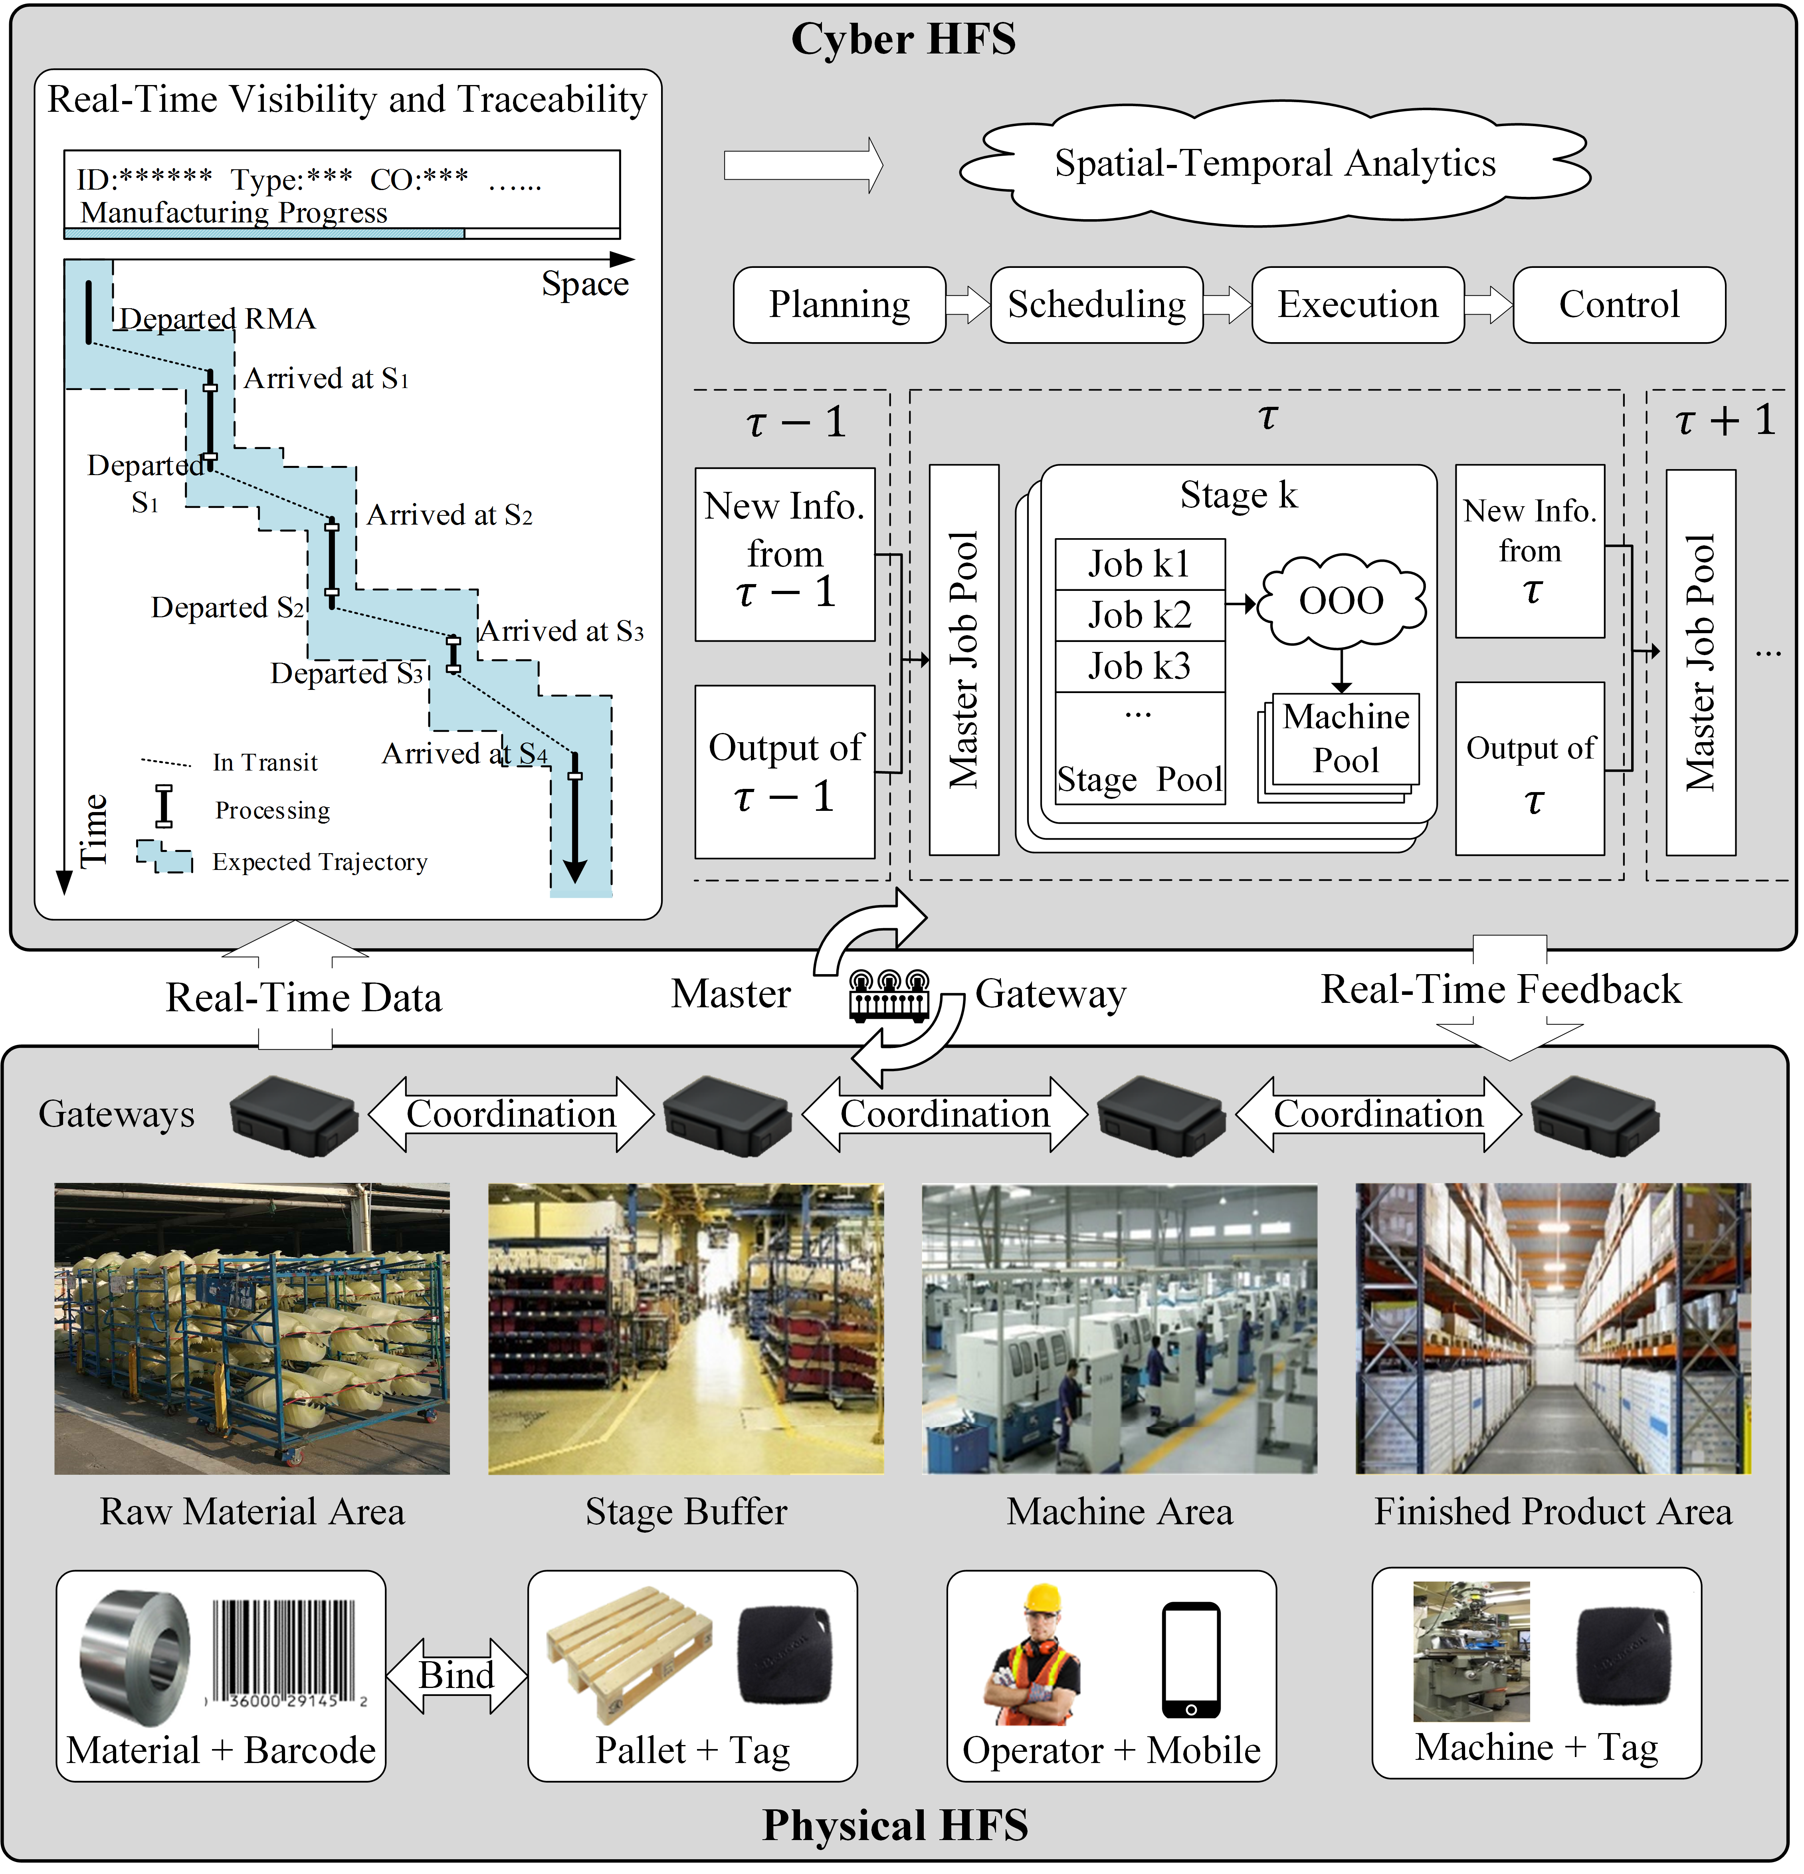
Figure 4. Cyber-Physical HFS
Three types of smart hardware devices are deployed in physical space, including smart tags (iBeacon tags), smart gateways, and smart visual devices. Smart tags with QR code are attached to machines, trolleys, and pallets as the flexible carriers of information and data (such as machine ID, position, status, type, and basic facts of materials). Smart gateways are set on key locations, including raw materials area, stage buffers, machines, and finished product area to coordinate with smart tags for capturing real-time location data, checking job status, and monitoring mistakes and disturbances automatically. The production department and logistics department are the major departments involved in the daily operation of the CP-HFS. Mobiles for operators and screens for supervisors are smart visual devices that provide smart services. Operation execution and control services are provided in the Mobile Application for onsite operators. Production planning and scheduling services are provided in the Desktop Application for supervisors.
In the CP-HFS, the physical space is characterized by advanced connectivity between physical entities, high-quality real-time data, and information acquisition. Master gateways are deployed to synchronize cyber and physical spaces, analyze the status of entities, and establish interoperability between entities. The production data and information are real-timely captured and transmitted to cyber space through master gateways for achieving RTVT. The cyber space integrates cloud service, intelligent data management, data-centric analytics, and mechanisms for information sharing. Supported by cyber services and RTVT, supervisors can analyze the system status and state real-timely to make production decisions accordingly. CPS provides the HFS with greater interconnectedness of resources, better circulation of production information flow, and data flow as a solid foundation for applying ST-OOO.

Parameters Setting
Three performance measures are used: 1) MS; 2) TST; 3) MOFT. Experiment data are generated from Table 2. The assumptions are: 1) All processing time and setup time are known; 2) Parallel machines at each stage are identical; 3) A job might skip some production stages; 4) Preemption of jobs is not allowed; 5) The transportation time of jobs between stages is negligible.
Table 2 Experiment Data
Data | Value
Number of stages | 5
Number of machines per stage | 3, 6, 9
Total number of customer orders | 48, 60, 72
Number of jobs per order | 10
Ratio of dynamically arriving orders | 1/3, 1/2, 2/3
Stage skipping probability | 20%
Processing time (min) | U [31, 50]
Setup time (min) | U [0, 15]
Orders inter-arrival time (min) | Pois (90)

In the clustering-based synchronization strategy, the distances of jobs are given as:
$$d(i,j)=w_{1}⋅d_{1}+w_{2}⋅d_{2}$$
The descriptions of the notations are in Table 1. The more similar two jobs are, the smaller their distance is. 21 combinations of weights are considered in Table 3.
Table 3 The Performance of Different Combinations of Weights
 | (0.0, 1.0) | (0.05, 0.95) | (0.1, 0.9) | (0.15, 0.85) | (0.2, 0.8) | (0.25, 0.75) | (0.3, 0.7)
MS | 7842 | 7807 | 7820 | 7823 | 7748 | 7820 | 7853
TST | 13987 | 13943 | 14032 | 14377 | 13681 | 13859 | 13838
MOFT | 4838.5 | 4719.95 | 4681.8 | 4717.4 | 4712 | 4784.8 | 4714.9
 | (0.35, 0.65) | (0.4, 0.6) | (0.45, 0.55) | (0.5, 0.5) | (0.55, 0.45) | (0.6, 0.4) | (0.65, 0.35)
MS | 7808 | 7887 | 7794 | 7880 | 7853 | 7950 | 7946
TST | 13971 | 14307 | 14227 | 14169 | 14598 | 15527 | 15671
MOFT | 4682.1 | 4799.2 | 4655.3 | 4781.8 | 4744.0 | 4699.2 | 4651.6
 | (0.7, 0.3) | (0.75, 0.25) | (0.8, 0.2) | (0.85, 0.15) | (0.9, 0.1) | (0.95, 0.05) | (1.0, 0.0)
MS | 7965 | 8025 | 8082 | 8000 | 8013 | 8041 | 8064
TST | 16162 | 16234 | 16742 | 16653 | 16661 | 16817 | 17297
MOFT | 4672.7 | 4699.1 | 4668.5 | 4713.8 | 4614.0 | 4693.9 | 4492.5

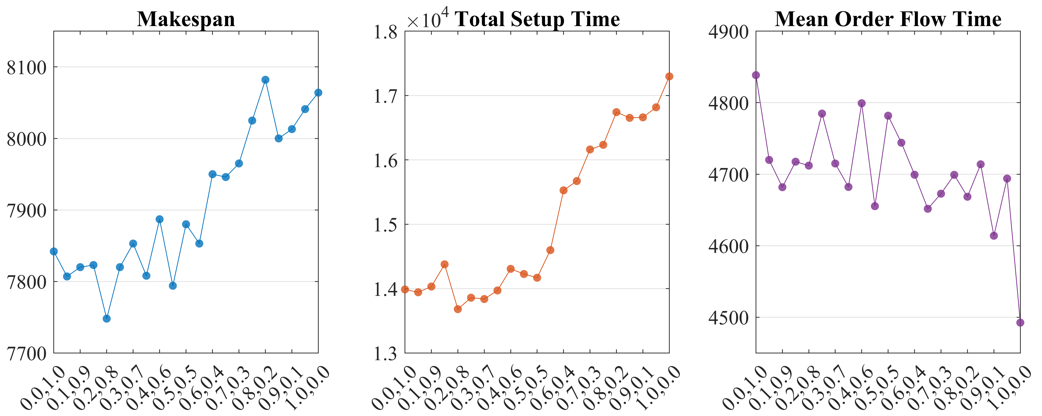
Figure 5. The Performance of Different Combinations of Weights
As shown in Figure 5, when $w_{1}$ increases and $w_{2}$ decreases, the MS ranges from about 7,750 mins to over 8,000 mins, the TST ranges from slightly over 13,500 mins to almost 17,500 mins. Both MS and TST present the rising trend in fluctuations. While on the whole, the MOFT generally shows the declining trend ranging from nearly 4,850 mins to around 4,500 mins. It is noteworthy that the MS and MOFT show obvious and similar fluctuations, this may on account of the mutual effect between MS and MOFT. For example, as$w_{1}$ grows, jobs in the same customer order tend to be clustered to reduce MOFT so that the TST tends to grow. Consequently, the MS is prolonged, and part of processing jobs flow in the shopfloor for a longer time. To attain well-balanced performance, the weights are set as (0.2, 0.8) for the subsequent experiments.

Performance Evaluation
This subsection evaluates the performance of ST-OOO under various patterns of customer demand. Three typical dispatching rules are adopted as references. Since the decisions should be made real-timely and frequently, it is more appropriate to use the algorithms that require less computational efforts (even if in large instances): 1) Least Work Remaining (LWKR) is found to be effective in reducing job flow time (Kia, Davoudpour, & Zandieh, 2010); 2) Shortest Processing Time (SPT), which is one of most classical rules in literature; 3) First-Come First-Served (FCFS), intuitively, as orders are processed one by one under FCFS, this rule might be useful in reducing MOFT.
The number of customer orders is set as 48, 60, and 72, and the ratio of dynamically arriving orders is set as 1/3, 1/2, and 2/3. 10 instances are generated for each setting. The total number of customer orders represents the total demand, and the ratio of dynamically arriving orders reflects the dynamics of the market. The primary consideration for this setting is to evaluate the stability and adaptiveness of ST-OOO in a dynamic environment. Table 4 presents the average value of the results. It is observed that FCFS performs better in terms of MOFT, but compromises on other measures. ST-OOO can obtain well-balanced solutions that minimizing MS and TST with reasonable MOFT. To obtain a more reliable comparison, Figure 6 gives the scattered boxplots of different methods. One noteworthy finding is that although ST-OOO does not show a significant improvement in terms of average MS in Table 4, the interval plots of ST-OOO and other rules are disjoint in Figure 6, this implies that ST-OOO performs better in terms of MS and TST statistically and it is more stable compared with FCFS. In contrast, despite FCFS obtains smaller average values of MOFT, the interval plots of ST-OOO and FCFS overlap in Figure 6, which indicates that the difference between the two methods is not statistically significant.
Table 4 Comparison with Traditional Strategies
 | ST-OOO |  |  |  | LWKR |  |  |  |  | SPT |  |  |  |  |  | FCFS
 | 1/3 | 1/2 | 2/3 |  | 1/3 |  | 1/2 | 2/3 |  | 1/3 |  | 1/2 |  | 2/3 |  | 1/3 | 1/2 | 2/3
48 Customer Orders
MS | 6381 | 6398 | 6364 |  | 6755 |  | 6728 | 6740 |  | 6824 |  | 6806 |  | 6830 |  | 6980 | 6759 | 6642
TST | 10823 | 10944 | 10989 |  | 14959 |  | 15021 | 15215 |  | 16331 |  | 16363 |  | 16543 |  | 16816 | 14972 | 13755
MOFT | 4494 | 4223 | 3951 |  | 6014 |  | 5993 | 5995 |  | 6093 |  | 6059 |  | 6078 |  | 4007 | 3785 | 3653
60 Customer Orders
MS | 7899 | 7948 | 7893 |  | 8368 |  | 8356 | 8339 |  | 8479 |  | 8474 |  | 8467 |  | 8735 | 8466 | 8239
TST | 13623 | 13911 | 13740 |  | 19054 |  | 19232 | 19290 |  | 21002 |  | 21182 |  | 21260 |  | 22176 | 19820 | 17865
MOFT | 5473 | 5194 | 4812 |  | 7435 |  | 7425 | 7397 |  | 7573 |  | 7571 |  | 7531 |  | 4975 | 4701 | 4476
72 Customer Orders
MS | 9422 | 9456 | 9433 |  | 9943 |  | 9970 | 9979 |  | 10085 |  | 10120 |  | 10097 |  | 10466 | 10178 | 9866
TST | 16583 | 16652 | 16708 |  | 23339 |  | 23331 | 23726 |  | 25699 |  | 25904 |  | 26055 |  | 27196 | 24807 | 22128
MOFT | 6549 | 6230 | 5753 |  | 8815 |  | 8848 | 8844 |  | 9013 |  | 9024 |  | 8974 |  | 5937 | 5648 | 5325
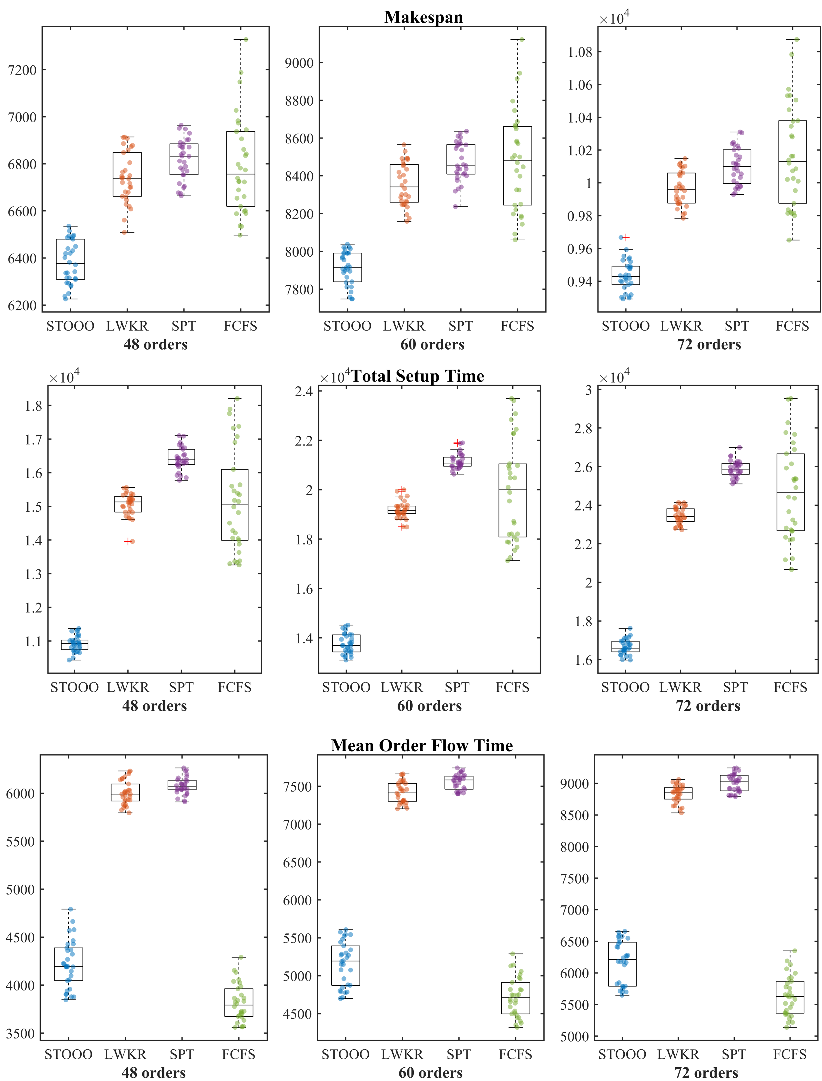
Figure 6. Scattered Boxplots of Different Methods

Sensitivity Analysis
This subsection carries out the sensitivity analysis to investigate the effects of the spatial and temporal scale $∆s$ and $∆t$, and some useful managerial insights are given based on the results.
In the HFS case, a single-stage is regarded as an essential space unit $∆s$. However, a stage may not necessarily be the most appropriate unit. One reason is that the number of machines per stage may be influential to the performance. Therefore, the number of machines is set as 3, 6, and 9 per stage in the following experiment (See Table 5). It is worth noting that as the number of machines increases, the performance of ST-OOO deteriorates. When the production capacity is doubled and tripled, the MS and MOFT of LWKR and SPT rules are reduced to around 1/2 and 1/3, while the MS and MOFT of ST-OOO are over 1/2 and 1/3, especially in MOFT. Besides, the TST of LWKR and SPT rules are basically unchanged, while the TST of ST-OOO shows an obvious increase. This implies that discretizing the space scope based on stage is more suitable for the situation where each stage has fewer machines. Yet, it is not the most cost-effective $∆s$ in meshing, especially when the number of machines per stage is relatively large.
Table 5 Effect of the Number of Machines
 | ST-OOO |  | LWKR |  |  |  |  |  | SPT |  |  |  | FCFS
3 Machines per Stage
MS | 1.0000 |  | 1.0000 |  |  |  |  |  | 1.0000 |  |  |  | 1.0000
TST | 1.0000 |  | 1.0000 |  |  |  |  |  | 1.0000 |  |  |  | 1.0000
MOFT | 1.0000 |  | 1.0000 |  |  |  |  |  | 1.0000 |  |  |  | 1.0000
6 Machines per Stage
MS | 0.5130 |  | 0.4981 |  |  |  |  |  | 0.5028 |  |  |  | 0.5363
TST | 1.2042 |  | 1.0071 |  |  |  |  |  | 1.0285 |  |  |  | 1.3199
MOFT | 0.5726 |  | 0.5068 |  |  |  |  |  | 0.5034 |  |  |  | 0.5789
9 Machines per Stage
MS | 0.3452 |  | 0.3342 |  |  |  |  |  | 0.3340 |  |  |  | 0.3574
TST | 1.2710 |  | 1.0640 |  |  |  |  |  | 1.0493 |  |  |  | 1.3526
MOFT | 0.3698 |  | 0.3359 |  |  |  |  |  | 0.3312 |  |  |  | 0.3925
Notes: The values in this table are the ratios of measures with the current number of machines to those with three machines per stage
Another crucial factor in meshing is $∆t$. In the subsequent experiments, $∆t=$ 60, 90, 120, 150, 180, 210, 240 $mins$ and 36, 48, 60, 72 orders are considered (see Table 6). Figure 7 gives the curves of the measures with different values of $∆t$. Generally, the tendencies of the measures are similar despite the number of orders. As the $∆t$ extended, the MS and TST decrease first and then increase with minimum value reached at $∆t=120 mins$ in most instances, while the MOFT generally shows a declining trend with fluctuations. Hence, in this case, it is preferred to set $∆t=120 mins$ in meshing to obtain overall well-balanced performance when applying ST-OOO.
Table 6 Effect of $∆t$
$$∆t$$ | 60 | 90 | 120 | 150 | 180 | 210 | 240
48 Customer Orders
MS | 1.0000 | 0.9765 | 0.9762 | 0.9875 | 0.9862 | 1.0006 | 1.0113
TST | 1.0000 | 0.9072 | 0.8637 | 0.9163 | 0.9593 | 1.0112 | 1.0286
MOFT | 1.0000 | 0.9819 | 0.9655 | 0.9837 | 0.9730 | 0.9790 | 0.9368
60 Customer Orders
MS | 1.0000 | 0.9824 | 0.9718 | 0.9871 | 0.9960 | 1.0004 | 0.9979
TST | 1.0000 | 0.9451 | 0.8747 | 0.8973 | 0.9625 | 0.9804 | 0.9932
MOFT | 1.0000 | 0.9960 | 0.9835 | 0.9836 | 0.9807 | 0.9872 | 0.9610
72 Customer Orders
MS | 1.0000 | 0.9885 | 0.9863 | 0.9986 | 1.0004 | 0.9992 | 1.0013
TST | 1.0000 | 0.9289 | 0.8997 | 0.9090 | 0.9246 | 0.9370 | 0.9687
MOFT | 1.0000 | 1.0101 | 1.0148 | 1.0107 | 1.0171 | 1.0170 | 0.9950
Notes: The values in the table are the ratios of performance measures with current $∆t$ to those with $∆t=60 mins$
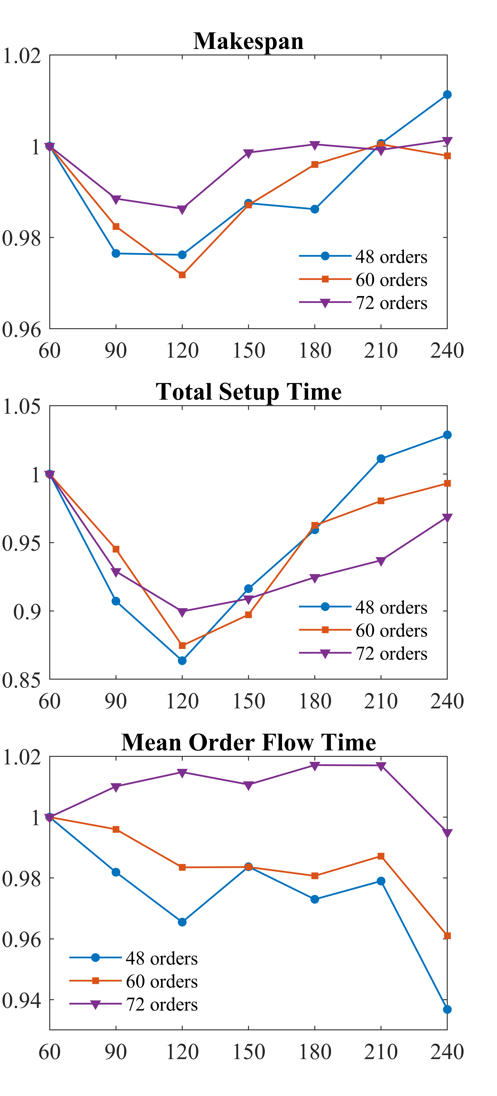
Figure 7. Effect of $∆t$ on the Performance

Managerial Implications
Based on the numerical results given in the above case study, several managerial implications can be concluded for practitioners as follows.
Firstly, massive shop floor data are captured by smart sensors and devices in the modern manufacturing industry. These data and information provide the manager with real-time visibility and traceability, the proposed method is proved effective to generate real-time APS decisions using visibility and traceability.
Secondly, in comparison with traditional planning and scheduling rules, ST-OOO can obtain overall balanced solutions regarding multiple measures, and its performance is more stable and resilient in a dynamic environment. Key parameters can be adjusted to fit in with the actual shop floor situation.
Thirdly, the size of ST-Element should be carefully decided according to the actual conditions of the factory, the schedule will be too rigid to lose resilience when the size is too small, while it is lack of responsiveness to frequent disturbances and the similarity of clustered jobs is weakened if the size is too large.

Conclusions
In conclusion, this paper has discussed the emerging characteristics of traditional production optimization problems in cyber-physical factories. In such a highly visible, traceable, transparent, and interconnected factory, RTVT means the information of space, time, status, and state of the shop floor are real-timely accessible to decision-makers. Thus, the novel ST-OOO that capitalizes on the RTVT of the CPF was proposed. By minimizing the complexity and uncertainty in meshing, the original problem can be discretized and solved in a rolling spatial-temporal manner to obtain a global solution. The detailed steps of ST-OOO were presented with a HFS example. Finally, a case study was carried out to examine the superiority of ST-OOO, and sensitivity analysis was conducted to investigate the impacts of two crucial factors on the performance.
In the case study, the performance of ST-OOO was evaluated comprehensively. The results showed that ST-OOO had a well-balanced performance on selected measures, by contrast, other strategies might be better on one specific measure but compromise with the others. Moreover, the ST-OOO performed more stably in a dynamic environment, while other strategies were volatile when the ratio of dynamic orders changed. In the sensitivity analysis, the effect of the number of machines per stage was firstly investigated. The performance of ST-OOO deteriorated as the number of machines increased. This implied that simply discretizing the space scope of the HFS according to the stage was straightforward. However, the stage might not be the most cost-effective scale of space in meshing. Besides, the effect of temporal scale $∆t$ was also examined. The results showed that as $∆t$ grew, the MS and TST decreased first and then increased, the overall well solution was obtained when $∆t=120 mins$. These two findings suggested that the most cost-effective elements should be made large enough to give usable results and yet small enough to reduce complexity and uncertainty.
The contributions of this paper are threefold: 1) It innovated a novel “divide and conquer” approach, ST-OOO, which provided a brand-new perspective for solving production optimization problems using RTVT in cyber-physical factories; 2) It applied the proposed ST-OOO in a HFS case with detailed steps and explanations for achieving RT-APS in a practical way; 3) It presented a case study and sensitivity analysis to verify the effectiveness of ST-OOO and to investigate how spatial and temporal factors affect its performance.
There are several limitations of this paper. First, the case study only considered dynamic orders. Other common uncertain events on the shop floor like machine failure, stochastic processing time were ignored. But it does not mean that the current ST-OOO cannot deal with these stochastic behaviors. A more comprehensive case study might be conducted in future work to consider various uncertain events, adopt more measures like schedule stability and robustness, and compare the ST-OOO with more advanced strategies. Second, the most cost-effective temporal scale was found in sensitivity analysis, yet the spatial scale was not. How to find the most cost-effective scale of ST-Element is the question to be answered in future work. Last but not least, the application of ST-OOO may be extended to solve other combinatorial optimization problems such as job shop scheduling and vehicle routing encountered in the real-world.

References
Balakrishnan, J., & Cheng, C. H. (2007). Multi-period planning and uncertainty issues in cellular manufacturing: A review and future directions. European Journal of Operational Research, 177(1), 281-309.
Bitran, G. R., Haas, E. A., & Hax, A. C. (1982). Hierarchical production planning: A two-stage system. Operations Research, 30(2), 232-251.
Brah, S. A., & Hunsucker, J. L. (1991). Branch and bound algorithm for the flow shop with multiple processors. European Journal of Operational Research, 51(1), 88-99.
Brah, S. A., & Wheeler, G. E. (1998). Comparison of scheduling rules in a flow shop with multiple processors: A simulation. Simulation, 71(5), 302-311.
Chen, J., Wang, M., Kong, X. T., Huang, G. Q., Dai, Q., & Shi, G. (2019). Manufacturing synchronization in a hybrid flowshop with dynamic order arrivals. Journal of Intelligent Manufacturing, 30(7), 2659-2668.
Dempster, M. A. H., Fisher, M., Jansen, L., Lageweg, B., Lenstra, J. K., & Rinnooy Kan, A. (1981). Analytical evaluation of hierarchical planning systems. Operations Research, 29(4), 707-716.
Efthymiou, K., Mourtzis, D., Pagoropoulos, A., Papakostas, N., & Chryssolouris, G. (2016). Manufacturing systems complexity analysis methods review. International Journal of Computer Integrated Manufacturing, 29(9), 1025-1044.
Fang, W., & Zheng, L. (2020). Shop floor data-driven spatial–temporal verification for manual assembly planning. Journal of Intelligent Manufacturing, 31(4), 1003-1018.
Guo, D., Zhong, R. Y., Lin, P., Lyu, Z., Rong, Y., & Huang, G. Q. (2020). Digital twin-enabled graduation intelligent manufacturing system for fixed-position assembly islands. Robotics and Computer-Integrated Manufacturing, 63, 101917.
Hax, A. C., & Meal, H. C. (1973). Hierarchical integration of production planning and scheduling. Massachusetts Institute of Technology, Sloan School of Management.
Huang, G. Q., Zhang, Y., Chen, X., & Newman, S. T. (2008). Rfid-enabled real-time wireless manufacturing for adaptive assembly planning and control. Journal of Intelligent Manufacturing, 19(6), 701-713.
Keller, B., & Bayraksan, G. (2009). Scheduling jobs sharing multiple resources under uncertainty: A stochastic programming approach. IIE Transactions, 42(1), 16-30.
Kia, H., Davoudpour, H., & Zandieh, M. (2010). Scheduling a dynamic flexible flow line with sequence-dependent setup times: A simulation analysis. International Journal of Production Research, 48(14), 4019-4042.
Komaki, G., Teymourian, E., & Kayvanfar, V. (2016). Minimising makespan in the two-stage assembly hybrid flow shop scheduling problem using artificial immune systems. International Journal of Production Research, 54(4), 963-983.
Kong, X. T., Luo, H., Huang, G. Q., & Yang, X. (2019). Industrial wearable system: The human-centric empowering technology in industry 4.0. Journal of Intelligent Manufacturing, 30(8), 2853-2869.
Kusiak, A. (2017). Smart manufacturing must embrace big data. Nature, 544(7648), 23-25.
Li, M., Xu, G., Lin, P., & Huang, G. Q. (2019). Cloud-based mobile gateway operation system for industrial wearables. Robotics and Computer-Integrated Manufacturing, 58, 43-54.
Li, Z., & Ierapetritou, M. G. (2010). Rolling horizon based planning and scheduling integration with production capacity consideration. Chemical Engineering Science, 65(22), 5887-5900.
Lin, P., Li, M., Kong, X., Chen, J., Huang, G. Q., & Wang, M. (2018). Synchronisation for smart factory-towards iot-enabled mechanisms. International Journal of Computer Integrated Manufacturing, 31(7), 624-635.
Lin, P., Shen, L., Zhao, Z., & Huang, G. Q. (2018). Graduation manufacturing system: Synchronization with iot-enabled smart tickets. Journal of Intelligent Manufacturing, 1-16.
Liu, Y., & Karimi, I. (2008). Scheduling multistage batch plants with parallel units and no interstage storage. Computers Chemical Engineering, 32(4-5), 671-693.
Luo, H., Yang, X., & Wang, K. (2019). Synchronized scheduling of make to order plant and cross-docking warehouse. Computers & Industrial Engineering, 138, 106108.
Menezes, G. C., Mateus, G. R., & Ravetti, M. G. (2016). A hierarchical approach to solve a production planning and scheduling problem in bulk cargo terminal. Computers & Industrial Engineering, 97, 1-14.
O'Reilly, S., Kumar, A., & Adam, F. (2015). The role of hierarchical production planning in food manufacturing smes. International Journal of Operations & Production Management, 35(10), 1362-1385.
Omar, M. K., & Teo, S. (2007). Hierarchical production planning and scheduling in a multi-product, batch process environment. International Journal of Production Research, 45(5), 1029-1047.
Oztemel, E., & Gursev, S. (2020). Literature review of industry 4.0 and related technologies. Journal of Intelligent Manufacturing, 31(1), 127-182.
Qin, W., Zhang, J., & Song, D. (2018). An improved ant colony algorithm for dynamic hybrid flow shop scheduling with uncertain processing time. Journal of Intelligent Manufacturing, 29(4), 891-904.
Rahmani, D., & Ramezanian, R. (2016). A stable reactive approach in dynamic flexible flow shop scheduling with unexpected disruptions: A case study. Computers & Industrial Engineering, 98, 360-372.
Ruiz, R., & Vázquez-Rodríguez, J. A. (2010). The hybrid flow shop scheduling problem. European Journal of Operational Research, 205(1), 1-18.
Sisinni, E., Saifullah, A., Han, S., Jennehag, U., & Gidlund, M. (2018). Industrial internet of things: Challenges, opportunities, and directions. IEEE Transactions on Industrial Informatics, 14(11), 4724-4734.
Sridharan, V., Berry, W. L., & Udayabhanu, V. (1987). Freezing the master production schedule under rolling planning horizons. Management Science, 33(9), 1137-1149.
Tao, F., Cheng, J., & Qi, Q. (2017). Iihub: An industrial internet-of-things hub toward smart manufacturing based on cyber-physical system. IEEE Transactions on Industrial Informatics, 14(5), 2271-2280.
Torkaman, S., Ghomi, S. F., & Karimi, B. (2017). Multi-stage multi-product multi-period production planning with sequence-dependent setups in closed-loop supply chain. Computers & Industrial Engineering, 113, 602-613.
Udoka, S. J. (1991). Automated data capture techniques: A prerequisite for effective integrated manufacturing systems. Computers & Industrial Engineering, 21(1-4), 217-221.
Vandevelde, A., Hoogeveen, H., Hurkens, C., & Lenstra, J. K. (2005). Lower bounds for the head-body-tail problem on parallel machines: A computational study of the multiprocessor flow shop. INFORMS Journal on Computing, 17(3), 305-320.
Wang, L., & Haghighi, A. (2016). Combined strength of holons, agents and function blocks in cyber-physical systems. Journal of Manufacturing Systems, 40, 25-34.
Wang, S., & Liu, M. (2013). A heuristic method for two-stage hybrid flow shop with dedicated machines. Computers & Operations Research, 40(1), 438-450.
Wittrock, R. J. (1988). An adaptable scheduling algorithm for flexible flow lines. Operations Research, 36(3), 445-453.
Yang, H., Kumara, S., Bukkapatnam, S. T., & Tsung, F. (2019). The internet of things for smart manufacturing: A review. IISE Transactions, 1-27.
Zhong, R. Y., Dai, Q., Qu, T., Hu, G., & Huang, G. Q. (2013). Rfid-enabled real-time manufacturing execution system for mass-customization production. Robotics and Computer-Integrated Manufacturing, 29(2), 283-292.
Zhong, R. Y., Xu, X., Klotz, E., & Newman, S. T. (2017). Intelligent manufacturing in the context of industry 4.0: A review. Engineering, 3(5), 616-630.
Zienkiewicz, O. C., Taylor, R. L., & Zhu, J. (2013). The finite element method: Its basis and fundamentals: Butterworth-Heinemann.

