A Review of Digital Twin in Product Design And Development
C.K. LO¹, C.H. CHEN², RAY. Y. ZHONG¹ (Email: zhongzry@hku.edu.hk)
1. Department of Industrial and Manufacturing Systems Engineering, The University of Hong Kong, Hong Kong
2. School of Mechanical & Aerospace Engineering, Nanyang Technological University, Singapore

Abstract
In the era of digitalization, there are many emerging technologies, such as the Internet of Things (IoT), Digital Twin (DT), Cloud Computing and Artificial Intelligence (AI), which are quickly developped and used in product design and development. Among those technologies, DT is one promising technology which has been widely used in different industries, especially manufacturing, to monitor the performance, optimize the progresses, simulate the results and predict the potential errors. DT also plays various roles within the whole product lifecycle from design, manufacturing, delivery, use and end-of-life. With the growing demands of individualized products and implementation of Industry 4.0, DT can provide an effective solution for future product design, development and innovation. This paper aims to figure out the current states of DT research focusing on product design and development through summarizing typical industrial cases. Challenges and potential applications of DT in product design and development are also discussed to inspire future studies.

Keywords: Digital Twin, Product Design, New Product Development, Product Lifecycle, Review

List of acronyms
AI Artificial Intelligence
AR Augmented Reality
BDA Big Data Analytics
CAD Computer-aided Design
CAE Computer-aided Engineering
CAM Computer-aided Manufacturing
DDS Data Distribution Service
DT Digital Twin
EEE Electrical and Electronic Engineering
FlexMM Flexible Material Model
HLA High Level Architecture
GE General Electric
GMOS Green Material Optimal-Selection
ICT Information and Communications Technology
IoT Internet of Things
LED Light-emitting Diode
MQTT Message Queuing Telemetry Transport
MOL Middle of Life
NASA The National Aeronautics and Space Administration
NPD New Product Development
PLM Product Lifecycle Management
PTC PTC Inc. - computer software company
PV system Photovoltaic system
RTI Run-Time Infrastructure
SUV Sport Utility Vehicle
UAV Unmanned Aerial Vehicle
VR Virtual Reality
WEEE Waste Electrical and Electronic Equipment

- Introduction
In recent years, the product design and development industry are moving to evolve into a comprehensive digital era. Various computer-aided technologies, i.e. Computer-aided design (CAD) and computer-aided engineering (CAE), are available to assist the designers and engineers effectively generating a new product design [56, 59]. CAD software is an essential and fundamental engineering tool so that most engineers can create 3D models for design assistance and verification. Therefore, CAD is an indispensable tool for product designers and design engineers. With the development of collaborative design environment, different parties, i.e. customers, manufacturers and designers, can exchange and share their idea and knowledge on the design stage. Therefore, the engineering models have become much more complicated [1, 3]. The digital models are mainly used to examine product performance, simulate manufacturing process and verify design feasibility. However, how to optimise the use of those models to enhance the design process and design collaboration is still needed to be investigated. The emergence of digital twin (DT) enriches the application of these models to several areas, and it is beneficial to enhance the traditional product design and development processes [4].
The concept of DT was firstly introduced in 2002 by Dr Michael Grieves from University of Michigan and it was called ''Conceptual Ideal for product lifecycle management (PLM)'' representing the linkage between real space and virtual space [6]. There were many definitions and terms used to describe that, digital avatars [57], digital master [132], digital shadows [131] and digital double [58]. Until NASA employed the terms “Digital Twin” in 2010 Technology Area 12 report [7], DT thus was widely accepted and used to represent the technology that duplicates and linkage of the physical objects and digital models. The first paper related to DT was published in 2011 [4] and the number of DT research has rapidly grown in recent years and expanded to different areas. The world-leading advisory company, Gartner, raised DT as one of the top ten strategic technologies in their annual industrial trends reports from 2017 to 2019 [48, 59]. It is forecasted that DT market will reach $15.66 billion by 2023 at a yearly growth rate of 37.87% [60]. DT is now in the rapid growth stage [4] and this research focuses on the state-of-art of DT in product design.
In the current product design process, 3D models are commonly used to assist designers and engineers to visualise the design concept, simulate the design performance and review the manufacturing procedures by using computer-aided manufacturing (CAM) software. DT enabled new developing product will be built when the digital model linkup with the product or prototype to improve all stages of new product development (NPD), i.e. idea generation, market analysis, product design and development, testing and commercialization [130, 131]. With varies applications of DT defined or being investigated, DT can play different roles in NPD, e.g. monitoring, simulating, diagnosing, predicting, etc [4]. As shown in Figure 1, product design is the initial stage of the product lifecycle that can affect directly to the subsequent stages, i.e. manufacturing, delivery, use and end-of-life [9, 10]. Therefore, developing and applying DT in the design stage is not only optimising the design processes (i.e. assisting design decision making, elevating design performance, predicting product features, etc.) but also be beneficial to upcoming events (e.g. manufacturing planning, product health monitoring, recycling management, etc.). This paper aims to figure out the distribution of DT research areas and current development of DT specialised in product design and development. Related research outcomes and states are summarised the current challenges in DT product design and development. Based on the review, some potential directions of DT in product design and development are suggested.

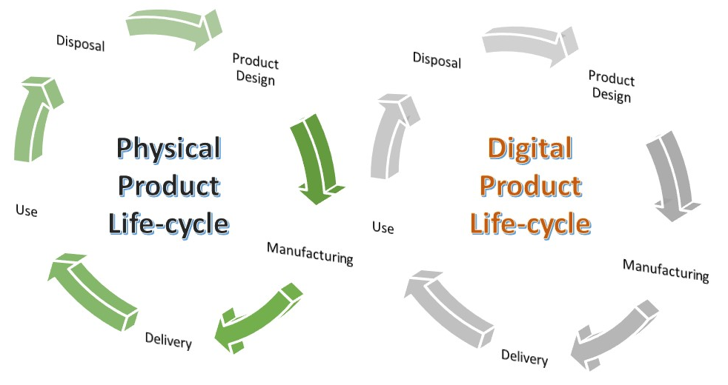
Figure 1. Product lifecycle DT model
The rest of the paper is organized as follows. Section 2 describes the research methodology used in this paper. Section 3 provides a statistical analysis and discussion on the searched result. Section 4 summarizes the DT related literature and industrial applications contributed to product design and development as well as classifies their outcomes. Section 5 discusses the challenges and suggests the potential direction for future study. Finally, Section 6 concludes this paper.

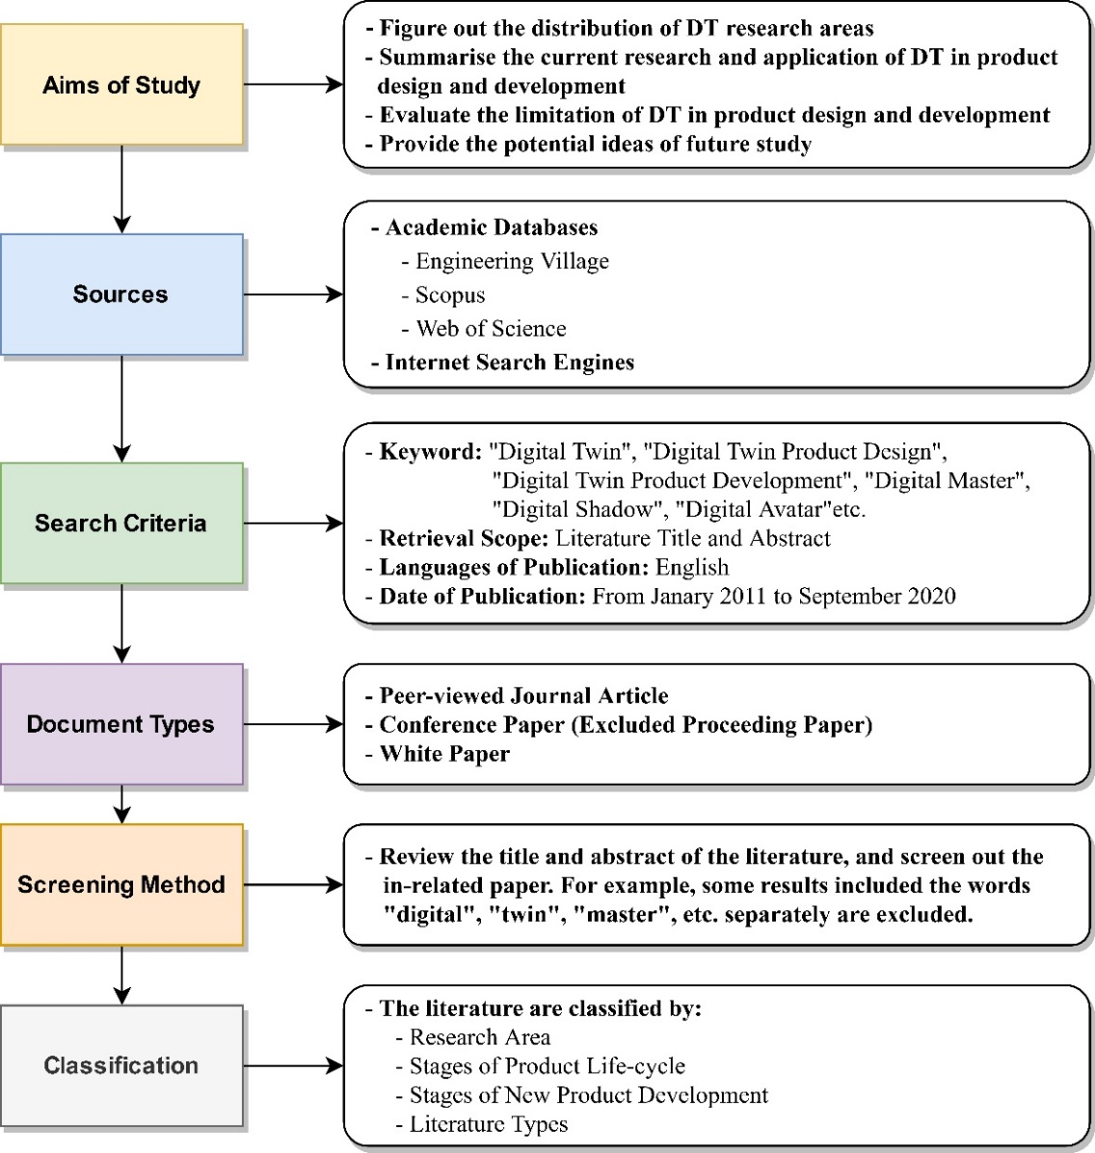
Figure 2. Summary of research methodology

- Methodology
  - Research Method
The articles published from 2011 to 2020 are searched with specific keywords, e.g. digital twin, digital twin product design, digital twin product development, digital twin product lifecycle, etc. Those papers are sourced from Engineering Village, Scopus and Web of Science, and the document types are limited to peer reviewed journal article and conference papers published in English. The industrial cases and white papers issued by the leading companies are also collected and reviewed. This paper targets to discover the trends of DT in popular research areas and review DT development in product design. The review methodology and workflow are summarized in Figure 2. A large number of papers has been initially searched, and some are not directly related to DT and product design or contains the keyword string separately. The titles and abstracts are read to screen out the irrelevant papers. The results are further discussed and analysed in detail in Section 3.
  - Classification
DT is widely applied in several research areas and procedures [62]. For accurate and effective analysis, the papers are classified by their research area, stages of the product lifecycle, stages of new product development and literature types as shown in Figure 3. First, the literature is summarised and assorted into widespread research areas [133, 134]. Eight popular areas are categorized, i.e. Manufacturing, ICT, Building & Smart City, Aerospace, Automotive, Energy, Medical & Healthcare, Education and Others. It can be figured out that the distribution of DT research in the last ten years is increasing. Then, product lifecycle related literature is sorted out and further classified to product design, production, logistic, use and end-of-life. Next, the papers are assorted by the literature types, i.e. concept, review and case Study. Finally, those literatures are classified by the stages of NPD, i.e. idea generation, market analysis, product design and development, testing, and commercialization, to analyse the application in each stage. The statistics and trends are shown in Section 3, and details of DT in product design and development aspect are discussed and summarised in Section 4.

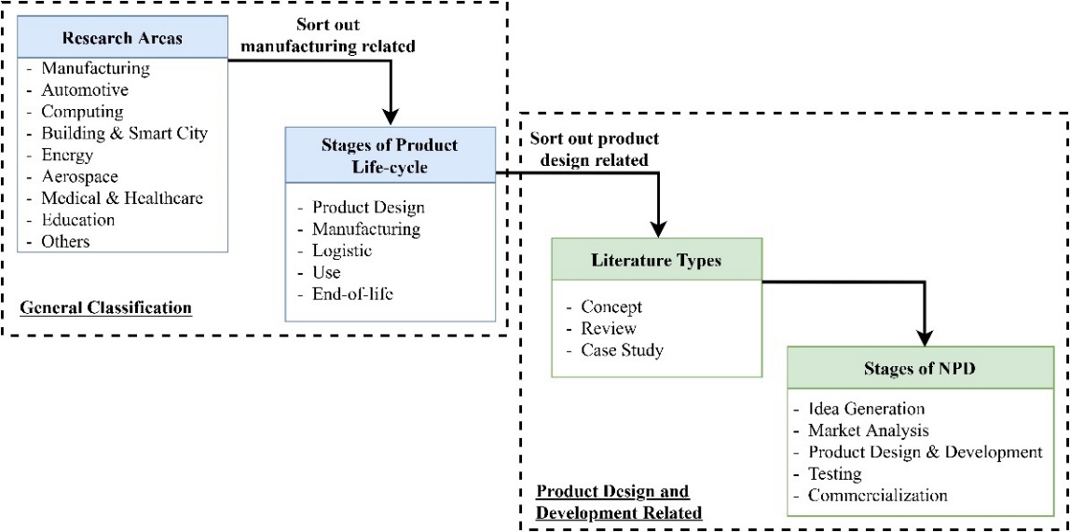
Figure 3. Literature classification approach

- Analysis and Discussion
  - Overview
The search results are analysed according to the suggested classification and discussed in this section. As shown in Table 1, there are 732 papers under the decided research methodology, and 60 are directly related to DT after screening. The rejected literature is caused by the over-general search, such as taking DT as an example but without further study or including the keywords, e.g. digital, twin, master, design, etc., separately. After screening and classification, the manufacturing and product design related papers are 309 and 46 separately. Most literature is searched from Scopus, and 472 relevant papers arefound. Also, 11 white papers and news published by the industrial giants and venders, e.g. Siemens, General Electric, PTC, Microsoft, etc., are found. The product design related literature and white papers are further analysed in detail in Section 4.
Table 1. Summary of the search results
Sources | Number of papers | Number of papers after screening
Sources | Number of papers | DT-related | Manufacturing-related | Product design-related
Engineering Village | 412 | 373 | 209 (56.0%) | 29 (7.8%)
Scopus | 582 | 472 | 236 (50.0%) | 30 (6.4%)
Web of Science | 316 | 283 | 153 (54.0%) | 21 (7.4%)
Total  (Removed duplications) | 732 | 601 | 309 (51.4%) | 46 (7.7%)

According to Figure 4, manufacturing is the most popular research area of DT, and it shares most of the proportion in DT research which is more than 50%. Most research focuses on optimising production planning, production simulation, monitoring and prognosis product tool and machine toward sustainable manufacturing. Another popular area is the building and smart city which focuses on structural health monitoring, building management and control, optimising project planning and predicting maintenance. ICT is also distinguished in DT research and widely applied on the edge computing system, communication security and cloud service investigation. Next, DT research related to energy contributes around 5% in total focusing on the power system monitoring, fault diagnosis (e.g. Windfarm, PV system) and power plant operation optimisation. The research topics on automotive, aerospace and medical and healthcare have a similar proportion which is mainly for product health monitoring and prognosis (e.g. airframe [64] and electric vehicle motor [68]), testing and simulation. Finally, DT related topics on education are rising in recent years because of the trend of online teaching and learning. The other various research areas are grouped including mining, agriculture, chemistry and so on. Manufacturing shares more than a half number of DT research because DT was firstly introduced as a tool for manufacturing and PLM. Thus, initial research topics mainly focused on manufacturing-related topics in the early stage. However, it is rapidly spreading to different areas, which are summarised in Table 2.

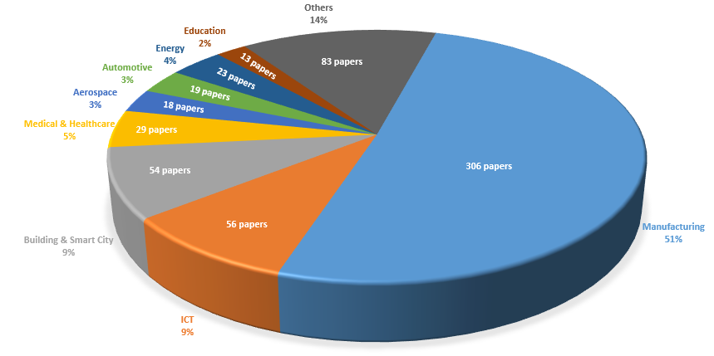
Figure 4. Distribution of DT Research Area

Table 2. Leading DT research areas and their popular topics
Areas | Selected Popular Research Topics | References
Aerospace | - Diagnostics and prognostics of aircraft health  - Virtual testing or simulation | [63], [64], [67]  [65], [66]
Automotive | - Vehicle health monitoring and prognosis  - Digital testing and verification (e.g. Crash Test)  - Driver intention prediction and automatic driving monitoring | [68], [69]  [70], [71]  [72], [73], [74]
Building & Construction | - Building structure health monitoring  - Virtual prototyping and verification (e.g. Lighting system)  - Building management and control (e.g. Energy Management)  - Optimize project planning and management (e.g. Schedule, Material ordering, etc)  - Predictive maintenance | [75], [76]  [77]  [78], [79], [80]  [81], [82]  [83], [84]
Energy | - Operation monitoring and fault diagnosis (e.g. Wind farm, PV system)  - Power plant performance optimization  - Toward energy grid development | [85], [86]  [87]  [88], [89]
Education | - Cyber-physical environment for learning  - Simulation for engineering teaching  - Using DT to optimize distance learning or online teaching | [90], [91]  [93]  [92], [94]
IT & Computing | - Edge computing system with DT  - Integrating cloud services  - Virtualization and communication between physical and digital system | [95]  [96]  [97], [98]
Manufacturing | - Optimize production planning and recourse allocation  - Production process simulation (e.g. Machining, Assembly, etc)  - Optimize industrial human-robot collaboration  - Toward sustainable production (e.g. energy control, waste control, etc)  - Realizing Industry 4.0, Industrial Internet of Thing and cyber physical production system  - Production tool or machine monitoring and prognosis  - Optimize warehouse management | [101], [102]  [99], [100], [124]  [103], [104], [105]  [106], [107]  [108], [109], [110]  [111], [112]  [113], [114]
Medical & Healthcare | - Optimize elderly healthcare services  - Surgery or medical simulation | [115], [116]  [117], [118]

Manufacturing related research and applications are the most popular ones in DT study. As manufacturing is a broad topic, those papers are further classified by the stages of the product lifecycle. According to Figure 5, 286 papers can be assorted into the stage of design (16.1%), production (63,6%), logistic (9.4%), use (5.9%) and end-of-life (4.9%). Production is the most pursuing area in DT research as it is the initial application in the early stage of DT development. It mainly focuses on production planning and monitoring, resource management and machine or tool prognosis and predictive maintenance. In recent years, the research is expending to the rest of the PLM stages, especially product design and development. Developing product DT in the design stage can be beneficial to the remaining stages of PLM [16].
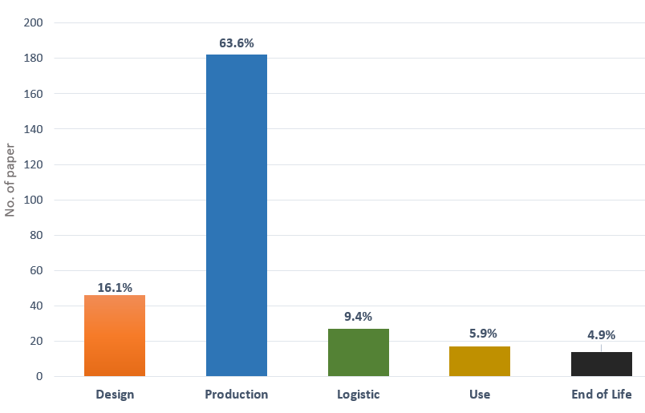
Figure 5. Contribution of DT research in the product lifecycle

In Figure 6, literature is sorted by the year of publication to show the trend of DT development in recent year and the number of research in the coming few years is forecasted. The first DT paper published in 2011 [4] and the number of publications was few due to the development of new technology. Since 2016, DT has entered a rapid growth stage that the literature of DT is shapely increased, and the topics are mainly related to manufacturing. In recent years, the ratio of manufacturing-related DT papers is decreasing that DT research is expanding to various areas such as smart cities. Based on the trend of DT development, it can be predicted that the DT research, including product design and development, will keep rapidly increasing due to the growing attention from both academia and practitioners [4, 135]. According to the current tendency, the research and application on DT will speedily increase in coming 3-5 years [4, 62]. It can be expected that the trend will be similar to the typical technology lifecycle in S-curve and enter the maturity stage.

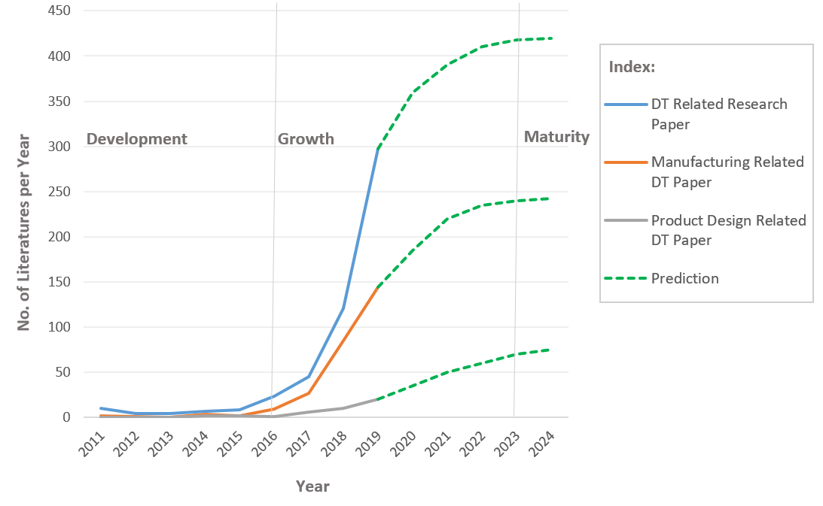
Figure 6. Development and predicted trend of DT publication

  - Product Design and Development
The number of papers related to product design and development is rare and 46 papers are found to further review and study. Among those paper, 8 papers (17.4%) are review articles, 35 papers (76%) are the technical papers presenting a concept or framework, and 3 papers (6.5%) are case studies. The review papers discuss the state of DT in the manufacturing industry [4, 137, 139] and applications of DT in product design [46, 123, 138]. It is found that few papers that specifically review DT in product design and development. The technical papers include various topics related to product design, e.g. DT-driven product design [27], material selection [39], product testing [66, 71], re-design [43], etc. The research cases are mainly focusing on the transportation (i.e. aircraft, automobile, bike and ship) and industrial products (i.e. 3D printer), aiming at the optimisation of high-value, complicated and electrical products to improve the productivity, cost and performance. While, simple and low-cost products (e.g. shoes, tableware, package, etc.) are not popular to assist their design due to the high development cost of DT [43].
The number of DT papers related to product design was gradually increasing in recent years. As shown in Table 3, the institutes from the world industrial powerhouses (e.g. China, United States and Germany) are keen on the DT research in product design and development. Chinese and German institutions are the main contributors in this area of research. Other leading countries (i.e. Singapore, Netherlands, Italy, United Kingdom, New Zealand, France and Russia) are the giants of manufacturing and technology based on DT technologies in Asia and European [32]. Those countries have world-class manufacturers in the automotive and aerospace industries which are beneficial from using DT technology to support local industries. It could be observed that four origins including China, Germany, US, and Singapore have counted over 50% of the contribution. It attributes to the industrial development with the great support from national initiatives and promotion from the big companies and government bodies.

Table 3. Contribution of origins of affiliate institutes
Origins of Institute | Count | Contribution
China | 14 | 22.4%
Germany | 11 | 12.2%
United States | 6 | 8.2%
Singapore | 5 | 8.2%
Netherlands | 5 | 6.1%
Italy | 5 | 6.1%
United Kingdom | 4 | 4.1%
New Zealand | 3 | 4.1%
France | 3 | 4.1%
Russia | 2 | 4.1%
Others | 13 | 20.4%
Total | 71 | 100.0%

- Product Design ANd DeVELOPMENT based on dt
In this section, different phases of product design and development are reviewed with the support of DT. The construction of DT for product design aims to provide information on building product DT. The industrial applications of DT in product design and development are also included in this section.

4.1 DT in Product Design and Development
In new product development, there are several vital stages (e.g. marketing research, conceptual design, design verification, etc.) [35]. In this paper, DT related research mainly focuses on conceptual design, detailed design, design verification and redesign.

- Conceptual Design
Conceptual design is the first and also the most crucial step of the product design process [137]. To generate a good design concept, the designer should consider a large number of data, information and knowledge from the market, customer, manufacturing and the internal parties. Tao et al. (2018.) suggested a DT based product design model with big data and used a bicycle for a case study. The physical factors (i.e. Function definition, Aesthetic design, Market competition and Investment strategy) and the virtual factors (i.e. Model building, Historical data, Customer reviews and Customer feedback) provided a variety of DT data for concept generation and improved the communication between client and designers [2]. Schimanski et al. (2019.) proposed a method to use the BIM data in construction to assist the construction equipment design and preparation and used a crane setup as an application for equipment industry [45]. The data and information collected from product Middle of Life (MOL), i.e. customer feedback and product performance, can be considered to assist the designer in generating a new design concept [139]. Hribernik et al. (2013) raised a concept to use digital product avatars representing product MOL Information to improve the design [140]. Zheng et al. (2019) proposed a value co-creation concept that leads users to participate in the product verification stage and try the prototype. The prototype and user data can be collected in the digital space to trigger the virtual model which could be analyzed for product innovation [129].
DT can also be used to increase the virtualization of the design concept. Ma et al. (2019) proposed a DT-enhanced human-machine interaction framework in the product lifecycle. From this research, it is observed that the interaction between designer and product in the conceptual design stage. In the simulated world, designers can “see”, “touch” or “use” the virtual model with AR/VR technologies [37]. Illmer et al. (2019) developed a virtual design method to provide a geometric query between virtual process twins that allow users to generate virtual processes with resource reference in early production engineering design phases without having to know every single detail about product structures [51].

- Detailed Design
In the detailed design phase, there are many factors e.g. product function, performance, material properties, manufacturing process, etc. and many parties are involved [8, 16]. Designers should review many information and data to make accurate decisions. Cheng et al. (2020) proposed a DT-enhanced industrial internet (DT-II) approach with an implementation mechanism so that the DT-II platform can collect different factors (e.g. market requirement, user review, etc.) for improving the product draft [44]. Huang et al. (2020) proposed a blockchain-based data management approach for product DT that improve the data monitoring and exchange in the product lifecycle where peer-to-peer network can enable the data share among participators [53]. Through this approach, designers are able to improve the detailed design via the status of product lifecycle. For product function design and material selection, Gusev et al. (2018.) used the Unmanned Aerial Vehicle (UAV) development as a case study to present the optimization approach using DT based on the data taken from the PLM to simulate and optimize the parameter selection in system, function and structure levels [40]. Xiang et al. (2019) developed a DT driven green material optimal-selection (GMOS) approach to select the most suitable material for the design [39]. The proposed DT model can simulate and optimize the properties of the candidate materials and compare predicted properties with expected properties iteratively. Wang et al. developed the product information models from design to remanufacturing that the product design information, i.e. assembly and disassembly information, can be added to EEE/WEEE based DT to verify the design compliant with the international standards [47].
Another important factor for product development is user-oriented involvement. To develop a DT for testing and collecting relevant design data, the physical prototype or reference model should be made. Arrichiello and Gualeni (2020) study the DT model for the entire cruise ships lifecycle [52]. The model can be constructed based on several ships of the same typology, characterized more or less by the same characteristics, for predicting future behaviour and performance. Schleich et al. (2017.) proposed a comprehensive reference model in design based on the concept of Skin Model Shapes [50]. The model distinguished the difference between the conceptual model and the virtual representation in DT and applied to geometrical variations management.

- Design Verification
Designers have put incredible effort to predict and avoid product failures as early as possible. Detzner and Eigner (2018) proposed an approach using DT for product quality monitoring and root cause analysis that can identify the potential problem and product failure in early product development [49]. Design verification has been focusing of using DT in product design for testing and virtual prototyping. Groen et al. (2018) proposed a new Flexible Material Model (FlexMM) approach to demonstrate the product shape change by internal stress [38]. In this research, DT is used to predict the accuracy of the process chain and shape changes in the product design stage. The simulation can be launched in virtual space to replace the time-consuming verification processes. Patrikeev et al. (2017) demonstrated the use of SUV’s DT to perform a serial of simulations (i.e. static stiffness and dynamic stiffness) to reduce the number of real testing for saving the time and costs in design verification [14]. Vuruskan & Ashdown (2017) created a DT-based half-scale human bodies using active digital forms to assist pattern development of cycling shorts and fit testing [143]. Colombo et al. (2014) presented a virtual approach based on a digital avatar to optimize the prosthesis socket design [144]. It integrated the finite mode model with the amputee’s avatar for performing gait simulation to determine the pressures distribution, and improve the product based on the simulated results.
DT can also be used as a digital prototype for product verification that can improve the visualizability and design cooperation of different parties. Han et al. (2019) combined DT, VR and AR, and developed a framework to extract and visualize 3D models that could be used in AR/VR in real-time [36]. With the framework, the AR platform can be used to verify the design in physical space. Martin et al. (2019) hosted a Delphi4LED European project that developed a multi-domain compact DT model to support the virtual prototyping for the design of luminaries [42]. Through the DT model, designers can choose the product components such as types or number of LEDs during the prototype design and development stage.

- Redesign
DT currently is not only a good opportunity for new concept generation but also provides valuable information for product improvement and redesign. Zheng & Sivabalan (2020) proposed a tri-model based approach (i.e. digital model, Computational Model and Graph-Based Model) for product level DT development [43]. In this research, digital model can be used to simulate real-world experiences. While, the computational model provides the numerical values regarding the status of the system based on the real-time collected data. The graph-based model can define the interaction between the environment and the system. The data provided by those models can support the design decision making in the next-generation product. Tao et al. (2018) proposed a DT-driven product design framework for optimizing the redesign process of the existing product [27]. In this framework, the virtual space would continuously collect, analyze and accumulate the data from the physical space. Those data can be applied to design or re-design the productso that the processes could be enhanced.

  - Construction of DT for product design
DT includes three essential elements which are physical entities, virtual replica and the linkage [6, 19]. Apart from those elements, the simulation environment and data should also be considered to develop a DT for product design and development. Associated with other enabling technologies such as Big Data Analytics (BDA), DT can effectively optimize the complete product design and development process. As shown in Figure 7, product DT plays different roles along with the product development cycle and keeps evaluating from the concept to final design. In the conceptual design phase, DT is able to work with the emerging data technologies, i.e. data mining and BDA, provide mass and useful information (e.g. customer feedback, existing product performance, client expectations, etc. for generating design concept. Using DT, the idea can be visualised via virtual reality (VR) and augmented reality (AR). Designers and other parties (i.e. client, manufacturer, engineer, recycler, etc.) can more effectively evaluate the conceptual design and exchange their data. In the detailed design phase, the design can be enriched based on the past product DT’s PLM data (i.e. manufacturing failure, user feedback and recycling processes. The 3D CAD model can be produced and used for simulation. Those data and results can be analyzed using BDA and artificial intelligence (AI) [19]. In the design verification stage, DT can be contributed for accurate simulation and prediction to reduce the time-consuming and complicated testing. The product prototype can be produced by 3D printing and assemble with sensors for recording the real-time data from the field test [145]. The design can also be verified in real space using VR/AR technology that can provide a clearer view of the actual product situation for the designers and clients [36]. In the redesign phase, the existing or previous product DTs can provide useful information for product improvement and redesign. Based on reverse engineering, the virtual model of the existing product can be produced using created DT. The mass data from whole product lifecycle can be continuously analyzed in real-time by the emerging computing technologies, i.e. cloud computing and machine learning. Then, those results can drive the design change automatically, and assist the designers to make the correct decision or co-responding action. The main components of the product DT are summarized as follows.
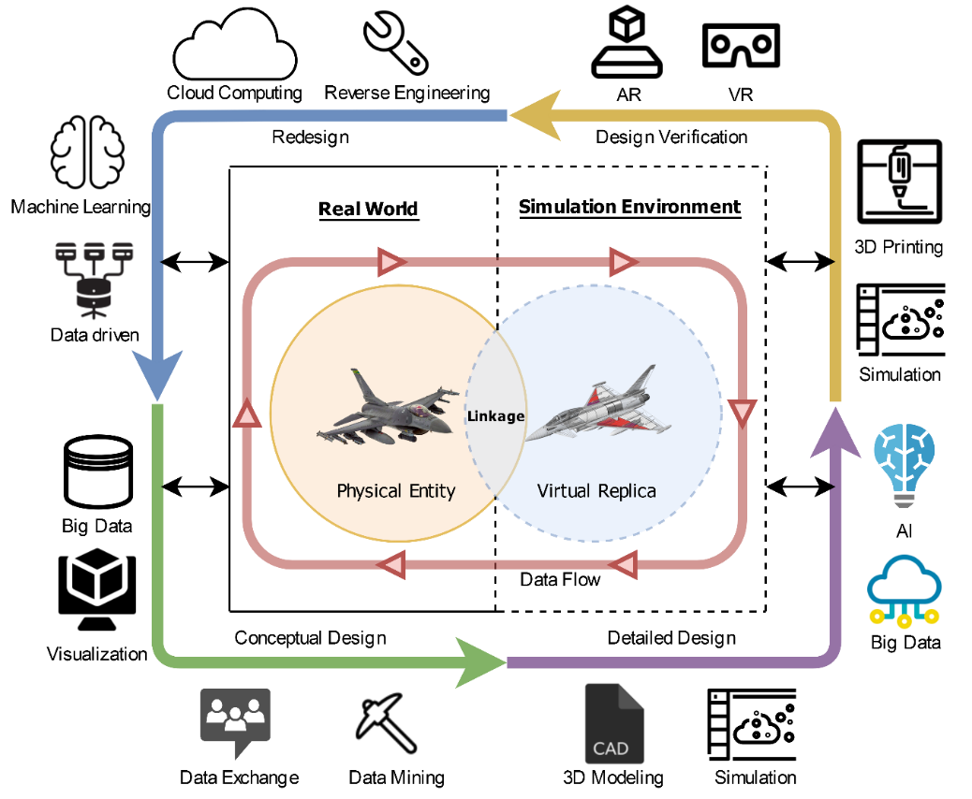
Figure 7. Elements of DT in product design and the enabling technologies

- Physical Entities: In the early stage of product development, there is no real product, even prototype, available for building a product DT. Thus, the existing products (e.g. family product and competitor’s product) with the same typology and similar characteristics can be employed as the initial physical model of DT for testing and generating design ideas [52]. When the design is consolidated, the new physical mock-up can be made using the rapid prototyping technologies (e.g. 3D printing) to evaluate the design performance. When preparing the prototype, the designer should consider the sensor arrangement and installation that will affect the test result and data accuracy [27]. For the final product design, designers should consider the sensor selection (e.g. type, accuracy, limitation, etc.), installation and repairment in the product because the product data should be recorded along with the whole product lifecycle [46].

- Virtual Replica: The digital 3D model can be created by existing CAD modelling software such as Solidwork, Inventor, Creo, Rhino, etc [43]. It can also be generated from the existing product by using reverse engineering technologies (e.g. 3D scanning). When creating the 3D model, the designer should consider the mapping between drawing parameters and sensor data. For example, the wall thickness can affect the product strength, thus, strength test results should feedback on the digital model and change the wall thickness in real-time.

- Linkage: In order to reflect the real-world situation of the digital environment, the physical entity and its virtual replica should be linked together so that they can interact with each other in real-time. Key design components are equipped with built-in sensors to detect parameters related to the product design [129]. With the rapid development of sensor technology, the product DT data in the whole lifecycle can be accurately measured and recorded by the suitable sensors. Therefore, designers should deeply consider the sensor selection for building DT. Another connection between physical and virtual products is product service. It can enable the communication between users, service providers and manufacturers and manage data transmission for product DT [41, 5]. The data can be transferred without delay by the emerging communication technologies, i.e. 5G and wireless communication [95].

- Simulation Environment: The physical product data synced with the digital model can simulate the situation in virtual space. Different from the traditional simulation, DT simulates the product result in real-time and bases on “what-if” methods [8, 13]. Some simulation software (e.g. Matlab [121], FlexSim [23] and Simul8 [28]) are supporting DT-based simulation that enables real-time data analysis (e.g. machine learning and deep learning) and communicates with the Internet-connect devices. The simulation can be continuously operated in the product development phase for failure detection, decision-making and optimization.

- Data: It is the most critical element to construct a product DT and the whole product development process [30]. To apply DT in product design and development, there many data should be processed. For the external DT data, different parties will have different input on the design, e.g. designer preference, government rules, design knowledge, manufacturer’s feedback, client requirements, etc. For the internal DT data, the interaction between the physical entity and virtual replica is the main data source. Schroeder et al. (2016) proposed an approach for data exchange between physical product and simulated product [136]. The sensors embedded in the product or prototype provide user input, environmental data, product information and failure records. Those data could be sent to the digital replica for running related simulation and analysis. Then, the digital side will feedback the simulated results, predicted information and decision to the product. Therefore, there are a huge amount of data transmission. Designer should design a completed data mapping in the early stage of building product DT and the data quality should be evaluated [142]. In addition, the standard of data transfer and communication should be considered, and it can base on the common industrial standard, e.g. DDS, HLA/RTI, MQTT, etc [141].

  - Industrial DT applications in product design
DT is not only ideas and theories interested in academic research, but also a possible and emerging application in the different industries. There are some industrial cases found from news and articles related to applying DT to assist the design process. The cases are summarised in Table 4 that includes 11 cases from the automotive, aviation and industrial product industry most of which are applying DT as a virtual prototype to perform testing and simulation in product development. DT can enhance the design visibility and reduce the time of product testing. Moreover, some companies enable DT in their product to record the product and user situation, and synchronous to the factory. The DT data can assist future product and software development (e.g. understanding user behaviour and need) to develop more user-friendly design, and achieve efficient, flexible, customized, cost-effective, and high-quality production [21]. CAD vendors in the industry are putting many efforts to extend their products and develop DT related product. Some definitions on DT and related product are summarized in Table 5. The understanding of DT between the companies are similar which connect the physical entity with its digital replica. The data from the product will sync to the virtual model in real time for detection, analysis, simulation, prediction and optimization [150-152]. DT are useful for the whole product lifecycle through extending the use of CAD model in product design [153].
Table 4. Summary of industrial application and cases
Company (County) | Application | Product Type (Model) | Source(s)
Aurus  (Russia) | Used DT to perform virtual prototyping and verification to simulate the model of a physical product that can be represented, analysed and tested as a real machine [122]. It reduced the production cycle time of the luxury car from 5-7 years to just two years and four months. | Limousine for the President of Russia (Cortege) | https://www.rt.com/sponsored-content/480670-polytech-days-in-berlin/
Maserati  (Italy) | Used the Siemens PLM software to generate the DT model for developing the sedan. The virtual modelling and simulation to reduce the number of expensive, real-world prototypes, wind tunnel tests, and test drives, cutting vehicle development time by 30 percent [26] | Sedan  (Ghibli) | https://www.eurekamagazine.co.uk/design-engineering features/interviews/maserati-has-fused-cutting-edge-digitalisation-methods-with-italian-passion-to-meet-customer-demand/161332/
Tesla  (USA) | Planned to develop DT model for every built car that connects the car with the factory and enable synchronous data transmissions. The data collected from the drivers enables more efficient resource allocation for their cars and software development [24, 50] | Electrical vehicle | https://expectexceptional.economist.com/digital-twins-analytics-internet-of-things.html
Boeing  (USA) | Achieved up to 40% improvement in first-time quality of the parts and systems it uses to manufacture commercial and military airplanes by using DT asset development model. The use of the DT is changing how the company designs its airplanes, by providing a virtual replication of physical airplane parts and simulating how they will perform over the lifecycle of the airframe [25]. It used DT to develop the Air Data Reference Function (ADRF) and the requirements could be validated at a very early stage in the program to avoid ambiguities, erroneous information and other specification flaws | Aircraft  (B777) | - https://www.boeing.com/features/innovation-quarterly/may2017/feature-technical-model-based-engineering.page  - https://www.aviationtoday.com/2018/09/14/boeing-ceo-talks-digital-twin-era-aviation/
Airbus  (France) | Created a data lake which is building a reservoir of data for each in-service aircraft. The A350 XWB aircraft installs 50,000 on-board sensors to collect 250 gigabytes of data per flight. The reservoir of data can be used to investigate the components’ lifecycle performance and used data to improve the future design [29] | Aircraft  (A350 XWB) | https://ascon-systems.de/en/digital-twin-is-about-to-rollout-by-airbus/
SpaceX  (USA) | Use Siemens NX software to create DT when designing and building their product. The virtual mock up can enable the designer to verify the design and simulate the motion to check its function. | Rocket  (Falcon 1) | https://www.sme.org/technologies/articles/2016/may/siemens-gives-some-details-of-digital-twin-work-with-spacex-maserati/
GE Aviation (USA) | Use DT in aviation jet and turboprop engines design to gather data on the jet engines and combined such data to predict the failure and frequency [22]. It also created the model-based digital twin to perform different aspects of simulation that the digital model can demonstrate the assets’ function and the designer can completely verify their design [31] | Jet Engine  (GE60) | https://www.aerospacetechreview.com/twinning-digital-twins-show-their-power-by-louise-bonnar/
Rolls Royce (UK) | The engineering team uses the digital twin to model the performance and health of the real machines uses. The scaled digital replicas of the physical engines are used to simulate the rigorous testing that is required for the engine certification | Jet Engine | https://www.cio.com/article/3525828/rolls-royce-cdo-neil-crockett-drives-data-into-engine-design.html
Schunk (Germany) | Digitalized the entire engineering process from concept to the mechanical, electrical system and software. They use DT to assist the product development, such as commissioning and simulation, to launch new products more and more frequently [33] | Gripping systems  (SVH 5-finger gripping hand) | https://schunk.com/de_en/company/about-us/milestones-of-innovation/
Philips  (Netherlands) | Created the digital twin for their medical equipment for hospitals or personal health devices to assist their design progress. For example, the designers conducted simulations in the development of a portable oxygen generator for patients with breathing problems and they used the digital prototypes to perform tests that save the times and several iterations to make the physical prototypes. It can reduce the product development time and design the product right in the first time | Medical Equipment | https://www.philips.com/a-w/about/news/archive/blogs/innovation-matters/20180830-the-rise-of-the-digital-twin-how-healthcare-can-benefit.html
Kaeser Kompressoren  (Germany) | The company changed their business mode from selling products to selling service that Kaeser will be the owner of the equipment and will also manage the operation of the compressors on customers’ behalf. [119, 120]. They used DT to monitor the lifecycle of their device and track its performance. The measured data can provide valuable insight into product design. They are used to find out the deficiencies of the product and improve their products and services. | Air Compression Devices | - https://www.mbtmag.com/home/article/13245373/wonder-twins  - https://www.challenge.org/insights/digital-twin-technology-companies/

Table 5. Definition of DT from the leading CAD vendors and their product
Company | Definition of DT | Product
Dassault Systemes | "A Digital Twin is an executable virtual model of a physical thing or system. The physical thing can be anything from a manufactured object, every single product has definable characteristics in the real world, and the Digital Twin combines and portrays the attributes virtually. [146] " | DELMIA
Siemens | A digital twin is a virtual double of a product, a machine, a process or of a complete production facility. It contains all the data and simulation models relevant to its original. Digital twins not only enable products to be conceived, simulated, and manufactured faster than in the past, but also to be designed with a view to improved economy, performance, robustness or environmental compatibility. The virtual twin of a product can also accompany it like a digital shadow through all the stages of the value chain – from design through production to operation to servicing and even recycling. [147] Digital twins can be used to virtually validate product performance, while also showing how your products are currently acting in the physical world. This “product digital twin” provides a virtual-physical connection that lets you analyze how a product performs under various conditions and make adjustments in the virtual world to ensure that the next physical product will perform exactly as planned in the field. [148] | Siemens PLM
PTC | Digital twins are digital models that virtually represent their physical counterparts. This virtual representation of a physical product, an operational process, or a person’s task is used to understand or predict the physical counterpart by leveraging both the business system data that defines it and its physical world experience captured through sensors.[149] | ThingWorx
Ansys | " A simulation-based digital twin is a connected, virtual replica of an in-service physical asset — in the form of an integrated multidomain system simulation —which mirrors the life and experience of the asset. Digital twins enable system design and optimization and predictive maintenance and optimize industrial asset management [150]." | Ansys Twin builder
GE | Digital Twin is defined as a software representation of a physical asset, system or process designed to detect, prevent, predict and optimize through real time analytics to deliver business value [151]. GE digital is focusing on the development of Asset DT, Network DT and Process DT. | Predix
Autodesk | Digital Twin is the Living Model with dynamics/functionality. It's the virtual representation of spaces, objects, smart devices and sensors binding in a single place to view the live updates, to perform analytics and simulations, and to create predictions for better decision making and predictive maintenance [152]. | Forge

- ChALLENGES and INSIGHTS IN PRODUCT DESIGN aND DEVELOPMENT using DT
In this section, the challenges and potential application of DT in product design and development are discussed. After reviewing the related literature, there are some difficulties and challenges in product design and the potential application in the future is proposed.

- Challenges of DT in Product Design and Development
- The essential components of digital twin are physical product, digital model and linkage between physical and virtual world [4, 6]. In the early stage of product design (i.e. conceptual design and idea generation), DT is not applicable and contribute a lot because there are no physical prototypes which can be used to collect the real-time data (e.g. user experience, effects on environmental change, etc.). In the current application, DT is developed on the existing product and provide valuable information for the next-generation products [19]. For the new idea or concept which have no previous version or even no similar products in the market, the use of DT to assist and optimise the idea generation process is challenging.

- Sensors play a crucial role in DT that be used to collect data from the physical world and sync to the virtual model for simulation and analysis. Therefore, the accuracy of sensors directly affects the performance of product DT (i.e. simulation results, decision making and prediction). Many variables (e.g. environmental factors, sensor installation, natural drift, etc.) can impact sensors’ measurement results [136]. Therefore, the engineer should cautiously consider the sensor selection, sensor location and sensors combination in the early stage of product design in order to collect accurate data. The sensors may affect the product appearance (e.g. limited the product sizes and shape) and the user experience (e.g. increased product weight and volume). Using additional sensors for achieving product DT will increase the development and product costs. It is a great challenge that the engineer or the company take a balance on product appearance, user satisfactory, product costs and product DT performance in the design and development stage.

- An important pillar of using digital twins is data [30]. The data plays a crucial role in digital twin and product design stage to support decision making and perform an accurate analysis. Applying DT at the beginning of product lifecycle can benefit to the rest of the stages (i.e. production, maintenance and recycling) [142], and the measured data (i.e. manufacturing data, user experience and product real-time situation) can be used to improve the product and provide suggestions for the next-generation products. However, the external parties (e.g. manufacturers, installers, government and users) may prohibit the products from measuring their private information. Some countries do not allow oversea companies to measure and analyse their citizen activities and behaviour due to national security concerns. Collecting DT data to enhance the conceptual idea generation and assist detail design (e.g. material selection and design for assembly) to optimise the following product life is beneficial to the design companies. However, it must solve the problem of data privacy and make agreements in use of data between different parties.
- Insights of DT in product design and development
- The traditional product design and development process is time-consuming and includes several procedures such as the market research, communication between different parties, testing and change of design [18]. According to Figure 8, the traditional product development is designer-led or engineer-led that the designs are driven based on the engineer’s experience and knowledge. Then, it is time-consuming to prepare the physical prototype and perform testing. If the tests fail, the design will be modified based on the analysis of the results and re-make the prototype and test it again. The verification and modification processes may repeat several rounds attributing to a majority of product development time. Using DT to assist product development can shorten the development times by virtual prototyping, employing simulation to replace physical testing and supporting design decision making [15, 17]. DT can also assist the setting-up operation to prepare and design the manufacturing process so it can reduce the production lead time. However, the performance and application of DT are not fully utilised in DT-assisted product development. Developing product DT in the conceptual design stage can maximise the DT participation in product design and whole product lifecycle. The universal physical prototype (UPP) can be developed according to the conceptual idea and link with its virtual Model to build the initial product DT.
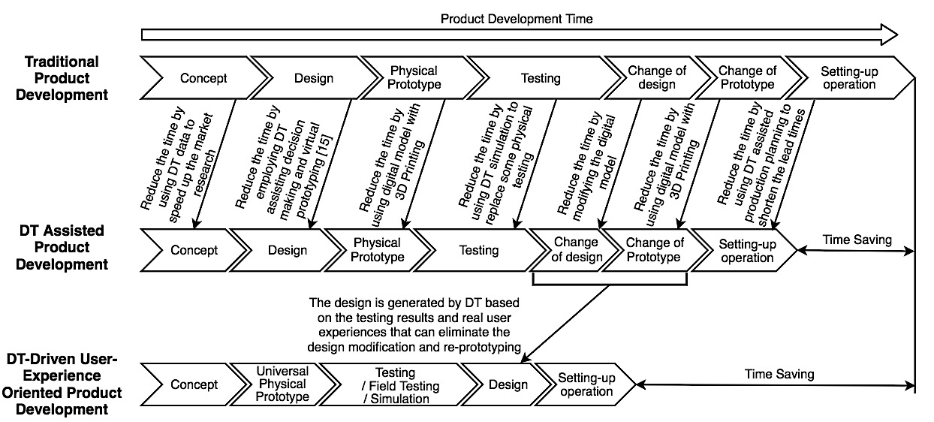
Figure 8. Comparison between the traditional, DT assisted and DT-driven product development
The UPP should be uncharacteristic and has no design preferences. The generic materials and parts will be used. It can be parametric modelling which makes use of numeric values like dimensions, equations and their relations to control the geometry. Then, it can be used to perform product testing, field testing and simulation, depending on the requirements. The design will be automatically modified using AI and machine learning based on the result analysis. It can eliminate the repeated verification and modification processes, and the whole product design cycle can be simplified and shorten the development time. Figure 9 shows an example that the UPP and its virtual replica can be developed and linked up as DT. Then, the prototype can be used for the product testing based on the product requirements and distributed to users for the field test. The results can be analysed automatically for suggesting changes in the parameters of the UPP. The virtual model can be modified and generate a new design based on the test results.
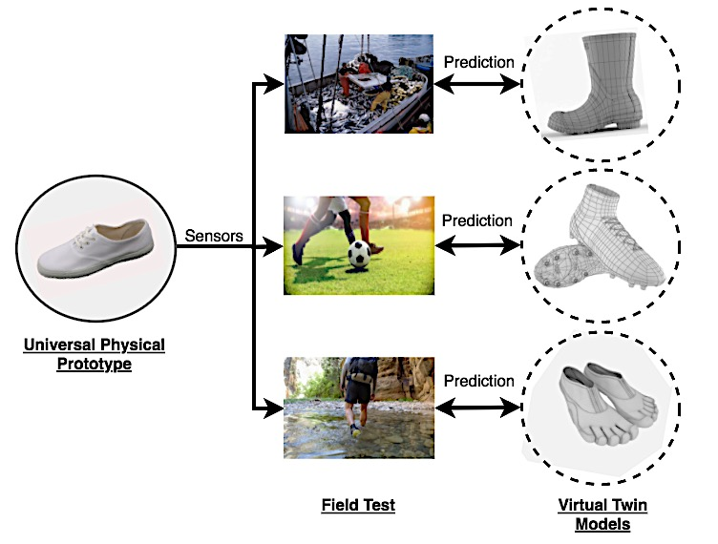
Figure 9. Example of design generation with Universal Physical Prototype DT

- DT is not effectively applied to generate new design idea in current development, but it is useful to assist the re-design or product improvement process. The DT developed on the existing product can provide valuable information (e.g. user behavior, environmental data, product performance, etc.) to enhance the design of next-generation product [145]. Therefore, DT driven product family design can be further studied in the future. As shown in Figure 10, the product DT can measure different information (i.e. production feedback, user experience and field data) over the product lifecycle. Associated with the internal factors, including product spec, updating engineering knowledge, simulation and testing results and different regulations, the DT database will become expending that more data can be used to support the design generation and more accurate decision making. Thus, the family products will become more and more production-friendly, user-friendly and environmental friendly following the product family evolution. The product life of the new generation product can be extended due to the improvement of product performance and customers’ satisfaction.
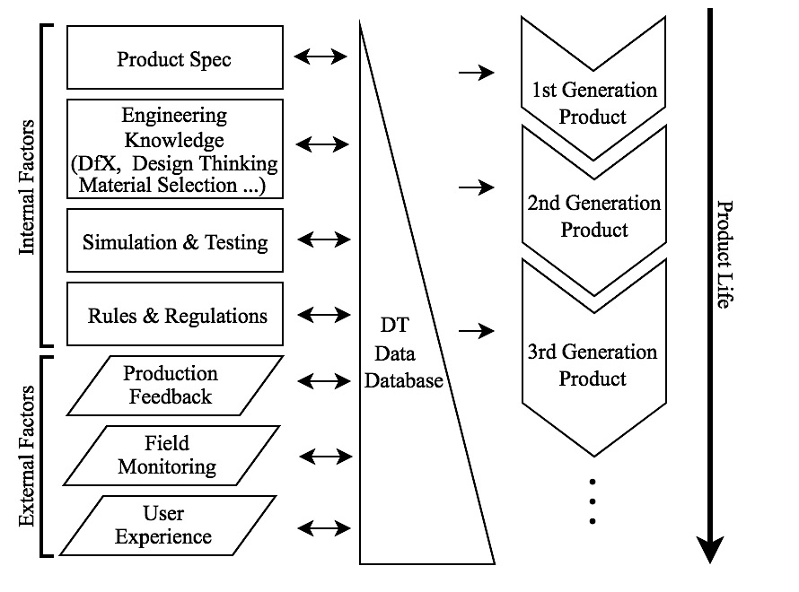
Figure 10. Concept of DT-driven product family design
- Conclusion
With the rapid growth of design industry, the DT related topics in product design and development are sharply increasing in recent years. Researchers are not only focusing on manufacturing but also different areas (e.g. automotive, healthcare, building technology, education, etc.) using DT. DT research in product design is increasing in recent years aimed to optimize the product design and, at the same time, the design processes (i.e. concept generation, material selection, design verification and decision making). A total of 46 papers and 6 white papers related to DT in product design and development are reviewed and they are classified into conceptual design, detailed design, design verification and redesign. It is observed that DT can effectively assist the concept generation and redesign based on the data from existing product DT. Associated with other emerging technologies (i.e. big data analysis, AR/VR, cloud computing, etc.), DT can be used to analysed a mass data from the real environment along with the whole product lifecycle and improve the visibility of design for verification. Some challenges and potential development are also discussed. Product design and development is a complex process which involves many signs of progresses and different parties. DT can play a vital role to simplify the design processes by employing digital prototyping, testing simulation and prediction with many potential applications in the product design stage. Hopefully, this paper can provide a insightful picture of DT development in product design to the researchers and inspire to address the future studies in DT of product design.

Acknowledgements

This work was supported in part by the Seed Fund for Basic Research in HKU under Grant 201906159001, and in part by ITF project (PRP/068/20LI).

References
[1] Red E., French D., Hepworth A., Jensen G., Stone B. (2014) Multi-User Computer-Aided Design and Engineering Software Applications. In: Schaefer D. (Eds_Cloud-Based Design and Manufacturing (CBDM). Springer, Cham

[2] Tao, Fei, Cheng, Jiangfeng, Qi, Qinglin, Zhang, Meng, Zhang, He, & Sui, Fangyuan. (2018). Digital Twin-Driven Product Design, Manufacturing and Service with Big Data. The International Journal of Advanced Manufacturing Technology, 94(9), 3563-3576.

[3] Srinivasan, V. (2011). An Integration Framework for Product Lifecycle Management. Computer-Aided Design, 43(5), 464-478.

[4] Tao, F., Zhang, H., Liu, A., & Nee, A. (2019). Digital Twin in Industry: State-of-the-Art. IEEE Transactions On Industrial Informatics, 15(4), 2405-2415.

[5] Schmitt, R. H., & Voigtmann, C. (2018). Sensor information as a service–component of networked production. Journal of Sensors and Sensor Systems, 7(1), 389-402

[6] Grieves, Michael. (2016). Origins of The Digital Twin Concept. 10.13140/RG.2.2.26367.61609.

[7] Bob Piascik, John Vickers, Dave Lowry, Steve Scotti, Jeff Stewart & Anthony Calomino., Technology Area 12: Materials, Structures, Mechanical Systems, And Manufacturing Road Map. 2010, NASA Office of Chief Technologist.

[8] Wright, L., & Davidson, S. (2020). How to tell the difference between a model and a digital twin. Advanced Modeling and Simulation in Engineering Sciences, 7(1), 1-13.

[9] Sudarsan, R., Fenves, S. J., Sriram, R. D., & Wang, F. (2005). A product information modeling framework for product lifecycle management. Computer-aided design, 37(13), 1399-1411.

[10] Ming, X. G., Yan, J. Q., Wang, X. H., Li, S. N., Lu, W. F., Peng, Q. J., & Ma, Y. S. (2008). Collaborative process planning and manufacturing in product lifecycle management. Computers in Industry, 59(2-3), 154-166.

[11] Pecht, M., & Dasgupta, A. (1995, October). Physics-Of-Failure: An Approach to Reliable Product Development. In IEEE 1995 International Integrated Reliability Workshop. Final Report (Pp. 1-4). IEEE.

[12] Varaee, H., & Ahmadi-Nedushan, B. (2011). Minimum Cost Design of Concrete Slabs Using Particle Swarm Optimization with Time Varying Acceleration Coefficients. World Appl Sci J, 13(12), 2484-9

[13] Deloitte (2020) Digital twins Bridging the physical and digital Retrieved from:
https://www2.deloitte.com/uk/en/insights/focus/tech-trends/2020/digital-twin-applications-bridging-the-physical-and-digital.html

[14] A. Patrikeev, A. Tarasov, A. Borovkov, M. Aleshin, O. Klyavin (2017) NVH ANALYSIS OF OFFROAD VEHICLE FRAME. EVALUATION OF MUTUAL INFLUENCE OF BODY-FRAME SYSTEM COMPONENTS, Materials Physics and Mechanics Vol. 34, 70-75

[15] Jiao, Jianxin & Simpson, Timothy & Siddique, Zahed. (2007). Product Family Design and Platform-Based Product Development: A State-Of-The-Art Review. Journal of Intelligent Manufacturing. 18. 5-29. 10.1007/S10845-007-0003-2.

[16] Jones, D.E., Snider, C., Kent, L., Hicks, B. (2019) ‘Early Stage Digital Twins for Early Stage Engineering Design’, In Proceedings of The 22nd International Conference On Engineering Design (ICED19), Delft, The Netherlands, 5-8 August 2019. DOI:10.1017/Dsi.2019.262

[17] Gromova, E. (2019). An Example of A Digital Product Design In Russian Industry. AIP Conference Proceedings, 2114(1), Exploring Resources, Process And Design FOR Sustainable Urban Development: Proceedings Of The 5th International Conference On Engineering, Technology, And Industrial Application (Icetia) 2018, Surakarta, Indonesia (12–13 December 2018).

[18] Zirger, B. J., & Hartley, J. L. (1996). The Effect of Acceleration Techniques On Product Development Time. IEEE Transactions On Engineering Management, 43(2), 143-152.

[19] Grieves, Michael. (2015). Digital Twin: Manufacturing Excellence Through Virtual Factory Replication. Available: Https://Theengineer.Markallengroup.Com/Production/Content/Uploads/2014/12/
Digital_Twin_White_Paper_Dr_Grieves.Pdf

[20] Adrian Fortino (December 18, 2017) Next-Gen Product Design And Development Demands Digital Thread. Retrieved From Https://Www.Industryweek.Com/Technology-And-Iiot/Article/22024771/Nextgen-Product-Design-And-Development-Demands-Digital-Thread

[21] Siemens “Getting to Market Quickly”. Retrieved From Https://New.Siemens.Com/Global/En/Company/Stories/Industry/Getting-To-Market-Quickly.Html

[22] Zaccaria, V., Stenfelt, M., Aslanidou, I., & Kyprianidis, K. G. (2018, June). Fleet Monitoring and Diagnostics Framework Based On Digital Twin of Aero-Engines. In ASME Turbo Expo 2018: Turbomachinery Technical Conference and Exposition. American Society of Mechanical Engineers Digital Collection.

[23] FlexSim (n.d.) FlexSim + Digital Twin, Retrieved from: https://www.flexsim.com/digital-twin/

[24] Tharma, Rajeeth & Winter, Roland & Eigner, Martin. (2018). An approach for the implementation of the digital twin in the automotive wiring harness field. 3023-3032. 10.21278/Idc.2018.0188.

[25] Hakan Aydemir, Ugur Zengin & Umut Durak (2020) The Digital Twin Paradigm for Aircraft Review And Outlook. AIAA Scitech 2020 Forum, 6-10 January 2020

[26] Jean Thilmany (2017) Digital World Spawns Identical Twins. Mechanical Engineering. Oct 2017, 139(10): 32-37

[27] Tao, Fei & Sui, Fangyuan & Liu, Ang & Qi, Qinglin & Zhang, Meng & Song, Boyang & Guo, Zirong & Lu, Stephen & Nee, Andrew. (2018). Digital Twin-Driven Product Design Framework. International Journal of Production Research. 1-19. 10.1080/00207543.2018.1443229.

[28] Simul8 (n.d.) Rapidly build digital twins with Simul8, Retrieved from: https://www.simul8.com/applications/digital-twins

[29] Georgemarsh (2010) Airbus A350 XWB Update. Reinforced Plastics, Vol. 54 (6), November–December 2010, 20-24

[30] Gerald Glocker “A Primer On Digital Twins In The Iota Primer On Digital Twins In The Iot” Retrieved From Https://Blog.Bosch-Si.Com/Bosch-Iot-Suite/A-Primer-On-Digital-Twins-In-The-Iot/

[31] D. Iglesias, P. Bunting, S. Esquembri, J. Hollocombe, S. Silburn, L. Vitton-Mea, I. Balboa, A. Huber, G.F. Matthews, V. Riccardo, F. Rimini & D. Valcarcel (2017). Digital Twin Applications for The JET Divertor. Fusion Engineering and Design, 125, 71-76.

[32] Yong Zeng, Kyoung-Yun Kim, Victor Raskin, Benjamin C.M. Fung & Yoshinobu Kitamura. (2013). Modeling, Extraction, And Transformation of Semantics in Computer Aided Engineering Systems. Advanced Engineering Informatics, Vol. 27(1), 1-3

[33] Gregera, M., Mulyonob, N. B., Hermanna, J., & Palma, D. (2019). Digital Twins in The Smart Factory. Journal of Engineering, Management and Operations Vol. I: Die Zeitschrift Präsentiert Ergebnisse Aus Der Angewandten Forschung Und Grundlagenforschung Mit Schwerpunkten In Den Bereichen Operations, Logistik, Produktentstehung, Industrie 4.0., 1, 41.

[34] Carr, V. L., Sangiorgi, D., Büscher, M., Junginger, S., & Cooper, R. (2011). Integrating Evidence-Based Design and Experience-Based Approaches in Healthcare Service Design. HERD: Health Environments Research & Design Journal, 4(4), 12-33.

[35] Eppinger, S. D. & Ulrich, K. T. (2015). Product Design and Development (6th Ed.). New York: Mcgraw-Hill Education.

[36] Young-Soo Han, Jaejoon Lee, Jungmin Lee, Wonhyuk Lee & Kyungho Lee (2019) 3D CAD Data Extraction and Conversion For Application Of Augmented/Virtual Reality To The Construction Of Ships And Offshore Structures, International Journal Of Computer Integrated Manufacturing, 32:7, 658-668, DOI: 10.1080/0951192X.2019.1599440

[37] Ma, X., Tao, F., Zhang, M., Wang, T., & Zuo, Y. (2019). Digital Twin Enhanced Human-Machine Interaction in Product Lifecycle. Procedia CIRP, 83, 789-793.

[38] M. Groen, G. Zijlstra, D. San-Martin, J. Post, & J.Th.M. De Hosson. (2018). Product Shape Change by Internal Stresses. Materials & Design, 157, 492-500.

[39] Xiang, F., Zhang, Z., Zuo, Y., & Tao, F. (2019). Digital Twin Driven Green Material Optimal-Selection Towards Sustainable Manufacturing. Procedia CIRP, 81, 1290-1294.

[40] Gusev M.P., Nikolaev S.M., Uzhinsky I.K., Padalitsa D.I., Mozhenkov E.R. (2018) Application of Optimization in The Early Stages Of Product Development, Using A Small UAV Case Study. In: Chiabert P., Bouras A., Noël F., Ríos J. (Eds) Product Lifecycle Management to Support Industry 4.0. PLM 2018. IFIP Advances in Information and Communication Technology, Vol 540. Springer, Cham

[41] Zheng, P., Lin, T., Chen, C., & Xu, X. (2018). A Systematic Design Approach for Service Innovation of Smart Product-Service Systems. Journal of Cleaner Production, 201, 657-667.

[42] Martin, G., Marty, C., Bornoff, R., Poppe, A., Onushkin, G., Rencz, M., & Yu, J. (2019). Luminaire Digital Design Flow with Multi-Domain Digital Twins of Leds. Energies, 12(12), Energies, Feb 2019, Vol.12(12).

[43] Zheng, P., & Sivabalan, A. (2020). A Generic Tri-Model-Based Approach for Product-Level Digital Twin Development in A Smart Manufacturing Environment. Robotics and Computer-Integrated Manufacturing, 64, Robotics and Computer-Integrated Manufacturing, August 2020, Vol.64.

[44] Cheng, J., Zhang, H., Tao, F., & Juang, C. (2020). DT-II: Digital Twin Enhanced Industrial Internet Reference Framework Towards Smart Manufacturing. Robotics and Computer-Integrated Manufacturing, 62, Robotics and Computer-Integrated Manufacturing, April 2020, Vol.62.

[45] Christoph Paul Schimanski, Gabriele Pasetti Monizza, Carmen Marcher, & Dominik T. Matt. (2019). Pushing Digital Automation of Configure-To-Order Services in Small And Medium Enterprises of The Construction Equipment Industry: A Design Science Research Approach. Applied Sciences, 9(18), 3780.

[46] Donoghue I., Hannola L., Papinniemi J., Mikkola A. (2018) The Benefits and Impact of Digital Twins In Product Development Phase Of PLM. In: Chiabert P., Bouras A., Noël F., Ríos J. (Eds) Product Lifecycle Management to Support Industry 4.0. PLM 2018. IFIP Advances in Information and Communication Technology, Vol 540. Springer, Cham

[47] Wang, Xi Vincent, & Wang, Lihui. (2019). Digital Twin-Based WEEE Recycling, Recovery and Remanufacturing in The Background Of Industry 4.0. International Journal of Production Research, 57(12), 3892-3902.

[48] Qi, Q., Tao, F., Zuo, Y., & Zhao, D. (2018). Digital Twin Service Towards Smart Manufacturing. Procedia CIRP, 72, 237-242.

[49] A. Detzner & M. Eigner (2018), A Digital Twin for Root Cause Analysis and Product Quality Monitoring, International Design Conference - Design 2018

[50] Schleich, B., Anwer, N., Mathieu, L., & Wartzack, S. (2017). Shaping The Digital Twin for Design and Production Engineering. CIRP Annals - Manufacturing Technology, 66(1), 141-144.

[51] Illmer, B., & Vielhaber, M. (2019). Synchronizing Digital Process Twins Between Virtual Products and Resources – A Virtual Design Method. Procedia CIRP, 84, 532-537.

[52] Arrichiello, V., & Gualeni, P. (2020). Systems Engineering and Digital Twin: A Vision for The Future Of Cruise Ships Design, Production And Operations. International Journal On Interactive Design and Manufacturing, 14(1), 115-122.

[53] Sihan Huang, Guoxin Wang, Yan Yan & Xiongbing Fang (2020). Blockchain-Based Data Management for Digital Twin of Product. Journal of Manufacturing Systems, Vol. 58, 361-371

[54] Ming-Chuan Chiu & Kong-Zhao Lin (2018). Utilising Text Mining and Kansei Engineering to Support Data-Driven Design Automation At Conceptual Design Stage. Advanced Engineering Informatics. Vol. 38, 826-839

[55] Amy J.C. Trappey, Charles V. Trappey, Chin-Yuan Fan, Ian J.Y. Lee. (2018.) Consumer Driven Product Technology Function Deployment Using Social Media and Patent Mining. Advanced Engineering Informatics. Vol. 36, 120-129

[56] Oliver Eck & Dirk Schaefer. (2011). A Semantic File System for Integrated Product Data Management. Advanced Engineering Informatics, Vol. 25(1), 177 -184

[57] Garner, T., Powell, W., & Carr, V. (2016). Virtual Carers for The Elderly: A Case Study Review of Ethical Responsibilities. Digital Health, 2, 2055207616681173.

[58] Daniël Ploeger. (2011). Digital Parts / Modular Doubles: Fragmenting The ‘Digital Double’. Body, Space & Technology Journal, 10(1), Body, Space & Technology Journal, 01 January 2011, Vol.10(1).

[59] A. El Saddik. (2018). Digital Twins: The Convergence of Multimedia Technologies, IEEE MultiMedia, vol. 25, no. 2, pp. 87-92, Apr.-Jun. 2018, doi: 10.1109/MMUL.2018.023121167.

[60] Lu, Y., Liu, C., Wang, K., Huang, H., & Xu, X. (2020). Digital Twin-driven smart manufacturing: Connotation, reference model, applications and research issues. Robotics and Computer-Integrated Manufacturing, 61, Robotics and Computer-Integrated Manufacturing, February 2020, Vol.61.

[61] Appleton, E. (2008). Product Design for Manufacture and Assembly. Assembly Automation, 28(3), Assembly Automation, 01 August 2008, Vol.28(3).

[62] Deloitte. (2017). Industry 4.0 and the digital twin: Manufacturing meets its match. Deloitte University Press. Retrieved From https://www2.deloitte.com/content/dam/Deloitte/cn/Documents/cip/deloitte-cn-cip-industry-4-0-digital-twin-technology-en-171215.pdf

[63] Tuegel, E., Ingraffea, A., Eason, T., & Spottswood, S. (2011). Reengineering Aircraft Structural Life Prediction Using a Digital Twin. International Journal of Aerospace Engineering, 2011(2011), 14.

[64] Millwater, H., Ocampo, J., & Crosby, N. (2019). Probabilistic methods for risk assessment of airframe digital twin structures. Engineering Fracture Mechanics, 221, Engineering Fracture Mechanics, November 2019, Vol.221.

[65] Losi, E., Venturini, M., Manservigi, L., Ceschini, G., & Bechini, G. (2019). Anomaly Detection in Gas Turbine Time Series by Means of Bayesian Hierarchical Models. Journal of Engineering for Gas Turbines and Power, 141(11), Journal of Engineering for Gas Turbines and Power, 11/01/2019, Vol.141(11).

[66] V. Bayer, S. Kunath, R. Niemeier, J. Horwege (2018). Signal-Based Metamodels for Predictive Reliability Analysis and Virtual Testing, Advances in Science, Technology and Engineering Systems Journal, vol. 3, no. 1, pp. 342-347

[67] Li, C., Mahadevan, S., Ling, Y., Choze, S., & Wang, L. (2017). Dynamic Bayesian Network for Aircraft Wing Health Monitoring Digital Twin. American Institute of Aeronautics and Astronautics. AIAA Journal, 55(3), 930-941.

[68] Venkatesan, S., Manickavasagam, K., Tengenkai, N., & Vijayalakshmi, N. (2019). Health monitoring and prognosis of electric vehicle motor using intelligent-digital twin. IET Electric Power Applications, 13(9), 1328-1335.

[69] Campean, F., Neagu, D., Doikin, A., Soleimani, M., Byrne, T., & Sherratt, A. (2019). Automotive IVHM: Towards Intelligent Personalised Systems Healthcare. Proceedings of the Design Society: International Conference on Engineering Design, 1(1), 857-866.

[70] Shcherba, D. I., Tarasov, A., & Borovkov, A. (2018). Developing of phenomenological damage model for automotive low-carbon structural steel for using in validation of Euroncap frontal impact. Materials Physics and Mechanics, 40(2), 246-253.

[71] Korostelkin, A. A., Klyavin, O. I., Aleshin, M. V., Guodong, W., Suifeng, W., & Jingyi, L. (2019). Optimization of Frame Mass in Crash Testing of Off-Road Vehicles. Russian Engineering Research, 39(12), 1021-1028.

[72] Kumar, S. A., Madhumathi, R., Chelliah, P. R., Tao, L., & Wang, S. (2018). A novel digital twin-centric approach for driver intention prediction and traffic congestion avoidance. Journal of Reliable Intelligent Environments, 4(4), 199-209.

[73] Fryer, T. (2019). Millbrook takes the virtual track. Engineering & Technology, 14(1), 40-41.

[74] Krämmer, A., Schöller, C., Gulati, D., & Knoll, A. (2019). Providentia-a large scale sensing system for the assistance of autonomous vehicles. arXiv preprint arXiv:1906.06789.

[75] Omer, M., Margetts, L., Hadi Mosleh, M., Hewitt, S., & Parwaiz, M. (2019). Use of gaming technology to bring bridge inspection to the office. Structure and Infrastructure Engineering, 15(10), 1292-1307.

[76] Bigoni, C., & Hesthaven, J. S. (2020). Simulation-based Anomaly Detection and Damage Localization: An application to Structural Health Monitoring. Computer Methods in Applied Mechanics and Engineering, 363, 112896.

[77] Poppe, A., Farkas, G., Gaál, L., Hantos, G., Hegedüs, J., & Rencz, M. (2019). Multi-domain modelling of LEDs for supporting virtual prototyping of luminaires. Energies, 12(10), 1909.

[78] Wei, Y., & Akinci, B. (2019). A vision and learning-based indoor localization and semantic mapping framework for facility operations and management. Automation in Construction, 107, 102915.

[79] Love, P. E., & Matthews, J. (2019). The ‘how’of benefits management for digital technology: From engineering to asset management. Automation in Construction, 107, 102930.

[80] Francisco, A., Mohammadi, N., & Taylor, J. E. (2020). Smart City Digital Twin–Enabled Energy Management: Toward Real-Time Urban Building Energy Benchmarking. Journal of Management in Engineering, 36(2), 04019045.

[81] Popa, C. L., Cotet, C. E., Popescu, D., Solea, M. F., Şaşcîm, S. G., & Dobrescu, T. (2018). Material flow design and simulation for a glass panel recycling installation. Waste Management & Research, 36(7), 653-660.

[82] Sepasgozar, S. M., Karimi, R., Shirowzhan, S., Mojtahedi, M., Ebrahimzadeh, S., & McCarthy, D. (2019). Delay causes and emerging digital tools: A novel model of delay analysis, including integrated project delivery and PMBOK. Buildings, 9(9), 191.

[83] Short, M., & Twiddle, J. (2019). An industrial digitalization platform for condition monitoring and predictive maintenance of pumping equipment. Sensors, 19(17), 3781.

[84] Shim, C. S., Dang, N. S., Lon, S., & Jeon, C. H. (2019). Development of a bridge maintenance system for prestressed concrete bridges using 3D digital twin model. Structure and Infrastructure Engineering, 15(10), 1319-1332.

[85] Llamas, A. A., Bartie, N. J., Heibeck, M., Stelter, M., & Reuter, M. A. (2020). Simulation-Based Exergy Analysis of Large Circular Economy Systems: Zinc Production Coupled to CdTe Photovoltaic Module Life Cycle. Journal of Sustainable Metallurgy, 6(1), 34-67.

[86] Kim, H. C., Kim, M. H., & Choe, D. E. (2019). Structural health monitoring of towers and blades for floating offshore wind turbines using operational modal analysis and modal properties with numerical-sensor signals. Ocean Engineering, 188, 106226.

[87] Xu, B., Wang, J., Wang, X., Liang, Z., Cui, L., Liu, X., & Ku, A.Y. (2019). A case study of digital-Twin-modelling analysis on power-plant-performance optimizations. Clean Energy, 3(3), 227-234.

[88] Kim, Y. M., Jung, D., Chang, Y., & Choi, D. H. (2019). Intelligent micro energy grid in 5G era: Platforms, business cases, testbeds, and next generation applications. Electronics, 8(4), 468.

[89] Zhou, M., Yan, J., & Feng, D. (2019). Digital twin framework and its application to power grid online analysis. CSEE Journal of Power and Energy Systems, 5(3), 391-398.

[90] Promyoo, R., Alai, S., & El-Mounayri, H. (2019). Innovative Digital Manufacturing Curriculum for Industry 4.0. Procedia manufacturing, 34, 1043-1050.

[91] Nikolaev, S., Gusev, M., Padalitsa, D., Mozhenkov, E., Mishin, S., & Uzhinsky, I. (2018, July). Implementation of “Digital Twin” Concept for Modern Project-Based Engineering Education. In IFIP International Conference on Product Lifecycle Management (pp. 193-203). Springer, Cham.

[92] Kim, H., Shin, H., Kim, H. S., & Kim, W. T. (2018). VR-CPES: A novel cyber-physical education systems for interactive VR services based on a mobile platform. Mobile Information Systems, 2018.

[93] Toivonen, V., Lanz, M., Nylund, H., & Nieminen, H. (2018). The FMS Training Center-a versatile learning environment for engineering education. Procedia Manufacturing, 23, 135-140.

[94] Verner, I. M., Cuperman, D., & Reitman, M. (2017). Robot online learning to lift weights: a way to expose students to robotics and intelligent technologies. International Journal of Online and Biomedical Engineering (iJOE), 13(08), 174-182.

[95] Dong, R., She, C., Hardjawana, W., Li, Y., & Vucetic, B. (2019). Deep learning for hybrid 5G services in mobile edge computing systems: Learn from a digital twin. IEEE Transactions on Wireless Communications, 18(10), 4692-4707.

[96] Dasbach, T., de Senzi Zancul, E., Schützer, K., & Anderl, R. (2019, July). Digital Twin–Integrating Cloud Services into Communication Protocols. In IFIP International Conference on Product Lifecycle Management (pp. 283-292). Springer, Cham.

[97] Arafsha, F., Laamarti, F., & El Saddik, A. (2019). Cyber-physical system framework for measurement and analysis of physical activities. Electronics, 8(2), 248.

[98] Dai, X., & Burns, A. (2020). Period adaptation of real-time control tasks with fixed-priority scheduling in cyber-physical systems. Journal of Systems Architecture, 103, 101691

[99] Sierla, S., Kyrki, V., Aarnio, P., & Vyatkin, V. (2018). Automatic assembly planning based on digital product descriptions. Computers in Industry, 97, 34-46.

[100] Liu, J., Zhou, H., Liu, X., Tian, G., Wu, M., Cao, L., & Wang, W. (2019). Dynamic evaluation method of machining process planning based on digital twin. IEEE Access, 7, 19312-19323.

[101] Rauch, L., & Pietrzyk, M. (2019). Digital twins as a modern approach to design of industrial processes. Journal of Machine Engineering, 19.

[102] Fang, Y., Peng, C., Lou, P., Zhou, Z., Hu, J., & Yan, J. (2019). Digital-Twin-Based Job Shop Scheduling Toward Smart Manufacturing. IEEE Transactions on Industrial Informatics, 15(12), 6425-6435.

[103] Oyekan, J. O., Hutabarat, W., Tiwari, A., Grech, R., Aung, M. H., Mariani, M. P., ... & Dupuis, C. (2019). The effectiveness of virtual environments in developing collaborative strategies between industrial robots and humans. Robotics and Computer-Integrated Manufacturing, 55, 41-54.

[104] Malik, A. A., & Bilberg, A. (2018). Digital twins of human robot collaboration in a production setting. Procedia manufacturing, 17, 278-285.

[105] Bilberg, A., & Malik, A. A. (2019). Digital twin driven human–robot collaborative assembly. CIRP Annals, 68(1), 499-502.

[106] Liu, Y., Zhang, Y., Ren, S., Yang, M., Wang, Y., & Huisingh, D. (2020). How can smart technologies contribute to sustainable product lifecycle management?. Journal of Cleaner Production, 249, 119423.

[107] Gupta, A., & Basu, B. (2019). Sustainable Primary Aluminium Production: Technology Status and Future Opportunities. Transactions of the Indian Institute of Metals, 72(8), 2135-2150.

[108] Yerra, V. A., & Pilla, S. (2017). IIoT-Enabled Production System for Composite Intensive Vehicle Manufacturing. SAE International Journal of Engines, 10(2), 209-214.

[109] Belli, L., Davoli, L., Medioli, A., Marchini, P. L., & Ferrari, G. (2019). Towards industry 4.0 with IoT: Optimizing business processes in an evolving manufacturing factory. Frontiers in ICT, 6, 17.

[110] Cozmiuc, D., & Petrisor, I. (2018). Industrie 4.0 by Siemens: steps made next. Journal of Cases on Information Technology (JCIT), 20(1), 31-45.

[111] Tugengol’d, A. K., Dimitrov, V. P., Borisova, L. V., Grankov, M. V., & Voloshin, R. N. (2019). Autonomous Maintenance of Digital Equipment. Russian Engineering Research, 39(6), 510-515.

[112] Tao, F., Zhang, M., Liu, Y., & Nee, A. Y. C. (2018). Digital twin driven prognostics and health management for complex equipment. Cirp Annals, 67(1), 169-172.

[113] Baruffaldi, G., Accorsi, R., & Manzini, R. (2019). Warehouse management system customization and information availability in 3pl companies. Industrial Management & Data Systems.

[114] Petković, T., Puljiz, D., Marković, I., & Hein, B. (2019). Human intention estimation based on hidden Markov model motion validation for safe flexible robotized warehouses. Robotics and Computer-Integrated Manufacturing, 57, 182-196.

[115] Liu, Y., Zhang, L., Yang, Y., Zhou, L., Ren, L., Wang, F.& Deen, M. J. (2019). A novel cloud-based framework for the elderly healthcare services using digital twin. IEEE Access, 7, 49088-49101.

[116] Bruynseels, K., Santoni de Sio, F., & van den Hoven, J. (2018). Digital twins in health care: ethical implications of an emerging engineering paradigm. Frontiers in genetics, 9, 31.

[117] Pizzolato, C., Saxby, D. J., Palipana, D., Diamond, L. E., Barrett, R. S., Teng, Y. T. D., & Lloyd, D. G. (2019). Neuromusculoskeletal Modelling-based Prostheses for Recovery after Spinal Cord Injury. Frontiers in Neurorobotics, 13, 97.

[118] Laaki, H., Miche, Y., & Tammi, K. (2019). Prototyping a digital twin for real time remote control over mobile networks: Application of remote surgery. IEEE Access, 7, 20325-20336.

[119] Bock, M., Wiener, M., Gronau, R., & Martin, A. (2019). Industry 4.0 enabling smart air: digital transformation at KAESER COMPRESSORS. In Digitalization Cases (pp. 101-117). Springer, Cham.

[120] Menon, K., Kärkkäinen, H., Mittal, S., & Wuest, T. (2019, July). Impact of IIoT Based Technologies on Characteristic Features and Related Options of Nonownership Business Models. In IFIP International Conference on Product Lifecycle Management (pp. 302-312). Springer, Cham.

[121] .MathWorks (n.d.) What is a Digital Twin?. Retrieved from: https://ww2.mathworks.cn/en/discovery/digital-twin.html

[122] Gromova, E. A. (2019). Digital economy development with an emphasis on automotive industry in Russia. Revista Espacios, 40(06).

[123] Lim, K. Y. H., Zheng, P., & Chen, C. H. (2019). A state-of-the-art survey of Digital Twin: techniques, engineering product lifecycle management and business innovation perspectives. Journal of Intelligent Manufacturing, 1-25.

[124] Ullah, A. S. (2019). Modeling and simulation of complex manufacturing phenomena using sensor signals from the perspective of Industry 4.0. Advanced Engineering Informatics, 39, 1-13.

[125] Chang, D., Gu, Z., Li, F., & Jiang, R. (2019). A user-centric smart product-service system development approach: A case study on medication management for the elderly. Advanced Engineering Informatics, 42, 100979.

[126] Zheng, P., Wang, Z., Chen, C. H., & Khoo, L. P. (2019). A survey of smart product-service systems: Key aspects, challenges and future perspectives. Advanced Engineering Informatics, 42, 100973.

[127] Simula, H., & Ahola, T. (2014). A network perspective on idea and innovation crowdsourcing in industrial firms. Industrial Marketing Management, 43(3), 400-408.

[128] Chang, D., & Chen, C. H. (2015). Product concept evaluation and selection using data mining and domain ontology in a crowdsourcing environment. Advanced Engineering Informatics, 29(4), 759-774.

[129]. Zheng, P., Lin, Y., Chen, C. H., & Xu, X. (2019). Smart, connected open architecture product: an IT-driven co-creation paradigm with lifecycle personalization concerns. International Journal of Production Research, 57(8), 2571-2584.

[130] Golder, P., & Mitra, D. (2018). Handbook of research on new product development (Research handbooks in business and management). Northampton, MA: Edward Elgar Publishing Limited.

[131] Günther Schuh, Eric Rebentisch, Michael Riesener, Thorben Ipers, Christian Tönnes, Merle-Hendrikje Jank (2019), Data quality program management for digital shadows of products, Procedia CIRP, Vol. 86, pp. 43-48

[132] A. Biahmou, C. Emmer, A. Pfouga and J. Stjepandić, Digital master as an enabler for industry 4.0, Advances in Transdisciplinary Engineering, Vol. 4, 2016, pp. 672-681.

[133] A. Fuller, Z. Fan, C. Day and C. Barlow, “Digital Twin: Enabling Technologies, Challenges and Open Research,” in IEEE Access, vol. 8, pp. 108952-108971, 2020, doi: 10.1109/ACCESS.2020.2998358.

[134] Jagreet Kaur Gill (2019) Digital Twin Technology Overview and Applications Retrieved from: https://www.xenonstack.com/blog/digital-twin-technology/

[135] 10 strategic technology trends for 2019. (2018). Networks Asia, Networks Asia, 2018-10-18.

[136] Schroeder, G. N., Steinmetz, C., Pereira, C. E., & Espindola, D. B. (2016). Digital twin data modeling with automationml and a communication methodology for data exchange. IFAC-PapersOnLine, 49(30), 12-17.

[137] Qi, Q., & Tao, F. (2018). Digital twin and big data towards smart manufacturing and industry 4.0: 360 degree comparison. Ieee Access, 6, 3585-3593

[138] Wagner, R., Schleich, B., Haefner, B., Kuhnle, A., Wartzack, S., & Lanza, G. (2019). Challenges and potentials of digital twins and Industry 4.0 in product design and production for high performance products. Procedia CIRP, 84, 88-93

[139] Schleich, B., Dittrich, M. A., Clausmeyer, T., Damgrave, R., Erkoyuncu, J. A., Haefner, B., ... & Wuest, T. (2019). Shifting value stream patterns along the product lifecycle with digital twins. Procedia CIRP, 86, 3-11.

[140] Hribernik, K., Wuest, T., & Thoben, K. D. (2013, October). Towards product avatars representing middle-of-life information for improving design, development and manufacturing processes. In IFIP International Conference on Digital Product and Process Development Systems (pp. 85-96). Springer, Berlin, Heidelberg.

[141] Yun, S., Park, J. H., & Kim, W. T. (2017, July). Data-centric middleware based digital twin platform for dependable cyber-physical systems. In 2017 Ninth International Conference on Ubiquitous and Future Networks (ICUFN) (pp. 922-926). IEEE.

[142] Schuh, G., Rebentisch, E., Riesener, M., Ipers, T., Tönnes, C., & Jank, M. H. (2019). Data quality program management for digital shadows of products. Procedia CIRP, 86, 43-48.

[143] Vuruskan, A., & Ashdown, S. P. (2017). Modeling of half-scale human bodies in active body positions for apparel design and testing. International Journal of Clothing Science and Technology.

[144] Colombo, G., Morotti, R., & Rizzi, C. (2014). FE Analysis of Contact between Residual Limb and Socket during Simulation of Amputee Motion. Computer-Aided Design and Applications, 11(4), 381-388.

[145] Tomiyama, T., Lutters, E., Stark, R., & Abramovici, M. (2019). Development capabilities for smart products. CIRP Annals, 68(2), 727-750.

[146] Dassault Systemes (2019.) What is a 3DEXPERIENCE Twin?. Retrieved from: https://blogs.3ds.com/exalead/2019/07/01/what-is-3dexperience-digital-twin-part-1-12-2/

[147] Siemens (n.d.) Digital Twins Simulation at Siemens. Retrieved from: https://new.siemens.com/global/en/company/stories/research-technologies/digitaltwin/digital-twin.html

[148] Siemens (n.d.) Digital Twin. Retrieved from: https://www.plm.automation.siemens.com/global/en/our-story/glossary/digital-twin/24465

[149] PTC (2020) Digital Twin: A Primer For Industrial Enterprises. Retrieved from: https://www.ptc.com/-/media/Files/PDFs/IoT/digital_twin_industrial-enterprises-6-11-19.pdf

[150] Ansys (n.d.) Ansys Twin Builder. Retrieved from: https://www.ansys.com/products/systems/ansys-twin-builder

[151] C. Parris (n.d.) What is a Digital Twin. Retrieved from: https://www.ge.com/digital/blog/what-digital-twin

[152] S.Shaik and F.Appere (2019) Digital Twin Implementation using Azure and Forge. Retrieved from: https://www.autodesk.com/autodesk-university/es/forge-content/au_class-urn%3Aadsk.content%3Acontent%3A7e1cb43d-d824-4bcb-a7c2-0926b79e18ee

[153] M.Grieves (2014) Virtual Twin: Manufacturing Excellence through Virtual Factory Replication

