Synchroperation in Industry 4.0 Manufacturing

Abstract
Industry 4.0 connotes a new industrial revolution with the convergence between physical and digital spaces, revolutionizing the way that production operations are managed. The requirement of increased productivity, improved flexibility and resilience, and reduced cost in Industry 4.0 manufacturing calls for new paradigms that complies with the changing of production and operations management. In this paper, a concept of manufacturing synchroperation, refers to “synchronized operations” in an agile, resilient and cost-efficient way, with the spatiotemporal synchronization of men, machines and materials as well as data-driven decision-making, by creating, establishing and utilizing cyber-physical visibility and traceability in operations management, is proposed as a new paradigm of production and operations management for Industry 4.0 manufacturing. A Hyperconnected Physical Internet-enabled Smart Manufacturing Platform (HPISMP) is developed as a technical solution to support manufacturing synchroperation. Graduation intelligent Manufacturing System (GiMS) with “divide and conquer” principles is proposed to address the complex, stochastic, and dynamic nature of manufacturing for achieving synchroperation. An industrial case is carried out to validate the effectiveness of the proposed concept and method. This article provides an insight for exploring production and operations management in the era of Industry 4.0.
Keywords: Industry 4.0; production and operations management; manufacturing synchroperation; Physical Internet; Graduation Intelligent Manufacturing System (GiMS)

Introduction
Industry 4.0 connotes a new industrial revolution with the convergence between physical and digital spaces, which is triggered by the confluence of disruptive technologies, such as Internet of Things (IoT) (Xu et al., 2014), cyber-physical systems (CPS) (Lee et al., 2015), cloud computing (Xu 2012), big data (Kusiak 2017), digital twin (Tao et al., 2018), etc. With the support of these emerging technologies, traditional manufacturing resources have been converted into smart objects augmented with identification, sensing and network capabilities (Korteum et al., 2010). Thus, the dynamic production operations could be organized and managed in an integrated, optimized and synchronized manner with real-time information sharing and visibility (Guo et al., 2020a). The hyper-connection, digitization and sharing in the context of Industry 4.0 have the potential to revolutionize, or at least change, the way that production operations are done and therefore, how operations should be managed (Olsen and Tomlin, 2020).
The production and operations management has been shifted over the past fifty years, and three paradigms, including manufacturing collaboration, manufacturing interaction and manufacturing interoperation, can be classified with the enabling technologies and changing market. The paradigm of manufacturing collaboration aims at automating shop-floors by integration and collaboration of different types of machines within a manufacturing company, which has rendered the feasibility of developing flexible manufacturing system (FMS) and computer-integrated manufacturing system (CIMS) (Buzacott and Yao, 1986; Mcgehee et al., 1994). Take the interaction of cross-organizational activities into account, the paradigm of manufacturing interaction extended production operations from a manufacturing company to a supply chain in a close-to-reality manner within a dynamic environment, which acts as key principles in agile manufacturing (AM) and networked manufacturing (NM) (Gunasekaran, 1999; Montreuil et al., 2000). More recently, to optimize the efficiency of production operations in the network, the paradigm of manufacturing interoperation is introduced, in which distributed manufacturing resources/capabilities can be interoperable in a close-loop network with timely production information exchange. It is viewed as one of core characteristics for the design of cloud manufacturing (CM) and ubiquitous manufacturing (UM) (Xu 2012; Lin and Chen, 2017).
These paradigms of production and operations management are widely appreciated but still insufficient in the era of Industry 4.0 (Yin et al., 2018; Koh et al., 2019; Ivanov et al., 2020). The requirement of customized demand, increased productivity, improved flexibility and resilience, and reduced cost calls for efficient production and operations management that complies with changing business climate in Industry 4.0 manufacturing. Paving the way for transformation and implementation of Industry 4.0 manufacturing, major challenges still exist and are list as follows.
- How to identify key characteristics for transformation and implementation of Industry 4.0 manufacturing, and derive a paradigm of production and operations management in the era of Industry 4.0 from these characteristics?
- How to leverage disruptive technologies in the era of Industry 4.0, and develop effective architectures as technical solutions to support the transformation of the new production and operations management paradigm?
- How to cope with the complex, dynamic and stochastic nature of manufacturing, and propose effective methodologies to support the implementation of the new production and operations management paradigm?
The challenges mentioned above motivated this study and, therefore, the concept of manufacturing synchroperation is proposed as a new paradigm of production and operations management in the era of Industry 4.0 with cyber-physical synchronization, data-driven decision synchronization and spatio-temporal synchronization. A Hyperconnected Physical Internet-enabled Smart Manufacturing Platform (HPISMP) assisted with digital twins and consortium blockchain is developed as a technical solution to support the transformation of manufacturing synchroperation. with the support of the HPISMP, Graduation intelligent Manufacturing System (GiMS) with “divide and conquer” principles is proposed to address the complex, stochastic, and dynamic nature of manufacturing for achieving synchroperation. An industrial case from an air conditioner manufacturer is carried out to illustrates the potential advantages of the new production and operations management paradigm-manufacturing synchroperation.
The remainder of this paper is organized as follows. Related research streams is briefly reviewed in Section 2. In Section 3, the concept of manufacturing synchroperation is introduced. A HPISMP is developed in Section 4. Section 5 presents GiMS with “divide and conquer” principles for achieving synchroperation. An industrial case from an air conditioner manufacturer is carried out in Section 6. Section 7 conclude the paper with some remarks on possible directions for future research.

Literature review
Many companies devote themselves to Industry 4.0 manufacturing by the fusion of disruptive technologies. For example, Siemens cloud-based IoT open operating system, MindSphere, connects products, plants, systems, and machines to enable industrial customers to harness the wealth of manufacturing data for decision-making. General Electric (GE) IIoT platform, Predix, provides a complete solution for industrial data monitoring and event management, combining asset connectivity, and edge-to-cloud analytics processing to improve operational efficiency. SAP cloud platform is designed to realize intelligent manufacturing that enables industrial customers to accelerate integration across the value chain while staying flexible and agile.
However, widely implementing advanced technologies does not signify the realization of Industry 4.0 manufacturing, because technologies are necessary but not sufficient. Except the application of these technologies, the essence of Industry 4.0 manufacturing deserves serious consideration as well as operations management of Industry 4.0 manufacturing. To do so, previous manufacturing paradigms are classified into three eras and then discussed.

Manufacturing collaboration
In the collaboration era, some typical manufacturing paradigms are developed to facilitate manufacturing within a manufacturing company, including FMS and CIMS.
FMS refers to an integrated, computer-controlled complex of numerically controlled machine tools, automated material handling devices and computer hardware and software for the automatic random processing of palletized parts across various workstations (Buzacott and Yao, 1986). The key theme of FMS is to utilize the flexibility of job shops to simultaneously machine several part types to attain the efficiency of well-balanced, machine-paced transfer lines (Stecke, 1983). Eight types of flexibilities are summarized, including machine flexibility, process flexibility, product flexibility, routing flexibility, volume flexibility, expansion flexibility, operation flexibility and production flexibility, to design a FMS (Browne et al., 1984).
CIMS refers to harmonious connection and integration of automation equipment within a manufacturing facility (Mcgehee et al., 1994). The aim of CIMS is to utilize computers and communication network to transform islands of enabling technologies into highly interconnected manufacturing system (Nagalingam and Lin, 1999), which achieved by developing solutions using STEP and STEP-NC for the integration of CAD, CAPP, CAM and CNC (Xu et al., 2005). CIMS improves data exchangeability and to promote adaptability of companies through the integration of local manufacturing resources using computers and advanced technologies.
The key features of manufacturing paradigms in this era are as follows: (1) They are widely used within a manufacturing company; (2) They aim at the automation of shop-floors by integration and collaboration of different types of machines; (3) They rarely integrate humans into manufacturing systems.

Manufacturing interaction
In the interaction era, typical paradigms are AM and NM. AM, originated from lean manufacturing, refers to the capability of surviving and prospering in a competitive environment of continuous and unpredictable change by reacting quickly and effectively to changing markets, driven by customer-designed products and services (Gunasekaran, 1999). The agility of manufacturing is provided through the integration of reconfigurable resources and best practices in a knowledge-rich environment (Yusuf et al., 1999). A virtual enterprise is a typical application to characterize the global supply chain of a single product in AM. It establishes the interaction with little liaison between companies and even units of companies to structure the whole system for agility (Martinez et al., 2001).
NM is the extension of agile manufacturing, and aims to collaboratively plan, control and manage daily activities and contingencies in a close-to-reality manner within a dynamic environment (Montreuil et al., 2000). Compared to AM, NM increasingly focuses on the significance of information sharing, and the interaction of business relationships is characterized by different levels of shared information on price and capacity based on a distributed collaborative vision (D'Amours et al., 1999). Thus, shared and standard information technology infrastructure is investigated to support cross-organizational activities for effective interaction (Akkermans and van der Horst, 2002).
The key characteristics of these paradigms in this era are summarized: (1) The scope is extended from a manufacturing company to a supply chain, and multiple companies are collaborated to manufacture a type of products; (2) Since companies could be distributed worldwide, information exchange plays a crucial role in the interaction between them; (3) Knowledge and wisdom of human are considered an important part of manufacturing systems.

Manufacturing interoperation
Recently, many manufacturing paradigms have been designed to realize manufacturing interoperation using various technologies, such as IoT and cloud. Typical paradigms are IoT-enabled manufacturing, CM, and UM.
IoT-enabled manufacturing is an advanced principle of manufacturing resources converted into smart manufacturing objects able to sense, interconnect, and interact with each other to automatically and adaptively carry out manufacturing logics (Zhong et al., 2017). IoT provides manufacturing resources with the ability to exchange data and information real-timely (McFarlane et al., 2003). With real-time information, open-loop networked manufacturing can be closed, and tedious and error-prone manual data collection can be eliminated so that manufacturing resources can work together effectively (Huang et al., 2009). Thus, IoT lays the foundation of interoperation. Huang et al. (2008) utilize wireless manufacturing to manage work-in-progress inventories in manufacturing job shops with typical functional layouts in order to retain existing operational flexibility while improving efficiency and capacity. Zhong et al. (2013) present a real-time manufacturing execution system enabled by RFID to track and trace manufacturing resources and collect real-time production data for making planning and scheduling decisions.
CM uses the network, cloud computing, service computing and manufacturing enabling technologies to transform manufacturing resources/capabilities into manufacturing services, which can be managed and operated in an intelligent and unified way to enable the full sharing and circulating of manufacturing/capabilities (Zhang et al., 2014). Interoperability is the prerequisite for CM because manufacturing resources/capabilities need to be described, componentized, virtualized and integrated in a manufacturing cloud before sharing them (Wang and Xu, 2013). Chen and Chiu (2017) point out that when different cloud services (e.g. simulation systems) are utilized, the smooth operation on cloud could be hampered by interoperability. Wang et al. (2018b) classify interoperability in CM into four levels: data level, computing service level, manufacturing process level and CM service level. At the manufacturing process level, a generic and costing-based operation and deployment model is designed to identify the key process parameters that influence the interoperability of CM (Mourad et al., 2020). Under CM, synchronization as the extension of interoperation is proposed to address dynamics in production logistics activities (Qu et al., 2016).
UM, similar to CM, enables on-demand network access to a shared pool of configurable manufacturing resources but emphasizes the mobility and dispersion of manufacturing resources and users (Lin and Chen, 2017). Interoperability in UM is also viewed as one of core characteristics that close the loop of production planning and control for adaptive decision-making (Zhang et al., 2011). Thus, manufacturing knowledge representation in UM need to be standardized as well as manufacturing data structure, so that diversified UM systems can be interoperable (Wang et al., 2018a). Wang et al. (2017) propose a function block-based integration mechanism to integrate various types of manufacturing facilities for interoperability in UM. Luo et al. (2017) present the synchronized production and logistics at the operational level via ubiquitous computing to make real-time decisions within a factory
The key characteristics of manufacturing paradigms in this era are (1) Manufacturing resources/capabilities worldwide can be interoperable (Newman et al., 2008); (2) IoT technology facilitates information and data exchange so that the open loop production process can be closed; (3) synchronization as an extension of interoperation is explored relying on real-time data to cope with dynamics.

Challenges
From the literature, factors related to manufacturing paradigms in three eras are summarized in Table 1. Based on these factors, several key challenges are proposed for Industry 4.0 manufacturing. The first is what the general principle is and what its key characteristics are to realize Industry 4.0 manufacturing. Although Industry 4.0 has been applied to different application scenarios with various objectives, the essence of Industry 4.0 is rarely considered. The second is how state-of-the-art technologies can be fused and integrated to provide a technical solution for Industry 4.0 manufacturing. Many advanced technologies are proposed to support Industry 4.0 manufacturing, but the fusion of these technologies is scarcely reported. The third is what approaches can be leveraged to address the complex, dynamic and stochastic nature of manufacturing optimization problems. Since manufacturing systems become increasingly complex and stochastic, traditional methods can hardly provide optimal solutions timely in the context of Industry 4.0. Therefore, this paper proposes the concept of synchroperation, introduces enabling technologies and designs a methodology for synchroperation.
Table 1. Summary of manufacturing paradigms
Category | Manufacturing collaboration | Manufacturing interaction | Manufacturing interoperation
Production mode | Flexible production | Mass customization | Mass customization
Society needs | Variety of products | Customized products | Customized products
Market | Demand>Supply | Supply>Demand | Supply>Demand
Product volume | Small volume demand | Smaller volume demand | Fluctuating demand
Scope | Machine- machine level | Factory-factory level | Supply chain level
Business model | Push | Pull-Push | Pull
Technology enabler | Computer | Information technology | IoT, cloud computing

Manufacturing Synchroperation

Concept of manufacturing synchroperation
The requirement of customized demand, increased productivity, improved flexibility and resilience, and reduced cost calls for efficient production and operations management that complies with changing business climate in Industry 4.0 manufacturing. On the basis of the evolution of production and operations management paradigms, and through a number of academic initiatives and industrial implementation in Industry 4.0 manufacturing, from a manufacturing point of view, we understand synchroperation as a new paradigm of production and operations management in the era of Industry 4.0 as follows.
Synchroperation refers to “synchronized operations” in an agile, resilient and cost-efficient way, with the spatiotemporal synchronization of men, machines and materials as well as data-driven decision-making, by creating, establishing and utilizing cyber-physical visibility and traceability in operations management.

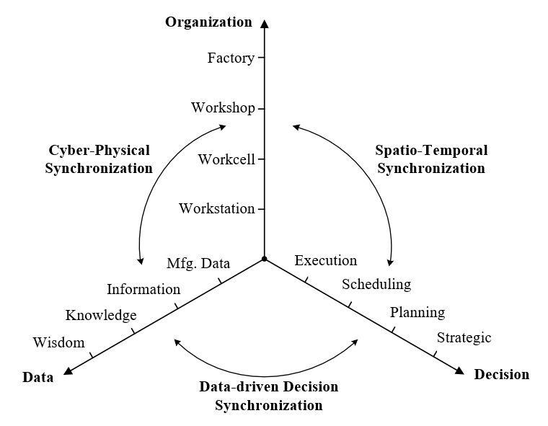

Fig.1. Overall framework for manufacturing synchroperation
Fig.1 shows the overall framework of manufacturing synchroperation with three keycharacteristics , including cyber-physical synchronization, spatio-temporal synchronization and data-driven decision synchronization. Cyber-physical synchronization focuses on the synchronization between cyber space and physical space through information visibility and traceability. The IoT and digital twin enabled ubiquitous connection, digitization and information- sharing in the context of Industry 4.0, present an opportunity for creating a digital equivalent representation of the physical entity (e.g. from small as a workstation, a workcell, to big as a workshop, a factory) and synchronizing them between cyber space and physical space with real-time information sharing.
Data-driven decision synchronization focuses on coordinated and global optimal production decisions benefiting from information sharing and data analytics. With enormous manufacturing data collected and shared in the cyber-physical system, valuable information and knowledge could be derived from the hidden patterns and correlations based on data mining, big data analytics and AI technologies. Thus, the coordinated, global optimal and even autonomous decision-making can be made for both short-term (e.g. scheduling and execution) and long-term (e.g. strategic and planning) production strategies.
For achieving successful implementation of these production strategies derived from data-driven decision models, spatio-temporal synchronization is crucial as it focuses on decomposing complex production environment and operations into spatio-temporal units and synchronizing them in a “divide and conquer” manner. It not only ensures that the required production resources (e.g. men, machines and materials) could be allocated and utilized in the right place at the right time with synchronization of production operations, but also in turns decouples the decision models towards practical industrial application by significantly reducing the uncertainty, randomness and complexity.

Synchroperability measures
Following the concept of synchroperation, we define synchroperability as the ability of a manufacturing system to achieve synchronized operations. Synchroperability is a measure for synchroperation in manufacturing. Three important aspects of measures for synchroperation, including simultaneity, punctuality and cost-efficiency are derived from the literature, and will be considered comprehensively in this section.
Table 2. Measures for synchroperability
Measures | References | Environment | Major aims | Indicators
Simultaneity | (Hsu and Liu, 2009) | Job shop | Reduce finished product inventory level | Flow time
Simultaneity | (Luo et al., 2017) | Flow shop | Improve overall performance of production and logistics | Flow time
Simultaneity | (Chen et al., 2019) | Flow shop | Improve production efficiency | Waiting time
Simultaneity | (Guo et al., 2020b) | Job shop | Improve the synchronization degree between manufacturing and logistics | Waiting time
Punctuality | (Chen et al., 2015) | Flow shop | Improve production lead time and shipment punctuality | Earliness and  tardiness
Punctuality | (Fazlollahtabar et al., 2015) | Job shop | Improve the performance of material handling system in production | Earliness and  tardiness
Cost-efficiency | (Qu et al., 2016) | Flow shop | Improve production-logistics resources utilization | Utilization
Cost-efficiency | (Lin et al., 2018) | Flow shop | Improve production efficiency | Setup time
Cost-efficiency | (Luo et al., 2019) | Flow shop | Improve overall performance of production and warehousing | Makespan
Cost-efficiency | (Lin et al., 2019) | Flow shop | Improve production efficiency | Makespan
As listed in Table 2, synchroperability measures are divided into three categories: simultaneity, punctuality and cost-efficiency. Simultaneity is one of the most important aspects of measures for synchroperation, and indicators for simultaneity, such as flow time and waiting time have been adopted in specific applications (Hsu and Liu, 2009; Luo et al., 2017; Chen et al., 2019; Guo et al., 2020b). Simultaneity concerns variation in completion times of jobs within the same package or order, which can be used to reduce finished product inventory level as well as improve production efficiency. Simultaneity could be considered as a measure in the production system that sensitive to job flow time or waiting time. For example, for producing large-size or fragile products, it is sensitive to job waiting time as holding such a product is quite expensive, which requires a measure of simultaneity in this production system (Guo et al., 2020c). Punctuality is another important aspect of measure that focuses on earliness and tardiness (Chen et al., 2015; Fazlollahtabar et al., 2015). Punctuality could be considered as a measure in the production system that advocates JIT production, as it can reduce the production lead time, inventory level and shipment punctuality (Chen et al., 2015). Cost-efficiency is a common aspect of measure for synchroperation, most of the literature deals with such regular indicators as makespan, utilization and setup time (Qu et al., 2016; Lin et al., 2018; Luo et al., 2019; Lin et al., 2019). Cost-efficiency could be used as a measure in a complicated production environment that involves across multi-echelon and inter-organizational production activities. For example, for achieving overall optimization of make-to-order production and cross-docking warehouse, Luo et al (2019) proposed a synchronized production and warehouse decision model to minimize the overall makespan.

Synchroperation Platform for cyber-physical traceability and visibility
To achieve the cyber-physical visibility and traceability serving for synchroperation, a hyperconnected Physical Internet-enabled smart manufacturing platform (HPISMP), leveraging various IoT technologies, digital twins, big data, artificial intelligent (AI) techniques and consortium blockchain, is proposed in this paper. The overview of the technical framework is shown in Fig. 2. The following subsections will elaborate on this architecture and discuss its traceability and visibility for synchroperation.
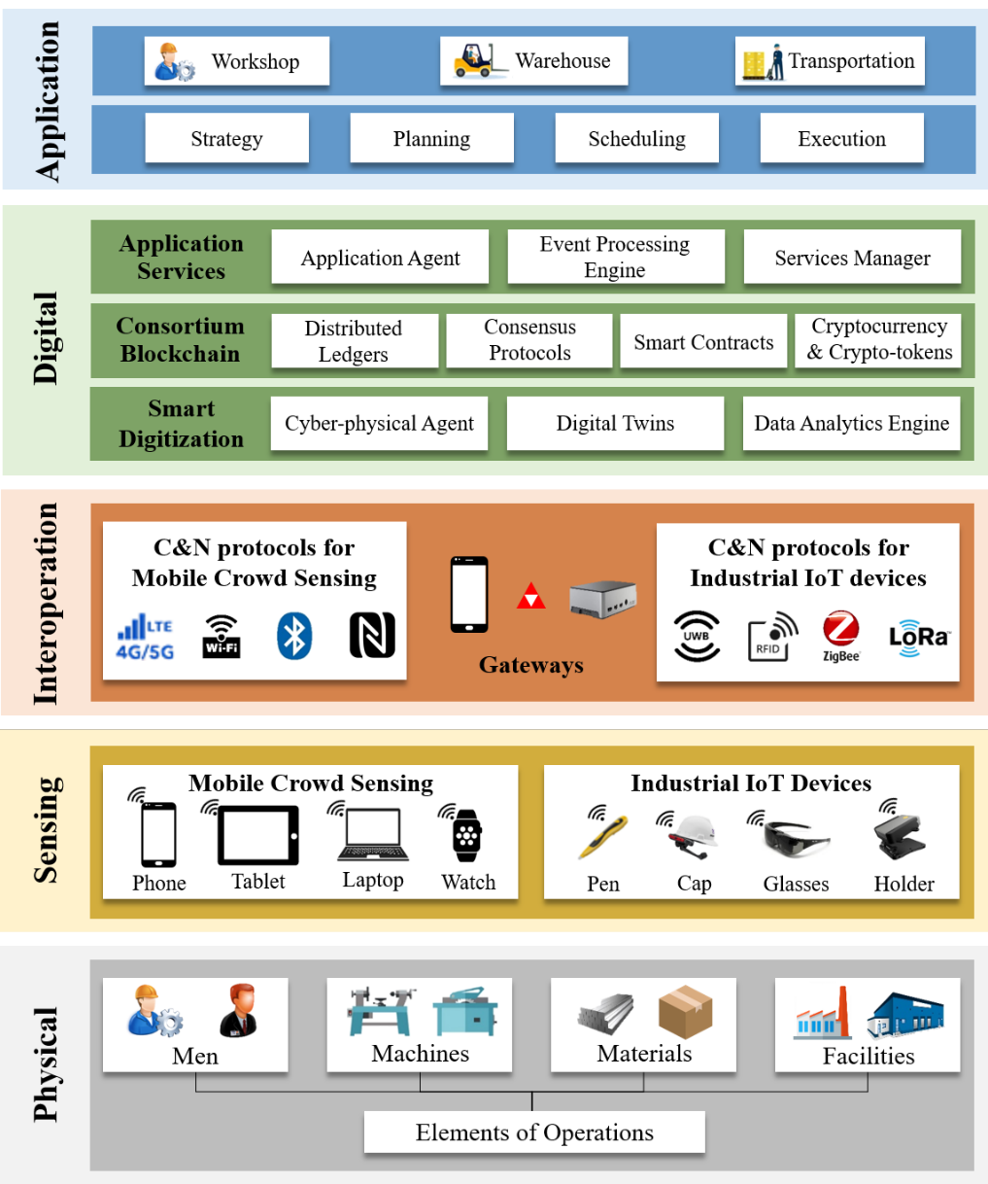
Fig. 2. Overview of hyperconnected Physical Internet-enabled smart manufacturing platform

Technical Framework of platform
The platform is divided into five layers, from bottom to top, namely physical, sensing, interoperation, digital, and application layer. Each layer is designed to connect, interact, and interoperate with each other so as to reinforce the overall synchroperability for production.
The first physical layer at the bottom is the physical space concerning men (eg., managers and onsite operators), machines (eg., production machines, vehicles and tools), materials (eg., raw materials, Work-In-Processes (WIPs) and finished products), and facilities (eg., production workshops and warehouses) that are fundamental elements of operations in manufacturing. Each type of element owns several categories classified by roles, functions, or phases. In line with actual demand, those elements may be equipped with electronic tags that contain a trickle of information primarily for identification in the cyber space, which can be captured passively or broadcast proactively. (Zhao et al., 2017) Under this condition, it endows each element with capability of communication and interaction.
The second sensing layer includes a variety of IoT equipment that is used to enable physical objects with sensible, interactive, and intelligently reasoning capabilities. To be specific, mobile crowdsensing (MCS) is to collectively gather sensing data from nearby sensors via ubiquitous mobile devices, such as smartphones, tablets, laptops, and smartwatches. (Ganti et al., 2011) It gains much popularity for real-life applications in virtue of its mobility, scalability, and cost-effectiveness. Besides the application of MCS, Industrial Internet of Things (IIoT) devices are also widely deployed for the real-time data collection and transmission. (Kong et al., 2020) Notably, wearable devices for men and machines enjoy high favour in the industry attributing to hands-free carry and convenient handling. For example, machines furnished with tag readers, like smart holders, are capable of detecting adjacent objects and triggering relevant events to facilitate operations. Else, men tend to carry smart devices to connect with peripheral objects and maintain responsive communication, such as versatile smartpens, caps, and glasses. Data or extracted information secured in this layer will be uploaded to the next layer for further processing.
The third interoperation layer aims to synchronize cyber-physical spaces and realize timely and seamless dual-way connectivity and interoperability between manufacturing objects and different application systems. It encompasses gateways and wireless communication and networking (WC&N) protocols. WC&N protocols serve as a data carrier to link with smart objects and the digital world. (Zhang et al., 2011) In this platform, diverse wireless communication technologies are devised to be applied, such as 4/5G, LTE, Wi-Fi, Bluetooth, and NFC, which are typically provided in smartphones and personal wearables, and others like UWB, RFID, ZigBee, and LoRa that are preferably harnessed in the industry. All those protocols are embedded in gateways. Besides acting as a hardware hub, the gateway also offers a suite of software services, named gateway operating system, including definition, configuration, execution, and monitoring. (Fang et al., 2013) Concretely, it can define the flow of data collection from heterogeneous devices and the cloud, configure essential setups and environmental conditions, execute data processing, information aggregation and exchanging, and, finally, monitor the entire operations for the malfunction detection. Also, gateways possess the data analytics capability so that they can process data comprehensively to utilize edge computing, thus alleviating burdens of cloud computing and saving storage. In addition, gateways have two types. One is the stationary gateways that are mounted at appointed spots and work in a plug-and-play way to ease the deployment. Another is the mobile gateways that are moveable and even portable since ubiquitous devices, like smartphones, can install dedicated applications to serve as a gateway, which significantly extends the channel of data collection and reduces development cost.
The fourth digital layer is the cyberspace, in the form of the cloud or servers in reality, that replicates the physical world and adopts services-oriented governance. This layer is divided into three modules that are smart digitization (Lin et al., 2019), consortium Blockchain (Li et al., 2017), and application services. The main function of smart digitization is to convert physical objects into cloud assets (Xu et al., 2018) and apply data analytics for different purposes. Thereinto, the cyber-physical agent acts as a gate of cyberspace to receive data from gateways. Based on those informative data, physical objects are mapped to digital twins with unique identifications recognized in the digital. Else, the data refinement or pre-processing is implemented in the data analytics engine, such as spatio-temporal analytics. The second module consortium Blockchain is used as a backbone to build up a database, facilitate workflow management, and ensure traceability, accountability, and transparency. In detail, the distributed ledgers serve as distributed databases where digital twins are stored and transactions recorded, and consensus protocols is a globally-agreed rule for distributed computing to control the access to the database and make sure ledgers trackable and irreversible. Any kind of codified procedures that refer to a series of real-life workflows are encrypted and stated in smart contracts to trigger events in order. Cryptocurrency or crypto-tokens working as an incentive mechanism is granted proportionally according to the quality and punctuality of task completion. The goal of the third module application services is to host and manage services committed to users. The application agent acts as another gate of the digital world to interact with user applications, like the post and get requests in HTTP protocols. Calling functions or taking responses pursuant to manipulations in the application behaves in the event processing engine. The services manager is devoted to administrating fundamental components of services, like objects information, and configuring logics between services.
The fifth application layer provides decision support systems and visualization tools to help conduct operations for participating stakeholders, including workshops, warehouses, and transportation in manufacturing. Each stakeholder is principally concerned with four kinds of applications, namely strategy, planning, scheduling, and execution. Additionally, applications are developed in forms of desktop and mobile terminal so that office staff can make decisions in front of the desktop, and operators simply bring mobile devices to accomplish tasks. Furthermore, those applications allow individuals from different departments to manipulate separately without interference but for the same goal among the whole factory in real time so as to synchronize operations. For example, when a batch of parts is being produced, an urgent order crops up, the production manager goes to adjust the schedule, the warehouse prepare the material, and the logistics initiate a shipping task accordingly via each application. Hence, the next production job could be launched as punctually as possible.

Traceability and Visibility for Synchroperation
Synchroperation in manufacturing anticipates high demand for a traceable and visible system that can synchronize the cyber and physical world greatly regarding organization, data, and decision. The main goal of this platform is to enhance information traceability and visibility so that the space, state, and status of physical objects can be tracked, traced, and visualized. The following paragraphs discuss these properties from three aspects claimed in the last chapter.
For the cyber-physical synchronization, PI technologies play an essential role in digitizing physical objects to provide a foundation for information traceability and visibility. Three Basic Laws of the PI are followed for the design. The first law is the “Law of Universal Value” that states what objects should be tagged and where smart devices should be deployed. This law minimizes the number of smart devices to the level that maximizes the adding value. The second law is the “Law of Sharing” by which Manufacturing Physical Internet (MPI) technologies are standardized and modularized so that they can be shared within the factory to minimize the costs and risks. The third law is the “Law of Interoperability” by which smart gateways capture actions and reactions between smart devices and objects in manufacturing environments without involving heterogeneous internal technical details. This law ensures scalable plug-and-play reconfigurability.
For the spatio-temporal synchronization, knowing which object is situated at which location at what time is fatal for efficient operations conduction in manufacturing. Based on data stemmed from sensors in electronic tags, indoor localization algorithms are implemented to position objects with timestamp in real time. Objects in operations are highly intertwined concerning time and space since the flow of men, machines, and materials in the factory are much frequent and intricate. To model and visualize these operations, a spatio-temporal analytics method is designed to segment space and time of operations for local dissolution and then integrate them to reap the overall effects. This novel methodology will be illuminated in the next section.
For the data-driven decision synchronization, it supports real-time decision-making at both tactical and operational levels, enabled by vast quantities of real-time data and information. Consortium blockchain provides an effective solution to sharing information among the platform safely and helping users easily track and trace. Based on data analytics engines, different applications are developed for data visualization to assist operators in making decisions. In this case, the visibility and traceability of the system get considerably enhanced.
The information traceability and visibility are of great significance for synchroperation achievement. Not only those state-of-the-art technologies are needed but effective methodologies coupled with technologies to realize overall synchroperation.

Graduation intelligent Manufacturing System for Synchroperation
This section proposes the GiMS with “divide and conquer” principles, to address the complex, stochastic, and dynamic nature of manufacturing for achieving synchroperation in factories based on the HPISMP. GiMS is initially proposed as a new manufacturing mode to organize production operations with simplicity and robustness, its basic form and principles can be found in previous research (Lin, et al., 2019; Guo et al., 2020a). As shown in Fig. 3, this paper presents the five key phases to implement GiMS in factories.

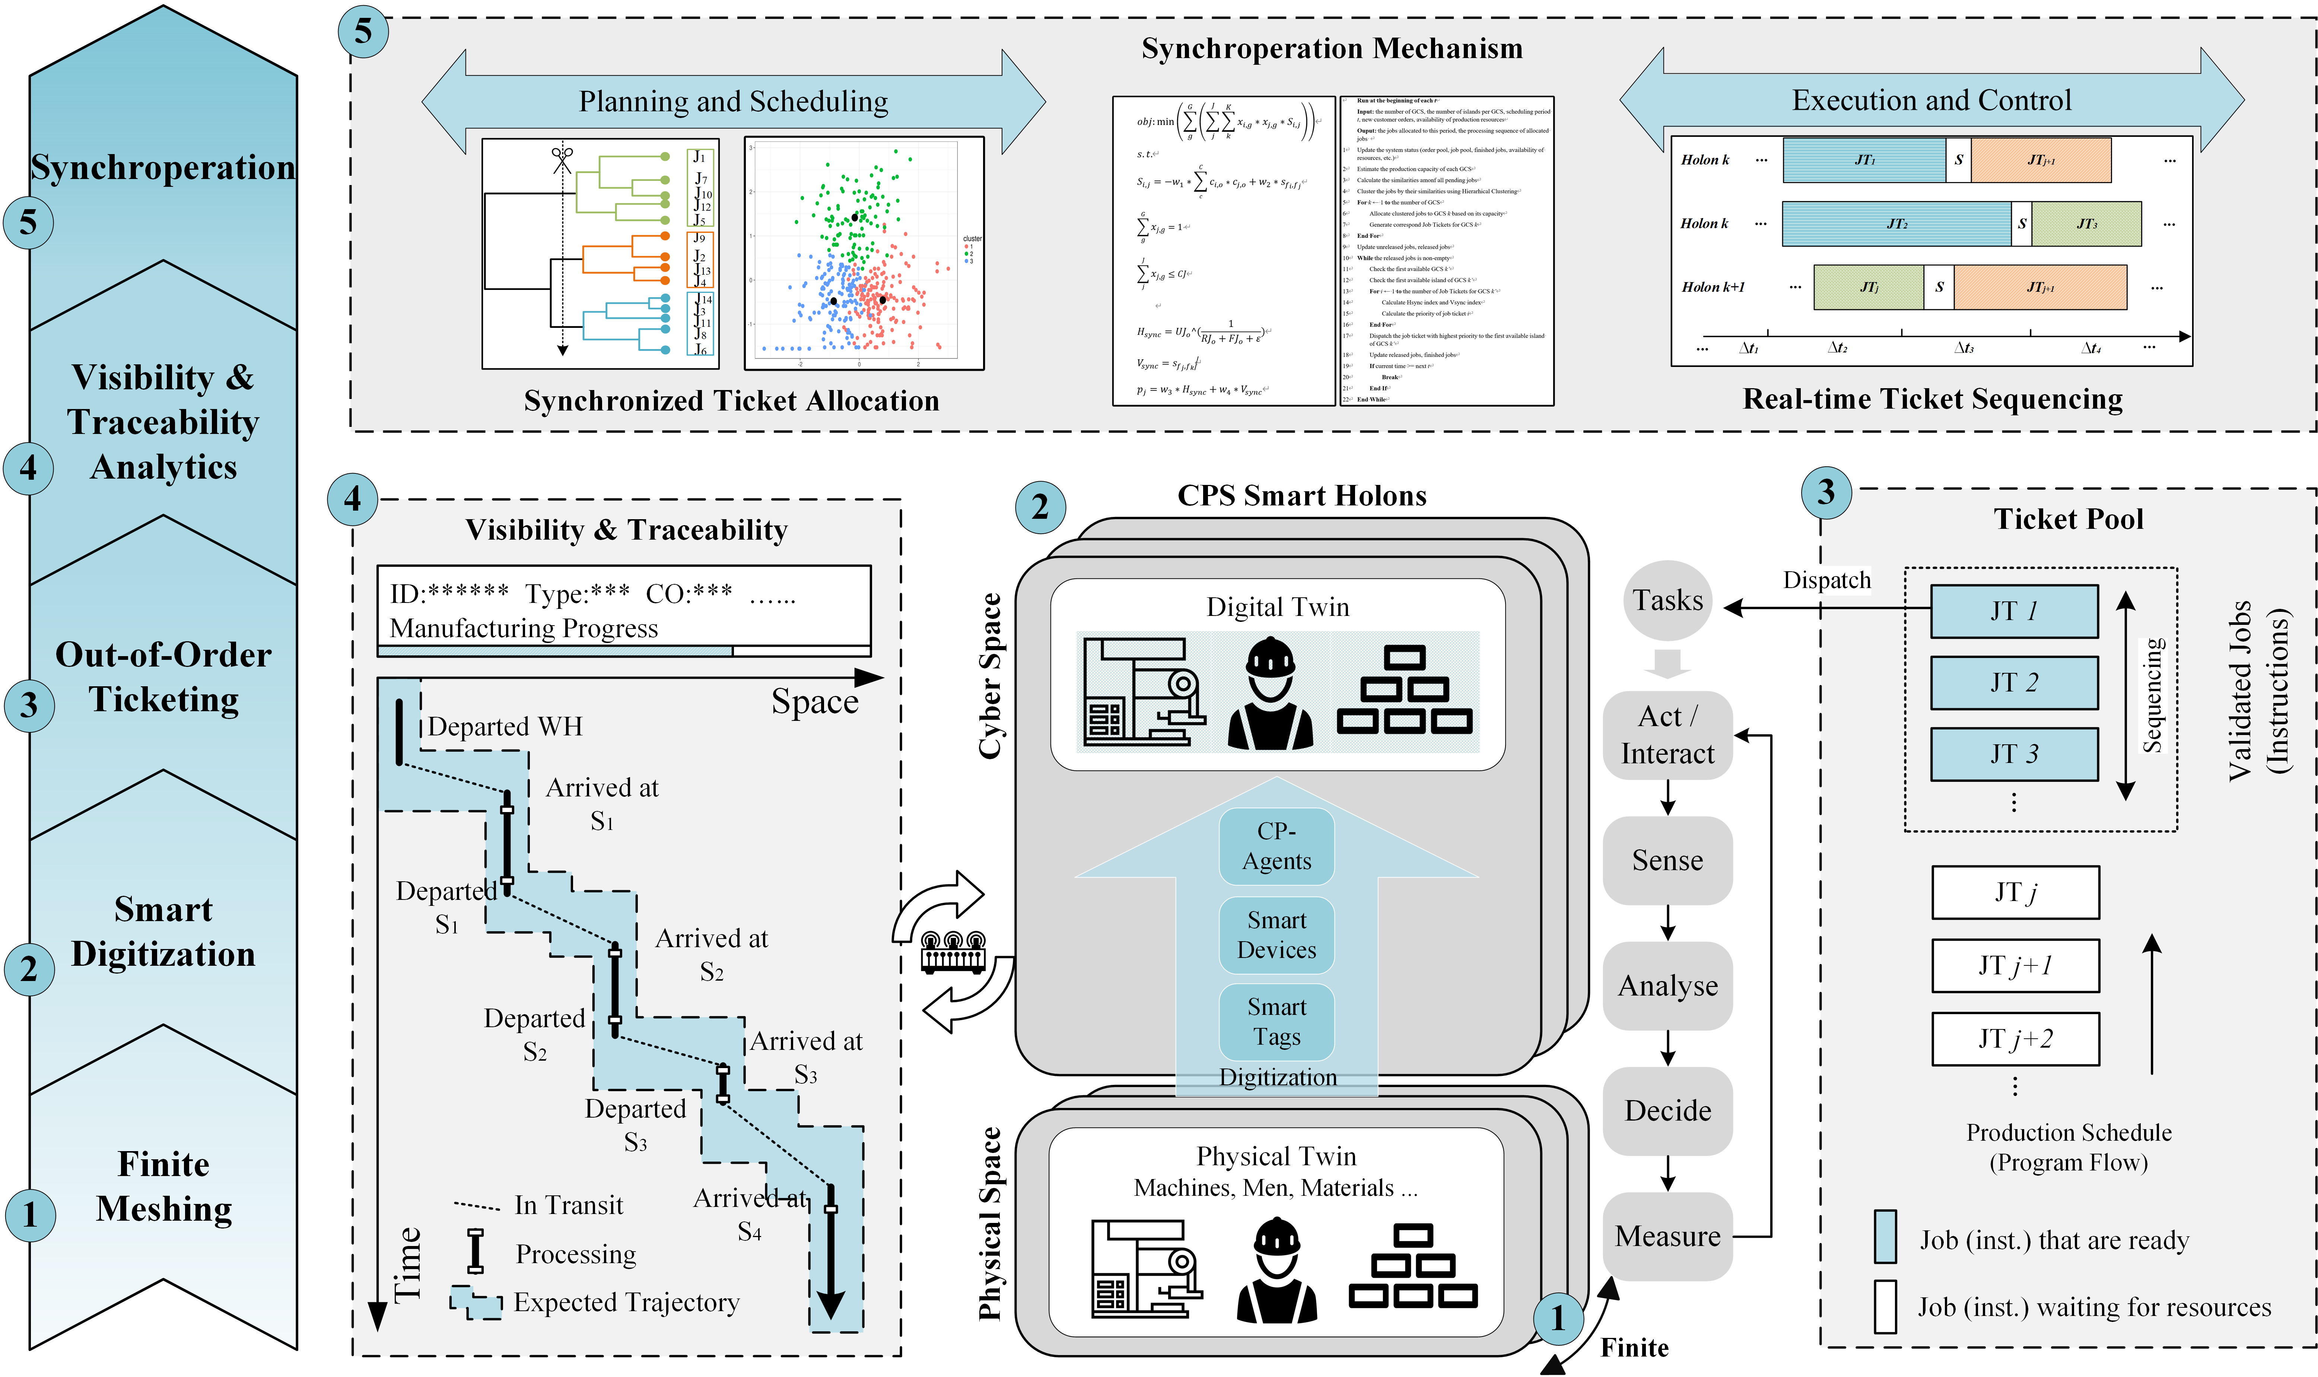
Fig. 3. Five phases of GiMS

Phase 1: Finite Meshing
This phase involves spatially dividing the factory organization and temporally discretizing the decision horizon into an equivalent system of finite “Graduation Ceremony Stages (GCS, a space unit in a time interval)”, to minimize complexity and localize uncertainties. Operation elements (men, machines, materials) are defined for all “stages” as physical twins.
Generally, the space scope of a factory contains various production, logistics, and storage facilities and areas that can be divided into multiple smaller space units. The overall decision horizon is discretized into multiple shorter time intervals (Balakrishnan and Cheng, 2007; Torkaman et al., 2017). Because the space unit and scheduling period of GCS in meshing are small enough relative to the original system, the subproblem size is limited, and more straightforward decision models can be built. All the uncertainties occur during the current period can be considered in the next period with negligible loss of service quality. There are different rules to generate the mesh: (1) Meshing according to absolute space and time. Usually, the factory is divided into finite space units based on their absolute spatial positions; the optimization horizon can be discretized into multiple medium-length time units representing a working shift or several hours. (2) Meshing based on functionality. This rule divides the factory into GCS with different functions. For instance, logistics facilities and production workstations belong to separate GCS. Production area can be further divided based on their functions and responsibilities (threading, heat-treating, etc.) to obtain finer granularity. Correspondingly, the time scope should be discretized with the characteristics of different function areas taken into account. (3) Meshing on a dynamic basis. This rule dynamically adjusts the granularity of spatiotemporal mesh based on the real-time situation to cope with various uncertainties in demand, supply, and so on. This usually requires a high level of visibility and traceability throughout the fast-changing supply chain. The manufacturer should choose the rule based on the actual situation of the factory to generate the most appropriate mesh.

Phase 2: Smart Digitization
Phase 2 is to digitize the operation elements at all GCS for generating digital twins with the deployment of enabling technologies. A highly visible, transparent, and interconnected Cyber-Physical Factory (CPF) with real-time visibility and traceability is built through smart digitization. This phase constructs the data dimension of physical twins, and the cyber-physical synchronization is achieved through smart gateways.
With the deployment of mobile crowdsensing, IIoT devices, and cyber-physical agents, all physical entities in the factory are digitized for generating cyber avatars. The physical twins combine with corresponding digital twins to form CPS smart holons (CPS-SHs) that are decentralized and of autonomy to some extent. All CPS-SHs are physically independent but digitally interconnected by the tasks. The capabilities of CPS-SHs include: 1) sense the environment, such as how it connects with other holons and the status of task pool; 2) analyze the real-time production data and information; 3) autonomously make decisions based on the status of tasks and the state of itself; 4) take actions accordingly and interact with each other; 5) finally measure the key production performance (e.g., holon utilization, efficiency) with embedded distributed analytics. Relevant applications, services, and analytics are integrated into the cyber space. Smart gateways are deployed to synchronize cyber and physical spaces, analyze the status of smart holons, and support visibility and traceability analytic between smart holons.

Phase 3: Out-of-Order Ticketing
This phase implements an Out-of-Order (OoO) ticketing for smart holons to facilitate smooth onsite production execution and flexible control of production progress with enhanced resilience of schedules. OoO ticketing guarantees the data-driven decision synchronization at the operational level.
Three kinds of tickets, including job ticket (JT), setup ticket (ST), operation ticket (OT) and twined logistics ticket (LT) are critical in GiMS. Smart tags serve as the carriers of digitalized tickets. JTs are designed for permitting the right jobs to produce in one batch with the consideration of customer demand and production capacity. STs are designed to control flexible setups between different job families so that the setup can be informed in advance and performed at the right time. OTs and twined LTs are designed to synchronize operation and JIT delivery. According to the demand and production capacity, these tickets are real-timely generated and allocated to the ticket pools of each GCS in a synchronized manner. OoO is a paradigm used in modern CPUs to avoid stalls and improve processing efficiency (Hwu & Patt, 1986). OoO allows the processor to execute instructions in an order governed by the availability of input data and execution units, rather than by the original program order. By analogy, the OoO ticketing in factories allows jobs to be processed in an order governed by the availability of materials, machines, and men. That is, smart holons look ahead in the ticket pool and find those that are ready to be processed. When a disturbance like material deficiency/loss or machine failure occurs, the smart holon can decide to process other ready jobs or using other available machines rather than wait. The ticket control mechanism and OoO ticketing organize the onsite production operations with simplicity and resilience, and offer a robust and straightforward logic to tackle frequent uncertainties in the real-life shop floor.

Phase 4: Visibility and Traceability Analytics
In phase 4, the cyber-physical visibility and traceability analytics is utilized to identify and establish the dependencies and connectivity of GCS and smart holons, and to mitigate the spatiotemporal uncertainties. Besides, this phase also serves as the foundation for spatio-temporal synchronization and higher-level data-driven decision synchronization.
The holonic dependency and connectivity usually refer to the logical relationship between holons, such as how the state of ticket pools of holons update over time, and how the tickets flow between holons. The cyber-physical visibility and traceability is the key tool to real-timely monitor ticket pools and to establish the connectivity from two aspects. Firstly, how the states of holons update over time: The input of one holon at the beginning of the current time unit consists of two parts. The first part is the output of that holon in the previous time unit; the second part contains new information that occurs in the previous time unit; these two parts are also strongly influenced by various uncertainties such as stochastic processing time, machine failure, absence of operator, etc. Secondly, how the tickets flow between holons: Completing a production job usually requires performing several operations. These operations and their intrinsic sequencing and spatial constraints are defined in the tickets. The jobs whose operation at the current holon in the previous time unit has been completed will be transferred to the following holons. And the jobs transferred to the current holon in the current time unit, are the union set of jobs whose operation in the previous holon has been completed. These real-time data and information are vital for supporting decision-making within GCS and connecting all holons so that the production activities can be well synchronized to obtain better synchroperability performance.

Phase 5: Synchroperation
This phase corresponds to the design of the synchroperation mechanism under GiMS to facilitate upper-level managerial decision-making and lower-level onsite production execution and control for higher system synchroperability. Spatio-temporal synchronization and data-driven decision synchronization are achieved in this phase.
In the upper-level synchroperation (planning and scheduling), the overall planning horizon $T$ is discretized into multiple shorter scheduling periods$t$. Based on the real-time customer demand (e.g., product type, quantity, receive date and due date) and production constraints (e.g., capacity, resource, and precedence constraints) in period $t$, the job ticket allocation mechanism aims to generate schedule for period $t+1$ on an aggregate basis for families of jobs (identical or similar products) and allocate job tickets. The similarity among jobs is usually measured from the aspects of setup, material requirement, operator skill requirement, correlative orders and so on. In the lower-level synchroperation (execution and control), as the jobs allocated to a single scheduling period are similar, the rigid sequence of these jobs is less significant. Thus, OoO ticketing of tickets is adopted. At the beginning of $t$, job tickets are released to each GCS task pool, the operation tickets and logistics tickets for this job are activated. A job ticket is validated queue once all required resources are available. When there is a vacancy in the workstation buffer, the sequencing is triggered, and the priorities of validated tickets are calculated based on real-time data, the job ticket with the highest priority will be dispatched, and setup ticket will be issued accordingly if it is required. The priorities are usually computed based on horizontal synchronization, vertical synchronization, and the matching degree of the job and workstation (job type, machine type, operator skill etc.). The bi-level synchroperation mechanism promises both optimized decisions in the managerial level and resilience execution, flexible control in the operational level to break the bottleneck of manufacturing complexity and uncertainty.

Case study: Synchroperable Hybrid-assembly line Based on GiMS
In this section, the GiMS method is applied to a novel manufacturing layout named hybrid assembly line (HAL). This layout is adopted by a world-leading air conditioner manufacturer G to face the fast-changing market and gradually adopted by other manufacturers to improve their production flexibility. Then, a comprehensive numerical analysis is presented by considering the proposed synchroperability measures. Results show that GiMS can obtain significant comprehensive performance improvements and help manufacturers achieve higher synchroperability.

GiMS enabled HAL
The whole GiMS enabled HAL assembly process can be described in Fig. 4. The manufacturing space in the shop floor is separated into independent station area and the HAL consists of a series of assembly stations. Each station has the machine space for operation equipment and the space for materials and tools. There is also an operation space for the worker to assembly products. All these divided spaces make up a station. Then multiple stations are combined according to production arrangements to form an assembly line. All operations for one product will be processed and completed on one movable assembly table called assembly trolley.
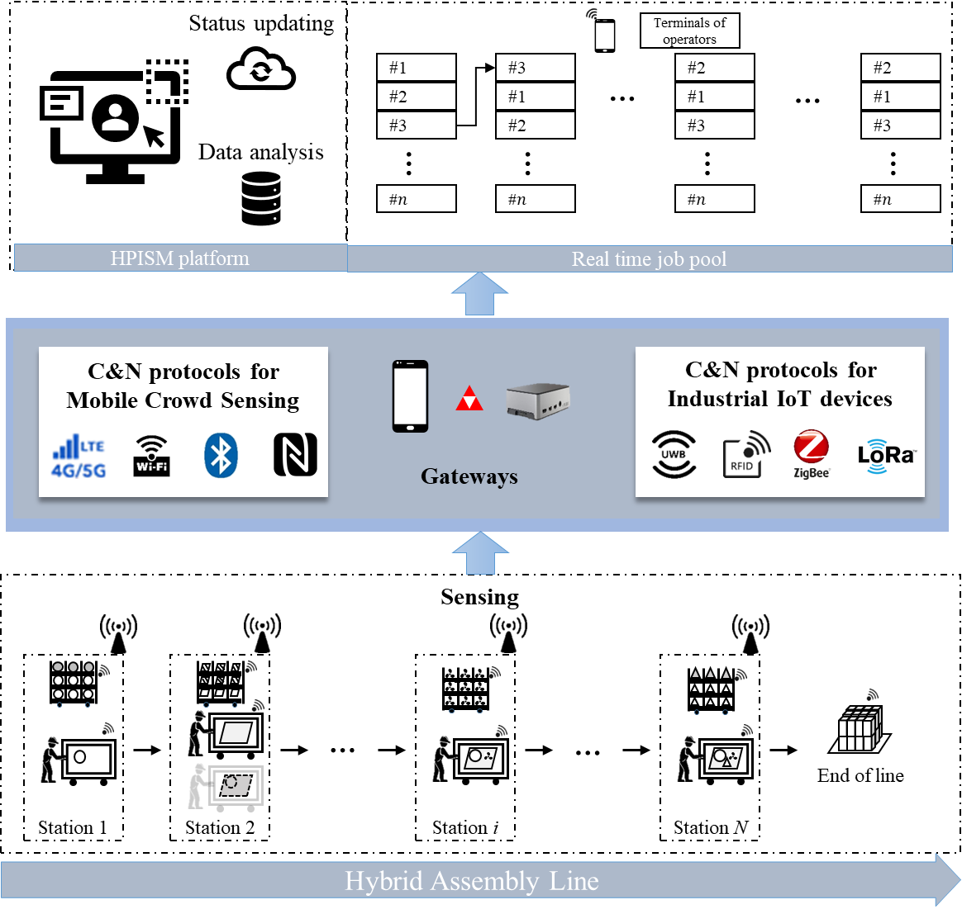
Fig. 4. GiMS enabled HAL assembly process
Then, the physical Internet infrastructure is deployed for creating the hyperconnected cyber-physical manufacturing environment. The production data are captured by the operators actively or by the monitor devices passively. Some triggers are deployed for requirement generation such as material delivery. Inventory units are put into specific locations and corresponding information is written to smart tags. The inbound and outbound time of shipment can be captured by the gateways automatically. To make sure the inventory accuracy, the stocktaking process is handled periodically or expeditiously with automation technologies. The production data and information are real-timely captured and transmitted to cyberspace through smart gateways for achieving cyber-physical visibility and traceability. The operators move the assembly trolley along the assembly line for assembly operations. After handling the final product, the operator moves the assembly trolley back to the first cell for next assembly job. In the assembly process, the job finished early can overtake the ones in front, which is described in the above part of Fig. 4. The job #3 is completed faster in cell $c$, and is the first job in the sequence when it comes to the next job pool. In the job assembly step, operators belonging to the same cell will take assembly job from the same job pool. Operators always take the first one from the job pool. Each operator can only process one job at a time and preemption of jobs is not allowed.
At the beginning of the production horizon, operation elements are spatio-Temporally meshed. Under the HAL setting, all operation elements can be classified into three categories: production element, warehouse element and logistic element. The production element contains the machine space for operation equipment and the space for materials and tools. There is also an operation space for the worker to assembly products. Each production element also includes the production personnel, machines, and raw materials related to this workstation. All these divided resources make up a production element. Then multiple production elements are combined according to production arrangements to form assembly elements. In this process, each HAL is regarded as a GCS and there are multiple homogeneous GCS in the plant. From the temporal perspective, different strategies including integral time units such as 1 hour or the average processing time in this element can be applied. The temporal division considered by each production element can be dynamically adjusted by each element according to the status of the whole factory in the production process. Warehouse elements: The outside partner includes suppliers, supply hubs, customers’ warehouses (VMI mode) and customers. Each partner can be seen as an individual warehouse element. Within the factory, the areas including on-site buffer and line side buffer are divided into warehouse elements. Each warehouse element contains related workers, equipment, and inventory. The division of the corresponding time horizon depends more on the replenishment cycle. The temporal division for outside warehouse elements may be one day or several days. While for the warehouse elements inside the factory, the temporal division is decided based on the space and production speed. Compared to the outside warehouse elements, the batch size of material delivery is smaller, and the delivery is more frequent for the inside ones. The temporal division of inside warehousing elements may be more dynamic as directly connected to the production process. Logistic elements: The logistic process takes up a large proportion of time over the whole production horizon, in which the uncertainty will affect the operations in the HAL production process. Each logistic element is considered individually and contains the area connecting different warehouse elements and production elements, relevant logistic operators, and transportation equipment. Similarly, the division of the corresponding time horizon depends more on the replenishment cycle.
Then, smart tags are attached to the machine, materials, and tools and all elements are digitalized for generating cyber avatars with basic infrastructure and corresponding gateways. The cyber avatars include all the essential information of the elements and not just several statuses. The CPS-SHs are formed from cyber avatars and their digital twins. Finally, the entire factory is discretized into CPS-SHs and all CPS-SHs are interconnected the tasks and of autonomy to some extent in task execution.
In the phase of Tickets Allocation and Out-Of-Order Execution, the customer orders are converted into production orders according to the production objectives. The OOO process for HAL is formulated mathematically. The customer orders dynamically come to the system and each order contains various product requirements, which is denoted by
$$o_{i}≜\left(at_{i},n_{i,p},d_{i}\right)$$
The $at_{i}$ represents the arrival time of order $i$ and $n_{i,p}$ represents the required quantity of product $p$. $d_{i}$ represents the order due time. Then, the production manager converts customer orders into assembly jobs and assigns them to the first job pool of the homogeneous HALs. When a HAL’s job pool is run out, a job requirement will send to the system and system will calculate the priority of all unreleased jobs. The comprehensive priority of job $j$ is calculated with V-sync and H-sync proposed in GIMS and due date priority (DP):
$$\begin{aligned}CP_{j}=w_{H}·norm\left(HS_{j}\right)+w_{V}·norm\left(VS_{j}\right)+w_{D}·norm\left(DP_{j}\right)\#\left(1\right)\end{aligned}$$
$$\begin{aligned}HS_{j}={\left(\frac{UJ_{i}}{α}\right)}^{\frac{1}{\left(\frac{RJ_{i}}{α}\right)+β}}\#\left(2\right)\end{aligned}$$
$$\begin{aligned}VS_{j}=\frac{b_{p_{j},p_{l}}}{1+\prod_{l^{'}∈L-l}{b_{p_{j},p_{l^{'}}}}}\#\left(3\right)\end{aligned}$$
$$\begin{aligned}DP_{j}=d_{i}-t\#\left(4\right)\end{aligned}$$
The job with smaller $CP_{j}$ has higher priority. $HS_{j}$ represents the production progress of the order that contains job $j$. ${UJ}_{i}$ and ${RJ}_{i}$ denote the unreleased jobs and released jobs of order $i$ respectively, $ε$ is an arbitrary small real number in case ${RJ}_{i}$ is equal to 0. $α$ and $β$ are positive real number used to smooth the $HS_{j}$ value. As setup is required for changeover between different products, $VS_{j}$ reflects the matching degree of the job $j$ and the available line $l$ (whether setup is required). $p_{j}$ and $p_{l}$ denote the product type of job $j$ and the setup condition of line $l$ left by previous job. $b_{p_{j},p_{l}}$ is a Boolean function, which takes the following form:
$$\begin{aligned}b_{p_{j},p_{l}}=\left\{\begin{aligned}0 if p_{j}=p_{l} \\ 1 otherwise\end{aligned}\right.\#\left(5\right)\end{aligned}$$
If the job type is same with the setup condition of line $l$, $VS_{j}$ is equal to 0 with a higher priority. When the job type is different, $VS_{j}$ is equal to 0.5. If there are other lines with the setup condition for the product type of job $j$, $VS_{j}$ is equal to 1 with the lowest priority relative to the current line. For $DP_{j}$, $d_{i}$ and $t$ are the modiﬁed due date of order $i$ and current time. The normalization function takes the following form:
$$\begin{aligned}norm\left(x\right)=\frac{x-min}{max-min}\#\left(6\right)\end{aligned}$$
Where the maximum and minimum can be derived from all unrealised jobs in the system. Then, the job with the highest priority will be chosen and released to the job pool of the first cell in the HAL. The maximum number of jobs assigned to each HAL is estimated by the operator number in each cell, meshing period $t$ and average job processing time.

Numerical Study
Several experiments will be performed to evaluate the performance of GIMS in the HAL case. The following measures will be used in all experiments. For the simultaneity measure, the average flow time (AFT) is adopt, which considers the time duration from the first assembly job starts processing on the HAL to all assembly jobs are finished. The AFT is calculated by
$$\begin{aligned}AFT=\frac{\sum_{i=1}^{I}{\left(\max_{j∈o_{i}}{c_{j}}-\min_{j∈o_{i}}{r_{j}}\right)}}{I}\#\left(7\right)\end{aligned}$$
Where $c_{j}$ and $r_{j}$ represent the complete time and released time of job $j$. The average tardiness (ATD) is used as the punctuality measure and takes the following form:
$$\begin{aligned}ATD=\frac{\sum_{i=1}^{I}{\left(\max\left(0,\max_{j∈o_{i}}{c_{j}}-d_{i} \right)\right)}}{I}\#\left(8\right)\end{aligned}$$
The makespan (MS) and average setup time (AST) are adopted as the cost efficiency measure of whole plant. The AST can be calculated as follows:
$$\begin{aligned}AST=\frac{\sum_{l=1}^{L}{\left({TST}_{l}\right)}}{L}\#\left(9\right)\end{aligned}$$
Where ${TST}_{l}$ represents the total setup time of each line. The experimental data are randomly generated from Table 3.
Table 3. Experimental data
Parameters | Value
Cell | 5
L | 5
Operators | 4
Average processing time in each cell (min) | N(10,2)
Average setup time (min) | 10,20, 30, 40
Customer orders | 50
Number of jobs per order | 5
Average orders inter-arrival time (min) | 15,25,35
Due dates of orders | U [7, 13] ×orders inter-arrival time
Products | 3, 6, 9,12
Element period | 100
The operation time for each job in each cell follows a normal distribution with mean 10 and standard deviation 2. The number of customer orders is set to 50. The time period, the setup time and types of products are set to several fixed numbers. The number of released jobs each time depends on the time period and through output rate of HAL. The order arrival time is generated from a Poisson process with mean 15, 25 and 35. The due date of each order is set to 7~13 times of average orders inter-arrival time (min) after the order arrives.
In the first experiment, the effectiveness of GIMS is compared to several common scheduling rules based on the synchroperability measures under different order amounts, In the second experiment, the sensitivity analysis is conducted to two crucial factors: product type and setup time, which could significantly affect the performanc of GIMS. To compare the performance, the following three common rules are adopted: ﬁrst-come-ﬁrst-serve (FCFS) rule (Schwiegelshohn and Yahyapour, 1998), Shortest processing time (SPT) (Pickardt and Branke 2012) and Earliest due date (EDD) (Baker, 1984). In this case, SPT considers that the order with less unreleased jobs has higher priority. The setup time is set to 30 and product type is set to 6. The element period is set to 100. First, the output rate and job arrival rate of the entire plant is given as:
$$\begin{aligned}r_{to}=\frac{oL}{P}\#\left(10\right)\end{aligned}$$
$$\begin{aligned}r_{ja}=\frac{P*J}{λ}\#\left(11\right)\end{aligned}$$
The order arrival rate which can balance the $r_{to}$ and $r_{ja}$ can be derived from other parameters and the current value is 25. When the value becomes smaller, which means that orders come to the system more frequently and can be considered as the peak season. Similarly, smaller value means the off season. The order arrival rate are gradually increased from 15 to 35 in steps of 10 and there are total 50 customer orders.
At the beginning of production horizon, each HAL holds the same number of jobs with same products type. Under each order amount, the experiments for the four rules are carried out individually for 100 times, which is large enough to ignore the extreme processing process and the average values of each measure can represent the common case. The results are summarized in Table 4.
Table 4. Synchroperability measures performance of HALs under different rules
Inter-arrival time | Rules | Measures
Inter-arrival time | Rules | AFT | ATD | MS | TST
15 | GIMS | 217.3851 | 72.3005 | 1216.085 | 1785.572
15 | FCFS | 221.9514 | 76.75619 | 1371.398 | 2157.09
15 | SPT | 221.3701 | 76.37134 | 1363.869 | 2156.957
15 | EDD | 221.8738 | 76.64523 | 1372.187 | 2157.06
25 | GIMS | 211.2348 | 5.708845 | 1208.925 | 1824.576
25 | FCFS | 219.4813 | 7.7747 | 1596.651 | 2204.133
25 | SPT | 219.8993 | 7.905285 | 1575.59 | 2203.765
25 | EDD | 219.6664 | 7.769687 | 1567.685 | 2203.273
35 | GIMS | 208.4382 | 0.005619 | 1506.978 | 1827.535
35 | FCFS | 214.5554 | 0.173307 | 1586.747 | 2171.051
35 | SPT | 214.3138 | 0.13862 | 1583.864 | 2171.605
35 | EDD | 214.6878 | 0.146956 | 1602.94 | 2171.842
It can be observed that GIMS achieve smaller MS in all experiment cases. This means that within GIMS has higher efficiency than other rules and less time is used to process the same jobs. Then, the assembly process under GIMS method incurs less TST. This means that GIMS can effectively reduce the setup operations and achieve the synchronization of assembly products, which belong to different customer orders. Besides, the assembly process under GIMS has smaller as well as less setup time under the same order compared to other rules. This shows the effectiveness of GIMS that can help the manufacturer achieve cost-efficiency and higher synchroperability. Then, the GIMS achieve less ATD in all cases and enable orders to be finished Simultaneity. In addition, it can improve the punctuality during peak seasons.
The sensitivity analysis is conducted to the product type and setup time. First, the product type is increased from 3 to 12 in steps of 3 with the setup value as 30. For further comparison, the result using FCFS policy under the same data. The results of GiMS and FCFS policy are shown in Fig. 5. Then, the setup value is increased from 10 to 40 in steps of 10 under product type 6. The results of GiMS and FCFS policy are shown in Fig. 6.
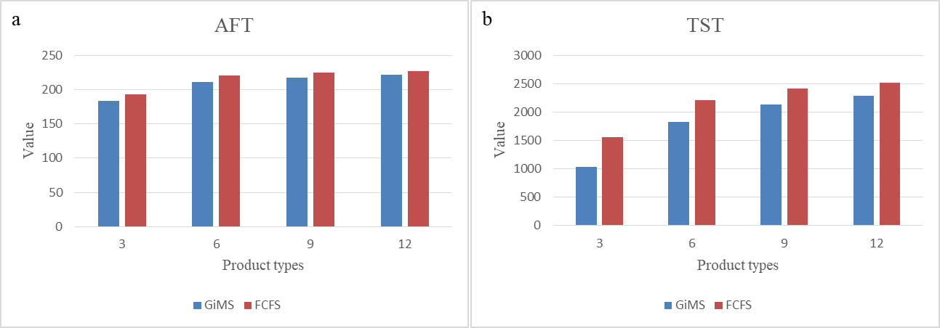
Fig. 5. Measures of GiMS and FCFS policy under different product types
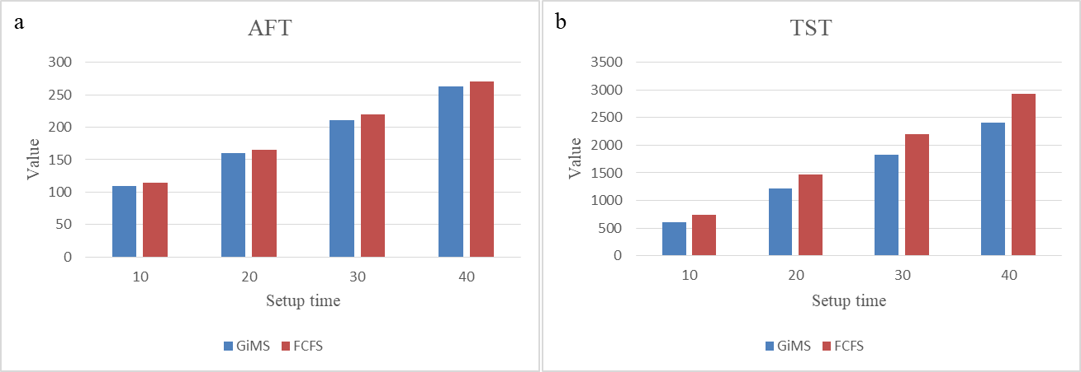
Fig. 6. Measures of GiMS and FCFS policy under different setup times
Fig. 5 shows that each measure has achieved a greater value with more product types under both policies. In each case, GiMS has less AFT and TST compared to FCFS policy. This shows that GiMS can achieve better performance in a wide range of regimes. For AFT, GiMS has a greater advantage over FCFS when there are fewer product types. For TST, it can be seen that GiMS also has a greater advantage when the product is small. This shows that GiMS can better integrate jobs under fewer products. In figure 6, GiMS has less AFT and TST compared to FCFS policy under each setup time. For AFT and TST, GiMS has a greater advantage over FCFS when the setup time increases. Besides, the TST measure has been significantly improved compared to AFT. This shows that GiMS can help manufacturers to reduce the setup time significantly especially when the setup time is larger.
The management insights can be summarized as follows: GIMS method has achieved significant performance improvement with the synchroperability measures in the HAL settting. With HPISMP, decision makers can more available information when making a decision. This enable a better decision, which considers more measures and real-time status. Even if certain measure has less weight in decision-making process, compared with the previous extreme way of consideration, it can be improved after execution due to the overall optimization.

Conclusions and Future perspectives
Industry 4.0 connotes a new industrial revolution with the convergence between physical and digital spaces, which are currently revolutionizing the way that production operations are managed. To explore the evolution of production and operations management paradigm in the era of Industry 4.0, a concept of manufacturing synchroperation with enabling technologies and associated methodologies are proposed for transformation and implementation of Industry 4.0 manufacturing.
The main contributions of this paper can be concluded as follows: (1) A concept of manufacturing synchroperation with cyber-physical synchronization, data-driven decision synchronization and spatio-temporal synchronization is proposed for Industry 4.0 production and operations management. (2) A HPISMP assisted with digital twins and consortium blockchain is developed as a technical solution to support the transformation of manufacturing synchroperation. (3) GiMS with “divide and conquer” principles is proposed as a methodology to address the complex, stochastic, and dynamic nature of manufacturing for achieving synchroperation. (4) The potential advantages of implementation of manufacturing synchroperation is illustrated with an industrial case from an air conditioner manufacturer.
This paper presents a new paradigm of production and operations management in the era of Industry 4.0-manufacturing synchroperation. The research is still in its infancy, and there are abundant research opportunities in this topic. Further research efforts on principles, methodologies, and support technologies for transforming production and operations management to Industry 4.0 manufacturing are necessary. Several possible research directions with related research questions are listed as follows.
RQ1: How to redesign the layout and organization of traditional manufacturing system considering the new synchroperability requirements in the era of Industry 4.0? What are the key factors in system design that affect the synchroperability performances?
Manufacturing layout and organization design is a classical problem studied in literature. Good production system design can overcome some traditional problems in structual and facilitate production and operations management. For example, the HAL design of company G is an attempt to eliminate unbalances in traditional assembly line. In the content of Industry 4.0 manufacturing synchroperation, some new questions such as how the production system design can be adaptive to emerging technologies for minimizing overall digitization costs, how the production system design can enhance the synchroperability performance and so on, merit further investigations.
RQ2: How manufacturing synchroperation reshapes the way manufacturer do business with their customers? How to establish adaptive business models for manufacturing synchroperation in the era of Industry 4.0?
Industry 4.0 manufacturing is revolutionizing the way that production operations are managed and done, which also has the potential to revolutionize the way manufacturer do business with their customers and suppliers. The concept of manufacturing synchroperation provides an insight for manufacturers to re-evaluate and develop their business model to capture and maximize the value of the customer in the Industry 4.0 manufacturing environment. More innovative business models need to be further explored.
RQ3: How to measure the disruptions of manufacturing synchroperation on supply chain? How to integrate manufacturing synchroperation with the processes of supply, warehousing and delivery to increase the agility of the supply chain?
Manufacturing synchroperation with cyber-physical synchronization promises to remove information or communications barriers cross multi-echelon and inter-organizational activities. Effective methods to measure the disruptions of manufacturing synchroperation on supply, warehousing and delivery processes, and increase the agility of the whole supply chain through the real-time cyber-physical visibility and traceability deserve further explorations.
RQ4: What is the technical requirement for transforming to Industry 4.0 manufacturing? How to design effective technical standards and architectures for real-time information exchange among "real-time things" to support manufacturing synchroperation?
The transformation of Industry 4.0 manufacturing requires technical infrastructures to support real-time visibility and information sharing. Technical standards and architectures with a high degree of connectivity, interoperability and accessibility must be designed to define the specifications for real-time information exchange among "real-time things", which is the basis for achieving manufacturing synchroperation in the era of Industry 4.0.
RQ5: What are the effects of the real-time visibility and information sharing on complexity and uncertainty nature of manufacturing? How to model and minimize the uncertainty and complexity in real-time manufacturing environment?
Although the potential benefits of the real-time visibility and information sharing in the era of Industry 4.0 have been acknowledged in general, the theoretical foundations are rarely considered. Innovative methods to model and measure the effects of the real-time visibility and information sharing on complexity and uncertainty nature of manufacturing, and minimize the uncertainty and complexity in the Industry 4.0 manufacturing environment are crucial.
RQ6: How to realize the full potentials of historical and real-time production data? How to derive decentralized/autonomous decision-making to create data-driven value-adding for Industry 4.0 manufacturing?
In Industry 4.0 manufacturing, production data can be captured and transmitted on a real-time basis, and it also brings manufacturing industry new decentralized production patterns, in which decentralized elements can independently or collaboratively make decisions and even take actions. Therefore, how to derive decentralized/autonomous decision-making from the fusion of enormous production data and management strategies to create data-driven value-adding for the manufacturing sector and support self-organization or self-configuration production need to be investigated.

Acknowledgement
Acknowledgement to Zhejiang Provincial, Hangzhou Municipal, Lin'an City Governments, Hong Kong ITF Innovation and Technology Support Program (ITP/079/16LP) and financial support from the 2019 Guangdong Special Support Talent Program-Innovation and Entrepreneurship Leading Team (China) (2019BT02S593).

Reference
Akkermans, H.A., van der Horst, H., 2002. Managing IT infrastructure standardisation in the networked manufacturing firm. International Journal of Production Economics, 75, 213-228.
Balakrishnan, J., & Cheng, C. H., 2007. Multi-period planning and uncertainty issues in cellular manufacturing: A review and future directions. European Journal of Operational Research, 177(1), 281-309.
Baker, K. R., 1984. Sequencing rules and due-date assignments in a job shop. Management Science, 30(9), 1093-1104.
Browne, J., Dubois, D., Rathmill, K., Sethi, S.P., Stecke, K.E., 1984. Classification of flexible manufacturing systems. The FMS magazine, 2, 114-117.
Buzacott, J. A., & Yao, D. D., 1986. Flexible manufacturing systems: a review of analytical models. Management Science, 32(7), 890-905.
Chen, J., Huang, G. Q., Luo, H., & Wang, J., 2015. Synchronisation of production scheduling and shipment in an assembly flowshop. International Journal of Production Research, 53(9), 2787-2802.
Chen, J., Wang, M., Kong, X. T., Huang, G. Q., Dai, Q., & Shi, G., 2019. Manufacturing synchronization in a hybrid flowshop with dynamic order arrivals. Journal of Intelligent Manufacturing, 30(7), 2659-2668.
Chen, T., Chiu, M.C., 2017. Development of a cloud-based factory simulation system for enabling ubiquitous factory simulation. Robotics and Computer-Integrated Manufacturing, 45, 133-143.
D'Amours, S., Montreuil, B., Lefrancois, P., Soumis, F., 1999. Networked manufacturing: The impact of information sharing. International Journal of Production Economics, 58, 63-79.
Da Xu, L., He, W., & Li, S., 2014. Internet of things in industries: A survey. IEEE Transactions on Industrial Informatics, 10(4), 2233-2243.
Fang, J., Qu, T., Li, Z., Xu, G. and Huang, G.Q., 2013. Agent-based gateway operating system for RFID-enabled ubiquitous manufacturing enterprise. Robotics and Computer-Integrated Manufacturing, 29(4), pp.222-231.
Fazlollahtabar, H., Saidi-Mehrabad, M., & Balakrishnan, J., 2015. Mathematical optimization for earliness/tardiness minimization in a multiple automated guided vehicle manufacturing system via integrated heuristic algorithms. Robotics and Autonomous Systems, 72, 131-138.
Ganti, R.K., Ye, F. and Lei, H., 2011. Mobile crowdsensing: current state and future challenges. IEEE communications Magazine, 49(11), pp.32-39.
Gunasekaran, A., 1999. Agile manufacturing: A framework for research and development. International Journal of Production Economics, 62, 87-105.
Guo, D., Li, M., Zhong, R. and Huang, G.Q., 2020a. Graduation Intelligent Manufacturing System (GiMS): an Industry 4.0 paradigm for production and operations management. Industrial Management & Data Systems.
Guo, D., Zhong, R. Y., Rong, Y., and Huang, G. Q., 2020d. Synchronization between manufacturing and logistics under IIoT and digital twin-enabled Graduation Intelligent Manufacturing System. IEEE Transactions on Industrial Informatics, under review.
Guo, D., Zhong, R. Y., Lin, P., Lyu, Z., Rong, Y., & Huang, G. Q., 2020c. Digital twin-enabled Graduation Intelligent Manufacturing System for fixed-position assembly islands. Robotics and Computer-Integrated Manufacturing, 63, 101917.
Guo, D., Zhong, R. Y., Ling, S., Rong, Y., & Huang, G. Q., 2020d. A roadmap for Assembly 4.0: self-configuration of fixed-position assembly islands under Graduation Intelligent Manufacturing System. International Journal of Production Research, 58(15), 4631-4646.
Hsu, S. Y., & Liu, C. H., 2009. Improving the delivery efficiency of the customer order scheduling problem in a job shop. Computers & Industrial Engineering, 57(3), 856-866.
Huang, G.Q., Wright, P.K., Newman, S.T., 2009. Wireless manufacturing: a literature review, recent developments, and case studies. International Journal of Computer Integrated Manufacturing, 22, 579-594.
Huang, G.Q., Zhang, Y.F., Jiang, P.Y., 2008. RFID-based wireless manufacturing for real-time management of job shop WIP inventories. The International Journal of Advanced Manufacturing Technology, 36, 752-764.
Hwu, W.-r., & Patt, Y. N., 1986. Hpsm, a high performance restricted data flow architecture having minimal functionality. ACM SIGARCH Computer Architecture News, 14(2), 297-306.
Ivanov, D., Tang, C. S., Dolgui, A., Battini, D., & Das, A., 2020. Researchers' perspectives on Industry 4.0: multi-disciplinary analysis and opportunities for operations management. International Journal of Production Research, 1-24.
Koh, L., Orzes, G., & Jia, F. J., 2019. The fourth industrial revolution (Industry 4.0): technologies disruption on operations and supply chain management. International Journal of Operations & Production Management, 39, 817-828.
Kong, X.T., Zhong, R.Y., Zhao, Z., Shao, S., Li, M., Lin, P., Chen, Y., Wu, W., Shen, L., Yu, Y. and Huang, G.Q., 2020. Cyber physical ecommerce logistics system: An implementation case in Hong Kong. Computers & Industrial Engineering, 139, p.106170.
Kortuem, G., Kawsar, F., Sundramoorthy, V., & Fitton, D., 2009. Smart objects as building blocks for the internet of things. IEEE Internet Computing, 14(1), 44-51.
Kusiak, A., 2017. Smart manufacturing must embrace big data. Nature, 544(7648), 23-25.
Lee, J., Bagheri, B., & Kao, H. A., 2015. A cyber-physical systems architecture for industry 4.0-based manufacturing systems. Manufacturing Letters, 3, 18-23.
Li, Z., Barenji, A.V. and Huang, G.Q., 2018. Toward a blockchain cloud manufacturing system as a peer to peer distributed network platform. Robotics and Computer-Integrated Manufacturing, 54, pp.133-144.
Lin, P., Li, M., Kong, X., Chen, J., Huang, G. Q., & Wang, M., 2018. Synchronisation for smart factory-towards IoT-enabled mechanisms. International Journal of Computer Integrated Manufacturing, 31(7), 624-635.
Lin, P., Shen, L., Zhao, Z., & Huang, G. Q., 2019. Graduation manufacturing system: synchronization with IoT-enabled smart tickets. Journal of Intelligent Manufacturing, 30(8), 2885-2900.
Lin, Y. C., & Chen, T., 2017. A ubiquitous manufacturing network system. Robotics and Computer-Integrated Manufacturing, 45, 157-167.
Luo, H., Wang, K., Kong, X. T., Lu, S., & Qu, T., 2017. Synchronized production and logistics via ubiquitous computing technology. Robotics and Computer-Integrated Manufacturing, 45, 99-115.
Luo, H., Yang, X., & Wang, K., 2019. Synchronized scheduling of make to order plant and cross-docking warehouse. Computers & Industrial Engineering, 138, 106108.
Martinez, M.T., Fouletier, P., Park, K.H., Favrel, J., 2001. Virtual enterprise-organisation, evolution and control. International Journal of Production Economics, 74, 225-238.
McFarlane, D., Sarma, S., Chirn, J.L., Wong, C.Y., Ashton, K., 2003. Auto ID systems and intelligent manufacturing control. Engineering Applications of Artificial Intelligence, 16, 365-376.
McGehee, J., Hebley, J., & Mahaffey, J., 1994. The MMST computer-integrated manufacturing system framework. IEEE Transactions on Semiconductor Manufacturing, 7(2), 107-116.
Montreuil, B., Frayret, J.M., D'Amours, S., 2000. A strategic framework for networked manufacturing. Computers in industry, 42, 299-317.
Mourad, M.H., Nassehi, A., Schaefer, D., Newman, S.T., 2020. Assessment of interoperability in cloud manufacturing. Robotics and Computer-Integrated Manufacturing, 61.
Nagalingam, S.V., Lin, G.C.I., 1999. Latest developments in CIM. Robotics and Computer-Integrated Manufacturing, 15, 423-430.
Newman, S.T., Nassehi, A., Xu, X.W., Rosso, R.S.U., Wang, L., Yusof, Y., Ali, L., Liu, R., Zheng, L.Y., Kumar, S., Vichare, R., Dhokia, V., 2008. Strategic advantages of interoperability for global manufacturing using CNC technology. Robotics and Computer-Integrated Manufacturing, 24, 699-708.
Olsen, T. L., & Tomlin, B., 2020. Industry 4.0: opportunities and challenges for operations management. Manufacturing & Service Operations Management, 22(1), 113-122.
Pickardt, C. W., & Branke, J., 2012. Setup-oriented dispatching rules–a survey. International Journal of Production Research, 50(20), 5823-5842.
Qu, T., Lei, S.P., Wang, Z.Z., Nie, D.X., Chen, X., Huang, G.Q., 2016. IoT-based real-time production logistics synchronization system under smart cloud manufacturing. The International Journal of Advanced Manufacturing Technology, 84, 147-164.
Schwiegelshohn, U., & Yahyapour, 1998. Analysis of first-come-first-serve parallel job scheduling. SODA, 98, 629-638.
Stecke, K.E., 1983. Formulation and Solution of Nonlinear Integer Production Planning Problems for Flexible Manufacturing Systems. Management Science, 29, 273-288.
Tao, F., Cheng, J., Qi, Q., Zhang, M., Zhang, H., & Sui, F., 2018. Digital twin-driven product design, manufacturing and service with big data. The International Journal of Advanced Manufacturing Technology, 94(9-12), 3563-3576.
Torkaman, S., Ghomi, S. F., & Karimi, B., 2017. Multi-stage multi-product multi-period production planning with sequence-dependent setups in closed-loop supply chain. Computers & Industrial Engineering, 113, 602-613.
Wang, X., Ong, S.K., Nee, A.Y.C., 2018a. A comprehensive survey of ubiquitous manufacturing research. International Journal of Production Research, 56, 604-628.
Wang, X.V., Wang, L.H., Gordes, R., 2018b. Interoperability in cloud manufacturing: a case study on private cloud structure for SMEs. International Journal of Computer Integrated Manufacturing, 31, 653-663.
Wang, X.V., Wang, L.H., Mohammed, A., Givehchi, M., 2017. Ubiquitous manufacturing system based on Cloud: A robotics application. Robotics and Computer-Integrated Manufacturing, 45, 116-125.
Wang, X.V., Xu, X.W., 2013. An interoperable solution for Cloud manufacturing. Robotics and Computer-Integrated Manufacturing, 29, 232-247.
Xu, G., Wang, J., Huang, G.Q. and Chen, C.H., 2017. Data-driven resilient fleet management for cloud asset-enabled urban flood control. IEEE Transactions on Intelligent Transportation Systems, 19(6), pp.1827-1838.
Xu, X., 2012. From cloud computing to cloud manufacturing. Robotics and Computer-integrated Manufacturing, 28(1), 75-86.
Xu, X.W., Wang, H., Mao, J., Newman, S.T., Kramer, T.R., Proctor, F.M., Michaloski, J.L., 2005. STEP-compliant NC research: the search for intelligent CAD/CAPP/CAM CNC integration. International Journal of Production Research, 43, 3703-3743.
Yin, Y., Stecke, K. E., & Li, D., 2018. The evolution of production systems from Industry 2.0 through Industry 4.0. International Journal of Production Research, 56(1-2), 848-861.
Yusuf, Y.Y., Sarhadi, M., Gunasekaran, A., 1999. Agile manufacturing: The drivers, concepts and attributes. International Journal of Production Economics, 62, 33-43.
Zhang, L., Luo, Y.L., Tao, F., Li, B.H., Ren, L., Zhang, X.S., Guo, H., Cheng, Y., Hu, A.R., Liu, Y.K., 2014. Cloud manufacturing: a new manufacturing paradigm. Enterprise Information Systems, 8, 167-187.
Zhang, Y., Qu, T., Ho, O.K. and Huang, G.Q., 2011. Agent-based smart gateway for RFID-enabled real-time wireless manufacturing. International Journal of Production Research, 49(5), pp.1337-1352.
Zhang, Y.F., Qu, T., Ho, O., Huang, G.Q., 2011. Real-time work-in-progress management for smart object-enabled ubiquitous shop-floor environment. International Journal of Computer Integrated Manufacturing, 24, 431-445.
Zhao, Z., Fang, J., Huang, G.Q. and Zhang, M., 2017. Location management of cloud forklifts in finished product warehouse. International Journal of Intelligent Systems, 32(4), pp.342-370.
Zhong, R.Y., Dai, Q.Y., Qu, T., Hu, G.J., Huang, G.Q., 2013. RFID-enabled real-time manufacturing execution system for mass-customization production. Robotics and Computer-Integrated Manufacturing, 29, 283-292.
Zhong, R.Y., Xu, X., Klotz, E., Newman, S.T., 2017. Intelligent Manufacturing in the Context of Industry 4.0: A Review. Engineering, 3, 616-630.

