Machine learning assisted screening of non-rare-earth elements for Mg alloys with low stacking fault energy

M. Wang, H.L. Yu, Y. Chen, M.X. Huang*
Department of Mechanical Engineering, The University of Hong Kong, Pokfulam Road, Hong Kong, China
*Corresponding author: M.X. Huang: email: mxhuang@hku.hk, Tel: +85228597906; Fax: +85228585415

Abstract
Improved density of $〈c+a〉$ dislocations is indispensable for enhancing the ductility of Mg alloys. More $〈c+a〉$ dislocations can be activated by reducing the basal stacking fault energies (SFEs) through the addition of rare-earth (RE) elements, but they are rare and costly. Therefore, it is worthwhile to develop a screening criterion of RE elements free Mg alloys with low SFEs, especially when the space of candidate materials grows significantly with increasing number of alloying components. In the present work, a non-linear functional form with the identified most important atomic features (volume, first ionization energy, and bulk modulus) was established via machine learning (ML) to predict the values of SFEs computed by density functional theory (DFT). The ML model was then applied to estimating the SFEs of 300 ternary RE elements free Mg alloy systems. The predicted results of several promising candidates were successfully validated by additional laborious DFT computations. Out of them, two candidate alloys with novel compositions were fabricated and demonstrated to have high density of $〈c+a〉$ dislocations. The proposed ML strategy shows broad applicability and potential in the rapid discovery of ductile multi-component Mg alloys without RE elements.
Keywords: machine learning; rare earth; Mg alloys; stacking fault energy; density functional theory;

Introduction
Magnesium (Mg) alloys are lightweight structural materials with great potential for weight reduction in automotive and aerospace applications. However, most Mg alloys have limited ductility and poor formability as a consequence of the pronounced activity of $〈a〉$ dislocation slip with insufficient modes of deformation [1, 2]. It is noted that $〈c+a〉$ pyramidal slip has drawn much attention since it alone provides five independent deformation modes to satisfy the von Mises criterion. Therefore, considerable effort has been devoted to increasing the activity of $〈c+a〉$ dislocations through alloying and investigating the underlying mechanisms. It is well known that the addition of a small amount of rare-earth (RE) elements, such as Y and Ce, to pure Mg is able to effectively increase the density of $〈c+a〉$ dislocations, leading to remarkably improved ductility in these Mg alloys [3-6]. Sandlöbes et al. [5, 7] observed <c+a> dislocations of high density, accompanied by a large amount of basal I1 and I2 stacking faults, in ductile Mg-Y alloy, but not brittle pure Mg. They also found that the basal stacking faults were not purely of basal nature and bound by Frank-type pyramidal partial dislocations. In other words, basal stacking faults can form defect structures on pyramidal planes. Inspired by one source mechanism of <c+a> dislocations introduced in ref. [2], Sandlöbes et al. [7] proposed that the basal stacking faults may first form sessile pyramidal defects and then serve as barriers to pin other dislocations so as to continuously produce further <c+a> dislocations. The hypothetical formation and propagation of <c+a> dislocations from basal stacking faults, $\frac{1}{6}\left[\overline{2}023\right]\overset{→}{}\frac{1}{6}\left[2\overline{2}0\overline{3}\right]+\frac{1}{3}\left[\overline{2}113\right]$, was validated to be energetically conceivable for various fault geometries by Agnew et al [8] using classical continuum elasticity-based dislocation theory. Moreover, in a recent study, Pei et al. [9] employed high-throughput simulations to compare the <c+a> nucleation source mechanism with a <c+a> mobility mechanism proposed in ref. [10], which also depends on the energy variation of stacking faults albeit of different types, and suggested that they are strongly correlated. Thus, it is generally believed that the basal stacking fault energies (SFEs) are decreased by the RE solutes so that the basal stacking faults, which may act as the nucleation sites of $〈c+a〉$ dislocations, are more energetically favored to occur [6-9, 11, 12]. Considering the fact that RE elements are limited natural resources and costly, it is essential to discover promising non-RE elements, which also have the capability of making such an intrinsic change.
Currently, ductile RE-elements free Mg alloys are mainly designed based on trial and error method. In many cases, ternary or higher-order Mg alloys are taken into consideration to acquire desired properties and satisfy certain application requirements. With increasing number of alloying elements, the selection of solutes becomes more complicated and cannot be conducted experimentally since the search space is too large and experiments are costly and time-consuming. It is thus of great importance to establish a rapid and accurate process of screening to narrow down the search space. Accordingly, data-driven statistical or machine learning (ML) methods, which aim at developing an explicit or implicit model based on existing data (known as training data) to make predictions or decisions on complicated issues, is coming into the spotlight. In contrast to ab-initio methods, the low computation cost or the succinct functional form of an ML model enables the unconstrained exploration of materials space. It has been reported in many studies that the data-based approach can successfully deal with the problem of discovering novel materials with targeted properties [13-21], such as screening the alloying elements of metal carbides for high synthesizability.
In this work, the descriptor reflecting the ability to activate $〈c+a〉$ dislocations is the basal SFE. More importantly, the intrinsic and unstable SFEs of the basal I1 and I2 faults are solute dependent [7, 8] and have been intensively investigated using ab-initio density functional theory (DFT) in binary Mg alloy systems [22-25]. Owing to the strong positive linear relationships between the intrinsic and unstable SFEs of both the basal I1 and I2 faults [23, 26], the unstable SFE of I2 fault $γ_{us2}$ was selected as the specific descriptor. In other words, the non-RE solutes or the combinations of non-RE solutes, which tend to result in a small value of $γ_{us2}$, hold promise for promoting the density of $〈c+a〉$ dislocations. Three ML methods were employed to train a suitable model to predict the value of $γ_{us2}$ and explore 300 ternary RE elements free Mg alloy systems. Additional DFT computations were performed on several ternary systems to verify the accuracy of the predictions. Regarding experimental validation, two novel ternary Mg alloys were fabricated and neutron diffraction experiments and microscopy observations were conducted to verify the density of $〈c+a〉$ dislocations.

Methods

ML methods
Three ML methods, namely, ordinary least-squares regression (OLSR), random forest regression (RFR) and least shrinkage and selection operator-based least-squares regression (LASSO-LSR), were implemented using sci-kit learn library [27] and compared to develop an appropriate predictive model, such as $γ_{us2}=f(X)$, to accurately map between the target $γ_{us2}$ and Ω-dimensional solute-dependent feature vector $X$. The theoretical values of $γ_{us2}$ of 43 binary Mg alloy systems obtained by DFT computations were collected from ref. [23]. Seven solute-dependent properties, which are likely to affect the value of $γ_{us2}$ [11, 22, 23], are shown in Table 1. All the collected data are summarized in Table A.1. To correctly determine the importance of the features in various units and different ranges of values, the data in Table A.1 were standardized by the scale function from sci-kit learn’s built-in preprocessing package.

Table 1. List of the solute-dependent properties affecting the SFEs.
Abbreviation | Description
$$E_{f}$$  $$E_{b}$$  $$E_{i1}$$  $$E_{i2}$$  $$V$$  $$κ$$  $$ven$$ | formation energy  binding energy  1st ionization energy  2nd ionization energy  equilibrium volume  equilibrium bulk modulus  electronegativity

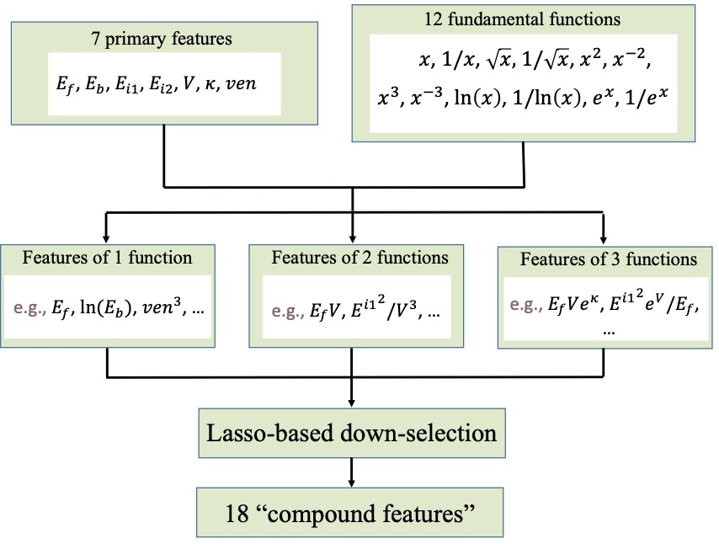
Fig. 1 Detailed workflow of obtaining compound features in the LASSO-LSR model. The x in the 12 fundamental functions is substituted with one of the 7 primary features to form the features of single function. Subsequently, the products of any 2 (or 3) features of single function become the features of 2 (or 3) functions.

The dataset in Table A.1 was then randomly split into a training set (32/43) and a test set (11/43) to develop and evaluate $f(X)$, respectively. In the OLSR and RFR models, the elements of $X$ were directly chosen from the set of the seven primary features in Table 1. While for the training of the LASSO-LSR model, compound features proposed in ref. [13] were generated to explore non-linear explicit functional relationship between $γ_{us2}$ and relevant atomic properties. The detailed work flow of obtaining the compound features of 1, 2 and 3 functions is depicted in Fig. 1 and 18 most relevant ones were down-selected by the LASSO algorithm and then used in a linear LSR model to fit $γ_{us2}$. The feature selection and hyperparameter tuning of the ML models were performed using ExhaustiveFeatureSelector in mlxtend library [28] with 5-fold cross validation. In other words, the training dataset was randomly split into five folds and a model was trained on any four folds to get a training accuracy and validated on the remaining fold to get a cross-validation accuracy. The validation process was then repeated five times until each fold was exactly validated once and the five training/cross-validation accuracies were averaged to produce a single estimation. The accuracies of training and cross-validation results were evaluated by the coefficient of determination (R²) given as:
$$\begin{aligned}R^{2}=1-\frac{\sum_{i=1}^{n}{{\left(y_{i}-{\hat{y}}_{i}\right)}^{2}}}{\sum_{i=1}^{n}{{\left(y_{i}-\overline{y}\right)}^{2}}}\#\left(1\right)\end{aligned}$$
where ${\hat{y}}_{i}$ is the model-predicted $γ_{us2i}$ for each solute $i$, $y_{i}$ is the theoretical $γ_{us2i}$ and $\overline{y}$ is the mean value of $y_{i}$. The value of R² ranges from 0 to 1, with 1 indicating a perfect model. It is noted that the value of R² of training results represents the ability of a model to fit known data, while that of cross-validation results indicates the ability to predict unknown data, that is, model generality. Overfitting occurs in a model if the former approaches 1 and is much higher than the latter. To intuitively understand the error of a model in terms of SFE, the performances of models were additionally assessed using root-mean-square error (RMSE):
$$\begin{aligned}RMSE=\sqrt{\frac{1}{n}\sum_{i=1}^{n}{{\left(y_{i}-{\hat{y}}_{i}\right)}^{2}}}\#\left(2\right)\end{aligned}$$
The smaller the RMSE is, the better the model performance is. Note that RMSE can only be compared between models using the same dataset.

DFT computations
DFT computations were performed using the Vienna ab-initio simulation package [29]. The Perdew-Burke-Ernzerhof exchange-correlation functional of a generalized gradient approximation [30] was applied with the projector-augmented wave method [31]. An energy cut-off of 300 eV was adopted for all DFT calculations. Monkhorst-Pack scheme [32] was used to sample the Brillouin zone with a grid spacing of approximately 2π×0.03 Å⁻¹. The electronic convergence criterion was set to 10⁻⁵ eV. To compute the generalized SFEs (GSFEs), (0001) slabs containing 48 and 96 atoms were constructed based on 2$×$2$×$12 and 4$×$2$×$12 Mg supercells with a vacuum of 15 Å. The I2 stacking fault structure was constructed by shearing half of the slab layers with a Burgers vector of$1/3[10\overline{1}0]$. The GSFE curves were mapped out via the climbing-image nudged elastic band (CINEB) method [33]. Atomic relaxations in the CINEB method were performed in the direction perpendicular to the glide plane.

Experiments
Tensile tests were performed at the strain rate of 0.001 s⁻¹ and room temperature using a universal testing machine, equipped with an extensometer of 10 mm gauge length. All extruded Mg alloys specimens were in the as-received condition and machined into cylindrical dog-bone shape according to ASTM-E8-04 standard with a reduced section length of 20 mm and a gauge diameter of 2.5 mm. The loading axis was parallel to the extrusion direction (ED).
Electron backscattered diffraction (EBSD) mapping was conducted on the ED plane of the specimens at 20 kV in a Zeiss Sigma 300 microscope equipped with HKL Channel 5 software (Oxford Instruments). After mechanical grinding, the EBSD samples were electro-polished using a solution of 10% perchloric acid and 90% ethanol (vol.%) at 30 V and at 238 K. For each map, a step size of 0.5 μm was selected. The fractions of twin boundaries were calculated by the HKL Channel 5 software. The boundaries with misorientations of 86.3°, 56.2° and 37.5° around $〈11\overline{2}0〉$ axis were identified and denoted as $\left\{10\overline{1}2\right\}$ extension, $\left\{10\overline{1}1\right\}$ contraction and $\left\{10\overline{1}1\right\}$-$\left\{10\overline{1}2\right\}$ double twin boundaries, respectively. The tolerance was set to be 5°. Pole figures and twin area fractions were obtained using ATEX software [34].
Dislocation substructures were observed by employing a Tecnai G2 20 transmission electron microscopy (TEM) (FEI Company) at 200 kV. TEM samples were prepared by ion milling. To quantify the density of dislocations at a bulk level, the general purpose powder diffractometer (GPPD) [35] at the China Spallation Neutron Source (CSNS) was used to conduct neutron diffraction experiments on the entire gauge volumes of the specimens before and after tensile testing. The 90° detector bank with fine radial collimator was chosen to collect the time-of-flight neutron data.

Results

Model performance
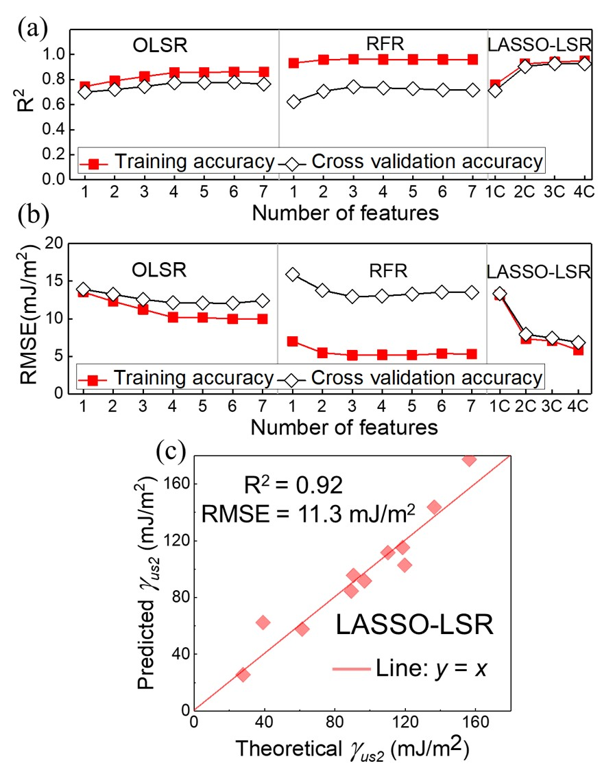
Fig. 2 (a) R² and (b) RMSE of the ML models using the best performing Ω-dimensional feature vectors on the training dataset with cross validation. The Ω ranges from 1 to 7 in the OLSR and RFR models. The compound features in the LASSO-LSR model are represented as ΩC, where Ω varies from 1 to 18 and only the first four results are given. (c) Performance of the final LASSO-LSR model on the test dataset. The predicted values of $γ_{us2}$ are plotted against the theoretical counterparts calculated by DFT. R² and RMSE values are given. The line y = x is shown to illustrate the deviation from the perfect predictions.

Applying the present three ML models to the training dataset, the variations of R² and RMSE with the number of features Ω are illustrated in Fig. 2a and 2b. For each choice of Ω, all the possibilities were considered and only the results of the best performing Ω-dimensional subset are shown in the figure. For each ML model, the best selection of features contributing to $γ_{us2}$ needs to strike a balance between accuracy and number of features. It can be seen that for the OLSR, RFR and LASSO-LSR models, R² reaches a saturated value with RMSE decreasing to a small value at Ω = 4, Ω = 3 and Ω = 2, respectively. In addition, the corresponding best subsets of features in the three models are $(V, κ, E_{i2}, E_{b})$, $(V, κ, E_{i2})$ and $(κV^{4}, \frac{κ^{2}V^{2}}{E_{i1}})$, respectively. In fact, LASSO-LSR is an advanced version of OLSR and allows the determination of non-linear functional form. With compound features, the LASSO-LSR model brings a significant improvement to both the training and validation accuracies compared with the OLSR model (Fig. 2a and 2b). For the two models, it is evident that the training and validation accuracies converge towards a specific value, indicating that the poor performance of OLSR is inherent in the methodology and independent of the number of training data. As the basal SFEs are not linearly correlated to the properties of solutes, the non-linear RFR and LASSO-LSR models were compared. From Fig. 2a and 2b, it is found that the model generality of the RFR model is much worse than that of the LASSO-LSR model since the former has high training accuracy (R² = 0.97 and RMSE = 5.3 mJ/m²) and low validation accuracy (R² = 0.78 and RMSE = 12.5 mJ/m²). Since the use of compound features improves the performance of OLSR model, compound features were also applied in the RFR model to verify whether the overfitting can be mitigated. It turns out that the improvement compound features bring to the RFR model is trivial and the problem of overfitting still remains (see Fig. A.1 in Appendix). In this case, adding more training data is likely to increase the validation accuracy to approach the high training accuracy and solve the problem of overfitting. However, the SFE values of most binary Mg alloy systems have already been gathered in this work and those related to ternary or higher-order systems were rarely studied comprehensively because the search space is too large to be computed exhaustively. Another advantage of the LASSO-LSR model over the RFR model is that the former can provide an explicit non-linear functional form and the latter is more like a black box. Therefore, the LASSO-LSR model is the best performing one and well encapsulates the effect of alloying elements on the SFEs using two compound features, $κV^{4}$ and $\frac{V^{2}κ^{2}}{E_{i1}}$, in spite of the small dataset. Accordingly, the LASSO-LSR model was chosen to predict the SFEs of Mg alloy systems and can be expressed as an explicit function as $γ_{us2}=c_{0}+c_{1}\frac{V^{2}κ^{2}}{E_{i1}}+c_{2}κV^{4}$, where $c_{0}$ is the intercept and $c_{1}$ and $c_{2}$ are the coefficients. After fitting the function to all data in the training set by LSR, the values of $c_{0}$, $c_{1}$ and $c_{2}$ were determined to achieve the smallest error and the final LASSO-LSR model can be written as:
$$\begin{aligned}γ_{us2}=87.8+0.0025\frac{V^{2}κ^{2}}{E_{i1}}-6×{10}^{-7}κV^{4}\#\left(3\right)\end{aligned}$$
Note that Eq. (3) is an empirical relationship formula and $γ_{us2}$, $V$, $κ$ and $E_{i1}$ are specified in the units of mJ/m², Å³/atom, GPa and mJ/mol, respectively. The final LASSO-LSR model, Eq. (3), was then applied to the test dataset and the comparison of the model-predicted and DFT-computed values is presented in Fig. 2c. Note that the test dataset was not involved in the previous training process. In other words, the tested Mg alloy systems were completely unknown to the model. The high R² value of about 0.92 in Fig. 2c shows that model is generalizable and has broad applicability.
Eq. (3) was first employed to predict the values of $γ_{us2}$ of the remaining binary Mg alloy systems with the addition of Sb, Ba and 12 RE elements (Ce, Pr, Nd, Eu, Gd, Tb, Dy, Ho, Er, Tm, Yb and Lu), as summarized in Table A.2. The results demonstrate that the additions of the 12 RE elements can effectively decrease $γ_{us2}$, which is consistent with the previous findings in the literature. To accelerate the design of complex multi-component Mg alloy systems with desired performance, Eq. (3) was extended to ternary Mg alloy systems. Similar to ref. [11], by assuming that the solutes have equal atomic fractions, the feature parameters (i.e., $V$, $κ$ and $E_{i1}$) of each studied solute pair were obtained by averaging the feature values of the two solutes. Note that the chemical elements insoluble in Mg matrix [36] were not taken into consideration. After removing those elements, the $γ_{us2}$ values of 300 ternary Mg alloy systems consisting of only non-RE elements (Li, Al, Ca, Mn, Co, Ni, Cu, Zn, Ga, Sr, Zr, Pd, Ag, Cd, In, Sn, Ir, Pt, Au, Hg, Tl, Pb, Bi, Sb and Ba) were determined. Table A.3 lists 83 non-RE solute pairs, which are promising to decrease the $γ_{us2}$ value of pure Mg by more than 10. It is evident that the solute pairs containing Ba or Sr are extremely effective in reducing $γ_{us2}$. Unfortunately, the solid solubilities of Ba and Sr in Mg are too small (~0.01 wt.% Ba [37] and <0.11 wt.% Sr [38]). Therefore, six promising non-RE solute pairs without Ba and Sr were selected and presented in Table 2.
Table 2. Six promising solute pairs predicted by the LASSO-LSR model and verified by DFT.
Solutes | Predicted $γ_{us2}$ | DFT-computed $γ_{us2}$
Solutes | (mJ/m²) | (mJ/m²)
Ca, Bi | 55.8 | 54.0
Ca, Sb | 61.6 | 54.4
Ca, Zr | 62.9 | 81.4
Ca, Sn | 63.9 | 60.9
Bi, Sb | 68.8 | 61.2
Sn, Bi | 72.2 | 67.1

DFT validation
To verify the reliability of Eq. (3) and corresponding predicted results, DFT computations similar to those carried out in ref. [23], from which the training data were obtained, were performed. Fig. 3a and 3b illustrate the perfect and I2 stacking fault atomic structures of a binary Mg alloy system. It can be seen that a 48-atom supercell 2$×$2$×$12 (Mg47-X) was used, in which there are 47 Mg atoms and one solute X, corresponding to a solute concentration of about 2.08 at.%. The $γ_{us2}$ values of binary Mg alloy systems with the additions of Al, K, Tc, Ir, Pt, Bi and Ca were calculated and the results agree well with those in ref. [23]. Subsequently, to simulate the additions of solute pairs in Table 2, a 96-atom supercell 4$×$2$×$12 (Mg94-X1-X2) was constructed by expanding the computational cell in Fig. 3a by 211, in which there are 94 Mg atoms, one solute X1 and one solute X2, corresponding to an equal concentration of about 1.04 at.% for both solutes. In other words, the former shows a periodic configuration of the latter, including the position of solute atom. Fig. 3c and 3d present the perfect and I2 stacking fault atomic configurations of a ternary Mg alloy system. Considering the fact that the DFT calculations were performed under periodic boundary conditions, the selected configuration ensures that when the two solute atoms X1 and X2 are of the same element, the SFE results of ternary systems are consistent with binary ones. Besides, exchanging the positions of two different solute atoms in current configuration makes no difference to the SFE results. As a result, the values of $γ_{us2}$ can be found at the saddle points of the GSFE curves in Fig. 3e and are summarized in Table 2. For the six studied ternary Mg alloy systems, it turns out that the ML-predicted results are very close to the DFT-computed ones with prediction errors ranging from about 3% to 13%, except Mg-Zr-Ca system. Among the candidates that are indeed effective in lowering $γ_{us2}$, Mg-Bi-Ca and Mg-Sn-Ca systems were reported to be ductile [39, 40]. Mg-Bi-Sn system was also developed for the investigation of corrosion behavior [41]. Only Mg-Sb-Ca and Mg-Bi-Sb systems were not explored in the literature. Therefore, the two new alloy systems were fabricated and investigated to experimentally validate the applicability of the ML-generated screening criterion, Eq. (3).
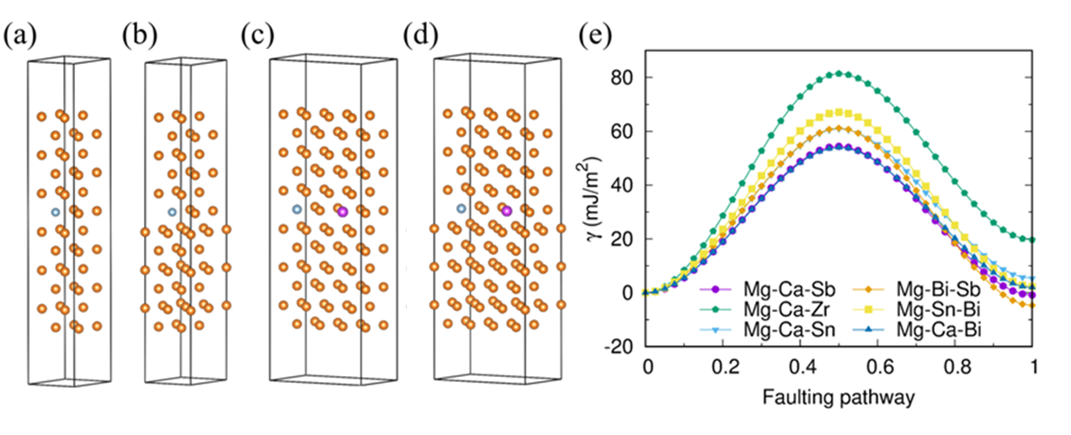
Fig. 3 Schematic of atomic configurations of (a, c) perfect and (b, d) I2 faulted (0001) slabs. Blue atoms in (a-d), and pink atoms in (c) and (d) represent solute atoms. (e) GSFE curves along the faulting pathway from (c) to (d).

Experimental validation
The additions of Ca, Bi and Sb in various Mg alloys have been investigated in the literature and corresponding experimental results were referred to determine the complex compositions of unexplored Mg-Sb-Ca and Mg-Bi-Sb alloys. It is noted that excess Ca is detrimental to ductility because of the formation of hard and brittle Ca-containing phase precipitates, which tends to cause the brittle failure of Mg alloys [12, 42-45]. By contrast, the increasing content of Bi (0.5-3 wt.% and 2-8 wt.%) or Sb (0.3-1.5 wt.% and 2-8 wt.%) made a relatively small difference in the elongation of Mg alloys [46-49] and no ductile-to-brittle transition was reported. Therefore, the composition design of Mg-Sb-Ca and Mg-Bi-Sb alloys depended on selecting the Ca content. Some studies reported that the optimal Ca content is around 0.6-0.7 wt.% [43-45] and the others claimed that it is below 0.3 wt.% [12, 42]. The nominal complex compositions of novel Mg alloys were then initially designed as Mg-2Sb-0.6Ca (wt.%) (Mg-0.4Sb-0.37Ca (at.%)), Mg-3Bi-2Sb (wt.%) (Mg-0.4Bi-0.4Sb (at.%)) and Mg-2Sb-0.2Ca (wt.%) (Mg-0.4Sb-0.12Ca (at.%)). The former two compositions were selected as the atomic fractions of solutes are almost equal. The last one was selected to decrease the content of Ca according to ref. [12, 42]. As the Mg-2Sb-0.6Ca alloy showed a brittle fracture at a small strain of about 0.03, the Mg-2Sb-0.2Ca and Mg-3Bi-2Sb alloys were presented in this work. Furthermore, the actual compositions of the above-mentioned two alloys are Mg-1.2Sb-0.1Ca (wt.%) (Mg-0.24Sb-0.06Ca (at.%)) and Mg-2.6Bi-1.4Sb (wt.%) (Mg-0.31Bi-0.29Sb (at.%)), respectively. The two novel RE-elements free Mg alloys were fabricated by extrusion and no further thermomechanical processing and heat treatments were conducted. Fig. 4 presents the tensile engineering stress-strain curves, EBSD inverse pole figure (IPF) maps and pole figures of the as-received alloys. They both exhibit a typical microstructure of an extruded Mg alloy, in which the c-axes of grains are aligned approximately perpendicular to the ED. Besides, they have similar yield strengths of about 230 MPa, ultimate tensile strengths of about 258 MPa and total elongations of 0.085 to 0.09. Subsequently, one of them, the Mg-1.2Sb-0.1Ca alloy, was studied as an example to see whether the density of $〈c+a〉$ dislocations is high.
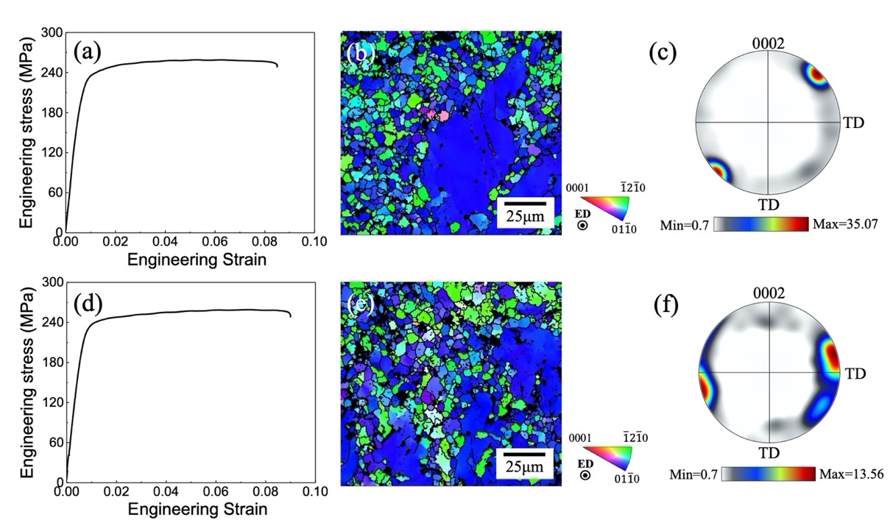
Fig. 4 Tensile engineering stress-strain curves at the strain rate of 0.001 s⁻¹, EBSD IPF maps and pole figures of the selected (a-c) Mg-1.2Sb-0.1Ca and (d-f) Mg-2.6Bi-1.4Sb samples. TD: transverse direction. The tensile direction was parallel to the ED.

To quantify the dislocation densities of the present alloy before and after tensile deformation, neutron diffraction experiments were carried out. The diffraction data were analyzed by following the same procedure introduced in ref. [50]. A number of plots for evaluating the data of undeformed specimen are presented below as an example. Fig. 5a shows that the measured neutron diffraction profile was well fitted by the pseudo-Voigt function [51]. The full width at half-maximum $∆K$ of eleven peaks, including (10.0), (00.2), (10.1), (10.2), (11.0), (10.3), (11.2), (20.1), (00.4), (20.2) and (10.4), were extracted to obtain the modified Williamson-Hall (MWH) plot [52, 53] in Fig. 5b, where $α$ is related to the averaged crystallite size and $x$ is a constant for each {hk.l} reflection. Subsequently, the values of anisotropy parameters ${q_{1}}^{(m)}$ and ${q_{2}}^{(m)}$ were derived from the MWH plot and compared with corresponding theoretical values according to the b2c procedure [54] to determine the possible fractions of $〈a〉$, $〈c〉$ and $〈c+a〉$-type dislocations, as demonstrated in Fig. 5c. With the averaged relative fraction of each dislocation type, the modified Warren-Averbach (MWA) plot [55] is given in Fig. 5d to calculate the overall dislocation density. Here, L, $A\left(L\right)$, $\overline{C_{hk.l}}$ and $b$ represent the Fourier length, the Fourier coefficients of the diffraction profile, the averaged contrast factor corresponding to each {hk.l} reflection and the absolute value of Burgers vector, respectively. The calculated dislocation densities of the samples before and after tensile testing are summarized in Fig. 5e. It indicates that with increasing strain up to 0.085, the total dislocation density goes up from 3.4×10¹⁴ m⁻² to 7.0×10¹⁴ m⁻². More importantly, a considerable amount of $〈c+a〉$ dislocations were produced during plastic deformation, accounting for about 28% of the total increase. It is noted that the value is much higher than those in pure Mg (<6%) [56] and an extruded Mg-Al-Sn-Zn alloy (~15%) [50] at room temperature calculated using the same method as this work.
Fig. 6 shows the TEM dark-field images of the sample subjected to tensile testing up to fracture. TEM analysis was conducted to observe the activity of $〈c+a〉$ dislocations based on the $g∙b$ criterion, where $g$ is the diffraction vector and $b$ is the Burgers vector. The criterion states that dislocations are invisible if $g∙b=0$. Therefore, only dislocations with both $〈a〉$-component and $〈c〉$-component are visible under two different diffraction conditions, $g=0002$ and $g=11\overline{2}0$, simultaneously. As the red arrows in Fig. 6 indicate, $〈c+a〉$ dislocations were frequently observed in the present sample. The EBSD IPF maps of the same sample are depicted in Fig. A.2a and A.2c. Deformation twins were found and the twinned area fraction is approximately between 11.3% and 14.0%. The twin boundaries, which occupy about 10% of the grain boundaries, were identified according to the twin/matrix misorientations, as shown in Fig. A.2b and A.2d. It is obvious that most of the deformation twins are extension type.
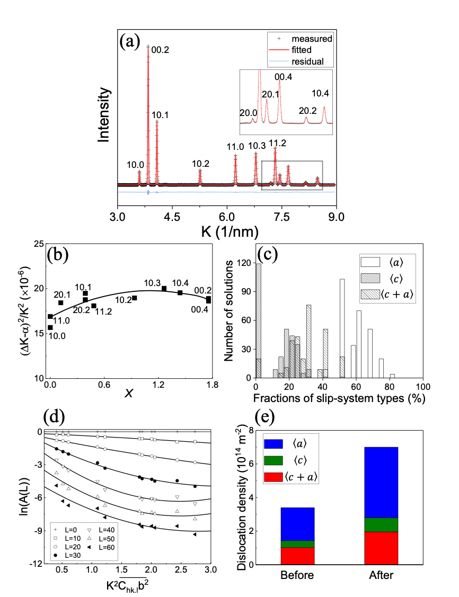
Fig. 5 (a) The measured and fitted neutron diffraction profiles of undeformed Mg-1.2Sb-0.1Ca sample. All the diffraction peaks are indexed according to the hexagonal close-packed structure of Mg. K is the reciprocal space variable. (b) The MWH plot, (c) a typical histogram of the frequency distribution of possible fractions of $〈a〉$, $〈c〉$ and $〈c+a〉$ dislocation types and (d) the MWA plot obtained from the diffraction profile in (a). (e) The respective contributions of $〈a〉$, $〈c〉$ and $〈c+a〉$ dislocation densities to the total dislocation densities of the Mg-1.2Sb-0.1Ca samples before and after tensile testing.

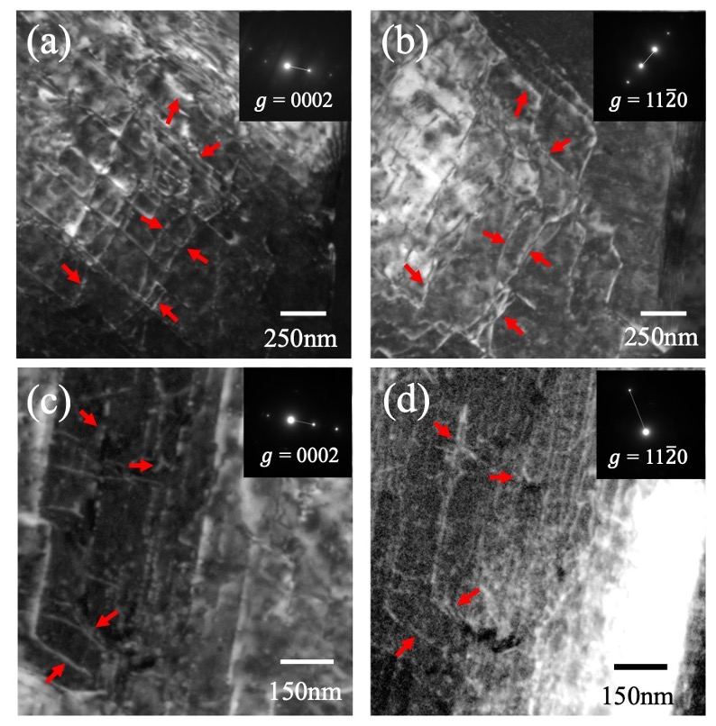
Fig. 6 TEM dark-field images of the Mg-1.2Sb-0.1Ca sample after tensile testing under two different two-beam conditions, (a, c) $g$ = 0002 and (b, d) $g$ = 11$\overline{2}$0. The same area is shown under different two-beam conditions and the same positions in the micrographs are indicated by red arrows.

Discussions
It should be noted that the value of $γ_{us2}$ considered in this work simplifies the following thermodynamic aspects. First, the DFT calculations were performed at 0 K. Second, the doping concentrations in the doping plane and entire Mg alloy system (both binary and ternary) were fixed to be 25.0 at.% and 2.08 at.%, respectively. Third, the solutes were only placed in the layer near the fault plane. As a consequence, $γ_{us2}$ here is only served as a nominal indicator to help researchers to capture the tendency of basal SFEs of Mg alloys with the additions of different solutes. Besides, if the data associated with more complex atomic configurations are obtained through laborious ab-initio calculations, the ML procedure proposed in this paper can also be applied to the updated data.
On the basis of the notion that “all models are wrong, but some are useful” [57], three ML methods, including OLSR, RFR and LASSO-LSR, were employed to find the most useful model for estimating the value of $γ_{us2}$ using fundamental atomic properties of alloying elements. The LASSO-LSR approach is superior to other methods (Fig. 2) and was employed to generate an empirical relationship formula (Eq. (3)) to rapidly predict the basal SFE $γ_{us2}$ and guide the design of multi-component RE-elements free Mg alloys with high $〈c+a〉$ dislocation density. Surprisingly, the constant term (87.8) in Eq. (3) is very close to the value of $γ_{us2}$ (89.6) of pure Mg, $γ_{us2}^{Mg}$, and then Eq. (3) can be rewritten as:
$$\begin{aligned}γ_{us2}=γ_{us2}^{Mg}+0.0025\frac{V^{2}κ^{2}}{E_{i1}}-6×{10}^{-7}κV^{4}\#\left(4\right)\end{aligned}$$
Note that Eq. (4) is comparable to the general form of the SFEs of Mg alloys proposed as [10]:
$$\begin{aligned}γ=γ_{Mg}+kc\#\left(5\right)\end{aligned}$$
where $k$ is a solute-dependent constant and $c$ is the solute concentration. The similarity of Eqs. (4) and (5) implies that the LASSO-LSR model unconsciously learns a general rule through the given dataset and attempts to unravel the comprehensive effect of the solute on the change of SFE using an analytical form, $0.0025\frac{V^{2}κ^{2}}{E_{i1}}-6×{10}^{-7}κV^{4}$. Assuming that the material properties of a solute pair mixed in an equiatomic fraction can be represented by averaging the material parameters of the two solutes, Eq. (3) was applied to the investigation of 300 RE-elements free ternary Mg alloy systems. Out of them, the predicted results of six promising solute pairs were verified computationally by DFT (Fig. 3c-e) and five out of the six model-predicted values are quite close to the DFT-computed counterparts (Table 2), indicating that the ML-generated Eq. (3) has good applicability and is effective and efficient to perform the given task.
Furthermore, two novel alloys with high $〈c+a〉$ dislocation density were fabricated out of the selected non-RE solute pairs (Sb, Ca) and (Bi, Sb) (Table 2), experimentally verifying the validity of the simple design rule, Eq. (3). The high density of $〈c+a〉$ dislocations in the discovered novel alloy was supported by three evidences. First, the neutron diffraction results in Fig. 5e demonstrate that the fraction of $〈c+a〉$ dislocations remains about 28% during plastic deformation, far exceeding the values in the literature. Second, the TEM images under two diffraction conditions in Fig. 6 indeed illustrate that the dislocations with $〈c+a〉$ Burgers vector were frequently observed in the specimen. The third evidence is an indirect one. It is known that the slip systems with $〈a〉$ Burgers vector cannot accommodate c-axis strain in Mg alloys so that either deformation twinning or $〈c+a〉$ slip is required to provide additional deformation modes. In the studied alloy, since the c-axes of almost all grains are aligned nearly perpendicular to the tensile loading direction (Fig. 4), deformation twinning is not favorable and the contribution of deformation twins to plastic strain is minimized. From Fig. A.2, the volume fraction of deformation twins at fracture strain (~0.085) is only about 11.3% to 14% and the contraction type twins can be neglected. It was reported that the maximum tensile strain produced by extension twinning is about 0.067 in a fully twinned Mg single crystal [58] and the twinning strain is proportional to the volume fraction of twins in general. Accordingly, the plastic strain accommodated by twinning in the alloy is estimated to be less than 0.01, which is insignificant compared with the total elongation of about 0.085. Therefore, a considerable amount of $〈c+a〉$ dislocations were expected to be activated, otherwise the premature fracture of the specimen would take place. Taking into account the above-mentioned three evidences, the utility of the Eq. (3) in discovering multi-component Mg alloys with low SFEs and high $〈c+a〉$ dislocation density was demonstrated experimentally.

Conclusions
In conclusion, an ML model for a fast initial screening of non-RE solutes was established to assist the development of ductile RE-elements free Mg alloys. Empowered by compound features, the LASSO-LSR method was able to generate an explicit functional form from previous DFT results to account for the non-linear relationship between the basal SFEs and the identified intrinsic characteristics of alloying elements (i.e., $V$, $κ$ and $E_{i1}$). The capability of the LASSO-LSR model to screen promising combinations of non-RE solutes for low-SFE ternary Mg alloy systems was validated by DFT calculations and experimental fabrications of two previously unreported compositions. The good performance and generality of the prediction model enlighten the rapid and accurate solute selection of ductile multi-component RE-elements free Mg alloys. Moreover, the proposed ML procedure allows the researchers to discover succinct functional forms when solving other non-linear problems in materials science.

Data availability
The data that support the findings of this study are available within the paper and supplemental file. Also, the data that support the plots and other findings of this study are available from the corresponding author upon reasonable request.

Acknowledgments
M.X.H. acknowledges the support from National Key Research and Development Program of China (No. 2019YFA0209900), National Natural Science Foundation of China (No. U1764252), Research Grants Council of Hong Kong (No. R7066-18, 17255016, 17210418). L.H. He is acknowledged for her help on the neutron powder diffraction experiments which were performed at GPPD of the China Spallation Neutron Source (CSNS), Dongguan, China.

References
[1] M. Yoo, Slip, twinning, and fracture in hexagonal close-packed metals, Metallurgical Transactions A 12(3) (1981) 409-418.
[2] M. Yoo, S. Agnew, J. Morris, K. Ho, Non-basal slip systems in HCP metals and alloys: source mechanisms, Mater. Sci. Eng. A 319 (2001) 87-92.
[3] Y. Chino, M. Kado, M. Mabuchi, Enhancement of tensile ductility and stretch formability of magnesium by addition of 0.2wt%(0.035at%)Ce, Mater. Sci. Eng. A 494(1) (2008) 343-349.
[4] R.K. Mishra, A.K. Gupta, P.R. Rao, A.K. Sachdev, A.M. Kumar, A.A. Luo, Influence of cerium on the texture and ductility of magnesium extrusions, Scr. Mater. 59(5) (2008) 562-565.
[5] S. Sandlöbes, S. Zaefferer, I. Schestakow, S. Yi, R. Gonzalez-Martinez, On the role of non-basal deformation mechanisms for the ductility of Mg and Mg–Y alloys, Acta Mater. 59(2) (2011) 429-439.
[6] S. Sandlöbes, Z. Pei, M. Friák, L.-F. Zhu, F. Wang, S. Zaefferer, D. Raabe, J. Neugebauer, Ductility improvement of Mg alloys by solid solution: Ab initio modeling, synthesis and mechanical properties, Acta Mater. 70 (2014) 92-104.
[7] S. Sandlöbes, M. Friák, S. Zaefferer, A. Dick, S. Yi, D. Letzig, Z. Pei, L.-F. Zhu, J. Neugebauer, D. Raabe, The relation between ductility and stacking fault energies in Mg and Mg–Y alloys, Acta Mater. 60(6-7) (2012) 3011-3021.
[8] S. Agnew, L. Capolungo, C. Calhoun, Connections between the basal I1 “growth” fault and< c+a> dislocations, Acta Mater. 82 (2015) 255-265.
[9] Z. Pei, J. Yin, The relation between two ductility mechanisms for Mg alloys revealed by high-throughput simulations, Materials & Design 186 (2020) 108286.
[10] Z. Wu, R. Ahmad, B. Yin, S. Sandlöbes, W. Curtin, Mechanistic origin and prediction of enhanced ductility in magnesium alloys, Science 359(6374) (2018) 447-452.
[11] Z. Pei, M. Friák, S. Sandlöbes, R. Nazarov, B. Svendsen, D. Raabe, J. Neugebauer, Rapid theory-guided prototyping of ductile Mg alloys: from binary to multi-component materials, New Journal of Physics 17(9) (2015) 093009.
[12] S. Sandlöbes, M. Friák, S. Korte-Kerzel, Z. Pei, J. Neugebauer, D. Raabe, A rare-earth free magnesium alloy with improved intrinsic ductility, Scientific Reports 7 (2017) 10458.
[13] C. Kim, G. Pilania, R. Ramprasad, From organized high-throughput data to phenomenological theory using machine learning: the example of dielectric breakdown, Chem. Mater. 28(5) (2016) 1304-1311.
[14] D. Xue, D. Xue, R. Yuan, Y. Zhou, P.V. Balachandran, X. Ding, J. Sun, T. Lookman, An informatics approach to transformation temperatures of NiTi-based shape memory alloys, Acta Mater. 125 (2017) 532-541.
[15] D. Xue, P.V. Balachandran, J. Hogden, J. Theiler, D. Xue, T. Lookman, Accelerated search for materials with targeted properties by adaptive design, Nat. Commun. 7 (2016) 11241.
[16] D. Xue, P.V. Balachandran, R. Yuan, T. Hu, X. Qian, E.R. Dougherty, T. Lookman, Accelerated search for BaTiO3-based piezoelectrics with vertical morphotropic phase boundary using Bayesian learning, Proceedings of the National Academy of Sciences 113(47) (2016) 13301-13306.
[17] M. Fernandez, P.G. Boyd, T.D. Daff, M.Z. Aghaji, T.K. Woo, Rapid and accurate machine learning recognition of high performing metal organic frameworks for CO2 capture, The journal of physical chemistry letters 5(17) (2014) 3056-3060.
[18] K. Kaufmann, D. Maryanovsky, W.M. Mellor, C. Zhu, A.S. Rosengarten, T.J. Harrington, C. Oses, C. Toher, S. Curtarolo, K.S. Vecchio, Discovery of high-entropy ceramics via machine learning, Npj Computational Materials 6 (2020) 42.
[19] P. Liu, H. Huang, S. Antonov, C. Wen, D. Xue, H. Chen, L. Li, Q. Feng, T. Omori, Y. Su, Machine learning assisted design of γ′-strengthened Co-base superalloys with multi-performance optimization, npj Computational Materials 6 (2020) 62.
[20] Z. Lu, X. Chen, X. Liu, D. Lin, Y. Wu, Y. Zhang, H. Wang, S. Jiang, H. Li, X. Wang, Z. Lu, Interpretable machine-learning strategy for soft-magnetic property and thermal stability in Fe-based metallic glasses, npj Computational Materials 6 (2020) 187.
[21] Z. Pei, J. Yin, J.A. Hawk, D.E. Alman, M.C. Gao, Machine-learning informed prediction of high-entropy solid solution formation: Beyond the Hume-Rothery rules, npj Computational Materials 6 (2020) 50.
[22] J. Zhang, Y. Dou, G. Liu, Z. Guo, First-principles study of stacking fault energies in Mg-based binary alloys, Computational Materials Science 79 (2013) 564-569.
[23] Q. Dong, Z. Luo, H. Zhu, L. Wang, T. Ying, Z. Jin, D. Li, W. Ding, X. Zeng, Basal-plane stacking-fault energies of Mg alloys: A first-principles study of metallic alloying effects, Journal of Materials Science & Technology 34(10) (2018) 1773-1780.
[24] C. Wang, H.-Y. Zhang, H.-Y. Wang, G.-J. Liu, Q.-C. Jiang, Effects of doping atoms on the generalized stacking-fault energies of Mg alloys from first-principles calculations, Scr. Mater. 69(6) (2013) 445-448.
[25] X.-Y. Cui, H.-W. Yen, S.-Q. Zhu, R. Zheng, S.P. Ringer, On the universality of Suzuki segregation in binary Mg alloys from first principles, J. Alloys Compd. 620 (2015) 38-41.
[26] D. Hull, D.J. Bacon, Introduction to dislocations, Butterworth-Heinemann2001.
[27] F. Pedregosa, G. Varoquaux, A. Gramfort, V. Michel, B. Thirion, O. Grisel, M. Blondel, P. Prettenhofer, R. Weiss, V. Dubourg, Scikit-learn: Machine learning in Python, the Journal of machine Learning research 12 (2011) 2825-2830.
[28] S. Raschka, MLxtend: providing machine learning and data science utilities and extensions to Python's scientific computing stack, Journal of open source software 3(24) (2018) 638.
[29] G. Kresse, J. Furthmüller, Efficiency of ab-initio total energy calculations for metals and semiconductors using a plane-wave basis set, Computational Materials Science 6(1) (1996) 15-50.
[30] J.P. Perdew, K. Burke, M. Ernzerhof, Generalized Gradient Approximation Made Simple, Phys. Rev. Lett. 77(18) (1996) 3865-3868.
[31] P.E. Blöchl, Projector augmented-wave method, Physical Review B 50(24) (1994) 17953-17979.
[32] H.J. Monkhorst, J.D. Pack, Special points for Brillouin-zone integrations, Physical review B 13(12) (1976) 5188.
[33] D. Sheppard, R. Terrell, G. Henkelman, Optimization methods for finding minimum energy paths, The Journal of chemical physics 128(13) (2008) 134106.
[34] B. Beausir, J. Fundenberger, Analysis tools for electron and X-ray diffraction, ATEX-software, Université de Lorraine-Metz (2017).
[35] L. He, J. Chen, H. Lu, P. Luo, Y. Wu, L. Kang, J. Zhang, J. Zhang, R. Du, X. Jia, T. Liang, F. Wang, First experimental results from the GPPD diffractometer at the CSNS, Neutron News 29(2) (2018) 7-10.
[36] H.E. Friedrich, B.L. Mordike, Magnesium technology, Springer2006.
[37] A. Nayeb-Hashemi, J. Clark, The Ba− Mg (Barium-Magnesium) system, Bulletin of Alloy Phase Diagrams 7(2) (1986) 144-149.
[38] R. Radha, D. Sreekanth, Insight of magnesium alloys and composites for orthopedic implant applications–a review, Journal of magnesium and alloys 5(3) (2017) 286-312.
[39] G. Hasani, R. Mahmudi, Tensile properties of hot rolled Mg–3Sn–1Ca alloy sheets at elevated temperatures, Materials & Design 32(7) (2011) 3736-3741.
[40] S. Remennik, I. Bartsch, E. Willbold, F. Witte, D. Shechtman, New, fast corroding high ductility Mg–Bi–Ca and Mg–Bi–Si alloys, with no clinically observable gas formation in bone implants, Materials Science and Engineering: B 176(20) (2011) 1653-1659.
[41] W.-l. Cheng, S.-c. Ma, Y. Bai, Z.-q. Cui, H.-x. Wang, Corrosion behavior of Mg-6Bi-2Sn alloy in the simulated body fluid solution: The influence of microstructural characteristics, J. Alloys Compd. 731 (2018) 945-954.
[42] Z.R. Zeng, M.Z. Bian, S.W. Xu, C.H.J. Davies, N. Birbilis, J.F. Nie, Effects of dilute additions of Zn and Ca on ductility of magnesium alloy sheet, Mater. Sci. Eng. A 674 (2016) 459-471.
[43] L. Wang, J. Li, L. Li, K. Nie, J. Zhang, C. Yang, P. Yan, Y. Liu, C. Xu, Microstructure, mechanical and bio-corrosion properties of Mg–Zn–Zr alloys with minor Ca addition, Mater. Sci. Technol. 33(1) (2017) 9-16.
[44] J. Yang, J. Peng, M. Li, E.A. Nyberg, F.-S. Pan, Effects of Ca addition on the mechanical properties and corrosion behavior of ZM21 wrought alloys, Acta Metallurgica Sinica (English Letters) 30(1) (2017) 53-65.
[45] H. Li, S. Qin, C. Yang, Y. Ma, J. Wang, Y. Liu, J. Zhang, Influence of Ca addition on microstructure, mechanical properties and corrosion behavior of Mg-2Zn alloy, China Foundry 15(5) (2018) 363-371.
[46] Y. Guangyin, S. Yangshan, D. Wenjiang, Effects of bismuth and antimony additions on the microstructure and mechanical properties of AZ91 magnesium alloy, Mater. Sci. Eng. A 308(1-2) (2001) 38-44.
[47] C. Ma, F. Pan, D. Zhang, A. Tang, Z. Lu, Effects of Sb Addition on Microstructural Evolution and Mechanical Properties of Mg–9Al–5Sn Alloy, Acta Metallurgica Sinica (English Letters) (2020) 1-11.
[48] H. Yu, S. Fan, S. Meng, J.O. Choi, Z. Li, Y. Go, Y.M. Kim, W. Zhao, B.S. You, K.S. Shin, Microstructural evolution and mechanical properties of binary Mg–xBi (x= 2, 5, and 8 wt%) alloys, Journal of Magnesium and Alloys (2020).
[49] R. Rajeshkumar, J. Jayaraj, A. Srinivasan, U. Pillai, Investigation on the microstructure, mechanical properties and corrosion behavior of Mg-Sb and Mg-Sb-Si alloys, J. Alloys Compd. 691 (2017) 81-88.
[50] M. Wang, X. Xu, H. Wang, L. He, M. Huang, Evolution of dislocation and twin densities in a Mg alloy at quasi-static and high strain rates, Acta Mater. 201 (2020) 102-113.
[51] T.H. De Keijser, J. Langford, E.J. Mittemeijer, A. Vogels, Use of the Voigt function in a single-line method for the analysis of X-ray diffraction line broadening, J. Appl. Crystallogr. 15(3) (1982) 308-314.
[52] I. Dragomir, T. Ungár, Contrast factors of dislocations in the hexagonal crystal system, J. Appl. Crystallogr. 35(5) (2002) 556-564.
[53] T. Ungár, I. Dragomir, Á. Révész, A. Borbély, The contrast factors of dislocations in cubic crystals: the dislocation model of strain anisotropy in practice, J. Appl. Crystallogr. 32(5) (1999) 992-1002.
[54] T. Ungár, O. Castelnau, G. Ribárik, M. Drakopoulos, J.L. Béchade, T. Chauveau, A. Snigirev, I. Snigireva, C. Schroer, B. Bacroix, Grain to grain slip activity in plastically deformed Zr determined by X-ray micro-diffraction line profile analysis, Acta Mater. 55(3) (2007) 1117-1127.
[55] T. Ungár, J. Gubicza, G. Ribárik, A. Borbély, Crystallite size distribution and dislocation structure determined by diffraction profile analysis: principles and practical application to cubic and hexagonal crystals, J. Appl. Crystallogr. 34(3) (2001) 298-310.
[56] K. Máthis, K. Nyilas, A. Axt, I. Dragomir-Cernatescu, T. Ungár, P. Lukáč, The evolution of non-basal dislocations as a function of deformation temperature in pure magnesium determined by X-ray diffraction, Acta Mater. 52(10) (2004) 2889-2894.
[57] G.E. Box, N.R. Draper, Empirical model-building and response surfaces, John Wiley & Sons1987.
[58] P. Chen, B. Li, D. Culbertson, Y. Jiang, Contribution of extension twinning to plastic strain at low stress stage deformation of a Mg-3Al-1Zn alloy, Mater. Sci. Eng. A 709 (2018) 40-45.

