The Upside-Down Molding Approach for Geometrical Parameter Tunable Photonic Perovskite Nanostructures
Lebin Nie, Wai Kit Ng, ZhiFu Liang, Xingang Ren, Tingbin Yang, Guanding Mei, Chi Wah Leung, Kam Sing Wong,* Wallace C.H. Choy*

Lebin Nie, ZhiFu Liang, Guanding Mei, Prof. Wallace C.H. Choy
Department of Electrical and Electronic Engineering
The University of Hong Kong
Pokfulam Road, Hong Kong, SAR, China
E-mail: chchoy@eee.hku.hk
Wai Kit Ng, Prof. Kam Sing Wong,
Department of Physics and and William Mong Institute of Nano Science and Technology
The Hong Kong University of Science and Technology
Clear Way Bay, Hong Kong, SAR, China
Dr. Xingang Ren
Key Laboratory of Intelligent Computing & Signal Processing
Anhui University, Hefei, China
Dr. Tingbin Yang
Core Research Facilities
Southern University of Science and Technology, Shenzhen, China
Prof. Chi Wah Leung
Department of Applied Physics
The Hong Kong Polytechnic University
Hung Hom, Kowloon, Hong Kong, SAR, China
KEYWORDS: Upside-down method, Room-temperature nanoimprint, Capillary force, Geometric parameter regulation, Distributed feedback lasers
ABSTRACT: Considering that the periodic photonic nanostructures are commonly realized by expensive nano-fabrication processes and the tunability of structure parameters is limited and complicated, we demonstrate a solution-processed upside-down molding method to fabricate photonic resonators on perovskites with a certain extent controllable pattern geometry. This upside-down approach not only reveals the effect of capillary force during the imprinting, but also can control the waveguide layer thickness due to the inversion of the perovskite membranes.
Introduction
The precisely designed photonic crystal structure has been proved to improve the optical properties of semiconductors such as III-V compound semiconductors for device applications, including enhancing light absorption in solar cells^{1,2} and photodetectors,³ improving light emission in LEDs,^{4,5} and providing feedback in distributed feedback (DFB) laser devices.^{6–8} However, conventional non-solution nanoimprint lithography (NIL) including hot embossing, thermoplastic, or UV-based nanoimprint involves time-consuming and cumbersome processes under extreme conditions like high temperature and pressure.⁹ For instance, in a typical thermoplastic NIL, the imprint resist polymer should be heated above the glass transition temperature (up to 200℃) and the pattern is pressed into the soft polymer under a pressure of 13 MPa.¹⁰ Therefore, it is highly desirable to realize the high-performance optical nano-resonators by simple room-temperature solution process, and to address the ever-demanding low-cost and efficient optoelectronic devices.

Lead halide perovskite has attracted extensive attention from worldwide researchers owing to its advantages of high quantum efficiency,¹¹ bandgap tunability,¹² large absorption coefficient^{13,14}, and solution processability.^{15,16} Compared with fast progress on the planar perovskite thin-film in optoelectronic devices,^{17,18,19} the periodically structured perovskites are less reported because of the complicated fabrication procedures and poor controllability. It is a potential alternative to boost the performance of devices by endowing the planar perovskite film with a specific photonic nanostructure. One method is directly imprinting patterns on solid perovskite films or gels through rigid or soft stamps, respectively. Nevertheless, for rigid stamps used in hot embossing,^{20–22} such as silicon chips patterned by electron-beam lithography or photolithography, there are concerns about the risk of damaging the costly and fragile molds under such high-pressure up to 100 bar. On the other hand, applying soft stamps like polydimethylsiloxane (PDMS) membrane^{23,24} on the top of the perovskite gel with direct compression would easily lead to nanostripes, with substrate exposed at some parts. Besides, the direct pattern on perovskites by electron-beam lithography²⁵ or laser beams²⁶ instead of utilizing as-prepared stamps would give rise to unexpected adverse effects to the crystallization quality and homogeneity, because of the poor tolerance of the perovskites to heat and high-energy particle. The other indirect approach is to deposit perovskites polycrystalline film on patterned substrates like quartz glass,²⁷ silicon wafers,²⁸ and Si₃N₄²⁹, or even biomaterials³⁰ by evaporation or spin coating methods. However, the patterned substrates, which are fabricated with complicated and expensive processes, serve as the component of the device and thus are one-off, leading to high-cost of perovskite-based devices and limitation of the substrates. Recently, the periodical perovskite nanostripes based on reusable and low-cost PDMS membrane by feasible phase transition with the assistance of methylamine (MA) gas and annealing treatment has been reported.³¹ However, this kind of nanostripes can hardly serve as the integrated optical resonators due to high energy loss in the active layer in photovoltaic or light-emitting devices, as exposed substrates part could lead to severe current leakage.^{32–34} Moreover, the annealing treatment is not adaptable for some temperature-sensitive flexible substrates and electronic components. Consequently, realizing an integrated perovskite nano-resonator fabricated by a facile room-temperature solution process is still a challenge. The further developments on perovskite nanostripes integrated waveguide structures with facile processing methods are of significance for extending the applications in optoelectronic devices.

Here, we demonstrate a solution-processed upside-down approach to fabricate photonic resonators with a certain range of controllable pattern geometry and waveguide thickness. We propose an approach of upside-down molding method by simply attaching desired nanopattern templates onto the flipped over perovskite film to avoid possible templates-substrate direct contact due to the weight of templates when the perovskite membranes are upward placed. This approach not only reveals the effect of the capillary force to make the gel penetrate into the nanoscale troughs of the template pattern, but also can control the thickness of the waveguide layer because of the inversion of the perovskites membranes. Besides, we take full advantage of methylamine induced phase transition and anti-solvent-vapor-assisted method to optimize the crystal quality of our perovskite resonators. Finally, after simply optimizing the crystal quality and geometrical parameters of our perovskite resonators, we demonstrate that the patterned perovskites can achieve remarkable lasing emission with a threshold of 15.3 μJ/cm² and linewidth of 0.52 nm at 782.9 nm. This work contributes an approach to realize controllable periodic perovskite nanostructures for emerging optoelectronic applications.
Results and Discussion
Controllable periodic nanostructures
Our upside-down molding method is suitable for general perovskite gels and precursors according to the mechanism. Here, considering the gels prepared by methylamine treatment boost excellent high-quality-film-forming ability,^{35,36} we take the methylamine induced gels as an example to show the whole process. The schematic procedures are shown in Figure. 1 A soft PDMS stamp with the periodic pattern was covered on top of the as-prepared MAPbI₃ perovskite film (Figure. 1 a and b). Different from the conventional imprinting method that the perovskite membranes are upward placed, we performed an upside-down process by reversing the substrate and keeping the PDMS-covered area suspended in mid-air (Figure. 1 c). Then, we adopted a volatile amine gas, methylamine (MA), to transform the raw perovskite film from solid state to liquid phase perovskite gel (MAPbI₃⋅xCH₃NH₂) at ultrafast speed (Figure. 1 d).³⁷ The proposed upside-down approach resorts to the capillary force to make the perovskite gel permeated into the narrow grooves of the soft stamp in dozens of seconds (Figure. 1 e). Besides, we can tune the thickness of the waveguide layer by changing the precursor concentration accordingly. This merit is unique to our method as no pressure is imposed. During the whole imprinting process, only a downward pulling force (stretching force) from the template’s weight is exerted on the perovskite gel, which, however, is balanced by the physical adhesion force between the perovskite gel and the template. The amount of gel is well retained to form the waveguide layer with different thickness instead of being squeezed away by the external force (downward extrusion force) in the conventional imprint method. Typically, after removing the organic amine gases, the transparent gel would return to dark brown solid perovskites at ultrafast speed without further treatment. However, when the soft stamp covers the perovskite gel, the release of the gases would be hindered and may lead to a transition in the crystal structure, as the recrystallization process will be prolonged to around 1 hour. The transparent perovskite gels attached by stamps turn light brown rather than pristine dark brown after such a long recrystallization time. The prolonged recrystallization will lead to worse surface morphology and decrease in photoluminescence. More detail would be discussed later down below. Here, we propose to introduce dichloromethane (DCM) vapor treatment to accelerate the recrystallization under room temperature (Figure. 1 f).

DCM is a kind of volatile non-polar solvent and often used as an anti-solvent vapor for the growth of bulk perovskite crystals^{38,39} and single crystal membranes.⁴⁰ Here, liquid antisolvent like chlorobenzene cannot work due to the soft membrane blocking. So, the volatile DCM was chosen to act as gaseous antisolvent. After the perovskite gel permeated into the groove of the soft stamp, we introduced DCM vapor into the container, as shown in Figure. S1 The PDMS covered perovskite gels were rapidly saturated and crystallized along with the diffusion of gaseous DCM. The transparent perovskite gel then turned dark brown from the edge to the middle of the stamp along with the DCM vapor’s diffusion. The recrystallization process would decrease from around 1 hour (room-temperature volatilization) to 10-20 minutes. It is of great significance to optimize the fabrication process to be conducted in a mild environment for various application scenarios. Besides, the room-temperature solution-based fabrication approach would offer low energy consumption and low-cost processes. Finally, after removing the hydrophobic soft stamp (Figure. 1 g), a waveguide integrated nanostructure without any exposed part was achieved for functioning optoelectronic device such as the representative device of photonic resonators. Figure. S2 shows the optical image of patterned and pristine perovskite films.

The upside-down method is the unique technique to form continuous optical waveguide structures and various patterns simultaneously. As shown in Figure. S3, we also imprinted the perovskites film using the conventional downwards method (the membranes are upward placed during imprinting) as a comparison. For the formation of the waveguide layer, when the soft stamp is on top of the perovskite gel in the conventional downward imprint process,^{23,24,31} the weight of the soft stamp or the extrinsic press through mechanical extrusion is the major contributor of imprinting patterns. However, these forces imposed on the liquid gel would easily lead to template-substrate direct contact, which is the main cause of the exposed substrates part especially when the pristine film is thin. In contrast, the template-covered perovskite film is inverted in our method. The van der Waals force between the perovskite and the template is the downward pulling force to the solution perovskite in the process. Such weak but sufficient pulling force allows the formation of the nanopattern and the waveguide layer simultaneously. As a result, the gap between the substrate and template can always be filled with perovskite gel and turn into the integrated waveguide structure after recrystallization. The comparison between the mode propagation profiles of the samples with (upside-down molding approach) and without (conventional approach) waveguiding layer are also detailed in Figure. S4 and discussed in Supplementary Note 1. Regarding the pattern formation, the nano- to micron-sized grooves on the soft mold are sufficiently small. The liquid gel is propelled to enter the narrow spaces due to the capillary phenomenon that is the combined effect of surface tension and adhesive forces between the liquid and template.

Our approach applies to various photonic patterns in one or two-dimensional structures. The morphologies of the pristine and patterned perovskite films are shown in Figure. 2 The atomic force microscope (AFM) image in Figure. 2 a show the pristine perovskite film exhibits a polycrystalline morphology with a roughness of 28.60 nm (root-mean-square, RMS). In representative line scans along the direction of perovskite gratings (Figure. 2 b, horizontal solid line c-d), the RMS roughness has greatly decreased from 28.60 nm to merely 3.9 nm after the imprinting process. In most of the optoelectronic devices such as DFB laser, the ultra-smooth semiconductor surface can significantly reduce the lasing threshold, resulting from the minimal light scattering and loss in the waveguide.²² Besides, the RMS deviation of altitude across the grating peaks was only 1.75 nm (Figure. 2 b, vertical dashed line a-b). It indicates the periodic change of effective refractive index across the grating is extremely regular, thus the distributed feedback structure can be precisely favoured to a particular emission mode. Therefore, the DFB laser based on the regular geometric construction pattern with an ultra-smooth surface would exhibit the properties of threshold and excellent monochromaticity. Figure. 2 c displays a two-dimensional dot matrix perovskite pattern. This kind of pattern allows periodic modulation of the refractive index along two directions.⁴¹ Overall, both patterns show excellent regularity that confirms our method would be broadly applicable to different nanopatterns.

Organic amine gases not only can dissolve the solid perovskites like other high boiling point polar solvents, but also can reduce defects in the raw perovskite films through the reversible gas-solid interaction.³⁷ Figure. 2 d shows the scanning electron microscope (SEM) image of the pristine film. The grain boundary is highly obvious. After the imprinting, a dense, smooth-surface perovskite grating emerged (Figure. 2 e). From the cross-sectional SEM images of the patterned perovskites (Figure. 2 f), we confirm that the liquid perovskite gel is always in close contact with the soft template when the substrate was inverted, no cracks or holes are observed from the cross-sectional image.
To understand the thickness of the waveguide on the effect of nanopatterned structure, we fabricated a series of perovskite films with different precursor concentrations (1.0 M, 1.2 M, and 1.4 M). As can be seen from the cross-sectional SEM images (Figure. S5), the teeth of the gratings almost have the same height, while the thickness of the waveguide layer increased with the precursor concentration. The waveguide thicknesses of the gratings made by 1.0 M (Figure. S5 a) and 1.2 M (Figure. S5 b) precursors are around 100 nm and 220 nm respectively, while the waveguide thickness of 1.4 M counterparts is around 500 nm (Figure. S5 c). This is because the amount of liquid gel into the mold grooves is constant under given conditions, hence, the thicker pristine film is resulted from the more perovskite gel between the substrate and the soft membrane.

To obtain a deeper understanding of the capillary phenomenon in grooves formation, we conducted hydrophilic treatment on the soft molds. To be specific, the patterned soft molds were immersed in an aqueous solution of sodium dodecyl benzenesulfonate and then dried in the oven. The increase in surface energy is demonstrated in the smaller contact angle of water droplets on the treated PDMS molds when compared to the pristine membrane, as shown in Figure. S6 The contact angle was decreased from 121.5° to 114.2°, which implies the enhancement of the interaction between the molds and the gel after the treatment. The height profiles from the AFM of relevant perovskite gratings are shown in Figure. 3. a (made from pristine PDMS) and Figure. 3 b (made from treated PDMS). Interestingly, the groove depth increased from 80 nm to 100 nm after treatment. According to Young’s equation (Equation 1):

$γ^{ls}=γ^{s}{+ γ}^{l}cosθ$ (1)

There are three kinds of interfacial energy on the three-phase intersection, including solid–vapor ($γ^{s}$), solid-liquid ($γ^{ls}$) and liquid-vapor ($γ^{l}$) interfacial energy as shown in Figure. 3 c. The hydrophilic treatment increases the solid–vapor ($γ^{s}$) interfacial energy and may lead to better wettability. Therefore, the three-phase intersection would drop, and thus we can achieve perovskite grating with increased grating height. Though the contact angle only decreased by 7.3° after hydrophilic treatment, the perovskite gel has filled the entire grooves as the depth of the soft stamp is just about 100 nm.

Materials optimization
To better analyse the effect of this gas solvent-assisted imprinting process on the structure and quality of the perovskites, we conducted measurement on the photoluminescence (PL) spectrum and time-resolved photoluminescence (TRPL). Note that a planar soft stamp is used in the imprinting process here, to eliminate the effects from grating structure onto the material crystal quality. Figure. 3 d shows that the PL intensities are significantly improved for the samples with amine treatment, no matter it was covered with the soft stamp or not. Typically, grain boundary and pin holes mean more defects/trap states in the perovskite membranes, which would lead to an increase in the non-radiative recombination and weak PL intensity. After the methylamine induced solid–liquid conversion, the cured perovskites membranes show a smooth and dense morphology and the defects/trap states are effectively suppressed. Approximately 4-fold intensity enhancement can be observed from the methylamine healed film and 2.5-fold improvement from the healed film covered by PDMS membrane. It also shows that if amine gases were delayed when discharging from the perovskite gel because of soft membrane blocking, not only the surface morphology would become worse,³¹ but also led to a decrease in PL intensity due to the pin holes as shown in Figure. S7. This is why we need DCM treatment to accelerate recrystallization. Unlike the SEM images with obvious pin holes as shown in Figure. S7 b, the DCM-induced perovskite patterns show smooth and dense surface morphology. Furthermore, the improvement in charge carrier properties was studied through the TRPL (Figure. 3 e). The carrier decay lifetimes of the pristine and imprinted perovskites are 5.47 ns ($τ_{1}=4.35 ns$, 81.74%; $τ_{2}=10.47 ns$, 18.26%) and 12.75 ns ($τ_{1}=7.98 ns$, 23.14%; $τ_{2}=14.18 ns$, 76.86%) respectively, from the bi-exponential fitting. The two components are representing the defect states located at the surface and bulk respectively.³⁹ The doubling in the lifetime from the imprinted film indicates the improvement of crystal quality through the stamping process. Additionally, the even prolonged lifetime of 17.49 ns ($τ_{1}=10.55 ns$, 46.30%; $τ_{2}=23.48 ns$, 53.70%) from the film just after methylamine post-treatment suggested the great reduction of traps and defects in the perovskite. Although the delay of the release in methylamine during post-treatment in the imprinting process would affect the crystal quality, its film quality still shows apparent improvement compared to the pristine film.

We further studied the X-ray diffraction (XRD) of the perovskite gratings that were recrystallized under different recrystallization conditions. Since the method of annealing the patterned perovskite gel has proven to be an alternative way for recrystallization,³¹ we put the annealing recrystallization samples here as a comparison to confirm the gaseous DCM’s ability to accelerate the recrystallization. As shown in Figure. 3 f, the peaks of the pristine perovskites located at 14.20°and 28.67°, representing (110) and (220) planes respectively.⁴² For the patterned samples, the imprinting process has altered the crystal orientation where the dominating signals in XRD appear at 14.20° and 24.60°, corresponding to the (110) and (202) planes of the tetragonal perovskite structure of MAPbI_{3.}⁴² Besides, using the annealing method to accelerate the recrystallization can contribute to much better crystal quality compared to room-temperature volatilization, as shown in the around 10-fold higher intensity of characteristic peaks at 24.60° ((202) plane). This claim is further attested by the significant narrowing of peak linewidths from 0.2399° before treatment to 0.1216° after annealing. The anti-solvent vapor-induced perovskite gratings also have characteristic peaks at 14.20° and 24.60°, which are the same as the annealing counterparts. Interestingly, the vapor-induced characteristic peak at 24.60° has about double intensity of the annealing-assisted samples, which implies the anti-solvent vapor-induced perovskite gratings have higher crystallinity in this lattice phase due to more efficient gas extraction.

Optical properties
The light polarization absorption spectra of perovskite planar film and grating are shown in Figure. S8. For the pristine film, the absorption curves of TE polarized light (electric field parallel to gratings) coincide with TM polarized light (electric field perpendicular to gratings). Differently, the absorption of TE polarized light in perovskite grating is slightly higher at the short wavelength region when compared to the pristine planar film, while the TM polarized light remains unchanged. This shows the polarization-dependent absorption properties induced from the perovskite gratings with the nanoimprinted periodical nanostructures. According to the theory of effective medium approximation (EMA),^{43,44} the extinction coefficient (imaginary part of the effective refractive index) of the TE polarized and TM polarized lights are separated in the grating structures. The absorption of light is, therefore, more desirable for TE polarization, resulting in a significant enhancement in TE polarized light absorption, especially in the blue to green regions.

Furthermore, we studied the angle-resolved photo-luminescence spectrum of the samples. There is a significant light emission enhancement at the angles of around ±7.5° and ±25° for the 320 nm gratings, while no enhancement at any angles for the planar film, as shown in Figure. 4 a. The peaks features are originated from light coupling in the grating structures, according to the grating equation.⁴⁵ Additionally, the overall enhancement of the PL intensity of grating is due to the combination of crystal quality improvement and optical resonance. The angle-independent emission curve from the pristine film conforms to the Lambertian radiation pattern as expected. To better analyze the angular distribution of the PL intensity, we conducted a full-wave simulation through the finite-difference time-domain (FDTD) method. The simulation results in Figure. 4 b shows a similar angular-distribution compared to experimental data. In the theoretical results, the PL intensity of perovskite grating is weaker than that of the planar film at certain angles. However, from the experimental data, the perovskite grating always shows higher PL intensity than the film at all angles. This difference can be explained by the improved crystallinity of the perovskite, as discussed earlier. Moreover, the simulated angle-resolved PL spectrum of the pristine perovskite also coincides with the Lambertian radiation pattern (Figure. 4 c). Regarding the 320 nm period grating, four significant peaks exist in the radiation pattern (Figure. 4 d). The peaks located at two emission angles of around ±7.5° and ±20° at the wavelength of about 780 nm. These simulation results are in good agreement with the experimental data. Combining with the PL emission results, our patterned perovskites show enhancement in both absorption and light-extraction efficiency, which is consistent with previous reports of enhanced performance for optoelectronics incorporated with photonic nanostructures. ^{[1-5, 37]} The enhanced optical properties through our imprinting method could contribute to the optimization of performance in various optoelectronics, including solar cells, photodetectors, and light-emitting devices.

Perovskite photonic resonators-based lasers
Among the patterned semiconductors optoelectronics, distributed feedback lasers require the dedicated design on the geometry parameters of the linear gratings. More importantly, the light scattering of guiding modes is highly sensitive to the surface roughness and homogeneity of the grating structure, which is the major cause of the deterioration of device lasing quality. Taking the advantage of excellently high gain from perovskite material,⁴⁶ together with the improved crystal quality and uniform gratings from our stamping method, it is possible to realize the highly controllable distributed feedback laser after parameter optimizations.

In demonstrating the lasing phenomenon from perovskite DFB laser, the grating parameters are designed through the Bragg Equation 2:
$λ_{L}=\frac{2n_{eff}Λ}{m}$ (2)
where $λ_{L}$, $n_{eff}$, $Λ$ and $m$ are resonant wavelength, effective refractive index, grating periodicity, and order of mode, respectively. In the following discussions, the DFB lasers with second-order mode ($m=2$) are designed because of their close-to-normal out-coupling from the grating structure, also for the ease of fabrication. This is beneficial to both device quality and allows easier lasing characterizations.

We fabricated and examined the lasing characteristics of one-dimensional perovskite gratings with a periodicity ($Λ$) of 320 nm, which resonance wavelength roughly matches with the PL emission range of the perovskite materials. The details of lasing characterization are described in Experimental Methods. As shown in Figure. 5 a and b, strong lasing at the wavelength of 782.9 nm is observed from our perovskite grating under the reasonably threshold of 15.3 μJ/cm². The effective refractive index of the laser mode of $n_{eff}=2.446$ is obtained according to the Bragg equation. This value is also close to the simulated fundamental TM mode effective index ($n_{eff}=2.388$) from the 320 nm perovskite waveguide using the finite-different eigenmode (FDE) method. It shows that the feedback from the grating structure has amplified the fundamental TM mode and allows it to lase in our device. Additionally, the emission linewidth, as displayed in Figure. 5 c, is significantly reduced from about 40 nm down to less than 5 nm, which demonstrates the property of emission narrowing in the laser oscillation. It shall be noted that the linewidth of the laser peaks as shown in Figure. 5 a and c were limited by the system resolution of the spectrometer ($\sim 5 nm$). The higher resolution grating (1200 lpmm) was used to resolve the lasing peak. The linewidth of $Δλ=0.52 nm$ at the fluence of just above the threshold was obtained, see Figure. 5 d. The high Q-factor of over 1500 indicates the excellent cavity qualities from the sample fabricated using the upside-down molding method.

Although the lasing linewidth we demonstrated here is relatively larger than some other photonic crystal perovskite DFB lasers,^{22,47} it is the limitations come from the large pumping area ($5 mm×0.3 mm$). With the longer stripe excitation, stronger feedback can be provided from more periods of DFB gratings. Hence, the threshold can be greatly reduced with large area excitation. However, obtaining lasing from a large area easily suffers from the inhomogeneity of the sample, especially in our spin-coated solution-based devices. The little unevenness of the layer thickness and periodicity usually can result in the broadening of laser linewidth, together with the slight increase in the lasing threshold. Undoubtedly, it is possible to narrow the emission linewidth by using microscopic excitations on only a few tens of micron-sized region (See Figure. S9, where laser linewidth of 0.38 nm was achieved). But the threshold and linewidth demonstrated here have already been comparable to the previously reported perovskite DFB lasers, see the comparison table in Table S1. This demonstrates the possibilities of making high-quality laser devices over a large imprinted area using this approach.

Additionally, the emission dependence on the excitation stripe orientation is also tested and illustrated in Figure. 5 d. The lasing phenomenon can only be observed when the pumping stripe is in the perpendicular orientation with respect to the grating lines, while only weak PL are emitted in the case of parallel orientation. This result further attested that the feedback from DFB structures is the major contribution to the lasing emission from our perovskite devices. It shows that with our new molding method, it is possible to engineer large area devices with controllable periodic nanostructures for a variety of use. The second-order laser emission that we demonstrate here shows in the head-on direction of the grating, which also promotes the potential of applying into the surface-emitting laser at the near-infrared region for different applications.
Conclusions
In summary, we have demonstrated an upside-down molding approach to fabricate perovskite photonic resonators with a certain range of controllable geometry and waveguide layer. We demonstrate the alteration of the templates’ surface tension could change the depth of the patterns. Meanwhile, the photonic structure with different waveguide layer thicknesses can be well achieved through the adjustment of the pristine membranes thickness. Besides, we reveal the permeation of methylamine-induced perovskite gel into the narrow grooves of the mold is driven by the capillary force under inversion circumstance. We further optimized the membranes’ morphology by simply using the volatile DCM vapor treatment to accelerate the crystallization during imprinting.

After imprinting and morphology optimization, the perovskites with high-quality resonators integrated with optical waveguide layer were achieved. We identify the enhancement in the absorption and emission properties from the patterned perovskite film. Finally, we utilize the imprinted linear grating structure as a demonstration and obtained a remarkable threshold of 15.3 μJ/cm² and linewidth of around 0.52 nm under pulsed excitations. Our work provides a strategy to fabricate geometrical parameter-controllable perovskite photonic resonators under room temperature. It suggests the promising applications of solution-based perovskites on different substrates including rigid and flexible ones. We believe this new approach can inspire the industry in commercializing high-quality perovskite-based devices, such as solar cells, LEDs, and lasers.

Materials and Methods
Materials
Lead iodide (PbI₂, 99.99%) and Methylamine iodine (MAI) were purchased from TCl and Dyesol separately. Methylamine chloride (99.5%, MACl) was purchased from Xi’an Polymer Light Technology Corp. Dimethylformamide (DMF, 99%), dimethyl sulfoxide (DMSO, 99%), and chlorobenzene were (CB, 99.80%) bought from Acros Organics. Methylamine (33 wt.% in absolute ethanol) was purchased from Aldrich. Sodium dodecyl benzenesulfonate was purchased from J&K Chemical. Sylgard 184 Silicone Elastomer Kit including base and curing agent was brought from Dow Corning. All the chemicals and solutions were used as received without further purification.

Pristine Perovskite Fabrication
Glass substrates were consecutively cleaned by ultrasonic treatment using detergent, deionized (DI) water acetone and ethanol and then dried in the oven. The substrates were exposed under ultraviolet ozone (UVO) for 20 minutes before use. For the perovskite precursor, stoichiometric PbI₂, MAI and MACl (molar ratio= 1: 1: 0.15) were dissolved in 1 mL DMF and DMSO mixture (volume ratio 4:1). The precursors were stirred under room temperature for 2 hours and then filtered by 0.22 µm PTFE Syringe Filters. The perovskite precursor was spin-coated onto the substrate at 5000 rpm for 20 s, and 500 μL CB was dropped on it at 15 s with uniform velocity. After the spin coating process, the substrate was annealing at 100 °C for 10 minutes. Spin coating and annealing were carried out in the nitrogen glove box. Note, other room temperature fabricated pristine film can also be appropriate for the following imprinting procedure.⁴⁸

Nanostructures Fabrication
The soft Polydimethylsiloxane (PDMS) stamps were prepared by adding Sylgard 184 Silicone Elastomer base and curing agent (v/v = 10:1) on the patterned or flat silicon wafer. After the elimination of the bubbles in the mixture under vacuum state for 20 minutes, the covered silicon wafer was annealed at 65 ℃ overnight to form the solid-state PDMS molds. The PDMS mold was stuck on a pristine perovskite thin film and then the substrate was inverted and placed in a petri dish. The petri dish was filled with gaseous methylamine by drop into 20 μL methylamine solution of ethanol. The uncovered perovskites turn to transparent immediately while the PDMS covered part completed this transition taking several minutes. After all the brown perovskites turn to transparent perovskite gel, dozens of seconds were necessary for the liquid perovskite gel to permeate into the narrow slit of the soft molds. The recrystallization of the perovskite gel was performed using either room-temperature volatilization, 120 ℃ annealing or dichloromethane vapor treatment. The dichloromethane vapor treatment means transferring the patterned perovskite gel into another petri dish filled with gaseous dichloromethane for 10-20 minutes. After finishing the recrystallization, the PDMS mold was torn away, leading to the formation of imprinted perovskites. All the processes completed in the nitrogen glove box. For the hydrophilic treatment on the patterned soft molds, we dissolved 1 mol sodium dodecyl benzenesulfonate in 40 ml deionized water and then immerse the molds in the aqueous solution for 10 minutes. Finally, the molds were transferred to an oven and dried at 100 ℃ for 6 hours before use.

Characterization of materials
The morphology of the pristine and patterned perovskites was characterized by SEM (Hitachi S-4800 FEG) and AFM (NT-MDT NTEGRA Prima). The XRD spectrum was achieved using a Bruker D2 Phaser, which was collected with angular range of 5-50 degrees (2 thetas) with step size 0.02. For the optical absorption spectrum and angle-resolved photoluminescence spectrum were collected by an angle-resolved spectrum system (R1, ideaoptics, China) equipped with a highly sensitive spectrometer (NOVA, ideaoptics, China). Polarized light was achieved after placing a polarizing prism between the light source and the sample.

Characterization of Laser Devices
The perovskite DFB samples were optically pumped by a Ti-Sapphire regenerative amplifier seeded optical parametric amplifier (OPA) system with a wavelength of 610 nm, a repetition rate of 1 kHz, and a pulse width of 100 fs. The excitation spot was elongated through a cylindrical lens, then focused down to a laser stripe with an area of $5 mm×0.3 mm$ on the sample. The laser emission from the perovskite sample was filtered by a dichroic beam splitter (632.8 nm 45˚ RazorEdge Dichroic™, Semrock), collected by a fiber-coupled Acton SpectraPro 500i spectrometer (150 lpmm and 1200 lpmm gratings), and the spectra were measured by a detector (Newton EMCCD Camera, Andor, Oxford Instruments).

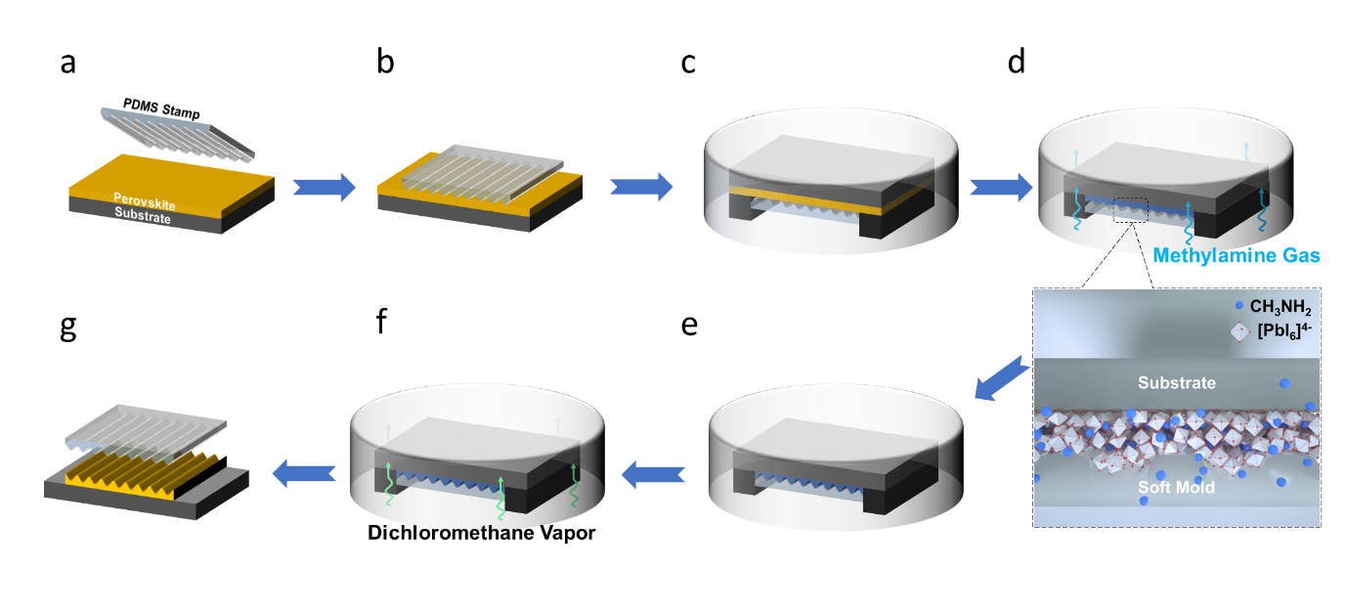
Figure. 1 Schematic illustration of the upside-down nanoimprinting approach for the fabrication of perovskite periodic nanostructures: (a) as-prepared MAPbI₃ film; (b) cover soft template on the top of perovskite film; (c) invert the sample in the container; (d) introduce methylamine in the container; (e) methylamine permeate into the molds; (f) dichloromethane vapor treatment to eliminate excess methylamine; (g) remove the soft template.

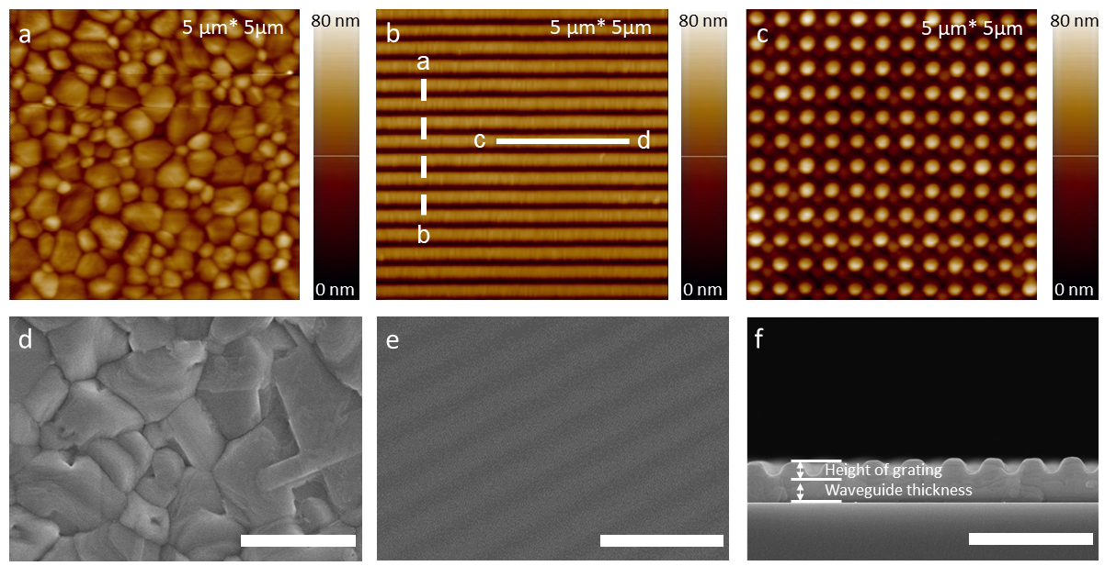
Figure. 2 The atomic force micrograph of (a) pristine perovskite film; (b) one-dimensional linear perovskite grating (320 nm in period); and (c) two-dimensional photonic perovskite pattern. The scanning electron microscope images of (d) the top-view pristine perovskite film; (e) top-view and (f) cross-sectional of perovskite grating with the periodicity of 320 nm. The inset scale bar represents 1 micrometer.

Figure. 3 Height profiles of perovskite gratings: imprinting by (a) pristine PDMS molds; (b) PDMS molds with hydrophilic treatment; (c) Schematic illustration of capillary force during the imprinting; (d) Photoluminescence spectrum and (e) time-resolved photoluminescence of the perovskites; (f) XRD spectrum of pristine and patterned perovskites through different recrystallization method.

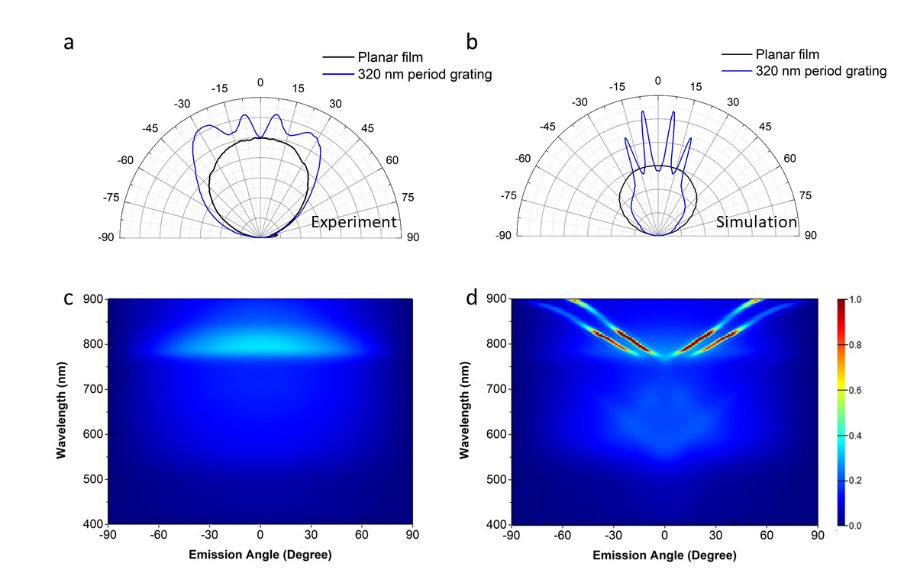
Figure. 4 Angle-resolved photoluminescence spectrums of perovskites through (a) experiment; (b) simulation. Angular- and wavelength-dependent radiation power of (c) planar perovskite film; (d) 320 nm in period perovskite grating.
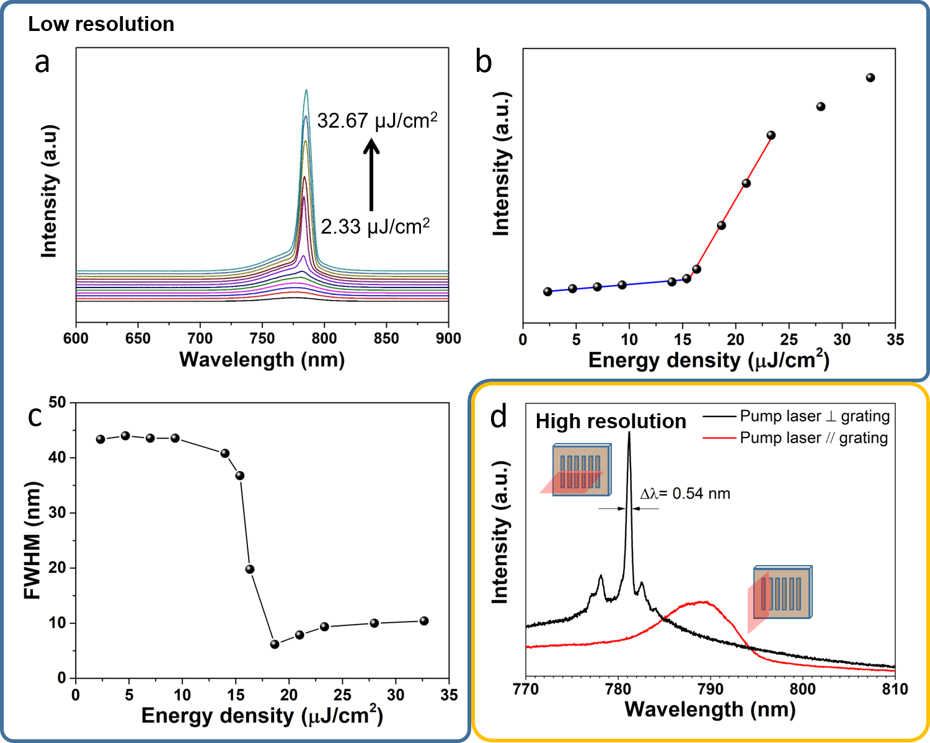
Figure. 5 Emission spectra of DCM vapor-induced 320 nm period gratings: (a) evolution of the emission spectrum with pump laser under $λ_{p}= 610 nm$ excitation; (b) laser output power as a function of pump laser intensity; (c) The evolution of the emission full width half maximum (FWHM) from the 320 nm period perovskite grating; (d) The laser emission spectrum measured at different excitation orientations. A low-resolution spectrometer grating was used in sub-figures (a) – (c), and a high-resolution grating in sub-figure (d).

Notes
There are no conflicts to declare.

Author Contributions
Lebin Nie and Wai Kit Ng contributed equally to this work. Lebin Nie accomplished most of the experimental works and composed most the part of the manuscript. Wai Kit Ng finished the laser emission relevant characterization and wrote the optical part. ZhiFu Liang conceived the original idea and Xingang Ren conducted the optical simulation. Tingbin Yang and Chi Wah Leung provided imprinting templates. Guanding Mei drew some schematic diagrams for the manuscript. Kam Sing Wong and Wallace C.H. Choy guided the manuscript writing.

Acknowledgements
This research was supported by Equipment fund, and seed fund (Grant Nos. 2019157209, and 201811159147), from the University Grant Council of the University of Hong Kong as well as the General Research Fund (Grant Nos. 17201819, 17200518, and 17204117) from the Hong Kong Special Administrative Region, China. WKN and KSW acknowledge the financial support of Research Grants Council of Hong Kong (Grant No. AoE/P02/12) and William Mong Institute of Nano Science and Technology (Grant No. WMINST19/SC04). T.B.Y. thanks the National Natural Science Foundation of China (no.51703092) for financial support. X.G.R. would like to acknowledge the financial support of National Natural Science Foundation of China under Grant 61701003. The authors acknowledge the assistance of SUSTech Core Research Facilities and Dr. Wang Yao for the fabrication of silicon grating stamps. We acknowledge Dr. Haiwei Yin and Shanghai Ideaoptics Corp. Ltd. for the support on the angle-resolved spectrum measurements, and Taili Liu from the City University of Hong Kong, China for their help in XRD characterizations.

Supporting Information
Photographic images, SEM images of grating, finite-difference time-domain simulations, contact angles and atomic force microscope images, absorption spectrum, lasing spectrum

References:

(1) Bermel, P.; Luo, C.; Zeng, L.; Kimerling, L. C.; Joannopoulos, J. D. Improving Thin-Film Crystalline Silicon Solar Cell Efficiencies with Photonic Crystals. Opt. Express 2007, 15 (25), 16986. https://doi.org/10.1364/OE.15.016986.
(2) Zhou, D.; Biswas, R. Photonic Crystal Enhanced Light-Trapping in Thin Film Solar Cells. J. Appl. Phys. 2008, 103 (9), 093102. https://doi.org/10.1063/1.2908212.
(3) Yang, J.-K.; Seo, M.-K.; Hwang, I.-K.; Kim, S.-B.; Lee, Y.-H. Polarization-Selective Resonant Photonic Crystal Photodetector. Appl. Phys. Lett. 2008, 93 (21), 211103. https://doi.org/10.1063/1.3036954.
(4) Zhou, W.; Min, G.; Song, Z.; Zhang, J.; Liu, Y.; Zhang, J. Enhanced Efficiency of Light Emitting Diodes with a Nano-Patterned Gallium Nitride Surface Realized by Soft UV Nanoimprint Lithography. Nanotechnology 2010, 21 (20), 205304. https://doi.org/10.1088/0957-4484/21/20/205304.
(5) Kim, S. H.; Lee, K.-D.; Kim, J.-Y.; Kwon, M.-K.; Park, S.-J. Fabrication of Photonic Crystal Structures on Light Emitting Diodes by Nanoimprint Lithography. Nanotechnology 2007, 18 (5), 055306. https://doi.org/10.1088/0957-4484/18/5/055306.
(6) Shindo, T.; Okumura, T.; Ito, H.; Koguchi, T.; Takahashi, D.; Atsumi, Y.; Kang, J.; Osabe, R.; Amemiya, T.; Nishiyama, N.; Arai, S. GaInAsP/InP Lateral-Current-Injection Distributed Feedback Laser with a-Si Surface Grating. Opt. Express 2011, 19 (3), 1884. https://doi.org/10.1364/OE.19.001884.
(7) Morthier, G.; Abbasi, A.; Verbist, J.; Keyvaninia, S.; Yin, X.; Lelarge, F.; Duan, G. H.; Bauwelinck, J.; Roelkens, G. High-Speed Directly Modulated Heterogeneously Integrated InP/Si DFB Laser. In European Conference on Optical Communication, ECOC; 2016.
(8) Matsuo, S.; Fujii, T.; Hasebe, K.; Takeda, K.; Sato, T.; Kakitsuka, T. Directly Modulated Buried Heterostructure DFB Laser on SiO_2/Si Substrate Fabricated by Regrowth of InP Using Bonded Active Layer. Opt. Express 2014, 22 (10), 12139. https://doi.org/10.1364/OE.22.012139.
(9) Lan, H.; Ding, Y. Nanoimprint Lithography. In Lithography; Wang, M., Ed.; InTech, 2010; pp 458–488. https://doi.org/10.5772/8189.
(10) Chou, S. Y.; Krauss, P. R.; Renstrom, P. J. Imprint Lithography with 25-Nanometer Resolution. Science (80-. ). 1996, 272 (5258), 85–87. https://doi.org/10.1126/science.272.5258.85.
(11) Lin, K.; Xing, J.; Quan, L. N.; de Arquer, F. P. G.; Gong, X.; Lu, J.; Xie, L.; Zhao, W.; Zhang, D.; Yan, C.; Li, W.; Liu, X.; Lu, Y.; Kirman, J.; Sargent, E. H.; Xiong, Q.; Wei, Z. Perovskite Light-Emitting Diodes with External Quantum Efficiency Exceeding 20 per Cent. Nature 2018, 562 (7726), 245–248. https://doi.org/10.1038/s41586-018-0575-3.
(12) Huang, H.; Raith, J.; Kershaw, S. V.; Kalytchuk, S.; Tomanec, O.; Jing, L.; Susha, A. S.; Zboril, R.; Rogach, A. L. Growth Mechanism of Strongly Emitting CH3NH3PbBr3 Perovskite Nanocrystals with a Tunable Bandgap. Nat. Commun. 2017, 8 (1), 1–7. https://doi.org/10.1038/s41467-017-00929-2.
(13) Pan, W.; Wu, H.; Luo, J.; Deng, Z.; Ge, C.; Chen, C.; Jiang, X.; Yin, W.; Niu, G.; Zhu, L.; Yin, L.; Zhou, Y.; Xie, Q.; Ke, X. Cs2AgBiBr6 Single-Crystal X-Ray Detectors with a Low Detection Limit. Nat. Photonics 2017, 11 (November), 1–8. https://doi.org/10.1038/s41566-017-0012-4.
(14) Ye, F.; Lin, H.; Wu, H.; Zhu, L.; Huang, Z.; Ouyang, D.; Niu, G.; Choy, W. C. H. High-Quality Cuboid CH3NH3PbI3 Single Crystals for High Performance X-Ray and Photon Detectors. Adv. Funct. Mater. 2019, 29 (6), 1–7. https://doi.org/10.1002/adfm.201806984.
(15) Jeon, N. J.; Noh, J. H.; Kim, Y. C.; Yang, W. S.; Ryu, S.; Seok, S. Il. Solvent Engineering for High-Performance Inorganic-Organic Hybrid Perovskite Solar Cells. Nat. Mater. 2014, 13 (9), 897–903. https://doi.org/10.1038/nmat4014.
(16) Zhang, Q.; Ha, S. T.; Liu, X.; Sum, T. C.; Xiong, Q. Room-Temperature near-Infrared High-Q Perovskite Whispering-Gallery Planar Nanolasers. Nano Lett. 2014. https://doi.org/10.1021/nl503057g.
(17) Xu, W.; Hu, Q.; Bai, S.; Bao, C.; Miao, Y.; Yuan, Z.; Borzda, T.; Barker, A. J.; Tyukalova, E.; Hu, Z.; Kawecki, M.; Wang, H.; Yan, Z.; Liu, X.; Shi, X.; Uvdal, K.; Fahlman, M.; Zhang, W.; Duchamp, M.; Liu, J.-M.; Petrozza, A.; Wang, J.; Liu, L.-M.; Huang, W.; Gao, F. Rational Molecular Passivation for High-Performance Perovskite Light-Emitting Diodes. Nat. Photonics 2019, 13 (6), 418–424. https://doi.org/10.1038/s41566-019-0390-x.
(18) Wang, L.; Zhou, H.; Hu, J.; Huang, B.; Sun, M.; Dong, B.; Zheng, G.; Huang, Y.; Chen, Y.; Li, L.; Xu, Z.; Li, N.; Liu, Z.; Chen, Q.; Sun, L.-D.; Yan, C.-H. A Eu 3+ -Eu 2+ Ion Redox Shuttle Imparts Operational Durability to Pb-I Perovskite Solar Cells. Science (80-. ). 2019, 363 (6424), 265–270. https://doi.org/10.1126/science.aau5701.
(19) Yakunin, S.; Sytnyk, M.; Kriegner, D.; Shrestha, S.; Richter, M.; Matt, G. J.; Azimi, H.; Brabec, C. J.; Stangl, J.; Kovalenko, M. V.; Heiss, W. Detection of X-Ray Photons by Solution-Processed Lead Halide Perovskites. Nat. Photonics 2015, 9 (7), 444–449. https://doi.org/10.1038/nphoton201582.
(20) Pourdavoud, N.; Haeger, T.; Mayer, A.; Cegielski, P. J.; Giesecke, A. L.; Heiderhoff, R.; Olthof, S.; Zaefferer, S.; Shutsko, I.; Henkel, A.; Becker-Koch, D.; Stein, M.; Cehovski, M.; Charfi, O.; Johannes, H. H.; Rogalla, D.; Lemme, M. C.; Koch, M.; Vaynzof, Y.; Meerholz, K.; Kowalsky, W.; Scheer, H. C.; Görrn, P.; Riedl, T. Room-Temperature Stimulated Emission and Lasing in Recrystallized Cesium Lead Bromide Perovskite Thin Films. Adv. Mater. 2019, 31 (39), 1903717. https://doi.org/10.1002/adma.201903717.
(21) Pourdavoud, N.; Mayer, A.; Buchmüller, M.; Brinkmann, K.; Häger, T.; Hu, T.; Heiderhoff, R.; Shutsko, I.; Görrn, P.; Chen, Y.; Scheer, H. C.; Riedl, T. Distributed Feedback Lasers Based on MAPbBr3. Adv. Mater. Technol. 2018, 3 (4), 1–6. https://doi.org/10.1002/admt.201700253.
(22) Pourdavoud, N.; Wang, S.; Mayer, A.; Hu, T.; Chen, Y.; Marianovich, A.; Kowalsky, W.; Heiderhoff, R.; Scheer, H.-C.; Riedl, T. Photonic Nanostructures Patterned by Thermal Nanoimprint Directly into Organo-Metal Halide Perovskites. Adv. Mater. 2017, 29 (12), 1605003. https://doi.org/10.1002/adma.201605003.
(23) Jeong, B.; Hwang, I.; Cho, S. H.; Kim, E. H.; Cha, S.; Lee, J.; Kang, H. S.; Cho, S. M.; Choi, H.; Park, C. Solvent-Assisted Gel Printing for Micropatterning Thin Organic-Inorganic Hybrid Perovskite Films. ACS Nano 2016, 10 (9), 9026–9035. https://doi.org/10.1021/acsnano.6b05478.
(24) Jeong, B.; Han, H.; Kim, H. H.; Choi, W. K.; Park, Y. J.; Park, C. Polymer-Assisted Nanoimprinting for Environment- and Phase-Stable Perovskite Nanopatterns. ACS Nano 2020, 14 (2), 1645–1655. https://doi.org/10.1021/acsnano.9b06980.
(25) Xiao, C.; Li, Z.; Guthrey, H.; Moseley, J.; Yang, Y.; Wozny, S.; Moutinho, H.; To, B.; Berry, J. J.; Gorman, B.; Yan, Y.; Zhu, K.; Al-Jassim, M. Mechanisms of Electron-Beam-Induced Damage in Perovskite Thin Films Revealed by Cathodoluminescence Spectroscopy. J. Phys. Chem. C 2015, 119 (48), 26904–26911. https://doi.org/10.1021/acs.jpcc.5b09698.
(26) Zhizhchenko, A.; Syubaev, S.; Berestennikov, A.; Yulin, A. V.; Porfirev, A.; Pushkarev, A.; Shishkin, I.; Golokhvast, K.; Bogdanov, A. A.; Zakhidov, A. A.; Kuchmizhak, A. A.; Kivshar, Y. S.; Makarov, S. V. Single-Mode Lasing from Imprinted Halide-Perovskite Microdisks. ACS Nano 2019, 13 (4), 4140–4147. https://doi.org/10.1021/acsnano.8b08948.
(27) Chen, S.; Roh, K.; Lee, J.; Chong, W. K.; Lu, Y.; Mathews, N.; Sum, T. C.; Nurmikko, A. A Photonic Crystal Laser from Solution Based Organo-Lead Iodide Perovskite Thin Films. ACS Nano 2016, 10 (4), 3959–3967. https://doi.org/10.1021/acsnano.5b08153.
(28) Saliba, M.; Wood, S. M.; Patel, J. B.; Nayak, P. K.; Huang, J.; Alexander-Webber, J. A.; Wenger, B.; Stranks, S. D.; Hörantner, M. T.; Wang, J. T. W.; Nicholas, R. J.; Herz, L. M.; Johnston, M. B.; Morris, S. M.; Snaith, H. J.; Riede, M. K. Structured Organic-Inorganic Perovskite toward a Distributed Feedback Laser. Adv. Mater. 2016, 28 (5), 923–929. https://doi.org/10.1002/adma.201502608.
(29) Cha, H.; Bae, S.; Lee, M.; Jeon, H. Two-Dimensional Photonic Crystal Bandedge Laser with Hybrid Perovskite Thin Film for Optical Gain. Appl. Phys. Lett. 2016, 108 (18). https://doi.org/10.1063/1.4948681.
(30) Xing, G.; Kumar, M. H.; Chong, W. K.; Liu, X.; Cai, Y.; Ding, H.; Asta, M.; Grätzel, M.; Mhaisalkar, S.; Mathews, N.; Sum, T. C. Solution-Processed Tin-Based Perovskite for Near-Infrared Lasing. Adv. Mater. 2016. https://doi.org/10.1002/adma.201601418.
(31) Mao, J.; Sha, W. E. I.; Zhang, H.; Ren, X.; Zhuang, J.; Roy, V. A. L.; Wong, K. S.; Choy, W. C. H. Novel Direct Nanopatterning Approach to Fabricate Periodically Nanostructured Perovskite for Optoelectronic Applications. Adv. Funct. Mater. 2017, 27 (10), 1606525. https://doi.org/10.1002/adfm.201606525.
(32) Wong, A. B.; Lai, M.; Eaton, S. W.; Yu, Y.; Lin, E.; Dou, L.; Fu, A.; Yang, P. Growth and Anion Exchange Conversion of CH3NH3PbX3 Nanorod Arrays for Light-Emitting Diodes. Nano Lett. 2015. https://doi.org/10.1021/acs.nanolett.5b02082.
(33) Li, G.; Rivarola, F. W. R.; Davis, N. J. L. K.; Bai, S.; Jellicoe, T. C.; De La Peña, F.; Hou, S.; Ducati, C.; Gao, F.; Friend, R. H.; Greenham, N. C.; Tan, Z. K. Highly Efficient Perovskite Nanocrystal Light-Emitting Diodes Enabled by a Universal Crosslinking Method. Adv. Mater. 2016. https://doi.org/10.1002/adma.201600064.
(34) Li, G.; Tan, Z. K.; Di, D.; Lai, M. L.; Jiang, L.; Lim, J. H. W.; Friend, R. H.; Greenham, N. C. Efficient Light-Emitting Diodes Based on Nanocrystalline Perovskite in a Dielectric Polymer Matrix. Nano Letters. 2015. https://doi.org/10.1021/acs.nanolett.5b00235.
(35) Ye, F.; Wu, H.; Qin, M.; Yang, S.; Niu, G.; Lu, X.; Wang, J.; Mitzi, D. B.; Choy, W. C. H. High-Quality MAPbBr3 Cuboid Film with Promising Optoelectronic Properties Prepared by a Hot Methylamine Precursor Approach. ACS Appl. Mater. Interfaces 2020. https://doi.org/10.1021/acsami.0c04516.
(36) Noel, N. K.; Habisreutinger, S. N.; Wenger, B.; Klug, M. T.; Hörantner, M. T.; Johnston, M. B.; Nicholas, R. J.; Moore, D. T.; Snaith, H. J. A Low Viscosity, Low Boiling Point, Clean Solvent System for the Rapid Crystallisation of Highly Specular Perovskite Films. Energy Environ. Sci. 2017. https://doi.org/10.1039/c6ee02373h.
(37) Zhou, Z.; Wang, Z.; Zhou, Y.; Pang, S.; Wang, D.; Xu, H.; Liu, Z.; Padture, N. P.; Cui, G. Methylamine-Gas-Induced Defect-Healing Behavior of CH 3 NH 3 PbI 3 Thin Films for Perovskite Solar Cells. Angew. Chemie Int. Ed. 2015, 54 (33), 9705–9709. https://doi.org/10.1002/anie.201504379.
(38) Saidaminov, M. I.; Adinolfi, V.; Comin, R.; Abdelhady, A. L.; Peng, W.; Dursun, I.; Yuan, M.; Hoogland, S.; Sargent, E. H.; Bakr, O. M. Planar-Integrated Single-Crystalline Perovskite Photodetectors. Nat. Commun. 2015, 6 (1), 8724. https://doi.org/10.1038/ncomms9724.
(39) Shi, D.; Adinolfi, V.; Comin, R.; Yuan, M.; Alarousu, E.; Buin, A.; Chen, Y.; Hoogland, S.; Rothenberger, A.; Katsiev, K.; Losovyj, Y.; Zhang, X.; Dowben, P. A.; Mohammed, O. F.; Sargent, E. H.; Bakr, O. M. Low Trap-State Density and Long Carrier Diffusion in Organolead Trihalide Perovskite Single Crystals. Science (80-. ). 2015, 347 (6221), 519–522. https://doi.org/10.1126/science.aaa2725.
(40) Lédée, F.; Trippé-Allard, G.; Diab, H.; Audebert, P.; Garrot, D.; Lauret, J.-S.; Deleporte, E. Fast Growth of Monocrystalline Thin Films of 2D Layered Hybrid Perovskite. CrystEngComm 2017, 19 (19), 2598–2602. https://doi.org/10.1039/C7CE00240H.
(41) Lodahl, P. 12 - All-Solid-State Quantum Optics Employing Quantum Dots in Photonic Crystals. In Woodhead Publishing Series in Electronic and Optical Materials; Jahnke, F. B. T.-Q. O. with S. N., Ed.; Woodhead Publishing, 2012; pp 395-422e. https://doi.org/https://doi.org/10.1533/9780857096395.4.393.
(42) Oku, T. Crystal Structures of CH3NH3PbI3 and Related Perovskite Compounds Used for Solar Cells. In Solar Cells - New Approaches and Reviews; InTech, 2015; Vol. 1. https://doi.org/10.5772/59284.
(43) Brundrett, D. L.; Glytsis, E. N.; Gaylord, T. K. Homogeneous Layer Models for High-Spatial-Frequency Dielectric Surface-Relief Gratings: Conical Diffraction and Antireflection Designs. Appl. Opt. 1994, 33 (13), 2695. https://doi.org/10.1364/AO.33.002695.
(44) Zhiwen, W.; Jinliang, G.; Aimei, D.; Bo, C. Mechanism Analyzation of the Effects of Grating Parameters on Polarization Transmission of Single-Layer Nanowire Gratings. Proc. Inst. Mech. Eng. Part N J. Nanomater. Nanoeng. Nanosyst. 2018, 232 (1), 41–47. https://doi.org/10.1177/2397791417744966.
(45) Ziebarth, J. M.; Saafir, A. K.; Fan, S.; McGehee, M. D. Extracting Light from Polymer Light-Emitting Diodes Using Stamped Bragg Gratings. Adv. Funct. Mater. 2004, 14 (5), 451–456. https://doi.org/10.1002/adfm.200305070.
(46) Xing, G.; Mathews, N.; Lim, S. S.; Yantara, N.; Liu, X.; Sabba, D.; Grätzel, M.; Mhaisalkar, S.; Sum, T. C. Low-Temperature Solution-Processed Wavelength-Tunable Perovskites for Lasing. Nat. Mater. 2014. https://doi.org/10.1038/nmat3911.
(47) Schünemann, S.; Brittman, S.; Chen, K.; Garnett, E. C.; Tüysüz, H. Halide Perovskite 3D Photonic Crystals for Distributed Feedback Lasers. ACS Photonics 2017, 4 (10), 2522–2528. https://doi.org/10.1021/acsphotonics.7b00780.
(48) Zhang, H.; Cheng, J.; Li, D.; Lin, F.; Mao, J.; Liang, C.; Jen, A. K.-Y.; Grätzel, M.; Choy, W. C. H. Toward All Room-Temperature, Solution-Processed, High-Performance Planar Perovskite Solar Cells: A New Scheme of Pyridine-Promoted Perovskite Formation. Adv. Mater. 2017, 29 (13), 1604695. https://doi.org/10.1002/adma.201604695.

