DOI: 10.1002/ ((please add manuscript number))
Article type: Full Paper

Efficient Gradient Potential Top Electron Transport Structure Achieved by Combining an Oxide Family for Inverted Perovskite Solar Cells with High Efficiency and Stability
Boping Yang#, Ruiman Ma#, Zishuai Wang, Dan Ouyang, Zhanfeng Huang, Jinlian Lu, Xiaohui Duan, Lu Yue, Ning Xu, and Wallace C. H. Choy *

Dr. B. Yang, Dr. J. Lu, X. Duan, Dr. L. Yue, Prof. N. Xu
Yancheng Institute of Technology
Xiwang Avenue, Yancheng 224051, China
Dr. B. Yang, R. Ma, Dr. Z. Wang, Dr. D. Ouyang, Dr. Z. Huang, Prof. W. C. H. Choy
Department of Electrical and Electronic Engineering
The University of Hong Kong
Pokfulam Road, Hong Kong 999077, China
Email: chchoy@eee.hku.hk
Prof. W. C. H. Choy
Guangdong-Hong Kong-Macao Joint Laboratory for Photonic-Thermal-Electrical Energy Materials and Devices
Shenzhen 518055, China.
# equally contributed in this work.

Keywords: low temperature, solution process, inorganic metal oxides, electron transport layer, perovskite solar cells

Abstract: Although inverted (p-i-n) structure perovskite solar cells (PSCs) have achieved high efficiency by commonly using fullerene or its derivatives as electron transport layers (ETLs), the device stability and cost of fullerene materials are still of great concerns. Herein, we demonstrate inorganic top ETLs simply composed from a family of metal oxides including In₂O₃ and its derivative of Sn:In₂O₃ with gradient potential structure. For inverted PSCs, typical film formation process of In₂O₃ will damage or degrade perovskite materials underneath, we report a low temperature synthesis approach offering to obtain In₂O₃ and Sn:In₂O₃ nanoparticles which can form effective top ETLs without any post-treatment. The one-family oxide based top ETL features with the enhanced built-in potential, high electron extraction, and low interfacial recombination, offering a power conversion efficiency (PCE) of 20.65% in PSCs constructed from oxide-only carrier (both hole and electron) transport layers (CTLs), which is the highest efficiency in oxide only CTL based inverted PSCs from our best knowledge. Equally important, the inverted PSCs based on Sn:In₂O₃/In₂O₃ ETL show the excellent operational stability and remain 90% of the initial value of PCE over 2000 hr. Consequently, this work contributes to the robust strategy of all oxide only CTL in developing rigid and flexible PSCs for practical photovoltaic applications.

1. Introduction
Inverted structure planar perovskite solar cells (PSCs) have been widely investigated due to their potential of long device stability, cost-effectiveness, low temperature processing processability and suppressed hysteresis characteristics.¹⁻⁶ Typically, there are several requirements such as chemically compatibility,^{5,7} high electron transport ability and low temperature treatment^{2,5,8-10} to form the electron transport layers (ETLs) on top of perovskite layer because perovskite thin films are vulnerable to high-temperature processes and polar solvents. Besides, carrier (electron and hole) transport layers (CTLs) play an indispensable role in planar PSCs not only for effectively transporting charges and reducing carriers recombination but also for preventing the damage of devices from ambient environment, such as humidity, oxygen, and light.¹⁰⁻¹⁴ As the most commonly used ETLs, C₆₀ and its derivative [6,6] -phenyl-C61-butyric acid methyl ester (PCBM) possess suitable energy alignment and effective charge collection ability, which has achieved a high PCE of about 22% in p-i-n planar PSCs.¹⁵⁻¹⁹ Although high performances were obtained for these organic ETLs, their high costs, complicated synthesis and purification process are highly unsuitable for large-scale applications.²⁰ Additionally, there is a concern in their long-term operational and thermal instability for future commercialization.^{21,22}
Inorganic ETLs, featuring abundant materials, low cost, and excellent stability, are potentially superior alternatives. Some inorganic n-type metal oxides, such as Ti(Nb)O_{x},²³ SnO₂,²⁴ Al-doped ZnO (AZO),²⁵ ZnO,²⁶⁻²⁹ and CeO_{x}³⁰ have been reported to be a layer material as a part of the ETL structures. While most of the metal oxide only ETL are reported in n-i-p PSCs,³¹⁻³⁶ there are no clear study of top ETLs for inverted planar PSCs composed from simply a family of metal oxides with gradient potential structure for improving PSC performances and stability. Indeed, most of the well performed and stable inverted PSCs are made from ETL structure composed of organic film such as PCBM and C₆₀ and the metal oxide layer.³⁷⁻³⁹
In this work, we demonstrate inorganic top ELTs simply from combining one family of metal oxides including In₂O₃ and its derivative of Sn doped In₂O₃ (hereafter named as Sn:In₂O₃) with gradient potential structure in p-i-n PSCs with high efficiency and stability. To our knowledge, In₂O₃ and it derivatives or their combination have not been used as top ETL in inverted PSCS since typical film formation processes of In₂O₃ ETL from indium salt precursors need annealing at 200-300 ℃,⁴⁰ degrading typical perovskite materials underneath. Meanwhile, while colloidal In₂O₃ nanoparticles can potentially be used as top ETL, such nanoparticles are mainly synthesized by hot-injection, which will involve the coating of insulative ligands such as oleyamine.⁴¹ This greatly decreases the conductivity of In₂O₃ film as ETL. Differently, we report a low temperature synthesis approach to obtain In₂O₃ and Sn:In₂O₃ nanoparticles which can form effective top ETLs without any post-treatment, overcoming the above challenging issues. In addition, since our gradient potential top ETL only involves one family of In₂O₃ and its derivatives without any other kind of oxides, we can simplify the material system, material synthesize and device fabrication processes. Furthermore, this all-inorganic one-family oxide stepped ETL structure with gradient carrier concentration and energy band not only displays efficient electron extracting and transporting ability but also exhibit substantially enhanced built-in potential. As a result, we achieve remarkable suppression of non-radiative recombination losses in the device and significant improvement in both the device efficiency and stability. The optimized PSCs based on Sn:In₂O₃/In₂O₃ ETL with the best PCE of 20.65% and ignorable hysteresis are demonstrated which is considerably higher than that of single In₂O₃ (16.33%) and Sn:In₂O₃ ETL (19.52%). Importantly, the inverted PSCs adopted the Sn:In₂O₃/In₂O₃ bilayer ETL exhibit excellent thermal- and photo-stability thanks to their good intrinsic stability. Consequently, this work not only offers a new low-temperature and solution-processed metal oxide only ETL for highly efficient inverted PSCs, but also provides a new strategy for designing an CTLs to achieve cost-effective, stable, and high-performance photovoltaic devices.
2. Results and discussion
(a) Properties of pristine and doped In₂O₃ nanoparticles and films.
We synthesized pristine and doped In₂O₃ via our low-temperature strategy as described in the experimental section. X-ray diffraction (XRD) measurement was conducted to confirm the component of as-synthesized pristine In₂O₃ and Sn-doped In₂O₃ (Sn:In₂O₃) NPs films. As shown in Figure 1a, the XRD of the pristine and Sn-doped In₂O₃ are similar. Their XRD peaks of 21.7º, 30.8º, 35.4º, 50.9º, and 60.8º correspond to (211), (222), (400), (440), and (622) planes respectively, which are in good agreement with that of In₂O₃ (PDF No. 071-2194). No other peaks appear except In₂O₃ peaks. The results indicate that no other oxides form in the synthesis process and Sn only acts as a dopant in In₂O₃. Notably, the strong diffraction peak of Sn:In₂O₃ located at 30º shifts toward the larger 2θ angle slightly. This shift can be explained by the reduced lattice distance when In³⁺ (0.81 Å) is substituted with the smaller radius Sn⁴⁺ (0.71 Å), demonstrating that Sn is successfully doped into In₂O₃.
Meanwhile, transmission electron microscopy (TEM) and selected area electron diffraction (SAED) characterization were conducted and the results are shown in Figure 1b, the Sn doped In₂O₃ NPs synthesized by our low-temperature strategy show a high crystallinity and small size distribution. The average size of Sn:In₂O₃ NPs is about 10 nm as shown in Figure 1c, which is beneficial to form high-quality top ETLs with good physical contact on perovskite surface thereby efficiently promoting charge collection in PSCs.^{10,13} Remarkably, through simple room-temperature spin-coating methods, compact and uniform Sn:In₂O₃ and In₂O₃ films are formed on perovskite surface as confirmed from the top-view scanning electron microscopy (SEM) image of the structure ITO/ hole transport layer (HTL)/ perovskite/ Sn:In₂O₃ in Figure S1. Consequently, In₂O₃ and Sn:In₂O₃ NPs are successfully synthesized and both of them can form high-quality oxide films on perovskite film by a simple room-temperature solution approach.
X-ray photoelectron spectroscopy (XPS) was utilized to further verify the presence of Sn⁴⁺ within the In₂O₃ NPs and the corresponding chemical states and the results are displayed in Figure 1d-f. Characteristic XPS signals in both In₂O₃ and Sn:In₂O₃ are observed at binding energies of 529.8 eV in Figure 1e and 445.9 eV, 453.1 eV in Figure 1f, which are ascribed to O 1s , In 3d_{3/2}, and In 3d_{5/2} respectively. Importantly, the XPS peaks of Sn 3d_{5/2} at 486.3 eV and Sn 3d_{3/2} at 495.4 eV are clearly observed from Sn:In₂O₃ NPs in Figure 1d, which are not existed in pristine In₂O₃ NPs. This further demonstrates the successful doping of Sn. It is estimated from the XPS results that the Sn content in Sn: In₂O₃ is 5%, which is very close to the Sn molar ratio used in the precursor. This result also indicates a good incorporation of Sn in In₂O₃. In addition, the corresponding doping concentration is confirmed by the measurement of inductively coupled plasma atomic emission spectroscopy (ICP-OES), and the results are shown in Table S1.
To assess the energy band alignment of Sn:In₂O₃/In₂O₃ bilayer, we analyze the Tauc plots and Ultraviolet electron spectroscopy (UPS) of pristine In₂O₃ and Sn:In₂O₃. From the Tauc plots (Figure 2a) and absorbance spectra (Figure S2), the bandgap energy increases from 3.81 eV (In₂O₃) to 3.89 eV (Sn:In₂O₃) after Sn doping. As discussed previously, partly substituting In³⁺ by smaller size Sn⁴⁺ will reduce the lattice size and enhance crystal field due to stronger coupling of In-O, resulting in the broadened bandgap of Sn:In₂O₃ film. The valance band energy () of In₂O₃ and Sn:In₂O₃ calculated from UPS spectra shown in Figure 2b are -8.32 and -8.21 eV, respectively. Then, the conduction band energy () is calculated by combining the bandgap and , where the (-4.51eV) of Sn:In₂O₃ decreases from -4.32 eV of In₂O₃ after doping with Sn into In₂O₃. Figure 3d shows the band alignment diagram of In₂O₃ and Sn:In₂O₃ and materials used in p-i-n structure PSCs. Notably, the small energy offset of 0.2 eV between the Sn:In₂O₃ layer (-4.32 eV) and perovskite film (-4.12 eV)¹² is beneficial for electron extraction from the perovskite layer.
The electrical properties of Sn:In₂O₃ ETLs, including carrier concentration (n), mobility (μ), and conductivity (σ) are investigated and calculated from the Hall Effect measurements as a function of Sn doping concentration as shown in Figure 2c. The electrical properties all show an increase at first and then decrease with increasing the doping concentration. It shall be noted that conductivity is calculated from the equation of σ = neμ, where e is one electron charge. From Figure 2a, the maximum of carrier concentration, mobility, and conductivity are 1.65 x 10¹⁶ cm⁻³, 14 cm² V⁻¹ s⁻¹ and 0.037 S cm⁻¹, respectively at 5% doping concentration. Notably, the higher conductivity of Sn:In₂O₃ compared to In₂O₃ contribute to enhancing the charge transport and collection at the interface. Moreover, as shown in Figure 2d, the designed Sn:In₂O₃/In₂O₃ bilayer ETL with a layer of In₂O₃ contacting directly with Ag electrode, where the Schottky-barrier (0.09 eV) between the conduction band minimum of In₂O₃ and work function (WF) of Ag electrode is very small, which can promote electron extraction from ETL to the cathode efficiently. Consequently, the gradient energy band alignments in the ETL region and at the cathode formed by the Sn:In₂O₃/In₂O₃ bilayer structure can 1) contribute to the carrier separation by offering higher built-in voltage, which comes from the higher carrier concentration, and 2) benefit the carrier extraction by the cascade energy alignment structure, which suppresses the recombination loss and contributes to the higher FF and V_{OC}.
(b) Device performances and detailed understanding.
p-i-n PSCs using pristine In₂O₃ only, Sn:In₂O₃ only, and Sn:In₂O₃/ In₂O₃ bilayer structure as top ETL are fabricated and the J-V curves are plotted in Figure 3a. Furthermore, Figure 3b shows the reproducibility of the PSCs efficiency based on different ETLs, suggesting the PSCs based on bilayer ETL have good reproducibility. To the best of our knowledge, this work has the best performance among the reported p-i-n planar PSCs with all metal-oxide top ETL.^{23,24} The cross-section SEM image in Figure S3 show the all oxide electron and hole transport layer based device structure of ITO/NiO_{x}/perovskite/Sn:In₂O₃/In₂O₃. It is important to note that by introducing the combined approaches of purifying ethanol solvent from residue water (before being used for the dispersion of the metal oxide NPs) and dynamic spin coating process in metal oxide film formation, we address the common issue of ethanol solvent induced damage on perovskite film as further described in Experimental details. This facilitates the formation of the top metal oxide only ETL structure for highly efficient and stable PSCs. Compared to PSCs based on pristine In₂O₃ ETL (PCE=16.33%), those with Sn:In₂O₃ ETL show better performances with PCE reaching 19.52% due the increase of both short circuit current (J_{SC}) and fill factor (FF), which is attributed to the enhanced electrical properties of Sn:In₂O₃ ETL. The detailed optimization of PSCs based on Sn:In₂O₃ with different doping concentrations and thicknesses are summarized in Table S2 and Table S3, respectively. Interestingly, by introducing Sn:In₂O₃/ In₂O₃ bilayer ETL, we can further boost PCE to 20.65 % (J_{SC} =23.22 mA cm⁻², open-circuit voltage (V_{OC})= 1.10V and FF=80.85%) and all device parameters improve as compared to those of PSCs with either pristine In₂O₃ (20.69 mA cm-2, 1.05V, and 75.18%) or Sn:In₂O₃ ETL (23.13 mA cm⁻², 1.06V, and 79.63%). Previous reports about PSCs based on oxide-only CTL are summarized in Table S4. To our best knowledge, the PCE of our PSCs is the highest among those reported values. The incident photon-to-electron conversion efficiency (IPCE) spectra of PSCs based on different ETLs together with the corresponding integrated current densities are displayed in Figure 3c, which is consistent with the value from J-V with an error less than 5%. Regarding the hysteresis properties of PSCs, we study J-V curves with different scan directions as shown in Figure S4, and the corresponding photovoltaic parameters are listed in Table S5. The results show that all PSCs with the oxide based ETLs show very small hysteresis particularly the bilayer ETL based PCSs with the hysteresis index of 0.7%. In order to understand the improved performances of Sn:In₂O₃/In₂O₃ bilayer ETL based PSCs. We will study carrier separation and extraction ability, energy band alignment, and built-in field, which will affect electron transport from perovskite layer to electrode, and charge recombination at the ETL/perovskite interface. When light is irradiated onto the photoactive layer, the photo-generated carriers will be extracted to charge transport layers at short-circuit conditions because of the intrinsic V_{bi}. A high V_{bi} can provide driving force to promote the separation of electrons and holes.⁴² By combining the as-synthesized Sn:In₂O₃ with pristine In₂O₃, we demonstrate Sn:In₂O₃/In₂O₃ bilayer as ETL offering high V_{bi} for the device and gradient carrier concentrations and energy bands thereby improving device performances especially V_{OC}, which will be discussed further in later sections with more detail results provided.
The most critical issue that limits the commercialization of PSCs is their long-term stability. It is confirmed that the poor device stability resulted from moisture- or O₂-induced perovskite decomposition can be controlled by well encapsulating. However, under realistic operating conditions, the stability of PSC is inevitably affected by light and high temperature, which is the focus of this work. As shown in Figure 3d, the time-related variation of the device performance is collected by testing the devices under 85 ℃ for 12 h and then under room temperature in dark for another 12 h, which is similar to the realistic operational condition with day and night alternates. Notably, in terms of the temperature stability test, the PSC is transferred in an oven rather than being placed on a hot plate in N₂ glove box for characterization. This arrangement ensures the whole device is in a high-temperature atmosphere (85 ℃) rather than only one side of the device was heated by the hot plate. As shown in Figure 5a, after 69 days (1656 hours), all PSC PCEs keep >90 % of their initial values, but PSCs based on Sn:In₂O₃/In₂O₃ bilayer ETL show a slightly higher remaining PCE (91.9 %), which is attributed to the excellent chemical inactivity of inorganic charge transport layers sandwiching the perovskite layer. Meanwhile, the advantages of more efficient charge extract and transport ability as well as enhanced built-in field of the used Sn:In₂O₃/In₂O₃ bilayer ELT are beneficial for separating photoexcited charges and then impeding the degradation of perovskite. Furthermore, the time-related variation of the device performance under 12 h continuous one sun illumination and then 12 h interval in dark is shown in Figure S5. Obviously, after 2000 h operation, the devices with Sn:In₂O₃/In₂O₃ bilayer ETL remain 91.8% PCEs of their initial values, preceding that of In₂O₃, Sn:In₂O₃. The improved photostability is considered to be resulted from less recombination due to more efficient electron extraction.
To investigate the improved performance of PSCs, especially for Sn:In₂O₃/In₂O₃ bilayer ETL, dynamics and device physics are discussed. To evaluate charge extraction from the devices, steady-state photoluminescence (PL) and time-resolved photoluminescence (TRPL) are measured and presented in Figure 4a and b. By inserting one layer of In₂O₃ ETL on top of perovskite layers, the PL intensity is significantly quenched due to the charge transfer from perovskite layers to In₂O₃ ETL. The charge transfer in Sn:In₂O₃ ETL/perovskite interface is more efficient than pristine In₂O₃ and Sn:In₂O₃/In₂O₃ bilayer has the most efficient charge extraction. As shown in Figure 4b, TRPL spectra are collected for better understand the charge extraction process. As expected, we can observe the PL decay lifetime (fitted with a bi-exponential decays model) is reduced from 9.6 ns of the pristine In₂O₃/perovskite sample to 7.4 ns of for Sn:In₂O₃/perovskite sample and 5.8 ns of Sn:In₂O₃/In₂O₃/perovskite sample respectively. The results indicate a more efficient charge transfer for Sn:In₂O₃/In₂O₃ bilayer ETL based PSCs,^{44,45} agreeing well with the PL spectra and the favorable energy band level. Charge extraction and recombination information can also be derived from transient photocurrent and photovoltage (Figure S6a and b). It can be calculated that the charge-extraction lifetime (CEL) are 0.52 μs, 0.44 μs and 0.31 μs, while the charge-recombination lifetime (CRL) are 1.2 μs, 1.8 μs and 2.1 μs for In₂O₃, Sn:In₂O₃, Sn:In₂O₃/In₂O₃ based device, respectively. Importantly, the shortest CEL and the longest CRL indicate a better charge extraction and lower recombination at Sn:In₂O₃/In₂O₃/perovskite interface than that of In₂O₃/perovskite and Sn:In₂O₃/perovskite interfaces. The result is well consistent with the PL and TRPL measurements as well as PSC performances. The conductivity of single In₂O₃ and Sn:In₂O₃ ETLs and Sn:In₂O₃/In₂O₃ bilayer ETL is also confirmed by characterizing current density (J) voltage (V) characteristics of ITO/ETL/Au under dark condition (as illustrated in Figure 4c). It is clear that the conductivity of bilayer is much higher that the mono-layer of In₂O₃ and Sn:In₂O₃. Notably, all the thickness of ETL is 60 nm, where the Sn:In₂O₃/In₂O₃ bilayer ETL consists of 30 nm In₂O₃ and 30 nm Sn:In₂O₃.
Capacitance-voltage(C-V) measurements are performed to further understand the effect of different ETLs on V_{OC}. The built-in potential of the device can be obtained from the x-intercept of the linear regime in the Mott-Schottky plot (Figure 4d) by fitting the experiments with the Mott-Schottky equation:^{[43]} $\frac{1}{C^{2}}=\frac{2}{εε_{0}eN}({V-V}_{bi})$, where ɛ is the dielectric constant of the material, ɛ₀ is the permittivity of the vacuum, e is the element charge, N is the carrier concentration in the device. The V_{bi} of device with Sn:In₂O₃/In₂O₃ bilayer ETL is 1.17 V, which is 0.08 V and 0.24 V higher than that of Sn:In₂O₃ (1.09 V) and In₂O₃ (0.93 V), respectively. Typically, the high V_{bi} not only offers a strong driving force to carrier separation and transport in PSCs, promotes V_{OC} of the device, but also contributes to the effectively suppressed recombination as well as improved device performance. The enhancement of V_{bi} of device with Sn:In₂O₃/In₂O₃ bilayer contributes to the increase of V_{OC} in PSCs, which results from the large difference of charge concentration between In₂O₃ and Sn:In₂O₃.
To obtain more information about charge transport and recombination mechanisms, the dependence of the J_{SC} and V_{OC} on the light power intensity are determined, plotted in Figure S7 and Figure 4c. J_{SC} has a power-law relationship with the light intensity (J_{SC} =kI^{α}). When the perovskite film is trap-free, the recombination in the perovskite film is bimolecular recombination and α is equal to 1. The slope based on bilayer ETL is 0.93, the closest value to 1, indicating the low non-radiative recombination. In addition, from the V_{OC} versus light intensity as shown in Figure 4e, the ideality factor is estimated by the formula$n=\frac{q}{kT}\frac{dV_{oc}}{dln(φ)}$, which also provides information about the recombination process in PSCs. Since the slope of V_{OC} versus the light intensity is greater than 1, it indicates the presence of additional trap-assisted Shockley-Read-Hall (SRH) recombination.⁴⁶⁻⁴⁸ As shown in Figure 4e, the slopes of 1.52 KT/q, 1.31 KT/q and 1.18 KT/q correspond to the devices based on In₂O₃, Sn:In₂O₃, and Sn:In₂O₃/In₂O₃ bilayer ETL, respectively. The decreased slope indicates a significant reduction in the trap-assisted SRH recombination in devices with Sn:In₂O₃/In₂O₃ bilayer ETL, which is consistent with the increment of V_{OC} and FF. Furthermore, the charge recombination in PSCs based on different ETL is also compared by their dark J-V curves. As shown in Figure S8, the Sn:In₂O₃/In₂O₃ bilayer ETL based PSCs exhibits the smallest dark current density compared to the single In₂O₃ and Sn:In₂O₃ ETL based PSCs, which corresponds to the lowest recombination loss in devices. The lowest SRH recombination of the Sn:In₂O₃/In₂O₃ bilayer ETL based devices should be ascribed to (1) the improved charge transport ability by using Sn doped In₂O₃ and appropriate energy band level of the designed bilayer ETL as well as (2) the enhanced built-in field in the whole devices.
Figure 4f shows the Nyquist plots collected from electrochemical impedance spectroscopy (EIS). The largest charge recombination resistances fitted by an equivalent circuit model is obtained as shown in the inset of Figure 4d for Sn:In₂O₃/In₂O₃ bilayer ETL based devices. The results reflect the efficiently suppressed recombination at Sn:In₂O₃/In₂O₃ bilayer/perovskite interface, which agrees with the previous discussion. Meanwhile, the smallest series resistance for Sn:In₂O₃/In₂O₃ bilayer ETL based devices proves the improved interfacial contact between Sn:In₂O₃/In₂O₃ bilayer ETL and perovskite, and also the enhanced charge transport due to the increased conductivity contributing to the enhancement of J_{SC} and FF in PSCs. To further demonstrate the mechanism of reduced charge recombination, the capacitance (C) of In₂O₃, Sn:In₂O₃ and bilayer are detected according to previous reports.^{4,49} The capacitance are shown in Figure S9 and the values are 31.6 nF, 36.2 nF and 39.7 nF, respectively. From which, we can determine the respective (relative permittivity) as 4.86, 5.58 and 6.11, thus resulting in reduced critical radius (R_{C}) of electron capture region of 11.94, 10.40, and 9.50 nm, respectively. Therefore, the electron capture region is 7.13×10⁻¹⁸, 4.71×10⁻¹⁸, and 3.59×10⁻¹⁸ cm⁻³, demonstrating only a half room for electron capture. The reduced electron capture region can result in an obvious suppress of the trap-assisted recombination and lead to a higher FF in the solar cells (which is shown in the latter results of the device parameters). This approach has also been adopted previously for studying the recombination loss.^{4,49}
3. Conclusions
In conclusion, Sn:In₂O₃ NPs are synthesized through a low-temperature solution process method and a post-treatment-free Sn:In₂O₃/In₂O₃ stepped structure of top bilayer ETL is proposed and demonstrated for achieving high-efficiency and stable p-i-n PSCs. Electrical properties are improved by doping Sn in In₂O₃, and the proposed the formation of gradient carrier structure and their energy bands with enhanced built-in electric field. After optimization, PSCs based on Sn:In₂O₃/In₂O₃ bilayer ETL exhibit a high PCE of 20.65 % with improved J_{SC}, V_{OC}, and FF on account of the enhanced charge separation, extraction and transfer and suppressed recombination. PSCs with this all oxide ETL structure also show high thermal- and photo- stability. Consequently, the PSCs constructed from oxide-only HTL and ETLs achieve high efficiency, stability and completely ambient conditions process which promote the development of inverted PSCs for practical applications.

4. Experimental details
Materials Synthesis and Devices Fabrication: Indium (III) acetate monohydrate (In(C₂H₃O₂)₃·H₂O, 99.99%) and Tin (IV) chloride (SnCl₄) are purchased from Sigma-Aldrich and Macklin Reagent, respectively. Ethanol absolute, Methanol, Chlorobenzene (CB, 99.8%, extra dry), Hydrochloric acid (37%), Dimethylformamide (DMF, 99%, extra dry), Dimethyl sulfoxide (DMSO, 99%, extra dry), 1,2-dichlorobenzene (DCB, 98+%, extra dry), Isopropanol (99.8%, extra dry) and ammonium hydroxide solution (28% in water) were purchased from Acros Organics. Methylammonium Iodide and Formamidinium Iodide were purchased from Dyesol. Lead (II) Iodide (PbI₂, 99%) was purchased from TCI. All chemicals were used as received unless otherwise noted. In₂O₃ and Sn:In₂O₃ NPs are synthesized via a modified hydrothermal approach, which similar to our previously reported method.^{[12]} Typically, a 0.62 g In(C₂H₃O₂)₃·H₂O was dissolved in 12 mL absolute ethanol and then add 0.4 ml NaOH (1g) aqueous solution. After stirring for 15 mins, the mixed solution was transferred into an 18 mL Teflon-lined autoclave, which was sealed and kept at 140 ℃ for 5 hours. In terms of the synthesis of Sn:In₂O₃, different amount of SnCl₄ was added with In(C₂H₃O₂)₃·H₂O together and the other process was the same as In₂O₃ synthesis. The NPs were dried and kept in glovebox for further using.
According to our previous work,¹⁰ the perovskite film is fabricated firstly. Subsequently, the ethanol solution of In₂O₃ or/and Sn:In₂O₃ NPs with different concentrations (20, 30, and 40 mg/mL) are dynamically spin-coated on top of the perovskite layers through different speeds (800 to 2000 rpm). Importantly, before the forming the ETL films, the well-dispersed metal oxide NP solution was prepared from the purified ethanol by removing possibly residual water. The purified ethanol was gained through vacuum distillation and cooling in glovebox. This combined processes could impede the damage of perovskite film by its direct contact with water. Additionally, it prevent the contact between perovskite film and water after the volatilization of ethanol due to its lower boiling point than water. Different amount of NPs were added in the evaporated ethanol in glovebox and then processed ultrasonic treatment. Last, 100 nm thick Ag electrodes are directly deposited on the top ETL.
Characterizations: The elemental analysis was carried out by inductively coupled plasma optical emission spectroscopy (ICP-OES). Photocurrent and photovoltage decay curves were measured by a 450 W Xenon lamp and a Keithley 2400 source meter. For Hall Effect measurement, Sn doped In₂O₃ films with different concentrations were spin-coated on glass substrate and Au electrode in Van der Pauw configuration was thermally evaporated. TPV and TPC decays were recorded by a digital oscilloscope (Tektronix TBS 1202B). To obtain the TPV data, 530 nm laser pulse was used and the PSCs were exposed to 0.3 sun background illumination. To obtain TPC measurements, the short-circuited PSCs were illuminated by a 530 nm laser pulse with a pulse width of 120 fs. The capacitance measurements were processed according to the previous report⁴ based on the capacitors with structure of ITO/NiOx/ETL/Ag. The details of other characterization have been described in our previous work.^{[12]}

Acknowledgements
B. Y. and R. M. contributed equally to this work. This research was supported by the National Nature Science Foundation of China under Grants (11947059), the National Nature Science Foundation of China (51802276), Six Talent Peaks Project of Jiangsu Province of China (XCL-067), Guangdong-Hong Kong-Macao Joint Laboratory for Photonic-Thermal-Electrical Energy Materials and Devices (2019B121205001), and Platform Research Fund and seed fund (Grant Nos. 2019157209 and 202011159254), from the University Grant Council of the University of Hong Kong. The General Research Fund (Grant Nos. 17204117, 17200518 17201819, and 17211220) and Collaboration Research Fund (C7035-20G and C5037-18G) from Hong Kong Special Administrative Region, China.

Received: ((will be filled in by the editorial staff))
Revised: ((will be filled in by the editorial staff))
Published online: ((will be filled in by the editorial staff))

Reference
(1) Ma, J. J.; Zheng, M. J.; Chen, C.; Zhu, Z. Q.; Zheng, X. L.; Chen, Z. J.; Guo, Y. X.; Liu, C.; Yan, Y. F.; Fang, G. J. Efficient and Stable Nonfullerene-Graded Heterojunction Inverted Perovskite Solar Cells with Inorganic Ga₂O₃ Tunneling Protective Nanolayer. Adv. Funct. Mater. 2018, 41, 1804128.
(2) Said, A. A.; Xie, J.; Zhang, Q. C. Recent Progress in Organic Electron Transport Materials in Inverted Perovskite Solar Cells. Small, 2019, 27, 1900854.
(3) Yu, J. C.; Badgujar, S.; Jung, E. D.; Singh, V. K.; Kim, D. W.; Gierschner, J.; Lee, E.; Kim, Y. S.; Cho, S.; Kwon, M. S.; Song, M. H. Highly Efficient and Stable Inverted Perovskite Solar Cell Obtained via Treatment by Semiconducting Chemical Additive. Adv. Mater. 2019, 6, 180554.
(4) Yang, D.; Zhang, X. R.; Wang, K.; Wu, C. C.; Yang, R. X.; Hou Y. C.; Jiang, Y. Y.; Liu, S. Z.; Priya, S. Stable Efficiency Exceeding 20.6% for Inverted Perovskite Solar Cells through Polymer-Optimized PCBM Electron-Transport Layers. Nano Lett. 2019, 19, 3313-3320.
(5) Liu, T. H.; Chen, K.; Hu, Q.; Zhu, R; Gong, Q. H. Inverted Perovskite Solar Cells: Progress and Perspectives. Adv. Energy Mater. 2016, 17,. 1600457.
(6) Ye, S. Y.; Rao, H. X.; Zhao, Z. R.; Zhang, L. J.; Bao, H. L.; Sun, W. H.; Li, Y. L.; Gu, F. D.; Wang, J. Q.; Liu, Z. W.; Bian, Z. Q.; Huang, C. H. A Breakthrough Efficiency of 19.9% Obtained in Inverted Perovskite Solar Cells by Using an Efficient Trap State Passivator Cu(thiourea)I. J. Am. Chem. Soc. 2017, 139, 7504-7512.
(7) Lin, X. S.; Cui, D. Y.; Luo, X. H.; Zhang, C. Y.; Han, Q. F.; Wang, Y. B.; Han, L. Y. Efficiency Progress of Inverted Perovskite Solar Cells. Energy Environ. Sci. 2020, 13, 3823-3847.
(8) Back, H.; Kim, G.; Kim, H.; Nam, C.-Y.; Kim, J.; Kim,Y. R.; Kim, T.; Park, B.; Durrant, J. R.; Lee, K. Highly Stable Inverted Methylammonium Lead Triiodide Perovskite Solar Cells Achieved by Surface Re-crystallization. Energy Environ. Sci. 2020, 13, 840-847.
(9) Lei, L.; Yang, S. W.; Yu, Y.; Li, M.; Xie, J. J.; Bao, S. H.; Jin, P.; Huang, A. B.; Long-Term Stable Perovskite Solar Cells with Room Temperature Processed Metal Oxide Carrier Transporters. J. Mater. Chem. A 2019, 7, 21085-21095.
(10) Ouyang, D.; Huang, Z. F.; Choy, W. C. H. Solution-Processed Oxide Nanocrystals as Carrier Transport Layers in Organic and Perovskite Solar Cells. Adv. Funct. Mater. 2019, 29, 1804660.
(11) Ouyang, D.; Xiao, J. Y.; Ye, F.; Huang, Z. F.; Zhang, H.; Zhu, L.; Cheng, J. Q.; Choy, W. C. H. Strategic Synthesis of Ultrasmall NiCo₂O₄ NPs as Hole Transport Layer for Highly Efficient Perovskite Solar Cells. Adv. Energy Mater. 2018, 16, 1702722.
(12) Yang, B. P.; Ouyang, D.; Huang, Z. F.; Ren, X. G.; Zhang, H.; Choy, W. C. H. Multifunctional Synthesis Approach of In:CuCrO₂ Nanoparticles for Hole Transport Layer in High-Peroformance Perovskite Solar Cells. Adv. Funct. Mater. 2019, 34, 1902600.
(13) Huang, Z. F.; Ouyang, D.; Ma, R. M.; Wu, W.; Roy, V. A. L.; Choy W. C. H. A General Method: Designing a Hypocrystalline Hydroxide Intermediate to Achieve Ultrasmall and Well-Dispersed Ternary Metal Oxide for Efficient Photovoltaic Devices., Adv. Funct. Mater. 2019, 45, 1904684.
(14) Zheng, S. Z.; Wang, G. P.; Liu, T. F.; Lou, L. Y.; Xiao, S.; Yang, S. H. Materials and Structure for the Electron Transport Layer of Efficient and Stable Perovskite Solar Cells. Sci. China Chem. 2019, 62, 800-809.
(15) Hsu, H. L.; Hsao, H. T.; Juang, T. Y.; Jiang, B. H.; Chen, S. C.; Jeng, R. J.; Chen, C. P. Carbon Nanodot Additives Realize High-Performance Air-Stable p-i-n Perovskite Solar Cells Providing Efficiencies of up to 20.2%. Adv. Energy Mater. 2018, 34, 1802323.
(16) Lang, F.; Jošt, M.; Bundesmann, J.; Denker, A.; Albrecht, S.; Landi, G.; Neitzert, H.-C.; Rappich, J.; Nickel, N. H. Efficient Minority Carrier Detrapping Mediating the Radiation Hardness of Triple-Cation Perovskite Soalr Cells under Proton Irradiation. Energy Environ. Sci. 2019, 12, 1634-1647.
(17) Yang, S.; Dai, J.; Yu, Z. H.; Shao, Y. C.; Zhou, Y.; Xiao, X.; Zeng, X. C.; Huang, J. S. Tailoring Passivation Molecular Strructure for Extremely Small Open-Circuit Voltage Loss in Perovskite Solar Cells. J. Am. Chem. Soc. 2019, 14, 5781-5787.
(18) Shin, S. S.; Lee, S. J.; Seok S. II. Metal Oxide Charge Transport Layers for Efficient and Stable Perovskite Solar Cells. Adv. Funct. Mater. 2019, 47, 1900455.
(19) Wu, W.-Q.; Rudd, P. N.; Wang, Q.; Yang, Z. B.; Huang, J. S. Blading Phase-Pure Formamidinium-Alloyed Perovskite for High-Efficiency Solar Cells with Low Photovoltage Deficit and Improved Stability. Adv. Mater. 2020, 28, 2000995.
(20) Ye, F.; Tang, W. T.; Xie, F. X.; Yin, M. S.; He, J. J.; Wang, Y. B.; Chen, H.; Qiang, Y. H.; Yang, X. D.; Han, L. Y. Low-Temperature Soft-Cover Deposition of Uniform Large-ScalePerovskite Films for High-Performance Solar Cells. Adv. Mater. 2017, 35, 1701440.
(21) Roy, P.; Sinha, N. K.; Tiwari, S.; Khare, A. A Review on Perovskite Solar Cells: Evolution of Architecture, Fabrication Techniques, Commercialization Issues and Status. Solar Energy 2020, 198, 665-688.
(22) Huang, F.; Li, M. J.; Siffalovic, P.; Gao, G. Z.; Tian, J. J. From Scalable Solution Fabrication of Perovskite Films towards Commercialization of Solar Cells. Energy Environ. Sci. 2019, 12, 518-549.
(23) Chen, W.; Wu, Y. Z.; Yue, Y. F.; Liu, J.; Zhang, W. J.; Yang, X. D.; Chen, H.; Bi, E. B.; Ashraful, I.; Gratzel, M.; Han, L. Y. Efficient and Stable Large-Area Perovskite Solar Cells with Inorganic Charge Extraction Layers. Science 2015, 350, 944-948.
(24) Zhu, Z. L.; Bai, Y.; Liu, X.; Chueh, C.-C.; Yang, S. H.; Jen, A. K.-Y. Enhanced Efficiency and Stability of Inverted Perovskite Solar Cells Using Highly Crystalline SnO₂ Nanocrystals as the Robust Electron-Transporting Layer. Adv. Mater. 2016, 30, 6478-6484.
(25) Savva, A.； Burgués-Ceballos, I.； Choulis, S. A. Improved Performance and Reliability of p-i-n Perovskite Solar Cells via Doped Metal Oxides. Adv. Energy Mater. 2016, 18, 1600285.
(26) Jeon, I.; Ryan, J. W.; Nakazaki, T.; Yeo, K. S.; Negishi, Y.; Matsuo, Y. Air-Processed Inverted Organic Solar Cells Utilizing A 2-Aminoethanol-Stabilized ZnO Nanoparticle Electron Transport Layer That Requires No thermal Annealing. J. Mater. Chem. A 2014, 2, 18754-18760.
(27) You, J. B.; Meng, L.; Song, T.-B.; Guo, T.-F.; Yang, Y. (M.); Chang, W.-H.; Hong, Z. R.; Chen, H. J.; Zhou, H. P.; Chen, Q.; Liu, Y. S.; De Marco, N.; Yang, Y. Improved Air Stability of Perovskite Solar Cells via Solution-Processed Metal Oxide Transport Layers. Nat. Nanotechnol. 2016, 11, 75-81.
(28) Yao, K.; Leng, S. F.; Liu, Z. L.; Fei, L. F.; Chen, Y. J.; Li, S. B.; Zhou, N. G.; Zhang, J.; Xu, Y.-X.; Zhou, L.; Huang, H. T.; Jen, A. K.-Y. Fullerene-Anchored Core-Shell ZnO Nanoparticles for Efficient and Stable Dual-Sensitized Perovskite Solar Cells. Joule 2019, 2, 417-431.
(29) Song, J.-X.; Yin, X.-X.; Li, Z.-F.; Li, Y.-W. Low-Temperature -Processed Metal Oxide Electron Transport Layers for Efficient Planar Perovskite Solar Cells. Rare Met. 2021, DOI: 10.1007/s12598-020-01676-y
(30) Hu, T.; Xiao, S. Q.; Yang, H. J.; Chen, L.; Chen, Y. W. Cerium Oxide as an Efficient Electron Extraction Layer for p-i-n Structured Perovskite Solar Cells. Chem. Commun. 2018, 54, 471-474.
(31) Jung, K.; Lee, J.; Im, C.; Do, J.; Kim, J.; Chae, W.-S.; Lee, M.-J. Highly Efficient Amorphous Zn₂SnO₄ Electron-Selective Layers Yielding over 20% Efficiency in FAMAPbI₃-Based Planar Solar Cells. ACS Energy Lett. 2018, 3, 2410-2417.
(32) Yan, L.; Xue, Q. F.; Liu, M. Y.; Zhu, Z. L.; Tian, J. J.; Li, Z. C.; Chen, Z.; Chen, Z. M.; Yan, H.; Yip, H.-L.; Cao, Y. Interface Engineering for All-Inorganic CsPnI₂Br Perovskite Solar Cells with Efficiency over 14%. Adv. Mater. 2018, 30, 1802509.
(33) Lv, Y. H.; Wang, P.; Cai, B.; Ma, Q. S.; Zheng, X. J.; Wu, Y. H.; Jiang, Q. K.; Liu, J. Y.; Zhang, W.-H. Facile Fabrication of SnO₂ Nanorod Arrays Films as Electron Transporting Layer for Perovskite Solar Cells. Solar RRL 2018, 2, 1800133.
(34) Cao, Q.; Li, Z.; Han, J,; Wang, S. J.; Zhu, J. M.; Tang, H. J.; Li, X. Q.; Li, X. H. Electron Transort Bilayer with Cascade Energy Alignment for Efficient Perovskite Cells. Solar RRL 2019, 3, 1900333.
(35) Mali, S. S.; Patil, J. V.; Arandiyan, H.; Hong, C. K.; Reduced Methylammonium Triple-Cation Rb_{0.05}(FAPbI₃)_{0.95}(MAPbBr₃)_{0.05} Perovskite Solar Cells Based on a TiO₂/SnO₂ Bilayer Electron Transport Layer Approaching a Stabilized 21% Efficiency: the Role of Antisolvents. J. Mater. Chem. A 2019, 7, 17516-17528.
(36) Wang, P. Y.; Li, R. J.; Chen, B. B.; Hou, F. H.; Zhang, J.; Zhao, Y. Zhang, X. D. Gradient Energy Alignment Enineering for Planar Perovskite Solar Cells with Efficiency Over 23%. Adv. Mater. 2020, 32, 1905766.
(37) Fang, R.; Wu, S. H.; Chen, W. T.; Liu, Z. H.; Zhang, S. S.; Chen, R.; Yue, Y. F.; Deng, L. L.; Cheng, Y.-B.; Han, L. Y.; Chen, W. [6,6]-Phenyl-C61-Butyric Acid Methyl Ester/Cerium Oxide Bilayer Structure as Efficient and Stable Electron Transport Layer for Inverted Perovskite Solar Cells. ACS Nano 2018, 3, 2403-2414.
(38) Seo, S.; Jeong, S.; Bae, C.; Park, N.-G.; Shin, H. Perovskite Solar Cells with Inorganic Electron- and Hole-Transport Layers Exhibiting Long-Term (≈500 h) Stability at 85 ℃ under Continuous 1 Sun Illumination in Ambient Air. Adv. Mater. 2018, 29, 1801010.
(39) Wang, Y.; Duan, C. H.; Li, J. S.; Han, W.; Zhao, M.; Yao, L. L.; Wang, Y. Y.; Yan, C.; Jiu, T. G. Performance Enhancement of Inverted Perovskite Solar Cells Based on Smooth and Compact PC₆₁BM:SnO₂ Electron Transport Layers. ACS Appl. Mater. Interfaces 2018, 23, 20128-20135.
(40) Huang, W. C.; Zhu, B. W.; Chang, S.-Y.; Zhu, S. L.; Cheng, P.; Hsieh, Y.-T.; Meng, L.; Wang, R.; Wang, C. C.; Zhu, C. H.; McNeill, C.; Wang, M. K.; Yang, Y. High Mobility Indium Oxide Electron Transport Layer for an Efficient Charge Extraction and Optimized Nanomorphology in Organic Photovoltaics. Nano Lett. 2018, 18, 5805-5811.
(41) Cho, S. H.; Ghosh, S.; Berkson, Z. J.; Hachtel, J. A.; Shi, J. J.; Zhao, X. H.; Reimnitz, L. C.; Dahlman, C. J.; Ho, Y. J.; Yang, A. N.; Liu, Y. Y.; Idrobo, J.-C.; Chmelka, B. F.; Milliron, D. J. Synthesis of Colloidan F:In₂O₃ Cubes: Fluorine-Induced Faceting and Infrared Plasmonic Response. Chem. Mater. 2019, 31, 2661-2676.
(42) Shao, S.; Loi, M. A. The Role of the Interfaces in Perovskite Solar Cells. Adv. Mater. Interfaces 2019, 1, 1901469.
(43) Guerrero, A.; Juarez-Perez, E. J.; Bisquert, J.; Mora-Sero, I.; Garcia-Belmonte, G. Electrical Field Profile and Doping in Planar Lead Halide Perovskite Solar Cells. Appl. Phys. Lett. 2014, 105, 133902.
(44) Lin, H.-S.; Lee, J.-M.; Han J. Y.; Lee, C.; Seo, S.; Tan, S.; Lee, H. M.; Choi, E. J.; Strano, M. S.; Yang, Y.; Maruyama, S.; Jeon, I.; Matsuo, Y.; Oh, J.-W. Denatured M13 Bacteriophage-Templated Perovskite Solar Cells Exhibiting High Efficiency. Adv. Sci. 2020, 7, 2000782.
(45) Kim, H.-S.; Park, N.-G. Importance of Tailoring Lattice Strain in Halide Perovskite Crystals. NPG Asia Mater. 2020, 12, 78.
(46) Leong, W. L.; Ooi, Z. E.; Sabba, D.; Yi, C. Y.; Zakeeruddin, S. M.; Graetzel, M.; Gordon, J. M.; Katz, E. A.; Mathews, N. Identifying Fundamental Limitations in Halide Perovskite Solar Cells. Adv. Mater. 2016, 12, 2439-2445.
(47) Li, C.; Ma, R. M.; He, X. J.; Yang, T. B.; Zhou, Z. M.; Yang, S.; Liang, Y. Y.; Sun, X. W.; Wang, J. N.; Yan, Y. F.; Choy, W. C. H. In Situ Tin(II) Complex Antisolvent Process Featuring Simultaneous Quasi-Core-Shell Structure and Heterojunction for Improving Efficiency and Stability of Low-Bandgap Perovskite Solar Cells. Adv. Energy Mater. 2020, 8, 1903013.
(48) Zhang, H.; Cheng, J. Q.; Lin, F.; He, H. X.; Mao, J.; Wong, K. S.; Jen, A. K.-Y.; Choy, W. C. H. Pinhole-Free and Surface-Nanostructured NiOx Film by Room-Temperature Solution Process for High-Performance FlexiblePerovskite Solar Cells with Good Stability and Reproducibility. ACS Nano 2016, 1, 1503-1511.
(49) Shao, S. Y.; Abdu-Aguye, M.; Qiu, L.; Lai, L.-H.; Liu, J.; Adjokatse, S.; Jahani, F.; Kamminga, M. E.; Brink, G. H. ten; Palstra, T. T. M.; Kooi, B. J.; Hummelen, J. C.; Loi, M. A. Elimination of the Light Soaking Effect and Performance Enhancement in Perovskite Solar Cells Using a Fullerene Derivative. Energy Environ. Sci. 2016, 9, 2444-2452.

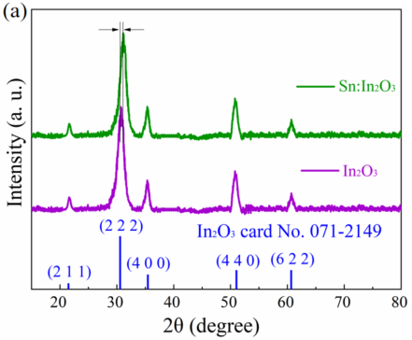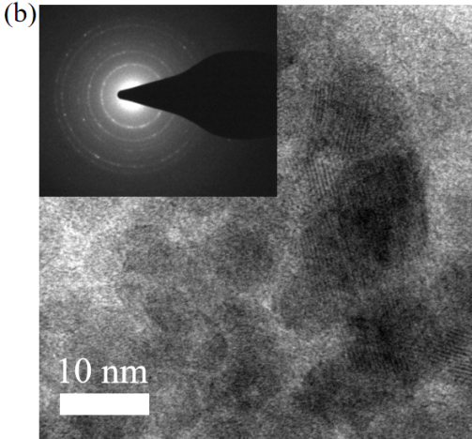
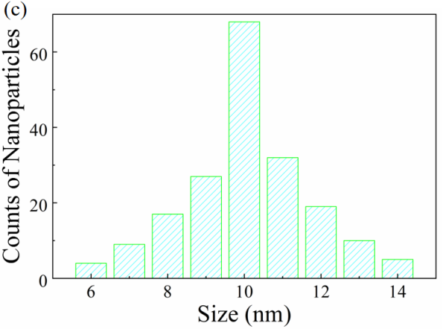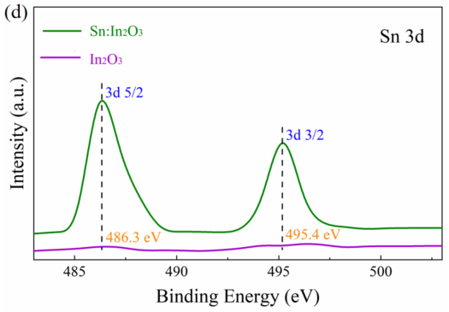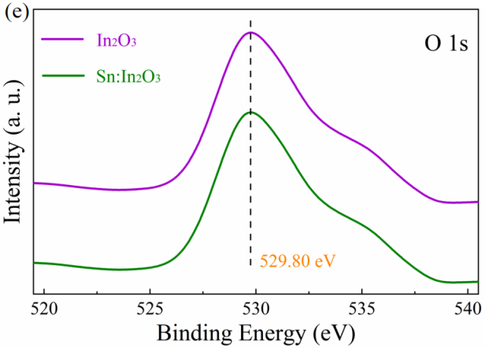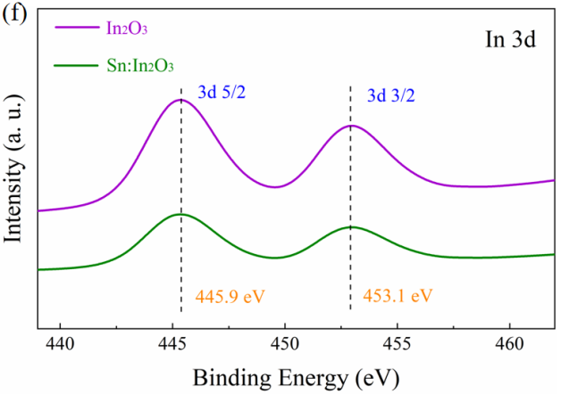
Figure 1. (a) XRD patterns, (b) TEM image and the corresponding diffraction pattern (inset) of Sn doped In₂O₃ NPs. (c) Size distribution of Sn doped In₂O₃ NPs. (d-f) Sn 3d, O 1s, and In 3d XPS spectra of pristine and Sn doped In₂O₃ NPs. .

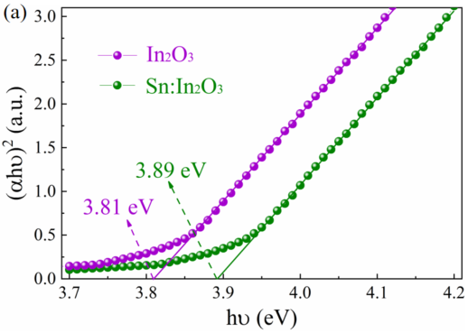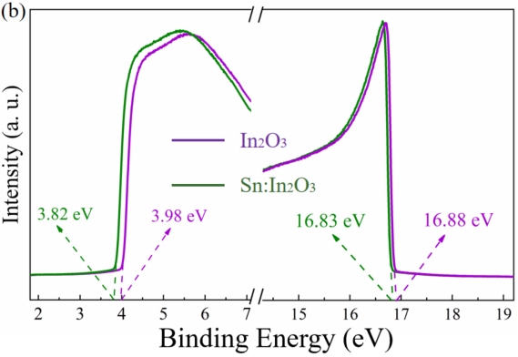
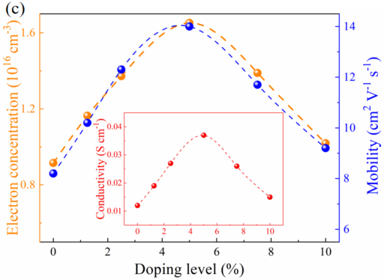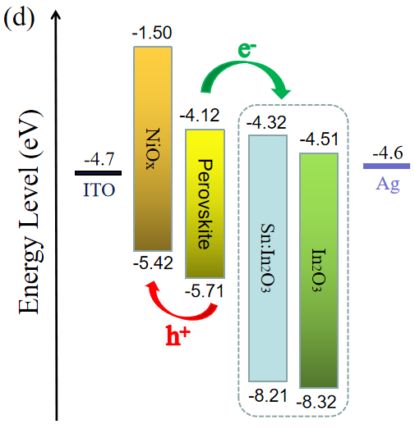
Figure 2. (a) Bandgap evaluated by the Tauc plots. (b) UPS spectra of In₂O₃ and Sn:In₂O₃. (c) Electron concentration and mobility of Sn:In₂O₃ with different Sn concentration. The insert shows the calculated conductivity according to the equation . (d) Band diagram of inverted perovskite solar cell.

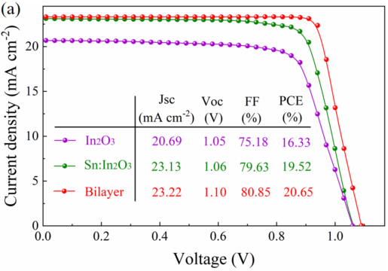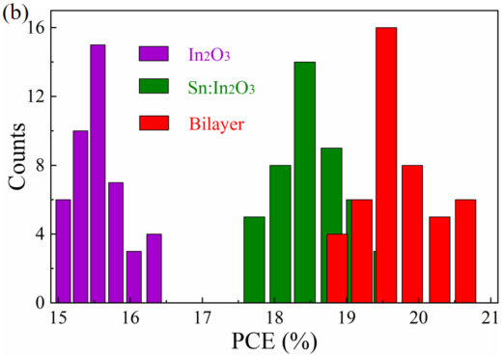
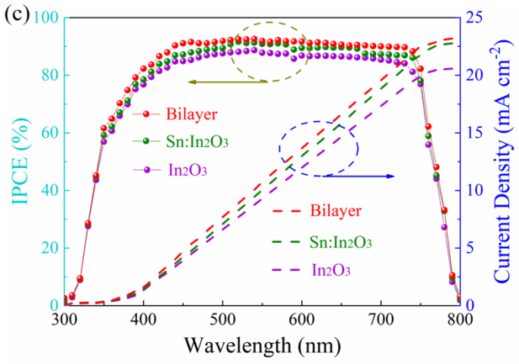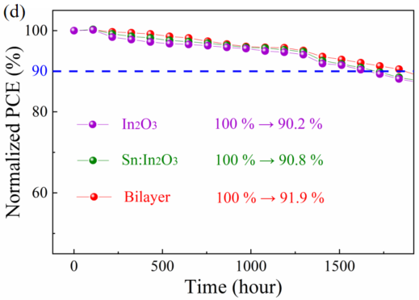
Figure 3. (a) J-V curves of the champion PSCs based on In₂O₃, Sn:In₂O₃, and bilayer (Sn:In₂O₃/In₂O₃). (b) Histograms of PCEs for PSCs based on different ETLs. (c) IPCE and integrated current of the devices based on different ETLs. (d) Time-related variation of the normalized PCE under simulated working condition between day (85℃) and night (room temperature) intervals.

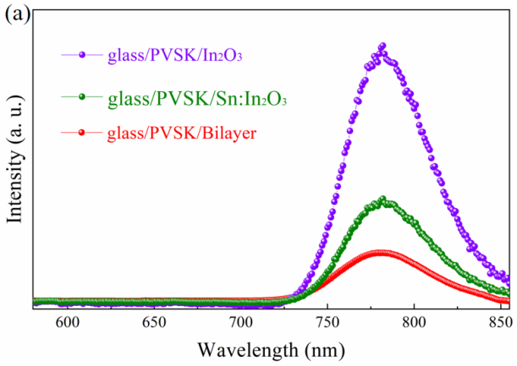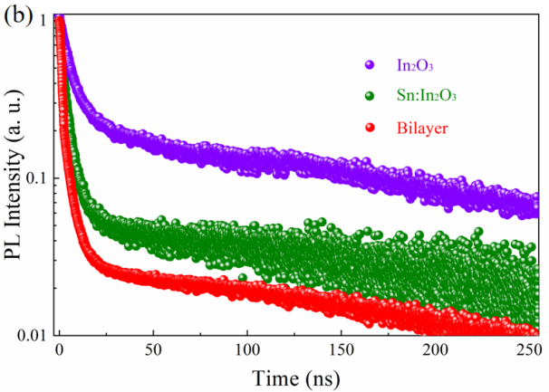
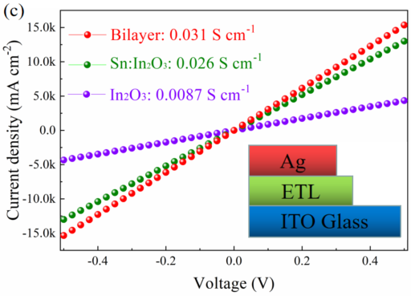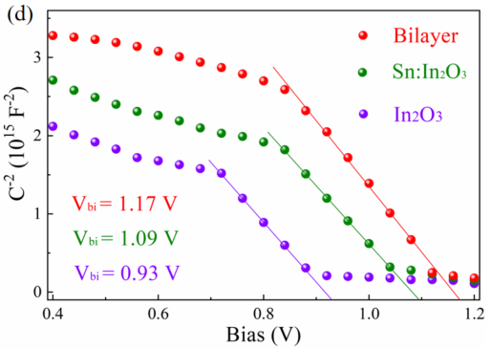
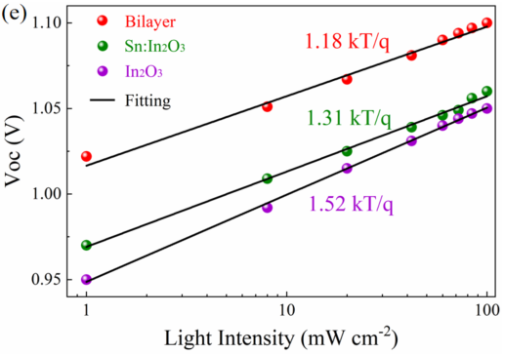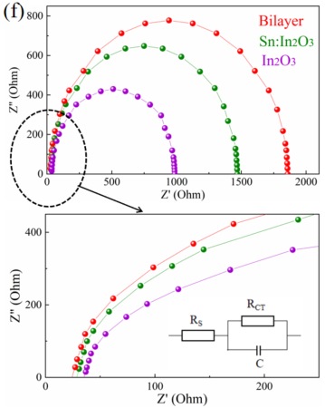
Figure 4 (a) Steady-state and (b) Time-resolved PL spectra of perovskite coated on glass, In₂O₃, Sn:In₂O₃ and bilayer of Sn:In₂O₃/In₂O₃, respectively. (c) Current-voltage curves of ITO/ETL/Au under dark conditions, ETL=In₂O₃, Sn:In₂O₃ and bilayer (Sn:In₂O₃/In₂O₃), respectively. (d) C⁻²-V dependence of PSCs based on different ETLs. (e) Voc as a function of light intensity for PSCs with different ETLs. (f) EIS spectra of the devices based on different ETL.

Graphic for manuscript

