Full paper
Efficacious multifunction codoping strategy on the room-temperature solution-processed hole transport layer for realizing high-performance perovskite solar cells
Dan Ouyang, Jiawei Zheng, Zhanfeng Huang, Lu Zhu, Wallace C. H. Choy*
Department of Electrical and Electronic Engineering, The University of Hong Kong, Pokfulam Road, Hong Kong 999077, China
* Corresponding author
E-mail address: chchoy@eee.hku.hk

Keywords: Codoping, Nanoparticle, Solution-processed, Hole transporting layer, Perovskite solar cells

ABSTRACT
The multifunctional carrier transport layer favoring outstanding carrier extraction, high-quality active layer formation, and facile low-temperature process for efficient and large-scale perovskite solar cells (PSCs) is highly desirable. While co-doping approaches have recently become a hot topic in carrier transport layers to address the negative effects and limitations of typical single doping and further boosting the carrier extraction properties and thus device performances, high-temperature, high power, and multi-steps processes/ treatments are required which hinder their applications and potentially damage underneath structures particularly in emerging flexible electronics. In this work, we demonstrate the first kind of room-temperature solution-processed and post-treatment-free Li and Cu codoped NiO_{x} nanoparticle-based hole transport layer (HTL). Simultaneously, the Li and Cu codoped NiO_{x} HTLs show the interesting and critical features of (1) improved electrical conductivity and optical transmittance, (2) high quality (pin-hole/crack free, compact and uniform) film morphology, (3) favoring large grain-size perovskite film formation, and (4) wide-range thermal stability up to 250 ºC. With these interesting multifunctions, PSCs with Li and Cu codoped NiO_{x} HTL achieve 20.8% and 18.2% for rigid and flexible PSCs, respectively. This work contributes to a promising route for realizing highly efficient and stable rigid and flexible PSCs using abundant low-cost inorganic HTLs.

1. Introduction
The rapidly developed perovskite solar cells (PSCs) have aroused tremendous interest owing to their excellent optoelectronic properties (such as broad absorption range, intense extinction coefficient, and high charge carrier mobility), long charge-carrier lifetime, low-temperature solution processability, and relatively low-cost fabrication [1-4]. The power conversion efficiency (PCE) of PSCs has been swiftly raised from ~3.8% [5] to recent certified 25% [6], showing the great commercial potential of this cell technology. In PSCs, carrier transport layers (CTLs) is crucial not only for achieving better energy alignment and carrier transport but also for obtaining improved stability, and tremendous efforts have been devoted to exploring effective CTLs featuring low resistance, good optical transparency, superior charge extraction/transport ability, as well as excellent stability. Among various CTL materials, inorganic CTLs are of particular interest due to their decent carrier mobility, very low cost of raw materials and synthesis, and good stability [7-15].
Recently, the modification in carrier transport materials by codoping has become a hot and attractive topic for increasing the efficiency of photovoltaic devices due to the advantages of compensating the negative effects of single doping or further enlarged the regulating range of carrier mobility, Fermi level, and etc. [16-20]. By combing the effect of Mg on bandgap and Er on light absorption and emission, the co-doped Er, Mg TiO₂ electron transport layer (ETL) under 500 ºC hydrothermal treatment and effectively improve the device efficiency [17]. Sm³⁺, Eu³⁺ co-doped TiO₂ ETL was also demonstrated via pulse laser deposition method and the PSCs exhibited a PCE of 19.01% with good ultraviolet (UV) light stability [21]. The improvement of device performance was explained by the UV light utilization due to the down-conversion dopant Eu³⁺, which can be enhanced by further doping with Sm³⁺. By doping Zr and F in SnO₂ to increase the conduction band and electrical conductivity, the PSCs with suitable annealing and UV-ozone treatment could achieve over 19% PCE with low hysteresis [22]. Moreover, co-doping also has been adopted in commonly used NiO_{x} hole transport layer (HTL) for modifying the electrical properties by increasing the dopant solubility, the activation rate by lowering the ionization energy of Ni vacancies, as well as the carrier mobility [20, 23-25]. For instance, high-temperature sol-gel processed Pb, Li and Ag, Li co-doped NiO_{x} thin films have been fabricated and served as HTL in PSCs, which exhibited a PCE of 17.02% and 19.24%, respectively [23-25]. Mg and Li co-doped NiO_{x} HTL formed by spray technique also achieved a PCE of 18.3% in inverted PSCs [24]. However, all the above cases require high temperatures (>200 ºC) during deposition and/or annealing treatment for realizing the expected electrical performance of co-doping materials, which not only increases the complexity and cost of device fabrication but also limits the possibility of PSCs application on flexible plastic substrates. It is highly desirable to explore room-temperature solution-processed codoped NiO_{x} HTL for flexible PSCs, featuring with efficient hole extraction capabilities and uniform morphologies. To the best of our knowledge, there is no report on room-temperature solution-processed co-doped NiO_{x} HTL for demonstrating highly efficient rigid and flexible PSCs.
Herein, we demonstrate a room-temperature solution-processed and post-treatment-free Li,Cu-codoped NiO_{x} (hereafter named as (Li,Cu):NiO_{x}) nanoparticles (NPs) based HTL for high-performance rigid and flexible inverted planar PSCs. The (Li,Cu):NiO_{x} film exhibits not only simultaneously enhanced electrical conduction and optical transmittance, but also improved morphology uniformity on various substrates such as rigid indium tin oxide (ITO)/glass and flexible ITO/polyethylene terephthalate (PET). Besides, the co-doped NiO_{x} HTL can promote the large grain perovskite film formation. The simultaneous interesting features result in the improvement of PCE by 15% as compared to the case of pristine NiO_{x} to the value of 20.8% and 18.2% for inverted PSCs on the rigid and flexible, respectively. While the effective co-doped (Li,Cu):NiO_{x} HTL is formed at room temperature, the high performance can sustain with annealing temperature up to 250 ºC. Moreover, the PSCs based on (Li,Cu):NiO_{x} showed decent stability, with 95% of the original efficiency remaining after 60 days of storage in inert conditions. This work provides a promising route to realize highly efficient and stable inverted planar PSCs both on rigid and flexible substrate using abundant and low-cost inorganic HTLs, which favor the development of large-scale perovskite optoelectronic devise.
2. Results and discussion
The undoped NiO_{x} and (Li,Cu):NiO_{x} NPs have been newly synthesized by a modified chemical coprecipitation approach [11, 26]. Particularly, a portion of Ni(NO₃)₂·6H₂O in precursor was replaced by Cu(NO₃)₂·3H₂O and LiNO₃ with appropriate mole ratio which can be used to low-temperature synthesize not only Cu doped and Li doped NiO_{x} NPs but also the targeted co-doped (Li,Cu):NiO_{x} NPs, as further details in the Experimental Section.
Fig. 1a shows X-ray diffraction (XRD) patterns of NiO_{x} and (Li,Cu):NiO_{x} powders. All samples show three prominent characteristic diffraction peaks that can be respectively assigned to (111), (200), and (220) planes of the NiO phase according to JCPDS (22-1189). The similar diffraction peaks for undoped and doped NiO_{x} illustrate that light doping of Cu and Li could hardly change the phase structure of NiO_{x} [27, 28]. Notably, the peak shift from 62.43º to 62.60º indicates the slight change of the lattice parameter after successfully co-doping with Cu and Li into NiO_{x}. Moreover, the high-resolution transmission electron microscopy (HRTEM) image and selective area electron diffraction pattern (SAED) of (Li,Cu):NiO_{x} nanocrystal (Fig. 1b) further verified that codoped NiO_{x} NPs possess good crystalline properties and pure NiO phase. TEM was applied to confirm the crystallite sizes of NiO_{x} and (Li,Cu):NiO_{x} NPs as shown in Fig. 1c and S1. Comparing with the pristine NiO_{x} (5.62 nm on average), the smaller grain size of (Li,Cu):NiO_{x} (4.28 nm on average, Fig. 1d) is a benefit for the formation of thin films featuring with densely packed and smooth morphology.
X-ray photoelectron spectroscopy (XPS) of pristine NiO_{x} and (Li,Cu):NiO_{x} samples are shown in Fig. S2. Both pristine and codoped NiO_{x} films have typical peaks including the main peak at ~854.1eV, shoulder at ~ 855.5eV, and shake-up satellite peak at ~ 861.2eV [29, 30]. The main peak corresponds to Ni²⁺ in the standard Ni-O octahedral bonding configuration in cubic rock salt NiO_{x} [31, 32]. The shoulder peak ascribes to the Ni-vacancy induced Ni³⁺ ion [32-35], nickel hydroxides and oxyhydroxides [32, 33], and nonlocal screening and surface states [29]. Notably, in Fig. S2b and c, XPS peaks corresponding to Cu 2p_{2/3} (933.6 eV), and Li 1s (55.9 eV) are clearly observed from (Li, Cu):NiO_{x} film, which are absence in undoped NiO_{x} film, revealing that Cu and Li are successfully incorporated into NiO_{x} [36]. Due to the Li and Cu doping, the obtained Ni³⁺/Ni²⁺ ratio of (Li,Cu):NiO_{x} film (1.68) is larger than that of undoped NiO_{x} (1.57) which contributes to the increase of hole conductivity as further studied in later section.
The surface morphologies of undoped NiOx and (Li,Cu):NiO_{x} thin films on ITO glass were determined by top-view scanning electron microscopy (SEM) and atomic force microscopy (AFM) as shown in Fig. 2a-d. Notably, (Li,Cu):NiO_{x} film consists of small-sized crystalline grains and is uniform without pin-holes (Fig. 2a). Moreover, 3D AFM images further confirm the closely packed and crack-free morphologies of (Li,Cu):NiO_{x} film with a smaller root-mean-square roughness (RMS) of 3.09 nm (Fig. 2c) compared to the pristine NiO_{x} film (4.00 nm; Fig. 2d). It is worth noting that the smooth and uniform surface in (Li,Cu):NiO_{x} film should be beneficial to the formation of high-quality perovskite films for realizing high-performance devices. Thus, the morphologies of perovskite layers on NiO_{x}, and (Li,Cu):NiO_{x} thin film was characterized by SEM as shown in Fig. S3a and b. It is found that all the perovskite films are homogeneous and densely packed. Notably, the perovskite crystal grains formed on (Li,Cu):NiO_{x} (511 nm) show a larger grain size than that of grown on NiO_{x} (440 nm), displayed in Fig. S3c and d. That is could because the slightly larger contact angle (inserted in Fig. S3a and b) provide a non-wetting surface, favoring to suppress heterogeneous nucleation [37] and promote the grain growth [12, 38, 39]. Consequently, (Li,Cu):NiO_{x} based HTL favors the formation of good quality perovskite film, which is one of the interesting properties for obtaining highly efficient PSCs.
The electrical and optical properties are particularly important for realizing efficient HTL. Firstly, we investigated the optical transmittance of NiO_{x} and (Li,Cu):NiO_{x} films coated on ITO glass as shown in Fig. 2e. Interestingly, for (Li, Cu):NiOx thin film, the transmittance reaches 87% at 460 nm, and shows an improvement over a large wavelength range from 500 to 800 nm than that of pristine NiO_{x}. Furthermore, while light Li only doping does not change the transparency, the Cu doping will reduce the doping transmittance decreases as shown in Fig. S4 due to the d-d transition of Cu²⁺ in the crystalline environment of NiO_{x}, which agrees with the report [32, 40, 41].
We further study the effect of Li and Cu co-doping on the electrical conductivity of NiO_{x} films by performing conductive atomic force microscopy (c-AFM) measurements, as described in Fig. 2f. From the I-V curves, it is clearly observed that a significantly higher current in (Li,Cu):NiO_{x} film (14.6 nA at a bias of 0.5 V), indicating a dramatically increased conductivity than the pristine NiO_{x} (8 nA at a bias of 0.5 V). The increased ratio of Ni³⁺/Ni²⁺ supports the successful doping by Li and Cu as well as the improved hole conductivity, which is in good agreement with others (Fig. S5) [24, 32, 41-44]. These results indicate the Li and Cu codoping strategy on NiO_{x} could achieve the significantly enhanced conductivity and keep high transparency, making it more suitable as efficient HTL for achieving high-performance PSCs.
To explore the function of the (Li,Cu):NiO_{x} film as the HTL, inverted PSCs with the structure of ITO/NiO_{x} (or (Li,Cu):NiO_{x})/perovskite/PC₆₁BM:C₆₀/ZrAcac/Ag have been fabricated, where the corresponding energy level diagram was depicted at Fig. 3a. The energy levels of ITO, perovskite, PC₆₁BM:C₆₀, ZrAcac, and Ag are collected from literature [12, 13, 45], and NiO_{x} or (Li,Cu):NiO_{x} are obtained from ultraviolet photoelectron spectroscopy (UPS). The cross-sectional view SEM image of the device configuration as shown in Fig. 3b. Fig. 3c depicted the current density-voltage (J-V) curves of the champion devices based on pristine NiO_{x} and (Li,Cu):NiO_{x} under AM 1.5G illuminated. The (Li,Cu):NiO_{x} based PSCs with an optimized thickness of 20 nm exhibited a short circuit current density (J_{SC}) of 23.156 mA cm⁻², an open-circuit voltage (V_{oc}) of 1.11 V, and a fill factor (FF) of 0.81 to yield the best PCE of 20.83%, clearly outperforming the PSCs based on pristine NiO_{x} as HTL. The best-performing reference cell using pristine NiO_{x} as HTL gave a J_{SC} of 22.02 mA cm⁻², V_{oc} of 1.09 V, FF of 0.75, and PCE of 17.91%. These values are comparable with those of a previous report on devices with the same structure [46]. Thanks to the simultaneously enlarged transmittance and conductivity of the codoped HTL and the high-quality perovskite film with larger grain size, the inverted PSCs displayed significantly enhanced J_{SC}, FF, and PCE, which is also excellent among the reported NiO_{x} based inverted PSCs, as shown in Table S1. Additionally, the PSCs based on (Li,Cu):NiO_{x} HTLs showed negligible J-V hysteresis in Fig. 3d, which is better than that of NiO_{x} based PSCs (Fig. S6). The narrow distributions of the statistical photovoltaic parameters (J_{SC}, V_{oc}, FF, and PCEs) from 30 devices further confirm the reliability of performance improvement of (Li,Cu):NiO_{x}-based PSCs (Fig. S7). Fig. 3e shows the incident photo-to-current efficiency (IPCE) spectra of the champion devices based on NiOx and (Li,Cu):NiO_{x}, where the integrated J_{SC} from the IPCE over an AM 1.5 G spectrum approximately agrees with those obtained from J-V curves. In addition, the steady-state photocurrent output at the maximum power point over 200 s has been measured by siting a bias of 0.97, as shown in Fig. 3f. There is no performance degradation under long illumination and exhibited a stable PCE of 20.24% for (Li,Cu):NiO_{x} based PSCs, which is consistent with that of J-V measurement.
In order to exploit the reasons for the improved performance by codoping with Li and Cu, we first compared work function (WF) of NiO_{x} and (Li,Cu):NiO_{x} films by Kelvin-Probe measurement. For each sample, 500 points are collected, as shown in Fig. S8. The measured WF values are collected in Table S2. WF of the pristine NiO_{x} film is determined to be 4.99 eV, and shifted to 5.12 eV of (Li,Cu):NiO_{x}. From the UPS and the corresponding energy level diagram in Fig. 4a and b, Cu and Li codoping can cause energy band shifts and increase the work function [47], resulting in a favorable energy level alignment with the perovskite layer (-5.4 eV, Fig. 3a) and an enhanced hole extraction ability. In addition, the valence band (VB) shifted by about 0.02 eV closer to the Fermi energy level after Li and Cu codoping (Fig. 4b), showing an enhanced p-type property and improved film conductivity, which is consistent with the previous discussion.
To verify the charge extraction ability at the interface of HTL/perovskite, the steady-state photoluminescence (PL, Fig. 4c) and time-resolved photoluminescence (TRPL, Fig. 4d) measurement of the perovskite layers deposited on NiO_{x}, and (Li,Cu):NiO_{x} films were conducted, respectively. It can clearly be observed that the (Li,Cu):NiO_{x} HTL exhibits efficient PL quenching compared to that of the pristine NiO_{x}, illustrating a more favorable ohmic contact with perovskite layer and obvious improvement of the hole extraction efficiency. Meanwhile, the TRPL profiles are shown in Fig. 4c, where the PL lifetime is fitted by two-exponential decay [42, 48]. There is a decrease in the average PL lifetime for (Li,Cu):NiO_{x} /perovskite (13 ns) as compared to the pristine NiO_{x}/perovskite (20 ns), which further validated that faster and more efficient hole extraction and transporting ability at the (Li,Cu):NiO_{x}/perovskite interface. Compared to NiO_{x}, the more effective hole extraction and transport by (Li,Cu):NiO_{x} HTL from perovskite active layer could be ascribed to the higher conductivity and increased work function, which would contribute to the high J_{SC} and FF values for (Li,Cu):NiO_{x} based PSCs.
Charge transport and recombination ability can also be studied from electronic impedance spectroscopy (EIS) measurement, where it is performed at a bias voltage of 0.9 V under a dark condition (Fig. 4e). The only one semicircle in the obtained Nyquist plot will be more likely related to the recombination resistance at the interface of the HTL/perovskite layer, where the larger the diameter is, the less hole recombination at the interface. Comparing to that of pristine NiO_{x} based devices (1.3 KΩ), (Li,Cu):NiO_{x} HTL based PSCs exhibit a larger charge recombination resistance (2.6 KΩ), illustrating less carrier recombination, which results in the increased J_{SC} and enhanced FF in the (Li,Cu):NiO_{x} HTL based PSCs. As shown in the dark current-voltage curves of Fig. S9, the lower dark current under negative bias in the (Li,Cu):NiO_{x} HTL based PSCs illustrates that those PSCs based on (Li,Cu):NiO_{x} HTL exhibited a lower leakage current, reducing leakage-induced recombination that would improve the Voc.
Regarding the stability and reversibility of PSCs, the PCE of (Li,Cu):NiO_{x} HTL based PSCs were characterized after one-month storage in a nitrogen-filled glovebox, as portrayed in Fig. 5. It is found that (Li,Cu):NiO_{x} HTL-based devices exhibited excellent stable performance, retained 95% of initial PCE after 60 days storage, implying the beneficial effect of Cu, Li in preventing the undesired oxidation process on the NiO_{x} surface.
To demonstrate the feasibility of post-treatment free and room-temperature processed (Li,Cu):NiO_{x} HTL for the application of flexible devices, we deposited (Li,Cu):NiO_{x} film onto ITO-PET substrate to fabricate flexible PSCs. A photograph of a typical flexible device with an area of 0.08 cm² is shown in Fig. 6a. Fig. 6b illustrates the J-V curves of the champion flexible PSCs with (Li,Cu):NiO_{x} HTL (under AM 1.5G illumination). The device exhibited a Jsc of 22.02 mA cm⁻², a Voc of 1.06, and a FF of 0.78, corresponding to the best PCE of 18.16%, which are comparable to those of the reported best flexible PSCs with inverted structures (Fig. 6c). To the best of our knowledge, 18.2% is the highest PCE value attained for NiO_{x} based flexible inverted PSCs. This result suggests that the (Li,Cu):NiO_{x} HTL without any high-temperature treatment is compatible with the flexible substrate and shows a broad application prospect for the roll-to-roll scale-up fabrication process.
Another interesting feature of the (Li,Cu):NiO_{x} films is that while only room temperature condition is needed for forming efficiency HTLs, the films can sustain a wide tolerance temperature for practical application of PSCs in the temperature changing environment. The J-V characteristics of PSCs using (Li,Cu):NiO_{x} HTL with different annealing temperatures are collected in Table S3. Our results show that all the devices show similar performances for the co-doped (Li,Cu):NiO_{x} HTL with annealing temperature up to 250 ºC. Until the annealing temperature further increases to 300 ºC, the PCE begins to decrease, which attributed to the decreased Jsc and Voc. Our results demonstrate that the (Li,Cu):NiO_{x} HTL in this work can function as effective HTLs without any post-treatment, as well as offer wide temperature stability from room temperature up to 250 ºC, which can contribute to the device stability during the fabrication and application of PSCs.
3. Conclusion
In summary, we have successfully demonstrated efficient HTL by a simple room-temperature solution process without any treatment for high performance rigid and flexible PSCs. Particularly, the co-doped (Li,Cu):NiO_{x} film simultaneously exhibits several interesting features of (1) improved electrical conductivity, (2) enhanced optical transmittance, (3) high quality (compact and uniform) film and (4) favoring large grain-size perovskite film formation. The PCE of PSCs based on (Li,Cu):NiO_{x} HTL improved by 15% as compared to the case of pristine NiO_{x} and reach a promising value of 20.8% on rigid substrates and 18.2% on flexible substrates. While the effective co-doped (Li,Cu):NiO_{x} HTL is formed at room temperature, the high performance can sustain with annealing temperature up to 250 ºC. Meanwhile, the PSCs exhibit excellent stability, with 95% of the original efficiency remaining after 1000 h of storage in ambient conditions. This work provides a promising route to realize highly efficient and stable rigid and flexible PSCs using abundant low-cost inorganic HTLs.

Declaration of competing interest
This author declares no competing financial interest.
Acknowledgements
This work was supported by This research was supported by the University Grant Council of the University of Hong Kong (Grant# 201811159147, and Research Equipment Fund), the General Research Fund (Grant 17204117, 17200518, and 17201819), and Collaborative Research Fund (C5037-18G) from the Research Grants Council (RGC), and Environment and Conservation Fund (ECF Project 64/2018) of Hong Kong Special Administrative Region, China.

Appendix A. Supplementary information
Supplementary data associated with this article can be found in the online version at

References
[1] N.J. Jeon, J.H. Noh, Y.C. Kim, W.S. Yang, S. Ryu, S.I. Seok, Nat. Mater., 13 (2014) 897-903.
[2] Q. Dong, Y. Fang, Y. Shao, P. Mulligan, J. Qiu, L. Cao, J. Huang, Science, 347 (2015) 967-970.
[3] H. Oga, A. Saeki, Y. Ogomi, S. Hayase, S. Seki, J. Am. Chem. Soc., 136 (2014) 13818-13825.
[4] C. Wehrenfennig, G.E. Eperon, M.B. Johnston, H.J. Snaith, L.M. Herz, Adv. Mater., 26 (2014) 1584-1589.
[5] A. Kojima, K. Teshima, Y. Shirai, T. Miyasaka, J. Am. Chem. Soc., 131 (2009) 6050-6051.
[6] (National Renewable Energy Laboratory, “NREL Efficiency Chart, 2019” . https://www.nrel.gov/pv/assets/pdfs/best-research-cell-efficiencies.20190128.pdf).
[7] P. Qin, S. Tanaka, S. Ito, N. Tetreault, K. Manabe, H. Nishino, M.K. Nazeeruddin, M. Gratzel, Nat. Commun., 5 (2014) 3834.
[8] Z. Zhu, Y. Bai, T. Zhang, Z. Liu, X. Long, Z. Wei, Z. Wang, L. Zhang, J. Wang, F. Yan, S. Yang, Angew. Chem. Int. Ed., 53 (2014) 12571-12575.
[9] S.S. Shin, W.S. Yang, J.H. Noh, J.H. Suk, N.J. Jeon, J.H. Park, J.S. Kim, W.M. Seong, S.I. Seok, Nat. Commun., 6 (2015) 7410.
[10] C. Zuo, L. Ding, Small, 11 (2015) 5528-5532.
[11] H. Zhang, J. Cheng, F. Lin, H. He, J. Mao, K.S. Wong, A.K. Jen, W.C. Choy, ACS Nano, 10 (2016) 1503-1511.
[12] D. Ouyang, J. Xiao, F. Ye, Z. Huang, H. Zhang, L. Zhu, J. Cheng, W.C.H. Choy, Adv. Energy Mater., 8 (2018) 1702722.
[13] H. Zhang, H. Wang, H. Zhu, C.-C. Chueh, W. Chen, S. Yang, A.K.Y. Jen, Adv. Energy Mater., 8 (2018) 1702762.
[14] D. Ouyang, Z. Huang, W.C.H. Choy, Adv. Funct. Mater., 29 (2019) 1804660.
[15] Z. Huang, D. Ouyang, C.J. Shih, B. Yang, W.C.H. Choy, Adv. Energy Mater., 10 (2020) 1900903.
[16] M. Hajizadeh-Oghaz, Ceram. Int., 45 (2019) 6994-7000.
[17] H. Chen, W. Zhu, Z. Zhang, W. Cai, X. Zhou, J. Alloys Compd., 771 (2019) 649-657.
[18] M. Vasilopoulou, N. Kelaidis, E. Polydorou, A. Soultati, D. Davazoglou, P. Argitis, G. Papadimitropoulos, D. Tsikritzis, S. Kennou, F. Auras, D.G. Georgiadou, S.G. Christopoulos, A. Chroneos, Sci. Rep., 7 (2017) 17839.
[19] A. Ioakeimidis, I.T. Papadas, D. Tsikritzis, G.S. Armatas, S. Kennou, S.A. Choulis, APL Materials, 7 (2019) 021101.
[20] S. Wang, B. Zhang, D. Feng, Z. Lin, J. Zhang, Y. Hao, X. Fan, J. Chang, J. Mater. Chem. C, 7 (2019) 9270-9277.
[21] B. Zhang, Z. Song, J. Jin, W. Bi, H. Li, C. Chen, Q. Dai, L. Xu, H. Song, J. Colloid Interface Sci., 553 (2019) 14-21.
[22] J. Tian, J. Zhang, X. Li, B. Cheng, J. Yu, W. Ho, Solar RRL, (2020) 10.1002/solr.202000090.
[23] D. Hou, J. Zhang, X. Gan, H. Yuan, L. Yu, C. Lu, H. Sun, Z. Hu, Y. Zhu, J. Colloid Interface Sci., 559 (2020) 29-38.
[24] M.H. Liu, Z.J. Zhou, P.P. Zhang, Q.W. Tian, W.H. Zhou, D.X. Kou, S.X. Wu, Opt. Express, 24 (2016) A1349-A1359.
[25] X. Xia, Y. Jiang, Q. Wan, X. Wang, L. Wang, F. Li, ACS Appl. Mater. Interfaces, 10 (2018) 44501-44510.
[26] F. Jiang, W.C. Choy, X. Li, D. Zhang, J. Cheng, Adv. Mater., 27 (2015) 2930-2937.
[27] Q. He, K. Yao, X. Wang, X. Xia, S. Leng, F. Li, ACS Appl. Mater. Interfaces, 9 (2017) 41887-41897.
[28] K.H. Kim, C. Takahashi, Y. Abe, M. Kawamura, Optik, 125 (2014) 2899-2901.
[29] S. Seo, I.J. Park, M. Kim, S. Lee, C. Bae, H.S. Jung, N.G. Park, J.Y. Kim, H. Shin, Nanoscale, 8 (2016) 11403-11412.
[30] Z. Qiu, H. Gong, G. Zheng, S. Yuan, H. Zhang, X. Zhu, H. Zhou, B. Cao, J. Mater. Chem. C, 5 (2017) 7084-7094.
[31] S.W.T. Jesse R. Manders, Michael J. Hartel, Tzung Han Lai, Song Chen, Chad M. Amb, John R. Reynolds, Franky So, Adv. Funct. Mater., 23 (2013) 2993-3001.
[32] W. Chen, Y. Wu, J. Fan, A.B. Djurišić, F. Liu, H.W. Tam, A. Ng, C. Surya, W.K. Chan, D. Wang, Z.-B. He, Adv. Energy Mater., 8 (2018) 1703519.
[33] J. Cui, F. Meng, H. Zhang, K. Cao, H. Yuan, Y. Cheng, F. Huang, M. Wang, ACS Appl. Mater. Interfaces, 6 (2014) 22862-22870.
[34] K.C. Wang, P.S. Shen, M.H. Li, S. Chen, M.W. Lin, P. Chen, T.F. Guo, ACS Appl. Mater. Interfaces, 6 (2014) 11851-11858.
[35] S.S. Mali, C.K. Hong, Nanoscale, 8 (2016) 10528-10540.
[36] J. Jang, S. Chung, H. Kang, V. Subramanian, Thin Solid Films, 600 (2016) 157-161.
[37] C. Bi, Q. Wang, Y. Shao, Y. Yuan, Z. Xiao, J. Huang, Nat. Commun., 6 (2015) 7747.
[38] B. Yang, D. Ouyang, Z. Huang, X. Ren, H. Zhang, W.C.H. Choy, Adv. Funct. Mater., 29 (2019) 1902600.
[39] P.-W. Liang, C.-C. Chueh, S.T. Williams, A.K.Y. Jen, Adv. Energy Mater., 5 (2015) 1402321.
[40] J.W. Jung, C.C. Chueh, A.K. Jen, Adv. Mater., 27 (2015) 7874-7880.
[41] S.C. Chen, T.Y. Kuo, Y.C. Lin, H.C. Lin, Thin Solid Films, 519 (2011) 4944-4947.
[42] H.S. Kim, J.Y. Seo, H. Xie, M. Lira-Cantu, S.M. Zakeeruddin, M. Gratzel, A. Hagfeldt, ACS Omega, 2 (2017) 9074-9079.
[43] J. Zheng, L. Hu, J.S. Yun, M. Zhang, C.F.J. Lau, J. Bing, X. Deng, Q. Ma, Y. Cho, W. Fu, C. Chen, M.A. Green, S. Huang, A.W.Y. Ho-Baillie, ACS Appl. Energy Mater., 1 (2018) 561-570.
[44] X. Wan, Y. Jiang, Z. Qiu, H. Zhang, X. Zhu, I. Sikandar, X. Liu, X. Chen, B. Cao, ACS Appl. Energy Mater., 1 (2018) 3947-3954.
[45] Y. Zhao, H. Zhang, X. Ren, H.L. Zhu, Z. Huang, F. Ye, D. Ouyang, K.W. Cheah, A.K.Y. Jen, W.C.H. Choy, ACS Energy Lett., 3 (2018) 2891-2898.
[46] S. Yue, K. Liu, R. Xu, M. Li, M. Azam, K. Ren, J. Liu, Y. Sun, Z. Wang, D. Cao, X. Yan, S. Qu, Y. Lei, Z. Wang, Energy Environ. Sci., 10 (2017) 2570-2578.
[47] S. Xiao, F. Xu, Y. Bai, J. Xiao, T. Zhang, C. Hu, X. Meng, H. Tan, H.P. Ho, S. Yang, Solar RRL, (2018) 1800278.
[48] Y. Li, L. Meng, Y.M. Yang, G. Xu, Z. Hong, Q. Chen, J. You, G. Li, Y. Yang, Y. Li, Nat. Commun., 7 (2016) 10214.

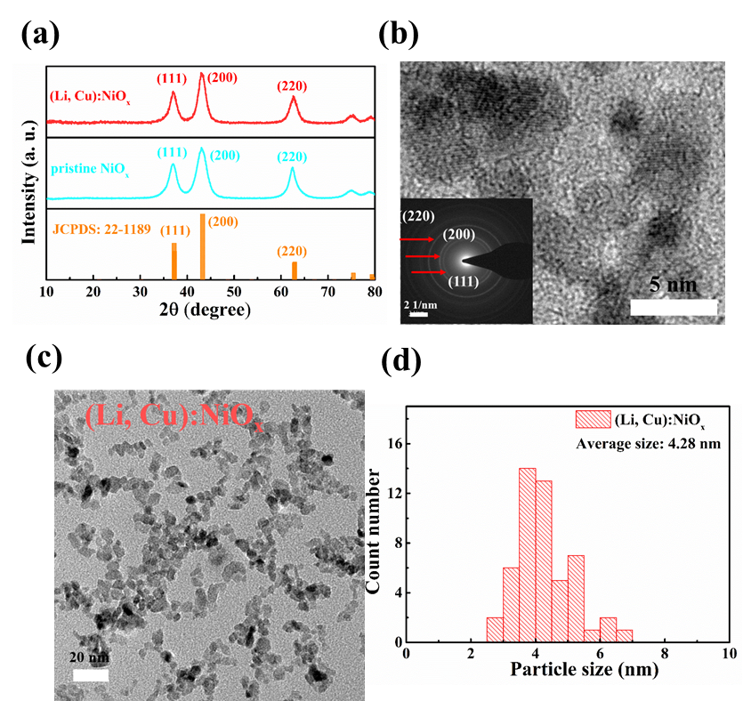
Fig. 1. (a) XRD patterns of the as-synthesized of NiO_{x} and (Li,Cu):NiO_{x} NPs. (b) HRTEM image with Indexed SAED pattern of as-synthesized (Li,Cu):NiO_{x} NPs. (c) TEM image and (d) size distribution of as-synthesized (Li,Cu):NiO_{x} NPs.

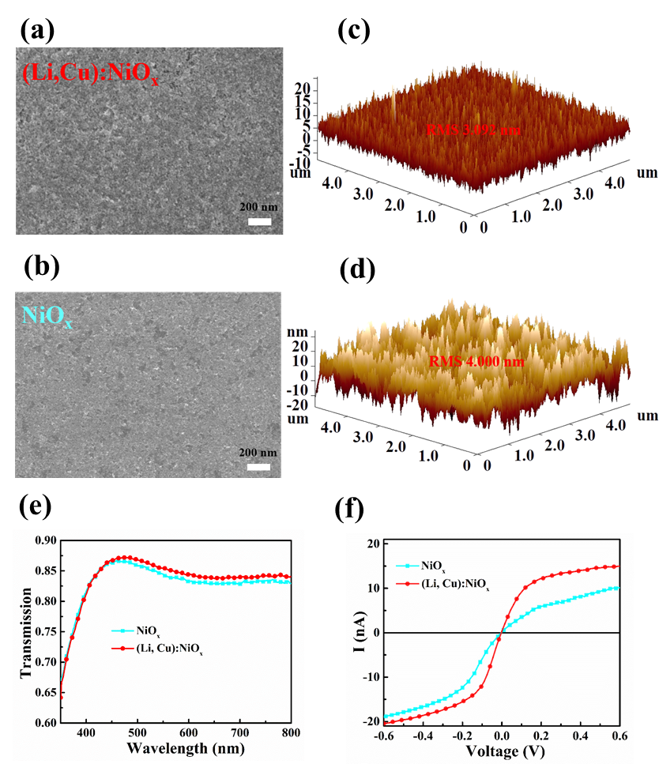
Fig. 2. SEM images of (a) (Li,Cu):NiO_{x} and (b) NiO_{x} films on ITO glass. 3D AFM images: (c) (Li,Cu):NiO_{x} and (d) NiO_{x} films. (e) The transmittance spectra of NiO_{x} and (Li,Cu):NiO_{x} films on ITO glass. (f) I-V conducting curves of NiOx and (Li,Cu):NiO_{x} films measured from the c-AFM mode.

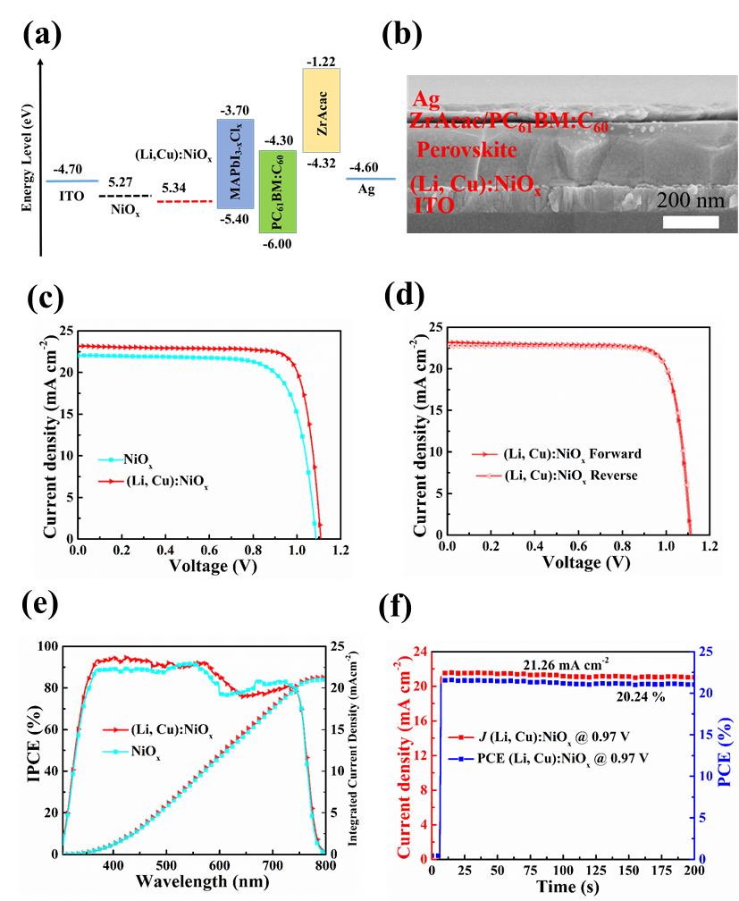
Fig. 3. (a) Energy band level diagram of the various layers in the inverted PSCs. (b) Cross-sectional SEM image of a complete perovskite device with (Li,Cu):NiO_{x} HTL. (c) J-V characteristics of the best NiO_{x} and (Li,Cu):NiO_{x} based PSCs measured under AM 1.5 G 100 mW cm⁻² illumination. (d) J-V characteristics of (Li,Cu):NiO_{x} based devices extracted from forward and reverse sweeping. (e) IPCE spectra and integrated J_{sc} curves of the best NiO_{x} and (Li,Cu):NiO_{x} based PSCs. (f) Steady-state photocurrent output at the maximum power point of (Li,Cu):NiO_{x} based PSCs under continuous simulated AM 1.5G illumination for 200 s.

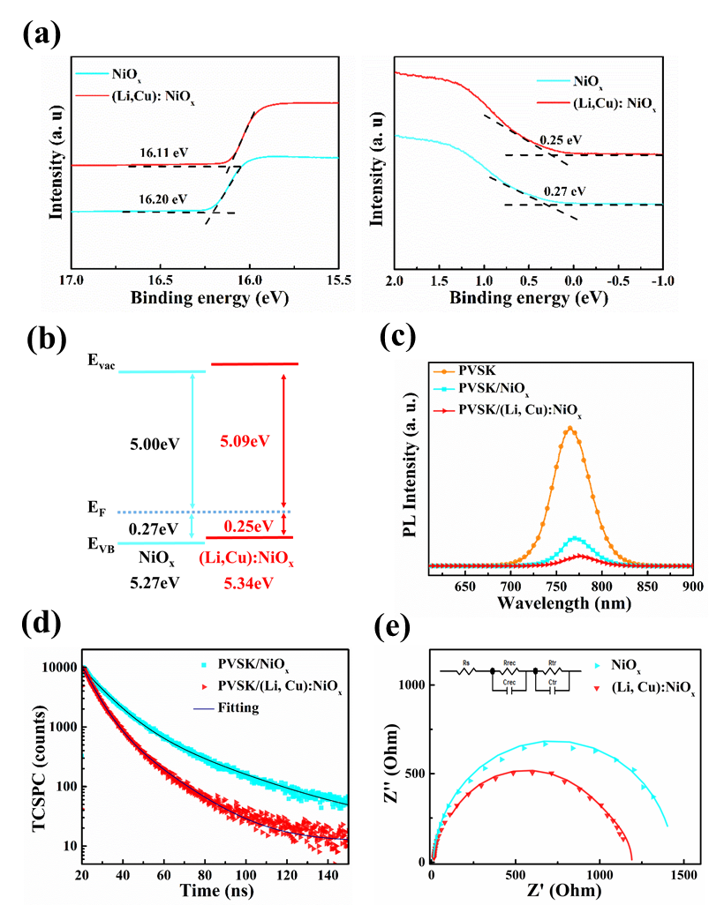
Fig. 4. (a) UPS of the NiO_{x} and (Li,Cu):NiO_{x} film on ITO glass. (b) Energy level diagrams of the NiO_{x} and (Li,Cu):NiO_{x} film. (c) PL spectra for perovskite films on different substrates: glass (orange), pristine NiO_{x} (blue), (Li,Cu):NiO_{x} (red), respectively. (d) Time-resolved PL spectra of perovskite film on NiO_{x} and (Li,Cu):NiO_{x} HTL, respectively. (e) Nyquist plots of EIS spectra for the device with NiO_{x} and (Li,Cu):NiO_{x} as HTL, respectively.

Fig. 5. Photovoltaic performance parameter (J_{sc}, V_{oc}, FF, PCE) of (Li,Cu):NiO_{x} based PSCs as a function of storage time under inert environment almost 60 days. All devices were encapsulated and stored at the glove box.

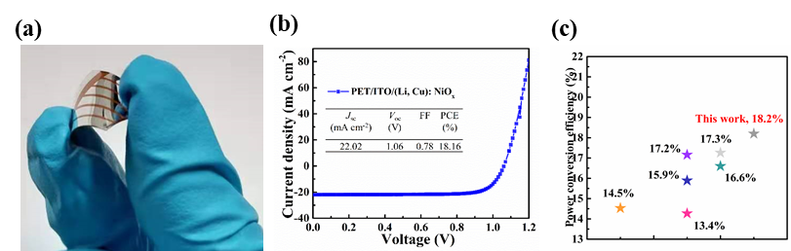
Fig. 6. (a) Photograph of a typical flexible PSC. (b) J-V characterization of (Li,Cu):NiO_{x} HTL based flexible device. (c) The efficiency of reported NiO_{x} based flexible devices.


Dan Ouyang received her Master’s degree from Qingdao Institute of Bioenergy and Bioprocess Technology, Chinese Academy of Sciences in 2012 working on conjugated polymers materials synthesis. She will receive a Ph.D. degree from the Department of Electrical Electronic Engineering, the University of Hong Kong in 2020. Her current research interests focus on interfacial layer materials in organic/perovskite photovoltaics.


Jiawei Zheng received his Master’s degree from Functional Nano & Soft Materials Laboratory，Soochow University in 2018 working on organic optoelectronics. He is currently working as a Ph.D. candidature in the Department of Electrical Electronic Engineering, the University of Hong Kong. His research interests focus on interfacial engineering in perovskite photovoltaics.


Zhanfeng HUANG obtained his Ph.D. degree at the University of Hong Kong in 2019. Currently, Dr. Huang is a postdoctoral fellow in the Department of Electrical and Electronic Engineering at The University of Hong Kong. His research interests are mainly metal oxide-based carrier transport materials, perovskite and polymer photovoltaic device design.


Hugh Lu Zhu received his B.Sc. degree from Northwest University in 2009, M.Sc. degree from Beijing Jiaotong University in 2012, Ph.D. degree from HKU in 2016. After three-year postdoctoral period in HKU, he now is an associate professor at School of Microelectronics Science and Technology, Sun Yat-sen University. His research interests include high-efficiency photodetectors, photodiode integration and imaging, flexible electronics, and nanofabrication.


Wallace C.H. Choy received his Ph.D. Degree in Electronic Engineering from University of Surrey, UK in 1999. Wallace C. H. Choy is a full professor in the Department of EEE, HKU. His research interests cover organic/inorganic optoelectronic devices, plasmonic structures, metal oxides, and nanomaterial devices. He has published more than 200 peer-reviewed papers, several book chapters, patents, and edited one book. He was recognized as top 1% of most-cited scientists in Thomson Reuter’s Essential Science Indicators from 2014 to 2019. He is named as one of the "Highly Cited Researchers" by Clarivate Analytics in 2018. He has served in various editorial boards of well-recognized publishers. He is an elected fellow of OSA.

