DOI: 10.1002/ ((please add manuscript number))
Article type: Full Paper

Establishing Multifunctional Interface Layer of Perovskite Ligand Modified Lead Sulfide Quantum Dots for Improving the Performance and Stability of Perovskite Solar Cells

Ruiman Ma, Zhenwei Ren, Can Li, Yong Wang, Zhanfeng Huang, Yong Zhao, Tingbin Yang, Yongye Liang, Xiao Wei Sun, and Wallace C. H. Choy*

R. Ma, Dr. Z. Ren, Dr. C. Li, Dr. Y. Wang, Dr. Z. Huang, Y. Zhao, Prof. W. C. H. Choy
Department of Electrical and Electronic Engineering
The University of Hong Kong
Pokfulam Road, Hong Kong 999077, China
E-mail: chchoy@eee.hku.hk
Dr. T. Yang, Prof. Y. Liang
Shenzhen Key Laboratory of Printed Electronics
Department of Materials Science and Engineering
Southern University of Science and Technology of China
Shenzhen 518055, P. R. China
Prof. X. W. Sun
Department of Electrical and Electronic Engineering
Southern University of Science and Technology
Shenzhen 518055, P. R. China

Keywords: perovskite solar cells, PbS QDs, ligand exchange, interface layer, ion mobilization

While organic-inorganic halide perovskite solar cells (PSCs) show great potential for realizing low-cost and easily fabricated photovoltaics, the unexpected defects and long-term stability against moisture are the main issues hindering their practical applications. Herein, we demonstrate a strategy to address the main issues by introducing lead sulfide quantum dots (QDs) on the perovskite surface as the multifunctional interface layer on perovskite film through establishing perovskite as the ligand on PbS QDs. Meanwhile, the multifunctions are featured in three aspects including the strong interactions of PbS QDs with perovskites particularly at the grain boundaries favoring good QDs coverage on perovskites for ultimate smooth morphology; an inhibition of iodide ions mobilization by the strong interaction between iodide and the incorporated QDs; and the reduction of the dangling bonds of Pb²⁺ by the sulphur atoms of PbS QDs. Finally, the device performances are highly improved due to the reduced defects and non-radiative recombination. Our results show that both open-circuit voltage and fill factor are significantly improved to the high values of 1.13 V and 80% respectively in CH₃NH₃PbI₃ based PSCs, offering a high efficiency of 20.64%. The QDs incorporation also enhanced PSCs’ stability benefitting from the induced hydrophobic surface and suppressed iodide mobilization.

1. Introduction
The lead halide perovskite has been a promising material in photoelectric field.^{[1-4]} In particular, perovskite solar cells (PSCs) with their unprecedented power conversation efficiency (PCE) progress soared from initial unstable 3.8%^{[5]} in 2009 to a certified 25.2% have drawn tremendous attraction.^{[6]} Although reaching high PCE, PSCs face the challenge of long-term stability issue which is the main obstacle for their practical application. Different unintentional defects are formed during crystal formation process of polycrystalline perovskite thin films, which results in the poor stability, large hysteresis, and severe non-radiative recombination.^{[7-9]} For instance, the dangling bonds, undercoordinated halides ions and halide vacancies originating from the grain boundary and surface of perovskite crystals will act as non-radiative recombination centers and cause ion migration resulting in perovskite degradation easily.^{[10]} Specially, the non-radiative recombination described by Shockley–Read–Hall (SRH) theory severely limits the quasi-Fermi level splitting and open-circuit voltage (Voc) in PSCs.^{[11, 12]}
Recently, interface engineering has been applied between perovskite film and charge transport layer to reduce the defects for improving the efficiency and stability of PSCs.^{[13-16]} Various materials including inorganic materials,^{[17, 18]} self-assembled monolayers,^{[19, 20]} functional polymers,^{[21, 22]} quantum dots (QDs)^{[23-25]} have been investigated to reduce defects and suppress ions mobilization. Although these interfacial buffer layers can optimize the interface to reduce defects or promote carrier extraction, the weak bond between interfacial buffer layer and perovskites are not strong such as hydrogen bond,^{[26, 27]} van der Waals interactions, ^{[28-30]} which are much weaker than the covalent bond and ionic bond. Therefore, the weak interaction of these materials with perovskite crystals limits further improvement in performance. Besides, the interaction mechanisms of each layers and the defects types are not studied in detail.
Previous studies suggest that PbS QDs are promising active layer materials for optoelectronic devices owing to their easily tunable bandgaps, high absorption coefficients and high air stability.^{[31, 32]} Perovskite materials have been introduced into PbS QDs based active layer for improving the optical and electrical properties of the devices.^{[32-38]} However, there are very limited studies of introducing of PbS QDs to perovskite active layer for improving the perovskite film quality and electrical properties. Although PbS QDs have been employed as an additive in the precursor to improve the crystallinity of perovskites during the film formation by supplying extra nucleation sites, the interaction between the two materials and the resultant influences such as ligand exchange and dangling bond termination effect between PbS QDs and perovskite film which will significantly affect the device performances and stability are not clearly studied.^{[39]}
Here, we propose to introduce PbS QDs on perovskite film to address the challenging issues of unexpected defects and device stability. Particularly, we demonstrate the multifunctional interface layer through establishing perovskite (PVSK) as ligand of PbS QDs (denoted as PbS-PVSK QDs). PbS QDs have a strong attachment on perovskites especially at the grain boundaries with good coverage on perovskites for achieving an extremely smooth morphology. Simultaneously, the PbS-PVSK QDs interface layer can inhibit the iodide ions mobilization and reduce the dangling bonds of Pb²⁺ on the perovskite surface. All these contribute to reducing defects and non-radiative recombination in the device. The inverted PSCs with the incorporation of this novel interface layer have significantly improved Voc and Fill Factor (FF) to 1.13 V and 80%, respectively, leading to a high PCE of 20.64%. Moreover, the time of PSCs with PbS-PVSK QDs interface layer decayed to 90% of its initial PCE is extended by nearly three times as compared to the control PCSs in ambient conditions under continuous light soaking. The work offers a new scheme to improve the perovskite film quality, enhance the carrier extraction properties and extend the device stability for promoting perovskites photovoltaics.

2. Results and discussion
We firstly synthesized the PbS QDs as shown by transmission electron microscopy (TEM) image in Figure 1a. The synthesis details are described in Experimental Section. The average size of PbS QDs is 2.39 nm, which is well dispersed in the toluene with uniformed size distribution. The absorbance and photoluminescence (PL) spectra of PbS QDs are shown in Figure S1 (Supporting Information). The absorbance peak wavelength of PbS QDs is 671 nm and the PL peak wavelength is 838 nm. Both TEM and PL confirm the good uniformity of as synthesized PbS QDs. Figure 1b shows the schematic of the PbS QDs dispersed in toluene solution coating the methylammonium lead triiodide (MAPbI₃) perovskites. Through incorporating PbS QDs layer on MAPbI₃ perovskite film, the long alkyl oleic acid (OA) ligands outside the PbS QDs are replaced by the perovskites to form PbS-PVSK QDs as shown in Figure 1c. The PbS-PVSK QDs interface layer is formed on the surface of perovskite film which offers impressive properties as to be described later.
To unveil the interaction between the PbS QDs and perovskites, some further characterized results are presented in Figure 2, which shows the scanning electron microscope (SEM) images of perovskite film and PbS QDs on perovskite surface. It is observed that the perovskite film is well crystallized with large grain sizes about 400-500 nm. After incorporating a 2 mg mL⁻¹ PbS QDs, the whole perovskite film is covered with PbS QDs uniformly as illustrated in Figure 2b. The strong interaction between iodide ions and PbS QDs, together with the easy protonation of OA leads to the desorption of OA from PbS QD surface with iodide ions instead.^{[32]} OA can be replaced by iodide in perovskite spontaneously via following reaction:^{[40]}
PbS-OA+PVSK$→$PbS-PVSK+OA (1)
The PbS QDs can be dispersed in toluene because of the long alkyl ligand OA. However, without the assistance of the OA, the newly formed PbS-PVSK QDs cannot become dispersible in solvent toluene. Therefore, we can study and verify the interaction between perovskite surface and PbS QDs by washing the perovskite surface with a non-polar solvent of toluene owing to the different polarity property of as synthesized PbS QDs and generated PbS-PVSK which cannot be washed by nonpolar toluene. Remarkably, the perovskite grain boundary is surrounded by the bright particles as shown in Figure 2c. Compared with Figure 2a and 2b, the bright spots in Figure 2c show a considerable amount of PbS-PVSK QDs attaching around perovskite crystals. We studied the composition of these bright particles by energy-dispersive X-ray spectroscopy (EDX) measurement. Figure S2 in the Supporting Information shows the element distribution of the perovskite surface and the bright particles covered at grain boundary regions. The atomic ratio of sulfur element in perovskite region and bright particles region is 0.31% and 0.68%, respectively, indicating that PbS QDs are distributed at the whole surface of perovskite surface and mainly located at the grain boundaries. The bright particles with a size of about 25nm in Figure 2c are the aggregated PbS QDs with perovskite ligand formed after high spin-coating process by toluene washing treatment. Moreover, the surface of PbS QDs covered perovskite film becomes very smooth according to the cross-sectional SEM images in Figure S3 (Supporting Information). The roughness of perovskite film was measured by atomic force microscope (AFM) and showed in Figure S4 (Supporting Information). The root mean square (RMS) roughness is significantly reduced from 9.5 nm to 3.1 nm after incorporation of PbS QDs. The ultimate smooth perovskite film with QD interface layer is beneficial to the contact with the PCBM/C₆₀ and thus facilitates the carrier extraction.^{[41]}
The X-ray photoelectron spectroscopy (XPS) was used to investigate the chemical interactions between PbS QDs and perovskite film, as shown in Figure 2d-f. The S 2p peak is shifted from 161.7 eV in pristine PbS QDs to 161.1 eV in PbS QDs coated perovskite film, indicating strong interactions between the S atoms in PbS QDs and Pb cations in perovskites, which contributes to reducing the Pb²⁺ dangling bonds on the perovskite surface. Meanwhile, for the XPS of I 3d5, the binding energy of PbS QDs coated perovskite shifts to a higher value, demonstrating that the iodide anions in perovskite have strong interactions with Pb cations in PbS QDs. Pb²⁺ in PbS QDs is electron deficient and I⁻ in perovskite is electron rich, thus the iodide in perovskite film is confined by the PbS QDs. As a result, the iodine mobilization is limited favoring better device stability as to be discussed later. Furthermore, the PbS QDs incorporation on the perovskite surface can prevent the volatilization of methylammonium iodide (MAI) thereby reducing the iodine vacancy. The XPS result of Pb 4f is shown in Figure 2f. In perovskite film coated with PbS QDs, two main peaks Pb 4f 7/2 and Pb 4f 5/2 are located at 138.35 eV and 143.18 eV, respectively. These two values are 0.23 eV, 0.30 eV larger than the control perovskite film and 0.34eV, 0.39 eV smaller than the pure PbS QDs respectively, indicating that the PbS QDs coated perovskite surface has different chemical states compared to the control film and PbS QDs film due to the replacement of the PbS QDs ligands by perovskites,which further confirms the strong interaction of PbS QDs and perovskite film. In addition, the O 1s result shown in Figure S5 indicates that the pure PbS QDs have large oxygen intensity because of the oxygen element from OA while the control perovskite film has extremely low oxygen intensity which may originate from adsorbed oxygen from the air. The perovskite with PbS-PVSK QDs interface layer has a peak much stronger than the control perovskite film. These results demonstrate that a small amount of OA originated from unreacted PbS QDs is still left on the surface, which provides a hydrophobic surface to improve the water resistance. From the XPS and EDX studies above, we confirm that there are strong interactions between PbS QDs with perovskite particularly at the grain boundaries offering a good coverage and smoothness of the perovksite film,which can reduce defects and suppress the iodide mobilization.
The steady-state photoluminescence (PL) and time-resolved PL (TRPL) were carried out to further confirm the chemical termination effects of PbS QDs on the perovskite film after ligand exchange. As shown in Figure 3a, the PL intensity of perovskites film with PbS-PVSK QDs based interface layer significantly increases to twice that of the reference film, indicating that the PbS QDs greatly reduce the surface non-radiative recombination. According to the normalized PL intensity in Figure S6 (Supporting Information), the PL peak of perovskite film is located at 779nm but it shifts to773 nm after coating with a thin PbS QDs layer due to reduced trap states of perovskite surface.^{[42]} TRPL curves and the fitted curves with a bi-exponential decay model are shown in Figure 3b and the fitting parameters are summarized in Table S1 in the supporting information. It can be clearly observed that the PL lifetime is extended with the multifunctional interface layer. The average PL lifetime of perovskite on glass is 201.73 ns while the perovskites coated with PbS QDs increases largely to 552.63 ns. The slower decays with PbS-PVSK QDs based interface layer favors efficient charge extraction in perovskite film. Longer lifetime indicates reduced defects density and less surface charge recombination, demonstrating effective defects termination by PbS-PVSK QDs based interface layer. According to the XPS analysis above, the mechanism of reduced defects density originates from the Pb²⁺ and I⁻ termination effect by strong interaction with PbS QDs.
PSCs devices with a configuration of ITO/NiO_{x}/perovskites (with and without PbS QDs coating)/PC₆₁BM:C₆₀/Zr(acac)₄/Ag as shown in Figure 4a have been fabricated for studying the device performances. Figure 4b shows the current density-voltage (J-V) curves of MAPbI₃ coated with different PbS QDs concentrations, and the corresponding photovoltaic performance parameters are summarized in Table 1. The results show that the optimal PbS QDs concentration is 2 mg mL⁻¹, which is a balance between the amount of PbS-PVSK QDs formed and unreacted PbS QDs. The results show that the optimal PbS QDs concentration is 2 mg mL⁻¹, which is a balance between the amount of PbS-PVSK QDs formed and unreacted PbS QDs. When the concentration is 0.5 mg mL⁻¹, though the PCE is a slightly higher than the control devices, the PbS QDs are insufficient for functioning as a good interface layer. As the concentration increased step-by-step to 1 mg mL⁻¹ and 2 mg mL⁻¹, the performance is further improved. However, the device performance degrades with further increasing the concentration because the ligand exchange between perovskite and OA is limited with excessive PbS QDs and the unreacted OA capped PbS QDs is insulative hence limiting the carrier extraction. Therefore, the Jsc is much lower with a concentration of 5 mg mL⁻¹ PbS QDs. The champion J-V curves of MAPbI₃ PSCs with and without PbS QDs coating are compared in Figure 4c. The devices with multifunctional PbS-PVSK QDs based interface layer exhibited a short-circuit current density (Jsc), Voc, FF of 22.81 mA cm⁻², 1.13 V, 0.80 respectively, resulting in a high PCE of 20.64% with negligible hysteresis, which is one of the best MAPbI₃ based inverted devices compared with published results.^{[43-45]} The corresponding external quantum efficiency (EQE) is displayed in Figure 4d with an integrated Jsc of 22 mA cm⁻². The steady state Jsc at maximum power point tracking displayed in Figure 4e is 20.86 mA cm⁻² corresponded a stabilized power output 20.23% at a voltage of 0.97 V.
We have also studied the reproducibility of device performance, statistical Jsc, Voc, FF and PCE distributions of 25 devices with and without PbS-PVSK QDs based interface layer are presented in Figure 4f. The average PCE increased significantly from 17.25% to 19.73%. Obviously, the performance improvement is mainly due to the increase of Voc and FF. The average Voc increased from 1.07V to 1.11V, indicating a strong defects termination on the perovskite surface. In addition, FF increased significantly from 0.742 to 0.805 and the maximum FF value reached 0.818 due to the enhancement of charge extraction. The small deviation of the device performance indicates high device reproducibility.
The transient photocurrent (TPC) and transient photovoltage (TPV) are measured to further reveal charge transfer and recombination dynamics in PSCs with and without PbS-PVSK QDs based interface layer. The samples were excited by a 532 nm 6 ps pulse laser, and the TPV and TPC results are normalized and fitted by an exponential decay model, as shown in Figure 5a and 5b respectively. The fitting parameters of TPC and TPV are illustrated in Table S2 and Table S3 respectively in the supporting information. Compared with photovoltage decay time 0.55 µs of the control PSCs, the PSCs coated with PbS QDs have a significantly longer lifetime of 1.13µs, reflecting less carrier recombination. In addition, the devices with PbS QDs coating display a shorter charge transfer time (0.16 µs) compared with the control device (0.33 µs) fitted from the TPC results, which implies that the devices with PbS QDs have a faster charge extraction with fewer surface defects. Consequently, establishing an interface layer of PbS QDs with perovskite ligand is an effective method to suppress the carrier recombination and facilitate the charge extraction.
In order to quantitatively evaluate the defect density in perovskite film, the space-charge-limited current (SCLC) characterization was conducted by the electron-only device with the configuration of ITO/SnO₂/perovskites (with and without PbS QDs coating)/ PCBM:C₆₀/Zr(acac)₄/ Ag.^{[46]} The dark current-voltage (I-V) curves are shown in Figure 5c and 5d respectively. The curve is divided and fitted in three parts by cyan, blue, and red lines respectively. The ohmic region at low voltage is denoted by cyan fitting line with a slope of n=1. All the trap stated are filled by the injected carriers in the ohmic region before reaching the trap-filled limited region at the intermediate bias. The voltage between the ohmic region and trap-filled limited region is trap filled limit voltage (V_{TFL}). The third part at high bias is a trap free SCLC region with a slope of n=2. The defects density (N_{d}) can be calculated by the formula$N_{d}= \frac{2ε_{0}ε_{r}V_{TFL}}{qL^{2}}$, where L is the thickness of perovskite, ɛ₀ is the vacuum permittivity and ɛ_{r} is the relative dielectric constant of perovskite. Finally, the defect density of PbS QDs incorporated perovskite device is determined as 9.96×10¹⁴ cm⁻³, which is significantly lower than that of the control device with a value of 1.49×10¹⁵ cm⁻³. The results due to the defect termination effect of PbS-PVSK QDs contribute to reduced non-radiative recombination from grain boundary and surface. In addition, from the Voc versus light intensity as shown in Figure S7 (supporting information), the ideality factor is estimated by the formula $n=\frac{q}{kT}\frac{dV_{oc}}{dln(φ)}$, which is an indicator of trap-assisted nonradiative recombination in PSCs.^{[47]} The lower slope value is 1.54 kT/q in PSCs with a PbS-PVSK QDs based interface layer while the higher slope is 1.70 kT/q in control device, beneficial to realize PSCs with lower trap-mediated recombination.
Perovskite film is sensitive to oxygen and moisture, and the defects on the surface will accelerate the degradation process. As discussed from charge dynamics analysis above, the defect density of perovskites coated with PbS-PVSK QDs interface layer decreases significantly, contributing to reducing the degradation process. Furthermore, with the formation of PbS-PVSK QDs based interface layer, the water contact angle is increased from 63° to 100° as shown from Figure S8 (supporting information) which can prevent moisture penetration and enhance stability. The film storage stability was measured in ambient environment at 25°C, 65-70% Relative Humidity(RH). The initial color of the film was dark black. After three months, the PbS QDs coated films remained black, but the control film almost completely turned yellow as shown in Figure S9 (supporting information), indicating that the perovskite degradation was suppressed and demonstrating the excellent film stability of PbS QDs coated film.
To further explore other reasons for the improved stability, the scanning electron microscopy with energy dispersive X-ray (SEM-EDX) measurements were conducted to detect the element distributions after annealing 80°C for 100 h in vertical and lateral directions as shown in Figure S10 and Figure S11 respectively (supporting information). The element distributions in Figure S10 are divided in three parts (from silver electrode (left) to ITO (right)) and the light green parts corresponds to the silver electrodes with high sliver intensity. The perovskites in light blue areas have a stronger iodine intensity. In order to compare the content of iodide ions diffusion in silver electrode directly, we determine I/Ag ratio for comparison as shown in Figure S10e. Obviously, the I/Ag ratio of the control device in the silver electrode is much higher than the PbS QDs incorporated device, indicating the reduction of iodide diffusion by PbS QDs interface layer. Moreover, the SEM-EDX scan along the silver electrode (Figure S11a,b in supporting information) shows the elements intensity of silver and iodine of devices with and without PbS QDs as in Figure S11c and d. Both devices have very small amount of iodine compared to silver. The calculated I/Ag ratio is presented in Figure S11e. Apparently, the device with the PbS-PVSK QDs based interface layer has a very small I/Ag ratio while the control device has a dozens of times larger value indicating an extremely small amount of iodide in the silver electrode of after the incorporation of PbS QDs, which further demonstrates the PbS-PVSK QDs based interface layer has an outstanding capability to inhibit the iodide diffusion process.
To quantitively evaluate the energy for ions to move, the ion migration activation energy (E_{a}) was measured by measuring the PL intensity under different continuous illumination time at different temperatures (T).^{[48, 49]} The normalized PL intensity is shown in Figure S12a and c and single exponential fit is used to extract time constant τ for the Arrhenius fits. After fitting the 1/T with PL rise rate (1/τ) through Arrhenius relation k = Aexp(-E_{a}/RT) (where A is a prefactor, R is the ideal gas constant), the ion migration activation energy (E_{a}) was estimated as shown in Figure S12 b and d. The E_{a} of control films is 0.38eV. In contrast, the E_{a} of PbS QDs coated film is 0.67eV, quantitatively showing that ion migration is harder for the perovskite with PbS QDs coating. Additionally, the device stability was measured under continuous illumination in ambient environment at 25°C, 65-70% RH. After 400 hours, the encapsulated PSC coated with PbS QDs maintained 85% of the initial PCE as shown in Figure S13 (supporting information) However, the control device degraded much faster and only 54% of the initial performance maintained at the same time. Moreover, the time of PSCs with PbS-PVSK QDs interface layer decayed to 90% of its initial PCE is extended nearly three times longer as compared to the control PCSs in ambient conditions under continuous light soaking. The improved long-term stability is attributed to inhibited iodide ions mobilization, reduced defects and a more hydrophobic surface by introducing the multifunctional interface layer.

3. Conclusion
In summary, we have demonstrated a multifunctional strategy to improve the performance and stability of PSCs via forming a new PbS-PVSK QDs based interface layer. The strong interactions of PbS QDs and perovskites inhibit the iodide ions mobilization and reduce the dangling bond Pb²⁺ on the perovskite surface simultaneously. In addition, PbS QDs show very good coverage on perovskites particularly at the grain boundaries to offer very smooth morphology. As a result, the devices exhibit reduced defect density and suppressed carrier non-radiative recombination. Hence, our results show that both Voc and FF are significantly improved, reaching a high photovoltage of 1.13 V and FF of 80% respectively, achieving a high PCE of 20.64%, which is among the best MAPbI₃ based PSCs. Moreover, the stability of the device with the multifunctional interface layer is significantly improved under continuous light soaking due to inhibited iodide ions mobilization, reduced defects and increased moisture resistance ability by a more hydrophobic surface. This work provides a new pathway for lead halide perovskites by forming an interface layer with crystal affinity quantum dots, which can be applied in other optoelectronic perovskite devices.

4. Experimental Section

4.1 Materials
PbI₂ (99.99%) is purchased from TCI. Methylammonium iodide (MAI) is purchased from Dyesol. Lead oxide (99.999%) is purchased from Strem Chemicals. PbCl₂ (99.999%), oleic acid, bis(trimethylsilyl) sulfide are purchased from Sigma Aldrich. Octadecene (ODE) is purchased from JK Chemicals. N,N-Dimethylformamide (DMF), isopropyl alcohol (IPA), chlorobenzene, 1,2-dichlorobenzene and toluene are purchased form Acros. NiO_{x} nanoparticles inks are prepared according to our previous reports.^{[50, 51]}

4.2 Synthesis of PbS QDs
PbS QDs were synthesized according to the literature.^{[38]} Briefly, 0.36 g lead oxide (PbO), 1 mL oleic acid, and 15 mL ODE were mixed, stirred, and heated to 100 °C under nitrogen atmosphere to obtain clear and colorless solution. Then, 4.0 mL ODE containing 168 μL Bis(trimethylsilyl) sulfide was quickly injected into the reaction flask, and then the heater was switched off at the same time. Therefore, the hot solution was naturally cooled down and the formed oil soluble PbS QDs were precipitated by adding isopropyl alcohol and acetone at a ratio of 1:1. Further purification was carried out by isopropyl alcohol and acetone washing. Finally, the PbS QDs were dispersed in toluene to produce a 50 mg mL⁻¹ stock solution.

4.3 Device fabrication
For MAPbI₃ perovskite precursor, MAI (190 mg), PbI₂ (500 mg), PbCl₂ (30 mg) were dissolved in 1 mL DMF. The precursors were then filtered by 0.2 µm PTFE syringe filter before use. Patterned ITO-coated glasses were washed with detergent, deionized water, acetone and ethanol with ultra-sonication 10 min each and dried by a nitrogen gas flow. Then the ITO glasses were ultraviolet ozone treated for 20 min. Next, 50 μL NiO_{x} (20 mg mL⁻¹ in deionized water) was spin coated on ITO glass by 2000 rpm for 50 s. After transferring substrates with NiO_{x} film into the nitrogen-filled glovebox, the CH₃NH₃PbI₃ perovskite precursor was spin coated on top of NiO_{x} layer at 5000rpm for 20s, and 200 mL of chlorobenzene was dropped onto the spinning samples at the 6th second to form a brown film. Then the film was annealed at 100 °C for 10 min. PbS QDs were diluted to 5 mg mL⁻¹, 2 mg mL⁻¹, 1 mg mL⁻¹ and 0.5 mg mL⁻¹ in toluene and spin coated on the perovskite film at 3000rpm respectively. Next, 20 mg mL⁻¹ mixed solution of PC₆₁BM/C₆₀ (weight ratio, 2:3) in dichlorobenzene was spin coated on PbS QDs coated perovskite surface at 1000 rpm for 60 s and then 4000 rpm for 30 s, followed by spin-coating zirconium(IV) acetylacetonate(Zr(acac)₄) (2 mg mL⁻¹ in isopropanol) at 4000 rpm for 40s. Finally, 120nm Ag electrode was thermally evaporated on top of the device under a vacuum of 10⁻⁴ Pa with a device area of 0.08 cm².

4.4 Measurement and Characterization
Simulated AM 1.5 sunlight was generated by an Abet Class AAB AM 1.5G solar simulator. The light intensity (100 mW cm⁻²) was calibrated by an ISO 17025-certified KG3-filtered silicon reference cell. The J-V curve was recorded by a Keithley 2635 sourcemeter with 0.1mV s⁻¹. The area of solar cell was 0.08 cm². Scanning electron microscope images were recorded by a Hitachi S4800 FEG Scanning Electron Microscope. Elemental analysis and mapping were conducted by Oxford Instruments X-Max 80 EDS Detector with AZtec software. UV-vis absorption spectra were obtained from a home-build system with a xenon lamp as a light source and an integrated sphere associated with charge-coupled device (Ocean Optics QE Pro) as a detector. Incident photon-to-current efficiency (IPCE) was measured by a home-built system with a xenon lamp, a monochromator (SpectraPro 2150i, Acton Research Corporation), a chopper at 150 Hz, two optical filters (320 nm and 570 nm), and a lock-in amplifier (SR830, Stanford Research Systems) together with a calibrated silicon photodetector (Hamamatsu mono-Si cell) as the reference solar cell. The photoluminescence and time-resolved photoluminescence were investigated using PicoQaunt FluoTime 300. The perovskite film was excited by a picosecond 510 nm pulse laser (LDH-P-C-510) with a pulse width of <40ps and a repetition rate of 5 MHz. The low temperater photoluminescence was measured with the Oxford Instrument Liquid nitrogen cryostat sample holder. The continuous light illumination stability characterization was measured with Keithley 2635 with white LED as the light source. TPC measurement was conducted with a 532 nm 6ps pulse width laser (130 µJ per pulse at 100 Hz) and recorded by a 4 GHz Keysight MSO9404A digital oscilloscope. TPV measurements were conducted with the same laser and oscilloscope under 0.5 sun illumination with white LED. X-ray photoelectron spectroscopy (XPS) of perovskite film was measured in the ultrahigh vacuum environment using Physical Electronics PHI 5802 with a monochromatic Al Kα X-ray source.

Supporting Information
Supporting Information is available from the Wiley Online Library or from the author.
Acknowledgements
This research was supported by the University Grant Council of the University of Hong Kong (Grant# 201811159147, and Research Equipment Fund), the General Research Fund (Grant 17204117, 17200518, and 17201819), and Collaborative Research Fund (C5037-18G) from the Research Grants Council (RGC), and Environment and Conservation Fund (ECF Project 64/2018) of Hong Kong Special Administrative Region, China.

Received: ((will be filled in by the editorial staff))
Revised: ((will be filled in by the editorial staff))
Published online: ((will be filled in by the editorial staff))

References
[1] Dong, Q.; Fang, Y.; Shao, Y.; Mulligan, P.; Qiu, J.; Cao, L.; Huang, J., Science 2015, 347 (6225), 967-970.
[2] Xing, G.; Mathews, N.; Sun, S.; Lim, S. S.; Lam, Y. M.; Grätzel, M.; Mhaisalkar, S.; Sum, T. C. J. S., Science 2013, 342 (6156), 344-347.
[3] Etgar, L.; Gao, P.; Xue, Z.; Peng, Q.; Chandiran, A. K.; Liu, B.; Nazeeruddin, M. K.; Grätzel, M., Journal of the American Chemical Society 2012, 134 (42), 17396-17399.
[4] Lee, M. M.; Teuscher, J.; Miyasaka, T.; Murakami, T. N.; Snaith, H. J., Science 2012, 338 (6107), 643-647.
[5] Kojima, A.; Teshima, K.; Shirai, Y.; Miyasaka, T. J. J. o. t. A. C. S., Journal of the American Chemical Society 2009, 131 (17), 6050-6051.
[6] Best Research-Cell Effciency Chart, https://www.nrel.gov/pv/assets/pdfs/best-research-cell-efficiencies.20200311.pdf
[7] Chen, B.; Rudd, P. N.; Yang, S.; Yuan, Y.; Huang, J., Chemical Society Reviews 2019.
[8] Ran, C.; Xu, J.; Gao, W.; Huang, C.; Dou, S., Chemical Society Reviews 2018, 47 (12), 4581-4610.
[9] Li, C.; Tscheuschner, S.; Paulus, F.; Hopkinson, P. E.; Kießling, J.; Köhler, A.; Vaynzof, Y.; Huettner, S., Advanced Materials 2016, 28 (12), 2446-2454.
[10] Ball, J. M.; Petrozza, A., Nature Energy 2016, 1, 16149.
[11] Queisser, H. J.; Haller, E. E., Science 1998, 281 (5379), 945-950.
[12] Caprioglio, P.; Stolterfoht, M.; Wolff, C. M.; Unold, T.; Rech, B.; Albrecht, S.; Neher, D., Advanced Energy Materials 2019, 9 (33), 1901631.
[13] Tan, H.; Jain, A.; Voznyy, O.; Lan, X.; García de Arquer, F. P.; Fan, J. Z.; Quintero-Bermudez, R.; Yuan, M.; Zhang, B.; Zhao, Y.; Fan, F.; Li, P.; Quan, L. N.; Zhao, Y.; Lu, Z.-H.; Yang, Z.; Hoogland, S.; Sargent, E. H., Science 2017, 355 (6326), 722.
[14] Wolff, C. M.; Zu, F.; Paulke, A.; Toro, L. P.; Koch, N.; Neher, D. J. A. M., Advanced Materials 2017, 29 (28), 1700159.
[15] Chen, W.; Zhou, Y.; Wang, L.; Wu, Y.; Tu, B.; Yu, B.; Liu, F.; Tam, H. W.; Wang, G.; Djurišić, A. B.; Huang, L.; He, Z., Advanced Materials 2018, 30 (20).
[16] Bai, Y.; Meng, X.; Yang, S., Advanced Energy Materials 2018, 8 (5).
[17] Zhu, Z.; Ma, J.; Wang, Z.; Mu, C.; Fan, Z.; Du, L.; Bai, Y.; Fan, L.; Yan, H.; Phillips, D. L.; Yang, S., Journal of the American Chemical Society 2014, 136 (10), 3760-3763.
[18] Lee, Y. H.; Luo, J.; Son, M.-K.; Gao, P.; Cho, K. T.; Seo, J.; Zakeeruddin, S. M.; Grätzel, M.; Nazeeruddin, M. K., Advanced Materials 2016, 28 (20), 3966-3972.
[19] Yalçin, E.; Can, M.; Rodriguez-Seco, C.; Aktas, E.; Pudi, R.; Cambarau, W.; Demiç, S.; Palomares, E. J., Energy & Environmental Science 2018.
[20] Zuo, L.; Chen, Q.; De Marco, N.; Hsieh, Y.-T.; Chen, H.; Sun, P.; Chang, S.-Y.; Zhao, H.; Dong, S.; Yang, Y., Nano letters 2017, 17 (1), 269-275.
[21] Wang, Q.; Dong, Q.; Li, T.; Gruverman, A.; Huang, J., Adv Mater 2016, 28 (31), 6734-9.
[22] Tan, F.; Tan, H.; Saidaminov, M. I.; Wei, M.; Liu, M.; Mei, A.; Li, P.; Zhang, B.; Tan, C. S.; Gong, X.; Zhao, Y.; Kirmani, A. R.; Huang, Z.; Fan, J. Z.; Quintero-Bermudez, R.; Kim, J.; Zhao, Y.; Voznyy, O.; Gao, Y.; Zhang, F.; Richter, L. J.; Lu, Z. H.; Zhang, W.; Sargent, E. H., Adv Mater 2019, 31 (14), e1807435.
[23] Zhang, J.; Bai, D.; Jin, Z.; Bian, H.; Wang, K.; Sun, J.; Wang, Q.; Liu, S. F., Advanced Energy Materials 2018, 8 (15).
[24] Cha, M.; Da, P.; Wang, J.; Wang, W.; Chen, Z.; Xiu, F.; Zheng, G.; Wang, Z. S., J Am Chem Soc 2016, 138 (27), 8581-7.
[25] Zheng, X.; Troughton, J.; Gasparini, N.; Lin, Y.; Wei, M.; Hou, Y.; Liu, J.; Song, K.; Chen, Z.; Yang, C.; Turedi, B.; Alsalloum, A. Y.; Pan, J.; Chen, J.; Zhumekenov, A. A.; Anthopoulos, T. D.; Han, Y.; Baran, D.; Mohammed, O. F.; Sargent, E. H.; Bakr, O. M., Joule.
[26] El-Mellouhi, F.; Marzouk, A.; Bentria, E. T.; Rashkeev, S. N.; Kais, S.; Alharbi, F. H., Chemsuschem 2016, 9 (18), 2648-2655.
[27] Li, N.; Tao, S.; Chen, Y.; Niu, X.; Onwudinanti, C. K.; Hu, C.; Qiu, Z.; Xu, Z.; Zheng, G.; Wang, L.; Zhang, Y.; Li, L.; Liu, H.; Lun, Y.; Hong, J.; Wang, X.; Liu, Y.; Xie, H.; Gao, Y.; Bai, Y.; Yang, S.; Brocks, G.; Chen, Q.; Zhou, H., Nature Energy 2019, 4 (5), 408-415.
[28] Zhang, M.; Ye, M.; Wang, W.; Ma, C.; Wang, S.; Liu, Q.; Lian, T.; Huang, J.; Lin, Z., Advanced Materials 2020, n/a (n/a), 2000999.
[29] Quan, L. N.; Yuan, M.; Comin, R.; Voznyy, O.; Beauregard, E. M.; Hoogland, S.; Buin, A.; Kirmani, A. R.; Zhao, K.; Amassian, A.; Kim, D. H.; Sargent, E. H., Journal of the American Chemical Society 2016, 138 (8), 2649-2655.
[30] Zhao, X. J.; Tao, L. M.; Li, H.; Huang, W. C.; Sun, P. Y.; Liu, J.; Liu, S. S.; Sun, Q.; Cui, Z. F.; Sun, L. J.; Shen, Y.; Yang, Y.; Wang, M. K., Nano Letters 2018, 18 (4), 2442-2449.
[31] Carey, G. H.; Abdelhady, A. L.; Ning, Z.; Thon, S. M.; Bakr, O. M.; Sargent, E. H., Chemical Reviews 2015, 115 (23), 12732-12763.
[32] Ning, Z.; Voznyy, O.; Pan, J.; Hoogland, S.; Adinolfi, V.; Xu, J.; Li, M.; Kirmani, A. R.; Sun, J. P.; Minor, J.; Kemp, K. W.; Dong, H.; Rollny, L.; Labelle, A.; Carey, G.; Sutherland, B.; Hill, I.; Amassian, A.; Liu, H.; Tang, J.; Bakr, O. M.; Sargent, E. H., Nat Mater 2014, 13 (8), 822-8.
[33] Yang, Z.; Janmohamed, A.; Lan, X.; García de Arquer, F. P.; Voznyy, O.; Yassitepe, E.; Kim, G.-H.; Ning, Z.; Gong, X.; Comin, R.; Sargent, E. H., Nano Letters 2015, 15 (11), 7539-7543.
[34] Lan, X.; Voznyy, O.; Kiani, A.; Garcia de Arquer, F. P.; Abbas, A. S.; Kim, G. H.; Liu, M.; Yang, Z.; Walters, G.; Xu, J.; Yuan, M.; Ning, Z.; Fan, F.; Kanjanaboos, P.; Kramer, I.; Zhitomirsky, D.; Lee, P.; Perelgut, A.; Hoogland, S.; Sargent, E. H., Adv Mater 2016, 28 (2), 299-304.
[35] Zhang, X.; Lu, M.; Zhang, Y.; Wu, H.; Shen, X.; Zhang, W.; Zheng, W.; Colvin, V. L.; Yu, W. W., ACS Central Science 2018.
[36] Zhao, D.; Huang, J.; Qin, R.; Yang, G.; Yu, J., Advanced Optical Materials 2018.
[37] Zhou, R.; Yang, Z.; Xu, J.; Cao, G., Coordination Chemistry Reviews 2018, 374, 279-313.
[38] Ren, Z.; Sun, J.; Li, H.; Mao, P.; Wei, Y.; Zhong, X.; Hu, J.; Yang, S.; Wang, J., Adv Mater 2017, 29 (33).
[39] Han, J.; Luo, S.; Yin, X.; Zhou, Y.; Nan, H.; Li, J.; Li, X.; Oron, D.; Shen, H.; Lin, H., Small 2018, 14 (31), 1801016.
[40] Zhang, X.; Zhang, J.; Phuyal, D.; Du, J.; Tian, L.; Öberg, V. A.; Johansson, M. B.; Cappel, U. B.; Karis, O.; Liu, J.; Rensmo, H.; Boschloo, G.; Johansson, E. M. J., Advanced Energy Materials 2018, 8 (6).
[41] Wang, J.-F.; Zhu, L.; Zhao, B.-G.; Zhao, Y.-L.; Song, J.; Gu, X.-Q.; Qiang, Y.-H., Scientific Reports 2017, 7 (1), 14478.
[42] Shao, Y.; Xiao, Z.; Bi, C.; Yuan, Y.; Huang, J., Nature Communications 2014, 5, 5784.
[43] Xu, L.; Qian, M.; Zhang, C.; Lv, W.; Jin, J.; Zhang, J.; Zheng, C.; Li, M.; Chen, R.; Huang, W., Nano Energy 2020, 67, 104244.
[44] Back, H.; Kim, G.; Kim, H.; Nam, C.-Y.; Kim, J.; Kim, Y. R.; Kim, T.; Park, B.; Durrant, J. R.; Lee, K., Energy & Environmental Science 2020, 13 (3), 840-847.
[45] Li, Y.; Sun, W.; Gu, F.; Ouyang, D.; Bian, Z.; Liu, Z.; Choy, W. C. H.; Kelly, T. L., Adv Mater 2019, 6 (14), 1900474.
[46] Bube, R. H., Journal of Applied Physics 1962, 33 (5), 1733-1737.
[47] Tress, W.; Yavari, M.; Domanski, K.; Yadav, P.; Niesen, B.; Correa Baena, J. P.; Hagfeldt, A.; Graetzel, M., Energy & Environmental Science 2018, 11 (1), 151-165.
[48] deQuilettes, D. W.; Zhang, W.; Burlakov, V. M.; Graham, D. J.; Leijtens, T.; Osherov, A.; Bulović, V.; Snaith, H. J.; Ginger, D. S.; Stranks, S. D., Nature Communications 2016, 7 (1), 11683.
[49] Hoke, E. T.; Slotcavage, D. J.; Dohner, E. R.; Bowring, A. R.; Karunadasa, H. I.; McGehee, M. D., Chemical Science 2015, 6 (1), 613-617.
[50] Zhang, H.; Cheng, J.; Lin, F.; He, H.; Mao, J.; Wong, K. S.; Jen, A. K. Y.; Choy, W. C. H., ACS Nano 2016, 10 (1), 1503-1511.
[51] Jiang, F.; Choy, W. C.; Li, X.; Zhang, D.; Cheng, J., Advanced Materials 2015, 27 (18), 2930-2937.

Figure 1. (a) TEM image of PbS QDs (b) schematic diagram of PbS QDs incorporated perovskite film (c) schematic diagram of the interaction between perovskite and PbS QDs

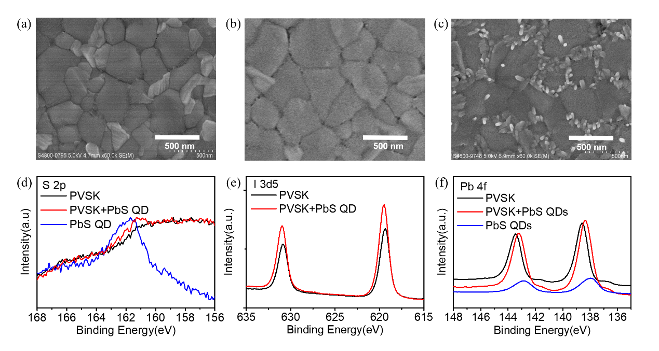
Figure 2. SEM images of (a) control perovskite, (b) film perovskite film with spin-coated PbS QDs and (c) perovskite film with spin-coated PbS QDs washed by toluene. XPS of (d) S2p, (e) I 3d5 and (e) Pb 4f.

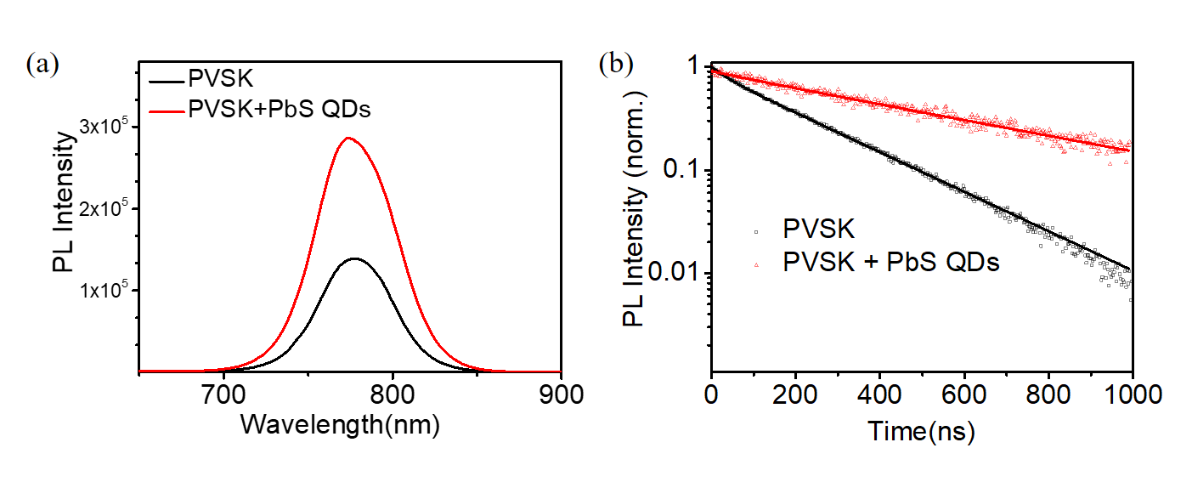
Figure 3. (a) PL intensities of control perovskite film and PbS QDs coated film (b) TRPL of perovskite film with and without PbS QDs with the biexponential fitting.

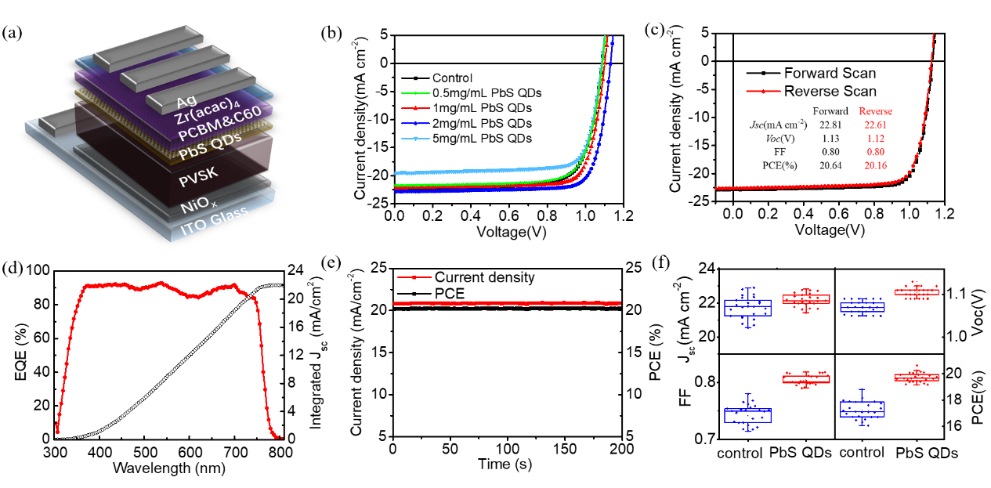
Figure 4. (a) The schematic diagram of PbS QDs coated PSCs. (b) J-V curve of devices with different concentration of PbS QDs. (c) J-V curve of best device with forward and reverse scan. Inserted table: J- V parameters of forward and reverse scan. (d) EQE of the champion PSC. (e) Stabilized Jsc and PCE. (f) PCE distribution of control devices and PbS QDs coated devices.

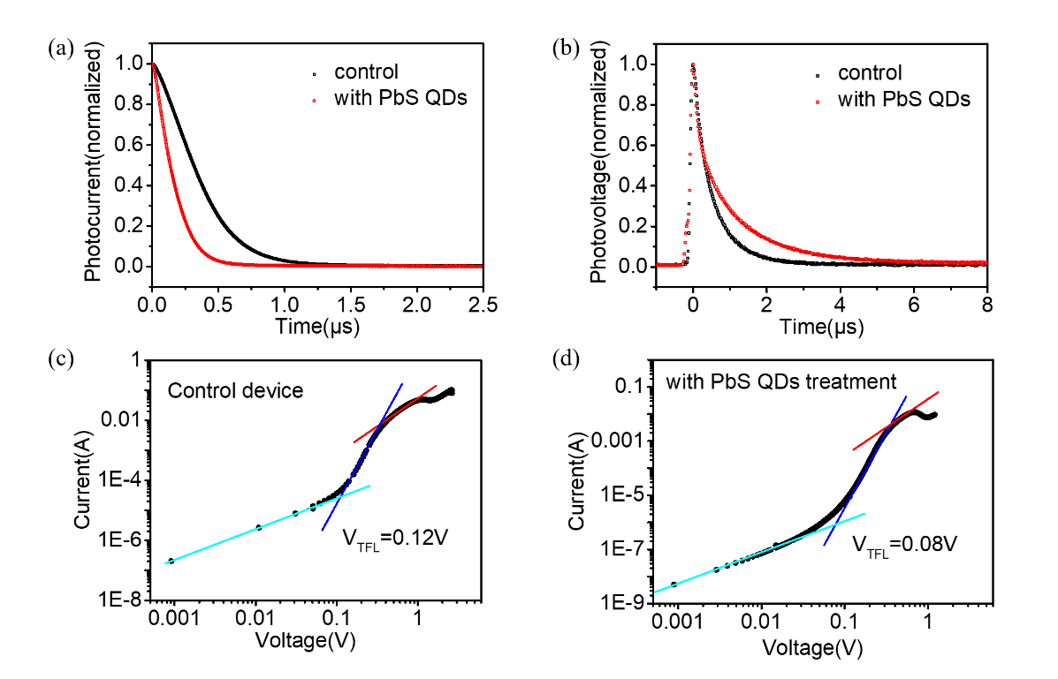
Figure 5. (a) The TPV and (b) TPC results of the control PSC and PSC coated with PbS QDs. (c) SCLC of control device and (d) SCLC of PbS QDs coated device.

Table1. The characteristic parameters of J-V curves of PSCs coated with PbS QDs.

PbS QDs concentration | Jsc (mA cm⁻²) | Voc (V) | FF | PCE (%)
control | 21.74 ± 0.64 | 1.07 ± 0.02 | 0.74 ± 0.02 | 17.25 ± 0.66
0.5 mg mL⁻¹ | 21.71 ± 0.29 | 1.08 ± 0.01 | 0.75 ± 0.01 | 17.52 ± 0.61
1 mg mL⁻¹ | 22.20 ± 0.53 | 1.10 ± 0.01 | 0.78 ± 0.01 | 19.20 ± 0.55
2 mg mL⁻¹ | 22.18 ± 0.39 | 1.11 ± 0.01 | 0.80 ± 0.01 | 19.73 ± 0.36
5 mg mL⁻¹ | 19.76 ± 1.07 | 1.08 ± 0.02 | 0.75 ± 0.03 | 16.06 ± 0.83

Multifunctional interface layer is formed on perovskite film through establishing perovskite as the ligand on PbS QDs. The multifunctions are strong interactions of PbS QDs with perovskites particularly at the grain boundaries, an inhibition of iodide ions mobilization and the reduction of the dangling bonds of Pb²⁺. Finally, the perovskite device efficiency and stability are highly improved.

perovskite solar cells, PbS QDs, ligand exchange, interface layer, ion mobilization

Ruiman Ma, Zhenwei Ren, Can Li, Yong Wang, Zhanfeng Huang, Yong Zhao, Tingbin Yang, Yongye Liang, Xiao Wei Sun, and Wallace C. H. Choy*

Establishing Multifunctional Interface Layer of Perovskite Ligand Modified Lead Sulfide Quantum Dots for Improving the Performance and Stability of Perovskite Solar Cells

