Simultaneous Low-order Phase Suppression and Defect Passivation for Efficient and Stable Blue Light Emitting Diodes
Zhenwei Ren,† Ling Li,§ Jiahao Yu,¶ Ruiman Ma,† Xiangtian Xiao,† Rui Chen,¶,* Kai Wang,¶,* Xiao Wei Sun,¶ Wan-Jian Yin,§ and Wallace C. H. Choy†,*
†Department of Electrical and Electronic Engineering, The University of Hong Kong, Pokfulam Road, Hong Kong, China
§College of Energy, Soochow Institute for Energy and Materials InnovationS (SIEMIS)
Jiangsu Provincial Key Laboratory for Advanced Carbon Materials and Wearable Energy Technologies, Soochow University, Suzhou 215006, China
¶Department of Electrical and Electronic Engineering, Southern University of Science and Technology, Shenzhen 518055, China
Email: wangk@sustc.edu.cn, chenr@sustech.edu.cn, chchoy@eee.hku.hk

ABSTRACT: Quasi-two-dimensional (quasi-2D) perovskite is rising as a promising luminescent material for blue perovskite light emitting diodes (PeLEDs). However, typical quasi-2D perovskites show a wide distribution of low-order phases, and low efficiency owing to the inefficient energy transfer. Meanwhile, the defects/traps generated during the perovskite crystallization increase non-radiative recombination, which further aggravate the external quantum efficiency (EQE). Herein, we demonstrate a unique quasi-2D perovskite with low-order phase suppression and defect passivation for efficient energy transfer and light emission by incorporating a 2D perovskite and an excess ammonium salt into the quasi-2D perovskite solution. By optimizing the new class of quasi-2D perovskite, we achieve blue PeLEDs with the brightness of 1765 cd m⁻², EQE of 7.51%, low turn-on voltage of 3.07 V, and long operation lifetime of 3961 sec under constant driving current without any shift in electroluminescence spectra. The work contributes to promoting efficient and stable PeLEDs.

Recently, perovskite light-emitting diodes (PeLEDs) have emerged as attractive optoelectronic devices, benefit from the promising properties of perovskites including tunable light emission color, high color purity, and high photoluminescence quantum yields (PLQYs).¹⁻⁵ Significant improvements have been achieved in green, red, and near-infrared PeLEDs where impressive external quantum efficiencies (EQEs) exceeding 20% are obtained,⁶⁻⁸ signaling a great potential towards practical applications. As compared with the efficient PeLEDs, only moderate performances were reported for blue PeLEDs,⁹⁻¹³ which set substantial limitations in the applications of full-color display and solid-state lighting. Therefore, it is highly desirable to realize highly performed blue PeLEDs.
One of the intensively investigated perovskite blue emitter is the inorganic perovskite nanocrystals (NCs) of CsPbX₃ where X is bromide, chloride, or mixture of bromide and chloride ions.^{14,15} In the year of 2015, the first blue PeLEDs based on the all-inorganic perovskite NCs was reported.¹⁶ However, there are some concerns such as mass non-radiative defects in the NCs and inefficient charge transport due to insulating organic ligands¹⁷⁻¹⁹ that tremendously impede the progress of perovskite NC blue PeLEDs. Different approaches have been investigating to improve the performances of NC based blue PeLEDs such as metal ion doping for reducing the non-radiative recombination,²⁰⁻²⁵ and ligand-exchange incorporation for enhancing carrier transportation.^{26,27}. Besides the zero-dimension perovskite NCs, the bromide-based two-dimensional (2D) perovskite nanoplatelets (NPls) with exciton quantum confinement in one dimension were also proved to obtain high PLQY for blue emission.²⁸⁻³⁴ However, their PeLED EQEs are normally below 1%, which may be attributed to the inefficient charge injection due to the randomly oriented distribution of the NPls.
Another potential material for blue PeLEDs is quasi-2D perovskites with the general formula of A₂(BPbX₃)_{n-1}PbX₄, where A is a long-chain organic ammonium, B is inorganic/organic cation such as Cs⁺ or methylammonium (MA⁺), and X is halide (e.g. Br, Cl ion).^{2,35} The blue emission peaks can be obtained by reducing the stacking number (n) of perovskite unit cells in the formula. Recently, quasi-2D perovskites have emerged as efficient luminescent materials for highly performed blue PeLEDs.³⁶⁻⁴³ For example, the mixed halides of Br and Cl together with the cation of PEA were employed to make PEA₂Cs_{n−1}Pb_{n}(Cl_{x}Br_{1−x})_{3n+1} quasi-2D perovskites, which were then assembled with the optimized thickness of PEDOT:PSS to modulate the position of the recombination zone for high device performances at emission wavelength of 480 nm with an EQE of 5.7% and a luminance of 3780 cd m⁻².³⁸ However, the electroluminescence (EL) red shifted at high bias voltage due to phase separation caused by the migration of the halides. In order to improve the EL spectral stability, the strategy of rubidium-cesium alloyed ‘A-site’ were combined to construct PEA₂(Rb_{x}Cs_{1−x})₂Pb₃Br₁₀ PeLEDs. The devices show stable EL spectra with a half-lifetime of 14.5 min and an EQE of 1.35% at 476 nm.³⁹ Subsequently, a cocktail strategy of multi-cation (Cs/Rb/FA/PEA/K)Pb(Cl/Br)₃ was proposed and demonstrated for excellent stability of blue PeLEDs.⁴⁰ Then an efficient blue EL from PeLEDs of quantum-confined perovskite nanoparticles embedded within the mixed-phase quasi-2D quantum well boosted with the EQE reaching 9.5%.⁴¹ Very recently, yttrium (III) chloride was reported to incorporate into the perovskite’s grain surface for increased bandgap of grain shell which can confine the charge carriers for efficient radiative recombination, and a high efficient performance of 11.0% was achieved in the PeLEDs.⁴² Different from bulk and quantum dot PeLED counterparts, the electrons and holes injected into the large bandgap phase of quasi-2D perovskite in PeLEDs, i.e., low-n phase with less perovskite layers, will transfer to the small bandgap phase, i.e., large-n phase with more perovskite layers. They will recombine in large-n phase and emit as photons.⁴⁴ It is also known that quasi-2D perovskites usually contain a variety of n species as mixed phases, especially the low-n phase quasi-2D perovskites which would result in low emission efficiency owing to the inefficient internal energy transfer.^{39,45,46} Therefore, fine modulation of the phases for high phase purity and thus for efficient energy transfer in quasi-2D perovskite is vital for high-efficient emission.^{43,44} Meanwhile, inevitable defects and traps will be generated during crystallization of quasi-2D perovskite prepared via solution-processed method, which will increase the chance for non-radiative recombination and thus low emission efficiency.
In this work, we propose an approach of incorporating a quasi-2D perovskite solution with a 2D perovskite and an excess ammonium salt to synthesize a new class of quasi-2D perovskites. The new perovskites show interesting features of phase redistribution through the low-n (low-order) phase suppression for efficient energy transfer, and defect passivation with the trap density reduction of over 60% for diminishing the non-radiative recombination. We also experimentally and theoretically investigate the roles of the incorporated materials on the quasi-2D perovskites. After optimizing the new qausi-2D perovskites, we achieve PeLEDs with very good EQE of 7.51%, high brightness of 1765 cd m⁻² and very low turn-on voltage of 3.07 V, which represents one of the most efficient blue PeLEDs reported. Notably, the blue PeLEDs show an ultra-long operational stability of 3961 sec under continuous constant driving current. In particular, the EL spectra stay unchanged without any peak shift monitored during the entire stability test, showing a superior property to the reported blue PeLEDs and thus contributing for high efficiency and stability blue PeLEDs.
The synthesis starts with propylamine hydrobromide (PABr) as the organic ammonium salt which has been proved to be good precursor material in our previous work⁴⁷. The precursor solution of PA₂(CsPbBr₃)_{n-1}PbBr₄ quasi-2D perovskite was prepared by dissolving PABr and CsPbBr₃ perovskite into DMSO, in which CsPbBr₃ perovskite was synthesized through the reported facile chemical precipitation method.⁶ Differently, we strategically introduce 2D PEA₂PbBr₄ into quasi-2D PA₂(CsPbBr₃)_{n-1}PbBr₄ perovskite solution to form a PA⁺ and PEA⁺ mixed ligand system and transform the quasi-2D perovskite into a new perovskite of PEA_{2-x}PA₂(CsPbBr₃)_{n-1}PbBr₄ with low order phase suppression. Details are discussed in the Experimental Section. The roles, explanation and verification of PEA₂PbBr₄ are studied in details as follows.
Regarding the optical properties of perovskite, Figure 1a shows UV-visible absorption spectra of the perovskite films incorporated with different amounts of PEA₂PbBr_{4.} When there is no PEA₂PbBr₄ incorporation, distinct excitonic absorption peaks appear at wavelengths 428 nm and 452 nm corresponding to n=2 and n=3 phases in the quasi-2D perovskites. Differently, when PEA₂PbBr₄ concentration increases from 0 to 20%, there is an obvious variation of the excitonic absorption properties (Figure 1a). The excitonic absorption peak at 428 nm (corresponding to n=2 phase) continuously weakens in increasing PEA₂PbBr₄ concentration. Ultimately, it is hard to observe the n=2 absorption peak at the concentration of 20%, showing the phase-modulation role of PEA₂PbBr₄ on the quasi-2D perovskites. To further confirm the phase modulation role of PEA₂PbBr₄, we investigate the effects of PEABr and PbBr₂ on the quasi-2D perovskites (see Figure S2). It is found that neither PEABr nor PbBr₂ can induce phase evolution between n=2 to n=3 of the quasi-2D perovskite, while such perovskite phase evolution can be achieved by incorporating PEA₂PbBr₄, stressing its importance on the distinct phase evolution. Additionally, the X-ray diffraction (XRD) measurements in Figure 1b show that the diffraction peak at 10.01º corresponding to the low-order (i.e. n=2) phase⁴⁸ (shown in Figure S3) gradually reduces when PEA₂PbBr₄ concentration increases and disappear when PEA₂PbBr₄ content reaches 20%. Moreover, we find the peak slightly shifts toward higher angles from 14.86º to 15.05º (Figure 1c), which can be assigned to the n = 2 and n = 3 phase with the layer lattice constant (d) of 17.7 Å and 23.5 Å, respectively (Table S1). We further performed the grazing incident X-ray diffraction (GIXRD) of pristine and PEA₂PbBr₄ incorporated quasi-2D perovskites to collect more information of the thin perovskite films (Figure S4 and Table S2). The results unveil the evolution of low-n (i.e. n=2) phase to large-n phase (i.e. n=3) in the perovskite films with the present of PEA₂PbBr₄ as further verified with the following transient absorption spectroscopy.
Then we fundamentally investigate the effects of organic cation ligands on perovskite phase formation after incorporation of PEA₂PbBr₄ into the perovskite. The first-principles total energy (TE) calculations have been performed to characterize the thermodynamic stability of the mixed ligands constructed perovskites (Figure 1d). The energy difference (ΔE) expressed in the formula: ΔE = E_{mix} − (E_{PEA} + E_{PA}), where E_{mix}, E_{PEA} and E_{PA} are the TEs of PEA⁺ and PA⁺ mixed ligands, PEA⁺, and PA⁺ single ligand formed quasi-2D perovskites, respectively, in which positive (negative) sign of ΔE indicates the unstable (stable) nature of the system. It is found that in the n=2 phase, E_{mix} is -911.51 eV which is larger than the sum of E_{PEA} (-558.73 eV) and E_{PA} (-353.49 eV), and positive ΔE is obtained for n=2 mixed ligand system. While E_{mix} of n=3 phase is -998.59 eV, which is smaller than the sum of corresponding E_{PEA} (-602.47 eV) and E_{PA} (-395.58 eV), leading to negative ΔE for n=3 mixed ligand system. The results show n=2 phase is thermodynamically unstable in the mixed ligands system while the conversion from single PA⁺ ligand to PA⁺ and PEA⁺ mixed ligand system is favorable for n=3 phase. This is consistent with the analysis of GIXRD patterns (Figure S4 and Table S2), where the signal of n=3 mixed ligand phase is observed while no signal of n=2 mixed ligand phase found in the PEA₂PbBr₄ incorporated perovskite. Consequently, we have successfully experimentally demonstrated the PEA₂PbBr₄ incorporated perovskite with low order phase suppression and theoretically proved the preferentially formed n=3 mixed ligand phase from the proposed approach.
To gain further inside of the transfer and recombination dynamics of photogenerated carriers in the pristine perovskite and PEA₂PbBr₄ incorporated perovskite, transient absorption spectroscopy has been used for characterization. Figure 2 shows the transient absorption (TA) characterizations of the samples at room temperature. As shown in Figure 2a, two distinctive ground-state photobleaching (PB) signals corresponding to n=2 and n=3 phases can be clearly observed in pristine perovskites. This indicates the two dominant phases in pristine quasi-2D perovskites, which is consistent with the steady-state absorption spectra. Figure 2b shows the TA spectra of pristine perovskites at different delay times. It is found that photogenerated carriers are principally generated in both the n=2 and n=3 phases at the initial stage. Due to the quantum confinement effect, the quasi-2D perovskite with larger n value will have a smaller bandgap. Therefore, the energy transfer can be expected if the two phases coexist in the materials. This can be verified by the TA signal. At a longer decay time, the signal related to n=2 phase decreases while the n=3 species increases, which indicates the energy transfer from n=2 to n=3 perovskite phase.^{49,50} To further study the carrier transfer process, time traces at selected probe wavelengths (428 and 452 nm corresponding to n=2 and n=3 species) are extracted as shown in Figure 2c. The kinetics of each PB can be well-fitted by a multi-exponential function: ∆A(t) = a₁ exp(-t/τ₁) + a₂ exp(-t/τ₂) + a₃ exp(-t/τ₃) – a₄ exp(-t/τ_{et}), where a₁, a₂, a₃, and a₄ are amplitudes; τ₁ is the fast decay time constant ascribed to the energy transfer process in the perovskite; τ₂ and τ₃ represent the slow decay constant due to complex decay processes such as trap-assisted recombination; and τ_{et} is the formation time constant,^{39,51} which are extracted and listed in Table S3. The PB of n=2 phase shows a fast decay component with τ₁ of 0.57 ps. Coincidentally, the τ_{et} fitted from the raising component of the PB of n=3 phase is 0.61 ps, within the timescale of τ₁ showing a fast energy transfer process in picoseconds. Besides, we also study the effect of excitation laser intensity on the energy transfer process in TA kinetics (Figure S6, Table S4). It is observed that the τ₁ value varies in a little range with the increase of the laser power intensity from 5 to 45 μJ cm⁻², indicating the energy transfer process is only slighted affected by the excitation power range. However, the values of τ₂ and τ₃ decrease obviously when raising the laser power, which likely ascribed to the increased Auger recombination at higher excitation density.⁵²
Differently, for PEA₂PbBr₄ incorporated perovskites, a strong PB peak around 452 nm can be found (Figure 2d), which indicates the dominant n=3 phase in the quasi-2D perovskites. Besides, a very weak signal of n=2 phase at a short decay time can be observed, which is greatly weakened as compared to the pristine perovskite (Figure S7). This also implies that the low order phases (particularly n=2 phase) can be remarkably suppressed after PEA₂PbBr₄ modulation. As shown in Figure 2e, it is found that the decay time of n=2 phase in the PEA₂PbBr₄ incorporated perovskites is much faster than that in pristine perovskite. To further confirm the fast decay time, the probed time trace of n=2 phase is extracted (Figure 2f), in which the decay time constant of τ₁ decreases from 0.57 ps (pristine) to 0.30 ps. This implies more efficient energy transfer from wider bandgap phase (n=2) to narrow one (n=3). The more efficient energy transfer can be further verified by the reduced τ_{et} of n=3 phase (0.33 ps) for PEA₂PbBr₄ incorporated perovskites, which is faster than that of pristine (0.61 ps) perovskites. Consequently, the data obtained by the ultrafast laser spectroscopy shows that the phases in quasi-2D perovskites can be transformed from mixed phases of n=2, 3 to the low-order phase (n=2) suppressed qusai-2D perovskite by the incorporation of PEA₂PbBr₄, which facilitates efficient energy transfer from the large bandgap phase to the small one without block of the adjacent large bandgap phases in the perovskites (Figure S8). The effective phase control ascribed to the PEA₂PbBr₄ incorporation is consisted with the optical characterizations shown in Figure 1, which implies the successful suppression of low order phase (n=2) after the modification. This is the main reason for the enhanced device performance as will be discussed later.
During the synthesis of the new quasi-2D perovskite, we strategically passivate the quasi-2D perovskite by incorporating excess PEABr. The PEA₂PbBr₄ incorporated perovskites show high trap state density of 3.85 × 10¹⁷ cm⁻³ (Figure S9) which will increase the chance for non-radiative recombination and result in limited emission efficiency. We find that the introduction of an excess amount of PEABr can effectively passivate perovskite defects as described in experimental section. As we know, inevitable defects generate during the perovskite crystallization owing to the ionic nature of hybrid perovskites. Although the origin of the defects is not very clear, they are widely believed to be related to the ionic defects such as halide and ammonium vacancies.⁵³ We theoretically confirm the role of passivation from studying the density of sates (DOS) of the perovskites (Figure S10). The DOS of the unpassivated perovskite shows a distinct trap state around the band edge due to the ion vacancies within the perovskite (Figure 3a). Interestingly, the ion vacancies can be annihilated by passivation of excess PEABr, which can provide both bromide and ammonium ions to fill the vacancy sites for the ionic compensation (Figure 3c). Consequently, the distinct trap states are eliminated in the excess PEABr decorated perovskite (Figure 3b), indicating its good defect passivation for the perovskite.
Experimentally, the defect passivation is further verified by the dramatic enhancement in the PL intensity as shown in Figure 3d. The PLQY increases from 39.5% (without PEABr decoration) to 49.6 % (with 5% excess PEABr decoration), which illustrates the defect passivation role of PEABr for a large reduction of non-radiative recombination. To further verify the passivation effect of PEABr and study the carrier recombination processes, the time-resolved PL (TRPL) spectra under different excitation intensities have been measured as shown in Figure 3e, f. The decays are fitted by biexponential curves, in which the fast and slow decay components are corresponding to the trap-assisted recombination and radiative recombination, respectively.⁵⁴⁻⁵⁶ The extracted parameters of the decay process are plotted in Figure S11e, f. It is revealed that both the fast and slow decay lifetimes for the excess PEABr decorated perovskite are much longer than that without excess PEABr decorated perovskite. Besides, the lifetime variations with the amount of the excess PEABr have also been studied (Figure S12). It is found that the average lifetime improves notably with increase of the PEABr concentration (Table S5). The results vividly confirm the effective passivation role of PEABr for less defects that the trap state density of excess PEABr decorated perovskite can be dramatically reduced to 1.43 × 10¹⁷ cm⁻³ from 3.85× 10¹⁷ cm⁻³ (without excess PEABr decoration) (Figure S9). Besides passivating perovskite defects, the PEABr will not change the phase of perovskite. Our results show that there is no shift of the absorption edge upon the decoration of excess PEABr. In addition, the ratio of the peak intensity between n=2 and n=3 phases is 1.13 maintains the same after the decoration of PEABr (see Figure 3d). Furthermore, there is no new XRD peak appeared in the quasi-2D perovskite after the decoration of PEABr (see Figure S13). Consequently, we demonstrate that the introduction of excess amount of PEABr will not only passivate the perovskite defects but also maintain perovskite phase. The efficient passivation role of PEABr will be a promising approach for pathing highly performed PeLEDs as discussed in the following parts.
We fabricate PeLEDs with a structure of ITO /NiO_{x} /perovskite /TPBi /LiF /Al, in which NiO_{x} is utilized as the hole injection layer (HIL) for the good hole injection properties,^{47,57,58} TPBi is the electron injection layer (EIL) and quasi-2D perovskites is the emission layer. The energy bands of pristine, PEA₂PbBr₄ incorporated, and excess PEABr decorated perovskites were determined by ultraviolet photoelectron spectroscopy (UPS) (Figure S14), which are summarized in Figure 4a. As compared with the pristine perovskite, the energy band of PEA₂PbBr₄ incorporated, and excess PEABr decorated perovskite films are slightly raised up and thus benefit for improving hole injection and bring down the turn-on voltage of PeLEDs. The thickness of HIL, emission layer, EIL, and LiF/Al layers is 24, 55, 70, and 130 nm, respectively, as measured from the cross-section scanning electron microscopy (SEM) image in Figure 4b. The device performances in Figure 4c-d show that the maximum brightness (L_{max}) of pristine PeLEDs is 982 cd m⁻² at a bias of 4.75 V, which increases to 1231 cd m⁻² for PEA₂PbBr₄ incorporated device at the same bias (Table 1). Similarly, EQE increases from 3.46 (pristine) to 6.15% (PEA₂PbBr₄ incorporated) (Figure 4e). The improvement is mainly attributed to the efficient energy transport of the PEA₂PbBr₄ incorporated perovskite (as shown in Figure 2). It is also noted that the turn-on voltage (V_{th}, corresponding with luminance of 1 cd m⁻²) of PEA₂PbBr₄ incorporated PeLEDs (2.98 V) is lower than that of pristine ones (3.22 V), which is among the lowest turn-on voltages from the reported blue PeLEDs³⁷⁻⁴³ owing to the narrowed energy barrier for efficient hole injection (Figure 4a). In addition, in order to study the charge injection and transfer capacity of the PeLEDs, the capacitance-voltage (C-V) characteristics are also measured (Figure S15). The capacitance improves with the increase of bias voltage and the carriers are injected into the perovskites. In other words, the capacitance of PEA₂PbBr₄ incorporated PeLEDs is larger than that of pristine device at the same bias up to the voltage value of 3.4 V and thus more charges are injected. At higher bias, the capacitance sharply declines in the PEA₂PbBr₄ incorporated case due to the largely reduced carriers caused by the large radiative recombination of electrons and holes.⁵⁹ While compared with pristine PeLEDs, the lower peak capacitance is observed for PEA₂PbBr₄ incorporated device, which indicates more charge transfer capacity in PEA₂PbBr₄ incorporated perovskite due to suppression of the low-order phase. To further study the effects of PEA₂PbBr₄, the PeLED performances with different incorporated PEA₂PbBr₄ concentrations are investigated as shown in Figure S16. The devices achieve the best performance at the PEA₂PbBr₄ concentration of 10%. The higher concentration of PEA₂PbBr₄ (such as the concentration of 15% and 20%) will reduce the device performances, due to the high induced trap states (Figure S17, S18). Consequently, by incorporating appropriate amount of PEA₂PbBr₄ into qusai-2D perovskite, the performances of PeLEDs can be improved.
By introducing excess PEABr to passivate the PEA₂PbBr₄ incorporated perovskites, the PeLED performances are further enhanced with the luminance improved from 1231 cd m⁻² (without excess PEABr decoration) to 1765 cd m⁻² (with PEABr decoration). Notably, a high EQE of 7.51% is also achieved for excess PEABr decorated PeLEDs which is among the highest blue PeLEDs.³⁶⁻⁴³ Besides, the excess PEABr decorated PeLEDs also show good reproducibility with EQE of 6.39% averaged from 20 devices (Figure S19). This enhancement is mainly attributed to the largely reduced defects in the perovskite films by over 60% as compared to the undecorated perovskite (Figure S9). In addition, we also study the hysteresis of PEA₂PbBr₄ and excess PEABr decorated PeLEDs (Figure S20). It is found that the PEA₂PbBr₄ incorporated PeLEDs show obvious hysteresis for both current density and luminance with scanning from forward to reverse direction. Nevertheless, the devices with excess PEABr show reduced hysteresis due to the passivation role of PEABr for less defects and thus less ion migration. Meanwhile, the lower efficiency droop is also observed for excess PEABr decorated PeLEDs (Figure S21). Although the origin for the large bandgap PeLED efficiency droop is not very clear, it is likely associated with the Auger recombination as it is observed the PL lifetime decrease at high excitation intensities for PEA₂PbBr₄ and excess PEABr decorated perovskites (Figure S11).^{60,61} The device performances with different PEABr concentrations are also studied as shown in Figure S23, in which the PeLED with 5% PEABr shows the highest EQE, and the performance begins to decline at higher concentrations owing to the induced low hole injection rate of the PeLEDs (Figure S24).
From the EL spectra of PeLEDs as shown in Figure 5a, the peaks centered at 488 nm are obtained for PEA₂PbBr₄ and excess PEABr decorated PeLEDs, which are consistent with their PL spectra assigned to the recombination center of n ≥ 4 phase (Figure S4) due to the energy funneling effect in quasi-2D perovskite. This implies that the EL is merely generated from the perovskite layer due to the strong confinement of the injected carriers within quasi-2D perovskites. The excess PEABr decorated PeLEDs show a narrowband emission with the full width at half maximum (FWHM) of around 25 nm and thus a good color purity with Commission Internationale de L'Eclairage (CIE) chromaticity coordinate at (0.084, 0.265) (Figure 5b). The CIE chromaticity coordinates of pristine and PEA₂PbBr₄ incorporated PeLEDs are also shown in Figure S25. It is known that the spectra stability is an important index to evaluate the PeLEDs towards practical applications and is a challenging issue of quasi-2D blue PeLEDs, possibly due to ion migration under voltage bias and phase instability with Joule heating or moist conditions.^{62,63} The EL spectra of excess PEABr decorated PeLEDs under different bias voltages are measured as shown in Figure 5c. It is found that the EL intensity increases when the bias voltage increases from 4.0 to 4.75 V, and then decline at higher bias. Under different bias, the EL peak wavelength (488 nm) and FWHM (≈25 nm) remain unchanged. This implies that the excess PEABr decorated PeLED has very good spectral stability.
As we know, LEDs are usually current drive devices, we dedicate to the lifetime tests of the devices under continuous constant current driving. The EL spectra under continuous driving current are shown in Figure 5d. It is noted that the peak positions remain at 488 nm as extending the operation time, revealing an excellent spectral stability during operation. The lifetime of the devices measured under continuous constant current (1.5 mA cm⁻² corresponding to the initial EQE of 6.02 %) is recorded in Figure 5e. A very impressive lifetime T₅₀ (defined as the elapsed time of LED decaying to 50% of its initial EQE) of 3961 s is achieved for the excess PEABr decorated PeLEDs, which is one of the most stable blue PeLEDs.³⁶⁻⁴³ The bias voltages during the lifetime measurements are also shown in Figure 5f, in which the slopes increase monotonically with the stress time increasing as the device resistance increases during operation. Besides, the lifetime of the devices measured under large injection current density of 10 and 20 mA cm⁻² were also carried out to show the potential practical applications of the PeLEDs (Figure S26). It is observed that the lifetime decreases rapidly under large injection current density, and the monitored lifetimes of 296 and 174 s are obtained at 10 and 20 mA cm⁻², respectively. Although the lifetimes are shortened at large injection current density, the peak positions stay unchanged, indicating a good spectral stability during operation. We also study the lifetimes of the pristine and PEA₂PbBr₄ incorporated PeLEDs as shown in Figure S27. the lifetimes are 496 and 1611 s with initial EQE of 2.87% and 5.03%, respectively, lagging far behind with that of the excess PEABr decorated PeLEDs. Consequently, our results show that the excess PEABr decorated PeLEDs show excellent spectral stability and exhibit the longest lifetime for blue PeLEDs, which promote the quasi-2D perovskites LEDs towards practical applications.
In summary, we demonstrate an efficient quasi-2D perovskite blue emitter of PEA_{2-x}PA₂(CsPbBr₃)_{n-1}PbBr₄ with simultaneous phase re-distribution and defect passivation for highly performed and stable blue quasi-2D PeLEDs. The new quasi-2D perovskite is realized by incorporation of PEA₂PbBr₄ and an excess PEABr into quasi-2D perovskite (PA₂(CsPbBr₃)_{n-1}PbBr₄) solution. The PEA₂PbBr₄ incorporated quasi-2D perovskite LEDs promote efficient energy transfer process from the low-n phase to high-n phase perovskites and thus improve device performance with the EQE increased from 3.46 (pristine) to 6.15% (PEA₂PbBr₄ incorporated). Then we further introduce the passivation of excess PEABr into the PEA₂PbBr₄ incorporated perovskites which remarkably reduces the trap state density by over 60%. Eventually, the excess PEABr decorated PeLEDs show an efficient EQE of 7.51% and a high brightness of 1765 cd m⁻² with a very low turn-on voltage of 3.07 V. It is noted that the devices reveal an excellent operation stability with an ultra-long lifetime T₅₀ of 3961 s under continuous constant driving current. Particular, the EL spectra are very stable without any peak shift during the entire stability test, signaling a great potential for the blue PeLEDs towards practical applications.

ASSOCIATED CONTENT
Supporting Information
The Supporting Information is available free of charge at http://pubs.acs.org.
Experimental section including materials, device fabrication, and characterizations; optical properties; electrical characteristics; theoretical calculation; and device performances of blue PeLEDs
AUTHOR INFORMATION
Corresponding Author
wangk@sustc.edu.cn, chenr@sustech.edu.cn, chchoy@eee.hku.hk
Notes
The authors declare no competing financial interest.
ACKNOWLEDGEMENTS
This research was supported by Equipment fund, Platform Research Fund and feed fund (Grant Nos. 201611159194, 201511159225, and 201811159147, and 2019157209), from the University Grant Council of the University of Hong Kong as well as the General Research Fund (Grant Nos. 17211916, 17204117, and 17200518, 17201819, and 17211220) from Hong Kong Special Administrative Region, China. We acknowledge Prof. Kam Sing Wong, Dr. Christopher Chang Sing Chan, Jiayun Sun, Shihao Ding, Xiaobin Tang and Zhaojin Wang for their help in characterization.

REFERENCES
- Yuan, M.; Quan, L. N.; Comin, R.; Walters, G.; Sabatini, R.; Voznyy, O.; Hoogland, S.; Zhao, Y.; Beauregard, E. M.; Kanjanaboos, P.; Lu, Z.; Kim, D. H.; Sargent, E. H. Perovskite Energy Funnels for Efficient Light-emitting Diodes. Nat. Nanotechnol. 2016, 11, 872–877.
- Chen, Y.; Sun, Y.; Peng, J.; Tang, J.; Zheng, K.; Liang, Z. 2D Ruddlesden–Popper perovskites for optoelectronics. Adv. Mater. 2018, 30, 1703487.
- Veldhuis, S. A.; Boix, P. P.; Yantara, N.; Li, M.; Sum, T. C.; Mathews, N.; Mhaisalkar, S. G. Perovskite Materials for Light‐emitting Diodes and Lasers. Adv. Mater. 2016, 28, 6804–6834.
- Protesescu, L.; Yakunin, S.; Bodnarchuk, M. I.; Krieg, F.; Caputo, R.; Hendon, C. H.; Yang, R. X.; Walsh, A.; Kovalenko, M. V. Nanocrystals of Cesium Lead Halide Perovskites (CsPbX₃, X = Cl, Br, and I): Novel Optoelectronic Materials Showing Bright Emission with Wide Color Gamut. Nano Lett. 2015, 15, 3692–3696.
- Richter, J. M.; Abdi-Jalebi, M.; Sadhanala, A.; Tabachnyk, M.; Rivett, J. P. H.; Pazos-Outón, L. M.; Gödel, K. C.; Price, M.; Deschler, F.; Friend, R. H. Enhancing Photoluminescence Yields in Lead Halide Perovskites by Photon Recycling and Light Out-Coupling. Nat. Commun. 2016, 7, 13941.
- Lin, K.; Xing, J.; Quan, L. N.; Pelayo García de Arquer, F.; Gong, X.; Lu, J.; Xie, L.; Zhao, W.; Zhang, D.; Yan, C.; Li, W.; Liu, X.; Lu, Y.; Kirman, J.; Sargent, E. H.; Xiong, Q.; Wei, Z. Perovskite Light-Emitting Diodes with External Quantum Efficiency Exceeding 20 Percent. Nature 2018, 562, 245–248.
- Cao, Y.; Wang, N.; Tian, H.; Guo, J.; Wei, Y.; Chen, H.; Miao, Y.; Zou, W.; Pan, K.; He, Y.; Cao, H.; Ke, Y.; Xu, M.; Wang, Y.; Yang, M.; Du, K.; Fu, Z.; Kong, D.; Dai, D.; Jin, Y.; Li, G.; Li, H.; Peng, Q.; Wang, J.; Huang, W. Perovskite Light-Emitting Diodes Based on Spontaneously Formed Submicrometre-Scale Structures. Nature 2018, 562, 249–253.
- Zhao, B.; Bai, S.; Kim, V.; Lamboll, R.; Shivanna, R.; Auras, F.; Richter, J. M.; Yang, L.; Dai, L.; Alsari, M.; She, X.-J.; Liang, L.; Zhang, J.; Lilliu, S.; Gao, P.; Snaith, H. J.; Wang, J.; Greenham, N. C.; Friend, R. H.; Di, D. High-Efficiency Perovskite–Polymer Bulk Heterostructure Light-Emitting Diodes. Nat. Photonics 2018, 12, 783–789.

- Xing, J.; Zhao, Y.; Askerka, M.; Quan, L. N.; Gong, X.; Zhao, W.; Zhao, J.; Tan, H.; Long, G.; Gao, L.; Yang, Z.; Voznyy, O.; Tang, J.; Lu, Z.-H.; Xiong, Q.; Sargent, E. H. Color-Stable Highly Luminescent Sky-Blue Perovskite Light-Emitting Diodes. Nat. Commun. 2018, 9, 3541.
- Wang, Q.; Ren, J.; Peng, X.-F.; Ji, X.-X.; Yang, X.-H. Efficient Sky-Blue Perovskite Light-Emitting Devices Based on Ethylammonium Bromide Induced Layered Perovskites. ACS Appl. Mater. Interfaces 2017, 9, 29901–29906.
- Chen, Z.; Zhang, C.; Jiang, X.-F.; Liu, M.; Xia, R.; Shi, T.; Chen, D.; Xue, Q.; Zhao, Y.-J.; Su, S.; Yip, H.-L.; Cao, Y. High‐Performance Color‐Tunable Perovskite Light Emitting Devices through Structural Modulation from Bulk to Layered Film. Adv. Mater. 2017, 29, 1603157.
- Sadhanala, A.; Ahmad, S.; Zhao, B.; Giesbrecht, N.; Pearce, P. M.; Deschler, F.; Hoye, R. L. Z.; Gödel, K. C.; Bein, T.; Docampo, P.; Dutton, S. E.; De Volder, M. F. L.; Friend, R. H. Blue-Green Color Tunable Solution Processable Organolead Chloride–Bromide Mixed Halide Perovskites for Optoelectronic Applications. Nano Lett. 2015, 15, 6095–6101.
- Congreve, D. N.; Weidman, M. C.; Seitz, M.; Paritmongkol, W.; Dahod, N. S.; Tisdale, W. A. Tunable Light-Emitting Diodes Utilizing Quantum-Confined Layered Perovskite Emitters. ACS Photonics 2017, 4, 476–481.
- Mondal, N.; De, A.; Samanta, A. Achieving Near-Unity Photoluminescence Efficiency for Blue-Violet-Emitting Perovskite Nanocrystals. ACS Energy Lett. 2019, 4, 32–39.
- Shamsi, J.; Urban, A. S.; Imran, M.; De Trizio, L.; Manna, L. Metal Halide Perovskite Nanocrystals: Synthesis, Post-Synthesis Modifications, and Their Optical Properties. Chem. Rev. 2019, 119, 3296–3348.
- Song, J.; Li, J.; Li, X.; Xu, L.; Dong, Y.; Zeng, H. Quantum Dot Light‐Emitting Diodes Based on Inorganic Perovskite Cesium Lead Halides (CsPbX₃). Adv. Mater. 2015, 27, 7162–7167.
- Huang, H.; Bodnarchuk, M. I.; Kershaw, S. V.; Kovalenko, M. V.; Rogach, A. L. Lead Halide Perovskite Nanocrystals in the Research Spotlight: Stability and Defect Tolerance. ACS Energy Lett. 2017, 2, 2071–2083.
- Li, G.; Wisnivesky Rocca Rivarola, F.; Davis, N. J. L. K.; Bai, S.; Jellicoe, T. C.; de la Peña, F.; Hou, S.; Ducati, C.; Gao, F.; Friend, R. H.; Greenham, N. C.; Tan, Z.-K. Highly Efficient Perovskite Nanocrystal Light‐Emitting Diodes Enabled by a Universal Crosslinking Method. Adv. Mater. 2016, 28, 3528–3534.
- Li, J.; Xu, L.; Wang, T.; Song, J.; Chen, J.; Xue, J.; Dong, Y.; Cai, B.; Shan, Q.; Han, B.; Zeng, H. 50‐Fold EQE Improvement up to 6.27% of Solution‐Processed All‐Inorganic Perovskite CsPbBr₃ QLEDs via Surface Ligand Density Control. Adv. Mater. 2017, 29, 1603885.
- Zhou, Y.; Chen, J.; Bakr, O. M.; Sun, H.-T. Metal-Doped Lead Halide Perovskites: Synthesis, Properties, and Optoelectronic Applications. Chem. Mater. 2018, 30, 6589–6613.
- Yong, Z.-J.; Guo, S.-Q.; Ma, J.-P.; Zhang, J.-Y.; Li, Z.-Y.; Chen, Y.-M.; Zhang, B.-B.; Zhou, Y.; Shu, J.; Gu, J.-L.; Zheng, L.-R.; Bakr, O. M.; Sun, H.-T. Doping-Enhanced Short-Range Order of Perovskite Nanocrystals for Near-Unity Violet Luminescence Quantum Yield. J. Am. Chem. Soc. 2018, 140, 9942−9951.
- Bi, C.; Wang, S.; Li, Q.; Kershaw, S. V.; Tian, J.; Rogach, A. L. Thermally Stable Copper(II)-Doped Cesium Lead Halide Perovskite Quantum Dots with Strong Blue Emission. J. Phys. Chem. Lett. 2019, 10, 943–952.
- Liu, M.; Zhong, G.; Yin, Y.; Miao, J.; Li, K.; Wang, C.; Xu, X.; Shen, C.; Meng, H. Aluminum‐Doped Cesium Lead Bromide Perovskite Nanocrystals with Stable Blue Photoluminescence Used for Display Backlight. Adv. Sci. 2017, 4, 1700335.
- Yao, J.-S.; Ge, J.; Han, B.-N.; Wang, K.-H.; Yao, H.-B.; Yu, H.-L.; Li, J.-H.; Zhu, B.-S.; Song, J.-Z.; Chen, C.; Zhang, Q.; Zeng, H.-B.; Luo, Y.; Yu, S.-H. Ce³⁺-Doping to Modulate Photoluminescence Kinetics for Efficient CsPbBr₃ Nanocrystals Based Light-Emitting Diodes. J. Am. Chem. Soc. 2018, 140, 3626−3634.
- Hou, S.; Gangishetty, M. K.; Quan, Q.; Congreve, D. N. Efficient Blue and White Perovskite Light-Emitting Diodes via Manganese Doping. Joule 2018, 2, 2421−2433.
- Pan, J.; Quan, L. N.; Zhao, Y.; Peng, W.; Murali, B.; Sarmah, S. P.; Yuan, M.; Sinatra, L.; Alyami, N. M.; Liu, J.; Yassitepe, E.; Yang, Z.; Voznyy, O.; Comin, R.; Hedhili, M. N.; Mohammed, O. F.; Lu, Z. H.; Kim, D. H.; Sargent, E. H.; Bakr, O. M. Highly Efficient Perovskite‐Quantum‐Dot Light‐Emitting Diodes by Surface Engineering. Adv. Mater. 2016, 28, 8718−8725.
- Zhang, B.-B.; Yuan, S.; Ma, J.-P.; Zheng, W.; Shen, H.; Wang, X.-C.; Sun, B.; Bakr, O. M.; Liao, L.-S.; Sun, H.-T. General Mild Reaction Creates Highly Luminescent Organic-Ligand-Lacking Halide Perovskite Nanocrystals for Efficient Light-Emitting Diodes. J. Am. Chem. Soc. 2019, 14, 15423−15432.

- Hoye, R. L. Z.; Lai, M.-L.; Anaya, M.; Tong, Y.; Gałkowski, K.; Doherty, T.; Li, W.; Huq, T. N.; Mackowski, S.; Polavarapu, L.; Feldmann, J.; MacManus-Driscoll, J. L.; Friend, R. H.; Urban, A. S.; Stranks, S. D. Identifying and Reducing Interfacial Losses to Enhance Color-Pure Electroluminescence in Blue-Emitting Perovskite Nanoplatelet Light-Emitting Diodes. ACS Energy Lett. 2019, 4, 1181−1188.
- Yang, D.; Zou, Y.; Li, P.; Liu, Q.; Wu, L.; Hu, H.; Xu, Y.; Sun, B.; Zhang, Q.; Lee, S.-T. Large-Scale Synthesis of Ultrathin Cesium Lead Bromide Perovskite Nanoplates with Precisely Tunable Dimensions and Their Application in Blue Light-Emitting Diodes. Nano Energy 2018, 47, 235−242.
- Peng, S.; Wang, S.; Zhao, D.; Li, X.; Liang, C.; Xia, J.; Zhang, T.; Xing, G.; Tang, Z. Pure Bromide‐Based Perovskite Nanoplatelets for Blue Light‐Emitting Diodes. Small Methods 2019, 3, 1900196.
- Wu, Y.; Wei, C.; Li, X.; Li, Y.; Qiu, S.; Shen, W.; Cai, B.; Sun, Z.; Yang, D.; Deng, Z.; Zeng, H. In Situ Passivation of PbBr₆^{4–} Octahedra toward Blue Luminescent CsPbBr₃ Nanoplatelets with Near 100% Absolute Quantum Yield. ACS Energy Lett. 2018, 3, 2030−2037.
- Bohn, B. J.; Tong, Y.; Gramlich, M.; Lai, M. L.; Döblinger, M.; Wang, K.; Hoye, R. L. Z.; Müller-Buschbaum, P.; Stranks, S. D.; Urban, A. S.; Polavarapu, L.; Feldmann, J. Boosting Tunable Blue Luminescence of Halide Perovskite Nanoplatelets through Postsynthetic Surface Trap Repair. Nano Lett. 2018, 18, 5231−5238.
- Liang, D.; Peng, Y.; Fu, Y.; Shearer, M. J.; Zhang, J.; Zhai, J.; Zhang, Y.; Hamers, R. J.; Andrew, T. L.; Jin, S. Color-Pure Violet-Light-Emitting Diodes Based on Layered Lead Halide Perovskite Nanoplates. ACS Nano 2016, 10, 6897−6904.
- Deng, W.; Jin, X.; Lv, Y.; Zhang, X.; Zhang, X.; Jie, J. 2D Ruddlesden–Popper Perovskite Nanoplate Based Deep‐Blue Light‐Emitting Diodes for Light Communication. Adv. Funct. Mater. 2019, 29, 1903861.
- Kumawat, N. K.; Liu, X.-K.; Kabra, D.; Gao, F. Blue Perovskite Light-Emitting Diodes: Progress, Challenges and Future Directions. Nanoscale 2019, 11,2109−2120.
- Yantara, N.; Jamaludin, N. F.; Febriansyah, B.; Giovanni, D.; Bruno, A.; Soci, C.; Sum, T. C.; Mhaisalkar, S.; Mathews, N. Designing the Perovskite Structural Landscape for Efficient Blue Emission. ACS Energy Lett. 2020, 5, 1593−1600.

- Vashishtha, P.; Ng, M.; Shivarudraiah, S. B.; Halpert, J. E. High Efficiency Blue and Green Light-Emitting Diodes Using Ruddlesden–Popper Inorganic Mixed Halide Perovskites with Butylammonium Interlayers. Chem. Mater. 2019, 31, 83−89.
- Li, Z.; Chen, Z.; Yang, Y.; Xue, Q.; Yip, H.-L.; Cao, Y. Modulation of Recombination Zone Position for Quasi-Two-Dimensional Blue Perovskite Light-Emitting Diodes with Efficiency Exceeding 5%. Nat. Commun. 2019, 10, 1027.
- Jiang, Y.; Qin, C.; Cui, M.; He, T.; Liu, K.; Huang, Y.; Luo, M.; Zhang, L.; Xu, H.; Li, S.; Wei, J.; Liu, Z.; Wang, H.; Kim, G.-H.; Yuan, M.; Chen, J. Spectra Stable Blue Perovskite Light-Emitting Diodes. Nat. Commun. 2019, 10, 1868.
- Yuan, F.; Ran, C.; Zhang, L.; Dong, H.; Jiao, B.; Hou, X.; Li, J.; Wu, Z. A Cocktail of Multiple Cations in Inorganic Halide Perovskite toward Efficient and Highly Stable Blue Light-Emitting Diodes. ACS Energy Lett. 2020, 5, 1062−1069.
- Liu, Y.; Cui, J.; Du, K.; Tian, H.; He, Z.; Zhou, Q.; Yang, Z.; Deng, Y.; Chen, D.; Zuo, X.; Ren, Y.; Wang, L.; Zhu, H.; Zhao, B.; Di, D.; Wang, J.; Friend, R. H.; Jin, Y. Efficient Blue Light-Emitting Diodes Based on Quantum-Confined Bromide Perovskite Nanostructures. Nat. Photonics 2019, 13, 760−764.
- Wang, Q.; Wang, X.; Yang, Z.; Zhou, N.; Deng, Y.; Zhao, J.; Xiao, X.; Rudd, P.; Moran, A.; Yan, Y.; Huang, J. Efficient Sky-Blue Perovskite Light-Emitting Diodes via Photoluminescence Enhancement. Nat Commun, 2019, 10, 5633.
- Yuan, S.; Wang, Z.-K.; Xiao, L.-X.; Zhang, C.-F.; Yang, S.-Y.; Chen, B.-B.; Ge, H.-T.; Tian, Q.-S.; Jin, Y.; Liao, L.-S. Optimization of Low‐Dimensional Components of Quasi‐2D Perovskite Films for Deep‐Blue Light‐Emitting Diodes. Adv. Mater. 2019, 31, 1904319.
- Leung, T. L.; Tam, H. W.; Liu, F.; Lin, J.; Ng, A. M. C.; Chan, W. K.; Chen, W.; He, Z.; Lončarić, I.; Grisanti, L.; Ma, C.; Wong, K. S.; Lau, Y. S.; Zhu, F.; Skoko, Ž.; Popović, J.; Djurišić, A. B. Mixed Spacer Cation Stabilization of Blue-Emitting n = 2 Ruddlesden–Popper Organic–Inorganic Halide Perovskite Films. Adv. Optical Mater. 2019, 8. 1901679.
- Yang, X.; Zhang, X.; Deng, J.; Chu, Z.; Jiang, Q.; Meng, J.; Wang, P.; Zhang, L.; Yin, Z.; You, J. Efficient Green Light-Emitting Diodes Based on Quasi-Two-Dimensional Composition and Phase Engineered Perovskite with Surface Passivation. Nat. Commun. 2018, 9, 570.

- Shang, Y.; Liao, Y.; Wei, Q.; Wang, Z.; Xiang, B.; Ke, Y.; Liu, W.; Ning, Z. Highly Stable Hybrid Perovskite Light-Emitting Diodes Based on Dion-Jacobson structure. Sci. Adv. 2019, 5: eaaw8072.
- Ren, Z.; Xiao, X.; Ma, R.; Lin, H.; Wang, K.; Sun, X. W.; Choy, W. C. H. Hole Transport Bilayer Structure for Quasi‐2D Perovskite Based Blue Light‐Emitting Diodes with High Brightness and Good Spectral Stability. Adv. Funct. Mater. 2019, 29, 1905339.
- Xiao, Z.; Kerner, R. A.; Zhao, L.; Tran, N. L.; Lee, K. M.; Koh, T.-W.; Scholes, G. D.; Rand, B. P. Efficient Perovskite Light-Emitting Diodes Featuring Nanometre-Sized Crystallites. Nat. Photonics 2017, 11, 108−115.
- Wang, N.; Cheng, L.; Ge, R.; Zhang, S.; Miao, Y.; Zou, W.; Yi, C.; Sun, Y.; Cao, Y.; Yang, R.; Wei, Y.; Guo, Q.; Ke, Y.; Yu, M.; Jin, Y.; Liu, Y.; Ding, Q.; Di, D.; Yang, L.; Xing, G.; Tian, H.; Jin, C.; Gao, F.; Friend, R. H.; Wang, J.; Huang, W. Perovskite Light-Emitting Diodes Based on Solution-Processed Self-Organized Multiple Quantum Wells. Nat. Photonics 2016, 10, 699−704.
- Shang, Q.; Wang, Y.; Zhong, Y.; Mi, Y.; Qin, L.; Zhao, Y.; Qiu, X.; Liu, X.; Zhang, Q. Unveiling Structurally Engineered Carrier Dynamics in Hybrid Quasi-Two-Dimensional Perovskite Thin Films toward Controllable Emission. J. Phys. Chem. Lett. 2017, 8, 4431−4438.
- Liu, J.; Leng, J.; Wu, K.; Zhang, J.; Jin, S. Observation of Internal Photoinduced Electron and Hole Separation in Hybrid Two-Dimentional Perovskite Films. J. Am. Chem. Soc. 2017, 139, 1432−1435.
- Manser, J. S.; Kamat, P. V. Band filling with free charge carriers in organometal halide perovskites. Nat. Photonics 2014, 8, 737−743.
- Yang, S.; Dai, J.; Yu, Z.; Shao, Y.; Zhou, Y.; Xiao, X.; Zeng, X. C.; Huang, J. Tailoring Passivation Molecular Structures for Extremely Small Open-Circuit Voltage Loss in Perovskite Solar Cells. J. Am. Chem. Soc. 2019, 141, 5781−5787.
- Zhang, L.; Yang, X.; Jiang, Q.; Wang, P.; Yin, Z.; Zhang, X.; Tan, H.; Yang, Y. M.; Wei, M.; Sutherland, B. R.; Sargent, E. H.; You, J. Ultra-Bright and Highly Efficient Inorganic Based Perovskite Light-Emitting Diodes. Nat. Commun. 2017, 8, 15640.
- Cho, H.; Jeong, S.-H.; Park, M.-H.; Kim, Y.-H.; Wolf, C.; Lee, C.-L.; Heo, J. H.; Sadhanala, A.; Myoung, N.; Yoo, S.; Im, S. H.; Friend, R. H.; Lee, T.-W. Overcoming the Electroluminescence Efficiency Limitations of Perovskite Light-Emitting Diodes. Science 2015, 350, 1222−1225.
- Shi, D.; Adinolfi, V.; Comin, R.; Yuan, M.; Alarousu, E.; Buin, A.; Chen, Y.; Hoogland, S.; Rothenberger, A.; Katsiev, K.; Losovyj, Y.; Zhang, X.; Dowben, P. A.; Mohammed, O. F.; Sargent, E. H.; Bakr, O. M. Low Trap-State Density and Long Carrier Diffusion in Organolead Trihalide Perovskite Single Crystals. Science 2015, 347, 519−522.
- Chih, Y.-K.; Wang, J.-C.; Yang, R.-T.; Liu, C.-C.; Chang, Y.-C.; Fu, Y.-S.; Lai, W.-C.; Chen, P.; Wen, T.-C.; Huang, Y.-C.; Tsao, C.-S.; Guo, T.-F. NiO_{x} Electrode Interlayer and CH₃NH₂/CH₃NH₃PbBr₃ Interface Treatment to Markedly Advance Hybrid Perovskite‐Based Light‐Emitting Diodes. Adv. Mater. 2016, 28, 8687−8694.
- Wang, K.-H.; Peng, Y.; Ge, J.; Jiang, S.; Zhu, B.-S.; Yao, J.; Yin, Y.-C.; Yang, J.-N.; Zhang, Q.; Yao, H.-B. Efficient and Color-Tunable Quasi-2D CsPbBr_{x}Cl_{3–x} Perovskite Blue Light-Emitting Diodes. ACS Photonics 2019,6, 667−676.
- Qu, X.; Zhang, N.; Cai, R.; Kang, B.; Chen, S.; Xu, B.; Wang, K.; Sun, X. W. Improving Blue Quantum Dot Light-Emitting Diodes by a Lithium Fluoride Interfacial Layer. Appl. Phys. Lett. 2019, 114, 071101.
- Zou, W.; Li, R.; Zhang, S.; Liu, Y.; Wang, N.; Cao, Y.; Miao, Y.; Xu, M.; Guo, Q.; Di, D.; Zhang, L.; Yi, C.; Gao, F.; Friend, R. H.; Wang, J.; Huang, W. Minimising Efficiency Roll-Off in High-Brightness Perovskite Light-Emitting diodes. Nat. Commun. 2018, 9, 608.
- Yang, M.; Wang, N.; Zhang, S.; Zou, W.; He, Y.; Wei, Y.; Xu, M.; Wang, J. Huang, W. Reduced Efficiency Roll-Off and Enhanced Stability in Perovskite Light-Emitting Diodes with Multiple Quantum Wells. J. Phys. Chem. Lett. 2018, 9, 2038−2042
- Yun, J. S.; Kim, J.; Young, T.; Patterson, R. J.; Kim, D.; Seidel, J.; Lim, S.; Green, M. A.; Huang, S.; Ho‐Baillie, A. Humidity‐Induced Degradation via Grain Boundaries of HC(NH₂)₂PbI₃ Planar Perovskite Solar Cells. Adv. Funct. Mater. 2018, 28, 1705363.
- Cho, H.; Kim, Y.‐H.; Wolf, C.; Lee, H.‐D.; Lee, T.‐W. Improving the Stability of Metal Halide Perovskite Materials and Light‐Emitting Diodes. Adv. Mater. 2018, 30, 1704587.

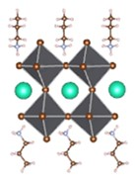
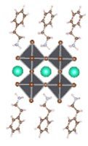
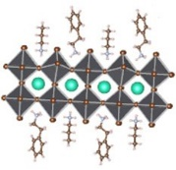
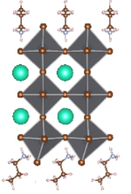
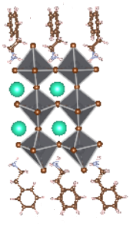
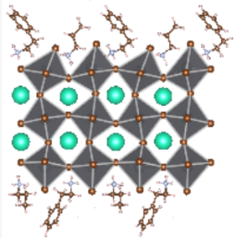
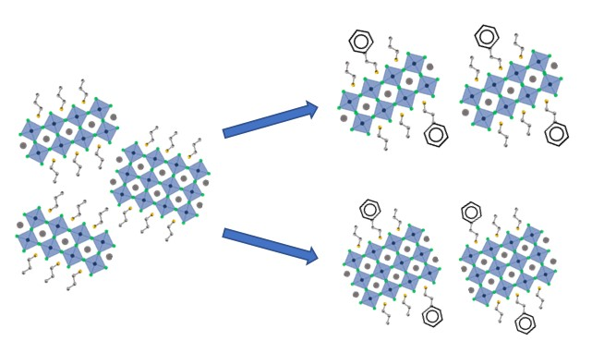
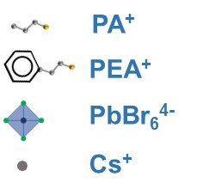
b)
c)
a)
n=2
n=3
TE = -353.49 eV
TE = -558.73 eV
d)
TE = -911.51 eV
TE = -395.58 eV
TE = -602.47 eV
TE = -998.59 eV
pristine precursor
PEA₂PbBr₄ incorporated pristine precursor
e)
PEA₂PbBr₄
favorable
PEA₂PbBr₄
unfavorable
Figure 1. (a) UV–visible absorption spectra of PEA₂PbBr₄ incorporated perovskite films. (b) XRD measurements for pristine and PEA₂PbBr₄ incorporated perovskites, and (c) the corresponding enlarged peak of the XRD patterns. (d) The crystal structures (n=2, 3 phases) of PA⁺, PEA⁺ single ligand, and PEA⁺ and PA⁺ mixed ligands formed quasi-2D perovskites and the corresponding total energies through first-principles calculations. (e) Schematic diagram of the effect of PEA₂PbBr₄ on the quasi-2D perovskite phases.
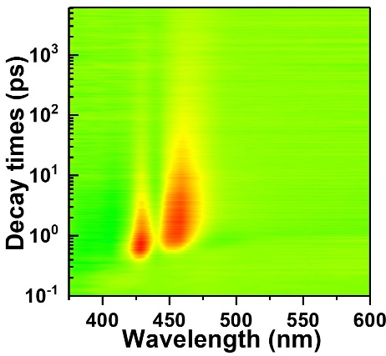
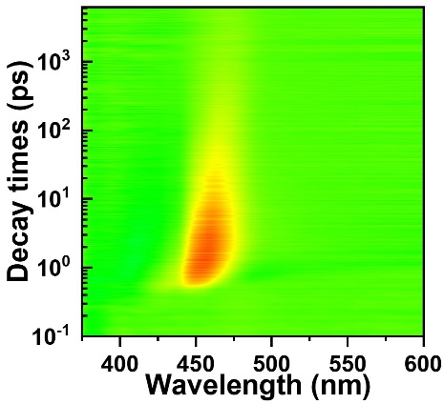
a)
ΔA
0.0133
-0.014
d)
ΔA
0.0116
-0.014
f)
fast decay
slow decay
b)
n=2
n=3
e)
n=2
n=3
c)
fast decay
slow decay

Figure 2. TA measurements for pristine (a), (b) and (c) and PEA₂PbBr₄ incorporated (d), (e) and (f) perovskites. (a), (d) TA time decay spectrograms; (b), (e) TA spectra at different probe delay times; and (c), (f) TA kinetics probed at selected wavelengths for pristine and PEA₂PbBr₄ incorporated perovskite films, respectively.

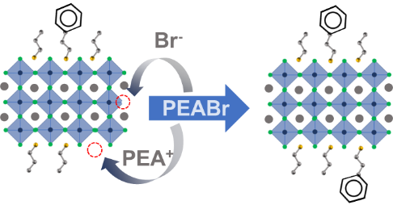

c)
a)
b)
trap state
band edge
f)
excess PEABr
PEA₂PbBr₄
e)
d)

Figure 3. Density of states (DOS) and optical and properties of PEA₂PbBr₄ incorporated perovskites with and without excess PEABr decoration: (a) Density of states (DOS), (b) the zoomed DOS extracted from (a), (c) schematic diagram of the passivation role of excess PEABr within the quasi-2D perovskites. (d) The UV–visible absorption spectra and the corresponding PL spectra. Time-resolved PL spectra under different excitation intensities of (e) PEA₂PbBr₄ and (f) excess PEABr incorporated perovskite films.

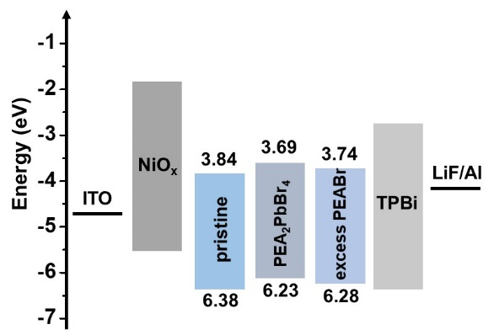
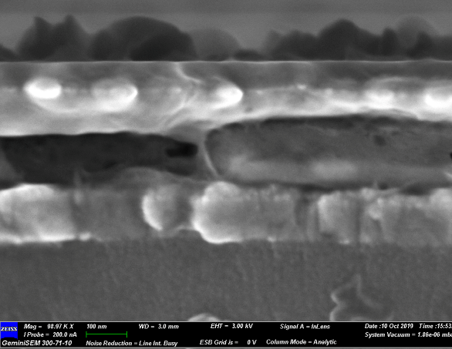
a)
b)
ITO
NiO_{x}
perovskite
TPBi
LiF/Al
200 nm
c)
d)
e)

Figure 4. Perovskite light-emitting diode structure and performance. a) Energy levels for different layers of the device, b) cross-sectional SEM image of the PeLEDs, c) current density–voltage (J–V), d) luminance–voltage (L–V), and e) EQE characterizations of the corresponding PeLEDs.

Table1. Device performances of pristine, PEA₂PbBr₄ and excess PEABr decorated PeLEDs.
Devices | V_{th} (V) | L_{max} (cd m⁻²) | EQE (%)
Pristine | 3.22 | 982 | 3.46
PEA₂PbBr₄ | 2.98 | 1231 | 6.15
excess PEABr | 3.07 | 1765 | 7.51

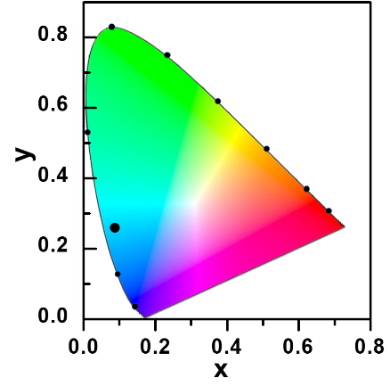
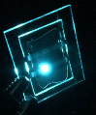
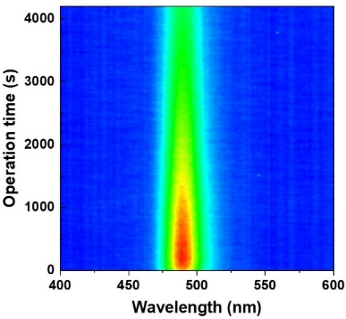
a)
560
580
520
620
600
500
540
CIE 1931
(0.084, 0.265)
460
480
b)
c)
e)
f)
d)
Figure 5. EL properties of the PeLEDs. a) EL spectra of pristine, PEA₂PbBr₄ incorporated and excess PEABr decorated blue PeLEDs. b) The CIE coordinate of excess PEABr decorated PeLEDs with the emission image in the inset, and the corresponding EL spectra c) at different biased voltages, and d) under continuous constant current of 1.5 mA cm⁻². e) The time-dependent stability lifetime measurements of excess PEABr decorated PeLEDs with constant current, and f) the corresponding bias voltage traces during the lifetime test.

Table of Content (TOC)

Simultaneous Low-order Phase Suppression and Defect Passivation for Efficient and Stable Blue Light Emitting Diodes
Zhenwei Ren,† Ling Li,§ Jiahao Yu,¶ Ruiman Ma,† Xiangtian Xiao,† Rui Chen,¶,* Kai Wang,¶,* Xiao Wei Sun,¶ Wan-Jian Yin,§ and Wallace C. H. Choy†,*
