Jing, J., An, X., Luo, Y., Chen, L., Chu, Z., & Li, K. H. (2021). A compact optical pressure sensor based on a III-nitride photonic chip with nanosphere-embedded PDMS. ACS Applied Electronic Materials, 3(5), 1982-1987.
https://doi.org/10.1021/acsaelm.1c00130

A compact optical pressure sensor based on a III-nitride photonic chip with nanosphere-embedded PDMS
Jixiang Jing
Xiaoshuai An
Yumeng Luo
Liang Chen
Zhiqin Chu
Kwai Hei Li

Department of Electrical and Electronic Engineering
Faculty of Engineering
The University of Hong Kong

Corresponding author: Zhiqin Chu, Department of Electrical and Electronic Engineering, The University of Hong Kong, Pokfulam Road, Hong Kong.
Email: zqchu@eee.hku.hk

Submitted to ACS Applied Electronic Materials Feb 7, 2021
Accepted April 25, 2021

A Compact Optical Pressure Sensor Based on a III-Nitride Photonic Chip with Nanosphere-Embedded PDMS

Abstract:
Pressure sensing based on high sensitivity and fast response photonic devices are great for transient and dynamic pressure detection, but it generally relies on the fiber-coupling assembly strategy. Here, we develop a compact pressure sensor based on the combination of a GaN-based photonic chip with a PDMS membrane. The emitter and detector are monolithically integrated on a GaN-on-sapphire chip consisting of InGaN/GaN multi-quantum wells. Self-assembled polystyrene nanospheres are embedded in the PDMS and function as an opal-based photonic crystal to provide effective reflective properties via the photonic bandgap effect. The sensors with opal film at four different positions are fabricated and their sensing abilities are extensively studied and compared through a series of pressure loading/unloading tests. In addition to ease of miniaturization and rapid response time of less than 10 ms, the demonstration of high repeatability, stability and durability after 7000 loading-unloading cycles verifies the feasibility of the chip-scale optical pressure sensor.
Keywords
gallium nitride; photonic integration; pressure sensing
Miniatured pressure microsensors that convert the physical force/pressure into electrical signals are of important significance in the fields of human−machine interaction [1], healthcare monitoring [2,3], and medical diagnosis and rehabilitation [4-6]. Owing to their high sensitivity and fast response time, the development of optical devices triggers the research of pressure sensing based on photonics. An optical pressure sensor based on integration fiber optics and waveguide is of great interest and considered as a promising technique, which is capable of sensing the external pressure change by analyzing the variation of transmitted optical signals [7]. Various pressure sensing schemes have been proposed for implementing fiber-optic systems, such as an interferometer [8−10], fiber Bragg grating [11,12], photonic crystal fibers [13,14] surface plasmon resonance [15,16] and so on, which are highly suitable for transient and dynamic pressure detection. In addition, the miniaturization of optical waveguide media sensitive to pressure variation has been demonstrated by integrating the planar waveguide array on a single chip through a wafer-scale manufacturing process [17−19].
However, the existing demonstrations mainly rely on the coupling efficiency between light source and photodetector and require precise and complicated optical alignment. This makes them not suitable for mass production, and the involved bulky system highly limits the scope of its practical application. To enhance the accessibility of the optical pressure sensor, it is highly desirable to miniaturize the device structure and
simplify the required optical elements together with mechanical components. Up to now, the compact integration of light source and detector for pressure sensing remains a great
challenge due to the lack of practical methods. Among the possible materials, GaN semiconductor and its alloys are one of the ideal platforms for constructing optoelectronic devices due to their inherent properties of long life span, high efficiency, fast response, and high physical and chemical stability [20−23]. Further integration of other III-nitride optical components such as detector and waveguide on a single wafer has been recently demonstrated [24−27], making the integrated chip as a miniature functional system not only for general on-chip communication but also for potential sensing applications such as monitoring of heart pulse and refractive index [28,29]. Despite the attractive features of the GaN optical device, the scope of pressure sensing based on integrated GaN-based optical devices has not been exploited and reported due
to the rigidity of the device structure.
In this work, we report a chip-scale pressure sensor based on a GaN diode-based chip combined with a nanosphere embedded PDMS thin film. Light emitter and photodetector are formed on a tiny chip utilizing a monolithic integration design. The electrical and optical properties of devices together with reflectance characteristics of nanosphere opal are investigated to verify the feasibility of the proposed optical pressure sensor. Compared with the hybrid assembly scheme, the compact integration strategy adopted in this work offers a significant improvement in terms of precision, reliability, fabrication cost, compactness, and robustness.
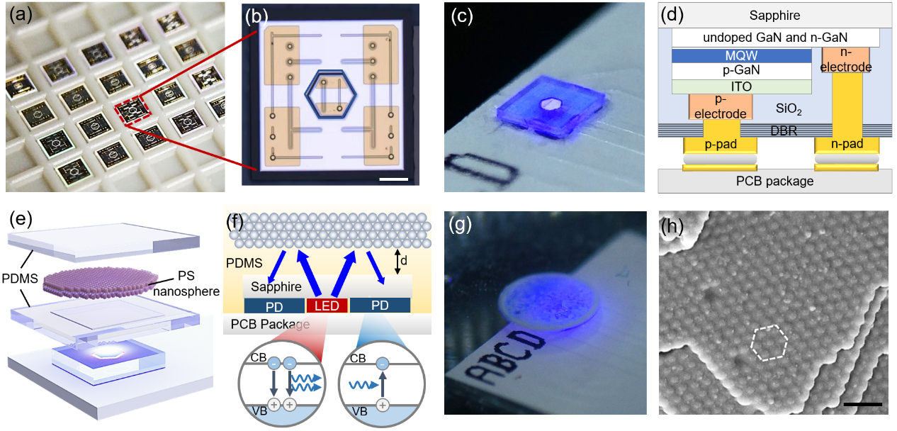
Figure 1 (a) Optical image of fabricated chips after dicing. (b) Microphotograph showing the chip consisting of emitter and detector. Scale bar: 200 μm. (c) Zoomed-in image of the chip bonded on a PCB. (d) Schematic diagram showing the cross-sectional view of the device structure. Schematic diagrams depicting (e) structural layout and (f) operating principle of the optical pressure sensor. (g) Optical image of the packaged chip with nanospheres-embedded PDMS. (h) FE-SEM image of nanospheres enclosed with PDMS. Scale bar: 500 nm.

The GaN photonic chips containing light-emitting and photo-detecting regions are fabricated through the wafer-scale microfabrication processes, including photolithography, etching, and deposition of metals and oxides (see Supporting Information). The fabricated 4-inch wafer is diced into chips by laser micromachining, as shown in Figs. 1(a)-(b). Each 1 x 1 mm² chip consists of an emitter with a diameter of 275 μm and the region beyond the center emitter corresponding to the detector. After bonding on printed circuit boards (PCB), the electrically isolated emitters and detectors can operate by connecting them to a current source and ammeter, respectively, as shown in Fig. 1(c). Figure 1(d) schematically illustrates the resultant device structure adopted in flip-chip design. As depicted in Figs. 1(e)-(g), the flip-chip configuration also enables the sapphire substrate to be fully exposed and the PDMS can be directly deposited without affecting the device properties. Colloidal polystyrene (PS) spheres with mean diameters of 180 nm suspended in DI water are dropped onto the PDMS-coated samples using a micro-pipette. During the evaporation of water, the nanospheres are self-assembled into an opal film in the form of a face-centered cubic lattice. The second uncured PDMS is covered over the sample and placed into a vacuum chamber to ensure the spheres are fully enclosed by PDMS. Figure 1(h) shows the field-emission scanning electron microscopy (FE-SEM) image captured from the cleaved surface of the PDMS embedded with opal structure, revealing that the opal structure comprising nanospheres into an ordered arrangement with face-centered cubic lattice are enclosed with the PDMS. Several observation point defects within the lattice amongst regular hexagonal packing is an intrinsic limitation of self-assembled crystals.

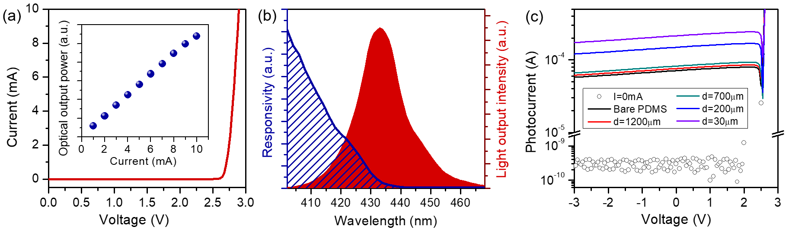
Figure 2 (a) I-V characteristics of the emitter. The inset presents the L-I characteristics of the LED. (b) EL spectrum of the emitter biased at 10 mA and normalized spectral responsivity of the unbiased detector. (c) I-V curves of the detector measured at a relaxed state. The solid line and ring-shaped symbol represent the data measured under emitters operating at 10 mA and 0 mA, respectively.

The current-voltage (I-V) characteristics of the emitter and detector are measured using a KEITHLEY 2450 sourcemeter offering a measurement resolution of 50 pA. From the I-V curve plotted in Fig. 2(a), the forward-biased voltage of the emitter is 2.89 V at 10 mA and the resistance determined from the slope of the linear region of the I-V curve is 50.3 Ω. The inset of Fig. 2(a) shows the light output intensity as a function of injection current and indicates a linear increasing relation. Since the detector has the same structure as the emitter, it is highly important to study its ability to detect light emitted from the same MQW. Figure 2(b) plots the electroluminescence (EL) spectrum of the emitter operating at 10 mA and the peak wavelength and spectral width (FWHM) are 433.3 nm and 19.3 nm, respectively. The responsivity curve of the detector is also plotted in the same figure, and it exhibits a gradually decreasing trend with the increase of wavelength, rather than a sharp decline. This is mainly due to the band tail effects caused by a combination of the QCSE and indium content fluctuations in the InGaN/GaN MQWs [30,31]. Despite the spectral shift effect between emission and absorption spectra, there exists a spectral overlap of ~30 nm. The light-detecting ability of the detector is further investigated by measuring its I-V curves, as plotted in Fig. 2(c). In the absence of emitter illumination, the photocurrents of the detector measured under reverse bias voltages are kept at very low levels of the order of 10⁻¹⁰. When a constant current of 10 mA is injected into the emitter, the photocurrent levels increase significantly by more than five orders of magnitude to 10⁻⁵-10⁻⁴. The observation of stable reverse bias current also suggests that the leakage current is negligible.

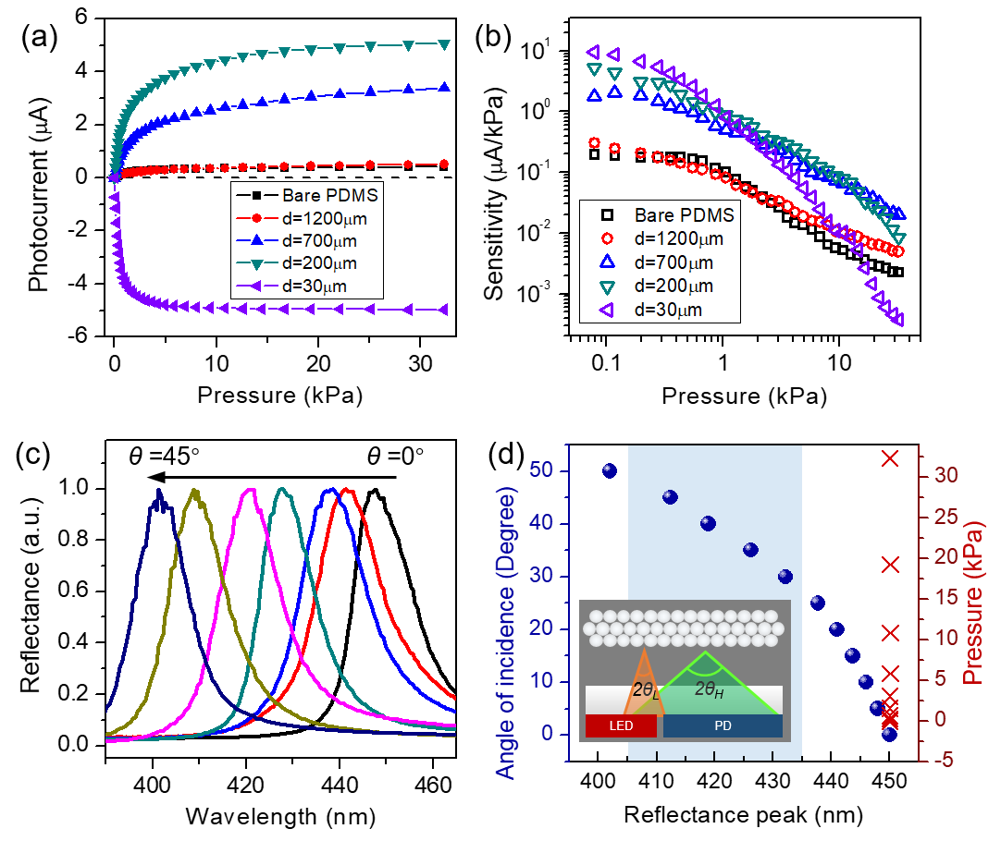
Figure 3 (a) Change of photocurrent relative to the photocurrent measured at relaxed state as a function of pressure. (b) Change of sensitivity corresponding to different pressures. (c) Normalized reflectance spectra of opal structure measured at varying angles of incidence (θ) from 0 to 50 degrees. (d) Reflectance peak wavelengths measured under varying angle of incidence and pressure loading. The inset illustrating the effective range of incident angle.

Forming on top of the GaN chip, the highly deformable PDMS membrane acts as a core to sense the pressure change. Initially, a 1.3-mm-thick bare PDMS is integrated with the chip and its sensing ability is determined by measuring its photocurrent change at varying pressures, as shown in Fig. 3(a). The sensor shows a very mild increase in photocurrent of 0.42 μA when the pressure rises from 0 to 32.8 kPa, suggesting that integration of bare PDMS results in a limited sensitivity. Although the traditional metal coatings such as Ag and Al can readily provide high reflectance over the blue spectral region, its uniform reflectance may not be able to highly modulate the light intensity during pressure change. Additionally, the adhesion of a metal coating to PDMS is usually poor. On the other hand, the low-cost self-assembled nanospheres adopted in this work can be firmly embedded in the PDMS membrane. Most importantly, the periodic hexagonal stacking opal structure that behaves as a photonic crystal can effectively suppress the propagation of light over a particular spectral range due to the photonic bandgap effect. In other words, the incident light with frequency within the PBG can be reflected and its reflective properties have a highly selective response to different incident angles of the incoming light. The increased reflectance is mainly originated from the presence of photonic bandgap (PBG) which can effectively reflect the incident light at a certain wavelength in the bandgap. The diameter of PS nanospheres is carefully selected to be 180 nm as its opal structure provides a high reflectance band coinciding with the emission spectrum of the emitter (see Supporting Information). Figure 3(c) shows the variation of the reflectance spectra measured from the nanosphere-embedded PDMS under different incident angles. The high reflectance can be attributed to the PBG effect while the other regions with relatively low reflectance correspond to the scattering effect, which is confirmed by the theoretical simulations (see Supporting Information). With increasing the incidence angle, the reflectance peak shifts towards a shorter wavelength. The angle-dependent peak positions are summarized in Fig. 3(d), including that the pronounced spectral shift from 450 to 400 nm for the angle increasing from 0 to 50 degrees. It is also found that the reflectance peak measured at normal incidence exhibits a very mild shift of less than 0.15 nm when increasing the pressure from 0 to 32.8 kPa.
Having identified the reflectance properties of the opal coating, four pressure sensors with different separation (d) between the opal coating and the chip are formed. For the sensor with d=1200 μm, its ability to sense is highly similar to the sensor with bare PDMS. Its weak response is due to the fact that the limited amount of light received by the detector reacts with the opal. By considering the chip dimension and the omnidirectional nature of light emission, the amount of light that can reach the outer light-detecting region is governed by an effective angle of incidence range of θ_{L}-θ_{H}, as illustrated in the inset in Fig. 3(d). The large spacing of d= 1200 μm results in a small effective angle range of 6.2-10.5 degrees and the corresponding reflectance peak induced by the opal coating is located at 448-446 nm which exceeds the detectable wavelength of the detector. During the pressure loading at 32.8 kPa, lowering the opal position relative to the chip can slightly increase the photocurrent up to 0.51 μA since the increased amount of scattered light reaching the detector is limited. Based on this observation, the effective incidence angle should be enlarged to facilitate the light experiencing the desired PBG effect. To achieve this, the reduction of the separation (d) can be an effective means, which can be achieved by tuning the PDMS coating process. From the plot in Fig. 2(c), by narrowing the interspace to 700, 200, and 30 μm, the photocurrents measured from the sensors at a relaxed state increase significantly to 82, 154, and 215 μA, respectively. It is also found that the abilities to sense the pressure variation are improved, and the photocurrent changes are summarized in Fig. 3(a). Among them, the largest photocurrent response of 5.1 μA at 32.8 kPa is obtained from the sensor with d=200 μm. The effective angle of 22.8-35.1 degrees at the relaxed state can offer a high reflectance band close to the light detection band. When adding pressure load, a further increase in the effective angle leads to more light experiencing the PBG effect, resulting in increased photocurrent. The nonlinear relationship observed in Fig. 3(a) suggests that the sensitivity of the sensor varies with pressure, which is studied by differentiating the measured data in Fig. 3(a). Figure 3(b) plots the sensitivity as a function of pressure on a logarithmic scale. For the sensor with d= 200 μm, high sensitivity of more than 1 μA/kPa is obtained at a pressure below 1 kPa while the sensitivity decreases to less than 0.1 μA/kPa at a pressure above 8.3 kPa. The change in position of the opal coating due to compression is more pronounced at low pressures than at high pressures, which is governed by the elastic properties of the PDMS membrane [32-34].
Notably, the sensor with the smallest d of 30 μm shows an opposing trend, i.e. the photocurrent reduces with increasing pressure, as illustrated in Fig. 3(a). At its relaxation state, light with an incident angle range of 24-40 degrees undergoes high reflectance whose peak wavelength already coincides with the detection band. An increase in the effective angle during pressure loading leads to reflectance exceeding the desired absorption band, resulting in a decline in photocurrent. Moreover, the photocurrents of the sensor with d= 30 μm are more readily to reach saturation than others, despite its higher sensitivity in a low-pressure regime.

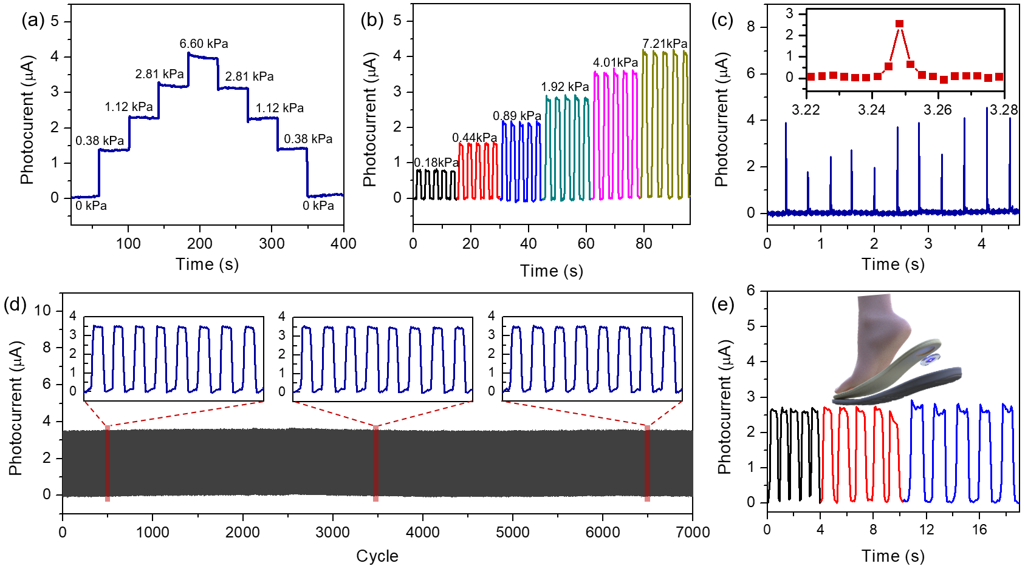
Figure. 4 Photocurrent response of the sensor measured under (a) continuous and (b) instantaneous pressure changes. (c) Time response of the sensor. The inset shows an enlarged view of the transient photocurrent response. (d) Photocurrent variation of the sensor under 7000 loading/unloading cycles and a pressure of 3.8 kPa. The insets show the enlarged views of measured data at the beginning, middle, and end of the cycles. (e) Photocurrent response measured during walking. The inset schematically describes the attachment of sensor to the shoe-insole.

According to the results presented above, the sensor with d=200 μm shows a balanced performance in both sensitivity and maximum detectable range, and its responses to varying pressure-loading conditions are further studied. During the measurement, a fixed current of 10 mA is injected into the emitter while the changes in photocurrent are recorded from the unbiased detector. To estimate the operation of the optical pressure sensor, a continuous loading and unloading pressure from 0 kPa to 6.60 kPa is applied and a holding time between the pressure change is about 40 s. The measured data showing the step-up and step-down responses are plotted in Fig. 4(a). The repeatability of the sensor is verified by measuring its instant response under five cycles of compression test with a pressure increasing from 0.18 kPa to 7.21 kPa. As shown in Fig. 4(b), the optical pressure sensor is highly reproducible and repeatable under different loads. The dynamic current responses in Figs. 4(a) and (b) are consistent with the data in Fig. 3(a).
The transient response of the sensor is measured by applying an instantaneous pressure change. It can be seen from Fig. 4(c) that once the pressure is removed, the photocurrent immediately returns to the initial value, and thus the discrete sharp peaks are obtained. From an enlarged view of transient response shown in Fig. 4(c), the response and relaxation times are less than 10 ms which is relatively small compared with those of previously reported PDMS-based pressure sensors (See Supporting Information). The rapid transient response is attributed to the fast photoelectric conversion of the photonic chip adopting an InGaN-based diode structure. The long-term durability and stability of the sensor are then evaluated through repeated loading and unloading cycle test at a frequency of 0.3 Hz. As shown in Fig. 4(d), the output signal of the sensor remains highly stable after 7000 cycles. The inset in Fig. 4(d) displays that the photocurrent waveforms at the middle and end of the test cycle are almost the same as that at the beginning, which further confirms the high durability and stability of the sensor.
The practicality of the miniature optical sensor is verified by attaching it to a shoe-insole to monitor the stepping pressure during walking. As illustrated in Figure 4(e), clear rising and falling profiles are tracked. When the heel contacts the ground, the compressive load on the sensor leads to the increase of photocurrent. Lifting the heel off the ground cause the sensor to unload, restoring the photocurrent to its initial level. The pressure-related signal can reflect the pressure and frequency changes induced by walking, which is useful for potential applications related to healthy subjects under different walking conditions.

In summary, we present an optical pressure sensor based on a GaN-based photonic chip combined with PDMS. The photonic chip composed of InGaN MQW diode structure can provide dual functions of light emission and photodetection. The self-assembled PS nanospheres with mean diameters of 180 nm are embedded in the PDMS membrane. As a photonic crystal, the opal film provides distinct reflection properties that are highly sensitive to the change of incident angle due to the PBG effect. The sensors with opal structures at four different positions are fabricated and their sensing abilities are thoroughly studied. The sensor with d=300 μm shows balanced performance in both sensitivity and measurable range and a series of pressure loading/unloading tests are carried out. The sensor demonstrates a rapid response time of less than 10 ms and high repeatability after 7000 cycles. The optical pressure sensor offers potential use for practical applications requiring compact structure, fast response, and high stability and durability.
Acknowledgements
L.K.H. acknowledges financial support from the National Natural Science Foundation of China (62004088 and 12074170) and the Basic and Applied Basic Research of Guangdong Province (2019A1515110772). Z.Q.C. acknowledges financial support from the HKSAR Research Grants Council (RGC) General Research Fund (GRF, No. 14306117), Early Career Scheme (ECS, No. 27202919), and HKU Start-Up Grant.
References
(1) He, F.; You, X.; Wang, W.; Bai, T.; Xue, G.; Ye, M. Recent Progress in Flexible Microstructural Pressure Sensors toward Human−Machine Interaction and Healthcare Applications. Small Methods 2021, 5, 2001041.
(2) Cheng, M.; Zhu, G. T.; Zhang, F.; Tang, W. L.; Jianping, S.; Yang, J. Q.; Zhu, L. Y. A review of flexible force sensors for human health monitoring. J. Adv. Res. 2020, 26, 53−68.
(3) Kenry; Yeo, J. C.; Lim, C. T. Emerging flexible and wearable physical sensing platforms for healthcare and biomedical applications. Microsyst Nanoeng 2016, 2, 16043.
(4) Ghosh, R.; Pin, K. Y.; Reddy, V. S.; Jayathilaka, W. A. D. M.; Ji, D. X.; Serrano-Garcia, W.; Bhargava, S. K.; Ramakrishna, S.; Chinnappan, A. Micro/nanofiber-based noninvasive devices for health monitoring diagnosis and rehabilitation. Appl. Phys. Rev. 2020, 7 (4), No. 041309.
(5) Poeggel, S.; Tosi, D.; Duraibabu, D.; Leen, G.; McGrath, D.; Lewis, E. Optical Fibre Pressure Sensors in Medical Applications. Sensors 2015, 15 (7), 17115−17148.
(6) Tian, Y.; Wu, N.; Zou, X. T.; Zhang, Y.; Barringhaus, K.; Wang, X. W. A Study on Packaging of Miniature Fiber Optic Sensors for In Vivo Blood Pressure Measurements in a Swine Model. IEEE Sens. J. 2014, 14 (3), 629−635.
(7) Vorathin, E.; Hafizi, Z. M.; Ismail, N.; Loman, M. Review of high sensitivity fibre-optic pressure sensors for low pressure sensing. Opt. Laser Technol. 2020, 121, 105841.
(8) Liao, C. R.; Liu, S.; Xu, L.; Wang, C.; Wang, Y. P.; Li, Z. Y.; Wang, Q.; Wang, D. N. Sub-micron silica diaphragm-based fiber-tip Fabry-Perot interferometer for pressure measurement. Opt. Lett. 2014, 39 (10), 2827−2830.
(9) Talataisong, W.; Wang, D. N.; Chitaree, R.; Liao, C. R.; Wang, C. Fiber in-line Mach-Zehnder interferometer based on an inner air cavity for high-pressure sensing. Opt. Lett. 2015, 40 (7), 1220−1222.
(10) Sun, Q. Z.; Liu, D. M.; Wang, H.; Liu, H. R. Distributed fiber optic vibration sensor using a ring Mach-Zehnder interferometer. Opt. Commun. 2008, 281 (6), 1538−1544.
(11) Ishikawa, R.; Lee, H.; Lacraz, A.; Theodosiou, A.; Kalli, K.; Mizuno, Y.; Nakamura, K. Pressure Dependence of Fiber Bragg Grating Inscribed in Perfluorinated Polymer Fiber. IEEE Photonics Technol. Lett. 2017, 29 (24), 2167−2170.
(12) Wang, Y. P.; Wang, M.; Xia, W.; Ni, X. Q.; Wu, D. J. Optical Fiber Bragg Grating Pressure Sensor Based on Dual-Frequency Optoelectronic Oscillator. IEEE Photonics Technol. Lett. 2017, 29 (21), 1864−1867.
(13) Jewart, C. M.; Quintero, S. M.; Braga, A. M. B.; Chen, K. P. Design of a highly-birefringent microstructured photonic crystal fiber for pressure monitoring. Opt. Express 2010, 18 (25), 25657−25664.
(14) Pinto, A. M. R.; Lopez-Amo, M. Photonic Crystal Fibers for Sensing Applications. J. Sens. 2012, 2012, 1−21.
(15) Duarte, D. P.; Alberto, N.; Bilro, L.; Nogueira, R. Theoretical Design of a High Sensitivity SPR-Based Optical Fiber Pressure Sensor. J. Lightwave Technol. 2015, 33 (22), 4606−4611.
(16) Topcu, G.; Guner, T.; Inci, E.; Demir, M. M. Colorimetric and plasmonic pressure sensors based on polyacrylamide/Au nanoparticles. Sens. Actuators, A 2019, 295, 503−511.
(17) Oh, M. C.; Kim, J. W.; Kim, K. J.; Lee, S. S. Optical Pressure Sensors Based on Vertical Directional Coupling With Flexible Polymer Waveguides. IEEE Photonics Technol. Lett. 2009, 21 (8), 501−503.
(18) To, C.; Hellebrekers, T.; Jung, J.; Yoon, S. J.; Park, Y. L. A Soft Optical Waveguide Coupled With Fiber Optics for Dynamic Pressure and Strain Sensing. Ieee Robot Autom Let 2018, 3 (4), 3821−3827.
(19) Yin, R.; Song, Z. R.; Huang, Q. J.; Ji, W.; Luo, Y. X.; Liu, F. Y.; Yang, H. L. Integrated pressure sensor with large range and linear measurement based on SiO2 arrayed waveguide grating (AWG). Measurement 2021, 170, 108705.
(20) Laubsch, A.; Sabathil, M.; Baur, J.; Peter, M.; Hahn, B. High Power and High-Efficiency InGaN-Based Light Emitters. IEEE Trans. Electron Devices 2010, 57 (1), 79−87.
(21) Chang, M. H.; Das, D.; Varde, P. V.; Pecht, M. Light emitting diodes reliability review. Microelectron. Reliab. 2012, 52 (5), 762−782.
(22) Jia, H. Q.; Guo, L. W.; Wang, W. X.; Chen, H. Recent Progress in GaN-Based Light-Emitting Diodes. Adv. Mater. 2009, 21 (45), 4641−4646.
(23) Islim, M. S.; Ferreira, R. X.; He, X. Y.; Xie, E. Y.; Videv, S.; Viola, S.; Watson, S.; Bamiedakis, N.; Penty, R. V.; White, I. H.; Kelly, A. E.; Gu, E. D.; Haas, H.; Dawson, M. D. Towards 10 Gb/sorthogonal frequency division multiplexing-based visible light
communication using a GaN violet micro-LED. Photonics Res. 2017, 5 (2), A35−A43.
(24) Li, K. H.; Fu, W. Y.; Choi, H. W. Chip-scale GaN integration. Prog. Quantum Electron. 2020, 70, 100247.
(25) Feng, M. X.; Wang, J.; Zhou, R.; Sun, Q.; Gao, H. W.; Zhou, Y.; Liu, J. X.; Huang, Y. N.; Zhang, S. M.; Ikeda, M.; Wang, H. B.; Zhang, Y. T.; Wang, Y. J.; Yang, H. On-Chip Integration of GaN-Based Laser, Modulator, and Photodetector Grown on Si. IEEE J. Sel. Top. Quantum Electron. 2018, 24 (6), 1−5.
(26) Wang, Y. J.; Zhu, G. X.; Cai, W.; Gao, X. M.; Yang, Y. C.; Yuan, J. L.; Shi, Z.; Zhu, H. B. On-chip photonic system using suspended p−n junction InGaN/GaN multiple quantum wells device and multiple waveguides. Appl. Phys. Lett. 2016, 108 (16), 162102.
(27) Tchernycheva, M.; Messanvi, A.; de Luna Bugallo, A.; Jacopin, G.; Lavenus, P.; Rigutti, L.; Zhang, H.; Halioua, Y.; Julien, F. H.; Eymery, J.; Durand, C. Integrated Photonic Platform Based on InGaN/GaN Nanowire Emitters and Detectors. Nano Lett. 2014, 14 (6), 3515−3520.
(28) Chen, L.; An, X.; Jing, J.; Jin, H.; Chu, Z.; Li, K. H. ACS Appl. Mater. Interfaces 2020, 12 (44), 49748−4975.
(29) Chen, L.; Wu, Y. P.; Li, K. H. Monolithic InGaN/GaN photonic chips for heart pulse monitoring. Opt. Lett. 2020, 45 (18), 4992−4995.
(30) Li, K. H.; Lu, H. T.; Fu, W. Y.; Cheung, Y. F.; Choi, H. W. Intensity-Stabilized LEDs With Monolithically Integrated Photodetectors. Ieee T Ind. Electron 2019, 66 (9), 7426−7432.
(31) Li, K. H.; Fu, W. Y.; Cheung, Y. F.; Wong, K. K. Y.; Wang, Y.; Lau, K. M.; Choi, H. W. Monolithically integrated InGaN/GaN light emitting diodes, photodetectors, and waveguides on Si substrate. Optica 2018, 5 (5), 564−569.
(32) Yang, J. C.; Kim, J. O.; Oh, J.; Kwon, S. Y.; Sim, J. Y.; Kim, D. W.; Choi, H. B.; Park, S. Microstructured Porous Pyramid-Based Ultrahigh Sensitive Pressure Sensor Insensitive to Strain and Temperature. ACS Appl. Mater. Interfaces 2019, 11 (21), 19472− 19480.
(33) Wang, Z. W.; Guo, S. J.; Li, H. W.; Wang, B.; Sun, Y. T.; Xu, Z. Y.; Chen, X. S.; Wu, K. J.; Zhang, X. T.; Xing, F. F.; Li, L. Q.; Hu, W. P. The Semiconductor/Conductor Interface Piezoresistive Effect in an Organic Transistor for Highly Sensitive Pressure Sensors. Adv. Mater. 2018, 31 (6), 1805630.
(34) Shuai, X. T.; Zhu, P. L.; Zeng, W. J.; Hu, Y. G.; Liang, X. W.; Zhang, Y.; Sun, R.; Wong, C. P. Highly Sensitive Flexible Pressure Sensor Based on Silver Nanowires-Embedded Polydimethylsiloxane Electrode with Microarray Structure. ACS Appl. Mater. Interfaces 2017, 9 (31), 26314−26324.

