Yu, B., Luo, Y., Chen, L., Chu, Z., & Li, K. H. (2021). An optical humidity sensor: A compact photonic chip integrated with artificial opal. Sensors and Actuators B: Chemical.
doi: 10.1016/j.snb.2021.130763
An optical humidity sensor: a compact photonic chip integrated with artificial opal
Binlu Yu
Yumeng Luo
Liang Chen
Zhiqin Chu
Kwai Hei Li
Department of Electrical and Electronic Engineering
Faculty of Engineering
The University of Hong Kong
Corresponding author: Kwai Hei Li, School of Microelectronics, Southern University of Science and Technology, Shenzhen 518055, China.
Email: khli@sustech.edu.cn
Submitted to Sensors and Actuators: B. Chemical Jun 11 2021
Accepted Sep 2021

Author Biographies

Binlu Yu received the B.S. degree from Wuhan University of Technology (Wuhan, China) in 2015, and received the M.S. degree from Tianjin University (Tianjin, China) in 2018, now he is pursuing his PhD degree in the School of Microelectronics, Southern University of Science and Technology (Shenzhen, China). His research interests include the GaN-based microsensors and nanosensors.

Yumeng Luo received her B.S. degree from the Southern University of Science and Technology. She is currently working toward the Ph.D. degree at the joint program of Southern University of Science and Technology and The Hong Kong University of Science and Technology. Her research interests include on-chip integration of GaN units and force sensing.

Liang Chen received the B.Eng. and M.Eng. degrees in 2003 and 2011, respectively, from the Huazhong University of Science and Technology, Wuhan, China, where he is currently working toward the Ph.D. degree. He is also a visiting Scholar with the School of Microelectronics, Southern University of Science and Technology, Shenzhen, China. His research interests include design, fabrication, and packaging of GaN optoelectronic devices.

Zhiqin Chu is currently an Assistant Professor in the Department of Electrical and Electronic Engineering (Joint Appointment with the School of Biomedical Sciences) at the University of Hong Kong. His current research interests include quantum sensing, biophysics, biophotonics, and materials-biology interface.

Kwai Hei Li is currently working as an assistant professor in the School of Microelectronics at the Southern University of Science and Technology. His current research interests include the design, fabrication, and characterization of III-nitride optoelectronic devices.

An optical humidity sensor: a compact photonic chip integrated with artificial opal

Abstract
A novel, miniaturized and easy-to-use optical sensor enabling accurate humidity measurement in real-time has been proposed in current study. This is achieved by the compact integration of a photonic chip with an artificial opal layer. The III-nitride chip with a size of 1×1×0.21 mm³ simultaneously provides two essential functions, i.e., photoemission and photodetection. The integrated opal film is comprised of silica powders with a hydrophilic nature, and its humidity-dependent light reflection can be precisely monitored by the on-chip detector without any aids of external optics. The optical sensing device shows a highly linear response in the relative humidity (RH) range of 3.8-90 % and a sensitivity of 0.046-0.051 μA/%RH. The real-time monitoring function of the sensor has been demonstrated by mounting it on a facial mask which is used under various human breathing conditions. With the advantages of its compact size, ease of operation, high linearity and repeatability, large dynamic range, and fast response time, this cost-effective chip-scale optical sensor shows great potential in a wide range of practical humidity-sensing applications.

Keywords: gallium nitride; relative humidity; optical humidity sensor; artificial opal; photonic integration

1. INTRODUCTION
Humidity monitoring is of crucial importance for a vast range of industrial and commercial applications, such as food processing, pharmaceutical preparation, air conditioning, agriculture, and electronic manufacturing. Recently, increasing attention has been paid to in-situ monitoring of human respiration rate by tracking the humidity in the inhaled and exhaled air [1-4]. For instance, the frequency and depth of humidity-related breathing signals can be analyzed to provide potential assistance in health assessment, such as noninvasive diagnosis of sleep apnea, asthma, and cardiac arrest [5], and physiological monitoring [6]. To achieve this goal, a humidity sensor with rapid response and high sensitivity is desired. Optical sensing based on fiber optics is an effective means to detect the variation of refractive index induced by humidity changes [7-10]. To enhance the sensitivity of the optical sensor to humidity, lots of efforts have been devoted to surface modification and a variety of humidity-sensitive coating layers has been reported, such as gelatin [11,12], polyvinyl alcohol [13,14], agarose gel [15,16], metal oxides [17,18], and polymers [19,20].
Attributed to the ease of one-step integration and the large-area manufacturability, artificial opal is a promising photonic material for humidity sensing. Typically, artificial opals are solid colloidal crystals composed of self-assembled spheres of uniform size [21,22], or their reversed replicas as inverse opals [23,24]. They behave as photonic crystals, in which the stop-band prohibits the propagation of light in a specific frequency range and shifts according to changes in relative humidity (RH). Despite their recent advances in rapid response and high sensitivity, the quantitative analysis of RH readings still heavily relies on expensive and bulky spectrometers to determine the spectral shifts [25,26]. In addition, effective light coupling involves the assembly of optical devices with external components and precise optical alignment is required. Therefore, the resulted bulky system may be difficult for large-scale manufacturing and high-density integration.
With the growing demand for portable devices in lab-on-a-chip and wearable applications, there is a great need to develop a miniaturized and low-cost humidity sensor by eliminating external components. In this work, we propose a fully integrated chip-scale humidity sensor based on the integration of an opal film onto a III-nitride chip. Noticeably, GaN and its alloys have been considered to be ideal materials for constructing light-emitting devices because of their high efficiency, high stability, and long lifespan [27-29]. In addition to the light emitter, another indispensable light detector is integrated on the same chip through a monolithic design. Covered on the chip surface, the opal film is composed of amorphous silica particles with the hydrophilic feature which is conducive to the rapid absorption of water vapor. The reflectance characteristic of opal film is investigated to verify the feasibility of the chip-scale optical sensor for rapid probing of surrounding RH.

2. EXPERIMENTAL SECTION
The epitaxial structure composed of an unintentionally doped GaN template layer, Si-doped n-type GaN, InGaN/GaN multi-quantum well (MQW), and Mg-doped p-type GaN is grown on a 4-inch c-plane sapphire substrate by metal-organic chemical vapor deposition (MOCVD). The III-nitride chips consisting of light-emitting diode (LED) and photodetector (PD) are fabricated through wafer-scale manufacturing processes. Details of the process sequence are schematically described in Supporting Information S1. The process begins with the photolithography for defining the LED and PD mesas, followed by inductively coupled plasma (ICP) etching. An indium-tin-oxide layer with a thickness of 120 nm is deposited on the surface of p-GaN as a current spreading layer. Photoresist masks are formed on the LED and PD as protective layers while the 10-μm-width GaN interval between them is unmasked. The exposed GaN is fully removed by ICP etching. Without the interconnecting GaN layers, the LED and PD are electrically isolated. The p- and n-electrodes are evaporated by electron-beam (e-beam) evaporation. Samples are then coated with a 360-nm-thick SiO₂ passivation layer by plasma-enhanced chemical vapor deposition and a 3.16-μm-thick SiO₂/TiO₂ distributed Bragg reflector via optical thin film coater. The p- and n-electrodes are exposed by photolithography and ICP etching, followed by deposition of p- and n-pads by e-beam evaporation.
The artificial opal bulk is purchased from Lingchang Jewelry Co., Ltd. (Lianyungang. China), and 30 g of opal bulk is crushed for about 5 minutes with a household electric grinder. The crushed powder is purified with aqua regia, and 1 g of opal powder is mixed with 25 mL deionized water, followed by sonication in an ultrasound bath for 10 min. The solid content of the suspension is measured to be 4.49 wt% by thermogravimetry (TA Q600, Waters) (see Supporting Information S3). The 4-μL aqueous suspension is dispensed onto the chip using a micropipette. With the hydrophobic nature of the sapphire surface and the edge effect of the chip, the entire suspension droplet is positioned on the chip. The chip is placed on a hot plate at 100°C for 5 minutes to evaporate the water, leaving an opal film with a thickness of ~60 μm on the chip surface.

3. RESULTS AND DISCUSSION
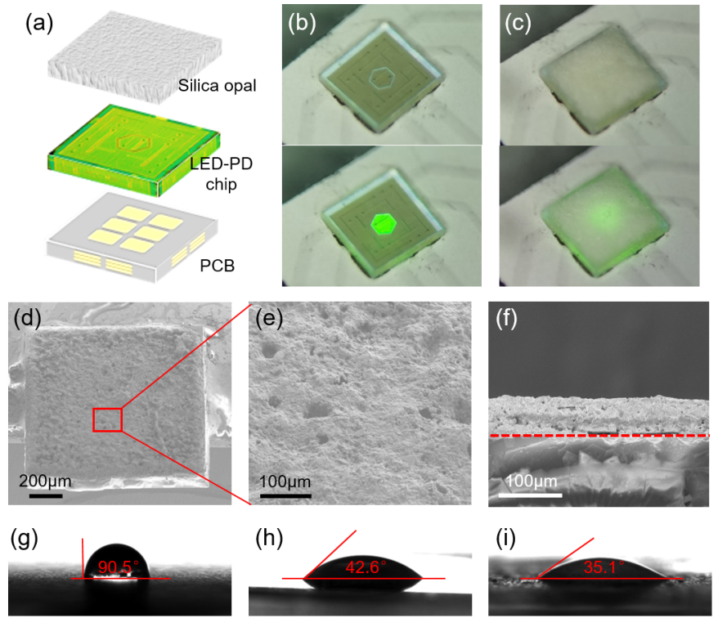
Figure 1. (a) Schematic illustration of the structural layout of the proposed humidity sensor. Optical images of the unilluminated and illuminated chip (b) before and (c) after deposition of opal film. (d) Scanning electron microscope (SEM) image of the sensor captured with a viewing angle of 45°. (e) Close-up SEM image of the opal film. (f) Cross-sectional SEM image of the opal film. The red dashed line represents the interface of sapphire and opal. Water contact angle of (g) sapphire substrate, (h) opal bulk, and (i) microporous opal film.
After dicing the fabricated wafer into small pieces, a 1×1×0.21 mm³ chip is flip-chip bonded on an aluminum-based printed circuit board and then integrated with an opal film, as schematically shown in Fig. 1(a). The hexagonal area at the chip center with a side length of 160 µm functions as a light emitter, while the outer region serves as a detector, as illustrated in Fig. 1(b). The opal powders are prepared by crushing an artificial opal bulk to small particles of 4-10 μm and then suspended in deionized water. The artificial opal powders containing constituent elements of Si and O show physical and chemical properties that are highly similar to natural opal (see Supporting information S2).
As shown in Fig. 1(c), the GaN chip with a flip-chip configuration allows the direct coating of opal film on the sapphire substrate without affecting the performance of underlying LED and PD. The surface morphology is examined by scanning electron microscopy (Zeiss Supra 55, Germany). As revealed in Fig. 1(d)-(e), the opal film composed of amorphous silica particles exhibit good integrity with the chip. The average thickness of the opal film determined from Fig. 1(f) is ~60 μm. The wettability of the material surface is studied by measuring the contact angle of a water droplet. Fig. 1(g)-(i) illustrate the contact angle of water droplets on sapphire substrate, opal bulk, and microporous opal film, respectively. Unlike the sapphire substrate with hydrophobic surface characteristics, the artificial opal bulk is intrinsically hydrophilic and exhibits a contact angle of less than 90°. The porous opal film with a large exposed surface area can further boost the hydrophilic surface capacity, thus attaining the smallest contact angle of 35.1° compared with opal bulk and sapphire substrate.

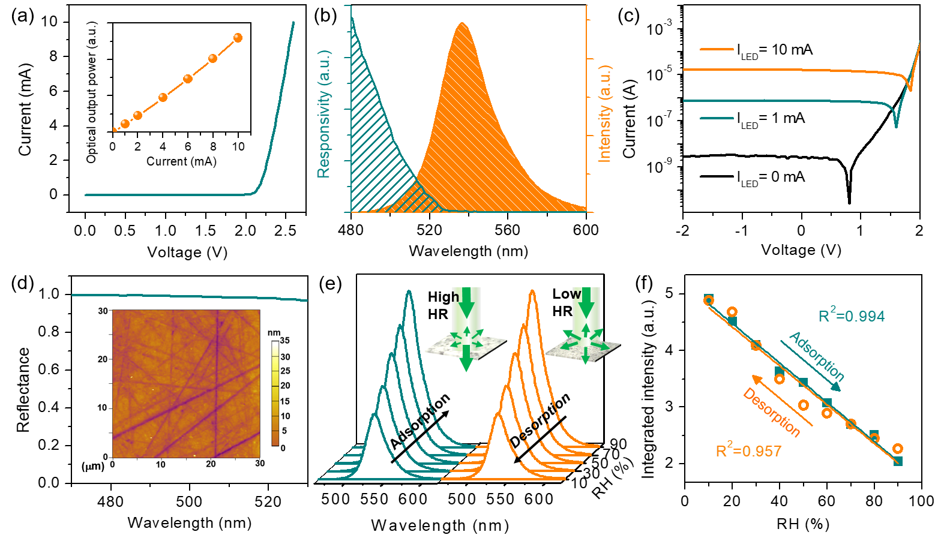
Figure 2. (a) Current-voltage (I-V) characteristics of the LED. The inset shows the output power versus current (L-I) characteristics of the LED. (b) EL spectrum of the LED biased at 10 mA and spectral responsivity of the unbiased PD. (c) I-V curves of the PD. (d) Reflectance spectra of the DBR. Inset shows the AFM image of the sapphire surface. (e) Reflectance spectra of the artificial opal film measured by fiber-coupled approach during adsorption and desorption. Schematics in the insets showing the strong and weak scattering effects induced by opal film at low RH and high RH respectively. (f) Plot of the integrated intensity of reflectance spectrum versus RH. The solid lines represent the linear fitting to the data points.
The chip containing InGaN/GaN MQW provides the two essential functions of light emission and photodetection for optical sensing and its electrical and optical properties are examined. The electrical properties of the LED and PD are measured with a Keithley 2450 SourceMeter with a resolution of 50 pA. The current-voltage (I-V) curve of LED in Fig. 2(a) shows a forward-biased voltage of 2.59 V at 10 mA and the resistance determined from the reciprocal slope is 38.9 Ω. The inset in Fig. 2(a) indicates that the light output power is linearly proportional to the bias current. Since the PD employs the identical MQW diode structure as the LED, it is necessary to study its ability to detect the light emitted by the LED. Fig. 2(b) shows the electroluminescence (EL) spectrum of the LED operating at 10 mA. The center wavelength and spectral width defined as the full-width at half-maximum (FWHM) are 538.7 nm and 34.7 nm, respectively. As presented in the same figure, the responsivity curve of the PD shows a spectral overlap of ~25 nm with the emission spectrum. The gradual decrease in responsivity with increasing wavelength can be attributed to the quantum-confined Stark effect and indium content fluctuations in the InGaN/GaN multi-quantum wells [30-32].
The light-detecting ability of the PD is further investigated by measuring its I-V curves, as plotted in Fig. 2(c). Under non-illuminated conditions, the photocurrent of the PD measured under reverse bias voltage remains at very low levels of the order of 10⁻⁹ A. When a constant current of 10 mA is injected into the emitter, the photocurrent rises by more than four orders of magnitude to 10⁻⁵-10⁻⁴ A. The stable reverse bias current also suggests that the leakage current of the PD can be neglected.
The chip is packaged in a flip-chip configuration and the light can be coupled into or out of the opal film through the transparent sapphire substrate. To enable the uniform coating of opal film, the sapphire face is polished to achieve a low root-mean-square (RMS) roughness of 3.43 nm as determined from the atomic force microscopy (AFM) scan image in the inset in Fig. 2(d). Optically, to promote the emitted light coupling into the opal film above the chip, a distributed Bragg reflector (DBR) with a high reflectance of more than 95 % for the wavelength range of 480-530 nm is inserted to behave as a bottom mirror, as shown in Fig. 2(d). Details of DBR coating can be found elsewhere [33].
The opal film is a key component that responds to the humidity changes and varies the amount of light received by the PD. The reflectance measurement is carried out by placing the sensor in a homemade vacuum chamber connected with the commercial humidifier and mechanical pump. The RH value is calibrated by a commercial SHT35 sensor. The reflectance spectra taken at normal incidence are measured through a transparent chamber window using an Ocean optics (Maya 2000 PRO) spectrometer combined with a Y-type fiber bundle. As shown in Fig. 2(e), the reflectance intensity declines with increasing RH and drops by ~58 % upon the RH increasing from 10 % to 90 %. Moreover, the opal film can undergo reversible changes when the RH returns from 90 % to 10 %, attributed to its effective adsorption and desorption abilities. At low RH, the opal film composed of irregularly shaped micro-particles highly scatters incident light due to the large refractive index contrast between opal (n_{opal} =1.45) and air (n_{air} =1), as illustrated in the inset in Fig. 2(e). As the humidity increases, the voids in the opal are enriched by water molecules, thus weakening its scattering effect due to the reduced refractive index contrast. Fig. 2(f) shows the integrated reflectance intensity as a function of RH. In the process of adsorption and desorption, the result shows a highly linear relationship and the R-squared values of fitted lines are larger than 0.95. The hysteresis between adsorption and desorption cycles can be possibly originated from the inhomogeneity of the coating [34-36]. It is also found that the opal film used in this work has a thickness variation of 5-10 %. The hysteresis can be alleviated by adjusting the coating process to improve the thickness uniformity, such as reducing the size variation of the opal powder and adding a surfactant to the suspension. Moreover, the measured humidity readings can be post-processed using mathematical procedures, such as artificial neural network (ANN) and support vector machine (SVM) techniques [37,38], to compensate for unwanted hysteresis.

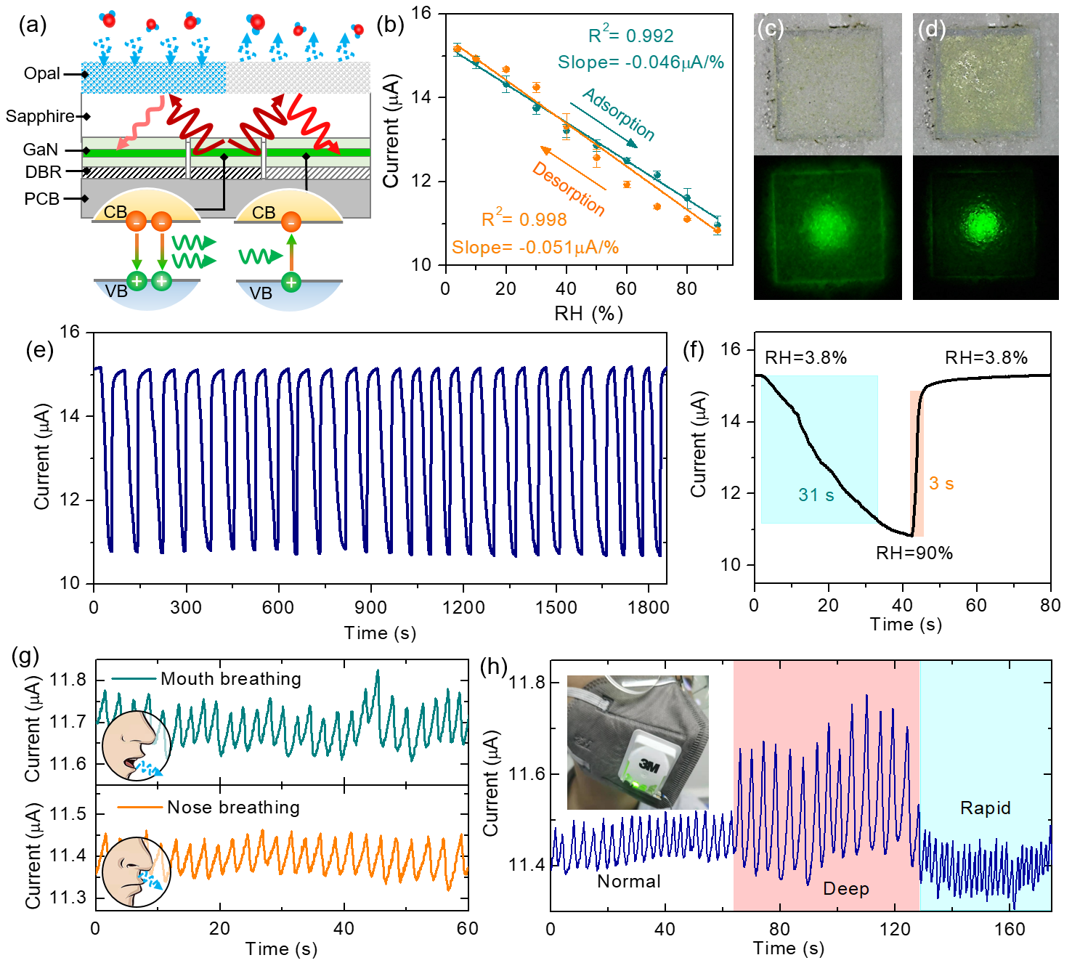
Figure 3. (a) Schematic illustration of the working principle of the humidity sensor. (b) Plot of photocurrent measured from the PD versus RH. The solid lines represent the linear fitting to the data. Microphotographs of the sensor captured at (c) RH = 10 % and (d) RH = 90 %. The lower images correspond to the operating sensor. (e) Continuous photocurrent response for RH changing cycles between 3.8 % and 90 %. (f) Enlarged view of photocurrent response curve showing the response time and recovery time. (g) Real-time photocurrent response of the sensor for monitoring the mouth and nose breathing. (h) Real-time photocurrent responses of the sensor mounted on a facial mask at different breathing conditions. Inset shows the photograph of the senor on the valve of mask.
Having identified the properties of the LED-PD chip and opal film, the functionality of the sensor is verified. Figure 3(a) illustrates the working principle of the humidity sensor. Through current injection, the LED emits light as a result of the recombination of injected charge carriers in the MQW active region. The opal film exhibits a linear change in reflectance with RH, thus regulating the amount of light entering the PD. The reflected light will be received by the InGaN layers of the PD to form electron-hole pairs, thereby generating a photocurrent. During the measurement, the LED is injected with a fixed current of 10 mA and the PD remains unbiased. The photocurrent signal is the key parameter indicating the change of RH and their correlation is measured and plotted in Fig. 3(b). The photocurrent shows a monotonic decrease (increase) with increasing RH (decreasing RH) and a highly linear response in a wide RH range of 3.8-90 % is obtained. Extracted from the linearly fitted lines in Fig. 3(b), the R-squared values are larger than 0.99. For the adsorption and desorption processes, the sensitivity defined as ΔI/ΔRH is determined to be 0.046 and 0.051 μA/%RH, respectively, where ΔRH is the relative humidity difference and ΔI is the photocurrent difference between RH = 3.8 and 90 %. Moreover, the decreasing trend of the measured photocurrent is highly consistent with the reflectance result shown in Fig. 2(f). Notably, the variation degree of the photocurrent is lower than that of reflectance intensity since part of light received by the PD passes through the sapphire substrate laterally rather than being scattered by the opal film.
Fig. 3(c) and 3(d) displays microphotographs of the sensor captured at RH = 10 % and RH = 90 % respectively. At a low RH, there exists a noticeable background emission in the non-emissive detector area, implying that the light emitted from the centered LED encounters strong scattering effects. At a high RH, the chip underneath becomes visibly clear and an intense spot at the center surrounded by a dark background is observed from the operating chip. Therefore, it can be further confirmed that the opal film scatters more light at low RH than at high RH, which correlates well with the results presented in Fig. 2(e) and Fig. 3(b).
The repeatability of the sensor is investigated by continuously recording the photocurrent in an RH range of 3.8-90 %. From the plot in Fig. 3(e), during the cyclic measurement, the photocurrent can restore its maximum and minimum at RH = 90 % and RH = 3.8 %, respectively, which indicates that the sensing reading is highly reproducible. From the enlarged view of the response curve in Fig. 3(f), the response time and recovery time are determined to be around 31 s and 3 s, respectively. The reason for the short recovery time is that the mechanical pump can effectively desorb water molecules from the opal film. It is worth noting that, different from the traditional fiber-optics sensing systems that rely on a thin sensing layer to introduce refractive index changes at the interface, the chip adopted in this work operates in reflection mode and requires an opal film with a thickness of tens of microns to induce a sufficient amount of reflected light to the PD. Moreover, the sensing performance is strongly related to the thickness of opal film (See Supporting Information S4). Although the thin structure can accelerate the transient response to RH changes, it inevitably sacrifices the capacity of adsorbing water molecules and results in a limited detectable RH range. The detectable range can be expanded by increasing the thickness of opal film, but additional response time is required for water vapor penetrating the thick opal structure. To achieve a balanced performance in terms of the measurable RH range and response time of the sensor, the thickness of opal film is chosen to be 60 μm. In addition to linear response and high reversibility, transient response is also found to be comparable with previously reported humidity sensors [39-45] (see Supporting Information S5).
The real-time monitoring capability of the sensor is demonstrated by measuring the photocurrent responses to RH change induced by inhaled and exhaled air. The sensor is placed about 7 cm away from the human face and the two sets of photocurrent responses are acquired during nose and mouth breathing. As shown in Fig. 3(g), the periodic photocurrent signal representing the respiratory cycle is clearly observed. The change in photocurrent induced by mouth breathing is about 1.8 times that of nose breathing, which can be due to the fact that the exhaled air from the mouth carries a large amount of moisture. The applicability of the sensor is further expanded by integrating the sensor on the exhalation valve of a respirator mask, as shown in the inset in Fig. 3(h). The sensor is capable of distinguishing different breathing rates, as shown in Fig. 3(h). The photocurrent variation measured during deep breathing is twice that measured during normal breathing. Moreover, a short respiratory period of 1.8-1.9 s can be detected during rapid breathing and the response time and recovery time are around 0.6 s and 1.0 s, respectively. By analyzing the frequency and depth of the breathing pattern, the measured photocurrent signal has potential applications in reflecting human health.

4. Conclusion
To summarize, we have developed a novel optical humidity sensor based on the compact integration of III-nitride chip with artificial opal. Adopting monolithic design, the GaN chip provides two essential functions of photoemission and photodetection and its electrical and optical properties are comprehensively demonstrated. The hydrophilic nature of opal film facilitates fast water molecule exchange. The opal film shows a linear reflectance response to the adsorption and desorption of water molecules. The reflectance variation induced by humidity change can be directly read by the on-chip PD without the need for external optics. The sensor shows a highly linear response for a wide range RH from 3.8-90 % and a sensitivity of 0.046-0.051 μA/%RH. With the distinct advantages of small size, simplicity of integration, ease of operation, high repeatability and fast response, the chip-scale fully integrated scheme presented in this letter represents an important step in the development of a miniature low-cost optical sensor, which is valuable for practical sensing applications, such as real-time monitoring of human breathing.

Author Contributions
Binlu Yu: Conceptualization, Data collection, Data analysis, Methodology, Writing - original draft. Yumeng Luo: Methodology, Data collection. Liang Chen: Methodology. Zhiqin Chu: Supervision, Writing - review & editing. Kwai Hei Li: Conceptualization, Methodology, and analysis, Supervision, Writing - review & editing.

Declaration of Competing
Interest The authors declare no conflict of interest.

Acknowledgement
L.K.H. acknowledges financial support from the National Natural Science Foundation of China (62004088 and 12074170) and the Shenzhen Natural Science Foundation Stability Support Program Project (20200925160044004). Z.Q.C. acknowledges financial support from the HKSAR Research Grants Council (RGC) Early Career Scheme (ECS, No. 27202919) and HKU Start-Up Grant.

Appendix. Supplementary data
Supplementary material related to this article can be found.

References
[1] T. Q. Trung, L. T. Duy, S. Ramasundaram, N. E. Lee, Transparent, stretchable, and rapid-response humidity sensor for body-attachable wearable electronics, Nano Res.10 (6) (2017) 2021-2033.
[2] F. Güder, A. Ainla, J. Redston, B. Mosadegh, A. Glavan, T. J. Martin, G. M. Whitesides, Paper-Based Electrical Respiration Sensor, Angew Chem Int Edit. 55 (19) (2016) 5727-5732.
[3] H. L. Yan, S. Y. Guo, F. Wu, P. Yu, H. B. Liu, Y. L. Li, L. Q. Mao, Carbon Atom Hybridization Matters: Ultrafast Humidity Response of Graphdiyne Oxides, Angew Chem Int Edit. 57 (15) (2018) 3922-3926.
[4] J. Zhang, X. X. Wang, B. Zhang, S. Ramakrishna, M. Yu, J. W. Ma, Y. Z. Long, In Situ Assembly of Well-Dispersed Ag Nanoparticles throughout Electrospun Alginate Nanofibers for Monitoring Human Breath-Smart Fabrics, ACS Appl. Mater. Interfaces. 10 (23) (2018) 19863-19870.
[5] H. Tai, S. Wang, Z. Duan, Y. Jiang, Evolution of breath analysis based on humidity and gas sensors: potential and challenges, Sens. Actuators B Chem. 318 (2020), 128104-128131.
[6] T. Dinh, T. Nguyen, H.-P. Phan, N.-T. Nguyen, D.V. Dao, J. Bell, Stretchable respiration sensors: advanced designs and multifunctional platforms for wearable physiological monitoring, Biosens. Bioelectron. 318 (2020),112460-112483.
[7] Y. Yi, Y. Jiang, H. Zhao, G. Brambilla, Y. Fan, P. Wang, High-Performance Ultrafast Humidity Sensor Based on Microknot Resonator-Assisted Mach-Zehnder for Monitoring Human Breath, ACS Sens. 5 (11) (2020) 3404-3410.
[8] Z. Xing, Y. Zheng, Z. Yan, Y. Feng, Y. Xiao, J. Yu, H. Guan, Y. Luo, Z. Wang, Y. Zhong, Z. Chen, High-sensitivity humidity sensing of microfiber coated with three-dimensional graphene network, Sens. Actuators B Chem. 281 (2019) 953-959.
[9] O. Fuentes, J. M. Corres, I. R. Matias, I. Del Villar, Generation of Lossy Mode Resonances in Planar Waveguides Toward Development of Humidity Sensors, J Lightwave Technol. 37 (10) (2019) 2300-2306.
[10] P.J. Thomas, J.O. Hellevang, A fully distributed fiber optic sensor for relative humidity measurements, Sens. Actuators B Chem. 247 (2017) 284-289.
[11] N. Irawati, H. A. Rahman, M. Yasin, S. Al-Askari, B. A. Hamida, H. Ahmad, S. W. Harun, Relative humidity sensing using a PMMA doped agarose gel microfiber, J Lightwave Technol. 35 (18) (2017) 3940-3944.
[12] R. Gao, Y. Jiang, W. H. Ding, Agarose gel filled temperature-insensitive photonic crystal fibers humidity sensor based on the tunable coupling ratio, Sens. Actuators B Chem. 195 (2014) 313-319.
[13] X. F. Wang, G. Farrell, E. Lewis, K. Tian, L. B. Yuan, P. F. Wang, A Humidity Sensor Based on a Singlemode-Side Polished Multimode-Singlemode Optical Fibre Structure Coated with Gelatin, J Lightwave Technol. 35 (18) (2017) 4087-4094.
[14] K.M. Tan, C.M. Tay, S.C. Tjin, C.C. Chan, H. Rahardjo, High relative humidity measurements using gelatin coated long-period grating sensors, Sens. Actuators B Chem. 110 (2005) 335-341.
[15] W. C. Wong, C. C. Chan, L. H. Chen, T. Li, K. X. Lee, K. C. Leong, Polyvinyl alcohol coated photonic crystal optical fiber sensor for humidity measurement, Sens. Actuators B Chem. 174 (2012) 563-569.
[16] J. C. Shin, M. S. Yoon, Y. G. Han, Relative Humidity Sensor Based on an Optical Microfiber Knot Resonator With a Polyvinyl Alcohol Overlay, J Lightwave Technol. 34 (19) (2016) 4511-4515.
[17] A. Lokman, H. Arof, S.W. Harun, Z. Harith, H.A. Rafaie, R.M. Nor, Optical fiber relative humidity sensor based on inline Mach-Zehnder interferometer with ZnO nanowires coating, IEEE Sens. J. 16 (2) (2016) 312-316.
[18] C. Huang, W. Xie, D. Lee, C. Qi, M. Yang, M. Wang, J. Tang, Optical Fiber humidity sensor with porous TiO₂/SiO₂/TiO₂ coatings on Fiber tip, Ieee Photonics Technol. Lett. 27 (14) (2015) 1495-1498.
[19] C. Kelb, M. Körner, O. Prucker, J. Rühe, E. Reithmeier, B. Roth, PDMAA hydrogel coated U-bend humidity sensor suited for mass-production, Sensors. 17 (3) (2017) 517-526.
[20] A. Petermann, T. Hildebrandt, U. Morgner, B. Roth, M. Meinhardt-Wollweber, Polymer based whispering gallery mode humidity sensor, Sensors. 18 (7) (2018) 2383-2392.
[21] F. Gallego-Gomez, M. Morales, A. Blanco, C. Lopez, Bare Silica Opals for Real-Time Humidity Sensing, Adv. Mater. Technol. 4 (2) (2019) 1800493.
[22] F. Gallego-Gomez, M. Morales, A. Blanco, C. Lopez, Tunable Visual Detection of Dew by Bare Artificial Opals, Adv. Funct. Mater. 28 (21) (2018) 1800591.
[23] S. Kim, S. G. Han, Y. G. Koh, H. Lee, W. Lee, Colorimetric Humidity Sensor Using Inverse Opal Photonic Gel in Hydrophilic Ionic Liquid, Sensors. 18 (5) (2018) 1357.
[24] R. A. Barry, P. Wiltzius, Humidity-sensing inverse opal hydrogels, Langmuir. 22 (3) (2006) 1369-1374.
[25] S. A. Kolpakov, N. T. Gordon, C. B. Mou, K. M. Zhou, Toward a New Generation of Photonic Humidity Sensors, Sensors. 14 (3) (2014) 3986-4013.
[26] J. Ascorbe, J.M. Corres, F.J. Arregui, I.R. Matias, Recent developments in fiber optics humidity sensors, Sensors. 17 (4) (2017) 893.
[27] M. H. Crawford, LEDs for Solid-State Lighting: Performance Challenges and Recent Advances, Ieee J Sel Top Quant. 15 (4) (2009) 1028-1040.
[28] M. H. Chang, D. Das, P. V. Varde, M. Pecht, Light emitting diodes reliability review, Microelectron Reliab. 52 (5) (2012) 762-782.
[29] A. Laubsch, M. Sabathil, J. Baur, M. Peter, B. Hahn, High-Power and High-Efficiency InGaN-Based Light Emitters, Ieee T Electron Dev. 57 (1) (2010) 79-87.
[30] Y. H. Huang, C. L. Cheng, T. T. Chen, Y. F. Chen, K. T. Tsen, Studies of stokes shift in In_{x}Ga_{1-x}N alloys, J Appl Phys. 101 (10) (2007) 103521.
[31] R. W. Martin, P. G. Middleton, K. P. O'Donnell, W. Van der Stricht, Exciton localization and the Stokes' shift in InGaN epilayers, Appl Phys Lett. 74 (2) (1999) 263-265.
[32] K. H. Li, H. T. Lu, W. Y. Fu, Y. F. Cheun, H. W. Choi, Intensity-Stabilized LEDs With Monolithically Integrated Photodetectors, Ieee T Ind Electron. 66 (9) (2019) 7426-7432.
[33] L. Chen, X. S. An, J. X. Jing, H. T. Jin, Z. Q. Chu, K. H. Li, Ultracompact Chip-Scale Refractometer Based on an InGaN-Based Monolithic Photonic Chip, ACS Appl. Mater. Interfaces. 12 (44) (2020) 49748-49754.
[34] Z. Zheng, N. Kim, WS. Wong, J.T.W. Yeow, Inkjet-printed CMUT humidity sensors with high sensitivity and low hysteresis. Sens. Actuators B Chem. 327 (2021) 128920-128930.
[35] M. Björkqvist, J. Paski, J. Salonen, V.P. Lehto, Studies on hysteresis reduction in thermally carbonized porous silicon humidity sensor, IEEE Sens. J. 6 (3) (2006) 542-546.
[36] E. Uk, B. Il, J. Chul, S. Woo, Y. Kim, Y. Choi, S. Lee, Correlation between the sensitivity and the hysteresis of humidity sensors based on graphene oxides, Sens. Actuators, B Chem. 258 (2018) 255-262.
[37] T. Islam, H. Saha, Hysteresis compensation of a porous silicon relative humidity sensor using ANN technique, Sens. Actuators B Chem. 114 (2006) 334-343.
[38] X. D. Wang, M. Y. Ye, Hysteresis and nonlinearity compensation of relative humidity sensor using support vector machines, Sens. Actuators B Chem. 129 (2008), 274-284.
[39] Z. Duan, Q. Zhao, S. Wang, Q. Huang, Z. Yuan, Y. Zhang, Y. Jiang, H. Tai, Halloysite nanotubes: natural, environmental-friendly and low-cost nanomaterials for high-performance humidity sensor, Sens. Actuators B Chem. 317 (2020) 128204.
[40] J. Zhao, N. Li, H. Yu, Z. Wei, M. Liao, P. Chen, S. Wang, D. Shi, Q. Sun, G. Zhang, Highly Sensitive MoS₂ Humidity Sensors Array for Noncontact Sensation, Adv. Mater. 29 (34) (2017) 1702076.
[41] R. Si, X. Xie, T. Li, J. Zheng, C. Cheng, S. Huang, C. Wang, TiO₂/(K, Na)NbO₃ nanocomposite for boosting humidity-sensing performances, ACS Sens. 5 (5) (2020) 1345-1353.
[42] Z. Duan, Y. Jiang, M. Yan, S. Wang, Z. Yuan, Q. Zhao, P. Sun, G. Xie, X. Du, H. A. Tai, Facile, Flexible, Cost-Saving and Environment-Friendly Paper-Based Humidity Sensor for Multifunctional Applications, ACS Appl. Mater. Interfaces. 11 (24) (2019) 21840-21849.
[43] M.A. Dipluran, F. Fadhila, C. Imawan, V. Fauzia, The enhanced performance of capacitive-type humidity sensors based on ZnO nanorods/WS₂ nanosheets heterostructure, Sens. Actuators B Chem. 310 (2020) 127810.
[44] N. Gao, H. Li, W. Zhang, Y. Zhang, Y. Zeng, Z. Hu, et al., QCM-based humidity sensor and sensing properties employing colloidal SnO₂ nanowires, Sens. Actuators B Chem. 293 (2019) 129-135.
[45] R. Gao, D.-f. Lu, J. Cheng, Y. Jiang, L. Jiang, Z.-M. Qi, Humidity sensor based on power leakage at resonance wavelengths of a hollow core fiber coated with reduced graphene oxide, Sens. Actuators B Chem. 222 (2016) 618-624.

