Bridge identification and damage detection using contact point response difference of moving vehicle

Ying Zhan ª, Francis T.K. Au ª, Jing Zhang ^{a,b}

ª Department of Civil Engineering, The University of Hong Kong, Pokfulam Road, Hong Kong, China
^{b} Department of Civil Engineering, Hefei University of Technology, Hefei, Anhui Province, China

Abstract
This paper presents the use of a moving vehicle to identify the bridge mode shapes and detect possible damage in the presence of bridge surface roughness. The method utilises the contact point responses at the contact between the wheel and bridge surface, which can be obtained from the vehicle responses and has a direct relation with the bridge responses and surface roughness. A double-pass mass-addition technique is proposed to obtain the contact point response difference using a test vehicle installed with sensors. Then the bridge frequencies can be identified from its spectrum, while the mode shapes can be further obtained by signal filtering and Hilbert transform. Simulation results show that the adverse effect of surface roughness on the contact point acceleration difference is largely reduced. The first three frequencies and mode shapes can be extracted with satisfactory accuracy. Multiple damage locations can be identified by performing wavelet transform on the contact point displacement difference and applying coordinate modal assurance criterion to the mode shapes constructed. The factors that may affect the performance of the proposed method are also investigated, including the distribution of added mass, measurement noise, speed of the test vehicle and co-existing traffic. Experimental validation is conducted on a simply supported aluminium channel beam with artificial roughness carrying a moving model vehicle. The results show that the proposed methodology for bridge identification works in the presence of road surface roughness.

Keywords:
Bridge mode shape; Contact point response; Damage detection; Surface roughness; Vehicle-bridge interaction

1. Introduction
Recent years have witnessed a rapid development in the indirect approach of bridge identification, i.e. methods using the vehicle responses to identify the bridge information. It is becoming a burgeoning field in structural health monitoring thanks to its advantages, which include its convenience because of the less hindrance to traffic and its economy as it requires fewer sensors on the test vehicle as compared to the many sensors required on a bridge in the direct method. Plenty of promising results have been obtained. Theoretical studies have been conducted using the vehicle responses to identify the bridge frequencies ¹⁻³, damping ⁴⁻⁶, mode shapes ⁷⁻⁹, surface roughness ¹⁰⁻¹⁴, etc. and to detect damage ¹⁵⁻¹⁷ and rail irregularities ¹⁸. Laboratory experiments and field tests have also been carried out successfully, albeit mainly on the extraction of bridge frequencies ¹⁹⁻²². Some researchers have adopted the bridge response under vehicle excitation or combined the responses of the bridge and vehicle together to identify the bridge information ²³⁻²⁵.
Some of the representative publications are further described below. Yang et al. ¹ initiated a theoretical study to extract the first bridge frequency using the response of a passing vehicle. Yang and Chang ² subsequently enhanced this work by applying the empirical mode decomposition technique. McGetrick et al. ³ used the vehicle acceleration to extract the dynamic parameters of a bridge, while González et al. ⁴ later identified the bridge damping using a moving instrumented vehicle. Keenahan et al. ⁵ further developed a structural damping monitoring technique using a truck-trailer vehicle system with accelerometers mounted on the trailer axles. Yang et al. ⁶ developed a theoretical framework to identify the damping ratios of simply supported bridges from the response of a two-axle test vehicle installed with several accelerometers and laser distance sensors. Yang et al. ⁷ further extended their work to constructing the bridge mode shape by Hilbert transform of the vehicle acceleration responses. Malekjafarian and O'Brien ⁸ used the short-time frequency domain decomposition technique to estimate the mode shapes from the accelerations of the two axles of the vehicle. Zhang et al. ⁹ made use of the time-varying nature of the coupled frequencies of an interaction system comprising a beam-like structure carrying a moving lumped mass and proposed a modified weighted polynomial chirplet transform method to construct the mode shapes from the non-stationary instantaneous frequencies obtained from the acceleration of the moving lumped mass.
As the frequencies induced by surface roughness could overshadow the bridge frequencies in the spectrum, Yang et al. ¹⁰ proposed a method to mitigate its adverse impact by deploying successively vehicles of the same frequency and speed. Later, a method using two connected vehicles ¹¹ is proposed to extract the bridge frequency considering the surface roughness, such that with proper arrangement of vehicles, up to the first three bridge frequencies could be identified. O'Brien et al. ¹² proposed an algorithm to identify the contact force between the vehicle and bridge using the vehicle acceleration, which could be used to estimate the surface roughness. Wang et al. ¹³ proposed a method to estimate the bridge pavement roughness and to further identify the moving vehicle parameters. Zhan and Au ¹⁴ introduced the double-pass mass-addition method to identify the bridge surface roughness by considering the vehicle-bridge interaction of a simple single-foot vehicle model. O'Brien and Malekjafarian ¹⁷ developed the mode shape-based damage detection approach using laser measurement from a vehicle crossing a simply supported bridge. Cantero and Basu ¹⁸ used the wavelet transformed acceleration response of a traversing vehicle to conduct damage detection of railway considering track irregularities.
There are two main approaches to construct the mode shapes from the vehicle response indirectly, depending upon how heavy the vehicle is as compared to the bridge mass. If the vehicle is very light as compared to the bridge, i.e. the light-vehicle assumption, the bridge frequencies can be identified first so that the component responses related to these frequencies can be obtained from the vehicle acceleration by filtering. The bridge mode shapes in absolute value can then be determined as the envelope of the component responses ⁷. If the vehicle is very heavy as compared to the bridge, i.e. the heavy-vehicle assumption, the time-varying coupled frequencies of the vehicle-beam interaction system can be identified first. Then the mode shapes can be constructed based on their relation with the instantaneous frequencies ⁹.
This study of drive-by technique has adopted the light-vehicle assumption, as deployment of a light instrumented vehicle is often more practical. However, it is difficult to extract the higher order bridge mode shapes from the vehicle responses. The quality of mode shapes may not be good enough for further refined analysis such as damage identification. Moreover, the presence of road surface roughness may contaminate the vehicle responses and mask the bridge information with noise. Traditionally, the responses of vehicle chassis have been adopted in the indirect method of bridge assessment, but the bridge vibration information is often distorted during the transmission from the bridge through the tyre and suspension system to the vehicle chassis ²⁶. Recently, the use of bridge contact point response has been proposed for the indirect approach ²⁷⁻³⁰, from which the higher order mode shapes with better quality can be extracted. However, the contact point response is more prone to the adverse effects of surface roughness. Although some methods have been proposed to deal with the adverse effects of surface roughness, including the use of a multi-vehicle system ^{11,31} and various forms of external excitation mechanisms ^{32,33}, these methods to deal with the surface roughness may not be directly applicable to the contact point responses. The double-pass mass-addition method is therefore applied in this study in conjunction with the newly introduced contact point response difference that can easily cater for the use of multi-axle instrumented vehicles. The estimated surface roughness can then be considered in the identification of bridge mode shapes and damage location for improvement of their accuracy. The methodology to obtain the contact point response for estimation of surface roughness and more accurate identification of bridge properties is illustrated using a normal half-car 4 degree-of-freedom (DOF) vehicle model.

2. Double-pass mass-addition method with contact point displacement difference

2.1 Vehicle-bridge interaction and contact point displacement difference

Although the double-pass mass-addition method ¹⁴ has been introduced to the vehicle-bridge interaction of a single-foot vehicle model for identification of surface roughness, extension to multi-axle vehicles is not that straightforward. The use of contact point displacement difference is therefore proposed to cater for common multi-axle vehicles. For simplicity and without loss of generality, the theoretical formulation is illustrated with the bridge modelled as a simply supported beam and the vehicle as a sprung mass, as shown in Fig. 1. The contact point displacement and associated quantities are then examined to provide the insight into their key characteristics and to steer the subsequent development with multi-axle vehicles. The governing equations of the vehicle-bridge interaction system with smooth bridge surface can be written as
$$\overline{m}\frac{∂^{2}u_{b}\left(x,t\right)}{∂t^{2}}+EI\frac{∂^{4}u_{b}\left(x,t\right)}{∂x^{4}}=f_{c}\left(t\right)δ\left(x-vt\right)$$ | (1)
$$m_{v}\frac{d^{2}u_{v}\left(t\right)}{dt^{2}}+k_{v}\left[u_{v}\left(t\right)-{\left.u_{b}\left(x,t\right)\right|}_{x=vt}\right]=0$$ | (2)
$$f_{c}\left(t\right)=-m_{v}g+k_{v}\left[u_{v}\left(t\right)-{\left.u_{b}\left(x,t\right)\right|}_{x=vt}\right]$$ | (3)
where $\overline{m}$, $E$, $I$ and $L$ denote the mass per unit length, modulus of elasticity, moment of inertia and span length of the bridge, respectively; $m_{v}$ and $k_{v}$ denote the mass and spring stiffness of the vehicle, respectively; $u_{b}\left(x,t\right)$ is the vertical displacement of the bridge at location $x$ and time $t$; $u_{v}(t)$ is the vertical displacement of the vehicle at time $t$; $v$ is the speed of vehicle that should be kept constant throughout the pass; $f_{c}\left(t\right)$ is the contact force between the bridge and vehicle; $g$ is the acceleration due to gravity; and $δ\left(x-vt\right)$ is the Dirac delta function to describe the movement of contact force.
Eq. (1) can be analysed by the mode superposition method ³⁴. Substituting the vertical displacement of bridge written as $u_{b}\left(x,t\right)=\sum_{j}{\left[ϕ_{j}(x)∙Y_{j}(t)\right]}$ in terms of the jth mode shape of the bridge $ϕ_{j}(x)=\sin{\frac{jπx}{L}}$ and the associated modal amplitude $Y_{j}(t)$ into Eq. (1), multiplying both sides by $ϕ_{i}(x)$, integrating with respect to x and applying the orthogonality of mode shapes yield
$$\overline{m}\frac{d^{2}Y_{i}(t)}{dt^{2}}\int_{0}^{L}{ϕ_{i}^{2}(x)dx}+\frac{j^{4}π^{4}}{L^{4}}Y_{i}\left(t\right)\int_{0}^{L}{EIϕ_{i}^{2}\left(x\right)dx}=f_{c}(t)\int_{0}^{L}{δ\left(x-vt\right)ϕ_{i}\left(x\right)dx}$$ | (4)
Substituting Eq. (3) into Eq. (4), and assuming that the vehicle mass is negligible compared to the bridge mass and zero initial vibration conditions of both the bridge and vehicle, the bridge displacement can be written as ²⁸
$$u_{b}\left(x,t\right)=\sum_{i=1}^{∞}{A_{i}\sin{\frac{iπx}{L}}\left[\sin{\frac{iπvt}{L}}-\frac{iπv}{Lω_{bi}}\sin\left(ω_{bi}t\right) \right]}$$ | (5)
where $A_{i}=\frac{-2m_{v}gL^{3}}{i^{4}π^{4}EI-i^{2}π^{2}v^{2}L^{2}\overline{m}}$; and $ω_{bi}=\frac{i^{2}π^{2}}{L^{2}}\sqrt{\frac{EI}{\overline{m}}}$ is the i-th circular frequency of the bridge. Substituting Eq. (5) into Eq. (2), one gets an ordinary differential equation in terms of the vehicle displacement $u_{v}\left(t\right)$, which can be solved by Duhamel’s integral as
$$u_{v}\left(t\right)=\sum_{i=1}^{∞}{\left\{B_{i,1}cos\left(ω_{bi}t-\frac{iπvt}{L}\right)+B_{i,2}cos\left(ω_{bi}t+\frac{iπvt}{L}\right)+B_{i,3}cos\left[\frac{\left(i-1\right)πvt}{L}\right]+B_{i,4}cos\left[\frac{\left(i+1\right)πvt}{L}\right]+B_{i,5}cos\left(ω_{v}t\right)\right\}}$$ | (6)
where the coefficients $B_{i,1}$ to $B_{i,5}$ are given explicitly in Appendix I. It is noted that the vehicle displacement $u_{v}\left(t\right)$ contains five groups of frequencies, including two frequencies that are symmetrical with respect to the i-th bridge frequency $ω_{bi}$, which proves that the vehicle response contains some bridge information. Differentiating the vehicle displacement $u_{v}\left(t\right)$ twice with respect to $t$ gives the vehicle acceleration that also contains the same five groups of frequencies. Therefore, it is possible to identify the bridge frequencies from the vehicle acceleration with spectral analysis tools and further construct the bridge mode shapes using a suitable signal filter and Hilbert transform.
However, there are several obstacles for mode shape identification using such an indirect approach:
(a) Although the vehicle response contains 5 groups of frequencies, it may be difficult to identify those that are related to the bridge, especially for the higher modes.
(b) The energy and magnitude of the vibration related to the bridge are relatively small, and research indicates that the bridge mode shapes can hardly be constructed from the vehicle responses without artificial excitation to enlarge the bridge vibration ³⁵.
(c) The presence of bridge surface roughness can severely contaminate the vehicle response and mask the bridge information.
An alternative form of the vehicle response is the contact point response, which is taken as
$$u_{b}\left(vt,t\right)=\sum_{i=1}^{∞}{A_{i}\text{sin}{\frac{iπvt}{L}}\left[\sin{\frac{iπvt}{L}}-\frac{iπv}{Lω_{bi}}\sin{{(ω}_{bi}t)}\right]}$$ | (7)
Since it is essentially the bridge response, the shortcomings (a) and (b) mentioned above can be mitigated. Moreover, it can be derived from vehicle response at the contact point, and therefore it has the advantages of the indirect method.
Although the surface roughness causes variations of the contact forces and further excites the bridge, this side effect is far outweighed by the uncertainties introduced by the surface roughness to the vehicle responses. The contact point response is likewise prone to the contamination of measurements due to surface roughness. However, this adverse effect can be mitigated using the double-pass mass-addition method proposed previously to identify bridge surface roughness ¹⁴, which will be elaborated later.
Because of the existence of surface roughness $R\left(x\right)$, the contact point displacement of the vehicle can be written as $u_{c}\left(t\right)=u_{b}\left(vt,t\right)+R\left(x\right)$ in terms of the contact point displacement of the bridge $u_{b}\left(vt,t\right)$. The above analysis can then be repeated by replacing $u_{b}\left(vt,t\right)$ in Eqs. (2) and (3) by $u_{b}\left(vt,t\right)+R\left(x\right)$, giving the bridge displacement as
$$u_{b}\left(x,t\right)=\sum_{i=1}^{∞}{\frac{-2L^{3}\left[m_{v}g+k_{v}R\left(x\right)\right]}{i^{4}π^{4}EI-i^{2}π^{2}v^{2}L^{2}\overline{m}}\sin{\frac{iπx}{L}}\left[\sin{\frac{iπvt}{L}}-\frac{iπv}{Lω_{bi}}\sin\left(ω_{bi}t\right)\right]}$$ |  | (8)
Therefore, the contact point displacement of the vehicle can be expressed as
$$u_{c}\left(t\right)=\sum_{i=1}^{∞}{\frac{-2L^{3}\left[m_{v}g+k_{v}R\left(vt\right)\right]}{i^{4}π^{4}EI-i^{2}π^{2}v^{2}L^{2}\overline{m}}\sin{\frac{iπvt}{L}}\left[\sin{\frac{iπvt}{L}}-\frac{iπv}{Lω_{bi}}\sin{{(ω}_{bi}t)}\right]}+R\left(vt\right)$$ | (9)
Let the vehicle pass over the bridge twice at the same speed$v$. For the first time, let the vehicle of mass $m_{v}$ run on the bridge. For the second time, extra mass is added and let the vehicle of mass $λm_{v}$ ($λ>1$) run on the bridge. Two contact point displacement histories from the two passes are obtained. Subtracting one from another gives the contact point displacement difference (CPDD) as
$${\hat{u}}_{c}\left(t\right)=\sum_{i=1}^{∞}{\frac{\left(λ-1\right)}{2}A_{i}\text{sin}{\frac{iπvt}{L}}\left[\sin{\frac{iπvt}{L}}-\frac{iπv}{Lω_{bi}}\sin{{(ω}_{bi}t)}\right]}$$ | (10)
Because the surface roughness $R\left(x\right)$ is eliminated, its adverse influence is reduced. As the CPDD also contains the bridge information, it is feasible to identify the bridge frequencies and construct the mode shapes from it.

2.2 Identification of bridge mode shapes using Hilbert transform

Hilbert transform is a linear operator that takes a time series $μ\left(t\right)$ and produces its transform pair $\overline{μ}\left(t\right)$ as
$$\overline{μ}\left(t\right)=\frac{1}{πt}p.v.\int_{-∞}^{+∞}{\frac{μ\left(τ\right)}{t-τ}}dτ$$ | (11)
where $p.v.$ denotes the Cauchy principal value. A function of Hilbert transform is shifting the phase of the series by $π/2$ radians, which turns sine into cosine and vice versa.
The CPDD ${\hat{u}}_{c}\left(t\right)$ in Eq. (10) involving products of trigonometrical functions can be rewritten using the product-to-sum trigonometric formulas as
$${\hat{u}}_{c}\left(t\right)=\sum_{i=1}^{∞}{\frac{\left(λ-1\right)}{2}A_{i}\left\{1-\cos{\frac{2iπvt}{L}}+\frac{iπv}{Lω_{bi}}\left[\cos\left(ω_{bi}+\frac{iπv}{L}\right)t-\cos\left(ω_{bi}-\frac{iπv}{L}\right)t\right]\right\}}$$ | (12)
Differentiating it twice with respect to time $t$, one obtains the contact point acceleration difference (CPAD) ${\hat{a}}_{c}\left(t\right)$ as
$${\hat{a}}_{c}\left(t\right)=\sum_{i=1}^{∞}{\frac{\left(λ-1\right)}{2}A_{i}\left[{\left(\frac{2iπv}{L}\right)}^{2}\cos{\frac{2iπvt}{L}}-\frac{iπv}{Lω_{bi}}{\left(ω_{bi}+\frac{iπv}{L}\right)}^{2}\cos\left(ω_{bi}+\frac{iπv}{L}\right)t+\frac{iπv}{Lω_{bi}}{\left(ω_{bi}-\frac{iπv}{L}\right)}^{2}\cos\left(ω_{bi}-\frac{iπv}{L}\right)t\right]}$$ | (131)
The component response $a_{i}(t)$ of CPAD corresponding to the i-th bridge frequency is obtained as
$$a_{i}(t)=A_{ri}\cos\left(ω_{bi}+\frac{iπv}{L}\right)t+A_{li}\cos\left(ω_{bi}-\frac{iπv}{L}\right)t$$ | (14)
where $A_{ri}=-\frac{\left(λ-1\right)}{2}A_{i}\frac{iπv}{Lω_{bi}}{\left(ω_{bi}+\frac{iπv}{L}\right)}^{2}$ and $A_{li}=\frac{\left(λ-1\right)}{2}A_{i}\frac{iπv}{Lω_{bi}}{\left(ω_{bi}-\frac{iπv}{L}\right)}^{2}$. The component response $a_{i}(t)$ can be extracted from the CPAD ${\hat{a}}_{c}\left(t\right)$ by a suitable signal filter. Performing Hilbert transform on the component response $a_{i}(t)$ gives its transform ${\overline{a}}_{i}(t)$ as
$${\overline{a}}_{i}(t)=A_{ri}\sin\left(ω_{bi}+\frac{iπv}{L}\right)t+A_{li}\sin\left(ω_{bi}-\frac{iπv}{L}\right)t$$ | (15)
Consequently, the envelope $E\left(t\right)$ can be obtained by calculating the amplitude of the transform pair as
$$E_{i}\left(t\right)=\sqrt{a_{i}^{2}\left(t\right)+{\overline{a}}_{i}^{2}\left(t\right)}=\sqrt{{\left(A_{ri}+A_{li}\right)}^{2}-4A_{ri}A_{li}\sin^{2}\frac{iπv}{L}t}≈\sqrt{-4A_{ri}A_{li}}\left|sin\frac{iπv}{L}t\right|$$ | (16)
For the lower modes, e.g. $i≤3$, the driving frequency $\frac{iπv}{L}$ is much lower than the bridge frequency $ω_{bj}$, indicating that $A_{ri}$ and $A_{li}$ are almost identical in magnitude but opposite in sign. The above approximation in Eq. (16) is therefore justified as the lower modes contain most of the energy. For the lower modes, the envelope $E_{i}\left(t\right)$ is the absolute value of the i-th bridge mode shape scaled by $sin\frac{iπx}{L}$. The lowest 3 or 4 modes are often sufficient for most of the engineering applications.
The bridge mode shape can be obtained accordingly by adjusting the sign of the envelope $E_{i}\left(t\right)$ and normalizing the resulting curve. For simple cases such as simply supported bridges, changing sign is straightforward, but it is more complicated for continuous bridges. The following steps are proposed for adjusting the sign of envelope to get the mode shape:
(a) Find the cusps in the envelope. The number of cusps in an envelope is equal to the sum of the order of mode shape and the number of intermediate supports minus one. For example, the envelope of the third mode shape of a three-span continuous bridge (with 2 intermediate supports) has 4 (i.e. 3 + 2 – 1) cusps as shown in Fig. 2(a).
(b) Adjusting the sign of all the points after each cusp and repeating this process for all cusps, one obtains the mode shape from the envelope as shown in Fig. 2(b).
Note that in order for mode shapes to be used in damage detection, the smoothness of the mode shapes should be maintained. Normalization is a linear operation which does not affect this property but changing the sign does. The envelope acquired by the above procedure is hardly perfect due to signal processing errors and measurement noise. Incidentally, some of the cusps may be close to but not exactly zero. Therefore, instead of adjusting the sign, it is better to adjust it according to the value of each cusp to maintain the smoothness. Specifically, to ensure slope continuity assuming regular grid data, one can adopt the adjusted value $V_{i,adjusted}$ as
$$V_{i,adjusted}=2×V_{cusp}-V_{i,original}$$ | (17)
where $V_{i}$ is the value of any point after a certain cusp whose value is $V_{cusp}$, and $V_{i,original}$ is the original value of $V_{i}$. The comparison of mode shape results from simple sign adjustment and adjustment ensuring slope continuity is shown in Fig. 3.

2.3 Performance evaluator and damage indicator

To evaluate the similarity of the theoretical and identified mode shapes, the modal assurance criteria (MAC) is adopted as
$$\text{MAC}=\frac{{\left|φ_{i}^{T}φ_{t}\right|}^{2}}{φ_{i}^{T}φ_{i}φ_{t}^{T}φ_{t}}$$ | (18)
where $φ_{i}$ denotes the identified mode shape and $φ_{t}$ denotes the theoretical mode shape.
Damage detection is conducted based on the understanding that damage adversely affects the integrity of a structure and leads to singularities of modal parameters such as mode shapes. Although such singularities can hardly be observed directly, they can be revealed by damage indicators such as wavelet transform coefficients and co-ordinate modal assurance criterion (COMAC).
The mathematical essence of the wavelet transform is a convolution of the mother wavelet and the signal analysed, which is expressed as
$$S_{w}\left(a,b\right)=\frac{1}{\sqrt{a}}\int_{-∞}^{∞}{s\left(x\right)}\overline{ψ}\left(\frac{x-b}{a}\right)dx$$ | (19)
where $a∈R^{+}$ and $b∈R$ are the scale and translational parameters, respectively; $s\left(x\right)$ is the input signal being analysed; $ψ\left(x\right)$ denotes the mother wavelet and $\overline{ψ}\left(x\right)$ is its complex conjugate; and $S_{w}\left(a,b\right)$ denotes the wavelet coefficients for scale $a$ and location $b$. The performance of wavelet transform is heavily dependent on the selection of proper mother wavelet. After a trial on various commonly used mother wavelets, including Daubechies, Biorthogonal, Gaussian, Symlets, Coiflets and other wavelet families, this study has adopted the fourth derivative of Gaussian function as the mother wavelet, which is expressed as
$$ψ\left(x\right)=-\frac{1}{\sqrt{2π}}\left(-3+6x^{2}-x^{4}\right)e^{-\frac{x^{2}}{2}}$$ | (20)
Wavelet transform has been performed on displacement histories of vehicle chassis ³⁶ and bridge mode shapes ³⁵ to locate damage. In this study, wavelet transform is performed on the CPDD.
COMAC has been developed to identify which measurement DOF leads to a negative contribution to MAC ^{37,38}. The damaged DOF will contribute negatively to MAC, consequently resulting in a notable drop in COMAC ³⁹. The value of COMAC is calculated by
$${COMAC}_{k}=\frac{\sum_{j=1}^{n}{{\left(φ_{k,j}^{i}φ_{k,j}^{d}\right)}^{2}}}{\sum_{j=1}^{n}{{\left(φ_{k,j}^{i}\right)}^{2}}\sum_{j=1}^{n}{{\left(φ_{k,j}^{d}\right)}^{2}}}$$ | (21)
where the subscripts $k$ and $j$ denote indices of the measurement DOF and mode shape, respectively; the superscripts $i$ and $d$ indicate the intact and damaged conditions, respectively; and $n$ is the total number of mode shapes used. The condition of COMAC = 1 indicates that the bridge is intact.

2.4 Implementation of the double-pass mass-addition method in practical cases

After exploring the use of CPDD with a single-foot sprung mass model and developing the strategy, one can investigate the feasibility of applying CPDD to surface roughness identification using a multi-axle vehicle. Fig. 4 shows a half-car 4-DOF model used in the present study, where $m_{c}$ and $J_{c}$ are the mass and mass moment of inertia of the chassis, respectively; $u_{c}$ and $θ_{c}$ are the vertical displacement and rotation of the centroid of chassis, respectively;$l_{1}$ and $l_{2}$ are the horizontal distances from the front and rear axles to the centroid of chassis, respectively; $m_{1}$ and $m_{2}$ are the aggregate masses of the front and rear axles, respectively, each covering the wheel and suspension system of the axle;$u_{w1}$ and $u_{w2}$ are the vertical displacements of the masses of the front and rear axles, respectively;$c_{1}$ and $c_{2}$ are the damping coefficients of the suspension systems of the front and rear axles, respectively; $k_{1}$ and $k_{2}$ are the stiffnesses of the suspension systems of the front and rear axles, respectively; and $k_{3}$ and $k_{4}$ are the equivalent tyre stiffnesses of the front and rear axles, respectively.
The front and rear contact point displacements can be derived as
$$u_{c1}=\frac{1}{k_{3}}\left[m_{1}{\ddot{u}}_{w1}-c_{1}\left({\dot{u}}_{c}-l_{1}{\dot{θ}}_{c}-{\dot{u}}_{w1}\right)-k_{1}\left(u_{c}-l_{1}θ_{c}-u_{w1}\right)+k_{3}u_{w1}\right]$$ | (22a)
$$u_{c2}=\frac{1}{k_{4}}\left[m_{2}{\ddot{u}}_{w2}-c_{2}\left({\dot{u}}_{c}+l_{2}{\dot{θ}}_{c}-{\dot{u}}_{w2}\right)-k_{2}\left(u_{c}+l_{2}θ_{c}-u_{w2}\right)+k_{4}u_{w2}\right]$$ | (22b)
where the over-dot denotes differentiation with respect to time $t$. The corresponding contact point accelerations can be obtained numerically by differentiating the contact point displacements $u_{c1}$ and $u_{c2}$ twice with respect to time $t$.
The symbols used and the sensor layout are shown in Fig. 4. To record the vertical motion and pitch of the vehicle chassis, at least two sensors are needed. They can be either an angular sensor and a linear sensor placed at the centre of mass of chassis, or two linear sensors mounted at the two ends of chassis. Normally only one type of sensor (usually accelerometer) is used and the other quantities can be obtained by either integration or differentiation, but any measurement noise will be amplified during the computation process.
There are two major approaches to minimise such errors. In the hardware approach, one may use multiple types of sensors to measure each kind of motion quantity directly so as to avoid intensive computations. Thanks to modern sensor technology, more advanced sensors are now available for damage identification purpose ^{40,41}. If only a certain type of sensor is available, there are also some techniques to reduce such numerical errors ^{42,43}. In the computational approach, the sequence of computation can be optimized to minimise the errors. One may calculate the contact point displacements of the two passes first, then perform subtraction to get CPDD, and finally differentiate CPDD with respect to time $t$ to get CPAD. This numerical error is smaller compared with that obtained by first calculating the contact point accelerations directly and getting CPAD by subtraction. The procedures of the proposed method are presented as a flow chart in Fig. 5.

3. Numerical verification with finite element simulation

3.1 Finite element formation of vehicle-bridge interaction system

The numerical simulation is conducted with a three-span bridge and a 4-DOF vehicle model. The finite element formulation of the vehicle-bridge interaction system is
$$\left[\begin{matrix}\left[M_{b}\right] & \left[M_{f}\right] \\ \left[0\right] & \left[M_{v}\right]\end{matrix}\right]\left\{\begin{matrix}\left\{{\ddot{u}}_{b}\right\} \\ \left\{{\ddot{u}}_{v}\right\}\end{matrix}\right\}+\left[\begin{matrix}\left[C_{b}\right] & \left[0\right] \\ \left[C_{f}\right] & \left[C_{v}\right]\end{matrix}\right]\left\{\begin{matrix}\left\{{\dot{u}}_{b}\right\} \\ \left\{{\dot{u}}_{v}\right\}\end{matrix}\right\}+\left[\begin{matrix}\left[K_{b}\right] & \left[0\right] \\ \left[K_{f}\right] & \left[K_{v}\right]\end{matrix}\right]\left\{\begin{matrix}\left\{u_{b}\right\} \\ \left\{u_{v}\right\}\end{matrix}\right\}=\left\{\begin{matrix}\left\{F_{b}\right\} \\ \left\{F_{v}\right\}\end{matrix}\right\}$$ | (23)
where $\left[M_{b}\right]$, $\left[C_{b}\right]$ and $\left[K_{b}\right]$ denote the bridge mass, damping and stiffness matrices, respectively, which can be formulated by Euler-Bernoulli beam elements ⁴⁴; $\left[M_{v}\right]$, $\left[C_{v}\right]$ and $\left[K_{v}\right]$ denote the vehicle mass, damping and stiffness matrices, respectively, given as
$$\left[M_{v}\right]=diag(m_{1}, m_{2},m_{c},J_{c})$$ | (24)
$$\left[C_{v}\right]=\left[\begin{matrix}c_{1} & 0 & {-c}_{1} & -l_{1}c_{1} \\ 0 & c_{2} & {-c}_{2} & l_{2}c_{2} \\ {-c}_{1} & {-c}_{2} & c_{1}+c_{2} & l_{1}c_{1}-l_{2}c_{2} \\ -l_{1}c_{1} & l_{2}c_{2} & l_{1}c_{1}-l_{2}c_{2} & l_{1}^{2}c_{1}+{l_{2}^{2}c}_{2}\end{matrix}\right]$$ | (25)
$$\left[K_{v}\right]=\left[\begin{matrix}k_{1}+k_{3} & 0 & {-k}_{1} & -l_{1}k_{1} \\ 0 & k_{2}+k_{4} & {-k}_{2} & l_{2}k_{2} \\ {-k}_{1} & {-k}_{2} & k_{1}+k_{2} & l_{1}k_{1}-l_{2}k_{2} \\ -l_{1}k_{1} & l_{2}k_{2} & l_{1}k_{1}-l_{2}k_{2} & l_{1}^{2}k_{1}+{l_{2}^{2}k}_{2}\end{matrix}\right]$$ | (26)
the matrices $\left[M_{f}\right]$, $\left[C_{f}\right]$ and $\left[K_{f}\right]$ account for the vehicle-bridge interaction on the effects of mass, damping and stiffness of the system given as
$$\left[M_{f}\right]=\left[\begin{matrix}m_{1}\left\{H_{1}\right\} & m_{2}\left\{H_{2}\right\} & \frac{m_{c}\left(\left\{H_{1}\right\}l_{2}+\left\{H_{2}\right\}l_{1}\right)}{l_{1}+l_{2}} & \frac{J_{c}\left(\left\{H_{1}\right\}-\left\{H_{2}\right\}\right)}{l_{1}+l_{2}}\end{matrix}\right]$$ | (27)
$$\left[C_{f}\right]={\left[\begin{matrix}{-c}_{b1}{\left\{H_{1}\right\}}^{T} & {-c}_{b2}{\left\{H_{2}\right\}}^{T} & {\left\{0\right\}}^{T} & {\left\{0\right\}}^{T}\end{matrix}\right]}^{T}$$ | (28)
$$\left[K_{f}\right]={\left[\begin{matrix}{-vc}_{b1}{\left\{{\dot{H}}_{1}\right\}}^{T}-k_{b1}{\left\{H_{1}\right\}}^{T} & {-vc}_{b2}{\left\{{\dot{H}}_{2}\right\}}^{T}-k_{b2}{\left\{H_{2}\right\}}^{T} & {\left\{0\right\}}^{T} & {\left\{0\right\}}^{T}\end{matrix}\right]}^{T}$$ | (29)
$\left\{H_{1}\right\}$ and $\left\{H_{2}\right\}$ denote the Hermite interpolation vectors corresponding to the positions of the front and rear axles, respectively; $\left\{u_{b}\right\}$ denotes the displacement vector of the bridge; $\left\{u_{v}\right\}$ denotes the displacement vectors of the vehicle given as
$$\left\{u_{v}\right\}={\left\{\begin{matrix}u_{w1} & u_{w2} & u_{c} & θ_{c}\end{matrix}\right\}}^{T}$$ | (30)
and $\left\{F_{b}\right\}$ and $\left\{F_{v}\right\}$ denote the load vectors of the bridge and vehicle, respectively, given as
$$\left\{F_{b}\right\}=-\left(m_{1}+\frac{l_{2}}{l_{1}+l_{2}}m_{c}\right)g\left\{H_{1}\right\}-\left(m_{2}+\frac{l_{1}}{l_{1}+l_{2}}m_{c}\right)g\left\{H_{2}\right\}$$ | (31)
$$\left\{F_{v}\right\}={\left\{\begin{matrix}k_{b1}R+c_{b1}\dot{R} & k_{b2}R+c_{b2}\dot{R} & 0 & 0\end{matrix}\right\}}^{T}$$ | (32)
in terms of the surface roughness$\text{ R}$. This matrix equation can be solved iteratively using Newmark-beta method.
The vehicle-bridge system used is shown in Fig. 4 while the finite element mesh of the bridge analysed is shown in Fig. 6. The mechanical properties of the bridge and the vehicle are given in Tables 1 and 2. The vehicle traverses the bridge at a speed of 2 m/s. The time step for simulation is taken as 0.002 s.

3.2 Bridge surface roughness generation

The surface roughness profiles $R\left(x\right)$ is generated by superposing harmonic waves as ⁴⁵
$$R\left(x\right)=\sum_{i=0}^{N}{\left[cos\left(2πn_{i}x+θ_{i}\right)\sqrt{2G_{d}\left(n_{0}\right){\left(\frac{n_{i}}{n_{0}}\right)}^{-2}n} \right] }$$ | (33)
where the roughness coefficient $G_{d}\left(n_{0}\right)$ governs the unevenness of profile, which is subdivided into 5 classes ⁴⁶;$N$ denotes the total number of waves used and is taken as 2000; $n_{i}=n_{l}+in$ is the spatial frequency of waves; $n={\left(n_{u}-n_{l}\right)}/N$ is the frequency interval between waves; the reference spatial frequency $n_{0}$ is taken as 0.1 m⁻¹; $n_{u}$ and $n_{l}$ are the upper and lower cut-off frequencies, which are taken as 0.01 and 20 cycle/m, respectively, to consider the size effect of vehicle wheel ^{47,48} and make sure that the first three bridge frequencies are within this range; and $θ_{i}$ is the random phase angle that follows a uniform distribution between 0 and $2π$. An example of generated surface roughness profile is shown in Fig. 7 with the magnitude scaled for the 5 classes for comparison.

3.3 Mode shape construction

The simulation begins from the instant when the front axle of vehicle enters the bridge and ends when the rear axle leaves the bridge. The contact point response history of the front axle is used for analysis, and the part of record after the front axle has left the bridge is truncated. For the second pass, the added mass is assumed to be distributed in the same way as the vehicle chassis mass. Therefore, the chassis mass moment of inertia J_{c} also increases by the same factor $λ$ as that for the chassis mass. The influence of the distribution of added mass will be further discussed later.
The values of MAC calculated from the theoretical mode shapes and those constructed from CPAD of the front axle under various surface roughness conditions are presented in Table 3. To obtain meaningful results from a statistical point of view, the table presents the average MAC values based on ten surface roughness profiles generated to test the performance of the proposed method. Most of the MAC values obtained are higher than 0.99, indicating a high degree of similarity between the constructed and theoretical mode shapes.
An example using the Class B surface roughness as shown in Fig. 7 is provided to offer a visual indication of the identification performance. The contact point displacement histories of the front axle obtained from the first and second passes, and their difference (CPDD) are plotted in Fig. 8. The CPAD obtained by successively differentiating the CPDD with respect to time is presented in Fig. 9 with the spectrum of CPAD shown in Fig. 10. One can find that the influence of surface roughness is largely reduced, and the peaks corresponding to bridge frequencies are therefore clearer. The first three bridge frequencies identified from the spectrum are 6.35 Hz, 13.45 Hz and 15.82 Hz, respectively; while the theoretical frequencies obtained by eigenvalue analysis are 6.31 Hz, 13.50 Hz and 15.86 Hz, respectively. The identification is considered accurate as the frequency resolution of Fast Fourier Transform is 0.015 Hz. There are still some other peaks corresponding to the frequencies of vehicle chassis and axles together with noise, but they do not have much effect unless the vehicle and bridge frequencies are close enough to cause resonance, which can be avoided by proper design or selection of test vehicle. The mode shapes constructed from CPAD are compared with the theoretical mode shapes in Fig. 11.

3.4 Damage detection

The 15th and 27th elements of the bridge shown in Fig. 6 are assumed to be damaged with a reduction in stiffness of 25% and 30%, respectively; while the rest of the parameters are the same as before. The frequencies identified from the CPAD spectrum are 6.23 Hz, 13.41 Hz and 15.76 Hz, while the theoretical frequencies obtained by eigenvalue analysis are 6.19 Hz, 13.38 Hz and 15.81 Hz, respectively. Again, only minor discrepancies are observed as compared to the frequencies of the intact case. However, it has been concluded that change of frequency alone is generally insufficient to identify either the existence or the location of damage ⁴⁹, and therefore some damage indicators are adopted.
The wavelet transform coefficients of the CPDD using the fourth derivative of Gaussian function as the mother wavelet with a scale of 100 are presented in Fig. 12. There are obvious local minima of wavelet coefficients when the front axle passes over the damaged elements, from which the damage can be located. There are also deviations near the two end supports of the bridge where the rotational stiffness is close to zero, and similar phenomenon has been observed by other researchers ^{35,50}. As the COMAC values calculated using the constructed mode shapes are invariably close to unity, to highlight its variation, the shortfall amounts compared with the unity value for perfect agreement, i.e. the difference (1 – COMAC), are presented in Fig. 13. The locations of damage are therefore revealed to be those elements with nodes having noticeable shortfall amounts compared with the others.
It can be concluded that both the wavelet coefficients of CPDD and COMAC of the constructed mode shapes are effective damage indicators. The former does not require any baseline data (i.e. information of the intact bridge) while the latter does. On the other hand, the former suffers from false alarm near simple end supports but the latter does not. A combination of the two methods can therefore provide information about damage location with more confidence.

4. Influence of various factors

4.1 Distribution of added mass

Adding mass on the vehicle chassis will alter its moment of inertia as well. To study the influence of the distribution of added mass, let $λ_{m}$ denote the factor of increase of chassis mass in the second pass and $λ_{J}$ denote the factor of increase of chassis mass moment of inertia. The three representative scenarios as shown in Fig. 14 with $λ_{m}=1.5$ are studied: (a) The added mass is concentrated primarily at the centre of mass of chassis, giving $λ_{J}=1<λ_{m}$; (b) The added mass is evenly distributed over the length of chassis that is roughly taken as the spacing between axles, giving $λ_{J}=λ_{m}=1.5$; and (c) The added mass is largely distributed at the two axles, giving $λ_{J}=2>λ_{m}$. The performance of mode shape construction in these scenarios is presented in Table 4. The MACs obtained remain almost identical in these three scenarios. Therefore, it is concluded that the distribution of mass does not have significant influence on the detection accuracy.

4.2 Measurement noise

To investigate the influence of measurement noise, artificial noise is added to each of the measured quantities as
$$\left\{Q_{n}\right\}=\left\{Q\right\}+\text{N/S}∙\left\{X\right\}∙σ\left(Q\right)$$ | (2)
where $\left\{Q\right\}$ and $\left\{Q_{n}\right\}$ denote that clean and noisy quantities, respectively; N/S denotes the noise-to-signal ratio; $\left\{X\right\}$ is a vector containing random numbers following the standard normal distribution; and $σ\left(Q\right)$ is the standard deviation of the quantity.
The influence of measurement noise is investigated by adding noise having noise-to-signal ratio of 1%, 2% and 5% to the measured quantities of the two passes. The ranges of MAC based on 10 simulations with randomly generated measurement noise in the presence of Class B surface roughness are presented in Table 5. It is found that the presence of measurement noise affects the identification accuracy, but the method can still provide satisfactory results when 5% noise is present.

4.3 Speed of the test vehicle

The mode shape estimation performance of the proposed method for different vehicle speeds ranging from 1 m/s (3.6 km/h) to 8 m/s (28.8 km/h) is presented in Table 6. Generally, the MACs decline slightly as the vehicle speed increases. The accuracy of the higher modes declines faster than that of the lower modes. In view of this, the vehicle speed should therefore be kept to a reasonably low level and maintained as steady as possible to ensure identification accuracy. As Table 6 shows that increasing the constant speed up to 8 times of the original value only affects the MACs slightly, the effects due to any unintentional variation of vehicle speed due to manual driving should therefore be minor. The use of a cruise control system may also help to maintain the steadiness of vehicle speed.
The speed limit is less constrained if only the first mode is needed. Moreover, the speed should be kept below $1.18f_{b1}L$ to avoid separation between the vehicle and bridge ⁵¹, where $f_{b1}$ is the first bridge frequency and $L$ is the total length of the bridge.

4.4 Co-existing traffic

To investigate the influence of co-existing traffic on the proposed method, randomly generated co-existing traffic is arranged as follows. For each pass of the test vehicle, a maximum of 3 vehicles are arranged following the test vehicle. To better simulate the normal co-existing traffic, randomness is introduced to the vehicle speed, the distance of each of the following vehicles from the test vehicle, and the existence of the last vehicle as shown in Table 7. The properties of the following vehicles are taken to be the same as those of the test vehicle without added mass. It is further assumed for simplicity that the vehicles may overtake if necessary and that there is negligible torsional response.
The simulation results are presented in Table 8. In some cases, the presence of co-existing traffic can improve the identification result as implied by a higher MAC compared to the case without co-existing traffic. However, in most cases, the presence of co-existing traffic slightly reduces the identification accuracy. In general, the influence of random traffic on the detection accuracy is minimal possibly because the vehicle mass is too small to cause any notable change to the bridge mode shapes. These findings are consistent with the simulation results of Yang et al ⁷ who used a spring-mass vehicle model and set the speeds of following vehicles as random variables.

4.5 Initial conditions at commencement of test

Analysis of the drive-by technique is often based upon the assumption of negligible initial vibrations of the bridge and vehicle. However, at the commencement of measurement by the instrumented vehicle, there may be some initial vibrations of the bridge due to the environmental conditions and/or excitations from vehicles that have just traversed the bridge. While the vibrations due to environmental conditions such as wind action may persist, those due to vehicular traffic tend to attenuate with time due to damping. Similarly, when the instrumented vehicle accelerates to pick up speed at the bridge approach, the vehicle may also build up some vertical vibrations due to the road surface profile and roughness.
The initial vibrations of the bridge and vehicle at the commencement of test will invariably introduce uncertainties to the analysis. Therefore it is essential to keep these initial vibrations to an acceptable level. First, the test should be conducted under suitable weather when any wind-induced vibration is negligible. Second, excitations due to other vehicles should be kept to a minimum by the choice of an off-peak period or even after midnight when traffic is scarce. Third, the unintended vertical vibrations of the instrumented vehicle built up at the bridge approach can be controlled by choosing a reasonably low vehicle speed during test.

5. Experimental Verification
Laboratory experiments are carried out to verify the use of double-pass mass-addition technique in conjunction with contact point displacement difference to identify the bridge modal information. The experimental setup as shown in Fig. 15 includes a model bridge system, a model test vehicle, a vehicle movement guidance and control system, surface roughness profiles simulated by a collection of thin plywood strips, and a data acquisition and processing system comprising sensors, data loggers and the associated hardware and software. In the experiments, the model bridge is composed of three separate simply supported aluminium channel beams, i.e. the leading beam for acceleration of model vehicle, the main beam for actual testing where the speed of model vehicle is roughly constant, and the trailing beam for deceleration of model vehicle. Fig. 16(a) shows a two-axle model vehicle with horizontal guide wheels to constrain it to move along the aluminium channel beam. The model vehicle is pulled by a wire rope and driven by a motor and pulley system. The chassis of the model vehicle is supported by the two axles through suspension systems so that they can move independently in the vertical direction. Accelerometers are installed at the front and rear ends of chassis and both of the axles for acceleration measurement. The original aluminium channel beam is taken to have a smooth running surface. The surface roughness profile is then simulated by gluing 1 mm thick plywood strips to the aluminium channel beam as shown in Fig. 16(b).
The main beam is an aluminium channel beam having a cross section of 101 mm × 50 mm × 2 mm, a length of 6.11 m, a mass per unit length of 1.0854 kg/m, a modulus of elasticity of 72.57 GPa, and a damping ratio of 0.02%. Three levels of the speed control system are used for the model vehicle, including Level 3 for 0.463 m/s, Level 4 for 0.640 m/s, and Level 5 for 0.810 m/s. The roughness profile used in the experiment is achieved by sequentially gluing on the aluminium channel beam 4 plywood strips of length 200 mm at a typical clear spacing of 300 mm, and 4 plywood strips of length 300 mm at a typical clear spacing of 600 mm. The distances measured from the left end of main beam to the centres of plywood strips are 500 mm, 1000 mm, 1500 mm, 2000 mm, 2850 mm, 3750 mm, 4650 mm and 5550 mm, respectively. Therefore the roughness of running surface in the left half of beam is more severe compared to the other half. Using the CPAD obtained from the vehicle responses for tests at different vehicle speeds, the first three frequencies of the main beam are obtained and compared with those obtained from the theoretical analysis and impact test as shown in Table 9. The results of the mode shape construction are presented in Fig. 17. It is observed that the identified mode shapes agree with the theoretical results better in the middle part while some discrepancies are observed near the ends. There may be several possible reasons, including the imperfect boundary conditions in experiment and the unsteady vehicle movements when crossing the gaps at the ends of the main beam.

6. Conclusions
A method to identify the bridge modal parameters and detect possible damage indirectly from the responses of a moving instrumented vehicle is elaborated and verified in this paper. The following conclusions are drawn:
- Bridge mode shapes can be extracted from the CPAD obtained by the double-pass mass-addition technique using Hilbert transform. The accuracy is satisfactory even in the presence of surface roughness.
- The wavelet transform coefficients of the CPDD and the COMAC of the constructed mode shapes can be used as damage indicators, and multiple damage locations can be identified.
- The distribution of added mass and co-existing traffic do not severely affect the performance of the proposed method. It is suggested that the vehicle speed should be kept to a low level to guarantee the quality of the constructed mode shapes, especially for the higher modes.
There are, however, still issues to resolve for application of the proposed method to a real bridge, e.g. the effects of diurnal temperature variations and possible change of boundary conditions on the modal parameters and the consequent damage detection. Meaningful studies have been carried out ^{52,53} and further work is necessary to account for such effects in the proposed method, especially for the bridge types that are sensitive to such effects.

Acknowledgements
The work described here has been partially supported by the Ministry of Science and Technology, China (Project No.: 2019YFB1600702).

Appendix I
Explicit expressions for coefficients $B_{i,1}$ to $B_{i,6}$ in Eq. (6)

$$B_{i,1}=\frac{iπvm_{v}gω_{v}^{2}L^{2}}{ω_{bi}\left(i^{4}π^{4}EI-i^{2}π^{2}v^{2}L^{2}\overline{m}\right)\left(ω_{v}-ω_{bi}+\frac{iπv}{L}\right)\left(ω_{v}+ω_{bi}-\frac{iπv}{L}\right)}$$
$$B_{i,2}=\frac{-iπvm_{v}gω_{v}^{2}L^{2}}{ω_{bi}\left(i^{4}π^{4}EI-i^{2}π^{2}v^{2}L^{2}\overline{m}\right)\left(ω_{v}+ω_{bi}+\frac{iπv}{L}\right)\left(ω_{v}-ω_{bi}-\frac{iπv}{L}\right)}$$
$$B_{i,3}=\frac{-m_{v}gω_{v}^{2}L^{3}}{\left(i^{4}π^{4}EI-i^{2}π^{2}v^{2}L^{2}\overline{m}\right)\left[ω_{v}+\frac{\left(i-1\right)πv}{L}\right]\left[ω_{v}-\frac{\left(i-1\right)πv}{L}\right]}$$
$$B_{i,4}=\frac{m_{v}gω_{v}^{2}L^{3}}{\left(i^{4}π^{4}EI-i^{2}π^{2}v^{2}L^{2}\overline{m}\right)\left[ω_{v}+\frac{\left(i+1\right)πv}{L}\right]\left[ω_{v}-\frac{\left(i+1\right)πv}{L}\right]}$$
$$B_{i,5}=\frac{-4i{\left(πv\right)}^{2}m_{v}gω_{v}^{2}L}{\left(iπ^{4}EI-i^{2}π^{2}v^{2}L^{2}\overline{m}\right)\left[ω_{v}+\frac{\left(i-1\right)πv}{L}\right]\left[ω_{v}-\frac{\left(i-1\right)πv}{L}\right]\left[ω_{v}+\frac{\left(i+1\right)πv}{L}\right]\left[ω_{v}-\frac{\left(i+1\right)πv}{L}\right]}+\frac{4v^{2}m_{v}gω_{v}^{2}L}{i^{2}π^{2}EI\left(ω_{v}-ω_{bi}+\frac{iπv}{L}\right)\left(ω_{v}+ω_{bi}-\frac{iπv}{L}\right)\left(ω_{v}+ω_{bi}+\frac{iπv}{L}\right)\left(ω_{v}-ω_{bi}-\frac{iπv}{L}\right)}$$

References
1. Yang YB, Lin CW, Yau JD. Extracting bridge frequencies from the dynamic response of a passing vehicle. J Sound Vib. 2004;272(3-5):471-493.
2. Yang YB, Chang KC. Extraction of bridge frequencies from the dynamic response of a passing vehicle enhanced by the EMD technique. J Sound Vib. 2009;322(4-5):718-739.
3. McGetrick PJ, González A, O'Brien EJ. Theoretical investigation of the use of a moving vehicle to identify bridge dynamic parameters. Insight - Non-Destructive Testing and Condition Monitoring. 2009;51(8):433-438.
4. González A, O'Brien EJ, McGetrick PJ. Identification of damping in a bridge using a moving instrumented vehicle. J Sound Vib. 2012;331(18):4115-4131.
5. Keenahan J, O'Brien EJ, McGetrick PJ, González A. The use of a dynamic truck-trailer drive-by system to monitor bridge damping. Struct Health Monit. 2014;13(2):143-157.
6. Yang YB, Zhang B, Chen Y, Qian Y, Wu Y. Bridge damping identification by vehicle scanning method. Eng Struct. 2019;183:637-645.
7. Yang YB, Li YC, Chang KC. Constructing the mode shapes of a bridge from a passing vehicle: a theoretical study. Smart Struct Syst. 2014;13(5):797-819.
8. Malekjafarian A, O'Brien EJ. Identification of bridge mode shapes using short time frequency domain decomposition of the responses measured in a passing vehicle. Eng Struct. 2014;81:386-397.
9. Zhang Y, Zhao H, Lie ST. Estimation of mode shapes of beam-like structures by a moving lumped mass. Eng Struct. 2019;180:654-668.
10. Yang Y, Li Y, Chang K. Effect of road surface roughness on the response of a moving vehicle for identification of bridge frequencies. Interaction and Multiscale Mechanics. 2012;5(4):347-368.
11. Yang YB, Li YC, Chang KC. Using two connected vehicles to measure the frequencies of bridges with rough surface: a theoretical study. Acta Mechanica. 2012;223(8):1851-1861.
12. O'Brien EJ, McGetrick P, González A. A drive-by inspection system via vehicle moving force identification. Smart Struct Syst. 2014;13(5):821-848.
13. Wang H, Nagayama T, Zhao B, Su D. Identification of moving vehicle parameters using bridge responses and estimated bridge pavement roughness. Eng Struct. 2017;153:57-70.
14. Zhan Y, Au FTK. Bridge surface roughness identification based on vehicle-bridge interaction. Int J Struct Stab Dy. 2019;19(07):1950069.
15. Li ZH, Au FTK. Damage detection of a continuous bridge from response of a moving vehicle. Shock Vib. 2014;2014(3):146802.
16. O'Brien EJ, Keenahan J. Drive-by damage detection in bridges using the apparent profile. Struct Control Health Monit. 2015;22(5):813-825.
17. O'Brien EJ, Malekjafarian A. A mode shape-based damage detection approach using laser measurement from a vehicle crossing a simply supported bridge. Struct Control Health Monit. 2016;23(10):1273-1286.
18. Cantero D, Basu B. Railway infrastructure damage detection using wavelet transformed acceleration response of traversing vehicle. Struct Control Health Monit. 2015;22(1):62-70.
19. Lin CW, Yang YB. Use of a passing vehicle to scan the fundamental bridge frequencies: An experimental verification. Eng Struct. 2005;27(13):1865-1878.
20. O'Brien EJ, Carey C, Keenahan J. Bridge damage detection using ambient traffic and moving force identification. Struct Control Health Monit. 2015;22(12):1396-1407.
21. Elhattab A, Uddin N, O'Brien EJ. Drive-by bridge frequency identification under operational roadway speeds employing frequency independent underdamped pinning stochastic resonance (FI-UPSR). Sensors. 2018;18(12):4207.
22. Cantero D, McGetrick PJ, Kim CW, O'Brien EJ. Experimental monitoring of bridge frequency evolution during the passage of vehicles with different suspension properties. Eng Struct. 2019;187:209-219.
23. Ni P, Li J, Hao H, et al. Time-varying system identification using variational mode decomposition. Struct Control Health Monit. 2018;25(6):e2175.
24. Sun Z, Nagayama T, Nishio M, Fujino Y. Investigation on a curvature-based damage detection method using displacement under moving vehicle. Struct Control Health Monit. 2018;25(1):e2044.
25. Xin Y, Hao H, Li J. Operational modal identification of structures based on improved empirical wavelet transform. Struct Control Health Monit. 2019;26(3):e2323.
26. Yang YB, Yang JP. State-of-the-art review on modal identification and damage detection of bridges by moving test vehicles. Int J Struct Stab Dy. 2018;18(02):1850025.
27. Zhan Y, Au FTK. Using an instrumented vehicle to estimate surface roughness of a bridge. Paper presented at: Proceedings of the 6th International Conference on Computational Methods in Structural Dynamics and Earthquake Engineering 2017; Rhodes Island, Greece.
28. Zhan Y, Au FTK. Identification of Bridge Surface Roughness Profile Using Drive-by Technique. Paper presented at: Proceedings of the 39th IABSE Symposium 2017; Vancouver, Canada.
29. Yang YB, Zhang B, Qian Y, Wu YT. Contact-point response for modal identification of bridges by a moving test vehicle. Int J Struct Stab Dy. 2018;18(05):1850073.
30. Zhang B, Qian Y, Wu Y, Yang YB. An effective means for damage detection of bridges using the contact-point response of a moving test vehicle. J Sound Vib. 2018;419:158-172.
31. Oshima Y, Yamamoto K, Sugiura K. Damage assessment of a bridge based on mode shapes estimated by responses of passing vehicles. Smart Struct Syst. 2014;13(5):731-753.
32. Qi ZQ, Au FTK. Identifying mode shapes of girder bridges using dynamic responses extracted from a moving vehicle under impact excitation. Int J Struct Stab Dy. 2017;17(08):1750081.
33. Malekjafarian A, O'brien EJ. On the use of a passing vehicle for the estimation of bridge mode shapes. J Sound Vib. 2017;397:77-91.
34. Clough RW, Penzien J. Dynamics of structures. Berkeley, CA, USA: McGraw-Hill; 2003.
35. Qi ZQ. Damage detection of bridges based on responses of a moving vehicle under impact excitation. Pokfulam, Hong Kong, The University of Hong Kong; 2018.
36. Nguyen KV, Tran HT. Multi-cracks detection of a beam-like structure based on the on-vehicle vibration signal and wavelet analysis. J Sound Vib. 2010;329(21):4455-4465.
37. Lieven NAJ, Ewins DJ. Spatial correlation of mode shapes, the coordinate modal assurance criterion (COMAC). Paper presented at: Proceedings of the sixth international modal analysis conference 1988; USA: Hyatt Orlando, Kissimmee, Florida.
38. Allemang RJ. The modal assurance criterion–twenty years of use and abuse. Sound Vib. 2003;37(8):14-23.
39. Balsamo L, Mukhopadhyay S, Betti R, Lus H. Damage detection using flexibility proportional coordinate modal assurance criterion. Paper presented at: Proceedings of the 31st IMAC, A Conference on Structural Dynamics2013.
40. Li J, Hao H. Damage detection of shear connectors under moving loads with relative displacement measurements. Mech Syst Sig Process. 2015;60:124-150.
41. Pan Y, Wang D, Shen X, Xu Y, Pan Z. A novel computer vision-based monitoring methodology for vehicle-induced aerodynamic load on noise barrier. Struct Control Health Monit. 2018;25(12):e2271.
42. Prvan T. Integrating noisy data. Applied Mathematics Letters. 1995;8(6):83-87.
43. Chartrand R. Numerical differentiation of noisy, nonsmooth data. ISRN Applied Mathematics. 2011;2011.
44. Bathe K-J. Finite element procedures. Klaus-Jurgen Bathe; 2006.
45. Oliva J, Goicolea JM, Antolín P, Astiz MÁ. Relevance of a complete road surface description in vehicle–bridge interaction dynamics. Eng Struct. 2013;56:466-476.
46. ISO. Mechanical vibration-Road surface profiles-Reporting of measured data. In: International Organization for Standardization; 2016.
47. Camara A, Nguyen K, Ruiz-Teran A, Stafford P. Serviceability limit state of vibrations in under-deck cable-stayed bridges accounting for vehicle-structure interaction. Eng Struct. 2014;61:61-72.
48. Chang KC, Wu FB, Yang YB. Disk model for wheels moving over highway bridges with rough surfaces. J Sound Vib. 2011;330(20):4930-4944.
49. Salawu OS. Detection of structural damage through changes in frequency: a review. Eng Struct. 1997;19(9):718-723.
50. Hester D, González A. A wavelet-based damage detection algorithm based on bridge acceleration response to a vehicle. Mech Syst Sig Process. 2012;28:145-166.
51. Cheng YS, Au FTK, Cheung YK, Zheng DY, Vibration. On the separation between moving vehicles and bridge. J Sound Vib. 1999;222(5):781-801.
52. Aiello V, Boiero D, D'Apuzzo M, Socco L, Silvestri F. Experimental and numerical analysis of vibrations induced by underground trains in an urban environment. Struct Control Health Monit. 2008;15(3):315-348.
53. Li H, Li S, Ou J, Li H. Modal identification of bridges under varying environmental conditions: temperature and wind effects. Struct Control Health Monit. 2010;17(5):495-512.

Figures

Fig. 1 Vehicle-bridge interaction system used in theoretical derivation

(a) Cusps of envelope | (b) Numbering of envelope segments showing sign adjustment
Fig. 2 Process of sign adjustment of envelope segments to get mode shape

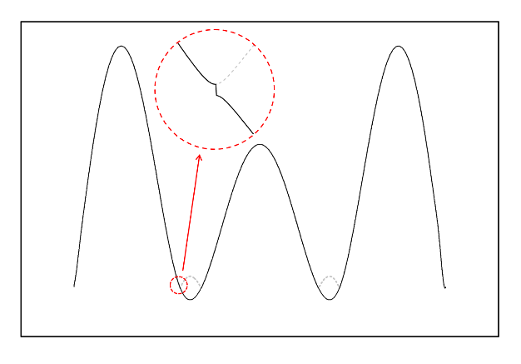 | 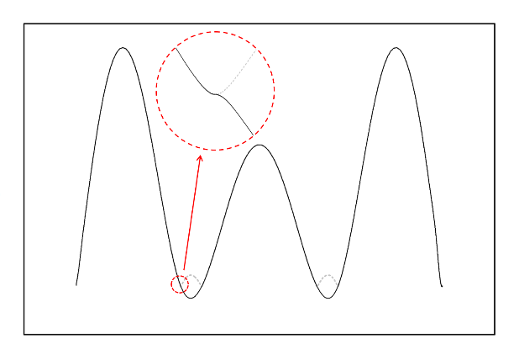
(a) Simple sign adjustment | (b) Adjustment ensuring slope continuity
Fig. 3 Comparison of mode shape results from different adjustment methods

Fig. 4 Vehicle-bridge system and vehicle sensor layout used in numerical simulation

Fig. 5 Flow chart for double-pass mass-addition method to estimate bridge mode shapes and locate damage

Fig. 6 Finite element mesh of bridge showing element numbering

Fig. 7 An example of surface roughness profile scaled for 5 classes for comparison

Fig. 8 Contact point displacement histories (Class B surface roughness)

Fig. 9 Contact point acceleration difference (Class B surface roughness)

Fig. 10 Spectrum of contact point acceleration difference (Class B surface roughness)

(a) First | (a) Second | (c) Third
Fig. 11 Theoretical and constructed mode shapes (Class B surface roughness; solid line: constructed mode shapes; dashed line: theoretical mode shapes)

Fig. 12 Wavelet coefficients of CPDD (Class B surface roughness)

Fig. 13 (1-COMAC) of constructed mode shapes (Class B surface roughness)

(a) Concentrated at centroid of chassis | (b) Evenly distributed | (c) Concentrated at two axles
Fig. 14 Three representative scenarios of the distribution of added mass

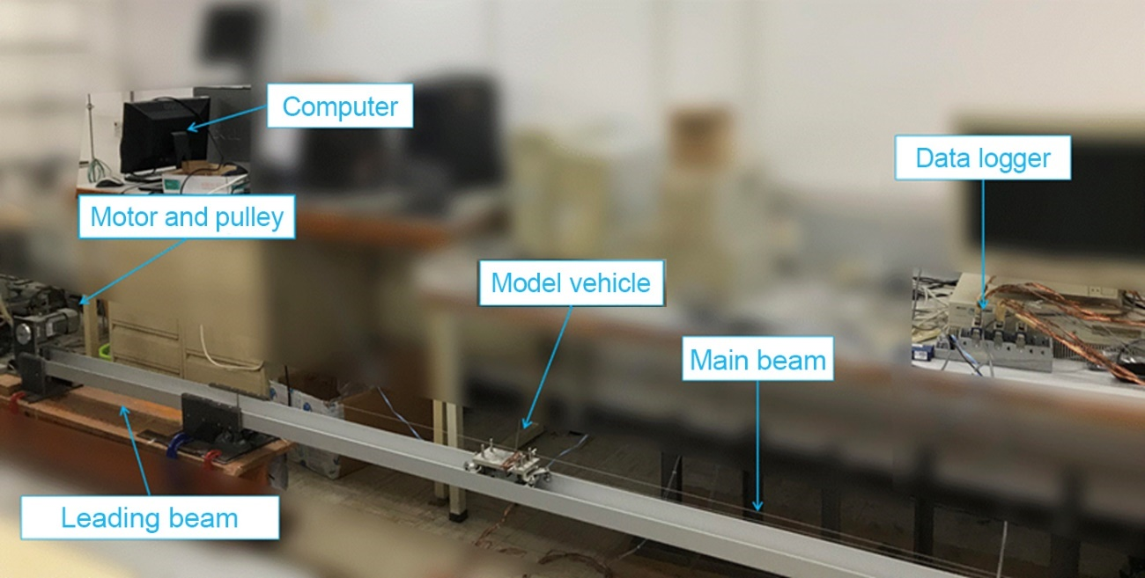

Fig. 15 Setup of experiment
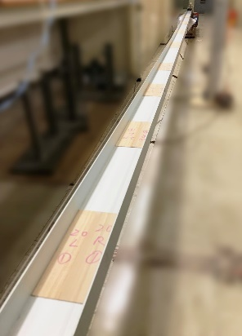

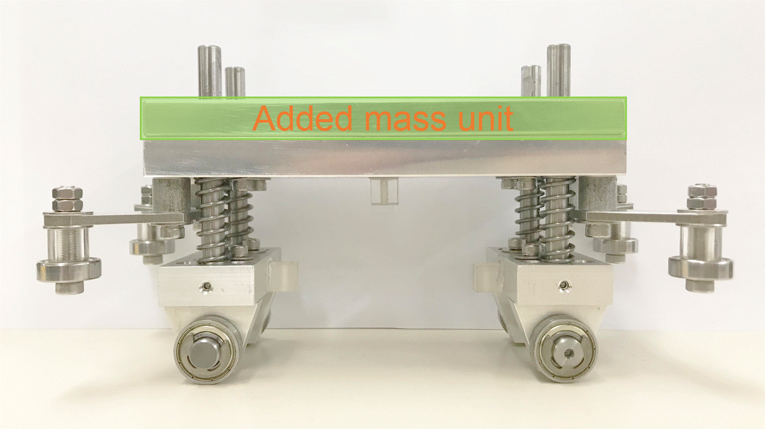

(a) Model vehicle with added mass unit (b) Plywood strips to simulate roughness
Fig. 16 Details of model vehicle and simulated surface roughness

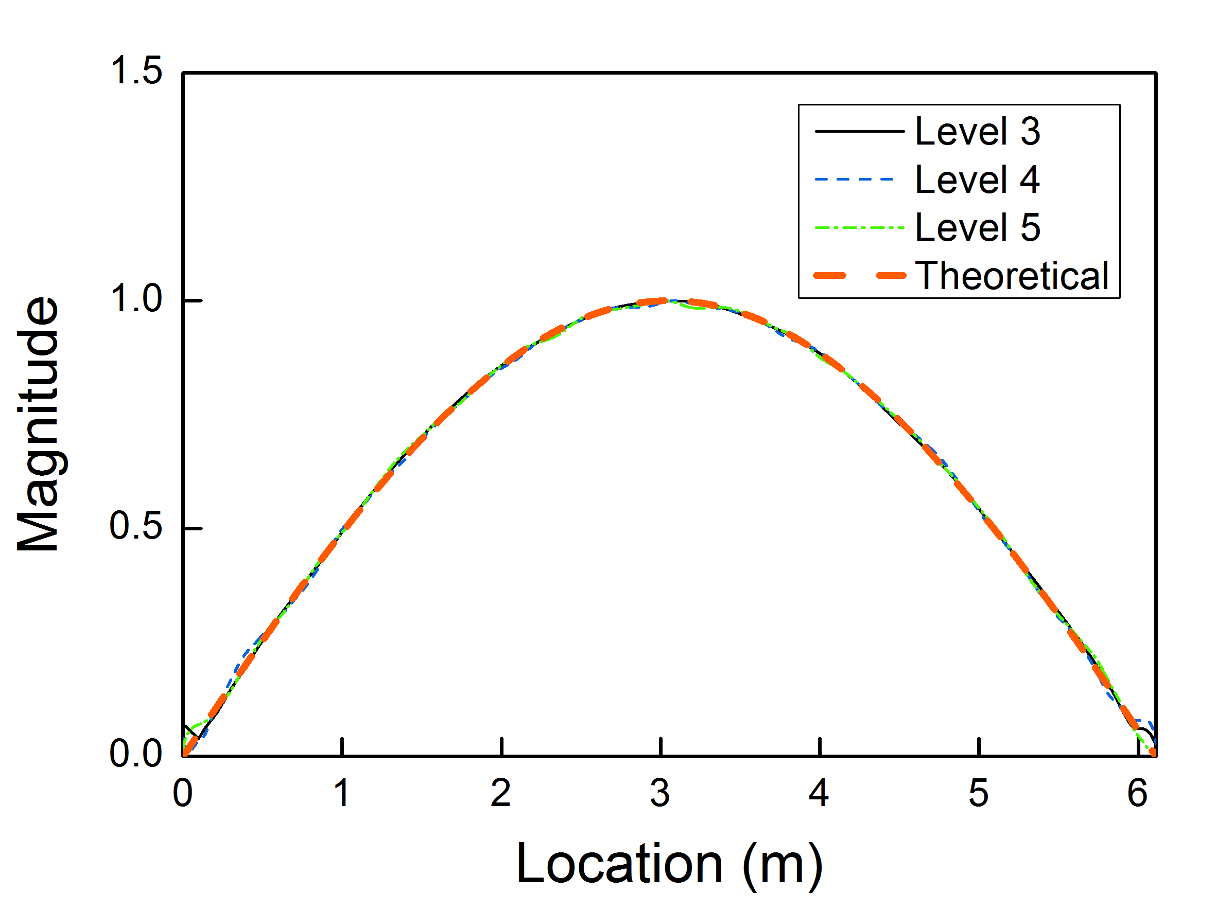 | 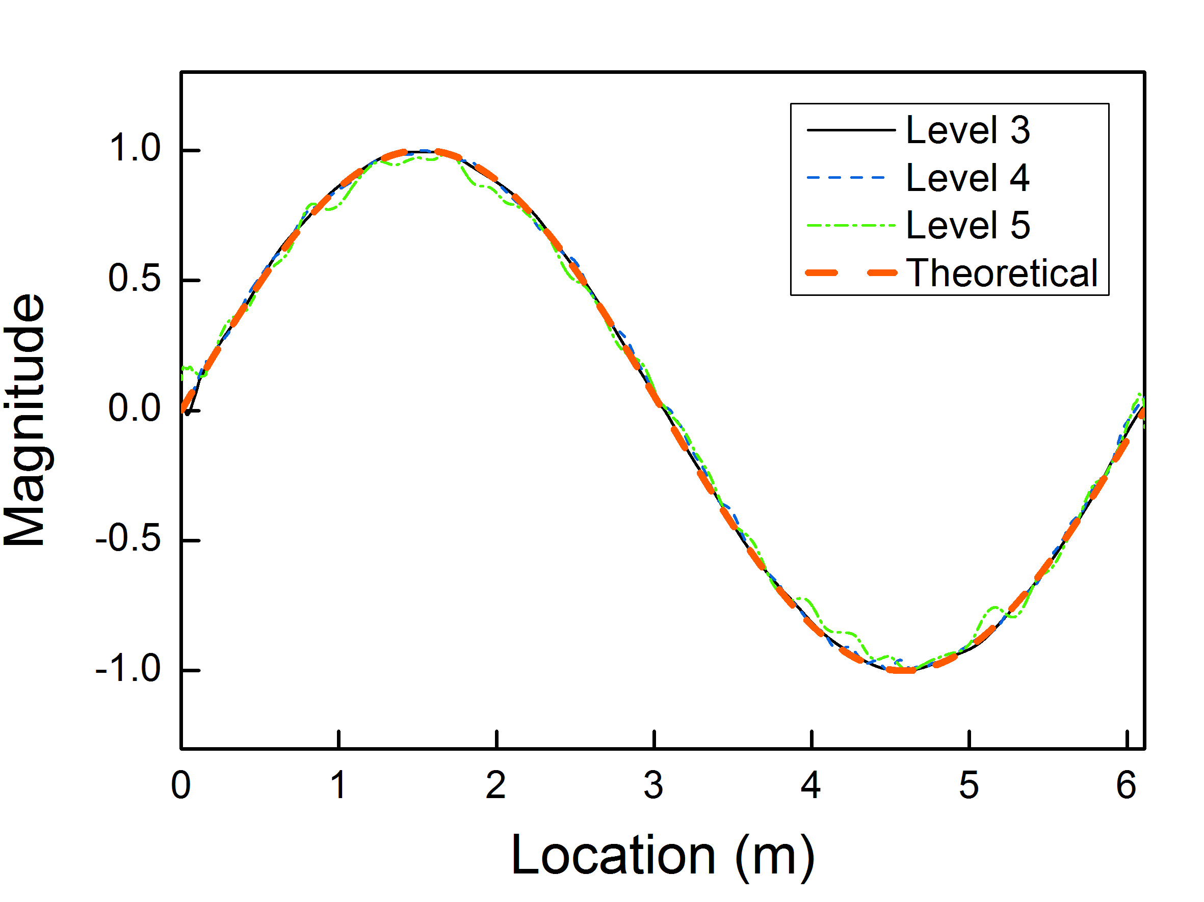
(a) First mode | (b) Second mode
Fig. 17 Constructed mode shapes of the test beam for different vehicle speed levels

Tables

Table 1 Properties of bridge
Item | Unit | Value
Span length | m | 18 (left); 30; 18 (right)
Mass density | kg/m³ | 2500
Modulus of elasticity | N/m² | 3.45×10¹⁰
Cross-sectional area | m² | 2.0
Second moment of area | m⁴ | 0.87
1st frequency | Hz | 6.31
2nd frequency | Hz | 13.50
3rd frequency | Hz | 15.86

Table 2 Properties of vehicle
Item | Symbol | Unit | Value
Chassis mass | m_{c} | kg | 3000
Chassis moment of inertia | J_{c} | kg·m² | 5000
Added mass ratio | λ | 1 | 1.5
Axle mass | m₁; m₂ | kg | 150
Suspension stiffness | k₁; k₂ | N/m | 1.5×10⁵
Suspension damping | c₁; c₂ | N·s/m | 1500
Tyre stiffness | k₃; k₄ | N/m | 2×10⁶
Distance from axle to the centre of mass | l₁; l₂ | m | 1
Chassis heave frequency | f₁ | Hz | 1.535
Chassis pitch frequency | f₂ | Hz | 1.190
Axle heave frequency | f₃; f₄ | Hz | 19.067; 19.069

Table 3 MACs of mode shapes constructed from CPAD and theoretical values
Surface roughness class | $G_{d}\left(n_{0}\right)$ (10⁻⁶) | 1st mode | 2nd mode | 3rd mode
Smooth | 0 | 1.000 | 0.996 | 0.999
Class A (very good) | 16 | 1.000 | 0.990 | 0.998
Class B (good) | 64 | 0.999 | 0.989 | 0.998
Class C (average) | 256 | 0.998 | 0.992 | 0.998
Class D (poor) | 1024 | 0.991 | 0.993 | 0.998
Class E (very poor) | 4096 | 0.976 | 0.995 | 0.997
Note: The MACs presented are average values of those of the ten cases with different randomly generated surface roughness profiles in that class except for the row for smooth surface.

Table 4 MACs with different distributions of added mass (Class B surface roughness)
Mass distribution | $$λ_{m}$$ | $$λ_{J}$$ | 1st mode | 2nd mode | 3rd mode
Concentrated at centre of mass | 1.5 | 1.0 | 0.999 | 0.989 | 0.998
Evenly distributed | 1.5 | 1.5 | 0.999 | 0.989 | 0.998
Concentrated at two ends | 1.5 | 2.0 | 0.999 | 0.990 | 0.998
Note: The MACs presented are average values of those of the ten cases with different randomly generated Class B surface roughness profiles.

Table 5 Ranges of MAC with measurement noise levels (Class B surface roughness)
Noise-to-signal ratio $N/S$ | 1st mode | 2nd mode | 3rd mode
0 | 0.999 | 0.989 | 0.998
1% | 0.996 ~ 0.999 | 0.984 ~ 0.989 | 0.995 ~ 0.999
2% | 0.993 ~ 0.999 | 0.980 ~ 0.987 | 0.992 ~ 0.998
5% | 0.982 ~ 0.997 | 0.967 ~ 0.984 | 0.985 ~ 0.996
Note: The surface roughness is the Class B profile shown in Fig. 7.

Table 6 MACs for different vehicle speeds (Class B surface roughness)
Vehicle speed (m/s) | 1st mode | 2nd mode | 3rd mode
1 | 0.997 | 0.998 | 0.999
2 | 0.999 | 0.989 | 0.998
4 | 0.998 | 0.973 | 0.986
6 | 0.996 | 0.962 | 0.949
8 | 0.988 | 0.942 | 0.921
Note: The MACs presented are average values of those of the ten cases with different randomly generated Class B surface roughness profiles.

Table 7 Properties of co-existing traffic
Vehicle No. | Speed (m/s) | Distance from test vehicle (m) | Probability of existence
1 | U (2, 4) | U (1, 2) | 1.0
2 | U (2, 4) | U (4, 5) | 1.0
3 | U (2, 4) | U (7, 8) | 0.5
Note: U (x, y) denotes continuous uniform distribution between limits x and y. The distance from the test vehicle is defined as the distance of the rear axle of the test vehicle to the front axle of the following vehicle.

Table 8 Ranges of MAC with and without co-existing traffic (Class B surface roughness)
Co-existing traffic | 1st mode | 2nd mode | 3rd mode
Present | 0.996~0.998 | 0.970~0.976 | 0.981~0.988
Absent | 0.998 | 0.973 | 0.986

Table 9 Experimental results of bridge frequency identification
Case | 1st mode | 2nd mode | 3rd mode
Theoretical* | 3.257 | 13.028 | 29.313
Impact test** | 3.243 | 13.022 | 24.057
Speed Level 3 | 3.232 | 12.992 | 23.989
Speed Level 4 | 3.202 | 12.803 | 23.770
Speed Level 5 | 3.156 | 12.597 | 23.573
* The theoretical frequencies are calculated based on the material and geometric properties of the aluminium test beam.
** The impact test is conducted with an impact hammer and accelerometers mounted on the bridge. The frequencies obtained by the impact test are regarded as the true frequencies of the bridge.

Corresponding author at: Department of Civil Engineering, The University of Hong Kong, Pokfulam Road, Hong Kong, China. E-mail addresses: zhangj@hfut.edu.cn

