Iterative reference-driven S-transform time-varying parameter identification for bridges under moving vehicle

Dong Yang^{1,2}, Ying Zhan², Jing Zhang^{∗1,2} and Francis T.K. Au²

¹Department of Civil Engineering, Hefei University of Technology, Hefei, China
²Department of Civil Engineering, The University of Hong Kong, Pokfulam, Hong Kong, China

Abstract
Traditional bridge health monitoring is both expensive and time-consuming because of the need for installing a large quantity of sensors on the bridge. The indirect monitoring method as a feasible alternative has become popular over the last decade, as useful information can be gathered from moving vehicles installed with sensors by considering vehicle-bridge interaction. This paper describes an indirect time-varying modal parameter identification method for bridges under a moving test vehicle. A novel reference-driven S-transform is proposed for the parametric modal identification of time-varying structural systems with non-stationary characteristics based on a multisensory arrangement, comprising a fixed reference sensor installed on the bridge and another movable sensor installed on a moving test vehicle. By the phase-preservation property of S-transform and the multisensory time-frequency analysis, the proposed iterative reference-driven S-transform can be used to extract the time-varying modal parameters of the vehicle-bridge system when the vehicle moves on the bridge. Based on the coherence between measurements from the sensors mounted on the bridge and vehicle, one can track the time-varying characteristics by combining the spatial and time-frequency information obtained by the multisensory array. The efficiency of the proposed reference-driven S-transform method is validated by numerical simulations and laboratory experiments using a simply supported beam with a moving vehicle. The effects of the vehicle property, driving speed, road roughness and measurement noise are discussed. The numerical and experimental results have demonstrated that the proposed method is useful for time-varying parameter extraction with a multisensory system. This will be useful to structural condition monitoring of bridges.

Keywords: Multisensory system, reference-driven, time-frequency analysis, time-varying characteristics, vehicle-bridge interaction.

1. Introduction

To ensure the quality and safety of structures under operational conditions, proper understanding of the structural performance is needed. In recent years, vibration-based structural health monitoring (SHM) has become popular for asset management since the global structural vibration behavior captured can be used to evaluate the structural state [1-3]. The identification of modal parameters from the dynamic responses acquired is an essential step of SHM for damage detection and model updating. Although this approach has been developed for many years and acceptable accuracy can be obtained, a large quantity of sensors are normally installed on the structure being monitored by the traditional approach. More importantly, for practical and economic considerations, it is unrealistic to provide permanent SHM systems to the majority of short- and medium-span bridges in the highway and railway systems. The indirect monitoring method is a feasible alternative to extract the structural properties of a bridge under operational conditions without any disruption to the traffic for detection of any gradual or unexpected structural deterioration of the bridge. The method is based on the vehicle-bridge interaction (VBI) between the moving vehicle installed with sensors and the bridge being tested. The indirect health monitoring method was first proposed by Yang’s group [4], and subsequently many researchers got involved in further development [5-8]. Hence tracking the changes of the dynamic properties of a bridge indirectly provides a convenient way for SHM to avoid any unexpected risk under various operational conditions [9]. However, identifying the structural characteristics accurately through a moving test vehicle is still challenging, as the structural parameters of the system vary with time for the bridge in service. The variation of dynamic properties of a bridge under moving vehicles is one of the most common issues [10] due to the VBI effect, which is always influenced by the road roughness, vehicle properties and operating conditions. In the early research work on VBI, the mass of vehicle has often been ignored in comparison with that of the bridge to allow simplified analysis. However, this assumption is not accurate strictly speaking, as the mass of vehicle cannot be neglected in most cases, especially for short- and medium-span bridges. As a mass-varying system, the dynamic properties of the bridge with the vehicles, such as the system frequencies, change not only with the position of vehicles but also with the mass of vehicles [11-14]. To improve the accuracy of the indirect health monitoring method, it is desirable to better understand this phenomenon and develop a feasible method to track the variation of the system frequencies with respect to time. The time-frequency analysis of the dynamic response of the VBI system is therefore a promising approach.
The time-frequency analysis can reveal the spectral variation of the response signals with time, and it is a powerful tool to analyze non-stationary signals caused by the time-varying characteristics of a coupled system. Most classical methods for time-frequency analysis are non-parametric and signal-independent. These methods are useful for those cases with limited information as they do not rely on any parametric model for the structure being studied. Wang et al. [15] estimated the instantaneous frequencies (IFs) of time-varying structures based on the wavelet ridges of the continuous wavelet transform. Liu et al. [16] proposed a method combining the maximum gradient algorithm and smoothing operation to extract the IFs for time-varying structures. Wang et al. [17] presented a substructure model-based method for abrupt stiffness degradation of a shear structure using discrete wavelet transform. Roshan-Ghias et al. [18] introduced a method for modal parameter estimation based on the pseudo Wigner-Ville distribution and extracted the ridges of the distribution for identification of frequency and damping ratio. Xin et al. [19] proposed an enhanced empirical wavelet transform approach based on synchro-extracting transform for time-varying system identification. Parametric time-frequency analysis is another way to analyze the time-frequency characteristics of the signal based on the parameterized generalization of the non-parameterized time-dependent representation. State-space and time-dependent autoregressive moving average models are typical solution methods in this category [20-22]. Between the purely parametric and non-parametric methods, there are several adaptive time-frequency analysis methods available. For example, Bao et al. [23] identified the time-varying cable forces of bridges using adaptive sparse time-frequency analysis so that the cable tension could be obtained from the relationship between the force and the identified frequencies. Various parameter identification approaches based on Hilbert transform have also been proposed. Ni et al. [24] developed a variational mode decomposition technique to decompose the measured structural responses into a limited number of intrinsic mode functions and identified the IFs of the structures by the Hilbert transform. Wang et al. [25] developed a recursive Hilbert transform-based time-varying structural parameter identification method, which is enhanced by an observer technique and a branch-and-bound technique.
S-transform [26] is an advanced time-frequency method of analysis introduced by Stockwell in 1996. S-transform can be considered as a proper mixture of short-time Fourier transform and wavelet transform. Apart from providing the variable analyzing window and phase information preservation, S-transform can also give a spectrum bearing a direct relationship with the Fourier spectrum. Thanks to these characteristics, S-transform possesses: (a) progressive resolution, (b) absolutely referenced phase information, and (c) frequency invariant amplitude response [27,28]. Owing to the unique features of S-transform and its great potential in various engineering applications, it is desirable to explore the use of S-transform in the indirect time-varying parameter extraction of bridges. Zhang et al. [29] proposed an IF identification technique based on modified S-transform reassignment. Reassignment is a post-processing step to improve the readability of the time-frequency spectrogram for further extraction of time-frequency characteristics, which involves reallocating the time-frequency coefficients from the original position to the center of gravity of the spectrogram both along the time and frequency axes. As the S-transform reassignment is applied to the time-frequency spectrogram rather than the signal directly, loss of accuracy often occurs to the IF curve during the reassignment. Incidentally, the majority of structural parameter identification methods are limited to simple single vibration response signals. Although the case of multiple vibration responses is much more important from a practical standpoint, it has thus far received limited attention [30,31].
Owing to the interaction between the bridge and vehicle, both the bridge displacement and the uncertain effect of road surface roughness can excite the vehicle through its suspension system. As the response measured from the vehicle contains information of both the bridge and vehicle, it can be used to monitor the state of the bridge after proper signal processing. In the face of various uncertainties, multisensory identification can provide more comprehensive information, reduced data processing time, improved dataset consistency, and improved modal parameter accuracy. Proper deployment of more sensors will provide more useful information on the structure being monitored regardless of the sensor types. In the indirect monitoring method, deployment of an additional reference sensor at a strategic position of the structure together with the mounting of movable sensor(s) on the test vehicle can provide both the local and global structural characteristics of the bridge. The structural conditions can then be assessed comprehensively. Sufficient information of the structural responses can be collected from this multisensory system even under unfavorable conditions such as missing data, road surface roughness, and measurement noise. The multisensory time-frequency method of analysis [32] is a feasible way to extract the critical discriminatory information from this kind of vehicle-bridge system for improved modal parameter identification and condition assessment of the structure by combining the spatial and time-frequency signatures. Owing to the passage of vehicles, the spectral characteristics of signals collected by the multisensory system are time-varying, which is particularly significant with the use of multiple sensors.
In this study, the time-varying characteristics of the signal and spatial information are specifically investigated by considering the simplest multisensory system comprising just a pair of sensors mounted, respectively, on the bridge and vehicle. The technique of iterative reference-driven S-transform (IrST) is proposed to provide reliable extraction of the time-varying characteristics of the bridge with moving vehicles. As the core algorithm of the proposed method, S-transform possesses many useful mathematical properties for extraction of IFs by the multisensory system: (a) the basis function of S-transform is adaptive both in the time and frequency domains according to the frequency variation; and (b) the physical significance of phase information of S-transform is the same as that in Fourier transform, which facilitates interpretation and application. The reference-driven S-transform is a cross S-transform of the reference signal and the signal being analyzed, which can be used for improvement in resolution and readability. After introducing S-transform and its properties in this paper, a comparison between S-transform and similar time-frequency methods of analysis is provided. Then the concept and formulation of IrST are elaborated with the merits of the proposed method illustrated by numerical examples. Finally, the IrST method is validated for the identification of time-varying characteristics of a simply supported model bridge under a moving vehicle. The IFs of the system vary with the location of the vehicle. Various parameters are also studied numerically, including the properties of vehicle, driving speed, road roughness and measurement noise. Both the numerical and experimental results illustrate that the proposed IrST method works well in indirect SHM under different conditions.

Iterative reference-driven S-transform

2.1 Motivation
To demonstrate the process, a simplified time-varying structure is considered here with the governing equation given as [33]
$M\left(t\right)\ddot{X}\left(t\right)+C\left(t\right)\dot{X}\left(t\right)+K\left(t\right)X\left(t\right)=F\left(t\right)$ (1)
where $M\left(t\right)$ is the mass matrix, $C\left(t\right)$ is the damping matrix, $K\left(t\right)$ is the stiffness matrix, $F\left(t\right)$ is the force vector, $X\left(t\right)$ is the displacement vector and the over-dot denotes differentiation with respect to time $t$. Since the mass, damping, and stiffness matrices of the system are time-varying, the structural modal parameters will also have instantaneous values. Based on the modal superposition principle and the orthogonal properties, Eq. (1) can be decoupled with the response signal written as
$X\left(t\right)=\sum_{i=1}^{m}{x_{i}\left(t\right)}=\sum_{i=1}^{m}{Φ_{i}\left(t\right)q_{i}\left(t\right)}$ (2)
where $x_{i}\left(t\right)$ is the i-th order modal response, $Φ_{i}\left(t\right)$ is the i-th order instantaneous mode shape vector, $q_{i}\left(t\right)$ is the i-th order modal coordinate, and $m$ is the number of modal responses used. The i-th order modal coordinate $q_{i}\left(t\right)$ can also be expressed as the product of the instantaneous amplitude $a_{i}\left(t\right)$ and the cosine of the instantaneous phase angle $ϕ_{i}\left(t\right)$ as
$q_{i}\left(t\right)=a_{i}\left(t\right)cos\left(ϕ_{i}\left(t\right)\right)$ (3)
The response $x_{p}\left(t\right)$ at the p-th degree of freedom of the structure can be obtained as
$x_{p}\left(t\right)=\sum_{i=1}^{N}{x_{pi}\left(t\right)}=\sum_{i=1}^{N}{Φ_{pi}\left(t\right)a_{i}\left(t\right)cos\left(ϕ_{i}\left(t\right)\right)}=\sum_{i=1}^{N}{A_{pi}\left(t\right)cos\left(ϕ_{i}\left(t\right)\right)}$ (4)
in which $x_{pi}\left(t\right)$ is the i-th order modal response at the p-th degree of freedom, $N$ is the number of modal responses used, and $A_{pi}\left(t\right)=Φ_{pi}\left(t\right)a_{i}\left(t\right)$. Applying Hilbert transform to both sides of Eq. (4) gives the analytic signal of the response $x_{p}\left(t\right)$ as
$Z_{p}\left(t\right)=\sum_{i=1}^{N}{Z_{pi}\left(t\right)}=\sum_{i=1}^{N}{\left[x_{pi}\left(t\right)+j{\overline{x}}_{pi}\left(t\right)\right]}=\sum_{i=1}^{N}{A_{pi}\left(t\right)e^{jϕ_{i}\left(t\right)}}$ (5)
in terms of the Hilbert transform ${\overline{x}}_{pi}\left(t\right)$ of $x_{pi}\left(t\right)$, the imaginary number $j=\sqrt{-1}$, the i-th order complex variable $Z_{pi}\left(t\right)$, and its magnitude $A_{pi}\left(t\right)$ and argument $ϕ_{i}\left(t\right)$, from which the i-th order structural angular IF can be obtained as
$ω_{i}\left(t\right)=\frac{{dϕ}_{i}\left(t\right)}{dt}$ (6)
The time-varying structural identification relies on the accurate IF extraction of each component of response signal. Therefore, it requires a method of time-frequency analysis with high resolution and readability. Effective extraction of the time-varying structural modal parameters allows the tracking of frequency content of the response signal, which changes over time. The response component can be assumed to have energy continuity without any abrupt frequency variation in the time axis. Linear time-frequency analysis tools, e.g. short-time Fourier transform and wavelet transform, can be used in such problems as they are simple to use and interpret. However, for the measured response signals, these conventional tools may fail to pinpoint the IFs precisely because of their inability to provide high resolution and readability. To improve the resolution and readability in the time-frequency domain, a reference-driven S-transform is proposed in this paper.

2.2 Basic theory of S-transform

The S-transform S$\left(t,f\right)$ [26] of a non-stationary signal $x\left(t\right)$ can be expressed as
$$S\left(t,f\right)=\int_{-∞}^{+∞}{x\left(τ\right)w\left(t-τ,f\right)e^{-j2πfτ}dτ}$$ | (7)
where $w\left(t,f\right)$ is a Gaussian window function given in terms of the parameter $σ\left(f\right)$ by
$$w\left(t,f\right)=\frac{1}{σ\left(f\right)\sqrt{2π}}e^{-\frac{t^{2}}{2σ^{2}\left(f\right)}}$$ | (8)
An advantage of S-transform is that the parameter $σ\left(f\right)$ denotes the window width in time-domain, which is the reciprocal of the frequency for standard S-transform
$$σ\left(f\right)=\frac{1}{\left|f\right|}$$ | (9)
The parameter $σ\left(f\right)$ provides the window function with smooth and adaptive properties thereby achieving good localization in both the frequency and time domains. The window width can vary with the frequency. As the frequency increases, the window width becomes narrower, while decreasing the frequency renders the window width wider. This means that the window function has good time-resolution at low frequencies and good frequency-resolution at high frequencies. Hence S-transform can be used as a tool for multi-resolution signal analysis. The window function of S-transform can be rewritten as
$$w\left(t,f\right)=\frac{\left|f\right|}{\sqrt{2π}}e^{-\frac{{f^{2}t}^{2}}{2}}$$ | (10)
Then the S-transform of a non-stationary signal has the form
$$S\left(t,f\right)=\frac{\left|f\right|}{\sqrt{2π}}\int_{-∞}^{+∞}{x\left(τ\right)e^{\frac{-{f^{2}\left(t-τ\right)}^{2}}{2}}e^{-j2πfτ}dτ}$$ | (11)
As both the phase and amplitude spectra are localized by the phase function $e^{-j2πft}$, this property always offers absolute phase information with reference to the original time point. As the Gaussian window can be normalized as
$$\int_{-∞}^{+∞}{w\left(t,f\right)dt=1}$$ | (12)
the relation between S-transform and Fourier transform is obtained as
$$\int_{-∞}^{+∞}{S\left(t,f\right)dt=\tilde{X}\left(f\right)}$$ | (13)
where $\tilde{X}\left(f\right)$ is the Fourier transform of $x\left(t\right)$. Moreover, $x\left(t\right)$can be recovered from $S\left(t,f\right)$ as
$$x\left(t\right)=\int_{-∞}^{+∞}{\left\{\int_{-∞}^{+∞}{S\left(t,f\right)}dt\right\}e^{i2πft}df}$$ | (14)
S-transform can be expressed in the convolution form as
$$S\left(t,f\right)=\int_{-∞}^{+∞}{\tilde{X}\left(ρ+f\right)\tilde{W}\left(ρ,f\right)e^{-j2πρt}dρ=F^{-1}\left(\tilde{X}\left(ρ+f\right)\tilde{W}\left(ρ,f\right)\right)}$$ | (15)
where $F^{-1}$ denotes the inverse Fourier transform, $\tilde{X}\left(ρ\right)$ and $\tilde{W}\left(ρ,f\right)$ are the Fourier transforms of the signal $x\left(t\right)$ and window function $w\left(t,f\right)$, respectively, and
$$\tilde{W}\left(ρ,f\right)=e^{-2π^{2}ρ^{2}}$$ | (16)
It shows that the Fourier transform $\tilde{X}\left(ρ\right)$ should be calculated and shifted along the f-axis. The Fourier transform $\tilde{W}\left(ρ,f\right)$ can be regarded as a band-pass filter while $\tilde{X}\left(ρ+f\right)\tilde{W}\left(ρ,f\right)$ is a filtering operation on $\tilde{X}\left(ρ+f\right)$.

2.3 Reference-driven S-transform

By definition, the k-th order angular IF of the continuous response signal considered is $ω_{k}=\frac{dϕ_{k}(t)}{dt}$, and the estimated value ${\hat{ω}}_{k}\left(t\right)$ of $ω_{k}\left(t\right)$ can be obtained from the S-transform spectrogram [34] as
${\hat{ω}}_{k}\left(t\right)=arg\left[\max_{ω_{k}∈Q_{ω_{k}}}{Λ\left(t,f\right)}\right]$ (17)
in which the circumflex (^) denotes an estimated value, $Λ\left(t,f\right)=\left|S\left(t,f\right)S^{*}\left(t,f\right)\right|$ is the S-transform spectrogram of the response signal, $Q_{ω_{k}}=\left\{ω: 0≤ω_{k}≤π/T\right\}$ is the basic interval along the frequency axis, ${\left\{∙\right\}}^{*}$ denotes the complex conjugate, and T is the sampling interval. Therefore, $Λ\left(t,f\right)$ can be regarded as the energy content in $x\left(t\right)$ at time t and frequency f. The IF of a response signal can therefore be tracked along the time axis by changes in the absolute phase of a certain frequency from $Λ\left(t,f\right)$.
The S-transform as described above has the absolute phase information that makes it useful for cross analysis in a local manner. However, for normal time-frequency spectrograms, the maximum spectrogram of each time bin varies randomly, as the components of response signal do not necessarily remain at the prominent locations in the spectrogram and are always contaminated by noise. It may result in inaccurate and messy IF estimation. An IrST-based method is therefore proposed to improve the accuracy of IF estimation. For an observed signal $x_{a}\left(t\right)$ and a reference signal $x_{r}\left(t\right)$ measured from the same structure, the reference-driven S-transform ${rST}_{a,\hat{r}}\left(t,f\right)$ is proposed in this paper.
To avoid interference on the time-frequency plane caused by the meaningless negative frequencies, the practically infinite-length analytic signal $Z_{a}$ is derived from the acquired response signal, which can be considered as an amplitude-phase modulated signal. In the proposed reference-based algorithm, the reference-driven S-transform $rST$ between the infinite-length analytic signal $Z_{a}$ and the analytic signal ${\hat{Z}}_{r}$ of reference signal $x_{r}\left(t\right)$ is defined as
$${rST}_{a,\hat{r}}\left(t,f\right)=S_{a}\left(t,f\right){\left\{S_{\hat{r}}\left(t,f\right)\right\}}^{*}=\frac{f^{2}}{2π}\int_{-∞}^{+∞}{Z_{a}\left(t+τ\right){\hat{Z}}_{r}^{*}\left(t-τ\right)e^{-{f^{2}\left(t-τ\right)}^{2}}e^{-j4πfτ}dτ}$$ | (18)
where $S_{a}\left(t,f\right)$ is the S-transform of $Z_{a}\left(t\right)$, and $S_{\hat{r}}\left(t,f\right)$ is the S-transform of $Z_{\hat{r}}\left(t\right)$. In the use of this method, the choice of an appropriate reference signal is crucial. Here, the analytic signal ${\hat{Z}}_{r}$ can be written as
${\hat{Z}}_{r}\left(t\right)=e^{j2π\int_{-∞}^{t}{{\hat{f}}_{i}\left(τ\right)}dτ+{\hat{∅}}_{r}(t)}$ (19)
where ${\hat{f}}_{i}\left(t\right)$ is the estimated i-th IF of the structure extracted from the reference signal, and ${\hat{∅}}_{r}$ is the estimated phase constant. The key function of the reference signal is to map the trajectory of time-varying frequencies of the analytic signal into a linear path parallel to the time axis.
In most cases, compared to the ideal value of IF $f_{i}\left(t\right)$ of interest, the estimated value ${\hat{f}}_{i}\left(t\right)$ can be interpreted as the sum of ideal IF $f_{i}\left(t\right)$ and an error term $f_{e}\left(t\right)$ as
${\hat{f}}_{i}\left(t\right)=f_{i}\left(t\right)+f_{e}\left(t\right)$ (20)
Similarly, the estimated phase constant ${\hat{∅}}_{r}(t)$ can be considered as the sum of ideal phase constant $∅_{i}\left(t\right)$ and an error term $∅_{e}\left(t\right)$ as
${\hat{∅}}_{r}\left(t\right)=∅_{i}\left(t\right)+∅_{e}\left(t\right)$ (21)
Therefore, in the time-domain, ${\hat{Z}}_{r}(t)$ can be expressed as the product of the signal with ideal IF component $Z_{r}(t)$ and the signal with error term $Z_{e}(t)$ as
${\hat{Z}}_{r}\left(t\right)=e^{j2π\int_{-∞}^{t}{f_{i}\left(τ\right)}dτ+∅_{i}\left(t\right)}∙e^{j2π\int_{-∞}^{t}{f_{e}\left(τ\right)}dτ+∅_{e}\left(t\right)}=Z_{r}\left(t\right)∙Z_{e}\left(t\right)$ (22)
Then Eq. (18) can be rewritten as
${rST}_{a,\hat{r}}\left(t,f\right)={rST}_{a,r}\left(t,f\right){\left\{S_{e}\left(t,f\right)\right\}}^{*}$ (23)
where $S_{e}\left(t,f\right)$ is the S-transform of the error term $Z_{e}\left(t\right)$. Eq. (23) shows that the reference-driven S-transform is obtained from the ideal IF smeared by the S-transform of the error term.
In this paper, an iterative strategy is proposed to suppress the error term in the IF extraction.
(a) For any reference signal $x_{r}\left(t\right)$, track the initial IF trajectory by the conventional S-transform.
(b) Establish the analytic signal ${\hat{Z}}_{r}$ by Eq. (19) for the target component.
(c) Form the reference-driven S-transform ${rST}_{a,\hat{r}}$ between the analytic observed signal $Z_{a}$ and the analytic reference signal ${\hat{Z}}_{r}$, and the amplitudes of ${rST}_{a,\hat{r}}$ attenuated with the increase of distance from the IF trajectory of the observed signal are mapped close to the IF trajectory.
(d) Extract the peak in the time-frequency distribution of the reference-driven S-transform ${rST}_{a,\hat{r}}$ as the new IF estimation.
(e) Repeat the procedure from Step (b) until the difference between the estimated IF and the previous one falls below a specified tolerance.
After k iterations, the estimated analytic signal ${\hat{Z}}_{r}^{k}\left(t\right)$ can be written as
${\hat{Z}}_{r}^{k}\left(t\right)=e^{j2π\int_{-∞}^{t}{f_{i}\left(τ\right)}dτ+∅_{i}\left(t\right)}∙e^{j2π\int_{-∞}^{t}{f_{e}^{k-1}\left(τ\right)}dτ+∅_{i}^{k-1}\left(t\right)}=Z_{r}\left(t\right)∙Z_{e}^{k}\left(t\right)$ (24)
Then, the iterative reference-driven S-transform ${IrST}_{a,\hat{r}}^{k}\left(t,f\right)$ can be obtained as
${IrST}_{a,\hat{r}}^{k}\left(t,f\right)={rST}_{a,r}\left(t,f\right){\left\{S_{e}^{k}\left(t,f\right)\right\}}^{*}$ (25)
For convenience, one can define the increments associated with the error terms as
$∆_{f}(t)={\hat{f}}^{k}\left(t\right)-{\hat{f}}^{k-1}\left(t\right)=f_{e}^{k}\left(t\right)-f_{e}^{k-1}\left(t\right)$ (26)
$∆_{∅}(t)={\hat{∅}}^{k}\left(t\right)-{\hat{∅}}^{k-1}\left(t\right)=∅_{e}^{k}\left(t\right)-∅_{e}^{k-1}\left(t\right)$ (27)
As the amplitudes of iterative reference-driven S-transform ${IrST}_{a,\hat{r}}$ attenuate with the increase of distance from the IF trajectory, the error terms $f_{e}\left(t\right)$ and $∅_{e}\left(t\right)$ will tend to fade away asymptotically [35], which means that $∆_{f}(t)$ and $∆_{∅}(t)$ will also approach the minimum when $k$ increases. Consequently, the estimate $\hat{f}\left(t\right)$ will differ from the ideal IF $f\left(t\right)$ by not more than a specified amount in this iterative procedure. The strategy can be summarized as a flowchart in Fig. 1.
By implementing this procedure to ensure convergence, the effects of noise and other contaminations can be suppressed. Clearly, the effect of such interference on the ${IrST}_{a,\hat{r}}$ amplitude will approach a constant level gradually. Hence the IF estimation extracted from ${IrST}_{a,\hat{r}}$ will be much less affected by the error term $f_{e}\left(t\right)$. A numerical signal simulation is used here to validate the proposed method. An observed signal $S_{a}$ and a reference signal $S_{r}$ are modeled, respectively, as follows
$S_{a}=\cos\left(2πφ_{1}\left(t\right)\right)+\cos\left(2πφ_{2}\left(t\right)\right)$ (28)
$S_{r}=\cos\left(2πφ_{1}\left(t\right)\right)+\cos\left(2πφ_{3}\left(t\right)\right)$ (29)
where the objective IF $φ_{1}\left(t\right)$ is assumed to vary from 20 Hz to 60 Hz, $φ_{2}\left(t\right)$ varies from 80 Hz to 40 Hz, and $φ_{3}\left(t\right)$ varies from 40 Hz to 80 Hz. Substantial noise has been added to these two signals such that the signal-to-noise ratios are -10 dB and -8 dB, respectively.
Fig. 1 Flowchart of the proposed IrST methodology for IF estimation.

The time-frequency representations of the original signals generated by S-transform are shown in Figs. 2(a) and (b), and the contaminated signals are shown in Figs. 2(c) and (d), respectively. As the time-frequency plots of both contaminated signals are blurry, with only the rough trends of time-frequency characteristics of the signals observed, it is difficult to extract any useful information. The results obtained by the proposed strategy are presented in Fig. 2(e). By increasing the number of iterations, the objective time-frequency features emerge more clearly, while the concentration of results and resolution improve. The theoretical objective IF and interferential IFs are displayed in Fig. 2(f), together with the extracted objective IF $φ_{1}\left(t\right)$ from the time-frequency representation of IrST. Fig. 2(f) shows three major components: (i) the objective IF extracted from Fig. 2(e) by a ridge detection method with a forward-backward greedy algorithm; (ii) the theoretical IF of the objective component; and (iii) the signals of $φ_{2}\left(t\right)$ and $φ_{3}\left(t\right)$, which are denoted as interference-1 and interference-2, respectively. The extracted IF exhibited in Fig. 2(f) is extracted by a ridge detection method. It is a forward backward greedy algorithm which detects the ridge by finding the sequence of S-transform spectrogram amplitude peaks possessing the highest energy at each time segment. Prescribing more stringent threshold for iteration will further improve the accuracy of results. Compared with other standard time-frequency analysis methods, it can be observed that the IrST method is appropriate for extracting time-frequency characteristics from complicated multi-channel signals.
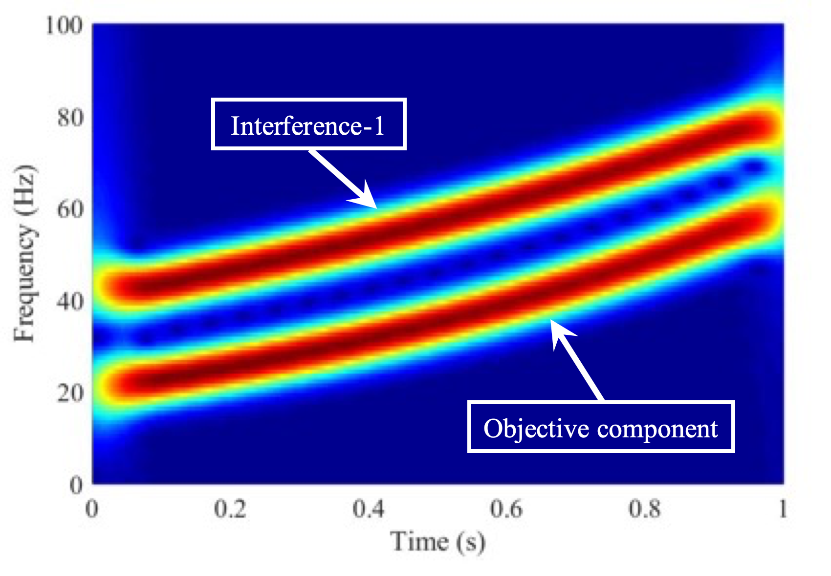 | 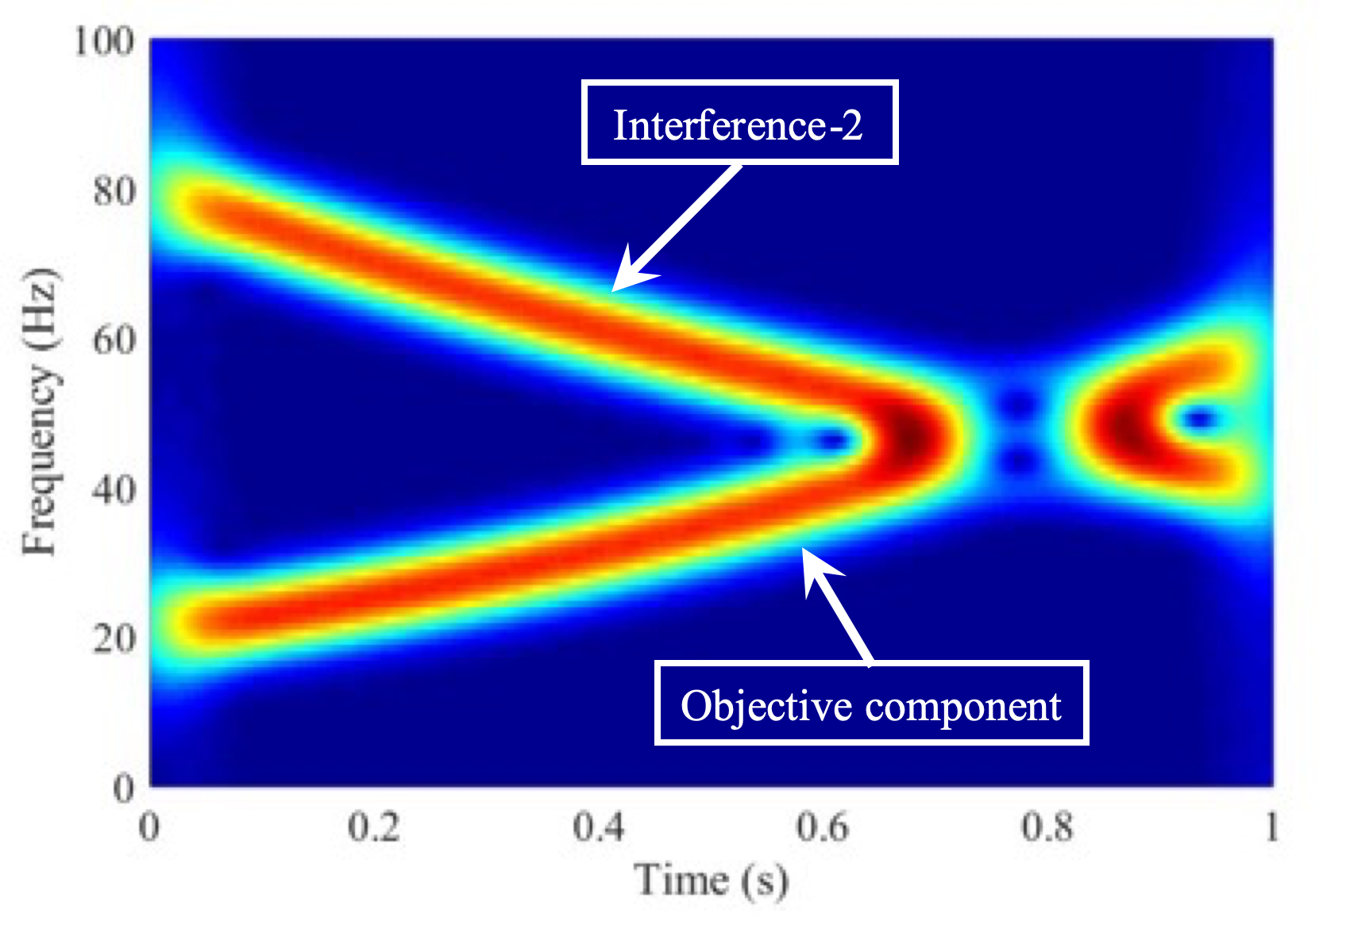
(a) | (b)
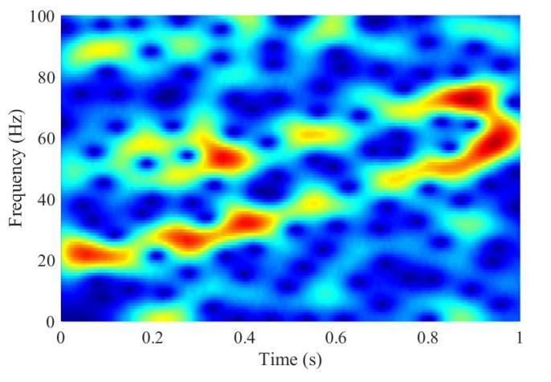 | 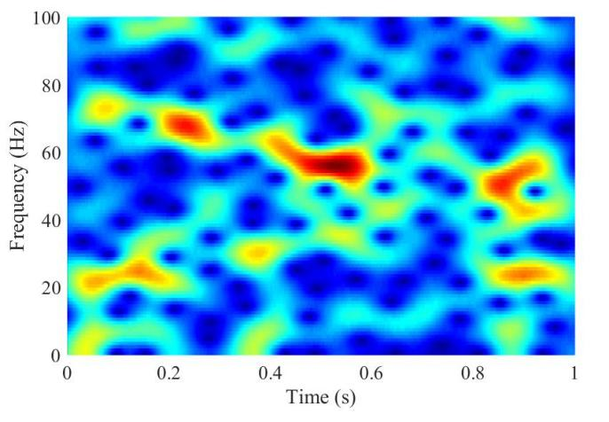
(c) | (d)
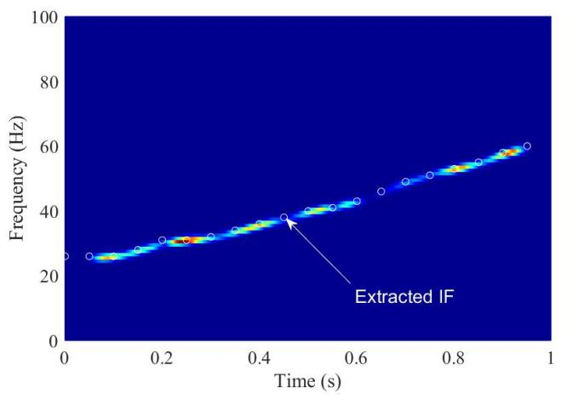 | 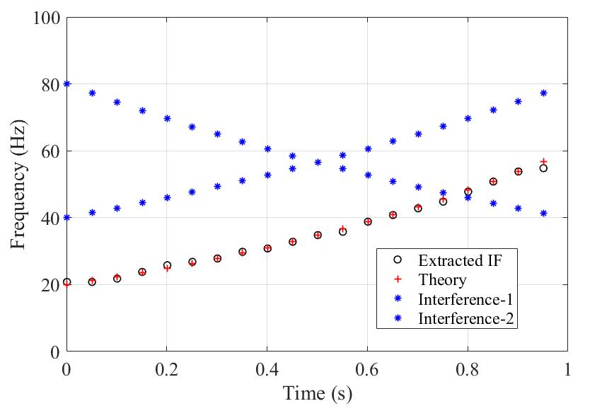
(e) | (f)
Fig. 2 Results of numerical simulation. (a) Observed signal $x_{a}\left(t\right)$, (b) reference signal $x_{r}\left(t\right)$, (c) contaminated signal $x_{a}\left(t\right)$, (d) contaminated signal $x_{r}\left(t\right)$, (e) IrST of $x_{r}\left(t\right)$ and $x_{a}\left(t\right)$, and (f) theoretical and extracted results.

2.4 Filtered IrST for multi-component signals

The IrST technique presented above is a time-frequency analysis method for mono-component signal. In practical applications, the measured signals are often more complicated with multiple components containing different parts. However, IrST cannot estimate all the constituent components effectively. Therefore, an iterative procedure known as filtered IrST (FIrST) is developed to address this problem. Specifically, each component needs a corresponding reference for the estimation enhancement. Then it can be decomposed iteratively by performing a filtering operation after the estimation, which can extract each component accurately one after another from the original signal.
It is assumed that there is no overlap of frequency bands due to transformation in applying this method. Based on this, one can filter the target component by a suitable band-pass filter for the IF component. In general, the rule for selection of filtering boundary for the k-th component is
$ω_{k}^{ub}=\frac{ω_{k}^{upper}+ω_{k+1}^{lower}}{2}$ (30)
$ω_{k}^{lb}=\frac{ω_{k-1}^{upper}+ω_{k}^{lower}}{2}$ (31)
in which $ω_{k}^{ub}$ and $ω_{k}^{lb}$ denote the upper and lower cutoff frequencies of the bandpass filter, respectively, and $ω_{k}^{upper}$ and $ω_{k}^{lower}$ denote the maximum and minimum frequencies of the k-th component, respectively, observed so far. With this strategy, the adverse effect of the neighboring components on the objective component being evaluated can be suppressed or even eliminated. By conducting FIrST iteratively, the time-frequency representation of each component can be obtained accurately. The above procedures of FIrST for multi-component signal processing can be summarized in the flowchart shown in Fig. 3.
The proposed FIrST technique can investigate relationships between the frequency components from different responses. The two signals can contain frequency components at the same frequency bands, but it may not be known whether they are causally related. The FIrST technique can uncover possible relationships by highlighting how well the IFs from the two signals are matched. For the VBI system, the causally related frequency components of the reference and movable sensors are the intrinsic frequencies of the bridge.
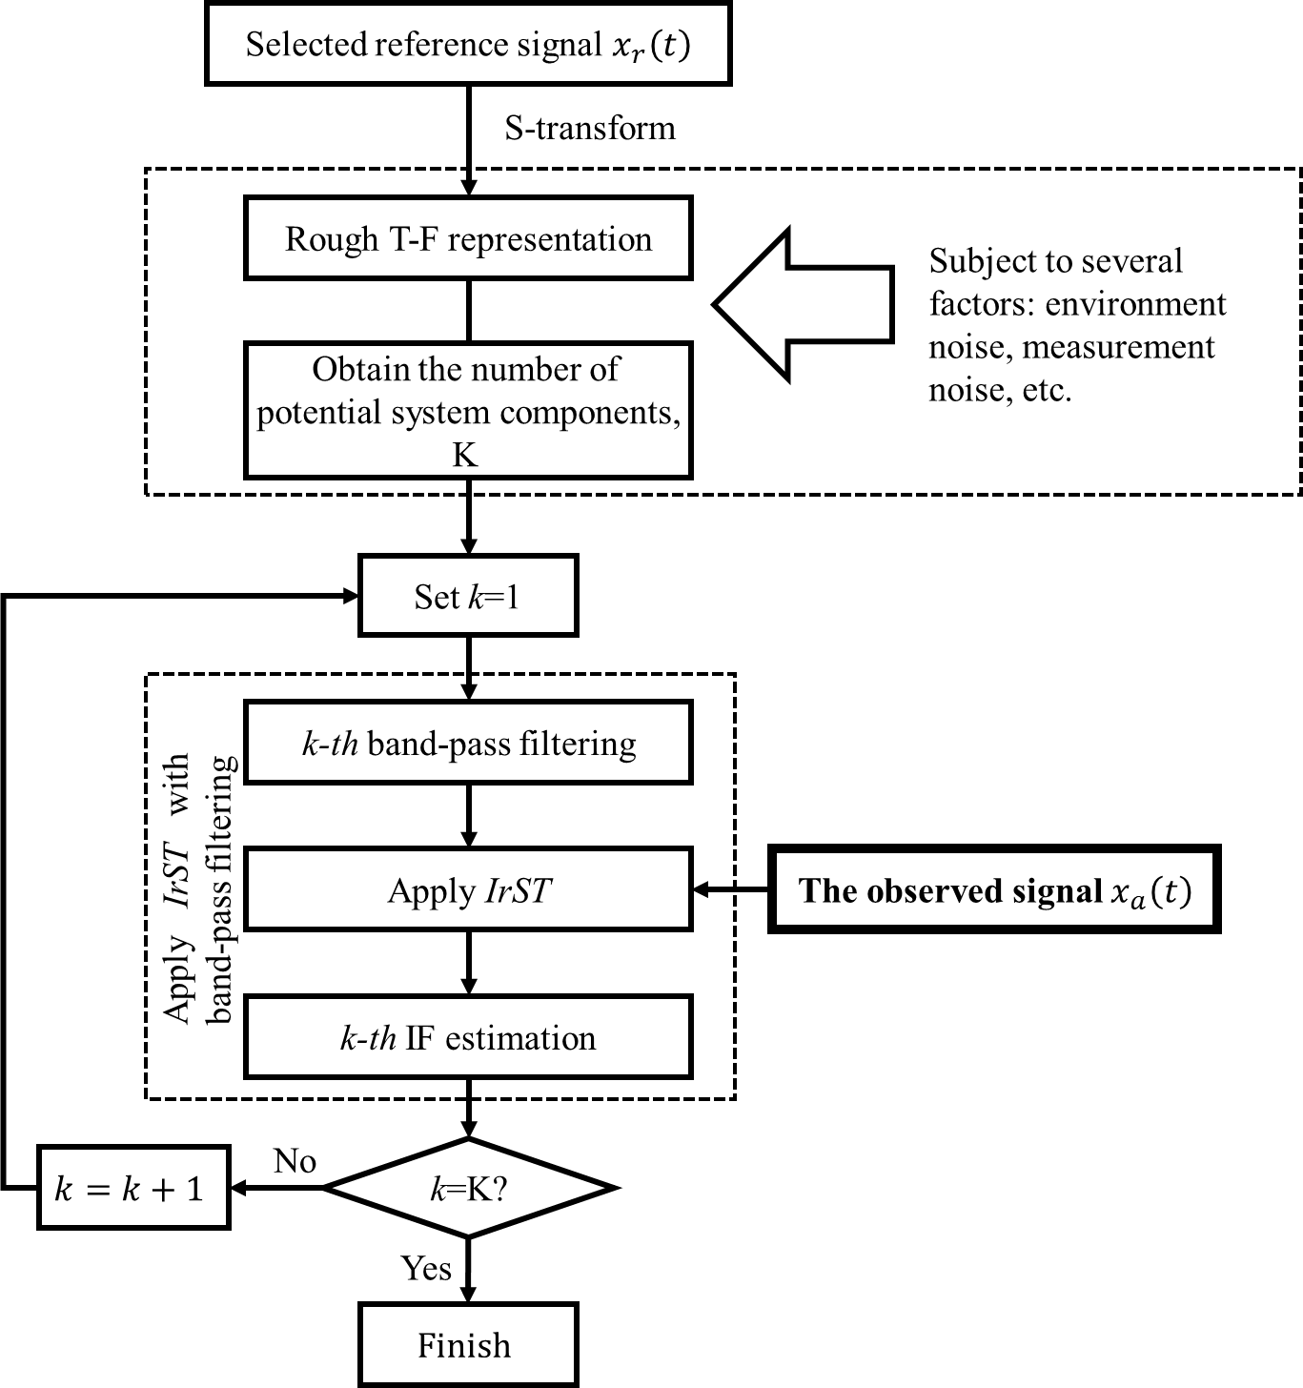
Fig. 3 Flowchart of the proposed FIrST for IF estimation.

3. Numerical simulation

3.1 Model description

As VBI is a typical time-varying system, the system response is also non-stationary. Before applying the proposed technique to the identification of operational modal parameters of real bridges, it is desirable to validate it numerically first. The coupled vehicle-bridge model for the VBI system shown in Fig. 4 is developed by MATLAB 8.0 (2012). As this study is primarily to verify the FIrST technique, a relatively simply system is adopted, which comprises a simply supported girder with a vehicle modelled as a spring-mass-damper system. In Fig. 4, $m_{v}$, $c_{v}$ and $k_{v}$ are the mass, damping coefficient and stiffness of the vehicle model, respectively, and $r\left(x\right)$ is the road roughness of the bridge expressed in terms of the global abscissa $x$.

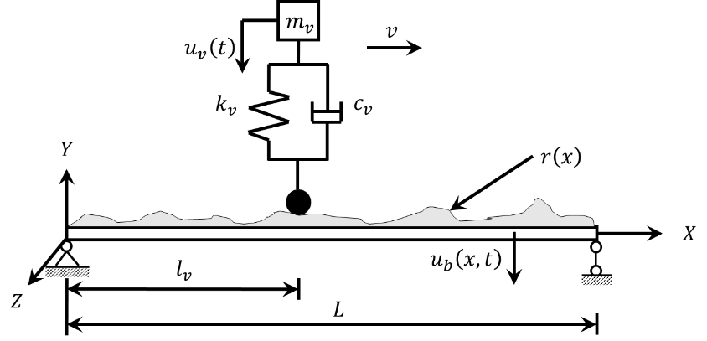
Fig. 4 The VBI system analyzed.

The bridge is simulated as a multi-degree-of-freedom finite element model, while the vehicle is modelled as a single degree-of-freedom spring-mass-damper system. The finite element equation of the VBI system can be written as [36]
$$\left[\begin{matrix}M_{b} & m_{v}l_{v}\left(t\right) \\ 0 & m_{v}\end{matrix}\right]\left\{\begin{matrix}{\ddot{u}}_{b}\left(t\right) \\ {\ddot{u}}_{v}\left(t\right)\end{matrix}\right\}+\left[\begin{matrix}C_{b} & 0 \\ -c_{v}l_{v}^{'}\left(t\right) & c_{v}\end{matrix}\right]\left\{\begin{matrix}{\dot{u}}_{b}\left(t\right) \\ {\dot{u}}_{v}\left(t\right)\end{matrix}\right\}+\left[\begin{matrix}K_{b} & 0 \\ -k_{v}l_{v}^{'}\left(t\right)-vc_{v}{\dot{l}}_{v}^{'}\left(t\right) & k_{v}\end{matrix}\right]\left\{\begin{matrix}u_{b}\left(t\right) \\ u_{v}\left(t\right)\end{matrix}\right\}=\left\{\begin{matrix}-m_{v}gl_{v}\left(t\right) \\ c_{v}\dot{r}\left(t\right)+k_{v}r\left(t\right)\end{matrix}\right\}$$ | (32)
where $M_{b}$, $C_{b}$ and $K_{b}$ are the mass, damping and stiffness matrices of the bridge, respectively; ${\ddot{u}}_{b}$, ${\dot{u}}_{b}$ and $u_{b}$ are the acceleration, velocity and displacement vectors of the bridge, respectively; ${\ddot{u}}_{v}$, ${\dot{u}}_{v}$ and $u_{v}$ are the acceleration, velocity and displacement vectors of the vehicle, respectively; $g$ is the acceleration due to gravity; $r\left(t\right)$ denotes the road roughness experienced by the vehicle at time $t$; and $l_{v}\left(t\right)$ denotes the location of vehicle at time $t$. The displacement of the bridge at the contact point with the vehicle can be calculated from the displacement vector of the element where the vehicle is located using the Hermite interpolation vector
$$H\left(x\right)={\left[\begin{matrix}\begin{matrix}h_{1} & h_{2}\end{matrix} & \begin{matrix}h_{3} & h_{4}\end{matrix}\end{matrix}\right]}^{T}$$ | (33)
where
$h_{1}=1-3{\left(\frac{\overline{x}}{l}\right)}^{2}+2{\left(\frac{\overline{x}}{l}\right)}^{3}$, $h_{2}=\overline{x}{\left(1-\frac{\overline{x}}{l}\right)}^{2}$ | (34)
$h_{3}=3{\left(\frac{\overline{x}}{l}\right)}^{2}-2{\left(\frac{\overline{x}}{l}\right)}^{3}$, $h_{4}=\overline{x}{\left(1-\frac{\overline{x}}{l}\right)}^{2}$ | (35)
$\overline{x}$ is the local abscissa, and $l$ is the length of the element. This VBI system can then be solved by the Newmark-Beta method.

3.2 The multisensory testing system in the proposed method

The indirect approach was proposed to extract the bridge information by analyzing the response of a vehicle with sensors mounted on its axle during its passage over the deck. In the spectrogram of the vehicle dynamic responses, the vehicle frequencies would become dominant components, making it difficult to extract the bridge frequency components [37]. Moreover, there are other factors that may also affect the extraction [38], such as the driving-related frequency components and road surface roughness. Therefore, this paper has proposed a method to extract efficiently the bridge-related properties from the dynamic responses of vehicle by suppressing the undesirable effects. Specifically, a sensor is mounted at a fixed location on the bridge serving as the reference sensor while the other one on the vehicle moves over the deck serving as a movable sensor. Fig. 5 shows a simple multisensory testing system comprising a moving instrumented vehicle with a movable sensor and a fixed reference sensor mounted at a convenient position on the bridge for measurement of the dynamic responses. The spectrogram of the responses obtained from the reference and movable sensors can be processed using the FIrST technique to extract the frequencies of the bridge accurately.
The stationary reference sensor mounted on the bridge is proposed here to provide supplementary data to improve the accuracy of information extracted in the application of indirect monitoring method. Measurements of responses from the vehicle and the bridge deck may likely contain similar frequency components, also possessing similar noise and components unrelated to the bridge. Under such circumstances, it is difficult to highlight the components related to the bridge in the IrST spectrograms. Nevertheless, analysis of the responses of the multisensory system by the IrST technique can still improve the accuracy for similar components as it can reduce the variance inherent in each response. Furthermore, the noise and measurement errors associated with the sensors are independent and the use of multisensory system can improve the signal-to-noise ratio.

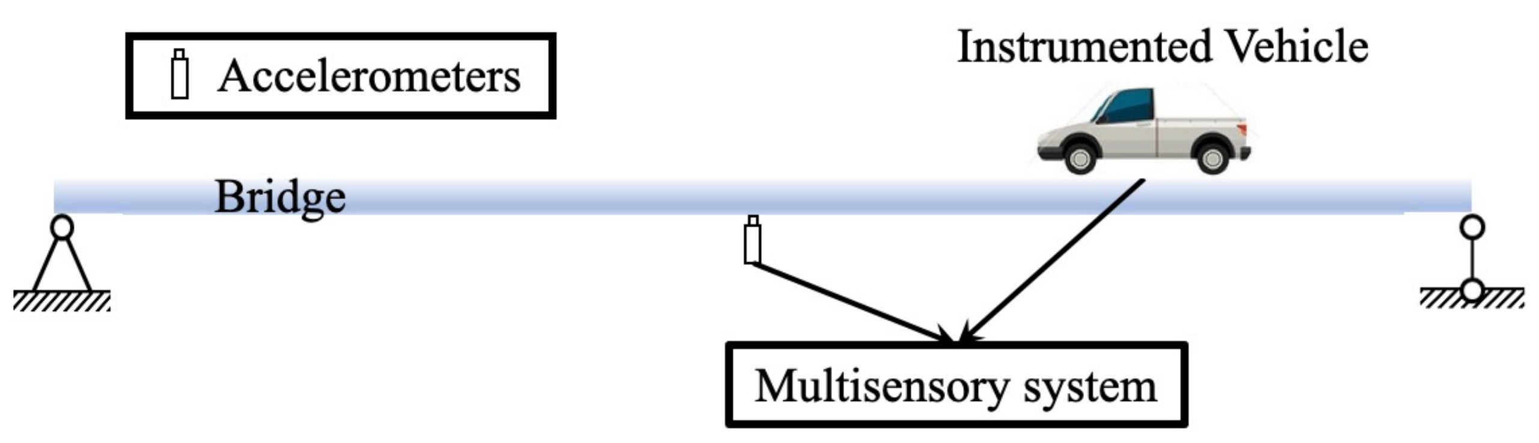
Fig. 5 Schematic diagram of a simple multisensory system.

3.3 Parameter study: A simply supported bridge under a moving vehicle

The procedures of FIrST for multi-component signal processing of the bridge response due to VBI have been presented in Section 2.4. In this section, the effects of vehicle mass, vehicle speed, measurement noise and road roughness on the time-varying characteristics extraction are studied. The properties of the simply supported bridge studied are as follows: span $L=$30 m, modulus of elasticity $E=$2.7510¹⁰ N/m², mass per unit length $\overline{m}=$1.510³ kg/m, and the moment of inertia $I=$ 0.175 m⁴. The spring-mass-damper model is used to simulate the test vehicle.

- Effect of vehicle mass

The effect of vehicle property on the FIrST technique is studied first. The vehicle mass is taken to be $m_{v}$ = 500, 1500 or 3000 kg, while the spring stiffness, damping coefficient and speed of the vehicle are taken to be $k_{v}=$2.8210⁷ kN/m, $c_{v}=$ 390 kg/s and $v_{v}=$2 m/s, respectively, with 5% measurement noise added to the simulated results of all the cases described here. White noise is added to the computed numerical acceleration response ${Acc}_{n}$ to simulate the contaminated measurement ${Acc}_{c}$ as
${Acc}_{c}={Acc}_{n}+E_{l}∙σ_{acc}∙wn$ (36)
where $E_{l}$ is the noise level, $σ_{acc}$ is the standard deviation of ${Acc}_{n}$, and $wn$ is the white noise with zero mean and unit variance. The sampling rate is $f_{s}=$1000 Hz. The frequencies associated with the bridge modes vary when the vehicle traverses across the bridge. Then the responses of the VBI system with different vehicle masses are obtained for further processing. The extracted time-varying frequencies are shown in Fig. 6, where the heavier vehicle causes more noticeable frequency variation. Results identified from the proposed FIrST procedure are shown in Fig. 7(a) and results of the percentage difference as compared to the theoretical results are shown in Fig. 7(b). The theoretical IFs in each time step can be calculated by solving the eigenvalue problem of the equation of motion of the system comprising the bridge with the vehicle “frozen” at the longitudinal location. While the present results are reasonably close to those of the theoretical results, the effects of moving vehicle with different masses on the IF results can be clearly seen.

Fig. 6 Parametric study: Results of FIrST of the VBI system with different vehicle masses.

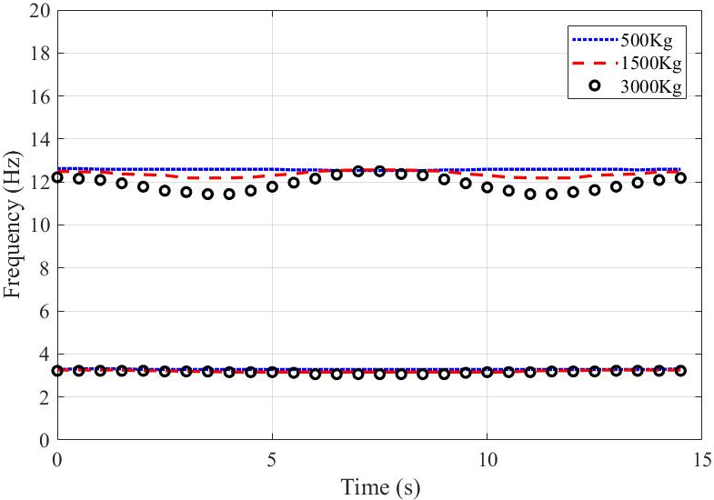 | 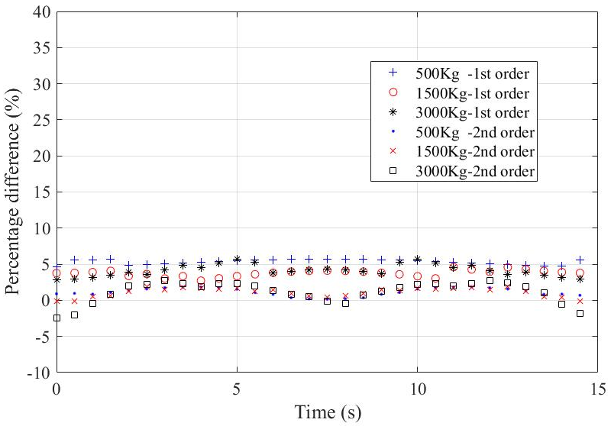
(a) | (b)
Fig. 7 Parametric study: Extracted IFs of the VBI system with different vehicle masses. (a) Identified results and (b) difference compared with theoretical results.

- Effect of vehicle speed

To analyze the effect of vehicle speed on the results of FIrST, the vehicle speed is taken to be $v_{v}=$1 m/s, 2 m/s or 4 m/s, while the spring stiffness, damping coefficient and mass of the vehicle are taken to be $k_{v}=$2.8210⁷ kN/m, $c_{v}=$ 390 kg/s and $m_{v}$= 3000 kg, respectively, with 5% measurement noise added. The results of time-varying frequencies of the VBI system with different vehicle speeds are shown in Fig. 8. The results identified are compared with theoretical results, and it can be observed that the relative difference is below 5%, which demonstrates that the vehicle speed may affect the accuracy of extracting time-varying frequencies. The results show that, higher speeds give IFs of lower accuracy, while lower speeds provide better extraction of IFs.

Fig. 8 Parametric study: Results of FIrST of the VBI system with different vehicle speeds.

- Effect of measurement noise
Different levels of measurement noise of 5%, 10% and 20% are then considered to verify the robustness of the proposed method. The mass, damping coefficient and stiffness of the vehicle are taken to be $m_{v}$ = 3000 kg, $c_{v}=$390 kg/s and $k_{v}=$2.8210⁷ kN/m, respectively, while the vehicle speed is taken as $v_{v}=$1 m/s. Fig. 9 and Fig. 10 show that the IFs obtained from the vehicle and bridge responses contaminated by different levels of measurement noise are close to one another, which indicates that the proposed method is robust and relatively insensitive to measurement noise. Therefore, the method is suitable for practical applications.

Fig. 9 Parametric study: Results of FIrST of the VBI system with different measurement noise.

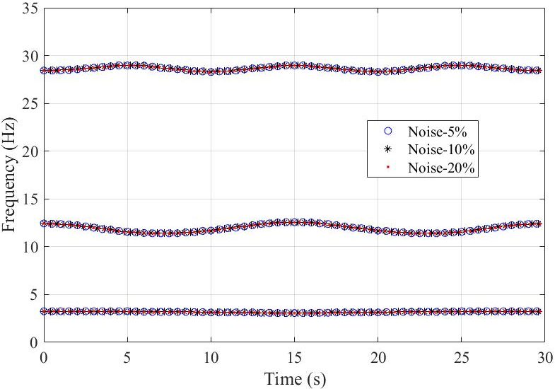
Fig. 10 Parametric study: Extracted IFs of the VBI system with different measurement noise.

- Effect of road surface roughness
The road surface roughness often leads to an uncertain effect on the VBI system, thereby producing potentially misleading results, which can contaminate the vehicle response and confuse the valuable information in the responses. It is known that surface roughness is a random process by which the information can be best to be obtained by field measurement. However, even for the measured profiles, they are presented in discrete form depending on the sampling rate of the measured data.
To assess the performance of the proposed method in the presence of other interference, road roughness is also considered in the numerical simulation, as the additional excitation due to road roughness will contaminate the vehicle response and confuse any valuable information in the response. A typical road roughness profile is often represented by a normal zero-mean real-valued stationary Gaussian process expressed as a sum of trigonometric functions with different coefficients and spatial frequencies. Here, the road roughness profiles are generated according to the standard ISO 8608:2016 [39] where the roughness profiles are classified into 5 classes: A, B, C, D and E. Road surface roughness profiles of Classes A and C are considered, while the mass, damping coefficient and stiffness of the vehicle are taken to be $m_{v}$= 3000 kg, $c_{v}=$390 kg/s and $k_{v}=$ 2.8210⁷ kN/m, respectively, and the vehicle speed is taken to be $v_{v}=$1 m/s. Fig. 11 shows as examples the second-order IFs obtained directly by S-transform from the vehicle and bridge responses with road roughness of Classes A and C, which are blurry as compared to the ideal values. It demonstrates that poor road surface quality could have adverse effect on the measured responses and results, but the proposed FIrST method can suppress effectively the undesirable influence.

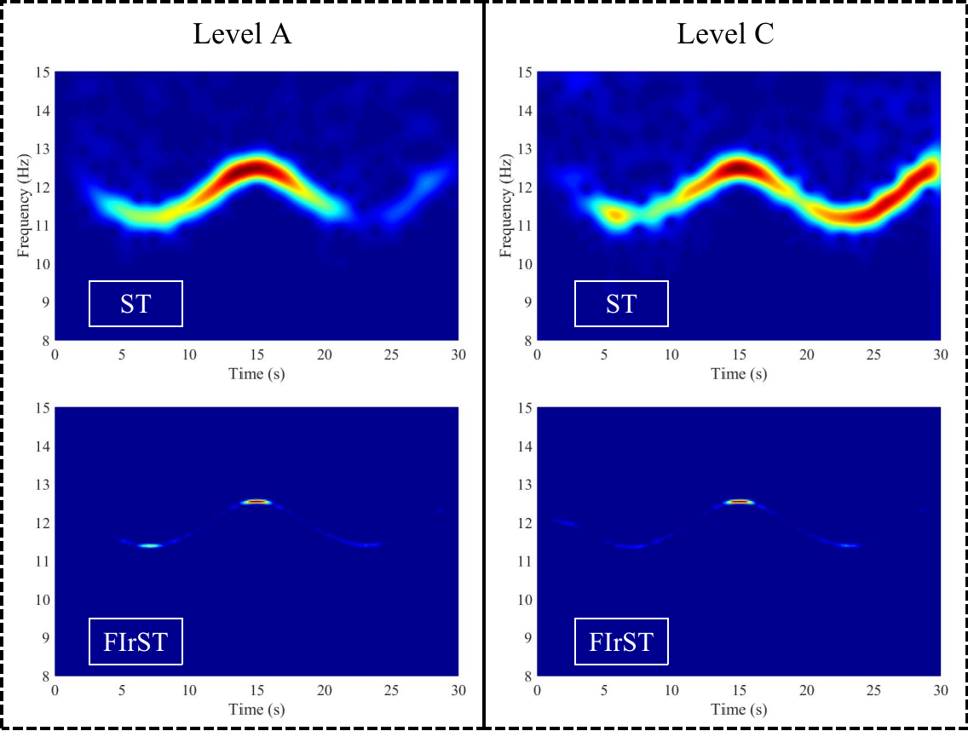
Fig. 11 Parametric study: Results of second-order IFs by FIrST of the VBI system with different classes of road roughness.

4. Experimental validation

An experiment is conducted in the laboratory as shown in Fig. 12 to validate the proposed technique. The model bridge is a simply supported beam of aluminum channel section. The length of the channel beam is 6.11 m, with the section oriented such that the web carries the model vehicle, and the flanges constrain the motion of the model vehicle moving along the bridge. The section is 101 mm wide and 50 mm deep. The leading and trailing beams are assembled at the front and rear ends of the beam for acceleration and deceleration of the model vehicle, respectively, and both are 1.01 m in length. The first three frequencies of the model bridge are 3.52 Hz, 13.82 Hz and 30.47 Hz, respectively.
A two-axle model vehicle is used, which is pulled through the beam at different speeds, i.e. $v_{1}=$0.22 m/s and $v_{2}=$ 0.76 m/s. The total mass of the model vehicle can be changed by addition of mass blocks, and the total vehicle mass can be set as either $m_{1}=$3.624 kg (Vehicle-1) or $m_{2}=$2.377 kg (Vehicle-2). A reference accelerometer is installed at the mid-span of the model bridge, and an accelerometer is mounted on the model vehicle to acquire its response when traversing the model bridge. Both the responses of the model vehicle and model bridge are employed for the IF identification based on the proposed FIrST technique.

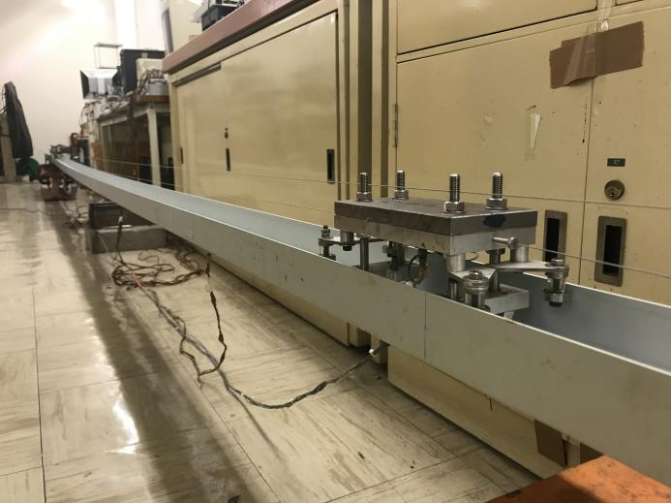 | 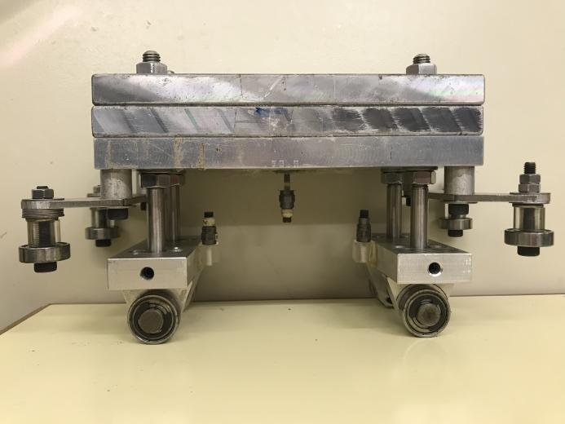
(a) | (b)
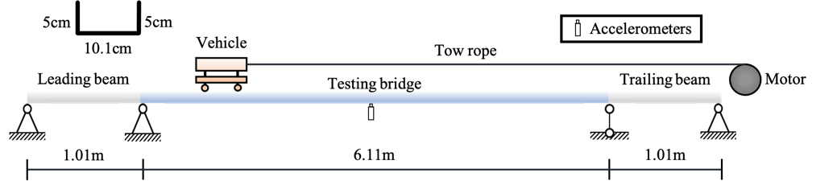
(c)
Fig. 12 Experimental VBI system used. (a) The model bridge, (b) the model vehicle with sensors, and (c) schematic diagram of the model bridge.

Then the IFs of the experimental VBI system are extracted following the procedures presented in Section 2.5. Figs. 13(a) and 13(b) show the spectrograms obtained by the FIrST technique and the identified IFs for a vehicle speed of 0.22 m/s, while Fig. 13(c) presents the corresponding identified IFs. These results show that the extracted IFs are similar for testing by vehicles of different masses. However, a heavier vehicle leads to more drastic frequency variation. Figs. 14(a) and 14(b) show the spectrograms for vehicle speed of 0.76 m/s, and the corresponding identified IFs are shown in Fig. 14(c). The proposed method can estimate the IFs of the test VBI system at a speed of 0.22 m/s clearly. For the case of the higher vehicle speed of 0.76 m/s, the extracted 3rd order IF becomes unclear, possibly because of the difficulty of reaching and maintaining a constant vehicle speed when it is relatively high.

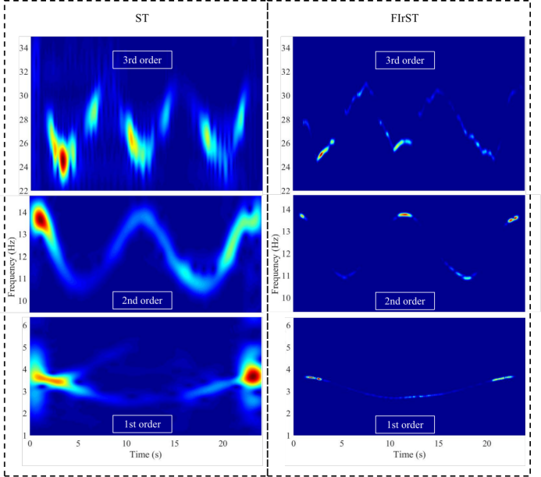 | 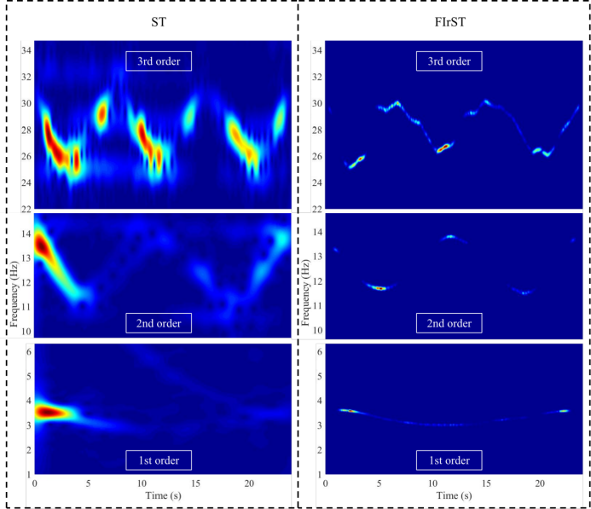
(a) | (b)
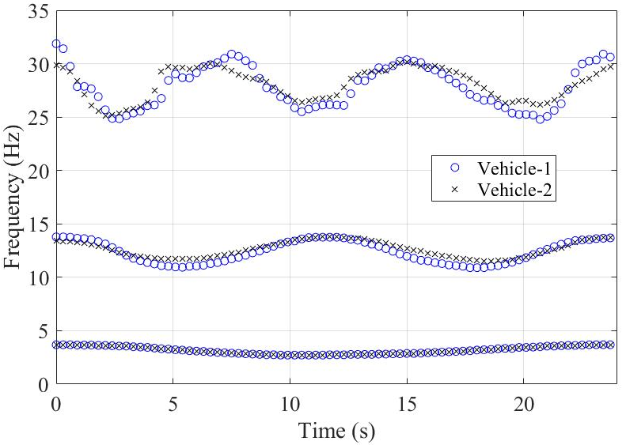
(c)
Fig. 13 Results of the laboratory test with different vehicle masses (Speed $v_{1}$ = 0.22 m/s). (a) Vehicle-1 ($m_{1}$= 3.624 kg), (b) Vehicle-2 ($m_{2}$= 2.377 kg) and (c) comparison of the extracted IFs.

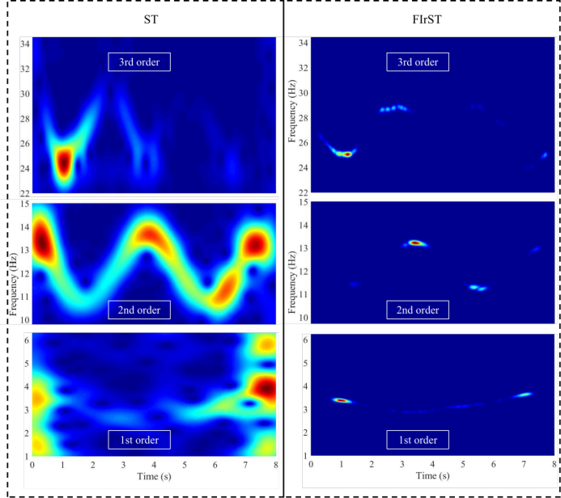 | 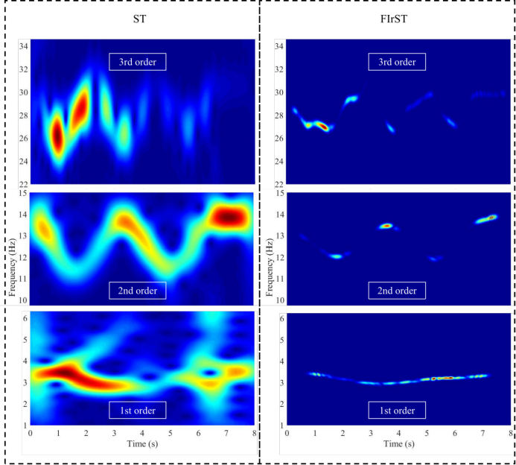
(a) | (b)
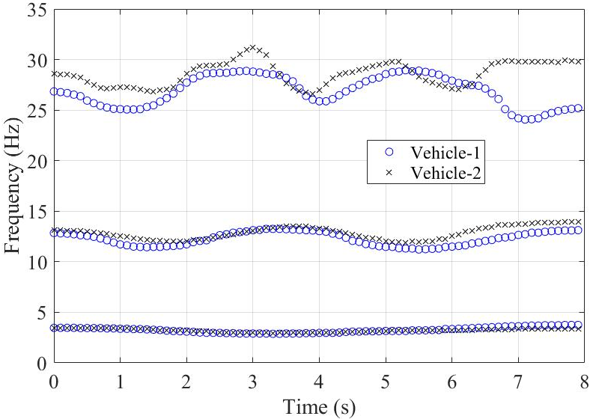
(c)
Fig. 14 Results of the laboratory test with different vehicle masses (Speed $v_{2}$= 0.76 m/s). (a) Vehicle-1 ($m_{1}$= 3.624 kg), (b) Vehicle-2 ($m_{2}$= 2.377 kg), and (c) comparison of the extracted IFs.

5. Conclusions

The drive-by technique involving the use of an instrumented vehicle is a convenient method for the identification of bridge parameters. However, the method is still prone to various problems, including the uncertain excitation due to road roughness, measurement noise, etc. The adoption of a multisensory system can be a simple solution, which may comprise a moving instrumented vehicle and a single fixed sensor on the bridge. In this paper, a method for identifying the time-varying characteristics of a vehicle-bridge system is proposed based on the filtered iterative reference-driven S-transform. Firstly, the reference-driven S-transform is formulated and an iterative strategy is proposed for interference elimination. Then, the procedures for extracting the structural modal parameters are presented making use of the FIrST technique with band-pass filter. Numerical examples of a VBI system and the laboratory experiment are carried out to validate the proposed method. Results show that the IFs of the VBI system can be extracted from the spectrograms of FIrST successfully, and they are less influenced by the interference compared to other vehicle response-based time-frequency analysis methods. In other words, the proposed method retains the advantage of obtaining high-resolution time-varying structural characteristics from the multisensory system, and it also overcomes the disadvantage of high sensitivity of passing-by methods to interference. The proposed method can estimate the IFs with satisfactory accuracy in different conditions with no requirement of the prior information about the bridge structure.

Acknowledgments

The work described here has been supported by the Ministry of Science and Technology, China (Project No.: 2019YFB1600702).

References

[1] J.X. Mao, H. Wang, Y.G. Fu, B.F. Spencer Jr, Automated modal identification using principal component and cluster analysis: Application to a long‐span cable‐stayed bridge, Structural Control and Health Monitoring, 26 (2019) e2430.
[2] T. Rogers, K. Worden, R. Fuentes, N. Dervilis, U. Tygesen, E. Cross, A Bayesian non-parametric clustering approach for semi-supervised Structural Health Monitoring, Mechanical Systems and Signal Processing, 119 (2019) 100-119.
[3] C.R. Farrar, K. Worden, An introduction to structural health monitoring, Philosophical Transactions of the Royal Society A: Mathematical, Physical and Engineering Sciences, 365 (2007) 303-315.
[4] Y.B. Yang, C.W. Lin, J.D. Yau, Extracting bridge frequencies from the dynamic response of a passing vehicle, Journal of Sound and Vibration, 272 (2004) 471-493.
[5] Y.B. Yang, J.P. Yang, State-of-the-art review on modal identification and damage detection of bridges by moving test vehicles, International Journal of Structural Stability and Dynamics, 18 (2018) 1850025.
[6] Y.B. Yang, Y.C. Li, K.C. Chang, Constructing the mode shapes of a bridge from a passing vehicle: a theoretical study, Smart Structures and Systems, 13 (2014) 797-819.
[7] A. Malekjafarian, P.J. McGetrick, E.J. OBrien, A review of indirect bridge monitoring using passing vehicles, Shock and vibration, 2015 (2015).
[8] C.-W. Kim, R. Isemoto, P. McGetrick, M. Kawatani, E.J. O'Brien, Drive-by bridge inspection from three different approaches, Smart Structures and Systems, 13 (2014) 775-796.
[9] H.P. Zhu, L. Ye, S. Weng, W. Tian, Damage identification of vehicle-track coupling system from dynamic responses of moving vehicles, Smart Structures and Systems, 21 (2018) 677-686.
[10] D. Cantero, D. Hester, J. Brownjohn, Evolution of bridge frequencies and modes of vibration during truck passage, Engineering Structures, 152 (2017) 452-464.
[11] S.D. Zhou, W. Heylen, P. Sas, L. Liu, Parametric modal identification of time-varying structures and the validation approach of modal parameters, Mechanical Systems and Signal Processing, 47 (2014) 94-119.
[12] S.D. Zhou, Y.C. Ma, L. Liu, J. Kang, Z.S. Ma, L. Yu, Output-only modal parameter estimator of linear time-varying structural systems based on vector TAR model and least squares support vector machine, Mechanical Systems and Signal Processing, 98 (2018) 722-755.
[13] W. Yang, L. Liu, S.-D. Zhou, Z.-S. Ma, Moving Kriging shape function modeling of vector TARMA models for modal identification of linear time-varying structural systems, Journal of Sound and Vibration, 354 (2015) 254-277.
[14] J. Li, X. Zhu, S.-s. Law, B. Samali, Time-varying characteristics of bridges under the passage of vehicles using synchroextracting transform, Mechanical Systems and Signal Processing, 140 (2020) 106727.
[15] C. Wang, W.X. Ren, Z.C. Wang, H.P. Zhu, Instantaneous frequency identification of time-varying structures by continuous wavelet transform, Engineering Structures, 52 (2013) 17-25.
[16] J. Liu, X. Wei, R.-H. Qiu, J.-Y. Zheng, Y.-J. Zhu, I. Laory, Instantaneous frequency extraction in time-varying structures using a maximum gradient method, Smart Structures and Systems, 22 (2018) 359-368.
[17] C. Wang, D. Ai, W.-X. Ren, A wavelet transform and substructure algorithm for tracking the abrupt stiffness degradation of shear structure, Advances in Structural Engineering, 22 (2019) 1136-1148.
[18] A. Roshan-Ghias, M. Shamsollahi, M. Mobed, M. Behzad, Estimation of modal parameters using bilinear joint time–frequency distributions, Mechanical Systems and Signal Processing, 21 (2007) 2125-2136.
[19] Y. Xin, H. Hao, J. Li, Time-varying system identification by enhanced empirical wavelet transform based on synchroextracting transform, Engineering Structures, 196 (2019) 109313.
[20] A. Poulimenos, S. Fassois, Parametric time-domain methods for non-stationary random vibration modelling and analysis—a critical survey and comparison, Mechanical systems and signal processing, 20 (2006) 763-816.
[21] K. Liu, L. Deng, Experimental verification of an algorithm for identification of linear time-varying systems, Journal of Sound and Vibration, 279 (2005) 1170-1180.
[22] M. Niedzwiecki, Identification of time-varying processes, Wiley New York, 2000.
[23] Y. Bao, Z. Shi, J.L. Beck, H. Li, T.Y. Hou, Identification of time‐varying cable tension forces based on adaptive sparse time‐frequency analysis of cable vibrations, Structural Control and Health Monitoring, 24 (2017) e1889.
[24] P. Ni, J. Li, H. Hao, Y. Xia, X. Wang, J.M. Lee, K.H. Jung, Time‐varying system identification using variational mode decomposition, Structural Control and Health Monitoring, 25 (2018) e2175.
[25] Z.C. Wang, W.X. Ren, G.D. Chen, A Hilbert transform method for parameter identification of time-varying structures with observer techniques, Smart materials and structures, 21 (2012) 105007.
[26] R.G. Stockwell, L. Mansinha, R. Lowe, Localization of the complex spectrum: the S transform, IEEE transactions on signal processing, 44 (1996) 998-1001.
[27] A. Moukadem, D.O. Abdeslam, A. Dieterlen, Time-frequency domain for segmentation and classification of non-stationary signals: The Stockwell transform applied on Bio-signals and electric signals, John Wiley & Sons, 2014.
[28] S. Ventosa, C. Simon, M. Schimmel, J.J. Dañobeitia, A. Mànuel, The S-transform from a wavelet point of view, IEEE Transactions on Signal Processing, 56 (2008) 2771-2780.
[29] J. Zhang, D. Yang, W.-X. Ren, Y. Yuan, Time-varying characteristics analysis of vehicle-bridge interaction system based on modified S-transform reassignment technique, Mechanical Systems and Signal Processing, 160 (2021) 107807.
[30] S. Fassois, MIMO LMS-ARMAX identification of vibrating structures—part I: the method, Mechanical systems and signal processing, 15 (2001) 723-735.
[31] A. Florakis, S. Fassois, F. Hemez, MIMO LMS-ARMAX identification of vibrating structures—part II: a critical assessment, Mechanical Systems and Signal Processing, 15 (2001) 737-758.
[32] B. Boashash, A. Aïssa-El-Bey, Robust multisensor time–frequency signal processing: A tutorial review with illustrations of performance enhancement in selected application areas, Digital Signal Processing, 77 (2018) 153-186.
[33] Y.B. Yang, J.P. Yang, Y. Wu, B. Zhang, Vehicle scanning method for bridges, Wiley Online Library, 2019.
[34] E. Sejdic, L. Stankovic, M. Dakovic, J. Jiang, Instantaneous frequency estimation using the S-transform, IEEE signal processing letters, 15 (2008) 309-312.
[35] B. Boashash, P. O'shea, Use of the cross Wigner-Ville distribution for estimation of instantaneous frequency, IEEE Transactions on Signal Processing, 41 (1993) 1439-1445.
[36] D. Thambiratnam, Y. Zhuge, Dynamic analysis of beams on an elastic foundation subjected to moving loads, Journal of sound and vibration, 198 (1996) 149-169.
[37] Y. Yang, K. Chang, Y. Li, Filtering techniques for extracting bridge frequencies from a test vehicle moving over the bridge, Engineering Structures, 48 (2013) 353-362.
[38] X. Kong, C. Cai, B. Kong, Numerically extracting bridge modal properties from dynamic responses of moving vehicles, Journal of Engineering Mechanics, 142 (2016) 04016025.
[39] I. ISO, Mechanical vibration—Road surface profiles—Reporting of measured data, 1995.

∗Corresponding author. E-mail addresses: yangdong@hfut.edu.cn (Dong Yang), yingzhan@connect.hku.hk (Ying Zhan), zhangj@hfut.edu.cn (Jing Zhang), francis.au@hku.hk (Francis T.K. Au).

