Advanced Engineering Informatics

Mass Personalisation as a Service in Industry 4.0: A Resilient Response Case Study
Shohin Aheleroff ^{a*}, Naser Mostashiriª, Xun Xuª, Ray Y. Zhong^{b}
ª Department of Mechanical Engineering, The University of Auckland, New Zealand
^{b} Department of Industrial and Manufacturing Systems, The University of Hong Kong, Hong Kong

Abstract
The Fourth Industrial Revolution (Industry 4.0) leads to mass personalisation as an emerging manufacturing paradigm. Mass personalisation focuses on uniquely made product to individuals at scale. Global challenges encourage mass personalisation manufacturing with efficiency competitive to mass production. Driven by individualisation as a trend and enabled by increasing digitalisation, mass personalisation can go beyond today’s mass customisation. This paper aims to introduce Mass Personalisation as a Service (MPaaS) to address unique and complex requirements at scale by harnessing Industry 4.0 technologies, including Internet of Things, Additive Manufacturing, Big Data, Cloud Manufacturing, Digital Twin, and Blockchain. A case study for the implementation of MPaaS in personalised face masks is presented. Novel Coronavirus (Covid-19) pandemic requires patients and frontline healthcare workers to use personal protective equipment (PPE), such as facemasks, for longer hours resulting in pressure-related ulcers. This prolonged use of PPE highlights the importance of personalisation to avoid ulcers and other related health concerns. Most studies have used Additive Manufacturing for individualisation and cloud capabilities for large scale manufacturing. This study develops a framework and mathematical model to demonstrate the capability of the proposed solution to address one of the most critical global challenges by making personalised face masks as an essential PPE to combat the Covid-19.

Keywords: Industry 4.0; Internet of Things; Cloud Manufacturing; Additive Manufacturing; Personalisation; Service Oriented Architecture.

- Introduction
The industrial revolution recognises the need to provide outstanding service to customers. Mass production facilitates the efficient manufacturing of vast numbers of products, often using automated production lines. Later, by only replacing some parts in a product, the cost per unit of customised products has been reduced for large production volumes, resulting in limited variety representing customisation [1]. Industry 4.0 and the Lean management approach [2] introducing extra customisation while taking full advantage of productivity, waste elimination, quality improvement, and segmentation [3]. The lean production initiatives, including make-to-stock, assemble-to-order, and make-to-order, have been implemented successfully in different business sectors [4]. However, the industrial competition encourages meeting individuals’ requirements with the low unit costs associated with mass production.
Several new applications require a combination of recently emerging Industry 4.0 technologies [5]. Industry 4.0 derives flexibility and collaboration among resources in intelligent manufacturing systems [6]. In an increasingly competitive market and Covid-19 pandemic, businesses must develop a resilient response [7] to the individuals’ needs as personalisation has transformed from a preference to a necessity. Table 1 provides the main concerns, recipients, and advantages across three different manufacturing paradigms. While users in mass production can only buy affordable products, mass customisation allows customers to choose from a range of available products. The ultimate goal is to provide affordable bespoke products to consumers.
This study makes an original contribution outlining essential Industry 4.0 technologies and capabilities for meeting personalisation at scale. The main contribution of this research is to introduce a novel Mass Personalisation as a Service (MPaaS) model with scalable and resilient service-oriented architecture. The research findings should make an important contribution to Industry 4.0 development. A review of the recent related literature is presented in section 2. Section 3 describes the proposed MPaaS model. Section 4 discusses a valuable application scenario to address the most suitable face mask for the Covid-19 outbreak. Section 5 discusses the findings of the paper in more detail. Section 6 concludes and points out future works.

Table 1 Comparison of manufacturing paradigms
Principles | Mass  Production | Mass  Customisation | Mass  Personalisation
Advantage | Cost | Variety | Efficiency
Goal | Scale | Scale, Scope | Scale, Scope, Value
Offer | Buy | Choose | Personalise
Production | Dedicated | Reconfigurable | On-demand
Recipient | User | Customer | Consumer
- Overview
The shift from mass production towards mass customisation and mass personalisation aims to concerning productivity and sustainability. Mourtzis et al. (2015) designed and developed a Cloud-based production planning and control system to address capacity constraints, lot sizing, and priority control [8]. To address major personalisation challenges, a Cloud-based platform can minimise the cost of IT infrastructure ownership and enables Industry 4.0 capabilities, resource utilisation, and mobility due to being device and location independent under a service model paradigm. Subsequently, technology convergence should transform into fusion to maintain agility, resilience, and flexibility for mass personalisation as the most complex manufacturing paradigms.
This section gives an overview of mass personalisation and Industry 4.0 technologies, including Additive Manufacturing (AM), Augmented Reality (AR), Big Data, Blockchain, Cloud Manufacturing (CMfg), Digital Twin, and Internet of Things (IoT), which can create a synergy for getting the best out of cutting-edge technologies and manufacturing capabilities toward mass personalisation.
- Mass Personalisation
Technology has evolved to the point where advancements in the Industry 4.0 era do not depend on one-size-fits. The mass personalisation paradigm as a profitable business strategy allows individuals to tailor products [9]. Although personalisation is more feasible than ever, the concept has not been developed adequately at scale [10]. Recent developments in Industry 4.0 have heightened the need for mass personalisation in a wide range of industries, including home appliances, healthcare, and wearable devices [11]. Nevertheless, achieving mass personalisation is a severe challenge due to dependencies, data privacy, complexities, and access to a manufacturing resource pool [12].
According to McKinsey & Company, personalisation can make from five up to fifteen percent increase in revenue and from ten to thirteen percent increase in marketing efficiency [13]. However, critical enabling technologies will be required in a suitable production process for making various products simultaneously [14]. The advanced technologies in AM and Smart Manufacturing and the established Business to Business and Business to Customer models can make mass personalisation more feasible than ever since Industry 4.0 emerged. In response to the individuals’ needs, Ogunsakin et al. (2021) proposed a mass personalisation manufacturing system to address unpredicted changes in product design and manufacturing processes due to customers’ ability to co-create and co-design products based on personal preferences [15].
Most studies have tried adopting existing digital technologies, primarily aimed at visualising personalisation using 3D technologies to enhance the user experience of the new products [16]. Industry 4.0 enables novel forms of personalisation in a shorter time and with a lower cost than traditional personalisation. The producer and the customer will share the new value to fill the gaps between mass customisation and mass personalisation using a suitable framework under Industry 4.0 umbrella [17].

- Industry 4.0 enabling technologies for personalisation
The manufacturing industry is undergoing a significant transformation for providing on-demand services [18] with high reliability, scalability, and availability in a distributed environment [19]. Industry 4.0 enables data-oriented applications to meet longevity with higher satisfaction [20]. The vision of future production characterises personalised products’ manufacturing in a batch size while keeping costs at or near mass production. Industry 4.0 presents smart features and encourages scaling up or down per demand by customising solutions [21].
Crucial Industry 4.0 enabling technologies are required to orchestrate cutting-edge capabilities for achieving personalisation at scale. A Cloud-based design and manufacturing model focusing on matching service seekers and service providers can directly benefit from Industry 4.0 capabilities to offer personalisation [22]. Table 2 shows a list of vital Industry 4.0 technologies with significant contributions to the mass personalisation paradigm.
- Additive Manufacturing for mass personalisation
Additive Manufacturing has evolved beyond prototyping to become a ubiquitous technology that can easily be found in different places for personalisation. It can also provide affordable personalisation due to reducing time-to-market, cutting inventory cost, and making a highly complex, unique design [23], which most subtractive techniques, such as Computer Numerical Control machines, have difficulties in manufacturing [21].
Small to medium enterprise companies have time, cost, and quality challenges for personalisation that can be addressed by AM [24]. However, using AM at scale remained the biggest challenge. In this study, AM is used as one of the Industry 4.0 technologies to make a high degree of mass personalisation (DoMP). 3D printers are the crucial personalisation manufacturing enabler in this research.
Cloud-based AM can discover affordable 3D printing services in the context of a manufacturing-as-a-service considering primary factors, such as supplier capabilities, customer experience, and scale of operations with further improvement using machine learning methods [25].
Several industries and business sectors, such as the medical sector, gain extensive advantages of AM to push the boundaries of cost-efficiency, convenience, and customisation [26]. 3D printing technology enables making distinguished products concerning co-design, coordination, and configuration [27]. Recent improvements in AM enable making one-off products via co-design processes [28].
- Augmented Reality for mass personalisation
Augmented Reality overlays instant information on a physical environment [29]. This capability can turn most customer service centres into a smart customer experience to improve engagement and enhance personalisation while scaling up and reducing costs. AR’s value proposition is attractive to individuals due to the automated augmented user experience [30], enabling mass personalisation regardless of time, location, and scale constraints. It can also be adopted where diverse tasks with a personalised interface can support distinct features.
Personalisation is linked to the interests of individuals. AR as an enabling technology can influence a personalised experience. AR enables context-driven personalisation, allowing users to visualise products on their bodies or within their environment, such as using augmented models to fit clothes [31]. In comparison, a non-AR experience such as a product catalogue does not allow customers to attempt in a personally relevant situation. As individuals prefer self-relevant information, AR-enabled personalisation is foreseen to provoke positive, persuasive consequences [32].
AI-driven with other developing technologies such as IoT, Big Data, Cloud computing, and computer vision add significant value to visualise customers’ experience of a personalised product before an actual product is manufactured. Therefore, individuals can experience the augmented product, which helps to visually evaluate the product’s size, shape, and colour before finalising their order. AR empowers personalisation to reduce costs and offers scalability and agility features in the digital transformation [33]. Companies exploiting the customer’s integration in product personalisation aim to support the design of manufacturing networks since individuals can interact and manipulate a digital version of the product before manufacturing [34].
- Big Data for mass personalisation
In an IoT-enabled system, enormous data could be captured and collected [35]. Big Data and IoT together can empower a considerable volume of data for personalisation at scale. Analysing the collected data, predicting, and responding to individuals’ unspoken needs would result in a dynamic response to mass personalisation.
Personalisation is at the top of every progressive manufacturing paradigm when the goal is to provide a better customer experience. The capability of Big Data in unique consumer experiences has the potential for achieving non-intrusive personalisation at scale [36].
One size does not fit all since individuals’ characteristics and preferences are not the same. Providers use Big Data technology to understand customers’ needs better and empower providers to serve individuals accordingly in the digital world. Big Data can give an opportunity to go beyond the use of direct requirement gathering for personalisation and leverage the global network of connected things [37]. Big Data technology is used in this study to identify patterns reflecting the desired individuals’ requirements and the performance of mass personalisation service providers.
- Blockchain for data privacy in personalisation at scale
Mass personalisation is fast becoming the cornerstone of customer satisfaction. The user data on smart systems is often considered private and is challenging to be shared across external providers for personalisation. Blockchain provides a new way of sharing data that is secure and decentralised [38].
Blockchain has begun to revolutionise the logistics industry [39], which can significantly benefit mass personalisation due to a shift from a make-to-stock to a make-to-order strategy. With mass personalisation, small and medium enterprises must find ways to collaborate and share competency in a trustable manner [40]. Blockchain protects customers’ data from deletion, tampering, and revision in different aspects of production that can play a crucial role in scalable personalisation. Blockchain effectively supports transparency and sustainability [41] to address scalable data privacy and transparency. Therefore, personal data and manufacturing information are kept safe.
Manufacturers turn more to customer-oriented production models since Industry 4.0 emerged. Blockchain would be a suitable technology to address scalable data privacy and traceability while complementing other Industry 4.0 technologies, such as IoT, Cyber-Physical System (CPS), and Big Data which have made significant progress in the manufacturing sector [42].
Distributed manufacturing resources and capabilities fit mass personalisation well using Big Data, CPS, CMfg, Digital Twin, IoT technologies. However, data privacy and traceability at scale are missing to meet mass personalisation. Service-oriented manufacturing is a distributed and collaborative model that suits mass personalisation. Blockchain empowers a strong trust relationship so that multiple providers can share resources and capabilities for customised manufacturing [43].
- Cloud Manufacturing for mass personalisation
What began as an academic theory just over ten years ago is now a reality and the future of manufacturing. The merging CMfg paradigm utilises distributed manufacturing more efficiently [44], providing access to appropriate manufacturing resources and capabilities for mass personalisation. As mass production evolves into mass personalisation, CMfg is a zero-asset plug-and-play and highly flexible manufacturing paradigm. CMfg platforms can grow their product range rapidly. As highly automated and digitised service providers, they have the potential to become exclusive suppliers.
First discussed by Beihang University professors Bo Hu Li and Lin Zhang, in their 2009 paper, “Cloud Manufacturing: A New Service-Oriented Networked Manufacturing Model,” the concept of cloud manufacturing was defined and presented as a solution to overcoming application impediments through the development of networked manufacturing [45].
Wang and Xu [46] proposed an interoperable Cloud-enabled manufacturing service model [47], which suits mass personalisation with access to a shared pool of configurable manufacturing. While CMfg brings a crucial value to mass personalisation, and unlike mass personalisation, CMfg is limited to manufacturing, and there has been no standardised definition for CMfg [48].
CMfg adopts Cloud computing resources, such as servers, networks, and software, in the entire manufacturing life cycle [49]. CMfg is a service-oriented, customer-centric, and demand-driven manufacturing model [50]. Therefore, CMfg supports distinguished products [51]. Cloud-based manufacturing is networked and decentralised manufacturing [52]. The convergence of Cloud and conventional manufacturing has given birth to a new concept, CMfg, promoting manufacturing to a highly collaborative, innovative, and service-oriented model [45]. CMfg empowers consumers to demand manufacturing capabilities and resources, such as 3D printers, dynamically and agilely as a service that suits affordable and scalable personalisation [53].
Companies must adopt different manufacturing technologies to transform mass production into mass customisation or personalisation [54]. However, Current studies fail to pay sufficient attention to integrating required technologies into smart manufacturing for achieving product customisation. Note that product customisation refers to the production process and result, where the products are designed specifically according to the requirements of individuals [55].
- Digital Twin for mass personalisation
Digital Twin provides a physical entity’s digital replica that fulfils mass personalisation [56]. Digital Twin can make a digital replica of wanted characteristics, material, appearance, functionality, process, and system [57], extending to a personalised product’s digital replica. Aheleroff et al. [58] proposed a Digital Twin reference architecture and explored the bi-directional relation between the physical artefact and the digital model [59] for meeting mass personalisation.
Digital Twin has a structure consisting of connected elements, meta-information, and semantics that seamlessly converge AR and IoT to offer mass personalisation [60]. The mutual data flow between the physical, digital, and cyberspace is required to fusion customers’ expectations, digital model of personalised products, and Cloud-based manufacturing resources.
Efficient personalisation satisfies individuals when using Digital Twin as a core technological element of cyber-physical production systems. Therefore, Digital Twin plays a crucial role in achieving personalised products. A smart factory was successfully proved an unmanned modular manufacturing system using Digital Twin, AM, and IoT to produce affordable one-off products in response to demands associated with various prototypes [61].
- Internet of Things for mass personalisation
In today’s connected world, devices inconspicuously sharing data about our preferences and almost everything related to individuals. Big Data helps companies achieve their targets using personalisation for higher customer satisfaction and profit. Globalisation, digitalisation, and personalisation have been influenced by emerging technologies, particularly IoT, in the Industry 4.0 era [62]. Targeting personalisation at scale was not feasible before evolving IoT to address the increasing complexity and variety [63].
Since IoT emerged, billions of connected users and smart devices transform from the connection era into the IoT fusion era [64]. IoT and mass personalisation complement each other. The former deals power of the Internet, data processing and analytics to the real world of physical objects, and the latter engages individuals purposefully, which enable mass personalisation. IoT orchestrates other crucial Industry 4.0 technologies as a network backbone and involves in every stage of mass personalisation, from order placement by customers and data collection to Cloud manufacturing and delivering a personalised product.
- Mass Personalisation as a Service (MPaaS)
The demand shifts for personalisation has never reached high proportions as today. Rules for success in the digital era is making products and services personal for everyone. Before the first industrial revolution, low volume and expensive personalised products were made by highly skilled craftspeople. Making personalised products is often costly and time-consuming due to the effort required for meeting customer’s requirements. However, an on-demand service can provide a better response to an individual’s needs. This might result in a personalised product that is more affordable and sustainable than an off-the-shelf one close or even cheaper than mass production by eliminating unwanted features.
There are many reasons for personalisation, and they are growing. For instance, purchasing the wrong appearance, size, or fit is the top reason for returns and attempts for new products. Therefore, personalisation is essential in minimising returns, increasing sustainability, and being more human friendly toward the fifth Industrial revolution. As-a-service is a precise approach for personalisation because individuals pay for what they need, which encompasses the required time, cost, and effort in contrast to the off-the-self products in mass production. As-a-service model is necessary but not sufficient for mass personalisation. Therefore, the value advantages of crucial Industry 4.0 technologies are required concerning affordability, flexibility, agility, scalability, and accessibility.
The service-oriented business model has extended from computing and storage to tourism, transportation, food delivery, medical, and healthcare services and becomes an effective strategy with a great potential to address on-demand needs at scale in a wide range of industries, including the manufacturing industry [65]. However, Industries struggle to survive in today’s socio-economic environment characterised by globalisation, demand for increased product variety, and high uncertainty.
The service-oriented model can offer different physical and non-tangible things, such as data, infrastructure, software, and platform, as a service. Similarly, MPaaS can offer physical personalised products and non-tangible personalised services at a scale. MPaaS represents a carrier for orchestrating required resources and capabilities, including distinguished data, software, infrastructure, and manufacturing for scalable personalisation.
Xu (2013) explained that in CMfg, distributed resources are encapsulated into cloud services and managed centralised for users to request services ordering from product design, manufacturing, testing, managing, and all other product life cycle stages [66]. CMfg is a manufacturing paradigm for transforming manufacturing resources and capabilities into on-demand manufacturing services. Consequently, MPaaS is beyond the manufacturing process because a considerable part of personalisation is before and after manufacturing in an end-to-end production process.
The principles of the service-oriented model stress the separation of concerns into customer fit, isolated, autonomous, adaptable, transparent, and accessible features. Similarly, MPaaS uses virtualise resources as a service over the Internet and presents a scalable personalisation. Therefore, MPaaS offers exclusive benefits that CMfg and service-oriented business model promise under Industry 4.0 capabilities. MPaaS and CMfg use Cloud computing as a vital enabler to create a network for effective collaboration, offering pay-as-you-go business models, scaling up and down per demand, and flexibility in making changes.
MPaaS adopts the value propositions of the existing service-oriented business models, such as software as a Service (SaaS), Infrastructure as a Service (IaaS), data as a Service (DaaS), and Platform as a Service (PaaS) to make personalisation on demand efficiently. MPaaS allows underlying manufacturing resources like Machine Tool 4.0 similar to IaaS. MPaaS is licensed on a subscription basis identical to SaaS, but MPaaS is distributed and not centrally hosted as SaaS. SaaS enables DaaS and analyses data with business intelligence. Similarly, Big Data analysis empowers MPaaS to identify, analyse, and predict individuals’ needs. Finally, MPaaS is a platform-based service that allows providers to offer personalisation without the complexities required for building and maintaining a new platform.
The current digital transformation is moving beyond Cloud-based applications due to behavioural changes. However, enabling personalisation needs an as-a-service capability in data, infrastructure, platform, software, manufacturing, and customer experience. Providers need to ensure affordability, like the value advantage of off-the-shelf products, while offering scalability, flexibility, and agility. Therefore, the current digital transformation is moving beyond Cloud-based applications due to behavioural changes.
Exclusively for SMEs, collaborative networks are critical to the personalisation for using several shared resources and capabilities. MPaaS can use Cloud services to build or migrate existing design and manufacturing capabilities. By utilising a Cloud infrastructure, providers can benefit from highly reliable infrastructure worldwide to focus more on core business than personalisation.
The latest trend shows more leading service companies and fewer manufacturers than in previous decades since Industry 4.0 emerged. Industry 4.0 and the service-oriented model are considered two of the most recent trends for transforming industrial companies. The relative importance of service in production inspires this study to adopt service-oriented architecture for meeting mass personalisation. Therefore, a service-product continuum has replaced the traditional separation between product and service using crucial technologies under Industry 4.0 umbrella.
Customisation and personalisation are often thought to be synonymous. Customisation approaches are established based on the pre-defined product based on customer segmentation, which may not support a high DoMP due to distinguish features, shape, material, look and feel for individuals. Similarly, mass customisation and mass personalisation are not interchangeable paradigms. Mass customisation is a reasonably established concept with several industrial success stories, while it is hard to find a practical mass personalisation case study. However, mass personalisation is known as the best practice in digital marketing and information technology business sectors. This study provisions Industry 4.0 technologies and capabilities to expand personalisation beyond digital space.
The ‘mass’ component of mass personalisation commits to meet individual expectations close to mass production efficiency. This study proposes MPaaS powered by Industry 4.0 capabilities to deliver bespoke products on a large scale. MPaaS recognises the ability to provide a vast number of unique products within acceptable cost, time, and quality to individuals as a service. MPaaS uses Industry 4.0 capabilities and adopts a holistic approach from Infrastructure as a Service, Data as a Service, Software as a Service, Platform as a Service.
- CMfg-enabled Mass Personalisation Manufacturing
The technology for achieving suitable personalisation has become more available than ever. Therefore, the real competitive advantages will shift from production economies to scalable, affordable, and highly personalised manufacturing. In the Industry 4.0 era, companies can utilise manufacturing resources, capabilities, and advanced technologies such as CMfg and IoT to achieve on-demand manufacturing efficiently. Therefore, the manufacturing industry will no longer be a barrier to rapid rates of change. This can be called CMfg-enabled mass personalisation, where individuals have the opportunity to decide a range of manufacturing services concerning the appearance, material, features, manufacturing time, etc.
Several manufacturing methods have transformed towards seamless integration, flexibility, and decentralisation, reflecting remarkable evolution in manufacturing systems supported by information and communication technologies. Nevertheless, a new paradigm shift is emerging in manufacturing. As a result, the tendency to move from traditional production-oriented manufacturing shifts to the service-oriented manufacturing paradigm. Therefore, the alliance between smart manufacturing and service-oriented architecture forms Cloud-enabled manufacturing as a Service [65].
While each Industry 4.0 technology offers value advantages, often they have significant issues due to a lack of seamless integration. For instance, integrating Blockchain, CMfg, and service-oriented architecture can enable customers to access a large capacity of decentralised manufacturing capabilities and resources over secure networks [67]. However, mass personalisation manufacturing needs to go beyond connection by technology and business fusion. The manufacturing part can be improved significantly for personalisation using cutting edge manufacturing technologies, such as AM and CMfg under Industry 4.0 umbrella.
The as-a-service paradigm can scale personalisation for affordable and reasonable delivery time toward higher product sustainability. Industries need to align with the values of individuals. Customers expect providers to ensure their personalised products have a comparable price as off-the-shelf products. Flexibility, rapid changes, and agility motivate both individuals and providers to scale personalisation demand and supply.
Mass Personalisation Manufacturing is the manufacturing of exclusive products without corresponding cost, time, and quality to address a prospective business strategy as an essential catalyst in digital transformation. Mass personalisation manufacturing is not merely about a tremendous increase in a variety of pre-defined products. Instead, it is about the capability and capacity for tailoring products to satisfy every customer’s requirements and preferences. Figure 1 shows that mass personalisation manufacturing targets the greatest variety while keeping the cost at the mass production efficiency. Using Industry 4.0 helps to eliminate unnecessary features through an Agile process and achieve mass personalisation manufacturing.
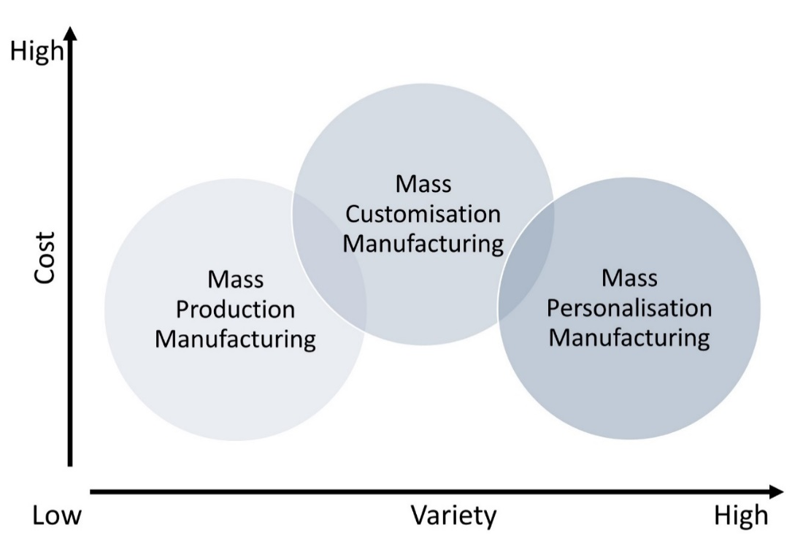
Figure 1 Variety and cost in manufacturing paradigms
- MPaaS empowering resilience
Industry 4.0 has a way of changing not just technology but the entire business. The capability to recover from difficulties as quickly as possible is highly demanded due to global challenges raised by the COVID-19 pandemic [68]. The unpredictability and uncertainty become more critical than ever. Therefore, preparation for recovery in the supply chain with resilience is essential [69], which is embedded in the proposed MPaaS.
MPaaS offers the capacity to change from pre-defined design, manufacturing, and supply chain due to the complementary capabilities, such as connection, contribution, and resource utilisation, that present resilience. MPaaS is proposed to address on-demand requirements at reasonable costs and time despite uncertain needs and changes due to the service-oriented architecture and value proposition of Industry 4.0 enabling technologies. Therefore, the nature of MPaaS supports unforeseen requirements regardless of time and location constraints, which are the main concerns of resilience.
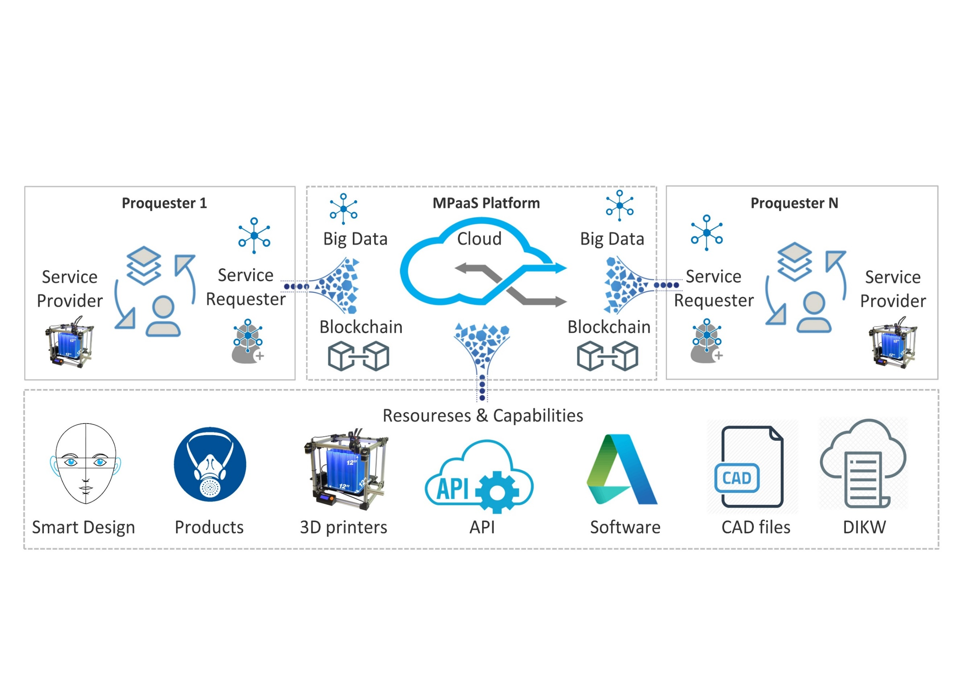
Figure 2 Proquester in Mass Personalisation as a Service (MPaaS)
Now, it is a demand to make sure that the production line can change rapidly to produce different products that were not initially planned to be manufactured. In response, MPaaS acts as an orchestration of a suitable business model, architecture, and Industry 4.0 technologies with resilient infrastructures and a set of capabilities. Ubiquitous technologies, including IoT, AM, and CMfg, could react to unforeseen changes. As MPaaS adopted these ubiquitous technologies, it fulfils exclusive requirements quickly in the face of adversity.
- MPaaS Architecture
Industry 4.0 integrates cutting-edge technologies for a higher value based on the standard Reference Architecture Model Industry 4.0 [40]. Figure 2 shows critical Industry 4.0 technologies and a pool of resources and capabilities in the MPaaS, which providers and requesters can complement on the Internet. While service providers and requesters can play a different roles, they might also exchange resources at the same time over the Internet.
The term “proquester” refers to the complementation of providers and requesters. Proquester blends the provider with the requester to simultaneously utilise the demand-supply relationship by sharing and consuming resources and capabilities. By using the MPaaS platform, a proquester can provide and request services. For instance, a service provider can share a 3D printer with a suitable material but has a limited CAD capability to manufacture a complicated part. Therefore, this provider might become a service requester to fill the gap. The main reason to coin this term is that a provider can be a requester simultaneously. For instance, a CAD designer as a service provider might need a 3D printer to build the design, which puts the person in the role of a requester.
The proposed MPaaS uses IoT for interaction among proquesters and keeps privacy at scale by utilising Blockchain. Besides, Big data is utilised for using a pool of resources, including 3D printers and capabilities such as smart design to improve service availability and customer satisfaction.
MPaaS is a cloud-based model where a third-party provider delivers services toward personalisation at scale. A range of service providers, including design, manufacturing, and test, can be integrated into MPaaS with Cloud features such as scalability, high availability, and multitenant capability. The proposed MPaaS is based on the Service-Oriented Architecture concept and service delivery platform, enabling service providers to develop and deliver personalised services more rapidly with the most negligible impact by replacing any component.
Figure 3 shows the proposed MPaaS architecture as converged services providing a mass personalised service delivery platform. The eight major components, including web/ mobile UI, smart design, IoT, AR, multitenant, degree of mass personalisation, manufacturing, and visualisation, are orchestrated by the proposed MPaaS integrated through an application programming interface (API). The assumption is that the initial personalised design is not pre-defined. Consequently, MPaaS empowers an iterative and incremental process to address the issue. This architecture is a foundation for flexible service creation, deployment, provisioning, and management to ensure the designed product fits the individuals’ expectations.
As shown in Figure 3, adopting the proposed approach from information technology to the manufacturing industry encourages reusable capabilities to reduce product and service development costs with rapid changes to meet customers’ needs. This allows for moving CMfg towards an eco-system of multi-service and third-party service models. Common capabilities, including the eight modules, are third-party services with a high collaboration for an on-demand personalisation at scale.
Management and Service Discovery modules provide a wide range of third-party service providers, including content, payment, and location, to enable services through the developer portal for service creation. MPaaS has policy management, charging, content management, resource registry, and access control in the Management and Service Discovery modules.
IoT plays a crucial role in building Digital Twins based on CAD models, simulations, BIM models and seamless integration with AR. Furthermore, it allows bi-directional data from the physical artefact, digital models, and resources shared on the Cloud, including AM. Lastly, IoT forms the multitenant module, enables suitable DoMP analysis and provides instant visualisation.
To make mass personalisation more responsive to changes, the proposed MPaaS implements microservice architecture while utilises Industry 4.0 technologies, including IoT and Big Data [70]. Microservices are a suite of small services. Each service runs in its process with lightweight communication, which the manufacturing industry can adopt from software engineering to increase product variety [71]. A microservice is called via an endpoint API, so it should be well defined. APIs play the role of orchestration to the MPaaS microservices [72] and act as a gateway to MPaaS for providers who can use resources to build their distinguished applications.
Figure 3 Proposed MPaaS architecture as a set of converged service components
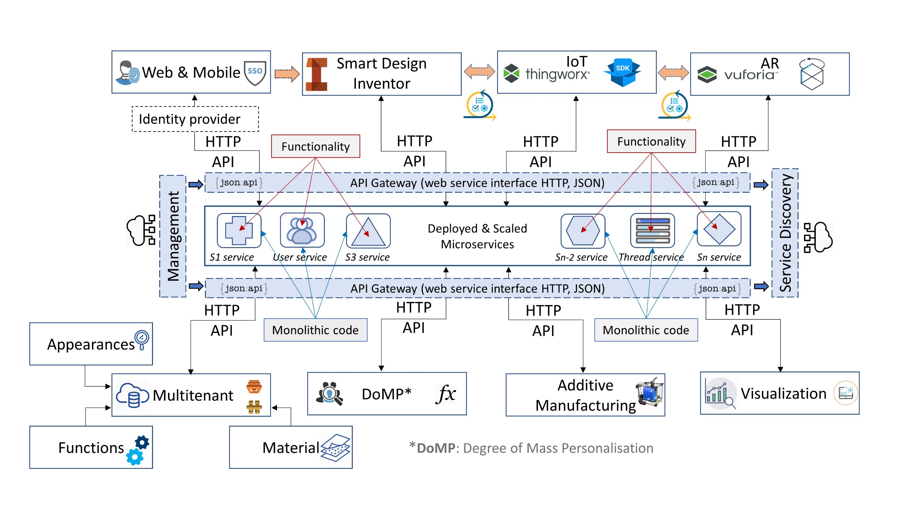
Smart systems require flexibility to respond quickly to continuous market changes, offer more personalised products, integrate the entire value chain, and increase operational efficiency. MPaaS uses a distributed capability that integrates communications, computation, and storage resources in real-time through microservices, a variant of the service-oriented architecture used by Uber, Netflix, and Etsy. Microservices refers to an architectural model in which complex applications are composed of small, independent processes using APIs communicating with each other. Microservices are a collection of highly maintainable services, independently deployable, owned by small teams and organised around business capabilities. Microservices architectures make personalisation easier to scale and faster to develop, enabling innovation and accelerating time-to-market for unique features.
By adopting microservices, providers can change any services, which leads to faster deployments. More importantly, each service’s performance can be tracked, and problems can be quickly isolated from running services. Utilising microservice architecture can shorten the time-to-market for personalised features, increase system resiliency, and make large, complex, and scalable personalisation as a service.
- Mass personalisation: A theoretical model
In this section, a model offers two prices for a personalised (100% personalised) product and a customised (partially personalised) product to the customers. For a particular product, there are multiple variants, and each variant has limited options. The customer will be asked to choose among the available options for different variants of a product and flag them as either a prioritised or a non-prioritised option. For example, for a particular product, two variants can be “colour” and “delivery” of the product. The former variant can have a few options such as “green, pink, black”, and the latter variant can offer “fast, medium, regular” as available options. For a customer, the colour of the product might be very important, and the desired colour is pink. Hence, the pink colour is flagged as a prioritised option by the customer, and the option for this variant is restricted to pink by the proposed model. However, the delivery time may not be as important as the colour of the product for the customer. Therefore, this customer chooses the fast option but flags the speedy delivery as a non-prioritised option.
If there are $n$ variants for a product $\begin{matrix}v_{1} & v_{2} & ⋯ & v_{n}\end{matrix}$, and $m$ providers $\begin{matrix}p_{1} & p_{2} & ⋯ & p_{m}\end{matrix}$, who can offer all the desired options of variants chosen by the customer, then the matrix ${Mat}_{1}(n×m)$, in which element $a_{ij}$ denotes the price for variant option $i$ offers by provider $j$ can be defined as follows,
${Mat}_{1}=\left[\begin{matrix}a_{11} & … & a_{1m} \\ ⋮ & ⋱ & ⋮ \\ a_{n1} & … & a_{nm}\end{matrix}\right]$. | (1)
Then the cost associated with the personalised (100% personalised) product offered by the $j^{th}$ provider can be found as,
$c_{j}=\sum_{i=1}^{n}{a_{ij}}$, | (2)
This results in $C_{j}$ collection that has $m×c_{j}$, $C_{j}=\left\{\begin{matrix}c_{1}, & c_{2}, & c_{3}, & ⋯, & c_{m}\end{matrix}\right\}$. $Min C_{j}$ will be the minimum price that the proposed model offers to the customer as a 100% personalised product.
However, a better price might be available for the customer by replacing the non-prioritised options with the cheapest available ones. For instance, if there are $m$ providers $\begin{matrix}p_{1} & p_{2} & ⋯ & p_{m}\end{matrix}$, who can offer $n_{p}$ the customer chose prioritised variants, then ${Mat}_{2}(n×m)$, can be defined as follows,
${Mat}_{2}=\left[\begin{matrix}b_{11} & … & b_{1m} \\ ⋮ & ⋱ & ⋮ \\ b_{n^{'}1} & … & b_{n^{'}m} \\ ⋮ & ⋱ & ⋮ \\ b_{n1} & … & b_{nm}\end{matrix}\right]$, | (3)
where the first $n^{'}=n-n_{p}$ elements of column $j$ represent the lowest price for non-prioritised variants offered by provider $j$. It should be noted that $b_{ij}$ denotes the price for option $i$ that can be offered by provider $j$. The elements of column $j$ from row $n^{'}+1$ to $n$ represent the cost of the prioritised variants offers by provider $j$. Then the cost associated with the customised (partially personalised) product offering by $j^{th}$ provider can be found by,
$${c^{'}}_{j}=\sum_{i=1}^{n}{b_{ij}},$$ | (4)
This results in ${C^{'}}_{j}$ collection that has $m×{c^{'}}_{j}$, ${C^{'}}_{j}=\left\{\begin{matrix}{c^{'}}_{1}, & {c^{'}}_{2}, & {c^{'}}_{3}, & ⋯, & {c^{'}}_{m}\end{matrix}\right\}$. $Min {C^{'}}_{j}$ will be the price that the proposed model offers to the customer for their customised (partially personalised) product. It is worth mentioning that both $a_{ij}$ and $b_{ij}$ are the prices that can be offered to the customer and are not the manufacturing costs.
Therefore, the proposed model offers two prices to the customer, $Min C_{j}$ and $Min {C^{'}}_{j}$, which are the 100% personalised product price and the lowest price for partially personalised product, respectively. Table 3 presents an example for a personalised and a customised product offers by the proposed model based on the customer’s priorities. The priority column shows customer’s preferences in a binary mode, where 0 and 1 denote non prioritised and prioritised variants chosen by the customer, respectively. Summation of the prices listed in the last two columns of the table is the system’s two total prices to select. The higher price is for the personalised product, and the lower price is for the customised products.
Table 2 An example of two prices offered by the system
Variant | Customer’s preference | Priority | Alternative options suggested by the system | Min price offered by j^{th} provider in Mat₁ | Min price offered by j^{th} provider in Mat₂
Material | TPU | 1 | TPU | $$ | $$
Colour | Pink | 0 | Black | $$ | $
Sensors | PPM | 1 | PPM | $$ | $$
Delivery | Fast | 0 | Medium | $$ | $
- Advantages and limitations of MPaaS
There is a strong indication that personalisation and service-oriented business model is a match made. Every interaction over the Internet can be stored, analysed, and driven a timely, relevant, and tailored experience. A significant value proposition of MPaaS is eliminating unwanted features instead proceed with unique features to make. Besides, it can be a subscription-based service with no single point of failure. Therefore, the proposed MPasS can delight individuals for the advantages of Industry 4.0 technologies (listed in Table 2) and for the make-to-order approach, resulting in saving time, cost, effort, and higher sustainability [73,74].
The leading product personalisation companies are more focused on personalising product design than an eco-system to support affordable personalisation. The proposed MPaaS is empowered by a sophisticated architecture and a suitable business model under Industry 4.0 umbrella. It has great potential to get the best out of design and manufacturing resources over the Internet. It can advance affordable and precise personalisation for a wide range of applications and industries that facilitate providers to offer cost-effective personalisation at scale.
The proposed MPaaS has some limitations inherited from Industry 4.0 technologies. For instance, IoT’s main concerns are the breach of data privacy and over-reliance on technology. Similarly, the security risks of Cloud-based solutions have become the top concern in service-oriented businesses. While Blockchain offers scalable security, Blockchain faces compliance and lack of expertise challenges. Besides, 3D printing and AR are the other two primary Industry 4.0 technologies with significant value for mass personalisation. The former has several constraints: slow production, high post-processing effort, limited printing size, and material. Some other limitations are associated with the latter, such as hardware issues and expensive devices. Even though there are different limitations, it is clear that utilising Industry 4.0 is a trend that grows.
Moreover, a practical challenge remains to establish a consortium as an authority in personalisation, joining academia, government, and industry to develop required technical and manufacturing standards.
- A practical application
The number of confirmed COVID-19 cases has already passed 270 million worldwide while writing this paper. The pandemic not only has threatened individuals’ lives but also has increased bankruptcy dramatically. Business owners and their employees need to ensure wellbeing with the highest productivity during these unprecedented times. As such, this study decided to take advantage of MPaaS to assist in bringing the pandemic under control by providing suitable facial masks at scale.
4.1 Problem Statement
Workers in essential businesses, such as frontline healthcare and factories, who are wearing single size generic masks are exposed to two main issues:

- The fitting of masks is a severe problem since everyone has a different face shape and size. Therefore, the constant exposure to Covid-19 makes it crucial to ensure that the mask has a good fit based on the Occupational Safety and Health Administration Act, which enforces health, safety, and environmental standards.
- Pressure-related ulcers due to prolonged use of unappropriated off-the-shelf masks is another problem that can be addressed by personalisation.

The World Health Organization (WHO) reported that, due to the Covide-19 pandemic, the demand and price for face masks surged, respectively. There is a need to develop a solution to address the high cost, demand, and sealing and fitting challenges associated with off-the-shelf masks. Table 4 lists the main challenges and consequences related to off-the-shelf face masks. In addition to the personalised face mask for front liners, the Bacteria Filtration Efficiency (BFE) is a severe issue for everyone since COVID-19. Therefore, fit and filtration are crucial [75].
Off-the-shelf masks must close tightly to ensure protection. With frontline healthcare workers wearing face masks during the day, most are experiencing uncomfortable skin damage and some ulcers with pain, increasing the risk of infections and leaving scars. Besides, if a person is a glasses wearer, most probably will face glasses fogging up when wearing a conventional face mask. Continually wiping glasses throughout the day is uncomfortable, but it will increase the risk of infections. However, the major challenge in off-the-shelf face masks is a weak seal around the nose and mouth, which can cause germ leakage. Last but not least, plain face masks are missing valuable personal data and advanced features.

Table 3 The significant off-the-shelf face mask challenges
Challenge | Cause
Fitting | Pain and ulcers
Fog | Vision problem for glasses wearers
Sealing | Germs leakage to/from the environment
Not connected | No data to add extra value

Several attempts have already been made to offer valuable specifications, as shown in Table 5. However, the ultimate goal is to make the most out of all specs for providing the most suitable personalised masks. There are facial masks with a feature to adjust, but they are not convenient as they are not made for individuals. Healthcare PPE provider market leaders claim that they offer sealed, comfortable, and easy to use masks, but the masks are limited to a few sizes (Small, Medium, and Large) for individuals [76]. This constraint results in poorly fitted masks with gaps from which germs can pass. Therefore, there is a vital need to address the ineffective adjustable feature in masks.
4.2 Resolution
During the Covid-19 pandemic, factories with on-site workers cannot be operated if workers and the environment are not safe. The MPaaS platform offers both personalised masks and personalised services. The former is the most fitted and sealed mask for meeting individuals’ size, shape, and desired material. Therefore, transforming ordinary into a bespoke mask since retrofitting results in a satisfactory and sustainable mask. A suitable personalised mask allows significant risk reduction, which can bring a factory back to operation.
This case study shows that achieving a high DoMP is challenging due to extremely different face shapes, sizes, materials, and costs associated with a final personalised mask. Besides, it can provide real-time feedback about the performance. This is a complicated scenario where personalisation is demanded with scalability and affordability together. The proposed architecture offers a multitenant profile consist of desire functionality, e.g., smartness, shape, size, material, and acceptable price based on the proposed mathematical model. The three main modules, including smart design, IoT, and AR, along with DoMP, assist a customer in making a trade-off between cost and product. In contrast, a highly personalised design can be achieved by converting a 3D scan to a 3D model using Web & Mobile and Smart Design modules in Figure 3 proposed MPaaS architecture as a set of converged service components. Also, MPaaS converges AM, Cloud and IoT to make a CMfg in practice.
Besides, MPaaS can offer a data-oriented service by using IoT, Big Data, edge computing, and smart sensors to collect and analyse the data while a mask is used. Most masks in the market are not IoT-enabled to get the best out of the data. An IoT-enabled personalised mask can provide awareness, warnings, and recommendations such as unsafe environment alerts and filter replacement, respectively. On the other hand, any trend resulting from IoT-enabled masks in a factory can provide information, knowledge, and wisdom to predict and plan better management.

Table 4 The main off-the-shelf face mask models
Spec | Description | Design
OSFM | One-size-fits-most to order easier in a batch. | 
Centre-Joint | Adds an angle that curves nicely to the face for comfort. | 
Pleated | To create a looser fit but add in a two-layer filter. | 
Plane | The low-cost mask without sewing. | 
Neck Gaiters | It can wear around the neck when not in use. | 
Ear Ribbon | The strap creates adjustability for a wide fit range. | 
Multi Sizes | Limited to small, medium, and large sizes fitting. | 
Layered | 3-layer pattern endorsed by WHO for achieving breathability & filtration. | 
Ear protector | To reduce ear tension from prolonged mask-wearing. | 
While people use regular facial masks every day, frontline workers in different industries, including healthcare, mining, manufacturing, and laboratories, need careful consideration, particularly for three main reasons:
- Ensure a seal and fit mask that can be last long without uncomfortable skin damage and some ulcers with pain.
- An IoT-enabled facial mask can control moisture and expel heat from the mask using oxy-breathe ventilators, which reduces the risk of infection due to the continuous wearing of a mask.
- Powering the business by valuable knowledge, such as pattern analysis and provide instant information to individuals.
MPaaS can also offer factories to manage operations cost-efficiently by selecting a subscription fee or pay-as-you-go for the IoT-enabled personalised mask. The MPaaS helps factories make the best possible decision using the return of investment value calculator system based on working hours and the number of employees who use masks.
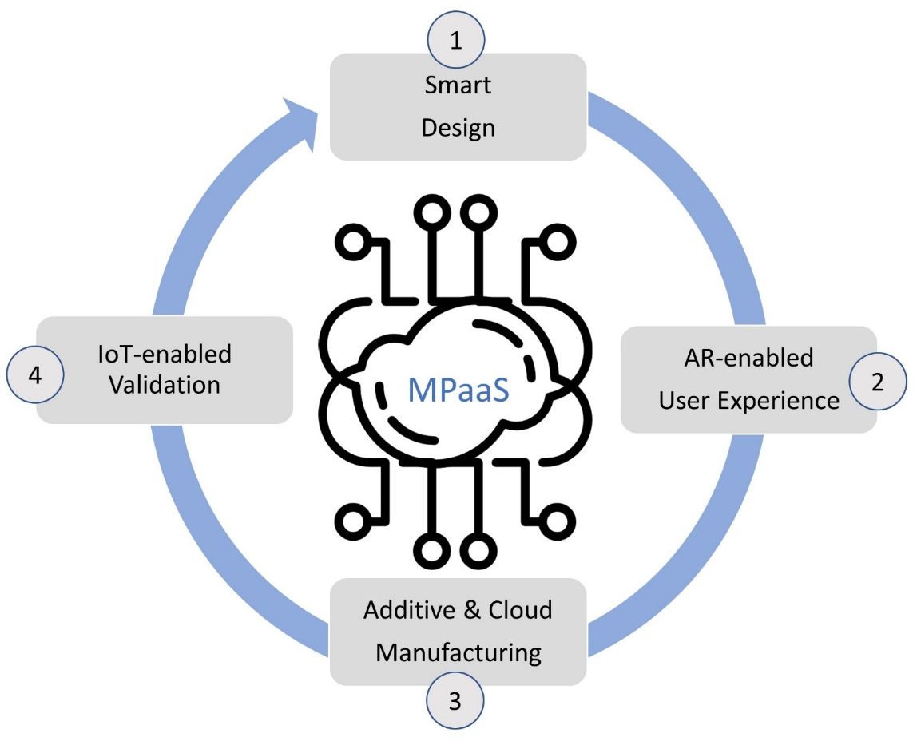
Figure 4 shows an overview of the four key services in the proposed MPaaS. The first service is a smart design that captures a person’s face to adapt dimensions and make sure the mask will be well fitted to the face. The second service provides an augmented user experience, which helps the person visualise a mask’s design from different angles. AM and CMfg optimisation is the third leading service, which plays a key role in matching the most suitable 3D printing farm and related manufacturing capabilities. The fourth step provides a premium IoT-enabled mask where both data-oriented features bring significant value to validate wanted performance.
Figure 4 An overview of end-to-end MPaaS
4.3 Business Process
For customers, mass personalisation means unique products and services, while for providers, it means the possibility to establish lasting relationships with customers by added outstanding value to customers. However, mass personalisation is challenging for manufacturers to adapt to, primarily because of production and business process challenges. Severe business and manufacturing challenges, including smart design, resource utilisation, and validation, transform off-the-shelf masks into personalised masks on a global scale.
4.3.1 Workflow

MPaaS empowers industries using their products to offer personalisation as a service rather than a one-off sale. MPaaS provisions all required services to provide sealed and fitted masks at scale. Figure 5 shows a flowchart of separate sequential order steps, including five direct inputs using UI, building an AR according to a facial 3D scan service, online payment service, manufacturing service by selected AM farm, and finally, shipment service.
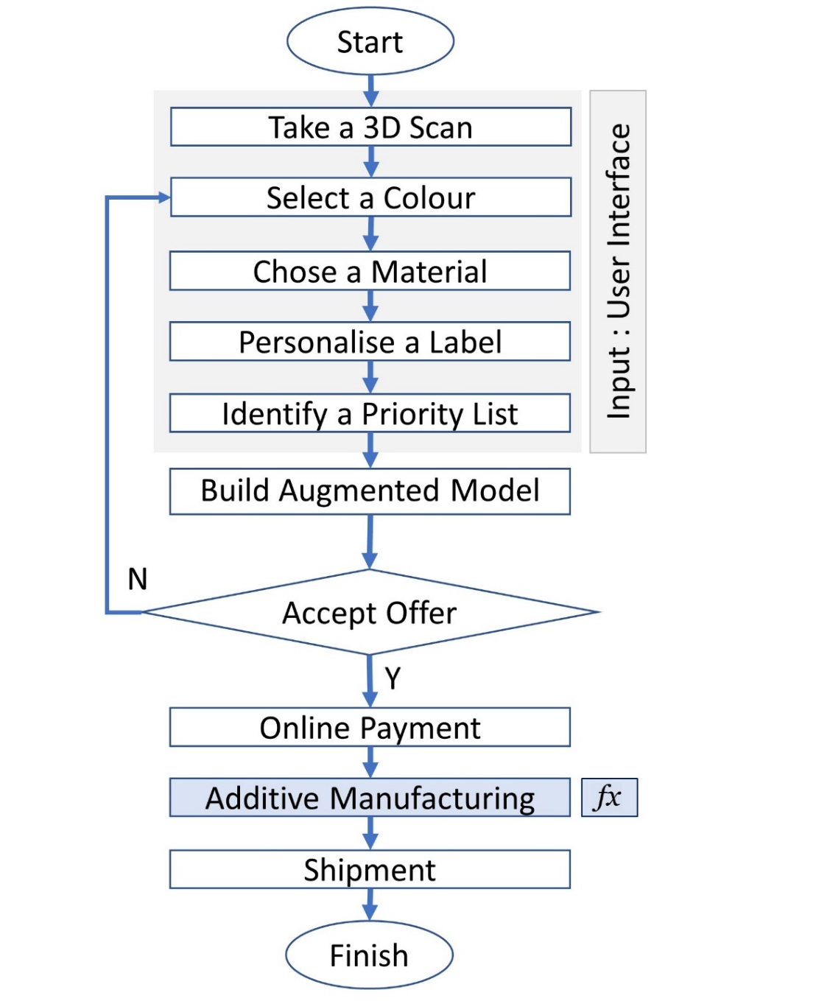
Figure 5 Flowchart of the proposed MPaaS
For the most suitable facial mask to protect an individual, this flowchart starts with a facial 3D scan following preference selection, including colour, material, and label, along with a priority list. Upon individuals’ requirements, an offer from a suitable provider will be accepted or rejected. The former leads to online payment, manufacturing, and finally shipment. The latter helps an individual to make changes until achieving satisfaction.
4.3.2 Sequence Diagram
To clarify the process and show time-based interaction, a sequence diagram is essential. Figure 6 shows a sequence diagram to illustrate use-case realisations and to show how objects interact to perform the behaviour of individuals, third-party providers, and the MPaaS platform across the process.
Customers need to sign in/up to the web-based system for privacy before starting the process (Step 1). Visual instruction for a 3D scan process by a smartphone or tablet is provided (Step 2). The 3D model of the customer’s face (not the actual images) passes to the MPaaS platform (Step 3). The customer can then select the colour, material, and priority options, such as delivery time, affordability, and quality, before sending the data to the MPaaS (Step 4). A query is sent to the manufacturing resource pool for a resource availability check based on the customer’s requirements (Step 5).
Consequently, the manufacturing resource pool replies to share the latest availability (resources and capabilities) to the MPaaS platform (Step 6). Then preferred and available options are sent to the web-based application (Step 7), where a Digital Twin of the desired mask with a quotation as a package is given to the customer (Step 8). Then the customer can either reject or accept the package. A rejection brings the customer back to Step 3 while accepting the package triggers the MPaaS platform (Step 9). A query is sent to the manufacturing resource pool (Step 10), where demand is sent to the provider of 3D
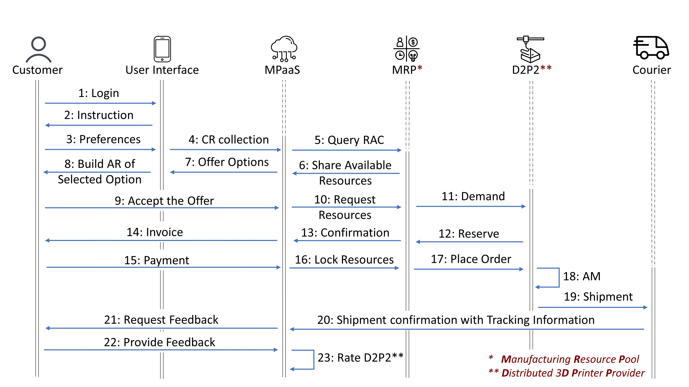
Figure 6 Sequence diagram of the proposed Mass Personalisation as a Service (MPaaS)

printers based on the Cloud-based dynamic ranking system (Step 11). The selected 3D printer provider reserves required resources (Step 12), and the manufacturing resource pool sends a confirmation to the MPaaS platform (Step 13).
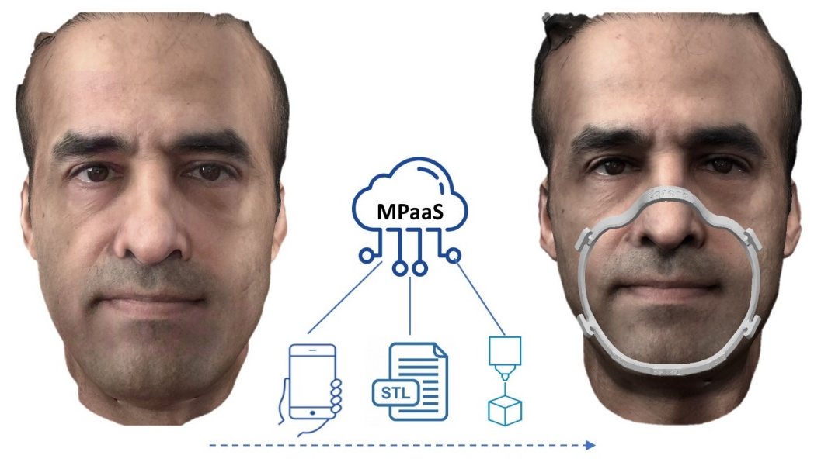
The entire process is Blockchain-enabled to make sure 3D scan, manufacturing, and financial information are encrypted and secured with the highest transparency. An invoice is provided by the MPaaS platform to the customer (Step 14) and can be paid through an online payment gateway (Step 15). After processing the payment, the required resources in the manufacturing resource pool will be allocated to the customer’s task (Step 16), and the task will be assigned to the 3D printer provider (Step 17). A personalised mask is manufactured by the 3D printer provider (Step 18).
Although at this step, the product is ready for shipment by the 3D printer provider, to preserve customer’s privacy, all addresses are kept in MPaaS, which is responsible for requesting a courier service provider to pick the personalised mask and deliver it to the customer with an associated tracking number (Step 19). A feedback process will be in place if a customer asks for an ordinary personalised mask or an IoT-enabled one (Step 20). Feedback will be likely provided to the MPaaS (Step 21). Finally, information is used to analyse and update the Cloud-based dynamic ranking system in the MPaaS platform (Step 22) for improvements, predictions, and optimisations.
4.4 Smart Unique Design
Individuals have different face sizes and shape, which lead to producing a unique CAD file. Figure 7 shows building a realistic 3D model of a person’s face (frontal scan of 180 degrees angle of view of the head) by using Apple’s TrueDepth camera technology and consequently generating a unique CAD file for a personalised facial mask design. We use a licensed SDK for iOS Developer Program to achieve a high-resolution 3D scan using the TrueDepth Camera integrated within the iPhone X product family and the late 2018 models of the iPad Pro. The resulting texture quality depends on the camera’s capabilities. We have utilised smartphone capabilities for 3D scanning, AI-enabled computer vision, and 3D printing to offer affordable and personalised mask. Nevertheless, a cloud API using credentials and Software Development Kit provides the ability to export model data to the proposed MPaaS platform.
Figure 7 Smart, personalised facial mask design in MPaaS
Based on an individual’s choice, a pre-defined off-the-shelf mask will be considered. Then MPaaS fill the gap between the individual CAD file of the person’s face and the generic CAD file of an off-the-shelf mask. As a result, MPaaS passes the personalised Standard Tessellation Language (STL) file to a selected 3D printer provider seamlessly. This service has been developed for mass personalisation and integrated into the MPaaS platform to provide smart design regardless of the number of individuals, time, and location. Figure 8 shows how a retrofit was developed to meet the highest possible seal for an individual.
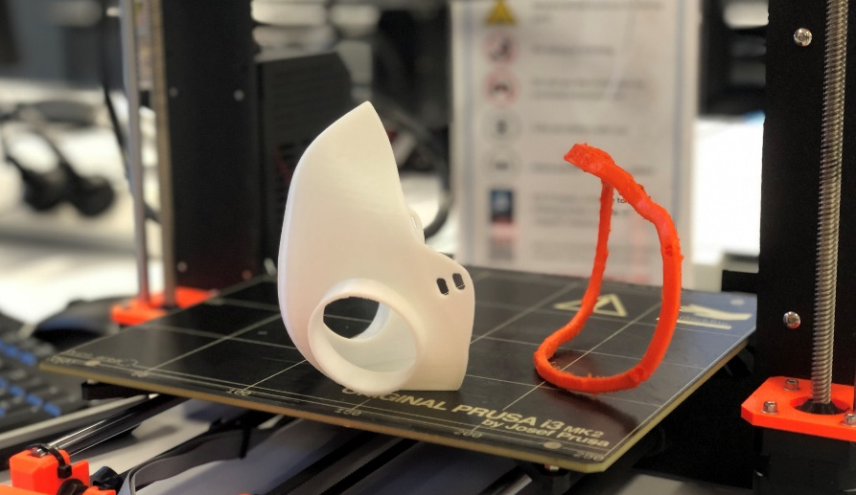
Figure 8 Retrofit design in MPaaS
4.5 Distributed 3D Printing Farms
In light of the COVID-19 pandemic, a global shortage of manufacturing resources and closed operations made rapid design and manufacturing necessary. MPaaS uses CMfg and AM technologies to get the best out of distributed 3D printing farms. Figure 9 shows different types of 3D printers available in the Multi-Disciplinary Learning Spaces at the University of Auckland, including Stereolithography 3D printer for elastic, flexible, and rigid materials Figure 9 (a), large size 3D printers for an instantaneous print of multiple of-the-shelf masks Figure 9 (b), multicolour Flexi and PLA filaments for flexible and rigid materials Figure 9 (c) 3D printers capable of printing tissue friendly TPU material and multicoloured printing Figure 9 (d). Subsection 3.4 proposed a mathematical model for optimal personalisation, which results in selecting the most appropriate manufacturing resources consisting of 3D printers, material, engineering capabilities, availability and affordability. MPaaS provide two options:
- Printing a personalised mask from scratch based on the STL file of the 3D-scanned model.
- Printing a retrofit to match an off-the-shelf mask according to a person’s face and selected mask.
For this experiment, three different available AM farms have been considered, which MPaaS will consider as a distributed AM pool for optimisation. Figure 10 shows a 3D-printed face mask with Polylactic Acid (PLA) filament from a smart and personalised design STL file. While there are several available 3D printers in Auckland, one of the 3D printing farms at the Multi-Disciplinary Learning Spaces was projected to print personalised masks for some staff and students at the University of Auckland based on the proposed mathematical personalisation model.
4.6 Validation - IoT-enabled smart mask
Transforming off-the-shelf to personalised masks or printing a new personalised mask for frontline workers dealing with the Covid-19 pandemic needs careful validation. Printed masks can become IoT-enabled with an extra cost due to the embedded smart sensor and data-oriented services.
The personalised mask keeps a user from suffering exposure to infectious particles from the environment or an infected person. The leak and comfort depend on the mask’s personalised fit, which must be independently verified as individuals have different faces and require unique masks’ shapes. Figure 11 shows an IoT-enabled personalised mask with real-time data overlayed on a web-based and mobile interface to connect the application with the theoretical and mathematical framework.
An embedded sensor in the personalised facial mask is connected to the ThingWorx, an IoT platform that reflects the performance using Unity, OpenCV, and Vuforia, an AR software development kit. To model a real-life facial mask, a ThingShape called Mask was created in ThingWorx for reflecting desires in personalised masks. Mask can have properties, including colour (number), size (number), material (number), and delivery time to achieve the most suitable personalised mask based on the proposed flowchart in Figure 5 and the sequence diagram in Figure 6.
(a) | 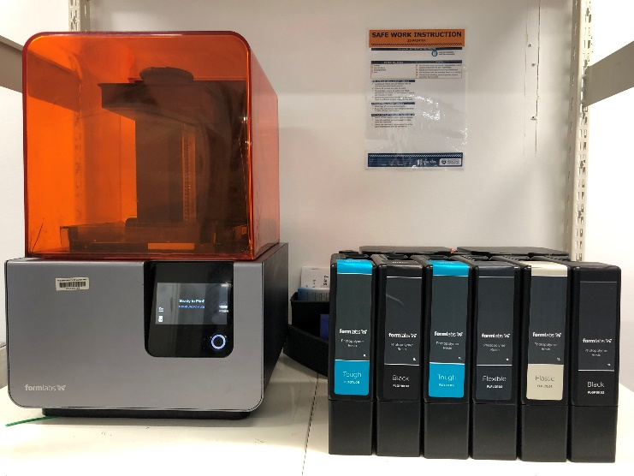
(b) | 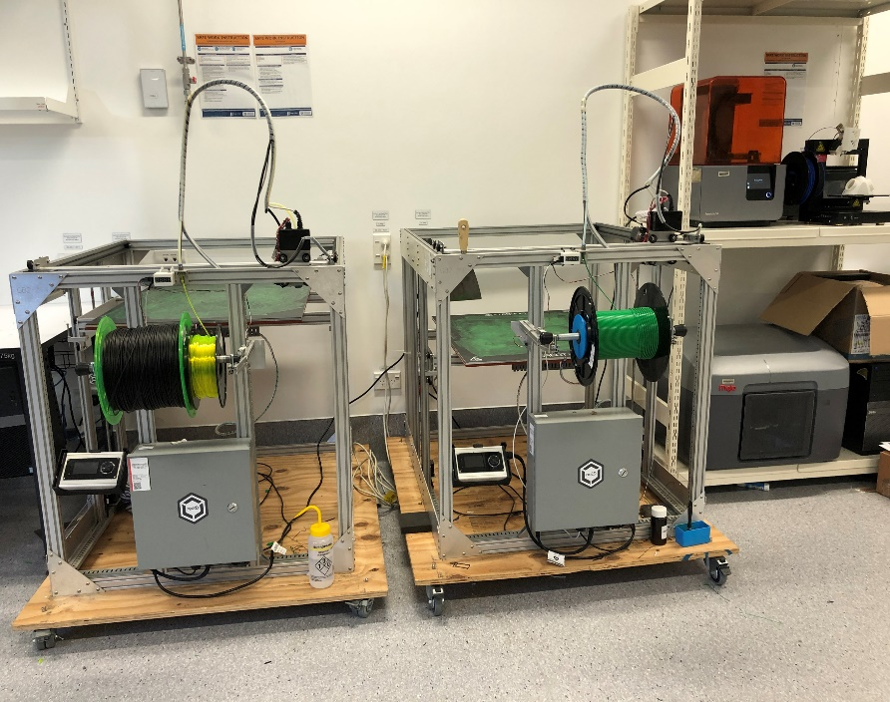
(c) | 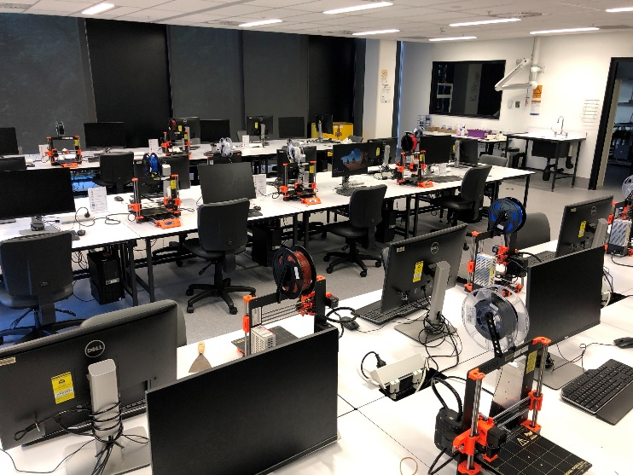
(d) | 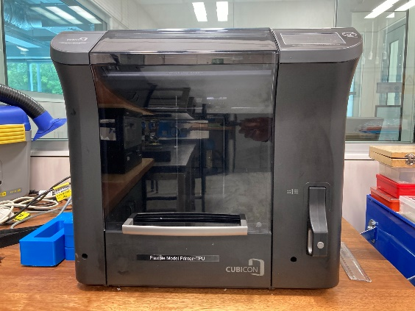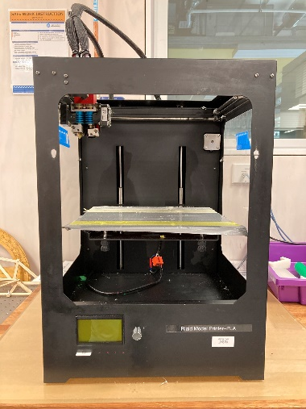
Figure 9 A pool of 3D printers with different capabilities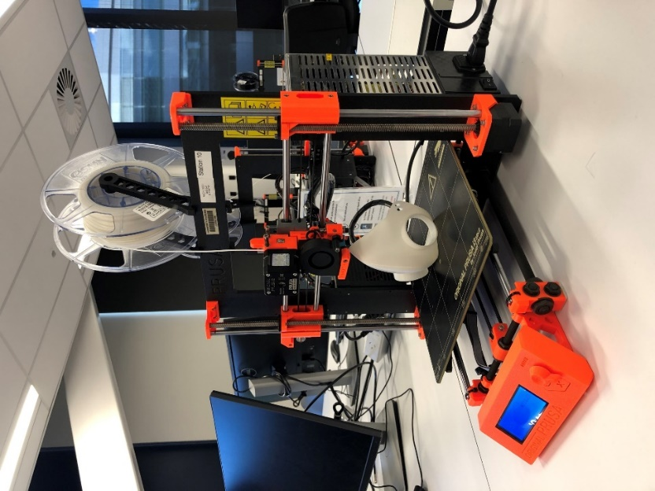
Figure 10 A personalised mask with PLA filament
4.7 MPaaS performance in digital transformation
The proposed MPaaS can deliver extraordinary customer experiences through an end-to-end seamless process, fact-based decision making, resource utilisation, and a service-oriented digital transformation. While affordable personalisation will be more feasible than ever, building a resilient and more competent service-oriented model is required. When industry and society face uncertainty, mass personalisation is needed like never before. The most resilient is a built-for-change architecture that aligns around data-driven and customer-oriented decision making. Therefore, the proposed MPaaS can be adopted to create and scale an affordable new product quickly.

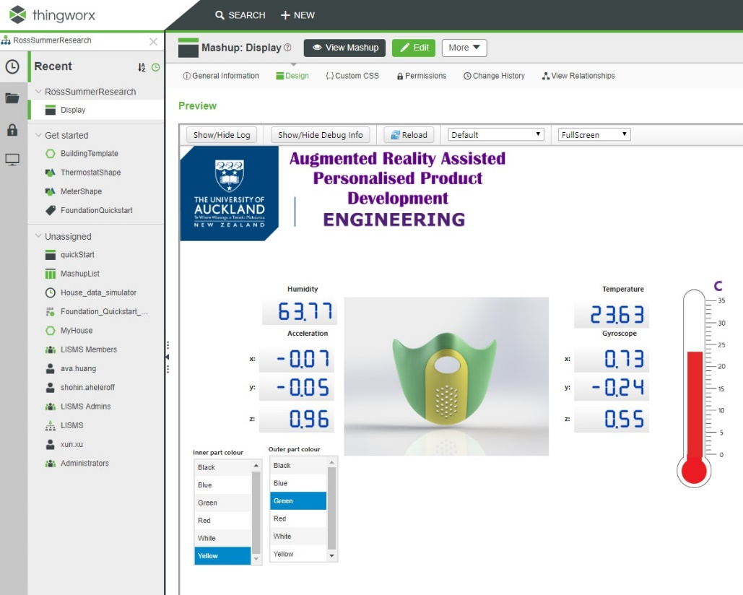
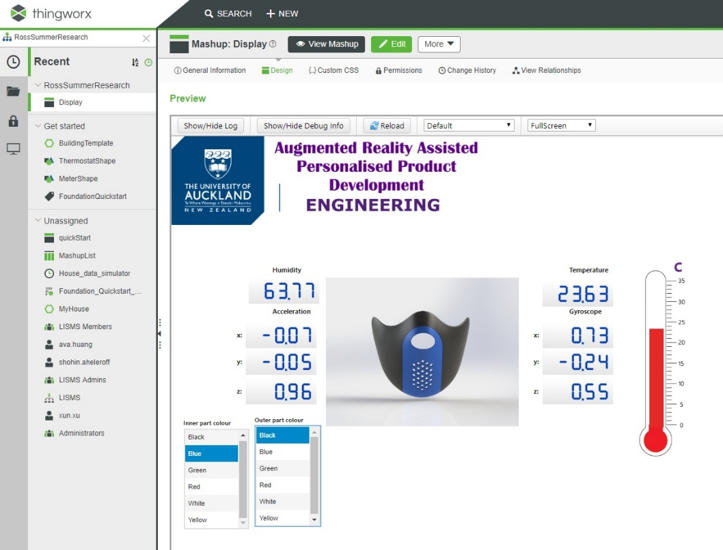
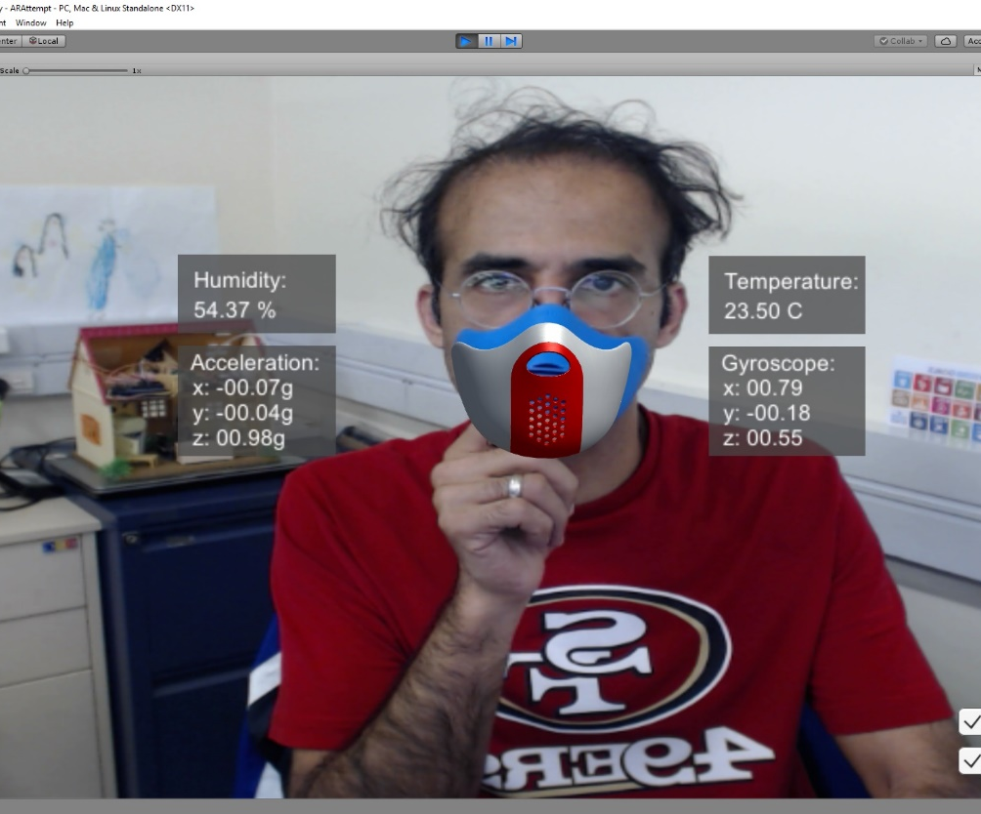
Figure 11 An IoT-enabled 3D-printed personalised face mask
5. Discussion
Although personalisation and individual Industry 4.0 technologies such as AM, AR, Digital Twin, IoT, and CMfg concepts have already been studied, the novelty of this study is a seamless integration of crucial Industry 4.0 technologies with the value proposition of each cutting-edge technology, which offers mass personalisation as a service. In other words, the originality of this work is beyond personalisation in a particular industry or a specific application because this study offers a novel eco-system for mass personalisation instead of costly personalisation.
The literature shows most personalisation studies are made for a purpose. Consequently, any changes beyond the scope can significantly cause risk and impact, including extra time, cost, resources, and effort. In comparison, the proposed MPaaS supports resilience to make rapid changes due to the nature of personalisation. Providing suitable capabilities and help to make a high DoMP in an iterative and incremental process makes MPaaS a proactive approach for resilience in the manufacturing industry.
Unlike most technology-oriented studies, the proposed MPaaS paradigm stands out from the crowd due to the novel service-oriented approach with the value of crucial Industry 4.0 technologies, resource utilisation, and sustainability.
Like any other technology and engineering initiative, MPaaS requires industry players’ support to contribute to standardisation and further commercialisation. Therefore, a collaboration between industry and academia can significantly change mass customisation to mass personalisation under Industry 4.0 umbrella.
Personalisation is an established, time-consuming, and costly process with several case studies since craft manufacturing. There are several attempts in different industries where individualisation or personalisation at scale have been targeted. However, mass personalisation is an emerging paradigm with rare industrial-led case studies. Although some research has been carried out on personalisation, no single study exists about mass personalisation as a service with an empirical investigation that can be extended to other highly demanded personalised products, such as airphone hearing aid, insole heel, orthopaedic bunion corrector, back and neck brace.
Although flexible production lines provide an opportunity to move beyond mass production, fast-growing AM can make an economic revolution in personalisation. Flexible and optimised production lines add significant value to mass customisation [77], which may not be sufficient for efficient and effective mass personalisation. Critical Industry 4.0 technologies, including Big Data, CMfg, Digital Twin, and IoT with 3D print farms, suits scalable personalisation through a service-oriented approach.
Mass personalisation considers a complex paradigm due to using different Industry 4.0 technologies. Such complexity requires a wide range of resources and vast capabilities to be discovered rather than approaching a single technology. Therefore, it is challenging how to merge required capabilities to create unique value for individuals. Several studies focused on the eco-system and adopted a social exchange perspective to address this challenge. Rong et al. [78] investigated how IoT could lead to a co-evolving business eco-system within a 6C framework and identified three patterns. Reynolds et al. [79] studied the pathways and opportunities for fostering innovation capacity to support the importance of manufacturing. The proposed MPaaS offers a service-oriented eco-system to get the best out of Industry 4.0 technologies and capabilities for mass personalisation as one of the most complicated paradigms.
6. Conclusions and Future Works
Industry 4.0 is the foundation of a successful shift to the mass personalisation era economy. MPaaS powers the market and a great deal of the services to continue functioning economically and socially with higher customer satisfaction worldwide. This study offers a service-oriented mass personalisation to meet individual’s needs by utilising Industry 4.0 technologies and capabilities, eliminating unnecessary features, and cutting the extra retail cost, including keeping in a warehouse, shipping, and managing inventory. However, personalisation at scale faces three significant challenges, including technologies, processes, and architecture. This study’s novelty is MPaaS with the competence to meet adaptive, resilient, and scalable personalisation to address these challenges.
Covid-19 as a pandemic has increased the need for sealed and fit facial masks globally, which is a severe challenge for employees in different industries, frontline healthcare workers, and individuals. To the best of the authors’ knowledge, this is the first study investigating a significant application of mass personalisation to provide sealed and fit facial masks globally, which is a severe challenge for frontline healthcare workers and individuals since the Covid-19 pandemic.
The proposed MPaaS adds value to combat off-the-shelf product challenges. Similarly, the application of the proposed MPaaS can be extended to manufacture other personalised products at scale, including but not limited to shields, shoes, and safety goggles. MPaaS offers perspectives on personalisation at scale, which has become a core capability for marketers striving for rapid changes, growth, efficiency, higher customer satisfaction. Personalisation leaders have found proven ways to drive considerable increases in revenue.
Next-generation companies will focus on their products and not worry about on-demand manufacturing, supply chain, and personalisation development. Therefore, a significant shift will make personalisation more personal, using IoT-enabled systems. Mass personalisation is crucial in delivering unique experiences to the consumer and value to the business in a wide range of industries by orchestrating data, decisions, design, make and distribution.
The proposed MPaaS offers a scalable architecture with seamless communications to address main challenges, including resource utilisation, system configuration changes, inflexible manufacturing automation, and agile production independent of a unique product, service, and application. While this study demonstrates a personalised facial mask, MPaaS can be adopted in automotive, agriculture, renewable energy, smart city, home appliances, furniture, telco, wearable devices, and healthcare industries.
The present study extends the application of Industry 4.0, which will serve as a base for future studies and development in mass personalisation. Furthermore, it can give new capabilities without extra effort to scale the manufacturing within the same integrated environment. Finally, some limitations need to be considered. First, the lack of an industry standard to develop APIs for MPaaS. Second, the absence of a wide range of 3D printers and filaments to implement the proposed MPaaS in an extended experiment. Third, using MPaaS for other PPEs and products with strict regulations. Therefore, the findings of this study need to be interpreted cautiously concerning professional bodies, trade associations, and international standardisation.
Bringing digitisation from individuals to the product, MPaaS amplifies the use and benefits of all Industry 4.0 technologies. Relying on AM technology allows for flexible production lines since 3D printers can use a wide range of materials to make various products. However, intrinsic limitations associated with 3D printers restrict the current study, which can be addressed by integrating more manufacturing technologies, such as laser cutters, into the proposed MPaaS, for manufacturing other products apart from healthcare products, such as face masks, in our future research.
Last but not least, Industry 4.0 moves towards the fifth industrial revolution (Industry 5.0), and the workforce will be upskilled to provide value-added tasks in production, leading to mass personalisation for individuals. The new concept of Industry 5.0 could not come at a better time as it complements the existing Industry 4.0 approach. Transfer to Industry 5.0 enables further tailor-made for the individuals. Therefore, new mass personalisation related studies are expected to demonstrate links between the industrial transition beyond mass production for profit towards a sustainable, human-centric and resilient global industry. Therefore, building a more sustainable and resilient economy is highly demanded to bring prosperity to society.
Acknowledgments
The authors would like to thank the Laboratory for Industry 4.0 Smart Manufacturing Systems and Multi-Disciplinary Learning Spaces at the University of Auckland for their support.
Nomenclature
AM | Additive Manufacturing
API | Application Programming Interface
AR | Augmented Reality
BIM | Building Information Modeling
CAD | Computer Aided Design
CAM | Computer Aided Manufacturing
CMfg | Cloud Manufacturing
CPS | Cyber-Physical System
D2P2 | Distributed 3D Printer Provider
DaaS  DoMP | Data as a Service  Degree of Mass Personalisation
IaaS  IoT | Infrastructure as a Service  Internet of Things
UI. | User Interface
MDLS | Multi-Disciplinary Learning Spaces
MPaaS | Mass Personalisation as a Service
MRP | Manufacturing Resource Pool
OSFM | One Size Fits Most
PaaS  PLA | Platform as a Service  Polylactic Acid
PPE | Personal Protective Equipment
PPM | Parts Per Million
SaaS  STL | Software as a Service  Standard Tessellation Language
TPU | Thermoplastic polyurethane
WHO | World Health Organization
References
[1] Mourtzis, D., Fotia, S., Boli, N., and Vlachou, E., 2018, “An Approach for the Modelling and Quantification of PSS Customisation,” International Journal of Production Research, 56(3), pp. 1137–1153.
[2] Rosin, F., Forget, P., Lamouri, S., and Pellerin, R., 2020, “Impacts of Industry 4.0 Technologies on Lean Principles,” International Journal of Production Research, 58(6), pp. 1644–1661.
[3] Zheng, T., Ardolino, M., Bacchetti, A., and Perona, M., 2020, “The Applications of Industry 4.0 Technologies in Manufacturing Context: A Systematic Literature Review,” International Journal of Production Research.
[4] Bittencourt, V. L., Alves, A. C., and Leão, C. P., 2020, “Industry 4.0 Triggered by Lean Thinking: Insights from a Systematic Literature Review,” International Journal of Production Research.
[5] Xu, L. da, Xu, E. L., and Li, L., 2018, “Industry 4.0: State of the Art and Future Trends,” International Journal of Production Research, 56(8), pp. 2941–2962.
[6] Guo, D., Zhong, R. Y., Ling, S., Rong, Y., and Huang, G. Q., 2020, “A Roadmap for Assembly 4.0: Self-Configuration of Fixed-Position Assembly Islands under Graduation Intelligent Manufacturing System,” International Journal of Production Research, 58(15).
[7] Namdar, J., Torabi, S. A., Sahebjamnia, N., and Nilkanth Pradhan, N., 2020, “Business Continuity-Inspired Resilient Supply Chain Network Design,” International Journal of Production Research.
[8] Mourtzis, D., Doukas, M., Lalas, C., and Papakostas, N., 2015, “Cloud-Based Integrated Shop-Floor Planning and Control of Manufacturing Operations for Mass Customisation,” Procedia CIRP, pp. 9–16.
[9] Delloite, 2019, “The Deloitte Consumer REview: Made-to-Order: The Rise of Mass Personalisation Contents,” Deloitte Development LLC.
[10] Aheleroff, S., Zhong, R. Y., and Xu, X., 2018, “IoT-Enabled Personalisation for Smart Products and Services in the Context of Industry 4.0,” Proceedings of International Conference on Computers and Industrial Engineering, CIE, Dr.M. Dessouky, ed., Computers and Industrial Engineering, Auckland, p. 20p.
[11] Aheleroff, S., Xu, X., Lu, Y., Aristizabal, M., Pablo Velásquez, J., Joa, B., and Valencia, Y., 2020, “IoT-Enabled Smart Appliances under Industry 4.0: A Case Study,” Advanced Engineering Informatics, 43, p. 101043.
[12] Aheleroff, S., Philip, R., Zhong, R. Y., and Xu, X., 2019, “The Degree of Mass Personalisation under Industry 4.0,” Procedia CIRP, 81, pp. 1394–1399.
[13] McKinsey & Company, 2020, Perspectives on Personalisation @ Scale.
[14] Gu, X., and Koren, Y., 2018, “Manufacturing System Architecture for Cost-Effective Mass-Individualization,” Manufacturing Letters, 16.
[15] Ogunsakin, R., Marin, C. A., and Mehandjiev, N., 2021, “Towards Engineering Manufacturing Systems for Mass Personalisation: A Stigmergic Approach,” International Journal of Computer Integrated Manufacturing, 34(4).
[16] Uduwela, W. C., de Silva, R. K. J., and Rupasinghe, T. D., 2020, “Digital Transformations in the Apparel Value Chain for Mass Personalization,” IEEE International Conference on Industrial Engineering and Engineering Management.
[17] Wang, Y., Ma, H. S., Yang, J. H., and Wang, K. S., 2017, “Industry 4.0: A Way from Mass Customization to Mass Personalization Production,” Advances in Manufacturing, 5(4), pp. 311–320.
[18] Rossit, D. A., Tohmé, F., and Frutos, M., 2019, “Industry 4.0: Smart Scheduling,” International Journal of Production Research, 57(12), pp. 3802–3813.
[19] Zhong, R. Y., Xu, X., and Aheleroff, S., 2017, “Smart Manufacturing Systems for Industry 4.0: A Conceptual Framework,” Proceedings of International Conference on Computers and Industrial Engineering, CIE, Lisbon, pp. 10–31.
[20] Sahal, R., Breslin, J. G., and Ali, M. I., 2020, “Big Data and Stream Processing Platforms for Industry 4.0 Requirements Mapping for a Predictive Maintenance Use Case,” Journal of Manufacturing Systems, 54, pp. 138–151.
[21] Zhong, R. Y., Xu, X., Klotz, E., and Newman, S. T., 2017, “Intelligent Manufacturing in the Context of Industry 4.0: A Review,” Engineering, 3(5), pp. 616–630.
[22] Thekinen, J., and Panchal, J. H., 2017, “Resource Allocation in Cloud-Based Design and Manufacturing: A Mechanism Design Approach,” Journal of Manufacturing Systems, 43.
[23] Wang, Y., Lin, Y., Zhong, R. Y., and Xu, X., 2019, “IoT-Enabled Cloud-Based Additive Manufacturing Platform to Support Rapid Product Development,” International Journal of Production Research, 57(12), pp. 3975–3991.
[24] Deng, C., Guo, R., Liu, C., Zhong, R. Y., and Xu, X., 2018, “Data Cleansing for Energy-Saving: A Case of Cyber-Physical Machine Tools Health Monitoring System,” International Journal of Production Research, 56(2), pp. 1000–1015.
[25] Pahwa, D., and Starly, B., 2020, “Network-Based Pricing for 3D Printing Services in Two-Sided Manufacturing-as-a-Service Marketplace,” Rapid Prototyping Journal, 26(1).
[26] Banks, J., 2013, “Adding Value in Additive Manufacturing: Researchers in the United Kingdom and Europe Look to 3D Printing for Customisation,” IEEE Pulse, 4(6), pp. 22–26.
[27] Srinivasan, R., Giannikas, V., McFarlane, D., and Ahmed, M., 2017, Customisation in Manufacturing: The Use of 3D Printing.
[28] Spallek, J., and Krause, D., 2016, “Process Types of Customisation and Personalisation in Design for Additive Manufacturing Applied to Vascular Models,” Procedia CIRP, pp. 281–286.
[29] Ong, S. K., Yuan, M. L., and Nee, A. Y. C., 2008, “Augmented Reality Applications in Manufacturing: A Survey,” International Journal of Production Research, 46(10), pp. 2707–2742.
[30] Chang, M. M. L., Nee, A. Y. C., and Ong, S. K., 2020, “Interactive AR-Assisted Product Disassembly Sequence Planning (ARDIS),” International Journal of Production Research, 58(16), pp. 4916–4931.
[31] Smink, A. R., van Reijmersdal, E. A., van Noort, G., and Neijens, P. C., 2020, “Shopping in Augmented Reality: The Effects of Spatial Presence, Personalisation and Intrusiveness on App and Brand Responses,” Journal of Business Research, 118, pp. 474–485.
[32] Baek, T. H., Yoo, C. Y., and Yoon, S., 2018, “Augment Yourself through Virtual Mirror: The Impact of Self-Viewing and Narcissism on Consumer Responses,” International Journal of Advertising, 37(3), pp. 421–439.
[33] Aheleroff, S., Zhong, R. Y., Xu, X., Feng, Z., and Goyal, P., 2020, “Digital Twin Enabled Mass Personalization: A Case Study of a Smart Wetland Maintenance System,” Proceedings of the ASME 2020 15th International Manufacturing Science and Engineering Conference MSEC2020, pp. 1–6.
[34] Mourtzis, D., Doukas, M., and Vandera, C., 2014, “Mobile Apps for Product Customisation and Design of Manufacturing Networks,” Manufacturing Letters, 2(2), pp. 30–34.
[35] Zhong, R. Y., Xu, C., Chen, C., and Huang, G. Q., 2017, “Big Data Analytics for Physical Internet-Based Intelligent Manufacturing Shop Floors,” International Journal of Production Research, 55(9).
[36] Asaithambi, S. P. R., Venkatraman, S., and Venkatraman, R., 2021, “Big Data and Personalisation for Non-Intrusive Smart Home Automation,” Big Data and Cognitive Computing, 5(1).
[37] Zheng, P., Lin, Y., Chen, C.-H., and Xu, X., 2019, “Smart, Connected Open Architecture Product: An IT-Driven Co-Creation Paradigm with Lifecycle Personalisation Concerns,” International Journal of Production Research, 57(8), pp. 2571–2584.
[38] Singla, K., Bose, J., and Katariya, S., 2018, “Machine Learning for Secure Device Personalisation Using Blockchain,” 2018 International Conference on Advances in Computing, Communications and Informatics, ICACCI 2018, pp. 67–73.
[39] Pournader, M., Shi, Y., Seuring, S., and Koh, S. C. L., 2020, “Blockchain Applications in Supply Chains, Transport and Logistics: A Systematic Review of the Literature,” International Journal of Production Research, 58(7), pp. 2063–2081.
[40] Corradi, A., Foschini, L., Giannelli, C., Lazzarini, R., Stefanelli, C., Tortonesi, M., and Virgilli, G., 2019, “Smart Appliances and RAMI 4.0: Management and Servitization of Ice Cream Machines,” IEEE Transactions on Industrial Informatics, 15(2), pp. 1007–1016.
[41] Bai, C., and Sarkis, J., 2020, “A Supply Chain Transparency and Sustainability Technology Appraisal Model for Blockchain Technology,” International Journal of Production Research, 58(7), pp. 2142–2162.
[42] Baygin, N., Baygin, M., and Karakose, M., 2020, “Blockchain Application in Mass Customization: A Furniture Sector Example,” 2020 International Conference on Data Analytics for Business and Industry: Way Towards a Sustainable Economy, ICDABI 2020.
[43] Shang, X., Chen, X., Niu, L., Xiong, G., Shen, Z., Dong, X., Shen, Z., Liu, C., and Xi, B., 2020, “Blockchain-Based Social Manufacturing for Customization Production,” IFAC-PapersOnLine, pp. 53–58.
[44] Xu, X., 2012, “From Cloud Computing to Cloud Manufacturing,” Robotics and Computer-Integrated Manufacturing, 28(1), pp. 75–86.
[45] Li, B. H., Zhang, L., Wang, S. L., Tao, F., Cao, J. W., Jiang, X. D., Song, X., and Chai, X. D., 2010, “Cloud Manufacturing: A New Service-Oriented Networked Manufacturing Model,” Jisuanji Jicheng Zhizao Xitong/Computer Integrated Manufacturing Systems, CIMS, 16(1).
[46] Vincent Wang, X., and Xu, X. W., 2013, “An Interoperable Solution for Cloud Manufacturing,” Robotics and Computer-Integrated Manufacturing, 29(4), pp. 232–247.
[47] Tao, F., Zhang, L., Liu, Y., Cheng, Y., Wang, L., and Xu, X., 2015, “Manufacturing Service Management in Cloud Manufacturing: Overview and Future Research Directions,” Journal of Manufacturing Science and Engineering, 137(4), pp. 1–11.
[48] Liu, Y., Wang, L., Wang, V., Xu, X., and Jiang, P., 2019, “Cloud Manufacturing: Key Issues and Future Perspectives,” International Journal of Computer Integrated Manufacturing, 32(9), pp. 858–874.
[49] Tao, F., Zhang, L., Venkatesh, V. C., Luo, Y., and Cheng, Y., 2011, “Cloud Manufacturing: A Computing and Service-Oriented Manufacturing Model,” Proceedings of the Institution of Mechanical Engineers, Part B: Journal of Engineering Manufacture, pp. 1969–1976.
[50] Wu, D., Greer, M. J., Rosen, D. W., and Schaefer, D., 2013, “Cloud Manufacturing: Strategic Vision and State-of-the-Art,” Journal of Manufacturing Systems, 32(4), pp. 564–579.
[51] Berman, B., 2012, “3-D Printing: The New Industrial Revolution,” Business Horizons, 55(2), pp. 155–162.
[52] Wang, P., Gao, R. X., and Fan, Z., 2015, “Cloud Computing for Cloud Manufacturing: Benefits and Limitations,” Journal of Manufacturing Science and Engineering, Transactions of the ASME, 137(4), p. 044002.
[53] Huo, Y., Xiong, J., You, Q., Guo, Z., and Xiang, H., 2021, “A Personalised Method of Cloud Manufacturing Service Customization,” International Journal of Computer Integrated Manufacturing, 34(4), pp. 440–454.
[54] Hu, S. J., 2013, “Evolving Paradigms of Manufacturing: From Mass Production to Mass Customization and Personalization,” Procedia CIRP, 7, pp. 3–8.
[55] Zhang, Z., Wang, X., Zhu, X., Cao, Q., and Tao, F., 2019, “Cloud Manufacturing Paradigm with Ubiquitous Robotic System for Product Customisation,” Robotics and Computer-Integrated Manufacturing, 60, pp. 12–22.
[56] Aheleroff, S., Zhong, R. Y., and Xu, X., 2020, “A Digital Twin Reference for Mass Personalization in Industry 4.0,” Procedia CIRP, 93, pp. 228–233.
[57] Aheleroff, S., Polzer, J., Huang, H., Zhu, Z., Tomzik, D., Lu, Y., Lin, Y., and Xu, X., 2020, “Smart Manufacturing Based on Digital Twin Technologies,” Industry 4.0, CRC Press, Boca Raton, FL : CRC Press/Taylor & Francis Group, [2020] |, pp. 77–122.
[58] Aheleroff, S., Xu, X., Zhong, R. Y., and Lu, Y., 2021, “Digital Twin as a Service (DTaaS) in Industry 4.0: An Architecture Reference Model,” Advanced Engineering Informatics, 47, p. 101225.
[59] Kritzinger, W., Karner, M., Traar, G., Henjes, J., and Sihn, W., 2018, “Digital Twin in Manufacturing: A Categorical Literature Review and Classification,” IFAC-PapersOnLine, 51(11), pp. 1016–1022.
[60] Tao, F., Sui, F., Liu, A., Qi, Q., Zhang, M., Song, B., Guo, Z., Lu, S. C.-Y., and Nee, A. Y. C., 2019, “Digital Twin-Driven Product Design Framework,” International Journal of Production Research, 57(12), pp. 3935–3953.
[61] Park, K. T., Lee, J., Kim, H. J., and Noh, S. do, 2020, “Digital Twin-Based Cyber Physical Production System Architectural Framework for Personalized Production,” International Journal of Advanced Manufacturing Technology, 106(5–6).
[62] Liu, Y., Wang, L., Wang, V., Xu, X., and Zhang, L., 2019, “Scheduling in Cloud Manufacturing: State-of-the-Art and Research Challenges,” International Journal of Production Research, 57, pp. 4854–4879.
[63] Lee, C. K. M., Lv, Y., Ng, K. K. H., Ho, W., and Choy, K. L., 2018, “Design and Application of Internet of Things-Based Warehouse Management System for Smart Logistics,” International Journal of Production Research, 56(8), pp. 2753–2768.
[64] Park, S., Park, S., Park, S., and Byun, J., 2016, “Design of a Mass-Customisation-Based Cost-Effective Internet of Things Sensor System in Smart Building Spaces,” International Journal of Distributed Sensor Networks, 12(8).
[65] Moghaddam, M., Silva, J. R., and Nof, S. Y., 2015, “Manufacturing-as-a-Service - From e-Work and Service-Oriented Architecture to the Cloud Manufacturing Paradigm,” IFAC-PapersOnLine.
[66] Xu, X., 2013, “Cloud Technology for Service-Oriented Manufacturing,” 20th ISPE International Conference on Concurrent Engineering, CE 2013 - Proceedings.
[67] Hasan, M., Ogan, K., and Starly, B., 2021, “Hybrid Blockchain Architecture for Cloud Manufacturing-as-a-Service (CMaaS) Platforms with Improved Data Storage and Transaction Efficiency,” Procedia Manufacturing, 53.
[68] Ivanov, D., and Dolgui, A., 2020, “Viability of Intertwined Supply Networks: Extending the Supply Chain Resilience Angles towards Survivability. A Position Paper Motivated by COVID-19 Outbreak,” International Journal of Production Research, 58(10), pp. 2904–2915.
[69] Ivanov, D., Dolgui, A., and Sokolov, B., 2018, “Scheduling of Recovery Actions in the Supply Chain with Resilience Analysis Considerations,” International Journal of Production Research, 56(19), pp. 6473–6490.
[70] Ciavotta, M., Alge, M., Menato, S., Rovere, D., and Pedrazzoli, P., 2017, “A Microservice-Based Middleware for the Digital Factory,” Procedia Manufacturing, 11, pp. 931–938.
[71] Thramboulidis, K., Vachtsevanou, D. C., and Kontou, I., 2019, “CPuS-IoT: A Cyber-Physical Microservice and IoT-Based Framework for Manufacturing Assembly Systems,” Annual Reviews in Control, 47, pp. 237–248.
[72] Fernandez, J.-M., Vidal, I., and Valera, F., 2019, “Enabling the Orchestration of IoT Slices through Edge and Cloud Microservice Platforms,” Sensors (Switzerland), 19(13).
[73] Yao, J., Shi, H., and Liu, C., 2020, “Optimising the Configuration of Green Supply Chains under Mass Personalisation,” International Journal of Production Research.
[74] Briem, A.-K., Betten, T., Held, M., Wehner, D., and Baumann, M., 2019, “Environmental Sustainability in the Context of Mass Personalisation - Quantification of the Carbon Footprint with Life Cycle Assessment,” International Journal of Industrial Engineering and Management, 10(2), pp. 171–180.
[75] Manomaipiboon, A., Pupipatpab, S., Chomdee, P., Chitsomkasem, A., Apichatbutr, Y., Boonyapatkul, P., and Trakarnvanich, T., 2020, “The New Silicone Elastometric Half-Piece Respirator, VJR-NMU: A Novel and Effective Tool to Prevent COVID-19,” PLoS ONE, 15(12 Decembe), p. e0237206.
[76] Wood, F. E., Morley, C. J., Dawson, J. A., Kamlin, C. O. F., Owen, L. S., Donath, S., and Davis, P. G., 2008, “Improved Techniques Reduce Face Mask Leak during Simulated Neonatal Resuscitation: Study 2,” Archives of Disease in Childhood - Fetal and Neonatal Edition, 93(3), pp. F230–F234.
[77] Dalenogare, L. S., Benitez, G. B., Ayala, N. F., and Frank, A. G., 2018, “The Expected Contribution of Industry 4.0 Technologies for Industrial Performance,” International Journal of Production Economics, 204, pp. 383–394.
[78] Rong, K., Hu, G., Lin, Y., Shi, Y., and Guo, L., 2015, “Understanding Business Ecosystem Using a 6C Framework in Internet-of-Things-Based Sectors,” International Journal of Production Economics, 159, pp. 41–55.
[79] Reynolds, E. B., and Uygun, Y., 2018, “Strengthening Advanced Manufacturing Innovation Ecosystems: The Case of Massachusetts,” Technological Forecasting and Social Change, 136, pp. 178–191.

