Big data-enabled intelligent synchronization for complex production logistics system under opti-state control strategy
Kai Zhang^{a, c}, Ting Qu ^{b, c, d}*, Yongheng Zhang ^{a, c}, Ray Y.Zhong ^{e}, and George Huang ^{c, e}
ª School of Management, Jinan University, Guangzhou, PR China; ^{b} School of Intelligent Systems Science and Engineering, Jinan University (Zhuhai Campus), Zhuhai, PR China; ^{c} Institute of Physical Internet, Jinan University (Zhuhai Campus), Zhuhai, PR China; ^{d} Institute of the Belt and Road & Guangdong-Hong Kong-Macao Greater Bay Area, Jinan University, PR China; ^{e} Dept. Industrial and Manufacturing Systems Engineering, The University of Hong Kong, Hong Kong, China
Corresponding author: Ting Qu. Email: quting@jnu.edu.cn

Big data-enabled intelligent synchronization for complex production logistics system under opti-state control strategy
Abstract: The evaluation of uncertainty impact degree (UID) is necessary for the decision and control process after disturbances in production system. This paper firstly discusses the definition of system states under the opti-state control strategy after analysing the difficulty of evaluating the UID accurately. Then, based on the simulation data of system operation, big data technology is used to mine the relationship between the UID and the system states and operation relations, and a wrapper GA-DNN (Deep Neural Network) feature selection and classification method is proposed to evaluate the UID. Based on the evaluation results, the synchronized decision is made under the opti-state control strategy and the system is guided to adjust the operation state to achieve the optimal operation. The results show that big data-enabled intelligent synchronization for complex production system under opti-state control strategy can accurately evaluate the UID and avoid the waste of resources and the increased operating costs in the system caused by excessive evaluation of the UID, which also improves the effectiveness and efficiency of the opti-state control strategy.
Keywords: opti-state control; production logistics synchronization; bid data; uncertainty.

Introduction
Due to the strong competition between modern manufacturing and service industries, intelligent production and services have become more and more important. To gain competitive advantages, manufacturing companies have shifted their value chain from manufacturing-centric to service-centric (Zheng et al. 2019). Under such a circumstance, a production system with a sufficiently complex structure and operation will always be in a high-frequency and random uncertainty factors interference environment originating from orders, resources, materials, quality, and services (Zhang et al 2020). How to deal with uncertain disturbances in operation through the coordination of the various units within the production structure and the optimization of decision and control, this always been a problem faced by academia and industry.
Djamila and Sanja (2009) summarized the uncertainties impact categories facing the production system and the three main coping strategies: completely reactive scheduling, predictive–reactive scheduling, and robust pro-active scheduling. These response strategies are designed to recalculate the operation of the production system (or one certain unit) to minimize the impact of interference on the system after uncertainty interference.
The research team the author belongs to is dedicated to solving the problem of dynamic decision-making after the production system is disturbed by dynamics. The research team proposes the synchronization decision approach based on IoT real-time information that responds to the impact of uncertainties on production systems through the synchronized operation of the various operating units (Qu et al. 2016, 2017). The synchronization decision method is a passive response to uncertainty interference, that is, a response method to solve the specific impact of the dynamics on the system. Qu et al. (2018) proposed the opti-state control strategy, which can make the system reach the optimal operating state that can be achieved at present by analyzing both the impact of uncertainties and the status of the system, and makes active, timely and synchronized adjustments to the overall structure of the system and the parameters of the synchronization operating. The opti-state control strategy aims at the optimal operation of the system by introducing appropriate production resources to make new decisions, and even rebuild the production structure, to reduce the interference of dynamics on the system.
The evaluation of the impact of uncertainties on the system and the judgment of the optimal state of the system are the core contents of optimal state control. Among them, the evaluation of the degree of uncertainty impact on the system is the first necessary work, and its accuracy will affect the accuracy and efficiency of the opti-state control. The degree of uncertainty impact on the operation of a production system is closely related to the type of dynamic, the state of operation of the system, and the coupling relationship within the system (Ladyman et al. 2013). At present, there are studies on uncertainty quantification for different types of uncertainties, which have certain restrictions on the establishment of models and the methods of solving them. The production system is a complex dynamic system, and the production environment is complex and changeable. In this case, it is challenging to assess the degree of uncertainty disturb base on the real-time status of a production system, and this is also the motivation of this work.
With the improvement of intelligent production equipment and management information systems, as well as the large-scale deployment of Internet of Things equipment on the production site, the production system operation and decision data can be collected comprehensively and accurately, which provides data support for big data-based production system decisions. Big data in production system is characterized by multi-source heterogeneous and complex data relationships that record not only the operational status of resources in the manufacturing process but also business data that manages operations, such as historical data on planning and decision-making (Kuo and Andrew 2019). For different types of uncertainty, big data technology can combine the historical operating status at that moment of dynamic interference and dig out the relationship between it and the system operating environment, system parameters or execution parameters, to effectively determine the degree of uncertainty impact on the system.
Therefore, this paper aims at the problem that it is difficult to judge the impact of uncertainty on the system in the decision-making process after the system is disturbed by uncertainty, and difficult to make the system reach the optimal state of operation. Big data technology is used to mine historical data when the system was disturbed by uncertainties and combined with certain predictions to determine the degree of impact and the optimal operating state of the system after the new uncertainty disturbance. Then combine the opti-state control strategy to determine the optimal re-decision goal and guide the system to adjust the state of the system to achieve optimal operation.
The organization of this paper is as follow: In section 2, some previous studies relevant to this study are reviewed. Section 3 defines the system state in opti-state control strategy, analyzes the impact of uncertainties on the state of the system and the challenge of assessing the degree of impact, and proposes an intelligent optimal state control method and scheme framework based on big data. Section 4 divides the degree of uncertainty impact into different levels according to the opti-state control strategy and introduces in detail the GA-DNN method used to determine the degree of uncertainty impact on the system. In Section 5, a case study to test the effectiveness of big data-enabled intelligent synchronization for complex production logistics system under opti-state control strategy. Conclusion and future work are introduced in section 6.

Literature review
Under the requirements of customized products, the operation process of the production system will be subject to uncertainty impact from orders, resources, materials, services and so on. Many scholars have classified the uncertainty and analysed its influence on production system. Davis (1993) proposed three sources of uncertainty in supply chain, which are demand, manufacturing process and supply uncertainty. Moreover, he explained that because demand fluctuations will affect the uncertainty of manufacturing process and then the timely fulfilment of orders, it’s usually considered to be the most serious type for demand and supply uncertainty. This suggestion is supported by other authors (Gupta and Costas 2003, Simangunsong et al. 2012). There are also plentiful achievements in the classification of uncertainty impact in the operation process of production system. Li et al. (2004) divided the uncertainty factors into internal and external factors from the perspective of sources and analysed their characteristics. Wang et al. (2012) took flow Shop as the research object and divided the uncertainty factors into resource-related (e.g., machine breakdown) and task-related factors (e.g., schedule changing). Katragjini et al. (2013) summarized previous studies and divided the uncertainty into capacity impact and order impact and studied the rescheduling problem of flow shop based on machine breakdown, new job rivals, and job ready time variations.
Considering the uncertainty of production executive process, it is essential to define the dynamic scheduling strategy of the impact during execution. Now there are three main response modes: Completely reactive decision, Predictive reactive decision, and Robust pro-active decision (Zandieh et al. 2010). Among them, the robust pro-active decision needs to first anticipate the influence of impact factors on scheduling and then generate scheduling plans/schemes which are insensitive to impact factors (Doh et al. 2013). However, in the production environment with various and frequent uncertainty, it is difficult to predict the impact of uncertainty in advance. The completely reactive decision is an event-based real-time scheduling strategy (Sharma et al. 2017). In flexible workshop, heuristic priority rules, such as device selection rules and job dispatch rules, are generally adopted to meet the real-time scheduling requirements of completely reactive decision (Qi et al. 2006, Chen et al. 2015). The predictive-reactive decision is a two-stage scheduling process. In the first stage, a pre-scheduling plan for an initial target is formulated, and in the second stage, the pre-scheduling plan is modified according to uncertainty impact (Luo et al. 2019).
With the increasing requirements of customized products and services and the frequent fluctuations of the market, it is the current research trend to cope with the uncertainty impact of production system in a systematic way. In order to realize the overall optimization, reduce operating costs and improve customer response level, the synchronization of production and logistics operation has become the trend. The authors proposed a synchronized decision method based on IoT real-time information (Qu et al. 2016). Chen et al. (2015) studies a synchronized scheduling problem of workshop scheduling simultaneity and warehouse delivery punctuality, which showed that product inventory can be significantly reduced under consideration of production simultaneity (i.e., ensuring all products belonging to the same customer orders are completed at the same time). Devapriya et al. (2017) developed an evolutionary algorithm to solve the problem of integrated production and distribution scheduling, whose purpose is to determine the production sequence, the number of vehicles and the route to minimize the total distribution cost at the most degree. Zhang et al. (2018) proposed a framework describing the mechanism and method of production logistics system and solved the problem of intelligent modelling of manufacturing resources in the infrastructure layer and the self-organizing configuration of smart manufacturing service groups, realizing the self-adaptive and collaborative optimization of production logistics system. Luo et al. (2017) proposed solutions of synchronized production and logistics via ubiquitous technology combining with the practical problems of enterprises and verified the improvement performance on KPI of enterprises 'realistic operation.
As reviewed above, the production system has been more complex. More, the probability of being impacted by uncertainty factors gradually increases and the impact degree of uncertainty on the system has been more difficult to evaluate. In recent years, with the gradual mature of big data and artificial intelligence technology, more scholars solve scheduling problems relying on artificial intelligence methods. Big data technology can direct the realistic scheduling activities according to the required rules and knowledge extracting from the relevant historical data, which are generated in the system operation process. Zhong et al. (2015) applied the big data method to the logistics track discovery in the production process of automobile parts enterprises and designed the big data process to realize business analysis. Zhong et al. (2017b) took the RFID-enabled intelligent shop floor as the research object and analysed the logistics time at each stage of workshop operation through big data collected by various sensors. His key findings are useful for users to make logistics decisions under IoT-enabled intelligent shop floors. Nasiri et al. (2018) obtained a real-time combination method of priority scheduling rules for machines, which are extracted from discrete event simulation data by multi-layer perceptual artificial neural network, radial basis function (RBF) and data envelopment analysis (DEA). Qiao et al. (2020) proposes a closed-loop adaptive scheduling solution based on the Cyber-Physical Production System (CPPS), in which an industrial big-data-driven scheduling strategy adjustment method is proposed. This method consists of GA-based offline knowledge learning and KNN-based online adjustment, and it can enhance the system adaptability.
In general, it has been the hot topic to make re-decisions of production system after uncertainty impact. More and more scholars have solved the problem with systematic thoughts. On the one hand, there are not enough studies on the uncertainty quantification of the production process in the field of operation research management, and even fewer studies on the quantitative assessment of the impact of timely adjustment combining the operation state of the production system on the uncertainty. On the other hand, it has also gradually been the trend to apply big data and artificial intelligence into production operation management. But there is a lack of research on the application of these technologies in the assessment of the impact of production process uncertainty on the system and the direct use of them to redecide.
Therefore, this paper will take them as the research gap and the general production logistics system as the research object, use the big data method to evaluate the impact degree of uncertainty on the system, and make the opti-state decision and control based on the impact degree, making the system reach a new optimal operation state after uncertainty impact.

Problem description

Definition of system state and the impact of uncertainties on the system
As Chryssolouris points out, “A manufacturing system can be defined as a combination of humans, machinery, and equipment that are bound by a common material and information flow” (Chryssolouris et al. 2013). Before the execution of the system, reasonable operational objectives and plans need to be formulated to guide the system to achieve specific needs, and the performance of the decision variables associated with the decision objectives in the time dimension is the operation state of the system. For example, the operation objective of a production system is to complete all orders in the shortest time, and the related decision variables include the processing time of every job. Then the state of the system is the processing status of job j at the t moment, that is, every job j should be produced by a specific machine at a certain time.
The production environment is becoming more and more complex, and the uncertainty impact on the production system is more frequent and unpredictable. Considering the complexity of the intelligent manufacturing system, due to the randomness of customer orders, the dynamics of production requirements, the serviceability of external resources and the low repetition of the production process, the execution process will inevitably be affected by orders, resources, service, and other uncertainty factors. Djamila et al. (2009) classified the uncertainty factors into order-related uncertainties and resource-related uncertainties. Table 1 shows the common factors according to this classification.
Table 1. the classification of uncertainty factors
Resource-related uncertainties | Order-related uncertainties
machine breakdown, operator illness, unavailability, or tool failures, loading limits, delay in the arrival or shortage of materials, etc. | rush jobs, job cancellation, due date changes, early or late arrival of jobs, change in job priority, changes in job processing time, etc.
After being affected by these uncertainties during the operation of the production system, its operating state will be disturbed and cannot maintain its original state. For example, machine breakdown will postpone the originally planned completion time of the working job. This results in a deviation between the actual operating state of the system and the plan state, and this is also a direct impact of uncertainties on the state of the system.

Opti-state control strategy challenges of evaluate the uncertainty impact degree
Zhang et al. (2020) gives a detailed explanation of opti-state control strategy. The figure 1 is shows the control framework of three-state hierarchical guidance and multi-stage synchronization decision that is indicated by the opti-state control strategy. Through the dynamic matching mechanism of "theoretical optimal state-actual optimal state-actual state" to obtain the optimal target guidance path in real-time, then a multi-stage synchronization decision is made by using the multi-disciplinary optimization method to ensure that the system is operating in an optimal state.
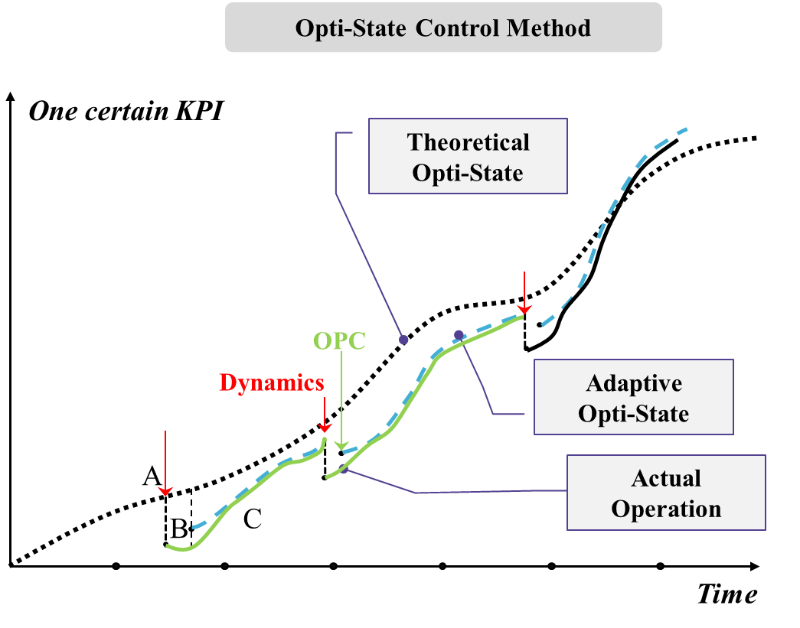
Figure 1. Schematic diagram of opti-state control strategy
The state of a system will change from the theoretical optimal state to the actual state after the uncertainty impact. In order to cope with this impact, the optimal state control strategy needs to develop new theoretical opti-state objective and states that can make the system operate optimally. The determination of this objective not only needs to consider the deviation between the theoretical state and the actual state, but also needs to combine the overall operating status of the current system.
The degree to which uncertainty affect the system is determined not only by the deviation of the two states, but also by the ability of the overall state of the system to function in conjunction with the system at that moment. For example, an order stored in a warehouse location is affected by the uncertainty of the order due date delayed by 2 hours. The direct impact of this uncertainty causes the delivery date of order I to be delayed by 2 hours and following orders may not be stored normally. However, the degree of this uncertainty impact needs to be determined according to the overall state of the system. If the following orders will be in the warehouse after 2 hours, or there are other free locations in the warehouse for the following orders, then the impact of this uncertainty can be ignored. However, if the following order is waiting for entering and there is no other available location, this uncertainty impacts the system to a high degree, and the system needs to adopt the optimal state strategy to make corresponding new storage location arrangement decision to make the system return to the optimal state.
Therefore, the accurate evaluation of the uncertainty impact degree will directly affect the effectiveness of the opti-state decision. Insufficient evaluation will cause the re-decision cannot eliminate the impact on the system; and if the degree of uncertainty impact is over-evaluated, excessive resources or computing power may be invested when the system makes a new decision, resulting in waste of resources and economic costs.
The above example of uncertainty impact evaluation is a simple case of an independent operating unit, and the evaluation of uncertainty impact degree on the complex production system will be much more complicated. The state of a production system is represented from different perspectives, such as WIP, cost. These states correspond to the different system operating objectives and resources status. As the intelligent production system becomes more complex and its production environment becomes unstable, it will be difficult to accurately describe and evaluate the degree of uncertainty impact with clear relationship formulas. Moreover, the evaluation of the uncertainty impact degree should pay attention to the dynamic of the production system, not only to consider the status, but also may need to combine predictions to determine the impact degree on the system.

Big data-enable intelligent opti-state decision and control architecture
With the intelligence of the production system improving, the multi-sources and heterogeneous data of the system execution and decision process can be completely obtained and forming the industrial big data environment of the system. Based on the massive data generated by the historical operation of the production system, big data technology can use data mining models to discover the relationship among the state of the system, various operational indicators, and the impact degree of different uncertainty factors, then use artificial intelligence to train the evaluate model to reach a certain accuracy level. After a specific uncertainty impacts the system, it can quickly and accurately evaluate its impact on the system and determine its degree. Based on the uncertainty impact degree, the opti-state control strategy is used to determine what is the optimal state of the system after being affected and guide the system to operate to that state. This is the basic problem-solving idea of big data-enabled intelligent synchronization for complex production logistics system under opti-state control strategy.

3.3.1 Uncertainty impact degrees
The core decision method of opti-state control strategy is the synchronization decision method proposed by Qu et al. (2017). The synchronization decision is a method in which the affected units synchronized to make a new decision based on the real-time information after the system is impacted by uncertainties. That work clearly states that according to the degree of uncertainty impact on the system, the synchronization decision needs to eliminate uncertainty impact with four different synchronized levels. Based on this classification level, this paper divides the uncertainty impact into four levels to show the degree of interference with the system:
- D1 is independent unit impact degree. This degree of impact only affects a specific unit, and the unit can eliminate the interference by re-planning in the unit without introducing new external resources.
- D2 is synchronized units’ impact degree. This degree of impact affects multiple related units, and the impact needs to be eliminated by the synchronization decision-making of these units. No new resources are introduced at this level.
- D3 is system configuration impact degree. When the impact degree increases, it is difficult to deal with the impact by re-planning. Currently, it is necessary to introduce external resources or change the system configuration to deal with the impact. We define this impact degree as system configuration degree.
- D4 is demand changing impact degree. This impact degree is a degree that it is difficult by using the existing resources of the production system and the available external resources to cope with the impact, and the impact can only be reduced by changing the production demand.

3.3.2 Big data-enable intelligent opti-state decision and control architecture
The operation and decision-making process of the system will produce generate massive amounts of data, and the characteristics of the big data of the production system in this paper are manifested in the complex quantity, super high dimensionality, complex structure, and frequently update. In a highly dynamic environment, the opti-state decision and control strategy mainly include the evaluation of uncertainty impact degree, synchronization decision, and optimal state control. In order to ensure the effectiveness, timeliness and accuracy of decision and execution, this chapter proposes a big data-enable intelligent opti-state decision and control architecture is proposed in this work. As shown in figure 2, there are three layers include: 1) Acquisition and processing of multi-source heterogeneous data for complex systems; 2) Real-time state-oriented uncertainty impact degree evaluation, and 3) Optimal state decision and control.
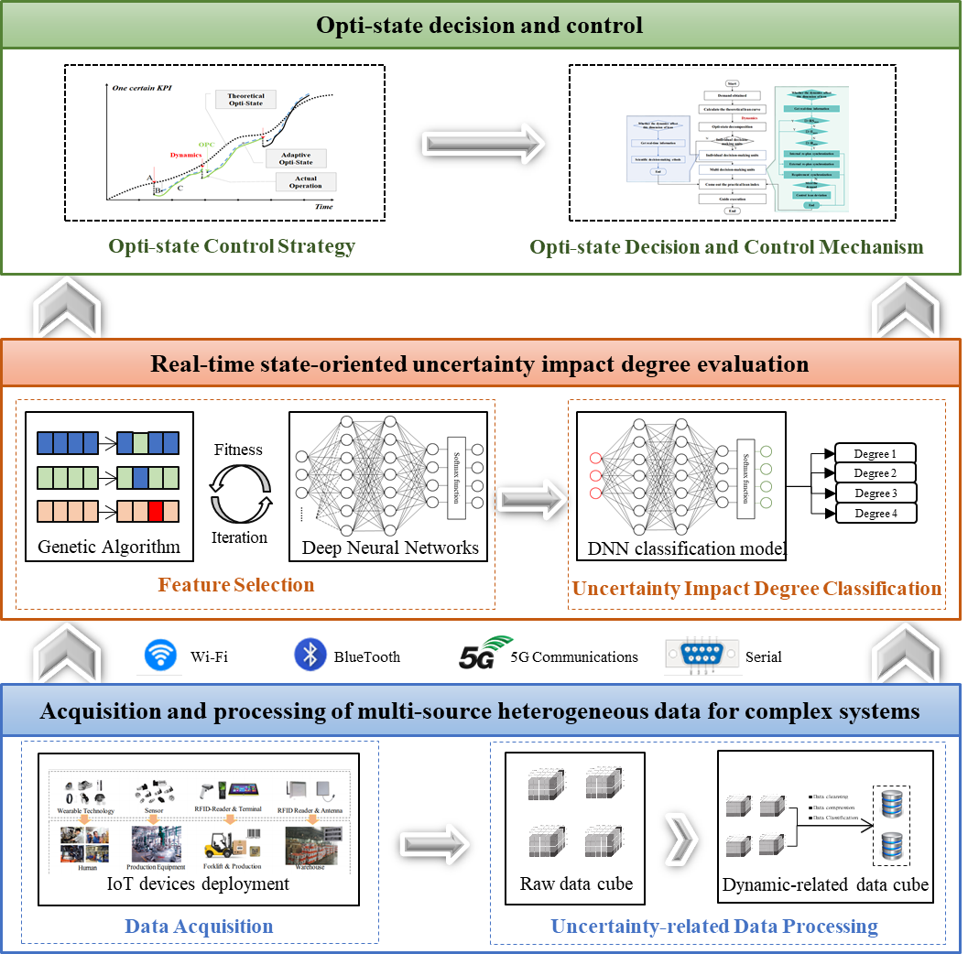
Figure 2. Big data-enable intelligent opti-state decision and control architecture
The layer of acquisition and processing of multi-source heterogeneous data for complex systems. It is the data support for the opti-state decision of complex systems. Its purpose is to collect effective, accurate and relevant operating state and management decision data from different levels of systems (such as equipment layer, workshop layer, and enterprise layer), and integrate and extract the data to obtain an uncertainty-related data cube for further use. The collected raw data mainly comes from machine operation information collected by various industrial control software, IoT equipment attached to resources, and various decision management software. For data processing, raw data is first arranged in an orderly manner according to its respective dimensions to integrate into raw data cube, and then the raw data cube is further transfer into the uncertainty-related data cube through extraction to ensure that the data cube is of sufficient quality provide reliable data for uncertainty impact degree classification models.
The Layer of real-time state-oriented uncertainty impact degree evaluation. It is the core layer of this architecture and provides important support for Big data-enabled intelligent opti-state decision and control. Big data technology will be used to mining the relationships among system states, operation indicators, and the impact degree of uncertainty factors. Feature selection and degree classification methods are the key techniques at this level. Reasonable feature selection and hierarchical classification methods can reduce the dimensionality of the data cube and improve the overall computing efficiency. This work uses GA-DNN method to realize feature selection and impact degree classification.
The Layer of optimal state decision and control. It is the core layer of the mechanism and methods for decision and control after the system is affected by uncertainty. This layer is based on the opti-state control strategy, combines with the uncertainty impact degree, determines the decision strategy, mechanism, and method that should be adopted, and mobilizes reasonable resources, applies the new decision to the system execution layer at an appropriate time and adjusts the state of the system to achieve the optimal operation of the system.

Big data-based uncertainty impact degree classification

Uncertainty-related data acquisition and processing
Complex, multi-source heterogeneous, and multi-scale are the characteristics of big data in production systems. The complexity of the data refers to the complex structure and large quantity, which contains the production system at the executive level and decision-making level, including human, machines, tools, relations, and environment data. The multi-source and heterogeneous characteristics of data reflect the wide range of data sources, including various sensors, PLC controllers, industrial control software, and management software. At the same time, the data structure is difficult to unify due to different sources, such as data from different operating systems (Windows, Unix), data in different formats (including different relational databases or file data, such as txt, csv). The multi-scale of data reflects the complexity of multi-scale under different dimensions, such as data of different scales (time, day, month, year) in the time dimension, and spatial scale contains different units (machine level, workshop level, enterprise level).
When the production system is functioning normally, the various states remain stable according to the established plan until the system is disturbed, such as machine quality, order change. At this time, complete data related to the uncertainty factors are collected for the evaluation of the impact of the system. As shown in figure 3(a), all uncertainty-related data is stored in a raw data cube. The raw data cube integrates data in four dimensions: tuple, operation, time, and information. Tuple dimensions include orders, electronic product code (EPC), storage, machine, cloud-resource, and timestamp. In the operation dimension, location, operation sequences and scheduling rules and other data representing the execution process and operation are recorded. The Time dimension records the time information of system state changes or other key event information, such as the timestamp of the occurrence of uncertainty. In the Information dimension, the attributes of each tuple are converted into valid information and displayed at the top of the data cube.
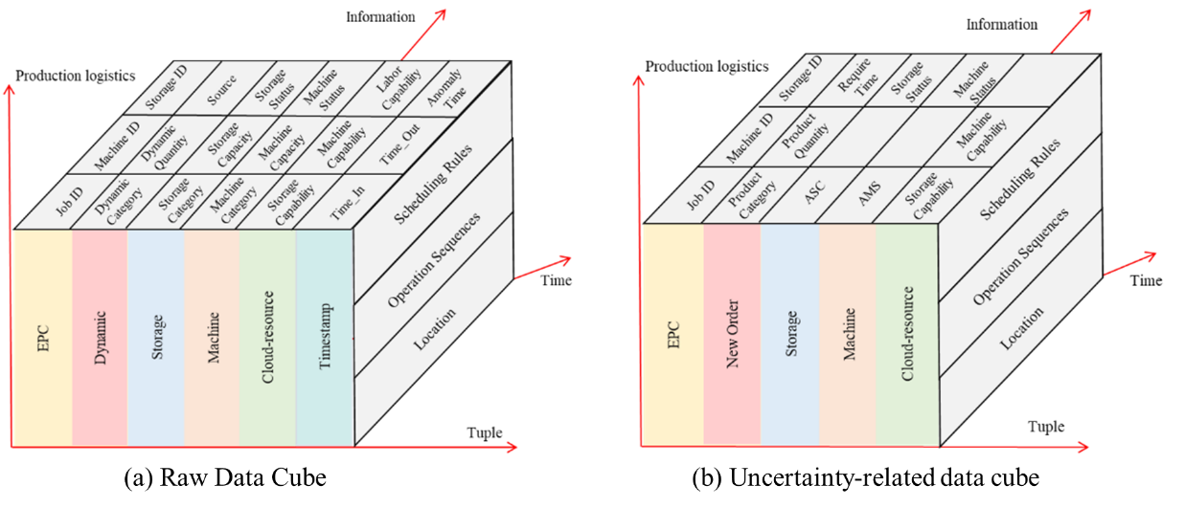
Figure 3. diagram of the raw data cube & uncertainty-related data cube
The raw data cube has problems such as huge data scale, complex data types and structures, and high noise, which can have an impact on the accuracy and efficiency of data analysis. To improve the calculation accuracy and efficiency of the uncertainty impact degree classification method, the quality of the raw data cube needs to be improved. Zhong et al. (2015) proposed a complete framework for raw data cube data processing to solve the problem of poor availability of raw data cube. The solution includes three key steps, and this study will learn from this solution for data processing.
- Data cleaning. The raw data cube has a large amount of redundant data that needs to be removed by data cleaning methods, such as the data has little meaning for uncertainty factor degree evaluation. On the other hand, the data set contains a lot of noise to be clean, including incompleteness and duplication of tuple attributes. Data cleaning ensures data quality and high availability, and it provides reliable data for follow-up work.
- Data compression. The cleaned data cube is still huge, which will affect the efficiency of subsequent data transmission IO. Therefore, it is necessary to compress the data of the cleaned cube. Data compression usually refers to a technology that compresses the data volume or reorganizes the data through some algorithms without losing valid data. For example, every machine$m_{i}$ has a unique machine ID, $C_{m_{i}}$represent the capacity of machine$m_{i}$, $δ_{m_{i}}$is a boolean variable that stand for the use status of machine$m_{i}$, and the current available equipment capacity is recorded as available machine capabilities, AMC, then $AMC=\sum{C_{m_{i}}δ_{m_{i}}}$. If use AMC to replace original data include $m_{i}$、$δ_{m_{i}}$and Machine ID, it will reduce the dimensions and volume of the data cube.
- Data Classification. The compressed data cube needs to be classified according to certain rules, such as dividing the data set according to different types of uncertainty factors. Figure 3(b) shows the classified uncertainty-related data cube according to a rush order uncertainty factor.

GA-DNN uncertainty impact degree classification method
The uncertainty-related data cube obtained after data processing contains all relevant information related to uncertainty factors, including system real-time status, (SRS), operation relation set (ORS) and uncertainty attributes set (UAS).
This work uses GA-DNN encapsulated method to realize feature selection and impact degree classification. The wrapper feature selection method is adopted. First, the feature set is randomly searched through Genetic Algorithm（GA）method, and then the Deep Neural Network (DNN) classification model is used to verify the effectiveness of the searched feature set for the classification of uncertain impact degree, then the population is iterated through crossover and mutation. Finally, the optimal feature set is obtained in a loop, and the training of the DNN model is completed.
- GA-based feature selection
Genetic Algorithm is a heuristic that emulates the evolution of nature, using fast, random search capabilities to find the best solution. In the process of feature selection, GA is used to select the appropriate sub-cube from the Uncertainty-related data cube to improve the efficiency and accuracy of the classification process. Its fitness is solved according to the following method:
Use the test accuracy of DNN as the fitness function evaluation of GA. First set a constant with an initial value of 0, then iteratively compare with the previous one, re-assign the accuracy of each classification, and finally select the feature combination with the highest classification accuracy. Its fitness function is as follows:
$Fitness=δ*DNN_{acc}+η*(-\frac{\left|X_{sel}\right|}{N})$ (1)
${DNN}_{acc }=\frac{{\hat{x}}_{acc}}{n}*100\%$ (2)
Among them, $δ$ and$η$ are used to control the contribution of the number of features and classification accuracy to the function. $DNN_{acc}$ represents the accuracy of the classification result of DNN. $|X_{sel}|$ represents the number of features of the selected feature subset. $N$ represents the total number of features. $n$ represents the total number of samples. ${\hat{x}}_{acc}$ represents the number of samples that are classified correctly.
For the other key steps of GA used in feature selection, the design includes adopting binary coding, using {0,1} binary string to represent the selected feature combination, 0 means not selecting the corresponding feature, 1 means selecting the corresponding feature. Using roulette wheel selection as selection mechanism. the crossover method of multi-point crossover and the mutation strategy of random mutation are adopted. Besides, the multi-point intersection and random variation strategy are adopted.
- DNN -based method for system dynamic classification
Deep Neural Network (DNN) is a deep architecture with multiple hidden layers that can adaptively capture representative information from data and approximate complex nonlinear functions. Therefore, DNN is suitable to reflect the mapping relationship among the system states, operation status and the uncertainty impact degree to construct the classification model.
DNN is divided into input layer, hidden layer, original output layer, final output layer and softmax function. After the genetic algorithm randomly selects a set of feature sets, first use the normalization method to transform the sample data, and map the input feature set in the interval [0,1], which can be expressed as:
$X=\frac{X_{n}-X_{min}}{X_{max}-X_{min}}$ (3)
Among them, $X$ is the normalized value, $X_{n}$ is the data to be processed, $X_{min}$ is the minimum value in the sample, $X_{max}$ is the maximum value in the sample.
For the uncertainty impact degree classification model based on DNN, input the uncertain factors (denoted as m) and system-related features (denoted as n) at time t, and the output impact degree (denoted as L) at time t. this can be expressed as:
$\left\{\begin{aligned}x^{m}=\left\{x_{1}^{m},x_{2}^{m},…,x_{N}^{m}\right\} \\ y^{m}=\left\{y_{1}^{m},y_{2}^{m},…,y_{L}^{m}\right\}\end{aligned}\right.$ (4)
A DNN-based system dynamic classification model needs to be constructed. In the encoding process, the data of the input layer needs to be converted into the data of the hidden layer, which can be expressed as:
$h_{j}=f_{1}(\sum_{i=1}^{n}{ω_{ij}x_{i}+b_{i}})$ (5)
$h_{j}$ represents the j th hidden layer neuron, $x_{i}$represents the ith input layer neuron, $ω_{ij}$ represents the weight between $h_{j}$ and $x_{i}$, $b_{i}$ represents the bias value of $x_{i}$, $f_{1}$ represents the activation function between the input layer and the hidden layer.
In the decoding process, the data of the hidden layer is transformed into the result of the output layer, which can be expressed as:
${\hat{x}}_{k}=f_{2}(\sum_{j=1}^{m}{ω_{jk}h_{j}+b_{j}})$ (6)
${\hat{x}}_{k}$ represents the kth output value. $ω_{ij}$ represents the weight between $h_{j}$ and ${\hat{x}}_{k}$, $b_{i}$ represents the bias value of $h_{j}$, $f_{2}$ represents the activation function between the output layer and the hidden layer.
Since the uncertainty impact degree classification studied in this work is a multi-classification problem, when constructing the DNN model, it is necessary to construct a softmax function between the original output layer and the final output layer, which is denoted as:
${softmax(y)}_{i}=y_{i}^{'}=\frac{e^{y_{i}}}{\sum_{k=1}^{n}{e^{y_{k}}}}$ (7)
$y_{i}$ represents the original output value of the classification of the ith item, $y_{k}$ the original output value matrix, n represents the number of neurons in the original output layer.
Set the error loss function between the evaluable output vector and the expected vector as the cross-entropy function, which is denoted as:
$Loss(p,q)=-\sum{p(x)*\log{q(x)}}$ (8)
Among them, p represents the correct classification result; q represents the value output by the softmax function.
The above are the key steps of DNN -based method for uncertainty impact degree classification. This method is used to evaluate the uncertainty impact efficiently and accurately.

The algorithmic process
The flowchart of GA-DNN uncertainty impact degree classification method is as below:
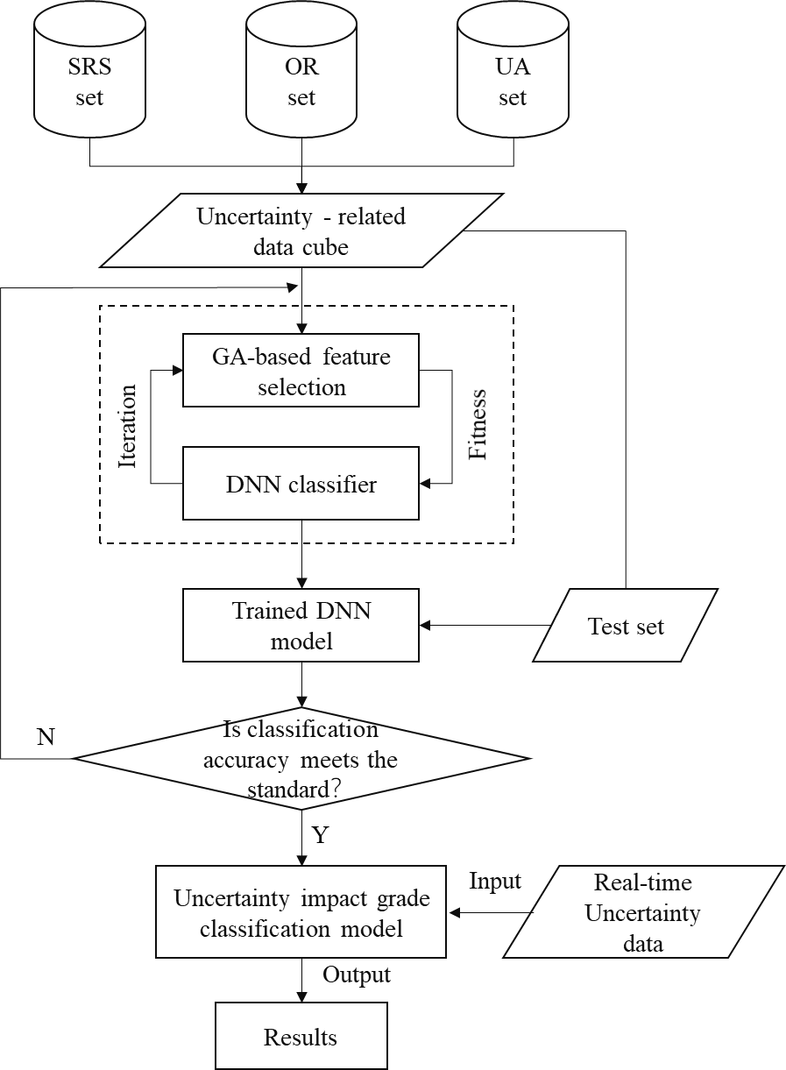
Figure 4. The flowchart of GA-DNN uncertainty impact degree classification method
- Step 1: The moment of uncertainty impacts the system is recorded as t, and the system state data at time t is collected and processed to form an uncertainty-related data cube, which includes the characteristics of system state, operation relations, and uncertainty properties.
- Step 2: Further feature selection processing for uncertainty-related data cubes. Because the data cube at this time may contain interfering features that are not related to the uncertain factors, which will affect the calculation efficiency of the evaluation model and the accuracy of the evaluation.
- Step 3: Use the Wrapper GA-DNN feature selection method to randomly select the sub-cubes from the uncertainty-related data cube.
- Step 4: Classify by training the DNN model and record the accuracy of the classification results.
- Step 5: Select different feature combinations for classification test through crossover and mutation.
- Step 6: Determine whether the classification accuracy meets the standard. If it does not meet the standard, return to step 3, and recalculate.
- Step 7: Iterate until the most effective sub-cube for dynamic classification is selected.
- Step 8: Output the classification results through the trained DNN model after input a real-time uncertainty-related data set.
The above Flowchart describes the key steps of GA-DNN uncertainty impact degree classification method. After determining the impact degree, it is applied in the opti-state decision-making and control process to guide the system to operate in the optimal state.

Case study
Based on the daily business process of a company, this case study is appropriately assumed and simplified to form a common typical case, which illustrates the application and effect of the big data-enabled intelligent synchronization method for complex production logistics system under opti-state control strategy.

Business process of case system
The system is an intelligent production-logistics system. The hardware layer deploys necessary sensors and industrial control software to collect and on-site data. The decision layer is supported by management decision software. The execution and management data generated during the entire production process can be collected in real-time and stored in the database for analysis. The production-logistics system is composed of a manufacturing unit and a warehousing unit. The two units have independent decision-making capabilities, which can make production or warehouse plans according to order requirements. The production system adopts the MTO production method to meet the needs of customers with multiple varieties and small batches. The finished product is transported to the warehouse for storage, and 3PL transport the products to the customer at the due date.
Table 2. Sales orders information
Order No. | Product Types | Total Orders (unit: tray) | Due Time
1 | A | 25 | 13：00
2 | A | 35 | 15：50
3 | B | 36 | 17：00
4 | B | 10 | 16：30
5 | B | 38 | 16：10
6 | B | 15 | 16：30
7 | C | 20 | 16：00
8 | C | 24 | 16：30
9 | C | 10 | 11：15
Table 3. Basic information for production scheduling
 | Unit Processing Time (mins/per pce.)
 | Process1 |  |  | Process2 |  |  |  | Process3
 | M₁₁ | M₁₂ | M₁₃ | M₂₁ | M₂₂ | M₂₃ | M₂₄ | M₃₁ | M₃₂ | M₃₃
A | 3.2 | / | 2.0 | 3.2 | / | 3.2 | 4.0 | 1.6 | 3.2 | 2.4
B | 3.2 | / | 4.8 | 3.2 | / | 4.8 | 5.6 | 1.6 | 3.2 | 4.0
C | 4.8 | 3.2 | 6.4 | 6.4 | 4.8 | / | 4.8 | 1.6 | 1.6 | 3.2
The enterprise layer sends the sales orders (as shown in Table 2) to the production unit. The production unit formulates the production scheduling plan for the day according to a series of rules such as the corresponding relationship between the product process and the machine tool, so that each order can be completed before the due date. Table 3 shows the basic information of production scheduling.
Table 4. Basic information of warehouse
Area | Storage No. | Cargo Capacity (unit: tray)
1# | A1-A15 | 10
2# | B1-B10 | 20
The warehousing unit makes the storage plan according to the production plan of the day. Products are stored according to order requirements. The warehouse is divided into an area to be shipped and a scattered order area. Each storage area has multiple storage locations with limited capacity. The basic information of the warehouse is shown in Table 4, and the key cost indicators of the system operation process are shown in Table 5.
Table 5. Cost in production-logistics system
Cost category | Cost (Yuan)
Fixed cost of production | 2000
Unit product cost | 200
Cost of storage warehouse | 20
Cost of finished products buffer | 50
Penalty cost for delay of order | 50
Working cost | 40
Machine consumption cost | 30
In this case, the uncertain factor of machine breakdown is used as an example to discuss the effect of the solution proposed in this work. The uncertainty factor-related information is shown in Table 6. The repair time of the faulty machine will affect the completion of the working job and the unfinished jobs in this machine, and it also affects the storage plan of the warehouse, and even the product cannot be finished until the due date. However, the repair time is an uncertain value, and most cases are determined by the experience of the maintenance workers. When the workshop has heavy production tasks, the timely acquisition of accurate repair time can greatly help the workshop dispatcher to make reasonable rescheduling.
Table 6. Uncertainty factor-related information
Uncertainty factor | Working job | Process No. | Failed machine No. | Estimated repair time | Time of failure
Machine breakdown | Order 9 | 2 | M₂₂ | 30 mins | 9:32
However, as machine tools become more intelligent and precise, the structure of the machine becomes more complicated, which makes it more difficult to estimate the repair time, and thus it is difficult to evaluate the impact of machine breakdown on the production system. On the other hand, with the generalization of resource leasing, the repair of cloud resources will also be restricted by the available time of the repair service or the proficiency of enterprise-owned maintenance workers with the cloud resource. Therefore, the difficulty of accurately estimating the repair time in a short period of time based on manual experience is gradually increasing, and the machine repair time requires more scientific calculation methods.
This case discusses the interference of the machine breakdown when the production system is executed according to the pre-plan. Big-data technology is used to estimating the machine repair time and evaluate the impact degree of this uncertainty factor on the system. Then the opti-state control strategy is used to make new decisions on this uncertainty impact degree. In contrast to this is the method of evaluating the degree of uncertainty impact through experience and making new decisions on this basis, and the operating costs.

Mathematical models
    - Data structure of uncertainty impact degree classification model
In Section 4.2, the GA-DNN based uncertainty impact degree classification method is illustrated detailly. The quality of classification results is not only related to the choice of methods, but also related to the quality of the basic data. Due to the uncertainty-related data proposed in this case has factors such as large quantity and complex relationship, etc, therefore, the data in this experiment were screened preliminary to simplify the calculation and improve the calculation effect, and get the key data as the foundation for the uncertainty impact degree classification of this case, as shown in Table 7.
Table 7. Key data foundation for the model
Sort | Uncertainty-related data set
SRS | - Processing time of the working job  - Waiting time of the sequence job  - Earliest time of the available equipment  - Warehouse enter time of the working job  - Available capacity of the storage locations | - Processing time of the cloud-resource  - Storage capacity of the cloud resource  - Renting cost of the cloud-resources  - Equipment utilization  - Delivery time of all jobs, etc
ORS | - Process sequence of tasks by equipment  - Occupation relationship between job and location | - Frequency of departure  - Correspondence between equipment and product, etc
UAS | - Time of occurrence  - Maintenance time | - Equipment serial number  - The number of Affected orders

    - Production-logistics collaborative decision-making model
Collaborative Optimization (CO) as the system-level coordination algorithm is used for synchronization decision-making production-logistics systems, which synchronized the scheduling of workshop and the location planning of storage. System-level optimization objective is to minimize the system operating costs, and unit-level optimization goals are to minimize production costs and storage costs, respectively. The optimization model are shown as follow, and all the parameters are shown in the appendix.
- Production schedule model
The production scheduling problem is a typical JSP problem. The scheduling model takes the minimum production cost ${Cost}_{P}$ as the optimization goal, and the cost includes the production cost of each order and the penalty cost for delay of order. Its objectives and constraints are as follows:
Objective:
J=$\min{\sum_{t}{\sum_{i}{\sum_{j}{({Cm}_{ijt}+{Cd}_{ijt})}}}}，∀j∈P，i∈M\left(j\right)，t∈Τ$ | (P-1)
$${Cm}_{ijt}=\left(T_{ijt}^{f}-T_{ijt}^{s}\right)*Q_{tij}*{cm}_{ij}+{cf}_{ij}$$ | (P-2)
$${Cd}_{ijt}=λj*\left|{DT}_{ij}^{min}-T_{ijt}^{f}\right|*{cd}_{j}$$ | (P-3)
Subject to:
$$\sum_{j}{ψ_{tj}}=ϕ_{ti}，∀i∈M，j∈P\left(i\right)，t∈Τ$$ | (P-4)
$$T_{ij'(t+1)}^{s}≥T_{ijt}^{f}-Τ（2-ψ_{tj}-ϕ_{ti}），∀j,j'∈P(i)，i∈M，t∈Τ，j≠j'$$ | (P-5)
$$T_{ijt}^{f}≤{DT}_{ij}^{min}，∀j∈P(i)，i∈M，t∈Τ$$ | (P-6)
Eq. (P-1) is the overall goal of scheduling is to minimize production costs and overdue penalty costs; Eqs. (P-2) and (P-3) are production and penalty costs respectively; Eq. (P-4) means each device can only handle one task at any time; Eq. (P-5) means the start time of job j' produced at time t+1 on equipment i must be after the end of job j produced at time t; Eq. (P-6) means completion time of task j on equipment i cannot be later than the earliest delivery date in task set P(i) at that time t.
- Warehouse scheduling model
The optimization problem of the warehouse in this case is the storage location assignment program (SLAP), which use the lowest storage cost and picking cost as the optimization goal. Mathematic model is as follows:
Objective:
$$min\sum_{i∈SS}{\sum_{m∈MS}{μ_{x}*x_{o, y,x}*{T_{s}}_{o}^{x}}}$$ | (S-1)
Subject to:
${T_{s}}_{o}^{x}=T_{o}^{OUT}-T_{o}^{IN}$  $$o=1,2,3,…, SS,, x=0, 1, 2, 3,…, MS$$ | (S-2)
$$\sum_{m=1}^{M}{z_{o, x}}=Q_{o}$$ | (S-3)
$$z_{o, x}≤V_{m}, o=1,2, 3,…, SS, x=0, 1, 2, 3,…, MS$$ | (S-4)
$$\sum_{o=1}^{SS}{φ_{o}^{x}}≤1, x=1,2,3,…, MS$$ | (S-5)
Eq. (S-2) is calculation formula of inventory time of order o; Eq. (S-3) means product of order o are allocated to the assigned location; Eq. (S-4) means the quantity of order o stored in location x cannot exceed the capacity of the location; Eq. (S-5) means the maximum number of orders stored in each location x does not exceed 1.

Result analysis
The solution environment of this case is Windows 10 X64 operating system, 16GB memory. For GA-DNN algorithm, the main parameters are population number 100, maximum number of iterations 100, crossover probability 0.8, mutation probability 0.05; The input layer of DNN is the number of chromosomes selected by GA, the output layer is the uncertainty impact degree (D1- D4), the learning rate is 0.01, and the number of training is 1000 times. The storage assignment planning of the warehouse adopts a rule-based location assignment, which is expressed by the SLAP model in section 5.2.
The scale of the data sets used by the GA-DNN classification method is 500, and the dimension of features is 20. As shown in Fig. 5 (a), the classification accuracy result of GA-DNN in extracting feature subsets of different dimensions is illustrated. When the GA-DNN algorithm selects 12 features such as predicted equipment maintenance time, order product type, order remaining processing time, order delivery time, cloud resource cost, etc., as a feature subset, the accuracy of the classification of system uncertainty impact degree is 92.28%, which is higher than select other dimensions. In addition, the application of the GA-DNN algorithm can reduce the feature dimension from 20 to 12, which greatly improves the computational efficiency, as shown in Fig. 5(b). Therefore, the GA-DNN method has a high-level accuracy of classification, which can be applied to the uncertainty impact judgment, providing support for complex production logistics system under opti-state control strategy.

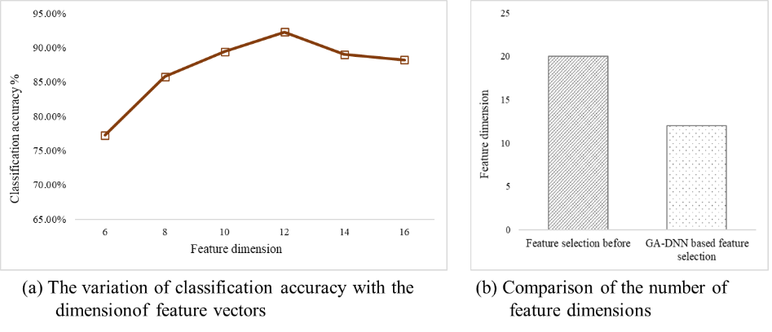
Figure 5. Accuracy and efficiency performance of GA-DNN method
In order to meet the order requirements of Table 1, and before the production-logistics system starts operating, the corresponding production scheduling pre-plan and warehousing pre-plan are formulated with the lowest cost as the operation objective based on the resource status and constraints of each unit. Fig. 6 shows the pre-planning Gantt chart of the workshop, and Table 8 shows the pre-planning of the two units.
Table 8. The pre-plan for the production-logistics system
Order No, | Production time | Processing machine No. |  |  | Finish time | Storage time | Location No. | Shipment time
O₁ | 0900 | M₁₃ | M₂₄ | M₃₁ | 1210 | 1230 | A1, B1 | 1300
O₂ | 0950 | M₁₃ | M₂₃ | M₃₂ | 1444 | 1457 | A4, A5 | 1550
O₃ | 1102 | M₁₁ | M₂₁ | M₃₁ | 1556 | 1612 | A2, A3 | 1700
O₄ | 1212 | M₁₃ | M₂₄ | M₃₃ | 1344 | 1402 | B3 | 1630
O₅ | 0900 | M₁₁ | M₂₁ | M₃₁ | 1404 | 1419 | A2, A3 | 1610
O₆ | 1100 | M₁₃ | M₂₃ | M₃₃ | 1504 | 1517 | B5, B6 | 1630
O₇ | 1049 | M₁₂ | M₂₄ | M₃₂ | 1516 | 1532 | A6 | 1600
O₈ | 0932 | M₁₂ | M₂₂ | M₃₃ | 1401 | 1414 | A1, B4 | 1630
O₉ | 0900 | M₁₂ | M₂₂ | M₃₂ | 1036 | 1044 | B2 | 1115
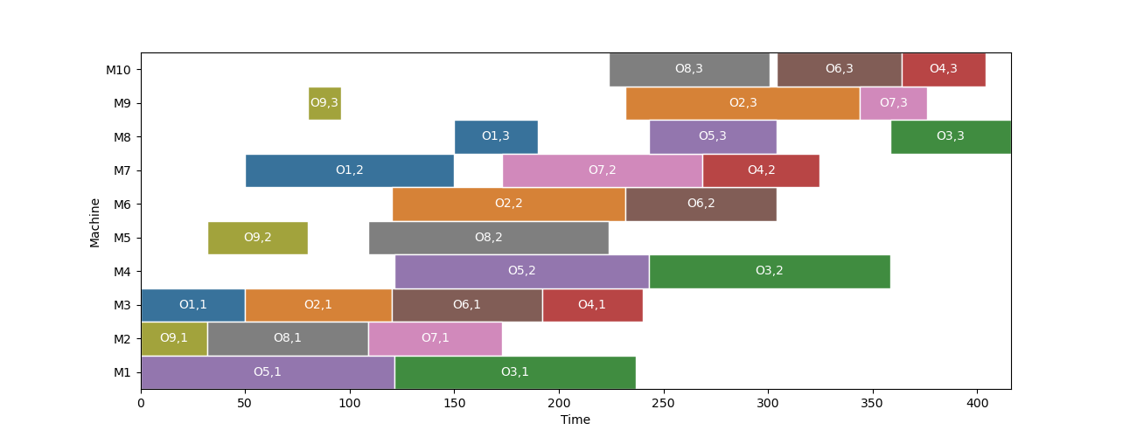
Figure 6. Production scheduling pre-planning Gantt chart
During the execution, the system encounters the interference of uncertain factors of machine failure. Table 6 shows the information of this uncertainty factor. Then, the system uses the previously trained classification model to determine the uncertainty impact degree quickly and accurately.
After analysis, the impact degree of this on the system is Degree 2, according to the description of the uncertainty impact degree in section 3.3.1, this degree can be dealt with by synchronize the related units to deal with the uncertainty interference. Figure 7 shows the synchronized scheduling gant chart. The accurate prediction of machine repair time based on big data is the key scheduling basic information for synchronization decision. Based on the accurate prediction of machine tool maintenance time based on big data is the key scheduling basic information in the linkage decision-making. Based on this information, the affected orders can still be shipped in time under the original lowest cost operation objective.
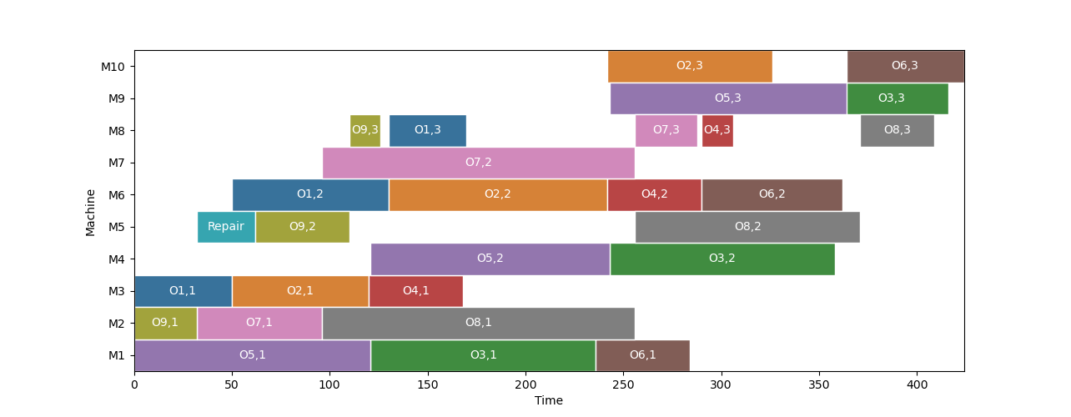
Figure 7. Synchronization scheduling gantt chart based on GA-DNN uncertainty degree classification
In contrast, if the machine tool maintenance time is judged based on experience, the planner will believe that the uncertainty impact would result in a delay in the delivery of order 9, which is a serious consequence for production. To cope with the uncertainty impact, it is necessary to introduce new resources to replace faulty machine, and to make synchronized decisions between production and warehouse units. Since the forecast-based repair time is no longer possible to make the order complete on time, the new scheduling is made with the minimum processing time as the objective. Figure 8 shows the scheduling Gantt chart of the production unit after the introduction of cloud resources. At this time, the new decision can ensure that order 9 and subsequent orders are not delayed.
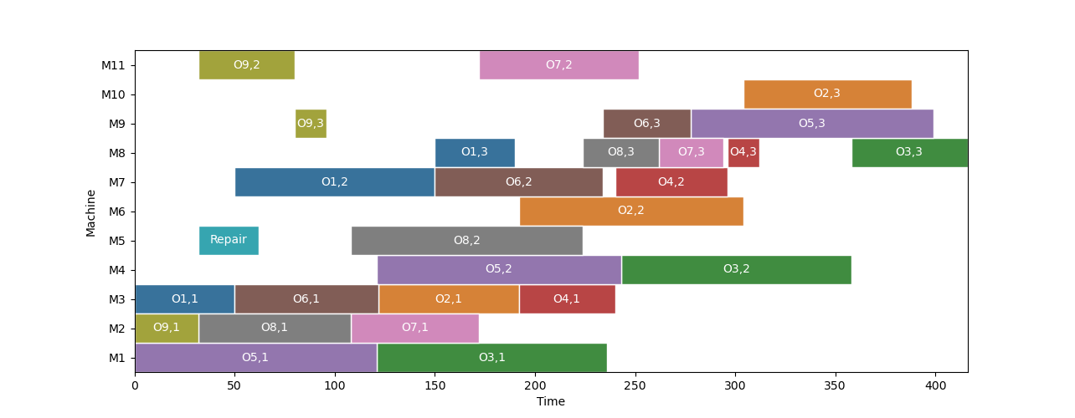
Figure 8. Synchronization scheduling gantt chart based on experience uncertainty degree classification
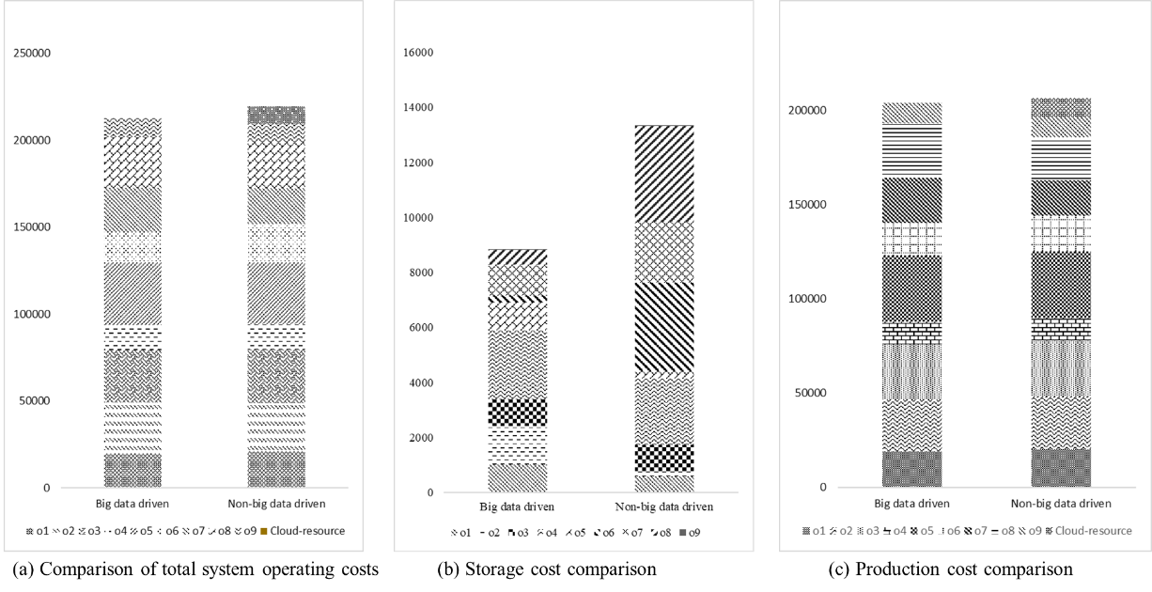
Figure 9. Cost comparison
Figure 9. Shows the cost effect of big data-enabled intelligent synchronization for complex production logistics system under opti-state control strategy. For the uncertainty of machine breakdown, the total system cost of this solution is lower than that of the method that does not use big data to analyze the dynamic impact degree. For the production unit, because of the reasonable evaluation of the impact degree, the uncertainty interference is reduced by the way of production and storage synchronization decision. Therefore, the cost does not include the cost of renting cloud resources. The cost difference between the two methods in the warehouse unit is more obvious. Due to the excessive evaluation of the uncertainty impact degree by the comparison method, the introduction of cloud resources not only increased the production cost, but also had to modify the operation objective to meet the delivery demand. Therefore, after the uncertainty impact, the scheduling plan with operation objective of shortest makspan allows the product to finish ahead of schedule, which leads to early storage and increases the storage cost of the warehouse.

Conclusions and future works
This paper proposes big data-enabled intelligent synchronization for complex production logistics system under opti-state control strategy, discusses the definition of system state under optimal state control strategy, and proposes an approach to use big data technology to classification the degree of uncertainty impact on system state. The case discusses the steps and effects of big data-enabled intelligent synchronization for complex production logistics system, comprising (1) obtain the historical data of the system state changes, operation relations and uncertainty related information after the system history is disturbed by the same uncertain factor; (2) uses the GA-DNN method to realize feature selection and impact degree classification; (3) based on this classification, the corresponding synchronization decision-making method under the opti-state control strategy is adopted to reduce the uncertainty interference so that the system can keep the optimal operating state. The results show that big data-enabled intelligent synchronization for complex production logistics system under opti-state control strategy can evaluate the impact of dynamics on the system and avoid the waste of resources and the increase operating costs in system caused by excessive evaluation of the impact degree. This improves the effectiveness and efficiency of the opti-state control strategy.
This work is considered as an initial attempt in introducing the Big-data technology to the opti-state control strategy. Although the potential and advantages have not yet been clarified, future research is essential for the further development of this field. The big data-based uncertainty impact degree classification method requires all-element data of the system operation. To make it have practical guiding significance, it is necessary to obtain the daily operation data in the real-life enterprise. The data in this case is based on the simulation data simplified from the daily operation data of the enterprise, some features and relations are set experientially, which may not be appropriate or even lead to inaccuracy. Thus, additional research is still needed to obtain more scientific features and relations. The potential relationship between the uncertainty impact degree and the selection of optimization objectives when the system makes a new decision is also needs to be studied in-depth, so that the opti-state control strategy can adaptively determine the optimization objectives according to uncertainty impact degree and the status of the system, and also set the state of optimal operation of the system and realize the optimal operation of the system.

Acknowledgements
This paper is financially supported from the 2019 Guangdong Special Support Talent Program -Innovation and Entrepreneurship Leading Team (China) (2019BT02S593), National Natural Science Foundation of China (51875251), 2018 Guangzhou Leading Innovation Team Program (China) (201909010006), Blue Fire Project (Huizhou) Industry-University-Research Joint Innovation Fund of the Ministry of Education (China) (CXZJHZ201722), and the Fundamental Research Funds for the Central Universities (11618401).

References

Caggiano, Alessandra. 2014. "Manufacturing System." In CIRP Encyclopedia of Production Engineering, edited by Luc Laperrière and Gunther Reinhart, 830-836. Berlin, Heidelberg: Springer Berlin Heidelberg.
Chen, Jian, George Q Huang, Hao Luo, and Junqiang Wang. 2015. "Synchronisation of production scheduling and shipment in an assembly flowshop." International Journal of Production Research 53 (9):2787-802.
Chryssolouris, George. 2013. Manufacturing systems: theory and practice: Springer Science & Business Media.
Davis, Tom. 1993. "Effective supply chain management." Sloan management review 34:35.
Devapriya, Priyantha, William Ferrell, and Neil Geismar. 2017. "Integrated production and distribution scheduling with a perishable product." European Journal of Operational Research 259 (3):906-16.
Doh, Hyoung-Ho, Jae-Min Yu, Ji-Su Kim, Dong-Ho Lee, and Sung-Ho Nam. 2013. "A priority scheduling approach for flexible job shops with multiple process plans." International Journal of Production Research 51 (12):3748-64.
ElMaraghy, Hoda A. 2005. "Flexible and reconfigurable manufacturing systems paradigms." International journal of flexible manufacturing systems 17 (4):261-76.
Gupta, Anshuman, and Costas D Maranas. 2003. "Managing demand uncertainty in supply chain planning." Computers & chemical engineering 27 (8-9):1219-27.
Katragjini, Ketrina, Eva Vallada, and Rubén Ruiz. 2013. "Flow shop rescheduling under different types of disruption." International Journal of Production Research 51 (3):780-97.
Kuo, Yong-Hong, and Andrew Kusiak. 2019. "From data to big data in production research: the past and future trends." International Journal of Production Research 57 (15-16):4828-53.
Ladyman, James, James Lambert, and Karoline Wiesner. 2013. "What is a complex system?" European Journal for Philosophy of Science 3 (1):33-67.
Li, Wenkai, Chi-Wai Hui, Pu Li, and An-Xue Li. 2004. "Refinery planning under uncertainty." Industrial & engineering chemistry research 43 (21):6742-55.
Li, Ming, Gangyan Xu, Peng Lin, and George Q Huang. 2019. "Cloud-based mobile gateway operation system for industrial wearables." Robotics and Computer-Integrated Manufacturing 58:43-54.
Li, Ming, Peng Lin, Gangyan Xu, and George Q Huang. 2018. "Cloud-based ubiquitous object sharing platform for heterogeneous logistics system integration." Advanced Engineering Informatics 38:343-56.
Luo, Hao, Kai Wang, Xiang TR Kong, Shaoping Lu, and Ting Qu. 2017. "Synchronized production and logistics via ubiquitous computing technology." Robotics and Computer-Integrated Manufacturing 45:99-115.
Luo, Hao, Xuan Yang, and Kai Wang. 2019. "Synchronized scheduling of make to order plant and cross-docking warehouse." Computers & Industrial Engineering 138:106108.
Nouiri, Maroua, Abdelghani Bekrar, Abderezak Jemai, Smail Niar, and Ahmed Chiheb Ammari. 2018. "An effective and distributed particle swarm optimization algorithm for flexible job-shop scheduling problem." Journal of Intelligent Manufacturing 29 (3):603-15.
Ouelhadj, Djamila, and Sanja Petrovic. 2009. "A survey of dynamic scheduling in manufacturing systems." Journal of scheduling 12 (4):417-31.
Qi, Xiangtong, Jonathan F Bard, and Gang Yu. 2006. "Disruption management for machine scheduling: the case of SPT schedules." International Journal of Production Economics 103 (1):166-84.
Qiao, Fei, Juan Liu, and Yumin Ma. 2020. "Industrial big-data-driven and CPS-based adaptive production scheduling for smart manufacturing." International Journal of Production Research:1-21.
Qu, T, K Zhang, M Yan, H Guo, GQ Huang, C Li, and X Li. 2018. "Synchronized decision-making and control method for opti-state execution of dynamic production systems with internet of things." J. Mech. Eng. 54 (16):24-33.
Qu, T, SP Lei, ZZ Wang, DX Nie, X Chen, and George Q Huang. 2016. "IoT-based real-time production logistics synchronization system under smart cloud manufacturing." The International Journal of Advanced Manufacturing Technology 84 (1-4):147-64.
Qu, Ting, Yanghua Pan, Xuan Liu, Kai Kang, Congdong Li, Matthias Thurer, and George Q Huang. 2017. "Internet of Things-based real-time production logistics synchronization mechanism and method toward customer order dynamics." Transactions of the Institute of Measurement and Control 39 (4):429-45.
Reaidy, Jihad, Daniel Diep, and Pierre Massotte. 2003. Management and control of complex production systems: co-opetition through game theory principles and agents based information systems. Paper presented at the IEEE International Conference on Industrial Informatics, 2003. INDIN 2003. Proceedings.
Sharma, Pankaj, and Ajai Jain. 2017. "Effect of routing flexibility and sequencing rules on performance of stochastic flexible job shop manufacturing system with setup times: Simulation approach." Proceedings of the Institution of Mechanical Engineers, Part B: Journal of Engineering Manufacture 231 (2):329-45.
Simangunsong, Eliot, Linda C Hendry, and Mark Stevenson. 2012. "Supply-chain uncertainty: a review and theoretical foundation for future research." International Journal of Production Research 50 (16):4493-523.
Wang, K, and SH Choi. 2012. "A decomposition-based approach to flexible flow shop scheduling under machine breakdown." International Journal of Production Research 50 (1):215-34.
Zandieh, M, and MA Adibi. 2010. "Dynamic job shop scheduling using variable neighbourhood search." International Journal of Production Research 48 (8):2449-58.
Zheng, Pai, Zuoxu Wang, Chun-Hsien Chen, and Li Pheng Khoo. 2019. "A survey of smart product-service systems: Key aspects, challenges and future perspectives." Advanced Engineering Informatics 42:100973.
Zhong, Ray Y, Chen Xu, Chao Chen, and George Q Huang. 2017. "Big data analytics for physical internet-based intelligent manufacturing shop floors." International Journal of Production Research 55 (9):2610-21.
Zhong, Ray Y, George Q Huang, Shulin Lan, QY Dai, Xu Chen, and T Zhang. 2015. "A big data approach for logistics trajectory discovery from RFID-enabled production data." International Journal of Production Economics 165:260-72.
Zhong, Ray Y, Xun Xu, Eberhard Klotz, and Stephen T Newman. 2017. "Intelligent manufacturing in the context of industry 4.0: a review." Engineering 3 (5):616-30.
Zhang, Kai, Ming Wan, Ting Qu, Hongfei Jiang, Peize Li, Zefeng Chen, Jinjie Xiang, Xiaodong He, Congdong Li, and George Q Huang. 2019. "Production service system enabled by cloud-based smart resource hierarchy for a highly dynamic synchronized production process." Advanced Engineering Informatics 42:100995.
Zhang, Kai, Ting Qu, Dajian Zhou, Hongfei Jiang, Yuanxin Lin, Peize Li, Hongfei Guo, Yang Liu, Congdong Li, and George Q Huang. 2020. "Digital twin-based opti-state control method for a synchronized production operation system." Robotics and Computer-Integrated Manufacturing 63:101892.
Zhang, Yingfeng, Zhengang Guo, Jingxiang Lv, and Ying Liu. 2018. "A framework for smart production-logistics systems based on CPS and industrial IoT." IEEE Transactions on Industrial Informatics 14 (9):4019-32.

Appendix: Nomenclature
M | set of equipment，M={1, 2, …, i, …, m}
P | set of process task，P={1, 2,…, j, …, p}，
M(j) | set of equipment for task j
P(i) | set of tasks be processed by equipment i
$$Τ$$ | set of scheduling period, Τ= {0,1,2…t, …, h}, the total scheduling time
$${DT}_{ij}^{min}$$ | the earliest delivery date in the task set P(i) processed by equipment i at time t
$$ψ_{tj}$$ | boolean variable, whether task j is executed at time t
$$ϕ_{ti}$$ | boolean variable, whether device i is running at time t
$$Q_{tij}$$ | the amount of tasks j processed on device i at time t
$$T_{ijt}^{f}$$ | decision variable, time t, the end time of processing task j on device i
$$T_{ijt}^{s}$$ | decision variable, the start time of processing task j on device i at time t
$${cm}_{ij}$$ | unit processing cost of equipment i processing task j
$${cd}_{j}$$ | unit penalty cost for delay of shipment
$${Cm}_{ijt}$$ | total processing cost
$${Cd}_{ijt}$$ | total cost of penalties for delay of delivery
$$λj$$ | boolean variable, whether task j is delay processing
MS | set of storage location number, MS= {0, 1, 2, …, x, …, M}, that there are M storage location
SS | set of storage of order, SS= {1, 2, …, o, …, S}
$$Q_{o}$$ | total number of products in order o
$${T_{s}}_{o}^{x}$$ | storage time of order o on location x
$$T_{o}^{IN}$$ | warehouse entering time of order o
$$T_{o}^{OUT}$$ | delivery time of order o
$$z_{o, x}$$ | quantity of order o stored in location x
$$φ_{o}^{x}$$ | boolean variable, whether location x is occupied by order o

