Wordcount: 7995

A Blockchain-based Model with An Incentive Mechanism for Cross-border Logistics Supervision and Data Sharing in Modular Construction
Liupengfei Wuª, Xiao Liª*, Rui Zhaoª, Weisheng Luª, Jinying Xuª, and Fan Xueª
ª Department of Real Estate and Construction, The University of Hong Kong, Hong Kong, China
*Corresponding author: Email: xl1991@hku.hk

Abstract
Sustainability in cross-border logistics requires issues such as fragmented management to be addressed. Particular challenges arise in cross-border logistics in modular construction (CLMC) because supervision is inefficient, primarily due to continued use of paper-based documentation. Researchers have developed digital platforms that integrate accurate prefabricated module location information but their centralized operation creates information security issues such as tampering. Blockchain technology can overcome this limitation but relies on user participation. This study, therefore, develops a blockchain-based supervision (BBS) model with incentives for application in CLMC. The BBS model is developed using a design science research approach to enhance supervision of CLMC and motivate users to share data promptly, and then a prototype system is developed and evaluated in a CLMC case. The results show that the system brings a positive change in product accountability (df=8, t=0.6601, p=0.528) compared with current paper-based recording process (df=8, t=0.0035, p=0.997), and a positive change in data traceability (df=8, t=1.468, p=0.180) compared with existing process (df=8, t=0.042, p=0.967). In addition, this study obtains higher scores (552) than others in evaluating the incentive mechanisms. The security analysis is also discussed through data immutability, non-repudiation, authentication, and authorization. The ﬁndings of this study pave the way for a tamper-proof, incentive-enabled supervision mechanism in modular construction.
Keywords: Blockchain; Modular construction; Cross-border logistics; Sustainability; Incentive mechanism

1. Introduction
The construction industry is a major cause of sustainability challenges through its consumption of energy and materials (Lu et al., 2018). Widely advocated as a more sustainable alternative to traditional in-situ construction, modular construction involves fabrication of freestanding integrated modules under controlled off-site conditions and transportation of the large units to building sites for assembly (Wu et al., 2022a). It offers social, economic, and environmental benefits, including enhanced safety and productivity and reduced waste (Lu et al., 2018). However, successful modular construction project delivery involves complex logistics with multiple processes and stakeholders (Lu et al., 2022). This is especially true in territories like Hong Kong where high construction costs and labor shortages mean that modular housing production is outsourced to factories in Guangdong Province, Mainland China, requiring cross-border logistics (Li et al., 2021b). To ensure an efficient transition from production to on-site assembly, proper technologies must be adopted to facilitate the cross-border logistics process.

The key to efficient cross-border logistics in modular construction (CLMC) is transparency of information for involved entities (Chang et al., 2020a). With increasingly fierce competition in the global construction market, advanced project management software such as enterprise resource planning systems (Wang et al., 2020) and building information modeling (BIM) and geographic information system (GIS) technologies have been adopted to facilitate information sharing and decision support in CLMC (Li et al., 2022). However, current information systems or platforms work in a centralized way, leading to information security issues (Xue & Lu, 2020). BIM, for example, cannot ensure a single point of trust for any modification, creating a risk of tampering. Where module quality becomes a focus of cross-border disputes in CLMC, logistics information cannot be secured.

Blockchain technology has the potential to create a shift in information management practices prevalent in construction. A blockchain is a distributed database of records linked with cryptography and reliant on a decentralized consensus that effectively records and endorses transactions between participants (Xue and Lu, 2020). Its benefits, therefore, include reinforced security and traceability (Chang et al., 2020a). Blockchains also promote information sharing through distributed networks and reduce costs by removing intermediaries (Li et al., 2021a). In construction, blockchain technology has potential applications in internal administration (Wang et al., 2020), self-executing transactions with smart contracts (Lu et al., 2021b), immutable records of transactions (Li et al., 2021b), secure payment (Das et al., 2021), and in combination with BIM and Internet of Things (IoT) (Lee et al., 2021). Blockchains have also been adopted for information management in prefabricated construction (e.g., Zhang et al., 2020). However, in current blockchain solutions, unwillingness of users to share data presents a challenge. Compared with prefabricated components though, prefinished modules are larger and more valuable, requiring better quality supervision and more efficient data sharing when using blockchain in CLMC.

Thus, this study aims to develop a blockchain-based supervision (BBS) model with incentives for CLMC. The objectives of this study are: (1) to develop a BBS model to enhance the CLMC supervision process; (2) to improve the willingness of BBS model users to share data; and (3) to evaluate the proposed model through prototype system development. The rest of this paper is organized as follows. Section 2 is a literature review of blockchain technology for information management, logistics, and incentive mechanism. Section 3 reviews the current business process of CLMC. Section 4 presents the research methodology. Section 5 gives the details of the BBS model. Section 6 shows the prototype system and evaluates its performance. Section 7 offers our discussion, and Section 8 concludes this research.

2. Literature Review

2.1 Blockchain Technology for Information Management
Blockchain technology has found information management applications in several spheres. Fan et al. (2018) developed a blockchain-based system for medical information sharing, but privacy issues compromised the willingness of users to share information. Recently, Nguyen et al. (2021) used a deep belief network with a residual network model to secure blockchain-enabled systems in healthcare. Cui et al. (2021) adopted 5G and blockchain to realize traceable vehicle-to-vehicle information sharing, pointing out that vehicles may be reluctant to share data with others but failing to explain how to solve this problem. Esposito et al. (2021) proposed a novel solution for distributed management of identity in smart cities using blockchain but, again, encouraging citizens to upload their identity information on the new platform would be a challenge. Mohan and Gladston (2020) integrated Merkle Tree-based cloud audit and a blockchain-based recording system to manage cloud data auditing results, but the system lacked incentives for users to upload verification results to the system. Blockchain technology has also been used to manage Android permission histories (Ouaguid et al., 2018) and donor profiles (Lamba et al., 2019). In all cases, however, in the process of data sharing the fundamental problem of unwillingness to share is yet to be overcome.

In construction, blockchain conceptual models and proof-of-concept work related to information management have recently been investigated. For example, blockchain technology has been used to share different types of construction information, including records related to design (Pradeep et al., 2021), production (Li et al., 2021b), quality verification (Zhong et al., 2020), scheduling (Zhang et al., 2020), on-site assembly (Wu et al., 2022a), equipment maintenance (Pan et al., 2022), disputes (Saygili et al., 2022), carbon emission (Shu et al., 2022), and safety (Wu et al., 2022b). While data sharing on the blockchain can reduce duplication of data collection and processing efforts, again studies assume that users are willing to share their data. In addition, Das et al. (2021) and Wu et al. (2022c) developed similar blockchain-based systems to manage payment information for preventing late payment, but as payment verification is a manual process participants have to be motivated to upload verification results on time. Hamledari and Fischer (2021) attempted to improve construction payment automation using blockchain-enabled smart contracts and robotic reality capture technologies. However, due to the complex and dynamic nature of construction sites, the applicability of this innovation is limited to certain building elements (e.g., columns).

Lee et al. (2021) and Li et al. (2022) integrated the IoT, BIM, and blockchain technology to support automatic information sharing in construction projects. However, quality verifications at each checkpoint during the construction process involve manual upload, so sharing verification results on time is still an issue. Scott et al. (2021) reviewed 121 academic documents on blockchain in the construction industry. The review chapter presented 33 application categories and was organized into seven subject areas. An identified gap in research for further studies is the lack of an incentive mechanism for blockchain data sharing.

2.2 Blockchain Technology for Logistics
In logistics, blockchains are mainly used to record product quality. For example, Singh et al. (2020) used blockchain technology to record the transportation status of medicines in pharmacy logistics but did not investigate the willingness of drivers to share information. Choi (2019) developed a blockchain platform in luxury logistics and, Sreenu et al. (2022) developed a blockchain-based ecosystem for vaccine logistics, and Saurabh and Dey (2020) have developed blockchain architectures for tracing food quality. Blockchain-based supervision also covers e-commerce logistics (Li et al., 2019a), air logistics (Choi et al., 2019), and port logistics (Ahmad et al., 2021). Again, investigations of the willingness of users to share information are lacking in these studies. In cross-border logistics, blockchain research is minimal. Li and Li (2020) proposed a blockchain model for customs clearance of cross-border logistics without considering information-sharing incentives, and Liu and Li (2020) proposed a blockchain-based framework for cross-border e-commerce logistics, pointing out the need to investigate incentive mechanisms in the future research. Chang et al. (2020a) provided a holistic overview of the blockchain state-of-the-art, challenges, gaps, and opportunities in cross-border logistics. They emphasized that government agencies should study how to motivate private sectors to upload information to blockchains.

In construction logistics, blockchains have mainly been adopted to ensure the traceability of products en route to construction sites. Shemov et al. (2020) and Tezel et al. (2021), however, focused on testing blockchain security instead of evaluating the level of user participation. The same is true in precast construction, where Wang et al. (2020) developed a blockchain-based framework for improving logistics traceability, and in the development by Li et al. (2021a) of a blockchain-based system to improve information transparency of prefabricated housing construction. A literature search reveals few blockchain applications in cross-border logistics. Lu et al. (2022) developed an e-Inspection 2.0 system for cross-border modular construction logistics. However, their system application and testing are focused on the production phase rather than the transportation phase. Given the larger physical volume and higher price of prefabricated modules than components, stakeholders inevitably require better quality supervision and efficient data sharing in CLMC, particularly as cross-border dispute resolution can be time-consuming and expensive.

2.3 Incentive Mechanisms in Blockchains
Blockchain success depends on the contributions of users. Ren et al. (2018) used digital currency as an incentive to encourage participants to share data in a blockchain for wireless sensor networks but did not provide an evaluation. He et al. (2018) proposed a blockchain-based incentive mechanism for distributed P2P applications, which applies cryptocurrencies to incentivize user cooperation. However, cryptocurrencies are restricted by many governments. Xuan et al. (2020) proposed an incentive mechanism for data sharing based on blockchain technology and Chang et al. (2020) for edge-computing-based blockchain, neither of which were evaluated in real-life practice. Huang et al. (2020) demonstrated a reputation-based incentive mechanism to encourage users to endorse blockchains transactions, while Wang et al. (2018) developed native tokens as a financial incentive for blockchain user participation in the consensus mechanism.

In construction, only a few studies involve incentive mechanisms in blockchains. Lu et al. (2021a) demonstrated a blockchain-based supervision model with reputational and financial incentives for recording project information, including logistics, but does not provide a detailed explanation about the incentive mechanism nor test it. Lu et al. (2021b) proposed a smart construction objects (SCOs)-enabled blockchain oracles framework and designed an incentive mechanism to reward stakeholders who deploy SCOs during the process, but detailed information about the effectiveness of the incentive mechanism is lacking.

Thus, the research gaps identified can be summarized as follows. Firstly, there is a lack of a model to guide the establishment of an efficient supervision mechanism for CLMC and to help endorse the information (e.g., loading conditions and status, customs clearance status, and arrival conditions and status) at each checkpoint for clear product accountability and traceability in cross-border logistics. Secondly, a mechanism to increase user willingness to share data in blockchains has not been investigated for CLMC. Thus, this study aims to develop a BBS model for CLMC.

3. Analysis of the Business Process of Cross-border Logistics in Modular Construction
The CLMC business process usually involves logistics preparation, execution, and completion (Figure 1). The scope of the CLMC process has been identified as follows: (1) the entry criterion is that the manager of the prefabrication manufacturer signs the bills of transportation to start the delivery; (2) the inputs are the loading lists and related details for the logistics tasks; (3) the exit criterion is that the vehicle drivers return the signed delivery dockets to the manufacturer; and (4) the outputs are the quality assured modules.

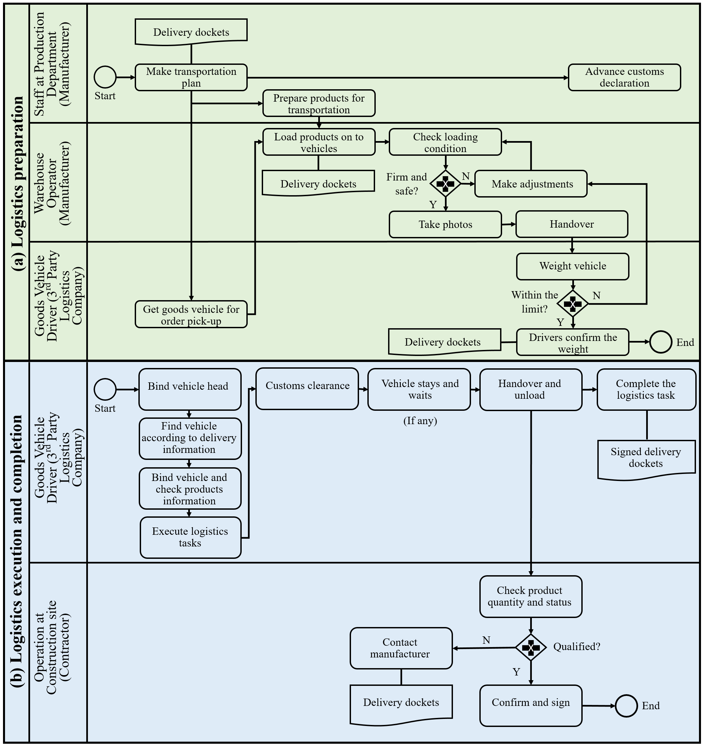
Figure 1. The business processes of cross-border logistics in modular construction: (a) preparation; (b) execution and completion

Several existing information management issues have been found in the business process of CLMC:
- Unclear product accountability: The product accountability in the module loading and unloading stages is unclear, mainly due to the use of paper. Manual recording (e.g., paper-based inspection records and handwriting) often leads to input error.
- Low real-time traceability of cross-border logistics records: The customs clearance status is not notified to all stakeholders in a timely manner, resulting in information asymmetry among participants.
- Lack of incentives for data sharing: Due to the tight logistics schedule and repetitiveness of verification works, operators and drivers are unwilling to share verification records promptly. This problem worsened during the COVID-19 pandemic, as CLMC drivers must submit more information (e.g., the receipt of nucleic acid tests) to local governmental agencies.
- Logistics file loss and data manipulation: Current logistics file records may be lost or even modified without strict supervision

As shown in Table 1, blockchain has several advantages over existing approaches that can address these issues. It can securely provide user authentication and authorization to prevent impersonation (Esposito et al., 2021). Blockchain provides a timestamp for each recorded transaction to ensure that stakeholders can track logistics history and a decentralized network that can enhance recorded timestamps to prevent loss (Chang et al., 2020a). Blockchain offers different options for implementing incentive mechanisms, such as cryptocurrency-based incentives or combined with external incentive models (Lu et al., 2021a). The distributed ledges of blockchain are scattered in many places in a shared manner to log logistics data. Unlike traditional solutions that may suffer from tampering risks or require the continued purchase of servers, blockchain can prevent data loss because the same copy of the data record is replicated, encrypted, and stored in the peer network (Pradeep et al., 2021). For these reasons, blockchain can be exploited to realize CLMC supervision.

Table 1. Existing methods for addressing issues in CLMC and blockchain advantages
Issues | Existing tools | Blcokchain advantages | References
Unclear product accountability | Paper-based documentation, Barcodes, QR codes | Blocckahin can provide secure user authentication and authorization | Esposito et al. (2021)
Low real-time traceability | Radio-frequency identiﬁcation (RFID) tags | Blockchain can provide the records with a timestamp through a decentralized network | Chang et al. (2020a)
Lack of incentives for data sharing | Incentive policies | Blcockhain can provide cryptocurrency-based incentives or be integrated with external incentive model | Lu et al. (2021a)
Logistics file loss and data manipulation | Multi-server system, Cloud system | Blockchain can offer distributed ledgers with encryption | Pradeep et al. (2021)

4. Research Methodology
In this study, the design science research (DSR) approach was adopted to develop a BBS model for CLMC. DSR is a scientific knowledge production philosophy that tries to produce creative constructs that address real-world issues (Pradeep et al., 2021). Our study used three steps as shown in Figure 2.

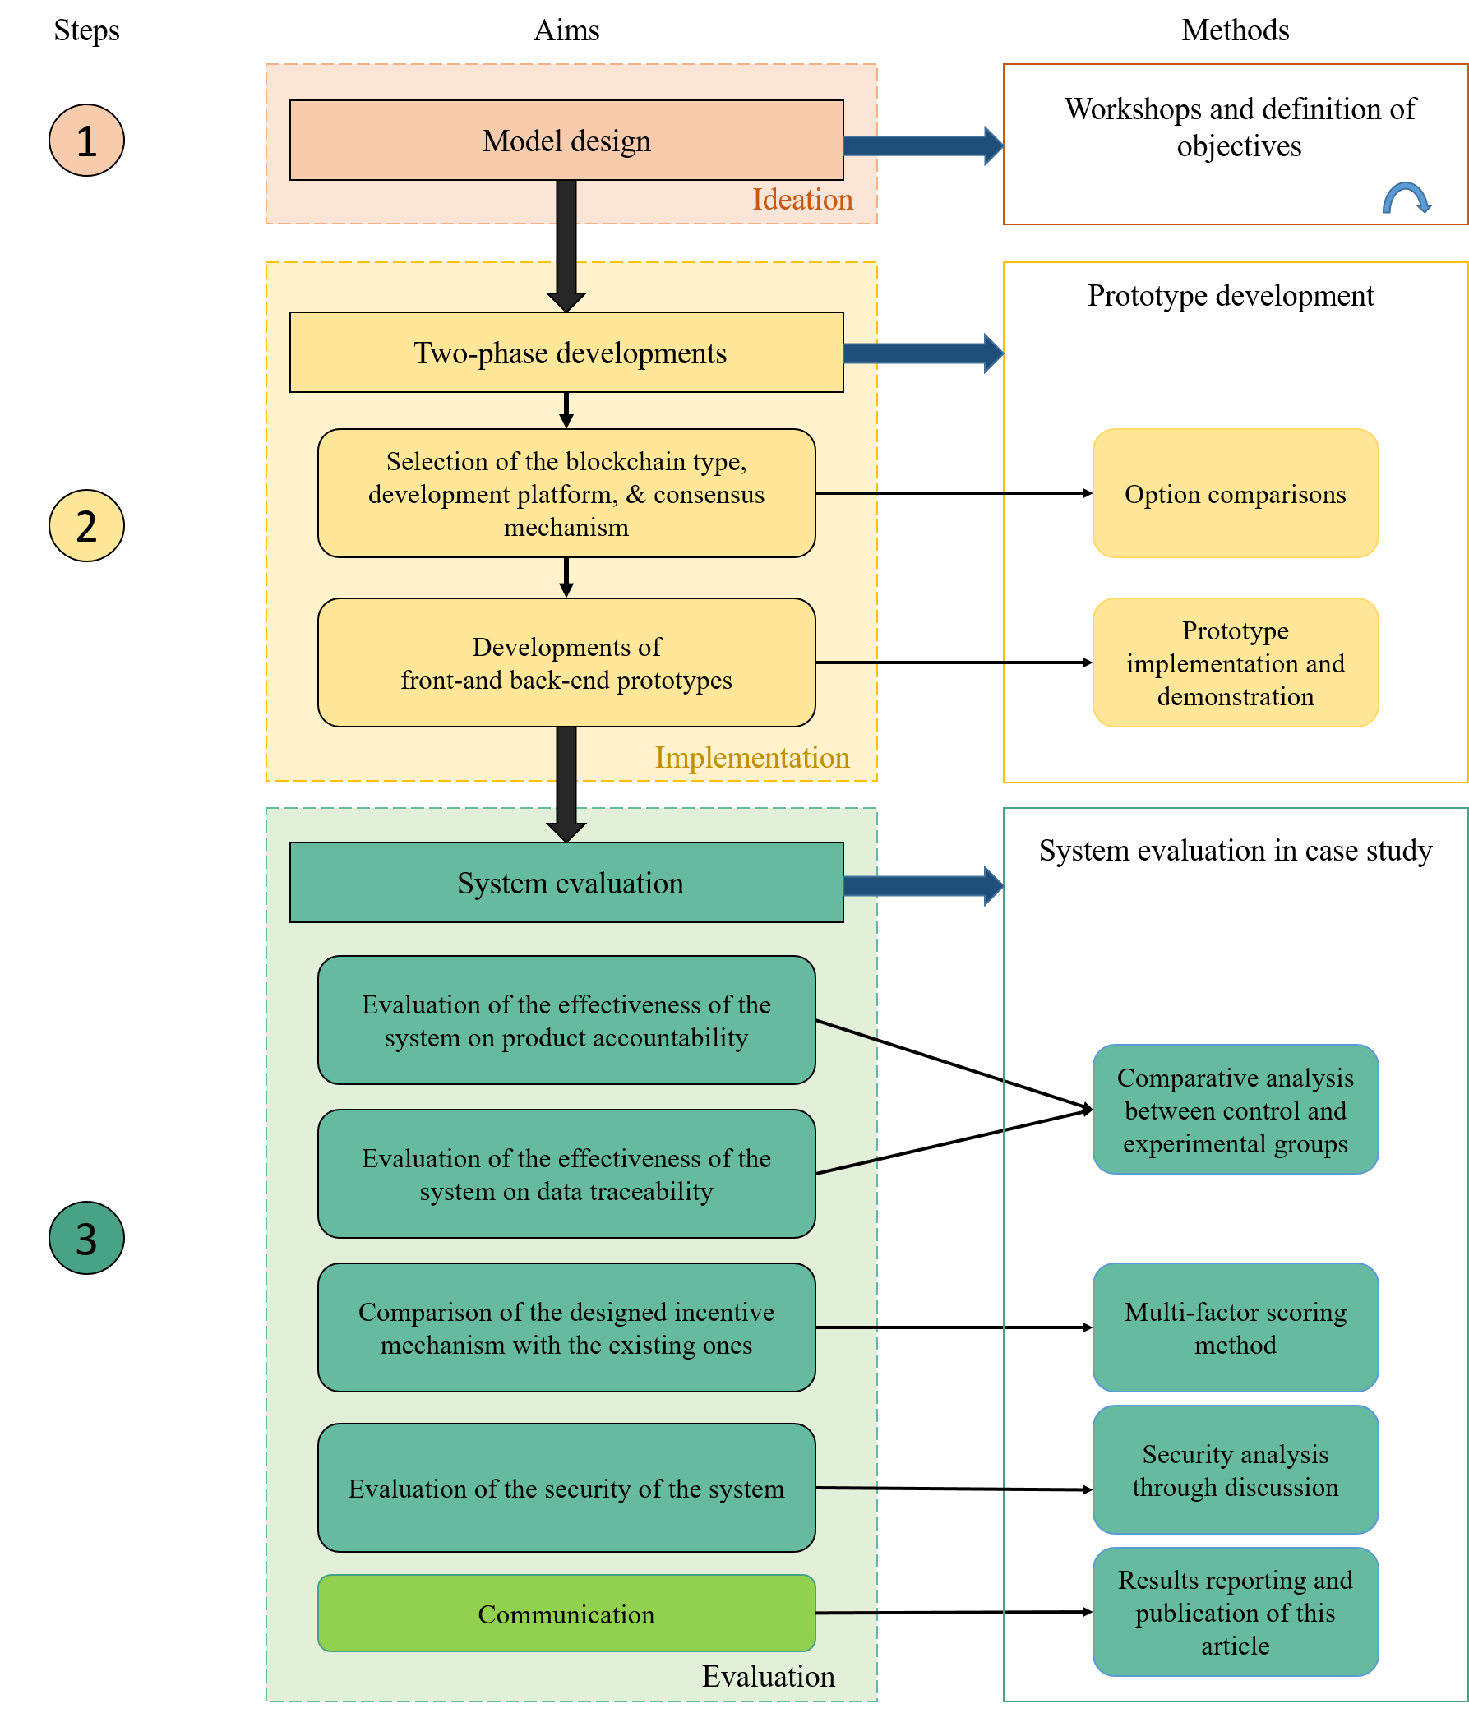
Figure 2. Research methodology

4.1 Designing Model
In the first step, to design a BBS model to meet the research objectives, the research team brainstormed in four meetings in January 2021, analyzing and synthesizing knowledge obtained from the literature. This process was non-linear and required multiple iterations to develop a promising solution (because some solutions are feasible but not the most promising) for which the model was developed.

4.2 Developing and Implementing the Prototype
The second step involved a two-phase development of the prototype system. In the first phase, blockchain type, development platform, and consensus mechanism were selected to implement the system. Among blockchain types (public, private, and consortium), the consortium blockchain was selected because CLMC involves various organizations and only approved project members can join the network. Then, Hyperledger Fabric was adopted as the development platform because it provides developers with security-enhanced alternatives and resources (Li et al., 2021b). Then, the crash fault tolerance (CFT) consensus was selected. CFT can avoid network crashes and partitions (Li et al., 2021b) and is relatively fast compared to Byzantine fault tolerance (Lu et al., 2021a).

In the second phase, front- and back-end prototypes were develop in Linux version 5.4.0-58-generic-lpae (5.4.0-58.64~18.04.1) (Ubuntu 18.04.1 LTS). The back-end prototype was implemented using SpringBoot (version 2.4.0) allowing the research team to quickly develop database management systems and web servers. AdminLTE (version 3.0) was used to develop front-end prototypes to enable the user interfaces. Hyperledger Fabric Explorer was used to provide users with browsing access to information on the blockchain.

4.3 Evaluating the Model Performance
In the third step, four evaluations were conducted in a modular construction case to demonstrate that the model operates as intended. The case project involves two 17-story student residence tower buildings on top of a 3-story podium structure, as shown in Figure 3(a). A total of 1008 modules (excluding mock-up modules) of five types were delivered from Foshan, Mainland China, to Hong Kong for assembly (see Figure 3(b)). The typical floor plan is shown in Figure 3(c).

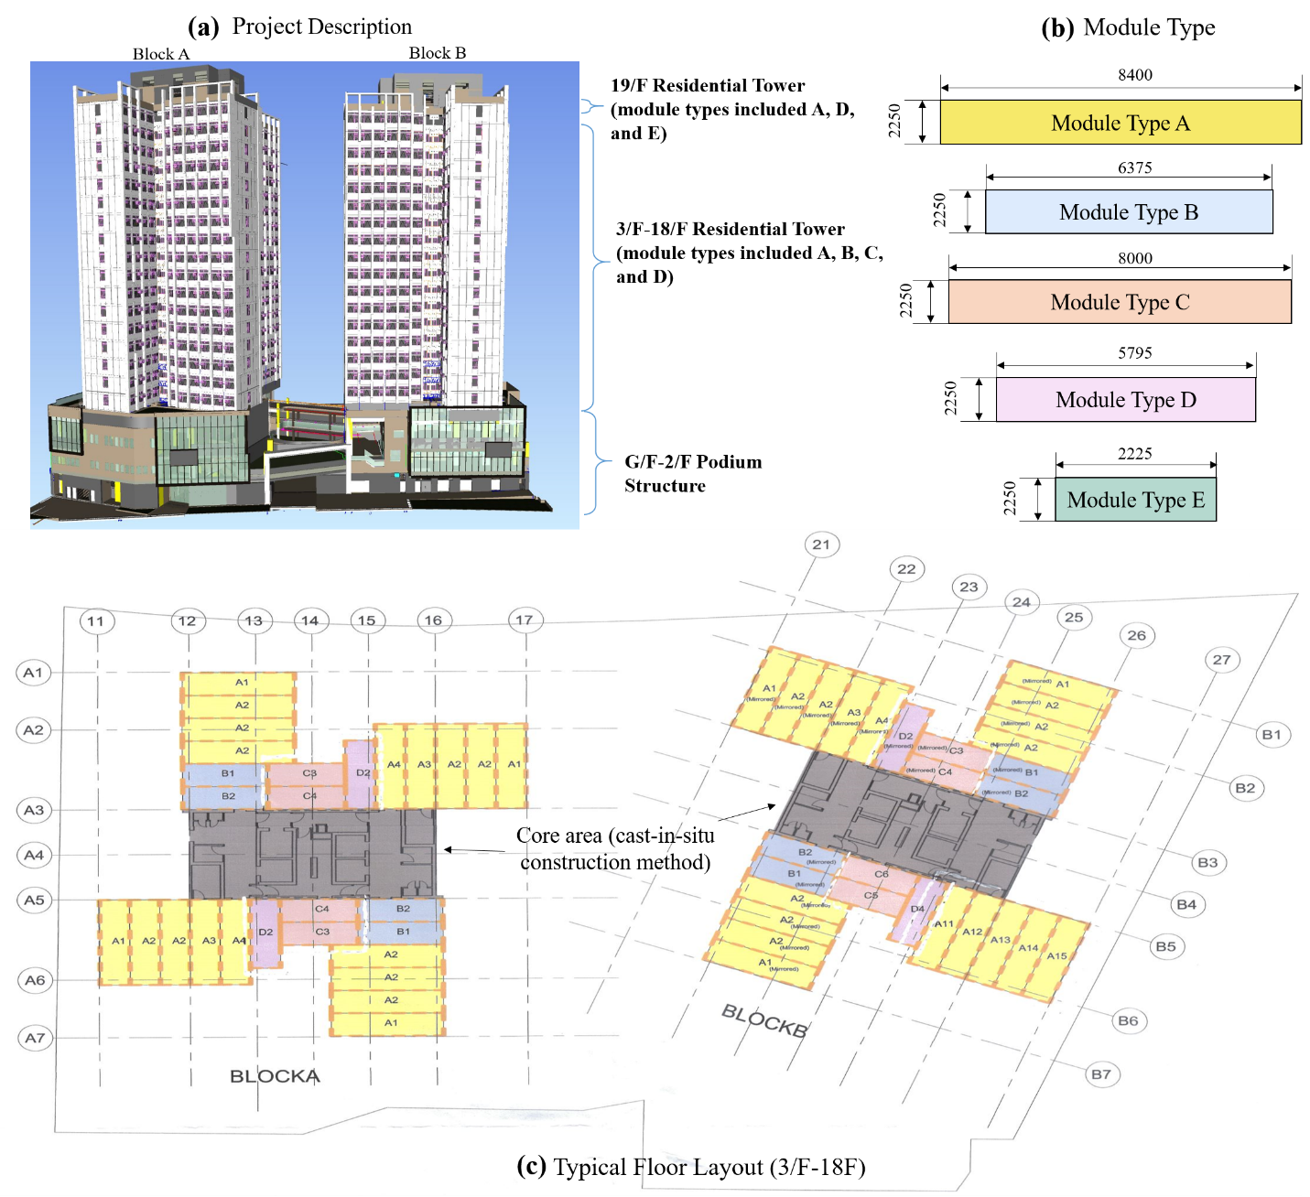
Figure 3. The case project

Firstly, we aimed to evaluate whether the model can improve the CLMC supervision processes in terms of product accountability by allowing users to record operations promptly. The evaluation was done through comparative analysis of use of paper records and the BBS system over six weeks. In previous studies (e.g., Farzan et al., 2008), comparative analysis has been used to test the effectiveness of various information systems. Twenty-eight drivers confirm departure from Foshan, posting the status of customs clearance at the border, and reporting on arrival at the site (see Figure 4). At each delivery, drivers should submit transactions for hold points. Every driver is assigned one CLMC delivery per week. These 28 participants are called the control group and are instructed to record on paper the six weeks of operations. Meanwhile, 28 drivers from the experimental group use the same method to record the exact operations in the first three weeks and then switch to the developed system in the last three weeks. Five evaluation indicators proposed by Li et al. (2019b) were used to test the effectiveness of the system; that is, the time to record vehicle information, driver information, module quality information, cross-border permit documents, and logistics status.

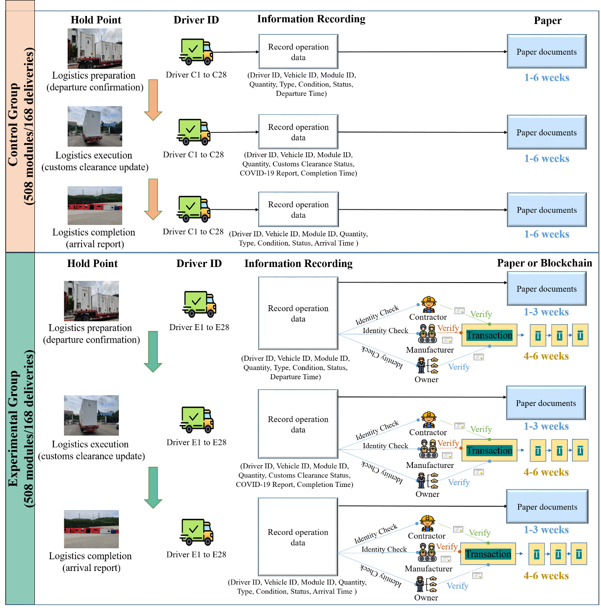
Figure 4. The evaluation scenario for product accountability

Secondly, we aimed to evaluate whether the developed model can improve the CLMC supervision processes in terms of data traceability by allowing users to query operations promptly. Similar to the evaluation of the product accountability, five indicators were used to test the effectiveness of the system; that is, the time to query vehicle information, driver information, module quality information, cross-border permit documents, and logistics status.

Thirdly, a multi-factor scoring (MFS) method was used to evaluate whether the designed incentive mechanism was more efficient than existing mechanisms encouraging users to publish transactions promptly in blockchains. Based on the study conducted by Zuo et al. (2012), the first-level indicators (I_{i}) for measuring the performance of an incentive mechanism were proposed (see Figure 5). Then, a list of detailed performance indicators was formulated built upon Li et al. (2019b). After that, a workshop was conducted in late July 2021 with the logistics company involved in the surveyed project to assess the suitability of the second-level indicators (I_{i-j}) and establish the values of the relative weighting parameters Wi of I_{i} and wij of I_{i-j}. Next, a 3-part questionnaire was sent to the logistics company in early August 2021. In Part I of the questionnaire, five incentive mechanisms (including the incentive mechanism designed in this study) were explained to respondents. Part II of the questionnaire gathered the demographic characteristics of the respondents. In Part III, respondents were asked to score I_{i-j} based on the scaling statements (0, Inferior; 3, Poor; 6, Fair; 9, Good; 12, Superior) for each mechanism. The score $S_{i}$ (the weighted score from assessing I_{i-j}) was determined using Equation 1:

$S_{i}$ $=\sum_{j=1}^{x}{w_{ij}S_{ij}}$ (1)
where x denotes the number of second-level indicators under I_{i}. The final value of each incentive mechanism is defined as the total score collected from the assessment results on I_{i-j}, which are subdivided from I_{i}. The final values were calculated by using Equation 2:

Final value $=\sum_{i=1}^{n}{W_{i}S_{i}}$ (2)
where n denotes the number of first-level indicators. Of the questionnaires distributed, we received 78 responses, but some were abandoned due to incompleteness. The remaining 56 were output and analyzed in Excel spreadsheets. Regarding demographic characteristics, 85% of respondents held a bachelor’s degree or above. About 50% had 1–5 years’ experience in the logistics industry, 17.9% had 6–10 years’ experience, and 32.1% had more than 10 years’ experience.

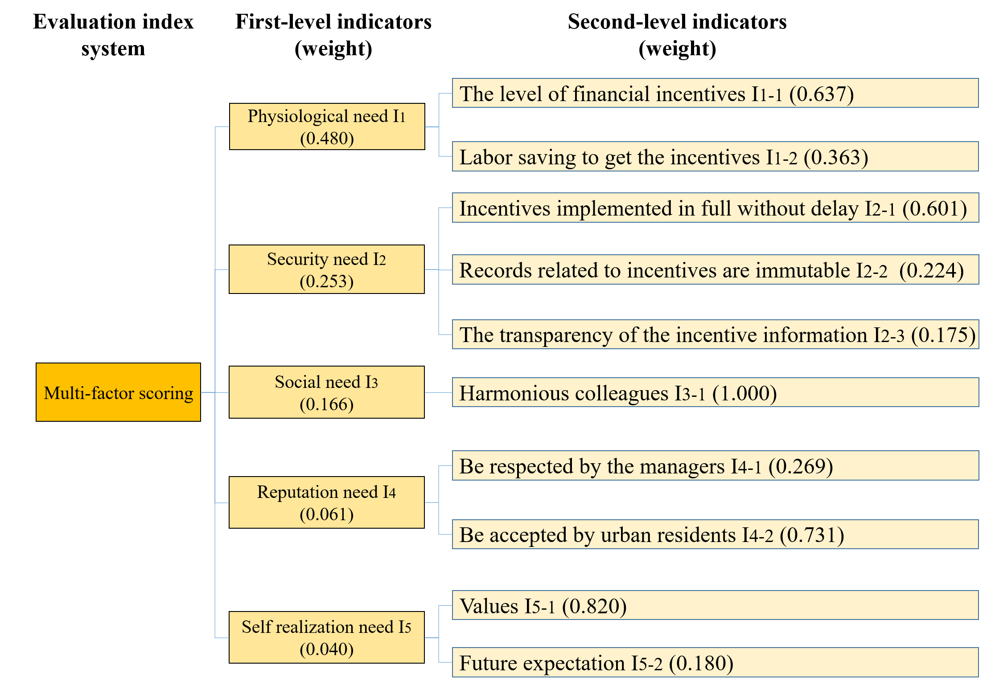
Figure 5. Indicators of the multi-factor scoring (MFS) system

Finally, we aimed to discuss the security of the proposed blockchain-based model. According to Lu et al. (2021b) and Li et al. (2021b), the security analysis of the proposed model can be discussed through data immutability, non-repudiation, authentication and authorization. The analysis results were disseminated to audiences in modular construction.

5. The BBS Model for CLMC

5.1 The BBS Model
The proposed BBS model has two parts: (a) an incentive mechanism (see Figure 6(a)); and a blockchain-based supervision mechanism (see Figure 6(b)). The proposed model includes four organizations: owner, manufacturer, transporter, and contractor, and every involved organization has many operators to record their operation transactions. According to the delivery schedule, the manufacturer’s operators first load the prefinished modules onto the delivery vehicles and record the condition and status of modules. Then, the operators (e.g., drivers) of the transporter confirm the condition of the loaded modules and deliver them to the border. After customs clearance, the transporter’s operators should update the status of delivery and deliver modules to the site. The contractor’s operators (e.g., site engineers) will verify the delivered modules (e.g., quality, quantity) and sign the delivery dockets.

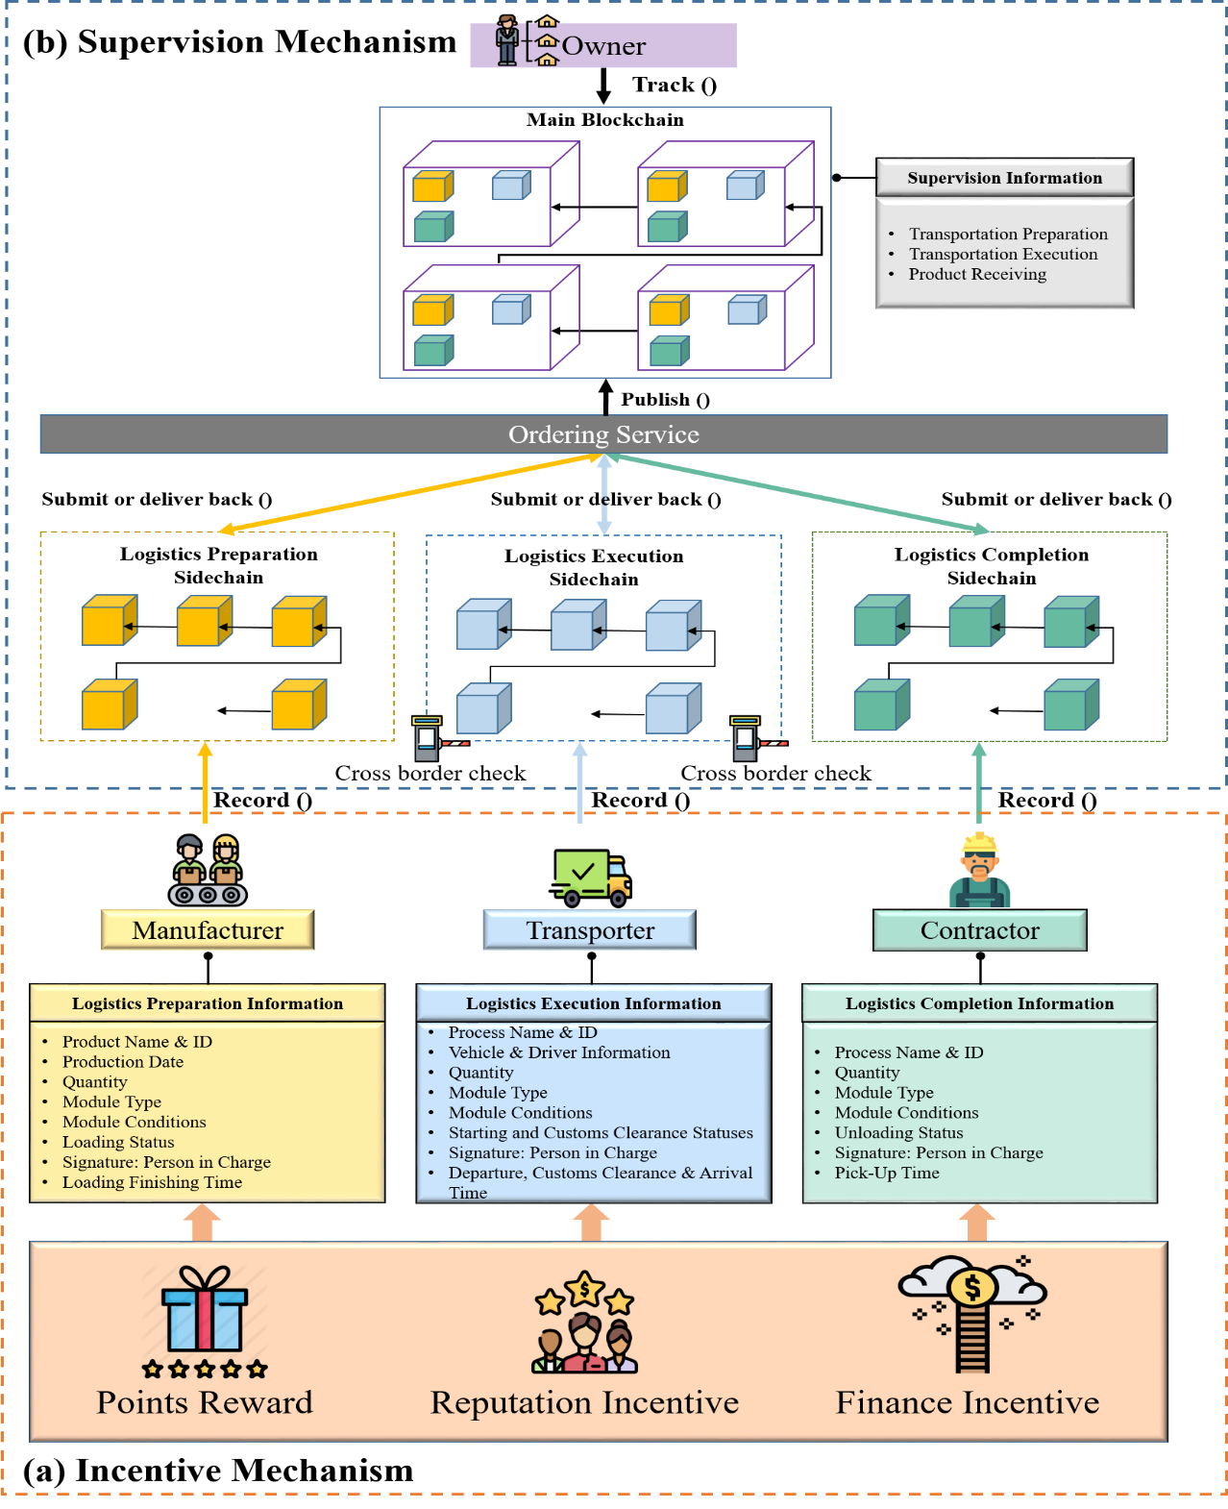
Figure 6. The blockchain-based supervision model for cross-border logistics in modular construction: (a) incentive mechanism; (b) supervision mechanism

In the BBS model, the project owner can supervise the entire CLMC process by including an information record-track supervision pattern and a consensus mechanism. Thus, transaction information such as logistics preparation, execution, and completion can be recorded, published, endorsed, and tracked. Logistics preparation information contains data about module ID, production date, type, conditions, status, signature, and loading finishing time. Logistics execution information includes data about transportation operations, while logistics completion information includes the data about the receiving verification operations.

5.1.1 Model Structure
The first part of the model is a points-based incentive mechanism. The points system can motivate users to make contributions in enterprise social networking as points can turn their participation into a value for themselves (Farzan et al., 2020). Table 2 shows the calculation principles of the system. In BBS, users will receive a point for each recorded transaction. Each recorded transaction published within one hour of finishing the operation will help users earn an extra 30 points. The total points are the sum of points received from recording transactions and publishing on time. Five reputation statuses (fail, pass, credit, distinction, and high distinction) are also defined. The reputation incentive is a long-lasting incentive mechanism, benefits of which include more business opportunities, cost-free advertising, and higher company value (Huang et al., 2020). The mechanism is also integrated with financial incentives to improve participant attitudes to sharing data promptly and drive the progress of projects (Lu et al., 2021a). In the BBS model, each point obtained by the user can be traded for three dollars from the owner. All transaction records are stored in the blockchain to achieve a transparent and immutable incentive mechanism. The incentive reward will be canceled if a participant cheats. Further, if modules are damaged, and the difference between the actual cost and compensation payment received from the insurance company exceeds 1,500 dollars, the corresponding participant will not obtain the incentives.

Table 2. A points-based incentive mechanism
Participants | Reward point for each published transaction | Total number of transactions published (variable) | No. of transactions recorded on time*  (no. of transactions not recorded on time) | Reward points per transaction  (on-time)* | Total points**  (T)
Manufacturer A | 1 | O | X (O−X), where X≤O | 30 | 1×O+X×30
Transporter B | 1 | P | Y (P−Y) , where Y≤P | 30 | 1×P+Y×30
Contractor C | 1 | Q | Z (Q−Z) , where Z≤Q | 30 | 1×Q+Z×30
*Transactions published within 1 h after corresponding operations are completed.
**Total points < 500: fail; 500 ≤ total points < 650: pass; 650 ≤ total points < 750: credit; 750 ≤ total points < 850: distinction; and 850 ≤ total points: high distinction.

The second part of the model is a blockchain-based supervision mechanism. The blockchain consists of two layers. The lower layer includes three sidechains to manage information related to logistics preparation, logistics execution, and logistics completion. These three sidechains are held by the manufacturer, the transporter, and the contractor, respectively. The data frame structure in the sidechain can be seen in Figure 7(a). Each transaction consists of a timestamp, a hash pointer of the current transaction, a hash pointer of the previous transaction, and data. The data contains a key-value pair, where the key gives the operation category, including “Logistics Preparation”, “Logistics Execution”, and “Logistics Completion”. The value shows the data content, such as module ID and custom clearance status. Under this data frame structure, operation transactions can be converted to the same format. The upper layer is the main blockchain. Each block in the mainchain contains a header and a set of transactions. The block header includes an index (the sequence of blocks in the chain), a timestamp, a signature validator, and hash pointers of current and previous blocks. Figure 7(b) shows that three categories of transactions from the sidechains can be published to the mainchain, and the owner can also track records from the mainchain.
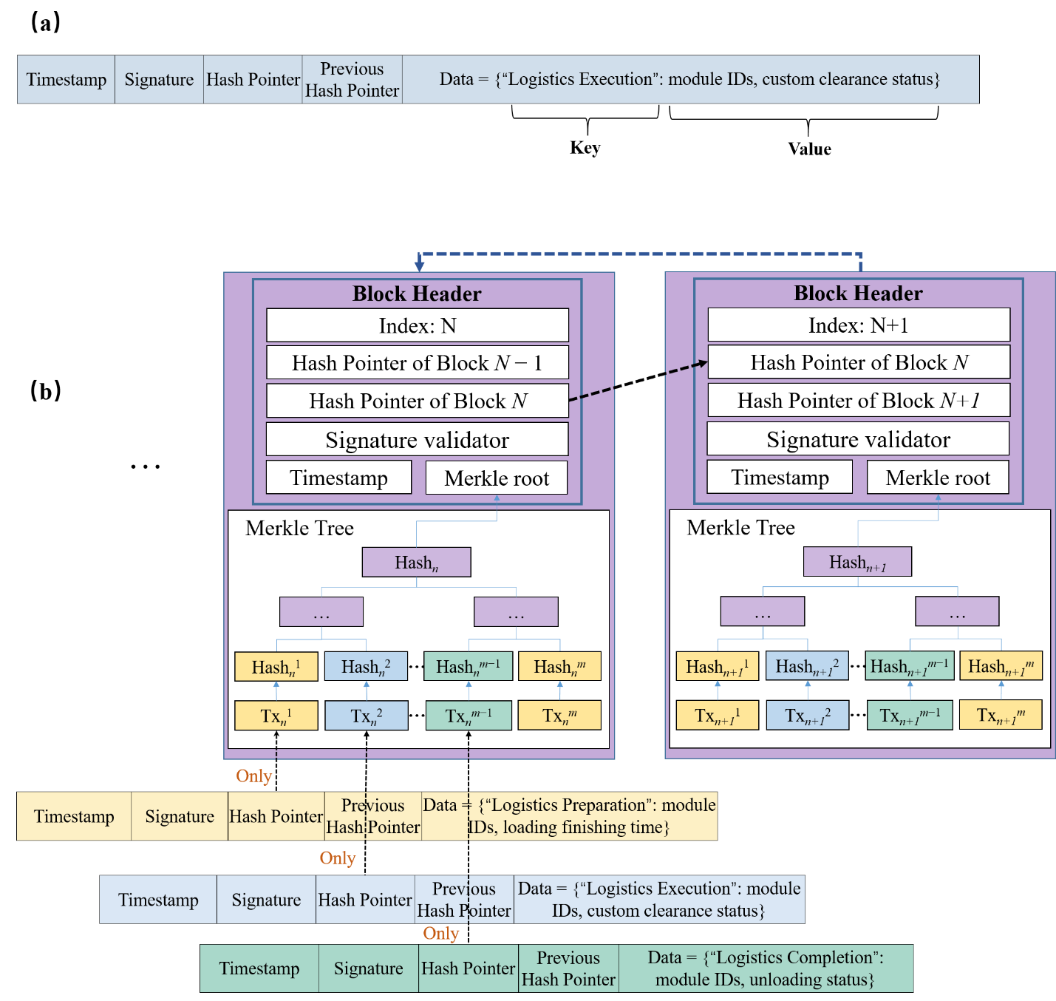
Figure 7. Transaction and blockchain: (a) data frame structure in sidechains; and (b) block structure in the mainchain

5.1.2 Incentive and Supervision Processes in the BBS Model
The BBS model has three main processes to implement incentive and supervision mechanisms: registration, supervision, and incentive, as shown in Figure 8.

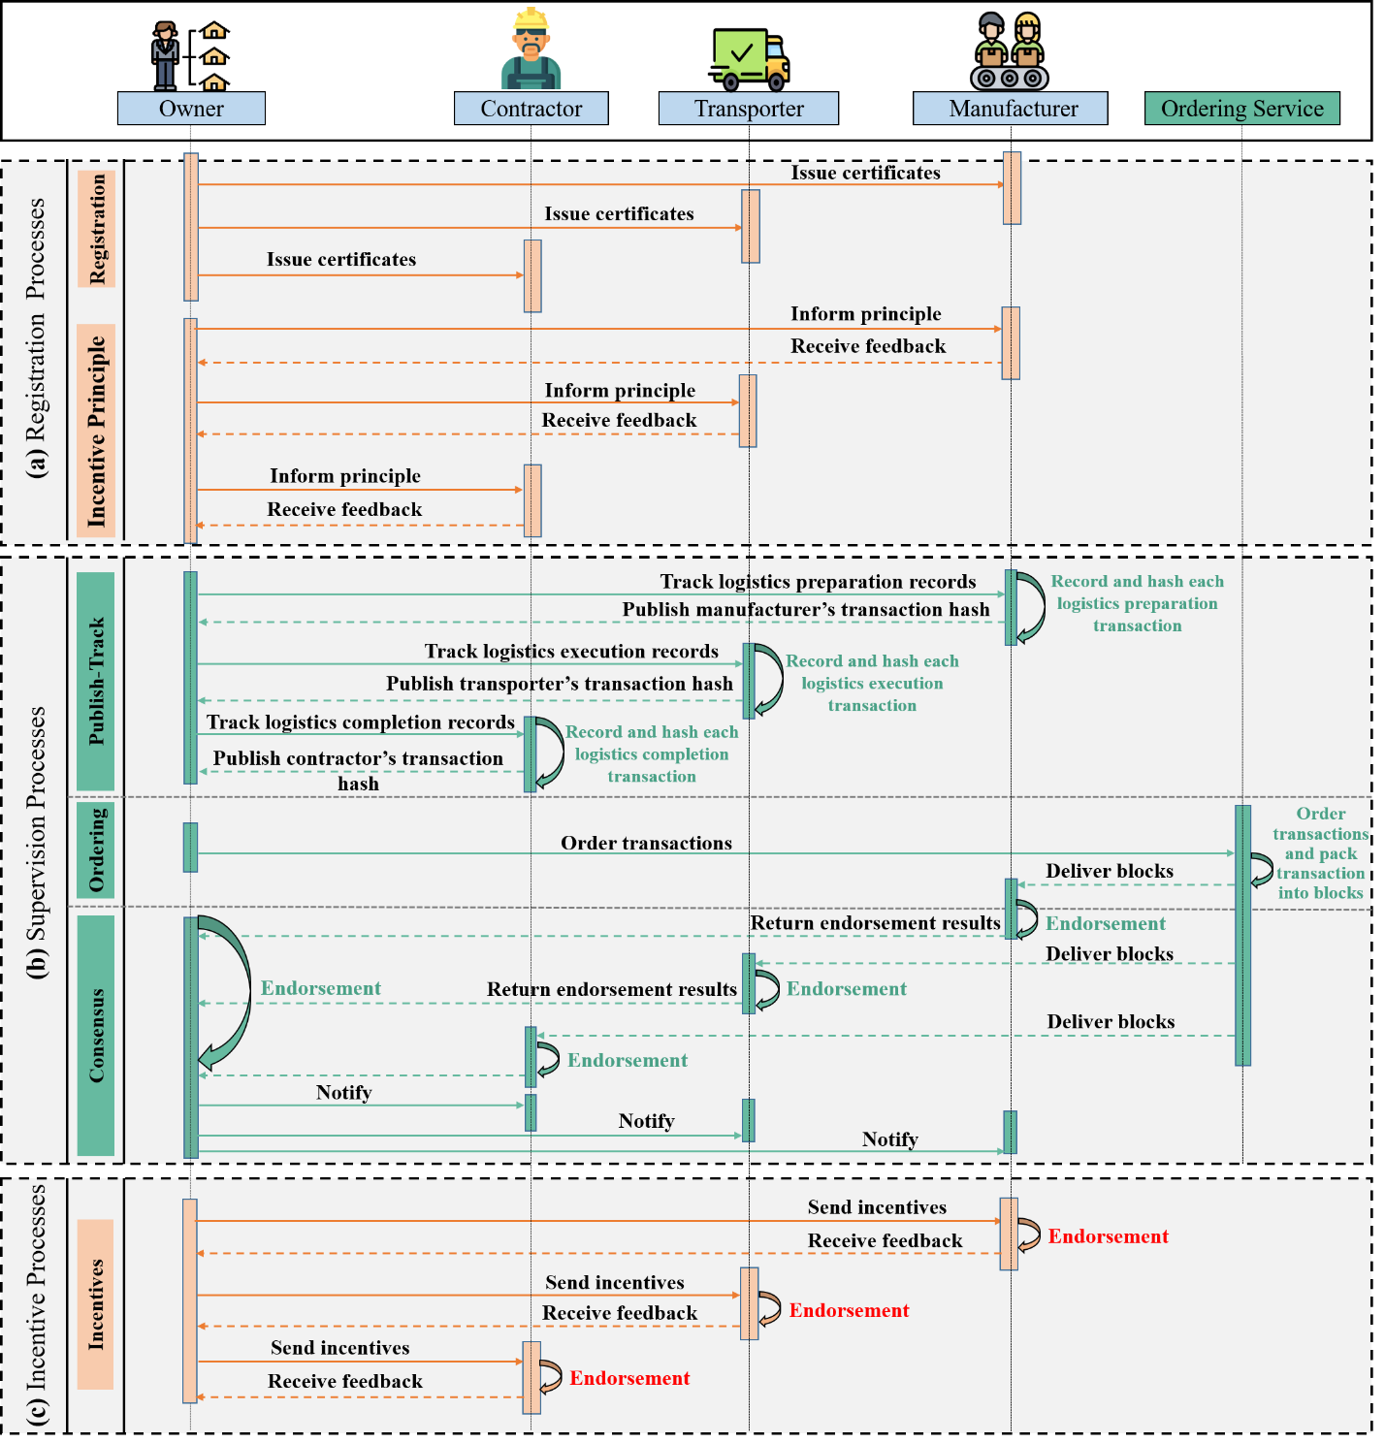
Figure 8. Incentive and supervision processes in the blockchain-based supervision model

(1) Member Registration and Incentive Principle Notificaiton
Member registration is essential for access control in the BBS network. Participants first need to verify their identities by sending membership registration requests to the owner (see Figure 8(a)). The owner can then issue certificates to eligible participants and register them as network members. Member registration ensures that participants are reviewed and given permissions, as well as detailed information on the incentive mechanism for those who need to record and publish transactions.

(2) Supervision Processes
A publish-track supervision pattern is adopted in the second process to allow members to publish CLMC transactions to the main blockchain (see Figure 8(b)). The owner can also supervise the CLMC processes by tracking the transactions. For instance, when the transporter’s operators begin to deliver the modules to the site, the owner can track the transaction records of logistics execution. The operators of the transporter then record and hash each operation in the logistics execution information sidechain. Next, these operators publish the transaction hashes to the owner for supervision. Similarly, the owner can establish this publish-track supervision pattern with the manufacturer and the contractor.

The BBS model employs an ordering service to form orderly blockchains. The owner acts as an ordering node in the network, ordering transaction hashes published by operators and packaging them into new blocks. The ordering service cannot access the data in transactions, nor can it update unapproved blocks. Instead, it can only deliver the packed blocks to participants for endorsements. The BBS model adopts a CFT consensus algorithm to help participants to endorse logistics transactions. Both valid and invalid transactions are recorded in blocks. Afterward, members will be notified of the endorsement results.

(3) Incentive Implementation
The third process is to implement the incentive mechanisms (see Figure 8(c)). After the operator completes the specified operation and publishes the transaction, the owner will calculate his/her points, reputation status, and financial incentives based on the records in the BBS. For instance, the transporter’s operator needs to record 40 transactions, of which 35 are recorded and published within one hour of finishing the operations. According to Table 1, this operator will earn 1,090 points (1 × 40 + 35 × 30), a high distinction reputational reward, and a financial reward of $3,270.

6. Prototype System and Evaluation

6.1 Prototype System
A prototype system was developed to implement the BBS model for CLMC, containing four organizations: (i) owner; (ii) manufacturer; (iii) transporter; (iv) contractor. The configuration information of these four organizations is shown in Figure 9(a). Participants were registered as members by using the cryptogen in Hyperledger Fabric to issue certificates (see Figure 9(b)). To initialize the ordering service, the genesis block was configured (see Figure 9(c)). Subsequently, Hyperledger Explorer was established to allow users to browse the blockchain network internally (see Figure 9(d)).

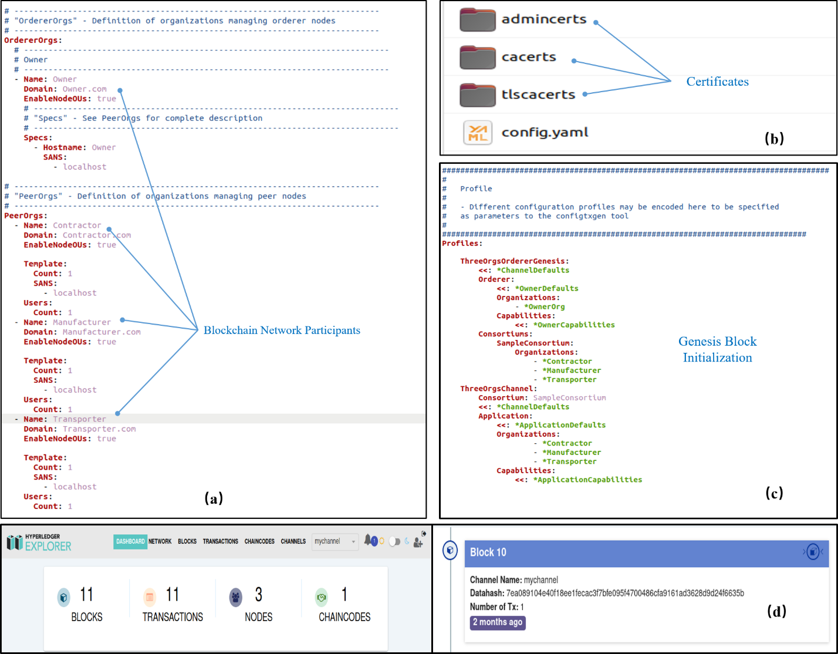
Figure 9. System configuration: (a) organizations; (b) certificates; (c) genesis block; and (d) explorer

The development of the front-end prototype makes the interfaces available to users. For example, when a driver delivers a batch of modules to the border and passes through customs, the driver can record and publish logistics execution information such as the driver ID, vehicle number, quantity, module ID, customs clearance status, completion time, and the driver’s COVID-19 test report, as shown in Figure 10(a). The JavaScript Object Notation (JSON) form plug-in will convert the recorded information into a JSON ﬁle and store it in the sidechain. Then, the file will be hashed and published to the owner in the mainchain. After reaching a consensus, the file will be appended as the latest block to the participants’ blockchain.

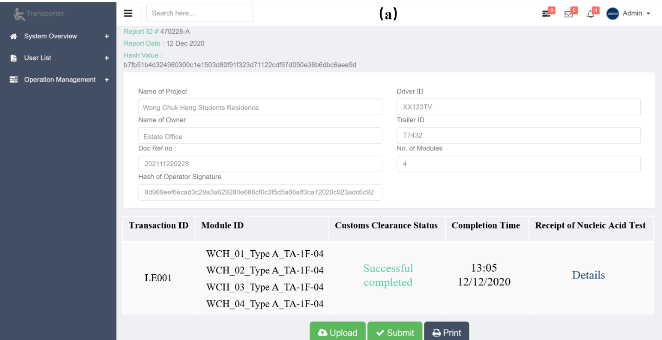
- Transporter’s interface for publishing transactions
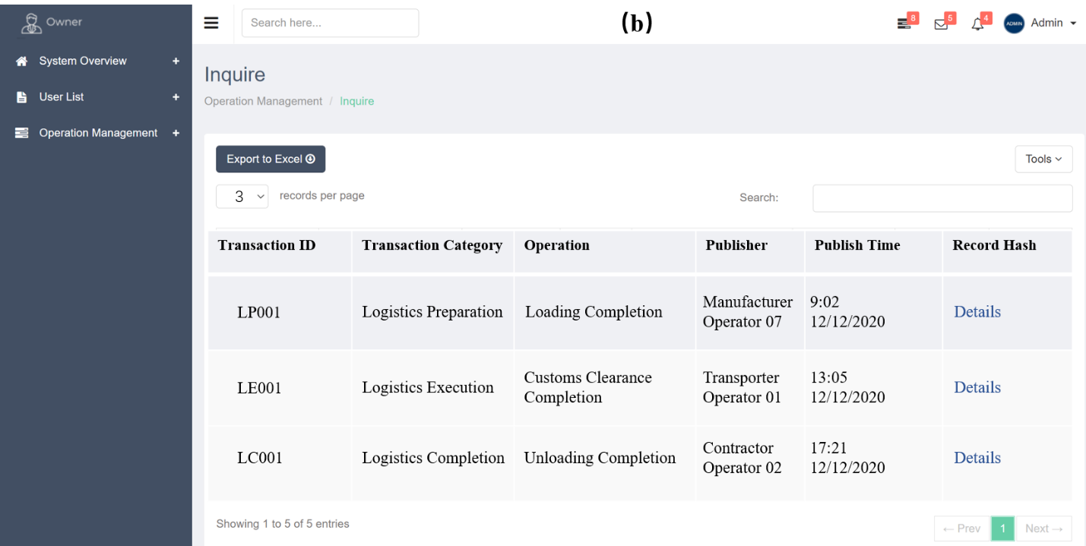
(b) Owner’s interface for tracking operations
Figure 10. User interfaces

The project owner can supervise the CLMC process by tracking logistics transaction information. For example, the owner can use the interface shown in Figure 10(b) for tracking historical operations. Corresponding information related to modules such as transaction ID, transaction category, operation name, publisher ID, and publish time can be viewed through the interface. The owner can also check the block details by clicking on any recorded transaction. These details include a block index, timestamp, operator signature, and the hash pointers of the current and previous blocks.

6.2 System Performance Evaluation

6.2.1 Evaluation Results of the Product Accountability
The time spent by the control and the experimental groups to record the five types of information during the supervision processes is shown in Figure 11. For the control group, the recording time for each kind of information remained constant for six weeks. In contrast, after introducing the system in the 4th week, the experimental group spent less time recording each type of information (see Figure 11). The t-test was used to compare the recording time spent by each group between week 3 and week 4. The results showed almost no difference in the recording time spent by the control group between weeks 3 and 4 (df=8, t=0.0035, p=0.997), whereas there was a change in recording time spent by the experimental group after the system was introduced (df=8, t=0.6601, p=0.528). Thus, the developed system implements effective product accountability for CLMC.
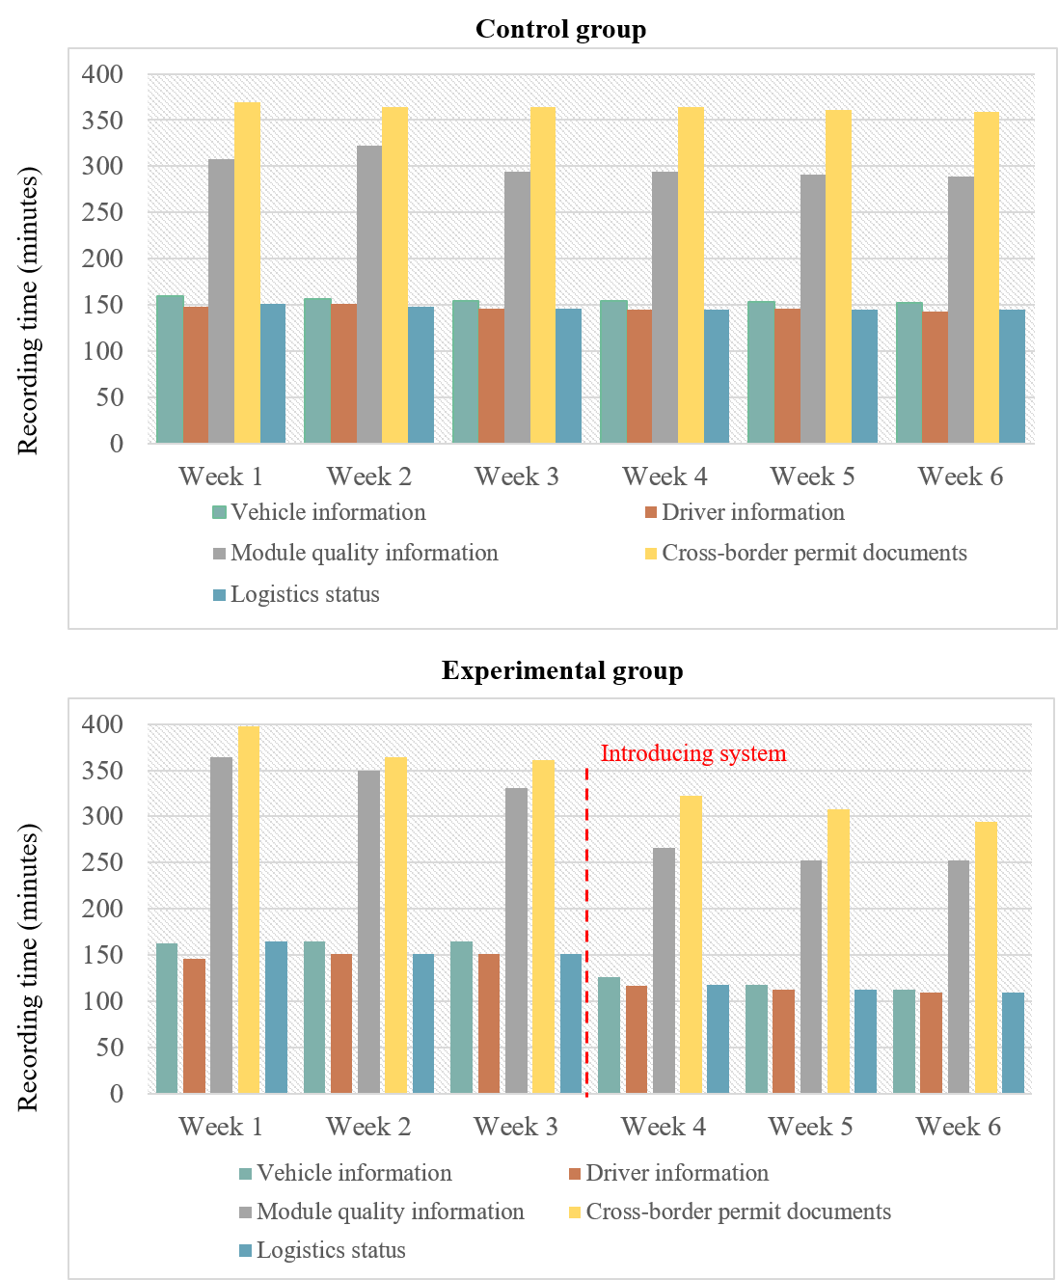
Figure 11. Evaluation results of the product accountability

6.2.2 Evaluation Results of the Data Traceability
The time spent by the control and the experimental groups to trace the five types of information during the supervision processes is shown in Figure 12. The amount of time the control group spent tracing each type of information remained constant. After introducing the system, the time the experimental group spent on tracing information decreased significantly. The t-test showed only a small difference in the tracking time spent by the control group between weeks 3 and 4 (df=8, t=0.042, p=0.967), whereas there was a statistically significant difference between weeks 3 and 4 in the experimental group (df=8, t=1.468, p=0.180). Thus, the developed system implements effective data traceability for CLMC.

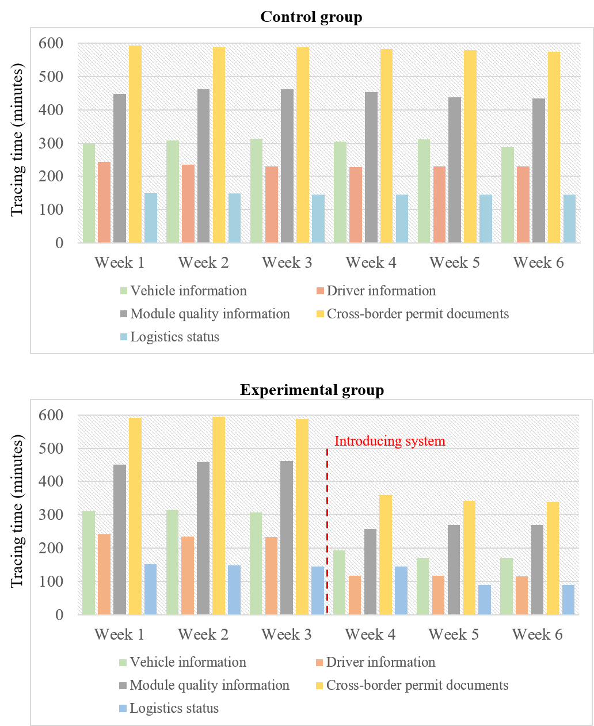
Figure 12. Evaluation results of the data traceability

6.2.3 Evaluation Results of the Incentive Mechanism
The evaluation results of the incentive mechanisms is presented in Table 3. Compared with Xuan et al. (2020) and Huang et al. (2020), the first three studies meet physiological needs by introducing financial rewards, encouraging users to share information promptly. Due to the use of blockchain, all studies received close scores in meeting security needs. Chang et al. (2020b) received the lowest score in terms of social needs. This may be because their incentive mechanism is designed to encourage fierce competition, leading to discordant relationships. The first and fifth studies obtained higher scores than others for the fourth dimension because they considered reputational incentives. Also, the first study received the highest scores for meeting self-realization needs, mainly because points can turn participation into value for participants. Overall, the incentive mechanism proposed in this study received the highest value.

Table 3. Evaluation results of the incentive mechanism
No. | Selected studies | W₁S₁ | W₂S₂ | W₃S₃ | W₄S₄ | W₅S₅ | Final value
1 | This study | 273.03 | 157.65 | 57.27 | 39.92 | 24.13 | 552
2 | Wang et al. (2018) | 179.70 | 144.51 | 56.70 | 18.03 | 16.06 | 415
3 | Chang et al. (2020b) | 181.06 | 159.14 | 22.81 | 11.30 | 15.78 | 390
4 | Xuan et al. (2020) | 84.55 | 157.45 | 56.77 | 18.27 | 15.96 | 333
5 | Huang et al. (2020) | 58.54 | 158.65 | 50.30 | 38.59 | 23.92 | 330

6.2.4 Analysis Results of the System Security
The security analysis of the proposed system is discussed through data immutability, non-repudiation, authentication and authorization.
- Data immutability and non-repudiation: For a transaction to have data immutability, it cannot be modified during its transmission. All exchanged transactions in the system are tamper-proof with timestamps. Furthermore, to prevent “man in the middle” attacks and otherwise secure communications, Transport Layer Security (TSL) in Hyperledger Fabric facilitates a transaction immutability check among participants.
- Authentication: Authentication mechanisms rely on digital signatures requiring each participants to hold a cryptographical key pair: a public key is made widely available and acts as an authentication anchor, and a private key is used to produce digital signatures on transactions.
- Authorization: This study uses membership service provider (MSP) in Hyperledger Fabric to prove authorized peers’ identity. Only authorized peers can record and trace corresponding CLMC data.

7. Discussion
In CLMC, numerous operation records need to be recorded, endorsed, and tracked, and failure of supervision may lead to costly and protracted cross-border litigation. The first contribution of this research is to examine the business process of CLMC, identify its information management problems, and define the scope of supervision on three types of logistics operation records, i.e. preparation, execution, and completion.

Although construction stakeholders have begun to explore blockchain technology as a means of enhancing traceability of construction supply chain management, an incentive mechanism to increase users’ willingness to share data is lacking. The second novel contribution of this research is to propose a BBS model that enhances supervision of CLMC while improving the willingness of users to share data. The incentive mechanism uses points to turn participation into an activity that is essential to users. Reputational and financial incentives are integrated with the points system to further motivate users to share data within the predefined period. The third novel contribution of this study is that the BBS model is an adaptive structure that can extend applications to off-site production and on-site assembly in modular construction. It can also include other participants such as governmental agencies and consultants.

The study has several limitations. First, the operation data recorded on the blockchain is uploaded by humans, so there is a risk of opportunistic behavior. Second, the designed incentive mechanism is not dynamic in nature. For example, the reputation status needs to be adjusted manually based on the total number of uploaded transactions. Third, the proposed model lacks automation for implementing incentives.

8. Conclusions
Sustainability issues have prompted the construction industry to seek ways to mitigate the impacts of inefficient operations. In modular construction, supervision of cross-border logistics is challenging because the wide adoption of paper-based documentation means that information verification is inefficient. Although digital platforms (e.g., BIM and GIS) have been developed to improve the supervision of CLMC, they work in a centralized way, leading to information security issues such as tampering. If module quality becomes the focus of cross-border dispute, the logistics information cannot be secured. Blockchain technology has the potential to improve information security and support CLMC supervision, but requires investigation of incentive mechanisms to increase user willingness to share data.

This study develops a blockchain-based supervision (BBS) model with incentives for CLMC. The model is developed using a DSR approach to enhance supervision of CLMC and motivate users to share data promptly. The proposed model achieves the research objectives through three stages: member registration and incentive principle notification, supervision processes, and incentive implementation. A prototype system is developed to evaluate the proposed model in a CLMC case. The results show a positive change in recording time spent by the experimental group in terms of product accountability after the system was introduced (df=8, t=0.6601, p=0.528). Also, the evaluation results show a statistically significant difference between weeks 3 and 4 in the tracing time spent by the experimental group in terms of data traceability (df=8, t=1.468, p=0.180). In addition, this study obtains higher scores (552) than others in evaluating the incentive mechanisms. The security analysis is discussed through data immutability, non-repudiation, authentication, and authorization. Thus, the system implements effective supervision for CLMC through product accountability and data traceability. It also achieves efficient data sharing and security for CLMC.

The limitations of this study provide opportunities for future research. More research is needed on the blockchain oracles that connect the off-chain and cyber worlds. Lu et al. (2021b) recently explored SCOs as blockchain oracles to provide a data authenticity mechanism. Future research can integrate the proposed model with the SCO-enabled blockchain oracles and evaluate the integrated solution in real-life projects. For example, researchers can explore decentralized SCOs to protect data for secure upload to BIM and blockchain. Future research can also focus on dynamic incentive mechanisms to further maintain user participation. Das et al. (2020) used smart contracts to improve the efficiency of construction payments. Therefore, future studies can explore the combined application of the BBS model and smart contracts to reward users. Researchers can also integrate the BBS model with BIM, GIS, and 5G technologies. Finally, the model can be extended to industries other than construction.

Data Statement
Some or all data, models, or code that support the findings of this study are available from the corresponding author upon reasonable request. (Blockchain prototype code).

Acknowledgments
The work presented in this paper was financially supported by the Hong Kong Innovation and Technology Commission (ITC) with the Innovation and Technology Fund (ITF) (No. ITP/029/20LP).

References
Ahmad, R. W., Hasan, H., Jayaraman, R., Salah, K., & Omar, M. (2021). Blockchain applications and architectures for port operations and logistics management. Research in Transportation Business & Management, 100620.
Chang, Y., Iakovou, E., & Shi, W. (2020a). Blockchain in global supply chains and cross border trade: a critical synthesis of the state-of-the-art, challenges and opportunities. International Journal of Production Research, 58(7), 2082-2099.
Chang, Z., Guo, W., Guo, X., Zhou, Z., & Ristaniemi, T. (2020b). Incentive mechanism for edge-computing-based blockchain. IEEE Transactions on Industrial Informatics, 16(11), 7105-7114.
Choi, T. M. (2019). Blockchain-technology-supported platforms for diamond authentication and certification in luxury supply chains. Transportation Research Part E: Logistics and Transportation Review, 128, 17-29.
Choi, T. M., Wen, X., Sun, X., & Chung, S. H. (2019). The mean-variance approach for global supply chain risk analysis with air logistics in the blockchain technology era. Transportation Research Part E: Logistics and Transportation Review, 127, 178-191.
Cui, J., Ouyang, F., Ying, Z., Wei, L., & Zhong, H. (2021). Secure and Efficient Data Sharing Among Vehicles Based on Consortium Blockchain. IEEE Transactions on Intelligent Transportation Systems.
Das, M., Luo, H., & Cheng, J. C. (2020). Securing interim payments in construction projects through a blockchain-based framework. Automation in Construction, 118, 103284.
Esposito, C., Ficco, M., & Gupta, B. B. (2021). Blockchain-based authentication and authorization for smart city applications. Information Processing & Management, 58(2), 102468.
Farzan, R., DiMicco, J. M., Millen, D. R., Dugan, C., Geyer, W., & Brownholtz, E. A. (2008). Results from deploying a participation incentive mechanism within the enterprise. In Proceedings of the SIGCHI conference on Human factors in Computing Systems (pp. 563-572).
Fan, K., Wang, S., Ren, Y., Li, H., & Yang, Y. (2018). Medblock: Efficient and secure medical data sharing via blockchain. Journal of Medical Systems, 42(8), 1-11.
He, Y., Li, H., Cheng, X., Liu, Y., Yang, C., & Sun, L. (2018). A blockchain based truthful incentive mechanism for distributed P2P applications. IEEE Access, 6, 27324-27335.
Huang, C., Wang, Z., Chen, H., Hu, Q., Zhang, Q., Wang, W., & Guan, X. (2020). Repchain: A reputation based secure, fast and high incentive blockchain system via sharding. IEEE Internet of Things Journal, 8(6), 4291 – 4304.
Hamledari, H., & Fischer, M. (2021). Construction payment automation using blockchain-enabled smart contracts and robotic reality capture technologies. Automation in Construction, 132, 103926.
Lamba, R., Gupta, Y., Kalra, S., & Sharma, M. (2019). Preventing waiting list manipulation and black marketing of donated organs through Hyperledger Fabric. 2019 International Conference on Computing, Communication, and Intelligent Systems (ICCCIS) (pp. 280-285). IEEE.
Lee, D., Lee, S. H., Masoud, N., Krishnan, M. S., & Li, V. C. (2021). Integrated digital twin and blockchain framework to support accountable information sharing in construction projects. Automation in Construction, 127, 103688.
Li, M., Shen, L., & Huang, G. Q. (2019a). Blockchain-enabled workflow operating system for logistics resources sharing in E-commerce logistics real estate service. Computers & Industrial Engineering, 135, 950-969.
Li, X., Shen, G. Q., Wu, P., & Yue, T. (2019b). Integrating building information modeling and prefabrication housing production. Automation in Construction, 100, 46-60.
Li, X., & Li, Q. (2020). The Model of Blockchain Application in the Customs Clearance of Cross-Border Logistics from the Perspective of “The Belt and Road”. Design Engineering, 661-671.
Li, C. Z., Chen, Z., Xue, F., Kong, X. T., Xiao, B., Lai, X., & Zhao, Y. (2021a). A blockchain-and IoT-based smart product-service system for the sustainability of prefabricated housing construction. Journal of Cleaner Production, 286, 125391.
Li, X., Wu, L., Zhao, R., Lu, W., & Xue, F. (2021b). Two-layer Adaptive Blockchain-based Supervision model for off-site modular housing production. Computers in Industry, 128, 103437.
Li, X., Lu, W., Xue, F., Wu, L., Zhao, R., Lou, J., & Xu, J. (2022). Blockchain-enabled IoT-BIM platform for supply chain management in modular construction. Journal of construction engineering and management, 148(2), 04021195.
Liu, Z., & Li, Z. (2020). A blockchain-based framework of cross-border e-commerce supply chain. International Journal of Information Management, 52, 102059.
Lu, W., Chen, K., Xue, F., & Pan, W. (2018). Searching for an optimal level of prefabrication in construction: An analytical framework. Journal of Cleaner Production, 201, 236-245.
Lu, W., Wu, L., Zhao, R., Li, X., & Xue, F. (2021a). Blockchain Technology for Governmental Supervision of Construction Work: Learning from Digital Currency Electronic Payment Systems. Journal of Construction Engineering and Management, 147(10), 04021122.
Lu, W., Li, X., Xue, F., Zhao, R., Wu, L., & Yeh, A. G. (2021b). Exploring smart construction objects as blockchain oracles in construction supply chain management. Automation in Construction, 129, 103816.
Lu, W., Wu, L., Xu, J., & Lou, J. (2022). Construction E-Inspection 2.0 in the COVID-19 Pandemic Era: A Blockchain-Based Technical Solution. Journal of Management in Engineering, 38(4), 04022032.
Mohan, A. P., & Gladston, A. (2020). Merkle tree and Blockchain-based cloud data auditing. International Journal of Cloud Applications and Computing (IJCAC), 10(3), 54-66.
Nguyen, G. N., Le Viet, N. H., Elhoseny, M., Shankar, K., Gupta, B. B., & Abd El-Latif, A. A. (2021). Secure blockchain enabled Cyber–physical systems in healthcare using deep belief network with ResNet model. Journal of Parallel and Distributed Computing, 153, 150-160.
Ouaguid, A., Abghour, N., & Ouzzif, M. (2018). A novel security framework for managing android permissions using blockchain technology. International Journal of Cloud Applications and Computing (IJCAC), 8(1), 55-79.
Pradeep, A. S. E., Yiu, T. W., Zou, Y., & Amor, R. (2021). Blockchain-aided information exchange records for design liability control and improved security. Automation in Construction, 126, 103667.
Pan, X., Zhong, B., Sheng, D., Yuan, X., & Wang, Y. (2022). Blockchain and deep learning technologies for construction equipment security information management. Automation in Construction, 136, 104186.
Ren, Y., Liu, Y., Ji, S., Sangaiah, A. K., & Wang, J. (2018). Incentive mechanism of data storage based on blockchain for wireless sensor networks. Mobile Information Systems, 2018, 6874158.
Singh, R., Dwivedi, A. D., & Srivastava, G. (2020). Internet of things based blockchain for temperature monitoring and counterfeit pharmaceutical prevention. Sensors, 20(14), 3951.
Saurabh, S., & Dey, K. (2020). Blockchain technology adoption, architecture, and sustainable agri-food supply chains. Journal of Cleaner Production, 124731.
Shemov, G., de Soto, B. G., & Alkhzaimi, H. (2020). Blockchain applied to the construction supply chain: A case study with threat model. Frontiers of Engineering Management, 7(4), 564-577.
Saygili, M., Mert, I. E., & Tokdemir, O. B. (2022). A decentralized structure to reduce and resolve construction disputes in a hybrid blockchain network. Automation in Construction, 134, 104056.
Shu, Z., Liu, W., Fu, B., Li, Z., & He, M. (2022). Blockchain-enhanced trading systems for construction industry to control carbon emissions. Clean Technologies and Environmental Policy, 1-20.
Scott, D. J., Broyd, T., & Ma, L. (2021). Exploratory literature review of blockchain in the construction industry. Automation in construction, 132, 103914.
Sreenu, M., Gupta, N., Jatoth, C., Saad, A., Alharbi, A., & Nkenyereye, L. (2022). Blockchain based secure and reliable Cyber Physical ecosystem for vaccine supply chain. Computer Communications, 191, 173-183.
Tezel, A., Febrero, P., Papadonikolaki, E., & Yitmen, I. (2021). Insights into Blockchain Implementation in Construction: Models for Supply Chain Management. Journal of Management in Engineering, 37(4), 04021038.
Wang, Z., Wang, T., Hu, H., Gong, J., Ren, X., & Xiao, Q. (2020). Blockchain-based framework for improving supply chain traceability and information sharing in precast construction. Automation in Construction, 111, 103063.
Wang, J., Li, M., He, Y., Li, H., Xiao, K., & Wang, C. (2018). A blockchain based privacy-preserving incentive mechanism in crowdsensing applications. IEEE Access, 6, 17545-17556.
Wu, L., Lu, W., Zhao, R., Xu, J., Li, X., & Xue, F. (2022a). Using Blockchain to Improve Information Sharing Accuracy in the Onsite Assembly of Modular Construction. Journal of Management in Engineering, 38(3), 04022014.
Wu, H., Zhong, B., Li, H., Chi, H. L., & Wang, Y. (2022b). On-site safety inspection of tower cranes: A blockchain-enabled conceptual framework. Safety Science, 153, 105815.
Wu, L., Lu, W., & Xu, J. (2022c). Blockchain-based smart contract for smart payment in construction: A focus on the payment freezing and disbursement cycle. Frontiers of Engineering Management, 1-19.
Xuan, S., Zheng, L., Chung, I., Wang, W., Man, D., Du, X., ... & Guizani, M. (2020). An incentive mechanism for data sharing based on blockchain with smart contracts. Computers & Electrical Engineering, 83, 106587.
Xue, F., & Lu, W. (2020). A semantic differential transaction approach to minimizing information redundancy for BIM and blockchain integration. Automation in Construction, 118, 103270.
Zhang, Z., Yuan, Z., Ni, G., Lin, H., & Lu, Y. (2020). The quality traceability system for prefabricated buildings using blockchain: An integrated framework. Frontiers of Engineering Management, 7(4), 528-546.
Zuo, W., Wang, Q., & Yang, P. (2012). Research on the current situation of peasant-workers in construction industry based on AHP. Systems Engineering Procedia, 5, 405-411.

