Natural Language Processing for smart construction: current status and future directions
Chengke Wuª, Xiao Li^{b}, Yuanjun Guoª, Jun Wang^{c}, Zengle Renª, Zhile Yang^{a*}
ªShenzhen Institue of Advanced Technology, Chinese Academy of Sciences, Shenzhen, China
^{b}Department of Real Estate and Construction, The University of Hong Kong, Hong Kong SAR, China
^{c}School of Architecture and Built Environment, Deakin University, Melbourne, Australia
*Corresponding author: Zhile Yang, (E-mail): zl.yang@siat.ac.cn

Abstract
Unstructured texts almost dominate the data in construction projects. With the evolution of natural language processing (NLP) techniques, mining unstructured text data for smart construction has become more and more significant. To better understand the state-of-the-art NLP for smart construction and from which to uncover the related issues and propose possible improvements., this paper presents a comprehensive and in-depth review of bottom-level techniques and current applications of NLP. In total, 124 journal articles published in the last two decades are reviewed. It is found that NLP involves five core steps supported by various techniques, such as syntactic parsing, heuristic rules, machine learning, and deep learning. NLP has been applied for information extraction, information exchanging, and various downstream applications to facilitate management and decision-making in the construction field. The role of NLP in smart construction and current challenges for fully reaping the benefits of NLP are thoroughly discussed, and four potential directions including … are identified. It is envisioned that the outcomes of this paper could assist both researchers and industrial practitioners with appreciating the research and practice frontier of NLP for smart construction and soliciting the latest NLP techniques.

Introduction
Human history has experienced three industrial revolutions related to mechanization, electrification, and automation, respectively. The world is witnessing the fourth revolution (i.e., industry 4.0), which can significantly improve the way of manufacturing through ubiquitous connectivity and informed decision-making enabled by big data and artificial intelligence (AI). These technologies have a far-reaching influence on the construction sector (CS) and lead to smart construction (construction 4.0) which by referring to industry 4.0, is regarded as integrated adoption of information and automation technologies in construction projects to address engineering challenges [1].
The essence of smart construction is to 1) generate a digital twin of a project through real-time data collection and integration; 2) simulate all life-cycle activities, i.e., planning, design, construction, and operation and maintenance (O&M); 3) optimise decision-making in the activities; 4) carry out the physical project following optimised decisions, which brings various benefits, e.g., minimising costs, compressing schedules, and increasing quality, safety, and productivity.
Smart construction heavily relies on data to build the interaction between the physical-virtual world. Data include structured and unstructured data. Structure data (e.g., sensor readings) is often stored in column-row tables which however cannot handle unstructured data (e.g., images and texts). Current smart construction focuses on structured data, for instance, information platforms (e.g., Building Information Modelling (BIM), Geographical Information System (GIS), and project systems built on Internet-of-things) heavily rely on table databases [2]. However, over 80% data in CS is unstructured, most of which are texts. In addition, compared to images/audios, it is much easier to obtain text data in construction projects [3]. Hence, it is important and cost-effective to extract and understand text data automatically and intelligently. Natural Language Processing (NLP) techniques can fulfill this purpose therefore have been increasingly applied in CS [1, 4].
There are efforts reviewing AI research in CS. They cover all AI aspects (e.g., computer vision and robotics) but lack comprehensive insights for NLP [1, 5, 6]. Besides, although NLP techniques are shared in different sectors and can be found in reviews in other sectors [7, 8], the CS has unique data sources and applications. Thus, existing studies cannot summarise current achievements and provide advice for NLP-enabled smart construction. To bridge the gap, this paper provides a comprehensive review of main methods, applications, challenges, and trends of NLP in CS. In this paper, Section 2 introduces review strategies; Section 3 presents an overview of collected articles; Section 4 introduces bottom-level NLP techniques; Section 5-7 summarises popular NLP-enabled applications; Section 8 discusses insights, challenges, and directions of NLP in smart construction; Section 9 concludes the review.

Data collection
The review strategy includes five steps. First, the scope is defined as NLP in CS. The second step determines databases and keywords for collecting articles. The Scopus and Web of Science (WoS) databases were selected due to wide coverage and well recognised quality. The query for searching the Scopus is shown below. A similar query with minor syntax modification was used to search WoS.
(construction PRE/5 project*) OR (civil W/5 engineering) OR (civil PRE/5 project*) OR (construction W/5 manag*) OR (infrastructure*) OR (construction PRE/5 industry)) AND ((information W/5 extract*) OR (entit* PRE/2 recogni*) OR extract* OR mining OR reasoning OR retriev* OR (natural AND language AND process*) OR NLP) AND (text* OR document* OR "project specification*" OR reports OR records OR "contracts" OR "regulations" OR "files”).
The query covers three aspects separated by ‘AND’: 1) the scope (i.e., CS), 2) main NLP functions, and 3) common data sources. The query considers synonyms and word variations and combinations, e.g., manag* includes manage, manages, and management, and ‘W/n’ specifies the number of words between two terms. The searching is restricted to journal articles to ensure quality. In the third step, 1288 articles were collected, and 492 duplicated ones were removed. The abstracts/keywords of the remained 796 articles were checked to ensure compliance with the scope, which left 124 articles for full-text review in the final step.

Overview of the results

Distribution of articles
Figures 1-3 present article distributions based on years, journals, and regions, respectively. There is an overall increasing trend of NLP-related studies conducted for smart construction, which has become significant since 2015. This complies with other AI techniques (e.g., computer vision) in SC and is largely due to the increasing needs of data for project management, enhanced capacity of computer hardware, and fast development and spread of AI techniques, e.g., DL/ML models [5]. As for article sources, 54 journals published relevant articles. Most journals focus on the interdisciplinary sector of civil engineering, construction management, and computer science. Figure 2 only shows journals with two more publications. Nevertheless, Automation in Construction is the most significant journal with 34 articles, about twice that of the journal ranked second (i.e., the Journal of Computing in Civil Engineering). Finally, the US plays a dominant role in this field, which has published one-third of reviewed articles and is followed by China, UK, and Korea. The remaining articles are distributed in Hong Kong, Taiwan and several countries (e.g., Spain and Italy).
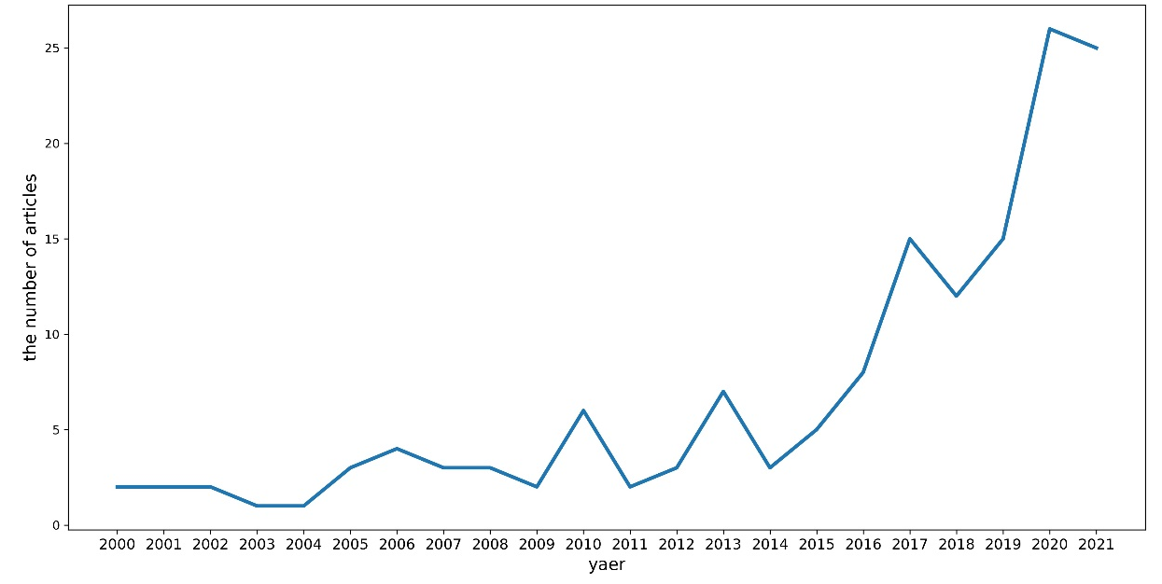
Figure 1 Articles distributed by years
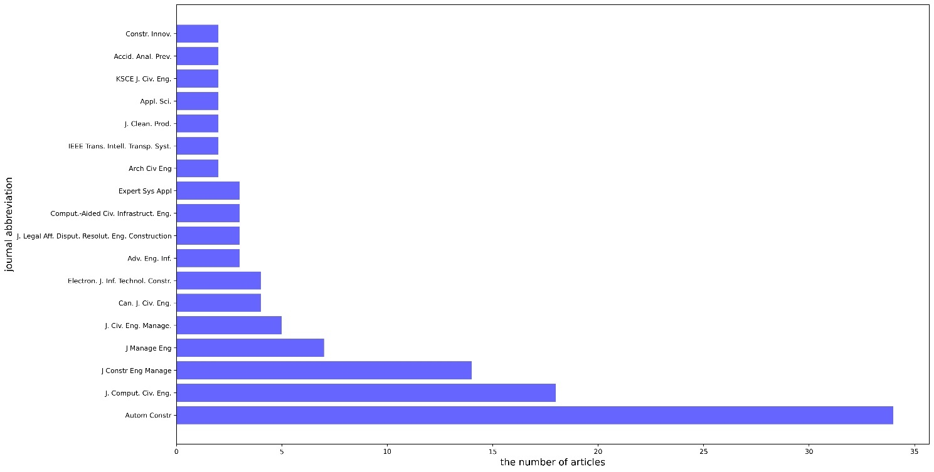
Figure 2 Articles distributed by journals
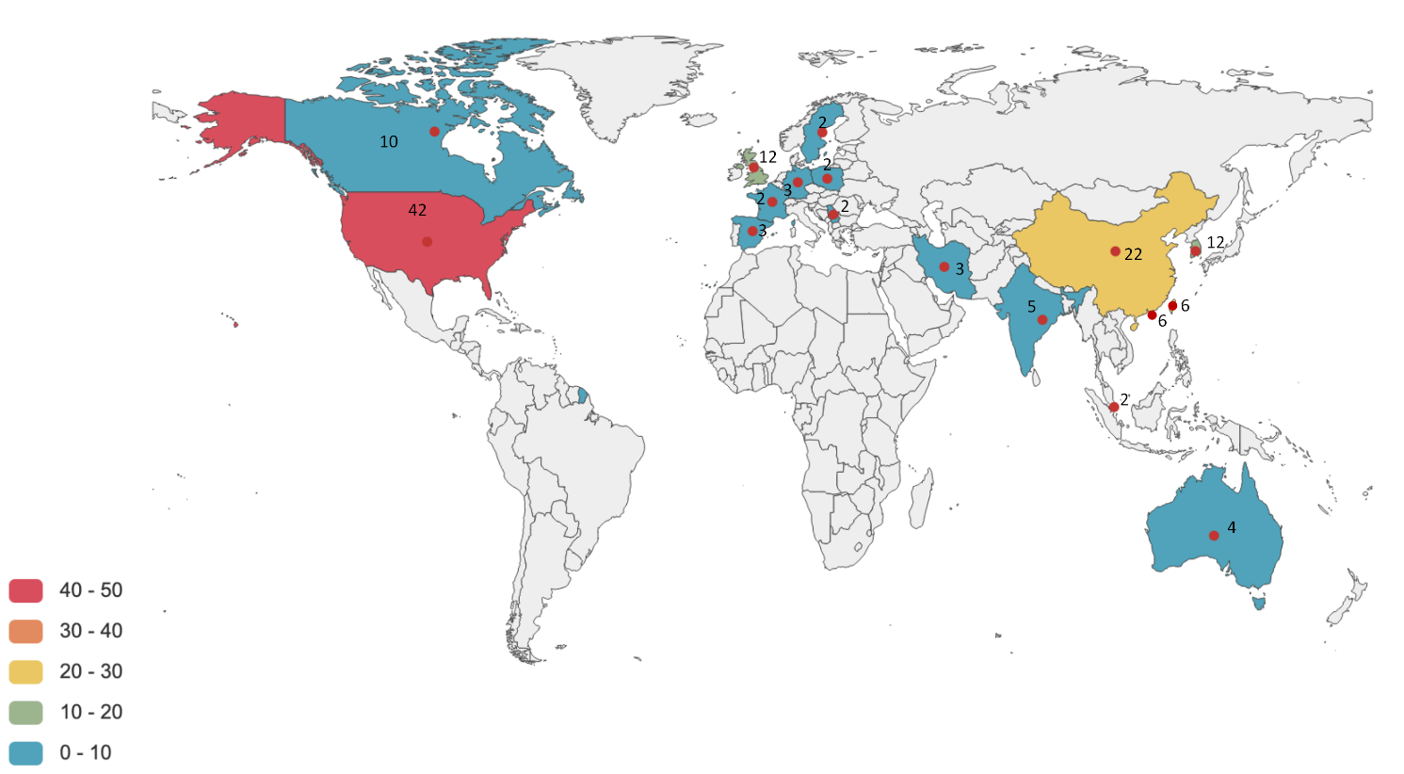
Figure 3 Articles distributed by regions

A knowledge map of topics
To gain an overall understanding of NLP in smart construction, abstracts of all reviewed articles are pre-processed and analysed using basic NLP techniques, i.e., frequency analysis of keywords and word cloud visualisation (Figure 4). Details of the techniques are introduced in Section 4.
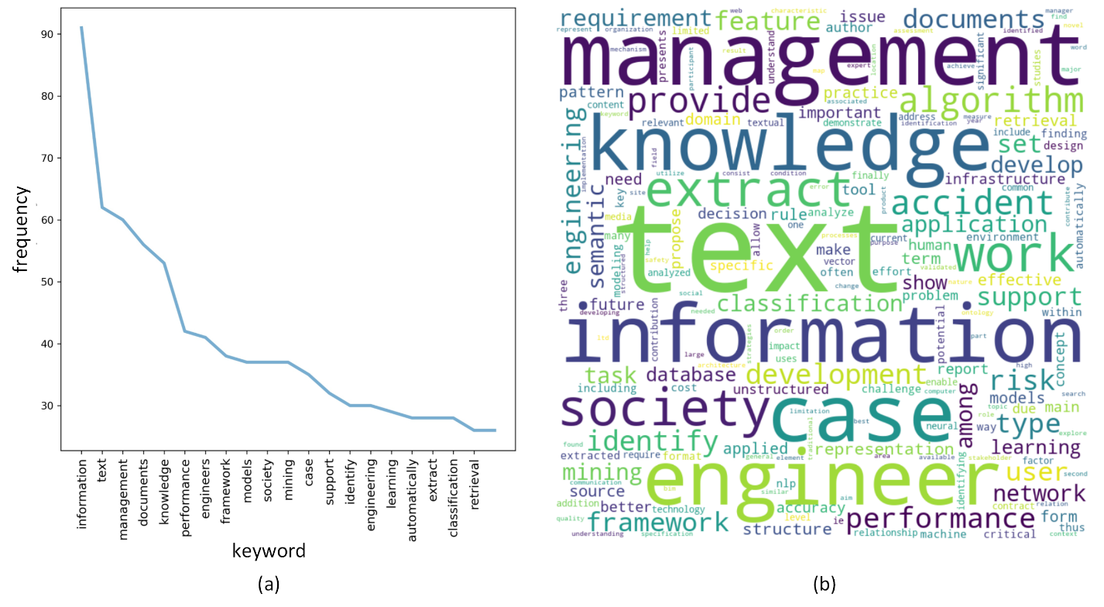
Figure 4 Frequencies of keywords(a) and word cloud (b)
The results present clear patterns. Keywords with the highest frequencies include ‘information’, ‘text’, and ‘engineering documents’, and ‘management’, indicating objects to which NLP is applied. They are followed by words of NLP techniques, e.g., ‘mining’, ‘support’ (representing support vector machines), and ‘case’ (representing case-based reasoning). Finally, words like ‘extract’, ‘retrieval’, and ‘classification’ indicate main NLP functions realised by the approaches. The word cloud reveals additional keywords of particular applications, e.g., ‘accident’, ‘risk’, ‘type’, and ‘semantic’. The structure of following sections (Figure 5) is constructed referring to the initial exploration analysis, which covers critical keywords and introduces in-detail NLP techniques and applications for smart construction.
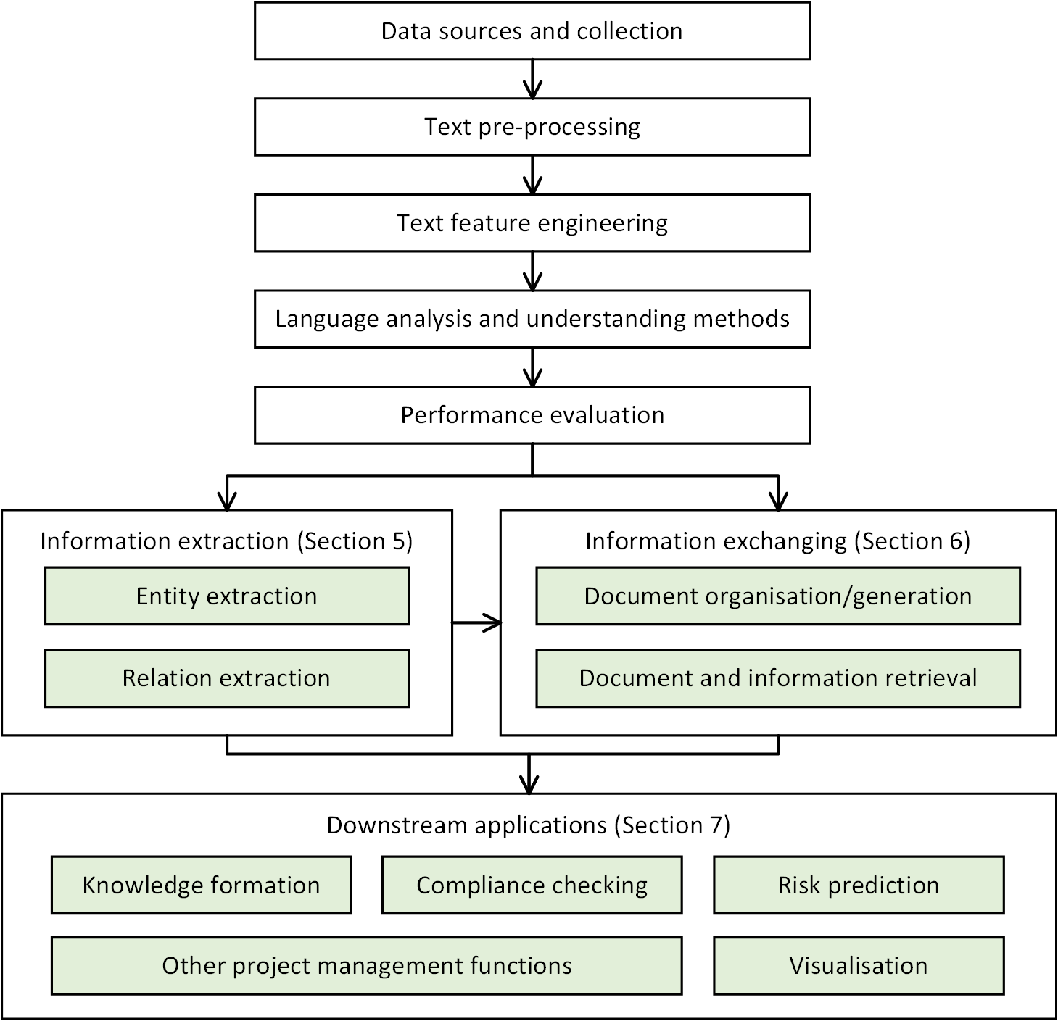
Figure 5 Reviewed contents

Understanding NLP in construction projects
This section introduces the five core steps to apply NLP for smart construction: data collection, pre-processing, feature engineering, text analysing and understanding, and performance evaluation.

Data sources and collection
Data for NLP is mainly plain texts (called corpus). Table 1 lists dominant data types in CS. Data demands vary significantly in different articles, depending on data availability, problems faced and analysing methods. For instance, text data on social media is very large (e.g., millions of tweets) [9], while much less data (e.g., hundreds or thousands) is collected for project-level applications [10]. Besides, supervised ML/DL models require much more data than rule-based methods [11]. Most data is collected in three ways: 1) downloading from public databases, e.g., standards in government websites [12], 2) collecting from project teams [13], and 3) web-crawling [14]. All data is converted in digital forms, e.g., pdf, doc, and csv.
Table 1 Data for applying NLP in smart construction projects
Level | Source type | Examples
Project | Legislation documents | Contracts, bidding documents, claims, lawsuit case reports, dispute resolution records [15-18]
Project | Safety documents | Injury reports, incident narratives [11, 19-21]
Project | Project management and evaluation documents | Cost/quantity records, working plans, drawings, site issue records, post-project reviews (PPRs), case reports, lessons learned records, disclosures [22-24]
Project | Maintenance documents | Maintenance records, inspection reports [25-27]
Project | Collaboration texts | E-mails, meeting agendas, requests for information (RFIs), chatting records, design change records [28-30]
External | Online resources | News, advertisements, web-pages, patents, research articles [31-35]
External | Social media texts | Twitter, WeChat [35-37]
External | Regulatory documents | Standards, manuals, specifications, guidelines, codes [38-41]

Text pre-processing
Freely written texts are very noisy. Hence, it is necessary to apply pre-processing for data cleaning. Table 2 introduces common pre-processing methods.
Table 2 Summary of text pre-processing methods
Type | Method | Description
Separation | Sentence splitting | Identify individual sentences based on boundaries, e.g., periods.
Separation | Tokenisation | Divide a sentence into separated tokens. A token can be single words/characters or phrases.
Cleaning | Normalisation | Remove non-textual contents (e.g., images) and non-relevant texts, e.g., texts of project team are removed for safety analysis.
Cleaning | Length-based removal | Remove sentences/words/characters shorter than a certain length.
Cleaning | Frequency-based removal | Remove words/characters with frequencies less than a threshold.
Cleaning | Punctuations/stopwords removal | Remove punctuations and words/characters without significant meanings (e.g., ‘and’, ‘the’), which is often based on published dictionaries recording common stopwords.
Modification | Lowercasing | Change all words/characters to lowercase.
Modification | Stemming or lemmatisation | Convert words to standard forms. Stemming directly chops off ends of words; lemmatization returns words to dictionary forms using a vocabulary or morphological analysis.
Modification | Sentence simplification | Convert complex sentences (e.g., nested or parallel forms) to simple sentences using heuristic rules.
Modification | Extraction | Extract texts from particular formats (e.g., XML or HTML), which is often applied to online data.

Text feature engineering
NLP methods rely on features hidden in texts. Moreover, computers can only handle numerical values. Thus, feature engineering is critical for NLP applications.

Text features
Text features consist of syntactic and semantic features. Syntactic features refer to arrangements and attributes of characters/words/phrases in sentences, e.g., a verb precedes a noun. Semantic features refer to semantic meanings of words/phrases, which can vary in different contexts. Common syntactic and semantic features are listed in Table 3.
Table 3 Summary of text features
Type | Feature | Description and examples
Syntactic | n-grams | The number of words/characters in a token, e.g., unigram, bigram, and trigram indicate tokenisation returns tokens containing one, two, and three words/characters, respectively [28, 42, 43]
Syntactic | Frequencies | The frequency of n-gram tokens [33, 44, 45]
Syntactic | Part-of-speech (POS) | Word types (e.g., verbs, nouns) distinguished based on ideas denoted and functions performed in a sentence [41, 46].
Syntactic | Phrase-grammatical structure (PSG) | Labels of short phrases of tokens/n-grams (e.g., noun phrases, verb phrases) [39, 47]
Syntactic | Dependency grammar | Governor-dependent relationships among tokens/n-grams, e.g., amod (actual, condition) means ‘condition’ is governed by the adjective word ‘actual’ [46-48]
Semantic | Domain classes | Concepts of tokens/n-grams in knowledge bases (KBs) (e.g., the class of ‘tower crane is ‘Crane’). KBs are elaborated in the next section [49, 50]
Semantic | Synonyms/antonyms | Words having similar (e.g., ‘subway’ and ‘metro’) and opposite meanings (e.g., ‘success’ and ‘failure’) [51-53]
Semantic | Negations | Words with negative connotation (e.g., no, not) [38, 54]
Semantic | Hierarchical or semantic relations | A tree structure among KB classes (e.g., super- and sub-classes) or network structure when semantic-rich relations (see Section 5.2 for more details) are added [52, 55]

Feature extraction and development of knowledge bases (KBs)
Most syntactic features can be directly extracted through open-source tools (Section 4.6). However, extracting semantic features needs domain knowledge, i.e., domain classes and their relations. Most studies define such knowledge in two types of KBs (Table 4).
Table 4 Two main KB types
Type | Explanation | Examples
KBs without relations | Group of distinct domain characters/words/phrases | Thesaurus, lexicons, dictionaries, vocabularies, gazetteers, and lists [56-60]
KBs with relations | Interconnected domain classes | Meta-models (e.g., International Framework for Dictionaries (IFD) and Industry Foundation Class (IFC)) [61-63], taxonomies and hierarchies [55], ontologies [49, 50, 58, 59], and knowledge graphs (KGs) [25, 64, 65]
Manually building KBs is labour intensive and time-consuming, which fortunately can be to-some-extent automated using NLP. To develop KBs without relations, key entities can be extracted (see Section 5 for more details) and directly modelled as classes. However, auto-developing KBs with semantic-rich relations (e.g., ontologies) is challenging [66]. Many studies are limited to modelling taxonomical relations (i.e., sub-class) by using hierarchical clustering to group entities [58]. For insance, Chi et al. [55] proposed an iterative expansion approach to create taxonomies for seismic engineering. The top-level classes were used as queries to retrieve documents, whereas lower-level classes were derived from top-terms in retrieved documents based on the terms’ correlation (Chi-square) with higher-level classes (query terms).
Utilising KBs in method development (Section 4) and other applications (Sections 5-7) requires a mapping between tokens/n-grams and KB classes, based on existence checking or cosine similarity (Figure 6) [57, 67]. Once the mapping is finished, additional related classes can be derived to enrich rules and vectors (Section 4.4) through navigating KB relations, e.g., generalisation/specialisation, composition/aggregation, logical relations (e.g., disjoint or equivalent), and concept association (e.g., a beam supports a floor) [59].
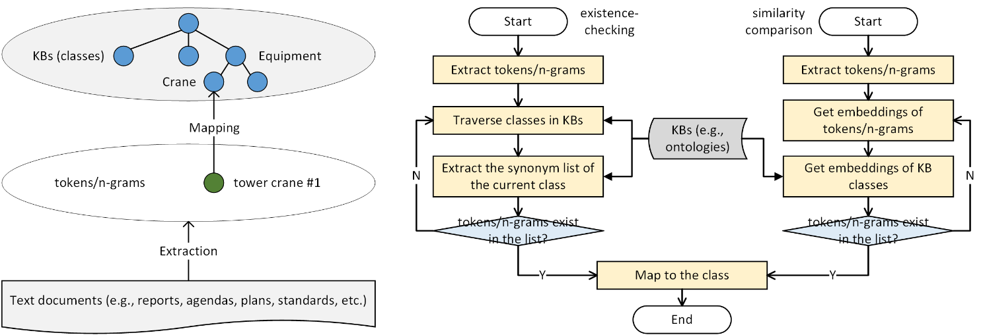
Figure 6 Mapping between KB and tokens/n-grams (a) conceptual scheme (b) workflows

Text analysis and understanding
This section introduces mainstream methods for text analysis and language understanding, whereas particular methods worth introducing are additionally discussed in Section 5-7.

Heuristic rule-based methods
Heuristic rules are widely applied to extract entities/relations, exchange information, and compliance checking by matching pre-defined patterns. Rule development has three levels.
Simple rules are developed on basic features (e.g., POS/PSG tags and orders of tokens/n-grams) [48, 68, 69] and tuple-patterns formed by several tokens/n-grams (e.g., subject-verb-object (SVO) tuples) [12, 70]. Tuple-patterns are mainly employed for extracting relations (Section 5.2). For example, a simple rule for extracting entities in contracts is ‘if a noun is followed by a modal word and a basic verb, then the sentence is a clause, and the noun is the clause subject’. However, simple rules suffer from low expressiveness thus can be improved by adding features listed in Table 5.
Table 5 Features for rule improvement
Feature type | Explanation/examples
Syntactic features | Regular expressions [57, 71, 72]
Syntactic features | Distance between tokens/n-grams
Syntactic features | Positions of tokens/n-grams [23, 73]
Syntactic features | Special labels of online texts (e.g., XML/HTML tags and URLs) [33, 74]
Semantic features | Classes, relations, and synonyms defined in KBs [65, 75, 76]
Semantic features | ‘Trigger’ words, such as negations, modal words (e.g., shall, must), and transition words (e.g., because, but), which are useful for regulatory documents and contracts [77-79]
Latent features | Weights according to expert opinions [23, 24, 33, 65, 74, 76]
Simple rules can be combined as complex rules by logic operators (e.g., AND, NOT, OR). The logical components, together with semantic features, enable reasoning to evaluate applicable conditions and exceptions of rules [75, 80-82]. For example, when querying provisions (Section 6.2) of the ‘lifting’ action, a complex rule can deduce that ‘crane’ (implicit) is associated with explicit entities ‘lifting’ and ‘bucket’ in the query. The query therefore is expaned as provisions about ‘crane’ are evaluated as applicable [83]. Finally, special rules (e.g., conflict resolution rules) are needed to handle exceptions. For instance, entity extraction can be confused when two words representing comparative relations (e.g., above and not less than) are matched; in this case, priority rules (e.g., a higher priority is set for ‘not-less-than’) are applied to solve the conflicts and extract the entity following ‘not-less-than’ [57, 68]. Heuristic rules can reach high precision. However, patterns for rule development are restricted to certain corpus, thus, rules often suffer low recall and poor generalisation ability [6].

Vectorisation
Most analytic models take numerical vectors as inputs. Thus, two approaches are applied to convert texts to vectors. The first one utilises a vocabulary recording tokens/n-grams and their frequencies. The vocabulary covers all V unique tokens/n-grams in the corpus containing N documents. As the example demonstrated in Figure 7, each document and the corpus are represented by a vector $∈R^{V}$ (called bag-of-words (BOW) or term-frequency (TF) vector), and a matrix $∈R^{D×V}$ (called term-frequency (TD) matrix), respectively [84]. The vectors can be enhanced by weighting and enriching. For instance, Eq. 1 assigns more weights to tokens/n-grams with high frequencies in individual documents and low frequencies in the corpus, where ${tf}_{d}$ and ${tf}_{d}$ represent term-frequencies in one document and the corpus, respectively. This can recognise distinct tokens/n-grams and produce the widely-used term-frequency-inverse-document-frequency (TF-IDF) vectors [85]. More sophisticated weighting is applicable to vector elements based on their length/position (called C-value, e.g., if a token/n-gram appears in section heads) [27, 64, 86, 87], information entropy, mutual information, and correlation (e.g., Chi-square) [34, 40, 52, 55]. Meanwhile, vectors enriching employs similar features of rule enhancement, which appends syntactic/semantic features (e.g., the number of grammatical dependencies and KB class of a token/n-gram) to the original vector [53, 61, 63, 88, 89].
$TF-IDF=log⁡({tf}_{d}+1)×[1+\log\left(\frac{N}{{tf}_{N}}\right)]$ Eq. 1
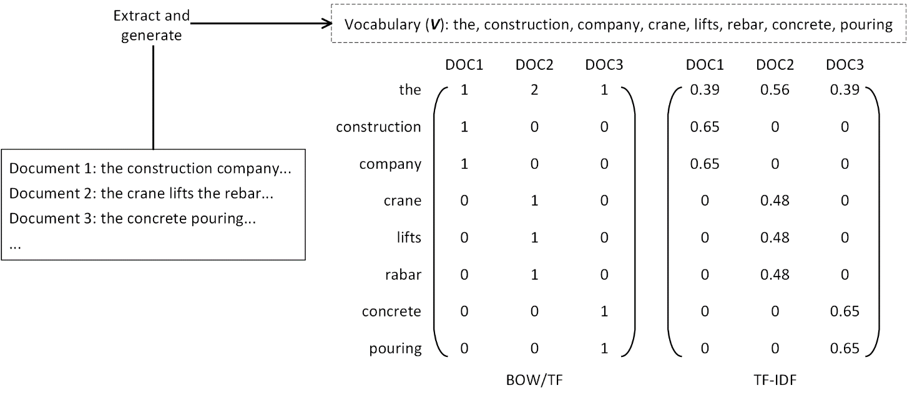
Figure 7 Frequency-based vectorisation
The second approach (word2vec) converts texts by capturing their semantics using low-dimension vectors (i.e., embeddings). As demonstrated in Figure 8, this is realised by ML models trained with ‘contexts’ (windows of tokens/n-grams) surrounding a central token/n-gram. Two training strategies (i.e., CBOW and skip-gram) are applicable. CBOW takes context tokens/n-grams as inputs to predict the central token/n-gram, while skip-gram reverses the roles [7, 52]. Besides, the doc2vec approach has been proposed to generate embeddings for longer texts (e.g., paragraphs) [90]. However, training embeddings is data-demanding and time-consuming. Thus, many studies use published embeddings pre-trained on large databases (e.g., Wikipedia) and fine-tune the values in downstream applications [43, 91].
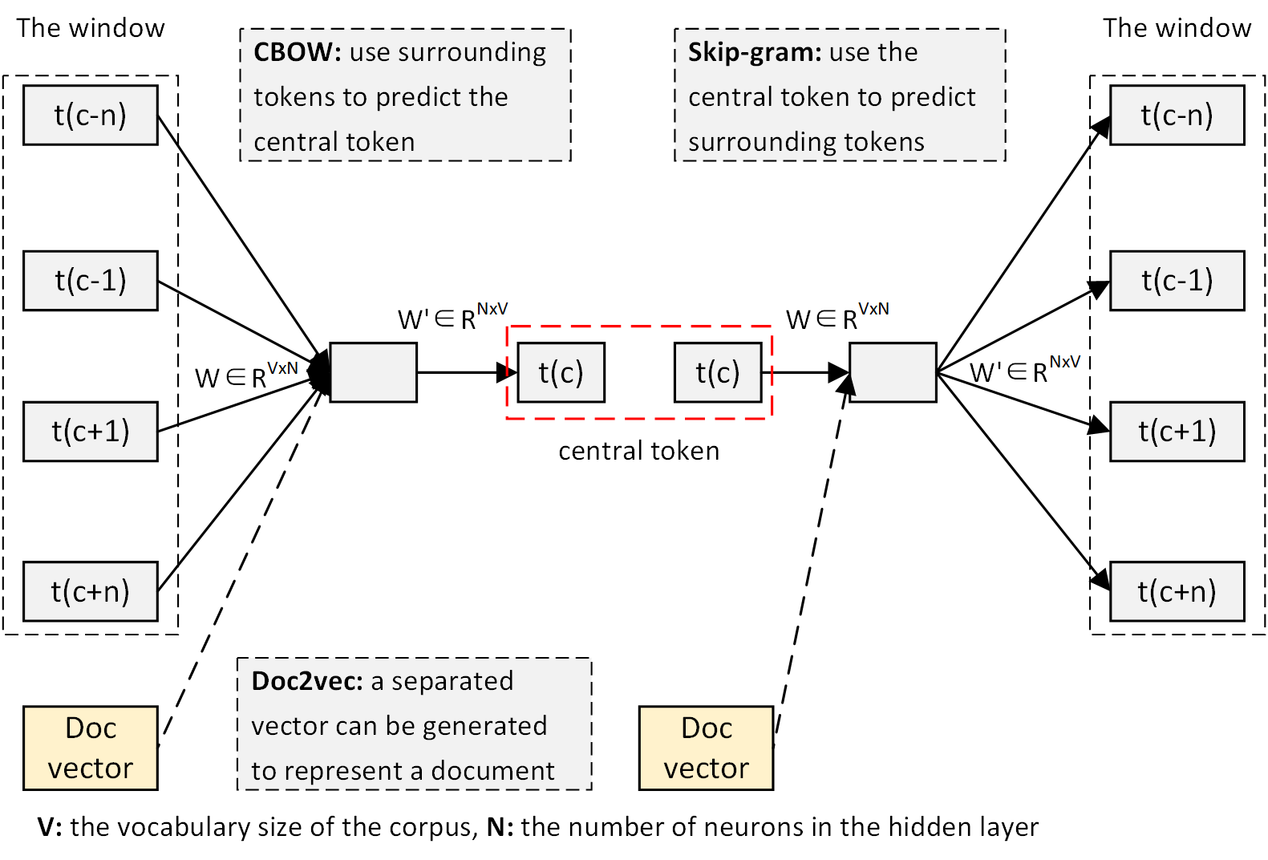
Figure 8 ML-based vectorisation
Finally, the obtained vectors/matrices are usually large and sparse. Hence, many studies implement decomposition methods to identify data eigenvectors and reduce dimensions, including singular value decomposition (SVD), principal component analysis (PCA), latent semantic index (LSI), and latent semantic analysis (LSA) [16, 84, 89, 92]. It has been proved these techniques can increase efficiency and accuracy in subsequent analysis [93].

Unsupervised methods
- Clustering
Clustering is a simple but effective approach to partition data into clusters based on the distance to cluster centroids (Figure 9(a)). Therefore, clustering results depend on distance measures which in CS usually include Euclidean distance (Eq. 2), cosine distance (Eq. 3), Manhattan distance (Eq. 4), and Chebyshev distance (Eq. 5), where m is the number of vector elements [94].
$D\left(u,v\right)=\sqrt{\sum_{i=1}^{m}{{(u_{i}-v_{i})}^{2}}}$ Eq. 2
$D⁡(u,v)={u∙v}/{\left|u\right|\left|v\right|}$ Eq. 3
$D\left(u, v\right)=\sum_{i=1}^{m}{\left|u_{i}-v_{i}\right|}$ Eq. 4
$D\left(u, v\right)=\underset{i}{argmax(}\left|u_{i}-v_{i}\right|)$ Eq. 5
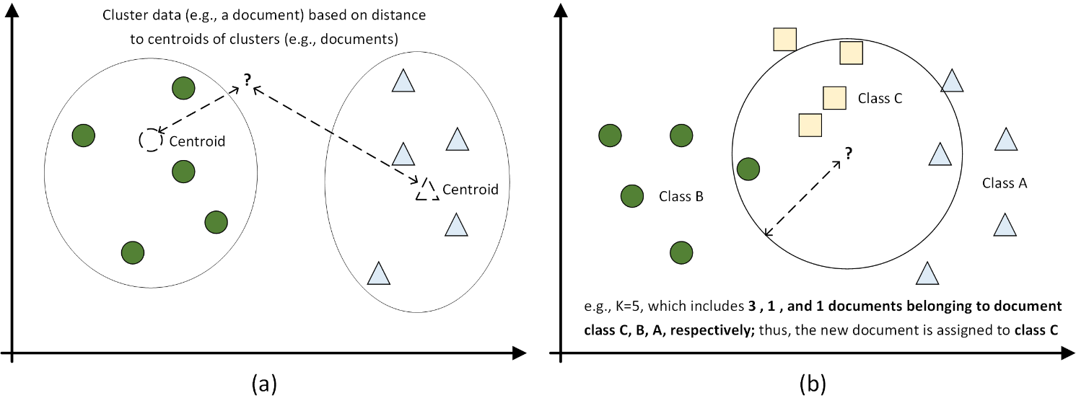
Figure 9 Distance-based algorithms (a) clustering, (b) KNN
- Topic modelling
Topic modelling identifies themes from texts by mimicking document generation. Latent Dirichlet Allocation (LDA) is the most popular topic model in CS. As shown in Figure 10, LDA works by deriving four distributions based on text statistics, two for topic-document association and two for words-topic association. Several variants of LDA, e.g., Dynamic Topic Model (DTM) and Social Topic Model (STM) which consider correlation and dynamics of words and documents, are also proposed to improve modelling results [31].
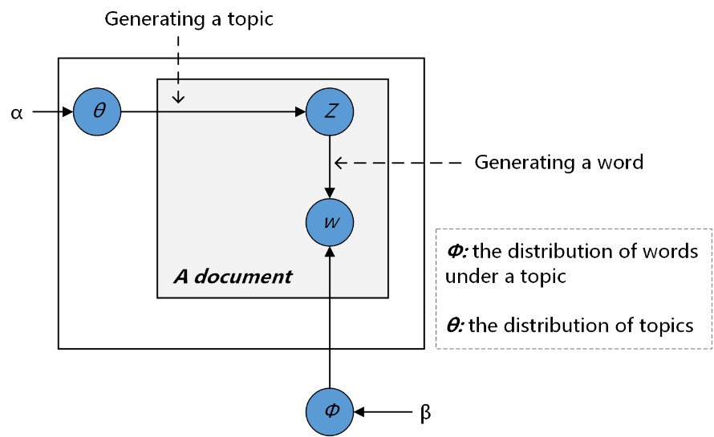
Figure 10 LDA modelling
- Association rule mining
Association rule mining discovers data dependency patterns based on three measures (confidence, support, and lift). The measures are computed through Eq. 6-8 and reflect the probability of patterns $A→B$ appearing in texts. Apriori, which tests candidate patterns with grid searching and forms rules if their measures exceed certain thresholds, is the main rule mining algorithm [95].
$Confidence\left(A→B\right)={P(A∪B)}/{P(A)}$ Eq. 6
$Support\left(A→B\right)=P(A∪B)$ Eq. 7
$Lift\left(A→B\right)={P(B|A)}/{P(B)}$ Eq. 8

Supervised ML/DL models
Unsupervised methods are easy to implement while often suffer low accuracy and instability. Thus, many NLP studies employ supervised models.
- Naïve Bayes (NB)
Naïve Bayes aims to find joint probabilities of data features and classes which are assumed to be independent. The model is trained by estimating statistics (Eq. 9), where $d_{i}$ and C indicate the $i^{th}$ feature and class of a sample, respectively. Then, new data is assigned to classes C with the highest probability, i.e., $argmax(P(C|d))$ [96].
$P\left(C|d_{i}\right)={P(d_{i}|C)×P(C)}/C i=1,2…$ Eq. 9
- Decision tree (DT) and random forest (RF)
DT is a classification algorithm which builds a tree by splitting a feature (i.e., a node) into sub-nodes (Figure 11). According to Eq. 10-12, DT splits the feature which results in most information gain (G(S)), where D and $D_{j}$ are the dataset and subset (S) split on $j^{th}$ feature (suppose there are k features and m samples) [97].
$H\left(X\right)=-\sum_{i=1}^{m}{p_{i}×\log_{2}{(p_{i})}}$ Eq. 10
$H_{S}\left(D\right)=-\sum_{j=1}^{k}{\frac{\left|D_{j}\right|}{\left|D\right|}×H(D_{j})}$ Eq. 11
$G\left(S\right)=H\left(D\right)-H_{S}(D)$ Eq. 12
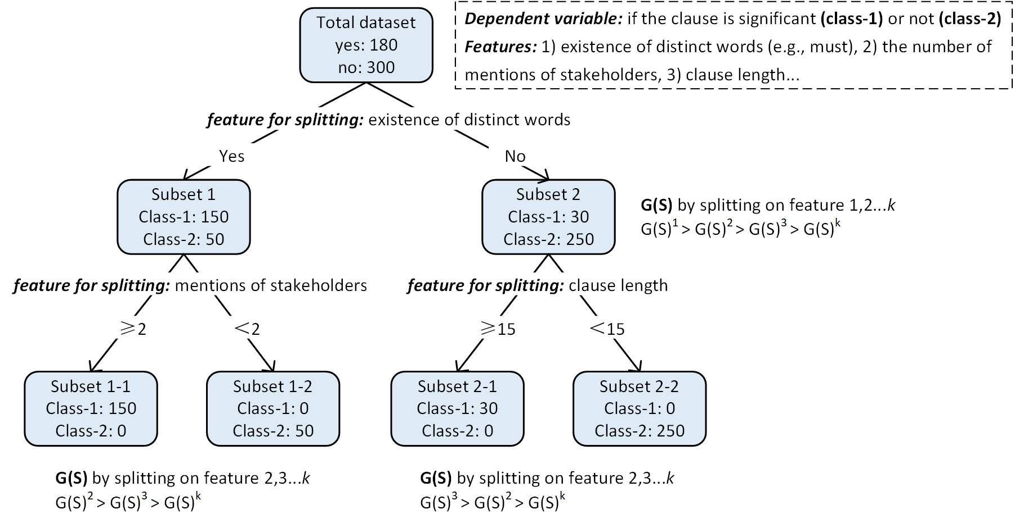
Figure 11 DT mechanism
- K-near neighbour (KNN)
Similar to clustering, KNN classifies data based on data distance in the training set (Figure 9(b)). During testing, KNN: 1) finds K samples in the training set with the closest distance to the new data, 2) assigns new data to the class containing most samples among the K samples [29].
- Support vector machine (SVM)
Some data cannot be distinguished in low-dimensional spaces. SVM adopts kernel functions $f$ to project data into a high-dimensional space. Then, SVM finds a hyperplane which 1) separates data according to the distance d to the hyperplane and 2) maximises margin $γ$ between classes by solving the optimisation problem (Figure 12 and Eq. 13-16) [98].
$γ=2/{\left\|w\right\|}$ Eq. 13
$d={f(w}^{T}x+b)$ Eq. 14
${minimise}_{w,b}=1/2{\left\|w\right\|}^{2}$ Eq. 15
$subject to={y_{i}(w}^{T}x_{i}+b)≥1, for i=1,2…$ Eq. 16
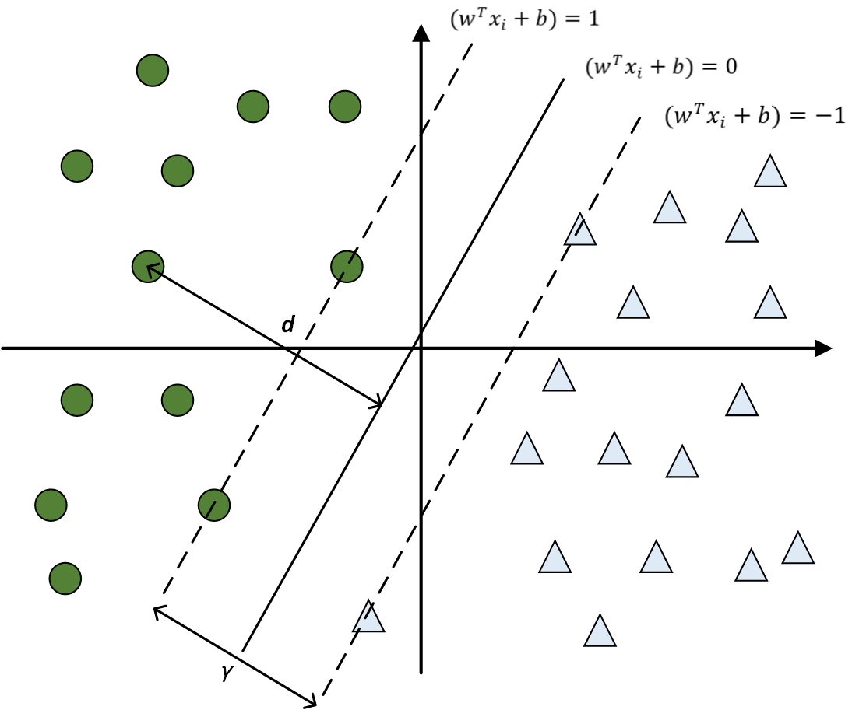
Figure 12 SVM mechanisms
- Ensemble model
ML models have unique advantages/disadvantages. Ensemble models can combine individual models to form a stronger classifier. In NLP studies, popular ensemble models include Bagging, AdaBoost, gradient boosting and regression tree (GBRT), and Random Forest (RF) for DT. The final predictions are mainly made by voting, averaging, and quadratic programming [40, 97].
- DL models
The main drawback of ML models is the reliance on manual feature engineering. This is very time-consuming and hinders model generalisation as features are restricted to certain datasets. Therefore, recent studies in CS train DL models to extract features automatically. The three widely applied DL-NLP models are the gated recurrent unit (GRU) [42], long-short-term-memory (LSTM) [66], and convolutional neural network (CNN) [91, 98]. The difference is that CNN uses a sliding window to scan texts and extract features with convolution and pooling opertiaon, while GRU/LSTM process texts sequentially, where a specialised vector is developed to memorise information in early steps; Figure 13 shows the working mechanisms, and interested readers can refer to [99].
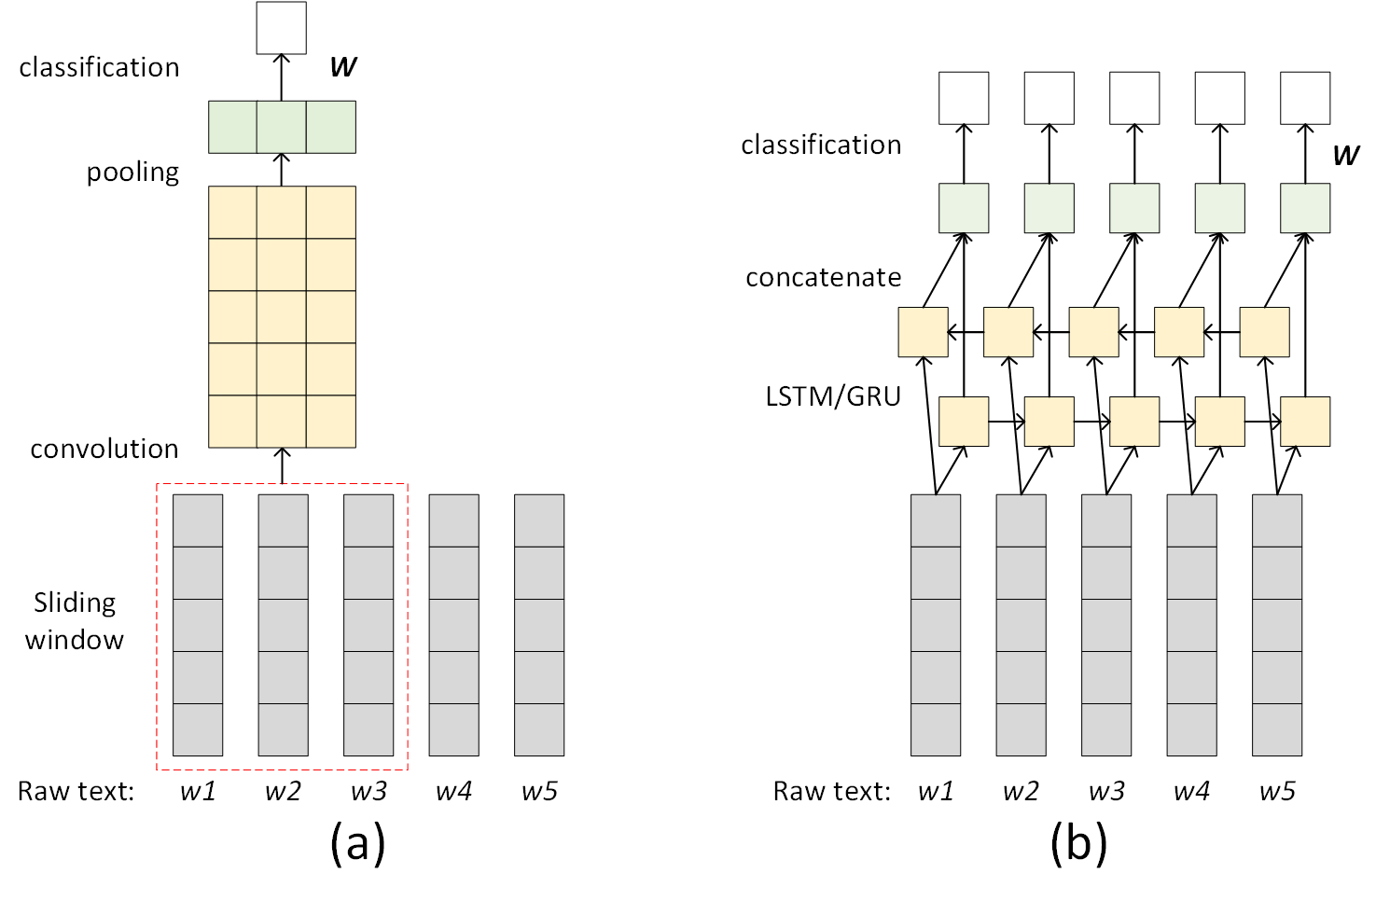
Figure 13 Mechanisms of DL models (a) CNN, (b) GRU/LSTM

Case-based reasoning (CBR)
CBR retrieves the most similar case (e.g., a technical specification) given the query (e.g., problem descriptions), which involves four steps (Figure 14) and depends on the distance between query-case vectors. The vectors can be formed with text features (e.g., BOW) [53], categorial attributes (e.g., if a risk factor exists), and combined information [100] .
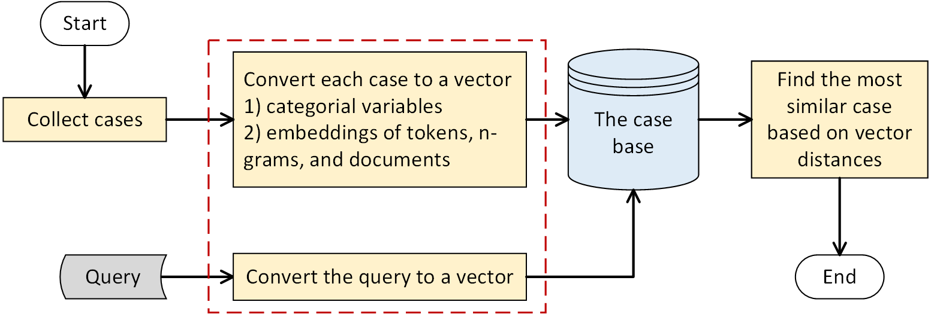
Figure 14 CBR mechanism

Network analysis
Network is another useful NLP-related tool in smart construction. Networks are created by either co-occurrence relations (e.g., social network) or semantic-rich relations (e.g., material constrains task). Section 5.2 introduces more details of relation types. Nevertheless, network analysis relies on certain measures and is conducted at three levels (Table 6).
Table 6 Network measures and usages
Level | Common measures | Usages
Node | betweenness, centrality, in-/out- degree, PageRank, and follower/following ratio for social media [36] | Identify critical nodes, classify nodes, predict missing nodes
Edge | average path length and path exploration [64] | Identify mutual impact and causal relations, predict missing links
Graph | centralisation, density, and topology (i.e., node connections) [101] | Cross-compare, partition, and classify graphs

Performance evaluation
Above analysing techniques can only be applied when appropriate performance evaluation methods are in place, and Table 7 lists main quantitative performance measures.
Table 7 Main performance measures
Task type | Measures
Classification | Label measures: true positives (TP), false positives (FP), true negatives (TN), false negatives (FN), Precision (P) (i.e., sensitivity), Recall (R), Specifity (S), Accuracy (ACC), and F1-score (F1), Kappa value, and Area Under Curve (AUC) [24, 25, 39, 85]
Classification | $P=\frac{TP}{TP+FP}$, $R=\frac{TP}{TP+FN}$, $S=\frac{TN}{TN+FP}$, $F1=\frac{2×P×R}{P+R}$  For multi-label classification, macro-P, macro-R, and macro-F1 should be used, where P, R, F1 are computed for each label and averaged
Classification | $ACC=\frac{TP+TN}{TP+TN+FP+FN}$
Classification | $Kappa=\frac{ACC-pe}{1-pe}$ where $pe=\frac{\sum_{i=1}^{n}{sum(row(i))}×sum(col(i))}{∀i∈C {(sum\left(i\right) )}^{2}}$
Classification | AUC: area under the Receiver Operating Characteristic (ROC) curve formed by different P and R values
Information extraction/retrieval | Label measures: P, R, F1, similar to classification measures [89, 102, 103]
Information extraction/retrieval | Ranking: true relevant items in the list of all items [45]
Information extraction/retrieval | Efficiency: time, and consumed memory for retrieval [36]
Regression | Difference error measures: mean square error (MSE), root mean square error (RMES), sum of square regression (SSR), sum of square total (SST) [28, 100, 104]
Regression | $(MSE)=\frac{1}{N}\sum_{i=1}^{N}{{w_{i}({y_{i}-\hat{y}}_{i})}^{2}}$, $RMSE=\sqrt{MSE}$, $SSR=\sum_{i=1}^{N}{w_{i}({\hat{y}}_{i}-\overline{y})}$  $SST=\sum_{i=1}^{N}{w_{i}(y_{i}-\overline{y})}$, $R^{2}=\frac{SSR}{SST}$ ${\hat{y}}_{i}$, $y_{i}$, and $\overline{y}$ are predicted, true, and average of true values, respectively
Clustering | Distance measures: clustering is more coherence when data have smaller and lager distance when they are in the same and different clusters, respectively. The widely used measures include Jaccard index, KL divergence silhouette coefficient and DB index [27, 31, 105]
Clustering | Entropy measures: Perplexity (mainly used for topic modelling) [21, 31]
Clustering | Label measures: P, R, F1, when labelled clustering results are available [36, 95]

NLP toolkits
There are many tools realising NLP functions. As shown in Figure 15, some tools are developed for specific functions, whereas others encapsulate multiple functions. Besides, some tools/packages are developed using specific languages, and others can be implemented by multiple languages.
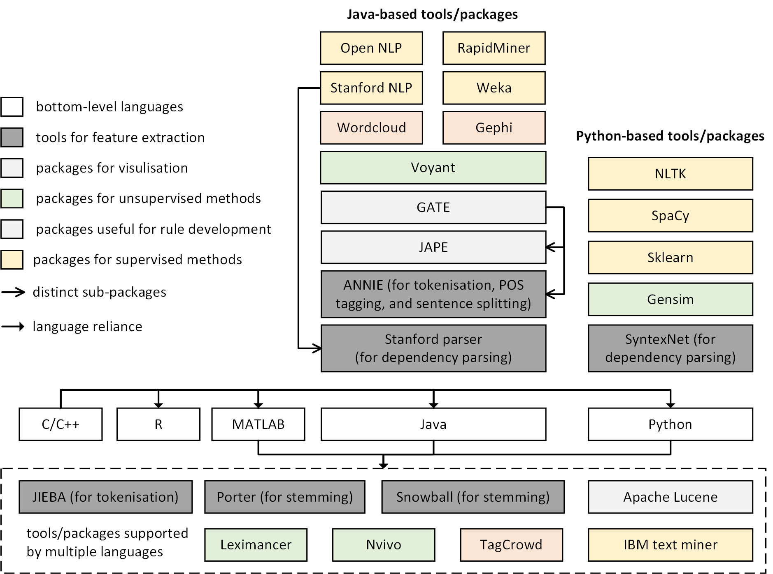
Figure 15 Mainstream NLP toolkits
Based on the review of NLP techniques, two main ways are identified for increasing performance (especially accuracy), i.e., applying more sophisticated ML/DL models and integrating more domain information or knowledge as additional features.

Information extraction
This section introduces two fundamental functions of NLP for smart construction, entity extraction and relation extraction.

Entity extraction

Entity types
Entities are tokens/n-grams carrying important meanings. As revealed in Figure 16, the procedure identifies useful entities and discards other tokens/n-grams [94, 106]. Table 8 presents main entity types and their sources.
Table 8 Entity types
Entity types | Examples
Safety accident/incident information | Accident types, root causes, injured body parts, outcomes [34, 57, 69, 104]
Safety hazards | Hazardous objects, locations [72, 80]
Risk factors | Change order, policy, time (e.g., season and day), weather, site condition, and market [17, 86]
Obligations and requirements | Shall not subcontract the whole work, shall comply with engineers’ instruction [75, 77, 107]
Project stakeholders | Contractor, supplier, and owner [77, 108]
Project products and facility information | Beam, column, and floor, landmark, facility equipment state, location and type [13, 26, 48, 56, 87, 109, 110]
Project execution information | Materials, labour, equipment, temporary facilities, site layouts, and documents, names, cost items, job contents, and priority of tasks/procedures [47, 87, 104, 105, 109, 111, 112]
Project attributes and performance | Location, type, contract status, and key performance indicators (KPIs) (e.g., profits, duration, cost per quantity) [28, 78, 104, 106]
Construction techniques | Sensor, server, BIM functionalities [113, 114]
Infrastructure disruption information | Disruption types (e.g., utility burst), severity, and affected stakeholders (e.g., road users) [69, 71, 88, 115, 116]
Relation names | The names of relations, which do not connect any entities [54, 68]

Entity extraction approaches
Based on methods introduced in Section 4, Table 9 summarises four ways to extract entities.
Table 9 Entity extraction methods
Method types | Methods
Criticality-based | Extract tokens/n-grams as entities based on criticality (i.e., frequency features or information in KBs):  - Frequency-based: extract tokens/n-grams if their frequency features (e.g., TF and TF-IDF) exceed a threshold [60, 64, 105, 116].
Criticality-based | - KBs-supervised: extract tokens/n-grams if they or their synonyms/related classes exist in KBs [10, 56, 73, 110].
Heuristic rule-based | Extract tokens/n-grams as entities if they match patterns defined in rules [23, 54, 65, 71-73, 77-79, 112].
ML/DL-based | Extract entities as a named entity recognition (NER) task with ML/DL models. Model inputs are texts and ouputs are tags assigned to certain tokens/n-grams for specifying their entity types (e.g., tasks and materials)  - ML models: SVM, KNN, DT, LR, NB, and CRF and ensemble models [72, 74, 80]
ML/DL-based | - DL models: LSTM, GRU [42, 76], and Transformer [113]
ML/DL-based | - Combine LSTM with ML models (e.g., CRF), where the former extracts word-level features while the latter capture features of entities tags [76, 78, 111]

Relation extraction

Relation types
As shown in Figure 16, relation extraction (except relation names) includes two levels: tuples and semantic relations. Tuple extraction groups tokens/n-grams into chunks, only implying existence of relations among tokens/n-grams. Semantic relation extraction recognises explicit and semantic-rich relations among two or three tokens/n-grams. Table 10 reveals main relation types to be extracted.
Table 10 Main relation types
Level | Relation types | Examples
Level-2 | Tuple-relations | spatial relations [38, 54, 82], stakeholders-obligations/rights [51], components-risks-control measures [79], subject-properties-values [81], co-occurrence/sequence of project entities (e.g., components, tasks, and stakeholders) [30, 62, 117]
Level-3 | Logical relations | similar-to (synonymy), disjoint-with, different-from [40, 83]
Level-3 | Belonging relations | is-a, instance-of, part-of/piece-of (meronymy) [52, 58]
Level-3 | Hierarchical relations | sub-class-of, super-class-of [58]
Level-3 | Constraining relations | concrete-constrains-pouring, power-supply-constrains-crane [66, 75]
Level-3 | Task dependencies | start-to-finish, start-to-start [111]

Relation extraction approaches
Table 11 presents major relation extraction methods. It is worth noting that as an early attempt for extracting semantic-rich relations in CS, Wu et al. [66] trained knowledge representation learning (KRL) models to extract constraining relations among project entities and reached an accuracy over 80%. KRL is a cutting-edge technique for extracting relations of triple forms (i.e., head-relation-tail or h, r, t) by assuming $t≈h+r$ for valid training triples, where word embeddings of entity/relation names are adopted to represent h, r, t while triple features are extracted by CNN. Interested readers can refer to [118].
Table 11 Methods for relation extraction
Level | Type | Methods
Level-2 | Co-occurrence analysis | Extract relations if co-occurrence frequencies of or correlation statistics (e.g., Chi-square) between tokens/n-grams exceeds a threshold [30, 62, 64, 81]
Level-2 | Association rule mining or Unsupervised ML models | Extract sequences or groups of critical tokens/n-grams as tuple-relations based on distance and rule-mining measures [95]
Level-3 | Heuristic rules | Extract relations if tokens/n-grams (including tuples) and their sequences match patterns defined in rules [38, 39, 46, 51, 68, 70, 82]
Level-3 | ML/DL-based | Train ML/DL models which take texts or entity pairs as inputs and semantic-rich relations (e.g., triples) as outputs, e.g., classifying if a relation exists between an entity pair)  - Minimal-supervised ML models [52]  - LSTM and multi-layer neural networks [111]  - KRL models which are enhanced by stacking embeddings of domain classes in model inputs [66]
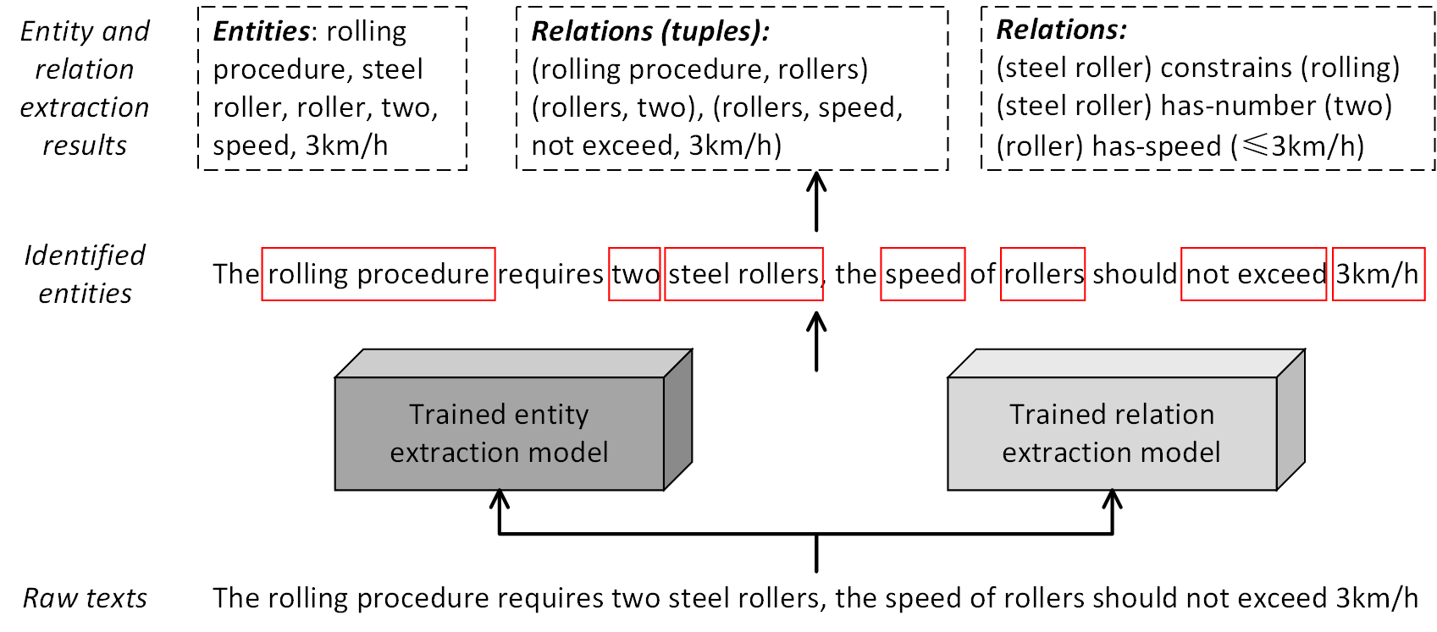
Figure 16 conceptual mechanism of entity and relation extraction
Despite of current achievements of NLP-based information extraction, they focus on entity extraction. Research for relation extraction is inadequate, and only relations with basic semantics (e.g., similar-to and hypernym) can be extracted [2].

Information exchanging
Construction projects are notorious for poor collaboration among stakeholders owing to inefficient information exchanging [4]; therefore, studies employ NLP to address the challenge by organising documents and assisting information retrieval.

Document organisation and generation
Most construction documents are organised by metadata (e.g., date and document type). Metadata is abstract and cannot reflect semantic meanings of document contents, making document organisation and retrieval ineffective [45]. Thus, NLP is applied to classify different documents, e.g., claims, PPRs, specifications, web-pages, and change requests. For this purpose, many studies develop ML models based on vectors (e.g., BOW, TF-IDF) of tokens/n-grams/tuples in key positions of documents (e.g., titles and abstracts), while both unsupervised (e.g., K-means, Rocchio, and hierarchical clustering) [27, 67, 84, 92, 106, 119, 120] and supervised models (e.g., SVM, NB, DT, and ensemble classifiers) [84, 119, 120] are extensively adopted. Classification can be binary (e.g., positive/negative attitudes of PPRs) [95] and multi-labels (e.g., differet claims according to reasons) [19, 92, 103]. Models can be improved again by incorporating semantic features, especially KB classes [67, 106]. A few studies classify documents by computing a matching score between documents and document classes with ordered weighted summation, considering frequencies, positions, and expert opinions of tokens/n-grams in documents and the corpus [23, 24].
Manually drafting documents (e.g., reports, meeting agendas, RFIs, and change request) is very time consuming, making document auto-generation necessary. Given automatically generated documents usually have standard structures of contents, a common method is to develop templates for different document types [63, 110, 121]. To further standardise document contents, KBs (e.g., ontologies) can be applied. Specifically, when drafting documents, ontologies can detect critical tokens/n-grams and suggest their ontological and unambiguous forms (e.g., standard class names) [49].

Document and information retrieval
This task aims to explore file systems and information models (e.g., BIM) to retrieve documents and information (e.g., sentences, provisions, clauses) within documents (similar to question answering), which largely depends on matching query and text contents. The relevant applications and retrieval methods are listed in Table 12 and 13, respectively.
Table 12 Main applications of NLP-based document/information retrieval
Type | Applications
Document retrieval | Share documents among CS companies (e.g., the e-Cognos project) [49, 50, 59]
Document retrieval | Search for online articles or technical documents to guide construction practice [67]
Document retrieval | Identify CAD drawings/documents for design reuse [45, 89]
Document retrieval | Find technical speficificaitons for engineering problems (e.g., concrete cracks) [83, 93, 122], building maintenance [123], and remedial actions for incidents [100]
Information retrieval within documents | Find applicable regulations, requirements, clauses and criteria of quality, cost, safety [12, 17, 81, 90], useful contents in web-pages [14, 103], component information for answering RFIs and project progress/cost/quantity information in BIM [13, 30, 48, 117, 121] based on user queries
Table 13 Main methods for document/information retrieval
Method type | Explanation
Token/n-gram based | Check existence of query tokens/n-grams in key positions of a document (e.g., titles, abstracts, and keywords) [26, 83, 93, 121]. Queries can be expanded using 1) synonyms and KB classes of tokens/n-grams [13, 14, 63, 80], 2) tuple-relations among tokens/n-grams [70]
Statistic-based | Compute and match statistics of tokens/n-grams in queries and documents, including basic frequency statistics [23, 24] and more sophisticated ones (e.g., Chi-square) [55]
Rule-based | Evaluate applicability of documents/information based on contexts (e.g., if a document fits certain topics) and application/exception conditions indicated by patterns of tokens/n-grams and distinct words (e.g., ‘should’ or ‘not’) [17, 81, 83]
Distance-based | Compute and match distance between vectors (e.g., TF-IDF, KL-divergence, and Okapi) of documents and queries (vectors are often enhanced with semantic features) [25, 45, 47, 50, 102, 103, 122].
ML-based | Train ML models to determine if a document should be retrieved given text and meta-features of the query [47]
CBR | Retrieve the most similar documents stored in CBR databases [100, 123]
Other | Apply path finding (e.g., Dijkstra) to IFC/IFD (tree structures) to retrieve BIM information by mapping extracted entities to IFC/IFD items [48]
Moreover, retrieved information and generated documents can be inserted into BIM to enrich its information richness. For instance, Oti et al. [22] and Xie et al. [56] mapped lessons learned of site issues and facility equipment to BIM elements, respectively. BIM elements and texts were vectorized and cross-compared based on their existence in a reference list formed by IFC entities; other studies created templates of project correspondences to record communication texts which were integrated in BIM for timely reuse [77, 117].

Downstream applications
In Sections 5-6, NLP is directly applied to texts for extracting and exchanging information, while this section introduces studies utilising extracted information in various downstream applications.

Knowledge discovery and formation
Construction management is knowledge-driven. Thus, it is valuable to discover and form knowledge at two levels (Table 14): 1) project situations (similar to automatic summarisation) and 2) general and deeper knowledge of CS.
Table 14 Summary of knowledge formed
KB types | Knowledge and examples
Project level | Reasons behind legal issues e.g., unbalanced duty allocation, cost overrun, and damages to products [10]
Project level | Safety hazard/risk factors/categories (i.e., reasons of accidents), e.g., lack of supervision and illegal operations [19, 20, 34, 42, 72, 85, 94, 98, 124]
Project level | Contract/bidding risk factors, e.g., payment methods, quantity clarification, and unclear duties [29, 32]
Project level | Other project risk factors, e.g., underground conditions, environmental impacts, and market uncertainties [40, 94, 125]
Project level | Major site issues, quality problems, and defects/deficiencies [27, 91, 105, 126]
Project level | Critical resources, parties, and tasks/procedures [66, 76]
Project level | Infrastructure failure patterns (i.e., interconnections among infrastructures and stakeholders and how the failure of one infrastructure cause failure of other infrastructures)
Project level | Roles and responsibilities of project parties [108, 127]
Industry level | End user needs/demands on construction projects and technologies [33, 96]
Industry level | Attitudes and perceptions of government, project stakeholders, and public against various issues, e.g., environmental impacts and infrastructure resilience [9, 37, 128]
Industry level | Job demand, categories, and affecting factors behind [31, 127]
Industry level | Evolution of technologies (e.g., BIM) [21, 44, 114]
Table 15 presents main methods for forming knowledge. Howver, it is necessary to distinguish entity extraction (Section 5.1) and knowledge formation. They overlap in terms of extracting information, but, the former directly works on texts and extracts entities explicitly mentioned, while the latter can recognise implicit knowledge (e.g., hidden topics).
Table 15 Main methods for domain knowledge formation
Aspect | Main methods
Topic identification | Key terms analysis, i.e., derive topics based on existence/frequencies of pre-defined key terms in extracted tokens/n-grams [9, 10, 20, 114, 115]
Topic identification | LDA [10, 19, 21, 44, 96, 105, 128], STM [31]
Topic identification | Apply clustering (e.g., K-means, unsupervised seeding/mapping) and partitioning (e.g., multi-dimensional scaling, modularity maximization) to tokens/n-grams or their vectors and then derive topics by manually interpreting the results [27, 100, 108]
Topic identification | Identify principle components using PCA [34]
Factor extraction and classification | Extract topics based on cosine similarity between vectors of tokens/n-grams and pre-defined classes (i.e., topics) [94]
Factor extraction and classification | Train ML models [36, 37, 98] and DL models [19, 91], taking extracted tokens/n-grams/tuples as inputs and factors as outputs
Relationship exploration | Interpret mutual relations based on co-occurrence frequencies [87, 106, 108, 125], correlation statistics (e.g., Chi-square), and association rule patterns [71, 115, 117]. The interpretation can be manual or enabled by SVD, PCA, and Analytic Hierarchy Process [35, 96, 100, 127]
Relationship exploration | Network analysis  - Node- or edge-level analysis [21, 36, 65, 87, 114]  - Network- or graph-level analysis [37, 101]
Knowledge evolving | Analysing change of knowledge formed using one of above three approaches over time [44, 105, 114, 117]

Compliance checking
NLP-enabled auto-compliance checking is another hot topic. Compliance checking can be realised by straightforward comparison, e.g., checking if required safety information exists in project plans [73, 90] and detecting inconsistency of accident types in reports [129]. However, the mainstream practice involves four steps (Figure 17). Extracted rule patterns usually take the form of tuple-relations. The rule-logic transformation can include 1) standardisation (if applicable) which adopts schemas (e.g., XML) to standardise contents in regulatory documents [75, 83]) and 2) applying transforming rules based on the tuple patterns and their syntactic/semantic features. An example is shown in Figure 17. As-is information to be checked is extracted from digital documents or information systems (e.g., BIM/GIS) with plug-ins. Finally, compliance checking is conducted by filling as-is information in checking rules. Currently, NLP-based compliance checking is mainly employed to assess building design [39], working procedures dependencies [111], and spatial configurations between underground utilities and their surroundings [38, 54, 82].
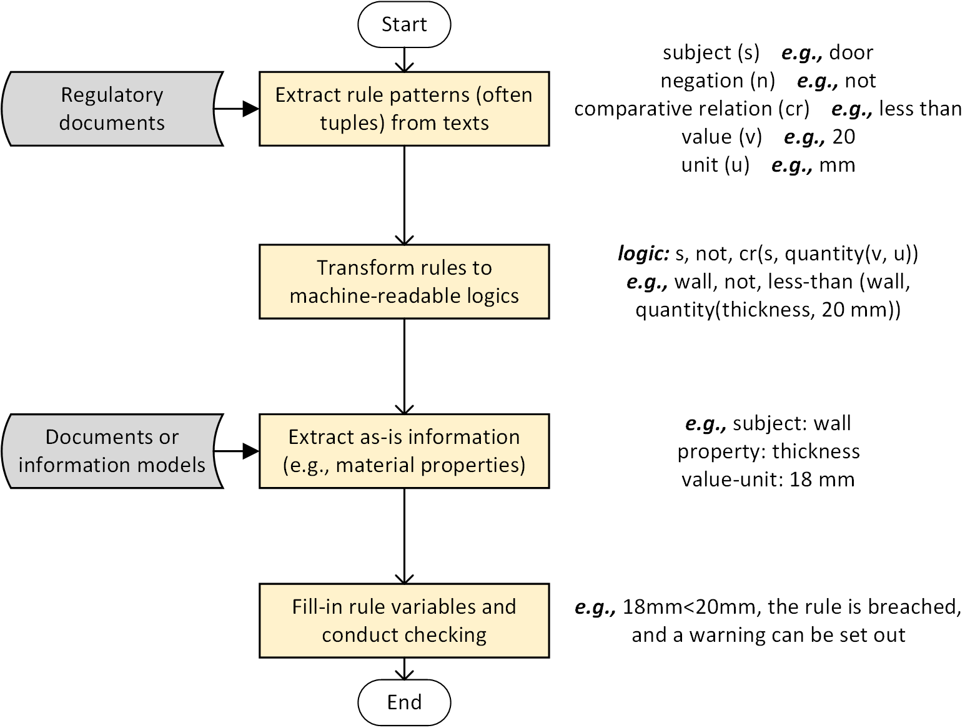
Figure 17 Steps for auto-compliance checking

Risk prediction
Text information can indicate potential risks which NLP can to-some-extent predict with the help of formed domain knowledge (Section 7.1). Table 16 introduces main risk types and prediction methods.
Table 16 Risks and prediction methods
Risk type | Application | Methods and explanation
Contract | Classify clauses as requirements and non-requirements or distinct categories (e.g., construction, design, and O&M) to prevent ignoring requirements | Train ML models (NB, LR, SVM, and RF) and DL models (CNN and LSTM) [43, 130, 131]
Contract | Detect biased/poisonous clauses | - Compare extracted tuple-relation patterns with pre-defined biased patterns [46, 51]  - Train ML models (DT, NN, and NB) to predict existence of extracted contract risk factors [32]
Contract | Detect substantial contract changes | Train ML models (KNN, SVM, ANN, LR, RF) with texts of change descriptions [18]
Contract | Estimate risk levels | Compute frequency/density of extracted obligation clauses and contract risk factors [17, 107]  Estimate importance of extracted obligation clauses according to probability of clause breaching and impact (obtained from expert opinions) [12]
Contract | Select bidders | - Train ML models (SVM, KNN, and ANN), based on extracted contract risk factors and common factors (e.g., the number of issued addenda and bidders) [29]  - Train DNN models to predict benchmarks of stakeholders’ KPI based on extracted KPI entities for tender selection [28]
Contract | Predict litigation results to facilitate dispute resolution | Conduct CBR-based searching [16, 53]
Safety | Predict safety risks | Train ML (DNN and ANN) models to identify risk existence based on extracted safety risk factors and then predict possible degree of injury [19, 104]
Other | Predict risk levels or classify risk types in other aspects (e.g., environmental, financial, and political) | Train ML models (SVM, KNN, DT, GBRT, NB, and radius-based neighbours (RBN) which is similar to KNN but determines the class based on the number of samples in a fixed radius of the new sample) for risk prediction [40, 125]
However, training data can be inadequate for risk prediction, and different models can suit different datasets. As an example to solve this, Li et al. [11] developed four datasets of main safety accidents, where documents were represented by doc2vc vectors. When new accident reports came in, the most similar dataset was selected based on doc2vec similarity to share key factors for predicting injury degrees. Then, a meta-leaner was trained to recommend ML model based on dataset meta-features (e.g., the proportion of categorial factors) to maxmise prediction performance.

Other project management functions
Apart from above mainstream topics, Table 17 reveals minority applications of NLP in other project management aspects.
Table 17 Other NLP-based project management
Aspect | Application | Methods
Schedule and cost management | Schedule monitoring and deviation detection | Develop a knowledge map of scheduling and cross-compare project situations [126]
Schedule and cost management | Predict cost overrun (i.e., severe overrun, normal, and underrun) | Train ML models (K-star, RBF NN, and ensemble models) using numerical features (e.g., quantities and schedule) and text data (project descriptions) [15]
Schedule and cost management | Calculate cost index | - Compare extracted entities in descriptions of pay items to merge inconsistent items  - Clean pay items based on statistics (e.g., price ratio) of extracted price information
O&M management | O&M task auto-assignment | Train ML and attention-enhanced DL models, taking O&M documents as inputs and task types and priority as outputs [91, 109]
Infrastructure O&M management | Evaluate incident severity, prioritise O&M actions, and provide advice for future infrastructure projects | Sentiment analysis (i.e., positive, neutral, and negative) according to 1) frequencies of pre-defined sentiment words [9], and 2) ML models (SVM, RF, NB, and ensemble classifers) [74, 88, 132]
Constraint management | Identify unremoved constraints for current tasks | Network analysis by exploring project KGs with path reasoning [2, 76]
It can be argued that the application of NLP for project management is still limited compared to that of computer vision (CV) [5], but the coverage of NLP in smart construction keeps increasing in the last decade.

Discussion

Insights of applying NLP in smart construction

The role of NLP in the framework of smart construction
Based on insights in [1, 4, 5], a simplified framework of smart construction is illustrated in Figure 18, consisting of two pillars and three features. NLP is essential for smart construction, because it has direct and indirect contribution to the digitalisation pillar. Most data in CS is unstructured texts [2, 3]; thus, NLP directly and significantly improves effectiveness and efficiency when handling such data using text cleaning and information extraction. NLP also indirectly facilitates AI-enabled decision-making and BIM-based management. According to the decision-making pyramid, decisions are made from data following four steps: data, information, knowledge, and decisions [133], while only three of them are covered by core functions of NLP. Therefore, it is more beneficial that NLP supplements other functions by providing useful data. For instance, optimising infrastructure O&M plans with planning techniques based on damage severity extracted from twitter and enriching BIM for efficient information exchanging [107, 125]. The more capable of NLP methods, the more unstructured data are handled, more sophisticated AI techniques are enabled, and more efficient BIM collaboration is applicable, which make CS more digitalised, automated, and connected, respectively.
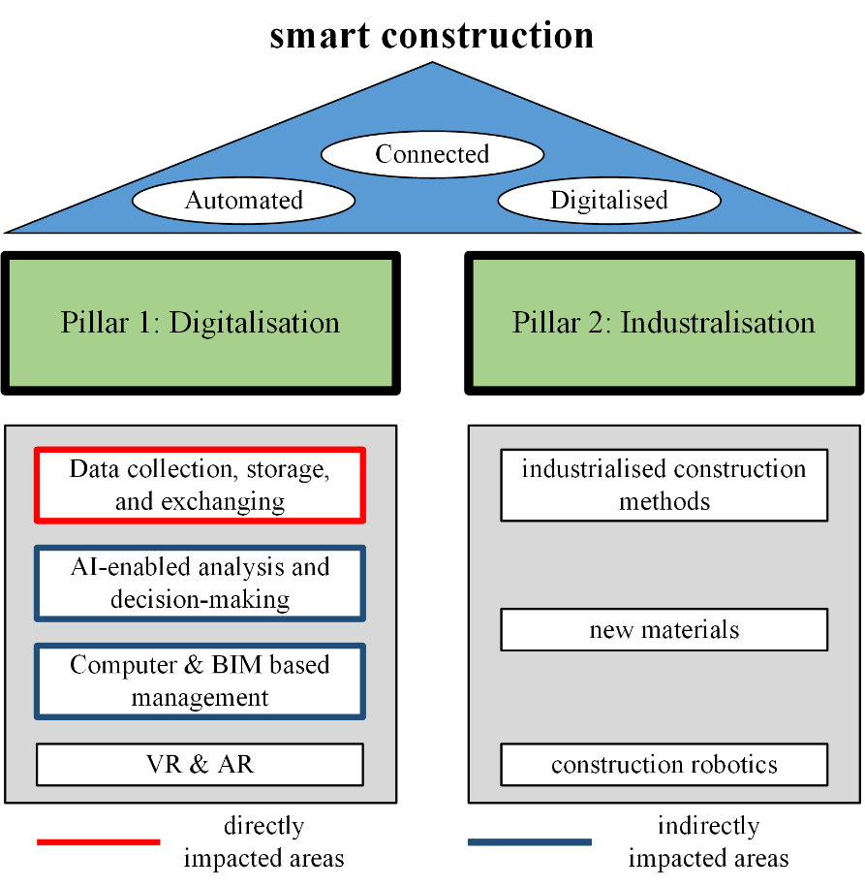
Figure 18 A simplified smart construction framework

The expansion of NLP-related application areas
NLP studies present an unbalance of application areas partially due to the supplementary role. Most studies, especially those early ones, focus on document organisation/retrieval [50, 89, 121]. It is not until 2015 that NLP is increasingly adopted for various engineering applications, because of two reasons, i.e., data availability and algorithm capacity. In the last decade, CV is the common method to support applications mentioned in Section 7. However, most CV models are supervised models, and collecting images for training is time-consuming and expensive (e.g., when high-quality images are needed) [8]. In contrast, collecting texts is much quicker and cheaper. Most text data (e.g., pdf) is accessible from engineers’ PC, and more data exists online. Therefore, much data can be collected in a short time (e.g., using crawlers) without using expensive equipment. Besides, texts are easy to be cleaned and often encounter less privacy issues [3].
Besides, text analysing algorithms have achieved significant improvements. Early algorithms depend on sparse BOW/TF-IDF, which cannot capture complex text features to extract entities and relations with rich semantics therefore hinder downstream applications (e.g., knowledge discovery based on extracted entities) [120]. In contrast, word embeddings can effectively capture such features thus increase capacity of ML models. Moreover, word embeddings are complementary to state-of-the-art DL models (e.g., CNN, LSTM, and Transformer), which enable many complex analysing tasks [7]. Nevertheless, as discussed, the expansion of applications is a good sign that the importance of NLP for smart construction is increasing.

The trade-off between efficiency and accuracy
Fully understanding human-written texts is extremely challenging, as texts are very unstructured, complex, ambiguous, and noisy (e.g., missing/incorrect words). Sophisticated text analysis needs a deep understanding of human knowledge, while no current AI can satisfy [6]. DL NLP models are increasingly implemented in CS. However, training DL models requires manually labelling a large amount of data, which is impractical for project teams; besides, DL models do not necessarily reach superior performance over ML models. This is because different models suit different tasks and data, while SVM and ensemble models trained with TF-IDF often achieve the best performance [43, 85, 119]. Meanwhile, it is time saved and working efficiency increasing that bring substantial benefits in practice. Thus, NLP for smart construction should reach a accuracy-efficiency trade-off, which again reflects its supplementary role. Rather than struggling to increase accuracy by 2% (e.g., 88%-90%) when extracting 50% information at the cost of developing models with excessive data demands and complexity, it is more beneficial to extract 80% information with 80% accuracy, completely saving 80% time and leaving 20% work for human engineers [90]. In fact, experienced engineers are very good at high-level tasks (e.g., detecting contract risks) given key information (e.g., obligations and duties) is extracted from raw texts using NLP [2, 6].

Challenges and future directions
Although NLP can drive smart construction, many challenges exist, which together with potential directions enabled by cutting-edge techniques, are discussed below.
- Challenge-1: excessive manual work
Currently, applying NLP techniques needs much manual work, while the increasing of application areas further worses the situation. For one thing, rule-based methods need to manually discover text patterns and develop rules; ML-based techniques depend on manual feature engineering and data labelling; DL models, although automate feature extraction, still need to manually label data [134]. In addition, KBs are usually adopted to improve NLP methods, most of which are manually built [2, 7, 8]. The volume of text data is often much larger than that of images, which is a double-edged sword. Big data improves model capacity but significantly increases manual workload, which necessitates supplementary methods to alleviate the burden.
- Challenge-2: poor relation extraction
NLP techniques in CS focus on entity extraction and can extract most entity types [1]. In contrast, relation extraction is less addressed. A few studies apply DL and complex rules to extract semantic-rich relations (e.g., constraining relations among project resources). However, the infeasibility of rules affects their usefulness, while the performance of DL models remains low (around 80%), especially for relations with uncertain directions (e.g., in the construction stage, scaffolding ‘constrains’ labour, whereas in the temporary facility construction stage, scaffolding and labour ‘constrains’ each other) [66]. Poor relation extraction restricts NLP applications and increase manual workload, as relations are more valuable for developing KBs, extracting information, and discovering knowledge [134].
- Challenge-3: poor mapping between functions and NLP techniques
No superior NLP technique outweighs others. An accuracy-efficiency trade-off exists when applying NLP, where the effectiveness is subject to specific data and functions (i.e., tasks). Unfortunately, few studies can assist selecting the most suitable NLP techniques for specific tasks. This hinders NLP implementation in smart construction, as it is impractical for project teams with inadequate computer background to make such selection. The work of [11] is inspiring for addressing the challenge, which trained meta-learners to first determine appropriate ML models according to features of testing data (e.g., the number of samples and categorial features). However, that study is restricted to safety documents and ML model selection, leaving enormous room for improvements, e.g., automatically selecting rule-based, ML, and DL based techniques by developing more capable meta-learners.
- Direction-1: Information extraction improvement
Studies in this direction can address challenges 1-2. KRL models (see Section 5.2) can significantly improve relation extraction. Besides, many variants of KRL models (e.g., TransR, ConvKB, ConvE) are proposed in recent years and are worth being applied in CS to realise more robust information extraction [134]. Such techniques not only assist extracting semantic-rich entities/relations, but also to-some-extent automate rule design, as many rules are derived from tuple-relations. Furthermore, distant supervision (DS) can supplement KRL models as an effective auto-labelling method to save manual workload. DS assumes that if two entities hold a relation in KBs, all texts (e.g., sentences) containing the entities imply the relation and are labelled as valid triples [135]. Hence, DS can improve KRL models by automatically labelling much more training data. Given the strong assumption causes much noise, the attention mechanism can be adopted to learn probabilities of sentences expressing different relations by simultaneously learning their attention values (i.e., weights) [136].
- Direction-2: KBs auto-development
Studies in this direction are complementary direction-1 thereby also addressing challenges 1-2. As mentioned, it is critical to realise auto-development of KBs with rich semantics (e.g., ontologies and KGs). This requires effectively extracting relations as bottom-level components of KBs. Although KRL models and DS can improve relation extraction, extracted information usually contains many errors (e.g., ambiguous and missing information) hence cannot be used to form KBs [118]. Two methods based on KBs’ topology can be considered to tackle the problem. One is rule-based, which adopts semantic reasoning for disambiguation (e.g., inferring two entities are synonyms) and detecting missing entities/relations (e.g., if certain nodes are linked to a central node, then a link should be established between the central and another node). The other is based on the graph neural network (GNN). GNN represents cutting-edge DL models for KBs completion. It can automatically recognise topology patterns defined in above reasoning rules and then classify duplicated nodes and predict missing nodes/edges by integrating information in a neighbourhood of node/edges, which has been used for financial fraud detection and transportation flow prediction [137].
- Direction-3: multi-modal information integration
Studies in this direction can address challenges 2-3. Current studies focus on text data while ignore other information modals apart from KBs, which however can greatly supplment NLP, e.g., images and audios. Information of some entities can be ambiguous when being described only by texts. For instance, descriptions of similar materials contain many similar tokens/n-grams; therefore, ML/DL models require more training data for extracting them but still suffer low accuracy [8]. The models can be enhanced by incorporating images if it is easier to distinguish the entities in images. Specifically, CNN can extract image features as vectors and concatenate them to text embeddings for training multi-modal models [137]. Moreover, when text data of certain entities/relations is inadequate, images can serve as latent information to realise zero- or few-shot learning [137].
Typing texts can be inefficient especially for onsite employees. In this case, utilising audio data is an useful alternative. Texts and audios are both human languages, and audios are often converted to texts before further analysis. This involves additional steps of automatic speech recognition (ASR), i.e., signal processing and pattern recognition. Relevant studies in CS are inadequate and limited to audio-based BIM information retrieval using mature audio-to-text tools [13]; thus, more studies are needed to explore the potential of integrating audio data in other NLP functions (e.g., audio-triggered event extraction from onsite reports).
- Direction-4: framework development for NLP-enabled decision-making
This direction mainly addresses challenge 3. With the aim to maximise management and decision-making efficiency by applying NLP to unstructured texts, a comprehensive framework with three layers can be constructed. At the bottom of the framework lie NLP techniques and NLP-supported functions/tasks. Sections 4-7 provide a good starting point but need elaboration. Then, indicators of applying NLP techniques should be proposed considering both accuracy and efficiency, including those introduced in Section 4.5 and more efficiency measures, e.g., data demands, training time, and model complexity. Finally, a detailed function-technique mapping is setup. This can help evaluate suitability of NLP techniques with the indicators given specific tasks and data. For instance, with the mapping results, an engineer can identify entity/relation types with distinct patterns and train ML models as the cost-effective method to extract them; while it is more efficient to extract remaining entities/relations using rules or manual approaches. Moreover, when more data (i.e., mapping results) is available, a meta-leaner which is the expanded version of [11], can be trained to assist selecting NLP-techniques automatically thereby increasing their practicality. A summary of above discussed contents is illustrated in Figure 19.
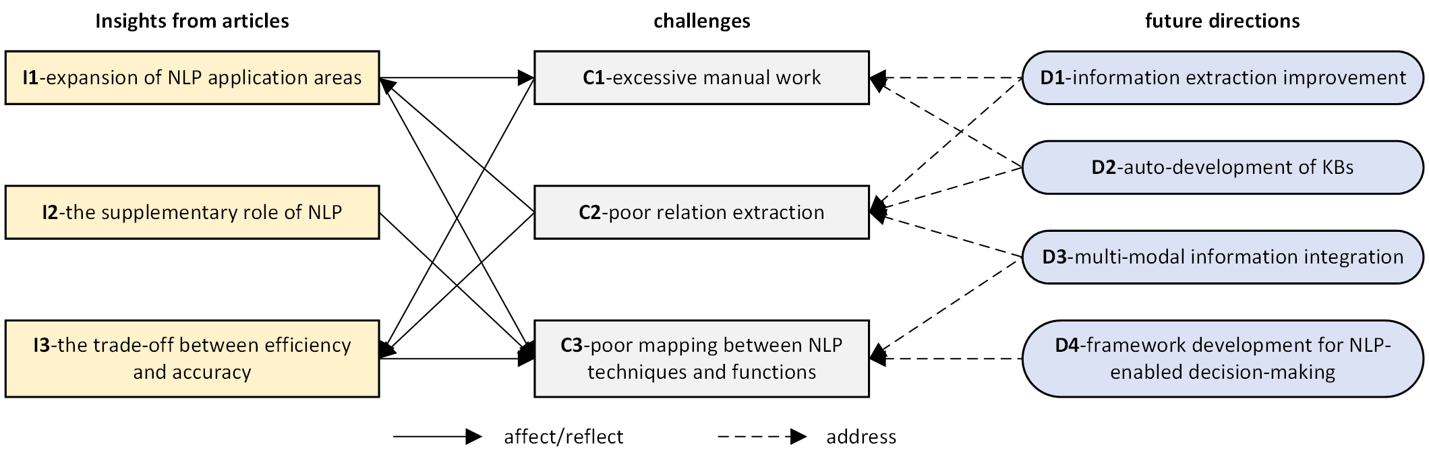
Figure 19 Summary of discussion

Conclusion
In the last decades, an increasing number of studies are conducted to solve problems in CS through NLP. This paper provides a state-of-the-art review appraising studies and applications of NLP in CS. In summary, the core functions of NLP, i.e., information extraction and document organisation has been largely improved with various techniques. NLP can also assist many downstream applications and enhance decision-making and management effectiveness. However, additional efforts are needed to continuously improve relation extraction, reduce manual workload, and develop a framework for NLP application considering the accuracy-efficiency trade-off. To the authors’ best knowledge, the paper is unique as: unlike other efforts reviewing AI in CS, which only generally introduce NLP, this paper is the first that provides 1) comprehensive introduction of bottom-level techniques (Section 4), core applications (Section 5-6), and downstream applications (Section 7), and 2) in-depth discussion of insights, challenges, and future directions. These findings serve as valuable agenda for leveraging NLP to realise smart construction. The study also has practical value, which provides project teams useful references to recognise cutting-edge NLP techniques and to-some-extent spot suitable ones according to specific needs.

Reference
1. Yan, H., N. Yang, Y. Peng, and Y. Ren, Data mining in the construction industry: Present status, opportunities, and future trends. Automation in Construction, 2020. 119: p. 103331.
2. Wu, C., P. Wu, J. Wang, R. Jiang, M. Chen, and X. Wang, Ontological knowledge base for concrete bridge rehabilitation project management. Automation in Construction, 2021. 121: p. 103428.
3. Gharehchopogh, F.S. and Z.A. Khalifelu. Analysis and evaluation of unstructured data: text mining versus natural language processing. in 2011 5th International Conference on Application of Information and Communication Technologies (AICT). 2011. IEEE.
4. Darko, A., A.P. Chan, M.A. Adabre, D.J. Edwards, M.R. Hosseini, and E.E. Ameyaw, Artificial intelligence in the AEC industry: Scientometric analysis and visualization of research activities. Automation in Construction, 2020. 112: p. 103081.
5. Xu, S., J. Wang, W. Shou, T. Ngo, A.-M. Sadick, and X. Wang, Computer vision techniques in construction: a critical review. Archives of Computational Methods in Engineering, 2020: p. 1-15.
6. Otter, D.W., J.R. Medina, and J.K. Kalita, A survey of the usages of deep learning for natural language processing. IEEE Transactions on Neural Networks and Learning Systems, 2020. 32(2): p. 604-624.
7. Rong, X., word2vec parameter learning explained. arXiv preprint arXiv:1411.2738, 2014.
8. Wu, S., K. Roberts, S. Datta, J. Du, Z. Ji, Y. Si, S. Soni, Q. Wang, Q. Wei, and Y. Xiang, Deep learning in clinical natural language processing: a methodical review. Journal of the American Medical Informatics Association, 2020. 27(3): p. 457-470.
9. Myneni, M., L. Prasad, and G.G. Reddy, Automatic assessment of floods impact using twitter data. International Journal of Civil Engineering and Technology, 2017. 8(5): p. 1228-1238.
10. Jallan, Y., E. Brogan, B. Ashuri, and C.M. Clevenger, Application of natural language processing and text mining to identify patterns in construction-defect litigation cases. Journal of Legal Affairs and Dispute Resolution in Engineering and Construction, 2019. 11(4): p. 04519024.
11. Li, X., R. Zhu, H. Ye, C. Jiang, and A. Benslimane, MetaInjury: Meta-learning framework for reusing the risk knowledge of different construction accidents. Safety science, 2021. 140: p. 105315.
12. Faraji, A., M. Rashidi, and S. Perera, Text Mining Risk Assessment–Based Model to Conduct Uncertainty Analysis of the General Conditions of Contract in Housing Construction Projects: Case Study of the NSW GC21. Journal of Architectural Engineering, 2021. 27(3): p. 04021025.
13. Shin, S. and R.R. Issa, BIMASR: Framework for Voice-Based BIM Information Retrieval. Journal of Construction Engineering and Management, 2021. 147(10): p. 04021124.
14. Robert, J.M., L. Moulet, G. Lizarralde, C.H. Davidson, J.Y. Nie, and L.D. Sylva, Finding out: a system for providing rapid and reliable answers to questions in the construction sector. Construction Innovation, 2006. 6(4): p. 250-261.
15. Williams, T.P. and J. Gong, Predicting construction cost overruns using text mining, numerical data and ensemble classifiers. Automation in Construction, 2014. 43: p. 23-29.
16. Fan, H. and H. Li, Retrieving similar cases for alternative dispute resolution in construction accidents using text mining techniques. Automation in construction, 2013. 34: p. 85-91.
17. Choi, S.J., S.W. Choi, J.H. Kim, and E.-B. Lee, AI and Text-Mining Applications for Analyzing Contractor’s Risk in Invitation to Bid (ITB) and Contracts for Engineering Procurement and Construction (EPC) Projects. Energies, 2021. 14(15): p. 4632.
18. Khalef, R. and I.H. El-adaway, Automated Identification of Substantial Changes in Construction Projects of Airport Improvement Program: Machine Learning and Natural Language Processing Comparative Analysis. Journal of Management in Engineering, 2021. 37(6): p. 04021062.
19. Zhong, B., X. Pan, P.E. Love, L. Ding, and W. Fang, Deep learning and network analysis: Classifying and visualizing accident narratives in construction. Automation in Construction, 2020. 113: p. 103089.
20. Kekkonen, P., A. Reiman, S. Väyrynen, and H.-K. Rajala, Occupational safety and health in shared workplaces according to workplace inspection reports. International Journal of Occupational Safety and Ergonomics, 2019.
21. Pan, X., B. Zhong, X. Wang, and R. Xiang, Text mining-based patent analysis of BIM application in construction. Journal of Civil Engineering and Management, 2021. 27(5): p. 303-315.
22. Oti, A., J. Tah, and F. Abanda, Integration of lessons learned knowledge in building information modeling. Journal of Construction Engineering and Management, 2018. 144(9): p. 04018081.
23. Martínez-Rojas, M., N. Marín, and M.A.V. Miranda, An intelligent system for the acquisition and management of information from bill of quantities in building projects. Expert Systems with Applications, 2016. 63: p. 284-294.
24. Martínez‐Rojas, M., N. Marín, and M.A. Vila, An approach for the automatic classification of work descriptions in construction projects. Computer‐Aided Civil and Infrastructure Engineering, 2015. 30(12): p. 919-934.
25. Tserng, H.P., S.Y.L. Yin, and M.H. Lee, The use of knowledge map model in construction industry. Journal of Civil Engineering and Management, 2010. 16(3): p. 332-344.
26. Stenstroem, C., M. Aljumaili, and A. Parida, Natural language processing of maintenance records data. International Journal of Comadem, 2015. 18(2): p. 33-37.
27. Ng, H., A. Toukourou, and L. Soibelman, Knowledge discovery in a facility condition assessment database using text clustering. Journal of infrastructure systems, 2006. 12(1): p. 50-59.
28. Bilal, M. and L.O. Oyedele, Big Data with deep learning for benchmarking profitability performance in project tendering. Expert Systems with Applications, 2020. 147: p. 113194.
29. Lee, J. and J.-S. Yi, Predicting project’s uncertainty risk in the bidding process by integrating unstructured text data and structured numerical data using text mining. Applied Sciences, 2017. 7(11): p. 1141.
30. Zhu, Y., W. Mao, and I. Ahmad, Capturing implicit structures in unstructured content of construction documents. Journal of computing in civil engineering, 2007. 21(3): p. 220-227.
31. Zheng, J., Q. Wen, and M. Qiang, Understanding Demand for Project Manager Competences in the Construction Industry: Data Mining Approach. Journal of Construction Engineering and Management, 2020. 146(8): p. 04020083.
32. Mahfouz, T., A. Kandil, and S. Davlyatov, Identification of latent legal knowledge in differing site condition (DSC) litigations. Automation in Construction, 2018. 94: p. 104-111.
33. Moon, S., Y. Shin, B.-G. Hwang, and S. Chi, Document management system using text mining for information acquisition of international construction. KSCE Journal of Civil Engineering, 2018. 22(12): p. 4791-4798.
34. Kim, J.-S. and B.-S. Kim, Analysis of fire-accident factors using big-data analysis method for construction areas. KSCE Journal of Civil Engineering, 2018. 22(5): p. 1535-1543.
35. Kinawy, S., M.N. Bakht, and T. El-Diraby, Mismatches in stakeholder communication: The case of the Leslie and Ferrand transit stations, Toronto, Canada. Sustainable cities and society, 2017. 34: p. 239-249.
36. Nik-Bakht, M. and T. El-Diraby, Project collective mind: Unlocking project discussion networks. Automation in Construction, 2017. 84: p. 50-69.
37. Tang, L., Y. Zhang, F. Dai, Y. Yoon, Y. Song, and R.S. Sharma, Social media data analytics for the US construction industry: Preliminary study on Twitter. Journal of Management in Engineering, 2017. 33(6): p. 04017038.
38. Xu, X. and H. Cai, Semantic approach to compliance checking of underground utilities. Automation in Construction, 2020. 109: p. 103006.
39. Zhang, J. and N.M. El-Gohary, Integrating semantic NLP and logic reasoning into a unified system for fully-automated code checking. Automation in construction, 2017. 73: p. 45-57.
40. Zhou, P. and N. El-Gohary, Domain-specific hierarchical text classification for supporting automated environmental compliance checking. Journal of Computing in Civil Engineering, 2016. 30(4): p. 04015057.
41. Xue, X. and J. Zhang, Building Codes Part-of-Speech Tagging Performance Improvement by Error-Driven Transformational Rules. Journal of Computing in Civil Engineering, 2020. 34(5): p. 04020035.
42. Cheng, M.-Y., D. Kusoemo, and R.A. Gosno, Text mining-based construction site accident classification using hybrid supervised machine learning. Automation in Construction, 2020. 118: p. 103265.
43. Hassan, F. and T. Le, Automated requirements identification from construction contract documents using natural language processing. Journal of Legal Affairs and Dispute Resolution in Engineering and Construction, 2020. 12(2): p. 04520009.
44. Choo, S., H. Park, T. Kim, and J. Seo, Analysis of trends in Korean BIM research and technologies using text mining. Applied Sciences, 2019. 9(20): p. 4424.
45. Hsu, J.-y., Content-based text mining technique for retrieval of CAD documents. Automation in construction, 2013. 31: p. 65-74.
46. Lee, J.H., J.S. Yi, and J.W. Son, Development of Automatic-Extraction Model of Poisonous Clauses in International Construction Contracts Using Rule-Based NLP. Journal of Computing in Civil Engineering, 2019. 33(3): p. 04019003.1-04019003.13.
47. Fan, H., F. Xue, and H. Li, Project-based as-needed information retrieval from unstructured AEC documents. Journal of Management in Engineering, 2015. 31(1): p. A4014012.
48. Lin, J.R., Z.Z. Hu, J.P. Zhang, and F.Q. Yu, A natural‐language‐based approach to intelligent data retrieval and representation for cloud BIM. Computer‐Aided Civil and Infrastructure Engineering, 2016. 31(1): p. 18-33.
49. El-Diraby, T. and J. Zhang, A semantic framework to support corporate memory management in building construction. Automation in Construction, 2006. 15(4): p. 504-521.
50. Lima, C., T.E. Diraby, and J. Stephens, Ontology-based optimisation of knowledge management in e-Construction. Electronic Journal of Information Technology in Construction, 2005. 10: p. 305-327.
51. Lee, J., Y. Ham, J.-S. Yi, and J. Son, Effective risk positioning through automated identification of missing contract conditions from the contractor’s perspective based on FIDIC contract cases. Journal of Management in Engineering, 2020. 36(3): p. 05020003.
52. Le, T. and H. David Jeong, NLP-based approach to semantic classification of heterogeneous transportation asset data terminology. Journal of Computing in Civil Engineering, 2017. 31(6): p. 04017057.
53. Zou, Y., A. Kiviniemi, and S.W. Jones, Retrieving similar cases for construction project risk management using Natural Language Processing techniques. Automation in Construction, 2017. 80: p. 66-76.
54. Li, S., H. Cai, and V.R. Kamat, Integrating natural language processing and spatial reasoning for utility compliance checking. Journal of Construction Engineering and Management, 2016. 142(12): p. 04016074.
55. Chi, N.-W., Y.-H. Jin, and S.-H. Hsieh, Developing base domain ontology from a reference collection to aid information retrieval. Automation in Construction, 2019. 100: p. 180-189.
56. Xie, Q., X. Zhou, J. Wang, X. Gao, X. Chen, and C. Liu, Matching real-world facilities to building information modeling data using natural language processing. IEEE Access, 2019. 7: p. 119465-119475.
57. Tixier, A.J.-P., M.R. Hallowell, B. Rajagopalan, and D. Bowman, Automated content analysis for construction safety: A natural language processing system to extract precursors and outcomes from unstructured injury reports. Automation in Construction, 2016. 62: p. 45-56.
58. Mounce, S.R., C. Brewster, R.M. Ashley, and L. Hurley, Knowledge management for more sustainable water systems. Journal of information technology in construction, 2010. 15: p. 140-148.
59. Rezgui, Y., Ontology-centered knowledge management using information retrieval techniques. Journal of Computing in Civil Engineering, 2006. 20(4): p. 261-270.
60. Vanier, D.J. and T.M. Froese, Use of keyphrase extraction software for creation of an AEC/FM thesaurus. Electronic Journal of Information Technology in Construction, 2000. 5.
61. Liu, H., Y.-S. Liu, P. Pauwels, H. Guo, and M. Gu, Enhanced explicit semantic analysis for product model retrieval in construction industry. IEEE transactions on industrial informatics, 2017. 13(6): p. 3361-3369.
62. Mao, W., Y. Zhu, and I. Ahmad, Applying metadata models to unstructured content of construction documents: A view-based approach. Automation in Construction, 2007. 16(2): p. 242-252.
63. Hajjar, D. and S.M. Abourizk, Integrating Document Management with Project and Company Data. Journal of Computing in Civil Engineering, 2000. 14(1): p. 70-77.
64. Nedeljković, Đ. and M. Kovačević, Building a construction project key-phrase network from unstructured text documents. Journal of Computing in Civil Engineering, 2017. 31(6): p. 04017058.
65. Yeung, C.L., W.M. Wang, C.F. Cheung, E. Tsui, R. Setchi, and R.W. Lee, Computational narrative mapping for the acquisition and representation of lessons learned knowledge. Engineering Applications of Artificial Intelligence, 2018. 71: p. 190-209.
66. Wu, C., X. Wang, P. Wu, J. Wang, R. Jiang, M. Chen, and M. Swapan, Hybrid deep learning model for automating constraint modelling in advanced working packaging. Automation in Construction, 2021. 127: p. 103733.
67. Costa, R., C. Lima, J. Sarraipa, and R. Jardim-Gonçalves, Facilitating knowledge sharing and reuse in building and construction domain: an ontology-based approach. Journal of Intelligent Manufacturing, 2016. 27(1): p. 263-282.
68. Zhang, J. and N.M. El-Gohary, Semantic NLP-based information extraction from construction regulatory documents for automated compliance checking. Journal of Computing in Civil Engineering, 2016. 30(2): p. 04015014.
69. Xu, N., L. Ma, L. Wang, Y. Deng, and G. Ni, Extracting domain knowledge elements of construction safety management: Rule-based approach using Chinese natural language processing. Journal of Management in Engineering, 2021. 37(2): p. 04021001.
70. Al Qady, M. and A. Kandil, Concept relation extraction from construction documents using natural language processing. Journal of Construction Engineering and Management, 2010. 136(3): p. 294-302.
71. Zhou, S., S. Ng, Y. Yang, and J. Xu, Delineating infrastructure failure interdependencies and associated stakeholders through news mining: the case of Hong Kong's water pipe bursts. 2020.
72. Zhang, F., H. Fleyeh, X. Wang, and M. Lu, Construction site accident analysis using text mining and natural language processing techniques. Automation in Construction, 2019. 99: p. 238-248.
73. Martínez-Rojas, M., R.M. Antolín, F. Salguero-Caparrós, and J.C. Rubio-Romero, Management of construction Safety and Health Plans based on automated content analysis. Automation in Construction, 2020. 120: p. 103362.
74. Roy, K.C., S. Hasan, and P. Mozumder, A multilabel classification approach to identify hurricane‐induced infrastructure disruptions using social media data. Computer‐Aided Civil and Infrastructure Engineering, 2020.
75. Wang, H.-H., Semi-automated identification of construction safety requirements using ontological and document modeling techniques. Canadian Journal of Civil Engineering, 2015. 42(10): p. 756-765.
76. Wu, C., P. Wu, J. Wang, R. Jiang, M. Chen, and X. Wang, Developing a hybrid approach to extract constraints related information for constraint management. Automation in Construction, 2021. 124: p. 103563.
77. Marzouk, M. and M. Enaba, Text analytics to analyze and monitor construction project contract and correspondence. Automation in Construction, 2019. 98: p. 265-274.
78. Moon, S., G. Lee, S. Chi, and H. Oh, Automated construction specification review with named entity recognition using natural language processing. Journal of Construction Engineering and Management, 2021. 147(1): p. 04020147.
79. Yuan, J., X. Li, X. Xiahou, N. Tymvios, Z. Zhou, and Q. Li, Accident prevention through design (PtD): Integration of building information modeling and PtD knowledge base. Automation in construction, 2019. 102: p. 86-104.
80. Kim, T. and S. Chi, Accident case retrieval and analyses: using natural language processing in the construction industry. Journal of Construction Engineering and Management, 2019. 145(3): p. 04019004.
81. Boukamp, F. and B. Akinci, Automated processing of construction specifications to support inspection and quality control. Automation in construction, 2007. 17(1): p. 90-106.
82. Xu, X. and H. Cai, Ontology and rule-based natural language processing approach for interpreting textual regulations on underground utility infrastructure. Advanced Engineering Informatics, 2021. 48: p. 101288.
83. Wang, H.-H., F. Boukamp, and T. Elghamrawy, Ontology-based approach to context representation and reasoning for managing context-sensitive construction information. Journal of Computing in Civil Engineering, 2011. 25(5): p. 331-346.
84. Gajzler, M., Text and data mining techniques in aspect of knowledge acquisition for decision support system in construction industry. Technological and Economic Development of Economy, 2010(2): p. 219-232.
85. Goh, Y.M. and C. Ubeynarayana, Construction accident narrative classification: An evaluation of text mining techniques. Accident Analysis & Prevention, 2017. 108: p. 122-130.
86. Xu, N., L. Ma, Q. Liu, L. Wang, and Y. Deng, An improved text mining approach to extract safety risk factors from construction accident reports. Safety science, 2021. 138: p. 105216.
87. Sun, J., K. Lei, L. Cao, B. Zhong, Y. Wei, J. Li, and Z. Yang, Text visualization for construction document information management. Automation in Construction, 2020. 111: p. 103048.
88. Madichetty, S. and M. Sridevi, Disaster damage assessment from the tweets using the combination of statistical features and informative words. Social Network Analysis and Mining, 2019. 9(1): p. 1-11.
89. Demian, P. and R. Fruchter, Measuring Relevance in Support of Design Reuse from Archives of Building Product Models. Journal of Computing in Civil Engineering, 2005. 19(2): p. 119-136.
90. Moon, S., G. Lee, and S. Chi, Semantic text-pairing for relevant provision identification in construction specification reviews. Automation in Construction, 2021. 128: p. 103780.
91. Yang, D., B. Kim, and H. Kim, Automated defect classification in the maintenance phase using a channel attention-based convolutional neural network model of natural language processing. 2021.
92. Al Qady, M. and A. Kandil, Automatic classification of project documents on the basis of text content. Journal of Computing in Civil Engineering, 2015. 29(3): p. 04014043.
93. Lin, Y.-C., L.-C. Wang, and H.P. Tserng, Enhancing knowledge exchange through web map-based knowledge management system in construction: Lessons learned in Taiwan. Automation in Construction, 2006. 15(6): p. 693-705.
94. Jallan, Y. and B. Ashuri, Text Mining of the Securities and Exchange Commission Financial Filings of Publicly Traded Construction Firms Using Deep Learning to Identify and Assess Risk. Journal of Construction Engineering and Management, 2020. 146(12): p. 04020137.
95. Ur-Rahman, N. and J.A. Harding, Textual data mining for industrial knowledge management and text classification: A business oriented approach. Expert Systems with Applications, 2012. 39(5): p. 4729-4739.
96. Zhou, S., S.T. Ng, S.H. Lee, F.J. Xu, and Y. Yang, A domain knowledge incorporated text mining approach for capturing user needs on BIM applications. Engineering, Construction and Architectural Management, 2019.
97. Prajwala, T., A comparative study on decision tree and random forest using R tool. International journal of advanced research in computer and communication engineering, 2015. 4(1): p. 196-199.
98. Baker, H., M.R. Hallowell, and A.J.-P. Tixier, Automatically learning construction injury precursors from text. Automation in Construction, 2020. 118: p. 103145.
99. Goodfellow, I., Y. Bengio, and A. Courville, Deep learning. 2016: MIT press.
100. Ayhan, B.U. and O.B. Tokdemir, Safety assessment in megaprojects using artificial intelligence. Safety science, 2019. 118: p. 273-287.
101. Aragao, R. and T.E. El-Diraby, Network analytics and social BIM for managing project unstructured data. Automation in Construction, 2021. 122: p. 103512.
102. Lin, K., K. Chou, H. Lin, S. Hsieh, and H.P. Tserng, Exploring the Effectiveness of Chinese-to-English Machine Translation for CLIR Applications in Earthquake Engineering. Journal of computing in civil engineering, 2009. 23(3): p. 140-147.
103. Kovacevic, M., J.Y. Nie, and C. Davidson, Providing Answers to Questions from Automatically Collected Web Pages for Intelligent Decision Making in the Construction Sector. Journal of Computing in Civil Engineering, 2008. 22(1): p. 3-13.
104. Ajayi, A., L. Oyedele, H. Owolabi, O. Akinade, M. Bilal, J.M. Davila Delgado, and L. Akanbi, Deep learning models for health and safety risk prediction in power infrastructure projects. Risk Analysis, 2020. 40(10): p. 2019-2039.
105. Lin, J.-R., Z.-Z. Hu, J.-L. Li, and L.-M. Chen, Understanding On-Site Inspection of Construction Projects Based on Keyword Extraction and Topic Modeling. IEEE Access, 2020. 8: p. 198503-198517.
106. Choudhary, A.K., P. Oluikpe, J.A. Harding, and P.M. Carrillo, The needs and benefits of Text Mining applications on Post-Project Reviews. Computers in Industry, 2009. 60(9): p. 728-740.
107. Agrawal, A.K., M. Jagannathan, and V.S.K. Delhi, Control Focus in Standard Forms: An Assessment through Text Mining and NLP. Journal of Legal Affairs and Dispute Resolution in Engineering and Construction, 2021. 13(1): p. 04520040.
108. Lin, X., B. McKenna, C.M. Ho, and G.Q. Shen, Stakeholders’ influence strategies on social responsibility implementation in construction projects. Journal of Cleaner Production, 2019. 235: p. 348-358.
109. Mo, Y., D. Zhao, J. Du, M. Syal, A. Aziz, and H. Li, Automated staff assignment for building maintenance using natural language processing. Automation in Construction, 2020. 113: p. 103150.
110. Dawood, H., J. Siddle, and N. Dawood, Integrating IFC and NLP for automating change request validations. Journal of Information Technology in Construction, 2019. 24: p. 540-552.
111. Zhong, B., X. Xing, H. Luo, Q. Zhou, H. Li, T. Rose, and W. Fang, Deep learning-based extraction of construction procedural constraints from construction regulations. Advanced Engineering Informatics, 2020. 43: p. 101003.
112. Liu, H., V. Kwigizile, and W.-C. Huang, Holistic Framework for Highway Construction Cost Index Development Based on Inconsistent Pay Items. Journal of Construction Engineering and Management, 2021. 147(7): p. 04021052.
113. Wu, H., G.Q. Shen, X. Lin, M. Li, and C.Z. Li, A transformer-based deep learning model for recognizing communication-oriented entities from patents of ICT in construction. Automation in Construction, 2021. 125: p. 103608.
114. Al Hattab, M., The dynamic evolution of synergies between BIM and sustainability: A text mining and network theory approach. Journal of Building Engineering, 2021. 37: p. 102159.
115. Sz, A., B. Yy, A. Stn, D. Jfxac, and E. Dl, Integrating data-driven and physics-based approaches to characterize failures of interdependent infrastructures - ScienceDirect. International Journal of Critical Infrastructure Protection, 2020. 31: p. 100391.
116. Chong, W.K., H. Naganathan, H. Liu, S. Ariaratnam, and J. Kim, Understanding infrastructure resiliency in Chennai, India using Twitter’s Geotags and texts: a preliminary study. Engineering, 2018. 4(2): p. 218-223.
117. Marzouk, M. and M. Enaba, Analyzing project data in BIM with descriptive analytics to improve project performance. Built environment project and asset management, 2019. 9(4): p. 476-488.
118. Bordes, A., N. Usunier, A. Garcia-Duran, J. Weston, and O. Yakhnenko, Translating embeddings for modeling multi-relational data. Advances in neural information processing systems, 2013. 26.
119. Caldas, C.H. and L. Soibelman, Automating hierarchical document classification for construction management information systems. Automation in Construction, 2003. 12(4): p. 395-406.
120. Caldas, C.H., L. Soibelman, and J. Han, Automated classification of construction project documents. Journal of Computing in Civil Engineering, 2002. 16(4): p. 234-243.
121. Chan, S.L. and N.N. Leung, Prototype Web-Based Construction Project Management System. Journal of Construction Engineering & Management, 2004. 130(6).
122. Tserng, H.P. and C.H. Chang, Developing a project knowledge management framework for tunnel construction: lessons learned in Taiwan. Canadian Journal of Civil Engineering, 2008.
123. Gajzler, M., Supporting the technical management of residential buildings in the process of their exploitation. Archives of Civil Engineering, 2021: p. 437-454-437-454.
124. Zhong, B., X. Pan, P.E. Love, J. Sun, and C. Tao, Hazard analysis: A deep learning and text mining framework for accident prevention. Advanced Engineering Informatics, 2020. 46: p. 101152.
125. Siu, M., W.-Y.J. Leung, and D.W. Chan, A data-driven approach to identify-quantify-analyse construction risk for Hong Kong NEC projects. 2018.
126. Brilakis, I., Y. Hong, H. Xie, and G. Bhumbra. Comparing Natural Language Processing Methods to Cluster Construction Schedules. 2021. American Society of Civil Engineers.
127. Hosseini, M.R., I. Martek, E. Papadonikolaki, M. Sheikhkhoshkar, S. Banihashemi, and M. Arashpour, Viability of the BIM manager enduring as a distinct role: association rule mining of job advertisements. Journal of construction engineering and management, 2018. 144(9): p. 04018085.
128. Wu, L., K. Ye, P. Gong, and J. Xing, Perceptions of governments towards mitigating the environmental impacts of expressway construction projects: A case of China. Journal of Cleaner Production, 2019. 236: p. 117704.
129. Ger Be R, M.S. and L. Tang, Automatic Quality Control of Transportation Reports Using Statistical Language Processing. IEEE Transactions on Intelligent Transportation Systems, 2013. 14(4): p. 1681-1689.
130. Jeon, K., G. Lee, and H.D. Jeong. Classification of the Requirement Sentences of the US DOT Standard Specification Using Deep Learning Algorithms. in International Conference on Computing in Civil and Building Engineering. 2020. Springer.
131. Hassan, F. and T. Le, Computer-assisted separation of design-build contract requirements to support subcontract drafting. Automation in Construction, 2021. 122: p. 103479.
132. Buladaco, M., L. Cantero, and J. Buladaco, Sentiments Analysis On Public Land Transport Infrastructure in Davao Region using Machine Learning Algorithms. International Journal of Advanced Trends in Computer Science and Engineering, 2020. 9(1): p. 685-690.
133. Jennex, M.E. and S.E. Bartczak, A revised knowledge pyramid. International Journal of Knowledge Management (IJKM), 2013. 9(3): p. 19-30.
134. Zhang, Z., P. Cui, and W. Zhu, Deep learning on graphs: A survey. IEEE Transactions on Knowledge and Data Engineering, 2020.
135. Mintz, M., S. Bills, R. Snow, and D. Jurafsky. Distant supervision for relation extraction without labeled data. in Proceedings of the 47th Annual Meeting of the ACL. 2009.
136. Ji, G., K. Liu, S. He, and J. Zhao. Distant supervision for relation extraction with sentence-level attention and entity descriptions. in Proceedings of the AAAI Conference on Artificial Intelligence. 2017.
137. Pan, Z., C. Su, Y. Deng, and J. Cheng, Video2Entities: A computer vision-based entity extraction framework for updating the architecture, engineering and construction industry knowledge graphs. Automation in Construction, 2021. 125: p. 103617.

