DOI: ***
ORIGINAL ARTICLE
Smart Work Package Learning for Decentralized Fatigue Monitoring through Facial Images

Xiao Li¹ | Jianhuan Zeng² | Chen Chen³ | Hung-lin Chi¹ | Geoffrey Qiping Shen¹

¹ Department of Building and Real Estate, The Hong Kong Polytechnic University, Hong Kong SAR, China.
² Shenzhen Cloud Computing Tech Co., Ltd, Shenzhen, China.
³ Department of Real Estate and Construction, The University of Hong Kong, Hong Kong SAR, China.
Correspondence
KB715, Knowles Building, The University of Hong Kong, Pokfulam, Hong Kong, China
Email: jaden@hku.hk

ABSTRACT
Monitoring the fatigue of construction equipment operators (CEOs) is critical for preventing accidents and ensuring precision construction occupational health and safety (COHS). However, there exists a theoretical dilemma between centralized technical efficiency and decentralized data privacy. Thus, this study introduces the Smart Work Package Learning (SWPL), a decentralized deep learning approach to monitor CEOs’ fatigue without privacy exposure risks. To illustrate the feasibility of SWPL as the fatigue classifier, this study implements fatigue monitoring through non-invasive facial images, and SWPL merges the updated parameters of the model from each smart work package (SWP). These updates are then validated by SWPs in the blockchain network and stored on the blockchain. More than 356 videos were derived from 124 operators. The results present that SWPL on decentralized SWP networks outperforms the deep learning model on individual SWP. The computational novelty is SWPL’s dynamic parameter aggregation mechanism to avoid parameter exposure in centralized or fixed aggregators. The proposed SWPL will open up advanced developments in precision COHS.

1. INTRODUCTION
With increasing advancements in intelligent construction equipment systems (ICES), construction equipment operators’ (CEOs) operation data in each cockpit can be gathered distributedly by the smart work package (SWP) module (Li, 2019), which can provide real-time CEOs fatigue analytics to monitor fatigue states using sensed data from sources, e.g., camera, electroencephalogram, heart rate. (Li et al., 2020). As an essential component of ICES, SWP can help monitor each CEO’s fatigue status, alert to CEO and site superintendents when the fatigue level exceeds the given threshold, and improve shift and break mechanism, ultimately improving the construction occupational health and safety (COHS).
Monitoring CEOs’ fatigue via facial images with features, e.g., eye state, yawning, nodding, compared with measuring physiological signals, is a non-invasive, fast-speed, and cost-effective way for the precision COHS (Li et al., 2019; Liu et al., 2020). Deep learning techniques currently show excellence for classification and prediction in construction (Rafiei & Adeli, 2016, 2017, 2018; Rafiei et al., 2017) and also in fatigue prediction by learning facial features and improving prediction performance (Yu et al., 2018; Dua et al., 2021). However, deep learning models need to use massive spatial-temporal facial image data for training purposes. As SWP is inherently decentral in each construction equipment, the size of local data is always inadequate to train reliable classifiers or predictors. Consequently, aggregating data into central is a way that has been widely used to address the local insufficiency.
While centralized solutions are more technology achievable, they have built-in drawbacks, such as traffic for boosted data (Martins et al., 2020), growing challenges in data ownership, privacy, security, and data monopolies (e.g., big data discriminatory pricing) that favor data collectors. FedSWP proposed by the authors addresses some of these aspects using federated learning (Li et al., 2021), a distributed learning paradigm that enables individuals (e.g., SWP) to collectively train a global model published by the central server. The application of federated learning can effectively reduce privacy exposure risks for SWP by performing the task of fatigue monitoring through facial images (FMFI) locally. However, suppose malicious SWP systems submit incorrect or poor model parameters to the central server. In that case, the convergence of loss or accuracy deteriorates, reducing the SWP system’s FMFI performance, ultimately affecting the safe equipment operations. The latest decentralized methods (Zhao et al. 2021; Qi et al. 2021) have made efforts to use blockchain to share and verify the updated parameters of the model and allow the model to be built independently on private data. However, model parameters are still processed in a central or fixed server, and this centralized setting decreases fault tolerance. If the central or fixed server is compromised, the complete SWP systems risk single-point-of-failure (SPoF), which may readily expose personal information. Furthermore, FMFI has heterogeneity in SWP devices, datasets, and deep learning models. Thus, it is difficult to apply previous methods to CEOs' FMFI directly.
To address the above challenges, this study introduces the smart work package learning (SWPL), which aims to form a dynamic parameter aggregator-based consortium blockchain with a customized deep learning model to improve the accuracy of FMFI with privacy-preserving capability. To this end, two primary objectives are designed accordingly: (1) To create a customized SWPL model for decentralized and privacy-persevering FMFI; (2) To develop a consortium blockchain with a dynamic parameter aggregator for SWPL to avoid SPoF and ensure the quality of model parameter sharing.
The remainder of this study is organized as follows: Section 2 reviews the state-of-the-art literature on FMFI, SWP, and distributed learning. Section 3 establishes the methodology for SWPL. An experiment using facial image datasets for fatigue monitoring demonstrates and evaluates the proposed method’s performance in Section 4. Section 5 compares with existing works to discuss novelties and limitations. Finally, conclusions and future works are presented in Section 6.

2. BACKGROUND

2.1 Fatigue Monitoring
Construction equipment operators (CEOs), such as crane operators, paver, and truck drivers, should be physically strong and have agility in hearing, vision, and reactions for safe and productive operation (Tam and Fung, 2011). However, these capacities will be degraded when CEOs are fatigued or drowsy. Compared with normal vehicle drivers, the fatigue monitoring system for CEOs is necessary because (1) CEOs have to attentively perform their tasks while sitting in their control cabins for prolonged periods, particularly for crane operators who work at height; (2) These operations are more complex and physical-demanded than vehicle drivers; (3) Mental fatigue is caused by the sustained attention required and the passive physical fatigue arising from prolonged sitting. Previous studies have made efforts to develop various fatigue monitoring systems for detecting and alerting driver’s or operator’s fatigue operation, which mainly uses equipment trajectory, facial expression, and physiological signal to judge the level of fatigue (Thiffault and Bergeron, 2003; Ji and Yang, 2002; Borghini et al., 2014). Equipment trajectory can be measured by movement speed, acceleration, path deviation, steering, and turning angle. The physiological signals, e.g., heart rate, electrocardiogram (ECG), electromyogram (EMG), electromyogram (EMG), electrooculogram (EOG), and electroencephalogram (EEG) (Hassanpour et al., 2019), can be measurements. However, many disturbances (e.g., operation faults owing to inexperience, ineffective communication with site signallers) may impact construction equipment operation trajectory, and the physiological signals are aggregated in an inconvenient and invasive manner for CEOs. As a result, fatigue monitoring through facial expressions (e.g., eye state, yawning, nodding) can be more practical, speedy, and cost-effective. Sundelin et al. (2013) scientifically investigated human fatigue (or sleep deprivation) can affect features relating to the eyes, mouth, and skin. With the development of deep learning, FMFI reaches a high accuracy level. For instance, Zhang et al. (2015) employed a convolutional neural network (CNN) to extract yawning features in the nose rather than the mouth due to the impact of head turns. However, it can be challenging to discern between fatigue states, such as blinking and closing eyes. Huynh et al. (2016) used the 3D-CNN as a more practical method by taking into account more face features as well as temporal features in sequential video frames. However, It is still challenging to discriminate lengthy dependent statuses on the face, e.g., talking and yawning. Guo and Markoni (2018) and Lyu et al. (2018) improved the model with temporal features extractor by combing CNN with a Long Short-term Memory (LSTM) that enables the detection of long-term dynamic features over consecutive frames. Li et al. (2019) further considered backward dependencies learned from reverse-order frames with deep bi-directional LSTM for learning dependencies of periodic fatigue facial expression in the crane operations (e.g., discriminate the fatigue nodding and head slant to track the crane hook movements, yawning, and talking with signallers). However, monitoring the CEO’s facial fatigue in each construction equipment has a significant privacy exposure risk. Particularly in the global privacy crisis, privacy-preserving deep learning solutions are demanded to avoid contemporary data privacy scandals (Newman, 2015; Tuttle, 2018). At the same time, a growing number of regions or countries have promulgated laws, policies, or regulations to respond to privacy and security issues in data. For example, European Union issued General Data Protection Regulation (GDPR) (Voigt et al., 2017) and the Personal Information Protection Law by China (Determann et al., 2021). As a result, technical solutions for monitoring the CEOs’ facial fatigue while preserving personal information are urgently needed.

2.2 Smart Work Package
SWP can be the smallest distributed agent to facilitate task planning, scheduling, and execution with smartness capacities, e.g., perceiving, networking, inferencing, and predicting (Li et al., 2019a; Soto Gutierrez & Adeli, 2017). Many approaches have been developed in SWP to achieve automatic work package generation, adaptive work package scheduling, and efficient work package execution. For instance, the dynamic ontology-based mapping approach is proposed to map products to tasks and group tasks to work packages in modular construction (Li et al., 2022a). The hybrid SD-DES model developed in SWP can assess the dynamic impacts of work packages’ constraints on project schedules (Li et al., 2019b). By computing the dynamic distance between crane loads and site obstacles (e.g., walking workers), the probabilistic roadmap with A* proposed in SWP can optimize operation decisions (Li et al., 2020). Moreover, SWP’s hybrid deep neural networks have been employed to monitor CEOs’ fatigue (Li et al., 2021a).
Instead of providing a new workflow in FMFI, SWP can enable generated operations with smartness properties, such as adaptivity, sociability, and autonomy (Li et al., 2019a). The CEO’s FMFI required in equipment operations is one of the applications to leverage SWP’s autonomy for work package execution with tracking, updating, and predicting. Previous investigations by the authors have looked into the SWP-enabled FMFI service, and the system architecture of service is shown in Li et al. (2019b, 2021). The infrastructure and functions of this service are enabled by smart construction objects (SCOs) (Lu et al., 2021) and the building information modeling (BIM) platform (Li et al., 2022b). To facilitate the efficiency in data provision and capture, SCOs are developed by empowering objects, such as humans (operator), machines (crane cabin, helmet), and material (prefabricated components) with multimode IoT sensors, e.g., bio-medical ped, camera, IMU, temperature, and humidity sensors. SCOs can also help enrich BIM semantics or exchange information with BIM. SWP can then perform the FMFI tasks after the triggers from CEOs through the human-machine interfaces. Models and approaches developed into SWP may frequently require data sharing or aggregating from construction workers. However, using CEOs’ private data may expose them to privacy risks. The privacy concerns expressed by CEOs may stymie the adoption of SWP and other wearable innovations. An ideal scenario is that sufficient image data could be available locally, and deep learning algorithms can be performed locally in each SWP. However, each SWP may collect image data only from an individual construction site, single construction equipment, or even one operator resulting in data shortage, which requires gathering data into the cloud to train and test better deep learning models. This data centralization issue can lead to data privacy exposure risks.

2.3 Distributed Learning
In COHS, previous studies mainly rely on training worker-related data, including massive private information, such as location, motion, and images. However, direct worker-related data gathering is not always easy or allowed in real-life construction sites. Thus, the emergence of Federated Learning (FL) addresses some of these aspects. After being introduced by Google (Konečný et al.,2016), FL received much attention from researchers and pushed forward its revolution, such as communication cost optimization, heterogeneity improvement (Sattler et al., 2019), advanced encryption and differential privacy algorithms (Ali et al., 2019), and applications in a wide field, e.g., medicine data in healthcare, IoT data in industrial engineering, financial and personal data in mobile devices (Li et al., 2020a). In FL, in each round of model training, each participant downloads an initial global model, completes local model training, and transmits local model parameters to the central server without submitting data. The central server then combines all updates from local trained models to form an aggregated global model, subsequently released to the local. This process is iterative until performance convergence. However, FL for SWP-based FMFI may present the following issues: (1) the centralized updated parameters of the model may suffer from the SPoF; (2) malicious SWPs can provide erroneous or poor model parameters to the central server.
To address these two issues, the latest studies developed blockchain with distributed databases, consensus mechanisms, and encryption algorithms to incentivize participants to share data parameters and verify them. For example, Zhang et al. (2022) developed a framework for using blockchain and smart contracts to manage multimode data (e.g., text, time-series, and image) in different application scenarios of construction. By combining blockchain with federated learning (FL), Kang et al. (2019) developed an incentive mechanism in blockchain with tamper-proof reputation management for model learning. The reliability of FL is improved in further investigation (Kang et al., 2020). Lu et al. (2020a) developed an asynchronous FL scheme with blockchain for private data sharing on the internet of vehicles, and this scheme is also extended to the digital twin application (Lu et al., 2020b). Qu et al. (2020) evaluated the performance of blockchain-based FL, including latency, consensus delays, communication cost, and computation for optimal block generation rate. Moreover, they adopted this blockchain FL framework for cognitive computing (Qu et al., 2020b). Zhao et al. (2021) created a Blockchain FL system using a reputation mechanism to incentivize customers in data provision to facilitate the manufacturers of home appliances in training machine learning models. Qi et al. (2021) also established an FL framework with a consortium blockchain by involving a noise-adding mechanism for differential privacy methods to improve privacy preservation of traffic flow prediction. Although decentralized FL or distributed learning methods have raised great attention with advantages in only aggregating model parameters and keeping data locally, 1) it still has a fixed aggregator to gather parameters, which has parameter exposure risks and increases the communication cost in exchanging parameters among blockchain networks. 2) As FMFI exists statistical heterogeneity in SWP devices (e.g., camera), datasets (i.e., personalized data with glass, mustache, beard), and models, it is difficult to apply previous methods directly to CEOs' FMFI. Given datasets non-identically independently distributed (Non-IID), the proposed SWPL with a customized deep learning model can achieve personalization by updating gradients iteratively without calculating Hessian Matrix to optimize the personalized model for each node. Inspired by swarm learning (Warnat-Herresthal et al., 2021), this study proposed a consortium blockchain-based distributed learning method among SWPs, namely SWP learning, to protect privacy and ensure data quality shared in CEO-FMFI.

3. SMART WORK PACKAGE LEARNING
This study considers the CEOs as entities in fatigue monitoring through facial images (FMFI). Each CEO corresponds to an SWP with the sensory camera. This study uses the SWP to represent the CEO entity in the proposed SWPL framework (See Fig.1). Each SWP includes specific CEOs’ facial fatigue image datasets. SWPL aims to prevent privacy exposure and improve FMFI accuracy by sharing model parameters among isolated SWPs in the consortium blockchain network.

3.1 Problem Statement
This study is given facial image data from N SWPs, denoted the SWP by $W=\{W_{1},W_{2},⋯W_{N}\}$, while SWPs’ datasets are denoted by $D=\{D_{1},D_{2},⋯D_{N}\}$. Here, FMFI has two primary states: normal and fatigue. Conventional methods train a model $M_{central}$ by combining all the data $D=D_{1}∪ D_{2}{∪⋯∪D}_{N}$, or train individual model $M_{indiv}$ on each local dataset due to privacy concerns. SWPL approach shares all model parameters $P=P_{1}∪ P_{2}{∪⋯∪P}_{N}$ to train a model locally and compute $O_{t+s}$ = $f_{i}(t+s,D_{i})$ for each SWP. If accuracy is denoted as $A$, then the objective is to ensure the accuracy of SWPL outperforms conventional methods denoted by Equations (1) & (2)
$A_{SWPL}-A_{indiv}>0$ (1)
$A_{SWPL}-A_{central}>0$ (2)
Where $t$ and $O_{t}$ stand for the t-th timestamp of temporal data and the t-th fatigue state in facial images. s is the prediction frame at $t$ and $f\left(t,D\right)$ presents the function for FMFI.

3.2 Overview of SWPL framework
Inspired by the swarm learning in Warnat-Herresthal et al. (2021), this section introduces smart work package learning (SWPL) to share model parameters via smart work package chain (SWPC) and train deep learning models on private facial image data locally at SWPL nodes. SWPC is achieved via consortium blockchain, and each SWP should be defined and authorized before parameter sharing. The framework of SWPL is presented in Fig.1(a), which includes the SWPC node, SWPL node, SWP control interface (SWPCI) node, license server, and server node. SWPC nodes form the Ethereum-based consortium blockchain network to broadcast and keep global state information from updated parameters of the model while not holding the whole model. SWPL nodes run the deep learning models to train and update models in FMFI. SWPCI is the command interface tool to view, control, and manage the processes of parameter sharing, merging, and updating via application programming interface (API) ports. SWPC nodes can obtain license tokens from the license server for running the SWPC network and SWPL nodes. Sever nodes use the SPIRE (SPIFFE Runtime Environment, SPIFFE refers to Secure Production Identity Framework for Everyone) framework to provide SVID (SPIFFE Verifiable Identity Document) and trust bundles to SWPC nodes and SWPL nodes. The process of SWPL is shown in Fig.1 (b). A new SWP joins through smart contracts in blockchain, receives the model, and trains the model locally until satisfying defined synchronization conditions. Before initiating a new round of training, model parameters are shared through an
API in SWPCI and aggregated to build an updated model. For each SWP (see Fig.1(c)), SWPL is composed of layers of application, middleware, and infrastructure. The CEO-FMFI task is one of the application scenarios. The middleware layer contains blockchain and deep learning models. The infrastructure layer includes a containerized API for executing SWPL in hardware environments.

3.3 Deep neural networks in SWPL
This study leverages and makes improvements of hybrid deep neural networks for FMFI in the authors’ previous work (Li et al., 2021). As shown in Fig.2, the private facial data (e.g., image or video) from each SWP is considered as the input data, which would be preprocessed locally by a face detector and a spatial feature extractor. The MultiTask Cascaded Convolutional Neural Network (MTCNN) can achieve real-time face detection with high accuracy and robustness (Zhang et al., 2016). Thus the face detector in this study used MTCNN to retrieve bounding boxes and facial landmarks with three-stage models: P-Net, R-Net, and O-Net. As MobileNets are compact, low-latency, low-power models and can be parameterized to facilitate real-time fatigue feature extraction, the latest MobileNet V3 Large is applied as the spatial feature extractor to proceed with common features, e.g., eyes, mouth, head, on the face through start stage: one convolutional layer (Conv 1), middle stage: a mobile block with two expansion layers and several depthwise separable convolution layers (Conv 2-18), later stage: one average-pooling layer (Avg pooling), and two convolutional layers (Conv 19 and 20) (Howard et al., 2019). The MTCNN and MobileNet V3 Large are used to preprocess data locally, which indicates that their parameters will not be updated in backpropagation.
FMFI involves the periodicity of temporal data, especially for repeating fatigue patterns. Bidirectional LSTM (Bi-LSTM) can play a critical role in helping extract high-level dynamic temporal features by learning both forward and backward long-term dependencies (Greff et al., 2016). Thus, this study will update and share parameters of Bi-LSTM during the training process. The sigmoid activation function is used to normalize the classification output to a probability distribution.

3.4 Consortium Blockchain for SWPL
As shown in Fig.3, a permissioned blockchain, namely SWPC, is configured to realize the decentralized SWPL. To facilitate SWPL functionality, SWPC nodes are first registered on the blockchain network using the API. Then, SWPC nodes can interact with other SWPC nodes using blockchain for parameter sharing and control the local model training process through related SWPL nodes. Thirdly, instead of depending on a confirmed central aggregator in federated learning, a dynamic selection mechanism of shifting aggregators is implemented at each parameter merging round through smart contracts to make SWPL decentralized. Moreover, a package of state-of-the-art security technologies, e.g., network encryption, trusted execution environment, and secure containment, is applied to protect facial images from unauthorized access. Since the SWPL network is typically configured starting from its lower boundary at its early stage, two SWPC network nodes, four SWPL nodes, and two SPIRE server nodes are established for this study. With the implementation of this setting in consortium blockchain, SWPL can be performed, including the following stages:
- Model training on SWPL nodes—each SWPL node uses its local datasets to train the Bi-LSTM model to get the latest local updates and provide these parameters to the nearest SWPC node.
- Parameters merging on SWPC—when a leader is dynamically selected ( the first node to finish its training is set as the leader in each epoch) among SWPC nodes, the leader will aggregate their parameters and generate a new data block to store all model parameters.
- Parameters synchronizing between SWPC nodes—Finally, the new block with merged parameters is stored on the SWPC, responsible for sharing block data with each SWPC node. Moreover, each SWPL node computes its model using the latest merged parameters until meeting the determined performance metrics.
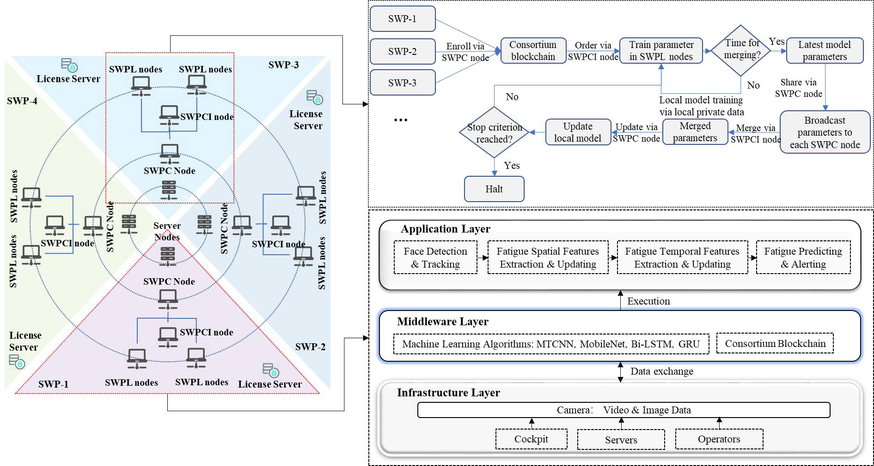
FIGURE 1. SWPL framework for decentralized and privacy-preserving FMFI of CEOs

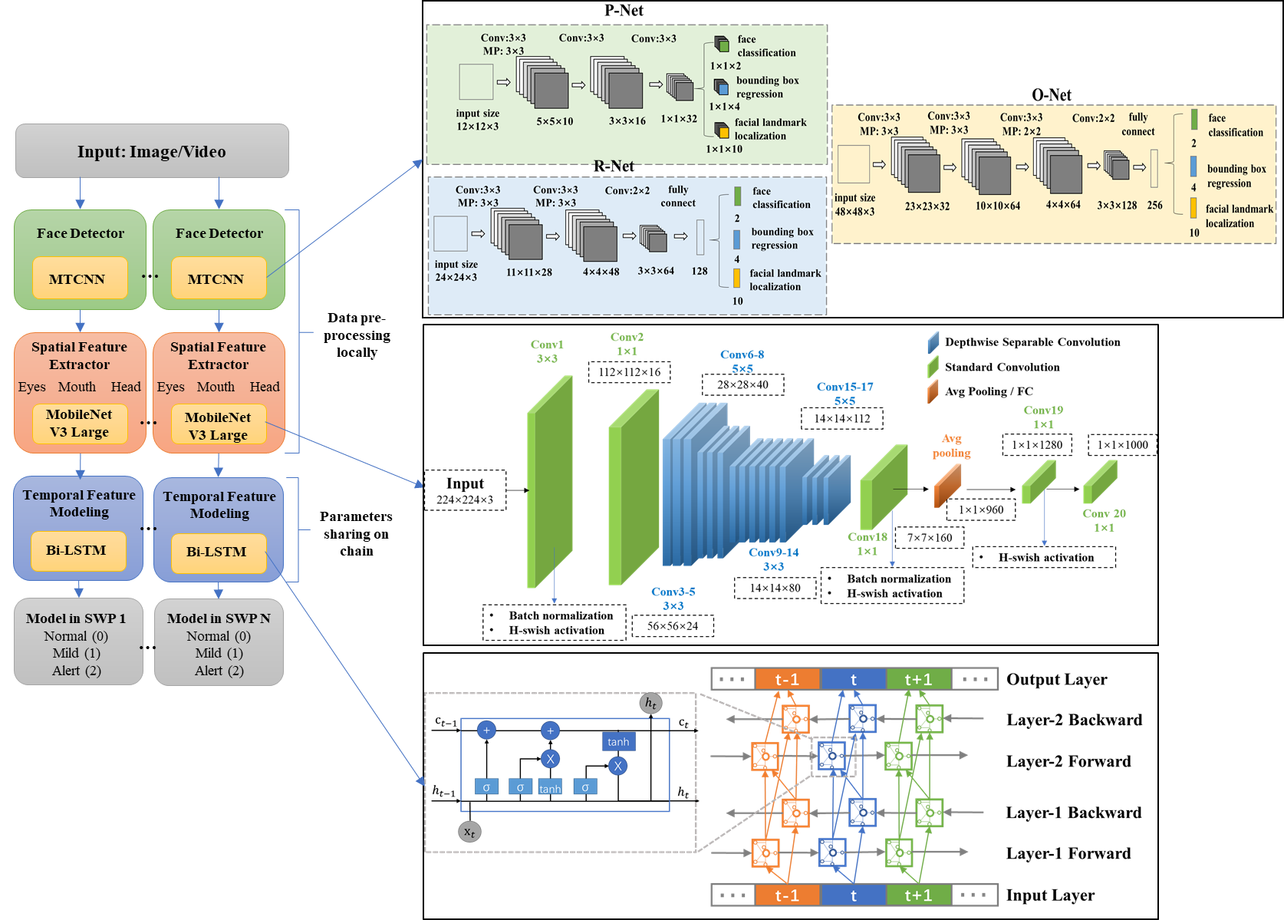
FIGURE 2. Deep neural networks for facial fatigue monitoring

As shown in Fig.4, a consensus process is designed for the consortium blockchain of SWPL.
- Initialization—It begins with the enrollment of a set of construction equipment operators’ SWPs to formulate the operational and legal requirements of the decentralized system, which includes consensus on model training performance, parameter sharing agreements and synchronization frequency, incentive mechanism, and deep learning model to be used.
- Configuration—All the SWPs install the SWPL function on their SWPC nodes to form the SWPC network, which overlays the underlying IP network (See Fig.3) connection between SWPC nodes.
- Training—(1) SWPL training starts with each SWPL node enrollment via smart contract. Each SWPL node can record its information (e.g., uniform resource identifier (URI)) in the ledger to facilitate its trained parameters extracted by other nodes in SWPC. (2) Then, SWPL nodes iteratively train the local replica of the model over numerous epochs. For each epoch, each SWPL node trains a local model through various data batches for the defined iterations. Upon reaching the iteration number, it notifies the SWPC nodes that it is ready for parameter sharing. (3) When the number of SWPL nodes ready for parameter sharing comes to a minimum threshold determined in initialization, parameter sharing begins. After each epoch, the elected SWPC node leader retrieves the trained parameters via URI and aggregates them. (4) All aggregated parameters are merged through predefined methods, e.g., mean, weighted mean, and median, and the leader notifies other SWPC nodes when the merging process is completed. Each SWPC node can then download the latest merged parameters and update the local models of its SWPL nodes. (5) All SWPL nodes evaluate the model performance, e.g., accuracy and loss, using the smart contract. After completing the validation process in each SWPL node, the leader of SWPC nodes will aggregate all local validation metrics and get the global performance.
- Testing—Testing new local datasets can be conducted when the training process reaches a reasonable performance. Otherwise, the SWPL nodes start the next training batch with the merged parameters.
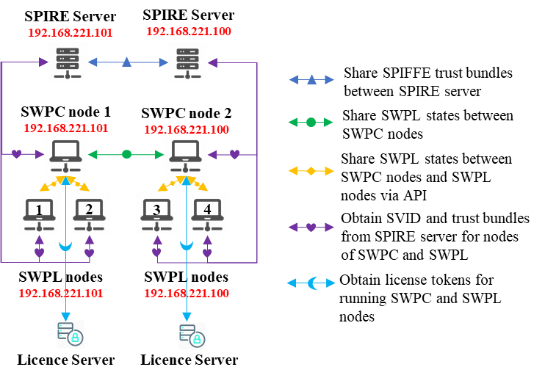
FIGURE 3. Consortium blockchain architecture for two-node SWPC

4. EXPERIMENT
Experiments are conducted in this section to assess the SWPL’s accuracy and privacy performance for FMFI, one of the most privacy-concerned operations for CEOs in COHS. The datasets, implementation details, and results analysis are presented below.

4.1 Facial Fatigue Monitoring Dataset
YawDD, a popular public dataset for the vehicle operator (Abtahi et al., 2014), is used in this study’s experiment and evaluation process. The justification for using this dataset is threefold: (1) The authors have tested a similar hybrid model (MTCNN, MobileNet, LSTM) on existing public datasets (e.g., NTHU-DDD, UTA-RLDD, YawDD), which the YawDD outperforms others in accuracy and loss as apparent facial features in fatigue than others (Liu et al., 2021); (2) monitoring of CEOs’ fatigue statuses through facial images is nearly the same as the scenarios for vehicle operators, where operators sit in the cockpit for operating vehicles or equipment; (3) it will be easier to compare the performance of SWPL with previous centralized or federated learning methods as training and testing on the same dataset. YawDD has two datasets of videos (640×480 pixels resolution and 24-bit true color (RGB) without audio) recorded by in-cockpit cameras and captured in various lighting conditions within natural environments. Each dataset includes various facial features, e.g., talking, laughing, singing, normal stillness, yawning, nodding, slow blink rate of eyes, different gender, with and without glasses/sunglasses, and various ethnic groups. The first dataset includes 322 videos for 90 participants (47 male and 43 female), which all are captured through a video camera installed in the front mirror of the cabin. Each participant is documented with three or four videos, each of which covers normal, talking/singing, and yawning facial expressions. The second dataset includes 29 videos (one for each participant, namely, 16 male and 13 female), which are recorded via a video camera positioned on the dashboard of the cabin. YawDD datasets contain five scenarios, including Bareface, Glasses, Sunglasses, Mustache, and Breard, all captured at a window size of 30 fps (frames per second). In datasets, each participant presents different combinations of fatigue expressions (yawning, nodding, slow blink rate of eyes) and normal signs (talking, singing, laughing, normal stillness). All details of YawDD are summarized in Table 1. A two-node SWPC scenario with four SWPL nodes is established. Each SWPL node is assigned with uneven videos to simulate the real-world situation, where each SWP may include different CEOs in single construction equipment or a construction site that creates such COHS data subject to local privacy regulations.
TABLE 1. YawDD Details
Participants | Behavior | Illumination | Camera  Type | Scenarios | Camera Position
119 | •Normal Stillness  •Talking or Singing  •Yawning  •Sleepy Blinking  •Nodding | Day (from early morning till sunset) | RGB | •Glasses  •Sunglasses  •Mustache  •Beard  •Bare Face | Front mirror  &  Dash-board

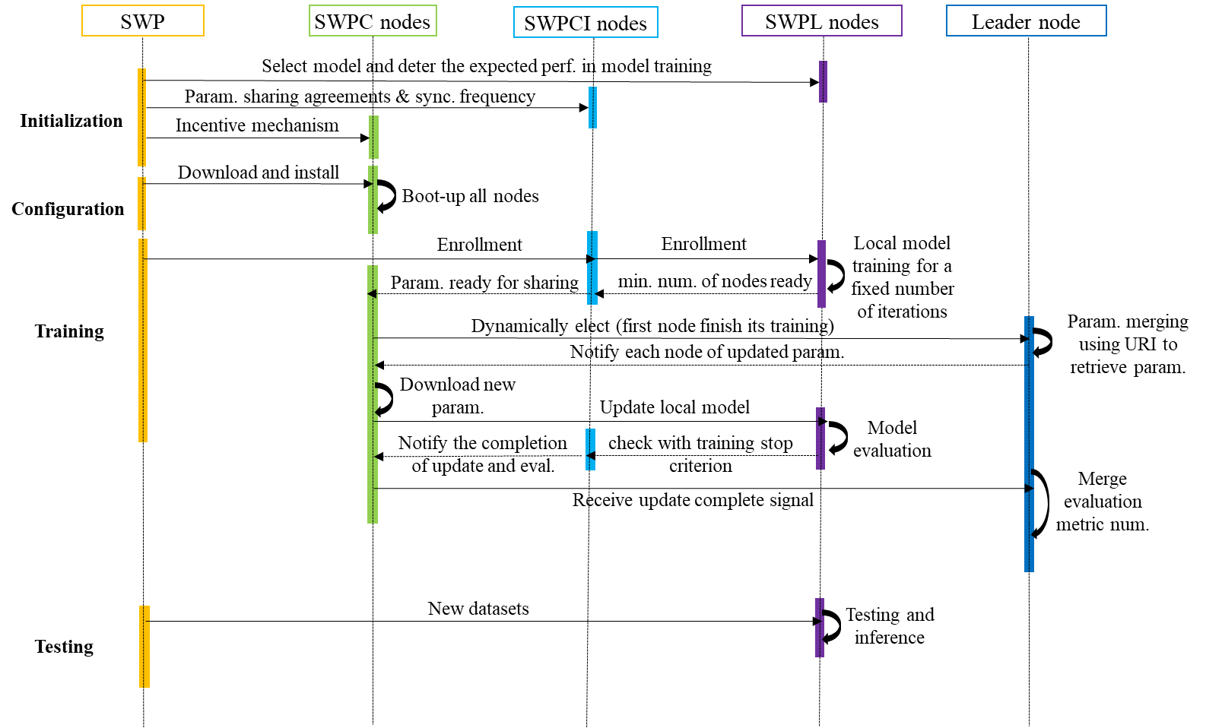
FIGURE 4. The consensus process for the consortium blockchain of SWPL

4.2 SWPL Implementation Details

4.2.1 Experiment Environment Settings
The experiment environment includes two virtual machines within a Linux Ubuntu 20.04 system to run the training and evaluation process. The computer configurations and development package specifications for this experiment are listed in the following:
- Hardware: 20 cores, 64GB of RAM, 256 GB SSD, and 2TB HDD
- Network: Up to 3 open ports in each node
- Architecture: AMD64
- Container hosting platform: Docker 18.01.0
- CPU: Intel (R) Xeon (R) E5-2640 v4@ 2.40 GHz (20 CPUs)
- GPU: NVIDIA GeForce GTX 1080
- Deep learning framework: Python 3.73, Keras 2.3.1, Tensorflow 1.15.0
- Image operation cross-platform: OpenCV-Python

4.2.2 Facial Fatigue Data Pre-processing
Firstly, the MTCNN is applied locally in each SWPL node to recognize the faces and extract the frame landmarks. After that, the MobileNet v3 is used to transform the face frames to feature embeddings (512). The facial features of fatigue status can be presented by the expressions of the eyes, head, and mouth. The temporal fatigue features are easily identified in each video as long-term dependencies, indicating that accurately predicting each frame’s state should make good use of frames from preceding or succeeding seconds. However, within a few seconds, these facial expressions (e.g., closing eyelids, yawning, and nodding) on a sequence of frames would still be detected as fatigue symptoms if they had just remained expressions to alert following fatigue states. To accurately distinguish the temporal states between normal and fatigue, the YawDD is relabeled accurately with two fatigue levels: (1) Normal (label: 0): the participant shows no indicators of facial drowsiness. (2) Fatigue (label: 1): the participant exhibits facial sleepiness. As indicated in Table 2, the least connected behaviors to facial fatigue include stillness, looking away, normal blinking and chatting, talking, laughing, and singing. Thus, the frames with such expressions can be labeled to 0. As for apparent facial expressions of fatigue, such as closing eyes, yawning, and nodding, they can be labeled as 1.
TABLE 2. Label details on YawDD
Behavior |  | State | Fatigue Level
Talking, laughing, singing  Looking aside  Normal blinking  Stillness |  | Normal | 0
Closing eyes  Yawning  Nodding |  | Fatigue | 1

Table 3 and Figure 5 present the statistical details for samples and datasets on YawDD (image array n= 78,081), which are divided into well-separated training datasets (75%) and a test dataset (25%) that are applied for validating models developed by SWPL and at individual nodes. All participants with different scenarios are assigned to each SWPL node (node 1 (23): female with glasses, node 2 (17): female with non-glasses, node 3 (26): male with glasses, node 4 (25): male with non-glasses, test node (28%): all scenarios). The training dataset is randomly and unevenly assigned to SWPL nodes (node 1: 20%, node 2: 14%, node 3:18%, node 4: 23%). Within training and testing data, samples with heterogeneity were maintained at each SWPL node to simulate real-world scenarios. The ratio between positive (fatigue) and negative (non-fatigued) samples are also presented in Fig.4.
TABLE 3. Statistics on samples for each node
Scenario | Participant | Status | Instance | Type | Shape | Source
Original | 90 | 2 | 322 | Videos | (:, 640, 480, 3) | Mirror
Original | 29 | 2 | 29 | Videos | (:, 640, 480, 3) | Dashboard
SWPC node1 | 23 | 2 | 15675 | Array | (:, 30, 512) | SWPL node 1
SWPC node1 | 17 | 2 | 10864 | Array | (:, 30, 512) | SWPL node 2
SWPC  node 2 | 26 | 2 | 14352 | Array | (:, 30, 512) | SWPL node 3
SWPC  node 2 | 25 | 2 | 17603 | Array | (:, 30, 512) | SWPL node 4
SWPC  Test node | 28 | 2 | 19587 | Array | (:, 30, 512) | SWPL  Test node

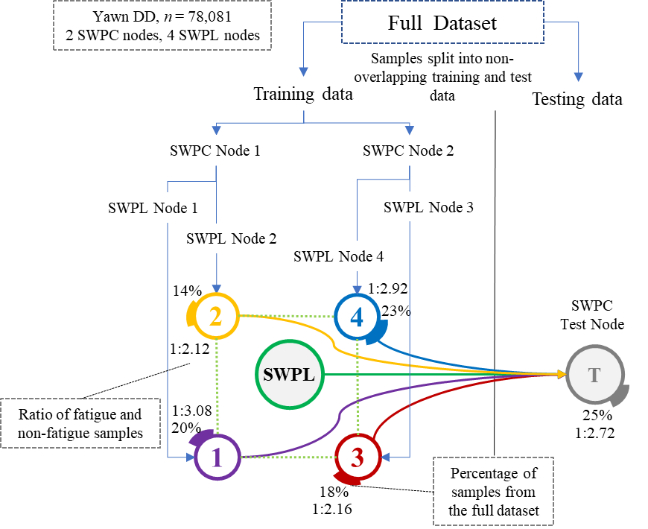
FIGURE 5. Statistical information on Datasets

4.2.3 Decentralized Training
Neural network algorithm. The hybrid deep neural networks developed in the authors’ previous works are leveraged (Li et al., 2019a, 2021; Liu et al., 2021), and there is an improvement in the spatial feature extractor of the hybrid model by using MobileNet V3 instead of Mobile Net or VGG-16. The layers for the face detector (MTCNN) and temporal feature extractor (Bi-LSTM or gated recurrent unit (GRU)) have also been improved and are shown in Table 4. MTCNN and MobileNet V3 are processed locally in each SWPL node, and only the parameters of Bi-LSTM/GRU are trained and are shared through the blockchain network. The trained LSTM-2 model consists of one input layer, three hidden layers, and one output layer. The input layer is processed by two hidden LSTM layers with 512 cells, a rectified linear unit activation function, and a dropout rate of 50%. The output layer is densely connected and
consists of one node and a sigmoid activation function. The model is configured for training with RMSprop optimization and to compute the binary cross-entropy loss between true labels and predicted labels. The model is used for training both the individual nodes and SWPL nodes. The model is trained over 200 epochs with a batch size of 32 and a learning rate of 0.001.
Trainability | Model Name | Layers
Non-trainable | MTCNN  (Face Detector) | P-Net(12,12,3)  R-Net(24,24,3)  O-Net(48,48,3)  Input_1(:,224,224,3)  Conv_1(:,112,112,32)  …
Non-trainable | MobileNet V3  (Spatial Feature Extractor) | Conv_13(:,7,7,1024)  Global_average_pooling2d_1(:,1024)  Reshape_1(:,1,1,1024)  Dropout(:, 1, 1, 1024)  Conv_preds(:, 1, 1, 1000)  Softmax(:, 1, 1, 1000)  Dense_1(:, 1, 1, 512)  Flatten_1(:, 512)
Trainable | Bi-LSTM/GRU (Temporal Feature Extractor) | LSTM/GRU_1（:, 30, 512）  LSTM/GRU_2（:, 256）  Dense_1(:,128)  Dropout_1(:,128)  Dense_2(:,1)
Parameter tuning. The model hyperparameters are fine-tuned for better performance (e.g., higher sensitivity) (See Table 5). For example, to improve accuracy and loss, the dropout rate is reduced to 10% and increased the number of epochs to 200. The optimal window size is 30. The parameter merge frequency can be changed through API, which dynamically impacts the efficiency of model convergence to reduce training time.
Parameter merging. Leader node coordinated parameter merging at each synchronization interval (3000 times training). The parameters are merged using a weighted average method.
4.2.4 Evaluation Metrics
The evaluation in this study compares SWPL’s performance with the deep learning model’s performance on individual SWP nodes. As the hybrid deep neural networks for SWPL is a binary classification model, the performance of SWPL can be evaluated quantitatively through metrics of accuracy, F1 score, AUC, sensitivity, specificity, and loss (See Equation (3)), which are calculated after the test. Bootstrapping is applied to estimate all performance metrics with 95% confidence intervals. The one-sided Wilcoxon signed-rank test with continuity correction examines the differences in performance metrics.
$loss= -\sum_{1}^{n}{\hat{y_{i}}}\log{y_{i}+\left(1-\hat{y_{i}}\right)log⁡\left(\left(1-\hat{y_{i}}\right)\right)}$ (3)
The predicted fatigue level can be denoted by $y_{i}$ and the ground truth value of the label is represented by $\hat{y_{i}}$. The number of samples (video frames) for facial fatigue prediction can be defined as n.
TABLE 4. Details of the model for decentralized training

4.3 Experiment results analysis

4.3.1 Performance Analysis
This study firstly compares the performance of SWPL with two comparable temporal feature extractors (LSTM and GRU) as they both use getting mechanisms to learn long-term dependencies and outperform traditional machine learning

TABLE 5. Hyper-parameter tuning results
Hyper-parameter | Explanation/Usage | Scope |  | Optimal values
Learning rate | Determines the step size at each iteration while moving toward a minimum of a loss function | {5-3, 8-3,10-3,5-2,8-2,10-2}  (Trenta et al., 2019; Shih et al., 2016; Guo et al., 2021) |  |  | 0.001
Batch size | Determines the number of samples utilized in one iteration | {$2^{k}$ k=1,2…12}  (Dua et al., 2021; Huynh et al., 2016) |  |  | 32
Epoch | Determines the number of times that the model processes all training data | {50, 100, 200…1000}  ( Lyu et al., 2018; Yu et al., 2018) |  |  | 200
Dropout | It is a regularization technique that randomly selected neurons are ignored during training | {10%, 20%, 30%…60%}  (Li et al., 2021; Warnat-Herresthal et al., 2021) | 10% &50%
Activation function | Trigger non-linearity transformation in the model structure | {sigmoid, Relu, elu}  (Liu, 2021; Li et al., 2019) |  |  | Sigmoid
Optimizer | Adjusts model parameters to minimize the loss | {Adam, RMSprop, Nadam, sgd, adagrad}  (Michielli et al., 2019) |  |  | RMSprop

models for temporal feature prediction in FMFI (Li et al., 2021). Table 6, with the metric of accuracy, shows the results of SWPL-LSTM and SWPL-GRU during 195-200 epochs with the different hidden layers that indicate similar accuracy. Thus, this study uses LSTM with two hidden layers for further analysis as it has more parameters (three gates) than GRU (two gates), which can demonstrate whether SWPL is efficient with more parameters.
Fig.6 demonstrates the performance comparison among
SWPL, individual node (individual SWP), and central model (traditional centralized deep learning). Fig.6 (a) indicates SWPL is significantly higher than individual nodes in the test
accuracy with significance labels (asterisk), which is estimated with the one-sided Wilcoxon signed-rank test. The more asterisks (*) present more significance with smaller p-values. The p-values for each compared group are: node1-vs-SWPL (0.005<0.05), node2-vs-SWPL (0.0081<0.05), node3-vs-SWPL (0.0129<0.05), and node4-vs-SWPL (0.0081<0.05). The F1 score is a measure of binary classification accuracy, and its results in Fig.6 (b) also support the findings that SWPL outperforms individual nodes significantly.
Fig.6 (c) uses AUC to express the magnitude or value of separability, which indicates how well the model can discriminate between classes. It shows SWPL has a higher AUC in median than other individual nodes, which means SWPL performs better at distinguishing between normal and fatigue. Fig. 6 (d) and (e) also present the sensitivity and specificity. The former shows that SWPL’s ability to predict true positives of each available category is higher than individual nodes in the median value. The latter indicates that SWPL’s ability to predict the true negatives of each available category is slightly worse than nodes 1, 3, and 4 in the median value. This is because sensitivity and specificity are inversely proportional. As sensitivity rises, specificity falls, and vice versa. More positive values are received when the threshold is lowered, which increases sensitivity while decreasing specificity. Fig.6 (f) compares the test accuracy between SWPL and the central model, which shows that SWPL evenly and slightly outperforms the central model. To show the details of the FMFI process, Fig.7 presents a participant’s FMFI process to support the above results with a specific example. In Fig.7, the predicted results of SWPL (line with diamonds in Fig.7) for each frame keep more aligned with ground truth (line with nothing) than the results from an individual node (Node 1, line with triangles in Fig.7), and is comparable to the central model (line with circles in Fig.7). In summary, SWPL demonstrates better performances for FMFI in a decentralized manner than performing this task in individual, local, and even central datasets.
Fig.8 and 9 demonstrate the loss and accuracy curves within 200 epochs during training and test for SWPL and the central model. The weights for two fatigue labels (normal 0, fatigue 1) are tuned at optimum as {0:1, 1:4}. Four training nodes reach the plateau after the 43 (node 1), 38 (node 2),51 (node3), and 45 (node4) epochs. The results show that the central model’s training outperforms SWPL in accuracy and loss, while the SWPL is slightly better in test performance. See Fig.9, to reach the plateau (training accuracy is around 0.94), the central model needs around 35 epochs while SWPL needs around 65 epochs, which reduces the number of 30 epochs in the central model training. It may owe to the trade-off between loss and privacy. As the training of the central model has already set parameters for tunings, such as dropout, batch size, and learning rate, it does not require parameter sharing and merging. However, SWPL considers more hyperparameters,

TABLE 6. Comparison of LSTM and GRU performance in SWPL
Model | Hidden Layer | Test Accuracy (95-100 epochs)
Model | Hidden Layer | 1 | 2 | 3 | 4 | 5 | 6
SWPL-LSTM | 1, (256) | 0.8899 | 0.8998 | 0.9003 | 0.9053 | 0.8971 | 0.8973
SWPL-LSTM | 2, (512, 256) | 0.8958 | 0.9057 | 0.8964 | 0.8875 | 0.8905 | 0.8978
SWPL-GRU | 1, (256) | 0.8856 | 0.8838 | 0.8952 | 0.8852 | 0.8933 | 0.8885
SWPL-GRU | 2, (512, 256) | 0.8951 | 0.9025 | 0.897 | 0.8953 | 0.8924 | 0.8941

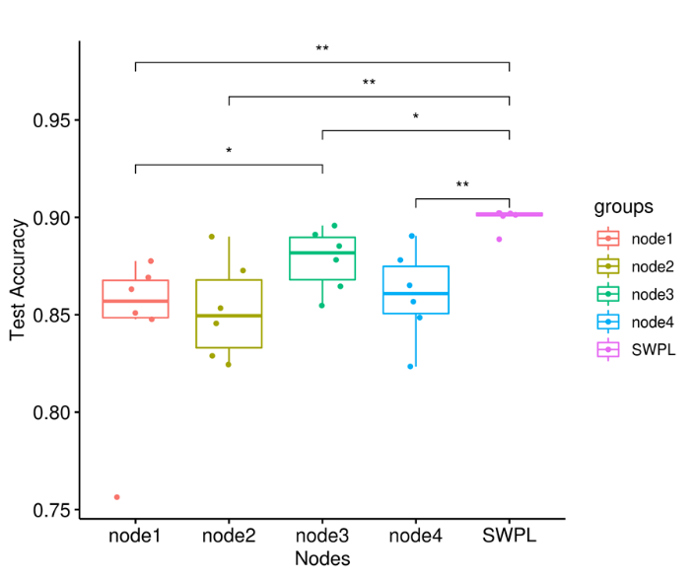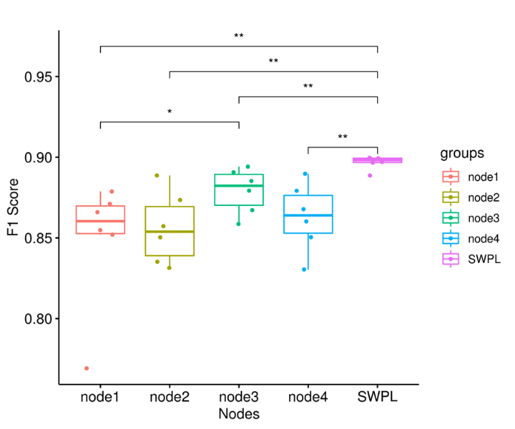
FIGURE 6 (a) Accuracy FIGURE 6 (b) F1 Score
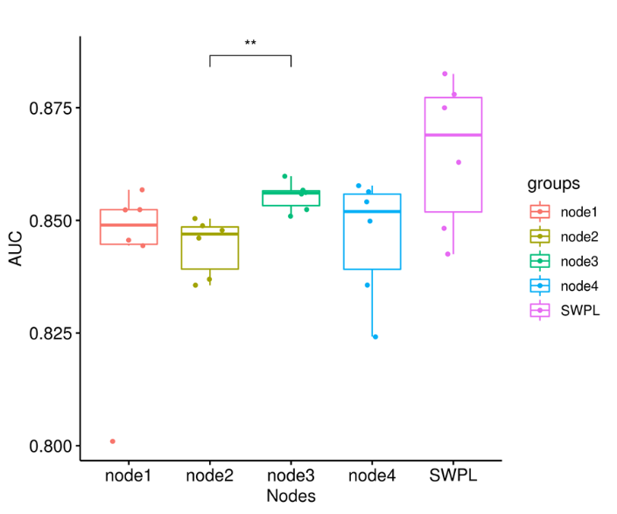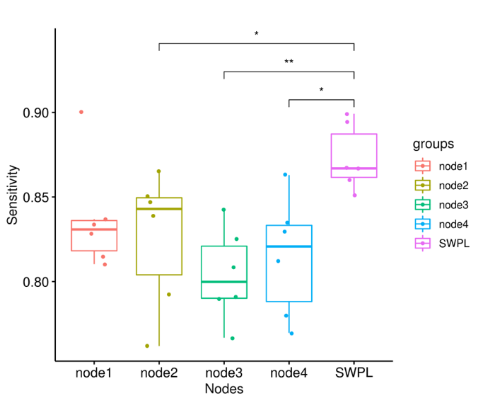
FIGURE 6 (c) AUC FIGURE 6 (d) Sensitivity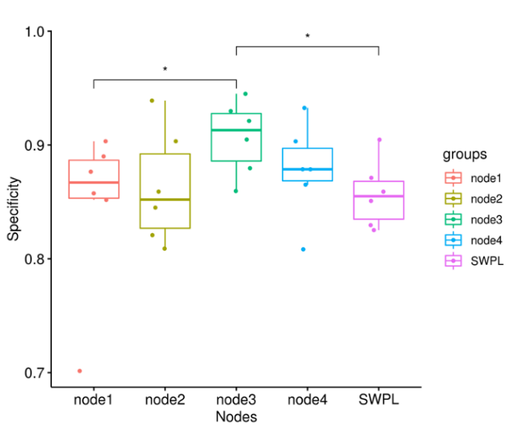 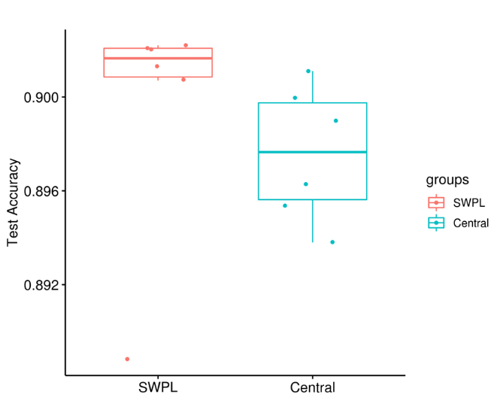
FIGURE 6 (e) Specificity FIGURE 6 (f) SWPL vs Central Model

including synchronization interval, the weighted average for parameters, blockchain rules, etc. Thus, it may sacrifice the

loss during the training process to preserve the privacy of these hyperparameters.

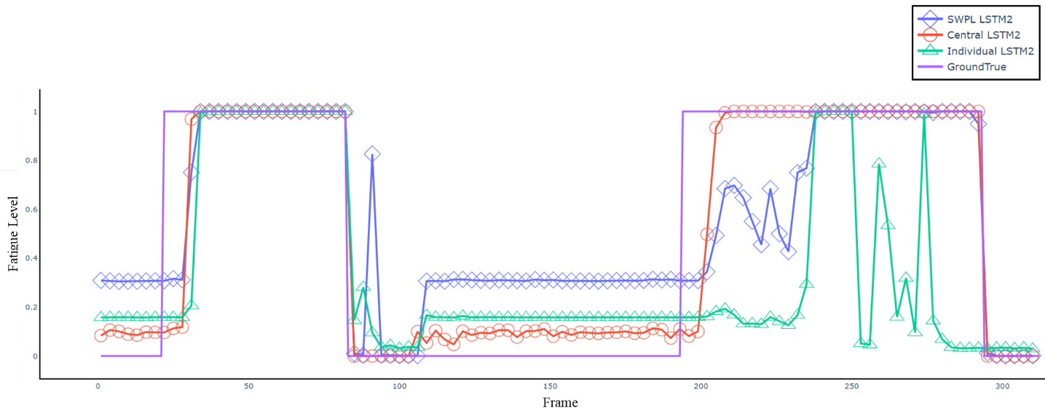
FIGURE 7. Fatigue prediction process

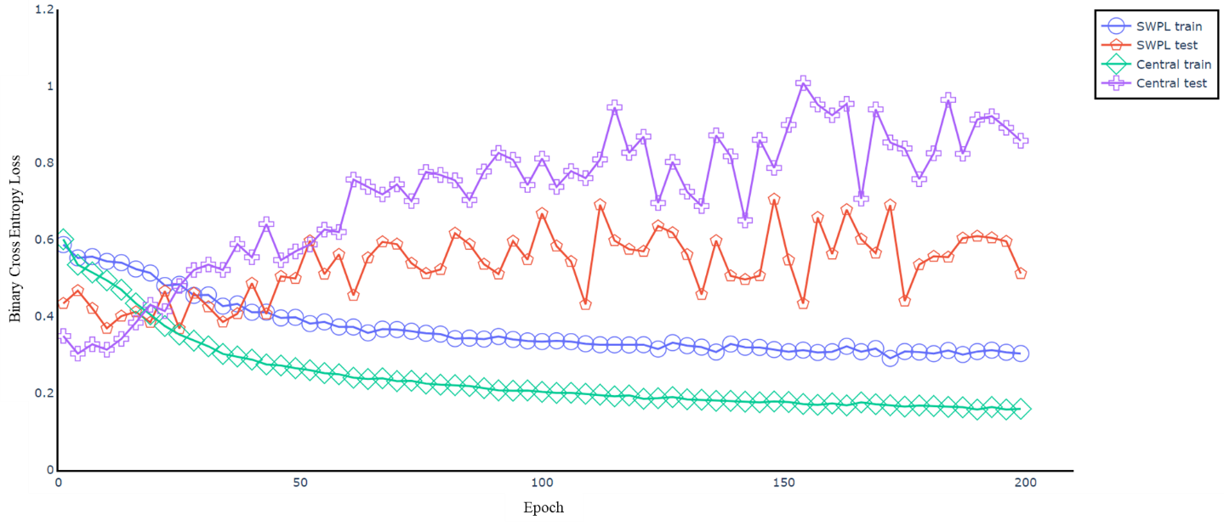
FIGURE 8. Binary Cross-Entropy Loss for SWPL and central model
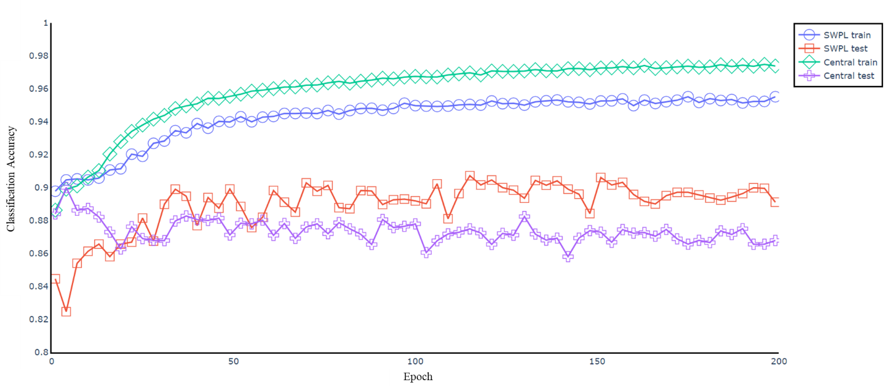
FIGURE 9. Classification accuracy for SWPL and central model

4.3.2 Privacy Analysis
The following evidence can explain the privacy-preserving performance in SWPL.
- Data parameters: this study uses the open-source Ethereum as the permissioned blockchain network. All SWPC nodes register in this network and interact with other SWPC nodes to keep the global state information of the trainable Bi-LSTM model and track progress. SWPC nodes use the information of parameter merging state and progress to control the training process of SWPL nodes. Thus, this design ensures that the datasets are maintained in each SWPL node locally, and all shared data parameters are stored in the blockchain. For the security of servers for storing the shared parameters, this study introduces the SPIRE server nodes, and the SPIRE Agent Workload Attestor plugin is used to attest the identities of SWPC nodes and SWPL nodes to ensure secure interactions between servers and the blockchain network.
- Model performance: there is an inherent trade-off between model accuracy and privacy. To improve the model accuracy, increasing tuning hyperparameters is required, such as datasets weights, class weight, learning rate, regularization, batch size, and dropout rate, which results in privacy-preserving burdens during these parameters sharing process. If the required level of privacy-preserving increases, reducing the tune of parameters is needed, thus sacrificing the model performance. However, results show that SWPL slightly outperforms the central model with the same model parameters, which indicates SWPL can achieve good performance in FMFI without compromising privacy.

5. DISCUSSION
Smart work packaging (SWP), in previous studies, provides strong evidence to be an inherently distributed system to equip each construction equipment operator (CEO) with capacities in managing (e.g., modeling, optimizing, monitoring) isolated construction occupational health and safety (COHS) data and provide insights (e.g., analytical results, predicated warnings) ready for each CEO’s safe operations. However, current centralized or federated deep learning methods used in SWP for monitoring workers’ private information (e.g., fatigue status through facial images) still need to aggregate their private data to a central server or share trained model parameters to a central server. It may expose risks to private data leakage or result in a SPoF with the central server. These risks could prevent the willingness of data provision from more distributed CEOs or construction sites worldwide to improve the efficiency in monitoring fatigue or other COHS issues in the construction.
With expanding endeavors to enhance data privacy and security in the construction industry and prevent data traffic in centralized computing and data insulation in distributed computing, a decentralized model will be ideal for processing, learning, analyzing, and predicting distributed construction data. Particularly in COHS, numerous studies have reported that deep learning has been widely applied in construction sites, such as construction equipment detection (Arabi et al., 2020), detection of wearing safety helmets (Shen et al., 2021), and struck-by accidents monitoring (Yan et al., 2021). However, the further advances are blocked by the insufficient datasets and emerging privacy regulations as the COHS data is generated from geographically dispersed construction resources and is more private when involving workers’ data. This barrier makes distributed AI system more appealing to COHS than a centralized one. SWPL is such a decentralized learning model for replacing the centralized or federated data sharing cross construction workers and preserving the private facial information of CEOs for FMFI. In summary, there are three aspects to proposed SWPL’s novelties compared with existing works.
- Firstly, SWPL is a novel computational framework that combines permissioned blockchain and distributed deep learning for FMFI, which is critical to enhancing privacy and incentivizing data sharing in COHS. Previously, Li et al. (2021) developed FedSWP using federated transfer learning to avoid data leakage and facilitate cooperation between construction workers in data provision. However, FedSWP still exists issues in a SPoF as it requires gathering the model parameters to a centralized model, which may expose model parameters to the risks. In the SWPL process, a leader node will be dynamically elected to coordinate an iteration that does not require a fixed central parameter aggregator, enhancing resilience and fault tolerance. Apart from that, the performance of SWPL is averagely better than FedSWP. For example, the average accuracy of SWPL-LSTM with two hidden layers in 95-100 epochs is 0.8956, while the average accuracy of FedSWP is 0.8638 (see Li et al. 2021).
- Secondly, SWPL provides a more accurate and private deep learning strategy to monitor and predict CEOs’ fatigue status through facial images during their high physical strength operation, as (1) the performance of SWPL presents strong evidence that SWPL outperforms the deep learning model merely on individual nodes and (2) permissioned blockchain governs all rules of interaction between nodes to ensure SWPL’s privacy-preserving mechanism. It is interesting that the SWPL performs without fine-tuning weights and applying them to SWPL nodes for different samples or datasets. The performance results indicate that access to more data is also an option to improve performance than optimizing a centralized deep learning model.
- Thirdly, SWPL shows a high capacity for personalization in performing complex deep learning tasks with more features and data parameters. The previous centralized deep learning strategy in Liu et al. (2021) showed that it trains on one operator’s image data and tests on another operator, leading to poor performance. It mainly results from the distribution differences of complex spatial-temporal features between various datasets in FMFI. In addition, FedSWP, in the authors’ previous work, bears high communication costs as each edge SWP needs to share and communicate with the central model, which may lead to data parameters traffic.
Despite the above innovations, this study has limitations.
- First, this study lacks real datasets with multimodality for CEO-FMFI. The SWPL is mainly tested on the YawDD. The crane operator’s facial data used in the authors’ previous work (Liu et al., 2021) is also tested in SWPL (See Table 7). The test accuracy and loss indicate that YawDD is comparable and valuable to the SWPL development. However, studying other bio-signals, e.g., EOG, EMG, EEG, ECG, and other biochemical changes, can contribute more to improving fatigue monitoring.
TABLE 7. Comparison of YawDD and real datatsets
SWPL | Hidden Layer | Datasets | Test-accuracy  (30 epochs) |  | Test-loss
SWPL  -LSTM | 1,  (256) | YawDD | 0.871 | 0.871 | 0.3853
SWPL  -LSTM | 1,  (256) | Crane_  Operator Data | 0.8689 | 0.8689 | 0.9077
SWPL  -LSTM | 2,  (512, 256) | YawDD | 0.8897 | 0.8897 | 0.7099
SWPL  -LSTM | 2,  (512, 256) | Crane_  Operator Data | 0.8912 | 0.8912 | 0.5089
SWPL  -GRU | 1,  (256) | YawDD | 0.9005 | 0.9005 | 0.6375
SWPL  -GRU | 1,  (256) | NewData | 0.8677 | 0.8677 | 1.1409
SWPL  -GRU | 2,  (512, 256) | YawDD | 0.894 | 0.894 | 0.5706
SWPL  -GRU | 2,  (512, 256) | Crane_  Operator Data | 0.8671 | 0.8671 | 0.9748
- Second, as limited by computer nodes for the experiment, SWPL is only trained and tested on two SWPC nodes (four SWPL nodes). As shown in Table 8, given the good quality of data in each node, SWPL can get more data to improve model performance when a new node is added. However, if the newly added node owns invalid data, it will reduce the model's performance. A further test is also conducted to see what data size the deep learning model on a single node can be equivalent to the SWPL (See Table 9). The results in this test indicate that more than twice the data size required for a single node to reach the same performance as SWPL. However, this result is dependent on the data quality because each data have different contributions to the SWPL model.
TABLE 8. Incremental gains after new node added
Nodes | Test-accuracy | Test-loss
Node1 & Node2 | 0.8634 | 0.7104
Node1 & Node2 & Node 3 | 0.8977 | 0.3787
TABLE 9. Incremental gains after new node added
Model | Node | Data size | Fatigue:  Normal | Test-accuracy | Test-loss
SWPL  -LSTM 2 | node1 | (15675,512) | 1：3.08 | 0.8616 | 0.673
SWPL  -LSTM 2 | node2 | (10864,512) | 1：2.12 | 0.8616 | 0.673
SWPL  -LSTM 2 | node3 | (14352,512) | 1：2.92 | 0.8616 | 0.673
SWPL  -LSTM 2 | node4 | (17603,512) | 1：2.16 | 0.8616 | 0.673
SWPL  -LSTM 2 | Sum. | (58494,512) | 1：2.59 | 0.8616 | 0.673
Single-LSTM 2 | Single | (28746,512) | 1：2.43 | 0.8636 | 0.6617
In the real-life SWP scenario, each CEO should have an SWP, which means hundreds of SWPL nodes will join the blockchain network. Thus, this study has not measured the scalability and efficiency of parameters merging among massive nodes.
- Third, this study assumes the permissioned blockchain that provides robust mechanisms against malicious nodes. In-depth privacy and security techniques development, such as advanced encryption algorithms (Sun et al., 2021), differential privacy algorithms (Jia et al., 2021), and security analysis, have not been investigated in this study.

6. CONCLUSION
This study presents the smart work package learning (SWPL) as a new paradigm for CEO-FMFI built on distributed deep learning and permissioned blockchain. SWPL is designed with different types of nodes, including smart work package chain (SWPC) nodes for model parameter sharing and SWPL nodes for training deep learning models locally. For the distributed deep learning model, this study customizes the MTCNN, MobileNet V3, and Bi-LSTM to form the hybrid deep neural networks for performing FMFI tasks. For the blockchain network, this study registers the SWPC nodes on SWPC using the API, where they can interact with each other using blockchain for parameter sharing and with other SWPL nodes for controlling the training process. A dynamic selection mechanism is proposed for the blockchain consensus to shift aggregators for each parameter-merge round through smart contracts. The final experiment is conducted in two SWPC nodes with four SWPL nodes, and the results demonstrate that the accuracy performance of SWPL is relatively better than the model performed merely on any individual node and even slightly outperforms the central model. Other performance metrics, e.g., F1 score, sensitivity, AUC, and privacy analysis, also indicate SWPL is robust and outperforms individual nodes. However, future studies are still needed to strengthen SWPL in the following aspects:
- In the direction of privacy and security, advanced encryption and differential privacy algorithms should be developed and embedded into SWPL to further enhance the privacy-preserving and security of permissioned blockchain networks.
- In the direction of scalability and resilience, more SWPC and SWPL nodes should be involved with a novel asynchronous learning mechanism to test its scalability. More varieties of samples for each node, such as the provision of different combinations in trades (e.g., crane, truck operator, crane operator may suffer from prolonged sitting (lead to passive physical fatigue) than truck driver), gender, glasses/non-glasses, camera positions, ethnic groups, illumination conditions, and also the health status of CEOs (e.g., sleep sufficiency, diet, and lifestyle) should be designed for testing the resilience.
- In the direction of data availability and deep learning models, multimode data (e.g., EEG, ECG, EOG, audio data) should be further considered to enlarge datasets for CEO-FMFI, and the latest advances in deep learning model (e.g., transformer) can be further applied to see better models or access to more enlarged datasets which is more sensitive for performance improvement.

ACKNOWLEDGEMENT
The authors would like to appreciate the financial support from The Hong Kong Polytechnic University Start-up Fund (No. P0039232) and the Fellowship of China Post-doctoral Science Foundation (No. 2021M692169).

REFERENCE
Ali, M., Karimipour, H., & Tariq, M. (2021). Integration of Blockchain and Federated Learning for Internet of Things: Recent Advances and Future Challenges. Computers & Security, 102355. DOI: 10.1016/j.cose.2021.102355
Arabi, S., Haghighat, A., & Sharma, A. (2020). A deep learning-based computer vision solution for construction vehicle detection. Computer-Aided Civil and Infrastructure Engineering, 35(7), 753-767. DOI: 10.1111/mice.12530
Determann, L., Ruan, Z. J., Gao, T., & Tam, J. (2021). China’s draft Personal Information Protection Law. Journal of Data Protection & Privacy, 4(3), 235-259. Retrieved from https://hkpolyuhkg.library. ingentaconnect.com/content/hsp/jdpp/2021/00000004/00000003/art00002
Dua, M., Singla, R., Raj, S., & Jangra, A. (2021). Deep CNN models-based ensemble approach to driver drowsiness detection. Neural Computing and Applications, 33(8), 3155-3168. DOI: 10.1007/s00521-020-05209-7
Kang, J., Xiong, Z., Niyato, D., Xie, S., & Zhang, J. (2019). Incentive mechanism for reliable federated learning: A joint optimization approach to combining reputation and contract theory. IEEE Internet of Things Journal, 6(6), 10700-10714. DOI: 10.1109/JIOT.2019.2940820
Kang, J., Xiong, Z., Niyato, D., Zou, Y., Zhang, Y., & Guizani, M. (2020). Reliable federated learning for mobile networks. IEEE Wireless Communications, 27(2), 72-80. DOI: 10.1109/MWC.001.1900119
Greff, K., Srivastava, R. K., Koutník, J., Steunebrink, B. R., & Schmidhuber, J. (2016). LSTM: A search space odyssey. IEEE Transactions on Neural Networks and Learning Systems, 28(10), 2222-2232. DOI: 10.1109/TNNLS.2016.2582924
Guo, J. M., & Markoni, H. (2018). Driver drowsiness detection using the hybrid convolutional neural network and long short-term memory. Multimedia Tools and Applications, 1-29. DOI: 10.1007/s11042-018-6378-6
Hassanpour, A., Moradikia, M., Adeli, H., Khayami, S. R., & Shamsinejadbabaki, P. (2019). A novel end‐to‐end deep learning scheme for classifying multi‐class motor imagery electroencephalography signals. Expert Systems, 36(6), e12494. DOI: 10.1111/exsy.12494
Howard, A., Sandler, M., Chu, G., Chen, L.C., Chen, B., Tan, M., Wang, W., Zhu, Y., Pang, R., Vasudevan, V. & Le, Q.V. (2019). Searching for mobilenetv3. In Proceedings of the IEEE/CVF International Conference on Computer Vision (pp. 1314-1324). DOI: 10.1109/ICCV.2019.00140
Huynh, X. P., Park, S. M., & Kim, Y. G. (2016, November). Detection of driver drowsiness using the 3D deep neural network and semi-supervised gradient boosting machine. In Asian Conference on Computer Vision (pp.134-145). Springer, Cham. DOI: 10.1007/978-3-319-54526-4_10
Jia, B., Zhang, X., Liu, J., Zhang, Y., Huang, K., & Liang, Y. (2021). Blockchain-enabled Federated Learning Data Protection Aggregation Scheme with Differential Privacy and Homomorphic Encryption in IIoT. IEEE Transactions on Industrial Informatics. DOI: DOI: 10.1109/TII.2021.3085960
Konečný, Jakub, H. Brendan McMahan, Felix X. Yu, Peter Richtárik, Ananda Theertha Suresh, and Dave Bacon. “Federated learning: Strategies for improving communication efficiency.” arXiv preprint arXiv:1610.05492 (2016). Retrieved from: https://arxiv.org/abs/1610.05492
Li, L., Fan, Y., Tse, M., & Lin, K. Y. (2020a). A review of applications in federated learning. Computers & Industrial Engineering, 106854. DOI: 10.1016/j.cie.2020.106854
Li, X., Shen, G. Q., Wu, P., Xue, F., Chi, H. L., & Li, C. Z. (2019a). Developing a conceptual framework of smart work packaging for constraints management in prefabrication housing production. Advanced Engineering Informatics, 42, 100938. DOI: 10.1016/j.aei.2019.100938
Li, X., Wu, C., Wu, P., Xiang, L., Shen, G. Q., Vick, S., & Li, C. Z. (2019b). Smart Work Packaging enabled constraints modeling for the on-site assembly process of prefabrication housing production. Journal of Cleaner Production, 239, 117991. DOI: 10.1016/j.jclepro.2019.117991
Li, X., Chi, H. L., Wu, P., & Shen, G. Q. (2020). Smart work packaging-enabled constraint-free path re-planning for tower crane in prefabricated products assembly process. Advanced Engineering Informatics, 43, 101008. DOI: 10.1016/j.aei.2019.101008
Li, X., Chi, H. L., Lu, W., Xue, F., Zeng, J., & Li, C. Z. (2021). Federated transfer learning-enabled smart work packaging for preserving personal image information of construction workers. Automation in Construction, 128, 103738. DOI: 10.1016/j.autcon.2021.103738
Li, X., Wu, C., Xue, F., Yang, Z., Lou, J., & Lu, W. (2022a). Ontology-based mapping approach for automatic work packaging in modular construction. Automation in Construction, 134, 104083. DOI: 10.1016/j.autcon.2021.104083
Li, X., Lu, W., Xue, F., Wu, L., Zhao, R., Lou, J., & Xu, J. (2022b). Blockchain-Enabled IoT-BIM Platform for Supply Chain Management in Modular Construction. Journal of Construction Engineering and Management, 148(2), 04021195. DOI: 10.1061/(ASCE)CO.1943-7862.0002229
Liu, P., Chi, H. L., Li, X., & Guo, J. (2021). Effects of dataset characteristics on the performance of fatigue detection for crane operators using hybrid deep neural networks. Automation in Construction, 132, 103901. DOI: 10.1016/j.autcon.2021.103901
Lu, W., Li, X., Xue, F., Zhao, R., Wu, L., & Yeh, A. G. (2021). Exploring smart construction objects as blockchain oracles in construction supply chain management. Automation in Construction, 129, 103816. DOI: 10.1016/j.autcon.2021.103816
Lu, Y., Huang, X., Zhang, K., Maharjan, S., & Zhang, Y. (2020a). Blockchain empowered asynchronous federated learning for secure data sharing in internet of vehicles. IEEE Transactions on Vehicular Technology, 69(4), 4298-4311. DOI: 10.1109/TVT.2020.2973651
Lu, Y., Huang, X., Zhang, K., Maharjan, S., & Zhang, Y. (2020b). Communication-efficient federated learning and permissioned blockchain for digital twin edge networks. IEEE Internet of Things Journal, 8(4), 2276-2288. DOI: 10.1109/JIOT.2020.3015772
Lyu, J., Yuan, Z., & Chen, D. (2018). Long-term multi-granularity deep framework for driver drowsiness detection. arXiv preprint arXiv:1801.02325. Retrieved from https://arxiv.org/abs/1801.02325
Martins, G. B., Papa, J. P., & Adeli, H. (2020). Deep learning techniques for recommender systems based on collaborative filtering. Expert Systems, 37(6), e12647. DOI: 10.1111/exsy.12647
Michielli, N., Acharya, U. R., & Molinari, F. (2019). Cascaded LSTM recurrent neural network for automated sleep stage classification using single-channel EEG signals. Computers in Biology and Medicine, 106, 71-81. DOI: 10.1016/j.compbiomed.2019.01.013
Newman, A. L. (2015). What the “right to be forgotten” means for privacy in a digital age. Science, 347(6221), 507-508. DOI: 10.1126/science.aaa4603
Qi, Y., Hossain, M. S., Nie, J., & Li, X. (2021). Privacy-preserving blockchain-based federated learning for traffic flow prediction. Future Generation Computer Systems, 117, 328-337. DOI: 10.1016/j.future.2020.12.003
Qu, Y., Gao, L., Luan, T. H., Xiang, Y., Yu, S., Li, B., & Zheng, G. (2020a). Decentralized privacy using blockchain-enabled federated learning in fog computing. IEEE Internet of Things Journal, 7(6), 5171-5183. DOI: 10.1109/JIOT.2020.2977383
Qu, Y., Pokhrel, S. R., Garg, S., Gao, L., & Xiang, Y. (2020b). A blockchained federated learning framework for cognitive computing in industry 4.0 networks. IEEE Transactions on Industrial Informatics, 17(4), 2964-2973. DOI: 10.1109/TII.2020.3007817
Rafiei, M. H., & Adeli, H. (2016). A novel machine learning model for estimation of sale prices of real estate units. Journal of Construction Engineering and Management, 142(2), 04015066. DOI: 10.1061/(ASCE)Co.1943-7862.000104.
Rafiei, M. H., Khushefati, W. H., Demirboga, R., & Adeli, H. (2017). Supervised Deep Restricted Boltzmann Machine for Estimation of Concrete. ACI Materials Journal, 114(2). DOI:10.14359/51689560
Rafiei, M. H., & Adeli, H. (2017). NEEWS: A novel earthquake early warning model using neural dynamic classification and neural dynamic optimization. Soil Dynamics and Earthquake Engineering, 100, 417-427. DOI: 10.1016/j.soildyn.2017.05.013
Rafiei, M. H., & Adeli, H. (2018). Novel machine learning model for construction cost estimation taking into account economic variables and indices. Journal of Construction Engineering and Management, 144(12), 04018106. DOI: 10.1061/(ASCE)CO.1943-7862.0001570
Sattler, F., Wiedemann, S., Müller, K. R., & Samek, W. (2019). Robust and communication-efficient federated learning from non-iid data. IEEE Transactions on Neural Networks and Learning Systems. DOI: 10.1109/TNNLS.2019.2944481
Shen, J., Xiong, X., Li, Y., He, W., Li, P., & Zheng, X. (2021). Detecting safety helmet wearing on construction sites with bounding‐box regression and deep transfer learning. Computer-Aided Civil and Infrastructure Engineering, 36(2), 180-196. DOI: 10.1111/mice.12579
Shih, T. H., & Hsu, C. T. (2016, November). MSTN: Multistage spatial-temporal network for driver drowsiness detection. In Asian Conference on Computer Vision (pp. 146-153). Springer, Cham. DOI: 10.1007/978-3-319-54526-4_11
Soto Gutierrez, M., & Adeli, H. (2017). Multi-agent replicator controller for sustainable vibration control of smart structures. Journal of Vibroengineering, 19(6), 4300-4322. DOI: 10.21595/jve.2017.18924
Sun, Jin, Ying Wu, Shangping Wang, Yixue Fu, and Xiao Chang. “A permissioned blockchain frame for secure federated learning.” IEEE Communications Letters (2021). DOI:10.1109/LCOMM.2021. 3121297
Sundelin, T., Lekander, M., Kecklund, G., Van Someren, E. J., Olsson, A., & Axelsson, J. (2013). Cues of fatigue: effects of sleep deprivation on facial appearance. Sleep, 36(9), 1355-1360. DOI:
10.5665/sleep.2964
Tam, V. W., & Fung, I. W. (2011). Tower crane safety in the construction industry: A Hong Kong study. Safety Science, 49(2), 208-215. DOI: 10.1016/j.ssci.2010.08.001
Trenta, F., Conoci, S., Rundo, F., & Battiato, S. (2019, May). Advanced motion-tracking system with multi-layers deep learning framework for innovative car-driver drowsiness monitoring. In 2019 14th IEEE International Conference on Automatic Face & Gesture Recognition (FG 2019) (pp. 1-5). IEEE. DOI: 10.1109/FG.2019.8756566
Tuttle, H. (2018). The Facebook scandal raises data privacy concerns. Risk Management, 65(5), 6-9. Retrieved from: https://www.proquest.com/docview/2101229017?pq-origsite=gscholar&fromopenview=true
Voigt, P., & Von dem Bussche, A. (2017). The EU general data protection regulation (GDPR). A Practical Guide, 1st Ed., Cham: Springer International Publishing. Retrieved from: https://link.springer.com /content/pdf/10.1007/978-3-319-57959-7.pdf
Warnat-Herresthal, S., Schultze, H., Shastry, K. L., Manamohan, S., Mukherjee, S., Garg, V., ... & Schultze, J. L. (2021). Swarm Learning for decentralized and confidential clinical machine learning. Nature, 594(7862), 265-270. DOI: 10.1038/s41586-021-03583-3
Yan, X., Zhang, H., & Li, H. (2020). Computer vision‐based recognition of the 3D relationship between construction entities for monitoring struck‐by accidents. Computer-Aided Civil and Infrastructure Engineering, 35(9), 1023-1038. DOI: 10.1111/mice.12536
Yu, J., Park, S., Lee, S., & Jeon, M. (2018). Driver drowsiness detection using condition-adaptive representation learning framework. IEEE Transactions on Intelligent Transportation Systems, 20(11), 4206-4218. DOI: 10.1109/TITS.2018.2883823
Zhang, K., Zhang, Z., Li, Z., & Qiao, Y. (2016). Joint face detection and alignment using multitask cascaded convolutional networks. IEEE Signal Processing Letters, 23(10), 1499-1503. DOI: 10.1109/LSP.2016.2603342
Zhang, W., Murphey, Y. L., Wang, T., & Xu, Q. (2015, July). Driver yawning detection based on deep convolutional neural learning and robust nose tracking. In 2015 International Joint Conference on Neural Networks (IJCNN) (pp. 1-8). IEEE.
Zhang, Y., Wang, T., & Yuen, K. V. (2022). Construction site information decentralized management using blockchain and smart contracts. Computer-Aided Civil and Infrastructure Engineering. DOI: 10.1111/mice.12804
Zhao, Y., Zhao, J., Jiang, L., Tan, R., Niyato, D., Li, Z., ... & Liu, Y. (2020). Privacy-preserving blockchain-based federated learning for IoT devices. IEEE Internet of Things Journal, 8(3), 1817-1829. DOI: 10.1109/JIOT.2020.3017377

Appendix 1 List of Abbreviations
Abbrev. | Description
API | Application Programming Interface
CEO | Construction Equipment Operators
CNN | Convolutional Neural Network
COHS | Construction Occupational Health and Safety
ECG | Electrocardiogram
EEG | Electroencephalogram
EMG | Electromyogram
EOG | Electrooculogram
FL | Federated Learning
FMFI | Fatigue Monitoring through Facial Images
GDPR | General Data Protection Regulation
GRU | Gated Recurrent Unit
ICES | Intelligent Construction Equipment Systems
LSTM | Long Short-term Memory
Bi-LSTM | Bidirectional LSTM
MTCNN | MultiTask Cascaded Convolutional Neural Network
SCO | Smart Construction Object
SPIFFE | Secure Production Identity Framework for Everyone
SPIRE | SPIFFE Runtime Environment
SPoF | Single Point of Failure
SWP | Smart Work Package
SWPC | Smart Work Package Chain
SWPCI | Smart Work Package Control Interface
SWPL | Smart Work Package Learning
URI | Uniform Resource Identifier

