Automatic work package sizing for cost-effective modular construction
Zisheng Liu¹, Xiao Li^{2*}, Chengke Wu¹, Jun Ma³, Zhile Yang ^{1,4}, Yuanjun Guo^{1,4}
¹Shenzhen Institute of Advanced Technology, Chinese Academy of Sciences, Shenzhen, China
² Department of Civil Engineering, The University of Hong Kong, Hong Kong SAR, China
³ Department of Urban Planning and Design, The University of Hong Kong, Hong Kong SAR, China
⁴ Guangdong Institute of Carbon Neutrality (Shaoguan), Shaoguan, China

*Corresponding author: Email: shell.x.li@hku.hk.

Abstract
The accurate determination of work package size is crucial for cost reduction and achieving efficient mass production in modular construction (MC) projects. However, effectively balancing sizing and cost poses a significant challenge due to the absence of a precise trade-off method. This paper describes an automatic work package sizing (AWPS) method in MC production to optimize work package sizing while minimizing costs. First, the multi-stakeholders-oriented MC production process is modeled to identify the tasks in MC production. Second, critical factors affecting the size of work packages are identified and analyzed. Then, a dynamic programming algorithm is developed to merge the tasks to work packages at a minimal cost. The AWPS method is validated in a case study, and the results show that the AWPS can effectively package production tasks while reducing costs by 1.28%-16.25% compared with traditional task-organizing methods.
Keywords: Work package, Modular construction, Cost management, Dynamic programming
- Introduction
The traditional construction industry is undergoing reform and innovation due to its over-reliance on the human experience, leading to cost overrun and decreased productivity [1]. Off-site production in modular construction (MC) projects offers a “smart” and “efficient” production strategy that meets the industry’s demands, which has attracted increasing interest from governments around the world [2]. Fig. 1 presents a real-world MC project of HKU Wong Chuk Hang student residence. MC is a modern technique where individual sections or modules are prefabricated off-site in a factory and then transported to the construction site for assembly. These modules are typically constructed using the same materials and standards as traditional buildings but are assembled more quickly and efficiently. MC can be used for various structures, including steel, concrete, wood, and hybrid [3]. The main difference between MC and traditional construction methods is twofold. First, MC produces modules in a controlled factory environment, but traditional construction relies on on-site tasks. Second, MC simplifies the process by assembling prefabricated modules on-site to form the permanent structure, but traditional construction builds a structure using a cast-in-situ manner with raw materials. Therefore, the MC has several advantages over traditional construction methods, including quality assurance in a standardized and controlled environment, reduced material waste and pollution, and the ability to improve construction efficiency and alleviate labor shortages in densely populated areas [4]. On-time delivery of prefabricated modules is the key to MC projects. To this end, module manufacturers are urged to increase manufacturing productivity by hiring professional workers and upgrading production equipment. However, these changes can result in a significant increase in the total cost for manufacturers.
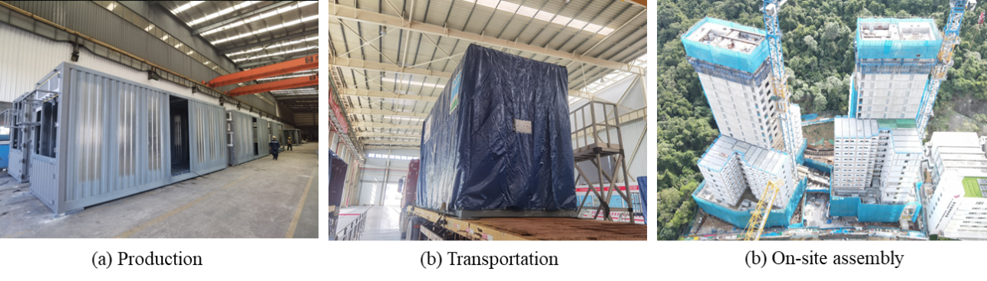
Fig. 1 MC project: HKU Wong Chuk Hang student residence
Some efforts are dedicated to reducing MC production costs by minimizing the costs of storing prefabricated products. The “just in time” management strategy has been widely adopted to decrease the costs of the prefabricated products handover process [5]. Other studies focus on reducing total costs by optimizing flow shop scheduling and the production sequence and eliminating idle time [6-8]. Although optimizing the production process can lower costs, these studies fail to consider how design decisions made during project planning can affect the cost of execution.

The work breakdown structure (WBS) is a valuable tool for project managers to plan project tasks and make delivery plans. The concept of WBS has been widely used in various fields of project management [9]. For instance, WBS is used to identify hazards and risks, develop safety plans, determine safety cost components, and calculate safety costs in prefabricated bridge engineering [10]. WBS has also been used to improve work interface management, which enhances information transparency and helps to avoid rework and delays [11]. Work packages serve as the fundamental decomposition level of WBS during the initial stages of project planning, each with a pre-defined deadline and budget. Examining the work package individually can provide a detailed understanding of work execution [12]. Li et al. [13] developed a mathematical model of work package sizing, which can change the size by re-planning work contents in a package based on minimum cost. It found that the total number of work packages and their size impact the total project costs. However, such a generalized model does not adequately consider the features of MC. For instance, the design and manufacturing of modular units require a high level of standardization and prefabrication [14]. Thus, MC manufacturers usually invest more in advanced technology and facilities. Without considering technology investment and mass production in the MC production model will lead to an imbalance in work package size and cost. In addition, MC needs to deal with quality and safety inspections by project stakeholders. Without inspection tasks may result in reworks and production delays and again affect the work package size. Thus, it is essential to incorporate inspection tasks into the model of MC manufacturing process.

As such, this study proposes an automatic work package sizing (AWPS) method to reduce MC cost, which covers the above MC features and can bridge the work package theory and MC practice. The objectives include: (1) establishing a customized work package size model based on the MC characteristic; (2) developing an automatic work packages merging method using a dynamic programming algorithm; (3) analyzing the effect of model parameter values on the results of work package sizing.

The paper is organized as follows: Section 2 introduces the production process of MC with multi-stakeholders while summarizing the advantages of optimizing work package size for MC production. Section 3 reviews studies on MC, work packaging, and dynamic programming. Section 4 identifies critical factors affecting the size of work packages. Section 5 delineates the research method, including the work package sizing model for improving cost performance, the identification process of serial tasks, and the work package merging method based on dynamic programming. Section 6 validates the proposed method in a case study, which compares the cost between the proposed and traditional methods, and analyzes the impact of changing work package size on the project costs. Section 7 discusses the proposed method’s novelty and limitations. Section 8 concludes the paper and provides recommendations for future work.
- Problem statement
This section introduces a framework for off-site modular construction production (OMCP) in factories, as shown in Fig. 2. The framework has three OMCP stages: project preparation, production, and inspection. The scope of OMCP generally contains 1) The project begins when the manufacturer’s manager signs the contract to confirm the production; 2) the designer, the contractor, and the manufacturer agree on the production plan and design drawings as input; 3) The process flow is module production and component assembly; 4) The production ends when the client confirms the delivery order; 5) A qualified modular housing unit is regarded as the output.
Fig. 2. Production process of modular construction with multi-stakeholders (Adapted from Li et al. [15](a) Production preparation; (b) Modular room and bathroom production and inspection.
In the production preparation stage, contractors and designers collaboratively create an initial product design and production plan, considering project requirements and constraints. Once the owner approves the plan and places an order, the manufacturer’s production department creates detailed shop drawings [16,17]. The contractor and owner review these drawings, after which the production department formulates a production master plan and execution plan. The procurement department uses the execution plan to compile a list of required materials, including 2D panels, rebar, and other items sent to suppliers. Upon arrival, the inspection department inspects the materials, and qualified materials are delivered to the factory. Finally, the production department can start to produce MC units.

The production process for a standard modular room is divided into several sub-processes, including the structure, door/window, wall, print, electrical & mechanic service, and test & commission. If the room being produced is a bathroom with a toilet, the wet trade procedure must be completed before the print procedure. To meet clients’ needs, managers can create work packages based on the production sub-processes outlined above as the deliverables [18]. These production sub-processes can be further broken down into more detailed work contents. For example, the structure production process may contain 2D panel assembly, 3D assembly, rebar fixing, pouring concrete, etc. The manufacturer assigns professional teams and technicians to oversee quality control and quality assurance at each stage of the production process.

Additionally, client supervisors implement hold points at significant production steps to ensure quality [19,20]. The hold point test normally contains a dimension check, visual inspection, and water test for the chassis enclosure, and clients must keep records of the results. Fine granularity task planning is essential for product quality control. However, packaging each task independently and delivering it as a staged production result can lead to high costs due to frequent inspection and work progress reporting. Tasks can be packaged based on the deliverables, such as structure, door, and wall, to minimize this cost. However, this kind of packaging method results in irregular work package sizes, which leads to extra costs in estimating schedules and increases the risk of overlooking critical hold points.

Optimizing work package size has several advantages in reducing the cost of OMCP. Firstly, project managers often need to pay more attention to the impact of work package size on total costs. Optimizing work package size helps managers specify work contents to balance the trade-off between larger/fewer work packages and smaller/more work packages. Secondly, the optimization process considers the client’s or supervisors’ hold point as a single work package, which avoids the cost of re-inspection and repeated information collection when the hold point is contained in the work package.
- Literature review

3.1. Modular construction
The modular construction mode offers several advantages over conventional on-site construction, including enhanced efficiency, improved worker safety, and reduced total cost. However, MC projects also face challenges due to their fragmented, discontinuous, and poorly interoperable nature, leading to difficulties in project planning and the increased cost of additional design and consulting services [21]. For instance, suppliers, manufacturers, and clients are typically in different regions. Time and space differences result in asymmetry information exchange. In the production process, frequent progress reviews incur an additional cost, and fewer progress reviews lead to progress disorder. To mitigate these issues, managers often assign responsible personnel for each step in the production process to ensure information synchronization between a construction site and a factory, but this strategy increases the management cost.

Some researchers [22,23] studied the cost risk evolution in MC projects to find ways of reducing total costs. Nasirian et al. [24] found that managers often make design decisions in project planning based on personnel experience and actual production conditions, which leads to total cost overrun and progress delay. To address these issues, Zhong et al. [25] have developed an information management platform that combines the Internet of Things (IoT) with Building Information Modeling (BIM) technology. This platform enhances production process visibility and traceability, streamlining logistics and on-site assembly services to achieve just-in-time coordination. Moreover, optimizing the production process is necessary to reduce costs and to ensure schedule. Some researchers [26-28] have developed intelligent algorithms to optimize production scheduling. These methods found the optimal cost solution within a specified time frame, which reduces the cost by compressing waiting time. However, the uneven distribution of management and production resources remains a major contributing factor to increased costs, especially in planning execution costs. This disparity can lead to inefficiencies and delays, increasing the project's cost. Therefore, addressing the issue of resource distribution is crucial to optimizing costs and improving overall performance in MC.

3.2. Work packaging
The concept of Work Breakdown Structure (WBS) originated from the Program Evaluation and Review Technique (PERT), a method for monitoring and controlling project development progress [29]. WBS decomposes tasks into smaller, more detailed parts based on the project’s content [30]. Recognized as a powerful project-organizing tool, WBS has been widely adopted, even in the construction industry [31,32]. The work package is defined as the lowest level of WBS, providing a logical basis for defining activities or assigning responsibilities to specific people or organizations [33]. Li et al. [34,35] developed an information integration method for Smart Work Packages (SWP), which combined basic work packages with advanced technology for adaptivity, sociability, and autonomy. These studies have demonstrated that work packages contain crucial information in the decision-making process and can independently complete the contents in each package. However, the expansion of the work package concept in construction management has ignored the impact of its size on project cost. Bredael et al. [36] studied a project scheduling problem that involves balancing time and cost, where each work package has a specified due date and budget. The size of the work package reflects the length of the due date, and the results indicate that the due date of a work package affects the overall cost. However, they ignored the influence of other factors besides the due time on the size of the work package. Some researchers [37] have outlined various factors influencing work package size. Li [13] developed a method for merging tasks to adjust the size of work packages and evaluated its impact on project costs. However, an efficient packing approach enables more effective design decisions among MC project stakeholders for cost-saving still needs to be improved.

3.3. Dynamic programming algorithm
The above studies demonstrate that the work package size can impact the project’s total cost. In the MC project, a work package can contain one or multiple tasks in the production network, and executing a work package means executing the tasks within it [38]. However, with the increasing number and content of tasks, organizing several tasks into work packages with the optimal sizing by personnel experiences is challenging. In order to improve the performance of a project, it is necessary to find an efficient algorithm that organizes tasks into work packages of optimal size. The greedy algorithm (GA) is an algorithmic strategy that makes locally optimal choices at each step. GA does not backtrack, making them faster than other algorithms for specific problems. Despite its advantages, genetic algorithms (GAs) are limited in their ability to continuously find the globally optimal solution. In some cases, GAs can become trapped in local minima or maxima, which may result in suboptimal solutions. Dynamic programming [39,40] uses a table or matrix to store the solutions of subproblems and uses those solutions to solve larger problems. Dynamic programming has several advantages when used to find the optimal solution in a graph or network: 1) Dynamic programming can efficiently compute the shortest path between two points in a graph or network by breaking down the problem into smaller subproblems and solving each subproblem only once. This method avoids redundant computations and reduces the overall time complexity of the algorithm. 2) Dynamic programming is a memory-efficient algorithm that requires only a tiny amount of additional memory to store intermediate solutions to subproblems. This feature makes it ideal for efficiently finding the shortest path in large graphs or networks, unlike other methods that may require excessive memory usage. 3) Dynamic programming is a highly efficient approach that meets the requirements of rapid computation, global optimum solutions, and comprehensible formulas. Therefore, this study uses a dynamic programming algorithm that organizes active tasks into work packages with the objective of minimal total cost.

3.4. Research gaps
In summary, the above literature review focuses on optimal production scheduling and the definition of a generalized model of work package sizing. However, some limitations have been identified in previous studies: a lack of a universal and effective work package sizing model for MC production considering resource distribution, mass production equipment, advanced technology, and the granularity of inspection tasks. Additionally, most researchers focus on schedule sequences of machines, workers, and products by heuristic algorithms to reduce total costs. However, they ignored the impact of a design decision on execution cost. In this study, we develop a work package size optimization model considering the critical features in the MC production process to organize a project’s tasks into work packages more accurately.
- Critical factors affecting work package size in MC
For forming work packages, most established guidelines are based on experiences from project management practices. Some project managers favor the design of smaller work packages, aiming to delegate tasks as specifically as possible to individual workers or teams. Conversely, other managers advocate for larger work packages, aiming to streamline management structures and ensure better control over the content of each work package. However, there appears to be a lack of research specifically addressing the customization of work package sizes for individual projects. Raz and Globerson [37] highlight several essential factors and associated costs that project managers should consider when determining the sizes of their work packages. Based on their discourse and the fundamental principles of risk pooling, Li [13] discussed how to model the nine factors (See Table 1) that affect work package sizing decisions. However, the above factors cannot adequately reflect the features of MC production. In the following contents, critical factors (See Table 2) affecting the MC project's work package sizing are identified and discussed by the related academic literature and project management practice.
Table 1 Factors affecting work package size in the previous study [13]
Factors | Signal | The definition of WPs size
Workload | ω | large
Cost and schedule estimation | f (·) | large
Monitoring and control | g (·) | small
Economies of scale | h (·) | large
Cash flow | $$ξx_{w}\left(1-e^{-αc_{w}}\right)$$ | small
Responsibility Assignment | R1 | Inactive package
Internal cohesion | R2 | Inactive package
Risk management | R3 | Inactive package
Table 2 Factors affecting work package size in this study
Factors | Signal | The definition of WPs size
Organization unit | ω | large
Cost and schedule estimation | f (·) | large
Production supervision | g (·) | small
Production scale | h (·) | large
Advanced Information technology | y (·) | small
Cash flow | $$ξx_{w}\left(1-e^{-αc_{w}}\right)$$ | small
Hold point | R | Inactive package

(1) Organization unit:
An organization unit represents a department or a group of staff who execute tasks in a work package. Breaking a project into more but smaller work packages increases the number of organization units, which causes the increased cost of managing work packages.
(2) Cost and schedule estimation:
In the planning stage, managers need to estimate the costs and schedules of MC production tasks. Inherent uncertainties in the production process can cause random errors in the estimations. When these estimation inaccuracies are either independent or weakly correlated, increasing the work package size can reduce the adverse impact of errors on estimation accuracy.
(3) Production supervision:
One of the MC’s features is shifting tasks from construction sites into factories, improving production quality. On the other hand, supervising partially completed work packages is more challenging than overseeing the completion of fully completed work packages [41]. The efficiency of supervision could be improved by dividing the work packages into smaller sizes.
(4) Production scale:
MC is an efficient industrialized production mode in the factory, which invests in the fixed production infrastructure and has the potential for mass production (high turnover rate in using molds). As the production scale increases, a work package can generate more output using the same fixed resources.
(5) Advanced information technology:
To effectively finish an MC project, the project manager must tackle the issues of information fragmentation and complex collaborations. These problems can result in delayed and ineffective delivery of work packages. Introducing advanced information technology in the MC production process can improve the manager’s information collection and communication. As Li et al. [42] stated, “Information technologies can transform prefabricated products into smart objects (SOs) with the ability for awareness, autonomy, and communicativeness. The smart work packaging (SWP) with adaptivity, sociability, and autonomy seems to be a viable solution to manage the massive constraints that exist by processing information from SOs.” For smaller work packages, the improvement capabilities of advanced information technology are more precise and significant.
(6) Cash flow:
When a group of tasks forms a work package, managers have to consider the financial position of cash flow, which can be defined as payment planning in the order completion process [43,44]. Generally, construction projects have huge carrying costs and extended holding times, inevitably making construction projects suffer more risks of market changes. Therefore, making smaller and more work packages helps release costs more quickly and reduces the market risk [45,46].
(7) Inactive tasks:
In an MC project, setting hold points can promote the construction progress and ensure quality. The hold point is a mandatory verification point beyond which the project cannot proceed without approval from the professional supervisor. The hold point meets three requirements of independent tasks, 1) independent distribution of personnel, 2) high risk, and 3) low relevance to the main content [13]. First, the hold points require stakeholders to send professionals to inspect products. These inspectors are employed by customers or regulatory authorities, which are different from manufacture’s inspectors. Next, the project reports issued by inspectors need the permission and approval of various departments and participants, a typical high-risk activity. The risk sources vary according to the type of license or approval [37]. Finally, stakeholders need different equipment and personnel in the testing process, which have little correlation with the main steps in the manufacturing process.
- Research method
This section introduces the AWPS method to reduce MC production costs by optimizing work package sizes. The method is demonstrated in Fig. 3 and consists of three steps: 1) To establish a work package sizing model considering cost performance. 2) To identify the serials tasks in task networks considering the MC production task dependencies. 3) To develop the dynamic programming approach for merging tasks into work packages with minimum cost.
Fig. 3. Overall design of the AWPS approach

5.1. Work package sizing model with cost performance in MC
This section introduces a work package sizing model considering the cost performance of the MC project. The input data for the model consists of a set of primary tasks $N = \left\{ 1, 2, ..., n \right\}$ and their respective precedence constraints. Each task $a∈N$ has a predefined duration $ta$≥ 0 and work content $xa$≥ 0. We define a work package $W = \{a_{1}, a_{2}, . . .,a_{k} \}$, formed by organizing a set of tasks $a_{1}, a_{2}, . . .,a_{k} ∈N$. The work content of a work package is $x_{w}=\sum_{a∈w}{xa}$, including the work contents of all tasks in the package. The duration of a work package is denoted by $t_{W} =\sum_{a∈W}{ta}$, which equals the difference between the finish time of the last task and the start time of the first task in the work package. We let $C_{W}$ denote the completion time of the work package, which equals the sum of the completion time of the last work package and the duration time of the current work package. Then, each of the work package sizing factors identified in Section 4 (see Table 2) is formulated below:
(1) Organization unit:
Each work package has a fixed cost $ω$, which represents the cost of administering and maintaining a work package, and is independent of the work package's content. This factor encourages managers to make larger and fewer work packages.
(2) Cost and schedule estimation:
The MC production procedures are intricately interlinked. Each succeeding step relies on the completion of products in the preceding step. Thus, any errors in estimating the time or cost of a task can impact the project’s overall schedule and cost. Therefore, managers must hedge inaccurate estimates by allocating additional resources and budgets in advance. The costs of additional resources and budgets depend on the content of the work package. In AWPS, the cost and schedule estimation is modeled as a function $f (·)$, which is concave and non-decreasing, and it encourages larger and fewer work packages.
(3) Production supervision:
The cost of production supervision, modeled as a function $g (·)$, is related to the content of the work package. This function is convex and non-decreasing because this factor encourages having more but smaller work packages.
(4) Production scale:
The production scale is modeled as a function $h (·)$, which encourages managers to make larger and fewer work packages. The $h (·)$ is a concave non-decreasing function.
(5) Advanced information technology:
The cost of advanced information technology for MC projects can be modeled as a function $y (·)$. This function is concave and non-decreasing, as it encourages having smaller and more work packages.
(6) Cash flow:
The work package’s duration significantly impacts the project’s cash flow, which is a function related to the work package’s completion time and work content. The total discounted cash flow cost of the work package is $ξx_{w}\left(1-e^{-αc_{w}}\right)$, where $ξ$ denotes the cost per unit of work content, $x_{w}$ denotes the work package content, $α$ denotes the discounted rate, $c_{w}$ denotes the completion time of a work package.
(7) Inactive tasks:
Two types of tasks are inactive. The first type of task is the marking task at the start and end of the project, which is described as a dummy task with no work content. Another type refers to hold-point tasks. A hold point task forms a work package independently and cannot be merged. A group of tasks $R= \{a_{1}, a_{2}, . . ., a_{k}\} (k∈n)$ denotes inactive tasks.
We assume that $f(0)$ = $g(0)$ = $h(0)$ = $y(0)$ = 0 and that the functions $f(·)$, $g(·)$, $h\left(·\right)$, and $y(·)$ can be evaluated in constant time. Let
$F\left(x\right)=f\left(x\right)+g\left(x\right)+h\left(x\right)+y(x)$ (1)
For $x≥0, F\left(x\right)$ is a non-decreasing function. The cost associated with a work package $W$ is
$ω+F\left(x_{W}\right)+ ξx_{w}\left(1-e^{-αc_{w}}\right)$ (2)
Let $R_{1}, R_{2}, …,{ R}_{m}$ denote all the subsets of tasks that are required to form their own work packages as a result of hold point, where $R_{k} \bigcap{R_{l}}= ∅$for any $1≤k<l≤m$. The two dummy tasks in the problem are considered inactive tasks, and each of them must independently form a work package.
In this model, $p$ is defined as a decision variable representing the number of work packages for the active task in the project. The number of non-dummy tasks is $p+ m-2$. The model aims to divide active tasks into work packages $W_{1}, W_{2},…,W_{p}$ to minimize the total cost.
$TC=ω\left(p-m-2\right)+\sum_{k=1}^{p}{F\left(x_{W_{k}}\right)}+\sum_{k=1}^{m}{F\left(x_{R_{k}}\right)}+ξ\sum_{k=1}^{p}{x_{W_{k}}}\left(1-e^{-αC_{W_{k}}}\right)+ ξ\sum_{k=1}^{m}{x_{R_{k}}}\left(1-e^{-αC_{R_{k}}}\right)$ (3)
Subject to the constraints that the precedence network of the work packages $W_{1}, W_{2}, …, W_{P}, R_{1}, R_{2},…, R_{m}$ is acyclic, and a given deadline $d$ must complete the project.

5.2. Identification of serial tasks
Task dependencies can be classified into serial, parallel, and coupled relations [13,47]. Fig. 4 clearly shows different relations of nodes between serial and non-serial tasks. Only Task 1 and Task 2 in Fig. 4 (a) are serial.
(a) (b) (c) (d)
Fig. 4. Task dependencies
The MC production task involves a strong precedence relationship, similar to job shop scheduling [48] and the assembly of mechanical products [49]. This shared feature highlights the importance of effectively managing task dependencies to optimize production efficiency. Recognizing an active serial network is the first step in organizing tasks into work packages. It is crucial to define the active serial network accurately, as it determines the boundary of active tasks belonging to the serial network. Let $\overline{R}$ = $N \backslash (R_{1}∪R_{2}∪… ∪R_{m})$and $\overline{n}$ = $\left|\overline{R}\right| >0$. We refer to the tasks in $(R_{1}∪R_{2}∪… ∪R_{m})$ as inactive tasks and the tasks in $\overline{R}$ as active tasks. A group of tasks is described as serial tasks if (i) $a_{1}, a_{2}, . . ., a_{k}∈\overline{R}$; (ii) $a_{i}$ is the only immediate predecessor of $a_{i+1}$, and $a_{i+1}$is the only immediate successor of $a_{i}$, for $i∈1, 2, . . ., k-1$, as shown in Fig. 5. An active serial network is a collection of active serial tasks. The search is halted if a non-serial or inactive task is encountered during a search.
Fig. 5. Multi-serial paths in a network
The method for searching serial tasks is shown in algorithm 1. The $scanned (·)$ is denoted as an integer, and $scanned (i)$=1 represents task $i$ has been scanned, and task $i$ is considered as a leading task of any group of serial tasks. Searching serial tasks always starts with a task $i$ that has not been scanned. The task $i∈\{2, 3, ..., n-1\}$, where n represents the total number of tasks in the network since the starting and ending tasks in the network are merely dummy tasks. When the $scanned (i)$=0, the $SerialTask (·)$ records the task $i$ as a serial task. The program evaluates the relationship between the task pointed to by the pointer and the task immediately following it. If the relationship meets the requirements, as shown in algorithm 1, the pointer is updated to point to the subsequent task. The number of serial tasks, tasks recorded by the serial task, and the scanned result of task $i+1$ are all updated. This looping process continues until a non-serial or inactive task is encountered. The entire process is then repeated until all tasks have been scanned.
Algorithm 1 The process of searching serial tasks
Input: Task relationships network
Output: Subsets of serial tasks
for i=2,3···n-1 do
if scanned(i)=0 Then
// Look for an unscanned elemental task.
pointer←i;
// The pointer points to i th element.
Number of serial tasks←1;
SerialTask(Number of serial tasks)←pointer;
// Mapping task numbers in the serial task with task numbers in all tasks.
scanned(pointer)←1;
while the number of successor tasks of the pointed task is 1,
the number of predecessors of the pointed task’s successor task is 1,
and the successor tasks of the pointed task are active tasks do
pointer←Successor(pointer, 1);
// Advance pointer to the successor of the currently pointed elemental task.
Number of serial tasks←Number of serial tasks+1 ;
SerialTask(Number of serial tasks) ← pointer;
scanned(pointer)←1;
loop
if the number of serial tasks>1, Then
Call Algorithm 2
end
end
return subsets of serial tasks

5.3. Organizing tasks into work packages based on dynamic programming
A set of serial tasks can be generated from the above computational processes. The decision to organize serial tasks with minimum cost into work packages will be made using a dynamic programming algorithm. This algorithm is used to solve the shortest-path problem for acyclic networks. The Equation (4)-(5) shows detailed preprocessing steps, where $t_{a_{j}}$ denotes the duration of the task $a_{j}$, $x_{a_{l}}$ denotes the work content of the task $a_{l}$, and $C_{a_{j}}$ denotes the completion time of the task $a_{j}$, which is the accumulation of the duration of all tasks before $a_{j}$. $c\left(i,j\right)$ is the total cost of tasks {$a_{i+1}$, $a_{i+2}$, …, $a_{j}$} when they are grouped into a work package.
Preprocessing:
$C_{a_{j}}= \sum_{1}^{j}{t_{a_{j}}}$ (4)
$c\left(i, j\right)= ω+F\left( \sum_{l=i+1}^{j}{x_{a_{l}}}\right)+ξ\sum_{l=i+1}^{j}{x_{a_{l}}}\left(1-e^{-αC_{a_{j}}}\right)$ (5)
Unlike the information regarding the content and duration of individual tasks, which is stored in nodes, the information about total cost is attached in the arc, as shown in Fig.6. This is because the cost calculation considers both the content of individual tasks and task completion time, which is influenced by preceding tasks.
Fig. 6. Preprocessing and searching process for minimal costs
Equation (6-8) shows the application of a dynamic programming algorithm to find the shortest path in a directed acyclic graph, where $S\left(j\right)$ is the value of the minimal cost from the task${ a}_{i }$to $a_{j}$.
Recurrence relation:
$S(j)=\min_{i<j}{[S(i)+c(i, j)]} \left(j=1, 2, 3, …, k\right) \left(c\left(i, j\right)=∞ , if \left(i,j\right)∉A\right)$ (6)
Boundary condition:
$S(0)=0$ (7)
Optimal solution value:
$S\left(j\right)$ (8)
Algorithm 2 shows the critical steps for calculating the minimum cost of serial tasks by dynamic programming and the policy of organizing serial tasks into work packages. The $policy (·)$ represents the optimal strategy function, determining the optimal number of tasks to be organized in the work package. Once the optimal policy is determined, the information regarding the work package is updated. The change of elements in the work package is recorded in five aspects, the number of work packages, $SerialWPLead \left(·\right),$ $SerialWPCardinality (·)$, $SerialWPContent (·)$, and $SerialWPDuration (·)$. After organizing the serial tasks into work packages, the task network consists of work packages generated by serial tasks and inactive tasks that form independent work packages. Finally, the total cost of the optimized task network is calculated using Equation (3).
Algorithm 2 Cost calculation and work packages merging
Input: Number of serial tasks, SerialTask (·).
Output: Number of work packages, The updated serial work packages lead (·), cardinality (·), content (·), and duration (·).
Initial: S (0) ← 0, BestValueFound ← infinity.
for ii=1, 2, ···, Number of serial tasks do
for jj=ii, ii+1, ···, Number of serial tasks do
WorkContent (ii, jj) ← 0;
Duration (ii, jj) ← 0;
for ll=ii, ii+1, ···, jj do
WorkContent (ii, jj) ← WorkContent (ii, jj) + x (SerialTask (ll));
Duration (ii, jj) ← Duration (ii, jj) + t (SerialTask (ll));
Calculate the c (ii, jj) by Equation (1);
// c (ii, jj), which is equal to c (i, j) in Equation (3);
for jj=1, 2, ···, Number of serial tasks do
for ii=1, 2, ···, jj do
temp ← c (ii, jj) + S (ii-1);
if temp < BestValueFound then
BestValueFound ← temp;
Policy(jj) ← ii;
end if
S (jj) ← BestValueFound
jj ← NumSerialTasks
while jj > 0 do
update NumWPs, SerialWPLead (·), SerialWPCardinality (·), SerialWPContent (·), SerialWPDuration (·);
for ii = Policy(jj), ···, jj do
update SerialWPLead (·);
jj ← Policy(jj) - 1
wend
- Experiments
The proposed AWPS method is validated in an actual MC case project. The key project data that serve as inputs of the model in Fig. 2 are listed in Table 3.
Table 3 Production data in the MC project
Item | work | Description | Working Day |  | Client’s REP
 |  | Steel material in the factory | Day
1 | structure | Board, profile pretreatment, and punching | Day | 1
1 | structure | Board, profile pretreatment, and punching | Day | 2
1 | structure | Board, profile pretreatment, and punching | Day | 3
2 | structure | 2D Panel Assembly (Butt weld and Fillet Weld included) | Day | 4
2 | structure | 2D Panel Assembly (Butt weld and Fillet Weld included) | Day | 5
2 | structure | 2D Panel Assembly (Butt weld and Fillet Weld included) | Day | 6
3 | structure | 2D Panel Weld Test | Day | 7
4 | structure | 2D Panel Hot Dip Galvanizing Treatment | Day | 8
4 | structure | 2D Panel Hot Dip Galvanizing Treatment | Day | 9
5 | structure | 3D assembly, including (welding work for bondek, Shear Stud, bracket wall & ceiling sheet) | Day | 10
5 | structure |  | Day | 11
5 | structure |  | Day | 12
5 | structure |  | Day | 13 | HP
6 | structure | 6 Touch-up galvanized paint | Day | 14
7 | structure | Apply fire paint to the structural member | Day | 14
7 | structure | Apply fire paint to the structural member | Day | 15
7 | structure | Apply fire paint to the structural member | Day | 16
7 | structure | Apply fire paint to the structural member | Day | 17
7 | structure | Apply fire paint to the structural member | Day | 18
7 | structure | Apply fire paint to the structural member | Day | 19
7 | structure | Apply fire paint to the structural member | Day | 20
8 | structure | Rebar Fixing and Pouring Concrete | Day | 21
9 | structure | Concrete Curing | Day | 22
9 | structure | Concrete Curing | Day | 23
10 | Door/window | Door and window frame installation | Day | 24
11 | Door/window | Water Spray Test | Day | 24 | HP
12 | Wall | Ceiling stud, rockwool in-fill, and fire board installation at ceiling surface | Day | 25 | HP
12 | Wall |  | Day | 26 | HP
13 | Wall | Fireboard, Wall stud installation | Day | 27 | HP
13 | Wall | Fireboard, Wall stud installation | Day | 28 | HP
14 | Wall | Rockwool in-fill and the second layer of fire board installation at the wall surface | Day | 29 | HP
15 | Wall | Installation of MEP conduit inside hostel room at wall surface (at hostel room). | Day | 30 | HP
15 | Wall |  | Day | 31 | HP
16 | Wall | Installation of gypsum board at the wall surface | Day | 32 | HP
17 | Print | Gypsum Plaster and Sanding (wall and ceiling) | Day | 33
17 | Print | Gypsum Plaster and Sanding (wall and ceiling) | Day | 34
18 | Print | First layer painting (hostel room and corridor) | Day | 35
19 | Print | Second layer painting | Day | 36
20 | Print | Top coat paint (ceiling) | Day | 37
21 | E&M | Installation of MEP trunk at the ceiling (in the common area) | Day | 38
22 | E&M | installation of sprinkler pipes (in the hostel room) | Day | 39
23 | E&M | Apply paint for MEP Services | Day | 40
24 | E&M | Electrical Cable Wiring | Day | 41
25 | E&M | Window Type AC Installation | Day | 42
26 | E&M | Installation of lighting / MEP final fix | Day | 42
27 | T&C | Cladding panel installation/ Top coat wall paint | Day | 43
27 | T&C | Cladding panel installation/ Top coat wall paint | Day | 43
28 | T&C | Installation of Vinyl floor and skirting (Hostel room and corridor) | Day | 44
29 | T&C | Cabinets/ Wardrobe installation | Day | 45
30 | T&C | Door ironmongery and windows installation, water test on window | Day | 46
31 | T&C | General Cleaning and Floor Protection | Day | 47
32 | T&C | Packing & Protection of Furniture | Day | 48
33 | T&C | MEP Final Check (AC, FS, Electrical) | Day | 49
33 | T&C | MEP Final Check (AC, FS, Electrical) | Day | 50
34 | T&C | 3D dimension check, Paint touch-up, and Final QC Inspection | Day | 51 | HP
35 | T&C | Labeling of MC module, packaging, and protection of MC module | Day | 51 | HP
 |  | Ready to transport from factory to HK | Day | 52

6.1. Validity of AWPS
The first experiment compared AWPS with the traditional work packing method, where each task is packaged independently, as depicted in Fig.7. Based on the case project, $N = \{a_{1}, a_{2}, . . .,a_{39} \}$, task R₁ = {1}, R₂ = {7}, R₃ = {13}, R₄ = {14}, R₅ = {15}, R₆ = {16}, R₇ = {18}, R₈ = {19}, R₉ = {37}, R₁₀ = {38}, R₁₁ = {39}, where R₁ and R₁₁ are dummy tasks. In our case, (x_{a1}, x_{a2}, …, x_{a39}) = (t_{a1}, t_{a2}, ..., t_{a39}) = (0, 24, 24, 8, 16, 24, 8, 4, 52, 8, 16, 4, 4, 16, 16, 8, 8, 8, 8, 16, 8, 8, 8, 8, 8, 8, 8, 4, 4, 8, 8, 8, 8, 8, 8, 16, 4, 4, 0), (C_{w1}, C_{w2}, …., C_{R11}) = (24, 48, …,408). We define the value of the initial parameter based on the experiment [13]. $f\left(x\right)=h\left(x\right)=3x^{0.8}$, $g\left(x\right)=y\left(x\right)=x^{1.2}$, $ω=$ 50, $ξ=$50, $α=$0.00025. We set $d$ to be $1.1×Δ$, with $d$ representing the project delivery time in units of hours and $Δ$ representing the project makespan.
Fig. 7. Traditional work packaging method
Next, the manager packages tasks based on the type of production task, forming seven work packages of active tasks, as depicted in Fig. 8. W₁= {2, 3, 4, 5, 6}, W₂= {8, 9, 10, 11}, W₃= {12}, W₄= {17}, W₅= {20, 21, 22, 23}, W₆= {24, 25, 26, 27, 28, 29}, W₇= {30, 31, 32, 33, 34, 35, 36}. (x_{w1}, x_{w2}, x_{w3}, x_{w4}, x_{w5}, x_{w6}, x_{w7}, x_{R1}, x_{R2}, x_{R3}, x_{R4}, x_{R5}, x_{R6}, x_{R7}, x_{R8}, x_{R9}, x_{R10}, x_{R11}) = (t_{w1}, t_{w2}, t_{w3}, t_{w4}, t_{w5}, t_{w6}, t_{w7}, t_{R1}, t_{R2}, t_{R3}, t_{R4}, t_{R5}, t_{R6}, t_{R7}, t_{R8}, t_{R9}, t_{R10}, t_{R11}) = (96, 80, 4, 8, 40, 40, 64, 0, 8, 4, 16, 16, 8, 8, 8, 4, 4, 0), and (C_{w1}, C_{w2}, C_{w3}, C_{w4}, C_{w5}, C_{w6}, C_{w7}, C_{R2}, C_{R3}, C_{R4}, C_{R5}, C_{R6}, C_{R7}, C_{R8}, C_{R9}, C_{R10}) = (96, 184, 188, 240, 296, 336, 400, 104, 192, 208, 224, 232, 248, 256, 404, 408).
Fig. 8. Forming work packages based on task types
Finally, the optimal work package size generated using the proposed AWPS is shown in Fig. 9, where five work packages of active tasks are formed: W₁= {2, 3, 4, 5, 6}, W₂= {8, 9, 10, 11, 12}, W₃= {17}, W₄= {20, 21, 22, 23, 24, 25, 26, 27, 28, 29, 30, 31, 32, 33, 34, 35}. In this solution, (x_{w1}, x_{w2}, x_{w3}, x_{w4}, x_{R1}, x_{R2}, x_{R3,} x_{R4}, x_{R5}, x_{R6}, x_{R7}, x_{R8}, x_{R9}, x_{R10}, x_{R11}) = (t_{w1}, t_{w2}, t_{w3}, t_{w4}, t_{R1}, t_{R2}, t_{R3,} t_{R4}, t_{R5}, t_{R6}, t_{R7}, t_{R8}, t_{R9}, t_{R10}, t_{R11}) = (96, 84, 8, 144, 0, 8, 4, 16, 16, 8, 8, 8, 4, 4, 0), and (C_{w1}, C_{w2}, C_{w3}, C_{w4}, C_{R2}, C_{R3}, C_{R4}, C_{R5}, C_{R6}, C_{R7}, C_{R8}, C_{R9}, C_{R10} = (96, 188, 240, 400, 104, 192, 208, 224, 232, 248, 256, 404, 408).
Fig. 9. Forming work packages using AWPS
Following Equations (1-8), it can be found that the optimal solution reaches a total cost of 4821, which is significantly less than both the traditional method (with a cost of 5756.28) and the task-type based packaging method (with a cost of 4883.54) by 935.28 and 62.54, respectively. The results highlight the impact of different work package sizes on MC production costs, which also demonstrates that appropriate planning of the work package size can reduce costs.

6.2. Impact of parameter changes on work package size and cost
The second experiment assessed the impact of parameter changes on work package size and cost. We let $f(·)$ = $h(·)$ = $x^{λ}k1$, $g(·)$ = $y(·)$ = $x^{μ}k2.$ The results in Fig. 10 (a)–(g) show that the change of parameters ($ω, ξ, α, μ, λ, k1, k2$), leads to different performance when applying the AWPS for optimizing MC production. Analyzing the impact of various parameters on optimization results can further assist managers in adjusting those parameters to meet actual production requirements. The left and right vertical axes in Fig. 10 represent the number of active work packages and a performance gap, respectively. The x-axis represents the change in the values of parameters, highlighting the impact of different parameters on work package sizing.
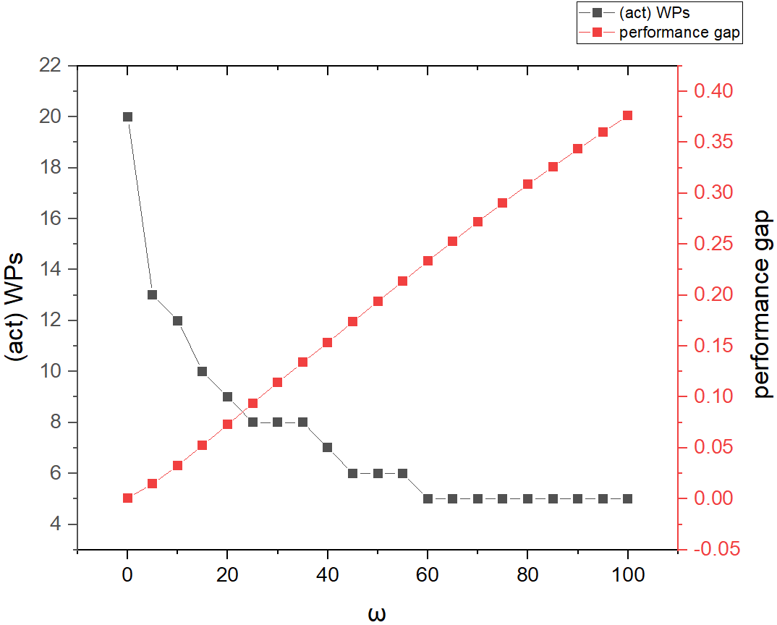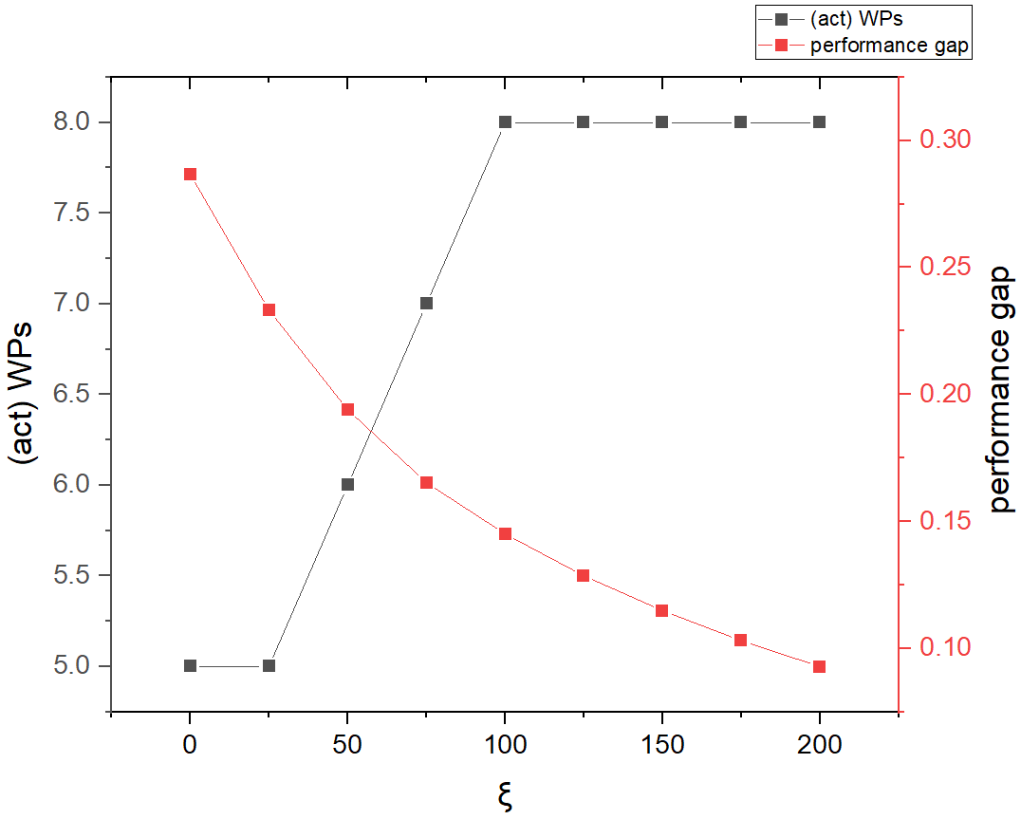
(a) (b)
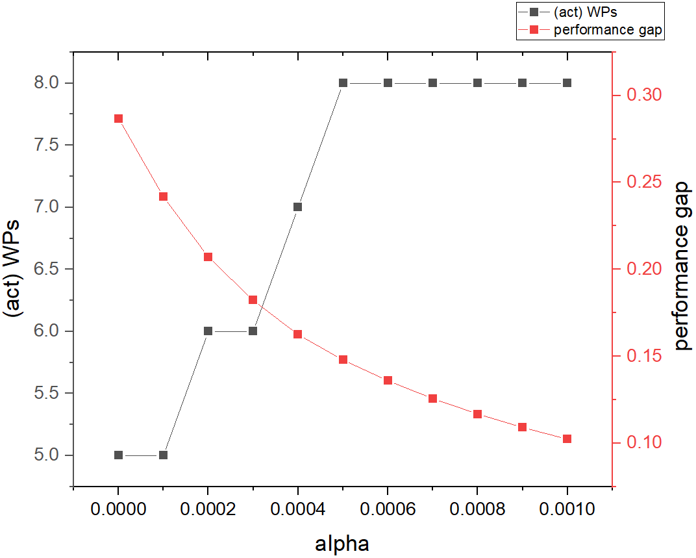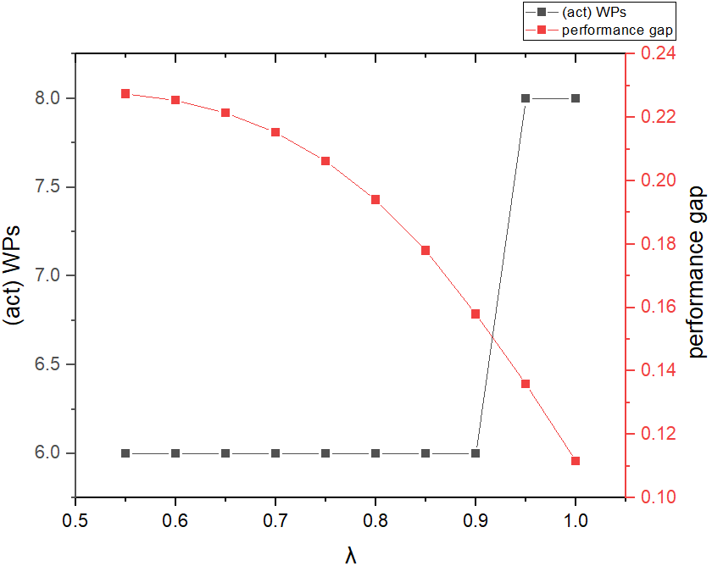
(c) (d)
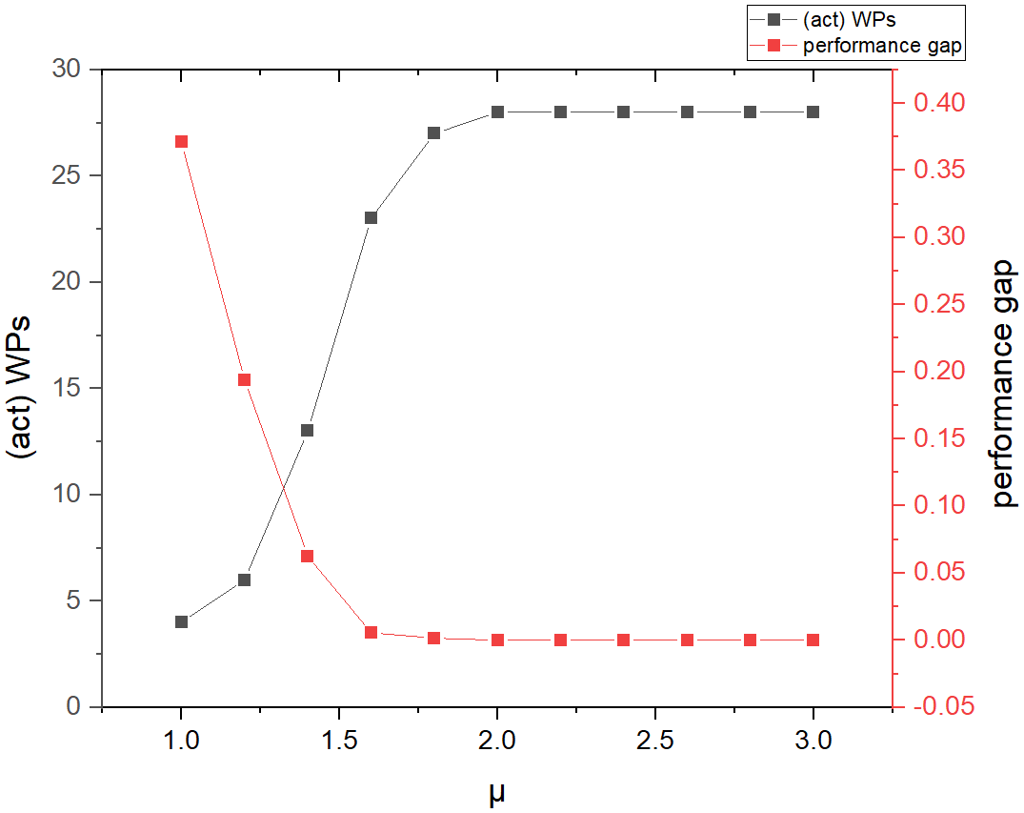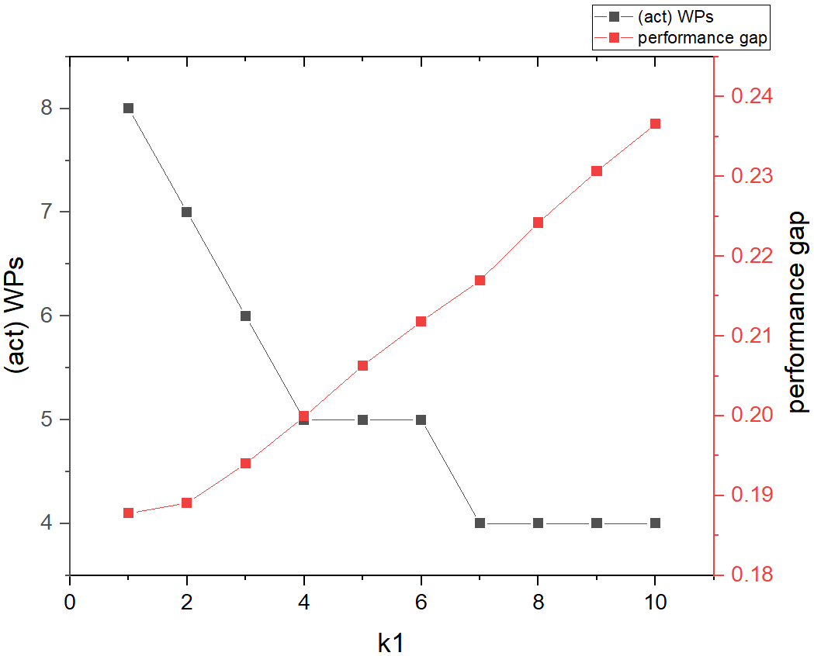
(e) (f)
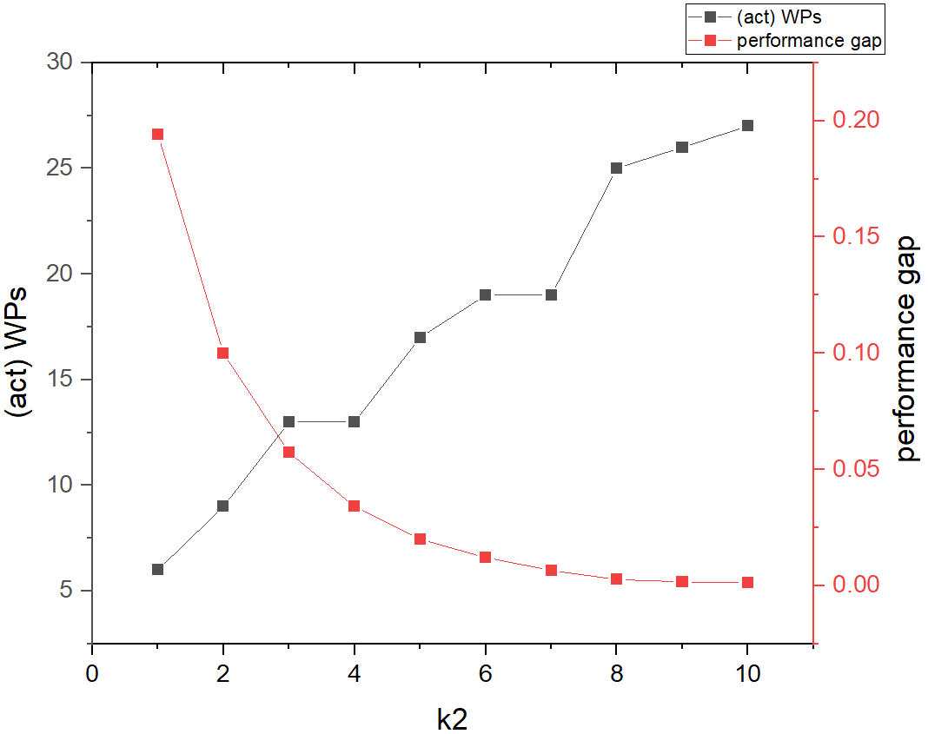
(g)
Fig. 10. Impact of parameters on the performance gap and number of active work packages
We computed the AWPS method’s cost for every test and denoted it as $OC$. Additionally, we computed the cost of the independent task packaging by using Equation (5), and referred to it as $NC$. In Fig. 10, we evaluated the impact of factor changes on performance (i.e., performance gap) by calculating the sensitivity coefficient defined in Equation (9), which measures how much the dependent variable changes in response to a change in an independent variable. As the magnitude of $\left|E_{i}\right|$ increases, the sensitivity of performance to factor i also increases
$E_{i}=\frac{ΔP}{ΔF_{i}}$ $(9)$
Where $ΔP=\frac{\left(NC-OC\right)}{OC} × 100\%,$ $ΔF_{i}$= the change rate of factor i
As the values of $ξ$, $α$, $µ$, and $k2$increase, the performance gap decreases. Moreover, these factors lead to an increase in the number of active work packages. The values of $ξ$ and $α$ are relevant to cash flow. As they increase, the discounted cash flow becomes more critical in terms of avoiding cost overruns caused by carrying too much cost throughout the production process. Forming smaller work packages contributes to a quicker release of fees upon task completion. The values of $µ$ and $k2$ are relevant to $g(·)$ and $y(·)$. An increase in $µ$ and $k2$ results in more important roles of the functions $g(·)$ and $y(·)$. Achieving greater precision in measuring performance and exercising tighter control is vital in promoting the formation of smaller, more manageable work packages.
In contrast to the above factors, as $ξ$, $α$, $µ$, and $k2$ increase, the performance gap also increases. When the values of ω and k1 increase, the performance gap decreases. As $ω$ increases, the fixed cost of each package becomes increasingly crucial and enlarges the performance gap. To mitigate the impact of fixed costs on total costs, reducing the number of work packages while increasing their size is an effective option. As the value of $k1$ increases and $λ$ decreases, $f(·)$ and $h(·)$ play more significant roles in terms of forming the performance gap compared to $g(·)$ and $y(·)$, which results in a small number of work packages with larger sizes.
As shown in Fig. 10, the maximum number of active work packages is 28, while the minimum number is 4. An increase in the values of $ω$, $λ$, and $k1$ tends to decrease the number of active work packages. As $ω$ increases from 0 to 20, there is a significant decrease in the number of active work packages. When $ω$ increases from 20 to 60, the decreasing trend is less significant, and when $ω$ reaches 60, the number of active work packages remains at 4. The values of $λ$ and $k1$ are related to $f(·)$ and $h(·)$, which encourage larger work packages. As $λ$ decreases and $k1$ increases, the number of work packages decreases in a stepwise manner, and they have a mild impact on the number of active work packages compared to $ω$. An increase in the values of $ξ$, $α$, $µ$, and $k2$ can increase the number of active work packages. As $ξ$ and $α$ increase, the number of work packages increases accordingly, and they have a mild impact on the number of active work packages. As$µ$ increases from 1 to 1.6, there is a significant increase in the number of active work packages. When $µ$ increases from 1.6 to 3, the increasing trend is less significant, and when $µ$ reaches 2, the number of active work packages remains at 28. The parameter $µ$ greatly impacts the number of active work packages. Moreover, the growth of $k2$ leads to an increase in the number of work packages, which shows a stepped upward trend. To increase supervision depth and transparency in the production process and mitigate the adverse effects on cash flow, managers should consider increasing the values of $ξ$, $α$, $µ$, and $k2$ in MC projects. In addition to the factors mentioned above, the number and location of inactive tasks also limit the number of work packages. Thus, the number of active work packages is not solely determined by the variability of work package size, and managers should adjust the factor values according to the actual project needs.

6.3. Merging strategy for different numbers of tasks
Experiment 3 tests the effect of changing the number of tasks on work package sizes without inactive tasks. The result indicates that the AWPS method considers balancing the cost load of each work package to ensure that the amount of work content within each work package is roughly the same. We randomly generate a task network using the network generator RanGen2 [50]. When using RanGen2, we specify the following network measures: 1) The number of tasks. We set the number of non-dummy tasks with five sets {10, 20, 30, 40, 50} to represent the task quantity from less to more. The number of tasks is determined based on the production process of standard modular rooms and expert experiences. 2) $I_{2}$. $I_{2}$ is the serial or the parallel indicator. When $I_{2}$=1, RanGen2 generates a group of serial tasks. We set the other network measures of RanGen2 by default. 3) Each task’s work content is a random integer distributed between 1 to 10. A total of 50 instances are generated for the above five task instance sets, with ten random test instances for each set.
The parameters of the sizing optimization model have been set to be the same as those in Experiment 1. $f\left(x\right)=h\left(x\right)=3x^{0.8}$, $g\left(x\right)=y\left(x\right)=x^{1.2}$, $ω=$ 50, $ξ=$50, $α=$0.00025. Table 4 presents a summary of the results, with each row (excluding the first cell) indicating the average of ten random test instances.
Table 4 Avergae of ten test instances

Num. of active tasks | Total task content | Work package cardinality | Mean work package content | Active work package quantity | Total cost (one task/ work package) | Total cost (Optimized)
10 | 56.6 | 10 | 56.6 | 1 | 922.55 | 496.06
20 | 115.2 | 10 | 57.6 | 2 | 1901.38 | 1050.02
30 | 151.7 | 13.5 | 67.5 | 2.3 | 2725.23 | 1416.54
40 | 218.9 | 12.7 | 68.6 | 3.2 | 3854.89 | 2132.22
50 | 289 | 11.25 | 64.7 | 4.5 | 5063.14 | 2931.73
The first five columns of Table 4 show the number of active tasks, total task content, work package cardinality (i.e., the average number of tasks in each work package), mean of work package content, and the number of active work packages, respectively. The data shows that as the number of active tasks increases from 10 to 50, the total task content also increases from 56.6 to 289. At the same time, the work package cardinality remains steady at ten first and slightly increases to 13.5, and the mean work package content stays relatively constant at around 56.6 to 68.6. Additionally, we can observe that as the number of active tasks increases, the number of active work packages also increases from 1 to 4.5. However, the results suggest that the method of AWPS does not encourage the formation of larger and fewer packages, as the work package cardinality remains steady and the mean work package content remains relatively high. The results indicate that the work package sizing can only extend partially, and the solutions tend to balance the work content in every work package. Thus, the AWPS ensures a fair distribution of work content and maximizes the use of resources, thereby enhancing overall efficiency. On the other hand, the last two columns of Table 4 show the total cost before and after optimization, respectively. The total cost of one task/ work package (i.e., only one task in a work package) and the total cost after optimization increase as the number of active tasks increases. However, as the number of tasks increases, the total cost can be optimized, thereby reducing the cost. For example, for 50 active tasks, the total cost after optimization is 2931.73, and each task/work package cost is 5063.14. Therefore, managing the work package sizing is essential for optimizing project efficiency and budget.
- Discussion
The proposed AWPS is a novel method to package MC production tasks more accurately and decrease costs by meeting the delivery time. The novelty of this method, in comparison to previous studies, can be summarized as follows.
• Firstly, this study model the MC production process with multi-stakeholders. Previous studies developed the business process of MC production, which focused on operation records, such as material, production, and inspection. However, the production process in the context of multi-stakeholders and the inspection immutability task in the production process (i.e., hold point) is generally ignored [47]. Thus, the AWPS method provides a more fine-granularity production process, standardizing MC production tasks and providing critical information for inspection tasks with multi-stakeholders in practical production planning.
• Secondly, this study is the first in the MC that proposes the work package sizing method, which establishes a relationship between work package sizes and cost based on several empirical factors. Previous studies adopt the generalized model to map an abstract instance, which is less efficient as it needs to consider inspection task independencies, mass production, and advanced information technologies in the MC project [13,37]. These gaps can adversely impact the model's performance in the MC. This study uses a dynamic programming algorithm to organize fine-granularity tasks into a work package and find the right delivery frequency of deliverables, thereby decreasing cost by 1.3%-16%. Furthermore, the AWPS method can indirectly enhance project quality and productivity by promoting collaboration between design decisions and planning executions.
• Thirdly, the practical usage of the AWPS method is tested in experiments. The results demonstrate that it can significantly reduce execution costs by accurately formulating work package sizes. Moreover, the study discusses how various parameter settings influence work package sizes and the performance of the optimization method. The results can help managers better understand the mechanisms and adjust parameter settings based on the demand of the actual project by which various factors related to work package sizing affect project performance.

Although this study has made significant contributions, it still has some limitations.
• First, due to the lack of cost and schedule data, the data used in this study is collected from a single case project. Although the features of serial task networks can represent most off-site construction activities of the MC project, rich datasets of the workflow plan for off-site production are needed in future studies.
• Secondly, this study focuses on optimizing work package size to reduce project costs rather than minimizing costs by project scheduling. Although both approaches aim to reduce costs, they adopt divergent perspectives in reaching this goal. Thus, a more sophisticated model can be developed to optimize both the sequence of production criteria and work package sizes.
- Conclusions
This paper presents a method for optimizing the work package size in MC production processes to minimize total costs. This method focuses on finding the best balance between larger/fewer work packages and smaller/more work packages to achieve optimal cost performance. Several experiments are conducted to demonstrate the algorithmic performance and practical effectiveness of the AWPS approach. In Experiment 1, we used actual data from an MC project to simulate the managers' packaging decision and validate our method's effectiveness by comparing the optimized results with simulation results. In Experiment 2, we explore the relation between parameter value and the size of work packages. The results indicate that as the organization unit $ω$, the coefficient parameter $k1$ in $f(·)$ and $h(·)$ increases (cost and schedule estimation, production scale), or as the exponent parameters $λ$ in $f(·)$ and $h(·)$, coefficient parameter $k2$ and exponent parameter $μ$ in $g(·)$ and $y(·)$ (production supervision, advanced information technology), the cost per unit of work content $ξ$ and the discount rate $α$ in cash flow decrease, the cost performance gap widens. Conversely, as $ξ$, $α$, $µ$, $λ$, and $k_{2}$ increase and $ω$, $k_{1}$ decrease, the number of work packages increases.
In Experiment 3, we found that the capacity of work packages is finite in a specific parameter condition. As the size of the task network increases, the trend in forming work packages encourages the creation of larger work packages initially and more work packages subsequently. In summary, managers can use the AWPS method to automatically package MC tasks, which can reduce execution costs while maintaining duration by effectively planning the grouping of tasks and allocating resources.

Several topics remain open for future studies. First, the AWPS method can be improved by considering the transport and assembly process. It would be valuable to broaden the scope of our model to encompass the entire process of the MC project and analyze how multi-stage tasks influence the sizing decisions for work packages. Second, this study establishes several functions for mapping the relationship between decision costs and work contents. However, the parameters in the function are manually selected. Therefore, it is beneficial to develop an approach to automatically select mapping functions based on the theory of applied mathematics and task types. In conclusion, this study paves the way for developing automatic work package sizing methods to decrease the MC project cost while encouraging further research.

Acknowledgment
The work described in this paper is supported by grants from the Research Grants Council of the Hong Kong SAR of China, the National Natural Science Foundation of China, The University of Hong Kong, Guangdong Basic and Applied Basic Research Foundation (RGC Project No.15219422 & G-HKU502/22, NSFC Project No. 72201228 and 52208324, HKU Project No. 2201100548, 2023A1515011162).

References
[1] J.M.D. Delgado, L. Oyedele, Digital Twins for the built environment: learning from conceptual and process models in manufacturing, Advanced Engineering Informatics. 49 (2021), p. 101332. http://doi.org/https://doi.org/10.1016/j.aei.2021.101332.
[2] J. Hong, G.Q. Shen, Z. Li, B. Zhang, W. Zhang, Barriers to promoting prefabricated construction in China: A cost–benefit analysis, Journal of Cleaner Production. 172 (2018), pp. 649-660. http://doi.org/10.1016/j.jclepro.2017.10.171.
[3] S. Abdelmageed, T. Zayed, A study of literature in modular integrated construction-critical review and future directions, Journal of Cleaner Production. 277 (2020), p. 124044. http://doi.org/10.1016/j.jclepro.2020.124044.
[4] W. Ferdous, Y. Bai, T.D. Ngo, A. Manalo, P. Mendis, New advancements, challenges and opportunities of multi-storey modular buildings–A state-of-the-art review, Engineering structures. 183 (2019), pp. 883-893. http://doi.org/10.1016/j.engstruct.2019.01.061.
[5] M. Hussein, T. Zayed, Critical factors for successful implementation of just-in-time concept in modular integrated construction: A systematic review and meta-analysis, Journal of Cleaner Production. 284 (2021), p. 124716. http://doi.org/ https://doi.org/10.1016/j.jclepro.2020.124716
[6] J.D. García-Nieves, J.L. Ponz-Tienda, A. Ospina-Alvarado, M. Bonilla-Palacios, Multipurpose linear programming optimization model for repetitive activities scheduling in construction projects, Automation in Construction. 105 (2019), p. 102799. http://doi.org/10.1016/j.autcon.2019.03.020.
[7] Z. Yang, Z. Ma, S. Wu, Optimized flowshop scheduling of multiple production lines for precast production, Automation in Construction. 72 (2016), pp. 321-329. http://doi.org/10.1016/j.autcon.2016.08.021.
[8] Z. Wang, H. Hu, J. Gong, Framework for modeling operational uncertainty to optimize off-site production scheduling of precast components, Automation in Construction. 86 (2018), pp. 69-80. http://doi.org/10.1016/j.autcon.2017.10.026.
[9] D. Ivanov, C.S. Tang, A. Dolgui, D. Battini, A. Das, Researchers' perspectives on Industry 4.0: multi-disciplinary analysis and opportunities for operations management, International Journal of Production Research. 59 (7) (2021), pp. 2055-2078. http://doi.org/10.1080/15623599.2023.2203501.
[10] D.D. Gebremichael, H. Lee, Y. Lee, Y. Jung, Unified Breakdown Structure for Information Integration to Enhance Interoperability in the Built Environment, Journal of Computing in Civil Engineering. 36 (6) (2022), p. 04022030. http://doi.org/10.1061/(ASCE)CP.1943-5487.0001046.
[11] H.-W. Wang, J.-R. Lin, J.-P. Zhang, Work package-based information modeling for resource-constrained scheduling of construction projects, Automation in Construction. 109 (2020), p. 102958. http://doi.org/10.1016/j.autcon.2019.102958.
[12] T. Narbaev, Ö. Hazır, M. Agi, A review of the use of game theory in project management, Journal of Management in Engineering. 38 (6) (2022), p. 03122002. http://doi.org/10.1061/(ASCE)ME.1943-5479.0001092.
[13] C.-L. Li, N.G. Hall, Work package sizing and project performance, Operations Research. 67 (1) (2019), pp. 123-142. http://doi.org/10.1287/opre.2018.1767.
[14] X. Li, C. Wu, Z. Yang, Y. Guo, R. Jiang, Knowledge graph-enabled adaptive work packaging approach in modular construction, Knowledge-Based Systems. 260 (2023), p. 110115. https://doi.org/10.1016/j.knosys.2022.110115
[15] X. Li, L. Wu, R. Zhao, W. Lu, F. Xue, Two-layer Adaptive Blockchain-based Supervision model for off-site modular housing production, Computers in Industry. 128 (2021), p. 103437. http://doi.org/https://doi.org/10.1016/j.compind.2021.103437
[16] A. Ezzeddine, B.G. de Soto, Connecting teams in modular construction projects using game engine technology, Automation in Construction. 132 (2021), p. 103887. http://doi.org/10.1016/j.autcon.2021.103887.
[17] C. Wu, P. Wu, J. Wang, R. Jiang, M. Chen, X. Wang, Ontological knowledge base for concrete bridge rehabilitation project management, Automation in Construction. 121 (2021), p. 103428. http://doi.org/https://doi.org/10.1016/j.autcon.2020.103428.
[18] F.A. Mir, A.H. Pinnington, Exploring the value of project management: linking project management performance and project success, International Journal of Project Management. 32 (2) (2014), pp. 202-217. http://doi.org/10.1016/j.ijproman.2013.05.012.
[19] Q. Tian, J. Ma, J. Liang, R.C. Kwok, O. Liu, An organizational decision support system for effective R&D project selection, Decision Support Systems. 39 (3) (2005), pp. 403-413. http://doi.org/10.1016/j.dss.2003.08.005.
[20] C. Wu, P. Wu, J. Wang, R. Jiang, M. Chen, X. Wang, Critical review of data-driven decision-making in bridge operation and maintenance, Structure and Infrastructure Engineering. 18 (1) (2021), pp. 47-70. http://doi.org/https://doi.org/10.1080/15732479.2020.1833946.
[21] C. Tsz Wai, P. Wai Yi, O. Ibrahim Olanrewaju, S. Abdelmageed, M. Hussein, S. Tariq, T. Zayed, A critical analysis of benefits and challenges of implementing modular integrated construction, International Journal of Construction Management. 23 (4) (2023), pp. 656-668. http://doi.org/https://doi.org/10.1080/15623599.2021.1907525
[22] D. Lopez, T.M. Froese, Analysis of costs and benefits of panelized and modular prefabricated homes, Procedia Engineering. 145 (2016), pp. 1291-1297. http://doi.org/https://doi.org/10.1016/j.proeng.2016.04.166
[23] C. Wu, X. Li, Y. Guo, J. Wang, Z. Ren, M. Wang, Z. Yang, Natural language processing for smart construction: Current status and future directions, Automation in Construction. 134 (2022), p. 104059. http://doi.org/https://doi.org/10.1016/j.autcon.2021.104059
[24] A. Nasirian, M. Arashpour, B. Abbasi, A. Akbarnezhad, Management, Optimal work assignment to multiskilled resources in prefabricated construction, Journal of Construction Engineering. 145 (4) (2019), p. 04019011. http://doi.org/10.1061/(ASCE)CO.1943-7862.0001627.
[25] R.Y. Zhong, Y. Peng, F. Xue, J. Fang, W. Zou, H. Luo, S.T. Ng, W. Lu, G.Q. Shen, G.Q. Huang, Prefabricated construction enabled by the Internet-of-Things, Automation in Construction. 76 (2017), pp. 59-70. http://doi.org/10.1016/j.autcon.2017.01.006.
[26] L. Li, H. Luan, X. Yin, Y. Dou, M. Yuan, Z. Li, Management, Understanding Sustainability in Off-Site Construction Management: State of the Art and Future Directions, Journal of Construction Engineering and Management. 148 (11) (2022), p. 03122008. http://doi.org/https://doi.org/10.1061/(ASCE)CO.1943-7862.0002396
[27] Z. Liu, Z. Liu, M. Liu, J. Wang, Optimization of flow shop scheduling in precast concrete component production via mixed-integer linear programming, Advances in Civil Engineering. 2021 (2021), pp. 1-14. http://doi.org/https://doi.org/10.1155/2021/6637248
[28] B. Anvari, P. Angeloudis, W.Y. Ochieng, A multi-objective GA-based optimisation for holistic manufacturing, transportation and assembly of precast construction, Automation in Construction. 71 (2016), pp. 226-241. http://doi.org/https://doi.org/10.1016/j.autcon.2016.08.007
[29] M.G. Sánchez, E. Lalla-Ruiz, A.F. Gil, C. Castro, S. Voß, Resource-Constrained Multi-Project Scheduling Problem: A Survey, European Journal of Operational Research. 301 (3) (2022), pp. 958-976. http://doi.org/https://doi.org/10.1016/j.ejor.2022.09.033
[30] N. Torkanfar, E.R. Azar, Quantitative similarity assessment of construction projects using WBS-based metrics, Advanced Engineering Informatics. 46 (2020), p. 101179. http://doi.org/https://doi.org/10.1016/j.aei.2020.101179
[31] D.K. Chua, M. Godinot, management, use of a WBS matrix to improve interface management in projects, Journal of Construction Engineering and Management. 132 (1) (2006), pp. 67-79. http://doi.org/https://doi.org/10.1061/(ASCE)0733-9364(2006)132:1(67)
[32] E. Siami-Irdemoosa, S.R. Dindarloo, M. Sharifzadeh, Work breakdown structure (WBS) development for underground construction, Automation in Construction. 58 (2015), pp. 85-94. http://doi.org/10.1016/j.autcon.2015.07.016.
[33] S. Isaac, M. Curreli, Y. Stoliar, Work packaging with BIM, Automation in Construction. 83 (2017), pp. 121-133. http://doi.org/10.1016/j.autcon.2017.08.030.
[34] X. Li, C. Wu, P. Wu, L. Xiang, G.Q. Shen, S. Vick, C.Z. Li, SWP-enabled constraints modeling for on-site assembly process of prefabrication housing production, Journal of Cleaner Production. 239 (2019), p. 117991. http://doi.org/10.1016/j.jclepro.2019.117991.
[35] X. Li, J. Zeng, C. Chen, H.-l. Chi, G.Q. Shen, Smart work package learning for decentralized fatigue monitoring through facial images, Computer‐Aided Civil and Infrastructure Engineering. 38 (6)(2023), p. 799-817. https://doi.org/10.1111/mice.12891.
[36] D. Bredael, M. Vanhoucke, Multi-project scheduling: A benchmark analysis of metaheuristic algorithms on various optimisation criteria and due dates, European Journal of Operational Research. (2022). http://doi.org/10.1016/j.ejor.2022.11.009.
[37] T. Raz, S. Globerson, Effective sizing and content definition of work packages, Project Management Journal. 29 (4) (1998), pp. 17-23. http://doi.org/10.1177/875697289802900403.
[38] Z. Zhao, M. Zhou, S. Liu, Iterated greedy algorithms for flow-shop scheduling problems: A tutorial, IEEE Transactions on Automation Science Engineering. (2021). http://doi.org/https://doi.org/10.1109/TASE.2021.3062994
[39] Q. Deng, B.F. Santos, R. Curran, A practical dynamic programming based methodology for aircraft maintenance check scheduling optimization, European Journal of Operational Research. 281 (2) (2020), pp. 256-273. http://doi.org/https://doi.org/10.1016/j.ejor.2019.08.025
[40] I. Mahdavi, R. Nourifar, A. Heidarzade, N.M. Amiri, A dynamic programming approach for finding shortest chains in a fuzzy network, Applied Soft Computing. 9 (2) (2009), pp. 503-511. http://doi.org/https://doi.org/10.1016/j.asoc.2008.07.002
[41] M. Jaber, J. Peltokorpi, C. Glock, E. Grosse, M. Pusic, Adjustment for cognitive interference enhances the predictability of the power learning curve, International Journal of Production Economics. 234 (2021), p. 108045. http://doi.org/https://doi.org/10.1016/j.ijpe.2021.108045
[42] X. Li, G.Q. Shen, P. Wu, F. Xue, H.-l. Chi, C.Z. Li, Developing a conceptual framework of smart work packaging for constraints management in prefabrication housing production, Advanced Engineering Informatics. 42 (2019), p. 100938. http://doi.org/10.1016/j.aei.2019.100938.
[43] N. Dayanand, R. Padman, Project contracts and payment schedules: The client's problem, Management Science. 47 (12) (2001), pp. 1654-1667. http://doi.org/10.1287/mnsc.47.12.1654.10242.
[44] A. Marchioni, C.A. Magni, Investment decisions and sensitivity analysis: NPV-consistency of rates of return, European Journal of Operational Research. 268 (1) (2018), pp. 361-372. http://doi.org/10.1016/j.ejor.2018.01.007.
[45] E.D. Omopariola, A. Windapo, D.J. Edwards, W.D. Thwala, Contractors’ perceptions of the effects of cash flow on construction projects, Journal of Engineering, Design Technology. 18 (2) (2020), pp. 308-325. http://doi.org/10.1108/JEDT-04-2019-0099.
[46] T. Zayed, Y. Liu, Cash flow modeling for construction projects, Engineering, Construction Architectural Management. (2014). http://doi.org/10.1108/ECAM-08-2012-0082.
[47] X. Li, C. Wu, F. Xue, Z. Yang, J. Lou, W. Lu, Ontology-based mapping approach for automatic work packaging in modular construction, Automation in construction. 134 (2022), p. 104083. http://doi.org/10.1016/j.autcon.2021.104083.
[48] D. Bredström, M. Rönnqvist, Combined vehicle routing and scheduling with temporal precedence and synchronization constraints, European Journal of Operational Research. 191 (1) (2008), pp. 19-31. http://doi.org/10.1016/j.ejor.2007.07.033.
[49] J. Wang, J. Liu, Y. Zhong, A novel ant colony algorithm for assembly sequence planning, The International Journal of Advanced Manufacturing Technology. 25 (2005), pp. 1137-1143. http://doi.org/10.1007/s00170-003-1952-z.
[50] M. Vanhoucke, J. Coelho, D. Debels, B. Maenhout, L.V. Tavares, An evaluation of the adequacy of project network generators with systematically sampled networks, European Journal of Operational Research. 187 (2) (2008), pp. 511-524. http://doi.org/https://doi.org/10.1016/j.ejor.2007.03.032

Appendix
Symbol | Meaning | Description
$$a_{1}, a_{2}, …, a_{n}$$ | Tasks | A node in the task network diagram
$$N=\{a_{1}, a_{2}, …,a_{n} \}$$ | Task sets | A collection of n tasks from the network
$$W_{1}, W_{2}, …, W_{n}$$ | Work packages | Consists of one or more elemental tasks, and can reflect the content and duration.
$$ω$$ | Organization unit | A fixed cost in each work package encourages larger work packages.
$$f (·)$$ | Cost and schedule estimation | A function encourages larger work packages.
$$g (·)$$ | Production supervision | A function encourages smaller work packages.
$$h (·)$$ | Production scale | A function encourages larger work packages.
$$y (·)$$ | Advanced information technology | A function encourages smaller work packages.
$$ξx_{w}\left(1-e^{-αc_{w}}\right)$$ | The total discounted cash flow cost of the work package. | A function encourages smaller work packages. $ξ$ is the cost per unit of work content. $α$ is the discount rate.
$$x_{w}$$ | Work package content | The sum of task contents within the work package.
$$c_{w}$$ | Work package completion time | The sum of task durations within each work package.
$$R= \left\{a_{1}, a_{2}, . . ., a_{k}\right\}$$ | Inactive tasks set | Including 1) dummy tasks representing the start and end of a project; 2) independent tasks that cannot be merged.
$\overline{R}$= $\left\{a_{1}, a_{2}, . . ., a_{k}\right\}$ | Active tasks set | $\overline{R}$ = $N \backslash (R_{1}∪R_{2}∪… ∪R_{m})$
$$p$$ | the number of work packages for the active task | A decision variable
$$t_{a_{i}}$$ | Task duration | The duration of the task $a_{i}$.
$$x_{a_{i}}$$ | Task content | The work content of the task $a_{i}$.
$$C_{a_{i}}$$ | Task completion time | The cumulative duration of all tasks preceding $a_{i}$.
$$c(i, j)$$ | The total cost of a group of tasks | The total cost when a group of tasks $\{a_{i+1}, a_{i+2}, …, a_{j}\}$ is organized into a work package.
$$d$$ | Project delivery time | The time it takes to start a project until all tasks are completed.
$$Δ$$ | Project completion time | The project completion date is specified before the project begins.
$$OC$$ | Opportunity Cost | The cost is computed for every test instance using the AWPS method.
$$NC$$ | Normal Cost | The cost of independent task packaging.
$$ΔP$$ | Performance Gap | The difference in performance between the normal cost and opportunity cost.
$$E_{i}$$ | Sensitivity Coefficient | Measures how much a dependent variable changes in response to a change in an independent variable.
$${ΔF}_{i}$$ | Change Rate | The change rate of factor $i$.
$$I_{2}$$ | Serial or Parallel Indicator | When $I_{2}=1$, RanGen2 generates a group of serial tasks. When $I_{2}=0$, RanGen2 generates a group of parallel tasks.
$$λ$$ | Exponent | $λ∈\left(0, 1\right)$, which makes $f(·)$ and $h(·)$ become a concave nondecreasing function.
$$μ$$ | Exponent | $μ∈\left(1, 3\right)$, which makes $g(·)$ and $y(·)$ become a concave nondecreasing function.
$$k1$$ | Coefficient | The change in value affects the rate at which the functions $f(·)$ and $h(·)$ change.
$$k2$$ | Coefficient | The change in value affects the rate at which the functions $g(·)$ and $y(·)$ change.

