Residual mechanical performance and rust characterization of self-prestressing UHPC subjected to chloride-induced corrosion
M. Khan, L.J. Chen, X.W. Deng, R.K.L. Su
Department of Civil Engineering, The University of Hong Kong, Hong Kong
Abstract:
Chloride-induced corrosion poses extreme vulnerabilities to the strength degradation and delamination of reinforced concrete structures in the oceanic environment. For this reason, the self-prestressing effect produced from the synergy of the combined addition of expansive agent (EA) and steel fibre (SF) into the concrete is suggested to enhance the corrosion performance (cracking and degradation) of concrete-steel tubular columns (CSTCs). Four concrete mixtures were prepared with the no EA and SF, individual use of EA or SF and combined use. The corrosion rate was measured by the linear polarization resistance (LPR) method, while crack-width and pit-depth were measured with scanning electron microscopy (SEM). Test results revealed that the self-prestressing ultra-high-performance concrete (UHPC) prepared by the combined use of EA and SF reduced the corrosion rate, pit depth, and crack width up to 87.3%, 55.8%, and 68.3%, respectively. Furthermore, it also results in the highest residual compressive strength. The corrosion products characterized by using an energy-dispersive x-ray detector (EDX) and x-ray diffractometry (XRD) for self-prestressing UHPC were oxides with a volume ratio to parent iron of approximately 2, which is the lowest amongst all and justifies its superior performance.
Keywords: Expansive agent; Steel fibre; self-prestressing; linear polarization resistance; residual compressive strength; x-ray diffractometry.

1. Introduction
Chloride-induced corrosion is one of the most critical deterioration and premature failure issues of reinforced concrete (RC) structures [1, 2]. It is prevalent in marine and offshore structures due to aggressive corrosive agents and high salinity [3, 4]. Chloride ions present in seawater penetrate concrete and destroy steel’s passive film. Once this passive film is destroyed, rust accumulates, resulting in the concrete cracking [5]. Once a crack has formed, it reduces the overall stiffness and strength. Furthermore, water and chlorides can penetrate faster through cracked concrete, speeding up the corrosion process [6-8].
Researchers suggest using concrete fibre reinforcement to arrest bending [8, 9] and tensile cracking [10, 11]. Fibre reinforcement is also helpful in delaying corrosion-induced cracking as it provides passive confinement [12]. In addition, some researchers have added expansive agent (EA) into concrete to improve cracking performance [13-15]. EA produces a chemical prestressing effect in concrete, enhancing bond strength and tension-stiffness performance [16-19]. Furthermore, expansive concrete can also act as prestressed concrete in the constrained region [20]. However, the expansive concrete microstructure becomes loose under free curing conditions with many cracks at the paste-aggregate interface [21].
An innovative solution to this problem is combining fibre and EA. The chemical reaction of EA induces autogenous expansion. This autogenous expansion is restricted by the fibre in the matrix and could develop chemical prestress along with the fibre. On the other hand, autogenous expansion could result in stress developing perpendicular to fiber length if the concrete volume is constrained. Such stress around the fibre could improve the bond at the interface of fibre-matrix [18, 21, 22]. Such a self-prestressing effect arising from the combined addition of EA and steel fibres (SF) has been verified by recent studies [15, 23], which resulted in improved mechanical performance; however, this self-prestressing effect on corrosion performance has not been studied yet.
Due to their lightweight nature, hollow structural sections are frequently used in bridge piers and offshore wind farms [24]. In addition, the hollow interior space also enables the installation of service facilities. [25]. However, the columns used in bridge foundations and offshore wind farms are often prefabricated and placed in the harsh marine environment, exposing them to chloride-induced corrosion. Therefore, applying hollow steel columns to support maritime structures without protection against chloride-induced corrosion is unacceptable. Consequently, we proposed a simple type of concrete-steel-tubular-column (CSTC) with a concrete cover outside (see Fig. 1) to protect it from chloride-induced corrosion. However, a plain concrete cover would not meet its demands, especially within the corrosive marine environment. As earlier reported, the joint addition of EA and SF can produce dense microstructure and delay corrosion cracking, making it highly suitable for corrosion-resistant structures. In addition, pioneering works have shown that fibre-reinforced concrete has superior corrosion resistance over plain concrete [8, 26]. However, insufficient research has been directed on the possible synergetic effects of the combined addition of EA and SF on the residual mechanical behaviour of CSTCs. Moreover, very few reported studies have considered the effect of rust chemical composition on mechanical performance.
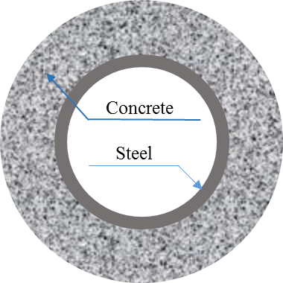
Fig. 1. Cross-section of CSTC.
Based on the above discussions, the current study aims to improve the residual mechanical performance of CSTCs subjected to chloride-induced corrosion, considering concrete mixture and cover thickness as variables. For this study, four concrete mixtures – plain concrete (PC), expansive concrete (EC), fibre-reinforced concrete (FRC), and self-prestressing ultra-high performance concrete (SPUHPC) – have been considered, each with three different concrete covers (16.85, 22.65 and 29.95 mm). Linear polarization resistance (LPR) was monitored during the propagation phase up to 56 days for the electrochemical measurements, while the initiation phase was accelerated. An accelerated corrosion test (ACT) has been carried out to assess the effects of corrosion on the mechanical performance of CSTCs. The mechanical performance of corroded specimens was measured and compared with the un-corroded specimens in terms of axial compression behaviour to reveal the effects of EA and SF on corrosion resistance. Furthermore, crack width and pit depth analyses have been performed using backscattered electron (BSE) images created by scanning electron microscopy (SEM). Moreover, corrosion products have been characterized by the coupling of electron microscopy and optical tools (SEM, EDX, and XRD) to investigate the rust composition. The results show that the combined addition of EA and SF can effectively improve the residual mechanical performance and alter rust composition of CSTCs.

2. Materials and experimental methodology
2.1. Raw materials
In this experiment, the cementitious materials used were ordinary portland cement (OPC) and EA. OPC was of Type 1 52.5 N. The properties of the EA are tabulated in Table 1, as provided by the manufacturer. The OPC and EA were found to have relative densities of 3.11 and 2.87, respectively. Steel fibres were 13 mm long and had a diameter of 0.2 mm. The steel fibre has the tensile and yield strengths of 1200 MPa and 200 GPa, respectively (specifications provided by the supplier). The maximum size of quartz sand used in this study was 1.18 mm. A hollow circular tube of steel (S275) was used as reinforcement, while counter electrode was of stainless steel plate.
Table 1
Expansive agent properties.
Property | Standard requirement | Test result
Residue on 1.18 mm sieve (%) | ≤ 0.5 | 0.2
Specific surface area (m²/kg) | ≥ 200 | 420
Restrained expansion in water after 7 days (%) | ≥ 0.025 | 0.030
Restrained expansion in air after 21 days (%) | ≥ -0.020 | -0.005
MgO content (%) | ≤ 5.0 | 2.62
Initial setting time (min) | ≥ 45 | 150
Final setting time (min) | ≤ 600 | 225
7 day compressive strength (MPa) | ≥ 20.0 | 25.5
28-day compressive strength (MPa) | ≥ 40.0 | 44.5

2.2. Mix proportions
All mortar mixtures have a water/cement ratio (W/C) of 0.25. Four different mixtures have been prepared, varying EA and SF volume. Aggregate (quartz sand) volume has remained constant for all mixtures. The cementitious paste volume (CPV) consists of cement, water, and steel fibre (if applicable) and is kept at 75% for all mixtures. EA replaces CPV by 2.0%, while volume of SF and dosage of SP are fixed at 2.0% and 1.5%, respectively. For simplicity, each mixture has been allocated a short name, such as PC (plain concrete (with no EA or SF)), EC (expansive concrete (with no SF)), FRC (fibre reinforced concrete (with no EA)), and SPUHPC (self-prestressing ultra-high performance concrete (with both SF and EA)). Mixture proportions are provided in Table 2.
Table 2
Mixture proportions of mortar mixes.
Mixture | Cement content  (kg/m³) | Water content  (kg/m³) | Expansive agent  (kg/m³) | Quartz sand (kg/m³) | Steel fibre  (kg/m³) | SP  (kg/m³)
PC | 1307 | 311 | 0 | 650 | 0 | 19.6
EC | 1272 | 303 | 60 | 650 | 0 | 19.1
FRC | 1272 | 303 | 0 | 650 | 157 | 19.1
SPUHPC | 1237 | 294 | 60 | 650 | 157 | 18.6

2.3. Preparation of test specimens
Cylindrical CSTC specimens, having dimensions of 100 × 200 mm, prepared with hollow steel tubes of 200 mm lengths with different diameters placed at the centre, were cast from the four different concrete mixtures (see Table 2). Steel tubes with three different internal diameters and corresponding cover thicknesses were employed, and their details are provided in Table 3. For easier identification, all the specimens were allocated short names, e.g., CSTC-SP, where CSTC denotes the type of the column and the first letter after the dash denotes cover thickness (e.g., S(16.85 mm), M (22.65 mm), and L (29.95 mm)), while the second letter denotes the type of concrete mixture (P as PC, E as EC, F as FRC, and S as SPUHPC). Sandpaper was used to clean steel tubes and eliminate the mill scale. The ends of the steel tubes were trimmed and made uniform using a grinding machine. Specialized moulds were designed to provide the placement of steel tubes at the centre of the mould. The open ends of the steel tubes were covered with copper plates to prevent concrete flow inside the tubes. Electrical cables were attached to the steel tubes’ upper ends for the electrochemical procedure. Prior to the accelerated corrosion test, the specimens were allowed to cure at room temperature for 14 days.
For electrochemical measurements during the wetting and drying cycle, the initiation phase was accelerated by oven-drying at 50 °C until constant mass to increase the capillary absorption of the chloride solution. Specimens were then quickly immersed in a 5% NaCl solution previously used for plain cement concrete specimens [27]. After that, alternate wetting and drying cycles were performed with exposure conditions of one week in NaCl solution and one week’s air exposure at 23 ± 2 °C. For the electrochemical study, the specimens with the only medium cover thickness (22.65 mm) were studied. The specimens were sealed with epoxy at the bottom and silicon glue at the top.
Table 3
Test specimens IDs and details.
Specimen ID | Mixture | Steel tube |  | Concrete over, t_{c} (mm)
Specimen ID | Mixture | D_{s} (mm) | t_{s} (mm) | Concrete over, t_{c} (mm)
CSTC-SP | PC | 60.3 | 3.0 | 16.85
CSTC-SE | EC | 60.3 | 3.0 | 16.85
CSTC-SF | FRC | 60.3 | 3.0 | 16.85
CSTC-SS | SPUHPC | 60.3 | 3.0 | 16.85
CSTC-MP | PC | 48.3 | 3.2 | 22.65
CSTC-ME | EC | 48.3 | 3.2 | 22.65
CSTC-MF | FRC | 48.3 | 3.2 | 22.65
CSTC-MS | SPUHPC | 48.3 | 3.2 | 22.65
CSTC-LP | PC | 33.7 | 3.2 | 29.95
CSTC-LE | EC | 33.7 | 3.2 | 29.95
CSTC-LF | FRC | 33.7 | 3.2 | 29.95
CSTC-LS | SPUHPC | 33.7 | 3.2 | 29.95

2.4. Electrochemical measurements
All electrochemical experiments were carried out in a controlled room at a constant temperature of 25 ± 2 °C using a PARSTAT 3000A-DX bipotentiostat, Princeton Applied Research, USA. All studies were conducted using a three-electrode setup that included a steel tube which acts as working electrode (WE), AgCl as reference electrode (RE), and stainless steel as the counter electrode (CE). To avoid limiting oxygen diffusion, the specimens were partially immersed in tap water during all electrochemical studies. RE and CE were also submerged in water with corrosion specimens. The corrosion behaviour of the specimens was evaluated during the wetting cycles. Linear polarization resistance and corrosion rate of the CSTC specimens were obtained.
2.5. Impressed current density method (ICDM)
The specimens were immersed in a 5% NaCl solution and exposed to a continuous impressed current density of 343 μA/cm² for 28 days after 14 days of curing. This current density was chosen based on past studies that proposes the current density range of 100-500 μA/cm² (regarding to the steel’s exposed surface area), for which Faraday’s law still holds for concretes contaminated with chlorides [28-30]. The current direction is adjusted so that the anode is steel tube while cathode is the stainless steel plate in the tank.
2.6. Compressive strength test
On the CSTC specimens, axial compression tests were performed utilizing a servo-controlled hydraulic testing apparatus with a 5000 kN capacity. The end shortening of the specimens was measured using four 50 mm range Linear Voltage Differential Transducers (LVDTs), which were evenly distributed between the bottom and top bearing plates. A typical test setup for the CSTCs is depicted in Fig. 2. A plaster coating was applied on the top of the specimens to apply the load uniformly. Before starting the test, an initial load of approximately 2 kN was applied until the plaster was hardened. The load was applied continuously during the axial compression test. The displacement control method was used with a 0.5 mm/min constant loading rate. A data logger recorded the data of the LVDTs at intervals of 1 s during testing.
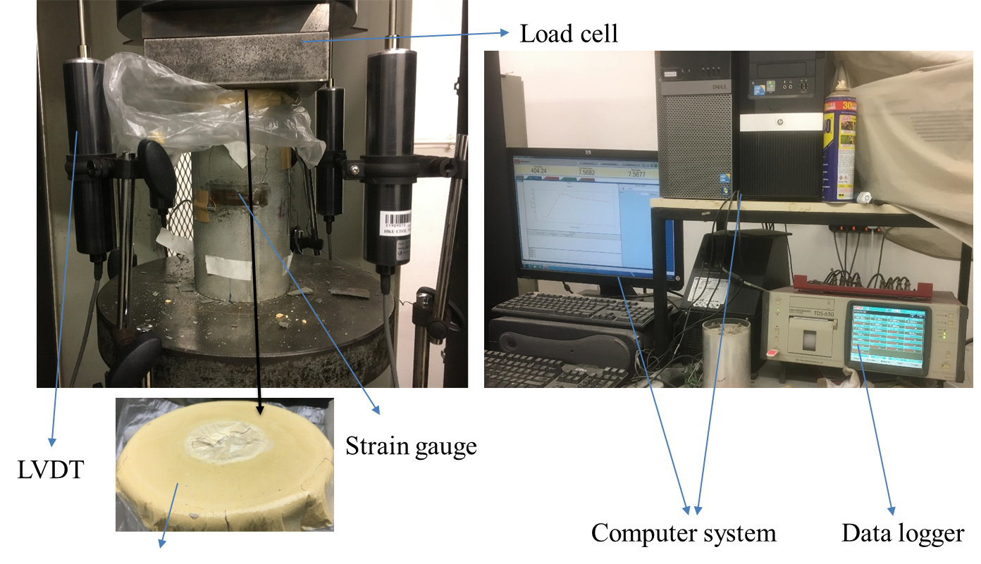
Fig. 2. Experimental setup of axial compression test of CSTCs.
2.7. SEM/EDX
At the concrete age of 42 days, each concrete specimen was sliced by a diamond blade. The cutting machine used in this study was an ATM Brilliant 200. The cutting wheel had a diameter of 250 mm and rotated at a rate of 2850 RPM. The lubricant used during the cutting process was water. Instead of drying in an oven, the concrete slices were dried at room temperature in a properly ventilated research laboratory environment for 24 hours. Prior to epoxy impregnation, the samples were kept in a vacuum chamber at -600 mm Hg for ten minutes. An ultra-low viscosity epoxy was then impregnated into the rubber formwork to support the pore structure of the slices [31]. The epoxy was forced into the pores of the samples by altering the pressure from -600mm Hg to 760 mm Hg three times. After being impregnated with epoxy, the samples were dried in a laboratory at ambient temperature. ATM Saphir 250 A1-ECO, an automatic polishing machine, was used to grind and polish the samples [32].
The energy-dispersive X-ray (EDX) detector-equipped Hitachi S3400N scanning electron microscope was used for the SEM test in this investigation. The samples were firstly captured under BSE mode with a magnification of x40. The working distance was around 10 mm with an accelerating voltage of 20kV. Before capturing BSE photos, a greyscale histogram was adjusted to spread out as much as possible within the greyscale spectrum, as recommended in [33], by choosing suitable brightness and contrast values. Upon the capture under BSE mode, the EDX mapping was performed to collect the chemical element information of the steel-concrete interface (SCI). The dwell time for each pixel in the EDX mapping was 400 μs to minimize possible damage [34] and drifting problems. The pitting depth and crack width of the rust were calculated from the SEM images of the samples using ImageJ analysis software. Before the SEM, the samples were coated with carbon to get clear images and remove the noise from the Fe in the cementitious matrix. [34, 35]. A conductive silver paint was also applied to each sample to provide a path to the metallic sample holder and ground for the incoming electrons during the capture.
2.8. XRD
After completion of SEM, the corroded specimens were carefully retrieved. The iron coating from the samples was removed by further grinding and polishing. The rust inside the cracks was used to perform an X-ray diffractometry (XRD) analysis. The corroded samples were immediately collected in sealed plastic bags and subjected to X-ray diffraction analysis within four hours to prevent the corrosion products from oxidizing in the atmosphere. Compounds within the corrosion products were identified using XRD Bruker D8 Advance. The XRD analysis was performed using MDI Jade 6 software.

3. Results
3.1. Mix properties
The properties of the different mortar mixtures are presented in Table 4. A slump-flow cone test was performed to assess the workability of the mortar mixes by Chinese Standard GB/T 50080-2016. After lifting the cone, the height of the mortar mixture was measured to determine the slump. To determine the flow diameter for each mix, the mortar patty’s four perpendicular spread diameters were averaged. Table 4 shows that the slump and flow daimeter of the mortar mixes are reduced when EA and SF are added, however, it can still satisfy the workability requirements.
Table 4
Properties of mortar mixes.
Mixture | Slump (mm) | Flow diameter (mm)
PC | 59 | 416.2
EC | 58 | 410.5
FRC | 41 | 215
SPUHPC | 37 | 191.2

3.2. Electrochemical measurements
The Linear Polarization Resistance (LPR) method, which uses the Stern-Geary equation to calculate the corrosion rate, is used for calculating the corrosion current (I_{corr}) during the wetting period [36, 37].
 | $$I_{corr}=\frac{β_{a}β_{c}}{2.3R_{p}\left(β_{a}+β_{c}\right)}=\frac{B}{\left(R_{p}-R_{c}\right)A_{st}}$$ | (1)
where $β_{c}$ and $β_{a}$ are the cathodic and anodic Tafel slopes, respectively. $R_{p}$ can be calculated from the slope of polarization curve in the region of corrosion potential $\left(E_{corr}\right)$ by measuring $E_{corr}$ beforehand [36]:
 | $$R_{p}={\left(\frac{∆E}{∆I}\right)}_{∆E→0}$$ | (2)
For a potentiodynamic test, $∆E$ is the potential step used to polarize the corrosion system within a narrow range of overpotentials ($E-E_{corr}=-10 to+10 mV$ in the current study), and $∆I$ is the system reaction to the potential excitation. Concrete resistance $\left(R_{c}\right)$ was measured by electrochemical impedance spectroscopy (EIS) and subtracted from $R_{p}$ (measured by LPR) to compensate for the effect of concrete resistance on polarization resistance while $A_{st}$ is the area of steel tube. The concrete resistance was calculated using the impedance at the minimum of the negative phase angle. [38]. Value of $B=26 mV$ are specified for the active state and are extensively utilized to estimate corrosion rates [36].
The electrochemical results obtained during the wetting and drying cycle are summarized in Table 5. $R_{p}$values which are commonly used to distinguish the state corrosion state are presented along with corrosion rate. It leads to the conclusion that the inclusion of EA and SF results in the increase of $R_{p}$ and correspondingly decrease in corrosion rate. The highest value of $R_{p}$ was observed for the combined inclusion of SF and EA and correspondingly lowest corrosion rate. Similar behavior was seen in a prior study we conducted utilizing ACT, where the addition of EA, SF and both EA and SF resulted in a decrease in corrosion rate [39].
Table 5
Corrosion rate results for wetting and drying method.
Mixture | Wetting and drying method
Mixture | Compensated $R_{p} \left(Ω\right)$ | Corrosion rate $\left(μA/{cm}^{2}\right)$ | % decrease in corrosion rate
PC | 31.97 | 3.24 | -
EC | 50.66 | 2.19 | 32.47
FRC | 153.85 | 0.52 | 83.89
SPUHPC | 198.90 | 0.41 | 87.31
3.3. Crack width and pit depth analysis
SEM operated in BSE mode was used to study pit depth and crack width in the corrosion-induced pits and cracks with the help of ImageJ software. The boundaries of the steel, corrosion (inner layer (IL) and outer layer (OL)), and unaltered paste (UP) were distinguishable in the colour images. This characterization of corrosion products in multi-layers is similar to the [40, 41] characterization. Based on EDX analysis, the rust was characterized in the inner and outer layers. The difference between the inner and outer rust layers is that the inner layer contains more iron than the outer layer. The images were segmented using the ImageJ software, and pit depth and crack width were measured by considering IL and OL thickness. Typical examples for measuring pit depth and crack width are displayed in Fig. 3(a) and (b), respectively.
(a) | (b)
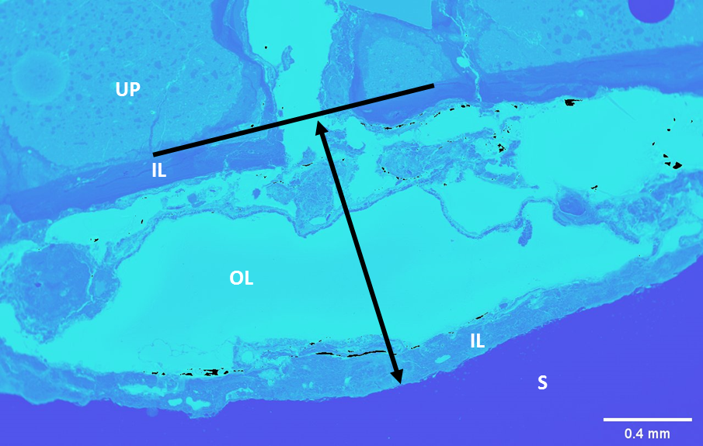 | 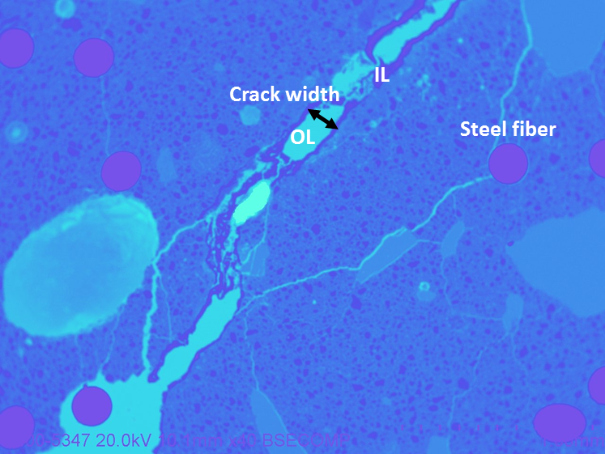
Fig. 3. BSE segmented images showing accumulation of corrosion products (S, steel; IL, inner layer; OL, outer layer; UP, unaltered paste) at: (a) corrosion pit (b) crack.
To check the effect of the inclusion of EA and SF on pit depth and crack width, specimens with a concrete cover of 16.85 mm were studied. Different cover thicknesses on pit depth and crack width were not investigated due to the complexity of cutting and fitting specimens in the rubber formwork (having an inner diameter of 25 mm) for SEM BSE capture. For each corrosion-induced crack, pit depth and crack width were measured for CSTC specimens. For crack width, the average value was taken after measuring the width of the crack at seven different locations along each crack. The PC, EC, and FRC specimens were noted to develop three cracks, while SPUHPC developed only two.
Table 6
Pit depth results for CSTC specimens with a concrete cover of 16.85 mm.
Specimen | Sample number (w.r.t. crack) | Pit depth (mm) | Average pit depth (mm)
CSTC-SP | PC1 | 2.119 | 1.514
CSTC-SP | PC2 | 2.034 | 1.514
CSTC-SP | PC3 | 0.389 | 1.514
CSTC-SE | EC1 | 2.260 | 1.462
CSTC-SE | EC2 | 0.227 | 1.462
CSTC-SE | EC3 | 1.898 | 1.462
CSTC-SF | FRC1 | 2.112 | 0.997
CSTC-SF | FRC2 | 0.184 | 0.997
CSTC-SF | FRC3 | 0.696 | 0.997
CSTC-SS | SPUHPC1 | 0.677 | 0.669
CSTC-SS | SPUHPC2 | 0.661 | 0.669

Tables 6 and 7 show the pit depth and crack width results for CSTCs with a concrete cover of 16.85 mm. The results show that pit depth and crack width decrease with the addition of EA, SF, and EA+SF. The highest average pit depth and crack width of 1.514 mm and 0.857 mm, respectively, were observed for PC, while the lowest was 0.669 mm and 0.272 mm for SPUHPC. The addition of EA and SF separately also reduced pit depth and crack width; however, the most significant results were achieved with the addition of EA and SF together, which confirms its superior performance.
Table 7
Crack width results for CSTC specimens with a concrete cover of 16.85 mm.
Specimen | Sample number (w.r.t. crack) | Crack width (mm) | Average crack width (mm)
CSTC-SP | PC1 | 1.336 | 0.857
CSTC-SP | PC2 | 0.665 | 0.857
CSTC-SP | PC3 | 0.570 | 0.857
CSTC-SE | EC1 | 0.985 | 0.686
CSTC-SE | EC2 | 0.637 | 0.686
CSTC-SE | EC3 | 0.436 | 0.686
CSTC-SF | FRC1 | 0.204 | 0.486
CSTC-SF | FRC2 | 0.764 | 0.486
CSTC-SF | FRC3 | 0.490 | 0.486
CSTC-SS | SPUHPC1 | 0.420 | 0.272
CSTC-SS | SPUHPC2 | 0.125 | 0.272

3.4. Compressive strength analysis
Axial compressive behavior of the CSTCs was investigated for the uncorroded and corroded specimens to examine the effect of chloride-induced corrosion on the mechanical performance of the CSTCs. The peak compressive strength and corresponding deformation of the uncorroded and corroded specimens are shown in Table 8. The axial stress versus axial deformation curve was obtained for each CSTC specimen. The axial stress was calculated from the applied load and deformation recorded by the actuator and the LVDTs. Fig. 4 shows the stress-deformation curve for the uncorroded and corroded CSTC specimens with different cover thicknesses, separated by solid and dashed lines. Different colours correspond to the different concrete mixes (black for PC, red for EC, green for FRC and blue for SPUHPC). Three and two specimens were tested for each mix before and after corrosion, respectively.
Table 8
Test results of CSTC specimens.
Specimen | f_{uc}’ (MPa) | f_{c}’ (MPa) | $\text{D}\text{uc}$ (mm) | $\text{D}\text{c}$ (mm) | f_{c}’/f_{uc}’ | $${D_{c}}/{D_{uc}}$$
CSTC-SP | 84.7 | 54.1 | 1.41 | 0.95 | 0.639 | 0.677
CSTC-SE | 80.8 | 52.1 | 1.27 | 1.01 | 0.645 | 0.799
CSTC-SF | 121.1 | 81.2 | 1.40 | 1.17 | 0.671 | 0.834
CSTC-SS | 127.6 | 91.2 | 1.44 | 1.21 | 0.715 | 0.839
CSTC-MP | 110.9 | 93.7 | 1.35 | 1.17 | 0.845 | 0.861
CSTC-ME | 107.4 | 91.8 | 1.10 | 0.98 | 0.855 | 0.885
CSTC-MF | 116.6 | 103.6 | 1.38 | 1.21 | 0.889 | 0.881
CSTC-MS | 123.1 | 114.2 | 1.42 | 1.38 | 0.928 | 0.970
CSTC-LP | 88.1 | 79.4 | 1.61 | 1.09 | 0.901 | 0.674
CSTC-LE | 84.8 | 76.6 | 1.59 | 1.31 | 0.903 | 0.819
CSTC-LF | 97.4 | 91.1 | 1.76 | 1.33 | 0.935 | 0.756
CSTC-LS | 99.4 | 93.9 | 1.77 | 1.75 | 0.945 | 0.989

Fig. 4(a) shows the stress-deformation curve for uncorroded and corroded specimens with a concrete cover of 16.85 mm for the different mixes. It can be seen that residual peak stress and deformation for corroded specimens were reduced significantly. This was due to the corrosion-induced concrete cracking, reduction in steel tube cross-sectional area and the deterioration of bond between the steel tube and concrete. This phenomenon is significant for PC, where peak stress and deformation drop from 84.7 MPa to 54.1 MPa and 1.41 mm to 0.95 mm, respectively, due to corrosion. The lowest strength reduction due to corrosion was recorded for SPUHPC, where stress dropped from 127.6 MPa to 91.2 MPa and deformation dropped from 1.44 mm to 1.21 mm. The general trend for residual strength (strength after corrosion) is in the following order: SPUHPC > FRC > EC > PC. Figs. 4(b) and (c) show the stress-deformation curve for uncorroded and corroded specimens with cover thicknesses of 22.65 mm and 29.95 mm for different mixes. The general trend for residual strength is similar to that for a cover thickness of 16.85 mm, although residual strength increases with increased cover thickness.
The axial compressive strength test results for uncorroded and corroded CSTCs are summarised in Table 8. Note that f_{uc}’ and f_{c}’ denote the peak compressive strength, while $\text{D}\text{uc}$ and $\text{D}\text{c}$ denote the peak deformation for uncorroded and corroded CSTCs, respectively. The residual strength ratio (f_{c}’/f_{uc}’) and residual deformation ratio ${{(D}_{c}}/{D_{uc}})$ were calculated and are shown in Table 6. The residual strength and residual deformation ratios increase with the addition of EA and SF, and the combined addition of EA and SF (for CSTC-SP, CSTC-SE, CSTC-SF and CSTC-SS, this is 0.639, 0.645, 0.671, 0.715 and 0.677, 0.799, 0.834, 0.839, respectively). SPUHPC exhibited superior performance before and after corrosion for the cover thickness of 16.85 mm, and the trend is in the following order: SPUHPC > FRC > EC > PC. A similar trend is observed in Fig. 5, where an increase in cover thickness led to a reduction in the gap between the compression loads of corroded and uncorroded specimens. The CSTCs with SPUHPC showed the highest residual strength ratios of 0.715, 0.928, and 0.945 after corrosion for the cover thicknesses of 16.85, 22.65, and 29.95 mm, respectively. This confirms the superior corrosion resistance of CSTCs with SPUHPC before and after corrosion due to their denser microstructure, higher cracking resistance and improved fibre-matrix interface [39].
(a) | (b)
(c)
Fig. 4. Stress-deformation curve for uncorroded and corroded CSTC specimens with cover thicknesses of: (a) 16.85 mm (b) 22.65 mm (c) 29.95 mm.
All specimens with a cover thickness of 16.85 mm developed cracks after being subjected to ACT; however, the cracks were tiny for the FRC and SPUHPC specimens. Furthermore, the SPUHPC specimens developed only two small cracks compared to others with three major cracks as shown in Figure 6. Upon being subjected to axial compression loading, failure for the PC and EC specimens was due to concrete spalling. This occurred due to severe corrosion of the specimens and a weak bond between the steel tube and concrete, resulting in concrete debonding when the compression load was applied. However, there was no concrete spalling for the FRC and SPUHPC specimens due to the fibre, which resists cracking and improves the bond between the steel tube and concrete.
(a) |  | (b)
(c)
Fig. 5. Comparison of compression loads for uncorroded and corroded specimens with cover thicknesses of: (a) 16.85 mm (b) 22.65 mm (c) 29.95 mm.
(a) | (b) | (c) | (d)
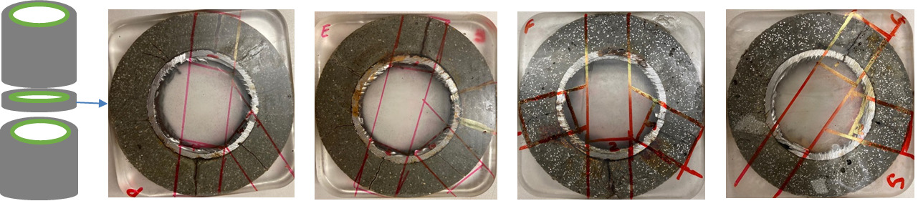
Fig. 6. Sliced specimens for the cracks: (a) CSTC-SP (b) CSTC-SE (c) CSTC-SF (d) CSTC-SS.
The failure patterns of CSTCs with a cover thickness of 16.85 mm after the compression test are displayed in Fig. 7. For the FRC and SPUHPC specimens, compression cracks were observed in similar positions to corrosion cracks. The failure pattern was identical for all cover thicknesses; however, the width and density of the corrosion cracks reduced with increased cover thickness. For the cover thickness of 22.65 mm, the SPUHPC specimen developed no visible cracks, while the other specimens developed visible cracks due to corrosion. Moreover, the cover thickness of 29.95 mm developed no macro cracks visible from the outside; however, cracks were observable for the PC and EC specimens along the cross-section after cutting the specimens.
(a) | (b) | (c) | (d)
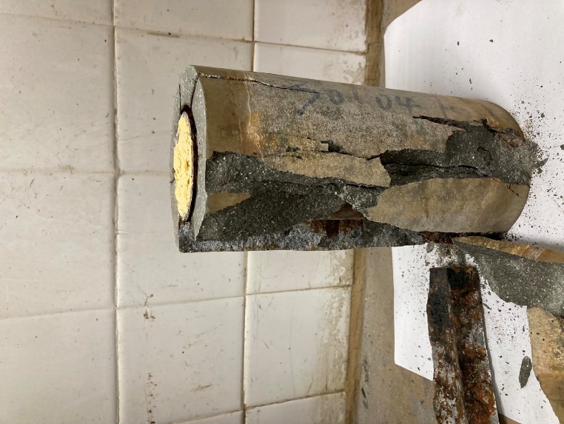 | 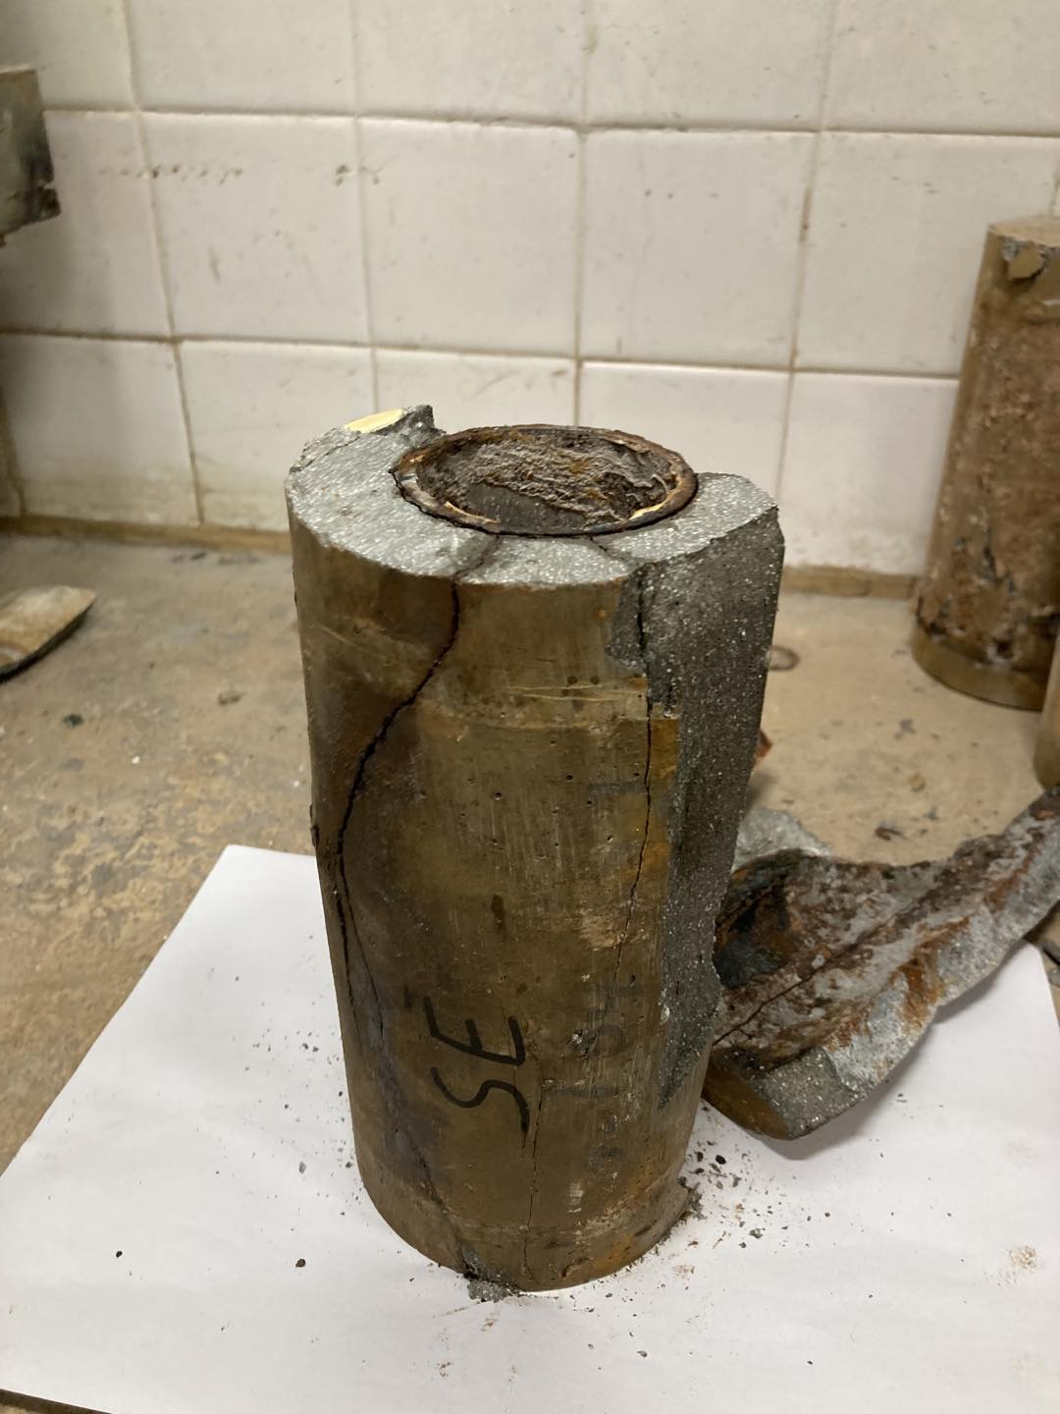 | 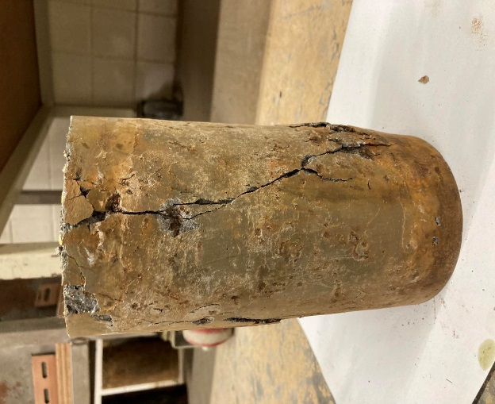 | 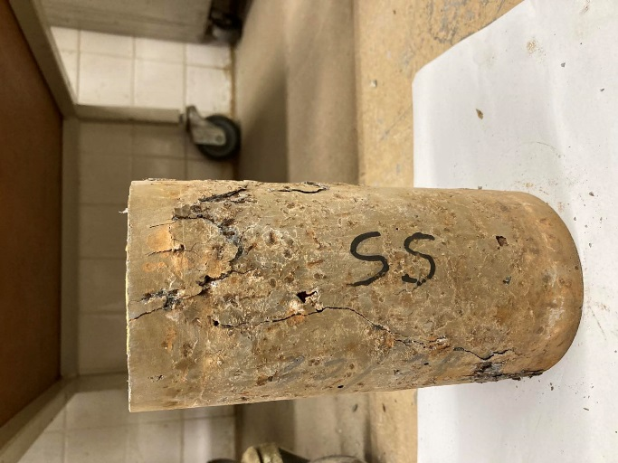
Fig. 7. CSTC specimens’ failure pattern after axial compression test: (a) CSTC-SP (b) CSTC-SE (c) CSTC-SF (d) CSTC-SS.

3.5. Characterization of corrosion products
The composition of steel corrosion products with and without EA and SF in the concrete mixes was characterized by EDX and XRD analysis. Fig. 8 shows an x-ray cartography illustration of the Fe, O, Cl, and Ca distribution. It can be seen that Fe is abundant within the corrosion (IL and OL) layer. Oxygen (O) is present within the whole sample, chlorides (Cl) are primarily present within the corrosion layer and corrosion-filled inside paste, and Ca is abundant within the concrete region. EDX was used to determine the chemical elements present in the sample and can also assess their relative abundance based on atomic percentage. Since these chemical elements can be present as part of compounds (other than oxides or hydroxides) other than rust elements, an XRD analysis was performed to determine which compounds were present within the corrosion products.
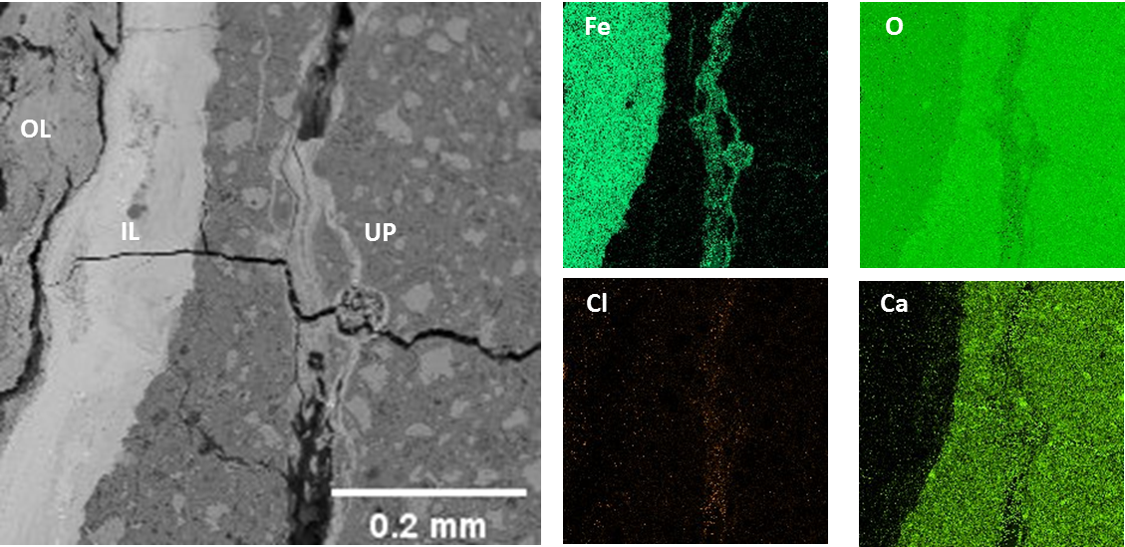
Fig. 8. BSE image and EDX element mapping of Fe, O, Cl, and Ca at cracks for SPUHPC specimens (IL, inner layer; OL, outer layer; UP, unaltered paste).
3.5.1 EDX elemental composition of the corrosion layer
The elemental composition of the rust layers of the four different mixes was determined using EDX analysis with the help of Aztec software. Table 9 shows the differences in the elemental composition of different corrosion layers for the various concrete mixtures. The corrosion layers of all the specimens contained more oxygen than iron, suggesting iron oxides and hydroxides in the rust. The elemental composition of the rust was divided into two parts – corrosion pits and cracks –to establish the differences between them. It can be seen that the amount of oxygen present in the cracks is higher than that in the corrosion pits, which is due to the easy access for oxygen near the cracks in contrast to the corrosion pits. A typical case for the elemental composition of the corrosion layer for SPUHPC is shown in Fig. 9.
(a) | (b)
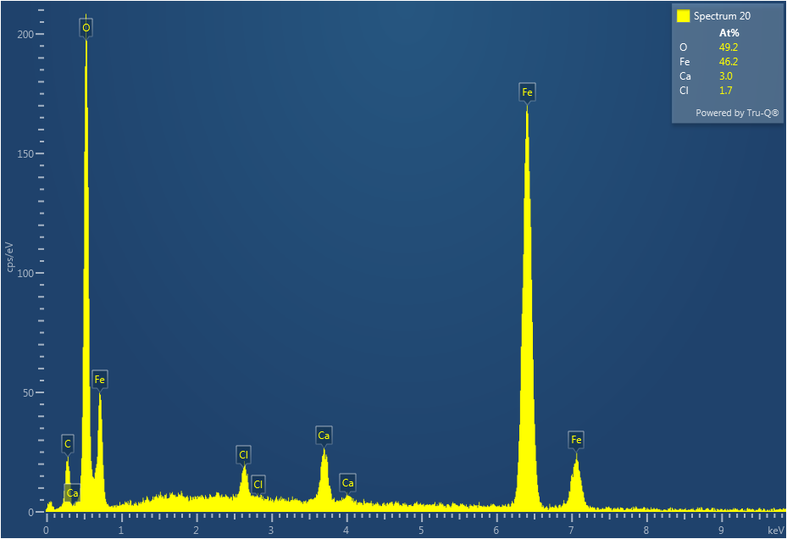 | 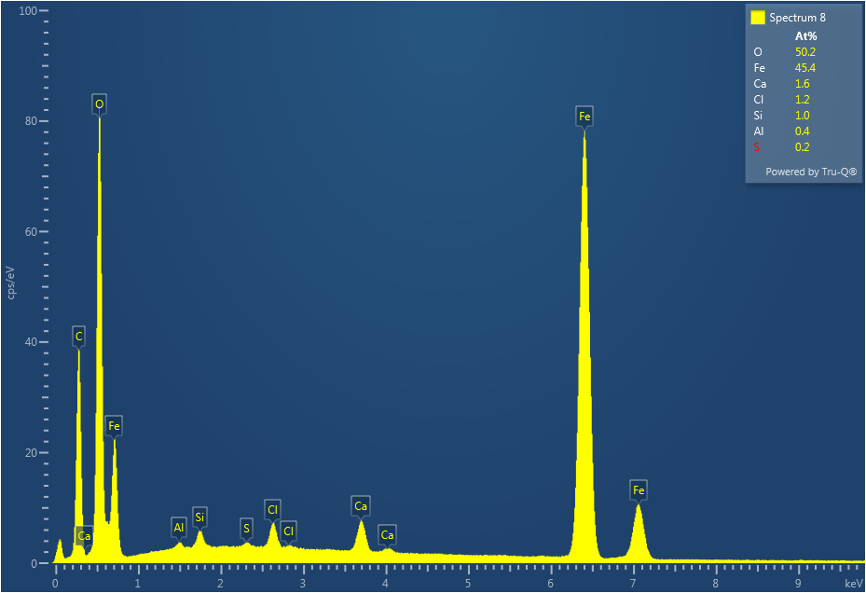
Fig. 9. Elemental composition (atomic %) of corrosion layer for SPUHPC specimens: (a) corrosion pits (b) cracks.
The corrosion products accumulated in the cracks and pits display different Fe/O atomic ratios, as shown in Table 9. This is probably due to the different oxidation levels present – levels dependent on such prevailing conditions as the availability of oxygen [42]. EDX analysis showed that the PC has a lower mean Fe/O atomic ratio (0.727), suggesting rust formation in an oxygen-rich environment than the SPUHPC (Fe/O = 0.906). This could be due to the dense structure of SPUHPC, which allows minimum oxygen penetration. Furthermore, PC has marginally higher penetration levels of Cl compared to other mixes. The lowest levels of Cl were measured for SPUHPC. From this, we can conclude that the combined addition of EA and SF produces dense concrete, which minimizes the penetration of chlorides and oxygen and results in lower oxidation for rust.
Table 9
Elemental composition of corrosion layer by EDX for CSTC specimens with a cover thickness of 16.85 mm.
Specimen | Chemical element | Average atomic percentage |  | Fe/O
Specimen | Chemical element | Corrosion pits | Cracks | Corrosion pits | Cracks | Average
CSTC-SP | O | 50.703 | 54.633 | 0.781 | 0.678 | 0.727
CSTC-SP | Fe | 39.593 | 37.017 | 0.781 | 0.678 | 0.727
CSTC-SP | Cl | 4.267 | 1.517 | 0.781 | 0.678 | 0.727
CSTC-SE | O | 48.944 | 52.283 | 0.848 | 0.705 | 0.774
CSTC-SE | Fe | 41.510 | 36.864 | 0.848 | 0.705 | 0.774
CSTC-SE | Cl | 3.111 | 1.433 | 0.848 | 0.705 | 0.774
CSTC-SF | O | 49.274 | 50.417 | 0.913 | 0.731 | 0.821
CSTC-SF | Fe | 44.975 | 36.867 | 0.913 | 0.731 | 0.821
CSTC-SF | Cl | 2.475 | 1.298 | 0.913 | 0.731 | 0.821
CSTC-SS | O | 49.225 | 50.1 | 0.928 | 0.885 | 0.906
CSTC-SS | Fe | 45.675 | 44.350 | 0.928 | 0.885 | 0.906
CSTC-SS | Cl | 2.750 | 1.150 | 0.928 | 0.885 | 0.906

3.5.2 XRD compound composition of corrosion products
XRD analysis was conducted to identify the compounds in the corrosion products. The relative volume corresponding to each compound is presented in Fig. 10. It can be seen that the volume of oxides (1~2) is much smaller than the volume of hydroxides (2~6.5). XRD patterns of the specimens subjected to ACT are shown in Fig. 11 for the different mixes. The corrosion products were identified using MDI JADE 6 software, and the corresponding powder diffraction files (PDF) numbers are written below the figure. The products identified for PC and EC were mainly hydroxides containing hydrated ferric oxide, akageneite, lepidocrocite, and goethite. The relative volume of these compounds was greater than three times the iron, explaining the greater crack width for PC and EC over the other mixes. The products identified for FRC were mostly goethite, lepidocrocite and certain chloride compounds with relative volumes 2~3 times those of the parent iron. The corrosion products identified for SPUHPC were mainly oxides (wustite and magnetite) with relative volumes below 2, rationalizing its minimal cracking due to corrosion. Consequently, we can conclude from the XRD results that the SPUHPC, with the addition of EA and SF together, developed corrosion products mainly composed of oxides with approximate unit volumes lower than 2. This explains its minimal crack width and pit depth compared to the other mixes.
Fig. 10. Relative volumes of corrosion products of Fe to the parent metal [43].

4. Discussions
4.1. Effects of EA, SF, and cover thicknesses on residual compressive strength
The results of compressive strength presented in section 3.4 show a reduction in residual compressive strength after exposure to ACT. This residual compressive strength is reduced significantly (specifically for a cover thickness of 16.85 mm) due to early corrosion initiation compared to other thicknesses. Additionally, the mix without the addition of EA and SF displayed the lowest residual compressive strength of all the mixes due to its loose microstructure and severe corrosion.
(a) | (b)
(c) | (d)
Fig. 11. XRD pattern of corrosion product. A – Akaganeite (PDF 29-0713); G – Goethite (PDF 29-0713); HF – hydrated ferric oxide (PDF 29-0712); FH – Ferric hydroxide (PDF 46-1436); L – Lepidocrocite (PDF 08-0098); F – Ferroxyhite (PDF 13-0087); X – Chloride composites; M – Magnetite (PDF 46-1452); W – Wuestite (PDF 85-0625): (a) CSTC-SP (b) CSTC-SE (c) CSTC-SF (d) CSTC-SS.
Since the combined addition of EA and SF produced different positive effects on residual compressive strength, it is necessary to explain the individual effect of EA and SF and elaborate upon why their combined addition is more beneficial. In this regard, residual compressive strengths (%) without EA and SF (PC), including EA individually (EC), SF individually (FRC), and adding EA and SF together (SPUHPC) are presented in Fig. 12. The residual compressive strength benefitted from the individual and combined addition of SF and EA. These findings highlight the effectiveness of adding EA and SF to enhance mechanical performance. The only inclusion of EA and SF resulted in increased residual compressive strength to 64.5% and 67.1% from 63.9%, respectively, for a cover thickness of 16.85 mm. Similarly, for cover thicknesses of 22.65 mm and 29.95 mm, residual compressive strength increased to 85.5% and 88.9% from 84.5%, 90.3% and 93.5% from 90.1%, respectively. However, the most significant increase in residual compressive strength occurred with the addition of EA and SF together, increasing residual compressive strength to 71.5%, 92.8%, and 94.5% for cover thicknesses 16.85 mm, 22.65 mm, and 29.95 mm, respectively.
Fig. 12. Residual compressive strength for different mixes and cover thicknesses.
The percentage increases in residual compressive strength due to the addition of EA, SF, and SF+EA, compared to the residual strength of a plain mixture, are given in Table 10 for a more easy comparison. This shows that the percentage increases in residual compressive strength brought about by the comparable solitary addition of SF and EA were not as considerable as those brought about by the use of SF and EA together. For instance, the residual compressive strength of the mixture containing both EA and SF at medium (22.65 mm) cover thickness was 8.28% higher than that of the PC, and the value of 8.28% was significantly higher than the sum of the percentage increases of 0.98% and 4.36% caused by the addition of EA and SF. The spillover of 8.28% - (0.98% + 4.36%) = 2.94% demonstrates the synergistic effect of the combined use of SF and EA on residual compressive strength. This synergistic effect develops due to the combined addition of EA and SF and could improve residual compressive strength and corrosion resistance and allow the development of self-prestressing concrete.
Table 10
Percentage increase in residual compressive strength of CSTC specimens.
Specimen | Addition of | Increase in residual compressive strength (%)
CSTC-S | EA | 0.61
CSTC-S | SF | 3.18
CSTC-S | EA+SF | 7.60
CSTC-M | EA | 0.98
CSTC-M | SF | 4.36
CSTC-M | EA+SF | 8.28
CSTC-L | EA | 0.20
CSTC-L | SF | 3.40
CSTC-L | EA+SF | 4.40

4.2. Influence mechanism of crack width and pit depth
As explained in section 3.3, the addition of EA, SF, and SF+EA decreases crack width and pit depth. A similar practice to the above (section 4.1) was implemented to analyze the effect of adding EA and SF on pit depth and crack width. The percentage decreases in average pit depth and crack width attained by adding EA, SF and EA+SF are reported in Table 10. It is evident from the table that the addition of SF led to a more significant percentage decrease in pit depth and crack width than the addition of EA. Subsequently, the combined addition of EA and SF led to a noticeably more significant percentage decrease in pit depth and crack width. For instance, the combined addition of SF and EA decreases pit depth and crack width by 55.81% and 68.26%, respectively, which values greater than the sum of the percentage decrease for individual additions by 37.59% and 63.24%, respectively. Such quantitative expressions of the synergistic effect on pit depth and crack width demonstrate the beneficial effects of the combined addition of SF and EA. Moreover, SF can improve cracking. Its combined addition with EA could produce a self-prestress around fibre due to the synergistic effect, producing a dense structure and improving cracking and corrosion resistance.
Table 10
Percentage decrease in average pit depth and crack width of CSTC specimens.
Addition of | Decrease in average pit depth (%) | Decrease in average crack width (%)
EA | 3.44 | 19.95
SF | 34.15 | 43.29
EA+SF | 55.81 | 68.26

4.3. Effects on corrosion products of the addition of SF and EA
The effects of the addition of SF and EA on the characterization of the corrosion products for the CSTC specimens exposed to electrochemical ACT were analyzed using SEM/EDX and XRD analysis. The SEM/EDX analysis results based on the atomic percentages of the minerals were characterized, as shown in Table 9. The results show that the Fe/O ratio increases with the individual addition of SF and EA and the combined addition of EA and SF. This increase in Fe/O ratio most likely results from the low oxygen concentration due to the dense structure of the mixes with EA, SF and EA+SF. Moreover, a higher concentration of Fe/O ratio is observed in corrosion pits compared to cracks, primarily because of the higher concentration of oxygen available in the cracks.
The XRD analysis of the corrosion products with the addition of EA, SF and SF+EA shows different corrosion compound peaks, as shown in Fig. 13. For specimens without EA and SF, XRD analysis confirms akageneite and hydrated ferric oxide as the primary corrosion products, indicating a higher concentration of oxygen penetration inside the sample, resulting in a higher volume of rust. Meanwhile, the addition of SF and EA results in the formation of corrosion products with lower relative volume. For instance, the addition of EA and SF mainly results in the formation of the corrosion products of goethite and hydrated ferric oxide and goethite and lepidocrocite, respectively. This is primarily due to an improvement in the sample’s microstructure resulting from the addition of SF and EA, which reduces porosity and correspondingly lowers oxygen availability.
Meanwhile, XRD analysis confirms the corrosion products with minimum relative volume in those specimens with the addition of SF and EA together. Such XRD analysis provides quantitative evidence that wustite and magnetite-type rust is predominant in those specimens with the addition of EA and SF together, which have the lowest relative volume. This composition of corrosion products demonstrates why the combined addition of SF and EA shows superior performance when subjected to ACT.
Fig. 13. Comparison among different mixes for XRD results.

5. Conclusions
The residual mechanical performance and rust compositions of CSTCs with varying mixes and cover thicknesses subjected to chloride-induced corrosion were comprehensively investigated using axial compression testing, crack width and pit depth measurements, and advanced corrosion product characterization techniques, including EDX and X-ray diffraction (XRD). This study has led to the following key findings:
- The electrochemical measurements showed that the self-prestressing UHPC had the lowest corrosion rate of 0.41 $μA/{cm}^{2}$, which is 87.3% lower than concrete mixture without EA and SF.
- The self-prestressing UHPC, with the addition of EA and SF together, sustained maximum residual peak loading and experienced minimum strength loss due to corrosion. It demonstrated higher cracking resistance and displayed the narrowest crack widths and lowest pit depths after corrosion compared to the other mixes.
- EDX results showed the Fe/O ratio was highest for self-prestressing UHPC, indicating that only oxide compounds may be present and the lowest relative volume for rust.
- XRD results confirmed that self-prestressing UHPC had mostly wustite and magnetite type rust with a unit volume of 2 times compared to lepidocrocite, akageneite, and hydrated ferric oxide with a unit volume of 3 to 6.5 times that of other mixes. This strengthens our argument for the superior corrosion performance of self-prestressing UHPC.

Acknowledgements
This work was supported by the National Natural Science Foundation of China (Project No. 51878586). We also acknowledge Dr. Shaohua Chu for his sincere guidance and help during the preparation of mixture design.

Author contributions
M. Khan: Conceptualization; Data curation; Formal analysis; Investigation; Methodology; Writing – original draft
L.J. Chen: Investigation
X.W. Deng: Supervision; Validation; Funding acquisition; Writing – review & editing
R.K.L. Su: Writing – review & editing

References
[1] Z.P. Bazant, Physical model for steel corrosion in concrete sea structures-theory, ASCE J Struct Div 105(6) (1979) 1137-1153.
[2] M. Santhanam, M. Otieno, 5 - Deterioration of concrete in the marine environment, in: M.G. Alexander (Ed.), Marine Concrete Structures, Woodhead Publishing2016, pp. 137-149.
[3] A.R. Al-Rabiah, Rasheeduzzafar, R. Baggott, Durability requirements for reinforced concrete construction in aggressive marine environments, Marine Structures 3(4) (1990) 285-300.
[4] T. Senga Kiesse, S. Bonnet, O. Amiri, A. Ventura, Analysis of corrosion risk due to chloride diffusion for concrete structures in marine environment, Marine Structures 73 (2020) 102804.
[5] A. Poursaee, C.M. Hansson, Potential pitfalls in assessing chloride-induced corrosion of steel in concrete, Cement and Concrete Research 39(5) (2009) 391-400.
[6] K. Wang, D.C. Jansen, S.P. Shah, A.F. Karr, Permeability study of cracked concrete, Cement and Concrete Research 27(3) (1997) 381-393.
[7] A. Djerbi, S. Bonnet, A. Khelidj, V. Baroghel-bouny, Influence of traversing crack on chloride diffusion into concrete, Cement and Concrete Research 38(6) (2008) 877-883.
[8] J. Blunt, G. Jen, C.P. Ostertag, Enhancing corrosion resistance of reinforced concrete structures with hybrid fiber reinforced concrete, Corrosion Science 92 (2015) 182-191.
[9] M. Di Prisco, G. Plizzari, L. Vandewalle, Fibre reinforced concrete: new design perspectives, Materials and structures 42(9) (2009) 1261-1281.
[10] A. Jansson, M. Flansbjer, I. Löfgren, K. Lundgren, K. Gylltoft, Experimental investigation of surface crack initiation, propagation and tension stiffening in self-compacting steel–fibre-reinforced concrete, Materials and structures 45(8) (2012) 1127-1143.
[11] H.H. Abrishami, D. Mitchell, Influence of steel fibers on tension stiffening, Structural Journal 94(6) (1997) 769-776.
[12] C.G. Berrocal, I. Fernandez, K. Lundgren, I. Löfgren, Corrosion-induced cracking and bond behaviour of corroded reinforcement bars in SFRC, Composites Part B: Engineering 113 (2017) 123-137.
[13] S. Chatterji, J.W. Jeffery, The volume expansion of hardened cement paste due to the presence of “dead-burnt” CaO, Magazine of Concrete Research 18(55) (1966) 65-68.
[14] P. Yan, X. Qin, The effect of expansive agent and possibility of delayed ettringite formation in shrinkage-compensating massive concrete, Cement and Concrete Research 31(2) (2001) 335-337.
[15] J.D. Carter, M. Abdulazeez, M.A. ElGawady, K.H. Khayat, FRP confinement of SCC incorporating expansive agent and saturated lightweight sand, Construction and Building Materials 252 (2020) 118924.
[16] W.L. Repette, N.P. Mailvaganam, Calcium Sulfoaluminate-Based Expansive Admixtures A Review, Special Publication 217 (2003) 177-194.
[17] R. Sahamitmongkol, T. Kishi, Tensile behavior of restrained expansive mortar and concrete, Cement and Concrete Composites 33(1) (2011) 131-141.
[18] V. Corinaldesi, A. Nardinocchi, J. Donnini, The influence of expansive agent on the performance of fibre reinforced cement-based composites, Construction and Building Materials 91 (2015) 171-179.
[19] R. Sahamitmongkol, T. Kishi, Tension stiffening effect and bonding characteristics of chemically prestressed concrete under tension, Materials and structures 44(2) (2011) 455-474.
[20] L. Mo, M. Deng, M. Tang, A. Al-Tabbaa, MgO expansive cement and concrete in China: Past, present and future, Cement and Concrete Research 57 (2014) 1-12.
[21] H. Shuguang, L. Yue, Research on the hydration, hardening mechanism, and microstructure of high performance expansive concrete, Cement and Concrete Research 29(7) (1999) 1013-1017.
[22] W. Sun, H. Chen, X. Luo, H. Qian, The effect of hybrid fibers and expansive agent on the shrinkage and permeability of high-performance concrete, Cement and Concrete Research 31(4) (2001) 595-601.
[23] S. Chu, M. Khan, X. Deng, C. Unluer, Bio-inspired self-prestressing concrete (SPC) involving basalt fibers and expansive agent, Cement and Concrete Research 155 (2022) 106735.
[24] O. Alajarmeh, A. Manalo, B. Benmokrane, W. Ferdous, A. Mohammed, R. Abousnina, M. Elchalakani, A. Edoo, Behavior of circular concrete columns reinforced with hollow composite sections and GFRP bars, Marine Structures 72 (2020) 102785.
[25] T.-H. Kim, D.-J. Seong, H.M. Shin, Seismic performance assessment of hollow reinforced concrete and prestressed concrete bridge columns, International Journal of Concrete Structures and Materials 6(3) (2012) 165-176.
[26] K.M.A. Hossain, M.A. Hossain, T. Manzur, Structural performance of fiber reinforced lightweight self-compacting concrete beams subjected to accelerated corrosion, Journal of Building Engineering 30 (2020) 101291.
[27] Q.D. Nguyen, A. Castel, Reinforcement corrosion in limestone flash calcined clay cement-based concrete, Cement and Concrete Research 132 (2020) 106051.
[28] T.A. El Maaddawy, K.A. Soudki, Effectiveness of impressed current technique to simulate corrosion of steel reinforcement in concrete, Journal of materials in civil engineering 15(1) (2003) 41-47.
[29] B. Sanz, J. Planas, J.M. Sancho, An experimental and numerical study of the pattern of cracking of concrete due to steel reinforcement corrosion, Engineering Fracture Mechanics 114 (2013) 26-41.
[30] R. Hay, C.P. Ostertag, Acidification at rebar-concrete interface induced by accelerated corrosion test in aggressive chloride environment, Cement and Concrete Composites 110 (2020) 103573.
[31] H.S. Wong, N.R. Buenfeld, Patch microstructure in cement-based materials: Fact or artefact?, Cem. Concr. Res. 36(5) (2006) 990-997.
[32] L. Chen, R.K.L. Su, Influence of rebar geometry on the steel-concrete interface of reinforced concrete, Construction and Building Materials 304 (2021) 124668.
[33] H.S. Wong, M.K. Head, N.R. Buenfeld, Pore segmentation of cement-based materials from backscattered electron images, Cem. Concr. Res. 36(6) (2006) 1083-1090.
[34] K. Scrivener, R. Snellings, B. Lothenbach, A practical guide to microstructural analysis of cementitious materials, Crc Press2018.
[35] J.I. Goldstein, D.E. Newbury, J.R. Michael, N.W. Ritchie, J.H.J. Scott, D.C. Joy, Scanning electron microscopy and X-ray microanalysis, Springer2017.
[36] C. Andrade, C. Alonso, Corrosion rate monitoring in the laboratory and on-site, Construction and Building Materials 10(5) (1996) 315-328.
[37] M. Stern, A.L. Geaby, Electrochemical Polarization, Journal of The Electrochemical Society 104(1) (1957) 56.
[38] U. Angst, M. Büchler, On the applicability of the Stern–Geary relationship to determine instantaneous corrosion rates in macro‐cell corrosion, Materials and Corrosion 66(10) (2015) 1017-1028.
[39] M. Khan, S.H. Chu, X.W. Deng, Y. Wang, Protection of steel tube against corrosion using self-prestressing UHPC prepared with expansive agent and steel fibers, Structures 37 (2022) 95-108.
[40] G.S. Duffó, W. Morris, I. Raspini, C. Saragovi, A study of steel rebars embedded in concrete during 65 years, Corrosion Science 46(9) (2004) 2143-2157.
[41] A. Köliö, M. Honkanen, J. Lahdensivu, M. Vippola, M. Pentti, Corrosion products of carbonation induced corrosion in existing reinforced concrete facades, Cement and Concrete Research 78 (2015) 200-207.
[42] K.K. Sagoe-Crentsil, F.P. Glasser, “Green rust”, iron solubility and the role of chloride in the corrosion of steel at high pH, Cement and Concrete Research 23(4) (1993) 785-791.
[43] Y. Zhao, J. Yu, B. Hu, W. Jin, Crack shape and rust distribution in corrosion-induced cracking concrete, Corrosion Science 55 (2012) 385-393.

*Corresponding author. Email: xwdeng@hku.hk (X.W. Deng) Address: Room HW 6-28, Haking Wong Building, The University of Hong Kong, Hong Kong

