Chloride-induced corrosion propagation of alkali-activated slag mortar with pulverized fuel ash and metakaolin replacements

Lijie Chen, Mahram Khan, Xiaowei Deng, Ray K.L. Su*
Department of Civil Engineering, The University of Hong Kong, Hong Kong
Abstract: Alkali-activated materials have great potential in reducing CO₂ emissions in cement production industry. This study aims to investigate the corrosion propagation performance of alkali-activated slag mortars with various pulverized fuel ash (PFA) and metakaolin (MK) replacements subject to chloride-induced corrosion. The corrosion propagation performances including corrosion potential, corrosion rate and mortar electrical resistivity under wetting and drying cycles in seawater are studied. Scanning electron microscope (SEM), mercury intrusion porosimetry (MIP) and pH value measurement were conducted to analyze the effects of PFA and MK replacements on the relationship between reaction degree, pore structure, pH value and corrosion propagation performances. The results show that the MK replacement can enhance the corrosion propagation resistance of slag-based alkali-activated mortars under high activator concentration while the PFA replacement reduces the resistance to metallic corrosion of alkali-activated mortars. Mechanisms controlling the corrosion propagation are discussed.

Keywords: alkali-activated slag; fly ash; metakaolin; corrosion propagation; mercury intrusion porosimetry

1. Introduction
The production of ordinary Portland cement (OPC) as a cementitious material in construction sector has been widely recognized as one of the main sources of global CO₂ emission (7~8% of global CO₂ emission [1, 2]). To reduce the use of OPC, a low carbon cementitious material, known as alkali-activated materials (AAMs) [1, 3], has been proposed. The cementing property of AAMs is obtained by activating precursors (pulverized fuel ash, granulated blast furnace slag, calcined clay, etc.) with alkali-activators (sodium hydroxide, water glass, etc.). The carbon footprint of this clinker-free cementitious material has been found to be 40%~80% lower than that of OPC-based concrete [4-7].
As one of the most important durability indices, the chloride-related durability performance of reinforced concrete (RC) structures with AAMs must be fully characterized prior to their wide applications. Main chloride-related durability performances of RC are chloride penetration resistance and resistance to chloride-induced corrosion propagation, which are critical for the service life modeling of marine and coastal structures, e.g. offshore wind turbines [13-15] as a source of clean, renewable energy. Table 1 summarizes the chloride-related durability performances of AAMs in comparison with OPC in literatures. It can be found that the performances of AAMs are not always superior to those of OPC-based mortar or concrete. This indicates that the chloride-related durability performances should be carefully tailored by considering relevant parameters. By increasing the concentration of water glass [8] or sodium hydroxide [9], it has been found that the chloride penetration resistance and resistance to steel corrosion of pulverized fuel ash (PFA)-based AAMs are higher as compared to their OPC counterparts. In blended PFA and ground granulated blastfurnace slag (GGBS) AAMs, the increase in GGBS portion can also enhance the chloride diffusion resistance and resistance to steel corrosion [10, 11]. Another important factor is curing method and aging. For PFA-based AAM, heat curing is necessary for early strength development. It has been claimed in [8, 12] that the heat curing accelerates the reaction degree and gives better chloride-related durability performances of PFA-based alkali-activated concrete as compared with OPC concrete at early age. However, the strength and chloride-related durability performances of OPC concrete develop with time while the continuous reaction of PFA-based alkali-activated concrete is limited. Therefore, the long-term chloride-induced performances of PFA-based alkali-activated concrete have been found to be lower than that of OPC concrete [12]. This argument is further supported by [11]. In [11], both alkali-activated mortars and OPC mortars were cured at elevated temperatures. Although alkali-activated binders and mortars showed higher or similar compressive strengths, most of the chloride penetration resistances of alkali-activated binders and mortars were worse than those of OPC binder and mortars. Table 1 also shows that so far most of research efforts have been paid on chloride diffusion resistance and there has been little discussion about the chloride-induced corrosion propagation performance of AAMs.
There has been increasing research interest in binary and ternary binder systems by replacing high-calcium binders (e.g. GGBS) with low-calcium binders (e.g. PFA and metakaolin (MK)) [1]. N-A-S-(H) gels as products of PFA can offer excellent chemical resistance [13], chloride binding ability [10, 14] and rheology properties [15], while C-A-S-H gels as products of high-calcium binder can reduce permeability by chemically binding water [16]. In recent years, there has been an increasing interest in partially replacing GGBS in AAMs by MK. This is because the inclusion of the hydration products of MK (N-A-S-H gels) can improve the stability of products obtained by the alkali-activation of slags (C-A-S-H gels). The mechanical [17], chemical resistance [18] and chloride permeability [19] performances have been found to be enhanced due to the partial replacement of MK. At low to moderate activator concentration, the setting time of alkali-activated slags can be extended [17, 20, 21].
In view of the potential important role of AAMs as a sustainable construction material, the knowledge on the chloride-induced corrosion propagation of AAMs is far from enough. To fill this research gap, this study aims to investigate chloride-induced corrosion propagation performance of alkali-activated slag mortars with PFA and MK replacements. Nine mortar mixes with various PFA and MK replacement levels were activated by sodium hydroxide solution and sealed curing at ambient temperature. The chloride-induced corrosion propagation of the AAM mortars was investigated by measuring electrochemical potential, rate of metallic loss of steel tubes and electrical resistivities of mortars with the use of linear polarization resistance (LPR) and electrochemical impedance spectroscopy (EIS) techniques. pH values of mortar mixes were obtained to better understand the mechanism of chloride-induced corrosion propagation. Scanning electron microscopy (SEM) and mercury intrusion porosimetry (MIP) were used to examine the reaction degree of slags and the pore structure of mortar mixes. The experimental results are discussed to get insights into the chloride-induced corrosion propagation of alkali-activated slags with different PFA and MK replacements.

2. Materials and methodology

2.1 Mix design
In this study, 52.5N ordinary Portland cement (OPC) is used to cast reference mortars for alkali-activated mortars. The precursors of alkali-activated mortars are metakaolin (MK), ground granulated blast furnace slag (GGBS) and pulverized fuel ash (PFA). The oxide compositions of OPC, MK, GGBS and PFA can be found in Table 2. NaOH pellets were added into water one day prior to casting in order to make a 10 M NaOH solution. Fine-grained quartz sands with a maximum diameter of 1.18 mm were used as fine aggregate. Straight steel fibers were used with a length of 13 mm, a diameter of 0.2 mm and a tensile strength of 1200 MPa.
Table 3 shows the mix designs of the mortars investigated in this study. The water/binder ratio is kept as 0.45. For alkali-activated mortar, binder means precursor. Sand volume is kept as 20%. The volume percentage of steel fiber is 0.5%. Superplasticizer was used as 2% of the binder. OPC denotes the fiber-reinforced OPC mortar. G-X denotes fiber-reinforced MK- and GGBS-based alkali-activated mortar. X denotes the percentage replacement level of GGBS by MK. GP-X denotes fiber-reinforced MK-, GGBS- and PFA-based alkali-activated mortar. X denotes the percentage replacement level of GGBS and PFA by MK. In GP-X mortars, the weights of GGBS and PFA are equal. The concentration of activator is expressed as weight percentage of Na₂O relative to the mass of precursors, which is 12.4% in this study.

2.2 Specimen preparation for studying chloride-induced corrosion propagation
As shown in Figure 1, hollow steel tubes with different diameters were placed in a steel mold with a diameter of 100 mm. The thicknesses of mortar are 18.35 mm, 24.25 mm and 31.55 mm. The height of the specimens is 200 mm. During casting, the binders were first dry–mixed for 4 minutes, and then the alkaline solution was added and stirred in Hobart mixer for another 4 minutes. Steel fibers were slowly added after pouring alkaline solution. The mixtures were then compacted on a vibration table.
After tap water-curing in ambient temperature for 28 days, a round block of epoxy resin was cast under each specimen to prevent water leakage. An electrical lead was welded on the steel tube for electrochemical measurements. After then, the upper surface of a specimen was covered by a plastic sheet and then sealed by an adhesive glue.

2.3 Experimental methods
During mortar casting, a mini-slump flow cone with a base and top internal diameter of 100 mm and 70 mm was used to measure the slump flow on a 250 mm flow table disc. The measurement of the slump flow is in accordance with BS EN 12350–8: 2010 [22].
In order to test the compressive strengths of the mixes shown in Table 3, several cubes with a dimension of 40 mm were casted. The cubes were cured by immersion in ambient temperature tap water. At different ages of the cubes, the compressive strengths were tested at a loading rate of 3 kN/s.
To study the effect of MK replacement on the reaction degree of the slag in the alkali-activated mortars, several cubes with a dimension of 40 mm were casted and cured in ambient temperature tap water. On Day 7, these cubes were taken out from water. The cubes were then cut, ground, polished to make samples of scanning electron microscope (SEM) tests. The procedure of preparing SEM samples is basically the same as the method adopted in [23]. Backscattered electron (BSE) images were captured under 500x magnification in order to determine the reaction degrees according to the method recommended in [24]. The reaction degree of a solid material can be determined by the following equation:
$R=1-\frac{V_{u}}{V_{t}}$
where R denotes the reaction degree of a solid material, V_{u} denotes the volume fraction of the unreacted solid material, which is determined by couting the points located on the un-reacted grains in BSE images (so-called point-counting analysis) [25], V_{t} denotes the total volume fraction of the solid material without any reactions, which is determined by the mortar mix design. The point-counting analysis has been proven to be accurate enough to estimate the reaction degree of cementitious materials with supplementary cementitious materials in [24, 25].
To study the chloride-induced corrosion performance of the mixes, the cured specimens shown in Figure 1 were placed in an oven with a temperature of 50 °C for four days. The specimens were then immersed in seawater for the ingression of chloride ions. This method of accelerating the initiation of chloride-induced corrosion has been adopted in a previous study [26]. After the corrosion initiation, the specimens were subject to alternate wetting and drying cycles, which consist of one week of partial immersion in seawater and one week of air exposure in an indoor lab environment. Alternate wetting and drying cycles for monitoring corrosion propagation of the mortars last for two months.
During the wetting cycles, electrochemical measurements were conducted by using an electrochemical workstation PARSTAT 3000A-DX bipotentiostat, Princeton Applied Research, USA. The corrosion potentials of the specimens were measured by using a AgCl electrode. A stainless-steel plate was used as counter electrode. The corrosion rates of the specimens were measured by linear polarization resistance (LPR) technique, in which the potential of the steel was polarized from a potential 30 mV lower than the corrosion potential of the steel, to a potential 30 mV higher than the corrosion potential of the steel with a scan rate of 0.16 mV/s according to [27]. By using LPR technique, the polarization resistance can be obtained, and the corrosion rate can be calculated by dividing the Stern-Geary coefficient of 26 mV with the polarization resistance. The mortar resistivity was measured by electrochemical impedance spectrum (EIS) technique, in which the mortar resistance was selected as the impedance at the minimum of the negative phase angle [28, 29]. The frequency of the EIS technique ranged from 100 mHz to 10 kHz, with a maximum perturbation potential of 10 mV [29]. A cell constant [30], which is based on the material property and specimen geometry, was calculated by a COMSOL model. The mortar resistivity can be obtained by multiplying the mortar resistance measured by the EIS technique with the cell constant by the COMSOL simulation. The effect of mortar resistivity was excluded in calculating the corrosion rate by using Stern-Geary equation [28].
To determine the pH value of the pore solution of the mixes, a 5 g paste sample of the mixes was ground below 150 um and mixed with mineral water at a weight ratio of 1:1. The mixed solution was shaken for 5 minutes to unify the suspension. A pH meter with 0.01 accuracy was used to the filtered suspension to get the pH value of the pore solution after 7 days of cube specimens water curing [31, 32].
To determine the pore size distribution of the mortars, small cubes were cut from the 40 mm cubes after 28 days of water curing. The samples were dried and then examined by MicroActive AutoPore V9600 mercury porosimeter. The mercury intrusion porosimetry (MIP) was conducted with a pressure range of 0.1~61000 Psia and a contact angle between the mercury and the pore surface of 130°.

3. Results

3.1 Workability, compressive strength and reaction degree
Figure 2 shows the slump flow diameters of the mixes in this study. It can be observed that the workability of the mixes can be significantly influenced by changing the precursor composition. More specifically, the slump flow diameter of OPC mortar can be decreased from 140 mm to around 105 mm by using slag and metakaolin as precursors. A slump flow diameter of 105 mm indicates the workability of the slag-based alkali-activated mortar is poor. On the other hand, the workability of the slag-based alkali-activated mortar can be significantly enhanced by partially replacing 50% of GGBS with PFA, e.g. from 103 mm to 192 mm for the cases without MK replacement. Moreover, the workability of GGBS-PFA-based alkali-activated mortar can be better than that of the reference OPC mortar. The MK replacement significantly decreases the workability of GGBS-PFA-based alkali-activated mortar from 192 mm to 110 mm. The results in Figure 2 indicate that an optimal slump flow can be designed by adjusting the proportions of PFA and MK in GGBS-based alkali-activated mortar.
Figure 3 presents the compressive strengths of mortar mixes at different ages. The compressive strengths of OPC mortars are higher than those of alkali-activated mortar mixes at different hydration ages except for G-15 on Day 3. The compressive strength can be significantly increased by partially replacing MK, especially for hydration ages longer than 1 day. It should be noted that 15% of MK replacement can achieve a compressive strength comparable with that of reference OPC mortars. The 28 day compressive strengths of GGBS-based alkali-activated mortars are decreased by 50% replacement of PFA, which is consistent with [11].
Figure 4 shows the reaction degrees of the slags in GGBS-based alkali-activated mortars and GGBS-PFA-based alkali-activated mortars at Day 7. As reference, the reaction degree of cement grain in OPC mortar is higher than those of alkali-activated mortars. The MK replacement can accelerate the reaction of slags. This effect is more significant for GGBS-PFA-based alkali-activated mortar as compared with GGBS-based alkali-activated mortar. The MK replacement effect on the reaction degree correlates well with that on compressive strength.
The effects of PFA replacement on the workability and compressive strengths are generally in accordance with the results in [15, 33, 34]. The partial replacement of GGBS with PFA in alkali-activated slag mortars increases the workability by delaying the geopolymerisation and smoothing the mix components [15]. As a result, the compressive strength can be decreased accordingly [11, 34].
On the other hand, the effects of MK replacement on workability and compressive strength depend on the activator concentration. Bernal et.al. [20, 35] found increased MK proportion in GGBS-MK-based alkali-activated materials with relatively low activator content (5% Na₂O by mass of GGBS+MK) can enhance the workability, but with higher permeability and reduced compressive strength. However, by increasing the activator concentration to 9.1% ~14.5% Na₂O by mass of GGBS+MK in [19], they found that increased MK content can lead to reduced water sorptivity and higher compressive strengths. It can be concluded from the results of [19, 20, 35] that sufficient alkalinity should be provided (e.g. Na₂O by mass of GGBS+MK around 10%) in order to produce a stable C-A-S-H and N-A-S-H gel system. This is supported by the decreased workability, enhanced compressive strength and increased reaction degree of GGBS by increasing MK replacement as found in this study (12.4% Na₂O by mass of precursors). Similar effects of MK replacement on workability and mechanical performances of AAMs can be also found in [17] and [34] (13.5% Na₂O by mass of GGBS+MK).

3.2 Electrochemical measurement

3.2.1 Corrosion potential
Figure 5 shows the average corrosion potential of the mixes with different cover thicknesses under the effect of PFA and MK replacements. All corrosion potentials as shown in Figure 5 are lower than -233 mV vs. AgCl, which is a critical corrosion potential as recommended by ASTM C876 [36], corresponding to 90% probability of corrosion for metal. The corrosion potentials of alkali-activated mortars are much lower than that of OPC mortars. Similar results have also been found in [10]. Reduction in redox potential led by sulphide ions in slag-rich binders has been used to explain the decrease in corrosion potential of rebar embedded in alkali-activated materials [10, 37]. It appears that the corrosion potential of GGBS-based alkali-activated mortar can be increased by replacing GGBS with MK, while there is no significant effect of MK replacement on the corrosion potential of GGBS-PFA-based alkali-activated mortars. The differences between the corrosion potentials of GGBS-based and GGBS-PFA-based alkali-activated mortars are slight.

3.2.2 Corrosion rate
Figure 6 (a)-(c) show the corrosion rate of the mixes under the effect of PFA and MK replacements with different cover thicknesses. The PFA replacement significantly increases the corrosion rate, while the MK replacement can decrease the corrosion rate of GGBS-based alkali-activated mortars. For simplicity, Figure 6 (d) presents the average corrosion rate of the mixes with various mortar cover thicknesses. Unlike corrosion potential, the corrosion rate of OPC mortars is close to those of GGBS-based alkali-activated mortars, which can be characterized as moderate according to RILEM TC 154-EMC [38]. On the other hand, the corrosion rates of GGBS-PFA-based alkali-activated mortars are significantly higher as compared with those of OPC mortars and GGBS-based alkali-activated mortars. There is an effect of MK replacement on decreasing the corrosion rate of alkali-activated mortars. By increasing MK replacement level up to 15% the corrosion rate of GGBS-based alkali-activated mortars can be lower than that of OPC mortars, while it appears that the effect of MK substitution on decreasing the corrosion rate of GGBS-PFA-based alkali-activated mortars is optimal at a replacement level of 10% although with a corrosion rate higher than that of OPC mortars.

3.2.3 Mortar resistivity
Figure 7 shows the effect of PFA and MK replacements on average electrical resistivities of mortars with different cover thicknesses. The electrical resistivity of OPC mortars is highest. As for the alkali-activated mortars, the electrical resistivity can be increased by partially replacing 50% of GGBS with PFA in the precursors. It should be noted that the effects of MK replacement on the electrical resistivity vary with different precursor constitutions. For GGBS-based alkali-activated mortars, the MK substitutions can decrease the electrical resistivity. On the other hand, the electrical resistivity of GGBS-PFA-based alkali-activated mortars is increased by MK substitutions. The results as shown in Figure 7 indicate that the increased mortar resitivity upon PFA and MK replacements may be induced by increased portion of N-A-S-H gel in the cementitious matrix.

3.2.4 EIS test result
In general, the EIS result of cementitious material with steel reinforcedment has two distinct arcs. The first arc represents the cementitious materials while the second arc reveals the electrochemical behaviors of the steel reinforcement. The two arcs are separated by a point which locates at lowest imaginary impdance.
Figure 8 (a) and Figure 8 (b) compare the EIS results of OPC mortar with those of GGBS-based and GGBS-PFA-based alkali-activated mortars, respectively. It can be observed that the real part of impedance of OPC mortar is higher as compared with those of GGBS-based and GGBS-PFA-based alkali-activated mortars, which is in accordance with the results as shown in Figure 7. Figure 8 (a) also presents that the arcs corresponding to the corrosion of the steels embedded in GGBS-based alkali-activated mortars are similar with that of the steel embedded in OPC mortar, while the arcs of GGBS-PFA-based alkali-activated mortars as shown in Figure 8 (b) are depressed as compared with that of OPC mortar. As the polarization resistance can be obtained by fitting this arc (and then transferred to corrosion rate [28]), this indicates that the corrosion rates of GGBS-based alkali-activated mortars are similar with that of OPC mortar and the corrosion rates of GGBS-PFA-based alkali-activated mortars are significantly higher than that of OPC mortar. Therefore, the results by EIS tests as shown in Figure 8 justify the corrosion rates of the mortars by LPR tests as shown in Figure 6.

3.3 pH value measurement
The pH value of pore solution is critical for understanding the chloride-induced corrosion propagation. Figure 9 shows the pH values of pore solutions for OPC mortar and alkali-activated mortars. The pH value of OPC mortar is 13.67, which is lower than those of alkali-activated mortars without MK substitutions. More specifically, the pH values of alkali-activated mortars without MK substitutions can be around 14.1, however, which can be decreased to around 13.5 and around 13.7 by MK substitutions for GGBS-based alkali-activated mortars and GGBS-PFA-based alkali-activated mortars respectively. There is no significant effect of replacing 50% of GGBS with PFA in precursor constitution on the pH value of the pore solutions. This may indicate the significant change in corrosion rate by PFA replacement is not correlated with pH value.
The decreased pH value with increasing MK replacement level as shown in Figure 9 is consistent with the results in [21], which can be explained by the consumption of OH⁻ ions during the dissolution of MK and the formation of initial N-A-S-H gels.

3.4 Mercury Intrusion Porosimetry (MIP)
The pore structure is critical for characterizing the chloride-induced corrosion propagation performance of a cementitious material, as found in [39-41]. Figure 10 shows the overall porosity for different mixes in this study by MIP tests. The experimental results in Figure 10 indicate that the GGBS-PFA-based alkali-activated mortars are more porous than OPC mortar, of which the overall porosity is significant increased from around 16% up to around 30%. On the other hand, the MK replacement can decrease the overall porosity. This effect is more significant for GGBS-based alkali-activated mortars. The pore structure of GGBS-based alkali-activated mortars can be denser than that of OPC mortar by increasing the MK replacement level. However, the effect of MK replacement on reducing porosity of GGBS-PFA-based alkali-activated mortars is maximum at a replacement level of 10% and this maximum effect does not lead to a porosity close to that of OPC mortar. It seems there is a correlation between the corrosion rate as shown in Figure 6 (d) and the overall porosity, which will be further discussed in the discussion part.
Figure 11 compares the MIP test result of OPC mortar with those of alkali-activated mortars without MK replacement (G-0 and GP-0). As shown in Figure 11 (a), the cumulative porosity of G-0 is significantly higher than that of OPC with a pore size larger than 0.1 um. On the other hand, the curve of G-0 overlaps with that of OPC with a pore size lower than 0.1 um. GP-0 is significantly more porous than OPC with a pore size lower than 1um. The overall porosity of GP-0 is doubled as compared with OPC.
Based on the pore size, the pores can be divided into four types according to [42]: gel pores (<0.010 um), medium capillary pores (0.01 um-0.5 um), large capillary pores (0.5 um- 10 um) and macro-pores (>10 um). Figure 11 (b) shows the pore size distributions with the characterization of type of pores. Figure 11 (c) further compares the porosities corresponding to different types of pores with different mixes. Figure 11 (b) and Figure 11 (c) show that, G-0 has less medium capillary pores while more macro-pores as compared with OPC. The pore structure of GP-0 is similar with that of OPC in terms of macro-pores, while the capillary pores of GP-0 are significantly increased as compared with those of OPC, especially for medium capillary pores.
The increase in capillary porosity of GP-0 and reduction in medium capillary porosity of G-0 as compared with OPC are in accordance with the SEM results. The SEM image of OPC as shown in Figure 12 (a) is clearly more porous than that of G-0 as shown in Figure 12 (b) in terms of fine porosity. By comparing Figure 12 (c) with Figure 12 (a), GP-0 has significantly more fine porosities than OPC, whose pore sizes are around 1 um.
Figure 13 further presents the effect of MK replacement on MIP results of GGBS-based alkali-activated mortars. Figure 13 (a) shows that the curves of GGBS-based alkali-activated mortars overlap with that of OPC mortar with pore sizes from 0.02 um to 0.1 um. The overall porosity of GGBS-based alkali-activated mortars is decreased by increasing MK replacement. Figure 13 (b) and Figure 13 (c) reveal that the effect of MK replacement on porosity is the increase in pores with sizes larger than 0.5 um (large capillary pores and macro-pores), and the reduction in medium capillary pores.
Figure 14 presents the effect of MK replacement on MIP results of GGBS-PFA-based alkali-activated mortars. Figure 14 (a) shows that unlike GGBS-based alkali-activated mortars, the increased MK replacement does not reduce the overall porosity of GGBS-PFA-based alkali-activated mortars to a level close to that of OPC mortar. Figure 14 (b) shows that GGBS-PFA-based alkali-activated mortar is generally more porous than OPC mortar regardless of MK replacement levels and pore size. Figure 14 (c) reveals that the effect of MK replacement on the pore structure refinement of GGBS-PFA-based alkali-activated mortars lies on decreasing the medium and large capillary pores with an optimal replacement of 10%, while the macro-pores are always increased by increasing MK replacement.
The results of MIP tests in this study have shown that the pore structure of slag-based alkali-activated mortars can be significantly coarsened by replacing 50% of GGBS with PFA. John et.al. [16] has also found that the increasing PFA replacement in GGBS-based alkali-activated binders can lead to higher segmented porosity and reduction in diffusion tortuosity. Upon increased PFA replacement, the cementitious matrix is dominated by the N-A-S-(H) gels produced by PFA geopolymerization, which cannot provide enough pore network obstruction as compared with the C-A-S-H gels produced by GGBS alkali-activation.
The MK replacement has been found to decrease the porosity of the mortars under high activator concentration. Special attentions should be paid on the GGBS-PFA-based alkali-activated mortars. In this case, the MK replacement effect on porosity is maximum at 10% and cannot compensate the adverse effect of replacing 50% GGBS with PFA. This indicates that excessive N-A-S-H gels produced by MK and PFA geopolymerization can degradate the pore structure for a gel system consisting of N-A-S-H gels and C-A-S-H gels. The MK replacement effect on porosity correlates well with that on the compressive strength by comparing Figure 3 and Figure 10. It can be concluded that MK replacement in alkali-activated slag mortars with high activator concentration can enhance the compressive strength by reducing medium and large capillary porosity.

4. Mechanism of PFA and MK replacements on chloride-induced corrosion propagation of alkali-activated mortars
In this study, the change of pH value is unlikely to affect the corrosion rate. The experimental results have shown that the change in corrosion rate is corellated with the modification of pore structure upon PFA and MK replacements. The mechanism controlling corrosion rate of slag-based alkali-activated mortars under PFA and MK replacements will be illustrated as follows with the analysis of corrosion rate-corrosion potential relationship diagram.
The relationship between corrosion rate and corrosion potential has been used to analyse the mechanism controlling corrosion of metal. Figure 15 schematically shows possible mechanisms for corrosion of reinforcing steel in porous materials. Figure 15 (a) shows the corrosion of reinforcing steel can be controlled by anodic reaction or ohmic resistance, under which the corrosion rate increases with decreasing corrosion potential [43]. The cathodic reaction can also control the corrosion of reinforcing steel by affecting the oxygen supply as shown in Figure 15 (b), where the corrosion rate increases with increasing corrosion potential [44].
In recent years, there has been a novel statement about the mechanism of reinforcing steel, namely porosity or electrolyte control (Figure 15 (c)) [39, 40]. In this case, the corrosion rate changes significantly while the corrosion potential keeps more or less stable. A stable corrosion potential indicates that the tendency of steel to corrode remains constant [45, 46]. It seems like the significant change in corrosion rate is contradictory with the stable corrosion potential in Figure 15 (c). One may explain this by exploring the definition of corrosion rate:
$i_{corr}=\frac{I_{corr}}{A_{steel}}$
where i_{corr} is corrosion rate in uA/cm², I_{corr} is corrosion current in uA and A_{steel} is corroding area in cm². The measurement of corroding area of steel embedded in porous materials A_{steel} has been impeded since it is complicated by various factors, e.g. porosity of materials, degree of saturation and external polarization. Instead of measuring exact A_{steel}, a pre-defined corroding area A_{steel} has been used in corrosion rate measurement. In this case, the change in corrosion rate measurement equals to the change in corrosion current I_{corr}. So the significant change in corrosion rate with stable corrosion potential can be explained by the significant change in corrosion current, as a result of the change in material porosity or available electrolyte amount under different humidity conditions (so called “porosity/electrolyte control” as shown in Figure 15 (c)). In the porososity/electrolyte control, the electrochemical state of steel remains stable as evidenced by the stable corrosion potential.
Figure 16 compares the average corrosion rates with average corrosion potentials of specimens with different cover thicknesses. As mentioned in Section 3.2.1, the corrosion potential of slag-based alkali-activated mortars can be lower as compared with OPC mortars due to the sulphide ions without changing corrosion rate. The corrosion rates of GGBS-PFA-based alkali-activated mortars are significantly increased as compared with those of GGBS-based alkali-activated mortars with similar corrosion potentials. This correlates well with the increased capillary porosity by replacing GGBS by PFA as found in MIP tests. Figure 17 further shows the there is a strong linear correlation between the overall porosity by MIP tests and corrosion rates by LPR tests, in which a constant corroding area was used for calculating corrosion rate. Figure 16 and Figure 17 indicate that the corrosion states of the steels embedded in GGBS-based and GGBS-PFA-based alkali-activated mortars are similar. Higher corrosion rates measured for GGBS-PFA-based alkali-activated mortars as compared with GGBS-based alkali-activated mortars are due to coarsened pore structure upon PFA replacement. In conclusion, the corrosion of the steels embedded in the mortars in this study are controlled by porosity.
The corrosion propagation performances of alkali-activated materials have been found to be contradictory in existing literatures [9][47][10][12]. This may be induced by different compositions of precursors, activators and curing methods. Further research is clearly needed on the corrosion propagation performance of alkali-activated materials considering the limited number of literatures.

5. Conclusions
This study investigates the chloride-induced corrosion propagation of ground granulated blast furnace slag (GGBS)-based alkali-activated mortars with various pulverized fuel ash (PFA) and metakaolin (MK) replacements. Based on the experimental results in this study, following conclusions can be drawn:
- Compressive strength of GGBS-based alkali-activated mortars can be increased by increasing MK replacement with a high activator concentration (12% Na₂O of precursors). In this case, the MK replacement can decrease medium capillary pores (pore size from 0.01 um to 0.5 um) by forming a stable co-existing C-A-S-H and N-A-S-H gel system.
- Replacing 50% of GGBS with PFA can enhance the workability albeit decrease the compressive strength of GGBS-based alkali-activated mortars. PFA replacement can lead to a significant increase in capillary pores with size from 0.01 um to 10 um.
- The corrosion rates of GGBS-based alkali-activated mortars are close to those of OPC mortars, while the corrosion rates of GGBS-PFA-based alkali-activated mortars are significantly higher than those of OPC mortars.
- MK replacement can improve the corrosion rate performance of GGBS-based and GGBS-PFA-based alkali-activated mortars. The corrosion rate of GGBS-based alkali-activated mortars can be decreased by 15% MK replacement to a level lower than that of OPC mortars.
- The effects of PFA and MK replacements on the corrosion rate of GGBS-based alkali-activated mortars mainly lie on the change in porosity. The corrosion of the steels embedded in alkali-activated mortars can be controlled by porosity without significant change in corrosion potential.

Acknowledgment
We acknowledge the generous support provided by the “National Natural Science Foundation of China” (Project No. 51878586). We also want to acknowledge Dr. Hailong Ye for his continuous guidance and help during this project.

References
[1] J.L. Provis, S.A. Bernal, Geopolymers and Related Alkali-Activated Materials, Annu. Rev. Mater. Res. 44(1) (2014) 299-327.
[2] J.G. Olivier, J.A. Peters, G. Janssens-Maenhout, Trends in global CO2 emissions. 2012 report, (2012).
[3] J.L. Provis, Alkali-activated materials, Cem. Concr. Res. 114 (2018) 40-48.
[4] B.C. McLellan, R.P. Williams, J. Lay, A. Van Riessen, G.D. Corder, Costs and carbon emissions for geopolymer pastes in comparison to ordinary portland cement, J. Clean. Prod. 19(9-10) (2011) 1080-1090.
[5] J.S. van Deventer, J.L. Provis, P. Duxson, D.G. Brice, Chemical research and climate change as drivers in the commercial adoption of alkali activated materials, Waste and Biomass Valorization 1(1) (2010) 145-155.
[6] A. Heath, K. Paine, M. McManus, Minimising the global warming potential of clay based geopolymers, J. Clean. Prod. 78 (2014) 75-83.
[7] G. Habert, C. Ouellet-Plamondon, Recent update on the environmental impact of geopolymers, RILEM Tech. Lett. 1 (2016) 17-23.
[8] D.W. Law, A.A. Adam, T.K. Molyneaux, I. Patnaikuni, A. Wardhono, Long term durability properties of class F fly ash geopolymer concrete, Mater. Struct. 48(3) (2014) 721-731.
[9] F.U. Shaikh, Effects of alkali solutions on corrosion durability of geopolymer concrete, Adv. Concr. Constr. 2(2) (2014) 109.
[10] C. Tennakoon, A. Shayan, J.G. Sanjayan, A. Xu, Chloride ingress and steel corrosion in geopolymer concrete based on long term tests, Mater. Des. 116 (2017) 287-299.
[11] H. Zhu, Z. Zhang, Y. Zhu, L. Tian, Durability of alkali-activated fly ash concrete: Chloride penetration in pastes and mortars, Constr. Build. Mater. 65 (2014) 51-59.
[12] K. Pasupathy, M. Berndt, J. Sanjayan, P. Rajeev, D.S. Cheema, Durability of low‑calcium fly ash based geopolymer concrete culvert in a saline environment, Cem. Concr. Res. 100 (2017) 297-310.
[13] S.A. Bernal, J.L. Provis, B. Walkley, R. San Nicolas, J.D. Gehman, D.G. Brice, A.R. Kilcullen, P. Duxson, J.S. van Deventer, Gel nanostructure in alkali-activated binders based on slag and fly ash, and effects of accelerated carbonation, Cem. Concr. Res. 53 (2013) 127-144.
[14] I. Ismail, S.A. Bernal, J.L. Provis, R. San Nicolas, D.G. Brice, A.R. Kilcullen, S. Hamdan, J.S. van Deventer, Influence of fly ash on the water and chloride permeability of alkali-activated slag mortars and concretes, Constr. Build. Mater. 48 (2013) 1187-1201.
[15] S.M. Laskar, S. Talukdar, Preparation and tests for workability, compressive and bond strength of ultra-fine slag based geopolymer as concrete repairing agent, Constr. Build. Mater. 154 (2017) 176-190.
[16] J.L. Provis, R.J. Myers, C.E. White, V. Rose, J.S.J. van Deventer, X-ray microtomography shows pore structure and tortuosity in alkali-activated binders, Cem. Concr. Res. 42(6) (2012) 855-864.
[17] G.F. Huseien, J. Mirza, M. Ismail, S.K. Ghoshal, M.A.M. Ariffin, Effect of metakaolin replaced granulated blast furnace slag on fresh and early strength properties of geopolymer mortar, Ain Shams Eng. J. 9(4) (2018) 1557-1566.
[18] S.A. Bernal, E.D. Rodríguez, R. Mejía de Gutiérrez, M. Gordillo, J.L. Provis, Mechanical and thermal characterisation of geopolymers based on silicate-activated metakaolin/slag blends, J. Mater. Sci. 46(16) (2011) 5477-5486.
[19] S.A. Bernal, R. Mejía de Gutiérrez, J.L. Provis, Engineering and durability properties of concretes based on alkali-activated granulated blast furnace slag/metakaolin blends, Constr. Build. Mater. 33 (2012) 99-108.
[20] S.A. Bernal, J.L. Provis, V. Rose, R. Mejía de Gutierrez, Evolution of binder structure in sodium silicate-activated slag-metakaolin blends, Cem. Concr. Compos. 33(1) (2011) 46-54.
[21] Z. Li, M. Nedeljković, B. Chen, G. Ye, Mitigating the autogenous shrinkage of alkali-activated slag by metakaolin, Cem. Concr. Res. 122 (2019) 30-41.
[22] BS EN 12350–8, Testing fresh concrete, Slump-flow test Slump-flow test., 2010.
[23] L. Chen, R.K.L. Su, Influence of rebar geometry on the steel-concrete interface of reinforced concrete, Constr. Build. Mater. 304 (2021) 124668.
[24] M.H.N. Yio, J.C. Phelan, H.S. Wong, N.R. Buenfeld, Determining the slag fraction, water/binder ratio and degree of hydration in hardened cement pastes, Cem. Concr. Res. 56 (2014) 171-181.
[25] X. Feng, E.J. Garboczi, D.P. Bentz, P.E. Stutzman, T.O. Mason, Estimation of the degree of hydration of blended cement pastes by a scanning electron microscope point-counting procedure, Cem. Concr. Res. 34(10) (2004) 1787-1793.
[26] Q.D. Nguyen, A. Castel, Reinforcement corrosion in limestone flash calcined clay cement-based concrete, Cem. Concr. Res. 132 (2020).
[27] G. Astm, Standard test method for conducting potentiodynamic polarization resistance measurements, Annual Book of ASTM Standards 3 (2009) 237-239.
[28] L. Chen, R.K.L. Su, On the corrosion rate measurement of reinforcing steel in chloride induced macrocell corrosion, Cem. Concr. Compos. (2022) 104775.
[29] W. Nguyen, J.F. Duncan, T.M. Devine, C.P. Ostertag, Electrochemical polarization and impedance of reinforced concrete and hybrid fiber-reinforced concrete under cracked matrix conditions, Electrochim. Acta 271 (2018) 319-336.
[30] L. Chen, R.K.L. Su, Experimental and numerical investigations on macrocell corrosion of partially carbonated reinforced concrete with supplementary cementitious materials, Cem. Concr. Compos. (2022) 104827.
[31] K. Gu, F. Jin, A. Al-Tabbaa, B. Shi, J. Liu, Mechanical and hydration properties of ground granulated blastfurnace slag pastes activated with MgO–CaO mixtures, Constr. Build. Mater. 69 (2014) 101-108.
[32] F. Jin, K. Gu, A. Al-Tabbaa, Strength and hydration properties of reactive MgO-activated ground granulated blastfurnace slag paste, Cem. Concr. Compos. 57 (2015) 8-16.
[33] J. Zhu, Q. Zhong, G. Chen, D. Li, Effect of particlesize of blast furnace slag on properties of portland cement, Procedia Eng. 27 (2012) 231-236.
[34] M. Amin, Y. Elsakhawy, K. Abu el-hassan, B.A. Abdelsalam, Behavior evaluation of sustainable high strength geopolymer concrete based on fly ash, metakaolin, and slag, Case Stud. Constr. Mater. 16 (2022).
[35] S.A. Bernal, R.M. de Gutierrez, J.L. Provis, V. Rose, Effect of silicate modulus and metakaolin incorporation on the carbonation of alkali silicate-activated slags, Cem. Concr. Res. 40(6) (2010) 898-907.
[36] ASTM C876, Standard Test Method for Corrosion Potentials of Uncoated Reinforcing Steel in Concrete, ASTM, 2015.
[37] K.Y. Yeau, E.K. Kim, An experimental study on corrosion resistance of concrete with ground granulate blast-furnace slag, Cem. Concr. Res. 35(7) (2005) 1391-1399.
[38] C. Andrade, C. Alonso, Test methods for on-site corrosion rate measurement of steel reinforcement in concrete by means of the polarization resistance method, Mater. Struct. 37(9) (2004) 623-643.
[39] M. Stefanoni, U.M. Angst, B. Elsener, Electrochemistry and capillary condensation theory reveal the mechanism of corrosion in dense porous media, Sci. Rep. 8(1) (2018) 7407.
[40] M. Stefanoni, U.M. Angst, B. Elsener, Kinetics of electrochemical dissolution of metals in porous media, Nat. Mater. 18(9) (2019) 942-947.
[41] M. Stefanoni, U. Angst, B. Elsener, The mechanism controlling corrosion of steel in carbonated cementitious materials in wetting and drying exposure, Cem. Concr. Compos. 113 (2020).
[42] Z. Huang, T. Liang, B. Huang, Y. Zhou, J. Ye, Ultra-lightweight high ductility cement composite incorporated with low PE fiber and rubber powder, Constr. Build. Mater. 312 (2021) 125430.
[43] M. Stefanoni, U. Angst, B. Elsener, Corrosion rate of carbon steel in carbonated concrete – A critical review, Cem. Concr. Res. 103 (2018) 35-48.
[44] U. Angst, B. Elsener, C.K. Larsen, Ø. Vennesland, Chloride induced reinforcement corrosion: Rate limiting step of early pitting corrosion, Electrochim. Acta 56(17) (2011) 5877-5889.
[45] A.J. Bard, L.R. Faulkner, J. Leddy, C.G. Zoski, Electrochemical methods: fundamentals and applications, wiley New York1980.
[46] B. Elsener, C. Andrade, J. Gulikers, R. Polder, M. Raupach, Half-cell potential measurements—Potential mapping on reinforced concrete structures, Mater. Struct. 36(7) (2003) 461-471.
[47] K. Kupwade-Patil, E.N. Allouche, Examination of chloride-induced corrosion in reinforced geopolymer concretes, J. Mater. Civ. Eng. 25(10) (2013) 1465-1476.
[48] A. Adam, Strength and durability properties of alkali activated slag and fly ash-based geopolymer concrete, RMIT University, 2009.

Table 1 A summary of chloride-related durability performances of AAMs
Paper | Precursor | Activator | Ways to induce corrosion | Curing temperature of AAMs | Chloride diffusion resistance | Chloride-induced corrosion propagation resistance
[9] | Class F PFA | Na₂SiO₃ and NaOH | WDCs for 2 months | Steam cured at 60 °C for 24 hours | Better than OPC | Better than OPC
[47] | Class F PFA | Na₂SiO₃ and NaOH | WDCs for 12 months | Curing at 80 °C for 72 hours | Better than OPC | Better than OPC
[48] | GGBS | Na₂SiO₃ and NaOH | RCPT and chloride ponding for 90 days | Ambient | Worse than OPC | N.A.
[48] | Class F PFA | Na₂SiO₃ and NaOH | RCPT and chloride ponding for 90 days | Oven curing at 80 °C for 24 hours | Better than OPC | N.A.
[10] | Blended class F PFA and GGBS | Granular sodium metasilicate penta-hydrate | Chloride ponding for 5 weeks, RCPT and pre-mixed NaCl with partial immersion for 500 days | Ambient | Better than OPC | Better than OPC
[12] | Class F PFA | Na₂SiO₃ and NaOH | Natural exposure to a saline lake environment for 6 years | Steam cured at 60 °C for 24 hours | Worse than OPC | Worse than OPC
[11] | Class F PFA, blended class F PFA and GGBS | Na₂SiO₃ and NaOH | Partial immersion in saturated NaCl solution for 7 days | Sealed curing at 65 °C for 2 days or at 50 °C for 14 days | Worse than OPC | N.A.
[8] | Class F PFA | Na₂SiO₃ and NaOH | Chloride diffusion tests and RCPT | Curing at 90 °C | Comparable to OPC (modulus above 1.0), worse than OPC (modulus of 0.75) | N.A.
PFA: pulverized fuel ash
GGBS: ground granulated blast-furnace slag
WDCs: wetting and drying cycles
RCPT: rapid chloride permeability test

Table 2 Oxide compositions of OPC, MK, GGBS and PFA
(% by mass) | SiO₂ | Al₂O₃ | Fe₂O₃ | CaO | MgO | Na₂O | K₂O | TiO₂ | MnO
OPC | 21.20 | 5.80 | 3.30 | 67.00 | 0.70 | 0.46 | N.A. | N.A. | N.A.
MK | 50.12 | 44.48 | 1.88 | 0.25 | 0.30 | 0.20 | 1.26 | 1.50 | 0.01
GGBS | 45.18 | 10.78 | 2.30 | 32.73 | 5.38 | 0.14 | 0.93 | 0.43 | 1.38
PFA | 55.35 | 14.07 | 23.84 | 2.03 | N.A. | N.A. | 1.61 | 0.93 | 0.29

Table 3 Constitutional compositions of mortar mixes
Mixture ID | MK (%) | GGBS (%) | PFA (%) | OPC (%) | NaOH (g) | Water (g) | $V_{sand}$(%) | $V_{SF}$(%)
OPC | 0 | 0 | 0 | 100 | 0 | 45 | 20 | 0.5
G-0 | 0 | 100 | 0 | 0 | 16 | 41.4 | 20 | 0.5
G-5 | 5 | 95 | 0 | 0 | 16 | 41.4 | 20 | 0.5
G-10 | 10 | 90 | 0 | 0 | 16 | 41.4 | 20 | 0.5
G-15 | 15 | 85 | 0 | 0 | 16 | 41.4 | 20 | 0.5
GP-0 | 0 | 50 | 50 | 0 | 16 | 41.4 | 20 | 0.5
GP-5 | 5 | 47.5 | 47.5 | 0 | 16 | 41.4 | 20 | 0.5
GP-10 | 10 | 45 | 45 | 0 | 16 | 41.4 | 20 | 0.5
GP-15 | 15 | 42.5 | 42.5 | 0 | 16 | 41.4 | 20 | 0.5

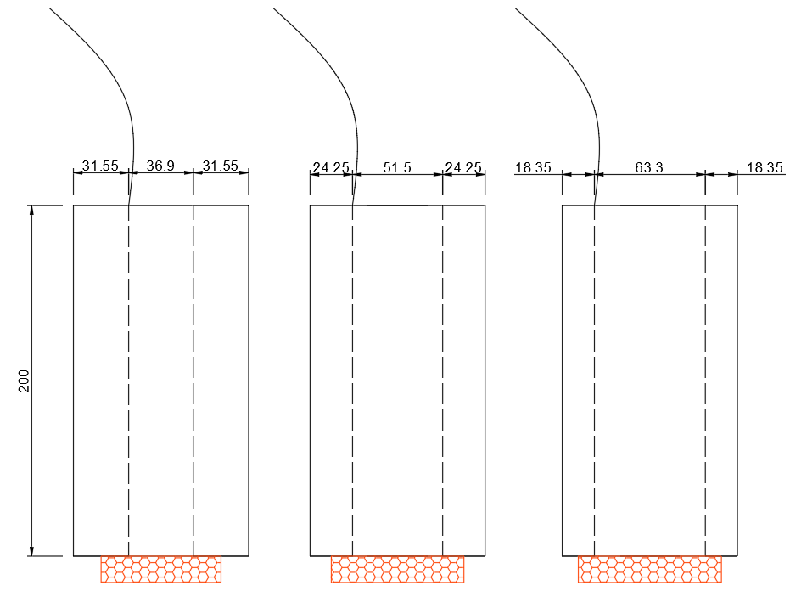
Epoxy resin
Electrical lead
Figure 1 Specimens with different cover thicknesses for corrosion propagation tests. Unit: mm.

Hollow steel tube
Mortar
Figure 2 Effects of PFA and MK replacements on slump flow diameter
Figure 3 Effects of PFA and MK replacements on compressive strengths at different ages

Figure 4 Effects of PFA and MK replacements on reaction degree at age of 7 days.

Figure 5 Effects of PFA and MK replacements on corrosion potential. Data are compiled from experimental results of specimens with cover thicknesses of 18.35 mm, 24.25 mm and 31.55mm.

Figure 6 Effects of PFA and MK replacements on corrosion rate. Cover thickness: (a) 18.35 mm, (b) 24.25 mm, (c) 31.55 mm. (d) compilation of data from specimens with different cover thicknesses.

Figure 7 Effects of PFA and MK replacements on mortar resistivity. Data are compiled from experimental results of specimens with cover thicknesses of 18.35 mm, 24.25 mm and 31.55 mm.

Figure 8 Effects of PFA and MK replacements on EIS results. (a) GGBS-based alkali-activated mortars and (b) GGBS-PFA-based alkali-activated mortars. Data from specimens with cover thickness of 31.55 mm.
Similar arcs
Depressed arcs

Figure 9 Effects of PFA and MK replacements on pH value

Figure 10 Effects of PFA and MK replacements on overall porosity

Figure 11 Comparisons between MIP results of OPC, G-0 and GP-0. (a) Cumulative porosity, (b) pore size distribution and (c) porosity characterized by different pore sizes
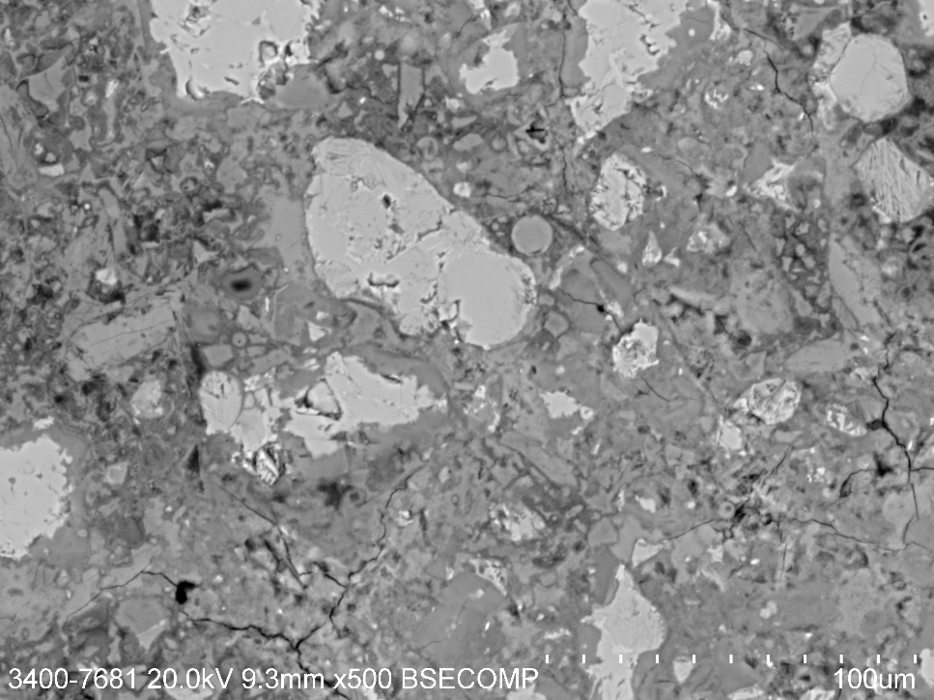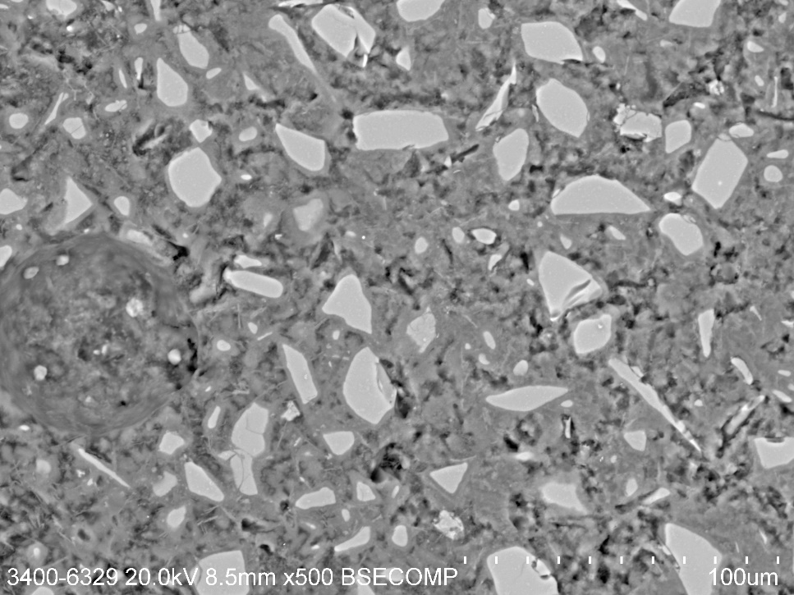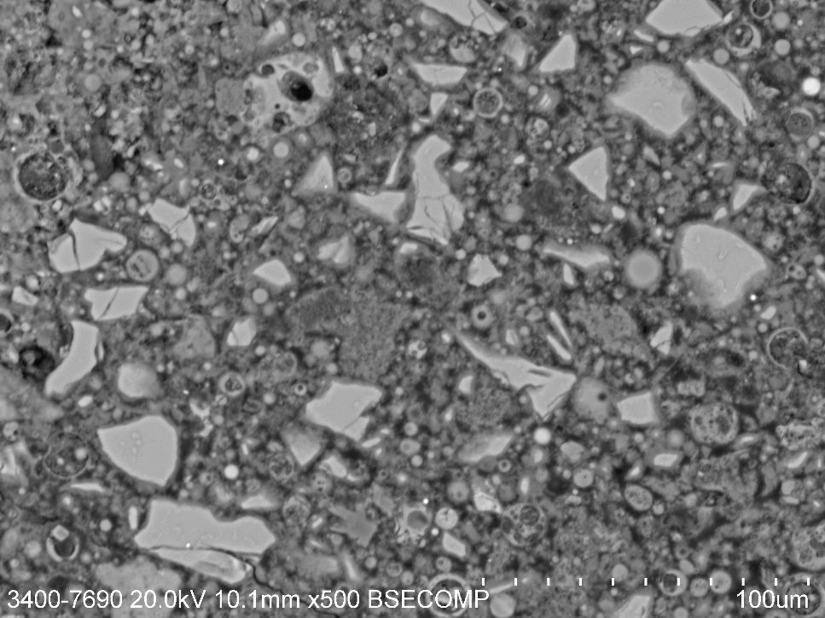
Figure 12 Typical SEM images showing capillary pores and macro-pores. (a) OPC, (b) G-0 and (c) GP-0
(a)
(b)
(c)
Figure 13 Effects of MK replacement on MIP results of GGBS-based alkali-activated mixes. (a) Cumulative porosity, (b) pore size distribution and (c) porosity characterized by different pore sizes

Figure 14 Effects of MK replacement on MIP results of GGBS-PFA-based alkali-activated mixes. (a) Cumulative porosity, (b) pore size distribution and (c) porosity characterized by different pore sizes.

Corrosion potential
Corrosion rate
Anodic / ohmic control
(a)
Corrosion potential
Corrosion rate
Cathodic control
(b)
Figure 15 Mechanisms controlling corrosion of steel. (a) anodic / ohmic control, (b) cathodic control and (c) porosity / electrolyte control
Corrosion potential
Corrosion rate
Porosity / electrolyte control
(c)

Figure 16 Comparisons between corrosion rate and corrosion potential. Data are compiled from experimental results of specimens with cover thicknesses of 18.35 mm, 24.25 mm and 31.55mm.
Sulphide ions induced potential reduction
Increased porosity

Figure 17 Correlation between corrosion rate and overall porosity. Data are compiled from experimental results of specimens with cover thicknesses of 18.35 mm, 24.25 mm and 31.55mm.

