Ionic liquid passivation for high-performance blue quasi-2D perovskite light-emitting diodes
Jiayun Sun^{a,b}, Zhenwei Ren^{b}, Zhaojin Wangª, Haoran Wang^{c}, Dan Wu^{d}, Xiao Wei Sunª, Wallace C.H. Choy^{b,}*, Kai Wang^{a,}*
ªDepartment of Electrical and Electronic Engineering, Southern University of Science and Technology, Shenzhen, China. Email: wangk@sustech.edu.cn
^{b}Department of Electrical and Electronic Engineering, The University of Hong Kong
Pokfulam Road, Hong Kong, China. Email: chchoy@eee.hku.hk
^{c}The School of Materials Science and Engineering, and Shenzhen Key Laboratory of Flexible Printed Electronics Technology, Harbin Institute of Technology, Shenzhen, China.
^{d}College of New Materials and New Energies, Shenzhen Technology University, Shenzhen, China.

ABSTRACT:
Great progress has been made in high-performance perovskite light-emitting diodes (PeLEDs). However, the external quantum efficiency (EQE) of blue PeLEDs still lags. Particularly, defects are inevitable in solution-processed perovskite films, which inhibit the efficient radiative recombination in blue PeLEDs. Herein, we report a facile ionic liquid (IL, 1,3-dimethyl-3-imidazolium hexafluorophosphate) post-treatment on the as-fabricated quasi-two-dimensional (quasi-2D) perovskite film, to passivate the uncoordinated Pb through the strong interaction with IL. The IL-assisted perovskite film demonstrates a great enhancement of radiative recombination efficiency, and the photoluminescence quantum yield of the film increases from 35.7% to 74.6%. IL post-treatment also adjusts the energy level of perovskite film and enhances the hole injection in PeLED. As a result, the peak EQE of the blue quasi-2D PeLED is improved from 4.0% to 9.0%, while the turn-on voltage is reduced from 3.3V to 3.0V. This work contributes to a feasible and effective approach for improving the quality of blue quasi-2D perovskite and enhancing the efficiency of blue PeLEDs.

Keywords: blue perovskite light-emitting diode, ionic liquid, defect passivation

1. Introduction
Metal halide perovskites are attracting a lot of attention due to their promising optoelectrical properties, e.g. high quantum efficiency, the narrow full width of half maximum (FWHM), tunable bandgap, and solution process compatibility, including spin-coating, thermal evaporation, and inkjet-printing. These merits enable the perovskite light-emitting diodes (PeLEDs) to be an emerging light source with high performance and low cost¹⁻³. Recently, there has been significant development in PeLED performances. Green, red, and near-infrared PeLEDs have been reported with a peak external quantum efficiency (EQE) of over 20%⁴⁻⁶. Substantial progress has been made to improve the performance of blue PeLEDs. However, the maximum EQE of blue PeLEDs lags far behind the analogous PeLEDs⁷⁻¹¹. To achieve full-color displays in future applications, there is an urgent need to improve the performance of blue PeLEDs.
Recently, low-dimensional perovskites have risen interest for efficient blue emission with enhanced radiative recombination, including perovskite nanocrystals¹², perovskite nanoplatelets^{13, 14}, and quasi-two-dimensional (quasi-2D) perovskites^{7, 15}. Quasi-2D perovskites have strong exciton binding energy due to the quantum and dielectric confinement, which favors the efficient generation of excitons and radiative recombination¹⁶. A typical structure of quasi-2D Ruddlesden-Popper (RP) perovskites has a formula of L₂(APbBr₃)_{n-1}PbBr₄, where L is the organic spacer cations (e.g., phenylethylammonium: PEA⁺; n-propylammonium: PA⁺), A is a monovalent cation (e. g., Cs⁺, methylammonium: MA⁺ or formamidinium: FA⁺), and n represents the number of lead halide octahedral layers. The thickness of the lead halide octahedral layers determines the bandgap of the quantum-well-like domains¹⁷. The quasi-2D perovskite film usually contains a mixture of domains with different thicknesses and energy bandgaps, which forms the self-organized energy funneling. The self-organized multiple-quantum-wells in quasi-2D perovskites facilitate an efficient carrier transfer and radiative recombination¹⁸. However, defects, particularly ionic defects, such as halide and ammonium spacer vacancies, are unavoidable during the solution-processed crystallization of quasi-2D perovskites¹⁹⁻²¹. Deep-level trap states will cause severe nonradiative recombination and thus low emission efficiency in blue perovskite with a large bandgap^{20, 22}. Therefore, defect passivation is essential for improving blue PeLED performance.
Recently, ionic liquids (IL) have been adopted to enhance the performance of perovskite solar cells, benefitting from the defect passivation, interface modification, crystallization control, and stability improvement²³⁻²⁷. The wide selection of cations and anions in IL provides massive possibilities and huge potential for various targeted functions. For example, Liu et al. used methyltrioctylammonium trifluoromethanesulfonate to passivate defects and to fill the surficial boundaries at the perovskite-electron transport layer interface for efficient electron extraction in perovskite solar cells²⁷. H. Snaith et al used 1-butyl-3-methylimidazolium tetrafluoroborate (BMIMBF₄) and 1-butyl-1-methylpiperidinium tetrafluoroborate (BMPBF₄) as the additive to retard the formation of impurity phases and thus enhance the long-term operational stability of perovskite solar cells^{23,24}. Besides, IL shows effectiveness as the charge transport layer modifier and the precursor solution additive²⁸⁻³⁰ in PeLEDs. Sun et al. incorporated imidazolium IL into green PeLEDs, in which the IL was employed to modify the interface between the hole transport layer of PEDOT:PSS and perovskite to passivate the interfacial halogen vacancies and suppress the interfacial exciton quenching.²⁸ Peng et al. added BMIMBF₄ into green perovskite precursor solution and achieved a peak EQE of 22.9% because the big π bond of N-C=N in the cation passivates the Pb-related defects.²⁹ Luo et al. adopted 1-butyl-3-methylimidazolium trifluoromethanesulfonate (BMIMOTf) in green PeLEDs for defects passivation through bonding [BMIM]⁺ cations to uncoordinated Br, OTf⁻ anions to uncoordinated Pb²⁺ defects.³⁰ Nevertheless, these approaches add ionic liquid additives into precursor solution, which rise challenges including storage stability of precursor solutions,⁵⁰ precise control of additives amount,^{23,50} and different crystallization kinetics^{23,51-53}. By contrast, post-treatment is separated from the fabrication of common perovskite films, which provides a general strategy to improve the quality of film and device. ^{51, 54}
Herein, we report a facile and effective post-treatment by spin-coating IL, 1,3-dimethyl-3-imidazolium hexafluorophosphate ([DMIM]⁺PF₆⁻), onto as-fabricated blue quasi-2D perovskite films. IL can effectively passivate the defects of uncoordinated Pb through the strong interaction with both cation and anion. Simultaneously, IL post-treatment benefits the hole injection in PeLED through the energy level adjustment. As a result, we realized an increased photoluminescence quantum yield (PLQY) of 74.6% from 35.7%. The IL-assisted blue PeLEDs exhibit the improved peak EQE of 9.0% , with a 0.3 V lower turn-on voltage of 3.0 V.
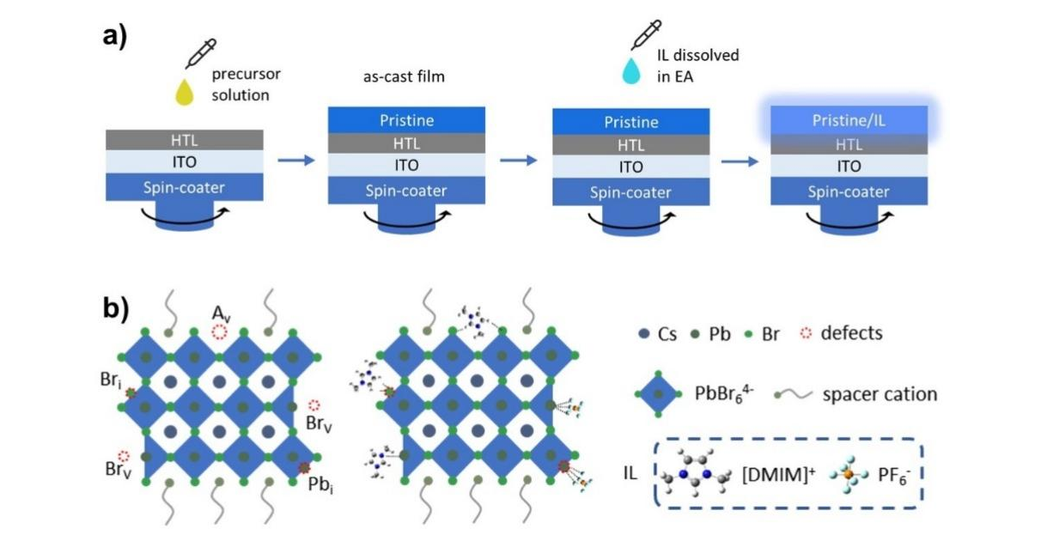 Figure 1 a) the schematic illustration of the IL treatment on the pristine perovskite film; b) the schematic illustration of the passivation functions of anions and cations of IL in perovskite films. A_{v}: A-site atom vacancy, Br_{i}: interstitial bromide, Br_{v}: bromide vacancy, Pb_{i}: interstitial lead.

2. Results and discussion
To avoid severe phase separation in the mix-halide perovskite,³¹ the bandgap is enlarged only by the phase modulation of the quasi-2D bromide perovskite to achieve blue emission. The pristine perovskites are constructed based on the quasi-2D perovskite of PEA_{x}PA_{2−x}(CsPbBr₃)_{n−1}PbBr₄, where PEA⁺ and PA⁺ act as spacer ligands. Dual spacer ligands are adopted here to suppress the formation of low-order phases with large bandgap (e.g., n=1 phase) which hinder carrier injection and energy transfer.³² The perovskite films are fabricated through the spin-coating process in which ethyl acetate (EA) is quickly dripped onto the film for rapid crystallization of perovskite. In preparation of the ionic liquid modified pristine perovskite films (denoted as pristine/IL perovskite), [DMIM]⁺PF₆⁻ is adopted for the post-treatment on the pristine perovskite films. The whole process scheme is shown in Figure 1a. After annealing of perovskite film, the solution of IL dissolved in EA is dripped onto the pristine perovskite via a dynamic way followed by depositing the following charge transport layer. Figure 1b illustrates the chemical structure of IL and the IL-assisted quasi-2D perovskites. It is considered that IL will not introduce new perovskite components with no additional x-ray diffraction (XRD) peaks after IL treatment (Figure S1). IL cation and anion are supposed to locate at the perovskite grains and the surface of perovskite film to passivate the defects. Details will be discussed in the following part.
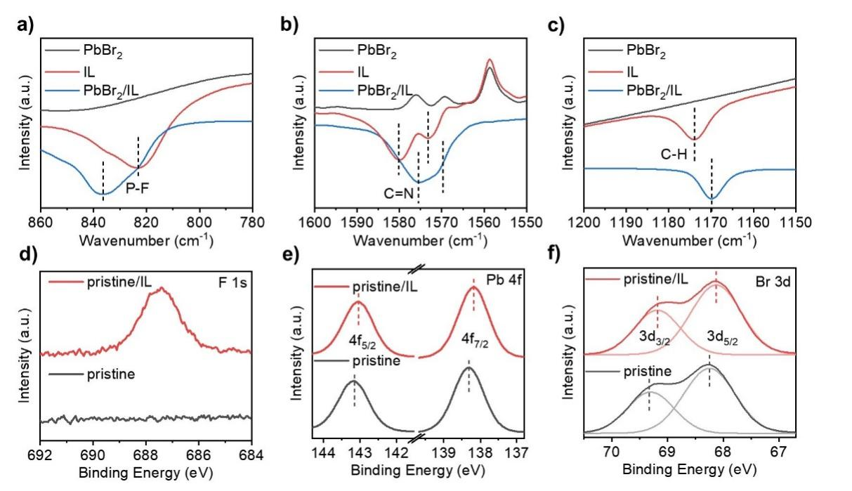Figure 2 a-c) FTIR spectra of PbBr₂, IL, and their mixture; XPS spectra of d) F 1s, e) Pb 4f, and f) Br 3d signals of pristine and pristine/IL perovskite films.
To explore the mechanism of IL passivation on the pristine perovskite films, PbBr₂ powder, IL powder, and their mixture were prepared and measured through Fourier transform infrared (FTIR) spectroscopy firstly. As shown in Figure 2a, the IL exhibits an intense absorption peak at ~823 cm⁻¹, which corresponds to the P-F asymmetric stretch of the IL.³³ While the P-F absorption peak shifts toward a higher wavenumber of ~836 cm⁻¹ for IL/PbBr₂, which indicates the strong interaction between PF₆⁻ and PbBr₂.^{28, 34} The C=N stretching vibration peak (Figure 2b) of pure IL in the imidazole ring shifted from 1580 and 1573 cm⁻¹ to 1575 and 1568 cm⁻¹, respectively, after mixing with PbBr₂ powders, due to the strong interaction between imidazole and undercoordinated Pb defects through the electron delocalization of π bond on N-C=N ^{29, 35}. In addition, the peak of C-H (Figure 2c) slightly shifted from 1173 cm⁻¹ to 1169 cm⁻¹, probably due to the formed hydrogen bond between C-H and Br atoms.²⁹ Moreover, X-ray photoelectron spectroscopy (XPS) of the pristine and the pristine/IL perovskite films was performed to clarify the interaction between IL and perovskite. As shown in Figure 2d, the peak at 687 eV of the F 1s signal derives from PF₆ ions, indicating that IL remains on the perovskite film after IL treatment. Figure 2e shows that the peaks of the Pb 4f_{5/2} and Pb 4f_{7/2} signal at 143.2 and 138.3 eV for the pristine perovskite film shift toward the lower binding energies after IL treatment. The reduced binding energy of both Pb 4f peaks indicates the lowered oxidation state of lead, that is to say, the surrounding electron cloud density of Pb²⁺ increases after IL-treatment. This is ascribed from the donation from the lonely electron pair on the nitrogen to the empty 6p orbital of Pb²⁺.^{28, 30, 36, 37} The lower wavenumber of the C=N peak in FTIR stands for a weaker bond of C=N and a lower electron cloud density around nitrogen, which donates electron to Pb²⁺. The red shift of the C=N peak in FTIR and the reduced binding energy of Pb demonstrate the interaction between nitrogen and undercoordinated Pb²⁺ ions. Similarly, the peaks of Br 3d_{3/2} and 3d_{5/2} signals of the pristine/IL perovskite film also shift toward lower binding energy from 69.3 and 68.3 eV of the pristine perovskite film (Figure 2f), because of the increased electron cloud density and hydrogen bond from the imidazole cation to bromine.^{29, 38} Consequently, we demonstrate the strong interaction between the IL and the perovskite through both the imidazole cation and PF₆⁻, which provide a strong passivation effect to unsaturated Pb²⁺ in the perovskite film, while the hydrogen bond also offers passivation to point defects like interstitial bromide and A-site vacancy, as illustrated in Figure 1b, benefitting the improved radiative recombination efficiency.
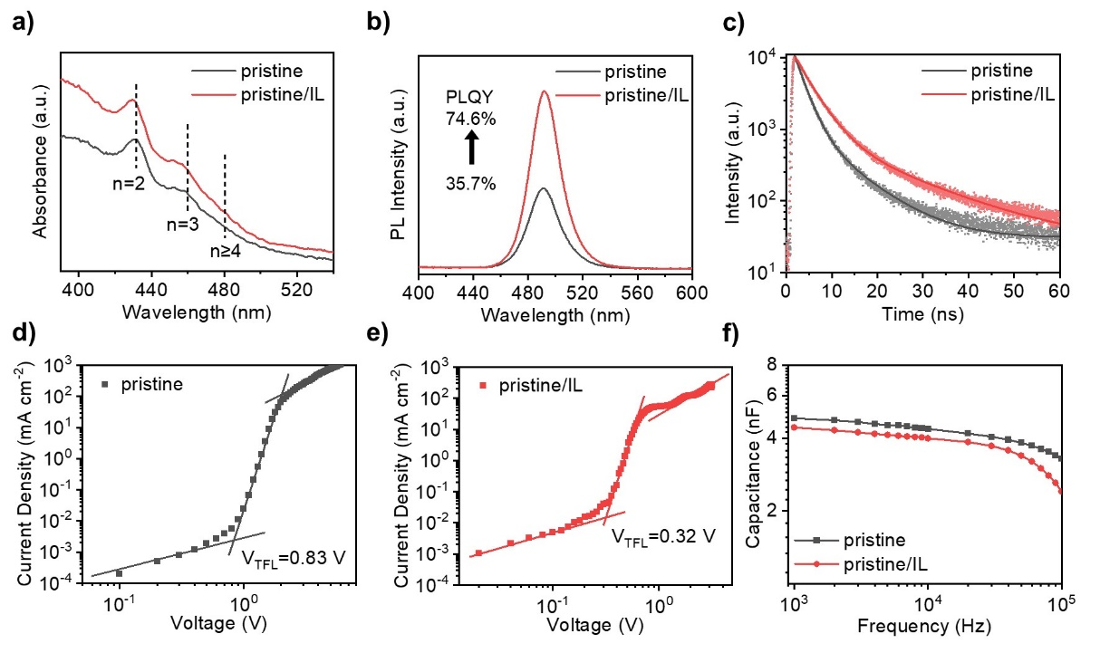Figure 3 a) The UV-visible absorption spectra, b) steady state PL spectra, c) TRPL decay spectra of pristine and pristine/IL perovskites films; d, e) space charge limited current (SCLC) measurements, f) Capacitance–frequency (C-f) curve of pristine and pristine/IL perovskite devices.
The optical properties of perovskite films are changed with IL assistance. The UV-vis absorption spectra of the perovskite films are shown in Figure 3a, in which both of the perovskite films present two obvious excitonic absorption shoulders at around 430 nm and 458 nm, corresponding to n=2 and n=3 phases, respectively.³² it is also observed that there is an absorption tail extended to 490 nm which can be assigned to n>=4 phases.³⁹ The increased absorbance of pristine/IL perovskite film benefits from the improved crystallinity, which is coordinated with XRD patterns (Figure S1). The improvement of crystallinity may due to the coordination between IL and exposed defects sites. From the UV-vis absorption spectra, the optical bandgap can be estimated by Tauc plot,⁴⁰ as shown in Figure S2. The calculated bandgap of the perovskite film has no obvious change after IL treatment, which means that the IL will not change the phase distribution in the film. Figure 3b shows the PL spectra of the pristine and the pristine/IL perovskite films. The perovskite films show the same PL peak at 490 nm with a FWHM of 25 nm due to the unchanged phase distribution of the perovskite films after IL treatment, as verified by the same absorption peaks (Figure 3a). While the pristine/IL perovskite film displays stronger PL intensity than that of the pristine perovskite film, indicating more radiative recombination of the carriers in the pristine/IL perovskite films. Accordingly, the pristine/IL perovskite film shows an enhanced PLQY of 74.6% which is over two-fold larger than 35.7% for the pristine perovskite film, indicating the reduced non-radiative recombination after IL treatment. Pure EA post-treatment on pristine film is performed through UV-visible absorption and PL spectra to exclude the effect of solvent, and the results show that pure EA post-treatment hardly influence the absorbance and PLQY of perovskite films (Figure S4a, b). Furthermore, the time-resolved photoluminescence (TRPL) measurement was performed to study the effect of IL treatment on the perovskite film carrier lifetime. As shown in Figure 3c, the TRPL decay curves are fitted by a biexponential function of $I\left(t\right)=I_{0}+a_{1} exp⁡(-t/τ_{1})+a_{2} exp⁡(-t/τ_{2})$, where $a_{1}$, $a_{2}$ are the amplitudes, $τ_{1}$, $τ_{2}$, are the time constants of fast and slow decay lifetimes. The fast time constant of $τ_{1}$ reflects the non-radiative recombination due to the trap states, while the slow time constant, $τ_{2}$, reflects the radiative recombination.^{41, 42} The fitted parameters are extracted in Supplement Table 1. The pristine/IL perovskite film has both longer fast decay and slow decay lifetimes of 3.60 ns and 15.79 ns than those of the pristine perovskite film of 2.16 ns and 8.23 ns, respectively, which promotes the average fluorescence lifetime ($τ_{av}$) of 7.33 ns (pristine/IL perovskite), near a two-fold longer than 4.13 ns of the pristine perovskite film. These results clearly show that IL treatment effectively suppresses the non-radiative recombination and enhances the radiative recombination⁴³, benefitting from the diminished trap states of the perovskite films. To evaluate the effect of IL-treatment on exciton dynamics and carrier energy transfer, transient absorption (TA) spectra are performed, as shown in Figure S7. However, there is no obvious difference in TA spectra in different delay times and kinetic fitting, which is predictable due to the similar UV-vis absorption spectra. It can be considered that the IL post-treatment will not affect the phase distribution and thus the exciton dynamics and energy transfer inside the perovskite film. To further verify the effect of ionic liquid on reducing the defect density of perovskite films, the space charge limited current (SCLC) is conducted. The current-voltage (J-V) curves of the devices were measured with a structure of ITO/perovskite/MoO₃/Ag, as shown in Figure 3d, e. The trap state density of the perovskite film can be calculated by the equation of $N=(2V_{TFL}ε_{r}ε_{0})/(eL^{2})$, where $V_{TFL}$ is the trap-filled limiting voltage, $L$ is the thickness of the perovskite film, $e$ is the elementary charge, $ε_{r}$ and $ε_{0}$ are the relative permittivity and the vacuum permittivity, respectively. In general, a lower $V_{TFL}$ means a lower defects density in the films. The values of defect density can be further calculated. The value of $ε_{r}$ is estimated by the equation of $ε_{r}=(CL)/(ε_{0}S)$, where the geometrical capacitance of C can be determined from the capacitance-frequency (C-f) curves at a high frequency of around 10³-10⁵ Hz (Figure 3f).⁴⁴ According to the calculation according to the capacitance at 1k Hz, the trap state density of the pristine/IL perovskite film is reduced to 8.83 × 10¹⁶ cm⁻³ from 2.54 × 10¹⁷ cm⁻³, (the pristine perovskite film), which further confirms the effective passivation of IL.
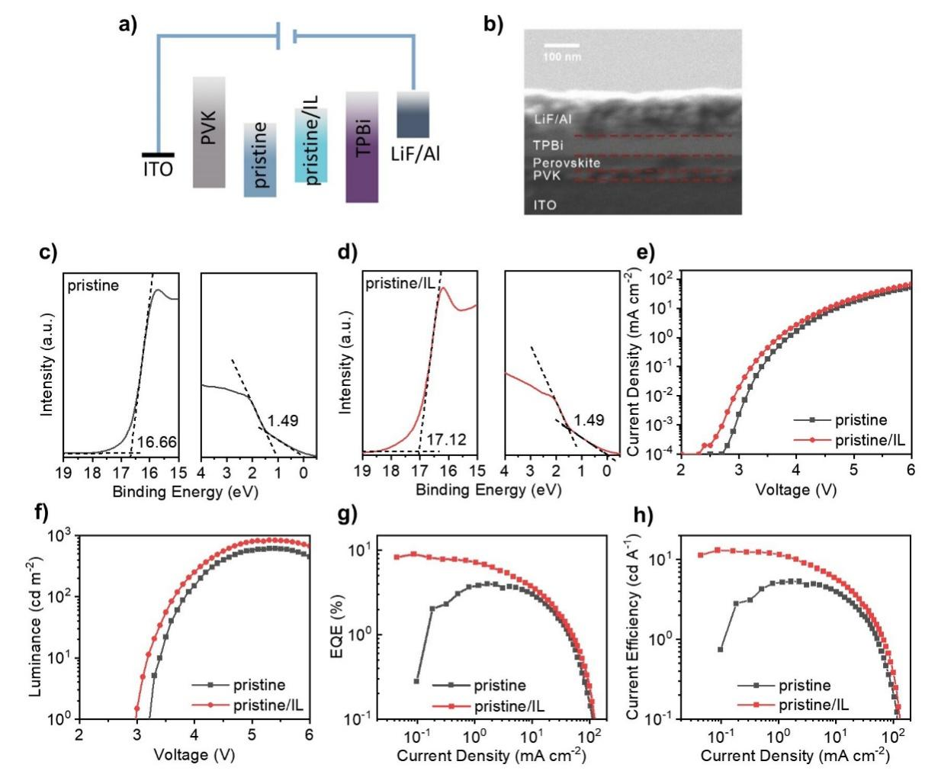Figure 4 a) Schematic energy levels alignment of the PeLED structure, b) the cross-section scanning electron microscopy (SEM) images of PeLEDs; ultraviolet photoelectron emission spectra (UPS) spectra of c) the pristine perovskite film and d) the pristine/IL perovskite film; e) current density-voltage (J-V), f) luminance-voltage (L-V) curves, g) external quantum efficiency-current density (EQE-J), and h) current efficiency-current density (CE-J).
To evaluate the effect of IL treatment on device electroluminescent performance, the blue PeLEDs based on the pristine perovskite and the pristine/IL perovskite were assembled. The PeLEDs were fabricated with a structure of ITO/Poly(9-vinylcarbazole) (PVK)/perovskite/1,3,5-Tris(1-phenyl-1Hbenzimidazol-2-yl)benzene(TPBi)/LiF/Al, where the pristine perovskite or the pristine/IL perovskite act as emission layer, PVK and TPBi act as the hole transport layer and electron transport layer, respectively. The energy levels alignment of the functional layer in PeLEDs is summed up in Figure 4a. The energy levels of the functional layers are obtained from the previous reports⁸, while the energy levels and band gaps of the pristine perovskite and pristine/IL perovskite films are calculated from the Tauc plot and ultraviolet photoelectron emission spectra (UPS) (Figure 4c and d and Figure S2), respectively. The results show that the pristine/IL perovskite film possesses a shallower valence band than that of the pristine perovskite films, which reduces the hole injection barrier and facilitates the hole injection. The work function of pristine/IL perovskite decreases to 4.00 eV from 4.56 eV. Considering the relative position of work function (WF) in the energy band, the reduced WF is not mainly caused by the reduced n-type or p-type trap density.^{45, 46} A surface dipole may exist at the top surface of perovskite film, which reduces the work function.^{25,46} The smaller PF₆⁻ anions may penetrate and coordinate with Pb²⁺ defect or partially replace bromide, while the larger imidazole cations accumulate at the surface, which forms surface dipoles spontaneously (Figure S5). The surface work function measurements of pristine and pristine/IL film are also performed through Kelvin probe after calibration by highly oriented pyrolytic graphite (HOPG), and confirming the reduced of work function after IL-treatment (Figure S6). From a typical scanning electron microscopy (SEM) image of the cross-section of the pristine/IL PeLED in Figure 4b, the thicknesses of PVK, perovskite film, TPBi, LiF/Al are around 25 nm, 50 nm, 45 nm, and 100 nm, correspondingly. The J-V and luminance-voltage (L-V) curves of the PeLEDs are shown in Figure 4e and f, respectively. The current density of the pristine/IL PeLED is larger than the pristine PeLED, which benefits from the lower hole injection barrier from PVK to perovskite film, according to the decreased work function and valence band. Thus, the turn-on voltage (defined as the voltage where L=1 cd m⁻²) of the pristine/IL PeLED decreases from 3.3 V to 3.0 V due to improved hole injection. The maximum luminance (L_{max}) of the pristine perovskite PeLED is 615 cd m⁻², which is improved to 840 cd m⁻² of the pristine/IL perovskite PeLED. The EL peaks of the pristine and pristine/IL PeLED are posited at the same wavelength of 492 nm (Figure 5b), which matches up with previous PL results. The picture of the operating pristine/IL PeLED is shown in the insert picture in Figure 5b. As shown in Figure 4g and h, the pristine PeLED reached the highest EQE of 4.0 % and the highest CE of 5.3 cd A⁻¹, while the pristine/IL PeLED reached the highest EQE of 9.0 % and the highest CE of 13.1 cd A⁻¹. The EQE exhibits a significant two-fold increase, and the CE exhibits a 2.47-fold increase. The improvement of PeLED performance after IL treatment can be attributed to the effective defect passivation and improved carrier injection. To further study the carriers' behavior in the PeLEDs, the capacitance-voltage (C-V) measurements of the pristine and pristine/IL PeLEDs were performed (Figure 5a). It is observed that the capacitances of the pristine and pristine/IL PeLEDs show a similar trend during the bias voltage scanning. The capacitance increases from 2.6 V to 3.5 V, which indicates a strong injection of majority carriers, corresponding to the increased current density in the J-V curve. When the bias voltage increases, the capacitance of the pristine/IL PeLED reaches the highest value and then decreases sharply with a larger slope as a result of the largely reduced charges caused by massive electrons and holes recombination.^{47, 48} The capacitance of pristine PeLED increases again at higher voltage of 4.0 V, which indicates a charge accumulation due to the poor hole injection. Therefore, it is verified that the IL benefit both the hole injection and radiative recombination to achieve a high-efficiency blue emission in PeLEDs.
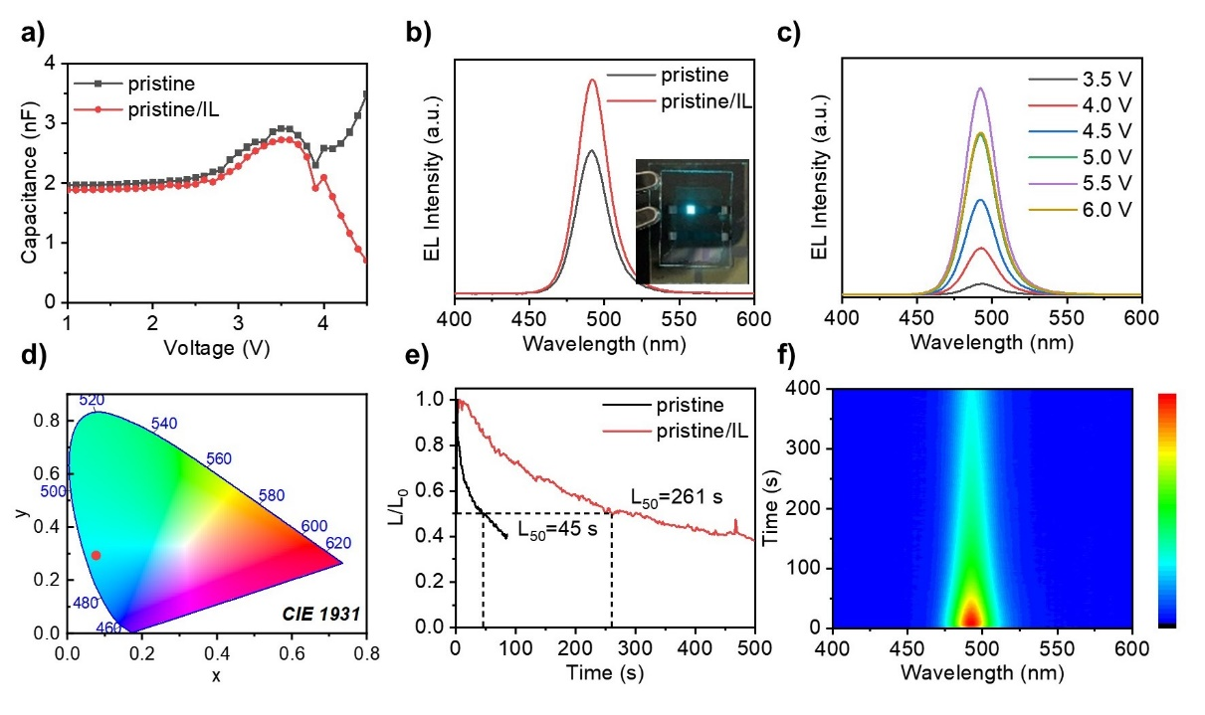
Figure 5 a) The capacitance-voltage (C-V) curves of pristine and pristine/IL Peled; b) electroluminescene (EL) spectra at 5.0 V (insert: pictures of lighting prisine/IL PeLED); c) EL spectra of pristine/IL PeLED at different bias voltage; d) the CIE coordinate of the pristine/IL PeLED; e) The time-dependent stability lifetime measurements under a current density of 0.75 mA cm⁻² of the pristine PeLED and the pristine/IL PeLED; f) The traced EL spectra of pristine/IL PeLED during operation.
The excellent spectra stability for blue PeLEDs is essential for practical application. The EL peaks and FWHM of pristine/IL PeLED maintain the same, ensuring good color consistency at a different voltage (Figure 5c). The pristine/IL PeLED emits with an FWHM of around 24 nm, allowing for a high color purity with Commission Internationale de L’Eclairage (CIE) chromaticity coordinate at (0.077, 0.293) (Figure 5d). The EL intensity of the PeLED increases from 3.5 V to 5.5 V during the voltage scanning and then decreases at the higher voltage, which may blame on Auger recombination in quasi-2D perovskite.⁴⁹ As shown in Figure 5e, the operation lifetime of the pristine PeLED and pristine/IL PeLED was also measured at a constant current density of 0.75 mA cm⁻² with an initial luminance of 49 and 66 cd m⁻² separately. The pristine/IL PeLED shows a half-lifetime (L₅₀, defined as the time it takes for a decrease to 50% of the initial value) of 261 s, which is nearly 5 times longer than that of the pristine PeLED (45 s). The tracing EL spectra during the operation display that the pristine/IL PeLED also keeps excellent spectral stability during operation (Figure 5f). Overall, our results show that the pristine/IL PeLEDs show excellent spectral and operational stability, indicating a great potential for blue PeLEDs in practical applications.

3. Conclusion
We introduced an IL, [DMIM]PF₆, to assist high-efficiency blue quasi-2D perovskite PeLEDs, through a facile post-treatment method of spin-coating onto as-fabricated perovskite film. Through the strong interaction of cation and anion in IL with undercoordinated Pb defects from the electron donation of imidazole ring and F atoms, the defects are well passivated, which concentration decreased from 2.54 × 10¹⁷ cm⁻³ to 8.83 × 10¹⁶ cm⁻³. Besides, the IL post-treatment also reduces the hole injection barrier between the charge transport layer and perovskite film for efficient carrier injection by energy level adjustment. As a result, a peak EQE of 9.0%, and a low turn-on voltage of 3.0 V are achieved in blue quasi-2D PeLEDs, with good spectra stability. This work proposes a feasible strategy of IL post-treatment on as-fabricated perovskite film for effect defect passivation for high-efficiency blue quasi-2D PeLEDs.

Experimental Section
Materials. Propylamine hydrobromide (PABr, 99.999%), and phenethylammonium hydrobromide (PEABr, 99.999%) were purchased from Greatcell Solar; Cesium bromide (CsBr, 99.999%), lead bromide (PbBr₂, 99.999%), anhydrous DMSO and HBr (48% wt in H₂O) were bought from Sigma-Aldrich. Poly(9-vinylcarbazole), Tris(1-phenyl-1H-benzimidazol-2-yl)benzene (TPBi, 99.5%) and LiF (99.99%) were purchased from Lumtec. [DMIM]PF₆ and ethyl acetate (superdry, 99.9%) were purchased from J&K Chemical Ltd.
Perovskite Emission Layer Preparation. CsPbBr₃ powder was first synthesized according to the previous method.²¹ The precursor of PEA_{x}PA_{2-x}(CsPbBr₃)_{n-1}PbBr₄ perovskite was prepared by dissolving 0.15 m CsPbBr₃ powder, 0.15 m PABr, and 0.015 m PEA₂PbBr₄ into DMSO. Then the pristine PEA_{x}PA_{2-x}(CsPbBr₃)_{n-1}PbBr₄ perovskite films were obtained by spin-coating the precursor at 3000 rpm for 60 s in which 300 μL of EA was quickly dripped on the substrate at 26 s after the spin-procedure starting, followed by annealing at 70 °C for 10 min. For the IL-treated perovskites, a 30 μL of IL-dissolved EA solution (0.30 mg/ml) was dynamically spin-coated on the films at 5000 rpm for 45 s.
Device Fabrication. The indium tin oxide (ITO)-coated glass substrates were sequentially cleaned by sonication in detergent, deionized water, acetone, and isopropyl alcohol and then dried with N2. After an oxygen plasma treatment of the ITO for 5 min, the PVK solution (4 mg mL-1 in chlorobenzene) was spin-coated onto the ITO substrate at 4000 rpm for 45 s and baked at 120 °C for 10 min. The 0.15 M precursor perovskite solution was spin-coated onto the PVK substrates as described. The TBPi layer (45 nm) and LiF/Al electrodes (1 nm/100 nm) were deposited using a thermal evaporation system through a shadow mask under a high vacuum of 5 × 10⁻⁴ Pa. The device's active area was 4 mm2 as defined by the overlapping area of the ITO and Al electrode. A Lambertian emission profile was assumed in calculating the brightness. The devices were encapsulated with an ultraviolet-curable resin (LOCTITE 3335) before testing in the atmosphere.
Characterization. UV–vis absorption spectra were carried out on the spectrophotometer of Perkin Elmer 950. The PLQYs were obtained using the equipment of Hamamatsu Quantaurus-QY, model no. C11347. The PL and TRPL spectra of the perovskites were performed on PicoQaunt FluoTime 300 equipped with a picosecond pulse laser (360 nm, LDH-P-C-360). X-ray diffraction analysis was carried out with X-ray diffractometer (Bruker Advance D8 Ew Germany) with Cu Kα radiation. The C-V measurements were recorded using a Keithley 4200A parameter analyzer at 1 kHz with an AC amplitude of 50 mV. The capacitance–frequency (C–f) measurements were performed using a Keithley 4200A parameter analyzer with a frequency range from 1k to 100k Hz and an AC amplitude of 50 mV. The value of absolute dielectric permittivity is 8.85 × 10-12 F m-1, the device area is 0.04 cm2, and the thickness of the perovskite film is 50 nm. The geometrical capacitances for pristine, pristine/IL are 4.83, and 4.42 nF, corresponding to the calculated ε of 6.81, and 6.23, respectively. The J-V-L curves were performed on an Ocean Optics system equipped with a Keithley 2400 source meter, an integrating sphere (FOIS-1), and a QE65 Pro spectrometer. The integrating sphere was calibrated with a radiometric calibration light source (HL-3plus) before use. The SEM images were obtained using ZEISS Gemini 300. He (I) ultraviolet radiation source (21.22 eV) from a He discharge lamp was used in the UPS measurements. The work functions and the highest occupied molecular orbital (HOMO) regions were extracted from the UPS spectra using the equations WF=21.22 eV-Ecutoff and HOMO=WF+Eonset. The Ecutoff and the Eonset were determined by the intercepts of the tangents of the peaks with the extrapolated baselines, as depicted in the relevant plots. The surface work function through kelvin probe was done by SKP5050 scanning Kelvin Probe System with a resolution 1-3 meV from KP Technology Ltd. The Kelvin Probe measurement used a new layer of HOPG as a reference (4.6 eV) to calculate the absolute work function values of different perovskite film. For transient absorption measurements system, the perovskite films were pumped with a femtosecond 365 nm laser pulse generated from an optical parametric amplifier (Lyra, Light Conversion). The probe pulses ranging from 380 to 800 nm were derived from the fundamental 800 nm laser pulses by a Ti:Sapphire regenerative amplifier(Orpheus). The pump and probe pulses were detected by a commercial TA spectrometer (Time-tech Spectra, Dalian).

Acknowledgments
This work was supported by National Key Research and Development Program (No.2022YFB3606504), Guangdong Basic and Applied Basic Research Foundation (No. 2022A1515011071), National Natural Science Foundation of China (No. 62122034, No.61875082, and No. 61905107), and Shenzhen Innovation Project (No. JCYJ20210324104413036 and No. JCYJ20190809152411655), as well as the General Research Fund (grant Nos. 17201819, 17211220, and 17200021), Collaborative Research (grant Nos. C7035-20G and C5037-18G) from the Research Grants Council of Hong Kong Special Administrative Region, China.

Author contributions
J. S. and Z. R. conceived the idea. J. S. fabricated and characterized the devices and wrote the manuscript. W. C. and K. W. supervised the project. Z.W and H. W helped characterized the films. Z. R., Z. W, H. W, D. W., X. S., W. C., and K. W. were involved in the data analysis. All authors contributed to the discussions and finalizing the manuscript.

Conflict of Interest
The authors declare no conflict of interest.

References
(1) Liu, X. K.; Xu, W.; Bai, S.; Jin, Y.; Wang, J.; Friend, R. H.; Gao, F. Metal halide perovskites for light-emitting diodes. Nat Mater 2021, 20 (1), 10-21. DOI: 10.1038/s41563-020-0784-7.
(2) Liu, M.; Johnston, M. B.; Snaith, H. J. Efficient planar heterojunction perovskite solar cells by vapour deposition. Nature 2013, 501 (7467), 395-398. DOI: 10.1038/nature12509.
(3) Jia, S.; Li, G.; Liu, P.; Cai, R.; Tang, H.; Xu, B.; Wang, Z.; Wu, Z.; Wang, K.; Sun, X. W. Highly Luminescent and Stable Green Quasi‐2D Perovskite‐Embedded Polymer Sheets by Inkjet Printing. Advanced Functional Materials 2020, 30 (24), 1910817. DOI: 10.1002/adfm.201910817.
(4) Lin, K.; Xing, J.; Quan, L. N.; de Arquer, F. P. G.; Gong, X.; Lu, J.; Xie, L.; Zhao, W.; Zhang, D.; Yan, C.; Li, W.; Liu, X.; Lu, Y.; Kirman, J.; Sargent, E. H.; Xiong, Q.; Wei, Z. Perovskite light-emitting diodes with external quantum efficiency exceeding 20 per cent. Nature 2018, 562 (7726), 245-248. DOI: 10.1038/s41586-018-0575-3.
(5) Cao, Y.; Wang, N.; Tian, H.; Guo, J.; Wei, Y.; Chen, H.; Miao, Y.; Zou, W.; Pan, K.; He, Y.; Cao, H.; Ke, Y.; Xu, M.; Wang, Y.; Yang, M.; Du, K.; Fu, Z.; Kong, D.; Dai, D.; Jin, Y.; Li, G.; Li, H.; Peng, Q.; Wang, J.; Huang, W. Perovskite light-emitting diodes based on spontaneously formed submicrometre-scale structures. Nature 2018, 562 (7726), 249-253. DOI: 10.1038/s41586-018-0576-2.
(6) Chiba, T.; Hayashi, Y.; Ebe, H.; Hoshi, K.; Sato, J.; Sato, S.; Pu, Y.-J.; Ohisa, S.; Kido, J. Anion-exchange red perovskite quantum dots with ammonium iodine salts for highly efficient light-emitting devices. Nature Photonics 2018, 12 (11), 681-687. DOI: 10.1038/s41566-018-0260-y.
(7) Zhu, Z.; Wu, Y.; Shen, Y.; Tan, J.; Shen, D.; Lo, M.-F.; Li, M.; Yuan, Y.; Tang, J.-X.; Zhang, W.; Tsang, S.-W.; Guan, Z.; Lee, C.-S. Highly Efficient Sky-Blue Perovskite Light-Emitting Diode Via Suppressing Nonradiative Energy Loss. Chemistry of Materials 2021, 33 (11), 4154-4162. DOI: 10.1021/acs.chemmater.1c00903.
(8) Ren, Z.; Yu, J.; Qin, Z.; Wang, J.; Sun, J.; Chan, C. C. S.; Ding, S.; Wang, K.; Chen, R.; Wong, K. S.; Lu, X.; Yin, W. J.; Choy, W. C. H. High-Performance Blue Perovskite Light-Emitting Diodes Enabled by Efficient Energy Transfer between Coupled Quasi-2D Perovskite Layers. Adv Mater 2021, 33 (1), e2005570. DOI: 10.1002/adma.202005570.
(9) Ren, M.; Cao, S.; Zhao, J.; Zou, B.; Zeng, R. Advances and Challenges in Two-Dimensional Organic-Inorganic Hybrid Perovskites Toward High-Performance Light-Emitting Diodes. Nanomicro Lett 2021, 13 (1), 163. DOI: 10.1007/s40820-021-00685-5.
(10) Karlsson, M.; Yi, Z.; Reichert, S.; Luo, X.; Lin, W.; Zhang, Z.; Bao, C.; Zhang, R.; Bai, S.; Zheng, G.; Teng, P.; Duan, L.; Lu, Y.; Zheng, K.; Pullerits, T.; Deibel, C.; Xu, W.; Friend, R.; Gao, F. Mixed halide perovskites for spectrally stable and high-efficiency blue light-emitting diodes. Nat Commun 2021, 12 (1), 361. DOI: 10.1038/s41467-020-20582-6.
(11) Shen, Y.; Li, Y. Q.; Zhang, K.; Zhang, L. J.; Xie, F. M.; Chen, L.; Cai, X. Y.; Lu, Y.; Ren, H.; Gao, X.; Xie, H.; Mao, H.; Kera, S.; Tang, J. X. Multifunctional Crystal Regulation Enables Efficient and Stable Sky‐Blue Perovskite Light‐Emitting Diodes. Advanced Functional Materials 2022, 32 (41). DOI: 10.1002/adfm.202206574.
(12) Dong, Y.; Wang, Y. K.; Yuan, F.; Johnston, A.; Liu, Y.; Ma, D.; Choi, M. J.; Chen, B.; Chekini, M.; Baek, S. W.; Sagar, L. K.; Fan, J.; Hou, Y.; Wu, M.; Lee, S.; Sun, B.; Hoogland, S.; Quintero-Bermudez, R.; Ebe, H.; Todorovic, P.; Dinic, F.; Li, P.; Kung, H. T.; Saidaminov, M. I.; Kumacheva, E.; Spiecker, E.; Liao, L. S.; Voznyy, O.; Lu, Z. H.; Sargent, E. H. Bipolar-shell resurfacing for blue LEDs based on strongly confined perovskite quantum dots. Nat Nanotechnol 2020, 15 (8), 668-674. DOI: 10.1038/s41565-020-0714-5.
(13) Wang, H.; Ye, F.; Sun, J.; Wang, Z.; Zhang, C.; Qian, J.; Zhang, X.; Choy, W. C. H.; Sun, X. W.; Wang, K.; Zhao, W. Efficient CsPbBr3 Nanoplatelet-Based Blue Light-Emitting Diodes Enabled by Engineered Surface Ligands. ACS Energy Letters 2022, 7 (3), 1137-1145. DOI: 10.1021/acsenergylett.1c02642.
(14) Shen, W.; Yu, Y.; Zhang, W.; Chen, Y.; Zhang, J.; Yang, L.; Feng, J.; Cheng, G.; Liu, L.; Chen, S. Efficient Pure Blue Light-Emitting Diodes Based on CsPbBr3 Quantum-Confined Nanoplates. ACS Appl Mater Interfaces 2022, 14 (4), 5682-5691. DOI: 10.1021/acsami.1c24662.
(15) Wang, Y. K.; Ma, D.; Yuan, F.; Singh, K.; Pina, J. M.; Johnston, A.; Dong, Y.; Zhou, C.; Chen, B.; Sun, B.; Ebe, H.; Fan, J.; Sun, M. J.; Gao, Y.; Lu, Z. H.; Voznyy, O.; Liao, L. S.; Sargent, E. H. Chelating-agent-assisted control of CsPbBr3 quantum well growth enables stable blue perovskite emitters. Nat Commun 2020, 11 (1), 3674. DOI: 10.1038/s41467-020-17482-0.
(16) Xing, G.; Wu, B.; Wu, X.; Li, M.; Du, B.; Wei, Q.; Guo, J.; Yeow, E. K.; Sum, T. C.; Huang, W. Transcending the slow bimolecular recombination in lead-halide perovskites for electroluminescence. Nat Commun 2017, 8, 14558. DOI: 10.1038/ncomms14558.
(17) Quan, L. N.; Yuan, M.; Comin, R.; Voznyy, O.; Beauregard, E. M.; Hoogland, S.; Buin, A.; Kirmani, A. R.; Zhao, K.; Amassian, A.; Kim, D. H.; Sargent, E. H. Ligand-Stabilized Reduced-Dimensionality Perovskites. J Am Chem Soc 2016, 138 (8), 2649-2655. DOI: 10.1021/jacs.5b11740.
(18) Wang, N.; Cheng, L.; Ge, R.; Zhang, S.; Miao, Y.; Zou, W.; Yi, C.; Sun, Y.; Cao, Y.; Yang, R.; Wei, Y.; Guo, Q.; Ke, Y.; Yu, M.; Jin, Y.; Liu, Y.; Ding, Q.; Di, D.; Yang, L.; Xing, G.; Tian, H.; Jin, C.; Gao, F.; Friend, R. H.; Wang, J.; Huang, W. Perovskite light-emitting diodes based on solution-processed self-organized multiple quantum wells. Nature Photonics 2016, 10 (11), 699-704. DOI: 10.1038/nphoton.2016.185.
(19) Abdi-Jalebi, M.; Andaji-Garmaroudi, Z.; Cacovich, S.; Stavrakas, C.; Philippe, B.; Richter, J. M.; Alsari, M.; Booker, E. P.; Hutter, E. M.; Pearson, A. J.; Lilliu, S.; Savenije, T. J.; Rensmo, H.; Divitini, G.; Ducati, C.; Friend, R. H.; Stranks, S. D. Maximizing and stabilizing luminescence from halide perovskites with potassium passivation. Nature 2018, 555 (7697), 497-501. DOI: 10.1038/nature25989.
(20) Ren, Z.; Wang, K.; Sun, X. W.; Choy, W. C. H. Strategies Toward Efficient Blue Perovskite Light‐Emitting Diodes. Advanced Functional Materials 2021, 31 (30). DOI: 10.1002/adfm.202100516.
(21) Ren, Z.; Xiao, X.; Ma, R.; Lin, H.; Wang, K.; Sun, X. W.; Choy, W. C. H. Hole Transport Bilayer Structure for Quasi‐2D Perovskite Based Blue Light‐Emitting Diodes with High Brightness and Good Spectral Stability. Advanced Functional Materials 2019, 29 (43), 1905339. DOI: 10.1002/adfm.201905339.
(22) Ran, C.; Xu, J.; Gao, W.; Huang, C.; Dou, S. Defects in metal triiodide perovskite materials towards high-performance solar cells: origin, impact, characterization, and engineering. Chem Soc Rev 2018, 47 (12), 4581-4610. DOI: 10.1039/c7cs00868f.
(23) Bai, S.; Da, P.; Li, C.; Wang, Z.; Yuan, Z.; Fu, F.; Kawecki, M.; Liu, X.; Sakai, N.; Wang, J. T.; Huettner, S.; Buecheler, S.; Fahlman, M.; Gao, F.; Snaith, H. J. Planar perovskite solar cells with long-term stability using ionic liquid additives. Nature 2019, 571 (7764), 245-250. DOI: 10.1038/s41586-019-1357-2.
(24) Lin, Y. H.; Sakai, N.; Da, P.; Wu, J.; Sansom, H. C.; Ramadan, A. J.; Mahesh, S.; Liu, J.; Oliver, R. D. J.; Lim, J.; Aspitarte, L.; Sharma, K.; Madhu, P. K.; Morales-Vilches, A. B.; Nayak, P. K.; Bai, S.; Gao, F.; Grovenor, C. R. M.; Johnston, M. B.; Labram, J. G.; Durrant, J. R.; Ball, J. M.; Wenger, B.; Stannowski, B.; Snaith, H. J. A piperidinium salt stabilizes efficient metal-halide perovskite solar cells. Science 2020, 369 (6499), 96-102. DOI: 10.1126/science.aba1628.
(25) Zhu, X.; Du, M.; Feng, J.; Wang, H.; Xu, Z.; Wang, L.; Zuo, S.; Wang, C.; Wang, Z.; Zhang, C.; Ren, X.; Priya, S.; Yang, D.; Liu, S. F. High-Efficiency Perovskite Solar Cells with Imidazolium-Based Ionic Liquid for Surface Passivation and Charge Transport. Angew Chem Int Ed Engl 2021, 60 (8), 4238-4244. DOI: 10.1002/anie.202010987.
(26) Niu, T.; Chao, L.; Gao, W.; Ran, C.; Song, L.; Chen, Y.; Fu, L.; Huang, W. Ionic Liquids-Enabled Efficient and Stable Perovskite Photovoltaics: Progress and Challenges. ACS Energy Letters 2021, 1453-1479. DOI: 10.1021/acsenergylett.0c02696.
(27) Huang, X.; Guo, H.; Wang, K.; Liu, X. Ionic liquid induced surface trap-state passivation for efficient perovskite hybrid solar cells. Organic Electronics 2017, 41, 42-48. DOI: 10.1016/j.orgel.2016.11.031.
(28) Sun, S.; Si, J.; Gao, Y.; Xu, R.; Du, Y.; Zhang, T.; Li, H.; Yao, X.; Ai, Q.; Cai, P.; Cai, M.; Tang, Y.; Rabchinskii, M.; Brunkov, P.; Ye, Z.; Dai, X.; Liu, Z. Decoupling the Positive and Negative Aging Processes of Perovskite Light-Emitting Diodes Using a Thin Interlayer of Ionic Liquid. J Phys Chem Lett 2021, 12 (32), 7783-7791. DOI: 10.1021/acs.jpclett.1c02024.
(29) Peng, X.; Yang, X.; Liu, D.; Zhang, T.; Yang, Y.; Qin, C.; Wang, F.; Chen, L.; Li, S. Targeted Distribution of Passivator for Polycrystalline Perovskite Light-Emitting Diodes with High Efficiency. ACS Energy Letters 2021, 6 (12), 4187-4194. DOI: 10.1021/acsenergylett.1c01753.
(30) Luo, Y.; Kong, L.; Wang, L.; Shi, X.; Yuan, H.; Li, W.; Wang, S.; Zhang, Z.; Zhu, W.; Yang, X. A Multifunctional Ionic Liquid Additive Enabling Stable and Efficient Perovskite Light-Emitting Diodes. Small 2022, 18 (19), e2200498. DOI: 10.1002/smll.202200498.
(31) Fakharuddin, A.; Gangishetty, M. K.; Abdi-Jalebi, M.; Chin, S.-H.; bin Mohd Yusoff, A. R.; Congreve, D. N.; Tress, W.; Deschler, F.; Vasilopoulou, M.; Bolink, H. J. Perovskite light-emitting diodes. Nature Electronics 2022, 5 (4), 203-216. DOI: 10.1038/s41928-022-00745-7.
(32) Ren, Z.; Li, L.; Yu, J.; Ma, R.; Xiao, X.; Chen, R.; Wang, K.; Sun, X. W.; Yin, W.-J.; Choy, W. C. H. Simultaneous Low-Order Phase Suppression and Defect Passivation for Efficient and Stable Blue Light-Emitting Diodes. ACS Energy Letters 2020, 5 (8), 2569-2579. DOI: 10.1021/acsenergylett.0c01015.
(33) Talaty, E. R.; Raja, S.; Storhaug, V. J.; Dölle, A.; Carper, W. R. Raman and Infrared Spectra and ab Initio Calculations of C2-4MIM Imidazolium Hexafluorophosphate Ionic Liquids. The Journal of Physical Chemistry B 2004, 108 (35), 13177-13184. DOI: 10.1021/jp040199s.
(34) Liu, X.; Lian, H.; Zhou, Z.; Zou, C.; Xie, J.; Zhang, F.; Yuan, H.; Yang, S.; Hou, Y.; Yang, H. G. Stoichiometric Dissolution of Defective CsPbI
2
Br Surfaces for Inorganic Solar Cells with 17.5% Efficiency. Advanced Energy Materials 2022, 12 (14), 2103933. DOI: 10.1002/aenm.202103933.
(35) Gu, X.; Xiang, W.; Tian, Q.; Liu, S. F. Rational Surface-Defect Control via Designed Passivation for High-Efficiency Inorganic Perovskite Solar Cells. Angew Chem Int Ed Engl 2021, 60 (43), 23164-23170. DOI: 10.1002/anie.202109724.
(36) Kong, L.; Zhang, X.; Li, Y.; Wang, H.; Jiang, Y.; Wang, S.; You, M.; Zhang, C.; Zhang, T.; Kershaw, S. V.; Zheng, W.; Yang, Y.; Lin, Q.; Yuan, M.; Rogach, A. L.; Yang, X. Smoothing the energy transfer pathway in quasi-2D perovskite films using methanesulfonate leads to highly efficient light-emitting devices. Nat Commun 2021, 12 (1), 1246. DOI: 10.1038/s41467-021-21522-8.
(37) Shahiduzzaman, M.; Wang, L.; Fukaya, S.; Muslih, E. Y.; Kogo, A.; Nakano, M.; Karakawa, M.; Takahashi, K.; Tomita, K.; Nunzi, J. M.; Miyasaka, T.; Taima, T. Ionic Liquid-Assisted MAPbI3 Nanoparticle-Seeded Growth for Efficient and Stable Perovskite Solar Cells. ACS Appl Mater Interfaces 2021, 13 (18), 21194-21206. DOI: 10.1021/acsami.1c00677.
(38) Zhang, D.; Fu, Y.; Zhan, H.; Zhao, C.; Gao, X.; Qin, C.; Wang, L. Suppressing thermal quenching via defect passivation for efficient quasi-2D perovskite light-emitting diodes. Light Sci Appl 2022, 11 (1), 69. DOI: 10.1038/s41377-022-00761-4.
(39) Xing, J.; Zhao, Y.; Askerka, M.; Quan, L. N.; Gong, X.; Zhao, W.; Zhao, J.; Tan, H.; Long, G.; Gao, L.; Yang, Z.; Voznyy, O.; Tang, J.; Lu, Z. H.; Xiong, Q.; Sargent, E. H. Color-stable highly luminescent sky-blue perovskite light-emitting diodes. Nat Commun 2018, 9 (1), 3541. DOI: 10.1038/s41467-018-05909-8.
(40) Tauc, J.; Grigorovici, R.; Vancu, A. Optical Properties and Electronic Structure of Amorphous Germanium. physica status solidi (b) 1966, 15 (2), 627-637. DOI: 10.1002/pssb.19660150224.
(41) Cho, H.; Jeong, S. H.; Park, M. H.; Kim, Y. H.; Wolf, C.; Lee, C. L.; Heo, J. H.; Sadhanala, A.; Myoung, N.; Yoo, S.; Im, S. H.; Friend, R. H.; Lee, T. W. Overcoming the electroluminescence efficiency limitations of perovskite light-emitting diodes. Science 2015, 350 (6265), 1222-1225. DOI: 10.1126/science.aad1818.
(42) Shi, D.; Adinolfi, V.; Comin, R.; Yuan, M.; Alarousu, E.; Buin, A.; Chen, Y.; Hoogland, S.; Rothenberger, A.; Katsiev, K.; Losovyj, Y.; Zhang, X.; Dowben, P. A.; Mohammed, O. F.; Sargent, E. H.; Bakr, O. M. Solar cells. Low trap-state density and long carrier diffusion in organolead trihalide perovskite single crystals. Science 2015, 347 (6221), 519-522. DOI: 10.1126/science.aaa2725.
(43) Wang, H.; Zhang, X.; Wu, Q.; Cao, F.; Yang, D.; Shang, Y.; Ning, Z.; Zhang, W.; Zheng, W.; Yan, Y.; Kershaw, S. V.; Zhang, L.; Rogach, A. L.; Yang, X. Trifluoroacetate induced small-grained CsPbBr3 perovskite films result in efficient and stable light-emitting devices. Nat Commun 2019, 10 (1), 665. DOI: 10.1038/s41467-019-08425-5.
(44) Awni, R. A.; Song, Z.; Chen, C.; Li, C.; Wang, C.; Razooqi, M. A.; Chen, L.; Wang, X.; Ellingson, R. J.; Li, J. V.; Yan, Y. Influence of Charge Transport Layers on Capacitance Measured in Halide Perovskite Solar Cells. Joule 2020, 4 (3), 644-657. DOI: 10.1016/j.joule.2020.01.012.
(45) Gharibzadeh, S.; Fassl, P.; Hossain, I. M.; Rohrbeck, P.; Frericks, M.; Schmidt, M.; Duong, T.; Khan, M. R.; Abzieher, T.; Nejand, B. A.; Schackmar, F.; Almora, O.; Feeney, T.; Singh, R.; Fuchs, D.; Lemmer, U.; Hofmann, J. P.; Weber, S. A. L.; Paetzold, U. W. Two birds with one stone: dual grain-boundary and interface passivation enables >22% efficient inverted methylammonium-free perovskite solar cells. Energy & Environmental Science 2021, 14 (11), 5875-5893. DOI: 10.1039/d1ee01508g.
(46) Tao, J.; Liu, X.; Shen, J.; Han, S.; Guan, L.; Fu, G.; Kuang, D. B.; Yang, S. F-Type Pseudo-Halide Anions for High-Efficiency and Stable Wide-Band-Gap Inverted Perovskite Solar Cells with Fill Factor Exceeding 84. ACS Nano 2022, 16 (7), 10798-10810. DOI: 10.1021/acsnano.2c02876.
(47) Qu, X.; Zhang, N.; Cai, R.; Kang, B.; Chen, S.; Xu, B.; Wang, K.; Sun, X. W. Improving blue quantum dot light-emitting diodes by a lithium fluoride interfacial layer. Applied Physics Letters 2019, 114 (7). DOI: 10.1063/1.5087102.
(48) Xiao, X.; Ye, T.; Sun, J.; Qu, X.; Ren, Z.; Wu, D.; Ding, S.; Sun, X. W.; Choy, W. C. H.; Wang, K. Capacitance–voltage characteristics of perovskite light-emitting diodes: Modeling and implementing on the analysis of carrier behaviors. Applied Physics Letters 2022, 120 (24). DOI: 10.1063/5.0088231.
(49) Jiang, Y.; Cui, M.; Li, S.; Sun, C.; Huang, Y.; Wei, J.; Zhang, L.; Lv, M.; Qin, C.; Liu, Y.; Yuan, M. Reducing the impact of Auger recombination in quasi-2D perovskite light-emitting diodes. Nat Commun 2021, 12 (1), 336. DOI: 10.1038/s41467-020-20555-9.
(50) Jung, M.; Ji, S. G.; Kim, G.; Seok, S. I. Perovskite precursor solution chemistry: from fundamentals to photovoltaic applications, Chem Soc Rev 2019, 48, 2011-2038. DOI: 10.1039/c8cs00656c.
(51) Caprioglio, P.; Cruz, D. S.; Caicedo-Dávila, S.; Zu, F.; Sutanto, A. A.; Peña-Camargo, F.; Kegelmann, L.; Meggiolaro, D.; Gregori, L.; Wolff, C. M.; et al. Bi-functional interfaces by poly(ionic liquid) treatment in efficient pin and nip perovskite solar cells. Energy & Environmental Science 2021, 14 (8), 4508-4522. DOI: 10.1039/d1ee00869b.
(52) Shahiduzzaman, M.; Yamamoto, K.; Furumoto, Y.; Yonezawa, K.; Hamada, K.; Kuroda, K.; Ninomiya, K.; Karakawa, M.; Kuwabara, T.; Takahashi, K.; et al. Viscosity effect of ionic liquid-assisted controlled growth of CH3NH3PbI3 nanoparticle-based planar perovskite solar cells. Organic Electronics 2017, 48, 147-153. DOI: 10.1016/j.orgel.2017.06.001.
(53) Niu, T.; Chao, L.; Gao, W.; Ran, C.; Song, L.; Chen, Y.; Fu, L.; Huang, W. Ionic Liquids-Enabled Efficient and Stable Perovskite Photovoltaics: Progress and Challenges. ACS Energy Letters 2021, 1453-1479. DOI: 10.1021/acsenergylett.0c02696.
(54) Zhang, H.; Ren, X.; Chen, X.; Mao, J.; Cheng, J.; Zhao, Y.; Liu, Y.; Milic, J.; Yin, W.-J.; Grätzel, M.; et al. Improving the stability and performance of perovskite solar cells via off-the-shelf post-device ligand treatment. Energy & Environmental Science 2018, 11 (8), 2253-2262. DOI: 10.1039/c8ee00580j.

