High-efficiency quantum-dot light-emitting diodes enabled by boosting the hole injection

Chunyan Cheng¹, Aqiang Liu¹, Guohang Ba¹, Wallace C. H. Choy², and Jianjun Tian^{1*}.

Chunyan Cheng, Aqiang Liu, Guohang Ba, and Jianjun Tian.
Institute for Advanced Materials and Technology,
University of Science and Technology Beijing, Beijing 100083, China
*E-mail: tianjianjun@mater.ustb.edu.cn

Wallace C. H. Choy
Department of Electrical and Electronic Engineering, The University of Hong Kong, Pokfulam Road, Hong Kong, 999077, China

Keywords: quantum-dot light-emitting diode, hole transport layer, carrier mobility, doping, charge balance

Abstract: Solution-processed quantum-dot light-emitting diodes (QLEDs) are attractive owing to high color purity and low-cost fabrication for large-area display panels, but the inferior carrier mobility of the organic polymer hole transport layer (HTL) seriously suppresses the improvement in their efficiency. Here, we devise a high carrier mobility HTL, which is achieved by doping poly(9-vinylcarbazole) (PVK) into poly[(9,9-dioctylfluorenyl-2,7-dily)-alt-(4,4ˈ-(N-(4-butylphenyl)] (TFB). The hole mobility is increased from 1.08×10⁻³ to 2.09×10⁻³cm²·V⁻¹·S⁻¹ due to the increased π-π stacking intensity. The highest occupied molecular orbital energy level is also downshifted to achieve well energy matching between the HTL and QDs, thus accelerating the hole transfer capability and balancing the electron injection within the QLED. In addition, the doped HTL shows a non-planar structure, which reduces the total internal reflection in the device. Consequently, the QLEDs present a high external quantum efficiency of 22.7%, luminance efficiency of 35.8 lm·W⁻¹, and long-term continuous operation stability T₉₅ >2,400 h at 1000 cd m⁻².
Introduction
Solution-processed quantum dot light-emitting diodes (QLEDs) have shown great promising for the large area display panels owing to high purity emission color, low turn-on voltages, and low-cost solution-fabrication [1-7]. Since the QLEDs were first reported in 1994 [8], fast progress and significant achievements have been made in this field owing to the strategies of QDs modification and device structure optimization [9-12]. To date, the external quantum efficiencies (EQEs) of the state-of-the-art QLEDs are more than 20%, approaching to the conventional LEDs prepared by metal organic chemical vapor deposition (MOCVD) [13-15].
In spite of this, the unbalanced carriers (electrons and holes) injection still is a severe issue that suppresses the efficiency improvement of the QLEDs, because the carrier mobility of the typical organic-based hole transport layer (HTL) is much lower than that of the ZnO inorganic electron transport layer (ETL). To address this problem, some metal elements are doped into ZnO to regulate its bandgap and work function for suppressing electrons injection rate, thus improving the carrier injection balance within the devices [16-18]. The other strategy is to slow down electron injection rate by inserting an insulator layer between the ETL and the QDs layer [13, 19]. Suppressing electrons injection rate will sacrifice the current efficiency of the devices, because the electrons cannot be fully converted to excitons or photons. Differently, boosting the hole mobility and transfer rate of HTL is an ideal way to construct high efficiency QLEDs.
Herein, we devise a fast carrier mobility HTL by doping poly(9-vinylcarbazole) (PVK) into poly[(9,9-dioctylfluorenyl-2,7-dily)-alt-(4,4ˈ-(N-(4-butylphenyl)] (TFB). The hole mobility of doped TFB (P-TFB) HTL was increased from 1.08×10⁻³ to 2.09×10⁻³cm²·V⁻¹·S⁻¹, which is attributed to the increased π-π stacking intensity. Meanwhile, the highest occupied molecular orbital (HOMO) energy level of the P-TFB is reduced to achieve well energy matching between the HTL and QDs. The increased hole mobility and downshifted HOMO of the P-TFB enhance the hole transfer capability and balance with the electron injection within the QLED. In addition, the non-planar structure of the P-TFB HTL decreases the total internal reflection in the device . As a result, the QLEDs present a high external quantum efficiency of 22.7% and luminance efficiency of 35.8 lm·W⁻¹. The device also showed excellent operation stability, the T₉₅ (the time required for the luminance decrease to 95% of the initial value) is up to 2438 h at 1000 cd m⁻².

Results and discussion

Figure 1 Formation and characteristics of the P-TFB. (a) Chemical structures of the polymer TFB and PVK. (b) Schematic diagram of the preparation process of the P-TFB. (c) The absorption spectra, (d) FTIR spectroscopy spectra and (e) GIXRD spectra of the TFB and P-TFB films, the incidence angle is 0.15°. (f) I-V characteristics of ITO/HTLs/Ag.

Figure 1a shows the chemical structure of the polymer TFB and PVK. The P-TFB was obtained by mixing the two polymers chlorobenzene solution (Figure 1b, and Figure S1a, b). As shown in Figure 1c, the absorption peaks at 394 nm and 345 nm wavelengths of the P-TFB film correspond to the characteristic absorption of TFB and PVK, respectively [20-23]. As shown in Figure S1c, as the doping amount of PVK in the P-TFB solution increases, the intensity of the absorption peak at 345 nm wavelength increases, further demonstrating the absorption peak at 345 nm wavelength is from PVK. The same variation trend is found in the P-TFB films prepared by spin-coating the P-TFB solution on the substrates (Figure S1d). The Fourier transform infrared (FTIR) spectra were performed to analyze the components of the P-TFB. As shown in Figure 1d and Figure S1e, the band between 3,000-2,800 cm⁻¹ can be assigned to the stretching vibrations of the C-H bonds from the saturated hydrocarbon chains of TFB and PVK [24]. The bands centered at 1,600, 1,509, and 1,460 cm⁻¹ can be assigned to the C＝C ring stretching of the triphenylamine moieties. The band centered at 1,260 cm⁻¹ represents the CN stretching from tertiary amine. The band at 815 cm⁻¹ is assigned to the C-H out-of-plane vibration from 1,4-disubstituted benzene rings [25]. This indicates that the main functional groups in the TFB and the PVK have been kept in the P-TFB, without the breaking and recombining of the chemical bonds. To further understand the crystallinity changes that occur after doping of PVK, grazing incidence X-Ray diffraction (GIXRD) measurement was performed on the films. As shown in Figure 1e, the TFB and P-TFB show obvious broad, diffused, and strong amorphous peaks at about 25°. The peak intensity of the P-TFB shows a significant increase compared with the TFB. The calculation of the integral peak area shows that the peak area of the P-TFB at about 25° (40, 165) is larger than that of the TFB (35, 805). The signal peak at around d = 3.59 Å (25°) corresponds to the π-π stacking peak. The increased peak intensity and peak area for the P-TFB indicates the enhanced π-π stacking intensity, which would boost the carrier mobility [26-28]. We speculate that there exists coherent charge transport in the P-TFB due to the improved π-π stacking, namely band-like transport, which is different from the hopping transport in conductive polymers. Band-like carriers exhibit superior charge transport characteristics due to their extended wave function [29, 30]. To verify this, the I-V characterizations of the device based on different HTLs with a structure of ITO/HTL/Ag were measured as shown in Figure 1f and Figure S1f. The slope of the P-TFB first increases and then decreases with the increase of the doping amount of PVK in the P-TFB. When the doping content is 10 %, the slope reaches the maximum value (Figure S1f), demonstrating the highest conductivity. The conductivity of the TFB and P-TFB (with doping content of 10%) are 3.27×10⁻⁶ S·cm⁻¹ and 4.79×10⁻⁶ S·cm⁻¹, respectively, as calculated from the conductivity calculation formula. This indicates the carrier mobility of the P-TFB is enhanced by doping PVK, which is attributed to the enhanced π-π stacking intensity.

Figure 2 Electronic properties of the TFB and P-TFB. UPS spectra of (a) the secondary-electron cutoff (E_{cutoff}), (b) valence-band edge regions (E_{onset}) and (c) energy band alignments. (d) The structure of the HOD. The electrical transportation is demonstrated by the current density versus voltage curves of the HOD based on (e) the TFB and (f) the P-TFB.

To demonstrate the holes transportation ability, the electronic structures of the TFB and P-TFB HTLs were characterized by ultraviolet photoelectron spectroscopic (UPS). Figure S2a exhibits the absorption spectra of the TFB and P-TFB films. The optical bandgaps are extracted to be 2.87 eV for the TFB and 2.89 eV for the P-TFB. Figure 2a, b exhibit the secondary electron cutoff (E_{cutoff}) regions and the valance band onset (E_{onset}) regions for the TFB and P-TFB films (the blue line and the red line, respectively). The work function (WF) value was calculated from the difference between the incident light energy of 21.2 eV and E_{cutoff} value. The WF values are 4.20 eV for the TFB HTL and 4.33 eV for the P-TFB HTL. The HOMO is calculated from the equation (1) [17]:
HOMO = 21.2 － (E_{cutoff} － E_{onset}) (1)
The HOMO values are 5.29 eV for the TFB HTL and 5.36 eV for the P-TFB HTL as displayed in Table S1. A 0.07 eV decrease of the HOMO for the P-TFB can be found. The energy band alignments of the TFB and P-TFB HTLs drawn from the absorption and UPS results are shown in Figure 2c. According to the diagram, the P-TFB exhibits a deeper lowest unoccupied molecular orbital (LUMO) and HOMO compared with the TFB. The HOMO of the P-TFB HTL is much closer to the valance band maximum (VBM) of the QDs layer, indicating a smaller energy barrier during the hole transfer from the HTL layer to the QDs layer. Meanwhile, a narrower difference between LUMO and Fermi-level (E_{F}) for the P-TFB than for the PVK indicates the increased hole concentration [17]. The hole-only devices (HODs) were prepared as shown in Figure 2d. The electrical properties of the HTLs were analyzed using HOD as displayed in Figure 2e, f. For the two HODs, the hole current increases as the voltage increases, indicating the increased hole injection and transfer efficiency with increase of voltage. The hole mobility of the HTLs can be obtained by fitting the space-charge-limited-current region with the child’s law (2) [31]:
J = $\frac{9}{8}×\frac{ε_{r}ε_{0}μ_{h}V^{2}}{d^{3}}$ (2)
where J is the current density, ε_{r} is the relative permittivity, ε₀ is the vacuum permittivity, μ_{h} is the hole mobility, and d is the film thickness. The ε_{r} for the HTLs is estimated to be 3.5 [32]. μ_{h} for the TFB and P-TFB are calculated to be 1.08×10⁻³ and 2.09×10⁻³cm²·V⁻¹·S⁻¹, respectively (Table S2), indicating that the higher hole mobility of the P-TFB HTL is than that of the TFB HTL. This is in accord with the results of Figure 1f. The increased hole mobility and decreased barrier energy would accelerate holes transfer from HTL to QDs, and promote holes transport in the QLEDs, thus matching with electrons mobility of the QLEDs [33-35].
Figure 3a shows the energy level of the layers in the QLEDs, including layers of the indium-tin-oxide (ITO), HTL, CdSe@ZnS QDs, ZnMgO (MZO) ETL, and metal cathode of Ag. As shown in the diagram, the P-TFB has deeper LUMO and HOMO than the TFB, which is benefit for the hole transportation. The solutions of CdSe@ZnS QDs with photoluminescence quantum yield (PLQY) of ~ 90 % were used as the emitting layer in the device. The corresponding cross-sectional scanning transmission electron microscopy (STEM) image of the device shows clear boundaries between each layer as shown in Figure 3b. The corresponding energy-dispersive X-ray spectroscopy (EDS) elemental analysis shows uniform distributions of Ag, Zn, Cd, Se, S, and Sn elements in the different layers and clear boundaries between each layer (Figure S3). The device performance of the QLEDs based on two different HTLs are shown in Figure 3c, d. It can be seen that at low voltage below 2.6 V, the current density of the P-TFB based device is lower than that of the TFB based device, which represents a much lower leakage current density in the P-TFB based device because of its high shunt resistance. The current density and luminance of the P-TFB based device are higher than those of the TFB based device when the voltage > 2.6 V, indicating the higher electro-optic conversion efficiency in the P-TFB based device [36]. At the luminance of 10,000 cd cm⁻², the voltage for the QLEDs based on P-TFB HTL is 3.3 V, less than that for the QLEDs based on TFB HTL (3.6 V), indicating the reduction of the hole injection barrier in the P-TFB based device [37]. Accordingly, the device based on P-TFB HTL displays a high EQE of 22.7 %, higher than that of the device based on the TFB HTL (17.6%) (Figure 3d). The current density as a function of the electric field (Figure 3e) shows that the highest current efficiency of the device based on P-TFB HTL is 29.3 cd A⁻¹, which is much higher than that of the TFB based device (23.2 cd A⁻¹), further demonstrating the higher electro-optic conversion efficiency in the P-TFB based device. The enhanced current efficiency would be attributed to the improved charge balance in the device, due to the energy level matching well between the P-TFB HTL and QDs (Figure 3a), and the increased hole mobility (Figure 2e and Figure 2f) of the P-TFB HTL.

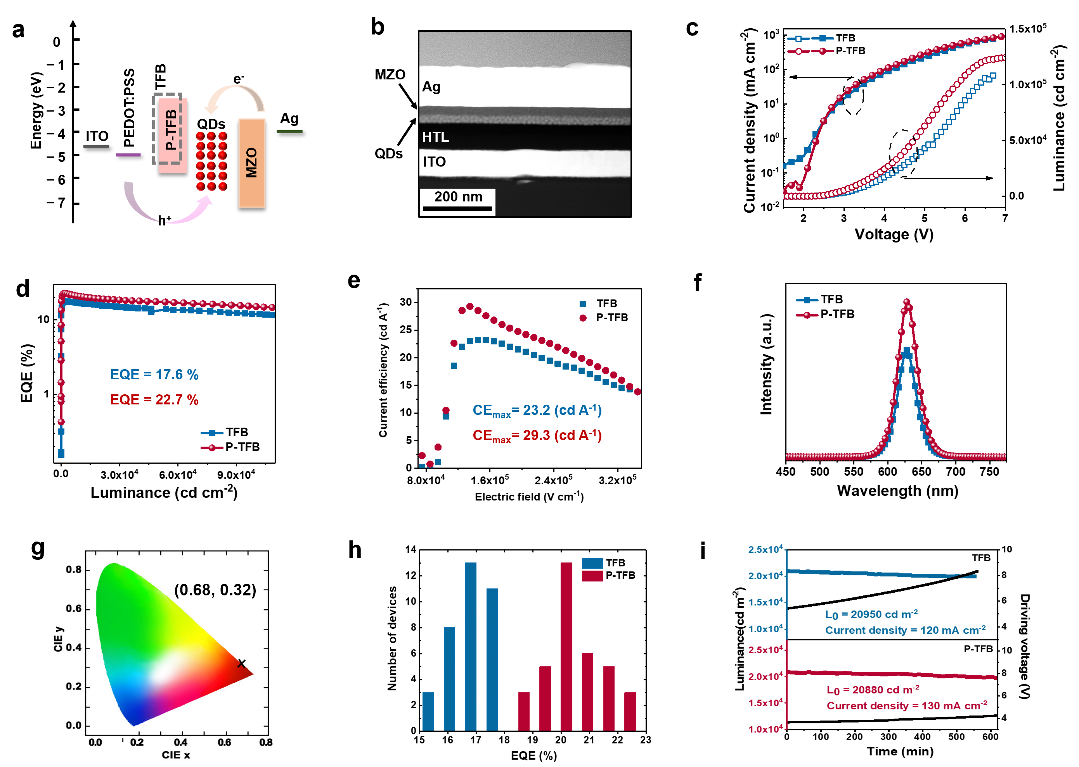
Figure 3. Performances of QLEDs. (a) Band structure of the QLEDs. (b) Cross-sectional STEM image of the device. (c) Current density and luminance as a function of voltage. (d) EQE as a function of luminance. (e) Current efficiency as a function of the electric field for the QLEDs. (f) EL spectra as a function of the voltage at 5V and the corresponding (g) CIE coordinates. (h) EQEs measured from 35 devices for QLEDs based on TFB and P-TFB HTLs. (i) Stability data for the QLED devices.

Figure 3f shows electroluminescence (EL) spectra of the QLEDs under a voltage of 5 V. As shown in the spectra, the emission intensity of the P-TFB based device is higher than that of the TFB based device at the same voltage, further demonstrating the improved current efficiency. Figure 3g displays the Commission Internationale de I’Eclairage (CIE) coordinates of the QLEDs, displaying purity red emission at 628 nm with (0.68, 0.32) CIE coordinates. Our work exhibits good reproducibility as displayed by the histogram of the EQE from 35 devices (Figure 3h). The average EQEs of the QLEDs based on TFB HTL and P-TFB HTL are 16.52 % and 20.67 %, respectively. The operational stability of the devices based on the TFB and P-TFB HTLs were evaluated at an initial luminance of 20,950 and 20,880 cd m⁻², under a constant driving current density of 120 and 130 mA cm⁻², respectively. The lifetime of T₉₅ for the device based on TFB HTL and P-TFB HTL are 9.3 and 10.2 h, respectively. The T₉₅ for the devices based on TFB and P-TFB HTLs at 1000 cd m⁻² were estimated to be 2,228 and 2,438 h, respectively, by assuming the acceleration factor of 1.8 [38] (Figure 3i). Although the operational lifetimes of the two devices are almost same, the variation of the driving voltage for the device based on the P-TFB is smaller than that for the device based on TFB, which is attributed to the balanced carrier injection and increased current efficiency.
The atomic force microscope (AFM) images show a flat structure for the TFB film with a small root-mean-square (RMS) value of 0.42 nm (Figure 4a). The P-TFB film shows an interesting an arrangement of the non-isometric cones, and an RMS value of 5.73 nm (Figure 4b). The non-planar structure of the P-TFB may have a positive effect on the device performance improvement based on the previous report [39]. The normalized EL intensity based on the TFB and P-TFB HTL was measured as a function of the viewing angles of the light between 0 - 90 ° as shown in Figure 4c. Within an angle of 15 - 45 °, the device based on the P-TFB shows the side-enhanced emission intensity compared with the device based on the TFB and the ideal Lambertian distribution of the device. This suggests the light redistributing to wide angle. In view of the previous work, the majority of the light generated in the device is waveguided because of the critical angle of total internal reflection [40]. The non-planar structure of HTL can effectively change the direction of the light generated in the QDs emitting layer, thus reducing the total internal reflection in the device [41-43]. This also contributes the enhancement in the luminance of the QLED.

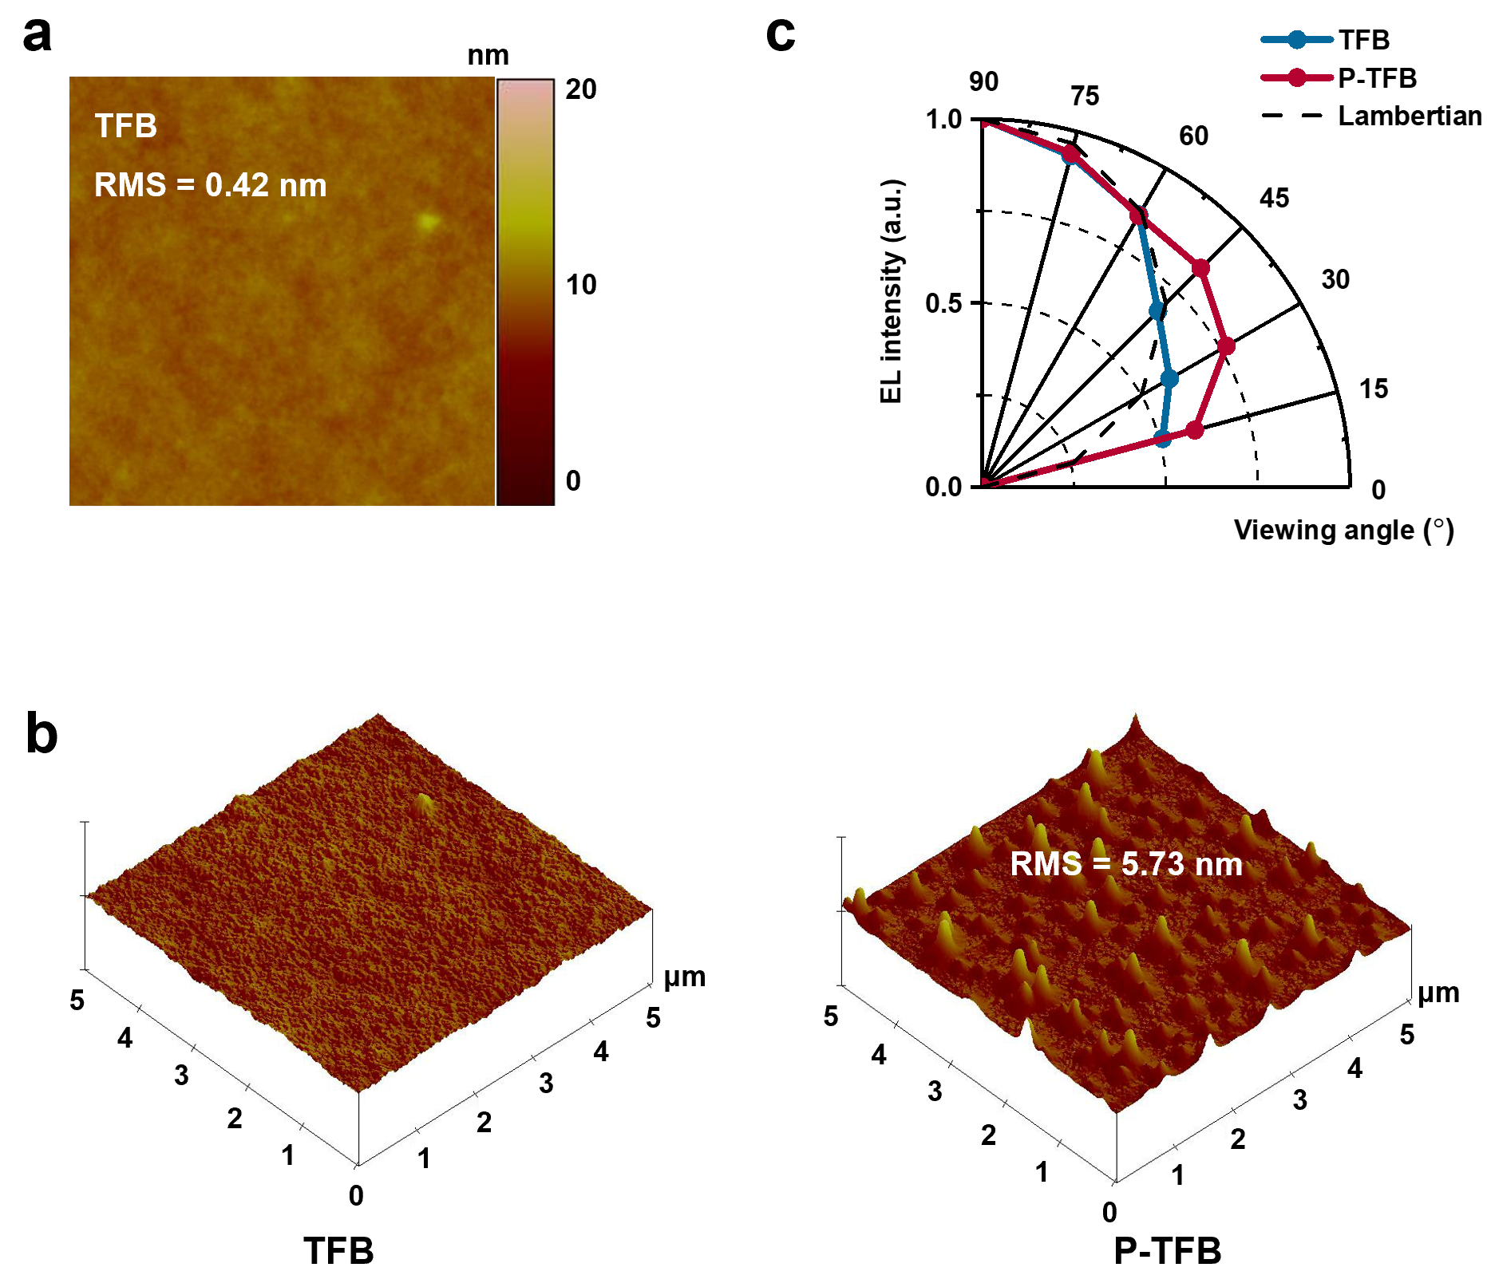
Figure 4 Characteristics of the HTL. (a, b) AFM images of the TFB and the P-TFB films. (c) Normalized EL spectra with different viewing angles.

Conclusions
In summary, we devised high carrier mobility HTL by doping PVK into TFB. The hole mobility of the doped HTL for P-TFB exhibited increased hole mobility due to enhanced π-π stacking intensity. Thus, the hole mobility was increased from 1.08×10⁻³ to 2.09×10⁻³cm²·V⁻¹·S⁻¹. Meanwhile, the P-TFB showed a little downshift of HOMO level, resulting in the decreased barrier energy between the HTL and QDs. The increased hole mobility of the HTL and decreased charge transfer barrier energy can accelerate hole transfer capability to balance with the electron injection within the QLED, thus increasing the current efficiency. In addition, the non-planar structure of the P-TFB HTL reduces the total internal reflection in the device. Therefore, the QLEDs based the doped HTL presented high EQE of 22.7%, luminance of 133100 cd·cm⁻², current efficiency of 29.3 cd·A⁻¹, power efficiency of 35.8 lm·W⁻¹, and long-term continuous operation stability T₉₅ >2,400 h at 1000 cd m⁻².
Acknowledgements
This work was supported by the Beijing Municipal Natural Science Foundation (2222061), National Natural Science Foundation of China (51961135107, 51774034), National Key Research and Development Program of China (2017YFE0119700). Choy would like to acknowledge the financial support of the General Research Fund (Grant Nos. 17201819, and 17211220) and Collaboration Research Fund (C7035-20G) from Hong Kong Special Administrative Region, China.

Conflict of interests
The authors declare no conflict of interest.
Supplementary information
Experimental details and the supporting data are available in the online version of the paper.
Reference
- C. Xiang, L. Wu, Z. Lu, M. Li, Y. Wen, Y. Yang, W. Liu, T. Zhang, W. Cao, S. Tsang, B. Shan, X. Yan, L. Qian. Nat. Commun, 2020, 11, 1646.
- C. Pu, X. Dai, Y. Shu, M. Zhu, Y. Deng, Y. Jin, and X. Peng. Nat. Commun, 2020, 11, 937.
- W. Cao, C. Xiang, Y. Yang, Q. Chen, L. Chen, X. Yan, and L. Qian. Nat. Commun, 2018, 9, 2608.
- C. Bi, Z. Yao, X. Sun, X. Wei, J. Wang, and J. Tian. Adv. Mater, 2021, 33, 2006722.
- Y. Li, X. Hou, X. Dai, Z. Yao, L. Lv, Y. Jin, and X. Peng. J. Am. Chem. Soc, 2019, 141, 6448.
- T. Meng, Y. Zheng, D. Zhao, H. Hu, Y. Zhu, Z. Xu, S. Ju, J. Jing, X. Chen, H. Gao, K. Yang, T. Guo, F. Li, J. Fan, L. Qian. Nature Photonics, 2022, 16, 297.
- H. Jia, F. Wang, and Z. Tan. Nanoscale, 2020, 12, 13186.
- Colvin. V L, Schlamp. M C, and Alivisatos A P. Nature. 1994, 370, 354.
- H. Shen, Q. Gao, Y. Zhang, Y. Lin, Q. Lin, Z. Li, L. Chen, Z. Zeng, X. Li, Y. Jia, S. Wang, Z. Du, L. Li, and Z. Zhang. Nature Photonics, 2019, 13, 192.
- Q. Yuan, T. Wang, P. Yu, H. Zhang, H. Zhang, and W. Ji. Org. Electron. 2021, 90, 106086.
- Z. Yao, C. Bi, A. Liu, M. Zhang, and J. Tian. Nano Energy, 2022, 95, 106974.
- S. Yang, C. Bi, W. Dong, X. Zhang, W. Zheng, W. C. H. Choy, and J. Tian. Adv. Opt. Mater. 2022, 2200189.
- X. Dai, Z. Zhang, Y. Jin, Y. Niu, H. Cao, X. Liang, L. Chen, J. Wang, and X. Peng. Nature, 2014, 515, 96.
- X. Li, Q. Lin, J. Song, H. Shen, H. Zhang, L. Li, X. Li, Z. Du. Adv. Opt. Mater. 2020, 8, 1901145.
- Kim T, Kim K H, Kim S, Choi S, Jang H, Seo H, Lee H, Chung D, and Jang E. Nature, 2020, 586, 385.
- Y. Sun, W. Wang, H. Zhang, Q. Su, J. Wei, P. Liu, S. Chen, and S. Zhang. ACS Appl. Mater. Interfaces, 2018, 10, 18902.
- H. Kim, S. Cho, J. Kim, H. Shin, and J. Jang. ACS Appl Mater Interfaces. 2018, 10, 24028.
- A. Alexandrov, M. Zvaigzne, D. Lypenko, I, Nabiev, and P. Samokhvalov. Sci. Rep, 2020, 10, 7496.
- A. Liu, C. Cheng, J. Tian. J. Mater. Chem. C, 2022, DOI: 10.1039/D2TC01355J.
- Y. Zou, Y. Liu, M. Ban, Q. Huang, T. Sun, Q. Zhang, T. Song, and B. Sun. Nanoscale Horiz, 2017, 2, 156.
- H. Yan, Lee P, Armstrong N R, Evmenenko G A, Dutta P, and Marks T J. J. Am. Chem. Soc. 2005, 127, 3172.
- L. Li, T. Hu, C. Yin, L. Xie, Y. Yang, C. Wang, J. Lin, M. Yi, S. Ye, and W. Huang. Polym. Chem. 2015, 6, 983.
- L. Gao, C. Li. J. Lumin. 2010, 130, 236.
- Ma L, Ma H. RSC Adv. 2019, 9, 18098.
- Renzi W, Cordeiro N J A, de Santana H, et al. Synth. Met. 2018, 236, 24.
- M. Pan, T. Lau, Y. Tang, Y. Wu, T. Liu, K. Li, M. Chen, X. Lu, W. Ma, and C. Zhan. J. Mater. Chem. A, 2019, 7, 20713.
- H. Xin, C. Ge, X. Jiao, X. Yang, K. Rundel, C. R. McNeill, and X. Gao. Angew. Chem. Int. Ed, 2018, 130, 1336.
- M. Zhang, L. Zhu, G. Zhou, T. Hao, C. Qiu, Z. Zhao, Q. Hu, B. Larson, H. Zhu, Z. Ma, Z. Tang, W. Feng, Y. Zhang, T. Russell, and F. Liu. Nat. Commun, 2021, 12, 309.
- A. J. Heeger, S. Kivelson, J. Schrieffer, and W.-P. Su. Rev. Mod. Phys. 1988, 60, 781.
- K. Ueji, M. Ohno, J. Takeya, and S. Watanabe. Appl. Phys. Express. 2019, 12, 011004.
- Y. Tian, Z. Qin, S. Zou, Y. Li, Y. Wang, W. Wang, C. Zhang, and J. Tang. Mater. Today Energy, 2021, 20, 100649.
- L. Zheng, G. Zhai, Y. Zhang, X. Jin, L Gao, Z. Yun, Y. Miao, H. Wang, Y. Wu, and B. She. Superlattices Microstruct. 2020, 140, 106460.
- Lee H, Lee S, and Lee H. ACS Appl. Mater. Interfaces, 2021, 13, 21534.
- C. Cheng, X. Sun, Z. Yao, C. Bi, X. Wei, J. Wang, and J. Tian. Sci. China Mater. 2022, Doi/10.1007/s40843-021-1976-9.
- Y. Zhu, Y. Liu, H. Hu, Z. Xu, J. Bai, K. Yang, T. Guo, F. Li. Sci. China Mater., 2022, 65, 1012.
- J. Song, T. Fang, J. Li, L. Xu, F. Zhang, B. Han, Q. Shan, H. Zeng. Adv. Mater. 2018, 30, 1805409.
- W. Cao, C. Xiang, Y. Yang, Q. Chen, L. Chen, X. Yan, and L. Qian. Nat. Commun. 2018, 9, 1.
- P. Wellmann, M. Hofmann, O. Zeika, A. Werner, and K. Leo. J Soc Inf Display, 2005, 13, 393.
- S. Wang, X. Dou, L. Chen, Y. Fang, A. Wang, H. Shen, and Z. Du. Nanoscale, 2018, 10, 11651.
- L. Xu, Q. Ou, Y. Li, Y. Zhang, X. Zhao, H. Xiang, J. Chen, L. Zhou, S. Lee, and J. Tang. ACS Nano, 2016, 10, 1625.
- Y. Liu, M. An, X. Zhang, Y. Bi, D. Yin, Y. Zhang, J. Feng, and H. Sun. Appl. Phys. Lett. 2016, 109, 193301.
- Möller S, Forrest S R. J. Appl. Phys. 2002, 91, 3324.
- L. Zhou, X. Jiang, Y. Li, A. Shi, J. Chen, Q. Ou, H. Liu, and J. Tang. ACS Appl. Mater. Interfaces. 2014, 6, 18139.

