Surface-reconstruction of NiO_{x} nanocrystals makes a breakthrough in flexible solar cells
Hong Zhang^{1,2*}, Wallace C. H. Choy^{1,*}
¹Department of Electrical and Electronic Engineering, The University of Hong Kong, Pokfulam Road, Hong Kong, P. R. China
²Institute of Optoelectronics, Fudan University, Shanghai 200433, P. R. China.
Email: hzhang@eee.hku.hk; chchoy@eee.hku.hk
Lightweight flexible perovskite solar cells are promising for building/vehicle integrated photovoltaics, wearable electronics, and aerospace applications. Recently in Nature Energy, Li and coworkers re-construct the surface properties of low-temperature processed NiO_{x} nanocrystal film by tailoring a self-assembled monolayer. A record power conversion efficiency of 24.4% (certified) was achieved in flexible solar cells using an all-perovskite tandem structure.
Lightweight flexible solar cells have attracted intensive attention because of their virous promising applications in building/vehicle-integrated photovoltaics, wearable electronics, portable energy systems and aerospace applications. Since the first demonstrated application in photovoltaics in 2009¹, metal halide perovskites have been widely regarded as the emerging light-harvesting materials for next-generation thin-film solar cells due to the merits of low-cost, high absorption coefficient, solution processable, long electron-hole diffusion length and so on. Their high absorption coefficient enables the active layer of the device to be very thin with an thickness of ~500 nm to absorb the entire visible solar spectrum. These features combined result in the capability to realize the low-cost, high-efficiency, and lightweight flexible solar cells.
The power conversion efficiency (PCE) of flexible perovskite solar cells (PSCs) have rapidly improved to over 21% (highest certified of 19.9%) within a decade². Recently, there is an increasing global effort to advance the flexible PSCs, and much of these endeavors are focused on the development of new composition, carrier transporting materials, interfacial engineering, and processing methods. In particular, non-stoichiometric nickel oxide (NiO_{x}) nanocrystals developed by our group³⁻⁴ have been extensively studied as a low-cost and highly efficient hole-transporting material in flexible PSCs due to their its robust chemical stability, low-temperature processability, high optical transmittance and low fabrication costs. However, high trap densities and energy-level misalignment at the NiO_{x}/perovskite interface constrain performance and operational stability of flexible PSCs.⁵ Surface passivation of NiO_{x} nanocrystal film with small molecules⁶, polymers⁷, ionic liquids⁸ and organic cations⁵ led to the best PCE of ~20%⁹ for p-i-n flexible PSCs. Therefore, modifying the surface properties of NiO_{x} nanocrystal film with tailored molecules is an effective strategy to minimize the PCE difference between PSCs fabricated on rigid and flexible substrates.
Writing in Nature Energy, Li and coworkers report a molecule-bridged hole-selective contact to mitigate interfacial recombination and facilitate hole extraction in flexible PSCs by anchoring hole-selective molecules on the low temperature-processed NiO_{x} nanocrystal film.¹⁰ Considering the excellent hole selectivity and effective chemical bonding formation, two types of molecule, namely 2PACz ([2-(9H-carbazol9-yl)ethyl] phosphonic acid) and MeO-2PACz ([2-(3,6-dimethoxy-9H-carbazol-9-yl)ethyl]phosphonic acid), were selected for this study. The 2PACz and MeO-2PACz molecules anchor on the surface of NiO_{x} via the phosphonic acid group, as evidenced by X-ray photoelectron spectroscopy and ultraviolet photoelectron spectroscopy measurements. In the meantime, the oxygen from the phosphoryl of the 2PACz passivates the defects in the buried interface of perovskite films via forming the Pb—O chemical bonding, as confirmed from the first-principle calculations. The anchoring of 2PACz and MeO-2PACz with different molecular dipole moments (2.0 debye vs. 0.2 debye) is also capable to tune the energy-level alignment between NiO_{x} and perovskites. As a result, the interfacial non-radiative recombination at the interface between NiO_{x} and perovskite absorber, which contributes to the improved photovoltaic performance of flexible single-junction PSCs. Furthermore, this strategy can be employed to fabricate flexible all-perovskite tandem solar cells with a certified PCE of 24.4% for device area of 0.049 cm², which represents the highest performance among all types of flexible thin-film solar cells reported to date. Meanwhile, surface-reconstruction of NiO_{x} nanocrystals with hole-selective molecules improves the mechanical and operational stability of flexible PSCs.
This report opens a new way to fabricate flexible solar cells with high efficiency and stability for the broad applications. However, the mechanism is still not very clear for the self-assembly of the 2PACz and MeO-2PACz mixtures on the surface of NiO_{x} nanocrystals. Meanwhile, the molecules used are still very expensive and may increase the fabrication cost of flexible PSCs. In the near future, more insightful studies should focus on design guideline for developing more efficient and cheaper self-assembled molecules for large-scale manufacturing of lightweight flexible solar cells. Toward the practical applications of flexible PSCs, the mechanical and operational stabilities need to be further improved by a combination of interface engineering, material innovation of each functional layer, and encapsulation techniques.
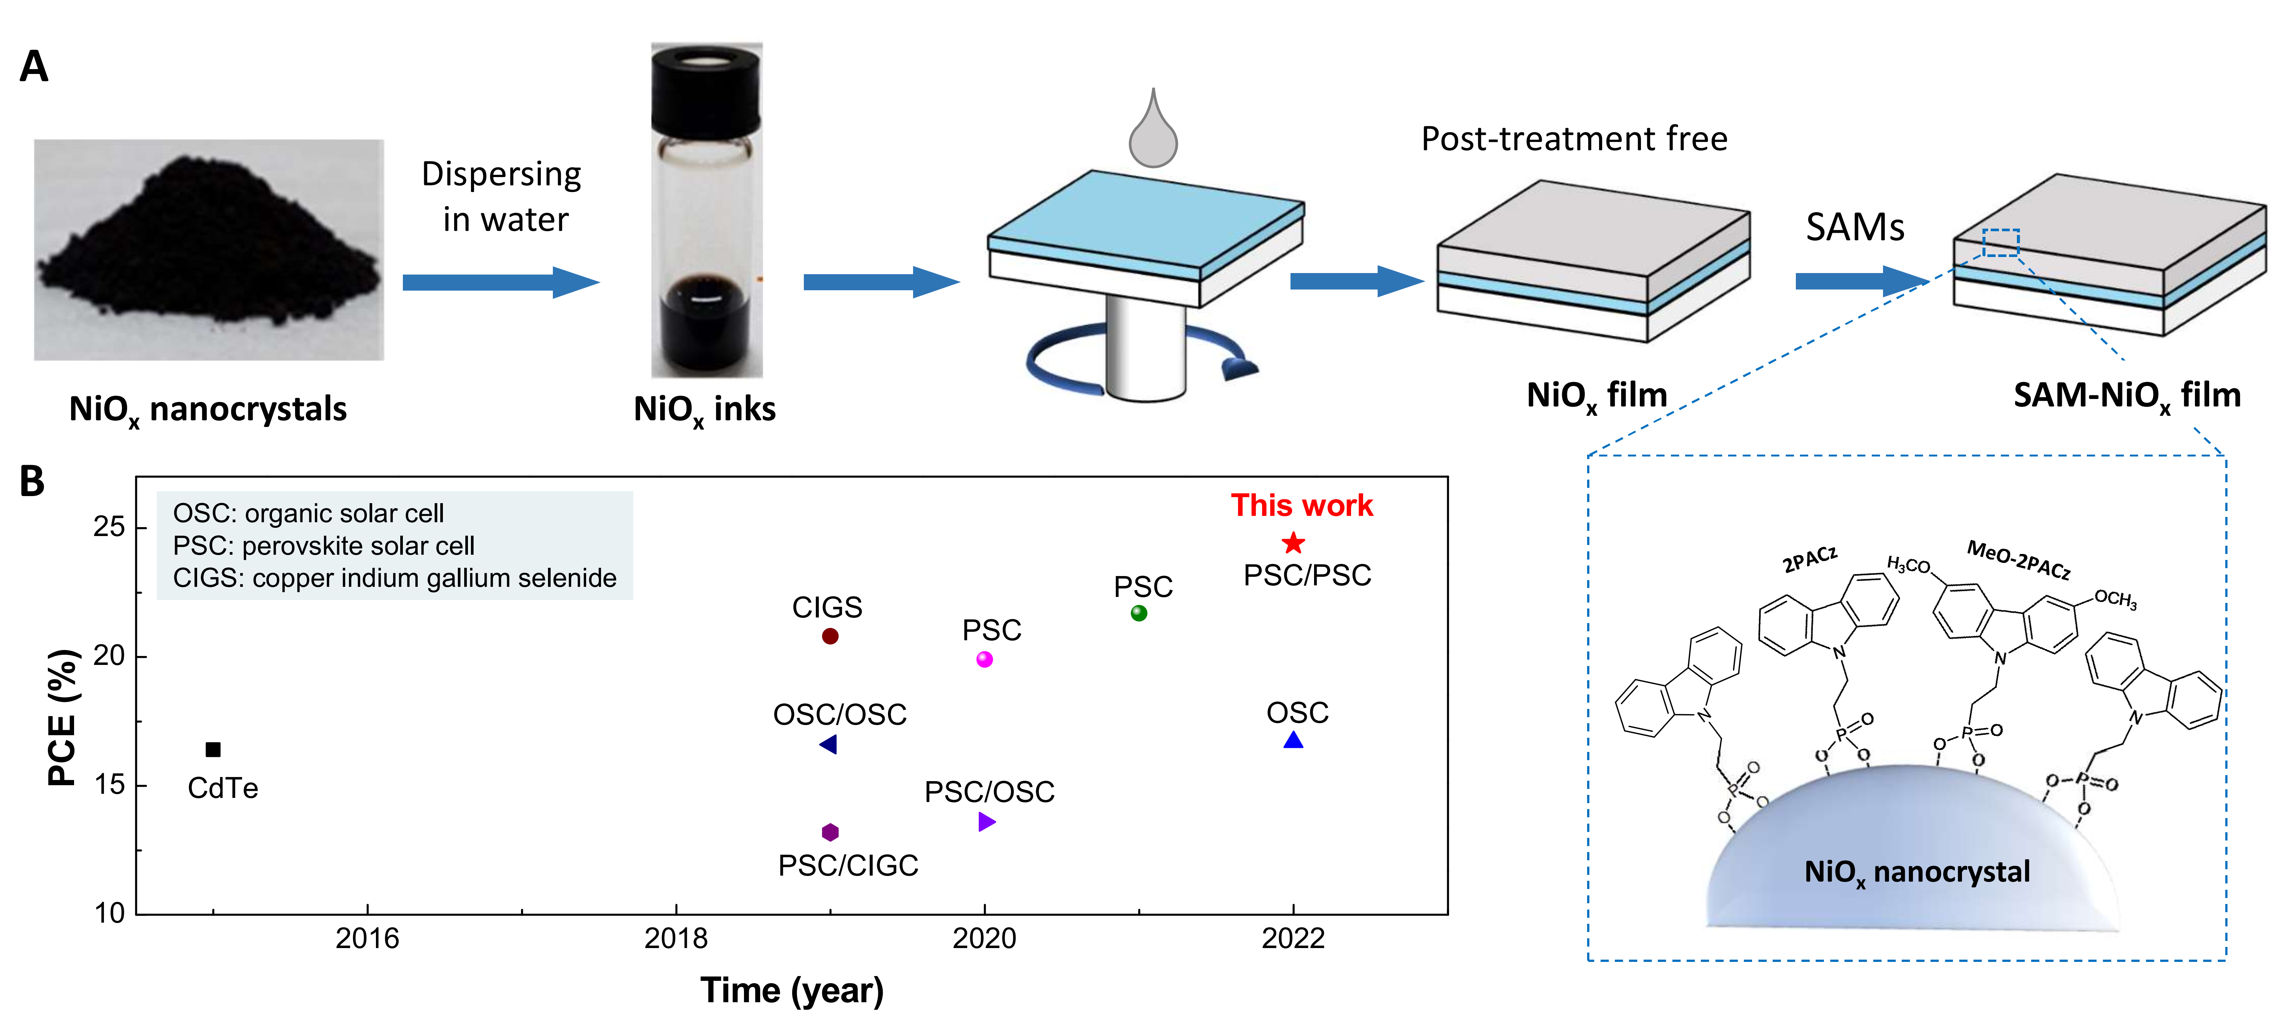
Figure 1. Preparation of SAM-NiO_{x} nanocrystal film and performance comparison of different types of flexible solar cells.
(A) Scheme of the SAM-NiO_{x} nanocrystal film formation and the surface-reconstruction of NiO_{x} nanocrystals with SAMs. (B) Comparison of the flexible all-perovskite tandem prepared on SAM-NiO_{x} substrate with other types of flexible solar cells.

References
1. Kojima, A.; Teshima, K.; Shirai, Y.; Miyasaka, T., Organometal Halide Perovskites as Visible-Light Sensitizers for Photovoltaic Cells. Journal of the American Chemical Society 2009, 131 (17), 6050-6051.
2. Palmstrom, A. F.; Eperon, G. E.; Leijtens, T.; Prasanna, R.; Habisreutinger, S. N.; Nemeth, W.; Gaulding, E. A.; Dunfield, S. P.; Reese, M.; Nanayakkara, S.; Moot, T.; Werner, J.; Liu, J.; To, B.; Christensen, S. T.; McGehee, M. D.; van Hest, M. F. A. M.; Luther, J. M.; Berry, J. J.; Moore, D. T., Enabling Flexible All-Perovskite Tandem Solar Cells. Joule 2019, 3 (9), 2193-2204.
3. Zhang, H.; Cheng, J.; Lin, F.; He, H.; Mao, J.; Wong, K. S.; Jen, A. K. Y.; Choy, W. C. H., Pinhole-Free and Surface-Nanostructured NiOx Film by Room-Temperature Solution Process for High-Performance Flexible Perovskite Solar Cells with Good Stability and Reproducibility. ACS Nano 2016, 10 (1), 1503-1511.
4. Jiang, F.; Choy, W. C. H.; Li, X.; Zhang, D.; Cheng, J., Post-treatment-Free Solution-Processed Non-stoichiometric NiOx Nanoparticles for Efficient Hole-Transport Layers of Organic Optoelectronic Devices. Advanced Materials 2015, 27 (18), 2930-2937.
5. Boyd, C. C.; Shallcross, R. C.; Moot, T.; Kerner, R.; Bertoluzzi, L.; Onno, A.; Kavadiya, S.; Chosy, C.; Wolf, E. J.; Werner, J.; Raiford, J. A.; de Paula, C.; Palmstrom, A. F.; Yu, Z. J.; Berry, J. J.; Bent, S. F.; Holman, Z. C.; Luther, J. M.; Ratcliff, E. L.; Armstrong, N. R.; McGehee, M. D., Overcoming Redox Reactions at Perovskite-Nickel Oxide Interfaces to Boost Voltages in Perovskite Solar Cells. Joule 2020, 4 (8), 1759-1775.
6. Wang, Q.; Chueh, C.-C.; Zhao, T.; Cheng, J.; Eslamian, M.; Choy, W. C. H.; Jen, A. K.-Y., Effects of Self-Assembled Monolayer Modification of Nickel Oxide Nanoparticles Layer on the Performance and Application of Inverted Perovskite Solar Cells. ChemSusChem 2017, 10 (19), 3794-3803.
7. Du, Y.; Xin, C.; Huang, W.; Shi, B.; Ding, Y.; Wei, C.; Zhao, Y.; Li, Y.; Zhang, X., Polymeric Surface Modification of NiOx-Based Inverted Planar Perovskite Solar Cells with Enhanced Performance. ACS Sustainable Chemistry & Engineering 2018, 6 (12), 16806-16812.
8. Zhang, S.; Wang, H.; Duan, X.; Rao, L.; Gong, C.; Fan, B.; Xing, Z.; Meng, X.; Xie, B.; Hu, X., Printable and Homogeneous NiOx Hole Transport Layers Prepared by a Polymer-Network Gel Method for Large-Area and Flexible Perovskite Solar Cells. Advanced Functional Materials 2021, 31 (47), 2106495.
9. Ru, P.; Bi, E.; Zhang, Y.; Wang, Y.; Kong, W.; Sha, Y.; Tang, W.; Zhang, P.; Wu, Y.; Chen, W.; Yang, X.; Chen, H.; Han, L., High Electron Affinity Enables Fast Hole Extraction for Efficient Flexible Inverted Perovskite Solar Cells. Advanced Energy Materials 2020, 10 (12), 1903487.
10. Li, L.; Wang, Y.; Wang, X.; Lin, R.; Luo, X.; Liu, Z.; Zhou, K.; Xiong, S.; Bao, Q.; Chen, G.; Tian, Y.; Deng, Y.; Xiao, K.; Wu, J.; Saidaminov, M. I.; Lin, H.; Ma, C.-Q.; Zhao, Z.; Wu, Y.; Zhang, L.; Tan, H., Flexible all-perovskite tandem solar cells approaching 25% efficiency with molecule-bridged hole-selective contact. Nature Energy 2022, https://doi.org/10.1038/s41560-022-01045-2.

