Cyano-Functionalized Fused Bithiophene Imide Dimer-Based n-Type polymers for High-Performance Organic Thermoelectrics

Kui Feng*, Wanli Yang, Sangyoung Jeong, Suxiang Ma, Yongchun Li, Junwei Wang, Yimei Wang, Han Young Woo, Paddy Kwok Leung Chan, Gang Wang*, Xugang Guo*, Meifang Zhu

Dr. K. Feng, W. Yang, S. Ma, Y. Li, J. Wang, Y. Wang, Prof. X. Guo
Department of Materials Science and Engineering, Southern University of Science and Technology, Shenzhen, Guangdong 518055, China
E-mail: fengk@sustech.edu.cn; guoxg@sustech.edu.cn

Dr. K. Feng
Academy for Advanced Interdisciplinary Studies, Southern University of Science and Technology, Shenzhen, Guangdong 518055, China

W. Yang, Prof. P. K. L. Chan
Department of Mechanical Engineering, The University of Hong Kong, Pokfulam Road, Hong Kong

S. Y. Jeong, Prof. Y. H. Woo
Department of Chemistry, Korea University, Anamro 145, Seoul 02841, Republic of Korea

Prof. G. Wang, Prof. M. Zhu
State Key Laboratory for Modification of Chemical Fibers and Polymer Materials, College of Materials Science and Engineering, Shanghai Key Laboratory of Lightweight Structural Composites, Key Laboratory of High Performance Fibers & Products, Ministry of Education, Donghua University, Shanghai 201620, China
E-mail: gwf8707@dhu.edu.cn

Keywords: n-type polymer semiconductors, cyano functionalization, morphology optimization, conductivity, organic thermoelectrics
Abstract: Doped n-type polymers usually exhibit low electrical conductivities and thermoelectric power factors (PFs), restricting the development of high-performance p-n junction-based organic thermoelectrics (OTEs). Herein we report the design and synthesis of a new cyano-functionalized fused bithiophene imide dimer (f-BTI2), CNI2, which synergistically combines the advantages of both cyano and imide functionalities, thus leading to substantially higher electron deficiency than the parent f-BTI2. On the basis of this novel building block, a series of n-type donor-acceptor and acceptor-acceptor polymers were successfully synthesized, all of which show good solubility, deep-lying frontier molecular orbital levels, and favorable polymer chain orientation. Among them, the acceptor-acceptor polymer PCNI2-BTI delivers an excellent electrcial conductivity up to 150.2 S cm⁻¹ and a highest PF of 110.3 µW m⁻¹ K⁻² in n-type OTEs, attributed to the optimized polymer electronic properties and film morphology with improved molecular packing and higher crystallinity assisted by solution-shearing technology. The PF value is the record of n-type polymers for OTEs to date. This work demonstrates a facile approach to designing high-performance n-type polymers and fabricating high-quality films for OTE applications.

Introduction
Organic thermoelectric (OTE) materials, which can directly convert waste heat to electricity, have drawn increasing attention, recently, due to their merits of light weight, mechanical flexibility, and solution processibility, making them very promising in developing energy generators, particularly for wearable devices or flexible electronics.^{[1-6]} The advance of the OTE field is mainly driven by material design, film morphology optimization, doping technique development and device engineering.^{[7-13]} To date, tremendous research efforts have been dedicated to p-type polymer semiconductors,^{[14-17]} resulting in a remarkable progress for p-type OTEs with an excellent electrical conductivity (σ) over 3000 S cm⁻¹, high power factor (PF) of＞500 µW m⁻¹ K⁻² and figure of merit (ZT) value of 0.75,^{[18-20]} while their n-type counterparts lag greatly behind due to the scarcity of highly electron-deficient building blocks with planar backbone framework, minimal steric hindrance, and excellent solubility, which are critical for accessing high-performance n-type polymers.^{[21-25]} By considerable efforts from materials scientists, there are some reports on efficient n-type polymers for OTEs. They mainly include donor-acceptor (D-A) polymers such as naphthalene diimde (NDI)-based N2200,^{[22]} p(gNDI-gT2),^{[26]} and PNDI2TEG-2Tz^{[27]}, bithiophene imide-based PDTzTIT-2F,^{[28]} amide-functionalized arenes-based FBDPPV,^{[29]} PzDPP,^{[30]} and P(PzDPP-CT2),^{[25]} acceptor-acceptor (A-A) polymers such as ladder-type polymers BBL,^{[31]} LPPV-1,^{[32]} N-N,^{[33]} and p(g7NC4N),^{[34]} boron-nitrogen coordination bond-based polymer PBN-19,^{[35]} and bithiophene imide-based polymers PCNI-BTI^{[36]} and PDTzTI.^{[37]} Nevertheless, the performance of such n-type polymers still lagged behind p-type ones, which limits the development of efficient thermoelectric generators since both p- and n-type thermoelectric polymers with high and comparable performance are required in such devices.^{[18, 38, 39]} Therefore, it is imperative to design and synthesize electron-deficient building blocks with good solubility, planar backbone, and the low-lying lowest unoccupied molecular orbital (LUMO) energy level.^{[31-33, 40]}
Fused bithiophene imide dimer (f-BTI2), one of bithiophene imide (BTI) derivatives, has been proved to be a versatile electron-deficient building block for n-type polymers.^{[41-43]} Incorporation f-BTI2 into polymeric backbones yielded high-performance n-type semiconductors for applications in OTEs,^{[28]} organic thin-film transistors (OTFTs),^{[44, 45]} all-polymer solar cells (all-PSCs),^{[43, 46]} and organic electrochemical Transistors (OECTs).^{[47, 48]} For example, polymer f-BTI2TEG-FT with branched oligo(ethylene glycol) (OEG) side chain delivered a sizable electrical conductivity (σ) of 87 S cm⁻¹ due to its very planar backbone, favourable polymer chain packing, and substantial n-doping efficiency.^{[28]} On another hand, cyano functionalization has been proved as a powerful approach to developing highly electron-deficient building blocks, and their resultant n-type semiconductors showed low-lying LUMO levels and improved n-type performance in various organic electronic devices.^{[36, 49-53]}
Driven by the great success of f-BTI2 with reduced steric hindrance and cyano functionalization strategy for lowering frontier molecular orbital (FMO) energy levels, we herein leverage the advantages of both cyano and imide functionalities to develop CNI2 with decent solubility, small steric hindrance, and strong electron-deficiency. The LUMO level of CNI2 is calculated to be −3.35 eV (Figure 1a), which is substantially suppressed as compared to that of the parent f-BTI2 (−2.97 eV),^{[46]} and close to that of the benchmark NDI (−3.40 eV),^{[54]} indicating its potential for constructing high-performance n-type polymers.^{[55]} By devising the synthetic routes, we can successfully attain CNI2 by forming the imide functional groups first followed by cyanation. Considering CNI2 with strong electron deficiency and small steric hindrance, both D-A copolymers, PPCNI2-V and PPCNI2-T, and A-A copolymer PPCNI2-BTI are synthesized. All polymers showed low-lying LUMO levels of below −3.80 eV, much deeper than the f-BTI2-based analogues. The PPCNI2-BTI-based OTFT devices fabricated via spin-coating showed a highest electron mobility (μ_{e}) of 0.22 cm⁻² V⁻¹ s⁻¹. Benefiting from their deep-lying LUMOs, the polymers can be efficiently n-doped by molecular dopant N-DMBI, consequently, the spin-coated PPCNI2-BTI exhibited a remarkable σ up to 89.2 S cm⁻¹ and PF of 75.1 µW m⁻¹ K⁻² in OTEs. When adopting solution-shearing method,^{[56]} all CNI2-based polymers exhibited much improved OTE performance with the champion electrical conductivity of 150.2 S cm⁻¹ and PF of 110.3 µW m⁻¹ K⁻², which represents a great advance in the OTE field.^{[21, 25, 30, 34]} This is the first example that solution-shearing technology can be efficiently used to improve the OTE performance, and the breakthrough demonstrates the power of combining material design with morphology control on driving the development of organic electronic devices.
Results and discussion
Material synthesis
Scheme 1 depicts the synthetic route to the cyano-functionalized fused bithiophene imide dimer CNI2 and its dibrominated monomers, which are synthesized via forming imide functionality first followed by cyanation. Briefly, starting from commercial diethyl thieno[3,2-b]thiophene-3,6-dicarboxylate 1, the bromination of the 2,5-positions followed by Stille coupling with methyl 2-(trimethylstannyl)thiophene-3-carboxylate yielded compound 3, which was subsequently brominated using elemental bromine to afford tetrabrominated compound 4. The following steps, including reduction, hydrolysis, dehydration, imidization, cyanation, and bromination, afforded dibrominated monomer CNI2-2Br(C8C10).^{[36]} Please note that monomer CNI2-2Br(C18C18) with a long and farther branched 4-octadecyldocosane side chain was also synthesized for better solubility and improved interchain interaction, which hence can be copolymerized with co-units with limited solubility. Detailed synthesis and characterization are included in the Supporting Information. The dibrominated CNI2-2Br was then copolymerized with (E)-1,2-bis(tributylstannyl)ethene and 2,5-bis(trimethylstannyl)thiophene under typical Stille coupling condition to afford alternating D-A copolymers PCNI2-V and PCNI2-T (Figure 1b and Scheme S1), respectively. Additionally, A-A type copolymer PCNI2-BTI was also synthesized by coupling CNI2-2Br with distannylated bithiophene imide.^{[45]} After polymerization, the product polymers were subjected to Soxhlet extractions using a different solvent sequence, depending on the polymer solubility. The polymer molecular weights were estimated by high-temperature gel permeation chromatography (GPC) vs polystyrene standards at 120 °C using 1,2,4-tricholorobenzene (TCB) as the eluent (Figure S1-S3), and the number-average molecular weight (M_{n}) and polydispersity index (PDI) are summarized in Table 1.

Scheme 1. Synthetic route to dibrominated cyano-functionalized bithiophene imide dimer monomer CNI-2Br.
Reagents and conditions: i) Br₂, CHCl₃; ii) Pd(PPh₃)₂Cl₂, DMF; iii) Br₂, CHCl₃, iv) Zn, HAc; v) KOH, THF, EtOH, H₂O; vi) Ac₂O; vii) DMAP, 1,4-dioxane, Ac₂O; viii) ZnCN₂, Pd₂(dba)₃, dppf, 1,4-dioxane; ix) Br₂, CHCl₃.

Polymer Thermal, Optical, and Electrochemical Properties
Thermal properties of the CNI2-based polymers were characterized using thermogravimetric analysis (TGA) and differential scanning calorimetry (DSC). As shown in Figure S5a, three polymers exhibit high thermal stability with a decomposition temperature >300 ºC (the temperature with a 5% weight loss). DSC curves show no significant thermal transition from 30 to 300 °C for all polymers (Figure S5b), similar to the f-BTI2-based analogues.^{[46]} The UV−vis absorption spectra of the polymers in chlorobenzene solution and as thin film are illustrated in Figure 1c and 1d, respectively, and the corresponding absorption parameters are summarized in Table 1. Three polymers exhibit an absorption maximum (λ_{max}^{sol}) in addition to an absorption shoulder between 500 and 900 nm in solution, indicating a certain degree of ordering of polymer chains. PCNI2-V shows an obviously red-shifted λ_{max}^{sol} of 623
Figure 1. (a) The LUMO energy levels of the cyano-functionalized imide-based CNI2 together with bithiophene imide (BTI) and fused bithiophene imide dimer (f-BTI2), calculated from density functional theory (DFT) at the B3LYP/6-31G(d) level. (b) Chemical structures of the CNI2-based donor-acceptor polymers PCNI2-V and PCNI2-T, and the acceptor-acceptor polymer PCNI2-BTI. (c) Normalized UV−vis absorption spectra of the cyano-functionalized imide-based polymers (d) in diluted chlorobenzene solution (10⁻⁵ M) and (d) as thin film. (e) FMO energy level alignment of polymers.

nm in comparison to that of PCNI2-T (556 nm). Going from solution to film, three polymers show a red-shifted λ_{max} (~20 nm), illustrating a stronger aggregation and/or better ordering of the CNI2-based polymers in film state. The optical bandgaps (E_{g}^{opt}s) of PCNI2-V, PCNI2-T, and PCNI2-BTI are 1.78, 1.83, and 1.87 eV, respectively, determined from the absorption onset (λ_{onset}^{film}) of polymer films. The larger E_{g}^{opt} of PCNI2-BTI is attributed to the suppressed ICT character in the A−A type polymeric backbone.
Three polymers exhibit pronounced reduction peaks during the CV measurement (Figure S6), indicating their n-type characters. Their E_{LUMO}s are found to be −4.02, −3.85, and −3.91 eV for PCNI2-V, PCNI2-T, and PCNI2-BTI (Figure 1e), respectively, based on their reduction
Table 1. Optical and electrochemical properties of the cyano-functionalized imide-based polymer semiconductors.
Polymer | M_{n}  [kDa] | PDI | λ_{max}^{soln}  [nm] ª | λ_{max}^{film}  [nm] ^{b} | λ_{onset}^{film}  [nm] | E_{g}^{opt}  [eV] ^{c} | E_{LUMO}  [eV] ^{d} | E_{HOMO}  [eV] ^{e}
PCNI2-V | 31.1 | 1.6 | 623 | 638 | 697 | 1.78 | −4.02 | −5.80
PCNI2-T | 12.6 | 2.0 | 556 | 581 | 686 | 1.83 | −3.85 | −5.68
PCNI2-BTI | 70.9 | 2.5 | 591 | 610 | 663 | 1.87 | −3.91 | −5.78
ª Absorption of solution (10⁻⁵ M in chlorobenzene). ^{b} Absorption of as-cast film from 5 mg mL⁻¹ chlorobenzene solution. ^{c} Optical bandgap (E_{g}^{opt}) derived from absorption onset of polymer film using the equation: E_{g}^{opt} = 1240/λ_{onset}^{film} (eV). ^{d} E_{LUMO} = − (E_{red}^{onset} + 4.80) eV, E_{red}^{onset} determined using the Fc/Fc⁺ external standard. ^{e} E_{HOMO} = E_{LUMO} − E_{g}^{opt}.

onset potentials relative to the ferrocene/ferrocenium redox couple. Due to the weak and undistinguishable oxidation peaks, the E_{HOMO}s were estimated based on the equation: E_{HOMO} = E_{LUMO} − E_{g}^{opt}, and the results are compiled in Table 1. The ultraviolent photoelectron spectroscopy (UPS) is used to further characterize LUMO levels of the CNI2-based polymers (Figure S7 and Table S2). The derived LUMO levels of PCNI2-V, PCNI2-T, and PCNI2-BTI are −3.93, −3.80, and −3.87 eV, which well correlate with the trend found from the CV results. The FMOs of these polymers are largely suppressed in comparison with the f-BTI2-based analogues, which should facilitate electron injection and suppress hole accumulation, demonstrating the advantages of cyano-functionalization in enabling n-type performance. From DFT calculations (Figure S8), the E_{LUMO}/E_{HOMO}s of three repeating units of polymers PCNI2-V, PCNI2-T, and PCNI2-BTI are found to be −3.86/−6.05, −3.62/−5.95, −3.72/−5.95 eV, respectively. The trend is in good agreement with the CV results. Geometry optimization revealed that polymer PCNI2-BTI has a higher degree of backbone planarity with smaller dihedral angles (< 3º) between CNI2 and neighboring BTI than PCNI2-V and PCNI2-T. Interestingly, PCNI2-BTI features ladder-type building blocks in backbone, thus leading to a distinct film morphology (vide infra) and affecting the device performance in OTFTs and OTEs. The DFT computation suggests that the cyano-functionalized CNI2 is a very promising electron-deficient building block to accessing n-type polymer semiconductors.

Polymer Charge Transport Property
The charge transport properties of the CNI2-based polymers were investigated using top-gate/bottom-contact (TG/BC) OTFT devices. The active layers are fabricated via spin-coating or solution-shearing in ambient environment. The output and transfer characteristics of the OTFTs fabricated under the optimal condition are shown in Figure 2a-f and S9 and the corresponding performance parameters are summarized in Table 2 and Table S1. All polymers show typical n-type transport character (Figure S9, 3a-f). It should be noted that these OTFTs feature kink-free transfer curves, thus avoiding performance overestimation. The PCNI2-V- and PCNI2-T-based devices fabricated via spin-coating exhibit an encouraging µ_{e} of 0.0081 and 0.015 cm² V⁻¹ s⁻¹ in saturated regime, respectively, and the PCNI2-BTI-based devices show a much increased µ_{e} of 0.22 cm² V⁻¹ s⁻¹. The improved μ_{e} of PPCNI2-BTI is in good accord with its more delocalized LUMO, more linear/planar backbone, and a higher degree of film crystallinity (vide infra). Such high mobility reflects the advantage of the A-A strategy for developing high-performance n-type polymers^{[53]}.
Solution-shearing technology holds advantages for fabrication of large-area and flexible devices. To our delight, the maximum µ_{e}s of OTFTs were improved by 2~5 times for three polymers fabricated under the optimal solution-shearing condition (Figure 2g and Table 2) compared to those of OTFTs fabricated using spin-coating method (S10-S11). Among them, the PCNI2-BTI-based devices yielded a champion saturated μ_{e} of 0.43 cm² V⁻¹ s⁻¹ and a relatively lower width-normalized contact resistance ($R_{c}W$) of 35 kΩ cm (Figure S12). Please note that the linear μ_{e}s are lower than the saturated ones, mainly attributed to the fact that the contact resistance in linear region is larger than that in saturated region, which can substantially hinder the charge injection, and hence the devices show relatively low I_{d}s in the linear region. In addition to the increased μ_{e}, the threshold voltages (V_{T}s) are reduced to 19 and 17 V for the PCNI2-V and PCNI2-T-based devices, respectively. The significantly improved device performance is attributed to the solution-shearing induced morphology optimization, which will be elaborated below.

Figure 2. OTFT output (top row) and transfer (bottom row) characteristics of the cyano-functionalized imide-based polymers fabricated with solution-shearing technology: (a, b) PCNI2-V, (c, d) PCNI2-T, and (e, f) PCNI2-BTI. (g) Electron mobility variation of the cyano-functionalized imide-based polymers in OTFTs fabricated via spin-coating or solution-shearing.

n-Doping Polymer Films
The deep-lying LUMOs of the cyano-functionalized CNI2-based polymers should facilitate n-doping, and the n-doping efficiency of three polymers was investigated by ultraviolet-visible-near-infrared (UV−Vis−NIR) absorption spectroscopy. 4-(1,3-Dimethyl-2,3-dihydro-1H-benzoimidazol-2-yl)phenyl)dimethylamine (N-DMBI) is selected as the
Figure 3. (a) UV−Vis−NIR spectra of N-DMBI doped cyano-functionalized imide-based polymer films. (b) Electron paramagnetic resonance (ESR) signals of polymers before and after n-doping with dopant N-DMBI. (c) The spin density of PCNI2-BTI films doped with N-DMBI at different concentration.

dopant due to its strong reducing ability, ready solution processability, and good stability.^{[8, 30, 57-59]} As shown in Figure 3a, there is no obvious absorption band over 800 nm for all pristine films. After doped with N-DMBI, the absorption band in the range of 400-800 nm clearly diminished accomplished by the appearance of substantial (bi)polaron absorption in the near-infrared region for three polymers, indicative of efficient doping. As illustrated in Figure 3b, clear electron spin resonance (ESR) signals can be found in three doped films compared with pristine films. The PCNI2-BTI films sequentially doped by N-DMBI solution with increased concentration displayed higher spin density (Figure S13). Notably, the spin-density saturated at 5 mg mL⁻¹ of N-DMBI doped samples (Figure 3c), suggesting an increased bipolaron generation in heavily doped PCNI2-BTI films. Therefore, the high charge concentration combined with its large μ_{e} leads to a highest electrical conductivity of the PCNI2-BTI films.

Polymer Thermoelectric Performance
To investigate the thermoelectric performance of the CNI2-based polymers, transition-metal catalyzed doping technique was adopted.^{[28]} For the electrical conductivity measurement (Figure S14), 30 nm Au electrodes were first thermally deposited on top of borosilicate glass substrate followed by the deposition of Au nanoparticle as the catalyst (~1 nm). Subsequently, the active layer was deposited using spin-coating in nitrogen or solution-shearing in air, then N-DMBI solution (0.1–5 mg mL^{–1}) was spin-coated on top followed by thermal annealing to
Figure 4. (a) Electrical conductivity, and (b) Seeback coefficient of doped CNI2-based polymer films fabricated by spin-coating. (c) Electrical conductivity, Seeback coefficient, and power factor of doped PCNI2-BTI films fabricated with solution-shearing. Comparison of (d) electron conductivity and (e) power factor of the devices fabricated via spin-coating and solution-shearing. (f) Trap density characterization of blade-sheared and spin-coated electron-only devices of PBTI2CN-BTI based on the space charge limited current analysis. (g) Electron conductivity and power factor values of PCNI2-BTI together with high-performance n-type TE polymers reported in literature.

complete the doping (Figure S15-S23). The relevant thermoelectric performance parameters are collected in Table 2. After N-DMBI doping, PCNI2-V and PCNI2-T fabricated with spin-coating achieved a maximal conductivity (σ) of 0.44 and 4.3 S cm⁻¹ (Figure 4a), respectively. Interestingly, a remarkable σ value of 89.2 S cm⁻¹ can be obtained for PCNI2-BTI, substantially higher than those of PCNI2-V and PCNI2-T. As shown in Figure S24, the Seebeck (S) values gradually decrease when the dopant concentration increases as a result of increased doping level for three polymers, which is ascribed to the negative correlation between electrical conductivity and Seebeck coefficient. Accordingly, the maximum PFs of 0.12, 2.0 and 75.1 μW m⁻¹ K⁻² were obtained for PCNI2-V, PCNI2-T, and PCNI2-BTI (Figure 4b), respectively, based on the equation: PF = S² σ. In terms of chemical structure, both PCNI2-V and PCNI2-T feature a side chain 4-octadecyldocosanyl, which has a reduced steric hindrance compared to the side chain 2-octyldodecyl used in PCNI2-BTI. In the ideal state, both PCNI2-V and PCNI2-T should have improved performance than PCNI2-BTI. However, PCNI2-BTI shows much higher OTE performance, which is more likely due to the backbone rather than the side chain. DFT calculation results indicated that polymers PCNI2-V and PCNI2-T have a more twisted backbone than polymer PCNI2-BTI, and film morphology characterizations revealed PCNI2-BTI featuring a stronger interchain interaction and higher crystallinity (vide infra), thus contributing to the most efficient charge transport and highest performance in devices.
Table 2. OTFT and OTE performance parameters of the cyano-functionalized imide-based polymers.
Polymer | Spin coating |  |  |  | Solution shearing
Polymer | μ_{e,sat} ª  cm² V⁻¹ s⁻¹ | σ ^{b}  (S cm⁻¹) | S ^{c}  (mV K⁻¹) | PF ^{c}  (µW m⁻¹ K⁻²) | μ_{e,sat} ª  (cm² V⁻¹ s⁻¹) | σ ^{b}  (S cm⁻¹) | S ^{c}  (mV K⁻¹) | PF ^{c}  (µW m⁻¹ K⁻²)
PCNI2-V | 0.0081  (0.0078) | 0.44  (0.42) | −49.4  (−49.1) | 0.12  (0.11) | 0.044  (0.039) | 1.3  (1.2) | −44.1 (−43.8) | 0.11  (0.22)
PCNI2-T | 0.015  (0.014) | 4.3  (3.9) | −68.1  (−67.9) | 2.0  (1.9) | 0.065  (0.061) | 11.3  (10.9) | −68.9  (−68.3) | 5.29  (5.21)
PCNI2-BTI | 0.22  (0.21) | 89.2  (87.1) | −119  (−118) | 75.1  (74.3) | 0.44  (0.42) | 150.2  (147.3) | −118  (−115) | 110.3  (107.8)
ª The highest μ_{e} with the average value included in parentheses. ^{b} The best conductivity of the polymers at their optimal N-DMBI dopant concentration with the average values at that concentration given in parentheses. ^{c} The best power factor with average values of the polymers and the corresponding Seebeck coefficient factor values. The average values are from at least five devices.

In addition to sequential doping, we also employed blend doping to probe the thermoelectric performance of PCNI2-BTI. When the dopant ratio was increased from 5% to 100%, the σ was monotonically enhanced but Seebeck coefficient was gradually decreased (Figure S25). A maximum PF of 9.2 µW m⁻¹ K⁻² (Table S3) was obtained at highest dopant ratio. However, the maximal values of σ and PF based on blend doping were significantly lower than both of sequential doping, demonstrating the great advantage of sequential doping for CNI2-based polymers.
It was found that the electric conductivity and S values can be greatly enhanced for the devices prepared by solution-shearing than by spin-coating (Figure 4c-e and S26-S27). Note that the thermoelectric performance shows anisotropicity and the improved parameters were obtained from the sample with parallel shearing (the direction of the blade moving is parallel to the electrical field E during OFET and OTE measurement, Figure S28). The σ values of PCNI2-T and PCNI2-BTI are up to ∼3× greater, leading to a substantial PF. To our delight, the PCNI2-BTI devices showed a σ value of 150.2 S cm⁻¹ at heavy doping. After optimization, the solution-sheared PCNI2-BTI devices yield a maximum PF value of 110.3 μW m⁻¹ at the 2 mg mL⁻¹ N-DMBI doping. The greater improved device performance enabled by solution shearing is attributed to the reduced trap density (Figure 4f), more ordered polymer chain packing and higher film crystallinity (vide infra). The PF values are the highest reported to date for solution-processed molecularly n-doped polymers (Figure 4g), which outperform the state-of-the-art n-type OTE polymers. Please note that the recently reported PBFDO have achieved ultra-high conductivity of ~2000 S cm⁻¹ while relatively inferior Seebeck coefficient of −21 μV K⁻¹, thus leading to a PF (~90 μW m⁻¹ K⁻²), which is still lower than our work.^{[60]} In order to make better comparison, PCNI2-BTI* with a low M_{n} of 19.3 kDa and a PDI of 2.69 was also prepared. It was found that PCNI2-BTI* also exhibits significantly improved σ and PF (Figure S29, and Table S3) compared to PCNI2-V and PCNI2-T when adopting spin-coating and solution-shearing, demonstrating the advantage of A-A strategy to constructing n-type polymers for high-performance organic thermoelectrics.
Polymer Chain Packing and Film Morphology
Two dimensional grazing incidence wide-angle X-ray scattering (2D-GIWAXS) (Figure 5a-g) was first used to investigate polymer chain packing and crystallinity. For the spin-coated films, PCNI2-V, PCNI2-T, and PCNI2-BTI exhibit hump-shaped Bragg lamellar diffraction peaks (100) along its in-plane (IP) direction at q_{xy} = 0.16, 0.16, and 0.22 Å⁻¹ (with lamellar spacing of 3.65, 3.65, and 3.69 Å), respectively, together with a (010) diffraction peak (originated from cofacial π–π stacking) along the out-of-plane (OOP) direction at q_{z} = 1.72, 1.72 and 1.70 Å⁻¹ (with d_{π–π} spacing of 3.65, 3.65, and 3.69 Å), respectively, indicating a predominant face-on orientation for three polymers. Among the polymers, PCNI2-BTI displays the stronger and sharper (100) diffraction peak in IP direction progressing to a higher order, disclosing a stronger interchain interaction. For the solution-sheared films, the sharper (010) diffraction peak in OOP and (100) diffraction peak in IP can be found in three films, suggesting a preferential face-on orientation with a higher degree of ordering compared with the spin-coated film.
Figure 5. 2D GIWAXS images of polymer films fabricated via spin-coating: (a) PCNI2-V, (b) PCNI2-T, (c) PCNI2-BTI, and solution-shearing: (d) PCNI2-V, (e) PCNI2-T, (f) PCNI2-BTI. (g) linecut profiles of polymer films prepared via spin-coating or solution-shearing. POM and AFM (inset) images of polymer films fabricated via spin-coating: (h) PCNI2-V, (i) PCNI2-T, (j) PCNI2-BTI, and solution-shearing: (k) PCNI2-V, (l) PCNI2-T, (m) PCNI2-BTI. Schematic illustrations of aggregate states of polymers fabricated via (n) spin-coating and (o) solution-shearing.

The crystal coherence lengths (CCLs) of (100) and (010) are quantified by the full width at half maximum of diffraction peaks via Scherrer equation^{[61]} and the related parameters are summarized in Table S2. For spin-coated films, the CCL_{xy,100} and CCL_{z,100} in the IP and OOP directions are calculated to be 196.58 and 34.33 Å for PCNI2-BTI, respectively, larger than those (137.36/19.15 Å and 178.70/34.21 Å) of PCNI2-V and PCNI2-T. The increased crystallinity of PCNI2-BTI leads to the improved electron mobility and higher conductivity in OTFTs and OTEs, respectively, in comparison to PCNI2-V and PCNI2-T. Processed with solution-shearing protocol, PCNI2-V, PCNI2-T, and PCNI2-BTI films showed significantly higher crystallinity as evidenced by the increased values of CCL_{xy,100}s and CCL_{z,100}s. Therefore, the solution-shearing is a powerful approach to improving polymer chain packing and crystallinity, benefitting to the performance of organic electronic devices.
The film morphology was further characterized by atom force microscopy (AFM) and polarizing optical microscopy and the related images of polymer films prepared under the optimal condition are illustrated in Figure 5h-m. It was found that the solution-shearing processed films feature a relatively smooth surface and oriented fiber-like aggregates with slightly smaller root-mean-square (RMS) roughness values of 0.50, 0.61, and 0.59 nm for PCNI2-V PCNI2-T, and PCNI2-BTI, respectively, indicating good alignment of polymer chains. From the polarized optical microscopy (POM), it was found that the solution-shearing protocol leads to the film with fiber-like microstructure perpendicular to the shearing direction and the areal polymer alignment (Figure 5k-m) at the relatively low shearing speed (v) of 0.1 mm s⁻¹, as illustrated in the schematic diagram in Figure 5n-o. The relative regularly structured stacking driven by solution-shearing technology would contributes to the efficient charge transport processes, thus leading to the improved performance of the related OTFT and OTEs compared with spin-coated method.
Conclusion
We have designed and synthesized a cyano-functionalized fused bithiophene imide dimer (CNI2) with well tailored physicochemical properties, which enriches the family of imide-functionalized (hetero)arene for n-type organic semiconductors. The donor−acceptor (D-A) and acceptor−acceptor (A-A) type polymers built from CNI2 have much lower-lying FMO levels compared to the parent f-BTI2-based analogues without cyano group, achieving unipolar n-type character in OTFTs. Assisted by solution-shearing technique, the A-A polymer PCNI2-BTI delivered the highest electrical conductivity of up to 150.2 S cm⁻¹ when sequentially doped with dopant N-DMBI, which is the highest value for n-type polymers reported to date. Consequently, a champion maximum power factor of 110.3 μW m⁻¹ K⁻² was achieved for the PCNI2-BTI-based OTEs, attributed to the large electron mobility and high doping efficiency compared with the D-A polymers PCNI2-V and PCNI2-T. This PF value is also the record for n-type OTEs to date, much larger than that of the state-of-the-art n-type OTEs. Hence CNI2 is an excellent building block for developing high-performance n-type polymers and cyano functionalization is a powerful strategy to accessing π-conjugated molecules with deep-lying LUMO levels. In addition, the strategy of integrating material design and morphology optimization is a promising and facile route to improving the performance of n-type OTEs.

Supporting Information
Supporting Information is available from the Wiley Online Library or from the author.

Experimental Section
The detailed materials synthesis and characterization are included in Supporting Information.
Statistical Analysis. All reported data (such as μ_{e}, σ, S, and PF) are obtained from at least five different measurements and reported in the format of highest values with average ones.

Acknowledgements
K.F. and W.Y. contributed equally to this work. X.G. is thankful for the financial support from the National Natural Science Foundation of China (52173171). K.F. acknowledges the financial support by the National Natural Science Foundation of China (22275078 and 22005135). H.Y.W. acknowledges the financial support from the National Research Foundation of Korea (2019R1A6A1A11044070 and 2020M3H4A3081814). This work is also supported by Center for Computational Science and Engineering at Southern University of Science and Technology (SUSTech). The authors acknowledge the assistance of SUSTech Core Research Facilities.

Received: ((will be filled in by the editorial staff))
Revised: ((will be filled in by the editorial staff))
Published online: ((will be filled in by the editorial staff))

References
[1] B. Russ, A. Glaudell, J. J. Urban, M. L. Chabinyc and R. A. Segalman, Nat. Rev. Mater. 2016 1, 16050.
[2] E. Bell Lon, Science 2008 321, 1457-1461.
[3] X. Guo and A. Facchetti, Nat. Mater. 2020 19, 922-928.
[4] R. Kroon, D. A. Mengistie, D. Kiefer, J. Hynynen, J. D. Ryan, L. Yu and C. Müller, Chem. Soc. Rev. 2016 45, 6147-6164.
[5] O. Bubnova and X. Crispin, Energy Environ. Sci. 2012 5, 9345-9362.
[6] Y. Wang, L. Yang, X.-L. Shi, X. Shi, L. Chen, M. S. Dargusch, J. Zou and Z.-G. Chen, Adv. Mater. 2019 31, 1807916.
[7] O. Bubnova, Z. U. Khan, A. Malti, S. Braun, M. Fahlman, M. Berggren and X. Crispin, Nat. Mater. 2011 10, 429-433.
[8] A. D. Scaccabarozzi, A. Basu, F. Aniés, J. Liu, O. Zapata-Arteaga, R. Warren, Y. Firdaus, M. I. Nugraha, Y. Lin, M. Campoy-Quiles, N. Koch, C. Müller, L. Tsetseris, M. Heeney and T. D. Anthopoulos, Chem. Rev. 2022 122, 4420-4492.
[9] B. T. McGrail, A. Sehirlioglu and E. Pentzer, Angew. Chem. Int. Id. 2015 54, 1710-1723.
[10] X. Wang, X. Zhang, L. Sun, D. Lee, S. Lee, M. Wang, J. Zhao, Y. Shao-Horn, M. Dincă, T. Palacios and K. K. Gleason, Sci. Adv. 2018 4, eaat5780
[11] B. Russ, M. J. Robb, F. G. Brunetti, P. L. Miller, E. E. Perry, S. N. Patel, V. Ho, W. B. Chang, J. J. Urban, M. L. Chabinyc, C. J. Hawker and R. A. Segalman, Adv. Mater. 2014 26, 3473-3477.
[12] W. Zhao, J. Ding, Y. Zou, C.-a. Di and D. Zhu, Chem. Soc. Rev. 2020 49, 7210-7228.
[13] Z. Wang, Y. Zou, W. Chen, Y. Huang, C. Yao and Q. Zhang, Adv. Electron. Mater. 2019 5, 1800547.
[14] E. M. Thomas, B. C. Popere, H. Fang, M. L. Chabinyc and R. A. Segalman, Chem. Mater. 2018 30, 2965-2972.
[15] N. Kim, S. Kee, S. H. Lee, B. H. Lee, Y. H. Kahng, Y.-R. Jo, B.-J. Kim and K. Lee, Adv. Mater. 2014 26, 2268-2272.
[16] B. Cho, K. S. Park, J. Baek, H. S. Oh, Y.-E. Koo Lee and M. M. Sung, Nano Lett. 2014 14, 3321-3327.
[17] H. J. Jeong, H. Jang, T. Kim, T. Earmme and F. S. Kim, Materials 2021 14, 1975.
[18] Z. Fan, D. Du, X. Guan and J. Ouyang, Nano Energy 2018 51, 481-488.
[19] Y. Zhong, V. Untilova, D. Muller, S. Guchait, C. Kiefer, L. Herrmann, N. Zimmermann, M. Brosset, T. Heiser and M. Brinkmann, Adv. Funct. Mater. 2022 32, 2202075.
[20] G. H. Kim, L. Shao, K. Zhang and K. P. Pipe, Nat. Mater. 2013 12, 719-723.
[21] Y. Lu, J.-Y. Wang and J. Pei, Chem. Mater. 2019 31, 6412-6423.
[22] R. A. Schlitz, F. G. Brunetti, A. M. Glaudell, P. L. Miller, M. A. Brady, C. J. Takacs, C. J. Hawker and M. L. Chabinyc, Adv. Mater. 2014 26, 2825-2830.
[23] S. Wang, H. Sun, T. Erdmann, G. Wang, D. Fazzi, U. Lappan, Y. Puttisong, Z. Chen, M. Berggren, X. Crispin, A. Kiriy, B. Voit, T. J. Marks, S. Fabiano and A. Facchetti, Adv. Mater. 2018 30, 1801898.
[24] Y. Sun, C.-A. Di, W. Xu and D. Zhu, Adv. Electron. Mater. 2019 5, 1800825.
[25] X. Yan, M. Xiong, J.-T. Li, S. Zhang, Z. Ahmad, Y. Lu, Z.-Y. Wang, Z.-F. Yao, J.-Y. Wang, X. Gu and T. Lei, J. Am. Chem. Soc. 2019 141, 20215-20221.
[26] D. Kiefer, A. Giovannitti, H. Sun, T. Biskup, A. Hofmann, M. Koopmans, C. Cendra, S. Weber, L. J. Anton Koster, E. Olsson, J. Rivnay, S. Fabiano, I. McCulloch and C. Müller, ACS Energy Lett. 2018 3, 278-285.
[27] J. Liu, G. Ye, B. v. d. Zee, J. Dong, X. Qiu, Y. Liu, G. Portale, R. C. Chiechi and L. J. A. Koster, Adv. Mater. 2018 30, 1804290.
[28] H. Guo, C.-Y. Yang, X. Zhang, A. Motta, K. Feng, Y. XIa, Y. Shi, Z. Wu, K. Yang, J. Chen, Q. Liao, Y. Tang, H. Sun, H. Y. Woo, S. Fabiano, A. Facchetti and X. Guo, Nature 2021 599, 67-73.
[29] K. Shi, F. Zhang, C.-A. Di, T.-W. Yan, Y. Zou, X. Zhou, D. Zhu, J.-Y. Wang and J. Pei, J. Am. Chem. Soc. 2015 137, 6979-6982.
[30] C.-Y. Yang, W.-L. Jin, J. Wang, Y.-F. Ding, S. Nong, K. Shi, Y. Lu, Y.-Z. Dai, F.-D. Zhuang, T. Lei, C.-A. Di, D. Zhu, J.-Y. Wang and J. Pei, Adv. Mater. 2018 30, 1802850.
[31] S. Wang, H. Sun, U. Ail, M. Vagin, P. O. Å. Persson, J. W. Andreasen, W. Thiel, M. Berggren, X. Crispin, D. Fazzi and S. Fabiano, Adv. Mater. 2016 28, 10764-10771.
[32] Y. Lu, Z.-D. Yu, R.-Z. Zhang, Z.-F. Yao, H.-Y. You, L. Jiang, H.-I. Un, B.-W. Dong, M. Xiong, J.-Y. Wang and J. Pei, Angew. Chem. Int. Id. 2019 58, 11390-11394.
[33] H. Chen, M. Moser, S. Wang, C. Jellett, K. Thorley, G. T. Harrison, X. Jiao, M. Xiao, B. Purushothaman, M. Alsufyani, H. Bristow, S. De Wolf, N. Gasparini, A. Wadsworth, C. R. McNeill, H. Sirringhaus, S. Fabiano and I. McCulloch, J. Am. Chem. Soc. 2021 143, 260-268.
[34] A. Marks, X. Chen, R. Wu, R. B. Rashid, W. Jin, B. D. Paulsen, M. Moser, X. Ji, S. Griggs, D. Meli, X. Wu, H. Bristow, J. Strzalka, N. Gasparini, G. Costantini, S. Fabiano, J. Rivnay and I. McCulloch, J. Am. Chem. Soc. 2022 144, 4642-4656.
[35] C. Dong, S. Deng, B. Meng, J. Liu and L. Wang, Angew. Chem. Int. Ed. 2021 60, 16184-16190.
[36] K. Feng, H. Guo, J. Wang, Y. Shi, Z. Wu, M. Su, X. Zhang, J. H. Son, H. Y. Woo and X. Guo, J. Am. Chem. Soc. 2021 143, 1539-1552.
[37] J. Liu, Y. Shi, J. Dong, M. I. Nugraha, X. Qiu, M. Su, R. C. Chiechi, D. Baran, G. Portale, X. Guo and L. J. A. Koster, ACS Energy Lett. 2019 4, 1556-1564.
[38] M. Massetti, F. Jiao, A. J. Ferguson, D. Zhao, K. Wijeratne, A. Würger, J. L. Blackburn, X. Crispin and S. Fabiano, Chem. Rev. 2021 121, 12465-12547.
[39] Y. Chen, Y. Zhao and Z. Liang, Energy Environ. Sci. 2015 8, 401-422.
[40] Y.-J. Hwang, T. Earmme, B. A. E. Courtright, F. N. Eberle and S. A. Jenekhe, J. Am. Chem. Soc. 2015 137, 4424-4434.
[41] K. Feng, H. Guo, H. Sun and X. Guo, Acc. Chem. Res. 2021 54, 3804-3817.
[42] Y. Wang, H. Guo, S. Ling, I. Arrechea-Marcos, Y. Wang, J. T. López Navarrete, R. P. Ortiz and X. Guo, Angew. Chem. Int. Id. 2017 56, 9924-9929.
[43] M. Saito, I. Osaka, Y. Suda, H. Yoshida and K. Takimiya, Adv. Mater. 2016 28, 6921-6925.
[44] Y. Wang, H. Guo, A. Harbuzaru, M. A. Uddin, I. Arrechea-Marcos, S. Ling, J. Yu, Y. Tang, H. Sun, J. T. López Navarrete, R. P. Ortiz, H. Y. Woo and X. Guo, J. Am. Chem. Soc. 2018 140, 6095-6108.
[45] Y. Shi, H. Guo, J. Huang, X. Zhang, Z. Wu, K. Yang, Y. Zhang, K. Feng, H. Y. Woo, R. P. Ortiz, M. Zhou and X. Guo, Angew. Chem. Int. Id. 2020 59, 14449-14457.
[46] Y. Wang, Z. Yan, H. Guo, M. A. Uddin, S. Ling, X. Zhou, H. Su, J. Dai, H. Y. Woo and X. Guo, Angew. Chem. Int. Id. 2017 56, 15304-15308.
[47] K. Feng, W. Shan, S. Ma, Z. Wu, J. Chen, H. Guo, B. Liu, J. Wang, B. Li, H. Y. Woo, S. Fabiano, W. Huang and X. Guo, Angew. Chem. Int. Ed. 2021 60, 24198-24205.
[48] K. Feng, W. Shan, J. Wang, J.-W. Lee, W. Yang, W. Wu, Y. Wang, B. J. Kim, X. Guo and H. Guo, Adv. Mater. 2022 n/a, 2201340.
[49] H. Usta, C. Risko, Z. Wang, H. Huang, M. K. Deliomeroglu, A. Zhukhovitskiy, A. Facchetti and T. J. Marks, J. Am. Chem. Soc. 2009 131, 5586-5608.
[50] K. Feng, J. Huang, X. Zhang, Z. Wu, S. Shi, L. Thomsen, Y. Tian, H. Y. Woo, C. R. McNeill and X. Guo, Adv. Mater. 2020 32, 2001476.
[51] J. Chang, Q. Ye, K.-W. Huang, J. Zhang, Z.-K. Chen, J. Wu and C. Chi, Org. Lett. 2012 14, 2964-2967.
[52] H. Sun, X. Guo and A. Facchetti, Chem 2020 6, 1310-1326.
[53] H. Li, F. S. Kim, G. Ren, E. C. Hollenbeck, S. Subramaniyan and S. A. Jenekhe, Angew. Chem. Int. Ed. 2013 52, 5513-5517.
[54] S. V. Bhosale, M. Al Kobaisi, R. W. Jadhav, P. P. Morajkar, L. A. Jones and S. George, Chem. Soc. Rev. 2021 50, 9845-9998.
[55] N. Zhou and A. Facchetti, Mater. Today 2018 21, 377-390.
[56] Y. Diao, L. Shaw, Z. Bao and S. C. B. Mannsfeld, Energy Environ. Sci. 2014 7, 2145-2159.
[57] D. Kim and F. S. Kim, Chem. Mater. 2021 33, 7572-7594.
[58] J. Liu, B. Van der Zee, D. R. Villava, G. Ye, S. Kahmann, M. Kamperman, J. Dong, L. Qiu, G. Portale, M. A. Loi, J. C. Hummelen, R. C. Chiechi, D. Baran and L. J. A. Koster, ACS Appl. Mater. Interfaces 2021 13, 29858-29865.
[59] J. Liu, L. Qiu, G. Portale, M. Koopmans, G. ten Brink, J. C. Hummelen and L. J. A. Koster, Adv. Mater. 2017 29, 1701641.
[60] H. Tang, Y. Liang, C. Liu, Z. Hu, Y. Deng, H. Guo, Z. Yu, A. Song, H. Zhao, D. Zhao, Y. Zhang, X. Guo, J. Pei, Y. Ma, Y. Cao and F. Huang, Nature 2022, 271-277.
[61] J. Rivnay, S. C. B. Mannsfeld, C. E. Miller, A. Salleo and M. F. Toney, Chem. Rev. 2012 112, 5488-5519.
Cyano-Functionalized Fused Bithiophene Imide Dimer-Based n-Type polymers for High-Performance Organic Thermoelectrics

Kui Feng*, Wanli Yang, Sangyoung Jeong, Suxiang Ma, Yongchun L, Junwei Wang, Yimei Wang, Young Woo Han, Paddy Kwok Leung Chan, Gang Wang*, Xugang Guo*, Meifang Zhu

ToC Figure
A series of cyano-functionalized bithiophene imide dimer-based n-type polymers are synthesized, featuing good solubility, deep-lying frontier molecular orbital levels, and favorable polymer chain orientation. By adopting solution-shearing assisted film-forming technology, acceptor-acceptor polymer PCNI2-BTI delivered a record power factor of 110.3 µW m⁻¹ K⁻². The study is informative for development of high-performance organic thermoelectrics.

Supporting Information
Cyano-Functionalized Fused Bithiophene Imide Dimer-Based n-Type polymers for High-Performance Organic Thermoelectrics

Kui Feng*, Wanli Yang, Sangyoung Jeong, Suxiang Ma, Yongchun Li, Junwei Wang, Yimei Wang, Young Woo Han, Paddy Kwok Leung Chan, Gang Wang*, Xugang Guo*, Meifang Zhu

Dr. K. Feng, W. Yang, S. Ma, Y. Li, J. Wang, Y. Wang, Prof. X. Guo
Department of Materials Science and Engineering, Southern University of Science and Technology, Shenzhen, Guangdong 518055, China
E-mail: fengk@sustech.edu.cn; guoxg@sustech.edu.cn

Dr. K. Feng
Academy for Advanced Interdisciplinary Studies, Southern University of Science and Technology, Shenzhen, Guangdong 518055, China

W. Yang, Prof. P. K. L. Chan
Department of Mechanical Engineering, The University of Hong Kong, Pokfulam Road, Hong Kong

S. Y. Jeong, Prof. Y. H. Woo
Department of Chemistry, Korea University, Anamro 145, Seoul 02841, Republic of Korea

Prof. G. Wang, Prof. M. Zhu
State Key Laboratory for Modification of Chemical Fibers and Polymer Materials, College of Materials Science and Engineering, Shanghai Key Laboratory of Lightweight Structural Composites, Key Laboratory of High Performance Fibers & Products, Ministry of Education, Donghua University, Shanghai 201620, China
E-mail: gwf8707@dhu.edu.cn

Table of Contents
1. Materials Synthesis
2. Materials Characterization
3. Supplementary Tables
4. Supplementary Figures

1. Materials Synthesis
The synthetic route to cyano-functionalizedCNI2 is illustrated in Scheme S1. The monomers V-2Sn and T-2Sn were purchased from Sigma-Aldrich and Suna Technology, respectively, and BTI-2Sn were synthesized according to the literature.¹ The polymers were purified by Soxhlet extraction and characterized by ¹H NMR and elemental analysis.

Scheme S1. Synthetic routes to CNI2-based donor-acceptor polymers PCNI2-V and PCNI2-T, and acceptor-acceptor polymer PCNI2-BTI.

Synthesis of diethyl 2,5-bis(3-(methoxycarbonyl)thiophen-2-yl)thieno[3,2-b]thiophene-3,6-dicarboxylate (3)
Compound 2² (0.66 g, 1.38 mmol), methyl-2-(trimethylstannyl)thiophene-3-carboxylate² (1.26 g, 4.14 mmol), Pd(PPh₃)₂Cl₂ (10 mg), and 15 mL N,N-Dimethylformamide were added to a tube, which was sealed under argon flow and then stirred at 150 ºC for 3 h under microwave irradiation. The reaction was cooled to room temperature and the solvent was removed under a reduced pressure. The residue was purified by column chromatography over silica gel using petroleum ether:dichloromethane (1:3) as the eluent to give a white solid as the compound 3 (0.40 g, yield: 51%). ¹H NMR (400 MHz, CDCl₃) δ (ppm): 7.58-7.57 (d, 2H, -CH₂-), 7.43-7.41 (d, 2H, -CH₂-), 4.26-4.21 (q, 4H, -CH₂-), 3.73 (s, 6H, -CH₃),1.24-1.20 (t, 6H, -CH₃). ¹³C NMR (100 MHz, CDCl₃) δ (ppm): 162.99, 161.48, 142.41, 139.67, 137.94, 132.89, 129.56, 126.96, 123.51, 77.40, 77.08, 76.77, 62.85, 51.82, 13.41.

Synthesis of diethyl 2,5-bis(4,5-dibromo-3-(methoxycarbonyl)thiophen-2-yl)thieno[3,2-b]thiophene-3,6-dicarboxylate (4)
To a solution of compound 3 (1.0 g, 1.77 mmol) in 50 mL chloroform, Br₂ (1.41 g, 8.85 mmol) was added in several portions. The reaction mixture was stirred at 60 ºC in dark for 7 days. After cooled to room temperature, Na₂SO₃ aqueous solution was added to the reaction mixture and stirred for 0.5 h. Then the reaction mixture was extracted with CH₂Cl₂ three times and the combined organic layer was dried over Na₂SO₄. The solvent was removed under a reduced pressure to afford a residue, which was purified by column chromatography over silica gel using petroleum ether:ethyl acetate (20:1) as the eluent to give the compound 4 (1.27 g, yield: 82%). ¹H NMR (400 MHz, CDCl₃) δ (ppm): 4.32-4.27 (q, 4H, -CH₂-), 3.72 (s, 6H, -CH₃), 1.31-1.27 (t, 6H, -CH₃). ¹³C NMR (100 MHz, CDCl₃) δ (ppm): 161.60, 160.95, 141.75, 138.89, 138.22, 132.31, 123.69, 114.92, 61.81, 52.35, 13.96.
Synthesis of diethyl 2,5-bis(4-bromo-3-(methoxycarbonyl)thiophen-2-yl)thieno[3,2-b]thiophene-3,6-dicarboxylate (5)
To a solution of compound 4 (1.0 g, 1.14 mmol) in 40 mL glacial acetic acid, activated zinc (0.75 g, 11.4 mmol) was added in several portions. The reaction mixture was stirred at 100 ºC overnight. After cooled to room temperature, the mixture was extracted with CH₂Cl₂ three times and the combined organic layer was dried over anhydrous Na₂SO₄. The solvent was removed under a reduced pressure to afford a residue, which was purified by column chromatography over silica gel using petroleum ether:ethyl acetate (6:1) as the eluent to give the compound 5 (0.58 g, yield: 70%). ¹H NMR (400 MHz, CDCl₃) δ (ppm): 7.42 (s, 2H, ArH), 4.30-4.24 (q, 4H, -CH₂-), 3.72 (s, 6H, -CH₃), 1.27-1.24 (t, 6H, -CH₃). ¹³C NMR (100 MHz, CDCl₃) δ (ppm): 162.31, 142.55, 139.14, 138.06, 131.67, 125.96, 123.44, 111.09, 61.64, 52.15, 13.93.

Synthesis of 2,5-bis(4-bromo-3-carboxythiophen-2-yl)thieno[3,2-b]thiophene-3,6-dicarboxylic acid (6)
Compound 5 (1.05 g, 1.45 mmol), KOH (0.49 g, 8.72 mmol), 10 mL ethanol, 2.5 mL H₂O and 10 mL THF were added to a round bottom flask under a nitrogen atmosphere. The reaction mixture was heated to 70 °C and stirred overnight. After cooled to room temperature, the THF was evaporated under a reduced pressure. The aqueous solution was cooled to 0 °C, and then 2 mL hydrochloric acid was added. The precipitate was collected by filtration and then washed with 30 mL water. After dried, a white solid was obtained as the product (0.90 g, yield: 97%), which was pure enough without any further purification for next step.
Synthesis of fused bithiophene dimer anhydride (7)
Diacid 6 (0.9 g, 1.25 mmol) was stirred in 50 mL of acetic anhydride under reflux for 12 h. Upon cooling to 0 °C, the solid was collected by filtration, washed with 20 mL cold acetic anhydride, and dried in vacuo at 120 °C overnight. The resulting red solid (0.73 g, 97% yield) was used without further purification.
Synthesis of compound 8(C8C10)
Compound 7 (0.50 g, 1.67 mmol), 2-octyldodecylamine (1.48 g, 4.98 mmol), 4-dimethylaminopyridine (0.60 g, 4.98 mmol), and 15 mL 1,4-dioxane were added to a round bottom flask under nitrogen atmosphere. The reaction mixture was heated to 100 °C and stirred overnight. Then, acetic anhydride (1 mL) was added to this solution and the solution was heated to 140 ºC and stirred 3 h. After cooled to room temperature, the mixture was extracted with CH₂Cl₂ three times and the combined organic layer was dried over Na₂SO₄. The solvent was removed under a reduced pressure to afford a residue, which was purified by column chromatography over silica gel using petroleum ether:dichloromethane (5:1) as the eluent to give compound 8(C8C10) (1.60 g, yield: 83%). ¹H NMR (400 MHz, CDCl₃) δ (ppm): 7.43 (s, 2H, ArH), 4.29-4.27 (d, 4H, -CH₂-), 1.93-1.87 (m, 2H, -CH<), 1.81-1.62 (m, 4H, -CH₂-), 1.33-1.23 (m, 60H, -CH₂-), 0.88-0.84 (m, 12H, -CH₃). ¹³C NMR (100 MHz, CDCl₃) δ (ppm): 162.07, 160.61, 140.11, 137.94, 137.57, 130.59, 125.22, 125.10, 114.93, 50.16, 36.64, 31.95, 31.93, 31.58, 30.04, 29.69, 29.68, 29.61, 29.57, 29.38, 29.35, 26.38, 22.71, 14.16.
Synthesis of CNI2(C8C10)
Compound 8(C8C10) (0.3 g, 0.26 mmol), ZnCN₂ (0.31 g, 2.60 mmol), Pd₂(dba)₃ (0.024 g, 0.026 mmol), dppf (0.048 g, 0.086 mmol), and 8 mL dioxane were added to a round bottom flask under nitrogen atmosphere. The solution was stirred at 100 ºC about 24 h. After cooled to room temperature, the mixture was extracted with CH₂Cl₂ three times and the combined organic layer was dried over anhydrous Na₂SO₄. The solvent was removed under a reduced pressure to afford a residue, which was purified by column chromatography over silica gel using petroleum ether:dichloromethane (1:2) as the eluent to give compound CNI2(C8C10) (0.20 g, yield: 72%). ¹H NMR (400 MHz, CDCl₃) δ (ppm): 8.09 (s, 2H, ArH), 4.35-4.22 (d, 4H, -CH₂-), 1.99-1.94 (m, 2H, -CH<), 1.42-1.21 (m, 64H, -CH₂-), 0.88-0.83 (m, 12H, -CH₃). ¹³C NMR (100 MHz, CDCl₃) δ (ppm): 172.40, 162.50, 157.52, 139.30, 138.29, 135.25, 127.45, 123.41, 115.61, 114.09, 59.33, 51.20, 47.92, 34.64, 34.42, 33.00, 31.94, 29.67, 29.58, 29.34, 26.32, 24.35, 23.91, 19.21, 18.31, 13.39. HRMS (m/z) Calcd for: C₆₀H₈₄O₄N₄S₄ ([M+1]): 1053.54, found: 1053.54. Anal. calcd for (C₆₀H₈₄O₄N₄S₄) (%): C, 68.04; H, 8.04; N, 5.32. Found (%): C, 68.11; H, 8.25; N, 5.31.
Synthesis of CNI2-2Br(C8C10)
To a solution of compound CNI2(C8C10) ((0.20 g, 0.19 mmol) in 5 mL chloroform, Br₂ (0.15 g, 0.95 mmol) and iron(III) chloride (6 mg) were added successively. The reaction mixture was stirred under reflux in dark for 7 days. Na₂SO₃ aqueous solution was added to the reaction mixture and stirred for 0.5 h. Then the mixture was extracted with CH₂Cl₂ three times and the combined organic layer was dried over Na₂SO₄. The solvent was removed under a reduced pressure to afford a residue, which was purified by column chromatography over silica gel using petroleum ether:dichloromethane (1:1) as the eluent to give the dibrominated monomer CNI-2Br(C8C10) (0.17 g, yield: 52%). ¹H NMR (400 MHz, CDCl₃) δ (ppm): 4.33-4.31 (d, 4H, -CH₂-), 2.09-1.97 (m, 2H, -CH<), 1.37-1.12 (m, 64H, -CH₂-), 0.88-0.84 (m, 12H, -CH₃). HRMS (m/z) Calcd for: C₆₀H₈₂O₄N₄Br₂S₄ ([M+1]): 1211.36, found: 1211.36. Anal. calcd for (C₆₀H₈₂O₄N₄Br₂S₄) (%): C, 59.49; H, 6.82; N, 4.63. Found (%): C, 59.55; H, 6.92; N, 4.71.

Synthesis of 8(C18C18)
Compound 7 (0.50 g, 1.67 mmol), 4-octadecyldocosan-1-amine (2.88 g, 4.98 mmol), 4-dimethylaminopyridine (0.60 g, 4.98 mmol), and 15 mL 1,4-dioxane were added to a round bottom flask under nitrogen atmosphere. The reaction mixture was heated to 100 °C and stirred overnight. Acetic anhydride (1 mL) was then added to this solution and the solution was heated to 140 ºC and stirred for 3 h. After cooled to room temperature, the mixture was extracted with CH₂Cl₂ three times and the combined organic layer was dried over Na₂SO₄. The solvent was removed under a reduced pressure to afford a residue, which was purified by column chromatography over silica gel using petroleum ether:dichloromethane (5:1) as the eluent to give compound 8(C18C18) (2.36 g, yield: 82%). ¹H NMR (400 MHz, CDCl₃) δ (ppm): 7.44 (s, 2H, ArH), 4.26-4.22 (t, 4H, -CH₂-), 2.44-2.34 (m, 4H, -CH₂-), 2.04-2.00 (m, 4H, -CH₂-), 1.99-1.78 (m, 6H, -CH₂- and -CH<), 1.65-1.22 (m, 136H, -CH₂-), 0.89-0.86 (m, 12H, -CH₃). ¹³C NMR (100 MHz, CDCl₃) δ (ppm): 162.54, 158.81, 140.36, 135.92, 131.97, 126.60, 123.54, 115.33, 77.83, 77.03, 76.78, 47.10, 36.95, 34.39, 32.32, 31.07, 30.59, 29.76, 29.74, 29.69, 29.39, 26.69, 25.38, 22.72, 15.09.
Synthesis of CNI2(C18C18)
Compound 8(C18C18) (0.2 g, 0.12 mmol), ZnCN₂ (0.14 g, 1.20 mmol), Pd₂(dba)₃ (0.011 g, 0.012 mmol), dppf (0.022 g, 0.040 mmol), and 6 mL dioxane were added to a round bottom flask under nitrogen atmosphere. The solution was stirred at 100 ºC for about 24 h. After cooled to room temperature, the mixture was extracted with CH₂Cl₂ three times and the combined organic layer was dried over anhydrous Na₂SO₄. The solvent was removed under a reduced pressure to afford a residue, which was purified by column chromatography over silica gel using petroleum ether:dichloromethane (1:2) as the eluent to give compound CNI2(C18C18) (0.14 g, yield: 73%). ¹H NMR (400 MHz, CDCl₃) δ (ppm): 8.06 (s, 2H, ArH), 4.28-4.25 (t, 4H, -CH₂-), 1.77-1.72 (m, 4H, -CH₂-), 1.29-1.24 (m, 146H, -CH₂-), 0.89-0.86 (m, 12H, -CH₃). ¹³C NMR (100 MHz, CDCl₃) δ (ppm): 161.91, 158.73, 140.53, 138.86, 135.88, 131.87, 124.78, 117.76, 114.96, 77.94, 77.04, 76.78, 48.37, 47.53, 36.79, 33.97, 31.95, 31.15, 29.75, 29.74, 29.69, 29.39, 26.71, 24.95, 23.33, 14.15. HRMS (m/z) Calcd for: C₁₀₀H₁₆₄O₄N₄S₄ ([M+1]): 1615.17, found: 1615.17. Anal. calcd for (C₁₀₀H₁₆₄O₄N₄S₄) (%): C, 74.39; H, 10.24; N, 3.47. Found (%): C,74.53; H, 10.29; N, 3.57.
Synthesis of CNI2-2Br(C18C18)
To a solution of compound CNI2(C18C18) (0.31 g, 0.19 mmol) in 5 mL chloroform, Br₂ (0.15 g, 0.95 mmol) and iron (III) chloride (6 mg) were added successively. The reaction mixture was stirred under reflux in dark for 7 days. Na₂SO₃ aqueous solution was added to the reaction mixture and stirred for 0.5 h. The mixture was then extracted with CH₂Cl₂ three times and the combined organic layer was dried over Na₂SO₄. The solvent was removed under a reduced pressure to afford a residue, which was purified by column chromatography over silica gel using petroleum ether:dichloromethane (1:1) as the eluent to give the dibrominated monomer CNI-2Br(C18C18) (0.19 g, yield: 53%). ¹H NMR (400 MHz, CDCl₃) δ (ppm): 4.27-4.23 (t, 4H, -CH₂-), 1.78-1.72 (m, 4H, -CH₂-), 1.68-1.28 (m, 146H, -CH₂-), 0.89-0.86 (m, 12H, -CH₃). ¹³C NMR (100 MHz, CDCl₃) δ (ppm): 159.70, 158.45, 139.22, 139.09, 138.95, 131.43,127.60, 125.48, 120.13, 113.72, 77.29, 77.04, 76.78, 47.27, 37.93, 34.14, 31.95, 31.08, 30.16, 29.77, 29.69, 26.70, 24.85, 22.72, 14.74. HRMS (m/z) Calcd for: C₁₀₀H₁₆₂O₄N₄Br₂S₄ ([M+1]): 1772.99, found: 1771.99. Anal. calcd for (C₁₀₀H₁₆₂O₄N₄Br₂S₄) (%): C, 67.76; H, 9.21; N, 3.16. Found (%): C, 67.85; H, 9.43; N, 3.27.
Synthesis of polymer PCNI2-V
To the dibrominated monomer CNI2-2Br(C18C18) (0.10 g, 0.0544 mmol) and n-hexabutylditin (0.033 g, 0.0544 mmol) in degassed 4 mL toluene was quickly added tris(dibenzylideneacetone)dipalladium(0) (Pd₂(dba)₃) (1.0 mg, 2% mmol) and tris(o-tolyl)phosphine (P(o-tol)₃) (1.3 mg, 8% mmol) under an argon atmosphere. The tube was sealed under argon flow and then stirred at 80 ºC for 10 min, 100 ºC for 10 min, and 140 ºC for 3 h under microwave irradiation. 0.1 mL 2-(tributylstanny)thiophene and 0.2 mL 2-bromothiophene were then successively added and the reaction mixture was stirred 0.5 h at 110 ºC for each after the addition. The mixture was cooled to room temperature and then dropped into 200 mL methanol under vigorous stirring. A red precipitate was collected by filtration, and the solid was then subjected to Soxhlet extraction successively with methanol, acetone, and hexane to remove oligomers and impurities. The remaining polymer was dissolved in chloroform and precipitated again into methanol. The precipitate was collected and dried under vacuum to give a black solid as the product polymer PCNI2-V (66.9 mg, yield: 75%). ¹H NMR (400 MHz, CDCl₃) δ (ppm): 7.25-6.92 (br, 2H, Ar-), 4.76-4.75 (br, 4H, -CH₂-), 2.03-1.92 (br, 4H, -CH₂-), 1.25-1.21 (br, 146H, -CH₂-), 0.89-0.84 (br, 12H, -CH₃).
Synthesis of polymer PCNI2-T
To the dibrominated monomer CNI2-2Br(C18C18) (0.10 g, 0.0544 mmol) and 2,5-bis(trimethylstannyl)thiophene (0.022 g, 0.0544 mmol) in 4 mL degassed toluene was quickly added tris(dibenzylideneacetone)dipalladium(0) (Pd₂(dba)₃) (1.0 mg, 2% mmol) and tris(o-tolyl)phosphine (P(o-tol)₃) (1.3 mg, 8% mmol) under a argon atmosphere. The tube was sealed under argon flow and then stirred at 80 ºC for 10 min, 100 ºC for 10 min, and 140 ºC for 3 h under microwave irradiation. Then, 0.1 mL 2-(tributylstanny)thiophene and 0.2 mL 2-bromothiophene were successively added and the reaction mixture was stirred 0.5 h at 110 ºC for each after the addition. The mixture was then cooled to room temperature and dropped into 200 mL methanol under vigorous stirring. A red precipitate was collected by filtration, and the solid was then subjected to Soxhlet extraction successively with methanol, acetone, and hexane to remove oligomers and impurities. The remaining polymer was dissolved in chloroform and precipitated again into methanol. The precipitate was collected and dried under vacuum to give a black solid as the product polymer PCNI2-T (72.0 mg, yield: 78%). ¹H NMR (400 MHz, CDCl₃) δ (ppm): 7.92-7.65 (br, 2H, Ar-), 4.28-4.24 (br, 4H, -CH₂-), 1.88-1.80 (br, 4H, -CH₂-), 1.29-1.21 (br, 146H, -CH₂-), 0.89-0.82 (br, 12H, -CH₃).
Synthesis of polymer PCNI2-BTI
To the dibrominated monomer CNI2-2Br(C8C10) (0.10 g, 0.0544 mmol) and BTI-2Sn (0.046 g, 0.0544 mmol) in 4 mL degassed toluene was quickly added tris(dibenzylideneacetone)dipalladium(0) (Pd₂(dba)₃) (1.0 mg, 2% mmol) and tris(o-tolyl)phosphine (P(o-tol)₃) (1.3 mg, 8% mmol) under a argon atmosphere. The tube was sealed under argon flow and then stirred at 80 ºC for 10 min, 100 ºC for 10 min, and 140 ºC for 3 h under microwave irradiation. Then, 0.1 mL 2-(tributylstanny)thiophene and 0.2 mL 2-bromothiophene were successively added and the reaction mixture was stirred 0.5 h at 110 ºC for each after the addition. The mixture was then cooled to room temperature and dropped into 200 mL methanol under vigorous stirring. A red precipitate was collected by filtration, and the solid was then subjected to Soxhlet extraction successively with methanol, acetone, and hexane to remove oligomers and impurities. The remaining polymer was dissolved in chloroform and precipitated again into methanol. The precipitate was collected and dried under vacuum to give a black solid as the product polymer PCNI2-BTI (64.8 mg, yield: 76%). ¹H NMR (400 MHz, CDCl₃) δ (ppm): 7.86-7.69 (br, 2H, Ar-), 4.10-4.05 (br, 4H, -CH₂-), 3.65-3.61 (br, 2H, -CH₂-), 1.99-1.93 (br, 3H, -CH₂-), 1.43-1.20 (br, 96H, -CH₂-), 0.90-0.80 (br, 12H, -CH₃).
Synthesis of polymer PCNI2-BTI*
To the dibrominated monomer CNI2-2Br(C8C10) (0.10 g, 0.0544 mmol) and BTI-2Sn (0.046 g, 0.0544 mmol) in 4 mL degassed toluene was quickly added tris(dibenzylideneacetone)dipalladium(0) (Pd₂(dba)₃) (1.0 mg, 2% mmol) and tris(o-tolyl)phosphine (P(o-tol)₃) (1.3 mg, 8% mmol) under a argon atmosphere. The tube was sealed under argon flow and then stirred at 80 ºC for 10 min, 100 ºC for 10 min, and 140 ºC for 1 h under microwave irradiation. Then, 0.1 mL 2-(tributylstanny)thiophene and 0.2 mL 2-bromothiophene were successively added and the reaction mixture was stirred 0.5 h at 110 ºC for each after the addition. The mixture was then cooled to room temperature and dropped into 200 mL methanol under vigorous stirring. A red precipitate was collected by filtration, and the solid was then subjected to Soxhlet extraction successively with methanol, acetone, and hexane to remove oligomers and impurities. The remaining polymer was dissolved in chloroform and precipitated again into methanol. The precipitate was collected and dried under vacuum to give a black solid as the product polymer PCNI2-BTI* (69.0 mg, yield: 81%).
2. Materials Characterization
¹H and ¹³C NMR spectra were recorded on Bruker Ascend-400 spectrometers. The chemical shifts (δ) were reported in ppm relative to the internal tetramethylsilane (TMS) standard. High resolution mass spectrometry (HRMS) measurements were performed on a Thermo Scientific Q-Exactive mass spectrometer. The elemental analyses (EAs) of monomers and polymers were carried out on a Vario EL CUBE elemental analyzer. Molecular weights of the polymers were determined by Polymer Laboratories GPC-PL220 high temperature GPC/SEC system at 120 ºC (vs polystyrene standards) using 1,2,4-trichlorobenzene as the eluent.
Thermal analysis.
Thermogravimetric analysis (TGA) and differential scanning calorimetry (DSC) were conducted on a Mettler, STARe TA Instrument and DSC measurement was performed at a heating ramp of 10 ºC min⁻¹ under N₂ flow rate of 90 mL min⁻¹.
Ultraviolet−visible-near-infrared (UV−Vis−NIR) absorption.
UV−Vis−NIR absorption spectra were recorded on a Shimadzu UV-3600 UV-VIS-NIR spectrophotometer.
Cyclic voltammetry.
Cyclic voltammetry measurements of polymer films were carried out on a CHI660 potentiostat/galvanostat electrochemical workstation at a scan rate of 50 mV s⁻¹ with 0.1 M tetra(n-butyl)ammoniumhexafluorophosphate in acetonitrile as the Supporting electrolyte, a platinum disk as the working electrode, a platinum wire as the counter electrode, and the Ag/Ag⁺ as the reference electrode. The ferrocene/ferrocenium (Fc/Fc⁺) redox couple was used as the reference for all measurements.
DFT calculation.
Calculations are performed on the trimers of polymer repeating units at the DFT//B3LYP/6-31G* level using the Gaussian 09 program, and the alkyl side chains are replaced with the methyl groups for calculation simplicity.
ESR.
The polymer films were prepared on PET substrates and cut into 3 mm by 12 mm in size, and then loaded into tightly sealed quartz ESR tubes. The measurement was performed on an X-band (9.84 GHz) Burker EMXplus-10 spectrometer, using a microwave power of 2 mW, a magnetic field modulation magnitude of 2 gausses and a modulation frequency of 100 kHz, respectively. The spin-counting was done with Burker software following standard procedures.
POM.
POM measurements of polymer films were carried out using NP-800RF.
AFM.
AFM measurements of polymer films were conducted using a Dimension Icon Scanning Probe Microscope (Asylum Research, MFP-3D-Stand Alone) in the tapping mode.
GIWAXS.
GIWAXS measurements were performed at the Beamline PLS-II 9A SAXS of Pohang Accelerator Laboratory, Republic of Korea.
OTFT fabrication and characterization.
Borosilicate glasses as substrates were diced into 1.2 cm × 1.2 cm after SC1 and SC2 cleaning process. For spin-coated devices, source-drain electrodes (3 nm Cr and 30 nm Au) with a channel length (L) of 10, 20, 50, 100 µm and a channel length width (W) of 5000 µm were patterned by photolithography. Next, the patterned glass substrates were cleaned by sonication in acetone and isopropanol for 15 min each, followed by UV-ozone treatment for 15 min. After that, the substrates were transferred into the $N_{2}$-filled glove box (O₂, H₂O concentration < 0.1 ppm). Cesium fluoride (CsF, Sigma Aldrich) dissolved in 2-ethoxymethanol (2 mg mL⁻¹) was spin-coated as an electron injection layer and then annealed at 120 ℃ for 20 min. The polymer active layer was spin-coated from 60 ℃ chlorobenzene solution (5 mg mL⁻¹) followed by a 10 min thermally annealing at 160 ℃ (thickness: ~30 nm). After 10 min cooling-down process, diluted CYTOP solution (CTL-809M:CT-SOLV180 = 2:1, volume ratio, Asahi Glass Co., Ltd.) was spin-coated on the active layer with a 400 nm thickness, then annealed at 90 ℃ for 30 min. Finally, 50 nm Al was thermally evaporated on top as the gate electrode. For solution-sheared devices, the source-drain electrodes were patterned by photolithography with a channel length (L) of 10, 20, 30, 50, or 70 µm and channel width (W) of 100 µm. The SiO₂ blade used for solution shearing was treated with octadecyltrichlorosilane (OTS) to enable a hydrophobic surface and the blade was kept at a constant height at 5~10 µm above the glass substrate. Then ~10 µL active layer solution was dropped between the substrate and the blade. Different blade speed (v) and substrate temperature (T_{S}) was selected to optimize the electronic performance (v = 0.01, 0.1, 1, 5 mm/s; T_{S} = 50, 60, 70℃). Note that all other treatments were the same for the spin-coated devices.
The devices were characterized by Keithley 4200-SCS semiconductor analyzer inside a N₂-filled glove box. For the transfer curves, drain current (I_{D}) was measured as V_{G} (gate voltage) was swept keeping a constant source to drain voltage (V_{SD}) of 5 V and 80 V. For the output curves, a variety of gate voltages (V_{G}s) were fixed with a 10 V step and V_{SD} was swept from 0 to 80 V. The mobilities in linear and saturation regimes were extracted from the equation:
$$I_{SD\left(lin\right)}=\frac{W}{L}μC_{i}\left(V_{SG}-V_{T}-\frac{V_{SD}}{2}\right)V_{SD} (1)$$
$$I_{SD\left(sat\right)}=\frac{W}{2L}μC_{i}{\left(V_{SG}-V_{T}\right)}^{2} (2)$$
Where L is the channel length, W is the channel width, C_{i} is the capacitance per unit area of the insulating layer, and V_{T} is the threshold voltage.
OTE fabrication and characterization.
Borosilicate glasses as substrate were cleaned by acetone and isopropanol sonication washing sequentially for 15 min each, followed by 15 min UV-ozone treatment. 30 nm Au electrodes of 100 µm length and 2000 µm width were deposited by shadow mask through thermal evaporation. Next, 0.1 nm Au particles were thermally evaporated on the substrate. (ⅰ) For spin-coated samples, the polymer film was spin-coated from chlorobenzene solution (5 mg mL⁻¹) at 1500 rpm for 30 s and annealed at 160 ℃ for 10 min (thickness: ~30 nm). (ii) For blade-sheared samples, the polymer film was blade-coated at a 100 µm s⁻¹ shearing speed (v) and 60 ℃ substrate (T_{S}). Then N-DMBI solution (0.1-5 mg mL⁻¹, n-butyl acetate) was spin-coated on top at 5000 rpm for 10 s followed by thermal annealing at 120 ℃ for 10 s to activate the doping. For electrical conductivity test, the linear I-V curves were measured by Keithley 4200-SCS system in a N₂-filled glove box. According to Ohm’s layer, average electrical conductivity values were calculated from five different measurements. For thermoelectric performance measurement, using a pair of Peltier devices with a separation distance of 1 mm, a temperature difference (ΔT) was generated between the electrodes by a pair of thermal couples. During the measurement, the temperature difference (ΔT) ranged from 0 to 2.8 K with a 0.7 K step. Then the thermal voltage records responded by Keithley 4200-SCS system in a N₂-filled glove box were used to extract Seebeck coefficients through the linear fitting of the thermal voltage versus ΔT. All the Seebeck coefficients were the average values from five different measurements.

3. Supplementary Tables
Table S1. Top-gate/bottom-contact OTFT performance parameters of the cyano-functionalized imide-based polymers reported in this study.
Polymer | Spin-coating protocol |  |  | Solution-shearing protocol
Polymer | μ_{e,lin} ª  (cm² V⁻¹ s⁻¹) | V_{th} ^{b} (V) | I_{on}/I_{off} | μ_{e,lin} ª  (cm² V⁻¹ s⁻¹) | V_{th} ^{b} (V) | I_{on}/I_{off}
PCNI2-V | 0.0013 | 40 | 1×10⁴ | 0.04 | 19 | 5×10⁴
PCNI2-T | 0.0051 | 26 | 1×10⁴ | 0.051 | 17 | 5×10⁴
PCNI2-BTI | 0.0093 | 2.2 | 1×10⁵ | 0.33 | 21 | 5×10⁴

Table S2. The FMO energy levels of the CNI2-based polymers.
polymer | E_{LUMO}ª (eV) | E_{HOMO}ª (eV) | E_{g}^{opt} (eV)
PCNI2-V | −3.93 | −5.71 | 1.78
PCNI2-T | −3.80 | −5.63 | 1.83
PCNI2-BTI | −3.87 | −5.74 | 1.87
ª Calculated based on E_{LUMO} = E_{g}^{opt}-E_{HOMO}. ^{b} Measured using UPS with the equation φ =21.22-(E_{cutoff}-E_{onset}). ^{c} Estimated from absorption onset of as-cast film using the equation: E_{g} =1240/λ_{onset}^{film} (eV).

Table S3. Performance parameters of the PCNI2-BTI*-based OTE devices fabricated with different coating protocols. The polymer PCNI2-BTI* has a M_{n} of 19.3 kDa.
Method | σª (S cm⁻¹) | S^{b} (mV K⁻¹) | PF^{b} (µW m⁻¹ K⁻²)
Spin-coating | 48.1  (45.7) | −83.8  (−81.6) | 20.2  (19.8)
Solution-shearing | 74.2  (72.5) | −107.2  (−106.3) | 33.9  (33.4)
ª The best conductivity of the polymer at their optimal N-DMBI dopant concentration with the average value at that concentration given in parentheses. ^{b} The best power factor with average value of the polymers and the corresponding Seebeck coefficient factor value. The average values are from at least five devices.

Table S4. Performance parameters of PCNI2-BTI-based OTE device based on blending doping.
σª  (S cm⁻¹) | S^{b}  (mV K⁻¹) | PF^{b}  (µW m⁻¹ K⁻²)
28.1  (27.5) | −58.7  (−58.1) | 9.8  (9.2)
ª The best conductivity of the polymer at the optimal N-DMBI dopant concentration with the average values at that concentration given in parentheses. ^{b} The best power factor with average value of the polymers and the corresponding Seebeck coefficient factor value. The average values are from at least five devices.

Table S5. 2D GIWXS lamellar and π-π stacking parameters of polymer films fabricated with spin-coating.
Film | Lamellar stacking |  |  |  | π-π stacking
Film | q_{xy,} ₍₁₀₀₎  (Å⁻¹) | q_{xy, (100)}  (Å) | FWHM  (Å⁻¹) | CCL_{xy,(100)}  (Å) | q_{z,} ₍₀₁₀₎  (Å⁻¹) | q_{z, (010)}  (Å) | FWHM  (Å⁻¹) | CCL_{z,} ₍₀₁₀₎  (Å)
PCNI2-V | 0.16 | 39.27 | 0.04574 | 137.36 | 1.72 | 3.65 | 0.3281 | 19.15
PCNI2-T | 0.16 | 39.27 | 0.03516 | 178.70 | 1.72 | 3.65 | 0.1836 | 34.21
PCNI2-BTI | 0.22 | 28.55 | 0.03196 | 196.58 | 1.70 | 3.69 | 0.1830 | 34.33

Table S6. 2D GIWXS lamellar and π-π stacking parameters of polymer films fabricated with solution-shearing.
Film | Lamellar stacking |  |  |  | π-π stacking
Film | q_{xy,} ₍₁₀₀₎  (Å⁻¹) | q_{xy, (100)}  (Å) | FWHM (Å⁻¹) | CCL_{xy,(100)} (Å) | q_{z,} ₍₀₁₀₎  (Å⁻¹) | q_{z, (010)}  (Å) | FWHM  (Å⁻¹) | CCL_{z,} ₍₀₁₀₎ (Å)
PCNI2-V | 0.16 | 39.27 | 0.04236 | 148.32 | 1.72 | 3.65 | 0.3135 | 20.04
PCNI2-T | 0.16 | 39.27 | 0.02912 | 215.76 | 1.72 | 3.65 | 0.1694 | 37.08
PCNI2-BTI | 0.22 | 28.55 | 0.02741 | 229.22 | 1.70 | 3.69 | 0.1683 | 37.33

4. Supplementary Figures
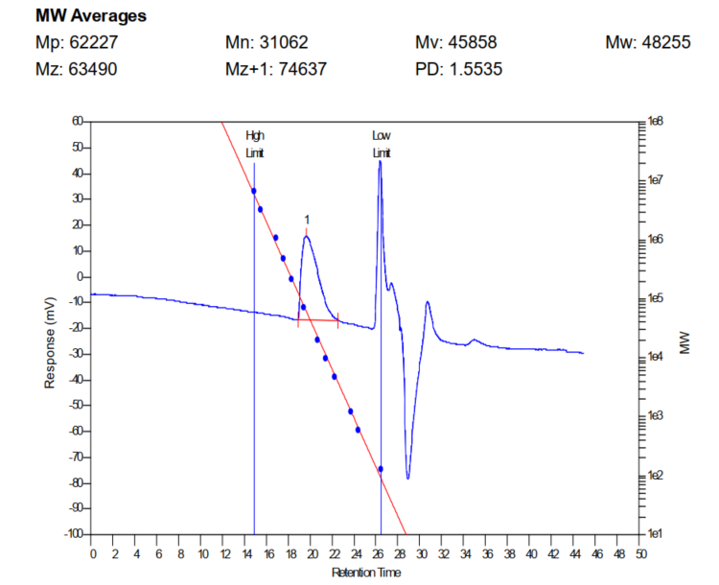
Figure S1. GPC curve of polymer PCNI2-V.

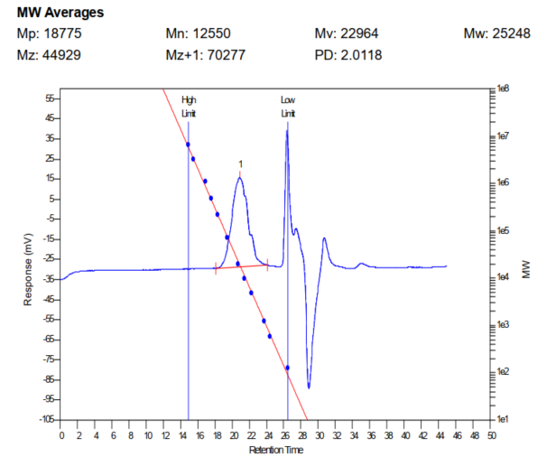
Figure S2. GPC curve of polymer PCNI2-T.

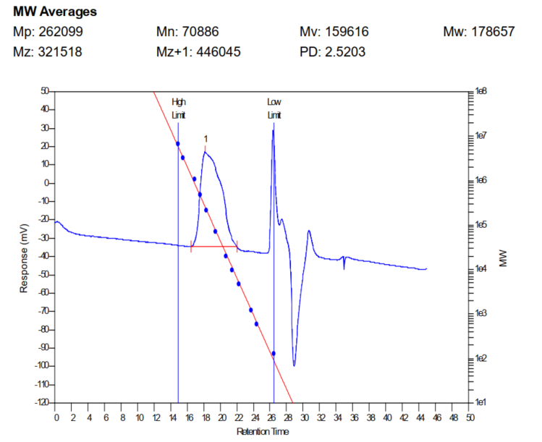
Figure S3. GPC curve of polymer PCNI2-BTI.

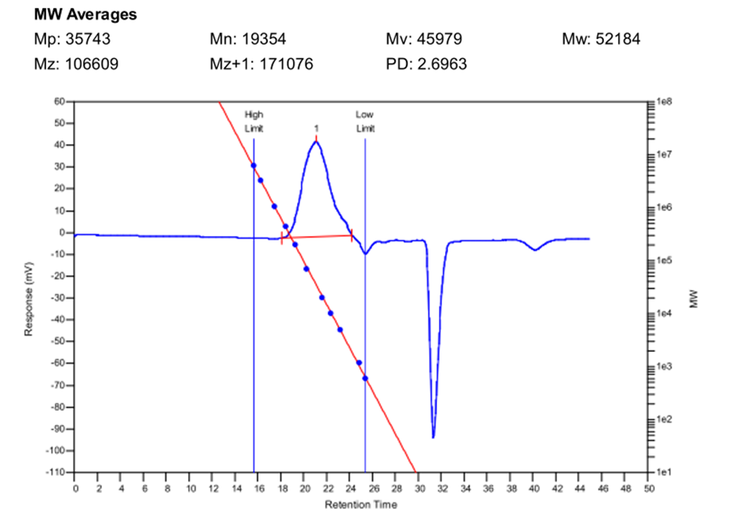
Figure S4. GPC curve of polymer PCNI2-BTI*.
Figure S5. Thermogravimetric (TGA) and (b) differential scanning calorimetry (DSC) curves of the polymers.

Figure S6. Cyclic voltammograms of polymer thin films measured in 0.1 M tetrabutylammonium hexafluorophosphate acetonitrile solutions with the Fc/Fc⁺ redox couple as the external standard.

Figure S7. The UPS spectra in the onset (left) and cutoff (right) energy regions of the CNI2-based polymers.
Figure S8. Optimized molecular geometries for three repeat units of polymers PCNI2-V, PCNI2-T, and PCNI2-BTI. The calculation was performed at the B3LYP/6-31G(d,p) level, and the alkyl chain was replaced with a methyl group for calculation simplicity.

Figure S9. OTFT output and transfer characteristics of the cyano-functionalized imide-based polymers fabricated with spin-coated technology: (a, b) PCNI2-V, (c, d) PCNI2-T, and (e, f) PCNI2-BTI.

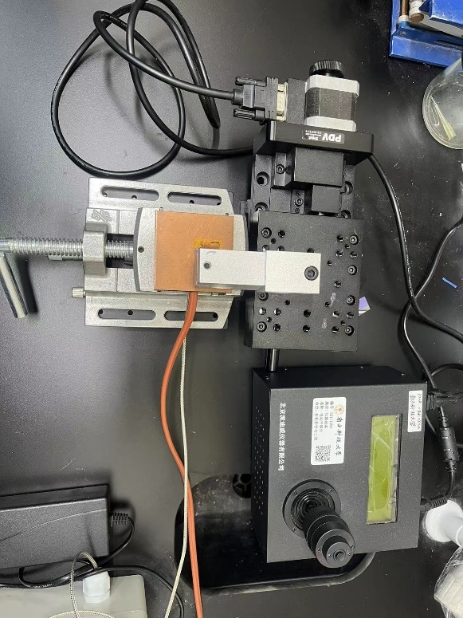
Figure S10. Solution-shearing device using in this work, as shown in the microscope images.

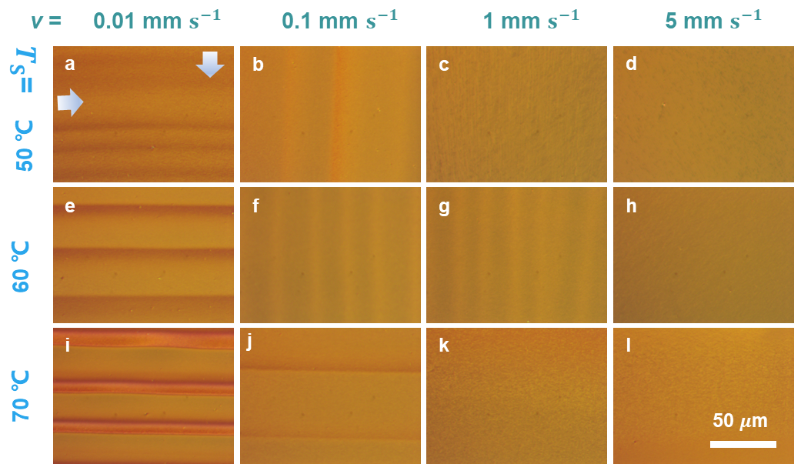
Figure S11. Qualitative study of the effect of the shearing speed (v) and the temperature of substrate (T_{s}) on polymer semiconductor POM morphology from chlorobenzene (CB). Four columns correspond to solvents with different v: (a, e, i) 0.01 mm s⁻¹, (b, f, j) 0.1 mm s⁻¹, (c, g, k) 1 mm s⁻¹, and (d, h, l) 5 mm s⁻¹. Horizontally, polymer semiconductor is deposited at different substrate temperature: (a, b, c, d) 50 ℃, (e, f, g, h) 60℃, and (i, j, k,l) 70℃ from top row to bottom one. The blue arrow indicates the solution shearing direction. For OTFT devices, the shearing speed of 1 mm s⁻¹ on the 60 ℃ substrate can lead to optimal performance. For OTE device, the shearing speed of 0.1 mm s⁻¹ on the 70 ℃ substrate can lead to optimal performance.
Figure S12. TLM (Transmission Line Method) analysis of top-gate/bottom-contact PCNI2-BTI OTFTs. The transfer curves for (a) blade-sheared samples and (b) spin-coated samples were measured from OTFTs with a channel length ranging from 10 to 70 µm and a channel width of 1000 µm. The total gate to contact electrodes overlapping of 50 µm provides complete charge injection in channel compared to actual carriers transfer length of 18.3 µm for blade-sheared devices and 9.7 µm for spin-coated devices. (c) Linear fits to the total width-normalized resistance ($R_{t}$W) at selected gate-overdrive voltages ($V_{g}-V_{th}$). (d) Calculated Width-normalized contact resistance ($R_{c}W$) and sheet resistance ($R_{sh}$) at various gate-overdrive voltages for blade-sheared and spin-coated TFTs.

Figure S13. ESR analysis of PCNI2-BTI doped with different N-DMBI concentration.

Figure S14. Schematic illustration of device structure and fabrication procedure via (a) spin-coating and (b) solution-shearing methods using sequential doping assisted by Au nanoparticles as the catalyst.

Figure S15. Representative thermal voltage response curves for spin-coated PCNI2-V polymer films doped with distinct N-DMBI concentrations in n-butyl acetate solution, including (a) 0.1 mg mL^{–1}, (b) 1 mg mL^{–1}, (c) 2 mg mL^{–1}, (d) 3 mg mL^{–1}, (e) 4 mg mL^{–1}, (f) 5 mg mL^{–1}. During the measurement, the temperature difference (ΔT) across the doped polymer films was systematically varied from 0 to 2.8 K with a step of 0.7 K then back to 0 K.
Figure S16. Representative thermal voltage response curves for spin-coated PCNI2-T polymer films doped with distinct N-DMBI concentrations in n-butyl acetate solution, including (a) 0.1 mg mL^{–1}, (b) 1 mg mL^{–1}, (c) 2 mg mL^{–1}, (d) 3 mg mL^{–1}, (e) 4 mg mL^{–1}, (f) 5 mg mL^{–1}. During the measurement, the temperature difference (ΔT) across the doped polymer films was systematically varied from 0 to 2.8 K with a step of 0.7 K then back to 0 K.

Figure S17. Representative thermal voltage response curves for spin-coated PCNI2-BTI polymer films doped with distinct N-DMBI concentrations in n-butyl acetate solution, including (a) 0.1 mg mL^{–1}, (b) 1 mg mL^{–1}, (c) 2 mg mL^{–1}, (d) 3 mg mL^{–1}, (e) 4 mg mL^{–1}, (f) 5 mg mL^{–1}. During the measurement, the temperature difference (ΔT) across the doped polymer films was systematically varied from 0 to 2.8 K with a step of 0.7 K then back to 0 K.
Figure S18. Representative thermal voltage response curves for solution-sheared PCNI2-V polymer films doped with distinct N-DMBI concentrations in n-butyl acetate solution, including (a) 0.1 mg mL^{–1}, (b) 1 mg mL^{–1}, (c) 2 mg mL^{–1}, (d) 3 mg mL^{–1}, (e) 4 mg mL^{–1}, (f) 5 mg mL^{–1}. During the measurement, the temperature difference (ΔT) across the doped polymer films was systematically varied from 0 to 2.8 K with a step of 0.7 K then back to 0 K.

Figure S19. Representative thermal voltage response curves for solution-sheared PCNI2-T polymer films doped with distinct N-DMBI concentrations in n-butyl acetate solution, including (a) 0.1 mg mL^{–1}, (b) 1 mg mL^{–1}, (c) 2 mg mL^{–1}, (d) 3 mg mL^{–1}, (e) 4 mg mL^{–1}, (f) 5 mg mL^{–1}. During the measurement, the temperature difference (ΔT) across the doped polymer films was systematically varied from 0 to 2.8 K with a step of 0.7 K then back to 0 K.
Figure S20. Representative thermal voltage response curves for solution-sheared PCNI2-BTI polymer films doped with distinct N-DMBI concentrations in n-butyl acetate solution, including (a) 0.1 mg mL^{–1}, (b) 1 mg mL^{–1}, (c) 2 mg mL^{–1}, (d) 3 mg mL^{–1}, (e) 4 mg mL^{–1}, (f) 5 mg mL^{–1}. During the measurement, the temperature difference (ΔT) across the doped polymer films was systematically varied from 0 to 2.8 K with a step of 0.7 K then back to 0 K.

Figure S21. Representative thermal voltage response curves for the spin-coated PCNI2-BTI* polymer films doped with distinct N-DMBI concentrations in n-butyl acetate solution, including (a) 0.1 mg mL^{–1}, (b) 1 mg mL^{–1}, (c) 2 mg mL^{–1}, (d) 3 mg mL^{–1}, (e) 4 mg mL^{–1}, (f) 5 mg mL^{–1}. During the measurement, the temperature difference (ΔT) across the doped polymer films was systematically varied from 0 to 2.8 K with a step of 0.7 K then back to 0 K.
Figure S22. Representative thermal voltage response curves for solution-sheared PCNI2-BTI* polymer films doped with distinct N-DMBI concentrations in n-butyl acetate solution, including (a) 0.1 mg mL^{–1}, (b) 1 mg mL^{–1}, (c) 2 mg mL^{–1}, (d) 3 mg mL^{–1}, (e) 4 mg mL^{–1}, (f) 5 mg mL^{–1}. During the measurement, the temperature difference (ΔT) across the doped polymer films was systematically varied from 0 to 2.8 K with a step of 0.7 K then back to 0 K.

Figure S23. Representative thermal voltage response curves for solution-sheared PCNI2-BTI* polymer films blended with distinct N-DMBI ratios, including (a) 5%, (b) 20%, (c) 40%, (d) 60%, (e) 80%, (f) 100%. During the measurement, the temperature difference (ΔT) across the doped polymer films was systematically varied from 0 to 2.8 K with a step of 0.7 K then back to 0 K.

Figure S24. Seeback coefficient of doped CNI2-based polymers film fabricated with spin-coating.

Figure S25. Electrical conductivity, Seeback coefficient, and power factor of blending-doped PCNI2-BTI films fabricated with solution-shearing.

Figure S26. Electrical conductivity, Seeback coefficient, and power factor of doped polymer PCNI2-V film fabricated with solution-shearing.

Figure S27. Electrical conductivity, Seeback coefficient, and power factor of doped polymer PCNI2-T film fabricated with solution-shearing.
Figure S28. The orientations of the sample measurements. When blade coating direction is parallel or perpendicular to the source/drain (S/D) channel, electrical field (E) is parallel or perpendicular to the coating direction, respectively.

Figure S29. Electrical conductivity, Seeback coefficient, and power factor of doped low-molecule-weight PCNI2-BTI* films fabricated via (a) spin-coating and (b) solution-shearing.

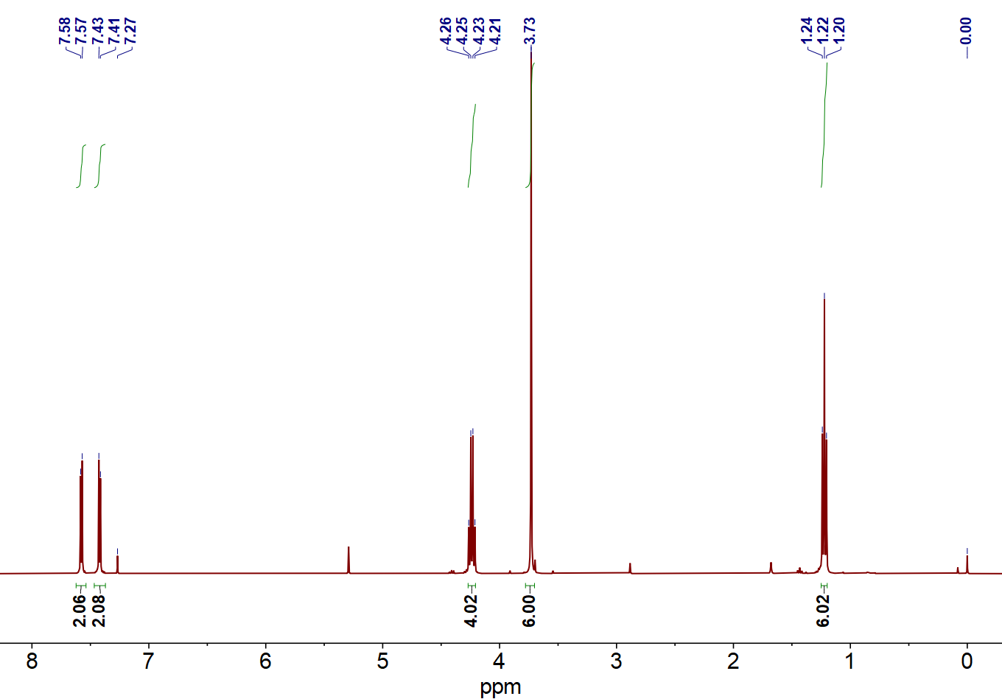
Figure S30. The ¹H NMR spectrum of compound 3.

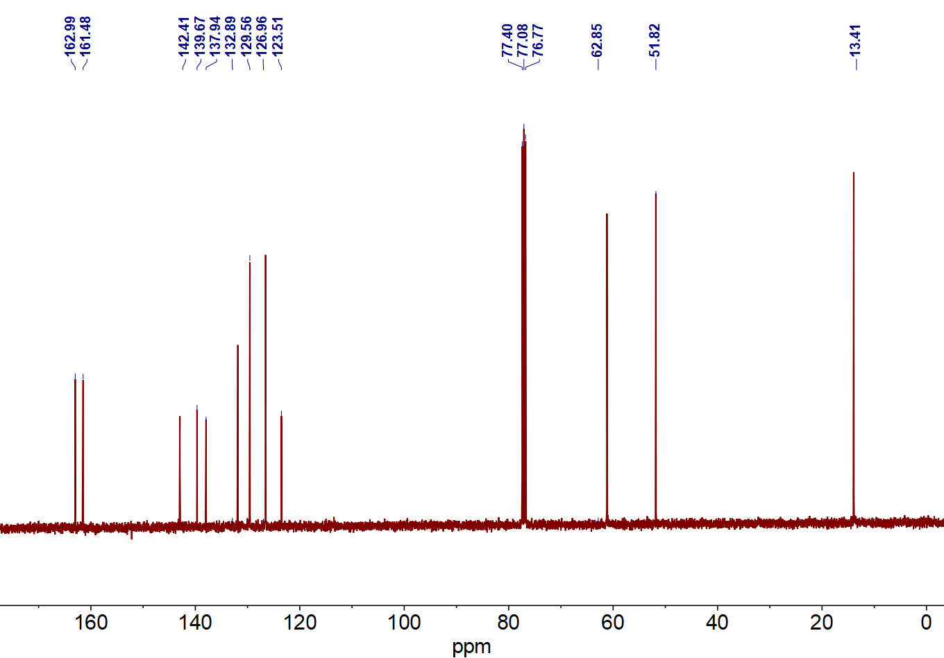
Figure S31. The ¹³C NMR spectrum of compound 3.

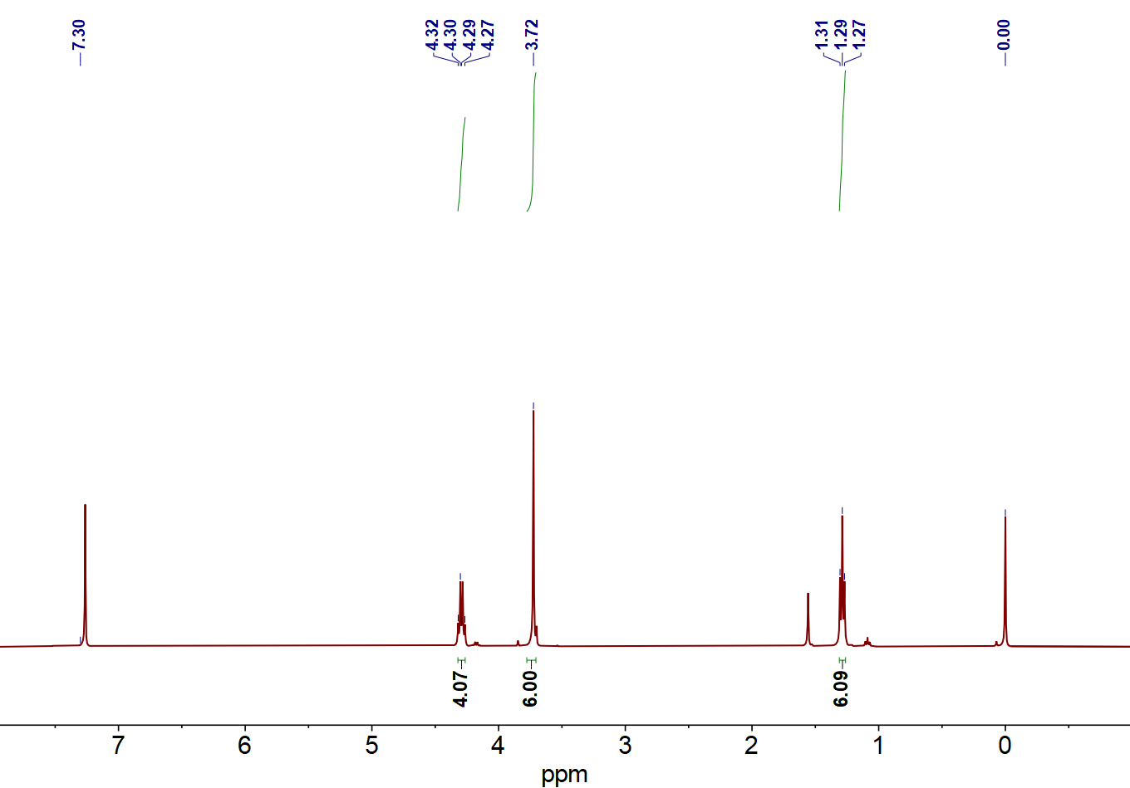
Figure S32. The ¹H NMR spectrum of compound 4.

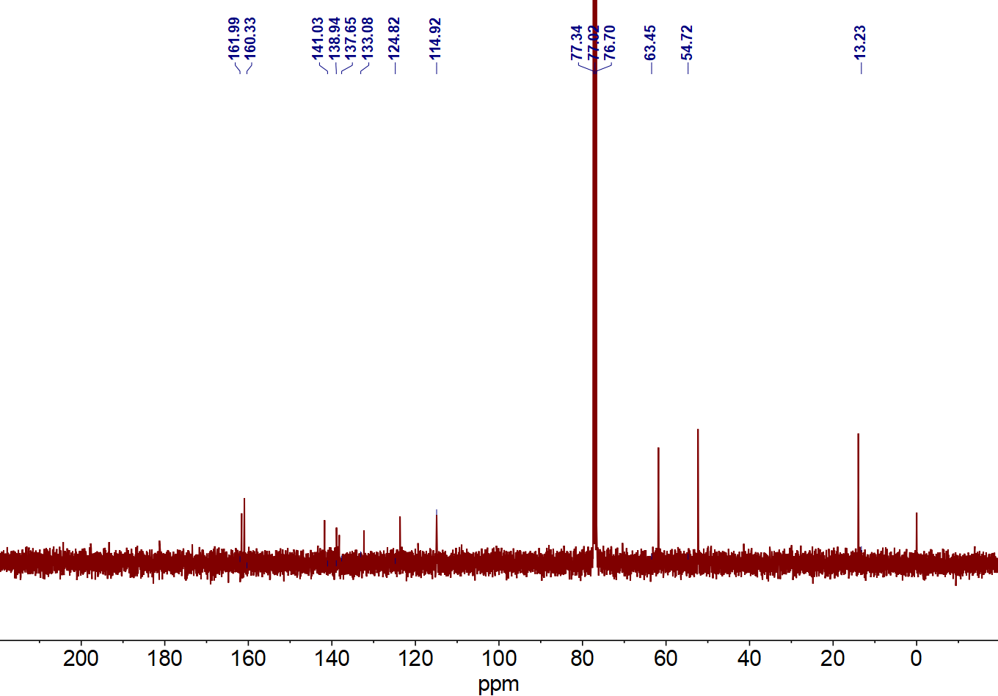
Figure S33. The ¹³C NMR spectrum of compound 4.

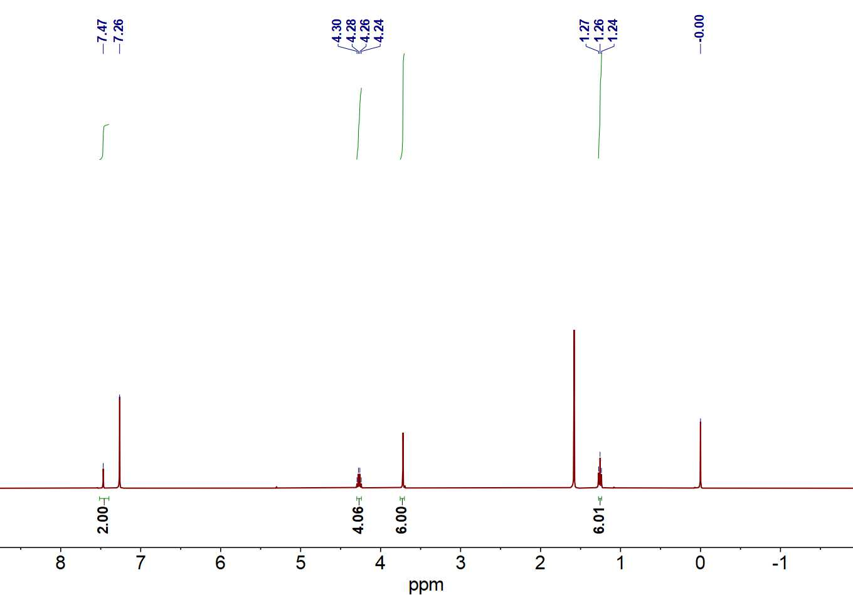
Figure S34. The ¹H NMR spectrum of compound 5.

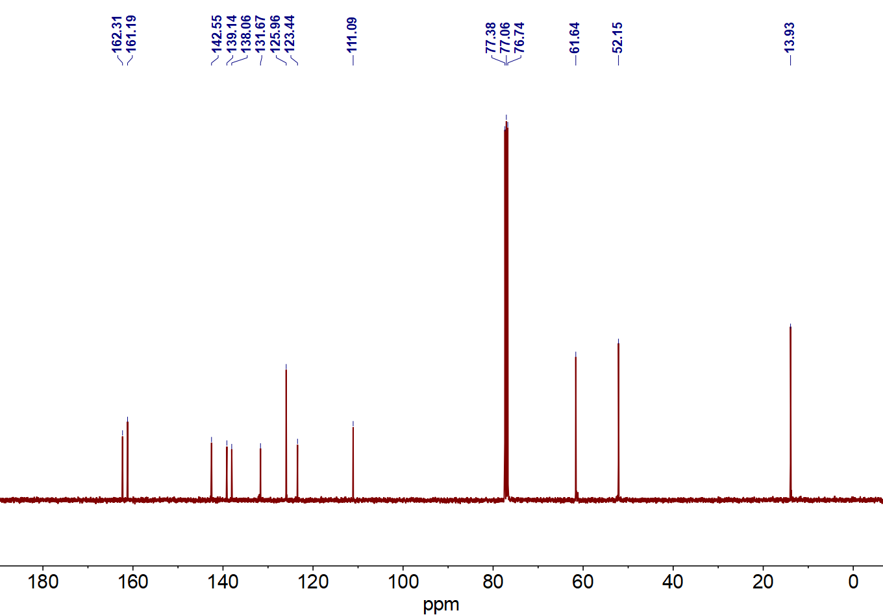
Figure S35. The ¹³C NMR spectrum of compound 5.

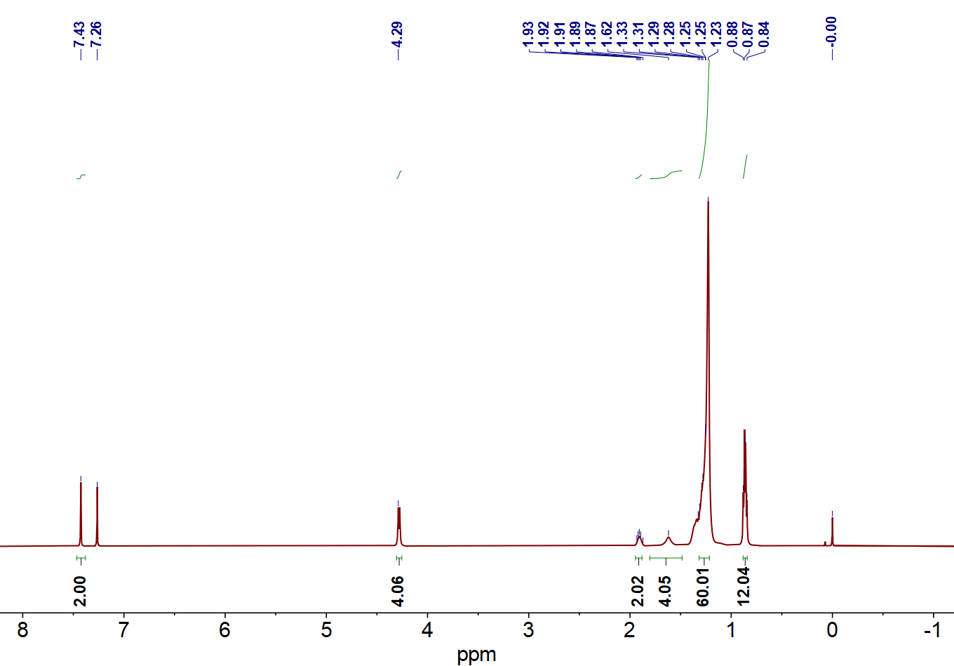
Figure S36. The ¹H NMR spectrum of compound 8(C8C10).

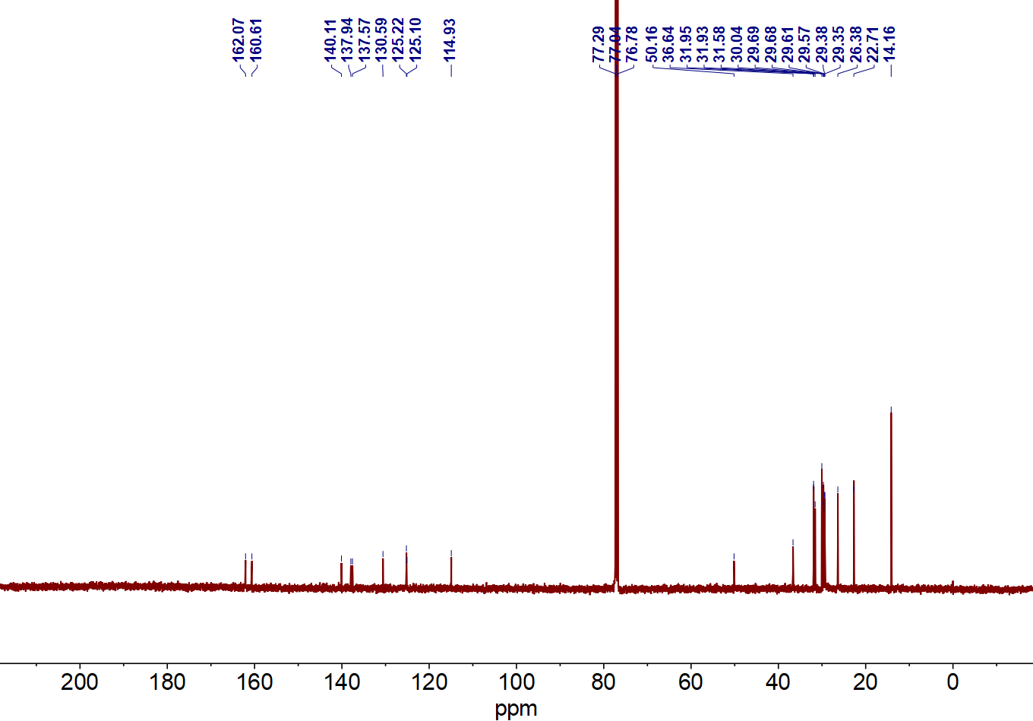
Figure S37. The ¹³C NMR spectrum of compound 8(C8C10).

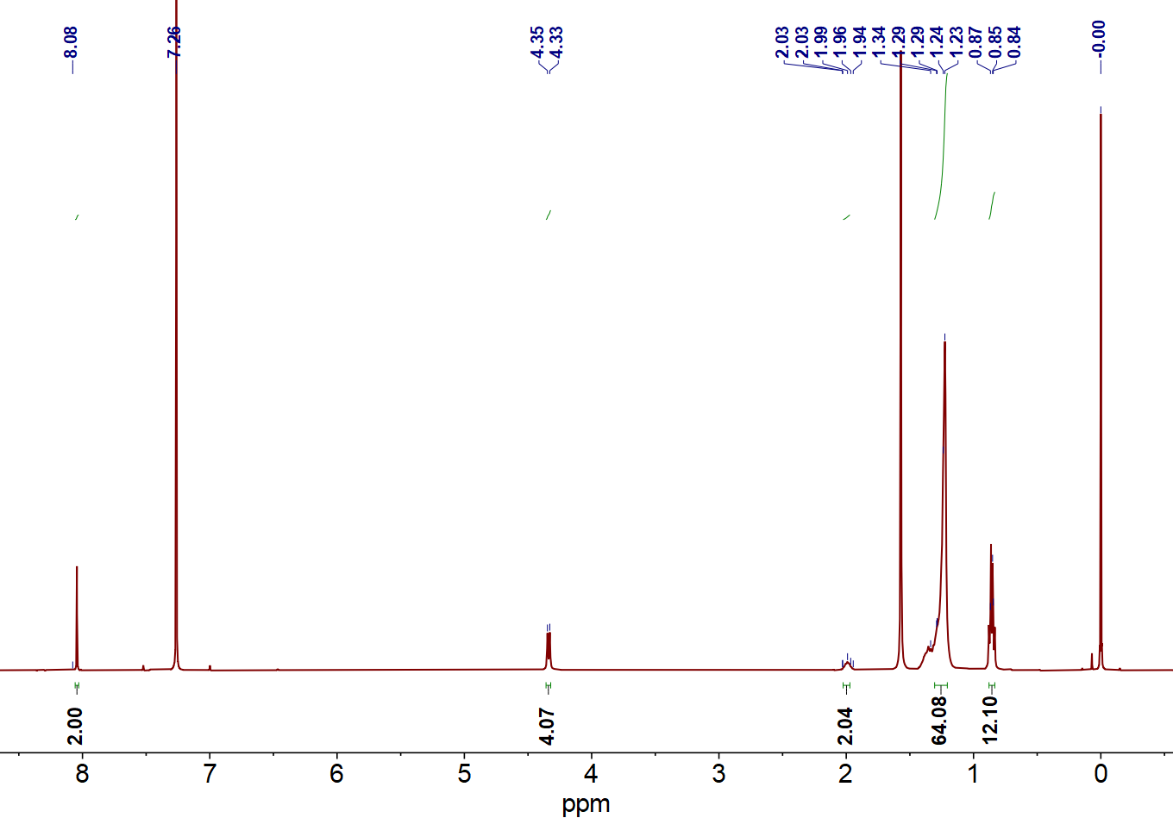
Figure S38. The ¹H NMR spectrum of compound CNI2(C8C10).

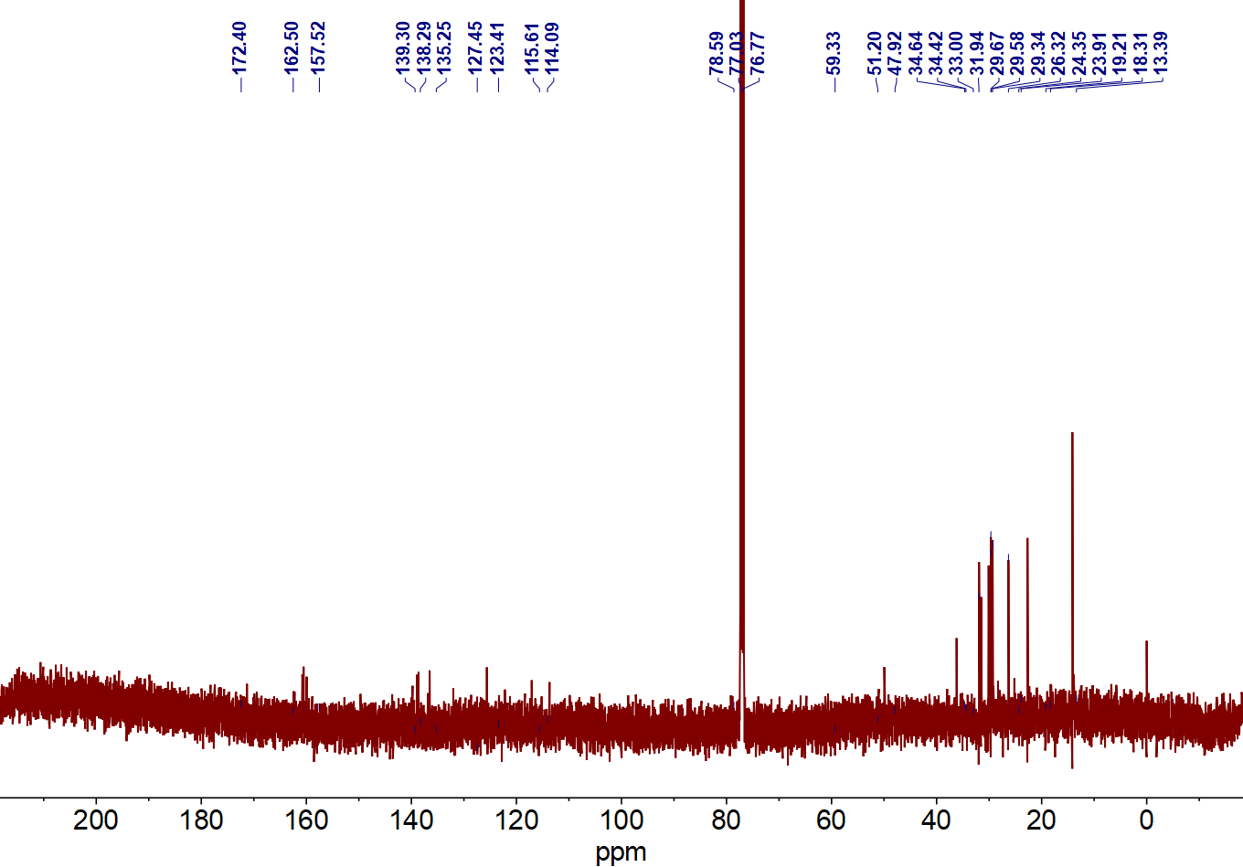
Figure S39. The ¹³C NMR spectrum of compound CNI2(C8C10).

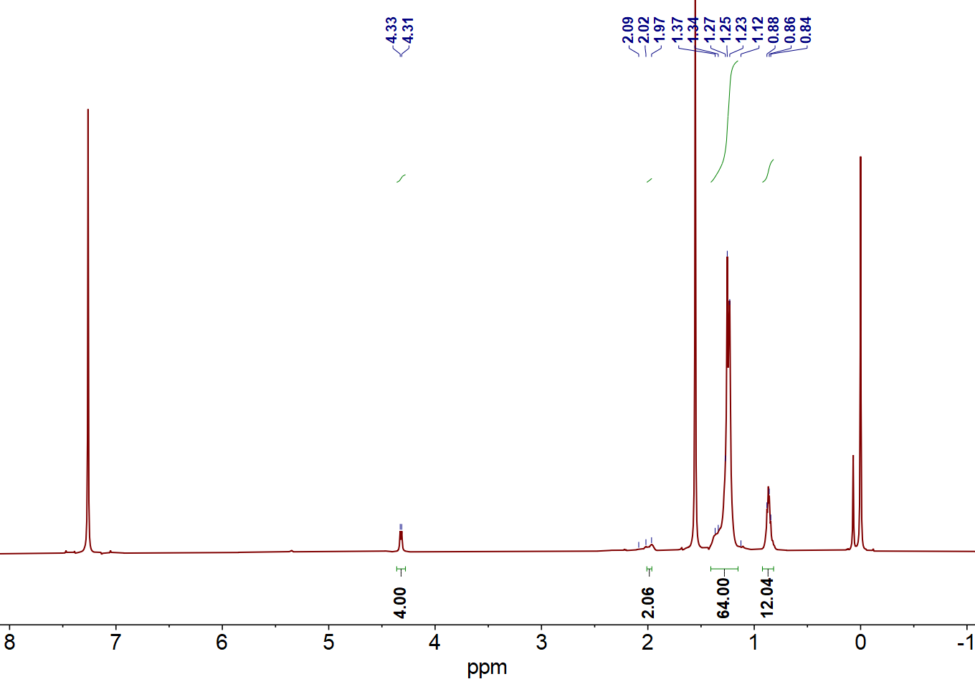
Figure S40. The ¹H NMR spectrum of monomer CNI2-2Br(C8C10).

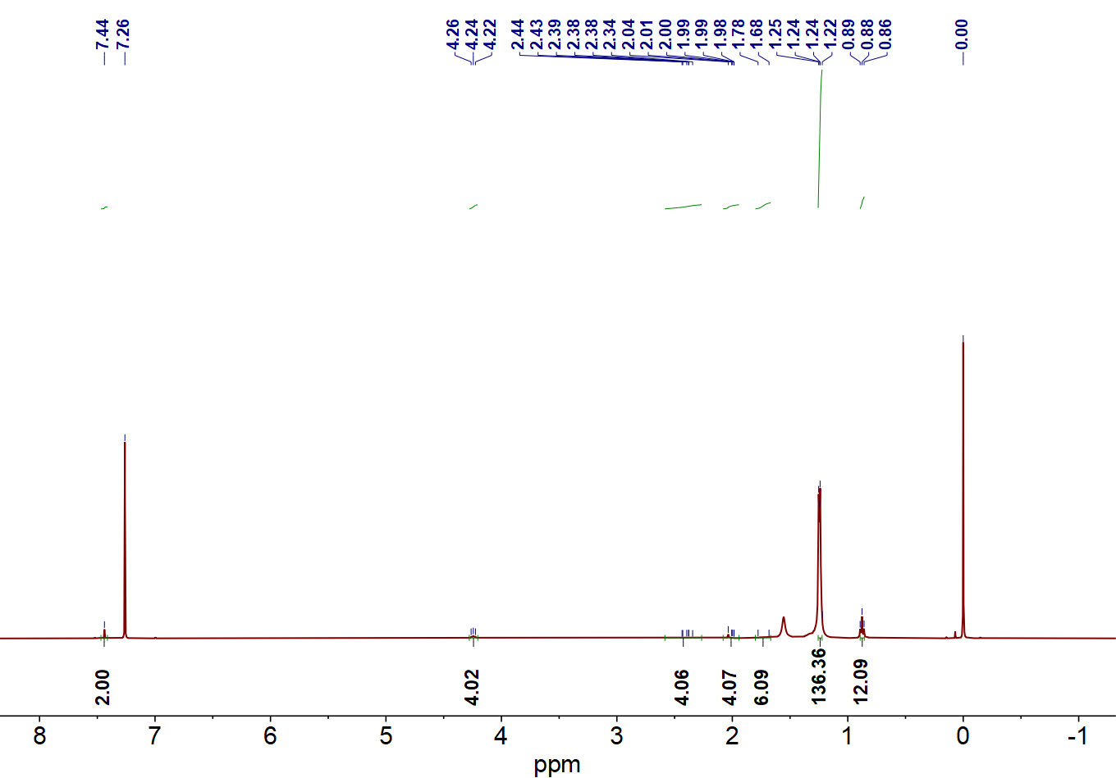
Figure S41. The ¹H NMR spectrum of compound 8(C18C18).

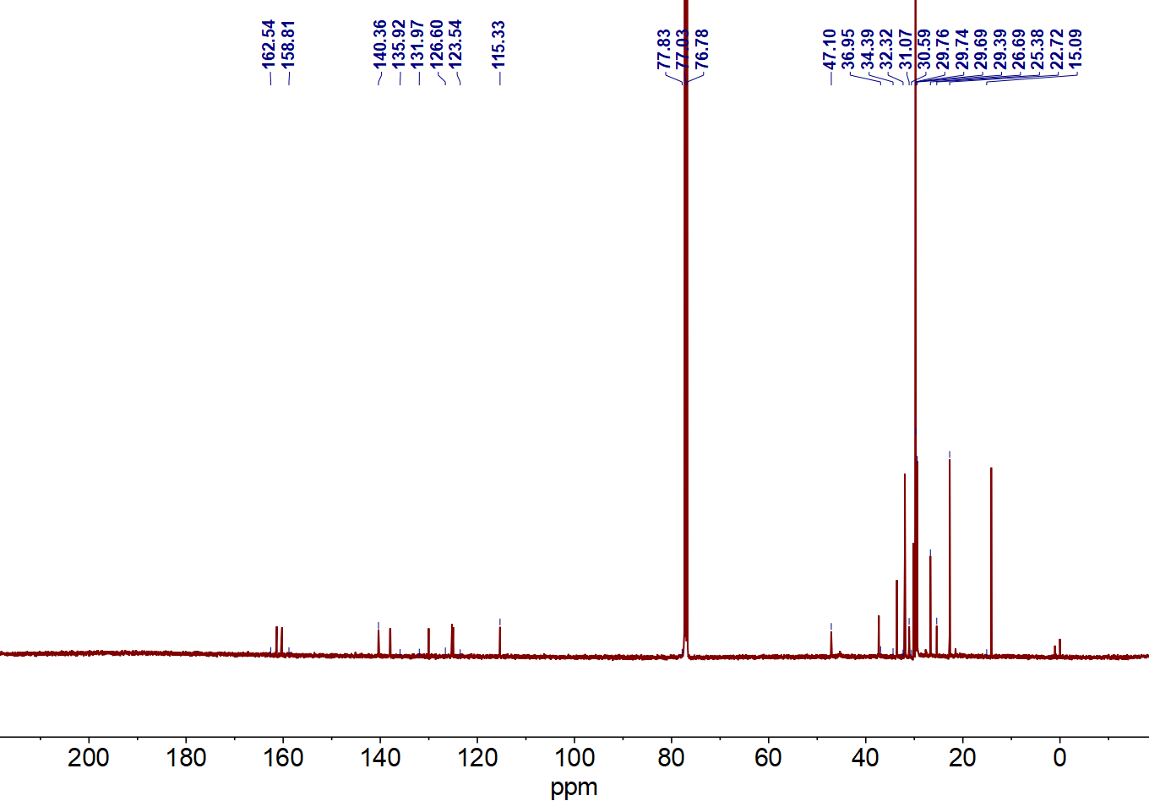
Figure S42. The ¹³C NMR spectrum of compound 8(C18C18).

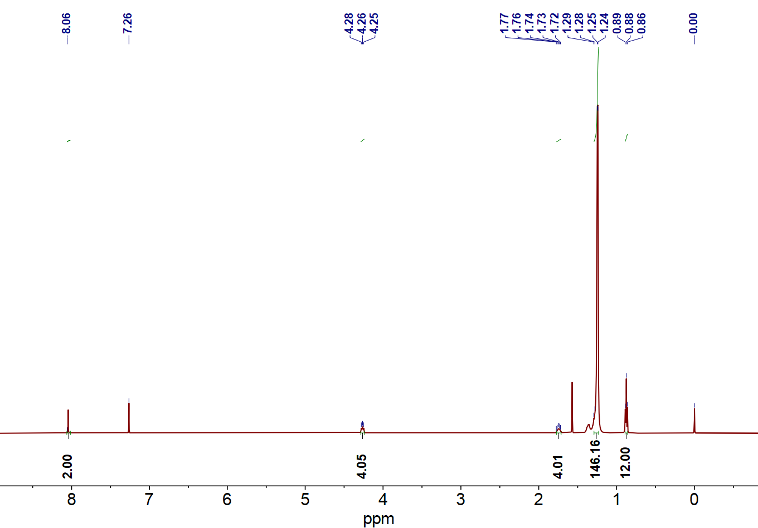
Figure S43. The ¹H NMR spectrum of compound CNI2(C18C18).

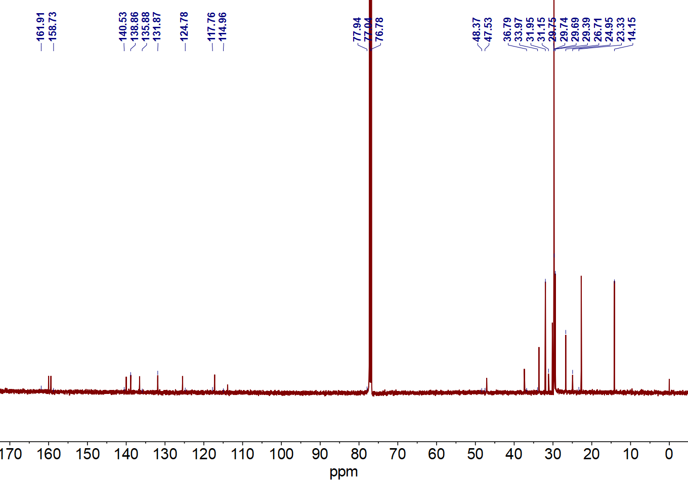
Figure S44. The ¹³C NMR spectrum of compound CNI2(C18C18).

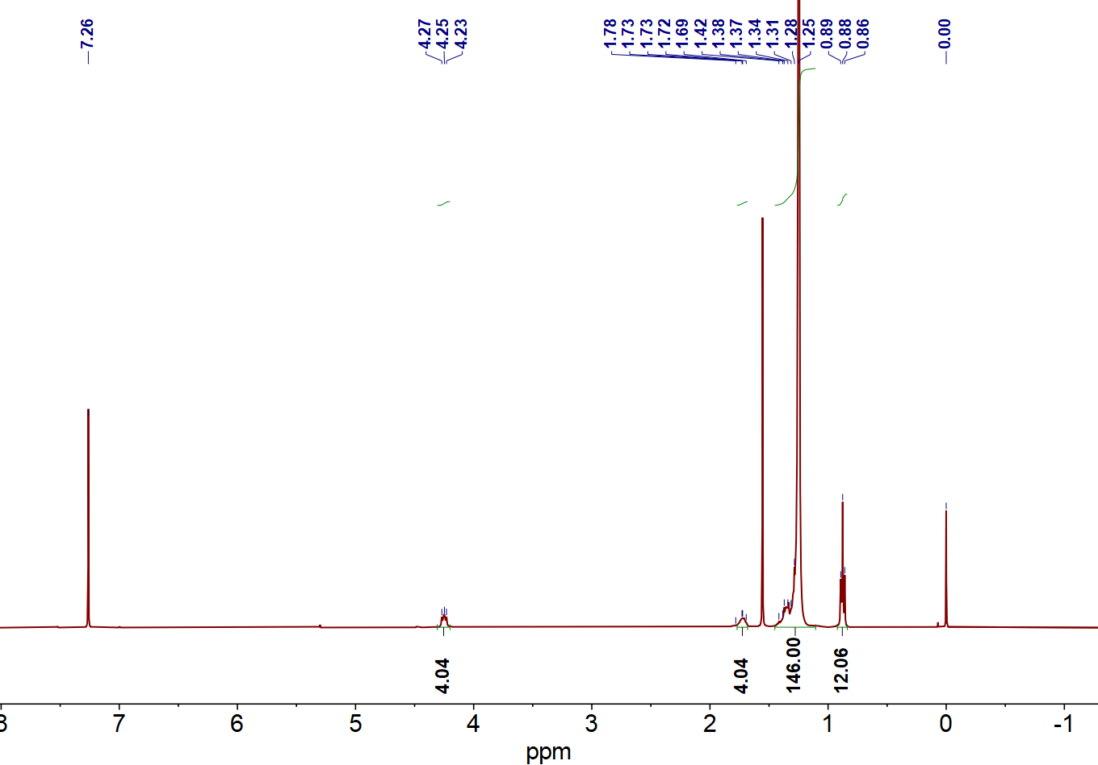
Figure S45. The ¹H NMR spectrum of monomer CNI-2Br(C18C18).

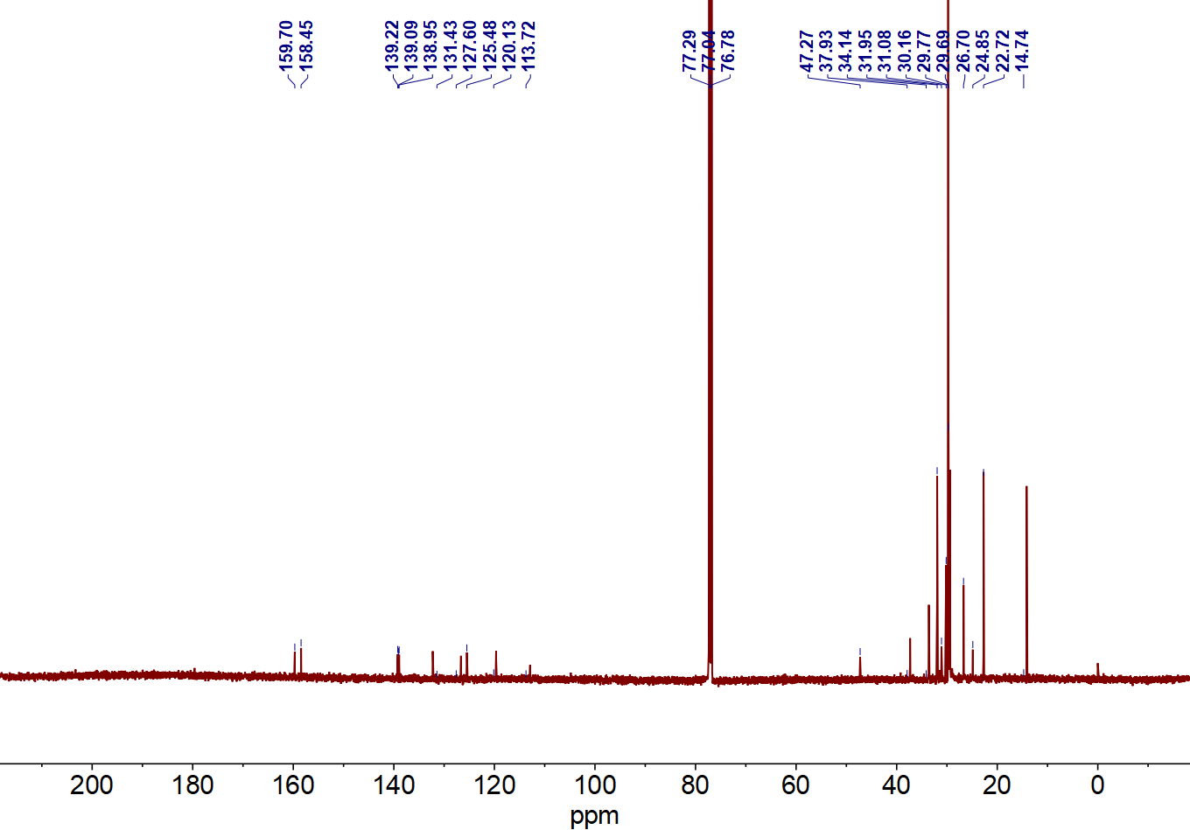
Figure S46. The ¹³C NMR spectrum monomer CNI-2Br(C18C18).

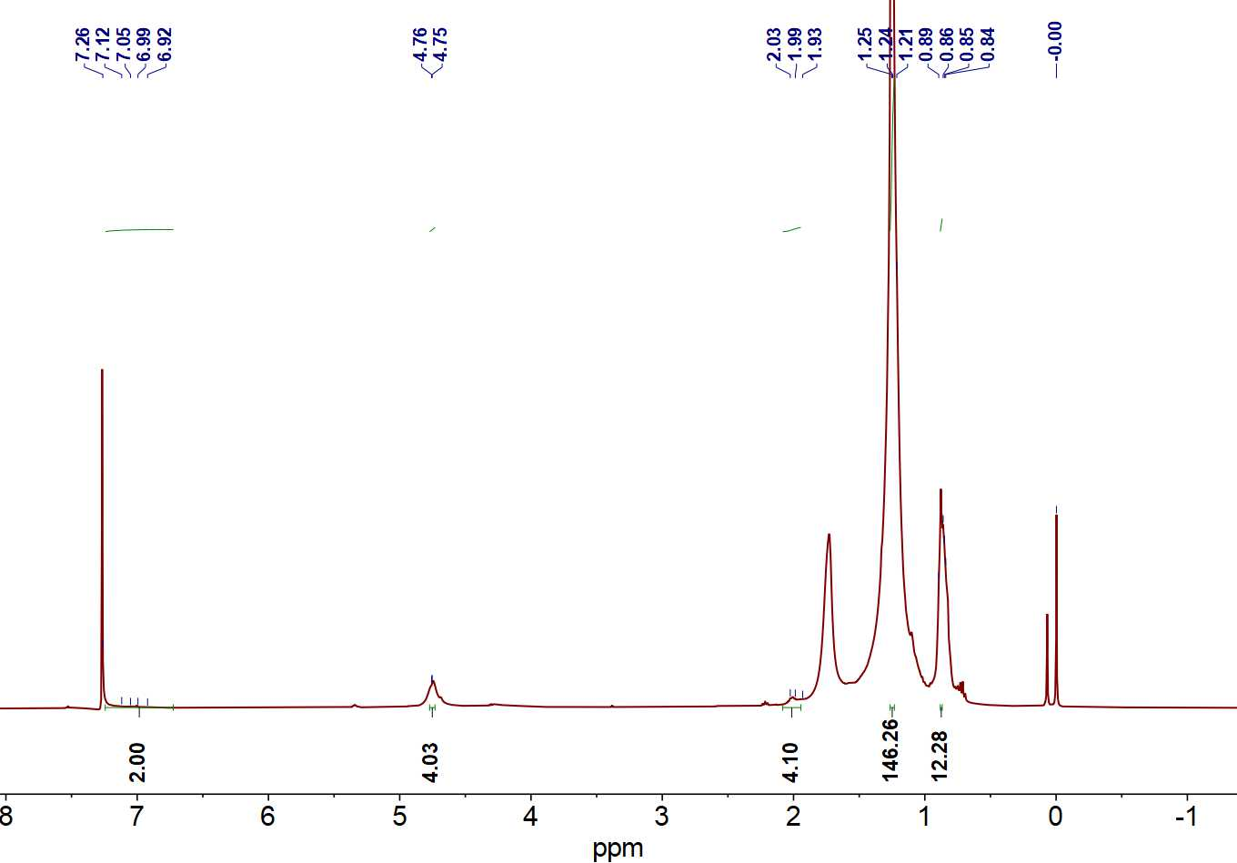
Figure S47. The ¹H NMR spectrum of PCNI2-V.

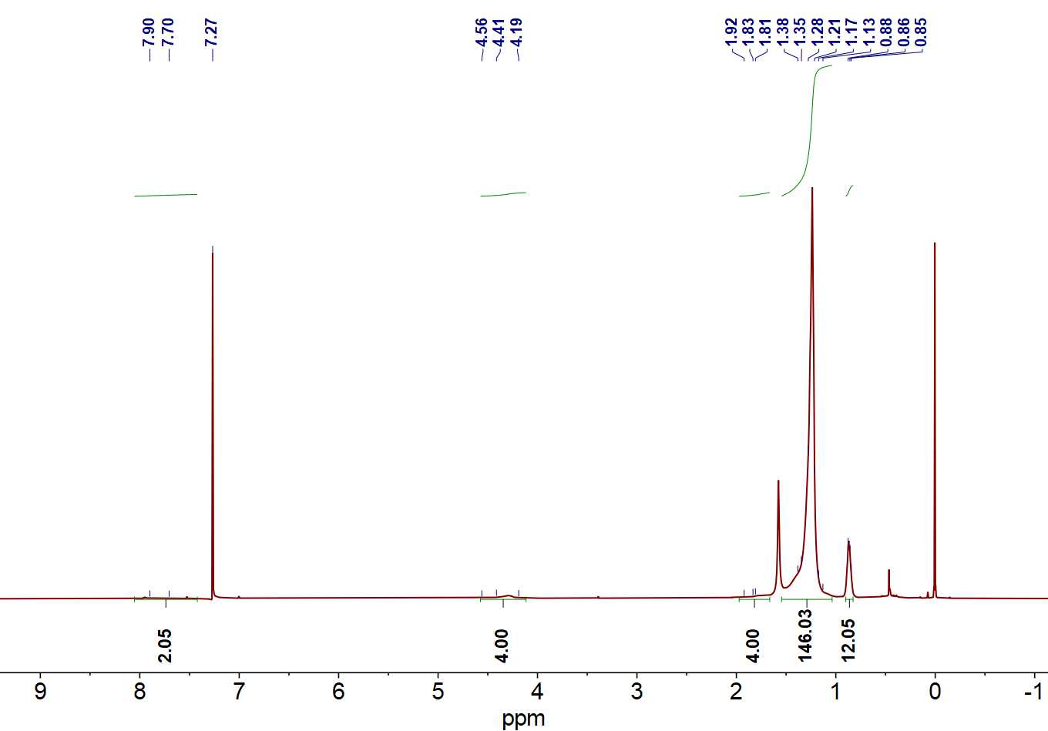
Figure S48. The ¹H NMR spectrum of PCNI2-T.

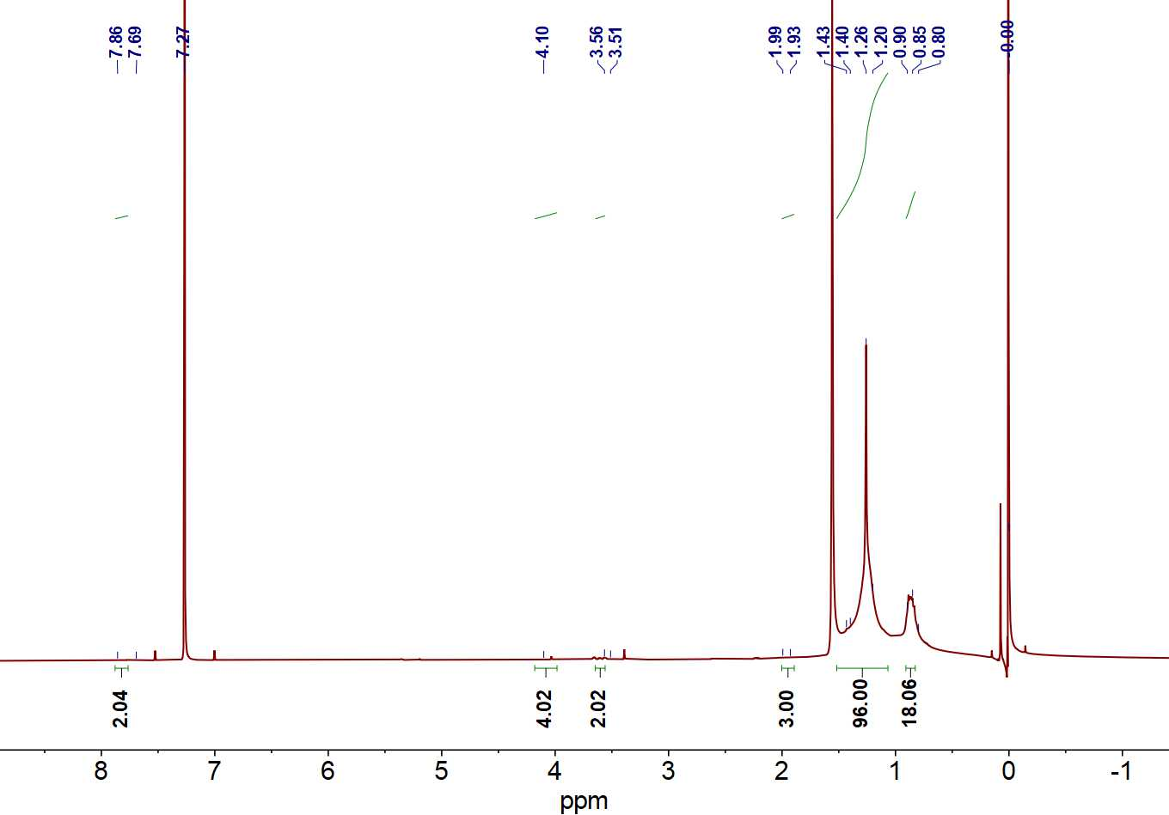
Figure S49. The ¹H NMR spectrum of PCNI2-BTI.

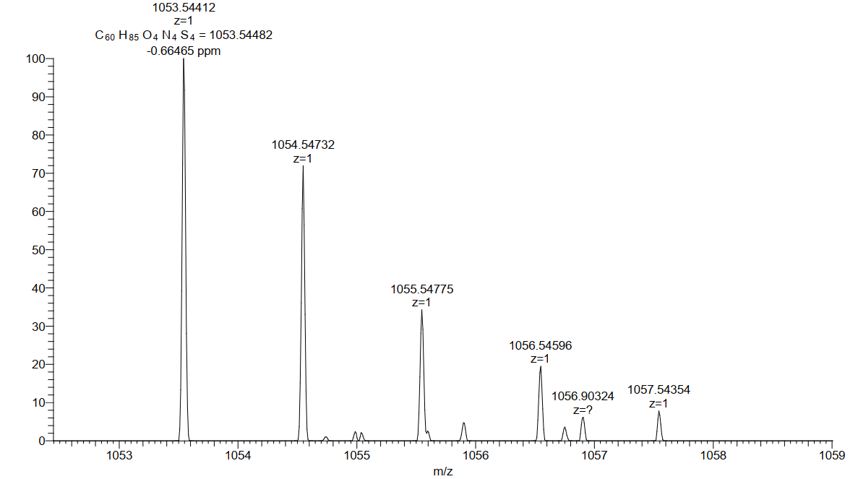
Figure S50. The HRMS (M+1) of compound CNI2(C8C10).

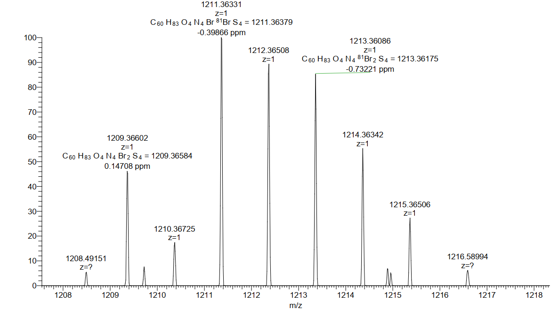
Figure S51. The HRMS (M+1) of compound CNI2-2Br(C8C10).

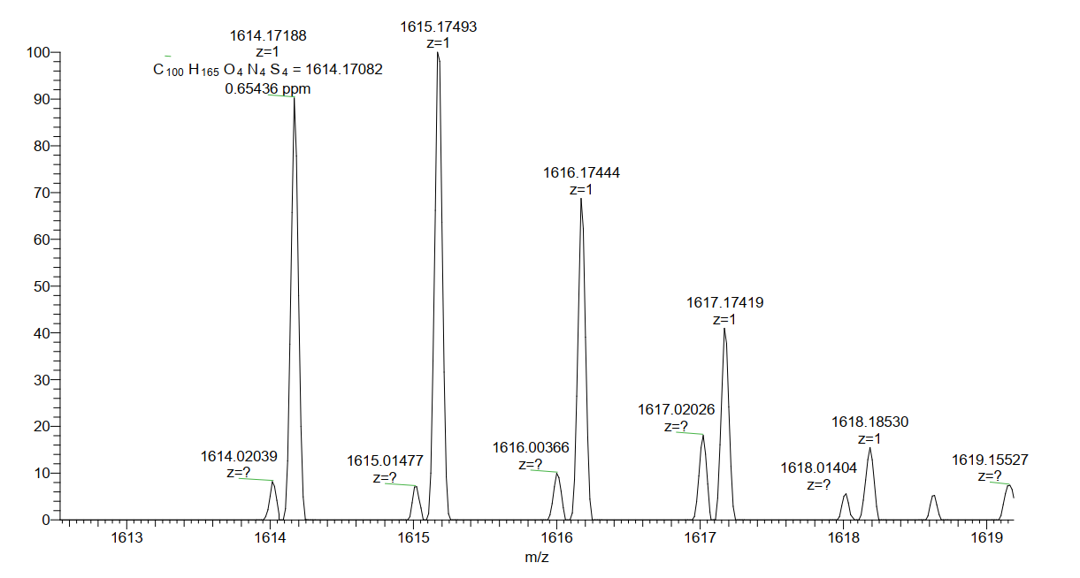
Figure S52. The HRMS (M+1) of compound CNI2(C18C18).

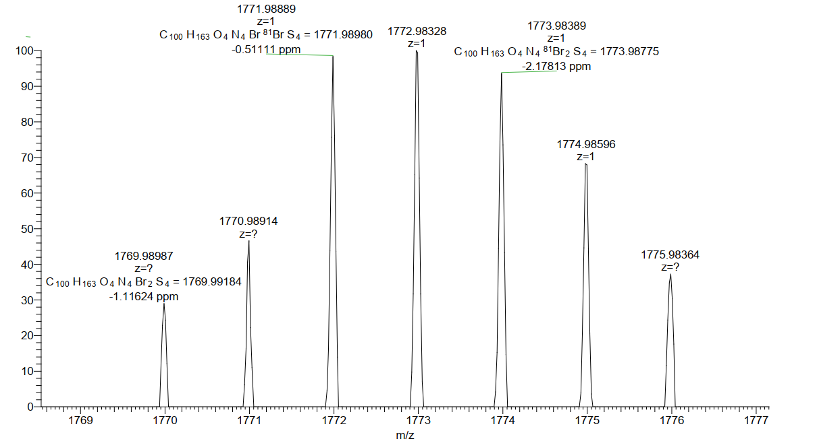
Figure S53. The HRMS (M+1) of compound CNI2-2Br(C18C18).

References
- Y. Shi, H. Guo, J. Huang, X. Zhang, Z. Wu, K. Yang, Y. Zhang, K. Feng, H. Y. Woo, R. P. Ortiz, M. Zhou, X. Guo, Angew. Chem., Int. Ed. 2020, 59, 14449−14457.
- Y. Wang, H. Guo, S. Ling, I. Arrechea-Marcos, Y. Wang, J. T. Llpez Navarrete, R. P. Ortiz, X. Guo, Angew. Chem. Int. Ed. 2017, 56, 9924–9929.

