Comparison of nano-silica-modified manufactured-sand concrete under steam curing and standard curing
Changjiang Liu^{a, g, *}, Fulian Chenª, Xiaowei Deng^{b, *}, Yuyou Wu^{c, *}, Zhoulian Zheng^{d,*}, Bo Yang^{d}, Dawei Yao^{e}, Jingwei Yang^{e}, Jiangying Yang^{f}
a. School of Civil Engineering, Guangzhou University, Guangzhou 510006, China
b. Department of Civil Engineering, The University of Hong Kong, Pokfulam, Hong Kong
c. School of Transportation, Civil Engineering and Architecture, Foshan University, Foshan, Guangdong 528000, China
d. School of Civil Engineering, Chongqing University, Chongqing 400045, China
e. Chongqing CSCEC Hailong Liangjiang Construction Technology Co., Ltd,
Chongqing 401139, China
f. School of Intelligent Construction, Chongqing Jianzhu College, Chongqing 400072, China
g. Guangdong Provincial Key Laboratory of Earthquake Engineering and Applied Technology, Guangzhou University, Guangzhou 510006, China
(* Correspondence: cjliu@gzhu.edu.cn; xwdeng@hku.hk; yuyou.wu@yahoo.com; zhengzl@cqu.edu.cn)

Abstract: There are obvious differences in mechanical properties and durability between steam-cured concrete and standard-cured concrete. In this paper, the different properties of nano-silica (NS) modified manufactured sand concrete (NSMC) under standard curing and steam curing were compared. The results showed that the effect of NS on concrete is similar under the two curing methods. The addition of NS can mitigate the loss of later strength and impermeability caused by steam curing. In addition, NS has a synergistic effect with steam curing, and steam-cured concrete with NS shows higher early strength and higher corrosion resistance coefficient. The above phenomena were explained by XRD, SEM, and MIP. The results show that NS under steam curing can further promote the consumption of calcium hydroxide, tricalcium silicate, and dicalcium silicate, as well as the generation of more hydration products to repair the micro-defects caused by steam curing.

Keywords: nano-silica-modified concrete; curing conditions; manufactured sand concrete; steam curing; synergistic effect.

1. Introduction
Nowadays, climate degradation and drastic reduction of resources have seriously affected the earth's life systems. Therefore, achieving sustainable development is urgent. But sustainable development is a huge challenge for the construction industry. According to global resource statistics, the construction industry consumes 32% of natural resources, generates 40% of greenhouse gases, and causes 40% of construction waste[1]. In China, the Carbon Emission Report of China's Building materials Industry in 2020 stated that the carbon emission of China's building materials industry in 2020 was 1.48 billion tons, up 2.7% from 2019. Moreover, domestic construction activities produce a large amount of wasted concrete, and the average annual growth of the wasted concrete is up to 8%, which implies a continuous increase in environmental pollution and disposal costs[2]. Therefore, how to solve the environmental problems of construction activities will be an important task in China for a long time in the future.
Concrete is the most widely used building material. In the past decades, as the most important fine aggregate of concrete, natural river sand (RS) has been exploited continuously, and the ecological security of rivers and lakes has been continuously damaged. Therefore, with the increase of environmental awareness, RS is gradually replaced by manufactured sand (MS), dune sand, and sea sand, among which MS is the most widely used substitute because MS is made by mechanical crushing of virgin rock or construction waste and has high environmental benefits[3, 4]. MS has poor gradation and strong angularity with a high content of flat-elongated particles, which is more likely to affect the workability of the concrete [5]. Huang et al. [6] focused on the study of flake particles of MS, and pointed out that the increase of flake particle content or particle size would weaken the fluidity and compressive strength of concrete. Yamei et al. [7] pointed out that RS has a more rounded shape and MS has a flat and rough shape. Compared with RS concrete, MS concrete has higher compressive strength but requires more water. Pilegis et al.[8] believe that the angular shape of MS has a positive impact on aggregate interlocking. Therefore, the compressive and flexural strength of MS concrete is better than that of RS concrete. Shen et al.[9] indicated that MS has a higher aspect ratio and surface roughness than RS. With similar workability and paste composition, MS concrete has higher strength but requires more water reducer. Yang et al.[10] stated that partial replacement of RS by MS would disturb the particle packing skeleton of UHPC and have a negative impact on fluidity and volume stability. It can be seen that there are certain differences between MS concrete and RS concrete in performance. Information collected from Chinese sand suppliers shows that the cost per ton of manufactured sand is 20 % lower than that of natural river sand. Moreover, the use of artificial sand can effectively curb the illegal use of natural sand [11]. Therefore, it is an inevitable trend that MS will replace NS to prepare concrete in the future. In this context, all aspects of concrete research cannot be limited to NS concrete.
The prefabricated building provides an effective way for the transformation of China's construction industry. Compared with traditional cast-in-place concrete buildings, prefabricated buildings have 63% lower carbon emissions and 34.55% less construction waste resources[12]. Prefabricated components are the most important part of prefabricated buildings. In order to improve the turnover efficiency, the factory will adopt the steam curing method to shorten the curing time for precast concrete components to reach demoulding strength. Steam curing can accelerate the early hydration and microstructure formation, thus conferring higher early strength to the concrete, but basically does not change the type of hydration products [13-16].Wu et al. [17] compared the early mechanical properties of UHPC under standard curing and steam curing. The results showed that the compressive strength and initial cracking tensile stress at 7 days of UHPC after steam curing were 80.4 % and 36.2 % higher than those of standard-cured specimens.Wang et al.[18] pointed out that steam curing increases the elastic modulus and tensile strength of concrete. Before demoulding, the volume change law of "expansion-shrinkage" will appear in concrete. However, it should not be ignored that steam curing will have adverse effects on the microstructure, late mechanical and durable properties of concrete. Shi et al. [19] reported that after steam curing, coarse pores and more microcracks appeared in the interface transition zone(ITZ), and the uneven temperature field would aggravate the deterioration of the concrete surface structure. The study of Wang et al. [20] showed that after steam curing, the microhardness of ITZ decreased significantly, and the width of ITZ increased significantly. Liu et al. [21] showed that concrete contain ultra-fine fly ash after steam curing showed lower compressive strength at 28 days. Shi and Liu et al. [22,23] pointed out that the permeability of concrete increased significantly after steam curing, and the surface permeability was higher than the internal permeability. Gallucci et al. [13] have explained that high temperature affects the apparent density of hydrated calcium silicate ( C-S-H ), which in turn affects the capillary porosity of the cement system, resulting in a decrease in mechanical and durability properties. These negative effects can be referred to as steam thermal damage[24], which can be reduced by optimizing the steaming regime, choosing a suitable subsequent curing method, and adding mineral admixtures[21, 25, 26].However, the first two methods often conflict with economic benefits in actual production. Therefore, adding mineral admixtures is the most suitable way at this stage [27]. Researchers have also conducted more research on existing mineral admixtures (fly ash, silica fume, slag, etc. ), and are constantly exploring suitable new materials.
Important breakthroughs have been realized due to the technological advances in Nanotechnology [28]. Nanomaterials have brought a radical change to traditional concrete with their unique properties. Addition of nanomaterials results in a denser microstructure, higher strength, better volumetric stability, and improved durability of concrete [29-33]. Hence, concrete members with longer service life and lower maintenance cost is of great significance for carbon emission reduction in the construction industry. Among them, nano-silica (NS) is the most widely used material to improve performance in concrete, researchers [34-36] summarized the effects of NS on concrete, showing that appropriate doses of NS can accelerate cement hydration, promote the formation of more C-S-H gels, and improve the durability and early strength of concrete. Li et al. [37] reported that the pozzolanic activity of NS is much higher than that of silica fume, and NS is beneficial to activate the activation of cement particles. Some reports [38, 39] also found that the addition of NS increased the heat release and hardening peak temperature of cement setting and hardening. Elkady et al. [40] added NS dispersed by ultrasonic into concrete and the compressive strength at 28 days increased by 23%. Xu et al. [41] studied the ITZ at 3 days, and concluded that the addition of NS helped to increase the ratio of Young's modulus of ITZ to Young's modulus of cement volume. Mohamed et al. [42] pointed out that when 0.75% NS was added to concrete, the filling performance of nanoparticles increased the flexural strength by 4% at 90 days. These effects can be attributed to the filling effect, nucleation effect, and high pozzolanic activity of NS, which promotes the densification and homogenization of hydration products. In addition, some studies have demonstrated the possibility of NS partially replacing cement [43-46], which suggests the environmental benefit of NS. In addition, some studies [47,48] have shown that high temperature may promote the pozzolanic activity of NS, which seems to suggest the potential of NS under steam curing.
It is discovered that even although there are many studies on NS-modified concrete, the major limitation about the curing method has not been investigated yet. At present, most of the research focuses on standard curing or water curing, and there are few studies on NS-modified concrete under other curing conditions. Whether the law of NS playing a role under other curing conditions is consistent with that under standard curing conditions is still not well answered. In addition, from the above discussion, it can be found that the high pozzolanic activity of NS at high temperature and the activation effect of NS on the activity of cement particles are expected to solve the problem of thermal damage, which is of great significance to the development of precast concrete elements. Therefore, in this study, the mechanical and durability properties of NS-modified MS concrete (NSMC) under standard curing and steam curing were investigated, and the compressive strength at 1d, 3d, 7d, 28d, and 56d was tested, which more comprehensively reflected the development of strength at an early and late stage. Water penetration resistance and sulfate corrosion resistance were tested to evaluate durability. The chemical composition changes were discussed by X-Ray Diffraction (XRD), and the microstructure of the two curing conditions was compared by Scanning Electron Microscope(SEM) and Mercury Intrusion Porosimetry (MIP). The research of this paper aims to solve the defects of steam curing and improve the production efficiency of steam-cured concrete components. At the same time, the findings of this paper also provide a solid theoretical basis for the sustainable development of the construction industry.

2. Experimental program

2.1. Materials
All mixtures are made of P.O.42.5 ordinary Portland cement (OPC) produced by Anhui Conch Cement Co., Ltd. and its chemical composition is shown in Table 1. Aggregates include limestone-manufactured sand and basalt crushed stone, and the physical properties of the aggregates are shown in Table 2. Fig.1 shows the grading curves of coarse and fine aggregates according to Chinese standards GB/T 14685[49] and GB/T 14684[50], respectively. The type of polycarboxylate superplasticizer used in the test is Sika 540P. Nano silica (NS) was obtained from Zhejiang Yuda Chemical Co., Ltd. and its main parameters are shown in Table 3. Other experimental materials included water, anhydrous sodium sulfate, and dilute sulfuric acid titrant.

 | Table 1 Chemical compositions of cement.
 | SiO₂ | CaO | Al₂O₃ | Fe₂O₃ | SO₃ | MgO | Na₂O | LOI
OPC(Wt.%) | 20.88 | 64.17 | 4.75 | 3.44 | 1.93 | 1.70 | 0.13 | 3.05
Note: LOI denotes loss of ignition.

Table 2 Physical properties of aggregates.
 | Apparent density (kg/m³) | MB value  (%) | Crushed index  (%) | Water absorption (%) | Fineness modulus
manufactured sand | 2744 | 0.21 | 18.8 | 1.60 | 2.8
Crushed stone | 2775 | 0.32 | 5.4 | 0.61 | /

Table 3 Characterization of nano-silica.
Technical parameter | Colloidal silica
Appearance | Translucent liquid
Solid content (% w/w) | 30%
Na₂O content (% w/w) | 0.1%
pH (at 20℃) | 7.4
Density (g/cm³) | 1.21
Viscosity (mPa s ) (at 20℃) | 5.6
Particle size (nm) | 12
Note: Data obtained from the supplier.

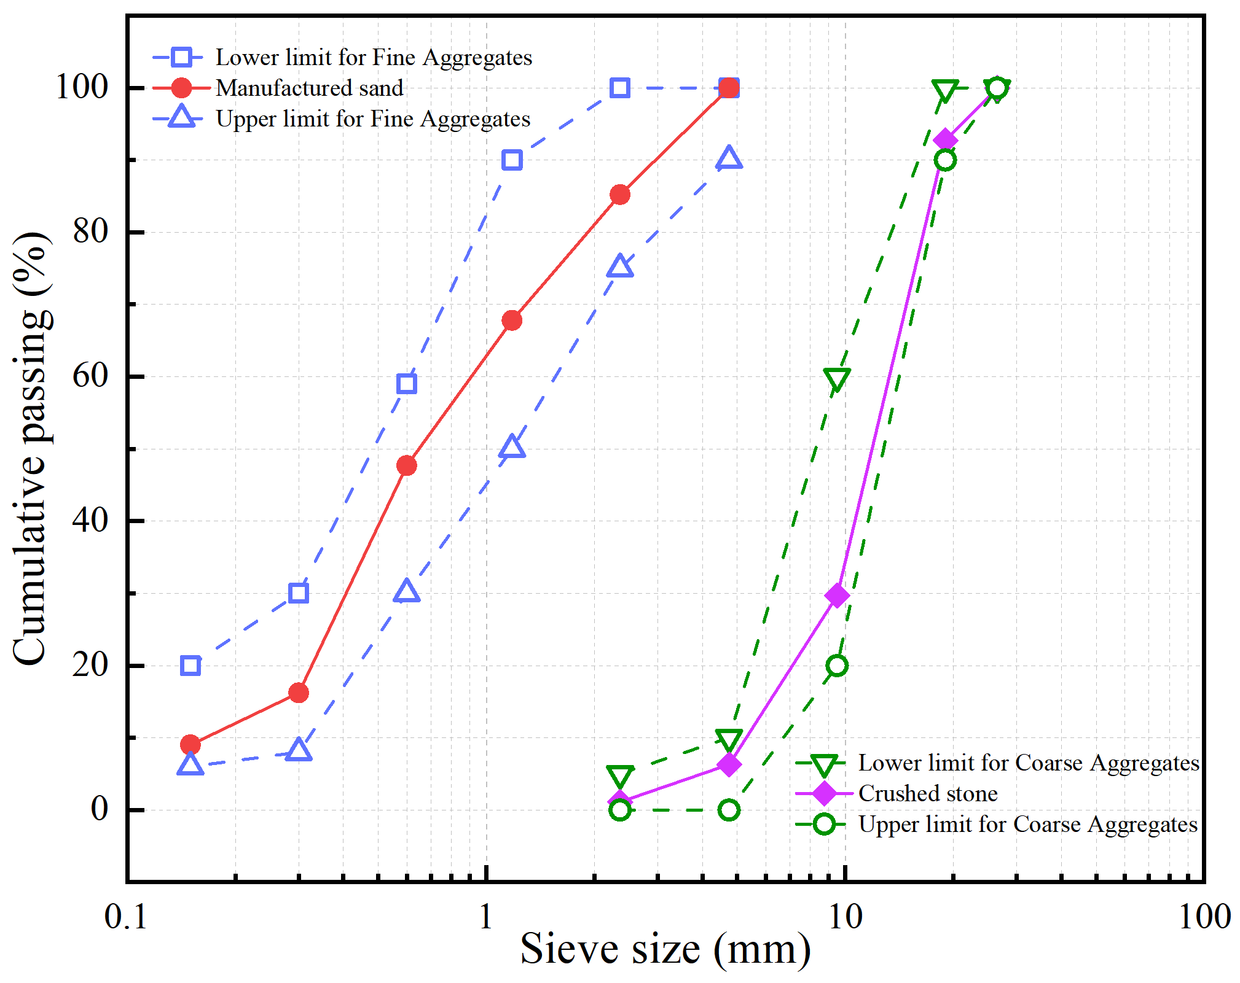
Fig.1. Grading curves of manufactured sand and crushed stone.

2.2. Concrete mixes design
A total of five concrete mixes are designed for this study, as summarized in Table 4. The mix proportion of NSMC-0 corresponds to a concrete grade of C30. The total amount of water was kept constant, but the amount of water present in colloidal nano-silica must be considered. NS is used as a cement substitute, and 0.5Wt.%, 1.0Wt.%, 1.5Wt.%, and 2.0Wt.% NS were used to replace cement to prepare specimens. Since NS reduces the fluidity of the mixture, superplasticizer is used in the experiment to keep the fluidity of the mixture at the same level. It ensures the good working performance of the mixture and reduces the influence of different fluidities on the results.

Table 4 Designed concrete mixes.
Specimens | NS |  | Cement  (kg/m³) | Total  water  (kg/m³) | Fine aggregate (kg/m³) | Coarse aggregate (kg/m³) | SP  (kg/m³) | W/B | Slump  (mm)
Specimens | Wt.% | kg/m³
NSMC-0 | 0% | 0 | 330 | 155 | 861.75 | 1053.25 | 0.66 | 0.47 | 192
NSMC-5 | 0.5% | 1.65 | 328.35 | 155 | 861.75 | 1053.25 | 0.74 | 0.47 | 193
NSMC-10 | 1.0% | 3.3 | 326.7 | 155 | 861.75 | 1053.25 | 0.82 | 0.47 | 191
NSMC-15 | 1.5% | 4.95 | 325.05 | 155 | 861.75 | 1053.25 | 0.91 | 0.47 | 193
NSMC-20 | 2.0% | 6.6 | 323.4 | 155 | 861.75 | 1053.25 | 0.99 | 0.47 | 190
Note: NS-Nanosilica, SP-Superplasticizer, W/B-Water/binder ratio

2.3. Specimen preparation and curing
The ambient temperature for preparing concrete specimens is 20±2°C, and the forced mixer is used for mixing. Mix SP with water and stir for 1 minute, then add colloidal silica and stir at high speed for 5 minutes to obtain solution A. Then, put the coarse aggregate, fine aggregate, and cement into the mixer for mixing for 2 minutes, pour in solution A, and then mix for 2 minutes. After the slump test is qualified, it shall be put into the mold and placed on the shaking table for vibration compaction to reduce the residual air bubbles in the concrete. After covering it with plastic film, move it to the standard curing room or steam curing box. The specimens in the standard curing room shall be demoulded after 24 hours and placed back in the standard curing room for curing to the corresponding age. The specimens cured by steam shall be demoulded after a complete steam curing cycle, and then moved to the standard curing room for curing to the corresponding age.
The test includes two kinds of curing methods (Fig.2). The first one is standard curing, with a temperature of 20±2°C and humidity$≥$98%. A complete steam curing cycle includes the pre-curing period, heating period, constant temperature period, and cooling period. The steam curing system for this test is provided by Chongqing CSCE Hailong Liangjiang Construction Technology Co., Ltd. The regime has been verified by production practice and has a good economic effect.

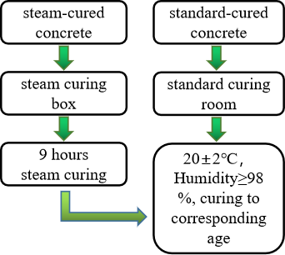 | 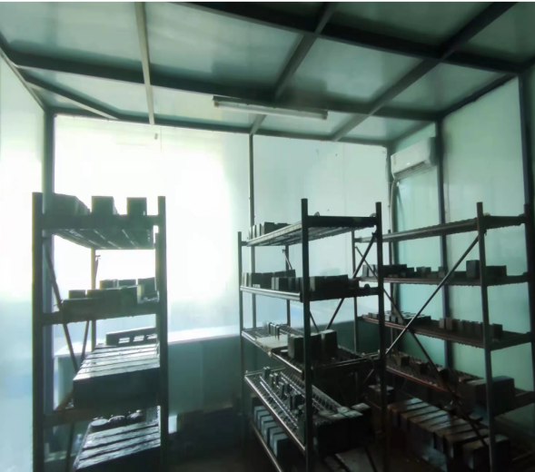
- Curing process of specimens | - Standard curing room
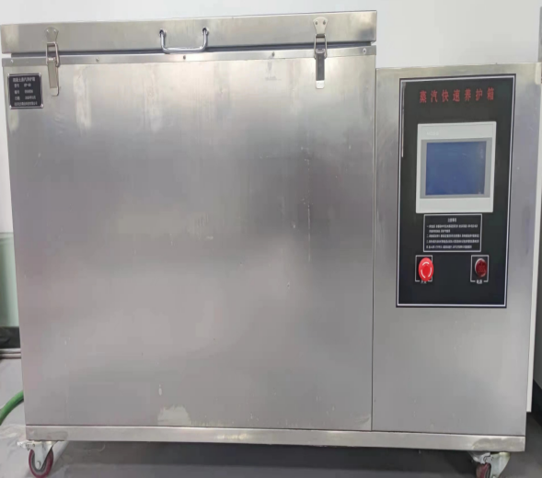 | 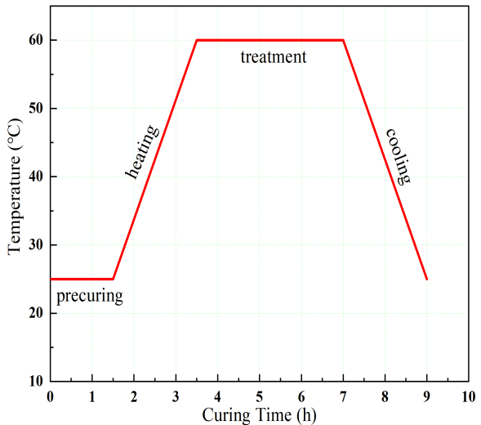
- Steam curing box | - Steam curing regime
Fig.2. Curing methods of concrete.

2.4. Testing procedure
The specimen for the compressive strength test is a cube with a dimension of 100mm × 100mm × 100mm. The compressive strength of concrete is tested according to GB/T 50081[51], and the loading rate is 0.65 MPa/s. In each group, three concrete specimens are tested at each age, and the average value is taken as the group strength of corresponding age .
The size of the test specimen for the water penetration resistance test is 150mm × 175mm × 185mm, sealed with paraffin before the test, and tested with an automatic impermeability meter according to GB/T 50082[52]. Then split the test piece and trace the watermark with a waterproof pen. Place the trapezoidal plate on the splitting surface of the test piece, and measure the water penetration height of 10 measuring points with a steel ruler at equal intervals along with the watermarks. The average value of 10 points is taken as the water penetration height of the test piece. Each group includes 6 specimens, and the average value is taken as the group penetration height of the group at the corresponding age.
The test piece for the sulfate corrosion resistance test is a cube with a dimension of 100mm × 100mm × 100mm, tested according to GB/T 50082[52]. When the specimen is cured for 26 days, take it out of the curing room, clean the specimen, place it in the oven and bake it at 85°C for 2 days. After drying, place it in a dry environment and cool it to room temperature. Then place it in the test piece box containing 5% Na₂SO₄ solution, and the solution exceeds the top surface of the test piece by 20mm. The whole dry-wet alternation process is 24 hours in total. One cycle included 16 hours of soaking in 5% Na₂SO₄ solution, 1 hour of natural air-drying, 6 hours of drying in the oven at 85°C, and 1 hour of natural cooling Throughout the test, check the pH value of the solution every 7 days, and ensure that the pH value of the solution is maintained at 6-8 by supplementing dilute sulfuric acid to neutralize calcium hydroxide (Ca(OH)₂) in the solution. The corrosion resistance coefficient of compressive strength should be calculated according to Eq. (1):
$K_{f}=\frac{f_{cn}}{f_{c0}}×100\%$ (1)
where, $K_{f}$ is the corrosion resistance coefficient, $f_{cn}$ is the measured value of the compressive strength of a group of concrete specimens corroded by sulfate after the dry-wet cycle, and $f_{c0}$ is the measured value of the compressive strength of concrete specimens at the same age that is not corroded by sulfate. $f_{cn}$ and $f_{c0}$ shall be determined as the arithmetic mean of the results of the compressive strength test of three specimens.
In addition, after drying and grinding the hardened cement slurry sample, an XRD test is carried out, and the diffraction angle is 5°~70°. The pore characteristics of each group of concrete samples were studied by MIP. The microstructure of each group of concrete was studied by SEM.

3. Experimental results and discussion

3.1. Mechanical property of concrete at different curing conditions
The compressive strength can reflect the overall performance of hardened concrete, which is closely related to the service performance of concrete components. Therefore, it is necessary to study the strength development trend of NSMC under standard curing and steam curing. The results of compressive strength are recorded in Fig.3, Table 5, and Table 6. In Table 6, $α_{com}$ is used to evaluate the variation of the strength of steam-cured specimens compared with normal standard-cured specimens, and its definition is as follows:
$α_{com}=\frac{f_{ST(nd)}}{f_{SD(0d)}}$ (2)
where, $f_{ST(nd)}$ represents the compressive strength of steam-cured concrete, $f_{SD(0d)}$ refers to the compressive strength of standard-cured concrete without NS. n refers to the content of NS, and d refers to the curing age. For example, $f_{ST(51)}$ is the compressive strength of 1 day mixed with 0.5Wt.% NS under steam curing, $f_{SD(01)}$ is the compressive strength of 1 day of standard-cured concrete without NS.

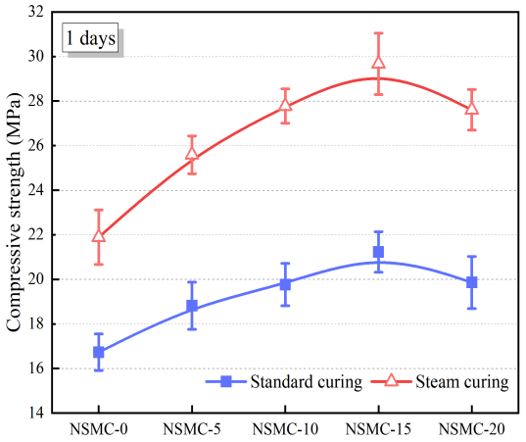 | 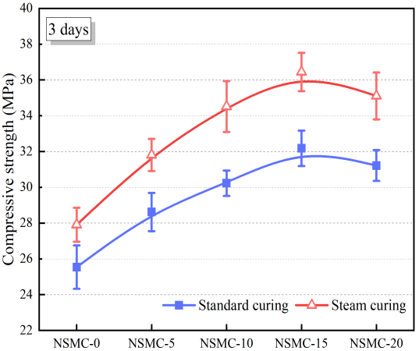
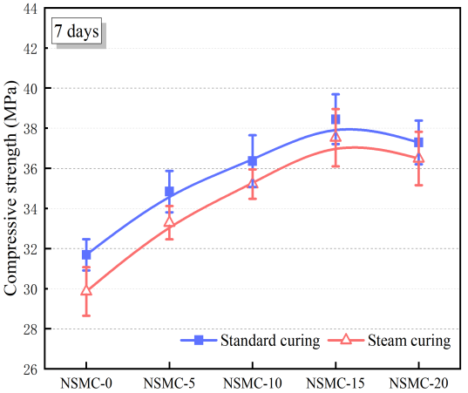 | 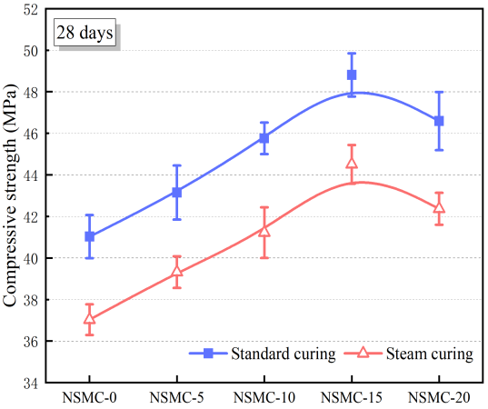
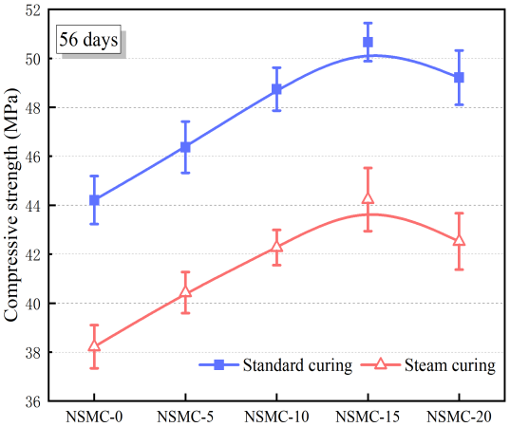
Fig.3. Comparison of compressive strength of different NS content at different ages.

Table 5 Difference of increase rate (DIS).
 | 1 day | 3 days | 7 days | 28 days | 56 days
NSMC-0 | 0% | 0% | 0% | 0% | 0%
NSMC-5 | 4.4% | 1.9% | 1.5% | 1.0% | 0.9%
NSMC-10 | 8.7% | 5.3% | 3.2% | -0.2% | 0.3%
NSMC-15 | 8.6% | 4.6% | 4.4% | 1.2% | 1.1%
NSMC-20 | 7.4% | 3.6% | 4.5% | 0.9% | -0.1%
DIS=$i_{steam}$-$i_{standard}$
$i_{steam}$: Increases rate of compressive strength under steam curing (%)
$i_{standard}$: Increases rate of compressive strength under standard curing (%) ;

Table 6 $α_{com}$
 | 1 day | 3 days | 7 days | 28 days | 56 days
NSMC-0 | 1.31 | 1.09 | 0.94 | 0.90 | 0.86
NSMC-5 | 1.53 | 1.25 | 1.05 | 0.96 | 0.91
NSMC-10 | 1.66 | 1.35 | 1.11 | 1.01 | 0.95
NSMC-15 | 1.77 | 1.43 | 1.18 | 1.08 | 1.00
NSMC-20 | 1.65 | 1.37 | 1.15 | 1.03 | 0.96
As shown in Fig.3, NS has a significant strengthening effect on both standard-cured concrete and steam-cured concrete. No matter under which curing condition, the compressive strength increases first and then decreases with the increase of NS content, and the corresponding optimal content is 1.5Wt.%. The important reason for the improvement of strength is that nano-filling effect and high pozzolanic activity of NS improve the compactness and structural stability of the matrix. In the early curing period (1-3 days), the strength of steam-cured specimens is higher than that of standard-cured specimens under the same NS dosage. However, from the 7th day, the strength of steam-cured specimens is gradually lower than that of the standard-cured specimens, and the strength difference increases with the increase of age, indicating that the thermal damage begins from the middle of curing, and the degree of damage is positively correlated with the age. The deterioration of the structure of hydration products and the gel layer around cement particles are the main reasons for the negative effect of steam curing on the later strength of concrete[27].
As shown in Table 5, in the early curing period (1-3 days), the increased rate of steam curing is higher than that of standard curing, while in the late curing period (28-56 days), the increased rate of steam curing is close to that of standard curing. This indicates that NS has a more obvious promoting effect on the early compressive strength after steam curing, indicating that there is a synergistic effect between steam curing and NS in the early curing stage, but this synergistic effect does not last until the late curing stage. This synergistic effect is mainly due to the fact that as steam curing promoted the formation of more Ca(OH)₂ in the early stage, and high temperature further enhances the pozzolanic activity of NS, the process of C-S-H formation by consuming Ca(OH)₂ is accelerated to the maximum extent in the early stage.
In Table 6, $α_{com}$ selects the strength of standard-cured ordinary concrete (SOC) as the denominator. It can be seen that the $α_{com}$ of day 1 and day 3 were both greater than 1.0, and the $α_{com}$ increased more obviously after the addition of NS, which indicates that steam curing improves the early strength of concrete, and the improvement effect can be enhanced by adding NS. The $α_{com}$ of NSMC-0 at 7,28, and 56 days are 0.94, 0.90, and 0.86, respectively, while the $α_{com}$ of NSMC-15 at 7,28, and 56 days are 1.18, 1.08, and 1.00, respectively. This indicates the addition of 1.5Wt.%NS can restore the strength of the steam-cured concrete to the level of SOC, implying that NS can mitigate steam thermal damage in terms of compressive strength. This mitigative effect is mainly due to the addition of NS in the early curing stage, which adjusts the uneven distribution of hydration products and reduces the pores of hydration products. This early optimization effect is conducive to resisting steam thermal damage[53-55]. However, it should be noted that the loss of strength in this study was low because the plastic film is used to cover the specimen after molding, which reduced the formation of pores due to stress changes caused by water vapor migration during the steam treatment[22]. In addition, the low heating and cooling rates adopted in the tests also prevented the formation of more microcracks due to excessive temperature changes.

3.2. Impermeability of concrete at different curing conditions

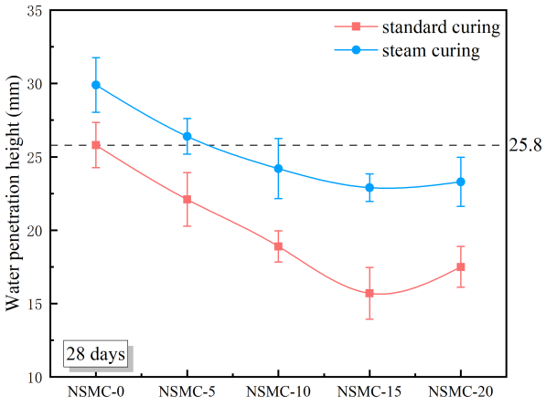 | 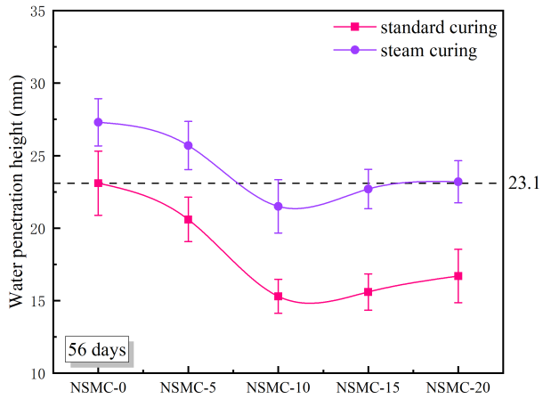
Fig.4. Water penetration height of the concrete.

Table 7 Decrease rate and $α_{im}$ of water penetration height.
 | 28 days |  | 56 days |  | $$α_{im}$$
 | $$d_{SD}$$ | $$d_{ST}$$ | $$d_{SD}$$ | $$d_{ST}$$ | 28 days | 56 days
NSMC-0 | 0.0 | 0.0 | 0.0 | 0.0 | 0.86 | 0.85
NSMC-5 | 14.3 | 11.7 | 10.8 | 5.86 | 0.98 | 0.90
NSMC-10 | 26.7 | 19.1 | 33.8 | 21.3 | 1.07 | 1.07
NSMC-15 | 39.2 | 24.3 | 32.5 | 16.9 | 1.13 | 1.02
NSMC-20 | 32.17 | 22.1 | 27.7 | 15.0 | 1.11 | 0.99
$d_{SD}$: Decrease rate of water penetration height under standard curing (%)
$d_{ST}$: Decrease rate of water penetration height under steam curing (%)

The results of the water penetration resistance test are recorded in Fig.4 and Table 7. In Table 7, $α_{im}$ is used to evaluate the change of penetration height of steam-cured specimens compared with normal standard-cured specimens, and its definition is as follows:
$α_{im}=\frac{h_{SD(0d)}}{h_{ST(nd)}}$ (3)
where $h_{ST(nd)}$ is the penetration height of steam-cured concrete, and $h_{SD(0d)}$ is the penetration height of standard-cured concrete without NS. n is NS dosage, and d is curing age.
As shown in Fig.4 that at the same age, the influence rule of NS content on water penetration height under both two curing conditions is the same, and there is an optimal NS content to make the water penetration height the lowest. After curing for 28 days, when the content of NS is 1.5Wt.%, the water penetration height of the standard-cured specimen and the steam-cured specimen is the lowest, which are 15.7mm and 22.9mm respectively, and the decrease rates are 39.2% and 24.3% respectively. After curing for 56 days, when the content of NS is 1.0Wt.%, the water penetration height of the standard-cured specimen and the steam-cured specimen is the lowest, which are 15.3mm and 21.5mm respectively, and the decrease rate is 33.8% and 21.3%. The improvement of impermeability is mainly due to the fact that NS promotes the production of more hydration products, which in turn interrupts the penetration channels formed by the connected internal pores. On the other hand, Fig.4 also shows that the water penetration height of steam-cured specimens is significantly higher than that of standard-cured specimens, implying that there is a significant negative effect of steam curing on the impermeability of the concrete, and this deterioration is mainly due to the fact that steam treatment increases the degree of disorganization of hydration products, and the increased internal pores provide the basis for the formation of permeation channels.
It can be found from Table 7 that at the same age, the improvement of permeability resistance of NS under standard curing is better than that under steam curing, which means that steam curing weakens the improvement effect of NS in the later stage of curing. Combine Fig.4 with $α_{im}$ (Table 7), it can be found that under steam curing, without adding NS, the water penetration resistance at 28 days and 56 days is lost by 14% and 15%, while adding 1.0-2.0Wt.% NS can gradually restore the impermeability of steam-cured specimens to the level of standard-cured ordinary concrete, this means that NS mitigates the damage caused by steam curing in terms of impermeability.

3.3. Sulfate corrosion resistance of concrete at different curing conditions

3.3.1 Visual inspection
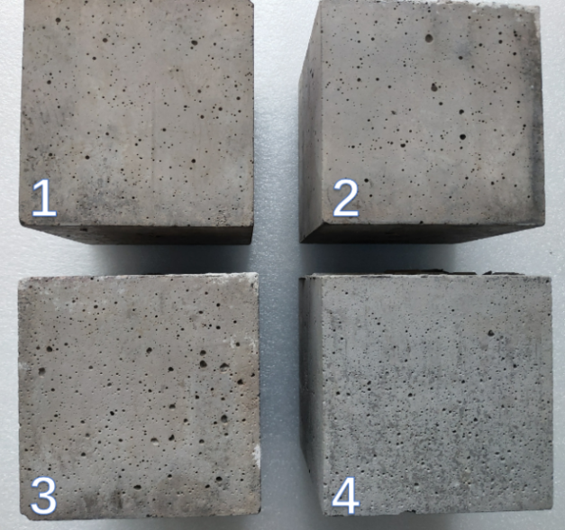 | 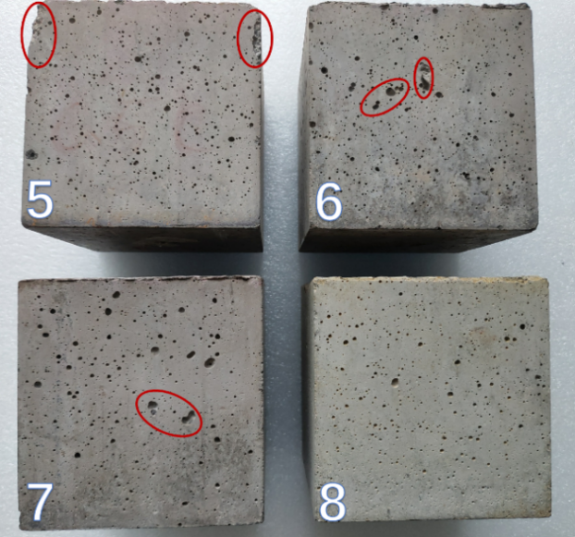
(a) standard curing. | (b) steam curing.
Fig.5.Visual appearance of specimens after 120 days of sulphate corrosion.
Fig.5 shows the apparent phenomenon of concrete after 120 days of sulfate corrosion. Among them, Specimens 1-3 and 5-7 are concrete without NS, and Specimens 4 and 8 are concrete mixed with 1.5Wt.% NS. It can be seen in Fig.5 that dense holes appear on the surface of the standard-cured blank specimen, and the area of some holes is large. The degradation degree of the specimen surface with NS is lower than that of the blank specimen. For the steam-cured specimen, Specimen 5 shows more intensive holes, and peeling occurs in the left and right upper corners. Several holes in Specimen 6 are connected due to the enlarged area. The number of large holes on the surface of Specimen 7 is the largest, and the surface deterioration of Specimen 8 is lower than that of the other steam-cured specimens, but there is still very slight edge and corner peeling
By comparing Fig.5(a) and Fig.5(b), it can be found that the surface deterioration of concrete after steam curing is more serious. It may be due to the fact that the surface of the concrete is more significantly affected by temperature changes during steam curing compared to the interior of concrete, resulting in lower quality of the surface concrete[22,26]. It is worth noting that even after 120 days of sulfate corrosion, no significant spalling or cracking occurred on the concrete surface, probably because the corrosion time was only 4 months. In some studies[56, 57], it took 9 months or even longer for significant spalling and cracking to occur in cement materials.

3.3.2 Mass change
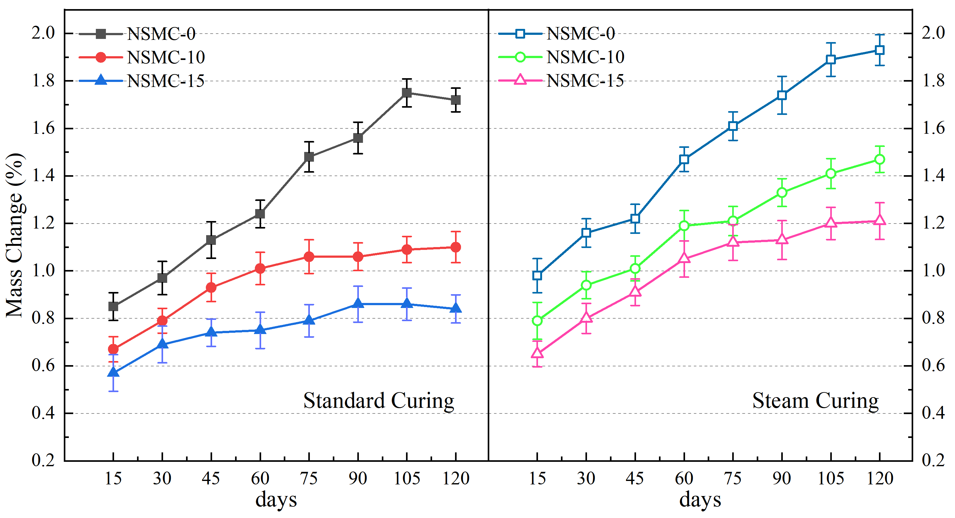
Fig.6. Mass change of sulfate corrosion in 120 days.
Mass changes can indirectly reflect the development of sulfate corrosion. During the test, mass changes were recorded every 15 days (Fig.6). It can be seen that the mass of all specimens showed a continuous increase during the 4-month test. This is because the specimens absorbed a large amount of sulfate solution, but the specimens were less damaged (Fig.5). It was noted that the increase in mass of the specimens after the addition of NS was less than that of the blank specimens for both standard and steam curing, and the specimens incorporated with 1.5% NS showed the lowest mass increase. The addition of NS improves the impermeability of concrete and limits the intrusion of external sulfate solution, thus reducing the amount of solution absorption. It should be noted that the mass increase of steam-cured specimens is generally higher than that of standard-cured specimens. It is because steam curing has greater damage to the microstructure of the concrete, more and coarser pores as well as more micro-cracks increasing the upper limit of sulfate solution absorption.

3.3.3 Corrosion resistance coefficient ($K_{f}$)
Table 8 Corrosion resistance coefficient.
Corrosion of time | NSMC-0 |  | NSMC-10 |  | NSMC-15
Corrosion of time | standard | steam | standard | steam | standard | steam
0 month | 100% | 100% | 100% | 100% | 100% | 100%
1 month | 105.84% | 107.58% | 102.34% | 104.44% | 100.85% | 102.11%
2 months | 94.65% | 91.21% | 95.52% | 98.26% | 97.46% | 99.64%
3 months | 89.77% | 87.17% | 92.67% | 95.59% | 95.23% | 98.25%
4 months | 84.29% | 81.45% | 89.55% | 92.88% | 93.49% | 97.12%
Note: standard=standard curing; steam=steam curing

Strength loss or strength retention is the most important characteristic of concrete after sulfate corrosion. The corrosion resistance coefficient ($K_{f}$) reflects the retention of compressive strength (Fig.8). It can be seen that under the two curing conditions,$K_{f}$ of each group of specimens showed a trend of first increasing and then decreasing. At the early stage of corrosion (0-1 month), the $K_{f}$ of all specimens were higher than 100%, and the specimens without NS had the highest $K_{f}$ in one month. The increase in early strength of the corroded specimens is due to the entry of sulfate ions into the cement matrix, which reacts with Ca(OH)₂ to produce ettringite (AFt、3CaO·Al₂O₃·CaSO₄·32H₂O), The reaction involved is shown in Eq. (4)- Eq. (6)[25]:
${Ca(OH)}_{2}+{SO}_{4}^{2-}+{2H}_{2}O→ {CaSO}_{4}{2OH}^{-}$ (4)
${3CaO∙Al}_{2}O_{3}∙{CaSO}_{4}∙{18H}_{2}O+2\left({CaSO}_{4}∙{2H}_{2}O\right)+{10H}_{2}O→{3CaO∙Al}_{2}O_{3}∙3{CaSO}_{4}∙{32H}_{2}O$ (5)
${3CaO∙Al}_{2}O_{3}+3\left({CaSO}_{4}∙{2H}_{2}O\right)+26H_{2}O→{3CaO∙Al}_{2}O_{3}∙{3CaSO}_{4}∙{32H}_{2}O$ (6)
Ettringite is expansive and acts as a filler to support the pores, so a slight increase in strength occurs in the early stages of corrosion. The $K_{f}$ of specimens containing NS was slightly lower than that of the blank specimens, because the addition of NS made the cement matrix denser, and reduced the invasion of sulfate, thus reducing the formation of AFt. While steam curing increases the content of Ca(OH)₂ in the cement matrix, and at the same time, steam curing increases the pores and micro-cracks, resulting in more sulfate solution invasion and more ettringite formation. Therefore, the $K_{f}$ in one month of the steam-cured specimens is higher than that of the standard-cured specimens.
With the increase of corrosion time, the corrosion resistance coefficient of each group of specimens began to decline, indicating the loss of strength of the eroded specimens, and the strength loss of the blank specimens was the most serious. After 4 months of corrosion, the $K_{f}$ of NSMC-0 under steam curing is lower than that under standard curing, which indicates that the sulfate resistance of ordinary concrete after steam curing is lower than that of standard curing. The corrosion resistance coefficients of all specimens were significantly improved after NS was incorporated, and the corrosion resistance coefficients were higher than 90%. The corrosion resistance coefficients of NSMC-10 and NSMC-15 specimens under steam curing were higher than those under standard curing, respectively, which means that there is a synergistic effect between NS and steam curing in improving the corrosion resistance of concrete.
The loss of strength is mainly due to the expansion cracking caused by ettringite development. Since the formation of ettringite depends on Ca(OH)₂, all methods to reduce the content of Ca(OH)₂ are expected to improve the sulfate resistance of concrete[58]. The pozzolanic effect of NS reduces the availability of Ca(OH)₂. In addition, NS improves the density of the cement matrix and reduces the invasion of sulfate solution. Therefore, NS effectively improves the sulfate resistance of concrete. Under steam curing, although high temperature promotes the formation of more Ca(OH)₂, high temperature also greatly increases the pozzolanic effect of NS, and most Ca(OH)₂ has been consumed before sulfate corrosion.

3.3.4 SEM image after sulfate corrosion
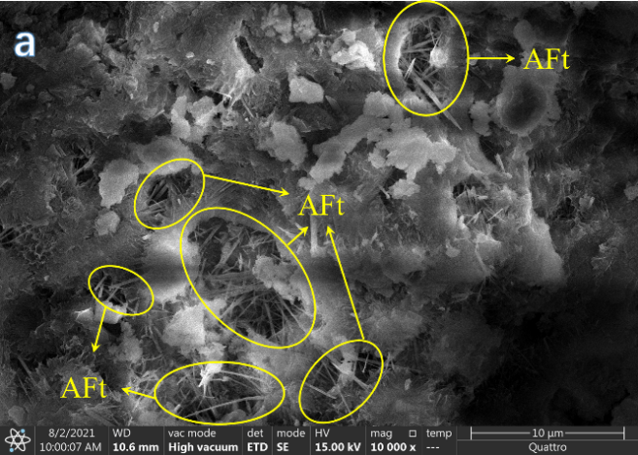 | 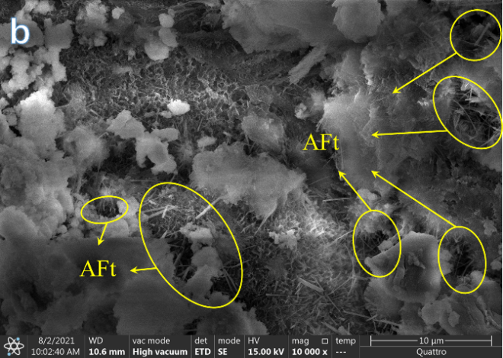
(a) NSMC-0 under standard curing. | (b) NSMC-0 under steam curing.
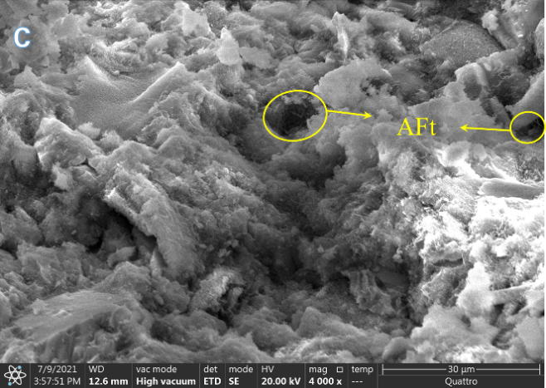 | 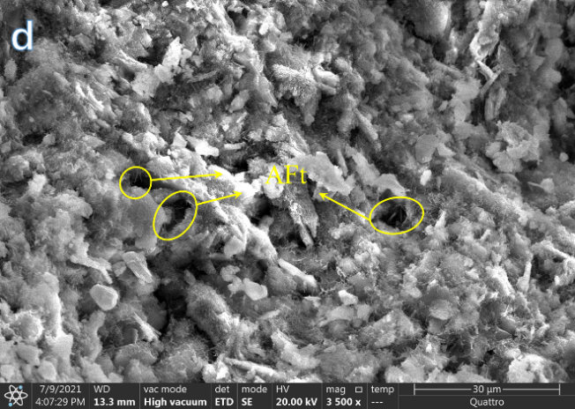
(c) NSMC-15 under standard curing. | (d) NSMC-15 under steam curing.
Fig.7. SEM image after 120-day sulfate corrosion.
Fig.7 shows the microscopic morphology of specimens after 120d of sulfate corrosion. It can be found that after sulfate corrosion, more slender needle-like ettringite is distributed in the pores of the standard-cured NSMC-0 specimens (Fig.7(a)), indicating that the area is more seriously eroded by sulfate, and the needle-like ettringite is disorderly distributed in the pores, which will lead to the continued expansion of the pores and even the appearance and extension of microcracks[42]. And in the micrographs of the steam-cured NSMC-0 specimens (Fig.7(b)), more ettringite also appeared in the pores. After the incorporation of NS, the microscopic morphology of standard-cured NSMC-15 specimens (Fig.7(c)) was uniformly dense and less porous, and a very small amount of ettringite could be observed, indicating that NS effectively inhibited the formation of ettringite. Under steam curing, the microscopic morphology of the NSMC-15 specimen (Fig.7(d)) was denser than that of NSCM-0 (Fig.7b)), although there were still a small number of pores, these pores contained only a very small amount of ettringite, indicating that the addition of NS improves the resistance of steam-cured concrete to sulfate.

3.4. Matrix composition
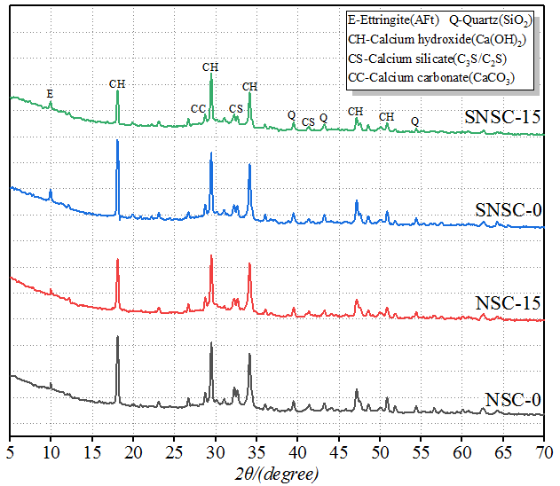 | 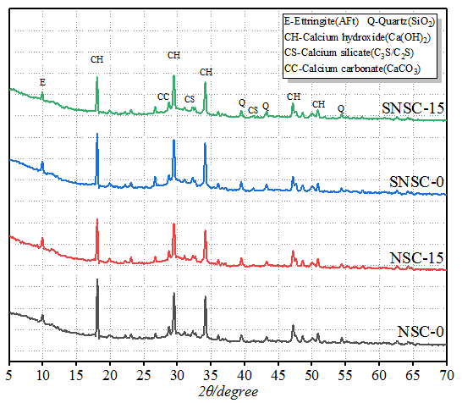
- 3 days. | - 28 days.
Fig.8. XRD patterns of hydration for 3 days.
From Fig.8, it can be found that the crystal phases observed in the 3-day and 28-day patterns are basically the same, mainly calcium hydroxide (Ca(OH)₂), tricalcium silicate (C₃S), dicalcium silicate (C₂S), calcium carbonate (CaCO₃), Ettringite (Aft), and silicon dioxide (SiO₂). It should be noted that the existence of CaCO₃ may be due to the additive limestone of ordinary Portland cement, or carbonization occurs during the preparation and curing of the specimens. SiO₂ exists in Portland cement or NS, indicating that cement particles or NS particles are not completely consumed. AFt is the hydration product formed by the reaction of C₃A and gypsum in cement, and its content is low. By analyzing the change of crystal phases such as Ca(OH)₂, C₃S, and C₂S, especially the change of Ca(OH)₂, the hydration degree of cement or the reaction degree of the pozzolanic effect can be indirectly reflected.
From Fig.8(a), it can be found that the Ca(OH)₂ content of the standard-cured NS specimens decreased significantly, indicating that NS consumed a large amount of Ca(OH)₂. In addition, the CS content also decreased, which was due to the decrease of Ca(OH)₂ concentration promoting the hydration reaction of C₃S and C₂S. Therefore, NS has a good promotion effect on cement hydration at 3 days. The Ca(OH)₂ content of the specimens without NS increased significantly after steam curing, while the CS content decreased, which indicated that steam curing promoted the early hydration of cement. The steam-cured NS specimens had the lowest content of Ca(OH)₂ and CS, which indicated that in the early stage, NS under steam-cured conditions underwent stronger pozzolanic reactions, resulting in more consumption of Ca(OH)₂, C₃S, and C₂S, and the pattern of steam-cured NSMC-15 specimens provides evidence for the synergistic effect between NS and steam curing.
It can be seen from Fig.8(b) that at 28 days, the Ca(OH)₂ content of the standard-cured NS specimens was lower than that of the standard-cured blank specimens, indicating that some pozzolanic activity still existed in the NS at the later stage of curing. The CS content of the steam-cured specimens without NS was higher than that of the standard-cured blank specimens, indicating that more unhydrated clinker existed in the steam-cured specimens than in the standard-cured specimens, which proved that steam curing had a negative effect on later hydration. The Ca(OH)₂ and CS contents of the steam-cured NS specimens were also lower, indicating that NS still had some promotion effect on the late hydration of steam curing, which is another evidence that NS can mitigate the damage of steam curing.

3.5. Microstructure

3.5.1. Micromorphology after curing for 3 days
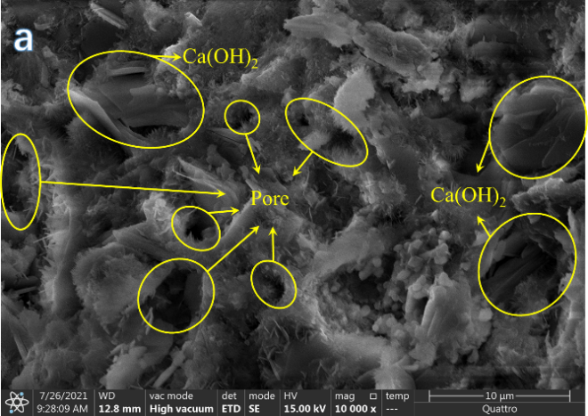 | 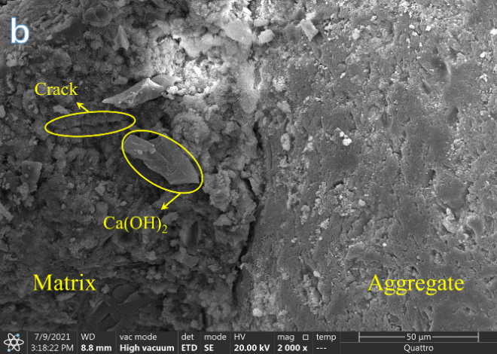
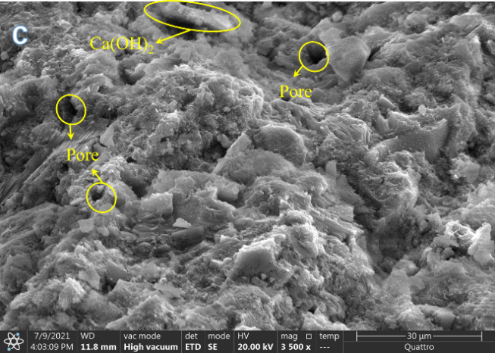 | 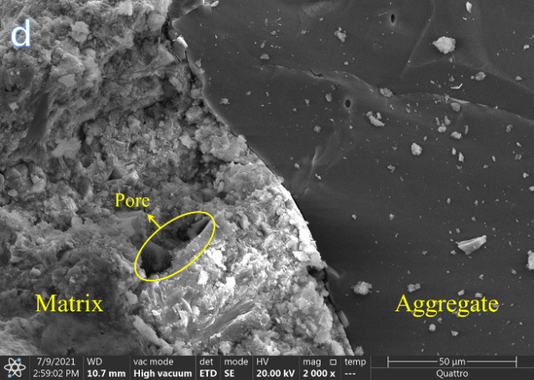
Fig.9. Micromorphology after standard curing for 3 days: (a, b) NSMC-0; (c, d) NSMC-15.

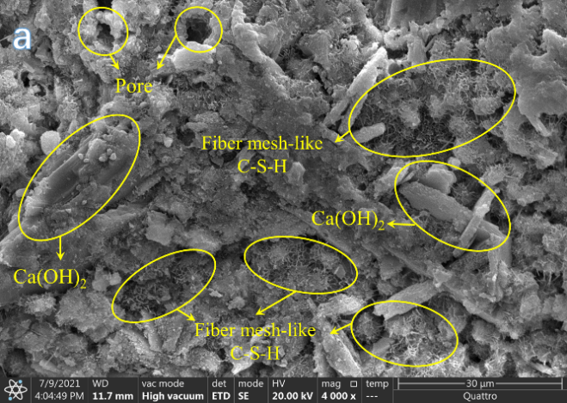 | 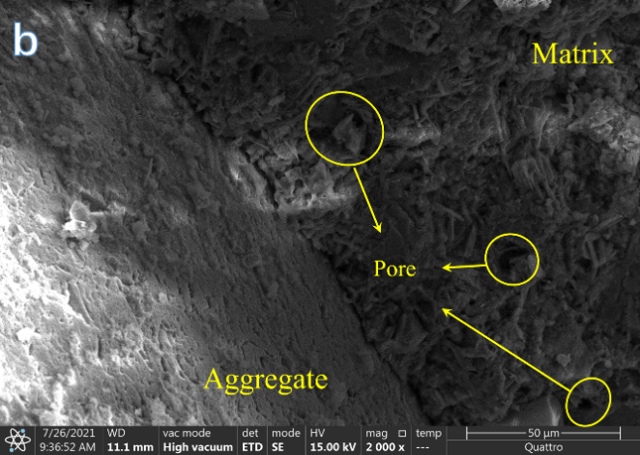
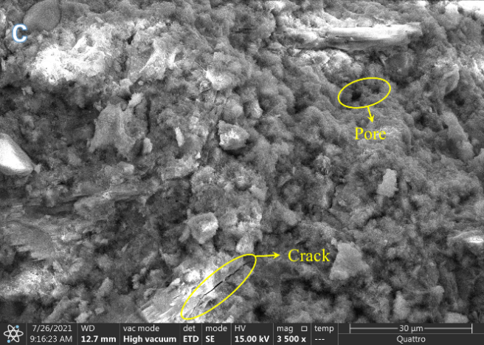 | 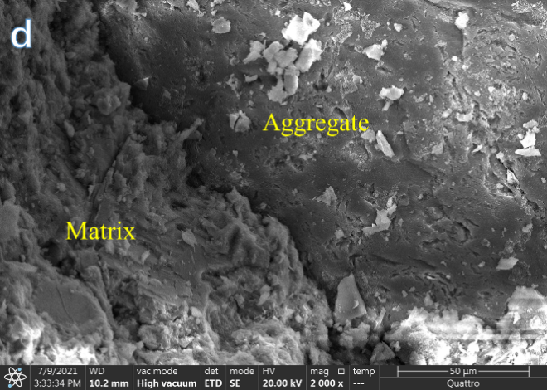
Fig.10. Micromorphology after steam curing for 3 days: (a, b) NSMC-0; (c, d) NSMC-15.

Fig.9 shows the microstructure of concrete after standard curing for 3 days. As shown in Fig.9(a), the microscopic morphology of NSMC-0 specimens under standard curing is immature, and a high amount of Ca(OH)₂ can be seen. Due to the small contribution of Ca(OH)₂ to strength, the presence of a large amount of Ca(OH)₂ tends to lead to low mechanical properties. In addition, there are an obvious large number of pores in Fig.9(a). The presence of porous areas also leads to lower mechanical properties and durability performance. The interface transition zone (ITZ) of NSMC-0 specimens (Fig.9(b)) was also immature, with an obvious gap between the aggregate and hydration products, and hydration products near the aggregate showed porous, loose, and poor continuity, and obvious cracks could be found. It can be seen from Fig.9(c) that NS has a good improvement on the microstructure of concrete. Only a small amount of Ca(OH)₂ was observed, indicating that the presence of NS reduces the growth space of Ca(OH)₂. The hydration products of NSMC-15 specimens were more mature, and no large pores were found. The overall structure showed a dense and continuous state, and the distribution of hydration products was relatively uniform, which reflected the regulatory effect of NS on early cement hydration. In the ITZ of NSMC-15 specimens (Fig.9(d)), it can be observed that the gap between the aggregate and hydration products is narrow. Although there are still a few holes, hydration products near the aggregate are closely intertwined with strong integrity, indicating that the presence of NS improves the bond between the aggregate and hydration products.
Fig.10 shows the microstructure of concrete after steam curing for 3 days. By comparing Fig.9(a) with Fig.10(a), it can be found that the early microstructure of NSMC-0 specimens becomes more mature after steam curing. Although the hydration products in Fig.10(a) still have a small amount of Ca(OH)₂, the C-S-H gel shows a relatively dense state, which can explain the view that steam curing improves early strength. However, some fiber mesh-like C-S-H gels were observed in Fig.10(a), and these fiber mesh-like gels were haphazardly distributed near the well-developed C-S-H gels, which did not have continuity and integrity, suggesting that steam curing was not conducive to the formation of a more dense microstructure. By comparing Fig.9(b) and Fig.10(b), it can be found that steam curing confers a better early ITZ to the NSMC-0 specimens. In Fig.10(b), the gap between the aggregate and hydration products is narrower, but it should be noted that there are still holes in hydration products near the aggregate. From Fig.10(c), it can be found that the denseness of the hydration products of the steam-cured NSMC-15 specimens (Fig.10(c)) is higher than that of the standard-cured and steam-cured NSMC-0 specimens (Fig.9(a), Fig.10(a)). The steam-cured NSMC-15 sample contains only a very small number of small pores, C-S-H gel is tightly and orderly bound together to form a continuous, complete, uniform, and dense microstructure, and Ca(OH)₂ is almost not observed. In addition, the aggregate of NSMC-15 specimens was closely bonded to hydration products, and there were no obvious holes in hydration products near the aggregate. However, it should be noted that a small number of cracks and holes exist in the steam-cured NSMC-15 specimens, indicating that NS is difficult to fully mitigate the damage to the microstructure by steam conservation.

3.5.2. Micromorphology after curing for 28 days
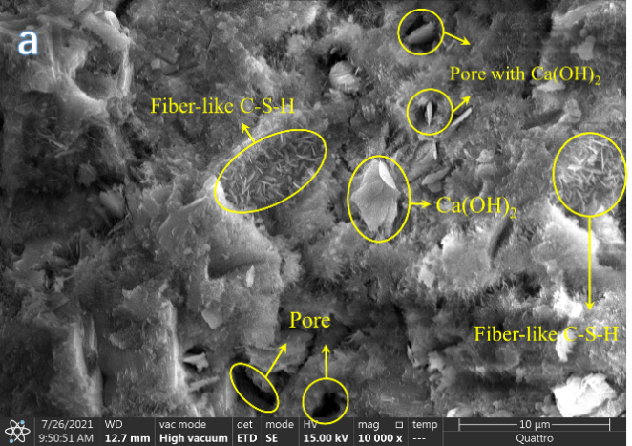 | 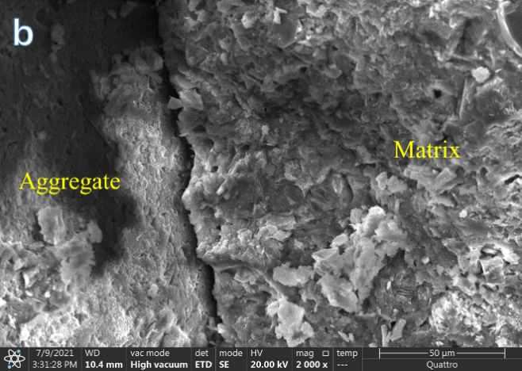
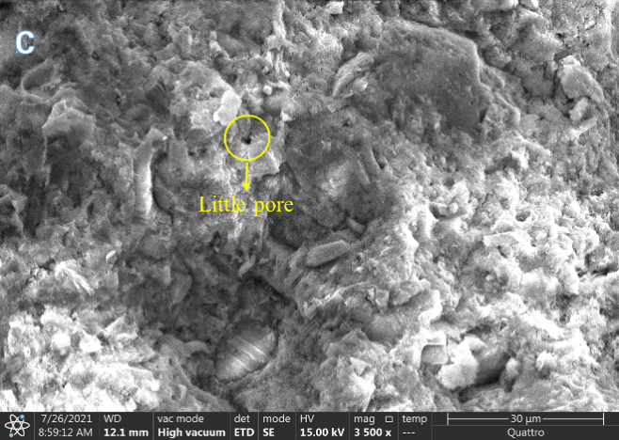 | 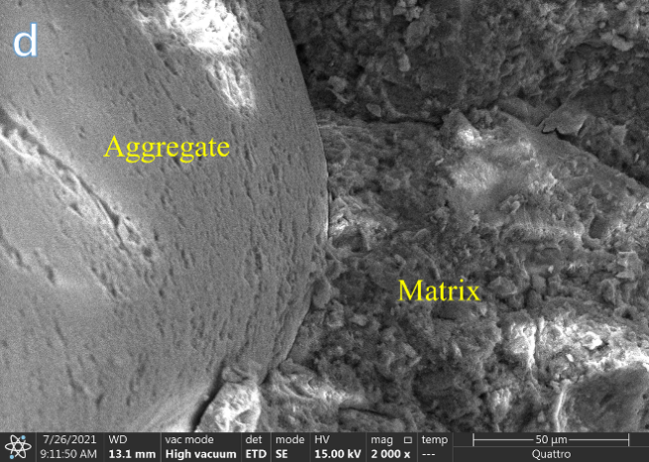
Fig.11. Micromorphology after standard curing for 28 days: (a, b) NSMC-0; (c, d) NSMC-15.

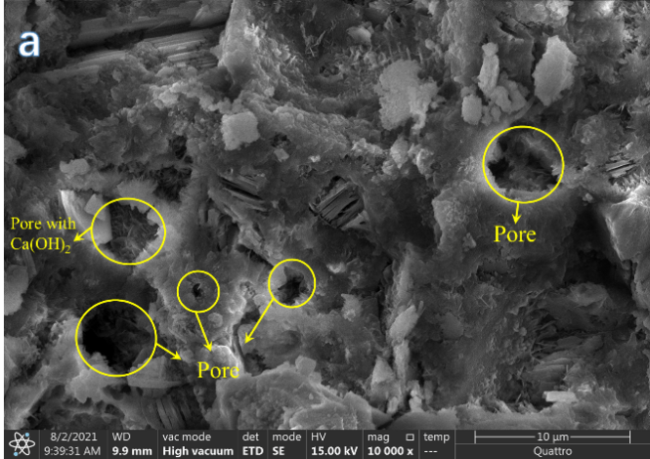 | 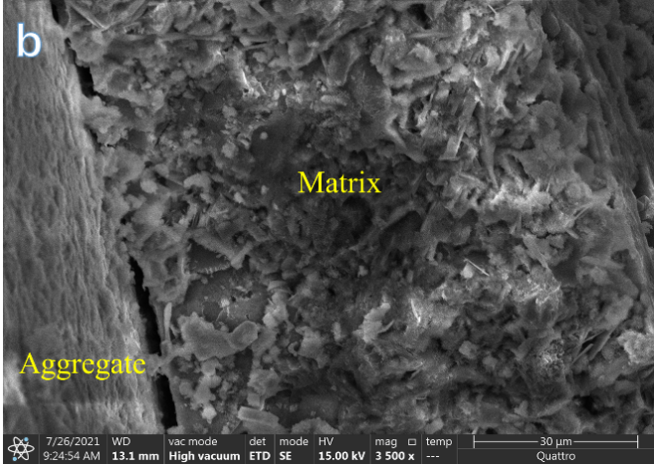
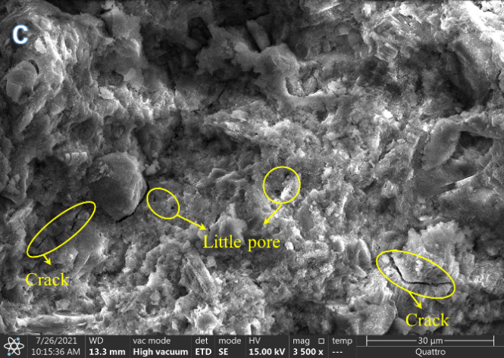 | 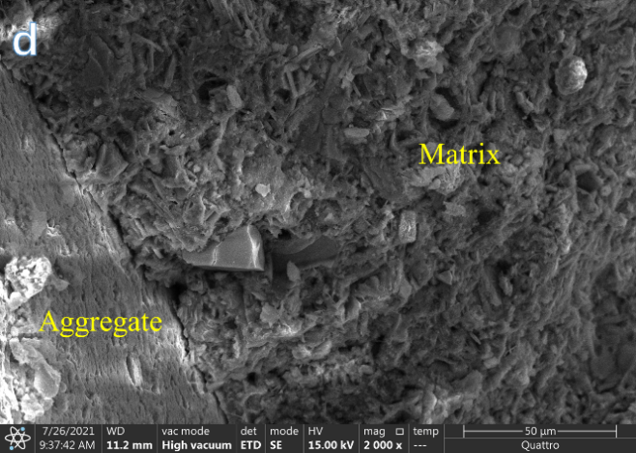
Fig.12. Micromorphology after steam curing for 28 days: (a, b) NSMC-0; (c, d) NSMC-15.

Fig.11 shows the microstructure of concrete after standard curing for 28 days. From Fig.11(a), it can be known that the hydration products of NSMC-0 specimens possess certain continuity and integrity after 28 days of standard curing, and a small part of the C-S-H gel showed fibrous shape, but a small number of pores still existed, in addition, small flakes of Ca(OH)₂ crystals filled in these pores. Fig.11(b) shows that the gap between the aggregate and the hydration products is still obvious, but the hydration products near the aggregate show a dense state. After adding NS, the microscopic morphology of the concrete changed significantly. As can be seen from Fig.11(c), the hydration products of NSMC-15 specimens at 28 days have a higher degree of denseness, and the C-S-H gels are tightly and uniformly bound together, forming a more regular morphology. Moreover, no obvious large pores are found, and only few fine pores are present. In addition, Fig.11(d) shows that the addition of NS increases the bonding of the aggregate to the matrix, and the hydration products near the aggregate show a uniform and dense state.
Fig.12 shows the microstructure of concrete after steam curing for 28 days. From Fig.12, it can be found that steam curing has a negative impact on the late microstructure of concrete. The continuity and integrity of hydration products of NSMC-0 specimens at 28 days (Fig.12(a)) are weak, and there are more large pores, which are filled with more small flaky Ca(OH)₂ crystals. These coarse pore areas are weak in mechanical and durability performance. Stress cracks and corrosion tend to develop from these coarse pores. From Fig.12(b), it can be observed that the ITZ of the NSMC-0 specimen is of low quality, there are obvious gaps between the aggregate and the matrix, and the hydration products near the aggregate are not sufficiently polymerized. The addition of NS has a mitigating effect on the microstructure damage. Hydration products of the NSMC-15 sample at 28 days (Fig.12(c)) returned to a relatively uniform and dense state. C-S-H gel was tightly interwoven and aggregated, and Ca(OH)₂ crystals could hardly be observed. In addition, pores were mostly fine and the number decreased, but some cracks still existed. Moreover, the gap between the aggregate and the matrix of the SNSC-15 sample (Fig.12(d)) became narrow, and the hydration products near the aggregate also returned to a uniform state. The mitigating effect of NS on microstructure can benefit from the optimization of hydration products and ITZ of steam-cured concrete in the early stage (Fig.10(c,d)). Since the early microstructure with better quality is used as the basis for hydration development, the quality of the microstructure in a later stage is improved.

3.6. Pore structure
(a) Cumulative pore volume. | - Pore size distribution.
Fig.13. MIP.

The porosity and pore size distribution of the concrete matrix limit the mechanics and durability. Wu[59] studied the influence coefficient of porosity on strength of various pore levels. Based on the results, pore sizes were divided into four categories: $≤$20nm (harmless), 20-50nm (less harmful), 50-200nm (harmful), and$≥$200nm ( more harmful). Fig.13 shows the results of the MIP test. It can be found that both NS and steam curing have an obvious influence on the pore structure of concrete.
Under standard curing, the porosity of the NSMC-0 specimen is 15.64%, and the pore size distribution is mainly concentrated at 20-50 nm and 50-200 nm, with a high proportion of harmful pores. The total porosity of NSMC-15 decreased to 9.21%, with a decrease rate of 41.11%. In addition, the pore distribution of the NSMC-15 specimen is greatly optimized, the pores are mainly harmless pores and less harmful pores, and the number of harmful and more harmful pores is significantly reduced. It is noteworthy that the pore structure of NSMC-15 is in good agreement with that of SEM images.
After steam curing, the pore structure of concrete deteriorates greatly. The porosity of the NSMC-0 specimen increased from 15.64% to 19.33%, and most of the pores were harmful or more harmful, indicating that steam curing had great damage to pore structure, which could be attributed to accelerated hydration at high temperatures but reduced the growth space of hydration products, and uneven precipitation was easy to form coarse pores[60]. After NS was added, the porosity of steam-cured NSMC-15 specimens was 5.56% and 1.87% lower than that of standard-cured NSMC-0 specimens and steam-cured NSMC-0 specimens, respectively, and the pores change to "less harmful and harmless pores", indicating that NS can effectively alleviate the damage of pore structure caused by steam treatment.

4、Conclusions
In this paper, the mechanical and durability properties of nano-silica-modified manufactured-sand concrete (NSMC) under steam curing and standard curing are comparatively studied by experiments, and the following conclusions can be drawn.
(1) In both standard curing and steam curing, the compressive strength of concrete increases first and then decreases with the increase of NS content. The optimal NS content for compressive strength under both curing conditions is 1.5Wt.%. In addition, there is a synergistic effect between steam curing and NS, which can give concrete higher early strength. However, steam curing has a negative effect on the later strength, and the strength loss is proportional to the curing time, but adding NS can effectively reduce the strength loss.
(2) Under both curing conditions, NS can improve the water permeability resistance of NSMC. Steam curing reduces the water permeability resistance of concrete and weakens the improvement effect of NS. However, the damage of steam curing against water permeability can still be mitigated by adding NS.
(3) After sulfate corrosion, steam-cured concrete shows more appearance deterioration characteristics, higher mass increase, and lower corrosion resistance coefficient. Adding NS can reduce the appearance deterioration degree, decrease the mass increase and improve the corrosion resistance coefficient. And there is a synergistic effect between NS and steam curing in improving the corrosion resistance of concrete.
(4) XRD results showed that NS accelerates the consumption of Ca(OH)₂, C₃S, and C₂S, while steam curing accelerates the consumption of C₃S and C₂S, but increases the content of Ca(OH)₂. The synergistic effect of NS and steam curing can further promote the consumption of Ca(OH)₂, C₃S, and C₂S. It is worth noting that the synergy between NS and steam curing is most significant in the early stages.
(5) SEM results showed that the addition of NS significantly improved the distribution morphology of hydration products, and hydration products showed high density and strong continuity after adding NS. Steam curing can promote the formation of hydration products in the early stage, but will destroy the uniformity and continuity of hydration products, and weaken the bond between the aggregate and hydration products in the late stage. NS can mitigate the thermal damage caused by steam curing, which can be attributed to the adjustment and optimization of hydration products and ITZ at the early stage of curing due to the synergistic effect of NS and steam curing.
(6) MIP results showed that the addition of NS not only reduces the total porosity but also optimizes pore size distribution. Steam curing degrades the pore structure. After steam curing, the total porosity increases greatly, and most of the pores are harmful and more harmful. The addition of NS under steam curing can reduce this deterioration phenomenon.

Acknowledgment
This research was supported by the Natural Science Foundation of China (52078079 and 51878586), Chongqing Technology Innovation and Application Development Special General Project (cstc2020jscx-msxmX0084), Chongqing Construction Science and Technology Plan Key Project (Urban Science 2021, No.1-8), Guangzhou Science and Technology Project (202102010455), Guangzhou Basic and Applied Basic Research Project (202201010750) and Cementitious materials-reducing admixture for the concrete project of GT New Materials and Infrastructure Technology Co., Ltd (GTRD202001).

References
[1] Y. Han, T. He, R. Chang, R. Xue, Development Trend and Segmentation of the US Green Building Market: Corporate Perspective on Green Contractors and Design Firms, Journal of Construction Engineering and Management 146(11) (2020).
[2] C. Liu, X. Deng, J. Liu, D. Hui, Mechanical properties and microstructures of hypergolic and calcined coal gangue based geopolymer recycled concrete, Construction and Building Materials 221 (2019) 691-708.
[3] Y. Duan, Q. Wang, Z. Yang, X. Cui, F. Liu, H. Chen, Research on the effect of steam curing temperature and duration on the strength of manufactured sand concrete and strength estimation model considering thermal damage, Construction and Building Materials 315 (2022).
[4] M.A.H. Lai, K.J. Wu, X.L. Ou, M.R. Zeng, C.W. Li, J.C.M. Ho, Effect of concrete wet packing density on the uni-axial strength of manufactured sand CFST columns, Structural Concrete.
[5] Z. Han, Y.S. Zhang, H.X. Qiao, Q. Feng, C.Z. Xue, M.G. Shang, Study on axial compressive behavior and damage constitutive model of manufactured sand concrete based on fluidity optimization, Construction and Building Materials 345 (2022)128176
[6] Z.G. Huang, Z.H. Xu, B.X. Li, D.X. Lyu, A. Huang, Effects of Flake Particles in Manufactured Sand on Properties and Microstructure of Mortar and Concrete,Bulletin of the Chinese Ceramic Society,41(6)(2022)
[7] H. Yamei, W. Lihua, Effect of Particle Shape of Limestone Manufactured Sand and Natural Sand on Concrete, Procedia Engineering 210 (2017) 87-92.
[8] M. Pilegis, D. Gardner, R. Lark, An Investigation into the Use of Manufactured Sand as a 100% Replacement for Fine Aggregate in Concrete, Materials 9(6) (2016).
[9] W. Shen, Z. Yang, L. Cao, L. Cao, Y. Liu, H. Yang, Z. Lu, J. Bai, Characterization of manufactured sand: Particle shape, surface texture and behavior in concrete, Construction and Building Materials 114 (2016) 595-601.
[10] R. Yang, R. Yu, Z. Shui, C. Guo, S. Wu, X. Gao, S. Peng, The physical and chemical impact of manufactured sand as a partial replacement material in Ultra-High Performance Concrete (UHPC), Cement and Concrete Composites 99 (2019) 203-213.
[11]J. Xia, K.Y Chen, Y.F. Wu, W.Q. Xiao, W.L. Jin, J. Zhang, Shear fatigue behavior of reinforced concrete beams produced with manufactured sand as alternatives for natural sand, Journal of Building Engineering 62 (2022) 105412
[12] S. Liu, Z. Li, Y. Teng, L. Dai, A dynamic simulation study on the sustainability of prefabricated buildings, Sustainable Cities and Society 77 (2022) 103551.
[13] E. Gallucci, X. Zhang, K.L. Scrivener, Effect of temperature on the microstructure of calcium silicate hydrate (C-S-H), Cement Concrete Res 53 (2013) 185-195.
[14] M.-f. Ba, C.-x. Qian, X.-j. Guo, X.-y. Han, Effects of steam curing on strength and porous structure of concrete with low water/binder ratio, Construction and Building Materials 25(1) (2011) 123-128.
[15] J. Shi, B. Liu, X. Wu, J. Qin, J. Jiang, Z. He, Evolution of mechanical properties and permeability of concrete during steam curing process, J Build Eng 32 (2020) 101796.
[16] Z. Zhang, Q. Wang, J. Yang, Hydration mechanisms of composite binders containing phosphorus slag at different temperatures, Construction and Building Materials 147 (2017) 720-732.
[17] J.D. Wu, L.P. Guo, Y.Z. Cao, Y.Y. Qin, Effect of steam curing system on the early mechanical property and microstructure of ultra-high performance concrete, Journal of Southeast University(Nature Science Edition) 52(4) (2022) 744-752
[18]P.G. Wang, H. Hua, T.F. Guo, L, Tian, T.J. Zhao, Deformation Behavior and Cracking Risk Assessment of Steam-cured Concrete, Materials Reports 36(24) 2022 20120185
[19] J.Y. Shi, B.J. Liu, F. Zhou, S. Shen, A.F. Guo, T.J. Xie, Effect of steam curing regimes on temperature and humidity gradient, permeability and microstructure of concrete, Construction and Building Materials 281 (2021) 122562
[20] M. Wang, Y. Xie, G. Long, C. Ma, X. Zeng, Microhardness characteristics of high-strength cement paste and interfacial transition zone at different curing regimes, Construction and Building Materials 221 (2019) 151-162.
[21] B.J. Liu, Y.J. Xie, H. Li, Influence of steam curing on the compressive strength of concrete containing supplementary cementing materials, Cement Concrete Res 35(5) (2005) 994-998.
[22] J. Shi, B. Liu, X. Wu, J. Tan, J. Dai, R. Ji, Effect of steam curing on surface permeability of concrete: Multiple transmission media, J Build Eng 32 (2020) 101475.
[23] B. Liu, J. Shi, F. Zhou, S. Shen, Y.B. Ding, J.L. Qin, Effects of steam curing regimes on the capillary water absorption of concrete: Prediction using multivariable regression models Construction and Building Materials 256 (2020) 119426
[24] Z.-m. He, G.-c. Long, Y.-j. Xie, Influence of subsequent curing on water sorptivity and pore structure of steam-cured concrete, Journal of Central South University 19(4) (2012) 1155-1162.
[25] S.a. Erdoǧdu, S.i. Kurbetci, Optimum heat treatment cycle for cements of different type and composition, Cement Concrete Res 28(11) (1998) 1595-1604.
[26] C. Zou, G. Long, C. Ma, Y. Xie, Effect of subsequent curing on surface permeability and compressive strength of steam-cured concrete, Construction and Building Materials 188 (2018) 424-432.
[27] A.M. Zeyad, B.A. Tayeh, A. Adesina, A.R.G. de Azevedo, M. Amin, M. Hadzima-Nyarko, I. Saad Agwa, Review on effect of steam curing on behavior of concrete, Cleaner Materials 3 (2022) 100042.
[28] S. Khan, S. Mansoor, Z. Rafi, B. Kumari, A. Shoaib, M. Saeed, S. Alshehri, M.M. Ghoneim, M. Rahamathulla, U. Hani, F. Shakeel, A review on nanotechnology: Properties, applications, and mechanistic insights of cellular uptake mechanisms, Journal of Molecular Liquids 348 (2022) 118008.
[29] C. Liu, F. Chen, Y. Wu, Z. Zheng, J. Yang, B. Yang, J. Yang, D. Hui, Y. Luo, Research progress on individual effect of graphene oxide in cement-based materials and its synergistic effect with other nanomaterials, Nanotechnology Reviews 10(1) (2021) 1208-1235.
[30] C. Liu, X. He, X. Deng, Y. Wu, Z. Zheng, J. Liu, D. Hui, Application of nanomaterials in ultra-high performance concrete: A review, Nanotechnology Reviews 9(1) (2020) 1427-1444.
[31] C. Liu, X. Huang, Y.-Y. Wu, X. Deng, Z. Zheng, The effect of graphene oxide on the mechanical properties, impermeability and corrosion resistance of cement mortar containing mineral admixtures, Construction and Building Materials 288 (2021).
[32] C. Liu, X. Huang, Y.-Y. Wu, X. Deng, Z. Zheng, Z. Xu, D. Hui, Advance on the dispersion treatment of graphene oxide and the graphene oxide modified cement-based materials, Nanotechnology Reviews 10(1) (2021) 34-49.
[33] C. Liu, X. Su, Y. Wu, Z. Zheng, B. Yang, Y. Luo, J. Yang, J. Yang, Effect of nano-silica as cementitious materials- reducing admixtures on the workability, mechanical properties and durability of concrete, Nanotechnology Reviews 10(1) (2021) 1395-1409.
[34] M. Balapour, A. Joshaghani, F. Althoey, Nano-SiO2 contribution to mechanical, durability, fresh and microstructural characteristics of concrete: A review, Construction and Building Materials 181 (2018) 27-41.
[35] A. P. P, D.K. Nayak, B. Sangoju, R. Kumar, V. Kumar, Effect of nano-silica in concrete; a review, Construction and Building Materials 278 (2021) 122347.
[36] A.A. Raheem, R. Abdulwahab, M.A. Kareem, Incorporation of metakaolin and nanosilica in blended cement mortar and concrete- A review, Journal of Cleaner Production 290 (2021) 125852.
[37] G.Y. Li, Properties of high-volume fly ash concrete incorporating nano-SiO_{2,} Cement and Concrete Research 34(6) (2004) 1043-1049．
[38] Byung Wan Jo, Chang Hyun Kim, Ghiho Tae, Characteristics of cement mortar with nano-SiO2 particles, Construction and Building Materials 21(6) (2007) 1351-1355．
[39] Said A.M, Zeidan M.S, Bassuoni M.T, Properties of concrete incorporating nano-silica, Construction and Building Materials 36 2012 838-844．
[40] H. Elkady, M.I. Serag, M.S. Elfeky, Effect of nano silica de-agglomeration, and methods of adding super-plasticizer on the compressive strength, and workability of nano silica concrete, Civ. Environ. Re. 3 (2) (2013) 21–34
[41] J. Xu, B. Wang, J. Zuo, Modification effects of nanosilica on the interfacial transition zone in concrete: A multiscale approach, Cem. Concr. Compo. 81 (2017) 1–1
[42] Mohamed A.M, Influence of nano materials on flexural behavior and compressive strength of concrete, HBRC Journal 12(2) (2016) 212-225．
[43] S. Chithra, S.R.R. Senthil Kumar, K. Chinnaraju, The effect of Colloidal Nano-silica on workability, mechanical and durability properties of High Performance Concrete with Copper slag as partial fine aggregate, Construction and Building Materials 113 (2016) 794-804.
[44] M. Fathi, A. Yousefipour, E. Hematpoury Farokhy, Mechanical and physical properties of expanded polystyrene structural concretes containing Micro-silica and Nano-silica, Construction and Building Materials 136 (2017) 590-597.
[45] A. Naji Givi, S. Abdul Rashid, F.N.A. Aziz, M.A.M. Salleh, Experimental investigation of the size effects of SiO2 nano-particles on the mechanical properties of binary blended concrete, Composites Part B: Engineering 41(8) (2010) 673-677.
[46] R. Yu, P. Spiesz, H.J.H. Brouwers, Effect of nano-silica on the hydration and microstructure development of Ultra-High Performance Concrete (UHPC) with a low binder amount, Construction and Building Materials 65 (2014) 140-150.
[47] Z.Q. Zhang, B. Zhang, P.Y. Yan, Hydration and microstructures of concrete containing raw or densified silica fume at different curing temperatures, Construction and Building Materials 121 (2016) 483-490
[48] J.P. Mei, B.G. Ma, H.B. Tan, H.N. Li, Influence of steam curing and nano silica on hydration and microstructure characteristics of high volume fly ash cement system, Construction and Building Materials 171 (2018) 83-95
[49] GB/T 14684-2022, Pebble and crushed stone for construction. Beijing: China Architecture & Building Press,(2022)
[50] GB/T 14684-2022, Construction sand. Beijing: China Architecture & Building Press,(2022).
[51] GB/T 50081-2019, Standard for test methods of concrete physical andmechanical properties. Beijing: China Architecture & Building Press,(2019)
[52]GB/T 50082-2009, Standard for test methods of long-term performanceand durability of ordinary concrete. Beijing: China Architecture & Building Press,(2009)
[53] M. Liu, H. Tan, X. He, Effects of nano-SiO₂ on early strength and microstructure of steam-cured high volume fly ash cement system, Construction and Building Materials 194 (2019) 350-359.
[54] J. Mei, H. Tan, H. Li, B. Ma, X. Liu, W. Jiang, T. Zhang, X. Li, Effect of sodium sulfate and nano-SiO₂ on hydration and microstructure of cementitious materials containing high volume fly ash under steam curing, Construction and Building Materials 163 (2018) 812-825.
[55] Z. Zhang, B. Zhang, P. Yan, Hydration and microstructures of concrete containing raw or densified silica fume at different curing temperatures, Construction and Building Materials 121 (2016) 483-490.
[56] Q. Huang, X. Zhu, G. Xiong, M. Zhang, J. Deng, M. Zhao, L. Zhao, Will the magnesium sulfate attack of cement mortars always be inhabited by incorporating nanosilica?, Construction and Building Materials 305 (2021).
[57] Q. Huang, X. Zhu, L. Zhao, M. Zhao, Y. Liu, X. Zeng, Effect of nanosilica on sulfate resistance of cement mortar under partial immersion, Construction and Building Materials 231 (2020).
[58] M.M.A. Elahi, C.R. Shearer, A.N.R. Reza, A.K. Saha, M.N.N. Khan, M.M. Hossain, P.K. Sarker, Improving the sulfate attack resistance of concrete by using supplementary cementitious materials (SCMs): A review, Construction and Building Materials 281 (2021).
[59] Z. Wu. Discussion on the recent development direction of concrete science and technology, J Chin Ceram Soc 3 (1979) 82-90.
[60] A. Gonzalez-Corominas, M. Etxeberria, C.S. Poon, Influence of steam curing on the pore structures and mechanical properties of fly-ash high performance concrete prepared with recycled aggregates, Cem. Concr. Compos. 71 (2016) 77-84.

