A data-driven layout optimization framework of large-scale wind farms based on machine learning
Yang Kun ¹, Deng Xiaowei *¹, Ti Zilong ^{2, 1}, Yang Shanghui ¹, Huang Senbin ¹, Wang Yuhang ³
- Department of Civil Engineering, The University of Hong Kong, Pokfulam, Hong Kong, China
- Department of Bridge Engineering, Southwest Jiaotong University, Chengdu, China
- School of Civil Engineering, Chongqing University, Chongqing, China
(* Corresponding author: xwdeng@hku.hk)

Abstract
This paper presents a data-driven wind farm layout optimization framework that uses a machine learning wake model that considers physical control stages. The machine learning wake model is trained using well-validated Computational Fluid Dynamics (CFD) simulation data, and consists of thousands of sub-models, each of which is an artificial neural network (ANN) wake model. The ANN wake models are trained separately for low-speed and high-speed inflows to ensure high accuracy of the predictions, with less than 2% error compared to CFD simulations. The accuracy and efficiency of the framework are validated, and the results show better agreement with CFD simulation than an analytical wake model developed in recent years. A parametric study on the number of wind turbines in the Horns Rev wind farm demonstrates that more wind turbines can be added with a minor decrease in average power, with more even and staggered layouts. Under full-wake uniform inflow, the selected analytical wake model exhibits a power prediction error of 5%-8%, while the differences between optimal layouts searched by different wake models range from 2% to 8%. When introducing a wider range of inflow direction sectors, the discrepancy between optimal layout performances decreases.
Key words: machine learning; wake model; Artificial Neural Networks; offshore wind farm; layout optimization

1 Introduction
Wind energy is a promising source of renewable energy that plays a significant role in reducing greenhouse gas emissions and transitioning to a renewable energy future. To capture wind energy more efficiently, wind turbines are typically arranged in wind farms, which can reduce costs and simplify operation and maintenance. As wind turbines continue to grow in size and wind farms increase in capacity [1-8]. While traditional regular layouts have been used for offshore wind farms, wake losses have become a significant concern due to the size of the turbines and farms [9]. In some offshore wind farms like Lillgrund offshore wind farm, the distance between wind turbines can be as close as 3.3D (diameter of the turbine rotor), while Horns Rev offshore wind farm can be a typical case with a large array distance of 7D [10, 11]. A proper layout can significantly reduce the wake loss for wind farms like Lillgrund. On the other hand, not only the wake loss will be alleviated, but also free space for more wind turbines will be provided for wind farms like Horns Rev. For the latter, the power density (power per unit land area) is also increased. In this context, optimizing the layout of wind farms is essential to reduce wake losses and increase power density.
Currently, several commercial programs, including WAsP[12-14], WindSim[15], and Meteodyn[16], can predict the annual power production of wind farms. Other programs, such as Windfarmer[17], WindPro[18], and OpenWind[19], are able to provide an optimal solution for wind farm layout [20]. Existing commercial software typically relies on fast analytical wake models to characterize wake effects in wind farms. Other programs, such as WindSim and Windfarmer, use computationally expensive RANS-based Computational Fluid Dynamics (CFD) simulations that offer higher accuracy. However, such approaches may not be practical for large-scale wind farms due to their computational expense. Therefore, there is a need for accurate and efficient wake models that can predict wind farm power output. Even after a suitable wake model is selected, there are still various options for optimization algorithms that can be used to design an optimal wind farm layout. Thus, designing a layout optimization framework for large-scale wind farms involves two key tasks: selecting an accurate and fast solver for wind farm power prediction, and choosing an appropriate optimization methodology. In this context, wake characterization plays a critical role in accurately predicting wind farm power output.
To accurately predict the wake effects of wind turbines, various CFD simulation techniques have been developed, including RANS and LES models. While these physics-based models provide accurate results, their computational cost can be prohibitive due to the large number of elements. Alternatively, simplified analytical models like the Katic [21] and Gauss models can evaluate wake deficit more efficiently and have gained popularity in the industry due to their affordability. However, the accuracy of analytical models is limited by the assumptions they make, as pointed out in Göçmen's review [22]. Six different wake models, including both analytical and numerical models, are described and inter-compared using two benchmark cases: the Sexbierum onshore and Lillgrund offshore wind farms [22]. However, the accuracy of analytical wake models is inevitably sacrificed due to the introduction of many assumptions. Therefore, a trade-off exists between the efficiency and accuracy of wake models, with analytical models being more efficient but less accurate, and high-fidelity numerical simulations being too expensive to be practical for larger wind farms.
The layout optimization of wind farms is an important aspect that requires proper optimization methodology [23]. Genetic algorithms have been a popular approach for wind farm layout optimization since Mosetti et al. proposed an optimization scheme in 1994 [24]. Grady studied different types of wind conditions, including unidirectional wind, uniform wind with variable direction, and non-uniform wind with variable direction, using Mosetti's scheme [25]. Rajper conducted a comparative study on wind farm layout optimization using different optimization techniques, including genetic algorithms and Monte Carlo simulation method, to provide a cost comparison [26]. Wan proposed Particle Swarm Optimization to maximize energy production in a fixed number of wind turbines equipped with the Jensen wake model [27]. Gonzalez reviewed the developments of the micro-siting problem in 2013, separating it into objective function, energy production model, constraints, and optimization algorithm [20]. Gao used a newly developed two-dimensional wake model instead of the Jensen model and made a comparison with the results from other scholars. The limitation that wind turbines can only be placed in the middle of the grid is also replaced by a minimum distance constraint [28]. However, in Mosetti’s scheme, each wind turbine is limited in its own grid. Recently, researchers have focused on more general schemes, in which all the wind turbines can have arbitrary positions. For example, Kusiak applied an evolutionary strategy algorithm to maximize power output of two to six wind turbines within a circular boundary constraint [29].
Machine learning techniques have been applied in wind engineering research to solve various problems. For instance, Zhang proposed a wake prediction model based on long-short term memory (LSTM) that investigated the velocity field of a fixed horizontal plane with time history [30]. Sun combined an artificial neural network (ANN) model with wake steering, building an ANN-wake-power model to optimize the yaw angle for five wind turbines [31]. Recently, Ti introduced a novel wake model using machine learning techniques to balance accuracy and efficiency, providing a new option for wake modeling [32, 33]. The proposed model has upgrade potential, and can be systematically improved to achieve higher performance and become more physically appropriate.
To summarize, traditional analytical models for predicting wake effects have limited accuracy, while numerical simulations are computationally expensive. Therefore, there is a need for a data-driven approach that can balance efficiency and accuracy. In this paper, a machine learning wake model based on physics considerations is proposed to improve wake prediction accuracy for wind farm layout optimization. A previous model developed by Ti in 2020 [33] was built upon, and significant improvements in performance are demonstrated. Additionally, an overset mesh technique is utilized to model wind farms with high-quality meshes, and a continuous scheme with arbitrary wind turbine positions is employed for layout optimization. A promising solution to the challenges faced by the wind energy industry in wind farm layout optimization is provided by our proposed approach.
The paper comprises a detailed introduction of an upgraded machine learning wake model that considers control stages, systematical validations, and a parametric study on wind turbine number. In Section 2, the CFD simulation method with an overset mesh is introduced, which forms the basis of the dataset generation and validation in Example 1. An advanced analytical model considering ambient turbulence intensity is selected for comparison instead of basic Jensen or Gaussian models. The optimization algorithms adopted in this paper are also introduced. In Section 3, the data preprocessing, architecture, physics considerations, and results of the well-trained ANN model are fully presented, followed by validations in Section 4. Afterward, Section 5 presents two example cases of layout optimization. Furthermore, a parametric study regarding the influence of the number of wind turbines is also conducted. Finally, conclusions are drawn in Section 6.

2 Methodology

2.1 Wake modeling techniques of standalone wind turbine
Two mainstreams in wake modeling have been introduced in this section, respectively. The first model is simulation-based. RANS/ADM-R coupling method is used in the first model. The details of this method can be found in previous work [32, 33]. The validation of this method is provided in Section 4. Overset mesh technique is newly employed to overcome the difficulties in modeling multiple wind turbines. Secondly, an analytical wake model is selected for comparison with the ANN wake model. The analytical wake model was developed by Ishihara and Qian [34], which is well accepted in academia [35] and has been adopted in software FLORIS from NREL [36].

2.1.1 Computational Fluid Dynamics simulation with overset mesh
CFD simulation approaches are widely used in numerical simulation of turbulent flows, like wind turbine wake prediction. RANS (Reynolds-averaged Navier-Stokes equations) simulation coupled with ADM-R (Actuator Disk Model with Rotation) method is employed to simulate the wind turbine wake under ABL (Atmospheric Boundary Layer) inflow condition. The RANS/ADM-R coupling model adopted in this study is able to generate a reliable dataset for training the ANN wind turbine wake model.
The modeling and meshing procedure in a wind farm with multiple wind turbines can be significantly enhanced through the use of the overset mesh technique. This technique enables the independent modeling of background and component structures at different resolutions, followed by a hole-cutting process that minimizes the overlap area. The overset solver is then used to solve the turbulence model. Details on the mapping algorithm in overlap areas and interpolation between cells can be found in the ANSYS Fluent User Manual version 18.1 and above, as well as in the literature. [37, 38]. The overset mesh technique is particularly well-suited to the requirements of this study. To ensure the performance of the ADM-R model, the mesh of the turbine rotor often requires local refinements, while the large background mesh can be relatively coarse, resulting in a sharp reduction in the number of elements. Additionally, wind farms typically use only one or two wind turbine models, which can be duplicated and mapped to their corresponding positions in the background mesh using the overset technique. This approach reduces the complexity of mesh association and computational costs.
Table 1. Turbulence model parameter.
$$C_{μ}$$ | $$C_{ε,1}$$ | $$C_{ε,2}$$ | $$σ_{k}$$ | $$σ_{ε}$$ | $$C_{R}$$
0.03 | 1.21 | 1.92 | 1.00 | 1.30 | 3.5
Overset mesh method has been adopted in some CFD simulation software like Ansys Fluent and OpenFOAM, supported by [39, 40] and the software documents. This paper uses Ansys Fluent with user-defined functions of the ADM-R model and ABL inflow conditions. The ADM-R model coupled with $k-ε-f_{P}$ turbulence model was introduced and well proved in the preliminary work in Ti [33], referring to the literature [41, 42]. The parameters of the turbulence model are shown in Table 1. The inlet surface is set as velocity-inlet, the outlet surface is set as pressure-outlet, the bottom surfaces are ground, and the side and top three surfaces are all set as symmetry.
The inflow velocity and turbulence intensity follow the ABL log law, which can be written as Eq. 1:
$$\begin{aligned}U\left(z\right)=\frac{u_{*}}{κ}\ln\left(\frac{z}{z_{0}}\right), k=\frac{u_{*}^{2}}{\sqrt{C_{μ}}}, ε=\frac{u_{*}^{3}}{κz}\#\left(1\right)\end{aligned}$$
where $κ$ is Von Karman constant (~0.41), $U$ denotes the wind velocity profile, $k$ is the turbulence kinetic energy (TKE), $ε$ is the TKE dissipation, $z$ is the height of position, $z_{0}$ is surface roughness or roughness length, and $u_{*}$ is the friction velocity.
According to the theory of the turbulence model, it should have not only enough elements but also a proper roughness height for the ground. The roughness height $K_{s}$ can be determined according to roughness length $z_{0}$ by using Eq. 2:
$$\begin{aligned}K_{s}=\frac{Ez_{0}}{C_{s}}\#\left(2\right)\end{aligned}$$
where $C_{s}$ is a constant, and $E$ is an empirical constant, which is suggested as 0.5 and 9.793, respectively [43-45].
This paper studies the Vestas V80 2MW wind turbine used in the Horns Rev wind farm. As ANN training and testing require a database of the standalone wind turbine, a CFD model using overset mesh technique and coupled with RANS/ADM-R model is built in ANSYS Fluent. It is found in testing that the wake deficit is smaller than 1% for a wide range of working conditions of the Vestas V80 2MW wind turbine at 28D streamwise, where D denotes the rotor diameter of wind turbine. Therefore, the computational domain for generating the dataset is 28D long, 12D wide, and 4D high, as shown in Fig. 1. In order to guarantee the accuracy of the database, the background has a relatively dense mesh of 3.98 million hexahedron cells, while the rotor zone has 0.14 million. The figure also cuts a transverse plane at the wind turbine position, which shows a refined mesh for the actuator disk and partition boundaries for overset.
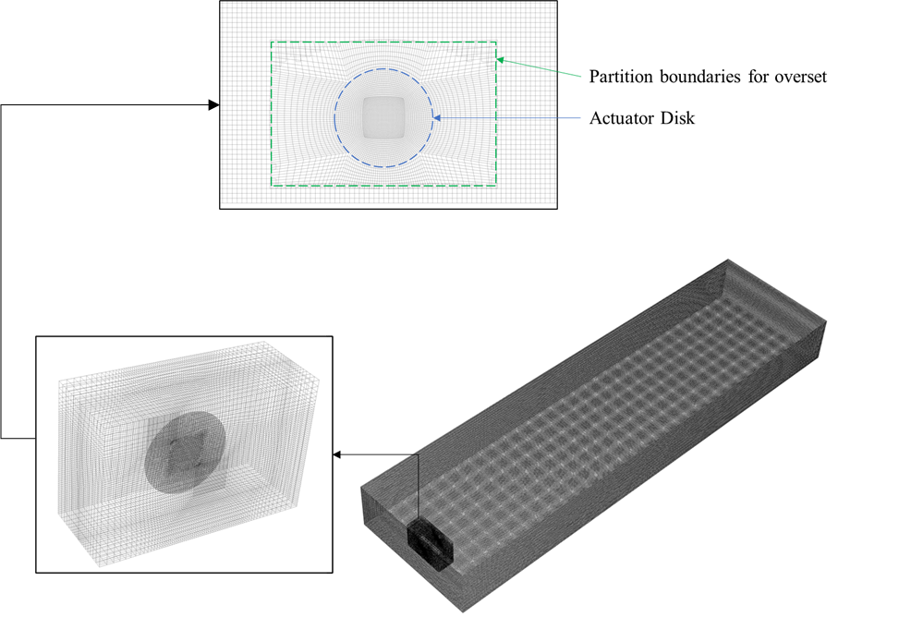
Fig. 1 Overset mesh technique applied in a standalone wind turbine for generating the dataset.
In order to demonstrate the grid convergence and assess the accuracy of our simulations, we conducted a grid sensitivity analysis by comparing four different grid sizes of background mesh with proportional variations from 0.194M to 11.93M cells. The grid sizes of the other cases were normalized based on the grid size of Case 3, which had 3.98M cells, as presented in Table 2. To evaluate the convergence of the grid, we focused on key variables, such as velocity and turbulence level in the wake. The results of the grid convergence analysis are shown in Fig. 2.
Table 2. Grid size of selected cases
Case | Grid size (M) | Normalized grid size
1 | 0.194 | 0.049
2 | 1.765 | 0.443
3 | 3.986 | 1.000
4 | 11.93 | 2.993
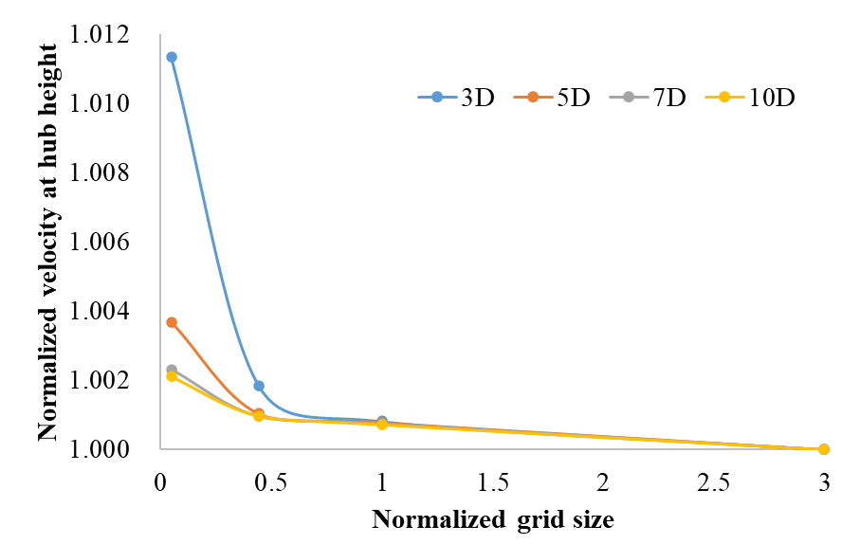 | 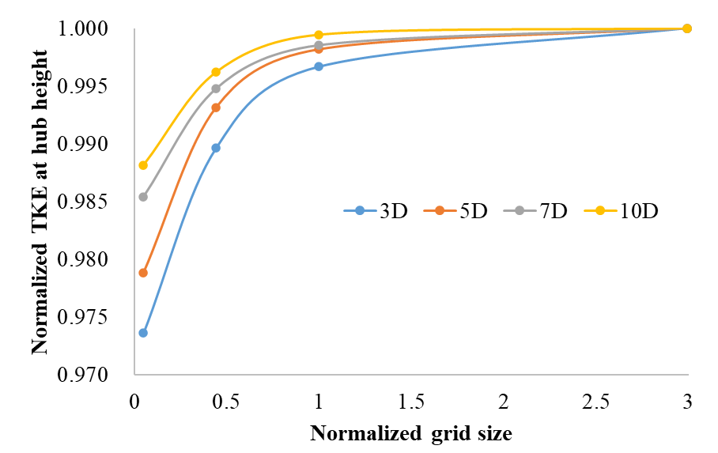
(a) | (b)
Fig. 2 Grid convergence check: (a) Normalized velocity at hub height; (b) Normalize turbulence kinetic energy at hub height.

2.1.2 Ishihara and Qian’s Analytical model
Analytical wake model has a long developing history. In the previous work, basic models like Jensen and Gaussian models are used for comparison. Recently, many new analytical wake models have been developed in different studies. A popular analytical model is selected to show the performance with different approaches in a more comparable way.
Katic wake model [21] and the original Gaussian model [46] do not consider the ambient turbulence intensity. However, turbulence intensity has a significant effect on wake recovery. In 2014, Bastankhah proposed a Gaussian wake model [46], which has been widely adopted and further developed in subsequent studies [47-49]. Bastankhah highlighted the importance of considering the wake growth rate ($k^{*}$) as a key parameter in the model and emphasized the inclusion of turbulence intensity. Additionally, Niayafar [47] reviewed two empirical equations for added streamwise turbulence intensity, namely Hassan’s equation [50] and Crespo and Hernandez’s equation [51], along with Frandsen and Thøgersen’s model [52], which considers neighboring upstream wind turbines.
Building upon these analytical models, Ishihara and Qian developed a novel analytical model that incorporates the effects of ambient turbulence intensity and thrust coefficient on predicting mean velocity and turbulence intensity in wind turbine wakes [34]. Their model is based on a Gaussian distribution and the self-similarity assumption, with parameters calibrated using LES/ADM-R numerical simulation results. Ishihara and Qian's model was developed with reference to Bastankhah's model and includes a comparison of turbulence intensity models with Crespo and Hernandez's model. Detailed equations can be found in [34, 53]. Notably, Ishihara and Qian's analytical model has also been calibrated using the same wind turbine model as in our example case. Therefore, in our study, Ishihara and Qian's analytical model has been chosen for the subsequent comparisons.

2.2 Wake superposition method
Wake superposition methods are convenient and efficient for merging the wind turbine wakes. In a wind farm including multiple wind turbines, wake modeling can be easily obtained using proper wake superposition methods. For the velocity field, the four most common approaches are listed in Table 3 [22, 54]:
Table 3 Four velocity superposition models
Approach 1: Geometric sum | $$\begin{aligned}\frac{u_{i}}{u_{inflow}}=\prod_{j=1}^{n}{\frac{u_{ij}}{u_{j}}}\#\left(3\right)\end{aligned}$$
Approach 2: Linear sum | $$\begin{aligned}\left(1-\frac{u_{i}}{u_{inflow}}\right)=\sum_{j=1}^{n}{\left(1-\frac{u_{ij}}{u_{j}}\right)}\#\left(4\right)\end{aligned}$$
Approach 3: Energy balance | $$\begin{aligned}\left(u_{inflow}^{2}-u_{i}^{2}\right)=\sum_{j=1}^{n}{\left(u_{j}^{2}-u_{ij}^{2}\right)}\#\left(5\right)\end{aligned}$$
Approach 4: Quadratic sum (SOS) | $$\begin{aligned}{\left(1-\frac{u_{i}}{u_{inflow}}\right)}^{2}=\sum_{j=1}^{n}{{\left(1-\frac{u_{ij}}{u_{j}}\right)}^{2}}\#\left(6\right)\end{aligned}$$
where $u_{i}$ denotes the velocity at downstream wind turbine $i$, $u_{inflow}$ is the wind velocity of inflow condition, $u_{j}$ denotes the velocity at upstream wind turbine $j$, $u_{ij}$ is the velocity at wind turbine $i$ influenced by wind turbine $j$, $n$ is the total number of wind turbines that have wake effects on the wind turbine $i$. Habenicht stated the significance of wake superposition and compared those four approaches, showing that Approaches 1 and 4 are better [55]. Ti also tested the models and found that Approach 4 (Quadratic sum or SOS model) is the best superposition model in this field [32, 33].
As stated above, turbulence intensity also significantly influences wind turbine wake. Previous research simplifies the problem by assuming that the wind turbine is only affected by the nearest wind turbine for turbulence intensity, which avoids the superposition problem in the turbulence level [47, 56]. However, Ti proposed a superposition model for added turbulence kinetic energy in the perspective of energy conservation, which is
$$\begin{aligned}k_{i}-k_{inflow}=\sum_{j}^{n}{∆k_{ij}}\#\left(7\right)\end{aligned}$$
The proposed superposition models of velocity and turbulence levels show excellent performance in multiple wind turbine wake predictions [32, 33].

2.3 Machine learning technique
M Artificial Neural Networks (ANN) is a fundamental branch of machine learning that is capable of predicting velocity and turbulence intensity fields using only two inflow parameters (wind speed and turbulence intensity at hub height). As this study aims to predict power using steady solutions, it does not require convolution or time step. Ti's previous work [32, 33] demonstrated that ANN is the most suitable choice for this problem. To generate the dataset for training, a RANS/ADM-R coupling model is used to balance efficiency and accuracy in CFD simulation. The ANN model is then trained and tested, and the results show that it can accurately predict wake effects within a short time. More details on the model are provided in Section 3.

2.4 Optimization technique
Layout optimization can be achieved using different algorithms such as genetic and particle swarm algorithms [27, 57]. However, the computational cost of these algorithms increases dramatically when the number of input parameters grows. The current study considers virtual wind farms and the Horns Rev wind farm with 80 wind turbines, and a case with 160 wind turbines is also discussed. As a result, the dimension of the input parameter, which is the coordinates of all wind turbines, is extremely high at 320. This computational burden makes it challenging to use these optimization methods.
To address this issue, a general solver, "fmincon" in MATLAB, is used for optimization, which can solve the nonlinear problem with constraints. The Sequential Quadratic Programming (SQP) method [58] is applied as the local search algorithm instead of the default interior-point method. This gradient-based algorithm allows the wind turbines to be placed at the boundaries. However, local search algorithms applied to nonlinear problems can be trapped in a local optimum. Therefore, the Multi-start method is employed in this study as a widely accepted global searching method [59-61].
To improve the reliability of the optimization results, tens or hundreds of initial points are used to search multiple local minima. Thus, the final solution is selected from the minimum of all the local minima. Furthermore, parallel computing can be employed to speed up the optimization process by distributing the local solver to multiple processors. To ensure reproducibility and reliability of results, a default random seed is used to generate the start points within the boundaries. This approach ensures that the same group of random start points can be obtained for the same problem, removing any subjectivity in the optimization process.

3 Data-driven ANN wake model considering control stages
Unlike previous models, the current ANN wake model has been redesigned with several key improvements to enhance its accuracy and physical appropriateness for wind turbine. Firstly, the CFD database cases have been updated and expanded to cover a wider range of cases. Secondly, the computational costs have been greatly reduced using the overset mesh technique. Additionally, the output layer of sub-models has been selected as streamwise grid points instead of transverse plane grid points, which maintains continuity in the streamwise direction.
To further improve the model's accuracy and physical appropriateness, an important physical consideration has been incorporated in the model training process. By separating the cases into low-speed region and high-speed region, it has been found that the model's accuracy can be increased to over 98% for the whole region. This approach is physically appropriate as the rotor speed is adjusted sharply and the blade pitch angle is slightly changed in the low-speed region (5 m/s to 10 m/s for Vestas V80 2MW wind turbine), while the rotor speed is fixed and the blade pitch angle is significantly changed in the high-speed region, see Fig. 3. These control strategies lead to different physical mechanisms of aerodynamics in wind turbines. The methodology of the data-driven physics-informed ANN wake model is introduced in Sections 3.1 and 3.2, and a comparison to the previous ANN wake model is provided in Section 3.3.
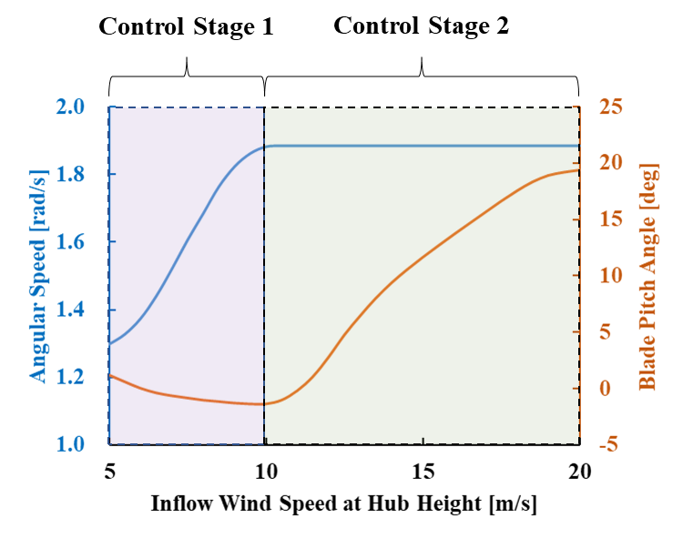
Fig. 3 Wind turbine servo control system endorses different control strategies in the two control stages.

3.1 Dataset preparation
The ANN training dataset and testing dataset are CFD simulation data in this study. The ANN model requires hub height velocity and turbulence intensity as input parameters and will provide velocity field and turbulence intensity field for the whole domain as outputs. Therefore, the CFD simulation of the standalone wind turbine, whose mesh is shown in Fig. 1, will be repeated with different inflow conditions and related wind turbine operational parameters.
To cover the entire working conditions, the inflow velocity at hub height $U_{hub}$ is set from 5m/s to 20m/s with a spacing of 0.5m/s, including 31 cases. On the other hand, the turbulence intensity at hub height $I_{hub}$ is chosen from 2% to 30% with a spacing of 2%, including 15 cases. In total, the dataset contains 31$×$15 = 465 cases, divided into 423 training sets and 42 testing sets.
The output domain is 28D long, 12D wide, and 4D high. A grid with 10 m spacing is determined as an output grid. For each case of the RANS/ADM-R coupling model, numerical results containing velocity components and turbulence intensity are output and interpolated into matrices $U$ and $I$, respectively. Matrices $U$ and $I$ have the same size of [225, 97, 32].

3.2 ANN wake model training
This section presents our original approach to building and training the ANN model using a custom, in-house code. Our code is based on Keras [62], an open-access API written in Python for deep learning, with a Tensorflow backend. The details of our data preprocessing methodology are discussed, followed by an analysis of our training loss, accuracy, and correlation coefficient. Our hyperparameters, including learning rate, layer, and layer size, have been carefully selected based on our previous work [33]. Detailed information on the ANN model can be found in [33]. In this paper, we focus on highlighting the upgrades comparing with the previous version.

3.2.1 Data preprocessing
The data should be preprocessed before applying to ANN model training. In detail, the datasets are preprocessed to be symmetric. Then, the input and output data are normalized to [-1,1]. The input data contains velocity and turbulence intensity at hub height and are normalized by using Eq. 8 and 9:
$$\begin{aligned}M_{in}\left(i,1\right)=\frac{U_{hub}\left(i\right)-C_{U}}{R_{U}}, i=1,2,…,N_{case}\#\left(8\right)\end{aligned}$$
$$\begin{aligned}M_{in}\left(i,2\right)=\frac{I_{hub}\left(i\right)-C_{I}}{R_{I}}, i=1,2,…,N_{case}\#\left(9\right)\end{aligned}$$
where $M_{in}$ is the input data matrix used in ANN model training, $U_{hub}$ and $I_{hub}$ are the matrices of velocity and turbulence intensity at hub height, respectively, $C_{U}$ and $C_{I}$ are the midpoint of $U_{hub}$ and $I_{hub}$, $R_{U}$ and $R_{I}$ are the range of $U_{hub}$ and $I_{hub}$, respectively, $N_{case}$ is the number of cases, which equals 423 for the training dataset and 42 for the testing dataset.
After a preliminary test, the ANN model cannot fulfill the demand of accuracy when training with all cases. Considering the control system of wind turbines is not the same in different wind speed stages, it is necessary to divide the cases into two parts: low-speed cases and high-speed cases.
For the low-speed cases, the inflow velocity is from 5 m/s to 10 m/s. Therefore, $C_{U}$ is set as 7.5 and $R_{U}$ is 2.5. On the other hand, the high-speed cases cover 10 m/s to 20 m/s. Correspondingly, 15 and 5 are used for $C_{U}$ and $R_{U}$. Besides, $C_{I}$ and $R_{I}$ are set to 0.15 for all cases. The divided point is 10m/s, which is also correlated to the control system of the Vestas V80 2MW wind turbine. Only rotor speed is adjusted when the inflow wind speed is lower than 10m/s. On the other hand, blade pitch control is involved when the inflow is over 10m/s. The blade pitch control will change the wake characteristics. Therefore, training the models in different wind speed regions matches the situation in practice.
After the input data has been preprocessed, the output data should also be normalized. The extrema of the velocity field and turbulence intensity field are checked in advance. Then, approximate midpoints and ranges are determined, respectively. The normalized equation for output data is as follows:
$$\begin{aligned}M_{out,U}=\frac{U-C_{out,U}}{R_{out,U}}\#\left(10\right)\end{aligned}$$
$$\begin{aligned}M_{out,I}=\frac{I-C_{out,I}}{R_{out,I}}\#\left(11\right)\end{aligned}$$
where $M_{out,U}$ and $M_{out,I}$ are the preprocessed output matrices of velocity and turbulence intensity, respectively. $C_{out,U}$ and $C_{out,I}$ are the approximate midpoints, $R_{out,U}$ and $R_{out,I}$ denote the approximate ranges. Both $C_{out,U}$ and $R_{out,U}$ are set to 6.0 for low-speed cases and 15.0 for high-speed cases. For turbulence, $C_{out,I}$ and $R_{out,I}$ are set to 0.35 for all the cases.

3.2.2 Architecture of ANN wake model
After preprocessing, a dataset containing 465 inflow cases is generated. However, as mentioned above, the output matrix has 225$×$97$×$32 = 698,400 grid points. It is challenging and inaccurate to train the single ANN wake model with a large output matrix. Therefore, sub-models are used to solve this problem, as shown in Fig. 4.
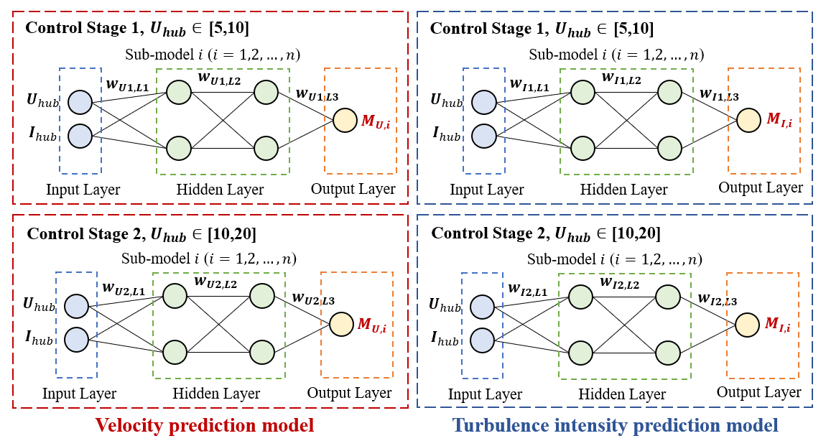
Fig. 4 Architecture of ANN wake model, consisting of four batches of sub-models.
In Fig. 4, the same input layers, including 423 training cases, are used in every sub-model, $w$ denotes the weights transferred between layers, $M_{U,i}$ and $M_{I,i}$ are matrices of output grid points of velocity deficit and added turbulence kinetic energy in sub-model $i$. In this study, the output grid points of the whole domain are divided into longitudinal lines for each sub-model. Therefore, the number of sub-models providing the prediction of a whole field is $n$ = 97$×$32 = 3104 for each situation. As there are four situations in total, the wake model for a wind turbine model has 3104$×$4=12416 sub-models. In each sub-model, the output matrix size is 225.
In addition, two hidden layers are used, which are hidden layer 1 with the tanh activation function $f_{1}\left(x\right)$ and hidden layer 2 with the Rectified Linear Unit (ReLU) activation function $f_{2}\left(x\right)$ as follows:
$$\begin{aligned}f_{1}\left(x\right)=\tanh\left(x\right)=\frac{2}{1+e^{-2x}}-1\#\left(12\right)\end{aligned}$$
$$\begin{aligned}f_{2}\left(x\right)=\max\left(x,0\right)\#\left(13\right)\end{aligned}$$
The tanh activation function helps in centering the data with a stronger gradient than Sigmoid function. Together with relu function, the double-layer model can has a training history with its loss function dropping faster than single-layer model with tanh function.
Moreover, different optimizers in Keras have been tested. As a result, the optimizer "Adam" is applied in this study [63], which shows the most stable and accurate results.

3.2.3 Training results
The mean square error (MSE) in this study, which is used as the loss function during training, drops below${10}^{-3}$ within the first 1000 epochs, as shown in Fig. 5 (a). Although the loss continues to decrease in subsequent epochs, the accuracy fluctuates, particularly from 3000 to 10000 epochs, as shown in Fig. 5 (b). However, after 10000 epochs, the results become both accurate and stable, with an accuracy close to 1.0 for most of the sub-models. Fig. 5 also shows that the accuracy has only small-scale fluctuations. To ensure that the best possible ANN model is obtained, a checkpoint is set during every training process to save the model only when its accuracy has improved. As a result, every sub-model is retained in its best state.
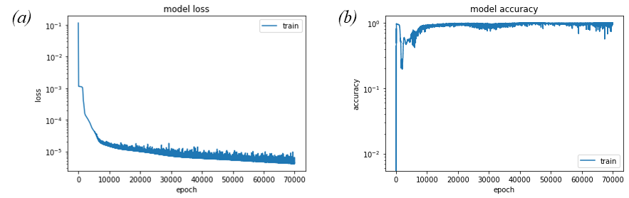
Fig. 5 Evolution of (a) mean square error (b) accuracy of ANN model.

3.2.4 Overfitting check
To assess the generalization ability of the trained ANN model, we divided the database into a training set and a testing set, as explained earlier. The testing set was not involved in the training process to avoid overfitting. After training, the test accuracy is found to be as high as the training accuracy, indicating that the model can generalize well to unseen data.
To further evaluate the accuracy of the trained model, we applied the ANN model to predict the test cases and compared the results with the CFD simulation results. As the variation in the wake is the largest, we selected the sub-model closest to the hub center for the accuracy check. We trained separate ANN models for low and high wind speeds because different control strategies were used. Therefore, we present the comparison of the ANN prediction and CFD simulation results for all the testing cases in the low wind speed region ($U_{hub}$ < 10m/s) in Fig. 6. Additionally, we provide the comparison for the high wind speed region ($U_{hub}$ = 10~20m/s) in Fig. 7. Moreover, we report detailed coefficient results in Table 4 and Table 5, where MSE represents the mean squared error, RMSE is the root mean squared error, $R^{2}$ is the coefficient of determination, and k is the slope of the trendline. The coefficient of determination is defined as:
$$\begin{aligned}R^{2}=\frac{\sum{{\left(\hat{y}-\overline{y}\right)}^{2}}}{\sum{{\left(y-\overline{y}\right)}^{2}}}=1-\frac{\sum{{\left(y-\hat{y}\right)}^{2}}}{\sum{{\left(y-\overline{y}\right)}^{2}}}\#\left(14\right)\end{aligned}$$
where $y$ is the reference data, $\overline{y}$ is the mean of the reference data, $\hat{y}$ denotes the predicted data.
Note that the intercept of the trend line is set to 0. Therefore, the slope of the trendline should be close to 1.0. According to the figures and tables, the $R^{2}$ is as high as 0.9999 while $k$ is very close to 1.0, which shows that the trained ANN model is in high agreement with CFD simulation results. More importantly, the testing dataset has not been involved in the training process. Therefore, the high accuracy of testing cases can also prove that the trained ANN model has no overfitting problem.
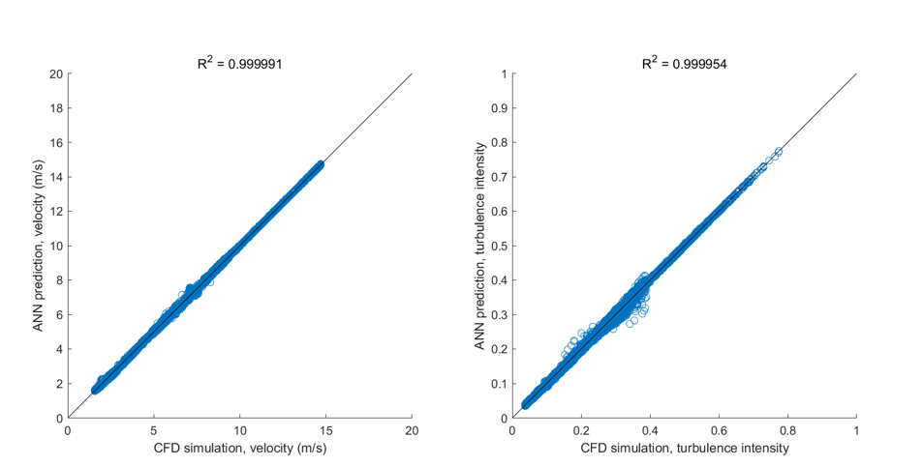
(a) | (b)
Fig. 6 ANN prediction versus CFD simulation of testing cases for low wind speed region
(a) velocity; (b) turbulence intensity
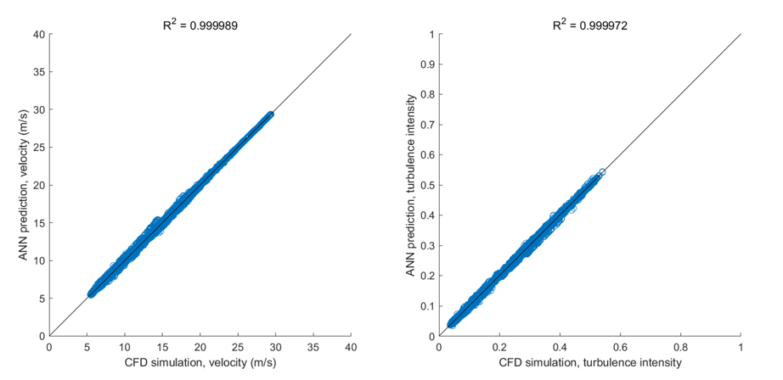
(a) | (b)
Fig. 7 ANN prediction versus CFD simulation of testing cases for high wind speed region
(a) velocity; (b) turbulence intensity.
Table 4 Testing results of the hub center sub-model for wind speed region one.
 | U | TI
MSE | $$3.8935×{10}^{-5}$$ | $$2.3918×{10}^{-7}$$
RMSE | 0.0062 | $$4.8906×{10}^{-4}$$
$$R^{2}$$ | 1.0000 | 1.0000
k | 1.0002 | 1.0004
Table 5 Testing results of the hub center sub-model for wind speed region two.
 | U | TI
MSE | $$1.9417×{10}^{-4}$$ | $$1.2504×{10}^{-7}$$
RMSE | 0.0139 | $$3.5361×{10}^{-4}$$
$$R^{2}$$ | 1.0000 | 1.0000
k | 1.0002 | 1.0001

    - Comparison to previous ANN wake model
In this paper, the proposed ANN wake model is an upgraded model based on the concept of the ANN wake model in Ti’s work[33]. However, the accuracy of velocity prediction in wind turbine wake is less than 7% for the whole domain and less than 5% for most of the area except near-wake region (within 1D in streamwise)[33]. The 5% error in wind speed prediction may lead to around ±13% error in power prediction when the realistic wind speed is 10 m/s, as shown in Fig.6.
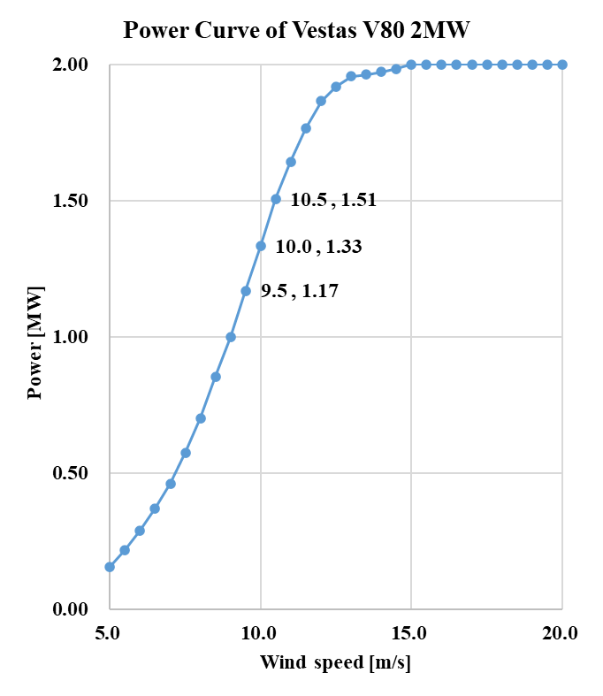
Fig. 8 Power curve of Vestas V80 2MW wind turbine.
In this paper, physical considerations are included in data preprocessing and training. Totally, there are 12416 sub-models for a standalone wind turbine model instead of 4000 in previous ANN wake model. After training sub-models separately based on the physical control stage, the model’s accuracy has been further improved to a higher level with an error less than 1%. Thus, the model is capable to be utilized in wind farm power prediction with many wind turbines. More cases about error analysis are attached in Appendix I.
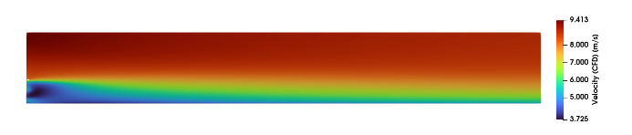 | 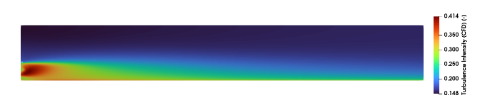
(a) Velocity Contour, CFD Simulation | (d) Turbulence Intensity Contour, CFD Simulation
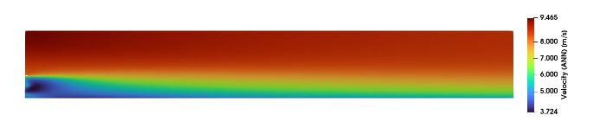 | 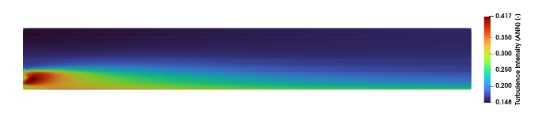
(b) Velocity Contour, ANN Prediction | (e) Turbulence Intensity Contour, ANN Prediction
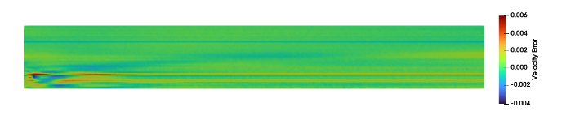 | 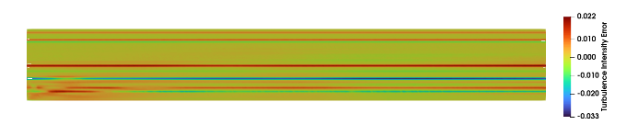
(c)Velocity Error | (f) Turbulence Intensity Error
Fig. 9 Error analysis of a demonstration case ($U_{hub}$=7m/s, $I_{hub}$=20%).

4. Numerical validation
The accuracy and efficiency of the RANS/ADM-R coupling model have already been well-validated in previous work [32, 33]. However, as the overset mesh technique is newly introduced, the same practical engineering example is investigated again using the updated method. A column of wind turbines is selected from a real wind farm, Horns Rev wind farm. Their power output under a typical full wake condition is tested by using RANS/ADM-R coupling model, Ishihara and Qian's analytical model, and the ANN model. The measurement data and Wu's LES simulation results are also compared. This case proved that both the trained ANN model and RANS/ADM-R coupling model have outstanding performance in multiple wind turbine wake prediction. In detail, eight wind turbines of a column in Horns Rev wind farm are studied with a full wake inflow condition of 270°.
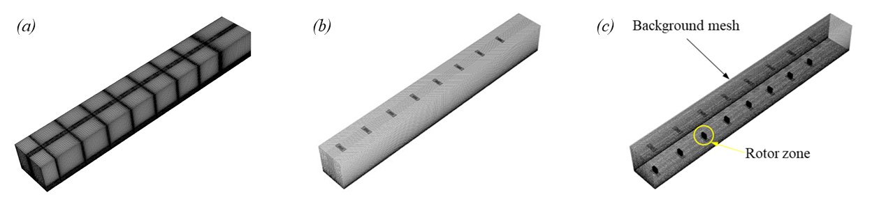
Fig. 9 Mesh of 8 wind turbines aligned in a column using (a) traditional modeling method (b) overset mesh technique (c) overset mesh technique, wireframe.
In particular, the overset mesh method is used in CFD simulation to reduce the computational cost and difficulties in modeling. In previous work, the traditional meshing methodology was adopted [33], and the model outline is shown in Fig. 9 (a) with 4.5 million cells. The mesh and wireframe of the model using overset mesh technique are displayed in Fig. 9 (b) and (c), respectively. One of the rotor zones is also marked in Fig. 9 (c). Each rotor zone has 88.0 thousand hexahedron cells, while the background has 656.2 thousand. In total, the model has 1.36 million hexahedron cells, which is only 30% of the previous model.
The inflow condition is 8 m/s for wind speed and 7.7% for turbulence intensity at the hub height. The same modified k-epsilon turbulence model in previous work is also applied. In Fig. 9(c), eight rotor zones represent 8 Vestas V80 2MW wind turbines. An ADM-R model is well established for each rotor under independent operation control, ensuring that every wind turbine follows the control system. In detail, rotor speed and blade pitch angle are adjusted by loops for every rotor in each CFD iteration. The rotor speed control and blade pitch control can be found in the literature [33, 42].
Eight wind turbines can automatically achieve the actual working status under provided wind conditions with the control system. Therefore, the wind velocity field is accurate, and the power can be calculated using Eq. 15, and the power output of wind turbines is shown in Fig. 10.
$$\begin{aligned}P=\frac{1}{2}ρC_{p}Au^{3}\#\left(15\right)\end{aligned}$$
After the RANS/ADM-R coupling model is validated in this case, the ANN model is also ready for the test. The same superposition models (Eq. 6 and 7) have also been combined with the ANN model. The power can be predicted efficiently, and the prediction results are also shown in Fig. 10.
In Fig. 10, the black triangles denote the measurement data from the Horns Rev wind farm. Blue circles represent the LES simulation results from [42]. Green squares are RANS/ADM-R coupling simulation results. Finally, the red circles denote the ANN model prediction results. We can see all the models show an excellent agreement from the figure. There are minor errors between ANN and RANS/ADM-R model because the tiny error for the standalone wind turbine has been summed up when applying the superposition model. However, in conclusion, the ANN model provides not only an extremely high correlation coefficient in the previous section but also an accurate power prediction in the current case.
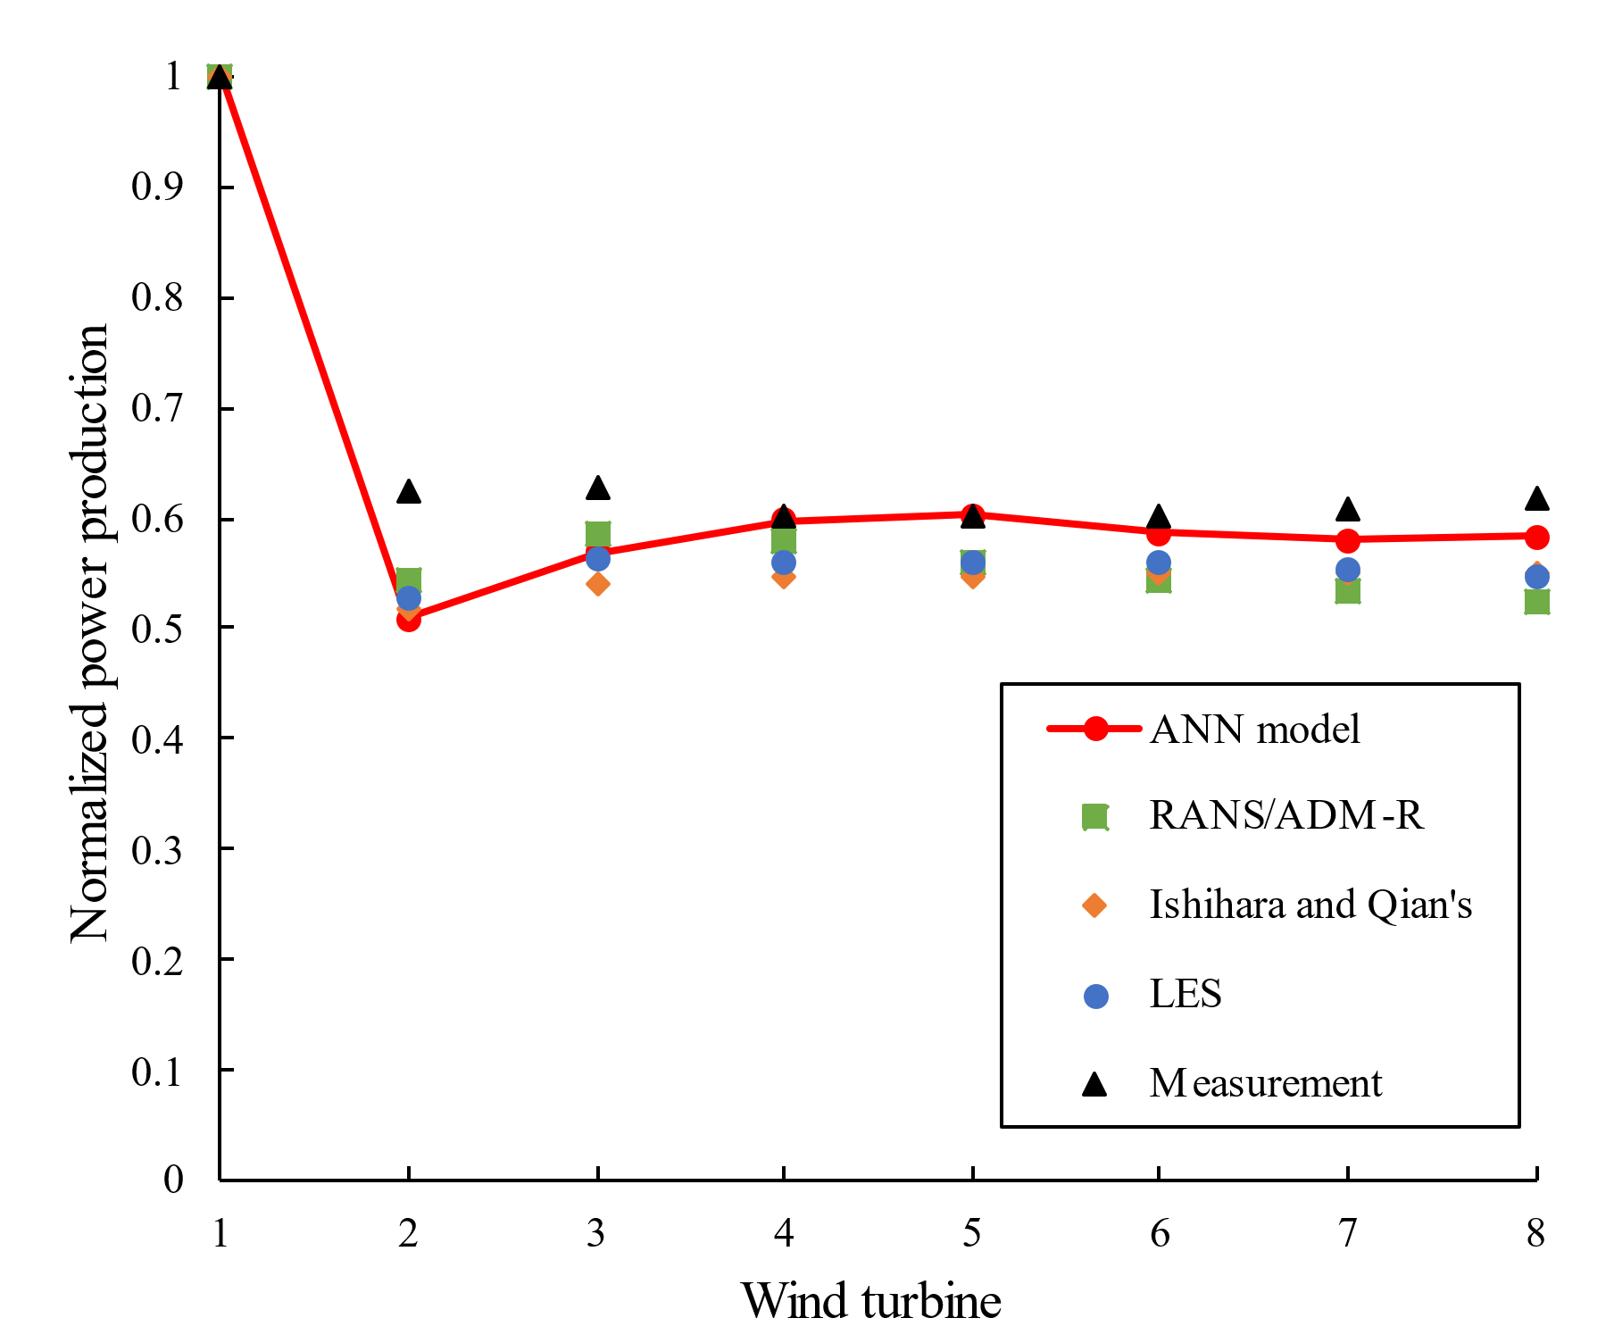
Fig. 10 Normalized power output of 8 wind turbines in a column (270°).

5 Applications of wind farm layout optimization
Two example cases are introduced in this section, and their results are also shown in detail. Example 1 is a virtual wind farm with nine wind turbines, which is easier to model using CFD simulation. Therefore, CFD simulations are adopted to check the results of power prediction for initial design and optimal designs. Besides, Example 2 is studied on the Horns Rev wind farm using the ANN and analytical models, respectively. Finally, the precision and computation speed are compared between the two models.

5.1 Example 1: Small wind farm with nine wind turbines

5.1.1 Optimization problem description
A virtual case with nine wind turbines is set up in this example case. The initial layout of wind turbines follows a regular 3$×$3 grid layout design, as shown in Fig. 11. The initial distance of the grid is set as 5D, which is close to the scheme proposed by Mosetti [24].In addition, the boundaries of the design domain strictly envelop the initial design, which are the red dash lines in the figure. Based on the case description, the optimization problem can be easily set up using Eq. 16 – Eq. 19.
$$\begin{aligned}\min{{f=P_{0}}/P} \#\left(16\right)\end{aligned}$$
$$\begin{aligned}s.t {lb}_{x}≤x_{i}≤{ub}_{x} \#\left(17\right)\end{aligned}$$
$$\begin{aligned}{lb}_{y}≤y_{i}≤{ub}_{y}\#\left(18\right)\end{aligned}$$
$$\begin{aligned}∀ ∆d≥3×D\#\left(19\right)\end{aligned}$$
where Eq. 16 is the objective function, $P_{0}$ is total power output of initial layout, $P$ is total power output of each trial. Eq. 17 and 18 indicate a rectangle design boundary. Eq. 19 denotes the minimum distance between every two turbines, which is set as 3D in this case.
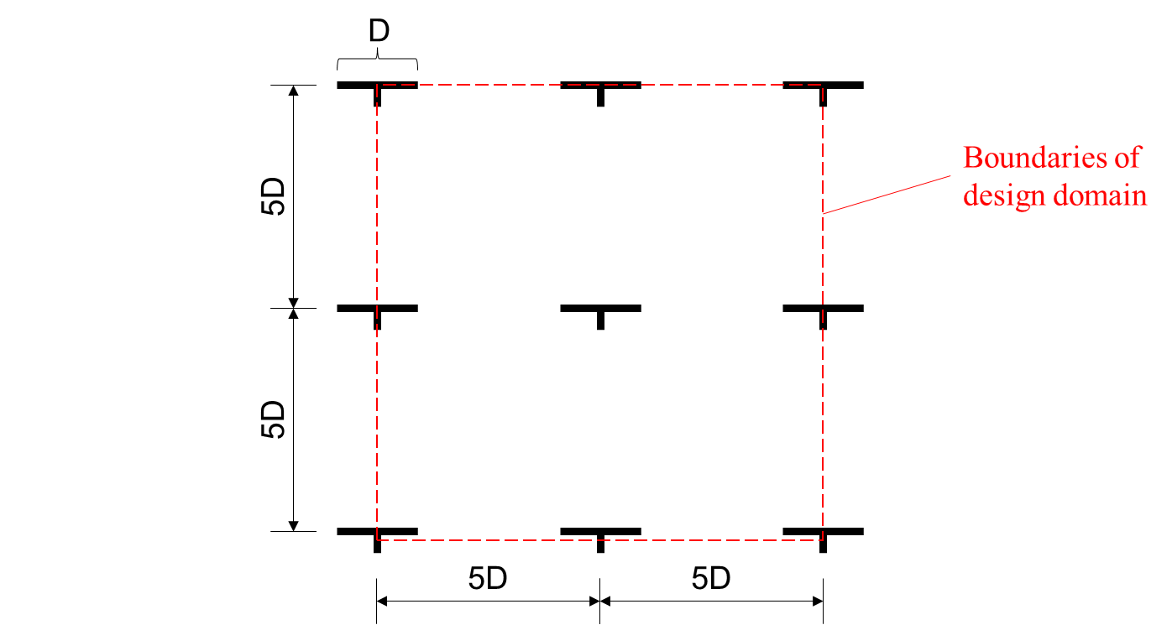
Fig. 11 Description of Example case 1: Small wind farm with nine wind turbines.

5.1.2 Initial design
Before optimization, RANS/ADM-R model, Ishihara and Qian's analytical model, and the ANN model are all used to predict the total power output of the initial layout. The CFD simulation model using overset mesh technique is presented in Fig. 12. A large computational domain with nine wind turbines is successfully modeled. The top view of the mesh shows the nine wind turbine zones with high-resolution meshes, as shown in the streamwise and transverse cross-sections. The background has 1.6 million hexahedral cells, while each rotor zones has 0.2 million. Therefore, only 3.4 million cells are required, which is affordable for a typical workstation.
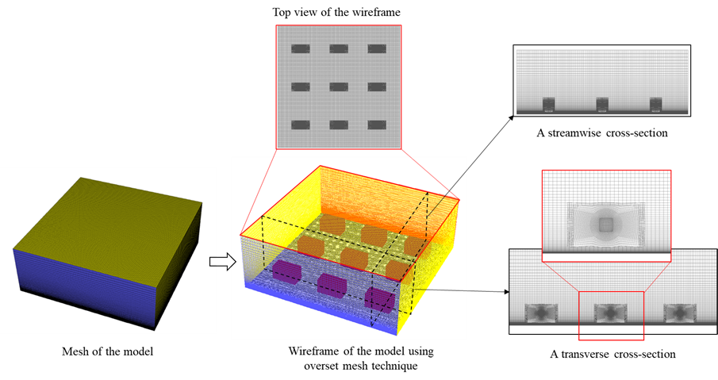
Fig. 12 Mesh of CFD simulation for the initial design.
The velocity and turbulence intensity contours from the CFD simulation are shown in Fig. 13(a) and (b), respectively. The results of power output are summarized in Table 6. According to the table, the results from the analytical model show a more significant wake effect for the downstream wind turbines, while the ANN model is very close to RANS/ADM-R coupling model. The error is lower than 1%, which also shows that the training of ANN is successful.
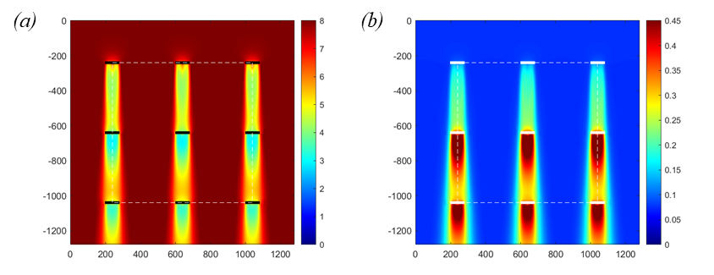
Fig. 13 Contour plots of hub height plane of initial design (a) velocity (b) turbulence intensity.
Compared with the CFD simulation, the errors are lower than 10% for both the analytical and ANN models. The ANN model shows better performance as its error is lower than 1%.
Table 6 Normalized power output of initial design
 | RANS/ADM-R | Analytical model | ANN model
Row1 | 1.000 $×$ 3 | 1.000 $×$ 3 | 1.000 $×$ 3
Row2 | 0.444 $×$ 3 | 0.397 $×$ 3 | 0.424 $×$ 3
Row3 | 0.541 $×$ 3 | 0.392 $×$ 3 | 0.558 $×$ 3
Sum of a column | 1.985 | 1.789 | 1.982
Total | 5.955 | 5.367 | 5.946
Error | $$-$$ | 9.2% | 0.73%

5.1.2 Optimal solutions
Two layout optimization frameworks are equipped with the analytical model and the ANN model, respectively. Those two frameworks have the same problem settings to ensure the objectivity and reliability of comparison. In this case, 100 random start points are used for both cases. The points are not specified but generated by the same random seed. In addition, the same optimizer and stopping criteria are applied to both cases as well.
As mentioned above, the analytical model and ANN model may have a certain error ratio compared with CFD simulation. However, CFD simulation is set as reference results in this case. Therefore, CFD simulation using overset mesh technique is applied to both optimal solutions. The mesh of the optimal layout design provided by the ANN model is demonstrated in Fig. 14. According to the figure, nine rotor zones are located irregularly. The arbitrary locations of wind turbines could lead to a highly dense mesh for nearly the whole area without overset mesh technique. Moreover, the wind turbines are no longer in a column, and the mesh size is unaffordable for computing on a typical workstation. In contrast, the number of cells remains at 3.4 million using overset mesh technique, which doesn't change with the wind farm layout.
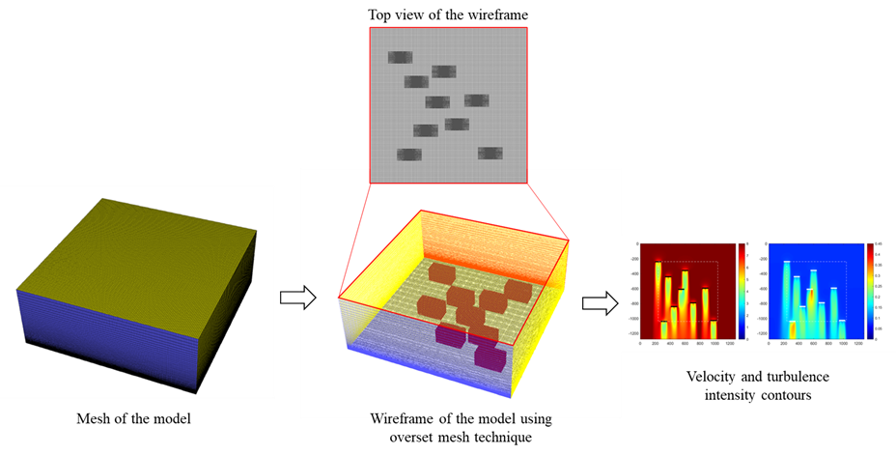
Fig. 14 Mesh of CFD simulation for the optimal design provided by the ANN model.
Fig. 15 contains velocity and turbulence intensity contours calculated by the RANS/ADM-R coupling model, while the layout designs are provided by the ANN and analytical models, respectively.
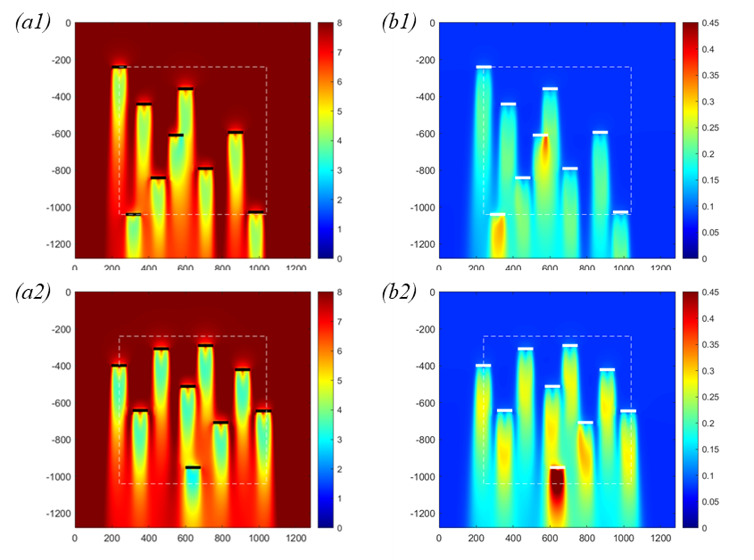
Fig. 15 Contours of (a) velocity (b) turbulence intensity of hub height plane for optimal layouts:
(1) ANN model (2) analytical model.
The figure also shows the wake effects of wind turbines. When comparing the two layouts, the most downstream wind turbine receives relatively high wake impacts for the layout provided by the analytical model. Meanwhile, the wind turbines in the second optimal layout from the ANN model are all operating in a good situation. Detailed results are summarized in Table 7. The optimal layout designs from both the analytical model and the ANN model show a significant optimal ratio, up to 40%. The optimal layout design from the ANN framework improves more about 3% in power production than that from the analytical framework. The error of the analytical framework checked by the CFD simulation drops lower than 5%, and the error of the ANN model is lower than 0.5%.
Table 7 Summary of optimal solutions
Wake model | Analytical model | ANN model
Normalized power output | 8.54 | 8.31
CFD simulation check | 8.15 | 8.34
Optimal ratio, r | 36.82% | 40.06%
Error | 4.86% | 0.37%

5.2 Example 2: Horns Rev wind farm

5.2.1 Optimization problem description
For Example 2, a real wind farm, Horns Rev wind farm, is studied. The layout design of the Horns Rev wind farm is shown in Fig. 16. Design boundaries are also marked using red dash lines as in Example 1. Fixed spacing of 7D is used for two directions, including 270° with 10 columns and 353° with eight rows. According to the literature [42], inflow direction $θ$ is selected as 270°, wind speed $U_{hub}$ is 8 m/s, and turbulence intensity $I_{hub}$ is 7.7% at the hub height.
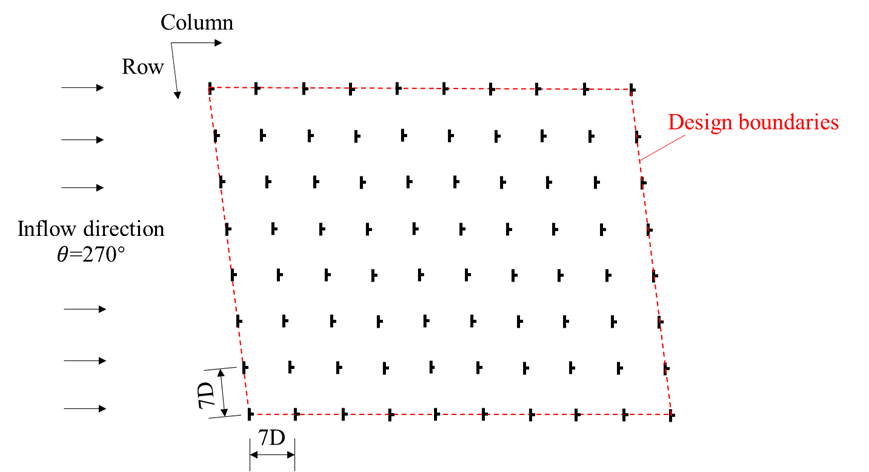
Fig. 16 Description of Example case 2: Horns Rev wind farm.
Before optimization, another validation study is conducted about total power output in the inflow directions from 180° to 360°. The results are presented in Fig. 17. In the figure, orange points represent the LES simulation results from the literature [64]. The blue line is calculated using Ishihara and Qian's analytical model, and the red line is the results provided by the ANN model. The analytical and ANN models’ results are calculated for every 3° for better comparison. The total power output is normalized by the power of 80 standalone wind turbines exposed to the same inflow condition.
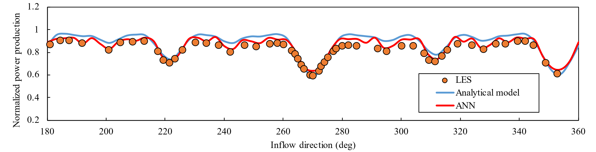
Fig. 17. The normalized power output of Horns Rev wind farm under different wind directions.
The figure shows a good agreement for both the analytical and ANN models around 270° full wake condition. However, there is a specific error level between the analytical model and LES simulation results in other situations, while ANN generally shows better performance. These results may be because Ishihara and Qian's analytical model is studied mainly under the full wake condition, which remains an error in other cases. However, the ANN model has been trained for a large computational domain within a wide range of inflow conditions, which finally increases the accuracy and robustness of the model. Therefore, the accuracy of power prediction using the ANN model is well-proved. In the following sections, both the ANN and analytical models' results are provided and compared, and ANN model results will be used as reference results.
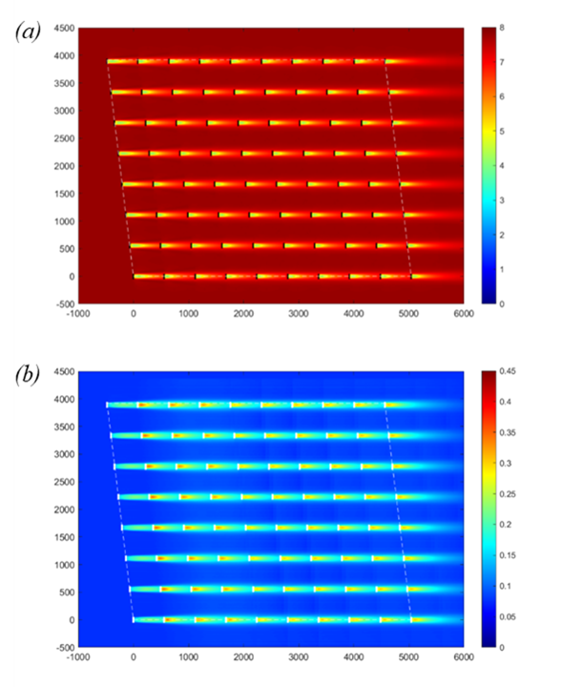
Fig. 18 Contour plots of hub height plane of initial design of Horns Rev wind farm (a) velocity (b) turbulence intensity.
Besides, the power output and contours of the initial layout of the Horns Rev wind farm in selected conditions ($θ$ = 270°) are displayed in detail. The velocity and turbulence intensity contours of the hub height horizontal plane are shown in Fig. 18. In Table 8, total power is calculated by ANN and analytical models, respectively. As the ANN model is proved to be accurate, the error of the analytical model referring to the ANN model is also provided, which is 7.4% for the initial design.
Table 8 Total power output of initial layout of Horns Rev wind farm ($θ$ = 270°)
 | ANN model | Analytical model | Check of Analytical model by ANN | Error
$P_{0}$ (MW) | 35.83 | 33.18 | 35.83 | 7.40%

5.2.2 The optimal solutions
After checking the initial design, two optimizations have been done using the ANN and analytical models, respectively. In each case, the multi-start optimization method is adopted with the same local solver (SQP method) and parallel settings. As the dimension of variables increases sharply (from 18 to 160), the start points were reduced from 100 to 40 in this case. Default random seed is also used in both cases. The time of calling the objective function is also measured. The objective function employing the analytical model can respond within 2 seconds, while the objective function with the ANN model needs 6~8 seconds. The testing environment is MATLAB under Windows with Intel® Core(TM) i7-3770 16 GB PC. Although the ANN model needs more time than the analytical model, it is efficient enough for layout optimization. The neural network prediction function occupies most of the time. Note that this time can be easily reduced using more powerful computing devices and systems.
Table 9 Summary of optimization results with 80 wind turbines
 | $P_{0}$ (MW) | $P$ (MW) | $$r$$
ANN model | 35.83 | 46.14 | 28.77%
Analytical model | 33.18 | 37.91 | $$-$$
Check of Analytical model by ANN model | 35.83 | 44.72 | 24.81%
Error | 7.40% | 15.23% | 3.96%
The optimization results using both the ANN and Analytical models are listed in Table 9, where $P_{0}$ and $P$ denote the total power output of the initial design and optimal solution, respectively; $r$ is the optimal ratio. For optimal layout designs, the results provided by the analytical model have been checked by the ANN model. According to the table, the ANN model's optimal design has an optimal ratio of 28.77% in total power output, while the analytical model's optimal design has 24.81%. However, the analytical model seems to have a more significant error (15.23%) for the analytical model's optimal design.
The contour plots for the two solutions are shown in Fig. 19, containing both velocity contour and turbulence intensity contour. The interesting point is that according to the contour plots, several wind turbines seem to be relatively close to the upstream wind turbines. However, as the gradient-based optimization method is selected, a few wind turbines may be "trapped" by the surrounded wind turbines, which means the gradient of its power production is close to 0 in every direction. Other literature has also investigated the performance of different algorithms [59]. The gradient-free method is also suggested for this kind of topic. However, as the gradient-based algorithm can also provide outstanding optimal results, this paper adopts the gradient-based algorithm for its high speed.
In addition, the optimal layout design shows that the wind farm still has ample free space for more wind turbines. Therefore, a parametric study on the number of wind turbines is presented in the next section.
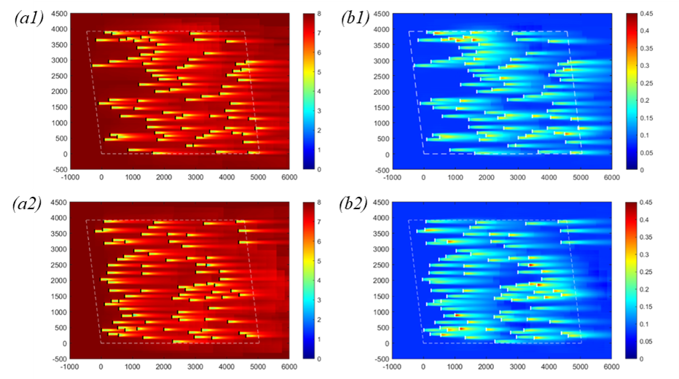
Fig. 19 Contours of (a) velocity (b) turbulence intensity of optimal design:
(1) ANN model (2) analytical model.

5.3 Parametric study on the number of wind turbines

5.3.1 Problem description
According to Fig. 19, the wind farm seems capable of more wind turbines. Therefore, the number of wind turbines is added to 90, 120, and 160. The results of those three study cases are shown below. In those studies, the power output of the original layout of the Horns Rev wind farm with 80 wind turbines is used as a baseline case for comparison. The optimal ratio is calculated, and contours of wake characteristics are also provided. Meanwhile, the average power outputs are compared.

5.3.2 Study case 1: 90 wind turbines
Table 10 Summary of optimization results with 90 wind turbines
 | $P_{0}$ (MW) (80 WTs) | $P$ (MW) | $$r$$
ANN model | 35.83 | 51.06 | 42.52%
Analytical model | 33.18 | 51.56 | $$-$$
Check of Analytical model by ANN model | 35.83 | 48.49 | 35.35%
Error | 7.40% | 6.33% | 7.17%
Table 10 summarizes the results of layout optimization with 90 wind turbines. The results show that the analytical model still has an error of 6.33% on total power prediction. The optimal ratio is rising to 42.52%. The layout of the optimal designs using the ANN model is similar to the 80 wind turbine case results, as shown in Fig. 20.
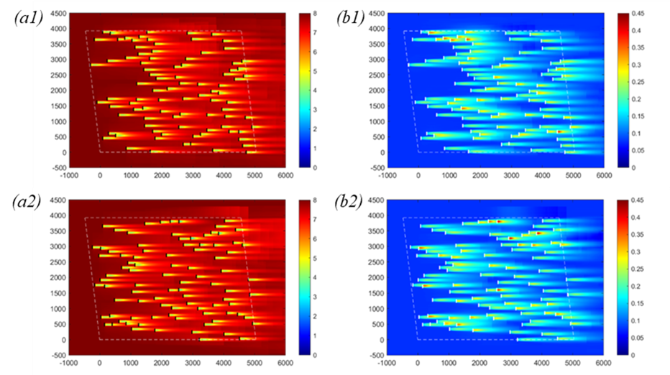
Fig. 20 Contours of (a) velocity (b) turbulence intensity of optimal design:
(1) ANN model (2) analytical model.

5.3.3 Study case 2: 120 wind turbines
Table 11 shows the results of layout optimization with 120 wind turbines. The contour plots are shown in Fig. 21. After adding 40 wind turbines, the layout of wind turbines becomes more regular. The error of the analytical model remains 5.87%. The optimal ratio has increased to 75.80%.
Table 11 Summary of optimization results with 120 wind turbines
 | $P_{0}$ (MW) (80 WTs) | $P$ (MW) | $$r$$
ANN model | 35.83 | 62.98 | 75.80%
Analytical model | 33.18 | 65.94 | $$-$$
Check of Analytical model by ANN model | 35.83 | 62.28 | 73.83%
Error | 7.40% | 5.87% | 1.97%

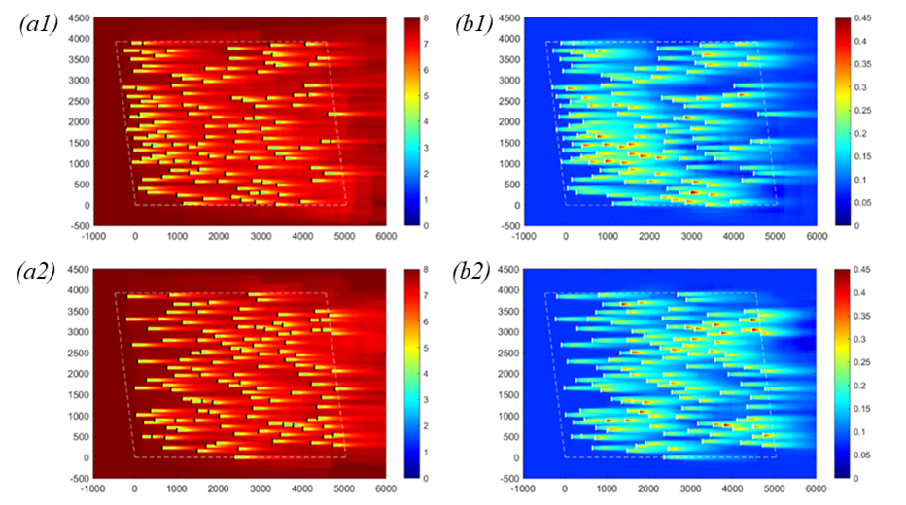
Fig. 21 Contours of (a) velocity (b) turbulence intensity of optimal design:
(1) ANN model (2) analytical model.

5.3.4 Study case 3: 160 wind turbines
Table 12 shows the optimization results with 160 wind turbines, which is also twice the original wind turbine number in the Horns Rev wind farm. The analytical model still has an error of 7.57%. The optimal ratio has increased to 118.63%.
Table 12 Summary of optimization results with 160 wind turbines
 | $P_{0}$ (MW) (80 WTs) | $P$ (MW) | $$r$$
ANN model | 35.83 | 78.33 | 118.63%
Analytical model | 33.18 | 82.69 | $$-$$
Check of Analytical model by ANN model | 35.83 | 76.87 | 114.55%
Error | 7.40% | 7.57% | 4.08%
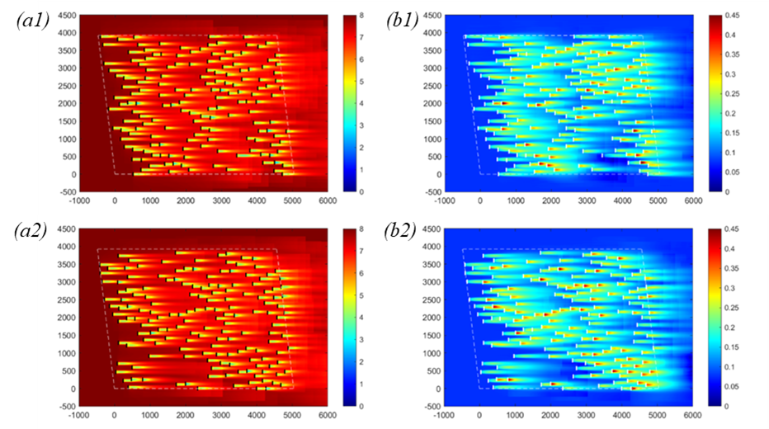
Fig. 22 Contours of (a) velocity (b) turbulence intensity of optimal design:
(1) ANN model (2) analytical model.

5.3.5 Discussions
Even though the analytical model has an error of around 7% with the ANN model, both can provide outstanding optimal layout designs for wind farm layout optimization. Especially the optimal layout design provided by the ANN model is displayed together for comparison in Fig. 23. In the figure, dotted lines are added to show the trends of layouts with different numbers of wind turbines. When the number of wind turbines is relatively small, the wind turbines are placed loosely. Only a few local parts are located in arrays. However, when the number of wind turbines increases, the trends are clearer, and the grid is denser. In Fig. 23 (d), 160 wind turbines inevitably have significant wake interference between wind turbines. Therefore, to avoid full wake interaction, the layout tends to become a staggered arrangement.
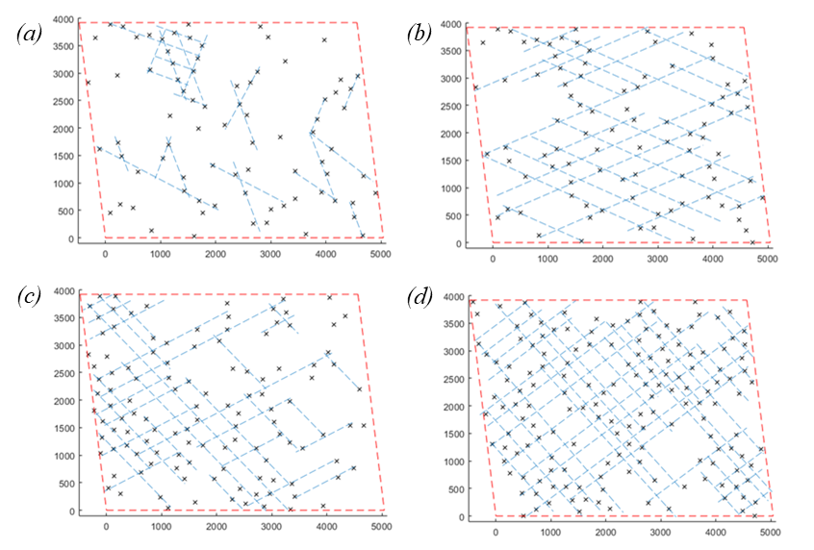
Fig. 23 Trends of optimal solutions with different numbers of wind turbines (a) 80 (b) 90 (c) 120 (d) 160
On the other hand, the optimal ratio increases rapidly with the number of wind turbines, as shown in Fig. 24.
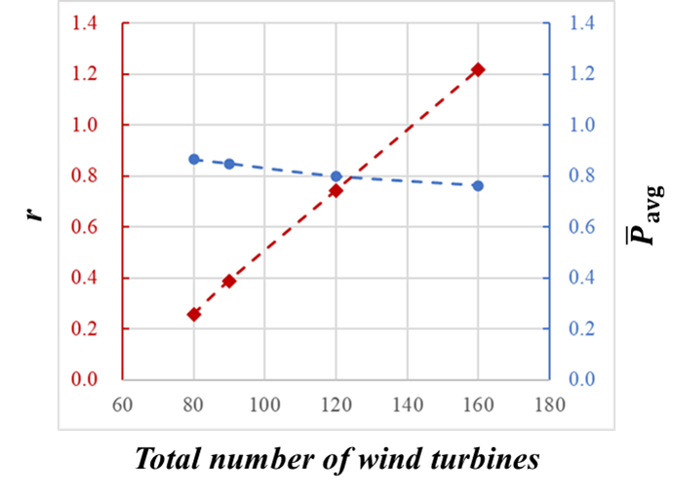
Fig. 24 Optimal ratio (main axis) and normalized average power output (secondary axis) versus the number of wind turbines.
According to the red dotted line, the increase in the optimal ratio is nearly linear. Besides, the average power output is also provided as the cases have different numbers of wind turbines. The average power output is normalized by the power output of a standalone wind turbine under the same wind condition, which slightly drops about 10% when the number of wind turbines increases from 80 to 160. Fig. 24 indicates that the normalized average power output can keep at a high level larger than 0.75, even if the number of wind turbines is doubled. Besides, the point of intersection indicates the trade-off between the optimal ratio and normalized average power output.

5.4 Multiple inflow cases

5.4.1 Description of multiple inflow cases
The optimization of wind farm layout is influenced significantly by the characteristics of inflow conditions. Previous studies have indicated a decreasing trend in performance improvement as the inflow directional distribution becomes more evenly distributed [65]. In order to reach more reliable conclusions, the investigation is extended to two cases with more inflow mainstream directions. These two cases, along with the previously studied 270° uniform inflow condition, are represented in the form of wind roses, as illustrated in Fig. 25. Inflows are simplified for affordable computational costs. The wind roses depict the adopted wind inflow directions for each case, indicated by black arrows.
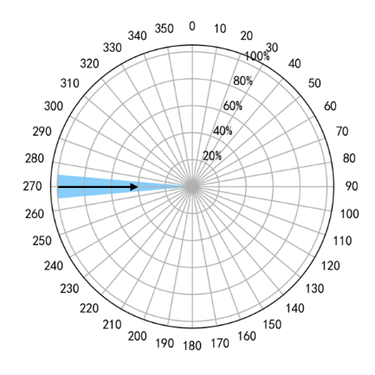 | 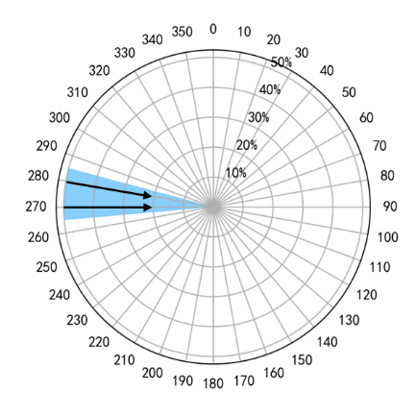 | 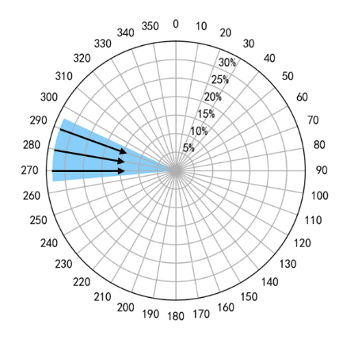
(a) Single mainstream | (b) Double mainstreams | (c)Triple mainstreams
Fig. 25 Schematics of inflow conditions
In the scenarios involving multiple inflow directions, the power output of a wind farm layout is calculated for each individual direction. The power outputs are then weighted and summed, considering the probability of each direction. Consequently, the computational expenses escalate linearly with the number of directions considered. Considering affordable computational expense, the number of directions of inflow is extended to 2 and 3 that representing the inflow with a range of 20° and 30° in case (b) and (c), respectively.
The steps can be described as follows:
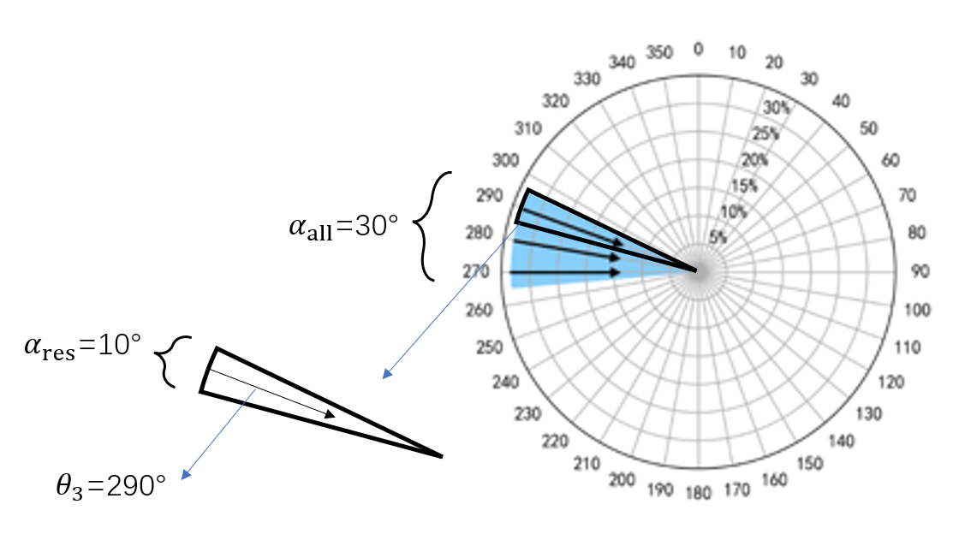
Fig. 26 Schematics of sector division under wind rose (c)
- If the covering range of inflow direction is $α_{all}$, define the resolution ($α_{res}$) based on the request, and obtain the representative angle ($θ_{i}$) of inflow in every sector.
- Define independent inflow cases $\left[U_{i}, I_{i},θ_{i}\right]$, $U_{i}, I_{i},θ_{i}$ are the wind speed, turbulence intensity, representative inflow angle of inflow case $i$.
- Compute the power production of wind farm under inflow case 1, 2, …, N, respectively, which is $P_{1},P_{2},…,P_{N}$.
- Compute weighted sum of power based on the weights of probability of every inflow case to obtain total power production: $P=w_{1}P_{1}+w_{2}P_{2}+…+w_{N}P_{N}$.
It should be noted that in Step 2, $U,I$ are constants in this study but can be different in further applications. Step 3 can be done parallelly because of the independence of cases. In Step 4, the weights are set equally for every inflow case currently but can varies in further applications.
Upon integrating the proposed optimization framework, optimal solutions are derived for inflow cases (b) and (c) using both Ishihara and Qian's analytical wake models, as well as the machine learning wake model. These solutions are obtained to evaluate and compare the performance of the different wake models under the specified inflow conditions.
Table 13 Summary of optimization results under wind rose (b)
 | $P_{0}$ (MW) | $P$ (MW) | $$r$$
ANN model | 45.79 | 55.86 | 21.98%
Analytical model | 43.24 | 53.41 | $$-$$
Check of Analytical model by ANN model | 45.79 | 55.07 | 20.26%
Error | 5.57% | 3.03% | 1.41%
Table 13 shows the results of optimization of Horns Rev wind farm with 80 wind turbines under wind rose Case (b) described in Fig. 25. The power prediction error is 5.57% and 3.03% for initial layout and the optimal layout searched by analytical model. Differences between optimal layouts decreases to 1.41%.
Table 14 Summary of optimization results under wind rose (c)
 | $P_{0}$ (MW) | $P$ (MW) | $$r$$
ANN model | 49.26 | 54.97 | 11.58%
Analytical model | 46.43 | 52.56 | $$-$$
Check of Analytical model by ANN model | 49.26 | 54.28 | 10.19%
Error | 5.75% | 3.17% | 1.25%
Table 14 presents the optimal results using the wind scenario of wind rose Case (c) described in Fig. 25. According to the results, the error of analytical model in power prediction is 5.75% and 3.17% for initial layout and optimal layout. In Case (c), the inflow directions are extended covering a range of 30°. For initial layout, the inflows from 280° and 290° are not full-wake conditions, which lead to a deduction of wake losses. As shown in the results, the initial power output is larger than before. Meanwhile, the optimal power output is similar between Case (b) and (c), both of which shows a great performance. For Case (b), the difference between two optimal layouts searched by different wake models is 1.41%, while the difference is 1.25% in Case (c). The results indicate that the difference on optimal layouts using different wake models will decrease.

6 Conclusions and future work
This paper proposes a data-driven layout optimization framework for large-scale wind farms based on the machine learning wake model. The machine learning wake model is systematically established with physics considerations and is driven by CFD simulation. The model includes the physics consideration that the control system works differently under low-speed inflow and high-speed inflow. Therefore, the model reaches a high accuracy that is 98% as accurate as CFD simulation in single wind turbine wake prediction. In testing, the ANN prediction also has a very high coefficient of determination $R^{2}$ of 0.9999 with CFD simulation. The high accuracy of independent test cases also proved that the machine learning wake model has no overfitting problems.
With overset mesh technique, the verification case with nine wind turbines using CFD simulation becomes affordable. The updated framework is first well-validated using CFD simulation. In the examples, the proposed layout optimization framework shows different performance with different wake models. The ANN model is as accurate as CFD simulation when the training range covers the inflow condition. Compared with the error of the analytical model, the ANN model shows high accuracy in power prediction. In demonstration examples, the error of the analytical model ranges from 4% to 10%, while the ANN model results in a small error of less than 1%. Note that a large error is mainly because of underestimation or overestimation of wake effects, leading to a lack of power production or a waste of resources.
It is indicated by the virtual test wind farm that the total power output increases by 40% using the proposed layout optimization framework. In the benchmark case of Horns Rev wind farm, the power output can increase by 28.77%. Moreover, by increasing the number of wind turbines to 160, the increasing proportion of power can further grow up to 118.63%. The optimization framework equipped with an analytical model may lead to a 5% - 8% overestimation of the power output. In contrast, the overall power production is 2% - 8% lower than the ANN-based optimization framework. In addition, wind turbines can maintain high power production for every optimal layout. The normalized average power production slightly drops 10% and keeps larger than 0.75 when the number of wind turbines grows from 0 to 160. Moreover, the wind farm layout tends to become more even and staggered. This trend is reasonable as the staggered layout can efficiently reduce the wake deficit under the specified inflow condition.
Based on the investigations conducted on multiple inflow direction cases, the effectiveness of our proposed framework has been demonstrated. Particularly noteworthy is the observation that the disparity in performance between optimal layouts obtained using different wake models diminishes as the number of inflow directions increases. As the inflow direction transitions from a single direction to three directions, the discrepancies between optimal layouts decrease from 3.96% to 1.25%. The power prediction error associated with the analytical wake model by Ishihara and Qian ranges from 3.03% to 5.75%.
This study has established an accurate framework for the computation of power production in large-scale wind farms, integrated with layout optimization methodologies. The analysis encompassed uniform single inflow as well as extended 2-3 inflow configurations, selected to ensure an affordable computational expense. Current framework can compute power production under any inflow case defining by three wind parameters: wind speed, turbulence intensity, and direction. Future endeavors could leverage more powerful parallel computing platforms to enable optimization across a comprehensive wind rose, capturing detailed wind speed distributions in every wind direction sector. This anticipated enhancement holds the potential to refine wind farm layout optimization, offering a deeper understanding of practical performance of layout optimization.
Besides, this paper focuses on power increase only. In the future, the cost will also be included by using indices like COE (cost of energy) or LCOE (Levelized Cost of Energy). Meanwhile, the dynamic loads can also be considered because unreasonable layout may lead to more significant wake effects, contributing to structural vibration or fatigue damage. Therefore, the loads can be introduced as another constraint.
This paper aims to provide an efficient, accurate, robust, and generic method for layout optimization of large-scale wind farms. For database, in the future, the framework can be further reinforced by merging measurement data from field monitoring or wind tunnel experiments. Therefore, the model with dynamic inflow conditions can be established, which is able to provide dynamic loads. In this way, it is more comprehensive to conduct a multi-objective optimization based on power and dynamic loads. The best layout provided by the multi-objective optimization will have a larger power production by guaranteeing structural safety.

Acknowledgments
This work is generously supported by the Research Grants Council via RGC/CRF (C7038-20GF) and RGC/GRF (17204122), and Shenzhen Science and Technology Innovation Committee via Fundamental Research General Program (2021302011). The computations were mainly performed using research computing facilities offered by Information Technology Services, the University of Hong Kong.

References
[1] AMSC. SeaTitan™ 10 MW Wind Turbine. (2012) https://www.amsc.com/wp-content/uploads/wt10000_DS_A4_0212.pdf.
[2] M.S. Energy. MySE11-203, Hybrid Drives the World. (2020) http://www.myse.com.cn/en/jtxw/info.aspx?itemid=773.
[3] C. Richard. First 10MW Chinese turbine connected to the grid. (2020) https://www.windpowermonthly.com/article/1689225/first-10mw-chinese-turbine-connected-grid?utm_source=website&utm_medium=social.
[4] S.G.R. Energy. The SG 11.0-200 DD: Power for Generations. https://www.siemensgamesa.com/en-int/-/media/siemensgamesa/downloads/en/products-and-services/offshore/brochures/siemens-gamesa-offshore-wind-turbine-brouchure-sg-11-0-200-dd.pdf.
[5] G.R. Energy. Haliade-X offshore wind turbine. https://www.ge.com/renewableenergy/wind-energy/offshore-wind/haliade-x-offshore-turbine.
[6] S.G.R. Energy. The SG 14-222 DD: Powering change. https://www.siemensgamesa.com/-/media/siemensgamesa/downloads/en/products-and-services/offshore/brochures/siemens-gamesa-offshore-wind-turbine-brouchure-sg-14-222-dd.pdf.
[7] V.W.S. A/S. V236-15.0 MW™ at a glance. https://www.vestas.com/en/products/offshore-platforms/v236_15_mw.
[8] R. Perveen, N. Kishor, S.R. Mohanty. Off-shore wind farm development: Present status and challenges. Renewable and Sustainable Energy Reviews. 29 (2014) 780-92.
[9] A. Dhunny, D. Timmons, Z. Allam, M. Lollchund, T. Cunden. An economic assessment of near-shore wind farm development using a weather research forecast-based genetic algorithm model. Energy. 201 (2020) 117541.
[10] T. Göçmen, G. Giebel. Estimation of turbulence intensity using rotor effective wind speed in Lillgrund and Horns Rev-I offshore wind farms. Renewable energy. 99 (2016) 524-32.
[11] Z. Liu, S. Fan, Y. Wang, J. Peng. Genetic-algorithm-based layout optimization of an offshore wind farm under real seabed terrain encountering an engineering cost model. Energy Conversion and Management. 245 (2021) 114610.
[12] N.G. Mortensen, D. Heathfield, L. Myllerup, L. Landberg, O. Rathmann. Wind atlas analysis and application program: WAsP 8 help facility. Risø National Laboratory, Roskilde, Denmark. 335 (2005).
[13] O. Rathmann, R. Barthelmie, S. Frandsen. Turbine wake model for wind resource software. European Wind Energy Conference and Exhibition, Athens (GR), 27 February-2 March 20062006.
[14] WAsP-Wind Atlas Analysis and Application Program. https://www.wasp.dk/WAsP.
[15] WindSim. https://windsim.com/.
[16] Meteodyn. https://meteodyn.com/.
[17] Wind Resource Assessment software - WindFarmer: Analyst. https://www.dnv.com/services/wind-resource-assessment-software-windfarmer-analyst-3766.
[18] WindPro. https://www.emd.dk/windpro/.
[19] Openwind Version 1.9. https://aws-dewi.ul.com/openwind-version-1-9/.
[20] J.S. González, M.B. Payán, J.M.R. Santos, F. González-Longatt. A review and recent developments in the optimal wind-turbine micro-siting problem. Renewable and Sustainable Energy Reviews. 30 (2014) 133-44.
[21] I. Katic, J. Højstrup, N.O. Jensen. A simple model for cluster efficiency. European wind energy association conference and exhibition1986. pp. 407-10.
[22] T. Göçmen, P. Van der Laan, P.-E. Réthoré, A.P. Diaz, G.C. Larsen, S. Ott. Wind turbine wake models developed at the technical university of Denmark: A review. Renewable and Sustainable Energy Reviews. 60 (2016) 752-69.
[23] B. Pérez, R. Mínguez, R. Guanche. Offshore wind farm layout optimization using mathematical programming techniques. Renewable energy. 53 (2013) 389-99.
[24] G. Mosetti, C. Poloni, B. Diviacco. Optimization of wind turbine positioning in large wind farms by means of a genetic algorithm. Journal of Wind Engineering and Industrial Aerodynamics. 51 (1994) 105-16.
[25] S. Grady, M. Hussaini, M.M. Abdullah. Placement of wind turbines using genetic algorithms. Renewable energy. 30 (2005) 259-70.
[26] S. Rajper, I.J. Amin. Optimization of wind turbine micrositing: A comparative study. Renewable and Sustainable Energy Reviews. 16 (2012) 5485-92.
[27] C. Wan, J. Wang, G. Yang, X. Zhang. Optimal micro-siting of wind farms by particle swarm optimization. International Conference in Swarm Intelligence. Springer2010. pp. 198-205.
[28] X. Gao, H. Yang, L. Lu. Optimization of wind turbine layout position in a wind farm using a newly-developed two-dimensional wake model. Applied Energy. 174 (2016) 192-200.
[29] A. Kusiak, Z. Song. Design of wind farm layout for maximum wind energy capture. Renewable energy. 35 (2010) 685-94.
[30] J. Zhang, X. Zhao. A novel dynamic wind farm wake model based on deep learning. Applied Energy. 277 (2020) 115552.
[31] H. Sun, C. Qiu, L. Lu, X. Gao, J. Chen, H. Yang. Wind turbine power modelling and optimization using artificial neural network with wind field experimental data. Applied Energy. 280 (2020) 115880.
[32] Z. Ti, X.W. Deng, M. Zhang. Artificial Neural Networks based wake model for power prediction of wind farm. Renewable Energy. 172 (2021) 618-31.
[33] Z. Ti, X.W. Deng, H. Yang. Wake modeling of wind turbines using machine learning. Applied Energy. 257 (2020) 114025.
[34] T. Ishihara, G.-W. Qian. A new Gaussian-based analytical wake model for wind turbines considering ambient turbulence intensities and thrust coefficient effects. Journal of Wind Engineering and Industrial Aerodynamics. 177 (2018) 275-92.
[35] P. Brugger, M. Debnath, A. Scholbrock, P. Fleming, P. Moriarty, E. Simley, et al. Lidar measurements of yawed-wind-turbine wakes: characterization and validation of analytical models. Wind Energy Science. 5 (2020) 1253-72.
[36] P. Fleming, J. King, C.J. Bay, E. Simley, R. Mudafort, N. Hamilton, et al. Overview of FLORIS updates. Journal of Physics: Conference Series. IOP Publishing2020. p. 022028.
[37] A. Khaware, V.K. Gupta, A. Rajan. Numerical Simulation of Aerospace Applications Using Overset Mesh. 2017 IEEE 24th International Conference on High Performance Computing Workshops (HiPCW). IEEE2017. pp. 43-50.
[38] D.D. Chandar, B. Boppana, V. Kumar. A comparative study of different overset grid solvers between OpenFOAM, StarCCM+ and Ansys-Fluent. 2018 AIAA Aerospace Sciences Meeting2018. p. 1564.
[39] M.J. Brazell, J. Sitaraman, D.J. Mavriplis. An overset mesh approach for 3D mixed element high-order discretizations. Journal of Computational Physics. 322 (2016) 33-51.
[40] M.C. Galbraith, J.A. Benek, P.D. Orkwis, M.G. Turner. A discontinuous Galerkin chimera scheme. Computers & Fluids. 98 (2014) 27-53.
[41] Y.-T. Wu, F. Porté-Agel. Atmospheric turbulence effects on wind-turbine wakes: An LES study. energies. 5 (2012) 5340-62.
[42] Y.-T. Wu, F. Porté-Agel. Modeling turbine wakes and power losses within a wind farm using LES: An application to the Horns Rev offshore wind farm. Renewable Energy. 75 (2015) 945-55.
[43] B. Blocken, T. Stathopoulos, J. Carmeliet. CFD simulation of the atmospheric boundary layer: wall function problems. Atmospheric environment. 41 (2007) 238-52.
[44] A. Ricci, I. Kalkman, B. Blocken, M. Burlando, M. Repetto. Impact of turbulence models and roughness height in 3D steady RANS simulations of wind flow in an urban environment. Building and Environment. 171 (2020) 106617.
[45] B. Blocken, J. Carmeliet, T. Stathopoulos. CFD evaluation of wind speed conditions in passages between parallel buildings—effect of wall-function roughness modifications for the atmospheric boundary layer flow. Journal of Wind Engineering and Industrial Aerodynamics. 95 (2007) 941-62.
[46] M. Bastankhah, F. Porté-Agel. A new analytical model for wind-turbine wakes. Renewable energy. 70 (2014) 116-23.
[47] A. Niayifar, F. Porté-Agel. Analytical modeling of wind farms: A new approach for power prediction. Energies. 9 (2016) 741.
[48] F. Porté-Agel, M. Bastankhah, S. Shamsoddin. Wind-turbine and wind-farm flows: A review. Boundary-layer meteorology. 174 (2020) 1-59.
[49] H. Zong, F. Porté-Agel. A momentum-conserving wake superposition method for wind farm power prediction. Journal of Fluid Mechanics. 889 (2020) A8.
[50] U. Hassan. A wind tunnel investigation of the wake structure within small wind turbine farms. (1993).
[51] A. Crespo, J. Herna. Turbulence characteristics in wind-turbine wakes. Journal of wind engineering and industrial aerodynamics. 61 (1996) 71-85.
[52] S. Frandsen, M.L. Thøgersen. Integrated fatigue loading for wind turbines in wind farms by combining ambient turbulence and wakes. Wind Engineering. (1999) 327-39.
[53] G.-W. Qian, T. Ishihara. A new analytical wake model for yawed wind turbines. Energies. 11 (2018) 665.
[54] J.Y. Kuo, D.A. Romero, C.H. Amon. A novel wake interaction model for wind farm layout optimization. ASME International Mechanical Engineering Congress and Exposition. American Society of Mechanical Engineers2014. p. V06BT7A074.
[55] G. Habenicht. Offshore wake modelling. Presentation at Renewable UK Offshore Wind. 2011 (2011).
[56] A. Duckworth, R. Barthelmie. Investigation and validation of wind turbine wake models. Wind Engineering. 32 (2008) 459-75.
[57] X. Gao, H. Yang, L. Lin, P. Koo. Wind turbine layout optimization using multi-population genetic algorithm and a case study in Hong Kong offshore. Journal of Wind Engineering and Industrial Aerodynamics. 139 (2015) 89-99.
[58] The MathWorks Inc. fmincon SQP Algorithm. (2022a) https://www.mathworks.com/help/optim/ug/constrained-nonlinear-optimization-algorithms.html#bsgppl4.
[59] R. Brogna, J. Feng, J.N. Sørensen, W.Z. Shen, F. Porté-Agel. A new wake model and comparison of eight algorithms for layout optimization of wind farms in complex terrain. Applied Energy. 259 (2020) 114189.
[60] R. Martí, J.A. Lozano, A. Mendiburu, L. Hernando. Multi-start methods. Handbook of heuristics. Springer2018. pp. 155-75.
[61] M.Z. Allahyari, A. Azab. Mathematical modeling and multi-start search simulated annealing for unequal-area facility layout problem. Expert Systems with Applications. 91 (2018) 46-62.
[62] F. Chollet. Introduction to keras. March 9th. (2018).
[63] D.P. Kingma, J. Ba. Adam: A method for stochastic optimization. arXiv preprint arXiv:14126980. (2014).
[64] F. Porté-Agel, Y.-T. Wu, C.-H. Chen. A numerical study of the effects of wind direction on turbine wakes and power losses in a large wind farm. Energies. 6 (2013) 5297-313.
[65] F. Bai, X. Ju, S. Wang, W. Zhou, F. Liu. Wind farm layout optimization using adaptive evolutionary algorithm with Monte Carlo Tree Search reinforcement learning. Energy Conversion and Management. 252 (2022) 115047.

