Unsupervised Fabric Defects Detection based on Spatial Domain Saliency and Features Clustering
Shuxuan Zhao ^{a,b}, Junliang Wang ª, Ray Y Zhong ^{b}, Chuqiao Xu ^{c}, Jie Zhang^{*a}
ª Institute of Artificial Intelligence, Donghua University, Shanghai 201600, China
^{b} Department of Industrial and Manufacturing Systems Engineering, University of Hong Kong, Hong Kong 999077, China
^{c} School of Mechanical Engineering, Shanghai Jiao Tong University, Shanghai 200040, China

Abstract: Fabric defects detection plays a critical role in the quality control of textile manufacturing industry. It is still a challenge to realize accurate fabric defects detection due to variations of fabric texture and the lack of defective samples. To solve this problem, this paper proposes an unsupervised learning fabric defects detection method. Firstly, a multi-level spatial domain saliency method (MSDS) is proposed to generate multi-level saliency values by convoluting color histograms with pixel values, which can greatly suppress background information via the fusion of multi-level saliency values. Secondly, fabric feature extraction method (FFE) is proposed to respectively extract geometrical features, intensity features, and texture features from potential defective regions. Finally, an adaptive fabric feature clustering algorithm (AFFC) is designed to adjust weights of fabric features and obtain final defects detection results. In experiment section, the influence of fabric features on defects detection is discussed. And compared with other unsupervised learning methods, the proposed method can achieve over 90% accuracy fabric defects detection within small samples, which is significantly better than other methods and can meet the practical requirements of fabric defects detection.

Keywords: Textile manufacturing, Fabric defects detection, unsupervised learning, small sample detection.

Introduction
Fabric defects detection plays an important role in controlling the product quality of textile manufacturing, which greatly influences the sale price of the products [1]. Traditionally, fabric defects are detected by skilled workers via visual inspection. However, manual detection method has some shortcomings such as low accuracy and labor-intensive. Therefore, it’s significant to develop an automated fabric defects detection method to improve the efficiency and accuracy of fabric defects detection [2].
Computer vision-based fabric defects detection methods have been widely studied due to their accurate detection. The Co-occurrence Matrix [3] and Gabor filter [4] are studied to realize the accurate segmentation of defects from raw fabric images. And deep learning [5,6] methods are also used in fabric defects detection, they can achieve precise defects detection of fabrics by constructing convolutional neural network.
Despite good effects have been achieved, it’s still a challenge to apply automatic fabric defects detection methods in industry because of the following reasons. First, factories will produce various types of fabrics with different textures and backgrounds in production, as shown in Fig.1. The variation of fabric background may lead to degradation on the performance of fabric defects detection methods. Therefore, the fabric defect detection method must be robust enough to handle different types of fabrics. Second, the fabric production always has the characteristics of small-batch, and high qualified rates, which leads that defective fabric samples are difficult to collect. The lack of defective samples further limits the performance of fabric defects detection method. Therefore, how to use small defective fabric samples to realize the precise feature extraction and defects detection of various fabric are also the key to design fabric defects detection methods.
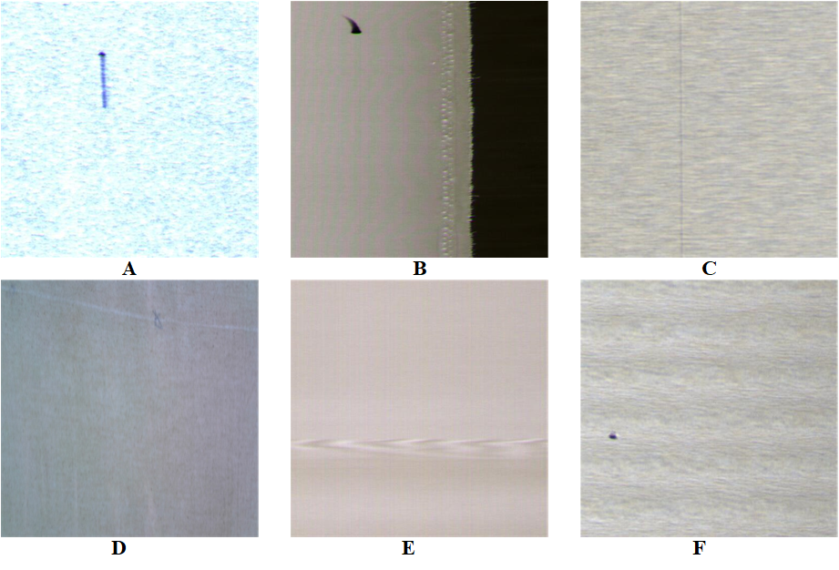
Fig.1. Various fabrics and defects (A) Linen fabric with end out defect (B) Cotton fabric with defect (C) Linen fabric with end out defect (D) Linen fabric with broken yarn and stain defects (E)Non-defective fabric with moire pattern (F) Cotton fabric with hole defect
This paper proposes an unsupervised method to realize accurate fabric defects detection within small samples. Firstly, a spatial domain saliency method is proposed to obtain saliency regions which may be potential defects. Secondly, fabric features extraction method is proposed to extract geometrical, intensity, and texture features from these saliency regions. Thirdly, an adaptative clustering algorithm is proposed for final fabric defects classification. The main contributions of this paper are highlighted as follows.
1) To reduce the impact of texture variations on defects detection, a multi-level spatial domain saliency method is proposed to generate multi-level saliency values for fabric image using color histograms to convolute with pixel values of image. The proposed method can greatly suppress the background information and obtain potential defects regions via the fusion of multi-level saliency values.
2) The feature extraction method is proposed to extract geometrical, intensity, and texture features to realize accurate representation of fabric features. And the influence of these three vital fabric features on fabric defects detection are quantitatively evaluated, which provides a potential way to improve the detection performance within small samples.
The rest of this paper is organized as follows. Section 2 reviews the related works in terms of classic fabric defects detection methods, supervised learning methods, and unsupervised learning methods. Section 3 describes the proposed unsupervised fabric defects detection method which includes the spatial domain saliency method, fabric feature extraction method, and adaptative clustering algorithm for fabric defects detection. Experiments and discussions are presented in section 4. Finally, conclusions and future work are given in Section 5.

Related Works
Fabric defect detection methods can be divided into two categories: classic methods and learning-based method. Classic methods highly rely on feature engineering with prior knowledge, which can be classified as statistical, structural, spectral, and model-based methods. And the learning-based methods can further be divided into supervised learning methods and unsupervised learning methods [7,8].
- Classic Fabric Defects Detection Methods
Statistical methods [9] distinguish defective and non-defective regions according to their different statistical features such as similarity, mean value, variance values, and regularity. The typical statistical methods include the auto-correlation metric and co-occurrence matrix methods. These methods consider outliers of statistical feature distribution as defective regions to realize the detection of fabric defects. And they are prone to be influenced by noise and background information.
Structural methods [10] consider the fabric as a composition of periodic texture, which realize the detection of whole fabric image by looking for the area with highest robustness as the elementary unit. The main difference among structural methods lies in the choice of elementary unit. And these methods are sensitive to noises of images or any changes in the process of detection.
Spectral methods [11,12] translate images to frequency domain and highlight the differences between defective and defect-free regions. Typical frequency-domain-based methods include Fourier transform, wavelet transform, and Gabor transform. These methods are well-suited for the segmentation of fabric defects because the information of defects is more obvious in frequency domain. Furthermore, the segmentation performance highly depends on the selection of operator.
Model-based methods [13,14] focus on modelling the texture of fabric images. In these methods, models are used to describe the texture of fabric images. And these models are used to determine whether there are defects in fabric images. Model-based methods can realize the accurate detection of complex patterned fabrics, but the modeling of fabric with complicated background is still a difficult problem.
Classic detection methods can realize the segmentation of defects through statistical analysis, filtering, and image modelling. But they are highly dependent on the feature engineering and are easily disturbed by fabric texture. Therefore, they are not robust enough to realize the detection of various types of fabrics.
- Supervised Learning Fabric Defects Detection Methods
In recent years, deep learning methods have attracted extensive attention in image classification task [15]. Lots of deep learning methods have been proposed to solve the fabric defects detection issues because they can efficiently extract features from complicated fabric images and realize the detection of defects by constructing convolutional neural network (CNN).
To realize the defects detection of various fabrics with complicated texture. Jing [16] decomposed fabric image into local patches and constructed the deep convolutional neural network to slide over the whole image and extract fabric features so as to realize the classification and location of defects. Zhao [17] designed a multi-scale convolutional neural network to obtain different scales of feature maps and enhance the representation of tiny fabric defects by fusing multi-scale features. It can realize the detection of five types of defects in linen and plaid fabrics. Jun [18] proposed a two steps deep-learning fabric defects detection framework, the first neural network is used to predict the existence of defects, and the second neural network is designed to realize the classification of defect.
To further improve the accuracy of defects detection within small samples, the generative adversarial network (GAN) was applied to fabric defects detection. Liu [19] respectively designed the semantic segmentation CNN for defects detection and the multistage GAN to synthesize reasonable defective fabric samples. The semantic segmentation CNN is used to extract fabric features and obtain the locations of defects. The multistage GAN is used to explore shapes and distributions of defects so as to generate reasonable defects in novel fabric. The generated fabric images are used to the re-training of semantic segmentation network so as to improve detection accuracy under different conditions. Le [20] proposed Wasserstein generative adversarial nets (WGANs) which combined transfer learning techniques with multi-model assembling framework. And it is proved that the proposed method is more effective on unbalanced and rare datasets of fabric with defects.
Deep learning methods can realize precise extraction of both texture and defects features of fabric so as to realize accurate defects detection, but it needs a large amount of labelled fabric images to do the model training. Although GAN can be used to generate defective fabric images from the data level. How to ensure the quality of generated fabric images is still a challenge.
- Unsupervised Learning Fabric Defects Detection Methods
Unsupervised learning methods have been extensively studied because they do not need labelled data to do model training. Mei [21] proposed a multi-scale convolutional autoencoder network model (MSCDAE) for fabric defect detection. This method used defect-free fabric samples to train the model and further improved the accuracy of detection via the fusing multi-scale Gaussian pyramid images. Hamdi [22] used non-extensive standard deviation filtering to segment defects from fabric images. It split fabric images into equal blocks and calculate the square difference between each block. And the K-Means clustering method is used to classify the blocks into defective and non-defective ones as these differences. Zhou [23] proposed a fabric defects detection method based on local patch approximation to realize automated defects segmentation from fabrics. With the clue of the differentiation in approximation error, defective regions can be detected from patch-level. Hu [24] designed a deep convolutional generative adversarial network (DCGAN) which consists of a discriminator and a generator, they are trained to learn fabric features and reconstruct normal fabric images. By subtracting the reconstruction image from the original image, potential defective regions will be highlighted.
Unsupervised learning methods realize the fabric defects detection by learning features of the defect-free fabric, so they do not rely on large number of defective samples for the model training, which are more suitable for fabric defects detection within small defective samples.
- Analysis and motivation
In summary, unsupervised learning methods can better realize the detection of various fabrics defects compared with classic methods and deep learning methods, because they can achieve great performance of defects detection and do not need a large amount of data for the model training.
However, current unsupervised learning methods mainly focus on learning the texture features from defect-free samples to realize the detection of fabric defects, and they still lack the research on the effect of defects features on fabric defects detection. Therefore, the efficient detection of fabric defects may not be achieved due to the lack of defects features.
In order to solve this problem and realize more accurate fabric defects detection within small samples, various fabric features and defects features need be extracted to analyze their influence on fabric defects detection. And before the feature extraction, the background information which may affect the extraction of defects features must be eliminated firstly. Therefore, an unsupervised learning method which includes data pre-processing stage, features extraction stage, and decision-making stage is proposed in this paper.
(1) In data pre-processing stage, in order to reduce the impact of fabric background on the extraction of fabric features, a spatial domain saliency method is proposed to suppress the background information and obtain saliency regions which may be potential defects.
(2) In features extraction stage, geometrical features, intensity features, and texture features are respectively extracted from those saliency regions to represent fabric features, and these extracted features are used to do the defects detecting.
(3) In decision making stage, an adaptative fabric features clustering algorithm is proposed to sum these features as the weight of each fabric so as to realize final fabric defects detection.

The Unsupervised learning method for fabric defects detection
This section introduces the unsupervised learning method for fabric defects detection in terms of spatial domain saliency method, fabric features extraction method, and an adaptive fabric feature clustering algorithm. The framework of the proposed fabric defect detection method is shown in Fig.2.
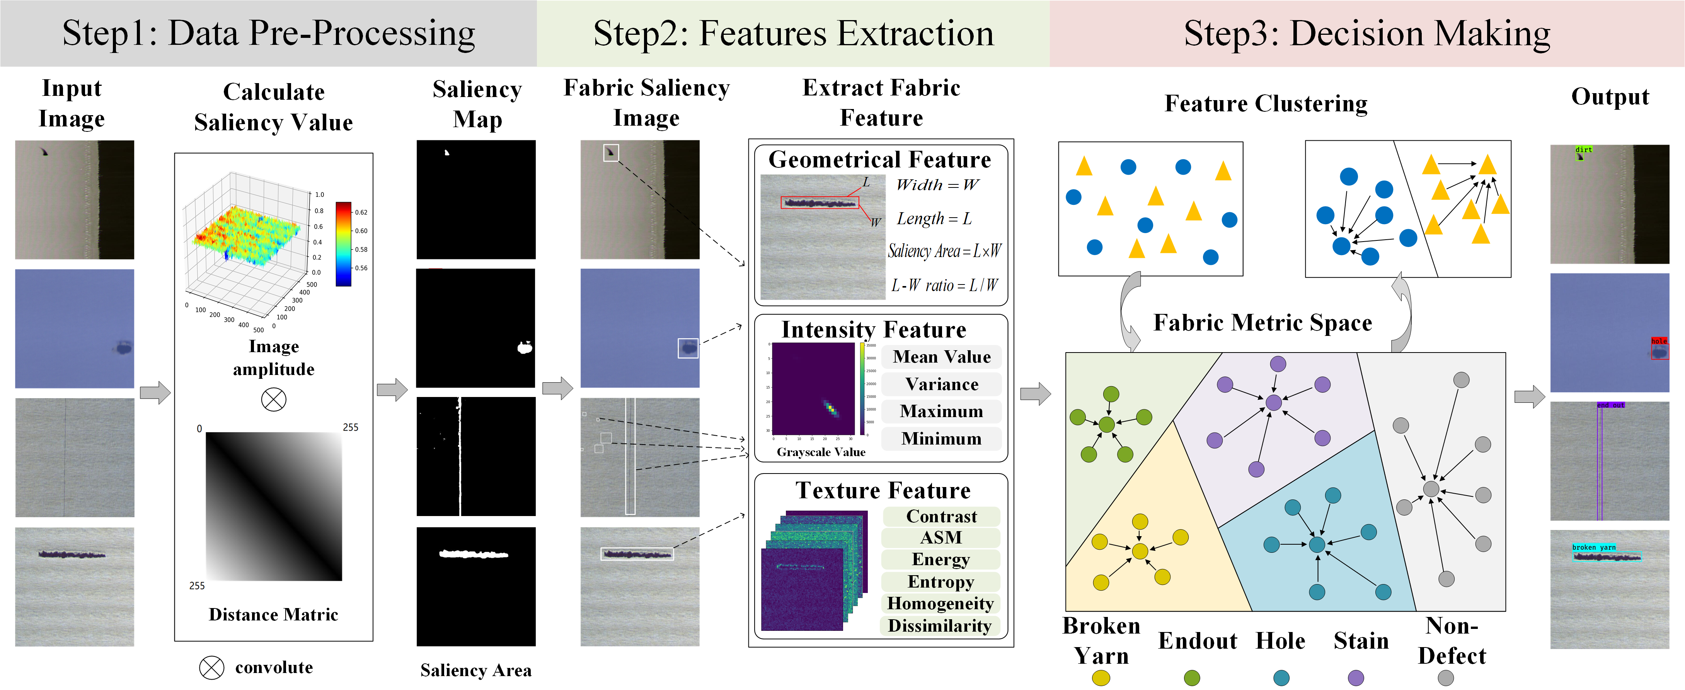
Fig.2. Framework of proposed unsupervised fabric defects detection method

Multi-level spatial domain saliency (MSDS) method
Psychological studies have proved that the visual system of humans is sensitive to the salient contrast of image areas, such as texture, color, and intensity [23,24]. Inspired by this inherent characteristic of human visual system, a multi-level spatial domain saliency method is proposed to suppress the background information and obtain saliency regions of fabric image, which can be divided into three steps: (1) The multi-level saliency values of the image are calculated; (2) The logical AND operation and 3-sigma criterion are used to filter the background information and obtain saliency map; and (3) The pixel-level region growing technique is designed to get the saliency regions of the image, as shown in Fig.3.
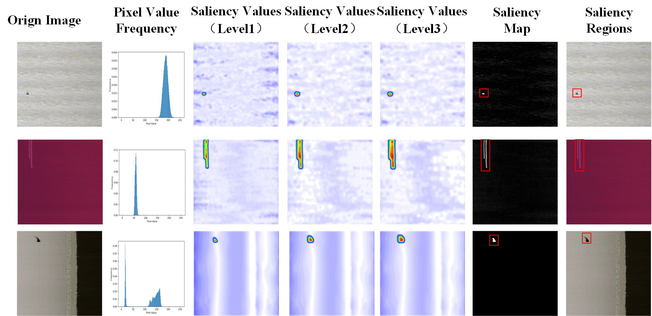
Fig.3. Segmentation and location results of proposed MSDS methods on various fabrics
(1) The saliency map of an image is obtained by calculating the color contrast between image pixels. The saliency value $S\left(I_{k}\right)$ of a pixel $I_{k}$ in the image $I$ is defined as:
$S\left(I_{k}\right)=\sum_{∀I_{i}∈I}{\left\|I_{k}-I_{i}\right\|}$ (1)
Where $I$ represents the color value of each pixel, which is in the range of $\left[0,255\right]$, and $\left\|⋅\right\|$ represents the distance metric of color values between two pixels. This formula can be expanded as:
$S\left(I_{k}\right)=\left\|I_{k}-I_{1}\right\|+\left\|I_{k}-I_{2}\right\|+⋯+\left\|I_{k}-I_{N}\right\|$ (2)
Where $N$ represents the total number of pixels in an image. In this formula, salient pixels with higher color values must be farther away from the other pixels and thus have greater saliency values.
However, one by one calculation of the distance metric is time-consuming. The proposed algorithm can reduce its complexity to linear computation by using image color histogram to calculate its saliency value. The formula can be further simplified as:
$S\left(I_{k}\right)=\sum_{n=0}^{255}{f_{n}}\left\|I_{k}-I_{n}\right\|$ (3)
Where $f_{n}$ is the frequency of pixel value in the image, which is expressed in the form of histograms. Since $I∈[0,255]$, the color distance metric $\left\|I_{k}-I_{n}\right\|$ is also in the range of $[0,255]$.
(2) To better suppress the background information and obtain shapes of defects, multiple pyramid saliency values ${S\left(I_{k}\right)}^{(i)}$ are obtained by multi-level maxpooling. Moreover, the feature maps in adjacent levels are combined via logical AND operation.
${S\left(I_{k}\right)}^{(i,i+1)}={S\left(I_{k}\right)}^{(i)}\&{S\left(I_{k}\right)}^{(i+1)}$ (4)
The symbol "&" refers to the AND operation between pixels at the same position. And the final saliency values $S\left(I_{k}\right)$ is obtained by the logical OR operation.
$S\left(I_{k}\right)={S\left(I_{k}\right)}^{(1,2)}|{S\left(I_{k}\right)}^{(2,3)}$ (5)
After getting the saliency values $S\left(I_{k}\right)$, the segmentation based on 3-sigma criterion is conducted to get the final saliency map $SalM\left(I_{k}\right)$.
Based on the 3-sigma criterion, the normal data distribution is $（μ\text{-3}σ,μ+3σ）$, where $μ$ stands for mean value and $σ$ stands for standard deviation $S\left(I_{k}\right)$, the final saliency map $SalM\left(I_{k}\right)$ can be defined as:
$SalM\left(I_{k}\right)=\left\{\begin{matrix}0 & S\left(I_{k}\right)∈(μ\text{-3}σ,μ+3σ) \\ 1 & \text{ otherwise }\end{matrix}\right.$ (6)
(3) In order to obtain complete region of fabric defects, a region growing technique is designed to calculate the coordinates of saliency regions. In the growing process, saliency map $SalM\left(I_{k}\right)$ is evenly divided in to $n×m$ regions. Given a seed point $S_{i}$, a rectangular box cantered on $S_{i}$ with unit size is created as the seed region $S_{r}$. The region $S_{r}$ contains four sides $r∈\{x_{l},x_{r},y_{t},y_{b}\}$, which iteratively expands by analyzing the saliency energy $EP(r)$. Two energies $E\left(s_{r}\right)$ and $E\left(s_{r}^{'}\right)$ are calculated for both internal and external saliency values respectively. The $EP(r)$ is calculated as follows:
$EP(r)=\frac{E\left(s_{r}\right)E\left(s_{r}^{'}\right)}{α^{2}}$ (7)
Where $E\left(s_{r}\right)$ is the sum of saliency values of current region, and $E\left(s_{r}^{'}\right)$ is the change of saliency value after one unit expansion, and $α^{2}$ is for normalization purpose. The region $S_{r}$ moves side $r∈\{x_{l},x_{r},y_{t},y_{b}\}$ outward with a unit length if $EP(r)>Th$. The expanding stops when $EP(r)<Th$, where $Th$ stands for pre-set thresholds. Thus, the expansion conducts only if both the internal $E\left(s_{r}\right)$ and external sides $E\left(s_{r}^{'}\right)$ have high values. And it will stop at the boundary between the high saliency regions for defects and the low saliency regions for the background, as shown in Fig.4.
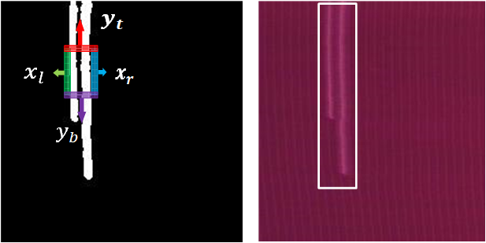
Fig.4. An example for region growing

Fabric feature extraction
Although different fabrics are quite different in color and texture, same defects of different fabrics always have similar features because they are caused by similar reasons. In the production of knitted fabric, broken-yarn defects are caused by the broken of several yarns, and end-out defects are produced because spinning needle’s fail to knit the yarn. Therefore, broken yarn and end-out defects are more prominent in the shape. The geometric features may be of great importance to their detection. The stain defects will cause the change of images pixel values in one specific area. So, intensity features may be important to the detection of stain defects because they will cause significant changes in pixel values. And those unique features can be used to support the defects classification [25,26].
In this section, the fabric feature extraction is designed to extract geometrical, intensity, and texture features of fabrics from the saliency regions in terms of the size, shape, color and texture information respectively based on above knowledge, realizing the accurate description of defects on the feature level.
Firstly, those fabrics are analyzed from the geometric feature. For instance, end-out defects are long and narrow in the vertical direction, while broken-yarn defects are long in the horizontal direction. Hole and stain defects have relatively regular shapes but tiny sizes. Therefore, by calculating the values of pixel points $P(i,j)$ in the saliency region $S_{r}$, four geometrical features are extracted to describe various defects, including Saliency Area, Length, Width, and Length-Width Ratio, which are used to describe geometrical features of defects by calculating the shape and size of saliency regions $S_{r}$, as shown in Fig.5.
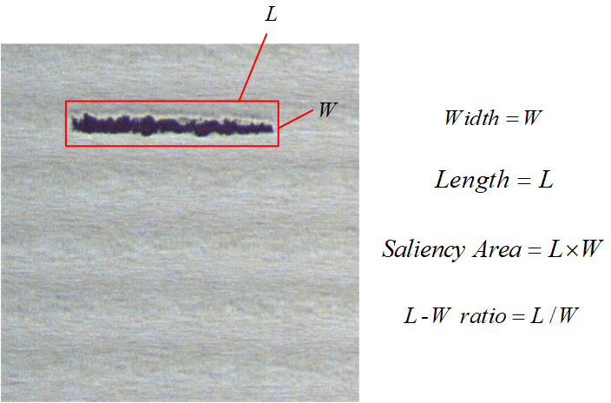
Fig.5. Samples of four fabric geometrical features
Secondly, compared with non-defective fabric, there are some changes in color and grayscale value in defective fabric regions. Therefore, eight intensity features including Grayscale Mean Value, Grayscale Variance Value, Grayscale Maximum, Grayscale Minimum, Background Grayscale Mean Value, Background Grayscale Variance Value, Background Grayscale Maximum, and Background Grayscale Minimum can be extracted to describe fabric intensity features by calculating the grayscale values and background grayscale values.
Finally, the appearance of defects will cause changes in fabric texture, which can make a great contribution to the detection of defects. The Grey Level Co-occurrence Matrix (GLCM) $G(i,j)$ [27] analyses the grayscale values’ spatial distribution of fabric images so as to obtain the texture feature of fabric, which has been widely used in the analysis of fabric texture. Based on the GLCM, six texture features including Energy, ASM, Contrast, Entropy, and Homogeneity are extracted, as shown in Fig.6.
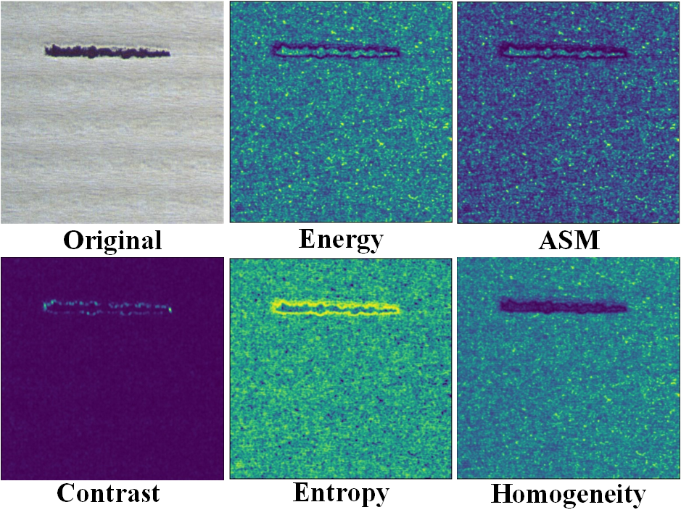
Fig.6. Samples of six fabric texture features
Energy describes the uniformity of image grey distribution and the thickness of texture. Larger energy value indicates that current texture is more regular and stable. It can be obtained by calculating the sum of $G(i,j)$.
$Energy=\sum_{i=1}^{n}{\sum_{j=1}^{m}{G(i,j)}}$ (8)
ASM is quadratic sum of $G(i,j)$, the texture is coarser when ASM value is larger.
$ASM=\sum_{i=1}^{n}{\sum_{j=1}^{m}{G(i,j)^{2}}}$ (9)
Contrast reflects comparison of the fabric texture’s brightness. The higher value of Contrast, the clearer its texture will be. It can be calculated as:
$Contrast=\sum_{k=1}^{n-1}{k^{2}}\sum_{\left|i-j=k\right|}{G(i,j)}$ (10)
Entropy is a measure of the randomness of the image texture, which shows the complexity of the image.
$Entroy=-\sum_{i=1}^{n}{\sum_{j=1}^{m}{G(i,j)\log{G(i,j)}}}$ (11)
Homogeneity represents the local uniformity of the fabric texture. The more uniform the fabric texture, the greater the value of homogeneity.
$Homogeneity=\sum_{i=1}^{n}{\sum_{j=1}^{m}{\frac{G(i,j)}{1+（i-j）^{2}}}}$ (12)
Where $n$ and $m$ represents the length and width of feature extraction area, which are calculated by coefficients $N$, $M$ and saliency region $S_{r}$. And $n=N(x_{r}-x_{l},)$, $m=M(y_{t}-y_{b})$, $x_{l},x_{r},y_{t},y_{b}$ are coordinates of saliency region $S_{r}$.
All the fabric features are shown in Table.1.
Table.1. Geometrical, intensity and fabric features
Feature Name | Feature Type
Saliency Area | Geometrical feature
Length | Geometrical feature
Width | Geometrical feature
Length-Width Ratio | Geometrical feature
Grayscale Mean Value | Intensity feature
Grayscale Variance Value | Intensity feature
Background Grayscale Mean Value | Intensity feature
Background Grayscale Variance Value | Intensity feature
Contrast | Texture feature
Homogeneity | Texture feature
Dissimilarity | Texture feature
ASM | Texture feature
Energy | Texture feature
Entropy | Texture feature

Adaptive feature weights K-Means clustering
In the clustering process, feature distribution of same class samples should be as close as possible, and feature distributions of different class samples should be as far as possible. It means that in the space of features, feature distance between in-class samples should be small and feature distance between out-class samples should be large.
Therefore, in this section, an adaptive fabric feature clustering algorithm is proposed to realize a reasonable distribution of fabric features in feature space. The feature weights matrix $t_{d}$ is used to map those features to Euclidean distance metric space. It is adaptively adjusted to realize the reasonable distribution of fabric features in feature space. To realize the adjustment of $t_{d}$, the density $S_{μ}^{(d)}$ and variance $S_{σ}^{(d)}$ are calculated firstly as follows.
$S_{μ}^{(d)}=\sum_{i=1}^{K}{\sum_{j=1}^{K}{{\left(μ_{i}^{(d)}-μ_{j}^{(d)}\right)}^{2}}};{i}≠j,d=1,2,…D$ (13)
$S_{σ}^{(d)}=\sum_{i=1}^{K}{\sum_{j=1}^{K}{\left(σ_{i}^{(d)^{2}}+σ_{j}^{(d)^{2}}\right)}};{i}≠j,d=1,2,…D$ (14)
Where $μ_{k}^{(d)}$ is the mean value of feature $d$ in all samples for class $k$, and $σ_{k}^{(d)}$ is the variance of feature $d$ in all samples for class $k$. $S_{μ}^{(d)}$ is the distances of fabric feature $d$ between all samples of each class, which represents the density of in-class samples. $S_{σ}^{(d)}$ is the sum of variance of feature $d$ between all samples of each class, which represents the dispersion of out-class samples.
Therefore, $S_{μ}^{(d)}$ represents the degree of aggregation between species and $S_{σ}^{(d)}$ represents the degree of dispersion between species, so that the $t_{d}$ can be updated as follows:
$J(d)=S_{μ}^{(d)}/S_{σ}^{(d)},d=1,2,…D$ (15)
${∆t}_{d}=J(d)/\sum_{1}^{d}{J}(d)$ (16)
$t_{d}=t_{d}+β{∆t}_{d}$ (17)
Where the $β$ is the learning rate. And the clustering process is as follows:
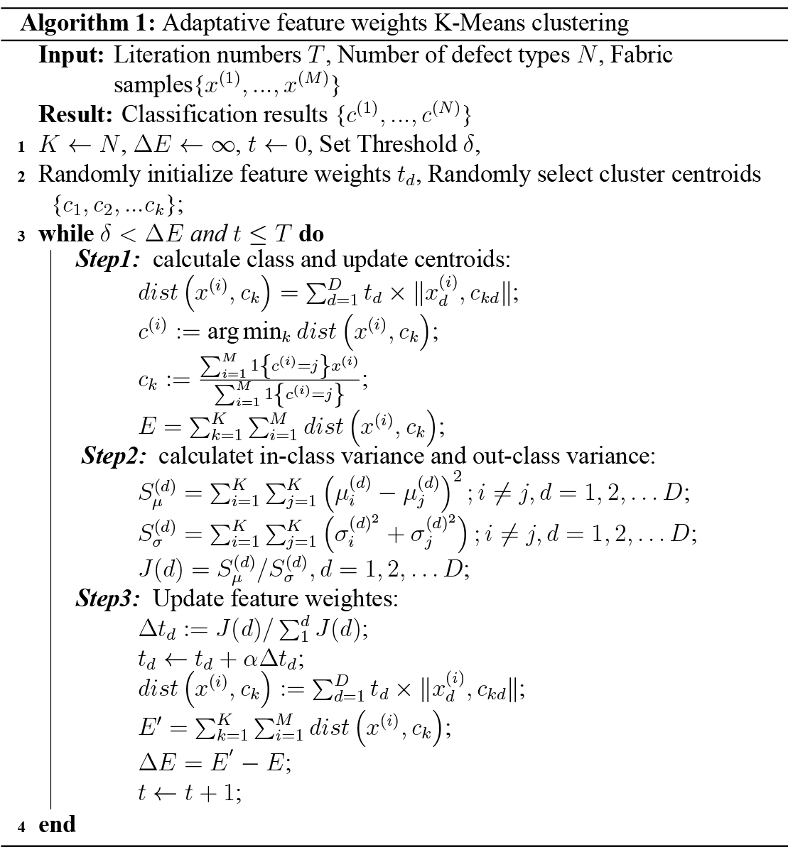
If the defects can be divided into $K$ types, each type contains $M(1,2,…,M)$ number of samples, and every sample has $D$ dimension of features. The Euclidean distance between various samples $x_{i}$ and the corresponding clustering center $c_{k}$ is:
$dist\left(x^{(i)},c_{k}\right)=\sum_{d=1}^{D}{t_{d}×{\left\|x_{d}^{(i)},c_{kd}\right\|}^{2}}$ (18)
Where $\operatorname{dist}\left(x^{(i)},c_{k}\right)$ is Euclidean distance between $x^{(i)}$ and $c_{k}$, $d=1,2,…,D$ represents different fabric features, $x_{d}^{(i)}$ and $c_{kd}$ represent the value of specific feature $d$ in sample $x^{(i)}$ and $c_{k}$. The clustering center $c_{k}$ is defined as:
$μ_{j}:{=}\frac{\sum_{i=1}^{m}{1}\left\{c^{(i)}=j\right\}x^{(i)}}{\sum_{i=1}^{m}{1}\left\{c^{(i)}=j\right\}}$ (19)
$c_{k}=\frac{1}{N_{k}}\sum_{i=1}^{N_{k}}{\sum_{d=1}^{D}{x_{id}(k=1,2,…K;{d}=1,2,…D)}}$ (20)
The optimized loss function $E$ is defined as:
$E=\sum_{k=1}^{K}{\sum_{i=1}^{M}{dist\left(x^{(i)},c_{k}\right)}}$ (21)

Experiments and discussions
To evaluate the performance of proposed fabric defect detection method, several experiments are carried out. Firstly, the experiment set-up and datasets are introduced. Secondly, the abilities of proposed MSDS method to suppress the non-defective fabrics areas and obtain the location of defective areas are evaluated in different types of fabric images. Thirdly, overall detection performance of proposed method is compared with several superior unsupervised methods on both of our fabric dataset and Tianchi fabric dataset. Fourthly, the influence of different kinds of fabric features on fabric defects detection is discussed. Then, the parameter setting of proposed methods is analyzed. Finally, the analysis about above experiments is given.

Experiment set-up and dataset introduction
In experiment section, learning rate $β$ is set as 10⁻³, iteration numbers $T$ is set as 1000, width coefficient $N$ and length coefficient $M$ are set as 1, which means fabric extraction area is equal to saliency region $S_{r}$. And two datasets are utilized in our study: a public fabric dataset from Alibaba Tianchi and one fabric dataset we collect in textile factory. And the training set and testing set are divided as 6:4.
The fabric images of our dataset are captured by fabric defects detection machines equipped in two textile factories in Shanghai and Jiangsu China, as shown in Fig.7. Two Line-Scan CCD cameras with 2048×2 pixels are used to capture images, and a line-array machine vision LED light is used to provide appropriate illumination.
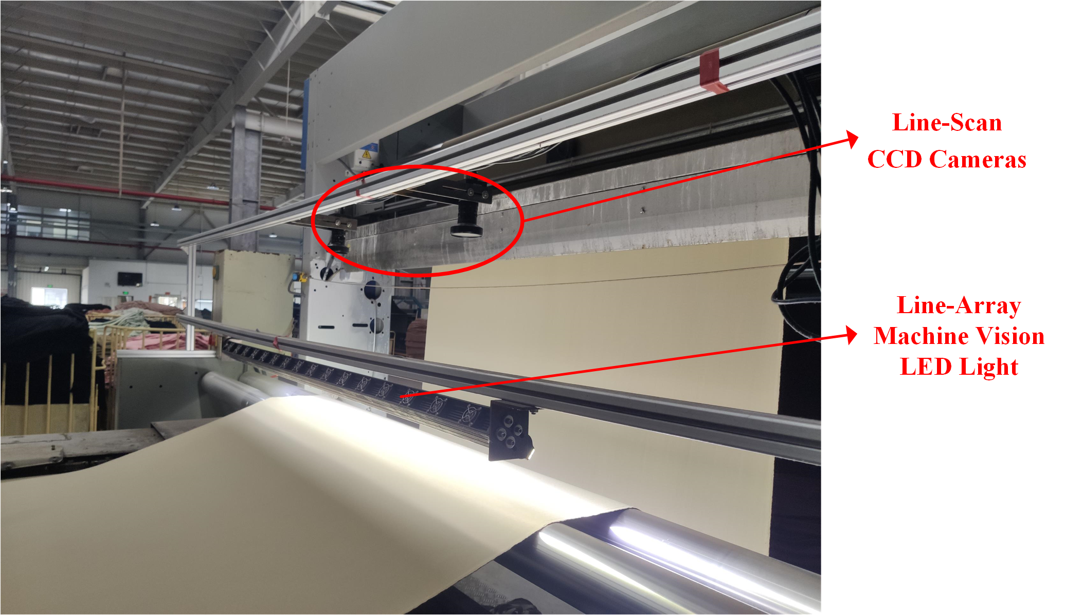
Fig.7. Fabric defects detection machine
Our dataset includes four most common types of defects in fabric production: stain, hole, broken yarn and end-out defects, and each type of defects has about 200 images from different fabrics. Besides, there are also about 2,000 images of non-defective fabrics in the dataset in order to evaluate the detection rate of proposed method. The Alibaba Tianchi fabric dataset includes about 8000 plain fabric images with more than ten types of defects. It is used for comparison experiment to evaluate the stability of proposed detection method.

MSDS performance evaluation
In order to evaluate the segmentation performance of proposed spatial domain saliency method (MSDS), the segmentation performance of MSDS with several superior algorithms such as the CDAN [28], SCP [29], LGMFC [30], LSG [31], SVD [32], LRD [33], OTSU [34] on our fabric dataset.
Some segmentation results of various textural samples are shown in Fig.8. The SHF method mistakenly detects Fig.8 (a) and (b) as defective fabrics. The LGMFC, LSG, SVD, LRD, and OTSU perform poorly in images with complicated texture such as Fig.8 (e) and (f). Our MSDS method achieves great segmentation results in both defective and non-defective fabrics. Compared with LGMFC, LSG and SVD, the proposed MSDS can better suppress the background information and moire pattern. Compared with CDAN and SHF, the MSDS can avoid false detection and realize more precise extraction of defects via the fusion of multi-level salient features.
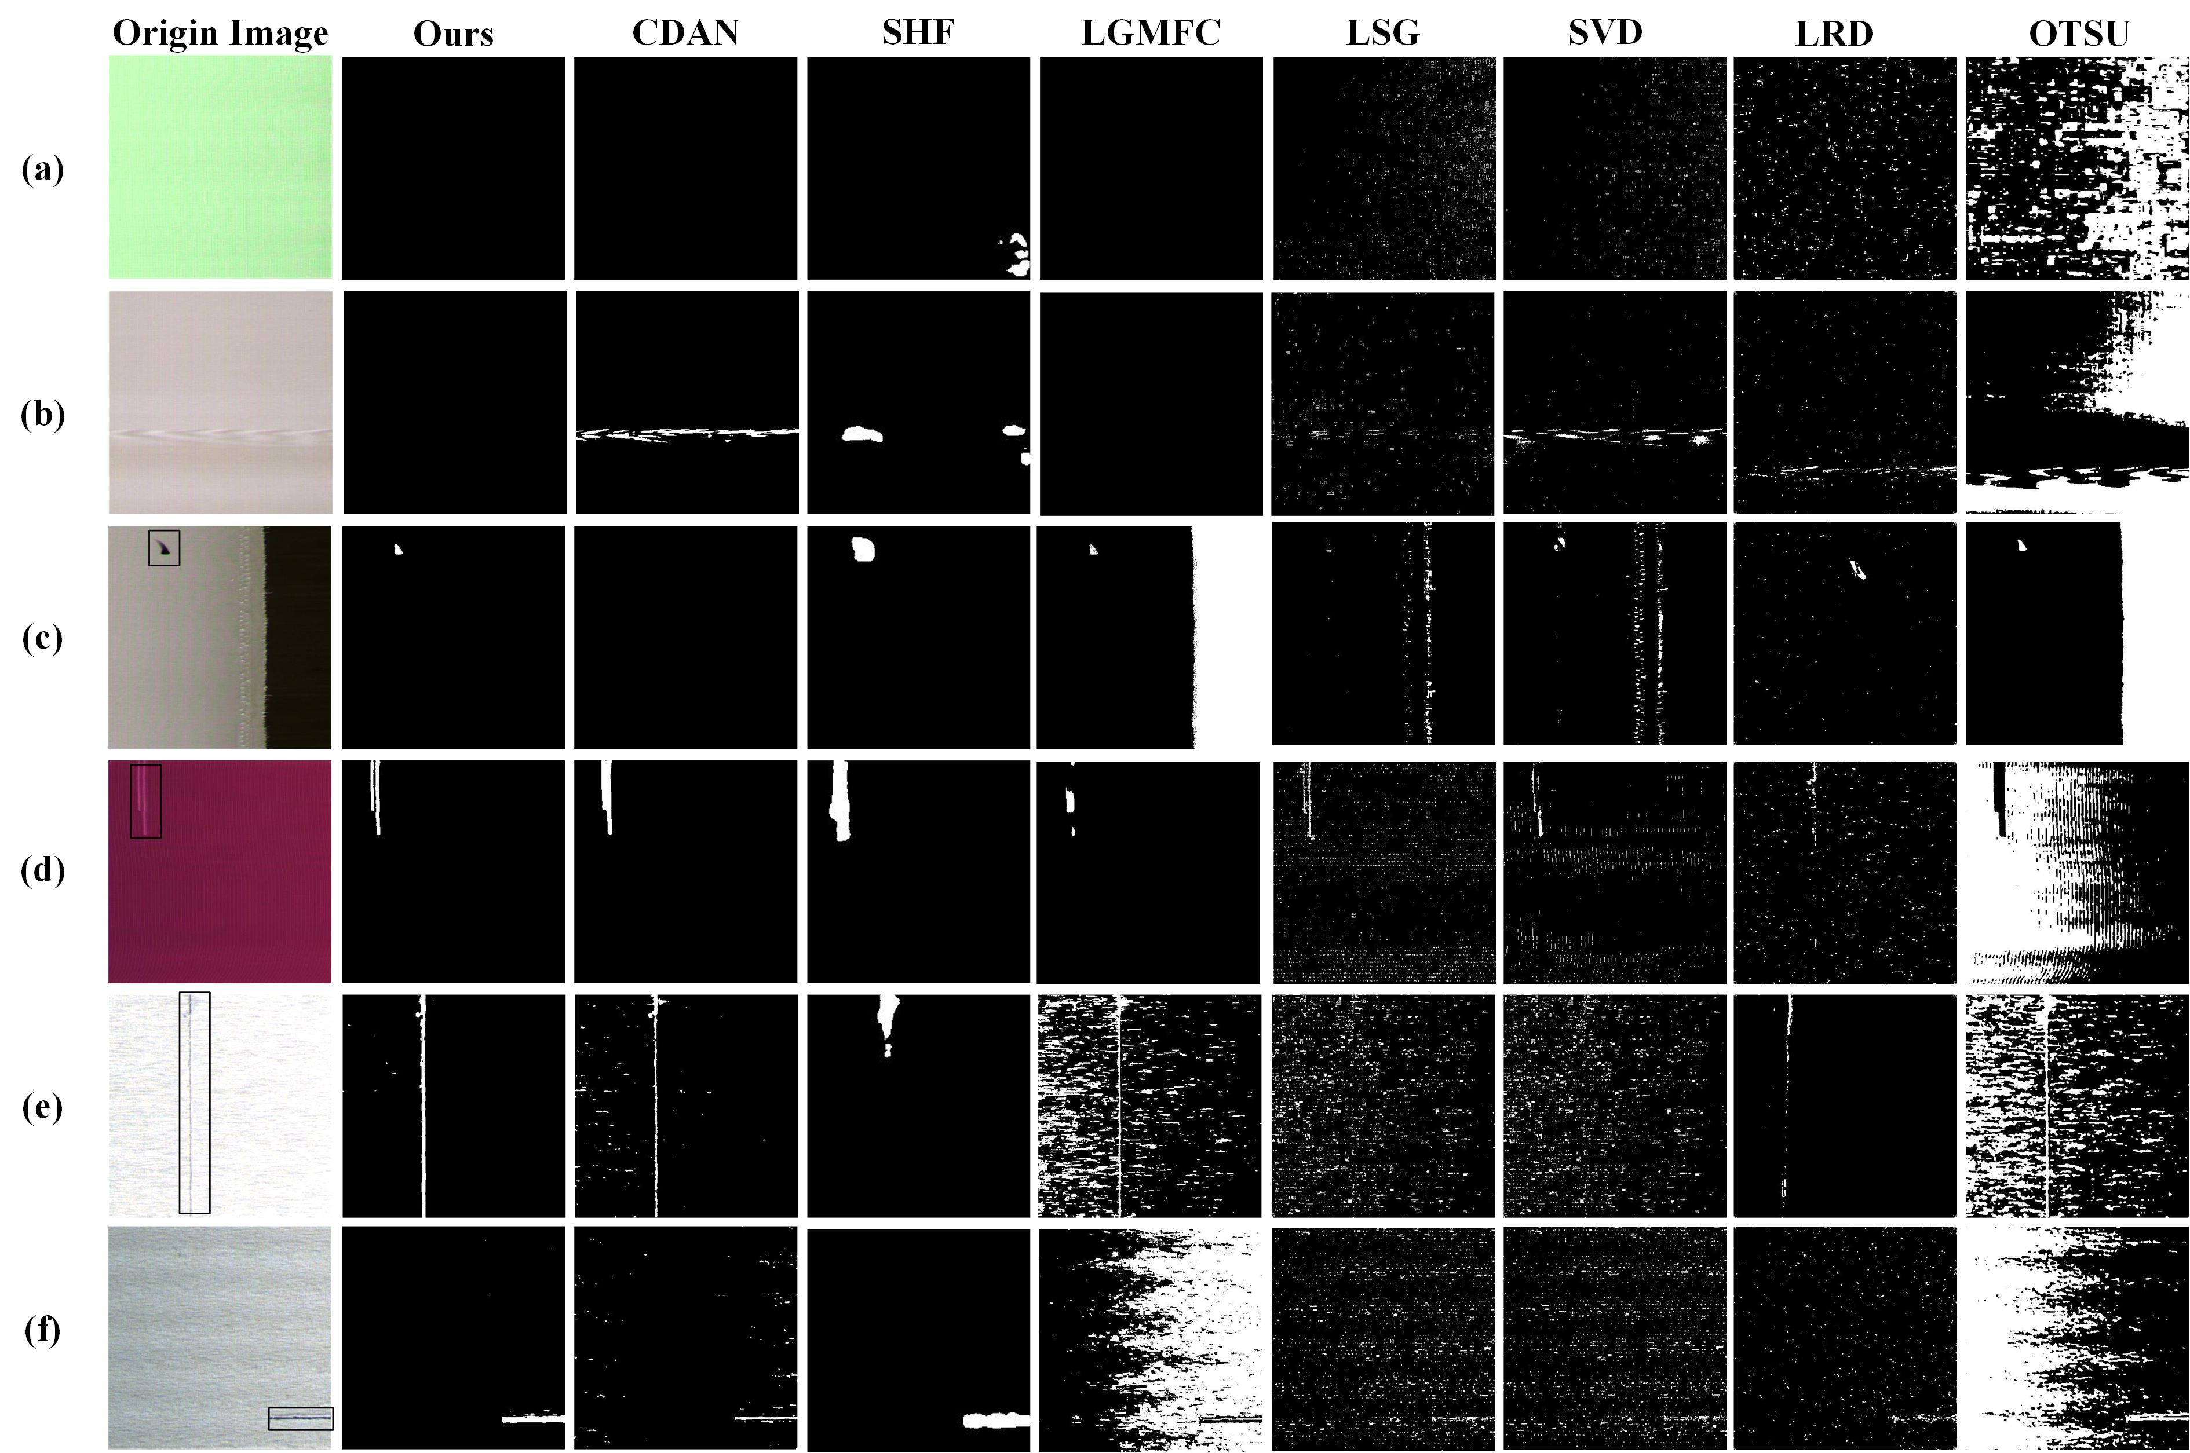
Fig.8. Segmentation results of various textural fabric samples

Overall performance comparison
To verify the detection performance of proposed adaptive fabric feature clustering algorithm (AFFC) within small fabric samples, detection results of proposed method are compared with other supervised deep-learning methods and unsupervised learning methods. The $Recall$ (Re) and $Precision$ (Pre) are used to evaluate the detection results:
${Recall}_{i}=\frac{{TP}_{i}}{{TP}_{i}+{FN}_{i}}×100\%$ (22)
${Precision}_{i}=\frac{{TP}_{i}}{{TP}_{i}+{FP}_{i}}×100\%$ (23)
In the experiment, the $K$ of AFFC is set to 5, which is equal to end-out, hole, broken yarn, stain and non-defective five classifications. The performance of proposed AFFC method is compared with other unsupervised fabric detection methods include: USE [36], DCGAN [24], TFKC [22], LPA [23], VTE [37], CRT [38] and AFFC detection method without adaptively fabric feature clustering (AFFC-WAC). The comparative results are shown in Table.2.
Table.2. Comparative detection results with different unsupervised methods
 | End-out |  | Hole |  | Broken Yarn |  | Stain
 | Re(%) | Pre(%) | Re(%) | Pre(%) | Re(%) | Pre(%) | Re(%) | Pre(%)
USE | 72.4 | 76.3 | 74.6 | 79.4 | 70.3 | 69.8 | 68.5 | 66.4
DCGAN | 87.2 | 88.3 | 91.3 | 90.7 | 92.0 | 91.2 | 90.9 | 92.1
TFKC | 86.3 | 89.6 | 84.8 | 86.3 | 88.3 | 89.6 | 90.3 | 91.5
LPA | 72.5 | 73.6 | 64.9 | 59.7 | 72.7 | 59.8 | 70.5 | 67.3
VTE | 88.9 | 91.2 | 92.3 | 93.5 | 93.7 | 95.2 | 92.6 | 95.3
CRT | 87.6 | 90.1 | 86.9 | 88.2 | 92.4 | 92.7 | 92.6 | 93.5
AFFC-WAC | 87.1 | 89.5 | 91.4 | 90.6 | 92.9 | 93.5 | 93.1 | 95.4
AFFC(Ours) | 90.1 | 92.4 | 96.1 | 94.6 | 98.5 | 98.6 | 96.4 | 97.2
It could be observed that the proposed AFFC achieves highest Re and Pre compared with other unsupervised detection methods. And compared with AFFC-WAC, the AFFC gets 2% improvement in precision by using adaptive feature clustering. Which indicates that the proposed AFFC method is more accurate in fabric defects detection within small samples.
To further validate the performance of the proposed fabric defects detection method, the proposed AFFC method is compared with above supervised learning and unsupervised methods on the Tianchi fabric dataset of Alibaba. The Tianchi fabric dataset has about twenty types of defects, in order to make experiment easy to carry out, some similar types of defects are combined and six types (end-type, hole, knots, needle lines, weft-type and stain defects) with the highest frequency are selected for experiments. The comparative results are shown in Fig.9.
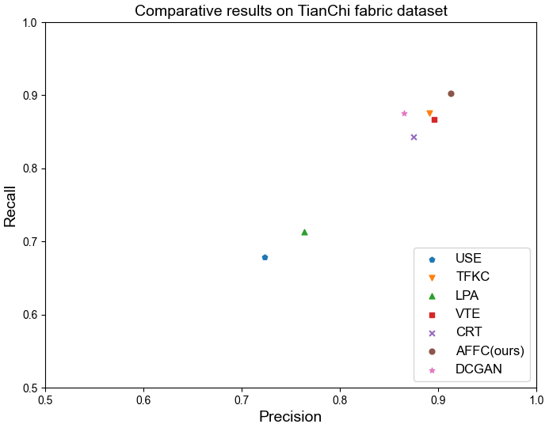
Fig.9. Comparative experiments on TianChi fabric dataset
It could be observed that the proposed AFFC fabric defects detection method can achieve about 90% precision and recall on TianChi fabric dataset. Compared with those unsupervised methods USE, TFKC, LPA, VTE, CRT, the detection performance of AFFC method on Tianchi fabric dataset is significantly better than them.
Various types of fabric samples for detection cases are shown in Fig.10. The detection results include two kinds of information: defect types and defect locations. It can be observed from Fig.10 that the proposed AFFC method can realize accurate defect detection of various types of fabrics with complicated textures and tiny defects.
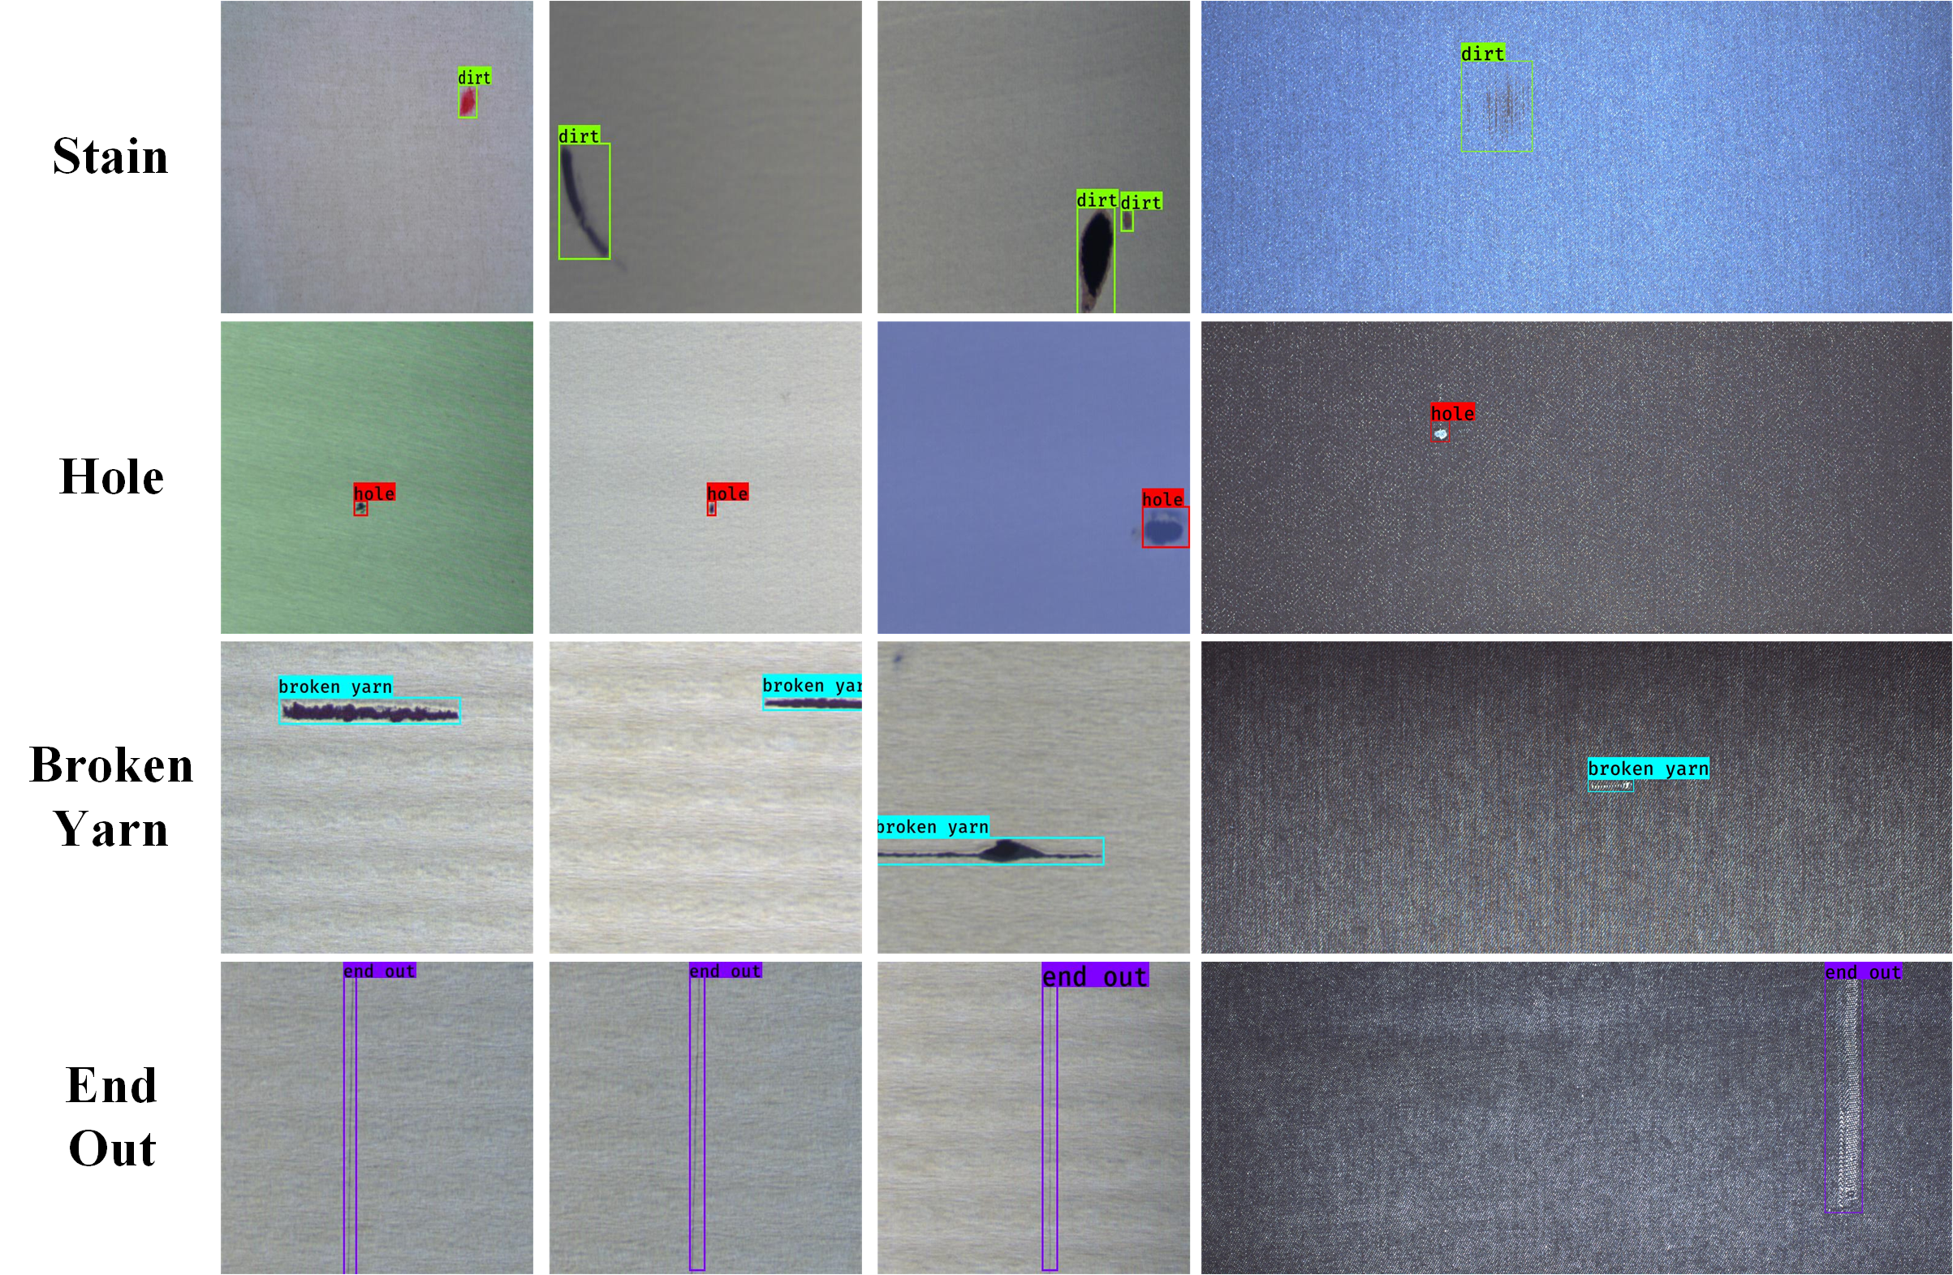
Fig.10. Detection results of various fabric samples

Influence of fabric features on detect precision
To evaluate the influence of different fabric features on the detection of defects, the influence of fabric features on detection precision are evaluated on our fabric dataset. The fabric geometrical, intensity and texture features are respectively used to perform the clustering operation, results are shown in Fig.11.
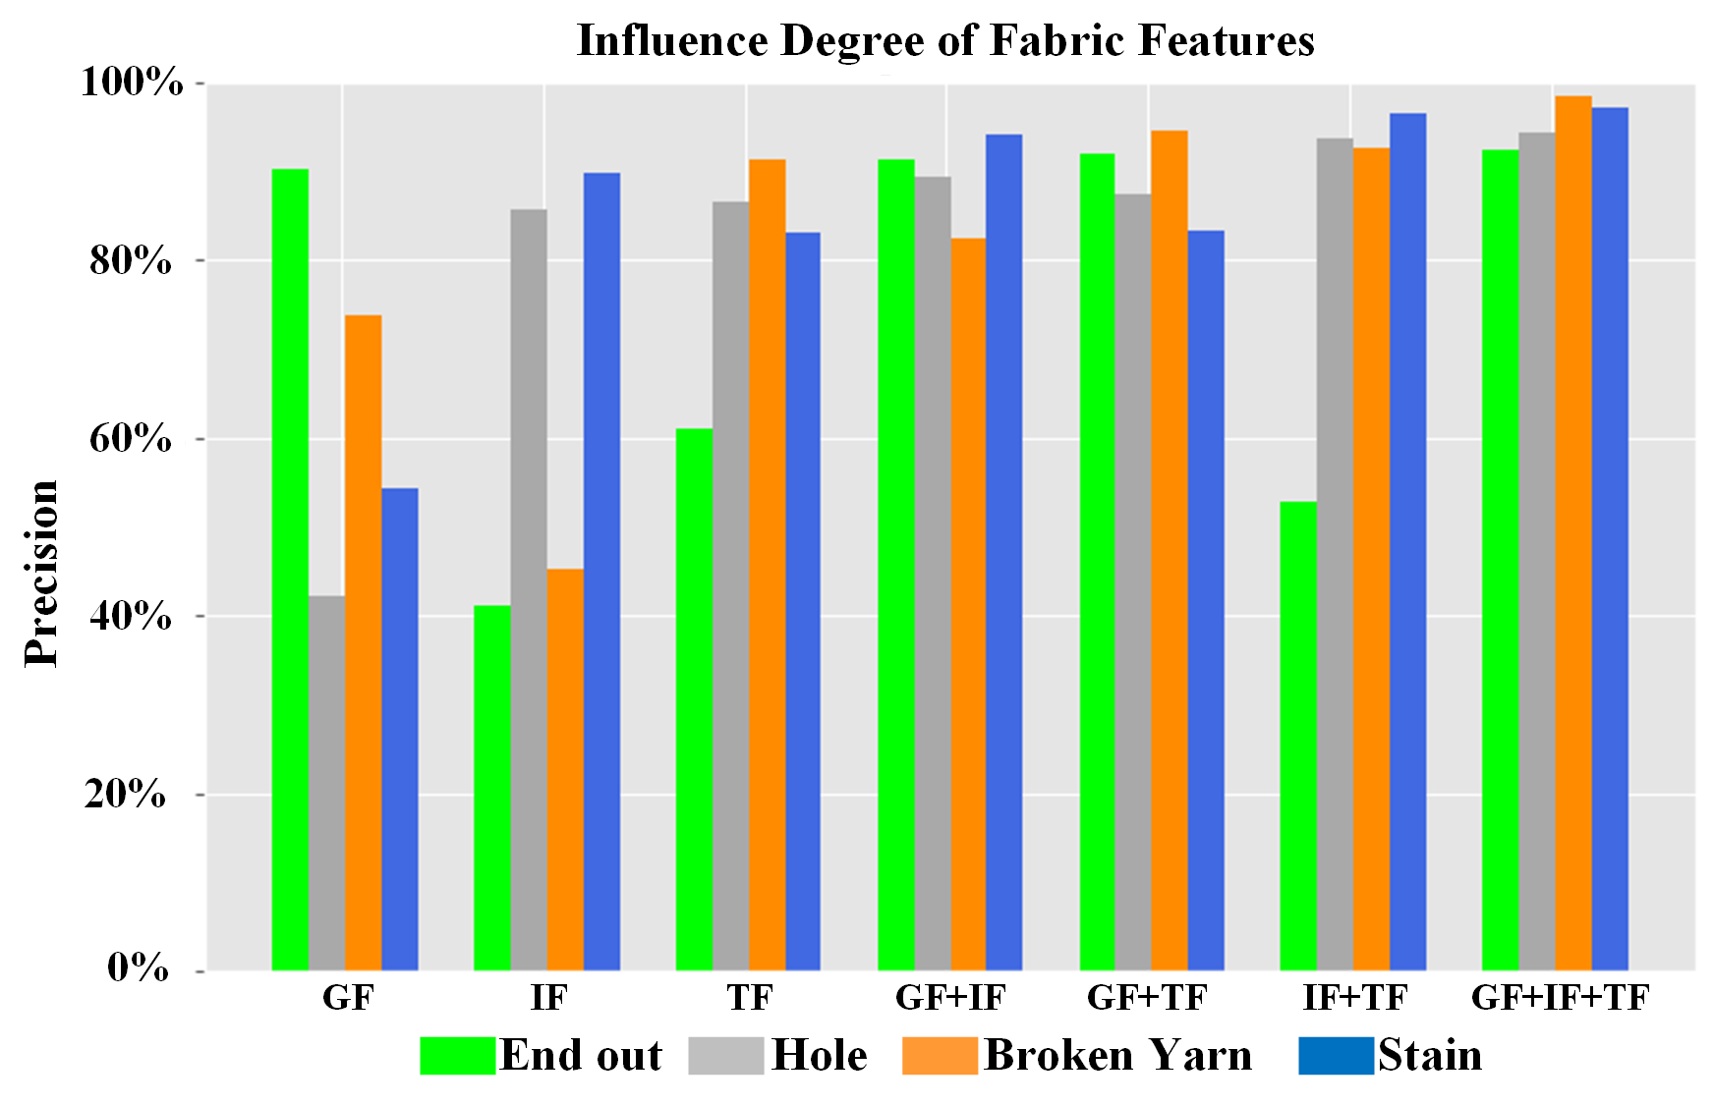
Fig.11. Influence of different fabric features on fabric defects detection precision
Where the GF represents that only geometrical features are used in detection. And GF+IF+TF represents that geometrical, intensity, and texture features are used together. It could be concluded that different defects are sensitive to specific fabric features. For example, the GF can achieve a better detection performance than IF+TF on the detection of end-out defects. It indicates that geometrical features have more important influence on the detection of end-out defects than intensity and texture features. Because end-out defects have tiny size and low contrast, which leads that their textures and intensity features are not obvious enough to be used in the detection of fabric defects. Moreover, the feature combinations which contain intensity features have a great performance on the detection of stain defects. It indicates that stain defects are sensitive to intensity features because stain defects can bring obvious changes in the color of the fabric. The broken yarn and hole defects are sensitive to the texture feature because both those two defects can lead to obvious differences in the texture of fabric. And the GF+IF+TF feature combination can achieve the best detection performance on four types of defects.

Parameter analysis
In this section, the setting of three main parameter $β$, $N$, $M$ are discussed via experiment analysis. For learning rate $β$, the value is set from 10⁻⁵ to 10⁻¹ increasing by a multiple of 10. Length and width coefficients $N$ and $M$ are set from 0.8 to 1.3 with the step size of 0.1.
For learning rate $β$, the precision is essentially same when it is lower than 10⁻³, so the learning rate $β$ is set as 10⁻³.
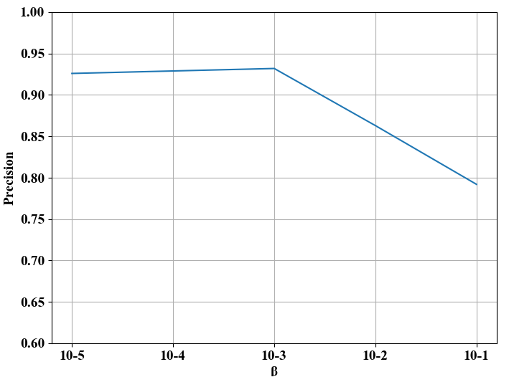
Fig.12. Experiments analysis of learning rate $β$
For the length and width coefficients $N$ and $M$, when both $N$ and $M$ are set as 1.1, the 93.7% precision can be achieved. Which means that the highest detection precision can be achieved when the feature extraction area is 1.1 times of saliency region $S_{r}$. When feature extraction area is same as the saliency region $S_{r}$, the 93.2% precision can be achieved. experimental results are shown in Table.3.
Table.3. Experiments analysis of coefficients $N$ and $M$
N  M | 0.8 | 0.9 | 1.0 | 1.1 | 1.2 | 1.3
0.8 | 72.3% | 76.2% | 70.5% | 71.9% | 69.6% | 63.7%
0.9 | 76.5% | 83.6% | 87.4% | 84.9% | 86.5% | 81.4%
1.0 | 74.1% | 81.6% | 93.2% | 91.5% | 89.6% | 83.1%
1.1 | 71.2% | 75.9% | 91.3% | 93.7% | 91.3% | 85.2%
1.2 | 65.8% | 70.5% | 83.4% | 90.6% | 92.9% | 87.4%
1.3 | 63.4% | 66.1% | 72.6% | 81.3% | 87.4% | 90.7%

4.7 Analysis and Discussions
From the above experiments, three findings are significant:
(1) Compared with other fabric defects segmentation methods, the proposed MSDS can greatly suppress the background information of fabric images via the fusion of multi-scale saliency maps, so as to get precise location of potential defects regions.
(2) In fabric defects detection, intensity features play an important role in the detection of stain defects because stain defects can bring an obvious change in the color of fabric. The broken yarn and hole defects are sensitive to the texture feature because both of those two defects can lead to obvious difference in fabric texture. And end-out defects have narrow shapes, so they are more sensitive to geometrical features. When geometrical features, intensity features, and texture features are used for fabric defects detection, it can realize the accurate detection of four types of defects.
(3) Compared with other unsupervised learning fabric defects detection methods, it can realize more accurate fabric defects detection by designing specific feature extraction method and adaptative clustering methods. Which indicates that it can realize more accurate fabric defects detection within small samples.

Conclusion
This paper proposed an effective unsupervised learning method to realize fabric defects detection within small samples. It can solve the variations of fabric texture and the lack of defective samples of industrial fabric defects detection, thereby reducing the production loss. By designing multi-level spatial domain saliency method, the background information can be suppressed, and potential defects regions can be obtained. Furthermore, three vital fabric features including geometrical, intensity, and texture features are extracted to quantitatively evaluate their influence on fabric defects detection. Benefit from the MSDS method and FFE method, the proposed fabric defects detection method achieves state-of-the-art performance for fabric defects detection within small samples.
Future work will be paid on applying the proposed method to fabrics with more complicated backgrounds and textures (e.g., patterned fabrics and jacquard fabrics), and low contrast defects such as crackiness. Besides, the analysis to improve the ability of fabrics feature extraction will be investigated in further research.

References
- Kumar A. Computer-Vision-Based Fabric Defect Detection: A Survey. IEEE Transactions on Industrial Electronics[J], 2008, 55(1):348-363.
- Chen Y, Ding Y, Zhao F, et al. Surface defect detection methods for industrial products: A review[J]. Applied Sciences, 2021, 11(16): 7657.
- Li F, Yuan L, Zhang K, et al. A defect detection method for unpatterned fabric based on multidirectional binary patterns and the gray-level co-occurrence matrix[J]. Textile Research Journal, 2020, 90(7-8): 776-796.
- Li Y, Luo H, Yu M, et al. Fabric defect detection algorithm using RDPSO-based optimal Gabor filter[J]. The Journal of The Textile Institute, 2019, 110(4): 487-495.
- Song S, Jing J, Huang Y, et al. EfficientDet for fabric defect detection based on edge computing[J]. Journal of Engineered Fibers and Fabrics, 2021, 16: 15589250211008346.
- Jun X, Wang J, Zhou J, et al. Fabric defect detection based on a deep convolutional neural network using a two-stage strategy[J]. Textile Research Journal, 2021, 91(1-2): 130-142.
- Nisha M F, Vasuki P, Roomi S M M. Survey on various defect detection and classification methods in fabric images[J]. Journal of Environmental Nanotechnology, 2017, 6(2): 20-29.
- Ngan H Y T, Pang G K H, Yung N H C. Automated fabric defect detection—a review[J]. Image and vision computing, 2011, 29(7): 442-458.
- Zhang K, Yan Y, Li P, et al. Fabric defect detection using salience metric for color dissimilarity and positional aggregation[J]. IEEE Access, 2018, 6: 49170-49181.
- Wang W, Deng N, Xin B. Sequential detection of image defects for patterned fabrics[J]. IEEE Access, 2020, 8: 174751-174762.
- Shao L, Zhang E, Ma Q, et al. Pixel-Wise Semisupervised Fabric Defect Detection Method Combined with Multitask Mean Teacher[J]. IEEE Transactions on Instrumentation and Measurement, 2022, 71: 1-11.
- Barman J, Wu H C, Kuo C F J. Development of a real-time home textile fabric defect inspection machine system for the textile industry[J]. Textile Research Journal, 2022: 00405175221111477.
- Vermaak H, Luwes N, Nsengiyumva P. A comparative study of methods for defect detection in textile fabrics[J]. Journal for New Generation Sciences, 2015, 13(3): 135-148.
- Li M, Cui S, Xie Z. Application of Gaussian mixture model on defect detection of print fabric[J]. J. Text. Res, 2015, 36(8): 94-98.
- He K, Zhang X, Ren S, et al. Deep residual learning for image recognition[C]. Proceedings of the IEEE conference on computer vision and pattern recognition. 2016: 770-778.
- Jing J F, Ma H, Zhang H H. Automatic fabric defect detection using a deep convolutional neural network[J]. Colouration Technology, 2019, 135(3): 213-223.
- Zhao S, Yin L, Zhang J, et al. Real‐time fabric defect detection based on multi‐scale convolutional neural network[J]. IET Collaborative Intelligent Manufacturing, 2020, 2(4): 189-196.
- Jun X, Wang J, Zhou J, et al. Fabric defect detection based on a deep convolutional neural network using a two-stage strategy[J]. Textile Research Journal, 2021, 91(1-2): 130-142.
- Liu J, Wang C, Su H, et al. Multistage GAN for fabric defect detection[J]. IEEE Transactions on Image Processing, 2019, 29: 3388-3400.
- Le X, Mei J, Zhang H, et al. A learning-based approach for surface defect detection using small image datasets[J]. Neurocomputing, 2020, 408: 112-120.
- Mei S, Wang Y, Wen G. Automatic fabric defect detection with a multi-scale convolutional denoising autoencoder network model[J]. Sensors, 2018, 18(4): 1064.
- Hamdi A A, Sayed M S, Fouad M M, et al. Unsupervised patterned fabric defect detection using texture filtering and K-means clustering[C].2018 International Conference on Innovative Trends in Computer Engineering (ITCE). IEEE, 2018: 130-144.
- Zhou J, Wang J. Unsupervised fabric defect segmentation using local patch approximation[J]. The Journal of The Textile Institute, 2016, 107(6): 800-809.
- Hu G, Huang J, Wang Q, et al. Unsupervised fabric defect detection based on a deep convolutional generative adversarial network[J]. Textile Research Journal, 2020, 90(3-4): 247-270.
- Yang C, Wu W, Wang Y, et al. A novel feature-based model for zero-shot object detection with simulated attributes[J]. Applied Intelligence, 2022, 52(6): 6905-6914.
- Peng Z, Gong X, Wei B, et al. Automatic Unsupervised Fabric Defect Detection Based on Self-Feature Comparison[J]. Electronics, 2021, 10(21): 2652.
- Shu Y, Zhang L, Zuo D, et al. Analysis of texture enhancement methods for the detection of eco-friendly textile fabric defects[J]. Journal of Intelligent & Fuzzy Systems, 2021, 41(3): 4439-4449.
- Mei S, Yang H, Yin Z. An unsupervised-learning-based approach for automated defect inspection on textured surfaces[J]. IEEE Transactions on Instrumentation and Measurement, 2018, 67(6): 1266-1277.
- Zhang K, Yan Y, Li P, et al. Fabric defect detection using salience metric for colour dissimilarity and positional aggregation[J]. IEEE Access, 2018, 6: 49170-49181.
- Zhang H, Ma J, Jing J, et al. Fabric defect detection using L0 gradient minimization and fuzzy C-means[J]. Applied Sciences, 2019, 9(17): 3506.
- Jia L, Chen C, Liang J, et al. Fabric defect inspection based on lattice segmentation and Gabor filtering[J]. Neurocomputing, 2017, 238: 84-102.
- Ma X, Xie X, Lam K M, et al. Saliency detection based on singular value decomposition[J]. Journal of Visual Communication and Image Representation, 2015, 32: 95-106.
- Shi B, Liang J, Di L, et al. Fabric defect detection via low-rank decomposition with gradient information and structured graph algorithm[J]. Information Sciences, 2021, 546: 608-626.
- Huang C, Li X, Wen Y. AN OTSU image segmentation based on fruitfly optimization algorithm[J]. Alexandria Engineering Journal, 2021, 60(1): 183-188.
- Bhalla K, Huang Y P. An Adaptive Thresholding Based Method to Locate and Segment Defects on LCD Panels[C].2021 International Conference on System Science and Engineering (ICSSE). IEEE, 2021: 328-333.
- Liu L, Zhang J, Fu X, et al. Unsupervised segmentation and elm for fabric defect image classification[J]. Multimedia Tools and Applications, 2019, 78(9): 12421-12449.
- Szarski M, Chauhan S. An unsupervised defect detection model for a dry carbon fiber textile[J]. Journal of Intelligent Manufacturing, 2022: 1-18.
- Hu X, Fu M, Zhu Z, et al. Unsupervised defect detection algorithm for printed fabrics using content-based image retrieval techniques[J]. Textile Research Journal, 2021, 91(21-22): 2551-2566.
- Xu R, Hao R, Huang B. Efficient surface defect detection using self-supervised learning strategy and segmentation network[J]. Advanced Engineering Informatics, 2022, 52: 101566.
- Chow J K, Su Z, Wu J, et al. Anomaly detection of defects on concrete structures with the convolutional autoencoder[J]. Advanced Engineering Informatics, 2020, 45: 101105.
- Dai W, Mujeeb A, Erdt M, et al. Soldering defect detection in automatic optical inspection[J]. Advanced Engineering Informatics, 2020, 43: 101004.

