Visible-light-mediated intermolecular crossed [2+2] cycloadditions using a heterogeneous copper triplet photosensitiser
Jun Guo^{1,5}, Qi Xia^{1,5}, Wing Yi Tang¹, Zekun Li¹, Xia Wu¹, Li-Juan Liu¹, Wai-Pong To¹, Hui-Xing Shu¹, Kam-Hung Low^{1,2}, Philip C. Y. Chow³, Tsz Woon Benedict Lo⁴ and Jian He^{1,2*}
¹Department of Chemistry, The University of Hong Kong, Hong Kong, China.
²State Key Laboratory of Synthetic Chemistry, The University of Hong Kong, Hong Kong, China.
³Department of Mechanical Engineering, The University of Hong Kong, Hong Kong, China.
⁴State Key Laboratory of Chemical Biology and Drug Discovery, Department of Applied Biology and Chemical Technology, The Hong Kong Polytechnic University, Hong Kong, China.
⁵These authors contributed equally: Jun Guo and Qi Xia.
*email: jianhe@hku.hk

Accepted by:
Nature Catalysis
January 18, 2024

Abstract: The photochemical [2+2] cycloaddition of styrenes provides an important and frequently used route for the synthesis of multi-substituted cyclobutanes. Despite the extensive studies in noble-metal- and organo-photocatalysis, developing sustainable cycloaddition methods with copper photosensitizers is still in its infancy, largely owing to their low reactivity and photostability. Herein, we show that the introduction of a binap-ligated heteroleptic copper(I) complex to the linker of a microporous zirconium-based metal−organic framework (MOF) produces a highly stable and reusable heterogeneous photocatalyst with an extended excited-state lifetime. Under visible light irradiation, this robust copper triplet photosensitizer efficiently promotes multiple intermolecular crossed [2+2] cycloadditions, including a previously unreported cycloaddition reaction of simple styrenes with electron-deficient alkenes. Our findings suggest that MOF-based heterogenization strategies have the potential to advance copper photocatalysis and foster a variety of visible-light-mediated energy-transfer processes.

Construction of aryl-substituted cyclobutane rings, the prominent structural features in a vast array of bioactive molecules^{1,2}, is essential for natural product synthesis and drug discovery^{3,4} (Fig. 1a). Photochemical [2+2] cycloadditions are arguably the most straightforward way to prepare such cyclobutane-containing compounds, which rely primarily on the activation of styrenes via electron or energy transfer with transition-metal or organic photosensitizers⁵⁻⁸ (Fig. 1b). In the homogeneous catalytic systems, an electron-rich styrene, typically bearing a 4-methoxy substituent, can undergo single-electron oxidation with strong oxidizing ruthenium complexes⁹, triaryloxopyrylium^{10,11}, or thioxanthylium salts¹² upon photoexcitation, affording the corresponding radical cation intermediate for subsequent trapping with another styrene. The same type of oxidative intermolecular crossed [2+2] cycloadditions have also been achieved using various polymer-based heterogeneous photocatalysts^{13,14}. While the Yoon group reported the first intramolecular crossed [2+2] cycloadditions of 1,2-disubstituted styrenes through triplet-energy-transfer catalysis in 2012¹⁵, intermolecular [2+2] cycloadditions between different styrenes involving triplet styrene formation were not realized until very recently¹⁶. Moreover, with the help of an iridium triplet photosensitizer, several exocyclic benzylidenes can efficiently participate in the cycloaddition reaction with electron-deficient alkenes to produce spirocycles¹⁷. In terms of heterogeneous photocatalytic energy transfer, only quantum dots are capable of promoting styrene [2+2] cycloadditions¹⁸; the reactivity is strongly associated with the introduction of a carboxylate substituent on the substrates¹⁹. Despite substantial advances in triplet photosensitization over the past decades, developing intermolecular crossed [2+2] cycloadditions of simple styrenes with other alkenes remains a significant challenge in visible light photocatalysis.
Due to their high photochemical tunability and relatively long photoexcited-state lifetimes, heteroleptic copper(I) complexes with bidentate nitrogen and phosphorus donor ligands are gaining importance as photoredox catalysts and photosensitizers for a wide range of light-mediated organic transformations^{20,21}. While it is possible to increase the energy-transfer activity of copper photosensitizers by replacing (9,9-dimethyl-9H-xanthene-4,5-diyl)bis(diphenylphosphane) (xantphos), one of the most commonly used bisphosphine ligands to construct photoactive copper species, with 2,2’-bis(diphenylphosphino)-1,1’-binaphthyl (binap)²², the corresponding cationic copper(I) complexes, such as [Cu(dmp)(binap)]⁺ (dmp = 2,9-dimethyl-1,10-phenanthroline), become completely unstable under light irradiation conditions²³ (Fig. 1c). While it is difficult to improve the photostability of copper–binap complexes by merely adjusting the steric and electronic properties of the chelating ligands, this fundamental issue may be resolved by heterogenizing the labile transition metal species on suitable framework matrices for catalyst-site isolation²⁴⁻²⁶. Our recent work has shown that a binap-based copper(I) photoredox catalyst stabilized on the surface of a pillar-layered MOF can efficiently promote iminyl radical-mediated reactions²⁷. We hypothesized that incorporating binap-ligated heteroleptic copper(I) species onto the organic linker of a structurally stable MOF support would prevent the photoinduced decomposition of copper triplet photosensitizers and extend their excited-state lifetimes due to MOF-enabled confinement effects²⁸ (Fig. 1c). This would be particularly advantageous for the development of visible-light-driven copper-catalyzed [2+2] cycloadditions through energy transfer.
In this Article we report the first intermolecular crossed [2+2] cycloadditions of simple styrenes with electron-deficient alkenes in visible light photocatalysis utilizing a MOF-supported copper triplet photosensitizer (Fig. 1d). Immobilization of the binap-ligated heteroleptic copper(I) complex in the MOF pore structures is vital for the dramatically improved photostability and photocatalytic activity. This heterogeneous copper photocatalyst significantly outperforms its homogeneous counterparts, with a turnover number (TON) of up to 4750 for the crossed [2+2] cycloadditions between different styrenes.

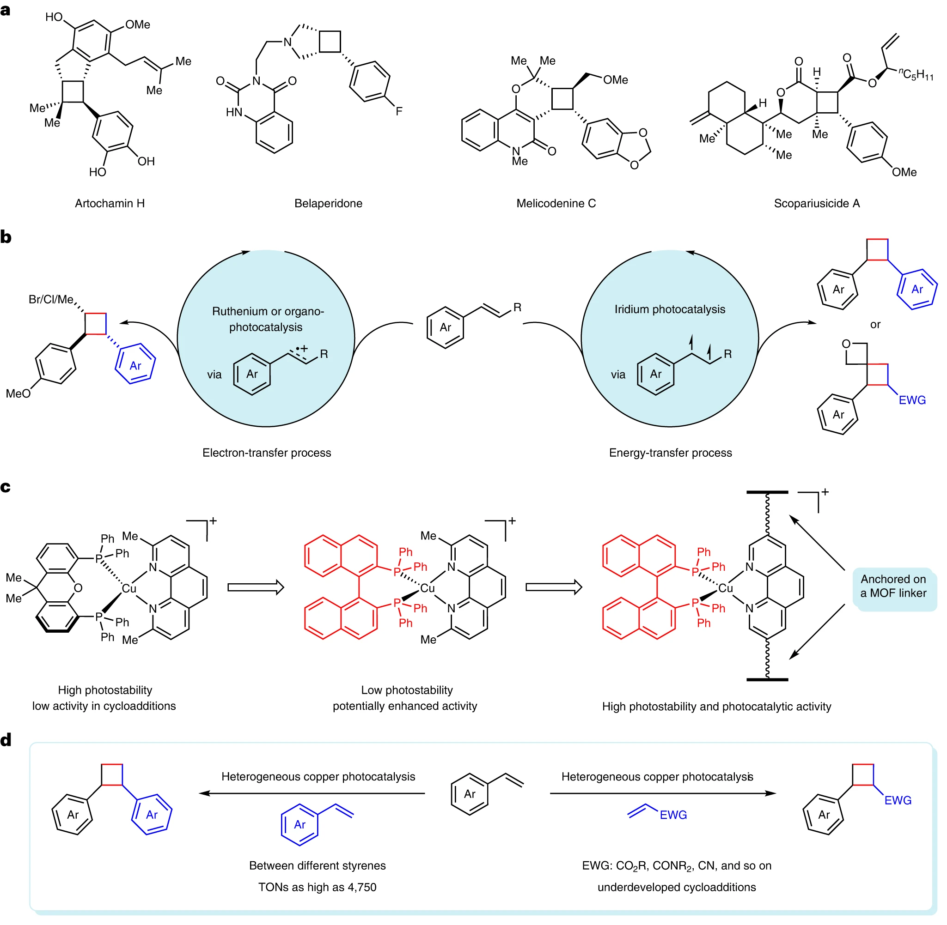
Fig. 1 | Photocatalytic intermolecular crossed [2+2] cycloadditions of styrenes under visible light irradiation. a, Several representative examples of biologically active cyclobutanes with aryl substituents. b, Previous homogeneous photocatalytic systems involving electron- or energy-transfer processes. c, Design of robust heterogeneous copper photosensitizers supported by MOFs. d, Demonstrating high catalytic efficiency and broad substrate scope in heterogeneous copper photocatalysis.

Results
Synthesis and characterization of MOF-supported copper photocatalysts. To accommodate a sterically hindered heteroleptic copper–binap complex in crystalline porous frameworks^{29,30}, the highly stable Universitetet i Oslo-69 (UiO-69) MOF^{31,32}, which consists of [Zr₆] inorganic nodes and terphenyl dicarboxylate organic linkers, was chosen as a desirable photocatalyst support. Considering that binap-ligated copper(I) complexes are intolerant of the solvothermal conditions for the MOF synthesis, we utilized a post-synthetic metalation method³³⁻³⁵ rather than pre-synthetic modification of MOF linkers^{36,37} to introduce the targeted copper species onto the UiO-69 MOF (Fig. 2a). To prevent a possible pore blockage during the metalation step, a small portion of the functionalized organic linker bearing a 1,10-phenanthroline (phen) moiety (i.e., 4,4’-(1,10-phenanthroline-3,8-diyl)dibenzoic acid) was mixed with a highly soluble tetramethyl-substituted terphenyl dicarboxylic acid in the synthesis of a phen-functionalized UiO-69 MOF (UiO-69-phen). The crystallinity and stability of UiO-69-phen are significantly superior to those of the one purely synthesized from the phen-containing linker. Its large Brunauer–Emmett–Teller (BET) surface area of 1,990 m² g^{–1} (Supplementary Fig. 11), comparable to that of the non-functionalized UiO-69 MOF³², and its pore width distribution centered at 1.6 nm (Supplementary Fig. 12) pave the way for the subsequent metalation with cationic bisphosphine-chelated copper(I) complexes.
Immersing UiO-69-phen in a dichloromethane solution of [Cu(xantphos)(MeCN)₂](PF₆) or [Cu(binap)(MeCN)₂](PF₆) at room temperature produced MOF-supported heteroleptic copper photocatalyst UiO-69-phen(xantphos)Cu or UiO-69-phen(binap)Cu. When the same metalation conditions were applied to non-functionalized UiO-69 MOF without a phen-containing linker, no heterogeneous copper catalyst was produced. It is worth noting that the phen-functionalized UiO-67 MOF with a much smaller pore width distribution³⁸ was unable to accommodate the bulky cationic binap-ligated copper(I) complex even at elevated temperatures, despite previous success in the integration of copper species bearing less hindered 1,2-bis(diphenylphosphino)ethane³⁹ (see details in Supplementary Information). Additionally, the attempts to directly encapsulate the desired copper(I) species in conventional porous hosts⁴⁰, such as UiO-67 and UiO-68 MOFs, failed to produce the corresponding heterogeneous binap-containing copper photosensitizers, presumably due to the low thermal stability of binap-ligated copper(I) complexes upon heating and their poor compatibility with strong Lewis acids. The heterogenized copper(I) species (UiO-69-phenCu) without chelation of bisphosphine ligands was prepared by treating UiO-69-phen with [Cu(MeCN)₄](PF₆) at 60 °C. According to the inductively coupled plasma atomic emission spectroscopy (ICP-AES) and nuclear magnetic resonance (NMR) analysis, approximately one copper atom per [Zr₆] node was successfully loaded onto the MOF support in all three cases. The consistency of copper contents determined by ICP-AES and NMR analysis, along with the absence of other phosphine-containing species in the NMR digestion samples, ruled out the possibility of bisphosphine-chelated copper(I) complexes occluding the MOF pores during post-synthetic metalation. The N₂ adsorption isotherms for these copper-loaded MOFs suggested that the microporosity was preserved despite the decrease in the BET surface area (Supplementary Fig. 11). A typical octahedral morphology of UiO-69 MOFs was maintained upon post-synthetic metalation (Fig. 2b). The powder X-ray diffraction (PXRD) patterns revealed that the MOF crystallinity remained unchanged after the metalation processes (Fig. 2c and Supplementary Fig. 13). Energy-dispersive X-ray spectroscopy mapping indicated the uniform incorporation of copper cations throughout the MOF crystallites (Supplementary Figs. 15–17). The Cu2p_{1/2} and Cu2p_{3/2} peaks in the X-ray photoelectron spectroscopy (XPS) spectra of the MOF-supported photocatalysts can be ascribed to copper(I) species (Fig. 2d). The minor shifts toward the lower binding energy region originate from the coordination of phenanthroline and bisphosphine ligands to the copper center.
The copper coordination environments in the pores of UiO-69-phen(binap)Cu and UiO-69-phen(xantphos)Cu were further investigated using X-ray absorption spectroscopy at the Cu K-edge (Fig. 2e and Supplementary Fig. 19). To better understand the binding mode of the copper(I) species in the UiO-69 MOFs, the extended X-ray absorption fine structure (EXAFS) data of UiO-69-phen(binap)Cu was fitted to the crystal structure of Cu-1 (Supplementary Fig. 1). The best fitting of the EXAFS regions suggests there are two Cu–N bonds at 1.86 ± 0.01 Å and two Cu–P bonds at 2.15 ± 0.01 Å, respectively (Supplementary Table 6). Each copper(I) center of UiO-69-phen(binap)Cu adopts a distorted tetrahedral geometry. The thermal gravimetric analysis (TGA) and ICP-AES results were used to determine the copper loading in each heterogeneous photosensitizer for exploring visible-light-mediated intermolecular crossed [2+2] cycloadditions (Supplementary Fig. 20).

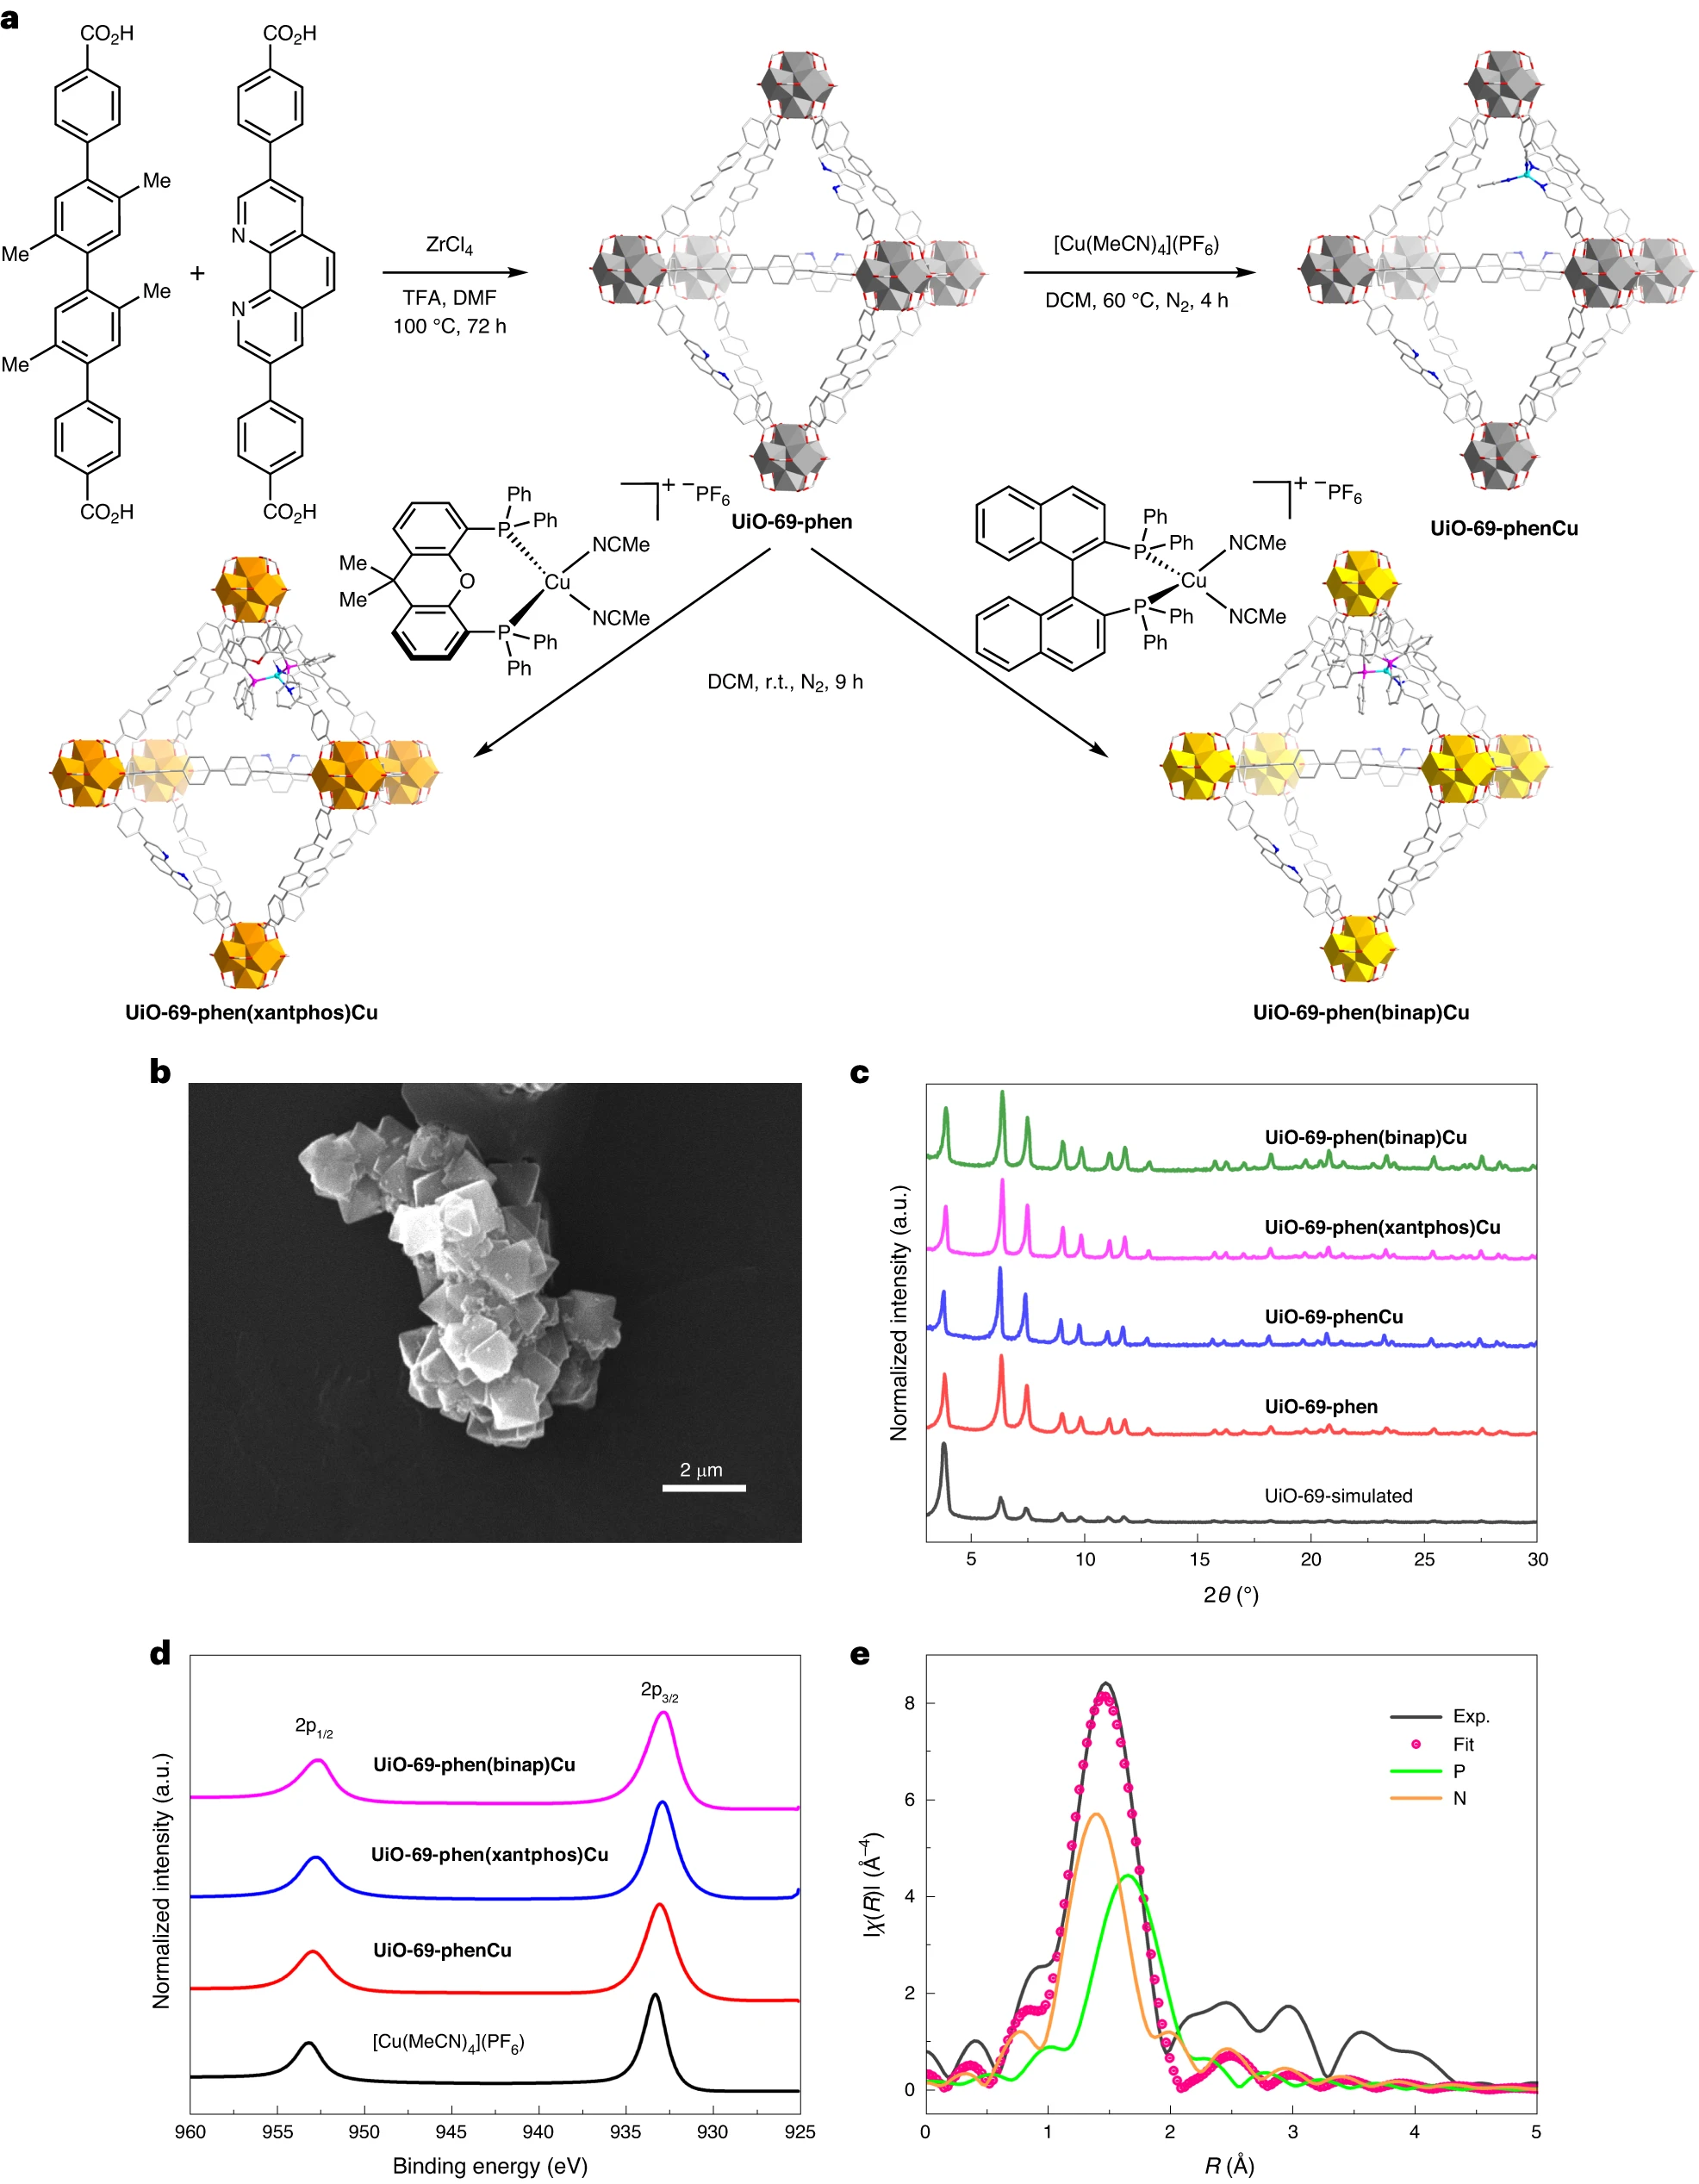
Fig. 2 | Catalyst preparation and characterization. a, Synthetic scheme of the UiO-69-type copper photocatalysts. Cyan, gray, blue, red and pink balls and sticks represent Cu, C, N, O, and P, respectively. Hexafluorophosphate anions and hydrogen atoms have been omitted for clarity. DMF, N,N-dimethylformamide; DCM, dichloromethane. b, SEM image of UiO-69-phen(binap)Cu crystals. c, Comparing PXRD patterns of UiO-69-phen(binap)Cu, UiO-69-phen(xantphos)Cu, UiO-69-phenCu, and UiO-69-phen with simulations of UiO-69 MOF. d, Cu2p XPS spectra showing the +1 oxidation state of the Cu centers in UiO-69-phen(binap)Cu, UiO-69-phen(xantphos)Cu, and UiO-69-phenCu. e, EXAFS spectrum (solid black line) and fitting data (red dots) in R-space at the Cu K-edge absorption of UiO-69-phen(binap)Cu. χ is the fine structure function. R is the interatomic distance from Cu.
Photocatalytic performances. At the outset of our studies, we envisaged that 1-vinylnaphthalene with a relatively low triplet energy would engage in energy transfer with photoexcited copper catalysts and then undergo an unprecedented [2+2] cycloaddition with methyl acrylate^{17,41} to afford trans-methyl 2-(naphthalen-1-yl)cyclobutane-1-carboxylate (1). After a systematic survey of various reaction parameters (see details in Supplementary Information), we established a procedure that achieves the desired cycloaddition using 0.2 mol% of UiO-69-phen(binap)Cu, with a TON of 365 and a diastereoselectivity of >10:1 (Table 1, entry 1). Control experiments demonstrated that the reaction did not take place in the absence of light or photocatalysts (Supplementary Table 7). Other MOF-supported copper(I) complexes lacking binap coordination failed to provide any cycloaddition products (entries 2 and 3), which indicates the formation of binap-based copper(I) photosensitizers is critical for promoting the crossed [2+2] cycloaddition. The low reactivity of the homogeneous counterparts (Cu-1 and Cu-2) highlighted the significance of immobilizing the heteroleptic copper(I) complex on the MOF support in order to generate an effective copper photocatalyst (entries 4–7). While a 10-fold increase in Cu-1 or Cu-2 loading gave a 7% yield of 1, the corresponding homogeneous xantphos-based copper(I) photosensitizers were ineffective (entries 8 and 9). Changing the substituents of 1,10-phenanthroline in xantphos-ligated heteroleptic copper(I) complexes⁴² did not improve their photocatalytic activity in the [2+2] cycloaddition with methyl acrylate (entries 10 and 11). The well-established [Ru(bpy)₃](PF₆)₂ photocatalyst, typically employed in the electron-transfer processes⁴³, was unable to yield the desired product (entry 12). The homogeneous iridium triplet photosensitizers with higher transition energies (entries 13 and 14)⁴⁴⁻⁴⁶, as well as their heterogeneous equivalents (entries 15–18)^{36,37,47,48}, are also incompatible with this reaction system, resulting in dramatic substrate decomposition. Not surprisingly, since the styrene substrate lacks a carboxylate substituent, CdSe quantum dots proved ineffective in the crossed [2+2] cycloaddition (entry 19)¹⁸. Furthermore, we investigated a number of heterogeneous framework-based photocatalysts and homogeneous organic photocatalysts that could promote [2+2] dimerization of styrenes mediated by electron transfer; none of them gave any desired products (Supplementary Table 8). The catalyst effect demonstrates conclusively that only binap-based copper triplet photosensitizers are capable of promoting intermolecular crossed [2+2] cycloadditions of styrenes with methyl acrylate, and successful integration of these photosensitizers on suitable MOF supports can significantly boost their photocatalytic activity.

Table 1 | Effect of different catalytic systems on the crossed [2+2] cycloaddition
Entry | Catalyst (mol%) | Yieldª (%) | TON^{b}
1 | UiO-69-phen(binap)Cu (0.2) | 73 (>10:1 d.r.)^{c} | 365
2 | UiO-69-phenCu (0.2) | <5 | –
3 | UiO-69-phen(xantphos)Cu (0.2) | <5 | –
4 | Cu-1 (0.2) | <5 | –
5 | Cu-2 (0.2) | <5 | –
6 | Cu-1 (2) | 7 | 3.5
7 | Cu-2 (2) | 7 | 3.5
8 | Cu-3 (2) | <5 | –
9 | Cu-4 (2) | <5 | –
10 | [Cu(dmp)(xantphos)](PF₆) (2) | <5 | –
11 | [Cu(bcp)(xantphos)](PF₆) (2) | <5 | –
12 | [Ru(bpy)₃](PF₆)₂ (2) | <5 | –
13 | Ir(ppy)₃ (2) | <5^{d} | –
14 | [Ir(ppy^{F})₂(dtbbpy)](PF₆) (2) | <5^{d} | –
15 | UiO-69-Ir(ppy)₂ (2) | <5^{d} | –
16 | UiO-67-Ir(ppy)₂ (2) | <5^{d} | –
17 | UiO-69-Ir(ppy^{F})₂ (2) | <5^{d} | –
18 | MOL-Hf-Ir(ppy^{F})₂ (2) | <5^{d} | –
19 | CdSe QDs (2) | <5 | –
Conditions: 1-vinylnaphthalene (0.2 mmol, 1.0 equiv.), methyl acrylate (5.0 equiv.), photocatalyst (0.2 or 2 mol%), and DMAP (1.2 equiv.) in anhydrous DCE (1 ml) under nitrogen atmosphere at room temperature with blue-LED light irradiation (440 nm) for 48 h. DMAP, 4-dimethylaminopyridine; DCE, 1,2-dichloroethane; dmp, 2,9-dimethyl-1,10-phenanthroline; bcp, bathocuproine; bpy, 2,2’-bipyridine; ppy, 2-(2-pyridyl)phenyl; dtbbpy, 4,4’-di-tert-butyl-2,2’-bipyridine; ppy^{F}, 3,5-difluoro-2-(5-trifluoromethyl-2-pyridyl)phenyl; MOL-Hf-Ir(ppy^{F})₂, a metal−organic layer containing [Hf₁₂]inorganic nodes and iridium-functionalized dicarboxylate organic linkers⁴⁸. ªYield was determined by ¹H NMR of the crude product using phenyltrimethylsilane as an internal standard. ^{b}TONs shown in Table 1 were calculated based on the crude NMR yield of 1. For other products, TONs were calculated based on isolated yields. ^{c}Diastereomeric ratio (d.r.) was determined by ¹H NMR analysis of the crude reaction mixture. ^{d}1-Vinylnaphthalene was fully decomposed.

After identifying the most effective copper photocatalyst (i.e., UiO-69-phen(binap)Cu), we first examined a variety of electron-deficient alkenes to evaluate the scope of the heterogeneous photocatalytic [2+2] cycloaddition reactions (Fig. 3). A number of α,β-unsaturated carbonyl compounds, such as acrylates, acrylamides, vinyl alkyl ketones, and fumarates, are highly reactive, furnishing the crossed cycloaddition products in yields of up to 87% (Fig. 3, products 1–15). In the crossed cycloadditions of various styrenes, the required amount of dimethyl fumarate can be reduced to 1.2 equivalents (Fig. 3, products 8–15), likely owing to the more electron-deficient nature of its double bond. To further investigate the styrene scope, acrylonitrile was chosen as the reaction partner. It is important to note that simple styrenes with different para-substituents delivered the cyclobutane products in good yields (Fig. 3, products 16–22), despite the use of 1.5 mol% of UiO-69-phen(binap)Cu for the substrates with higher triplet energies⁴⁹. Other olefins that bear fused aromatic rings, including quinolines and isoquinolines, participated in the crossed [2+2] cycloadditions with high reactivity (Fig. 3, products 23–28). Notably, in addition to the terminal styrenes, α- and β-methyl substituted 2-vinylnaphthalenes (Fig. 3, products 29 and 30), as well as β,β-disubstituted 1-vinylnaphthalenes (Fig. 3, products 31–34), are suitable substrates for the heterogeneous copper photocatalysis. In the synthesis of spiro-cycloadducts, the substrates are not limited to arylidene 4-membered rings: the 5- and 6-membered ring analogues also successfully yielded the desired products with 0.75 mol% of UiO-69-phen(binap)Cu. Moreover, isopropenylboronic acid pinacol ester, a 1,1-disubstituted electron-deficient alkene, gave a trisubstituted cyclobutane with a boryl group that is easily convertible to other useful functionalities⁵⁰ (Fig. 3, product 35). To demonstrate the practicality of our current method, we successfully prepared cycloadduct 1 on a gram scale (70% yield) using 0.15 mol% of the heterogeneous copper photocatalyst.
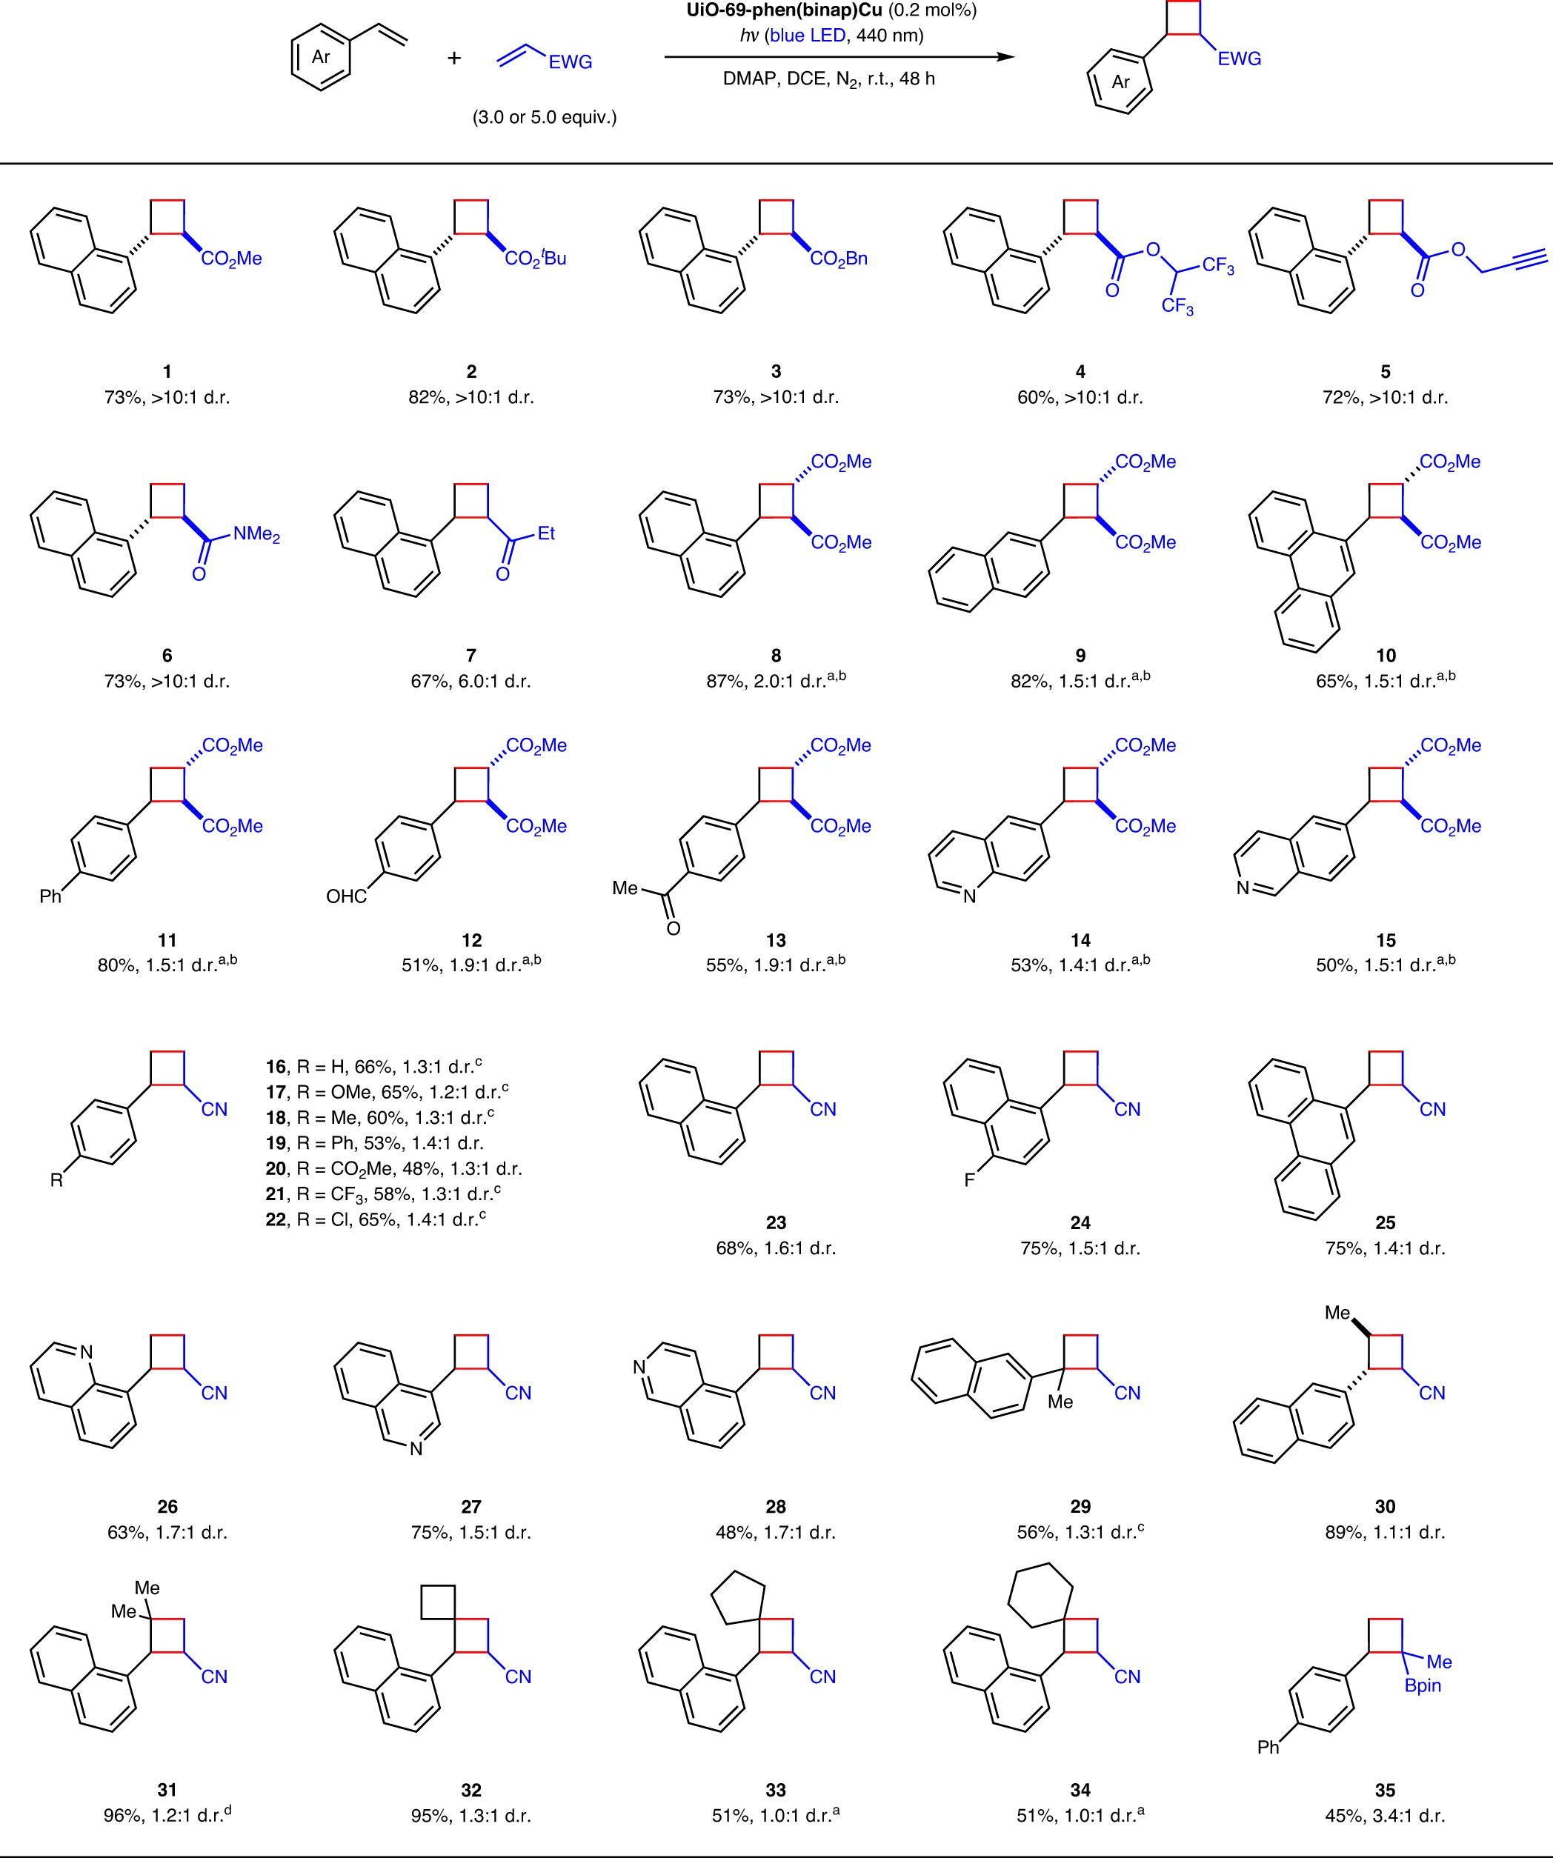
Fig. 3 | Substrate Scope. Crossed [2+2] cycloaddition of styrenes with electron-deficient alkenes. Reaction conditions: styrene (0.2 mmol, 1.0 equiv.), electron-deficient alkene (3.0 or 5.0 equiv.), UiO-69-phen(binap)Cu (0.2 mol%), and DMAP (1.2 equiv.) in anhydrous DCE (1 ml) under nitrogen atmosphere at room temperature with blue-LED light irradiation (440 nm) for 48 h. For each entry number (in bold), data are reported as isolated yields. Diastereomeric ratios were determined by ¹H NMR analysis of the crude reaction mixture. ªWith 0.75 mol% catalyst. ^{b}Dimethyl fumarate (1.2 equiv.) was used. ^{c}With 1.5 mol% catalyst. For experimental details, see Supplementary Methods. ^{d}With 0.5 mol% catalyst. DMAP, 4-dimethylaminopyridine; DCE, 1,2-dichloroethane; ^{t}Bu, tert-butyl; Bn, benzyl; Bpin, (pinacolato)boryl.
With respect to the [2+2] cycloadditions between different styrenes, the heterogeneous copper photocatalysis proved to be more efficient (Fig. 4). Only 0.02 mol% of UiO-69-phen(binap)Cu was needed to obtain synthetically useful yields, resulting in high TONs of up to 4750. To exploit the scope of styrene coupling partners, as well as to build a library of potentially bioactive quinoline derivatives, we selected 6-vinylquinoline as the limiting reagent in the copper-catalyzed photocycloaddition. Functional groups with different electronic properties are well tolerated at the ortho-, meta-, or para-positions of styrenes (Fig. 4, products 36–46). Diverse heterocycles (e.g., pyridine, indole, benzofuran, and benzothiophene) can be conveniently incorporated into the final cycloadducts (Fig. 4, products 47–50). The crossed cycloadditions with methyl cinnamate and benzylideneacetone afforded the corresponding trisubstituted cyclobutanes with high regioselectivity (Fig. 4, products 51 and 52).
During the photosensitization of other styrenes, the unsubstituted simple styrene was chosen as the coupling partner to determine the reaction scope. A wide range of substituted aryl groups and heterocyclic moieties were found to be compatible with this visible light photocatalysis (Fig. 4, products 53–65). It is noteworthy that there was a substantial increase in diastereoselectivity (>10:1 d.r.) when a bulky 1-naphthyl, 9-phenanthryl, or 4-isoquinolyl group was introduced to the substrate (Fig. 4, products 58, 59, 61, and 63). To further showcase the utility of this methodology, the substrates derived from bioactive molecules (i.e., (+)-menthol and formononetin) were utilized in the crossed [2+2] cycloadditions, giving the desired products in 64% and 85% yields, respectively (Fig. 4, products 66 and 67).
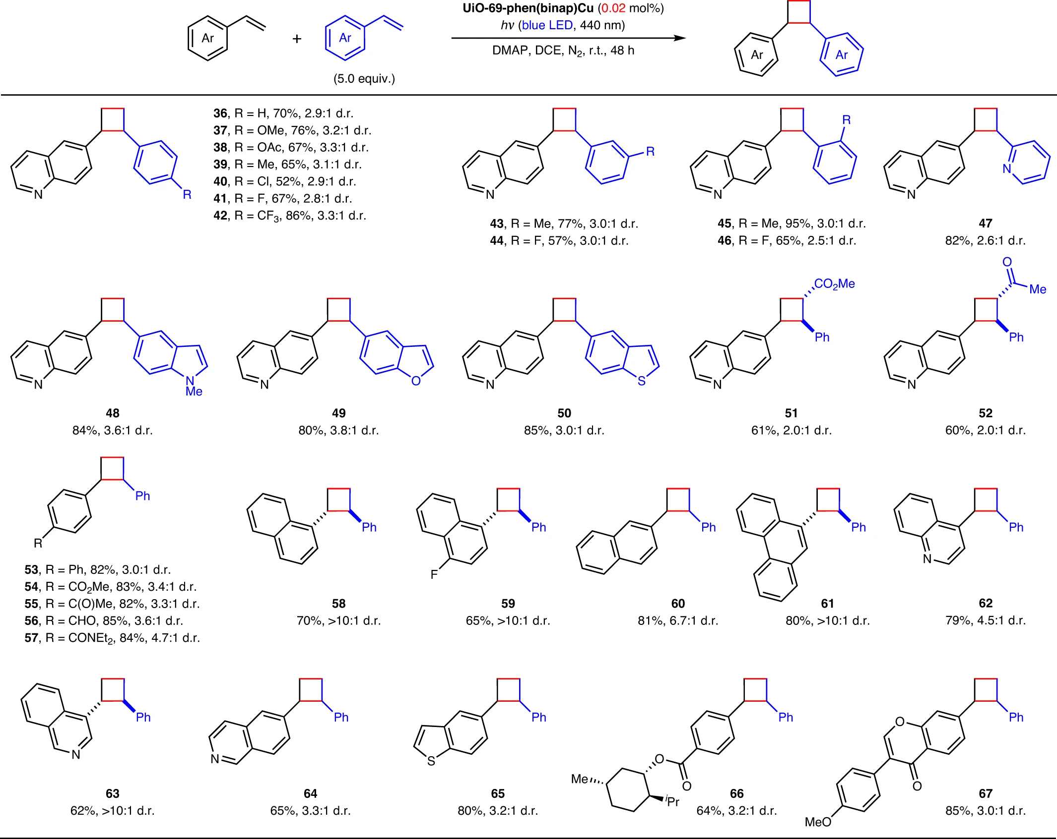
Fig. 4 | Substrate Scope. [2+2] cycloaddition between different styrenes. Reaction conditions: styrene (2.0 mmol, 1.0 equiv.), the other styrene (5.0 equiv.), UiO-69-phen(binap)Cu (0.02 mol%), and DMAP (1.2 equiv.) in anhydrous DCE (1 ml) under nitrogen atmosphere at room temperature with blue-LED light irradiation (440 nm) for 48 h. For each entry number (in bold), data are reported as isolated yields. Diastereomeric ratios were determined by ¹H NMR analysis of the crude reaction mixture. DMAP, 4-dimethylaminopyridine; DCE, 1,2-dichloroethane; Ac, acetyl; ^{i}Pr, isopropyl.

The exceptional photocatalytic activity of UiO-69-phen(binap)Cu prompted us to revisit the intermolecular crossed [2+2] cycloadditions of exocyclic arylidene 4-membered rings (other than cyclobutanes) with electron-deficient alkenes (Fig. 5), previously explored by Knowles and co-workers using a potent iridium(III) photosensitizer¹⁷. Under the same conditions established for the simple styrenes at low catalyst loadings (Fig. 3), various azetidine, thietane, and oxetane substrates reacted smoothly with acrylonitrile to give the corresponding 2-azaspiro[3.3]heptane, 2-thiaspiro[3.3]heptane, 2-oxaspiro[3.3]heptane products in good to excellent yields (Fig. 5, products 68–76), including several challenging substrates in the homogeneous iridium photocatalysis (Fig. 5, products 69 and 71). Similar to the situation in the synthesis of 58, the reaction of 3-(1-naphthylmethylene)oxetane is highly diastereoselective. The scope with regard to the electron-deficient alkenes is also fairly broad (Fig. 5, products 77–85). In addition to the previously reported examples, α-acetamidoacrylate and α-fluoroacrylate can serve as effective coupling partners in the crossed cycloaddition, providing a straightforward method for the preparation of 2-oxaspiro[3.3]heptanes containing α-amino acid moieties and fluorine atoms (Fig. 5, products 81 and 82).
As anticipated, the coupling partner scope in the heterogeneous copper photocatalytic system can be further expanded to include a wide array of styrenes that have yet to be investigated (Fig. 5). Electron-donating or -withdrawing groups at various positions of the aryl ring had no obvious impact on the reaction yield (Fig. 5, products 86–92). All the 2-oxaspiro[3.3]heptane products bearing heteroaryl groups, such as pyridyl (93), indolyl (94), benzofuranyl (95), and benzothienyl (96), can be synthesized efficiently. The cis-isomer of 93 was completely converted into the trans-isomer upon column purification with silica gel, possibly due to the ring-opening isomerization triggered by protonation of the pyridine moiety. Importantly, this reaction protocol also works well with 1,1-diphenylethylene, affording a triaryl substituted 2-oxaspiro[3.3]heptane (97) in 83% yield.
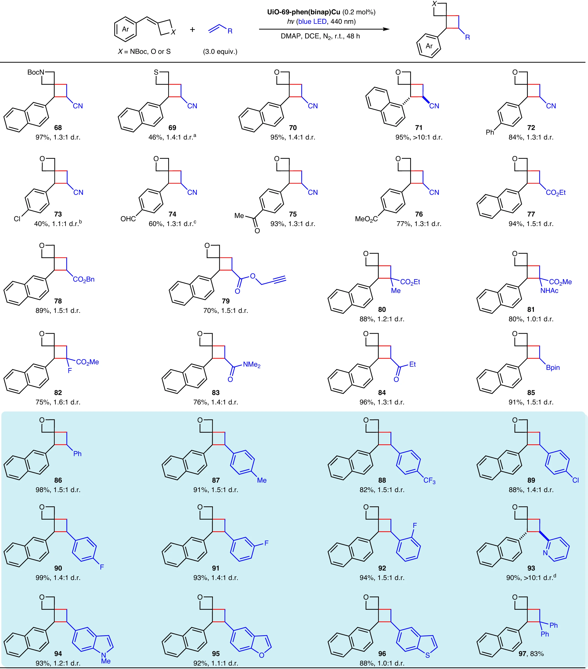
Fig. 5 | Substrate Scope. Crossed [2+2] cycloaddition of exocyclic arylidene azetidines, thietanes, and oxetanes with electron-deficient alkenes and styrenes. Reaction conditions: exocyclic arylidene azetidine, thietane, or oxetane (0.2 mmol, 1.0 equiv.), electron-deficient alkene or styrene (3.0 equiv.), UiO-69-phen(binap)Cu (0.2 mol%), and DMAP (1.2 equiv.) in anhydrous DCE (1 ml) under nitrogen atmosphere at room temperature with blue-LED light irradiation (440 nm) for 48 h. For each entry number (in bold), data are reported as isolated yields. Diastereomeric ratios were determined by ¹H NMR analysis of the crude reaction mixture. ªWith 0.75 mol% catalyst. ^{b}With 1 mol% catalyst. ^{c}With 0.5 mol% catalyst. ^{d}The diastereomeric ratio was determined after purification by silica gel column chromatography. DMAP, 4-dimethylaminopyridine; DCE, 1,2-dichloroethane; Boc, tert-butoxycarbonyl; Bn, benzyl; Ac, acetyl; Bpin, (pinacolato)boryl.
Stability and recyclability tests. The significance of employing a heterogenization strategy in the design of robust binap-based copper photosensitizers was clearly elucidated by the control experiments comparing the photostability of Cu-2 and UiO-69-phen(binap)Cu under the standard reaction conditions without substrates (Fig. 6a). Upon blue-LED light irradiation for 24 h, the heteroleptic copper(I) complex (Cu-2), which serves as the copper-functionalized linker for the UiO-69 MOF, was completely degraded into insoluble aggregates along with binap dioxide (Supplementary Fig. 22). In sharp contrast, UiO-69-phen(binap)Cu exhibited extraordinarily high stability when exposed to light: Cu-2 was detected by NMR after MOF digestion with deuterated phosphoric acid in a solvent mixture of deuterated water and dimethyl sulfoxide; the ratio between Cu-2 and the normal linker remained constant before and after light irradiation (Supplementary Fig. 23). Due to its heterogeneity nature and high photostability, UiO-69-phen(binap)Cu can be easily recovered by filtration and reused at least six times without any loss of its photocatalytic activity (Fig. 6b). The PXRD patterns, microscopic images, and N₂ adsorption isotherms of the recovered copper photocatalysts after six cycles of [2+2] cycloadditions indicated that UiO-69-phen(binap)Cu retained its crystalline structure after photocatalysis (Fig. 6c and Supplementary Figs. 24–26).
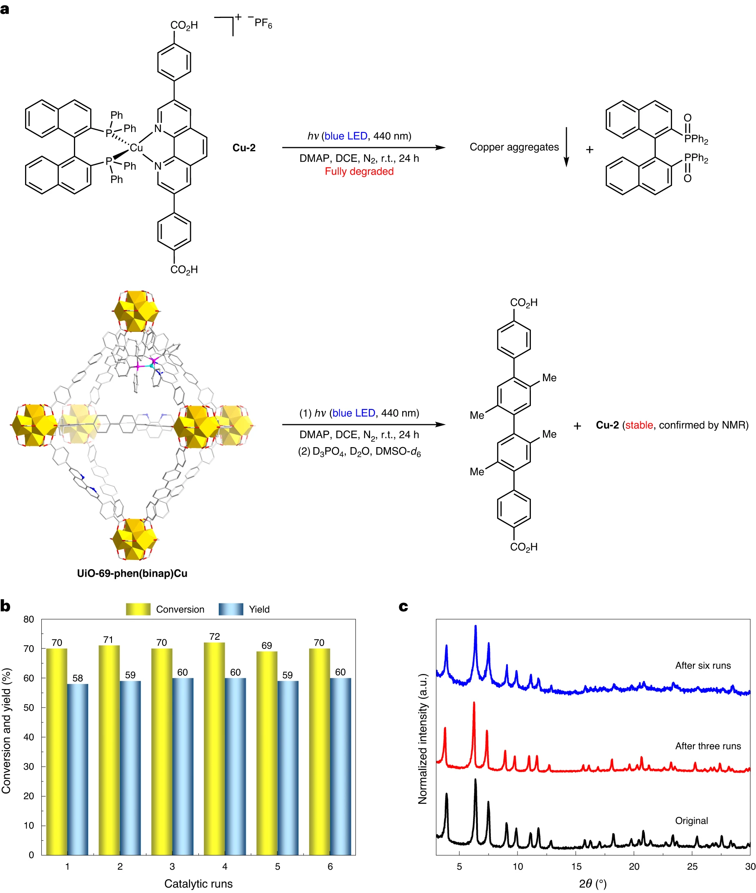
Fig. 6 | Using a heterogenized approach to stabilize copper photosensitizers. a, Photostability tests of binap-ligated copper species in Cu-2 and UiO-69-phen(binap)Cu. b, Recycling experiments for crossed [2+2] cycloaddition of 1-vinylnaphthalene with acrylonitrile. c, Comparison of PXRD patterns of the original and recycled UiO-69-phen(binap)Cu.

Mechanistic studies. Upon post-synthetic metalation with the cationic binap-ligated copper(I), the maximum absorption peak at 449 nm, resulting from metal-to-ligand charge transfer transitions, appeared alongside the original peak at 351 nm from the MOF support (UiO-69-phen) in the solid-state absorption spectrum of UiO-69-phen(binap)Cu (Supplementary Fig. 30). Compared to other heterogeneous copper photocatalysts, the absorption profile of UiO-69-phen(binap)Cu showed the highest intensity in the region of blue-LED excitation. Notably, the phosphorescence peak of the heterogenized copper(I) species is blue-shifted by 33 nm from that of its homogeneous counterpart, with an increased excited-state lifetime at room temperature from 1.52 to 4.31 μs (Fig. 7a). In the first triplet excited state (T₁) of heteroleptic copper complexes, the copper center tends to adopt square-planar coordination, as opposed to the tetrahedral coordination observed in the ground state (S₀). The geometrical restriction imposed by the octahedral UiO-69 MOF raises the energy of the T₁ state and impedes the T₁ → S₀ transition⁵¹. The increases in transition energies (from 45.7 to 48.3 kcal mol⁻¹) and excited-state lifetimes (nearly three folds) could greatly facilitate the energy-transfer processes in the intermolecular crossed [2+2] cycloadditions of styrenes. On the other hand, based on the estimated excited-state redox potentials of UiO-69-phen(binap)Cu (see details in Supplementary Information), the single-electron transfer between the copper active site and the styrene substrate is strongly disfavored⁵² (Fig. 7b). Furthermore, using trans-stilbene as a triplet-energy-transfer inhibitor⁵³, we found that the crossed cycloadditions with acrylonitrile were completely suppressed; no cycloadducts were detected (Fig. 7c).
We established that 1-vinylnaphthalene quenches the luminescence of UiO-69-phen(binap)Cu but not UiO-69-phen(xantphos)Cu (Supplementary Figs. 33 and 35), clearly demonstrating the superior activity of UiO-69-phen(binap)Cu in facilitating triplet energy transfer from photoexcited copper(I) to styrenes. In addition, the rate order of simple styrene was determined to be 4.28 ± 0.40 (Supplementary Fig. 43), indicating that substrate aggregation occurred prior to photoexcitation. Taken together, the following catalytic cycle may be operative (Fig. 7d). The styrene substrate aggregates in the MOF pores to form an exciplex with a much lower transition energy¹⁶, which is then sensitized by the excited-state copper(I) photocatalyst via energy transfer. The resulting 1,2-triplet styrene undergoes an intermolecular radical addition with an electron-deficient alkene or a simple styrene to generate a 1,4-triplet diradical. The intersystem crossing (ISC) followed by intramolecular radical recombination yields the [2+2] cycloaddition product.

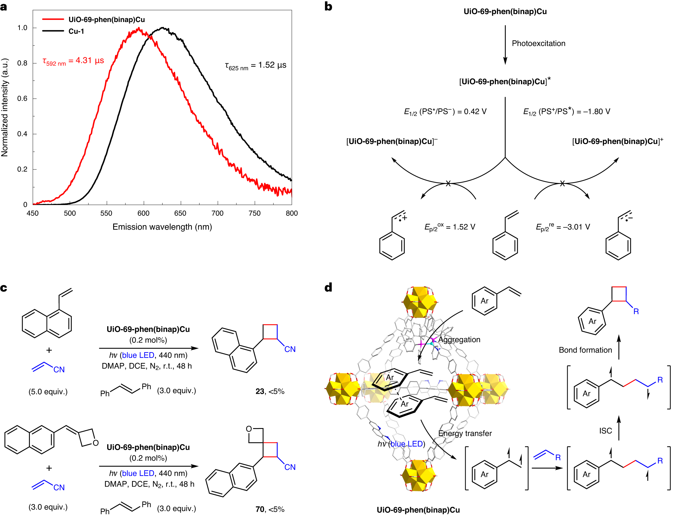
Fig. 7 | Mechanistic investigation of the title reactions. a, Solid-state emission spectra (excitation wavelength: 420 nm) of UiO-69-phen(binap)Cu and Cu-1 recorded under argon at room temperature. b, Ruling out electron-transfer pathways. PS, copper photosensitizer. c, Triplet excited-state quenching experiments. d, Proposed mechanism for heterogeneous photocatalytic [2+2] cycloaddition.
Conclusions
We describe here the use of well-defined crystalline MOFs to support heteroleptic copper(I) complexes in order to facilitate a series of intermolecular crossed [2+2] cycloadditions via energy transfer under visible light irradiation. The incorporation of binap-containing copper triplet photosensitizers onto the MOF organic linkers substantially improves the photostability and increases the excited-state lifetime, paving the way for the development of unprecedented cycloadditions of simple styrenes with electron-deficient alkenes. This newly developed heterogeneous copper photocatalysis demonstrates an extraordinarily broad substrate scope, excellent catalytic efficiency, and remarkable catalyst recyclability. Our work provides a general approach to designing highly reactive copper photocatalysts for diverse energy-transfer-mediated organic transformations.

Methods
Synthesis of the catalyst support UiO-69-phen. ZrCl₄ (179 mg, 0.77 mmol), 4,4’-(1,10-phenanthroline-3,8-diyl)dibenzoic acid (L2) (50 mg, 0.12 mmol), terphenyl dicarboxylic acid (L3) (270 mg, 0.60 mmol), and trifluoroacetic acid (0.4 ml) were ultrasonically dispersed in N,N-dimethylformamide (DMF) (34 ml). The resulting solution was heated to 100 °C in a 50-ml glass tube for 72 hours. After cooling to room temperature, the supernatant was decanted and the solid was washed five times with DMF and acetone. UiO-69-phen was then collected by filtration and dried in air to give a white solid (389 mg, 60% yield based on linkers). The product (2 mg) was digested in a mixture of a saturated K₃PO₄/D₂O solution and DMSO-d₆ (0.6 ml, 1:2 v/v) and subjected to ¹H NMR analysis. The ratio of L2 and L3 was found to be 1:5. The chemical formula of UiO-69-phen was determined to be Zr₆O₄(OH)₄(L2)(L3)₅4.0DMF based on NMR digestion data and TGA.

Synthesis of the catalyst UiO-69-phenCu. UiO-69-phen (30.0 mg, 5.6 μmol based on L2) was immersed in a 2-ml dichloromethane solution of Cu(MeCN)₄PF₆ (10.4 mg, 28 μmol) and stirred under N₂ atmosphere at 60 °C for 4 hours. After cooling to room temperature, the supernatant was decanted and the solid was washed five times with DMF and acetone. UiO-69-phenCu was then collected by filtration and dried in air to give a green solid (22.7 mg, 93% yield). ICP-AES analysis indicated a Zr/Cu ratio of 6:1.The chemical formula of UiO-69-phenCu was determined to be {Zr₆O₄(OH)₄(L2)(L3)₅[Cu(CH₃CN)₂PF₆]}4.4DMF based on ICP-AES and TGA.

Synthesis of the catalyst UiO-69-phen(Xantphos)Cu. UiO-69-phen (30.0 mg, 5.6 μmol based on L2) was immersed in a 2-ml dichloromethane solution of Cu(Xantphos)(MeCN)₂PF₆ (24.3 mg, 28 μmol) and stirred under N₂ atmosphere at room temperature for 9 hours. After post-synthetic metalation, the supernatant was decanted and the solid was washed five times with DMF and acetone. UiO-69-phen(Xantphos)Cu was then collected by filtration and dried in air to give a yellow solid (30.9 mg, 91% yield). ICP-AES analysis indicated a Zr/Cu ratio of 6:1. The product (2 mg) was digested in a solution of D₃PO₄/D₂O/DMSO-d₆ (1:1:5 v/v/v) and subjected to ¹H NMR analysis. The ratio of Cu-4 and L3 was found to be 1:5. The chemical formula of UiO-69-phen(Xantphos)Cu was determined to be {Zr₆O₄(OH)₄(L2)(L3)₅[Cu(Xantphos)PF₆]}4.9DMF based on NMR digestion data and TGA.

Synthesis of the catalyst UiO-69-phen(binap)Cu. UiO-69-phen (300 mg, 56 μmol based on L2) was immersed in a 20-ml dichloromethane solution of Cu(binap)(MeCN)₂PF₆ (256 mg, 0.28 mmol) and stirred under N₂ atmosphere at room temperature for 9 hours. After post-synthetic metalation, the supernatant was decanted and the solid was washed five times with DMF and acetone. UiO-69-phen(binap)Cu was then collected by filtration and dried in air to give a yellow solid (312 mg, 94% yield). ICP-AES analysis indicated a Zr/Cu ratio of 6:1. The product (2 mg) was digested in a solution of D₃PO₄/D₂O/DMSO-d₆ (1:1:5 v/v/v) and subjected to ¹H NMR analysis. The ratio of Cu-2 and L3 was found to be 1:5. The chemical formula of UiO-69-phen(binap)Cu was determined to be {Zr₆O₄(OH)₄(L2)(L3)₅[Cu(binap)PF₆]}6.0DMF based on NMR digestion data and TGA.

General procedure for the photoinduced crossed [2+2] cycloaddition of styrenes with electron-deficient alkenes. To a 25-ml flame-dried Schlenk tube cooled under N₂ atmosphere were added UiO-69-phen(binap)Cu (2.4 mg, 0.4 μmol based on Cu, 0.2 mol%), 4-dimethylaminopyridine (29 mg, 0.24 mmol, 1.2 equiv.), 1,2-dichloroethane (1.0 ml), styrene (0.2 mmol, 1.0 equiv.), and electron-deficient alkene (0.6 or 1.0 mmol, 3.0 or 5.0 equiv.) sequentially. After three freeze-pump-thaw cycles, the reaction mixture was irradiated by three 40-watt Kessil PR160L-440 blue-LED lamps at room temperature (with three fans) for 48 hours. After irradiation, ethyl acetate (10 ml) was added into the crude mixture; the resulting solution was filtered through a pad of silica gel and washed four times with ethyl acetate (4 × 10 ml). The combined filtrates were concentrated under vacuum and the diastereomeric ratio was determined by ¹H NMR analysis. The residue was purified by flash column chromatography on silica gel to afford the corresponding product.

General procedure for the photoinduced crossed [2+2] cycloaddition between different styrenes. To a 25-ml flame-dried Schlenk tube cooled under N₂ atmosphere were added UiO-69-phen(binap)Cu (2.4 mg, 0.4 μmol based on Cu, 0.02 mol%), 4-dimethylaminopyridine (293 mg, 2.4 mmol, 1.2 equiv.), 1,2-dichloroethane (1.0 ml), styrene (2.0 mmol, 1.0 equiv.), and the other coupling styrene (10 mmol, 5.0 equiv.) sequentially. After three freeze-pump-thaw cycles, the reaction mixture was irradiated by three 40-watt Kessil PR160L-440 blue-LED lamps at room temperature (with three fans) for 48 hours. After irradiation, ethyl acetate (10 ml) was added into the crude mixture; the resulting solution was filtered through a pad of silica gel and washed four times with ethyl acetate (4 × 10 ml). The combined filtrates were concentrated under vacuum and the diastereomeric ratio was determined by ¹H NMR analysis. The residue was purified by flash column chromatography on silica gel to afford the corresponding product.

General procedure for the photoinduced crossed [2+2] cycloaddition of exocyclic arylidene azetidines, thietanes, and oxetanes with electron-deficient alkenes and styrenes. To a 25-ml flame-dried Schlenk tube cooled under N₂ atmosphere were added UiO-69-phen(binap)Cu (2.4 mg, 0.4 μmol based on Cu, 0.2 mol%), 4-dimethylaminopyridine (29 mg, 0.24 mmol, 1.2 equiv.), 1,2-dichloroethane (1.0 ml), exocyclic arylidene azetidine, thietane, or oxetane (0.2 mmol, 1.0 equiv.), and electron-deficient alkene or styrene (0.6 mmol, 3.0 equiv.) sequentially. After three freeze-pump-thaw cycles, the reaction mixture was irradiated by three 40-watt Kessil PR160L-440 blue-LED lamps at room temperature (with three fans) for 48 hours. After irradiation, ethyl acetate (10 ml) was added into the crude mixture; the resulting solution was filtered through a pad of silica gel and washed four times with ethyl acetate (4 × 10 ml). The combined filtrates were concentrated under vacuum and the diastereomeric ratio was determined by ¹H NMR analysis. The residue was purified by flash column chromatography on silica gel to afford the corresponding product.

Gram-scale reaction. To a 100-ml flame-dried Schlenk tube cooled under N₂ atmosphere were added UiO-69-phen(binap)Cu (89 mg, 15 μmol based on Cu, 0.15 mol%), 4-dimethylaminopyridine (1.46 g, 12 mmol, 1.2 equiv.), 1,2-dichloroethane (50 ml), 1-vinylnaphthalene (1.54 g, 10 mmol, 1.0 equiv.), methyl acrylate (4.5 ml, 50 mmol, 5.0 equiv.) sequentially. After three freeze-pump-thaw cycles, the reaction mixture was irradiated by three 40-watt Kessil PR160L-440 blue-LED lamps at room temperature (with three fans) for 48 hours. After irradiation, ethyl acetate (100 ml) was added into the crude mixture; the resulting solution was filtered through a pad of silica gel and washed four times with ethyl acetate (4 × 50 ml). The combined filtrates were concentrated under vacuum and the diastereomeric ratio was determined by ¹H NMR analysis. The residue was purified by flash column chromatography on silica gel to afford 1 (1.68 g, 70% yield) as a colorless oil.

Data availability
The data that support the findings of this study are available from the corresponding author upon reasonable request.

References
1. Goetzke, F. W., Hell, A. M. L., van Dijk, L. & Fletcher, S. P. A catalytic asymmetric cross-coupling approach to the synthesis of cyclobutanes. Nat. Chem. 13, 880–886 (2021).
2. Dembitsky, V. M. Naturally occurring bioactive cyclobutane-containing (CBC) alkaloids in fungi, fungal endophytes, and plants. Phytomedicine 21, 1559–1581 (2014).
3. Namyslo, J. C. & Kaufmann, D. E. The application of cyclobutane derivatives in organic synthesis. Chem. Rev. 103, 1485–1538 (2003).
4. Wang, M. & Lu, P. Catalytic approaches to assemble cyclobutane motifs in natural product synthesis. Org. Chem. Front. 5, 254–259 (2018).
5. Poplata, S., Tröster, A., Zou, Y.-Q. & Bach, T. Recent advances in the synthesis of cyclobutanes by olefin [2 + 2] photocycloaddition reactions. Chem. Rev. 116, 9748–9815 (2016).
6. Zhou, Q.-Q., Zou, Y.-Q., Lu, L.-Q. & Xiao, W.-J. Visible-light-induced organic photochemical reactions through energy-transfer pathways. Angew. Chem. Int. Ed. 58, 1586–1604 (2019).
7. Sicignano, M., Rodríguez, R. I. & Alemán, J. Recent visible light and metal free strategies in [2+2] and [4+2] photocycloadditions. Eur. J. Org. Chem. 2021, 3303–3321 (2021).
8. Zhu, M., Zhang, X., Zheng, C. & You, S.-L. Energy-transfer-enabled dearomative cycloaddition reactions of indoles/pyrroles via excited-state aromatics. Acc. Chem. Res. 55, 2510–2525 (2022).
9. Ischay, M. A., Ament, M. S. & Yoon, T. P. Crossed intermolecular [2+2] cycloaddition of styrenes by visible light photocatalysis. Chem. Sci. 3, 2807–2811 (2012).
10. Riener, M. & Nicewicz, D. A. Synthesis of cyclobutane lignans via an organic single electron oxidant-electron relay system. Chem. Sci. 4, 2625–2629 (2013).
11. Das, S. et al. Asymmetric counteranion-directed photoredox catalysis. Science 379, 494–499 (2023).
12. Tanaka, K. et al. Redox potential controlled selective oxidation of styrenes for regio- and stereoselective crossed intermolecular [2 + 2] cycloaddition via organophotoredox catalysis. Org. Lett. 22, 5207–5211 (2020).
13. Li, R. et al. Photocatalytic regioselective and stereoselective [2 + 2] cycloaddition of styrene derivatives using a heterogeneous organic photocatalyst. ACS Catal. 7, 3097–3101 (2017).
14. Piane, J. J. et al. Organic photoredox-catalyzed cycloadditions under single-chain polymer confinement. ACS Catal. 10, 13251–13256 (2020).
15. Lu, Z. & Yoon, T. P. Visible light photocatalysis of [2+2] styrene cycloadditions by energy transfer. Angew. Chem. Int. Ed. 51, 10329–10332 (2012).
16. Liu, Z. et al. Aggregation-enabled intermolecular photo[2+2]cycloaddition of aryl terminal olefins by visible-light catalysis. CCS Chem. 2, 582–588 (2020).
17. Murray, P. R. D. et al. Intermolecular crossed [2 + 2] cycloaddition promoted by visible-light triplet photosensitization: expedient access to polysubstituted 2-oxaspiro[3.3]heptanes. J. Am. Chem. Soc. 143, 4055–4063 (2021).
18. Jiang, Y., Wang, C., Rogers, C. R., Kodaimati, M. S. & Weiss, E. A. Regio- and diastereoselective intermolecular [2+2] cycloadditions photocatalysed by quantum dots. Nat. Chem. 11, 1034–1040 (2019).
19. Jiang, Y., López-Arteaga, R. & Weiss, E. A. Quantum dots photocatalyze intermolecular [2 + 2] cycloadditions of aromatic alkenes adsorbed to their surfaces via van der Waals interactions. J. Am. Chem. Soc. 144, 3782–3786 (2022).
20. Hernandez-Perez, A. C. & Collins, S. K. Heteroleptic Cu-based sensitizers in photoredox catalysis. Acc. Chem. Res. 49, 1557–1565 (2016).
21. Forero Cortés, P. A., Marx, M., Trose, M. & Beller, M. Heteroleptic copper complexes with nitrogen and phosphorus ligands in photocatalysis: overview and perspectives. Chem. Catal. 1, 298–338 (2021).
22. Brégent, T., Bouillon, J.-P. & Poisson, T. Copper-photocatalyzed contra-thermodynamic isomerization of polarized alkenes. Org. Lett. 22, 7688–7693 (2020).
23. Cruché, C., Neiderer, W. & Collins, S. K. Heteroleptic copper-based complexes for energy-transfer processes: E → Z isomerization and tandem photocatalytic sequences. ACS Catal. 11, 8829–8836 (2021).
24. Rogge, S. M. et al. Metal–organic and covalent organic frameworks as single-site catalysts. Chem. Soc. Rev. 46, 3134–3184 (2017).
25. Wei, Y.-S., Zhang, M., Zou, R. & Xu, Q. Metal–organic framework-based catalysts with single metal sites. Chem. Rev. 120, 12089–12174 (2020).
26. Chen, W. et al. Site-isolated azobenzene-containing metal–organic framework for cyclopalladated catalyzed Suzuki-Miyuara coupling in flow. ACS Appl. Mater. Interfaces 13, 51849–51854 (2021).
27. Ma, B. et al. Metal–organic framework supported copper photoredox catalysts for iminyl radical-mediated reactions. Angew. Chem. Int. Ed. 62, e202300233 (2023).
28. Liu, J. et al. MOF-enabled confinement and related effects for chemical catalyst presentation and utilization. Chem. Soc. Rev. 51, 1045–1097 (2022).
29. Zhou, H.-C., Long, J. R. & Yaghi, O. M. Introduction to metal–organic frameworks. Chem. Rev. 112, 673–674 (2012).
30. Furukawa, H., Cordova, K. E., O’Keeffe, M. & Yaghi, O. M. The chemistry and applications of metal-organic frameworks. Science 341, 1230444 (2013).
31. Cavka, J. H. et al. A new zirconium inorganic building brick forming metal organic frameworks with exceptional stability. J. Am. Chem. Soc. 130, 13850–13851 (2008).
32. Newsome, W. J. et al. Solid state multicolor emission in substitutional solid solutions of metal–organic frameworks. J. Am. Chem. Soc. 141, 11298–11303 (2019).
33. Kalaj, M. & Cohen, S. M. Postsynthetic modification: an enabling technology for the advancement of metal–organic frameworks. ACS Cent. Sci. 6, 1046–1057 (2020).
34. Li, J. et al. Self-adaptive dual-metal-site pairs in metal-organic frameworks for selective CO₂ photoreduction to CH₄. Nat. Catal. 4, 719–729 (2021).
35. Ma, X. et al. Modulating coordination environment of single-atom catalysts and their proximity to photosensitive units for boosting MOF photocatalysis. J. Am. Chem. Soc. 143, 12220–12229 (2021).
36. Wang, C., Xie, Z., deKrafft, K. E. & Lin, W. Doping metal–organic frameworks for water oxidation, carbon dioxide reduction, and organic photocatalysis. J. Am. Chem. Soc. 133, 13445–13454 (2011).
37. Wang, C., deKrafft, K. E. & Lin, W. Pt nanoparticles@photoactive metal–organic frameworks: efficient hydrogen evolution via synergistic photoexcitation and electron injection. J. Am. Chem. Soc. 134, 7211–7214 (2012).
38. Zhang, X. et al. Catalytic chemoselective functionalization of methane in a metal−organic framework. Nat. Catal. 1, 356–362 (2018).
39. Pi, Y. et al. Metal−organic frameworks integrate Cu photosensitizers and secondary building unit-supported Fe catalysts for photocatalytic hydrogen evolution. J. Am. Chem. Soc. 142, 10302−10307 (2020).
40. Kong, X.-J., Lin, Z., Zhang, Z.-M., Zhang, T. & Lin, W. Hierarchical integration of photosensitizing metal–organic frameworks and nickel-containing polyoxometalates for efficient visible-light-driven hydrogen evolution. Angew. Chem. Int. Ed. 55, 6411–6416 (2016).
41. Coote, S. C. & Bach, T. Enantioselective intermolecular [2+2] photocycloadditions of isoquinolone mediated by a chiral hydrogen-bonding template. J. Am. Chem. Soc. 135, 14948–14951 (2013).
42. Mejía, E. et al. A noble-metal-free system for photocatalytic hydrogen production from water. Chem. Eur. J. 19, 15972–15978 (2013).
43. Ischay, M. A., Lu, Z. & Yoon, T. P. [2+2] cycloadditions by oxidative visible light photocatalysis. J. Am. Chem. Soc. 132, 8572–8574 (2010).
44. Lei, T. et al. General and efficient intermolecular [2+2] photodimerization of chalcones and cinnamic acid derivatives in solution through visible-light catalysis. Angew. Chem. Int. Ed. 56, 15407–15410 (2017).
45. Zhu, M., Zheng, C., Zhang, X. & You, S.-L. Synthesis of cyclobutane-fused angular tetracyclic spiroindolines via visible-light-promoted intramolecular dearomatization of indole derivatives. J. Am. Chem. Soc. 141, 2636–2644 (2019).
46. Girvin, Z. C. et al. Asymmetric photochemical [2 + 2]-cycloaddition of acyclic vinylpyridines through ternary complex formation and an uncontrolled sensitization mechanism. J. Am. Chem. Soc. 144, 20109–20117 (2022).
47. Yu, X. & Cohen, S. M. Photocatalytic metal−organic frameworks for selective 2,2,2-trifluoroethylation of styrenes. J. Am. Chem. Soc. 138, 12320−12323 (2016).
48. Fan, Y., Zheng, H., Labalme, S. & Lin, W. Molecular engineering of metal−organic layers for sustainable tandem and synergistic photocatalysis. J. Am. Chem. Soc. 145, 4158−4165 (2023).
49. Ni, T., Caldwell, R. A. & Melton, L. A. The relaxed and spectroscopic energies of olefin triplets. J. Am. Chem. Soc. 111, 457–464 (1989).
50. He, J., Shao, Q., Wu, Q. & Yu, J.-Q. Pd(II)-catalyzed enantioselective C(sp³)–H borylation. J. Am. Chem. Soc. 139, 3344–3347 (2017).
51. Keller, S. et al. Luminescent copper(I) complexes with bisphosphane and halogen-substituted 2,2'-bipyridine ligands. Dalton Trans. 47, 14263–14276 (2018).
52. Roth, H. G., Romero, N. A. & Nicewicz, D. A. Experimental and calculated electrochemical potentials of common organic molecules for applications to single-electron redox chemistry. Synlett 27, 714–723 (2016).
53. Cheng, X., Li, T., Liu, Y. & Lu, Z. Stereo- and enantioselective benzylic C–H alkenylation via photoredox/nickel dual catalysis. ACS Catal. 11, 11059–11065 (2021).

Acknowledgements
The authors gratefully acknowledge The University of Hong Kong, the Research Grants Council of the Hong Kong Special Administrative Region, People’s Republic of China (RGC: 27301820, 17313922, 27200822, 16302520, 15301521, and 15300819), the Croucher Foundation, the Innovation and Technology Commission (HKSAR, China), and the National Natural Science Foundation of China (No. 22201236 and 22172136) for their financial support. The authors thank C.-M. Che for help and discussions.

Author contributions
J.H. supervised the project and designed the experiments. J.G. developed the photocatalytic cycloadditions and expanded the substrate scope with the help of W.Y.T. Q.X., Z.L., and X.W. prepared and characterized the catalytic materials. L.-J.L. and K.-H.L. analyzed the crystal structures of the heteroleptic copper complexes. W.-P.T., H.-X.S., and P.C.Y.C. measured the solid-state emission spectra. T.W.B.L. simulated the EXAFS spectra. J.H. wrote the manuscript with the contributions from J.G., Q.X., and L.-J.L.

Competing interests
The authors declare no competing interests.

Additional information
Supplementary information The online version contains supplementary material available at https://doi.org/xxx.
Correspondence and requests for materials should be addressed to Jian He.
Reprints and permissions information is available at www.nature.com/reprints.
Publisher’s note Springer Nature remains neutral with regard to jurisdictional claims in published maps and institutional affiliations.

