High-member low-dimensional Sn-based perovskite solar cells
Hansheng Li^{1†}, Zihao Zang^{1†}, Qi Wei¹, Xianyuan Jiang¹, Mingyu Ma¹, Zengshan Xing², Jingtian Wang¹, Danni Yu¹, Fei Wang¹, Wenjia Zhou¹, Kam Sing Wong², Philip C. Y. Chow³, Yuanyuan Zhou^{4*} & Zhijun Ning^{1*}

¹School of Physical Science and Technology, ShanghaiTech University, Shanghai 201210, China;
²Department of Physics, Hong Kong University of Science and Technology, Hong Kong 999077, China;
³Department of Mechanical Engineering, The University of Hong Kong, Hong Kong 999077, China;
⁴Department of Physics, Hong Kong Baptist University, Hong Kong 999077, China
†These authors contributed equally to this work.
*Corresponding authors (email: yyzhou@hkbu.edu.hk; ningzhj@shanghaitech.edu.cn)

Accepted by
Science China Chemistry
December 11, 2022

Abstract
Sn-based perovskites are promising thin-film photovoltaic materials for their ideal bandgap and the eco-friendliness of Sn, but the performance of Sn-based perovskite solar cells is hindered by the short carrier diffusion length and large defect density in nominally-synthesized Sn-based perovskite films. Herein we demonstrate that a long carrier diffusion length is achievable in quasi-2D Sn-based perovskite films consisting of high-member low-dimensional Ruddlesden–Popper (RP) phases with a pre- ferred crystal orientation distribution. The key to the film synthesis is the use of a molecular additive formed by phenylethylammonium cations and optimally mixed halide–pseudohalide anions, which favorably tailors the quasi-2D Sn-based perovskite crystallization kinetics. The high-member RP film structure effectively enhances device short-circuit current density, giving rise to an increased power conversion efficiency (PCE) of 14.6%. The resulting device demonstrates a near-unity shelf stability upon 1,000 h in nitrogen. A high reproductivity is also achieved with a count of 50 devices showing PCEs within a narrow range from minimum 13.0% to maximum 14.6%.

Keywords
Sn-based perovskite, lead-free perovskite solar cells, low-dimensional structure, optoelectronics device

1 Introduction
Removing toxic Pb in state-of-the-art perovskite solar cells (PSCs) is a desirable goal in their path towards niche-market commercialization. Perovskites based on less-toxic Sn have emerged as one of the most promising candidates owing to their superior optoelectronic properties including narrow bandgaps, high absorption coefficients, and excellent carrier mobility as compared to other Pb-free alternatives [1–9]. Nevertheless, the attainment of high-quality Sn-based perovskite thin films is challenging due to the extraordinary crystal growth behavior, high Sn-vacancy density, and low oxidation resistance. Significant effort has thus been devoted to improving Sn-based PSCs by thin-film tailoring based on various methods such as compositional engineering, micro- structural manipulation, crystal-growth engineering and antioxidation control [10–13]. The adoption of these methods or their combination has led to a promising increase of power conversion efficiencies (PCEs) for Sn-based PSCs whereas the highest reported PCEs are yet still far below their theoretically attainable values.
The reduction of crystallographic dimensionality from three dimension (3D) to quasi-two dimension (2D) has been proven to be critical to achieve efficient and stable Sn-based PSCs. This is because quasi-2D perovskite structures inherently embraced large organic molecular spacers that can not only regulate the crystal growth but also enhance the oxidation resistance and passivate film interfaces, leading to reduced morphological and electronic defects [14–17]. This approach has recently enabled significant performance improvement of Sn-based PSCs [1,18,19]. Nevertheless, Sn- based PSC devices based on low-dimensional structures show relatively small current densities (<20 mA cm⁻² in general), thereby affecting the resultant PCEs. In nominally- processed quasi-2D Sn-based perovskite films, a range of phases with significant variable layer numbers (n) are formed, and usually the low-member phases with n=3–5 are dominated, while high-member phases with large n strongly favor to minimize the detrimental effects associated with poorly conducting organic spacers [20–24]. Furthermore, the crystal orientation of these anisotropic low-dimensional phases can influence carrier transport, and thus aligning the 3D octahedral slabs of quasi-2D Sn-based perovskites ver- tical to the film substrate is highly desired [22,25–27]. In this context, the attainment of high-member phases with preferred vertical crystallogrphic orientations in quasi-2D Sn- based perovskite films becomes an urgent need, but efforts towards that still remain elusive.
In this work, we leveraged the use of a tailored molecular additive, which is formed with phenylethylamine cations and mixed halide/pseudo-halide anions, to achieve this goal. This tailored additive reduces the cleavage energies of quasi-2D Sn-based perovskite structure and leads to crystal growth kinetics favoring the formation and preferred alignment of high-member phases. The as-formed quasi-2D Sn-based perovskite films feature a long electron diffusion length up to 480 nm and a remarkable carrier lifetime of 126 ns. The resulting device shows an open-circuit voltage (V_{OC}) of over 0.9 V, a short-circuit current density (J_{SC}) of over 20 mA cm⁻², and a champion PCE of 14.6%, reaching the level of the highest certified efficiency of Sn-based PSCs [1,18,19]. Furthermore, the controlled film growth enables an excellent reproducibility of resultant device PCEs.
2 Results and discussion
2.1 Structure and phase determination
The perovskite films made from the precursor only containing phenylethylamonium bromide (PEABr) are denoted as PEABr. To improve the quality of perovskite films, we further replaced a portion of PEABr by phenethylammonium thiocyanate (PEASCN), and the resulting films are denoted as PEABr–PEASCN. The chemical formula of the low-di- mensional perovskite is written as PEA₂FA_{n–1}Sn_{n}X_{3n+1} [28]. For simplicity, both PEA₂FASnX₄ (n=1, 1L) and PEA₂ FASn₂X₇ (n=2, 2L) structures are defined as 2D structure, while low dimensional structure with higher n number is named as quasi-2D structure.
We firstly studied the structure of the film by grazing- incidence wide-angle X-ray scattering (GIWAXS) at incident angle of 2°. Both PEABr and PEABr–PEASCN films show characteristic diffraction spots from 2D and quasi-2D structures. The diffraction spots at q value of 0.286 and 0.386 Å⁻¹ are attributed to (002) plane of 2L and 1L structures, respectively. The intensity of (002)_{1L} spot of PEABr film is higher than that of PEABr–PEASCN film, indicating that more structures with small n value are formed in the PEABr sample. The diffraction spots at 1.005, 1.425 and 1.755 Å⁻¹ can be ascribed to (100), (110) and (111) planes of quasi-2D or 3D FASnI₃ structure, respectively (Figure 1a, and see crystal directions and lattice planes in Figure S1) [29]. The diffraction intensity of (100) plane of PEABr– PEASCN film is concentrated at the azimuth angle around 90°, indicating that the film is highly oriented and grows along [001] axis perpendicular to the substrate. In comparison to PEABr–PEASCN, PEABr shows dispersive diffraction intensity in the azimuth analysis and the Debye ring can still be observed from the (100) plane, indicating relatively weak orientation (Figure 1a, b, Figure S2).
To analyze the composition of film surface, we tested GIWAXS patterns at smaller incident angle of 0.2° (Figure S3). For the PEABr–PEASCN film, the relative intensities of diffraction spots ascribed to the (002)_{2L} plane significantly increase, indicating that 2L structures are concentrated on the film surface (Figure 1c). In contrast, PEABr films show similar diffraction intensities from the 2L structure and the decrease of intensity from 1L structure, suggesting homogeneous distribution of the 2L structure in the film, while 1L structure is mainly located in the bulk. The diffraction in- tensity from 1L structure is stronger than that of 2L structure for PEABr, indicating that the 1L structure is dominated in the 2D structure. In contrast, the relative intensity from the 2L structure is much stronger than that from the 1L structure for the PEABr–PEASCN film, suggesting that the 2L structure dominates 2D structure. The increase of 2L struc- ture can be ascribed to the more negative formation energy (E_{for}) of the structure when SCN⁻-substituted molecules are included [30]. In comparison to 1L structure, 2L structure is thermodynamically more stable. Hence the high reaction enthalpy will drive the formation of more 2L structure. The film structure is further characterized by X-ray diffraction (XRD). The PEABr–PEASCN film shows much stronger diffraction peak at 2θ of 4.06° derived from the (002) plane of 2L structure, which is consistent with the GIWAXS measurement (Figure 1d). The full width at half maximum (FWHM) of (100) diffraction peaks are 0.082° for PEABr and 0.074° for PEABr–PEASCN (Figure 1e). The smaller FWHM value can be ascribed to the enhanced crystallinity derived from the increase of high-member quasi-2D structure of PEABr–PEASCN according to Scherrer equation.
We then studied the photophysical properties of films by absorption spectra (Abs) and photoluminescence (PL) measurement. Inferred from the Tauc plots of Abs, the bandgaps of PEABr and PEABr–PEASCN Sn-based perovskite thin films are determined to be 1.46 and 1.44 eV, respectively (Figure 1f). Both of them are larger than that of FASnI₃ (1.40 eV). Similarly, PL peaks of PEABr and PEABr– PEASCN are at 859 and 865 nm, respectively, shorter than that of 3D FASnI₃ film (893 nm) (Figure 1g, Figure S4), confirming the larger bandgaps of PEABr–PEASCN and PEABr films than 3D structure and the formation of quantum well structures. Both absorption and PL spectra of PEABr– PEASCN are red shifted in comparison to PEABr, demonstrating that the n value of quasi-2D structure in PEABr– PEASCN is relatively larger. It should be noted that the absorption and PL peak of FASnI_{2.975}SCN_{0.025} film is almost the same as that of FASnI₃, indicating the bandgap is not affected by trace thiocyanate (Figure S5).
The modification of low dimensional structure also chan- ges the electronic structure of perovskite films. Ultraviolet photoelectron spectroscopy (UPS) was employed to analyze the energy band structure of film surface. The Fermi energy (E_{F}) of Sn-based perovskite film surface is calculated by the cut-off of binding energy (E_{b}), and the E_{F} of FASnI₃, PEABr and PEABr–PEASCN is −4.62, −4.60, −4.58 eV, respectively. Based on the energy difference between valence-band maximum (VBM) and E_{F} (Figure 1h), the VBM of FASnI₃, PEABr, and PEABr–PEASCN is calculated to be −5.20, −5.06 and −5.02 eV, respectively. The shallower energy levels of PEABr–PEASCN and PEABr in comparison to 3D film is ascribed to the formation of quantum well structures, since low dimensional structure generally shows shallower energy level [31]. The shallower energy level of PEABr– PEASCN than that of PEABr could be attributed to the distribution of more 2D structure on the film surface [31]. In combination with characterizations above, we can conclude that PEASCN dramatically changes the composition of the film. More 2D structure is formed on film surface accompanied by the growth of highly-orientated high-member quasi-2D structure in the bulk.
2.2 Insights into crystallization kinetics
To clarify the mechanism for the dramatic structural differ- ence between PEABr–PEASCN and PEABr, we firstly stu- died the crystals growth speed by powder grinding reaction [32]. When SnI₂ was ground with formamidinium iodide (FAI) and PEASCN (FAI+PEASCN), black color was ob- served quickly, indicating the fast growth of perovskites. However, grinding SnI₂ with FAI and PEABr (FAI+PEABr) or FAI only generated brownish color product (Figure S6), suggesting that the reaction is slower. XRD patterns of the products were used to analyze the structure of the products. The powder by mixing SnI₂ and FAI+PEASCN shows that two groups of strong diffraction peaks are attributed to 2L and 1L structures, respectively [32] (Figure 2b). In contrast, diffraction peaks from the perovskite structure are tiny for the products via grinding SnI₂ with FAI+PEABr or SnI₂+FAI (Figure 2b), indicating that the reaction is slow as well. Hence, it can be concluded that the inclusion of PEASCN significantly accelerates the formation of 2D structure.
To reveal the crystal growth kinetics, we tracked the film growth by quasi-in situ GIWAXS measurements (Figure 2c) [33], in which 0 s denotes the antisolvent dripping point in spin coating, and film annealing starts at 15 s. the PEABr–PEASCN film shows (002)_{2L} peak in few seconds and the intensity reaches the strongest nearly before annealing (Figure 2c). It indicates the fast growth of 2D structure in the PEABr–PEASCN film before annealing. In contrast, no obvious diffraction peak from 2D structure is observed before annealing for the PEABr film, indicating the slow growth of 2D structure that requires external energy to overcome the crystallization barrier. During the annealing process of PEABr film, diffraction peaks from 2L structure appear firstly and subsequently decrease, which can be ascribed to the continuous growth of 2L structure and the thickness increase. The PEABr–PEASCN shows an almost stable diffraction peak of 2L structure in annealing process, likely derived from the separation of 2D structure on the surface, which limits its growth [34] (Figure 2c).
To elaborate the quick growth of the 2D structure based on PEASCN, we calculated the cleavage energies of the struc- tures with density functional theory (DFT). In the homogeneous nucleation process, the Gibbs free energy (ΔG) driving nucleation can be described by Eq. (1):
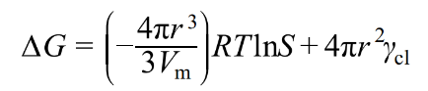 (1)
where, r, V_{m}, S and γ_{cl} represent nucleus radius, molar volume, supersaturation degree and cleavage energy, respectively. The cleavage energy of PEA₂FASn₂I₅SCN₂ (2D- PEASCN) is close to that of 3D FASnI₃ and much lower than that of PEA₂FASn₂Br₂I₅ (2D-PEABr) (Table S1). By integrating the cleavage and formation energies, the system free energy evolution in the crystallization process of FAS- nI₃, 2D-PEASCN and 2D-PEABr is exhibited in Figure 2a. Lower cleavage energy can reduce the crystallization barrier and increase the crystallization speed of low-dimension structures, which explains the fast growth of 2D structure in the PEABr–PEASCN films. Since 2D structure with higher surface coverage is mainly located on the film surface in parallel to the substrate firstly, it can then induce the oriented growth of quasi-2D structure perpendicular to the substrate, which explains the high orientation of PEABr–PEASCN films [32]. Furthermore, the consumption of PEA for 2D structure growth at the surface leads to the shortage of PEA in the bulk, bringing the formation of high-member quasi-2D structure with larger n values (Figure 2d). As a result, the PEABr–PEASCN films have a smoother surface with less pin holes (Figures S8, S9).
2.3 Photocarrier transport properties
Carrier recombination rate constants of these films were then calculated by fitting the time-resolved photoluminescence (TRPL) curves using carrier recombination equation (Figure S10 and supporting information) [35]. The bimolecular re- combination rate constant of PEABr–PEASCN film (1.3×10⁻⁸ cm³ s⁻¹) is lower than that of PEABr (2.0×10⁻⁸ cm³ s⁻¹), which can be ascribed to the increased ratio of high member of quasi-2D structures, which reduces exciton binding energy [36]. The PEABr–PEASCN film shows lower monomolecular rate constant (4.7×10⁶ s⁻¹) than that PEABr (5.4×10⁶ s⁻¹), indicating the reduced Shockley–Read–Hall (SRH) recombination [35]. This is consistent with the decrease of defect density based on space-charge- limited current (SCLC) measurement (Figure S11) [37,38]. The decrease of defect density and carrier recombination can be ascribed to the improvement of crystal orientation and high crystallinity.
The carrier diffusion length and mobility were determined based on carrier lifetimes of Sn-based perovskite films without and with quenching layers on top (supporting in- formation) [39,40]. The PL lifetime of PEABr–PEASCN thin films without quenching layers is 126 ns, larger than 105 ns of PEABr (Figure 3a, Table S2). The increased carrier lifetime is further affirmed by the kinetic analysis of the ground-state bleaching (GSB) in transient absorption spectroscopy (TAS) (Figure S13). The calculated electron diffusion length and mobility of PEABr-PEASCN is 480 nm and 0.7 cm² V⁻¹ s⁻¹, respectively, larger than 410 nm and 0.6 cm² V⁻¹ s⁻¹ of PEABr (Table S2). The improvement on diffusion length and mobility of PEABr–PEASCN can be ascribed to the increased n value of quasi-2D structure, as well as the decreased defect density.
2.4 Solar cell performance
We fabricated solar cells using the inverted architecture of ITO/PEDOT/Perovskite/ICBA/BCP/Ag (Figure 3b). The current density–voltage curves were measured under simulated AM1.5 G illumination (Figure 3c). The solar cell based on PEABr shows a PCE of 13.4% with V_{OC} of 0.908 V, J_{SC} of 19.4 mA cm⁻² and fill factor (FF) of 76.5%. The solar cell based on PEABr–PEASCN reaches an increased efficiency of 14.6%, derived from the V_{OC} of 0.905 V, J_{SC} of 20.6 mA cm⁻² and FF of 78.6%. The higher current density and fill factor can be ascribed to the enhanced carrier mobility, diffusion length and reduced carrier recombination. The J_{SC} integrated from external quantum efficiency (EQE) curves is 19.1 and 20.2 mA cm⁻² for PEABr and PEABr– PEASCN, respectively, matching with the J_{SC} from J–V curves (Figure 3d). Despite the increased recombination, the voltage of PEABr-based device is comparable to that of PEABr–PEASCN-based device, which could be ascribed to its slightly higher bandgap. 50 solar cells were fabricated based on the PEABr or PEABr–PEASCN, respectively, to obtain statistical performances. The average PCE and J_{SC} of PEABr–PEASCN is 13.9% and 20.2 mA cm⁻², respectively, obviously higher than those of PEABr devices (13.1% and 19.0 mA cm⁻², respectively) (Figure 3e). The encapsulated solar cell based on PEABr–PEASCN maintains 99.7% of the initial PCE in a N₂ glovebox for 1,000 h, higher than the 94.2% of PEABr (Figure 3f). 20 PEABr- and 20 PEABr– PEASCN-based devices were tracked and the PEABr– PEASCN-based devices maintain 98.2% (average value) of the initial PCE in N₂ glovebox while the average value of the PEABr-based solar cells is 92.6% after 1,000 h (Figure S14). Surface oxidation was evaluated by X-ray photoelectron spectroscopy (XPS). After the perovskite films were stored in the N₂ glovebox for 20 days, 9.4% of the Sn²⁺ at the surface was oxidized to Sn⁴⁺ for PEABr–PEASCN, which is lower than that (17.7%) of PEABr (Figure S15). The accumulation of 2D structure on the surface enhances the film oxidation resistance, contributing to the improvement on shelf stability of devices. The tracking of device PCE in ambient conditions supports the conclusion above. The en- capsulated PEABr–PEASCN-based solar cell maintains 83% of the initial PCE in air without humidity and temperature control for 460 h, while the PCE of PEABr-based device drop- ped down to 78% of the initial PCE within 50 h (Figure S16).
3 Conclusions
This study explores phenylethylaminium pseudo-halide salt to control the crystallization kinetics of low-dimensional Sn- based perovskite thin films. Mechanistic insights show that the inclusion of PEASCN reduces the crystallization barrier, giving rise to fast crystallization of 2D perovskites, which is attested by in-situ GIWAXS tracking of film growth. The fast growth of 2D structure at the top surface region of precursors initializes the growth of highly oriented high-member quasi- 2D structures, resulting in long photocarrier diffusion lengths and lifetimes, and underpinning the attainment of enhanced J_{SC} and PCEs up to 14.6%. This strategy sheds light on understanding and controlling the growth of low-dimensional perovskite films beyond Sn-based ones for high-performance, reproducible optoelectronics.

Acknowledgements
The authors thank Peihong Cheng, Na Yu, and Rong Gao for their kind assistance. This work was financially supported from the National Key Research and Development Program of China (2021YFA0715502), the National Natural Science Foundation of China (61935016, 92056119, 22175118), the Science and Technology Commission of Shanghai Municipality (20XD1402500, 20JC1415800) and ShanghaiTech start-up funding. Y.Z. acknowledges the Early Career Scheme (22300221) from the Hong Kong Research Grant Council and the Excellent Young Scientists Funds (52222318) from National Natural Science Foun- dation of China. Y.Z. also acknowledges the start-up grants, the Initiation Grant-Faculty Niche Research Areas (IG-FNRA) 2020/21 and the Inter- disciplinary Research Matching Scheme (IRMS) 2020/21 of Hong Kong Baptist University. P.C.Y.C. acknowledges support from the Hong Kong Research Grant Council (16302520) and Seed Funding from the University Research Committee (URC) of the University of Hong Kong. We appreciate the Shanghai Synchrotron Radiation Facility (beamline 14B and 16B) and X. Gao and Z. Su for their help with GIWAXS characterization. This work is partially supported by the Centre for High-Resolution Electron Microscopy (CħEM), SPST, ShanghaiTech University under contract No. EM02161943; and the Analytical Instrumentation Center, SPST, ShanghaiTech University under contract No. SPST-AIC10112914.
Conflict of interest
The authors declare no conflict of interest.
References
- Jiang X, Li H, Zhou Q, Wei Q, Wei M, Jiang L, Wang Z, Peng Z, Wang F, Zang Z, Xu K, Hou Y, Teale S, Zhou W, Si R, Gao X, Sargent EH, Ning Z. J Am Chem Soc, 2021, 143: 10970–10976
- Zhou J, Hao M, Zhang Y, Ma X, Dong J, Lu F, Wang J, Wang N, Zhou Y. Matter, 2022, 5: 683–693
- Jiang X, Wang F, Wei Q, Li H, Shang Y, Zhou W, Wang C, Cheng P, Chen Q, Chen L, Ning Z. Nat Commun, 2020, 11: 1245
- Chen M, Ju MG, Garces HF, Carl AD, Ono LK, Hawash Z, Zhang Y, Shen T, Qi Y, Grimm RL, Pacifici D, Zeng XC, Zhou Y, Padture NP. Nat Commun, 2019, 10: 16
- Chen M, Ju MG, Hu M, Dai Z, Hu Y, Rong Y, Han H, Zeng XC, Zhou Y, Padture NP. ACS Energy Lett, 2019, 4: 276–277
- Stoumpos CC, Malliakas CD, Kanatzidis MG. Inorg Chem, 2013, 52: 9019–9038
- Umari P, Mosconi E, de Angelis F. Sci Rep, 2014, 4: 4467
- Liao W, Zhao D, Yu Y, Grice CR, Wang C, Cimaroli AJ, Schulz P, Meng W, Zhu K, Xiong RG, Yan Y. Adv Mater, 2016, 28: 9333– 9340
- Shao S, Liu J, Portale G, Fang HH, Blake GR, ten Brink GH, Koster LJA, Loi MA. Adv Energy Mater, 2018, 8: 1702019
- Yang WF, Igbari F, Lou YH, Wang ZK, Liao LS. Adv Energy Mater, 2019, 10: 1902584
- Lee SJ, Shin SS, Kim YC, Kim D, Ahn TK, Noh JH, Seo J, Seok SI. J Am Chem Soc, 2016, 138: 3974–3977
- Jiang X, Zang Z, Zhou Y, Li H, Wei Q, Ning Z. Acc Mater Res, 2021, 2: 210–219
- Wu T, Liu X, Luo X, Lin X, Cui D, Wang Y, Segawa H, Zhang Y, Han L. Joule, 2021, 5: 863–886
- Zhou Y, Poli I, Meggiolaro D, De Angelis F, Petrozza A. Nat Rev Mater, 2021, 6: 986–1002
- Grancini G, Roldán-Carmona C, Zimmermann I, Mosconi E, Lee X, Martineau D, Narbey S, Oswald F, De Angelis F, Graetzel M, Na- zeeruddin MK. Nat Commun, 2017, 8: 15684
- Wang Z, Lin Q, Chmiel FP, Sakai N, Herz LM, Snaith HJ. Nat Energy, 2017, 2: 17135
- Lee JW, Tan S, Seok SI, Yang Y, Park NG. Science, 2022, 375: eabj1186
- Yu BB, Chen Z, Zhu Y, Wang Y, Han B, Chen G, Zhang X, Du Z, He Z. Adv Mater, 2021, 33: 2102055
- Wang T, Loi HL, Cao J, Qin Z, Guan Z, Xu Y, Cheng H, Li MG, Lee CS, Lu X, Yan F. Adv Sci, 2022, 9: 2200242
- Stoumpos CC, Soe CMM, Tsai H, Nie W, Blancon JC, Cao DH, Liu F, Traoré B, Katan C, Even J, Mohite AD, Kanatzidis MG. Chem, 2017, 2: 427–440
- Soe CMM, Nie W, Stoumpos CC, Tsai H, Blancon JC, Liu F, Even J, Marks TJ, Mohite AD, Kanatzidis MG. Adv Energy Mater, 2018, 8: 1700979
- Tsai H, Nie W, Blancon JC, Stoumpos CC, Asadpour R, Harutyunyan B, Neukirch AJ, Verduzco R, Crochet JJ, Tretiak S, Pedesseau L, Even J, Alam MA, Gupta G, Lou J, Ajayan PM, Bedzyk MJ, Kanatzidis MG, Mohite AD. Nature, 2016, 536: 312–316
- Ren H, Yu S, Chao L, Xia Y, Sun Y, Zuo S, Li F, Niu T, Yang Y, Ju H, Li B, Du H, Gao X, Zhang J, Wang J, Zhang L, Chen Y, Huang W. Nat Photonics, 2020, 14: 154–163
- Spanopoulos I, Hadar I, Ke W, Tu Q, Chen M, Tsai H, He Y, She- khawat G, Dravid VP, Wasielewski MR, Mohite AD, Stoumpos CC, Kanatzidis MG. J Am Chem Soc, 2019, 141: 5518–5534
- Sutanto AA, Caprioglio P, Drigo N, Hofstetter YJ, Garcia-Benito I, Queloz VIE, Neher D, Nazeeruddin MK, Stolterfoht M, Vaynzof Y, Grancini G. Chem, 2021, 7: 1903–1916
- Liu Y, Akin S, Pan L, Uchida R, Arora N, Milić JV, Hinderhofer A, Schreiber F, Uhl AR, Zakeeruddin SM, Hagfeldt A, Dar MI, Grätzel M. Sci Adv, 2019, 5: eaaw2543
- Wang F, Jiang X, Chen H, Shang Y, Liu H, Wei J, Zhou W, He H, Liu W, Ning Z. Joule, 2018, 2: 2732–2743
- Yang J, Yang T, Liu D, Zhang Y, Luo T, Lu J, Fang J, Wen J, Deng Z, Liu SF, Chen L, Zhao K. Sol RRL, 2021, 5: 2100286
- Kahmann S, Nazarenko O, Shao S, Hordiichuk O, Kepenekian M, Even J, Kovalenko MV, Blake GR, Loi MA. ACS Energy Lett, 2020, 5: 2512–2519
- Yu D, Wei Q, Li H, Xie J, Jiang X, Pan T, Wang H, Pan M, Zhou W, Liu W, Chow PCY, Ning Z. Angew Chem Int Ed, 2022, 61: e202202346
- Proppe AH, Quintero-Bermudez R, Tan H, Voznyy O, Kelley SO, Sargent EH. J Am Chem Soc, 2018, 140: 2890–2896
- Li H, Jiang X, Wei Q, Zang Z, Ma M, Wang F, Zhou W, Ning Z. Angew Chem Int Ed, 2021, 60: 16330–16336
- Qin M, Chan PF, Lu X. Adv Mater, 2021, 33: 2105290
- Chen AZ, Shiu M, Ma JH, Alpert MR, Zhang D, Foley BJ, Smilgies DM, Lee SH, Choi JJ. Nat Commun, 2018, 9: 1336
- Kirchartz T, Márquez JA, Stolterfoht M, Unold T. Adv Energy Mater, 2020, 10: 1904134
- Xing G, Wu B, Wu X, Li M, Du B, Wei Q, Guo J, Yeow EKL, Sum TC, Huang W. Nat Commun, 2017, 8: 14558
- Chen K, Wu P, Yang W, Su R, Luo D, Yang X, Tu Y, Zhu R, Gong Q. Nano Energy, 2018, 49: 411–418
- Tan H, Jain A, Voznyy O, Lan X, García de Arquer FP, Fan JZ, Quintero-Bermudez R, Yuan M, Zhang B, Zhao Y, Fan F, Li P, Quan LN, Zhao Y, Lu ZH, Yang Z, Hoogland S, Sargent EH. Science, 2017, 355: 722–726
- Xing G, Mathews N, Sun S, Lim SS, Lam YM, Grätzel M, Mhaisalkar S, Sum TC. Science, 2013, 342: 344–347
- Shrestha S, Li X, Tsai H, Hou CH, Huang HH, Ghosh D, Shyue JJ, Wang L, Tretiak S, Ma X, Nie W. Chem, 2022, 8: 1107–1120

Figures
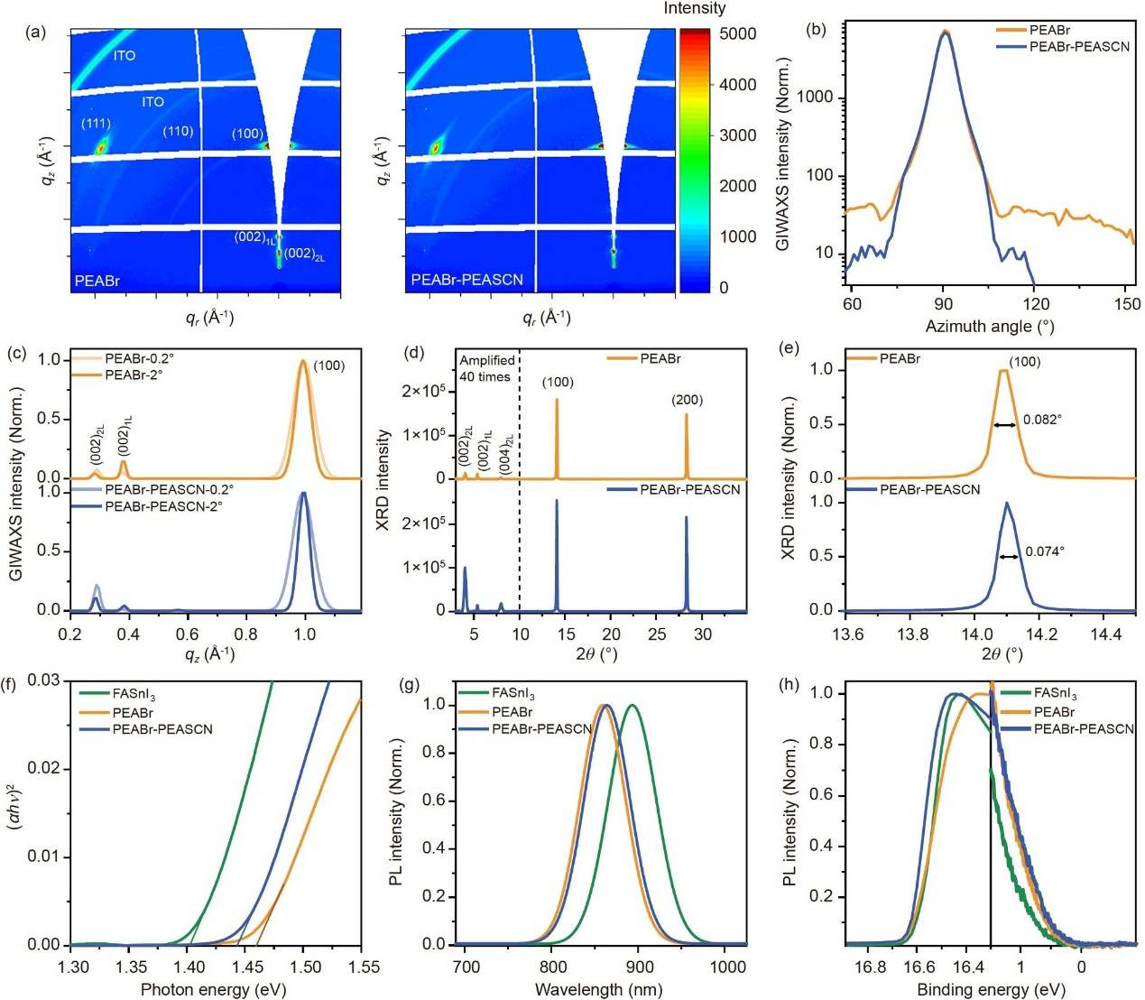
Figure 1 Film structure and photophysical properties. (a) GIWAXS patterns of tin-based perovskite films with incident angle of 2°. (b) GIWAXS intensity integrated azimuthally at q=1 Å⁻¹. (c) Line cut along q_{z} direction in GIWAXS patterns with different incident angles. (d) XRD patterns of tin-based perovskite thin films. The diffraction intensity in 3°–10° was amplified by a factor of forty for visual comparison. (e) XRD patterns with partially enlarged view of (100) plane. (f–h) Tauc plots, normalized PL spectra and UPS spectra of tin perovskite films (color online).

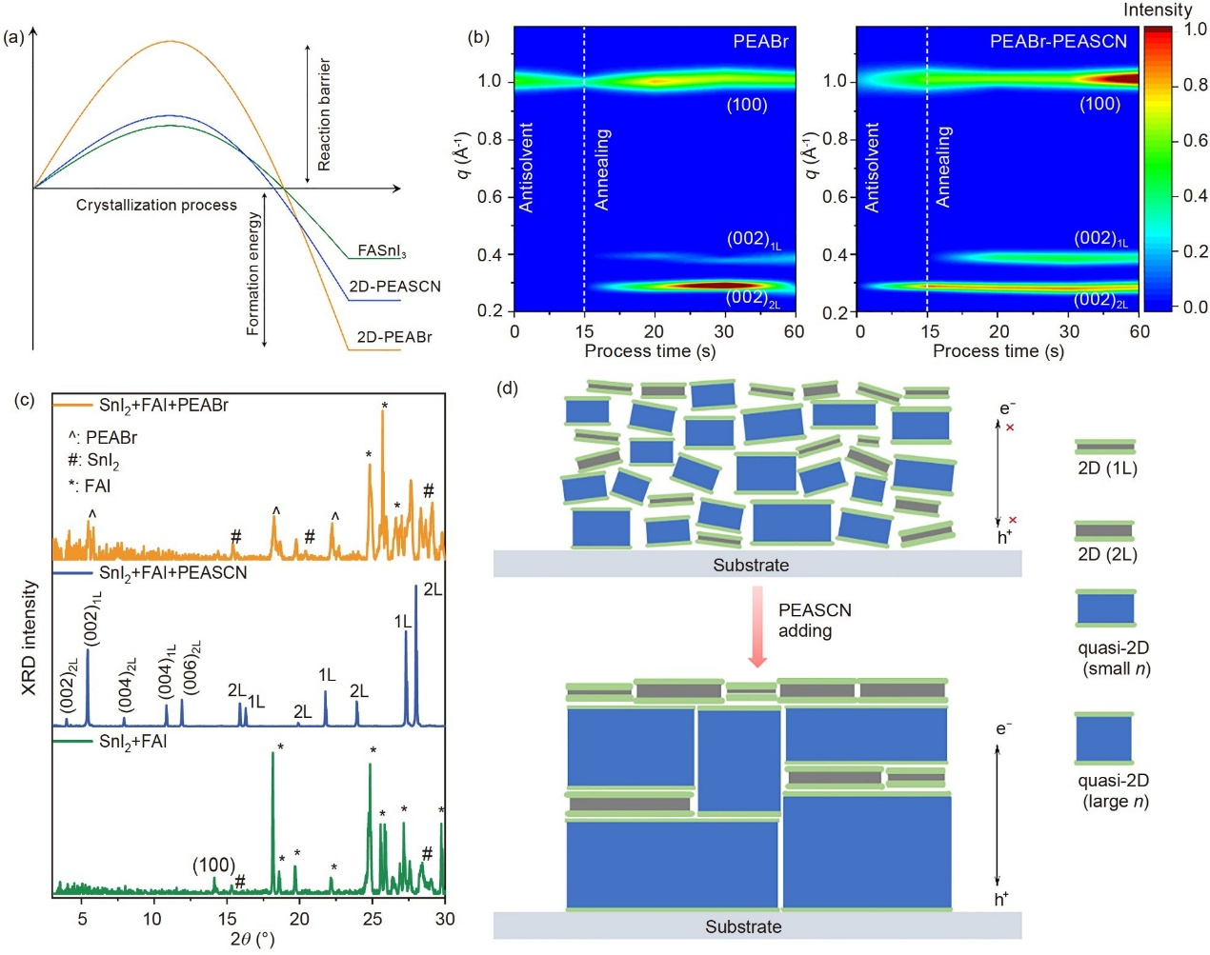
Figure 2 Film growth kinetics. (a) Schematic of the system free energy evolution in the crystallization of FASnI₃, PEA₂FASn₂I₅SCN₂ (2D-PEASCN) and PEA₂FASn₂Br₂I₅ (2D-PEABr). (b) XRD patterns of powder grinding products. (c) Quasi-in situ GIWAXS measurements of PEABr and PEABr–PEASCN films. GIWAXS intensities in each scattering vectors were integrated along the corresponding Debye rings. (d) Schematic of the crystallization mechanism of Sn-based perovskite films of PEABr and PEABr–PEASCN (color online).
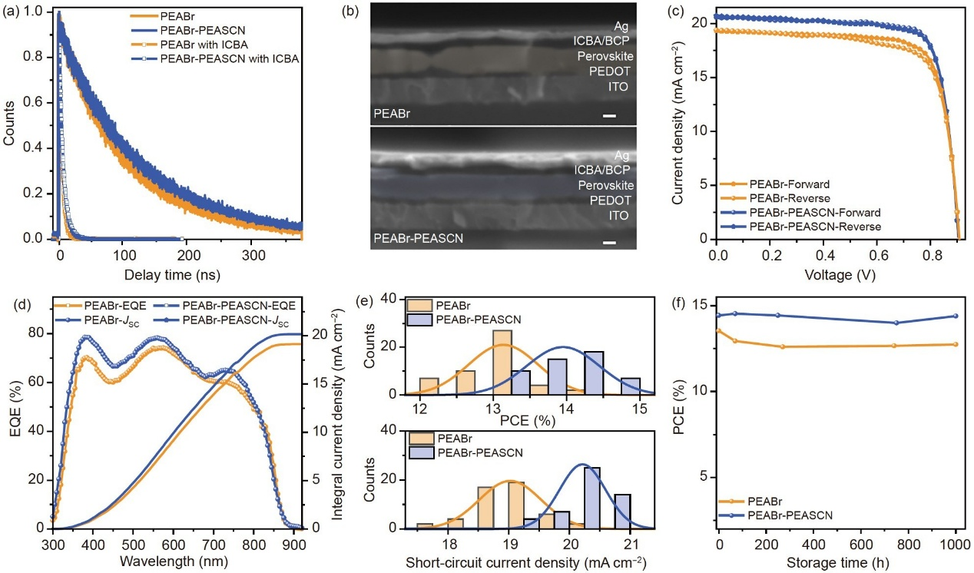
Figure 3 Solar cell performance and film properties. (a) TRPL spectra of PEABr and PEABr–PEASCN films with and without quenching layer. (b) Cross- section scanning electron microscope (SEM) images of Sn-based PSCs based on PEABr and PEABr–PEASCN. The scale bar is 100 nm. (c) Current density– voltage characteristic curves of Sn-based PSCs under simulated AM1.5 G illumination. (d) EQE and integrated current density of Sn-based perovskite solar cells. (e) Statistical PCE and J_{SC} from 50 PEABr and 50 PEABr–PEASCN Sn-based PSCs; (f) PCE evolution of encapsulated Sn-based perovskite solar cells stored in N₂ environment (color online).

