Eliminating the Burn-in Loss of Efficiency in Organic Solar Cells by Applying Dimer Acceptors as Supramolecular Stabilizers

Yanxun Li, Feng Qi, Baobing Fan, Kai-Kai Liu, Jifa Yu, Yuang Fu, Xianzhao Liu, Zhen Wang, Sen Zhang, Guanghao Lu, Xinhui Lu, Qunping Fan, Philip C. Y. Chow, Wei Ma, Francis R. Lin, Alex K.-Y. Jen*

Accepted by
Advanced Materials
April 04, 2024

Y. Li, K.-K. Liu. and A. K.-Y. Jen
Department of Materials Science & Engineering, City University of Hong Kong, Kowloon, Hong Kong, 999077, China
E-mail: alexjen@cityu.edu.hk
F. Qi, B. Fan, F. R. Lin and A. K.-Y. Jen
Department of Chemistry, City University of Hong Kong, Kowloon, Hong Kong, 999077, China
Y. Li, F. Qi, B. Fan, K.-K. Liu, F. R. Lin and A. K.-Y. Jen
Hong Kong Institute for Clean Energy, City University of Hong Kong, Kowloon, Hong Kong, 999077, China
A. K.-Y. Jen
Department of Materials Science & Engineering, University of Washington, Seattle, Washington, 98195, United States
A. K.-Y. Jen
State Key Laboratory of Marine Pollution, City University of Hong Kong, Kowloon, Hong Kong 999077, China
F. Qi
College of Materials Science and Engineering, Qingdao University, Qingdao, 266071, P. R. China
J. Yu and G. Lu
Frontier Institute of Science and Technology, Xi'an Jiaotong University, Xi'an, 710054, China
Y. Fu and X. Lu
Department of Physics, The Chinese University of Hong Kong, New Territories, Hong Kong, 999077, China
X. Liu, Z. Wang, and P. C. Y. Chow
Department of Mechanical Engineering, The University of Hong Kong, Pokfulam, Hong Kong, 999077, China
S. Zhang, Q. Fan and W. Ma
State Key Laboratory for Mechanical Behavior of Materials, Xi’an Jiaotong University, Xi’an, 710049, China
These authors contributed equally: Yanxun Li and Feng Qi.

Keywords: burn-in loss, organic photovoltaics, dimer acceptor, supramolecular stabilizer, thermal transition, trap state

Abstract
The meta-stable active layer morphology of organic solar cells (OSCs) has been identified as the main cause of the rapid burn-in loss of power conversion efficiency (PCE) during long-term device operation. However, effective strategies to eliminate the associated loss mechanisms from the initial stage of device operation are still lacking, especially for high-efficiency material systems. Herein, we report the introduction of molecularly engineered dimer acceptors with adjustable thermal transition properties into the active layer of OSCs to serve as supramolecular stabilizers for regulating the thermal transitions and optimizing the crystallization of the absorber composites. By establishing intimate π-π interactions with small-molecule acceptors, these stabilizers can effectively reduce the trap-state density (N_{t}) in the devices to achieve excellent PCEs over 19%. More importantly, the low N_{t} associated with an initially optimized morphology can be maintained under external stresses to significantly reduce the PCE burn-in loss in devices. Our research reveals a judicious approach to improving OPV stability by establishing a comprehensive correlation between material properties, active-layer morphology, and device performance, for developing burn-in-free OSCs.

1. Introduction
With the rapid development of small-molecule non-fullerene acceptors (SMNFAs), the power conversion efficiencies (PCEs) of single-junction organic solar cells (OSCs) have exceeded 19%.^{[1–5]} However, state-of-the-art OSCs adopting the bulk-heterojunction blend of polymer donors and SMNFAs often suffer from severe PCE burn-in loss even when operated under an inert atmosphere, showing irreversible and sharp decay in the beginning of device operation before stabilizing.^{[6–10]} This stems from the meta-stable morphology of OSC absorbers, especially the high-performance multi-component systems, which are extremely sensitive to external stresses under operation.^{[11–15]} This poses a major limitation for OSCs to compete with other photovoltaic technologies without such a burn-in loss feature, such as silicon, GaAs, and perovskites.
The earliest rationale behind using a multi-component active layer in OSC^{[16]} is motivated by the need to use materials with different electron affinities to ensure efficient exciton dissociation and charge transport. However, this approach creates issues concerning the miscibility between different materials to undermine OPV stability.^{[17]} Recent research has demonstrated that the morphological evolution driven by thermal stress^{[17]} plays a critical role in causing burn-in loss. The diffusion of SMNFAs and insufficient miscibility^{[18]} between different components in the blend of active layer contribute to the meta-stable morphology,^{[15,19]} resulting in the rapid decay of PCE. Therefore, the key to alleviating the burn-in loss lies in understanding and minimizing the causes of molecular diffusion to enable a robust morphology through regulated material thermal transitions. The glass-transition temperature (T_{g})^{[20]} corresponds to the motion of certain segments in semi-crystalline materials, and the onset crystallization temperature (T_{onset})^{[21]} represents the destruction of a crystalline phase when turns into amorphous, which are key indicators associated with the extent of burn-in loss in OSCs.^{[17,22]}
Most recently, Y6-derived oligomeric acceptors,^{[20]} especially the dimers,^{[23,24]} have displayed thermally stable morphology but often suffer from compromised PCEs. Since their molecular structures are highly similar to the SMNFAs, they are capable of establishing intimate π-π interactions with SMNFAs^{[25]} to serve as a supramolecular stabilizer to form a miscible blend in the ternary device^{[26]} for enabling a favorable nanostructure^{[27]} and robust morphology to minimize the burn-in loss. Herein, we report three dimerized acceptors with adjustable thermal transition properties, for application as supramolecular stabilizers to tune the thermal transition properties of absorbers in OSCs. By introducing dimer stabilizers and optimizing their flexible linker length, the T_{g} and T_{onset} of the acceptor blends can be improved compared to that of the pristine BTP-eC9, which help restrict molecular diffusion to result in robust active layer morphology. Consequently, the incorporation of dimer stabilizer in ternary planar-mixed heterojunction (PMHJ) OPV cells helps stabilize active layer nanostructure^{[28,29]}, enabling robust morphology to improve device stability. Based on these findings, we achieve over 19% PCE in the derived devices, and a negligible burn-in loss for realizing a T₉₈ lifetime of 600 h. Our work elucidates the causes and solutions to the notorious PCE burn-in loss and offers guidelines for the future development of highly efficient and durable OSCs.

2. Results and Discussions
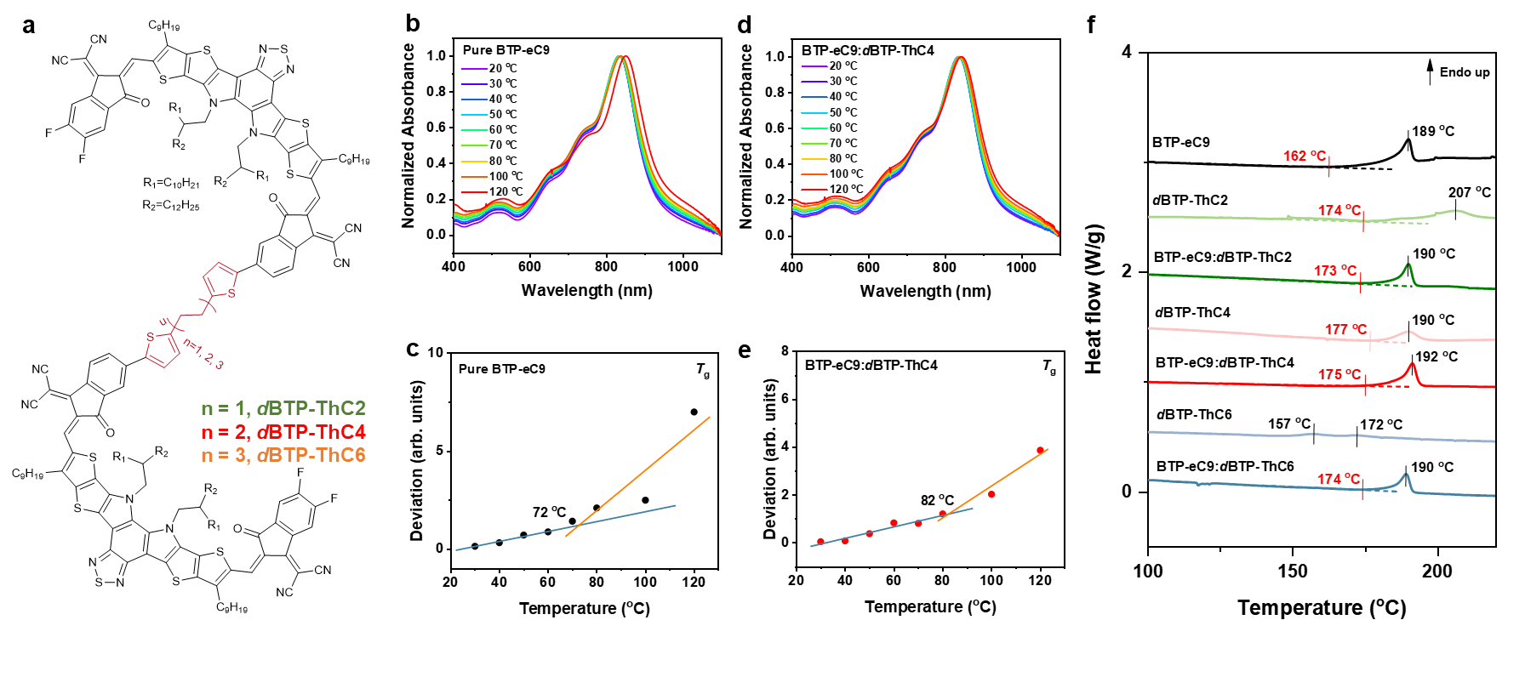
Figure 1. Properties of dimer acceptors. (a) The chemical structure of dBTP-ThC2, dBTP-ThC4, and dBTP-ThC6. (b-e) The temperature-dependent absorption spectra of pristine BTP-eC9 film (b) and BTP-eC9:dBTP-ThC4 film (d), and the temperature-dependent variations of absorption deviation for the pristine BTP-eC9 film (c) and BTP-eC9:dBTP-ThC4 film (e). (f) The endo-up DSC thermograms of pristine BTP-eC9, dBTP-ThC2, dBTP-ThC4 and dBTP-ThC6 films and blend BTP-eC9:dBTP-ThC2, BTP-eC9:dBTP-ThC4 and BTP-eC9:dBTP-ThC6 films. The heating rate during the DSC measurements is 10 ℃/min. In the DSC thermograms, the black and red lines mark the peak temperature (T_{c}) and onset temperature (T_{onset}) of crystallization, respectively.

2.1. Properties of Dimer Acceptors
Three dimer acceptors (dBTP-ThC2, dBTP-ThC4 and dBTP-ThC6) with Y6-derived conjugated backbones and different flexible linkers (Figure 1a) were synthesized as shown in Figure S1 (Supporting Information, SI), and the structural information of intermediates and final products are provided in Figures S2-9 (SI). The results of density-functional theory (DFT) calculations (Figure S10, SI) show that increasing the flexible linker length leads to decreased dihedral angle between the thienyls of the flexible linker and the acceptor backbone, thereby reducing the torsion of dimers and further regulating the thermal transition properties, crystallization, and supramolecular π-π interactions between dimers and SMNFAs.^{[30–32]} The lowest unoccupied molecular orbital (LUMO)/highest occupied molecular orbital (HOMO) energy levels of dBTP-ThC2, dBTP-ThC4 and dBTP-ThC6 were determined as 3.75/5.67 eV, 3.75/5.68 eV, and 3.77/5.69 eV (Figure S11, SI), respectively. Given that the LUMO/HOMO levels of BTP-eC9 are 4.05/5.64 eV,^{[33]} the introduction of these dimer acceptors with slightly larger bandgap into BTP-eC9 matrix can form the type I quantum well structure^{[34]} (Figure S11, SI) to enhance the open-circuit voltage (V_{oc}) of devices through the dilution effect.^{[34]} The optical bandgaps of BTP-eC9, dBTP-ThC2, dBTP-ThC4, and dBTP-ThC6 were determined as 1.32, 1.39, 1.40, and 1.39 eV (Figure S11, SI), respectively, whose trend agrees well with the results from cyclic voltammetry (CV) measurements.

Table 1. The parameters related to thermal transitions of pristine BTP-eC9 and blended acceptors.
Materials | T_{g} ª  (ºC) | T_{onset} ^{b}  (ºC) | T_{c} ^{b}  (ºC)
BTP-eC9 | 72 | 162 | 189
BTP-eC9:dBTP-ThC2 | 74 | 173 | 190
BTP-eC9:dBTP-ThC4 | 82 | 175 | 192
BTP-eC9:dBTP-ThC6 | 78 | 174 | 190
^{a.}The glass-transition temperature extracted from the temperature-dependent absorption spectra.
^{b.}The onset temperature and peak temperature of crystallization obtained from the DSC thermograms.

2.2. Thermal Transitions
The initial intention of synthesizing dimers is to improve the morphological stability of SMNFAs-based OSC active layer. Therefore, the thermal transition properties associated with molecular diffusion were first investigated to understand how dimers can affect device performance. The initial long-chain motion of molecular segments before reaching the rubbery state^{[35]-[36]} can be reflected by the glass-transition temperature (T_{g}), which was determined by the temperature-dependent absorption spectra in this research. As displayed in Figures 1b-c, the absorption deviation of pristine BTP-eC9 film shows an inflection point representing the T_{g}^{[37]} of around 72 ºC accompanied by a red-shift of 0-0 absorption peak^{[38]} of 19 nm. This indicates strong J-aggregation^{[39]} is formed due to the re-organization of BTP-eC9. In contrast, the acceptor blends composed of dimers and BTP-eC9 (Table 1, Figure S12 and Table S1) show higher T_{g}s than that of the pristine BTP-eC9 film, indicating dimers can serve as supramolecular stabilizers to inhibit the diffusion of SMNFAs by forming intimate π-π stacking. Among all blends, the BTP-eC9:dBTP-ThC4 blend exhibits the highest T_{g} of 82 ºC and the red-shift of 0-0 absorption peak can be reduced by 8 nm (Figures 1d-e), illustrating that the linker length can govern the interactions between dimer and SMNFA for mitigating SMNFA diffusion to avoid excessive aggregation. For reference, the introduction of the monomer into BTP-eC9 does not improve the T_{g} (Figure S13, SI). Besides, as exhibited in Figure S14 and Table S1 (SI), the T_{g}s of PMHJ films were further investigated, whose trend agrees well with that of acceptor blends. This result indicates that dimers have strong potential to retard the molecular diffusion in the composite containing polymer donors through the supramolecular π-π stacking to alleviate the meta-stable morphology of active layer.
To further decipher the emergence of excessive aggregation of SMNFAs observed in Figure 1b, the differential scanning calorimetry (DSC) measurements were performed to provide insights to the crystallization of materials. A very broad crystallization peak located at 207 ºC (crystallization temperature, T_{c}) corresponding to an onset temperature (T_{onset} = 174 ºC) of 33 ºC lower than that obtained in the DSC thermograms for dBTP-ThC2 (Figure 1f, Figure S15 and Table S2, SI). This indicates the surface crystallization^{[40]} and local crystallization^{[41]} were affected by the twisted backbone of dBTP-ThC2 which has the shortest flexible linker (C2). On the contrary, too long aliphatic linker (C6) triggers the formation of liquid crystalline phase^{[42,43]} to result in a pair of crystallization peaks emerging at 157 ºC and 172 ºC in the DSC thermogram of dBTP-ThC6. The dBTP-ThC4 with a moderate flexible linker length (C4) exhibits a similar T_{c} of 190 ºC as BTP-eC9, but a higher T_{onset} (177 ºC) than that of BTP-eC9 (164 ºC). Differences in the crystallization properties of these dimers further contribute to the crystallization of the dimer-SMNFA blends. As exhibited in Figure 1f, Figure S15 and Table S2 (SI), the acceptor blends show similar single crystallization peaks with the pristine BTP-eC9, indicating the well miscibility between dimer stabilizers and SMNFAs to form homogeneous blends.^{[26]} Compared with BTP-eC9 having the lowest T_{onset} of 162 ºC, the dimer-containing blends exhibit higher T_{onset}s, 173 ºC (dBTP-ThC2), 175 ºC (dBTP-ThC4), and 174 ºC (dBTP-ThC6), respectively, accompanying with narrower crystallization peaks. This result illustrates that thresholds of crystallization destruction of blends are higher than that of pristine SMNFAs. Therefore, SMNFAs with high diffusion coefficient and easily disrupted crystallinity can aggregate excessively. Contrarily, the blends with inhibited diffusion are less prone to aggregation, thereby enabling robust morphology with minimized burn-in loss. Moreover, the higher T_{onset}s also indicate slower crystallization^{[44]} and inhibited surface crystallization^{[45,46]} of blends, which facilitate the favorable crystal orientation and balance the trade-off between the device efficiency and stability.

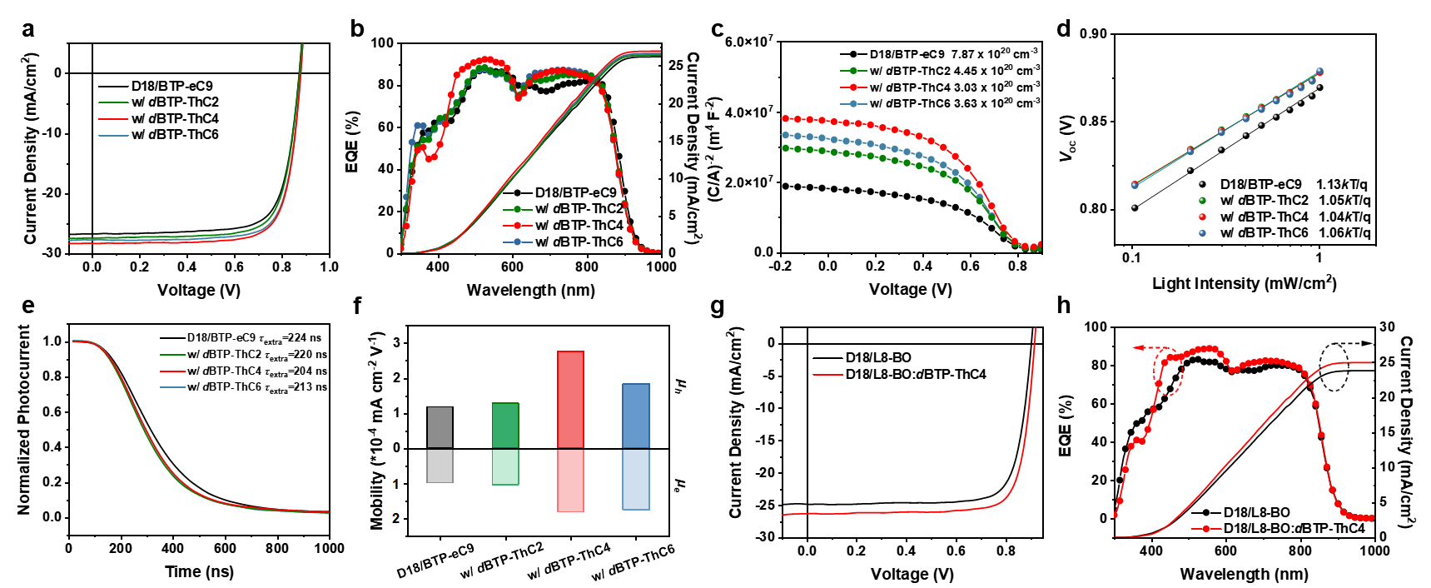
Figure 2. Device performance. The J-V characteristics (a) and EQE curves (b) of devices based on D18/BTP-eC9, D18/BTP-eC9:dBTP-ThC2 (w/ dBTP-ThC2), D18/BTP-eC9:dBTP-ThC4 (w/ dBTP-ThC4), and D18/BTP-eC9:dBTP-ThC6 (w/ dBTP-ThC6), respectively. (c) The Mott-Schottky analysis of OPVs based on binary D18/BTP-eC9, and ternary composites of w/ dBTP-ThC2, w/ dBTP-ThC4, and w/ dBTP-ThC6, respectively. The inset values are the corresponding trap-state densities (N_{t}). The dependence of V_{oc} over light intensity (d) and transient photocurrent (TPC) curves (e) of devices based on D18/BTP-eC9, w/ dBTP-ThC2, w/ dBTP-ThC4, and w/ dBTP-ThC6, respectively. (f) The hole/electron mobility (μ_{h}/μ_{e}) of single-carrier devices based on D18/BTP-eC9, w/ dBTP-ThC2, w/ dBTP-ThC4, and w/ dBTP-ThC6, respectively. The carrier mobility was calculated using the space-charge-limited current (SCLC) method. The upward and downward bar graphs represent the μ_{h} and μ_{e}, respectively. The J-V characteristics (g) and EQE curves (h) of devices based on D18/L8-BO and D18/L8-BO:dBTP-ThC4, respectively.

2.3. Impact on Device Performance
Our investigation over material thermal-transition properties indicates that dimer supramolecular stabilizers may eliminate the burn-in loss in high-efficiency devices. Therefore, these stabilizers were adopted to conventional OSC devices with a structure of ITO/PEDOT:PSS/PMHJ layer/PNDIT-F3N/Ag for investigating their impacts on device performance. By adjusting the composition ratio, when incorporating the dimer stabilizer at 10% mass ratio of BTP-eC9 achieved optimal device performance (Figure S16 and Table S3, SI). As shown in Figure 2a and Table 2, ternary devices with dimer supramolecular stabilizers exhibit higher PCEs than that of the binary D18/BTP-eC9 device (17.48%) and the device based on dBTP-ThC4 dimer showed a champion PCE of 19.09% with the optimal V_{oc}, J_{sc}, and FF, which can be attributed to the optimized crystallization as observed in the DSC thermograms to result in more favorable morphology. Meanwhile, the dimer supramolecular stabilizer with blue-shifted absorption, suitable energy levels, and larger bandgap not only enhances the V_{oc} through dilution effect,^{[34]} but also the device EQE response through improved active-layer absorption^{[47]} and more efficient charge extraction to enhance J_{sc}.
The impacts of dimers on devices were also investigated by studying the device physics. In Figure 2c, the Mott-Schottky analysis illustrates that the introduction of dimer can decrease the trap-state density (N_{t}) from 7.87 × 10²⁰ cm⁻³ (D18/BTP-eC9) to 4.45 × 10²⁰ cm⁻³ (w/ dBTP-ThC2), 3.03 × 10²⁰ cm⁻³ (w/ dBTP-ThC4), and 3.63 × 10²⁰ cm⁻³ (w/ dBTP-ThC6), respectively. These are achieved through suppressed charge recombination due to more regulated crystallization (Figure 2d and Figure S17, SI), which also facilitates charge separation and transport. The charge extraction time (τ_{extra}) was probed by the transient photocurrent (TPC) measurements (Figure 2e), illustrating that the devices with dimers show more rapid charge extraction associated with higher J_{sc}. Furthermore, the space-charge-limited current (SCLC) mothod^{[48]} was employed to obtain the hole/electron mobilities (μ_{h}/μ_{e}) (Figure S18, SI). In Figure 2f, the μ_{h}/μ_{e} of D18/BTP-eC9 devices were determined as 1.18 × 10⁻⁴ / 9.78 × 10⁻⁵ mA cm⁻² V⁻¹, which are lower than those of the devices having supramolecular stabilizers. Consequently, the dBTP-ThC4-based device exhibited the highest μ_{h}/μ_{e} of 2.76/1.81 × 10⁻⁴ mA cm⁻² V⁻¹, demonstrating that dimer with a moderate flexible linker length can optimize charge transport through regulated crystallization to enhance device performance. Moreover, it was found that dimers can be generally applicable to improve the performance of OPV devices with other Y6 derivatives. In Figures 2g-h, the device of D18/L8-BO:dBTP-ThC4 exhibits a champion PCE of 19.16%, with a V_{oc} of 0.915 V, J_{sc} of 26.30 mA cm⁻², and FF of 79.69%, illustrating the general applicability of dimer supramolecular stabilizers.

Table 2. The statistic of parameters of binary and ternary devices with PMHJ architecture.
PMHJ | V_{oc}  (V) | J_{sc} ª  (mA/cm²) | J_{sc}^{cal b}  (mA/cm²) | FF  (%) | PCE  (%)
D18/BTP-eC9 | 0.871 | 26.73 | 26.20 | 75.06 | 17.48
D18/BTP-eC9:dBTP-ThC2 | 0.872 | 27.41 | 26.42 | 75.59 | 18.06
D18/BTP-eC9:dBTP-ThC4 | 0.877 | 28.29 | 26.94 | 76.94 | 19.09
D18/BTP-eC9:dBTP-ThC6 | 0.877 | 27.72 | 26.62 | 77.05 | 18.73
D18/L8-BO | 0.902 | 24.84 | 23.79 | 78.75 | 17.65
D18/L8-BO: dBTP-ThC4 | 0.915 | 26.30 | 24.95 | 79.60 | 19.16
ª. J_{sc} extracted from the J-V characteristics.
^{b}. J_{sc} integrated from the EQE curves.

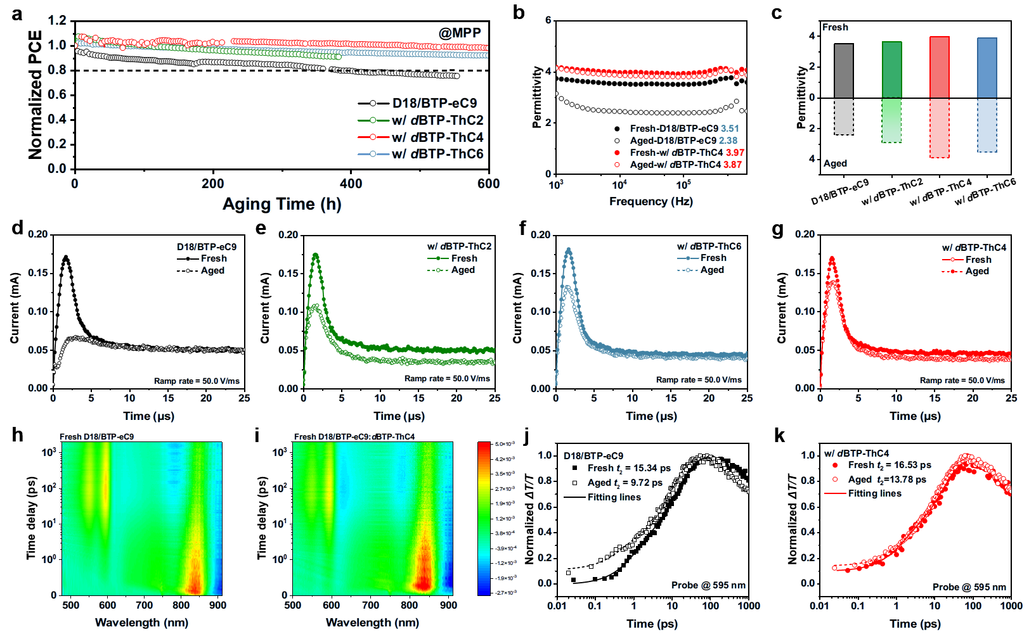
Figure 3. Burn-in loss mechanism. (a) The PCE evolutions of devices based on D18/BTP-eC9, D18/BTP-eC9:dBTP-ThC2 (w/ dBTP-ThC2), D18/BTP-eC9:dBTP-ThC4 (w/ dBTP-ThC4), and D18/BTP-eC9:dBTP-ThC6 (w/ dBTP-ThC6), respectively. (b) The permittivity of fresh and aged devices based on D18/BTP-eC9 and w/ dBTP-ThC4. (c) The statistics of permittivity for fresh and aged devices. The upward and downward bar graphs represent the permittivity of fresh and aged OPVs. The Photo-CELIV curves of fresh and aged devices based on D18/BTP-eC9 (d), w/ dBTP-ThC2 (e), w/ dBTP-ThC4 (f), and w/ dBTP-ThC6 (g), respectively. The ramp rate of Photo-CELIV examinations equals 50 V/ms. Transient absorption spectra (TAS) of fresh D18/BTP-eC9 film (h) and fresh w/ dBTP-ThC4 film (i). The dynamic plots of D18/BTP-eC9 film (j) and fresh w/ dBTP-ThC4 film (k) probed at 595 nm of the corresponding TAS.

2.4. Elucidate the Burn-in Loss Mechanism
The impacts of dimer on device stability and the corresponding mechanism were further investigated in detail. The maximum-power-point tracking (MPPT) of OPV cells was performed under one-sun illumination. As displayed in Figure 3a, a rapid burn-in loss can be observed in the D18/BTP-eC9 device, whose PCE quickly drops to 80% of the initial value within 350 h. In contrast, the burn-in loss can be significantly mitigated by introducing dimer stabilizers to retard the molecular diffusion by establishing a more robust morphology to reduce burn-in loss. Consequently, the ternary device of D18/BTP-eC9:dBTP-ThC4 exhibits negligible burn-in loss, maintaining 98% of the initial PCE after being tracked at MPPT for 600 h (T₉₈). Meanwhile, the extrapolated T₈₀ lifetime of ternary D18/BTP-eC9:dBTP-ThC4 devices is estimated to be ~ 2200 h. This result indicates that the supramolecular stabilizer dBTP-ThC4 with the most distinctly improved T_{g}, T_{onset}, and crystallization in the blend system can contribute to higher device performance and reduced burn-in loss.
To gain a deeper understanding of the dimer’s contribution to reducing OSC burn-in loss, mechanism studies were performed from the aspect of device physics. To understand the evolution between the fresh and the aged devices, all aged devices studied were tracked at MPP for 100 h. The relative permittivity (ε_{r}) is a parameter that can be easily influenced by the morphological variation.^{[49]} As displayed in Figure 3b, the ε_{r} of the fresh D18/BTP-eC9 device is 3.51, while that of the aged device drops to 2.38. This indicates that the meta-stable morphology of the binary active layer deteriorates rapidly under the MPP condition, causing increased exciton binding energy (E_{B}) to undermine device performance. In contrast, the changes in ε_{r}s of fresh and aged ternary devices with dimer stabilizers (Figure S19, SI and Figure 3c) are smaller than that of the binary device. Only negligible ε_{r} variation is found in the dBTP-ThC4-based ternary device (Figures 3b-c), with the ε_{r} of fresh and aged devices as 3.97 and 3.87, respectively. This result indicates that stable morphology realized by introducing dimers leads to stable ε_{r} and E_{B}, which should facilitate efficient charge separation even in an aged device. This is further confirmed by TPC characterization of aged devices (Figure S20, SI), where the rapid charge extraction process can still be maintained well after prolonged operation when dimer stabilizers were introduced.
The rapid increase of N_{t} is also an important reason causing performance loss in OSCs.^{[50]} In Photo-CELIV characterizations, the increased N_{t} can result in dispersive transport^{[51]} and a longer delay time (t_{d}).^{[52,53]} As displayed in Figure 3d, the aged D18/BTP-eC9 device exhibits a broader CELIV curve and longer t_{d} than that of the fresh binary device, indicating higher N_{t} caused by the morphological evolution. In contrast, similar CELIV curves and t_{d}s of fresh and aged ternary devices with dimer stabilizers indicate that retarded molecular diffusion and enhanced morphological stability can help maintain the N_{t} of devices at a relatively low level. Further Mott-Schottky analysis quantitatively analyzed the N_{t} of aged devices (Figure S21, SI), showing results agree well with that obtained from Photo-CELIV. Benefiting from dimer stabilizer regulated thermal transitions in blends, the retarded SMNFAs diffusion and the optimized crystallization can further enhance the morphological stability of active layer and maintain low-level N_{t} to realize negligible burn-in loss.
Transient absorption spectroscopy (TAS) characterizations were performed to understand the photophysical processes in active layer for reducing burn-in loss. As shown in Figures 3h-i and Figures S22-23 (SI), a 750 nm laser was utilized to selectively pump the acceptor to trigger the hole transfer from the acceptor to the donor, where the ground-state bleaching (GSB) signal of the donor was observed at 595 nm. The kinetics of the donor GSB signal (Figures 3j-k) were fitted to obtain two parameters, t₁ and t₂, corresponding to the exciton generation and diffusion,^{[54]} respectively. Among them, the excitons diffusion to the interface is affected by phase separation and morphology of the PMHJ layer, thereby revealing morphology-related information. As summarized in Table S3 (SI), the longer t₂ (16.53 ps / 13.78 ps) of fresh/aged films containing the dBTP-ThC4 than those of D18/BTP-eC9 films (15.34 ps / 9.72 ps) illustrates longer exciton lifetime in the ternary film with a dimer stabilizer, which is also corroborated by the time-resolved photoluminescence (TRPL) of acceptor films as displayed in Figure S24 (SI). This result further illustrates that ternary films containing dimer stabilizers have more favorable and robust morphology than that of D18/BTP-eC9 films, which not only facilitates more efficient charge transport, but also retains the desirable properties upon aging to alleviate the burn-in loss.
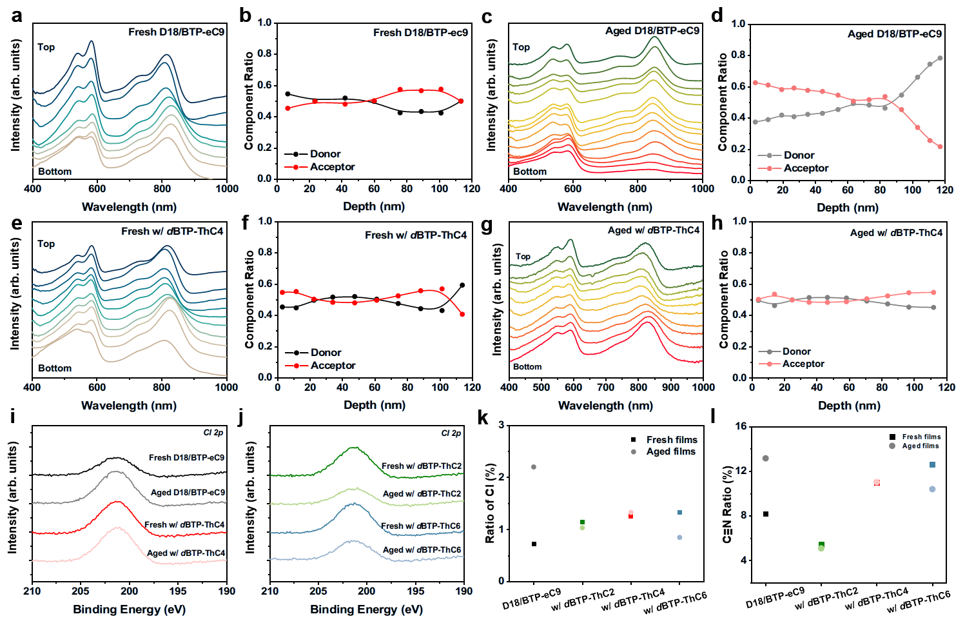
Figure 4. The Material Distribution. The film-depth-dependent light absorption spectra (FLAS) of the fresh D18/BTP-eC9 film (a), the aged D18/BTP-eC9 film (c), the fresh D18/BTP-eC9:dBTP-ThC4 (w/ dBTP-ThC4) film (e), and the aged w/ dBTP-ThC4 film (g), respectively. The component distribution along the depth of the fresh D18/BTP-eC9 film (b), the aged D18/BTP-eC9 film (d), the fresh w/ dBTP-ThC4 film (f), and the aged w/ dBTP-ThC4 film (h), respectively. The high-resolution Cl 2p core-level XPS spectra of fresh and aged D18/BTP-eC9 and w/ dBTP-ThC4 films (i), w/ dBTP-ThC2 and w/ dBTP-ThC6 films (j). The calculated Cl (k) and -C≡N (l) ratios in the fresh and aged PMHJ films.

2.5. The Material Distribution
Device physics studies indicate that the low-level N_{t} and the well-maintained morphology facilitated by the introduced dimer are the keys to minimizing the burn-in loss in ternary devices. To understand the microstructures of the ternary blends, the composition and morphology were further investigated to elucidate how dimer stabilizers affect the distribution and stacking of molecules, as well as the phase separation. To mimic the burn-in loss, aged films applied for morphological characterizations were aged at 65 ºC for 72 h under 1-sun illumination.
The film-depth-dependent light absorption spectra (FLAS) were measured to evaluate the vertical distribution of donor and acceptors.^{[29,55,56]} Compared to the fresh binary film (Figures 4a-b), a distinct component segregation is observed in the aged D18/BTP-eC9 film (Figures 4c-d), which can be attributed to the rapid diffusion and surface crystallization of SMNFAs. By introducing dimer stabilizers, the component segregation is much mitigated (Figures S25-26, SI and Figures 4e-h), leading to more stable active layer morphology. The ternary film of D18/BTP-eC9:dBTP-ThC4 exhibits the most robust component distribution after aging (Figures 4e-h), demonstrating that the employment of a suitable dimer stabilizer with moderate flexible linker length can effectively retard the SMNFAs diffusion and suppress the unfavorable surface crystallization.
Considering that the segregation of SMNFAs mainly occurs at the top surface of PMHJ films, the surface-sensitive XPS characterization^{[57]} was performed to examine the surface composition of fresh and aged PMHJ films. Using chloro group (Cl) as the signature species of BTP-eC9, the ratios of Cl at the surface of different PMHJ films were probed to estimate the surface distribution of BTP-eC9. As displayed in Figure 4i and Table S4 (SI), the Cl 2p core level spectra of aged D18/BTP-eC9 film exhibits a distinctly increased Cl ratio from 0.72% (fresh) to 2.20% (aged), demonstrating the segregation of BTP-eC9 after aging. This agrees well with the result from depth-dependent absorption spectra. In contrast, as shown in Figures 4i-k and Table S4, all ternary films with dimer stabilizer exhibit almost unchanged Cl ratio compared to that of the binary film, showing the effectiveness of dimer in inhibiting the segregation of SMNFAs. Meanwhile, the signal of cyano (-C≡N) group corresponding to BTP-eC9 and dimers can also be isolated from the high-resolution N 1s core level spectra to verify whether segregation occurs with dimer stabilizers. As shown in Figure 4l, Figures S27-32 and Table S5 (SI), the rule of -C≡N ratio change is similar to that of Cl within BTP-eC9, illustrating that the acceptor segregation is mainly due to the diffusion of small-molecule BTP-eC9 and the introduction of the dimer stabilizer can retard the diffusion of SMNFAs to inhibit unfavorable segregation.
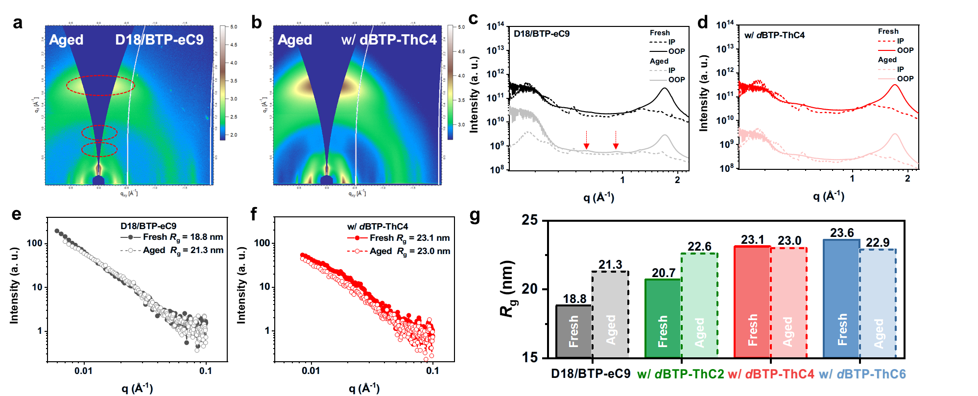
Figure 5. The morphology evolution. The two-dimensional (2D) GIWAXS patterns of the aged D18/BTP-eC9 (a) and D18/BTP-eC9:dBTP-ThC4 (w/ dBTP-ThC4) films (b), respectively. The line-cut-of profiles along the in-plane (IP) and out-of-plane directions (OOP) of fresh and aged D18/BTP-eC9 (c) and w/ dBTP-ThC4 films (d) corresponding to the 2D GIWAXS patterns. The GISAXS curves of fresh and aged D18/BTP-eC9 (e) and w/ dBTP-ThC4 films (f), where the filled and hollow dots represent the data of fresh and aged films, respectively. (g) The statistic of gyration radius (R_{g}) extracted from the GISAXS curves.

2.6. The Morphology Evolution
We further study the morphology evolution to intuitively describe the role of supramolecular stabilizers during device operation. The grazing incidence wide-angle X-ray scattering (GIWAXS) characterization was performed to study the molecular stacking. As shown in Figure S33 (SI) and Figure 5a, several new peaks located at 0.7/0.9 Å⁻¹ along the out-of-plane (OOP) direction are observed in the aged D18/BTP-eC9 film accompanied by the weakened peak at 1.70 Å⁻¹ (corresponding to the π-π stacking), indicating that the segregation of SMNFAs induced by rapid molecular diffusion and surface crystallization can destroy the favorable crystal orientation. In contrast, no segregation-caused peaks could be observed in the GIWAXS patterns of fresh and aged ternary films incorporating dimer stabilizers (Figure 5b and Figures S33-34, SI). This demonstrates that the employment of dimers could address SMNFA molecular diffusion to facilitate a favorable and well-maintained crystallization orientation. By comparing the crystal coherence length (CCL) of π-π stacking peak (Figures 5c-d, Figure S35 and Table S7, SI), it is confirmed that introducing dimer stabilizers not only enhances the π-π stacking of films, but also inhibits stress-induced morphological changes during aging to maintain efficient charge-transporting pathways. Besides, it is also noted that the D18/BTP-eC9:dBTP-ThC4 film exhibits the longest and unchanged CCL of π-π stacking, as benefited from the reduced component segregation and is critical for maintaining excellent ε_{r} and low N_{t}.
To quantify the variation of phase separation, the grazing incidence small-angle X-ray scattering (GISAXS) technique was adopted to examine the gyration radius (R_{g}), which reflects the domain size of acceptors.^{[59]} As shown in Figures 5e-f and Figure S36 (SI), the R_{g} of D18/BTP-eC9 film increases from 18.8 nm (fresh) to 21.3 nm (aged). Meanwhile, the R_{g}s of fresh and aged ternary films (Figure S37, SI and Figure 5g) show similar values, indicating higher tolerance of morphological stability in ternary films than the binary film to external stresses. Consequently, the negligible difference of R_{g} (23.1 nm v.s. 23.0 nm) is observed in the fresh and aged the D18/BTP-eC9:dBTP-ThC4 films, which illustrates the enhanced phase stability of the dimer-based active layer. In short, the stable morphology enabled by the dimer stabilizer stems from the retarded molecular diffusion and suppressed surface crystallization, which can further minimize the component segregation to maintain favorable π-π stacking and morphological stability. More importantly, the typical burn-in loss observed in MPPT is greatly eliminated due to the stable morphology associated with the optimal thermal transition properties of dimer stabilizers with moderate flexible linker length, resulting in low N_{t} in the corresponding devices.

3. Conclusion
Overcoming the meta-stable active layer morphology and maintaining a low-level N_{t} in the device under external stress are the critical keys to eliminating the burn-in loss of OPVs. To enable a stable morphology, ternary devices based on the dimer stabilizer with optimal flexible linker length (C4) and PMHJ architecture are capable of optimizing their thermal-transition properties to retard molecular diffusion and surface crystallization. This results in the more well-organized and robust molecular distribution, π-π stacking, and phase separation in the OSC blend. Meanwhile, the crystallization- and morphology-regulation effects of dimer stabilizers can also facilitate rapid charge extraction, suppressed charge recombination, efficient charge transport, and low N_{t} resulting in a high PCE of over 19%. These dimer supramolecular stabilizers enable excellent photovoltaic physical properties that can be maintained well under external stresses, which help eliminate the burn-in loss for maintaining a T₉₈ of 600 h under MPPT. Our investigation provides useful guidelines for the fabrication of burn-in-free OSCs to facilitate their future commercial deployment.

Methods
Materials: The D18 was synthesized according to the literature^{[60]}. BTP-eC9 and L8-BO were purchased from the Solarmer Inc. The PEDOT:PSS (PVP Al 4083) and PNDIT-F3N were purchased from Heraeus and eflex PV, respectively. All chemicals and reagents for the synthesis of dimers were purchased from commercial resources and were used without further purification. ThC2-Sn, ThC4-Sn, ThC6-Sn and Compound 4 were synthesized according to the literature.^{[61]}
J-V Characterizations, EQE and Stability Evaluation: The J−V characteristics were performed by the solar simulator (Enlitech SS-F5, Enlitech) along with AM 1.5 G spectra which intensity was calibrated by the certified standard silicon solar cell at 100 mW/cm². EQE spectra were measured by a Solar Cell Spectral Response Measurement System QE-S (Enlitech, Taiwan) equipped with a standard silicon diode, where the monochromatic light was generated from a Newport 300 W lamp. Dynamic MPPT was examined on an in-situ stability measurement system (CRYSCO, Guangzhou) under the LED lamp with an intensity equaling 1 sun. The chamber of MPPT was placed in the N₂-filled glovebox. The film samples for stability-related characterizations were heated at 65 ºC in the N₂ environment with 1-sun illumination simultaneously for 72 hours.
Device Characterization: For permittivity, devices were scanned from 10⁵ to 1 Hz with a disturbance AC signal of 20 mV (DC bias = 0 V) in dark conditions by using a CHI660 electrochemical workstation (CH Instrument, Inc.). For Mott-Schottky analysis, the devices were scanned with a DC bias from 1 to -0.2 V in dark condition. The N_{t} can be calculated by $\frac{{\text{A}}^{\text{2}}}{{\text{C}}^{\text{2}}}\text{= }\frac{\text{2(}{\text{V}}_{\text{bi}}\text{-}\text{V}\text{)}}{\text{q}{\text{ε}}_{\text{0}}{\text{ε}}_{\text{r}}{\text{N}}_{\text{t}}}$, where A is the device area, C represents the capacitance, ε₀ and ε_{r} represent the permittivity of free space and relative permittivity, V_{bi} is the built-in volatage of devices, q is the elementary charge. Transient photocurrent (TPC) and delay-time CELIV were measured on an integrated platform of Paios (Fluxim AG). For delay-time CELIV, a light pulse (100 μs) was applied prior to a voltage ramp of 1 V μs^{–1} and the sweep ramp rate was 50 V/ms. Transient absorption spectroscopy was conducted with an Ultrafast Systems Helios femtosecond transient absorption spectrometer. 1030 nm laser pulses were generated by a Light Conversion femtosecond laser amplifier, and then split into two beams to generate the pump and probe pulses. For probe, the pulses were focused onto a sapphire and a YAG crystal to generate the visible (500-910 nm) and infrared (1100-1600 nm) continuum, respectively.
Characterization of Thermal Transition: DSC thermograms were examined by Mettler-Toledo-DSC3 analyzer at a heating rate of 10 K min^{–1}. Glass-transition temperature (T_{g}) of film samples was obtained by extracting the deviation metric (DM) from the temperature-dependent absorption spectra. The DM can be calculated by the equation described as ${\text{DM}}_{\text{T}}\text{=}\sum_{{\text{λ}}_{\text{min}}}^{{\text{λ}}_{\text{max}}}{{\text{(}{\text{I}}_{\text{RT}}\text{(λ)-}{\text{I}}_{\text{T}}\text{(λ))}}^{\text{2}}}$, where I_{RT}(λ) and I_{T}(λ) represent the absorption intensity of as-cast and annealed acceptor films, respectively.
Morphology Characterization: The film-depth-dependent light absorption spectra (FLAS) were obtained from Beer–Lambert's law in combination with oxygen plasma etching. During etching, the oxygen plasma pressure was kept below 20 Pa to guarantee surface-selective etching without subsurface damage.^{[62]} The XPS characterization was conducted in a Thermo Fisher ESCALAB XI+ X-Ray Photoelectron Spectrometer. The Grazing Incidence Wide-Angle X-ray Scattering (GIWAXS) measurements were performed at beamline 7.3.3[1] at the Advanced Light Source. Samples were prepared on Si substrates based on the same processing method in device fabrication. The 10 keV X-ray beam was incident at a grazing angle of 0.11°-0.15°, selected to maximize the scattering intensity from the samples. The CCL for π-π stacking was calculated using the equation that CCL = 2πK/W, where π is the circular constant, K is a constant of 0.9 and W is the full width at half maximum of the peak at q = 1.70 Å⁻¹ in the out-of-plane direction. The scattered x-rays were detected using a Dectris Pilatus 2M photon counting detector. The grazing incidence small angle X-ray scattering (GISAXS) measurement was carried out with a Xeuss 2.0 SAXS laboratory beamline using a Cu X-ray source (8.05 keV, 1.54 Å) and a Pilatus3R 300K detector. The incident angle was 0.15°. The samples for GISAXS measurement were directly deposited on the silicon substrates under the same condition as the optimized devices.

Supporting Information
Supporting Information is available from the Wiley Online Library or from the author.

Acknowledgements
A.K.Y.J. thanks the sponsorship of the Lee Shau-Kee Chair Professor (Materials Science), and the support from the APRC Grants (9380086, 9610508, 9610419, 9610492) of the City University of Hong Kong, the TCFS Grant (GHP/018/20SZ) and MRP Grant (MRP/040/21X) from the Innovation and Technology Commission of Hong Kong, the Green Tech Fund (202020164) from the Environment and Ecology Bureau of Hong Kong, the GRF grants (11307621, 11316422) from the Research Grants Council of Hong Kong, Shenzhen Science and Technology Program (SGDX20201103095412040), Guangdong Major Project of Basic and Applied Basic Research (2019B030302007). The authors thank Prof. Hin-Lap Yip for providing the instrumental setup for stability tracking. X-ray data was acquired at beamlines 7.3.3 and 11.0.1.2 at the Advanced Light Source, which is supported by the Director, Office of Science, Office of Basic Energy Sciences, of the U.S. Department of Energy under Contract No. DE-AC02-05CH11231. The authors thank Dr. Eric Schaible and Dr. Chenhui Zhu at beamline 7.3.3, and Dr. Cheng Wang at beamline 11.0.1.2 for assistance with data acquisition.

Received: ((will be filled in by the editorial staff))
Revised: ((will be filled in by the editorial staff))
Published online: ((will be filled in by the editorial staff))

References
[1] J. Wang, Y. Wang, P. Bi, Z. Chen, J. Qiao, J. Li, W. Wang, Z. Zheng, S. Zhang, X. Hao, J. Hou, Adv. Mater. 2023, 2301583.
[2] J. Fu, P. W. K. Fong, H. Liu, C.-S. Huang, X. Lu, S. Lu, M. Abdelsamie, T. Kodalle, C. M. Sutter-Fella, Y. Yang, G. Li, Nat. Commun. 2023, 14, 1760.
[3] W. Gao, F. Qi, Z. Peng, F. R. Lin, K. Jiang, C. Zhong, W. Kaminsky, Z. Guan, C. Lee, T. J. Marks, H. Ade, A. K. ‐Y. Jen, Adv. Mater. 2022, 34, 2202089.
[4] K. Jiang, J. Zhang, C. Zhong, F. R. Lin, F. Qi, Q. Li, Z. Peng, W. Kaminsky, S.-H. Jang, J. Yu, X. Deng, H. Hu, D. Shen, F. Gao, H. Ade, M. Xiao, C. Zhang, A. K.-Y. Jen, Nat. Energy 2022, 7, 1076.
[5] Q. Fan, R. Ma, J. Yang, J. Gao, H. Bai, W. Su, Z. Liang, Y. Wu, L. Tang, Y. Li, Q. Wu, K. Wang, L. Yan, R. Zhang, F. Gao, G. Li, W. Ma, Angew Chem. Int. Ed. 2023, 62, e202308307.
[6] C. J. Brabec, S. Gowrisanker, J. J. M. Halls, D. Laird, S. Jia, S. P. Williams, Adv. Mater. 2010, 22, 3839.
[7] C. H. Peters, I. T. Sachs-Quintana, W. R. Mateker, T. Heumueller, J. Rivnay, R. Noriega, Z. M. Beiley, E. T. Hoke, A. Salleo, M. D. McGehee, Adv. Mater. 2012, 24, 663.
[8] C. H. Peters, I. T. Sachs-Quintana, J. P. Kastrop, S. Beaupré, M. Leclerc, M. D. McGehee, Adv. Energy Mater. 2011, 1, 491.
[9] M. Jørgensen, K. Norrman, S. A. Gevorgyan, T. Tromholt, B. Andreasen, F. C. Krebs, Adv. Mater. 2012, 24, 580.
[10] E. T. Hoke, I. T. Sachs-Quintana, M. T. Lloyd, I. Kauvar, W. R. Mateker, A. M. Nardes, C. H. Peters, N. Kopidakis, M. D. McGehee, Adv. Energy Mater. 2012, 2, 1351.
[11] X. Tong, N. Wang, M. Slootsky, J. Yu, S. R. Forrest, Sol. Energy Mater. Sol. Cells 2013, 118, 116.
[12] T. Heumueller, W. R. Mateker, I. T. Sachs-Quintana, K. Vandewal, J. A. Bartelt, T. M. Burke, T. Ameri, C. J. Brabec, M. D. McGehee, Energy Environ. Sci. 2014, 7, 2974.
[13] Q. Burlingame, X. Huang, X. Liu, C. Jeong, C. Coburn, S. R. Forrest, Nature 2019, 573, 394.
[14] E. M. Speller, A. J. Clarke, J. Luke, H. K. H. Lee, J. R. Durrant, N. Li, T. Wang, H. C. Wong, J.-S. Kim, W. C. Tsoi, Z. Li, J. Mater. Chem. A 2019, 7, 23361.
[15] C. Zhang, T. Heumueller, S. Leon, W. Gruber, K. Burlafinger, X. Tang, J. D. Perea, I. Wabra, A. Hirsch, T. Unruh, N. Li, C. J. Brabec, Energy Environ. Sci. 2019, 12, 1078.
[16] G. Yu, J. Gao, J. C. Hummelen, F. Wudl, A. J. Heeger, Science 1995, 270, 1789.
[17] M. Ghasemi, N. Balar, Z. Peng, H. Hu, Y. Qin, T. Kim, J. J. Rech, M. Bidwell, W. Mask, I. McCulloch, W. You, A. Amassian, C. Risko, B. T. O’Connor, H. Ade, Nat. Mater. 2021, 20, 525.
[18] L. Ye, H. Hu, M. Ghasemi, T. Wang, B. A. Collins, J.-H. Kim, K. Jiang, J. H. Carpenter, H. Li, Z. Li, T. McAfee, J. Zhao, X. Chen, J. L. Y. Lai, T. Ma, J.-L. Bredas, H. Yan, H. Ade, Nat. Mater. 2018, 17, 253.
[19] Y. Li, K.-K. Liu, F. R. Lin, A. K.-Y. Jen, Solar RRL 2023, 2300531.
[20] Y. Liang, D. Zhang, Z. Wu, T. Jia, L. Lüer, H. Tang, L. Hong, J. Zhang, K. Zhang, C. J. Brabec, N. Li, F. Huang, Nat. Energy 2022, 7, 1180.
[21] X. Cheng, M. Li, Z. Liang, M. Gao, L. Ye, Y. Geng, ACS Appl. Energy Mater. 2021, 4, 8442.
[22] C. J. Brabec, A. Distler, X. Du, H. Egelhaaf, J. Hauch, T. Heumueller, N. Li, Adv. Energy Mater. 2020, 10, 2001864.
[23] H. Wang, C. Cao, H. Chen, H. Lai, C. Ke, Y. Zhu, H. Li, F. He, Angew. Chem. Int. Ed. 2022, 134, 202201844.
[24] F. Qi, Y. Li, R. Zhang, F. R. Lin, K. Liu, Q. Fan, A. K.-Y. Jen, Angew. Chem. Int. Ed. 2023, 62, e202303066.
[25] J.-H. Deng, J. Luo, Y.-L. Mao, S. Lai, Y.-N. Gong, D.-C. Zhong, T.-B. Lu, Sci. Adv. 2020, 6, eaax9976.
[26] A. D. De Zerio, C. Müller, Adv. Energy Mater. 2018, 8, 1702741.
[27] L. Zhu, M. Zhang, J. Xu, C. Li, J. Yan, G. Zhou, W. Zhong, T. Hao, J. Song, X. Xue, Z. Zhou, R. Zeng, H. Zhu, C.-C. Chen, R. C. I. MacKenzie, Y. Zou, J. Nelson, Y. Zhang, Y. Sun, F. Liu, Nat. Mater. 2022, 21, 656.
[28] R. Sun, J. Guo, Q. Wu, Z. Zhang, W. Yang, J. Guo, M. Shi, Y. Zhang, S. Kahmann, L. Ye, X. Jiao, M. A. Loi, Q. Shen, H. Ade, W. Tang, C. J. Brabec, J. Min, Energy Environ. Sci. 2019, 12, 3118.
[29] H. Fu, Z. Peng, Q. Fan, F. R. Lin, F. Qi, Y. Ran, Z. Wu, B. Fan, K. Jiang, H. Y. Woo, G. Lu, H. Ade, A. K. ‐Y. Jen, Adv. Mater. 2022, 34, 2202608.
[30] A. Mahmood, A. Tang, X. Wang, E. Zhou, Phys. Chem. Chem. Phys. 2019, 21, 2128.
[31] F. Lin, K. Jiang, W. Kaminsky, Z. Zhu, A. K.-Y. Jen, J. Am. Chem. Soc. 2020, 142, 15246.
[32] Z. Ma, H. Fu, D. Meng, W. Jiang, Y. Sun, Z. Wang, Chem. Asian J. 2018, 13, 918.
[33] Y. Cui, H. Yao, J. Zhang, K. Xian, T. Zhang, L. Hong, Y. Wang, Y. Xu, K. Ma, C. An, C. He, Z. Wei, F. Gao, J. Hou, Adv. Mater. 2020, 32, 1908205.
[34] L. Zuo, S. B. Jo, Y. Li, Y. Meng, R. J. Stoddard, Y. Liu, F. Lin, X. Shi, F. Liu, H. W. Hillhouse, D. S. Ginger, H. Chen, A. K.-Y. Jen, Nat. Nanotechnol. 2022, 17, 53.
[35] J. H. Gibbs, E. A. DiMarzio, J. Chem. Phys. 1958, 28, 373.
[36] C. Buckley, Polymer 1995, 36, 3301.
[37] S. E. Root, M. A. Alkhadra, D. Rodriquez, A. D. Printz, D. J. Lipomi, Chem. Mater. 2017, 29, 2646.
[38] F. C. Spano, Acc. Chem. Res. 2010, 43, 429.
[39] D. Li, X. Zhang, D. Liu, T. Wang, J. Mater. Chem. A 2020, 8, 15607.
[40] T. Ozawa, Polymer 1971, 12, 150.
[41] H. Hu, M. Ghasemi, Z. Peng, J. Zhang, J. J. Rech, W. You, H. Yan, H. Ade, Adv. Mater. 2020, 32, 2005348.
[42] T. Wöhrle, I. Wurzbach, J. Kirres, A. Kostidou, N. Kapernaum, J. Litterscheidt, J. C. Haenle, P. Staffeld, A. Baro, F. Giesselmann, S. Laschat, Chem. Rev. 2016, 116, 1139.
[43] M. R. Wilson, J. Chem. Phys. 1997, 107, 8654.
[44] H. Li, M. A. Huneault, Polymer 2007, 48, 6855.
[45] S. H. K. Paleti, S. Hultmark, J. Han, Y. Wen, H. Xu, S. Chen, E. Järsvall, I. Jalan, D. R. Villalva, A. Sharma, Jafar. I. Khan, E. Moons, R. Li, L. Yu, J. Gorenflot, F. Laquai, C. Müller, D. Baran, Nat. Commun. 2023, 14, 4608.
[46] V. C. S. Reynoso, K. Yukimitu, T. Nagami, C. L. Carvalho, J. C. S. Moraes, E. B. Araújo, J. Phys. Chem. Solids. 2003, 64, 27.
[47] C. Han, J. Wang, S. Zhang, L. Chen, F. Bi, J. Wang, C. Yang, P. Wang, Y. Li, X. Bao, Adv. Mater. 2022, 2208986.
[48] F. Schauer, Sol. Energy Mater Sol. Cells. 2005, 87, 235.
[49] X. Zhang, C. Li, J. Xu, R. Wang, J. Song, H. Zhang, Y. Li, Y.-N. Jing, S. Li, G. Wu, J. Zhou, X. Li, Y. Zhang, X. Li, J. Zhang, C. Zhang, H. Zhou, Y. Sun, Y. Zhang, Joule 2022, 6, 444.
[50] B. Fan, W. Gao, X. Wu, X. Xia, Y. Wu, F. R. Lin, Q. Fan, X. Lu, W. J. Li, W. Ma, A. K.-Y. Jen, Nat. Commun. 2022, 13, 5946.
[51] X. Du, T. Heumueller, W. Gruber, A. Classen, T. Unruh, N. Li, C. J. Brabec, Joule 2019, 3, 215.
[52] A. Baumann, J. Lorrmann, D. Rauh, C. Deibel, V. Dyakonov, Adv. Mater. 2012, 24, 4381.
[53] M. Stephen, K. Genevičius, G. Juška, K. Arlauskas, R. C. Hiorns, Polym. Int. 2017, 66, 13.
[54] J. Tang, C. Liao, Y. Duan, X. Xu, M. Deng, L. Yu, R. Li, Q. Peng, Angew Chem. Int. Ed. 2022, 61, e202213252.
[55] L. Bu, M. Hu, W. Lu, Z. Wang, G. Lu, Adv. Mater. 2018, 30, 1704695.
[56] Z. Wang, Y. Hu, T. Xiao, Y. Zhu, X. Chen, L. Bu, Y. Zhang, Z. Wei, B. B. Xu, G. Lu, Adv. Optical Mater. 2019, 7, 1900152.
[57] Y. Li, B. Huang, X. Zhang, J. Ding, Y. Zhang, L. Xiao, B. Wang, Q. Cheng, G. Huang, H. Zhang, Y. Yang, X. Qi, Q. Zheng, Y. Zhang, X. Qiu, M. Liang, H. Zhou, Nat. Commun. 2023, 14, 1241.
[58] J. Qin, Z. Chen, P. Bi, Y. Yang, J. Zhang, Z. Huang, Z. Wei, C. An, H. Yao, X. Hao, T. Zhang, Y. Cui, L. Hong, C. Liu, Y. Zu, C. He, J. Hou, Energy Environ. Sci. 2021, 14, 5903.
[59] Y. Li, J. Ding, C. Liang, X. Zhang, J. Zhang, D. S. Jakob, B. Wang, X. Li, H. Zhang, L. Li, Y. Yang, G. Zhang, X. Zhang, W. Du, X. Liu, Y. Zhang, Y. Zhang, X. Xu, X. Qiu, H. Zhou, Joule 2021, 5, 3154.
[60] Q. Liu, Y. Jiang, K. Jin, J. Qin, J. Xu, W. Li, J. Xiong, J. Liu, Z. Xiao, K. Sun, S. Yang, X. Zhang, L. Ding, Sci. Bull. 2020, 65, 272.
[61] X. Zhao, Y. Zhao, Q. Ge, K. Butrouna, Y. Diao, K. R. Graham, J. Mei, Macromolecules 2016, 49, 2601.
[62] L. Bu, S. Gao, W. Wang, L. Zhou, S. Feng, X. Chen, D. Yu, S. Li, G. Lu, Adv. Electron. Mater. 2016, 2, 1600359.

A reliable dimer supramolecular stabilizer strategy is developed to eliminate the “burn-in” loss of organic solar cells. More mechanism study reveals that the restricted molecular diffusion, robust morphology and low-level trap state density are keys to address the “burn-in” loss, resulting in a long T₉₈ lifetime over 600 hours under the maximun-power-point tracking accompanied by a PCE over 19%.

Y. Li, F. Qi, B. Fan, K.-K. Liu, J. Yu, Y. Fu, X. Liu, Z. Wang, S. Zhang, G. Lu, X. Lu, Q. Fan, P. C. Y. Chow, W. Ma, F. R. Lin, A. K.-Y. Jen*

Eliminating the Burn-in Loss of Efficiency in Organic Solar Cells by Applying Dimer Acceptors as Supramolecular Stabilizers

ToC figure
