Carbon-induced negative strain-rate sensitivity in a quenching and partitioning steel

C.P. Huang ^{a,b}, M. Wang ^{a,b}, K.Y. Zhu ^{c}, A. Perlade ^{c}, M.X. Huang ^{a,b*}

ªDepartment of Mechanical Engineering, The University of Hong Kong, Pokfulam Road, Hong Kong, China
^{b}Shenzhen Institute of Research and Innovation, The University of Hong Kong, Shenzhen, China
^{c}ArcelorMittal Research, Voie Romaine-BP30320, 57583, Maizières-lès-Metz, France

*Corresponding author: mxhuang@hku.hk (M.X. Huang)

Abstract
The present work reports an abnormal negative strain-rate sensitivity (SRS) in a room-temperature quenching and partitioning (RT-Q&P) steel. The mechanisms responsible for such negative SRS were systematically investigated. Continuous and interrupted tensile tests at quasi-static (10⁻³ s⁻¹) and high strain rate (600 s⁻¹) were performed. It is found that the flow stress after yielding exhibits abnormal negative SRS. The microstructure evolutions during deformation at 10⁻³ s⁻¹ and 600 s⁻¹ were characterized by synchrotron high-energy X-ray diffraction (HEXRD) and transmission electron microscope (TEM). It is found that similar martensitic transformation occurs at both 10⁻³ s⁻¹ and 600 s⁻¹, implying that transformation induced plasticity (TRIP) effect is not responsible for the negative SRS. The dislocation densities of both martensite matrix and retained austenite increase remarkably at 10⁻³ s⁻¹, but remain nearly constant at 600 s⁻¹. On the contrary, the evolutions of micro-hardness are nearly identical for both strain rates. The designed interrupted rate-change tests and interrupted high-strain-rate load-unload-load tests were performed to reveal the significant effect of interstitial carbon atoms on the negative SRS. Moreover, the Cottrell atmospheres with carbon atoms segregated at dislocations were further confirmed by atom probe tomography (APT). The Cottrell atmosphere can be continuously rebuilt during deformation at quasi-static strain rate, but cannot be rebuilt at high strain rate since there is no sufficient time for carbon atoms to diffuse to the high-velocity dislocations. The lack of Cottrell atmospheres at high strain rate results in (1) absence of extra carbon dragging force and (2) a lower dislocation density, both of which contribute to a lower flow stress at high strain rate and therefore the negative SRS.

Keywords: Strain-rate sensitivity; Hopkinson tensile bar; Quenching and partitioning steel; TRIP; Dislocation density.

1. Introduction
The 3rd-generation advanced high-strength steels (AHSSs), including quenching and partitioning (Q&P) steels and medium Mn steels, are desirable for the construction of lightweight, crashworthy components of automobile [1, 2]. The excellent combination of high strength and good ductility in these AHSSs is thought to be ascribed to the transformation induced plasticity (TRIP) effect, which is associated with the deformation-induced martensitic transformation (DIMT) of retained austenite during plastic deformation [3, 4]. Due to the fact that the 3rd-generation AHSSs are primarily used for crucial anti-collision components (e.g., A, B pillars and crash-boxes) of automobile, which may be subjected to high-strain-rate (10² s⁻¹ - 10³ s⁻¹) deformation during catastrophic accident, it is of critical importance to investigate the deformation behaviors and mechanisms of these AHSSs over a broad range of strain rates.
The strain rate dependent deformation behavior of material is typically described by the strain-rate sensitivity (SRS) parameter m, defined as , where is the flow stress and is the strain rate. In general, pure metals exhibit positive SRS, which means the flow stress increases with increasing strain rate, including body-centered cubic (BCC) metals such as pure iron [5-7], tantalum [8], face-centered cubic (FCC) metals such as copper [9], nickel [7], and hexagonal close-packed (HCP) metals such as titanium [10]. The positive SRS phenomenon in pure metals is due to the nature of thermal activation of dislocation plasticity [11]. Similar to pure metals, most AHSSs also exhibit positive SRS, which is desirable for industrial applications, including dual phase (DP) steel [12, 13], conventional TRIP steel [14-16], Q&P980 steel [17], and Q&P1180 steel [18]. Nevertheless, the abnormal negative SRS has been found in some AHSSs, such as carbon-contained TWIP steel [19-21] and intercritically annealed medium Mn steel [22-24]. In a Q&P1500 steel, reduced work hardening was found at high strain rate, despite the SRS remaining positive [25].
Up to date, four possible mechanisms have been proposed to explain the negative SRS phenomenon observed in some AHSSs. Firstly, the Portevin-Le Chatelier (PLC) effect, or the dynamic strain ageing (DSA) effect, is thought to be one of the mechanisms, since the negative SRS phenomenon is often found to be associated with pronounced PLC serrations in some AHSSs including TWIP steel [26, 27] and medium Mn steel [23, 24, 28]. However, the negative SRS is also observed in some DSA-free AHSSs [22, 29-33]. Secondly, some studies revealed that martensitic transformation is inhibited at high strain rate due to altered transformation sequences, resulting in a reduced TRIP hardening behavior and the negative SRS phenomenon [34, 35]. Other studies, on the other hand, suggest that martensitic transformation becomes more pronounced with increasing strain rate due to much more martensite nucleation sites caused by increased shear band formation [36, 37]. Thirdly, some studies state that the dislocation multiplication, twinning and martensitic transformation are suppressed at high strain rate due to adiabatic heating, leading to a decreased work hardening and negative SRS [38-40]. However, some studies suggest that adiabatic heating is not responsible for the reduced work hardening, particularly at sudden strain-rate jump test and low strain state where adiabatic heating is negligible [41]. Fourthly, recent study discovered that the newly formed fresh martensite during high strain rate deformation is softer than that at low strain rate, leading to a lower work hardening rate due to the lack of composite-like deformation behavior [25]. Due to the complexity of deformation mechanisms in the 3rd-generation AHSSs, which include dislocation glide and multiplication, deformation twinning, martensitic transformation and DSA, it is a great challenge to determine the underlying mechanisms of the negative SRS in some 3rd-generation AHSSs, which could be a combination and interaction of several mechanisms aforementioned.
The present work aims to reveal the mechanisms responsible for the abnormal negative SRS in a 3rd-generation AHSS. For this purpose, a medium Mn steel subjected to a room-temperature quenching and partitioning (RT-Q&P) treatment is used as a model material. Firstly, the strain rate dependent mechanical properties of the present RT-Q&P steel were characterized by a series of continuous tensile tests over a wide range of strain rates from 10⁻⁵ s⁻¹ to 600 s⁻¹. Then, the interrupted tensile tests at quasi-static strain rate of 10⁻³ s⁻¹ and high strain rate of 600 s⁻¹ were performed, along with synchrotron high-energy X-ray diffraction (HEXRD) measurements, to reveal the strain rate dependent microstructure evolutions, including the evolutions of martensitic transformation and dislocation densities. The dislocation features at 10⁻³ s⁻¹ and 600 s⁻¹ were also directly observed by transmission electron microscope (TEM). The Vickers hardness tests were further performed on the interrupted specimens to reveal the strain rate dependent micro-hardness evolution. To further investigate the origin of the negative SRS, the designed interrupted rate-change tests and interrupted high-strain-rate load-unload-load tests were performed. Moreover, the atom probe tomography (APT) experiments were performed to directly confirm the Cottrell atmosphere with enriched carbon atoms segregating at dislocations. Finally, the SRS of carbon-free interstitial-free (IF) and martensitic steels were compared with the present carbon-contained RT-Q&P steel, to demonstrate the critical role of solid solution interstitial carbon atoms on the negative SRS.
To sum up, with these systematically experimental works, the origin of negative SRS in the present RT-Q&P steel is unveiled to be the interstitial carbon atoms in solid solution. At high strain rate, the lack of Cottrell atmospheres (i.e., interstitial carbon atoms segregation at dislocations) will leads to the absence of extra carbon dragging force and a lower dislocation density, thus result in a low work hardening and negative SRS. This work provides important implications to the other carbon-contained 3rd-generation AHSSs. Two conditions, i.e., low strain rate and interstitial carbon in solid solution, are required for obtaining good work hardening in 3rd-generation AHSSs.

2. Experiments

2.1 Material preparation
A medium Mn steel with a chemical composition of Fe-0.2C-9.3Mn-2Al (wt.%) was used in the present study. Table 1 shows the detailed chemical composition of the steel according to wet chemical analysis. Dog-bone shaped tensile specimens were cut along the rolling direction from the as-received hot-rolled steel plate. Initially, the tensile specimens were austenitized at 850 °C for 10 minutes and subsequently water quenched to room temperature (RT). Thereafter, the tensile specimens were further partitioned at 250 °C for 10 minutes, followed by water quenching to RT. This heat treatment is denoted as RT-Q&P, and the corresponding steel is referred to as RT-Q&P steel. Additionally, two carbon-free steels are also prepared for comparison. One is commercial IF steel. The other is a quenched and tempered steel with a chemical composition of Fe-9.5Mn (wt.%), similar to the composition of RT-Q&P steel but without carbon (referred to as Fe-9.5Mn steel hereafter). The quenching and tempering process for the Fe-9.5Mn steel is identical to the RT-Q&P process.

Table 1 Chemical composition of the steel employed in this study
Element | C | Mn | Al | Si | P | S | Fe
wt.% | 0.19 | 9.26 | 2.01 | 0.025 | 0.004 | 0.003 | Bal.
at.% | 0.86 | 9.14 | 4.04 | 0.048 | 0.007 | 0.005 | Bal

2.2 Microstructural characterization
The microstructure of the specimens was examined using scanning electron microscope (SEM, Zeiss Sigma 300) and electron backscatter diffraction (EBSD, Oxford Instruments Symmetry detector), performed at 5 kV and 20 kV, respectively. The SEM and EBSD samples were firstly mechanically grinded using silicon carbide grinding papers, followed by polishing with 3 μm and 1 μm diamond suspensions. Then the samples for SEM observations were etched using 2% nital solution (vol. %) for 30 s, and the samples for EBSD measurements were electro-polished in a solution of 10% perchloric acid and 90% glacial acetic acid (vol. %) at room temperature.

2.3 Strain rate dependent mechanical test
After RT-Q&P heat treatment, specimens were subjected to uniaxial tensile tests at various strain rates. The tensile tests over a wide range of strain rates of 10⁻⁵ s⁻¹, 10⁻⁴ s⁻¹, 10⁻³ s⁻¹, 10⁻² s⁻¹, 10⁻¹ s⁻¹ and 1 s⁻¹ were carried out using an MTS servo-hydraulic tensile machine. Specimens with a gauge dimension of 32 mm (length) × 6 mm (width) × 1.2 mm (thickness) were used. The specimens were gripped by hydraulic clamps of the MTS machine. A 25 mm gauge Epsilon extensometer was used to measure the strain.
Tensile tests at high strain rate of 600 s⁻¹ were conducted by a modified split Hopkinson tensile bar (SHTB). Specimens with a gauge dimension of 10 mm (length) × 4 mm (width) × 1.2 mm (thickness) were used. The specimens were fixed with high-strength glues. Noted that the glue-fixing technique is the best solution in SHTB for high-strain-rate tensile test, which results in the most accurate and smooth stress-strain curve [42]. The strain was measured by a non-contact laser extensometer. Additionally, the strain value was also calculated using the measured incident bar signal and transmitted bar signal according to the theory of Hopkinson bar, which was found to be consistent with the directly measured strain value by the non-contact laser extensometer. More detailed techniques about the SHTB apparatus can be found in reference [42]. The strain distribution in the specimen deformed at 600 s⁻¹ was measured by a high-speed digital image correlation (DIC) technique equipped with a Kinara high-speed camera.
Tensile tests under each loading condition were repeated at least three times to confirm reproducibility. Additionally, before the actual testing, a series of calibrations of the stress and strain values obtained from the two testing facilities were carried out to avoid instrument errors.

2.4 Interrupted tensile test
To study the microstructure evolution of specimens during plastic deformation, interrupted tensile tests were carried out at 10⁻³ s⁻¹ and 600 s⁻¹, respectively. The techniques for conducting high-strain-rate interrupted tensile tests at 600 s⁻¹ using SHTB apparatus were introduced in reference [43], and briefly summarized here as follows: (i) The length of striker bar is proportional to the loading duration, and thus proportional to the final strain when loading at the same strain rate. The interrupted strain of specimens can be precisely controlled by adjusting the length of striker bar. (ii) To protect specimens from being secondly reloaded by residual loading waves from incident bar and transmit bar, two momentum trapping bars are coaxially in contact with the front end of incident bar in succession, and one momentum trap bar is coaxially in contact with the tail end of transmit bar.
To verify the influence of interstitial carbon on the mechanical behavior of the present RT-Q&P steel, a designed interrupted rate-change tensile test was also conducted. The specimen was first loaded at a high strain rate (600 s⁻¹) and then interrupted and unloaded. After being aged for one hour at RT, the unloaded specimen was reloaded at a quasi-static strain rate (10⁻³ s⁻¹). Furthermore, an interrupted high-strain-rate load-unload-load tensile test was also performed to verify the carbon effect more clearly. The time interval between each unloading and reloading was one hour.

2.5 Austenite volume fraction and dislocation density measurement
To quantify the evolution of austenite volume fraction and dislocation density, the HEXRD experiments were carried out for all interrupted specimens at Shanghai Synchrotron Radiation Facility (SSRF) at Beam Line No. BL14B1. The energy of the monochromatic synchrotron X-ray beam was 18 keV, corresponding to a wavelength of 0.068879 nm. LaB₆ powder was used to calibrate the instrumental profile. The two-dimensional (2-D) diffraction patterns were recorded in the reflection mode by an image plate detector, and were integrated into one-dimensional (1-D) line profiles using the FIT2D software package [44]. Based on the 1-D HEXRD profiles, the austenite volume fractions of all interrupted specimens were calculated according to the ASTM E975 standard [45]. The dislocation densities of all interrupted specimens were calculated by combining the modified Williamson-Hall (MWH) method and modified Warren-Averbach (MWA) method [46]. In addition to HEXRD measurements, the dislocation features were also characterized by TEM (FEI Tecnai G2 20), operated at 200 kV. The thin foils for TEM observations were prepared by mechanical grinding to a thickness of 100 μm, followed by twin-jet electro-polishing in a solution of 5% perchloric acid, 25% glycerol and 70% ethanol (vol. %) performed at -10 °C and 36 V.

2.6 Micro-hardness measurement
The micro-hardness of interrupted specimens was measured by a Mitutoyo AVK-C2 Vickers hardness testing machine. An indentation load of 100 gram-force (gf) with a holding time of 10 s was applied. At least 10 indentation data points in the gauge part of the specimen were averaged for calculating the Vickers hardness of each specimen. The separation between any two neighboring indentations was at least 500 μm.

2.7 Carbon distribution analysis
The APT characterizations were performed in a local electrode atom probe (CAMEACA LEAP 5000X HR) to measure the carbon distribution in the present RT-Q&P steel. Needle-shaped samples were fabricated by lift-outs and annular milled in a FEI Scios focused ion beam/scanning electron microscope (FIB/SEM). The specimens were analyzed at 70 K in voltage mode, at a pulse repetition rate of 200 kHz, a pulse fraction of 20%, and an evaporation detection rate of 0.3% atom per pulse. The integrated visualization and analysis software AP Suite 6.1 was used for three-dimensional (3-D) reconstruction and data analysis.

3. Results

3.1 Initial microstructure
The initial microstructure of the present RT-Q&P steel is shown in Fig. 1. The SEM image of the etched sample (Fig. 1a) shows a two-phase microstructure including lath martensite (α´) and blocky retained austenite (γ). The prior austenite grain boundaries (PAGBs) can be clearly observed in the etched sample (Fig. 1a). Fig. 1b shows the HEXRD profile of the present RT-Q&P steel. The volume fractions of α´ and γ were calculated to be 76.17% and 23.83%, respectively, according to the ASTM E975 standard [45]. Fig. 1c and Fig 1d show the EBSD phase map and corresponding inverse pole figure (IPF) map of the RT-Q&P steel, respectively.
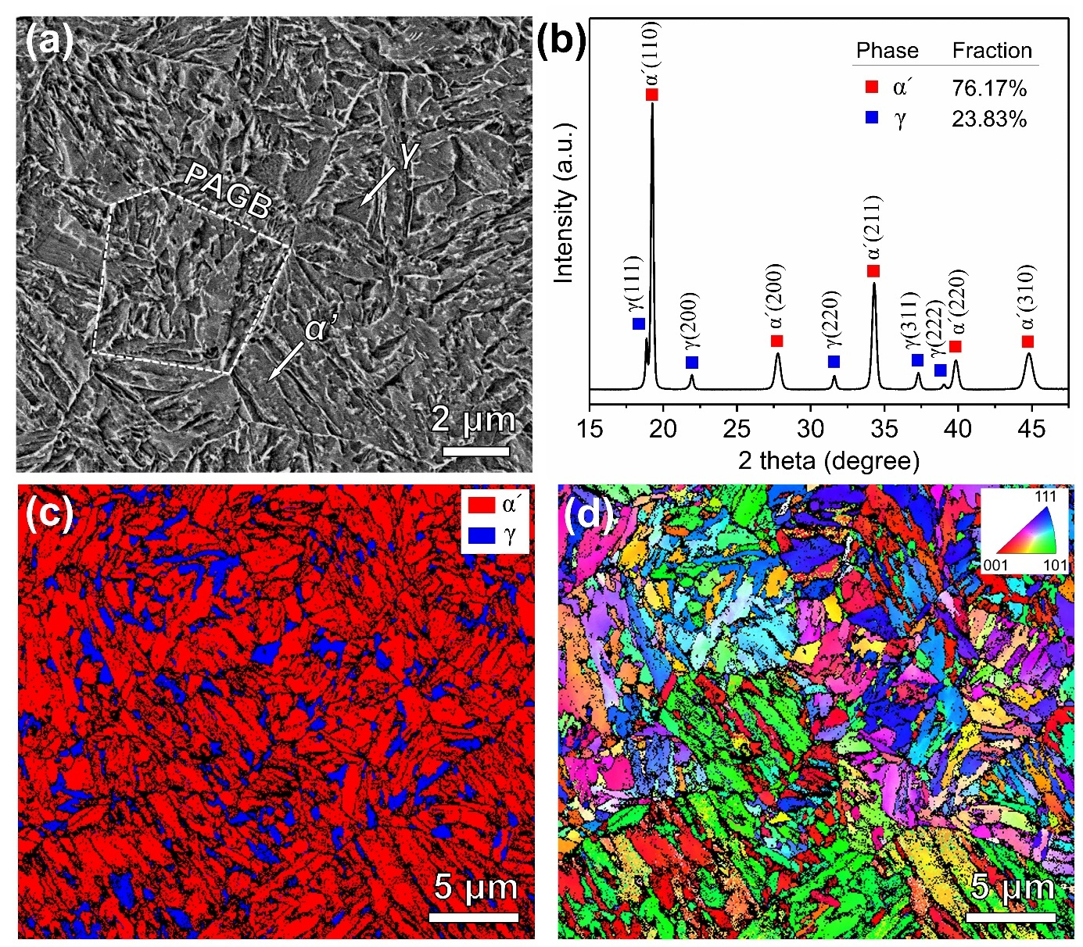
Fig. 1. Microstructure characterization of the present RT-Q&P steel before deformation. (a) SEM image of the etched sample, showing the martensite (α´) matrix and retained austenite (γ). The PAGB is shown in dashed white line. (b) 1-D synchrotron HEXRD profile of present steel, showing the presence of α´ and γ phases. The diffraction peaks of α´ and γ phases are indexed in red and blue, respectively. The volume fraction of each phase is calculated. (c) EBSD phase map and (d) corresponding inverse pole figure (IPF) map.

3.2 Strain rate dependent mechanical properties
Fig. 2a and Fig. 2b show the engineering and true stress-strain curves of the present RT-Q&P steel loaded at various strain rates ranging from 10⁻⁵ s⁻¹ to 600 s⁻¹, respectively. It is found that the work hardening rate decreases with increasing strain rate. Noted that the tensile curve at 600 s⁻¹ exhibits an apparent stress decrease upon yielding, commonly referred to as the yield drop phenomenon. Fig. 2c shows the high-speed DIC results at different plastic true strains loaded at 600 s⁻¹. It is indicated that the specimen was deformed uniformly during the yield drop region. The uniform deformation holds until the plastic true strain of 8%, where a slightly non-uniform deformation region appears. Fig. 2d shows the enlarged images of the true stress-strain curves around 8% true strain. It is noted that the flow stress at 8% true strain decreases with increasing strain rate. The flow stress values at 8% true strain over a wide range of strain rates from 10⁻⁵ s⁻¹ to 600 s⁻¹ are summarized in Fig. 2e. The SRS parameter (m) is evaluated by linear fitting of the flow stress () and the logarithm of strain rate () according to the equation . It can be found that the SRS is negative at 8% true strain (m = -9.45). In summary, for the present RT-Q&P steel, the flow stress exhibits abnormal negative SRS after yielding.
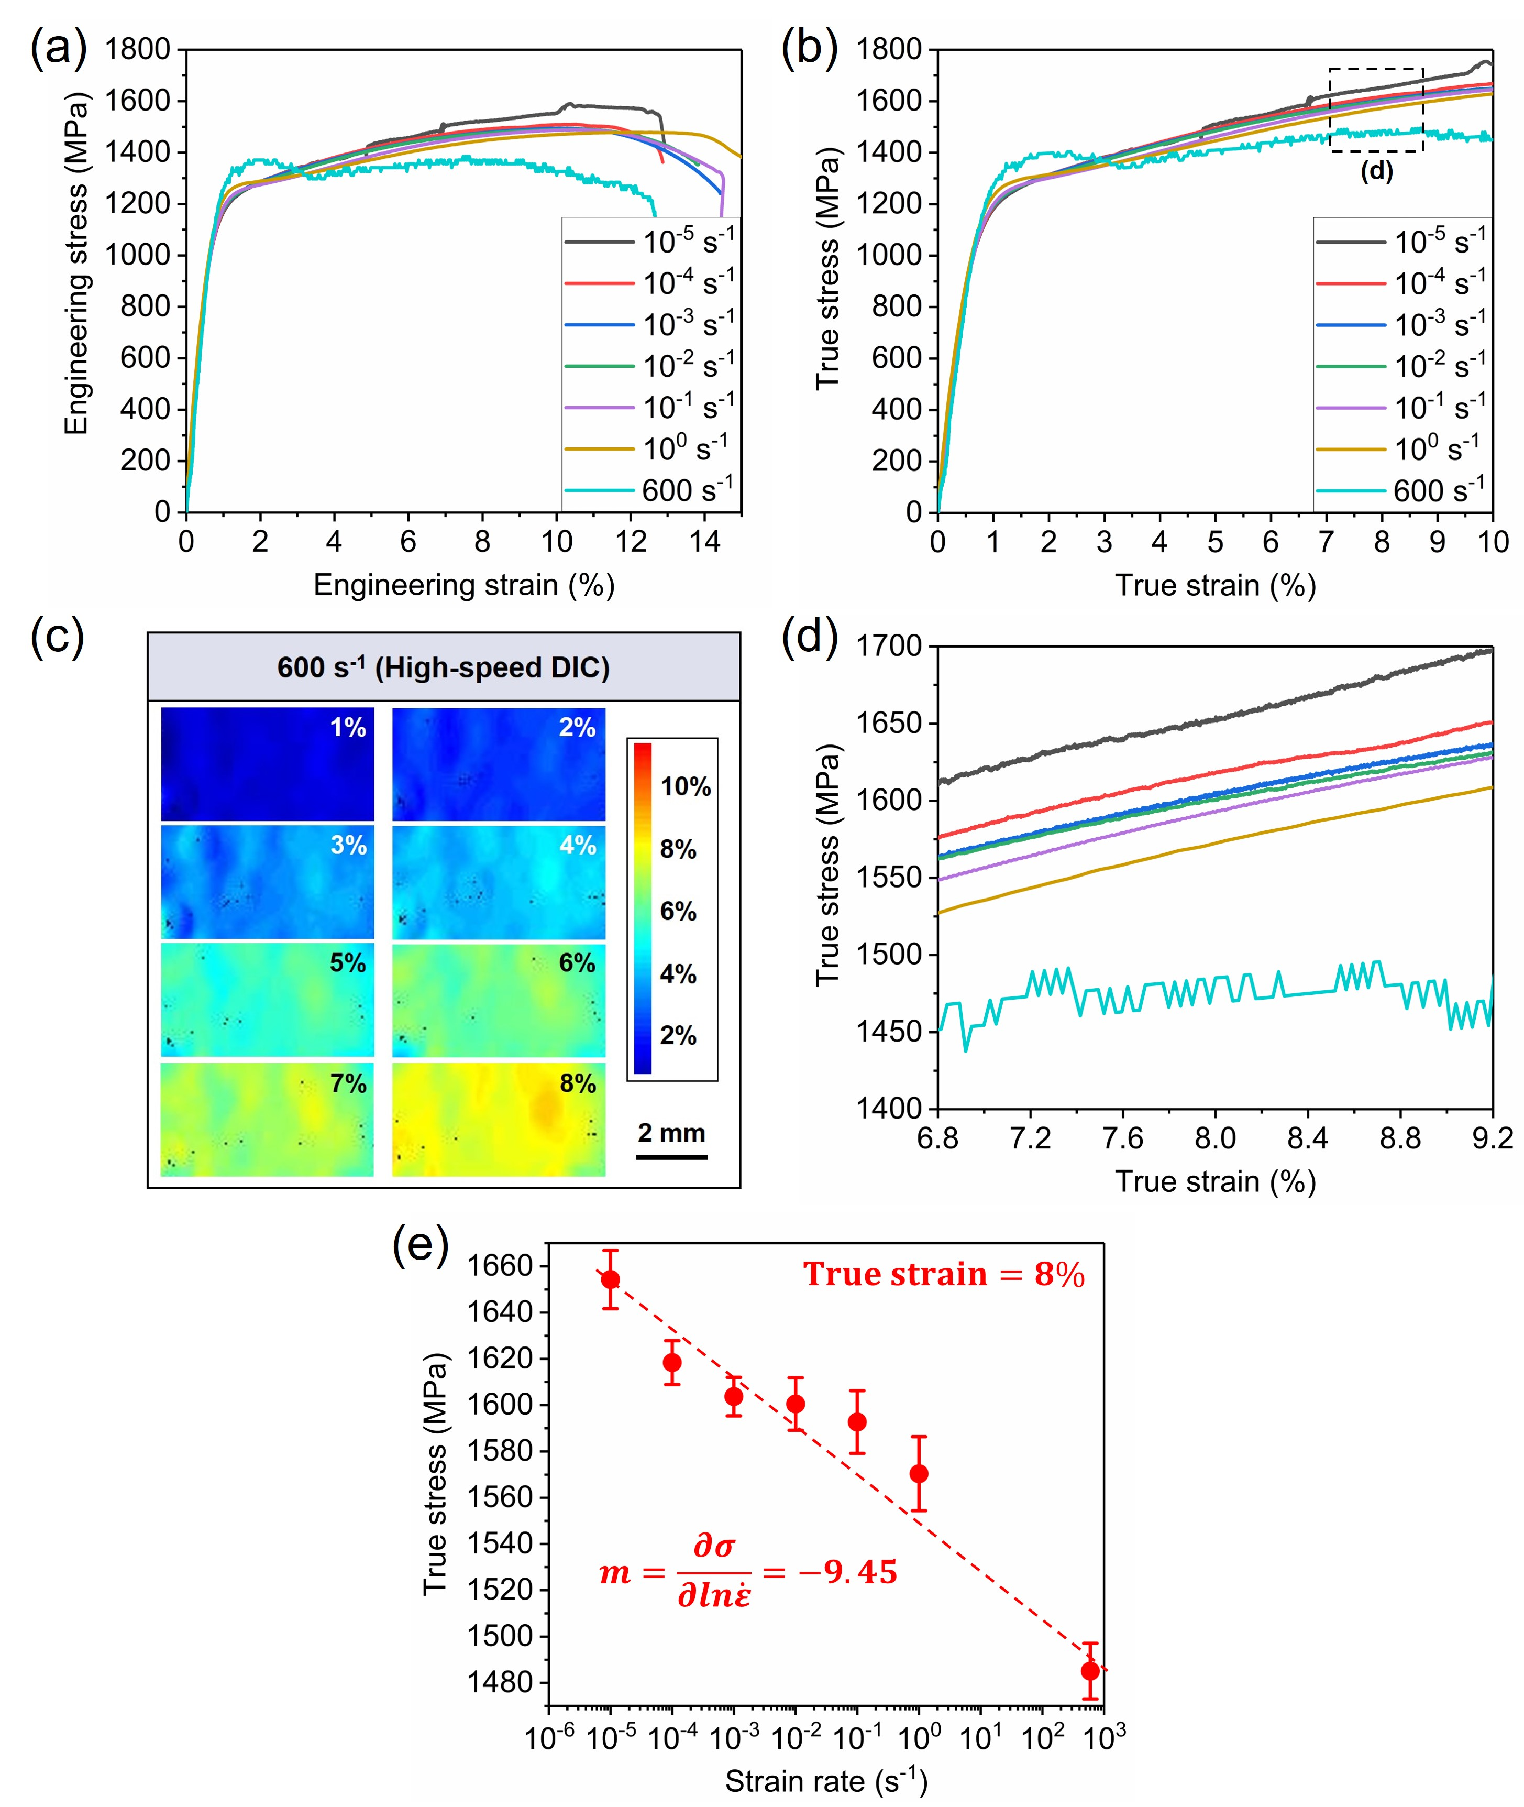
Fig. 2. Strain rate dependent mechanical properties of the present RT-Q&P steel deformed at RT. (a) Engineering and (b) True stress-strain curves with strain rates ranging from 10⁻⁵ s⁻¹ to 600 s⁻¹. (c) High-speed DIC results at different true strains loaded at 600 s⁻¹. (d) Enlarged true stress-strain curves around 8% true strain. (e) Variation of the flow stress at 8% true strain with different strain rates. m indicates the strain-rate sensitivity parameter, which is linear fitted by the dashed line.

3.3 Strain rate dependent microstructure evolution

3.3.1 Evolution of martensitic transformation
To investigate the microstructure evolution of the present RT-Q&P steel deformed at different strain rates, interrupted tensile tests were carried out at 10⁻³ s⁻¹ and 600 s⁻¹, respectively. The tensile tests were interrupted at plastic true strain levels of 1.4%, 3.3%, 5.1%, 7.1%, 9.1% at strain rate of 10⁻³ s⁻¹, and interrupted at plastic true strain levels of 1.6%, 3.5%, 4.7%, 7.3%, 9.4% at strain rate of 600 s⁻¹, as shown in Fig. 3a. The HEXRD profiles of interrupted samples with different plastic true strains at strain rate of 10⁻³ s⁻¹ and 600 s⁻¹ are shown in Fig. 3b and Fig. 3c, respectively. The austenite volume fractions of the interrupted specimens were calculated from the HEXRD profiles following the ASTM E975 standard [45], as shown in Fig. 3d. It can be seen that the austenite volume fractions decrease progressively at both strain rates of 10⁻³ s⁻¹ and 600 s⁻¹. Specifically, the austenite volume fraction decreases from 23.83% (undeformed) to 3.79% (at plastic true strain of 9.1%) when deformed at 10⁻³ s⁻¹, and to 5.92% (at plastic true strain of 9.4%) when deformed at 600 s⁻¹. Overall, the evolution of austenite volume fraction at 10⁻³ s⁻¹ and 600 s⁻¹ is similar, suggesting that the TRIP effect is not the main reason responsible for the negative SRS after yielding.
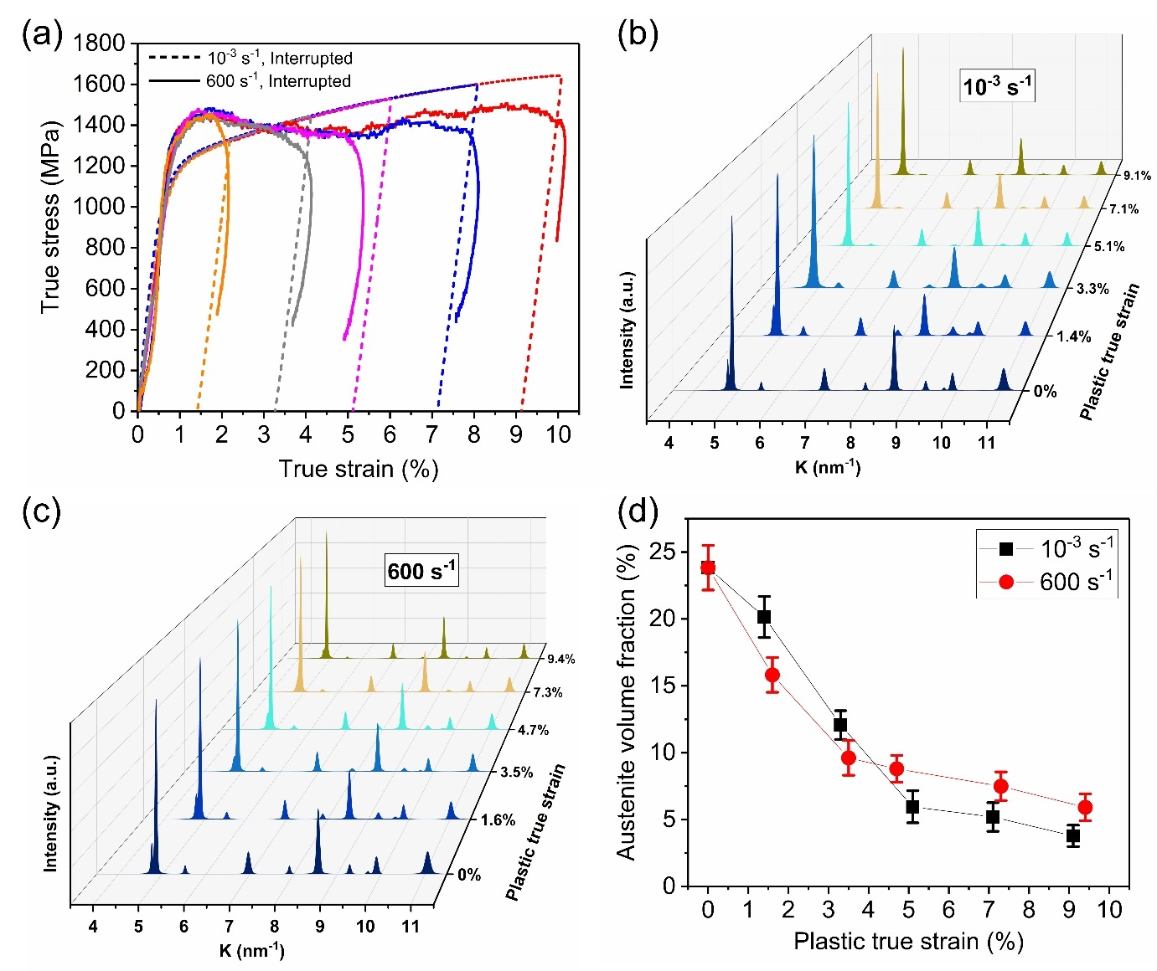
Fig. 3. (a) True stress-strain curves of the interrupted tensile tests at 10⁻³ s⁻¹ (dashed lines) and 600 s⁻¹ (solid lines). (b) HEXRD profiles of interrupted samples with different plastic true strains at strain rate of 10⁻³ s⁻¹. (c) HEXRD profiles of interrupted samples with different plastic true strains at strain rate of 600 s⁻¹. (d) Evolution of austenite volume fraction deformed at 10⁻³ s⁻¹ (black squares) and 600 s⁻¹ (red circles).

3.3.2 Evolution of dislocation density
The MWH and MWA methods were combined to calculate the average dislocation densities of all interrupted specimens based on the 1-D HEXRD profiles [46]. Using the undeformed specimen as an example, the measured 1-D HEXRD profiles were first fitted using the pseudo-Voigt function [47], as shown in Fig. 4a. The residual (solid blue line) between the measured (black triangle marks) and fitted (solid red line) profiles is negligibly small, which indicates a good fitting. Five martensite peaks including α´(110), α´(200), α´(211), α´(220), α´(310) and five austenite peaks including γ(111), γ(200), γ(220), γ(311), γ(222) shown in Fig. 4a were used for the calculation of average dislocation densities of martensite and austenite, respectively. The MWH and MWA plots calculated based on the martensite peaks in the fitted HEXRD profile are shown in Fig. 4b and Fig. 4c, respectively.
Before deformation, the initial dislocation density of martensite matrix is calculated to be 1.64×10¹⁵ m⁻². This value is in good agreement with previously reported martensite dislocation density of approximate 4.0×10¹⁵ m⁻² in a Fe-0.22C (wt.%) quenched and tempered martensitic steel [48], calculated using the convolutional multiple whole profile (CMWP) method [49]. Additionally, this value is also consistent with the TEM estimated dislocation density of martensite of about 1.33×10¹⁵ m⁻² in a Fe-0.18C (wt.%) as-quenched martensitic steel [50]. The initial dislocation density of retained austenite at an undeformed state is estimated to be 1.47×10¹⁵ m⁻², consistent with the value of approximate 1.35×10¹⁵ m⁻² in the retained austenite of a Fe-0.25C (wt.%) bainitic steel [51].
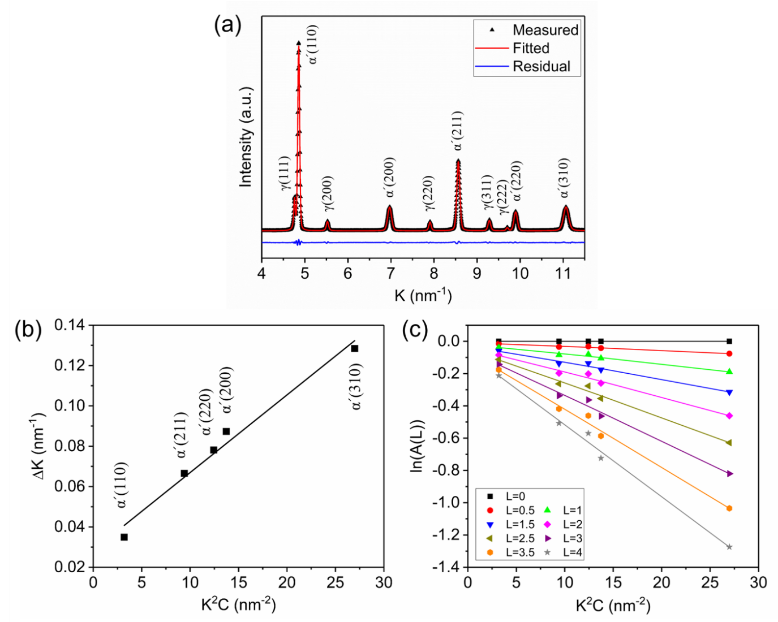
Fig. 4. Calculation of dislocation density. (a) The measured (black triangle marks) and fitted (solid red line) HEXRD profiles of the undeformed RT-Q&P sample. The residual between measured and fitted profiles is plotted in solid blue line. K is the reciprocal of the lattice spacing. (b) Modified Williamson-Hall plot and (c) Modified Warren-Averbach plot obtained from the peaks of martensite (α´) in the fitted HEXRD profile shown in (a).

The evolution of dislocation densities of martensite matrix and retained austenite of the present RT-Q&P steel during deformation at 10⁻³ s⁻¹ and 600 s⁻¹ are shown in Fig. 5a and Fig. 5b, respectively. It is found that, when deformed at 10⁻³ s⁻¹, the dislocation density of martensite matrix increases monotonically with increasing strain, from the value of 1.64×10¹⁵ m⁻² (undeformed) to 4.53×10¹⁵ m⁻² (at plastic true strain of 9.1%). In contrast, when deformed at 600 s⁻¹, the dislocation density of martensite matrix keeps nearly unchanged throughout the whole deformation. Similar to the evolution trend of dislocation density of martensite matrix, the dislocation density of retained austenite increases continuously with increasing strain when deformed at 10⁻³ s⁻¹, from the value of 1.47×10¹⁵ m⁻² (undeformed) to 5.26×10¹⁵ m⁻² (at plastic true strain of 9.1%), while almost maintains stable when deformed at 600 s⁻¹. Note that the dislocation density of retained austenite exhibits a fluctuation at strain of 7.1% at 10⁻³ s⁻¹, which is probably due to the fitting deviation owing to the extremely low volume fraction of retained austenite.
In summary, the dislocation densities of both martensite matrix and retained austenite are nearly stable throughout the deformation when deformed at 600 s⁻¹, which is in stark contrast to the monotonically increasing dislocation densities in both phases when deformed at 10⁻³ s⁻¹.
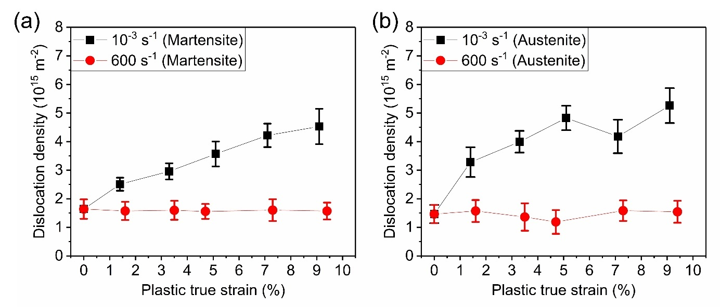
Fig. 5. (a) Evolution of dislocation density of martensite deformed at 10⁻³ s⁻¹ (black squares) and 600 s⁻¹ (red circles). (b) Evolution of dislocation density of austenite deformed at 10⁻³ s⁻¹ (black squares) and 600 s⁻¹ (red circles).

The TEM observations were performed to further qualitatively confirm the difference of dislocation densities under each loading conditions. All the TEM foils were extracted from the uniformly deformed gauge part in the fractured specimens. Fig. 6a and Fig. 6b show the typical two-beam bright-field (BF) TEM images of the fractured specimens at strain rates of 10⁻³ s⁻¹ and 600 s⁻¹, respectively, characterizing the dislocation substructures in martensite matrix. It can be observed that the dislocation density is extremely high, in the form of dense tangled forests, in the specimen deformed at 10⁻³ s⁻¹ (Fig. 6a). In comparison, the specimen deformed at 600 s⁻¹ shows a relatively lower dislocation density, in the form of clearly identified individual dislocations (Fig. 6b). This remarkable difference in dislocation densities between specimens deformed at 10⁻³ s⁻¹ and 600 s⁻¹ is consistent with our previous results obtained from HEXRD profiles (Fig. 5a).
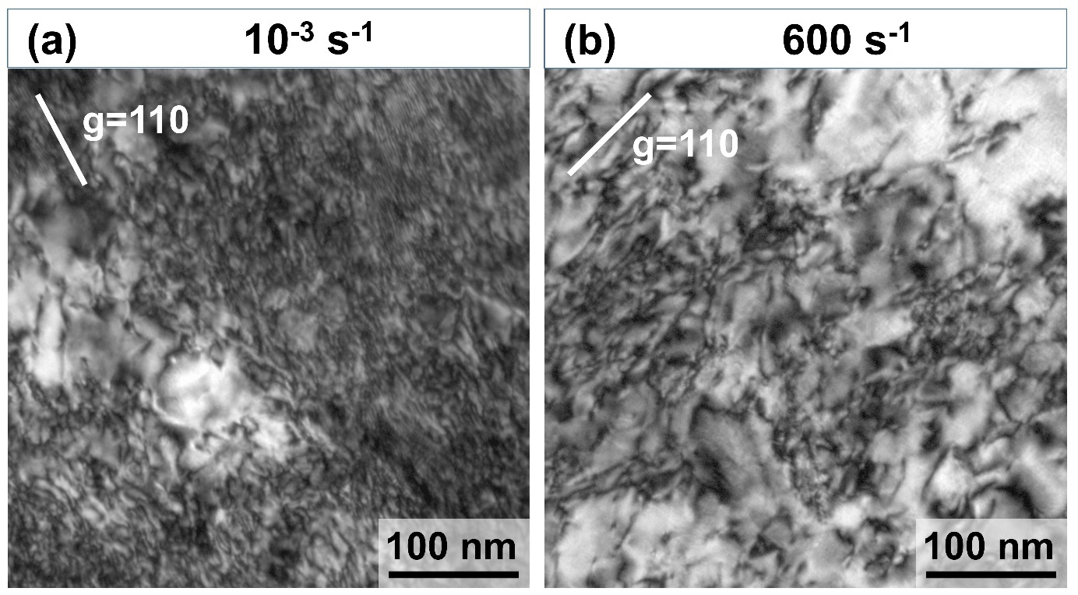
Fig. 6. Two-beam bright-field (BF) TEM characterization of the dislocation features in martensite matrix in the fractured specimens that deformed at (a) 10⁻³ s⁻¹, and (b) 600 s⁻¹.

3.3.3 Evolution of micro-hardness
Micro-hardness measurements were conducted on the interrupted specimens to further investigate the relationship between the microstructure evolution and flow stress evolution of the present RT-Q&P steel that deformed at different strain rates. Fig. 7 shows the evolution of Vickers hardness of the steel deformed at strain rates of 10⁻³ s⁻¹ and 600 s⁻¹. Surprisingly, it is found that the evolution trends of Vickers hardness are nearly identical under both loading conditions. Specifically, at both 10⁻³ s⁻¹ and 600 s⁻¹, the Vickers hardness increases monotonically with increasing strain, which is in sharp contrast with the dislocation density evolution trends of both martensite and austenite (Fig. 5). Conventionally, for most metals, a higher dislocation density should lead to a higher micro-hardness [43, 52]. However, in the present RT-Q&P steel, when loading at 600 s⁻¹, with increasing strain, the dislocation density stays unchanged (Fig. 5), while the micro-hardness increases continuously (Fig. 7). Moreover, the similar evolution trend of micro-hardness at 10⁻³ s⁻¹ and 600 s⁻¹ is also in contrary to the different flow stress evolution trend, which shows higher flow stress at 10⁻³ s⁻¹ than that of 600 s⁻¹ (Fig. 2a). This abnormal relationship between the evolution of dislocation density, flow stress and micro-hardness during deformation at different strain rates suggests some hidden mechanisms that may account for the negative SRS.
Fig. 7. Evolution of Vickers hardness deformed at 10⁻³ s⁻¹ (black squares) and 600 s⁻¹ (red circles).

4. Discussion
The most striking finding in this study is that the positive SRS upon yielding reverses to negative SRS after yielding, as shown in Fig. 2. This abnormal negative SRS after yielding is distinct from previous findings on SRS of most metals and alloys, which generally exhibit positive SRS throughout the whole deformation [11, 53]. The negative SRS after yielding could be attributed to the decreased work hardening rate at high strain rate (600 s⁻¹) compared to that at quasi-static (10⁻³ s⁻¹) loading condition, as shown in Fig. 2. Based on previous studies on the Q&P steels and medium Mn steels [3, 25], the excellent work hardening ability at quasi-static condition for the present RT-Q&P steel could be due to the following three reasons: (i) the TRIP effect; (ii) the increase of dislocation density in martensite matrix and retained austenite during deformation; and (iii) the dynamic strain ageing (DSA) effect due to the constant interaction between carbon atoms and dislocations during the deformation.
Our previous results have demonstrated that martensitic transformation occurs at both 10⁻³ s⁻¹ and 600 s⁻¹ and their evolution trends are similar (Fig. 3b). This suggests that martensitic transformation (i.e., TRIP effect) is not the factor that induces the abnormal negative SRS in the present RT-Q&P steel. The evolution of dislocation densities in the martensite matrix and retained austenite exhibit a huge difference between 10⁻³ s⁻¹ and 600 s⁻¹, as shown in Fig. 5a and Fig. 5b. The dislocation densities increase significantly with increasing strain at 10⁻³ s⁻¹, while keeping stable at 600 s⁻¹. This enormous distinction of dislocation density evolution between high-strain-rate and quasi-static deformation may be the possible reason responsible for the negative SRS. However, the Vickers hardness evolution trends at 10⁻³ s⁻¹ and 600 s⁻¹ are quite similar, (Fig. 7), in contrast to the large difference in flow stress and dislocation density under these two loading conditions. This implies that, in addition to dislocation density, there must be some other factors that contribute to the reduced flow stress at 600 s⁻¹. The presently unidentified factor disappears at continuous tensile test at 600 s⁻¹, but reappears at Vickers hardness tests at quasi-static condition on the interrupted specimens.
It is important to note that flow stress is a transient stress recorded during deformation, while Vickers hardness is a postmortem value determined after interrupted tests. The contradiction between flow stress and Vickers hardness may result from a time-dependent factor related to the diffusion of interstitial carbon atoms. It is well known that the interaction between solute atoms and dislocations can provide an additional dragging force for dislocation glide [54], which significantly influence the flow stress during tensile test. The most common phenomenon related to this is the upper yield point and DSA. Indeed, the DSA phenomenon can be observed in the present RT-Q&P steel when loaded at 10⁻⁵ s⁻¹, as shown in Fig. 2a,b, indicating significant carbon-dislocation interaction does exist during quasi-static deformation. Although the macroscopic DSA phenomenon was not observed in the stress-strain curves at strain rates greater than 10⁻⁵ s⁻¹, this does not mean the complete elimination of such carbon-dislocation interaction, as other hardening mechanisms may have concealed it.

4.1 Role of carbon on the negative SRS
To further confirm our hypothesis that the negative SRS of the present steel is due to the carbon-dislocation interaction, a special interrupted rate-change tensile test was conducted, as shown in Fig. 8a. The high-strain-rate tensile test at 600 s⁻¹ was interrupted and unloaded at about 6%, followed by one-hour ageing at RT to allow sufficient carbon atoms to diffuse to dislocations. The aged specimen was then reloaded at a quasi-static strain rate of 10⁻³ s⁻¹. In stark contrast to the continuous tensile curve at 600 s⁻¹ (solid red line in Fig. 8a), it is found that the quasi-static reloaded tensile curve (smooth solid blue line in Fig. 8a) almost coincides with the continuous tensile curve at 10⁻³ s⁻¹. This result is consistent with the nearly identical Vickers hardness values of 10⁻³ s⁻¹ and 600 s⁻¹ interrupted specimens shown in Fig. 7.
Furthermore, an interrupted high-strain-rate load-unload-load tensile test was also performed to observe the carbon effect, as shown in Fig. 8b. The time intervals between each unloading and reloading are one hour for adequate carbon diffusion. Compared with the transient flow stress of the continuous high-strain-rate tensile curve (solid red line in Fig. 8b), the yield stress of the interrupted high-strain-rate load-unload-load tensile curves (solid blue line in Fig. 8b) is significantly increased. The re-formed Cottrell atmosphere surrounding dislocations after one hour ageing at RT is responsible for this increased stress, as the re-pinning of dislocations by the Cottrell atmosphere provides an additional drag force to dislocation glide. When a pinned dislocation moves, it immediately destroys the corresponding Cottrell atmosphere. However, if the dislocation velocity is as low as the diffusion velocity of carbon atoms, such as at quasi-static condition, the destroyed Cottrell atmosphere could be rebuilt concurrently. In contrast, at high-strain-rate condition, as the dislocation velocity is much too higher, once the Cottrell atmosphere is destroyed, it cannot be rebuilt anymore, which is indicated by an apparent stress drop, shown in the high-strain-rate tensile curves.
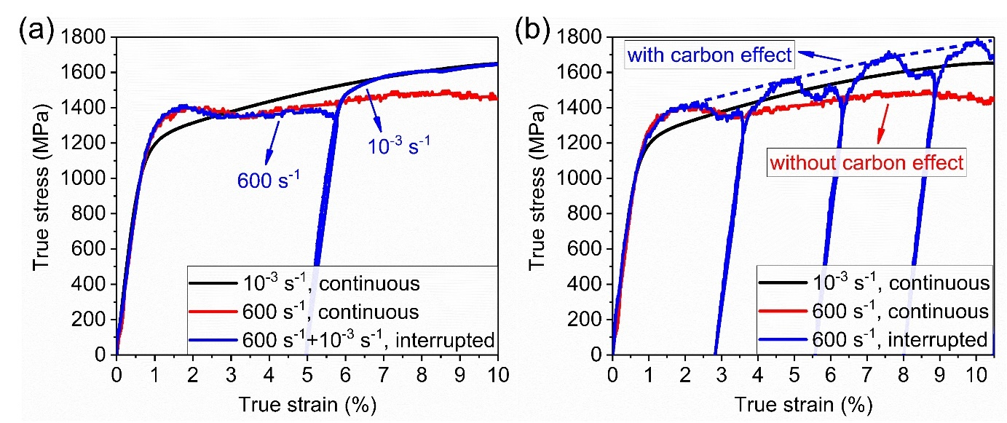
Fig. 8. Comparison of the true stress-strain curves deformed at different conditions. (a) Solid black line: 10⁻³ s⁻¹; solid red line: 600 s⁻¹; solid blue line: interrupted rate-change test at 600 s⁻¹ and 10⁻³ s⁻¹ successively. (b) Solid black line: 10⁻³ s⁻¹; solid red line: 600 s⁻¹; solid blue line: interrupted load-unload-load test at 600 s⁻¹. It is noted that the time intervals between each unloading and reloading are one hour to ensure adequate ageing. Dashed blue line: an imaginary stress-strain curve connecting all the yield points of the interrupted tests at 600 s⁻¹, which assumes the carbon diffusion rate is sufficiently high to catch up with the high-velocity dislocations all the time.

The fractured samples deformed by different loading conditions shown in Fig. 8 were also measured by HEXRD experiments. The HEXRD profiles are shown in Fig. 9. The corresponding dislocation densities were calculated and shown in Table 2. It is noticeable that the dislocation density substantially increases when continuously deformed at 10⁻³ s⁻¹, whereas it nearly keep stable when continuously deformed at 600 s⁻¹. However, for the sample firstly loaded and interrupted at ~6% at 600 s⁻¹, and then reloaded at 10⁻³ s⁻¹ after one-hour ageing (denoted as 600 s⁻¹ + 10⁻³ s⁻¹, interrupted), the final dislocation density significantly increases. Additionally, for the sample deformed under interrupted load-unload-load condition at 600 s⁻¹ (denoted as 600 s⁻¹, interrupted), the final dislocation density also increases considerably, compared to the sample deformed continuously at 600 s⁻¹.
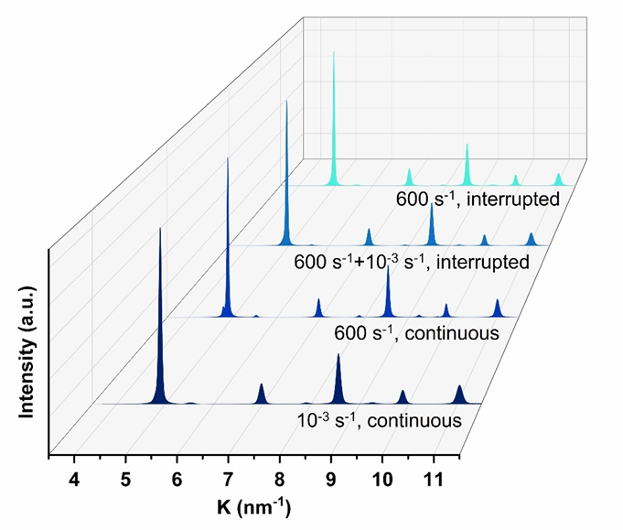
Fig. 9. HEXRD profiles of samples deformed by different loading conditions.

Table 2 Dislocation densities of samples deformed by different loading conditions.
Sample | 10⁻³ s⁻¹,  continuous | 600 s⁻¹,  continuous | 600 s⁻¹ + 10⁻³ s⁻¹,  interrupted | 600 s⁻¹,  interrupted
Dislocation density (m⁻²) | 4.53×10¹⁵ | 1.57×10¹⁵ | 3.52×10¹⁵ | 3.06×10¹⁵

The waiting time for temporarily pinned dislocations to break away is inversely proportional to plastic strain rate as [55, 56]:
(1)
where is the mobile dislocation density, is the forest dislocation density, and b is the Burgers vector. Ω is the elementary incremental strain described by . For the initial microstructure, the forest dislocation density was estimated to be = 1.64×10¹⁵ m⁻² according to the HEXRD result. Assuming the ratio of mobile dislocation to forest dislocation density is 18% for the martensite matrix phase [57], the mobile dislocation density is estimated to be = 2.95×10¹⁴ m⁻². The elementary incremental strain is estimated to be Ω = 1.81×10⁻³, which agrees well with previous studies [55]. Hence, the waiting times () for loading at strain rates of 10⁻³ s⁻¹ and 600 s⁻¹ are 1.81 s and 3×10⁻⁶ s, respectively.
Interstitial carbon atoms will diffuse towards the temporarily arrested dislocations during the waiting time. The diffusion time is related to the diffusion radius r and diffusivity D by [58]:
(2)
where is the diffusion radius, represents the number of pinning carbon atoms per atom along the dislocation line, = 0.0117 nm³ is the volume of iron atom in BCC martensite, = 0.2546 nm is the diameter of iron atom, = 0.65% is the atomic concentration of carbon in martensite matrix. Here we assume = 1, the diffusion radius is then estimated to be r = 1.5 nm. is the diffusivity, Q = 66.9 kJ·mol⁻¹ is the activation energy for carbon diffusion in martensite, = 0.02 cm²·s⁻¹ is a pre-exponential factor [59], R is the ideal gas constant, T is the absolute temperature. Hence, the diffusion time is estimated to be = 1.25×10⁻¹ s at RT, and = 6.57×10⁻⁴ s at 100 °C.
Comparing the values of waiting time and diffusion time , it is found that when loading at strain rate of 10⁻³ s⁻¹, both at RT and 100 °C. It suggests that the carbon atoms have sufficient time to diffuse to dislocation cores, rebuilding the Cottrell atmosphere, and thus the additional Cottrell drag force constantly exists during deformation. On the contrary, when loading at strain rate of 600 s⁻¹, indicating that carbon atoms would not have enough time to diffuse to dislocation cores, and the Cottrell drag force disappears immediately after yielding, indicated by a yield drop as shown in Fig. 8b (solid blue line).
If we assume the diffusion time of carbon atoms is infinitesimal such that the Cottrell atmosphere could be rebuilt continuously at 600 s⁻¹, the stress-strain curve would be the dashed blue line shown in Fig. 8b, which is an imaginary stress-strain curve created by connecting all the yield points of interrupted high-strain-rate tests. This imaginary high-strain-rate stress-strain curve takes the Cottrell drag force into account throughout the deformation.

4.2 Confirmation of Cottrell atmosphere by APT
In order to identify the carbon distribution in the present RT-Q&P steel before and after deformation under different strain rates, a series of APT analyses were carried out.
Prior to deformation, the carbon atom maps of martensite matrix and retained austenite are shown in Fig. 10a and Fig. 10b, respectively. An apparent inhomogeneous carbon distribution with some carbon atmospheres is observed in the martensite matrix (Fig. 10a), whereas nearly homogeneous carbon distribution is displayed in the retained austenite (Fig. 10b). Fig. 10c and Fig. 10d plot the carbon concentration profiles of two regions of interest (ROI) containing the carbon atmospheres shown in Fig. 10a, which are most likely the Cottrell atmospheres surrounding dislocations. It is revealed that the radius of the carbon atmosphere region is approximate 5 nm (Fig. 10c,d), which is in good agreement with the result of Wilde et al. [60] that showed the average radius of Cottrell atmosphere surrounding dislocation is approximate 6 ± 1 nm. Furthermore, it is observed that the carbon atmosphere in Fig. 10a has an average carbon concentration around 4.51 at.%, and a peak carbon concentration around 7 at.%, which is in good agreement with the prediction of Cochardt et al. [61] showing a saturation carbon concentration of 6-7 at.% in the region surrounding the dislocation core. Additionally, the curvy morphology of the carbon atmosphere shown in the bottom part of Fig. 10a further suggests it is a curved dislocation line decorated with Cottrell atmosphere.

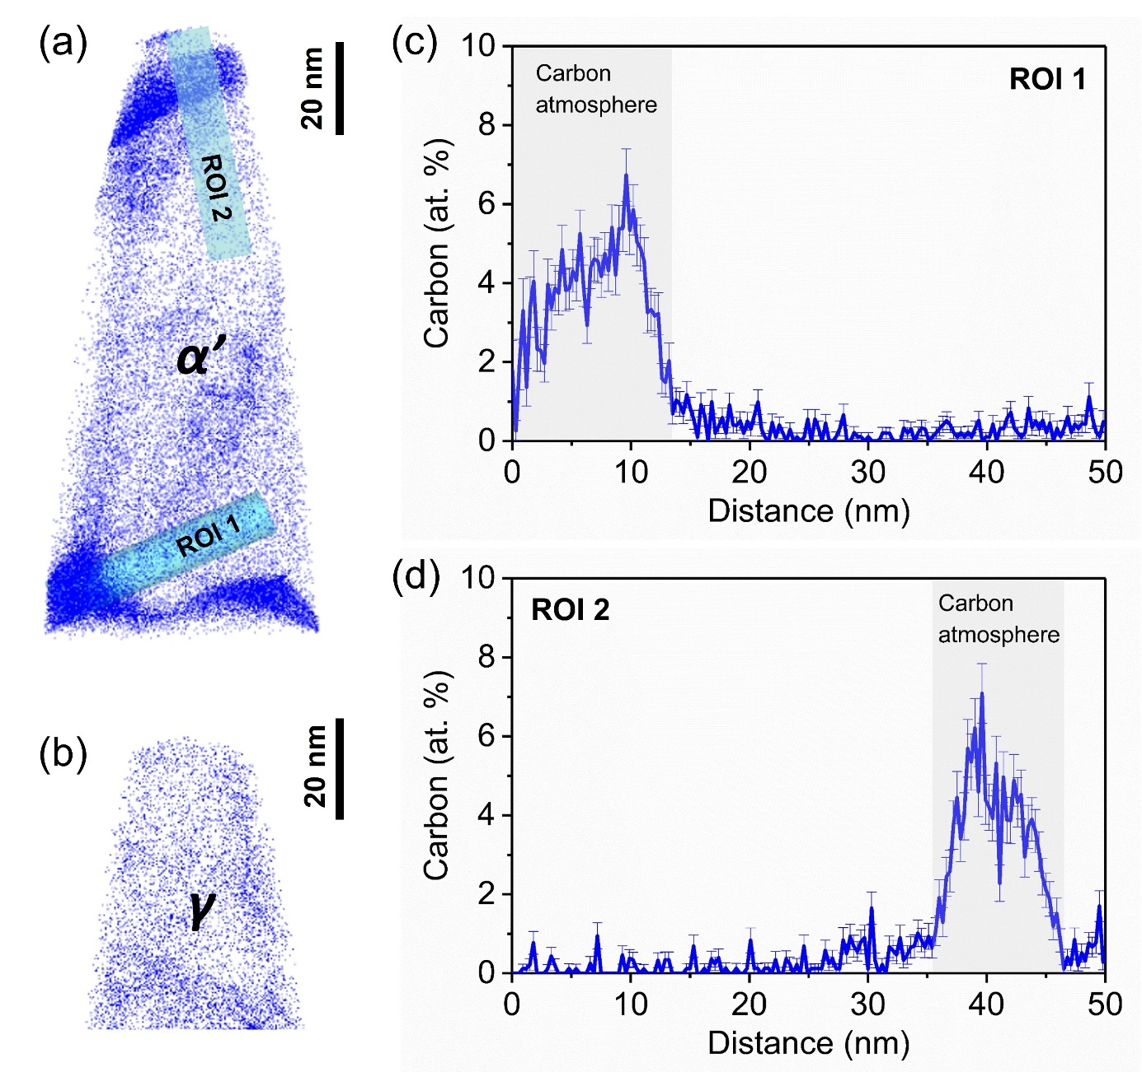
Fig. 10. Carbon distribution of the present RT-Q&P steel before deformation. (a) APT carbon atom map of martensite matrix. (b) APT carbon atom map of retained austenite. (c) and (d) Carbon concentration profiles taken from the ROI marked in (a), showing obvious carbon atmospheres.

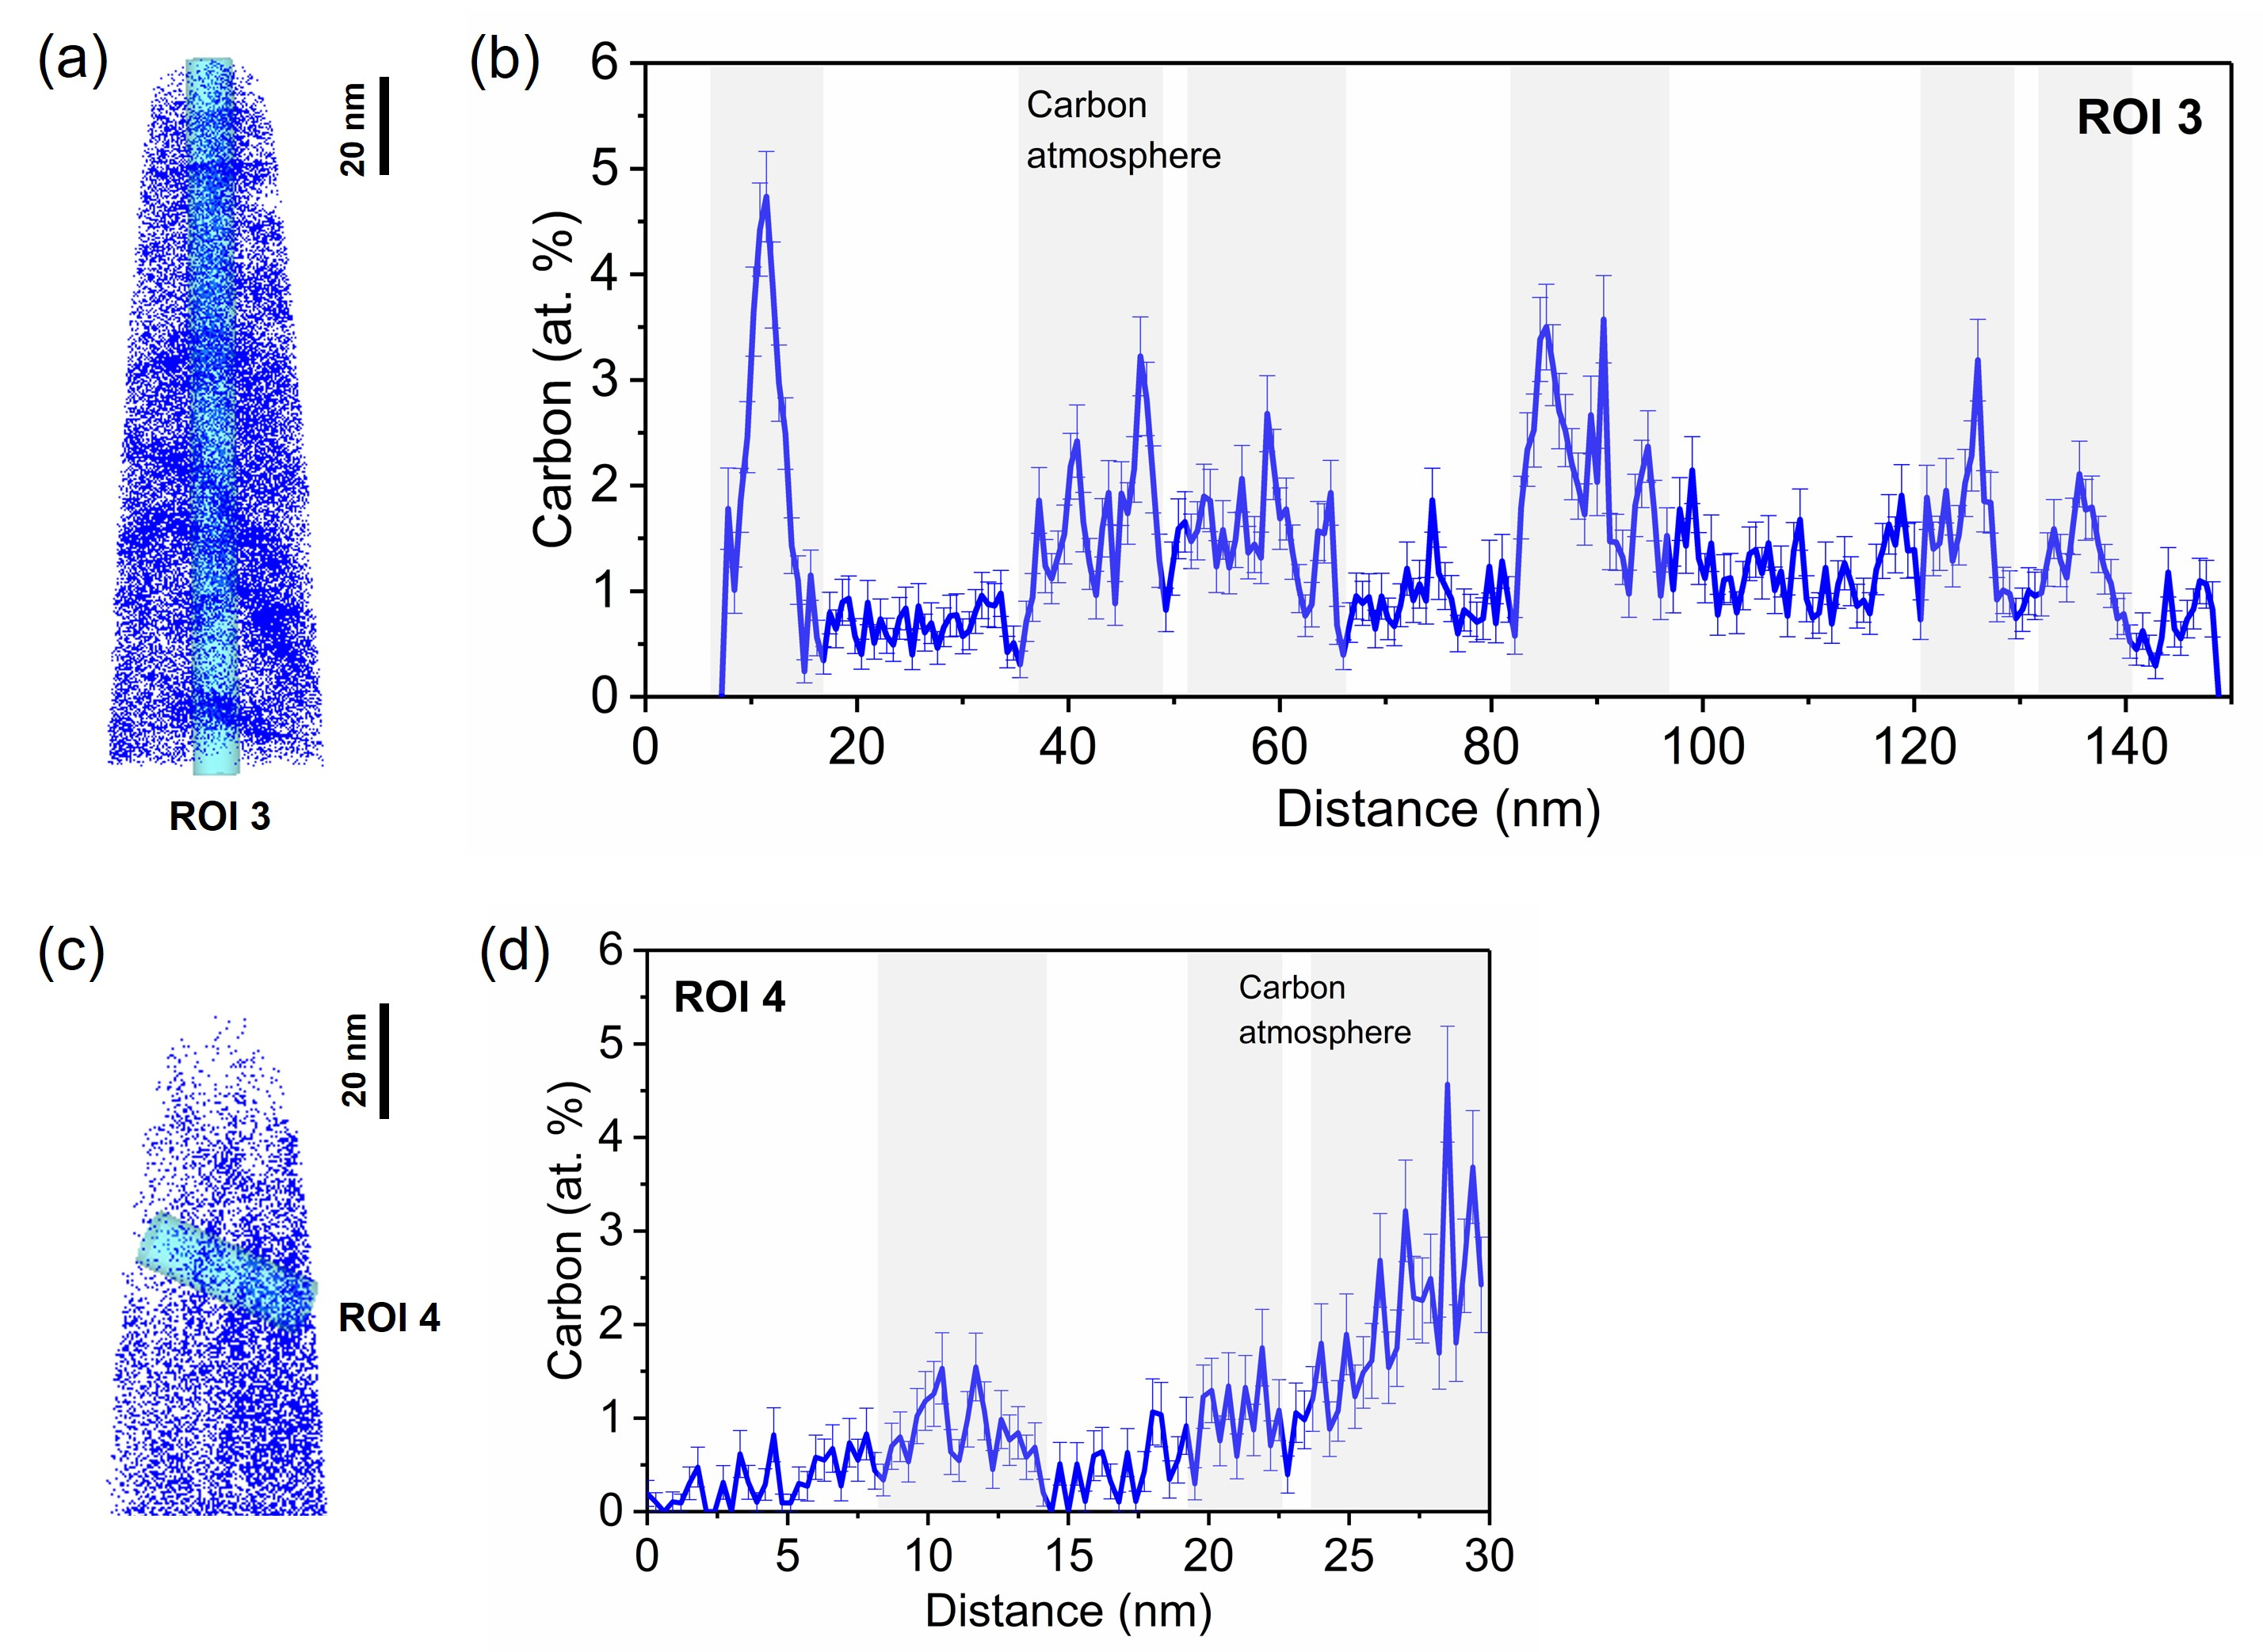
Fig. 11. Carbon distribution of the present RT-Q&P steel after deformation. (a) APT carbon atom map of martensite after fracture at strain rate of 10⁻³ s⁻¹. (b) Carbon concentration profile taken from ROI 3 marked in (a). (c) APT carbon atom map of martensite after fracture at strain rate of 600 s⁻¹. (d) Carbon concentration profile taken from ROI 4 marked in (c).

After deformation under different strain rates, the carbon distributions of the present RT-Q&P steel are shown in Fig. 11. The APT carbon atom map of martensite after fracture at strain rate of 10⁻³ s⁻¹ is shown in Fig. 11a. Large amounts of Cottrell atmospheres can be observed, which is well consistent with the high density of dislocations in this sample. The corresponding carbon concentration profile of ROI 3 marked in Fig. 11a is plotted in Fig. 11b. It is revealed that the carbon concentration of Cottrell atmospheres in this sample is around 2-5 at%, slightly lower than that in the undeformed sample (Fig. 10). This might be due to the substantially increased dislocation density in the deformed sample at 10⁻³ s⁻¹, so that the carbon concentration at each dislocation becomes lower. The APT carbon atom map of martensite after fracture at strain rate of 600 s⁻¹ is shown in Fig. 11c. The corresponding carbon concentration profile of ROI 4 marked in Fig. 11c is plotted in Fig. 11d. Several Cottrell atmospheres with carbon concentration of ~1.5-4 at% were also observed. This could be due to the carbon re-segregation to the dislocations during sample preparation after high-strain-rate deformation. Furthermore, it is worthy to note that the number of Cottrell atmospheres in the sample deformed at 600 s⁻¹ (Fig. 11c,d) is significantly less than that deformed at 10⁻³ s⁻¹ (Fig. 11a,b). This is in good consistency with the lower dislocation density in the sample deformed at 600 s⁻¹.
In summary, Cottrell atmospheres with carbon segregated at dislocations were identified by APT. At undeformed state, several Cottrell atmospheres were observed in the martensite matrix. After deformation to fracture, large amounts of Cottrell atmospheres were found in the martensite when deformed at low strain rate of 10⁻³ s⁻¹, while much less Cottrell atmospheres appeared when deformed at high strain rate of 600 s⁻¹, which is well consistent with the dislocation density. This evidence supports our claim that the Cottrell atmosphere plays a crucial role on the negative SRS of the present RT-Q&P steel.

4.3 Suppression of dislocation multiplication at high strain rate
The dislocation densities of both martensite matrix and retained austenite remain nearly constant during deformation at 600 s⁻¹, which are in huge contrast to the continuously increasing dislocation densities during deformation at 10⁻³ s⁻¹, as shown in Fig. 5. The Cottrell atmosphere plays a significant role on the multiplication of dislocations, both statistically stored dislocation (SSD) and geometrically necessary dislocation (GND), during deformation at quasi-static strain rate of 10⁻³ s⁻¹. However, this role disappears during deformation at high strain rate of 600 s⁻¹.
Firstly, the continuous pinning of the dislocations by Cottrell atmospheres at 10⁻³ s⁻¹ substantially promote the SSD multiplication through increasing Frank-Read source and multiple cross-slip. As previously discussed, during quasi-static deformation at 10⁻³ s⁻¹, the carbon atoms will have sufficient diffusion time to continuously diffuse to dislocation core areas, constantly re-forming the Cottrell atmosphere and pinning the dislocations [62-64]. As plastic deformation proceeds, the pinned dislocations would become depinning essentially in two ways [65, 66]. On the one hand, the pinned dislocations could bow out and form dislocation curves and loops, similar to the Frank-Read source mechanism, promoting the SSD multiplication [67, 68]. Some dislocation loops and extensive dislocation bowing-out can be observed in Fig. 6a, which confirms this mechanism. On the other hand, the pined dislocations could cross slip to other slip planes, which is another essential way of depinning [69, 70]. The multiple cross-slip could lead to the formation of superjogs and dipoles, which could also act as Frank-Read sources, and generate new dislocation loops [71, 72]. As a result, the multiple cross-slip effectively enhances SSD multiplication. Secondly, the stronger pinning effect of dislocations in fresh martensite due to higher carbon content inherited from retained austenite makes the fresh martensite much harder than martensite matrix [73, 74]. Such a hard-soft heterogeneous microstructure results in a composite-like deformation behavior, which produce a large strain gradient, and consequently, a large number of GNDs [75-77]. In summary, both SSD and GND significantly increase during deformation at 10⁻³ s⁻¹, with the benefit of Cottrell atmosphere.
However, during high-strain-rate deformation at 600 s⁻¹, since the diffusion velocities of carbon atoms are significantly slower than the gliding velocities of dislocations, once the pined dislocations break through the Cottrell atmospheres after yielding, they cannot be re-pined anymore, and become permanently mobile dislocations. Thus, the continuous pinning of dislocations by Cottrell atmosphere disappears in both martensite matrix and fresh martensite, resulting in the absence of both SSD and GND multiplications.

4.4 Comparison with carbon-free steels
In order to demonstrate more clearly the critical role of Cottrell atmosphere on the negative SRS in the present RT-Q&P steel, the SRS of two other carbon-free steels (i.e., IF steel and Fe-9.5Mn steel) are additionally tested for comparison. The true stress-strain curves of the IF steel and Fe-9.5Mn steel at various strain rates are shown in Fig. 12a and Fig. 12b, respectively. The evolution of SRS with the true strain of the three steels is presented in Fig. 12c. Note that the SRSs at different strains are fitted using the classical equation . Clearly, both the carbon-free IF steel and Fe-9.5Mn martensitic steel exhibit positive SRS with almost constant value throughout the deformation period. In contrast, the present carbon-contained RT-Q&P steel exhibits negative SRS after yielding (strain larger than 3%), and the value of SRS decreases continuously with increasing strain. The comparison between carbon-contained and carbon-free steels clearly demonstrates again the critical role of Cottrell atmosphere on the negative SRS in the present RT-Q&P steel.
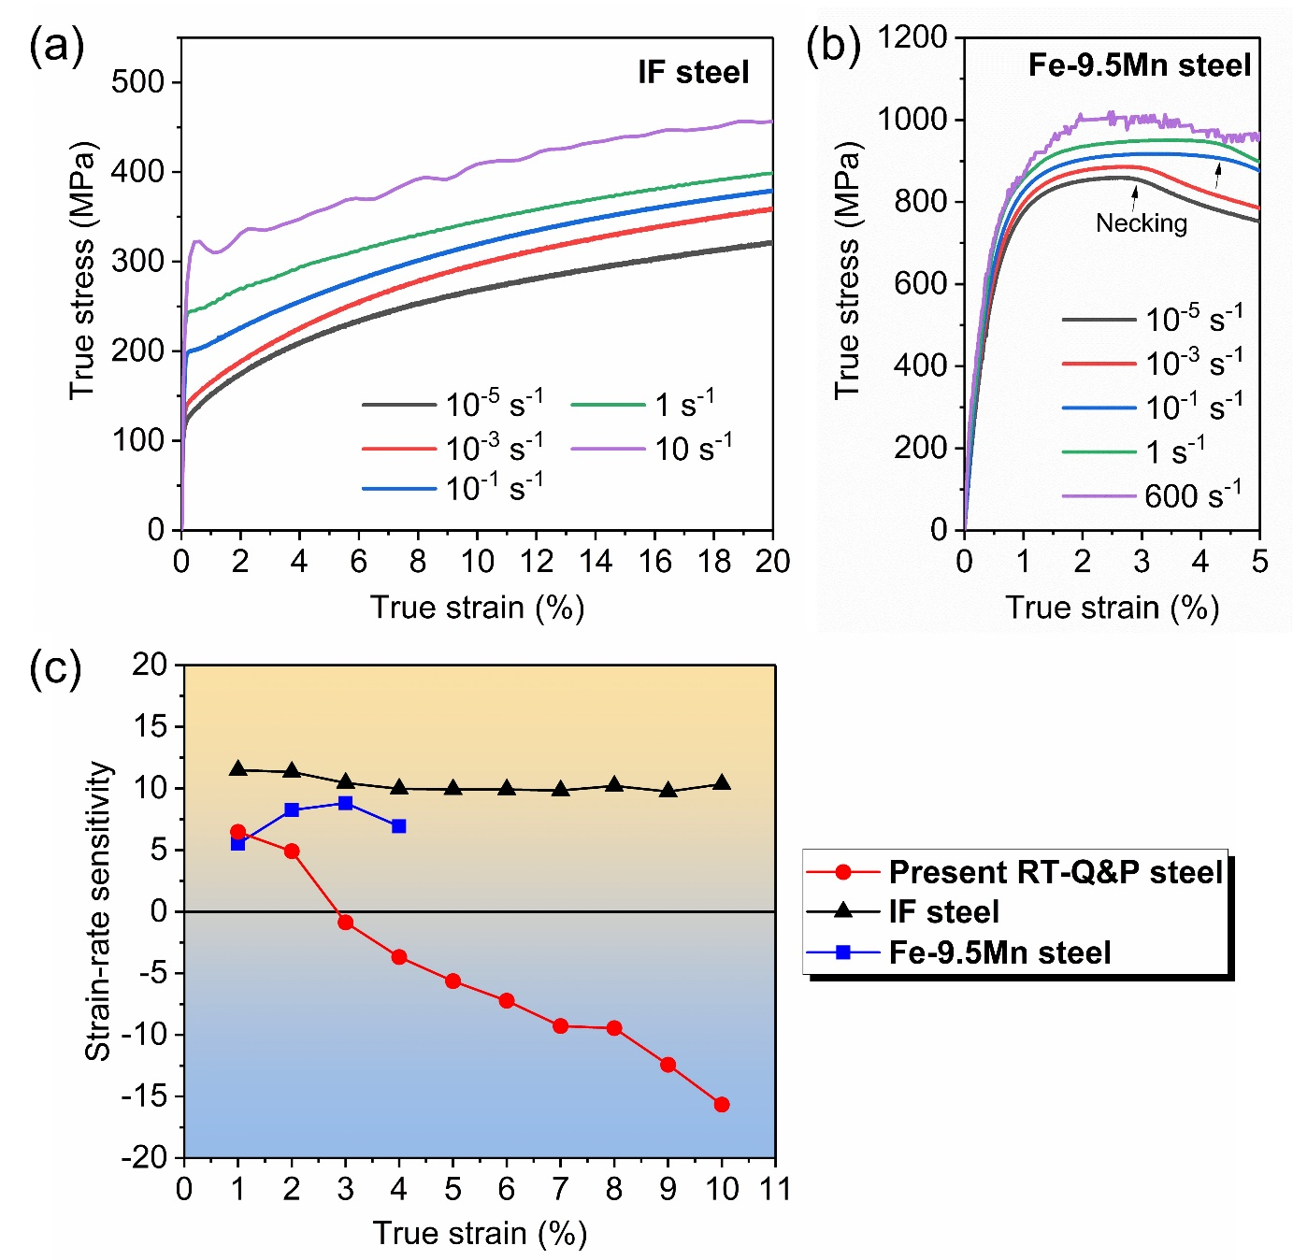
Fig. 12. (a) True stress-strain curves of IF steel at various strain rates ranging from 10⁻⁵ s⁻¹ to 10 s⁻¹. (b) True stress-strain curves of Fe-9.5Mn steel at various strain rates ranging from 10⁻⁵ s⁻¹ to 600 s⁻¹. (c) Evolution of strain-rate sensitivity with strain for the present RT-Q&P steel (red full circles), IF steel (black full triangles) and Fe-9.5Mn steel (blue full squares).

5. Conclusions
In the present work, the origin of the abnormal negative SRS in the RT-Q&P steel was systematically investigated by comprehensive experiments. Based on the experimental results, the main conclusions of this work is drawn as follow:
- The strain rate dependent mechanical properties of the RT-Q&P steel were obtained by a series of continuous tensile tests over a wide range of strain rates from 10⁻⁵ s⁻¹ to 600 s⁻¹. The flow stress after yielding exhibits abnormal negative SRS.
- The evolution trends of martensitic transformation are similar for deformation at 10⁻³ s⁻¹ and 600 s⁻¹, indicating that TRIP effect is not responsible for the abnormal negative SRS.
- Surprisingly, the dislocation densities of martensite matrix and retained austenite increase monotonically during deformation at 10⁻³ s⁻¹, but remain nearly constant during deformation at 600 s⁻¹.
- Confirmed by APT, significantly more Cottrell atmospheres were identified after deformation at 10⁻³ s⁻¹ than after deformation at 600 s⁻¹, indicating that Cottrell atmosphere plays a crucial role on the negative SRS. Comparison between the present RT-Q&P steel and the carbon-free IF and martensitic steels further confirms this point.
- The origin of the negative SRS in the present RT-Q&P steel is due to the lack of Cottrell atmospheres at high strain rate (i.e. 600 s⁻¹), which leads to absence of extra carbon dragging force and a lower dislocation density.

Declaration of competing interest
The authors declare that they have no known competing financial interests or personal relationships that could have appeared to influence the work reported in this paper.

Acknowledgements
M.X.H. acknowledges the support from National Natural Science Foundation of China (No. 52130102), National Key Research and Development Program of China (No. 2019YFA0209900), Research Grants Council of Hong Kong (No. R7066-18), Guangzhou Municipal Science and Technology Project (No. 202007020007) and Guangdong Basic and Applied Basic Research Foundation of China (No. 2020B1515130007). Shanghai Synchrotron Radiation Facility is acknowledged for supporting the synchrotron high energy X-ray diffraction experiments at the Beam Line No. BL14B1. Dr. J.H. Luan is acknowledged for conducting the atom probe tomography at the Inter-University 3D Atom Probe Tomography Unit of City University of Hong Kong.

References
[1] Y.K. Lee, J. Han, Current opinion in medium manganese steel, Materials Science and Technology 31(7) (2014) 843-856.
[2] C. Huang, C. Hu, Y. Liu, Z. Liang, M. Huang, Recent developments and perspectives of advanced high-strength medium Mn steel: from material design to failure mechanisms, Materials Futures 1(3) (2022) 032001.
[3] W. Bleck, X. Guo, Y. Ma, The TRIP effect and its application in cold formable sheet steels, Steel Research International 88(10) (2017) 1700218.
[4] L. Liu, B. He, M. Huang, The role of transformation‐induced plasticity in the development of advanced high strength steels, Advanced Engineering Materials 20(6) (2018) 1701083.
[5] H. Yada, H. Mimura, The strain-rate and temperature dependence of effective flow stress in pure iron and some iron alloys, Journal of the Physical Society of Japan 24(6) (1968) 1269-1278.
[6] D. Rittel, G. Ravichandran, A. Venkert, The mechanical response of pure iron at high strain rates under dominant shear, Materials Science and Engineering: A 432(1-2) (2006) 191-201.
[7] T. Muller, High strain rate behaviour of iron and nickel, Journal of Mechanical Engineering Science 14(3) (1972) 161-167.
[8] A.S. Khan, R. Liang, Behaviors of three BCC metal over a wide range of strain rates and temperatures: experiments and modeling, International Journal of Plasticity 15(10) (1999) 1089-1109.
[9] T. Glenn, W. Bradley, The origin of strain-rate sensitivity in OFHC copper, Metallurgical Transactions 4(10) (1973) 2343-2348.
[10] G.T. Gray III, Influence of strain rate and temperature on the structure. Property behavior of high-purity titanium, Le Journal de Physique IV 7(C3) (1997) C3-423-C3-428.
[11] G.T. Gray III, High-strain-rate deformation: mechanical behavior and deformation substructures induced, Annual Review of Materials Research 42 (2012) 285-303.
[12] J.-H. Kim, D. Kim, H.N. Han, F. Barlat, M.-G. Lee, Strain rate dependent tensile behavior of advanced high strength steels: Experiment and constitutive modeling, Materials Science and Engineering: A 559 (2013) 222-231.
[13] Y. Li, R. Song, L. Jiang, Z. Zhao, Strength response of 1200 MPa grade martensite-ferrite dual-phase steel under high strain rates, Scripta Materialia 164 (2019) 21-24.
[14] Z. Gronostajski, A. Niechajowicz, R. Kuziak, J. Krawczyk, S. Polak, The effect of the strain rate on the stress-strain curve and microstructure of AHSS, Journal of Materials Processing Technology 242 (2017) 246-259.
[15] A.S. Khan, M. Baig, S.-H. Choi, H.-S. Yang, X. Sun, Quasi-static and dynamic responses of advanced high strength steels: experiments and modeling, International Journal of Plasticity 30 (2012) 1-17.
[16] N. Tsuchida, S. Okura, T. Tanaka, Y. Toji, High-speed tensile deformation behavior of 1 GPa-grade TRIP-aided multi-phase steels, ISIJ International 58(5) (2018) 978-986.
[17] D. Zou, S. Li, J. He, Temperature and strain rate dependent deformation induced martensitic transformation and flow behavior of quenching and partitioning steels, Materials Science and Engineering: A 680 (2017) 54-63.
[18] P. Xia, F. Vercruysse, R. Petrov, I. Sabirov, M. Castillo-Rodríguez, P. Verleysen, High strain rate tensile behavior of a quenching and partitioning (Q&P) Fe-0.25 C-1.5 Si-3.0 Mn steel, Materials Science and Engineering: A 745 (2019) 53-62.
[19] B. De Cooman, L. Chen, H.S. Kim, Y. Estrin, S. Kim, H. Voswinckel, State-of-the-science of high manganese TWIP steels for automotive applications, Microstructure and texture in steels, Springer2009, pp. 165-183.
[20] P. Zavattieri, V. Savic, L. Hector Jr, J. Fekete, W. Tong, Y. Xuan, Spatio-temporal characteristics of the Portevin–Le Châtelier effect in austenitic steel with twinning induced plasticity, International Journal of Plasticity 25(12) (2009) 2298-2330.
[21] K. Renard, S. Ryelandt, P. Jacques, Characterisation of the Portevin-Le Châtelier effect affecting an austenitic TWIP steel based on digital image correlation, Materials Science and Engineering: A 527(12) (2010) 2969-2977.
[22] R. Alturk, L.G. Hector, C. Matthew Enloe, F. Abu-Farha, T.W. Brown, Strain rate effect on tensile flow behavior and anisotropy of a medium-manganese TRIP steel, JOM 70(6) (2018) 894-905.
[23] M. Callahan, A. Perlade, J.-H. Schmitt, Interactions of negative strain rate sensitivity, martensite transformation, and dynamic strain aging in 3rd generation advanced high-strength steels, Materials Science and Engineering: A 754 (2019) 140-151.
[24] Z. Cai, D. Zhang, L. Ma, H. Ding, Y. Feng, J. Hu, R. Misra, Competing deformation mechanisms in an austenite-ferrite medium-Mn steel at different strain rates, Materials Science and Engineering: A 818 (2021) 141357.
[25] M. Wang, M.X. Huang, Abnormal TRIP effect on the work hardening behavior of a quenching and partitioning steel at high strain rate, Acta Materialia 188 (2020) 551-559.
[26] S.-J. Lee, J. Kim, S.N. Kane, B.C. De Cooman, On the origin of dynamic strain aging in twinning-induced plasticity steels, Acta Materialia 59(17) (2011) 6809-6819.
[27] J.-K. Kim, L. Chen, H.-S. Kim, S.-K. Kim, Y. Estrin, B. De Cooman, On the tensile behavior of high-manganese twinning-induced plasticity steel, Metallurgical and Materials Transactions A 40(13) (2009) 3147-3158.
[28] D. Canadinc, C. Efstathiou, H. Sehitoglu, On the negative strain rate sensitivity of Hadfield steel, Scripta Materialia 59(10) (2008) 1103-1106.
[29] J.-E. Jin, Y.-K. Lee, Effects of Al on microstructure and tensile properties of C-bearing high Mn TWIP steel, Acta Materialia 60(4) (2012) 1680-1688.
[30] H. Yang, Z. Zhang, F. Dong, Q. Duan, Z. Zhang, Strain rate effects on tensile deformation behaviors for Fe–22Mn–0.6 C–(1.5 Al) twinning-induced plasticity steel, Materials Science and Engineering: A 607 (2014) 551-558.
[31] J. Min, L.G. Hector Jr, L. Zhang, L. Sun, J.E. Carsley, J. Lin, Plastic instability at elevated temperatures in a TRIP-assisted steel, Materials & Design 95 (2016) 370-386.
[32] S. Sevsek, C. Haase, W. Bleck, Strain-rate-dependent deformation behavior and mechanical properties of a multi-phase medium-manganese steel, Metals 9(3) (2019) 344.
[33] R.-g. Xiong, R.-y. Fu, S. Yu, L. Qian, X.-c. Wei, L. Lin, Tensile properties of TWIP steel at high strain rate, Journal of Iron and Steel Research, International 16(1) (2009) 81-21.
[34] M. Huang, J. Yuan, J. Wang, L. Wang, A. Mogucheva, W. Xu, Role of martensitic transformation sequences on deformation-induced martensitic transformation at high strain rates: A quasi in-situ study, Materials Science and Engineering: A 831 (2022) 142319.
[35] P. Lambert, C. Hustedt, D. Casem, N. Sinclair, X. Zhang, K. Lee, A. Leong, B. Schuster, T. Hufnagel, Strain-rate dependence of the martensitic transformation behavior in a 10 Pct Ni multi-phase steel under compression, Metallurgical and Materials Transactions A 51(10) (2020) 5101-5109.
[36] S. Hecker, M. Stout, K. Staudhammer, J. Smith, Effects of strain state and strain rate on deformation-induced transformation in 304 stainless steel: Part I. Magnetic measurements and mechanical behavior, Metallurgical Transactions A 13(4) (1982) 619-626.
[37] L. Murr, K. Staudhammer, S. Hecker, Effects of strain state and strain rate on deformation-induced transformation in 304 stainless steel: Part II. Microstructural study, Metallurgical Transactions A 13(4) (1982) 627-635.
[38] J. Talonen, H. Hänninen, P. Nenonen, G. Pape, Effect of strain rate on the strain-induced γ→ α′-martensite transformation and mechanical properties of austenitic stainless steels, Metallurgical and materials transactions A 36(2) (2005) 421-432.
[39] Z.Y. Liang, X. Wang, W. Huang, M.X. Huang, Strain rate sensitivity and evolution of dislocations and twins in a twinning-induced plasticity steel, Acta Materialia 88 (2015) 170-179.
[40] Z.Y. Liang, W. Huang, M.X. Huang, Suppression of dislocations at high strain rate deformation in a twinning-induced plasticity steel, Materials Science and Engineering: A 628 (2015) 84-88.
[41] N. Vázquez‑Fernández, M. Isakov, M. Hokka, Strain Hardening and Adiabatic Heating of Stainless Steels After a Sudden Increase of Strain Rate, Journal of Dynamic Behavior of Materials (2022) 1-6.
[42] B.A. Gama, S.L. Lopatnikov, J.W. Gillespie Jr, Hopkinson bar experimental technique: a critical review, Appl. Mech. Rev. 57(4) (2004) 223-250.
[43] M. Wang, X.Y. Xu, H.Y. Wang, L.H. He, M.X. Huang, Evolution of dislocation and twin densities in a Mg alloy at quasi-static and high strain rates, Acta Materialia 201 (2020) 102-113.
[44] A.P. Hammersley, FIT2D: a multi-purpose data reduction, analysis and visualization program, Journal of Applied Crystallography 49(2) (2016) 646-652.
[45] A. Standard, E975-03: Standard practice for x-ray determination of retained austenite in steel with near random crystallographic orientation, ASTM, West Conshohocken, PA (2003) (2003).
[46] T. Ungár, S. Ott, P. Sanders, A. Borbély, J. Weertman, Dislocations, grain size and planar faults in nanostructured copper determined by high resolution X-ray diffraction and a new procedure of peak profile analysis, Acta materialia 46(10) (1998) 3693-3699.
[47] T.H. De Keijser, J. Langford, E.J. Mittemeijer, A. Vogels, Use of the Voigt function in a single-line method for the analysis of X-ray diffraction line broadening, Journal of Applied Crystallography 15(3) (1982) 308-314.
[48] S. Harjo, T. Kawasaki, Y. Tomota, W. Gong, K. Aizawa, G. Tichy, Z. Shi, T. Ungár, Work Hardening, Dislocation structure, and load partitioning in lath martensite determined by in situ neutron diffraction line profile analysis, Metallurgical and Materials Transactions A 48(9) (2017) 4080-4092.
[49] G. Ribárik, B. Jóni, T. Ungár, The Convolutional Multiple Whole Profile (CMWP) Fitting Method, a Global Optimization Procedure for Microstructure Determination, Crystals 10(7) (2020) 623.
[50] S. Morito, J. Nishikawa, T. Maki, Dislocation density within lath martensite in Fe-C and Fe-Ni alloys, ISIJ international 43(9) (2003) 1475-1477.
[51] S. He, B. He, K. Zhu, R. Ding, H. Chen, M. Huang, Revealing the role of dislocations on the stability of retained austenite in a tempered bainite, Scripta Materialia 168 (2019) 23-27.
[52] A.A. Ameri, N.N. Elewa, M. Ashraf, J.P. Escobedo-Diaz, General methodology to estimate the dislocation density from microhardness measurements, Materials Characterization 131 (2017) 324-330.
[53] R. Armstrong, S. Walley, High strain rate properties of metals and alloys, International Materials Reviews 53(3) (2008) 105-128.
[54] R. Picu, A mechanism for the negative strain-rate sensitivity of dilute solid solutions, Acta Materialia 52(12) (2004) 3447-3458.
[55] L. Kubin, Y. Estrin, Evolution of dislocation densities and the critical conditions for the Portevin-Le Chatelier effect, Acta metallurgica et materialia 38(5) (1990) 697-708.
[56] L. Kubin, Y. Estrin, The Critical Conditions for Jerky Flow. Discussion and Application to Cu Mn Solid Solutions, Physica status solidi (b) 172(1) (1992) 173-185.
[57] T. Hatem, M. Zikry, A model for determining initial dislocation-densities associated with martensitic transformations, Materials Science and Technology 27(10) (2011) 1570-1573.
[58] J. Mola, G. Luan, Q. Huang, C. Ullrich, O. Volkova, Y. Estrin, Dynamic strain aging mechanisms in a metastable austenitic stainless steel, Acta Materialia 212 (2021) 116888.
[59] G. Thomas, J. Speer, D. Matlock, Quenched and partitioned microstructures produced via Gleeble simulations of hot-strip mill cooling practices, Metallurgical and Materials Transactions A 42(12) (2011) 3652-3659.
[60] J. Wilde, A. Cerezo, G.D.W. Smith, Three-dimensional atomic-scale mapping of a cottrell atmosphere around a dislocation in iron, Scripta Materialia 43(1) (2000) 39-48.
[61] A. Cochardt, G. Schoek, H. Wiedersich, Interaction between dislocations and interstitial atoms in body-centered cubic metals, Acta metallurgica 3(6) (1955) 533-537.
[62] R.G.d.A. Veiga, H. Goldenstein, M. Perez, C.S. Becquart, Monte Carlo and molecular dynamics simulations of screw dislocation locking by Cottrell atmospheres in low carbon Fe–C alloys, Scripta Materialia 108 (2015) 19-22.
[63] Y. Wang, D. Srolovitz, J. Rickman, R. Lesar, Dislocation motion in the presence of diffusing solutes: A computer simulation study, Acta materialia 48(9) (2000) 2163-2175.
[64] J. Svoboda, G. Zickler, E. Kozeschnik, F.D. Fischer, Kinetics of interstitial segregation in Cottrell atmospheres and grain boundaries, Philosophical Magazine Letters 95(9) (2015) 458-465.
[65] U. Messerschmidt, Dislocation dynamics during plastic deformation, Springer Science & Business Media2010.
[66] D. Chen, L.L. Costello, C.B. Geller, T. Zhu, D.L. McDowell, Atomistic modeling of dislocation cross-slip in nickel using free-end nudged elastic band method, Acta Materialia 168 (2019) 436-447.
[67] D. Hull, D.J. Bacon, Introduction to dislocations, Butterworth-Heinemann2001.
[68] R.-Y. Zheng, W.-R. Jian, I.J. Beyerlein, W.-Z. Han, Atomic-Scale Hidden Point-Defect Complexes Induce Ultrahigh-Irradiation Hardening in Tungsten, Nano Letters 21(13) (2021) 5798-5804.
[69] T. Hatano, T. Kaneko, Y. Abe, H. Matsui, Void-induced cross slip of screw dislocations in fcc copper, Physical Review B 77(6) (2008) 064108.
[70] Z. Lei, X. Liu, Y. Wu, H. Wang, S. Jiang, S. Wang, X. Hui, Y. Wu, B. Gault, P. Kontis, Enhanced strength and ductility in a high-entropy alloy via ordered oxygen complexes, Nature 563(7732) (2018) 546-550.
[71] Q. Feng, S.H. Whang, Cross-slip and glide behavior of ordinary dislocations in single crystal γ-Ti–56Al, Intermetallics 7(9) (1999) 971-979.
[72] D. Caillard, A. Couret, Dislocation movements controlled by friction forces and local pinning in metals and alloys, Materials Science and Engineering: A 322(1-2) (2002) 108-117.
[73] S. Harjo, N. Tsuchida, J. Abe, W. Gong, Martensite phase stress and the strengthening mechanism in TRIP steel by neutron diffraction, Scientific reports 7(1) (2017) 1-11.
[74] T. Yamashita, S. Morooka, S. Harjo, T. Kawasaki, N. Koga, O. Umezawa, Role of retained austenite in low alloy steel at low temperature monitored by neutron diffraction, Scripta Materialia 177 (2020) 6-10.
[75] J. Li, Q. Zhang, R. Huang, X. Li, H. Gao, Towards understanding the structure–property relationships of heterogeneous-structured materials, Scripta Materialia 186 (2020) 304-311.
[76] X. Zhang, P. Wang, D. Li, Y. Li, Multi-scale study on the heterogeneous deformation behavior in duplex stainless steel, Journal of Materials Science & Technology 72 (2021) 180-188.
[77] J. Li, W. Lu, S. Chen, C. Liu, Revealing extra strengthening and strain hardening in heterogeneous two-phase nanostructures, International Journal of Plasticity 126 (2020) 102626.

