High-Performance n-Type Polymeric Mixed Ionic-Electronic Conductors: The Impacts of Halogen Functionalization

Wanli Yang, Kui Feng,* Suxiang Ma, Bin Liu, Yimei Wang, Riqing Ding, Sang Young Jeong, Han Young Woo, Paddy Kwok Leung Chan,* Xugang Guo*

W. Yang, Dr. K. Feng, S. Ma, B. Liu, Y. Wang, R. Ding, Prof. X. Guo
Department of Materials Science and Engineering, Southern University of Science and Technology (SUSTech), Shenzhen, Guangdong 518055, China
E-mail: fengk@sustech.edu.cn; guoxg@sustech.edu.cn

W. Yang, Prof. P. K. L. Chan
Department of Mechanical Engineering, The University of Hong Kong, Pokfulam Road, Hong Kong

Prof. P. K. L. Chan
Advanced Biomedical Instrumentation Centre, Hong Kong Science and Technology Park, Shatin, Hong Kong
E-mail: pklc@hku.hk

Dr. K. Feng
Academy for Advanced Interdisciplinary Studies, Southern University of Science and Technology (SUSTech), Shenzhen, Guangdong 518055, China

S. Y. Jeong, Prof. Y. H. Woo
Department of Chemistry, Korea University, Anamro 145, Seoul 02841, Republic of Korea

Keywords: halogen functionalization, polymeric mixed ionic-electronic conductors, n-type polymer semiconductors, organic electrochemical transistors, organic thermoelectrics

Abstract: Developing high-performance n-type polymer mixed ionic-electronic conductors (PMIECs) is a grand challenge, which largely determines their applications in organic electronic devices based on logic circuits and p-n junctions, such as organic electrochemical transistors (OECTs) and organic thermoelectrics (OTEs). Herein, we report two halogen-functionalized PMIECs f-BTI2g-TVTF and f-BTI2g-TVTCl built from fused bithiophene imide dimer (f-BTI2) bearing branched oligo(ethylene glycol) side chain as the acceptor unit and halogenated thienylene–vinylene–thienylene (TVT) as the donor co-unit. Compared to the control polymer f-BTI2g-TVT, the fluorinated f-BTI2g-TVTF shows lower-positioned LUMO, improved charge transport property, and greater ion uptake capacity. As a result, f-BTI2g-TVTF delivers a state-of-the-art µC* of 90.2 F cm⁻¹ V⁻¹ s⁻¹ with a remarkable electron mobility of 0.41 cm² V⁻¹ s⁻¹ in OECTs and an excellent power factor of 64.2 μW m⁻¹ K⁻² in OTEs, higher than those of f-BTI2g-TVTCl and parent f-BTI2g-TVT. Using f-BTI2g-TVTF, we further demonstrate an OECT-based inverter amplifier with voltage gain up to 148 V V⁻¹, which is among the highest values for OECT inverters. Such results shed light on the impacts of halogen atoms for developing high-performing n-type PMIECs and pave the way for realizing highly efficient n-type OECT and OTE devices.

Introduction
Polymeric mixed ionic-electronic conductors (PMIECs) with coupled ionic and electronic transport properties have attracted increasing attention in the past few years in virtue of their excellent bio-compatibility, solution processibility, mechanical flexibility, and operational stability in aqueous and oxygen environment, which can enable applications in various bioelectronics devices, such as organic electronic ion pumps,^{[1]} biochemical sensors,^{[2–7]} cell impedance monitors,^{[6,8]} as well as neuromorphic computing devices.^{[9–11]} As one of the most important applications for PMIECs, organic electrochemical transistors (OECTs) possess the pronounced advantages of combining bio-signal transduction and amplification in a single device, meeting the requirement of high throughput fabrication at a reduced cost for the next-generation electronics.^{[12–17]} Differing from classical organic field-effect transistors (OFETs) with charge transport mainly occurring at dielectric/semiconductor interface, the gate voltage of OECTs is controlled by an ionic circuit within the electrolyte usually perpendicular to the electronic channel. Hence, the generation of charge carriers in the channel no longer relies on dielectric layers. Instead, the ions from the electrolyte can penetrate the bulk of active layer to enable fast electrochemical charging/discharging through redox charge transfer. Consequently, the figure of merit µC*, the product of volumetric capacitance (C*, a measure of ion uptake capability) and charge carrier mobility (µ), is adopted to evaluate the electrical and ionic performance of OECT channel materials.^{[18]}
To date, p-type channel materials have made great progress with excellent µC* values^{[19–26]} beyond 500 F cm⁻¹ V⁻¹ s⁻¹ achieved.^{[27]} In contrast, it is much more challenging to develop n-type OECT materials. Although enormous research efforts have been dedicated to developing high-performance n-type PMIECs, very few can achieve a µC* of ＞ 10 F cm⁻¹ V⁻¹ s⁻¹ in OECTs to date (Table S1). Based on the reported C* and µ_{e} values of n-type OECTs, it is clear that µC* is mainly limited by the electron mobility (µ_{e}) of channel materials. Thus, several strategies have been developed to improve electron transport within OECT channel, recently. Utilizing strongly electron-deficient building blocks is an effective approach to construct n-type materials with deep-lying lowest unoccupied molecular orbital (LUMO) energy levels, which can facilitate electron injection^{[28–42]} and improve device operational stability.^{[6,43–45]} On another hand, the introduction of ethylene glycol (EG) side chains is a simple but effective approach to increase the wetting trait of channel polymers in contact with aqueous electrolyte for accumulation-mode OECT devices, hence facilitating ion penetration and increasing C* value.^{[14,19,46]} Moreover, other practical methods, including backbone structure optimization,^{[34,37,47]} steric hindrance minimization,^{[47]} contact resistance reduction^{[48]} and polymer molecular weight regulation,^{[49]} also contributed to the continuous µC* enhancement from 0.0008 to > 10 F cm⁻¹ V⁻¹ s⁻¹ for n-type OECT devices.^{[28,48]}
As another application of PMIECs, organic thermoelectrics (OTEs) can generate electrical power from thermal energy or vice versa,^{[44,50]} making them particularly attractive in the fabrication of temperature sensors,^{[51,52]} thermoelectrical cells^{[53]} and power generators.^{[54–57]} The energy conversion efficiency of OTE devices can be evaluated based on the equation:
where S is the Seebeck coefficient derived from thermo-voltages, σ is the electrical conductivity of channel materials, T represents the absolute temperature, and κ stands for the thermal conductivity.^{[58]} Practically, the most efficient TE generators are comprised of n- and p- materials with similar ZT values.^{[59,60]} Instead of reporting ZT value, power factor (PF = S²σ) is the commonly used figure of merit to evaluate the device performance of OTE devices due to the difficulties of accurately measuring the thermal conductivities of organic semiconductor films. To date, the development of n-type OTE channel materials significantly lags behind that of p-type analogs, which limits the advance of the OTE field.^{[61]} For example, the benchmark p-type OMIEC material poly(3,4-ethylenedioxythiophene) (PEDOT) and its derivatives exhibited an excellent p-type electrical conductivity (σ) > 4000 S cm⁻¹,^{[62]} PF > 700 µW m⁻¹ K⁻², and ZT value > 0.4.^{[63]} Furthermore, a remarkable σ > 3000 S cm⁻¹ with a PF > 170 µW m⁻¹ K⁻² has been achieved in P3HT thin films doped with tris(4-bromophenyl)ammoniumyl hexachloroantimonate).^{[64]} Nevertheless, very few n-type OTE materials attained PFs exceeding 20 µW m⁻¹ K⁻²,^{[50,65,66]} which are mainly restricted by the scarcity of building blocks with compact geometry and high electron-deficiency.^{[30]} Additionally, the lack of powerful dopants greatly impedes the advancement of OTEs where dopant molecules reduce or oxidize the organic semiconductors to produce extra charge carriers.^{[50,67–69]} For doped organic semiconductors, composed of organic semiconductor matrix with spatially heterogeneously distributed dopants in the matrix, the aggregation of polymers might be greatly disturbed by the addition of dopant molecules, affecting the doping efficiency and carriers charge transport.^{[70]}
Notably, in order to generate substantial free mobile charge carriers, both OECT and OTE devices depend on effective doping, owing to the fact that PMIECs can be doped electrochemically and chemically in OECTs and OTEs, respectively. Hence developing new PMIECs with good charge transport character and ease to be doped is imperative. Here, to enable high-performance n-type OECT and OTE devices, we target the shortcomings of n-type PMIECs in common, i.e. low electron mobility and inefficient doping, and choose the electron-deficient building block to construct polymer semiconductors.^{[30,71]} Bithiophene imide (BTI) and its derivatives have been proven as the most effective type of building blocks in accessing high-performance n-type polymers with a highest electron mobility of 3 cm² V⁻¹ s⁻¹ ^{[38]} achieved in OFETs, mainly attributed to the small steric hindrance and well delocalized π-orbitals of thiophenes. As one of BTI derivatives, fused bithiophene dimer (f-BTI2), showed extended conjugation length and stronger electron deficiency, thus leading to a high-performance electron in OFETs. In addition, the degree of aggregation of polymer chains is also crucial for OECT performance. The moderate size of BTI2 should prevent over-aggregation and be beneficial to ion penetration. When f-BTI2 is decorated with branched oligo(ethylene glycol) (OEG) side chains, it tends to increase the interactions with water molecules via hydrogen bonds and provide critical water/ion uptake ability and high ion diffusion coefficient.^{[37,72,73]} For chemically doped OTE devices, polar OEG side chains show a strong affinity with dopant molecules and their ion, hence promoting the miscibility of the channel materials and dopants and spatially diminishing the negative influence of dopants on π–π stacking of polymer backbones.^{[19,46]} As a result, the new n-type polymer f-BTI2TEG-FT yielded a high electron mobility (μ_{e,OECT}) of 0.034 cm² V⁻¹ s⁻¹ and a record μC* of 15.2 F cm⁻¹ V⁻¹ s⁻¹ at that time when applied in n-type OECTs.^{[31]} Hence, we further synthesized two donor-acceptor (D-A) polymers, f-BTI2g-TVTF and f-BTI2g-TVTCl (Figure 1a), by introducing the novel donor co-unit thienylene–vinylene–thienylene (TVT) functionalized with halogen atoms due to the strong electron-withdrawing ability^{[74]} and strong polaron delocalization property.^{[73,75]} Halogen functionalization not only accelerates the ion/charge diffusion in OECT channels but also increases the charge density after n-doping for the resulting polymers in OTE devices, which is attributed to lower-positioned frontier molecular orbital (FMO) levels and high polarity of channel materials, respectively. Through a broad spectrum of optoelectrical and morphological characterizations as well as density function theory (DFT) calculations (Figure S1), it was found that besides the deeper-lying LUMO, functionalizing polymer backbones with fluorine atoms also exhibits operational stability without significantly sacrificing backbone planarity and polymer crystallinity, leading to high-performance OECT and OTE devices. Furthermore, we found that the fluorinated polymer contributes to better ion uptake ability and cycling stability during the electrochemically n-doping compared with the chlorinated polymer in their OECT devices. As a result, a remarkable PF of 64.2 μW m⁻¹ K⁻² and an excellent µC* of 90.2 F cm⁻¹ V⁻¹ s⁻¹ were achieved for polymer f-BTI2g-TVTF in OTEs and OECTs, respectively.
Material synthesis
Monomers f-BTI2g-2Br,^{[31]} TVTF-2Sn,^{[76]} TVTCl-2Sn^{[77]} and polymer f-BTI2g-TVT^{[71]} were prepared according to the reported procedures. The distannylated monomer TVTCl-2Sn can be facilely synthesized in high purity by lithiating TVTCl with lithium diisopropylamide (LDA), followed by the treatment with tributyltin chloride. Polymers f-BTI2g-TVTF and f-BTI2g-TVTCl were synthesized from the brominated monomers f-BTI2g and distannylated TVTF-2Sn and TVTCl-2Sn via typical Stille coupling based polycondensation using Pd₂(dba)₃/P(o-tol)₃ as the catalyst/ligand, respectively (Scheme S1), and the detailed synthetic procedures are described in the Supporting Information. After polymerization, the polymers were purified by sequential Soxhlet extraction to remove impurities and low molecular weight fractions, using methanol, acetone, and hexane. The final chloroform fractions were concentrated and precipitated into methanol to give the product polymers. The number-average molecular weights (M_{n}s) and dispersity (Đs) of three polymers were estimated by gel permeation chromatography (GPC) using hexafluoroisopropanol as the eluent. Polymers f-BTI2g-TVT, f-BTI2g-TVTF and f-BTI2g-TVTCl have the M_{n}s of 26.9, 51.5, and 46.2 kg mol⁻¹ with the Đs of 1.36, 1.36 and 1.47, respectively. The high and comparable M_{n}s of these polymers provide a great opportunity to study the effects of halogenation of polymer backbones. Both f-BTI2g-TVTF and f-BTI2g-TVTCl exhibit good thermal stability with a decomposition temperature (T_{d}, defined as the temperature with a 5% weight loss) over 350 °C, evaluated by thermogravimetric analysis (TGA) in N₂ at a heating ramp of 10 ºC min^{–1} (Figure S2a). In addition, differential scanning calorimetry (DSC) measurements show no distinctive peaks in the temperature range of 50−300 °C (Figure S2b).
Results and Discussion
The optical properties of polymers f-BTI2g-TVTF and f-BTI2g-TVTCl together with the control polymer f-BTI2g-TVT in solution (10⁻⁵ M in chloroform) and film state were characterized by ultraviolet-visible (UV−Vis) absorption spectra, showing absorption bands in the range of 400–800 nm (Figure 1b) with the corresponding parameters summarized in Table 1. Polymer f-BTI2g-TVT exhibited a maximum absorption peak of 649 nm in solution, attributed to the intramolecular charge transfer (ICT) enabled by the donor-acceptor (D-A) backbone motif. After functionalization with halogen atoms, the absorption peak of f-BTI2g-TVTF (623 nm) and f-BTI2g-TVTCl (577 nm) was blue-shifted by ~ 26 and 31 nm versus that of the control polymer, respectively, corroborating a weaker intramolecular charge transfer character. Going from solution to film, all three polymers exhibited red-shifted absorption typically due to intensified aggregation and more ordered polymer chains. Based on the absorption onsets of the polymer films, the optical band gaps (E_{g}^{opt}) of f-BTI2g-TVT, f-BTI2g-TVTF and f-BTI2g-TVTCl were found to be 1.70, 1.87 and 1.84 eV, respectively. After solidification, the 0-0/0-1 peak ratio of f-BTI2g-TVTF is higher than those of f-BTI2g-TVTCl and f-BTI2g-TVT, suggesting a more ordered polymer chain packing of f-BTI2g-TVTF,^{[78]} which is beneficial to the charge transport.
The cyclic voltammetry (CV) was then used to evaluate the polymer electronic properties (Figure S3) and the corresponding parameters were compiled in Table 1. As the results show, all polymers display a prominent reduction peak near -1 V versus the Ag/Ag⁺ reference electrode, indicative of their n-type characters. The reduction and oxidation onset potentials were found to be -0.8/0.9 eV, -0.7/1.3 eV, and -0.7/1.3 eV for f-BTI2g-TVT, f-BTI2g-TVTF, and f-BTI2g-TVTCl, respectively, referred to the ferrocene/ferrocenium redox couple. The trend of energy gaps of three polymers extracted by the equation: E_{g} = E_{red} − E_{ox} was consistent with that of optical band gaps calculated from the absorption onset of polymers (Figure 1b) and the DFT calculation results (Figure S1). Notably, although fluorine atoms have stronger electronegativity than chlorine atoms, the dipole moment of the Cl-substituted thiophene ring is higher than that of the F-substituted thiophene ring.^{[79,80]} It was found that the larger dipole moment of chlorine causes a higher electrostatic potential on the other side of the molecule, which indicates that chlorine is more effective in regulating electron distribution, in other words, controlling the energy levels. This finding should be related to the chlorine atom's empty 3d orbital, which may accommodate more electrons, resulting in a slightly deeper-positioned LUMO energy level for f-BTI2g-TVTCl than f-BTI2g-TVTF. The DFT calculations indicated a small torsion angle of < 0.1° between neighboring units for all polymers, suggesting their favorable backbone planarity, which should be beneficial to charge carrier transport. Additionally, f-BTI2g-TVTF (−66.8 kcal mol⁻¹) exhibits a larger free energy change from the neutral to reduced state than f-BTI2g-TVT (−62.1 kcal mol⁻¹), suggesting that the negative polarons on f-BTI2g-TVTF backbone should be more stable under the reduced state.^{[28,41]}
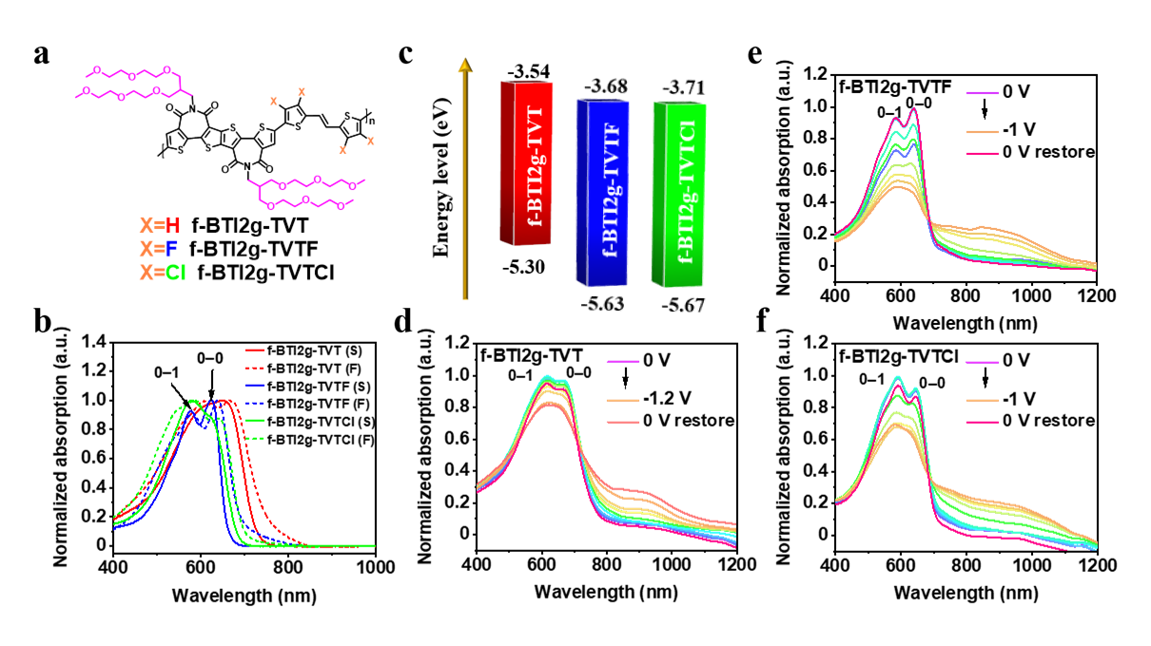
Figure 1. a) Chemical structures of f-BTI2g-TVT, and halogenated f-BTI2g-TVTF and f-BTI2g-TVTCl. b) Normalized UV-Vis absorption spectra of f-BTI2g-TVT, f-BTI2g-TVTF, and f-BTI2g-TVTCl in chloroform solution (S) (10⁻⁵ M) and as thin film (F). c) Energy level diagram of the polymers. UV−Vis−NIR electrochemical absorption spectra of d) f-BTI2g-TVT, e) f-BTI2g-TVTF, and f) f-BTI2g-TVTCl thin films in 0.1 M NaCl aqueous solution with different reduction voltage applied against Ag/Ag⁺ reference.

To further investigate electrochemical properties, we measured the ultraviolet-visible-near infrared (UV−Vis−NIR) absorption spectra of three polymer films in 0.1 M aqueous NaCl solution (Figure 1d-f). Upon the increase of reduction voltage from 0 to −1.2 V for f-BTI2g-TVT and 0 to -1 V for f-BTI2g-TVTF and f-BTI2g-TVTCl with an interval of −0.1 V, the neutral absorption bands (400–700 nm) of three polymers gradually decreased accompanied by the increased long-wavelength bands (800–1200 nm), which is due to the generation of polarons/bipolarons. After reduction, whether the neutral absorption can be recovered to its original intensity depends on the stability of polymer films during the electrochemical doping. According to the restored curves in Figure 1d−f, f-BTI2g-TVTF exhibits better electrochemical stability after the doping/dedoping process, whereas f-BTI2g-TVTCl and f-BTI2g-TVT showed more severe degradation. It is important to note that the 0-0/0-1 peak ratio of all polymers decreased during the charging process due to the insertion of ions from the electrolyte, which may affect the aggregation of the channel polymers. It was found that the decline of the 0-0/0-1 peak ratio started at distinct reduction voltages for three polymers because of their different threshold voltage (Figure S4). After discharging, only polymer f-BTI2g-TVTF can be restored in terms of both absorption intensity and 0-0/0-1 peak ratio, suggesting its favorable stability during the electrochemical operation.
Table 1. Physicochemical properties of polymers f-BTI2g-TVT, f-BTI2g-TVTF, and f-BTI2g-TVTCl.
Polymer | M_{n} [kg mol⁻¹]/Đ | λ_{max}^{soln a)}  [nm] | λ_{max}^{film b)}  [nm] | E_{g}^{opt c)}  [eV] |  | E_{red}/E_{oxid}^{d)}  [V] | E_{LUMO} ^{d)}  [eV] | E_{HOMO} ^{d)}  [eV]
f-BTI2g-TVT | 26.9/1.37 | 649 | 665 | 1.70 | -0.8/0.9 |  | −3.5 | −5.3
f-BTI2g-TVTF | 51.5/1.47 | 623 | 639 | 1.87 | -0.7/1.3 |  | −3.7 | −5.6
f-BTI2g-TVTCl | 46.2/1.37 | 577 | 586 | 1.84 | -0.7/1.3 |  | −3.7 | −5.7
^{a)} From chloroform solution (10⁻⁵ M); ^{b)} Polymer film cast from their chloroform solution (5 mg mL⁻¹); ^{c)} Derived from UV-Vis absorption onset of polymer films; ^{d)} From cyclic voltammogram of polymer films in 0.1 M tetra(n-butyl)ammonium hexafluorophosphate acetonitrile solution with Fc/Fc⁺ as the reference (red = reduction, oxid = oxidation).

For the OTE devices, molecular dopant 4-(1,3-dimethyl-2,3-dihydro-1H-benzoimidazol-2-yl)phenyl)dimethylamine (N-DMBI) was selected to n-dope the polymers due to its strong reducing ability, preferable stability and excellent solution processability.^{[68]} Our recent study demonstrated that transition metal nanoparticles (such as Au nanoparticles) can act as catalysts to reduce the activation energy of the N-H bond cleavage heterolytically to form active doping species hydride (H⁻) and increase the rate of doping reaction, which leads to improved
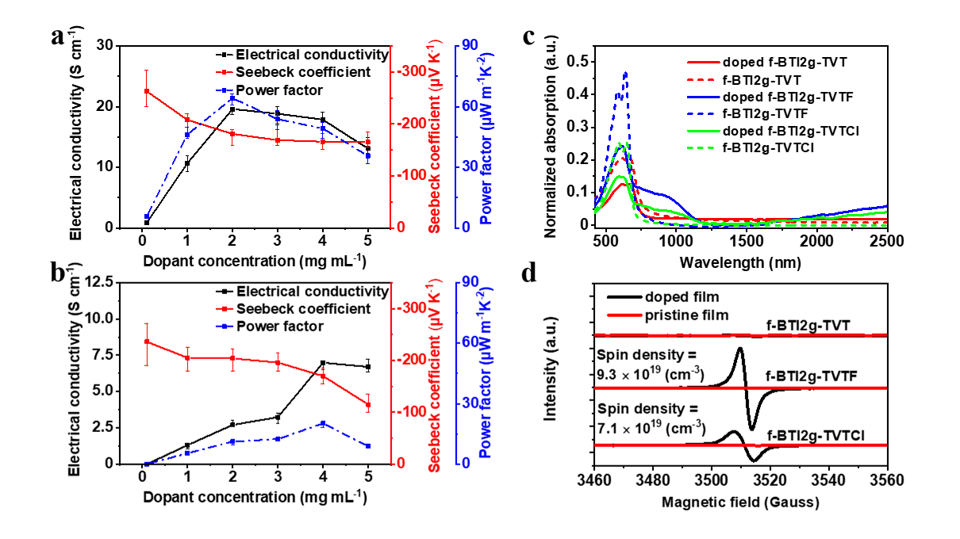
Figure 2. Electrical conductivity, Seebeck coefficient and power factor of doped a) f-BTI2g-TVTF and b) f-BTI2g-TVTCl thin films using gold nanoparticles as catalyst. c) UV−Vis−NIR absorption spectra and d) electron spin resonance (ESR) signals of pristine and n-doped polymer films.

molecular n-doping efficiency and device performance. Thus Au nanoparticles (~0.1 nm) were deposited in the channel via thermal evaporation before coating polymer layers. After that, a sequential doping approach was adopted to dope three films, affording an excellent chance to independently improve semiconductor layer and dopant deposition.^{[81]} The detailed device fabrication procedures are provided in Supporting Information. As depicted in Figure 2a,b and S8, the σ of f-BTI2g-TVTF reached the peak value of 19.7 S cm⁻¹ when the dopant concentration was 2 mg mL⁻¹. At the same time, the Seebeck coefficient decreased gradually upon increasing the dopant concentration from 0.1 to 5 mg mL⁻¹. By balancing the conductivity and Seebeck coefficient, the maximum PF of 64.2 μW m⁻¹ K⁻² was attained with a dopant concentration of 2 mg mL⁻¹. For f-BTI2g-TVTCl, the highest σ and PF were found to be 7.00 S cm⁻¹ and 20.2 μW m⁻¹ K⁻², respectively, both of which are substantially lower than expected. Considering their comparable LUMO energy level and backbone conformation, f-BTI2g-TVTCl and f-BTI2g-TVTF should have similar conductivities. However, the σ of f-BTI2g-TVTF is ~3 times larger than that of f-BTI2g-TVTCl, which may be due to their distinct surface hydrophilicity that affects the miscibility of dopants and polymers (vide infra).
Table 2. Summary of the OTE and OFET performance parameters of three polymers.
Polymer | σ^{a)}  [S cm⁻¹] | S^{b)}  [µV K⁻¹] | PF^{b)}  [µW m⁻¹ K⁻²] | μ_{e,OFET}^{c)}  [cm² V⁻¹ s⁻¹] | V_{th}^{d)}  [V] | I_{on/off}
f-BTI2g-TVT | 0.00053 ± 0.00012 | NA | NA | NA | NA | NA
f-BTI2g-TVTF | 19.6 ± 3.6 | −181 ± 12 | 64.2  (60.3 ± 11.7) | 0.0015  (0.0014 ± 0.0005) | 39 ± 3 | 10³
f-BTI2g-TVTCl | 7.0 ± 1.9 | −170 ± 9 | 20.2  (17.8 ± 5.4) | 0.0013  (0.0011 ± 0.0004) | 37 ± 5 | 10³
^{a)} The highest σ values with the average values included in parentheses at their optimal N-DMBI dopant concentration. ^{b)} The best PFs with average values of the polymers and the corresponding Seebeck coefficient factors; ^{c)} The best μ_{e}s with average values in the parenthesis for OFETs calculated from transfer curves in saturation regime; ^{d)} Threshold voltage V_{th}s with the average values extracted by the fitting plots of I_{ds}^{1/2} vs. V_{gs}.

The maximum σ of f-BTI2g-TVT only reached 0.00053 S cm⁻¹ even doped with the high dopant concentration of 5 mg mL⁻¹, which was smaller by four orders of magnitude than those of the halogen-functionalized polymers. All relevant thermoelectric performance parameters were collected in Table 2. The UV−Vis−NIR absorption spectra were characterized to further investigate the n-doping efficiency of halogen-functionalized polymers. All neat polymers showed no absorption band in the near-infrared range (800−2500 nm, Figure 2c), however, the polymer film doped with N-DMBI resulted in a decrease of the neutral absorption band in the range of 400–750 nm accompanied by a pronounced absorption of (bi)polaron in the near-infrared region, which indicates the successful doping of three polymers. Among them, the doped f-BTI2g-TVTF films displayed the largest polaron to π−π* peak (400–750 nm) ratio, indicative of the highest doping level. Figure 2d shows the electron spin resonance (ESR) signals for the neat and doped films of three polymers. There were no distinctive signals detected for the pure films of three polymers. After N-DMBI doping, f-BTI2g-TVTF and f-BTI2g-TVTCl exhibit greatly improved spin signals attributed to their deep-lying LUMO level, whereas the doping of f-BTI2g-TVT appeared to be less successful.
To explore the charge-transport capability of halogen-functionalized polymers, the saturated electron mobilities (μ_{e,OFET}s) were characterized by fabricating top-gate/bottom-contact (TGBC) OFETs with a device architecture of glass/Au/polymer/CYTOP/Al. The detailed fabrication procedures are elaborated in the Experiment Section. The transfer and output curves are shown in Figure S9 and the device performance parameters are compiled in Table 2. It was found that fBTI2g-TVTF and f-BTI2g-TVTCl yield comparable μ_{e,OFET}s of 0.0015 and 0.0013 cm² V⁻¹ s⁻¹ in the saturated regime, respectively, which are much lower than that of the typical BTI2-based polymers with alkyl side-chains.^{[38]} This is likely attributed to the fact that the OEG-type side chains introduce electron traps and broaden the density-of-states (DOS) of interfacial charges due to their hydrophilicity (vide infra) and high polarity, respectively.^{[82,83]} For f-BTI2g-TVT, however, there was no detectable field effect, hence the electron injection and transport were hampered by the high-lying LUMO and limited LUMO wavefunction delocalization length of f-BTI2g-TVT, respectively. The mobility of OFETs can function as an indicator regarding the capacity of charge carrier transport in its electrochemical transistor counterpart.
The electrochemical properties of three BTI-based polymers were investigated by fabricating OECT devices with the parylene-based peel-off method.^{[37]} The gold electrodes were patterned using a shadow mask via thermal evaporation and further defined through a parylene C layer to minimize the overlapping between the source/drain electrodes and active channels, suppressing the unnecessary leakage current for fast device switching. The channel length (L) and width (W) of the gold electrodes were 10 and 100 nm, respectively. The prepared devices were characterized in ambient using 0.1 M aqueous NaCl solution as the electrolyte and an immersed Ag/Ag⁺ as the gate electrode.
The performance of the OECT devices was evaluated based on the equation derived from the Bernards’ model:^{[84]}
Where g_{m} stands for the geometry-normalized transconductance extracted from the saturation regime, µC* is the product of charge carrier mobility and the capacitance of channel per unit volume, W, d, and L are the channel width, thickness, and length, respectively, V_{gs} is the applied voltage, and V_{th} denotes the threshold voltage. The desired unipolar n-type accumulation-mode properties were attained based on the transfer and output characteristics with small hysteresis shown in Figure 3b–d and the performance data was summarized in Table 3. Polymer f-BTI2g-TVTF yielded a maximum µC* of 90.2 F cm⁻¹ V⁻¹ s⁻¹ at V_{gs} = 1.0 V with a V_{th} of 0.75 V and
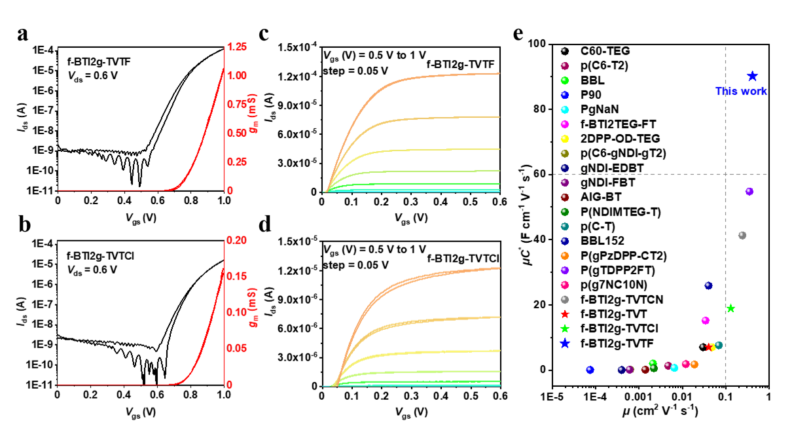
Figure 3. a, b) Transfer and c, d) output curves of f-BTI2g-TVTF and f-BTI2g-TVTCl based OECTs. The red line represents the curve of g_{m}. e) Comparison of the µC* and µ value of f-BTI2g-TVTF and f-BTI2g-TVTCl with high-performance n-type OECT materials reported in literature.[28,29,31,34,36,37,41,42,49,71,72,75,82,83,85,86] Please note that other detailed parameters of the polymers are listed in Table S1.

an on/off current ratio of 10⁵, corresponding to a high geometry-normalized g_{m,nrom} of 22.6 S cm⁻¹ (Table S1), both of which are among the highest values for n-type OECTs. With a comparable V_{th} of 0.79 V, f-BTI2g-TVTCl also displayed a high µC* of 18.9 F cm⁻¹ V⁻¹ s⁻¹ and g_{m,nrom} of 3.97 S cm⁻¹. For non-halogenated polymer f-BTI2g-TVT (Figure S10), a higher V_{th} of 0.97 V was needed to turn on the devices due to its higher-lying LUMO compared to f-BTI2g-TVTF and f-BTI2g-TVTCl, and a maximum µC* and g_{m,nrom} of 6.96 F cm⁻¹ V⁻¹ s⁻¹ and 1.60 S cm⁻¹ was attained for this polymer at V_{gs} = 1.2 V, respectively.
Table 3. Summary of the OECT performance parameters of the polymers.
Polymer | g_{m,norm}  [S cm⁻¹] | d^{a)}  [nm] | V_{th}^{b)}  [V] | C^{*c)}  [F cm⁻³] | µ_{e,OECT}^{d)}  [cm² V⁻¹ s⁻¹] | µC^{*f)}  [F cm⁻¹ V⁻¹ s⁻¹] | I_{on/off}
f-BTI2g-TVT | 1.60 | 36 ± 3 | 0.97 ± 0.04 | 180 ± 19 | 0.04 ± 0.03 | 6.96 ± 1.35 | $${10}^{4}$$
f-BTI2g-TVTF | 22.6 | 47 ± 2 | 0.75 ± 0.03 | 222 ± 12 | 0.41 ± 0.13 | 90.2 ± 10.5 | $${10}^{5}$$
f-BTI2g-TVTCl | 3.97 | 39 ± 3 | 0.79 ± 0.02 | 149 ± 16 | 0.13 ± 0.04 | 18.9 ± 6.95 | $${10}^{4}$$
^{a)} Average film thickness determined by profilometer; ^{b)} Average threshold voltage V_{th} extracted by the fitting plot of I_{ds}^{1/2} vs. V_{gs}; ^{c)} Average C* value determined by EIS measurement from OECTs with the best performance; ^{d)} Average OECT mobility µ_{e,OECT} calculated from µC* and EIS-measured C*; ^{f)} Figure of merit µC* calculated according to equation (2) in the saturation regime.

The electrochemical impedance spectroscopy (EIS) was then used to estimate the volumetric capacitance (C*) (Figure S11 and S12). The maximum C* was extracted with an average value of 180, 222, and 149 F cm⁻³ for f-BTI2g-TVT, f-BTI2g-TVTF, and f-BTI2g-TVTCl around the corresponding bias potentials (1.2, 1.0 and 1.0 V), respectively. Among them, polymer f-BTI2g-TVTCl exhibited the lowest C*, presumably owing to its highest hydrophobicity, which likely limits its swellability.^{[87]} Based on the average C* and µC* values under specific bias potentials, the µ_{e,OECT} of f-BTI2g-TVT, f-BTI2g-TVTF, and f-BTI2g-TVTCl was calculated to be 0.04, 0.41, and 0.13 cm² V⁻¹ s⁻¹ (Table 3), respectively. We further tested the transient response and long-term operational stability of three polymers. To simulate the real environment, the cycling pulse was applied to the gate electrode with a constant V_{ds} of 0.6 V (Figure 4a, 4c). After 1000 s on-off cycling in ambient, the on-current was retained at 80.1, 90.7, and 44.0% for f-BTI2g-TVT, f-BTI2g-TVTF, and f-BTI2g-TVTCl, respectively (Figure 4b, 4d and Figure S13a). After the exponential fitting of I_{ds} upon the switching moment, the estimated on/off time constant (τ_{on}/τ_{off}) was calculated to be 68/27, 53/4, and 250/10 ms for f-BTI2g-TVT,^{[71]} f-BTI2g-TVTF, and f-BTI2g-TVTCl, respectively, indicating the fastest response properties for the fluorinated polymer. The steady-state current was also studied through a continuous-mode bias potential test (Figure S13b). After biased for 1000 s, f-BTI2g-TVTF exhibited exceptional stability during operation, retaining 96% of its maximum current I_{ds} at t = 0. Moreover, the f-BTI2g-TVTF maintained a transfer curve current of over 50% compared to its initial value even after one week of storage in ambient air. (Figure S14). The good operation stability and rapid response characteristics of f-BTI2g-TVTF render it suitable for high-speed real-time sensing applications.
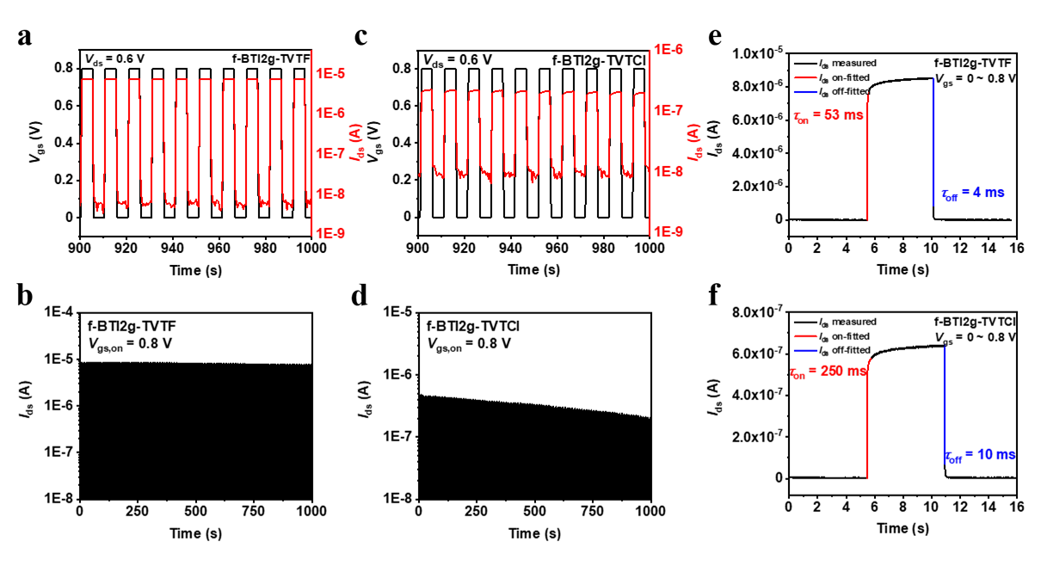
Figure 4. Operational stability of OECTs under cyclic square wave gate bias for a, b) f-BTI2g-TVTF and c, d) f-BTI2g-TVTCl over 1000 s with enlarged data in the period of 900–1000 s. Transient on/off measurement of OECT devices for e) f-BTI2g-TVTF and f) f-BTI2g-TVTCl with the time constant τ_{on/off} estimated from the time for I_{ds} raised to/decreased by 90% of its maximum values.

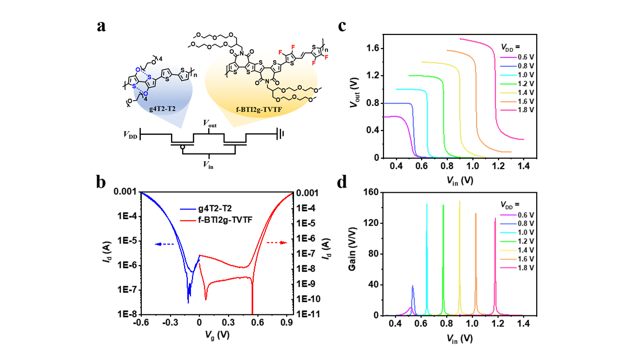
Figure 5. a) Wiring schematic of a complementary inverter consisting of p-type g4T2-T2 and n-type f-BTI2g-TVTF OECTs connected in series. b) Transfer curves of g4T2-T2-based and f-BTI2g-TVTF-based OECTs, exhibiting matched p-type and n-type transport characteristics. c) Voltage transfer characteristics (VTC) of the inverter at various supply voltages. d) Gains calculated from the slope of the VTC.

Polymer f-BTI2g-TVT was then used to fabricate complementary inverters with high-performance g4T2-T2 as p-type polymer because of their matched operating voltage and device performance (Figure 5a). Since the operating voltages of n- and p-channel materials are symmetrical around V_{g} = 0.25 V (Figure 5b), the voltage step of a well-balanced inverter occurs at V_{DD}/2 + 0.25 V. As shown in Figure 5c, the transition of voltage transfer characteristics (VTC) occurs under different supply voltage V_{DD}. A high gain value of 148 V V⁻¹ was obtained at V_{DD} = 1.4 V (Figure 5d), which is among the highest gain values for the state-of-the-art OECT inverters.^{[49,88,89]}
The wettability and morphology of the polymer films play a critical role in ion penetration and charge transport in the channel. The water contact angles of polymer films were measured to analyze the hydrophilicity. f-BTI2g-TVTF shows a lower water contact angle of 51°, which is more hydrophilic than f-BTI2g-TVTCl with a contact angle of 72°, respectively (Figure S15). 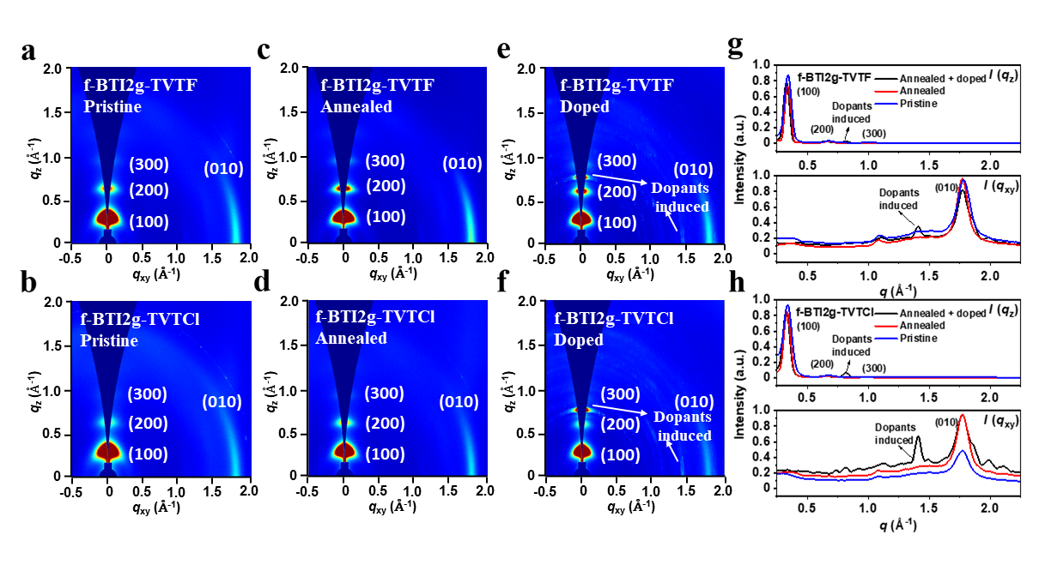
Figure 6. Two-dimensional GIWAXS patterns of a, b) pristine, c, d) annealed and e, f) N-DMBI doped thin-films of f-BTI2g-TVTF and f-BTI2g-TVTCl. The dopant concentration is 5 mg mL⁻¹. Corresponding line-cut profiles along the out-of-plane and in-plane direction for g) f-BTI2g-TVTF and h) f-BTI2g-TVTCl. Note, line-cuts along the q_{z} and q_{xy} directions represent scattering in the out-of-plane and in-plane directions, respectively.

These results are consistent with the trend of the C* values in OECTs for these polymers.^{[71]} Additionally, atomic force microscopy (AFM) was used to investigate the surface morphology of polymer films (Figure S16). The AFM height image of f-BTI2g-TVTF shows a relatively smooth surface with a small root-mean-square (RMS) roughness of 1.16 nm and displayed microfiber-like textures, whereas the height image of f-BTI2g-TVTCl features a higher RMS roughness of 2.21 nm with thicker microfibers. The f-BTI2g-TVT films show a surface roughness of 1.44 nm and feature a similar pattern to the f-BTI2g-TVTF films, indicating that fluorine functionalization had a minimal effect on surface morphology. Compared to the neat films, the doped f-BTI2g-TVTF, f-BTI2g-TVTCl, and f-BTI2g-TVT films displayed a higher RMS roughness of 12.91, 7.07, and 14.8 nm, respectively. Notably, uneven distribution of dopants on the surface of f-BTI2g-TVTCl was observed (Figure S15e) due to its lower wettability compared to that of f-BTI2g-TVTF, leading to its lower OTE performance.
Two-dimensional grazing incidence wide-angle X-ray scattering (2D-GIWAXS) was carried out to explore the film microstructure and molecular packing (Figure 6 and S17 and Table S2). It was found that f-BTI2g-TVT, f-BTI2g-TVTF, and f-BTI2g-TVTCl exhibit typical edge-on polymer chain packing with lamellar scatterings up to (300) in the out-of-plane (OOP) orientation together with π–π stacking (010) peak in the in-plane (IP) direction. After the annealing treatment at 120 °C for 10 min, the coherence lengths (CCLs) of f-BTI2-TVT are larger than those of f-BTI2-TVTF and f-BTI2-TVTCl in both OOP lamellar stacking and IP π–π stacking directions, indicative of a lower crystallinity for halogen-functionalized polymers. The lower crystallinity could lead to faster penetration of hydrated ions into the polymer bulk and promote a rapid response despite sacrificing some electron mobilities.^{[20,90,91]} After doping by N-DMBI, we observed the undesired peaks at q_{z} = 0.80 and q_{xy} = 1.41 induced by the dopants, which slightly affected the molecular packing of pure films. For example, the CCL of f-BTI2g-TVTCl decreased in the π–π stacking (CCL_{xy,010}) direction while increased in the lamellar (CCL_{z,100}) direction. However, for f-BTI2g-TVTF, the CCL in both orientations almost remained unchanged. This result manifested that the crystallinity of f-BTI2g-TVTF was not greatly interfered by the dopants, revealing a more robust molecular packing upon doping chemically than f-BTI2g-TVTCl.
Conclusion
To conclude, we have employed a halogen-functionalization strategy to devise two new f-BTI2-based n-type PMIECs, f-BTI2g-TVTF and f-BTI2g-TVTCl. Compared with the non-halogenated analogue, halogen-functionalized f-BTI2g-TVTF and f-BTI2g-TVTCl show lower-positioned FMO levels, thus leading to high electron mobility and efficient doping. We further explored the difference between f-BTI2g-TVTF and f-BTI2g-TVTCl, and it was found that the fluorinated polymer contributes to a better ion uptake ability and operational stability during n-doping electrochemically. Consequently, a remarkable µC* of 90.2 F cm⁻¹ V⁻¹ s⁻¹ with an excellent OECT electron mobility of 0.41 cm² V⁻¹ s⁻¹ and a high PF of 64.2 μW m⁻¹ K⁻² was obtained for f-BTI2g-TVTF, much higher than those of chlorinated f-BTI2g-TVTCl (µC* = 18.9 F cm⁻¹ V⁻¹ s⁻¹ and PF = 20.2 μW m⁻¹ K⁻²). Furthermore, the f-BTI2g-TVTF-based inverter amplifiers with high gains up to 148 V V⁻¹ are demonstrated, making them among the finest complementary inverters reported to date. This work demonstrates the power of halogen functionalization in designing n-type PMIECS for high-performance OECTs and OTEs.

Supporting Information
Supporting Information is available from the Wiley Online Library or from the author.

Acknowledgements
K.F. acknowledge the financial support by the National Natural Science Foundation of China (22275078 and 22005135). X.G. is grateful to the financial support from the National Natural Science Foundation of China (52173171) and Shenzhen Science and Technology Innovation Commission (JCYJ20220818100617037). H.Y.W. acknowledges the financial support from the National Research Foundation of Korea (2019R1A6A1A11044070 and 2020M3H4A3081814). This work is also supported by Center for Computational Science and Engineering at Southern University of Science and Technology (SUSTech). The authors acknowledge the assistance of SUSTech Core Research Facilities.

References
[1] J. Isaksson, P. Kjäll, D. Nilsson, N. Robinson, M. Berggren, A. Richter-Dahlfors, Nat. Mater. 2007, 6, 673.
[2] D. T. Simon, E. O. Gabrielsson, K. Tybrandt, M. Berggren, Chem. Rev. 2016, 116, 13009.
[3] B. D. Paulsen, K. Tybrandt, E. Stavrinidou, J. Rivnay, Nat. Mater. 2020, 19, 13.
[4] J. Rivnay, R. M. Owens, G. G. Malliaras, Chem. Mater. 2014, 26, 679.
[5] A. M. Pappa, D. Ohayon, A. Giovannitti, I. P. Maria, A. Savva, I. Uguz, J. Rivnay, I. McCulloch, R. M. Owens, S. Inal, Sci. Adv. 2018, 4, eaat0911.
[6] J. Rivnay, M. Ramuz, P. Leleux, A. Hama, M. Huerta, R. M. Owens, Appl. Phys. Lett. 2015, 106, 043301.
[7] D. Khodagholy, J. Rivnay, M. Sessolo, M. Gurfinkel, P. Leleux, L. H. Jimison, E. Stavrinidou, T. Herve, S. Sanaur, R. M. Owens, G. G. Malliaras, Nat. Commun. 2013, 4, 2133.
[8] C. Pitsalidis, A.-M. Pappa, A. J. Boys, Y. Fu, C.-M. Moysidou, D. van Niekerk, J. Saez, A. Savva, D. Iandolo, R. M. Owens, Chem. Rev. 2022, 122, 4700.
[9] Y. van de Burgt, E. Lubberman, E. J. Fuller, S. T. Keene, G. C. Faria, S. Agarwal, M. J. Marinella, A. Alec Talin, A. Salleo, Nat. Mater. 2017, 16, 414.
[10] A. Melianas, T. J. Quill, G. LeCroy, Y. Tuchman, H. v. Loo, S. T. Keene, A. Giovannitti, H. R. Lee, I. P. Maria, I. McCulloch, A. Salleo, Sci. Adv. 2020, 6, eabb2958.
[11] H. Ling, D. A. Koutsouras, S. Kazemzadeh, Y. van de Burgt, F. Yan, P. Gkoupidenis, Appl. Phys. Rev. 2020, 7, 011307.
[12] H. Sun, M. Vagin, S. Wang, X. Crispin, R. Forchheimer, M. Berggren, S. Fabiano, Adv. Mater. 2018, 30, 1704916.
[13] J. Rivnay, S. Inal, B. A. Collins, M. Sessolo, E. Stavrinidou, X. Strakosas, C. Tassone, D. M. Delongchamp, G. G. Malliaras, Nat. Commun. 2016, 7, 11287.
[14] A. Savva, R. Hallani, C. Cendra, J. Surgailis, T. C. Hidalgo, S. Wustoni, R. Sheelamanthula, X. Chen, M. Kirkus, A. Giovannitti, A. Salleo, I. McCulloch, S. Inal, Adv. Funct. Mater. 2020, 30, 1907657.
[15] J. Rivnay, S. Inal, A. Salleo, R. M. Owens, M. Berggren, G. G. Malliaras, Nat. Rev. Mater. 2018, 3, 17086.
[16] P. Romele, P. Gkoupidenis, D. A. Koutsouras, K. Lieberth, Z. M. Kovács-Vajna, P. W. M. Blom, F. Torricelli, Nat. Commun. 2020, 11, 3743.
[17] J. Chen, W. Huang, D. Zheng, Z. Xie, X. Zhuang, D. Zhao, Y. Chen, N. Su, H. Chen, R. M. Pankow, Z. Gao, J. Yu, X. Guo, Y. Cheng, J. Strzalka, X. Yu, T. J. Marks, A. Facchetti, Nat. Mater. 2022, 21, 564.
[18] S. Inal, G. G. Malliaras, J. Rivnay, Nat. Commun. 2017, 8, 1767.
[19] M. Moser, T. C. Hidalgo, J. Surgailis, J. Gladisch, S. Ghosh, R. Sheelamanthula, Q. Thiburce, A. Giovannitti, A. Salleo, N. Gasparini, A. Wadsworth, I. Zozoulenko, M. Berggren, E. Stavrinidou, S. Inal, I. McCulloch, Adv. Mater. 2020, 32, 2002748.
[20] H. Jia, Z. Huang, P. Li, S. Zhang, Y. Wang, J.-Y. Wang, X. Gu, T. Lei, J. Mater. Chem. C 2021, 9, 4927.
[21] X. Wu, Q. Liu, A. Surendran, S. E. Bottle, P. Sonar, W. L. Leong, Adv. Electron. Mater. 2021, 7, 2000701.
[22] S.-M. Kim, C.-H. Kim, Y. Kim, N. Kim, W.-J. Lee, E.-H. Lee, D. Kim, S. Park, K. Lee, J. Rivnay, M.-H. Yoon, Nat. Commun. 2018, 9, 3858.
[23] C. B. Nielsen, A. Giovannitti, D.-T. Sbircea, E. Bandiello, M. R. Niazi, D. A. Hanifi, M. Sessolo, A. Amassian, G. G. Malliaras, J. Rivnay, I. McCulloch, J. Am. Chem. Soc. 2016, 138, 10252.
[24] J. Rivnay, P. Leleux, M. Sessolo, D. Khodagholy, T. Hervé, M. Fiocchi, G. G. Malliaras, Adv. Mater. 2013, 25, 7010.
[25] M. Moser, A. Savva, K. Thorley, B. D. Paulsen, T. C. Hidalgo, D. Ohayon, H. Chen, A. Giovannitti, A. Marks, N. Gasparini, A. Wadsworth, J. Rivnay, S. Inal, I. McCulloch, Angew. Chem. Int. Ed. 2021, 60, 7777.
[26] Y. Wang, A. Hamidi-Sakr, J. Surgailis, Y. Zhou, H. Liao, J. Chen, G. Zhu, Z. Li, S. Inal, W. Yue, J. Mater. Chem. C 2021, 9, 13338.
[27] R. K. Hallani, B. D. Paulsen, A. J. Petty, R. Sheelamanthula, M. Moser, K. J. Thorley, W. Sohn, R. B. Rashid, A. Savva, S. Moro, J. P. Parker, O. Drury, M. Alsufyani, M. Neophytou, J. Kosco, S. Inal, G. Costantini, J. Rivnay, I. McCulloch, J. Am. Chem. Soc. 2021, 143, 11007.
[28] P. Li, J. Shi, Y. Lei, Z. Huang, T. Lei, Nat. Commun. 2022, 13, 5970.
[29] A. Marks, X. Chen, R. Wu, R. B. Rashid, W. Jin, B. D. Paulsen, M. Moser, X. Ji, S. Griggs, D. Meli, X. Wu, H. Bristow, J. Strzalka, N. Gasparini, G. Costantini, S. Fabiano, J. Rivnay, I. McCulloch, J. Am. Chem. Soc. 2022, 144, 4642.
[30] K. Feng, H. Guo, J. Wang, Y. Shi, Z. Wu, M. Su, X. Zhang, J. H. Son, H. Y. Woo, X. Guo, J. Am. Chem. Soc. 2021, 143, 1539.
[31] K. Feng, W. Shan, S. Ma, Z. Wu, J. Chen, H. Guo, B. Liu, J. Wang, B. Li, H. Y. Woo, S. Fabiano, W. Huang, X. Guo, Angew Chem Int Ed 2021, 60, 24198–24205.
[32] T. Lei, J.-H. Dou, X.-Y. Cao, J.-Y. Wang, J. Pei, Adv. Mater. 2013, 25, 6589.
[33] T. Lei, J.-H. Dou, Z.-J. Ma, C.-H. Yao, C.-J. Liu, J.-Y. Wang, J. Pei, J. Am. Chem. Soc. 2012, 134, 20025.
[34] Y. Wang, E. Zeglio, L. Wang, S. Cong, G. Zhu, H. Liao, J. Duan, Y. Zhou, Z. Li, D. Mawad, A. Herland, W. Yue, I. McCulloch, Adv. Funct. Mater. 2022, 32, 2111439.
[35] J. Yang, Z. Zhao, S. Wang, Y. Guo, Y. Liu, Chem 2018, 4, 2748.
[36] J. Surgailis, A. Savva, V. Druet, B. D. Paulsen, R. Wu, A. Hamidi Sakr, D. Ohayon, G. Nikiforidis, X. Chen, I. McCulloch, J. Rivnay, S. Inal, Adv. Funct. Mater. 2021, 31, 2010165.
[37] X. Chen, A. Marks, B. D. Paulsen, R. Wu, R. B. Rashid, H. Chen, M. Alsufyani, J. Rivnay, I. McCulloch, Angew. Chem. Int. Ed. 2021, 60, 9368.
[38] K. Feng, H. Guo, H. Sun, X. Guo, Acc. Chem. Res. 2021, 54, 3804.
[39] A. Giovannitti, C. B. Nielsen, D.-T. Sbircea, S. Inal, M. Donahue, M. R. Niazi, D. A. Hanifi, A. Amassian, G. G. Malliaras, J. Rivnay, I. McCulloch, Nat. Commun. 2016, 7, 13066.
[40] B. Sun, W. Hong, Z. Yan, H. Aziz, Y. Li, Adv. Mater. 2014, 26, 2636.
[41] J. Shi, P. Li, X.-Y. Deng, J. Xu, Z. Huang, Y. Lei, Y. Wang, J.-Y. Wang, X. Gu, T. Lei, Chem. Mater. 2022, 34, 864.
[42] J. J. Samuel, A. Garudapalli, A. A. Mohapatra, C. Gangadharappa, S. Patil, N. P. B. Aetukuri, Adv. Funct. Mater. 2021, 31, 2102903.
[43] D. M. de Leeuw, M. M. J. Simenon, A. R. Brown, R. E. F. Einerhand, Synth. Met. 1997, 87, 53.
[44] Y. Sun, C. Di, W. Xu, D. Zhu, Adv. Electron. Mater. 2019, 5, 1800825.
[45] B. A. Jones, A. Facchetti, M. R. Wasielewski, T. J. Marks, J. Am. Chem. Soc. 2007, 129, 15259.
[46] M. Moser, L. R. Savagian, A. Savva, M. Matta, J. F. Ponder, T. C. Hidalgo, D. Ohayon, R. Hallani, M. Reisjalali, A. Troisi, A. Wadsworth, J. R. Reynolds, S. Inal, I. McCulloch, Chem. Mater. 2020, 32, 6618.
[47] T. Lei, J.-Y. Wang, J. Pei, Acc. Chem. Res. 2014, 47, 1117.
[48] A. F. Paterson, H. Faber, A. Savva, G. Nikiforidis, M. Gedda, T. C. Hidalgo, X. Chen, I. McCulloch, T. D. Anthopoulos, S. Inal, Adv. Mater. 2019, 31, 1902291.
[49] H. Wu, C. Yang, Q. Li, N. B. Kolhe, X. Strakosas, M. Stoeckel, Z. Wu, W. Jin, M. Savvakis, R. Kroon, D. Tu, H. Y. Woo, M. Berggren, S. A. Jenekhe, S. Fabiano, Adv. Mater. 2022, 34, 2106235.
[50] Y. Lu, Z.-D. Yu, Y. Liu, Y.-F. Ding, C.-Y. Yang, Z.-F. Yao, Z.-Y. Wang, H.-Y. You, X.-F. Cheng, B. Tang, J.-Y. Wang, J. Pei, J. Am. Chem. Soc. 2020, 142, 15340.
[51] F. Zhang, Y. Zang, D. Huang, C. Di, D. Zhu, Nat. Commun. 2015, 6, 8356.
[52] B. Russ, A. Glaudell, J. J. Urban, M. L. Chabinyc, R. A. Segalman, Nat. Rev. Mater. 2016, 1, 16050.
[53] Y. Li, Q. Li, X. Zhang, B. Deng, C. Han, W. Liu, Adv. Energy Mater. 2022, 12, 2103666.
[54] B. Dörling, S. Sandoval, P. Kankla, A. Fuertes, G. Tobias, M. Campoy-Quiles, Synth. Met. 2017, 225, 70.
[55] H. Wang, C. Yu, Joule 2019, 3, 53.
[56] O. Bubnova, X. Crispin, Energy Environ. Sci. 2012, 5, 9345.
[57] Y. Zhang, Q. Zhang, G. Chen, Carbon Energy 2020, 2, 408.
[58] G. J. Snyder, T. S. Ursell, Phys. Rev. Lett. 2003, 91, 148301.
[59] S. Griggs, A. Marks, H. Bristow, I. McCulloch, J. Mater. Chem. C 2021, 9, 8099.
[60] F. Urbain, V. Smirnov, J.-P. Becker, A. Lambertz, F. Yang, J. Ziegler, B. Kaiser, W. Jaegermann, U. Rau, F. Finger, Energy Environ. Sci. 2016, 9, 145.
[61] C.-J. Yao, H.-L. Zhang, Q. Zhang, Polymers 2019, 11, 107.
[62] N. Kim, S. Kee, S. H. Lee, B. H. Lee, Y. H. Kahng, Y.-R. Jo, B.-J. Kim, K. Lee, Adv. Mater. 2014, 26, 2268.
[63] Y. Fang, H. Cheng, H. He, S. Wang, J. Li, S. Yue, L. Zhang, Z. Du, J. Ouyang, Adv. Funct. Mater. 2020, 30, 2004699.
[64] Y. Zhong, V. Untilova, D. Muller, S. Guchait, C. Kiefer, L. Herrmann, N. Zimmermann, M. Brosset, T. Heiser, M. Brinkmann, Adv. Funct. Mater. 2022, 32, 2202075.
[65] Y. Lu, Z. Yu, H. Un, Z. Yao, H. You, W. Jin, L. Li, Z. Wang, B. Dong, S. Barlow, E. Longhi, C. Di, D. Zhu, J. Wang, C. Silva, S. R. Marder, J. Pei, Adv. Mater. 2021, 33, 2005946.
[66] H. Tang, Y. Liang, C. Liu, Z. Hu, Y. Deng, H. Guo, Z. Yu, A. Song, H. Zhao, D. Zhao, Y. Zhang, X. Guo, J. Pei, Y. Ma, Y. Cao, F. Huang, Nature 2022, 611, 271.
[67] S. Wang, H. Sun, T. Erdmann, G. Wang, D. Fazzi, U. Lappan, Y. Puttisong, Z. Chen, M. Berggren, X. Crispin, A. Kiriy, B. Voit, T. J. Marks, S. Fabiano, A. Facchetti, Adv. Mater. 2018, 30, 1801898.
[68] Y. Zeng, W. Zheng, Y. Guo, G. Han, Y. Yi, J. Mater. Chem. A 2020, 8, 8323.
[69] J. Han, A. Chiu, C. Ganley, P. McGuiggan, S. M. Thon, P. Clancy, H. E. Katz, Angew. Chem. Int. Ed. 2021, 60, 27212.
[70] H. Un, S. A. Gregory, S. K. Mohapatra, M. Xiong, E. Longhi, Y. Lu, S. Rigin, S. Jhulki, C. Yang, T. V. Timofeeva, J. Wang, S. K. Yee, S. Barlow, S. R. Marder, J. Pei, Adv. Energy Mater. 2019, 9, 1900817.
[71] K. Feng, W. Shan, J. Wang, J. W. Lee, W. Yang, W. Wu, Y. Wang, B. J. Kim, X. Guo, H. Guo, Adv. Mater. 2022, 34, 2201340.
[72] D. Jeong, I. Jo, S. Lee, J. H. Kim, Y. Kim, D. Kim, J. R. Reynolds, M. Yoon, B. J. Kim, Adv. Funct. Mater. 2022, 32, 2111950.
[73] A. A. Szumska, I. P. Maria, L. Q. Flagg, A. Savva, J. Surgailis, B. D. Paulsen, D. Moia, X. Chen, S. Griggs, J. T. Mefford, R. B. Rashid, A. Marks, S. Inal, D. S. Ginger, A. Giovannitti, J. Nelson, J. Am. Chem. Soc. 2021, 143, 14795.
[74] Y. Gao, Y. Deng, H. Tian, J. Zhang, D. Yan, Y. Geng, F. Wang, Adv. Mater. 2017, 29, 1606217.
[75] S. Cong, J. Chen, L. Wang, L. Lan, Y. Wang, H. Dai, H. Liao, Y. Zhou, Y. Yu, J. Duan, Z. Li, I. McCulloch, W. Yue, Adv. Funct. Mater. 2022, 32, 2201821.
[76] C.-Y. Yang, W.-L. Jin, J. Wang, Y.-F. Ding, S. Nong, K. Shi, Y. Lu, Y.-Z. Dai, F.-D. Zhuang, T. Lei, C.-A. Di, D. Zhu, J.-Y. Wang, J. Pei, Adv. Mater. 2018, 30, 1802850.
[77] Y. Sui, Y. Shi, Y. Deng, R. Li, J. Bai, Z. Wang, Y. Dang, Y. Han, N. Kirby, L. Ye, Y. Geng, Macromolecules 2020, 53, 10147.
[78] J. Kim, T. M. Swager, Nature 2001, 411, 1030.
[79] H. Zhang, H. Yao, J. Hou, J. Zhu, J. Zhang, W. Li, R. Yu, B. Gao, S. Zhang, J. Hou, Adv. Mater. 2018, 30, 1800613.
[80] H. Yao, J. Wang, Y. Xu, S. Zhang, J. Hou, Acc. Chem. Res. 2020, 53, 822.
[81] H. Guo, C.-Y. Yang, X. Zhang, A. Motta, K. Feng, Y. Xia, Y. Shi, Z. Wu, K. Yang, J. Chen, Q. Liao, Y. Tang, H. Sun, H. Y. Woo, S. Fabiano, A. Facchetti, X. Guo, Nature 2021, 599, 67.
[82] D. Ohayon, A. Savva, W. Du, B. D. Paulsen, I. Uguz, R. S. Ashraf, J. Rivnay, I. McCulloch, S. Inal, ACS Appl. Mater. Interfaces 2021, 13, 4253.
[83] I. P. Maria, B. D. Paulsen, A. Savva, D. Ohayon, R. Wu, R. Hallani, A. Basu, W. Du, T. D. Anthopoulos, S. Inal, J. Rivnay, I. McCulloch, A. Giovannitti, Adv. Funct. Mater. 2021, 31, 2008718.
[84] D. A. Bernards, G. G. Malliaras, Adv Funct Mater 2007, 17, 3538–3544.
[85] C. G. Bischak, L. Q. Flagg, K. Yan, C.-Z. Li, D. S. Ginger, ACS Appl. Mater. Interfaces 2019, 11, 28138.
[86] Z. S. Parr, J. Borges‐González, R. B. Rashid, K. J. Thorley, D. Meli, B. D. Paulsen, J. Strzalka, J. Rivnay, C. B. Nielsen, Adv. Mater. 2022, 34, 2107829.
[87] H. Shen, A. Abtahi, B. Lussem, B. W. Boudouris, J. Mei, ACS Appl. Electron. Mater. 2021, 3, 2434.
[88] P. Romele, M. Ghittorelli, Z. M. Kovács-Vajna, F. Torricelli, Nat. Commun. 2019, 10, 3044.
[89] E. Stein, O. Nahor, M. Stolov, V. Freger, I. M. Petruta, I. McCulloch, G. L. Frey, Nat. Commun. 2022, 13, 5548.
[90] L. Q. Flagg, C. G. Bischak, J. W. Onorato, R. B. Rashid, C. K. Luscombe, D. S. Ginger, J. Am. Chem. Soc. 2019, 141, 4345.
[91] R. Giridharagopal, L. Q. Flagg, J. S. Harrison, M. E. Ziffer, J. Onorato, C. K. Luscombe, D. S. Ginger, Nat. Mater. 2017, 16, 737.
Supporting Information
High-Performance n-Type Polymeric Mixed Ionic-Electronic Conductors: The Impacts of Halogen Functionalization

Wanli Yang, Kui Feng,* Suxiang Ma, Bin Liu, Yimei Wang, Sang Young Jeong, Han Young Woo, Paddy Kwok Leung Chan,* Xugang Guo*

W. Yang, Dr. K. Feng, S. Ma, B. Liu, Y. Wang, Prof. X. Guo
Department of Materials Science and Engineering, Southern University of Science and Technology (SUSTech), Shenzhen, Guangdong 518055, China
E-mail: fengk@sustech.edu.cn; guoxg@sustech.edu.cn

W. Yang, Prof. P. K. L. Chan
Department of Mechanical Engineering, The University of Hong Kong, Pokfulam Road, Hong Kong

Prof. P. K. L. Chan
Advanced Biomedical Instrumentation Centre, Hong Kong Science and Technology Park, Shatin, Hong Kong
E-mail: pklc@hku.hk

Dr. K. Feng
Academy for Advanced Interdisciplinary Studies, Southern University of Science and Technology (SUSTech), Shenzhen, Guangdong 518055, China

S. Y. Jeong, Prof. Y. H. Woo
Department of Chemistry, Korea University, Anamro 145, Seoul 02841, Republic of Korea

Table of Contents
1. Materials Synthesis and Characterization
2. Supplementary Tables
3. Supplementary Figures

- Materials Synthesis and Characterization
  - Materials Synthesis
All reagents and chemicals were purchased from Admas-beta, Energy Chemical, and Bide pharmatch Ltd., etc., and used as received without further purification unless otherwise specified. Anhydrous tetrahydrofuran (THF), ether, and toluene were distilled from Na/benzophenone under argon. Unless otherwise stated, all reactions were carried out under an inert atmosphere using standard Schlenk line techniques. The synthetic routes to the polymers are depicted in Scheme S1 and the detailed synthetic procedures of f-BTI2g-TVTF and f-BTI2g-TVTCl are shown as followings.

Scheme S1. Synthetic route to the fused bithiophene imide dimer-based n-type polymers f-BTI2g-TVTF and f-BTI2g-TVTCl.

Synthesis of polymer f-BTI2g-TVTF
To a 5 mL dried vial was charged with monomer f-BTI2g-2Br^{[31]} (0.12 g, 0.1 mmol), 2,5-bis(trimethylstannyl)thiophene (TVTF-2Sn)^{[76]} (0.059 g, 0.1 mmol), tris(dibenzylideneacetone) dipalladium(0) (Pd₂(dba)₃, 4.0 mg), and tris(o-tolyl)phosphine (P(o-tolyl)₃, 10 mg). The vial was subjected to 3 pump/purge cycles with argon before the addition of anhydrous toluene (2.5 mL). The vial was sealed under argon flow and then heated at 140 ºC by microwave irradiation for 3 h. After cooling down to room temperature, the reaction mixture was dripped into 100 mL methanol. The precipitates were collected by filtration and further purified by Soxhlet extraction with methanol, acetone, hexane, dichloromethane, and chloroform, sequentially. The final chloroform fraction was concentrated and dripped into methanol under vigorous stirring. The precipitates were collected and dried to afford polymer f-BTI2g-TVTF (0.099 g, yield: 77%) as a black solid. Anal. calcd. for C₅₆H₆₂F₄N₂O₁₆S₆ (%): C, 52.24; H, 4.85; N, 2.18; S, 14.94. Found (%): C, 52.51; H, 5.12; N, 2.06; S, 14.84. ¹H NMR (400 MHz, CDCl₃) δ (ppm): 7.54–7.16 (br, 2H), 6.95–6.63 (br, 2H), 4.45–4.35 (br, 4H), 3.76–3.64 (br, 54H), 3.25–3.21 (br, 12H), 2.43–2.37 (br, 2H).
Synthesis of distannylated TVTCl-2Sn
A solution of LDA (5 mL, 4.42 mmol) was added dropwise to a solution of TVTCl^{[77]} (0.66 g, 2.01 mmol) in dry THF (15 mL) at -78 ºC under N₂ and stirred for 2 h. Bu₃SnCl (1.45 mL, 4.42 mmol) was then added dropwise, and the reaction mixture was allowed to reach room temperature and stirred overnight. The mixture was quenched with water and extracted with CH₂Cl₂ three times. The combined organic layer was dried over Na₂SO₄ and filtered. After the removal of the solvent under a reduced pressure via rot-vap, the residue was purified over flash column chromatography on silica gel basified with trimethylamine using hexane as the eluent to give the target compound as a yellow oil (1.21 g, 68%). 1H NMR (400 MHz, CDCl3) δ (ppm): 7.09 (s, 2H),1.60–1.54 (m, 12H), 1.39-1.30 (m, 12H) 1.25-1.21 (m, 12H), 0.92-0.87 (m, 18H). ¹³C NMR (100 MHz, CDCl₃) δ (ppm): 140.19, 131.72, 131.53, 124.07, 119.81, 28.87, 27.20, 13.64, 11.11.
Synthesis of polymer f-BTI2g-TVTCl
To a 5 mL dried vial was charged with monomer f-BTI2g-2Br (0.12 g, 0.1 mmol), 2,5-bis(trimethylstannyl)thiophene (TVTCl-2Sn) (0.091 g, 0.1 mmol), tris(dibenzylideneacetone) dipalladium(0) (Pd₂(dba)₃, 4.0 mg), and tris(o-tolyl)phosphine (P(o-tolyl)₃, 10 mg). The vial was subjected to 3 pump/purge cycles with argon before anhydrous toluene (2.5 mL) was added. The vial was sealed under argon flow and then heated at 140 ºC by microwave irradiation for 3 h. After cooling down to room temperature, the reaction mixture was dripped into 100 mL methanol under vigorous stirring. The precipitates were collected by filtration and further purified by Soxhlet extraction with methanol, acetone, hexane, dichloromethane, and chloroform, sequentially. The final chloroform fraction was concentrated and dripped into methanol under vigorous stirring. The precipitates were collected and dried to afford polymer f-BTI2g-TVTCl (0.11 g, yield: 79%) as a black solid. Anal. calcd. for C₅₆H₆₂Cl₄N₂O₁₆S₆ (%): C, 49.70; H, 4.62; N, 2.07; S, 14.21. Found (%): C, 49.42; H, 4.64; N, 2.51; S, 13.54. ¹H NMR (400 MHz, CDCl₃) δ (ppm): 7.75–7.54 (br, 2H), 7.43–7.09 (br, 2H), 4.38–4.32 (br, 4H), 3.83–3.71 (br, 54H), 3.24–3.17 (br, 12H), 2.41–2.35 (br, 2H).

  - Materials Characterization
Electron Spin Resonance (ESR)
The ESR measurements of polymer films were carried out by an X-band (9.84 GHz) Burker EMXplus-10 spectrometer under a microwave power of 2 mW, a magnetic filed modulation magnitude of 2 gausses, and a modulation frequency of 100 kHz. The polymer films were prepared on PET substrates, sliced into unified pieces of 3 mm by 10 mm and then loaded into customized ESR tubes. The spin-counting was calculated by Burker software according to the standard procedures.
Atomic Force Microscope (AFM)
The AFM images of polymer films were collected on a Dimension Icon Scanning Probe Microscope (Asylum Research, MFP-3D-Stand Alone) in the tapping mode.
Grazing-Incidence Wide-Angle X-ray Scattering (GIWAXS)
Two-dimensional GIWAXS measurements were performed at the Beamline PLS-II 9A SAXS of Pohang Accelerator Laboratory, Republic of Korea.
Ultraviolet−Visible-Near-Infrared (UV−Vis−NIR) Absorption
The samples were prepared on borosilicate glass substrates and characterized in a tightly sealed quartz cuvette to avoid exposure to the ambient atmosphere. UV−Vis−NIR absorption spectra were characterized by a Shimadzu UV-3600 UV−VIS−NIR spectrophotometer.

Cyclic Voltammetry (CV)
CV measurements of the polymer were conducted on a CHI660 Potentiostat/Galvanostat electrochemical workstation at a scan rate of 50 mV s⁻¹ in 0.1 M tetra(n-butyl)ammoniumhexafluorophosphate dissolved in acetonitrile as the supporting electrolyte with a platinum disk as the working electrode, a platinum wire as the counter electrode, and the Ag/Ag⁺ reference electrode. All the measurements were referred to the data from the ferrocene/ferrocenium (Fc/Fc⁺) redox couple.
Spectroelectrochemical Measurements
Spectroelectrochemical measurements of the polymer films were performed on a Shimadzu UV-3600 UV−VIS−NIR spectrophotometer under a reductant voltage applied by a CHI660 Potentiostat/Galvanostat electrochemical workstation. The prepared films on indium tin oxide (ITO) glass slides as working electrodes were immersed into 0.1 NaCl aqueous solution as the supporting electrolyte. An Ag/ Ag⁺ as the reference electrode and a Pt mesh as the counter electrode were then immersed into the electrolyte to enable a three-electrode system. The biased voltage was ranged from 0 to −1 V for f-BTI2g-TVTF and f-BTI2g-TVTCl and from 0 to −1.2 V for f-BTI2g-TVT with a −0.1 V interval. The doping states were analyzed from the absorption spectra collected by UV-VIS-NIR spectrophotometer under different working voltages.
Electrochemical Impedance Spectroscopy (EIS)
EIS measurements of the polymer films were carried out on a Parstat 4000 Potentiostat/Galvanostat workstation with a standard three-electrode connection: thermally evaporated square gold electrode as working electrode, an Ag/Ag⁺ pellet as the reference electrode and a Pt mesh as the counter electrode. The polymer films were spin-coated on the gold electrode as mentioned. Subsequently, the polymer films were immersed into the 0.1 M NaCl aqueous solution and applied the DC voltages biased from 0 to −1 V for f-BTI2g-TVTF and f-BTI2g-TVTCl and from 0 to −1.2 V for f-BTI2g-TVT with a −0.1 V interval. The EIS spectra were recorded from 100 kHz to 1 Hz with an AC bias of 10 mV. The EIS data at 1 Hz was then used to extract the effective capacitance of the polymer films with the formula:
where C is the capacitance, f is the frequency during the test, and Z is the complex impedance.
Fabrication of Organic Thermoelectric Devices
The borosilicate glass substrates were cleaned using acetone and isopropanol sequentially for 15 min each by sonication, followed by UV-ozone treatment for 15 min. The gold electrode arrays of 100 µm length (L) and 2000 µm width (W) were patterned using shadow mask through thermal evaporation. After that, 0.1 nm gold particles were deposited on the substrate as the catalyzers. The active layer was spin-coated from the polymer solution in chloroform (5 mg mL⁻¹) at 1500 rpm for 40 s and annealed at 120 ℃ for 10 min in N₂ atmosphere. Then 4-(1,3-Dimethyl-2,3-dihydro-1H-benzoimidazol-2-yl)phenyl)dimethylamine (N-DMBI-H) served as the dopant dissolved in n-butyl acetate (0.1–5 mg mL⁻¹) was spin-coated on the active layer at 5000 rpm for 10 s and then annealed at 120 ℃ for 10 s to speed up the doping process. All electrical data was measured by the Keithley 4200-SCS system in a N₂-filled glove box. According to Ohm’s law, the average electrical conductivities were extracted from I-V curves from five electrode pairs. For the thermoelectric test, a couple of Peltier device with a separation distance of 1 mm was selected to calculate the Seebeck coefficient. Under the measurement, a temperature difference (ΔT) from 0 to 2.8 K with a 0.7 K step was generated between the electrodes using thermal couples, and the thermal voltages were collected by Keithley 4200-SCS system.
Fabrication of Organic Field-Effect Transistors
Top-gate/bottom-contact (TGBC) organic field-effect transistors were fabricated to extract the electron mobility of the polymers. Interdigital electrodes (IDE) served as source/drain (S/D) electrodes with a channel length (L) of 10, 20, 50, 100 µm and a channel width (W) of 5000 µm were fabricated on glass substrates patterned by photolithography. Before film deposition, the substrates were cleaned sequentially in acetone and isopropanol by sonication washing for 15 min each, followed by 15 min UV-ozone treatment to strengthen the surface tension for better adhesion. Then the substrates were transferred into a glove box filled with N₂ (O₂, H₂O concentration < 0.1 ppm). The polymer films were fabricated by spin-coating method at 1500 rpm for 40 s from their chloroform solution with a concentration of 5 mg mL⁻¹, then annealed at 120 ℃ for 10 min. After that, diluted CYTOP solution (CYTOP-M:CT-SOLV 180 = 2:1, volume ratio, Asahi Glass Co., Ltd.) was spin-coated on polymer films at 1500 rpm for 60 s as dielectric layers and annealed at 90 ℃ for 30 min. Finally, 50 nm Al was thermally evaporated on the CYTOP layer as gate electrodes patterned through shadow masks. The electrical data was collected by Keithley 4200-SCS semiconductor analyzer. The mobilities in linear and saturation regimes were extracted from the equation:
where L is the channel length, W is the channel width, C_{i} is the capacitance per unit area of the insulating layer, and V_{th} is the threshold voltage.
Fabrication of Organic Electrochemical Transistors
The substrates of organic electrochemical transistors (OECTs) were prepared according to the standard photolithography of peel-off procedures. The source/drain electrodes (channel length L = 10 µm, channel width W = 100 µm) were patterned following photolithography procedures which is same as that used for OFETs. The first layer of Parylene C with a 2 µm thickness was deposited on the substrate through the vapor process (polymer vapor deposition equipment, LH300). Afterward, the anti-adhesive layer was spin-casted on top using a 2% diluted aqueous Micro-90 solution, followed by the second deposition of the sacrificial Parylene C layer with a 2 µm thickness. The OECT channel was patterned by photolithography (photoresist: AZ9260, developer: AZ-400K) and the Parylene C in the channel area was removed by reactive ion etching (400 W, O₂ flow: 50 sccm; CHF₃ flow: 10 sccm, 13 min). The polymer dissolved in chloroform (5mg mL⁻¹) was spin-coated on the prepared substrate at 1500 rpm for 40 s and annealed at 120 ℃ for 10 min in an ambient atmosphere. Subsequently, the second sacrificial layer of Parylene C was peeled off before the test. During the measurement, a specified PDMS well was utilized to localize 0.1 M NaCl aqueous solution as the electrolyte on the channel. A customized Ag/AgCl was then immersed into the NaCl solution working as the gate electrode. The devices were characterized by the Keithley 4200-SCS semiconductor analyzer in ambient air.
For the inverter characterizations, n-channel (f-BTI2g-TVTF, 5 mg mL⁻¹ in chloroform) and p-channel materials (M1, 3 mg mL⁻¹ in chloroform) were deposited on the newly designed circuit substrate by spin-coating. The electrodes on the substrate were patterned following the same procedures mentioned above but with a specific W ratio (1.8:1) for n- and p-channel materials to achieve the high inverter gain and noise margin. The n-channel transistor was connected to ground, the p-channel transistor was connected to V_{DD}, and the AgCl electrode was applied V_{in}. The voltage transfer characteristics were tested at a scan rate of 0.016 V s⁻¹.
- Supplementary Table
Table S1. Summary of OECT performance parameters for n-type materials reported in the literature.
Materials | g_{m,norm}  [S cm⁻¹] | µC*  [F cm⁻¹ V⁻¹ s⁻¹] | µ_{e,OECT}  [cm² V⁻¹ s⁻¹] | C*  [F cm⁻³] | I_{on/off} | τ_{on}  [ms] | Electrolyte |  | Ref.
p(gNDI-gT2) | 0.1085 | NA | NA | 397 | 10³ | 5 | 0.1 M NaCl | ^{[39]}
BBL | 0.36 | NA | 7.0×10⁻⁴ | NA | 10³ | 900 | 0.1 M NaCl | ^{[12]}
P50 | 0.067 | NA | NA | NA | 10² | NA | 0.1 M NaCl | ^{[91]}
P75 | 0.141 | NA | 1.5×10⁻⁴ | 188 | 10² | NA | 0.1 M NaCl | ^{[91]}
P90 | 0.21 | NA | 2.4×10⁻⁴ | 198.2 | 10³ | NA | 0.1 M NaCl | ^{[91]}
P100 | 0.204 | NA | 2.0×10⁻⁴ | 192.4 | 10³ | NA | 0.1 M NaCl | ^{[91]}
C60-TEG | 0.0146 | 7 | 3.0×10⁻² | 270 | 10⁴ | 80 | 0.1 M KCl | ^{[84]}
P90 | 0.0020 | 0.0009 | 9.8×10⁻⁶ | 91.6 | NA | NA | 0.1 M NaCl | ^{[48]}
P90 (MBT treated electrode) | 0.0059 | 0.0023 | 1.7×10⁻⁵ | 132.5 | NA | NA | 0.1 M NaCl | ^{[48]}
P90 (PFBT treated electrode) | 0.0111 | 0.0008 | 1.2×10⁻⁵ | 61.9 | NA | NA | 0.1 M NaCl | ^{[48]}
p(C2-T2) | 0.40 | 0.20 | 4.0×10⁻⁴ | 492 | NA | 6.4 | 0.1 M NaCl | ^{[81]}
p(C4-T2) | 0.63 | 0.30 | 1.9×10⁻³ | 158 | NA | 7.9 | 0.1 M NaCl | ^{[81]}
p(C6-T2) | 2.28 | 1.29 | 4.7×10⁻³ | 272 | NA | 10.0 | 0.1 M NaCl | ^{[81]}
p(C8-T2) | 0.15 | 0.13 | 3.8×10⁻³ | 342 | NA | 13.5 | 0.1 M NaCl | ^{[81]}
BBL | 0.815 | 1.99 | 2.1×10⁻³ | 731 | 10³ | 5.2 | 0.1 M NaCl | ^{[36]}
P90 | 0.009 | 0.034 | 7.5×10⁻⁵ | 261.5 | 10¹ | 41 | 0.1 M NaCl | ^{[36]}
PgNaN | 0.212 | 0.662 | 6.5×10⁻³ | 106 | 10⁴ | 127 | 0.1 M NaCl | ^{[37]}
PgNgN | 0.007 | 0.037 | 1.9×10⁻⁴ | 336 | 10³ | NA | 0.1 M NaCl | ^{[37]}
f-BTI2TEG-T | 0.27 | 2.30 | 4.4×10⁻³ | 52 | 10¹ | 322 | 0.1 M NaCl | ^{[31]}
f-BTI2TEG-FT | 4.60 | 15.2 | 3.4×10⁻² | 443 | 10³ | 272 | 0.1 M NaCl | ^{[31]}
2DPP-OD-TEG | 0.73 | 7 | 4.8×10⁻² | 146 | 10⁵ | 500 | 0.1 M NaClO₄ | ^{[42]}
p(gNDI-gT2) | 0.13 | 0.06 | 2.2×10⁻⁴ | 221 | 10¹ | NA | 0.1 M NaCl | ^{[82]}
p(C3-gNDI-gT2) | 0.34 | 0.13 | 9.2×10⁻⁴ | 72 | 10¹ | NA | 0.1 M NaCl | ^{[82]}
p(C6-gNDI-gT2) | 0.37 | 0.16 | 6.3×10⁻⁴ | 59 | 10¹ | NA | 0.1 M NaCl | ^{[82]}
gNDI-EDBT | 0.003 | 0.02 | 4.0×10⁻⁴ | 50.5 | 10³ | 377.6 | 0.1 M NaCl | ^{[75]}
gNDI-BT | 0.019 | 0.09 | 5.7×10⁻⁴ | 158.3 | 10⁴ | 102.3 | 0.1 M NaCl | ^{[75]}
gNDI-FBT | 0.036 | 0.12 | 6.1×10⁻⁴ | 196.6 | 10⁴ | 45.5 | 0.1 M NaCl | ^{[75]}
AIG-BT | 0.029 | 0.12 | 1.4×10⁻³ | 83.5 | NA | NA | 0.1 M NaCl | ^{[85]}
P(NDITEG-T) | 0.031 | 0.04 | 2.4×10⁻⁴ | 165.5 | NA | NA | 0.1 M NaCl | ^{[72]}
P(NDIDTEG-T) | 0.135 | 0.21 | 9.4×10⁻⁴ | 221.5 | NA | NA | 0.1 M NaCl | ^{[72]}
P(NDIDEG-T) | 0.359 | 0.51 | 2.1×10⁻³ | 239.9 | NA | NA | 0.1 M NaCl | ^{[72]}
P(NDIMTEG-T) | 0.378 | 0.56 | 2.2×10⁻³ | 250.9 | NA | NA | 0.1 M NaCl | ^{[72]}
p(C-T) | 0.8 | 6.7 | 6.9×10⁻² | 97 | NA | NA | 0.1 M NaCl | ^{[34]}
p(N-T) | 0.72 | 4.3 | 5.9×10⁻² | 73 | NA | NA | 0.1 M NaCl | ^{[34]}
p(C-2T) | 0.14 | 1.0 | 1.9×10⁻² | 53 | NA | NA | 0.1 M NaCl | ^{[34]}
BBL₁₅ | 0.617 | 1.94 | 3.6×10⁻³ | 540 | 10³ | 0.89 | 0.1 M NaCl | ^{[49]}
BBL₆₀ | 1.92 | 4.90 | 9.4×10⁻² | 520 | 10⁴ | 0.52 | 0.1 M NaCl | ^{[49]}
BBL₉₈ | 4.04 | 10.2 | 2.1×10⁻² | 499 | 10⁵ | 0.43 | 0.1 M NaCl | ^{[49]}
BBL₁₅₂ | 11.1 | 25.9 | 4.0×10⁻² | 589 | 10⁵ | 0.38 | 0.1 M NaCl | ^{[49]}
P(gPzDPP-2T) | - | 0.22 | 1.6×10⁻³ | 134 | NA | 22.7 | 0.1 M NaCl | ^{[41]}
P(gPzDPP-CT2) | - | 1.72 | 1.9×10⁻² | 91 | NA | 3.0 | 0.1 M NaCl | ^{[41]}
P(gTDPP2FT) | 15.3 | 54.8 | 3.5×10⁻¹ | 156 | 10⁶ | 1.75 | 0.1 M NaCl | ^{[28]}
p(g7NC2N) | 0.069 | 0.36 | 2.0×10⁻³ | 180 | NA | NA | 0.1 M NaCl | ^{[29]}
p(g7NC4N) | 0.035 | 0.18 | 1.5×10⁻³ | 126 | NA | NA | 0.1 M NaCl | ^{[29]}
p(g7NC6N) | 0.065 | 0.34 | 2.3×10⁻³ | 150 | NA | NA | 0.1 M NaCl | ^{[29]}
p(g7NC8N) | 0.240 | 1.19 | 6.0×10⁻³ | 199 | NA | NA | 0.1 M NaCl | ^{[29]}
p(g7NC10N) | 0.370 | 1.83 | 1.2×10⁻² | 153 | NA | NA | 0.1 M NaCl | ^{[29]}
p(g7NC12N) | 0.212 | 0.66 | 6.5×10⁻³ | 100 | NA | NA | 0.1 M NaCl | ^{[29]}
p(g7NC16N) | 0.047 | 0.33 | 3.8×10⁻³ | 86 | NA | NA | 0.1 M NaCl | ^{[29]}
f-BTI2g-TVT | 0.27 | 1.50 | 1.4×10⁻² | 110 | 10² | 68 | 0.1 M NaCl | ^{[92]}
f-BTI2g-TVTCN | 12.8 | 41.3 | 2.4×10⁻¹ | 170 | 10⁵ | 52 | 0.1 M NaCl | ^{[92]}
f-BTI2g-TVTCl | 3.97 | 12.3 | 1.9×10⁻¹ | 61.5 | 10⁴ | 250 | 0.1 M NaCl | This Work
f-BTI2g-TVTF | 22.6 | 90.2 | 4.1×10⁻¹ | 222 | 10⁵ | 83 | 0.1 M NaCl

Table S2. Molecular packing parameters of polymers under different condition. The parameters are derived from 2D GIWAXS measurements.
Polymer | Crystallographic parameters |  | Pristine | Annealed | Doped
f-BTI2g-TVTF | q_{xy} profile  (010) | q_{xy, (010)} (Å⁻¹) | 1.78 | 1.77 | 1.78
f-BTI2g-TVTF | q_{xy} profile  (010) | d_{xy, (010)} (Å) | 3.53 | 3.55 | 3.54
f-BTI2g-TVTF | q_{xy} profile  (010) | FWHM (Å⁻¹) | 0.102 | 0.091 | 0.090
f-BTI2g-TVTF | q_{xy} profile  (010) | CCL_{xy, (010)} (Å) | 55.4 | 62.1 | 62.8
f-BTI2g-TVTF | q_{z} profile  (100) | q_{z, (100)} (Å⁻¹) | 0.342 | 0.341 | 0.330
f-BTI2g-TVTF | q_{z} profile  (100) | d_{z, (100)} (Å) | 18.4 | 18.4 | 19.0
f-BTI2g-TVTF | q_{z} profile  (100) | FWHM (Å⁻¹) | 0.064 | 0.070 | 0.069
f-BTI2g-TVTF | q_{z} profile  (100) | CCL_{z, (100)} (Å) | 88.4 | 80.8 | 82.0
f-BTI2g-TVTCl | q_{xy} profile  (010) | q_{xy, (010)} (Å⁻¹) | 1.76 | 1.77 | 1.78
f-BTI2g-TVTCl | q_{xy} profile  (010) | d_{xy, (010)} (Å) | 3.55 | 3.54 | 3.54
f-BTI2g-TVTCl | q_{xy} profile  (010) | FWHM (Å⁻¹) | 0.117 | 0.101 | 0.110
f-BTI2g-TVTCl | q_{xy} profile  (010) | CCL_{xy, (010)} (Å) | 48.3 | 56.0 | 51.4
f-BTI2g-TVTCl | q_{z} profile  (100) | q_{z, (100)} (Å⁻¹) | 0.338 | 0.335 | 0.328
f-BTI2g-TVTCl | q_{z} profile  (100) | d_{z, (100)} (Å) | 18.6 | 18.8 | 19.2
f-BTI2g-TVTCl | q_{z} profile  (100) | FWHM (Å⁻¹) | 0.065 | 0.071 | 0.067
f-BTI2g-TVTCl | q_{z} profile  (100) | CCL_{z, (100)} (Å) | 87.0 | 79.6 | 84.4
f-BTI2g-TVT | q_{xy} profile  (010) | q_{xy, (010)} (Å⁻¹) | 1.77 | 1.77 | 1.76
f-BTI2g-TVT | q_{xy} profile  (010) | d_{xy, (010)} (Å) | 3.54 | 3.56 | 3.57
f-BTI2g-TVT | q_{xy} profile  (010) | FWHM (Å⁻¹) | 0.096 | 0.090 | 0.083
f-BTI2g-TVT | q_{xy} profile  (010) | CCL_{xy, (010)} (Å) | 58.9 | 62.8 | 68.1
f-BTI2g-TVT | q_{z} profile  (100) | q_{z, (100)} (Å⁻¹) | 0.345 | 0.337 | 0.333
f-BTI2g-TVT | q_{z} profile  (100) | d_{z, (100)} (Å) | 18.2 | 18.6 | 18.9
f-BTI2g-TVT | q_{z} profile  (100) | FWHM (Å⁻¹) | 0.061 | 0.062 | 0.064
f-BTI2g-TVT | q_{z} profile  (100) | CCL_{z, (100)} (Å) | 92.7 | 91.2 | 88.4
- Supplementary Figures
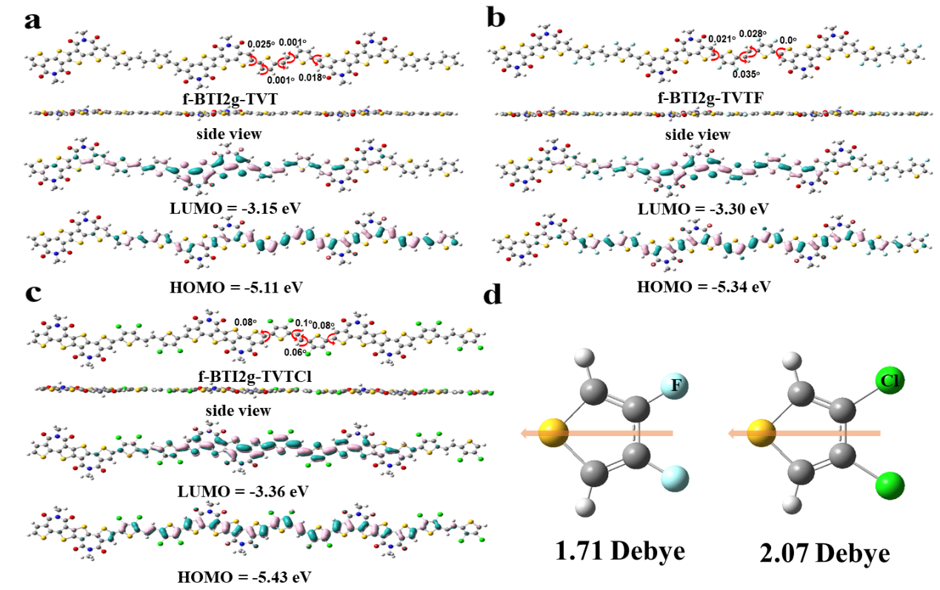
Figure S1. The density functional theory (DFT) calculated backbone geometry and frontier molecular orbitals for a) f-BTI2g-TVT, b) f-BTI2g-TVTF and c) f-BTI2g-TVTCl. d) The dipole moment of the F- and Cl-substituted thiophene rings. The calculations were performed at the B3LYP/6-31G(d,p) level, and the alkyl chain was replaced by a methyl group for simplified calculation.

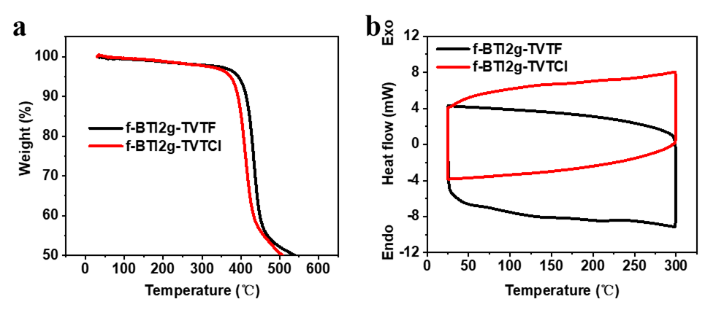
Figure S2. a) Thermogravimetric analysis (TGA) and b) differential scanning calorimetry (DSC) curves for f-BTI2g-TVTF and f-BTI2g-TVTCl.

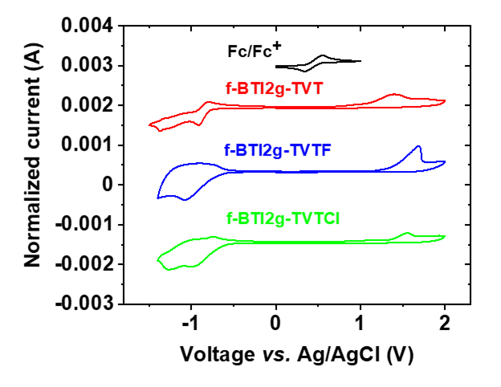
Figure S3. Cyclic voltammograms of f-BTI2g-TVT, f-BTI2g-TVTF, and f-BTI2g-TVTCl thin film in 0.1 M tetra(n-butyl)ammonium hexafluorophosphate acetonitrile solution with Fc/Fc⁺ as the reference.

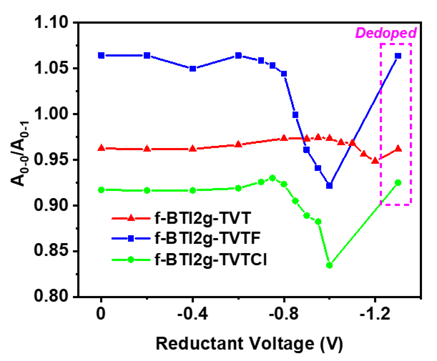
Figure S4. 0-0/0-1 vibrational peak ratio during and after electrochemical doping.

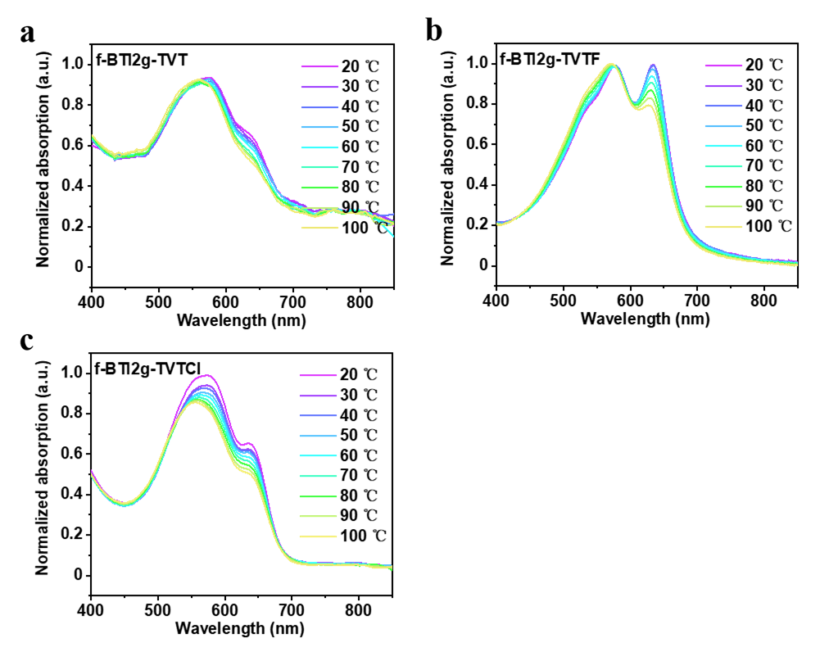
Figure S5. Variable-temperature UV-vis absorption spectra of polymers (a) f-BTI2g-TVT, (b) f-BTI2g-TVTF, and (c) f-BTI2g-TVTCl in diluted chlorobenzene solutions at indicated temperatures.

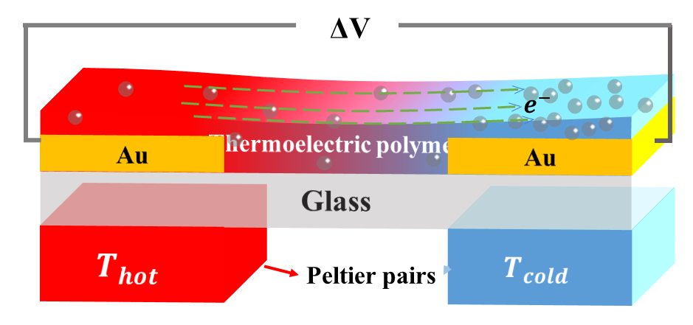
Figure S6. Schematic diagram of an n-type OTE device. A couple of Peltier device with a separation distance of 1 mm (W) was selected to calculate the Seebeck coefficient.

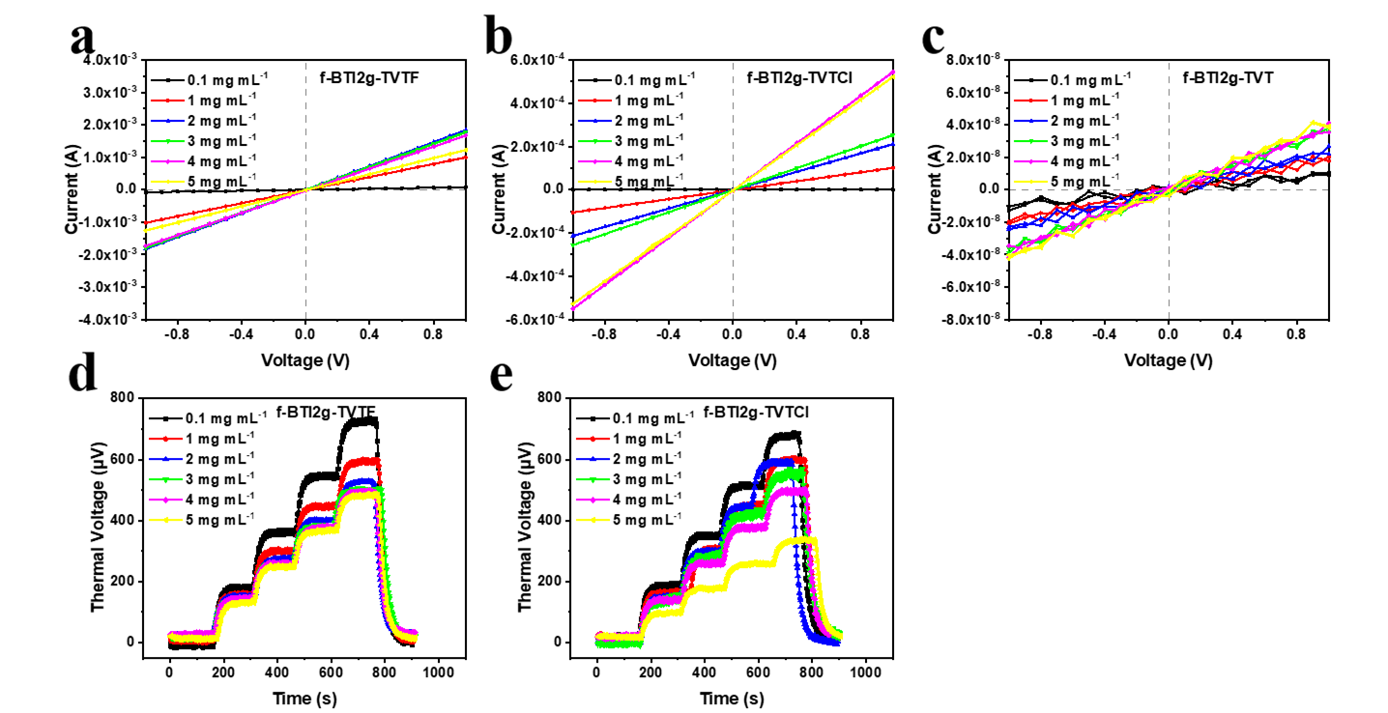
Figure S7. Representative a–c) I-V and d,e) thermal voltage curves for three polymers doped with different N-DMBI concentrations (0.1–5 mg mL⁻¹). During the thermal voltage measurement, the temperature difference (ΔT) was raised from 0 to 2.8 K with an interval of 0.7 K and then back to 0 K. Notably, it is hard to determine the thermal voltage plots of f-BTI2g-TVT since its results were static-electricity-dominated.

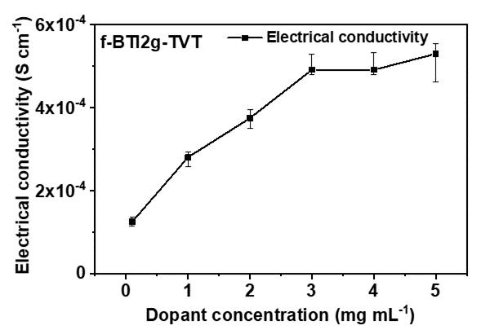
Figure S8. The electrical conductivities for polymer f-BTI2g-TVT doped with different N-DMBI concentrations (0.1–5 mg mL⁻¹).

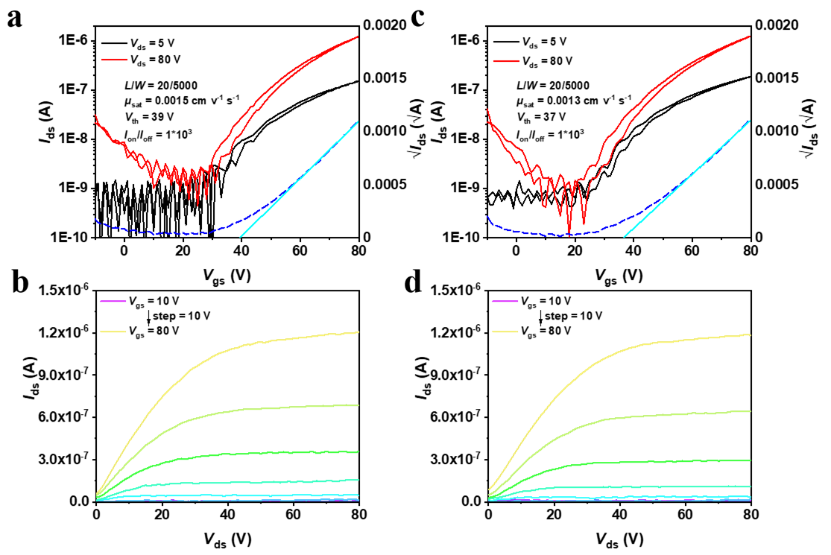
Figure S9. Transfer and output curves for a,b) f-BTI2g-TVTF and c,d) f-BTI2g-TVTCl based organic field-effect transistors with top-gate bottom-contact architecture.

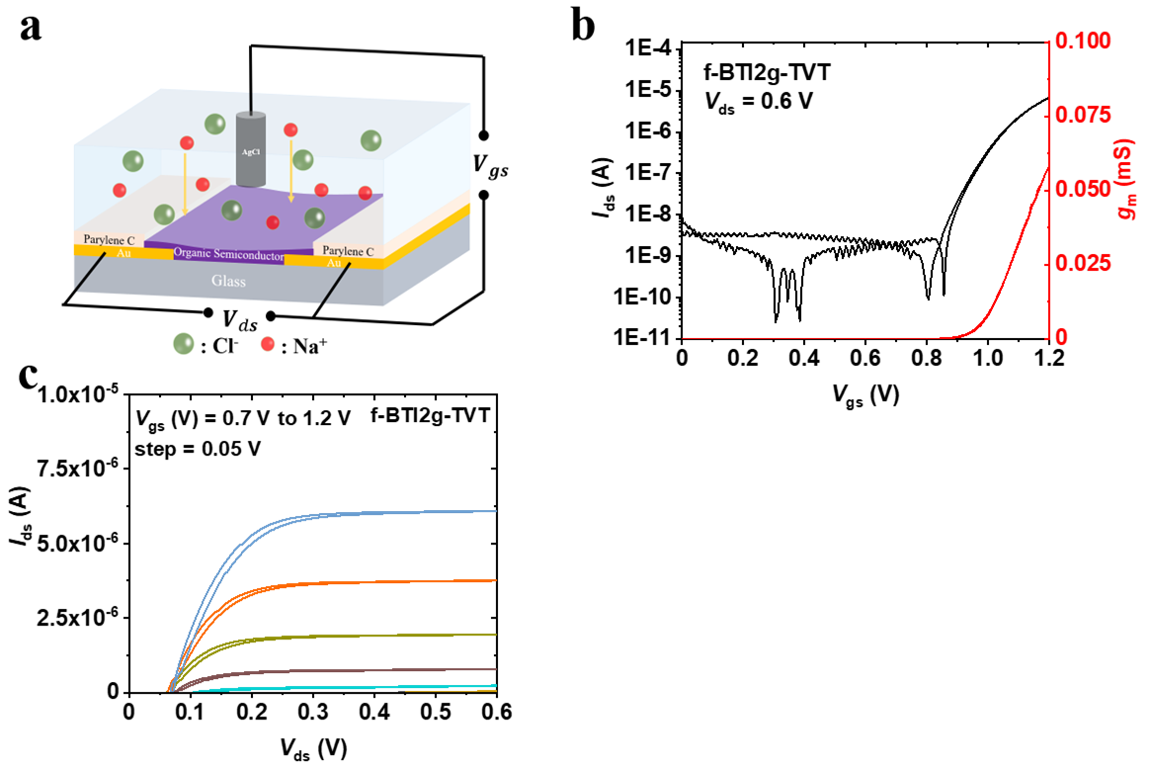
Figure S10. a) Schematic architecture of an OECT device using NaCl aqueous solution (0.1 M) as the electrolyte; Transfer b) and output c) curves of f-BTI2g-TVT-based OECTs. Herein, W/L = 100/10 µm and V_{ds} = 0.6 V. The red line represents the curve of g_{m}.
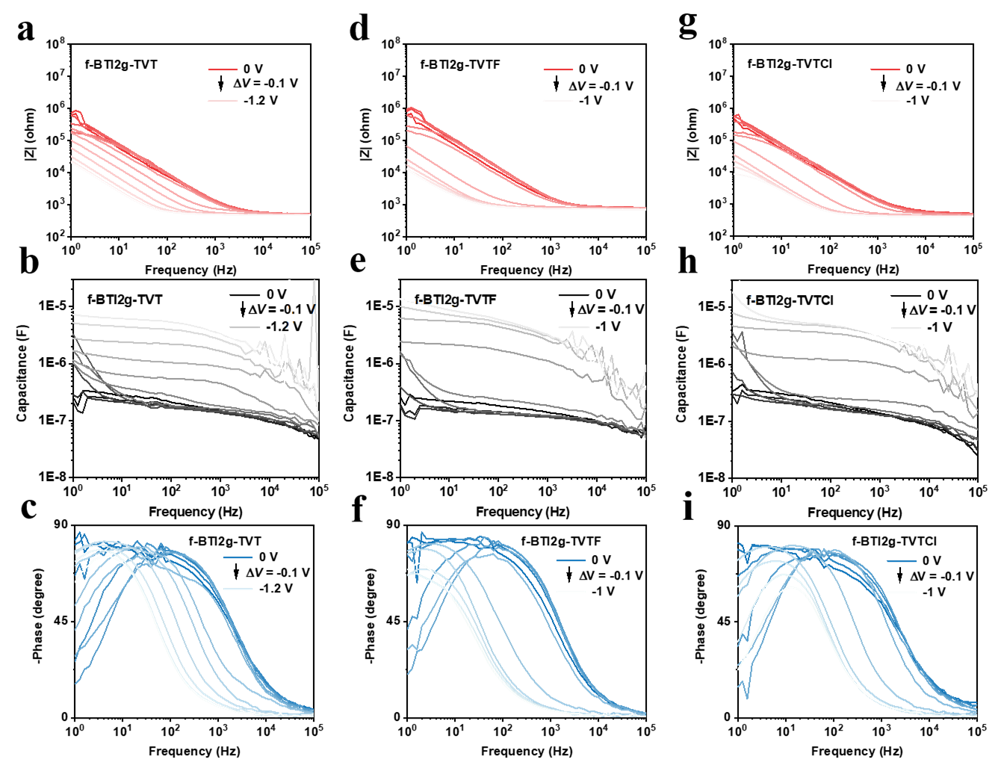
Figure S11. Electrochemical impedance spectra (EIS) in 0.1 M aqueous electrolyte for a,b,c) f-BTI2g-TVT, d,e,f) f-BTI2g-TVTF and g,h,i) f-BTI2g-TVTCl films casted on ITO substrates.

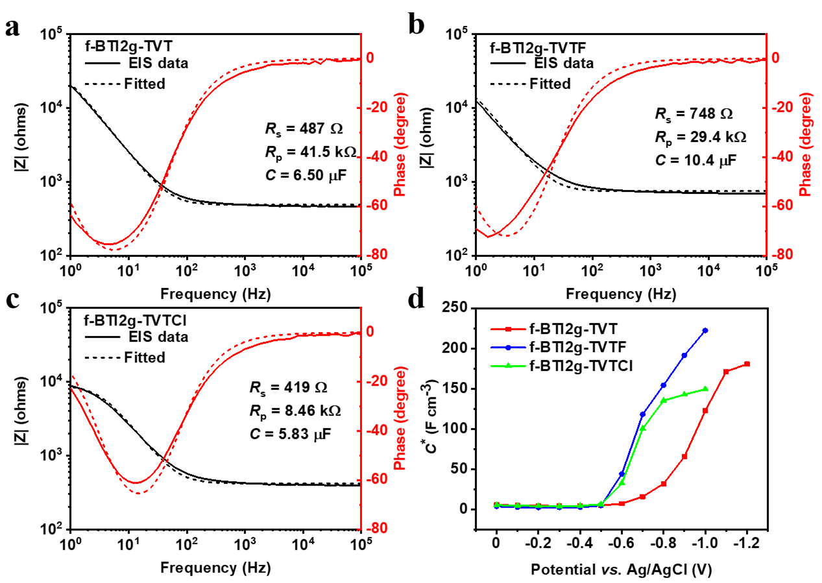
Figure S12. Fitting plots of EIS results for a) f-BTI2g-TVT, b) f-BTI2g-TVTF and c) f-BTI2g-TVTCl. The solid lines stand for the Bode and phase plots and the fitting dashed lines represent the results for Randles Circuit Model R_{s}(R_{p}ⅡR_{c}). d) EIS measured maximum C* for three polymers at 1Hz under different bias voltages with an interval of −0.1 V.
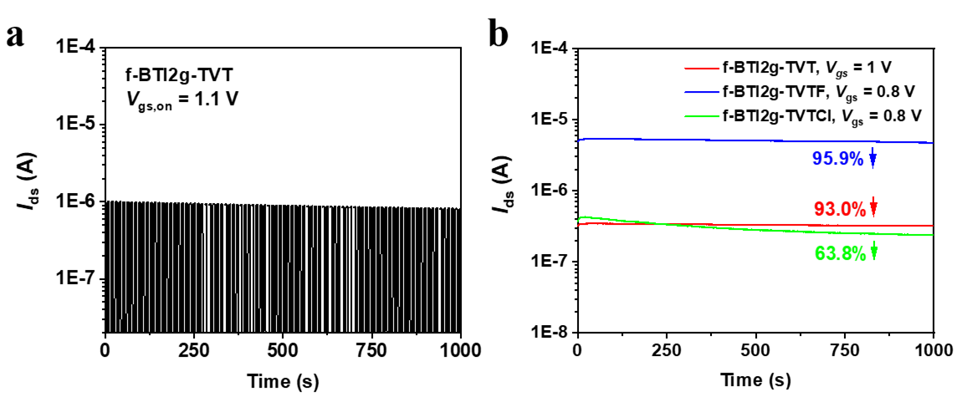
Figure S13. a) Operational stability of OECTs under cyclic square wave gate bias for f-BTI2g-TVT (V_{ds} = 1.0 V); b) Operational stability under continuous gate bias (V_{ds} = 0.8 V).

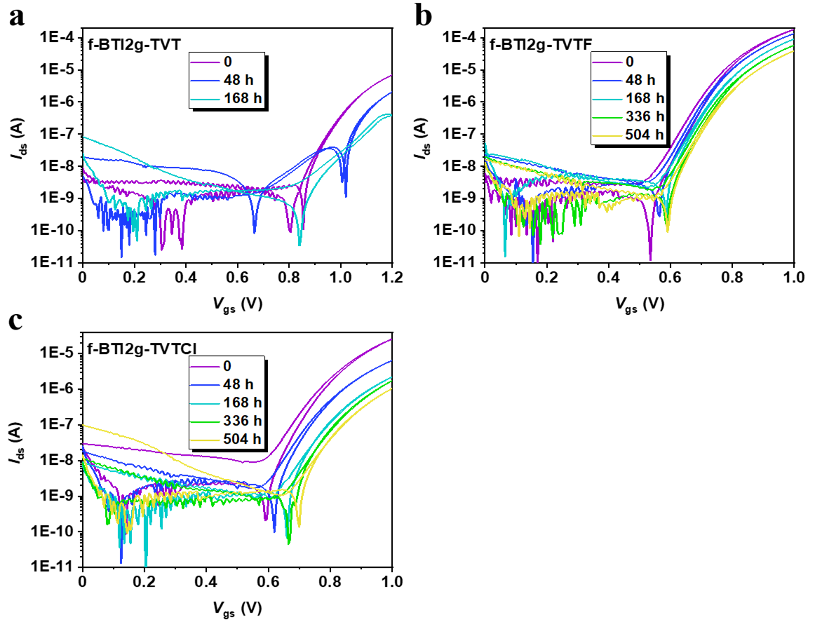
Figure S14. Transfer curves for a) f-BTI2g-TVT, b) f-BTI2g-TVTF and c) f-BTI2g-TVTCl after long-term storage in ambient air.

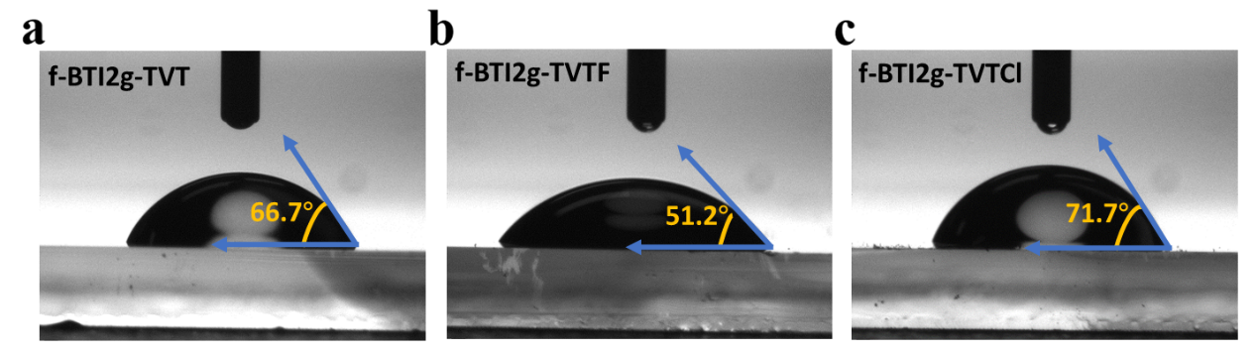
Figure S15. Water surface contact angle measurement for a) f-BTI2g-TVT, b) f-BTI2g-TVTF and c) f-BTI2g-TVTCl thin films.

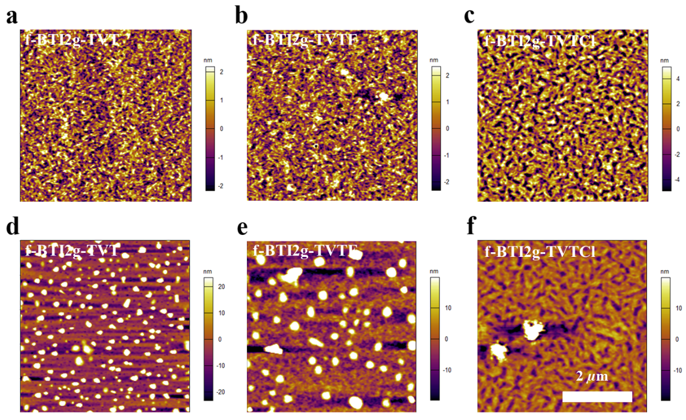
Figure S16. AFM height images of tapping mode for a–c) pristine and d–f) N-DMBI doped polymer thin films. The dopants were spin-coated atop the pure films with a concentration of 5 mg mL⁻¹.

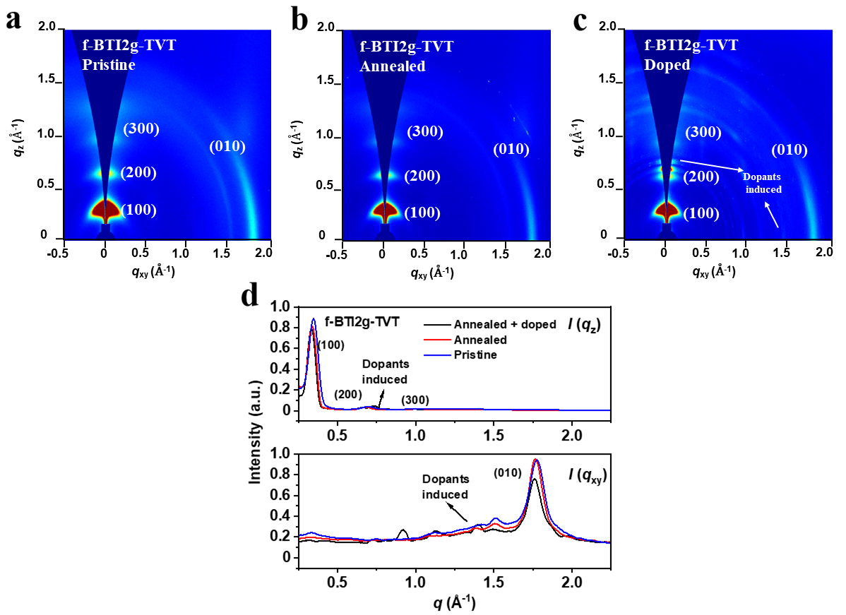
Figure S17. Two-dimensional GIWAXS patterns of a) pristine, b) annealed and c) N-DMBI doped thin-films for f-BTI2g-TVT. The dopant concentration is 5 mg mL⁻¹. d) The corresponding line-cut profiles along the out-of-plane and in-plane direction for f-BTI2g-TVT. Note, cuts along the q_{z} and q_{xy} directions represent scattering in the out-of-plane and in-plane directions, respectively.
Figure S18. The ¹H NMR spectrum ofTVTCl-2Sn.

Figure S19. The ¹³C NMR spectrum ofTVTCl-2Sn.
Figure S20. The ¹H NMR spectrum of polymer f-BTI2g-TVTF.

Figure S21. The ¹H NMR spectrum of polymer f-BTI2g-TVTCl.
References
[1] K. Feng, W. Shan, S. Ma, Z. Wu, J. Chen, H. Guo, B. Liu, J. Wang, B. Li, H. Y. Woo, S. Fabiano, W. Huang, X. Guo, Angew Chem Int Ed 2021, 8.
[2] C.-Y. Yang, W.-L. Jin, J. Wang, Y.-F. Ding, S. Nong, K. Shi, Y. Lu, Y.-Z. Dai, F.-D. Zhuang, T. Lei, C.-A. Di, D. Zhu, J.-Y. Wang, J. Pei, Adv. Mater. 2018, 30, 1802850.
[3] Y. Sui, Y. Shi, Y. Deng, R. Li, J. Bai, Z. Wang, Y. Dang, Y. Han, N. Kirby, L. Ye, Y. Geng, Macromolecules 2020, 53, 10147.
[4] A. Giovannitti, C. B. Nielsen, D.-T. Sbircea, S. Inal, M. Donahue, M. R. Niazi, D. A. Hanifi, A. Amassian, G. G. Malliaras, J. Rivnay, I. McCulloch, Nat. Commun. 2016, 7, 13066.
[5] H. Sun, M. Vagin, S. Wang, X. Crispin, R. Forchheimer, M. Berggren, S. Fabiano, Adv. Mater. 2018, 30, 1704916.
[6] A. Giovannitti, I. P. Maria, D. Hanifi, M. J. Donahue, D. Bryant, K. J. Barth, B. E. Makdah, A. Savva, D. Moia, M. Zetek, P. R. F. Barnes, O. G. Reid, S. Inal, G. Rumbles, G. G. Malliaras, J. Nelson, J. Rivnay, I. McCulloch, Chem. Mater. 2018, 30, 2945.
[7] C. G. Bischak, L. Q. Flagg, K. Yan, C.-Z. Li, D. S. Ginger, ACS Appl. Mater. Interfaces 2019, 11, 28138.
[8] A. F. Paterson, H. Faber, A. Savva, G. Nikiforidis, M. Gedda, T. C. Hidalgo, X. Chen, I. McCulloch, T. D. Anthopoulos, S. Inal, Adv. Mater. 2019, 31, 1902291.
[9] D. Ohayon, A. Savva, W. Du, B. D. Paulsen, I. Uguz, R. S. Ashraf, J. Rivnay, I. McCulloch, S. Inal, ACS Appl. Mater. Interfaces 2021, 13, 4253.
[10] J. Surgailis, A. Savva, V. Druet, B. D. Paulsen, R. Wu, A. Hamidi‐Sakr, D. Ohayon, G. Nikiforidis, X. Chen, I. McCulloch, J. Rivnay, S. Inal, Adv. Funct. Mater. 2021, 31, 2010165.
[11] X. Chen, A. Marks, B. D. Paulsen, R. Wu, R. B. Rashid, H. Chen, M. Alsufyani, J. Rivnay, I. McCulloch, Angew. Chem. Int. Ed. 2021, 60, 9368.
[12] J. J. Samuel, A. Garudapalli, A. A. Mohapatra, C. Gangadharappa, S. Patil, N. P. B. Aetukuri, Adv. Funct. Mater. 2021, 31, 2102903.
[13] I. P. Maria, B. D. Paulsen, A. Savva, D. Ohayon, R. Wu, R. Hallani, A. Basu, W. Du, T. D. Anthopoulos, S. Inal, J. Rivnay, I. McCulloch, A. Giovannitti, Adv. Funct. Mater. 2021, 31, 2008718.
[14] S. Cong, J. Chen, L. Wang, L. Lan, Y. Wang, H. Dai, H. Liao, Y. Zhou, Y. Yu, J. Duan, Z. Li, I. McCulloch, W. Yue, Adv. Funct. Mater. 2022, 32, 2201821.
[15] Z. S. Parr, J. Borges‐González, R. B. Rashid, K. J. Thorley, D. Meli, B. D. Paulsen, J. Strzalka, J. Rivnay, C. B. Nielsen, Adv. Mater. 2022, 34, 2107829.
[16] D. Jeong, I. Jo, S. Lee, J. H. Kim, Y. Kim, D. Kim, J. R. Reynolds, M. Yoon, B. J. Kim, Adv. Funct. Mater. 2022, 32, 2111950.
[17] Y. Wang, E. Zeglio, L. Wang, S. Cong, G. Zhu, H. Liao, J. Duan, Y. Zhou, Z. Li, D. Mawad, A. Herland, W. Yue, I. McCulloch, Adv. Funct. Mater. 2022, 32, 2111439.
[18] H. Wu, C. Yang, Q. Li, N. B. Kolhe, X. Strakosas, M. Stoeckel, Z. Wu, W. Jin, M. Savvakis, R. Kroon, D. Tu, H. Y. Woo, M. Berggren, S. A. Jenekhe, S. Fabiano, Adv. Mater. 2022, 34, 2106235.
[19] J. Shi, P. Li, X.-Y. Deng, J. Xu, Z. Huang, Y. Lei, Y. Wang, J.-Y. Wang, X. Gu, T. Lei, Chem. Mater. 2022, 34, 864.
[20] P. Li, J. Shi, Y. Lei, Z. Huang, T. Lei, Nat. Commun. 2022, 13, 5970.
[21] A. Marks, X. Chen, R. Wu, R. B. Rashid, W. Jin, B. D. Paulsen, M. Moser, X. Ji, S. Griggs, D. Meli, X. Wu, H. Bristow, J. Strzalka, N. Gasparini, G. Costantini, S. Fabiano, J. Rivnay, I. McCulloch, J. Am. Chem. Soc. 2022, 144, 4642.
[22] K. Feng, W. Shan, J. Wang, J. Lee, W. Yang, W. Wu, Y. Wang, B. J. Kim, X. Guo, H. Guo, Adv. Mater. 2022, 34, 2201340.

