Ultra-lightweight low-carbon LC³ cement composites: uniaxial mechanical behaviour and constitutive models
Tingting LIANG^{1,2}, Lijie CHEN³, Zhenyu HUANG^{1*}, Ying ZHONG⁴, Yi ZHANG⁵
1 Guangdong Provincial Key Laboratory of Durability for Marine Civil Engineering, Shenzhen University, Shenzhen, China
2 Shenzhen Shenshui Guangming Water Co., Ltd, Shenzhen 518107, China
3 Department of Civil Engineering, The University of Hong Kong, Pokfulam Road, Hong Kong, China
4 China State Construction Engineering (Hong Kong) Limited, Hong Kong, China
5 China State Construction International Medical Industry Development Co., Ltd.

Abstract
The present study aims to characterize the constitutive models of a novel ultra-lightweight low-carbon LC3 cement composite (ULCC-LC3) under monotonic uniaxial compression and tension tests. The compressive stress-strain curves of ULCC-LC3 were obtained based on axial compressive tests. The curve characteristics were analyzed and the data was fitted with the existing concrete compression constitutive model. Modified axial compression constitutive model for ULCC-LC3 was proposed and verified using the independent test data and related data of ULCC in other literatures. The characteristics of tensile stress-strain curves of ULCC-LC3 were also analyzed and studied. Based on existing experimental data, the applicability of the Tetsushi et. al.’s model to this composite was verified. The experimental results show that use of PE fibers can improve the ductility of ULCC-LC3. As compared with normal concrete, ULCC-LC3 exhibits a higher compressive peak strain (over 0.3% for fiber reinforced specimens and over 0.5% for non-fiber reinforced specimens). These findings contribute to the understanding of the mechanical behavior of ULCC-LC3 and provide constitutive models that can be used in numerical simulations and engineering applications to promote the use of this novel ultra-lightweight low-carbon material.
Keywords: ultra-lightweight cement composite; LC3; constitutive model; low carbon cement.

- Introduction
Ultra-lightweight cement composite (ULCC) is a cementitious composite material without gravel and sand. Using fly ash cenospheres (FAC) with densities ranging from 600 kg/m³ to 900 kg/m³ as fine aggregates added to the cementitious matrix, ULCC can achieve low density and high strength. FACs are obtained by screening fly ash, a byproduct generated from coal-fired power plants [1-4], during the coal combustion process. The FACs are hollow and filled with inert gases, with the shell thickness being approximately 2.5%-10.5% of the diameter [5, 6]. In terms of chemical composition, amorphous FACs have up to 90% SiO₂ and Al₂O₃ content, K₂O content exceeding CaO content below 1% [7]. Due to the presence of amorphous silica, FAC can undergo pozzolanic reactions similar to fly ash [8]. This makes the interface between aggregate and cement paste (ITZ) denser [9], thereby reducing the extent of cracking.
Over the past few decades, researchers have conducted extensive studies on ULCC encompassing various aspects such as material development, short-term mechanical properties, durability properties, effects of extreme low/high temperatures, thermal conductivity, and dynamic properties. Gao and Wang [12] conducted uniaxial compression and tension tests on four different densities of steel fiber-reinforced ULCC and established the constitutive relationships for uniaxial compression and tension of ULCC based on the stress-strain curves obtained from the tests. Wu et al. [13] found that the compressive strength, elastic modulus, and tensile strength of ULCC decrease with decreasing density. Liu et al. [14] studied the effects of low-temperature environments (0 to -60ºC) and various curing conditions (28-d moist curing, 7-d moist curing and 21-d lab air exposure) on the mechanical properties of ULCC. Compared with ordinary concrete and lightweight concrete of similar compressive strength, it was found that the elastic modulus of ULCC does not change significantly with decreasing temperature from 30ºC to -60ºC, but its flexural strength was affected by the duration of moist curing. Huang et al. [15] conducted an investigation on the mechanical properties of low-density ULCCs at high temperatures. Their findings indicated that incorporating a small amount of PVA fiber (0.2–0.5% in volume fraction) in ULCC effectively prevents spalling after exposure to temperatures up to 1000 °C. The effective prevention of spalling in ULCC is attributed to the addition of a small amount of PVA fibers. These fibers completely melt during the process, creating interconnected pores and small channels in the matrix. This feature reduces pore pressure within the ULCC, effectively hindering the occurrence of concrete spalling. Additionally, they proposed empirical formulas based on experimental data to calculate the residual compressive strength and elastic modulus of the material. In a separate study, they developed a novel material called rubber powder and PE fiber-containing rubberized ultra lightweight cement composite (RULCC) [16], intended for marine protective structures. The mechanical properties of this material were assessed through quasi-static tests and Split Hopkinson Pressure Bar (SHPB) impact tests. However, due to the lower elastic modulus of rubber powder and weaker bond strength between rubber particles and cementitious composites, the static compressive strength of RULCC decreased with increasing rubber powder content. The SHPB compression tests revealed that as the rubber content in RULCC increased, its dynamic compressive strength gradually decreased.
To enhance the strength and reduce brittleness of the ULCC matrix, numerous researchers have extensively investigated fiber-reinforced cementitious composites. Du [21] discovered that incorporating colloidal nano-silica (CNS) into ULCC effectively boosts compressive strength and densifies the microstructure through pozzolanic reactions and void-filling effects, particularly in the Interfacial Transition Zone (ITZ). This addition also improves water absorption, permeability, and chloride resistance, with a recommended usage of nano-silica up to 2% of the cement content. Moreover, the inclusion of various fiber types, such as polyvinyl alcohol (PVA) fibers [17, 18], polyethylene (PE) fibers [13, 19], polypropylene (PP) fibers [15], and steel fibers [19], has been demonstrated to enhance the toughness of the cement matrix, effectively preventing specimen spalling. Notably, shrinkage-reducing admixture (SRA) minimizes entrapped air in the cement paste, leading to a denser fiber-matrix interface [19]. When examining the performance under bending fatigue loads, ULCC containing 0.9% PVA fibers demonstrates superior characteristics compared to ordinary lightweight concrete of equal strength [17]. PVA fibers bridge cracks and delay their propagation, ultimately increasing fatigue life. Additionally, as the stress level decreases, the fatigue life of ULCC improves.
However, achieving high strength in ULCC necessitates the use of a substantial amount of cement, leading to significant carbon emissions and high energy consumption. This constraint hinders the widespread application of ULCC. Considering China's commitment to "carbon peaking and carbon neutrality goals," there is an urgent need to develop a cementitious material with low energy consumption and minimal carbon emissions. In response to this demand, limestone calcined clay cement (LC3) has emerged as a promising environmentally friendly alternative in recent years [10, 11]. By employing limestone and calcined clay instead of cement clinker, LC3 significantly reduces the reliance on cement clinker, thereby decreasing carbon emissions and energy consumption.
Hence, in order to fill this research gap and promote the widespread adoption of ULCC, this study develops a novel material known as ultra-lightweight low-carbon LC3 cement composite (ULCC-LC3). Comprehensive investigations have been conducted into its material development, mechanical properties, microstructure, and constitutive models. Specifically, for the design of ULCC-LC3 structures, establishing constitutive relationships for both compressive and tensile behaviors becomes crucial. However, as of the current moment, no constitutive model for ULCC-LC3 has been identified by the authors. To address this, the present study utilized fitting techniques to derive an axial compression constitutive model tailored for ULCC-LC3, and data fitting was conducted to verify the suitability of the uniaxial tensile constitutive bilinear model for ULCC-LC3.
- Experimental study

2.1 Raw materials and mix design
The raw materials for producing ULCC-LC³ in this study are: ordinary Portland cement (OPC), cenosphere, silica fume, calcined clay, limestone, gypsum, superplasticizer, shrinkage reducing admixture (SRA), tap water and PE fiber. The chemical compositions of the cementitious materials are shown in Table 1. The physical and mechanical properties of PE fiber are shown in Table 2. QK300 cenospheres with average particle sizes from 20~300 μm are used in this study. Clays were collected from industrial kaolinite tailings and calcined at 700~800 °C. Polycarboxylate superplasticizer is used in cementitious materials that significantly reduces the amount of water required in the mix without compromising the workability. SRA was used to reduce drying shrinkage of cement composite. Figure 2 presents the particle size distribution curves of the raw solid materials in this study. It can be observed that all solid materials are well-graded, ensuring good compaction of cementitious composites.
The mix design of ULCC-LC3 is shown in Table 3. The water/binder ratio is 0.27 and there are 12 groups of mixes in this study. The first six groups of mixes were mixed without PE fiber, while the last six groups were mixed with 1% PE fiber by volume. The traditional ULCC without mixing LC3 and PE fibers was used as a reference for the first six groups. The remaining five groups were characterized by the weight proportion of clinker (% of binder) and the mass ratio of calcined clay to limestone. For example, 50-2:1 refers to a group of mix in which 50% of the binder is clinker (by subtracting the content of CaSO₄ from OPC according to Table 1) and the mass ratio of calcined clay to limestone is 2:1. The last six groups of mixes were similar to the first six groups, except for the inclusion of 1% PE fibers by volume and an increased content of superplasticizer. The last six groups were characterized by an additional notation "-1" in their group names, indicating the volume proportion of PE fibers.
OPC, calcined clay, limestone powder, gypsum powder, cenosphere, silica fume were subsequently dry mixed in a mixer for 10 minutes at ultra-slow speed mode. Then, 3/4 of superplasticizer was mixed with water and added into the mixer. The mixture was mixed for 5 minutes at slow speed mode. This is followed by mixing at high speed mode for 5 minutes after adding SRA and remaining superplasticizer. For groups with PE fibers, the mixing at high speed mode was extended for another 5 minutes, during which the PE fibers were added. The cementitious composites were compacted at a vibration table for 20 seconds. A plastic sheet was covered on the specimens after casting for 24 hours. The samples were then cured at a standard moisture curing room (25℃, 100% humidity) until designated ages.

2.2 Experimental methods
For the 6 sets of mix proportions without PE fibers, 12 cubes with a side length of 100 mm were cast for testing the compressive strength at 1d, 3d, 7d, and 28d. For the 6 sets of mix proportions with PE fibers, 3 cubes with a side length of 100 mm were cast for testing the compressive strength at 28 days.
For the elastic modulus test, 3 cylindrical specimens with a diameter of 100 mm and a height of 200 mm were cast for all mix proportions as shown in Table 3. The bottom and top surfaces of the cylindrical specimens were leveled by applying gypsum plaster. The test setup for elastic modulus test is shown in Figure 3. An aluminum frame was fixed on a specimen, in which four linear variable differential transformers (LVDTs) were installed for measuring the vertical deformation within a reference distance of 100 mm. An MTS-YAW6306 with a load capacity of 3000 kN was used for compressive tests. The compressive tests were displacement-controlled with a loading rate of 0.3 mm/min.
The monotonic uniaxial tension tests were conducted on the last 6 mixes with PE fibers as shown in Table 3. For each mix, four duplicate dog-bone specimens were casted as shown in Figure 4. The specimens are typically cast in molds of appropriate dimensions to ensure consistency and accuracy during testing. The dog-bone specimens are securely mounted in a testing apparatus. The mounting ensures proper alignment of the specimens and allows for a uniaxial tensile force to be applied along the longitudinal axis. A controlled tensile load is gradually applied to the dog-bone specimen through the testing machine. The load and longitudinal displacement are steadily increased until the specimen fractures or reaches the desired endpoint, which may be the ultimate tensile strength or a specified elongation percentage. During the test, data on the applied load and the corresponding deformation or strain is continuously collected. This data is used to construct the stress-strain curve and analyze the tensile behavior of the ULCC-LC3.
A scanning electron microscope (SEM) Quanta TM 250 FEG was used for investigating the microscopical morphology of the samples. An SEM sample was collected from the residual between two tensile cracks of a specimen after tensile test. The SEM samples were immersed in isopropanol and de-hydrated for 48 hours. The samples were then placed in a vacuum drying chamber with a pressure of 0.1 MPa and a temperature of 60 °C for 72 hours. Before conducting SEM tests, the samples underwent a gold-coating process to enhance their conductivity. This step was taken to prevent excessive electron accumulation during sample observation, which could lead to an increase in temperature and potentially damage the sample. The samples were examined under a secondary electron (SE) mode.
- Experimental results and discussions

3.1 Monotonic uniaxial compression tests
Figure 5 presents the typical morphologies of the mixes with and without PE fibers in this study. At the beginning of the tests, the specimens remain stable and intact. With the increase in the compressive stress, micro cracks appeared and developed longitudinally on the surface of the specimens. At the ultimate stress, the specimens without PE fibers showed a significant brittle failure, as revealed by the rapid propagation of cracks and the steep decrease in stress. This was followed by the formation of several major cracks throughout the specimens. As a result, the specimens ended up with a significant spalling as shown in Figure 5. As for the specimens with PE fibers, the decrease in stress after ultimate strength was significantly slower as compared with those without PE fibers. The tensile performance of the specimens can be significantly enhanced by using PE fibers due to their unique mechanical properties. PE fibers act as reinforcement within the cementitious matrix, effectively bridging cracks and distributing stress more evenly when the material is subjected to tensile forces. When tensile stress is applied to a cementitious material, cracks tend to form. However, the presence of PE fibers prevents these cracks from propagating rapidly, leading to an increase in the tensile strength of the composite. The fibers effectively hinder crack growth by transferring the load from the matrix to the fibers, dissipating energy and providing a mechanism for crack arrest. PE fibers are known for their high tensile strength and flexibility, which allows them to absorb and redistribute tensile forces effectively. This property improves the ductility and toughness of ULCC-LC3, making it more resistant to cracking and failure under tensile loads. Consequently, the specimens containing PE fibers exhibited minimal spalling and remained relatively intact throughout the tests, as depicted in Figure 5. This observation leads to the conclusion that the incorporation of PE fibers in ULLC-LC3 substantially enhances its ductility.
Table 4 shows the ultimate stress, ultimate strain and elastic modulus of the specimens without PE fibers under monotonic uniaxial compressive tests. The 28-days compressive strength and elastic modulus appears to be decreased by using calcined clay and limestone. The effect of replacing OPC by calcined clay and limestone on the ultimate strain is insignificant. Table 5 shows the ultimate stress, ultimate strain and elastic modulus of the specimens with PE fibers under monotonic compressive tests. It can be observed that the ultimate stress is increased by using calcined clay and limestone for the specimens with PE fibers, expect for 50-1:1-1, in which the proportion of calcined clay is relatively low. The ultimate strain is decreased to around 0.3% from around 0.6% with the addition of PE fibers by comparing Table 5 with Table 4. The effect of replacing OPC with calcined clay and limestone on elastic modulus is insignificant for the specimens with PE fibers.
Figure 6 shows the stress-strain curves for the mixes without and with PE fibers under monotonic uniaxial compression tests. For each mix, the curve is obtained by averaging the stress-strain curves of three duplicate specimens. As shown in Figure 6 (a), there are no descending branches for the stress-strain curves of the mixes without PE fibers. During the monotonic uniaxial compression tests, the test machine stopped automatically when the specimen spalled at the ultimate stress. This may be induced by the insufficient stiffness of the test machine [22]. Therefore, for the mixes without PE fibers, only the ascending branch of the stress-strain curve is considered in this study. On the other hand, the test machine can collect the descending branches of the stress-strain curves for the mixes with PE fibers as shown in Figure 6 (b). The is due to the addition of the PE fibers, which can improve the ductility of the specimens as discussed above. The changes of the stress-strain curves at the ultimate stresses for the specimens with PE fibers are moderate as compared with those for the specimens without PE fibers.

3.2 Uniaxial compressive constitutive model
It can be observed in Figure 6 that there is no significant effect of replacing OPC with calcined clay and limestone on the shape of the stress-stain curve. The general trend of the stress-strain relationships can be described as follows:
- The stress is linearly proportional to the strain at the beginning of the tests;
- The slope of the stress-strain relationship is slightly decreased at the 60%~80% of the ultimate loading;
- The stress-strain relationship is curved between 80% and 100% of the ultimate loading;
- For a specimen with PE fibers, there observes a steep decrease in stress after the ultimate loading;
- For a specimen with PE fibers, after a specific segment the stress slightly decreases with a continuous increase in strain.
Figure 7 shows a typical stress-strain relationship of concrete under monotonic uniaxial compression tests. The stress and strain are normalized by:
where denotes the normalized strain, denotes the strain, denotes the ultimate strain, denotes the normalized stress, denotes the stress, denotes the ultimate stress.
The characteristics [23] of the typical stress-strain relationship as shown in Figure 7 are:
- , the slope of the curve monotonically decreases;
- There is a zero-curvature point D at the descending branch of the curve, where ;
- There is a point E after point D at the descending branch of the curve, where ;
- ;
- .
The curves in Figure 6 were normalized as shown in Figure 8. The curves of ULCC,50-1:1,50-2:1,45-2:1 and 65-2:1 were fitted in a piecewise way according the above-mentioned characteristics. The curve of 50-3:1 was used for the verification of the fitted constitutive model.
Based on Characteristic 1)~3) and 7), a cubic function is proposed:
Based on Characteristic 1) and 3), . Equation is transformed as:
Figure 9 compares the fitted curves and experimental curves. It can be observed the experimental curves are well fitted.
In order to fit the descending branch of the experimental stress-strain curves, the following equation [24] is used, which is in accordance with characteristics 3)~7):
Figure 10 compares the fitted curves and experimental curves for the descending branches. Table 6 and Table 7 list the results of fitting for the ascending branches and descending branches by using Equations and . It can be observed that the results of fitting are similar with a R squared value larger than 0.96. Therefore, the values of fitting parameters are selected as the average values as listed in Table 6 and Table 7. For mixes with PE fibers, a = 0.85 and b = 1.19, a = 0.70 for mixes without PE fibers. The constitutive models for monotonic uniaxial compression tests of ULCC-LC3 are:
without PE fibers.
with PE fibers.
Figure 11 compares the proposed constitutive models and experimental curves under monotonic uniaxial compression tests. It can be observed that the fitted constitutive models correlate well with the experimental data.
The proposed constitutive model under monotonic uniaxial compression tests can be verified as compared with the experimental curves of Group 50-3:1 and 50-3:1-1, which were not included in the fitting of the proposed models. The comparisons are shown in Figure 12. The correlation coefficient is 0.99, indicating the proposed constitutive models can well predict the experimental data in other groups.
To verify the applicability of the axially loaded constitutive model as shown in Equation to other ULCCs, the compressive stress-strain curves of four ULCCs with different densities and externally added steel fibers from literature [25] were unified and compared with the proposed axially loaded constitutive model (Equation ), as shown in Figure 13.
As can be seen from Figure 13, the correlation coefficient between the compressive stress-strain curves of ULCCs and the axially loaded constitutive model is above 0.94, indicating the curve fitting is quite good. Comparing the PE fibers in this study with the steel fibers in the literature, the steel fibers show weaker toughness enhancement in the descending section of the ULCC compressive stress-strain curve. For ULCC reinforced by steel fibers, the stress reduction rate is significantly faster than the strain increase rate, resulting in a significant decline in the early stage of the descending section. However, due to the bridging effect of steel fibers, the stress reduction rate slows down in the later stage of the descending section, with a certain residual strength and a gentle development of the curve. The overall development trend of the curve is similar to this study.

3.3 Monotonic uniaxial tension tests
Figure 14 shows the stress-strain curves under monotonic uniaxial tension tests for specimens with PE fibers in this study. There are strain hardening behaviors during the tests. The ultimate strains are higher than 3%. There are three stages in the tensile stress-strain curves:
- Elastic stage: the stress-strain relationship is linear. The deformation is linear without significant cracks on the tensile specimens.
- Strain-hardening stage: the first crack occurs with the increase in tensile stress. Due to the effect of PE fibers, a major crack slightly develops with several narrow and densified minor cracks. There is a strain hardening behavior, in which the stress increases towards the ultimate stress with fluctuation.
- Strain softening stage: the stress-strain relationship slightly decreases after the ultimate stress. The major crack is significantly extended, at which the dog-bone specimen fails.
The ultimate strain of ULCC-LC3 can be up to 4.5%, which is 450 times that of normal concrete (0.01%). This study only considers the elastic stage and strain-hardening stage in establishing a constitutive model for monotonic uniaxial tension model.

3.4 Uniaxial tensile constitutive model
Figure 15 presents the bilinear constitutive model, which was proposed by Tetsushi et. al. [26] and comprises two distinct parts. The first part is linear stage, ended up with initial crack stress f_{t}. There is no cracking in this stage. The second part is strain hardening stage, from the initial crack stress f_{t} towards ultimate tensile stress f_{tu}. Considering the initial eccentricity and environmental factors, a nominal initial crack strength f_{nt} is introduced in order to avoid the inaccuracy of the actual initial stress. The nominal initial crack strength f_{nt} is the intersection of the linear stage and strain hardening stage.
where E_{t} is the initial elastic modulus, E_{tu} is the elastic modulus of strain hardening stage, f_{nt} is the nominal initial crack strength, ε_{nt} is the nominal initial crack strain, ε_{tu} is the tensile strain.
Figure 16 compares the fitted results by using Equation and the experimental results under monotonic uniaxial tension tests. Table 8 shows the fitting parameters. In order to evaluate the fitting, Pearson correlation coefficients are also listed in Table 8. The Pearson correlation coefficient is used to measure whether two datasets lie on a straight line and to quantify the linear relationship between interval variables. For a significance level a = 0.01 in a 2-tailed Pearson correlation test, degree of freedom (n-2) = 100 (n is the number of samples), the critical value for the Pearson correlation coefficient is 0.254. The lowest Pearson correlation coefficient as listed in Table 8 is 0.83, which is larger than 0.254. Moreover, the number of points for linear fitting is much higher than 100. Therefore, the linear fitting by using Equation is statistically significant. The constitutive model of ULCC-LC3 for monotonic uniaxial tension tests can be well described by the Tetsushi et. al.’s model as shown in Equation .
Figure 17 presents the tensile properties including initial crack stress, tensile strength, tensile strain and strain energy of groups with PE fibers. Figure 17 (a) shows that there is a beneficial effect of using LC³ on increasing initial crack stress. This is because the initial crack strength depends on pore size of cementitious material. The pore structure can be refined by calcined clay, limestone and the product of pozzolanic reaction CASH gel. The tensile strength is also significantly increased by replacing OPC with calcined clay and limestone as shown in Figure 17 (b). On the other hand, the tensile strain can be decreased from 5.3% to 4.5% by using calcined clay. The strain energy of ULCC-1 can be increased by 12.9%-34.1% when OPC is replaced by calcined clay and limestone.
Figure 18 presents the photos of the specimens after monotonic uniaxial tension tests, showing the distribution of cracks at the end of the tests. Table 9 lists the number of cracks, average crack widths and average crack spacings. The average crack width is calculated by dividing the elongation of the central zone of the dog-bone specimen with the number of cracks in the central zone. The average crack spacing is calculated by dividing the length of the central zone (80 mm) with the number of cracks in the central zone. It can be observed from Figure 18 and Table 9 that the cracks of ULCC-1,50-1:1-1 and 50-2:1-1 are widely distributed with lower average crack widths (<200 um) and lower crack spacings. The widely distributed and narrow cracks observed in the concrete specimen indicate that the concrete is undergoing strain hardening, where the material becomes stronger and more resistant to further cracking as it deforms. This is because the small cracks act as stress concentrators, causing the concrete to redistribute the stress to other parts of the specimen.
Figure 19 shows the morphologies of PE fibers, fly ash cenosphere (FAC) and the cementitious matrix of ULCC-1 and 50-2:1-1 after the tensile tests. FACs are densely distributed in the cementitious matrix and covered by products of pozzolanic reactions. Micro cracks may develop along the FACs. Some FACs can be broken. There is a significant trace on the cementitious matrix after a PE fiber is pulled out. A PE fiber can be significantly damaged after being pulled out from cementitious matrix due to the friction between the fiber and cementitious matrix. Residuals of hydration products can be found on the surfaces of a pulled PE fiber and the trace on the cementitious matrix, indicating the fiber and cementitious matrix can work coherently due to the adhesion of the hydration products. Therefore, the ductility of ULCC-LC3 is significantly improved by adding PE fibers.
- Conclusions
This study develops a new type of ultra-lightweight low-carbon LC3 cement composites and investigates the compressive and tensile behavior of through monotonic uniaxial compression and tension tests. The failure model and axial stress-strain curves were obtained and analyzed. Scanning electrode microscope (SEM) tests were conducted to characterize microscopic properties. The main conclusions are as follows:
(1) Comparing the failure modes and patterns of the cylindrical specimens after the uniaxial compression test, the group without fiber reinforcement exhibited obvious brittle failure, forming through diagonal cracks, fractured cement blocks falling off, and resulting in a triangular pyramid failure shape. After the test of the fiber-reinforced group, due to the tensile action of the fiber in the cement matrix, the overall specimen remained relatively intact, showing a clear ductile failure mode. The compressive peak strain of ultra-lightweight low-carbon LC3 cementitious composites is higher than that of ordinary concrete, with more than 0.3% for fiber-reinforced group and more than 0.5% for the group without fiber reinforcement.
(2) The axial compressive stress-strain curve was divided into ascending and descending sections. Based on the axial compressive constitutive relationship of ordinary concrete, the axial compressive constitutive model of ultra-lightweight low-carbon LC3 cementitious composites was modified through data fitting (Equations 5 and 6). The correlation coefficients of the models are all above 0.96, indicating an ideal fit between the models and the data. Furthermore, the modified axial compressive constitutive model was validated using an independent set of mix ratios from this study and the compressive stress-strain curves of ULCC from other literature, resulting in a good agreement with the validation, with correlation coefficients above 0.94.
(3) The uniaxial tensile stress-strain curve of ultra-lightweight low-carbon LC3 cementitious composites was revealed as three stages: elastic stage, strain hardening stage, and strain softening stage. Combined with the Tetsushi et. al.’s model and introducing the nominal initial crack strength and nominal initial crack strain, the experimental data were validated and fitted. The results showed that the modified Tetsushi et al.’s bilinear model can accurately express the uniaxial tensile stress-strain relationship of ultra-lightweight low-carbon LC3 cementitious composites.

Acknowledgments
The authors would like to acknowledge the research grant received from the National Natural Science Foundation of China (Grants Nos. 51978407), Guangdong Outstanding Youth Fund (Grants No. 2022B1515020037), Guangdong Natural Science Foundation (Grants No. 2021A1515010932), Shenzhen International Science and Technology Cooperation Project (Grants No. GJHZ20200731095802008) and Guangdong Provincial Key Laboratory of Durability for Marine Civil Engineering (SZU) (Grant No. 2020B1212060074).

References
[1] D. Montgomery, S. Diamond, The influence of fly ash cenospheres on the details of cracking in flyash-bearing cement pastes, Cem. Concr. Res. 14(6) (1984) 767-775.
[2] A. Kwan, J. Chen, Adding fly ash microsphere to improve packing density, flowability and strength of cement paste, Powder technology 234 (2013) 19-25.
[3] V.B. Fenelonov, M.S. Mel’gunov, V.N. Parmon, The properties of cenospheres and the mechanism of their formation during high-temperature coal combustion at thermal power plans, KONA Powder and Particle Journal 28 (2010) 189-208.
[4] E.V. Fomenko, N.N. Anshits, M.V. Pankova, L.A. Solovyov, A.G. Anshits, Fly ash cenospheres: composition, morphology, structure, and helium permeability, World of Coal Ash (WOCA) Conference, 2011, p. 12.
[5] L.n. Ngu, H. Wu, D.k. Zhang, Characterization of ash cenospheres in fly ash from Australian power stations, Energy & Fuels 21(6) (2007) 3437-3445.
[6] A. Sarkar, R. Rano, K. Mishra, A. Mazumder, Characterization of cenospheres collected from ash-pond of a super thermal power plant, Energy Sources, Part A: Recovery, Utilization, and Environmental Effects 30(3) (2007) 271-283.
[7] J. Wang, M. Zhang, W. Li, K.S. Chia, R.J. Liew, Stability of cenospheres in lightweight cement composites in terms of alkali–silica reaction, Cem. Concr. Res. 42(5) (2012) 721-727.
[8] F. Blanco, P. Garcı́a, P. Mateos, J. Ayala, Characteristics and properties of lightweight concrete manufactured with cenospheres, Cem. Concr. Res. 30(11) (2000) 1715-1722.
[9] Z. Huang, K. Padmaja, S. Li, J.R. Liew, Mechanical properties and microstructure of ultra-lightweight cement composites with fly ash cenospheres after exposure to high temperatures, Constr. Build. Mater. 164 (2018) 760-774.
[10] Scrivener K, Martirena F, Bishnoi S, et al., 2018. Calcined clay limestone cements (LC3). Cement and Concrete Research, 114:49-56.
[11] Scrivener KL, John VM, Gartner EM, 2018. Eco-efficient cements: Potential economically viable solutions for a low-CO2 cement-based materials industry. Cement and Concrete Research, 114:2-26.
[12] X. Gao, J. Wang, Basic mechanical properties of ultra-lightweight cementitious composites, Journal of Harbin Institute of Technology 50(12) (2018) 67-73.
[13] Y. Wu, J. Wang, P.J. Monteiro, M. Zhang, Development of ultra-lightweight cement composites with low thermal conductivity and high specific strength for energy efficient buildings, Constr. Build. Mater. 87 (2015) 100-112.
[14] X. Liu, M.H. Zhang, K.S. Chia, J. Yan, J.R. Liew, Mechanical properties of ultra-lightweight cement composite at low temperatures of 0 to− 60° C, Cem. Concr. Compos. 73 (2016) 289-298.
[15] Z. Huang, J.R. Liew, W. Li, Evaluation of compressive behavior of ultra-lightweight cement composite after elevated temperature exposure, Constr. Build. Mater. 148 (2017) 579-589.
[16] Z. Huang, L. Sui, F. Wang, S. Du, Y. Zhou, J. Ye, Dynamic compressive behavior of a novel ultra-lightweight cement composite incorporated with rubber powder, Compos. Struct. 244 (2020) 112300.
[17] K. Sohel, K. Al Jabri, M. Zhang, J.R. Liew, Flexural fatigue behavior of ultra-lightweight cement composite and high strength lightweight aggregate concrete, Constr. Build. Mater. 173 (2018) 90-100.
[18] Z. Huang, W. Deng, S. Du, Z. Gu, W. Long, J. Ye, Effect of rubber particles and fibers on the dynamic compressive behavior of novel ultra-lightweight cement composites: Numerical simulations and metamodeling, Compos. Struct. 258 (2021) 113210.
[19] J. Wang, K.S. Chia, J.Y.R. Liew, M. Zhang, Flexural performance of fiber-reinforced ultra lightweight cement composites with low fiber content, Cem. Concr. Compos. 43 (2013) 39-47.
[20] A. Committee, Building code requirements for structural concrete (ACI 318-08) and commentary, American Concrete Institute, 2008.
[21] H. Du, Properties of ultra-lightweight cement composites with nano-silica, Constr. Build. Mater. 199 (2019) 696-704.
[22] M. Elices, G. Guinea, J. Gomez, J. Planas, The cohesive zone model: advantages, limitations and challenges, Eng. Fract. Mech. 69(2) (2002) 137-163.
[23] Z. Guo, Fundamentals of Strength and Deformation Testing and Constitutive Relationships of Concrete, Tsinghua University Press, Beijing, 1997.
[24] W. Liu, Research on Compressive and Tensile Properties and Constitutive Models of ECC, Zhengzhou University, Zhengzhou, 2018.
[25] X. Gao, J. Wang, Basic Mechanical Properties of Ultra-Lightweight Cement-Based Composite Materials, Journal of Harbin Institute of Technology 50(12) (2018) 67-73.
[26] T. Kanda, Z. Lin, V. Li, Tensile stress-strain modeling of pseudostrain hardening cementitious composites, J. Mater. Civ. Eng. 12 (2000) 147-156.

Table 1 Chemical compositions of OPC, silica fume, calcined clay, limestone and gypsum
Oxide | OPC (%) | Silica fume  (%) | Calcined clay (%) | Limestone powder (%) | Gypsum powder (%)
SiO₂ | 22.37 | 96.00 | 52.70 | 0.30 | 3.09
Al₂O₃ | 4.36 | 0.30 | 36.90 | 0.10 | 1.34
K₂O | 0.35 | 0.60 | 3.49 | - | 0.05
Fe₂O₃ | 3.38 | 0.30 | 1.99 | 0.08 | 0.36
MgO | 2.48 | 0.40 | 0.28 | 0.64 | 1.31
SO₃ | 2.4 | 0.20 | 0.12 | - | 40.87
CaO | 61.08 | 0.20 | 0.04 | 81.13 | 30.51
Others | 3.58 | 2.00 | 4.27 | 17.73 | 23.26

Table 2 Physical and mechanical properties of PE fiber
Density  (g/cm³) | Length  (mm) | Diameter  (um) | Elastic modulus  (GPa) | Tensile strength  (MPa) | Rupture strain  (%)
0.97 | 12 | 24 | 120 | 3000 | 2~3

Table 3 Mix design of ULCC-LC³
Group | OPC  (kg/m³) | Calcined clay  (kg/m³) | Limestone  (kg/m³) | Gypsum  (kg/m³) | Cenosphere  (kg/m³) | Silica fume  (kg/m³) | Water  (kg/m³) | Superplasticizier  (kg/m³) | SRA  (kg/m³) | PE fiber (%)
Ref-0-0 | 873.9 | 0 | 0 | 0 | 287.6 | 97.1 | 264.9 | 4.3 | 9.3 | 0
50-1:1 | 464.0 | 196.6 | 196.6 | 16.6 | 287.6 | 97.1 | 264.9 | 6.5 | 9.3 | 0
50-2:1 | 464.0 | 262.2 | 131.1 | 16.6 | 287.6 | 97.1 | 264.9 | 8.3 | 9.3 | 0
50-3:1 | 464.0 | 294.9 | 98.3 | 16.6 | 287.6 | 97.1 | 264.9 | 8.5 | 9.3 | 0
45-2:1 | 418.6 | 291.3 | 145.7 | 18.4 | 287.6 | 97.1 | 264.9 | 9.0 | 9.3 | 0
65-2:1 | 600.4 | 174.8 | 87.4 | 11.4 | 287.6 | 97.1 | 264.9 | 6.7 | 9.3 | 0
Ref-0-1 | 873.9 | 0 | 0 | 0 | 287.6 | 97.1 | 264.9 | 4.6 | 9.3 | 1
50-1:1-1 | 464.0 | 196.6 | 196.6 | 16.6 | 287.6 | 97.1 | 264.9 | 6.9 | 9.3 | 1
50-2:1-1 | 464.0 | 262.2 | 131.1 | 16.6 | 287.6 | 97.1 | 264.9 | 8.7 | 9.3 | 1
50-3:1-1 | 464.0 | 294.9 | 98.3 | 16.6 | 287.6 | 97.1 | 264.9 | 9.1 | 9.3 | 1
45-2:1-1 | 418.6 | 291.3 | 145.7 | 18.4 | 287.6 | 97.1 | 264.9 | 9.6 | 9.3 | 1
65-2:1-1 | 600.4 | 174.8 | 87.4 | 11.4 | 287.6 | 97.1 | 264.9 | 7.0 | 9.3 | 1

Table 4 Experimental results of compressive tests for groups without PE fibers
Group | ULCC | 50-1:1 | 50-2:1 | 50-3:1 | 45-2:1 | 65-2:1
Strength (MPa) | 64.15 | 51.76 | 56.04 | 56.99 | 50.28 | 57.04
Compressive strain (%) | 0.58 | 0.64 | 0.68 | 0.59 | 0.53 | 0.56
Elastic modulus (GPa) | 12.31 | 9.73 | 9.13 | 10.00 | 9.94 | 12.17

Table 5 Experimental results of compressive tests for groups with PE fibers
Group | ULCC-1 | 50-1:1-1 | 50-2:1-1 | 50-3:1-1 | 45-2:1-1 | 65-2:1-1
Strength (MPa) | 49.89 | 44.22 | 52.94 | 53.95 | 49.94 | 60.63
Compressive strain (%) | 0.32 | 0.37 | 0.39 | 0.40 | 0.34 | 0.38
Elastic modulus (GPa) | 16.33 | 19.31 | 15.17 | 16.98 | 15.71 | 17.15

Table 6 Fitting results of parameter a for groups without PE fibers
Group | a | R² square
ULCC | 0.92 | 0.98
50-1:1 | 0.62 | 0.99
50-2:1 | 0.71 | 0.98
45-2:1 | 0.66 | 0.98
65-2:1 | 0.59 | 0.99

Table 7 Fitting results of parameters a and b for groups with PE fibers
Group | a | R² square | b | R² square
ULCC-1 | 0.81 | 0.99 | 1.19 | 0.99
50-1:1-1 | 0.95 | 1.00 | 1.18 | 0.96
50-2:1-1 | 0.81 | 0.99 | 1.23 | 0.97
45-2:1-1 | 0.91 | 0.99 | 1.24 | 0.98
65-2:1-1 | 0.72 | 0.99 | 1.13 | 0.98

Table 8 Fitting results of bi-linear tensile constitutive model
Group | (MPa) | (%) | E_{t} (GPa) | E_{tu} (GPa) | Pearson correlation coefficient
ULCC-1 | 1.68 | 0.011 | 15.91 | 0.62 | 0.93
50-1:1-1 | 2.47 | 0.023 | 11.11 | 0.48 | 0.89
50-2:1-1 | 2.43 | 0.017 | 14.88 | 0.63 | 0.87
50-3:1-1 | 3.19 | 0.027 | 11.58 | 0.53 | 0.92
45-2:1-1 | 2.97 | 0.027 | 10.99 | 0.68 | 0.89
65-2:1-1 | 3.57 | 0.019 | 19.55 | 0.66 | 0.83

Table 9 Parameters for characterizing cracks
Group | Number of cracks | Average crack width (um) | Average crack spacing (mm)
ULCC-1 | 27±2 | 156.4 | 2.96
50-1:1-1 | 32±1 | 133.5 | 2.50
50-2:1-1 | 26±2 | 145.5 | 3.08
50-3:1-1 | 16±1 | 227.0 | 5.00
45-2:1-1 | 10±4 | 387.2 | 8.00
65-2:1-1 | 14±2 | 260.6 | 5.71

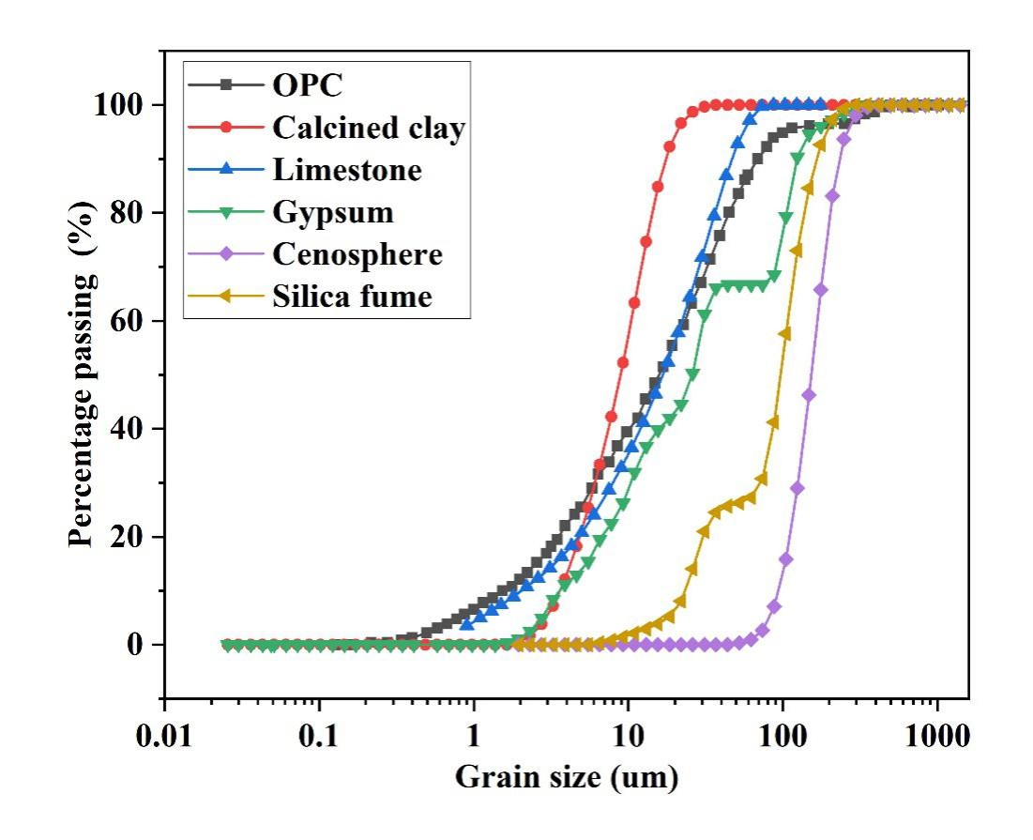
Figure 2 Particle size distribution curves for raw solid materials

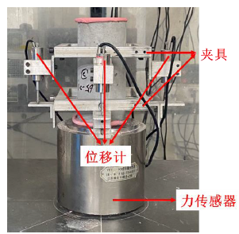
Figure 3 Setup for elastic modulus test
Aluminum frame
LVDT
Force sensor

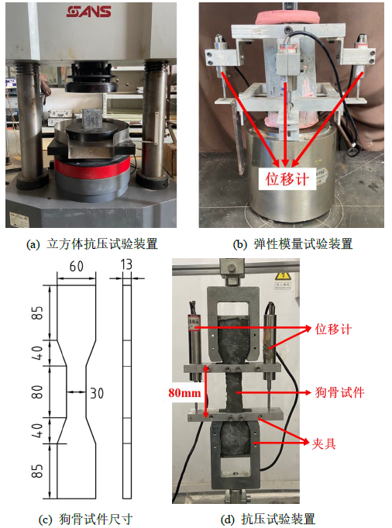
Figure 4 Geometrical size of dog-bone specimen and experimental setup for tensile tests (unit: mm)
LVDTs
Dog-bone specimen
Fixing frame
(a) Geometry of dog-bone specimen (b) Setup for tensile test
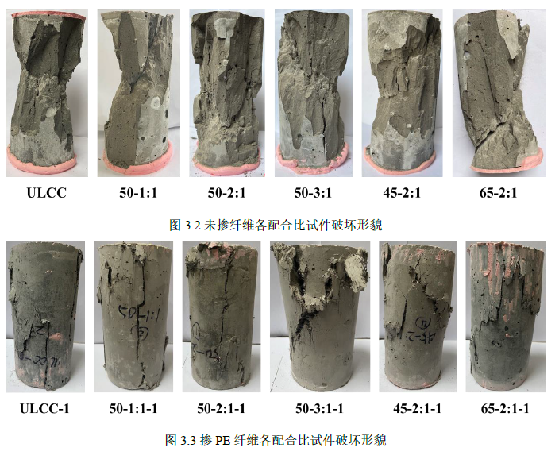
Figure 5 Failure pattern of typical specimens after monotonic compression tests
(a) specimens without fibers
(b) specimens with fibers

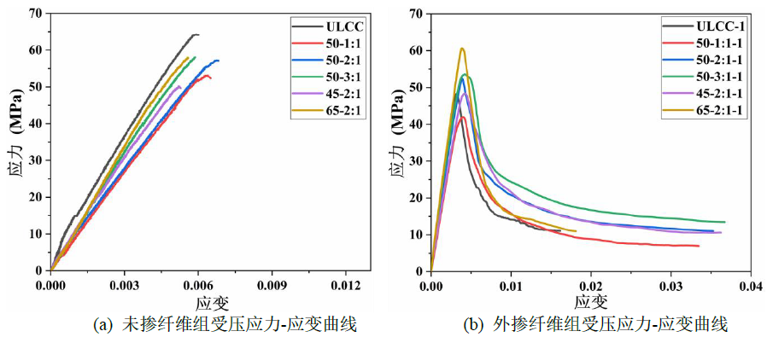
Figure 6 Stress-strain curves of specimens in monotonic compression tests. (a) without PE fibers and (b) with PE fibers
Stress (MPa)
Stress (MPa)
Strain Strain
(a) (b)

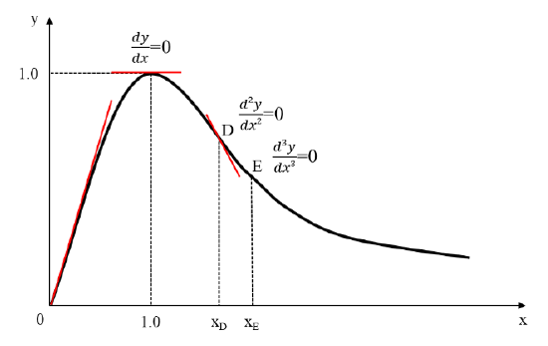
Figure 7 Classic unified stress-strain curve of concrete under uniaxial compression test

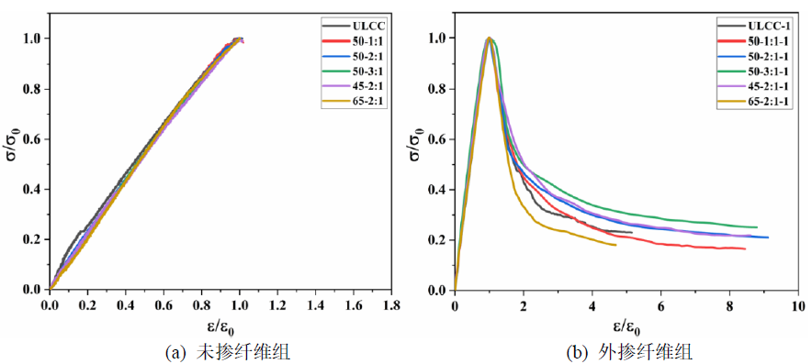
(a) (b)
Figure 8 Unified stress-strain curves of specimens in monotonic compression tests. (a) without PE fibers and (b) with PE fibers.

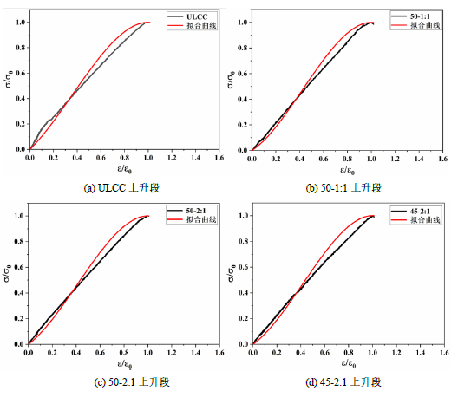
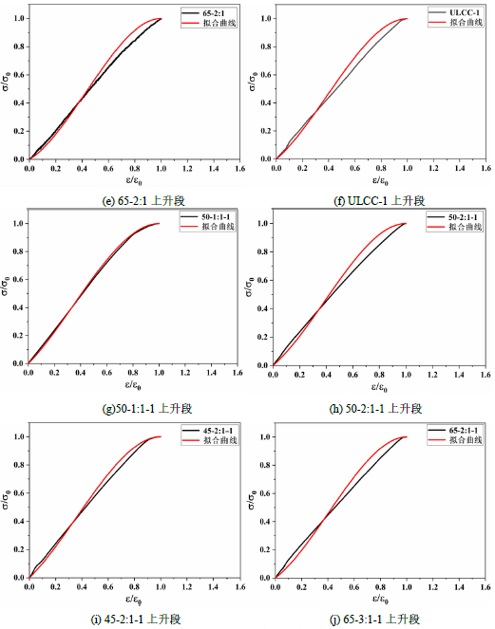
Figure 9 Comparisons between fitted and experimental ascending branches

ULCC
Proposed

50-1:1
Proposed

50-2:1
Proposed

45-2:1
Proposed

65-2:1
Proposed

ULCC-1
Proposed

50-1:1-1
Proposed

50-2:1-1
Proposed

45-2:1-1
Proposed

65-2:1-1
Proposed
(a) ULCC
(b) 50-1:1
(c) 50-2:1
(d) 45-2:1

(e) 65-2:1

(f) ULCC-1

(g) 50-1:1-1

(h) 50-2:1-1

(i) 45-2:1-1

(j) 65-2:1-1

(e) 65-2:1-1

(d) 45-2:1-1

(c) 50-2:1-1

(b) 50-1:1-1

(a) ULCC-1
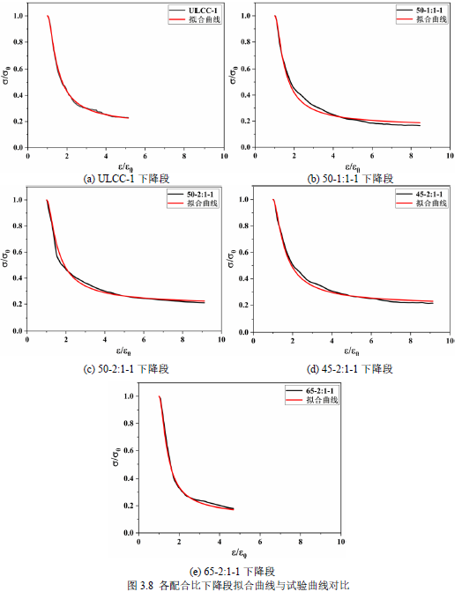
Figure 10 Comparisons between fitted and experimental descending branches

ULCC-1
Proposed

50-1:1-1
Proposed

50-2:1-1
Proposed

45-2:1-1
Proposed

65-2:1-1
Proposed

(a) ULCC-1

(b) 50-1:1-1

(c) 50-2:1-1

(e) 65-2:1-1

(d) 45-2:1-1

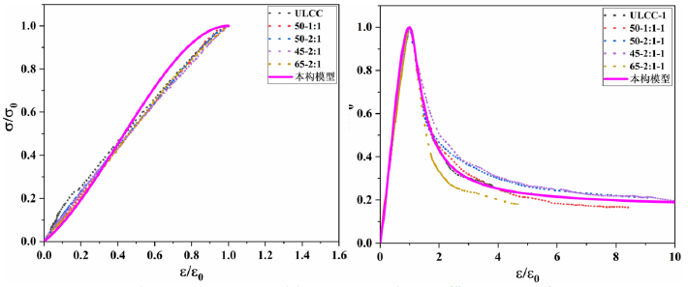
Figure 11 Comparison between proposed constitutive model and experimental curves under monotonic uniaxial compression tests. (a) Without PE fibers and (b) with PE fibers.

ULCC
50-1:1
50-2:1
45-2:1
65-2:1
Proposed

ULCC-1
50-1:1-1
50-2:1-1
45-2:1-1
65-2:1-1
Proposed
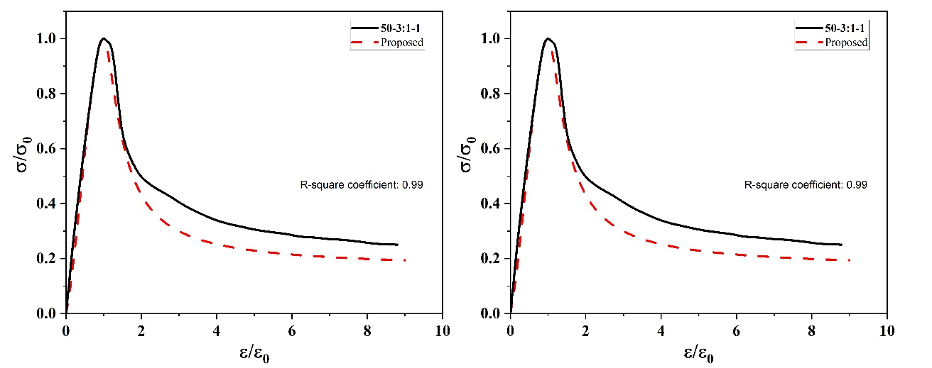
Figure 12 Comparison between proposed constitutive model and typical experimental curve under monotonic uniaxial compression tests. (a) without fibers and (b) with fibers.

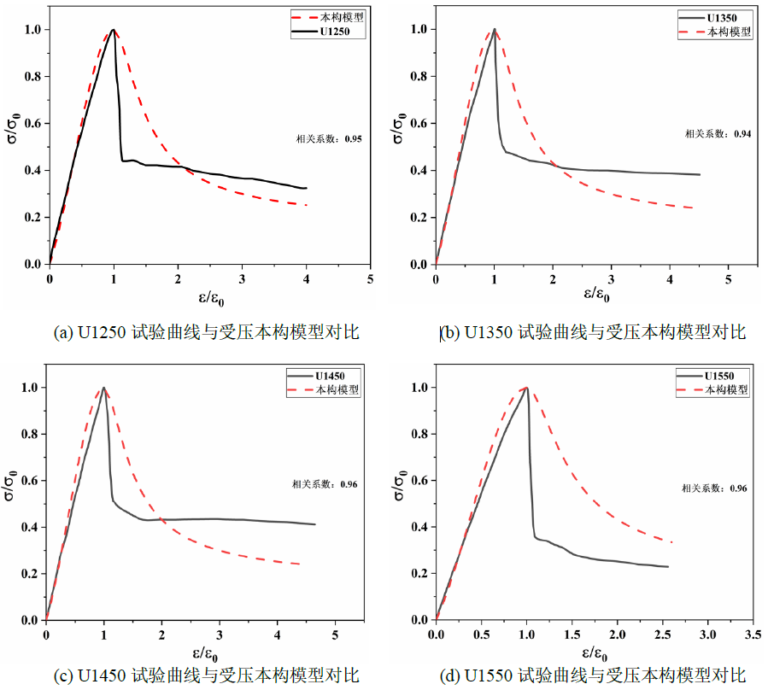
Figure 13 Comparison between proposed constitutive model and experimental data in existing literature under monotonic uniaxial compression tests.

U1250
Proposed

U1450
Proposed

U1350
Proposed

U1550
Proposed
(a) (b)
(c) (d)
R-squared coefficient: 0.95 0.95 (b)
R-squared coefficient: 0.94 (b)
R-squared coefficient: 0.96 (b)
R-squared coefficient: 0.96 (b)

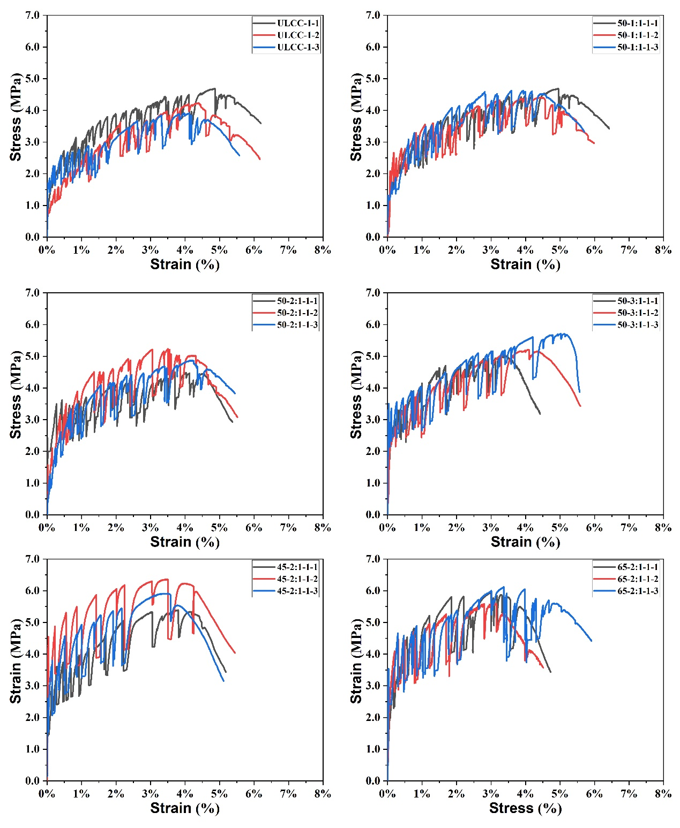
Figure 14 Stress-strain curves under monotonic uniaxial tension tests

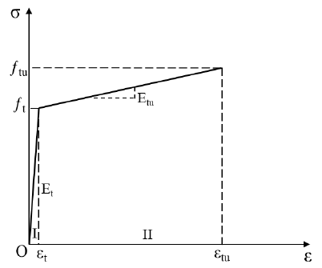
Figure 15 Bilinear stress-strain model for monotonic uniaxial tensile test

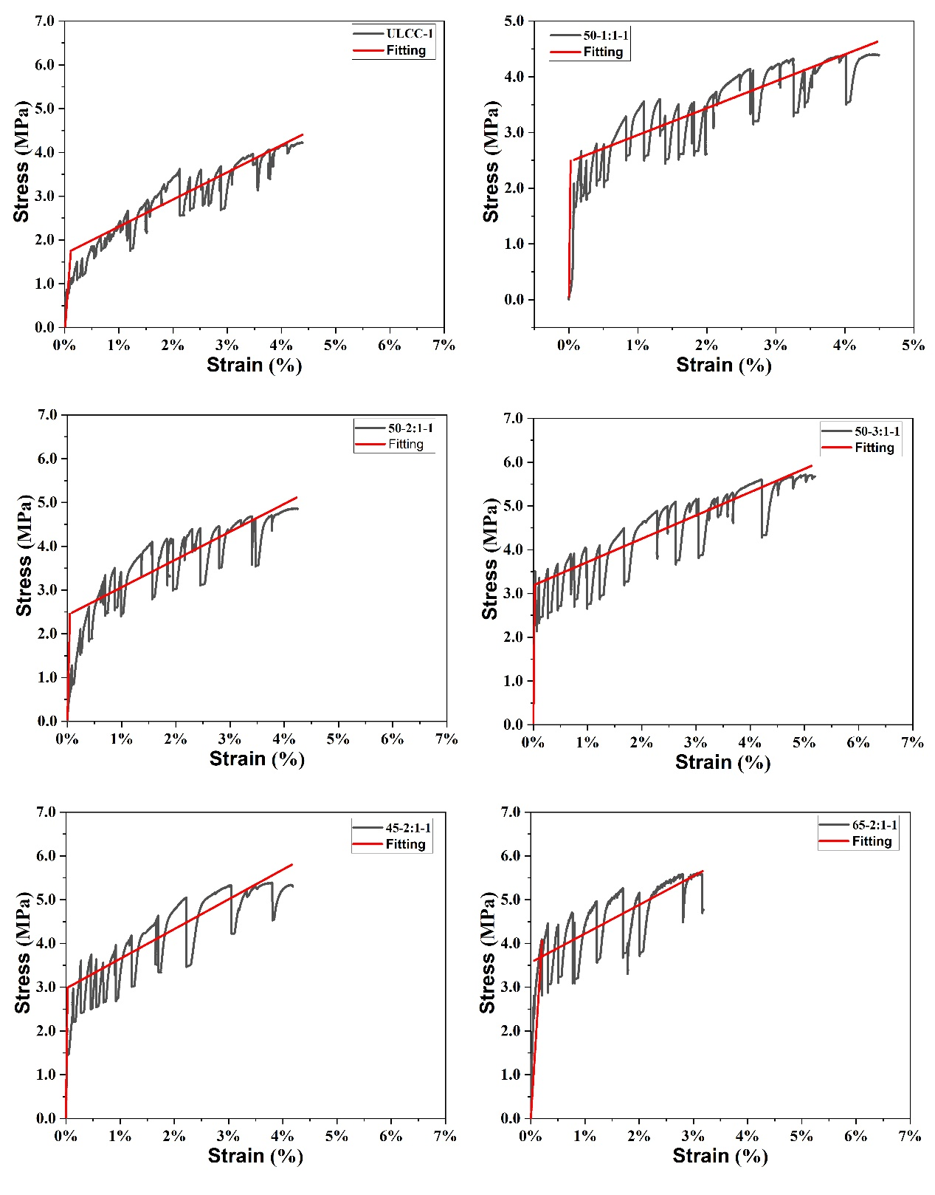
Figure 16 Comparisons between proposed constitutive model and experimental curves under monotonic uniaxial tension tests.

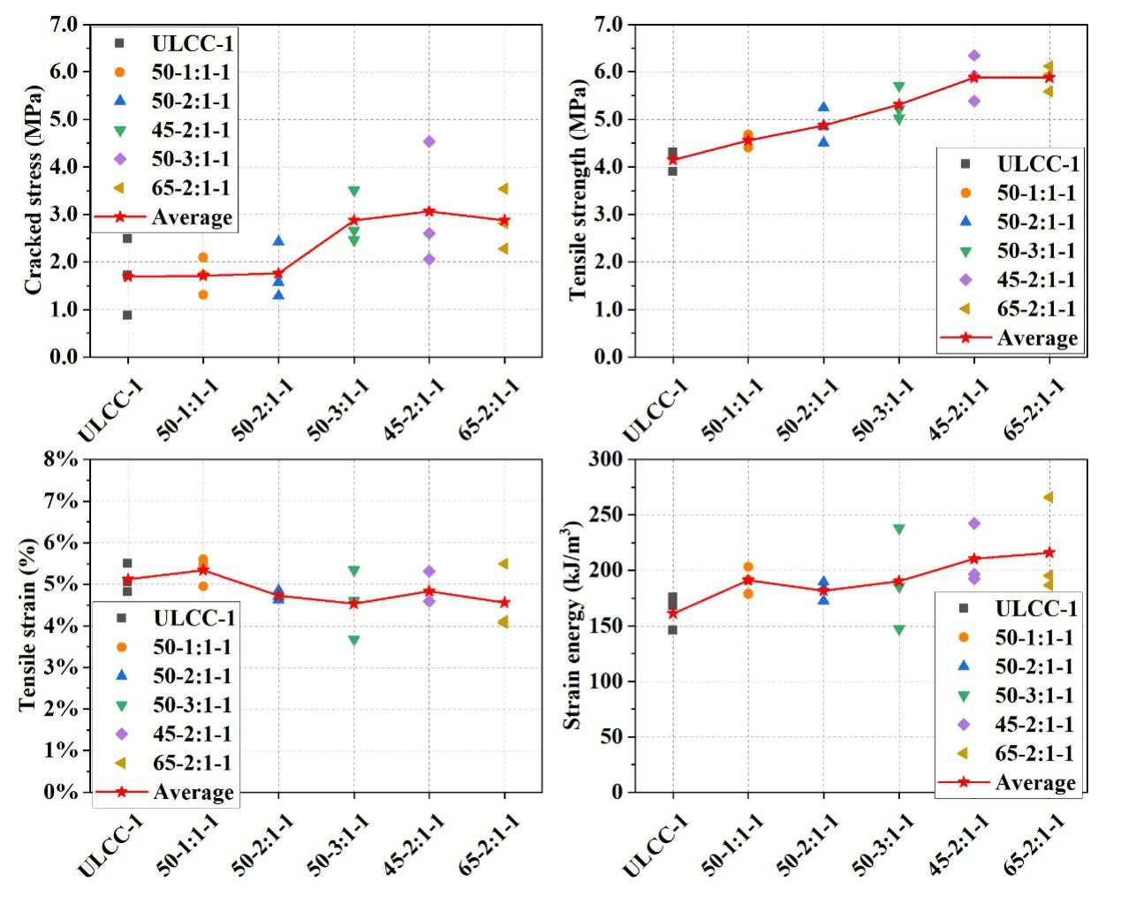
Figure 17 Critical parameters for characterizing tension tests

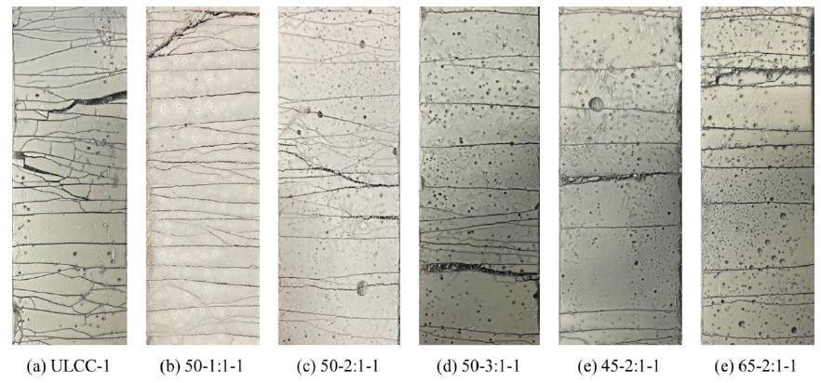
Figure 18 Distributions of cracks for specimens with PE fibers after tension tests

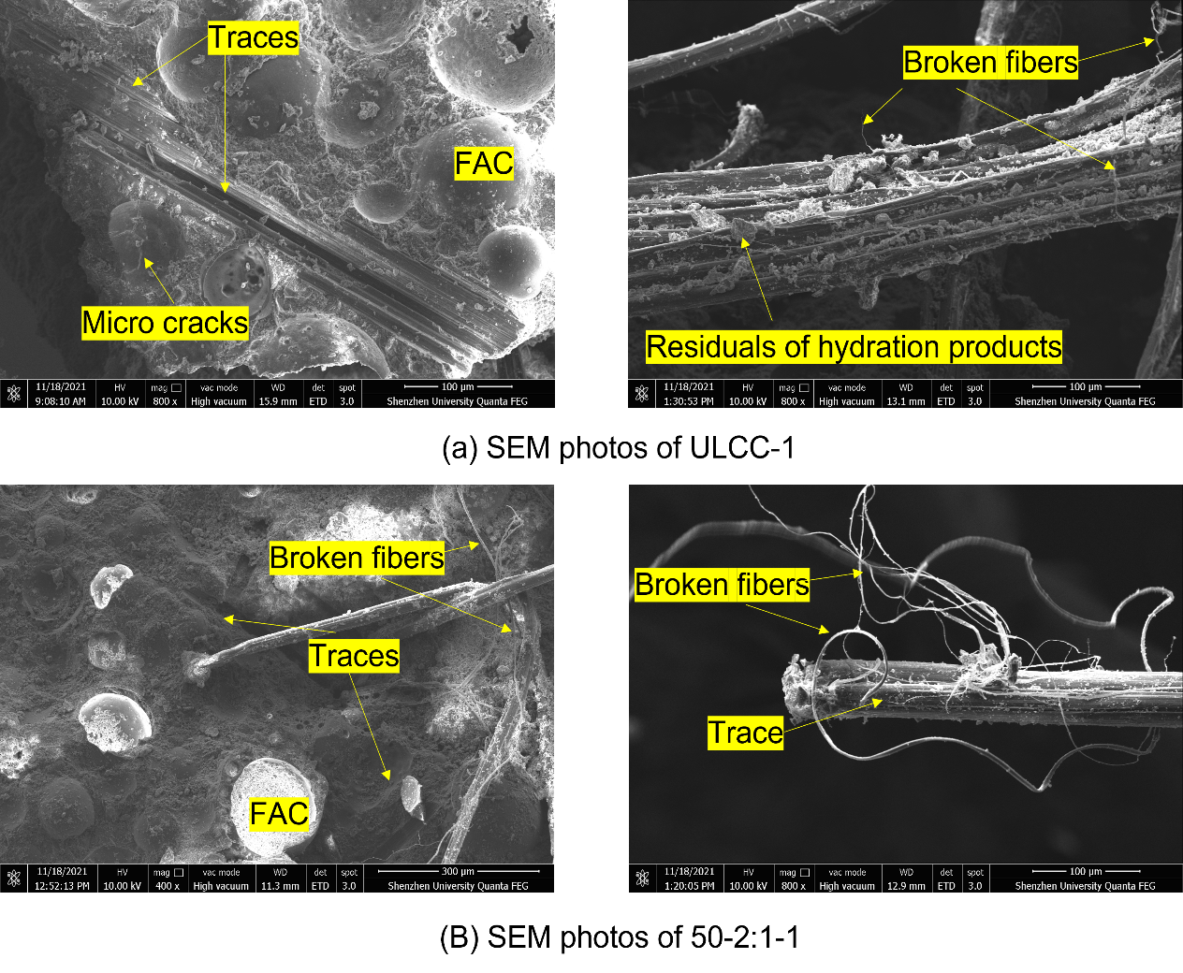
Figure 19 Comparison between SE images of ULCC-1 and 50-2:1-1

