Delocalization Engineering of Heme-Mimetic Artificial Enzymes for Augmented Reactive Oxygen Catalysis
Qian Li⁺, Zhenyang Zhao⁺, Fan Chen⁺, Xiaohui Xu, Lizhi Xu, Liang Cheng, Mohsen Adeli, Xianglin Luo, and Chong Cheng*
[*] Q. Li, Z. Zhao, F. Chen, Prof. X. Xu, Prof. X. Luo, Prof. C. Cheng
College of Polymer Science and Engineering, State Key Laboratory of Polymer Materials Engineering, Sichuan University Chengdu, 610065, China
E-mail: chong.cheng@scu.edu.cn chong.cheng@fu-berlin.de
Prof. L. Xu
Department of Mechanical Engineering The University of Hong Kong, Hong Kong SAR, China
Prof. L. Cheng
Department of Materials Science and Engineering, Macau University of Science and Technology Macau, China
Prof. M. Adeli
Institute of Chemistry and Biochemistry Freie Universitat Berlin, Takustr. 3, 14195 Berlin, Germany
Prof. M. Adeli
Department of Organic Chemistry, Lorestan University Khorramabad 68137-17133, Iran
Prof. C. Cheng
State Key Laboratory of Oral Diseases, National Clinical Research Center for Oral Diseases, West China Hospital of Stomatology Sichuan University, Chengdu, 610041, China
[+] These authors contributed equally to this paper.

Abstract
Developing artificial enzymes based on organic molecules or polymers for reactive oxygen species (ROS)-related catalysis has broad applicability. Herein, inspired by porphyrin-based heme mimics, we report the synthesis of polyphthalocyanine-based conjugated polymers (Fe-PPc-AE) as a new porphyrin-evolving structure to serve as efficient and versatile artificial enzymes for augmented reactive oxygen catalysis. Owing to the structural advantages, such as enhanced π-conjugation networks and π-electron delocalization, promoted electron transfer, and unique Fe-N coordination centers, Fe-PPc-AE showed more efficient ROS-production activity in terms of Vmax and turnover numbers as compared with porphyrin-based conjugated polymers (Fe-PPor-AE), which also surpassed reported state-of-the-art artificial enzymes in their activity. More interestingly, by changing the reaction medium and substrates, Fe-PPc-AE also revealed significantly improved activity and environmental adaptivity in many other ROS-related biocatalytic processes, validating the potential of Fe-PPc-AE to replace conventional (poly)porphyrin-based heme mimics for ROS-related catalysis, biosensors, or biotherapeutics. It is suggested that this study will offer essential guidance for designing artificial enzymes based on organic molecules or polymers.

Introduction
Natural enzymes use metal ions or metal-based cofactors to implement diverse and challenging transformations that govern many biocatalytic processes, such as metabolism, nutrition, inflammation, fighting pathogens, tissue regener-ation, and energy conversion in living organisms.[1] Despite the great potential of natural enzymes, however, their wide applications in broad fields have been hampered mainly owing to their undesirable intrinsic properties in terms of stability, high cost, difficulty in preparation, and reaction condition specificity.[2] Researchers have long sought to mimic the natural enzymatic reactions with structurally simpler compounds, either by employing small molecules to mimic the cofactors of natural enzymes to boost their biocatalytic performances or by simulating the active centers of natural enzymes to construct the biocatalytic nanostructures.[3] In particular, the versatility of transition and metal nanoparticles.[5] The development of organic molecules or polymers-based ROS biocatalysts is still encountering great challenges, especially in high catalytic activity, long-term stability, and broad-spectrum environmental adaptivity.[6]
Recent studies have revealed that the organic molecules or polymers-based artificial enzymes may offer better enzyme-mimicking metal-organic coordination structures and biocatalytic behaviors of natural enzymes. Recently, biochemical studies have presented that many ROS-production enzymes in nature consist of heme-structures with Fe-porphyrin centers, such as peroxidases, catalases, cyto-chromes P450, hemoglobin, and myoglobin,[7] which can produce ROS in the presence of H2O2 and O2 to regulate a variety of biochemical reactions.[8] As structural analogs to heme-structures in enzymes, the metalloporphyrin com-plexes and Por-based conjugated polymeric networks (PPor) have been intensively investigated for biocatalytic ROS production, aerobic oxidations, reduction and transport of dioxygen, destruction of peroxides, and many other bio-logical reactions.[9] For instance, our group has constructed a Pd-porphyrin coordination structure for biocatalytic ROS production in chem-/sono-/photo-trimodal tumor therapy.[10] Zhang group has constructed a Co-porphyrin-decorated bacteria as a light-driven biohybrid system for effective photochemical reactions.[11] Shi group has designed a Fe/Mn-tetrakis (4-carboxyphenyl) porphyrin-based coordination network towards the elimination of ROS for tissue regener-ation therapies.[12] However, besides the porphyrin-struc-tures-based ROS biocatalytic systems, very limited progress has been made for the heme-mimetic artificial enzymes.[5b]
Furthermore, the currently established porphyrin-based heme-mimics display insufficient ROS-biocatalytic activities when utilized at a low concentration,[7,13] while utilizing nanomaterials at high concentration may cause severe concerns on accumulative toxicity. Therefore, constructing new and more efficient heme-mimetic artificial enzymes for ROS biocatalytic applications is urgently needed in current biochemical and biomedical sciences.[14] Investigation on porous polymers in recent years have validated that the conjugated structure and coordination environment have a great impact on their catalytic performances,[15] but the related effects on ROS catalysis have not been studied, especially for the porphyrin-evolving artificial enzymes. Phthalocyanine can be recognized as the structural analogy with porphyrin in which the four methine bridge carbon atoms are replaced by nitrogen atoms, and the aromatic system is enlarged by adding four benzo rings,[16] and it shows good accessibility in terms of straightforward prepara-tion on a large scale and outstanding electrocatalytic performance in the energy fields.[17] Although phthalocya-nine-molecules-based artificial enzymes have been reported,[18] to date, the phthalocyanine-based conjugated polymers as heme-mimetic artificial enzymes for ROS catalysis have not been explored.
Inspired by the porphyrin-based heme-mimetic systems, here, we report on synthesizing the polyphthalocyanine-based conjugated polymers (Fe-PPc-AE) as a new porphyr-in-evolving structure to serve as efficient and versatile artificial enzyme for augmented reactive oxygen catalysis. To disclose and compare the ROS-related biocatalytic efficiencies and specificity, the chemical structures, catalytic activities, and reaction mechanisms of these Fe-PPc-AE and porphyrin-based conjugated polymers (control group, Fe-PPor-AE) have been comprehensively investigated by experimental and theoretical studies. Owing to the structural advantages in enhanced π conjugated networks and π-electron delocalization, promoted electron transfer, and unique Fe-N coordination centers of polyphthalocyanine networks,[19] the Fe-PPc-AE presents more efficient ROS-production activities in terms of Vmax and turnover numbers compared with the Fe-PPor-AE, which also surpasses the by-far-reported state-of-the-art ROS-biocatalytic artificial enzymes, including some representative Fe-based enzyme-mimics (Fe₂O₃, Fe₃O₄, Fe-N-C nanostructure, and PtFe nanoparticle). The density functional theory (DFT) calcu-lation indicates that the electron delocalization can regulate the position of the d-band center to optimize the adsorption energy and reduce the energy barrier during the peroxidase (POD)-like reaction. Consequently, the Fe-PPc-AE displays superior O2⁻ production capability and comparable OH production ratio to Fe-PPor-AE. More interestingly, by changing the reaction media and substrates, the Fe-PPc-AE also reveals significantly improved activity and environ-mental adaptivity in many other ROS-related biocatalytic processes, validating that the porphyrin-evolving Fe-PPc-AE with phthalocyanine conjugated networks exhibit great application potentials to substitute the conventional (poly)porphyrin-based heme-mimics for ROS-related catal-ysis, biosensors, or biotherapeutics.
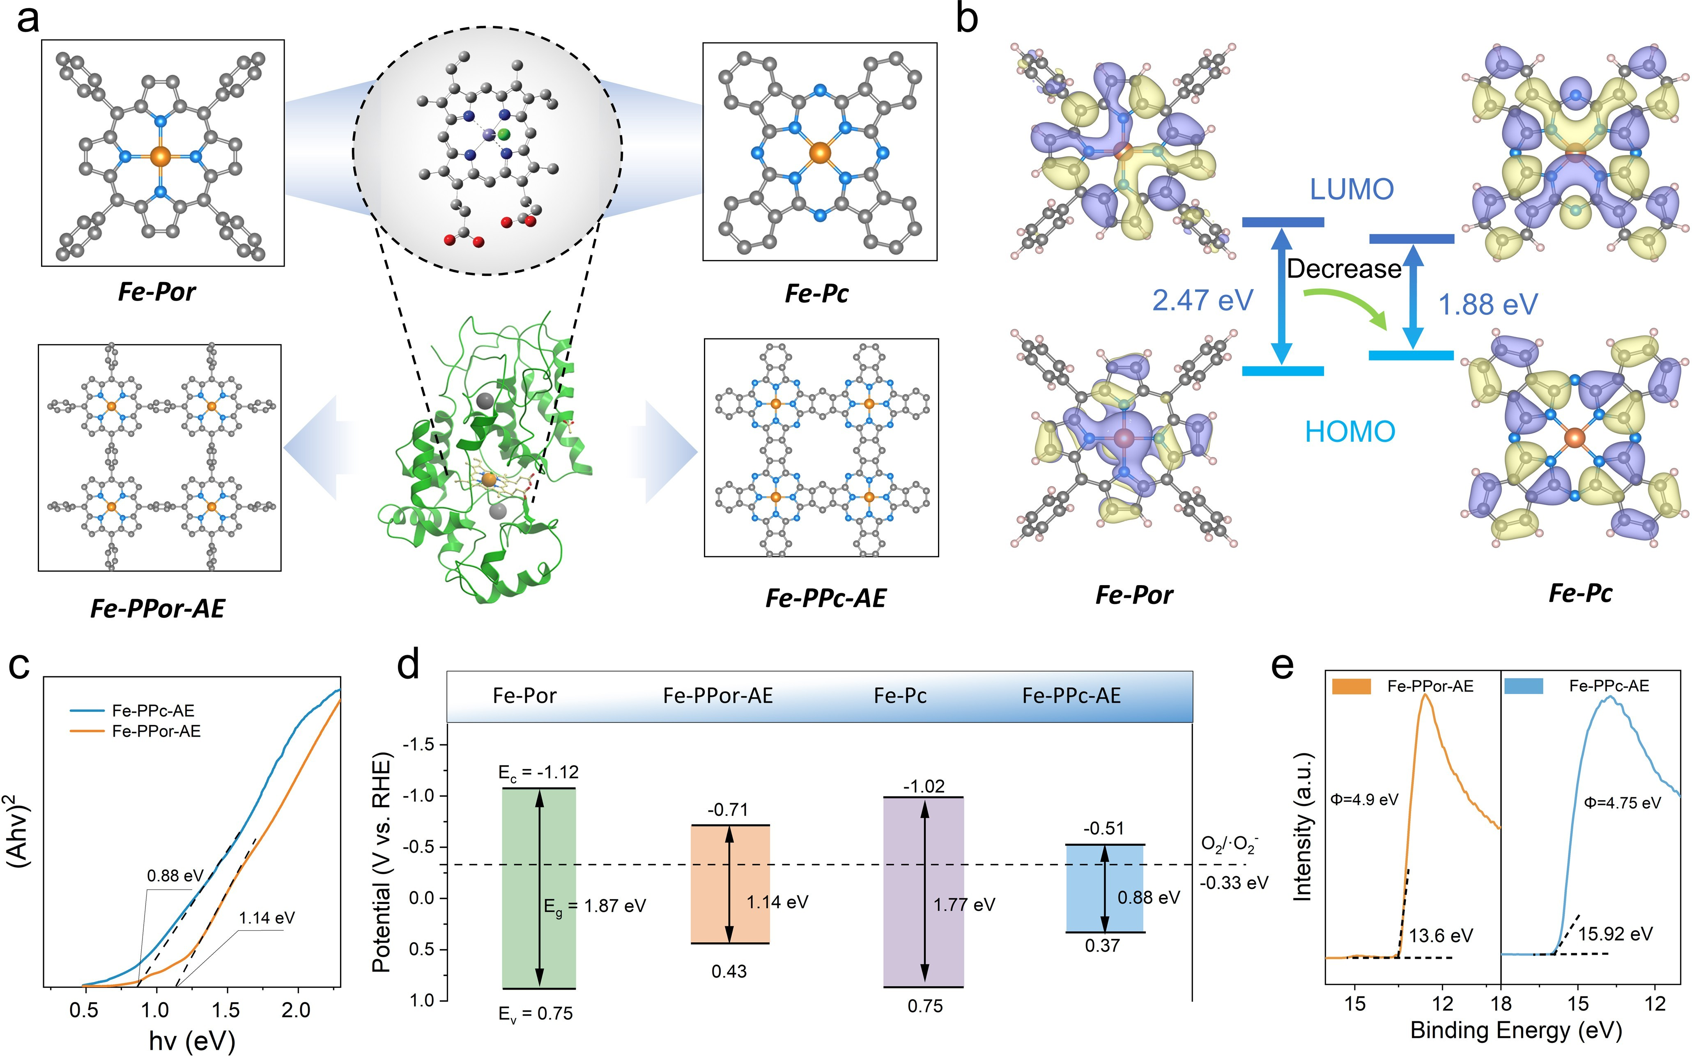
Figure 1. Design strategy and structure comparison of heme-mimetic artificial enzymes. a) Structures of HRP and heme-mimetic chemical structures (Fe-PPor-AE and Fe-PPc-AE). b) The calculated HOMO and LUMO diagrams of Fe-Por and Fe-Pc. c) Tauc plots of Fe-PPor-AE and Fe-PPc-AE. d) Energy spectrum distribution. e) Ultraviolet photoelectron spectroscopy (UPS) and the work function of Fe-PPor-AE and Fe-PPc-AE.
Results and discussion
To disclose and compare the ROS-related biocatalytic efficiencies and specificity of the porphyrin-based and porphyrin-evolving heme-mimetic artificial enzymes, the Fe-PPor-AE (heme-mimicking center) and Fe-PPc-AE (por-phyrin-evolving center) with different π conjugated net-works and π-electron delocalization have been synthesized (Figure 1a and Figure S1–S2). First, the exploration of the energy difference between a molecule’s Highest Occupied Molecular Orbital (HOMO) and its Lowest Unoccupied Molecular Orbital (LUMO) is conducted through density functional theory (DFT). The calculated orbital wavefunc-tion distribution diagrams (Figure 1b) show that iron phthalocyanine (Fe Pc) has a smaller HOMO–LUMO gap than iron meso-tetraphenylporphine (Fe-Por), indicating that Fe Pc-based structure may display stronger π-electron conjugation ability and faster electron transfer capability.[20] Based on the Kubelka–Munk theory (Figure 1c and Fig-ure S3), the optical band gap of Fe-PPc-AE was calculated to be ~0.88 eV, which is lower than that of Fe-PPor-AE (~1.14 eV), and the results are consistent with the above theoretical trend.
Recently, molecular biology has demonstrated that these heme-containing peroxidases (POD) can generate highly toxic ROS (e.g., O₂⁻) in the presence of H₂O₂.[21] For the conjugated structure-derived heme-mimetic artificial en-zymes, the band gaps and the positions of the conduction band minimum (CBM) and valence band maximum (VBM) may play key roles in determining the biocatalytic ROS generation activity.[22] Therefore, the band position align-ments for O₂⁻/O₂ of these polymers and small molecules are experimentally calculated and shown in Figure 1d. The Fe-Por, Fe-Pc, Fe-PPor-AE, and Fe-PPc-AE present the CBM values of -1.12 eV, -1.02 eV, -0.71 eV, and -0.51 eV, respectively; these are all negative than the O₂/O₂⁻ potential, which indicates that all four artificial enzymes could generate highly toxic O2⁻.[23] In addition, as shown in Figure 1e and Figure S4, the work function of Fe-PPc-AE (Φ = 4.75) is smaller than that of Fe-PPor-AE (Φ = 4.90), thus indicating that Fe-PPc-AE has better surface electronic properties than Fe-PPor-AE. Furthermore, the cyclic vol-tammetry curves and electrochemical impedance spectro-scopy are also recorded to compare the biocatalytic activity during the H₂O₂ catalysis in aqueous media (Figure S5), which indicates that the Fe-PPc-AE demonstrates enlarged π conjugated network and promoted electron transfer at interface compared to the Fe-PPor-AE.[24] According to the above data, it is suggested that the porphyrin-evolving Fe-PPc-AE may show higher reactive oxygen biocatalytic activities than the heme-mimicking Fe-PPor-AE.
After comparing their intrinsic differences on π con-jugated networks, we then carefully investigate the detailed coordination structures of heme-mimetic artificial enzymes at the atomic scale. As shown in Figure 2a, the characteristic peaks in the ¹³C nuclear magnetic resonance (NMR) spectrum of Fe-PPor-AE at 131.7 and 74.4 ppm are attributed to the porphyrin and benzene linkages, respec-tively. In addition, the Raman spectrum (Figure 2b) shows the typical B1 g mode at 1332 cm-1, which results from the presence of the porphyrin molecule. These data can confirm the successful preparation of porphyrin-based conjugated networks.[25] And the 13C NMR spectrum of the Fe-PPc-AE shows three characteristic peaks at 164.5, 132.4, and 114.9 ppm, which are attributed to the phthalocyanine macrocycle (Figure 2c).[26] Similarly, the Raman spectra of Fe-PPc-AE containing the breathing and deformation of C C bonds in the macrocycle are verified at 677 and 744 cm-1, as well as the stretching of C N C bridge bonds assignable to the band at 1456 cm-1, respectively (Fig-ure 2d).[26] The Fourier transform infrared spectroscopy (FT-IR) and UV/Vis spectra (Figure S6) also validate the unique structural peaks of Fe-PPc-AE. The powder X-ray diffrac-tion (PXRD) patterns indicate that both Fe-PPor-AE and Fe-PPc-AE are noncrystalline networks without metallic Fe or FeOx species (Figure S7).
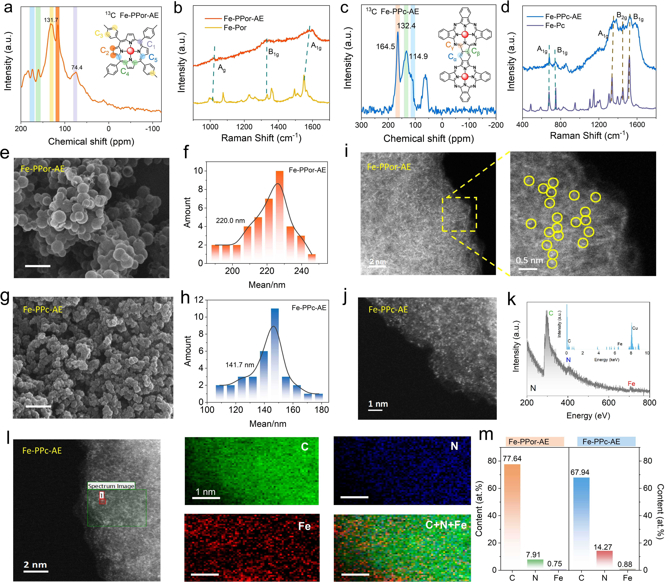
Figure 2. Structure characterization of heme-mimetic artificial enzymes. a) Solid-state 13C NMR spectra and b) Raman spectra of Fe-PPor-AE. c) Solid-state 13C NMR spectra and d) Raman spectra of Fe-PPc-AE. e, f) The SEM photograph and size distribution of Fe-PPor-AE. g, h) The size distribution of Fe-PPc-AE (scale bar 500 nm). i) AC-HAADF-STEM image and corresponding enlarged image of Fe-PPor-AE with iron atoms (bright points). j) AC-HAADF-STEM image of Fe-PPc-AE. k) EELS spectra and EDS patterns (inset) of C, N, and Fe elements of Fe-PPc-AE. AC-HAADF-STEM images i) Fe-PPor-AE and j) Fe-PPc-AE. l) Selected region and corresponding EELS mapping of C, N, and Fe in Fe-PPc-AE. m) Elemental content from XPS data. m) The XPS atomic content of Fe-PPor-AE and Fe-PPc-AE.
Then, the morphology and the coordinated Fe of Fe-PPor-AE and Fe-PPc-AE were observed in detail. As shown in Figure 2e–f and Figure 2g–h, scanning electron micro-scopy (SEM) indicates that the Fe-PPor-AE and Fe-PPc-AE present a spherical morphology of about 220 nm and 140 nm, respectively. The transmission electron microscopy (TEM) images show that both the Fe-PPor-AE and Fe-PPc-AE are amorphous structures (Figure S8–9), which is consistent with PXRD results. The aberration-corrected high-angle annular dark-field scanning TEM (AC-HAADF-STEM, Figure 2i, j, Figure S10) of Fe-PPor-AE and Fe-PPc-AE reveals numerous tiny bright spots (emphasized with yellow circles) within the matrix, proving clear proof clear proof of the abundance of atomic Fe coordination. Further-more, the HAADF-STEM images, along with the associated energy dispersive spectroscopy (EDS) elemental mapping, demonstrate a uniform distribution of atomic level Fe atoms on the Fe-PPor-AE and Fe-PPc-AE, as shown in Figur-es S11–12. The EDS patterns and electron energy loss spectrum (EELS) of Fe-PPc-AE, indicated by the green box in Figure 2k, distinctly display the C K edge, N K edge, and Fe L edge. Additionally, the EELS mapping in Fig-ure 2l further confirms the even spread of Fe within the carbon and nitrogen matrix. As shown in Figure 2m, the atom ratio of C, N, and Fe in Fe-PPor-AE and Fe-PPc-AE are calculated by X-ray photoelectron spectroscopy (XPS), and both materials exhibit atomic-level Fe contents (0.75 and 0.88 at.%).
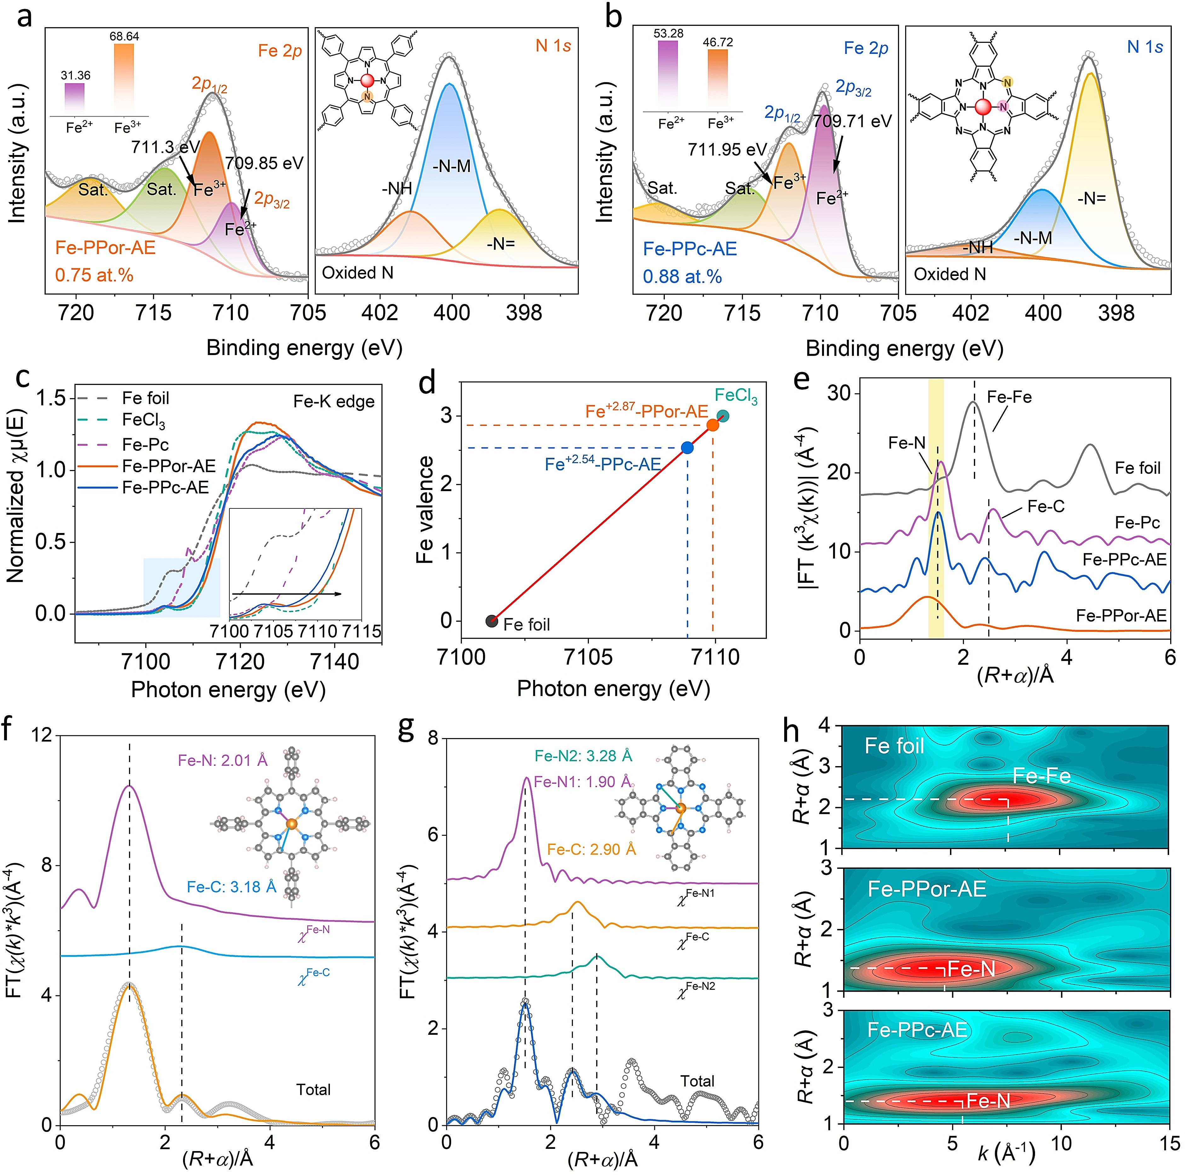
Figure 3. Fe coordination environments analysis of heme-mimetic artificial enzymes. Fe 2p and N 1s XPS spectra of a) Fe-PPor-AE and b) Fe-PPc-AE, inset: the Fe valence ratio of Fe2+ and Fe3+. c) The normalized XANES at the Fe K-edge of Fe foil, FeO, FeCl , Fe Pc, Fe-PPor-AE and Fe-PPc-AE. Inset: The pre-edge region at the Fe K-edge. d) The average oxidation state of Fe in Fe-PPc-AE and Fe-PPor-AE. e) Fourier transform (FT) k3-weighted χ(k)-function of the EXAFS spectra of samples in R-space. f) Fe K-edge EXAFS analysis of Fe-PPor-AE. The curves, arranged from top to bottom, represent the Fe—N and Fe—C two-body backscattering signals. The fitted curve of the overall signal (orange line) overlays the experimental signal (open circles). Curves from top to bottom are the Fe—N and Fe—C two-body backscattering signals. The fit curve of the total signal (orange line) is superimposed on the experimental signal (open circles). Inset: model of Fe-PPor-AE. The Fourier transforms have not been adjusted for phase shift. g) Fe K-edge EXAFS analysis of Fe-PPc-AE. The displayed curves, ranging from top to bottom, correspond to the Fe—N1, Fe—C, and Fe—N2 three-body backscattering signals. Fit curve for the total signal (blue line) is superposed on the experimental signal (open circles). Inset: schematic model of Fe-PPc-AE. h) WT of EXAFS for Fe foil, Fe-PPor-AE and Fe-PPc-AE.
The precise Fe-coordinated environments are further probed by XPS and X-ray absorption spectroscopy (XAS). As shown in Figure 3a, b and Table S1–S3, the Fe 2p spectra Fe 2p spectra can be divided and assigned to the 2p1/2 and 2p3/2 regions. Taking the 2p3/2 regions as an example, it fits well with two main components located at 709.85/709.71 and 711.3/711.95 eV, corresponding to Fe2+ and Fe3+ (Fig-ure 2m), which suggests the formation of atomic Fe N sites in both Fe-PPor-AE and Fe-PPc-AE. In addition, the Fe-PPc-AE contains a larger ratio of Fe2+ (53.28 %) than Fe-PPor-AE (31.36 %), which indicates the relatively electron-rich state of Fe atom in Fe-PPc-AE. The N 1s spectrum can be deconvoluted into three peaks of N=, N M (metal), and -NH for both materials. The corresponding C 1s spectra of Fe-PPor-AE and Fe-PPc-AE (Figure S13b) could be deconvoluted into C=C/C C, C N, and π–π satellite peaks. The increased intensity of the deconvoluted π–π peak in comparison to the Fe-PPc-AE can be ascribed to the amplified π conjugation and more robust bonding between the central iron ions and the phthalocyanine macrocycles.
To disclose the precise Fe N coordination structure, the X-ray absorption near-edge structure (XANES) and ex-tended X-ray absorption fine structure (EXAFS) measure-ments were characterized.[27] The Fe K-edge XANES and oxidation state analysis suggest the valence state of Fe in Fe-PPor-AE (+ 2.87) is higher than Fe-PPc-AE (+ 2.54) (Fig-ure 3c, d), which aligns with the Fe 2p XPS results. According to the k3-weighted Fourier-transform (FT) EX-AFS spectra, both Fe-PPc-AE and Fe-PPor-AE show major peaks at 1.53 Å (Figure 3e), indicating the Fe N structure. Besides, no obvious peaks assigned to the Fe Fe bond at 2.20 Å are observed, thus implying the absence of Fe0 clusters or crystalline particles.
Comparison of enzyme-like ROS production activities. After successfully characterizing the morphology and chem-ical structures for Fe-PPor-AE and Fe-PPc-AE, we further investigated the POD-like catalytic activity of H2O2 into ROS via a typical colorimetric probe, 3,3’,5,5’-tetrameth-ylbenzidine (TMB).[27b] As shown in Figure S16, the Fe-PPor-AE exhibits relatively low TMB oxidation capacity, approximately about 1/3 of Fe-PPc-AE. The normalized activity in Figure 4a and Table S5 shows that the conjugated polymers (Fe-PPor-AE and Fe-PPc-AE) exhibit much high-er catalytic performances than the small molecules (Hemin, Fe-Por, and Fe Pc) and inorganic ROS biocatalysts (Fe3O4), which may be owing to the rapid electron transfer within the conjugated networks.[28]
Then, we conducted the steady-state kinetic assay and determined the values of maximal reaction velocity (Vmax), Michaelis constant (Km), and turnover number (TON, defined as the maximum number of substrate conversions per unit of active catalytic center), calculate the values of maximal reaction velocity (Vmax), Michaelis constant (Km), and turnover number (TON, the maximum number of conversing substrates per unit active catalytic center). The Vmax (8.82×10-7 M· s-1) for H2O2 of Fe-PPc-AE is almost 1.7-fold than that of Fe-PPor-AE. Meanwhile, the Vmax value for TMB of Fe-PPc-AE (Vmax = 1.30×10-6 M· s-1) is much superi-or to Fe-PPor-AE. The TON values of Fe-PPc-AE (27.0×10-3 s-1 for H2O2 and 39.8×10-3 s-1 for TMB) are also much higher than that of Fe-PPor-AE (Figure 4b, Fig-ure S17–18, Table S5–6). Moreover, the Km values of Fe-PPc-AE are much lower than that of Fe-PPor-AE, leading to extremely excellent catalytic efficiency for Fe-PPor-AE (146-fold for H2O2 and 90-fold for TMB compared to Fe-PPor-AE). When compared with the recently established POD-mimics, including metallic oxides, metal nanoparticles, single-atom (SA) enzyme-mimics, and metal–organic frame-works (MOFs) (Table S7), the Fe-PPc-AE also exhibit the highest TON and Vmax values (Figure 4c). Meanwhile, the enzymatic indices of Fe-PPc-AE are further compared with some representative Fe-based POD-mimics (Fe2O3, Fe3O4, Fe-MOF, Fe N C SA, and PtFe). All these results show that Fe-PPc-AE exhibits the best or optimal catalytic performances concerning different indices, such as TON, Vmax, and Kcat/Km (Figure 4d).
To elucidate the catalytic process, electron paramagnetic resonance (EPR)[29] and fluorescence analysis were em-ployed to identify the ROS produced during catalysis. Figure 4e demonstrates that the characteristic peak of the DMPO/•OH adducts displays a distinct signal intensity pattern of 1 : 2 : 2 : 1. This pattern indicates that both Fe-PPor-AE and Fe-PPc-AE have produced •OH during the decomposition of H2O2. Disodium terephthalate (NaTA) is selected as a fluorescent probe for detecting •OH, as illustrated in Figure 4f and Figure S19.[30] The NaTA-•OH fluorescence intensity reveals that the Fe-PPor-AE produces a slightly higher amount of •OH than the Fe-PPc-AE. Moreover, the EPR analysis shows an obvious characteristic signal of •O2- for Fe-PPc-AE when the reaction solution is replaced by dimethylsulfoxide (a scavenger for OH) (Fig-ure 4g), indicating that Fe-PPc-AE can simultaneously produce abundant O2- during the decomposition of H2O2. Furthermore, the produced •O2- radical can also be verified via an O2--specific probe hydroethidine (HE) (Figure 4h and Figure S20).[31]
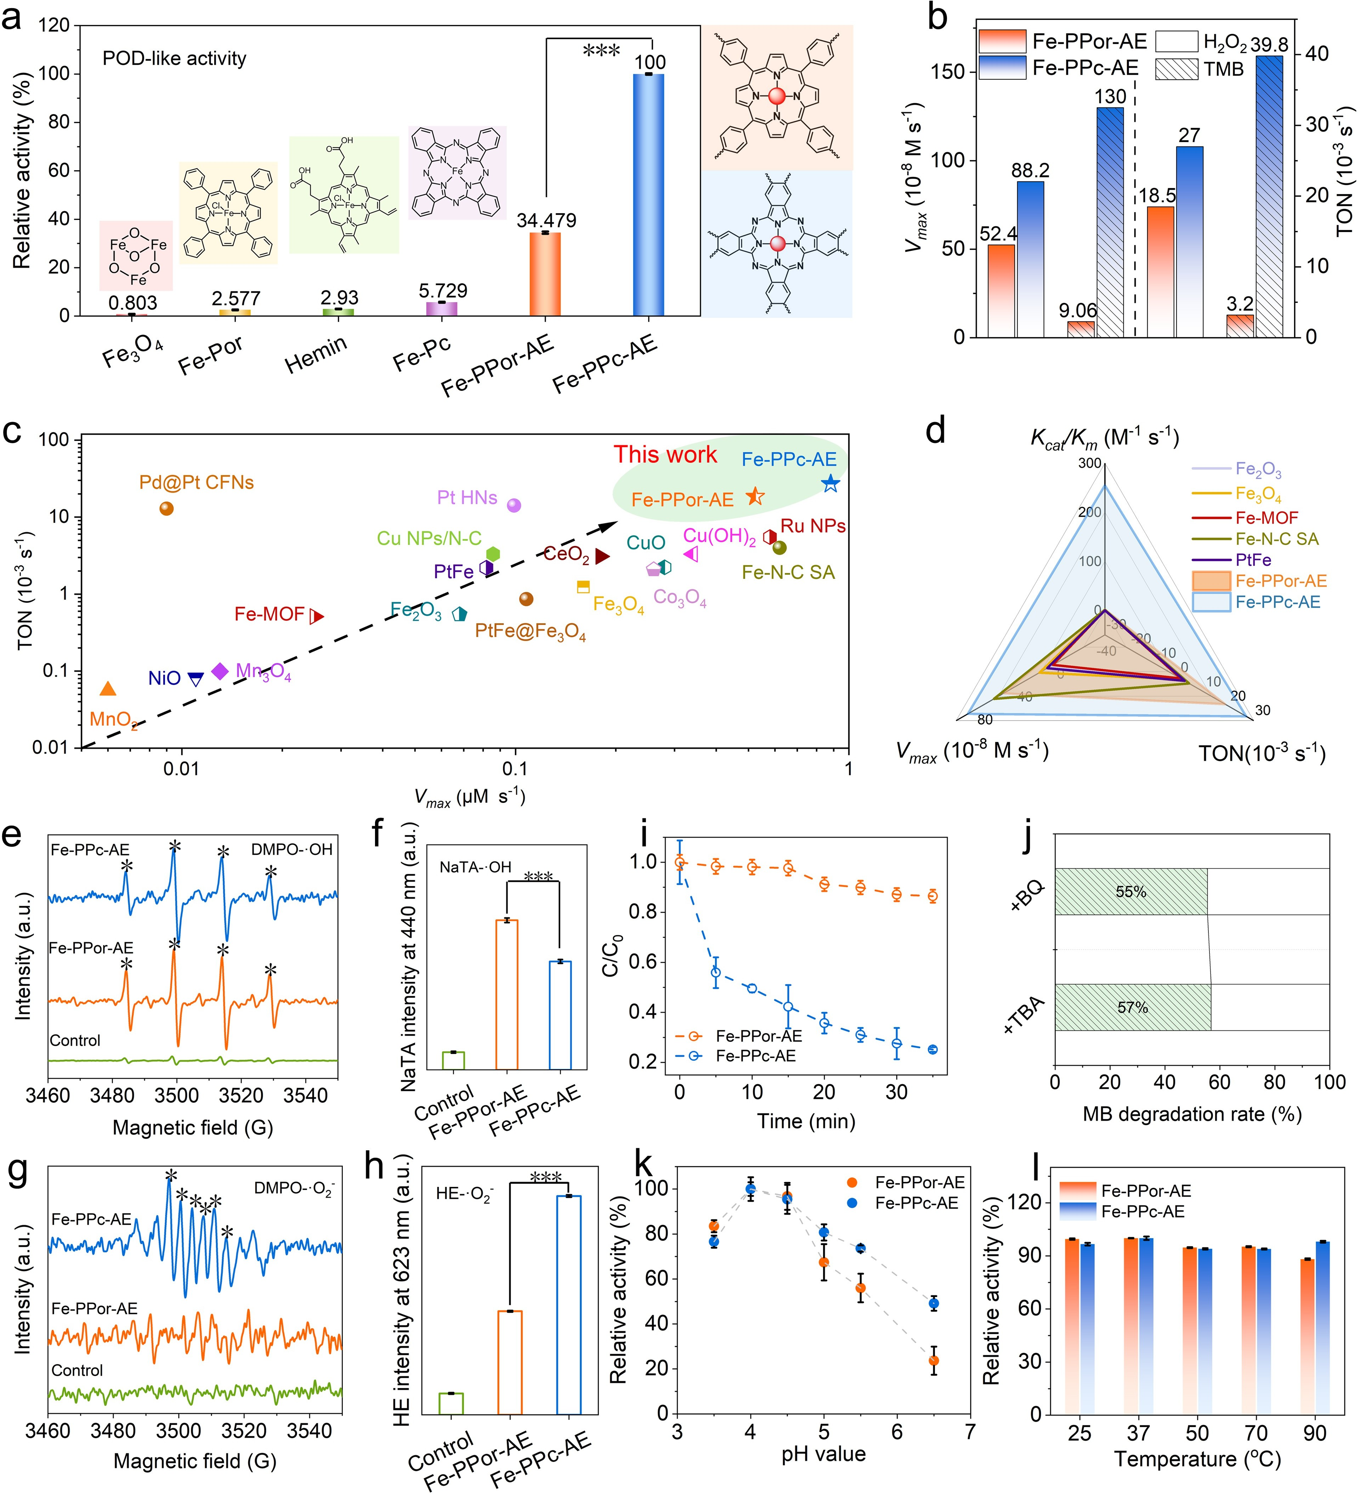
Figure 4. Comparison of enzyme-like ROS production activities. a) Quantitative analysis of absorbance values at λ = 652 nm. b) Vmax and TON values of Fe-PPor-AE and Fe-PPc-AE with H2O2 and TMB. c) Comparison of the Vmax and TON values of Fe-PPor-AE and Fe-PPc-AE with other recently reported catalysts. d) Catalytic performance index comparison of this study and earlier reported Fe-based ROS biocatalysts. EPR spectra for recording e) the *OH signal and g) the *O — signal. Fluorescence spectra for recording f) the *OH signal and h) the *O — signal. i) MB degradation assay for Fe-PPor-AE and Fe-PPc-AE. j) *OH quenched by TBA, *O- quenched by BQ in the catalytic degradation process of MB. POD-like activity of Fe-PPor-AE and Fe-PPc-AE at various k) pH values and l) temperatures, respectively, where the absorbance at pH 4.5 was defined as 100 %.
To compare the general catalytic activity of Fe-PPor-AE and Fe-PPc-AE in H2O2-assisted ROS production, the methylene blue (MB) degradation tests are further utilized as model experiments. As shown in Figure 4i and Fig-ure S21, compared with the slight degradation rate of Fe-PPor-AE (13.5 %), the Fe-PPc-AE displays fast degradation (74.8 %) on MB within 30 min. To distinguish the contribu-tion of •OH and •O2- in MB degradation of Fe-PPc-AE, tertiary butanol (TBA) and p-benzoquinone (BQ) are used as scavengers for •OH and •O2-, respectively. Figure 4j illustrates that the MB degradation rate significantly declines upon adding either TBA or BQ, indicating that both •OH and •O2- radicals are crucial contributors to the process. It is suggested that the Fe Pc-based conjugated networks (Fe-PPc-AE) will benefit the ROS catalytic activity compared to the Fe-Por-based structure (Fe-PPor-AE); the detailed mechanisms will be further explored in the following section. In addition, the POD-like activities of Fe-PPor-AE and Fe-PPc-AE all show pH-dependent man-ners and can maintain high enzyme-like activities over a wide range of temperatures (Figure 4k, l). As shown in Figure S22, the POD-like activity remains at about 2.5, which proves good stability and re-utilization of Fe-PPc-AE. Moreover, SEM images, Raman spectra, and FT-IR spectra indicate that it maintains its original spherical morphology (Figure S23), thus confirming its robust structural stability.
To gain atomic-scale insight into the detailed POD-like ROS catalytic mechanism of Fe-PPor-AE and Fe-PPc-AE, DFT calculations were carried out for theoretical analysis and performance comparison using the VASP code.[32] First, Fe-PPor-AE with Fe-N4C12 and Fe-PPc-AE with Fe-N8C8 model structures were constructed based on the above experimental data (Figure 5a and Figure S24). Bader charge analysis show more electrons transfer from the Fe center to adjacent N/C in Fe-PPc-AE than Fe-PPor-AE (1.27 vs. 1.14 e ), and the corresponding Fe N bond length is also shorter (1.92 vs. 1.98 Å). Those indicate the Fe N interaction is stronger in Fe-PPc-AE, which is consistent with the formation energy calculation (Table S9).
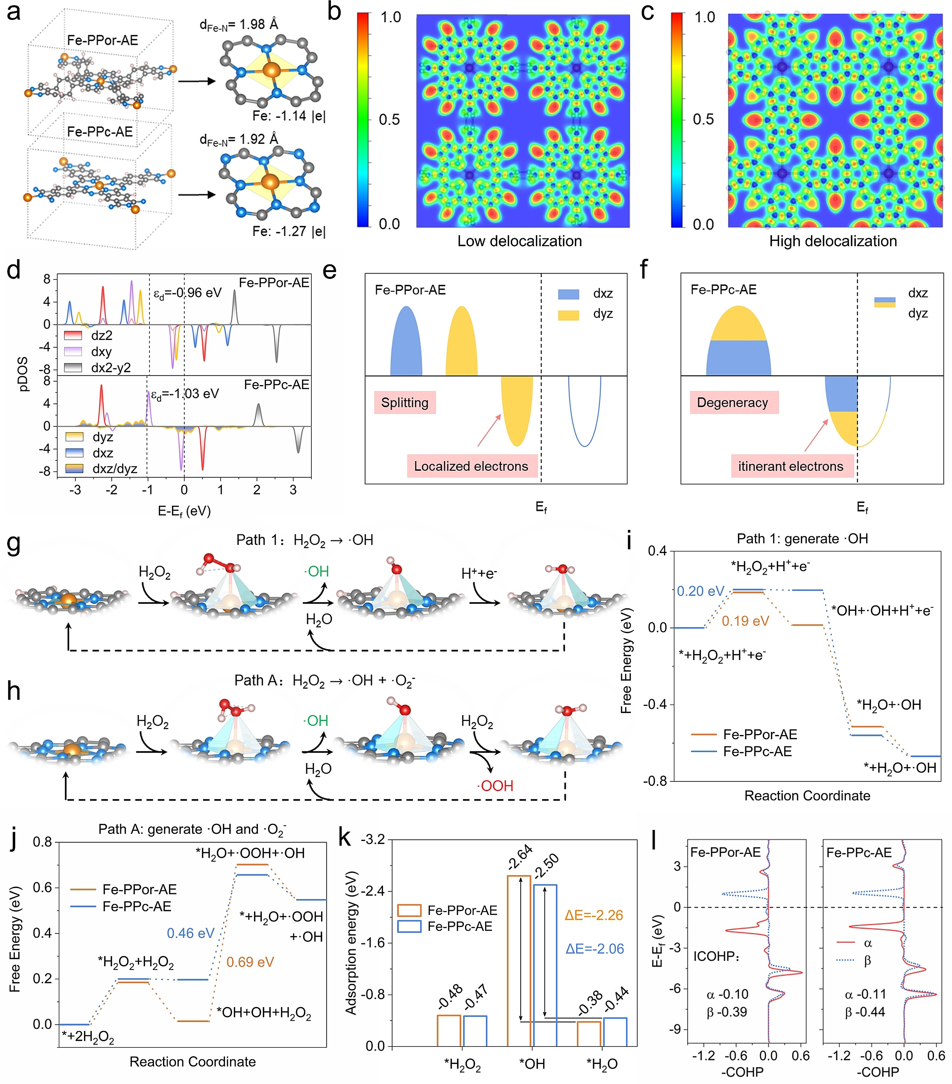
Figure 5. Theoretical analysis and comparison of the POD-like ROS catalysis. a) Optimized structure models of Fe-PPor-AE and Fe-PPc-AE with Bader charge of Fe sites. Calculated ELF diagrams of b) Fe-PPor-AE and c) Fe-PPc-AE. d) Computed Fe-3d pDOS of Fe-PPor-AE and Fe-PPc-AE. e, f) Illustrations of the dxz and dyz orbitals of Fe sites from (d). g, h) Proposed optimal reaction pathways and i, j) corresponding free energy diagrams toward *OH and *O2—, respectively (color code: Fe orange, C gray, N blue, O red, H white). k) The adsorption energy of Fe-PPor-AE and Fe-PPc-AE with different key oxygen intermediates. l) COHP and corresponding integrated values (ICOHP) of Fe—O interactions for *H2O(Fe-PPor-AE) and *H2O(Fe-PPc-AE).
The electron localization functions (ELF) diagrams show that electrons in Fe-PPc-AE are delocalized throughout the entire molecular plane via π–π and d-π conjugation, while in Fe-PPor-AE, the delocalization of electrons within the molecular framework is limited due to steric hindrance effects (Figure 5b, c and Figure S25).[33] This indicates that Fe-PPc-AE exhibits greater electronic delocalization and stronger electron transfer ability than Fe-PPor-AE, which may be conducive to ROS catalysis. Impressively, by comparing the projected density of states (pDOS) of Fe 3d orbitals (Figure 5d), it is found that they have similar dz2 orbitals, while the distribution of dxz and dyz is completely different. As shown in Figure 5e, f, the delocalized Fe-PPc-AE populates spin-electrons near the Fermi level, where the itinerant electrons are positive to enhance charge transfer from the catalyst surface to reaction intermediates, which is helpful to improve the POD-like activity of the catalyst.[34] In addition, Fe-PPc-AE has a deeper d-band center (ɛd) than Fe-PPor-AE ( 1.03 vs. 0.96 eV), indicating that electron delocalization can regulate the position of the d-band center to optimize the adsorption energy.
To elucidate the detailed POD-like catalytic mecha-nisms, multiple reaction paths have been attempted, as shown in Figure 5g–j and Figure S26–28. Among them, Figure 5g, h presents the optimal •OH and •O2- reaction pathways for Fe-PPc-AE, denoted as path 1 and path A, respectively. Specifically, the H2O2 molecule first adsorbed at the Fe site with a weak energy barrier to form •H2O2. Thereafter, the •H2O2 spontaneously and uniformly disso-ciates into two •OH. Immediately, one •OH is released into the environment to form •OH radical, and the other •OH continues to participate in subsequent reactions. If •OH is removed directly, a high energy barrier will be required, 1.90 and 2.08 eV for Fe-PPor-AE and Fe-PPc-AE, respec-tively (path 2, Figure S26). However, if •OH reacts with a proton from the acidic environment to form •H2O and eventually removes back to its initial state, the entire process is spontaneous except that the formation of •H2O2 requires a small energy barrier, 0.19 and 0.20 eV for Fe-PPor-AE and Fe-PPc-AE (path 1, Figure 5g, i). It suggests that path 1 is the most reasonable •OH producing process. Furthermore, •OH is also likely to snatch the H of the H2O2 molecule to generate •H2O and •OOH (i.e., •O2-) and ultimately return to the initial state (path A, Figure 5h, j). The rate-determin-ing step (RDS) of the entire reaction is the formation and removal of •OOH, with thermodynamic energy barriers of 0.69 and 0.46 eV for Fe-PPor-AE and Fe-PPc-AE, respec-tively, which means that delocalized Fe-PPc-AE has a stronger ability to produce •O2- radicals than Fe-PPor-AE. In addition, we also consider several other paths that may generate •O2-, as shown in Figure S27–28 (labeled as path B and path C). Based on the above analysis, Fe-PPc-AE has not only comparable •OH production capability to Fe-PPor-AE but also superior •O2- production capability. Conse-quently, the delocalized Fe-PPc-AE has stronger POD-like activity, which is consistent with experimental results (Fig-ure 4).
We then analyze the adsorption energy of various oxygen-containing intermediates (Figure 5k); the smaller the difference (ΔE), the easier the conversion between the two, and the lower the RDS barrier. Therefore, the mechanism behind RDS can be revealed through the analysis of •OH and •H2O. As shown in Figure S29, the results indicate that the essence of the adsorption difference originates from the strength of d–p orbital hybridization. Obviously, the •OH-(Fe-PPor-AE) has a stronger d–p hybridization, and the charge transfer results also confirm this conclusion.[14a] Therefore, in terms of the adsorption energy of •OH, Fe-PPor-AE is stronger than Fe-PPc-AE. Furthermore, we calculated the weak interaction nature of Fe O in •H2O through the crystal orbital Hamilton populations (COHP) analysis (Figure 5l). The results indicate that the Fe O weak interaction is mainly contributed by s-s hybridization, followed by d-p hybridization (Table S10–11). In addition, the ICOHP results show that the Fe-O interaction in •H2O(Fe-PPc-AE) is stronger than •H2O(Fe-PPor-AE), with values of -0.44 (-0.11) and -0.39 (-0.10), respec-tively. This means that the adsorption energy of •H2O in Fe-PPc-AE is stronger. Consequently, the delocalized Fe-PPc-AE has a smaller ΔE than Fe-PPor-AE (2.06 vs. 2.26, Figure 5k), resulting in a lower RDS energy barrier. In summary, the reason why Fe-PPc-AE exhibits superior POD-like activity is because the electron delocalization optimizes the adsorption energy of oxygen-containing inter-mediates, thus reducing the energy barrier of the ROS biocatalytic process.
After validating that the Fe-PPc-AE exhibits superior POD-like activity, we further explored the potential advan-tages of Fe-PPc-AE for other ROS-related biocatalytic processes, such as catalase (CAT)-like, oxidase (OXD)-like, halogen peroxidase (HPO)-like, and glutathione peroxidase (GPx)-like catalytic activities. For the CAT-mimics, it can catalyze the H2O2 into H2O and O2. By detecting the produced O2, it is validated that the Fe-PPc-AE exhibits 5.9 times higher activity than Fe-PPor-AE at neutral con-ditions (Figure 6a, Figure S30). Interestingly, the Fe-PPc-AE can even still maintain a high CAT-like activity under acidic conditions. For the OXD-mimics, it can catalyze the O2 to generate •O2- radical; our results show that the Fe-PPc-AE is far better (20 times) than Fe-PPor-AE (Figure 6b and Figure S31). In nature, the HPO can catalyze the halide oxidation by H2O2 to generate HOCl, which is a strong ROS in combating pathogens. The catalytic activity of an HPO-like process can be detected and compared by celestine blue (CB). As shown in Figure 6c, the Fe-PPc-AE displays 8 times higher activity than the Fe-PPor-AE, indicating that the Fe-PPc-AE can generate potent ROS in the presence of halogen (i.e., Cl-, Br-) (Figure S32). Furthermore, the Fe-PPc-AE exhibits an excellent GPx-like activity (70 times better than Fe-PPor-AE), which can transform H2O2 into H2O and convert glutathione (GSH) to glutathione (GSSG) via redox reactions (Figure 6d, Figure S33). Taken together, compared with the porphyrin-based Fe-PPor-AE, the por-phyrin-evolving Fe-PPc-AE presents not only superior POD-like performance but also significantly improved biocatalytic activities in other ROS-related enzyme-mimics, such as CAT-like, OXD-like, HPO-like, and GPx-like activities (Figure 6e), which thus validate that the porphyrin-evolving Fe-PPc-AE with phthalocyanine conjugated poly-meric network exhibits great application potentials to substitute the conventional (poly)porphyrin-based heme-mimetic artificial enzymes for ROS-related catalysis, bio-sensors, or biotherapeutics.
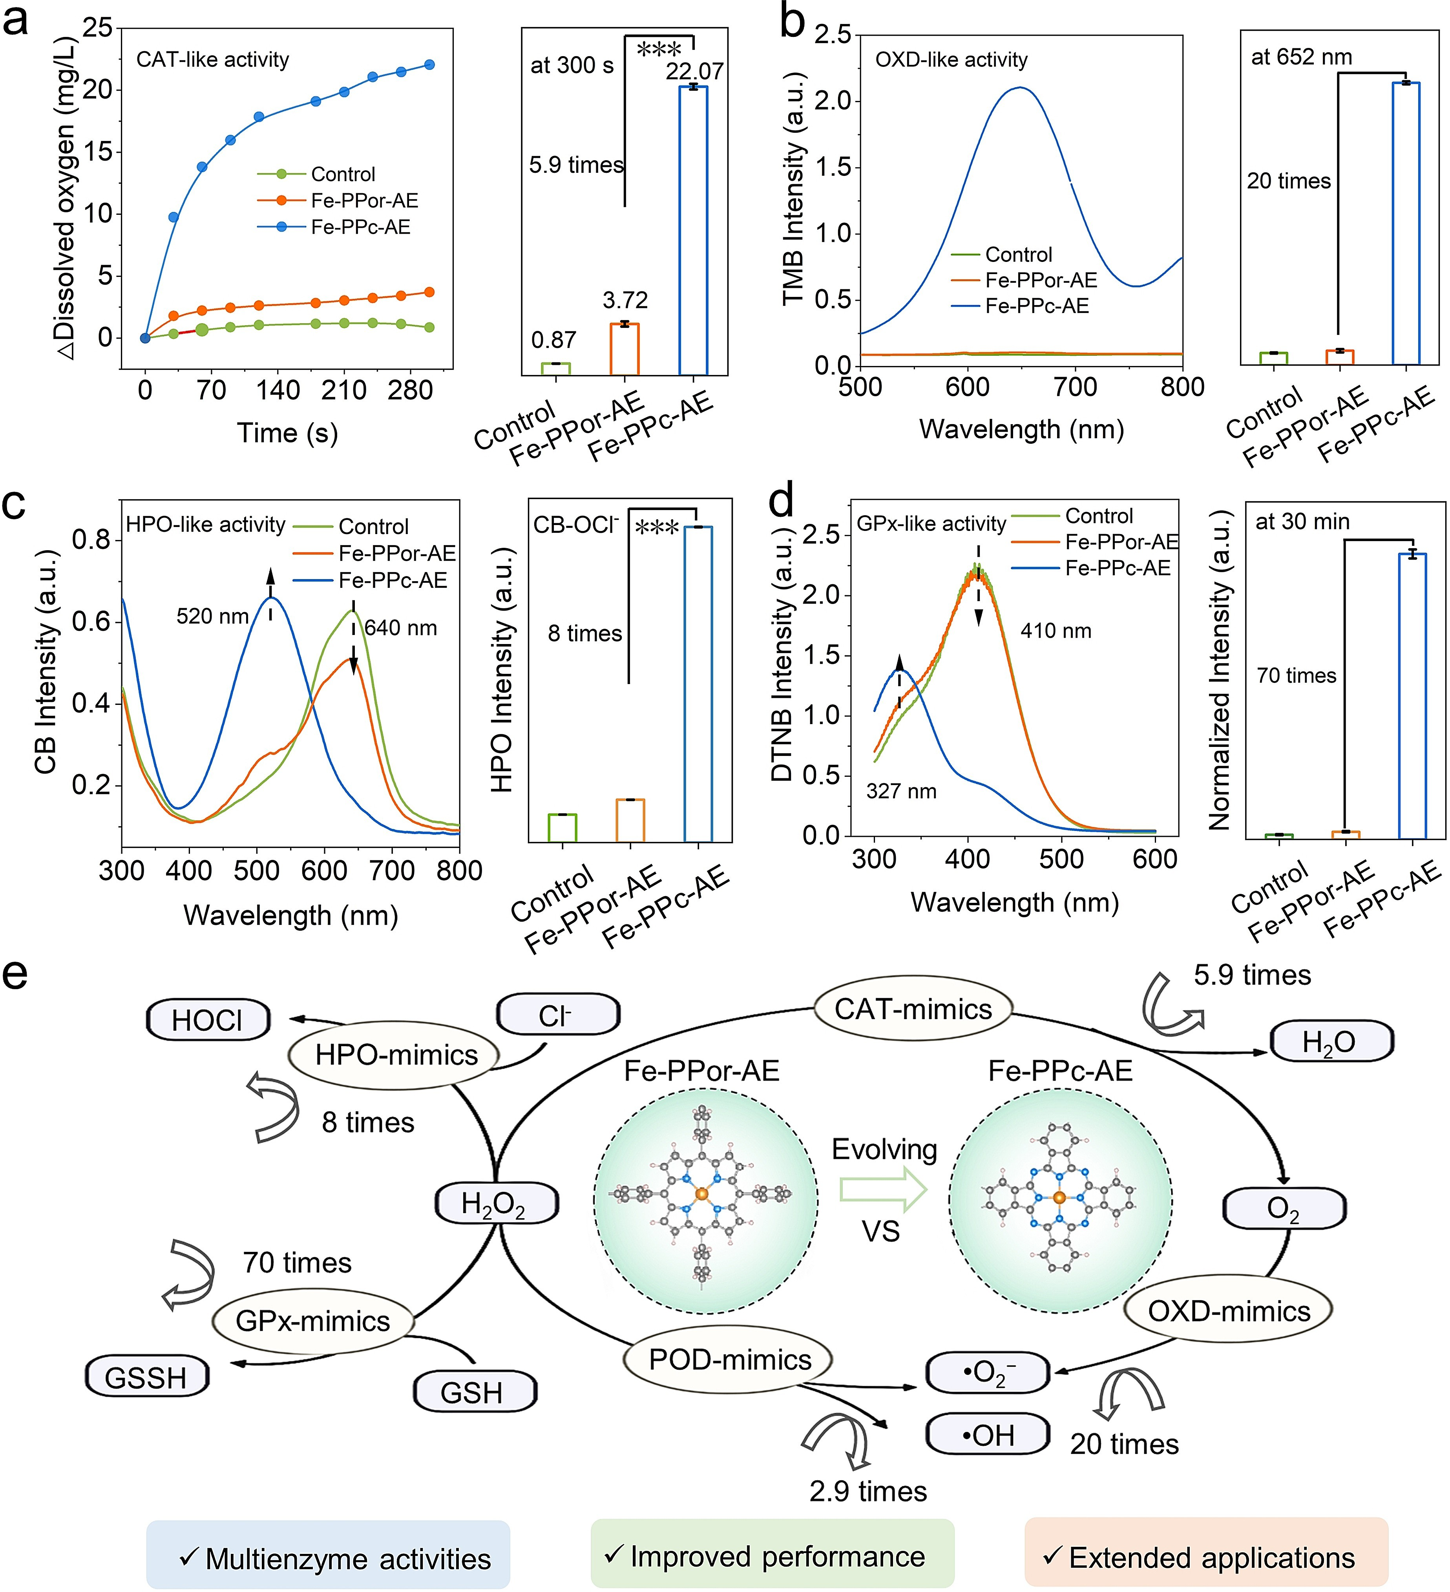Figure 6. Comparison of multiple enzyme-mimicking activities for heme-mimetic artificial enzymes. a) CAT-like activity, b) OXD-like activity, c) HPO-like activity, the relative activity refers to the rate of Intensity520 nm/Intensity645 nm (right; ***p < 0.001). d) GPx-like activity between Fe-PPor-AE and Fe-PPc-AE. e) Illustration of the multiple and improved performances of enzyme-mimicking activities of Fe-PPc-AE; here, n times refer to an improvement of enzyme-mimicking activities of Fe-PPc-AE when compared with Fe-PPor-AE and n values are calculated from Figure 4a and Figure 6a–d.

Conclusion
Inspired by the porphyrin-based heme-mimetic systems, we have demonstrated that the Fe-PPc-AE can serve as a new, efficient, and versatile porphyrin-evolving structure for augmented reactive oxygen catalysis. We comprehensively disclose and compare the ROS-related biocatalytic efficien-cies and specificity, the chemical structures, catalytic activ-ities, and reaction mechanisms between the Fe-PPc-AE and Fe-PPor-AE. Our experimental and theoretical studies indicate that the Fe-PPc-AE possesses several structural advantages, such as enhanced π conjugated networks and π-electron delocalization, promoted electron transfer, and unique Fe-N coordination centers. Consequently, the Fe-PPc-AE presents more efficient ROS-production activities in terms of Vmax and turnover numbers compared with the Fe-PPor-AE, which also surpasses the previously reported state-of-the-art ROS-biocatalytic artificial enzymes. More interestingly, by changing the reaction media and substrates, the Fe-PPc-AE also reveals significantly improved activity and environmental adaptivity in many other ROS-related biocatalytic processes, thus demonstrating that the porphyr-in-evolving Fe-PPc-AE with phthalocyanine conjugated networks exhibit great application potentials to substitute the conventional (poly)porphyrin-based heme-mimics for ROS-related catalysis, biosensors, or biotherapeutics. We believe that this study will offer essential guidance and new opportunities for creating efficient and versatile organic molecules and polymer-based artificial enzymes for broad applications.
Acknowledgements
This research was financially supported by the National Key R&D Program of China (2019YFA0110600 and 2021YFB3800705), National Natural Science Foundation of China (Nos. 52161145402, 52173133, 82302224, and 51973130), the Science and Technology Project of Sichuan Province (Nos. 2023YFH0008 and 2023YFS0019), and 1 · 3 · 5 Project for Disciplines of Excellence, West China Hospital, Sichuan University (No. ZYJC21047). Prof. Mohsen Adeli would like to thank Iran Science Elites Federation and Iran National Science Foundation (Project Number 4001281) for the financial support.
Conflict of Interest
The authors declare no conflict of interest.
Data Availability Statement
The data that support the findings of this study are available from the corresponding author upon reasonable request.
Keywords: artificial enzymes · biocatalysts · heme-mimetic materials · reactive oxygen species · peroxidase-like activity

References
[1] a) K. Chen, F. H. Arnold, Nat. Catal. 2020, 3, 203–213; b) A. J. Kirby, Angew. Chem. Int. Ed. 1996, 35, 706–724.
[2] a) J.-M. Choi, S.-S. Han, H.-S. Kim, Biotechnol. Adv. 2015, 33, 1443–1454; b) J.-P. Yuan, Z.-J. Guan, H.-Y. Lin, B. Yan, K.-K. Liu, H.-C. Zhou, Y. Fang, Angew. Chem. Int. Ed. 2023, 62, e202383161.
[3] a) H. Wei, E. Wang, Chem. Soc. Rev. 2013, 42, 6060–6093; b) J. Wu, X. Wang, Q. Wang, Z. Lou, S. Li, Y. Zhu, L. Qin, H. Wei, Chem. Soc. Rev. 2019, 48, 1004–1076; c) R. Zhang, K. Fan, X. Yan, Sci. China Life Sci. 2020, 63, 1183–1200; d) H. Huang, W. Geng, X. Wu, Y. Zhang, L. Xie, T. Ma, C. Cheng, Angew. Chem. Int. Ed. 2024, 63, e202310811.
[4] R. M. Bullock, J. G. Chen, L. Gagliardi, P. J. Chirik, O. K. Farha, C. H. Hendon, C. W. Jones, J. A. Keith, J. Klosin, S. D. Minteer, R. H. Morris, A. T. Radosevich, T. B. Rauchfuss, N. A. Strotman, A. Vojvodic, T. R. Ward, J. Y. Yang, Y. Surendranath, Science 2020, 369, eabc3183.
[5] a) M. Yuan, Q. Li, Z. Wu, H. Zhu, Y. Gao, M. Zhou, X. Luo, M. Wang, C. Cheng, Small 2023, 19, 2304532; b) S. Cao, Y. Long, S. Xiao, Y. Deng, L. Ma, M. Adeli, L. Qiu, C. Cheng, C. Zhao, Chem. Soc. Rev. 2023, 52, 6838–6881.
[6] a) Q. Wan, R. Zhang, Z. Zhuang, Y. Li, Y. Huang, Z. Wang, W. Zhang, J. Hou, B. Z. Tang, Adv. Funct. Mater. 2020, 30, 2002057; b) F. Hu, D. Mao, Kenry, X. Cai, W. Wu, D. Kong, B. Liu, Angew. Chem. Int. Ed. 2018, 57, 10182–10186.
[7] T. L. Poulos, Chem. Rev. 2014, 114, 3919–3962.
[8] a) S. McMillen Timothy, W. Heinecke Jay, C. LeBoeuf Renee, Circulation 2005, 111, 2798–2804; b) J. P. Gaut, G. C. Yeh, H. D. Tran, J. Byun, J. P. Henderson, G. M. Richter, M. L. Brennan, A. J. Lusis, A. Belaaouaj, R. S. Hotchkiss, J. W. Heinecke, PNAS 2001, 98, 11961–11966.
[9] a) C.-M. Che, J.-S. Huang, Chem. Commun. 2009, 3996–4015; b) T. Shimizu, A. Lengalova, V. Martínek, M. Martínková, Chem. Soc. Rev. 2019, 48, 5624–5657.
[10] F. Du, L. Liu, Z. Wu, Z. Zhao, W. Geng, B. Zhu, T. Ma, X. Xiang, L. Ma, C. Cheng, L. Qiu, Adv. Mater. 2021, 33, 2101095.
[11] J. Y. Zeng, X. S. Wang, X. H. Liu, Q. R. Li, J. Feng, X. Z. Zhang, Natl. Sci. Rev. 2023, 10, nwad142.
[12] B. Yang, H. Yao, J. Yang, C. Chen, J. Shi, Nat. Commun. 2022, 13, 1988.
[13] a) X. Liu, Z. Yan, Y. Zhang, Z. Liu, Y. Sun, J. Ren, X. Qu, ACS Nano 2019, 13, 5222–5230; b) C. Wang, F. Cao, Y. Ruan, X. Jia, W. Zhen, X. Jiang, Angew. Chem. Int. Ed. 2019, 58, 9846–9850; c) Y. Liu, Y. Cheng, H. Zhang, M. Zhou, Y. Yu, S. Lin, B. Jiang, X. Zhao, L. Miao, C. W. Wei, Q. Liu, Y. W. Lin, Y. Du, C. J. Butch, H. Wei, Sci. Adv. 2020, 6, eabb2695; d) G. Layer, J. Reichelt, D. Jahn, D. W. Heinz, Protein Sci. 2010, 19, 1137–1161.
[14] a) S. Cao, Z. Zhao, Y. Zheng, Z. Wu, T. Ma, B. Zhu, C. Yang, X. Xiang, L. Ma, X. Han, Y. Wang, Q. Guo, L. Qiu, C. Cheng, Adv. Mater. 2022, 34, 2200255; b) R. Zhang, X. Yan, K. Fan, Acc. Chem. Res. 2021, 2, 534–547.
[15] a) G. Fu, D. Yang, S. Xu, S. Li, Y. Zhao, H. Yang, D. Wu, P. S. Petkov, Z.-A. Lan, X. Wang, T. Zhang, J. Am. Chem. Soc. 2024, 146, 1318; b) R. Yan, B. Mishra, M. Traxler, J. Roeser, N. Chaoui, B. Kumbhakar, J. Schmidt, S. Li, A. Thomas, P. Pachfule, Angew. Chem. Int. Ed. 2023, 62, e202302276; c) F. Wang, Z. Liu, C. Yang, H. Zhong, G. Nam, P. Zhang, R. Dong, Y. Wu, J. Cho, J. Zhang, X. Feng, Adv. Mater. 2020, 32, 1905361; d) X. Zhao, P. Pachfule, S. Li, T. Langenhahn, M. Ye, C. Schlesiger, S. Praetz, J. Schmidt, A. Thomas, J. Am. Chem. Soc. 2019, 141, 6623–6630; e) J. Liu, Y. Chen, X. Feng, R. Dong, Small Struct. 2022, 3, 2100210; f) M. Wang, R. Dong, X. Feng, Chem. Soc. Rev. 2021, 50, 2764–2793; g) M. Gao, Z. Wang, Z. Liu, Y. Huang, F. Wang, M. Wang, S. Yang, J. Li, J. Liu, H. Qi, P. Zhang, X. Lu, X. Feng, Adv. Mater. 2023, 35, 2305575; h) W. Zhang, H. Zuo, Z. Cheng, Y. Shi, Z. Guo, N. Meng, A. Thomas, Y. Liao, Adv. Mater. 2022, 34, 2104952.
[16] a) A. B. Sorokin, Chem. Rev. 2013, 113, 8152–8191; b) P. A. Stuzhin, M. Hamdush, U. Ziener, Inorg. Chim. Acta 1995, 236, 131–139.
[17] a) C. W. Jones, Top. Catal. 2010, 53, 942–952; b) X. L. Li, Z. H. Xiang, Nat. Commun. 2022, 13, 57; c) Q. J. Zhi, W. P. Liu, R. Jiang, X. N. Zhan, Y. C. Jin, X. Chen, X. Y. Yang, K. Wang, W. Cao, D. D. Qi, J. Z. Jiang, J. Am. Chem. Soc. 2022, 144, 21328–21336.
[18] a) J. T. Hupp, Nat. Chem. 2010, 2, 432–433; b) W. Ji, T.-X. Wang, X. Ding, S. Lei, B.-H. Han, Coord. Chem. Rev. 2021, 439, 213875.
[19] a) H. Zhong, M. Ghorbani-Asl, K. H. Ly, J. Zhang, J. Ge, M. Wang, Z. Liao, D. Makarov, E. Zschech, E. Brunner, I. M. Weidinger, J. Zhang, A. V. Krasheninnikov, S. Kaskel, R. Dong, X. Feng, Nat. Commun. 2020, 11, 1409; b) M. Wang, R. Dong, X. Feng, Chem. Soc. Rev. 2021, 50, 2764–2793; c) P. Zhang, M. Wang, Y. Liu, S. Yang, F. Wang, Y. Li, G. Chen, Z. Li, G. Wang, M. Zhu, R. Dong, M. Yu, O. G. Schmidt, X. Feng, J. Am. Chem. Soc. 2021, 143, 10168–10176; d) F. Chen, H. Zhu, N. Lv, Q. Li, T. Ma, L. Wang, M. Zhou, S. Cao, X. Luo, C. Cheng, Chem. Eur. J. 2022, 28, e202104591; e) L. Zhang, T. Wang, W. Wang, X. Wang, Z. Zhang, C. Cheng, X. Liu, ChemPhotoChem 2022, 6, e202100229; f) Z. Zhang, W. Wang, X. Wang, L. Zhang, C. Cheng, X. Liu, Chem. Eng. J. 2022, 435, 133872.
[20] G. Yang, Z. Liu, S. Weng, Q. Zhang, X. Wang, Z. Wang, L. Gu, L. Chen, Energy Storage Mater. 2021, 36, 459–465.
[21] Y. Nosaka, A. Y. Nosaka, Chem. Rev. 2017, 117, 11302–11336.
[22] S. Suleman, Y. Zhang, Y. Qian, J. Zhang, Z. Lin, Ö. Metin, Z. Meng, H.-L. Jiang, Angew. Chem. Int. Ed. 2024, 63, e202314988.
[23] H. Tan, P. Zhou, M. Liu, Q. Zhang, F. Liu, H. Guo, Y. Zhou, Y. Chen, L. Zeng, L. Gu, Z. Zheng, M. Tong, S. Guo, Nat. Synth. 2023, 2, 557–563.
[24] F. Xia, Q. Shi, Z. Nan, Dalton Trans. 2020, 49, 12780–12792.
[25] B.-Q. Li, S.-Y. Zhang, X. Chen, C.-Y. Chen, Z.-J. Xia, Q. Zhang, Adv. Funct. Mater. 2019, 29, 1901301.
[26] J. Chen, K. Zou, P. Ding, J. Deng, C. Zha, Y. Hu, X. Zhao, J. Wu, J. Fan, Y. Li, Adv. Mater. 2019, 31, 1805484.
[27] a) T. Zhang, Z. Chen, A. G. Walsh, Y. Li, P. Zhang, Adv. Mater. 2020, 32, 2002910; b) M. Lu, C. Wang, Y. Ding, M. Peng, W. Zhang, K. Li, W. Wei, Y. Lin, Chem. Commun. 2019, 55, 14534–14537.
[28] S. Yang, Y. Yu, M. Dou, Z. Zhang, L. Dai, F. Wang, Angew. Chem. Int. Ed. 2019, 58, 14724–14730.
[29] J. Xiao, Q. Han, H. Cao, J. Rabeah, J. Yang, Z. Guo, L. Zhou, Y. Xie, A. Brückner, ACS Catal. 2019, 9, 8852–8861.
[30] X. Lu, S. Gao, H. Lin, L. Yu, Y. Han, P. Zhu, W. Bao, H. Yao, Y. Chen, J. Shi, Adv. Mater. 2020, 32, 2002246.
[31] Z.-Y. Wang, Y. Li, W.-Q. Chang, J.-Y. Zheng, P. Li, L.-F. Liu, G.-Z. Xin, Anal. Chim. Acta 2018, 999, 107–113.
[32] a) G. Kresse, J. Furthmüller, Phys. Rev. B Condens. Matter 1996, 54, 11169–11186; b) G. Kresse, J. Hafner, Phys. Rev. B 1994, 49, 14251–14269.
[33] Z. Wu, Y. Sun, S. Mu, M. Bai, Q. Li, T. Ma, L. Ma, F. Chen, X. Luo, L. Ye, C. Cheng, Angew. Chem. Int. Ed. 2023, 62, e202302329.
[34] a) L. Pan, M. Ai, C. Huang, L. Yin, X. Liu, R. Zhang, S. Wang, Z. Jiang, X. Zhang, J.-J. Zou, W. Mi, Nat. Commun. 2020, 11, 418; b) H. Li, S. Di, P. Niu, S. Wang, J. Wang, L. Li, Energy Environ. Sci. 2022, 15, 1601–1610.

