Towards ultra-high strength dual-phase steel with excellent damage tolerance: the effect of martensite volume fraction
Lang Liu ^{a, b}, Liejun Li ^{a, *}, Zhiyuan Liang^{c}, Mingxin Huang ^{d}, Zhengwu Peng ^{d}, Jixiang Gao ^{e}, Zhichao Luo ^{b, **}
ª National Engineering Research Center of Near-net Shape Forming Technology for Metallic Materials, South China University of Technology, Guangzhou 510640, China
^{b} Institute of New Materials, Guangdong Academy of Sciences, Guangzhou 510651, China
^{c} Songshan Lake Materials Laboratory, Dongguan 523808, China
^{d} Department of Mechanical Engineering, The University of Hong Kong, Pokfulam Road, Hong Kong, China
^{e} Guangdong Polytechnic Normal University, Guangzhou 510635, China
* E-mail addresses: luozhichao@gdinm.com (Z.C. Luo), liliejun@scut.edu.cn

Abstract: Ultra-high strength ( > 1 GPa) dual-phase (DP) steels were investigated extensively, yet, the damage tolerance of these DP steels remain mostly unexplored, which is crucial for the sheet formability and anti-crushing performance. In this work, a medium-Mn DP steel was proposed in order to develop strong but damage-resistant DP steel by refining the microstructure. Ultra-fine grained (< 1 µm) DP steels were obtained by a simple cold rolling and intercritical annealing process. The present DP steel can achieve an outstanding ultimate tensile strength (UTS) of over 1470 MPa with appreciable total elongation (TE) of over 9% when the martensite volume fraction (V_{m}) is 55%. Higher V_{m} results to a better combination of strength and elongation. However, the fracture strain, i.e., damage tolerance, decreases significantly with increasing V_{m}. The fracture strain of DP steel with a V_{m} of 85% is even much lower than that of a full martensite steel. Furthermore, the necking behaviour transfers from diffuse plus localized necking to diffuse necking with increasing V_{m}. The sufficient ferrite content in the present DP1470 steel enable void growth after nucleation, consequently leading to the occurrence of localized necking and higher fracture strain. In other words, a moderate V_{m} ranging from 45% to 65% is suggested for the development of 1470 MPa grade DP steel with excellent damage tolerance.

Keywords: Ultra-high strength DP steel, Damage tolerance, Martensite volume fraction, Ultra-fine grain, Medium-Mn.

Introduction
Dual-Phase (DP) steel, a typical type of advanced high-strength steel (AHSS), has been widely used in the automotive industry due to its robust thermo-mechanical processing and excellent combination of strength and elongation (Khosravani et al., 2017; Liao et al., 2017; Liu et al., 2020; Lu et al., 2022). To meet the increasing demand for lightweight vehicles, ultra-high strength DP steel is developing. Currently, the highest strength grade of commercial DP steel has reached 1470 MPa (Atreya et al., 2021; Kalhor et al., 2021), which is identical to that of the press hardening steel (PHS) 22MnB5. However, the development and utilization of ultra-high strength DP steel is being compromised by their poor damage tolerance and therefore, high edge cracking tendency and low hole expansion ratio (HER) (Shang et al., 2023).
Increasing carbon content and martensite volume fraction (V_{m}) can effectively improve the strength of DP steel (Pierman et al., 2014). The carbon content in conventional DP steel is generally kept below 0.15 wt.%. With the increasing demand for high strength, Lee et al., gradually rises the carbon content to around 0.2 wt.% (Lee et al., 2012). Mazaheri et al., reported a 1300 MPa DP steel with a carbon content of 0.17 wt.% (Mazaheri et al., 2015a). However, high carbon content inevitably increases the hardness of martensite phase. The large strength difference between martensite (M) and ferrite (F) causes strong strain gradient in the F/M interface and promote the F/M decohesion damage due to the accumulation of geometrically necessary dislocations (GND) (Kadkhodapour et al., 2011c). Lai et al., found that increasing the V_{m} can both improve the yield and tensile strength, but reduce the uniform elongation and fracture strain due to the onset of plastic deformation and damage accumulation in martensite (Lai et al., 2016). For instance, Pushkareva et al., prepared a 1180 MPa DP steel with a low ductile fracture strain of 0.3 when the V_{m} is as high as 82% (Pushkareva et al., 2015). Though high V_{m} will reduce the damage resistance of DP steel, it should be noted that high V_{m} is becoming a prerequisite for the development of recent ultra-high strength DP steels.
Grain refinement is yet the most effective method to improve both strength, ductility, and damage tolerance (Gao et al., 2021; Khan and Meredith, 2010; Miura et al., 2017). For DP steel, microalloying elements such as Nb, V, Mo, etc., are often utilized to achieve both grain refinement strengthening as well as precipitation strengthening (Li et al., 2019; Pelligra et al., 2022; Son et al., 2005). For instance, Samei et al., prepared a DP1300 steel with 0.14 wt.% V (Samei et al., 2019). The V addition can reduce the ferrite grain size from 4.8 µm to 1.6 µm. They further reported that the pronounced grain refinement can cause a significantly improved micromechanical compatibility and increased local ductility of DP steel (Pelligra et al., 2022). The wisdom of utilizing V or their precipitations to enhance the strength-ductility balance of DP steel can be traced back to 1979 (Davies, 1979). Recent developments (Kamikawa et al., 2015a; Scott et al., 2017; Scott et al., 2018; Zhang et al., 2021) have make considerable efforts to understand the mechanisms responsible for the improved mechanical properties of the V-alloyed DP steel. Among them, the softening of martensite was experimentally found (Scott et al., 2018) and enhanced martensite deformability was suggested in the V-alloyed DP steels (Zhang et al., 2021). Further study is required to investigate the influence of martensite fraction, grain size and/or precipitation on the deformation and fracture behaviour of the V-alloyed DP steels with high V_{m}.
Compared with the effect of microalloying elements on grain refinement, the Mn has received less attention despite its crucial role on the microstructure evolution of DP steel. Zou et al., suggest that a certain Mn content of around 1.5 wt.% is necessary for conventional DP steel to avoid grain growth during intercritical annealing and ensure sufficient hardenability (Zou et al., 2022). On the other hand, it has been reported that the 3-12 wt.% Mn in medium-Mn steel (the termed third-generation AHSS) enables the formation of ultra-fine grained microstructure with a grain size near or below 1 µm by one-step intercritical annealing treatment (Sun et al., 2023). Different from the carbides-forming elements, the addition of Mn can reduce the intercritical annealing temperature and retard the growth of austenite by its slow diffusion rate (Sun et al., 2023). By utilizing the combined effect of microalloying element and Mn on grain refinement may shed new light on the development of ultra-strong yet damage-tolerant DP steels.
The objective of this paper is to develop ultra-high strength DP steel with improved damage tolerance. We propose a medium-Mn DP steel strategy in order to refine the grain size to submicron level (< 1 µm). A Mn content of 3.2% is used for demonstration. DP steels with various V_{m} were obtained by a simple cold rolling and intercritical annealing under different temperatures. Nano-indentation and electronic probe microscope analyzer (EPMA) were conducted to determine the mechanical property and chemical composition of ferrite and martensite. We present the respective strength contribution of each phase constituency and each strengthening mechanism. The prepared DP1470 steel contains a V_{m} of about 55%, which enables sufficient void growth and therefore, excellent damage tolerance. As the V_{m} increases, the DP steels with higher strength and better strength-ductility combination were obtained. However, the necking behavior transforms from diffuse and localized necking into diffuse necking with increasing V_{m}, which in turn results to a sharp decrease of fracture stain.

Materials and methods
The experimental steel has a composition of Fe-0.19C-0.26Si-3.2Mn-0.16V-0.19Mo (in wt.%). The increased Mn content could avoid grain growth during annealing and reduce the Ac₁ temperature to improve grain size stability. The adequate carbon content enhances the solid-solution carbon concentration in martensite and promotes carbide precipitation. The moderate content of V and Mo could refine grain size, with V precipitating during the annealing process. The steel was melted in a vacuum induction furnace and then cast into a 50-kg ingot. It was homogenized at 1250 ℃ for 2 h to allow solid solution of alloy elements, and forged into square bars with a cross-sectional area of 100 × 100 mm² in the temperature range of 1150-1250 ℃.
The thermomechanical processing routs is shown in Fig. 1. Hot-rolled sheets with a thickness of 4 mm were obtained by hot rolling at 900-1150 ℃ and then cooled to room temperature in static air. After pickling and polishing the oxide skin on the surface of the hot-rolled plate, cold rolling with a reduction rate of 50% was carried out. Then the cold-rolled sheets with a thickness of 1.8-1.9 mm were heated to the intercritical region and maintained at different temperatures between 715 and 815 °C for 10 min, followed by oil quenching. The lower and upper critical temperatures i.e. Ac₁ and Ac₃ temperatures were determined by Gleeble-3800 thermal simulator.
Tensile tests were performed on a 100 kN Servo-Hydraulic Testing Machine with a Epsilon extensometer (strain rate 1e⁻³). All tensile samples are standard size samples with a 25 mm gauge length and 6 mm width, machined along rolling direction of the sheet (ASTM-E8M). Tensile samples under different stress triaxialities were prepared into samples with four different curvature radius notches as shown in Fig. 2.
The reference basis for the sample design size in this study is based on the correction equation proposed by Bridgman (PW, 1964) for the stress state in a flat (plane strain) specimen undergoing necking, which is as follows:
$$η=\frac{1}{3}+\ln\left[1+\frac{a}{2R}\left(1−\frac{y^{2}}{a^{2}}\right)\right] (1)$$
where η is the stress triaxiality, R is the radius of curvature due to deformation or prenotching, and ɑ is half the ligament width. The ligament width is the distance between the notches and is equivalent to the gauge width of the uniaxial specimens (4 mm in this work). Varying y permits the stress calculations along the width of the specimen. At the center of the specimen, Eq. (1) reduces to the form of:
$$η=\frac{1}{3}+\ln\left(1+\frac{a}{2R}\right) (2)$$
which is identical to that found for axisymmetric specimens.
In this work, four different notch radii were chosen (∞, 2.00, 1.06, and 0.64 mm) to obtain four initial triaxialities (0.33, 0.74, 1, and 1.5). All samples were fabricated with the rolling direction oriented along the tensile loading axis. The fracture strains (ε_{f}) can be obtained from the reduction of area (RA) using:
$$ε_{f}=\ln{\frac{A_{0}}{Af}}=\ln\left(\frac{1}{1−RA}\right) (3)$$
where A₀ is the initial cross-sectional area and A_{f} is the cross-sectional area after fracture.
The samples for nanoindentation were mechanically ground and polished, and then electrolytically polished in a solution of 10% perchloric acid + 90% acetic acid, electrolyzed 40 s at a voltage of 20 V. In the nano-indentation experiment, indentation points are arranged in a 10 × 10 matrix with a load of 800 μN and a loading and unloading rate of 50 μN/s. The distance between each indentation point is 2 μm.
The microstructure were examined by scanning electronic microscopy (SEM, Zeiss Sigma 300), electron back scattered diffraction (EBSD, Nova^{TEM}NanoSEM 450 with HIKARI SERIES), and transmission electron microscopy (TEM, Thermo Scientific FEI Talos F200X). The grain size and volume fraction of ferrite as well as martensite were measured by the software Image-J. Metallographic samples for SEM were mechanically ground and polished and then etched in a solution of 4% (volume fraction) nitric acid. Metallographic samples for EBSD were electrolytically polished in a solution of 10% perchloric acid + 90% acetic acid, electrolyzed for 35 s at a voltage of 20 v. In addition, samples for TEM were mechanically ground to a thickness of 200 μm and then electropolished in a twin-jet machine in a solution of 5% perchloric acid + 95% alcohol at 20 ℃.
The carbon concentration of the tested steels were examined by EPMA (JXA-IHP200F). The point scan area was outside the surface scan area to avoid high carbon concentration due to carbon deposition. A point scan radius of 0.5 μm was used to allow the entire point scan area to be located on the complete phase to maximize the accuracy of carbon concentration measurements. X-ray microtomography was used to display detailed 3D macro fracture diagram of the fracture samples by Xradia Versa 610. Each sample had 995 projections, and each projection had a scan thickness of 3.8 μm. The stage rotated at a constant speed during data acquisition.

Results
The mechanical properties of tested steels were investigated by quasi-static tensile tests. The engineering stress-strain curves are presented in Fig. 3a. The true stress-strain curves and work hardening rate (WHR) curves obtained from Fig. 3a are shown in Fig. 3(b, c). As the temperature increases, the UTS and yielding stress increase while TE decreases due to an increase in the volume fraction of hard martensite (Fig. 3(a, b)). Samples annealed at temperatures above 755 °C can achieve a UTS exceeding 1470 MPa, which represents the highest strength grade of commercial DP steel (Atreya et al., 2021; Lesch et al., 2017), while TE remains above 9%. Fig. 3c illustrates that as the heat treatment temperature exceeds 755 ℃, the WHR initially increases and then decreases rapidly with increasing strain during stage I.
Fig. 4 shows the microstructure of tested steels. All steels mainly consist of ferrite and martensite except the 715-10 steel. The EBSD results confirm the presence of 11 vol.% residual austenite in the 715-10 steel. Higher V_{m} is clearly observed with increasing intercritical annealing temperature as shown in Fig. 4. The martensite presents as an island-like morphology at low temperatures, but gradually transforms into lath-like martensite with rising temperature. In addition, a high density of non-dissolved carbide particles was observed in the 715-10 steel. These particles dissolve into the matrix as the temperature exceeds 755 °C. The V_{m} in 715-10, 735-10, 755-10, 775-10, 795-10, and 815-10 steel is 7%, 32%, 55%, 75%, 85%, and 99%, respectively.
The mechanical and microstructure characteristics are summarized in Table 1. It shows that the post-uniform elongation (PUE) and reduction of area (RA) initially decrease but then increase as the V_{m} increases. The yield ratio keeps increasing with V_{m} except the 715-10 steel. All tested steels exhibit the ultra-fine ferrite grains (0.79 - 1.7 μm), while conventional DP steels have grain sizes ranging from 3.24 to 9.4 μm (Nikkhah et al., 2019; Wu et al., 2020). It is interesting to find that the 755-10 steel possesses the lowest PUE of 2.6%. But the 755-10 steel has a much higher RA compared to the 795-10 steel, whose PUE is as high as 4.4%. It is inconsistent with the conventional views that higher PUE corresponds to higher RA (Samei et al., 2019).
Fig. 5 shows the EBSD results of the representative 715-10, 755-10, 795-10 and 815-10 steels. The IPF maps indicate that the grain size of 755-10 steel is much finer than that of 715-10 steel due to the presence of higher V_{m}. But the grain size does not change considerably with subsequent increases in temperature. This can be attributed to the presence of martensite islands, which disrupts the continuity of the ferrite matrix and prevents ferrite grain growth, resulting in a constant grain size when the matrix continuity of ferrite is disrupted (Badkoobeh et al., 2022). The amount of grain boundaries in vary with misorientation were quantitatively determined as shown in Fig.5. The density of low-angle grain boundaries does not change significantly with increasing intercritical annealing temperature. The density of high-angle grain boundary rapidly increases from 0.98 μm·um⁻² in 715-10 steel to 3.01 μm·um⁻² in 755-10 steel.
Fig. 5 also shows the band contrast (BC) and kernel average misorientation (KAM) maps. The lattice distortion occurs during the transition from austenite to martensite due to volume expansion. These strains exist within M, at M-M interfaces, at M-F interfaces, and at F-F interfaces. The highest strains are found at the M and M-M interfaces, followed by the M-F interface. Ferrite can act as a strain buffer and absorb the strain energy during the phase transformation. When local stress within a ferrite grain exceeds the elastic limit of ferrite, mobile dislocations are generated. These dislocations move under lower stresses, increasing the initial WHR on the one hand while eliminating the yield plateau on the other hand, thereby cause continuous yielding in DP steel (Atreya et al., 2021). Besides, the region with low local misorientation (blue area) is reduced due to the increase in V_{m}.
TEM was conducted to characterized the microstructure. Fig. 6(a-d) are TEM bright field (BF) micrographs at low magnification. The martensite and ferrite can be clearly identified. Many large-sized particles were observed in the 715-10 steel. They are identified as Mn-rich particles through EDS mapping (Fig. 6i). Fig. 6(e-h) are the higher magnifications of ferrite grains showing the distribution of dislocations. The observation of dislocation was conducted under the same g-vector condition ($\vec{g}$= ˂110>). As the V_{m} increased, the ferrite was compressed due to the expansion of martensite, leading to an increase of dislocation density in ferrite as shown in Fig. 6e and Fig. 6f. However, the differences between 755-10 steel and 795-10 steel are not significant. Particularly, the dislocation lines in four samples are uniformly distributed within the ferrite, inconsistent with the findings of (Atreya et al., 2021) which mentioned the inhomogeneous distribution of dislocation towards the F-M interface. The EDS results also indicate that the smaller particles are enriched with V. High-resolution (HR) TEM images of the V-rich phase on ferrite and martensite were obtained and shown in Fig. 6(j, k). The Fourier transformation (FFT) determines that the V-rich particles are VC phase.
The nanohardness of ferrite and martensite can be obtained by the loading and unloading curves from nano-indentation results as shown in Fig. S2. The calculation results are shown in Table 2. The data indicates that as V_{m} increases, the nanohardness of ferrite does not change significantly, while that of martensite initially increases and then decreases. The nanohardness difference between martensite and ferrite of 715-10, 755-10, and 795-10 steel is 2.5, 5.72, and 3.73 GPa, respectively. The carbon contents in ferrite and martensite were counted separately by the EPMA measurement as shown in Fig. S3. The results are also presented in Table 2. The carbon content in martensite of 715-10, 755-10 and 795-10 steel is 0.21, 0.34, and 0.18 (wt.%), respectively. The martensite in 755-10 steel contains the highest carbon content and hence possesses the highest hardness. In other words, the phase strength ratio (PSR) of ferrite against martensite in 755-10 steel is the lowest among all the test steels.
Tensile tests with varying stress triaxialities (η) were conducted to evaluate the damage tolerance of tested steels. Fig. 7 shows the fracture strains results depending on the heat treatment processes and η. The fracture strain exhibits a trend of initial decrease and then increase with rising temperature (Fig. 7a). The lowest fracture strain corresponds to 795-10 steel with a V_{m} of 85%. At an η value of 0.33, the fracture strain decreases from 0.86 of 715-10 steel to 0.3 of 795-10 steel, while increases to 0.65 of 815-10 steel. The influence of stress state on fracture strain is illustrated in Fig. 7b. A negative correlation between fracture strain and stress triaxiality is observed, consistent with findings by (Seo et al., 2022). The stress localization facilitates the formation of voids and microcracks, thus promoting the initiation and propagation of cracks (Seo et al., 2022).
Fig. 8 presents typical fracture surface morphologies of tested steels under two η conditions (0.33 and 1). Yellow circles in the figure denote the dimples, while red rectangles indicate the quasi-cleavage facets. An increase in temperature reduces the dimple density for smooth specimens (η = 0.33). Quasi-cleavage facets with tear ridges are observed in 775-10 and 795-10 steel. However, only dimples were observed in 815-10 steel. A similar trend is observed when η = 1. But quasi-cleavage facets become dominant in the fracture surfaces of 755-10, 775-10 and 795-10 steels as shown in Fig. 8. The findings from fracture surface morphologies are consistent with the results of fracture strain. In other words, the decrease of fracture strain with increasing η and V_{m} is accompanied by the occurrence and prevalence of quasi-cleavage fracture mechanism.
Fig. 9 displays the fracture modes of four tensile fracture samples with distinct microstructures and fracture strains. Smooth specimens (η = 0.33) were prepared and the results were obtained by X-ray microtomography and SEM. The 3D images reveal that the size reduction at the cross-section is clearly observed from top and side views. The fracture section shrinkage of 795-10 steel is the lowest among the four steels as shown in Fig. 9. The low-magnification SEM images show that the 795-10 steel exhibits diffuse necking, while the other three exhibit both diffuse and localized necking. Non-localized necking is present in 795-10 steel, indicating a very low section shrinkage (Samei et al., 2019). The high-magnification SEM images reveal the distribution characteristics of voids on different matrices. The matrix of 715-10 steel contains many Mn/V-rich particles of ferrite, with voids primarily nucleating and growing around these particles. For the 755-10 steel (with 55% V_{m}), voids tend to nucleate at the F/M interface. As the V_{m} reaches 85% (795-10 steel), no voids are observed in tensile sample. The absence of void in 795-10 steel may be caused by inadequate of necking and its low fracture strain.

Discussion

4.1 The origin of ultra-fine grained microstructure
The experimental results indicates that ultra-fine grained (less than 1 μm) DP steel has been prepared by simple thermomechanical processing routes. Fig. 10a illustrates the V_{m}-dependent tensile properties. The UTS increases while UE decreases as the V_{m} rises. When the V_{m} exceeds 55%, the UTS of all tested steels exceeds 1470 MPa and the UE exceeds 4.5%. It is interesting to find that when the V_{m} higher than 75%, the UTS remains essentially unchanged. The combined effect of decreasing carbon concentration in martensite and increasing V_{m} leads to the maintenance of the UTS.
The 755-10 steel (with 55% V_{m}) exhibits a favorable mechanical properties, with a YS of 1005 MPa, an UTS of 1632 MPa, allied with an UE of 5.9%. Despite the presence of a significant amount of hard martensite in 755-10 steel, the matrix structure remains ferritic as shown in Fig. 3. The continuity of the ferrite matrix structure ensures high plasticity of the 755-10 steel. Furthermore, with nearly equal volume fractions, the growth of both types of grains is mutually constrained, resulting in a relatively fine-grained dual-phase structure.
The medium-Mn content in the present DP steel plays a crucial role on the evolution of ultra-fine microstructure in several ways. Our TEM results demonstrate that the Mn content in martensite is as high as 3.22 - 4.12%, while that in ferrite is 1.60 - 2.06%. The large difference in M/F phase manifest a strong solute drag effect of Mn and thus reducing the grain boundary mobility (Qiu et al., 2015). The second beneficial effect of Mn is to lower the Ac₁ temperature, thus obtaining the same amount of austenite at lower temperatures. Annealing at lower temperatures means slower kinetics of grain growth (Calcagnotto et al., 2011b). Furthermore, Mn leads to a finer distribution of cementite in the initial microstructure, which further promotes the pinning effect to grain boundary (Morsdorf et al., 2023). Meanwhile, the original hot-rolled microstructure with bainite and carbide obtained by air cooling after austenitizing has much substructures after cold rolling, as shown in Fig. S1. These grain boundaries and dislocations promote the nucleation of ferrite and austenite, further refining the grains (Sun et al., 2023).
We compared our experimental results with those reported in other studies (Calcagnotto et al., 2011a; Dulucheanu et al., 2019; Frómeta et al., 2021; Kamikawa et al., 2015a; Kang et al., 2013; Mazaheri et al., 2019; Mazaheri et al., 2015a; Miernik and Pytel, 2014; Pushkareva et al., 2015; Scott et al., 2017; Zhang et al., 2021) (including carbon content, V_{m}, and UTS) and the commercial DP590, DP780, DP980, DP1180, and DP1470 steels. The results are presented in Fig. 10b. The UTS increases with an increase in V_{m}. Additionally, the carbon content of tested steels significantly increases UTS due to the strong effect soluted carbon to the dislocation density of martensite. Compared to other results, our work stands out significantly. Compared to the DP steels with a UTS above 1470 MPa, our steels require only a V_{m} of 55%, while others require 80% or even more. Therefore, the present medium-Mn DP steel strategy is demonstrated for the production of ultra-high strength DP steel with submicron grain size.
It has been reported that grain refinement plays a significant role in promoting ductile fracture mechanisms (Calcagnotto et al., 2011a). Coarse grain (CG) DP steel, characterized by martensite banding, large martensite islands, and unfavorable distribution along ferrite grain boundaries, tends to exhibit brittle fracture behavior. Conversely, fine grain (FG) and ultra-fine grain (UFG) DP steels show seldom occurrence of martensite cracking due to the enhanced martensite plasticity and improved interface strength (Pelligra et al., 2022). The plastic deformation of martensite releases part of the local concentrated stress and retards void formation, ultimately leading to higher fracture strains.

4.2 The respective strengthening mechanism
The strength of DP steel can be calculated using the rule of mixtures (Xiong et al., 2021), which can be expressed as:
$$σ_{tot}=f_{f}σ_{f}+f_{m}σ_{m} (4)$$
where σ_{tot} is the total yield strength, f_{f} and f_{m} are the volume fractions of ferrite and martensite, σ_{f} and σ_{m} are the yield strength of ferrite and martensite, respectively.
The relationship between yield strength and microstructure can be predicted by the following equation (Kang et al., 2013; Mazaheri et al., 2015b):
$$σ=σ_{0}+σ_{s}+σ_{P}+σ_{d}+σ_{g} (5)$$
where σ₀ is friction stress of single crystal pure iron (= 54 MPa), σ_{s}, σ_{p}, σ_{d} and σ_{g} are contributions from solid solution strengthening, precipitation strengthening, dislocation strengthening and grain boundary strengthening, respectively. The strength of 715-10 steel is not estimated due to exist of residual austenite.
The σ_{s} contribution could be expressed using the following empirical equation (Pan et al., 2023):
σ_{s} = 83 [Si] + 32 [Mn] + 11[Mo] + 13 [Al] $(6)$
where [X] represents the mass fraction (wt.%) of element X in solution. The contribution of carbon is not involved because it should be calculated by the dislocation strengthening (Chen et al., 2021; Pan et al., 2023). EDS point scanning results under TEM reveal that the Mn content is approximately double in martensite compared to ferrite, while the content of other elements in the matrices is similar. Thus, the calculated σ_{s} contributions of ferrite/martensite in 755-10, 795-10 and 815-10 steels are 99/153 MPa, 83/137 MPa, and 76/128 MPa, respectively.
The σ_{p} contribution could be expressed by following formula according to the data obtained in the physicochemical phase analysis (Xie et al., 2022):
$$σ_{P}=0.112×MGb\frac{\sqrt{V_{MC}}}{d}\ln\left(\frac{d}{b}\right) (7)$$
where M is Taylor factor related to the metal structure (2.54 for ferrite and 3 for martensite); G is shear modulus (83 GPa for ferrite and 80 GPa for martensite); V_{MC} is the volume fraction of VC particles; d is the mean radius of VC particles; b is Burgers vector (0.25 nm). The volume fractions of VC particles on ferrite and martensite are similar, but their sizes are different. The volume fraction and size was shown in Table S1. The calculated σ_{p} contributions of ferrite/martensite in 755-10, 795-10 and 815-10 steels are 138/136 MPa, 99/98 MPa, and 84/73 MPa, respectively.
The σ_{d} contribution of martensite can be expressed by following equation (Pan et al., 2023):
$$σ_{d}=MαGbρ^{1∕2} (8)$$
where α is a constant (0.24 for martensite); ρ is dislocation density. The results of dislocation density were derived from an empirical formula related to the carbon concentration of matrix (wt.% C: 0.0026~0.38) (MORITO et al., 2003):
$$ρ×{10}^{−15}=0.65+2.3wt.\% C (9)$$
The dislocation densities of martensite in 755-10, 795-10 and 815-10 steels are 1.43×10¹⁵ m⁻²,1.06×10¹⁵ m⁻² and 0.99×10¹⁵ m⁻², respectively. The σ_{d} contribution calculated are 545 MPa, 469 MPa and 454 MPa, respectively.
The σ_{g} contribution could be expressed by following formula equation (Kamikawa et al., 2015b):
$$σ_{g}=kd^{−1∕2} (10)$$
where k is the Hall-Petch coefficient (210 MPa/μm^{1/2}); d is grain size (μm). The grain sizes of martensite are counted by TEM images, and those in 755-10, 795-10 and 815-10 steels are 1.9 μm，0.37 μm and 0.21 μm. The calculated σ_{g} contributions of ferrite/martensite are 212/148 MPa, 231/ 347MPa, and 236/ 458MPa, respectively.
The σ_{d} contribution of ferrite mentioned above have not been calculated, but can be derived by the formula mentioned above ($σ=σ_{0}+σ_{s}+σ_{P}+σ_{d}+σ_{g}$). The derived σ_{d} contribution of ferrite in 755-10, 795-10 and 815-10 steels are 16 MPa, 132 MPa, and 211 MPa, respectively. The respective strengthening contributions are presented in Table 3. It shows that the precipitation hardening play a moderate role on the strength of DP steels. The ultra-high strength of DP steel is dominated by the forest dislocation hardening and grain boundary strengthening.

4.3 The correlation between damage mechanism and necking behaviour
The damage tolerance of DP steel is affected by both intrinsic and extrinsic factors (Kadkhodapour et al., 2011a; Kadkhodapour et al., 2011b). The intrinsic factors include martensite volume fraction (V_{m}) (Lai et al., 2015; Matsuno et al., 2014), martensite morphology (Ismail et al., 2019; Park et al., 2014; Yan et al., 2015), grain size (Calcagnotto et al., 2011a), and especially, nanohardness difference between ferrite and martensite (Azuma et al., 2013). For example, Lai et al. reported that the dominant damage mechanism changes from F/M decohesion to the crack of martensite as the V_{m} increases (Lai et al., 2015). Island martensite with a higher F/M strain gradient is prone to void nucleation, while chain martensite with low F/M strain gradient delays void nucleation but generates secondary voids in ferrite or brittle cracks at F-M interface, which in turn leads to insignificant necking and low fracture strain (Park et al., 2014). The external factors that affect the damage tolerance of DP steel are stress state and strain rate (Liu et al., 2019; Rodriguez et al., 2016; Roth and Mohr, 2014). In the present work, the fracture strain of DP steel decreases significantly with increasing V_{m} and stress triaxiality as shown in Fig. 7.
In the smooth tensile specimens of steel sheet, the obtainable fracture strain is a combination of uniform plastic deformation strain and post-uniform deformation strain associated with the necking. The uniform strain is limited by the onset of plastic instability, which depends on the strength and strain hardening rate of steel as well as the sample geometry (Roth and Mohr, 2016; STEINBRUNNER et al., 1988). While the strain during necking is much more complex and is controlled by strain-hardening ability, strain rate sensitivity, and the damage mechanism. The latter, i.e., the nucleation-growth-coalescence behavior of voids is controlled by the microstructure through the density and distribution of void nucleation sites, and through the local stress and strain concentration (Zhao et al., 2016).
Different necking types have varying effects on PUE and TE. For a better understanding of tensile elongation behavior, Eq. (11) can be used to consider the diffuse necking region and localized necking region as follows (Hwang, 2020):
TE = UE + PUE_{d} + PUE_{l} $(11)$
where PUE_{d} and PUE_{l} indicate the post-uniform elongation by diffuse necking and localized necking, respectively. Both types of necking cause changes to the cross-sectional area and thus impacting the fracture strain of samples.
The correlation among fracture strain, PUE and V_{m} is depicted in Fig. 11. Both PUE and fracture strain initially decrease and then increase with V_{m}. However, the 795-10 steel has a high PUE (4.4%) but the lowest fracture strain (0.3). Meanwhile, the 755-10 steel exhibits the lowest PUE (2.6%) but a relatively high fracture strain (0.64). These are not consistent with the claim that fracture strain is equivalent to PUE as proposed by (Mazaheri et al., 2015a). The inconsistency should be closely related to the necking behavior. During the necking process, the localized necking has a much greater effect than diffuse necking on the fracture strain. Therefore, the sample has higher fracture strain if it undergoes obvious localized necking.
It is known that the necking behavior is closely related to the damage mechanism, i.e., the void nucleation, growth, and coalescence (STEINBRUNNER et al., 1988). The void distributions of tested steels were shown in Fig. 9. For 715-10 steel (with 7% V_{m}), the origin of void nucleation is due to the high-density dislocations at grain boundaries and the combined effect of Mn/V-rich particles (Fig. 9(a)). As the V_{m} increases to 55% (755-10 steel), the damage mechanism changes into F/M interfaces decohesion (Fig. 9(b)). With the further increase of V_{m} to nearly full martensitic (815-10 steel), voids can be observed at M/M (prior austenite) grain boundaries (Fig. 9(d)). However, no void can be discovered in 795-10 steel (with 85% V_{m}) from Fig. 9(c). It is assumed that the damage mechanism of 795-10 steel should be F/M interfaces decohesion which is due to the fact that grain refinement can promote the transition from martensite cracking to F/M interface decohesion (Calcagnotto et al., 2011a). Meanwhile, the lath martensite in high V_{m} DP steel exhibits great plasticity thus suppressing the martensite cracking. Furthermore, there is a large nanohardness difference between ferrite and martensite in the present DP steels with high V_{m}, which promotes the F/M interface decohesion.
The neck geometries of samples after tensile failure of three typical DP steels are schematically presented in Fig. 12. Region A and B is the transition zone and uniform deformation region, respectively. Within the neck (region C), void nucleation and growth was observed. The strain localization plays an irreplaceable role in the growth of voids during necking. Comparing the strain vs position curves in Fig. 12, the 795-10 steel exhibits the longest necking zone. However, the 755-10 and 815-10 steel have higher strain localization than 795-10 steel since they exhibit both diffuse and localized necking behaviour.
Despite the larger nanohardness difference between ferrite and martensite in the 755-10 steel compared to the that in the 795-10 steel, the 755-10 steel exhibits a higher fracture strain. For the 755-10 steel, 45 vol.% ferrite allows the growth and expansion of voids. As a result, the necking process is enabled and delayed, leading to the occurrence of localized necking. In contrast, the 795-10 steel contains only 15 vol.% ferrite. Consequently, when voids are nucleated at the F/M interface, the growth of these voids is sufficiently limited. Instead, rapid expansion of voids occurs along the martensite phase, leading to the quick propagation through the whole cross-section and ultimately resulting in fracture without localized necking. On the other hand, for the 815-10 steel with a full martensite microstructure, the nucleation of void is delayed due to the absence of soft ferrite. The localized deformation is facilitated by the intrinsic plasticity of lath martensite. Future investigation will focus on exploring the effect of V_{m} on the fracture toughness of present ultra-high strength DP steels.

Conclusion
The ultra-high strength DP steel with excellent damage tolerance has been successfully prepared via a simple process. The following conclusions can be drawn:
(1) The medium-Mn content in DP steel plays an irreplaceable role in refining grains. The obtained ultrafine grain DP steel exhibits a martensite/ferrite grain size below 1 μm. The ultrafine grained DP steel with a carbon content of 0.19% and a V_{m} of 55% can achieve a UTS above 1470 MPa and a TE above 9%.
(2) A better strength-elongation combination was obtained with increasing V_{m}, but the fracture strain initially decreases and then increases with V_{m}. Among the tested steels, the 795-10 steel with 85 vol.% martensite exhibits the lowest fracture strain of 0.3, while the 755-10 steel with 55 vol.% martensite demonstrates a much higher fracture strain of 0.64. The dominant damage mechanism in the present ultra-high strength DP steel is F/M interface decohesion.
(3) The high ferrite content in the 755-10 steel allows sufficient void growth after nucleation, consequently leading to the occurrence of localized necking and high fracture strain. Conversely, the low ferrite content in the 795-10 steel hinders void growth and inhibits the occurrence of localized necking, thus leading to a low fracture strain.
(4) Compared with the strength difference between martensite and ferrite, the V_{m} has a more significant impact on the damage tolerance of ultrahigh strength DP steel. Therefore, a moderate V_{m} ranging from 45% to 65% is suggested for the development of 1470 MPa grade DP steel.

Acknowledgement
This work is financially supported by National Key R&D program [No. 2022YFB3707501], GDAS' Project of Science and Technology [2022GDASZH-2022010202], Guangdong Provincial Project [NO.2022A0505050053, 2020B0101340004, 2021B1515120071, and 2020B1515130007], and Guangzhou Municipal projects [202007020007].

References
Atreya, V., Bos, C., Santofimia, M.J., 2021. Understanding ferrite deformation caused by austenite to martensite transformation in dual phase steels. Scripta Materialia 202.
Azuma, M., Goutianos, S., Hansen, N., Winther, G., Huang, X., 2013. Effect of hardness of martensite and ferrite on void formation in dual phase steel. Materials Science and Technology 28, 1092-1100.
Badkoobeh, F., Mostaan, H., Rafiei, M., Bakhsheshi-Rad, H.R., Berto, F., 2022. Microstructural Characteristics and Strengthening Mechanisms of Ferritic–Martensitic Dual-Phase Steels: A Review. Metals 12.
Calcagnotto, M., Adachi, Y., Ponge, D., Raabe, D., 2011a. Deformation and fracture mechanisms in fine- and ultrafine-grained ferrite/martensite dual-phase steels and the effect of aging. Acta Materialia 59, 658-670.
Calcagnotto, M., Ponge, D., Raabe, D., 2011b. On the Effect of Manganese on Grain Size Stability and Hardenability in Ultrafine-Grained Ferrite/Martensite Dual-Phase Steels. Metallurgical and Materials Transactions A 43, 37-46.
Chen, S., Li, L., Peng, Z., Huo, X., Sun, H., 2021. On the correlation among continuous cooling transformations, interphase precipitation and strengthening mechanism in Ti-microalloyed steel. Journal of Materials Research and Technology 10, 580-593.
Davies, R.G., 1979. Early stages of yielding and strain aging of a vanadium-containing dual-phase steel. Metallurgical Transactions A 10, 1549-1555.
Dulucheanu, C., Severin, T., Potorac, A., Irimescu, L., 2019. Influence of intercritical quenching on the structure and mechanical properties of a dual-phase steel with low manganese content. Materials Today: Proceedings 19, 941-948.
Frómeta, D., Cuadrado, N., Rehrl, J., Suppan, C., Dieudonné, T., Dietsch, P., Calvo, J., Casellas, D., 2021. Microstructural effects on fracture toughness of ultra-high strength dual phase sheet steels. Materials Science and Engineering: A 802.
Gao, J., Jiang, S., Zhang, H., Huang, Y., Guan, D., Xu, Y., Guan, S., Bendersky, L.A., Davydov, A.V., Wu, Y., Zhu, H., Wang, Y., Lu, Z., Rainforth, W.M., 2021. Facile route to bulk ultrafine-grain steels for high strength and ductility. Nature 590, 262-267.
Hwang, J.-K., 2020. Revealing the small post-necking elongation in twinning-induced plasticity steels. Journal of Materials Science 55, 8285-8302.
Ismail, K., Perlade, A., Jacques, P.J., Pardoen, T., Brassart, L., 2019. Impact of second phase morphology and orientation on the plastic behavior of dual-phase steels. International Journal of Plasticity 118, 130-146.
Kadkhodapour, J., Butz, A., Ziaei-Rad, S., Schmauder, S., 2011a. A micro mechanical study on failure initiation of dual phase steels under tension using single crystal plasticity model. International Journal of Plasticity 27, 1103-1125.
Kadkhodapour, J., Butz, A., Ziaei Rad, S., 2011b. Mechanisms of void formation during tensile testing in a commercial, dual-phase steel. Acta Materialia 59, 2575-2588.
Kadkhodapour, J., Schmauder, S., Raabe, D., Ziaei-Rad, S., Weber, U., Calcagnotto, M., 2011c. Experimental and numerical study on geometrically necessary dislocations and non-homogeneous mechanical properties of the ferrite phase in dual phase steels. Acta Materialia 59, 4387-4394.
Kalhor, A., Karimi Taheri, A., Mirzadeh, H., Uthaisangsuk, V., 2021. Processing, microstructure adjustments, and mechanical properties of dual phase steels: a review. Materials Science and Technology 37, 561-591.
Kamikawa, N., Hirohashi, M., Sato, Y., Chandiran, E., Miyamoto, G., Furuhara, T., 2015a. Tensile Behavior of Ferrite-martensite Dual Phase Steels with Nano-precipitation of Vanadium Carbides. ISIJ International 55, 1781-1790.
Kamikawa, N., Sato, K., Miyamoto, G., Murayama, M., Sekido, N., Tsuzaki, K., Furuhara, T., 2015b. Stress–strain behavior of ferrite and bainite with nano-precipitation in low carbon steels. Acta Materialia 83, 383-396.
Kang, Y.-l., Han, Q.-h., Zhao, X.-m., Cai, M.-h., 2013. Influence of nanoparticle reinforcements on the strengthening mechanisms of an ultrafine-grained dual phase steel containing titanium. Materials & Design 44, 331-339.
Khan, A.S., Meredith, C.S., 2010. Thermo-mechanical response of Al 6061 with and without equal channel angular pressing (ECAP). International Journal of Plasticity 26, 189-203.
Khosravani, A., Cecen, A., Kalidindi, S.R., 2017. Development of high throughput assays for establishing process-structure-property linkages in multiphase polycrystalline metals: Application to dual-phase steels. Acta Materialia 123, 55-69.
Lai, Q., Bouaziz, O., Gouné, M., Brassart, L., Verdier, M., Parry, G., Perlade, A., Bréchet, Y., Pardoen, T., 2015. Damage and fracture of dual-phase steels: Influence of martensite volume fraction. Materials Science and Engineering: A 646, 322-331.
Lai, Q., Brassart, L., Bouaziz, O., Gouné, M., Verdier, M., Parry, G., Perlade, A., Bréchet, Y., Pardoen, T., 2016. Influence of martensite volume fraction and hardness on the plastic behavior of dual-phase steels: Experiments and micromechanical modeling. International Journal of Plasticity 80, 187-203.
Lee, J., Lee, S.J., Cooman, B.C.D., 2012. Effect of micro-alloying elements on the stretch-flangeability of dual phase steel. Materials Science and Engineering A 536, 231–238.
Lesch, C., Kwiaton, N., Klose, F.B., 2017. Advanced High Strength Steels (AHSS) for Automotive Applications − Tailored Properties by Smart Microstructural Adjustments. steel research international 88.
Li, C.-H., Chen, C.-Y., Tsai, S.-P., Yang, J.-R., 2019. Microstructure characterization and strengthening behavior of dual precipitation particles in Cu Ti microalloyed dual-phase steels. Materials & Design 166.
Liao, J., Sousa, J.A., Lopes, A.B., Xue, X., Barlat, F., Pereira, A.B., 2017. Mechanical, microstructural behaviour and modelling of dual phase steels under complex deformation paths. International Journal of Plasticity 93, 269-290.
Liu, W., Lian, J., Münstermann, S., 2019. Damage mechanism analysis of a high-strength dual-phase steel sheet with optimized fracture samples for various stress states and loading rates. Engineering Failure Analysis 106.
Liu, Y., Fan, D., Bhat, S.P., Srivastava, A., 2020. Ductile fracture of dual-phase steel sheets under bending. International Journal of Plasticity 125, 80-96.
Lu, Q., Lai, Q., Chai, Z., Wei, X., Xiong, X., Yi, H., Huang, M., Xu, W., Wang, J., 2022. Revolutionizing car body manufacturing using a unified steel metallurgy concept. Science Advances.
Matsuno, T., Maeda, D., Shutoh, H., Uenishi, A., Suehiro, M., 2014. Effect of Martensite Volume Fraction on Void Formation Leading to Ductile Fracture in Dual Phase Steels. ISIJ International 54, 938-944.
Mazaheri, Y., Jahanara, A.H., Sheikhi, M., Kalashami, A.G., 2019. High strength-elongation balance in ultrafine grained ferrite-martensite dual phase steels developed by thermomechanical processing. Materials Science and Engineering: A 761.
Mazaheri, Y., Kermanpur, A., Najafizadeh, A., 2015a. Microstructures, Mechanical Properties, and Strain Hardening Behavior of an Ultrahigh Strength Dual Phase Steel Developed by Intercritical Annealing of Cold-Rolled Ferrite/Martensite. Metallurgical and Materials Transactions A 46, 3052-3062.
Mazaheri, Y., Kermanpur, A., Najafizadeh, A., 2015b. Strengthening Mechanisms of Ultrafine Grained Dual Phase Steels Developed by New Thermomechanical Processing. ISIJ International 55, 218-226.
Miernik, K., Pytel, S., 2014. Microstructure and Mechanical Properties of Dual-Phase Steel/ Mikrostruktura I Własności Mechaniczne Stali Dwufazowej. Archives of Metallurgy and Materials 59, 1257-1261.
Miura, H., Kobayashi, M., Todaka, Y., Watanabe, C., Aoyagi, Y., Sugiura, N., Yoshinaga, N., 2017. Heterogeneous nanostructure developed in heavily cold-rolled stainless steels and the specific mechanical properties. Scripta Materialia 133, 33-36.
MORITO, S., NISHIKAWA, J., MAKI, T., 2003. Dislocation Density within Lath Martensite in Fe–C and Fe–Ni Alloys.
Morsdorf, L., Kashiwar, A., Kübel, C., Tasan, C.C., 2023. Carbon segregation and cementite precipitation at grain boundaries in quenched and tempered lath martensite. Materials Science and Engineering: A 862.
Nikkhah, S., Mirzadeh, H., Zamani, M., 2019. Improved mechanical properties of mild steel via combination of deformation, intercritical annealing, and quench aging. Materials Science and Engineering: A 756, 268-271.
Pan, X., Huang, B., Zhang, C., Sun, W., Zheng, K., Hu, J., 2023. Strengthening mechanism and precipitate evolution of a multi-application special engineering steel designed based on a hybrid idea. Journal of Alloys and Compounds 942.
Park, K., Nishiyama, M., Nakada, N., Tsuchiyama, T., Takaki, S., 2014. Effect of the martensite distribution on the strain hardening and ductile fracture behaviors in dual-phase steel. Materials Science and Engineering: A 604, 135-141.
Pelligra, C., Samei, J., Kang, J., Wilkinson, D.S., 2022. The effect of vanadium on microstrain partitioning and localized damage during deformation of unnotched and notched DP1300 steels. International Journal of Plasticity 158.
Pierman, A.P., Bouaziz, O., Pardoen, T., Jacques, P.J., Brassart, L., 2014. The influence of microstructure and composition on the plastic behaviour of dual-phase steels. Acta Materialia 73, 298-311.
Pushkareva, I., Allain, S., Scott, C., Redjaïmia, A., Moulin, A., 2015. Relationship between Microstructure, Mechanical Properties and Damage Mechanisms in High Martensite Fraction Dual Phase Steels. ISIJ International 55, 2237-2246.
PW, B., 1964. Studies in large plastic flow and fracture cambridge. Harvard University Press.
Qiu, C., Zurob, H.S., Hutchinson, C.R., 2015. The coupled solute drag effect during ferrite growth in Fe–C–Mn–Si alloys using controlled decarburization. Acta Materialia 100, 333-343.
Rodriguez, A.K., Ayoub, G.A., Mansoor, B., Benzerga, A.A., 2016. Effect of strain rate and temperature on fracture of magnesium alloy AZ31B. Acta Materialia 112, 194-208.
Roth, C.C., Mohr, D., 2014. Effect of strain rate on ductile fracture initiation in advanced high strength steel sheets: Experiments and modeling. International Journal of Plasticity 56, 19-44.
Roth, C.C., Mohr, D., 2016. Ductile fracture experiments with locally proportional loading histories. International Journal of Plasticity 79, 328-354.
Samei, J., Zhou, L., Kang, J., Wilkinson, D.S., 2019. Microstructural analysis of ductility and fracture in fine-grained and ultrafine-grained vanadium-added DP1300 steels. International Journal of Plasticity 117, 58-70.
Scott, C.P., Fazeli, F., Shalchi Amirkhiz, B., Pushkareva, I., Allain, S.Y.P., 2017. Structure-properties relationship of ultra-fine grained V-microalloyed dual phase steels. Materials Science and Engineering: A 703, 293-303.
Scott, C.P., Shalchi Amirkhiz, B., Pushkareva, I., Fazeli, F., Allain, S.Y.P., Azizi, H., 2018. New insights into martensite strength and the damage behaviour of dual phase steels. Acta Materialia 159, 112-122.
Seo, J.-M., Kim, H.-T., Kim, Y.-J., Yamada, H., Kumagai, T., Tokunaga, H., Miura, N., 2022. Effect of strain rate and stress triaxiality on fracture strain of 304 stainless steels for canister impact simulation. Nuclear Engineering and Technology 54, 2386-2394.
Shang, Z., Sun, T., Ding, J., Richter, N.A., Heckman, N.M., White, B.C., Boyce, B.L., Hattar, K., Wang, H., Zhang, X., 2023. Gradient nanostructured steel with superior tensile plasticity. Science Advances.
Son, Y.I., Lee, Y.K., Park, K.-T., Lee, C.S., Shin, D.H., 2005. Ultrafine grained ferrite–martensite dual phase steels fabricated via equal channel angular pressing: Microstructure and tensile properties. Acta Materialia 53, 3125-3134.
STEINBRUNNER, D.L., MATLOCK, D.K., KRAUSS, G., 1988. Void Formation during Tensile Testing of Dual Phase Steels. METALLURGICAL TRANSACTIONS A
Sun, B., Kwiatkowski da Silva, A., Wu, Y., Ma, Y., Chen, H., Scott, C., Ponge, D., Raabe, D., 2023. Physical metallurgy of medium-Mn advanced high-strength steels. International Materials Reviews, 1-39.
Wu, Y., Uusitalo, J., DeArdo, A.J., 2020. Investigation of effects of processing on stretch-flangeability of the ultra-high strength, vanadium-bearing dual-phase steels. Materials Science and Engineering: A 797.
Xie, Z., Hui, W., Zhang, Y., Zhao, X., Bai, S., 2022. Achieving ultra-high yield strength in austenitic low-density steel via drastic VC precipitation. Materials Science and Engineering: A 861.
Xiong, Z., Timokhina, I., Pereloma, E., 2021. Clustering, nano-scale precipitation and strengthening of steels. Progress in Materials Science 118.
Yan, D., Tasan, C.C., Raabe, D., 2015. High resolution in situ mapping of microstrain and microstructure evolution reveals damage resistance criteria in dual phase steels. Acta Materialia 96, 399-409.
Zhang, J., Sun, Y., Ji, Z., Luo, H., Liu, F., 2021. Improved mechanical properties of V-microalloyed dual phase steel by enhancing martensite deformability. Journal of Materials Science & Technology 75, 139-153.
Zhao, P.J., Chen, Z.H., Dong, C.F., 2016. Failure analysis based on microvoids damage model for DP600 steel on in-situ tensile tests. Engineering Fracture Mechanics 154, 152-168.
Zou, Y., Ding, H., Zhang, Y., Tang, Z., 2022. Microstructural evolution and strain hardening behavior of a novel two-stage warm rolled ultra-high strength medium Mn steel with heterogeneous structures. International Journal of Plasticity 151.

Tables
Table 1 Mechanical characteristics of tested steels under different heat treatment processes.
HTP | YS  (MPa) | UTS  (MPa) | UE  (%) | TE  (%) | PUE  (%) | RA  (%) | UTS×UE (GPa·%) | YR  (%) | V_{m}  (%) | d_{f}  (μm)
715-10 | 778±6 | 1008±10 | 15.9±1.5 | 21.8±1.8 | 6.0 | 58 | 21.974 | 77 | 7 | 1.70
735-10 | 518±6 | 1145±11 | 12.1±0.7 | 16.3±0.8 | 4.2 | 56 | 18.664 | 45 | 32 | 1.16
755-10 | 777±25 | 1484±14 | 7.2±0.4 | 9.8±0.6 | 2.6 | 48 | 14.543 | 52 | 55 | 0.98
775-10 | 1005±25 | 1632±26 | 5.9±0.4 | 9.3±0.6 | 3.4 | 34 | 15.178 | 62 | 75 | 0.82
795-10 | 1150±17 | 1662±14 | 5.6±0.4 | 9.9±0.2 | 4.4 | 26 | 16.454 | 71 | 85 | 0.79
815-10 | 1162±12 | 1643±2 | 4.5±0.7 | 9.4±0.5 | 4.9 | 48 | 15.444 | 71 | 99 | -
HTP: heat treatment process; YS: yield strength; UTS: ultimate tensile strength; UE: uniform elongation; PUE: post-uniform elongation; TE: total elongation; RA: reduction of area; YR: yield ratio; V_{m}: martensite volume fraction; d_{f}: ferrite grain size.

Table 2 Statistical table of carbon content and nanohardness for different matrices (ferrite and martensite) with changes in martensite volume fraction.
Sample | Volume fraction of martensite (%) | Carbon content  (wt.%) |  | Nanohardness  (GPa)
Sample | Volume fraction of martensite (%) | ferrite | martensite | ferrite | martensite
715-10 | 7 | 0.05±0.02 | 0.21±0.06 | 5.39±2.47 | 7.89
755-10 | 55 | 0.03±0.02 | 0.34±0.07 | 4.99±0.91 | 10.71±1.98
795-10 | 85 | 0 | 0.18±0.04 | 4.97±0.59 | 8.70±2.93
815-10 | 99 | 0 | 0.15±0.03 | - | 8.36±2.70

Table 3 Contributions of different strengthening mechanisms to the yield strength of ferrite and martensite under different heat treatment processes.
 | 755-10 |  | 795-10 |  | 815-10
 | ferrite | martensite | ferrite | martensite | ferrite | martensite
σ₀ (MPa) | 54 |  | 54 |  | 54
σ_{s} (MPa) | 99 | 153 | 83 | 137 | 76 | 128
σ_{p} (MPa) | 138 | 136 | 99 | 98 | 84 | 73
σ_{d} (MPa) | 16 | 545 | 132 | 469 | 211 | 454
σ_{g} (MPa) | 212 | 148 | 231 | 347 | 236 | 458
σ (MPa) | 519 | 1036 | 599 | 1105 | 661 | 1167

Figure captions
Fig. 1. Schematic of thermomechanical processing routes (Ac1:start and Ac3: finish temperature of austenite formation during heating; AC: air cooling; OQ: oil quenching; HR: hot rolling; CR: cold rolling).
Fig. 2. Geometries of sheet specimens with different stress triaxiality (unit: mm).
Fig. 3. Tensile properties of tested steels: (a) Engineering stress-strain curves, (b) true stress-strain curves, and (c) working hardening rate curves.
Fig. 4. SEM morphologies of tested steels under different heat treatment processes: (a)715-10, (b) 735-10, (c) 755-10, (d) 775-10, (e) 795-10 and (f) 815-10.
Fig. 5. EBSD inverse pole figure (IPF) with misorientation and degree maps, band contrast (BC) and kernel average misorientation (KAM) maps of tested steels: (a)715-10, (b) 755-10, (c) 795-10 and (d) 815-10.
Fig. 6. TEM micrographs and dislocation structures in the ferrite at $\vec{g}$=˂110> condition: (a,e)715-10, (b,f) 755-10, (c,g) 795-10, and (d,h) 815-10. The white dashed areas represent ferrite phase. (i) BF-STEM micrograph and EDS mappings of 755-10 steel. (j) and (k) present the VC in ferrite and martensite of 715-10 steel, respectively.
Fig. 7. The relationship between fracture strain, heat treatment process and stress triaxiality: (a) the effect of heat treatment process and (b) the effect of stress triaxiality.
Fig. 8. Typical fracture surface morphologies of tested steels under two stress triaxialities (0.33,1): (a, g) 715-10, (b, h) 735-10, (c, i) 755-10, (d, j) 775-10, (e, k) 795-10 and (f, l) 815-10.
Fig. 9. Macroscopic 3D and SEM images of tensile fracture samples for smooth samples (η=0.33): (a) 715-10, (b) 755-10, (c) 795-10 and (d) 815-10.
Fig. 10. (a) V_{m}-dependent yield strength (YS), ultimate tensile strength (UTS), and uniform elongation (UE) of present DP steels; and (b) The UTS of DP steels with various martensite volume fraction and carbon contents.
Fig. 11. V_{m}-dependent fracture strain and post-uniform elongation of present ultra-high strength DP steels.
Fig. 12. Schematic drawing shows the strain gradient associated with the reduced section of the tensile fractured specimen.

Figures
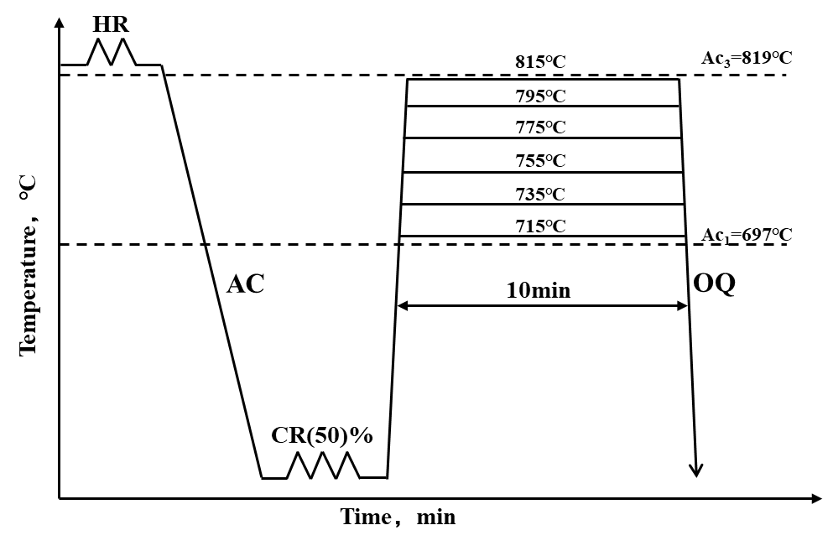
Fig. 1. Schematic of thermomechanical processing routes (Ac1:start and Ac3: finish temperature of austenite formation during heating; AC: air cooling; OQ: oil quenching; HR: hot rolling; CR: cold rolling).

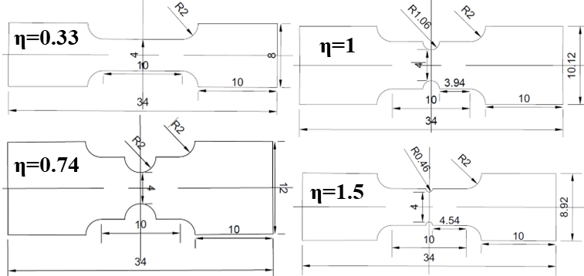
Fig. 2. Geometries of sheet specimens with different stress triaxiality (unit: mm).

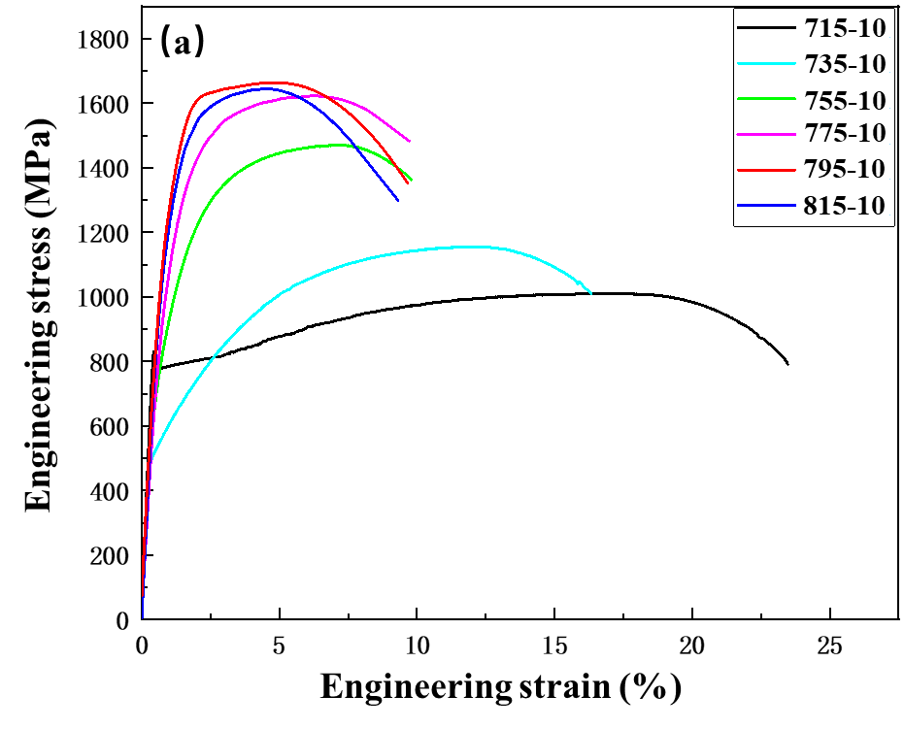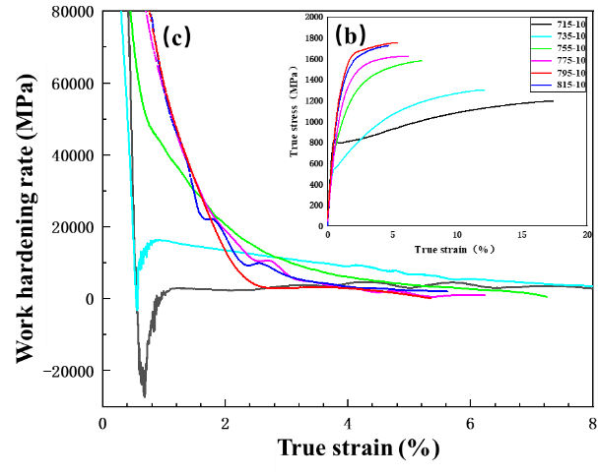
Fig. 3. Tensile properties of tested steels: (a) Engineering stress-strain curves, (b) true stress-strain curves, and (c) working hardening rate curves.

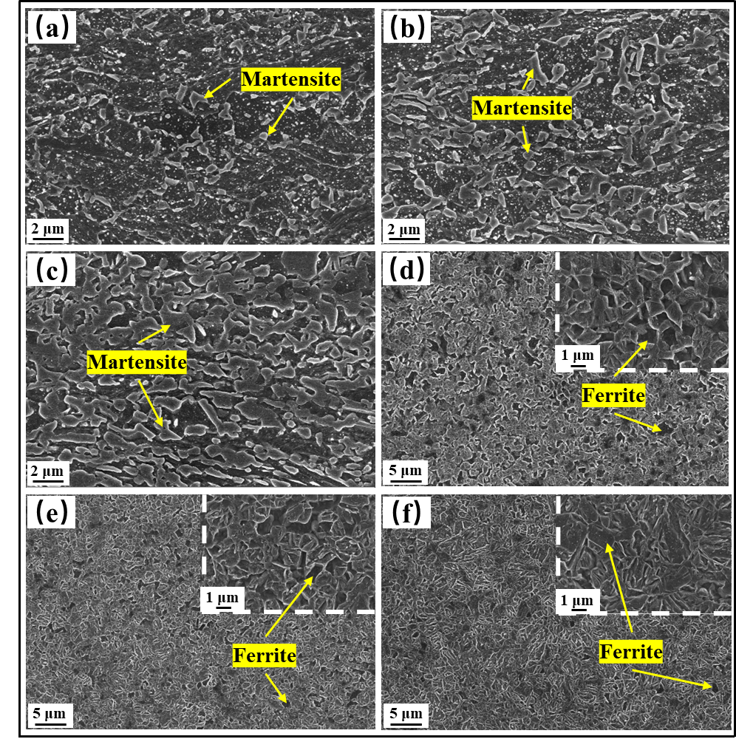
Fig. 4. SEM morphologies of tested steels under different heat treatment processes: (a)715-10, (b) 735-10, (c) 755-10, (d) 775-10, (e) 795-10 and (f) 815-10.

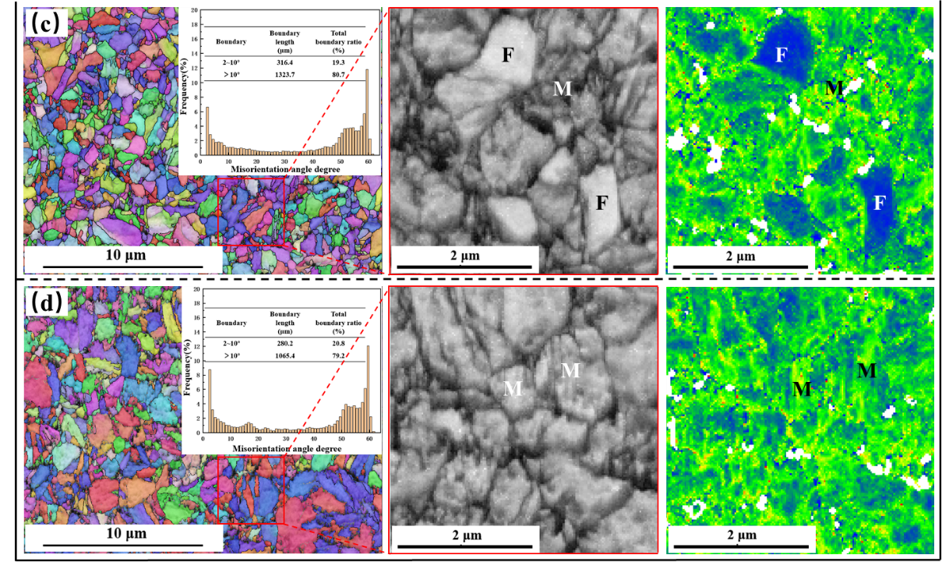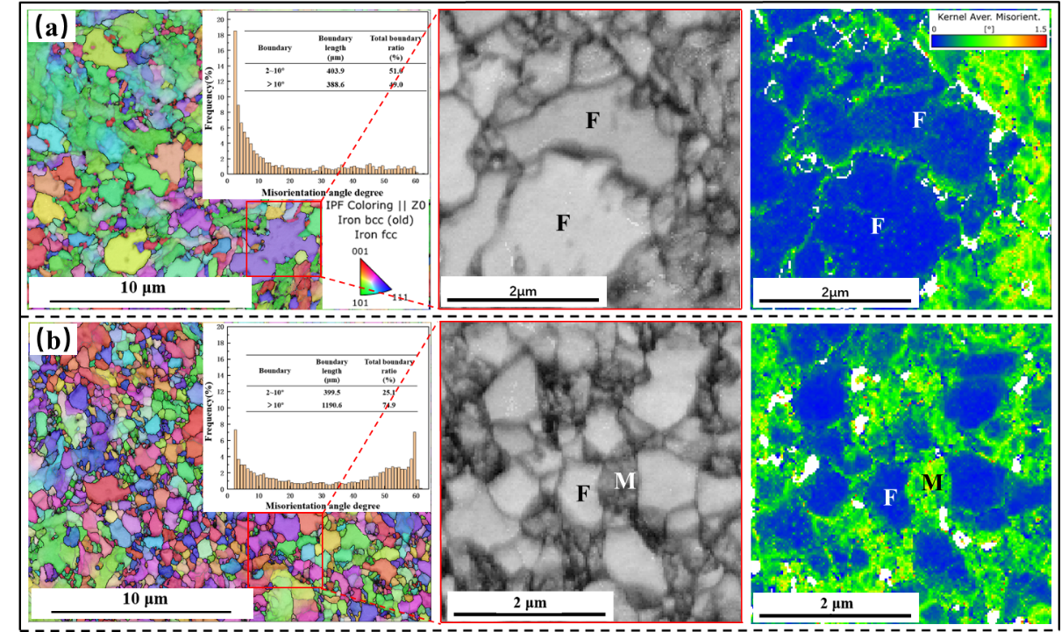
Fig. 5. EBSD inverse pole figure (IPF) with misorientation and degree maps, band contrast (BC) and kernel average misorientation (KAM) maps of tested steels: (a)715-10, (b) 755-10, (c) 795-10 and (d) 815-10.

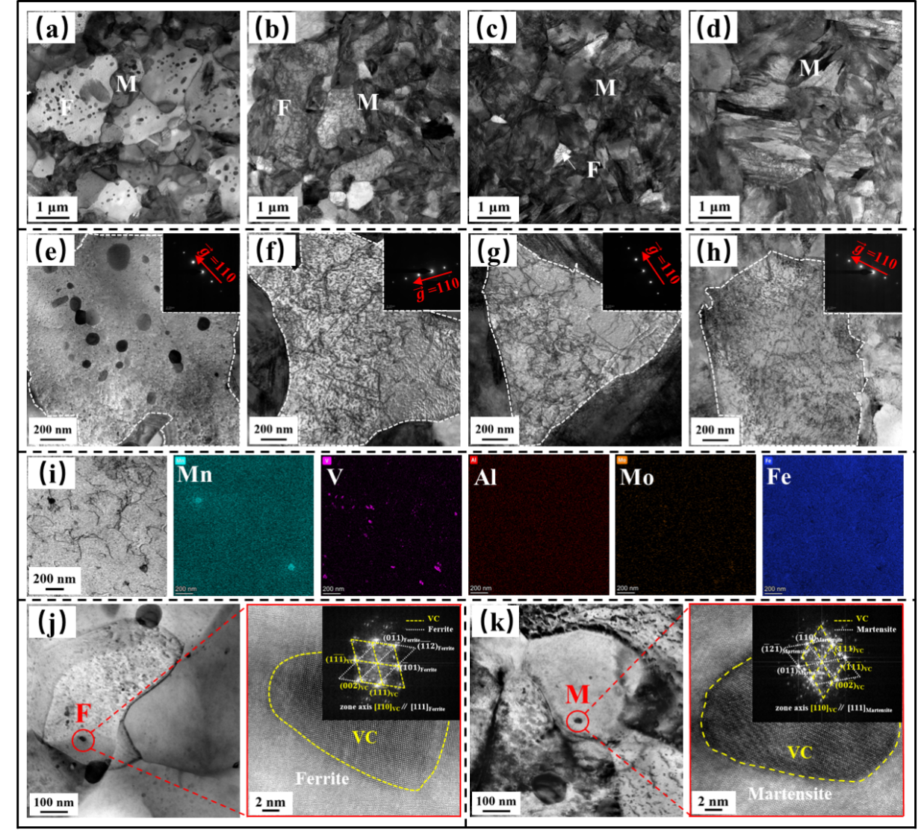
Fig. 6. TEM micrographs and dislocation structures in the ferrite at $\vec{g}$=˂110> condition: (a, e) 715-10, (b, f) 755-10, (c, g) 795-10, and (d, h) 815-10. The white dashed areas represent ferrite phase. (i) BF-STEM micrograph and EDS mappings of 755-10 steel. (j) and (k) present the VC in ferrite and martensite of 715-10 steel, respectively.

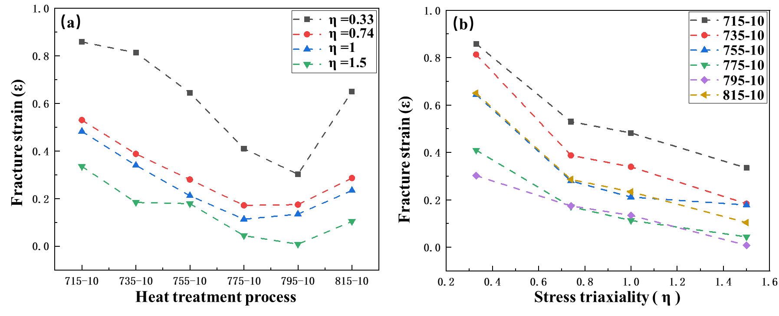
Fig. 7. The relationship between fracture strain, heat treatment process and stress triaxiality: (a) the effect of heat treatment process and (b) the effect of stress triaxiality.

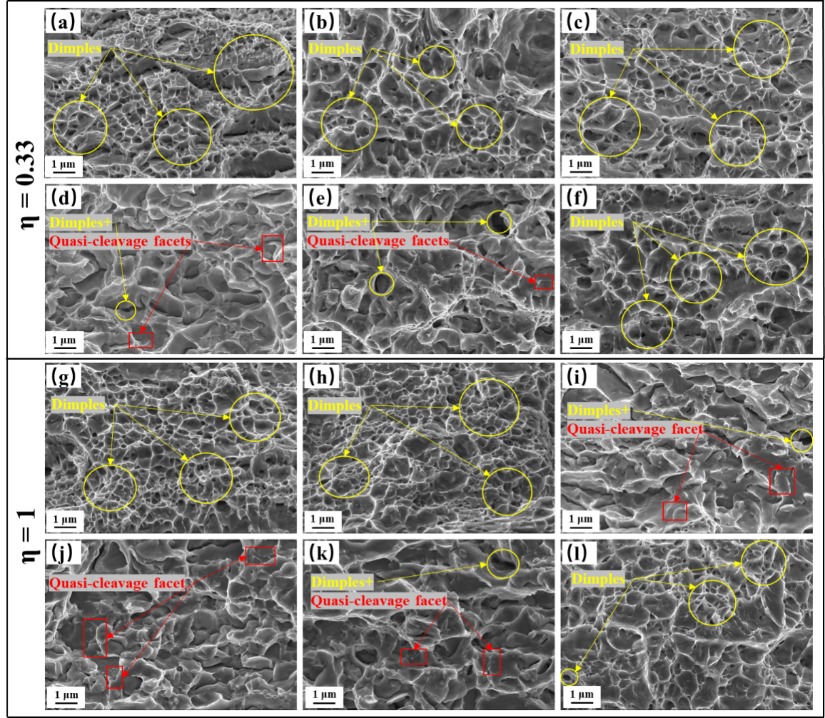
Fig. 8. Typical fracture surface morphologies of tested steels under two stress triaxialities (0.33,1): (a, g) 715-10, (b, h) 735-10, (c, i) 755-10, (d, j) 775-10, (e, k) 795-10 and (f, l) 815-10.

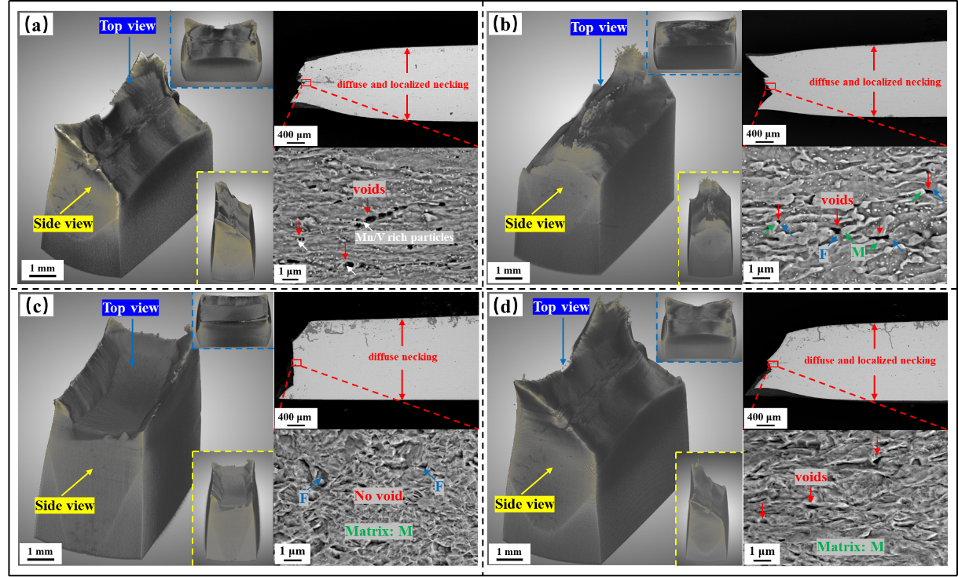
Fig. 9. Macroscopic 3D and SEM images of tensile fracture samples for smooth samples (η=0.33): (a) 715-10, (b) 755-10, (c) 795-10 and (d) 815-10.

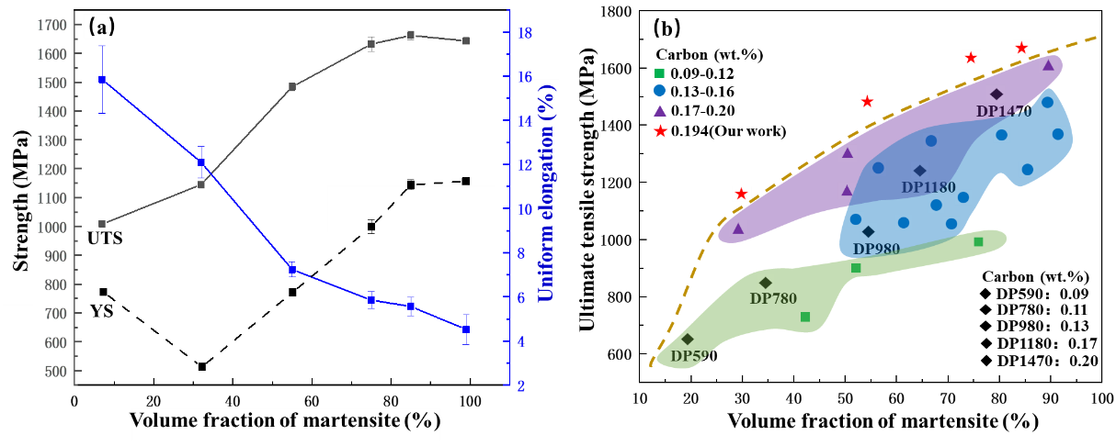
Fig. 10. (a) V_{m}-dependent yield strength (YS), ultimate tensile strength (UTS), and uniform elongation (UE) of present DP steels; and (b) The UTS of DP steels with various martensite volume fraction and carbon contents.

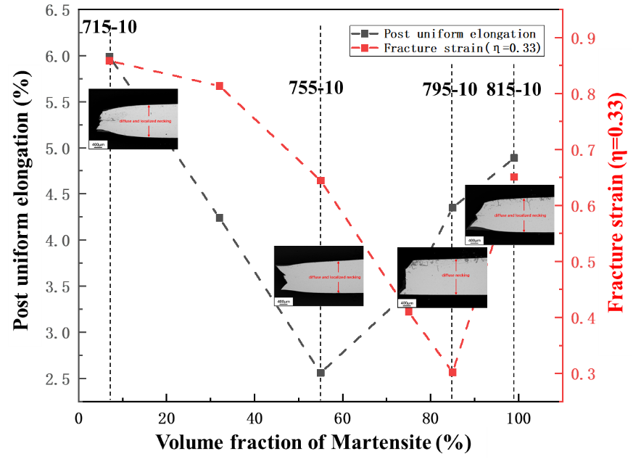
Fig. 11. V_{m}-dependent fracture strain and post-uniform elongation of present ultra-high strength DP steels.

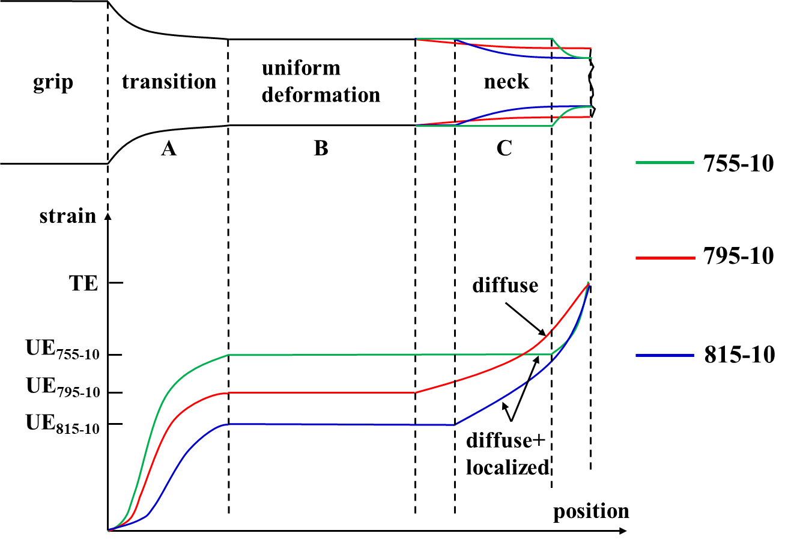
Fig. 12. Schematic drawing shows the strain gradient associated with the reduced section of the tensile fractured specimen.

